CEN/TC 250

Date: 2023-03-07

prEN 1991-1-7:2023

Secretariat: BSI

Eurocode 1 — Actions on structures — Part 1-7: Accidental actions

*Eurocode 1 – Actions sur les structures – Partie 1-7 : Actions accidentelles*

*Eurocode 1 – Einwirkungen auf Tragwerke – Teil 1-7: Außergewöhnliche Einwirkungen*

ICS:

|  |
| --- |
| CCMC will prepare and attach the official title page. |

Contents Page

European foreword 4

0 Introduction 5

1 Scope 8

1.1 Scope of prEN 1991-1-7 8

1.2 Assumptions 8

2 Normative references 8

3 Terms, definitions and symbols 8

3.1 Terms and definitions 8

3.2 Symbols 12

4 Basis of design 13

4.1 General strategies 13

4.2 Accidental design situations — strategies for identified accidental actions 13

4.3 Accidental design situations — use of consequence classes 14

5 Impact 16

5.1 Field of application 16

5.2 Classification of actions 17

5.3 Representation of actions 17

5.4 Accidental actions caused by road vehicles 17

5.5 Accidental actions caused by forklift trucks 21

5.6 Accidental actions caused by derailed rail traffic under or adjacent to structures 21

5.7 Accidental actions caused by ship traffic 24

5.8 Accidental actions caused by helicopters 27

6 Internal explosions 28

6.1 Field of application 28

6.2 Representation of action 28

6.3 Principles for design 29

Annex A (informative) Actions for tying systems and key members 31

A.1 Use of this Annex 31

A.2 Scope and field of application 31

A.3 Horizontal ties 31

A.4 Vertical ties 34

A.5 Key members 34

Annex B (informative) Information on risk assessment 35

B.1 Use of this annex 35

B.2 Scope and field of application 35

B.3 Description of scope, assumptions and limitations of a risk analysis 35

B.4 Methods of risk analysis 36

B.5 Risk evaluation and acceptance 37

B.6 Risk mitigating measures 39

B.7 Reconsideration 39

B.8 Communication of results and conclusions 39

B.9 Applications to buildings and civil engineering structures 39

Annex C (informative) Dynamic design for impact 47

C.1 Use of this annex 47

C.2 Scope and field of application 47

C.3 General 47

C.4 Impact dynamics 48

C.5 Impact from aberrant road vehicles 49

C.6 Impact by ships 52

Annex D (informative) Internal explosions 56

D.1 Use of this annex 56

D.2 Scope and field of application 56

D.3 General 56

D.4 Natural gas explosions 56

D.5 Dust explosions in rooms, vessels and bunkers 57

D.6 Explosions in road and rail tunnels 59

D.7 Dust, gas and vapour/air explosions in energy ducts 60

Annex E (informative) Actions from debris 64

E.1 Use of this annex 64

E.2 Scope and field of application 64

E.3 Actions from debris 64

Bibliography 66

European foreword

This document (prEN 1991‑1‑7:2023) has been prepared by Technical Committee CEN/TC 250 “Structural Eurocodes”, the secretariat of which is held by BSI. CEN/TC 250 is responsible for all Structural Eurocodes and has been assigned responsibility for structural and geotechnical design matters by CEN.

This document is currently submitted to the CEN Enquiry.

This document will supersede EN 1991‑1‑7:2006.

The first generation of EN Eurocodes was published between 2002 and 2007. This document forms part of the second generation of the Eurocodes, which have been prepared under Mandate M/515 issued to CEN by the European Commission and the European Free Trade Association.

The Eurocodes have been drafted to be used in conjunction with relevant execution, material, product and test standards, and to identify requirements for execution, materials, products and testing that are relied upon by the Eurocodes.

The Eurocodes recognize the responsibility of each Member State and have safeguarded their right to determine values related to regulatory safety matters at national level through the use of National Annexes.

In comparison with the previous edition, the following technical modifications have been made:

a) Transferring design strategies for robustness and related rules to EN 1990;

b) providing consistency between text and technical information on impact;

c) limiting the scope of Annex A to rules and actions for tying systems and key members; and

d) inserting technical clarifications in Annex C.

# 0 Introduction

**0.1 Introduction to the Eurocodes**

The structural Eurocodes comprise the following standards generally consisting of a number of Parts:

— EN 1990 Eurocode — Basis of structural and geotechnical design

— EN 1991 Eurocode 1 — Actions on structures

— EN 1992 Eurocode 2 — Design of concrete structures

— EN 1993 Eurocode 3 — Design of steel structures

— EN 1994 Eurocode 4 — Design of composite steel and concrete structure

— EN 1995 Eurocode 5 — Design of timber structures

— EN 1996 Eurocode 6 — Design of masonry structures

— EN 1997 Eurocode 7 — Geotechnical design

— EN 1998 Eurocode 8 — Design of structures for earthquake resistance

— EN 1999 Eurocode 9 — Design of aluminium structures

— New parts are under development, e.g. Eurocode for design of structural glass

The Eurocodes are intended for use by designers, clients, manufacturers, constructors, relevant authorities (in exercising their duties in accordance with national or international regulations), educators, software developers, and committees drafting standards for related product, testing and execution standards.

NOTE Some aspects of design are most appropriately specified by relevant authorities or, where not specified, can be agreed on a project-specific basis between relevant parties such as designers and clients. The Eurocodes identify such aspects making explicit reference to relevant authorities and relevant parties.

**0.2 Introduction to** EN1991(all parts)

(1) EN 1991 (all parts) specifies actions for the structural and geotechnical design of buildings, bridges and other civil engineering works, including temporary structures, in conjunction with EN 1990 and the other Eurocodes.

(2) EN 1991 (all parts) does not cover seismic design. Provisions for structures in seismic regions are given in EN 1998.

(3) EN 1991 (all parts) is also applicable to existing structures for:

— structural assessment,

— strengthening or repair,

— change of use.

NOTE In these cases, additional or amended provisions are necessary.

(4) EN 1991 (all parts) is also applicable for the design of structures where materials or actions outside the scope of the other Eurocodes are involved.

NOTE In this case, additional or amended provisions are necessary.

(5) EN 1991 is subdivided in various parts:

EN 1991‑1‑1, *Eurocode 1 — Actions on structures — Part 1‑1: Specific weight of materials, self-weight of construction works and imposed loads for buildings*

EN 1991‑1‑2, *Eurocode 1 — Actions on structures — Part 1‑2: Actions on structures exposed to fire*

EN 1991‑1‑3, *Eurocode 1 — Actions on structures — Part 1‑3: Snow Loads*

EN 1991‑1‑4, *Eurocode 1 — Actions on structures — Part 1‑4: Wind Actions*

EN 1991‑1‑5, *Eurocode 1 — Actions on structures — Part 1‑5: Thermal Actions*

EN 1991‑1‑6, *Eurocode 1 — Actions on structures — Part 1‑6: Actions during execution*

EN 1991‑1‑7, *Eurocode 1 — Actions on structures — Part 1‑7: Accidental actions*

EN 1991‑1‑8, *Eurocode 1 — Actions on structures — Part 1‑8: Actions from waves and currents on coastal structures*

EN 1991‑1‑9, *Eurocode 1 — Actions on structures — Part 1-9: Atmospheric icing*

EN 1991‑2, *Eurocode 1 — Actions on structures — Part 2: Traffic loads on bridges and other civil engineering works*

EN 1991‑3, *Eurocode 1 — Actions on structures — Part 3: Actions induced by cranes and machines*

EN 1991‑4, *Eurocode 1 — Actions on structures — Part 4: Silos and tanks*

**0.3 Introduction to prEN** 1991**-**1-7

prEN 1991‑1‑7 describes principles and application rules for the determination of accidental actions on buildings and other civil engineering works. The following actions are included:

— impact forces from vehicles, rail traffic, ships and helicopters;

— actions due to internal explosions of combustible gases and dust as well as of vapour-air-mixture; and

— actions for tying systems and key members.

NOTE Other Eurocodes can cover specific accidental actions.

**0.4 Verbal forms used in the Eurocodes**

The verb “shall” expresses a requirement strictly to be followed and from which no deviation is permitted in order to comply with the Eurocodes.

The verb “should” expresses a highly recommended choice or course of action. Subject to national regulation and/or any relevant contractual provisions, alternative approaches could be used/adopted where technically justified.

The verb “may” expresses a course of action permissible within the limits of the Eurocodes.

The verb “can” expresses possibility and capability; it is used for statements of fact and clarification of concepts.

**0.5 National Annex for prEN**1991**-**1-7

National choice is allowed in this standard where explicitly stated within notes. National choice includes the selection of values for Nationally Determined Parameters (NDPs).

The national standard implementing prEN 1991‑1‑7 can have a National Annex containing all national choices to be used for the design of buildings and civil engineering works to be constructed in the relevant country.

When no national choice is given, the default choice given in this standard is to be used.

When no national choice is made and no default is given in this standard, the choice can be specified by a relevant authority or, where not specified, agreed for a specific project by appropriate parties.

The National choice is allowed in prEN 1991‑1‑7 through the following clauses:

|  |  |  |  |
| --- | --- | --- | --- |
| 4.1(2) | 4.2(1) | 4.3(1) – 2 choices | 4.3(2) |
| 5.1(1) – 2 choices | 5.2(2) | 5.3(3) | 5.4.1(1) – 3 choices |
| 5.4.1(2) – 2 choices | 5.4.1(3) | 5.4.2(2) – 2 choices | 5.4.2(3) |
| 5.4.2(5) | 5.5(2) | 5.6.1(1) | 5.6.2.2(1) – 2 choices |
| 5.6.2.3(1) | 5.6.2.4(1) | 5.6.2.4(2) | 5.6.2.4(3) |
| 5.6.2.4(4) | 5.6.2.4(5) | 5.6.2.4(6) | 5.6.2.5(1) |
| 5.6.3(1) | 5.6.3(3) | 5.7.1(3) | 5.7.1(5) |
| 5.7.2(1) | 5.7.2(2) – 2 choices | 5.7.2(5) | 5.7.2(6) |
| 5.7.2(7) – 2 choices | 5.7.3(1) | 5.7.3(2) | 5.7.3(3) |
| 5.7.3(4) | 5.7.3(5) – 2 choices | 5.7.3(6) – 2 choices | 5.8(2) |
| 6.3.1(1) | A.1(1) | A.3.1(4) | A.3.2(3) |
| A.3.2(4) | A.3.3(1) | A.4.3(1) – 2 choices | A.5(1) |
| B.1(1) | C.1(1) | D.1(1) | D.6(3) |
| E.1(1) |  |  |  |

National choice is allowed in prEN 1991‑1‑7 on the application of the following informative annexes:

|  |  |  |  |
| --- | --- | --- | --- |
| Annex A | Annex B | Annex C | Annex D |

The National Annex can contain, directly or by reference, non-contradictory complementary information (NCCI) for ease of implementation, provided it does not alter any provisions of the Eurocodes.

# Scope

## Scope of prEN 1991-1-7

(1) prEN 1991‑1‑7 provides actions and rules for safeguarding buildings and other civil engineering works against identifiable accidental actions.

NOTE 1 Identifiable accidental actions include impact from vehicles and internal explosions.

NOTE 2 Rules on impact from vehicles travelling on a bridge deck are given in prEN 1991‑2.

(2) prEN 1991‑1‑7 also covers actions and rules for tying systems and key members; information on risk assessment; dynamic design for impact; actions for internal explosions; actions from debris.

## Assumptions

(1) The general assumptions of EN 1990 apply to prEN 1991‑1‑7.

(2) prEN 1991‑1‑7 is intended to be used in conjunction with EN 1990, EN 1991 (all parts) and the other Eurocode parts for the design of structures.

# Normative references

The following documents are referred to in the text in such a way that some or all of their content constitutes requirements of this document. For dated references, only the edition cited applies. For undated references, the latest edition of the referenced document (including any amendments) applies.

NOTE See the Bibliography for a list of other documents cited that are not normative references, including those referenced as recommendations (i.e. in “should” clauses), permissions (“may” clauses), possibilities (“can” clauses), and in notes.

EN 1990:2023, Eurocode — Basis of structural and geotechnical design

EN 1991 (all parts), Eurocode 1 — Actions on structures

# Terms, definitions and symbols

For the purposes of this document, the terms and definitions given in EN 1990 and the following terms, definitions and symbols apply.

NOTE Other specific symbols, especially treated in informative annexes, are given within the text.

## Terms and definitions

### General terms relevant to accidental actions

3.1.1.1

burning velocity

velocity of flame propagation relative to that of the unburned dust, gas or vapour that is ahead of the flame front

3.1.1.2

consequence class

categorization of the consequences of structural failure in terms of loss of human lives or personal injury and of economic, social, or environmental losses

[SOURCE: EN 1990:2023, 3.1.2.33]

3.1.1.3

deflagration

propagation of a combustion zone at a velocity that is less than the speed of sound in the unreacted medium

3.1.1.4

detonation

propagation of a combustion zone at a velocity that is greater than the speed of sound in the unreacted medium

3.1.1.5

dynamic force

force that varies in time and which has the potential to cause significant dynamic effects on the structure; in the case of impact, the dynamic force represents the force with an associated contact area at the point of impact (see Figure 1.1)

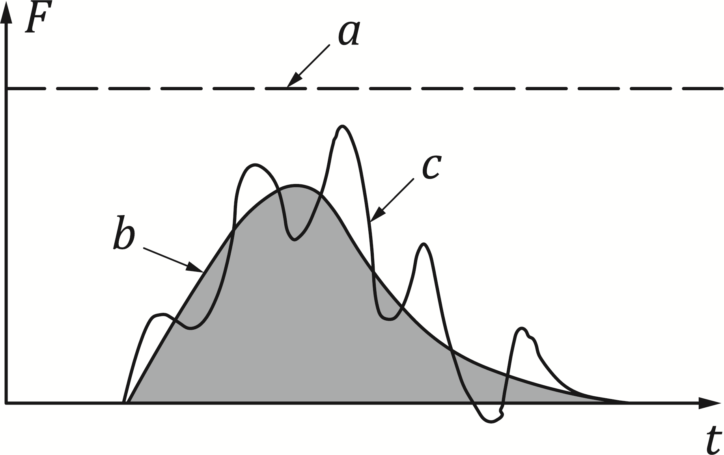

Key

|  |  |
| --- | --- |
| *a* | equivalent static force |
| *b* | dynamic force |
| *c* | structural response |

Figure 1.1 — Dynamic force

3.1.1.6

equivalent static force

alternative representation for a dynamic force including the dynamic response of the structure (see Figure 1.1)

3.1.1.7

flame speed

speed of a flame front relative to a fixed reference point

3.1.1.8

flammable limit

minimum or maximum concentration of a combustible material in a homogeneous mixture with a gaseous oxidizer that will propagate a flame

3.1.1.9

impacting object

object impacting upon a structure (e.g. vehicle, ship, etc.) during an accidental action

3.1.1.10

key member

structural member upon which the stability of the remainder of the structure depends

3.1.1.11

load-bearing wall construction

non-framed masonry cross-wall construction mainly supporting vertical loading, including lightweight panel construction comprising timber or steel vertical studs at close centres with particle board, expanded metal or alternative sheathing

3.1.1.12

localized failure

part of a structure that is assumed to have collapsed, or been severely disabled, by an event

3.1.1.13

risk

measure of the combination (usually the product) of the probability or frequency of occurrence of a defined hazard and the magnitude of the consequences of the occurrence

3.1.1.14

robustness

ability of a structure to withstand events like impact, explosions, fire or the consequences of human error, without being damaged to an extent disproportionate to the original cause

3.1.1.15

substructure

part of a building structure that supports the superstructure

Note 1 to entry: In the case of buildings, this usually relates to the foundations and other construction work below ground level. In the case of bridges, this usually relates to foundations, abutments, piers and columns, etc.

3.1.1.16

superstructure

part of a building structure that is supported by the substructure

Note 1 to entry: In the case of buildings this usually relates to the above ground construction. In the case of bridges this usually relates to the bridge deck.

3.1.1.17

venting panel

non-structural part of the enclosure (wall, floor, ceiling) with limited resistance that is intended to relieve the developing pressure from deflagration in order to reduce pressure on structural parts of the building

3.1.1.18

explosion

rapid chemical reaction of dust, gas or vapour in the air, leading to high temperatures and high overpressures, and whose pressures propagate as waves

### Specific terms relevant to Annex B

3.1.2.1

consequence

possible result of an (in risk analysis usually unwanted) event

Note 1 to entry: Consequences can be verbally or numerically expressed in terms of loss of life, injury, economic loss, environmental damage, disruption to users and the public, etc. Both immediate consequences and those that arise after a certain time has elapsed are to be included.

3.1.2.2

hazard scenario

critical situation at a particular time consisting of a leading hazard together with one or more accompanying conditions which leads to an unwanted event (e.g. complete collapse of the structure)

3.1.2.4

risk acceptance criteria

acceptable limits for probabilities of certain consequences of an undesired event, expressed in terms of annual frequencies

Note 1 to entry: These criteria are normally determined at national level to reflect the level of risk considered to be acceptable to people and society.

3.1.2.5

risk analysis

systematic approach for describing and/or calculating risk

Note 1 to entry: Risk analysis involves the identification of undesired events, and the causes, likelihoods and consequences of these events.

3.1.2.6

risk evaluation

comparison of the results of a risk analysis with the acceptance criteria for risk and other decision criteria

3.1.2.7

risk management

systematic measures undertaken by an organization in order to attain and maintain a level of safety that complies with defined objectives

3.1.2.8

undesired event

event or condition that can cause loss of life, injury, economic loss, environmental damage, disruption to users and the public, etc.

## Symbols

### Latin upper-case letters

|  |  |
| --- | --- |
| *C* | force term for helicopter impact |
| *F* | collision force |
| *F*dx | horizontal equivalent static or dynamic design force (frontal force, usually in the direction of the normal travel) |
| *F*dy | horizontal equivalent static or dynamic design force (lateral force, usually perpendicular to the direction of the normal travel) |
| *F*max | maximum pressure developed in a contained deflagration of an optimum mixture |
| *F*R | frictional impact force |
| *W* | sum of the net weight and hoisting load of a loaded forklift truck |

### Latin lower-case letters

|  |  |
| --- | --- |
| *a* | height of the application area of a collision force |
| *b* | width of the application area of a collision force |
| *bPier* | width of bridge pier |
| *d* | distance from the structural member to the centre line of the road or track |
| *h* | height of (resulting) collision force |
| *h0* | clearance between the road surface and the underside of the bridge deck, below which an impact on the superstructure needs to be taken into account without any reduction |
| *h1* | clearance between the road surface and the underside of the bridge deck, above which no impact needs to be considered |
| *ℓ* | ship length |
| *rF* | reduction factor |
| *s* | distance from structural member to the point where the vehicle leaves the trafficked lane |
| *m* | mass |
| *x* | direction of (normal) travel or track |
| *y* | direction perpendicular of (normal) travel or track |
| *v* | velocity (i.e. v0 is an initial moving velocity) |

### Greek lower-case letters

|  |  |
| --- | --- |
| *α* | inclination angle |
| *Δh* | difference between h1 and h0 |
| *μ* | friction coefficient |

# Basis of design

## General strategies

(1) Structures shall be designed for the relevant accidental design situations in accordance with EN 1990:2023, 5.2(3).

NOTE The strategies to be considered for accidental design situations are illustrated in Table 4.1, which is identical to Table E.1 of EN 1990:2023.

Table 4.1 — Strategies for Accidental Design Situations

|  |  |  |  |  |
| --- | --- | --- | --- | --- |
| **Design for accidental actions (**EN1991**)** | | **Design for enhanced robustness (**EN1990**)** | | |
| **Explicit design of the structure (e.g. against explosion, impact)** | | **Strategies based on limiting the extent of damage** | | |
| Design structure to resist the actiona | Prevent or reduce the action e.g. protective measures, control of events | Alternative load paths either providing adequate deformation capacity and ductility or applying prescriptive design rules | Key elements i.e. designing selected members to resist notional action(s) | Segmentation i.e. separation into parts |
| a Structural design against identified accidental actions can incorporate specifically designed members, which fall partially or fully, provided their failure does not lead to further structural collapse as agreed with the authorities (for strategies and methods to limit the extent of damages, see E.3 and E.4 in EN 1990:2023) | | | | |

(2) For some structures (e.g. construction works where there is no risk to human life, and where economic, social or environmental consequences are negligible) subjected to accidental actions, the complete collapse of the structure caused by an extreme event may be acceptable.

NOTE The decision criteria when such a collapse is acceptable can be given in the National Annex.

(3) Where appropriate, alternative load path design may be considered as an economic design method for accidental actions.

NOTE The application of either a vertical load on more than one column or a horizontal load on more than one beam allows for a redistribution of the action, if necessary. This can have also an effect on the load-bearing resistances in the event of an impact or explosion.

## Accidental design situations — strategies for identified accidental actions

(1) The accidental actions that should be taken into account depend upon:

— the measures taken for preventing or reducing the severity of an accidental action;

— the probability of occurrence of the identified accidental action;

— the consequences of failure due to the identified accidental action;

— public perception of the risk; and

— the level of acceptable risk.

NOTE 1 In practice, the occurrence and consequences of accidental actions can be associated with a certain risk level. If this level cannot be accepted, additional measures are necessary. A zero-risk level, however, is impracticable and, in most cases, it is necessary to accept a certain level of risk. Such a risk level can be determined by various factors, such as the potential number of casualties, the economic consequences and the cost of safety measures.

NOTE 2 Levels of acceptable risks can be given in the National Annex.

(2) A localized failure due to accidental actions may be acceptable, provided it will not endanger the stability of the whole structure, and that the overall load-bearing capacity of the structure is maintained and allows necessary emergency measures to be taken.

NOTE 1 For building structures, such emergency measures can involve the safe evacuation of persons from the premises and its surroundings.

NOTE 2 For bridge structures, such emergency measures can involve the closure of the road or rail service within a specific limited period.

(3) Measures should be taken to mitigate the risk of accidental actions and these measures should include, as appropriate, one or more of the following strategies:

a) preventing the action from occurring (e.g. in the case of bridges, by providing adequate clearances between the trafficked lanes and the structure) or reducing the probability and/or magnitude of the action to an acceptable level through the structural design process (e.g. in the case of buildings, providing sacrificial venting components with a low mass and strength to reduce the effect of explosions);

b) protecting the structure against the effects of an accidental action by reducing the effects of the action on the structure (e.g. by protective bollards or safety barriers); and/or

c) ensuring that the structure has sufficient robustness by adopting the robustness rules in EN 1990.

NOTE Protecting the structure by reducing the effects of an accidental action or preventing an action from occurring can be difficult. This is because an action is dependent upon factors which, over the design working life of the structure, can be outside the design assumptions. Preventative measures can involve periodic inspection and maintenance during the design working life of the structure.

(4) The safety of the structure immediately following the occurrence of the accidental action shall be addressed within an accidental design situation, for example where the evacuation of people is needed

## Accidental design situations — use of consequence classes

(1) The strategies for accidental design situations may be based on the following consequence classes as set out in EN 1990.

|  |  |  |
| --- | --- | --- |
| — | CC1 | Low consequences of failure |
| — | CC2 | Medium consequences of failure |
| — | CC3 | High consequences of failure |

NOTE 1 In some circumstances it can be appropriate to treat some parts of the structure as belonging to a different consequence class, e.g. a structurally separate low-rise wing of a building that is serving a less critical function than the main building.

NOTE 2 The National Annex can provide a categorization of structures according to the consequences classes in 4.3(1).

NOTE 3 Table 4.2 (NDP) gives the classification of consequences classes for internal explosions for different building types and occupancies, unless the National Annex gives a different categorization.

Table 4.2 (NDP) — Categorization of consequence classes for internal explosions.

| **Consequence class** | **Description of consequence class** | **Example of categorization of building type and occupancy a** |
| --- | --- | --- |
| CC 3 | High | All buildings defined above as Class 2 Lower and Upper Consequences Class that exceed the limits on area and number of storeys  All buildings to which members of the public are admitted in significant numbers  Stadia accommodating more than 5 000 spectators  Buildings containing hazardous substances and/or processes |
| CC 2b  Upper Risk Group | Medium high | Hotels, flats, apartments and other residential buildings greater than 4 storeys but not exceeding 15 storeys  Educational buildings greater than single storey but not exceeding 15 storeys  Retailing premises greater than 3 storeys but not exceeding 15 storeys  Hospitals not exceeding 3 storeys  Offices greater than 4 storeys but not exceeding 15 storeys  All buildings to which the public are admitted and which contain floor areas exceeding 2 000 m2 but not exceeding 5 000 m2 at each storey  Car parking not exceeding 6 storeys |
| CC 2a  Lower Risk Group | Medium low | 5 storey single occupancy houses  Hotels not exceeding 4 storeys  Flats, apartments and other residential buildings not exceeding 4 storeys  Offices not exceeding 4 storeys.  Industrial buildings not exceeding 3 storeys  Retailing premises not exceeding 3 storeys of less than 1 000 m2 floor area in each storey  Single storey educational buildings  All buildings not exceeding two storeys to which the public are admitted and which contain floor areas not exceeding 2 000 m2 at each storey |
| CC 1 | Low | Single occupancy houses not exceeding 4 storeys  Agricultural buildings  Buildings into which people rarely go, provided no part of the building is closer to another building, or area where people do go, than a distance of 1,5 times the building height |
| a For buildings intended for more than one type of use, the “consequence class” should be that relating to the most onerous type. In determining the number of storeys, basement storeys may be excluded, provided such basement storeys fulfil the requirements of “Consequences Class 2b Upper Risk Group”. | | |

(2) Accidental design situations for the different consequence classes given in 4.3(1) may be considered in the following manner:

— CC1: no specific consideration is necessary for accidental actions except to ensure that the robustness and stability rules given in EN 1990 to EN 1999, as applicable, are met;

— CC2: depending upon the specific circumstances of the structure, a simplified analysis by equivalent static action models may be adopted or prescriptive design/detailing rules may be applied;

— CC3: an examination of the specific case should be carried out to determine the level of reliability and the depth of structural analyses required. This may require a risk analysis to be carried out and the use of methods such as dynamic analyses, non-linear structural modelling and interaction between the load and the structure.

NOTE The National Annex can give reference to appropriate design approaches for higher and lower consequences classes.

(3) Preventative and/or protective measures are intended to remove or to reduce the probability of damage to the structure. Their effect can be reflected in the design by, for example, assigning the structure to a lower consequence class or using lower design forces.

# Impact

## Field of application

(1) This section defines accidental actions due to the following events:

— impact from road vehicles (excluding collisions on lightweight structures) (see 5.4);

— impact from forklift trucks (see 5.5);

— impact from trains (excluding collisions on lightweight structures) (see 5.6); and

— impact from ships (see 5.7);

— the hard landing of helicopters on roofs (see 5.8).

NOTE 1 Accidental actions on lightweight structures which are excluded from the field of application above (e.g. gantries, lighting columns, footbridges) can be provided in the National Annex.

NOTE 2 For impact loads on kerbs and parapets and on bridge decks due to derailment, see prEN 1991-2.

NOTE 3 The National Annex can give guidance on issues concerning the transmission of impact forces to the foundations.

(2) For buildings, actions due to impact shall be taken into account for:

— buildings used for car parking;

— buildings in which vehicles or forklift trucks are permitted; and

— buildings that are located adjacent to road or railway or waterway traffic.

(3) Actions due to impact from helicopters shall be taken into account for buildings where the roof contains a designated landing pad.

## Classification of actions

(1) Actions within the scope of this document shall be classified as accidental actions in accordance with EN 1990:2023, 8.3.3.4.

(2) Accidental actions due to impact should be considered as free actions unless otherwise specified.

NOTE The National Annex can specify the treatment of accidental actions which are not classified as free actions.

## Representation of actions

(1) Actions due to impact should be determined by a dynamic analysis or represented by an equivalent static force.

NOTE 1 The forces at the interface of the impacting object and the structure depend on their interaction.

NOTE 2 The basic variables for impact analysis are the impact velocity of the impacting object and the mass distribution, deformation behaviour and damping characteristics of both the impacting object and the structure. Other factors such as the angle of impact, the construction of the impacting object and movement of the impacting object after collision can also be relevant.

NOTE 3 Guidance on dynamic design for impact is given in Annex C.

(2) For structural design the actions due to impact may be represented by an equivalent static force giving the equivalent action effects in the structure. This simplified model may be used for the verification of static equilibrium, for strength verifications and for the determination of deformations of the impacted structure.

(3) The application of the dynamic or equivalent static horizontal design forces *F*dx and *F*dy should be defined.

NOTE *F*dx does not act simultaneously with *F*dy, unless the National Annex defines different rules for the application of *F*dx and *F*dy.

(4) For structures which are designed to absorb impact energy by elastic-plastic deformations of members (i.e. soft impact), the equivalent static loads may be determined by taking into account both plastic strength and the deformation capacity of such members.

NOTE For further information, see Annex C.

(5) For structures for which the energy is mainly dissipated by the impacting body (i.e. hard impact), the dynamic or equivalent static forces may be determined from subclauses 5.4 to 5.8.

NOTE Some information on parameters for masses and velocities of impacting objects as a basis for a dynamic analysis can be found in Annex C.

## Accidental actions caused by road vehicles

### Impact on supporting substructures

(1) Design values for actions due to impact on the supporting structures (e.g. columns and walls of bridges or buildings) adjacent to various types of roads should be defined.

NOTE 1 Equivalent static design forces for hard impact can be taken from Table 5.1 (NDP), unless the National Annex gives different values.

Table 5.1 (NDP) — Equivalent static design forces due to vehicular impact on members supporting structures over or adjacent to roadways

|  |  |  |
| --- | --- | --- |
| **Category of traffic** | **Force *F*dxa [kN]** | **Force *F*dyb [kN]** |
| Motorways and country national and main roads | 1 000 | 500 |
| Country roads in rural area | 750 | 375 |
| Roads in urban area | 500 | 250 |
| Courtyards and parking garages with access to:  — Cars  — Lorriesc | 50  150 | 25  75 |
| a *x* = direction of normal travel.  b *y* = perpendicular to the direction of normal travel.  c The term “lorry” refers to vehicles with maximum gross weight greater than 3,5 kN. | | |

NOTE 2 The National Annex can prescribe the force as a function of distance *s* from the structural member to the point where the vehicle leaves the trafficked lane and *d* the distance from the structural member to the centre-line of the road or track. Information on the effect of the distance *s*, where applicable, can be found in Annex C.

NOTE 3 The National Annex can define types or members of the structure that can be neglected for vehicular collision.

NOTE 4 For impact from traffic on bridges, see prEN 1991‑2.

NOTE 5 For guidance on accidental actions caused by road vehicles on bridges also carrying rail traffic, see UIC Code 777-1R.

(2) For impact on the supporting structures, the applicable area of resulting collision force *F* should be specified.

NOTE 1 For impact from lorries, the collision force *F* can be applied at any height *h* between 0,5 m to 1,5 m above the level of the carriageway or higher where certain types of protective barriers are provided (see Figure 5.1). The application area is *b* = 1,50 m (width) by *a* = 0,5 m (height) or the member width, whichever is the smaller. The National Annex can give different values.

NOTE 2 For impact from cars, the collision force *F* can be applied at *h* = 0,50 m above the level of the carriageway (see Figure 5.1). The application area is *b* = 1,50 m (width) by *a* = 0,25 m (height) or the member width, whichever is the smaller. The National Annex can give different values.

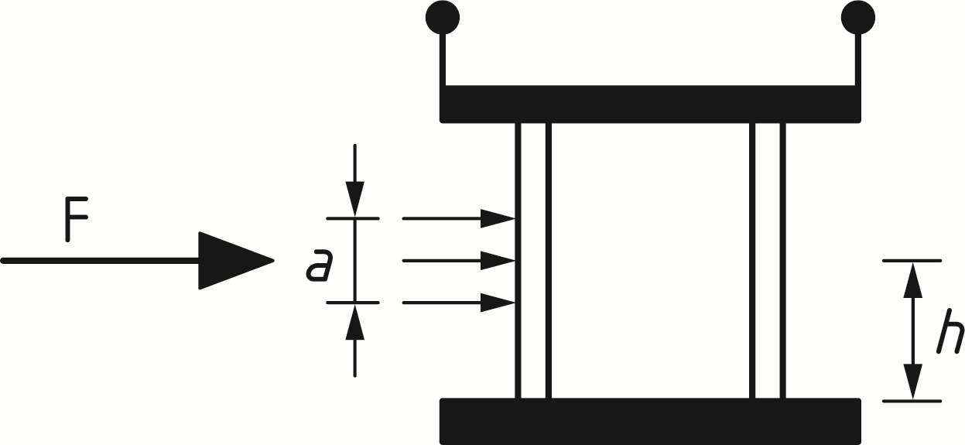

Key

|  |  |
| --- | --- |
| *a* | is the height of the force application area |
| *h* | is the location height of the resulting collision force *F* |

Figure 5.1 — Collision force on supporting substructures near traffic lanes for bridges and supporting structures for buildings

(3) Barriers and parapets in car parking areas, often connected with the supporting structure which are fall-protecting or enclosing structural members (e.g. protective devices) and their connecting means, should be designed using a horizontally free force and an impact area.

NOTE The collision force acting on barriers and parapets in car parking areas is *F* = 40 kN in a height of 0,5 m above the surface of the roadway and an impact area of *b x a* = 0,5 x 0,2 m; an impact energy of 5,5 kNm can be used as equivalent. The National Annex can give different values.

### Impact on superstructures

(1) Design values for actions due to impact from lorries and/or loads carried by the lorries on members of the superstructure should be defined, unless adequate clearances or suitable protection measures to avoid impact are provided.

(2) On vertical surfaces, the design impact actions shall be equal to the equivalent static design forces due to impact. For *h0* ≤ *h* ≤ *h1*, these values may be multiplied by a reduction factor *rF*.

NOTE 1 The equivalent static design forces *F*dx are given in Table 5.2 (NDP), unless the National Annex gives different values.

NOTE 2 The values of clearances *h0* and *h1* may be taken as 5,0 m and 6,0 m, respectively, unless the National Annex gives different values.

(3) When determining available clearance *h*, the effect of future re-surfacing, vertical sag curve and deflection of the bridge, and expected settlements should be considered.

Table 5.2 (NDP) — Equivalent static design forces due to impact on superstructures

|  |  |
| --- | --- |
| **Category of traffic** | **Equivalent static design force Fdxa** |
| [kN] |
| Motorways and country national and main roads | 500 |
| Country roads in rural area | 375 |
| Roads in urban area | 250 |
| Courtyards and parking garages | 75 |
| a x = direction of normal travel | |

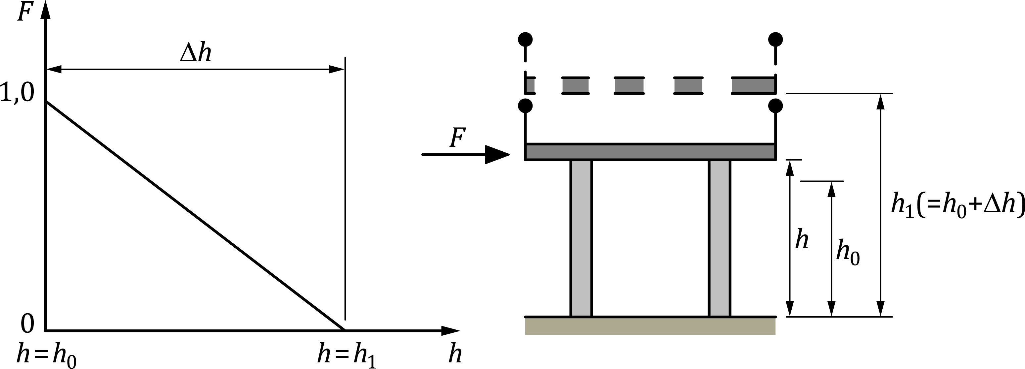

Key

|  |  |
| --- | --- |
| *rF* | reduction factor |
| *h* | clearance between the road surface and the underside of the bridge deck at the impact point |
| *h0* | clearance between the road surface and the underside of the bridge deck, below which an impact on the superstructure needs to be taken into account without any reduction |
| *h1* | clearance between the road surface and the underside of the bridge deck, above which no impact needs to be considered |
| *Δh* | difference in height between h1 and h0, i.e. *Δh* = *h1 - h0* |
| *F* | impact force |

Figure 5.2 — Recommended value of the factor *rF* for vehicular collision forces on horizontal structural members above roadways, depending on the clearance height *h*

(4) For underpart sides of bridge decks the same impact loads as above, but applied at an upward inclination, may be taken into account.

NOTE The value of upward inclination is *α* = 10o, see Figure 5.3, unless the National Annex gives a different value.

(5) In determining the value of the clearance *h*, allowance should be made for any possible future reduction caused by the resurfacing of the roadway under the bridge.

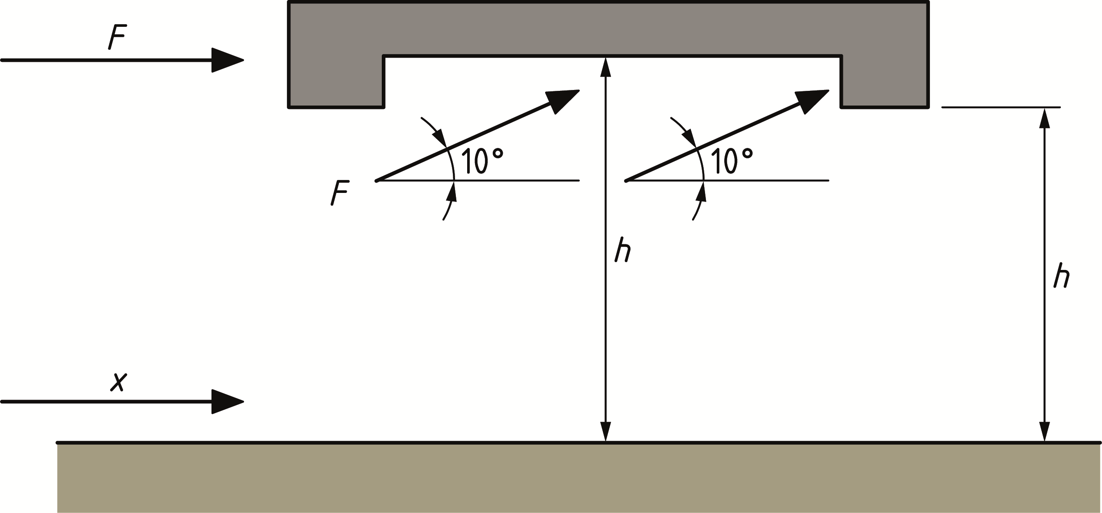

Key

|  |  |
| --- | --- |
| *F* | impact force with possible impact locations |
| *x* | direction of travel |
| *h* | is the clearance between the road surface and the underside of the bridge deck at the impact point |

Figure 5.3 — Impact force on members of the superstructure

(6) The applicable area of the impact force *F* on the members of the superstructure should be specified.

NOTE The area of impact is a square with the sides of 0,25 m length unless the National Annex gives a different value.

## Accidental actions caused by forklift trucks

(1) Design values for accidental actions due to impact from forklift trucks should be determined taking into account the dynamic behaviour of the forklift truck and the structure. The structural response may allow for non-linear deformation.

NOTE Information is given in C.4.

(2) As an alternative to a dynamic analysis, an equivalent static design force *F* may be applied.

NOTE The equivalent static design force *F* is 5*W*, where *W* is the sum of the net weight and hoisting load of a loaded truck (see prEN 1991‑1‑1), applied at a height of 0,75 m above floor level, unless the National Annex gives different values.

## Accidental actions caused by derailed rail traffic under or adjacent to structures

### General

(1) Accidental actions due to rail traffic should be defined.

NOTE The National Annex can give the types of rail traffic for which the rules in this clause are applicable.

### Structures spanning across or alongside operational railway lines

#### General

(1) Design values for actions due to impact on supporting members (e.g. piers and columns) caused by derailed trains passing under or adjacent to structures should be determined. See 5.6.2.2. The values chosen should be dependent on the classification of the structure.

NOTE 1 Derailment actions from rail traffic on bridges carrying rail traffic are specified in prEN 1991‑2.

NOTE 2 For further guidance on accidental actions related to rail traffic, reference can be made to the UIC Code 777‑2.

(2) The strategy for design may include other appropriate measures (both preventative and protective) to reduce, as far as is reasonably practicable, the effects of an accidental impact from a derailed train against supports of structures located above or adjacent to the tracks.

#### Classification of structures

(1) Structures that can be subject to impact from derailed railway traffic should be classified.

NOTE 1 Classes of structures subject to impact from derailed railway traffic are given in Table 5.3 (NDP). The structures to be included in either Classes A or B can be defined in the National Annex. Further information can be found in UIC Code 777‑2.

Table 5.3 (NDP) — Classes of structures subject to impact from derailed railway traffic

|  |  |  |
| --- | --- | --- |
| **Class** | **Type of structures** | **Examples** |
| **Class A** | Structures that span across or near to the operational railway that are either permanently occupied, serve as a temporary gathering place for people, or consist of more than one storey. | Offices, theatres and cinemas, multi-storey car parks |
| **Class B** | Massive structures that span across or near the operational railway | Road bridges, single storey structures that are not permanently occupied (e.g. parking areas) or do not serve as a temporary gathering place for people. |

NOTE 2 The National Annex can provide the classification of temporary structures such as temporary footbridges or similar structures used by the public as well as auxiliary structures, equipment and elements used during execution. See prEN 1991‑1‑6 (in development).

#### Accidental design situations in relation to the classes of structure

(1) Impact on the superstructure (deck structure) from derailed rail traffic under or on the approach to a structure may be specified.

NOTE The specification can be given in the National Annex.

#### Class A structures

(1) For class A structures, where the maximum speed of rail traffic at the location is less than or equal to 120 km/h, design values for the equivalent static forces *F*dx and *F*dy due to impact on supporting structural members (e.g. columns, walls) should be specified.

NOTE 1 The values for horizontal equivalent static design forces are given in Table 5.4 (NDP) unless the National Annex gives different values.

NOTE 2 Further information on risk assessment is set out in Annex B.

Table 5.4 (NDP) — Horizontal equivalent static design forces due to impact for class A structures over or alongside railways

|  |  |  |
| --- | --- | --- |
| **Distance “*d”* from structural members to the centre-line of the nearest track** | **Force *F*dxa** | **Force *F*dy ab** |
| [m] | [kN] | [kN] |
| Structural members:  *d* < 3 m | To be specified for the individual project. | To be specified for the individual project. |
| For continuous walls and wall type structures: 3 m ≤ *d* ≤ 5 m | 4 000 | 1 500 |
| *d* > 5 m | 0 | 0 |
| a *x* = track direction  b *y* = perpendicular to track direction. | | |

(2) Where supporting structural members are protected by solid plinths or platforms, etc., the value of impact forces *F*dx and *F*dy may be reduced from that specified in 5.6.2.4 (1).

NOTE Reductions can be given in the National Annex.

(3) If the maximum speed of rail traffic at the location is less than or equal to 50 km/h, the values of the impact forces *F*dx and *F*dy may be reduced from that specified in 5.6.2.4 (1).

NOTE The reduction is 50 % unless the National Annex gives a different value. Further information can be found in UIC Code 777-2.

(4) The values for the impact forces *F*dx and *F*dy should be applied at a specified height above track level.

NOTE The height is 1,8 m unless the National Annex gives a different value.

(5) Where the maximum permitted speed of rail traffic at the location is greater than 120 km/h, the values of the horizontal equivalent static design forces *F*dx and *F*dy*,* should be determined assuming that consequence class CC3 applies. See 4.3(1).

NOTE The values for *F*dx and *F*dy, which can take into account additional preventative and/or protective measures, can be given in the National Annex.

(6) Actions from debris for railways superstructures should be specified where relevant.

NOTE Information is given in Annex E.

#### Class B structures

(1) For class B structures, each requirement should be specified.

NOTE Specification can be given in the National Annex. Each requirement can be based on a risk assessment. Information on the factors and measures to consider is given in Annex B.

### Structures located in areas beyond track ends

(1) Structures or their supports should not be located in the area immediately beyond the track ends.

NOTE The area immediately beyond the track ends can be specified in the National Annex.

(2) When a structure or its supports are located in the area immediately beyond the track ends, overrunning of rail traffic beyond the end of a track or tracks (for example at a terminal station) should be taken into account as an accidental action.

(3) Where supporting structural members are required to be located near to track ends, an end impact wall should be provided in the area immediately beyond the track ends in addition to any buffer stop. Values of equivalent static forces due to impact onto an end impact wall should be specified.

NOTE The design values for the equivalent static force due to impact on the end impact wall is *F*dx = 5 000 kN for passenger trains and *F*dx = 10 000 kN for shunting and marshalling trains. These forces are applied horizontally and at a level of 1,0 m above track level, unless the National Annex defines different values.

## Accidental actions caused by ship traffic

### General

(1) Accidental actions due to collisions from ships should be determined taking account of the following:

— the type of waterway;

— the flood conditions;

— the type and draught of vessels and their impact behaviour; and

— the type of the structures and their energy dissipation characteristics.

NOTE For information on the probabilistic modelling of ship collision, see Annex B.

(2) The types of ships on inland waterways to be taken into account in the case of ship impact on structures should be classified according to the CEMT classification system reproduced in Table 5.5 (NDP).

(3) The characteristics of ships on sea waterways to be taken into account in the case of ship impact on structures should be defined.

NOTE The National Annex can define a classification system for ships on sea waterways.

(4) Where the design values for actions due to ship impact are determined by advanced methods, the effects of hydrodynamic added mass should be taken into account.

(5) The action due to lateral impact should be represented by a friction component *F*R parallel to *F*dx. The impact force due to friction *F*R acting simultaneously with the lateral impact force *F*dy should be determined from Formula (5.1):

 (5.1)

where

|  |  |
| --- | --- |
| *μ* | is the friction coefficient |

NOTE The value of *µ* for concrete and steel is 0,4, unless the National Annex gives a different value. The value of friction corresponds to the friction between the materials in question.

(6) Structures designed to accept ship impact in normal operating conditions, berthing, (e.g. quay walls and breasting dolphins) are out of the scope of this part of EN 1991.

### Impact from river and canal traffic

(1) Frontal and lateral dynamic design forces due to impact from river and canal traffic should be specified.

NOTE Values for the dynamic forces due to ship impact on inland waterways are given in Table 5.5 (NDP) for a number of standard ship characteristics including the effects of added hydraulic mass. The National Annex can give different values for frontal and lateral dynamic forces. For information on dynamic impact forces see C.6.2.

Table 5.5 (NDP) — Values for the dynamic forces due to ship impact on inland waterways

|  |  |  |  |  |  |  |
| --- | --- | --- | --- | --- | --- | --- |
| **CEMTa** | **Reference type of ship** | **Length *l*** | **Mass *m*** | **Force *F*dx c** | **Force *F*dy c** | |
| **Class** | [m] | [Ton]b | [kN] | [kN] | |
| I |  | 30-50 | 200-400 | 2 000 | | 1 000 |
| II |  | 50-60 | 400-650 | 3 000 | | 1 500 |
| III | “Gustav König” | 60-80 | 650-1 000 | 4 000 | | 2 000 |
| IV | Class “Europe” | 80-90 | 1 000-1 500 | 5 000 | | 2 500 |
| Va | Big ship | 90-110 | 1 500-3 000 | 8 000 | | 3 500 |
| Vb | Tow + 2 barges | 110-180 | 3 000-6 000 | 10 000 | | 4 000 |
| Vla | Tow + 2 barges | 110-180 | 3 000-6 000 | 10 000 | | 4 000 |
| Vlb | Tow + 4 barges | 110-190 | 6 000-12 000 | 14 000 | | 5 000 |
| Vlc | Tow + 6 barges | 190-280 | 10 000-18 000 | 17 000 | | 8 000 |
| VII | Tow + 9 barges | 300 | 14 000-27 000 | 20 000 | | 10 000 |
| a CEMT: European Conference of Ministers of Transport, classification proposed 19 June 1992, approved by the Council of European Union 29 October 1993.  b The mass *m* in Tons (1 Ton = 10 kN) includes the total mass of the vessel, including the ship structure, the cargo and the fuel. It is often referred to as the displacement tonnage.  c The forces *F*dx and *F*dy include the effect of hydrodynamic mass and are based on (probabilistic) background calculations, using expected conditions for every waterway class. | | | | | | |

(2) The forces due to impact should be applied at a height above the maximum navigable water level depending on the ship's draught (loaded or in ballast). The height of application of the impact force and the impact area *b × a* should be defined.

NOTE 1 The force is applied at a height *h* of 1,50 m above the relevant water level unless the National Annex gives different values.

NOTE 2 The impact area *b × a* is given by *b* = *bpier* and *a* = 0,5 m for frontal impact and *b* = 1,0 m and *a* = 0,5 m for lateral impact, unless the National Annex gives different values. Here *bpier* is the width of the obstacle in the waterway, for example of the bridge pier.

(3) Under certain conditions it may be necessary to assume that the ship is lifted over an abutment or foundation block prior to impacting with columns.

(4) Frontal and lateral dynamic design forces due to impact from river and canal traffic may be adjusted depending upon the consequences of failure of the ship impact. These dynamic values should be increased for high consequences of failure and reduced in the case of low consequences of failure.

(5) In the absence of a dynamic analysis for the impacted structure, the dynamic design forces given in Table 5.5 (NDP) should be multiplied by an appropriate dynamic amplification factor. For information on dynamic analysis, see C.4.

NOTE Values of the dynamic amplification factor are 1,3 for frontal impact and 1,7 for lateral impact unless the National Annex gives different values.

(6) In harbour areas, the forces due to ship impact on inland waterways may be reduced.

NOTE The forces can reduced by a factor of 0,5 unless the National Annex gives a different value.

(7) Where relevant, the deck of a bridge should be designed to sustain an equivalent static force due to impact from a ship acting in a transverse direction to the longitudinal (span) axis of the bridge.

NOTE 1 The equivalent static force is 1 000 kN unless the National Annex gives a different value.

NOTE 2 The National Annex can specify circumstances for which a ship impact to a bridge deck can be neglected.

### Impact from seagoing vessels

(1) Frontal and lateral dynamic design forces due to impact from seagoing vessels should be specified.

NOTE Values of frontal and lateral dynamic impact forces are given in Table 5.6 (NDP) unless different values are given in the National Annex. For information on dynamic impact forces see C.6.3.

Table 5.6 (NDP) — Values for the dynamic forces due to ship impact on sea waterways (ice-classed/non-ice-classed vessels)

| **Class of ship** | **Length *l*** | **Mass *m* a** | **Force *F*dx b,c** | **Force *F*dy b,c** |
| --- | --- | --- | --- | --- |
| [m] | [Ton] | [kN] | [kN] |
| Small | 50 | 3 000 | 30 000/  18 000 | 15 000/  9 000 |
| Medium | 100 | 10 000 | 80 000/  47 000 | 40 000/  23 500 |
| Large | 200 | 40 000 | 240 000/  144 000 | 120 000/  72 000 |
| Very large | 300 | 100 000 | 460 000/  275 000 | 230 000/  137 500 |
| a The mass m in Tons (1 Ton = 10 kN) includes the total mass of the vessel, including the ship structure, the cargo and the fuel. It is often referred to as the displacement tonnage. It does not include the added hydraulic mass.  b The forces given correspond to a velocity of about 5,0 m/s and for for typical sailing channels. They include the effects of added hydraulic mass.  c Where relevant, the effect of bulbs should be accounted for. | | | | |

(2) In the absence of a dynamic analysis for the impacted structure, the dynamic values should be multiplied by an appropriate dynamic amplification factor.

NOTE Values of the dynamic amplification factor are 1,3 for frontal impact and 1,7 for lateral impact, unless the National Annex gives different values. For information on dynamic analysis, see C.4.

(3) In harbour areas, the dynamic forces due to ship impact on sea waterways may be reduced by a factor.

NOTE The forces can be reduced by a factor of 0,5 unless the National Annex gives a different value.

(4) Bow, stern and midships side impact should be considered where relevant. Bow impact should be considered for the main sailing direction with a maximum deviation of 30°.

NOTE Mainly because of reduced velocities for midships and stern impact, the forces given in Table 5.6 (NDP) are multiplied by a factor of 0,3 unless the National Annex gives a different value. Midships impact can govern the design in narrow waters where head-on impact is not feasible.

(5) The position and area over which the impact force should be applied depend upon the geometry of the structure and the size and geometry (e.g. ship length *l*, with or without bulb) of the vessel, the vessel draught and trim, and tidal variations. The design water levels should be agreed for a specific project by the relevant parties. The vertical range of the point of impact shall account for the most unfavourable conditions for the vessels travelling in the area.

NOTE 1 Limits on the area of impact (see Figure 5.4) are *b* = 0,1 *l* for the width (*l* = ship length) and a = 0,05 *l* for the height, unless the National Annex gives different values.

NOTE 2 The limits on the position of the force in the vertical direction (see Figure 5.4) are 0,05 *l* below to 0,05 *l* above the design water levels, unless the National Annex gives different values.

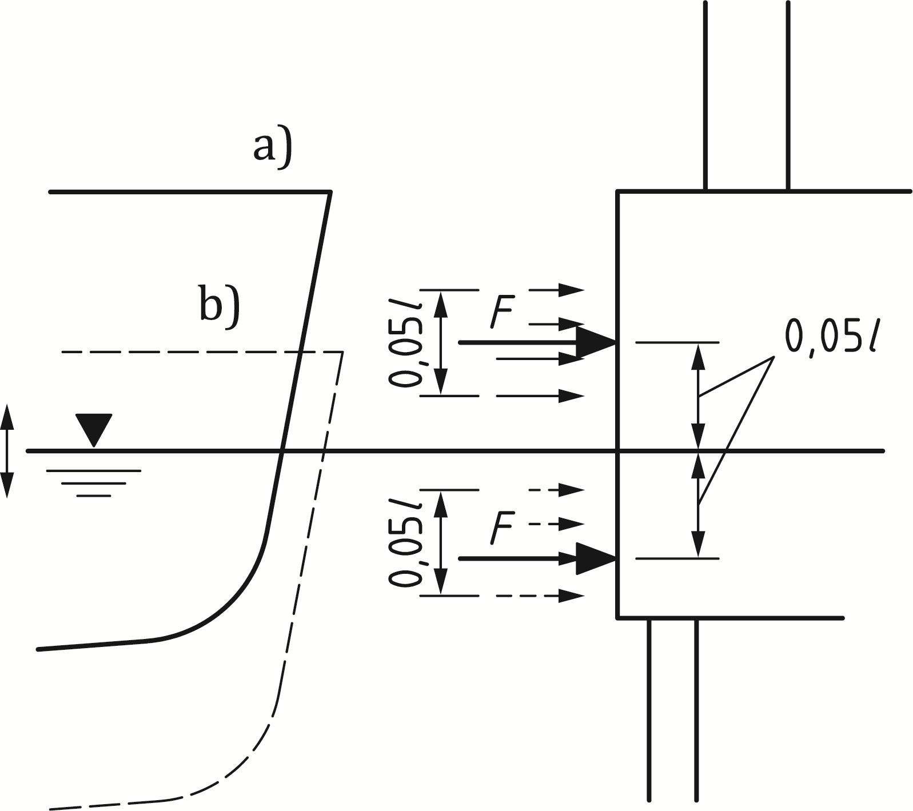

Figure 5.4 — Indicative impact areas for ship impact: a) ship in ballast b) loaded ship

(6) The forces on a superstructure should be determined by taking account of the height of the structure and the type of ship to be expected.

NOTE 1 In general, the force on the superstructure of the bridge will be limited by the yield strength of the ships' superstructure.

NOTE 2 A range of 5 % to 10 % of the bow impact force can be used, unless the National Annex gives a different value.

NOTE 3 In cases where only the mast is likely to impact on the superstructure, the design load is 1 MN, unless the National Annex gives a different value.

## Accidental actions caused by helicopters

(1) For buildings with roofs designated as a landing pad for helicopters, an emergency landing force should be taken into account.

(2) The vertical equivalent static design force *Fd* should be determined from Formula (5.2):

 (5.2)

where

|  |  |
| --- | --- |
| *C* | is 3 kN kg-0,5; |
| *m* | is the mass of the helicopter, in [kg]. |

(2) The force due to impact should be considered as acting on any part of the landing pad as well as on the roof structure within a maximum distance.

NOTE The maximum distance from the edge of the landing pad is 7 m and the area of impact is 2 m × 2 m, unless the National Annex gives different values.

# Internal explosions

## Field of application

(1) Explosions shall be taken into account in the design of all parts of the building and other civil engineering works where gas is burned or regulated, or where explosive material such as explosive gases, or liquids forming explosive vapour or gas is stored or transported (e.g. chemical facilities, vessels, bunkers, sewage constructions, dwellings with gas installations, energy ducts, road and rail tunnels), or where combustible dusts are present or can accumulate.

(2) Effects due to high explosives that detonate are outside the scope of this document.

(3) The influence on the magnitude of an explosion of cascade effects from several connected rooms filled with explosive dust, gas or vapour is also not covered in this document.

## Representation of action

(1) Explosion pressures on structural members should be determined taking into account, as appropriate, reactions transmitted to the structural members by members other than structural.

NOTE The pressure generated by an internal explosion depends primarily on the type of dust, gas or vapour, the percentage of dust, gas or vapour in the air and the uniformity of the dust, gas or vapour-air mixture, the ignition source, the presence of obstacles in the enclosure, the size, the shape and the strength of the enclosure in which the explosion occurs, and the amount of venting or pressure release that can be available.

(2) Due allowance should be given for the probable presence of dust, gas or vapour in rooms or groups of rooms throughout the building, for venting effects, for the geometry of the room or group of rooms under consideration, etc.

(3) For construction works classified as CC1 (see Clause 4), no specific consideration of the effects of an explosion should be necessary other than complying with the rules for connections and interaction between components provided in EN 1992 to EN 1999.

(4) For construction works classified as CC2 or CC3, key members of the structure should be designed to resist actions by either using an analysis based upon equivalent static load models, or by applying prescriptive design/detailing rules. Additionally, for structures classified as CC3 a dynamic analysis should be used.

NOTE For information on prescriptive design, see Annex A, and for dynamic analysis, see Annex D.

(5) Advanced design for explosions may include one or more of the following aspects:

— explosion pressure calculations, including the effects of confinements and venting panels;

— dynamic non-linear structural calculations;

— probabilistic aspects;

— analysis of failure consequences; and/or

— economic optimization of mitigating measures.

## Principles for design

### General

(1) Structures shall be designed to resist progressive collapse resulting from an internal explosion.

NOTE 1 The National Annex can give the procedures to be used for different types of internal explosions.

NOTE 2 Guidance on dealing with the following specific types of explosion is given in Annex D for:

— gas and vapour/air explosions in rooms and closed sewage basins;

— dust explosions in rooms, vessels and bunkers;

— gas and vapour/air explosions in road and rail tunnels;

— dust, gas and vapour/air explosions in energy ducts.

NOTE 3 The values presented in Annex D of this part are nominal values given that the explosion occurs.

(2) When calculating the structural response, dynamic and non-linear behaviour may be taken into account. The load-time function may be assumed triangular whereas a load duration of 0,2 s may be adopted.

NOTE A sensitivity study on the load-time function can be performed to identify the peak load-time within the 0,2 s duration.

(3) A limited part of the structure may be subject to failure, provided this does not include key members upon which the stability of the whole structure depends.

### Limiting consequences of explosions

(1) The consequences of explosions may be limited by applying one or more of the following measures:

— designing the structure to resist the explosion peak pressure;

NOTE Whilst the peak pressures can be higher than the values determined by the methods given in Annex D, such peak pressures have to be considered in the context of a maximum load duration of 0,2 s and assume plastic ductile material behaviour:

— using venting panels with defined venting pressures;

— separating adjacent sections of the structure that contain explosive materials;

— limiting the area of structures that are exposed to explosion risks; and

— providing specific protective measures between adjacent structures exposed to explosion risks to avoid propagation of pressures.

(2) The explosive pressure should be assumed to act simultaneously on all of the bounding surfaces of the enclosure in which the explosion occurs.

(3) The design should limit the possibility that the effects of a fire cause any impairment of the surroundings or initiates an explosion in an adjacent room.

(4) Venting panels should be placed close to the possible ignition sources, if known, or where pressures are likely to be high.

(5) Venting panels should be discharged at a suitable location that will not endanger personnel or ignite other material.

(6) The venting panel should be restrained so that it does not become a missile in the event of an explosion.

(7) Venting panels should be opened at a low pressure and should be as light as possible.

(8) Venting components should be located adjacent to the open air without obstructions.

(9) If windows are used as venting panels, the risk of injury to persons from glass fragments or other structural members should be considered.

(10) In determining the capacity of the venting panel, the dimensioning and construction of the supporting frame of the panel shall be taken into account.

(11) After the first positive phase of the explosion with an overpressure, a second phase follows with an under-pressure. This effect should be considered in the design where relevant.

(12) Advice should be sought from explosion specialists.

1. (informative)  
     
   Actions for tying systems and key members
   1. Use of this Annex

(1) This informative Annex provides supplementary guidance to 4.2 and Clause 6 for actions for tying systems and key members.

NOTE National choice on the application of this Informative Annex is given in the National Annex. If the-National Annex contains no information on the application of this informative annex, it can be used.

* 1. Scope and field of application

(1) This Annex A gives actions for tying systems and key members, which can be relevant for accidental design situations.

NOTE 1 This includes for example structures that can be subject to internal explosions.

NOTE 2 The guidance given in this annex can be used to determine actions for tying systems and key members for enhanced robustness according to EN 1990.

* 1. Horizontal ties
     1. Framed structures

(1) Horizontal ties should be provided around the perimeter of each floor and roof level and internally in two right angle directions to tie the column and wall members securely to the structure of the building.

(2) The ties should be continuous and be arranged as closely as practicable to the edges of floors and lines of columns and walls.

(3) At least 30 % of the ties should be located within the close vicinity of the grid lines of the columns and the walls.

(4) Each continuous tie, including its end connections, should be capable of sustaining a design tensile load of *Ti* for the accidental limit state in the case of internal ties, and *Tp*, in the case of perimeter ties.

NOTE 1 The values of *Ti* and *Tp* are determined from the following Formulae unless the National Annex gives different values:

|  |  |  |
| --- | --- | --- |
| For internal ties: |  | (A.1) |
| For perimeter ties: |  | (A.2) |

where

|  |  |
| --- | --- |
| *g*k | is the characteristic permanent action, in [kN/m2]; |
| *q*k | is the characteristic variable action, in [kN/m2]; |
| *s*t | is the spacing of ties, in [m]; |
| *L* | is the span of the tie, in [m]; |
| *ψ* | is the relevant combination factor for the accidental design situation, in [-]. |

NOTE 2 See the example in Figure A.1.

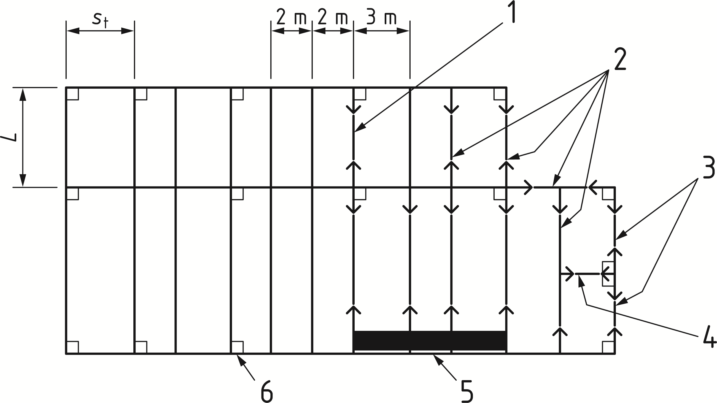

Key

|  |  |
| --- | --- |
| 1 | beam as internal tie with span *L* |
| 2 | all beams designed to act as ties |
| 3 | perimeter ties |
| 4 | tie anchored to a column |
| 5 | horizontal wall tie |
| 6 | edge column |

Figure A.1 — Example of horizontal tying of a *n* storey department store

(5) Members that bear actions other than accidental actions may be used for the tying system.

* + 1. Load-bearing wall constructions

(1) For Consequence Class 2a buildings (Lower Risk Group), see 4.3:

Instead of designing for an action, a cellular structure should be realized.

(2) For Consequence Class 2b buildings (Upper Risk Group), see 4.3:

Continuous horizontal ties are recommended in the floors. These should be internal ties distributed throughout the floors in both orthogonal directions and peripheral ties extending around the perimeter of the floor slabs within a 1,2 m width of the slab.

(3) The design tensile load *Ti* for internal ties and *Tp* for peripheral ties should be determined.

NOTE 1 The values of *Ti* and *Tp* are determined from the following Formulae unless the National Annex gives different values:

|  |  |  |
| --- | --- | --- |
| For internal ties: |  | (A.3) |
| For peripheral ties: |  | (A.4) |

where

|  |  |
| --- | --- |
| *F*t | is min {60 ; 20 + 4 *\* n*s }, in [kN/m] |
| *n*s | is the number of storeys; |
| *H* | is the storey height, in [m]; |
| *z* | is the lesser of, in [m]:  — 5 times the clear storey height *H*; or  — the greatest distance in the direction of the tie, between the centres of the columns or other vertical load-bearing members whether this distance is spanned by:  — a single slab; or  — by a system of beams and slabs. |

NOTE 2 *H* and *z* are illustrated in Figure A.2.

|  |  |
| --- | --- |
|  | |
| a) Plan | |
|  |  |
| b) Section: Flat slab | c) Section: Beam and slab |



Figure A.2 — Illustration of *H* and *z*

(4) Horizontal ties to walls should be capable of resisting a tensile force *tfac*.

NOTE The value of the tensile force is *tfac* ≥ 20 kN/m unless the National Annex gives another value.

* + 1. Columns

(1) Horizontal ties to columns should be capable of resisting a tensile force *T*Col.

NOTE The value of the tensile force is *TCol* ≥ 150 kN unless the National Annex gives another value.

* 1. Vertical ties
     1. General

(1) Each column and wall should be tied continuously from the foundations to the roof level.

* + 1. Framed structures

(1) In the case of framed buildings (e.g. steel or reinforced concrete structures) the columns and walls carrying vertical actions should be capable of resisting only an accidental design tensile force equal to the largest design vertical permanent and variable load reaction applied to the column from any one storey.

* + 1. Load-bearing wall construction

(1) For load-bearing wall constructions, the vertical ties may be designed for a vertical tie force *T*V.

NOTE 1 The value of *T*V is determined from the following Formula unless the National Annex gives different values:

 (A.5)

where

|  |  |
| --- | --- |
| *s*t | is the spacing of ties, in [m]; |
| *A* | is the cross-sectional area of the wall measured on plan, excluding the non load-bearing leaf of a cavity wall, in [mm2]; |
| *H* | is the clear storey height, in [m]; |
| *t* | is the thickness of the wall, in [m]. |

NOTE 2 The National Annex can specify design rules which provide equivalent reliability instead of a design with *TV*.

(2) The vertical ties should be placed a maximum of every 5 m along the wall and should have a maximum distance of 2,5 m from the free end.

* 1. Key members

(1) In accordance with EN 1990, for building structures, a “key member” should be capable of sustaining an accidental design action of *Ad* applied in horizontal and vertical directions (in one direction at a time) to the member and any attached components having regard to the ultimate strength of such components and their connections. Such accidental design loading should be applied in accordance with Formula (8.15) of EN 1990:2023 and may be a concentrated or distributed load.

NOTE The value of *Ad* for building structures is 34 kN/m2, unless the National Annex gives a different value.

1. (informative)  
     
   Information on risk assessment
   1. Use of this annex

(1) This Informative Annex provides supplementary guidance to 5.4, 5.6 and 5.7 and to risk assessments in all situations.

NOTE National choice on the application of this Informative Annex is given in the National Annex. If the National Annex contains no information on the application of this informative annex, it can be used.

* 1. Scope and field of application

(1) This Annex B gives guidance for the planning and execution of risk assessment in the field of buildings and civil engineering structures. A general overview is presented in Figure B.1, see B.4 to B.8.

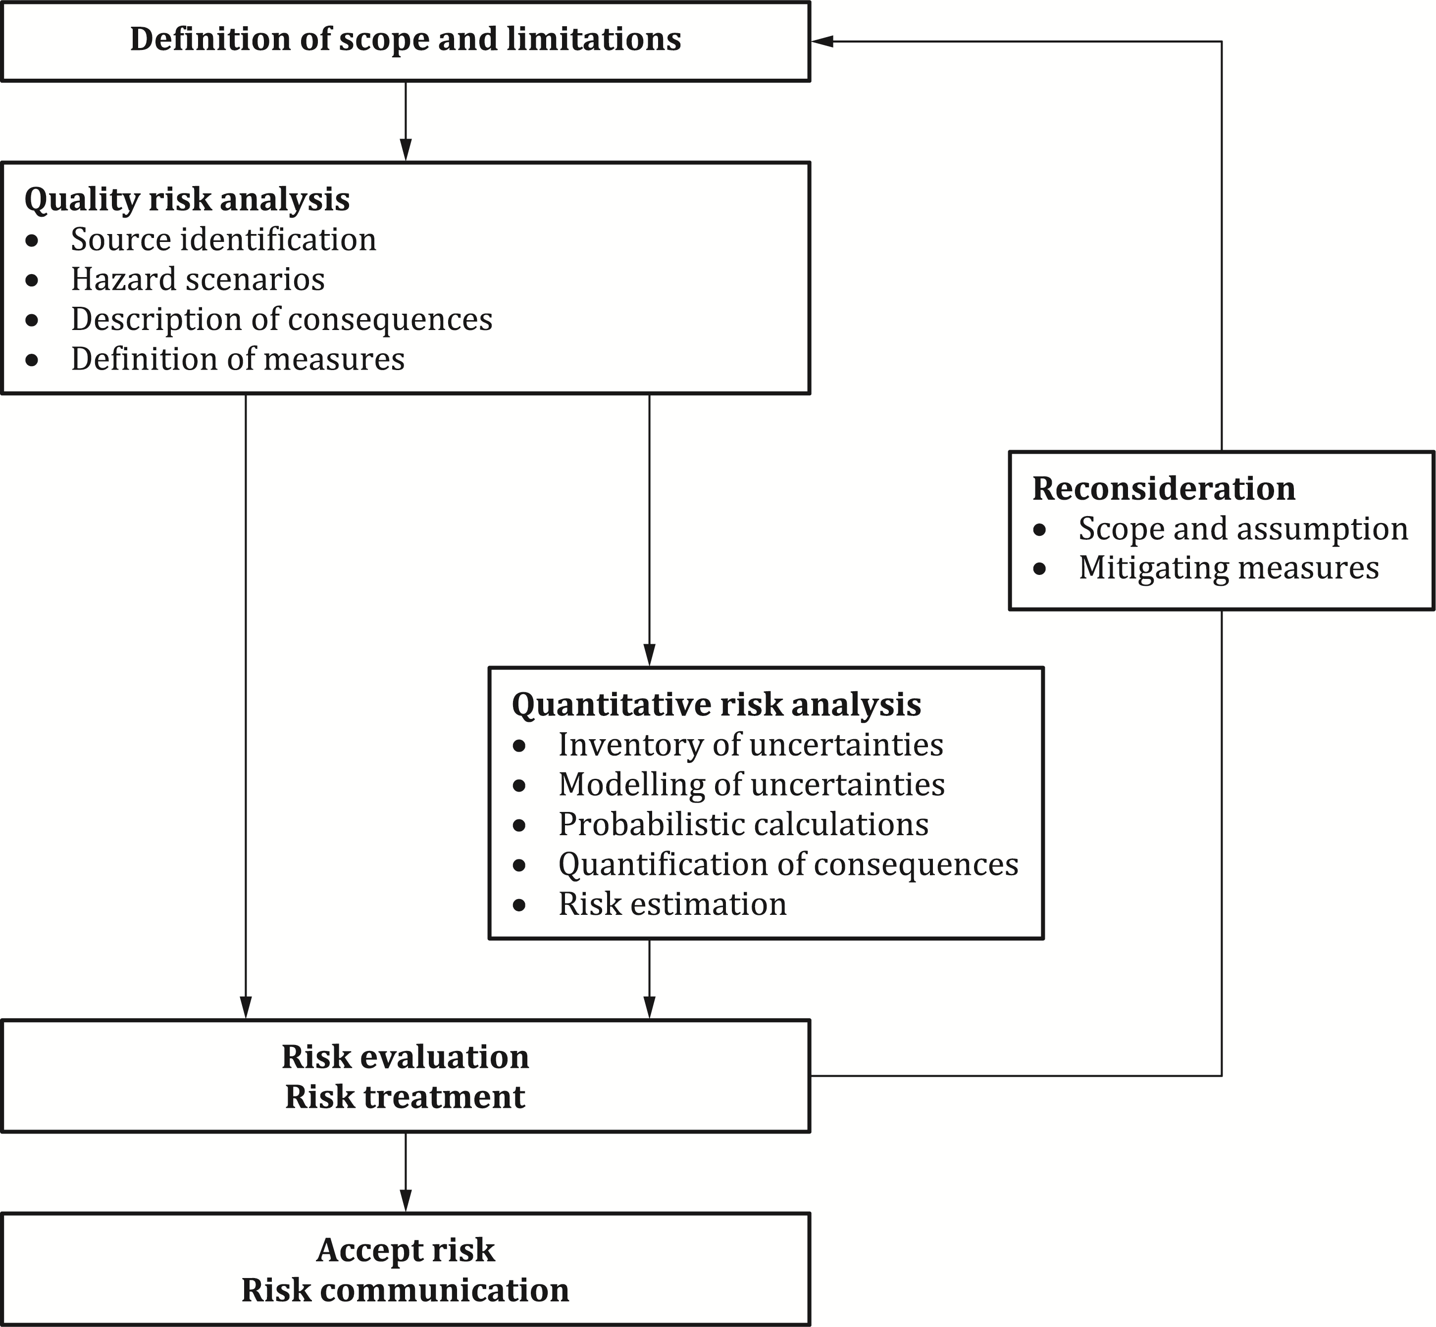

Figure B.1 — Overview over risk assessment

* 1. Description of scope, assumptions and limitations of a risk analysis

(1) The subject, background and objectives of the risk analysis should be fully described.

(2) All technical, environmental, organizational and human circumstances that are relevant to the activity and the problem being analysed, should be stated in sufficient detail.

(3) All presuppositions, assumptions, and simplifications made in connection with the risk analysis should be stated.

* 1. Methods of risk analysis

(1) The risk analysis has a descriptive (qualitative) part and may, where relevant and practicable, also have a numerical (quantitative) part.

B.4.1 Qualitative risk analysis

(1) In the qualitative part of the risk analysis, all hazards and corresponding hazard scenarios should be identified based on a detailed examination and understanding of the system.

NOTE 1 Identification of hazards and hazard scenarios is a crucial task to a risk analysis. For this reason, a variety of techniques have been developed to assist the engineer in performing this part of the analysis (e.g. PHA, HAZOP, fault tree, event tree, decision tree, causal networks, etc.).

NOTE 2 In structural risk analysis the following conditions can, for example, present hazards to the structure:

— high values of ordinary actions;

— low values of resistances, possibly due to errors or unforeseen deterioration;

— ground and other environmental conditions different from those assumed in the design;

— accidental actions like impact, explosion, fire, flood (including scour) or earthquake;

— unspecified accidental actions.

(2) The following should be taken into account in defining the hazard scenarios:

— the anticipated or known variable actions on the structure;

— the environment surrounding the structure;

— the proposed or known inspection regime of the structure;

— the concept of the structure, its detailed design, materials of construction and possible points of vulnerability to damage or deterioration;

— the consequences of type and degree of damage due to the identified hazard scenario.

(3) The main usage of the structure should be identified in order to ascertain the consequences for safety in case the structure fails to withstand the leading hazard event with likely accompanying actions.

B.4.2 Quantitative risk analysis

(1) In the quantitative part of the risk analysis, probabilities should be estimated for all undesired events and their subsequent consequences.

(2) If failure can be expressed numerically, the risk may be presented as the mathematical expectation of the consequences of an undesired event. A possible way of presenting risks is indicated in Table B.1.

(3) Any uncertainty in calculations/figures of the data and models used should be fully described.

(4) The risk analysis shall be terminated at an appropriate level, taking into account for example:

— the objective of the risk analysis and the decisions to be made;

— the limitations made at an earlier stage in the analysis;

— the availability of relevant or accurate data; and

— the consequences of the undesired events.

(5) The assumptions upon which the analysis is based should be reconsidered when the results of the analysis are available. Sensitivities of factors used in the analysis should be quantified.

Table B.1 — Possible presentation diagram for the outcome of a quantitative risk analysis

|  |  |  |  |  |  |
| --- | --- | --- | --- | --- | --- |
| **Classification of severity of potential failure** a | **Probability** | | | | |
| 0,00001 | 0,0001 | 0,001 | 0,01 | > 0,1 |
| Very high | X |  |  |  |  |
| High | X |  |  |  |  |
| Medium |  | X |  |  |  |
| Low |  |  | X |  |  |
| Very low |  |  |  | X |  |
| NOTE X represents examples of maximum acceptable risk levels. | | | | | |
| a The severity of potential failure shall / should be identified for each hazard scenario. The classification may be as follows: — Very high: Sudden collapse of structure occurs with high potential for loss of life and injury — High: Failure of part(s) of the structure with high potential for partial collapse and some potential for injury and disruption to users and public — Medium: Failure of part of the structure. Total or partial collapse of structure unlikely. Small potential for injury and disruption to users and public — Low: Local damage — Very Low: Local damage of small importance | | | | | |

* 1. Risk evaluation and acceptance

(1) Following the identification of the level of risk, it should be decided whether mitigating (structural or non-structural, see B.9.1) measures should be specified.

(2) In risk acceptance usually the ALARP (as low as reasonably practicable) principle is used. According to this principle two risk levels are specified: if the risk is below the lower bound of the broadly tolerable (i.e. ALARP) region no measures need to be taken; if it is above the upper bound of the broadly tolerable region the risk is considered as unacceptable. If the risk is between the upper and lower bound an economical optimal solution should be sought.

(3) When evaluating the risk of a failure event and its consequences over a period of time, a discount rate should be taken into account.

(4) Risk acceptance levels should be as specified by the relevant authority or, if not specified, agreed for a specific project by the relevant parties.

(5) Risk acceptance levels should be formulated on the basis of the following two acceptance criteria:

— the individual acceptable level of risk: individual risks are usually expressed as fatal accident rates. They may be expressed as an annual fatality probability or as the probability per time unit of a single fatality when actually being involved in a specific activity.

— the socially acceptable level of risk: the social acceptance of risk to human life, which can vary with time, is often presented as an F-N curve, indicating a maximum yearly probability *F* of having an accident with more than *N* casualties.

(6) Alternatively, risk acceptance levels may be formulated using concepts like value for prevented fatality (VPF) or life quality index.

(7) Acceptance criteria may be determined from certain national regulations and requirements, certain codes and standards, or from experience and/or theoretical knowledge that may be used as a basis for decisions on acceptable risk.

(8) Acceptance criteria may be expressed qualitatively or numerically.

(9) In the case of qualitative risk analysis, the following criteria may be used:

a) the general aim should be to minimize the risk without incurring a substantial cost penalty;

b) for the consequences within the vertically hatched area of Figure B.2, the risks associated with the scenario can be accepted;

c) for the consequences within the diagonally hatched area of Figure B.2, a decision on whether the risk of the scenario can be accepted and whether risk mitigation measures can be adopted at an acceptable cost should be made;

d) for the consequences considered to be unacceptable (those falling in the horizontally hatched area of Figure B.2 are likely to be unacceptable) appropriate risk mitigation measures (see B.6) should be taken.

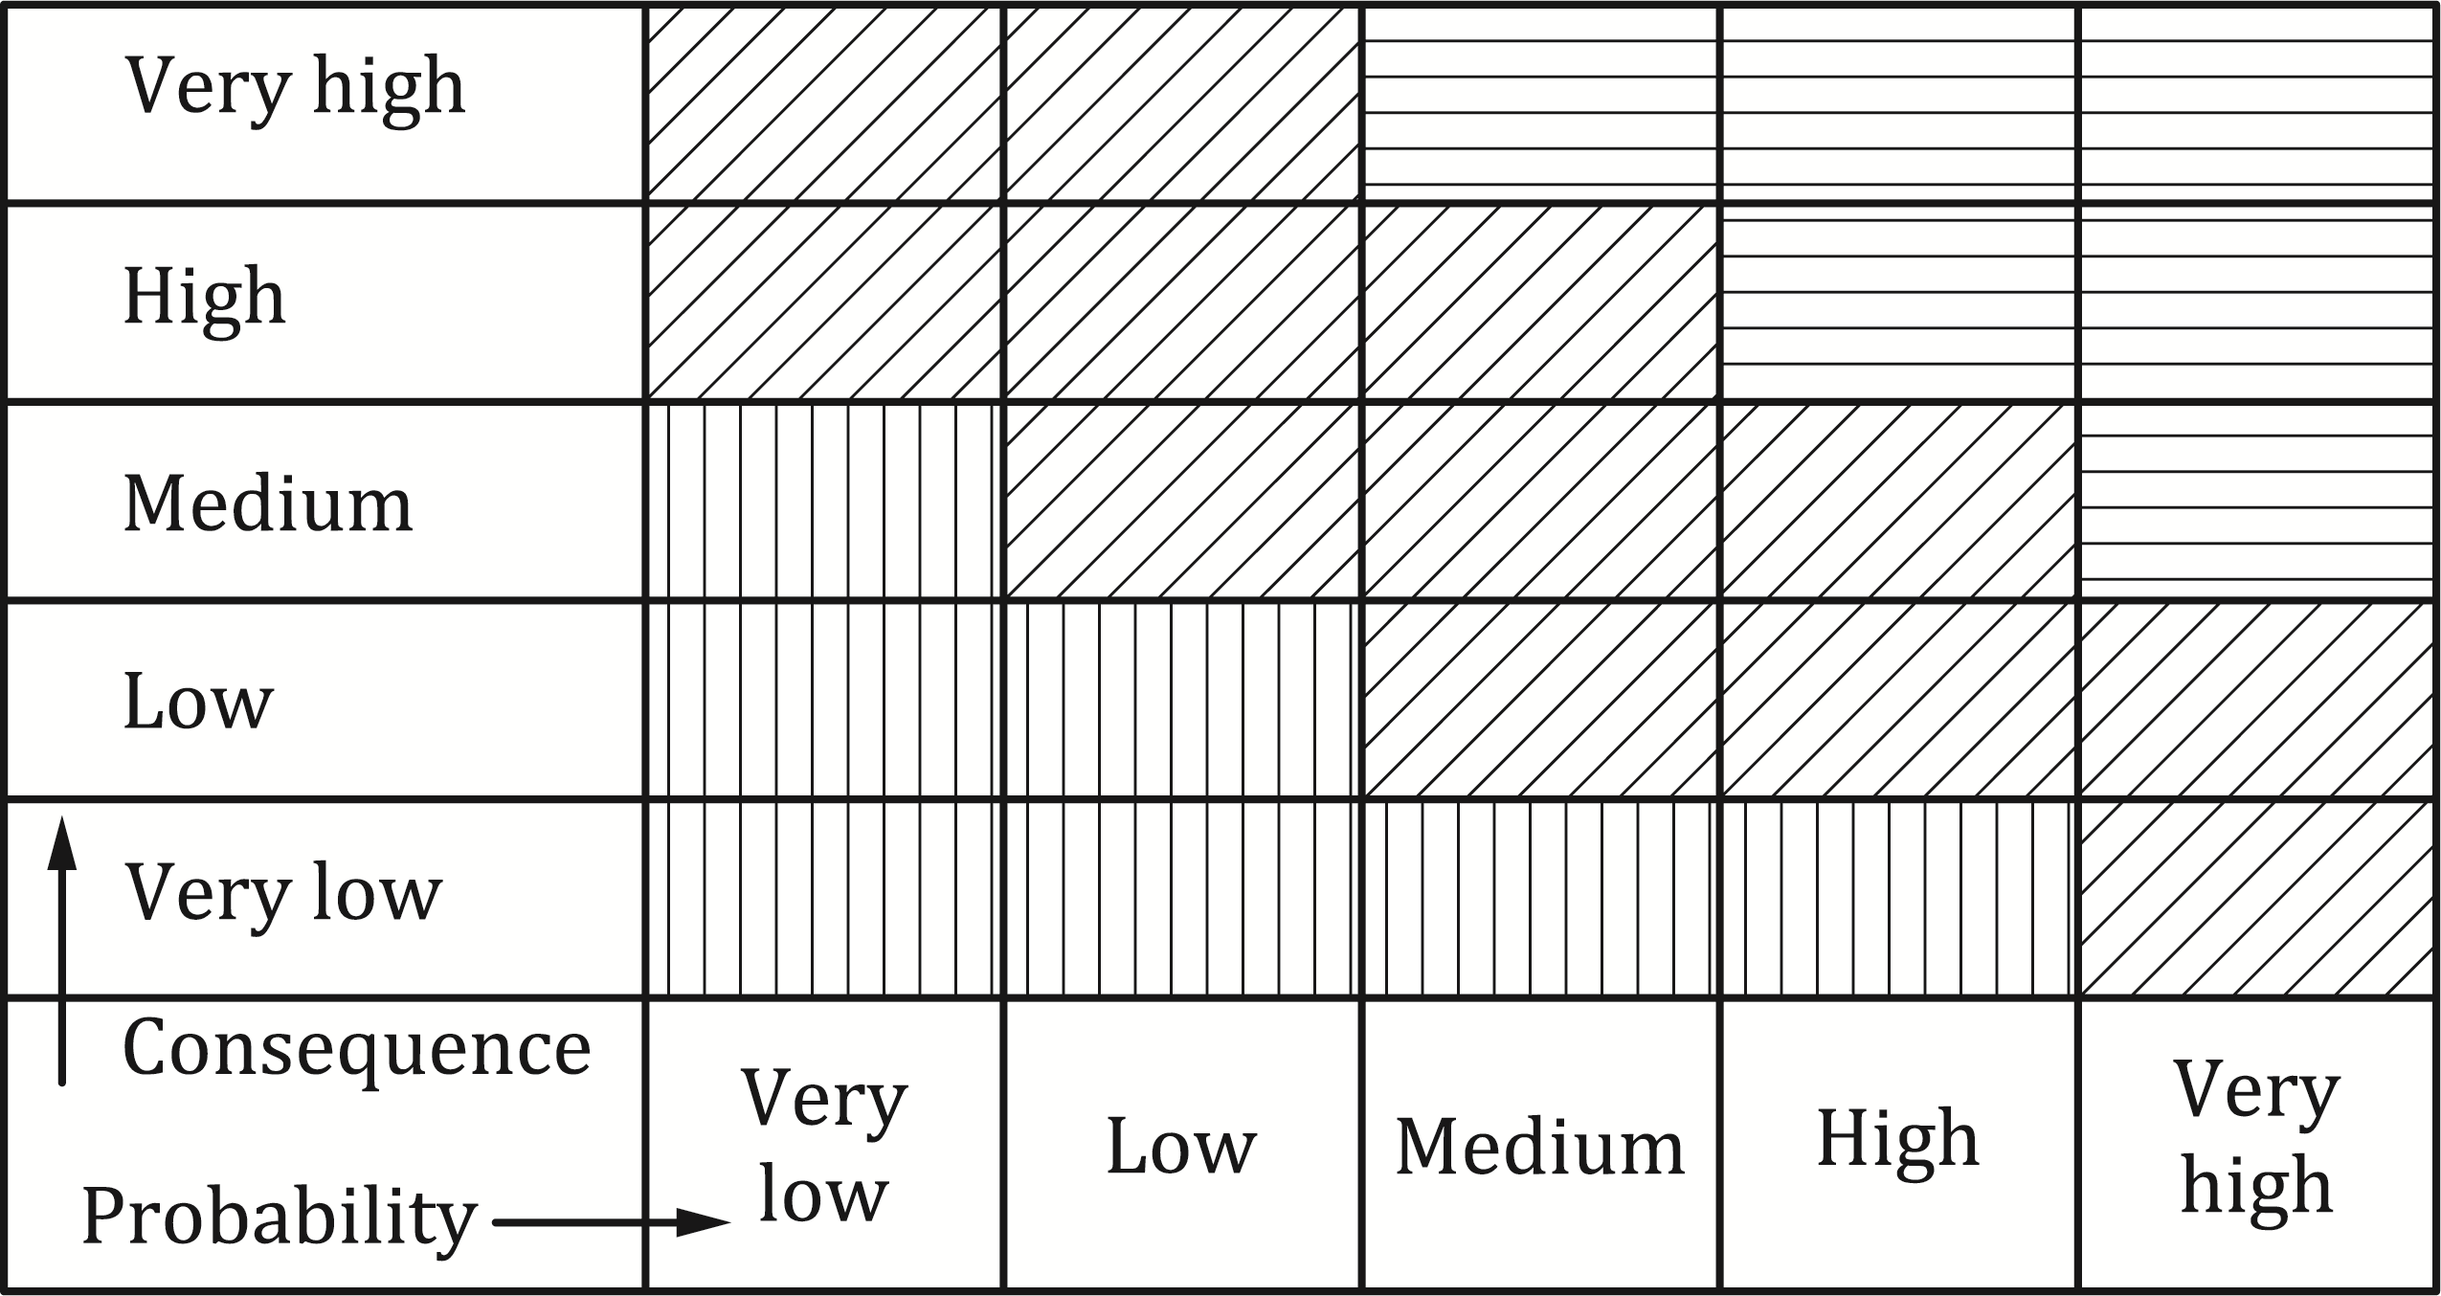

Figure B.2 — Possible presentation diagram for the outcome of a qualitative risk analysis

* 1. Risk mitigating measures

(1) Risk mitigation measures may be selected from one or more of the following:

a) elimination or reduction of the hazard;

NOTE 1 For example, by making an adequate design, modifying the design concept, and providing the countermeasures to combat the hazard, etc.

b) by-passing the hazard by changing the design concepts or occupancy;

NOTE 2 For example, through the protection of the structure, provision of sprinkler system, etc.

c) controlling the hazard;

NOTE 3 For example, by controlled checks, warning systems or monitoring.

d) overcome the hazard by providing;

NOTE 4 For example, increased reserves of strength or robustness, availability of alternative load paths through structural redundancy, or resistance to degradation, etc.

e) permitting controlled collapse of a structure where the probability of injury or fatality may be reduced;

NOTE 5 For example, for impact on lighting columns or signal posts.

* 1. Reconsideration

(1) The revision of the scope, assumptions (see Figure B.1) should be re-evaluated against the scenarios until it is possible to accept the structure with the selected mitigation measures.

* 1. Communication of results and conclusions

(1) The results of the qualitative and (if available) the quantitative analysis should be presented as a list of consequences.

(2) Probabilities and their degree of acceptance should be communicated with all stakeholders.

(3) All data and its sources that have been used to carry out a risk analysis should be specified.

(4) All the essential assumptions, pre-conditions and simplifications that have been made should be summarized so that the validity and limitations of the risk analysis are made clear.

(5) Recommendations for measures to mitigate risk should be stated and be based on conclusions from the risk analysis.

* 1. Applications to buildings and civil engineering structures
     1. General

(1) In order to mitigate the risk in relation to extreme events in buildings and civil engineering structures, one or more of the following measures should be considered:

— structural measures, where the structure and the structural members have been designed to have reserves of strength or alternative load paths in the case of local failures;

— non-structural measures, which include reduction of:

— the probability of the event occurring;

— the action intensity; or

— the consequences of failure.

(2) The probabilities and effects of all accidental and extreme actions (e.g. actions due to impact, explosion, fire, earthquake, extreme climatic actions) should to be considered for a suitable set of possible hazard scenarios. The consequences should then be estimated in terms of the number of casualties and economic losses. Detailed information is presented in B.9.2 and B.9.3.

NOTE The approach mentioned in B.9.1(2) can be less suitable for unforeseeable hazards (design or construction errors, unexpected deterioration, etc.). As a result, more global damage tolerance design strategies (see Annex A) have been developed, e.g. the classical requirements on sufficient ductility and tying of members. A specific approach, in this respect, is the consideration of the situation that a structural member (beam, column) has been damaged, by whatever event, to such an extent that the member has lost its normal load-bearing capacity.

(3) For the remaining unoffended part of the structure, the structure shall withstand the “normal” loads for a relatively short period of time (defined as the repair period *T*) with some prescribed reliability, see Formula (B.1):

 (B.1)

NOTE The target reliability *ptarget* depends on the normal safety target for the building, the period under consideration (hours, days or months) and the probability that the member under consideration is removed (by causes other than those already considered in design).

(4) For conventional structures all relevant collapse possibilities should be included in the design. Where this can be justified, failure causes that have only a remote likelihood of occurring may be disregarded. The approach given in B.9.1(2) should be taken into account. In many cases, and in order to avoid complicated analyses, the strategy given in B.9.1(3) may be investigated.

(5) For unconventional structures (e.g. very large structures, those with new design concepts, those using new materials), the probability of having some cause of failure should be considered as substantial. A combined approach of the approaches described in B.9.1(2) and B.9.1(3) should be taken into account.

* + 1. Structural risk analysis

(1) Risk analysis of structures subject to accidental actions may be approached by the following three steps:

— Step 1: assessment of the probability of occurrence of different hazards with their intensities.

— Step 2: assessment of the probability of different states of damage and corresponding consequences for given hazards.

— Step 3: assessment of the probability of inadequate performance(s) of the damaged structure together with the corresponding consequence(s).

(2) The total risk R may be assessed using Formula (B.2):

 (B.2)

where

|  |  |
| --- | --- |
| *NH* | different hazards; |
| *ND* | different ways in which the structure is damaged (can be dependent on the considered hazards); |
| *NS* | discretization of the performance of the damaged structure; |
| *P*(*Hi*) | the probability of occurrence (within a reference time interval) of the ith hazard; |
| *P*(*Dj*|*Hi*) | is the conditional probability of the jth damage state of the structure given the ith hazard; |
| *P*(*Sk*|*Dj*) | is the conditional probability of the *k*th adverse overall structural performance *S* given the ith damage state; |
| *SK* | adverse state of the damaged structure, discretized by *NS* ; |
| *C*(*Sk*) | corresponding consequence to adverse states. |

NOTE 1 It is assumed that the structure is subjected to *NH* different hazards, that the hazards can damage the structure in *ND* different ways (can be dependent on the considered hazards) and that the performance of the damaged structure can be discretized into *NS* adverse states *SK* with corresponding consequences *C*(*Sk*).

NOTE 2 *P*(*Sk*|*Dj*) and *C*(*Sk*) can be highly dependent on time (e.g. in case of fire and evacuation, respectively) and the overall risk can be assessed and compared to acceptable risks accordingly.

NOTE 3 Formula (B.2) can form the basis for risk assessment of structures not only for structures subject to rare and accidental loads, but also for structures subject to ordinary loads.

(3) Within risk assessment, different strategies for risk control and risk reduction should be investigated for economic feasibility:

— risk may be reduced by reduction of the probability that the hazards occur, i.e. by reducing *P*(*H*);

NOTE 1 For example, for ship impacts on bridge pier structures, the hazard (the event of a ship impact) can be mitigated by construction of artificial islands in front of the bridge piers. Similarly, the risk of explosions in buildings might be reduced by removing explosive materials from the building.

— risk may be reduced by reducing the probability of significant damage for given hazards, i.e. *P*(*D*|*H*);

NOTE 2 For example, damage which might follow as a consequence of the initiation of fires can be mitigated by passive and active fire control measures (e.g. foam protection of steel members and sprinkler systems).

— risk may be reduced by reducing the probability of adverse structural performance given structural damage, i.e. *P*(*S*|*D*).

NOTE 3 This can be undertaken by designing the structures with a sufficient degree of redundancy, thus allowing for alternative load transfer if the static system change is due to damage.

* + 1. Modelling of risks from extreme events
       1. General format

(1) As part of a risk analysis extreme hazards like explosions, collisions, etc. should be investigated. The general model for such an event may consist of the following components (Figure B.3):

— a triggering event at some place and at some point in time *t*;

— the magnitude *M* of the energy involved in the event and possibly some other parameters;

— the physical interactions between the event, the environment and the structure *S*, leading to the exceedance of some limit state in the structure.

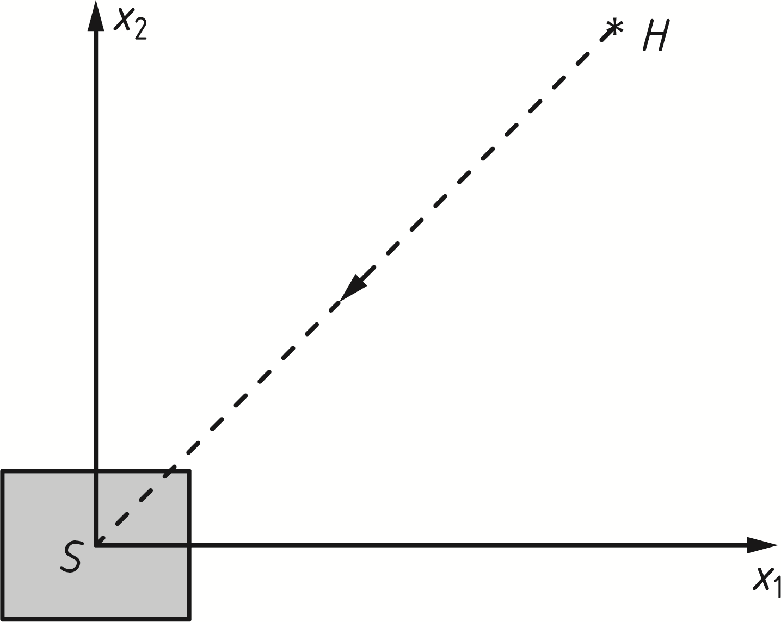

Key

|  |  |
| --- | --- |
| *S* | structure |
| *H* | hazard event with magnitude *M* at time *t* |
| *x*i | location in space *i* |

Figure B.3 — Components for the extreme event modelling

(2) The occurrence of the triggering event for hazard *H* in B.9.3.1(1) may often be modelled as events in a Poisson process of intensity *λ(t,x)* per unit volume and time unit, *t* representing the point in time and *x* the location in space (*x1, x2, x3*). The probability of occurrence of failure during the time period up to time *T* (for constant *λ* and small probabilities) may be calculated from Formula (B.3):

 (B.3)

where

|  |  |
| --- | --- |
| *N* = *λT* | is the total number of relevant initiating events in the considered period of time; |
| *f*M *(m)* | is the probability density function of the random magnitude *M* of the hazard. |

(3) The probability of failure can depend on the distance between the structure and the location of the event. In that case, an explicit integration over the area or volume of interest should be undertaken.

* + - 1. Application to impact from vehicles

(1) For the situation shown in Figure B.4 impact will occur if a vehicle, travelling along the roadway leaves its intended course at a critical place with sufficient speed.

NOTE 1 The required speed for impact depends on the distance from the structure or a structural member or member to the road, the angle of the collision course, the initial velocity and the topographical properties of the terrain between road and structure. In some cases, there can be obstacles or height differences in terrain.

NOTE 2 Figure B.4 shows a vehicle which leaves the intended course at point *Q* with velocity *v0* and angle *φ*. A structure or structural member in the vicinity of the roadway at distance *s* is hit with velocity *vr*.

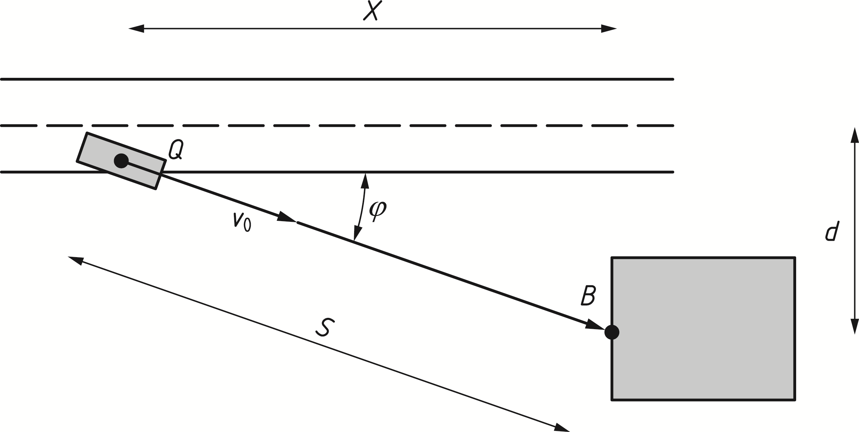

Figure B.4 — Impact from vehicles

(2) Based on the Formula (B.3), the failure probability for this case should be calculated from Formula (B.4):

 (B.4)

where

|  |  |
| --- | --- |
| *N* = *nλT* | the total number of initiating events in the period under consideration; |
| *n* | is the traffic intensity; |
| *λ* | is the probability of a failure per unit travelling distance (e.g. per vehicle km); |
| *T* | is the reference period (usually 1 year); |
| *F* | is the impact force. |
| *R* | represents the resistance of the structure; and |
| *b* | is the width of the structural member or two times the width of the impacting vehicle, whichever is the less; |
| *φ* | is the direction angle; |
| *f(φ)* | is its probability density function; |

* + - 1. Application to impact from ships

(1) For the application to impact from ships Formula (B.3) is further developed as given in Formula (B.5), see Figure B.5:

 (B.5)

where

|  |  |
| --- | --- |
| *N* = *n λ T* (1- pa) | is the total number of incidents in the period under consideration; |
| *n* | is the number of ships per time unit (traffic intensity); |
| *λ* | is the probability of a failure per unit travelling distance (e.g. per vehicle km); |
| *T* | is the reference period (usually 1 year); |
| *p*a | is the probability that a collision is avoided by human intervention; |
| *x* | is the coordinate of the point of the fatal error or mechanical failure; |
| *F*dyn | is the impact force on the structure following from impact analysis (see Annex C); and |
| *R* | is the resistance of the structure. |

(2) Where relevant, the distribution of the initial ship position in the y-direction may be taken into account, see Figure B.5.

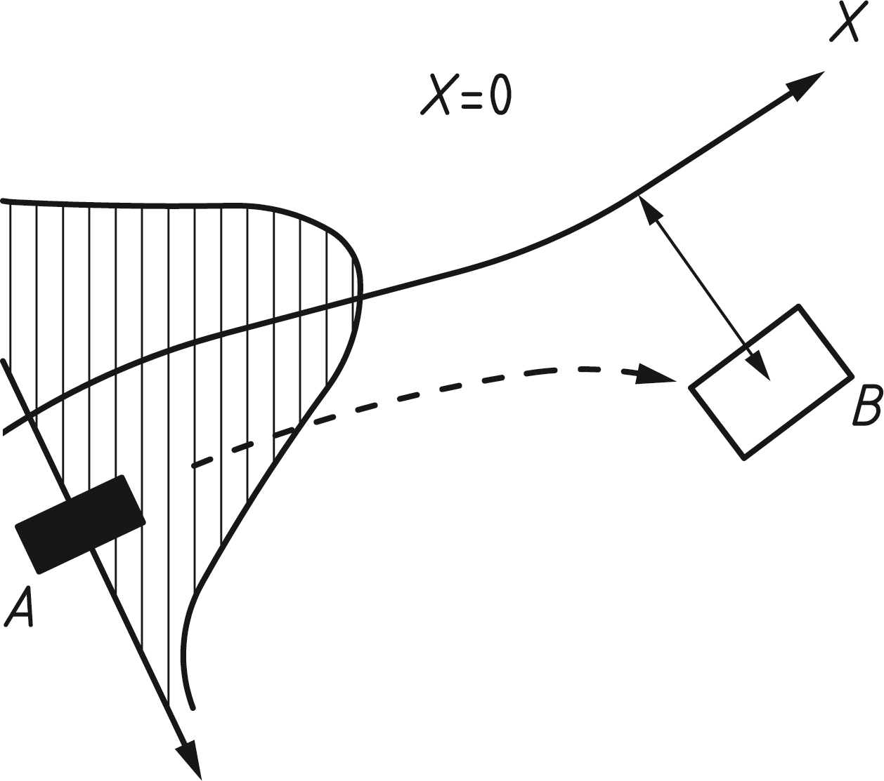

Key

|  |  |
| --- | --- |
| A | object |
| B | structure |
| X | direction of (normal) travel |

Figure B.5 — Ship collision scenario

* + 1. Guidance for application of risk analysis related to impact from rail traffic

(1) The following factors should be taken into account when assessing the risk to people from derailed trains on the approach to class A structures where the maximum permitted line speed is over 120 km/h and class B structures:

— the likelihood of derailed trains on the approach to the structure;

— the permissible speed of trains using the line;

— the predicted deceleration of derailed trains on the approach to the structure;

— the lateral distance a derailed train is predicted to travel;

— whether the line is single or not in the vicinity of the structure;

— the type of traffic (passenger/freight) passing under the structure;

— the predicted number of passengers in the train passing under the structure;

— the frequency of trains passing under the structure;

— the presence of switches and crossings on the approach to the structure;

— the static system (structural configuration) of the structure and the robustness of the supports;

— the location of the supports to the structure relative to the tracks;

— the predicted number of people, outside the train, who are at risk from harm from a derailed train; and

— the ground topography between the track and the structure.

(2) The following factors also affect the risk from derailed trains, but to a lesser extent:

— the curvature of the track in the vicinity of the structure; and

— the number of tracks, where there are more than two.

(3) The effect that any preventative and protective measures proposed have on other parts or other users of the adjacent infrastructure should be taken into account.

NOTE 1 This includes for example the effect on signal sighting distances, authorised access, and other safety considerations relating to the layout of the track.

NOTE 2 Further recommendations and guidance for class A and class B structures (see 5.6.2.2) are set out in UIC Code 777-2R “Structures Built Over Railway Lines” (Construction requirements in the track zone). UIC Code 777-2R includes specific recommendations and guidance on the following:

— carrying out a risk assessment for class B structures;

— measures (including construction details) to be considered for class A structures, including situations where the maximum line speed at the site is less than 50 km/h;

— measures to be considered for class A structures where the distance from the nearest structural support and the centre line of the nearest track is 3 m or less.

(2) The following should be considered for Class B structures either singly or in combination in determining the appropriate measures to reduce the risk to people from a derailed train on the approach to a structure:

— provision of robustness to the supports of the structure to withstand the glancing impact from a derailed train to reduce the likelihood of collapse of the structure;

— provision of continuity to the spans of the superstructure to reduce the likelihood of collapse following impact with the supports of the structure from a derailed train;

— provision of measures to limit the lateral deviation of the derailed train on the approach to the structure to reduce the likelihood of impact from a derailed train;

— provision of increased lateral clearance to the supports of the structure to reduce the likelihood of impact from a derailed train;

— avoidance of supports located on a line that is crossed by a line extended in the direction of the turnout of a switch to reduce the likelihood of a derailed train being directed towards the supports of the structure;

— provision of continuous walls or wall type supports (in effect the avoidance of supports consisting of separate columns) to reduce the likelihood of collapse following impact with the supports of the structure from a derailed train;

— where it is not reasonably practicable to avoid supports consisting of separate columns provision of supports with sufficient continuity so that the superstructure remains standing if one of the columns is removed;

— provision of deflecting devices and absorbing devices to reduce the likelihood of impact from a derailed train.

* + 1. Simplified determination of the design impact force

(1) Owing to the derivation of the design load by the probability of failure according to B.9.3.2 and B.9.3.3, the direct calculation using an exceedance probability might be appropriate.

(2) The design impact force may be estimated using Formula (B.6):

 (B.6)

where

|  |  |
| --- | --- |
| *n, T, λ(x), x,y* | are symbols from B.9.3.2 and/or B.9.3.3; |
| *m, vr, k* | are symbols from C.4 to C.6; *k* can be a linear or a non-linear stiffness, dependent on the information. |

and in conjunction with Formula (B.7):

 (B.7)

whereby an exceedance probability of 10-4/annum seems appropriate.

1. (informative)  
     
   Dynamic design for impact
   1. Use of this annex

(1) This Informative Annex provides supplementary guidance to Clause 5.

NOTE National choice on the application of this Informative Annex is given in the National Annex. If the National Annex contains no information on the application of this informative annex, it can be used.

* 1. Scope and field of application

(1) This annex provides guidance for the approximate dynamic design of structures subject to accidental impact by road vehicles, rail vehicles and ships, on the basis of simplified, empirical or advanced models.

NOTE 1 The models given in this annex, in general, better approximate the design in combination with models presented in Annex B.

NOTE 2 The basic variables for an impact analysis are the velocity of the impacting object, the mass distribution as well as the deformation behaviour and the damping behaviour of both the impacting object and the impacted structure. Consideration can also be given to other variables such as the angle of impact, the construction of the impact object and the movement of the impacting object after the collision.

(2) Only dynamic effects are dealt within this annex.

NOTE 1 Advanced design of structures to sustain actions due to impact can explicitly include one or several of the following aspects: dynamic effects and/or non-linear material behaviour.

NOTE 2 For probabilistic aspects and analysis of consequences, see Annex B.

* 1. General

(1) Impact is an interaction phenomenon between a moving object and a structure, in which the kinetic energy of the object is suddenly transformed into energy of deformation. To find the dynamic interaction forces, the mechanical properties of both the object and the structure should be determined. Equivalent static forces are commonly used in design.

NOTE The greater the impact action, the more advisable it is to determine a dynamic impact force for a dynamic analysis for reasons of economic design.

(2) It may be assumed that the impacting body absorbs all the energy (hard impact).

NOTE In general, this assumption gives conservative results.

(3) For determining the material properties of the impacting object and of the structure, upper or lower characteristic values should be used, where relevant. Strain rate effects should also be taken into account, where appropriate.

* 1. Impact dynamics
     1. General

(1) When undertaking dynamic design of a structure subject to accidental impact, hard and soft impacts shall be determined as relevant.

NOTE 1 In hard impact, the energy is mainly dissipated by the impacting body.

NOTE 2 In soft impact, the structure is designed to deform in order to absorb the impact energy.

* + 1. Hard impact

(1) For hard impact, equivalent static forces or dynamic forces can be obtained from 5.4 to 5.8.

(2) For hard impact it is assumed that the structure is rigid and immovable and that the impacting object deforms during the impact phase. The mechanical models which are the bases for Clause 5 are given in C.5 to C.6.

NOTE 1 Basic information for dynamic design can be found in literature.

NOTE 2 A very simple model for the impact force *F* is given by Formula (C.1):

 (C.1)

where

|  |  |
| --- | --- |
| *m* | is the mass of the impacting object; |
| *v*r | is the impact velocity; |
| *k* | is the equivalent (spring) stiffness of the impacting object, *k* = *F*/*u*max or *k* ≈ *E*A/L*; |
| *u*max | is the total deformation |
| *E* | is the modulus of elasticity; |
| *A* | is the cross sectional area; |
| *L* | is the length of the impacting object. |

* + 1. Soft impact

(1) If the structure is assumed elastic and the impacting object rigid, Formula (C.1) apply and should be used with *k* being the stiffness of the impacted structure.

(2) If the structure is designed to absorb the impact energy by plastic deformations, provision should be made so that its ductility is sufficient to absorb the total kinetic energy *Etot* = ½ *m vr*2 of the impacting object.

(3) In the limit case of rigid-plastic response of the structure, the above requirement shall be satisfied by the condition of Formula (C.2):

 (C.2)

where

|  |  |
| --- | --- |
| *m* | is the mass of the impacting object; |
| *v*r | is the impact velocity; |
| *F*o | is the plastic strength of the structure, i.e. the limit value of the static force *F*; |
| *y*o | is its deformation capacity, i.e. the displacement of the point of impact that the structure can undergo. |

NOTE Analogous considerations apply to structures or other barriers specifically designed to protect a structure from impacts (see e.g. EN 1317 “Road restraint systems” (all parts)).

* 1. Impact from aberrant road vehicles

(1) In case of a road vehicle is impacting a structural member, the velocity of impact *v*r should be determined using Formula (C.3):

 (C.3)

where (see also Figure C.2)

|  |  |
| --- | --- |
| *v*o | is the velocity of the road vehicle leaving the trafficked lane; |
| *a* | is the average deceleration of the road vehicle after leaving the trafficked lane; |
| *s* | is the distance from the point where the road vehicle leaves the trafficked lane to the structural member (see Figure C.2); *s* = *d*/*sin φ*; |
| *d* | is the distance from the centre of the trafficked lane to the structural member; |
| *d*b | is the braking distance, *d*b = (*v*02/*2a*) *sin* *φ*, where *φ* is the angle between the trafficked lane and the course of the impacting vehicle. |

(2) Formula (C.4) uses a simple impact model (see C.4.2), where the dynamic impact force *F*dyn is:

 (C.4)

where

|  |  |
| --- | --- |
| *m* | is the vehicle mass; |
| *k* | is the equivalent (spring) stiffness; |
| *v*r | is the impact velocity; |
| *v*0, *a,s* | see Formula (C.3). |

(3) Probabilistic information for the basic variables partly based on statistical data and partly on engineering judgement is recommended in Table C.1.

NOTE See also Annex B.

Table C.1 — Data for probabilistic collision force calculation

|  |  |  |  |  |
| --- | --- | --- | --- | --- |
| **Variable** | **Designation** | **Probability distribution** | **Mean value** | **Standard deviation** |
| *v*o | vehicle velocity  — highway  — urban area  — courtyard  — parking garage | Lognormal  Lognormal  Lognormal  Lognormal | 80 km/h  40 km/h  15 km/h  5 km/h | 10 km/h  8 km/h  5 km/h  5 km/h |
| *a* | Deceleration | Lognormal | 4,0 m/s2 | 1,3 m/s2 |
| *m* | Vehicle mass – lorry | Normal | 20 000 kg | 12 000 kg |
| *m* | Vehicle mass – car | ---- | 1 500 kg | -- |
| *k* | Vehicle stiffness | Deterministic | 300 kN/m | -- |
| *φ* | Angle | Rayleigh | 10° | 10° |
| *λ* | Vehicle failure intensity | Poisson | 10-7 / m | -- |

(4) Values for *F0* and *db* are recommended in Table C.2, together with values for *m* and *v*. All these values correspond approximately to the averages given in Table C.1 plus or minus one standard deviation.

NOTE 1 In particular cases, when specific information is available, different design values can be chosen, depending on the target safety, the traffic intensity and the accident frequency.

NOTE 2 The presented model is a rough schematisation and neglects at least in detail many influences that can play an important role like the presence of kerbs, bushes, fences and the cause of the incident. To some extent the scatter in the deceleration is supposed to compensate for those factors.

(5) Calculation of the dynamic impact force *F*dyn using Formula (C.4) may be modified on the basis of a risk analysis taking into account the potential consequences of an impact, the rate of deceleration, the tendency of the vehicle to deviate away from the carriageway, the likelihood of the vehicle leaving the carriageway and the likelihood of the vehicle hitting the structure.

(6) In the absence of a dynamic analysis, the dynamic amplification factor for the elastic response may be assumed to be equal to 1,4.

NOTE The derived forces in this annex are intended to be used with an elasto-plastic dynamic structural analysis.

Table C.2 — Values for vehicle mass, velocity and basic dynamic impact force *F*dyn

|  |  |  |  |  |  |
| --- | --- | --- | --- | --- | --- |
| **Type of road** | **Mass** | **Velocity** | **Deceleration** | **Impact force** | **Distance** |
| ***m*** | ***v*o** | ***A*** | ***F*0** | ***d*b**a |
| **based on Formula (C.3) with *v*r = *v*o** |
| [kg] | [km/h] | [m/s2] | [kN] | [m] |
| Motorwaysb | 30 000 | 90 | 3 | 2 400 | 20 |
| Urban areas | 30 000 | 50 | 3 | 1 300 | 10 |
| Courtyards  — cars only  — all vehicles | 1 500  30 000 | 20  15 | 3  3 | 120  500 | 2  2 |
| Parking garages  — cars only | 1 500 | 10 | 3 | 60 | 1 |
| a Road in areas where the speed limit is 50 km/h.  b The value of *d*b may be multiplied by 0,6 for uphill slopes and by 1,6 for downhill slopes (see Figure C.2) | | | | | |

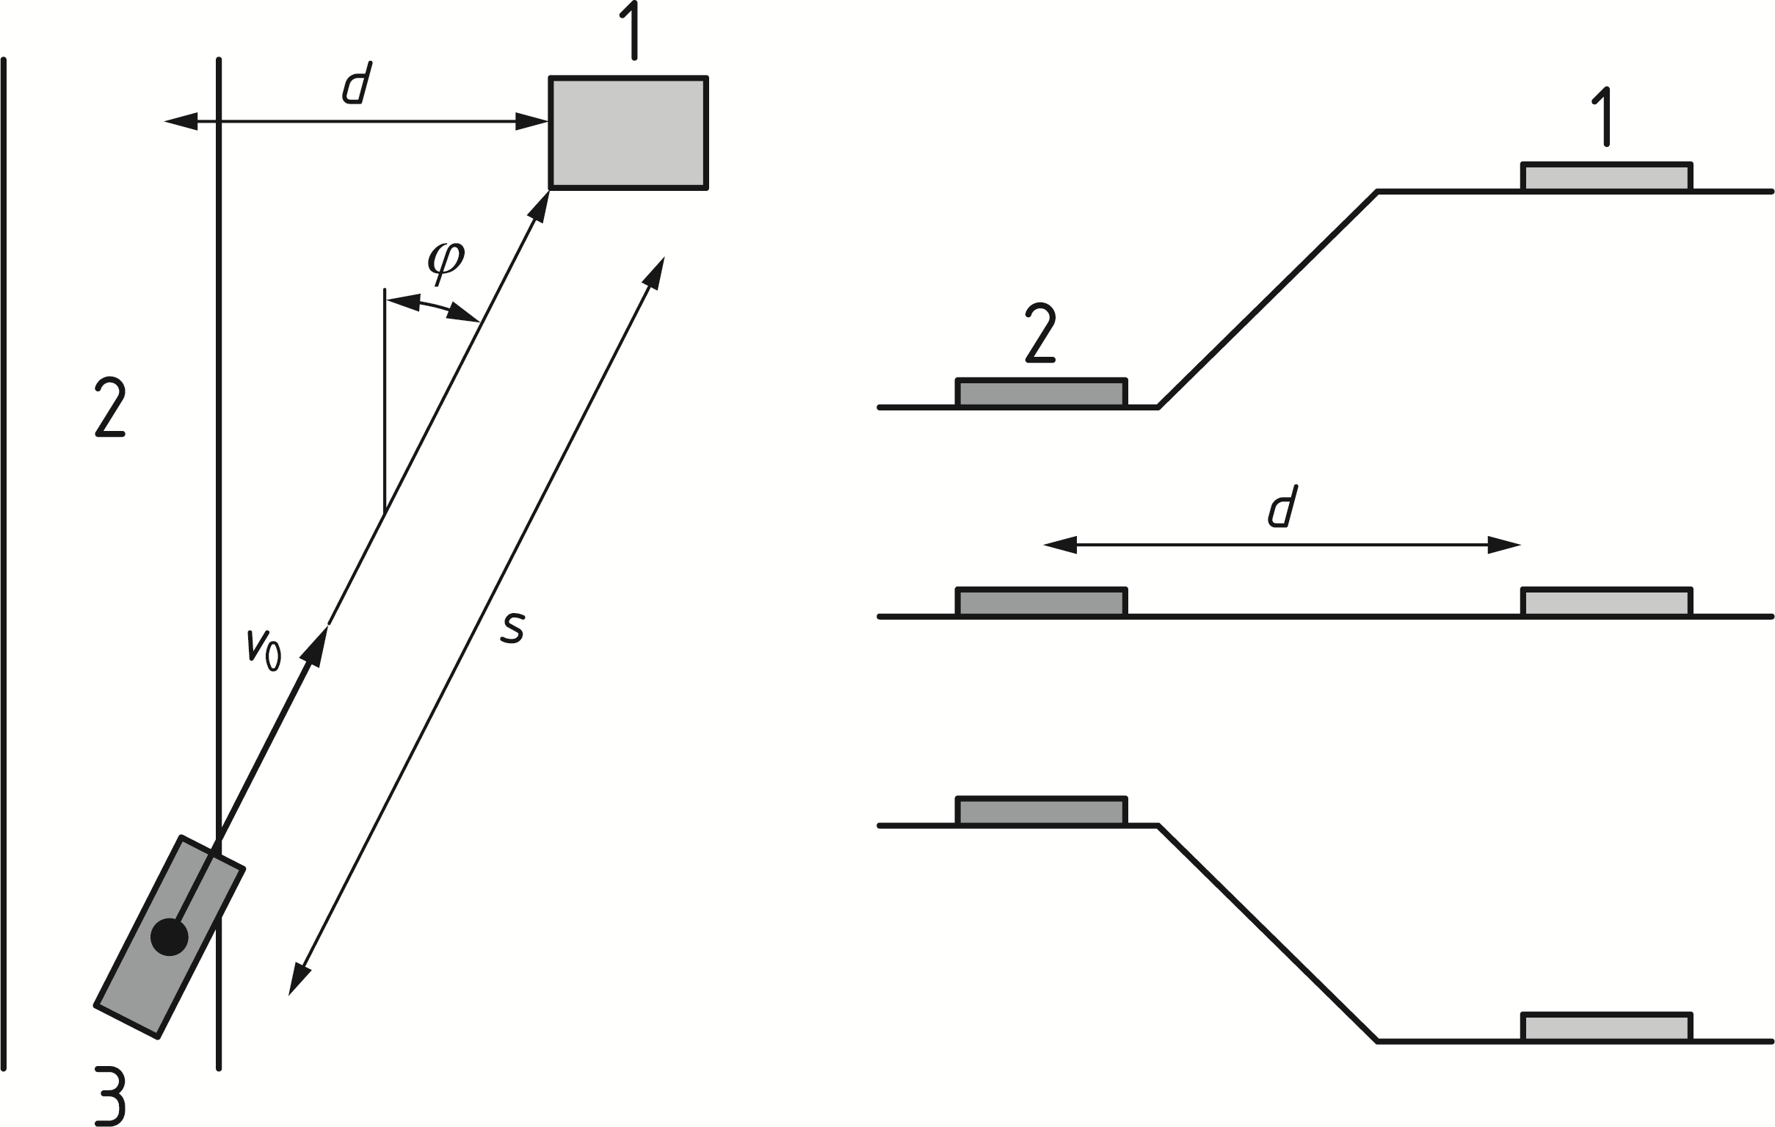

Key

|  |  |
| --- | --- |
| 1 | structure |
| 2 | road |
| 3 | vehicle |

Figure C.2 — Situation sketch for impact by vehicles (top view and cross sections for upward slope, flat terrain and downward slope)

* 1. Impact by ships
     1. General

(1) Impact by ships against solid structures on inland waterways and on seaways should normally be considered as hard impact, with the kinetic energy being dissipated by elastic or plastic deformation of the ship itself.

(2) In the absence of an advanced analysis, Table 5.5 (NDP) gives recommended values of the forces due to ship impact for inland navigation and Table 5.6 (NDP) gives recommended values of the forces due to ship impact for sea waterways.

NOTE The dynamic forces for ship impact for inland navigation in Table 5.5 (NDP) have been determined considering the specific dynamics in C.6.2 and probabilistic analyses in B.9.3.3 and B.9.5.

(3) Calculation of the dynamic impact force *F*dyn according to C.6.2 and C.6.3 may be modified on the basis of a risk analysis taking into account the potential consequences of an impact, the rate of deceleration, the tendency of the ship to deviate away from the fairway, the likelihood of the ship leaving the fairway and the likelihood of the ship hitting the structure.

* + 1. Advanced ship impact analysis for inland waterways

(1) The dynamic impact force *F*dyn may be derived from Formulae (C.5) to (C.7).

NOTE 1 An average mass value for the relevant ship class defined in Table 5.5 (NDP) and a design velocity *vrd* equal to 3 m/s increased by the water velocity can be used unless specified differently by the relevant parties.

(2) Where a hydrodynamic mass has to be taken into account, values of 10 % of the mass of displaced water for bow and 40 % for side impact should be used.

(3) For elastic deformations (*E*def ≤ 0,21 MNm) the dynamic design impact force may be calculated from Formula (C.5):

 (C.5)

(4) For plastic deformations (when *E*def > 0,21 MNm), the dynamic design impact force may be calculated from Formula (C.6):

 (C.6)

where the deformation energy *E*def [MNm] is equal to the available total kinetic energy Ea in case of frontal impact, while in case of lateral impact with angle *α* < 45°, a sliding impact may be assumed and the deformation energy taken equal to Formula (C.7):

 (C.7)

(5) Information on probabilistic models of the basic variables determining the deformation energy or the ship’s impact behaviour may be used for the design impact force based on probabilistic methods.

(6) If a dynamic structural analysis is used, the impact forces should be modelled as a half-sine-wave pulse for *F*dyn ≤ 5 MN (elastic impact) and a trapezoidal pulse for *F*dyn > 5 MN (plastic impact); load durations and other details are presented in Figure C.3.

|  |  |
| --- | --- |
|  |  |
| a) | b) |

Key

|  |  |
| --- | --- |
| *t*r | elastic elapsing time, in [s]; |
| *t*p | plastic impact time, in [s]; |
| *t*e | elastic response time, in [s]; |
| *t*a | equivalent impact time, in [s]; |
| *t*s | total impact time, in [s]; *t*s = *t*r + *t*p + *t*e |
| *c* | elastic stiffness of the ship, in [MN/m]; c = 60 MN/m |
| *F*0 | elastic-plastic limit force, in [MN]; F0 = 5 MN |
| *FD* | mean force, in [MN]; |
| *x*e | elastic deformation, in [m]; xe ≈ 0,1 m |
| *v*n | a) the sailing speed vr*,* for frontal impact, in [m/s]  b) velocity of the impacting ship normal to the impact point *v*n = (*v*r sin α), for lateral impact, in [m/s] |
| The mass *m*\* to be taken into account is: | |
|  | a) for frontal impact: the total mass of the impacting ship/barge  b) for lateral impact: *m*\* = (*m*1 + *m*hydr)/3, with *m*1 the mass of the impacting ship or barge and *m*hyd the hydraulic added mass. |

Figure C.3 — Load-time function for ship collision, respectively for a) elastic and b) plastic ship response

(7) When a design value for the impact force is given, e.g. taken from Table 5.5 (NDP), and the load duration has to be calculated, the mass *m*\* may be determined as follows:

— if *F*dyn > 5 MN: by setting *E*def, Formula (C.6), equal to the kinetic energy *E*a = 0,5 *m*\* *v*n2, in [MNm];

— if *F*dyn ≤ 5 MN: directly by *m*\* = (*F*dyn/*v*n)2 * (1/*c*), in [MN s2/m].

(8) Unless specified differently by the relevant parties:

— a design velocity *vrd* equal to 3 m/s increased by the water velocity should be used;

— in harbours the velocity may be assumed as 1,5 m/s;

— the angle *α* may be taken as 20°.

* + 1. Advanced ship impact analysis for sea waterways

(1) The dynamic impact force for seagoing ice-classed merchant vessels between 500 Dead Weight Tons (DWT) and 300 000 DWT may be determined from Formula (C.8):

 (C.8)

and for non-ice-classed vessels from Formula (C.9):

 (C.9)

where







and

|  |  |
| --- | --- |
| *F*bow | is the maximum bow collision force, in [MN]; |
| *F*o  *F1* | is the reference collision force, in [MN], *F0* = 210 MN;  is the reference collision force in [MN], *F1* = 230 MN; |
| *E*imp | is the energy to be absorbed by plastic deformations, in [MNm]; |
| *L*pp | is the length of vessel, in [m]; |
| *m*x | is the mass plus added mass with respect to longitudinal motion, in [106 kg]; |
| *vr* | is the sailing speed (impact velocity) of the vessel, in [m/s]. |

(3) From the energy balance the maximum indentation *smax* is determined using Formula (C.10) for ice-classed vessels and Formula (C.11) for non-ice-classed vessels:

 (C.10)

 (C.11)

(4) The associated impact duration, *T*0, should be calculated from Formula (C.12) for ice-classed vessels and Formula (C.13) for non-ice-classed vessels:

 (C.12)

 (C.13)

(5) A sailing speed *vr* equal to 5 m/s increased by the water velocity should be used; in harbours the velocity may be assumed as 2,5 m/s, unless specified differently by the relevant parties.

(6) Probabilistic models for basic variables determining the deformation energy or the ship’s impact behaviour may be used where the determination of the design impact force is based on probabilistic methods.

1. (informative)  
     
   Internal explosions
   1. Use of this annex

(1) This Informative Annex provides supplementary guidance to Clause 6.

NOTE National choice on the application of this Informative Annex is given in the National Annex. If the National Annex contains no information on the application of this informative annex, it can be used.

* 1. Scope and field of application

(1) This Informative Annex covers natural gas explosions, dust explosions in rooms, vessels and bunkers, explosions in road and rail tunnels and dust, gas and vapour/air explosions in energy ducts.

* 1. General

(1) Essential parameters for the pressures generated during internal explosions are:

— type of dust, gas or vapour,

— proportion of dust, gas or vapour in the air,

— the uniformity of the dust, gas or vapour-air mixture,

— the ignition source,

— the presence of obstacles in the room,

— the size, shape and strength of the enclosure,

— the extent of available openings and venting panels.

(2) Further calculations for explosions may include the following:

— dynamic non-linear models,

— probabilistic aspects

— failure consequences,

— economic optimization of pressure-reducing measures.

* 1. Natural gas explosions

(1) For buildings which might have piped natural gas installed, or where gas canisters can be present, the structure may be designed to withstand the effects of an internal natural gas explosion using a nominal equivalent static pressure given by Formulae (D.1) and (D.2), valid for a single room up to 1 000 m3 total volume.:

 (D.1)

or

 (D.2)

whichever is the greater;

where

|  |  |
| --- | --- |
| *p*d | is the nominal equivalent static pressure to design the structure, in [kN/m2]; |
| *p*stat | is the uniformly distributed static pressure at which venting components will fail, in [kN/m2]; |
| *A*v | is the area of venting components, in [m2]; |
| *V* | is the volume of rectangular enclosure, in [m3]. |

NOTE 1 The pressure due to deflagration acts effectively simultaneously on all of the bounding surfaces of the room.

NOTE 2 Multi-room explosions can give much higher pressures. The pressures are difficult to calculate as they are not simply limited by the strength of the vent panels; therefore, for this type of explosion, the strategy based on limiting the extent of localized failure (see Table 4.1) can be adopted.

(2) Where building components with different *pstat* values contribute to the venting area, the largest value of *pstat* should be used. Value of *pd* greater than 50 kN/m2 may be neglected.

(3) The ratio of the area of venting components and the volume should comply with Formula (D.3):

 (D.3)

NOTE Natural gas is a gaseous fossil fuel consisting primarily of methane but including significant quantities of ethane, butane, propane, carbon dioxide, nitrogen, helium and hydrogen sulphide. Before natural gas can be used as a fuel, it undergoes extensive processing to remove almost all materials other than methane.

* 1. Dust explosions in rooms, vessels and bunkers

(1) The design value *pd* for the maximum pressure developed in vented cubic and elongated rooms, vessels and bunkers for dust explosions within a single room may be determined from the empirical Formula (D.4) under the restrictions given in (3):

 (D.4)

where

|  |  |
| --- | --- |
| *A*v | is the venting area, in [m2]; |
| *p*max | is the maximum pressure of an explosion of the dust (see Clause (2)), in [kN/m2]; |
| *K*St | is the deflagration index of a dust cloud (see Clause (2)), in [kN/m2]; |
| *p*d | is the design value of the pressure in the vented vessel, in [kN/m2]; |
| *p*stat | is the static activation pressure of the vent areas, in [kN/m2]; |
| *V* | is the volume of room, vessel, bunker, in [m3]; |
| *E*f | is the effectivity venting factor acc. to EN 14797, see also EN 14491; in [-]. |

(2) Values for *p*max and *K*St may be experimentally determined by standard methods for each type of dust.

NOTE 1 The value of *K*St depends on factors such as the chemical composition, particle size and moisture content. Indicative values for *p*max and *K*St are given in Table D.1.

NOTE 2 For standard methods, see for instance EN 14034-1 and EN 14034-2.

Table D.1 — *pmax* and *KSt* values for dust explosions

|  |  |  |
| --- | --- | --- |
| **Type of dust** | ***p*max** | ***K*St** |
| [kN/m2] | [kN/m2] |
| Brown coal | 810 to 1 000 | 18 000 |
| Cellulose | 800 to 980 | 27 000 |
| Coffee |  | 9 000 |
| Corn, corn crush |  | 12 000 |
| Corn starch |  | 21 000 |
| Grain |  | 13 000 |
| Milk powder | 810 to 970 | 16 000 |
| Mineral coal |  | 13 000 |
| Mixed provender |  | 4 000 |
| Paper |  | 6 000 |
| Pea flour |  | 14 000 |
| Pigment | 650 to 1 070 | 29 000 |
| Rubber | 740 | 14 000 |
| Rye flour, wheat flour |  | 10 000 |
| Soya meal |  | 12.000 |
| Sugar | 820 to 940 | 15.000 |
| Washing powder |  | 27.000 |
| Wood, wood flour | 770 to 1.050 | 22.000 |

(3) Formula (D.4) is valid with the following restrictions:

— 0,1 m3 ≤ *V* ≤ 10 000 m3;

— *L3 /DE* ≤ 2, where L3 is the largest dimension and *DE* = 2(*L1 × L2/ π*)0,5, where *L1* and *L2* are the other two dimensions of the room;

— 10 kN/m2 ≤ *pstat* ≤ 100 kN/m2, rupture disks and panels with low mass which respond almost without intertia;

— 10 kN/m2 ≤ *pd* ≤ 200 kN/m2;

— 500 kN/m2 ≤ *pmax* ≤ 1 000 kN/m2 for 1 000 kN/m2(m/s) ≤ *KSt* ≤ 30 000 kN/m2;

— 500 kN/m2 ≤ *pmax* ≤ 1 200 kN/m2 for 30 000 kN/m2(m/s) ≤ *KSt* ≤ 80 000 kN/m2.

(4) For elongated rooms with *L3/DE* ≥ 2 the following increase for the venting area should be considered:

 (D.5)

where

|  |  |
| --- | --- |
| *ΔAv* | is the increase for venting area, in [m2]. |
| *L3, DE* | see Clause (3). |

NOTE In dust explosions, pressures reach their maximum value within a time span in the order of 20 ms to 50 ms. The decline to normal values strongly depends on the venting device and the geometry of the enclosure.

* 1. Explosions in road and rail tunnels

(1) In case of a detonation in road and rail tunnels, the pressure time function may be determined using Formulae (D.6) to (D.8), see Figure D.1 a):

 (D.6)

 (D.7)

 for all other conditions (D.8)

where

|  |  |
| --- | --- |
| *p*0 | is the peak pressure, in [kN/m2]; *p*0 = 2 000 kN/m2 for a typical liquefied natural gas; |
| *c*1 | is the propagation velocity of the shock wave, in [m/s]; *c*1 ≈ 800 m/s; |
| *c*2 | is the acoustic propagation velocity in hot gases, in [m/s]; *c*2 ≈ 800 m/s; |
| *t*0 | is the time constant, in [s]; *t*0 = 0,01 s; |
| |x| | is the distance between the pressure sampling point and the centre of the explosion, in [m]; |
| *t* | is the time, in [s]. |

(2) In case of a deflagration in road and rail tunnels, the following pressure time characteristic may be taken into account, see Figure D.1 b):

 (D.9)

where

|  |  |
| --- | --- |
| *p*0 | is the peak pressure, in [kN/m2]; *p*0 = 100 kN/m2 for a typical liquefied natural gas; |
| *t* | is the time, in [s]; |
| *t*0 | is the time constant, in [s]; *t*0 = 0,1 s. |

|  |  |
| --- | --- |
|  |  |
| a) | b) |

Figure D.1 — Pressure as time function for (a) detonation and (b) deflagration

(3) Other types of explosions in road and rail tunnels (i.e. Boiling Liquid Expanding Vapour Explosion (BLEVE)) shall be considered if relevant.

NOTE 1 The relevance of other types of explosions in road and rail tunnels can be set in the National Annex.

NOTE 2 Information about explosions in tunnels can be found in ISO 10252.

* 1. Dust, gas and vapour/air explosions in energy ducts
     1. General

(1) Ducts including pipelines, cables, etc. for transport and distribution of gases, water, compressed air or electricity for the supply of industry, traffic and/or population which are normally accessible for maintenance should be designed to resist the anticipated overpressure of a possible explosion.

(2) Pipes and ducts for transport and distribution of dusts for the supply of industry, which normally are accessible for maintenance, should be designed to resist the anticipated overpressure of a possible dust explosion.

NOTE 1 Dust explosions and gas explosions in energy ducts have a similar behaviour concerning the pressure. In general, gas explosions result in higher maximum pressures. Turbulence-producing devices have a greater influence on the increase of the pressure for gas than for dust explosions.

NOTE 2 Ducts (and elongated vessels) are characterized with length-to-diameter ratios equal or greater than 5.

NOTE 3 The measurements of the duct (cross-section, length) as well as the layout of the duct (closed at both sides, open at both sides, open at one side, closed at the other) and whether obstacles are built in the duct influence the combustion and the resulting pressures.

NOTE 4 Especially high pressure is reached when the pressure wave of a detonation is moving directly against walls or other fixed structures (for example the end wall of a duct). The pressure wave will be reflected. The pressure at the flange will be up to three times as high as the pressure at the side wall of a straight duct.

* + 1. Vent area

(1) The venting area should be taken as equal to the cross-sectional area of the duct at each venting location at distances less than the critical distance *L* (see D.7.3).

NOTE Multiple venting locations within the critical distance *L* are possible. The area of several openings can be added.

(2) The effective diameter *D* of non-circular venting areas in D.7.3 may be determined as *D = 4 A/U*, where *A* is the venting area and *U* the venting perimeter.

(3) The mass per unit area of the deflagration venting closure should not exceed 12,2 kg/m2.

(4) Vent areas should be placed close to possible leakage or ignition sources.

(5) Vent areas should not be placed in regions where people can be endangered.

* + 1. Critical distances

(1) For propane and dust explosions, the critical distance *L* for a smooth straight pipe or duct may be determined from Figure D.2.

NOTE By providing sufficient vent areas at a distance less than the critical length *L*, deflagration can be prevented from transitioning into a detonation.

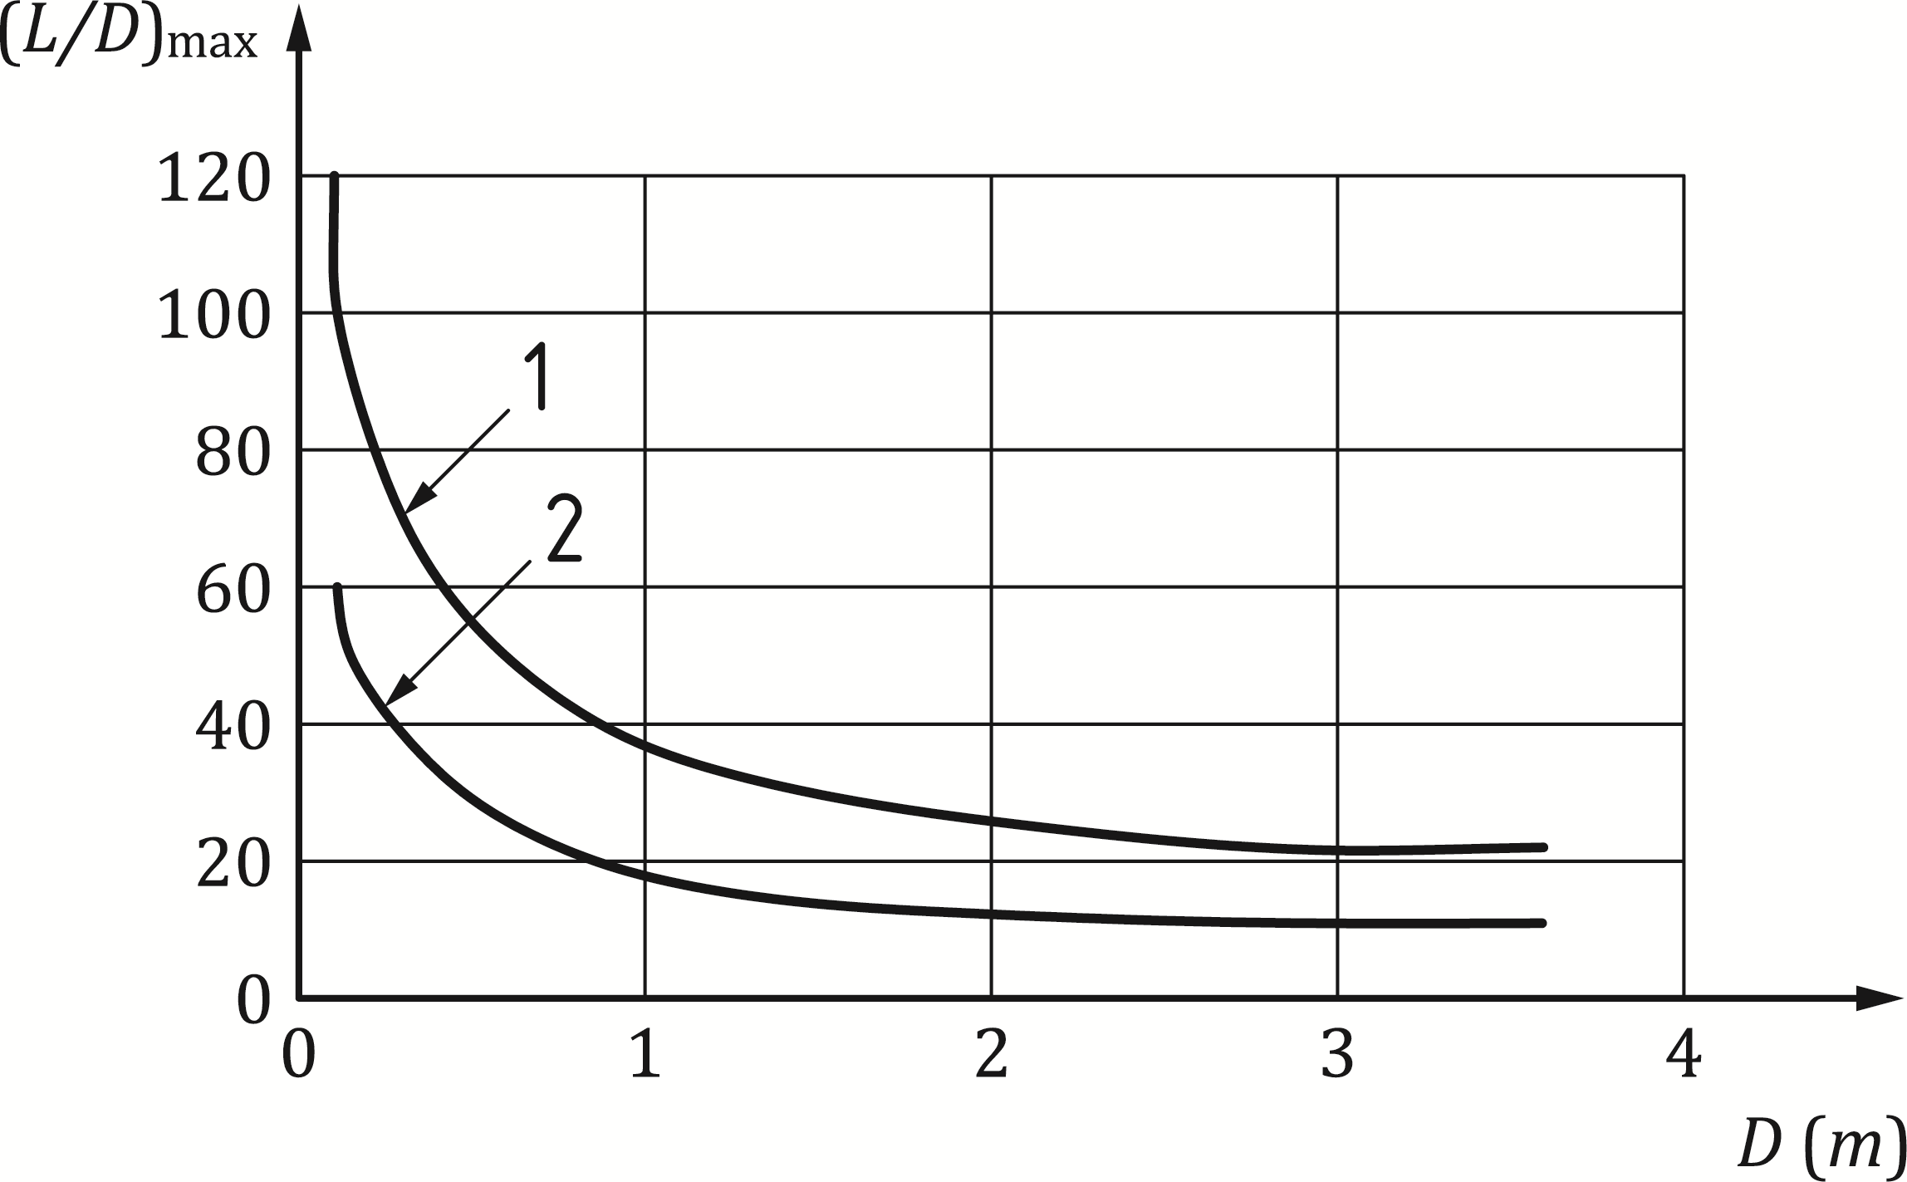

Key

|  |  |
| --- | --- |
| *L* | is the distance between deflagration vents or length of pipe or duct having one end open |
| 1 | dusts with *KSt* ≤ 20 000 kN/m2 |
| 2 | propane/dusts with *KSt* > 20 000 kN/m2 |

Figure D.2 — Critical distance *L* for a smooth straight pipe or duct (for *D* see D.7.2(2))

(2) In order to keep the pressure during deflagration less than 17 kN/m2 for an explosion of propane, the maximum distance between vents given in Figure D.3 shall be used.

(3) *L/D*-values during a deflagration to comply with a maximum pressure of propane explosion of 17 kN/m2 are presented in Figure D.3 for propane and dusts with *KSt* ≤ 30 000 kN/m2 and initial flow velocity between 2 m/s and 20 m/s.

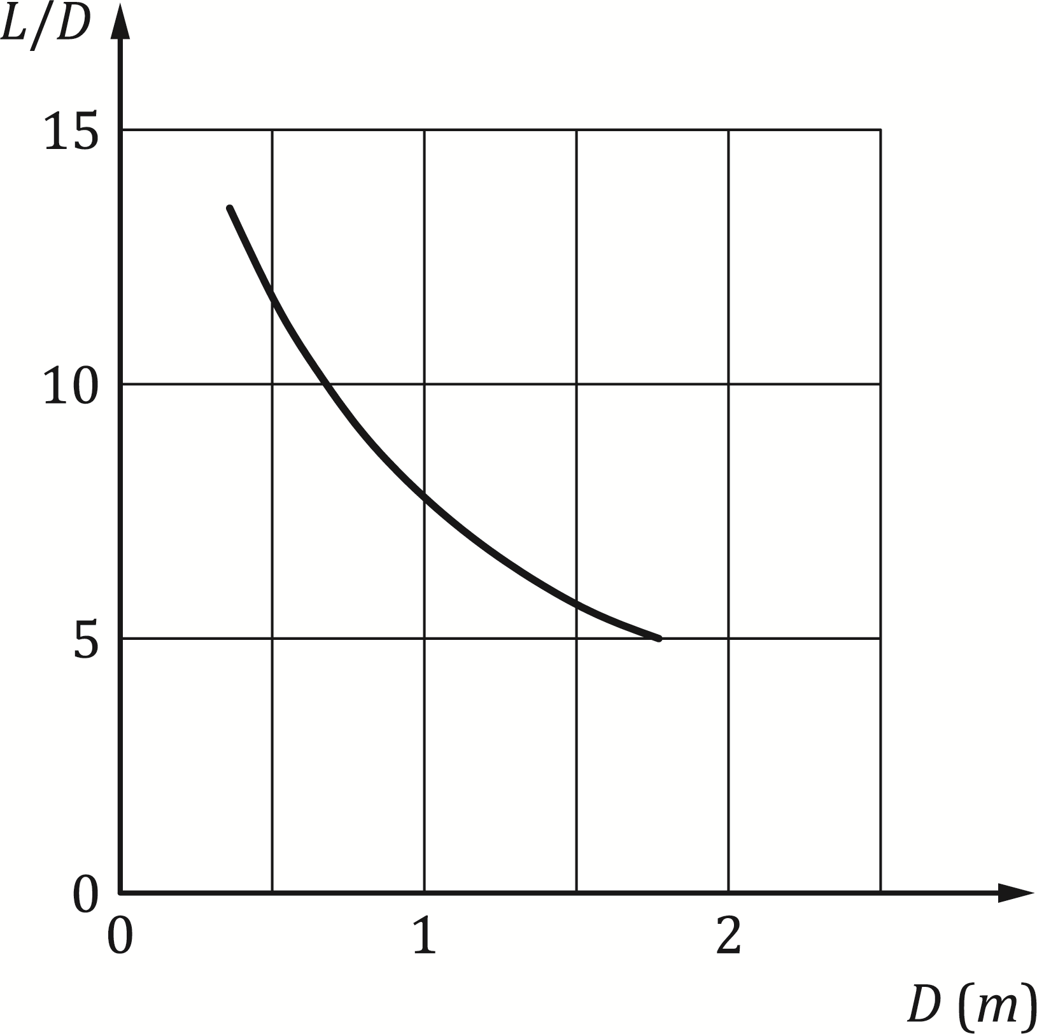

Figure D.3 — *L/D*-values during a deflagration to comply with a maximum pressure of propane explosion of 17 kN/m2 (see D.7.2(2) for *D* and D.7.2(3) for limitations)

(4) For gases other than propane, the critical distance between vents may be calculated using Formula (D.10):

 (D.10)

where

|  |  |
| --- | --- |
| *L*x | is the critical distance between vents for gas X, in [m]; |
| *L*P | is the critical distance between vents for propane, in [m]; |
| *S*u,P | is the fundamental burning velocity for propane, in [m/s]; |
| *S*u,X | is the fundamental burning velocity for gas X, in [m/s], see Table D.2. |

* + 1. Design pressure

(1) The design pressure *p*d in the vented pipe for dust may be determined from Figure D.4.

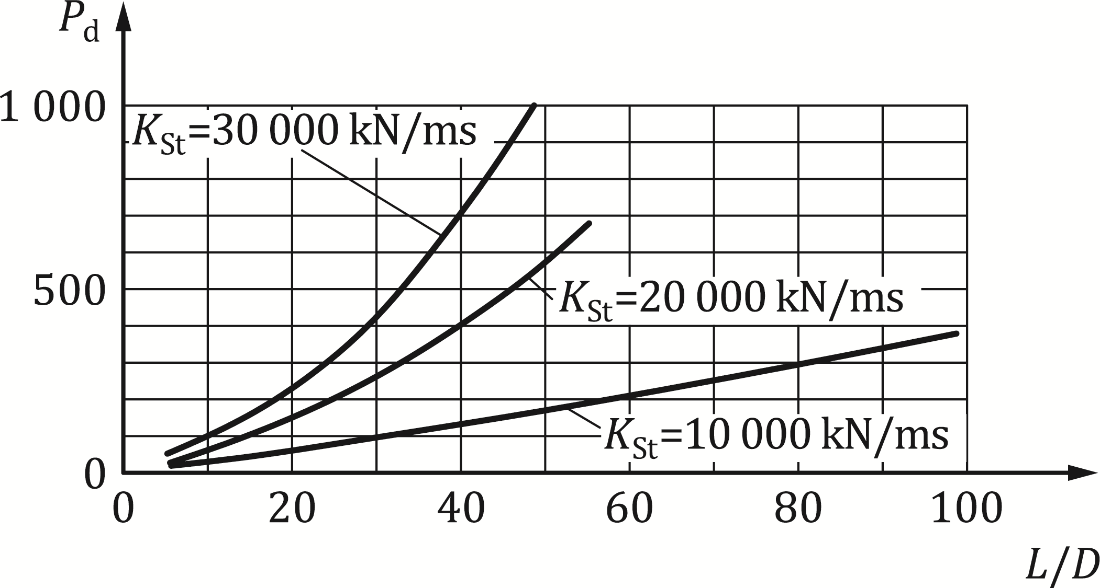

Figure D.4 — Design pressure *p*d for vented pipe containing dust

(2) The design overpressure *pd* for the pipe for a gas having a fundamental burning velocity of less than 0,60 m/s may be determined from Figure D.5.

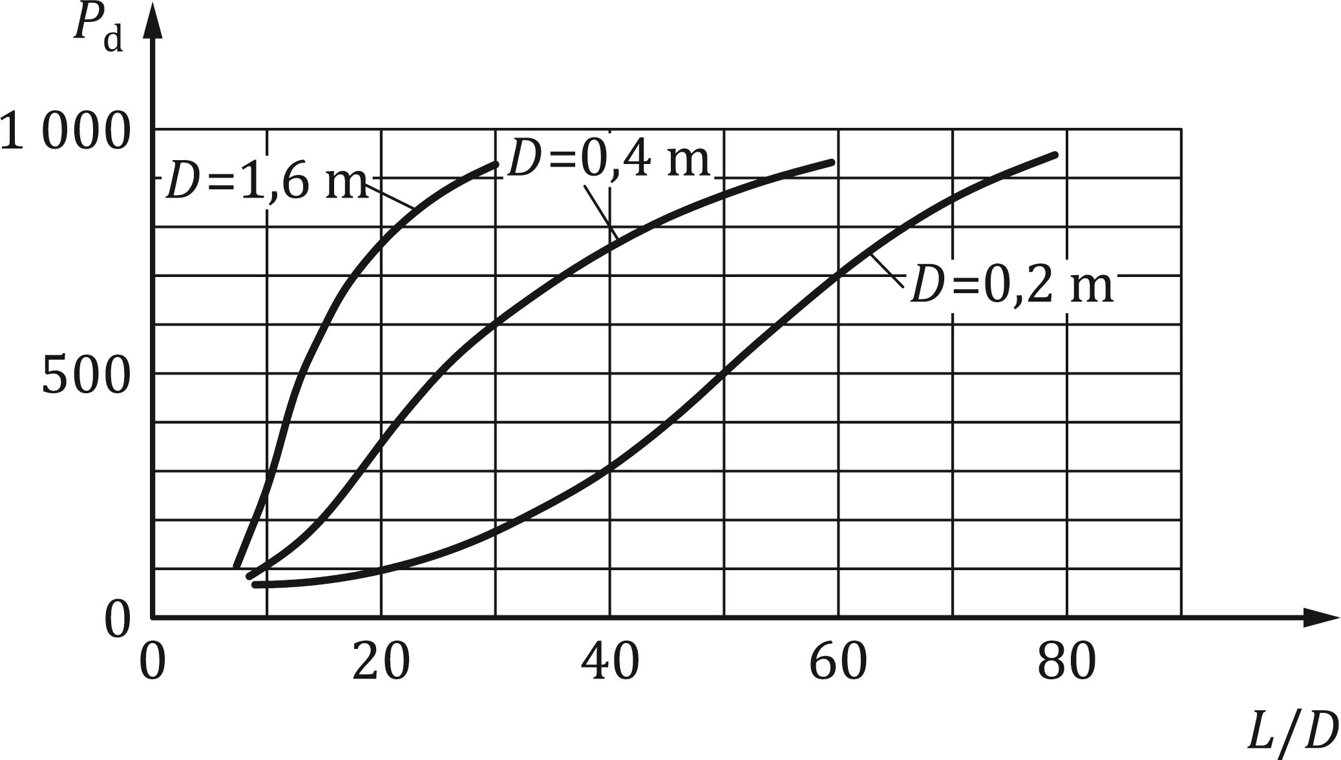

Figure D.5 — Design value of the overpressure *p*d for gases with fundamental burning velocity of less than 0,60 m/s

(3) For gases other than propane, the maximum pressure and the distance between vents may be calculated using Formula (D.11):

 (D.11)

where

|  |  |
| --- | --- |
| *p*d,X | is the maximum explosion overpressure of the gas X, in [kN/m2]; |
| *p*d,P | is the maximum explosion overpressure of propane, in [kN/m2]; |
| *S*u,X | is the fundamental burning velocity for gas X, in [m/s], see Table D.2; |
| *S*u,P | is the fundamental burning velocity for propane, in [m/s]. |

(4) For gases with fundamental burning velocities greater than 0,60 m/s (see Table D.2) additional vent area should be provided by using multiple vent locations to decrease the spacing between the vents determined for propane.

Table D.2 — Fundamental burning velocity *S*u

|  |  |
| --- | --- |
| **Type of gas** | ***S*u** |
| **[m/s]** |
| Acetone | 0,54 |
| Acetylene | 1,66 |
| Benzene | 0,48 |
| Butane | 0,45 |
| Ethane | 0,47 |
| Ethylene | 0,80 |
| Gasoline | 0,40 |
| Heptane | 0,46 |
| Hydrogen | 3,12 |
| Jet fuel, grade JP-1 | 0,40 |
| Methane | 0,40 |
| Pentane | 0,46 |
| **Propane** | **0,46** |
| Toluene | 0,41 |

1. (informative)  
     
   Actions from debris
   1. Use of this annex

(1) This Informative Annex provides supplementary guidance to 5.6.2.4

NOTE National choice on the application of this Informative Annex is given in the National Annex. If the National Annex contains no information on the application of this informative annex, it can be used.

* 1. Scope and field of application

(1) This Informative Annex covers debris from elevating structures supported by railway superstructures.

* 1. Actions from debris

(1) Railway superstructures that are generally occupied should be designed assuming the equivalent static actions given in Table E.1.

(2) These actions are to be taken into account in addition to the permanent and/or variable actions (e.g. self-weight, imposed loads, traffic loads, earth pressure and water pressure, if any) acting on the member in order to ensure that the relevant traffic routes are free of obstacles.

Table E.1 — Actions from debris

|  |  |  |  |
| --- | --- | --- | --- |
| **Action from debris** | | **Number n of full storeys** | |
| **n ≤ 5** |  |
|  |  |  |  |
|  |  |  |
| Uniformly distributed vertical load on floors | *pv* | 10,0 kN/m2 | 15,0 kN/m2 |
| Uniformly distributed horizontal load for perimeter walls above ground level | *phi* | 10,0 kN/m2 | 15,0 kN/m2 |
| Uniformly distributed horizonal load for perimeter walls at ground level, depending on the type of soil: | | | |
| Sand and gravel | *pha* | 4,5 kN/m2 | 6,75 kN/m2 |
| Loam of mean consistency | *pha* | 6,0 kN/m2 | 9,0 kN/m2 |
| Loam of a soft consistency and clay | *pha* | 7,5 kN/m2 | 11,25 kN/m2 |
| Soils in groundwater | *pha* | 10,0 kN/m2 | 15,0 kN/m2 |

Bibliography

**References contained in recommendations (i.e. “should” clauses)**

The following documents are referred to in the text in such a way that some or all of their content constitutes highly recommended choices or course of action of this document. Subject to national regulation and/or any relevant contractual provisions, alternative documents could be used/adopted where technically justified. For dated references, only the edition cited applies. For undated references, the latest edition of the referenced document (including any amendments) applies.

EN 1992 (all parts), Eurocode 2 — Design of concrete structures

EN 1993 (all parts), Eurocode 3 — Design of steel structures

EN 1994 (all parts), Eurocode 4 — Design of composite steel and concrete structures

EN 1995 (all parts), Eurocode 5 — Design of timber structures

EN 1996 (all parts), Eurocode 6 — Design of masonry structures

EN 1997 (all parts), Eurocode 7 — Geotechnical design

EN 1998 (all parts), Eurocode 8 — Design of structures for earthquake resistance

EN 1999 (all parts), Eurocode 9 — Design of aluminium structures

**References contained in permissions (i.e. “may” clauses)**

The following documents are referred to in the text in such a way that some or all of their content expresses a course of action permissible within the limits of the Eurocodes. For dated references, only the edition cited applies. For undated references, the latest edition of the referenced document (including any amendments) applies.

EN 14491, Dust explosion venting protective systems

EN 14797, Explosion venting devices

**References contained in possibilities (i.e. “can” clauses) and notes**

The following documents are cited informatively in the document, for example in “can” clauses and in notes.

EN 1317 (all parts), Road restraint systems

prEN 1991-1-6, Eurocode 1 — Actions on structures — Part 1 6: General actions — Actions during execution (in development)

prEN 1991‑2, Eurocode 1 — Actions on structures — Part 2: Traffic loads on bridges and other civil engineering works

EN 14034‑1, Determination of explosion characteristics of dust clouds — Part 1: Determination of the maximum explosion pressure pₘax of dust clouds

EN 14034‑2, Determination of explosion characteristics of dust clouds — Part 2: Determination of the maximum rate of explosion pressure rise (dp/dt)ₘax of dust clouds

ISO 10252, Bases for design of structures — Accidental actions

UIC Code 777-1R, *Measures to protect railway bridges against impacts from road vehicles, and to protect rail traffic from road vehicles fouling the track*

UIC Code 777-2R, *Structures Built Over Railway Lines — Construction requirements in the track zone*