CEN/TC 250

Date: 2023-03-07

prEN 1993-1-14:2023

Secretariat: BSI

Eurocode 3 — Design of steel structures — Part 1-14: Design assisted by finite element analysis

*Eurocode 3 — Bemessung und Konstruktion von Stahlbauten — Teil 1-14:*

*Eurocode 3 — Calcul des structures en acier — Partie 1-14 :*



CCMC will prepare and attach the official title page.

Contents Page

European foreword 4

0 Introduction 5

1 Scope 8

1.1 Scope of prEN 1993-1-14 8

1.2 Assumptions 8

2 Normative references 9

3 Terms, definitions and symbols 9

3.1 Terms and definitions 9

3.2 Symbols and abbreviations 11

4 Basis of design and modelling 14

5 Modelling 15

5.1 Geometrical models 15

5.2 Support and load models 17

5.3 Material models 18

5.4 Imperfections 24

5.5 Imperfection combinations 31

6 Analysis 32

6.1 Structural analysis 32

6.2 Thermal analysis 34

7 Validation and verification 35

7.1 General 35

7.2 Verification 36

7.3 Validation 37

8 Design methodology 38

8.1 Ultimate limit state 38

8.2 Fatigue limit state 44

8.3 Serviceability limit state 54

9 Documentation 54

Annex A (informative) Calculation of model factor (γFE) 55

A.1 Use of this Annex 55

A.2 Scope and field of application 55

A.3 Calculation of model factor (γFE) 55

Annex B (informative) Stress concentrations 57

B.1 Use of this Annex 57

B.2 Scope and field of application 57

B.3 Separation of stress concentration and numerical singularities 57

B.4 Consideration of stress concentration in design 58

Annex C (normative) Limits on maximum strains for beam finite elements 60

C.1 Use of this Annex 60

C.2 Scope and field of application 60

C.3 Strain limits 60

Bibliography 64

European foreword

This document (prEN 1993-1-14:2023) has been prepared by Technical Committee CEN/TC 250 “Structural Eurocodes”, the secretariat of which is held by BSI. CEN/TC 250 is responsible for all Structural Eurocodes and has been assigned responsibility for structural and geotechnical matters by CEN.

This document is currently submitted to the CEN Enquiry.

The first generation of EN Eurocodes was published between 2002 and 2007. This document forms part of the second generation of the Eurocodes, which have been prepared under Mandate M/515 issued to CEN by the European Commission and the European Free Trade Association.

The Eurocodes have been drafted to be used in conjunction with relevant execution, material, product and test standards, and to identify requirements for execution, materials, products and testing that are relied upon by the Eurocodes.

The Eurocodes recognize the responsibility of each Member State and have safeguarded their right to determine values related to regulatory safety matters at national level through the use of National Annexes.

0 Introduction

**0.1 Introduction to the Eurocodes**

The Structural Eurocodes comprise the following standards generally consisting of a number of Parts:

— EN 1990, Eurocode: Basis of structural and geotechnical design

— EN 1991, Eurocode 1: Actions on structures

— EN 1992, Eurocode 2: Design of concrete structures

— EN 1993, Eurocode 3: Design of steel structures

— EN 1994, Eurocode 4: Design of composite steel and concrete structures

— EN 1995, Eurocode 5: Design of timber structures

— EN 1996, Eurocode 6: Design of masonry structures

— EN 1997, Eurocode 7: Geotechnical design

— EN 1998, Eurocode 8: Design of structures for earthquake resistance

— EN 1999, Eurocode 9: Design of aluminium structures

— New parts are under development, e.g. Eurocode for design of structural glass

The Eurocodes are intended for use by designers, clients, manufacturers, constructors, relevant authorities (in exercising their duties in accordance with national or international regulations), educators, soft-ware developers, and committees drafting standards for related product, testing and execution standards.

NOTE Some aspects of design are most appropriately specified by relevant authorities or, where not specified, can be agreed on a project-specific basis between relevant parties such as designers and clients. The Eurocodes identify such aspects making explicit reference to relevant authorities and relevant parties.

**0.2 Introduction to** EN 1993 (all parts)

EN 1993 (all parts) applies to the design of buildings and civil engineering works in steel. It complies with the principles and requirements for the safety and serviceability of structures, the basis of their design and verification that are given in EN 1990 – Basis of structural and geotechnical design.

EN 1993 (all parts) is concerned only with requirements for resistance, serviceability, durability and fire resistance of steel structures. Other requirements, e.g. concerning thermal or sound insulation, are not covered.

EN 1993 is subdivided in various parts:

— EN 1993-1, *Design of steel structures – Part 1: General rules and rules for buildings*

— EN 1993-2, *Design of steel structures – Part 2: Bridges*

— EN 1993-3, *Design of steel structures – Part 3: Towers, masts and chimneys*

— EN 1993-4, *Design of steel structures – Part 4: Silos and tanks*

— EN 1993-5, *Design of steel structures – Part 5: Piling*

— EN 1993-6, *Design of steel structures – Part 6: Crane supporting structures*

— EN 1993-7, *Design of steel structures – Part 7: Sandwich panels* (under preparation)*.*

EN 1993-1 in itself does not exist as a physical document, but comprises the following 14 separate parts, the basic part being EN 1993-1-1:

— EN 1993-1-1, *Design of steel structures – Part 1-1: General rules and rules for buildings*

— EN 1993-1-2, *Design of steel structures – Part 1-2: Structural fire design*

— EN 1993-1-3, *Design of steel structures – Part 1-3: Cold-formed members and sheeting*

NOTE Cold-formed hollow sections supplied according to EN 10219 are covered in EN 1993-1-1.

— EN 1993-1-4, *Design of steel structures – Part 1-4: Stainless steel structures*

— EN 1993-1-5, *Design of steel structures – Part 1-5: Plated structural elements*

— EN 1993-1-6, *Design of steel structures – Part 1-6: Strength and stability of shell structures*

— EN 1993-1-7, *Design of steel structures – Part 1-7: Plate assemblies with elements under transverse loads*

— EN 1993-1-8, *Design of steel structures – Part 1-8: Joints*

— EN 1993-1-9, *Design of steel structures – Part 1-9: Fatigue*

— EN 1993-1-10, *Design of steel structures – Part 1-10: Material toughness and through-thickness properties*

— EN 1993-1-11, *Design of steel structures – Part 1-11: Tension components*

— EN 1993-1-12, *Design of steel structures – Part 1-12: Additional rules for steel grades up to S960*

— EN 1993-1-13, *Design of steel structures – Part 1-13: Beams with large web openings*

— EN 1993-1-14, *Design of steel structures – Part 1-14: Design assisted by finite element analysis*

All parts numbered EN 1993-1-2 to EN 1993-1-14 treat general topics that are independent from the structural type such as structural fire design, cold-formed members and sheeting, stainless steels, plated structural elements, etc.

All parts numbered EN 1993-2 to EN 1993-7 treat topics relevant for a specific structural type such as steel bridges, towers, masts and chimneys, silos and tanks, piling, crane supporting structures, etc. EN 1993-2 to EN 1993-7 refer to the generic rules in EN 1993-1 and supplement, modify or supersede them.

**0.3 Introduction to** **prEN** 1993**-**1-14

prEN 1993-1-14 gives principles and requirements for the use of numerical methods in the design of steel structures, more specifically for the ultimate limit state (including fatigue) and serviceability limit state verifications. It also gives principles and requirements for the application of advanced finite element and similar modelling techniques for research purposes, which may also be used in design processes.

**0.4 Verbal forms used in the Eurocodes**

The verb “shall" expresses a requirement strictly to be followed and from which no deviation is permitted in order to comply with the Eurocodes.

The verb “should” expresses a highly recommended choice or course of action. Subject to national regulation and/or any relevant contractual provisions, alternative approaches could be used/adopted where technically justified.

The verb “may" expresses a course of action permissible within the limits of the Eurocodes.

The verb “can" expresses possibility and capability; it is used for statements of fact and clarification of concepts.

**0.5 National Annex for** **prEN** 1993**-**1-14

National choice is allowed in this standard where explicitly stated within notes. National choice includes the selection of values for Nationally Determined Parameters (NDPs).

The national standard implementing prEN 1993-1-14 can have a National Annex containing all national choices to be used for the design of buildings and civil engineering works to be constructed in the relevant country.

When no national choice is given, the default choice given in this standard is to be used.

When no national choice is made and no default is given in this standard, the choice can be specified by a relevant authority or, where not specified, agreed for a specific project by appropriate parties.

National choice is allowed in prEN 1993-1-14 through notes to the following clauses:

|  |  |  |  |
| --- | --- | --- | --- |
| 4(11) | 4(15) | 5.4.2(1) | 7.1(2) |
| 7.2(2) | 7.3(1) | 7.3(3) | 7.3(6) |
| 8.1.2(3) | 8.1.2(5) | 8.1.5(2) | 8.1.5(3) |
| C.3(1) |  |  |  |

National choice is allowed in prEN 1993-1-14 on the application of the following informative annexes:

|  |  |
| --- | --- |
| Annex A | Annex B |

The National Annex can contain, directly or by reference, non-contradictory complementary information for ease of implementation, provided it does not alter any provisions of the Eurocodes.

# Scope

## Scope of prEN 1993-1-14

(1) This document gives principles and requirements for the use of numerical methods in the design of steel structures, more specifically for the ultimate limit state (including fatigue) and serviceability limit state verifications. It also gives principles and requirements for the application of advanced finite element (FE) and similar modelling techniques for numerical simulation which also covers safety assessment.

(2) This document covers general methodologies such as the finite element method (FEM), finite strip method (FSM) or generalized beam theory (GBT) for modelling, analysis and design of steel structures made of the following members and joint configurations:

a) hot-rolled profiles,

b) cold-formed members and sheeting,

c) welded plated profiles,

d) stainless steel profiles,

e) plate assemblies,

f) shell structures,

g) welded and bolted joints.

In addition to the general design rules, specific additional rules can also be found in the relevant standard parts in EN 1993.

(3) This document contains harmonized design rules in terms of the application of the numerical modelling methods, development of the numerical models, application of analysis types, result evaluation methods, and determination of the resistance of steel structures for different limit states.

## Assumptions

(1) This document gives rules intended for engineers who are experienced in the use of FE.

(2) It is recognized that structural analysis, based upon the laws of physics, has been successfully researched, developed, historically or currently used for the design and verification of elements or whole structural frames. This remains appropriate for many structural solutions. However, when a more detailed understanding of structural behaviour is required, the methods described in this document can be useful for the professional design.

(3) Unless specifically stated, EN 1990, EN 1991 (all parts) and the other relevant parts of EN 1993-1 apply.

(4) The design methods given in prEN 1993-1-14 are applicable if

— the execution quality is as specified in EN 1090-2 and/or EN 1090-4, and

— the construction materials and products used are as specified in the relevant parts of EN 1993, or in the relevant material and product specifications.

# Normative references

The following documents are referred to in the text in such a way that some or all of their content constitutes requirements of this document. For dated references, only the edition cited applies. For undated references, the latest edition of the referenced document (including any amendments) applies.

NOTE See the Bibliography for a list of other documents cited that are not normative references, including those referenced as recommendations (i.e. through ‘should’ clauses) and permissions (i.e. through ‘may’ clauses).

EN 1090‑2, Execution of steel structures and aluminium structures - Part 2: Technical requirements for steel structures

EN 1090‑4, Execution of steel structures and aluminium structures - Part 4: Technical requirements for cold-formed structural steel elements and cold-formed structures for roof, ceiling, floor and wall applications

EN 1990:2023, Eurocode - Basis of structural and geotechnical design

EN 1991 (all parts), Eurocode 1 - Actions on structures

EN 1993 (all parts), Eurocode 3 - Design of steel structures

# Terms, definitions and symbols

For the purposes of this document, the following terms, definitions and symbols apply.

## Terms and definitions

3.1.1

analysis requiring subsequent design check

analysis (e.g. LA, LBA, GNA, GNIA, MNA) performed for design checks, which results are different system response quantities to be further used in the static check of the analysed structure

3.1.2

benchmark case

offers the inputs and outputs of the analytical or numerical solutions to verify the results by comparison on simplified model, or experimental tests used to check the quality of the numerical model to be validated

3.1.3

degree of freedom

DOF

number of independent motions that are allowed to the structure

Note 1 to entry: DOF can be defined as DOF per node (1 to 7 – maximum 3 translational, 3 rotational and warping) and total number of DOFs for the whole structure as sum of all node's DOFs.

3.1.4

direct resistance check

analysis (e.g. MNA, GMNA, GMNIA) performed for design checks, which result is the ultimate resistance of the analysed structure

3.1.5

follower load

load changing direction as a function of the deformation of the analysed structure in a non-linear analysis

3.1.6

global analysis

structural analysis of the complete structure or part of the structure under investigation, rather than individual structural members or components treated separately

3.1.7

numerical model

numerical idealization to simulate and predict aspects of behaviour of a system used to represent the structural behaviour of the analysed structure or a part of it

3.1.8

multi-level or combined model

modelling of the entire structure using different types of elements (e.g. coupling of beam, plate, shell or solid elements) within one model, making the DOFs compatible at the intersection regions

3.1.9

numerical design calculation

numerical model and analysis type used for the static design check of a structure or a part of it

Note 1 to entry: Results of the numerical model can be (i) different system response quantities (SRQs) to be used for further evaluation or (ii) resistances to be used for direct resistance check.

3.1.10

numerical simulation

complementation or extension of physical experiments to determine the direct resistance of a structure

3.1.11

second order analysis

geometrically non-linear analysis based on second order approximations (geometric stiffness or stress stiffening approach)

3.1.12

standard design case

numerical model-based design check of failure modes for which Eurocode based design resistance model also exists

3.1.13

sub-model

part of the entire structure modelled using equivalent support conditions representing the neglected part of the structure

3.1.14

system response quantity

SRQ

relevant output value resulting from a certain analysis; it reflects the main objective of the analysis by selecting the major parameters and the limitation of their errors in both validation and verification

3.1.15

validation

comparison of the numerical solution and the experimental behaviour (or known accurate solutions)

3.1.16

verification

comparison of the numerical solutions and accurate analytical or numerical results

## Symbols and abbreviations

### Latin upper-case symbols

|  |  |
| --- | --- |
| *A* | elongation after fracture defined in the relevant material specification |
| C1, C2 | material coefficient for hot-rolled steels |
| *E* | modulus of elasticity |
| *E*1*, E*2*, E*3 | strain hardening modulus of the stress-strain curve for cold-formed structures covered by prEN 1993-1-3 |
| *E*0.2 | tangent modulus of the stress-strain curve at the yield strength for cold-formed steel and stainless steels |
| *E*sh | strain hardening modulus for hot-rolled steels |
| *H* | total section depth of welded box-sections |
| *L* | member length |
| *L*r,min , *L*r,max | limits of the extrapolation region for tubular joints in fatigue design situation |
| *Rcomp* | structural resistance computed by the numerical model |
| *R*b,d | design buckling resistance |
| *R*b,k | characteristic buckling resistance |
| *R*check | computed resistance for the check structural resistance case |
| *R*cr | lowest elastic critical bifurcation load of the examined structure |
| *R*GMNA | calculated plastic resistances based on GMNA analysis |
| *R*GMNIA | calculated buckling resistances based on GMNIA analysis |
| *R*k,known | calculated or known characteristic structural resistance |
| *R*test,known | known test result |
| *R*MNA | calculated plastic resistance based on MNA analysis |
| *R*pl | plastic resistance of the examined structure or cross-section |
| *R*pl,d | design plastic resistance of the examined structure |
| *R*pl,k | characteristic plastic resistance of the examined structure |
| *V*X | coefficient of variation of the ratio of the measured (or known) and computed results |
| VEd | design value of the shear force |
| Vpl,Rd | design value of the plastic resistance to shear force |

### Latin lower-case symbols

|  |  |
| --- | --- |
| *a* | length of a panel or sub-panel |
| *b* | width of a panel or sub-panel |
| *b*f | flange width |
| *ars, brs, crs, drs, ers, frs, grs, hrs* | geometrical parameters of the residual stress patterns |
| *e*0 | amplitude of the equivalent geometric imperfection |
| *e*0,dist | imperfection magnitude for distortional buckling mode |
| *f*u | ultimate tensile strength |
| *f*y | yield stress |
| *f*yb | basic yield strength of cold-formed steel |
| *h*w | web depth |
| *k*n | characteristic fractile factor |
| *m* | second strain hardening exponent for the Ramberg-Osgood type material model cold-formed steel and stainless steels |
| *m*X | mean value of the ratio of the measured (or known) and computed results |
| *n* | material coefficient for the Ramberg-Osgood type material model for cold-formed steel and stainless steels |
| *r* | radius of notch in fatigue design situation |
| *t* | plate thickness |
| *t*w | web thickness |
| *t*0 | chord member wall thickness in tubular joints |
| *t*1 | brace member wall thickness in tubular joints |

### Greek upper-case symbols

|  |  |
| --- | --- |
| Θ | flank angle of the weld model in fatigue design situation |
| Ω | project specific parameter that defines the maximum permissible level of plastic strain in the structure |

### Greek lower-case symbols

|  |  |
| --- | --- |
| *𝛼* | imperfection factor |
| *𝛼*ult,k | minimum load amplifier of the design loads to reach the characteristic resistance of the most critical cross-section |
| *𝛽*LT | reference relative bow imperfection for lateral torsional buckling |
| ε | strain |
| ε0,2 | total strain at 0,2 % proof stress for the Ramberg-Osgood type material model cold-formed steel and stainless steels |
| ε1,0 | total strain at 1 % proof stress for the Ramberg-Osgood type material model cold-formed steel and stainless steels |
| εcsm | maximum allowed plastic strain based on continuous strength method |
| εEd | design value of the maximum longitudinal compressive strain |
| εmb | maximum plastic strain for bolts |
| εmpb | maximum allowed plastic strain for bolts |
| εsh | strain hardening strain for hot-rolled steels |
| ε*true* | true-strain |
| εu | ultimate strain |
| ε*y* | yield strain |
|  | relative slenderness |
| 𝜎 | stress |
| 𝜎0,05 | 0,05 % proof stress for the Ramberg-Osgood type material model cold-formed steel and stainless steels |
| 𝜎1,0 | 1 % proof stress for the Ramberg-Osgood type material model cold-formed steel and stainless steels |
| 𝜎0,4t | calculated stress change in a distance of 0,4·t from the weld toe in fatigue design situation |
| 𝜎0,5t | calculated stress change in a distance of 0,5·t from the weld toe in fatigue design situation |
| 𝜎0,9t | calculated stress change in a distance of 0,9·t from the weld toe in fatigue design situation |
| 𝜎1,0t | calculated stress change in a distance of 1,0·t from the weld toe in fatigue design situation |
| 𝜎1,5t | calculated stress change in a distance of 1,5·t from the weld toe in fatigue design situation |
| 𝜎4mm | calculated stress change in a distance of 4 mm from the weld toe in fatigue design situation |
| 𝜎5mm | calculated stress change in a distance of 5 mm from the weld toe in fatigue design situation |
| 𝜎8mm | calculated stress change in a distance of 8 mm from the weld toe in fatigue design situation |
| 𝜎12mm | calculated stress change in a distance of 12 mm from the weld toe in fatigue design situation |
| 𝜎15mm | calculated stress change in a distance of 15 mm from the weld toe in fatigue design situation |
| 𝜎*rt* | tensile residual stress |
| 𝜎*rc* | compressive residual stress |
| 𝜎*ft,* 𝜎*wt* | tensile residual stress of stainless steel welded or laser welded I-sections and welded box sections |
| 𝜎*fc,* 𝜎*wc* | compressive residual stress of stainless steel welded or laser welded I-sections and welded box sections |
| 𝜎cr,cs | elastic local critical bifurcation stress of the full cross-section |
| 𝜎cr,d | elastic critical distortional bifurcation stress |
| 𝜎nom | nominal stress in fatigue design situation |
| 𝜎HS | geometric (hot spot) stress in fatigue design situation |
| 𝜎EN | effective notch stress in fatigue design situation |
| 𝜎true | true-stress |
| 𝜌 | reduction factor to determine the design value of the reduced plastic resistance to bending moment making allowance for the presence of shear forces |
| 𝜌csm | reduction factor for the maximum allowed strain limit in beam elements considering interaction between bending and shear |
| 𝛾FE | model factor covering the uncertainties of the numerical model and the executed analysis type |

# Basis of design and modelling

(1) The basis of design with numerical methods shall be in accordance with the general rules given in EN 1990 and EN 1991 (all parts) and the specific design provisions for steel structures given in the relevant parts of EN 1993-1 (all parts).

(2) Steel structures designed according to this document shall be executed according to EN 1090-2 and/or EN 1090-4 with construction materials and products used as specified in the relevant parts of EN 1993, or in the relevant material and product specifications.

(3) Dynamic effect should be taken into account according to the relevant application part of EN 1993 (all parts). This document does not contain rules for dynamic analysis.

(4) This document gives design rules for the

a) ultimate limit state design (excluding fatigue),

b) fatigue design situation,

c) serviceability limit state design.

(5) Finite element analysis-based design may be executed by one of the following two methods, which should be recognised as different and treated differently in the design process:

a) numerical design calculation,

b) numerical simulation.

(6) The design methods differ regarding the (i) applied geometrical and material properties, (ii) results of the analysis, (iii) validation and verification process, (iv) further evaluation method of output data and (v) reliability assessment of the calculation results.

(7) Numerical design calculations may be different based on the analysis type and results; design rules are given based on the following two categories:

a) analysis requiring subsequent design check,

b) direct resistance check.

(8) In the case of analysis requiring subsequent design check one of the following analysis methods should be used: LA, LBA, GNA, GNIA, MNA. The results of the analysis are different system response quantities which are to be further used in the design check of the analysed structure.

(9) In the case of direct resistance check one of the following analysis methods should be used: MNA, GMNA, GMNIA. The result of the analysis is the ultimate resistance of the analysed structure, determined according to 8.1.5.

(10) In the case of numerical design calculations, nominal values should be used for the geometrical and stiffness parameters, e.g. Young’s modulus. Strength parameters, e.g. material properties, are taken as nominal values from the product standards, which represent fractile values.

(11) Numerical simulations may be applied to complement or extend laboratory tests used in test-based design.

NOTE The National Annex can give further rules and limitation on the application of numerical simulation.

(12) In the case of numerical simulations, measured (or mean) values should be used for geometrical and material properties. The result of the analysis is the resistance of the analysed structure.

(13) Application of finite element analysis-based design methods should not bring significant resistance increases compared to well-established traditional design methods, unless shown to be reasonable through validation and verification of the employed finite element model according to Clause 7 covering all relevant failure modes.

(14) The rules of prEN 1993-1-14 are independent of the software used. However, the capabilities of the chosen software should be checked by the designer and it should be confirmed that the software is applicable for the limit state check being used (see Clause 8).

(15) To ensure design quality, the applicability of the design using numerical methods should be linked to design qualification and experience levels (DQLs).

NOTE Minimum appropriate qualifications and experience of personnel designing structures using numerical models can be defined in the National Annex based on EN 1990:2023, Table B.1.

# Modelling

## Geometrical models

### General rules for geometrical modelling and discretization

(1) The chosen finite element (linear or higher order element) shall be related to the chosen mesh density, geometry complexity (curvature) and the solution method to ensure that the results meet both the validation and verification requirements.

(2) The discretization of the chosen model should be adequate and it should follow the geometrical properties of the structure. A finer mesh may be used in zones where large gradients of stresses, strains or temperatures are expected. Element shape properties should be of suitable quality to ensure accuracy (element aspect ratio, jacobian ratio, warping factor, etc.).

(3) At locations with high stress or strain concentrations or at the location where failure of the structure is anticipated, mesh refinement should be used to ensure the required accuracy, except for fatigue verification which applies predefined mesh refinements according to 8.2.

(4) The accuracy of the chosen FE mesh (density, chosen element types) should be proven by model verification according to Clause 7.

(5) Cold-formed steel cross-sections should be modelled with rounded corners, unless their effect is not relevant according to prEN 1993-1-3.

(6) Where FE analysis is used in support of design calculations for the joints of cold-formed structures covered by prEN 1993-1-3, the joint FE model should be validated by test results or verified against appropriate design rules.

(7) Element types (such as truss or cable elements, etc.) not covered by the following clauses may also be applied in the numerical model taking special care on their modelling specialties.

(8) A geometrically non-linear global analysis of beam structures (see 6.1.2) may normally be based on second order theory.

NOTE As a general rule, the accuracy of calculations according to second order theory is sufficient for global analysis of frame structures. In exceptional cases, more accurate geometrically non-linear calculations are required, if the displacements are large enough to significantly change the stress resultants in the structure.

(9) The degrees of freedom (DOFs) of the chosen element should be made compatible within the modelled structure and with the chosen boundary conditions.

### Models using beam elements

(1) The system axis of the beam model should be identical to that of the centroid of the cross-sections, or it should be chosen such that the effects of its displacement from the centroid of the cross-sections are sufficiently small to ignore.

(2) If the system axis differs from the centroid line (or if shear and gravity centres differ and are relevant in the calculation), either eccentricities should be included in the interpretation, or internal force adjustment should be made by the numerical analysis.

(3) When using a beam model, the behaviour of the joints between the beam structural members should be considered. The assumed stiffness (hinged joint, continuous joint, semi-rigid joint) should be determined according to EN 1993-1-8.

(4) If torsion and/or stability problems involving torsion (e.g. lateral torsional buckling, torsional buckling, torsional-flexural buckling, etc.) are being studied using beam models, the used elements should be capable of capturing torsion-related warping effects (for example elements using 7 DOFs - 3 translational, 3 rotational and warping).

(5) Beam elements should include shear effects if relevant.

(6) Strain limits to determine the point at which cross-section failure occurs are given in Annex C.

NOTE The calculation of elastic critical loads (for lateral torsional buckling) for members of varying height can require the use of specific beam elements.

### Models using plate or shell elements

(1) The middle surface of a plate or shell may be taken as the reference surface for modelling. Care should be taken that the effects of eccentricities and offsets from mid-surfaces are properly included in the model and that they realistically represent the structural behaviour of the modelled structure.

(2) Eccentricities and steps in the middle surface should be included in the model, if they induce significant bending effects caused by the membrane stress resultants following an eccentric path.

(3) For the modelling of 3D surface bodies (plated, cold-formed and shell structures) shell elements should be used having 5 or 6 DOFs at each node. The chosen elements should be able to model thin or moderately-thick shells. Special shell elements with different DOFs may be used in specific shell problems (e.g. shells of revolution, cylindrical, conical or spherical shells, etc.).

(4) Additional requirements modelling shell structures are given in prEN 1993-1-6.

(5) Care should be taken at zones where higher through thickness shear stresses occur.

### Models using solid elements

(1) For the modelling of solid bodies loaded by either in-plane loads or loads perpendicular to their plane, plane elements with 2 or 3 DOFs (only translational) at each node may be used for meshing (e.g. plane stress/strain or axisymmetric problems).

NOTE Solid elements usually have 3 DOFs (only translational) at each node. Special care is needed to the application of loads and supports defined in a compatible way with these three DOFs (i.e. bending moments and rotational loads cannot be applied).

(2) The chosen mesh should be continuous at the intersection points, in the joint regions and at the location of thickness changes.

(3) In solid models, bolts can be modelled by using the shank area with their nominal cross-section for sufficiently accurate consideration of the stiffness of the bolt. Where stress checks on the shank or the threaded area of the bolt are to be made, appropriate modifications should be made (e.g. the bolt diameter corresponding to the stress area of the bolt may be used).

### Multi-level and combined models

(1) In multi-level or combined models, continuous load, displacement and rotation transfer should be provided at the interfaces between the different modelled parts.

(2) If different levels of modelling are used and different structural elements are connected, their eccentricities should be included within the model.

(3) In multi-level or combined models, contact elements or other interface elements may be used to couple the different model parts. The different DOFs of the different elements should be made compatible as well as the discretization of different parts.

(4) Effects acting on the sub-model should be identical to the effects of the relevant modelled part within the entire structure.

## Support and load models

### Definition of supports

(1) The support conditions in the numerical model should be chosen to reflect in a realistic or conservative manner the behaviour of the physical supports in the real structure.

(2) Where sub-modelling is used, the chosen supports should be in compliance with the supporting effect of the adjacent components of the global model. The chosen supports should consider the stiffness properties and the deformation capacity of the adjacent structural components.

(3) If concentrated or point supports are used in plate, shell or solid models, numerical stress concentrations may occur near the supports, which should be investigated. Recommendations are given in Annex B.

(4) Special care should be given to the definition of supports in non-linear analyses (specially in case of plate, shell and solid elements) to avoid undesired clamping effects.

NOTE Supports that act as pinned supports in a linear analysis can produce undesired stiffening effects in a non-linear analysis.

(5) Special boundary conditions for shell structures are given in prEN 1993-1-6.

(6) If a member of open section is subject to torsional rotations resulting from instability or applied loads (e.g. cold-formed structures covered by prEN 1993-1-3), special care should be taken with the warping conditions of the supports and joints.

(7) Care should be taken if symmetry conditions are applied and symmetry plane passes through supports or loads.

NOTE Symmetry can only be used where the expected structural behaviour (failure mode, buckling mode, deformed shape, loading and supporting conditions, etc.) has been verified to be symmetrical.

(8) In axisymmetric shells, the use of symmetry in one segment (cake slice) of the structure may be effective. However, care should be taken to ensure that unsymmetrical buckling modes crossing the symmetry plane are not critical. For further information, see prEN 1993‑1‑6.

### Definition of loads

(1) Loading applied in the numerical model should be related to the chosen solution technique (load or displacement controlled analysis).

(2) Where a non-linear analysis is used, the appropriateness of the load definition mode should be checked and verified according to Clause 7.

NOTE Load and displacement controlled analyses can lead to different results, arising from the different load transfer and load distribution modes in the numerical model.

(3) Where geometrically non-linear analysis is performed, and follower load effects are possible, either they should be incorporated into the analysis, or it should be verified that their influence is negligible.

## Material models

### General

(1) Material properties should be taken as nominal values where the analysis is used in support of numerical design calculations.

(2) In the case of analysis used for model validation, the chosen material properties should be based on relevant material tests (measured values).

(3) The stress-strain relationship of steel in compression may be assumed to be identical to that in tension.

(4) The material properties given in this standard apply to temperatures below 100 °C. In the case of fire, the mechanical properties of carbon steel and stainless steels may be taken from prEN 1993-1-2. These defined properties are only valid for heating rates in fire situations (as defined in prEN 1993-1-2) and are not applicable to other heating rates, especially where enduring high temperature condition occur.

(5) Under elevated temperatures, the effects of basic creep need not be given explicit consideration provided that the stress-strain relationships given in prEN 1993-1-2 are used.

(6) In case of numerical design calculations using analysis types with a linear elastic material law according to Table 6.1, linear elastic material model should be applied.

(7) The non-linear material models defined in 5.3.2 and 5.3.3 are applicable to monotonic loading. For cyclic plasticity modelling, see 5.3.4 and EN 1998-1.

(8) For steel grades up to S700, exhibiting a sharply defined yield point and yield plateau, the material models in 5.3.2 may be used.

(9) For steel grades up to S700, exhibiting a rounded stress-strain curve, the material model in 5.3.3 may be used.

(10) The von Mises yield criterion should be adopted for capacity analysis of steel structures other than the fatigue design situation unless there are special conditions that make it inappropriate.

(11) If strain hardening is considered in the analysis, the hardening model may be chosen as isotropic for a non-cyclic load or kinematic (or a combination of both) for a cyclic load.

(12) Material models given in 5.3.2 and 5.3.3 concern engineering stresses and strains.

(13) Where the analysis involves material contraction (e.g. solid element models or shells with thickness reduction effect) the true-stress true-strain curve up to the uniform elongation calculated from the quad-linear stress-strain model or a measured engineering tensile stress-strain curve according to Formula (5.1) and Formula (5.2) may be adopted.

 (5.1)

 (5.2)

(14) The modulus of elasticity and Poisson’s ratio of carbon and stainless steel may be assumed according to EN 1993-1-1:2022, 5.2.5 and prEN 1993-1-4:2023, 5.1.5, respectively.

NOTE 1 Where test results are being modelled, the measured modulus of elasticity can be adopted. Where elastic buckling is critical to the structure, consideration can be given to a reduced value of the modulus.

NOTE 2 Note that Poisson’s ratio in the elastic range goes up to 0,5.

(15) The modulus of elasticity may also be assumed as specified in (14) in GMNIA carried out to determine the ultimate strength of an element or structure, unless elastic instability is dominant. In the latter case, a reduced value of 200 000 N/mm2 for carbon steel and 191 000 N/mm2 for stainless steel may be used.

### Material models for hot-rolled steels

(1) Depending on the type of analysis and its requirements in accuracy and allowable strains, the following models of material behaviour may be used in material non-linear calculations, as shown in Figure 5.1:

a) linear elastic – perfectly plastic material model without strain hardening,

b) linear elastic – perfectly plastic material model with a nominal plateau slope for numerical stability,

c) linear elastic – linear hardening plastic material model (quad-linear material model with strain hardening),

d) linear elastic – non-linear hardening material model based on coupon-test results using engineering or true stress-strain curve.

|  |  |
| --- | --- |
|  |  |
| **a) without strain hardening** | **b) with nominal plateau slope** |
|  | |
| **c) with yielding plateau and strain hardening** | |
|  | |
| **d) using measured stress-strain curve** | |

Key

|  |  |
| --- | --- |
| 1 | tan-1 (E/10 000) |
| 2 | stress-strain curve from tensile test |
| 3 | true stress-strain curve |

Figure 5.1 — Modelling of hot-rolled steels

(2) The quad-linear material model is given by Formula (5.3) and shown in Figure 5.1 (c).

 (5.3)

where

|  |  |
| --- | --- |
| *f*y | is the yield stress, |
| *ε*y= *f*y/*E* | is the yield strain, |
| *fu* | is the ultimate tensile strength*,* |
| *ε*sh | is the strain hardening strain, which is given by: |

 but  (5.4)

|  |  |
| --- | --- |
| *ε*u | is the ultimate strain, which is given by: |

 but  (5.5)

|  |  |
| --- | --- |
| *A* | is the elongation after fracture defined in the relevant material specification, |
| *C*1 | is a material coefficient which is given by: |

 (5.6)

*E*sh is a strain hardening modulus which is given by:

 (5.7)

*C*2 is a material coefficient which is given by:

 (5.8)

(3) The material models apply to materials conforming to the grades in EN 1993-1-1:2022, Tables 5.1 and 5.2 and the following product standards: EN 10025 series, EN 10149 series and EN 10210 series.

(4) If the material model from EN 1993-1-1:2022, Table 5.1 (d) is used, for a uniaxial tensile test only the part of the stress-strain curve prior to diffuse necking (i.e. maximum engineering stress) should be used.

### Material models for cold-formed steel, high strength steel and stainless steels

(1) For cold-formed, stainless steel material and for steels up to S700 that exhibit a rounded stress-strain curve, the two-stage Ramberg-Osgood model given by Formula (5.9) and shown in Figure 5.2 may be used in material non-linear calculations.

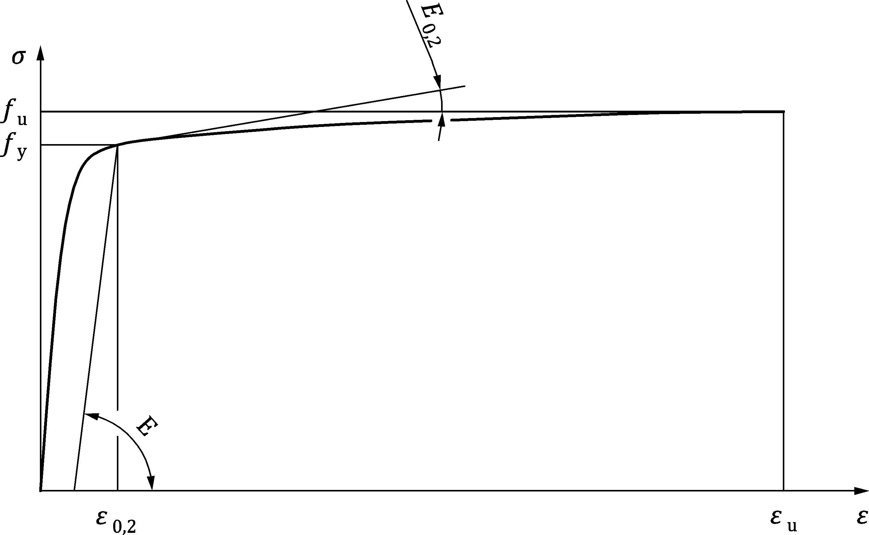

Figure 5.2 — Two-stage Ramberg-Osgood model

 (5.9)

|  |  |
| --- | --- |
| *σ* | is the stress, |
| *ε* | is the strain, |
| *E, fy* and *fu* | are given in EN 1993-1-1 for carbon steels and in EN 10088 (all parts) for stainless steels, |
| *n* | is a coefficient that may be taken from Table 5.1 or else calculated using measured properties and calculated as: |

 (5.10)

in which *σ*0,05 is the 0,05 % proof stress.

Table 5.1 — Values of *n*

|  |  |
| --- | --- |
| **Steel** | **Coefficient *n*** |
| Cold-formed steels | 8 |
| Austenitic stainless steels | 7 |
| Ferritic stainless steels | 14 |
| Duplex stainless steels | 8 |
| Steel grades of S500 – S700 | 14 |

*E0,2* is the tangent modulus of the stress-strain curve at the yield strength defined as:

 (5.11)

*ε*u is the ultimate strain, which is given by:

|  |  |  |
| --- | --- | --- |
|  | for cold-formed steels and ferritic stainless steels | (5.12) |
|  | for austenitic and duplex stainless steels |  |

but *ε*u ≤ *A*, where *A* is the elongation after fracture provided in material specifications.

*m* is the second strain hardening exponent that may be determined from Formula (5.13):



 (5.13)

or calculated from measured properties, as follows:

 (5.14)

in which *σ*1,0 is the 1 % proof stress and *ε*1,0 is the corresponding total strain at *σ*1,0.

NOTE For more ductile materials, the approximate relationship , can provide a simpler version of Formula (5.9).

(2) As an alternative to the two-stage Ramberg-Osgood model, the above given curves may be represented by multi-linear material models.

NOTE Where the structure is susceptible to buckling in the hardening region and sensitive to small changes in the tangent modulus (e.g. as in shell structures), a multi-linear model often gives numerical convergence problems and abrupt variations in resistance with small changes in loading or geometry.

(3) As an alternative to the Ramberg-Osgood type models the quad-linear material model shown in Figure 5.3 may be used for cold-formed structures covered by prEN 1993-1-3. Further simplification of this material model can also be made using E1=E2=E and E3=E/100.

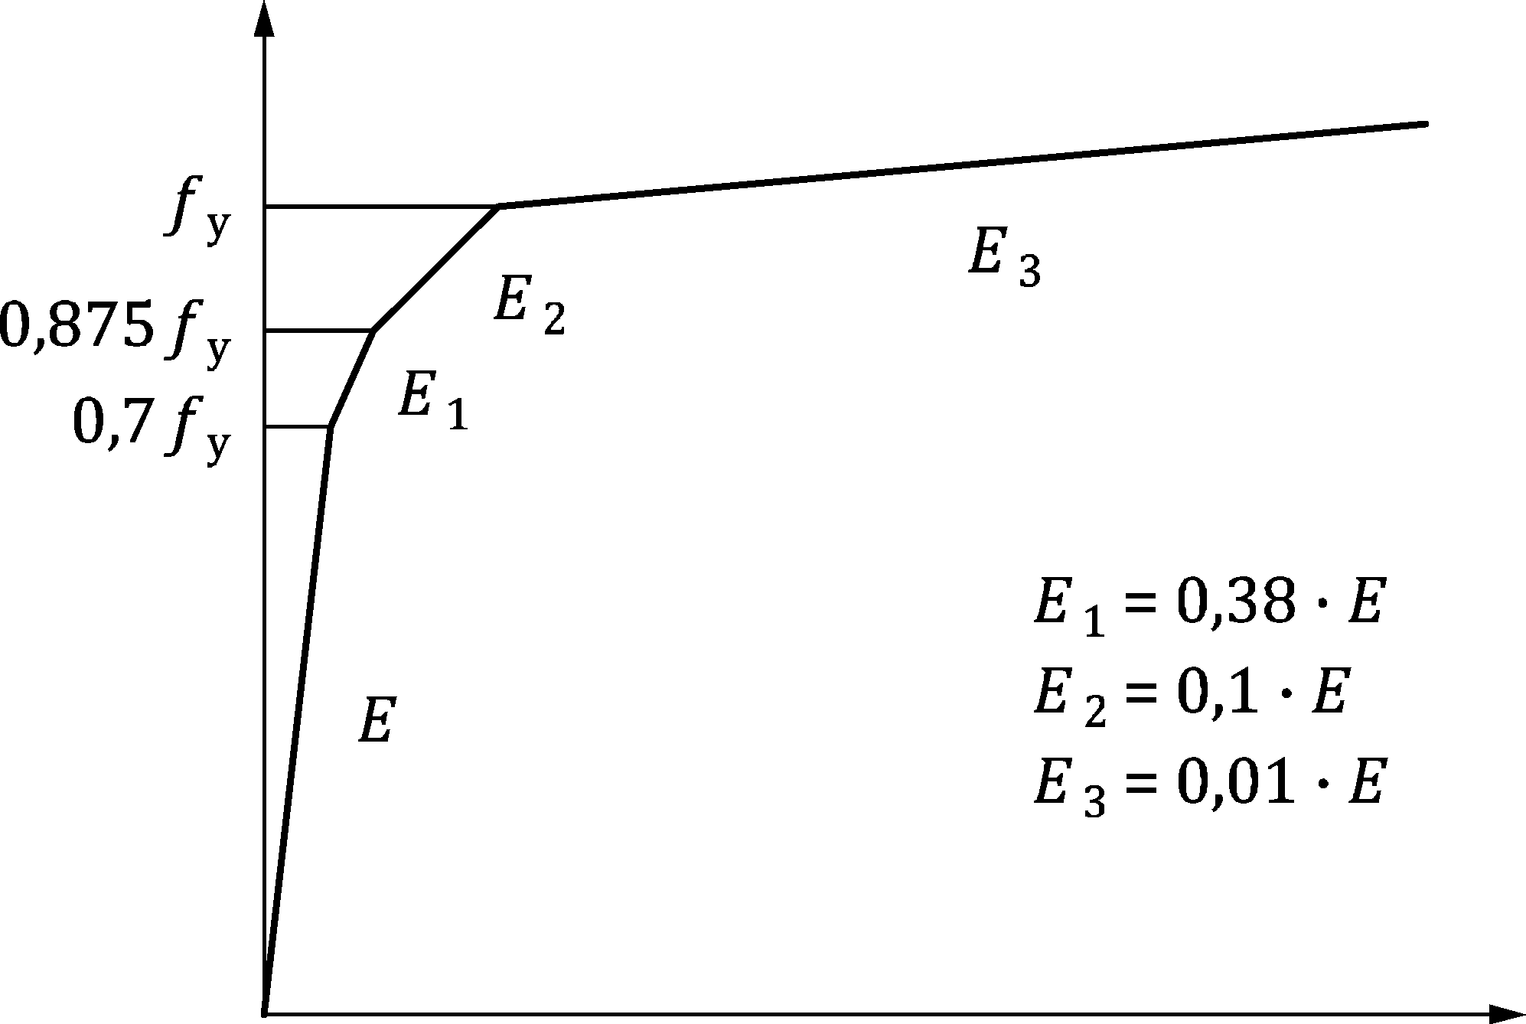

Figure 5.3 — Quad-linear material model for cold-formed structures

### Advanced material models

(1) Where the governing failure mode is fracture (tension elements, bolts, plates with large plastic deformations) and the ultimate limit state resistance is being calculated by non-linear material model, cumulative damage material models should be used, if no strain limit is used according to criterion C2 in 8.1.5(2).

(2) In analyses involving cyclic loading causing plasticity, the form of the hardening rule is essential due to the Bauschinger effect. A material model with either kinematic or combined kinematic and isotropic hardening should be used in such analyses.

## Imperfections

### Types of imperfection

(1) Where imperfections are included in the FE model, they should account for the effects of geometric deviations from the perfect shape, residual stresses and boundary condition defects (e.g. uneven foundation, etc.).

(2) One of the following imperfection types may be applied:

a) geometric imperfections (see 5.4.2) and additional residual stresses due to fabrication (see 5.4.3),

b) equivalent geometric imperfections (see 5.4.4) by modification of the perfect shape of the structure; these imperfections are intended to cover the effect of both the geometrical imperfections and the residual stresses and have larger magnitudes than solely geometric imperfections.

(3) Geometric imperfections or equivalent geometric imperfections may be defined in the FE model in the following ways:

a) measured imperfection shape of the structural element (only permitted for geometric imperfections),

b) imperfection shapes based on the functions defined in 5.4.4, or modification of the perfect shape by a predefined displacement (permitted for both geometric and equivalent geometric imperfections),

c) imperfection shape based on linear bifurcation analysis (LBA) corresponding to the eigenmode (shape) associated with the expected failure mode or to a combination of eigenmodes (permitted for both geometric and equivalent geometric imperfections).

(4) If geometric or equivalent geometric imperfections are used in a non-linear analysis, imperfections corresponding to each investigated buckling mode should be adopted.

(5) The most detrimental imperfection (that could realistically occur) should be chosen in calculating each potential failure mode. If the choice of this mode is not clearly evident, several imperfection shapes and combinations should be investigated.

(6) If more than one geometric or equivalent geometric imperfection form is used, combinations of these forms should additionally be considered. Rules for the Formulation of such combinations depend on the type of structure: frames, plated structures, cold-formed or shell structures. Rules are defined in 5.5.

(7) For FE analysis of cold-formed structures covered by prEN 1993-1-3 where imperfections are modelled, all imperfections should be modelled with equivalent geometric imperfections.

(8) The direction of the chosen imperfection(s) (imperfection combinations) should be chosen to identify the lowest resistance. If the relevant imperfection direction is not evident or defined by other rules, imperfections with different directions should be investigated, where physically possible.

### Geometric imperfections

(1) Geometric imperfections may be chosen by considering manufacturing and erection processes and the associated manufacturing and erection tolerances. The imperfection shapes may be chosen according to 5.4.1(3).

NOTE 1 For cross-section imperfections and structural member imperfections 80 % of the geometric manufacturing tolerances (at least L/1000) given in EN 1090-2 can be used, unless the National Annex gives different values.

NOTE 2 For shell structures, prEN 1993-1-6 gives the relevant information.

### Residual stresses

(1) Residual stresses may be represented by a stress pattern that derives from the fabrication process.

(2) Residual stresses should be represented by initial strains or stresses in the model, giving an equilibrium stress state without application of external loads.

(3) For welded structures, the peak value of the tensile residual stress may be taken as equal to the yield strength of the material for steel grades between S235 and S700. The peak value of the compressive residual stress depends on the manufacturing process and the geometry of the cross-section.

(4) Residual stress patterns for hot-rolled and welded carbon steel I-sections and for welded box sections may be taken from Figure 5.4 to Figure 5.6.

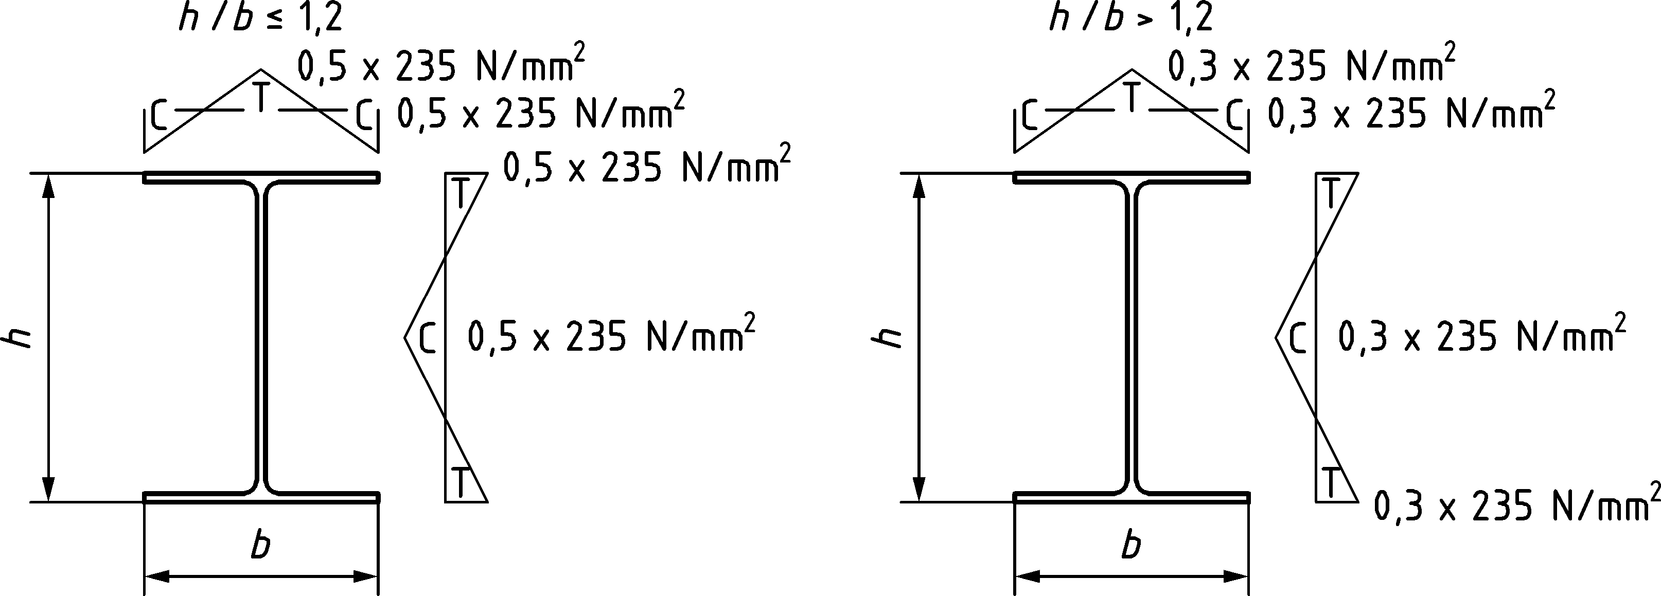

Figure 5.4 — Residual stresses for hot-rolled I-sections

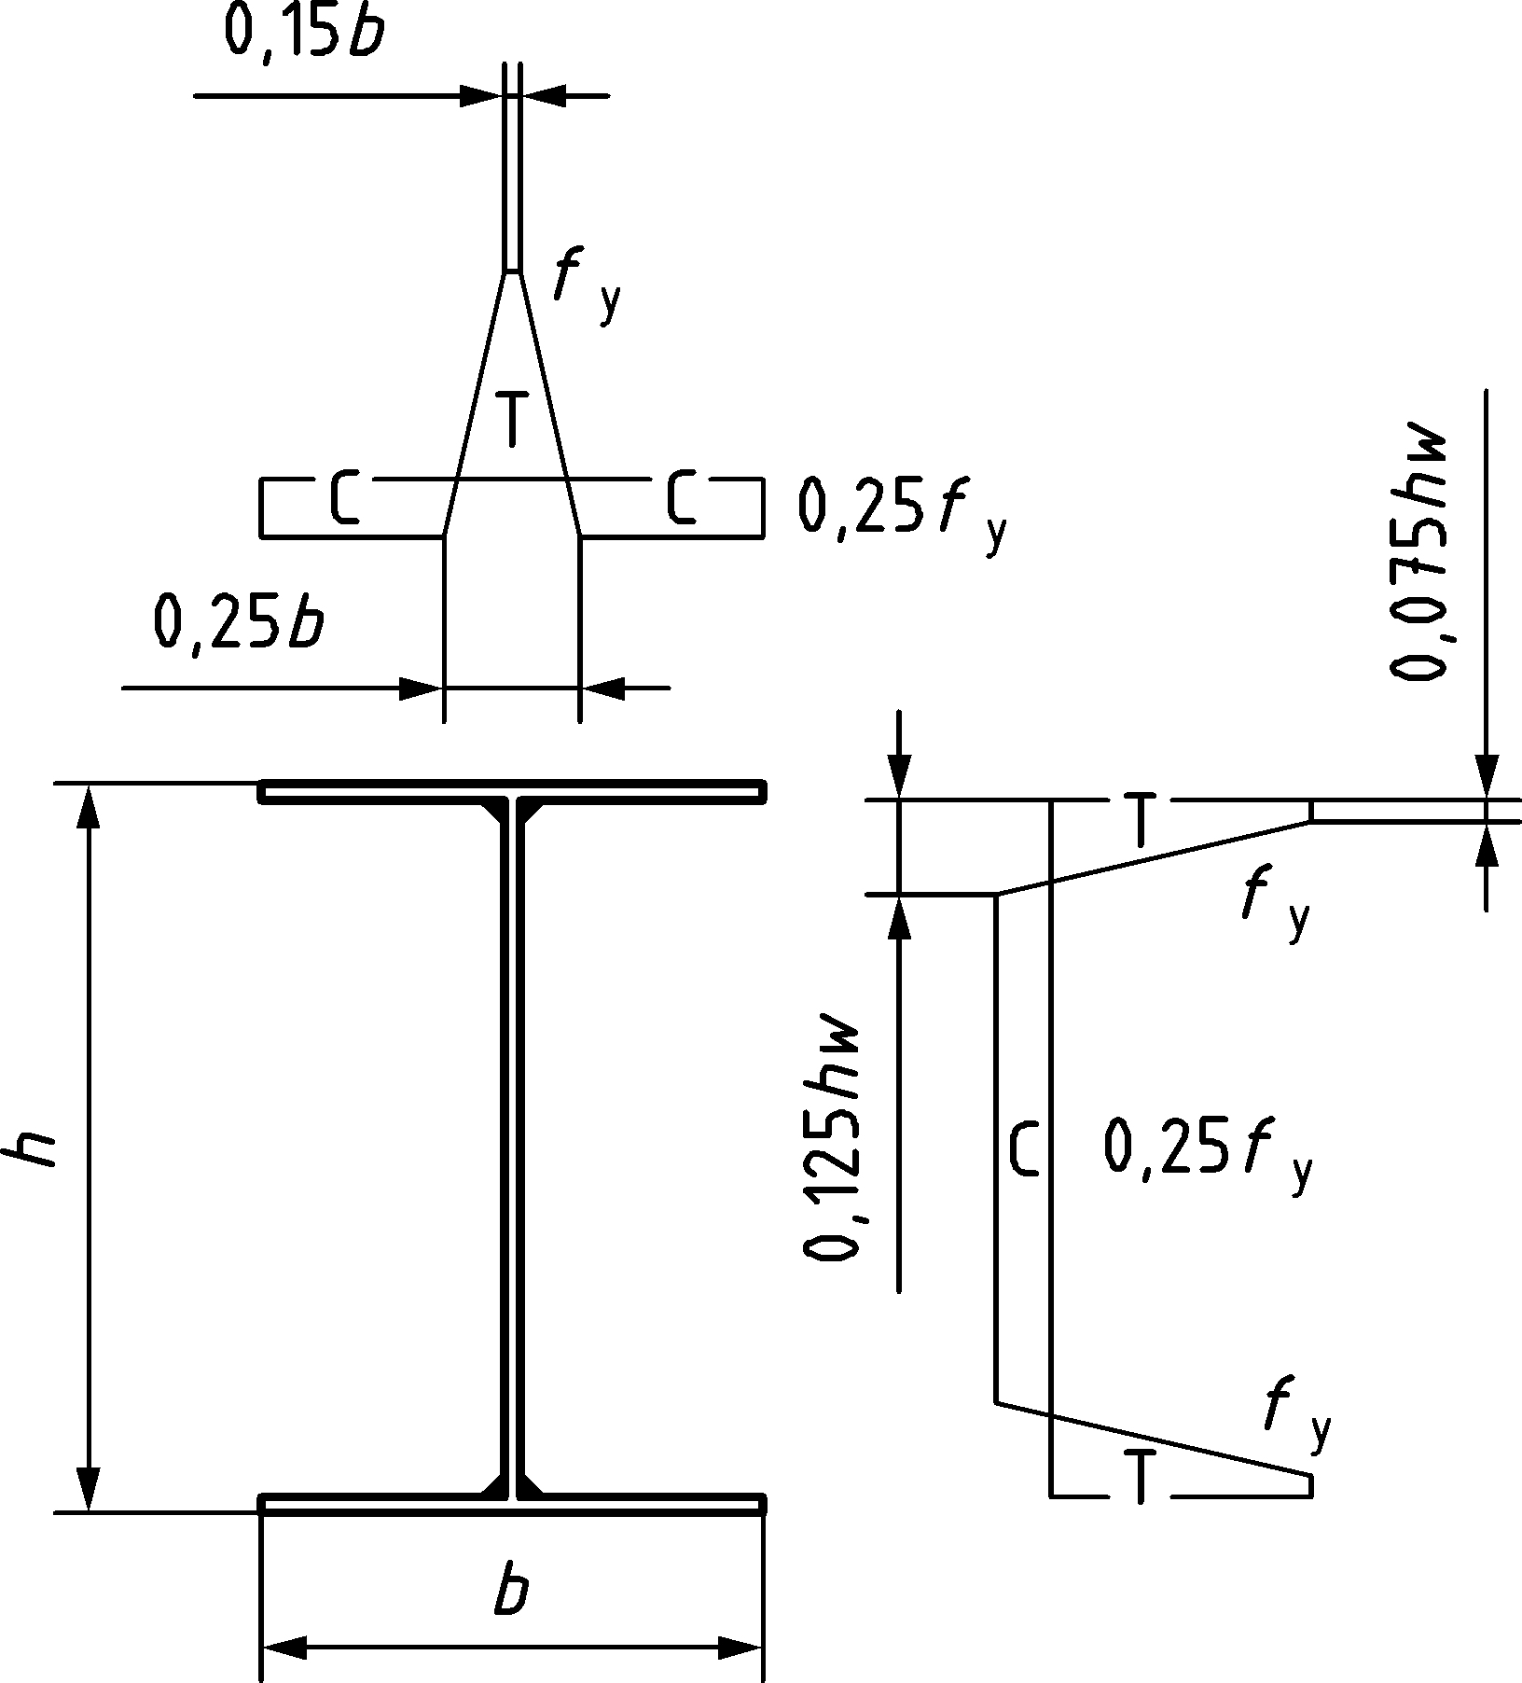

Figure 5.5 — Residual stresses for welded I-sections

Table 5.2 — Residual stresses for welded box sections

|  |  |  |  |  |  |  |
| --- | --- | --- | --- | --- | --- | --- |
| H/t | Welding type | *σrt/fy* | *σrc/fy* | *a*rs | *b*rs |  |
| 10 | - | 1,0 | -0,60 | 0 | from equilibrium |
| 20 | Heavy weld | 1,0 | -0,82 | 3 *t* | 3 *t* |
| 20 | Light weld | 1,0 | -0,29 | 1,5 *t* | 1,5 *t* |
| 40 | Heavy weld | 1,0 | -0,29 | 3 *t* | 3 *t* |
| 40 | Light weld | 1,0 | -0,13 | 1,5 *t* | 1,5 *t* |

(5) Residual stress patterns for CHS and RHS sections may be taken from Figure 5.6 and Figure 5.7.

|  |  |
| --- | --- |
|  |  |
| **a) hot finished** | **b) cold finished** |

Figure 5.6 — Residual stresses for CHS sections

|  |  |
| --- | --- |
|  |  |
| **a) hot finished** | **b) cold finished** |

Figure 5.7 — Residual stresses for RHS sections

(6) For stainless steel welded or laser welded I-sections and welded box sections, the residual stress patterns may be taken from Figure 5.8, Table 5.3 and Table 5.4.

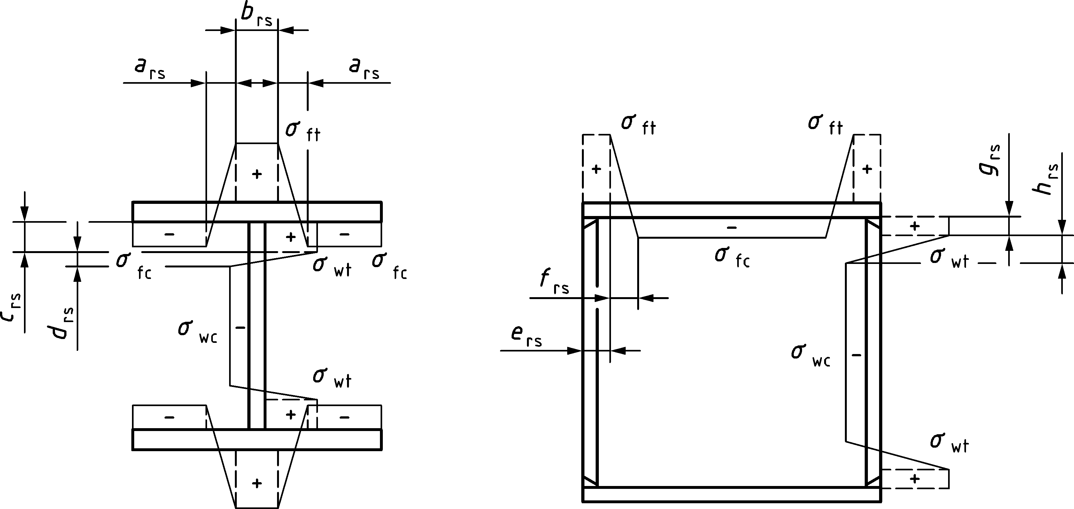

Figure 5.8 — Residual stresses for welded stainless steel sections

Table 5.3 — Residual stress model for welded stainless steel I-sections

|  |  |  |  |  |  |  |  |
| --- | --- | --- | --- | --- | --- | --- | --- |
| Predictive model | | *σ*ft = *σ*wt | *σ*fc = *σ*wc | *a*rs | *b*rs | *c*rs | *d*rs |
| Austenitic | welded | 0,8*f*y | from equilibrium | 0,225*b*f | 0,05*b*f | 0,025*h*w | 0,225*h*w |
| Duplex, Ferritic | 0,6*f*y |
| Austenitic, Duplex, Ferritic | laser welded | 0,5*f*y | from equilibrium | 0,1*b*f | 0,075*b*f | 0,0375*h*w | 0,1*h*w |

Table 5.4 — Residual stress model for welded stainless steel box sections

|  |  |  |  |  |  |  |
| --- | --- | --- | --- | --- | --- | --- |
| Predictive model | *σ*ft = *σ*wt | *σ*fc = *σ*wc | *e*rs | *f*rs | *g*rs | *h*rs |
| Austenitic | 0,8*f*y | from equilibrium | 0 for *b*w/*t*(*b*f/*t*)<20  *t*w+0,025*c*f  for *b*w/*t*(*b*f/*t*)≥20 | 5*t*f | 0 for *b*w/*t*(*b*f/*t*)<20  0,025*h*w  for *b*w/*t*(*b*f/*t*)≥20 | 5*t*w |
| Duplex, Ferritic | 0,6*f*y |

(7) Residual stresses based on laboratory tests may also be used in the model.

NOTE Positive effect of post-production treatment methods (e.g. in the case of hot-rolled sections continuously straightened by rotarization) can be considered on residual stress pattern.

### Equivalent geometric imperfections

(1) Equivalent geometric imperfections are classified into the following sub-groups:

a) equivalent geometric imperfections for global structures (e.g. frames),

b) equivalent geometric imperfections for structural members,

c) equivalent geometric imperfections for cross-sections (plates),

d) equivalent geometric imperfections for shell structures.

(2) Unless a more refined analysis of both the member geometric imperfections and the full structural imperfections is performed, equivalent geometric imperfections may be used.

(3) Equivalent geometric imperfections for global structures (frames) may be chosen in accordance with EN 1993-1-1:2022, 7.3.2.

(4) Equivalent geometric imperfections for use in geometrically non-linear elastic analysis (GNIA) and second order plastic hinge analysis of structural members may be chosen in accordance with EN 1993‑1-1:2022, 7.3.3 or EN 1993-2. Other specific equivalent geometric imperfections may be defined in EN 1993 (all parts).

(5) Equivalent geometric imperfections for use in geometrically and materially non-linear analysis (GMNIA) of structural members for flexural buckling may be determined from Formula (5.15). The equivalent imperfection shape may be either a bow (half-sine wave) or buckling mode.

|  |  |  |  |
| --- | --- | --- | --- |
|  | but |  | (5.15) |

where

|  |  |
| --- | --- |
| *L* | the member length, |
| *α* | the imperfection factor, taken from EN 1993-1-1 or EN 1993-1-4. |

NOTE In case of members with rigid intermediate restraints, *L* can be chosen equal to the distance between the rigid restraints.

(6) Equivalent geometric imperfections for use in geometrically and materially non-linear analysis (GMNIA) of structural members for lateral torsional buckling may be determined from Formula (5.16).

|  |  |  |  |
| --- | --- | --- | --- |
|  | but |  | (5.16) |

where

|  |  |
| --- | --- |
| *α* | is the imperfection factor for minor axis flexural buckling, taken from EN 1993-1-1 or EN 1993-1-4, |
| *β*LT | is the reference relative bow imperfection for lateral torsional buckling according to Table 5.5 to be applied lateral to the plane of bending. |

Table 5.5 — Equivalent geometric imperfections for structural members for lateral torsional buckling

|  |  |
| --- | --- |
| **Shape** | 𝜷**LT** |
| bow | combination of 1/150 (half-sine wave)  and 1/215 (full sine wave) |
| buckling shape | 1/150 |

(7) Equivalent geometric imperfections for cross-sections of plated structures may be taken from Table 5.6 and from Table 5.7.

Table 5.6 — Equivalent geometric imperfections for cross-sections of plated structures

|  |  |  |
| --- | --- | --- |
| **Component/type of imperfection** | **Shape** | **Magnitude** |
| longitudinal stiffener with length *a* | bow | min (*a*/400, *b*/400) |
| panel or sub-panel with short span *a* or *b* | buckling shape | min (*a*/200, *b*/200) |
| stiffener or flange subject to twist | bow twist | 1 / 50 |
| outstand elements for cold-formed structures – local | buckling shape | *b* / 125 |
| outstand elements for cold-formed structures – distortional | buckling shape | see Formula (5.17) |

(8) The imperfection magnitude for the distortional buckling mode may be determined by Formula (5.17):

 (5.17)

where

|  |  |
| --- | --- |
| *t* | is the thickness of the sheet, |
| *f*yb | is the basic yield strength according to prEN 1993-1-3, |
| *σ*cr,d | is the elastic critical distortional buckling stress. |

(9) Equivalent geometric imperfections may be substituted by appropriate fictitious forces acting on the member. The fictitious force for a frame imperfection and for a member bow imperfection may be chosen according to EN 1993-1-1:2022, 7.3.2 and 7.3.3.

(10) In the case of cold-formed structures covered by prEN 1993-1-3 the global and member equivalent imperfections should be defined according to prEN 1993-1-3, and the cross-section equivalent imperfections according to 5.4.4 (7).

(11) For shell structures, equivalent geometric imperfections should be chosen as defined in prEN 1993‑1-6, depending on the fabrication tolerance quality class of the structure.

Table 5.7 — Equivalent geometric imperfections for plates and plated structures

| **Type of imperfection** | **Component** |
| --- | --- |
| longitudinal stiffener with length *a* |  |
| panel or sub-panel |  |
| stiffener or flange subject to twist |  |
| local buckling of outstand elements for cold-formed structures |  |
| distortional buckling of cold-formed sections |  |

## Imperfection combinations

(1) Where both geometric imperfections and residual stresses are used, all the geometric imperfections and the residual stresses should be applied to the model at the same time, with their nominal values as given in 5.4.2 and 5.4.3, no combination rules are required.

(2) Where equivalent geometric imperfections arising from different sub-groups are being used (e.g. frame imperfections, member imperfections and cross-section imperfections) each imperfection should be taken with its amplitude as given in 5.4.4. The different imperfection types may be linearly added.

(3) For equivalent cross-section imperfections in plated structures, the combination of the imperfections given in Table 5.7 may be necessary. The leading imperfection should be chosen first, with accompanying imperfections at amplitudes reduced to 70 % of the defined value. Each imperfection type in turn should be chosen as the leading imperfection, with the remainder taken as the accompanying imperfections.

(4) In case of cold-formed structures covered by prEN 1993-1-3, if local and/or distortional buckling modes are combined with the global mode, the recommended value for the global equivalent imperfection is *L*/1 000, where *L* is the length of the member.

NOTE In case of members with rigid intermediate restraints, *L* can be chosen equal to the distance between the rigid restraints.

(5) In case of cold-formed structures covered by prEN 1993-1-3, combinations of local and distortional imperfections should be investigated to find the most detrimental one.

(6) Amongst all the explored imperfection combinations (where physically relevant), the one that gives the smallest resistance value should be used to determine the resistance of the structure.

# Analysis

## Structural analysis

### General

(1) Structural non-linearities arise from the following sources:

a) moderate-to-large displacements and/or strains (geometric non-linearity),

b) non-linear stress-strain relationships (yield and material non-linearity),

c) change of connectivity – contact status (topological/contact non-linearity).

(2) Linear analysis may be used if none of the above non-linearities is required for the FE model or if the non-linearity is covered by the design checks. Where any source of non-linearity is a necessary part of the evaluation, a non-linear analysis should be used.

(3) If linear analysis is used, the principle of the superposition is applicable and the solution is independent of the loading history.

(4) If non-linear analysis is used, a separate analysis of each load case or load combination should be performed; superposition cannot be applied.

(5) Geometric non-linearity is caused by a change in the geometry of the structure (moderate-to-large displacements relative to the geometry, and/or strains in parts of the structure) resulting in changes in the force distribution or stiffness conditions. The causes of geometric non-linearity should be considered when choosing an appropriate simulation and depending on the expected structural behaviour.

(6) Topological non-linearity comes from a change in the contact status during the analysis.

(7) Material non-linearity arises from the non-linear stress-strain relationship of the material when the structure or part of it is loaded beyond the linear elastic part of the material model. Material models should be distinguished in the analysis as linear and non-linear. Where a non-linear material model is used, the material law in the non-linear range together with the hardening rule should be defined.

NOTE 1 Non-linearities can also be caused by elastic structural elements in an assembly, where an abrupt change in stiffness occurs, such as a slender tension member passing into compression (or vice-versa).

NOTE 2 Non-linear joint behaviour is another source of structural non-linearity.

### Types of analysis

(1) The choice of the relevant analysis depends on the problem to be solved. The types of analysis given in Table 6.1 should be selected depending on the relevant limit state criteria.

Table 6.1 — Analysis types

|  |  |  |  |
| --- | --- | --- | --- |
| Type of analysis | deformations | material law | geometry |
| Linear elastic analysis (LA) | linear | linear elastic | perfect |
| Linear bifurcation (eigenvalue) analysis (LBA) | bifurcation | linear elastic | perfect |
| Materially non-linear analysis (MNA) | linear | elastic-plastic | perfect |
| Geometrically non-linear analysis (GNA) | non-linear | linear elastic | perfect |
| Geometrically and materially non-linear analysis (GMNA) | non-linear | non-linear | perfect |
| Geometrically non-linear elastic analysis with imperfections (GNIA) | non-linear | linear elastic | imperfect |
| Geometrically and materially non-linear analysis with imperfections (GMNIA) | non-linear | non-linear | imperfect |

(2) Linear elastic analysis (LA)

An analysis that predicts the behaviour of the structure on the basis of small displacements and small strains and linear elastic material, related to the perfect geometry of the modelled structure. The linearity of the theory results from the assumptions of a linearization of all the physical (linear elastic stress-strain relationship), geometrical (small strains) and equilibrium equations (small displacements).

(3) Linear bifurcation (eigenvalue) analysis (LBA)

A linear bifurcation analysis (LBA) predicts the eigenvalues and eigenmodes of the structure at which the structure may buckle into different deformed shapes, assuming no change of geometry before bifurcation, and linear elastic material model. Imperfections of all kinds are ignored. The analysis provides the elastic critical bifurcation load of the structure, defined by *R*cr. It is recommended to use the initial stiffness when modelling non-linear joints in a LBA analysis.

(4) Materially non-linear analysis (MNA)

An analysis of the perfect structure using the assumptions of small displacements, small strains and an elastic-plastic material law. The result of the MNA analysis is the plastic resistance of the structure (*R*MNA), where the effect of changes in the geometry are ignored. To determine the plastic reference load of the structure under the given load combination the ideal, linear elastic-perfectly plastic material law without strain hardening should be adopted.

(5) Geometrically non-linear analysis (GNA)

An analysis of the perfect structure using a linear elastic material law and including geometric non-linearity. The GNA analysis may be used to determine the internal forces, stresses or stress resultants in the perfect structure including the effects of geometric non-linearities.

(6) Geometrically and materially non-linear analysis (GMNA)

An analysis of the perfect structure using the combined non-linearities described in (4) and (5). It leads to the resistance *R*GMNA without considering imperfections.

(7) Geometrically non-linear elastic analysis with imperfections (GNIA)

An analysis of the imperfect structure using a linear elastic material law and including the geometric non-linearities described in (5). The imperfections are explicitly included and may include geometrical deviations, deviations in boundary conditions and the effects of residual stresses. A GNIA analysis may be used to determine the internal forces, stresses or stress resultants in the imperfect structure due to geometric non-linearity.

(8) Geometrically and materially non-linear analysis with imperfections (GMNIA)

An analysis of the imperfect structure using the assumptions of combined non-linearities described in (4) and (5). The imperfections are explicitly included and may include geometrical deviations, deviations in boundary conditions and the effects of residual stresses. The GMNIA analysis may be used to determine the characteristic resistance of the structure (*R*GMNIA) covering imperfections, geometrical and material non-linearities.

(9) The expected results and the graphical explanation of the different analysis types are presented in Figure 6.1.

NOTE LBA does not always provide the highest load factor amongst these different analyses, as suggested by Figure 6.1, since the post-buckling behaviour of the structure can lead to higher loads before a fully non-linear failure criterion is reached (stable secondary loading path).

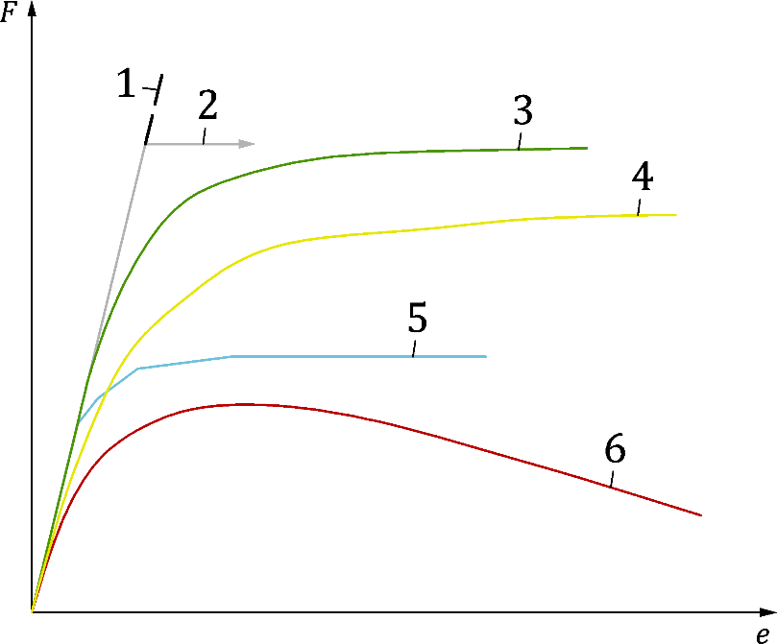

Key

|  |  |
| --- | --- |
| 1 | Linear analysis: LA |
| 2 | Elastic bifurcation: LBA |
| 3 | Geometrically nonlinear elastic: GNA |
| 4 | Geometrically nonlinear elastic with imperfections: GNIA |
| 5 | Plastic collapse:MNA |
| 6 | Geometrically and materially nonlinear with imperfections: GMNIA |

Figure 6.1 — Graphical explanation of different analysis types

## Thermal analysis

(1) FE applied to thermal analysis shall be based on the acknowledged principles and assumptions of the theory of heat transfer.

(2) In thermo-mechanical problems, the heat generated by plasticity during deformation may be neglected, thus uncoupling the thermal and the mechanical problems. The transient heat transfer equation may first be solved to obtain the evolution of the temperature field in the structural elements. The mechanical analysis of the problem should then be conducted. Where mechanical response is likely to influence the temperature distribution in structural elements, a coupled thermal and mechanical analysis should be carried out.

(3) In thermo-mechanical problems, the mechanical response model should consider the:

a) temperatures calculated according to prEN 1993-1-2 in fire design cases,

b) temperature dependence of the mechanical properties of the material,

c) geometric imperfections (if relevant),

d) geometrically non-linear effects (if relevant),

e) non-linear material behaviour (if relevant).

(4) The thermal response model should consider the:

a) relevant thermal actions,

b) relevant boundary conditions,

c) temperature dependent thermal properties of the materials,

d) definition of an adequate time step size to avoid numerical oscillation of the solution,

e) definition of a convergence criteria due to the non-linearity of the problem.

(5) Residual stresses are considered as negligible in fire situation; only geometric imperfections should be considered in thermo-mechanical problems.

# Validation and verification

## General

(1) Verification and validation should prove that the model is appropriate.

(2) Verification and validation may be executed according to 7.2 and 7.3. Restrictions and exceptions are given in 7.1(6)-(8).

NOTE For use of validation and verification of FE results the given rules are applicable unless the National Annex provides additional information and application rules.

(3) Validation is the comparison of the numerical results to experimental data or known accurate solutions to demonstrate that the model correctly or conservatively captures the physical phenomena to be modelled. The numerical model should be validated for each phenomenon to be analysed.

(4) Verification demonstrates that the numerical solution is a good approximation of the exact mathematical solution and the numerical model is properly implemented, understood and used. Verification should check the model sensitivity to discretization and prove the appropriate application of the numerical model and analysis.

(5) Validation and verification processes may be partially or fully overlapping. At first, the accuracy of the numerical model, the discretization of the mathematical model and the chosen analysis method should be demonstrated by verification. Validation should be the second step comparing the physical behaviour and the results of the chosen numerical model or modelling technique.

(6) If the numerical model is used for numerical design calculation for standard design cases (check of failure modes with existing Eurocode-based design resistance model) or analysis requiring subsequent design check, the validation and verification process may be made on the basis of previous experience on similar models.

(7) The design rule given in (6) should not be applied if validation and verification according to 4(13) is required.

(8) Special validation and verification rules are required for shell structures given in prEN 1993-1-6.

(9) A graphical interpretation of the validation and verification process is presented in Figure 7.1.

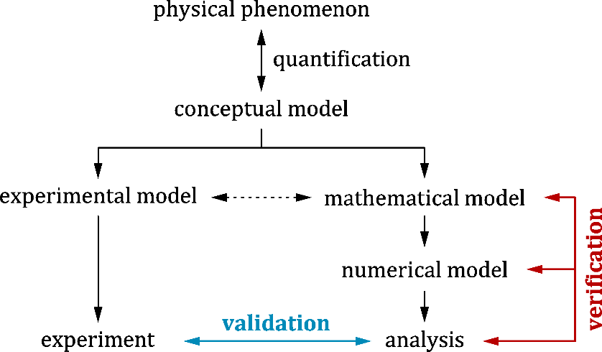

Figure 7.1 — Interpretation of the validation and verification process

## Verification

(1) The verification process should include the following checks:

a) discretization error check (mesh density study),

b) sensitivity check of input parameters,

c) imperfection sensitivity analysis (if relevant),

d) engineering judgement of the calculation results.

(2) A mesh density study should be used to show that the chosen mesh size and element type are accurate for the analysed problem and the calculation results are not significantly influenced by the discretization. A convergence study should be executed to check if the relevant SRQ converges if the mesh is refined. If the numerical model is applied for numerical design calculations and analysis requiring subsequent design check is applied, the discretization error check can be supplemented by engineering judgement according to (5). These rules do not apply for fatigue, see 8.2.

NOTE A more secure prediction of the correct value of an SRQ can be obtained by plotting its predicted value against the inverse of the total number of DOFs in the mesh. Extrapolation of the resulting curve to the SRQ axis provides a clear indication of the best estimate of the correct solution and permits the 5 % test (5 % difference with the converged value of the SRQ) to be used with confidence, unless the National Annex gives a different value or application rule.

(3) A sensitivity study involving minor changes to the input parameters determines which data items are crucial to the required SRQ and shows whether this item must be defined with higher precision or not. This check should be made only for models and input data for which there are no previous experiences or possible sensitivity is raised.

(4) A set of imperfection sensitivity analyses should be executed to check whether the result of the numerical solution (SRQ) is sensitive to the chosen imperfection type, shape and magnitude. This check should be performed in the case of numerical simulations and in the case of numerical design calculations, if imperfection sensitivity is relevant.

(5) Engineering judgement should be applied to the results of a calculation. The main characterising outputs (deformations, load-displacement paths, internal force diagrams, etc.) should be checked. Such checks may use simple mechanical models or previous experience.

## Validation

(1) A benchmark case should be adopted as a reference in the validation process to check the numerical model and its application (analysis type, solution settings, limit state criteria, etc.) in the particular application field. During the validation process accurate, analytical, numerical or experimental benchmark solutions should be used as the basis of comparison. If no exact benchmark case is available, one case closest to the analysed problem should be used. Within a comparison, a numerical model having identical parameters to the benchmark case should be developed and recalculated. The difference between the calculation result and the accurate benchmark result should be evaluated.

NOTE If a numerical model is used in numerical design calculation for direct resistance check or for fatigue assessment, the comparison to benchmark cases can be eliminated on the basis of experience of previous satisfactory performance in similar cases, unless the National Annex gives different application rules.

(2) The highest level of validation is found when using comparison methods in which the numerical results are treated as stochastic variables, with their own input and output uncertainties. Instead of single values for the input and the corresponding result, there are value ranges that can be characterised e.g. by the mean and standard deviation. The result of such a calculation is provided by repeated computations as the inputs are varied according to the estimated probability distributions of the experimental data.

(3) Except where a more advanced method is performed according to (2), the reliability of the numerical model should be checked by using the model factor (*γ*FE).

NOTE The calculation method of the model factor (*γ*FE) is given in Annex A unless a different method or exact value is given by the National Annex.

(4) The model factor (*γ*FE) covers the uncertainties of the numerical model and the executed analysis type and does not override the application of any other partial factors given in EN 1993 (all parts). The application method of the model factor is given in Figure 7.2.

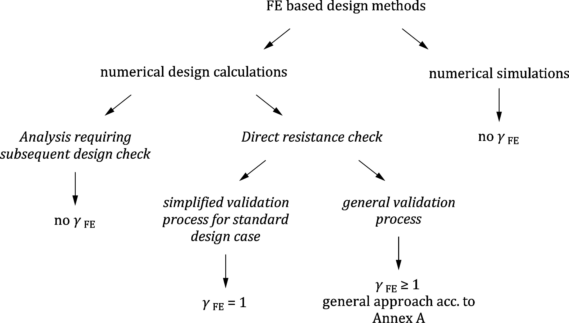

Figure 7.2 — Application of the model factor (*γ*FE)

(5) If the numerical model is applied for numerical design calculations using analysis requiring subsequent design check, the model uncertainty of the structural resistance is covered by the partial factor according to EN 1990 and EN 1993 (all parts) and the model factor (*γ*FE) should not be applied.

(6) If the numerical model is applied for numerical design calculations and direct resistance check is used, the uncertainty of design should be evaluated on the basis of combination of the partial factors according to EN 1993 (all parts) and the model factor (*γ*FE) defined by 7.3(2) to (3).

NOTE Rules on the application of general and simplified validation processes are given in Annex A, unless the National Annex gives other rules.

(7) If the numerical model is applied for numerical simulations and statistical evaluation according to EN 1990 is performed to determine test-based resistance (i.e. actual partial factor), the model factor (*γ*FE) should not be applied. The uncertainty of design by numerical simulation is treated in the same way as physical experiments according to EN 1990.

(8) In the case of fatigue design situation or if MNA analysis is applied for the plastic reference load calculation, the model factor (*γ*FE) should not be applied.

(9) If experimental data is used for validation, then material model parameters and geometrical input data should come from experimentally measured values, irrespective of the applied design method (numerical design calculation or numerical simulation).

(10) If the numerical simulation is performed using imperfections, imperfection sensitivity study should be carried out within the validation process using different imperfection amplitudes (including imperfections in opposite directions, where physically possible) and imperfection combinations, if relevant.

# Design methodology

## Ultimate limit state

### General

(1) The ultimate limit state check (excluding fatigue) using a FE model should be performed in one of the following ways:

a) stress check and design based on computed stresses, where stability problems are not relevant (covered in 8.1.2),

b) plastic resistance check, where stability problems are not relevant (covered in 8.1.3),

c) buckling resistance check (covered in 8.1.4).

(2) This standard gives design rules to predict the characteristic values of resistances calculated by numerical analysis.

(3) Additional design rules may be also specified in all other relevant parts of EN 1993 (e.g. in prEN 1993-1-6 for the ultimate limit state of shell structures).

### Elastic limit state – stress check

(1) One of the following analyses should be used to calculate the design stresses and stress resultants and to perform a stress or stress resultant check:

a) linear elastic analysis (LA),

b) geometrically non-linear analysis (GNA).

(2) At each point in the structure, the design value of the stress (*σ*eq,Ed) should be taken as the highest von Mises equivalent stress determined in the numerical analysis unless it is a singularity, which should be taken as the basis of design checks according to EN 1993 (all parts).

(3) The numerical model may lead to stress concentrations at locations of junctions, joints, load introduction places and in the region of supports or at locations where the FE mesh has changes in its regularity. Stress concentrations can have different origins which are classified as:

a) geometrical (physical) stress concentrations,

b) numerical stress concentrations (singularities).

NOTE The National Annex can give rules for separation of geometric and numerical stress concentrations. The method given in Annex B, B.1 can be used, unless the National Annex says otherwise.

(4) Numerical stress concentrations (singularities) may be neglected in the design as they result from errors of numerical approximation of the physical stresses or strains.

(5) Geometrical stress peaks should be considered or neglected in the design depending on the chosen analysis method and limit state criteria.

NOTE The method given in Annex B, B.2 can be used, unless the National Annex gives other design rules.

(6) Additional design criteria (for example limitations for maximum allowed strains or stresses) are given in the relevant standard parts.

### Plastic resistance check

(1) One or more of the following analyses should be used for the calculation of the plastic resistance of the structure:

a) materially non-linear analysis (MNA),

b) geometrically and materially non-linear analysis (GMNA).

(2) The MNA analysis may be used to determine the behaviour of the structure represented by a load-displacement path related to the analysed load case combination but should not be used directly for the determination of the design resistance if the structure may be affected by buckling phenomena (see 8.1.4).

(3) Where a change in the geometry of the structure may significantly influence the structural behaviour, the plastic resistance of the structure should always be calculated using GMNA.

(4) In MNA or GMNA analyses, the structure should be subjected to design values of the applied load combinations multiplied by the load amplification factor (starting from zero) until the plastic limit state is reached.

(5) The plastic resistance of the structure (*R*MNA, *R*GMNA, as appropriate) may be determined by evaluating the calculated load-deformation path obtained from either an MNA or GMNA analysis according to 8.1.5.

(6) The MNA analysis should use the ideal, linear elastic-perfectly plastic material law without strain hardening to provide the plastic reference load of the analysed shell structure, see prEN 1993-1-6:2023, 6.3 (5).

(7) The characteristic plastic resistance (*R*pl,k) may be determined by the resistance provided by the MNA or GMNA analysis (*R*MNA or *R*GMNA, as appropriate) adjusted by the model factor *γ*FE according to the following formulae:

 or  (8.1)

where

|  |  |
| --- | --- |
| *𝛾*FE | is the model factor according to 7.3 and Annex A, |
| *R*MNA or *R*GMNA | are the calculated plastic resistances based on MNA or GMNA analysis considering the limit state criteria given in 8.1.5. |

NOTE In case of shell structures, only MNA analysis can be used.

(8) The design plastic resistance (*R*pl,d) may be determined on the basis of the characteristic plastic resistance (*R*pl,k) divided by partial factors for the relevant failure modes according to EN 1990 and EN 1993 (all parts). Additional design rules are given in the relevant standard parts.

### Buckling resistance check

#### Design methods

(1) For the buckling resistance check the following alternative methods may be used:

a) design by LA (or MNA) and LBA analysis,

b) design by GNIA analysis in combination with LBA analysis,

c) design by GNIA analysis in combination with cross-sectional resistance,

d) design by GMNIA analysis.

(2) Other design methods may be used in accordance with the relevant parts of the standard.

(3) Checks on the buckling resistance of a shell structure should be performed in accordance with the provisions of prEN 1993-1-6.

(4) Special boundary conditions to be chosen in a compatible way with the buckling check are given in the relevant parts of the standard. Shell structures should be supported in accordance with the rules of prEN 1993-1-6.

(5) When performing a stability check of shells, the membrane stresses should be used for evaluation.

#### Design by LA or MNA and LBA analysis

(1) Linear elastic analysis (LA) or material non-linear analysis (MNA) and linear elastic bifurcation analysis (LBA) may be used together to determine the relative slenderness ratio of the investigated structure, that is related to the particular load case combination and loading situation.

(2) The relative slenderness should be calculated according to:

 (8.2)

where

|  |  |
| --- | --- |
| *R*cr | is the lowest elastic critical buckling resistance of the examined structure, |
| *R*pl | is the plastic resistance of the examined structure or cross-section (as defined by the relevant parts of EN 1993). |

(3) The elastic critical bifurcation load (*R*cr) should be determined using a LBA analysis related to the defined loads. The lowest eigenvalue which corresponds to the investigated failure mode should be considered in the analysis.

(4) The plastic resistance (*R*pl) should be determined from a MNA analysis. A conservative assumption may be obtained using an LA analysis based on stresses.

(5) Where this method is applied to frame or plated structures the plastic resistance *R*pl may be estimated as the minimum load amplifier (*α*ult,k) specified in EN 1993 (all parts).

NOTE This method provides a conservative estimate of the plastic resistance, since the relevant resistance includes stability phenomena, whilst the strict plastic reference resistance, required to define a relative slenderness in a universally consistent manner, omits stability considerations.

(6) In a frame or plated structure, the relevant values of *R*cr and *R*pl may also be determined for each different stress component (normal stresses in different directions, shear stresses) separately, or they may alternatively be determined for combined stress fields. The application of the relative slenderness ( ), however, should be interpreted in a manner consistent with its use in the relevant standard (EN 1993 (all parts)).

(7) The calculated relative slenderness () may be used to determine the design buckling resistance according to the rules of EN 1993-1-1 to EN 1993-1-5.

(8) For shell structures, the formal method of MNA-LBA should be used according to the rules of prEN 1993-1-6.

(9) The loading and supporting conditions chosen in the numerical model should match the assumptions of the relevant design methods of EN 1993 (all parts) for which the overall slenderness ratio is used to calculate buckling reduction factors.

#### Design by GNIA analysis in combination with LBA analysis

(1) Geometrically non-linear analysis with imperfection (GNIA) and linear elastic bifurcation analysis (LBA) may be used together to determine the geometrically non-linear internal forces, stresses and the relative slenderness of the analysed structure related to the relevant load case combination.

(2) This method is applicable if several different buckling modes on the same structure should be checked. The method is applicable only for in-plane buckling modes in accordance with the provisions of EN 1993-1-1:2022, 7.2.2 (methods M3 and M4).

(3) One or more buckling modes to be checked may be substituted by equivalent geometric imperfections according to 5.4.4 and performing GNIA analysis. In this case the buckling check should not be executed based on the calculation of the overall relative slenderness and the relevant buckling reduction factor but it may be undertaken by verifying the cross-sectional resistance.

NOTE The principle underlying this method is the assumption that the stability check can be substituted by a geometrically non-linear imperfect analysis that calculates the second order internal forces or stresses, and that these can be used as the basis of a stress check using the rules of EN 1993-1-1 to EN 1993-1-5.

(4) This design method involves a global stability check of the complete structure using global equivalent geometric imperfections and performing a GNIA analysis. If the geometrically non-linear – second order – effects in individual members or certain individual member imperfections are not fully included in the global analysis, the individual stability of members should be checked according to the relevant criteria given in EN 1993-1-1. More detailed rules are given in EN 1993-1-1:2022, 7.2.2 (method M3).

(5) As an alternative to (4), if the geometrically non-linear – second order effects – in all the individual members and relevant in-plane member imperfections are fully included in the global analysis of the structure, no individual in-plane stability check for the members is necessary. However, a supplementary out-of-plane stability check should be performed according to the rules of EN 1993‑1‑1:2022, 7.2.2 (method M4) or 8.3 (General method).

(6) This design method should not be used for shell structures.

#### Design by GNIA analysis in combination with cross-sectional resistance

(1) Design by numerical analysis using GNIA analysis in combination with cross-sectional resistance is an improved version of the combination of GNIA and LBA analysis. This treatment models all possible imperfections associated with different buckling modes (in-plane and out-of-plane buckling together with the torsional modes). More detailed rules are given in EN 1993-1-1:2022, 7.2.2 (method M5).

(2) When equivalent geometric imperfections associated with all possible failure modes are defined on the structure and GNIA analysis is performed, the buckling check may be substituted by a stress check according to the rules of EN 1993-1-1 to EN 1993-1-5.

(3) This design method should not be used for shell structures.

#### Design by GMNIA analysis

(1) A geometrically and materially non-linear analysis with imperfections (GMNIA) may be used to determine the behaviour of the structure represented by a load-displacement path related to the chosen boundary conditions and analysed load case combination.

(2) In a GMNIA analysis, the effects of the following imperfections should be considered:

a) geometric imperfections (according to 5.4.2),

b) structural imperfections (e.g. residual stresses according to 5.4.3).

(3) Geometric imperfections and residual stresses may be separately applied to the FE model, or covered together by equivalent geometric imperfections according to 5.4.4. Further specific design rules on the application of imperfections may be specified in EN 1993 (all parts).

(4) Eigenmode-affine equivalent geometric imperfection may be also used.

NOTE The eigenmode-affine pattern is the critical buckling mode associated with the elastic critical load of the investigated structure based on an LBA analysis. There can be more than one relevant eigenmode, so the lowest eigenvalue is not always the source of the most important imperfection.

(5) The final imperfect shape of the analysed structure should be obtained by superposition of the imperfections (geometric imperfections and residual stresses or equivalent geometric imperfections) on the perfect structure covering all possible failure modes and geometric deviations according to 5.5. Further specific design rules about imperfection superposition may be specified in relevant parts of EN 1993.

(6) The pattern of the equivalent geometric imperfections should reflect the constructional detailing and the boundary conditions in a realistic and safe manner.

(7) In the case of combination of different equivalent geometric imperfections all the possible imperfection combinations (with different signs) should be checked and the combination resulting in the smallest resistance should be chosen for the resistance calculation.

(8) All the relevant load case combinations causing compressive or shear membrane stresses should be accounted for checking the buckling resistance. For each investigated load case combination, a separate GMNIA analysis should be performed.

(9) To evaluate the ultimate resistance of the structure, the design values of the applied load case combinations should be increased by the load amplification factor to determine the relevant load-deformation curve representing the elastic-plastic structural behaviour of the analysed structure.

(10) The buckling resistance (*R*GMNIA) should be determined by evaluation of the calculated load-deformation path obtained from the GMNIA analysis according to 8.1.5.

(11) Shell structures should be checked according to the rules of prEN 1993-1-6.

(12) In the case of structures where first yield criterion has to be also checked (e.g. steel bridges) GMNIA (or GMNA) analysis can be also applied by the provision that only the elastic part of the relevant load-displacement path should be considered in the resistance calculation. The elastic part of the load-displacement path can be determined by comparison of the results of a GNIA (or GNA) and GMNIA (or GMNA) analysis.

(13) The characteristic buckling resistance (*R*b,k) may be determined by modifying the resistance assessed from a GMNIA analysis (*R*GMNIA) according to the model factor *γ*FE and using the following Formula:

 (8.3)

where

|  |  |
| --- | --- |
| *𝛾*FE | is the model factor according to 7.3, |
| *R*GMNIA | is the calculated buckling resistance based on GMNIA analysis considering the limit state criteria given in 8.1.5(2). |

(14) The design buckling resistance (*R*b,d) may be determined on the basis of the characteristic buckling resistance (*R*b,k) divided by partial factors for the relevant failure modes according to EN 1990 and EN 1993 (all parts). Additional design rules are given in the relevant standard parts.

### Evaluation method of the material non-linear analysis

(1) In the case of a direct resistance check or a numerical simulation, the structure should be subjected to the design values of the applied load case combinations increased by a load amplification factor to determine the relevant load-deformation path representing the elastic-plastic structural behaviour of the investigated structure.

NOTE The calculated resistance, derived from the maximum load amplification when the criterion of failure of that analysis is reached, depends on the specific assumptions of the analysis.

(2) The structural resistance *R*comp should be determined by the evaluation of the calculated load-deformation path by taking the lowest resistance obtained from the following two criteria C1, C2 (see Figure 8.1).

a) Criterion C1: the maximum load level of the computed load-deformation path (maximum load or limit load),

b) Criterion C2: the largest tolerable deformation (or strain), where this occurs during the loading path before reaching the limit load. The maximum acceptable plastic strain for cold-formed structures is given in prEN 1993-1-3, for plated structures in prEN 1993-1-5 and for shell structures in prEN 1993-1-6. For beam finite elements, maximum acceptable strains, to be applied in place of cross-section classification and cross-section resistance checks, are given in Annex C. If there are no other values given, a recommended value for the material maximum acceptable plastic strain of 5 % may be assumed.

NOTE The National Annex can give rules on the maximum allowed strains.

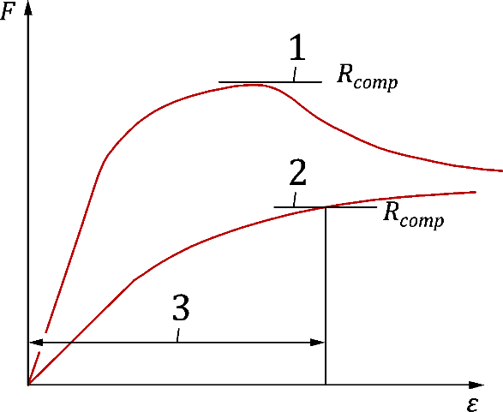

Key

|  |  |
| --- | --- |
| 1 | criterion C1 |
| 2 | criterion C2 |
| 3 | largest tolerable strain |
| F | applied load |
| *ε* | strain |

Figure 8.1 — Determination of structural resistance by material non-linear analysis

(3) In the case of direct resistance check of bolted joints using spring model for the bolts the recommended maximum allowed plastic strain for bolts *ε*mpb should be taken as 25 % of its maximum plastic strain *ε*mb. For a bolt alone, this should be determined from the elongation after fracture. For bolts according to EN ISO 898-1:2013 these values are summarized in Table 8.1.

Table 8.1 — Maximum allowed plastic strains for bolts

|  |  |  |  |  |  |  |
| --- | --- | --- | --- | --- | --- | --- |
| Bolt grade | 4.8 | 5.6 | 5.8 | 6.8 | 8.8 | 10.9 |
| *εmpb %* | 3,5 | 5,0 | 2,5 | 2,0 | 3,0 | 2,3 |

NOTE The National Annex can give rules on the maximum allowed strain for bolts.

(4) The structural resistance *R*comp should be sufficient to achieve the required reliability. The reliability should be evaluated in accordance with the principles set out in EN 1990.

(5) In the case of a direct resistance check the computed structural resistance *R*comp may be adjusted by the model factor (*γ*FE) covering the uncertainties of the numerical model and analysis method, see 7.3, 8.1.3 and 8.1.4.

## Fatigue limit state

### General

(1) Linear elastic analysis should be used, in combination with the following methods, for verification of the fatigue design situation:

a) nominal stress method, when the nominal stresses are determined from FE analysis,

b) geometric (hot spot) stress method,

c) effective notch stress method.

(2) The definitions of these three reference stresses are given below and illustrated in Figure 8.2.

(3) Nominal stress (σnom): the stress in the parent metal or in a weld calculated at the point of a potential crack location using an LA analysis and excluding all stress concentration effects already accounted for in the fatigue detail category.

(4) Geometric (hot spot) stress (σHS): the stress in the parent metal at a weld toe, incorporating all stress raising effects due to the overall detail geometry, but excluding that of the weld profile itself.

(5) Effective notch stress (σEN): the total stress in a fictitious notch at the weld toe or root calculated by an LA analysis. The effective notch stress includes the effect of all geometrical properties of the welded detail including the stress peak due to the weld itself and the resulting locally varying stress distribution (non-linear peak stress).

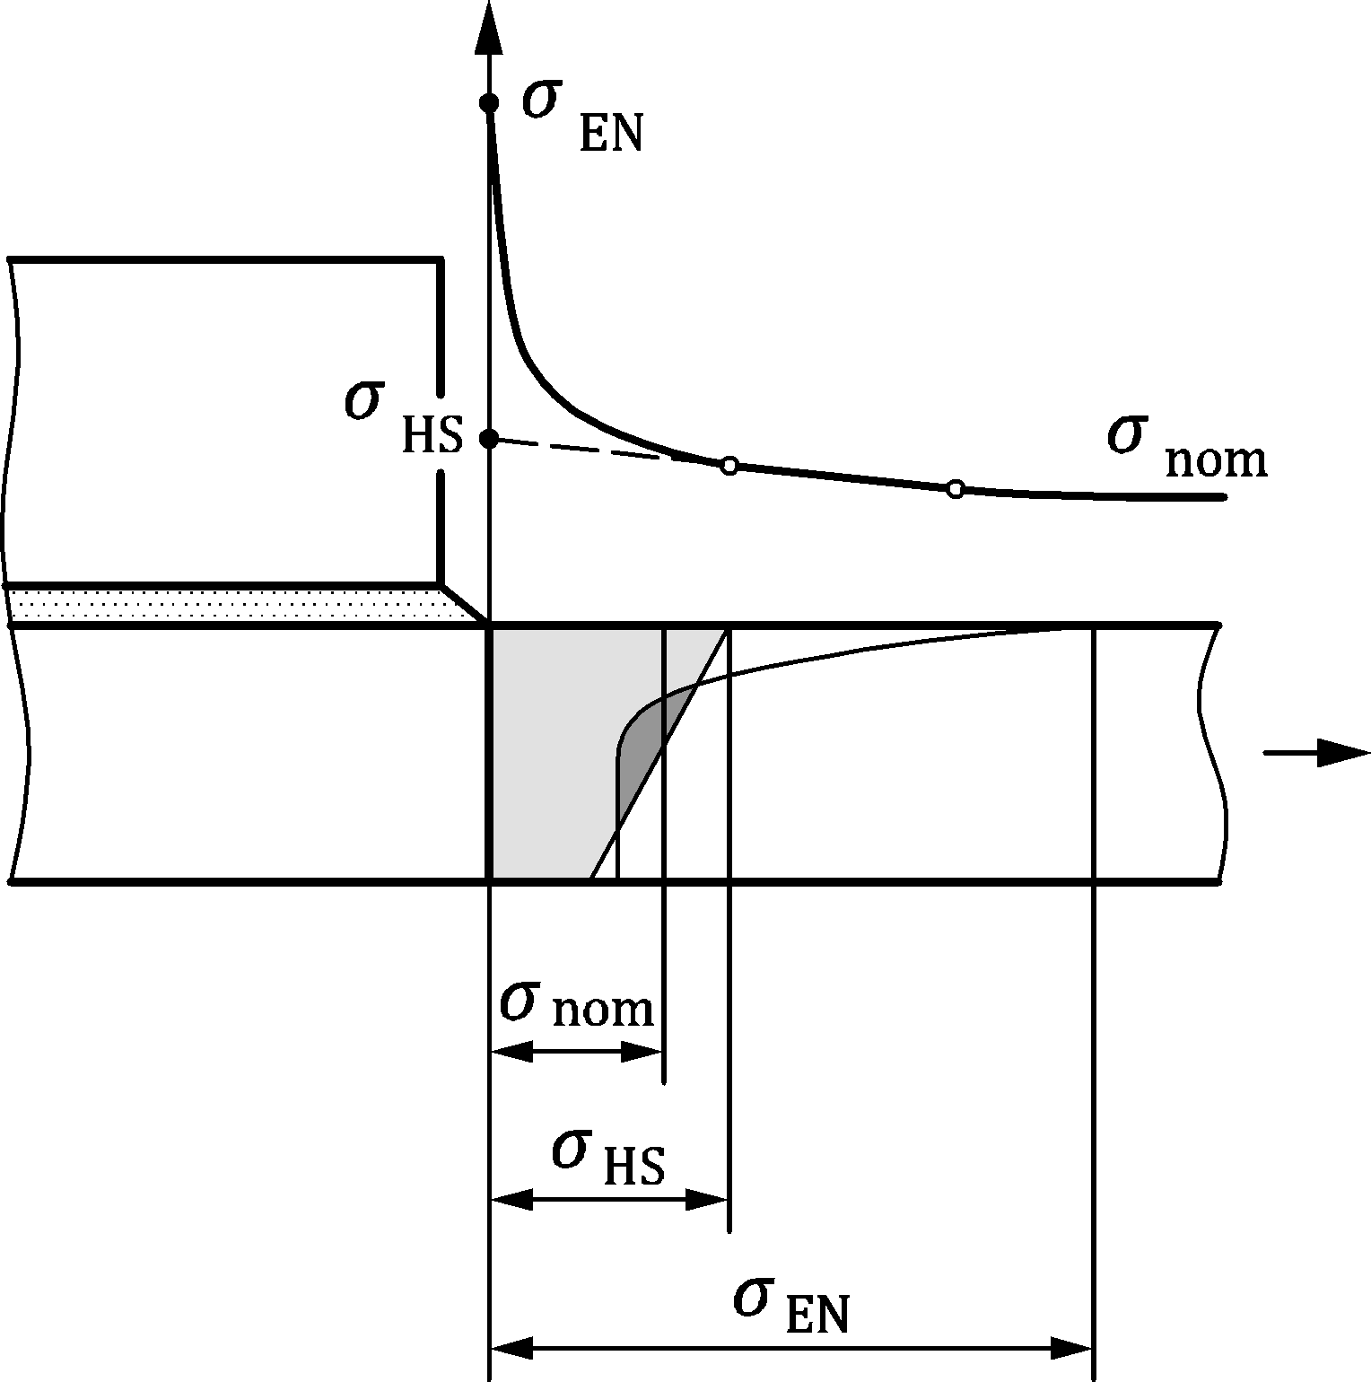

Figure 8.2 — Definitions of nominal stress, hot spot stress and effective notch stress

(6) When using the hot spot stress method, three fatigue strength categories (type “a”, “b” and “c” according to prEN 1993-1-9:2023, Annex B) are used for the fatigue assessment. The relevant fatigue resistance curves are given in prEN 1993-1-9:2023, Annex B.

(7) Calculation of stresses and stress ranges for fatigue assessment with the hot spot stress and effective notch stress methods are covered in prEN 1993-1-9:2023, Annex B and Annex C, respectively.

### Fatigue checking by the hot spot and effective notch stress method

(1) Fatigue verification should be performed using fatigue resistance curves and the relevant detail category given in prEN 1993-1-9 for the hot spot and effective notch stress methods.

(2) The stress components to be used for fatigue verification using the hot spot and effective notch stress methods are given in prEN 1993-1-9.

(3) The hot spot stress is obtained by excluding the non-linear peak stress due to weld geometry. This may be done by extrapolating the stresses at specific locations on the surface of the plate to the location of the potential crack.

(4) Determination of the hot spot stress, except for structural hollow section joints is given in 8.2.3. For structural hollow section joints, the extrapolation rules are given in 8.2.4.

### Stress extrapolation for the hot spot stress method in joints except in structural hollow section joints

(1) The hot spot stress is determined by extrapolating the surface stresses at appropriate reference nodes to the location of hot spot (crack site). The choice of the reference nodes depends on the type of hot spot, the type of FE mesh and the type of extrapolation procedure. The FE mesh should be carefully constructed with attention to the requirements of the locations of these nodes.

(2) To determine the structural hot spot stress, a distinction should be made between two types of hot spot: type “a” and type “b”, as shown in Figure 8.3. The main difference between these two types is seen in the stress distribution through the thickness of the plate where cracking may occur.

a) Type “a” hot spot denotes cracking at the weld toe on a plate surface. In this case the stress varies considerably through thickness of the plate with crack.

b) Type “b” hot spot refers to fatigue cracking at a plate edge, where the stress at the hot spot is not dependent on the plate thickness.

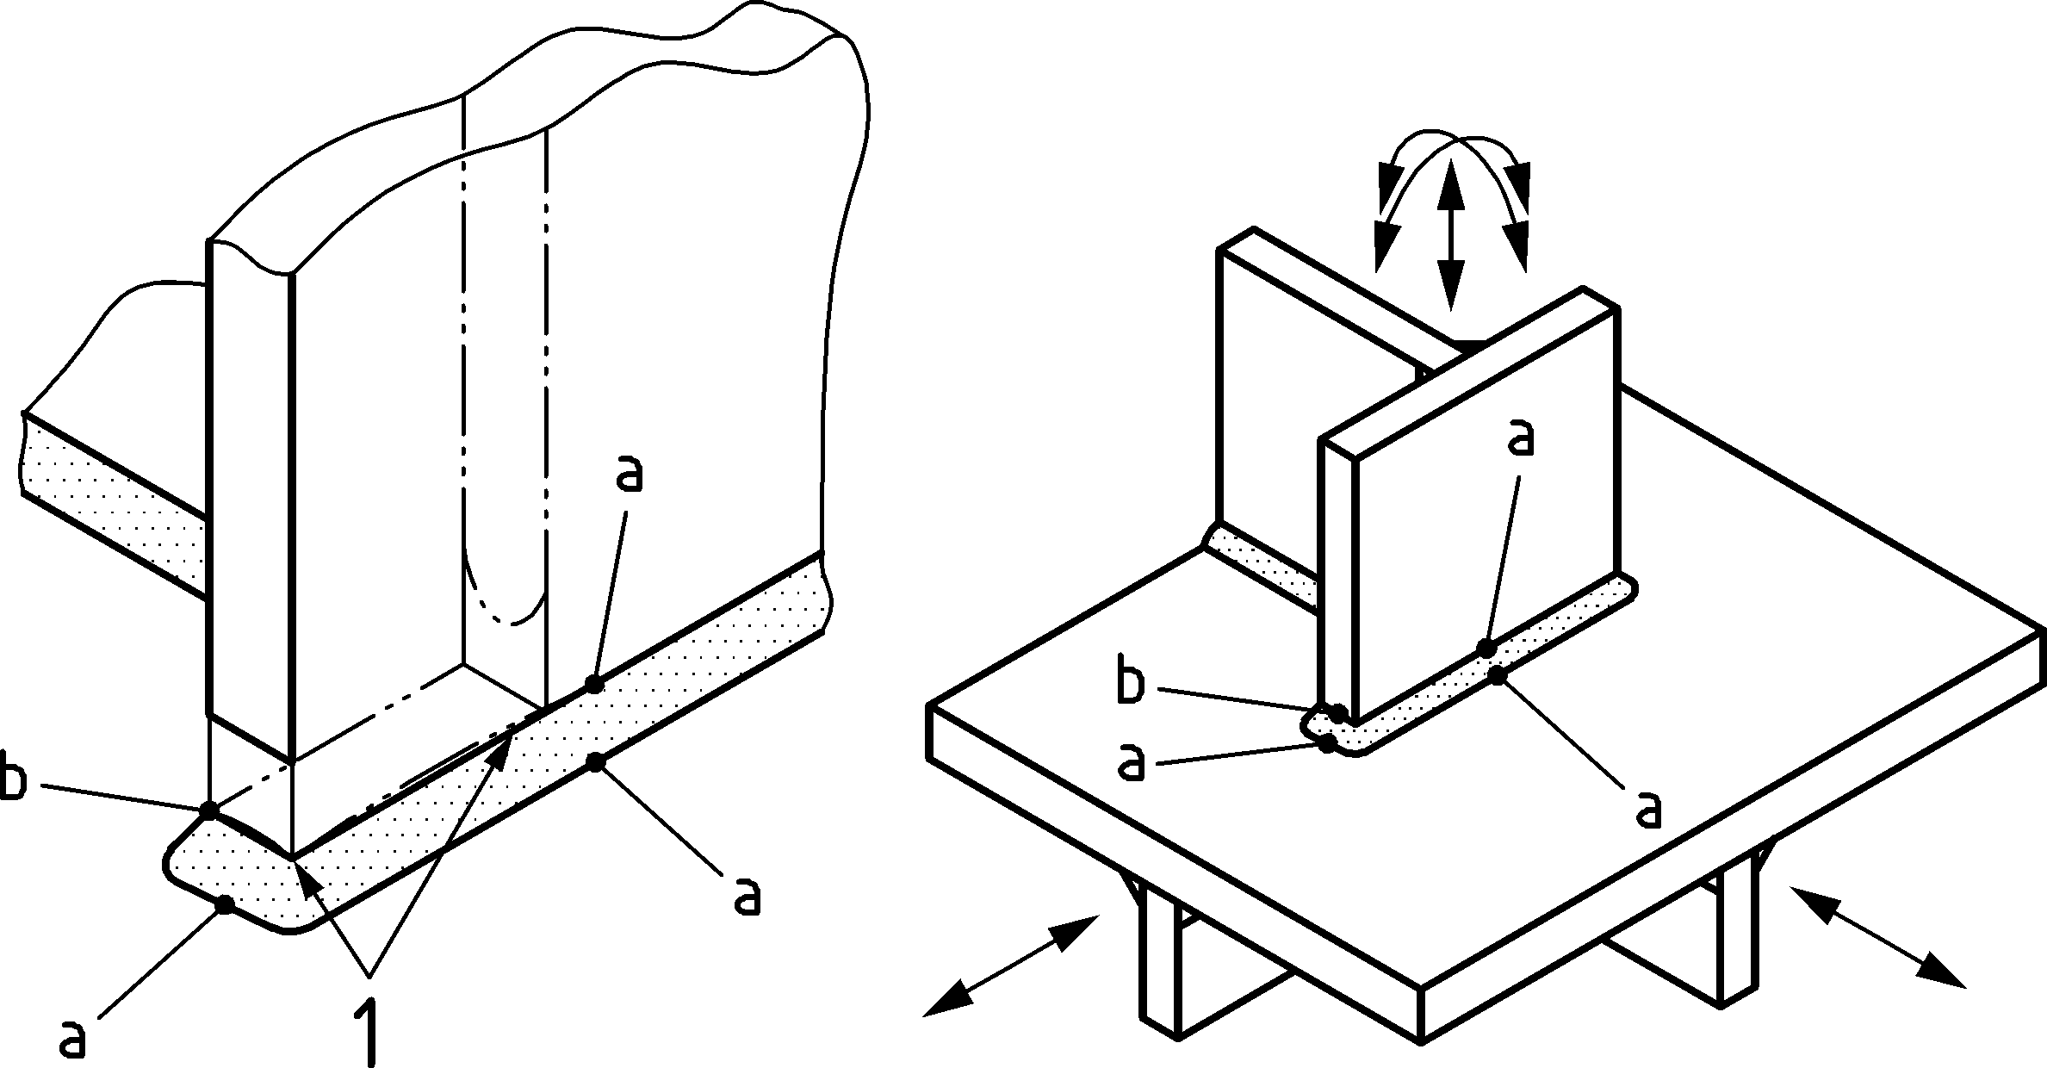

Key

|  |  |
| --- | --- |
| 1 | cracks |

Figure 8.3 — Definition of hot spot type “a” and type “b”

(3) For a hot spot type “a” the locations of the extrapolation points depend on the plate thickness, while for hot spot type “b” they are independent of the plate thickness.

(4) Extrapolation of the surface stresses may be performed using either linear or quadratic functions (see Figure 8.4 and Figure 8.5) as seems appropriate to the case. Linear extrapolation is sufficient for most structural details and loading situations. Quadratic extrapolation should be used in the cases where the stress distribution is highly curved (steepness varying), which may be caused by an abrupt local change in stiffness or loading.

(5) Solid FE models with either “coarse” or “fine” meshes may be used for fatigue assessment using the hot spot stress concept. A “coarse” mesh here implies the use of a single element through the plate thickness, whilst a “fine” mesh refers to several elements through the plate thickness.

(6) In FE models using a “coarse” mesh, higher order elements should be used (e.g. 20-node isoparametric 3D elements). The length of FE elements closest to the hot spot (in the direction of extrapolation) should be selected to ensure that the locations of the mid-side nodes is closely related to the locations of extrapolation points, see Figure 8.4 (b). Coarse mesh should not be used in cases where plate bending is restrained (e.g. due to symmetry in the detail). In these cases, coarse mesh will give a hot spot stress equal to the nominal stress.

(7) A “fine” mesh may be constructed using linear or quadratic elements. The size of the element should not be greater than the distance from expected crack location to the first extrapolation point, see Figure 8.4.

(8) The expressions for stress extrapolation are given in Table 8.2.

|  |  |
| --- | --- |
|  |  |
| **a) Finely meshed model** | **b) coarsely meshed model** |

Key

|  |  |
| --- | --- |
| 1 | notch stress |
| 2 | total surface stress |
| 3 | hot spot stress |
| 4 | extrapolation points (edge nodes) |
| 5 | extrapolation points (mid-side nodes) |
| a | type a |
| b | type b |

Figure 8.4 — Linear extrapolation of the hot spot stress from “fine” and “coarse” mesh models

|  |  |
| --- | --- |
|  |  |
| **a) Type "a"** | **b) Type "b"** |

Key

|  |  |
| --- | --- |
| 1 | notch stress |
| 2 | non-linear peak stress |
| 3 | hot spot stress |
| 4 | extrapolation points (edge nodes) |

Figure 8.5 — Quadratic stress extrapolation of structural hot spot stress

Table 8.2 — Extrapolation rules for different types of hot spots and mesh density

|  |  |  |  |
| --- | --- | --- | --- |
| ***Type of hot spots point*** | ***Linear extrapolation*** | | ***Quadratic extrapolation*** |
| ***Fine mesh*** | ***Coarse mesh*** | ***Fine mesh*** |
| type “a” | 0,4 t and 1,0 t | 0,5 t and 1,5 t | 0,4 t, 0,9 t and 1,4 t |
| 1,67 σ0,4t – 0,67 σ1,0t | 1,5 σ0,5t – 0,5 σ1,5t | 2,52 σ0,4t – 2,24 σ0,9t + 0,72 σ1,4t |
| type “b” | -- | 5 mm and 15 mm | 4, 8 and 12 mm |
| -- | 1,5 σ5mm – 0,5 σ15mm | 3 σ4mm – 3 σ8mm + σ12mm |

(9) The extrapolation rules given in (8) are also valid for 3D models built up using shell elements. The stresses for extrapolation should be read at the shell element side (top or bottom) corresponding to the location of crack (i.e. accounting for bending stresses), see points (a) and (b) in Figure 8.6.

(10) When shell elements are used the welds should be included in the model if these are essential for the stress concentration at the hot spot. Omitting the welds in these cases (see Point (a) in Figure 8.6 (b)) will give a hot spot stress equal to the nominal stress.

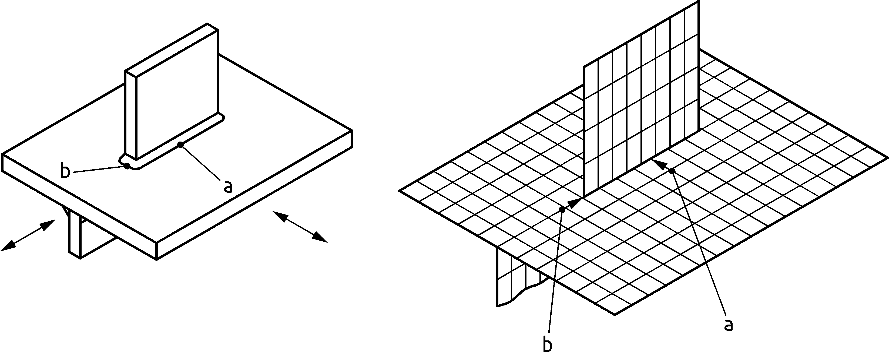

Figure 8.6 — 3D shell model with two extrapolation paths

(11) For point (a) on Figure 8.6, the weld should be included in the model. The applied weld elements should represent the stiffness of the weld correctly. Oblique shell elements can be used for this purpose. These should have a thickness equal to the weld throat thickness and placed in the weld gravity centre, see Figure 8.7.

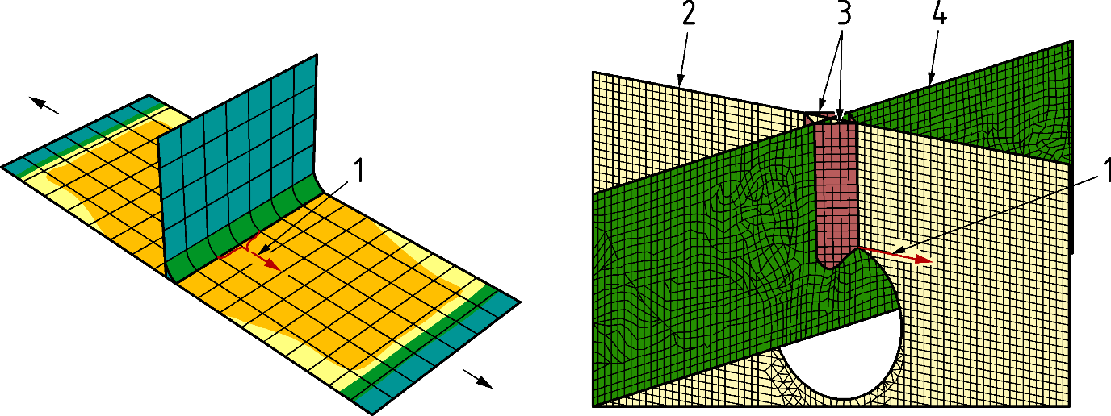

Key

|  |  |
| --- | --- |
| 1 | extrapolation path |
| 2 | attached plate |
| 3 | oblique shell elements (welds) |
| 4 | main plate |

Figure 8.7 — Modelling the weld with oblique shell elements

### Stress extrapolation for the hot spot stress method in structural hollow section joints

(1) In structural hollow section joints (hot spot type “c”), the locations from which the stresses have to be extrapolated, depends on the type of tubular members, the dimensions of the joint and the position around the intersection. The extrapolation points should be selected within the so-called extrapolation region. The limits for the extrapolation region are given in Table 8.3 for CHS and RHS joints, see also Figure 8.8.

(2) For joints between CHS members, linear extrapolation (with two extrapolation points and 1st-order equation) should be used.

(3) For joints between RHS members, quadratic extrapolation (with three extrapolation points and 2nd-order equation) should be used.

(4) The refinement of the FE mesh of a structural hollow section joint depends on the type of elements and on the stress/strain gradient over the element. The refinement of the mesh should be such that any further refinement does not result in a substantial change of the stress distribution in the extrapolation region. Element dimensions of 0,5 *t* may be used in a first step.

(5) The welds of structural hollow section joints should be included in the model in order to obtain reliable results (see also 8.2.6).

(6) For rectangular structural hollow sections, a stress redistribution around the corners should be observed especially for butt welded joints. Modelling of the corners with several elements is recommended. The minimum number of elements depends on the thickness of the RHS members. Recommended number of elements around corners are 2 for *t* ≤ 8 mm, 3 for 8 < *t* < 16 mm and 4 for *t* ≥ 16 mm.

Table 8.3 — Boundaries of the extrapolation region for CHS and RHS structural hollow section joints

|  |  |  |  |  |  |  |  |
| --- | --- | --- | --- | --- | --- | --- | --- |
| **Limits for extrapolation region** | | **Extrapolation type** | **Chord** | | **Brace** | | |
| **Saddle** | **Crown** | **Saddle** | **Crown** |
| CHS | *L*r,min a | Linear | 0,4×*t*0 | | 0,4×*t*1 | | |
| *L*r,max b | 0,09×*r*0 | 0,4× | 0,65× | | |
| RHS | *L*r,min a | Quadratic | 0,4×*t*0 | | 0,4×*t*1 | | |
| *L*r,max | *L*r,min + *t*0 | | *L*r,min + *t*1 | | |

|  |
| --- |
| a Minimum value for *L*r,min is 4 mm.  b Minimum value for *L*r,max is *L*r,min + 0,6 × *t*1. |

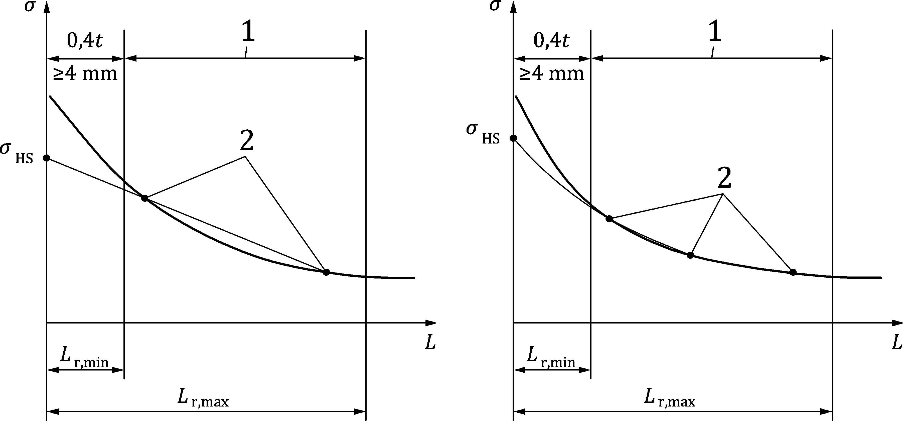

Key

|  |  |
| --- | --- |
| 1 | Extrapolation region |
| 2 | Extrapolation points |

Figure 8.8 — Definition of extrapolation regions and points in structural hollow section joints

### FE modelling – hot spot stress

(1) FE models for the fatigue assessment of welded details by the hot spot stress method should be modelled as follows:

a) The size of the elements within the region of stress extrapolation in the detail should be chosen with regard to the reference stress extrapolation points. The latter should coincide with the elements’ mid-side or edge nodes (see 8.2.3(6)).

b) The maximum aspect ratio of finite elements (i.e. the ratio of the longest dimension to the shortest dimension in the element) should be kept below 3. Within the stress extrapolation region, a ratio of 1,0 should be used in conjunction with “coarse” mesh and a ratio between 1,0 and 2,0 elsewhere.

c) Mesh transitions, from a “fine” meshed to a “coarse” meshed region should be gradual and smooth, when this transition is placed adjacent to the reference stress extrapolation points.

d) Mid-plane orientation: shell elements should be placed with their middle surface at the mid-plane of the modelled plate. Where there is an eccentric connection between adjacent plates, appropriate plates may be modelled with the offset function which is available in most FE programs.

e) For structural hollow section joints second order solid elements with reduced integration are recommended. At least two elements through wall thickness are in general needed in this case. For modelling the welds, quadratic triangular prism elements with six nodes are recommended.

f) Modelling of the welds: when fatigue assessment is performed using the hot spot stress method, the model may omit explicit modelling of the welds, except in the following two cases:

1) when the weld is the main source of stress concentration, such as in transverse attachments (e.g. see details in prEN 1993-1-9:2023, Table 8.4 rows 6 to 8),

2) when the weld is vital for a correct representation of the stiffness of the detail (e.g. in a plate subject to local high bending close to the weld, or in situations with closely located welds).

In such cases, the welds should be modelled, (e.g. by using oblique shell elements).

### FE modelling – effective notch stress

(1) The stress components and the relevant detail categories and their fatigue resistance curves to be used in fatigue assessment by the effective notch stress method are given in prEN 1993-1-9:2023, Annex C.

(2) Where FE analysis is used to calculate the effective notch stress, the mesh density in the local notch areas should be chosen to ensure that accurate and convergent stresses can be obtained. Recommendations for element sizes in the notch region are given in Figure 8.9 and Table 8.4.

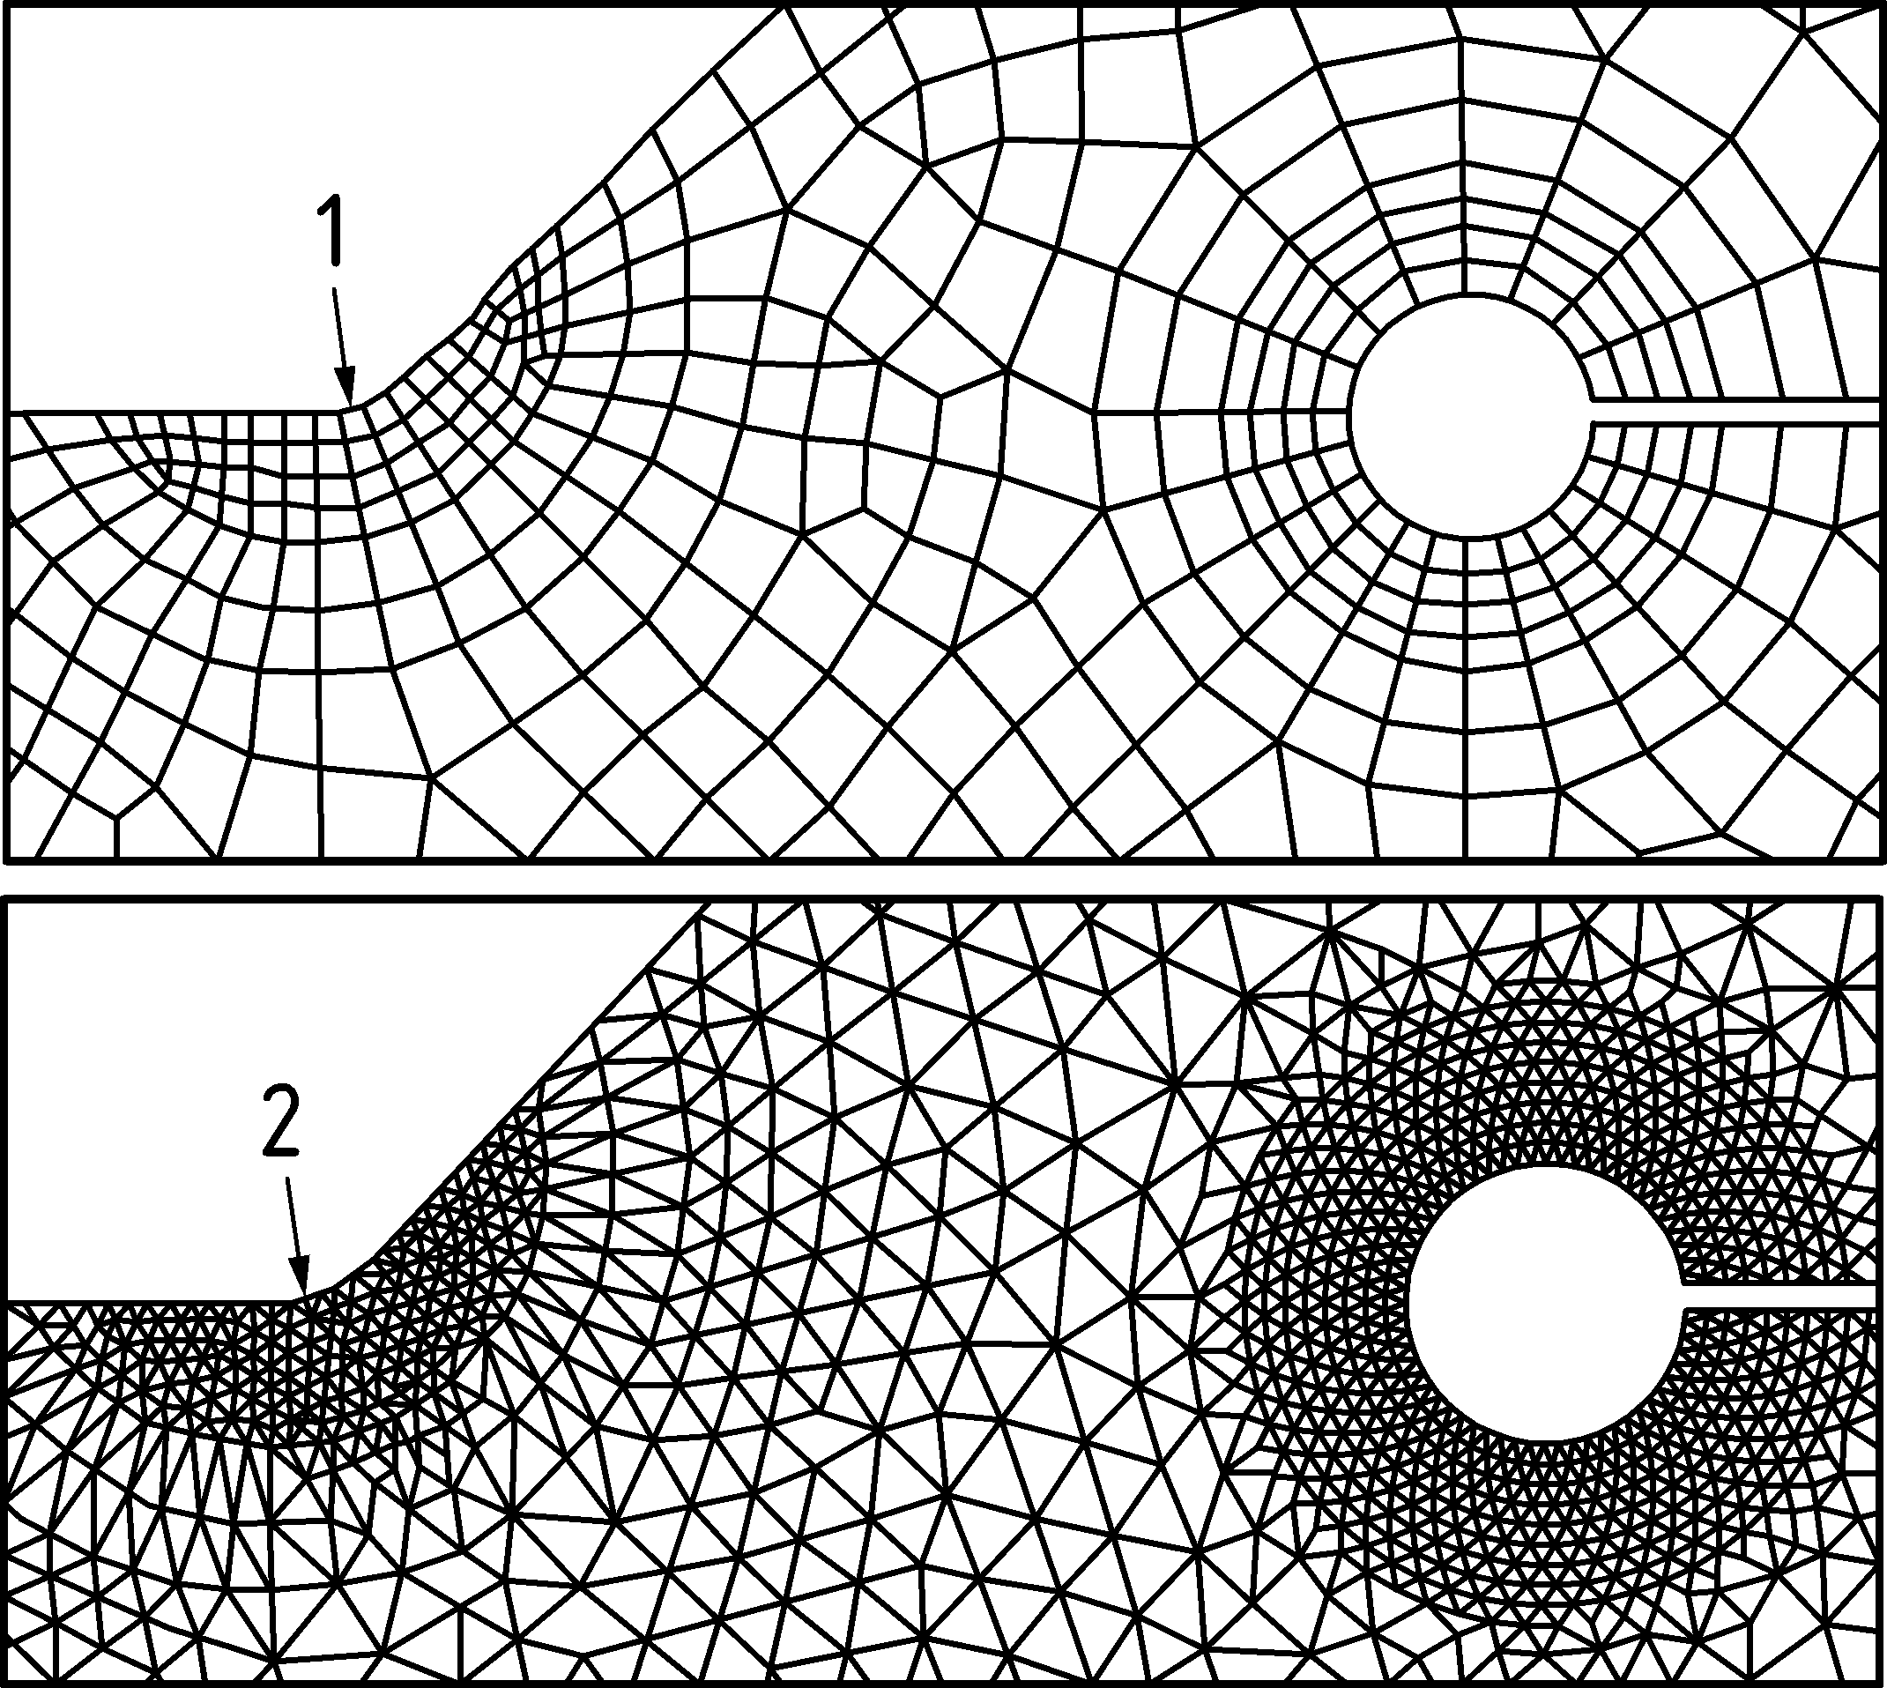

Key

|  |  |
| --- | --- |
| 1 | Element < 0,25 mm, *r* = 1 mm |
| 2 | Element < 0,15 mm, *r* = 1 mm |

Figure 8.9 — Recommendations for element size in the local region around the notch at weld toe and weld root region

Table 8.4 — Parameters for element size in the local region around the notch at weld toe and weld root region

|  |  |  |
| --- | --- | --- |
| **Element type** | | **Element size** |
| Hexahedral | Quadratic | 0,25 mm |
| Linear | 0,15 mm |
| Tetrahedral | Quadratic | 0,15 mm |

(3) With reference to root cracking in fillet welds, the keyhole or U-shaped notch should be positioned so that the weld root point lies on the circumference of the circle, see Figure 8.10.

|  |  |
| --- | --- |
|  |  |
| a) Rounding of a butt weld | b) Rounding of a fillet weld |
|  |  |
| c) Rounding weld root by a keyhole | d) Rounding weld root by an U-shape |

Figure 8.10 — Rounding of weld toe and weld root in different types of welded details

(4) To obtain sufficient accuracy, the recommended element size along the radii of a notch should be extended on both sides of the notch and in the depth direction to ensure capturing the steep stress gradient usually present at and close to the notch. If a 3D solid model is used, the element size in the 3rd direction should be selected based on the expected stress gradient or change in this direction.

(5) In large FE models sub-modelling may be used in steps moving from the global FE model to local model for assessment with the effective notch stress method.

### Additional considerations

(1) FE models used for fatigue assessment with the hot spot and effective notch stress methods commonly assume that connected plates are perfectly aligned. Both axial and angular misalignments can substantially increase the local stresses in a welded joint associated with the secondary bending stresses.

(2) The effect of some misalignment is already accounted for in the fatigue strength curves for the hot spot and effective notch stress method. This is limited to a 5 % stress magnification due to misalignment.

(3) If larger misalignment is possible or expected (e.g. based on measurements or production tolerances), their additional effect should be included in the model or in the assessment. This may be done by either of the following:

a) directly, by incorporating eccentricities into the FE model,

b) indirectly, by magnifying the local fatigue stresses above the idealized model with a relevant stress concentration factor according to prEN 1993-1-9.

(4) The effect of possible additional misalignment should be considered for axially loaded transverse butt welds and for cruciform joints. In these cases, the joint configuration is such that secondary bending of the loaded plates is not restrained.

## Serviceability limit state

(1) The numerical model can be used to check all the relevant serviceability criteria given in EN 1990 and in EN 1993 (all parts) with the provision that the design rules of EN 1990:2023, 5.4 and 8.4 are considered in the numerical model.

(2) Where FE is used in support of the serviceability limit state check, the geometrical properties of the model should be taken as nominal values for predicting the relevant stresses, deformations and vibrations (or eigen-frequencies) of the investigated structure.

(3) The cross-section properties (full or effective) shall be considered according to the rules of EN 1993 (all parts).

(4) The same analysis types (given in 6.1.2) can be used to check serviceability limit state criteria than used to ultimate limit state check considering additional design rules may be given in EN 1993 (all parts).

(5) Stresses and deformations should be calculated assuming linear elastic behaviour using LA, GNA or GNIA analysis considering the design rules of the relevant parts of EN 1993.

(6) If material non-linearities are considered in the analysis, and if plastic redistribution of the forces and moments can occur in the structure at the design load level in the serviceability limit state, they should be considered according to the rules of the relevant parts of EN 1993.

(7) If slip in the connections should be considered according to the rules of the relevant parts of EN 1993, specific joint elements, constrains or contact elements should be applied in the numerical model.

# Documentation

(1) The documentation of all FE analyses should include all relevant details of the modelled geometry, assumptions, chosen analyses and modelling steps. It should contain all the input data as well as the output documented in such a way that the calculations should be reproducible by third parties.

(2) The documentation of the FE model, analysis and design may contain the following data:

a) name and version of the chosen FE program,

b) geometrical model (FE model geometry, element type, FE mesh, eccentricities, etc.),

c) material model (linear or non-linear, properties and characteristics),

d) support and load model (boundary conditions, prescribed displacements, loads with their combinations),

e) imperfections (geometrical imperfections, residual stresses, if relevant),

f) analysis type and convergence criteria (if relevant),

g) failure criteria,

h) results of the model validation and verification (if relevant),

i) results of the analysis (internal forces, stress distributions, displacements, deformed shapes, limit loads, bifurcation points, eigenvalues, buckling modes, where relevant),

j) limit state criteria to be checked (bases of the static check).

1. (informative)  
     
   Calculation of model factor (γFE)
   1. Use of this Annex

(1) This Informative Annex provides complementary guidance to 7.3(3) and 7.3(6) for defining the value of the model factor.

NOTE National choice on the application of this Informative Annex is given in the National Annex. If the National Annex contains no information on the application of this informative annex, it can be used.

* 1. Scope and field of application

(1) This Informative Annex applies to numerical models used for numerical design calculations with direct resistance check.

* 1. Calculation of model factor (γFE)

(1) The model factor may be determined based on the comparison of the numerical calculation (*R*check) to test results (*R*test,known) or to known resistances obtained by well accepted calculation methods (*R*k,known).

|  |  |
| --- | --- |
| *R*k,known | is the calculated or known characteristic structural resistance, |
| *R*test,known | is the known test result, |
| *R*check | is the computed resistance for the check structural resistance case. |

(2) By using the same program the resistance (*R*check) for other similar structure types for which the characteristic structural resistance (*R*k,known) is known should be calculated. The known case used as a check should use similar assumptions and be similar in the failure mode, and in the controlling parameters (relative slenderness, post-buckling behaviour, geometric non-linearity, material characterisation, imperfection sensitivity, and any other relevant aspects). By comparison of the calculated values (*R*check) with test results (*R*test,known), the check cases should satisfy the same similarity conditions as given above.

(3) The model factor may be determined by a general or a simplified model validation process defined in (4) and (5) depending on the purpose of the numerical model.

(4) If general model validation is applied, and numerous test results or characteristic structural resistances are available (*R*test,known or *R*k,known) and numerical calculations are performed for each known cases (*R*check), the model factor may be calculated based on statistical evaluation of the validation/application domain according to the rules given in EN 1990:2023, Annex D. The ratio of the test results and the numerical simulation (*R*k,known/*R*check or *R*test,known/*R*check) should be calculated at first for each sample (*n*) and the mean value (*m*X) and the coefficient of variations (*V*X) may be determined for the analysed validation/application domain. Based on the statistical evaluation the model factor may be determined from Formula (A.1).

 (A.1)

where

|  |  |
| --- | --- |
| *m*X | is the mean value of the ratio of the measured (or known) and computed results for *n* samples, |
| *k*n | is the characteristic fractile factor according to EN 1990:2023, Annex D, Table D.1 (data row corresponding to *V*X unknown should be used), |
| *V*X | is the coefficient of variation of the ratio of the measured (or known) and computed results for *n* samples. |

NOTE If mean value (*m*X) lies outside the range of 0,8 < *m*X < 1,25, this procedure cannot be used. The simulation result can be deemed invalid and further calculations can be undertaken to establish the causes of discrepancy.

(5) If a direct resistance check is used to investigate standard design cases (check of failure modes with existing Eurocode based design resistance model) and if the numerical model is verified according to subclause 7.2, simplified model validation process can be applied using a predefined value for the model factor without performing statistical evaluation (Figure 7.2). For this case the recommended value is γFE =1,0. This approach is not applicable for shell structures.

(6) If a direct resistance check is performed to check failure modes where no relevant test results exists and identification of similar structural form, loading and boundary conditions is difficult, the designer should use engineering judgement and seek expert advice to establish a suitable value.

(7) The model factor is related to the numerical model (each model can have different model factor). If previously validated numerical models are used for problems with similar or slightly changed geometrical, loading or supporting conditions and there is no significant change in the analysed failure mode, the previously determined model factor can be applied.

1. (informative)  
     
    Stress concentrations
   1. Use of this Annex

(1) This Informative Annex provides complementary guidance to 5.2.1(3), 8.1.2(3) and 8.1.2(5) for defining the separation method of stress concentration and numerical singularities and considering the stress concentration in design.

NOTE National choice on the application of this Informative Annex is given in the National Annex. If the National Annex contains no information on the application of this informative annex, it can be used.

* 1. Scope and field of application

(1) This Informative Annex applies to plate, shell and solid finite element models where stress concentration occurs.

* 1. Separation of stress concentration and numerical singularities

(1) One possible approach to separate the geometrical (physical) stress concentration and the numerical singularities is based on the determination of the mesh independent stresses or strains. The mesh independent stresses or strains are calculated values at integration points of the elements which are not affected by further FE mesh refinement, as shown in Figure B.1. By mesh refinement an increased part of the geometric stress concentration can be approached and the zone of the numerical singularities can be reduced. The mesh independent stresses can only be defined in the zones where calculation results using different FE mesh sizes are existing and the calculated values are identical (differences are smaller than 1% for all applied mesh size). If sharp edges are used in the numerical model the numerical singularities cannot be avoided.

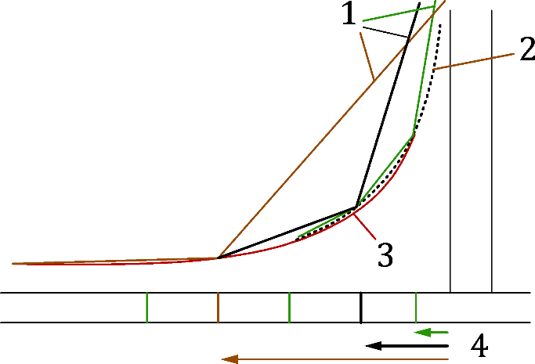

Key

|  |  |
| --- | --- |
| 1 | Numerical singularities |
| 2 | Geometrical stress concentration |
| 3 | Mesh independent stress |
| 4 | Applied element size |
|  | Calculation with coarse mesh |
|  | Calculation with finer mesh |
|  | Calculation with very fine mesh |
|  | Physical stress concentration |
|  | Mesh independent stresses |

Figure B.1 — Determination of the mesh independent stresses

(2) Another optional way is to implement a rounding at the location of the sharp edges/corners. The size of the rounding radius has impact on the geometrical stress concentration. Special attention should be given to its value, where engineering judgement or real values can be used.

(3) Special attention should be given to the separation of the geometrical (physical) stress concentration and the numerical singularities. The maximum computed stresses are sensitive to the applied finite element type, element settings, shape and size of the mesh. Accuracy of the model has to be checked by model verification.

* 1. Consideration of stress concentration in design

(1) The need to consider stress concentration depends on the limit state criteria to be checked.

(2) In the case of numerical design calculations using analysis requiring subsequent design check, stress concentration can be neglected in the elastic stress check or in determination of stresses or internal forces used for further evaluation in elastic or plastic strength check or in stability check. Extrapolated nominal stresses can be used for the evaluation of the resistance, and an additional check should be performed according to B.4(5).

(3) In the case of numerical design calculations using direct resistance check, effect of stress concentration is implicitly covered by the numerical model and the applied failure criteria according to subclause 8.1.5.

(4) Stress concentration should be not neglected if fatigue or fracture limit states (using γM2) are checked.

(5) If geometrical stress concentration is neglected according to B.4(2), the stress concentration may be checked by an additional material non-linear analysis and limiting the maximum plastic strains within the stress concentration zone. In this approach, mesh independent plastic strains should be determined according to B.3(1) or (2). The maximum mesh independent strain should be smaller than the maximum allowed plastic strain according to 8.1.5.

(6) The maximum mesh independent plastic strains should be checked on different load levels based on the applied analysis method. In the case of numerical design calculations using analysis requiring subsequent design check, the maximum mesh independent strains should be checked on the load level of the analysed load case combination. If direct resistance check is applied the maximum mesh independent strains should be checked at the ultimate load level determined according to 8.1.5.

1. (normative)  
     
   Limits on maximum strains for beam finite elements
   1. Use of this Annex

(1) This Normative Annex contains additional provisions to 5.1.2 and 8.1.5(2) for defining cross-section failure in beam finite element models through the application of strain limits.

* 1. Scope and field of application

(1) This Normative Annex applies to beam finite element models and replaces the need for cross-section classification and cross-section resistance checks.

(2) This Normative Annex applies to doubly-symmetric I- and H-sections and square and rectangular hollow sections.

(3) This Normative Annex does not apply to shell finite element models.

* 1. Strain limits

(1) Strain limits, from the Continuous Strength Method (CSM), may be used to simulate cross-section failure due to local buckling in beam finite element analyses. The design value of the maximum longitudinal compressive strain *ε*Ed at each cross-section shall satisfy:

 (C.1)

|  |  |
| --- | --- |
|  | is the design value of the maximum longitudinal compressive strain, see C.3(2), |
|  | is the *CSM* strain limit given by Formula (C.2) when a material model with a sharply-defined yield point (e.g. for hot-rolled steel) is used (see 5.3.2(1)c) and Formula (C.3) when a rounded material model (e.g. the two-stage Ramberg-Osgood model for cold-formed steel and stainless steel) is used (see 5.3.3). |

|  |  |  |
| --- | --- | --- |
|  |  | (C.2) |
|  |

|  |  |  |
| --- | --- | --- |
|  |  | (C.3) |
|  |  |  |

where

|  |  |
| --- | --- |
|  | is the yield strain, |
|  | is the local slenderness of the full cross-section, |
|  | is the elastic local buckling stress of the full cross-section, |
|  | is a project specific parameter that defines the maximum permissible level of plastic strain in the structure. |

NOTE The value of project specific parameter (Ω) is 15 unless the National Annex gives a different value.

(2) The design value of the maximum compressive strain at each cross-section *ε*Ed may be taken as the maximum value averaged over a length of member equal to the elastic local buckling half-wavelength *L*b,cs. A maximum element length equal to the elastic local buckling half-wavelength *L*b,cs should be used. Strains should be averaged over the number of elements that lie wholly within *L*b,cs.

(3) The interaction between bending and shear should be accounted for by applying a reduced strain limit *ε*csm,V, and the following criterion should be satisfied:

 (C.4)

 (C.5)

 (C.6)

 (C.7)

|  |  |
| --- | --- |
|  | is the cross-section major axis bending moment resistance considering the flanges alone, |
|  | is the cross-section minor axis bending moment resistance considering the webs alone, |
|  | is the elastic major axis bending resistance of the full cross-section, |
|  | is the elastic minor axis bending resistance of the full cross-section, |

 (C.8)

— for I-sections:

 (C.9)

— for RHS:

 (C.10)

|  |  |
| --- | --- |
|  | are the design values of shear forces, |
|  | the cross-section shear resistances, taken as the plastic cross-section shear resistances. |











For I-sections, *M*fl = *bt*f(*h*-*t*f)*f*y and *M*w may be taken as 0.

Shear checks should also be carried out:  and , and shear buckling should be considered, see prEN 1993-1-5.

(4) The interaction between bending, shear and torsion should be accounted for by applying a reduced strain limit *ε*csm,V, as given by Formula (C.4) to Formula (C.7), but with  and  determined according to Formula (C.11) to Formula (C.13):

 (C.11)

— for I-sections:

|  |  |  |
| --- | --- | --- |
|  |  | (C.12) |
|  |  |  |
|  |  |  |



— for RHS:



 (C.13)

*η*y and *η*z are factors to represent the utilisation of a cross-section under combined shear and torsion for major axis bending cases and minor axis bending cases, respectively, obtained from Table C.1.

Table C.1 — Factors *η*y and *η*z for considering the combined effects of shear stresses due to shear force and torsion

|  |  |  |
| --- | --- | --- |
| Cross-section | Major axis bending | Minor axis bending |
| I-section |  |  |
| RHS |  |  |
| where  *T*t,Ed and *T*w,Ed are the design values of internal St. Venant torsion and warping torsion;  *T*t,Rk and *T*w,Rk are the cross-section St. Venant torsion and warping torsion resistances, may be taken as plastic St. Venant torsion resistance and elastic warping torsion resistance, respectively. | | |

Torsion and shear checks should also be performed, as follows:



*T*t,Ed/*T*t,Rd ≤ 1,0, *η*y ≤ 1,0 and *η*z ≤ 1,0 (C.14)

and shear buckling should be considered, see prEN 1993-1-5.

Bibliography

**Other references**

The following documents are cited informatively in the document, for example in notes.

EN 10025 (all parts), Hot rolled products of structural steels

EN 10088 (all parts), Stainless steels

EN 10149 (all parts), Hot rolled flat products made of high yield strength steels for cold forming

EN 10210 (all parts), Hot finished structural hollow sections of non-alloy and fine grain steels