CEN/TC 250

Date: 2023-03-21

prEN 1993‑5:2023

CEN/TC 250

Secretariat: BSI

Eurocode 3 — Design of steel structures — Part 5: Piling

*Eurocode 3 — Bemessung und Konstruktion von Stahlbauten — Teil 5: Pfähle und Spundwände*

*Eurocode 3 — Calcul des structures en acier — Partie 5 : Pieux et palplanches*

Contents Page

European foreword 7

0 Introduction 8

1 Scope 11

1.1 Scope of EN 1993‑5 11

1.2 Assumptions 11

2 Normative references 12

3 Terms, definitions, symbols 13

3.1 Terms and definitions 13

3.1.1 Terms and definitions for piles 13

3.1.2 Terms and definitions relating to anchors, tension piles and waling 16

3.2 Symbols 22

3.2.1 General 22

3.2.2 Latin upper-case symbols 23

3.2.3 Latin lower-case symbols 25

3.2.4 Greek symbols 26

3.3 Convention for sheet pile axes 28

4 Basis of design 29

4.1.1 Basic requirements 29

4.1.2 Structural reliability and consequences of failure 30

4.1.3 Robustness 30

4.1.4 Design service life 31

4.1.5 Durability 31

4.1.6 Sustainability 31

4.2 Principles of limit state design 31

4.2.1 Design situations 31

4.2.2 Ultimate limit state criteria 31

4.2.3 Serviceability limit state criteria 32

4.3 Basic variables 33

4.3.1 Actions and environmental influences 33

4.3.2 Material and product properties and geometrical data 34

4.4 Verification by the partial factor method 34

4.4.1 Design values of actions 34

4.4.2 Design values of material properties 34

4.4.3 Design values of geometrical properties 34

4.4.4 Construction tolerances 34

4.4.5 Imperfections 34

4.5 Driveability 34

4.6 Design assisted by finite element analysis 35

4.6.1 General 35

4.6.2 Secondary elements 35

4.7 Design assisted by testing 35

4.8 Verification by observational method 36

4.9 Fatigue 36

5 Materials 36

5.1 General 36

5.2 Material properties for steel piles 36

5.2.1 Strength of bearing piles 36

5.2.2 Strength of hot rolled sheet piles 37

5.2.3 Strength of cold formed sheet piles 37

5.2.4 Strength of steel members used for combined walls 37

5.2.5 Ductility of steel piles 38

5.2.6 Fracture toughness of steel piles 38

5.3 Interlocks and connecting devices 39

5.4 Material properties for steel elements used for anchors and tension piles 39

5.4.1 General 39

5.4.2 Anchor tension elements 39

5.4.3 Ductility of anchors and tension piles 40

5.5 Material properties for steel members used for bracing 40

6 Durability 40

6.1 General 40

6.2 Durability requirements for piling 42

6.3 Durability requirements for anchors and tension piles 43

6.4 Corrosion rates for design 43

6.4.1 Corrosion rates for design in soil and water 43

6.4.2 Corrosion rates for design due to mechanical wearing 45

6.4.3 Corrosion due to stray currents 46

6.4.4 Corrosion rates for design in atmospheric environment 46

7 Structural analysis 46

7.1 Structural modelling 46

7.1.1 Modelling of the structure 46

7.1.2 Modelling of anchors, tension piles, walings, bracing and connections 46

7.2 Global analysis for ultimate limit state design checks 47

7.3 Imperfections 51

7.4 Methods of analysis considering material nonlinearities 52

7.5 Classification of cross-sections 52

7.5.1 Classification of U, Z and Ω sheet piles 52

7.5.2 Classification of other cross-sections 53

8 Ultimate limit state 53

8.1 General 53

8.2 Partial factors 54

8.3 Sheet piling 54

8.3.1 Bending resistance of sheet piling considering shear lag 54

8.3.2 Shear resistance of sheet piling 57

8.3.3 Resistance of sheet piling for combined bending, shear and axial force 59

8.3.4 Buckling of sheet piling in bending and axial compression 60

8.3.5 Local effects of water pressure 63

8.3.6 Concentrated load introduction 64

8.4 Bearing piles 67

8.4.1 General 67

8.4.2 Design methods and design considerations 67

8.4.3 Buckling of bearing piles 68

8.4.4 Verification of steel piles filled with concrete 69

8.5 High modulus walls 69

8.6 Jagged walls 70

8.7 Combined walls 70

8.7.1 General 70

8.7.2 Secondary elements 70

8.7.3 Connectors 72

8.7.4 Primary elements 72

8.8 H-piles used as primary elements 73

8.8.1 General 73

8.8.2 H-piles in axial compression and bending 73

8.8.3 Lateral torsional buckling of H-piles 74

8.8.4 Shear buckling of H-piles 78

8.8.5 The combined effect of member forces and flange bending 78

8.9 Tubular sections used as primary elements 80

8.9.1 General 80

8.9.2 Tubular piles in bending and shear 81

8.9.3 Tubular piles in axial compression and bending 81

8.9.4 Buckling of tubular piles 81

8.9.5 Effects of transverse loads 82

8.9.6 The combined effect of member forces and circumferential bending 84

8.9.7 The effect of circumferential deformation on member resistance 85

8.9.8 Flexibility and ductility of the tubular piles 87

8.10 Straight web steel sheet piles 88

8.10.1 General 88

8.10.2 Verification of junction piles 89

8.11 Anchors and tension piles 90

8.11.1 General 90

8.11.2 Design resistance of tension elements for anchors 91

8.11.3 Anchors and tension piles subject to proof testing 93

8.12 Walings and bracings 94

8.13 Connections 94

9 Serviceability limit state 96

9.1 Basis 96

9.2 Displacements of retaining walls 96

9.3 Displacements of bearing piles 96

9.4 Structural aspects of steel sheet piling 97

9.5 Anchors and tension piles 97

Annex A (normative) Cold formed and class 4 steel sheet piles 98

A.1 Use of this annex 98

A.2 Scope and field of application 98

A.3 General 98

A.3.1 Form of cold formed steel sheet piles 98

A.3.2 Terminology 99

A.4 Basis of design 99

A.4.1 Ultimate limit states 99

A.4.2 Serviceability limit states 99

A.5 Properties of materials and cross-sections 99

A.5.1 Material properties 99

A.5.2 Section properties 100

A.6 Local buckling 101

A.7 Resistance of cross-sections 103

A.7.1 General 103

A.7.2 Bending moment 104

A.7.3 Shear force 104

A.7.4 Local transverse forces 105

A.7.4.1 General 105

A.7.4.2 Webs subject to transverse compressive forces 105

A.7.4.3 Webs subject to transverse tensile forces 105

A.7.5 Combined shear force and bending moment 105

A.7.6 Combined bending moment and local transverse forces 106

A.7.7 Combined bending moment and axial force 106

A.7.8 Local transverse bending 106

A.8 Design by calculation 107

Annex B (normative) Testing of class 4 steel sheet piles 108

B.1 Use of this annex 108

B.2 Scope and field of application 108

B.3 General 108

B.4 Tests on material 109

B.5 Cross-sectional data based on testing 109

B.6 Single span beam test 109

B.7 Intermediate support test 110

B.8 Double span beam test 111

B.9 Evaluation of test results 112

B.9.1 General 112

B.9.2 Adjustment of test results 112

B.9.3 Characteristic values 112

B.9.4 Design values 112

Annex C (normative) Conditions for use of plastic analysis and elasto-plastic verification for sheet pile walls 113

C.1 Use of this annex 113

C.2 Scope and field of application 113

C.3 Type of analysis 113

C.3.1 General 113

C.3.2 Use of nonlinear behaviour for determination of the bending moment 113

C.4 Flexural capacity of cross sections 114

C.4.1 Determination of required rotational capacity 115

Annex D (normative) Reference resistance design formulas for class 3 and 4 manufactured tubular piles loaded in longitudinal bending 119

D.1 Use of this annex 119

D.2 Scope and field of application 119

D.3 Section resistance 120

D.4 Buckling strength verification 120

D.5 Buckling parameters 121

Annex E (normative) Properties of semi-compact sections 123

E.1 Scope and field of application 123

E.2 Section properties 123

Annex F (informative) Typical grades of reinforcing and prestressing steels used for tension elements 124

F.1 Use of this annex 124

F.2 Scope and field of application 124

Bibliography 126

European foreword

This document (prEN 1993‑5:2023) has been prepared by Technical Committee CEN/TC 250 “Structural Eurocodes”, the secretariat of which is held by BSI. CEN/TC 250 is responsible for all Structural Euro-codes and has been assigned responsibility for structural and geotechnical design matters by CEN.

This document is currently submitted to the CEN Enquiry.

This document will supersede EN 1993‑5:2007.

The first generation of EN Eurocodes was published between 2002 and 2007. This document forms part of the second generation of the Eurocodes, which have been prepared under Mandate M/515 issued to CEN by the European Commission and the European Free Trade Association.

The Eurocodes have been drafted to be used in conjunction with relevant execution, material, product and test standards, and to identify requirements for execution, materials, products and testing that are relied upon by the Eurocodes.

The Eurocodes recognize the responsibility of each Member State and have safeguarded their right to determine values related to regulatory safety matters at national level through the use of National Annexes.

0 Introduction

**0.1** **Introduction to the Eurocodes**

The Structural Eurocodes comprise the following standards generally consisting of a number of Parts:

• EN 1990 Eurocode: Basis of structural and geotechnical design

• EN 1991 Eurocode 1: Actions on structures

• EN 1992 Eurocode 2: Design of concrete structures

• EN 1993 Eurocode 3: Design of steel structures

• EN 1994 Eurocode 4: Design of composite steel and concrete structures

• EN 1995 Eurocode 5: Design of timber structures

• EN 1996 Eurocode 6: Design of masonry structures

• EN 1997 Eurocode 7: Geotechnical design

• EN 1998 Eurocode 8: Design of structures for earthquake resistance

• EN 1999 Eurocode 9: Design of aluminium structures

• New parts are under development, e.g. Eurocode for design of structural glass

The Eurocodes are intended for use by designers, clients, manufacturers, constructors, relevant authorities (in exercising their duties in accordance with national or international regulations), educators, software developers, and committees drafting standards for related product, testing and execution standards.

NOTE Some aspects of design are most appropriately specified by relevant authorities or, where not specified, can be agreed on a project-specific basis between relevant parties such as designers and clients. The Eurocodes identify such aspects making explicit reference to relevant authorities and relevant parties.

**0.2** **Introduction to** EN 1993 (all parts)

EN 1993 (all parts) applies to the design of buildings and civil engineering works in steel. It complies with the principles and requirements for the safety and serviceability of structures, the basis of their design and verification that are given in EN 1990 – Basis of structural and geotechnical design.

EN 1993 (all parts) is concerned only with requirements for resistance, serviceability, durability and fire resistance of steel structures. Other requirements, e.g. concerning thermal or sound insulation, are not covered.

EN 1993 is subdivided in various parts:

EN 1993‑1, *Design of steel structures — Part 1: General rules and rules for buildings;*

EN 1993‑2, *Design of steel structures — Part 2: Bridges;*

EN 1993‑3, *Design of steel structures — Part 3: Towers, masts and chimneys;*

EN 1993‑4, *Design of steel structures — Part 4: Silos and tanks;*

EN 1993‑5, *Design of steel structures — Part 5: Piling;*

EN 1993‑6, *Design of steel structures — Part 6: Crane supporting structures;*

EN 1993‑7, *Design of steel structures — Part 7: Sandwich panels* (under preparation).

EN 1993‑1 in itself does not exist as a physical document, but comprises the following 14 separate parts, the basic part being EN 1993‑1‑1:

EN 1993‑1‑1, *Design of steel structures — Part 1-1: General rules and rules for buildings;*

EN 1993‑1‑2, *Design of steel structures — Part 1-2: Structural fire design;*

EN 1993‑1‑3, *Design of steel structures — Part 1-3: Cold-formed members and sheeting;*

NOTE Cold-formed hollow sections supplied according to EN 10219 (all parts) are covered in EN 1993‑1‑1.

EN 1993‑1‑4, *Design of steel structures — Part 1-4: Stainless steel structures;*

EN 1993‑1‑5, *Design of steel structures — Part 1-5: Plated structural elements;*

EN 1993‑1‑6, *Design of steel structures — Part 1-6: Strength and stability of shell structures;*

EN 1993‑1‑7, *Design of steel structures — Part 1-7: Plate assemblies with elements under transverse loads;*

EN 1993‑1‑8, *Design of steel structures — Part 1-8: Joints;*

EN 1993‑1‑9, *Design of steel structures — Part 1-9: Fatigue;*

EN 1993‑1‑10, *Design of steel structures — Part 1-10: Material toughness and through-thickness properties;*

EN 1993‑1‑11, *Design of steel structures — Part 1-11: Tension components;*

EN 1993‑1‑12, *Design of steel structures — Part 1-12: Additional rules for steel grades up to S960;*

EN 1993‑1‑13, *Design of steel structures — Part 1-13: Rules for beams with large web openings;*

EN 1993‑1‑14, *Design of steel structures — Part 1-14: Design assisted by finite element analysis* (under preparation).

All subsequent parts EN 1993‑1‑2 to EN 1993‑1‑14 treat general topics that are independent from the structural type like structural fire design, cold-formed members and sheeting, stainless steels, plated structural elements, etc.

All subsequent parts numbered EN 1993‑2 to EN 1993‑7 treat topics relevant for a specific structural type like steel bridges, towers, masts and chimneys, silos and tanks, piling, crane supporting structures, etc. EN 1993‑2 to EN 1993‑7 refer to the generic rules in EN 1993‑1 and supplement, modify or supersede them, where relevant.

**0.3** **Introduction to** EN 1993**‑**5

EN 1993‑5 gives design rules for steel sheet piling and bearing piles to supplement the generic rules in EN 1993‑1. The focus in EN 1993‑5 is on design rules that supplement, modify or supersede the equivalent provisions given in EN 1993‑1

EN 1993‑5 is intended to be used with Eurocodes EN 1990 - Basis of structural and geotechnical design, EN 1991 - Actions on structures and EN 1997 - Geotechnical Design.

**0.4** **Verbal forms used in the Eurocodes**

The verb “shall” expresses a requirement strictly to be followed and from which no deviation is permitted in order to comply with the Eurocodes.

The verb “should” expresses a highly recommended choice or course of action. Subject to national regulation and/or any relevant contractual provisions, alternative approaches could be used/adopted where technically justified.

The verb “may” expresses a course of action permissible within the limits of the Eurocodes.

The verb “can” expresses possibility and capability; it is used for statements of fact and clarification of concepts.

**0.5** **National annex for** EN 1993**‑**5

National choice is allowed in this standard where explicitly stated within notes. National choice includes the selection of values for Nationally Determined Parameters (NDPs).

The national standard implementing EN 1993‑5 can have a National Annex containing all national choices to be used for the design of buildings and civil engineering works to be constructed in the relevant country.

When no national choice is given, the default choice given in this standard is to be used.

When no national choice is made and no default is given in this standard, the choice can be specified by the relevant authority or, where not specified, agreed for a specific project by the relevant parties.

National choice is allowed in prEN 1993‑5 through notes to the following:

|  |  |  |  |  |
| --- | --- | --- | --- | --- |
| 4.1.3 (2) | 4.6.1 (2) | 4.6.2 (2) | 5.2.6 (1) | |
| 6.4.1 (1) | 6.4.4 (1) | 7.4. (2) | | 8.2 (1) |
| 8.2 (2) | 8.2 (3) | 8.3.1 (2) | | 8.11.2 (1) |
| 9.4 (4) |  |  | |  |

National choice is allowed in EN 1993‑5 on the application of the following informative annexes:

|  |  |  |  |
| --- | --- | --- | --- |
| Annex F |  |  |  |

The National Annex can contain, directly or by reference, non-contradictory complementary information for ease of implementation, provided it does not alter any provisions of the Eurocodes.

# Scope

## Scope of EN 1993‑5

(1) EN 1993‑5 provides rules for structural design of bearing piles and sheet piles made of steel.

(2) EN 1993‑5 provides rules for the structural design of steel elements for foundations and retaining structures constructed using steel piles.

(3) EN 1993‑5 is applicable to:

— steel piled foundations for civil engineering works on land and over water;

— temporary or permanent structures needed to carry out steel piling work;

— temporary and permanent retaining structures made of continuous steel piling.

(4) EN 1993-5 does not apply to:

— offshore platforms;

— dolphins;

— ground reinforcing elements.

NOTE Ground reinforcing elements include rock bolts; soil nails; sprayed concrete; wire mesh and facing elements.

(5) EN 1993‑5 does not cover the following aspects:

— geotechnical design;

— seismic design.

NOTE 1 For geotechnical design see prEN 1997 (all parts).

NOTE 2 For the effects of ground movement caused by earthquakes see EN 1998.

(6) EN 1993‑5 provides methods for design by calculation and for design assisted by testing.

## Assumptions

(1) Unless specifically stated, EN 1990, EN 1991 (all parts), EN 1993‑1 (all parts) and EN 1997 (all parts) apply.

(2) The design methods given in EN 1993‑5 are applicable if

— the execution quality for steel piles is as specified in EN 12063, EN 12699, EN 14199 and

— the execution quality for associated steel elements (such as bracing, anchors, waling, etc.) is as specified in EN 1090‑2, EN 1537 and

— the execution quality for concreting of bearing piles is as specified in EN 1536 and

— the construction materials and products used are as specified in the relevant parts of EN 1993 (all parts), or in the relevant material and product specifications.

(3) The methods for design by calculation apply only within the stated ranges of material properties and geometric proportions, for which sufficient experience and test evidence is available. These limitations do not apply to design assisted by testing.

# Normative references

The following documents are referred to in the text in such a way that some or all of their content constitutes requirements of this document. For dated references, only the edition cited applies. For undated references, the latest edition of the referenced document (including any amendments) applies.

NOTE See the Bibliography for a list of other documents cited that are not normative references, including those referenced as recommendations (i.e. in ‘should’ clauses), permissions (‘may’ clauses), possibilities ('can' clauses), and in notes.

EN 1090‑2, Execution of steel structures and aluminium structures — Part 2: Technical requirements for steel structures

EN 1536, Execution of special geotechnical work — Bored piles

EN 1537, Execution of special geotechnical works — Ground anchors

EN 1990:2023, Eurocode — Basis of structural and geotechnical design

EN 1991 (all parts), Eurocode 1 — Actions on structures

prEN 1992‑1‑1:2021, Eurocode 2 — Design of concrete structures – Part 1-1: General rules and rules for buildings, bridges and civil engineering structures

EN 1993‑1, (all parts), Eurocode 3 — Design of steel structures

prEN 1994‑1‑1:202x, Eurocode 4 — Design of composite steel and concrete structures — 1-1: General rules and rules for buildings (under development)

EN 1997 (all parts), Eurocode 7 — Geotechnical design

EN 10210 (all parts), Hot finished steel structural hollow sections

EN 10219 (all parts), Cold formed welded steel structural hollow sections

EN 10248 (all parts), Hot-rolled steel sheet piles

EN 10249 (all parts), Cold formed steel sheet piling

EN 12063, Execution of special geotechnical work — Sheet pile walls, combined pile walls, high modulus walls

EN 12699, Execution of special geotechnical work — Displacement piles

EN 14199, Execution of special geotechnical work — Micropiles

# Terms, definitions, symbols

## Terms and definitions

For the purposes of this document, the following terms and definitions apply.

NOTE Figures 3.1 to Figure 3.7 are only examples and are provided to enhance the understanding of the wording of the terminology used. The examples are by no means exhaustive and they do not represent any preferred detailing.

### Terms and definitions for piles

3.1.1.1

bearing pile

pile that transmits forces to the ground either by compression through end bearing or by friction between the surface of the pile and the adjacent ground or a combination of both

Note 1 to entry: See examples in Figure 3.1a.

3.1.1.2

box pile

non-circular hollow pile fabricated from any combination of sheet pile and plate continuously or intermittently welded together in longitudinal direction (see Figures 3.1a and 3.1c)

3.1.1.3

bracing

system of walings and struts to support the structure (see Figure 3.2)

3.1.1.4

cantilever wall

wall whose stability depends solely upon embedment of the piles (sheet piles, combi-wall or high-modulus wall) made of steel into the ground (see Figure 3.2a)

3.1.1.5

cellular structure

retaining structure whose stability depends upon the self weight of the fill

Note 1 to entry: These structures are typically constructed from straight web profiles with sufficient interlock tensile strength to resist the circumferential tension developed in the walls due to the radial pressure of the contained fill (see Figure 3.4).

3.1.1.6

circular cell wall

wall constructed of individual cellular structures connected by arcs of smaller diameter (see Figure 3.3e)

3.1.1.7

combined wall

embedded retaining wall composed of connecting primary and secondary elements

Note 1 to entry: The primary elements are normally steel tubular piles, H-piles or box types, spaced uniformly along the length of the wall. The secondary elements are generally steel sheet piles of various types installed in the spaces between the primary elements and connected to them (see Figure 3.3c).

3.1.1.8

connector

hot rolled or fabricated device that connects adjacent piles by means of a thumb and finger or similar configuration to make a continuous wall

Note 1 to entry: Connectors perform the same function as interlocks but are fabricated separately and not as an integral part of the pile.

3.1.1.9

diaphragm cell wall

wall constructed of special cellular structures using two rows of circular arcs connected together by diaphragms perpendicular to the axis of the structure (see Figure 3.3f)

3.1.1.10

double U-pile

two threaded single U-piles with shear connections

3.1.1.11

driveability

ability of a sheet pile or bearing pile to be driven through the ground strata to the required penetration depth without detrimental effects

3.1.1.12

driving

method, or combination of methods, for installing a pile into the ground to the required depth

EXAMPLE 1 impact

2 vibrating

3 pressing

4 resonance

5 screwing

3.1.1.13

foundation

construction for transmitting forces to the supporting ground

3.1.1.14

ground structure interaction

mutual influence of deformations on ground and a foundation or a retaining structure

3.1.1.15

high modulus wall

retaining wall formed by connecting primary steel elements that have the same geometry, see Figure 3.3b

3.1.1.16

interlock

portion of a steel sheet pile that connects adjacent elements by means of a thumb and finger or similar configuration to make a continuous wall

Note 1 to entry: Interlocks can be described as

— free: threaded interlocks that are neither crimped nor welded;

— crimped: Interlocks of threaded single piles that have been mechanically connected by crimped points to form a shear connection;

— welded: interlocks of threaded single piles that have been mechanically connected by continuous or intermittent partial penetration butt welds to form a shear connection.

3.1.1.17

jagged wall

special sheet pile wall configuration in which the single piles are arranged either to enhance the moment of inertia of the wall or to suit special applications (see Figure 3.3d)

3.1.1.18

junction pile

special element (see Figure 3.5) connecting primary and secondary cells or adjacent diaphragm cells (see Figures 3.3e and 3.3f)

3.1.1.19

micropile

drilled pile which has a diameter smaller than 300 mm

Note 1 to entry: If not otherwise specified all provisions relating to piles also apply to micropiles.

3.1.1.20

pile

slender structural member, substantially underground, intended to transmit forces from above ground and/or forces caused by retaining of soil, into load-bearing strata below the surface of the ground

3.1.1.21

pile coupler

mechanical sleeve used to lengthen a steel tubular pile

3.1.1.22

piled foundation

foundation that incorporates one or more piles

3.1.1.23

propped wall

retaining wall whose stability depends upon embedment of piles into the ground and upon one or more levels of support (see Figure 3.2b)

Note 1 to entry: Support systems can include bracing, struts, props or floors.

3.1.1.24

retaining structure

construction element including walls retaining ground, similar material and/or water, and, where relevant, their support systems (e.g. anchors)

3.1.1.25

shear connection

any mode of connection preventing the relative displacement of piles at the interlocks when loaded

Note 1 to entry: Shear connections are typically fabricated by crimping or partial penetration butt welding the interlocks together. Shop crimping can be double or triple points. Shop or site welding can be continuous or intermittent.

3.1.1.26

sheet pile

product obtained by hot rolling or cold forming steel (e.g. drawing, bending, roll forming) to a shape such that, by interlocking of the joints or fitting of longitudinal grooves or by means of special fasteners, it forms partitions or continuous walls

Note 1 to entry: The types of steel sheet piles covered in this Part 5 are shown in Figure 3.1b.

3.1.1.27

sheet pile wall

line of sheet piles that forms a continuous wall by threading of the interlocks

Note 1 to entry: For typical examples see Figure 3.3.

3.1.1.28

soldier wall

Berlin wall

wall composed of vertical piles installed at intervals supporting intermediate horizontal elements (boarding, planks or lagging), see Figure 3.3g

3.1.1.29

straight web sheet pile

flat or slightly bent section with interlocks working in tension only, see Figure 3.1b

3.1.1.30

triple U-pile

sheet pile consisting of three threaded single U-piles with shear connections

3.1.1.31

tubular pile

pile of circular cross-section manufactured in a factory under controlled processes using seamless, longitudinal or helical welding processes (see Figures 3.1a and 3.1c)

### Terms and definitions relating to anchors, tension piles and waling

3.1.2.1

anchor

structural element capable of transmitting an applied tensile load from the anchor head through a free anchor length to a resisting element and finally into the ground (see Figure 3.2c)

3.1.2.2

anchor head

element of an anchor which transmits tensile load to the structure

Note 1 to entry: For examples of typical anchor heads see Figure 3.6.

3.1.2.3

anchored wall

retaining wall whose stability depends upon embedment of the piles into the ground and also upon one or more levels of tensile restraint

Note 1 to entry: Restraint can be provided by tension elements including anchors and tension piles see Figure 3.2c.

3.1.2.4

deadman

discrete passive structural element buried in or secured to the ground for the purpose of providing anchorage for tie rods through passive earth pressure

Note 1 to entry: Deadman anchorage can also be continuous, e.g. anchor sheet pile wall, ground beams, etc.

3.1.2.5

grouted anchor

anchor that uses a bonded length formed of cement grout, resin or similar material to transmit the tensile force to the ground

3.1.2.6

permanent anchor

anchor with a design service life which is in excess of two years

3.1.2.7

prestressed anchor

anchor which is stressed and locked off after installation, but before load enters the anchor (e.g. due to excavation, ground water lowering or service loads)

Note 1 to entry: Not all anchors are pre-stressed. Anchors are pre-stressed to limit deformation of the anchored structure. Prestressed anchors are also termed active anchors, whereas non-prestressed anchors are also termed passive anchors.

3.1.2.8

temporary anchor

anchor with a design service life of two years or less

3.1.2.9

tendon

part of an anchor that is capable of transmitting tensile load from the anchor head to the resisting element in the ground

EXAMPLE 1 solid steel rod or reinforcing steel bar

2 hollow bar

3 strand

3.1.2.10

tension pile

pile that transmits tension load to the ground by friction between the surface of the pile and the adjacent ground (see Figure 3.2c)

3.1.2.11

tie rod

tie bar

circular solid steel rod (bar) with terminations transmitting tensile load from the anchor head to a deadman or anchor wall

Note 1 to entry: Tie rods are considered part of an anchor in this document.

3.1.2.12

waling

horizontal beam, usually of steel or reinforced concrete, fixed to the retaining wall and used to transmit the design support force for the wall into the anchors, tension piles or struts (see Figures 3.2 and 3.6)

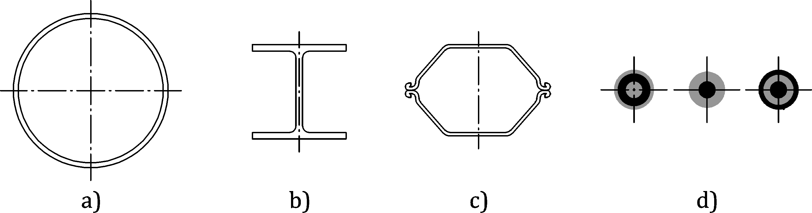

a) Bearing pile sections

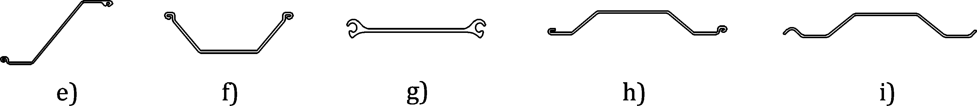

b) Sheet pile sections

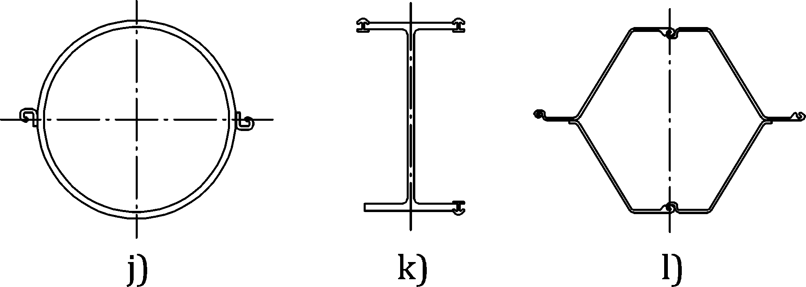

c) Primary pile sections

Key

|  |  |  |  |  |  |
| --- | --- | --- | --- | --- | --- |
| a | tubular pile | e | Z-pile | i | trench pile |
| b | H-pile | f | U-pile | j | tubular pile |
| c | box pile | g | Straight web pile | k | H-pile |
| d | micropiles | h | Ω-pile (Omega pile) | l | box pile |

NOTE Ω-piles and trench piles are dealt with in Annex A.

Figure 3.1 — Examples of typical pile sections

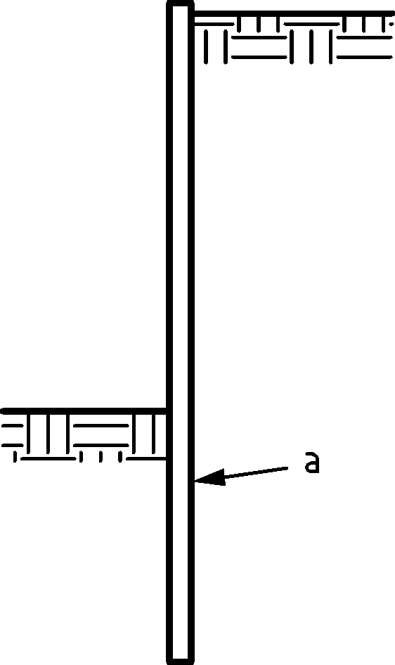

a) Cantilever retaining wall

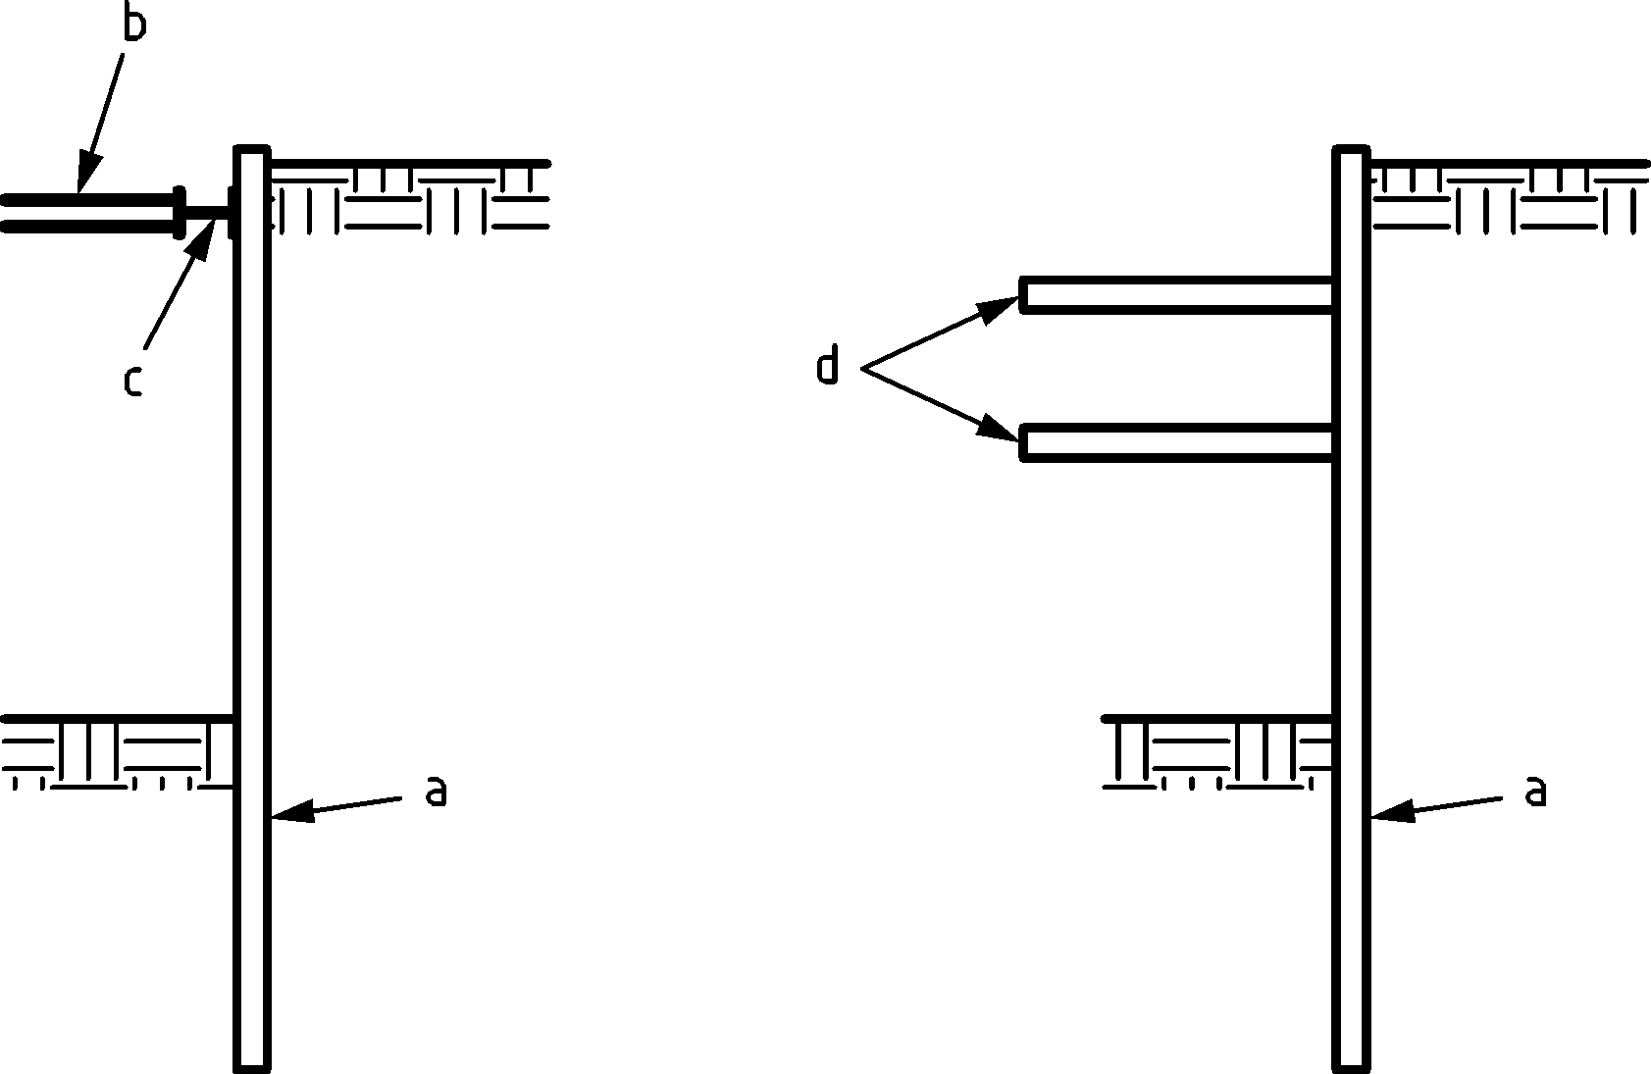

b) Propped retaining wall

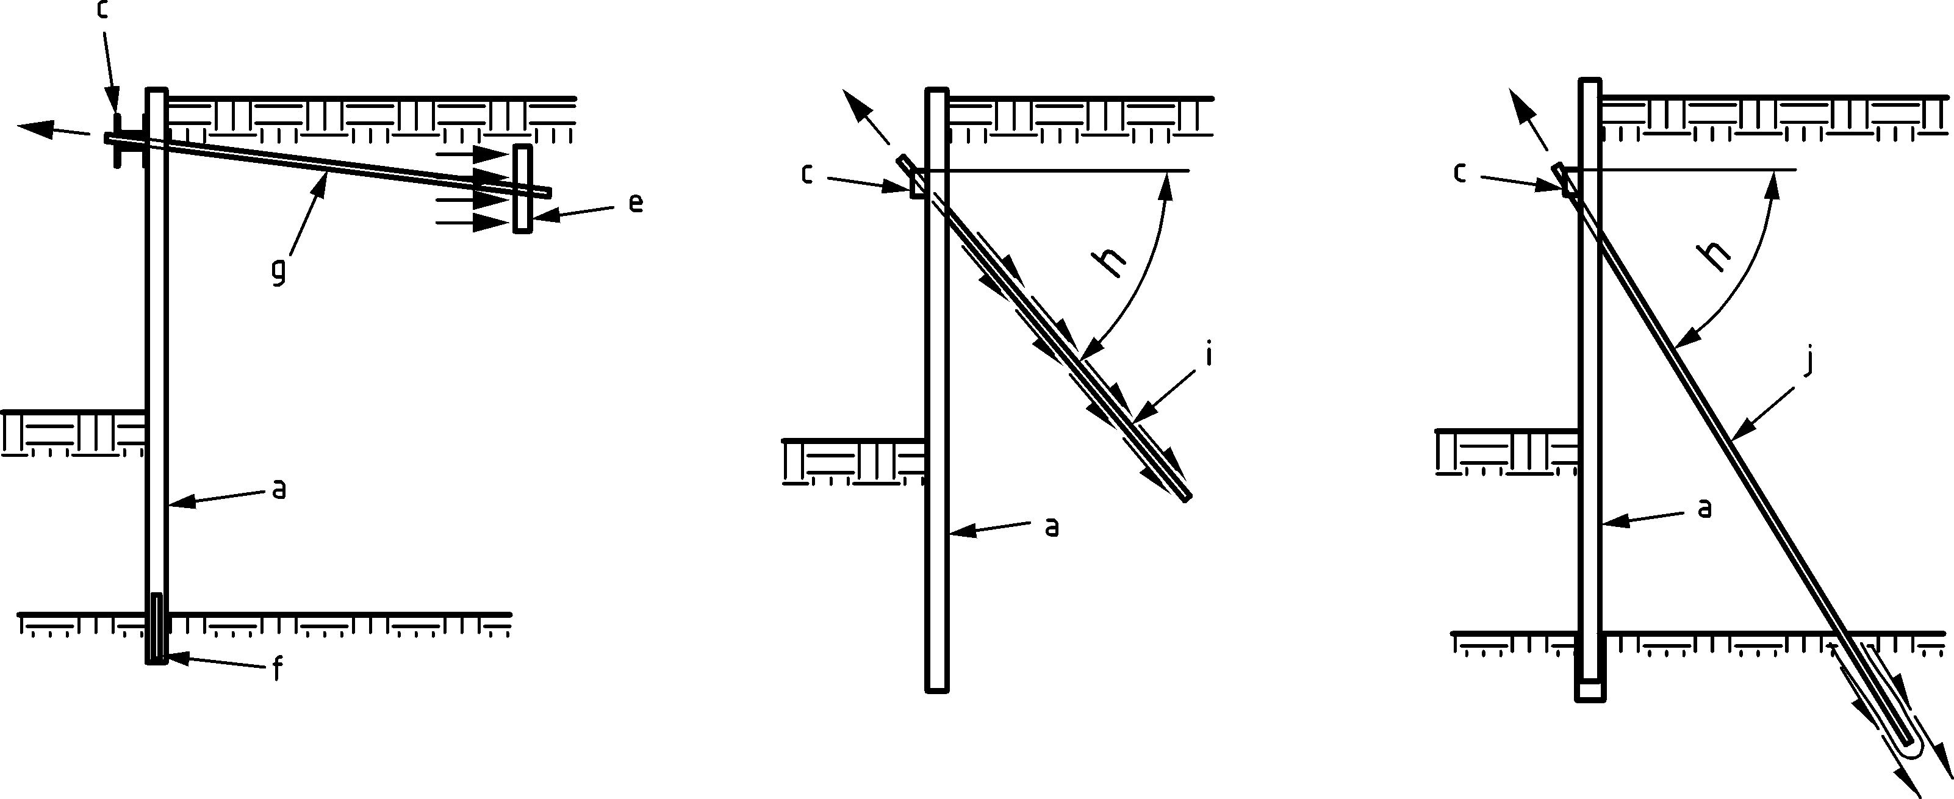

c) Anchored retaining wall

Key

|  |  |  |  |
| --- | --- | --- | --- |
| a | sheet pile wall | f | rock dowel (where required) |
| b | strut / prop | g | tie rod anchor |
| c | waling | h | variable angle |
| d | floor | i | tension pile |
| e | deadman (anchor or wall) | j | grouted anchor |

Figure 3.2 — Examples of retaining walls

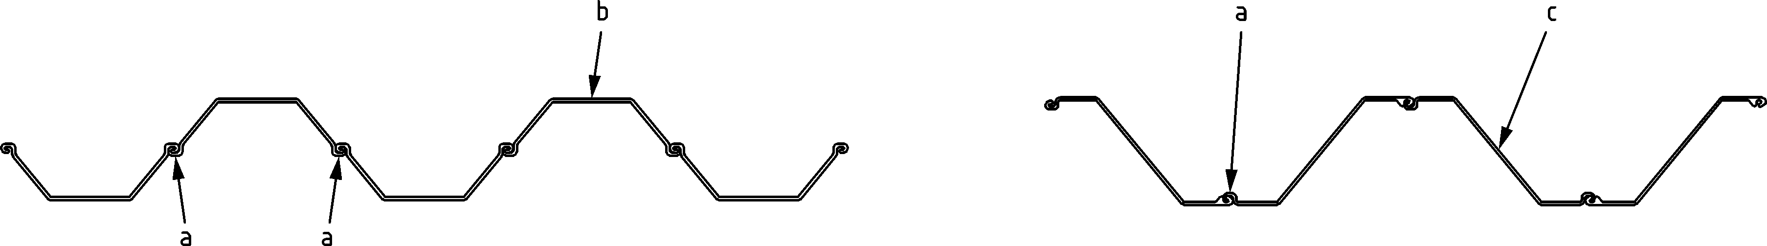

a) Sheet pile wall

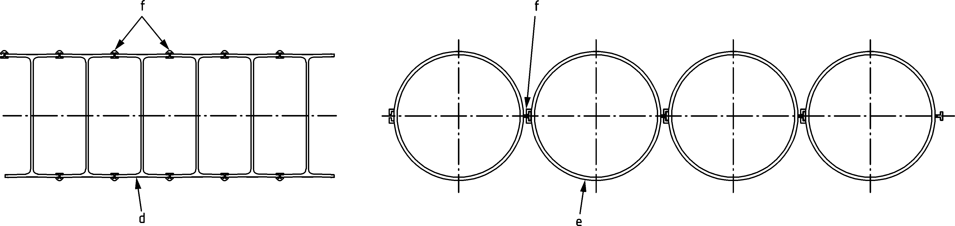

b) High modulus wall

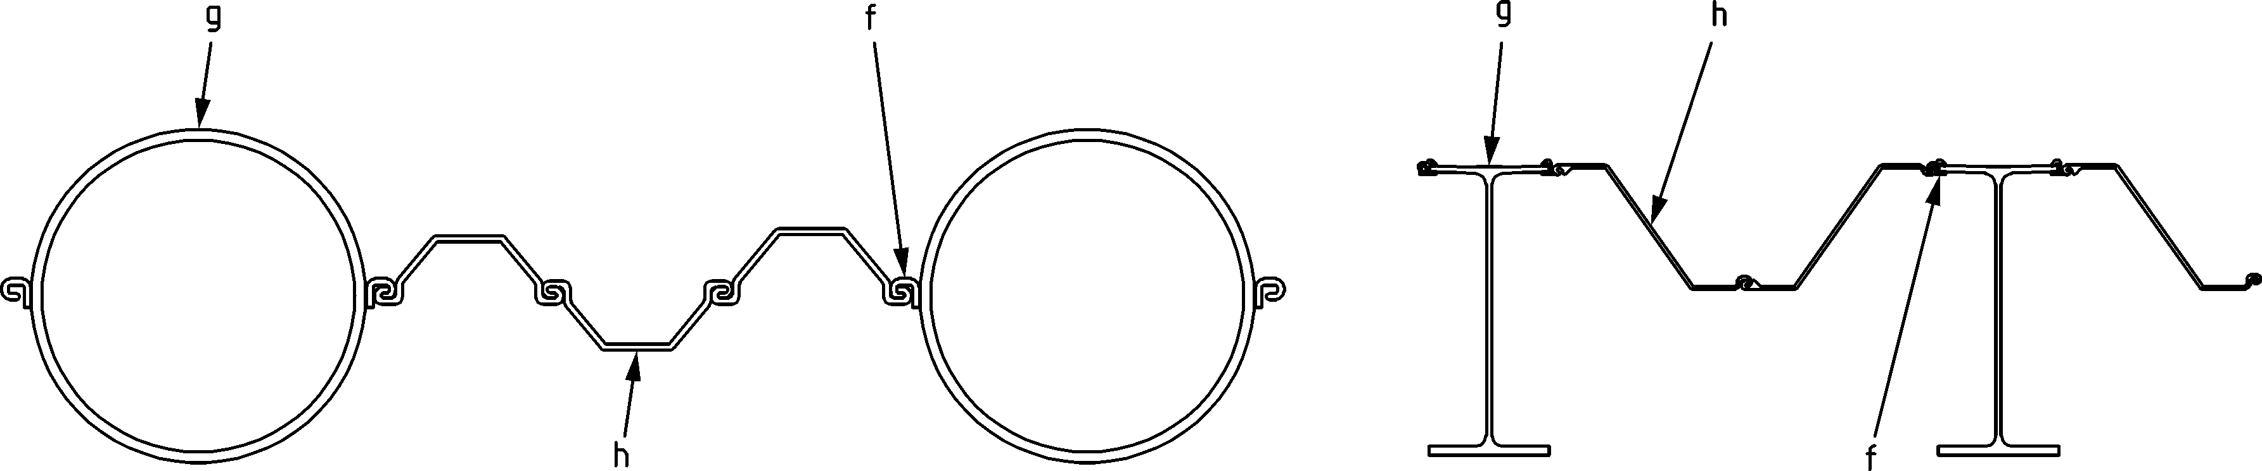

c) Combined wall

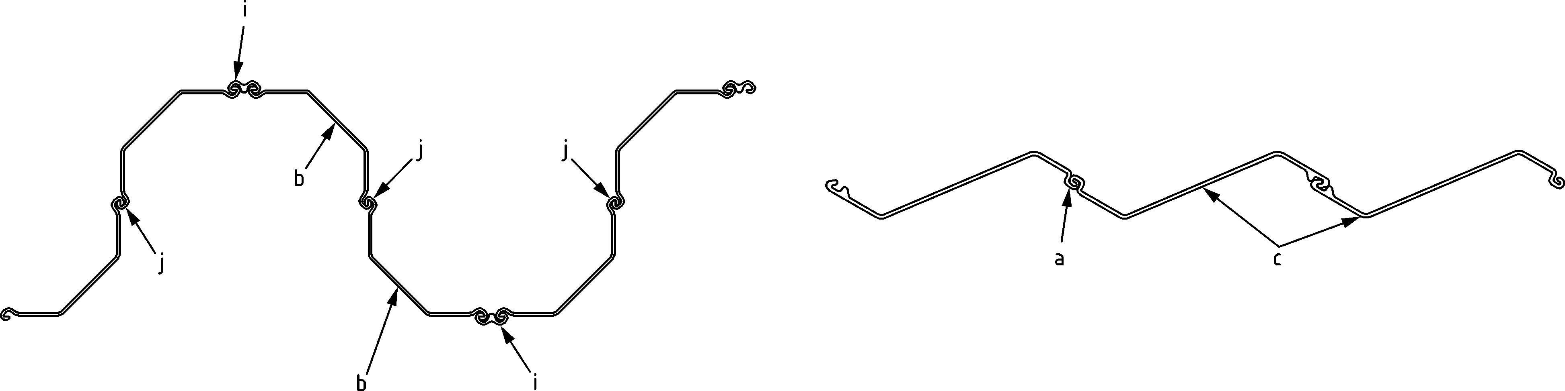

d) Jagged wall

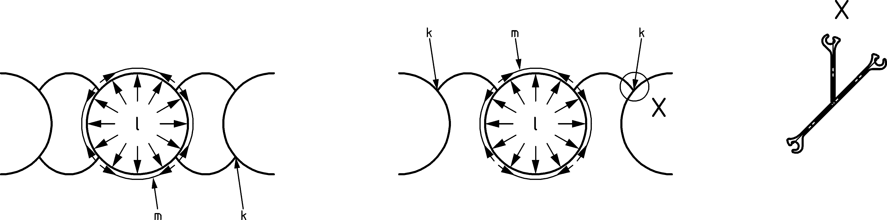

e) Circular cellular wall

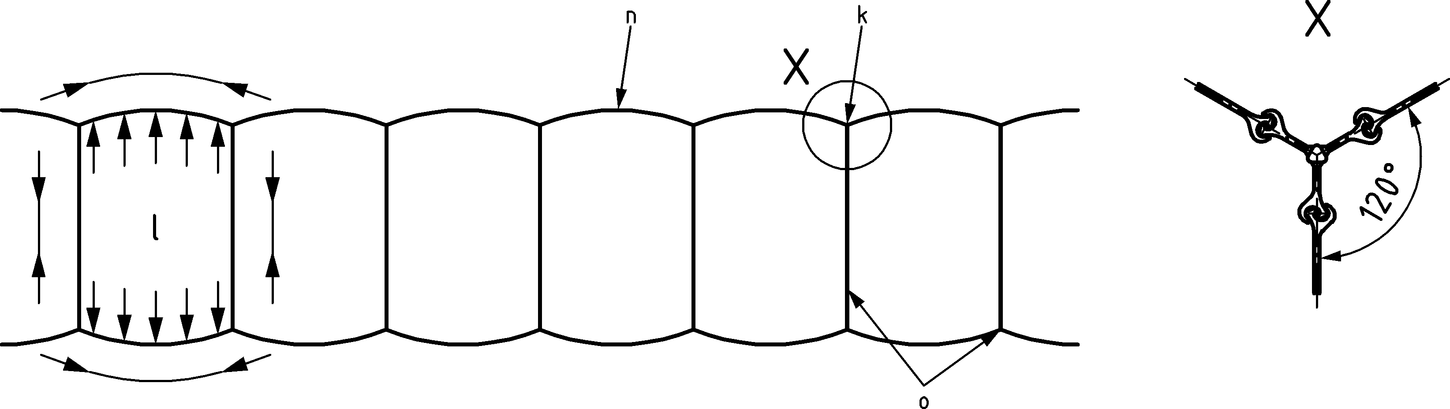

f) Diaphragm cell wall

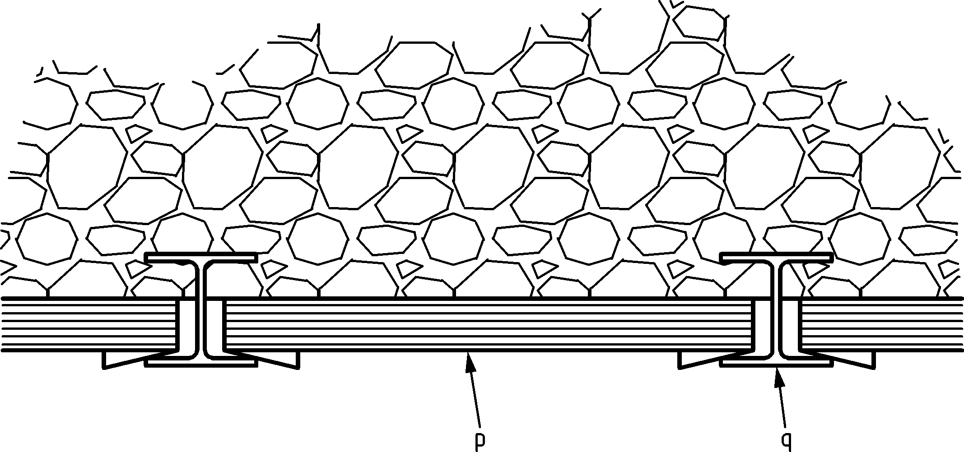

g) Soldier pile wall

Key

|  |  |  |  |  |  |
| --- | --- | --- | --- | --- | --- |
| a | interlock | g | primary elements | m | circumferential tensile force |
| b | U-pile | h | Secondary elements | n | arc |
| c | Z-pile | i | welded connector | o | diaphragm wall |
| d | H-pile | j | crimped interlock | p | lagging, boarding, planks, steel plates |
| e | tubular pile | k | junction pile | q | soldier-pile |
| f | connector | l | internal pressure |  |  |

Figure 3.3 — Examples of pile configurations for retaining walls

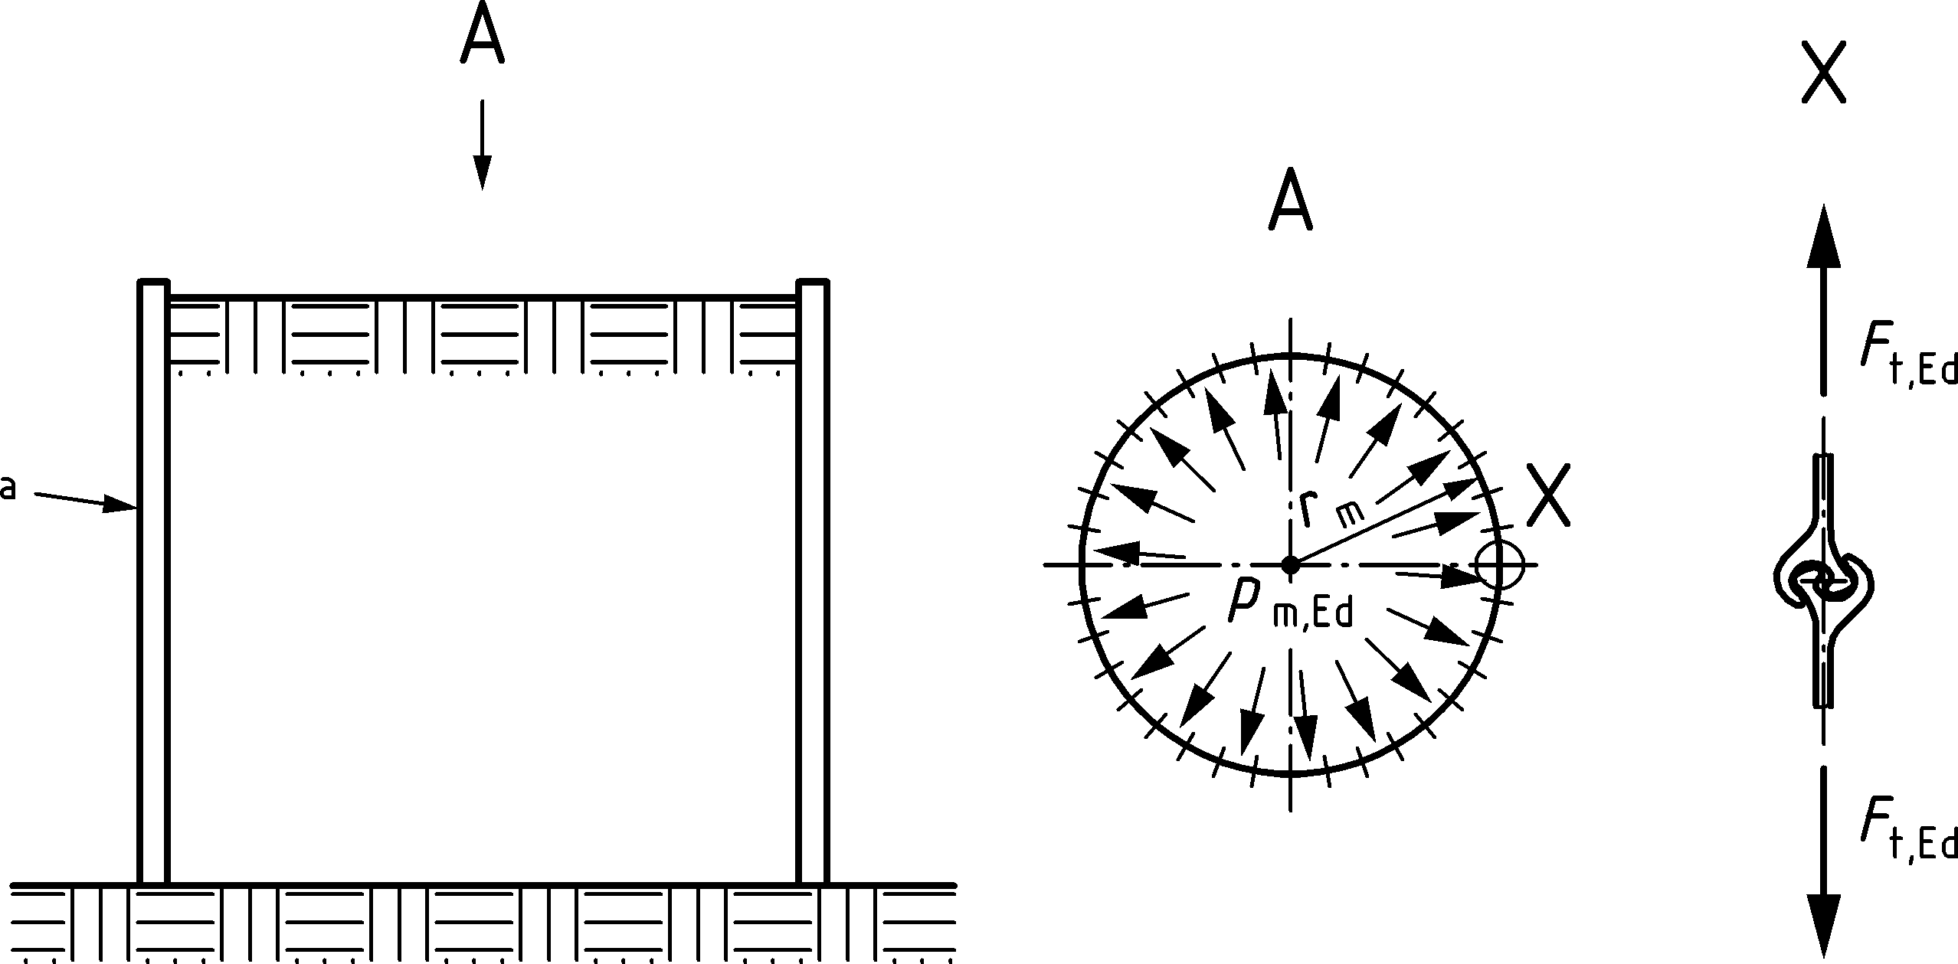

Key

|  |  |  |
| --- | --- | --- |
| a |  | straight web piles |

Figure 3.4 — Cellular structure

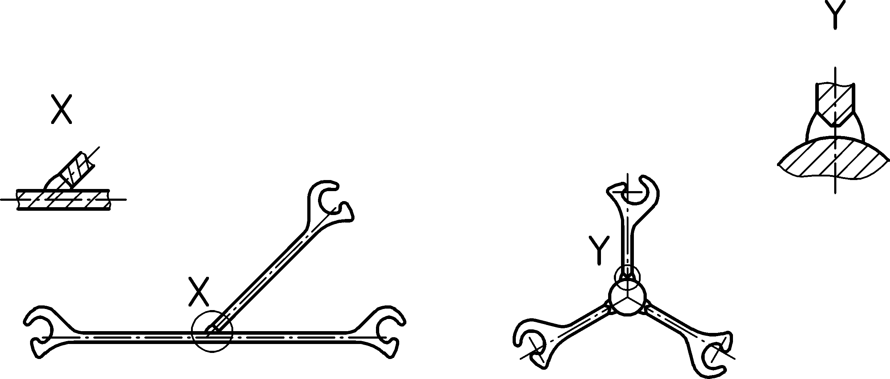

Figure 3.5 — Example junction piles

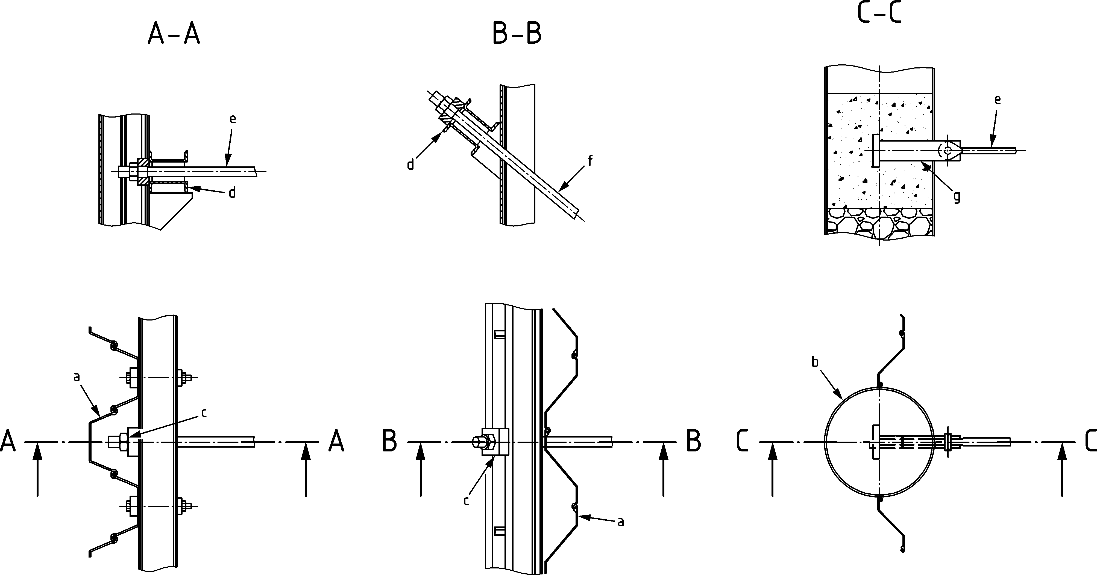

Key

|  |  |  |  |
| --- | --- | --- | --- |
| a | sheet pile | e | tie rod |
| b | tubular pile | f | grouted anchor or tension pile |
| c | bearing plate | g | tie rod connector |
| d | waling |  |  |

Figure 3.6 — Examples of anchor head connections

## Symbols

### General

(1) For the purposes of this document, the following symbols apply.

### Latin upper-case symbols

|  |  |
| --- | --- |
| *A* | cross-sectional area |
| *A*g | gross cross-sectional area of the tension element |
| *A*n | nominal metallic cross-sectional area of reinforcing steel |
| *A*s | tensile stress area of the tension element at the termination |
| *A*v | projected shear area, see Figure 8.1 |
| *B* | (effective) width of the pile, in contact with soil |
| *B*p,Rd | design punching shear resistance of the anchor head and the nut |
| *B*t,Rd | design tensile resistance of washer plate assembly |
| *C* | member curvature |
| *C*cr | critical curvature |
| *C*y | Curvature at the point of first yield |
| *C*ϴ | non-dimensional rotational flexibility |
| *D* | diameter or width of pile |
| *E* | modulus of elasticity |
| *F*cr | elastic critical buckling load for global instability mode based on initial elastic stiffness (see EN 1993‑1‑1) |
| *F*d | design force |
| *F*Q,Ed | additional horizontal force resulting from global buckling to be resisted by the toe of a sheet pile to allow for the assumption of a non-sway buckling mode |
| *F*t,Ed | design value of the circumferential tensile force in a cellular cofferdam |
| *F*SLS | axial force under characteristic loading |
| *F*ta,Ed | design tensile force in the arc cell of a cellular cofferdam |
| *F*tc,Ed | design tensile force in the common wall of a cellular cofferdam |
| *F*tm,Ed | design tensile force in the main cell of a cellular cofferdam |
| *F*ts,Rd | design tensile resistance of simple straight web steel sheet piles |
| *G* | shear modulus |
| *H*A | fictitious horizontal load applied at the level of the anchor or support structure |
| *I* | second moment of area |
| *I*T,eff | torsional moment of inertia of partially welded double H-section |
| *I*T,D | torsional moment of inertia of a continuously welded double H-section |
| *I*T,S | torsional moment of inertia of a single H-section |
| *J* | current density |
| *K*V(*T*) | impact energy |
| *K* | lateral rigidity of the anchor or support structure |
| *K*1 | parameter depending on category of cross-sections |
| *L* | length of the pile |
| *L*a | length of intermittent weld |
| *L*B | fraction of the distance between the toe and the horizontal support |
| *L*c | weak axis free length of a partially embedded H-pile above a weaker soil layer |
| *L*f | free length of a partially embedded pile |
| *L*f,z | weak axis free length of a partially embedded H-pile, i.e. pile support to top of coarse soil layer |
| $$L_{cr}^{}$$ | buckling length |
| *L*cr, LT | lateral torsional buckling length |
| *L*s | height of the system |
| *L*Mmax | length from the point of introduction of the external vertical load to the level of maximum design bending moment |
| *M*c,Rd | design moment resistance of the cross-section |
| *M*c,Rk | characteristic moment resistance of the cross-section |
| *M*Ed | design value of bending moment |
| *M*N,Rd | reduced design moment resistance allowing for the axial force |
| *M*pl,Rd | design value of design plastic bending moment resistance |
| *M*Rk | characteristic value of the bending moment resistance |
| *M*V,Rd | reduced design plastic moment resistance allowing for the shear force |
| $$M_{Ed}^{N=0}$$ | design bending moment assuming zero external vertical load and no sway imperfection |
| *N*cr | elastic critical load for the relevant buckling mode of the sheet pile wall |
| *N*cr,sw | elastic critical buckling load for sway mode |
| *N*Ed | design value of the compression force |
| *N*pl,Rd | design value of plastic compression resistance |
| *N*Rk | characteristic value of the compressive resistance |
| *P*p | proof load |
| *Q* | manufacturing tolerance class parameter |
| *R*c,Rd | design resistance of a sheet pile to a local transverse force |
| *R*e,Rd | elastic design resistance to the local transverse force |
| *R*GEO,d | design ultimate geotechnical resistance of an anchor or tension pile |
| *R*k | characteristic resistance of the crimped point determined by testing |
| *R*k,s | characteristic interlock resistance of straight web piles |
| *R*p,Rd | plastic design resistance to the local transverse force |
| *R*STR,d | design ultimate structural tensile resistance of an anchor or tension pile |
| *R*tg,d | design tensile resistance of the gross cross-section of the tension element shaft |
| *R*tt,d | design tensile resistance at the termination, or coupling, of the tension element |
| *R*tt,Md | design tensile resistance at the termination, or coupling, of the tension element allowing for any bending effects |
| *R*tw,Rd | design tensile resistance of the webs of a sheet pile to the introduction of a local transverse force |
| *R*ULS,d | design value of the geotechnical ultimate limit state resistance of an anchor or tension pile |
| *R*Vf,Rd | design shear resistance of the flange of a sheet pile to the introduction of a local transverse force |
| *R*w,Rd | design value of the in-plane resistance of the web |
| *R*w,Rk | characteristic in-plane resistance of the web |
| *S*n | nominal metallic cross-sectional area of prestressing steel |
| *T* | design service life |
| *T*27J | test temperature |
| *V*b,Rd | design value of the shear buckling resistance |
| *V*Ed | design value of shear force |
| *V*pl,Rd | design value of plastic shear resistance |
| *W*ep | elasto-plastic section modulus for semi-compact sections |
| *W*el | elastic section modulus determined about the wall axis, with full shear transfer |
| *W*pl | plastic section modulus determined about the wall axis, with full shear transfer |
| *X*n | nominal value of a basic variable |

### Latin lower-case symbols

|  |  |
| --- | --- |
| *a* | ovalisation of tube |
| *b*f | width of the flat portion of the flange |
| *b* | width of flange for a Z pile |
| *b*a | width of washer plate |
| *c* | width or depth of a part of a cross-section  For U, Z and Ω piles it is the slant height of the web of steel sheet piles |
| *c1* | rotational stiffness of connecting beam (at node 1) |
| *d* | outer diameter of a tube |
| *e* | eccentricity of the force introduced into the web |
| *f*0.2k | characteristic proof strength at 0,2 % strain for reinforcing steel |
| *f*b,v | shear buckling strength |
| *f*p0.1k | characteristic proof strength at 0,1 % strain for prestressing steel |
| *f*pk | characteristic tensile strength for prestressing steel |
| *f*tk | characteristic tensile strength for reinforcing steel |
| *f*u | ultimate tensile strength |
| *f*y | nominal values of the yield strength |
| *f*y,red | reduced yield strength |
| *f*yb | nominal yield strength of the basic steel used for cold forming |
| *h* | depth of a cross-section |
| *h*a | length of washer plate |
| *h*w | height of the web between flange midlines |
| *k* | lateral linear subgrade reaction of the soil to the bearing pile [N/m3] |
| *k*gr | lateral linear subgrade reaction of coarse granular soil to a bearing pile [N/m3] |
| *k*fi | lateral linear subgrade reaction of fine cohesive soil to a bearing pile [N/m3] |
| *k*1 | translational stiffness (at node 1) |
| *kB*0 | reference value of the lateral subgrade reaction multiplied with the pile width [N/m3] |
| *k*t | reduction factor for anchor tension elements in tension |
| *k*b | reduction factor for anchor tension elements in bending |
| *k*yy | interaction factor for flexural member buckling |
| *l* | length |
| *L*y | effective bearing length |
| *n* | ratio between load and critical buckling force |
| *m*x,Ed | transversal bending moment in interlock [Nm/m] |
| *p*m,Ed | design value of the internal pressure acting in the main cell of a cellular cofferdam |
| *q*y,Ed | horizontal force in interlock [N/m], in *y*-direction |
| *r* | midline radius of the corners between the webs and the flanges |
| *rt* | mid-line radius of the tube |
| *r’* | radius of the circular tube in ovalized state |
| *r*0 | outside radius of the corner between flange and web |
| *r*a | initial radius of the arc cell in a cellular cofferdam |
| *r*m | initial radius of the main cell in a cellular cofferdam |
| *s*s | length of stiff bearing |
| *t*f | nominal flange thickness of a steel sheet pile |
| *t*min | lesser of *t*f or *t*w for a Z pile |
| *tred* | reduced plate thickness |
| *t*w | nominal web thickness of a steel sheet pile |
| *t*w,*i* | varying web thicknesses |
| *v* | Poisson’s ratio |

### Greek symbols

|  |  |
| --- | --- |
| *α* | angle of inclination of the web |
| 𝛼e | buckling parameter in the elastic range |
| 𝛼T | coefficient of linear thermal elongation |
| 𝛼1 | stiffness factor of the lateral resistance of the embedded part of the pile, defined at surface level |
| *β* | ratio between the lateral linear subgrade reaction of the soil and flexural rigidity of the pile |
| *β* 0 | critical length coefficient for weak axis buckling, i.e. ratio between the critical length and the free length of a partially embedded pile |
| *β* 1 | critical length coefficient for weak axis buckling, for a partially embedded pile in uniform dense soil |
| *β* 2 | critical length coefficient for weak axis buckling, for a partially embedded pile in uniform soft soil |
| *β* 3 | critical length coefficient for weak axis buckling, for a fully embedded pile in uniform soft soil |
| *β*p | buckling parameter in the plastic range |
| *β*a | reduction factor accounting for effect of the decrease of the diameter |
| *β*D | factor accounting for the possible reduction of the bending stiffness of U-piles due to insufficient shear force transmission in the interlocks |
| *β*m | reduction factor accounting for transverse shell bending |
| *β*T | factor accounting for the behaviour of a welded junction pile at ultimate limit states |
| 𝛽B | factor accounting for the possible reduction of the section modulus of U-piles due to insufficient shear force transmission in the interlocks |
| *β*soil fill | reduction factor of transverse shell bending to account for soil fill |
| *β*ov | over-design factor of anchors, struts, walings and connections in the transient and persistent design situations |
| *βw* | degree of welding in zone of intermittent welding |
| *δ*high-low | offset of the weld shell parts of equal thickness |
| *δ*un | undulation of tube wall |
| *δ*y | imposed in-plane displacement on secondary piles caused by misalignment of primary piles |
| *δ*z | maximum relative deflection of a sheet pile wall occurring between the supports according to a first order analysis |
| *δ*A | horizontal displacement at the level of the anchor or support structure due to *H*A, relative to the bottom end of the member |
| *h* | differential water head [m] |
| *∆l* | additional pile length |
| *∆M*imp | additional bending moment due to sway imperfection |
| *t*d,mw | total loss of thickness due to corrosion caused by mechanical wearing during the design service life |
| *ε* | material parameter |
| *ε*mp | maximum plastic strain |
| FE | model factor covering the uncertainties of the numerical model and the executed analysis type |
| *γ*Mi | partial factor (generic symbol) |
| *γ*M0 | partial factor for resistance of cross-sections |
| *γ*M1 | partial factor for resistance of members to instability assessed by member checks |
| *γ*M2 | partial factor for resistance of cross-sections in tension to fracture |
| *γ*M3,ser | partial factor for resistance of connection cross-sections in tension at serviceability limit state |
| *γ*Mt,A | partial factor for resistance of reinforcing or prestressing steel in tension to fracture |
| *γ*s | partial factor for resistance of cross-sections in reinforcing or prestressing steel |
| *γ*t | partial factor for resistance of reinforcing or prestressing steel in tension to fracture |
| *η*sys | factor for differences in behaviour under test and service conditions |
| *λ* | non-dimensional slenderness factor |
| $$\bar{λ}$$ | web slenderness, shell slenderness |
| *ρ* | unit mass |
| *ρ*C | reduction factor |
| *ρ*P | factor accounting for the effects of differential water pressure on transverse local plate bending |
| *ϕ*Cd | design plastic rotation angle provided by the cross-section |
| *ϕ*Ed | maximum design rotation angle demand for the actual design case |
| *φ*k | design value of the internal friction angle of the fill material |
| *ϕ*y,Ed | rotation angle corresponding to the reduced plastic moment resistance *M*pl,Rd |
| *ϕ*rot,Ed | design angle at ultimate limit state |
| 𝜌 | reduction factor to determine reduced design values of the resistance to bending moments making allowance for the presence of shear forces |
|  | buckling coefficient |

## Convention for sheet pile axes

(1) For sheet piling the following Cartesian axis convention is used:

— generally

— x – x is the longitudinal axis of a pile;

— y – y is the principal cross-sectional axis parallel to the retaining wall;

— z – z is the other cross-sectional axis;

— where necessary

— u – u is the principal axis nearest to the plane of the retaining wall if this does not coincide with the y-y-axis;

— v – v is the other principal axis if this does not coincide with z-z.

See Figure 3.7.

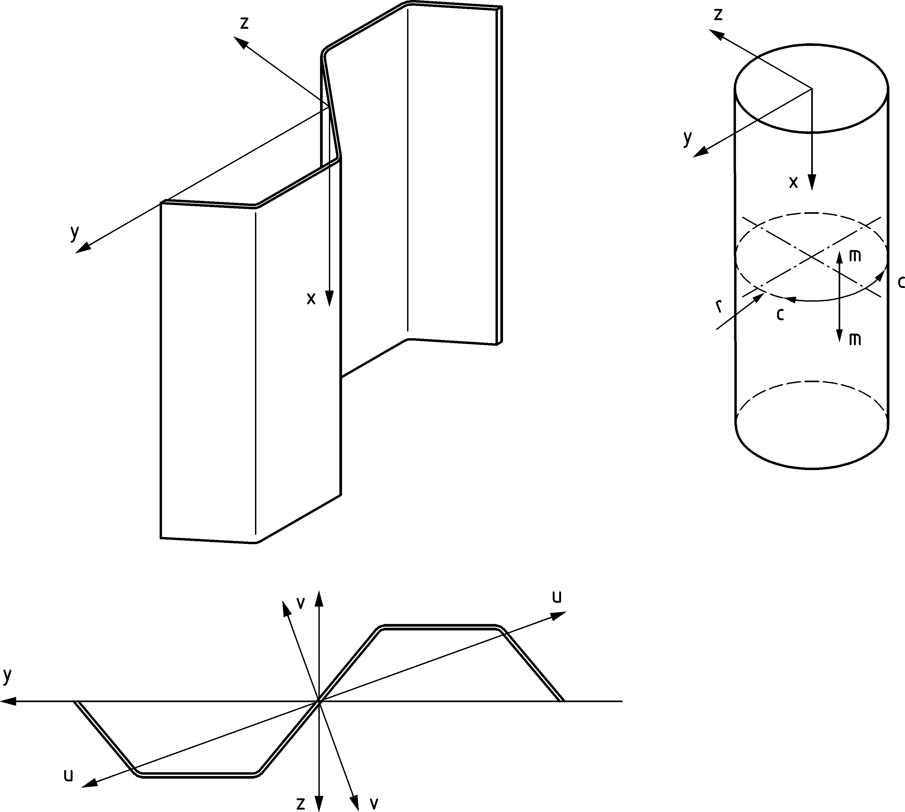

Key

|  |  |  |
| --- | --- | --- |
| m |  | meridional axis |
| c |  | circumferential axis |
| r |  | radial axis |

Figure 3.7 — Convention for sheet pile axes

# Basis of design

### Basic requirements

(1) The design of piling structures shall be in accordance with the general rules given in EN 1990 and EN 1991 (all parts) and the specific design provisions for steel structures given in EN 1993‑1 (all parts).

(2) Geotechnical actions and resistances shall be in accordance with EN 1997 (all parts).

(3) Piling structures designed according to this document shall be executed according to

— EN 12063 for sheet piling, combined pile walls, high modulus walls

— EN 12699 for displacement piles

— EN 14199 for micropiles

— EN 1090‑2 for walings, bracings, struts, connecting parts and structural steel parts of anchors and tension piles

— EN 1537 for grouted anchors

— EN 1536 for concreting of bearing piles

with construction materials and products used as specified in the relevant parts of EN 1993, or in the relevant material and product specifications.

NOTE The scope of EN 1090‑2 does not include steel sheet piles.

### Structural reliability and consequences of failure

(1) To obtain the reliability of the completed works required according to EN 1990, an appropriate execution class shall be selected in accordance with EN 1993‑1‑1:2022, Annex A for steel piles executed to EN 12063, EN 12699 and EN 14199 and for associated steel structures (waling, bracing, connections, etc.) executed to EN 1090‑2.

(2) The execution class of steel pile foundations under seismic loading should be chosen equal to the one of the building they support. The execution class of other steel piles and associated steel structures under seismic loading that have no ductility class according to EN 1998 (all parts) should follow the same execution class as if DC1.

NOTE See prEN 1998‑1‑1:2022, 4.4.2 for definition of ductility classes DC1, DC2 and DC3.

(3) If different levels of reliability are required, they should be achieved by an appropriate choice of quality management measures in design and execution according to EN 1990, and relevant execution codes mentioned in 4.1.1 (3).

(4) Consequence classes should be determined according to EN 1990 and prEN 1997 (all parts).

### Robustness

(1) To achieve the required level of robustness according to EN 1990 and prEN 1997‑3, retaining walls, walings, anchors, struts and connections should at least comply with clause (2), (3) and (4). Additional measures and strategies of design should be taken in accordance with prEN 1997‑1 where needed.

(2) Retaining walls, walings, anchors, struts and connections should be designed against progressive collapse to achieve the required level of robustness according to EN 1990 and prEN 1997‑3 either by

— designing for a failing structural element, e.g. a failing anchor or strut in the accidental design situation (method 1) or by

— over-designing of anchors, struts, walings and connections with a factor *β*ov in the transient and persistent design situations (method 2).

NOTE 1 The choice of method can be given in the National Annex. The value of *β*ov = 1,25 for anchors and connections, unless the National Annex specifies a different value.

NOTE 2 Robustness can be achieved in different ways. Prevention of accidental situations is an important consideration.

NOTE 3 Designing the walings as continuous in tension and/or bending can enhance the resistance in case of a failing anchor or strut.

(3) In cases with risk of (ship or vehicle) impacts detailing for anchor heads should provide adequate protection. Protrusion of anchor heads should be avoided.

(4) The design of the pile structure shall be checked and modified (if necessary) to account for any significant variations encountered during installation.

### Design service life

(1) The required design service life of a piling structure should be specified according to EN 1990. According to the specific needs the required design service life may be specified by the relevant authority or, where not specified, as agreed for a specific project by the relevant parties.

NOTE Guidance on the design service life of specific geotechnical structures is given in prEN 1997‑3.

### Durability

(1) Depending upon the type of action affecting the design service life (see EN 1990), piling structures shall be:

— designed for the effects of corrosion (see Clause 6)

— designed for driveability (see 4.5)

— designed for accidental actions (see prEN 1991‑1‑7)

— designed for the effects of fatigue where relevant (see prEN 1993‑1‑9)

— inspected and maintained.

(2) The durability requirements stated in this document shall be followed, see Clause 6.

### Sustainability

(1) Piling structures should be designed for sustainability according to EN 1990.

## Principles of limit state design

### Design situations

(1) All design situations, including each stage of execution and use, shall be taken into account.

NOTE For the selection of design situations, see EN 1990.

### Ultimate limit state criteria

(1) The following ultimate limit state criteria shall be taken into account:

— failure of the system or component of the system, by exceedance of the resistance of the ground, or by other geotechnical failure mechanisms, see prEN 1997‑3;

— structural failure of any component of the system and/or connections of the components;

— combination of failure in the ground and structural failure.

(2) Verifications related to ultimate limit state criteria should be carried out in accordance with prEN 1997‑1 and prEN 1997‑3.

(3) Depending on the design situation the resistance to one or more of the following modes of structural failure should be verified:

— for bearing piles:

— failure due to bending and/or axial force;

— failure due to overall flexural buckling, taking account of the restraint provided by the ground and by the supported structure at the connections to it;

— local failure at points of load application;

— fatigue.

— for retaining walls, walings, bracings and struts:

— failure due to bending and/or axial force;

— failure due to overall flexural buckling, taking account of the restraint provided by the ground;

— local buckling due to overall bending;

— local failure at points of load application (e.g. web crippling);

— fatigue.

— for anchors and tension piles:

— structural failure caused by the applied force;

— structural failure caused by loads arising from prestressing or proof loading during testing;

— structural failure caused by deformation of surrounding ground during the life of the structure, such as settlements;

— fatigue.

(4) For the verification of ultimate limit states, the effects of actions on the walings and bracing should be determined for all relevant design situations.

### Serviceability limit state criteria

(1) Unless otherwise specified, the following serviceability limit state criteria should be taken into account:

— for bearing piles:

— limits to vertical settlements or horizontal displacements necessary to suit the supported structure;

— vibration limits necessary to suit structures directly connected to, or adjacent to, the bearing piles.

— for retaining walls, walings, bracings and struts:

— deformation limits necessary to suit the serviceability of the retaining wall itself;

— limits to horizontal displacements, vertical settlements or vibrations, necessary to suit structures directly connected to, or adjacent to, the retaining wall itself.

— for anchors and tension piles:

— deformation limits necessary to suit the serviceability of the retaining wall.

(2) Values for the limits given in (1), in relation to the combination of actions to be taken into account according to EN 1990, should be specified.

(3) Where relevant, values for limits imposed by adjacent structures should be specified.

NOTE 1 Guidance for determining such limits is given in prEN 1997‑1, prEN 1997‑3 and EN 1990.

NOTE 2 Serviceability criteria can be the governing criteria for the design.

## Basic variables

### Actions and environmental influences

(1) Parameters for ground and/or backfill shall be determined from geotechnical investigation in accordance with prEN 1997‑2.

(2) Where relevant, actions should be taken from EN 1991, otherwise they should be specified by the relevant authority or, where not specified, as agreed for a specific project by the relevant parties.

(3) In the case of piled foundations, actions due to vertical or transverse ground movements (e.g. down-drag, passive loading due to horizontal movement, etc.) should be assessed in accordance with prEN 1997‑1 and prEN 1997‑3.

(4) The actions transmitted to the structure through the ground should be assessed by using models selected in accordance with prEN 1997‑1 or should be taken as specified by the relevant authority or, where not specified, as agreed for a specific project by the relevant parties.

(5) Where necessary, the effects of actions resulting from variations in temperature with time, should be taken into account. The design may prescribe measures to reduce the influence of temperature variations.

NOTE Examples for which temperature effects are likely are struts and bracings.

(6) Where necessary, the effects of actions resulting from special loads not specified in EN 1991 (all parts), should be taken into account.

NOTE 1 Examples of special loads are:

— loads due to falling objects or swinging buckets;

— loads from excavators and cranes;

— imposed loads such as pumps, access ways, intermediate struts, staging for materials or stacking of bundles of steel reinforcement.

(7) Unless otherwise specified, for retaining walls subject to loads from a road or a railway track, simplified models for such loads (for example uniformly distributed loads) derived from those defined for bridges may be used, see prEN 1991‑2 and prEN 1997‑1:2022, Annex F.

(8) Where applicable, seismic actions should be considered in accordance with EN 1998 (all parts).

### Material and product properties and geometrical data

(1) The material properties for steels and other construction products and the geometrical data to be used for design should be those specified in the relevant EN and EN ISO product standards, or according to a transparent and reproducible assessment that complies with all the requirements of a European Assessment Document (EAD) or European Technical Approval (ETA) specific to piling applications, unless otherwise indicated in Clause 5 of this document.

## Verification by the partial factor method

### Design values of actions

(1) For the design of piled foundations and sheet pile walls, combination of actions and partial factors of actions shall be derived from EN 1990: 2023, Annex A or EN 1997 where applicable.

### Design values of material properties

(1) For the design of steel structures, nominal values *X*n of material properties shall be used as indicated in Clause 5.

### Design values of geometrical properties

(1) Except where the design is sensitive to the effects of variations, assessment of the effects of actions in piled foundations and in sheet pile walls may be carried out based on nominal values of geometrical properties.

### Construction tolerances

(1) For sheet pile walls the construction tolerances for position and verticality of sheet piles should be as specified in EN 12063.

(2) In order for the piling to develop its nominal resistance and stiffness properties, the wall alignment should be in accordance with EN 12063.

(3) The construction tolerances of bearing piles and micropiles should be as specified in EN 12699 and EN 14199 respectively.

### Imperfections

(1) Root gap imperfections shall be taken into account in the verification of welds according to prEN 1993‑1‑8 if quality level D welds are considered in accordance with EN 12063.

NOTE Welding imperfections are described in ISO 5817

## Driveability

(1) In the design of all piles (bearing piles or sheet piles), the practical aspects of installing the piles to the required penetration depth shall be taken into account. Reference shall be made to EN 12063, EN 12699 and EN 14199.

(2) The type, size and detailing of the piles should be chosen, in combination with the effectiveness of the piling plant used for installation and extraction, and the driving procedure (driving parameters), to be suitable for the ground conditions through which the piles must be driven.

(3) If pile points, stiffeners or friction reducers are used as an aid to driving or to strengthen the piles during installation, their effects on the performance of the piles under service conditions should be taken into account.

## Design assisted by finite element analysis

### General

(1) Finite element analysis for critical buckling, ultimate limit state, serviceability limit state or fatigue verification should be carried out according to the rules given in prEN 1993‑1‑14.

(2) The evaluation of the numerical simulation results should be made according to prEN 1993‑1‑14.

NOTE The recommended value of the maximum acceptable plastic strain is εmp = 5 %, unless otherwise specified by the National Annex.

(3) Plastic strains greater than the recommended value may be used for tension members if tests of a specific construction detail and steel grade have proven that they can be achieved.

NOTE Different limits of plastic strains can apply in longitudinal and in transverse direction due to rolling effects.

(4) The provisions of prEN 1993‑1‑14 for numerical simulations used to supplement testing apply.

(5) When needed, modelling of the ground or ground-structure interaction should be carried out in accordance with prEN 1997‑1 and prEN 1997‑3 in addition to prEN 1993‑1‑14.

### Secondary elements

(1) The evaluation of the numerical simulation results for verification of secondary elements in accordance with 8.7.2 (2) should be made according to prEN 1993‑1‑14. 60 % of the elongation at failure according to EN 10248 may be used as maximum acceptable plastic strain for elements in tension.

(2) To avoid safety by-pass, an appropriate value of γFE should be used in combination with γM2.

NOTE 1 For finite element models using shell or solid elements, the recommended value of γFE is 1,2, unless the National Annex gives a different value.

NOTE 2 For finite element models using beam elements, the recommended value of γFE is the maximum of γFE determined according to prEN 1993‑1‑14:2023, Annex A and 1,2, unless the National Annex gives a different value.

## Design assisted by testing

(1) The general provisions for design assisted by testing of structural elements given in EN 1990 should be satisfied unless more specific provisions are given in prEN 1993‑5.

NOTE 1 Guidance on the determination of structural design resistance from tests is given in of EN 1990:2023, Annex D.

NOTE 2 The geotechnical design of bearing piles and tension piles can be performed by calculation based on geotechnical investigation and / or tests. Further guidance can be found in prEN 1997‑3.

NOTE 3 The geotechnical design of an anchor depends on the type of anchor used, e.g. grouted anchors are based on *in situ* testing. Further guidance can be found in prEN 1997‑3.

(2) Testing of class 4 sheet piles shall be in accordance with Annex B.

(3) Design assisted by testing may be used in following cases

— Classification of piles, see 7.4

— Verification of effects of eccentric anchors, see 8.3.6

— Verification of secondary elements, see 8.7.2, connectors, see 8.7.3 and overall resistance of primary elements, see 8.7.4.1

— Verification of junction piles, see 8.10.2

— Verification of terminations and connections, see 8.11.1

— Verification of joints between pile elements, see 8.13

(4) Testing may be supplemented by numerical simulations in accordance with 4.6.

## Verification by observational method

(1) The assumptions made in the design of piling, anchors, walings, struts and connections may be verified by the observational method according to prEN 1997‑1 (for instance in the case of an excavation procedure).

(2) Calibration of a calculation model and modification of the design during execution shall be in accordance with prEN 1997‑1.

## Fatigue

(1) Where a structure or a part of it is sensitive to fatigue phenomena, the fatigue verification should be carried out in accordance with prEN 1993‑1‑9.

NOTE The fatigue resistance is significantly influenced by corrosion and a suitable corrosion protection can be applied.

(2) The effects of impact or vibration during installation of bearing piles or sheet piles may be neglected in fatigue analysis.

# Materials

## General

(1) This document shall be used for the design of piles and retaining walls fabricated from steel conforming with the standards referred to in 5.2 to 5.5.

(2) This document may also be used for other steels, provided that adequate data exist to justify application of the relevant design and fabrication rules. Test procedures and test evaluation should conform with EN 1990:2023, Annex D and the test requirements should align with those given in the relevant standards mentioned in 5.2 to 5.5.

(3) Re-used and repurposed steel used as steel piles shall as a minimum comply with the requirements concerning geometrical and material properties specified in the design and shall be free from damage and deleterious matters that would affect strength and durability.

(4) Stainless steels may be used in accordance with prEN 1993‑1‑4 and (2) above.

## Material properties for steel piles

### Strength of bearing piles

(1) Material properties of bearing piles fabricated from structural steel to EN 10025, EN 10210‑1, EN 10210‑2, EN 10219‑1 and EN 10219‑2 shall conform with EN 1993‑1‑1.

(2) For the properties of bearing piles fabricated from steel sheet piles see 5.2.2 to 5.2.4.

### Strength of hot rolled sheet piles

(1) Hot rolled steel sheet piles shall be in accordance with EN 10248 (all parts).

(2) Nominal values of the yield strength *fy* and the ultimate tensile strength *fu* for hot rolled steel sheet piles may be obtained from Table 5.1, which are the minimum values given in EN 10248‑1.

NOTE The steel grades listed in Table 5.1 are accepted as satisfying these requirements.

Table 5.1 — Nominal values of yield strength *f*y and ultimate tensile strength *f*u for hot rolled steel sheet piles according to EN 10248‑1

| **Steel name to**  EN 10027 | *f*y  N/mm2 | *f*u  N/mm2 |
| --- | --- | --- |
| S240 GP  S270 GP  S320 GP  S355 GP  S390 GP  S430 GP  S460 GP a | 240  270  320  355  390  430  460 | 340  410  440  480  490  510  530 |
| a S460 GP is not a grade included in EN 10248‑1:1995 but is included in prEN 10248‑1:2023. | | |

### Strength of cold formed sheet piles

(1) Cold formed steel sheet piles shall be in accordance with EN 10249 (all parts).

(2) Nominal values for the basic yield strength *f*yb and the ultimate tensile strength *f*u for cold formed steel sheet piles may be obtained from Table 5.2 which is in accordance with EN 10249‑1.

NOTE The basic yield strength *f*yb is the nominal yield strength of the basic steel used for cold forming.

Table 5.2 — Nominal values of basic yield strength *f*yb and ultimate tensile strength *f*u for cold formed steel sheet piles according to EN 10249‑1

|  |  |  |
| --- | --- | --- |
| **Steel name to**  EN 10027 | *f*yb  N/mm2 | *f*u  N/mm2 |
| S235 JRC  S275 JRC  S355 JOC | 235  275  355 | 340  410  490 |

### Strength of steel members used for combined walls

(1) Steel properties of special H-section piles used as the primary elements of combined walls shall be in accordance with EN 10248‑1. See Table 5.1 of this document.

(2) Tubes used as the primary elements in combined walls shall conform with EN 10210 (all parts) or EN 10219 (all parts).

(3) Steel properties of box piles used as the primary elements of combined walls shall satisfy the requirements given in 5.2.2.

(4) Steel properties of the secondary elements used for combined walls shall satisfy the requirements given in 5.2.2 or 5.2.3 respectively.

### Ductility of steel piles

(1) The provisions on ductility given in EN 1993‑1‑1 apply to all steel piles unless different requirements are given below.

(2) Secondary sheet piles shall comply to the ductility requirements for plastic global analysis even if elastic analysis is performed.

(3) Steels conforming to any of the grades listed in Tables 5.1 and 5.2 may be assumed to satisfy the minimum ductility requirements for elastic and plastic global analysis.

### Fracture toughness of steel piles

(1) The material shall have sufficient toughness to avoid brittle fracture at the lowest service temperature expected to occur within the design service life of the structure.

NOTE The lowest service temperature can be given in the National Annex.

(2) For sheet piles with a flange thickness not more than 40 mm, steels with values of *T*27J according to Table 5.3 may be used, provided that the lowest service temperature is not lower than −30°C.

NOTE The *T*27J value is the test temperature at which an impact energy *K*V(*T*) > 27 Joule is required to fracture a Charpy-V-notch specimen. For the test see EN 10045.

(3) For cases other than those covered in prEN 1993‑1‑10:2023, Table 5.3 shall be used.

(4) Where there are holes (e.g. for anchors) in a flange stressed in tension, the reduction of the cross-sectional resistance should be taken into account by using a reduced yield strength or an effective cross-sectional area.

Table 5.3 — Test temperature *T*27J for fracture toughness of hot rolled steel piles according to EN 10248‑1

|  |  |  |  |  |  |  |  |  |  |
| --- | --- | --- | --- | --- | --- | --- | --- | --- | --- |
|  | | Flange thickness [mm] | **Yield strength** *f*y  N/mm2 | | | | | | |
| 240 | 270 | 320 | 355 | 390 | 430 | 460 |
| Values of *T*27J | for lowest service temperature of  −15°C | ≤ 25 | 35° | 35° | 35° | 15° | 15° | 15° | 15° |
| ≤ 30 | 30° | 30° | 30° | 10° | 10° | 10° | 10° |
| ≤ 40 | 20° | 20° | 20° | 0° | 0° | 0° | 0° |
| for lowest service temperature of  −30°C | ≤ 25 | 20° | 20° | 20° | 0° | 0° | 0° | 0° |
| ≤ 30 | 10° | 10° | 10° | −10° | −10° | −10° | −10° |
| ≤ 40 | 5° | 5° | 5° | −15° | −15° | −15° | −15° |
| NOTE 1 These values have been calculated for a lowest service temperature of −15°C respectively −30°C and a flange thickness of not more than 40 mm without taking into account fatigue effects.  NOTE 2 Higher toughness requirements can be necessary if driving of the piles is foreseen in hard ground at temperatures below −10 °C. | | | | | | | | | |

## Interlocks and connecting devices

(1) Hot Rolled sheet pile interlock types and their minimum interlocking interference shall comply with EN 10248‑2.

(2) The characteristic resistance of the straight web sheet pile interlock *R*k,s depends upon the cross-section of the interlock and the steel grade adopted. The characteristic interlock resistance *R*k,s shall be determined by testing in accordance with EN 10248‑1.

(3) The characteristic resistance of the crimped point *R*k of U-piles depends upon the cross-section and the steel grade adopted. The characteristic resistance of the crimped point *R*k shall be determined by testing in accordance with EN 10248‑1.

NOTE Testing procedures for interlock resistance of straight web piles and resistance of crimping points included in EN 10248‑1.

(4) Hot rolled connectors for piles shall be in accordance with EN 10248‑1.

(5) For other connecting devices (e.g. bolts and welding consumables) the provisions given in prEN 1993‑1‑8 should apply.

## Material properties for steel elements used for anchors and tension piles

### General

(1) The selection of steel shall be appropriate for the installation conditions and execution considering the environmental conditions and effects of corrosion – see Clause 6.

(2) Material properties of steel elements shall conform with EN 1993‑1‑1unless noted otherwise below.

(3) Material properties of reinforcing steels and prestressing steels shall conform with prEN 1992‑1‑1.

(4) Reinforcing steel used as tension elements in grouted piles (e.g. micropiles) shall conform to prEN 1992‑1‑1.

(5) For properties of steel tension elements used in anchors see 5.4.2.

### Anchor tension elements

(1) Steel grades from the following product standards may be used as tension elements provided the requirements of this standard are met,

— EN 10025 (all parts), *Hot-rolled products of structural steel*;

— EN 10080, *Steel for the reinforcement of concrete*;

— EN 10210‑1, *Hot finished structural hollow sections of non-alloy and fine grain steels*;

— EN 10219‑1, *Cold formed welded structural hollow sections of non-alloy and fine grain steels*

NOTE 1 Manufacturers of anchors can be consulted for properties of steel elements that comply with this standard.

NOTE 2 Not all grades in EN 10080 are suitable or commercially available. Typical reinforcing steel grades used as tension elements that comply with this standard are given in Annex F (informative).

(2) Pre-stressing strand or bar may be used as tension elements and shall comply with the relevant standards for prestressing steel.

NOTE 1 The National Annex can specify relevant standards for prestressing steel.

NOTE 2 The harmonized product standard prEN 10138 for prestressing steels is currently under development

NOTE 3 Not all grades in prEN 10138 are suitable or commercially available. Typical prestressing steel grades used as tension elements that comply with this standard are given in Annex F (informative).

(3) Prestressed grouted anchors, including tendon anchorage assemblies and tendon coupler assemblies, suitable for design of anchors in accordance with this Eurocode should have a suitable European technical product specification for use in geotechnical structures.

### Ductility of anchors and tension piles

(1) The provisions on ductility of EN 1993‑1‑1 shall apply to all elements unless noted otherwise below.

NOTE Reinforcing steel meeting the requirements of Class B according to prEN 1992‑1‑1:2021, Table 5.5 can be considered to meet this requirement.

(2) For prestressed applications the ductility requirements of tension elements shall comply with the relevant standards for prestressing steel.

## Material properties for steel members used for bracing

(1) Steel used for bracing shall conform to EN 1993‑1‑1.

# Durability

## General

(1) Dependent upon the aggressiveness of the media surrounding the steel member, measures against corrosion effects shall be taken into account if substantial losses of steel thickness are to be expected.

(2) The loss of thickness due to corrosion may be neglected for a required design service life of less than 4 years for retaining walls and bearing piles and less than 2 years for anchors and tension piles, unless a different period is specified by the relevant authority or, where not specified, is agreed for a specific project by the relevant parties.

(3) Corrosion protection systems should be specified.

(4) The design service life should be met by consideration of one or more of the following measures:

— the use of additional steel thickness as a corrosion allowance in accordance with 6.2, 6.3 and 6.4;

— the use of protective coatings (usually paints, grouting or galvanizing for piles and grouting or covering in a protective sheath(s) for anchors);

— the use of cathodic protection, with or without protective coatings;

— providing a concrete, mortar or grout protection;

— detailing to avoid exposure to severe corrosion;

— the use of low corrosion steel grades.

(5) A combination of different protective measures may be applied to obtain the required design service life.

NOTE The whole protective system can be defined taking into account the design of the structure and of the protective coating as well as the feasibility of inspection and maintenance.

(6) If the required design service life is longer than the duration of the protective effect of a coating, the loss of thickness occurring during the remaining design service life should be taken into account in serviceability limit state and ultimate limit state verifications.

(7) Values in Table 6.1 and 6.2 may also be applied to low corrosion steel grades and stainless steel in soil and water unless more specific values are available. Selection of an appropriate stainless steel grade for application in marine atmosphere should be made according to prEN 1993‑1‑4. Provisions about bimetallic corrosion in prEN 1993‑1‑4:2023, Annex A apply if necessary.

(8) The possibility that corrosion may not be uniform over the whole length of a pile may be considered, allowing an economic design to be achieved by selection of a moment distribution adapted to the corrosion distribution, see Figure 6.1.

|  |  |  |
| --- | --- | --- |
|  |  |  |
| **a) Vertical zoning of sea water aggressivity** | **b) Corrosion rate distribution at side exposed to sea water** | **c) Typical bending moment distribution** |

Key

|  |  |
| --- | --- |
| A | Zone of high attack (Splash zone) |
| B | Intertidal zone |
| C | Zone of high attack (Low water zone) |
| D | Permanent immersion zone |
| E | Buried zone (Water side) |
| F | Anchor |
| G | Buried zone (Soil side) |
| MHW | Mean high water |
| MLW | Mean low water |

NOTE Corrosion rate distribution and zones of sea water aggressivity can vary considerably from the example shown in Figure 6.1, dependent upon the conditions prevailing at the location of the structure.

Figure 6.1 — Example of corrosion rate distribution

## Durability requirements for piling

(1) Unless otherwise specified, the strength verification of individual piles for both serviceability and ultimate limit state should be carried out considering a uniform loss of steel thickness around the complete perimeter of the cross-section. For piled walls the corrosion rates apply to each side.

(2) Unless otherwise specified, for serviceability and ultimate limit states the reduction of thickness due to corrosion of individual piles, piled walls, and other structural elements in contact with water or with soil (with or without groundwater) should be taken from 6.4, dependent upon the required design service life of the structure.

(3) If the aggressiveness of the soil or water is different on opposite sides of a piled wall, two different corrosion rates may be applied.

(4) If two different corrosion rates are applied on opposite sides for primary elements, then their effect on the geometry should be considered.

NOTE Different corrosion rates can lead to asymmetric profiles, see Figure 6.2.

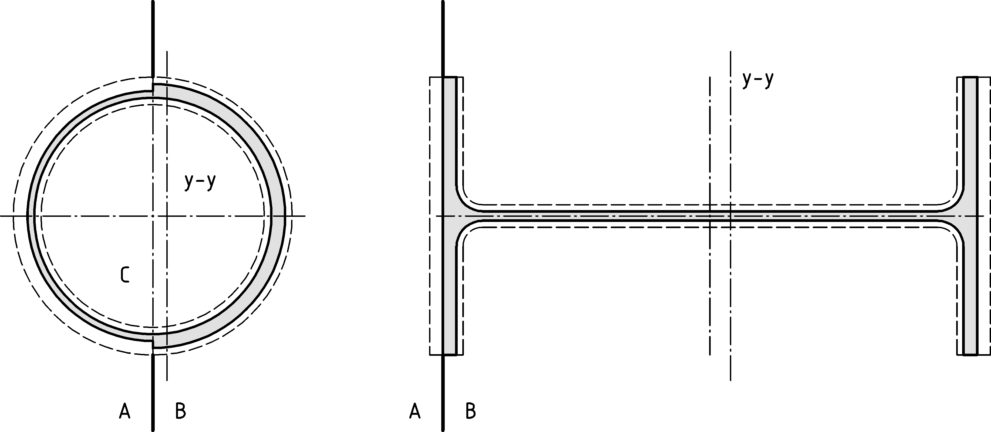

Key

|  |  |
| --- | --- |
| A / B / C | environments with different corrosion rates |
| yy | Shifted neutral axis |

Figure 6.2 — Corrosion of primary piles exposed to environments with different corrosion rates

(5) Analysis of local buckling in the corroded state may be based on a cross-section with assumed uniform reduced thickness to be chosen at the side of the highest compression and on stress levels considering the shift of neutral axis.

(6) Corrosion inside hollow piles may be neglected for piles filled with concrete or piles that have watertight connections and closed ends, both resistant to driving. Soil plugs may be considered as watertight ends if the permeability k of the soil at toe level according to prEN 1997‑2 is smaller than 10 - 9 m/s.

(7) Durability aspects should be considered in the design of connections between pile and pile cap.

## Durability requirements for anchors and tension piles

(1) Durability considerations should include:

— chemical components of ground or groundwater able to adversely affect the material properties of the steel in such a way that the element loses its serviceability;

— corrosion protection;

— susceptibility of steel parts in tension to stress corrosion cracking;

— additional loads introduced during the design service life of the structure due to soil or structure movement.

(2) Anchors and tension piles should be protected against corrosion according to their execution standard, where relevant, unless additional requirements are given below.

(3) Connections around the waterline or in other areas of high corrosion should be adequately detailed against localized corrosion effects.

NOTE Localized corrosion at the pile connections in combination with occurrence of bending of the tension element due to additional loads from settlements can have a detrimental effect on the durability of the structure, especially for retaining walls whose stability is reliant solely on restraint.

(4) Corrosion rates given in 6.4 for piles may be used for tie rod anchors and tension piles.

NOTE The grouted anchor execution standard EN 1537 requires tendons to be fully protected against the effects of corrosion.

(5) Where a suitable corrosion protection system is not used (e.g. in accordance with EN 1537) on the main tension element, the nominal yield strength *fy* should be ≤ 500 N/mm2 for durability reasons.

NOTE The susceptibility of a steel to hydrogen embrittlement and stress corrosion cracking is influenced by the microstructure of the steel as well as strength of the steel.

(6) Where sacrificial steel is used as a corrosion protection any variation in strength across the section should be considered.

NOTE Some manufacturing methods of reinforcing steel result in steel properties varying across the section with higher strengths towards the outer surface. This can affect durability particularly if high sacrificial rates are being considered.

## Corrosion rates for design

### Corrosion rates for design in soil and water

(1) Corrosion rates given in this section should be considered as calculative values for design only, assuming a mean uniform corrosion.

NOTE 1 The values for the loss of thickness due to corrosion are given in Table 6.1 (NDP) and Table 6.2 (NDP) unless the National Annex gives different values.

NOTE 2 The values given in the tables are values of uniform corrosion and do not consider potential localized corrosion for carbon steels nor potential pitting corrosion for stainless steels.

Table 6.1 (NDP) — Value for the loss of thickness [mm] due to corrosion for steel elements in piling in soils, with or without groundwater

|  |  |  |  |  |  |
| --- | --- | --- | --- | --- | --- |
| **Required design service life [years]** | **5** | **25** | **50** | **75** | **100** |
| Undisturbed natural soils (sand, silt, clay, schist, ....) | 0,00 | 0,30 | 0,60 | 0,90 | 1,20 |
| Polluted natural soils and industrial sites | 0,15 | 0,75 | 1,50 | 2,25 | 3,00 |
| Aggressive natural soils (swamp, marsh, peat, ...) | 0,20 | 1,00 | 1,75 | 2,50 | 3,25 |
| Non-compacted and non-aggressive fills (clay, schist, sand, silt, ....) a | 0,18 | 0,70 | 1,20 | 1,70 | 2,20 |
| Non-compacted and aggressive fills (ashes, slag, ....) a | 0,50 | 2,00 | 3,25 | 4,50 | 5,75 |
| a Corrosion rates apply to non-compacted fills. For compacted fills, the corrosion rates may be reduced by 50 %.  NOTE The values given for 5 and 25 years are based on measurements, whereas the other values are extrapolated. | | | | | |

Table 6.2 (NDP) — Value for the loss of thickness [mm] due to corrosion for steel elements in piling in fresh water or in sea water

|  |  |  |  |  |  |
| --- | --- | --- | --- | --- | --- |
| **Required design service life [years]** | **5** | **25** | **50** | **75** | **100** |
| Common fresh water (river, ship canal, ....) in the zone of high attack (water line) | 0,15 | 0,55 | 0,90 | 1,15 | 1,40 |
| Very polluted fresh water (sewage, industrial effluent, ....) in the zone of high attack (water line) | 0,30 | 1,30 | 2,30 | 3,30 | 4,30 |
| Sea water in temperate climate in the zone of high attack (low water and splash zones) | 0,55 | 1,90 | 3,75 | 5,60 | 7,50 |
| Sea water in temperate climate in the zone of permanent immersion or in the intertidal zone | 0,25 | 0,90 | 1,75 | 2,60 | 3,50 |
| NOTE 1 The highest corrosion rate is usually found in the splash zone or at the low water level in tidal waters. However, in most cases, the highest bending stresses in piles occur in the permanent immersion zone, see Figure 6.1.  NOTE 2 The values given for 5 and 25 years are based on measurements, whereas the other values are extrapolated. | | | | | |

(2) Local conditions influencing the corrosion rates should be considered and corrosion rates for design may be modified accordingly. If necessary specific ground and water properties should be determined according to prEN 1997‑2.

NOTE 1 The following have a major influence on the corrosion rates in soils:

— the type of soil (mineralogy, water content, organic content);

— the soil density;

— the variation of the level of the groundwater table;

— the presence of oxygen;

— the presence of contaminants (pollution, de-icing salts, etc.).

NOTE 2 The following have a major influence on the corrosion rates in water:

— the type of water;

— the presence of oxygen;

— the presence of contaminants;

— the presence of mechanical wearing (e.g. ice or soil particles in propeller or natural flow).

(3) Mean uniform corrosion rates may be derived from local measurements. Measurements should be taken at specific levels and should not be combined with other locations. They should be averaged along the horizontal corrosion zone. Sufficient measures should be taken to be statistically robust and achieve a coefficient of variation lower than 0,3. Pitting values and localized corrosion values should be disregarded when deriving mean uniform corrosion rates of retaining walls.

NOTE 1 Locations are different whenever parameters influencing the corrosion rates are different.

NOTE 2 Further guidance can be obtained from RFCS report EUR 22433 (2007).

(4) Unless regularly inspected, the sheet pile should have sufficient thickness to avoid loss of soil due to holes resulting from pitting or localized corrosion.

### Corrosion rates for design due to mechanical wearing

(1) The effect of mechanical wearing shall be based on local conditions and comparable experience.

(2) Unless more detailed prediction is available, a constant corrosion rate may be deduced from the loss of thickness after the first 5 years according to Table 6.2 (NDP). The design value ${∆t}_{d,mw}$ for the total loss of thickness over the design service life of the structure may be calculated as follows:

${∆t}_{d,mw}=T \frac{{∆t}_{5y}}{5}$ (6.1)

where

*t*d,mw is the total loss of thickness due to corrosion caused by mechanical wearing during the design service life in mm;

*t*5y is the loss of thickness after 5 years from Table 6.2 in mm;

*T* is the design service life in years.

NOTE Mechanical wearing is affected by the strength of propeller flows, the frequency in which it applies and the amount of soil particles in the flow. Real loss of thickness can therefore be significantly lower or higher, depending on local conditions.

### Corrosion due to stray currents

(1) Where poorly isolated sources of direct current are likely to produce stray currents in the soil, protection should be in accordance with EN 50162.

### Corrosion rates for design in atmospheric environment

(1) The loss of thickness due to atmospheric corrosion should consider the aggressiveness of the surrounding environment.

NOTE The value for the loss of thickness due to atmospheric corrosion is 0,01 mm per year in normal atmospheres and 0,02 mm per year in locations where marine conditions affect the performance of the structure, unless the National Annex gives different values.

# Structural analysis

## Structural modelling

### Modelling of the structure

(1) Global analysis should be carried out to determine the effects of actions (internal forces and moments, stresses, strains and displacements) over the whole or part of the structure. Additional local analyses of the structure should be carried out where necessary, e.g. load application points, connections, etc.

(2) Analyses may be carried out using idealisations of the geometry, behaviour of the structure and behaviour of the ground. The idealisations should be selected with regard to the design situation.

(3) The analysis of the structure should be carried out using a suitable ground-structure model in accordance with prEN 1997‑1 and prEN 1997‑3.

(4) Assessment of the effects of actions in piled walls should be carried out based on the relevant failure mode for ultimate limit state verifications in accordance with prEN 1997‑3.

(5) Depending on the design situation, anchors and tension piles may be modelled either as simple supports or as springs.

(6) The axial stiffness of the anchor system or tension pile should be considered in the design of retaining walls. It may be assessed by preliminary testing or from comparable experience.

NOTE It can be useful to estimate the effect of the anchor stiffness on the design of retaining walls by using a maximum/minimum approach for the stiffness. It can also be estimated in an iterative procedure that leads to equal displacements at anchor level.

(7) If joints have a major influence on the distribution of internal forces and moments, they should be taken into account in the structural analysis.

(8) Where necessary, structural fire design should be considered in accordance with prEN 1993‑1‑2 and prEN 1991‑1‑2.

### Modelling of anchors, tension piles, walings, bracing and connections

(1) The effects of actions in anchors, tension piles, walings, bracing and connections shall be determined from the structural analysis considering the interaction between the ground and the structure.

(2) Appropriate simplified methods of analysis may be used in which the actions applied to the various elements of the structure take account of the behaviour of individual members.

(3) Unless otherwise specified, the connection between the bearing pile and the pile cap may be taken into account in different (conservative) ways for the design of the steel pile and for the design of the pile cap.

NOTE The degree of fixity at the connection between a pile and the pile cap or foundation determines the local shear forces and moments that must be designed for.

(4) The structural properties of connections (pinned or fixed connections) between the heads of the piles and the pile cap, which depend on their rigidity and design detailing, should be chosen in accordance with the selected method of load transfer, examples of which are provided in Figure 8.17 and Figure 8.18, see also EN 1994.

NOTE Direct connection of a steel structure to a bearing pile is also possible as illustrated in Figure 8.19.

## Global analysis for ultimate limit state design checks

(1) The effects of the deformed geometry (second-order effects) shall be considered if they significantly increase the action effects or significantly modify the structural behaviour. The method of analysis and the ultimate limit state design checks should be carried out accordingly. See Figure 7.3 summarizing the clauses below.

(2) Horizontal deformations due to soil and water load are not a second order effect. The additional moments due to the eccentricity of compression loads stemming from this deformation are a first order effect and should be considered in *M*Ed.

(3) In accordance with of EN 1993‑1‑1:2022, 7.2.1 second order effects and buckling may be neglected if

$N_{Ed}≤\frac{N_{cr}}{25}$ (7.1)

where

*N*cr is the minimum elastic critical flexural buckling load calculated with an appropriate ground model, considering only compression forces in the sheet pile.

(4) In accordance with EN 1993‑1‑1:2022, 7.2.1 (6), second order effects due to lateral torsional buckling may be neglected for the global analysis and the verifications in the following cases:

— for U, Z and Ω sheet piles, welded box sections and tubular piles;

— in case of sufficient restraint to the compression flange, see EN 1993‑1‑1: 2022, Annex D;

(5) If a non-sway buckling mode can be assumed according to (6) and (7) and if the condition (7.2) is satisfied, first order analysis considering sway imperfections (see Figure 7.4) may be used for the determination of bending moments for cross-section verification and buckling verification:

$N_{Ed}≤\frac{N_{cr}}{10}$ (7.2)

NOTE When the condition (7.2) is satisfied, the increase of the internal forces and moments due to sway second order effects is no more than 10 % of the internal forces and moments according to first order theory.

(6) It may be assumed that (partially) fixed boundary conditions at the pile toe (supplied by elements such as earth support, underwater concrete, etc.) give positional restraint corresponding to the non-sway buckling mode. Free earth support conditions may be assumed to give sufficient restraint for non-sway buckling if the toe of the sheet pile wall is fixed in bedrock or is able to resist an additional horizontal force *F*Q,Ed by friction or passive soil resistance. *F*Q,Ed is given by:

$F_{Q,Ed}= N_{Ed}\left(\frac{{}_{z}}{L}+0.01\right)$ (7.3)

where *δ*z is the maximum relative deflection of the sheet pile wall occurring between the supports according to a first order analysis, see Figure 7.1.

NOTE In cases where free earth support does not provide sufficient restraint to the toe of the sheet pile wall, the piles can be made longer, and an analysis as partially fixed earth support can be made.

|  |  |  |
| --- | --- | --- |
|  |  |  |
| **a) deflected shape** | **b) simplified system** | **c) typical bending moment distribution** |

Figure 7.1 — Relative deflection of the sheet pile

(7) It may be assumed that the boundary conditions at the support level supplied by elements (anchor, strut, capping beam, etc.) give positional restraint corresponding to the non-sway buckling if following condition is satisfied:

$N_{Ed}≤\frac{N_{cr,sw}}{10}$ (7.4)

*N*cr,sw= *K L*s (7.5)

where

*N*cr,swis the elastic critical buckling load for sway mode

NOTE In piling applications sway modes can occur as a consequence of low lateral stiffness of the anchorage, strut, bracing or adjacent pile and deck beam arrangements. See Figure 7.2.

*L*s is the height of the system, defined as the difference between the top support and the bottom support which may be assumed at the level where the resultant of the passive horizontal soil pressure is acting;

*K* is the effective lateral rigidity of the anchor system or support structure considering the soil stiffness. This may be calculated from a linear elastic analysis using the following formula:

$K=\frac{H_{A}}{{}_{A}}$ (7.6)

where

*H*A is a fictitious horizontal load applied at the level of the anchor or support structure;

*δ*A is the additional horizontal displacement at the level of the anchor or support structure due to *H*A.

|  |  |  |  |
| --- | --- | --- | --- |
|  | |  | |
| deflected shape | simplified system | deflected shape | simplified system |
| **a) anchored retaining wall** | | **b) pile with lateral support structure** | |

Figure 7.2 — Buckling modes with definition of the parameters *H*A, *δ*A and *L*s

(8) If boundary conditions do not provide sufficient restraint for non-sway buckling mode (i.e. the condition (6) or (7) are not satisfied), second order effects due to sway (see Figure 7.4) shall be considered for the verification of cross-sectional resistance and for buckling verification.

(9) The distribution of internal forces and moments may be determined on first order theory considering sway imperfections (see Figure 7.4), using the non-sway buckling length if following condition is satisfied:

$N_{Ed}≤\frac{N_{cr}}{4}$ (7.7)

(10) For centrically loaded bearing piles with *N*Ed/*N*cr > 0,10, fulfilling non-sway boundary conditions (6) and (7) and in case of absence of horizontal deformation, a second order analysis should be performed including sway and bow imperfections.

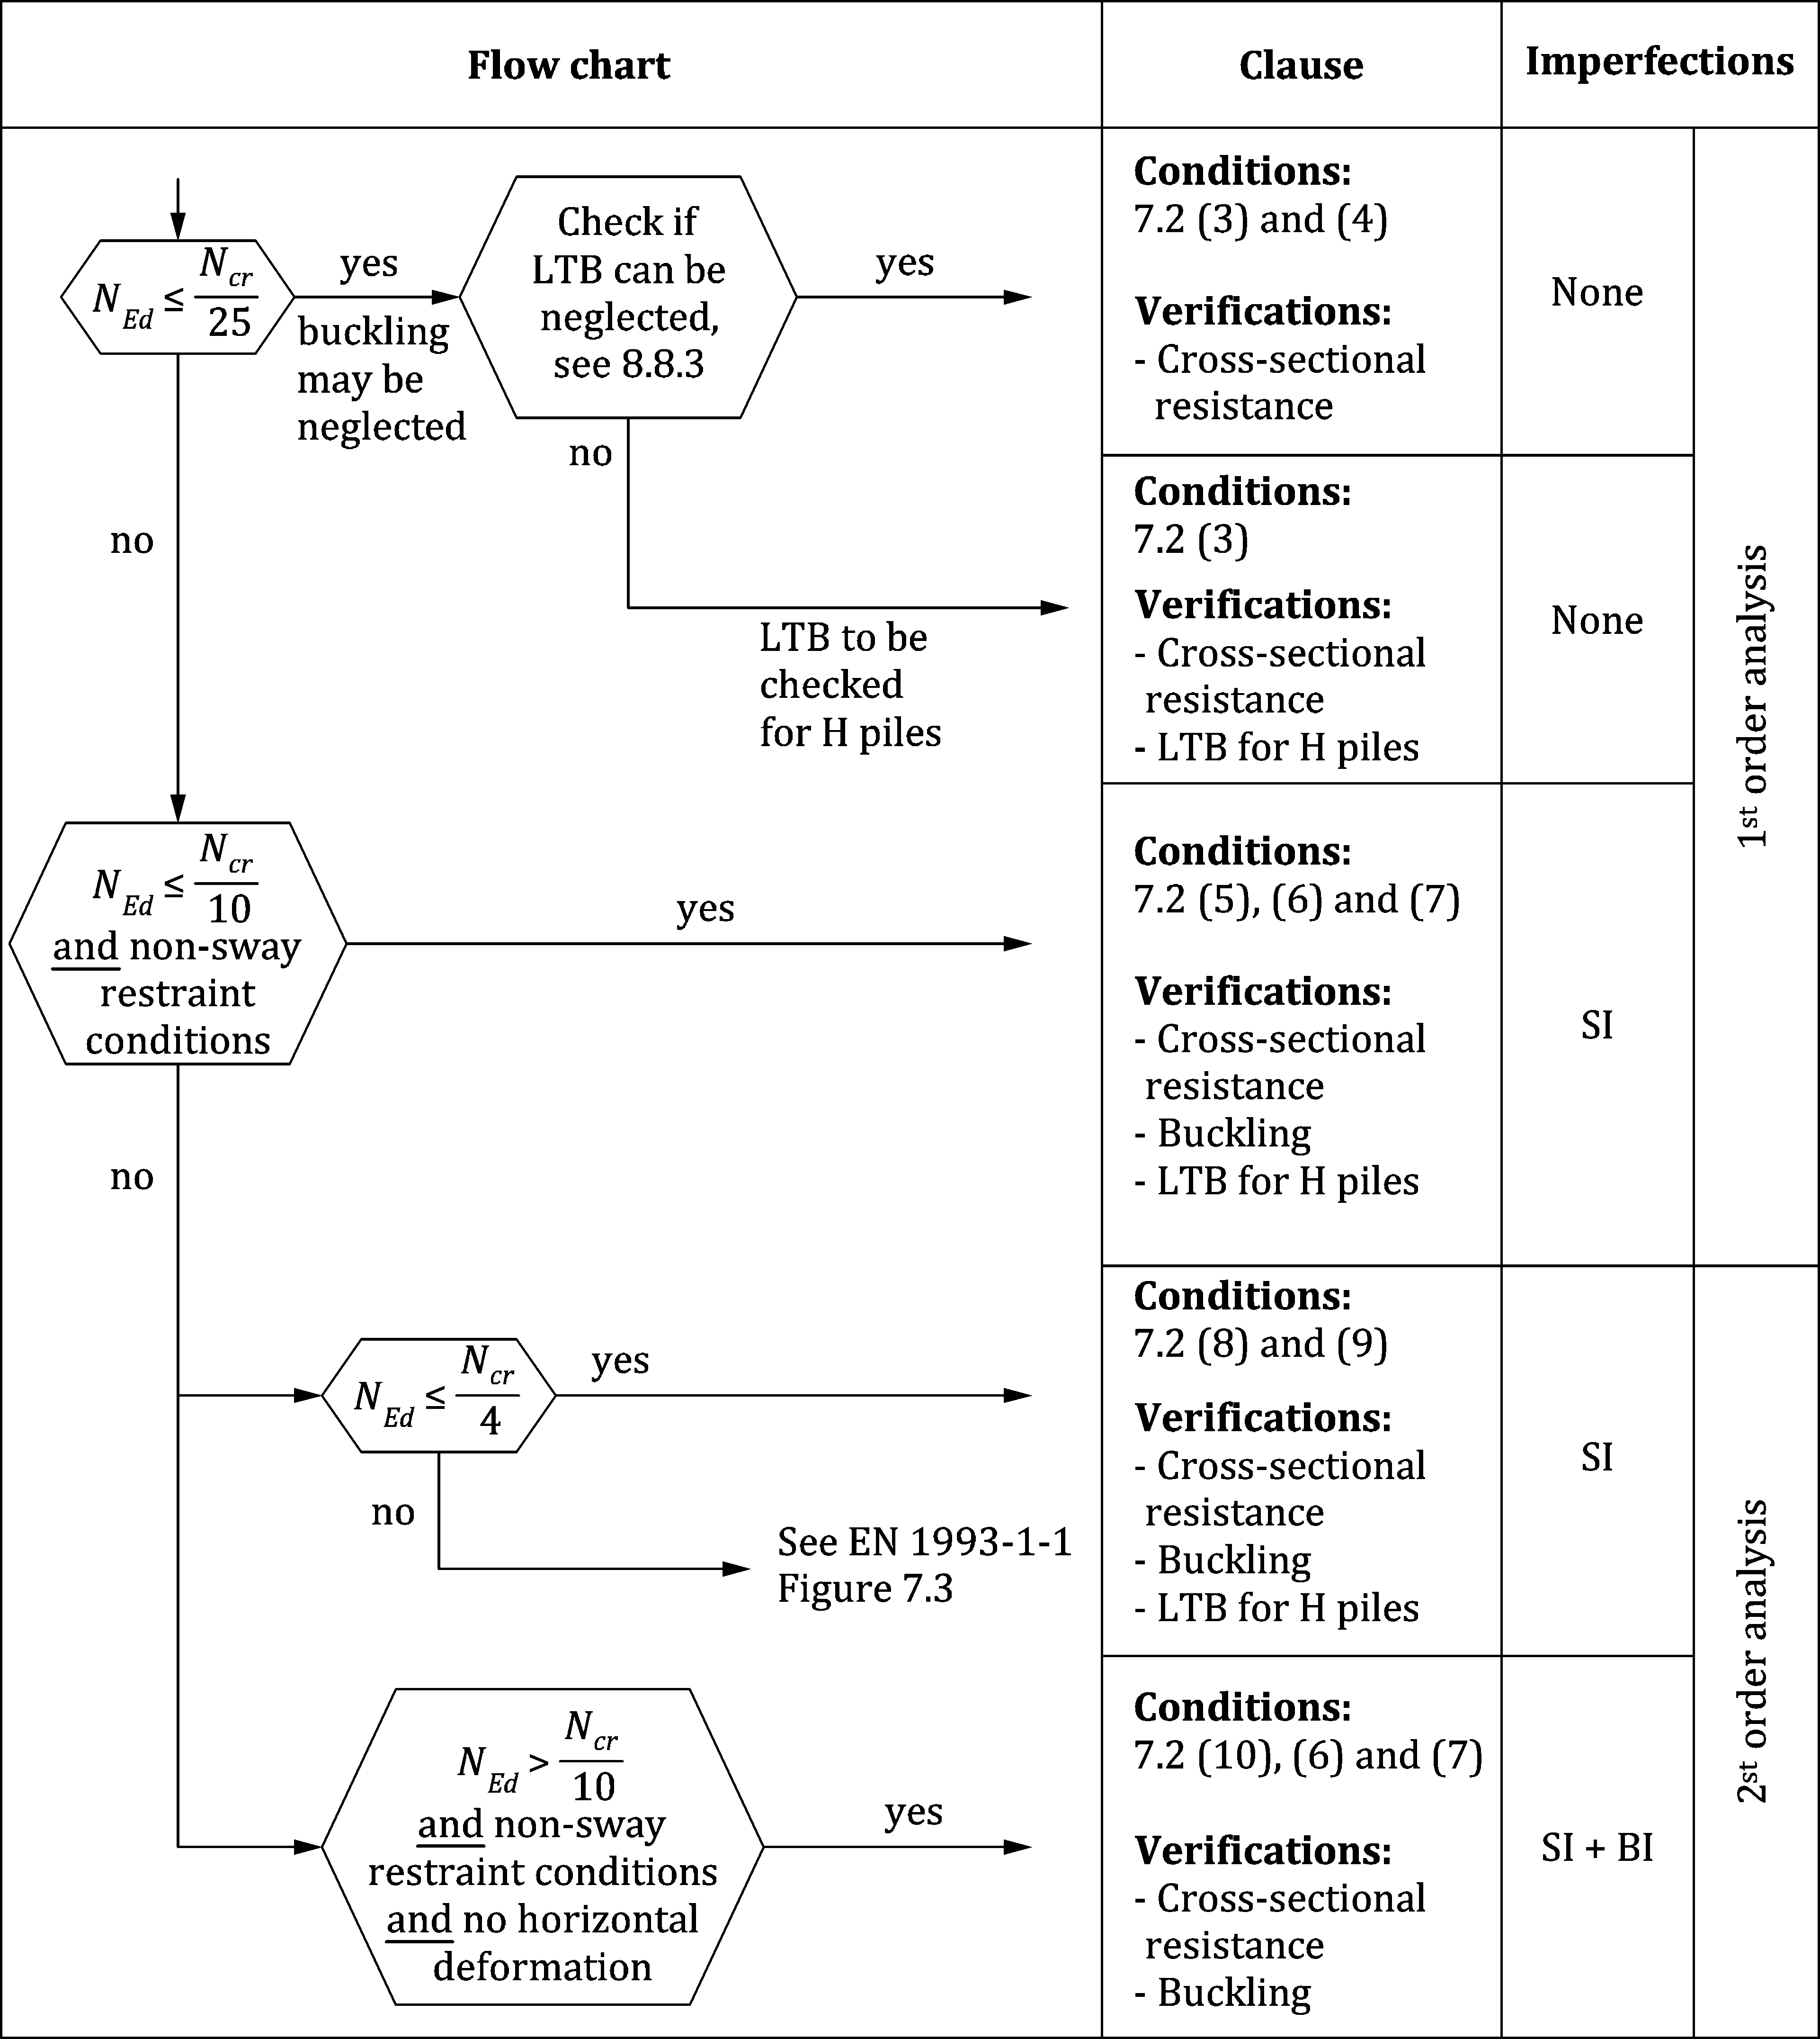

Key

|  |  |
| --- | --- |
| LTB | Lateral Torsional Buckling |
| SI | Sway Imperfection |
| BI | Bow Imperfection |

Figure 7.3 — Methods of structural analysis applicable to ultimate limit state design checks

(11) If global buckling verification is required for bearing piles, the following is applicable:

— lateral and rotational support due to the surrounding soils should be taken into account using an appropriate model (e.g. p-y approach, subgrade reaction model) based on second order theory; see 8.3.4 and 8.4.3 for partially embedded piles and prEN 1997‑3:2022, Annex C.13 for fully embedded piles;

— the phenomenon that soil on slopes may move and cause passive loading of the piles should be taken into account;

— sway frame effects, including the second order effect of piles of different length should be analysed to establish the loads of the individual buckling members.

(12) For cases not covered by the flow chart of Figure 7.3, see EN 1993‑1‑1:2022, Figure 7.3.

## Imperfections

(1) If global buckling verification is required according to Figure 7.3, then due consideration should be given to supplementary initial imperfections (e.g. due to joints or installation) in accordance with EN 12063, EN 12699 and EN 14199 in addition to the imperfections given in EN 1993‑1‑1.

|  |  |
| --- | --- |
|  |  |
| **a) retaining wall with anchor system** | **b) pile structure with bracing system** |

Figure 7.4 — Sway imperfections

(2) For retaining walls in a non-sway buckling mode and fulfilling (7.2), sway imperfections may be disregarded if

$\frac{∆M_{imp}}{M_{Ed}^{N=0}}≤0,25$ (7.8)

where

$$∆M_{imp}= N_{Ed}\tan{\text{φ}} L_{Mmax}$$

*L*Mmax is the length from the point of introduction of the external vertical load to the level of maximum design bending moment

*N*Ed is the design value of the compression force

$M_{Ed}^{N=0}$ is the design bending moment assuming zero external vertical load and no sway imperfection.

## Methods of analysis considering material nonlinearities

(1) The internal forces and moments may be determined in accordance with EN 1993‑1‑1, using either

a) Elastic global analysis or

b) Plastic global analysis.

(2) To replace EN 1993‑1‑1:2022, 7.4.1 (3) for U and Z sheet piles, a plastic global analysis may be used in accordance with Annex C for structures made of steel grades up to S460 and for cross-sections classified as Class 1 according to Table 7.1. For other cross-sections EN 1993‑1‑1:2022, 7.4.1 (3) applies.

NOTE The method given in Annex C using plastic global analysis can also be used as an alternative for Class 2 and Class 3 sections. The applicability of Annex C for Class 2 and Class 3 sections can be set by the National Annex.

(3) The global analysis used for serviceability limit states of piled retaining walls and of piled foundations should be based on a linear elastic model of the structure.

(4) The structural analysis of piled foundations for ultimate limit states may be based on the same type of model as used for serviceability limit states.

(5) Where accidental situations need to be taken into account, the assessment of effects of actions in the piles may be carried out on the basis of a plastic model, both for the whole structure and for the soil-structure interaction.

NOTE An example of an accidental situation is a ship collision against a bridge pier.

## Classification of cross-sections

### Classification of U, Z and Ω sheet piles

(1) For the determination of the resistance, cross-sections should be classified in accordance with EN 1993‑1‑1:2022, 7.5.2.

(2) Table 7.1 in this document should be used in place of EN 1993‑1‑1:2022, Table 7.3.

(3) Reduction of steel thickness due to corrosion should be accounted for.

(4) Resistance of sections classified as class 4 shall follow the provisions given in Annex A.

(5) A simplified approach according to EN 1993‑1‑1:2022, 7.5.2 (9) may also be performed for class 4 sections.

(6) However, when verifying the design buckling resistance using 8.3.4, the limiting proportions for Class 3 should always be obtained from Table 7.1.

(7) If the effects of compression according to 8.3.3 (4) cannot be neglected, then flanges may be classified according to Table 7.1 and webs may be classified according to EN 1993‑1‑1:2022, Table 7.3.

Table 7.1 — Classification of cross-sections for U, Z and Ω sheet piles

|  |  |  |  |  |  |  |  |  |  |  |
| --- | --- | --- | --- | --- | --- | --- | --- | --- | --- | --- |
| **Classification** | | | **Z-profile** | | | | **U-profile** | | | |
|  | | |  | | | |  | | | |
| Class 1 | | | — the same boundaries as for class 2 apply  — a rotation check has to be carried out according to Annex C | | | | | | | |
| Class 2 | | | $$\frac{{b_{f}}/{t_{f}}}{ε}≤40$$ | | | | | | | |
| Class 3 | | |  | | | |  | | | |
|  | *f*y [N/mm2] | 240 | | 270 | 320 | 355 | | 390 | 430 | 460 |
| ε | 0,99 | | 0,93 | 0,86 | 0,81 | | 0,78 | 0,74 | 0,71 |
| **Key**  *b*f width of the flat portion of the flange, measured between the corner radii, provided that the ratio r/tf is not greater than 5,0; otherwise a more precise approach should be used;  *t*f thickness of the flange for flanges with constant thickness;  *r* midline radius of the corners between the webs and the flanges;  *f*y yield strength. | | | | | | | | | | |

### Classification of other cross-sections

(1) For the determination of the resistance of cross-sections other than U, Z and Ω, classification should be in accordance with EN 1993‑1‑1:2022, 7.5.2, accounting for reduction of steel thickness due to corrosion.

(2) For the classification of flanges in box piles made of U, Z and Ω sheet piles Table 7.1 may be used.

(3) Piles may be classified by design assisted by testing according to 4.7 or in accordance with prEN 1993‑1‑14.

# Ultimate limit state

## General

(1) Piles and their components shall be designed such that the basic design requirements for ultimate limit states given in Clause 4 are satisfied.

(2) The following provisions should be applied for the verification of the resistances of cross-sections and members with respect to ultimate limit states.

(3) If elastic global analysis is used, it shall be verified that the maximum effects of actions do not exceed the resistances that correspond to the cross-section Class.

(4) If plastic global analysis is used, it shall be verified that the maximum effects of actions do not exceed the plastic resistance of the steel pile. In addition, the rotation capacity shall be verified, see Annex C.

(5) Retaining walls and bearing piles should be checked for:

— resistance of the cross-section and global buckling of sheet piling (see 8.3) and of bearing piles (see 8.4);

— the resistance of anchors and tension piles (see 8.11);

— the resistance of walings, bracing and connections (see 8.12 and 8.13);

— global failure of the structure as a result of soil failure (see Clause 4).

(6) The effects of actions in other structural elements and connections shall not exceed the resistances of those elements and connections.

## Partial factors

(1) Partial factors γM0, γM1 and γM2 shall be applied to the resistance of piles, anchors and tension piles, in accordance with the definitions in EN 1993‑1‑1.

NOTE 1 The value of γM0 = 1,0, γM1 = 1,10 and γM2 = 1,25, unless the National Annex gives a different value.

NOTE 2 The value of partial factors for piling can be different from those in EN 1993‑1‑1, to achieve the required reliability as per EN 1990.

(2) When applicable, partial factors γM2 and γM3,ser shall be applied to connections, in accordance with the definitions in prEN 1993‑1‑8.

NOTE The value of γM2 = 1,25, γM3,ser = 1,10, unless the National Annex gives a different value.

(3) For accidental design situations, lower partial factors should be used.

NOTE For accidental design situations, the value of γM0 = 1,00, γM1 = 1,00 and γM2 = 1,00, unless the National Annex gives a different value.

## Sheet piling

### Bending resistance of sheet piling considering shear lag

(1) In the absence of shear and axial force, the design value of the bending moment *M*Ed at each cross-section shall satisfy:

*M*Ed ≤ *M*c,Rd (8.1)

where

*M*Ed is the design bending moment, derived from a calculation in accordance with the relevant case of prEN 1997‑1 and prEN 1997‑3;

*M*c,Rd is the design moment resistance of the cross-section.

(2) The design moment resistance of the cross-section *M*c,Rd should be determined from the following:

* Class 1 or 2 cross-sections: $M_{c,Rd}= { β}_{B} { β}_{Z}{ W}_{pl} \frac{f_{y}}{γ_{M0}}$ (8.2)
* Class 3 cross-sections: $M_{c,Rd}= { β}_{B}{ W}_{el} \frac{f_{y}}{γ_{M0}}$ (8.3)

As an alternative for Class 3 sections *M*c,Rd may be determined from the following:

$M_{c,Rd}= { β}_{B}{ W}_{ep} \frac{f_{y}}{γ_{M0}}$ (8.4)

where

*W*el is the elastic section modulus determined about the wall axis with full shear transfer;

*W*ep is the elasto-plastic section modulus for semi-compact (class 3) sections, determined about the wall axis with full shear transfer, given in Annex E;

*W*pl is the plastic section modulus determined about the wall axis with full shear transfer;

γM0 partial factor in accordance with 8.2 (1);

*β*B is a factor that takes account of the lack of shear force transmission in the interlocks and has the following values:

*β*B = 1,0 for Z-piles and triple U-piles

*β*B  1,0 for single and double U-piles.

The value of *β*B *W*pl should never be taken smaller than the plastic modulus of the individual piles with zero shear transfer. The value of *β*B *W*e should never be taken smaller than the elastic modulus of the individual piles with zero shear transfer.

*β*Z is a factor that takes account of flange rotation due to bending and has the following values:

*β*Z = 0,97 for not welded Z-piles

*β*Z = 1,0 for welded Z-piles in accordance with (3), and for U-piles.

NOTE 1 The degree of shear force transmission in the interlocks of U-piles is strongly influenced by:

— the type of soil into which the piles have been driven;

— the type of element installed;

— the number of support levels and their way of fixation in the plane of the wall;

— the method of installation;

— the treatment of the interlocks to be threaded on site (lubricated or partly fixed by welding, a capping beam, etc.);

— the cantilever height of the wall (e.g. if the wall is cantilevered to a substantial distance above the highest waling or below the lowest waling).

NOTE 2 The values for *β*B are given in the Table 8.1 (NDP) unless the National Annex gives different values.

Table 8.1 (NDP) — Value for reduction factors *β*B and *β*D taking into account lack of shear force transmission in the interlocks of U-piles

|  |  |  |  |  |  |
| --- | --- | --- | --- | --- | --- |
| **Wall consisting of** | **Number of anchors/supports** | **Soil type (density/strength)** | | **Reduction factors** | |
| **Density of coarse soils** | **Strength of fine soils** | ***β*B** | ***β*D** |
| Single piles  (without shear connections at interlocks) | Any | Water, air b | | 0,4 | 0,3 |
| All soils c | | 0,6 | 0,4 |
| Double pile  (with shear connections along whole central interlock) a | 0 | Loose to medium dense d | Low to medium d | 0,7 | 0,6 |
| Dense to very dense e,f | High to very high e | 0,8 | 0,7 |
| 1 | Loose to medium dense d | Low to medium d | 0,8 | 0,7 |
| Dense to very dense e,f | High to very high e | 0,9 | 0,8 |
| ≥ 2 | Loose to medium dense d | Low to medium d | 0,9 | 0,8 |
| Dense to very dense e,f | High to very high e | 1,0 | 0,9 |
| a If piles are connected on site after pile driving, the connection can be considered in the analysis as rigid only for the loading phase after the connection process (see 3.12(4)). Connection of interlocks on site is normally impossible at points below the excavation base.  b This category includes sheet piles installed in predrilled soil and installed with aid of water jetting.  c In the case of coarse dense to very dense soil above the ground water level, values may be increased by 0,2.  d Soils in the lower category are defined as:  — coarse soil: relative density *I*D = 15 to 65 % in accordance with EN ISO 14688‑2:2018, Table 5  — fine graded cohesive soil: cu = 20 to 75 kPa in accordance with EN ISO 14688‑2:2018, Table 6  For the purposes of this classification, backfills should be considered loose/low to medium dense/strength soils.  This category includes sheet piles installed in pre-drilled soil and sheet piles installed with aid of water jetting.  This category includes sheet piles in atmospheric condition and in water.  e Soils in the higher category are defined as:  — coarse soil: relative density *I*D = 65 to 100 % in accordance with EN ISO 14688‑2:2018, Table 5  — fine graded cohesive soil: *c*u = 75 to 300 kPa in accordance with EN ISO 14688‑2:2018, Table 6.  f In case of coarse dense to very dense soil above the ground water level, the values may be increased by 0,1. | | | | | |

(3) Welding of the interlocks of Z-piles to avoid rotation of two adjacent compression flanges should, as a minimum, consist of intermittent fillet welds of 6 mm to one side of the interlock. The degree of welding is at least equal to 0,5, supplemented with 400 mm continuous welding at both ends of the sheet pile.

(4) For Class 4 sheet piles the design moment resistance of the cross-section *M*c,Rd shall be determined in accordance with Annex A.

(5) For sheet pile walls one value of the reduction factors *β*B and *β*D should be applied for a sheet pile span between two supports, or between two extremes of the shear force, based on the lowest soil category present at the positions of the extreme shear. For sheet pile walls without anchors/supports one value of *β*B and *β*D should be applied for the whole sheet pile, based on the soil category layer present at the position of the extreme shear.

(6) It shall be verified that the shear connections of interlocks are able to transmit the resulting interlock shear forces.

(7) The resistance of shear connections of the interlocks may be summed to give a total shear resistance for a length of the pile with a shear force of the same sign.

(8) The shear connections of welded or crimped double or triple U-piles used in sheet pile walls should be verified assuming that the shear force is transferred in the connected interlocks only.

NOTE This assumption allows for conservative design of the connections.

(9) The verification of the continuous or intermittent partial penetration butt welds for the transmission of the shear force should be in accordance with prEN 1993‑1‑8:2021, 6.7.2 and 6.9. Determination of the *β*w factor for sheet pile steel grades not mentioned in prEN 1993‑1‑8:2021, Table 6.1 may be done through interpolation.

(10) In the case of intermittent partial penetration butt welds, a length of not less than *l* = 0,5 m should be made continuous at each end of the pile in order to avoid possible overstressing during installation, unless otherwise specified by the relevant authority or agreed for a specific project by the relevant parties.

(11) Provided that the spacing of the single or double crimped points does not exceed 0,7 m and the spacing of triple crimped points does not exceed 1,0 m, each crimped point may be assumed to transmit an equal shear force *V*Ed ≤ *R*k /γM0 where *R*k is the characteristic resistance of the crimped point determined by testing in accordance with EN 10248‑1.

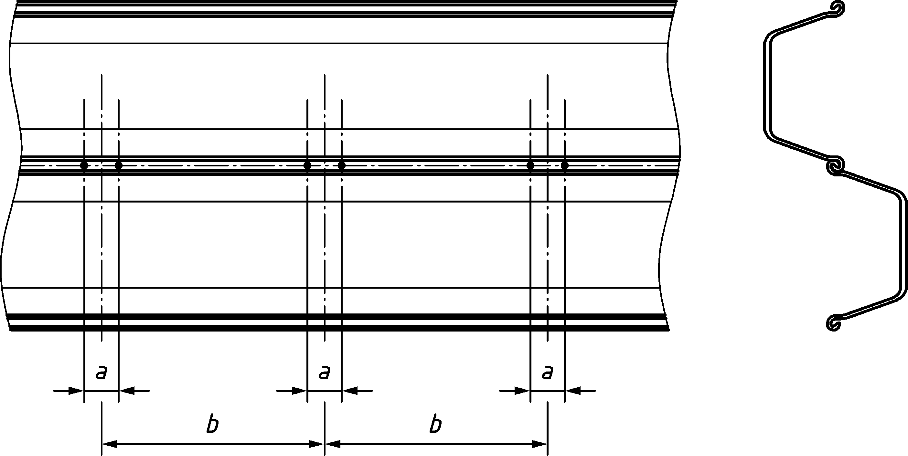

*a* ≤ 0,1 m *b* ≤ 0,7 m

Figure 8.1 — Spacing of double crimped points

### Shear resistance of sheet piling

(1) The webs of sheet piles shall be verified for shear resistance.

(2) The design value of the shear force *V*Ed at each cross-section shall satisfy:

*V*Ed ≤ *V*pl,Rd (8.5)

where

*V*pl,Rd is the design plastic shear resistance for each web given by $\frac{A_{V}f_{y}}{\sqrt{3}γ_{\text{M0}}}$ (8.6)

*A*v is the projected shear area for each web, acting in the same direction as *V*Ed.

(3) The projected shear area *A*v may be taken as follows for each web of a U-profile or a Z-profile, see Figure 8.2:

$A_{V}=t_{W}(\text{h}-t_{f})$ (8.7)

where

*h* is the depth of the cross-section;

*t*f is the flange thickness;

*t*w is the web thickness. In the case of varying web thicknesses *t*w*,i* over the slant height *c*, excluding the interlocks, *t*w in Formula (8.7) should be taken as the minimum value of *t*w*,i*.

|  |  |
| --- | --- |
|  |  |
|  |  |
| **a) Z-pile** | **b) U-pile** |

Figure 8.2 — Definition of the shear area

(4) In addition, the shear buckling resistance of the webs of sheet piles should be verified if

*c*/*t*w > 72 𝜀 (8.8)

(5) The shear buckling resistance should be obtained from:

$V_{\text{b,Rd}}=\frac{(\text{h}\text{-}t_{f}) t_{w} f_{\text{bv}}}{γ_{\text{M0}}}$ (8.9)

where *f*b,v is the shear buckling strength in accordance with prEN 1993‑1‑3: 2022, Table 8.2 for a web without stiffening at the support and for a relative web slenderness given by:

$\bar{λ}=0,346\frac{c}{t_{w}}\sqrt{\frac{f_{y}}{E}}$ (8.10)

### Resistance of sheet piling for combined bending, shear and axial force

(1) If the design value of the shear force *V*Ed does not exceed 50 % of the design plastic shear resistance *V*pl,Rd the effect of the shear force on the design bending moment resistance *M*c,Rd may be neglected.

(2) If *V*Ed exceeds 50 % of *V*pl,Rd the design bending moment resistance of the cross-section should be reduced to account for the combined effect of the shear force. The reduced bending moment resistance *M*V,Rd should be obtained as follows:

$M_{\text{V,Rd}}=\left[β_{B}W_{\text{pl}}-\frac{ρ{A_{V}}^{2}}{4 t_{W}\sin{α}}\right]\frac{f_{y}}{γ_{\text{M0}}}$ but $M_{\text{V,Rd}}≤M_{\text{c,Rd}}$ (8.11)

with

𝜌 = (2 *V*Ed / *V*pl,Rd - 1)2 (8.12)

where

*A*v is the shear area in accordance with 8.3.2;

*t*w is the web thickness;

α is the angle of inclination of the web in accordance with Figure 8.2;

*βB* is the factor defined in 8.3.1 (2).

NOTE *A*v and *t*w are related to the width considered for *W*pl.

(3) For members subject to axial force, the design value of the axial force *N*Ed at each cross-section should satisfy:

*N*Ed ≤ *N*pl,Rd (8.13)

in which *Npl,Rd* is the plastic design resistance of the cross-section with:

$N_{\text{pl,Rd}}=Af_{y}/γ_{\text{M0}}$ (8.14)

(4) The effects of axial force on the bending moment resistance of the cross-section of Class 1, 2 and 3 sheet piles may be neglected if:

— for Z-profiles of Class 1 and 2:

$\frac{N_{\text{Ed}}}{N_{\text{pl,Rd}}}$ ≤ 0,1 (8.15)

— for U-profiles of Class 1 and 2:

$\frac{N_{\text{Ed}}}{N_{\text{pl,Rd}}}$ ≤ 0,25 (8.16)

— for Class 3 profiles:

$\frac{N_{\text{Ed}}}{N_{\text{pl,Rd}}}$ ≤ 0,1 (8.17)

(5) If the axial force exceeds the limiting values given in (4), the following criteria should be satisfied in the absence of shear force:

— Class 1 and 2 cross-sections:

— for Z-profiles:

*M*N,Rd = 1,11 *M*c,Rd (1 - *N*Ed / *N*pl,Rd) but *M*N,Rd ≤ *M*c,Rd (8.18)

— for U-profiles:

*M*N,Rd = 1,33 *M*c,Rd (1 - *N*Ed / *N*pl,Rd) but *M*N,Rd ≤ *M*c,Rd (8.19)

— Class 3 cross-sections:

*M*N,Rd = *M*c,Rd (1 - *N*Ed / *N*pl,Rd) (8.20)

— Class 4 cross-sections: Annex A shall be used.

where

*M*N,Rd is the reduced design bending moment resistance allowing for the axial force.

(6) If the axial force exceeds the limiting value given in (4), account should be taken of the combined presence of bending, axial and shear force as follows:

a) If the design value of the shear force *V*Ed does not exceed 50 % of the design plastic shear resistance *V*pl,Rd no reduction need be made in combinations of moment and axial force that satisfy the criteria in (4).

b) If *V*Ed exceeds 50 % of *V*pl,Rd, the design resistance for the combined effect of bending moment and axial force should be calculated using a reduced yield strength *f*y,red = (1 - *ρ*) *f*y for the shear area, where ρ = (2 *V*Ed / *V*pl,Rd - 1)2.

(7) If the sheet piles are loaded in the plane of the retaining wall, attention should be paid to the distribution of associated bending stress over the piles, and over the height of the piles. Reduction of the out-of-plane bending capacity *M*c,Rd and the axial capacity *N*pl,Rd of the piles should be applied, depending on the spacial coincidence with stresses caused by in-plane loading.

### Buckling of sheet piling in bending and axial compression

(1) Unless 7.2 (3) is satisfied, the buckling resistance shall be verified.

(2) *N*cr should be calculated with an appropriate soil model, considering only compression forces in the sheet pile.

(3) As an alternative to (2) *N*cr may be taken as:

$N_{cr}={}^{2}EI {}_{D}/ L_{cr}^{2}$ (8.21)

in which *L*cr is the buckling length, determined in accordance with Figure 8.3 for a free or partially fixed earth support or in accordance with Figure 8.4 for a fixed earth support and *β*D is a factor that takes account of the lack of shear force transmission in the interlocks and has the following values:

*β*D = 1,0 for Z-piles and triple U-piles

*β*D ≤ 1,0 for single and double U-piles, see Table 8.1.

(4) The resistance of members to instability may be assessed by the following member checks where, in accordance with EN 1993‑1‑1:2022, 8.1, γM1 shall be used for the member capacity:

— for Class 1, 2 and 3 sections:

$\frac{N_{Ed}}{ N_{Rk} / {}_{M1}}+k_{yy} \frac{M_{Ed}}{ M_{c,Rk} / {}_{M1}} ≤1.0$ (8.22)

$k_{yy}=\frac{1}{{\left(1-\frac{N_{Ed}}{ N_{Rk} / {}_{M1}}\right)}^{0.33}}$ (8.23)

where

*N*Ed is the design value of the axial compression force, including anchor force component and adverse soil friction effects;

*N*Rk is the characteristic resistance of the cross-section loaded in compression;

*M*Ed is the design bending moment caused by transversal loads, when required in accordance with 7.2 including the second order effect caused by axial load and deformations;

*M*c,Rk is the characteristic moment resistance of the cross-section;

γM1 is the partial factor in accordance with 8.2 (1);

*k*yy interaction factor;

*χ* is the buckling coefficient from EN 1993‑1‑1:2022, 8.3.1.3, using curve d and the non-dimensional slenderness given by:

$\overline{λ}=\sqrt{\frac{Af_{y}}{N_{\text{cr}}}}$ (8.24)

with

*N*cr is the elastic critical load, which may be determined in accordance with (Formula 8.21);

*A* is the cross-sectional area;

— for Class 4 sections: see Annex A.

NOTE Buckling curve *d* covers initial imperfections, which include bow imperfections up to 0,5 % of *L*cr, and/or non-verticality of cantilevering piles up to 1 % of *L*cr, and/or non-verticality up to 1,5 % measured over the top 1 m, which is consistent with the common driving tolerance of EN 12063.

(5) When required in accordance with 7.2, increase of *M*Ed to account for second order effects may be done by adding the term

$\frac{n}{n-1} {}_{z} N_{Ed}$ (8.25)

where

*n* is the ratio between load and critical buckling force: (*n* = *N*cr / *N*Ed);

δz is the total first order deflection caused by loads, relative to the straight line representing the rigid body displacement of the wall, in the ULS state considered, see Figure 8.3.

(6) For the simplified approach the buckling length *L*cr may be determined as follows, assuming a non-sway buckling mode in accordance with 7.2:

— for a free earth support, provided that sufficient restraint exists in accordance with 7.2 (7), *L*cr may be taken as the distance between the toe and the horizontal support (waling, anchor), see Figure 8.3;

— for a (partially) fixed earth support *L*cr may be taken as a fraction of the distance *L*B between the level of zero shear (*M*B) and the horizontal support (strut or anchor), see Figure 8.4.

where

*M*A is the absolute value of the maximum bending moment of the wall,

*M*B is the absolute value of the embedment bending moment

$L_{cr}=0,707 L_{B} \sqrt{1+\frac{M_{A}/M_{B}}{0,675+M_{A}/M_{B}}}$ (8.26)

(7) If the system does not satisfy the non-sway restraint conditions 7.2 (6) and 7.2 (7), a detailed buckling investigation should be carried out, based on the methods given in EN 1993‑1‑1:2022, 7.2.2.

|  |  |
| --- | --- |
|  |  |
| **a) deflected shape due to buckling** | **b) simplified system** |

Figure 8.3 — Suggested method for determination of buckling length *L*cr, for free earth support

|  |  |
| --- | --- |
|  |  |
| **a) deflected shape due to buckling** | **b) simplified system** |

Figure 8.4 — Suggested method for determination of buckling length *L*cr, for (partially) fixed earth support

### Local effects of water pressure

(1) In the case of differential water pressure exceeding 5 m head for Z-piles and 20 m head for U-piles the effects of water pressure on transverse local plate bending should be considered to determine the resistance of axial force *N*Rd and longitudinal bending *M*c,Rd.

(2) As a simplification, this verification may be carried out for Z-piles using the following procedure:

— if the differential water pressure is more than 5 m head, the cross-sectional verification should be carried out at the locations of the maximum overall bending moments;

— the effect of differential water pressure should be taken into account by using a reduced yield strength

*f*y,red = *ρ*P *f*y (8.27)

with *ρ*P taken from Table 8.2, for the determination of the cross-sectional resistance;

— to determine *ρ*P from Table 8.2 the differential water pressure acting at the relevant locations of maximum moment should be considered.

Table 8.2 — Reduction factors *𝛒*P for Z-piles due to differential water pressure

|  |  |  |  |  |
| --- | --- | --- | --- | --- |
| *Δh* | (*b*f*/t*min) ε = 20,0 | (*b*f*/t*min) ε = 30,0 | (*b*f*/t*min) ε = 40,0 | (*b*f*/t*min) ε = 50,0 |
| 5,0 | 1,00 | 1,00 | 1,00 | 1,00 |
| 10,0 | 0,99 | 0,97 | 0,95 | 0,87 |
| 15,0 | 0,98 | 0,96 | 0,92 | 0,76 |
| 20,0 | 0,98 | 0,94 | 0,88 | 0,60 |
| **Key**  *b*f is the width of the flange, but *b*f should not be taken as less than $c/\sqrt{2}$, where *c* is the slant height of the web  *t*min is the lesser of *t*f or *t*w  *t*f is the flange thickness  *t*w is the web thickness  *Δh* is the differential head in m $ε=\sqrt{235/f_{y}}$ ; *f*y is the yield strength in N/mm2. | | | | |
| *ρ*P = 1,0 may be used if the interlocks of Z-piles are welded.  Intermediate values may be interpolated linearly. | | | | |

### Concentrated load introduction

(1) Where local concentrated loads are introduced (e.g. anchors, waling bolts, struts, bracing, etc.) the resistance of the sheet pile shall be verified.

(2) Where introduced loads place the web of the sheet pile into tension, either via a waling or a bearing plate (see Figure 8.5), the resistance of the sheet pile may be verified in accordance with the following:

a) Shear resistance of the flange:

*F*Ed ≤ *R*Vf,Rd (8.28)

where

*F*Ed is the design value of the local transverse force applied through the flange;

*R*Vf,Rd is the design value of the shear resistance of the flange under the bearing plate, given as

$R_{\text{Vf,Rd}}=2 (b_{a}+{\text{h}}_{a})t_{f}\frac{f_{y}}{\sqrt{3}γ_{\text{M0}}}$ (8.29)

with

*b*a is the width of the bearing plate;

*f*y is the yield strength of the sheet piling;

*ha* is the length of the bearing plate, but ≤ 1,5 *b*a;

*t*f is the flange thickness;

b) tensile resistance of webs:

*F*Ed ≤ *R*tw,Rd (8.30)

where

*R*tw,Rd is the design value of the tensile resistance of two webs, given as

*R*tw,Rd = 2 *h*a *t*w *f*y / γM0 (8.31)

with

*t*w is the web thickness;

c) width of bearing plate:

*b*a ≥ 0,8 *b*f (8.32)

where

*b*a is the width of the bearing plate;

*b*f is the width of the flange, see Figure in Table 7.1.

NOTE A smaller value for *b*a can be taken provided flange bending is checked.

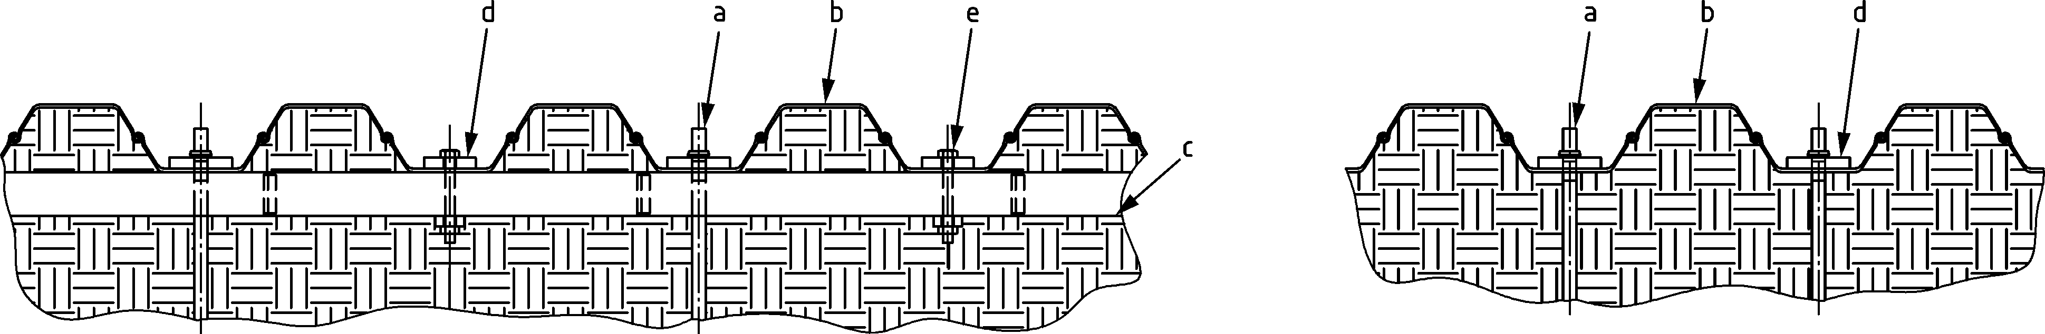

Key

|  |  |
| --- | --- |
| a | anchor / tie rod |
| b | sheet pile |
| c | waling |
| d | bearing plate |
| e | waling bolt |

Figure 8.5 — Examples of anchoring with pile web placed in tension

(3) Where introduced loads place the web of the sheet pile into compression via a waling according Figure 8.6 a), the resistance of the sheet pile may be verified in accordance with the following:

*F*Ed ≤ 0,5 *R*c,Rd: no further verification necessary.

*F*Ed > 0,5 *R*c,Rd: (8.33)

where

*F*Ed is the design value of the local transverse force per web applied through the waling;

*R*c,Rd is the design resistance to the local transverse force. *R*c,Rd should be taken as the minimum of *R*e,Rd and *R*p,Rd for each web, given by:

$R_{\text{e,Rd}}=ε \frac{s_{S}+4s_{\text{ec}}}{4e} \sin{α}\left(t_{w}^{2}+t_{f}^{2}\right)f_{y}/γ_{\text{M0}}$ (8.34)

*R*p,Rd = *χ R*po/γM0 (8.35)

with

*χ* = $0,06+\frac{0,47}{λ}≤1,0$ (8.36)

*λ* = $\sqrt{\frac{R_{\text{p0}}}{R_{\text{cr}}}}$ (8.37)

*R*cr = (8.38)

*R*p0 = (8.39)

*b*f is the width of the flange, see Figure in Table 7.1;

*c* is the slant height of the web as shown in Figure 8.2;

*e* is the eccentricity of the force introduced into the web, given by

e = $r_{0}\tan\left(\frac{α}{2}\right)-\frac{t_{w}}{2 \sin{α}}$, but not less than 5 mm; (8.40)

*f*y is the yield strength of the sheet pile;

*r*0 is the outside radius of the corner between flange and web;

*s*ec = with α in degrees; (8.41)

*s*s is the length of stiff bearing, determined from EN 1993-1-1:2022, Figure 8.4. If the waling consists of two parts, e.g. two channel-sections, *s*s is the sum of both parts plus the minimum of the distance between the two parts or the length *s*ec;

*t*f is the flange thickness;

*t*w is the web thickness;

α is the angle of inclination of the web, see Figure 8.2;

ε = $\sqrt{\frac{235}{f_{y}}}$ with *f*y in N/mm²;

*M*Ed is the design value of the bending moment at the location of the anchor force or strut force;

*M*c,Rd is the design bending resistance of the sheet pile from 8.3.1(2).

(4) If a bearing plate is used for the introduction of the anchor force into the webs according to Figure 8.6 b) verification of the web in compression may be made in accordance with (3), provided that the width of the bearing plate *b*a is equal or greater than the width of the flange *b*f.

(5) If the width of the bearing plate *b*a is taken smaller than the width of the flange *b*f, flange bending and effect of eccentricity of the web should be checked.

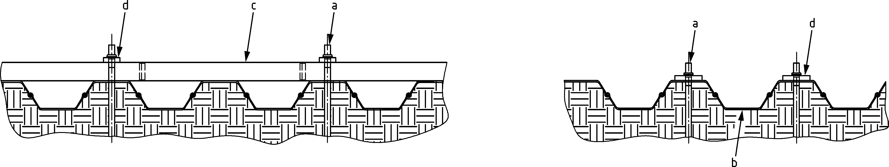

1. **b)**

Key

|  |  |
| --- | --- |
| a | anchor / tie rod |
| b | sheet pile |
| c | waling |
| d | bearing plate |

Figure 8.6 — Examples of anchoring with pile web placed in compression

(6) Bearing plates should be verified for bending and should have a minimum thickness of 2*t*f.

(7) Eccentric anchoring of Z piles may be checked by design assisted by testing according to 4.7.

## Bearing piles

### General

(1) The effects of actions in piles should be determined in accordance with prEN 1997‑3, taking account of both equilibrium and compatibility.

(2) Ultimate limit state verifications should be carried out for failure in the soil for both individual piles and pile groups in accordance with prEN 1997‑3, and for failure of the piles and their connections to the structure in accordance with prEN 1993‑5, EN 1992 and EN 1994.

### Design methods and design considerations

(1) For piles subjected to axial and transverse loading, the soil resistance should be taken from prEN 1997‑3.

(2) The effects of actions in the pile due to transverse forces should be taken into account in combination with those due to axial forces and applied moments. They may be determined by superimposing the results of separate calculations in which the soil in contact with separate portions of the pile length is assumed to be resisting different actions. Alternatively, the axial force, bending moments and transverse forces may be considered as resisted by soil over the same length of pile, provided that the soil is capable of resisting their combined effects.

(3) The structural design of an individual pile should be verified in accordance with EN 1993‑1‑1:2022, Clause 7.

(4) For axial forces acting at the head of the pile, the distribution of stress may be conservatively taken as constant over the length of the pile for the determination of the effects of actions, except in the case of negative skin friction.

(5) The transmission of torsional moments acting at the head of the pile should not be assumed unless special provisions allow the introduction of the torque into the soil. The distribution of the torque should be taken as constant over the pile length.

### Buckling of bearing piles

(1) Cross-sectional verification of steel bearing piles shall be in accordance with EN 1993‑1‑1.

(2) Lateral and rotational support conditions of piles include support by embedment in the soil. The buckling length of partially embedded bearing piles being part of non-sway systems may be estimated based on subgrade reaction theory, using the following approach (see Figure 8.7):

$L_{cr}=\sqrt{\frac{{}^{2}}{{}_{1}}+\frac{5+{}_{1}}{5+2{}_{1}} \frac{5+{}_{2}}{5+2{}_{2}}} L_{f}$ (8.42)

where

*L*cr is the buckling length in the buckling plane considered;

*L*f is the free length of the bearing pile between top of soil and its connection to a beam or deck structure;

α1 is the stiffness factor of the lateral resistance of the embedded part of the pile;

*ρ*1 is the stiffness factor of the rotational resistance of the embedded part of the pile;

*ρ*2 is the stiffness factor of the rotational resistance of the beam or deck.

with

${}_{1}=\frac{k_{1}{{ L}_{f}}^{3}}{EI}$ (8.43)

${}_{1}=\frac{c_{1}{ L}_{f}}{EI}$ (8.44)

${}_{2}=\frac{c_{2}{ L}_{f}}{EI}$ (8.45)

$k_{1}=\frac{kB}{2}$ (8.46)

$c_{1}=\frac{kB}{4{}^{3}}$ (8.47)

$=\sqrt[4]{\frac{kB}{4 EI}}$ (8.48)

*k* is the linear subgrade reaction of the soil to the bearing pile [in N/m3], in accordance with prEN 1997-3:2022, Annex A.x, to be averaged over the top part with a length of π/*β;*

*B* is the pile diameter or pile width perpendicular to the buckling plane considered;

*c*2 is the rotational stiffness of connecting beams, in the buckling plane considered.

NOTE *k*1 and *c*1 are transversal and rotational springs determined by the subgrade reaction *k*, and the bending stiffness *EI* of the pile. The given formulas are valid for piles with an embedded length larger than 3/β.

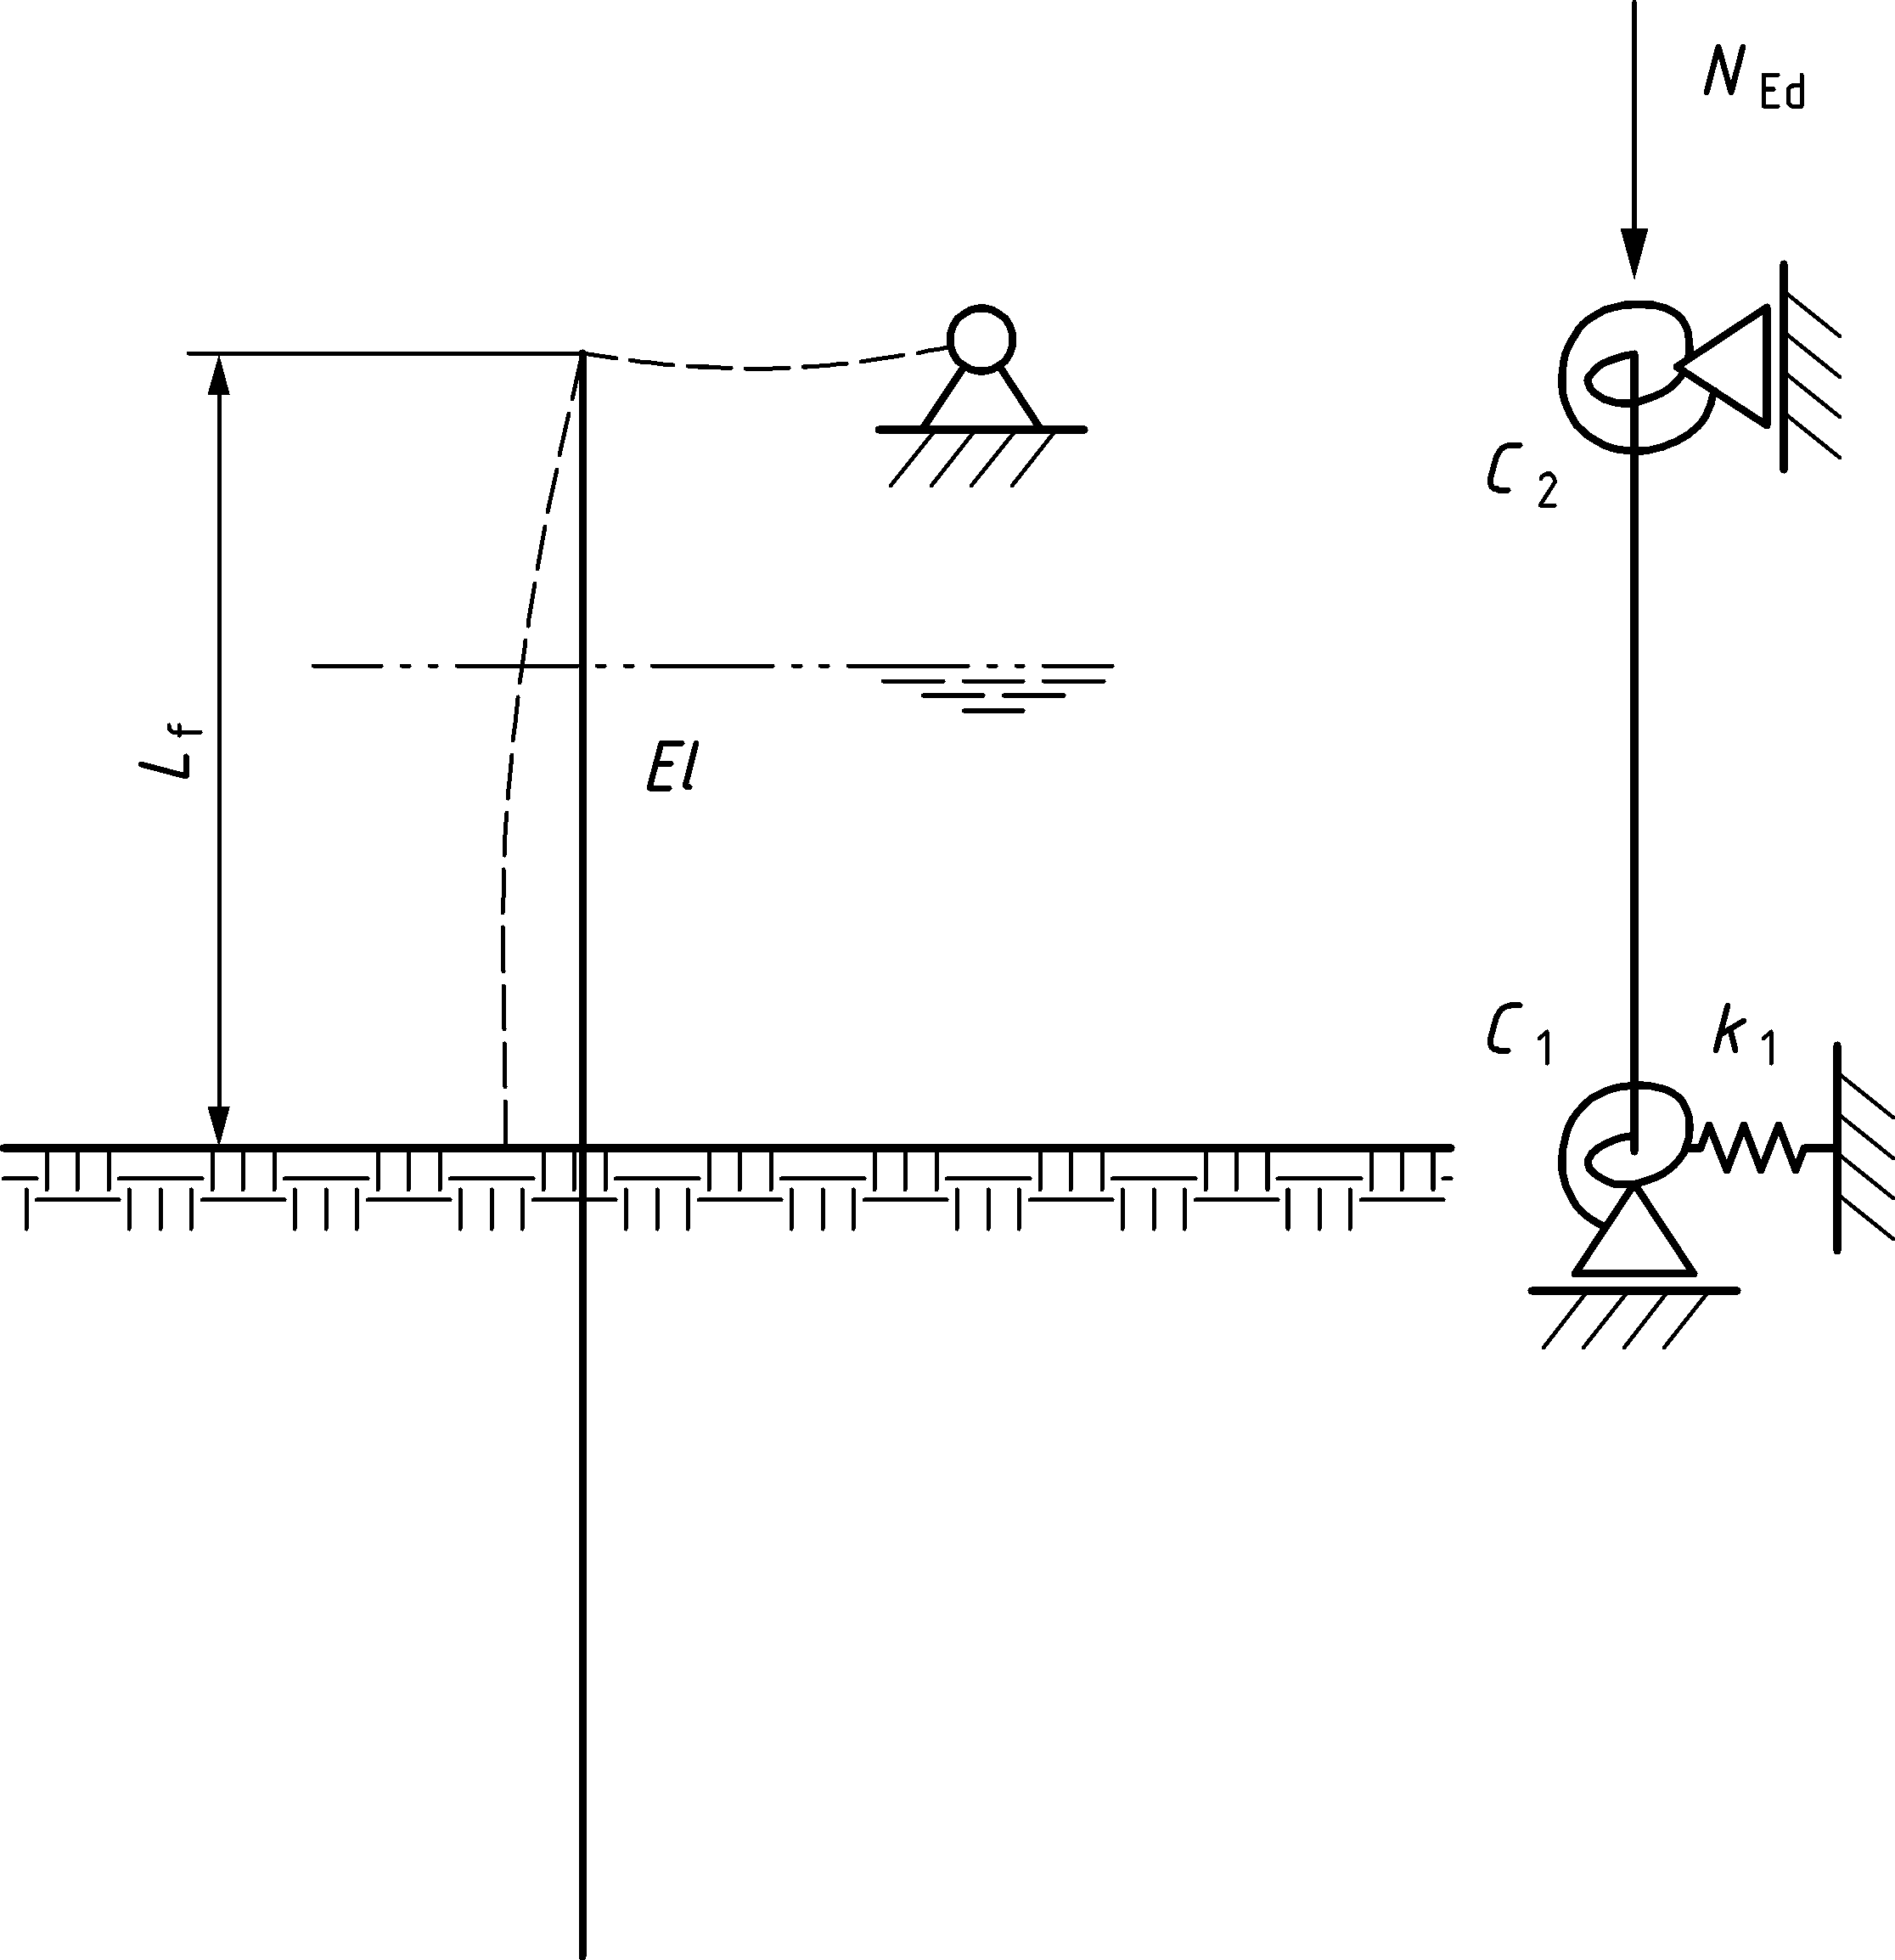

Figure 8.7 — Simplified estimation of buckling length for bearing piles with lateral support

(3) The buckling length of partially embedded bearing piles being part of sway systems should be determined using advanced geotechnical modelling, in accordance with 7.2 (11), considering nonlinear soil stiffness and limits to the soil resistance. For this case the use of subgrade reaction formulas shall not be applied.

### Verification of steel piles filled with concrete

(1) Steel piles filled with concrete should be designed in accordance with prEN 1994‑1‑1.

(2) Cross-sectional verifications of steel piles filled with concrete should be in accordance with prEN 1994‑1‑1.

(3) Verification of global buckling resistance shall be in accordance with 8.4.3 of this standard and prEN 1994‑1‑1:202x, 8.8.

## High modulus walls

(1) The design of high modulus walls should be carried out in accordance with the provision for sheet pile walls, taking into account the specific geometry of the sections used, see Figure 3.3b, allowing for local effects due to earth and water pressures and for the introduction of concentrated forces at the connections to anchors, struts and walings.

(2) The determination of cross-section resistance may be conservatively based on an elastic analysis of the cross-section, provided that:

— buckling of plate elements is checked using prEN 1993‑1‑5;

— the shear lag effect is taken into account for built-up elements.

## Jagged walls

(1) The design of jagged walls should be carried out in accordance with the provision for sheet pile walls in 8.3, taking into account the specific geometry of the sections used, see Figure 3.3d, allowing for local effects due to earth and water pressures and the introduction of anchor and waling forces.

(2) The determination of cross-section resistance may be conservatively based on an elastic analysis of the cross-section, provided that – if applicable - the shear lag effect is taken into account.

NOTE The factors *β* B and *β* D given in 8.3.1 are specific for U-piles and their values are not valid for jagged wall arrangements.

## Combined walls

### General

(1) In the following provisions for the ultimate limit state are given for the following types of combined walls, see Figure 3.3c:

— mixed tubular sections and sheet pile walls;

— mixed special H-piles and sheet pile walls;

— mixed box sections and sheet pile walls.

(2) The design of the primary and secondary elements should be based on their functionality:

— the primary elements act as retaining elements against the earth and water pressures and may act as bearing piles for vertical loads;

— the secondary elements only fill the gap between the primary elements and transmit the loads resulting from earth and water pressures to the primary elements.

(3) No transmission of longitudinal shear forces may be considered in the free interlocks between primary and secondary elements.

(4) Installation imperfections of the primary elements, including misalignment at soil level and non-verticality, should be considered as specified by the relevant authority or, where not specified, as agreed for a specific project by the relevant parties.

NOTE Dependent on the ground type, driving equipment and contractor experience, installation imperfections of the primary elements can occur.

### Secondary elements

(1) For the design of secondary elements, it shall be verified that the secondary elements are able to transmit the forces resulting from earth and water pressures into the primary elements via the connector. The secondary elements shall also be able to transmit the internal forces caused by imperfect installation of the primary piles.

NOTE It can be advantageous to take into account arching effects leading to a supplementary loading on the primary elements and a reduction of the earth pressures acting on the secondary elements.

(2) Verification of the secondary elements may be carried out using a FEM nonlinear analysis with shell or solid elements or using a simplified two-dimensional frame model. The analysis approach shall be in accordance with prEN 1993‑1‑14. If the installed (as built) clearance between primary piles differs to the theoretical clearance (e.g. caused by imperfect pile installation), this should be taken into account in this analysis via the imposed displacement *δ*y using the boundary conditions given in Figure 8.8, which shows a double Z-pile and a triple U-pile as an example of a secondary element.

NOTE The imposed displacement δy can be composed of the anticipated in-plane driving imperfection supplemented with an equivalent amount of imposed displacement δy to take out-of-plane driving imperfection into account, as the infill sheet piles will rotate (“interlock swing”) and stretch.

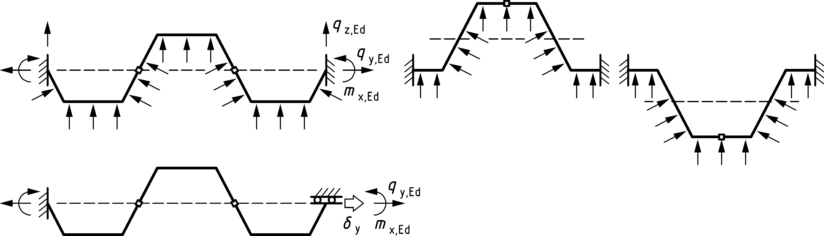

Figure 8.8 — Simplified models for secondary elements

(3) For the verification of the cross-section in the simplified frame model, a plastic analysis combined with large displacements may be used. In the simplified plastic frame model, the interlocks may be assumed as rigid. Plastic deformation capacity should be verified. If members of the frame model are stressed in compression, particular attention should be paid to the possibility of instability, such as “snap-through”. If members of the frame model are stressed in tension, particular attention should be paid to the possibility of interlock failure.

(4) As an alternative to (2), the verification of (1) may be based on the results of testing in accordance with 4.7.

NOTE For test evaluation see EN 1990:2023, Annex D.

(5) The test set-up should be able to simulate the behaviour of the intermediate elements.

(6) For sheet piles used as secondary elements, further verification may be omitted if all the following conditions are met:

— wall thickness of the sheet piles: ≥ 10 mm;

— pressure difference acting on the sheet piles: ≤ 40 kN/m2, corresponding to 4 m differential water head;

— clearance between the primary elements is not more than 1,8 m for U-piles and 1,6 m for Z-piles.

(7) It may be useful to have the secondary elements shorter than the primary elements. Shortening of the secondary elements should be checked in accordance with prEN 1997‑3.

NOTE 1 For shortened secondary elements, care is needed to avoid underflow in the case of high differential water pressure, or where there is a danger of scour.

NOTE 2 Guidance on the distribution of passive earth pressure acting on primary elements can be found in prEN 1997‑3.

### Connectors

(1) The connections between the primary and secondary elements shall be designed to allow the transmission of the forces from the interlocks of the secondary elements into the primary elements.

(2) This verification may be based on the results of testing in accordance with 4.7.

(3) If the verification is carried out by calculation it should be verified that the connections are able to transfer the support reactions determined in accordance with 8.7.2 (2).

(4) Plasticity should be considered for the verification of the connector in plate bending.

### Primary elements

(1) The overall effects of actions due to earth and water pressures shall be determined considering the loading on both primary and secondary elements and possible supplementary loading due to arching effects in the soil, see 8.7.2 (1).

(2) Account should be taken of the reduction of the overall resistance of the primary elements due to the forces introduced by the secondary elements via the connector. This requirement may be deemed to be satisfied, if the earth pressure is supposed to act on the primary elements directly, due to the arching effect and if the differential water pressure acting on the secondary elements is not more than 4 m of water head.

(3) For strength verification of primary elements, unless a more advanced method is used, the design forces from secondary elements introduced via connections, should be considered using support reactions determined in accordance with 8.7.2 (2).

(4) The overall resistance may be determined either by testing in accordance with 4.7 or by calculation as given below.

(5) The verification of H-piles or tubular piles should be in accordance with EN 1993‑1‑1 2022, 7.

(6) The effects on the resistance of H-piles due to the introduction of forces from secondary elements via connections should be considered in accordance with EN 1993‑1‑1.

(7) The procedure given in 8.8.5 may be used to determine the reduced overall resistance of H-piles used as primary elements in combined walls due to the application of the design forces from the secondary elements.

(8) The effects on the resistance of tubular piles due to the introduction of forces from secondary elements via connections should be considered in accordance with EN 1993‑1‑1 and prEN 1993‑1‑6.

(9) The procedure given in 8.9.5 may be used to determine the reduced overall resistance for tubular piles used as primary elements in combined walls due to the application of the design loads from the secondary elements.

(10) For the application of concentrated loads via walings, anchors, etc. the tubular pile should either be verified accordingly or be provided with stiffeners or be filled with concrete or with well-compacted dense to very dense coarse soil to avoid local buckling.

(11) In the case of a tubular pile that is filled in accordance with (10), the full cross-sectional resistance in accordance with EN 1993‑1‑1, and in case of concrete in accordance with prEN 1994‑1, may be used in the filled part of the tube.

(12) Box sections used as primary elements should be verified in accordance with 8.5, provided that due consideration is given to the effect of load application resulting from the secondary elements.

(13) If the simplified approach of 8.5(2) is used, the local effects due to the application of the support reactions determined in accordance with 8.7.2(2) should be considered.

## H-piles used as primary elements

### General

(1) The verification of H-piles used as elements of high-modulus walls or as primary elements in combined walls, see Figure 3.5, shall be in accordance with EN 1993‑1‑1.

(2) H-piles used as primary elements in combined walls, see Figure 3.5, which appear to be Class 1, Class 2 or Class 3 sections in accordance with 7.5.2, should be verified in accordance with the procedure given in 8.8.2.

(3) Class 4 cross-sections should be verified in accordance with prEN 1993‑1‑5.

(4) Determination of the buckling length of primary piles having a free length should be in accordance with 8.4.3 (6) and Figure 8.7.

(5) For primary piles having a dominant retaining function the buckling length (for the buckling direction perpendicular to the wall) should be obtained from the bending moment diagram, in accordance with 8.3.4 (6) and Figure 8.3 or 8.4.

(6) If primary piles loaded in compression and/or bending have a free length of the compression flange or have a compression flange embedded in low to medium dense coarse soil or low to very low strength fine soil, they should be verified for lateral torsional buckling. Determination of the buckling length of primary piles having a free length of the compression flange should be in accordance with 8.8.3 (4) and Figure 8.11.

(7) Transverse bending stresses due to the design forces introduced by the secondary elements via connections should be considered in accordance with 8.8.5, see Figure 8.12.

### H-piles in axial compression and bending

(1) The resistance for combined axial force and bending of double-symmetric primary H-piles should be determined in accordance with EN 1993‑1‑1:2022, 8.2.9, whereby 8.8.3 (5) may be used.

(2) The reduction of bending resistance due to occurrence of shear in the cross section should be determined in accordance with EN 1993‑1‑1:2022, 8.2.10.

NOTE In piling applications, the reduction of the bending resistance due to shear force can be relevant when more than one level of restraint is applied.

(3) The resistance for bending considering lateral torsional buckling of double-symmetric primary H-piles should be determined in accordance with EN 1993‑1‑1:2022, 8.3.2 and 8.8.3.

(4) Uniform double-symmetric primary H-piles should be verified in accordance with EN 1993‑1‑1:2022, 8.3.3, requiring verification of flexural buckling in two directions, using buckling curves in accordance with EN 1993‑1‑1.

NOTE H-piles with connectors can be considered double-symmetric.

(5) Verification of weak axis bending may be excluded if:

$L_{cr,z}<$ (8.49)

where

*L*cr,y may be determined in accordance with 8.3.4 (5).

*L*cr,z may be determined in accordance with 8.4.3, with an appropriate value of the subgrade reaction ky for the transverse soil pressure on the pile, and with EIy.

NOTE In earth retaining structures the primary H-piles are typically embedded in the soil on the active side, leading to a dominant bending moment *M*y,Ed, a corresponding large free length *L*f,y, and a smaller free length *L*f,z, if any.

(6) The torsional moment of inertia of partially welded double H-piles may be determined based on the torsional moment of the single and double pile and the degree of welding, using (7), if all conditions below are respected:

— the flanges of the double H-piles are connected using welds of sufficient resistance, applying an equal scheme at the front and back side of the pile;

— in case of intermittent welding, intermediate distances between welds are not greater than the width of the double section;

— the degree of welding *β*w ≥ 0,1, where *β*w = *Σ L*a / (*L*- 2 *L*w,end)

— at the top and the bottom end of the pile continuous welds are applied over a distance of more than 0,5 times the width of the double section;

— welded according to EN 12063;

— resistance of welds is verified, particularly for torsional stress.

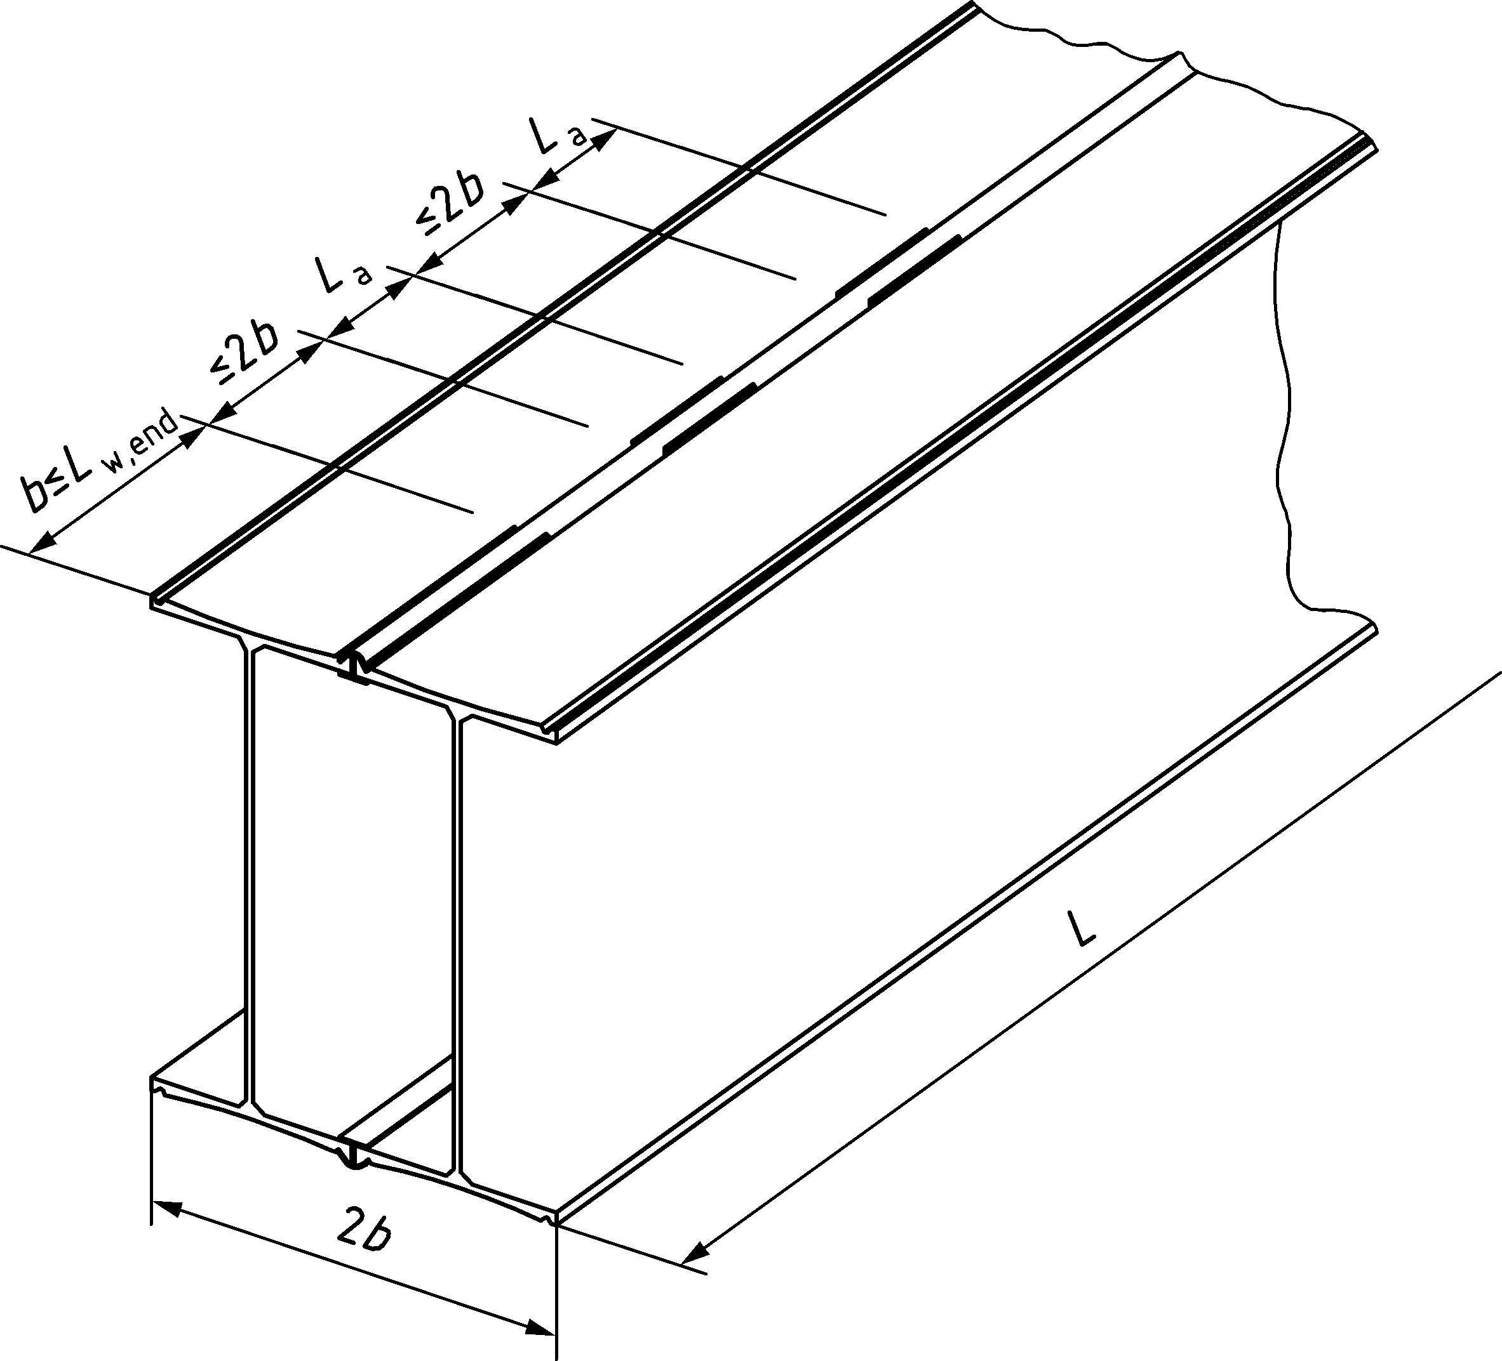

Figure 8.9 — Definition scheme of welding of double H-piles

(7) The effective torsional moment of inertia may be calculated based on the degree of intermittent welding using:

$I_{T, eff}={}_{w} I_{T, D}$ (8.50)

* for end weld lengths between 0,5 of the double flange width and 0,05 of the length of the pile:

${}_{w}={{}_{w}}^{0.4}$ (8.51)

* for longer end welds:

${}_{w}={{}_{w}}^{0.4}+0.4\left(\frac{L_{w,end}}{L}-0.05\right)≤1$ (8.52)

where

*η*w is the factor for the effect of degree of welding on the effective torsional stiffness

*β*w is the degree of welding in the zone of intermitted welding, which is defined as the total intermittent weld seam length at one side, divided by the pile length section of the intermittent welding. The toe and top end welding not considered.

*L*w,end is the applied continuous weld seam length at the end of the pile

*L* is the length of the pile

*I*T,D = moment of inertia of a continuously welded double H-pile

### Lateral torsional buckling of H-piles

(1) Verification of lateral torsional buckling of H-piles may be neglected when the relative slenderness for lateral torsional buckling satisfies LT ≤ 0,4, with the relative slenderness for lateral torsional buckling LT as defined in EN 1993‑1‑1:2022, 8.3.2.2.

For cases with H-pile sections in compression and bending with *N*Ed ≤ 0,1 *M*Ed *A*/*W*el verification of lateral torsional buckling may be neglected when the relative slenderness for lateral torsional buckling satisfies LT ≤ 0,38.

(2) In order to verify the lateral torsional buckling resistance according to EN 1993‑1‑1:2022, 8.3.2.1 or in case of bending and compression according to EN 1993‑1‑1:2022, 8.3.3, the elastic critical moment for lateral torsional buckling may be determined as in (3), provided the criterion $k_{gr}B≥$ 30 000 kN/m2 for the embedment in homogenous soil is fulfilled. The width *B* may be taken as 0,3 *h*, see Figure 8.10.

(3) The elastic critical moment for lateral torsional buckling may be assumed as the equivalent elastic critical moment *M*cr for a simply supported beam with an equally distributed load and fork supports on both ends as follows:

$M_{cr}=1,12⋅\frac{π^{2}⋅EI_{z}}{{L_{cr,LT}}^{2}}⋅\left(\sqrt{\frac{I_{ω}}{I_{z}}+\frac{{L_{cr,LT}}^{2}⋅GI_{T}}{π^{2}⋅EI_{z}}+{\left(0,45∙\frac{h}{2}\right)}^{2}}-0,45∙\frac{h}{2}\right)$ (8.53)

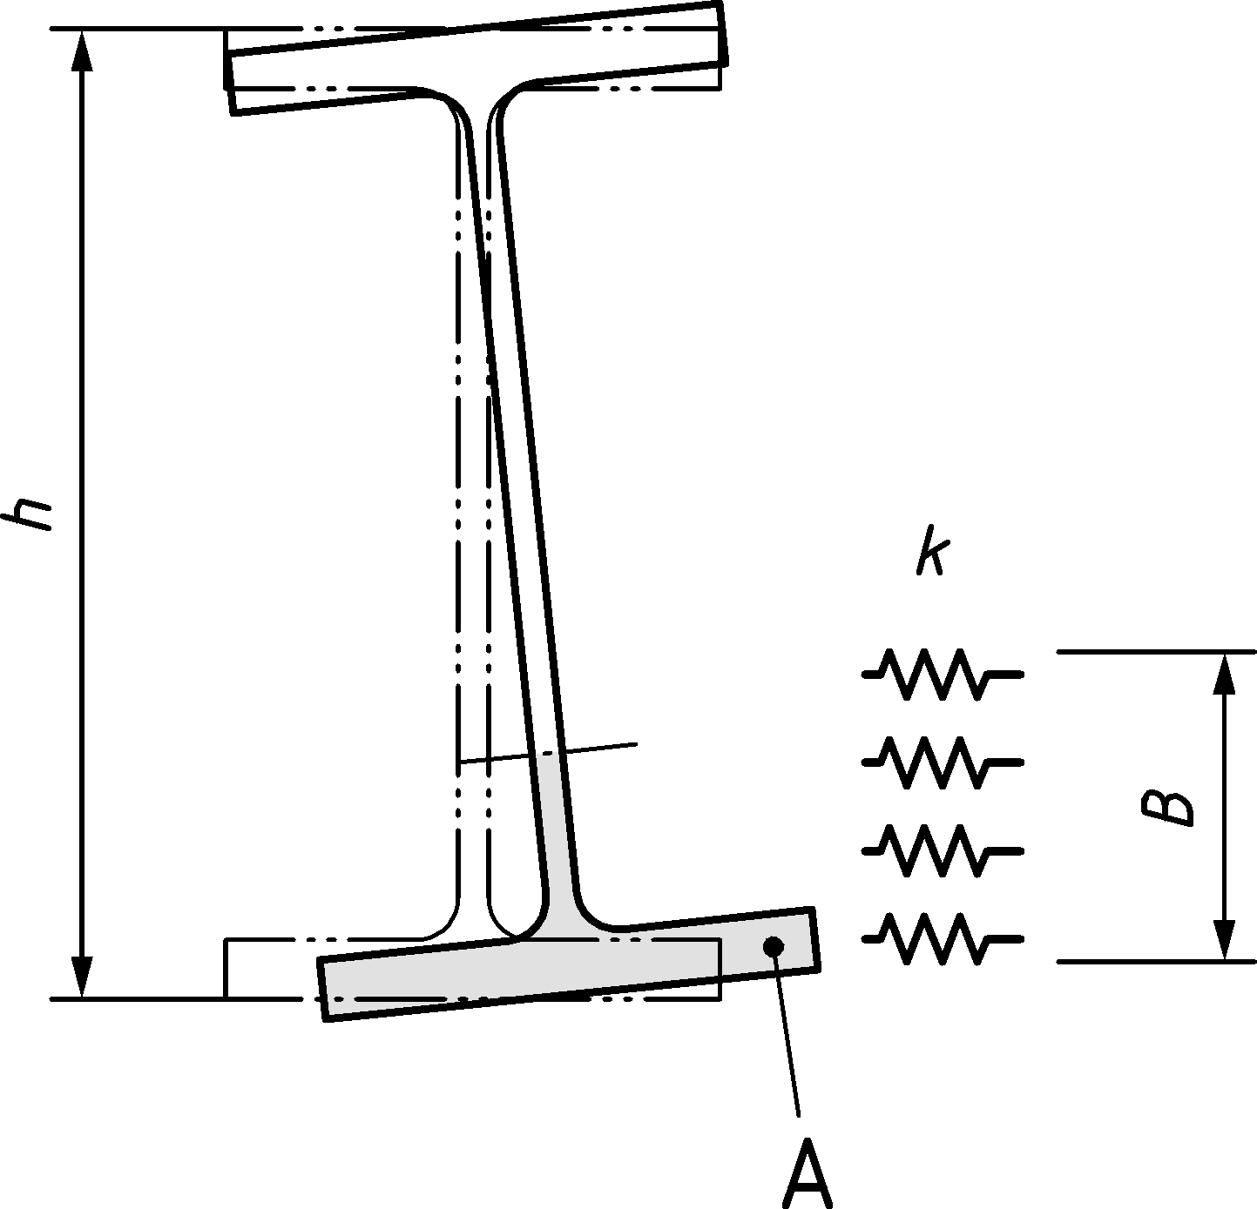

Key

|  |  |
| --- | --- |
| A | equivalent compression flange |

Figure 8.10 — Definition of the soil reaction resisting LTB

(4) Provided the following criteria are fulfilled:

— The relative bulk density *I*D of the non-cohesive soil (with subgrade reaction *k*gr) is at least medium dense.

— The consistency index *I*c of the fine cohesive soil (with subgrade reaction *k*fi) is > 0,5.

— The profile and system dimensions correspond to the usual ranges in steel sheet pile walls.

The critical length *L*cr, LT for lateral torsional buckling of partially embedded piles may be approximated as follows:

$L_{cr,LT}=β_{0}∙L_{f,z}$ (8.54)

where

$β_{0}$ is the critical length coefficient about the weak axis

For uniform soils the critical length coefficient $β_{0}$ may be determined using:

$β_{0}=\frac{1.55}{ξ^{0.60}}+0.7 with ξ=\sqrt{\frac{{k_{gr}∙B∙L_{f,z}}^{4}}{EI}}$ (8.55)

|  |  |
| --- | --- |
| *Lf,z* | free length in the considered weak axis direction |
| *k*gr | is the subgrade reaction in uniform coarse granular soil [kN/m3] |
| *B* | Is the width of the pile |

For layered soils the critical length coefficient $β_{0}$ may be determined using:

$β_{0}=\min\left\{\begin{aligned}β_{1}∙\left(\frac{L_{c}}{L_{f,z}}\right) +β_{3}∙\left(1-\frac{L_{c}}{L_{f,z}}\right) \\ β_{2} ∙\left(\frac{L_{c}}{L_{f,z}}\right) \end{aligned} \right.$ (8.56)

with

$β_{1}=\frac{1.55}{{ξ_{1}}^{0.60}}+0.7 with ξ_{1}=\sqrt{\frac{{k_{gr}∙B∙L_{f,z}}^{4}}{EI}}$ (8.57)

$β_{2}=\frac{1.55}{{ξ_{2}}^{0.60}}+0.7 with ξ_{2}=\sqrt{\frac{{k_{fi}∙B∙L_{c}}^{4}}{EI}}$ (8.58)

$β_{3}={\left(2.41-0.106∙\left(\frac{k_{fi} B}{{kB}_{0}} \right)\right)}/{ξ_{1}^{0.44+0.0433∙\ln\left(\frac{k_{fi} B}{{kB}_{0}}\right)}}$ (8.59)

|  |  |
| --- | --- |
| *L*c | is the free length to the top of the layer of fine cohesive soil, in case of layered soil (see Figure 8.11 for definition of *L*c and *L*z,f in case of layered soil) |
| β1 | is the critical length coefficient for weak axis buckling without the consideration of *k*fi |
| β2 | is the critical length coefficient for weak axis buckling with a soft soil layer (*L*c > 0 and *L*f,z >> *L*c) |
| β3 | is the critical length coefficient for weak axis buckling for a fully backfilled wall (*L*c = 0) |
| *k*fi | is the linear subgrade reaction in fine cohesive soil [kN/m3] |
| *kB*0 | is the reference value for the subgrade reaction multiplied with the pile width, *kB*0 = 8 000 [kN/m²] |

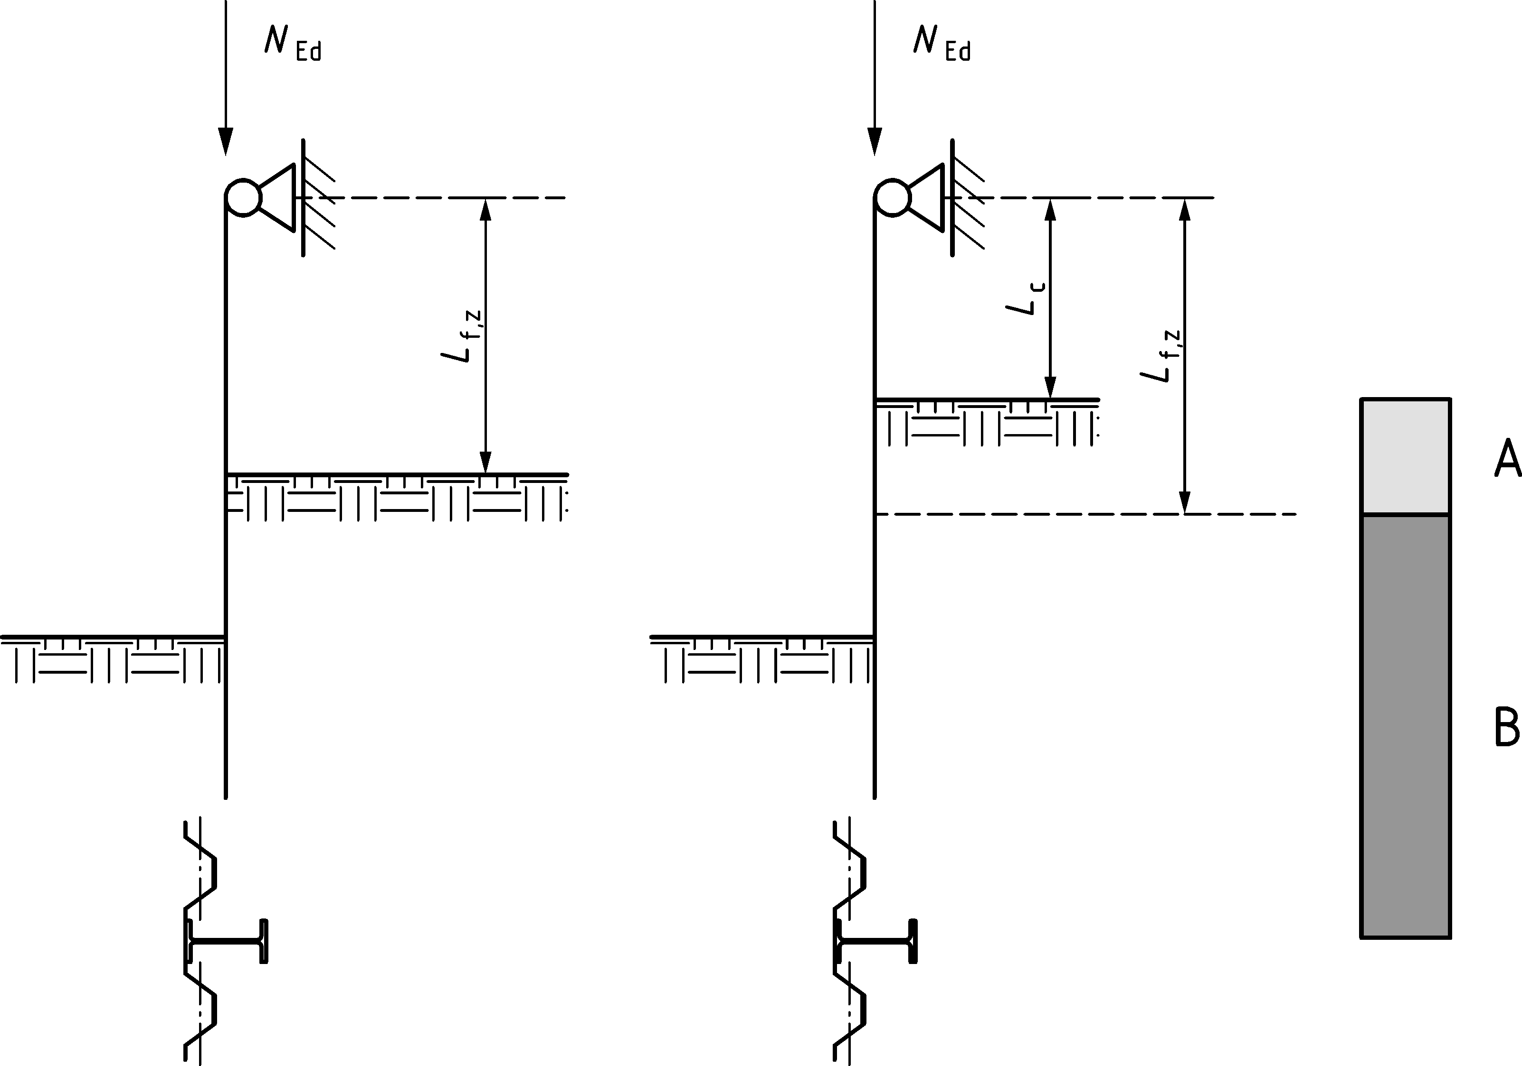

Key

|  |  |
| --- | --- |
| A | fine cohesive soil |
| B | coarse granular soil |

Figure 8.11 — Definition of free lengths of partially embedded H-pile susceptible to LTB

(5) A simplified verification of lateral torsional buckling in combination with compressive axial force may be applied using EN 1993‑1‑1:2022, 8.3.2.4 in the following manner.

The effect of the combination of axial compression and bending moment should be combined to calculate a compression force in the equivalent flange:

$N_{c,Ed}=\frac{N_{Ed}}{2}+\frac{M_{Ed}}{h_{f}}$ (8.60)

$N_{c,Ed}<N_{c,Rd}={}_{c,z} A_{c}\frac{f_{y}}{{}_{M1}}$ (8.61)

where

χc,z is the reduction factor for flexural buckling of the equivalent compression flange about the weak axis of the section, determined with ${\overline{}}_{c,z,mod}$ in accordance with EN 1993‑1‑1:2022, 8.3.2.4 (3) and (4). For hot-rolled profiles buckling curve c may be used. In the verification *N*cr,c,z should be determined using *N*cr = π2EI/*L*cr2 based on *L*cr = *L*cr,LT, see (4).

*A*c is the area of the equivalent compression flange, to be determined dependent on the location of application of the load, in accordance with EN 1993‑1‑1:2022, 8.3.2.4 (4).

*h*f is the internal lever arm between the centroids of the flanges.

For cases with axial force utilization $\frac{\frac{N_{Ed}}{2}}{N_{c,Rd}}>0,3$, *β*c = 1 and *k*c = 1 should be used for the determination of the reduction factor for flexural buckling χc,z for evaluation in (Formula 8.61).

NOTE 1 The formulae in this clause can be used for single and for double H-piles.

NOTE 2 The range of application of the simplified method of EN 1993‑1‑1:2022, 8.3.2.4 is here for H-piles used as primary piles widened to the combination of bending and axial force.

### Shear buckling of H-piles

(1) Shear buckling verification of the webs should be made in accordance with prEN 1993‑1‑5:2022, 7.1 and 7.3. In the case of unstiffened webs at the support, the slenderness $\overline{{}_{w}}$ should be smaller than 1,4 and *η* should be taken equal to 1.

### The combined effect of member forces and flange bending

(1) For H-piles in combined walls transverse flange bending and its effect on the longitudinal member capacity should be verified in accordance with EN 1993‑1‑1:2022, 8.2.1 (5).

(2) The following simplified procedure may be applied for the verification of H-piles taking into account the interaction of longitudinal bending and normal force, and transverse bending and normal force in the flanges due to forces from the secondary elements.

NOTE A more advanced calculation method that considers both material and geometrical nonlinearities can lead to a more economical design. A more advanced calculation method is also recommended to deal with water pressures exceeding 10m head.

(3) Up to a water pressure of *Δh* = 10m head (or equivalent earth pressure in very soft soils) the interaction of transverse bending, and longitudinal capacity may be taken into account as follows:

— The verification of the primary elements should be carried out in accordance with EN 1993‑1‑1:2022, 8.2.8, 8.2.9 and 8.2.10, considering an increased longitudinal normal stress in the flange to determine *M*Ed and *N*Ed:

for *Δh* = 10 m: ${}_{Eq, Ed}=1,1 {}_{x,Ed}$

for *Δh* ≤ 4 m: ${}_{Eq, Ed}={}_{x,Ed}$

for 4 m < *Δh* < 10m: linear interpolation

Transverse flange bending of the flanges should be verified in accordance with (4).

(4) Transverse flange bending in the flanges should be verified for at the beginning of the fillet taking into account the forces introduced via the connectors, see Figure 8.12, using:

$\frac{m_{Ed}}{m_{Rd}} + {\left(\frac{n_{Ed}}{n_{Rd}}\right)}^{2}≤1$ (8.62)

where

*m*Ed and *n*Ed are the design action effects for transverse bending and normal force, given by

*m*Ed *= mx,*Ed *+ q*z,Ed *c*  (8.63)

*n*Ed *= q*y,Ed (8.64)

*m*Rd and *n*Rd are the design values of the resistance for transverse bending and normal force, given by:

*m*Rd *=* 0,2875 *t*2 *f*y */ γ*M0 (8.65)

*n*Rd *= t f*y */ γ*M0 (8.66)

where *t* is the flange thickness at the beginning of the fillet.

The transverse shear force interaction may be neglected.

NOTE The transverse action effects and capacities *m*Ed, *n*Ed, *m*Rd and *n*Rd are to be taken per unit length.

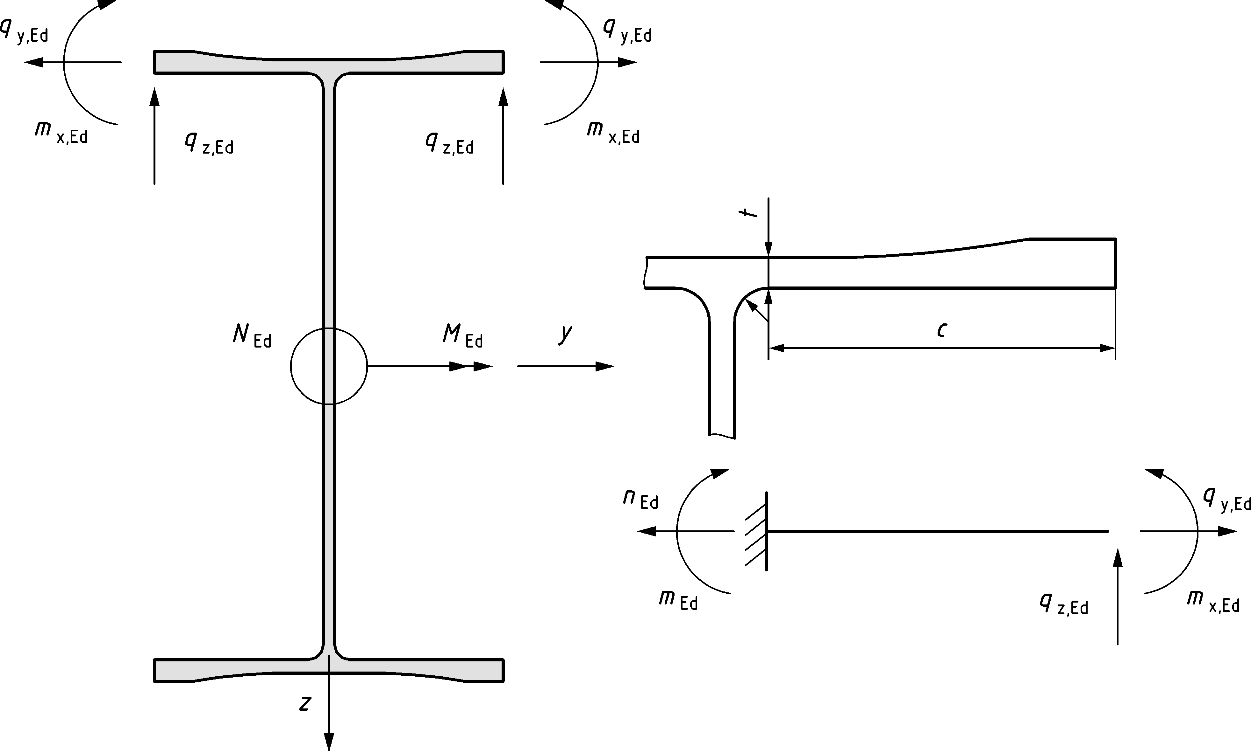

Figure 8.12 — H-piles with longitudinal and transverse bending

## Tubular sections used as primary elements

### General

(1) The verification of tubular piles used as elements of high-modulus walls or as primary elements in combined walls shall be in accordance with EN 1993‑1‑1 unless indicated otherwise below.

(2) Tubular piles used as primary elements in combined walls, which appear to be Class 1, Class 2 or Class 3 sections in accordance with EN 1993‑1‑1:2022, Table 7.3, should be verified in accordance with the procedure given in 8.9.2.

(3) Tubular piles of Class 4 sections used as primary elements in combined walls, loaded with meridional loads and/or non-uniform circumferential bending shall be designed in accordance with 8.9.3 and 8.9.7.

(4) Tubular piles of Class 4 sections used as primary elements in combined walls, loaded with combined meridional loads and uniform circumferential compression should be verified in accordance with prEN 1993‑1‑6:2023, 9.5.1 and Annex D.1.

(5) For Class 1 and Class 2 sections nonlinear flexibility of the tubular piles may be used in the calculation of bending moments caused by soil pressures on the retaining wall. Nonlinear flexibility and ductility of tubular piles in Class 3 may also be used in accordance with the limitations given in 9.8.4.

(6) Determination of the buckling length of primary piles having a free length shall be in accordance with 8.4.3.

(7) For primary piles having a dominant retaining function the buckling length (for the buckling direction perpendicular to the wall) should be obtained from the bending moment diagram, in accordance with 8.3.4 (5).

(8) Circumferential bending stresses due to the design forces introduced by the secondary elements via connectors should be considered in accordance with 8.9.5.

(9) For Class 4 tubular piles local buckling should be verified taking in account the effect of geometrical imperfections. Manufacturing tolerance classes for the buckling relevant imperfections of tubular sections are given in EN 12063, in Table B.11 of EN 1090‑2 and in prEN 1993‑1‑6:2023, 9.4.

### Tubular piles in bending and shear

(1) For tubular piles of class 1, 2 and 3 the resistance shall be obtained in accordance with EN 1993‑1‑1:2022, 8.2.5 and 8.2.6 for bending and shear, respectively.

(2) For Class 3 tubular piles with *d*/*t* > 115 ε2 the following formula for *M*c,Rd should be used.

$M_{c,Rd}=\frac{W_{ep} f_{y}}{{}_{M0}}$ (8.67)

where

Wep is the elasto-plastic section modulus, given in Annex E.

NOTE 1 This is specific for piling applications and considers the large difference between *W*pl and *W*el and the transition between Class 3 and 4.

NOTE 2 See 8.2 (1) for the value of γM0.

(3) For Class 3 tubular piles with *d*/*t* < 115 ε2 Formula (8.67) may be used.

(4) For class 4 tubular piles manufactured by cold-forming and welding, with 500 mm < d < 2500 mm, should be verified using Annex D.

For class 3 piles manufactured by cold-forming and welding, Annex D may be used.

(5) For Class 4 tubular piles manufactured by cold-forming and welding the use of EN 1993‑1‑1, 2022, 8.2.2.5 (4) and (5) is not permitted.

(6) For tubular piles with d/t > 100 *ε* 2 shear buckling shall be considered. The shear resistance shall be obtained from prEN 1993‑1‑6:2023, D.1.5 and may be used to determine the effect of the shear force on the bending moment capacity *M*V,Rd.

(7) Shear buckling may be neglected at points of load introduction, provided that these points are stiffened by a concrete fill or appropriately designed stiffeners.

### Tubular piles in axial compression and bending

(1) Tubular piles of Class 1, 2 and 3 loaded in axial compression and longitudinal bending shall be verified in accordance with EN 1993‑1‑1:2022, 8.2.9.1. In absence of a formula for circular hollow sections *M*N,Rd shall be determined as follows:

For Class 1 and 2 sections: $M_{N,Rd}=M_{pl,Rd}\left[1-{\left(N_{Ed}/N_{pl,Rd}\right)}^{1,7}\right]$ (8.68)

For Class 3 sections: $M_{N,Rd}=M_{c,Rd}\left[1-\left(N_{Ed}/N_{pl,Rd}\right)\right]$ (8.69)

(2) Class 4 sections loaded in axial compression and longitudinal bending shall be verified in accordance with prEN 1993‑1‑6:2023, E.1.3.

### Buckling of tubular piles

(1) Global buckling verification should be made in accordance with EN 1993‑1‑1:2022, 8.3.3 using elastic cross-sectional properties, considering the effect of circumferential bending in accordance with 8.9.5,

(2) Where the tubular pile is filled with coarse soil with relative density *I*D = 15 to 65 % in accordance with EN ISO 14688‑2:2018, Table 5, or with fine graded cohesive soil with cu = 20 to 75 kPa in accordance with EN ISO 14688‑2:2018, Table 6, the effects of transverse loads and the associated circumferential stresses and deformation on the longitudinal member resistance and longitudinal flexural stiffness may be neglected for the global buckling verification. Presence of soil fill over the full length is required, apart from the very top or pile cap connection that might remain empty.

(3) The global buckling verification may be deemed to be satisfied by verifying the interaction criterion:

$\frac{N_{\text{Ed}}}{\frac{χN_{\text{Rk}}}{γ_{\text{M1}}}}+1,5\frac{M_{\text{Ed}}}{\frac{M_{\text{Rk}}}{γ_{\text{M1}}}}≤1,0$ (8.70)

where

*N*Ed and *M*Ed are the design values of the compressive force and the bending moment in the governing cross-section;

*N*Rk and *M*Rk are the characteristic resistances, determined in accordance with (1);

*χ* is the reduction factor due to global flexural buckling taken from EN 1993‑1‑1: 2022, 8.3.1.3, based on a buckling length in accordance with 8.9.1 (6) and (7), and on a reduced flexural stiffness *EI*red accounting for circumferential deformation, in accordance with 8.9.7 (1).

### Effects of transverse loads

(1) Circumferential bending, shear and normal forces caused by transverse loads introduced by the secondary members or by direct or indirect soil pressure shall be determined in accordance with (2) and (3) and the respective resistance shall be verified.

(2) Circumferential bending moments *m*Ed may be calculated using the formulas in Table 8.3.

Table 8.3 — Formulas for transverse bending moments and deformations

|  |  |  |
| --- | --- | --- |
| Case with tensile forces from secondary members | | |
|  | $$m_{A}=-\frac{1}{}q_{y,Ed} r$$ | –0,3183 |
| $$m_{B}=\left(\frac{1}{2}-\frac{1}{}\right)q_{y,Ed} r$$ | 0,1817 |
| $$d_{y}=\left(\frac{}{4}-\frac{2}{}\right)\frac{q_{y,Ed} r^{3}}{EI}$$ | 0,1488 |
| $$d_{z}=-\left(\frac{2}{}-\frac{1}{2}\right)\frac{q_{y,Ed} r^{3}}{EI}$$ | –0,1366 |
| Case with bending moments from secondary members | | |
|  | $$m_{A}=±\frac{1}{2}m_{x,Ed}$$ | ±0,5 |
| $$m_{B}=\left(\frac{2}{}-\frac{1}{2}\right)m_{x,Ed}$$ | 0,1366 |
| $$d_{y}=0$$ | 0 |
| $$d_{z}=0$$ | 0 |
| Case with soil pressure from one side | | |
|  | $$m_{A}=-\frac{1}{8}q{ r}^{2}$$ | –0,1250 |
| $$m_{B}=\left(\frac{3}{8}-\frac{2}{3}\right)q{ r}^{2}$$ | 0,1628 |
| $$m_{C}=\left(\frac{2}{3}-\frac{1}{8}\right)q{ r}^{2}$$ | 0,0872 |
| $$d_{y}=\frac{1}{12}\frac{q{ r}^{4}}{EI}$$ | 0,0833 |
| $$d_{z}=-\frac{1}{12}\frac{q r^{4}}{EI}$$ | –0,0833 |
| Case with soil pressure from two opposite sides | | |
|  | $$m_{A}=-\frac{1}{4}q{ r}^{2}$$ | –0,2500 |
| $$m_{B}=\frac{1}{4}q{ r}^{2}$$ | 0,2500 |
| $$m_{C}=\frac{1}{4}q{ r}^{2}$$ | 0,2500 |
| $$d_{y}=\frac{1}{6}\frac{q r^{4}}{EI}$$ | 0,1667 |
| $$d_{z}=-\frac{1}{6}\frac{q{ r}^{4}}{EI}$$ | –0,1667 |

where

EI is the flexural rigidity of the shell wall: $E \frac{1}{12} t^{3}$

NOTE 1 The corresponding shear and normal forces can be derived from equilibrium.

NOTE 2 The ovalisation deformation, perpendicular to the retaining wall, $a=\frac{1}{2}d$, often Δ*d*z.

NOTE 3 No re-rounding effect caused by soil support to the sides of the tube has been taken in account.

(3) For simplification the horizontal forces *q*y,Ed may be assumed to act only in tension.

(4) Circumferential bending moments *m*M associated with the deformation of the circular tube caused by longitudinal bending (the Brazier effect) shall be considered.

$m_{M,Ed}=0,071 M_{Ed} C$ (8.71)

where

MEd is the longitudinal bending moment

C is the corresponding longitudinal curvature, that might be nonlinear

(5) Where the tubular pile is filled with coarse soil with relative density *I*D = 65 to 100 % in accordance with EN ISO 14688‑2:2018, Table 5, the bending moments calculated in accordance with (1) may be reduced by applying the factor *β*soil fill determined in accordance with 8.9.7 (6). Presence of fill with soil of the specified relative density is required till at least 2 D above the cross section considered.

(6) The resistance for circumferential bending should be taken as the plastic shell bending resistance, also for Class 4 sections.

$m_{pl,Rd}= \frac{1}{4}{ t}^{2}{ f}_{y}$ (8.72)

### The combined effect of member forces and circumferential bending

(1) The resistance for longitudinal normal force and bending shall be reduced in case of combined circumferential bending. The effect of non-uniform circumferential normal force may be neglected.

$M_{m,Rd}={}_{m} M_{Rd}$ (8.73)

$N_{m,Rd}={}_{m} N_{Rd}$ (8.74)

where

*β*m is a factor to determine the reduced longitudinal resistance *M*m,Rd and *N*m,Rd due to the circumferential bending stress;

${}_{m}=\frac{c_{1}}{6}+\frac{c_{2}}{3}$ (8.75)

$c_{1}=\sqrt{4-2\sqrt{3}\frac{m_{Ed}}{m_{pl,Rd}}}$ (8.76)

$$c_{2}=2$$

*m*Ed is the circumferential bending moment calculated in accordance with 8.9.5.

NOTE This effect can be neglected for Class 1 tubes.

### The effect of circumferential deformation on member resistance

(1) Tubular piles shall be verified for the effect of circumferential deformation on the member resistance and for its effect and the longitudinal bending stiffness.

$M_{c,Rd}={}_{a }{}_{m} M_{Rd}$ (8.77)

${EI}_{red}={\left({}_{a }\right)}^{1.5} EI$ (8.78)

where

βa is a reduction factor accounting for effect of the decrease of the diameter

${}_{a}=1-\frac{2}{3}\frac{a}{r_{t}}$ (8.79)

*a* is the circumferential deformation as defined in Figure 8.13.

*a* = ½Δ*d* (8.80)

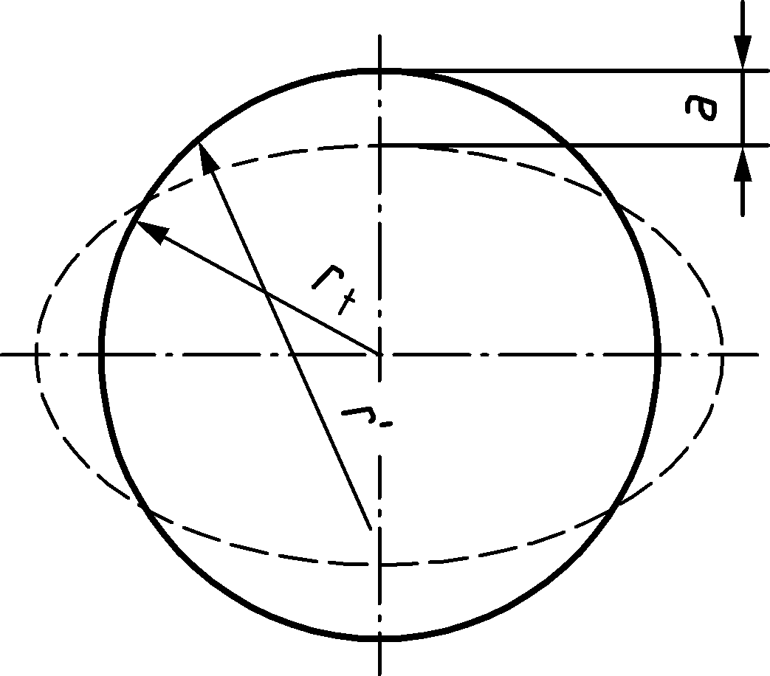

Figure 8.13 — Definition of the circumferential deformation *a*

*M*Rd is the member resistance of a cold-formed manufactured tubular pile taking in account shell buckling, determined in accordance with Annex D, neglecting any effect of ovalisation.

NOTE The effect of ovalisation is included by adding the factor *β*a, which introduces a small correction in case of pure bending of the empty tube, and a larger correction in case of other causes of circumferential deformation.

(2) The circumferential deformation *a* should include deformation caused by secondary member forces and soil pressure, using the formulas in 8.9.5.

(3) The circumferential deformation *a* should include deformation caused by load introduction near anchors and/or other supports.

(4) The circumferential deformation *a* should include ovalisation *a*C due to longitudinal bending (Brazier effect).

If *C* ≤ *C*y (8.81)

If *C* > *C*y  (8.82)

When in case of Class 4 sections the longitudinal bending resistance *M*R,d is calculated in accordance with 8.9.1 (4) the effect of ovalisation may be assumed to be included in *M*R,d.

(5) Non-uniform radial pressure of surrounding soils, and their effect on circumferential bending and deformation may be included using advanced analysis.

(6) In cross-sections where the tubular pile is filled with coarse soil with relative density *I*D = 65 to 100 % in accordance with EN ISO 14688‑2:2018, Table 5, the soil fill may be assumed to reduce the circumferential deformation *a* to be applied in (1). To account for this effect the soil fill shall be present up to the level of at least two diameters above the cross-section considered.

$a_{red}= {}_{soil fill} a$ (8.83)

where

*a* is the circumferential deformation when the circumferential loads are resisted by the steel shell only.

*a*red is the reduced value of the circumferential deformation accounting for permanent support of the soil fill of the pile

*β*soil fill is a reduction factor. In absence of advanced analysis *β*soil fill may be calculated using

${}_{soil fill}=\frac{\frac{12 EI}{r_{t}^{4}}}{\frac{12 EI}{r_{t}^{4}}+\frac{E_{soil fill}}{r_{t}^{}}}$ (8.84)

*EI* is the flexural stiffness of the shell wall

*E*soil fill is the deformation modulus [kPa] of the soil, accounting for the density and stress level in the soil.

NOTE 1 The contribution of the soil fill can be unreliable in the top part of a soil plug, typically one diameter high.

NOTE 2 Installation of tubular piles in consolidated soils creates soil fills with predictable properties, provided that the soil does not plug. For coarse soils of low density, properties of soil fills can be modified by the installation procedure. *In situ* tests after installation can be used to verify the properties. Filling of the piles with soil after installation of the piles is generally considered ineffective unless the required density and stiffness is confirmed by *in situ* testing of the fill.

(7) A possible contribution of a soil fill consisting of coarse soil with relative density *I*D < 65 % in accordance with EN ISO 14688‑2:2018, Table 5, may be considered based on advanced analysis and on drained soil properties.

(8) A possible contribution of a soil fill consisting of fine graded soil of high to very high strength may be taken into account based on advanced analysis. This analysis should account for compressibility of the soil, for shear failure and shear deformation and for creep.

### Flexibility and ductility of the tubular piles

(1) Tubular piles should be verified for the effect of circumferential deformation on the bending stiffness of the member and on the nonlinear deformation capacity.

(2) When the flexibility is used for energy absorption or for accurate calculation of soil pressures on a retaining wall, the deformation capacity shall be verified.

The nonlinear curvature of a tubular pile loaded in bending may be determined as follows:

$C_{cr}=2\frac{f_{y}}{E}\frac{1}{d}(R+1)$ (8.85)

where

*C*cr is the critical curvature, beyond which local buckling may occur

*R* is the permitted critical curvature ratio:

*R* = 0 for *d*/*t* ≥ 140 ε2

*R* = 3 for *d*/*t* = 70 ε2

*R* = 4 for *d*/*t* = 50 ε2

Intermediate values of *R* may be determined by linear interpolation.

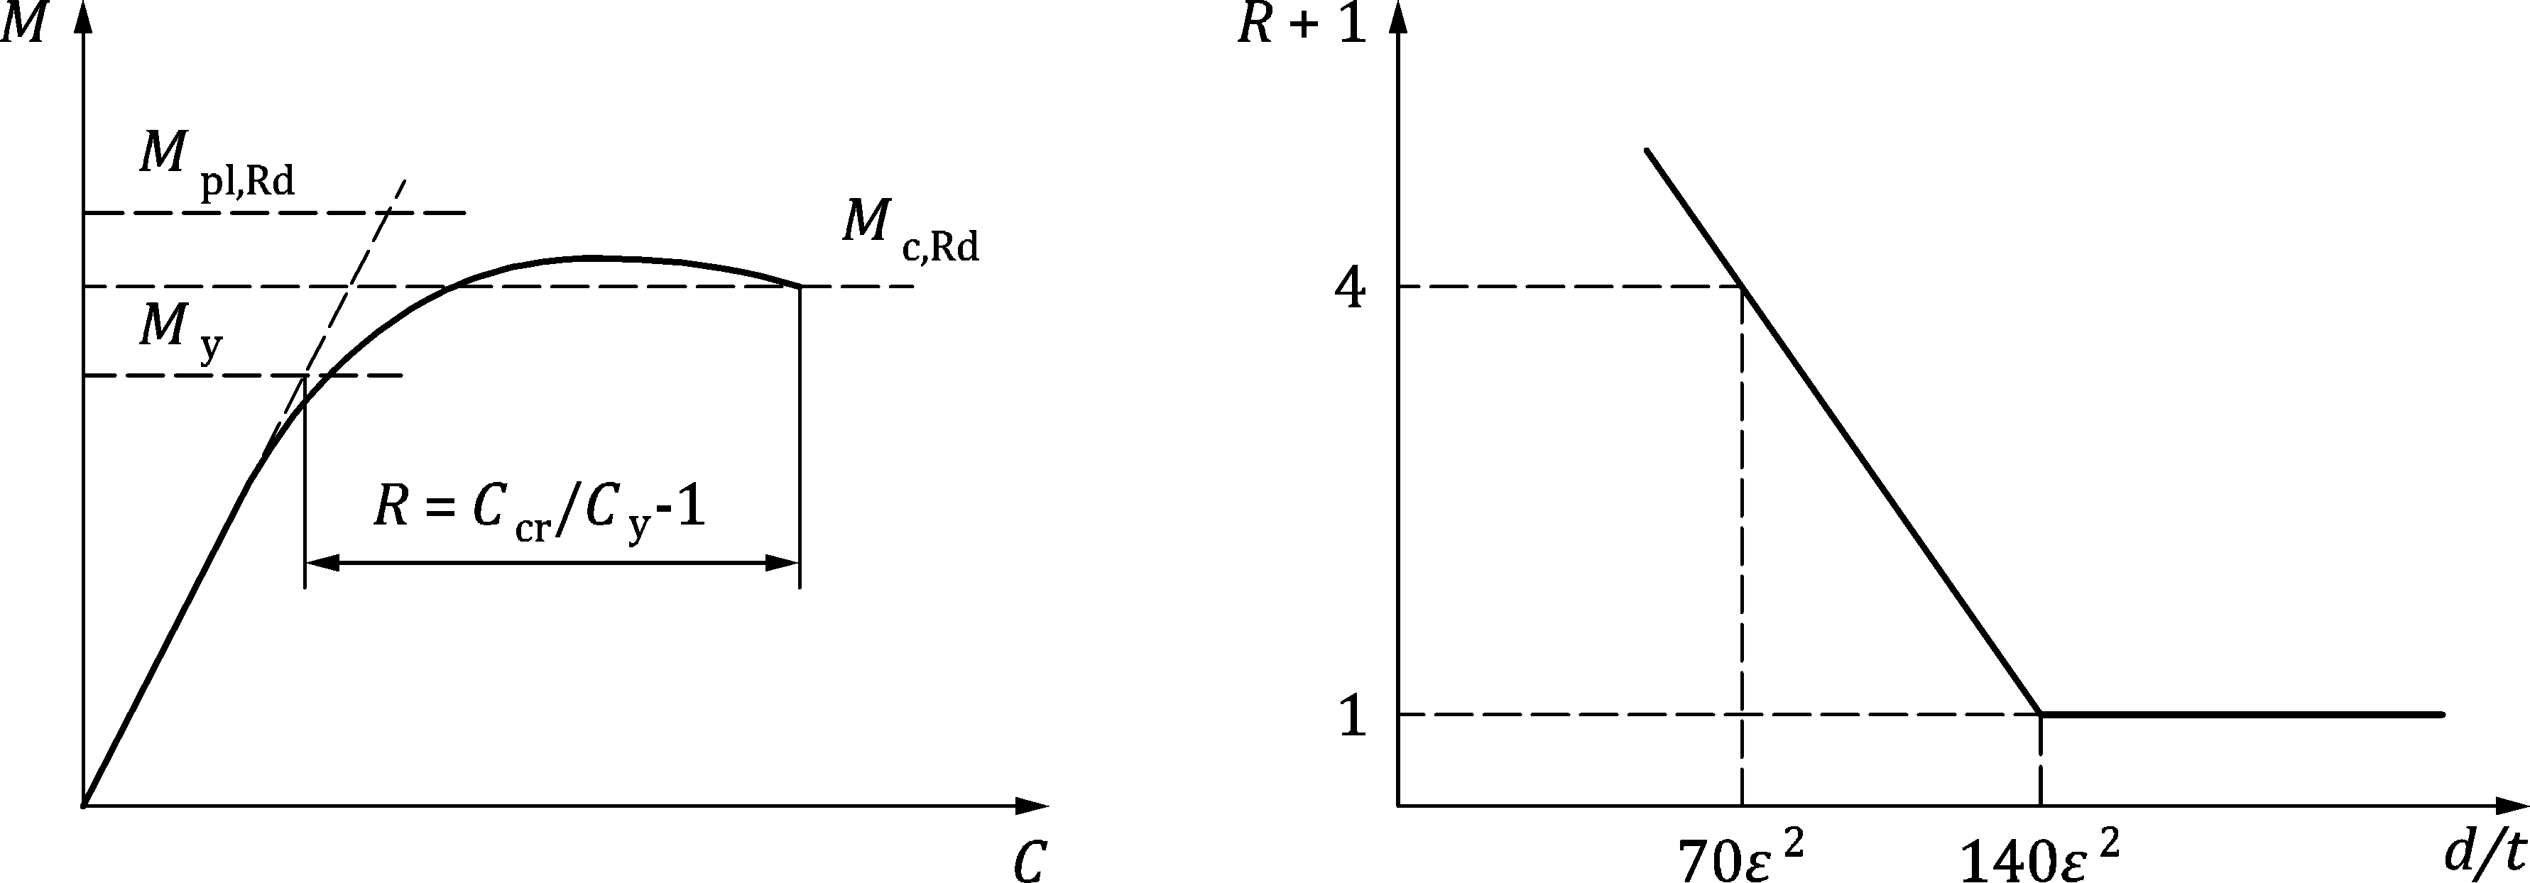

Figure 8.14 — Definition of the deformation capacity of tubular members in bending

NOTE Formulas for the idealized plastic moment-curvature diagram can be given as:

For *C* < *C*y: (8.86)

For *C* > *C*y: (8.87)

where

*C* is the longitudinal curvature of the section;

*C*y is the value of *C* at the point of first yield;

*θ* is yield angle in the cross-section, starting at ½π at first yield, and decreasing to 0 for the full plastic moment, in [rad];

$θ=\sin^{-1}\left(\frac{C_{y}}{C}\right)$ (8.88)

(3) For fabricated piles the effect of residual stress on the curvature should be taken into account using the following formula. The modified curvature due to residual stress Cres is calculated as $α_{res} C$.

For *M* < 0,5 *M*y (8.89)

For *M* > 0,5 *M*y (8.90)

## Straight web steel sheet piles

### General

(1) The effects of actions for strength verification of straight web steel sheet piles used in cellular structures, shall be determined from a model that describes the behaviour of the piling at ultimate limit states.

(2) The fill model should be in accordance with prEN 1997‑1.

(3) The piling model should be in accordance with EN 1993‑1‑1.

NOTE It can be beneficial to use models considering large displacements for the piling.

(4) A two-dimensional analysis in the governing horizontal plane may be used.

(5) The internal pressure resulting from or transmitted through the fill should be determined using a value not less than the at rest value of the earth pressure, see prEN 1997‑3.

(6) The tensile resistance *F*ts,Rd of plain straight web steel sheet piles, (other than junction piles) should be taken as the lesser of the interlock resistance and the resistance of the web, using:

*F*ts,Rd = 0,8 *R*k,s / *γ*M0 but *F*ts,Rd ≤ *t*w *f*y / *γ*M0 (8.91)

where

*f*y is the yield strength;

*R*k,s is the characteristic interlock resistance;

*t*w is the web thickness.

(7) The characteristic resistance of the interlock *R*k,s depends upon the cross-section of the interlock and the steel grade adopted. The characteristic interlock resistance *R*k,s should be determined by testing in accordance with 4.7 and EN 10248‑1.

(8) Plain piles should be verified such that:

*F*t,Ed ≤ *F*ts,Rd (8.92)

where

*F*ts,Rd is the design tensile resistance in accordance with Formula (8.91);

*F*t,Ed is the design value of the circumferential tensile force.

(9) When piles of different sizes are used in the same segment of a wall, the lowest tensile resistance should be used for the verification.

(10) The deviation angle (180° minus the angle between two adjacent faces) should be limited to the maximum value given by the manufacturer.

### Verification of junction piles

(1) The design of junction piles in accordance with Figure 8.15 should take account of the stresses due to plate bending.

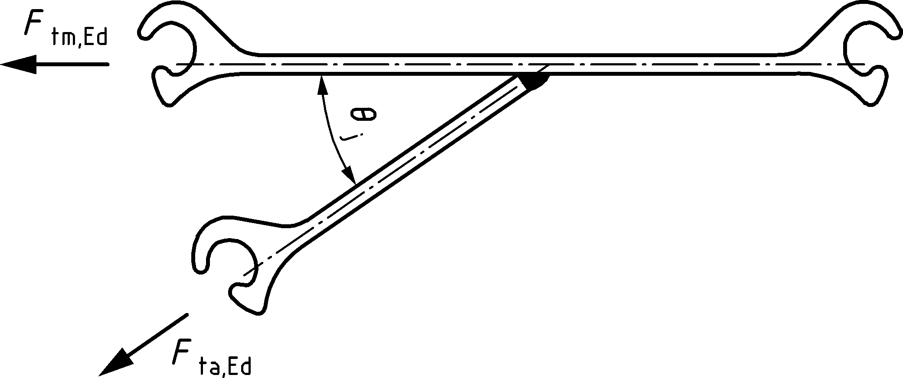

Figure 8.15 — Welded junction pile

(2) For welded junction piles used in cellular cofferdams, steel grades with appropriate properties should be used.

(3) Provided that welding is carried out in accordance with the procedure given in EN 12063 the welded junction pile may be verified using:

*F*tm,Ed ≤ *β*T *F*ts,Rd (8.93)

where

*F*ts,Rd is the design tensile resistance of the pile in accordance with Formula (8.91);

*F*tm,Ed is the design tensile force in the main cell given by:

*F*tm,Ed = *p*m,Ed *r*m (8.94)

with

*p*m,Ed is the design value of the internal pressure of the main cell in the governing horizontal plane due to water pressure and the at rest pressure of the fill;

*r*m is the radius of the main cell, see Figure 8.16.

*β*T is a reduction factor that takes into account the behaviour of the welded junction pile at ultimate limit states and should be calculated as follows:

*β*T = 0,9 (1,3 - 0,8 *r*a / *r*m) (1 - 0,3 tan *φ*k) (8.95)

in which *r*a and *r*m are the radii of the connecting arc and of the main cell in accordance with Figure 8.16 and *φ*k is the characteristic value of the internal friction angle of the fill material.

NOTE 1 The factor *β*T considers the rotation capacity (ductility) of the junction pile as well as the rotation demand (up to 20°) in accordance with a model covering the behaviour of the cofferdam at ultimate limit states.

NOTE 2 Formula (8.93) - although developed for cellular cofferdams with aligned connecting arcs, see Figure 8.16, yields acceptable results for alternative configurations. Where more appropriate values are required, these values can be determined either by comparable experience or by testing in combination with a suitable design model in accordance with 8.10.1(1).

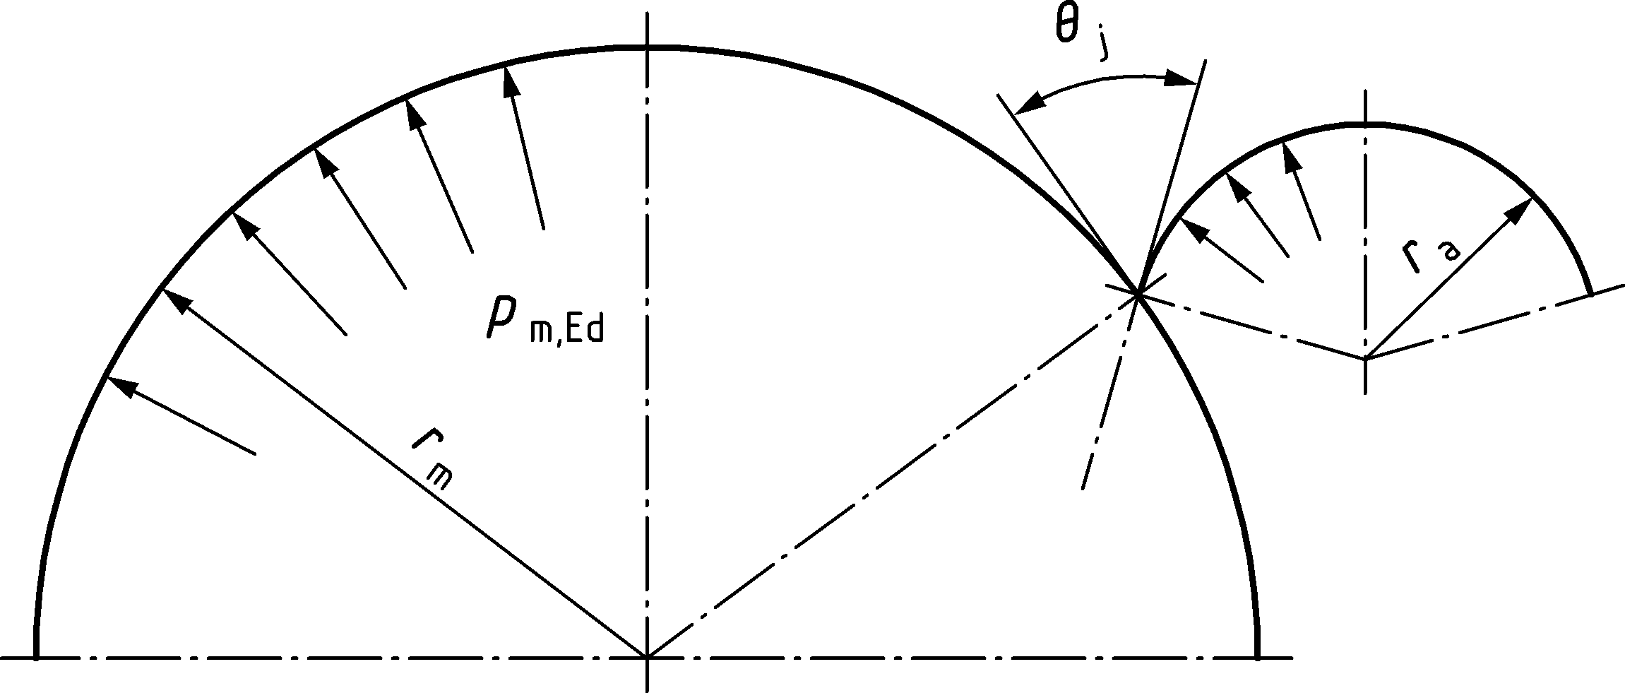

Figure 8.16 — Geometry of circular cell and the aligned connecting arc

## Anchors and tension piles

### General

(1) Anchors, tension piles and their components shall be designed such that the basic design requirements for ultimate limit states given in Clause 4 are satisfied.

(2) This section refers to the structural design of steel parts for anchors and tension piles only. For geotechnical design see prEN 1997‑3.

(3) The design value of the ultimate limit state resistance of an anchor or tension pile shall satisfy the inequality:

*F*𝑑 ≤ min { *R*GEO,d ; 𝑅STR,d } (8.96)

where

*F*d is the maximum design value of the anchoring force (including the effect of lock-off load where appropriate) sufficient to prevent any ultimate limit state or serviceability limit state in the supported structure;

*R*GEO,d is the design value of the geotechnical ultimate limit state resistance of the anchor or tension pile calculated in accordance with prEN 1997‑3;

*R*STR,d is the structural ultimate limit state design resistance of the anchor or tension pile calculated in accordance with this document.

NOTE *R*GEO,d = *R*ad,ULS and *R*STR,d = *R*t,d in prEN 1997‑3

(4) The ultimate tensile resistance *R*STR,d shall be based on the minimum cross-sectional area of the tension element allowing for any loss of section due to corrosion – see 6.4 and 6.5.

(5) The design resistance *R*STR,d for tension elements used in anchors shall be in accordance with 8.11.2.

NOTE Tie rods are considered as the tension element part of a deadman anchor.

(6) The design resistance *R*STR,d for steel tension piles shall be determined in accordance with EN 1993‑1‑1 unless noted otherwise below.

(7) The design resistance *R*STR,d for reinforcing steel elements in grouted tension piles (e.g. micropiles) shall be determined in accordance with prEN 1992‑1‑1.

(8) All terminations and connections (anchor head, couplers, washer plates, etc.) should be designed such that their ultimate resistance is higher than the ultimate resistance of the tension element.

(9) The ultimate resistance of terminations and connections shall be determined in accordance with prEN 1993‑1‑8. Values for resistances may be determined using design assisted by testing methods in accordance with EN 1990:2023, Annex D considering the provisions in this document.

(10) The design punching shear resistance of the anchor head bearing plate *Bp,Rd* should be calculated as per prEN 1993‑1‑8:2021, Table 5.9 and should be greater than *Fd*.

*F*d ≤ *B*p,Rd (8.97)

### Design resistance of tension elements for anchors

(1) Unless noted otherwise, when loaded in pure tension, the design resistance *R*STR,d of steel tension elements shall be based on

*R*STR,d *=* min {*R*tg,d ; *R*tt,d } (8.98)

where

*R*tg,d  = *f*yd *Ag*  (8.99)

$R_{tt,d}=k_{t} f_{ud} A_{s}$ (8.100)

*R*tg,dis the tensile resistance of the gross cross-section of the tension element shaft;

*R*tt,dis the tensile resistance at the termination of the tension element;

*f*yd is the design yield strength of the steel;

for structural steel

*f*yd = *f*y/ *γ*M0  where *f*y is the  minimum yield strength (*R*eH) in accordance with EN 10025;

for reinforcing steel

*f*yd = *f*0.2k/ *γ*s where *f*0.2k is the characteristic proof strength at 0,2% strain in accordance with EN 10080;

for prestressing steel

*f*yd = *f*p0.1k/ *γ*s  where *f*p0.1k is the characteristic proof strength at 0,1% strain in the relevant standard for prestressing steels;

*f*ud is the design tensile strength of the steel

for structural steel

*f*ud = *f*u/ *γ*M2  where *f*u is the minimum tensile strength (*R*m) in accordance with EN 10025;

for reinforcing steel

*f*ud = *f*tk/ *γ*Mt,A *γ*s where *f*tk is the characteristic tensile strength in accordance with EN 10080;

for prestressing steel

*f*ud = *f*pk/ *γ*Mt,A *γ*s

where *f*pk is the characteristic tensile strength in the relevant standard for prestressing steels;

*A*g is the gross cross-sectional area of the of the tension element (for reinforcing bar *Ag* can be taken as the nominal metallic cross-sectional area *An* in accordance with EN 10080 and for prestressing steel *Ag* can be taken as the nominal metallic cross-sectional area *Sn* in accordance with the relevant standards for prestressing steels);

*As* is the tensile stress area of the tension element at the termination (see Table 8.4);

*k*tis a calibration factor dependent on the type of termination used in the tendon (*kt* ≤ 1). Table 8.4 gives values for different types of terminations;

*γ*M0*, γ*M2 are the partial factors according to 8.2;

*γ*S is the partial factor for reinforcing or prestressing steel according to Table 4.3 of prEN 1992‑1‑1:2021;

*γ*Mt,A is the partial factor for resistance of reinforcing or prestressing steel in tension to fracture.

NOTE 1 The partial factor *γ*S can be taken equal to *γ*S = 1,15 as in prEN 1992‑1‑1.

NOTE 2 The partial factor *γ*Mt,A is taken to equal to 1,2 unless the National Annex gives a different value.

Table 8.4 — Tensile stress areas and calibration factor for terminations

| **Type of termination** | **Tensile stress area *A*s** | ***k*t** |
| --- | --- | --- |
| Metric cut or rolled thread | Calculated in accordance with ISO 898‑1 | 0,9 |
| Hot rolled thread rib reinforcing bar | nominal metallic cross-sectional area *A*n in accordance with EN 10080 | 0,9 |
| Hot rolled thread rib prestressing bar | nominal metallic cross-sectional area *S*n in accordance with prEN 10138‑4 | 0,9 |
| Prestressing strand | nominal metallic cross-sectional area *S*n in accordance with prEN 10138‑3 | 1 a |
| a The value is dependent on whether or not measures are applied at the terminations of the strand to reduce bending moments from rotations. Suitability of measures can be verified by testing or specified in an ETA.  NOTE kt is a test determined factor which considers the influence of the termination towards the measured breaking force. Values can differ from table values based on test data certified by a Technical Assessment Body. | | |

(2) Where bending moments are likely to be introduced at anchor connections (e.g. as a result of settlement of backfill on underlayers and associated differential movement at the anchor head) the design resistance *R*STR,d of steel tension elements shall be based on

*R*STR,d *=* min {*R*tg,d ; *R*tt,Md } (8.101)

where

$R_{tt,Md}=k_{b} f_{ud} A_{s}$ (8.102)

*k*b is a reduction factor to account for possible bending moments at the connection. Provided that the angle of imposed deformation at the connection is smaller than 0,035 rad (2 degrees) the value of *k*b may be conservatively assumed at 0,60.

NOTE Typically only tie rod anchors suffer from local bending, generally due to settlement of the fill below the tie rod, particularly at the connection to the front wall. It is a common cause of failure. If structural detailing of the location where the tie rod is joined to the wall is such that bending moments are avoided at that location (e.g. by use of hinges) bending moments can be ignored.

(3) The reduction factor *k*b may also be calculated with an appropriate model that accounts for imposed settlement, the tensile pre-load and the flexural stiffness of the tendon, as well as the direct soil load on the tendon. Verification of the cross section may be performed based on plastic analysis. For structural steels according to EN 10025 plastic verification of the cross-section verification is allowed, respecting a plastic total strain limit of 15 *f*yd/*E*.

NOTE 1 A recommended safe plastic total strain limit for reinforcement bar of ductility class B and C according prEN 1992‑1‑1 can be conservatively assumed at 5 *f*yd/E, unless other information can be obtained.

NOTE 2 A safe plastic total strain limit for pre-stressing bar can be derived from the ETA documentation. The use of these steels in areas with settlement risk, in conjunction with detailing that restrains rotation at the termination is not recommended.

(4) Imposed flexure of tension elements may be assumed to have no effect on the tensile resistance provided that the curvature is less than 200 times the diameter of the tendon.

(5) Terminations for tension elements should be designed for the ultimate limit state according to EN 1993‑1‑1 and prEN 1993‑1‑8.

(6) Termination devices (e.g. nuts for tie rods, wedges for strands, etc.) should comply with European Standards or a have a suitable European Technical product assessment for use in piled structures.

### Anchors and tension piles subject to proof testing

(1) Anchors and tension piles subjected to proof testing shall satisfy the following requirement

*P*p ≤ min { 0,80 *f*u *A*s ; 0,95 *f*y *A* } (8.103)

where

*P*p is the proof load from prEN 1997‑3;

*fu* is the tensile strength of the tension element;

for reinforcing steel *fu* = *ftk* the characteristic tensile strength in accordance with EN 10080;

for prestressing steel *fu* = *fpk* the characteristic tensile strength in the relevant standard for prestressing steels;

*f*y is the yield strength of the tension element;

for reinforcing steel *fy* = *f0.2k* the characteristic proof strength at 0.2 % strain in accordance with EN 10080;

for prestressing steel *fy* = *fp0.1k* the specified proof strength at 0.1 % strain in the relevant standard for prestressing steels;

*A* is the minimum tensile stress area of the tension element.

NOTE The requirement for an anchor or tension pile to be tested is determined in prEN 1997‑3. All grouted anchors are subjected to an acceptance test according to EN ISO 22477‑5.

## Walings and bracings

(1) The cross-sectional resistance of the members should be in accordance with EN 1993‑1‑1.

(2) The design of steel load-distributing members should be in accordance with EN 1993‑1‑1.

(3) In the case of an inclined anchor or tension pile, it should be demonstrated that the component of the anchoring force acting in the direction of the longitudinal axis of the sheet pile can be safely transferred to the walings or the flange of the sheet pile and into the ground, see prEN 1997‑1.

## Connections

(1) The resistance of connections should be verified according to prEN 1993‑1‑8.

(2) Joints between pile elements should be designed in accordance with prEN 1993‑1‑8 for the forces which occur in the permanent situation and any applicable temporary situation including pile driving. Alternatively, verification of joints between pile elements may be based on the results of testing in accordance with EN1990:2023, Annex D.

(3) Products with ETA/EAD’s may be used provided they are suitable for both permanent and any applicable temporary situation (including pile driving if relevant).

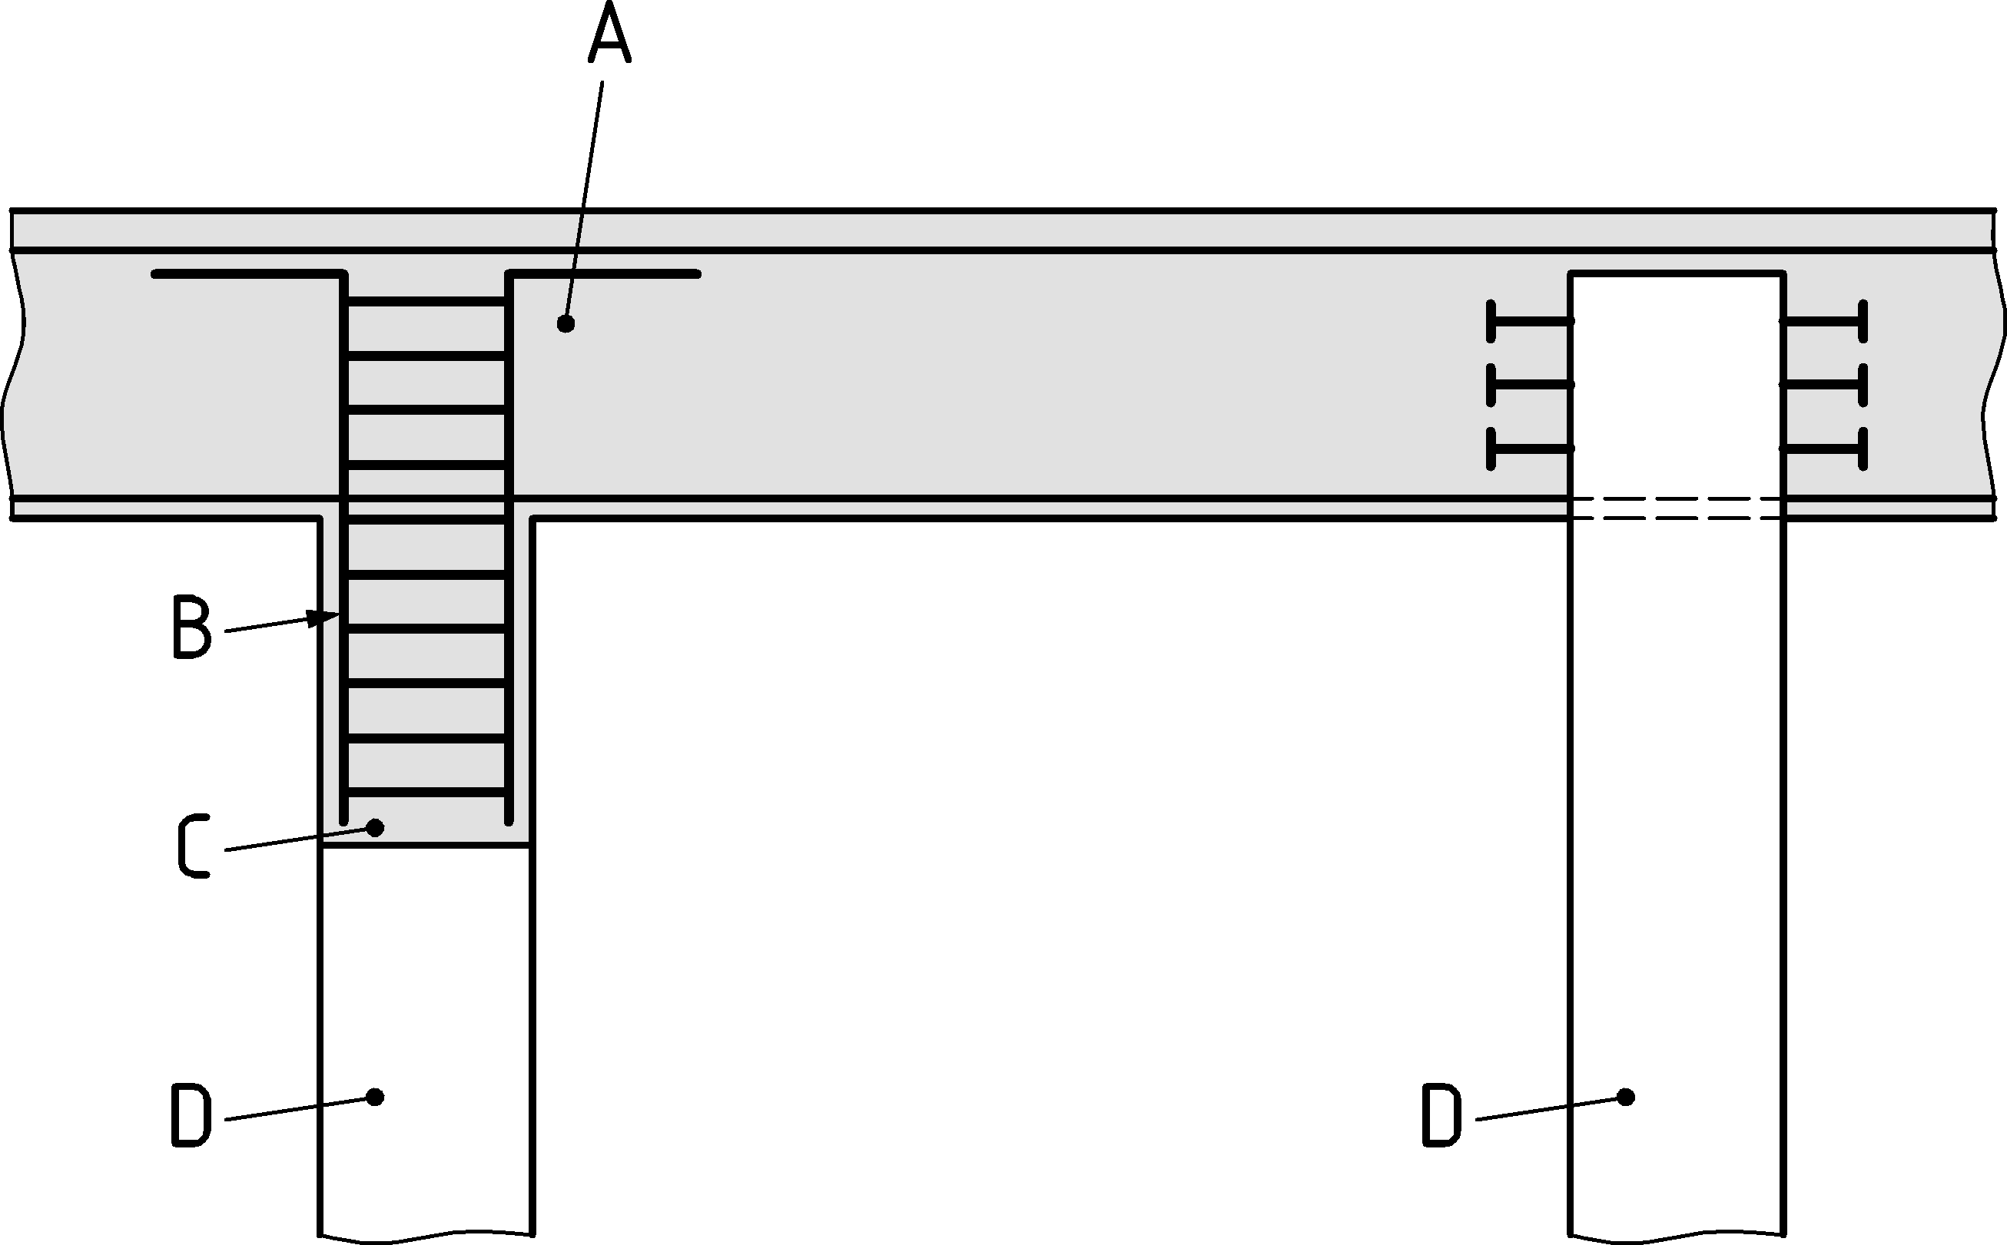

Key

|  |  |
| --- | --- |
| A | Concrete slab / pile cap |
| B | Reinforcement |
| C | Reinforced concrete infill |
| D | Steel pile |

Figure 8.17 — Tubular and box type piles, examples of connections with the pile cap

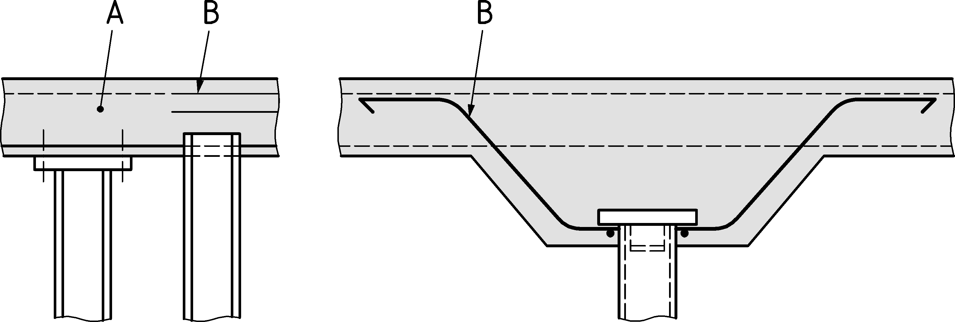

a) compressive loading

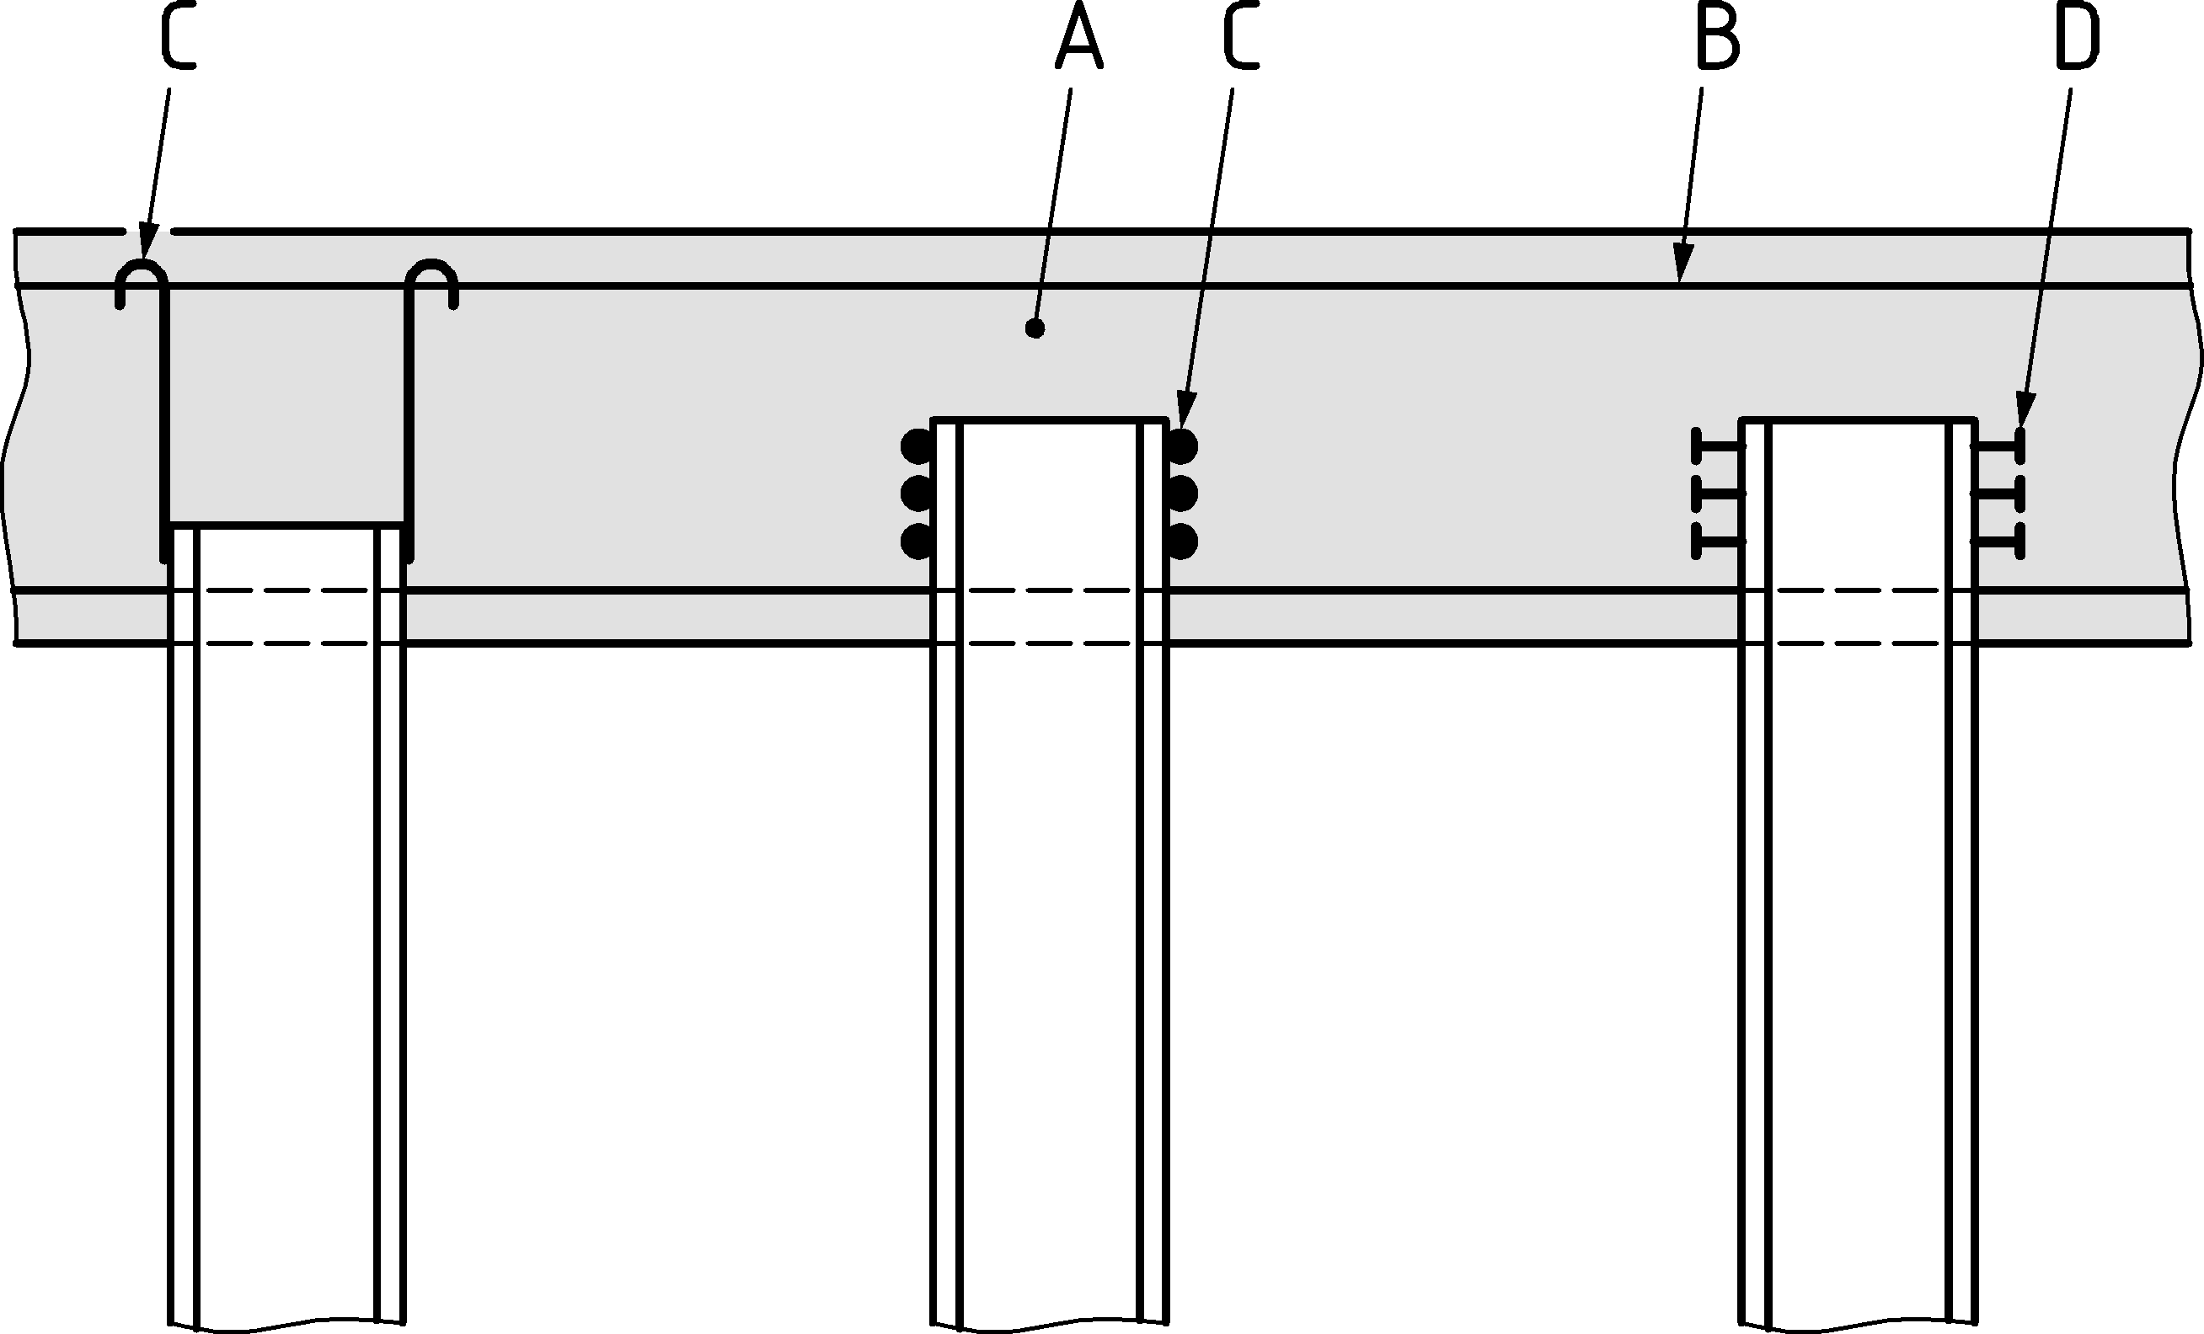

b) compressive and tensile loading

Key

|  |  |
| --- | --- |
| A | Pile cap |
| B | reinforcement designed to take into account the method of load transfer to the concrete slab |
| C | Rebar welded to piles |
| D | Shear studs or welded on angle |

Figure 8.18 — Examples of bearing pile connections with a concrete pile cap

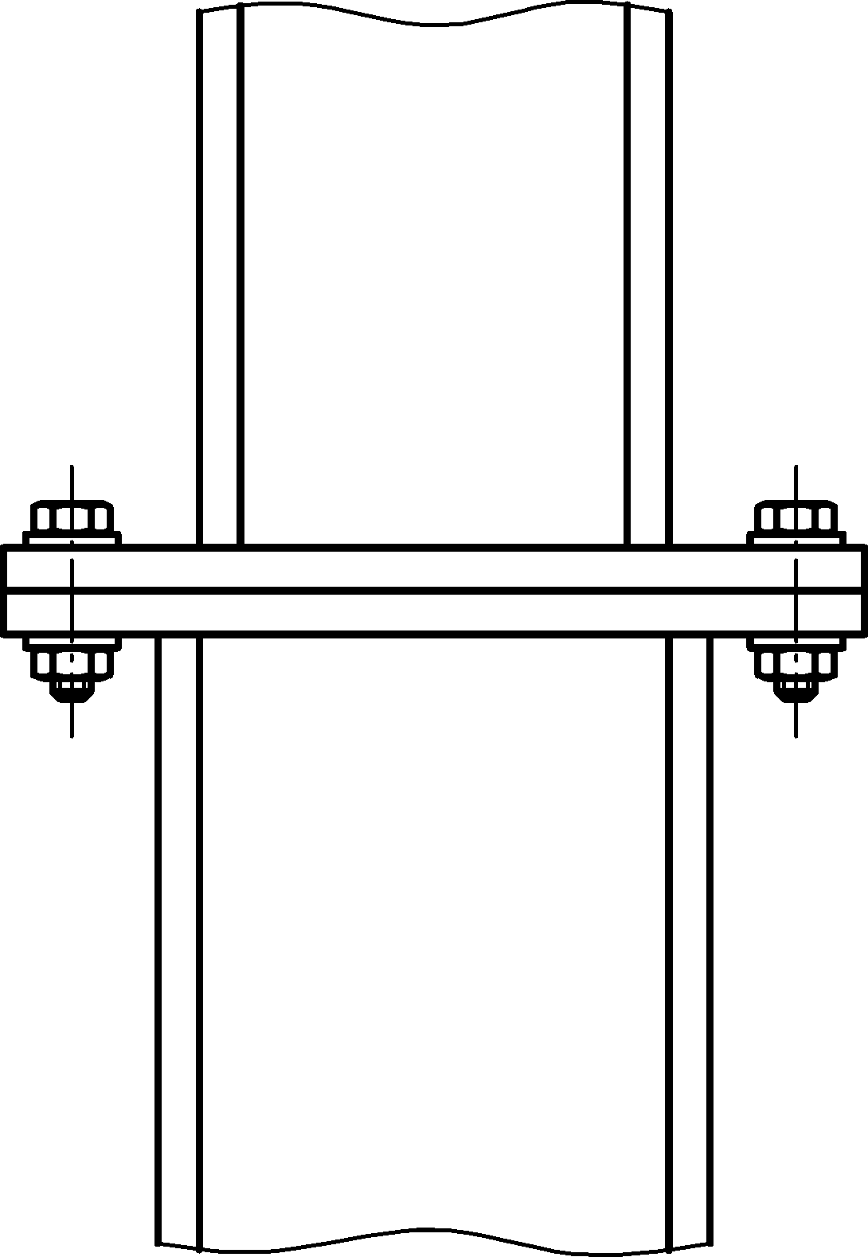

Figure 8.19 — Example of a bearing pile connection to a column of a steel structure above the foundation

# Serviceability limit state

## Basis

(1) The significance of deformations such as settlements and horizontal displacements, as well as vibrations should be defined. The limiting values should be given for the project considering the local conditions.

(2) The design of all piling elements should be checked at serviceability limit states using appropriate design situations as specified in prEN 1997‑3.

(3) The limiting values should be confirmed by a serviceability limit state verification.

(4) Even if no limiting values are given, it should be verified that plastic deformations do not occur, using a model in accordance with 7.1 (5). This need not be applied to secondary piles.

NOTE Secondary piles can experience plastic deformations already due to installation in order to compensate for driving imperfections of primary piles.

## Displacements of retaining walls

(1) prEN 1997‑3 should be taken into account when assessing the displacements of retaining walls.

(2) Displacements due to the movement of supports (such as walings, bracing, anchors) should be considered.

(3) If necessary, initial imperfections due to driving should be taken into account in addition to the deformations due to loading based on the driving tolerances indicated in EN 12063.

NOTE This can be necessary if a particular clearance is required in a cofferdam.

(4) When assessing the displacements of a sheet pile wall account should be taken of the fact that the quality of the workmanship and supervision during execution has an important influence on the magnitude of those displacements.

## Displacements of bearing piles

(1) prEN 1997‑3 should be considered when determining the displacements of bearing piles.

## Structural aspects of steel sheet piling

(1) When calculating the displacements of the retaining structure, the possible supplementary displacements due to local deformation at the location of anchors, walings and bracing should be considered where their effect is significant.

NOTE These effects can be relevant if high local transverse forces are introduced into unstiffened jagged walls, see Figure 3.3d, through an H-beam used as waling.

(2) The effective flexural stiffness shall be considered.

(3) The effective flexural stiffness should consider a reduction of steel thickness due to corrosion.

(4) The effective flexural stiffness of sheet piling made of U-piles may be determined as follows, considering the degree of shear force transmission in interlocks that are located close to the centroidal axis of the wall:

$(EI)_{\text{eff}}=β_{D}(EI)$ (9.1)

where

*I* is the second moment of area of the continuous wall;

*β*D is a factor with a value ≤ 1,0, accounting for the possible reduction due to insufficient shear force transmission in the interlocks.

NOTE *β*D depends on many local influences as given in Note 1 to 8.3.1 (2). The values for *β*D are given in Table 8.1 (NDP) in 8.3.1 unless the National Annex gives different values.

(5) It shall be verified by testing, in accordance with EN 10248‑1, that the stiffness of the crimped point is not less than 15 kN/mm.

NOTE 1 This stiffness requirement corresponds to a shear force of 75 kN at a displacement of 5 mm.

NOTE 2 Crimped points can be single, double or triple crimped points.

## Anchors and tension piles

(1) For serviceability limit state verifications, the cross-section of the tension elements shall be designed to prevent deformations due to yielding under the characteristic load combination.

(2) The principle (1) may be deemed to be satisfied provided that

$F_{SLS}≤\frac{f_{y} A}{γ_{M3, ser}}$ (9.3)

where

*A* is the smallest tensile stress area of the tensile elements;

*F*SLS is the axial force under characteristic loading;

γM3,ser is the partial factor according to 8.2 (2).

1. (normative)  
     
   Cold formed and class 4 steel sheet piles
   1. Use of this annex

(1) This Normative Annex contains additional provisions to 7.4.1 (4), 8.3.1 (2), 8.3.3 (5) and 8.3.4 (4) for the resistance of class 4 sheet piles.

* 1. Scope and field of application

(1) This Normative Annex applies to the following class 4 sheet piles in accordance with 7.5:

— cold-formed Omega sections

— cold-formed Z sections

— cold-formed Trench sections

— hot rolled sections

(2) This Normative Annex should be used for the determination of the resistance and of the stiffness of these steel sheet piles and for some special aspects. For simplification purpose the design methods in this annex are presented in terms of cold-formed sheet piles.

(3) This Normative Annex does not apply to cross-sections made up of elements with intermediate stiffeners. This restriction need not be applied to the design assisted by testing, in accordance with Annex B.

(4) Profiles made up of elements with intermediate stiffeners and designed by calculation should be in accordance with prEN 1993‑1‑3.

(5) In the case of class 4 sheet piles, design by calculation may not always lead to economic solutions and it is often useful to use tests for the determination of resistance. Testing of class 4 Z-piles and Ω−piles shall follow rules given in Annex B.

(6) The provisions for design by calculation given in this annex may be used only for steel within the range of nominal thickness *t* as follows:

2,0 mm ≤ *t* ≤ 15,0 mm.

(7) For thicker or thinner class 4 steel sheet pile cross-sections, the load bearing capacity should be determined by design assisted by testing in accordance with Annex B.

(8) Restrictions regarding geometrical properties or materials only apply to design by calculation.

* 1. General
     1. Form of cold formed steel sheet piles

(1) Cold formed steel sheet piles are products made from hot rolled flat products according to EN 10249. They consist of straight and rounded walls. Over their entire length, within the permitted tolerances, they have a constant cross-section and a thickness not less than 2 mm.

(2) These sheet piles are obtained solely by cold forming (rolling or pressing).

(3) The edges of the cross-section of a sheet pile may consist of interlocks.

(4) Some examples of cold formed piling sections covered in this annex are given in Table A.1.

* + 1. Terminology

(1) The terminology for cross-section dimensions given in prEN 1993‑1‑3:2022, 3.3 applies.

(2) For cold formed steel sheet piles the axis convention given in 3.3 applies.

Table A.1 — Examples of cold formed piling sections

|  |  |
| --- | --- |
|  | **Example of cross-section** |
| Ω - pile |  |
| Z - pile |  |
| Trench sheet pile |  |

* 1. Basis of design
     1. Ultimate limit states

(1) The general provisions given in Clause 4, 6, 7, 8.1 and 8.2 should also be applied to cold formed profiles, except where different provisions are given in this annex.

* + 1. Serviceability limit states

(1) The general provisions given in 4.2.2, 9.1 and 9.2 should also be applied to cold formed profiles, except where different provisions are given in this annex.

(2) Serviceability limit state verifications should be in accordance with prEN 1993‑1‑3:2022, 9.

* 1. Properties of materials and cross-sections
     1. Material properties

(1) Properties of materials covered in this annex shall conform with Clause 5 of this document.

(2) The nominal values of the basic yield strength *f*yb given in Table 5.1 and Table 5.2 should be adopted as characteristic values in design calculations. For other steels the characteristic values should be based on the results of tensile tests carried out in accordance with EN ISO 6892‑1.

(3) It may be assumed that the properties of steel in compression are the same as those in tension.

(4) For the steels covered by this annex, the other material properties to be used in design should be taken as follows:

modulus of elasticity: *E* = 210 000 N/mm2;

shear modulus: *G* = E / [2(1 + v)] N/mm2;

Poisson's ratio: *v* = 0,3;

coefficient of linear thermal elongation: 𝛼T = 12 × 10-6 1/K;

unit mass: ρ = 7 850 kg/m3.

(5) The effect of an increased yield strength due to cold forming may be taken into account on the basis of tests in accordance with Annex B.

(6) To replace prEN 1993‑1‑3:2022, 5.2.2, where the yield strength is specified using the symbol *fy* either in this annex or in EN 1993‑1‑3, either the basic yield strength *fyb* from Table 5.2 or the yield strength from Table 5.1 should be used.

* + 1. Section properties

(1) Section properties should be calculated, taking due account of the sensitivity of the properties of the overall cross-section to any approximations used, see prEN 1993‑1‑3:2022, 7.3.1, and their influence on the predicted resistance of the member.

(2) The effects of local buckling should be considered by using effective cross-sections as specified in A.6.

(3) The properties of the gross cross-section should be determined using the specified nominal dimensions. In calculating gross cross-sectional properties, small holes need not be deducted but allowance should be made for large openings.

(4) The net area of a pile cross-section, or an element of a cross-section, should be taken as its gross area minus appropriate deductions for all holes and openings.

(5) The influence of rounded corners on the profile properties should be taken into account according to prEN 1993‑1‑3:2022, 7.3.1 (4).

NOTE An example of an idealized sheet pile cross-section with sharp corners is given in Figure A.1.

(6) For design by calculation, the width-to-thickness ratios should not exceed the values given in Table A.2.

(7) The use of width-to-thickness ratios exceeding these values is not precluded, but the resistance of the pile at ultimate limit states and its behaviour at serviceability limit states should be verified by testing in accordance with Annex B.

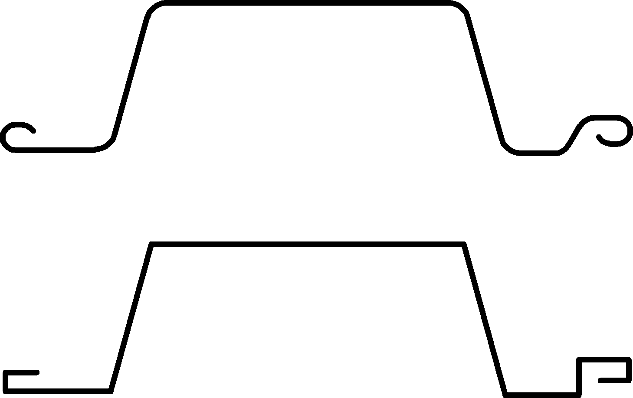

Figure A.1 — Example of an idealized cross-section

Table A.2 — Maximum width-to-thickness ratios; modelling of statical behaviour

|  |  |  |  |
| --- | --- | --- | --- |
| **Part of Cross section** | | **Model Modelling of statical behaviour** | |
|  |  |  |  |
| *b/t* ≤ 90 | |
|  |  |  |  |
| *b/t* ≤ 200 | |
|  |  |  |  |
| 45° ≤ *α* ≤ 90°  *c/t* ≤ 200 | |

* 1. Local buckling

(1) The effects of local buckling should be considered in determining the resistance and stiffness of class 4 steel sheet pile cross-sections according to prEN 1993‑1‑3:2022, 7.6, except where different provisions are given in this annex.

(2) Unstiffened plane elements of sheet pile cross-sections are covered in prEN 1993‑1‑3:2022, 7.6.2.

(3) Plane elements with interlocks acting as edge stiffeners should be considered according to prEN 1993‑1‑3:2022, 7.6.3.

NOTE Figure A.2 gives an example of the idealization of the geometry of the interlock acting as an edge stiffener.

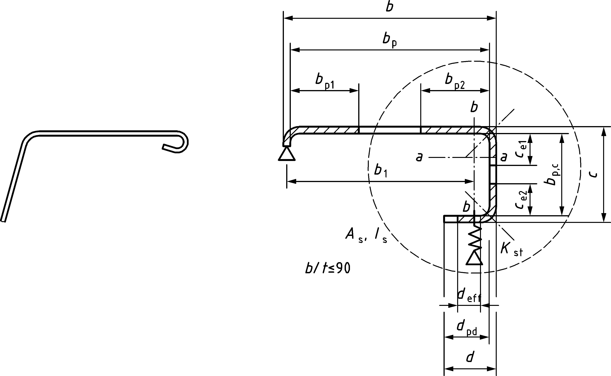

Figure A.2 — Interlock to be treated as an edge stiffener

(4) For plane compression elements with interlocks acting as edge stiffeners, the design should be based on the principle given in prEN 1993‑1‑3:2022, 7.6.3.1 (1).

(5) The spring stiffness of the interlock acting as an edge stiffener should be determined according to prEN 1993‑1‑3:2022, Formula (7.15).

(6) prEN 1993‑1‑3:2022, Formulae (7.16) and (7.17) may be applied to sheet piling as follows for the Z-profile as shown in Figure A.3 and Figure A.4, by using the plate bending stiffness (*E t*3) / 12 / (1 - *v* 2). The stiffness of the rotational spring representing the web, see Figure A.4, may be determined from:

*EIw* θ = ½ × 1 × 1 × *sw* (A.1)

$C_{θ}=\frac{1}{θ}=\frac{2EI_{w}}{c}$ (A.2)

$I_{w}=\frac{t^{3}}{12(1-ν^{2})}$. (A.3)

The actual bending moment acting in the rotational spring due to the unit load is *F*unit × *bp* and the corresponding rotation is given by:

$θ=\frac{F_{unit}b_{p}}{C_{θ}}=\frac{{F_{unit}b}_{p}c}{2EI_{w}}$ (A.4)

So prEN 1993‑1‑3:2022, Formula (7.16) becomes:

$v_{st}=\frac{2F_{unit}b_{p}^{2}(1-ν^{2})}{Et^{3}}(3c+2b_{p})$ (A.5)

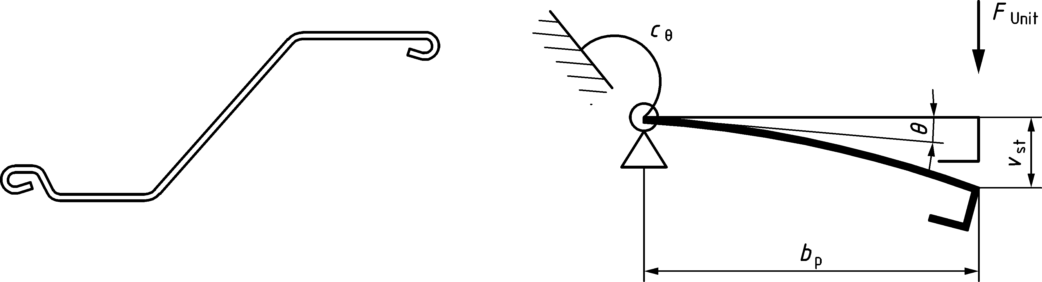

Figure A.3 — Determination of spring stiffness of the flange

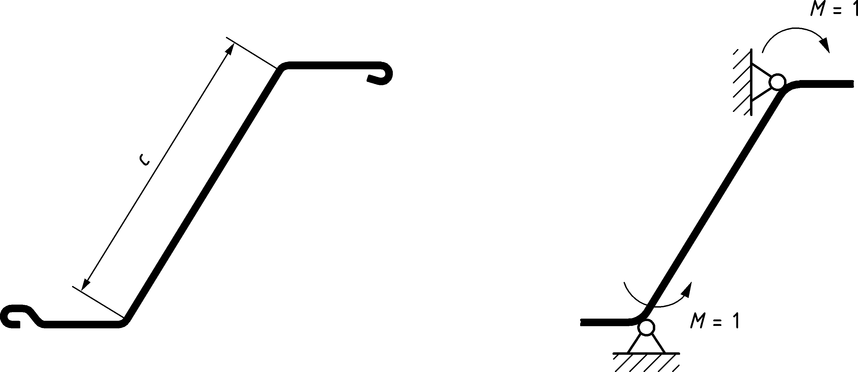

Figure A.4 — Determination of the spring stiffness of the web

* 1. Resistance of cross-sections
     1. General

(1) The design values of the internal forces and moments at each cross-section shall not exceed the design values of the corresponding resistances.

(2) The design resistance of a cross-section should be determined either by calculation, using the methods given in this section, or by design assisted by testing, in accordance with Annex B.

(3) The provisions of A.7 should not be applied except for monoaxial bending with *Mz* = 0.

(4) It may be assumed that one of the principal axes of the sheet piling is parallel to the system axis of the retaining wall.

(5) For design by calculation, the resistance of the cross-section should be verified for:

— bending moment, taking into account the effects of local transverse bending;

— local transverse forces;

— combined bending moment and shear force;

— combined bending moment and axial force;

— combined bending moment and local transverse forces.

(6) Design assisted by testing may be used instead of design by calculation for any of these resistances.

NOTE Design assisted by testing is particularly likely to be beneficial for cross-sections with relatively high *bp*/*t* ratios, for instance in relation to inelastic behaviour or web crippling.

(7) For design by calculation, the effects of local buckling should be considered by using effective cross-sectional properties determined as specified in A.6.

(8) The provisions given in this section do not account for possible global instability of the sheet piles due to compression forces. Verification of instability shall be in accordance with prEN 1993‑1‑3:2022, 8.2.

(9) The criterion given in 7.2 (3) should be satisfied. Higher axial forces leading to overall instability should be avoided when using class 4 cross-sections.

(10) Walings in front of or behind the sheet pile wall should be used to introduce forces from anchors or struts (see Figure A.5a), thereby allowing for redistribution of the forces. If a washer plate is used to introduce the force from a tie rod directly into the sheet pile as shown in Figure A.5b, tests in accordance with section 4.7 should be carried out if the thickness of the sheet pile profile is ≤ 6 mm.

(11) When using iterative calculation procedures, several iterations should be carried out if necessary to avoid a lack of accuracy.

|  |  |
| --- | --- |
|  |  |
| **a) with a waling** | **b) with a washer plate** |

Figure A.5 — Introduction of anchor forces

* + 1. Bending moment

(1) The moment resistance of the class 4 sheet pile cross-section should be determined according to prEN 1993‑1‑3:2022, 8.1.4, except where different provisions are given in this annex.

(2) The effects of shear lag may be neglected in steel sheet piling.

(3) No plastic redistribution of bending moments should be made in retaining walls consisting of class 4 cross-sections.

(4) If the moment resistance of the profile is different for positive and negative bending moments, this should be considered in the design.

* + 1. Shear force

(1) The shear resistance of the web should be determined according to prEN 1993‑1‑3:2022, 8.1.5, except where different provisions are given in this annex.

(2) The shear buckling strength *fbv* should be determined using prEN 1993‑1‑3:2022, Table 8.2 for webs without stiffening at the support.

* + 1. Local transverse forces
       1. General

(1) If the waling is located in front of the wall on the excavation side as shown in Figure 8.7, the verification should be carried out according to A.7.4.2.

(2) If the waling is located behind the wall as shown in Figure 8.5, the verification should be carried out according to A.7.4.3.

* + - 1. Webs subject to transverse compressive forces

(1) To avoid crushing, crippling or buckling in a web subject to a support reaction via a waling, the applied design transverse force *FEd* should satisfy:

FEd ≤ Rw,Rd

where

*Rw,Rd* is the design value of the local in-plane resistance of the web.

(2) For an unstiffened web, the local transverse design resistance *Rw,Rd* should be obtained from prEN 1993‑1‑3:2022, 8.1.6.3 except where different provisions are given in this annex.

NOTE Z-profiles are covered by this paragraph, considering a double pile made up of two Z-profiles.

(3) For a waling acting as support:

— the value of the effective bearing length *l*y to be used in prEN 1993‑1‑3:2022, Formula (8.37) should be determined according to prEN 1993‑1‑3:2022, 8.1.6.3 (5);

— the value of the coefficient *K*1 to be used in prEN 1993‑1‑3:2022, Formula (8.37) should be obtained from the following:

for category 1: *K*1 = 0,075

for category 2: *K*1 = 0,15.

NOTE 1 Category 1 applies if the distance between the waling and the edge of the pile is ≤ 1,5 *h*w, where *h*w is the height of the web between flange midlines, see prEN 1993‑1‑3:2022, Table 7.3, otherwise category 2 applies, see prEN 1993‑1‑3:2022, Table 8.6.

NOTE 2 For the definition of stiff bearing length *l*sb, see 8.3.6 of this code and EN 1993‑1‑1:2022, Figure 8.4 where it is named *s*s.

NOTE 3 *l*y is named *l*bl in prEN 1993‑1‑3.

* + - 1. Webs subject to transverse tensile forces

(1) For webs subject to transverse tensile forces, checks should be carried out in accordance with 8.3.6 (3).

* + 1. Combined shear force and bending moment

(1) For combined shear force and bending moment, the verification should be carried out using prEN 1993‑1‑3:2022, Formula (8.57).

* + 1. Combined bending moment and local transverse forces

(1) For combined bending moment and local transverse forces, the verification should be carried out according to prEN 1993‑1‑3:2022, 8.1.11.

* + 1. Combined bending moment and axial force

(1) The combination of bending moment with axial tension should be verified according to prEN 1993‑1‑3:2022, 8.1.7, without taking bending about the z-z axis into account.

(2) The verification for combined bending moment and axial compression should be carried out according to prEN 1993‑1‑3:2022, 8.1.8 without taking bending about the z-z axis into account.

* + 1. Local transverse bending

(1) In the case of a differential water pressure exceeding 1 m head, the effects of water pressure on transverse local plate bending should be considered when determining the overall bending resistance.

(2) As a simplification, this verification may be carried out using the following procedure:

— the cross-sectional verification need only be carried out at the locations of the maximum moments where the differential water pressure is more than 1 m head;

— the effect of differential water pressure should be taken into account by using a reduced plate thickness *tred* = ρP *t* with ρP according to Table A.3;

— for the determination of ρP according to Table A.3 the differential water pressure acting at the relevant locations of the maximum moments should be taken into account.

Table A.3 — Reduction factors *𝛒*P for plate thickness due to differential water pressure

|  |  |  |  |  |
| --- | --- | --- | --- | --- |
| *Δh* | *(b*f*/tmin)* ε = 40,0 | *(b*f*/tmin)* ε = 60,0 | *(b*f*/tmin)* ε = 80,0 | *(b*f*/tmin)* ε = 100,0 |
| 1,0 | 0,99 | 0,98 | 0,96 | 0,94 |
| 2,5 | 0,98 | 0,94 | 0,88 | 0,78 |
| 5,0 | 0,95 | 0,86 | 0,67 | 0,00 |
| 7,5 | 0,92 | 0,75 | 0,00 | 0,00 |
| 10,0 | 0,88 | 0,58 | 0,00 | 0,00 |
| **Key**  *b*f is the width of the flat portion of the flange, but bf should not be taken as less than $c/\sqrt{2}$, where *c* is the slant height of the web;  *tmin* is the minimum thickness of flange or web;  *Δh* is the head of differential water pressure in m;  *ε* = $\sqrt{\frac{235}{f_{y}}}$ , with fy in N/mm2 | | | | |
| NOTE These values apply to Z-piles and are conservative for Ω- and U-piles. An increase of ρ*P* is possible (for instance if interlocks are welded), but an additional investigation is then necessary. | | | | |

* 1. Design by calculation

(1) The following procedure may be adopted for the design of a retaining wall made up of class 4 sheet piles.

(2) The effects of actions in the piles at ultimate limit states may be determined using an elastic beam model and an appropriate model for the soil in accordance with the relevant part of EN 1997.

(3) If required, the structural input data for the beam model should be chosen as a best estimate.

(4) For axial compression it should be verified whether buckling may be neglected.

(5) For design by calculation to be applicable, it should be verified that the corresponding criteria given in this annex are fulfilled by the steel sheet piles that are expected to be used.

(6) Based on the resistances of the cross-sections provided by the manufacturer of the steel sheet piles, the chosen pile cross-section should be verified according to A.7, making allowance for corrosion effects, if necessary.

NOTE Cross-section resistance data that can be provided by the manufacturer are: *Mc,Rk*, *NRk*, *Vb,Rk*, *Rw,Rk*, taking into account the steel grade and the reduced thickness due to corrosion.

(7) If required, the effective stiffness of the cross-section at ultimate limit states should be used with the beam model in an iterative procedure.

NOTE The stiffness data for the cross-section at ultimate limit states can be provided by the manufacturer in section property tables.

(8) If a verification at serviceability limit states is required, an elastic beam model combined with an appropriate model for the soil in accordance with the relevant part of EN 1997 may be used.

(9) Serviceability limit state verifications should use cross-section stiffness data determined in accordance with prEN 1993‑1‑3:2022, 9.1.

1. (normative)  
     
   Testing of class 4 steel sheet piles
   1. Use of this annex

(1) This Normative Annex contains additional provisions to 4.7 (2) and A.2 (5) and to prEN 1993‑1‑3:2022, 12 and A.4.2 for the resistance of class 4 sections determined by testing.

* 1. Scope and field of application

(1) This Normative Annex covers the specific requirements for the application of the principles for design assisted by testing given in EN 1990:2023, Clause 7, to cold formed steel sheet piling.

(2) Although the following provisions have been developed for cold formed profiles, they may also be applied to hot rolled steel sheet piles.

(3) Testing may be undertaken under any of the following circumstances:

— if the properties of the steel are unknown;

— if there is a need to take account of the actual properties of the cold formed profile;

— if adequate analytical procedures are not available for designing a sheet pile profile by calculation alone;

— if realistic data for design cannot otherwise be obtained;

— if the performance of an existing structure needs to be checked;

— if it is desirable to build a number of similar structures or components on the basis of a prototype;

— if confirmation of consistency of production is required;

— if it is necessary to prove the validity and adequacy of an analytical procedure;

— if it is desirable to produce resistance tables based on tests, or on a combination of testing and analysis;

— if it is desirable to take into account practical factors that may alter the performance of a structure, but are not addressed by the relevant analysis method in design by calculation.

* 1. General

(1) Loading may be applied through air bags, or by cross beams arranged to simulate distributed loading. To prevent distortion of the profile at the points of load application or support, transverse ties and/or stiffeners (such as timber blocks or steel plates) may be applied.

(2) During load application, up to attainment of the service load, the load may be removed and then reapplied. For this purpose, the service load may be estimated as 30 % of the ultimate load. Above the service load, the loading should be held constant at each increment until any time-dependent deformations due to plastic behaviour have become negligible.

(3) For tests on Z-piles at least one double sheet pile should be used.

(4) For Ω-piles at least one sheet pile should be used.

(5) The accuracy of measurement should be consistent with the magnitude of the measurements and should be within ±1 % of the value to be determined.

(6) The cross-sectional measurements of the test specimen should cover the following geometrical properties:

— overall dimensions (width, depth and length) to an accuracy of ±1,0 mm;

— width of flat profile parts to an accuracy of ±1,0 mm;

— radii of bends to an accuracy of ±1,0 mm;

— inclination of flat walls (angle between two surfaces) to an accuracy of ±2°;

— the thickness of the material to an accuracy of ±0,1 mm.

(7) It should be ensured that the load direction remains constant during the test.

* 1. Tests on material

(1) Tensile testing of steel should be carried out in accordance with EN ISO 6892‑1. Testing of other steel properties should be carried out in accordance with the relevant European Standards.

* 1. Cross-sectional data based on testing

(1) The cross-sectional resistances and the effective stiffness of a cold formed steel sheet pile may be determined according to prEN 1993‑1‑3:2022, A.4.2.

* 1. Single span beam test

(1) The test setup shown in Figure B.1 should be used to obtain the moment resistance (when the shear force is negligible) and the effective bending stiffness.

(2) In this test at least two load points as shown in Figure B.1 should be used.

(3) The span should be chosen in such a way that the test results represent the moment resistance of the sheet piling. The deflections should be measured in the middle of the span on both sides of the sheet (excluding the deformations of the supports).

(4) The maximum load applied to the specimen coincident with or prior to failure should be recorded as representing the ultimate bending moment resistance. The bending stiffness should be obtained from the load deflection curve.

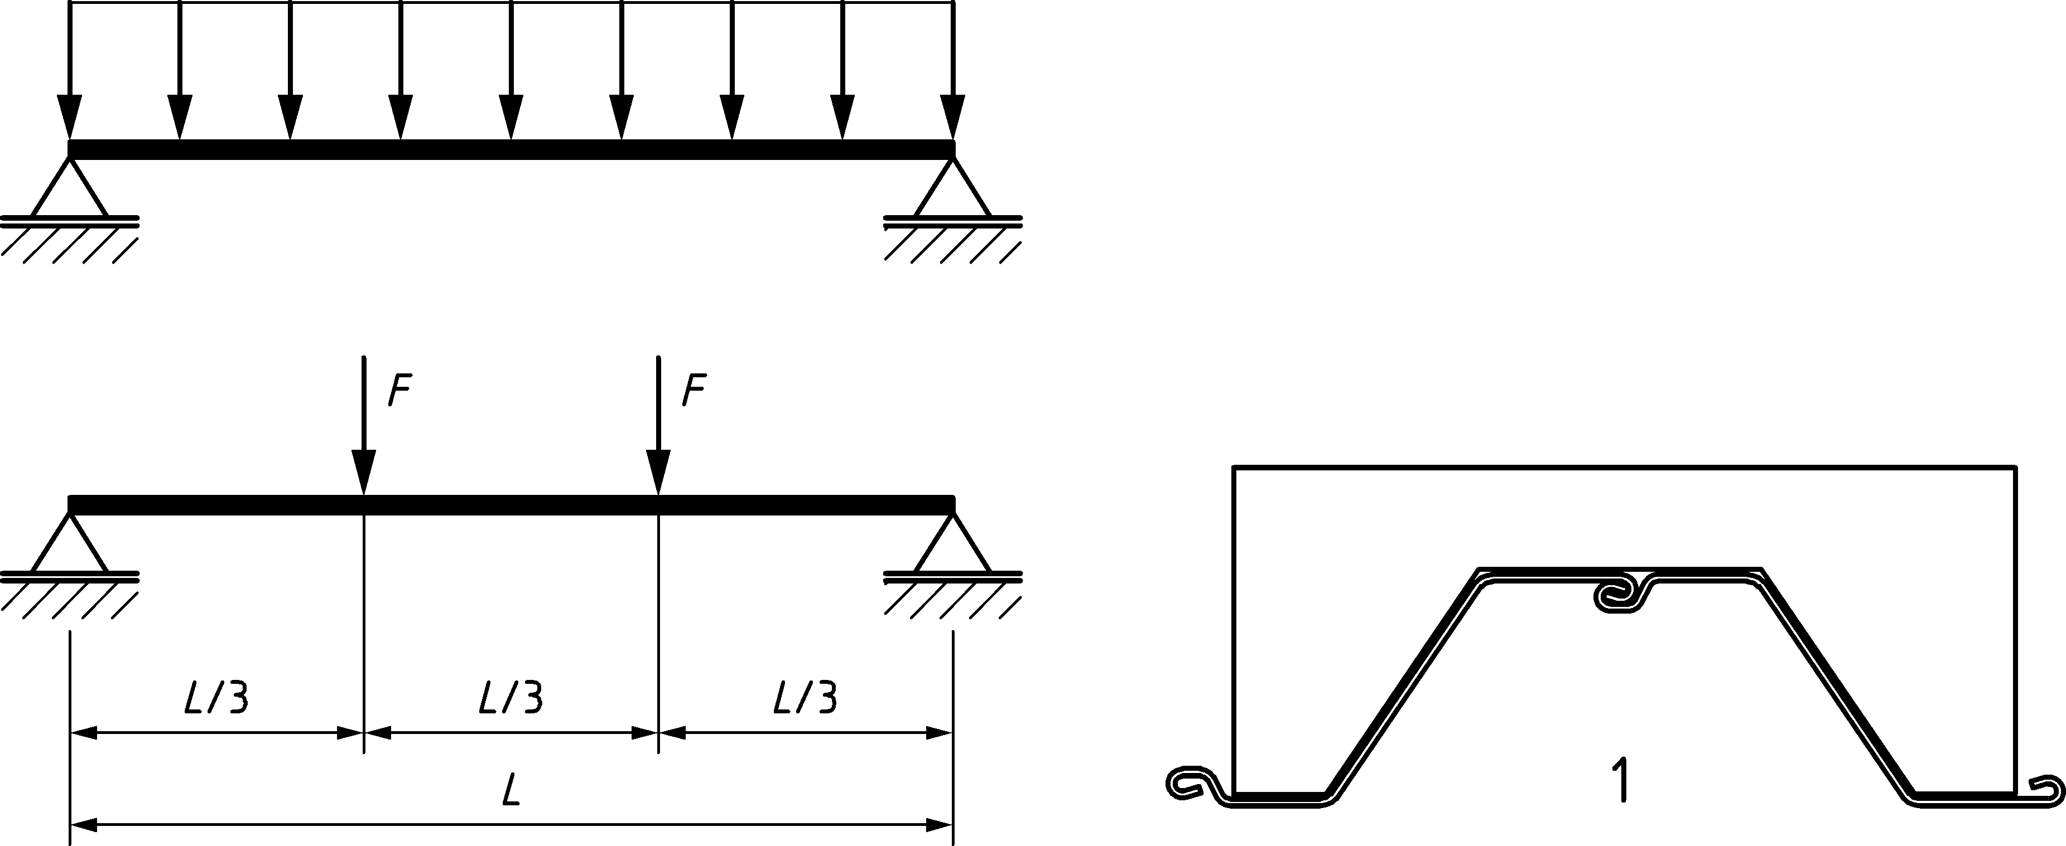

a) Loading

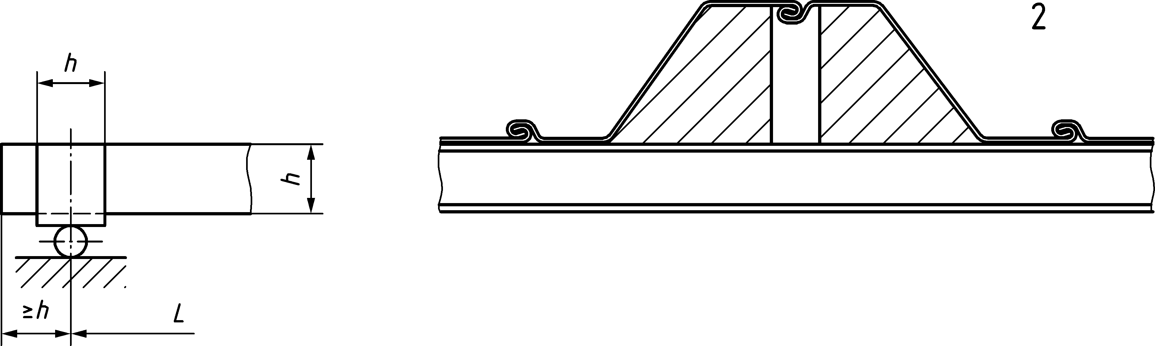

b) Preventing distortion of the section

Key

|  |  |
| --- | --- |
| A | at the loading point |
| B | at the support |

NOTE The direction of loading can be reversed for unsymmetrical sections.

Figure B.1 — Test set-up for moment resistance determination

* 1. Intermediate support test

(1) The test setup shown in Figure B.2 may be used to obtain the resistance to combined bending moment and shear force at the intermediate support of sheet piling, as well as the interaction between moment and support reaction for a given support (waling) width.

(2) In order to obtain a comprehensive record of the declining (unstable) part of the load deflection curve, the test should be continued for a suitable period after reaching the maximum load.

(3) The test span *L* should be selected so that it represents the portion of the pile between the points of contraflexure each side of the support.

(4) The width of the loading bar *bB* should represent the waling width used in practice.

(5) The deformations of the specimen should be measured on both sides of the specimen (excluding the deformations of the supports).

(6) The maximum load applied to the specimen coincident with or prior to failure should be recorded as the ultimate crippling load. This represents the support bending moment and the support reaction for a given support width. To obtain information about the interaction between the moment and the support reaction, tests should be carried out with various spans.

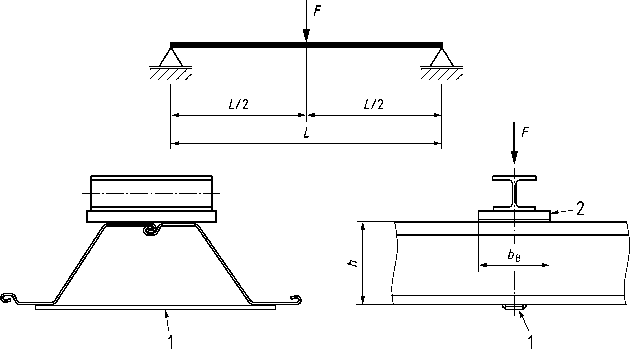

Key

|  |  |
| --- | --- |
| A | Tie |
| B | Plate |

Figure B.2 — Load introduction for the determination of bending resistance and shear resistance at intermediate support (waling)

* 1. Double span beam test

(1) As an alternative to B.5 double span beam tests may be carried out to determine the ultimate resistance of cold formed sheet piling. The loading should preferably be applied uniformly distributed (e.g. air bag).

(2) This loading may be replaced by any number of point loads that adequately reflect the behaviour under uniformly distributed loading (see Figure B.3).

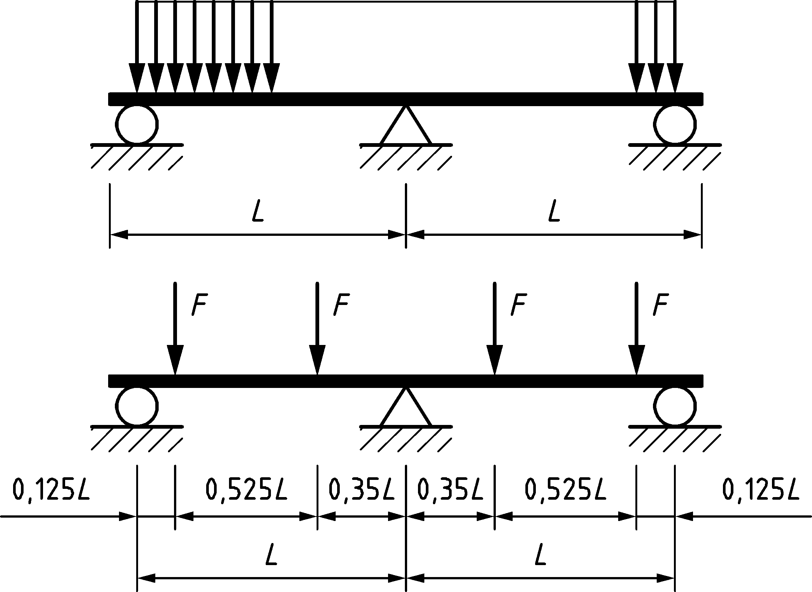

Figure B.3 — Test set-up for double span tests

* 1. Evaluation of test results
     1. General

(1) A specimen under test should be regarded as having failed if the applied test loads reach their maximum values, or if gross deformations exceeding agreed limits occur, see prEN 1993‑1‑3:2022, A.6.1.

* + 1. Adjustment of test results

(1) Adjustment of test results shall be in accordance with prEN 1993‑1‑3:2022, A.6.2.

* + 1. Characteristic values

(1) The characteristic value *Rk* may be determined from test results according to prEN 1993‑1‑3:2022, A.6.3.

* + 1. Design values

(1) The design value of a resistance *Rd* should be derived from the corresponding characteristic value *Rk* determined by testing, using:

*Rd = Rk /* γ*M /* η*sys* (B.1)

where

γ*M* is the partial factor for resistance according to 8.2 (1);

η*sys* is a factor for differences in behaviour under test and service conditions and should be taken equal to 1.

NOTE The value of γM can be determined using statistical methods for a family of at least four tests in accordance with EN 1990:2023, Annex D.

1. (normative)  
     
   Conditions for use of plastic analysis and elasto-plastic verification for sheet pile walls
   1. Use of this annex

(1) This Normative Annex contains additional provisions to 7.4 and 8.3 for use of plastic analysis and elasto-plastic verification for sheet pile walls.

(2) Plastic analysis of sheet pile walls may be effectively used in conjunction with geotechnical analysis methods that account for wall deformation to determine the ground pressures acting on the wall.

* 1. Scope and field of application

(1) This Normative Annex provides rules for plastic analysis and elasto-plastic verification of U and Z sheet piles.

(2) This Normative Annex does not apply to Class 4 sections.

* 1. Type of analysis
     1. General

(1) In accordance with 7.4 (1) a), the sheet piles should be analysed using elastic global analysis when plastic redistribution is not taken into account.

NOTE Elastic beam models with a nonlinear subgrade reaction are considered as elastic global analysis.

(2) In accordance with 7.4 (2) the sheet piles should be analysed using plastic global analysis when plastic redistribution is considered. Plastic global analysis may be carried out using elasto-plastic beam models (with nonlinear subgrade reaction), or combined soil and steel finite element models.

* + 1. Use of nonlinear behaviour for determination of the bending moment

(1) If moment redistribution, and nonlinear rotation, is considered in the design, the following design requirements should be fulfilled:

• Class 1 or Class 2 cross-sections should be used in combination with a rotation check as given below;

• Other cross sections used should have a guaranteed ductile behaviour. If the bending-curvature moment shows softening, nonlinear rotational capacity that is available at reduced levels of bending moment resistance may be taken in account. The extent of available nonlinear rotation may be derived from Table C.1 and Figure C.1.

• The bending moments to be verified against the (reduced) cross section capacity should be determined using a beam model that allows for plastic rotation (e.g. plastic zone or plastic hinge beam model).

(2) The classification of a cross-section may be carried out by using *b*f*/tf* ratios according to one of the following procedures:

• classification according to Table 7.1: *b*f*/tf* ratio limits are given below which the plastic moment resistance defined in 8.3.1 (2) applies;

• classification according to Table C.1 in which the *b*f*/tf* ratios are given for a reduced level of 85 % to 100 % of the full plastic moment resistance, in steps of 5 %.

Table C.1 — Classification of cross-sections in bending on a reduced *M*pl,Rd level

|  |  |  |  |  |
| --- | --- | --- | --- | --- |
| Class | 2 | 3 | | |
| Reduction factor *ρ*C b on *M*pl,Rd | 1,0 a | 0,95 | 0,90 | 0,85 |
| U-piles | $\frac{{b_{f}}/{t_{f}}}{ε}$ ≤ 35 | $\frac{{b_{f}}/{t_{f}}}{ε}$ ≤ 40 | $\frac{{b_{f}}/{t_{f}}}{ε}$ ≤ 46 | $\frac{{b_{f}}/{t_{f}}}{ε}$ ≤ 49 |
| Z-piles | $\frac{{b_{f}}/{t_{f}}}{ε}$ ≤ 40 | $\frac{{b_{f}}/{t_{f}}}{ε}$ ≤ 50 | ≤ 60 | ≤ 66 |
| a If Z-pile interlocks are not welded *M*pl,Rd is reduced by a factor βZ = 0,97 to obtain *M*c,Rd.  b For class 2 sections a ρz factor is applied according to 8.3.1 (2). | | | | |

* 1. Flexural capacity of cross sections

(1) If classification is made according to Table C.1 the section may be verified as a ductile section, having nonlinear deformation capacity at the level of a reduced plastic moment corresponding to *ρ*C *M*pl,Rd.

(2) In addition to the verifications according to chapter 8, using the reduced plastic moment corresponding to *ρ*C *M*pl,Rd, following verification should be made:

${}_{Ed}≤{}_{Cd}$ (C.1)

where

*ϕ*Ed is the rotation angle demand for the actual case, needed for the extent of redistribution considered in ultimate limit state.

*ϕ*Cd is the design rotation capacity of the cross-section beyond the elastic limit, see Figure C.1 and Figure C.2;

(3) Rotation capacity angles ϕ*Cd* may be taken from Figure C.1 for different *Mpl,Rd* levels, dependent on *b*f / *tf* / ε ratios of the cross-section.

NOTE Graphs shown in Figure C.1 are based on results from bending tests with steel sheet piles in accordance with the definition shown in Figure C.2, as well as finite element simulations.

|  |  |
| --- | --- |
|  |  |
| **a) U-piles** | **b) Z-piles** |

Figure C.1 — Rotation capacity angle *𝛟Cd* provided by the cross-section at different levels of reduction of *M*pl,Rd

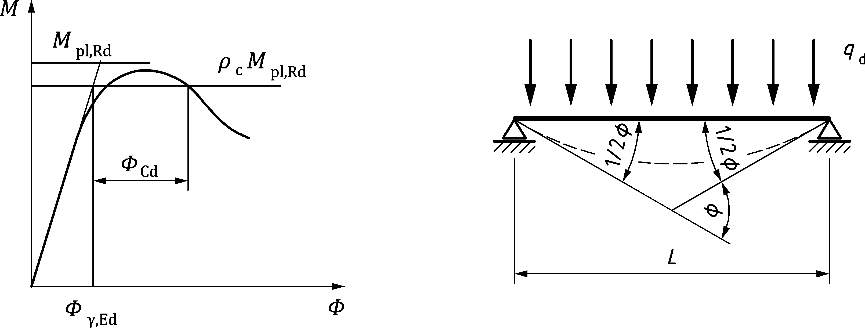

Figure C.2 — Definition of the rotation capacity angle ϕCd

* + 1. Determination of required rotational capacity

(1) The rotation angle demand *ϕ*Ed for the actual design case in ultimate limit state may be determined from a structural elasto-plastic beam model calculation using one of the following methods:

• direct determination from the rotation in a plastic hinge;

• based on the total rotation in a span between two supports;

• based on the beam displacements at certain points along the span.

(2) Using the method of direct determination *ϕ*Ed is the maximum rotation angle occurring in any plastic hinge.

NOTE If the calculation program used for the design allows unloading of the sheet pile after the calculation process, ϕEd can be derived from remaining plastic rotation after elastic unloading. <relocated>

(3) Based on the total rotation in a span between two supports the value of *ϕ*Ed may be found as:

*ϕ*Ed *= ϕ*tot,Ed *– ϕ*y,Ed (C.2)

where

*ϕ*tot,Ed is the total angle at ultimate limit state, measured at the points of zero moment (see Figure C.3);

*ϕ*y,Ed is the rotation angle corresponding to the reduced plastic moment resistance *ρ*C *M*pl,Rd, assuming linear elastic behaviour up to that point.

As a simplified procedure *ϕ*y,Ed may be determined as follows:

${}_{y,Ed}=\frac{2}{3} \frac{{}_{C}M_{pl,Rd}L}{{}_{D} EI}$ (C.3)

where

*L* is the distance between the points of zero moment at ultimate limit state, see Figure C.3;

*EI* is the elastic bending stiffness of the sheet pile;

*β*D is a factor defined in 9.4(4).

*ρ*C is the reduction of *M*pl,Rd based on the bf/t/ε ratio.

(4) Based on the calculated displacements of the wall as shown in Figure C.4, the value of *ϕ*Ed may be found as:

${}_{Ed}={}_{w,Ed}-\frac{5}{8}{}_{y,Ed}$ (C.4)

with

${}_{w,Ed}=\frac{w_{2}-w_{1}}{L_{1}}+\frac{w_{2}-w_{3}}{L_{2}}$ (C.5)

${}_{y,Ed}=\frac{2}{3} \frac{{}_{C}M_{pl,Rd}L}{{}_{D} EI}$ (C.6)

where

*w*i are the total deflections of the sheet pile wall, as defined in Figure C.4;

*L*i is the distance between the hinge and the nearest point of zero moment in ultimate limit state, see Figure C.4;

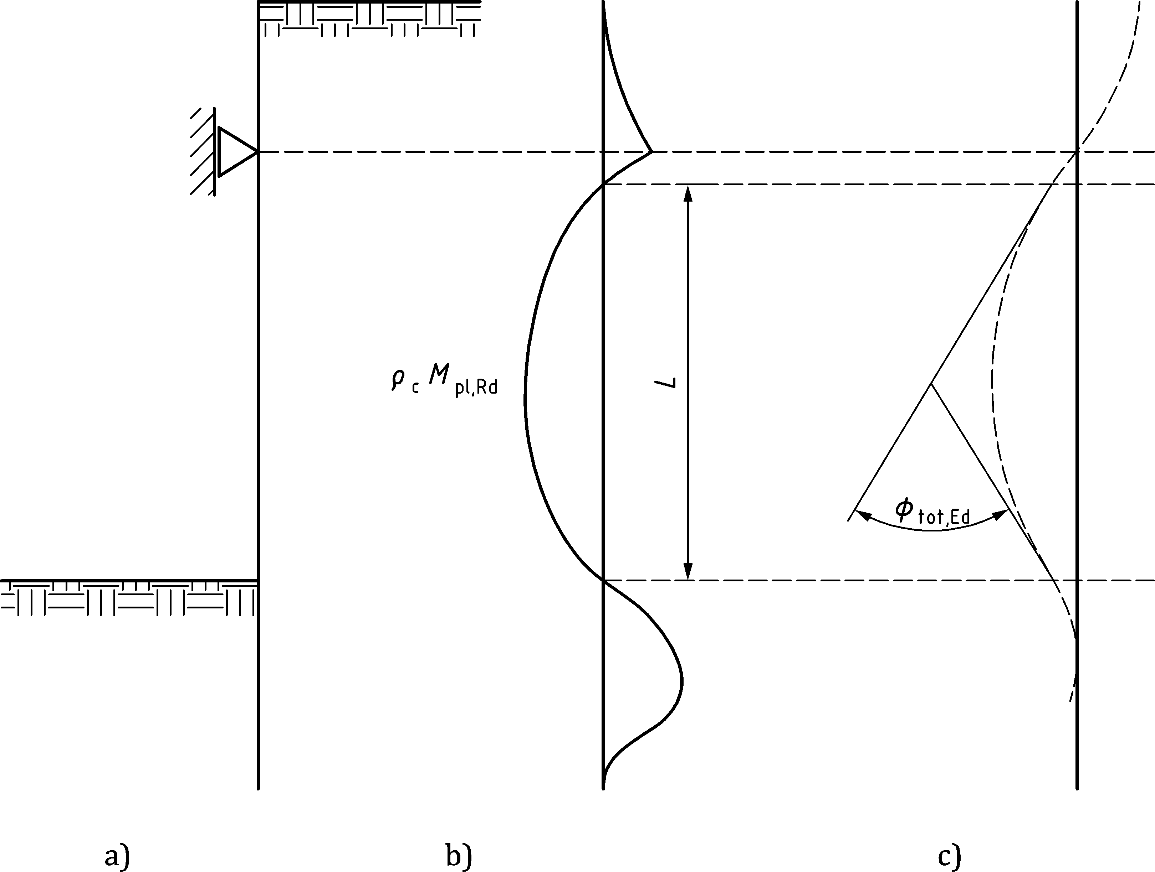

**a) System b) Moment distribution c) Deflection (scaled up)**

Figure C.3 — Definition of the total rotation angle *ϕ*rot,Ed using rotation angles

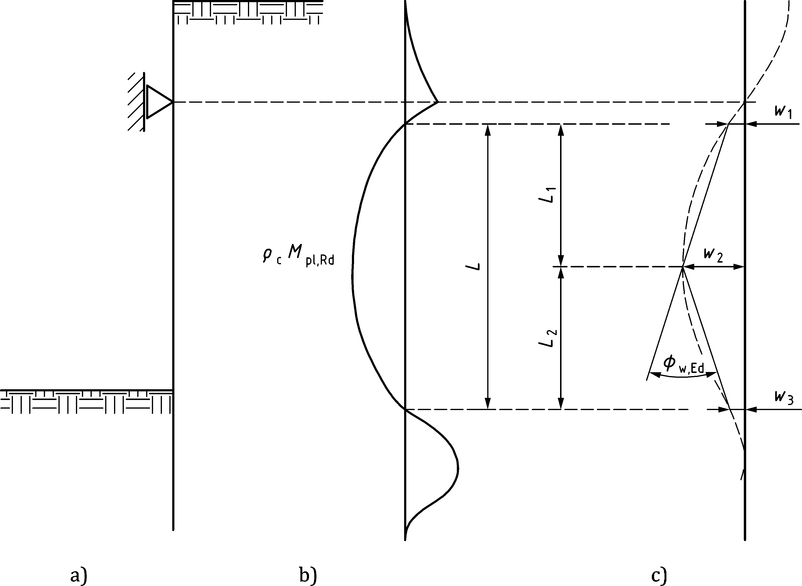

**a) System b) Moment distribution c) Deflection (scaled up)**

Figure C.4 — Definition of the total rotation angle *ϕ*rot,Ed based on displacements

1. (normative)  
     
   Reference resistance design formulas for class 3 and 4 manufactured tubular piles loaded in longitudinal bending
   1. Use of this annex

(1) This annex gives additional rules to 8.9 tubular sections. It should be used to determine the resistance of tubular piles with predominant bending and, when applicable, combined with transversal load effects.

(2) To verify all relevant combinations of loads of tubular primary piles in combined walls, the resistance calculated in this annex should be applied in conjunction with the formulas in 8.9.

* 1. Scope and field of application

(1) The following rules apply to uniform unstiffened fabricated circular tubes of class 3 and 4 subjected to longitudinal bending.

NOTE The application includes cold-formed longitudinal and spiral welded tubes with girth welds.

(2) The formulas for the resistance bending moment are calibrated for non-uniform bending within the limits of

$\frac{M_{Ed}}{V_{Ed}}<3d$ (D.1)

where

*M*Ed is the maximum bending moment in a section between two cross-sections with zero bending or boundaries;

*V*Ed is the maximum shear force in the section with *M*Ed.

(3) The rules are limited to the range given by:

50 ≤ *d*/*t* ≤ 160 (D.2)

where

*d* is the outer diameter of the tube;

*r*t is the radius of the tube wall middle surface;

*t* is the uniform thickness of the tube wall;

*L* is the length of the tube, to be taken between connections, diaphragms or free endings;

*M* is the longitudinal bending moment acting on the tube;

*V* is the shear force acting on the tube.

(4) The rules given are applicable to tubes with fixed and hinged boundary conditions.

(5) The rules are applicable to long tubes and tubes having so-called transitional length, defined as

Ω ≥ 0,5 (D.3)

where Ω is a dimensionless length of the tube

$= \frac{L}{r_{t}}\sqrt{\frac{t}{r_{t}}}$ (D.4)

(6) The following rules apply to global bending characterized by the bending moment *M*. Rules for combination of this loading condition with other loading conditions are given in 8.9.

* 1. Section resistance

(1) The plastic reference moment *M*R,pl may be obtained from:

$M_{R,pl}={(d-t)}^{2} t f_{yk}$ (D.5)

(2) The elastic critical buckling moment *M*R,cr is given by:

$M_{R,cr}=0,907 C_{m} \frac{E}{\sqrt{1-{}^{ 2}}}(d-t){ t}^{2}$ (D.6)

(3) The value of *C*m may be taken conservatively as:

$C_{m}=1+\frac{4}{{}^{2}}$ (D.7)

where the dimensionless length ω is given by:

(D.8)

* 1. Buckling strength verification

(1) The buckling resistance verification is given by:

 (D.9)

$M_{Rd}= \frac{M_{Rk}}{ _{M1}}$ (D.10)

where the safety factor γM1 should be taken from 8.2 (1).

(2) In case of empty tubes, or tubes filled with water or with low to medium dense coarse soils, or fine soils with low to medium strength, the effect of ovalisation of the cylinder caused by longitudinal bending and by circumferential loads (i.e. βa and βm) should be taken in account in accordance with 8.9.7.

(3) The characteristic buckling resistance should be determined from the reference plastic resistance *M*R,pl and the elastic-plastic buckling reduction factor *χ* in accordance with the methodology of prEN 1993‑1‑6:2023, 9.5.2.

$M_{Rk}= M_{R,pl}$ (D.11)

where χ is the elastic-plastic buckling reduction factor which depends on the relative slenderness

(4) The elastic-plastic buckling reduction factor is defined for the various domains as follows:

$= {}_{h}-\frac{\overline{}}{{\overline{}}_{0}}({}_{h}-1)$ when ${\overline{} \overline{}}_{0}$

$= 1-{}_{p}{\left(\frac{\overline{}-{\overline{}}_{0}}{{\overline{}}_{p}-{\overline{}}_{0}}\right)}^{}$ when ${\overline{}}_{0}{ \overline{} \overline{}}_{p}$ (D.12)

$=\frac{{}_{e}}{{\overline{}}^{2}}$ when ${\overline{}}_{p } \overline{}$

where

is the relative slenderness, in this case defined as:

$\overline{}=\sqrt{\frac{M_{R,pl}}{M_{R,cr}}}$ (D.13)

${\overline{}}_{0}$ is the squash limit relative slenderness, which shall in this case be taken as 0,27 to correspond with the class boundary of *d*/*t* = 70 ε2 in EN 1993‑1‑1:2022, 7.5;

${\overline{}}_{p}$ is the plastic limit relative slenderness, by definition

${\overline{}}_{p }=\sqrt{\frac{{}_{e}}{1-{}_{p}}}$ (D.14)

For the buckling parameters *α*e, *β*p and *η* see D.5.

* 1. Buckling parameters

(1) The elastic buckling reduction factor α should be found as:

${}_{e} = {}_{G} {}_{ I}$ (D.15)

with *α*G accounting for the effect of the tube length and *α* I for the effect of imperfections

${}_{G}=0,90 \left(\frac{1-0,22 +0,061 ^{2.94}}{1+0,12 ^{2,94}}\right)$ when $0,5 <7,0$ (D.16)

${}_{G}=0,45$ when $7,0$

${}_{ I}=\frac{1,2}{1+2{(\frac{w_{k}}{t})}^{0.8}}$ (D.17)

where

Δ*w*k is the characteristic imperfection amplitude:

$w_{k}=\frac{1}{Q}\sqrt{r_{t}t}$ (D.18)

in which *Q* is the manufacturing tolerance class parameter given in Table D.1.

Table D.1 — Values for manufacturing tolerance class parameter *Q*

|  |  |  |
| --- | --- | --- |
| **Quality Class** | **Description** | ***Q*** |
| Class A | excellent | 40 |
| Class B | high | 25 |
| Class C | normal | 16 |

(2) The plastic range factor *β*p should be taken as:

${}_{p}=1-\frac{0,9}{1+{(\frac{w_{k}}{t})}^{0,15}}$ (D.19)

(3) The interaction exponent *η* should be taken as:

$=0,6+0,2(\frac{w_{k}}{t})$ (D.20)

(4) The hardening limit *χ*h may be taken as:

${}_{h}=1,1$ (D.21)

NOTE The values of *α* I, *β*p and *η* are chosen to match with the class boundary of *d*/*t* = 140ε2 in accordance with EN 1993‑1‑1:2022, 7.5.

1. (normative)  
     
   Properties of semi-compact sections
   1. Scope and field of application

(1) This Normative Annex contains additional provisions to 8.3.1(2) and 8.9.2 for the design of semi-compact (class 3) pile sections against bending.

* 1. Section properties

(1) The partial-plastic section modulus *W*ep for the respective cross-sections of Z and U-piles, as well as H-piles and tubular piles should be determined from an interpolation between the plastic section modulus and the elastic section modulus of a cross-section as follows:

— for Z-piles:

$W_{ep}= β_{z} W_{pl}+(W_{el}-β_{z} W_{pl}){\left(\frac{b_{f} / t_{f}-40ε}{26ε}\right)}^{0,3\left(\frac{66ε- b_{f} / t_{f}}{26ε}\right)}$ (E.1)

For the slenderness range $40<\left(\frac{b_{f} / t_{f}}{ε}\right)<66$

— for U-piles:

$W_{ep}= W_{pl}+(W_{el}-W_{pl}){\left(\frac{b_{f} / t_{f}-35ε}{14ε}\right)}^{0.4\left(\frac{49ε- b_{f} / t_{f}}{14ε}\right)}$ (E.2)

For the slenderness range $35<\left(\frac{b_{f} / t_{f}}{ε}\right)<49$

— for H-piles:

See EN 1993‑1‑1:2022, Annex B

— for tubular piles:

$W_{ep}=W_{pl}+\left(\frac{W_{el}}{1.1}-W_{pl}\right){\left(\frac{d/t-70{}^{2}}{70{}^{2}}\right)}^{0,7}$ (E.3)

For the slenderness range $70<\left(\frac{d / t}{ε^{2}}\right)<140$

1. (informative)  
     
   Typical grades of reinforcing and prestressing steels used for tension elements
   1. Use of this annex

(1) This Informative Annex provides complementary / supplementary guidance to 5.4 for typical grades of reinforcing and prestressing steels used for tension elements in anchors and tension piles.

NOTE 1 National choice on the application of this Informative Annex is given in the National Annex. If the National Annex contains no information on the application of this informative annex, it can be used.

NOTE 2 EN 10080 does not specify specific strengths for reinforcing steel. Table F.1 gives typical, commercially available, strengths. The National Annex can refer to other technical specifications, e.g. national product standards for reinforcing steel.

NOTE 3 As long as the harmonized product standard prEN 10138 (all parts) is not published, the National Annex can refer to other technical specifications, e.g. national product standards for prestressing steel.

* 1. Scope and field of application

(1) This Informative Annex applies to tension elements for anchors and tension piles only.

Table F.1 — Typical grades of reinforcing and prestressing steels used for tension elements

|  |  |  |  |  |  |  |
| --- | --- | --- | --- | --- | --- | --- |
| Type of Steel | Relevant Standard | Steel Name | Yield **strength** a | | Tensile **Strength** a | |
| symbol | N/mm2 | symbol | N/mm2 |
| Reinforcing steel with thread ribs | EN 10080 | B500B | *f*0.2k | 500 | *f*tk | 550 |
| B555B | *f*0.2k | 555 | *f*tk | 700 |
| B670B | *f*0.2k | 670 | *f*tk | 800 |
| Prestressing steel with thread ribs | prEN 10138‑4 | Y1030H | *f*p0.1k | 830 | *f*pk | 1030 |
| Y1050H | *f*p0.1k | 950 | *f*pk | 1050 |
| Y1230H | *f*p0.1k | 1080 | *f*pk | 1230 |
| Prestressing strand | prEN 10138‑3 | Y1770S7 | *f*p0.1k | 1550 | *f*pk | 1770 |
| Y1860S7 | *f*p0.1k | 1650 | *f*pk | 1860 |
| a Values stated are minimum where;  *f*0,2k = *R*p0,2 (specified proof strength at 0,2 % strain) and *f*tk = *R*m (specified tensile strength) determined in accordance with EN 10080;  *f*p0,1k = characteristic proof strength at 0,1 % strain and *f*pk = characteristic tensile strength derived from prEN 10138‑3 and prEN 10138‑4 respectively | | | | | | |
| NOTE 1 The grades shown above are common, commercially available, grades. Consult with manufacturers for diameters available. Other grades can be used provided they comply with the requirements of 5 in this document.  NOTE 2 The steel types shown above might not be suitable for all types of anchors and tension piles particularly with regards to durability – see 6.3 | | | | | | |

Bibliography

**References contained in recommendations (i.e. “should” clauses)**

The following documents are referred to in the text in such a way that some or all of their content constitutes highly recommended choices or course of action of this document. Subject to national regulation and/or any relevant contractual provisions, alternative documents could be used/adopted where technically justified. For dated references, only the edition cited applies. For undated references, the latest edition of the referenced document (including any amendments) applies.

EN 1998 (all parts), Eurocode 8 — Design of structures for earthquake resistance

EN ISO 6892‑1, Metallic materials — Tensile testing — Part 1: Method of test at room temperature (ISO 6892‑1)

EN 50162, Protection against corrosion by stray current from direct current systems

**References contained in permissions (i.e. “may” clauses)**

The following documents are referred to in the text in such a way that some or all of their content expresses a course of action permissible within the limits of the Eurocodes. For dated references, only the edition cited applies. For undated references, the latest edition of the referenced document (including any amendments) applies.

EN 10025 (all parts), Hot-rolled products of structural steel

EN 10080, Steel for the reinforcement of concrete — Weldable reinforcing steel — General

prEN 10138 (all parts), Prestressing steels (under development)

**References contained in possibilities (i.e. “can” clauses) and notes**

The following documents are cited informatively in the document, for example in “can” clauses and in notes.

ISO 898‑1, Mechanical properties of fasteners made of carbon steel and alloy steel — Part 1: Bolts, screws and studs with specified property classes — Coarse thread and fine pitch thread

ISO 5817, Welding — Fusion-welded joints in steel, nickel, titanium and their alloys (beam welding excluded) — Quality levels for imperfections

prEN 1998‑1‑1:2022, Eurocode 8 — Design of structures for earthquake resistance — Part 1-1: General rules and seismic action

EN 10027, Designation systems for steels

EN 10045, Metallic materials Charpy impact test

EN ISO 14688‑2:2018, Geotechnical investigation and testing — Identification and classification of soil — Part 2: Principles for a classification (ISO 14688‑2:2017)

EN ISO 22477‑5, Geotechnical investigation and testing — Testing of geotechnical structures — Part 5: Testing of grouted anchors (ISO 22477‑5)

RFCS report EUR 22433 2007, Publications Office of the EU: Design method for steel structures in marine environment including the corrosion behaviour. ISBN 92‑79‑03768-4