NATIONAL ANNEX

TO

CYS EN 1998-2:2005/A1:2009/ A2:2011/AC:2010 Eurocode 8: Design of structures for earthquake resistance

Part2: Bridges

PUBLIC ENQUIRY DRAFT

Prepared by: CYS/TC18

Cyprus Organisation of Standardisation

INTRODUCTION
This National Annex has been prepared by the CYS/TC18 Committee of the Cyprus Organisation of Standardisation.

SCOPE
This National Annex is to be used together with CYS EN 1998-2:2005 (Including A1:2009, A2:2011 and AC:2010). Any reference in the rest of this text to CYS EN 1998-2:2005 means the above document
This National Annex gives:
- Nationally determined parameters for the following clauses of CYS EN 1998-2:2005 where National choice is allowed (see Section NA 2)
- 1.1.1 (8)
- 2.1 (3)P
- 2.1 (4)P
- 2.1 (6)
- 2.2.2 (5)
- 2.3.5.3 (1)
- 2.3.6.3 (5)
- 2.3.7 (1)
- 3.2.2.3
- 3.3 (1)P
- 3.3 (6)
- 4.1.2 (4)P
- 4.1.8 (2)
- 5.3 (4)
- 5.4 (1)
- 5.6.2 (2)P b
- 5.6.3.3 (1)P b
- 6.2.1.4 (1)P
- 6.5.1 (1)P
- 6.6.2.3 (3)
- 6.6.3.2 (1)P
- 6.7.3 (7)
- 7.4.1 (1)P
- 7.6.2 (1)P
- 7.6.2 (5)
- 7.7.1 (2)
- 7.7.1 (4)
- J.1 (2)
- J.2 (1)

- Decision on the informative use of Annexes A, B, C, D, E, F, H, JJ and K (see Section NA 3)
- References to non-contradictory complementary information to assist the user to apply CYS EN 1998-2:2005 (see Section NA 4).

NATIONALLY DETERMINED PARAMETERS

Clause 1.1.1 (8) Scope of CYS EN 1998-2:2005
Annexes A, B, C, D, E, F, H, JJ and K of CYS EN 1998-2:2005 may be used as Informative Annexes, whereas Annexes G and J of CYS EN 1998-2:2005 shall be used as Normative Annexes.

Clause 2.1 Design seismic action
(3)P The value for the reference return period TNCR is set equal to 475 years.
(4)P Bridges are classified in three importance classes, as follows:
Importance class II comprises bridges of average importance with the exceptions noted below.
Importance class III comprises bridges of critical importance for maintaining communications, especially in the immediate post-earthquake period, bridges the failure of which is associated with a large number of probable fatalities and major bridges where a design life greater than normal is required.
Importance class I comprises bridges of less than average importance. A bridge shall be classified to importance class I when both of the following conditions are met:
- the bridge is not critical for communications, and
- the adoption of either the reference probability of exceedance, PNCR, in 50 years for the design seismic action, or of the standard bridge design life of 50 years is not economically justified.
(6) The values of the importance factor γI for importance classes I, II, and III are defined as follows:
γ_{I} = 0,85 for importance class I
γ_{I} = 1,00 for importance class II
γ_{I} = 1,30 for importance class III

Clause 2.2.2 (5) No-collapse (ultimate limit state)
The seismic action shall not be considered as an accidental action under any conditions. Clauses 2.2.2 (3) and 2.2.2 (4) of CYS EN 1998-2:2005 are always applicable.

Clause 2.3.5.3 (1) Local ductility at the plastic hinges
The expression of the length of plastic hinges Lp for concrete members is given by equation E.19 of Annex E of CYS EN 1998-2:2005.

Clause 2.3.6.3 (5) Control of displacements - Detailing
The value of fraction for the design seismic displacement p_{E} is set equal to 0,4, and for the thermal movement p_{T} is set equal to 0,5.

Clause 2.3.7 (1) Simplified criteria
Clause 2.3.7 (1) of CYS EN 1998-2:2005 is not applicable in Cyprus.

Clause 3.2.2.3 Near source effects
A seismotectonic fault is considered to be active when there is an average historic slip rate of at least 1 mm/year and topographic evidence of seismic activity within the Holocene times (past 11000 years).

Clause 3.3 Spatial variability of the seismic action
(1)P The value of the continuous deck limiting length, L_{lim}, is specified as
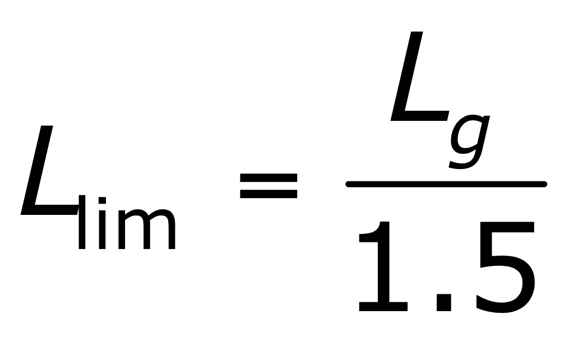
where the length L_{g} is defined in clause 3.3 (6) Table 3.1N of CYS EN 1998-2:2005.
(6) The values of the distance L_{g}, beyond which ground motions are considered as completely uncorrelated, depending on the ground type are given in Table 3.1N (CYS):
Table 3.1N (CYS): Distance beyond which ground motions are considered uncorrelated
Ground Type | A | B | C | D | E
L_{g} (m) | 600 | 500 | 400 | 300 | 500

The factor accounting for the magnitude of ground displacements occurring in apposite direction at adjacent supports β_{r} is defined as follows:
β_{r} = 0,5 when all three supports have the same ground type
β_{r} = 1,0 when the ground type at one of the supports is different than at the other two.

Clause 4.1.2 (4)P Masses
The values of ψ₂₁ factor for traffic loads assumed concurrent with the design seismic action are defined as:
ψ₂₁ = 0 for bridges with normal traffic and footbridges
ψ₂₁ = 0,2 for road bridges with severe traffic, and
ψ₂₁ = 0,3 for railway bridges with severe traffic.

Clause 4.1.8 (2)P Regular and irregular seismic behaviour of ductile bridges
The upper limit for the value of ρ_{o} is set equal to 0,2.

Clause 5.3 (4) Capacity design
The value of the overstrength factor is set equal to
γ_{o} = 1,35 for concrete members, and
γ_{o} = 1,25 for steel members.

Clause 5.4 (1) Second order effects
Approximate methods for estimating second order effects in linear analysis under seismic actions are based on the assumption that the increase of bending moments of the plastic hinge section due to second order effects is
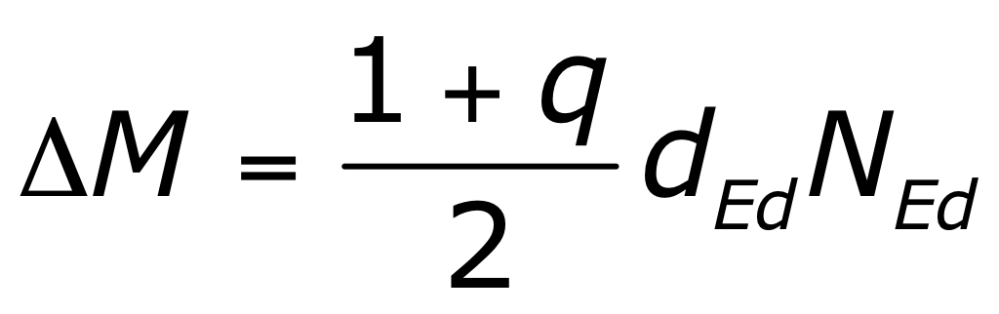
where N_{Ed} is the axial force and d_{Ed} is the relative transverse displacement of the ends of the considered ductile member, both in the design seismic situation.

Clause 5.6.2 (2)P b Structures of limited ductile behaviour
The value of the additional safety factor against brittle failure γ_{Bd1} is set equal to 1,25.

Clause 5.6.3.3 (1)P b Shear resistance of members outside the region of plastic hinges
To determine the value of the additional safety factor γ_{Bd} on shear resistance of ductile members outside the region of plastic hinges, equation (5.8b) is recommended since it is more conservative.

Clause 6.2.1.4 (1)P Required confining reinforcement
All types of confinement reinforcement are allowed.

Clause 6.5.1 (1)P Verification of ductility of critical sections
Clause 6.5.1 (1)P of CYS EN 1998-2:2005 is not applicable in Cyprus.

Clause 6.6.2.3 (3) Elastomeric bearings
According to Clause 2.2.2 (5) of CYS EN 1998-2:2005, the seismic action shall not be considered as an accidental action under any conditions.

Clause 6.6.3.2 (1)P Holding-down devices
The value of the percentage of the compressive (downward) reaction p_{H} due to the permanent load that is exceeded by the total vertical reaction on a support due to the design seismic action, for holding-down devices is specified as follows:
p_{H} = 80% in bridges of ductile behaviour, where the vertical reaction due to the design seismic action is determined as a capacity design effect,
p_{H} = 50% in bridges of limited ductile behaviour, where the vertical reaction due to the design seismic action is determined from the analysis under the design seismic action alone (including the contribution of the vertical seismic component).

Clause 6.7.3 (7) Abutments rigidly connected to the deck
The upper value of the design seismic displacement d_{lim} to limit damage of the soil or embankment behind abutments rigidly connected to the deck is given in Table 6.2N (CYS):
Table 6.2N (CYS): Recommended limit value of design seismic displacement at abutment rigidly connected to the deck
Bridge Importance class | Displacement Limit d_{lim} (mm)
III | 30
II | 60
I | No limitation

Clause 7.4.1 (1)P Design spectra
The value of period T_{D} for the design spectrum of bridges with seismic isolation is specified as T_{D} = 2,5 sec.

Clause 7.6.2 Isolating system
(1)P The value of the amplification factor γ_{IS} on design displacement of isolator units is specified at γ_{IS} = 1,50.
(5) The value γ_{m} for elastomeric bearings is specified at γ_{m} = 1,00.

Clause 7.7.1 (2) Lateral restoring capability
The value of the factor δ is set equal to 0,5.

Clause 7.7.1 (4) Lateral restoring capability
The value of the numerical coefficient γ_{du} is set equal to 1,2.

Clause J.1 (2) Factors causing variation of design properties
The minimum isolator temperature for the seismic design situation
, T_{min,b}, should correspond to the climatic conditions of the bridge location. The method for determining the value of the minimum isolator temperature is as follows:
T_{min,b} =T_{av} - ψ₂ (T_{av} - T_{min} ) + ψ₂ ΔT₁
where
T_{av} is the annual average shade air temperature at the location of the bridge. It may be taken as the average of the characteristic values of the maximum and minimum ambient shade air temperatures at the bridge location, in accordance with EN 1991-1-5:2003, 6.1.3.2 i.e. T_{av} = (T_{max} + T_{min})/2. If no specific information is available the value T_{av} = 10ºC may be used.
ψ₂ is the combination factor for thermal actions for seismic design situations, in accordance with EN 1990:2002 and EN 1990:2002/A1:2005, Annex A2 and
ΔT₁ = T_{e,min} – T_{min} is the difference between the minimum uniform bridge temperature component T_{e,min} and the minimum shade air temperature T_{min} , in accordance with EN 1991-1-5: 2003 and EN 1991-1-5:2003/AC:2009, 6.1.3.1(4).

Clause J.2 (1) Evaluation of the variation
The values of λ-factors for commonly used isolators are given in Annex JJ, which may be used as Informative Annex.

DECISION ON USE OF THE INFORMATIVE ANNEXES A, B, C, D, E, F, H, JJ and K

Annex A
Annex A may be used.

Annex B
Annex B may be used.

Annex C
Annex C may be used.

Annex D
Annex D may be used.

Annex E
Annex E may be used.

Annex F
Annex F may be used.

Annex H
Annex H may be used.

Annex JJ
Annex JJ may be used.

Annex K
Annex K may be used.

REFERENCES TO NON-CONTRADICTORY COMPLEMENTARY INFORMATION
None

