CEN/TC 250

Date: 2023-08

prEN 1991‑3:2024

Secretariat: BSI

Eurocode 1 — Actions on structures — Part 3: Actions induced by cranes and machines

Eurocode 1 — Einwirkungen auf Tragwerke — Teil 3: Einwirkungen infolge von Kranen und Maschinen

Eurocode 1 — Actions sur les structures — Partie 3: Actions induites par les appareils de levage et les machines

ICS:

Contents Page

European foreword 3

Introduction 4

1 Scope 7

1.1 Scope of EN 1991‑3 7

1.2 Assumptions 7

2 Normative references 7

3 Terms, definitions and symbols 7

3.1 Terms and definitions 7

3.1.1 General terms and definitions 7

3.1.2 Terms and definitions commonly used in crane design 9

3.1.3 Terms and definitions specific for travelling cranes 11

3.1.4 Terms specific for supporting structures of travelling crane 15

3.1.5 Actions on cranes 15

3.2 Symbols 16

4 Basis of design 17

5 Classification of actions from cranes travelling on fixed runways or from machines 17

5.1 Actions from cranes travelling on fixed runways 17

5.1.1 Actions to be classified 17

5.1.2 Crane specific classification 18

5.2 Actions from fixed machines 19

6 Actions from cranes travelling on fixed runways 20

6.1 Field of application 20

6.2 Design situations 20

6.2.1 Single crane operation 20

6.2.2 Multiple crane operation 21

6.3 Representation of actions 22

6.4 Load groups 24

6.5 Load arrangements 26

6.6 Characteristic values of crane-induced actions under normal service conditions 26

6.6.1 Vertical crane-induced actions 26

6.6.2 Horizontal crane-induced actions 28

6.7 Characteristic values of actions from crane tests 30

6.8 Characteristic values of crane-induced actions under exceptional service conditions 30

6.9 Crane-induced fatigue actions 31

6.9.1 Single crane action 31

6.9.2 Multiple crane action 33

6.9.3 Single wheel load effect 33

6.9.4 Multiple wheel load effect 34

6.10 In-service wind 34

7 Actions from fixed machines 34

7.1 Field of application 34

7.2 Design situations 35

7.3 Representation of actions 35

7.3.1 Nature of the loads 35

7.3.2 Modelling of dynamic actions 35

7.3.3 Modelling of machine-structure interaction 35

7.4 Characteristic values 36

7.5 Serviceability criteria 37

Annex A (informative) Guidance on crane classification for fatigue design of crane supporting structures 38

A.1 Use of this informative annex 38

A.2 Scope and field of application 38

A.3 Classification 38

Annex B (informative) Guidance on simplified calculation of actions from selected bridge cranes 39

B.1 Use of this informative annex 39

B.2 Scope and field of application 39

B.3 Four-wheeled bridge crane 39

B.3.1 Horizontal actions due to acceleration and deceleration of crane 39

B.3.2 Horizontal actions due to acceleration and deceleration of trolley 41

B.3.3 Horizontal actions due to skewing of crane 41

B.4 Eight-wheeled bridge crane 43

B.4.1 Horizontal actions due to acceleration and deceleration of crane 43

B.4.2 Horizontal actions due to acceleration and deceleration of trolley 43

B.4.3 Horizontal actions due to skewing of crane 43

Annex C (informative) Actions from travelling wall cranes 46

C.1 Use of this informative annex 46

C.2 Scope and field of application 46

C.3 Actions due to crane self-weight and hoist load 46

C.4 Actions due to acceleration of crane 47

C.5 Actions due to acceleration of trolley 48

C.6 Actions due to crane buffer collision 48

C.7 Actions due to trolley buffer collision 49

Bibliography 50

European foreword

This document (prEN 1991‑3:2024) has been prepared by Technical Committee CEN/TC 250 “Structural Eurocodes”, the secretariat of which is held by BSI. CEN/TC 250 is responsible for all Structural Eurocodes and has been assigned responsibility for structural and geotechnical design matters by CEN.

This document is currently submitted to the CEN Enquiry.

This document will supersede EN 1991‑3:2006.

The first generation of EN Eurocodes was published between 2002 and 2007. This document forms part of the second generation of the Eurocodes, which have been prepared under Mandate M/515 issued to CEN by the European Commission and the European Free Trade Association.

The Eurocodes have been drafted to be used in conjunction with relevant execution, material, product and test standards, and to identify requirements for execution, materials, products and testing that are relied upon by the Eurocodes.

The Eurocodes recognize the responsibility of each Member State and have safeguarded their right to determine values related to regulatory safety matters at national level through the use of National Annexes.

Introduction

**0.1 Introduction to the Eurocodes**

The Structural Eurocodes comprise the following standards generally consisting of a number of parts:

— EN 1990, *Eurocode* — *Basis of structural and geotechnical design*

— EN 1991, *Eurocode 1* — *Actions on structures*

— EN 1992, *Eurocode 2* — *Design of concrete structures*

— EN 1993, *Eurocode 3* — *Design of steel structures*

— EN 1994, *Eurocode 4* — *Design of composite steel and concrete structure*

— EN 1995, *Eurocode 5* — *Design of timber structures*

— EN 1996, *Eurocode 6* — *Design of masonry structures*

— EN 1997, *Eurocode 7* — *Geotechnical design*

— EN 1998, *Eurocode 8* — *Design of structures for earthquake resistance*

— EN 1999, *Eurocode 9* — *Design of aluminium structures*

— New Eurocodes under development, e.g. Eurocode for design of structural glass

The Eurocodes are intended for use by designers, clients, manufacturers, constructors, relevant authorities (in exercising their duties in accordance with national or international regulations), educators, software developers, and committees drafting standards for related product, testing and execution standards.

NOTE Some aspects of design are most appropriately specified by relevant authorities or, where not specified, can be agreed on a project-specific basis between relevant parties such as designers and clients. The Eurocodes identify such aspects making explicit reference to relevant authorities and relevant parties.

**0.2 Introduction to** **EN** **1991** **(all parts)**

EN 1991 (all parts) specifies actions for the structural design of buildings, bridges and other civil engineering works, or parts thereof, including temporary structures, in conjunction with EN 1990 and the other Eurocodes.

EN 1991 (all parts) does not cover the specific requirements of actions for seismic design. Provisions related to such requirements are given in EN 1998 (all parts), which complement and are consistent with EN 1991.

EN 1991 is also applicable to existing structures for their:

— structural assessment,

— strengthening or repair,

— change of use.

NOTE 1 In these cases additional or amended provisions can be necessary.

EN 1991 (all parts) is applicable for the design of structures where materials or actions outside the scope of the other Eurocodes are involved.

NOTE 2 In this case additional or amended provisions can be necessary.

EN 1991 is subdivided in various parts:

— EN 1991‑1‑1, *Eurocode 1 — Actions on structures — Part 1-1: Specific weight of materials, self-weight of construction works and imposed loads for buildings*

— EN 1991‑1‑2, *Eurocode 1 — Actions on structures — Part 1-2: Actions on structures exposed to fire*

— EN 1991‑1‑3, *Eurocode 1 — Actions on structures — Part 1-3: Snow Loads*

— EN 1991‑1‑4, *Eurocode 1 — Actions on structures — Part 1-4: Wind Actions*

— EN 1991‑1‑5, *Eurocode 1 — Actions on structures — Part 1-5: Thermal Actions*

— EN 1991‑1‑6, *Eurocode 1 — Actions on structures — Part 1-6: Actions during execution*

— EN 1991‑1‑7, *Eurocode 1 — Actions on structures — Part 1-7: Accidental actions*

— EN 1991‑1‑8, *Eurocode 1 — Actions on structures — Part 1-8: Actions from waves and currents on coastal structures*

— EN 1991‑1‑9, *Eurocode 1 — Actions on structures — Part 1-9: Atmospheric icing*

— EN 1991‑2, *Eurocode 1 — Actions on structures — Part 2: Traffic loads on bridges and other civil engineering works*

— EN 1991‑3, *Eurocode 1 — Actions on structures — Part 3: Actions induced by cranes and machines*

— EN 1991‑4, *Eurocode 1 — Actions on structures — Part 4: Silos and tanks*

**0.3 Introduction to** **EN** **1991‑3**

EN 1991‑3 gives design guidance and actions for the structural and geotechnical design of buildings and civil engineering works that are subject to:

− actions from bridge, gantry and wall cranes on fixed runways;

− actions from machines that cause a harmonic dynamic loading on fixed supporting structures.

EN 1991‑3 is intended to be used with EN 1990, the other parts of EN 1991 and the other Structural Eurocodes.

**0.4 Verbal forms used in the Eurocodes**

The verb “shall” expresses a requirement strictly to be followed and from which no deviation is permitted in order to comply with the Eurocodes.

The verb “should” expresses a highly recommended choice or course of action. Subject to national regulation and/or any relevant contractual provisions, alternative approaches could be used/adopted where technically justified.

The verb “may” expresses a course of action permissible within the limits of the Eurocodes.

The verb “can” expresses possibility and capability; it is used for statements of fact and clarification of concepts.

**0.5 National annex for** **EN** **1991‑3**

National choice is allowed in this standard where explicitly stated within notes. National choice includes the selection of values for Nationally Determined Parameters (NDPs).

The national standard implementing EN 1991‑3 can have a National Annex containing all national choices to be used for the design of buildings and civil engineering works to be constructed in the relevant country.

When no national choice is given, the default choice given in this standard is to be used.

When no national choice is made and no default is given in this standard, the choice can be specified by a relevant authority or, where not specified, agreed for a specific project by appropriate parties.

National choice is allowed in EN 1991‑3 through a note to the following clause:

|  |  |  |  |  |
| --- | --- | --- | --- | --- |
| 6.2.2(2) |  |  |  |  |

National choice is allowed in EN 1991‑3 on the application of the following informative annexes:

|  |  |  |  |
| --- | --- | --- | --- |
| Annex A | Annex B | Annex C |  |

The National Annex can contain, directly or by reference, non-contradictory complementary information for ease of implementation, provided it does not alter any provision of the Eurocodes.

# Scope

## Scope of EN 1991‑3

(1) EN 1991‑3 defines actions imposed by cranes and other machines including dynamic effects, if relevant, for the structural design of crane or machine supporting structures.

(2) EN 1991‑3 provides guidance on crane classification in terms of dynamic factors and fatigue actions.

(3) EN 1991‑3 applies to supporting structures of

− bridge, gantry and wall cranes travelling on fixed runways;

− fixed machines that cause a harmonic dynamic loading on fixed supporting structures.

(4) The principles provided in EN 1991‑3 can be applied also to determine actions on supporting structures of cranes other than those referred to in (3).

(5) EN 1991‑3 does not provide partial factors for actions.

NOTE For partial factors for actions, see Annex A.5 to prEN 1990‑1:2024.

(6) EN 1991‑3 does not provide actions or provisions for the design of cranes and machines.

## Assumptions

(1) The general assumptions of EN 1990‑1 apply.

(2) The design of structures supporting cranes or machines is undertaken using information on actions provided by the manufacturer of the crane or machine.

# Normative references

The following documents are referred to in the text in such a way that some or all of their content constitutes requirements of this document. For dated references, only the edition cited applies. For undated references, the latest edition of the referenced document (including any amendments) applies.

NOTE See the Bibliography for a list of other documents cited that are not normative references, including those referenced as recommendations (i.e. in “should” clauses), permissions (“may” clauses), possibilities (“can” clauses), and in notes.

prEN 1990‑1:2024,[1] Eurocode — Basis of structural and geotechnical design — Part 1: New structures

# Terms, definitions and symbols

## Terms and definitions

For the purposes of this document, the terms and definitions given in EN 1990 and the following apply.

### General terms and definitions

3.1.1.1

machine

assembly, fitted with or intended to be fitted with a drive system consisting of linked parts or components, at least one of which moves, and which are joined together for a specific application

[SOURCE: EN ISO 12100, modified]

Note 1 to entry: The design of machines is outside the scope of the Structural Eurocodes, since machines are covered by the Machinery Directive.

3.1.1.2

crane

machine intended for the hoisting and moving in space of a load suspended by means of a hook or other load-handling device

[SOURCE: ISO 4306‑1, modified]

Note 1 to entry: If the term “machine” is used in the following, it refers to machines others than cranes.

3.1.1.3

crane or machine supporting structure

arrangement of elements that is considered part of a civil engineering structure and that is exposed to crane or machine induced actions

3.1.1.4

crane or machine induced actions

actions from cranes or machines exerted on their supporting structures, see Figure 3.1b

Note 1 to entry: Cranes are subjects to actions such as crane self-weight, hoist load etc. as shown in Figure 3.1a. The crane reactions caused by these actions are the actions on the crane supporting structure. The actions on cranes are defined in 3.1.5 and 3.1.6.

|  |  |
| --- | --- |
|  |  |
| a) Actions on a bridge crane  due to hoist load *Q*H | b) Actions, e.g. wheel loads *F*VL and *F*VR, from the crane exerted on its supporting structure |

Key

|  |  |
| --- | --- |
| a | crane |
| b | crane supporting structure |

Figure 3.1 — Distinction between actions on and from cranes (exemplified for a bridge crane)

3.1.1.5

technical data file

part of the instruction manual of a crane or machine comprising relevant technical data including actions on the supporting structure under normal and exceptional service conditions

3.1.1.6

normal service conditions

all operations of a crane or machine that occur if the crane or machine is used for its intended purpose

3.1.1.7

exceptional service conditions

abnormal crane or machine operations for example caused by foreseeable wrong use

3.1.1.8

dynamic factor

ratio of the dynamic response of a structure to its static response

Note 1 to entry: Dynamic factors can be defined for cranes, machines and their supporting structures.

3.1.1.9

natural frequency

frequency of free vibration of a system

Note 1 to entry: For a multiple degree-of-freedom system, the natural frequencies are the frequencies of the normal modes of vibration.

3.1.1.10

free vibration

vibration of a system that occurs in the absence of forced vibration

3.1.1.11

forced vibration

vibration of a system if the response is imposed by an excitation

3.1.1.12

damping

dissipation of energy during vibration

Note 1 to entry: Damping causes the attenuation of the response behaviour of a structure after an excitation.

### Terms and definitions commonly used in crane design

3.1.2.1

hoist

load-lifting and/or load-lowering mechanism; denoted as ‘1’ in Figure 3.2

[SOURCE: ISO 4306‑1:2007, 4.7, modified]

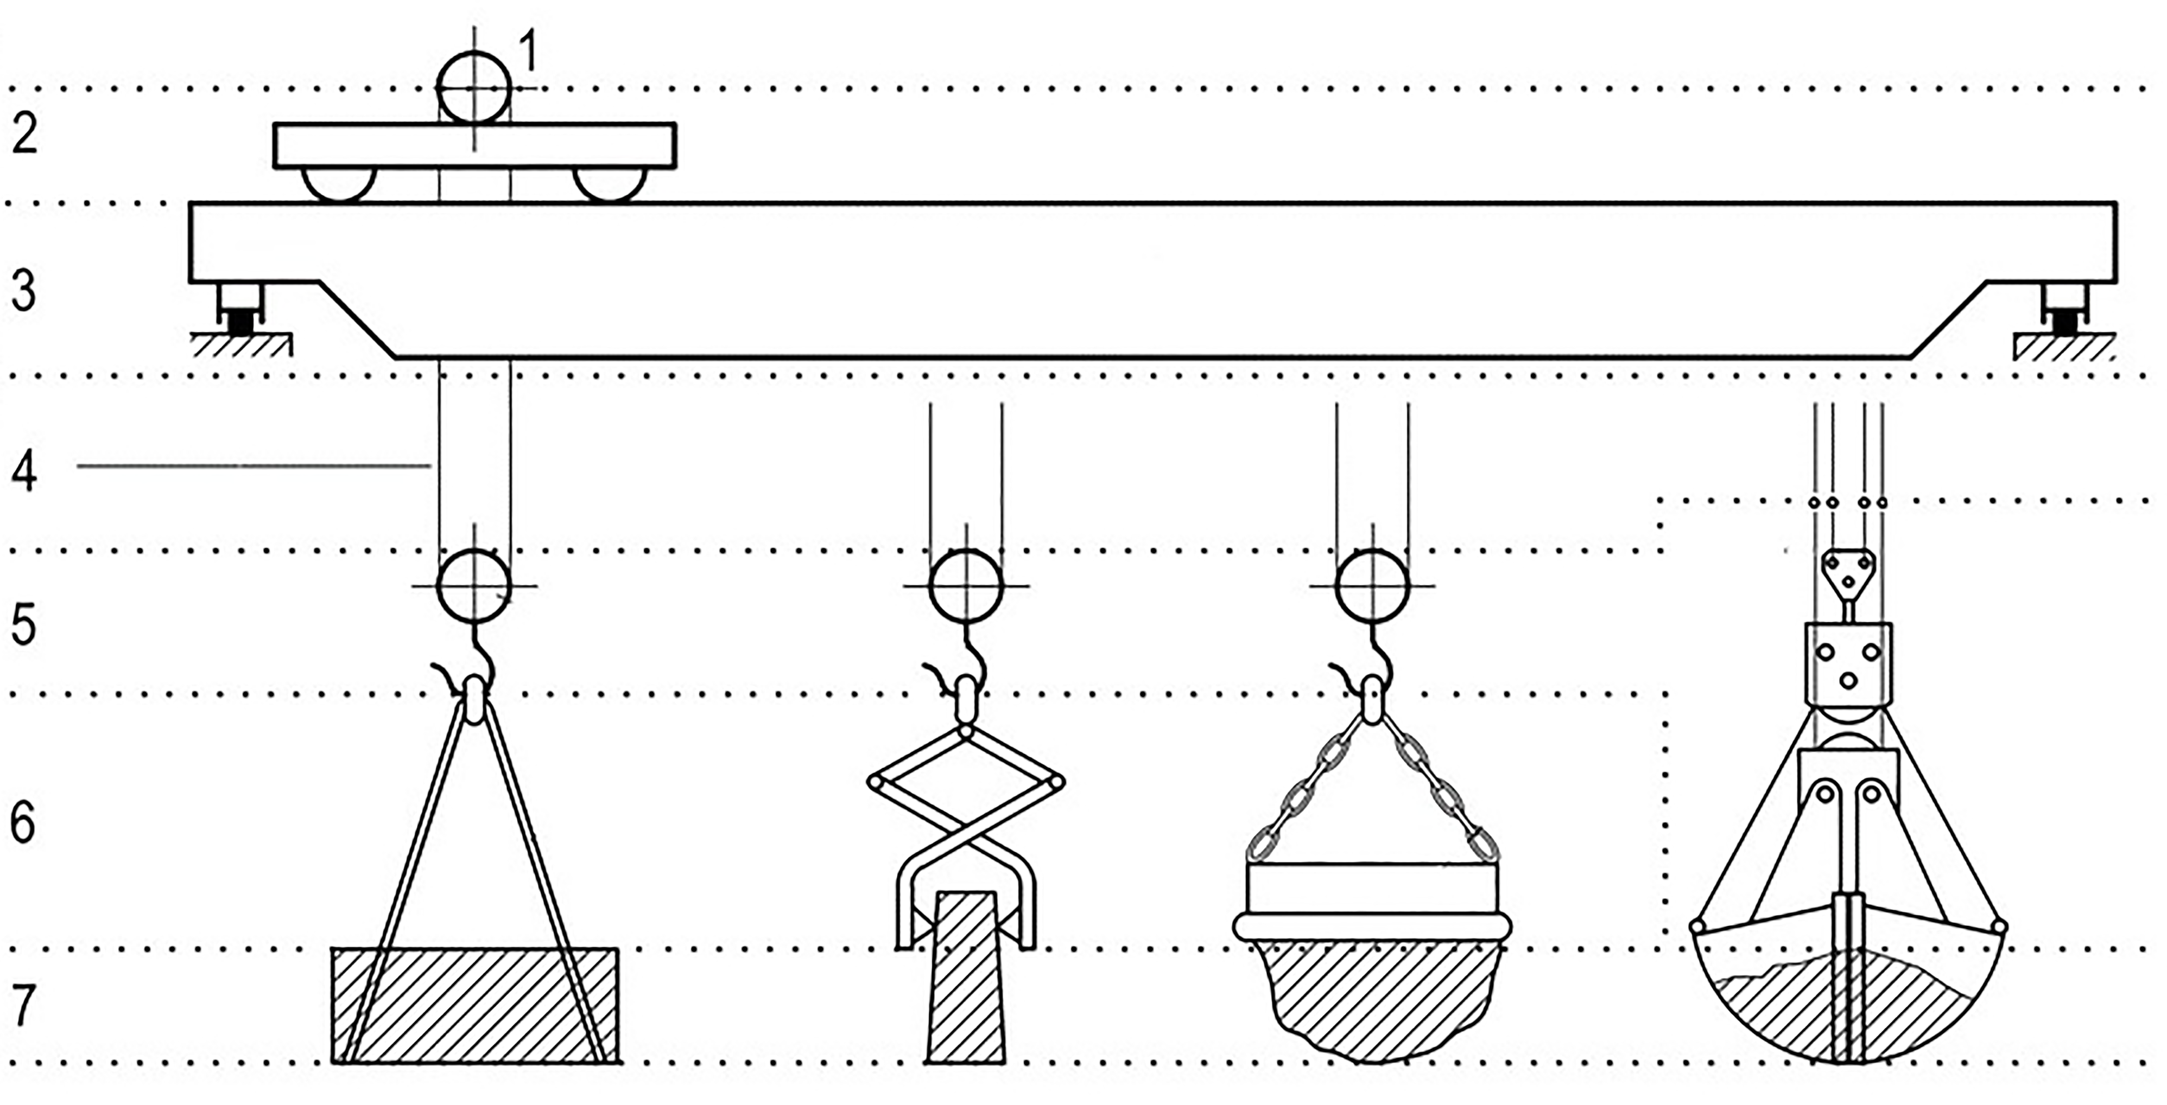

Key

|  |  |
| --- | --- |
| 1 | hoist |
| 2 | trolley |
| 3 | crane bridge |
| 4 | hoist medium |
| 5 | fixed load-lifting attachment |
| 6 | non-fixed load-lifting attachment |
| 7 | payload |

Figure 3.2 — Crane-related terms (exemplified for a bridge crane)

3.1.2.2

trolley

assembly designed to traverse the suspended load; denoted as ‘2’ in Figure 3.2

[SOURCE: ISO 4306‑1:2007, 4.12, modified]

3.1.2.3

main structure of crane

major structural part of the crane, including if exist counterweight(s), mechanical and electrical equipment; denoted as ‘3’ in Figure 3.2

3.1.2.4

hoist medium

wire rope(s), chain(s) or any other equipment hanging down from the crane used to lift and lower loads suspended from the lower end(s) of the hoist medium(s); denoted as ‘4’ in Figure 3.2

[SOURCE: ISO 4306‑1:2007, 6.1.6, modified]

Note 1 to entry: Hoist mediums are part of the crane.

3.1.2.5

fixed load-lifting attachment

any equipment, from which the net load can be suspended and which is permanently fastened to the lower end(s) of the hoist medium(s); denoted as ‘5’ in Figure 3.2

Note 1 to entry: Fixed load-lifting attachments are part of the crane.

[SOURCE: ISO 4306‑1:2007, 6.1.4, modified]

3.1.2.6

non-fixed load-lifting attachment

any equipment which connects the payload with the crane and which is neither part of the crane nor the payload; denoted as ‘6’ in Figure 3.2

Note 1 to entry: Non-fixed load-lifting attachments are easily detachable from the crane and from the payload.

[SOURCE: ISO 4306‑1:2007, 6.1.2, modified]

3.1.2.7

payload

load which is lifted by the crane and suspended from the non-fixed load-lifting attachment(s) or, if such an attachment is not used, directly from the fixed load-lifting attachments; denoted as ‘7’ in Figure 3.2

Note 1 to entry: If cranes are used for lifting gates at hydro-power stations or for lifting the load from water, the payload can also include forces due to waterflow suction or water adhering by suction.

[SOURCE: ISO 4306‑1:2007, 6.1.1, modified]

3.1.2.8

net load

load, which is lifted by the crane and suspended from the fixed load-lifting attachment(s)

Note 1 to entry: Net load contains the payload and the non-fixed load-lifting attachment(s).

[SOURCE: ISO 4306‑1:2007, 6.1.3, modified]

3.1.2.9

rated capacity

maximum net load that the crane is designed to lift for a given crane configuration and load location during normal operation

[SOURCE: ISO 4306‑1:2007, 6.1.8, modified]

3.1.2.10

skewing

deviation from free-rolling, natural travelling or traversing direction

### Terms and definitions specific for travelling cranes

3.1.3.1

travelling crane

crane capable of moving itself during operation with need for a fixed crane supporting structure (runways)

[SOURCE: ISO 4306‑1:2007, 1.3.5, modified]

3.1.3.2

monorail hoist block

hoist with wheels that is able to travel along the bottom flange of a runway beam, see Figure 3.3

Note 1 to entry: A monorail hoist is considered as the simplest type of a travelling crane.

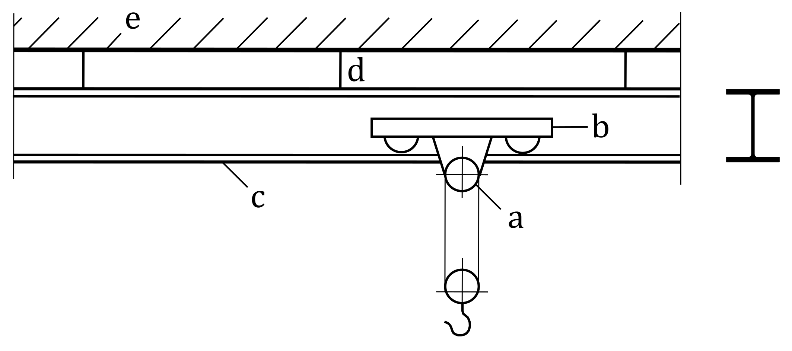

Key

|  |  |
| --- | --- |
| a | hoist |
| b | trolley |
| c | runway beam |
| d | runway beam support (here: suspension) |
| e | runway supporting structure |

Figure 3.3 — Example of a monorail hoist block

3.1.3.3

overhead travelling crane (bridge crane)

crane with its bridge girders directly supported on runway beams by travelling carriages

[SOURCE: ISO 4306‑1:2007, 1.1.1.1, modified]

3.1.3.4

top-mounted bridge crane

bridge crane that is supported on top of the runway beams, see Figure 3.4a

|  |  |
| --- | --- |
|  |  |
| a) top-mounted bridge crane | b) underhung bridge crane |

Key

|  |  |
| --- | --- |
| a | crane bridge |
| b | hoist |
| c | trolley |
| d | crane runway |
| e | crane runway supporting structure |

Figure 3.4 — Examples of bridge cranes

3.1.3.5

underhung bridge crane

bridge crane that is supported on the bottom flanges of the runway beams, see Figure 3.4b

3.1.3.6

gantry crane (portal bridge crane)

crane with the bridge girders supported on the rail tracks by legs, see Figure 3.5a

[SOURCE: ISO 4306‑1:2007, 1.1.1.2]

|  |  |
| --- | --- |
|  |  |
| a) gantry crane | b) semi-gantry crane |

Key

|  |  |
| --- | --- |
| a | crane bridge |
| b | hoist |
| c | trolley |
| d | crane runway, either overhead or at ground level |
| e | crane runway supporting structure or ground |

Figure 3.5 — Examples of gantry cranes

3.1.3.7

semi-gantry crane (semi portal bridge crane)

crane with its bridge girders supported on the rail track directly at one end and by legs at the other end, see Figure 3.5b

[SOURCE: ISO 4306‑1:2007, 1.1.1.3]

3.1.3.8

travelling wall crane

cantilever crane capable of travelling along a system of elevated horizontal and vertical crane runway beams, Figure 3.6

[SOURCE: ISO 4306‑1:2007, 1.1.3.9.2, modified]

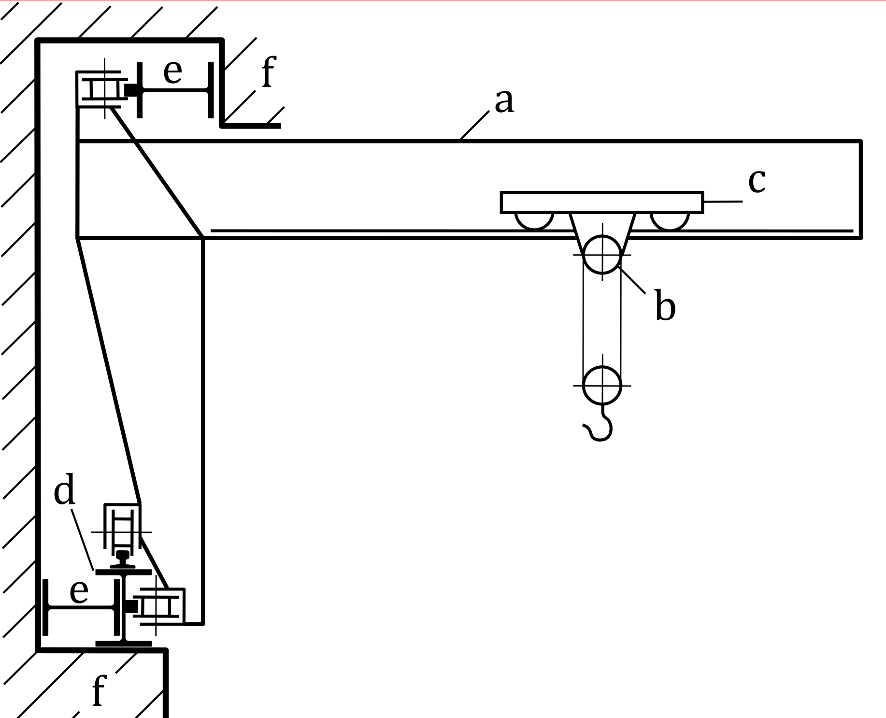

Key

|  |  |
| --- | --- |
| a | jib |
| b | hoist |
| c | trolley |
| d | vertical crane runway |
| e | horizontal crane runway |
| f | crane runway supporting structure |

Figure 3.6 — Example of a travelling wall crane

3.1.3.9

guide means

system used to keep travelling cranes aligned on runway beams through horizontal reactions, using either wheel flanges or guide rollers, see Figure 3.7

|  |  |
| --- | --- |
|  |  |
| a) Flanged wheel | b) Guide roller |

Key

|  |  |
| --- | --- |
| 1 | crane wheel |
| 2 | wheel flange |
| 3 | crane rail |
| 4 | guide roller |
| *H* | horizontal force |

Figure 3.7 — Guide means

### Terms specific for supporting structures of travelling crane

3.1.4.1

runway beam for travelling hoist

beam, part of the supporting structure of a travelling hoist, that serves as track and support system, on whose bottom flange the hoist can travel and operate, see Figure 3.3

3.1.4.2

crane runway beam

beam, part of the supporting structure of a travelling crane, that serves as track and support system, on which the crane can operate

3.1.4.3

crane runway supporting structure

crane supporting structure transmitting all crane-induced actions from the crane runway beam to the foundations

### Actions on cranes

The following terms and definitions are specific for travelling cranes.

3.1.5.1

self-weight of crane

*Q*C

self-weight of all fixed and movable elements of the crane, including the mechanical and electrical equipment, except the hoist medium and the lifting attachments, see Figure 3.8

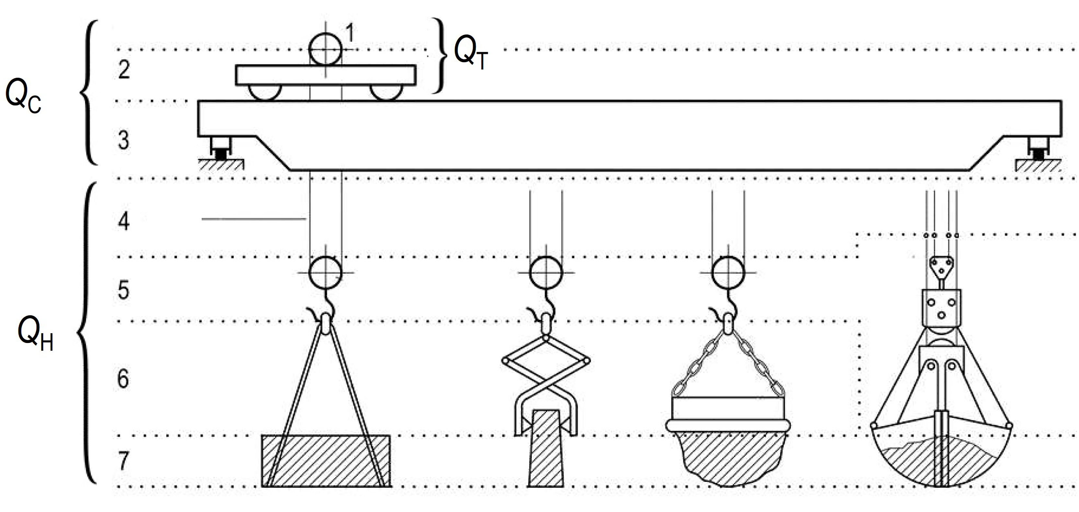

NOTE See Figure 3.2

Figure 3.8 — Definition of self-weight *Q*C and hoist load *Q*H of a bridge crane

3.1.5.2

hoist load

*Q*H

load which is suspended directly from the crane, see Figure 3.8

[SOURCE: ISO 4306‑1:2007, 6.1.7, modified]

Note 1 to entry: The hoist load is also called the gross load in crane design, see ISO 4306‑1.

Note 2 to entry: The hoist load comprises the payload, the non-fixed load-lifting attachments, the fixed load-lifting attachment(s) and the hoist medium.

3.1.5.3

self-weight of trolley

*Q*T

gravitational force applied to the crane bridge by the trolley including the hoist, see Figure 3.8

## Symbols

For the purposes of this document, the symbols given in EN 1990 and the following apply.

NOTE The notation used is based on ISO 3898.

*Latin upper-case letters*

|  |  |
| --- | --- |
| *C* | total number of working cycles during design service life |
| *C*02 to *C*9 | classification of fatigue action from crane |
| *F*eq | static equivalent force |
| *F*wH | in-service wind action on the hoist load |
| *F*w* | forces caused by in-service wind |
| *H*L | longitudinal forces caused by acceleration and deceleration of the crane |
| *H*S | horizontal forces caused by skewing of the crane |
| *H*T1; *H*T2 | transverse forces caused by acceleration and deceleration of the crane |
| *H*T3 | transverse forces caused by acceleration and deceleration of the trolley |
| *H*B,1 | buffer forces related to movements of the crane |
| *H*B,2 | buffer forces related to movements of the trolley |
| *H*TA | tilting force |
| *N* | actual number of wheel load events |
| *N*ref | reference number of wheel load events |
| *Q*0 to Q5 | classes of load spectrum factor kQ (see EN 13001‑1) |
| *Q*C | self-weight of crane |
| *Q*H | hoist load |
| *Q*R | rated capacity |
| *Q*ST | static test load |
| *Q*T | trolley load |
| *Q*e | damage equivalent constant amplitude loading spectrum |
| *F*fat | fatigue action |
| *Q*k | characteristic value of static component of the crane action |
| *Q*r | wheel load on rail |
| *Q*r,max | maximum wheel load |
| *Q*ϕk | characteristic value of a crane-induced action, including its static and dynamic components |
| *S* | surge force |
| *U*0 to *U*9 | classes of total numbers of working cycles *C* (see EN 13001‑1) |

*Latin lower-case letters*

|  |  |
| --- | --- |
| *a* | spacing of flanged wheels or guide rollers |
| *b*hr | width of rail head |
| *e*y | eccentricity of wheel load |
| *f*w* | in-service wind pressure |
| *kQ* | load spectrum factor |
| *s* | span of crane bridge |
| *s*g | eccentricity of centre of gravity of loaded crane, with trolley at limit of travel |

*Greek lower-case letters*

|  |  |
| --- | --- |
| *ϕi* | dynamic factors (*i* = 1, 2, 3, 4, 6, 7) applied to actions from cranes |
| *ϕ*5 | dynamic factors applied to actions from drives |
| *ϕ*M | dynamic factor applied to actions from machines |
| *ϕ*fat | dynamic factor relevant in the fatigue design situation |

# Basis of design

(1) Actions used for the design of supporting structures for cranes and machinery to the Eurocodes shall be in accordance with the provisions of EN 1990.

NOTE 1 Information on actions is provided by the manufacturer of the crane or machine, see assumptions in 1.2.

NOTE 2 Standards defining actions for crane design are crane product standards listed in EN 13001‑2:2021, Annex E.

NOTE 3 The basis of crane design has differences from Eurocode design of the crane supporting structure. For example, regular, occasional and exceptional loads are used in crane design, whereas a design according to Eurocode uses permanent, variable and accidental actions.

# Classification of actions from cranes travelling on fixed runways or from machines

## Actions from cranes travelling on fixed runways

### Actions to be classified

(1) Actions from travelling cranes should be classified as permanent, variable or accidental actions.

(2) Following actions induced by travelling cranes under normal service conditions should be classified, if relevant:

− actions due to gravity effects acting on mass of crane structure (crane self-weight);

− actions due to gravity effects acting on hoisted mass (hoist load);

− dynamic actions due to inertial effects caused by acceleration and deceleration of crane or trolley amplifying the corresponding self-weight and hoist load;

− dynamic actions due to inertial effects caused by crane travelling on uneven surfaces amplifying the crane self-weight and hoist load;

− skewing action at guide means of guided wheel-mounted cranes or trolleys during travelling or traversing at uniform speed;

− wind actions on crane structure and hoist load.

(3) Following actions induced by travelling cranes under exceptional service conditions should be classified, if relevant:

− buffer forces due to collision with end stops;

− tilting forces due to collision of lifting attachments with obstacles.

(4) Where relevant, further exceptional service conditions to be considered for travelling cranes should be as specified by the relevant authority or, where not specified, as agreed for a specific project by the relevant parties.

### Crane specific classification

(1) All crane-induced actions under normal service conditions listed in 5.1.1(2) should be classified as free variable actions.

(2) All crane-induced actions under exceptional service conditions listed in 5.1.1(3) and (4) should be classified as accidental actions.

(3) Actions from cranes under normal service conditions occurring frequently at specific positions of the crane supporting structure resulting to fatigue should be classified as fatigue actions.

(4) If there is no possibility of resonance or other significant dynamic response of the supporting structure, crane-induced actions may be classified as quasi-static actions. In such a case, the dynamic effects due to inertial and damping forces should be amplified by *ϕi* according to Formula (5).1).

*F*ϕk = *ϕi F*k (5.1)

where:

|  |  |
| --- | --- |
| *F*ϕk | is the characteristic value of the crane-induced action; |
| *ϕi* | is the dynamic factor listed in Table 5.1; |
| *F*k | is the characteristic value of the static component of the crane-induced action to be amplified by *ϕi* according to Table 5.1. |

NOTE Clause 6 contains information on the characteristic values and the dynamic factors to be considered for travelling cranes.

Table 5.1 — Dynamic factors for actions from cranes

|  |  |  |
| --- | --- | --- |
| Factor | Amplifying dynamic effects | Action from crane to be amplified caused by |
| *ϕ*1 | Excitation of the crane structure  due to lifting the payload | Self-weight of crane *Q*C |
| *ϕ*2 | Inertial effects of transferring an unrestrained payload from the ground to the crane | Hoist load *Q*H |
| *ϕ*3 | Inertial effects of a sudden release of a payload  (for example, if grabs or magnets are used) | Hoist load *Q*H |
| *ϕ*4 | Inertial effects produced when the crane is travelling on rails or directly on top or bottom flanges of runway beams | Self-weight of crane *Q*C  and hoist load *Q*H |
| *ϕ*5 | Inertial effects due to acceleration of crane or trolley | Drive force |
| *ϕ*6 | Inertial effects of a test load moved by the drives  in the way that the crane is used | Dynamic test load |
| *ϕ*7 | Loads due to impact on buffers | Buffer loads |
| Note 1: See B.4(1) or EN 13001‑2-for definition of drive force.  Note 2: The dynamic factor *ϕ*3 can be neglected for load groups given in 6.4(1) as it is lower than 1. | | |

(5) The values of the dynamic factors may be determined in accordance with EN 15011 in conjunction with EN 13001‑2.

## Actions from fixed machines

(1) Actions applied to structures by fixed machines with moving parts should be classified as permanent, variable or accidental actions.

(2) The vertical force component caused by actions from machine self-weight should be classified as fixed permanent action.

(3) All other actions from machines under normal service conditions exerted on the supporting structure should be classified as variable actions.

(4) Actions exerted on the machine-supporting structure during erection, maintenance or repair caused by scaffolding and other auxiliary devices should be classified as free variable actions.

(5) The actions under exceptional service conditions applied by fixed machines should be classified as accidental actions.

NOTE Examples of exceptional service conditions can be:

− accidental increase of the eccentricity of moving parts (for instance by accidental deformation or rupture of moveable parts);

− loss of synchronisation of machines;

− electrical short circuits;

− impulsive effect of fluids due to sudden shutdown of pipes.

(6) Where relevant, further accidental actions to be considered should be as specified by the relevant authority or, where not specified, as agreed for a specific project by the relevant parties.

(7) If there is no possibility of resonance or other significant dynamic response of the supporting structure, machine-induced actions may be classified as quasi-static actions. In such a case, the dynamic effects due to inertial and damping forces should be amplified by appropriate dynamic factors.

(8) Actions from machines under normal service conditions occurring frequently at specific positions of the supporting structure resulting to fatigue should be classified as fatigue actions.

# Actions from cranes travelling on fixed runways

## Field of application

(1) This clause specifies actions induced by the following types of cranes on their fixed runways:

− travelling hoist (as simplest type of crane);

− bridge cranes;

− gantry and semi-gantry cranes;

− travelling wall cranes.

## Design situations

### Single crane operation

(1) The actions from a travelling crane should be determined for all relevant design situations according to EN 1990.

(2) In the persistent and transient design situations, actions caused by normal service conditions of the crane, as mentioned in 5.1.1(2), should be considered.

(3) The following persistent design situations including wind actions should be taken into account for supporting structures of outdoor cranes, as well for supporting structures of indoor cranes in open buildings:

− operating crane exposed to maximum in-service wind according to 6.10;

− out of service crane exposed to maximum wind according to EN 1991‑1‑4.

(4) Actions from cranes caused by crane tests should be taken into account in the transient design situation.

NOTE Travelling cranes are usually tested before being taken into service (that means the first use for its intended purpose) according to the Machinery Directive.

(5) For each accidental design situation, only one action caused by exceptional service conditions of the crane, as mentioned in 5.1.1(3) and (4), should be taken into account.

(6) For the fatigue design situation, the fatigue actions given in 6.9 should generally be taken into account unless other Eurocodes specify differently.

(7) For verification of the serviceability limit state, only design situations with actions caused by normal crane service, as mentioned in 5.1.1(2), should be considered.

(8) For the serviceability limit state, the relevant design situations to be considered for the characteristic, frequent and quasi-permanent combinations of EN 1990 should be as specified by other Eurocodes.

(9) For the combination of crane-induced actions with other actions in the different design situations of ultimate and serviceability limit states, the rules given by Annex A.5 of prEN 1990‑1:2024 should be used.

NOTE The action from cranes caused by in-service wind on the crane structure and on the hoist load is treated as a crane-induced action. See load grouping in 6.4.

(10) Where the supporting structure is subjected to actions from more than one travelling crane, the provisions in 6.2.2 should be taken into account.

### Multiple crane operation

(1) Two or more cranes that are intended to mostly operate together to lift a single payload should be treated as a single crane in all design situations.

(2) Where two or more cranes operate independently, the number of cranes to be taken into account in their most unfavourable positions, when verifying the fundamental (persistent and transient) and fatigue design situations of the ultimate limit state, may be limited according to Table 6.1 (NDP).

Table 6.1 (NDP) — Maximum number of bridge cranes in fundamental (persistent and transient) and fatigue design situations for the verification of the ultimate limit states

|  |  |  |  |
| --- | --- | --- | --- |
| **Maximum number of cranes for** | **Crane runway** | **Crane runway supporting structures** | |
| **Single-bay structures** | **Multi-bay structures** |
|  |  |  |
| Vertical actions (*Q*r) | **3** cranes maximum on the same runway | **4** cranes maximum in the same bay, either:  a) 3 on the same runway and 1 on another runway,  *or*  b) 2 on the same runway and 2 on another runway,  *or*  c) 2 on the same runway and 2 on separate runways. | **6** cranes maximum, with either:  a) 4 positioned in one of the ways listed for single bay structures and 2 in another bay,  *or*  b) 6 distributed over several bays. |
| Horizontal crane actions (*H*T, *H*L, *H*S) | **1** crane only, except for two cranes operating in tandem. | **2** cranes maximum  on different runways, unless they operate in tandem. | **4** cranes maximum, taking into account the provisions for crane runways and single-bay structure. |

NOTE 1 The maximum numbers of bridge cranes are given in Table 6.1 (NDP) unless the National Annex gives different values. Table 6.1 (NDP) also applies for semi-gantry and travelling wall cranes if the horizontal crane-induced actions *Q*r,h caused by crane self-weight and hoist load (see Figures 6.2 and 6.3) are treated as *Q*r in terms of maximum crane number.

NOTE 2 In terms of fatigue design situation, Table 6.1 (NDP) accounts for a limited number of cranes whose workspaces frequently overlap.

NOTE 3 See 6.6.1(7) for reduced dynamic factors in case of multiple crane operation.

(3) For accidental design situations, only the accidental action of the crane with the most adverse effect should be taken into account.

(4) For serviceability limit states, only the crane or the cranes that are treated as a single crane according to 6.2.2(1) with the most adverse effect should be considered.

## Representation of actions

(1) The actions from travelling cranes under normal service conditions should be separated into:

− vertical forces (*Q*r) caused by crane self-weight (*Q*C) and hoist load (*Q*H) that are exerted on the crane runways by wheels;

− if relevant, horizontal forces (*Q*r,h) caused by crane self-weight (*Q*C) and hoist load (*Q*H) due to restrained deformations in case of statically indeterminate crane structure;

− horizontal forces caused by acceleration and deceleration of crane, acting transversely on the crane runway (*H*T) and along the crane runway (*H*L);

− if relevant, vertical forces (*Q*r,HL) caused by acceleration and deceleration of crane;

− horizontal forces caused by skewing of crane, acting transversely on the crane runway (*S*, *H*S,T) and along the crane runway (*H*S,L);

− horizontal forces caused by acceleration and deceleration of trolley, acting transversely on the crane runway (*H*TT).

NOTE 1 Horizontal forces *Q*r,h occur for non-articulated gantry and semi-gantry crane structures and travelling wall cranes, see Annex C.

NOTE 2 Vertical forces *Q*r,HL occur for travelling wall cranes, see Annex C.

NOTE 3 The horizontal transverse forces are exerted on the crane runways either by wheel flanges or by guide rollers, depending on the system of guide means, and by slip resistance of wheel-rail contact. The horizontal longitudinal forces are exerted on the crane runways by slip resistance of wheel-rail contact.

(2) The actions from travelling cranes under exceptional service conditions should at least be separated into:

− horizontal buffer forces from crane (*H*B), acting along the crane runway;

− if relevant, resulting horizontal actions (*H*B,h), acting transversely on the crane runway and/or resulting vertical actions (*Q*r,B) if the buffer forces (*H*B) act eccentrically with respect to the mass centroid of the crane;

− horizontal buffer forces from trolley (*H*BT), acting transversely on the crane runway.

NOTE 1 Figures 6.1 to 6.3 show examples of the representation of actions from a bridge crane, a travelling wall crane and a non-articulated semi-gantry crane.

NOTE 2 Horizontal transverse forces *H*B,h and vertical forces *Q*r,B from crane collision with end stops can occur for semi-gantry cranes and travelling wall cranes, see Annex C.

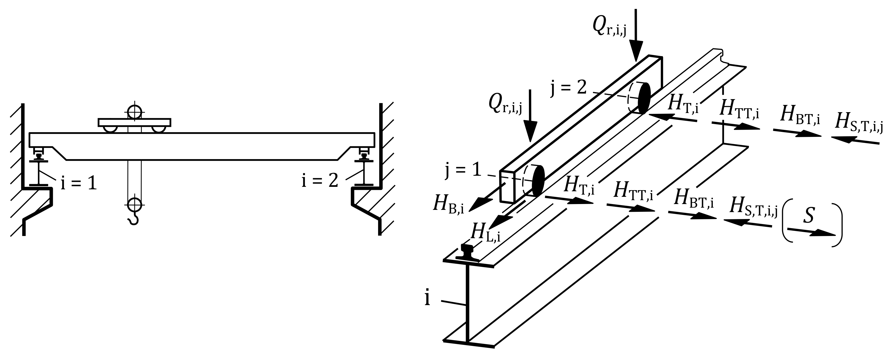

Figure 6.1 — Example for actions on a crane runway beam from a bridge crane with two wheel axles and single driven wheels (schematic illustration)

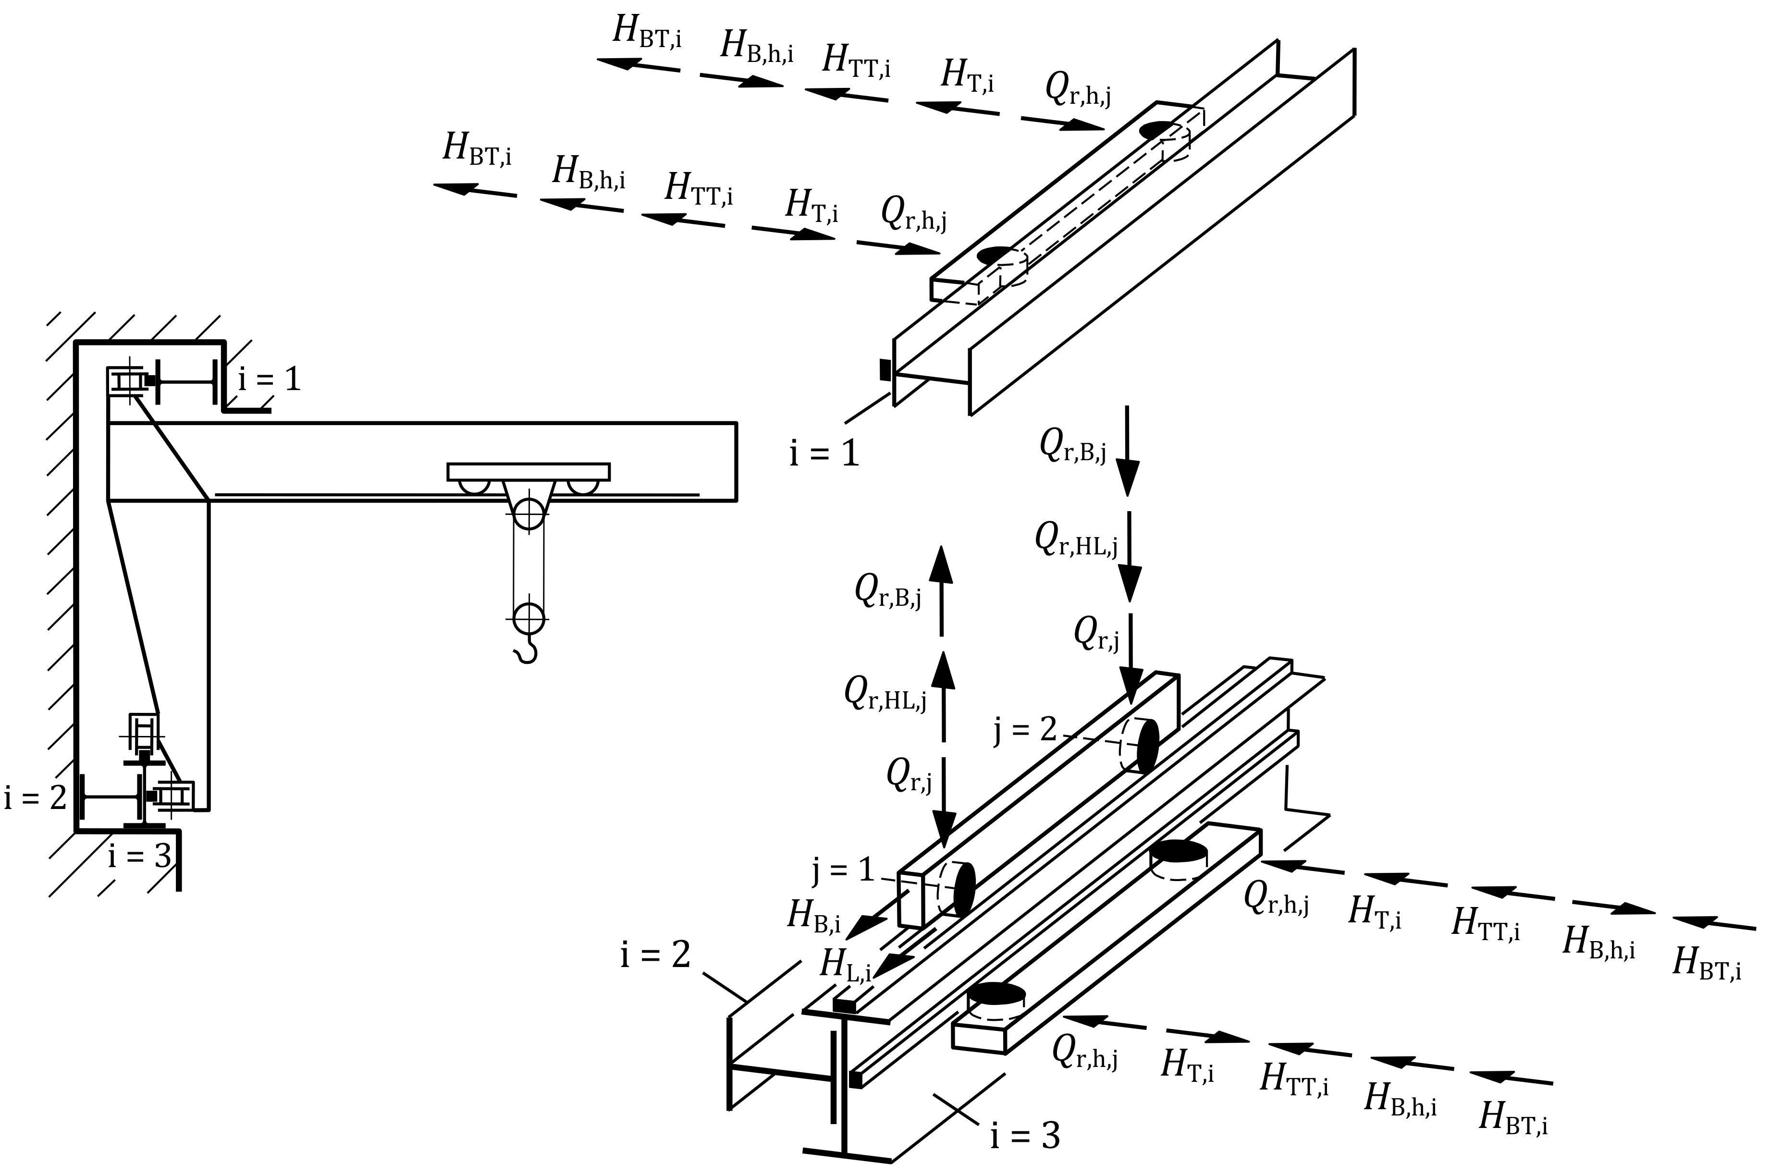

Figure 6.2 — Example for actions from a travelling wall crane (schematic illustration)

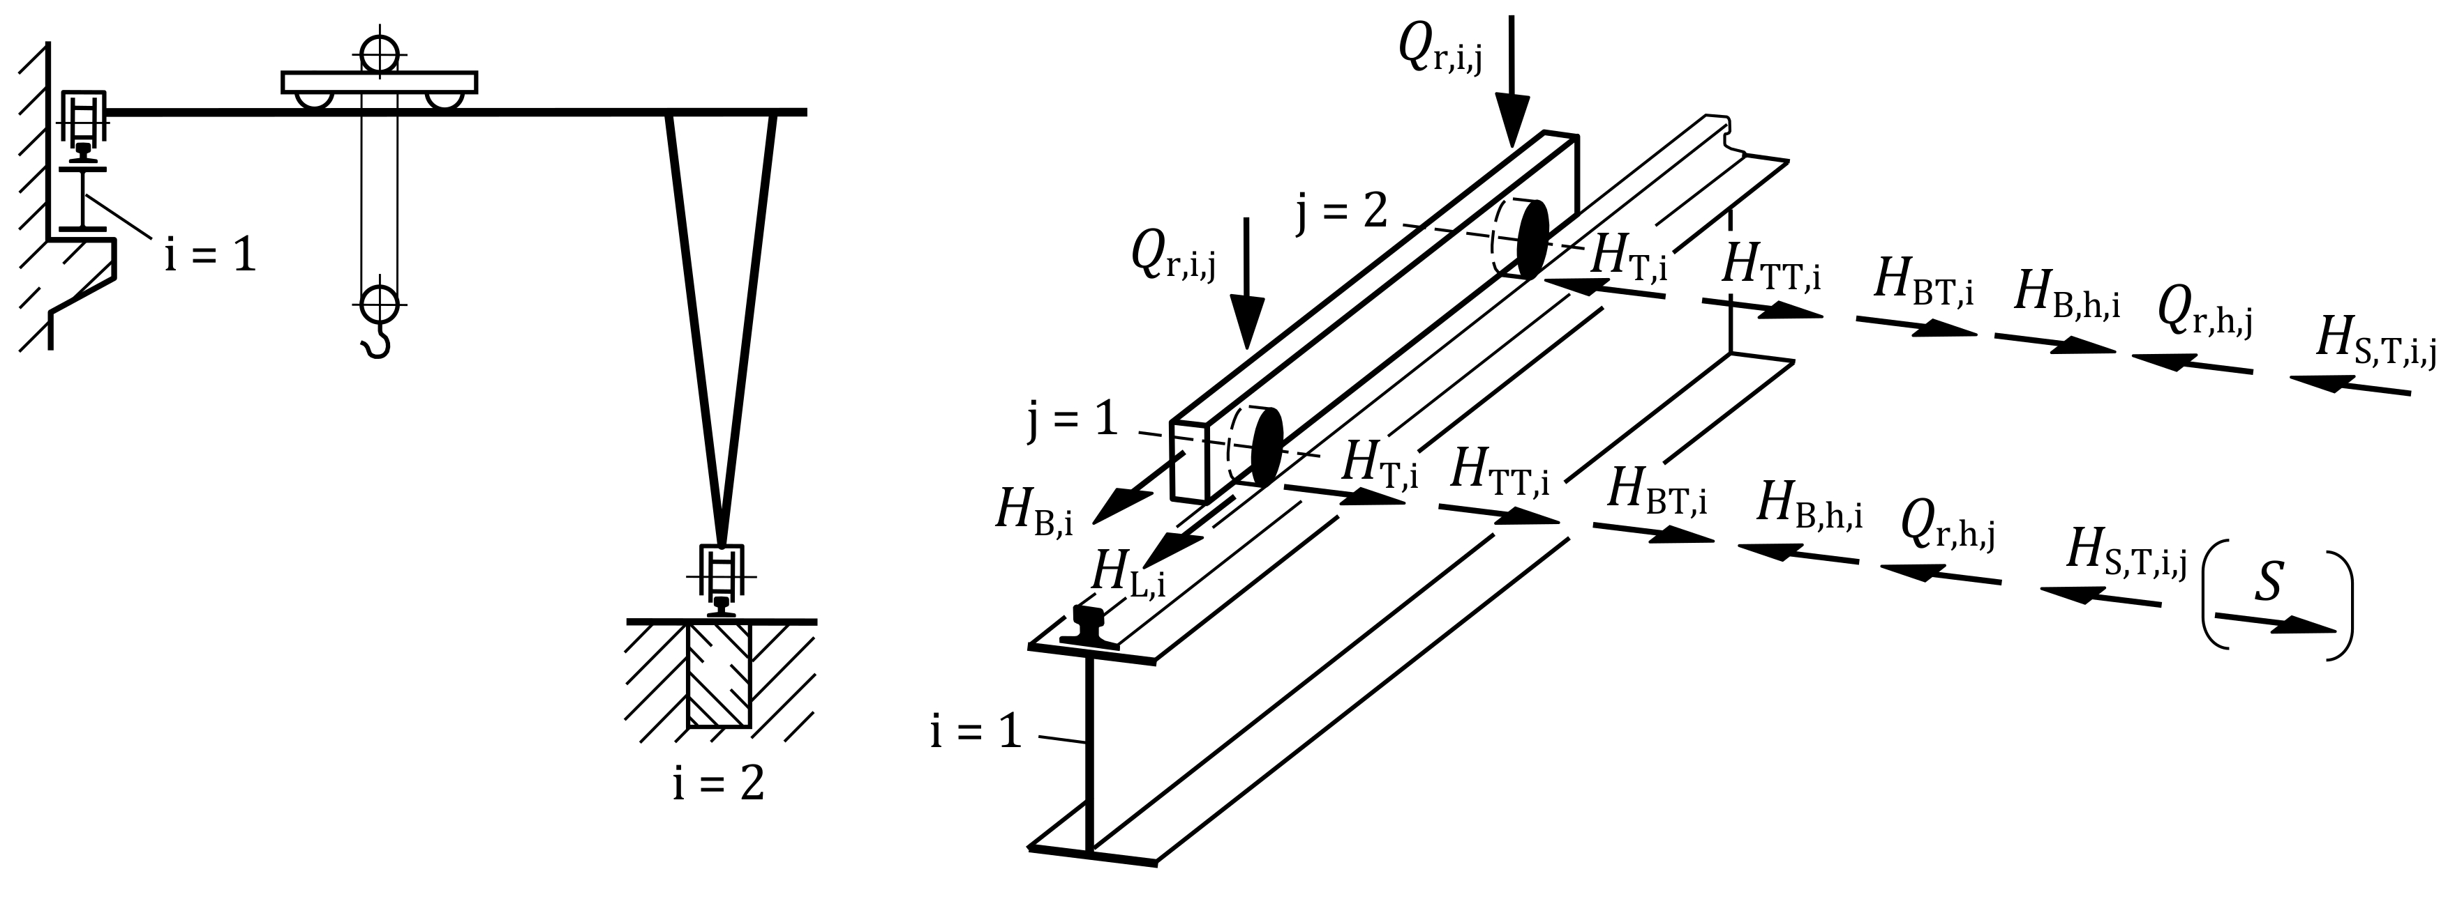

Figure 6.3 — Example for actions on a crane runway beam from   
a non-articulated semi-gantry crane (schematic illustration)

## Load groups

(1) The simultaneity of the different kinds of actions from a single crane should be taken into account in the design situations of the limit states by considering groups of loads as identified in Tables 6.2 and 6.3.

NOTE Tables 6.2 and 6.3 list all possible types of actions. For a specific type of travelling crane, some actions can be irrelevant.

(2) Each of the load groups in Tables 6.2 and 6.3 should be considered as defining one characteristic crane-induced action classified as variable action for the combination with non-crane actions.

NOTE The horizontal actions from acceleration or deceleration of crane or trolley and the actions from skewing of crane are not superposed in the load groups based on investigations.

(3) Where relevant, further load groups to be considered should be as specified by the relevant authority or, where not specified, as agreed for a specific project by the relevant parties.

(4) In case of multiple crane action, the load groups should contain the actions of all cranes to be considered according to Table 6.1 (NDP).

Table 6.2 — Load groups treated as a single action from crane for design situations   
of Ultimate Limit State

|  |  |  |  |  |  |  |  |  |  |  |  |
| --- | --- | --- | --- | --- | --- | --- | --- | --- | --- | --- | --- |
| **Load Group** | | | **Design situations of Ultimate Limit State** | | | | | | | | |
| **Persistent** | | | | **Transient** | | **Accidental** | | **Fatigue** |
| Normal service conditions,  see Note 1 | | | | Crane tests | | Exceptional service conditions | | Normal service conditions, see Note 2 |
| Static | Dynamic |
| **Action from** | **Symbol** | **Clause** | **1** | **2** | **3** | **4** | **5** | **6** | **7** | **8** | **9** |
| Self weight of crane | *Q*C | 6.6.1 | *ϕ*1 | *ϕ*4 | *ϕ*4 | *ϕ*4 | *ϕ*1 | *ϕ*1 | 1 | 1 | (*ϕ*1 + 1)/2 |
| Hoist load | *Q*H | 6.6.1 | *ϕ*2 | *ϕ*4 | *ϕ*4 | *ϕ*4 | − | − | 1 | 1 | (*ϕ*2 + 1)/2 |
| Acceleration of crane | *H*L, *H*T | 6.6.2 | *ϕ*5 | *ϕ*5 | − | − | − | *ϕ*5 | − | − | − |
| Acceleration of trolley | *H*TT | 6.6.2 | − | − | *ϕ*5 | − | − | − | − | − | − |
| Skewing of crane | *H*S | 6.6.2 | − | − | − | 1 | − | − | − | − | − |
| In-service wind | *F*W* | 6.10 | 1 | 1 | 1 | 1 | 1 | 1 | − | − | − |
| Buffer forces | *H*B or *H*BT | 6.8 | − | − | − | − | − | − | *ϕ*7 | − | − |
| Tilting forces | *H*TA | 6.8 | − | − | − | − | − | − | − | 1 | − |
| Test load | *Q*Test | 6.7 | − | − | − | − | 1 | *ϕ*6 | − | − | − |
| NOTE 1 to Table Explanation of load groups in persistent design situation: 1 − lifting of hoist load, 2 − acceleration or deceleration of loaded crane while it travels on uneven runway, 3 − acceleration of loaded trolley while it travels on uneven runway, 4 − skewing of loaded crane travelling with uniform velocity | | | | | | | | | | | |
| NOTE 2 to table Horizontal crane actions occur randomly scattered along the runways. Due to this irregular occurrence, they are generally negligible in the fatigue design situation, except for cases where acceleration and braking actions are planned to occur regularly at certain parts of the runways as specified by the client. | | | | | | | | | | | |

Table 6.3 — Load groups treated as a single action from crane for Serviceability Limit State criteria such as deformations and displacements

|  |  |  |  |  |  |  |  |
| --- | --- | --- | --- | --- | --- | --- | --- |
| **Load group** | | | **Design situations of Serviceability Limit State** | | | | |
| Normal service conditions,  see Note | | | Crane tests | |
| Static | Dynamic |
| **Action from** | **Symbol** | **Clause** | **101** | **102** | **103** | **104** | **105** |
| Self weight of crane | *Q*C | 6.6.1 | 1 | 1 | 1 | 1 | 1 |
| Hoist load | *Q*H | 6.6.1 | 1 | 1 | 1 | − | − |
| Acceleration of crane | *H*L, *H*T | 6.6.2 | − | 1 | − | − | 1 |
| Acceleration of trolley | *H*TT | 6.6.2 | − | − | − | − | − |
| Skewing of crane | *H*S | 6.6.2 | − | − | 1 | − | − |
| In-service wind | *F*W* | 6.10 | 1 | 1 | 1 | 1 | 1 |
| Test load | *Q*Test | 6.7 | − | − | − | 1 | 1 |
| NOTE to Table Explanation of load groups under normal service conditions: 101 − parked loaded crane, 102 − acceleration of loaded crane, 103 − skewing of loaded crane travelling with uniform velocity | | | | | | | |

## Load arrangements

(1) The single crane, and in case of multiple crane operation all relevant cranes according to 6.2.2, should be taken into account in their most unfavourable position.

(2) The hoist load should be neglected if it affects the crane supporting structure favourably.

## Characteristic values of crane-induced actions under normal service conditions

### Vertical crane-induced actions

(1) The characteristic values of the actions applied to a structure by a crane should be taken equal to the characteristic values of the reactions from the crane.

(2) For a bridge, semi-gantry or gantry crane designed in accordance with EN 15011, the following information should be obtained from the technical data file provided by the crane manufacturer to derive the vertical crane-induced actions:

− maximum and minimum characteristic static wheel loads *Q*r,i,j caused by crane self-weight *Q*C;

− maximum and minimum characteristic static wheel loads *Q*r,i,j caused by hoist load *Q*H;

− corresponding dynamic factors *ϕ*1, *ϕ*2, *ϕ*3, *ϕ*4 and *ϕ*6;

− wheel load arrangement (wheel spacing etc.).

NOTE 1 Table 5.1 describes the dynamic factors *ϕ*1, *ϕ*2, *ϕ*3 and *ϕ*4.

NOTE 2 EN 15011 contains information relevant to bridge, semi-gantry and gantry cranes.

(3) Where the vertical actions and data listed in (2) are not available from the technical data file of the crane manufacturer, these actions and data should be determined following the provisions of EN 15011 in conjunction with EN 13001‑2 for bridge and gantry cranes, as appropriate.

(4) In the absence of more accurate information, the dynamic factors *ϕ*1 and *ϕ*2 may be assumed according to Table 6.4 with a maximum steady hoisting speed of *v*h,max = 20 m/min.

Table 6.4 — Simplified dynamic factors *ϕ*1 and *ϕ*2

|  |  |
| --- | --- |
| Stiffness class | *ϕ*1 = *ϕ*2 |
| HC 1 | 1,10 |
| HC 2 | 1,20 |
| HC 3 | 1,30 |
| HC 4 | 1,40 |

(5) The dynamic factors should be neglected if they have a favourable effect on the supporting structure.

NOTE The dynamic factor *ϕ*3 is usually neglected for the design of the supporting structure of bridge, gantry and semi-gantry cranes since it is smaller than 1.

(6) In the absence of more accurate information, the dynamic factor *ϕ*4 may be obtained from Table 6.5.

Table 6.5 — Dynamic factor *ϕ*4

|  |  |
| --- | --- |
| Travel surface | Value of dynamic factor |
| Continuous rail clamped to crane runway beam with welded rail splice joints ground smooth, no steps or gaps | *ϕ*4 = 1,0 |
| Rail fastened by welds to crane runway beam with non-welded bevel joints in rail, ground smooth, no steps or gaps | *ϕ*4 = 1,0 |
| Rail fastened by welds to crane runway beam with non-welded bevel joints in rail and ‘Functional tolerances’ according to EN 1090‑2 and under the assumptions of the note | |
| class 1 | *ϕ*4 = 1,2 |
| class 2 | *ϕ*4 = 1,1 |
| Any other case | Determine *ϕ*4 in accordance with EN 13001‑2 |
| NOTE The values of *ϕ*4 can be calculated according to EN 13001‑2:2021, 4.2.2.4 with following assumptions for the crane: travelling velocity of 40 m/min, natural frequency of 5 Hz, wheel radius ≤ 400 mm. | |

(7) When calculating the action effects due to simultaneous action of multiple cranes, the dynamic factors *ϕ*1 and *ϕ*2 should be applied to the most unfavourable crane in terms of *Q*r,ϕ (vertical crane-induced action including the dynamic factor). For the other crane(s), the dynamic factors *ϕ*1 and *ϕ*2 according to class HC 1 in Table 6.4 may be applied.

(8) For top-mounted cranes, the eccentricity *e*y of a wheel load *Q*r from the rail centre line should be taken as a part of the width of the rail head *b*hr as shown in Figure 6.4, with the value depending on the design situation and the material of the crane supporting structure.

NOTE The amount of eccentricity and the design situations, when this eccentricity is to be accounted for, can be provided in the relevant material-specific Eurocode.

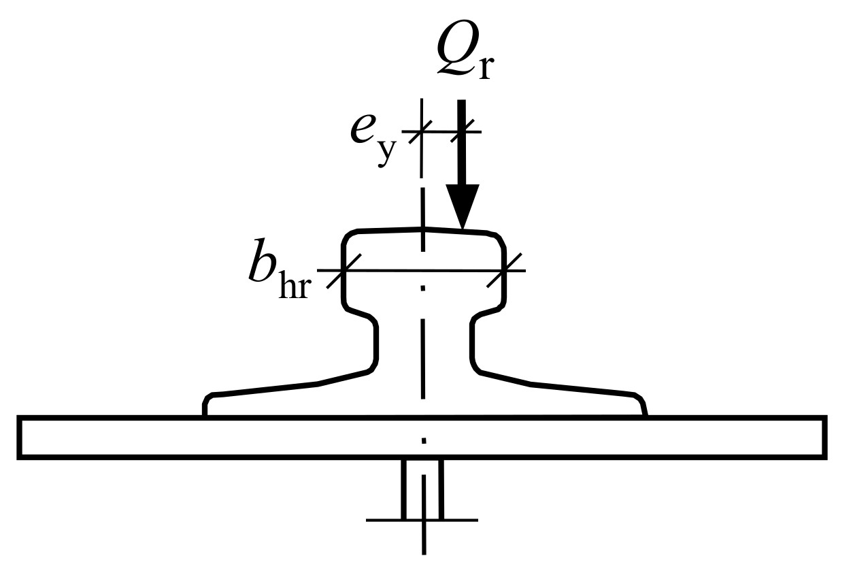

Figure 6.4 — Eccentricity of wheel loads

### Horizontal crane-induced actions

#### Top-mounted bridge cranes

(1) For a bridge, semi-gantry or gantry crane designed in accordance with EN 15011, the following information should be obtained from the technical data file provided by the crane manufacturer to derive the horizontal crane-induced actions:

− static transverse forces *H*T,i and static longitudinal forces *H*L,i caused by accelerated or decelerated crane travel together with the corresponding dynamic factors *ϕ*5;

− static transverse forces *H*TT,i caused by accelerated or decelerated trolley travel together with the corresponding dynamic factors *ϕ*5;

− transverse forces *H*S,T,i,j, skewing force *S* and longitudinal forces *H*S,L,i,j caused by crane skewing;

− arrangement of aforementioned forces (force direction, point of application etc.).

NOTE 1 The dynamic factors *ϕ*5 for crane acceleration/deceleration and trolley acceleration/deceleration can be different.

NOTE 2 See Figures 6.1 to 6.3 for examples of these actions.

NOTE 3 EN 15011 contains information relevant to bridge, semi-gantry and gantry cranes.

(2) Where the horizontal actions and data listed in (1) are not available from the technical data file of the crane manufacturer, these actions and data should be determined following the provisions of EN 15011 in conjunction with EN 13001‑2 for bridge, semi-gantry and gantry cranes, as appropriate.

NOTE Annex B contains guidance on a simplified calculation of the horizontal crane-induced actions from important types of bridge cranes.

(3) In the absence of more accurate information, the dynamic factor *ϕ*5 given in Table 6.6 may be used.

Table 6.6 — Dynamic factor *ϕ*5

|  |  |
| --- | --- |
| Values | Specific use |
| *ϕ*5 = 1,0 | for centrifugal forces |
| *ϕ*5 = 1,5 | for systems where forces change smoothly |
| *ϕ*5 = 2,0 | for cases where sudden changes can occur |
| *ϕ*5 = 3,0 | for drives with considerable backlash |
| NOTE The table contains safe-sided values according to EN 13001‑2:2021, 4.2.2.5. | |

#### Underhung bridge cranes

(1) For a underhung bridge crane designed in accordance with EN 15011, the crane-induced horizontal actions should be obtained from the technical data file provided by the crane manufacturer.

(2) In the absence of more accurate information, the horizontal transverse forces at the wheel contact surface should be taken as at least 10 % of the maximum vertical wheel load (without dynamic factor).

#### Travelling hoists

(1) For a travelling hoist, the horizontal actions should be obtained from the technical data file provided by the crane manufacturer.

(2) In the absence of more accurate information, the horizontal transverse forces should be taken as at least 5 % of the maximum vertical wheel load (without dynamic factor) in the case of fixed runway beams.

(3) In the absence of more accurate information, Paragraph (2) should also be applied in the case of swinging suspended runway beams.

#### Gantry, semi-gantry and travelling wall cranes

(1) The provisions of 6.6.2.1 for top-mounted bridge cranes should be applied, unless otherwise stated in this clause.

(2) For a semi-gantry or gantry crane designed in accordance with EN 15011, the maximum and minimum horizontal actions *Q*r,h caused by crane self-weight *Q*C and hoist load *Q*H should be obtained from the technical data file provided by the crane manufacturer.

(3) For a semi-gantry or gantry crane designed in accordance with EN 15011, the maximum horizontal action *H*B,h caused by eccentrically acting buffer forces *H*B should be obtained from the technical data file provided by the crane manufacturer.

NOTE See Figure 6.3 for examples of these actions.

(4) Where the data listed in (1) to (3) are not available from the technical data file of the crane manufacturer, this data should be determined following the provisions of EN 15011 in conjunction with EN 13001‑2 for gantry and semi-gantry cranes, as appropriate.

(5) For a travelling wall crane, the relevant maximum and minimum horizontal and vertical crane-induced actions should be obtained from the technical data file provided by the crane manufacturer.

NOTE Annex C contains guidance on a simplified calculation of the crane-induced actions from travelling wall cranes.

#### Other travelling cranes

(1) Where the horizontal actions are not available from the technical data file of the crane manufacturer, these actions may be determined following the provisions of EN 13001 (all parts), as appropriate.

## Characteristic values of actions from crane tests

(1) Where tests are performed on cranes, see 6.2.1(4), the supporting structure should be designed for the test loads.

(2) In the absence of more accurate information, the characteristic value of the static test load for a powered crane should be equal to 125 % of the rated capacity for stiffness class HC 1 and HC2, 130 % of the rated capacity for HC 3 and 140 % of the rated capacity for HC 4.

(3) In the absence of more accurate information, the characteristic value of the static test load for a manually operated crane should be equal to 150 % of the rated capacity.

NOTE During a static crane test, the test load is applied without using the crane drives.

(4) In the absence of more accurate information, the characteristic value of the dynamic test load should be equal to 110 % of the rated capacity, amplified by a dynamic factor *ϕ*6 taken as:

*ϕ*6 = (*ϕ*2 + 1)/2 (6.1)

where:

*ϕ*2 is the dynamic factor for transfer of the hoist load to the crane, see Table 5.1.

NOTE During a dynamic crane test, the loaded crane is moved by the crane drives in a way the crane will be used.

(5) The horizontal crane-induced actions due to acceleration/deceleration of the crane during crane testing should be determined according to 6.6.2.1 to 6.6.2.4 accounting for the increased hoist load (test load).

## Characteristic values of crane-induced actions under exceptional service conditions

(1) Where relevant, following information on accidental actions to be considered for a crane should be obtained from the technical data file provided by the crane manufacturer:

− buffer forces *H*B,i (and, if relevant, *H*B,h,i and *Q*r,B,i) due to collision of a crane with buffers;

− buffer forces *H*BT,i due to collision of a trolley with buffers;

− tilting forces forces *H*TA,i due to collision of lifting attachments with obstacles;

− arrangement of aforementioned forces (force direction, point of application etc.).

NOTE 1 For example, for buffer forces due to collision of a crane with the buffers, the height of the application point above the rail surface is needed.

NOTE 2 EN 15011 contains information relevant to bridge, semi-gantry and gantry cranes.

(2) In the absence of information from the technical data file, the accidental actions should be as specified by the relevant authority or, where not specified, as agreed for a specific project by the relevant parties.

## Crane-induced fatigue actions

### Single crane action

(1) The fatigue action from a single travelling crane on its supporting structure (crane runways) should be defined by the loading spectra.

(2) The loading spectrum should take into account:

− variation of hoist load between crane working cycles (dependent of net load spectrum of crane);

− variation of trolley position between crane working cycles;

− travels of unloaded crane (influence of self-weight of crane).

NOTE Due to varying trolley positions and travels of the unloaded crane along the crane runway, the loading spectrum of the crane supporting structure can significantly differ from the net load spectrum of the crane in terms of spectral shape and number of load cycles.

(3) For a travelling crane, following information should be obtained from the technical data file provided by the crane manufacturer:

− number of working cycles (*N*C) of the crane;

− net load spectrum factor (*kQ*) of the crane.

NOTE EN 15011 contains information relevant to bridge, semi-gantry and gantry cranes.

(4) Alternatively, the service conditions of the crane may be represented by its class of utilization, U class, and its load spectrum class, Q class, according to EN 13001‑1.

(5) Based on the number of working cycles *N*C (or U class) and the spectrum factor *kQ* (or Q class), the C class, which describes the fatigue action due to crane operations as a whole, should be determined from Table 6.7.

Table 6.7 — Classification of the fatigue actions from cranes

|  |  |  |  |  |  |  |  |
| --- | --- | --- | --- | --- | --- | --- | --- |
| **Class of net load spectrum  of the crane** | | Q0 | Q1 | Q2 | Q3 | Q4 | Q5 |
| *kQ* ≤ 0,0313 | 0,0313 < *kQ* ≤ 0,0625 | 0,0625 < *kQ* ≤ 0,125 | 0,125 < *kQ* ≤  0,25 | 0,25 < *kQ* ≤ 0,5 | 0,5 < *kQ* ≤ 1,0 |
| **Class of total number of  working cycles of the crane** | |  |  |  |  |  |  |
| U0 | *N*C ≤ 1,6 < 104 | C02 | C02 | C02 | C02 | C01 | C0 |
| U1 | 1,6 × 104 < *N*C ≤ 3,15 × 104 | C02 | C02 | C02 | C01 | C0 | C1 |
| U2 | 3,15 × 104 < *N*C ≤ 6,30 × 104 | C02 | C02 | C01 | C0 | C1 | C2 |
| U3 | 6,30 × 104 < *N*C ≤ 1,25 × 105 | C02 | C01 | C0 | C1 | C2 | C3 |
| U4 | 1,25 × 105 < *N*C ≤ 2,50 × 105 | C01 | C0 | C1 | C2 | C3 | C4 |
| U5 | 2,50 × 105 < *N*C ≤ 5,00 × 105 | C0 | C1 | C2 | C3 | C4 | C5 |
| U6 | 5,00 × 105 < *N*C ≤ 1,00 × 106 | C1 | C2 | C3 | C4 | C5 | C6 |
| U7 | 1,00 × 106 < *N*C ≤ 2,00 × 106 | C2 | C3 | C4 | C5 | C6 | C7 |
| U8 | 2,00 × 106 < *N*C ≤ 4,00 × 106 | C3 | C4 | C5 | C6 | C7 | C8 |
| U9 | 4,00 × 106 < *N*C ≤ 8,00 × 106 | C4 | C5 | C6 | C7 | C8 | C9 |
| where:  *kQ* is a net load spectrum factor for all tasks of the crane according to EN 13001‑1;  *N*C is the total number of working cycles of the crane during the design service life of the crane runway   provided that each working cycle involves only one travel of loaded crane along it | | | | | | | |
| NOTE The definition of U and Q classes is identical to that in EN 13001‑1. | | | | | | | |

NOTE 1 The C class assumes that each working cycle is connected with one travel of the loaded crane along the crane supporting structure, e.g. one global effect of the crane on all locations along the supporting structure. The C class cannot describe the actual fatigue action effect in the crane supporting structure because of following unconsidered effects:

− multiple wheel load effects;

− variation of trolley position between the working cycles;

− travels of unloaded crane (influence of self-weight of crane).

NOTE 2 Information and guidance on how to transfer the C class of the crane into an appropriate classification of the loading spectrum for the crane supporting structure is provided in other Eurocodes. For example, EN 1993‑6 provides rules for the translation of the C class into a corresponding R class that describes the fatigue action of crane runway beams made of steel.

(6) If each working cycle of the crane involves more than one travel of the loaded crane along the crane supporting structure, then the number of working cycles *N*C should be increased correspondingly.

(7) In the absence of more accurate information, the indicative values of classification provided by Annex A may be used.

### Multiple crane action

(1) Each crane should be classified according to Table 6.7 as a single crane.

(2) If two cranes are intended to operate together (in tandem or otherwise) to a substantial extent during the design service life of the crane supporting structure, the two cranes should be treated as a single crane and classified as such, according to Table 6.7.

### Single wheel load effect

(1) The fatigue action effect from the single wheel load of a travelling crane on the supporting structure, that is represented by a stress (range) spectrum of the constructional detail to be verified, should be derived from the loading spectrum as specified by the relevant material-specific Eurocode.

(2) Where sufficient information is available, the determination of the fatigue action effect may take into account the distribution of crane working positions along the crane supporting structure.

NOTE For example, a travelling crane can have preferred working positions. As a consequence, some parts of a crane supporting structure can be more or less stressed than others.

(3) As a simplification to determine the fatigue action effect, the fatigue action of the single wheel load *Q*r on the crane supporting structure may be expressed as fatigue damage equivalent load *Q*e that is taken as constant for all possible crane working positions along the crane supporting structure:

*Q*e = *ϕ*fat *λ Q*r,max (6.2)

where:

*Q*r,max is the maximum value of the characteristic static wheel load *Q*r;

*ϕ*fat is the dynamic factor relevant in the fatigue design situation;

*λ* is the fatigue damage equivalent factor specified by the relevant material-specific Eurocode.

NOTE The transit of the fatigue damage equivalent load *Q*e along the crane supporting structure results in a stress range at the considered constructional detail. Assuming a frequency of *N*ref = 2 ⨯ 106 load cycles for *Q*e, the damage due to the stress range caused by *Q*e equals the damage due to the many different stress ranges caused by the loading spectrum of the wheel load *Q*r

(4) In the absence of more accurate information, the dynamic factors *ϕ*fat,1 and *ϕ*fat,2 may be assumed for normal service conditions of the crane as:

*ϕ*fat,1 = (1 +*ϕ*1)/2 (6.3)

*ϕ*fat,2 = (1 +*ϕ*2)/2 (6.4)

where:

*ϕ*1 is the dynamic factor for excitation of the crane self-weight, see Table 5.1, and

*ϕ*2 is the dynamic factor for transfer of the hoist load to the crane, see Table 5.1.

(5) If relevant for a specific type of travelling crane, (1) to (4) should also be applied for other crane-induced actions than the wheel loads *Q*r.

NOTE 1 The material specific Eurocodes specify the crane-induced actions that are relevant for fatigue design. The vertical forces *Q*r are usually only considered for crane runway beams of bridge cranes.

NOTE 2 Horizontal crane loads occur randomly scattered along the runways. Due to this irregular occurrence, they are generally negligible in fatigue design, except for cases where acceleration and braking actions are occurring regularly at specific parts of the runways as specified by the client.

### Multiple wheel load effect

(1) The effect of multiple wheel loads from a single crane or from multiple crane action on the crane supporting structure should be accounted for as specified by the relevant material-specific Eurocode.

NOTE The λ-value in Formula (6).2) does usually not account for effects from multiple wheel loads or multiple crane actions.

## In-service wind

(1) Where crane service is considered to be simultaneous with wind, the combination value *ψ*0 ⋅ *F*wk of the wind action on the crane structure, on the hoist load and on the crane supporting structure should be limited to a value *F*w* determined by substituting a value *v*b,0* for the fundamental value of the basic velocity *v*b,0 according to EN 1991‑1‑4.

NOTE 1 The value *v*b,0* is set to 12 m/s, unless the National Annex gives a different value.

NOTE 2 In-service wind is only relevant for:

− outdoor crane supporting structures

− indoor crane supporting structures in buildings whose envelope is not closed according to EN 1991‑1‑4.

(2) The characteristic value of the in-service wind action applied to a structure by a crane should be taken equal to the characteristic values of the reactions from the crane.

(3) For a bridge, semi-gantry or gantry crane designed in accordance with EN 15011, the information in terms of in-service wind should be obtained from the technical data file provided by the crane manufacturer.

NOTE In absence of detailed information, the aerodynamic force factor of the hoist load can be set to *c*f = 2,4 and the corresponding reference area *A*ref = 0,005 ⋅ *m*H ≥ 0,8 m2, where *m*H is the mass of the hoist load in kilogram, see 4.2.3.1 of EN 13001‑2:2021.

# Actions from fixed machines

## Field of application

(1) This clause applies to structures supporting machines with rotating parts that can induce significant dynamic effects in one or more planes that can be represented by sinusoidal functions.

NOTE For other dynamic effects, additional information can be needed.

## Design situations

(1) Actions from machines on their supporting structures should be determined for all relevant design situations according to prEN 1990‑1:2024, 5.2.

(2) In each accidental design situation, only one action caused by exceptional service conditions of the machine as listed in 5.2(5) and (6) should be taken into account.

(3) For the serviceability limit state, the relevant design situations to be considered for the characteristic, frequent and quasi-permanent combinations of EN 1990 should be as specified by other Eurocodes.

(4) For the combination of machine-induced actions with other actions in the different design situations of ultimate and serviceability limit state, the rules given by Annex A.5 of prEN 1990‑1:2024 should be used.

## Representation of actions

### Nature of the loads

(1) In the determination of action effects produced in structures by machines, a distinction should be made between static and dynamic action effects.

(2) The dynamic action effects should be determined taking into account the interaction between the excitation from the machine and the supporting structure.

(3) Where appropriate soft mountings may be used for damping.

(4) Where relevant, dynamic action effects should be determined by a dynamic calculation with an appropriate modelling of the vibrating system and the dynamic action, see 7.3.2.

NOTE 1 Small machines with rotating parts, having a power of less than 50 kW and weighing less than 5 kN are examples where dynamic effects are not relevant.

NOTE 2 Dynamic effects for small machines (such as washing machines and small ventilators) are included as quasi static actions within the nominal values of imposed load specified in EN 1991‑1‑1.

### Modelling of dynamic actions

(1) The dynamic actions of machines with rotating parts consisting of periodically changing forces~~,~~ may be represented by a sinusoidal moment-time function.

(2) An electrical short circuit moment may be represented by a combination of sinusoidal moment-time diagrams acting between the rotating part and the casing.

### Modelling of machine-structure interaction

(1) The vibrating system composed of the machine and its supporting structure should be modelled such that the excitations, the mass components and the stiffness and damping properties are sufficiently taken into account to accurately describe the machine-structure interaction.

(2) The model of the vibrating system may be linear elastic with concentrated or distributed masses connected with springs and supported by springs.

(3) In general, three-dimensional models should be analysed accounting for all possible translational and rotational degrees of freedom. However, a two-dimensional analysis may be used, provided that the structure is modelled sufficiently accurately.

(4) The stiffness and damping properties of the supporting structure should be appropriately represented.

NOTE The following properties can be used to represent

− springs: linear and rotational spring constants;

− rubber springs: spring constants and damping data;

− piles: dynamic spring constants in vertical and horizontal directions;

− soils: dynamic *G*-modulus and damping constants;

− beams, frames and slabs supporting machines: flexural and shear stiffness.

## Characteristic values

(1) Characteristic values of the actions applied to a structure by a machine should be taken equal to the characteristic values of the reactions from the machine.

(2) For a machine, the following information should be obtained for all relevant design situations from the technical data file as a minimum:

− characteristic gravitational forces of static and rotating machine parts;

− minimum and maximum characteristic inertial forces and/or moments of rotating machine parts;

− load arrangement;

− normal excitation frequency of machine;

− natural frequency of machine;

− dimensions of the machine;

− dimensions of the supporting structure, if relevant;

− allowable displacements at the machine bearing points during normal operation.

(3) If there is no risk of resonance or other significant dynamic response of the supporting structure, machine-induced actions may be classified as quasi-static actions and the dynamic effects due to inertial and damping forces may be accounted for by appropriate dynamic factors *ϕ*M.

*F*ϕk = *ϕ*M *F*k (7.1)

where:

*F*ϕk is the characteristic value of the machine-induced action;

*ϕ*M is the dynamic factor;

*F*k is the characteristic static component of the machine-induced action to be amplified by *ϕ*M.

(4) Where machine service is considered to be simultaneous with wind, the combination value *ψ*0 ⋅ *F*wk of the wind action on the machine and on the machine supporting structure should be limited to a value *F*w* determined by substituting a value *v*b,0* for the fundamental value of the basic velocity *v*b,0 according to EN 1991‑1‑4.

NOTE The value *v*b,0* depends on the individual project.

## Serviceability criteria

(1) Serviceability limits for the supporting structure to ensure the machine functionality should be as specified by the relevant authority or, where not specified, as agreed for a specific project by the relevant parties.

NOTE 1 Criteria for machine functionality are based on the technical data file provided by the machine manufacturer.

NOTE 2 Serviceability limits can be displacement amplitudes, velocity amplitudes and/or acceleration amplitudes.

(2) The amplitudes of the vibrating system should be calculated allowing for the range of variation (upper and lower values) of the stiffness and damping properties taking the translational as well as the rotational vibrations caused by the dynamic forces and moments into account.

1. (informative)  
     
   Guidance on crane classification for fatigue design of crane supporting structures
   1. Use of this informative annex

(1) This informative annex provides supplementary guidance to 6.9.1(7) for C-classes.

NOTE National choice on the application of this informative annex is given in the National Annex. If the National Annex contains no information on the application of this informative annex, it can be used.

* 1. Scope and field of application

(1) This informative annex covers the selection of C-classes for selected types of travelling cranes.

* 1. Classification

(1) In absence of more accurate information, the indicative values of C-classes according to Table A.1 may be used.

Table A.1 — Indications of typical C–classes of bridge and gantry cranes

|  |  |  |  |
| --- | --- | --- | --- |
| Item | Type of crane | C-Class | Stiffness class |
| 1 | Hand-operated cranes | C0 | HC1 |
| 2 | Assembly and maintenance cranes with intermittent operation | C01 | HC1, HC2 |
| 3 | Factory and warehouse cranes with intermittent operation | C2 | HC2 |
| 4 | Warehouse cranes with continuous operation | C5 | HC3, HC4 |
| 5 | Workshop cranes – hook operation | C1 | HC2, HC3 |
| 6 | Paper mill cranes in process operation | C4 | HC2 – HC4 |
| 7 | Cranes in steel production processes | C5 | HC2 – HC4 |
| NOTE This table is based on the U- and Q-classes specified by Table A.3 of EN 15011:2020 and recommends an upper safe-sided classification. | | | |

1. (informative)  
     
   Guidance on simplified calculation of actions from selected bridge cranes
   1. Use of this informative annex

(1) This informative annex provides supplementary guidance to 6.6.2.1(2) for horizontal actions from top-mounted bridge cranes with four or eight flanged wheels in following situations:

− preliminary design of the crane supporting structure at a time when the crane supplier is not yet known;

− design of the crane supporting structure on which an already existing older crane is supposed to operate whose crane-induced actions according to EN 13001‑2 are not available.

NOTE National choice on the application of this informative annex is given in the National Annex. If the National Annex contains no information on the application of this informative annex, it can be used.

* 1. Scope and field of application

(1) This informative annex covers a simplified calculation of horizontal actions from bridge cranes with four or eight flanged wheels and wheel pair combination IFF using the usually available crane data.

NOTE 1 Usually available crane data are the minimum and maximum wheel loads, span of crane bridge, self-weight of trolley, wheel base.

NOTE 2 Different combinations of transversally in-line wheel pairs are defined by Figure 9 in EN 13001‑2:2021. In terms of guide means and crane system, following identification letters are used:

I − wheel pair with independently supported non-driven or single-driven wheels;

C − wheel pair with mechanically or electrically coupled wheels;

F − single wheel fixed with crane structure in respect of lateral movement;

M − single wheel movable in respect of lateral movement.

* 1. Four-wheeled bridge crane
     1. Horizontal actions due to acceleration and deceleration of crane

(1) For four-wheeled bridge cranes with wheel pair combination IFF and equal drive forces *K*1 and *K*2, see Figure B.1, the resultant drive force *K* that acts at the middle of the crane bridge should be calculated by Formula (B.1).

*K* = *K*1 + *K*2 = *μ Q*r,1,min + *μ Q*r,2,min (B.1)

where

|  |  |
| --- | --- |
| *Q*r,*i*,min | is the minimum wheel load of the driven wheel on crane runway *i* with unloaded trolley at far end position, without hoist load and without dynamic factors; |
| *μ* | is the friction factor of the contact between wheel and rail. |

(2) The longitudinal forces *H*L,*i* that are exerted on the crane runway should be assumed with the corresponding drive force *Ki*.

(3) If friction in the wheel/rail contact limits the transmitted drive forces, a friction factor *μ* = 0,2 (steel-steel) may be assumed.

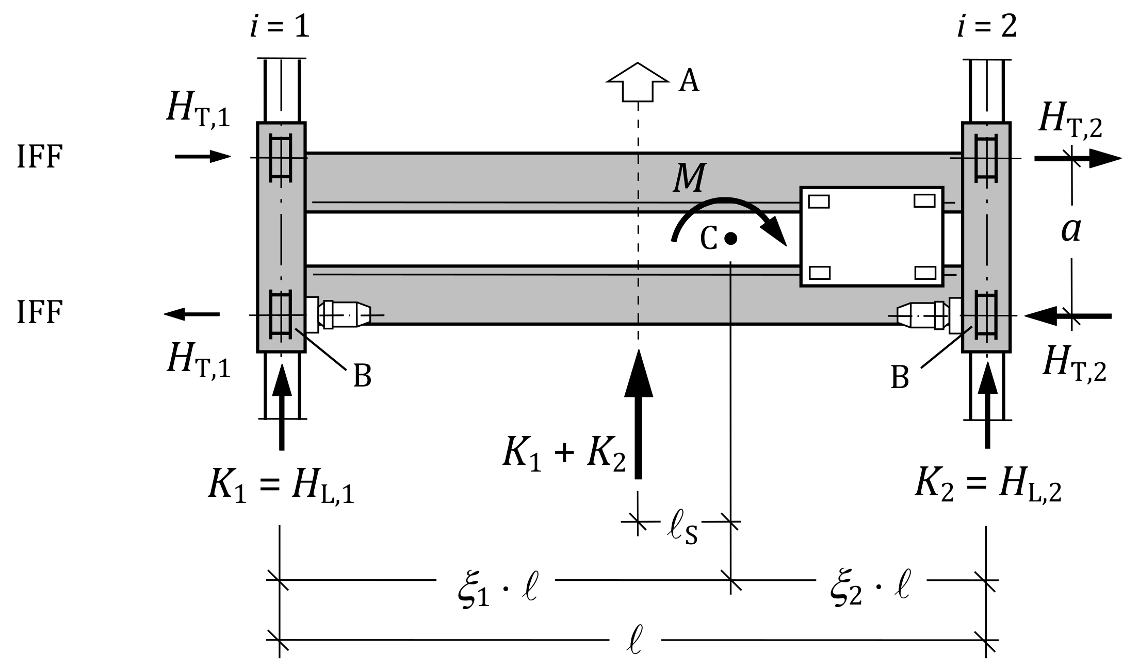

Key

|  |  |
| --- | --- |
| A | travel direction |
| B | driven wheel |
| C | mass centroid |

Figure B.1 — Definition of the transverse forces *H*T,i for four-wheeled crane   
(example with flanged wheels)

(4) If the trolley operates at its end position, the resultant drive force *K* has a lever arm ℓS with respect to the mass centroid and exerts a horizontal moment *M* on the crane that should be taken into account:

*M* = *K* ℓS (B.2)

where:

ℓS = (*ξ*1 – 0,5) ℓ;

*ℓ* is the span of the crane bridge;

*ξ*1 = Σ *Q*r,max / Σ *Q*r ;

Σ *Q*r is the sum of all wheel loads without dynamic factors;

Σ *Q*r,max is the sum of maximum wheel loads without dynamic factors on the higher loaded crane runway beam for the considered trolley position;

(5) The horizontal moment *M* causes pairs of horizontal transverse forces *H*T,*i* acting at each crane runway beam that should be calculated by Formulae (B.3) and (B.4) and arranged as shown in Figure B.1.

*H*T,1 = *ξ*2 *M* / *a* (B.3)

*H*T,2 = *ξ*1 *M* / *a* (B.4)

where:

*ξ*2 = 1 - *ξ*1

*a* is the spacing of flanged wheels or guide rollers.

NOTE 1 The horizontal transverse forces are applied to the rail by friction in the wheel/rail contact and/or contact of rail and guidance means.

NOTE 2 For deceleration of the crane, the horizontal transverse forces in Figure B.1 act in the opposite directions.

* + 1. Horizontal actions due to acceleration and deceleration of trolley

(1) For four-wheeled trolley with two driven wheels, the resultant drive force *K*T should be calculated as:

*K*T = *μ* 2 *Q*rT,min (B.5)

where:

*Q*rT,min is the minimum wheel load of a driven trolley wheel for unloaded trolley and without dynamic factors;

*μ* is the friction factor of the contact between wheel and rail, see B.3.1(3).

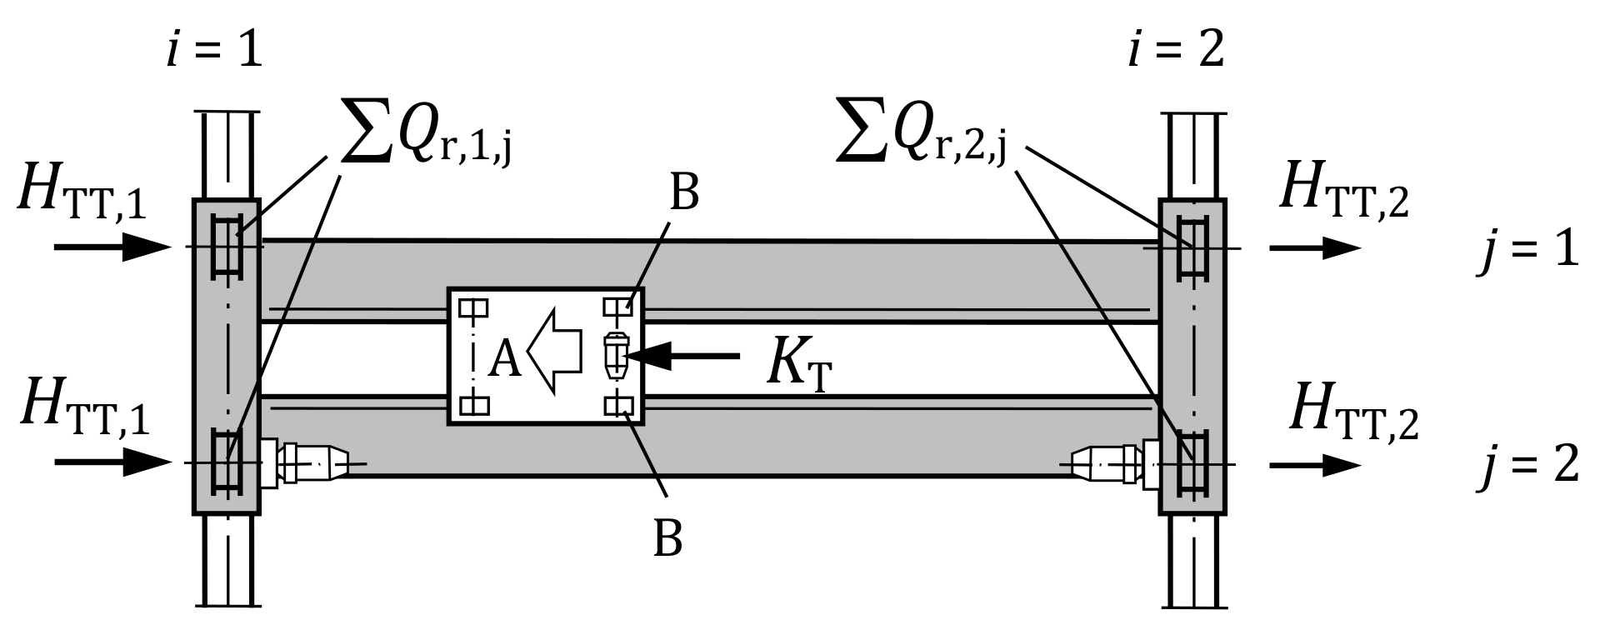

Key

|  |  |
| --- | --- |
| A | travel direction of trolley |
| B | driven trolley wheel |

Figure B.2 — Definition of the transverse forces *H*TT for four-wheeled crane

(2) Where no more information is available, *Q*rT,min may be assumed as 25 % of the trolley self-weight.

(3) The horizontal force *H*TT caused by the drive force *K*T due to acceleration and deceleration of trolley should be distributed between the two supporting runway beams in direct proportion to the vertical loads (without dynamic factors):

*H*TT,1 = *K*T Σ *Q*r,1,*j* / Σ *Q*r,*i*,*j*  (B.6)

*H*TT,2 = *K*T Σ *Q*r,2,*j* / Σ *Q*r,*i*,*j*  (B.7)

NOTE For deceleration of trolley, the horizontal transverse forces in Figure B.2 act in the opposite directions.

* + 1. Horizontal actions due to skewing of crane

(1) The horizontal actions caused by skewing should be calculated according to EN 15011 in conjunction with EN 13001‑2:2021, 4.2.3.4.

NOTE If a crane travels slightly at an angle to the crane runway, the first guide means (wheel flange or guide roller) touches the rail with the so-called guide force *S*, see Figure B.3. This force simultaneously acts on the crane, so the crane rotates in ground plan. This rotation causes slip frictional forces *H*S in the wheel/rail contact areas of the wheels that are fixed in respect of lateral movement. The forces *S* and *H*S depend on the guide and drive system of the crane.

(2) For rigid four-wheeled bridge cranes with wheel pair combination IFF with flanged wheels and two of them are driven, the skewing force *S* should be calculated by

*S* = 0,5 *f* Σ *Q*r  (B.8)

where:

Σ *Q*r is the sum of all wheel loads without dynamic factors;

*f* is the friction coefficient of the rolling wheel.

NOTE Formula (B.8) is obtained from EN 13001‑2:2021, 4.2.3.4 with *n* = 2, *m* = 0, *d*1 = 0, *h* = *d*2 = *w*b. EN 15011 contains additional provisions for horizontal actions due to skewing of bridge cranes with flexible characteristics.

(3) A friction coefficient *f* = 0,3 may be assumed as conservative.

NOTE Clause 4.2.3.4 of EN 13001‑2:2021 allows a more exact calculation of the friction coefficient.

(4) The horizontal transverse force should be calculated by Formulae (B.9) to (B.11) and arranged as shown in Figure B.2.

*H*S,T,1,1 = 0,5 *f* Σ *Q*r,min  (B.9)

*H*S,T,2,1 = 0,5 *f* Σ *Q*r,max  (B.10)

*H*S,T,1,2 = *H*S,T,2,2 = 0  (B.11)

where:

Σ *Q*r,min is the wheel load sum of the less loaded crane runway beam without dynamic factors;

Σ *Q*r,max is the wheel load sum of the higher loaded crane runway beam without dynamic factors.

NOTE 1 The skewing force *S* can act at crane runway beam ‘1’ or at crane runway beam ‘2’ without influence on the distribution of the forces *H*S,T,*i*,*j*. The maximum resulting force on the crane runway beam occur when the skewing force acts on the less loaded crane runway beam ‘1’ as shown in Figure B.3. In that case, the resulting force for crane runway beam ‘1’ amounts to (*S* - *H*S,T,1,1).

NOTE 2 The forces *S* and *H*S,T,*i*,*j* can also act in the opposite direction as shown in Figure B.3.

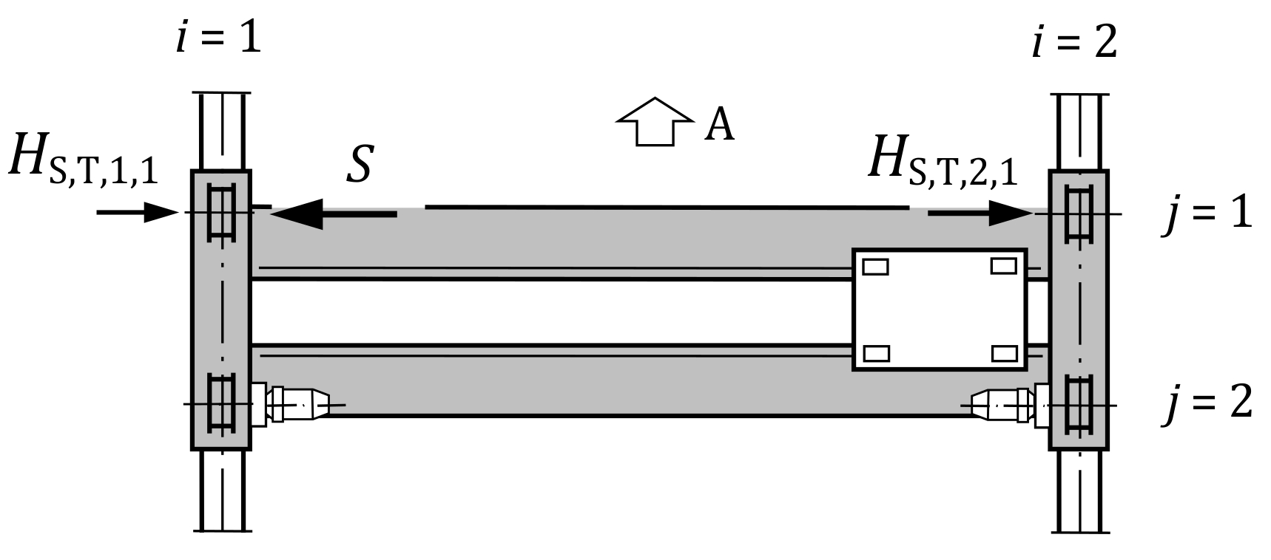

Key

|  |  |
| --- | --- |
| A | travel direction |

Figure B.3 — Definition of the transverse forces *H*S,T,*i*,*j* for four-wheeled crane   
(example with flanged wheels)

* 1. Eight-wheeled bridge crane
     1. Horizontal actions due to acceleration and deceleration of crane

(1) For eight-wheeled bridge cranes with wheel pair combination IFF and equal drive forces *K*1 and *K*2, see Figure B.4, the paragraphs of B.3.1 should be applied to calculate the horizontal actions due to acceleration and deceleration of the crane.

(2) The spacing *a* of wheels to be used in Formulae (B.3) and (B.4) should be determined according to Figure B.4.

* + 1. Horizontal actions due to acceleration and deceleration of trolley

(1) For four-wheeled trolley with two driven wheels, the resultant drive force *K*T should be calculated in accordance with B.3.2(1) to (3), see Figure B.5.

* + 1. Horizontal actions due to skewing of crane

(1) The horizontal actions caused by skewing should be calculated according to EN 15011 in conjunction with EN 13001‑2:2021, 4.2.3.4.

NOTE See note to B.3.3 for explanations.

(2) For rigid eight-wheeled bridge cranes with wheel pair combination IFF with flanged wheels and two of them are driven, the skewing force *S* should be calculated by

*S* = λS *f* Σ *Q*r (B.12)

with

λS = 1 ‒ 0,25 Σ *e*j/*h* (B.13)

*h* = *a*1 [*η* + 1 + 1/(2 + *η*)] (B.14)

where:

Σ *Q*r is the sum of all wheel loads without dynamic factors;

*f* is the friction coefficient of the rolling wheel;

Σ *e*j is the sum of all wheel distances as shown in Figure B.6;

*η* is the ratio *a*1 / *a*2 in Figure B.6.

NOTE Formulae (B.12) to (B.14) are obtained from EN 13001‑2:2021, 4.2.3.4. EN 15011 contains additional provisions for horizontal actions due to skewing of bridge cranes with flexible characteristics.

(3) A friction coefficient *f* = 0,3 may be assumed as conservative.

NOTE Clause 4.2.3.4 of EN 13001‑2:2021 allows a more exact calculation of the friction coefficient.

|  |  |
| --- | --- |
|  |  |
| a) flanged wheels | b) guide rollers |

Key

|  |  |
| --- | --- |
| A | travel direction |
| B | driven wheel |
| C | mass centroid |

Figure B.4 — Definition of the transverse forces *H*T,i for eight-wheeled crane

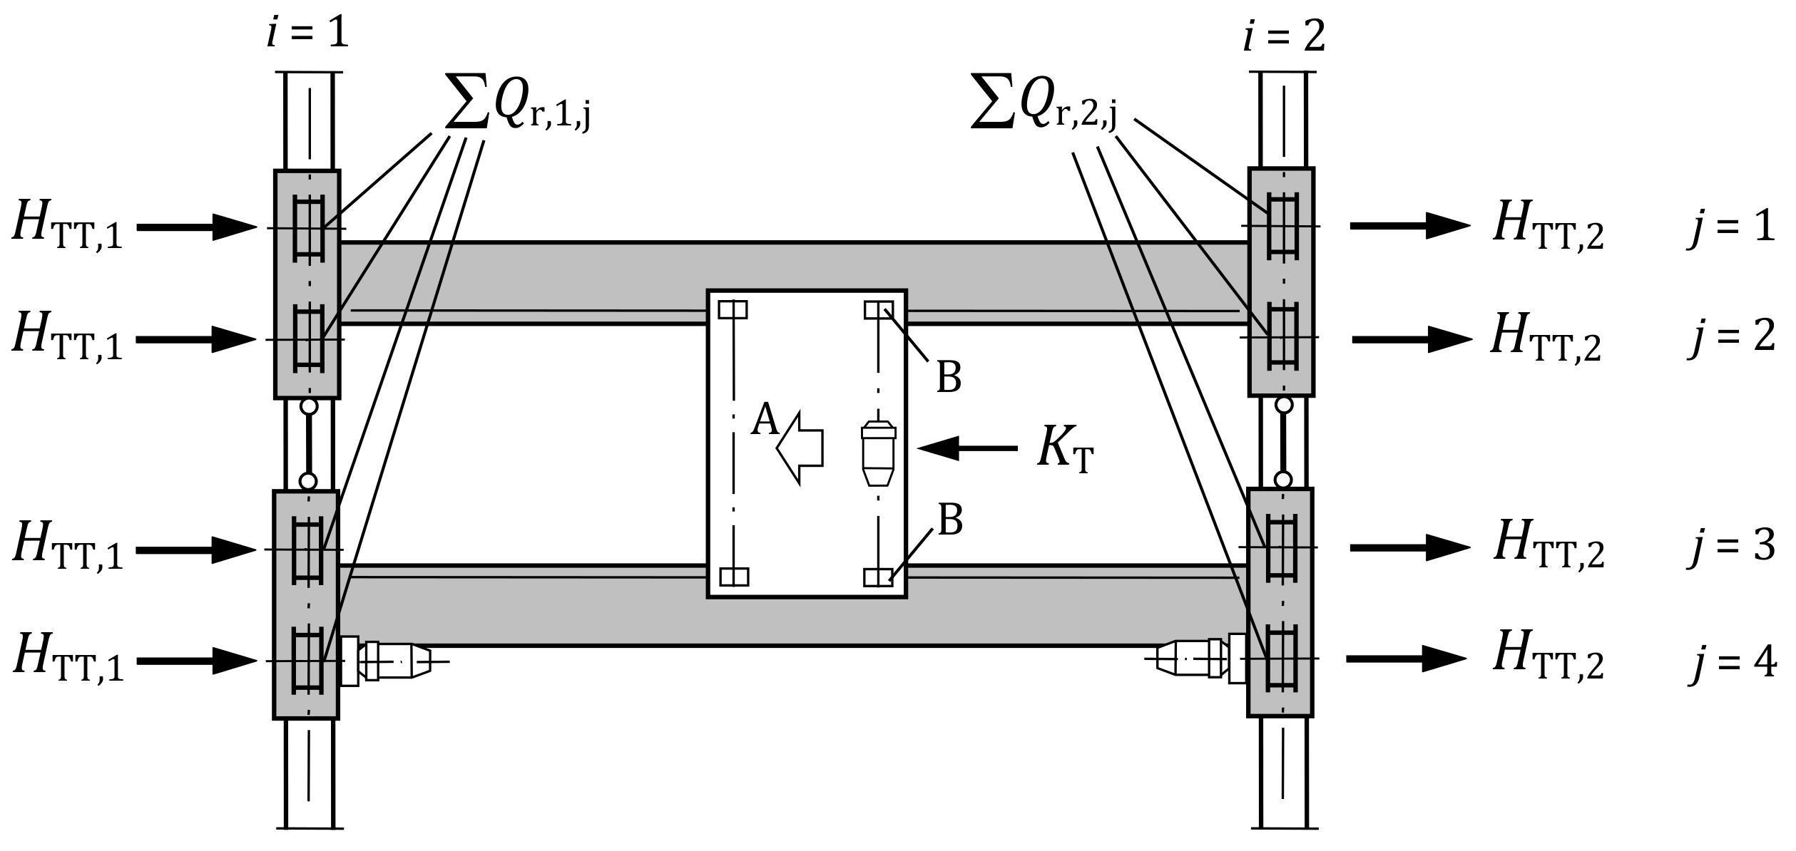

Key

|  |  |
| --- | --- |
| A | travel direction of trolley |
| B | driven trolley wheel |

Figure B.5 — Definition of the transverse forces *H*TT for eight-wheeled crane

(4) The horizontal transverse force should be calculated by Formulae (B.15) and (B.16) and arranged as shown in Figure B.6.

*H*S,T,1,*j* = 0,25 λS,*j f* Σ *Q*r,min  (B.15)

*H*S,T,2,*j* = 0,25 λS,*j f* Σ *Q*r,max  (B.16)

with λS,*j* = 1 ‒ *ej*/*h*

where:

Σ *Q*r,min is the wheel load sum of the less loaded crane runway beam without dynamic factors;

Σ *Q*r,max is the wheel load sum of the higher loaded crane runway beam without dynamic factors;

*e*j is the wheel distance as shown in Figure B.6;

*h* is determined by Formula (B.14).

NOTE 1 The skewing force *S* can act at crane runway beam ‘1’ or at crane runway beam ‘2’ without influence on the distribution of the forces *H*S,T,*i*,*j*. The maximum resulting force on the crane runway beam occur when the skewing force acts on the less loaded crane runway beam ‘1’ as shown in Figure B.6.

NOTE 2 The forces *S* and *H*S,T,*i*,*j* can also act in the opposite direction as shown in Figure B.6.

|  |  |
| --- | --- |
|  |  |
| a) Flanged wheels | b) Guide rollers |

Key

|  |  |
| --- | --- |
| A | travel direction |

Figure B.6 — Definition of the transverse forces *H*S,*i*,*j*,T for eight-wheeled crane

1. (informative)  
     
   Actions from travelling wall cranes
   1. Use of this informative annex

(1) This informative annex provides supplementary guidance to 6.6.2.4(5) for actions from travelling wall cranes.

NOTE National choice on the application of this informative annex is given in the National Annex. If the National Annex contains no information on the application of this informative annex, it can be used.

* 1. Scope and field of application

(1) This annex gives guidance how to calculate the actions from a travelling wall crane on its two crane runways (*i* = 1, 2) being subject to horizontal forces and on its crane runway (*i* = 3) being subject to vertical forces as shown in Figure C.1. Each crane runway supports two crane wheels (*j* = 1, 2).

(2) Symmetry of the crane with respect to the vertical axis of the jib girder is assumed.

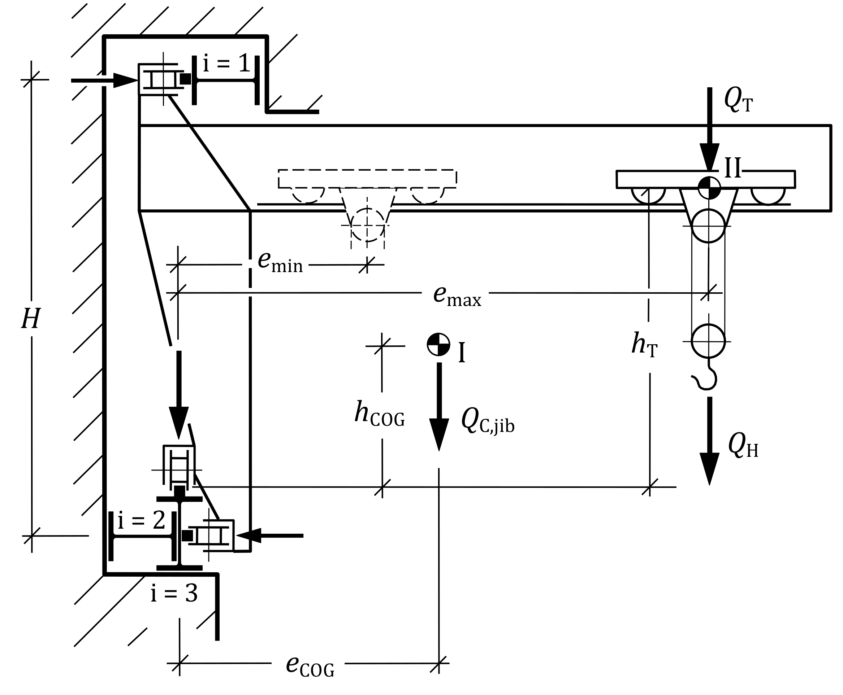

Key

|  |  |
| --- | --- |
| I | jib’s centre of gravity |
| II | trolley’s centre of gravity |

Figure C.1 — Dimensions and actions of travelling wall crane

* 1. Actions due to crane self-weight and hoist load

(1) The single wheel action *Q*r from the crane on the crane runway (*i* = 3) as shown in Figure C.2a due to total self-weight of the crane (*Q*C = *Q*C,jib + *Q*T) should be calculated as:

*Q*r = 0,5 *Q*C (C.1)

and due to hoist load as:

*Q*r = 0,5 *Q*H (C.2)

(2) Depending on the trolley position, the maximum and minimum single wheel action *Q*r,h from the crane on the crane runways (*i* = 1 or 2) as shown in Figure C.2a due to self-weight should be calculated as

*Q*r,h,max = 0,5 (*Q*C,jib *e*COG + *Q*T *e*max) / *H* (C.3)

*Q*r,h,min = 0,5 (*Q*C,jib *e*COG + *Q*T *e*min) / *H* (C.4)

(3) The maximum single wheel action *Q*r,h from the crane on the crane runways (*i* = 1 or 2) as shown in Figure C.2a due to the hoist load should be calculated as

*Q*r,h,max = 0,5 *Q*H *e*max / *H* (C.5)

|  |  |
| --- | --- |
|  |  |
| a) Actions due to crane self-weight and hoist load | b) Actions due to crane acceleration |

Figure C.2 — Actions from crane on crane runways

* 1. Actions due to acceleration of crane

(1) The drive force for crane travelling should be calculated by:

*K* = *a*C (*Q*C + *Q*H) / *g* (C.6)

where:

*a*C is the maximum crane acceleration;

*Q*C = *Q*C,jib + *Q*T;

*g* is the gravitational acceleration (9,81 m/s2).

(2) The longitudinal forces *H*L that are exerted on the crane runway (*i* = 3) should be assumed with the drive force *K,* see Figure C.2b.

(3) The drive force *K* acts with an eccentricity to the centre of gravity of the crane, see Figure C.1, and exerts a horizontal moment *M*h and a vertical moment *M*v on the crane that should be taken into account:

*M*h = *K* ℓS,h  (C.7)

*M*v = *K* ℓS,v  (C.8)

where:

ℓS,h = (*Q*C,jib *e*COG + *Q*T *e*max) / *Q*C

ℓS,v = (*Q*C,jib *h*COG + *Q*T *h*T) / *Q*C

(4) Under the assumption that uplifting forces are over pressed by actions due to crane self-weight, the maximum single wheel action from the crane on the crane runways (*i* = 1, 2) as shown in Figure C.2b due to crane acceleration should be calculated as

*H*T = 0,5 *M*h / *b*h (C.9)

and on the crane runway (*i* = 3) as

*Q*r,HL = *M*v / *b*v (C.10)

* 1. Actions due to acceleration of trolley

(1) The drive force should be calculated by:

*K*T = *a*T (*Q*T*+ Q*H) / *g* (C.11)

where:

*a*T is the maximum trolley acceleration along the jib girder;

*g* is the gravitational acceleration (9,81 m/s2).

(2) The horizontal force *H*TT caused by the drive force *K*T due to acceleration and deceleration of trolley should only be distributed between the wheels of the crane runway (*i* = 1 or 2) without uplifting wheel actions.

* 1. Actions due to crane buffer collision

(1) The buffer force should be calculated as:

*H*B = *a*BC *Q*C */g* (C.12)

where:

*a*BC is the maximum acceleration due to crane buffer collision;

*Q*C = *Q*C,jib + *Q*T;

*g* is the gravitational acceleration (9,81 m/s2).

NOTE In calculation buffer forces, the effects of suspended loads that are horizontally unrestrained (free to swing) need not to be taken into account.

(2) The buffer force *H*B acts with an eccentricity to the centre of gravity of the crane and exerts a horizontal moment *M*h and a vertical moment *M*v on the crane that should be taken into account:

*M*h,B = *H*B ℓS,h  (C.13)

*M*v,B = *H*B ℓS,v  (C.14)

NOTE The dimensions ℓS,h and ℓS,v are defined in C.4(3).

(3) Under the assumption that actions due to crane self-weight prevent from uplift, the maximum single wheel action from the crane on the crane runways (*i* = 1, 2) as shown in Figure C.3 should be calculated as

*H*B,h = 0,5 *M*h,B / *b*h (C.15)

and on the crane runway (*i* = 3) as

*Q*r,B = *M*v,B / *b*v (C.16)

* 1. Actions due to trolley buffer collision

(1) The buffer force should be calculated as:

*H*BT = *a*BT *Q*T */g* (C.17)

*a*BT is the maximum acceleration due to trolley buffer collision;

*g* is the gravitational acceleration (9,81 m/s2).

NOTE In calculation buffer forces, the effects of suspended loads that are horizontally unrestrained (free to swing) need not to be taken into account.

(2) Under the assumption that actions due to crane self-weight prevent from uplift, the buffer force *H*BT should be distributed between the wheels of crane runways (*i* = 1 or 2).

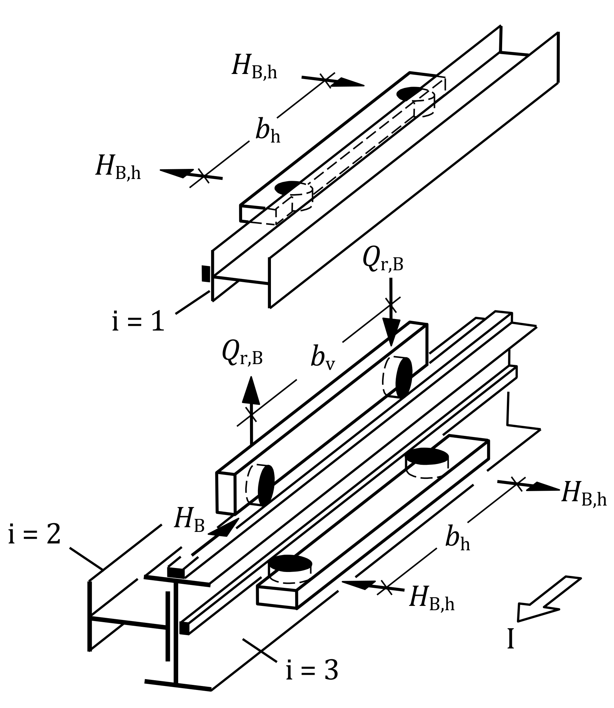

Key

|  |  |
| --- | --- |
| I | Travel direction |

Figure C.3 — Actions due to crane buffer collision

Bibliography

**References contained in recommendations (i.e. “should” clauses)**

The following documents are referred to in the text in such a way that some or all of their content constitutes highly recommended choices or course of action of this document. Subject to national regulation and/or any relevant contractual provisions, alternative documents could be used/adopted where technically justified. For dated references, only the edition cited applies. For undated references, the latest edition of the referenced document (including any amendments) applies.

prEN 1991‑1‑4:20241, Eurocode 1 — Actions on structures — Part 1‐4: Wind actions

EN 13001‑2:2021, Crane safety - General design - Part 2: Load actions

EN 15011:2020, Cranes - Bridge and gantry cranes

**References given in permissions (i.e. “may” clauses)**

The following documents are referred to in the text in such a way that some or all of their content expresses a course of action permissible within the limits of the Eurocodes. For dated references, only the edition cited applies. For undated references, the latest edition of the referenced document (including any amendments) applies.

EN 1090‑2, Execution of steel structures and aluminium structures - Part 2: Technical requirements for steel structures

EN 13001 (all parts), Cranes — General design

EN 13001‑1:2021, Cranes — General design — Part 1: General principles and requirements

**References contained in permissions (i.e. “can” clauses) and notes**

The following documents are cited informatively in the document, for example in “can” clauses and in notes.

prEN 1991‑1‑1:20231, Eurocode 1 — Actions on structures — Part 1-1: Specific weight of materials, self-weight of construction works and imposed loads for buildings

prEN 1993‑6:20241, Eurocode 3 — Design of steel structures — Part 6: Crane supporting structures

EN ISO 12100, Safety of machinery - General principles for design - Risk assessment and risk reduction (ISO 12100:2010)

ISO 3898, Bases for design of structures — Names and symbols of physical quantities and generic quantities

ISO 4306‑1:2007, Cranes — Vocabulary — Part 1: General

1. At draft stage