CEN/TC 250

Date: 2023-08

prEN 1994-1-2:2024

Secretariat: BSI

**Eurocode 4 — Design of composite steel and concrete structures — Part 1-2: Structural fire design**

***Eurocode 4 – Bemessung und Konstruktion von Verbundtragwerken aus Stahl und Beton – Teil 1-2: Tragwerksbemessung für den Brandfall***

***Eurocode 4 – Calcul des structures mixtes acier-béton – Partie 1-2 : Calcul du comportement au feu***

Contents Page

European foreword 6

0 Introduction 7

1 Scope 10

1.1 Scope of prEN 1994-1-2 10

1.2 Assumptions 10

2 Normative references 10

3 Terms, definitions and symbols 10

3.1 Terms and definitions 10

3.2 Symbols and abbreviations 12

3.2.1 Symbols 12

3.2.2 Latin lower-case letters 14

3.2.3 Additional symbols used in Annex A of prEN 1994-1-2 19

3.2.4 Additional symbols used in Annex B of prEN 1994-1-2 19

3.2.5 Additional symbols used in Annex C of prEN 1994-1-2 20

3.2.6 Additional symbols used in Annex D of prEN 1994-1-2 20

3.2.7 Additional symbols used in Annex E of prEN 1994-1-2 21

3.2.8 Additional symbols used in Annex F of prEN 1994-1-2 22

3.2.9 Additional symbols used in Annex G of prEN 1994-1-2 23

3.2.10 Additional symbols used in Annex H of prEN 1994-1-2 24

3.2.11 Additional symbols used in Annex I of prEN 1994-1-2 25

4 Basis of design 26

4.1 General 26

4.2 Nominal fire exposure 26

4.3 Physically based fire exposure 27

4.4 Actions 27

4.5 Design values of material properties 27

4.6 Verification methods 28

4.7 Member analysis 28

4.8 Analysis of parts of the structures 29

4.9 Global structural analysis 29

5 Material properties 29

5.1 General 29

5.2 Thermal properties 30

5.2.1 Carbon steel 30

5.2.2 Concrete 31

5.2.3 Fire protection materials 34

5.3 Mechanical properties 34

5.3.1 Carbon steel 34

5.3.2 Concrete 38

6 Tabulated design data 41

6.1 General 41

6.2 Beams 41

6.3 Columns 44

6.3.1 General 44

6.3.2 Composite columns made of totally encased steel sections 45

6.3.3 Composite columns made of partially encased steel sections 46

6.3.4 Composite columns comprising concrete filled hollow sections 47

7 Simplified design methods 48

7.1 General 48

7.2 General rules for composite slabs and composite beams 48

7.3 Composite slabs 49

7.3.1 Unprotected composite slabs 49

7.3.2 Protected composite slabs 50

7.4 Composite beams 50

7.4.1 Thermal analysis 50

7.4.2 Mechanical analysis 54

7.5 Composite columns 63

7.5.1 General 63

7.5.2 Partially encased steel sections 65

7.5.3 Unprotected concrete filled hollow steel sections 65

7.5.4 Protected concrete filled hollow steel sections 65

8 Advanced design methods 66

8.1 General 66

8.2 Thermal analysis 66

8.3 Mechanical analysis 66

8.4 Validation 67

9 Detailing 67

9.1 General 67

9.2 Composite beams 68

9.2.1 Composite beams comprising steel beams with partial encasement 68

9.2.2 Composite shallow floor beams 69

9.3 Composite columns 70

9.3.1 Composite columns comprising partially encased steel sections 70

9.3.2 Composite columns comprising concrete filled hollow sections 71

9.4 Connections between composite beams and columns 72

9.4.1 General 72

9.4.2 Connections between composite beams and composite columns comprising steel sections encased in concrete 73

9.4.3 Connections between composite beams and composite columns with partially encased steel sections 73

9.4.4 Connections between composite beams and composite columns comprising concrete filled hollow sections 74

Annex A (normative) Strain-hardening of structural steel at elevated temperatures 76

A.1 Use of this annex 76

A.2 Scope and field of application 76

A.3 Stress-strain relationships at elevated temperatures for structural steel 76

Annex B (informative) Model for the calculation of the fire resistance of unprotected composite slabs 79

B.1 Use of this annex 79

B.2 Scope and field of application 79

B.3 Fire resistance with respect to thermal insulation 79

B.4 Calculation of the sagging moment of resistance Mfi,Rd+ 81

B.5 Calculation of the hogging moment resistance MRd,fi- 84

B.6 Effective thickness of a composite slab 87

Annex C (normative) Model for the calculation of the sagging and hogging moment resistances of a steel beam connected to a concrete slab and exposed to fire from underneath 88

C.1 Use of this annex 88

C.2 Scope and field of application 88

C.3 Calculation of the sagging moment resistance MRd,fi+ 88

C.4 Calculations of the hogging moment resistance MRd,fi- 90

C.5 Local resistance at supports 91

C.6 Vertical shear resistance 92

Annex D (normative) Model for the calclulation of the bending moment resistances of a partially encased steel beam connected to a concrete slab and exposed to fire 93

D.1 Use of this annex 93

D.2 Scope and field of application 93

D.3 Reduced cross-section for sagging moment resistance $M\text{Rd}\text{,fi}+$ 94

D.4 Reduced cross-section for hogging moment resistance MRd,fi- 98

Annex E (normative) Model for the calculation of the axial buckling resistance about the weak axis of a partially encased composite column exposed to fire 100

E.1 Use of this annex 100

E.2 Scope and field of application 100

E.3 General 101

E.4 Flanges of the steel section 101

E.5 Web of the steel section 102

E.6 Concrete 103

E.7 Reinforcing bars 104

E.8 Calculation of the acial buckling load at elevated temperatures 105

E.9 Eccentricity of loading 106

Annex F (normative) Simple caculation model for concrete filled hollow sections exposed to the standard temperature-time curve 107

F.1 Use of this annex 107

F.2 Scope and field of application 107

F.3 Steps 108

F.4 Temperature distribution 108

F.5 Design axial buckling load at elevated temperature 110

F.6 Eccentricity of loading 113

Annex G (normative) Simple calculation method for fire resistance of steel and concrete composite floors under tensile membrane action 114

G.1 Use of this annex 114

G.2 Scope and field of application 114

G.3 General rules 114

G.4 Temperature distribution 116

G.5 Calculation of floor loadbearing capacity under tensile membrane action 116

G.6 Detailing 123

Annex H (normative) Calculation of the sagging moment of resistance Mfi,Rd+ of a shallow floor beam exposed to fire 125

H.1 Use of this annex 125

H.2 Scope and field of application 125

H.3 Calculation of the sagging moment resistance MRd,fi+ 127

H.4 Protected shallow floor beams 131

Annex I (normative) Beams with large web openings exposed to fire 133

I.1 Use of this annex 133

I.2 Scope and field of application 133

I.3 Thermal response 133

I.4 Mechanical response 133

Bibliography 135

European foreword

This document (prEN 1994-1-2:2024) has been prepared by Technical Committee CEN/TC 250 “Structural Eurocodes”, the secretariat of which is held by BSI. CEN/TC 250 is responsible for all Structural Eurocodes and has been assigned responsibility for structural and geotechnical design matters by CEN.

This document is currently submitted to the CEN Enquiry.

This document will supersede EN 1994-1-2:200 and its amendments and corrigenda.

The first generation of EN Eurocodes was published between 2002 and 2007. This document forms part of the second generation of the Eurocodes, which have been prepared under Mandate M/515 issued to CEN by the European Commission and the European Free Trade Association.

The Eurocodes have been drafted to be used in conjunction with relevant execution, material, product and test standards, and to identify requirements for execution, materials, products and testing that are relied upon by the Eurocodes.

The Eurocodes recognize the responsibility of each Member State and have safeguarded their right to determine values related to regulatory safety matters at national level through the use of National Annexes.

0 Introduction

**0.1** **Introduction to the Eurocodes**

The Structural Eurocodes comprise the following standards generally consisting of a number of Parts:

* EN 1990, Eurocode — Basis of structural and geotechnical design
* EN 1991, Eurocode 1 — Actions on structures
* EN 1992, Eurocode 2 — Design of concrete structures
* EN 1993, Eurocode 3 — Design of steel structures
* EN 1994, Eurocode 4 — Design of composite steel and concrete structures
* EN 1995, Eurocode 5 — Design of timber structures
* EN 1996, Eurocode 6 — Design of masonry structures
* EN 1997, Eurocode 7 — Geotechnical design
* EN 1998, Eurocode 8 — Design of structures for earthquake resistance
* EN 1999, Eurocode 9 — Design of aluminium structures
* New parts are under development, e.g. Eurocode for design of structural glass

The Eurocodes are intended for use by designers, clients, manufacturers, constructors, relevant authorities (in exercising their duties in accordance with national or international regulations), educators software developers and committees drafting standards for related product, testing and execution standards.

NOTE Some aspects of design are most appropriately specified by relevant authorities or, where not specified, can be agreed on a project-specific basis between relevant parties such as designers and clients. The Eurocodes identify such aspects making explicit reference to relevant authorities and relevant parties.

**0.2 Introduction to EN 1994 (all parts)**

EN 1994 applies to the design of steel and concrete composite structures in buildings and civil engineering works. It complies with the principles and requirements for the safety and serviceability of structures, the basis of their design and verification that are given in EN 1990, *Basis of structural and geotechnical design*.

EN 1994 is concerned only with the requirements for resistance, serviceability, durability and fire resistance of steel structures. Other requirements, e.g. concerning thermal or sound insulation, are not covered.

EN 1994 is subdivided in various parts:

EN 1994-1-1, *Eurocode 4 — Design of composite steel and concrete structures — Part 1‑1: General rules and rules for buildings;*

EN 1994-1-2, *Eurocode 4 — Design of composite steel and concrete structures — Part 1‑2: Structural fire design;*

EN 1994-2*, Eurocode 4 — Design of composite steel and concrete structures — Part 2: Bridges.*

**0.3 Introduction to prEN 1994-1-2**

prEN 1994-1-2 describes the principles, requirements and rules for the structural design of steel and concrete composite buildings exposed to fire.

prEN 1994-1-2 is intended for clients (e.g. for the formulation of their specific requirements), designers, contractors and relevant authorities.

The general objectives of fire protection are to limit risks with respect to the individual and society, neighbouring property and where required, environment or directly exposed property, in the case of fire.

The parts of the Structural Eurocodes relating to fire deal with specific aspects of passive fire protection in terms of designing structures and parts for adequate loadbearing resistance and for limiting fire spread as relevant.

Required functions and levels of performance can be specified either in terms of nominal (standard) fire resistance rating, generally given in national fire regulations or by referring to fire safety engineering for assessing passive and active measures, see EN 1991-1-2.

Supplementary requirements concerning, e.g.:

* the possible installation and maintenance of sprinkler systems;
* conditions on occupancy of building or fire compartment; and
* the use of approved insulation and coating materials, including their maintenance

are not given in this standard because they are subject to specification by the competent authority.

**0.4 Verbal forms used in the Eurocodes**

The verb “shall" expresses a requirement strictly to be followed and from which no deviation is permitted in order to comply with the Eurocodes.

The verb “should” expresses a highly recommended choice or course of action. Subject to national regulation and/or any relevant contractual provisions, alternative approaches could be used/adopted where technically justified.

The verb “may" expresses a course of action permissible within the limits of the Eurocodes.

The verb “can" expresses possibility and capability; it is used for statements of fact and clarification of concepts.

**0.5 National Annex for prEN 1994-1-2**

National choice is allowed in this standard where explicitly stated within notes. National choice includes the selection of values for Nationally Determined Parameters (NDPs).

The national standard implementing prEN 1994-1-2 can have a National Annex containing all national choices that relate to the design of buildings and civil engineering works constructed in the relevant country.

When no national choice is given, the default choice given in this standard is to be used.

When no national choice is made and no default is given in this standard, the choice can be specified by a relevant authority or, where not specified, agreed for a specific project by the relevant parties.

National choice is allowed in prEN 1994-1-2 through notes to the following clauses:

|  |  |  |  |
| --- | --- | --- | --- |
| 4.5(1) | 4.7(2) | G.2(1) |  |

National choice is allowed in prEN 1994-1-2 on the application of the following informative annex:

|  |  |  |  |
| --- | --- | --- | --- |
| Annex B |  |  |  |

The National Annex can contain, directly or by reference, non-contradictory complementary information for ease of implementation, provided it does not alter any provisions of the Eurocodes.

# Scope

## Scope of prEN 1994-1-2

(1) prEN 1994-1-2 gives rules for the design of steel-concrete composite structures for the accidental design situation of fire exposure. It only identifies differences from, or supplements to, rules for normal temperature design.

(2) prEN 1994-1-2 only applies to structures, or parts of structures, that are within the scope of EN 1994‑1‑1 and are designed accordingly.

## Assumptions

(1) The assumptions of EN 1990 apply, along with the following:

* The choice of the relevant design fire scenario is made by appropriate qualified and experienced personnel or is given by the relevant national regulation;
* Any fire protection measure taken into account in the design will be adequately maintained.

# Normative references

The following documents are referred to in the text in such a way that some or all of their content constitutes requirements of this document. For dates references, only the edition cited applies. For undated references, the latest edition of the referenced document (including amendments) applies

NOTE See the Bibliography for a list of other documents cited that are not normative references, including those referenced as recommendations (i.e. in ‘should’ clauses), permissions (‘may’ clauses), possibilities (‘can’ clauses), and in notes.

EN 1990, *Eurocode — Basis of structural and geotechnical design*

EN 1991 (all parts), *Eurocode 1 — Actions on structures*

FprEN 1991-1-2:2023, *Eurocode 1 — Actions on structures — Part 1-2: Actions on structures exposed to fire*

EN 1992-1-1, *Eurocode 2 — Design of concrete structures — Part 1-1: General rules and rules for buildings, bridges and civil engineering structures*

EN 1993-1-1:2022, *Eurocode 3 — Design of steel structures — Part 1-1: General rules and rules for buildings*

prEN 1994-1-1:2024, *Eurocode 4 — Design of composite steel and concrete structures — Part 1-1: General rules and rules for buildings*

# Terms, definitions and symbols

## Terms and definitions

For the purposes of this document, the terms and definitions given in EN 1990 and EN 1991-1-2 and the following apply.

3.1.1

axis distance

distance between the centre of the reinforcing bar and the nearest edge of concrete

3.1.2

critical temperature of reinforcement

temperature of reinforcement at which loadbearing failure of the element is expected to occur at a given stress

3.1.3

critical temperature of structural steel element

temperature for a given load level, at which failure is expected to occur in a structural steel element assuming a uniform temperature distribution

3.1.4

effective cross-section

cross-section of the member in structural fire design used in the effective cross-section method

Note 1 to entry: It is obtained by removing parts of the cross-section with assumed zero strength and stiffness.

3.1.5

failure time of fire protection system

duration of protection of member against direct fire exposure (e.g. when the fire protective sheathing or other protection fall off the composite member, or when a structural member initially protecting the member fails due to collapse, or when the protection from another structural member is no longer effective due to excessive deformation)

3.1.6

fire protection material

any material or combination of materials applied to a structural member for the purpose of increasing its fire resistance

3.1.7

maximum stress level

for a given temperature, the stress level at which the stress-strain relationship of steel is truncated to provide a yield plateau

3.1.8

part of structure

isolated part of a structure with appropriate support and boundary conditions

3.1.9

protected members

members for which measures are taken to reduce the temperature rise in the member due to fire

3.1.10

section factor

**f**or a steel member, the ratio between the exposed surface area and the volume of steel; for an enclosed member, the ratio between the internal surface area of the exposed encasement and the volume of steel

## Symbols and abbreviations

For the purposes of this document, the following symbols apply.

### Symbols

#### Latin upper-case letters

|  |  |  |
| --- | --- | --- |
| **Symbol** | **Definition** |  |
| A | cross-sectional area |  |
| Ac | cross-sectional area of concrete part |  |
| Af | cross-sectional area of a steel flange |  |
| Ai | area of part i of the cross-section or exposed surface area of part i of the steel cross-section per unit length |  |
| Ai,θ | Reduced area of part i of the cross-section at temperature θ |  |
| Ai / Vi | section factor of part i of the steel cross-section (non-protected member) |  |
| Ap | area of the inner surface of the fire protection material per unit length of the steel beam |  |
| Ap / V | section factor of the steel cross-section with box protection |  |
| Ap,i | area of the inner surface of the fire protection material per unit length of part i of the steel member |  |
| Ap,i / Vi | section factor of part i of the steel cross-section |  |
| As | cross-sectional area of the reinforcing bars |  |
| E | integrity criterion |  |
| Ea | characteristic value for the modulus of elasticity of structural steel at 20 °C |  |
| Ea,θ | characteristic value for the slope of the linear elastic range of the stress-strain relationship of structural steel at elevated temperatures |  |
| Ec,sec, θ | characteristic value for the secant modulus of concrete in the fire situation, given by *f*c,θ divided by *ε*cu,θ |  |
| Ed | design effect of actions for normal temperature design |  |
| Ed,fi | design effect of actions in the fire situation, assumed to be time independent |  |
| (EI)eff,fi | effective flexural stiffness in the fire situation |  |
| Ek | characteristic value for the modulus of elasticity at 20 °C |  |
| Es | characteristic value for the modulus of elasticity of modulus of elasticity of reinforcing bars at 20 °C |  |
| Es,θ | characteristic value for the slope of the linear elastic range of the stress-strain relationship of reinforcing steel at elevated temperatures |  |
| Fa | tensile force in the steel section |  |
| Fc | compressive force in the slab |  |
| HC | hydrocarbon fire exposure curve |  |
| I | thermal insulation criterion |  |
| Ii,θ | second moment of area of the partially reduced part i of the cross-section for bending around the weak or strong axis in the fire situation |  |
| L | system length of a column in the relevant storey |  |
| LC | lightweight concrete |  |
| MRd,fi+; MRd,fi- | design value of the sagging or hogging moment resistance in the fire situation |  |
| MRd,fi,t | design moment resistance in the fire situation at time t |  |
| NC | normal weight concrete |  |
| Nfi,cr | elastic critical load in the fire situation |  |
| Npl,Rd,fi | design value of the plastic resistance to axial compression in the fire situation |  |
| Npl,R,fi | value of Npl,Rd,fi when the factors M,fi,a, M,fi,s and M,fi,c are taken as 1,0 |  |
| NRd,fi | design value of the resistance of a member in axial compression in the fire situation |  |
| PRd | design shear resistance of a shear connector at normal temperature. |  |
| PRd,fi | design shear resistance of a shear connector in the fire situation |  |
| R | Load bearing criterion |  |
| R30, R60, R90, R120, R180 | a member complying with the loadbearing criterion for 30, 60, 90, 120 or 180 minutes in standard fire exposure |  |
| Rd | design resistance for normal temperature |  |
| Rd,fi,t | design resistance in the fire situation, at time t |  |
| Vi | volume of part i of the steel cross-section per unit length |  |
| Xd,fi | design values of mechanical (strength and stiffness) material properties in the fire situation |  |
| Xk | characteristic value of a strength or stiffness property for normal temperature |  |
| Xk, θ | characteristic value of a strength or stiffness property in the fire situation |  |

### Latin lower-case letters

|  |  |  |
| --- | --- | --- |
| aw | throat thickness of weld |  |
| b | width |  |
| b1 | width of the bottom flange of the steel section |  |
| b2 | width of the top flange of the steel section |  |
| bc | depth of the composite column made of a totally encased section or width of concrete partially encased steel beams |  |
| beff | effective width of the concrete slab |  |
| c | concrete cover from edge of concrete to border of structural steel |  |
| ca | specific heat of steel |  |
| cc | specific heat of concrete |  |
| cp | specific heat of the fire protection material |  |
| d | diameter of the composite column made of concrete filled circular hollow section or diameter of the studs welded to the web of the steel section |  |
| dp | thickness of the fire protection material |  |
| e | thickness of hollow section |  |
| e1 | thickness of the bottom flange of the steel section |  |
| e2 | thickness of the top flange of the steel section |  |
| ef | thickness of the flange of the steel section |  |
| ep | thickness of the bottom plate of a shallow floor beam (type A) |  |
| ew | thickness of the web of the steel section |  |
| ef | external fire exposure curve |  |
| fap,θ | proportional limit of structural steel in the fire situation |  |
| fau,θ | ultimate tensile strength of structural steel or steel for stud connectors in the fire situation, allowing for strain-hardening |  |
| fay,θ | maximum stress level or effective yield strength of structural steel in the fire situation |  |
| fay,θ,i | maximum stress level or effective yield strength of part i of the steel section in the fire situation |  |
| fay,θcr | effective yield strength of structural steel at critical temperature θcr |  |
| fay | characteristic or nominal value for the yield strength of structural steel at 20 °C |  |
| fck | characteristic value of the compressive cylinder strength of concrete at 28 days and at 20 °C |  |
| fck,j | characteristic value of the compressive cylinder strength of part j of the concrete at 28 days and at 20 °C |  |
| fc,θ | characteristic value for the compressive cylinder strength of concrete at temperature θ |  |
| fc,θ,20 °C | characteristic value for the compressive cylinder strength of concrete heated to a maximum temperature c,max and having cooled down to 20 °C |  |
| fc,θmax | characteristic value for the compressive cylinder strength of concrete in the fire situation at maximum temperature θmax |  |
| fk | characteristic value of strength of the material |  |
| fsy | characteristic or nominal value for the yield strength of a reinforcing bar at 20 °C |  |
| fsp,θ | proportional limit of reinforcing steel in the fire situation |  |
| fsy,θ | maximum stress level or effective yield strength of reinforcing steel in the fire situation |  |
| fy,i | nominal yield strength *f*y for the elemental area *A*i taken as positive on the compression side of the plastic neutral axis and negative on the tension side |  |
| h | depth or height of the steel section |  |
| h1 | height of the concrete part of a composite slab above the sheeting |  |
| h2 | height of the concrete part of a composite slab within the sheeting |  |
| h3 | thickness of the screed situated on top of the concrete |  |
| hc | thickness of the concrete slab or depth of the composite column made of a totally encased section |  |
| heff | effective thickness of a composite slab |  |
| hfi | height reduction of the encased concrete between the flanges in the fire situation |  |
|  | design value of the net heat flux per unit area |  |
|  | design value of the net heat flux per unit area by convection |  |
|  | design value of the net heat flux per unit area by radiation |  |
| hv | height of the stud welded on the web of the steel section |  |
| hw | height of the web of the steel section |  |
| kc,θ | reduction factor for the compressive strength of concrete giving the strength at elevated temperature fc, |  |
| kc,θ,j | reduction factor for the compressive strength of part j of concrete giving the strength at elevated temperature fc, |  |
| kc,θ,max | reduction factor for the compressive strength of concrete giving the strength corresponding to the maximum temperature c,max |  |
| kE,θ | reduction factor for the elastic modulus of structural steel or reinforcing bars giving the slope of the linear elastic range at elevated temperature Ea, |  |
| kE,θ,j | reduction factor for the elastic modulus of part i of structural steel or reinforcing bars giving the slope of the linear elastic range at elevated temperature Ea, |  |
| ky,θ | reduction factor for the yield strength of structural steel or reinforcing bars giving the maximum stress level at elevated temperature fa, |  |
| ky,θ,i | reduction factor for the yield strength of structural steel or reinforcing bars for the elemental area Ai giving the maximum stress level at elevated temperature fa, or fs, |  |
| kp,θ | reduction factor for the yield strength of structural steel or reinforcing bars giving the proportional limit at elevated temperature fap, or fsp, |  |
| kr, ks | reduction factor for the yield strength of a reinforcing bar |  |
| ksh | correction factor for the shadow effect |  |
| ku,θ | reduction factor for the yield strength of structural steel giving the strain hardening stress level at elevated temperature q |  |
| kθ | temperature-dependent reduction factor for a strength or stiffness property |  |
| l | length at 20 °C of the member |  |
| l1, l2, l3 | specific dimensions of the re-entrant or trapezoidal steel sheeting |  |
| la | width of support of the concrete slab |  |
| lfi | buckling length of the column in the fire situation |  |
| lw | length of weld |  |
| mEd,fi | design transverse bending moment per unit length of the bottom plate or flange under fire conditions |  |
| mpl,Rd,θ | plastic bending resisting moment per unit length of the bottom plate or flange at temperature q |  |
| t | time, duration of fire exposure |  |
| us | minimum axis distance of the reinforcing bars |  |
| u1 ; u2 | minimum axis distance or shortest distance from the centre of the reinforcing bar to any point on a web of the steel sheet |  |
| zi ; zj | distance from the plastic neutral axis to the centroid of the elemental area Ai or Aj |  |

#### Greek upper-case letters

|  |  |
| --- | --- |
| ∆l | temperature induced expansion of the member |
| ∆l/l | thermal expansion |
| ∆t | time interval |
| ∆θa,t | increase of temperature of a steel beam during the time interval ∆*t* |
| ∆θt | increase in the ambient gas temperature [°C] during the time interval ∆*t* |
| ☞ | configuration factor |

#### Greek lower-case letters

|  |  |
| --- | --- |
| 1 | reduction of yield strength of a flange (or plate) due to transversal shear and bending |
| c | convective heat transfer coefficient |
| slab | coefficient to allow the use of the assumption of the rectangular stress block when designing concrete slabs and composite shallow floor beams |
|  | load level of a plate (or flange) under transversal shear |
| M,fi | partial factor for a material property in the fire situation |
| M,a,fi | partial factor for the strength of structural steel in the fire situation |
| M,c,fi | partial factor for the strength of concrete in the fire situation |
| M,s,fi | partial factor for the strength of reinforcing bars in the fire situation |
| M,v,fi | partial factor for the shear resistance of stud connectors in the fire situation |
| v | partial factor for the shear resistance of stud connectors at normal temperature |
| εa,θ | steel strain in the fire situation |
| εae,θ | ultimate strain of steel in the fire situation |
| εay,θ | yield strain of steel in the fire situation |
| εap,θ | strain at the proportional limit of steel in the fire situation |
| εau,θ | limiting strain for yield strength of steel in the fire situation |
| εc,θ | concrete strain in the fire situation |
| εc1,θ | concrete strain corresponding to *f*c,θ |
| εcu1,θ | maximum concrete strain in the fire situation |
| εf | emissivity coefficient of the fire |
| εfi | coefficient for cross-sectional classification for the fire situation |
| εm | surface emissivity of the member |
|  | reduction factor for the residual concrete strength after heating and cooling down in physical based models |
| s | diameter of stirrup |
| r | diameter of longitudinal reinforcement |
| b | diameter of bar through the web |
| φi,q | the reduction coefficient depending on the effect of thermal stresses of part i or flexural stiffness correction factor |
| η | load level of a plate (or flange) under transversal bending |
| ηfi | reduction factor applied to *E*d in order to obtain *E*fi,d |
| ηfi,t | load level for fire design |
| θa | steel temperature |
| θa,t | steel temperature at time t |
| θc | concrete temperature |
| θc,max | maximum temperature of concrete |
| θcr | critical temperature of a structural member |
| θi | temperature in the elemental area *A*i |
| θs | reinforcing steel temperature |
| θt | ambient gas temperature at time t |
| θv | temperature of stud connectors |
| a | thermal conductivity of steel |
| c | thermal conductivity of concrete |
| p | thermal conductivity of fire protection material |
| $${\overset{-}{λ}}_{θ}$$ | relative slenderness in the fire situation |
| ρa | density of steel |
| ρc | density of concrete |
| ρc,LC | density of lightweight concrete |
| ρp | density of fire protection material |
| ⬧ | Stephan Boltzmann constant (= 5,67*10-8 [W/(m2K4)]) |
| σc, θ | stress of concrete under compression in the fire situation |
| Ed | design transversal shear per unit length [kN/m] of the bottom plate at normal temperature |
| pl,Rd | plastic shear resistance per unit length [kN/m] of the bottom plate at normal temperature |
|  | reduction coefficient |

### Additional symbols used in Annex A of prEN 1994-1-2

#### Greek lower-case symbols

|  |  |
| --- | --- |
| σa, θ | stress of the steel section in the fire situation |

### Additional symbols used in Annex B of prEN 1994-1-2

#### Latin upper-case letters

|  |  |
| --- | --- |
| A | concrete volume per metre of member length |
| A/Lr | rib geometry factor |
| Lr | exposed area of the rib per metre of rib length |
| Ns | normal force in the hogging reinforcement |
| Y | Y (major) axis |

#### Latin lower-case letters

|  |  |
| --- | --- |
| ai | coefficients for determination of the fire resistance with respect to thermal insulation |
| bi | coefficients for the determination of the temperatures of the parts of the steel sheeting |
| br | width of the upper flange of the steel sheeting |
| ci | coefficients for the determination of the temperature of the reinforcing bars in the rib |
| def | height of the top re-entrant stiffener |
| di | coefficients for the determination of the limiting temperature |
| h1,mod | modified height of the concrete part of a composite slab above the sheeting in case of profiled steel sheeting with re-entrant stiffener |
| h2,mod | modified height of the concrete part of a composite slab within the sheeting in case of profiled steel sheeting with re-entrant stiffener |
| hp | overall height of the profiled steel sheeting, excluding the height of the top re-entrant stiffener |
| ti | fire resistance time with respect to thermal insulation |
| u3 | distance from the centre of the reinforcing bar to the lower flange of the steel sheet |
| ws | width of the top re-entrant stiffener |
| z | value which defines the position of the bar in the rib |

#### Greek upper-case letters

|  |  |  |
| --- | --- | --- |
| ☞ | view factor of the upper flange |  |

#### Greek lower-case letters

|  |  |
| --- | --- |
|  | angle of the web |
| θlim | limiting temperature |

### Additional symbols used in Annex C of prEN 1994-1-2

#### Latin upper-case letters

|  |  |
| --- | --- |
| Ar /Vr | section factor of stiffeners |
| F+, F- | total compressive force in the composite section in case of sagging or hogging bending moments |
| N | number of shear connectors related to the governing critical length |
| Ry,Rd,fi | design yield resistance of the web with the stiffeners |
| T+ , T- | tensile force |

#### Latin lower-case letters

|  |  |
| --- | --- |
| beff- | effective width of the concrete slab in a region of hogging moment |
| hcr | depth corresponding to a concrete temperature below 250 °C |
| hu | thickness of the compressive zone |
| hu,n | thickness of the compressive zone (with n layers ) |
| n | total number of concrete layers in compression |
| r | root radius for a rolled section |
| ss | length of the rigid support |

#### Greek lower-case letters

|  |  |
| --- | --- |
| θr | temperature of stiffener |

### Additional symbols used in Annex D of prEN 1994-1-2

#### Latin upper case letters

|  |  |
| --- | --- |
| *V*pl,Rd,fi | design value of the shear plastic resistance in the fire situation |
| *V*Ed,fi | design value of the shear force in the fire situation |

#### Latin lower-case letters

|  |  |  |
| --- | --- | --- |
| bfi | width reduction of top flange in the fire situation |  |
| hc,fi | thickness reduction of the concrete slab |  |
| hh | top part of depth of the web |  |
| hl | bottom part of depth of the web |  |
| ka | reduction factor of the yield point of the lower flange |  |
| ui | the distance from the axis of the reinforcing bar to the inner side of the flange |  |
| usi | the distance from the axis of the reinforcing bar to the concrete surface |  |

### Additional symbols used in Annex E of prEN 1994-1-2

#### Latin upper-case letters

|  |  |
| --- | --- |
| Am | directly heated surface area of member per unit length |
| Am /V | section factor of structural member |
| Ea,f | characteristic value for the modulus of elasticity of a steel flange at 20 °C |
| Ea,f,t | characteristic value for the modulus of elasticity corresponding to the average flange temperature |
| (EI)c,z,fi | flexural stiffness of concrete in the fire situation (related to the central axis Z of the composite cross-section) |
| (EI)f,z,fi | flexural stiffness of the two flanges of the steel section in the fire situation (related to the central axis *Z* of the composite cross-section) |
| (EI)s,z,fi | flexural stiffness of the reinforcing bars in the fire situation (related to the central axis Z of the composite cross-section) |
| (EI)eff,z,fi | effective flexural stiffness (related to the central axis Z of the composite cross-section) in the fire situation |
| (EI)w,z,fi | flexural stiffness of the web of the steel section in the fire situation (related to the central axis Z of the composite cross-section) |
| Is,z | the second moment of area of the reinforcing steel about the central axis Z |
| Ncr,z,fi | elastic critical load around axis Z in the fire situation |
| Npl,Rd,f,fi | design value of the plastic resistance to axial compression of the two flanges |
| Npl,Rd,w,fi | design values of the plastic resistance to axial compression of the web |
| Npl,Rd,c,fi | design values of the plastic resistance to axial compression of the concrete in the fire situation |
| Npl,Rd,s,fi | design values of the plastic resistance to axial compression of the reinforcing bars in the fire situation |
| NRd | design value of the resistance of a member in axial compression at 20 °C |
| NRd, | design axial buckling load in case of an eccentric load at normal temperature |
| NRd,fi | design buckling load for a column subjected to a load with an eccentricity |
| NRd,z,fi | design value of the resistance of a member in axial compression, for buckling around the axis *Z*, in the fire situation |
| V | volume of the member per unit length |
| Z | Z (weak) central axis of the composite cross-section |

#### Latin lower-case letters

|  |  |  |
| --- | --- | --- |
| bc,fi | thickness reduction of the concrete area in the fire situation |  |
| hw,fi | height reduction of the web in the fire situation |  |
| kE,t | reduction factor of the modulus of elasticity of the reinforcing bars |  |
| ky,t | reduction factor of the yield strength of the reinforcing bars |  |

#### Greek lower-case letters

|  |  |  |
| --- | --- | --- |
| δ | eccentricity |  |
| θc,t | average temperature in the concrete |  |
| θf,t | average flange temperature |  |
| z | reduction coefficient for bending around axis Z |  |

### Additional symbols used in Annex F of prEN 1994-1-2

#### Latin upper-case letters

|  |  |
| --- | --- |
| B | shorter outer dimension of a rectangular or elliptical cross-section |
| D | outer diameter of a circular cross-section |
| (EI)eff,II,fi | effective flexural stiffness for second-order analysis in the fire situation |
| *E*i, | the modulus of elasticity of part i at temperature i |
| H | larger outer dimension of a rectangular or elliptical cross-section |
| Ii | second moment of area of part *i* of the cross-section |
| Ke,II | correction factor to be used in the design of composite columns |
| Ko | calibration factor to be used in the design of composite columns |
| K | correction factor to be used in the design of composite columns at elevated temperature |

#### Greek lower-case letters

|  |  |
| --- | --- |
| **M | coefficient related to bending of a composite column |
| i | coefficient for calculation of equivalent reinforcing bars temperature |
| θc,eq | equivalent temperature of the concrete core |
| θs,eq | equivalent temperature of the reinforcing bars |
| θa,eq | equivalent temperature of the steel section |
| ρs | reinforcement ratio of the concrete core |

### Additional symbols used in Annex G of prEN 1994-1-2

#### Latin upper-case letters

|  |  |
| --- | --- |
| K | ratio of tensile force per unit width of the reinforcing mesh in the shorter side cross-section to tensile force per unit width of the reinforcing mesh in the longer side cross-section |
| L | longer span of the floor design zone |
| L1, L2 | spans of composite slab |
| *M*0,fi | sagging moment resistance per unit width of the composite slab cross-section along the longer side of the floor design zone |
| MEd,b,1,fi | design value of bending moment in the fire situation in the two perimeter secondary beams |
| MEd,b,2,fi | design value of bending moment in the fire situation in the primary perimeter beams |
| MRd,j,fi | design value of the sagging moment resistance of the internal secondary composite beam j |
| VEd,b,1,fi | design value of shear force in the fire situation in the two perimeter secondary beams |
| VEd,b,2,fi | design value of bending moment in the fire situation in the primary perimeter beams |

#### Latin lower-case letters

|  |  |
| --- | --- |
| a | aspect ratio of the floor design zone |
| bj | width of the composite slab supported by the internal composite beam j |
| cM | factor in respect to primary or secondary beams taking into account tensile membrane action |
| d | distance between the centre of the reinforcing mesh (median plane) and the top side of the composite slab |
| e | overall enhancement factor under tensile membrane action |
| (g0)1,(g0)2 | parameters defining the compressive stress block of concrete for sagging moment resistance of the composite slab per unit width in the shorter and the longer side cross-sections respectively |
| nub | total number of internal secondary composite beams |
| qEd,fi | uniformly distributed load to be supported by the floor design zone in the fire |
| qRd,fi | reference loadbearing capacity of the composite slab based on a yield line solution |
| qRd,slab,fi | loadbearing capacity of the composite slab under tensile membrane action |
| w | deflection limit of a composite floor in the fire situation under tensile membrane action |

#### Greek lower-case letters

|  |  |
| --- | --- |
| c | coefficient of thermal expansion of concrete |
| θ1 | temperature of the unexposed side of the composite slab |
| θ2 | temperature of the exposed side of the composite slab |
| ❍ | coefficient defining the ratio of sagging moment resistances of the composite slab in orthogonal directions |

### Additional symbols used in Annex H of prEN 1994-1-2

#### Latin upper-case letters

|  |  |  |
| --- | --- | --- |
| Ai, Aw, Ar | parameters for determination of the bending resistance of a shallow floor beam |  |
| Bi, Bw, Br | parameters for determination of the bending resistance of a shallow floor beam |  |
| Ci, Cw, Cr | parameters for determination of the bending resistance of a shallow floor beam |  |
| Nc,Rd,fi | maximum design value of the concrete compressive force |  |
| Nt,Rd,fi | tensile resistance of the steel section |  |
| Vw,Rd,fi | shear resistance of the steel web |  |

#### Latin lower-case letters

|  |  |  |
| --- | --- | --- |
| bf | flange width |  |
| bp | width of bottom plate of a shallow floor beam (type A) |  |
| bp,eff,fi | reduced width of the bottom plate acting as support of the concrete slab welded to the structural steel section (type A) in the fire situation |  |
| bfb,eff,fi | reduced width of the bottom flange acting as support of the concrete slab welded to the structural steel flange (type B) in the fire situation |  |
| bfb | width of the bottom flange of a shallow floor beam (type B) |  |
| bft | width of the top flange of a shallow floor beam (type B) |  |
| bw | width of in situ concrete between two slabs of a shallow floor beam (types A and B) |  |
| cz | concrete cover above the top flange of the steel section |  |
| efb | thickness of the bottom flange of a shallow floor beam (type B) |  |
| eft | thickness of the top flange of a shallow floor beam (type B) |  |
| hc,1 | height of in situ concrete between slab and top flange of a shallow floor beam (types A and B) |  |
| hs | concrete height defining the position of longitudinal reinforcement in relation to the web of the steel profile for shallow floor beams (types A and B) |  |
| kc | coefficient depending on slab covering the surface of the bottom plate |  |
| kh | coefficient for the calculation of the maximum design value of the concrete compressive force |  |
| kt | coefficient for the calculation of the bottom flange temperature of a shallow floor beam |  |
| kwy, | Reduction factor for shear resistance of the steel web |  |
| la | width of support of the concrete slab (same as for lp in 7.4.2.4) |  |
| uc | horizontal concrete cover of the longitudinal reinforcement of a shallow floor beam (types A and B) |  |
| ur | vertical concrete cover of the longitudinal reinforcement of a shallow floor beam (types A and B) |  |
| uw | concrete cover between the longitudinal reinforcement and the steel web of a shallow floor beam (types A and B) |  |

#### Greek lower-case letters

|  |  |  |
| --- | --- | --- |
| θfb | temperature of the bottom flange |  |
| θp | temperature of the welded plate |  |
| θw | temperature in the web |  |

### Additional symbols used in Annex I of prEN 1994-1-2

#### Latin upper-case letters

|  |  |
| --- | --- |
| *N*oc,Rd | design value of compression resistance of concrete slab at the centre of an opening |
| *V*oc,Rd | design shear resistance of the concrete slab at the opening position |

#### Latin lower-case letters

|  |  |
| --- | --- |
| beff,o | effective widths for local shear and bending |
| ka,fi | reduction factor to the Vierendeel bending resistance due to composite action |

# Basis of design

## General

(1) The structural fire design shall be in accordance with the general rules given in EN 1990 and EN 1991 (all parts) and the specific design provisions for steel and concrete composite structures given in EN 1994-1-1.

(2) Where mechanical resistance in the case of fire is required, composite steel and concrete structures shall be designed and constructed in such a way that they maintain their loadbearing function during the relevant fire exposure.

(3) Where compartmentation is required, the elements forming the boundaries of the fire compartment, including joints, shall be designed and constructed in such a way that they maintain their separating function during the relevant fire exposure to ensure that both integrity failure and insulation failure do not occur.

NOTE For non-loadbearing elements, the loadbearing function under self-weight is expected to be maintained in order to fulfil the separating function.

(4) Deformation criteria shall be applied where the means of fire protection require consideration of the deformation of the loadbearing structure.

(5) Consideration of the deformation of the loadbearing structure may be omitted when the efficiency of the means of protection has been evaluated according to 5.2.3.

(6) Deformation criteria shall be applied where the design criteria for separating elements require taking into account deformation of the loadbearing structure.

(7) Consideration of the deformation of the loadbearing structure may be omitted when the separating elements fulfil requirements of a nominal fire exposure.

(8) Composite steel and concrete structures designed in accordance with EN 1993-1-1 should be considered to have sufficient minimum robustness for the accidental fire design case. Where additional requirements are necessary the procedures of prEN 1991-1-7:2023, Annex A, apply.

## Nominal fire exposure

(1) For standard fire exposure, elements shall comply with one of the following functions or combinations of function defined in EN 1991-1-2 during the required time of fire exposure:

* loadbearing function only: loadbearing capacity (R);
* separating function only: integrity (E) and, when requested, insulation (I);
* separating and loadbearing functions: criteria R, E and, when requested, I.

NOTE 1  The loadbearing function is assumed to be satisfied when loadbearing capacity is maintained.

NOTE 2  The separating function is assumed to be satisfied when integrity and, when requested, insulation are maintained.

NOTE 3  Integrity is assumed to be maintained when a separating element of building construction, exposed to fire on one side, prevents the passage through it of flames and hot gases and the occurrence of flames on the unexposed side.

NOTE 4  Insulation is assumed to be maintained when the average temperature rise over the whole of the unexposed surface is limited to 140 K, and the maximum temperature rise at any point of that surface does not exceed 180 K.

(2) With the external fire exposure curve the same functions (R, E, I) apply, however the reference to this specific curve shall be identified by the letters "ef".

(3) With the hydrocarbon fire exposure curve the same functions (R, E, I) apply, however the reference to this specific curve shall be identified by the letters "HC".

## Physically based fire exposure

(1) The loadbearing function shall be maintained during the complete duration of the fire, including the cooling phase, or during a required period of time according to FprEN 1991-1-2:2023, 4.4(4).

(2) For the verification of the separating function the following applies, assuming that the normal temperature is 20 °C:

* the average temperature rise of the unexposed side of the construction should be limited to 140 K and the maximum temperature rise of the unexposed side should not exceed 180 K during the heating phase until the maximum temperature in the fire compartment is reached;
* the average temperature rise of the unexposed side of the construction should be limited to 200 K and the maximum temperature rise of the unexposed side should not exceed 240 K during the cooling phase.

## Actions

(1) Thermal and mechanical actions shall be taken from EN 1991-1-2.

## Design values of material properties

(1) Design values of mechanical (strength and stiffness) material properties for the fire situation Xd,fi are defined as follows:

$X_{d,fi}=k_{θ}X_{k}/γ_{M,fi}$ (4.1)

where

|  |  |
| --- | --- |
| *X*k | is the characteristic value of a strength or stiffness property (generally fk or Ek) for normal temperature design according to EN 1994-1-1; |
| *k* | is the temperature-dependent reduction factor (Xk,θ / Xk) for a strength or stiffness property, see Section 5.3; |
| *γ*M,fi | is the partial factor for the relevant mechanical material property for the fire situation, as defined according to 4.5(2). |

NOTE 1 For mechanical properties of steel and concrete, the recommended values of the partial factor for the fire situation are γM,a,fi = 1,0; γM,s,fi = 1,0; γM,c,fi = 1,0 unless the National Annexes of EN 1992-1-2 and EN 1993-1-2 give a different value.

NOTE 2 The recommended value of the partial factor for the shear resistance of stud connector in the fire situation is γM,v,fi = 1,0 unless the National Annex gives a different value.

(2) The design values of thermal material properties for the fire situation should be taken equal to the characteristic values.

NOTE The characteristic values of thermal properties correspond to the mean values.

## Verification methods

(1) The model of the structural system adopted for design shall reflect the performance of the structure in the fire situation.

(2) Mechanical resistance shall be verified for the required duration of fire exposure *t* according to Formula (4.2).

 (4.2)

where

|  |  |
| --- | --- |
| *E*d,fi,t | is the design effect of actions for the fire situation, determined in accordance with EN 1991-1-2, including effects of thermal expansions and deformations; |
| *R*d,fi,t | is the corresponding design resistance in the fire situation. |

(3) The structural analysis for the fire situation should be carried out according to EN 1990:2023, 7.1.5.

NOTE For verifying resistance requirements based on the standard fire curve, unless otherwise specified, a member analysis is sufficient.

(4) Where application rules given in this Part of EN 1994 are valid only for the standard fire curve, this is identified in the relevant clauses.

(5) The following design methods may be used in order to satisfy 4.6(2):

* use of tabulated design data for specific types of members, see Clause 6;
* use of simplified design methods for specific types of members, see Clause 7; and
* use of advanced design methods for the analysis of members, parts of the structure or the entire structure, see Clause 8.

(6) As an alternative to design by calculation, fire design may be based on the results of fire tests, or on fire tests in combination with calculations.

## Member analysis

(1) The design effect of actions should be determined for time *t* = 0 using combination factors according to FprEN 1991-1-2:2023, 6.3.

(2) As a simplification, the value of ηfi = 0.65, except for imposed loads according to category E as given in EN 1991-1-1 (areas susceptible to accumulation of goods, including access areas) where the value of ηfi =0.7 should be used.

NOTE As indicated in FprEN 1991-1-2:2023, 6.3, different values for the reduction factor ηfi can be given in the National Annex.

(3) For use of tabulated design data in Clause 6, the load level for fire design fi,t should be calculated from Formula (4.3):

 (4.3)

where

|  |  |
| --- | --- |
| Ed,fi | is the design effect of actions in the fire situation; |
| *R*d | is the design resistance for normal temperature. |

(4) The effects of thermal deformations resulting from thermal gradients across the cross-section shall be taken into account.

(5) The effects of axial or in-plane thermal expansions may be neglected.

(6) The kinematic boundary conditions at the supports and ends of members, applicable at time *t* = 0, may be assumed to remain unchanged throughout the fire exposure.

(7) Tabulated design data and simplified or advanced design methods given in this document may be used for verifying members under fire conditions.

## Analysis of parts of the structures

(1) The effect of actions should be determined for time *t* = 0 using combination factors according to FprEN 1991-1-2:2023, 6.3.

(2) Within the part of the structure to be analysed, the relevant failure mode in fire, the temperature-dependent material properties and member stiffness, effects of thermal expansions and deformations (indirect fire actions) shall be taken into account.

(3) The part of the structure to be analysed should be specified on the basis of the potential thermal expansions and deformations such that their interaction with other parts of the structure can be approximated by time-independent support and boundary conditions during fire exposure.

(4) As an alternative to 4.8(1), the reactions at supports and internal forces and moments at boundaries of part of the structure may be obtained from structural analysis for normal temperature design as given in 4.7.

(5) A composite floor constructed of primary steel/composite beams, secondary steel/composite beams and composite slabs can be divided into a number of structural zones, each of which being analysed separately. The fire resistance of each zone can be justified by taking into account the tensile membrane effect that can develop in the composite slab supported by the surrounding edge beams, thereby allowing elimination of fire protection to the internal secondary beams. The edge beams should be able to resist the additional vertical loads from the load distribution path of tensile membrane action.

(6) This tensile membrane effect shall be justified by advanced design methods described in Clause 8 taking into account material and geometrical non-linearities or by use of Annex G, which provides a simplified approach.

## Global structural analysis

(1) A global structural analysis for the fire situation shall take into account:

* the relevant failure mode in fire exposure;
* the temperature-dependent material properties and member stiffness; and
* effects of thermal expansions and deformations (indirect fire actions).

# Material properties

## General

(1) Unless given as design values, the values of material properties given in Clause 5 shall be treated as characteristic values.

(2) The mechanical properties of concrete, reinforcing steel and prestressing steel at normal temperature (20 °C) shall be taken as those given in EN 1992-1-1 for normal temperature design.

(3) The mechanical properties of structural steel at normal temperature (20 °C) shall be taken as those given in EN 1993-1-1 for normal temperature design.

## Thermal properties

### Carbon steel

#### Emissivity coefficient

(1) The values of surface emissivity εm in relation to the different types of steel should be taken from Table 5.1.

Table 5.1 — Surface emissivity of different types of steel

|  |  |  |
| --- | --- | --- |
| Type of steel | εm ( 500ᵒC) | εm ( 500ᵒC) |
| Carbon steel | 0,7 | |
| HDG steela | 0,35 | 0,7 |
| a Steel that has been hot-dip galvanized according to EN ISO 1461 and with steel composition according to Category A or B of EN ISO 14713-2:2020, Table 1. | | |

#### Thermal conductivity

(1) The thermal conductivity of steel *λ*a valid for all structural and reinforcing steel qualities should be determined from the following:

[W/(m.K)] for 20 °C ≤ *θ*a ≤ 800 °C (5.1)

[W/(m.K)] for 800 °C < *θ*a ≤ 1 200 °C (5.2)

where

|  |  |
| --- | --- |
| θa | is the steel temperature. |

NOTE The variation of the thermal conductivity and temperature is illustrated in Figure 5.1.

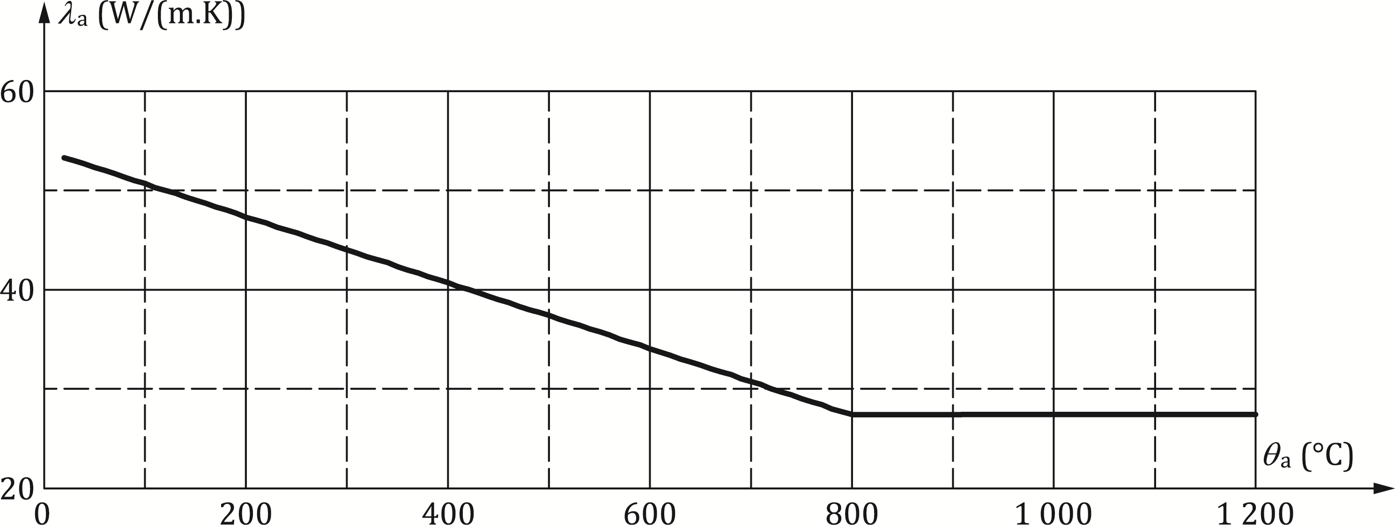

Figure 5.1 — Thermal conductivity of steel as a function of temperature

#### Specific heat

(1) The specific heat of steel *c*a valid for all structural and reinforcing steel qualities should be determined from Formulae (5.3) to (5.6):

[J/(kg.K)] for 20 ≤ θa ≤ 600 °C (5.3)

[J/(kg.K)] for 600 < θa ≤ 735 °C (5.4)

[J/(kg.K)] for 735 < θa ≤ 900 °C (5.5)

[J/(kg.K)] for 900 < θa ≤ 1 200 °C (5.6)

where

|  |  |
| --- | --- |
| θa | is the steel temperature. |

NOTE The variation of the specific heat with temperature is illustrated in Figure 5.2.

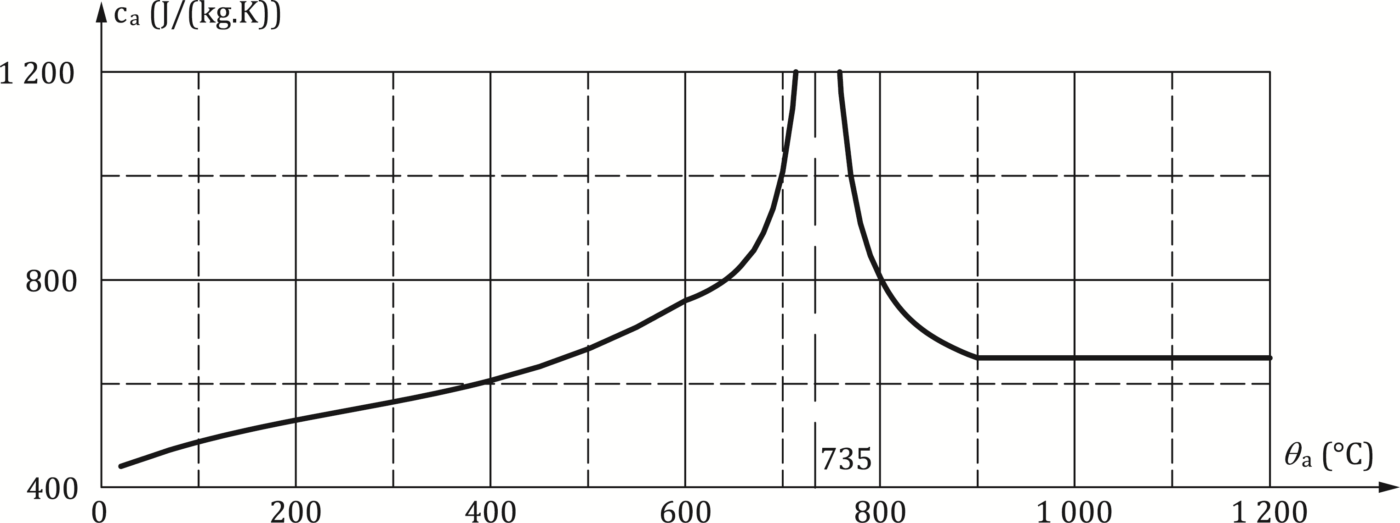

**Figure 5.2 — Specific heat of steel as a function of temperature**

#### Density

(1) The density of steel *ρ*a may be considered as independent of the steel temperature. The following value should be taken:

[kg/m3] (5.7)

### Concrete

#### Emissivity coefficient

(1) The emissivity coefficient for concrete surface should be taken as 0.7.

#### Thermal conductivity

(1) The thermal conductivity *λ*c of normal weight concrete should be determined from Formulae (5.8) to (5.10):

 [W/(m.K)] for θc ≤ 140 °C (5.8)

[W/(m.K)] for 140 < *θ*c < 160 °C (5.9)

[W/(m.K)] for *θ*c ≥ 160 °C (5.10)

where

|  |  |
| --- | --- |
| *θ*c | is the concrete temperature [ °C]. |

(2) The thermal conductivity *λ*c of lightweight concrete should be determined from the following:

[W/(m.K)] for 20 °C ≤ *θ*c ≤ 800 °C (5.11)

[W/(m.K)] for *θ*c > 800 °C (5.12)

NOTE The variation of the thermal conductivity *λ*c with temperature is illustrated in Figure 5.3.

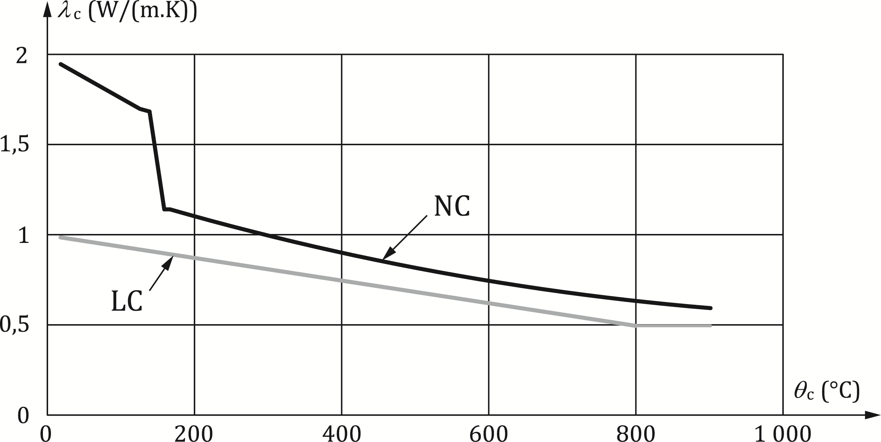

Key

|  |  |
| --- | --- |
| 1 | LC |
| 2 | NC |

Figure 5.3 — Thermal conductivity of normal weight concrete (NC) and lightweight concrete (LC) as a function of temperature

#### Specific heat

(1) The specific heat cc of normal and lightweight aggregate dry concrete (moisture content u = 0 %) should be taken as:

 [J/(kg.K)] for 20 °C ≤ *θ*c ≤ 100 °C (5.13)

 [J/(kg.K)] for 100 °C < θc ≤ 200 °C (5.14)

 [J/(kg.K)] for 200 °C < θc ≤ 400 °C (5.15)

 [J/(kg.K)] for 400 °C < θc ≤ 1200 °C (5.16)

where

|  |  |
| --- | --- |
| *θ*c | is the concrete temperature [°C]. |

(2) The moisture content of normal weight concrete should be taken equal to the equilibrium moisture content. If these data are not available, the moisture content should not exceed 4 % of the concrete weight.

(3) Where the moisture content is not considered explicitly in the calculation method, the function given for the specific heat of concrete may be calculated by a constant value $c_{c}^{*}$ between 100 °C and 115 °C and a linear relationship between 115 °C and 200 °C.

 = 900 for a moisture content of 0 % of concrete weight and [J/(kg.K)] (5.17)

= 1 470 for a moisture content of 1,5 % of concrete weight and [J/(kg.K)] (5.18)

 = 2 020 for a moisture content of 3 % of concrete weight and [J/(kg.K)] (5.19)

 = 5 600 for a moisture content of 10 % of concrete weight and [J/(kg.K)] (5.20)

(4) A linear interpolation may be taken for moisture content within the ranges in (5). Moisture contents up to 10 % may occur for hollow sections filled with concrete.

(5) The moisture content of lightweight concrete should be taken equal to the equilibrium moisture content. If these data are not available, the moisture content should not exceed 5 % of the concrete weight.

NOTE The variation of the specific heat with temperature is illustrated in Figure 5.4.

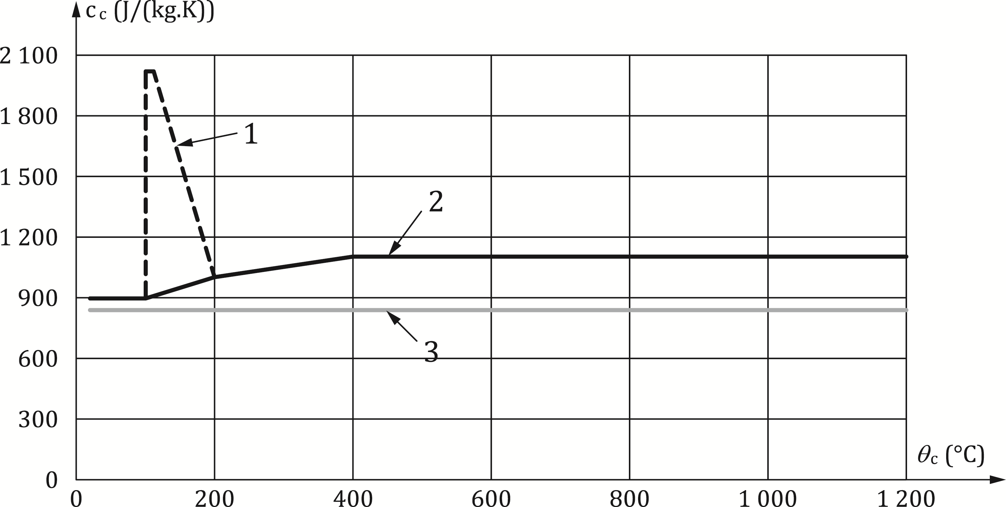

**Key**

|  |  |
| --- | --- |
| 1 | NC with u = 3 % |
| 2 | NC with u = 0 % |
| 3 | LC |

Figure 5.4 — Specific heat of normal weight concrete (NC) and lightweight concrete (LC) as a function of temperature

#### Density

(1) The variation of concrete density with temperature is influenced by water loss and should be taken as follows:

(kg/m3) for 20 °C ≤ *θ*c ≤ 115 °C (5.21)

(kg/m3) for 115 °C < θc ≤ 200 °C (5.22)

(kg/m3) for 200 °C < θc ≤ 400 °C (5.23)

(kg/m3) for 400 °C < θc ≤ 1 200 °C (5.24)

(2) The density of lightweight aggregate concrete for structural design shall be in the range of:

*ρ*c,LC = 1 200 to 2 000 [kg/m3] (5.25)

### Fire protection materials

(1) The properties and performance of fire protection materials used in design should have been assessed using test procedures given in the relevant parts of EN 13381, as appropriate.

## Mechanical properties

### Carbon steel

#### Thermal expansion

(1) The thermal expansion of steel ∆*l* / *l* valid for all structural and reinforcing steel qualities, may be determined from the following:

for 20 °C < θa ≤ 750 °C (5.26)

 for 750 °C < θa ≤ 860 °C (5.27)

 for 860 °C < θa 1 200 °C (5.28)

where

|  |  |
| --- | --- |
| *l* | is the length at 20 °C of the steel member |
| ∆*l* | is the temperature induced expansion of the steel member |
| *θ*a | is the steel temperature [C]. |

NOTE The variation of the thermal expansion with temperature is illustrated in Figure 5.5.

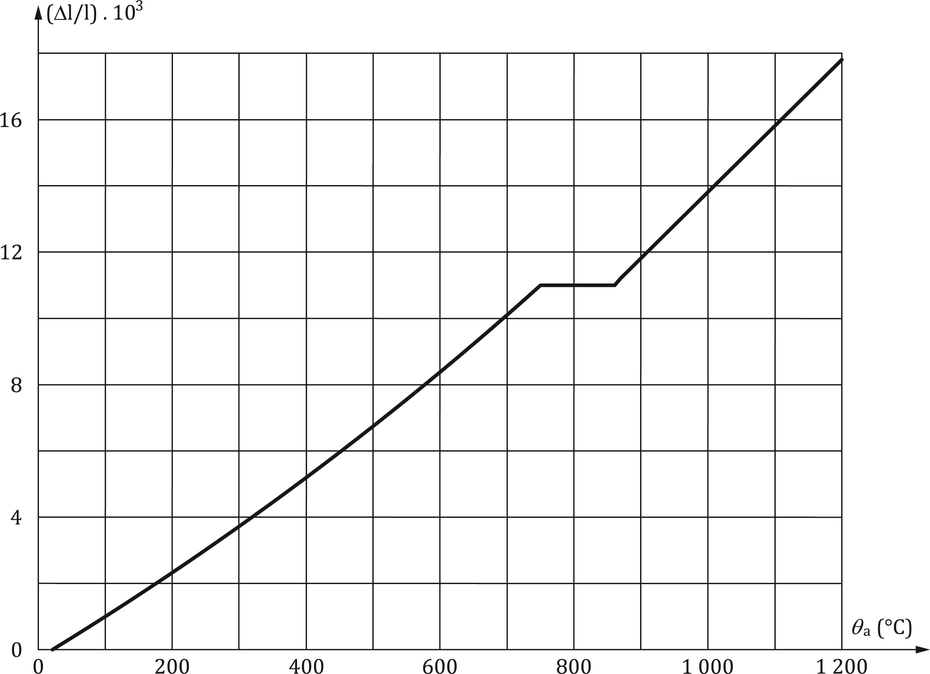

Figure 5.5 — Thermal expansion of steel as a function of temperature

#### Strength and stiffness properties of structural steel

(1) For heating rates between 2 and 50 K/min, the strength and stiffness properties of structural steel at elevated temperatures should be obtained from the stress-strain relationship given in Figure 5.6 and Table 5.2.

NOTE The stress-strain relationships given in Figure 5.6 and Table 5.2 are defined by three parameters:

* slope of the linear elastic range of the stress-strain relationship of structural steel at elevated temperatures *E*a,θ;
* the proportional limit *f*ap,θ ;
* the maximum stress level or effective yield strength *f*ay,θ.

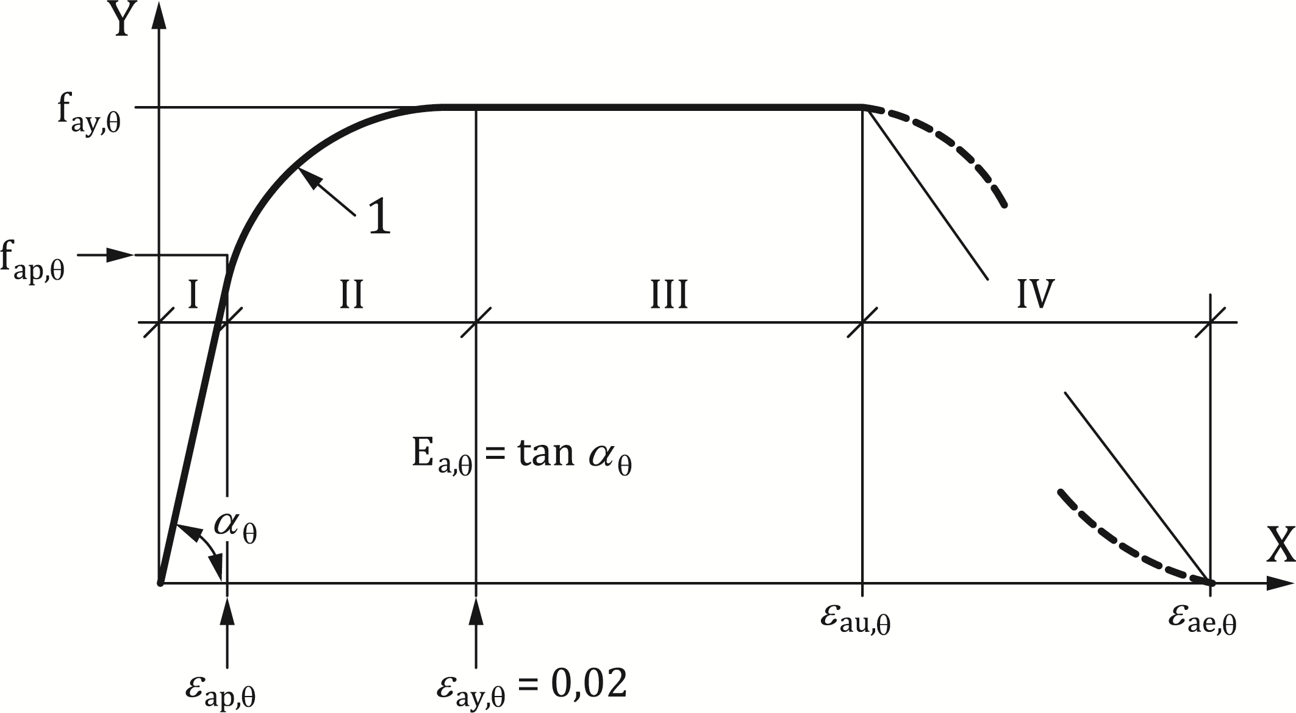

**Key**

|  |  |
| --- | --- |
| 1 | elliptic branch |

Figure 5.6 — Mathematical model for stress-strain relationships of structural steel at elevated temperatures

Table 5.2 — Relation between the various parameters of the mathematical model of Figure 5.6

|  |  |  |
| --- | --- | --- |
| **Strain Range** | **Stress σ** | **Tangent modulus** |
| I / elastic |  |  |
| II / transit elliptical | with |  |
| III / plastic |  | 0 |

(2) The formulation of stress-strain relationships has been derived from tensile tests. These relationships may also be applied for steel in compression.

(3) The reduction factors *k*θ for the stress-strain relationship of steel at elevated steel temperatures given in Table 5.3 shall be applied to the appropriate value *E*a or *f*ay in order to determine the parameters in (1). For intermediate values of the temperature, linear interpolation may be used.

(4) Alternatively, for temperatures below 400 °C, the stress-strain relationships specified in (1) may be extended by allowing for strain hardening, provided local or member buckling does not lead to premature collapse. Where strain hardening is allowed for, use Annex A (normative).

NOTE  Values for εau,θ and εae,θ defining the range of the maximum stress branches and decreasing branches according to Figure 5.6, are given in normative Annex A.

(5) In case of thermal actions according to FprEN 1991-1-2:2023, 5.3, (physically based models), particularly when taking into account the decreasing temperature branch, the values specified in Table 5.3 for the stress-strain relationships of structural steel up to and including S500 may be used as a sufficiently precise approximation. For intermediate values of the steel temperature, linear interpolation may be used.

Table 5.3 — Reduction factors *k*θ for stress-strain relationships of structural steel

|  |  |  |  |  |
| --- | --- | --- | --- | --- |
| **Steel Temperature θa** **[ °C]** |  |  |  |  |
| 20 | 1,00 | 1,00 | 1,00 | 1,25 |
| 100 | 1,00 | 1,00 | 1,00 | 1,25 |
| 200 | 0,90 | 0,807 | 1,00 | 1,25 |
| 300 | 0,80 | 0,613 | 1,00 | 1,25 |
| 400 | 0,70 | 0,420 | 1,00 | |
| 500 | 0,60 | 0,360 | 0,78 | |
| 600 | 0,31 | 0,180 | 0,47 | |
| 700 | 0,13 | 0,075 | 0,23 | |
| 800 | 0,09 | 0,050 | 0,11 | |
| 900 | 0,0675 | 0,0375 | 0,06 | |
| 1000 | 0,0450 | 0,0250 | 0,04 | |
| 1100 | 0,0225 | 0,0125 | 0,02 | |
| 1200 | 0 | 0 | 0 | |

#### Strength and stiffness properties of reinforcing steel

(1) The strength and stiffness properties of reinforcing steels at elevated temperatures may be obtained by the same mathematical model as that presented in 5.3.1.2 for structural steel.

(2) The three main parameters for hot rolled and cold worked reinforcing steel given in Table 5.4 should be used. For intermediate values of the temperature, linear interpolation may be used.

(3) The strength and stiffness properties of prestressing steels given in FprEN 1992-1-2:2023, 5.3.3.1 should be used.

Table 5.4 — Reduction factors *k*θ for stress-strain relationships of hot rolled and cold worked reinforcing steel at elevated temperature

|  |  |  |  |  |  |  |
| --- | --- | --- | --- | --- | --- | --- |
| **Steel Temperature θs [ °C]** |  | |  | |  | |
|  | **hot-rolled** | **cold-worked** | **hot-rolled** | **cold-worked** | **hot-rolled** | **cold-worked** |
| **1** | **2** | **3** | **4** | **5** | **6** | **7** |
| 20 | 1,00 | 1,00 | 1,00 | 1,00 | 1,00 | 1,00 |
| 100 | 1,00 | 1,00 | 1,00 | 0,96 | 1,00 | 1,00 |
| 200 | 1,00 | 1,00 | 0,81 | 0,92 | 0,90 | 0,87 |
| 300 | 1,00 | 1,00 | 0,61 | 0,81 | 0,80 | 0,72 |
| 400 | 1,00 | 0,94 | 0,42 | 0,63 | 0,70 | 0,56 |
| 500 | 0,78 | 0,67 | 0,36 | 0,44 | 0,60 | 0,40 |
| 600 | 0,47 | 0,40 | 0,18 | 0,26 | 0,31 | 0,24 |
| 700 | 0,23 | 0,12 | 0,07 | 0,08 | 0,13 | 0,08 |
| 800 | 0,11 | 0,11 | 0,05 | 0,06 | 0,09 | 0,06 |
| 900 | 0,06 | 0,08 | 0,04 | 0,05 | 0,07 | 0,05 |
| 1000 | 0,04 | 0,05 | 0,02 | 0,03 | 0,04 | 0,03 |
| 1100 | 0,02 | 0,03 | 0,01 | 0,02 | 0,02 | 0,02 |
| 1200 | 0 | 0 | 0 | 0 | 0 | 0 |

(4) For the limits of the decreasing branch:

* and  for Class A reinforcement
* and for Class B and Class C reinforcement

(5) In case of thermal actions according to FprEN 1991-1-2:2023, 5.3 (physically based fire models), particularly when taking into account the decreasing temperature branch, the values specified in Table 5.3 for the stress-strain relationships of structural steel and Table 5.4 for the stress-strain relationships of reinforcing steel, may be used as a sufficiently precise approximation.

### Concrete

#### Thermal expansion

(1) The thermal expansion Δl/l of concrete should be determined from the following reference to the length at 20 °C regardless of the concrete strength:

Siliceous aggregates:

 for 20 °C ≤ θc ≤ 700 °C (5.29)

 for 700 °C < θc ≤ 1 200 °C (5.30)

Calcareous aggregates:

 for 20 °C ≤ *θ*c ≤ 700 °C (5.31)

 for 700 °C < θc ≤ 1 200 °C (5.32)

Lightweight aggregate concrete:

 (5.33)

where

|  |  |
| --- | --- |
| *l* | is the length at 20 °C of the concrete member |
| ∆*l* | is the temperature induced expansion of the concrete member |
| *θ*c | is the concrete temperature |

#### Strength and stiffness properties of concrete

(1) The strength and stiffness properties of concrete under uniaxial stresses at elevated temperatures should be obtained from the stress-strain relationships as presented in Figure 5.8.

(2) The stress-strain relationships given in Figure 5.8 should be defined by three parameters:

* the compressive strength *f*c,θ;
* the strain *ε*cu,θ corresponding to *f*c,θ.
* the ultimate strain *ε*ce,θ

(3) Values of the above parameters should be taken from Table 5.5. as a function of concrete temperature. For intermediate values of the temperature, linear interpolation may be used.

(4) The parameters specified in Table 5.5 should be used for normal weight concrete with siliceous or calcareous (containing at least 80 % calcareous aggregate by weight) aggregates.

Table 5.5 — Values for the two main parameters of the stress-strain relationships of normal weight concrete (NC) and lightweight concrete (LC) at elevated temperatures

|  |  |  |  |  |
| --- | --- | --- | --- | --- |
| Concrete temperature θc | NC | NC | εc1,θ ⋅ 103 | εcu1,θ ⋅ 103 |
| [ °C] | Siliceous aggregates | Calcareous aggregates | NC | NC |
| 20 | 1 | 1 | 2,5 | 20,0 |
| 100 | 1 | 1 | 4,0 | 22,5 |
| 200 | 0,95 | 1 | 5,5 | 25,0 |
| 300 | 0,85 | 1 | 7,0 | 27,5 |
| 400 | 0,75 | 0,88 | 10,0 | 30,0 |
| 500 | 0,60 | 0,76 | 15,0 | 32,5 |
| 600 | 0,45 | 0,64 | 25,0 | 35,0 |
| 700 | 0,30 | 0,52 | 25,0 | 37,5 |
| 800 | 0,15 | 0,40 | 25,0 | 40,0 |
| 900 | 0,08 | 0,28 | 25,0 | 42,5 |
| 1 000 | 0,04 | 0,16 | 25,0 | 45,0 |
| 1 100 | 0,01 | 0,04 | 25,0 | 47,5 |
| 1 200 | 0 | 0 | — | — |

(5) The values of the the cu, and ce, for lightweight aggregate concrete should be based on testing.

(6) For thermal actions in accordance with FprEN 1991-1-2:2023, 5.3 (Physically based models), when taking into account the cooling phase, the strength of concrete heated to a maximum temperature *θ*c,max and having cooled down to 20 °C may be taken according to Formula (5.34):

 (5.34)

where

; (5.35)

 (5.36)

; (5.37)

where

|  |  |
| --- | --- |
| fck | is characteristic value of the compressive cylinder strength of concrete at 28 days and at 20 °C. |
|  | is the reduction factor which corresponds to *k*c,θ at the maximum temperature *θ*c,max, it is taken according to Table 5.5. |
| *ε*c1,θ and *ε*cu1,θ | are the values of the strain-stress relationship during the cooling phase, which may be taken as the same as those corresponding to the maximum temperature *θ*c,max. |

During the cooling down of concrete with *θ*c,max ≥ *θ* ≥ 20 °C, the corresponding compressive cylinder strength *f*c,θ may be interpolated linearly between *f*c,θmax and *f*c,θ,20 °C.

(7) Conservatively the tensile strength of concrete may be assumed to be zero.

(8) If tensile strength is taken into account in verifications carried out with an advanced design model, it should not exceed the values based on FprEN 1992-1-2:2023, 5.3.1.2.

(9) In case of tension in concrete, models with a descending stress-strain branch should be considered as presented in Figure 5.7.

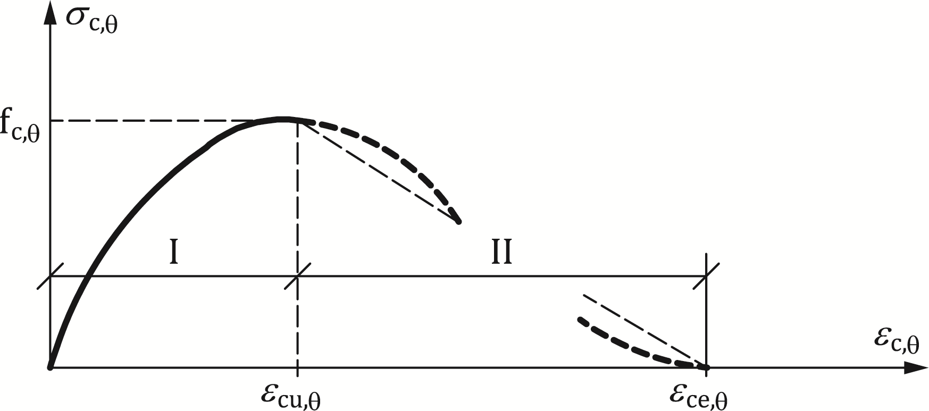

Figure 5.7 — Mathematical model for stress-strain relationships of concrete under compression at elevated temperatures

# Tabulated design data

## General

(1) Tabulated design data refer to member analysis according to 4.7. They shall be used only for the standard fire exposure

(2) The temperature distribution should be assumed to be the same along the length of the structural members.

(3) Tabulated design data shall give safe-sided results compared to relevant tests or simplified or advanced design methods. They shall be applied without extrapolation outside their range of application.

NOTE Tabulated data can be derived from tests, calculation models or some combination of the two and can be presented either in the form of a table or an equation.

(4) Tabulated design data may be used to obtain recognised design solutions generally in relation to member typology (dimensions, axis distance, reinforcement ratio etc.) without recourse to any form of equilibrium equation.

(5) For the tabulated data given in the Tables 6.1 to 6.7, linear interpolation may be done for all physical parameters.

NOTE When classification is impossible, this is marked by "-" in the tables.

## Beams

(1) Composite beams comprised a steel beam with partial concrete encasement may be specified according to Table 6.1.

(2) The values given in Table 6.1 are valid for simply supported beams.

(3) When determining *R*d and *R*d,fi,t = *η*fi,t *R*d in connection with Table 6.1, the following conditions shall be satisfied:

* the thickness of the web ew does not exceed 1/15 of the width b;
* the thickness of the bottom flange ef does not exceed twice the thickness of the web ew;
* the thickness of the concrete slab hc is at least 120 mm;
* the additional reinforcement area related to the total area between the flange As / (Ac + As) does not exceed 5 %;
* the value of *R*d is calculated on the basis of EN 1994-1-1 provided that:
* the effective slab width *b*eff does not exceed 5 m; and
* the additional reinforcement *A*s is not taken into account.

(4) The values given in Table 6.1 are valid for the structural steel grade S355. If another structural steel grade is used, the minimum values for the additional reinforcement given in Table 6.1 should be factored by the ratio of the yield point of this other steel grade to the yield point of grade S355.

(5) The values given in Table 6.1 are valid for the steel grade B500 used for the additional reinforcement *A*s.

(6) The values given in Tables 6.1 and 6.2 are valid for beams connected to solid slabs.

(7) The values given in Tables 6.1 and 6.2 may be used for beams connected to composite slabs with profiled steel sheetings, if at least 85 % of the upper side of the steel section is directly covered by the steel sheet. If not, void fillers should be used on top of the beams.

(8) The material used for void fillers should be suitable for fire protection of steel (see EN 13381-4 for applied passive protection to steel members and/or EN 13381-5 for applied protection to concrete/profiled sheet steel composite member).

(9) Additional reinforcement should be placed as close as possible to the bottom flange taking into account the axis distances u1 and u2 of Table 6.2.

Table 6.1 — Minimum cross-sectional dimensions b and minimum additional reinforcement in relation to the area of flange As / Af, for composite beams comprising steel beams with partial concrete encasement

|  |  |  |  |  |  |  |  |
| --- | --- | --- | --- | --- | --- | --- | --- |
|  |  | Condition for application: | **Standard fire resistance** | | | | |
| slab: hc ≥ 120 mm |
| beff ≤ 5 m |
| steel section: b / ew ≥ 15 |
| ef / ew ≤ 2 |
| additional reinforcement area, related to total area between the flanges: As/(Ac + As) ≤ 5 % |
|  |  | **R30** | **R60** | **R90** | **R120** | **R180** |
| 1 | Minimum cross-sectional dimensions for load level ηfi,t ≤ 0,3 | |  |  |  |  |  |
|  | min *b* [mm] and additional reinforcement *A*s in relation to | |  |  |  |  |  |
|  | the area of flange As / Af | |  |  |  |  |  |
| 1.1 | h ≥ 0,9 × min b | | 70/0,0 | 100/0,0 | 170/0,0 | 200/0,0 | 260/0,0 |
| 1.2 | h ≥ 1,5 × min b | | 60/0,0 | 100/0,0 | 150/0,0 | 180/0,0 | 240/0,0 |
| 1.3 | h ≥ 2,0 × min b | | 60/0,0 | 100/0,0 | 150/0,0 | 180/0,0 | 240/0,0 |
| 2 | Minimum cross-sectional dimensions for load level *η*fi,t ≤ 0,5 | |  |  |  |  |  |
|  | min b [mm] and additional reinforcement As in relation to | |  |  |  |  |  |
|  |  | |  |  |  |  |  |
|  | the area of flange As / Af | |  |  |  |  |  |
| 2.1 | h ≥ 0,9 × min b | | 80/0,0 | 170/0,0 | 250/0,4 | 270/0,5 | — |
| 2.2 | h ≥ 1,5 × min b | | 80/0,0 | 150/0,0 | 200/0,2 | 240/0,3 | 300/0,5 |
| 2.3 | h ≥ 2,0 × min b | | 70/0,0 | 120/0,0 | 180/0,2 | 220/0,3 | 280/0,3 |
| 2.4 | h ≥ 3,0 × min b | | 60/0,0 | 100/0,0 | 170/0,2 | 200/0,3 | 250/0,3 |
| 3 | Minimum cross-sectional dimensions for load level *η*fi,t ≤ 0,7 | |  |  |  |  |  |
|  | min b [mm] and additional reinforcement As in relation to the area of flange As / Af | |  |  |  |  |  |
| 3.1 | h ≥ 0,9 × min b | | 80/0,0 | 270/0,4 | 300/0,6 | — | — |
| 3.2 | h ≥ 1,5 × min b | | 80/0,0 | 240/0,3 | 270/0,4 | 300/0,6 | — |
| 3.3 | h ≥ 2,0 × min b | | 70/0,0 | 190/0,3 | 210/0,4 | 270/0,5 | 320/1,0 |
| 3.4 | h ≥ 3,0 × min b | | 70/0,0 | 170/0,2 | 190/0,4 | 270/0,5 | 300/0,8 |

Table 6.2 — Minimum axis distance for additional reinforcement of composite beams

|  |  |  |  |  |  |  |
| --- | --- | --- | --- | --- | --- | --- |
|  | **Section width b [mm]** | **Min. axis distance [mm]** | **Standard fire resistance** | | | |
| **R60** | **R90** | **R120** | **R180** |
| 170 | u1 u2 | 100 45 | 120 60 | — — | — — |
| 200 | u1 u2 | 80 40 | 100 55 | 120 60 | — — |
| 250 | u1 u2 | 60 35 | 75 50 | 90 60 | 120 60 |
| ≥ 300 | u1 u2 | 40 25 a | 50 45 | 70 60 | 90 60 |
| a This value should be checked according to FprEN 1992-1-1:2023, 6.4.2. | | | | | | |

(10) If the concrete encasing the steel beam is only an insulation function, the fire resistance R30 to R180 may be fulfilled for a concrete cover c of the steel section according to Table 6.3.

Table 6.3 — Minimum concrete cover for a steel section with concrete acting as fire protection

|  |  |  |  |  |  |
| --- | --- | --- | --- | --- | --- |
| Key  1 solid or composite slab  2 concrete for insulation | **Standard fire resistance** | | | | |
| R30 | R60 | R90 | R120 | R180 |
| Concrete cover c [mm] | 0 | 25 | 30 | 40 | 50 |
| NOTE For R30, concrete between the flanges of the steel section is sufficient. | | | | | |

(11) Where a concrete encasing only has an insulation function, mesh reinforcement should be placed according to 9.1(6).

## Columns

### General

(1) The design Tables 6.4, 6.6 and 6.7 are valid for braced frames.

(2) Load levels *η*fi,t in Tables 6.6 and 6.7 are defined by 4.7(3), assuming that the calculation of Rd is based on twice the buckling length used in the fire design situation.

(3) Tables 6.4 to 6.7 are valid both for concentric axial or eccentric loads applied to columns. When determining *R*d, the design resistance for normal temperature design, the eccentricity of the load should be taken into account.

(4) The tabulated data given in Tables 6.4 to 6.7 are valid for columns with a maximum length of 30 times the minimum external dimension of the cross-section chosen.

### Composite columns made of totally encased steel sections

(1) Composite columns made of totally encased steel sections may be classified by use of Table 6.4.

(2) All load levels *η*fi,t may be used when the design resistance in the fire situation is calculated by 

(3) The longitudinal reinforcement should consist of at least 4 bars with a minimum diameter of 12 mm. For stirrups it should be referred to EN 1992-1-1.

Table 6.4 — Minimum cross-sectional dimensions, minimum concrete cover of the steel section and minimum axis distance of the reinforcing bars, of composite columns made of totally encased steel sections

|  |  |  |  |  |  |  |  |
| --- | --- | --- | --- | --- | --- | --- | --- |
|  |  | **Standard fire resistance** | | | | | |
|  |  | **R30** | **R60** | **R90** | **R120** | **R180** | **R240** |
| 1.1 | Minimum dimensions hc and bc [mm] | 150 | 180 | 220 | 300 | 350 | 400 |
| 1.2 | Minimum concrete cover of steel section c [mm] | 40 | 50 | 50 | 75 | 75 | 75 |
| 1.3 | Minimum axis distance of reinforcing bars us [mm] | 20* | 30 | 30 | 40 | 50 | 50 |
|  | Or |  |  |  |  |  |  |
| 2.1 | Minimum dimensions hc and bc [mm] | — | 200 | 250 | 350 | 400 | — |
| 2.2 | Minimum concrete cover of steel section c [mm] | — | 40 | 40 | 50 | 60 | — |
| 2.3 | Minimum axis distance of reinforcing bars us [mm] | — | 20* | 20a | 30 | 40 | — |
| a These values should be checked according to FprEN 1992-1-1:2023, 6.4.2. | | | | | | | |

(4) If the concrete encasing the steel section is only an insulation function, when designing the column for normal temperature design, the fire resistance R30 to R180 may be fulfilled for a concrete cover *c* of the steel section according to Table 6.5.

Table 6.5 — Minimum concrete cover for a steel section with concrete acting as fire protection

|  |  |  |  |  |  |
| --- | --- | --- | --- | --- | --- |
| **Key**  1 Concrete for insulation | **Standard fire resistance** | | | | |
| **R30** | **R60** | **R90** | **R120** | **R180** |
| Concrete cover c [mm] | 0 | 25 | 30 | 40 | 50 |
| NOTE For R30, concrete between the flanges of the steel section is sufficient. | | | | | |

(5) Where concrete encasing is only an insulation function, mesh reinforcement should be placed according to 9.1(6), except for R30.

### Composite columns made of partially encased steel sections

(1) Composite columns made of partially encased steel sections may classified according to Table 6.6.

(2) When determining *R*d and *R*d,fi,t = ηfi,t Rd, in connection with Table 6.6, reinforcement ratios *A*s / (*A*c + *A*s) higher than 6 % or lower than 1 %, should not be taken into account.

(3) Table 6.6 may be used for the structural steel grades S235, S275 and S355.

Table 6.6 — Minimum cross-sectional dimensions, minimum axis distance and minimum reinforcement ratios of composite columns made of partially encased steel sections

|  |  |  |  |  |  |
| --- | --- | --- | --- | --- | --- |
|  |  | **Standard fire resistance** | | | |
| **R30** | **R60** | **R90** | **R120** |
|  | Minimum ratio of web to flange thickness ew/ef | 0,5 | 0,5 | 0,5 | 0,5 |
| 1 | Minimum cross-sectional dimensions for load level *ŋ*fi,t ≤ 0,28 |  |  |  |  |
| 1.1 | Minimum dimensions h and b [mm] | 160 | 200 | 300 | 400 |
| 1.2 | Minimum axis distance of reinforcing bars us [mm] | -— | 50 | 50 | 70 |
| 1.3 | Minimum ratio of reinforcement As/(Ac+As) in % | — | 4 | 3 | 4 |
| 2 | Minimum cross-sectional dimensions for load level *ŋ*fi,t ≤ 0,47 |  |  |  |  |
| 2.1 | Minimum dimensions h and b [mm] | 160 | 300 | 400 | — |
| 2.2 | Minimum axis distance of reinforcing bars us [mm] | — | 50 | 70 | — |
| 2.3 | Minimum ratio of reinforcement As/(Ac+As) in % | — | 4 | 4 | — |
| 3 | Minimum cross-sectional dimensions for load level *ŋ*fi,t ≤ 0,66 |  |  |  |  |
| 3.1 | Minimum dimensions h and b [mm] | 160 | 400 | — | — |
| 3.2 | Minimum axis distance of reinforcing bars us [mm] | 40 | 70 | — | — |
| 3.3 | Minimum ratio of reinforcement As/(Ac+As) in % | 1 | 4 | — | — |

### Composite columns comprising concrete filled hollow sections

(1) Composite columns made of concrete filled hollow sections may be classified according to Table 6.7.

(2) The values given in Table 6.7 are valid for reinforcement of steel grade B500.

(3) As an alternative to (1), the design rules given in FprEN 1992-1-2:2023, 6.3.2 or 6.3.3 may be used, neglecting the contribution of the steel section.

(4) When calculating Rd and *R*d,fi,t = *η*fi,t *R*d , in connection with Table 6.7, the following rules apply:

* irrespective of the steel grade of the hollow sections, a nominal yield point of 235 N/mm² is assumed;
* the wall thickness e of the hollow section is considered up to a maximum of 1/25 of d for circular sections or the minimum of (b, h) for rectangular sections;
* reinforcement ratios *A*s/(*A*c+*A*s) higher than 3 % are not taken into account;
* the concrete strength is as assumed to be that for normal temperature design.

Table 6.7 — Minimum cross-sectional dimensions, minimum reinforcement ratios and minimum axis distance of the reinforcing bars of composite columns comprising concrete filled hollow sections

|  |  |  |  |  |  |  |
| --- | --- | --- | --- | --- | --- | --- |
|  |  | **Standard fire resistance** | | | | |
| Steel section: (b / e) ≥ 25 or (d / e) ≥ 25 | **R30** | **R60** | **R90** | **R120** | **R180** |
| 1 | Minimum cross-sectional dimensions for load level *ŋ*fi,t ≤ 0,28 |  |  |  |  |  |
| 1.1 | Minimum dimensions h and b or minimum diameter d [mm] | 160 | 200 | 220 | 260 | 400 |
| 1.2 | Minimum ratio of reinforcement *A*s / (*A*c + *A*s) in (%) | 0 | 1,5 | 3,0 | 6,0 | 6,0 |
| 1.3 | Minimum axis distance of reinforcing bars us [mm] | — | 30 | 40 | 50 | 60 |
| 2 | Minimum cross-sectional dimensions for load level *ŋ*fi,t ≤ 0,47 |  |  |  |  |  |
| 2.1 | Minimum dimensions h and b or minimum diameter d [mm] | 260 | 260 | 400 | 450 | 500 |
| 2.2 | Minimum ratio of reinforcement *A*s / (*A*c + *A*s) in (%) | 0 | 3,0 | 6,0 | 6,0 | 6,0 |
| 2.3 | Minimum axis distance of reinforcing bars us [mm] | — | 30 | 40 | 50 | 60 |
| 3 | Minimum cross-sectional dimensions for load level *ŋ*fi,t ≤ 0,66 |  |  |  |  |  |
| 3.1 | Minimum dimensions h and b or minimum diameter *d* [mm] | 260 | 450 | 550 | — | — |
| 3.2 | Minimum ratio of reinforcement *A*s / (*A*c + *A*s) in (%) | 3,0 | 6,0 | 6,0 | — | — |
| 3.3 | Minimum axis distance of reinforcing bars us [mm] | 25 | 30 | 40 | — | — |

# Simplified design methods

## General

(1) Simplified design methods refer to member analysis according to 4.7. They shall give safe-sided results compared to relevant tests or advanced design methods. They shall be applied without extrapolation outside their range of application.

NOTE 1 Simplified design methods are based on global equilibrium equations, which are satisfied for a section or for a member.

NOTE 2 Solving the global equilibrium equation of a simplified design method results in the determination of a single quantity, e.g. a temperature in a section or part of it, a loadbearing capacity for a section or a member.

## General rules for composite slabs and composite beams

(1) Rules that are common to composite slabs and composite beams are given here. Additional rules for slabs are given in 7.3 and for composite beams in 7.4.

(2) For composite beams in which the section is Class 1 or Class 2 (see EN 1994-1-1), and for composite slabs, the design bending resistance should be determined by plastic theory.

(3) The plastic neutral axis of a composite slab or composite beam should be determined from Formula (7.1):

$\sum_{i=1}^{m}{A_{i}k_{y,θ,i}\left(\frac{f_{y,i}}{γ_{M,a,fi}}\right)}+α_{slab}\sum_{j=1}^{n}{A_{j}k_{c,θ,j}\left(\frac{f_{c,j}}{γ_{M,c,fi}}\right)}$ (7.1)

where

|  |  |
| --- | --- |
|  | is the coefficient that allows the assumption of the rectangular stress block when designing slabs, slab = 0,85 the same value may be used for beams; |
|  | is the nominal yield strength *f*y for the elemental steel area A*i*, taken as positive on the compression side of the plastic neutral axis and negative on the tension side; |
|  | is the characteristic strength for the elemental concrete area *A*j at 20 °C. Concrete parts in tension are ignored |
| *k*y,θ,i or *k*c,θ,j | are as defined in Table 5.3 (or Table 5.4) and Table 5.5. |

(4) The design moment resistance MRd,fi,t should be determined from Formula (7.2):

$M_{Rd,fi,t}=\sum_{i=1}^{m}{A_{i}z_{i}k_{y,θ,i}\left(\frac{f_{y,i}}{γ_{M,a,fi}}\right)}+α_{slab}\sum_{j=1}^{n}{{A_{j}z}_{j}k_{c,θ,j}\left(\frac{f_{c,j}}{γ_{M,c,fi}}\right)}$ (7.2)

where

|  |  |
| --- | --- |
|  | is the distance from the plastic neutral axis to the centroid of the elemental area *A*i or *A*j. |

(5) For continuous composite slabs and beams, the rules of EN 1992-1-2 and EN 1994-1-1 apply in order to guarantee the required rotation capacity.

(6) Simplified design methods for slabs and beams may be based on specific temperature distributions through the cross-section, as given in 7.4, or distributions determined by other appropriate methods or by tests.

## Composite slabs

### Unprotected composite slabs

(1) The following rules apply to the calculation of the standard fire resistance of both simply supported and continuous concrete slabs with steel sheeting and reinforcement, as described below when heated from below according to the standard temperature-time curve.

(2) This method is only applicable to directly heated steel sheetings not protected by any thermal insulation and to composite slabs with no insulation between the composite slab and the screed (see Figures 7.1 and 7.2).

NOTE A method is given in B.4 of Annex B for the calculation of the effective thickness heff.

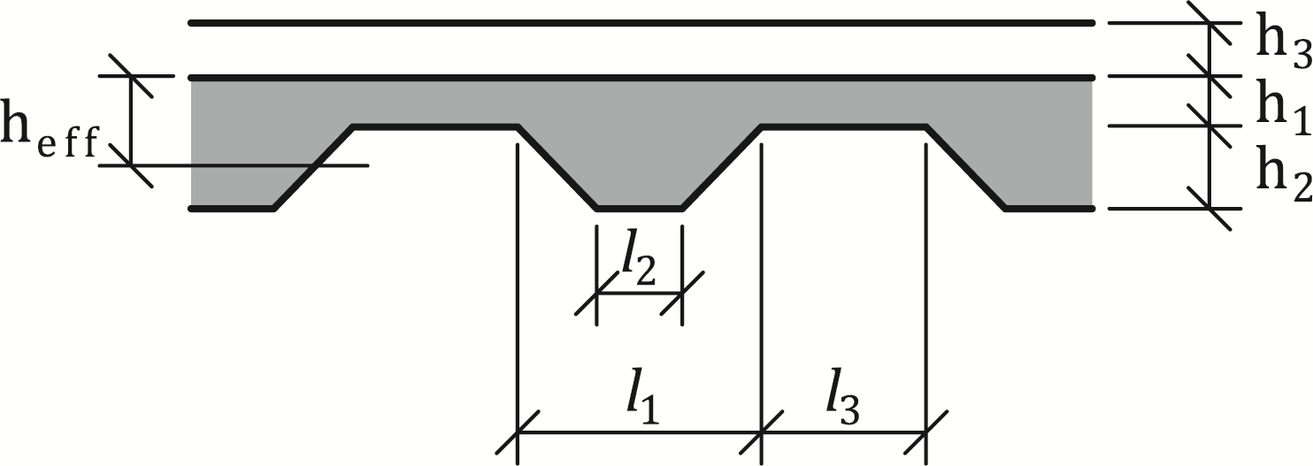

**Figure 7.1 — Geometry of slab with trapezoidal sheeting**

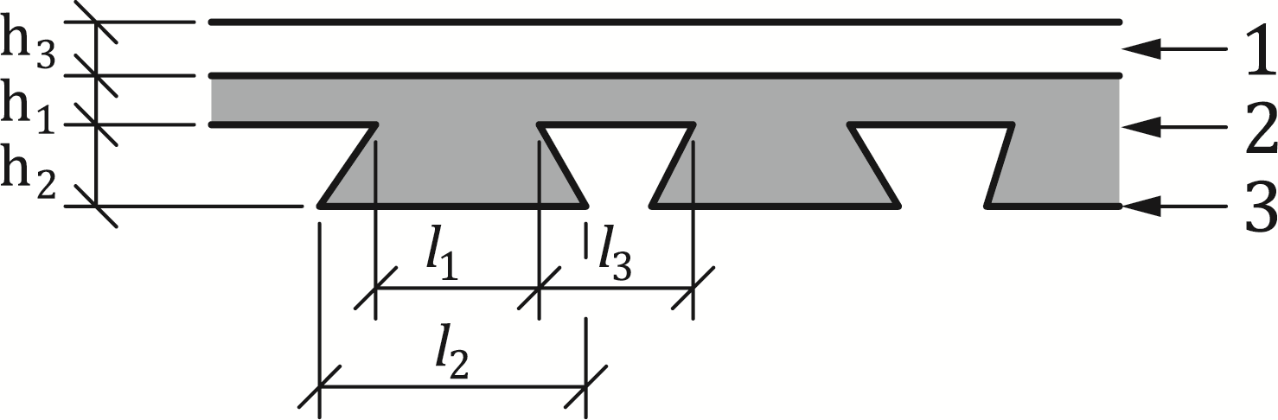

**Key**

|  |  |
| --- | --- |
| 1 | screed |
| 2 | concrete |
| 3 | steel sheeting |

Figure 7.2 — Geometry of slab with re-entrant sheeting

(3) The possible effect of axial restraint on the fire resistance is not taken into account in the subsequent rules.

(4) For composite slabs the integrity criterion "E" may be assumed to be satisfied.

(5) For composite slabs, the criterion of thermal insulation “I” shall be verified.

NOTE Annex B defines a method for the calculation of the fire resistance with respect to the criterion of thermal insulation “I”.

(6) For a slab design complying with EN 1994-1-1, the fire resistance of the slab, with or without additional reinforcement, may be taken as at least 30 minutes, when assessed under the loadbearing criterion "R" according to (1) of 4.1.

NOTE Annex B defines a method for the calculation of the fire resistance with respect to the criterion of mechanical resistance “R” in relation to the sagging and hogging moment resistances.

(7) Rules of 7.3.1 apply to composite slabs made of lightweight concrete as defined in 5.2.2 and 5.3.2.

### Protected composite slabs

(1) An improvement in the fire resistance of a composite slab may be obtained by using a protection system applied to the steel sheeting in order to decrease the heat transfer to the composite slab.

(2) The performance of the protection system used for a composite slab should be assessed according to:

* EN 13381-1 for suspended ceilings; and
* EN 13381-5 for protection materials.

(3) The thermal insulation criterion "I" is assessed by deducing from the effective thickness *h*eff the equivalent concrete thickness of the protection system (see EN 13381-5).

(4) The loadbearing criterion "R" is fulfilled as long as the temperature of the steel sheeting is not greater than 350 °C, when heated from below by the standard fire.

NOTE The fire resistance, with regard to the loadbearing criterion “R”, of protected composite slabs is at least 30 minutes [see 7.3.1(6)].

## Composite beams

### Thermal analysis

#### General

(1) The temperature distribution in a composite beam should be assessed by considering separately the steel section and the slab. A simplified method is defined only for steel sections without concrete encasement.

(2) A beam supporting a solid slab is assumed to be heated only from the three lower sides.

(3) A beam supporting a composite slab is assumed to be heated only from the lower sides when at least 85 % of the top flange of the steel section is in contact with the composite slab or, when any void formed between the top flange and the steel sheeting is filled with non-combustible material.

#### Composite beams comprising steel beams with no concrete encasement

##### Temperature distribution in the steel section

(1) When calculating the temperature distribution in the steel section, the cross-section may be divided into parts according to Figure 7.3.

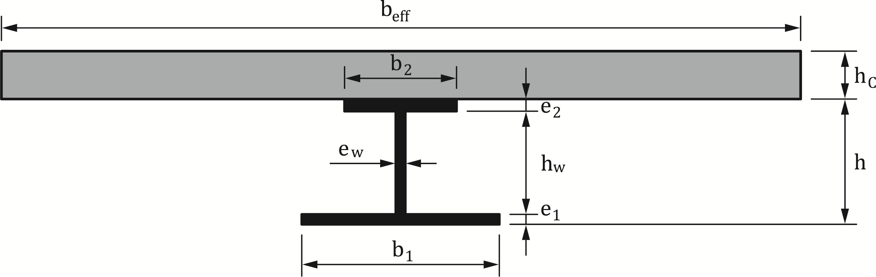

**Figure 7.3 — Elements of a cross-section**

(2) It is assumed that there is no heat transfer between these parts or between the top flange of the steel beam and the concrete slab.

(3) The increase in temperature ∆θa,t of a part of an unprotected steel beam during the time interval ∆t should be determined from Formula (7.3):

[ °C] (7.3)

where

|  |  |
| --- | --- |
| *k*sh | is a correction factor for the shadow effect [see (4)] |
| *c*a | is the specific heat of steel in accordance with (1) of 5.2.1.4 [J/kgK] |
| *ρ*a | is the density of steel in accordance with (1) of 5.2.1.5 [kg/m3] |
| *A*i | is the exposed surface area of the part i of the steel cross-section per unit length [m²/m] |
| *Ai* /*V*i | is the section factor [1/m] of the part i of the steel cross-section |
| *Vi* | is the volume of the part i of the steel cross-section per unit length [m3/m] |
| Δ*t* | is the time interval |
|  | is the design value of the net heat flux per unit area |

[W/m2] (7.4)

with

[W/m2] (7.5)

[W/m2] (7.6)

where

|  |  |
| --- | --- |
| *α*c | is the coefficient of heat transfer by convection, according to EN 1991-1-2 |
| *Φ* | is the configuration factor, according to FprEN 1991-1-2:2023, 5.1(7) |
| *ε*m | is the emissivity coefficient as defined in 5.2.1.1(1) |
| *ε*f | is the emissivity of the fire according to FprEN 1991-1-2:2023, 5.1(6) |
| *θ*t | is the ambient gas temperature at time t [°C] |
| θa,t | is the steel temperature at time t [°C] assumed to be uniform in each part of the steel cross-section |
| ⬧ | is the Stephan Boltzmann constant (= 5,67 ⋅ 10−8 W/(m2K4)) |



(4) For a part of an unprotected steel beam, the shadow effect should be determined from Formula (7.7).

 (7.7)

with *e*1, *b*1, *e*w, *h*w, *e*2, *b*2 being cross-sectional dimensions according to Figure 7.3.

For more advanced calculation models, the configuration factor *Φ* as presented in FprEN 1991-1-2:2023, 5.1 and Annex G may be used in Formula (7.6).

NOTE The application of shadow factor ksh given by Formula (7.7) to all the parts of the steel section is an approximation based on the results of extensive studies.

(5) For a part of an unprotected steel beam, the value of the time interval ∆*t* should not be taken as more than 5 seconds.

(6) For a part of an insulated steel beam, the increase in temperature ∆θa,t during the time interval ∆*t* may be obtained from Formula (7.8):

 (7.8)

with

 and

where

|  |  |
| --- | --- |
| λp | is the thermal conductivity of the fire protection material as specified in (1) of 5.2.3 [W/mK] |
| *d*p | is the thickness of the fire protection material [m] |
| *A*p,i | is the area of the inner surface of the fire protection material per unit length of the part i of the steel member [m²/m] |
| *A*p,i */V* i | Is the section factor of part i of the steel cross-section [m²/ m3] |
| *c*p | is the specific heat of the fire protection material as specified in (1) of 5.2.3 [J/kgK] |
| *ρ*p | is the density of the fire protection material [kg/m3] |
| *θ*t | is the ambient gas temperature at time *t* [°C] |
| ∆*θ*t | is the increase of the ambient gas temperature [°C] during the time interval ∆t |

(7) For a part of an insulated steel beam, any negative value of temperature increase ∆θa,t, should be taken as zero.

(8) For a part of an insulated steel beam, the value of ∆*t* should not be taken as more than 30 seconds for (6).

(9) For unprotected members and members with contour protection, the section factor *A*i/*V*i or *A*p,i/ *V*i should be calculated as follows:

for the bottom flange;

or  (7.9)

for the top flange, when at least 85 % of the top flange of the steel section is in contact with the concrete slab or, when any void formed between the top flange and steel sheeting is filled with non-combustible material;

or  (7.10)

for the top flange when used with a composite slab when less than 85 % of the top flange of the steel section is in contact with the profiled steel sheeting and the voids are unfilled;

or  (7.11)

(10) If the beam depth *h* does not exceed 500 mm, the temperature of the web may be taken as equal to that of the bottom flange.

(11) For members with box-protection, a uniform temperature may be assumed over the entire cross-section when using (6) together with the section factor of the steel section with box protection *A*p/*V*

where

|  |  |
| --- | --- |
| *A*p | is the area of the inner surface of the box protection per unit length of the steel beam [m²/m] |
| *V* | is the volume of the complete cross-section of the steel beam per unit length [m3/m] |

(12) The evolution of temperature of a beam with large web openings should be calculated according to FprEN 1993-1-2:2023, Annex E using section factors which depend on whether a uniform or non-uniform temperature approach is adopted.

(13) As an alternative to (6), temperatures in a steel section after a given time of fire duration may be obtained from design flow charts determined in conformity with EN 13381 Parts 4, 8 and 9.

(14) Protection of a steel beam in contact with a concrete slab on top may be achieved using a protective ceiling. The temperature development in the beam may be calculated according to FprEN 1993-1-2:2023, 7.6.3.

##### Temperature distribution in the concrete slab

(1) The following rules (2) to (3) may be used for solid slabs, or for composite slabs with re-entrant or trapezoidal steel sheeting.

(2) A uniform temperature distribution may be assumed over the effective width *b*eff of the slab.

NOTE In order to determine temperatures over the thickness of the slab a method is given in Annex B.

(3) For the mechanical analysis it may be assumed, that for concrete temperatures below 250 °C, no strength reduction of concrete is taken into account.

### Mechanical analysis

#### General

##### General design procedure

(1) Composite beams shall be checked for:

* bending resistance of critical cross-sections, see 7.4.2.1.3;
* vertical shear resistance and local resistance at support, see 7.4.2.1.4; and
* resistance to longitudinal shear, see 7.4.2.1.5.

NOTE Guidance on critical cross-sections is given in prEN 1994-1-1:2024, 8.1.1(4).

(2) In addition to (1), composite beams with large web openings shall be checked for:

* resistance to *Vierendeel* bending;
* web buckling resistance in case of widely spaced openings; and
* web-post buckling, shear and bending resistance in case of closely spaced openings.

(3) The verification of composite beams with large web openings in zones with openings shall be carried out according to Annex I.

(4) In addition to (1), the bottom part of the cross-sections of composite shallow floor beams shall be checked under combinations of shear and bending due to local load introduction. Use Annex H (normative) for two specific typologies of shallow floor beam cross-sections. For configurations not covered by Annex H, or for other types of shallow floor beam, advanced methods should be applied.

##### Temperature distribution

(1) The temperature distribution over the cross-section may be determined from test, advanced design methods (Section 8) or for composite beams comprising steel beams with no concrete encasement, from the simplified design method of 7.4.1.2.1.

##### Bending resistance

(1) The design bending resistance may be determined by plastic theory for any class of cross-sections except for class 4.

(2) For simply supported beams, the steel flange in compression may be treated, independent of its class, as class 1, provided it is connected to the slab by shear connectors placed in accordance with 8.6.5.5 of prEN 1994-1-1:2024.

NOTE For class 4 steel cross-sections, refer to FprEN 1993-1-2:2023, 7.4.5 and 7.4.7.

(3) Where in the fire situation, test evidence (see EN 1365-3) of composite action between the slab and the steel beam is available, beams which are considered as non-composite may be assumed to be composite in fire conditions.

##### Vertical shear resistance and local resistance at supports

(1) The resistance to vertical shear and the local resistance at supports should be taken as the resistance of the structural steel section (see 7.4.3(7) and 7.4.4(4) of FprEN 1993-1-2:2023), unless the value of a contribution from the concrete part of the beam has been established by tests.

NOTE 1 For the calculation of the vertical shear resistance of the structural steel section, Annex C applies.

NOTE 2 For the calculation of the vertical shear resistance, Annex H applies to two specific typologies of shallow floor beam cross-sections.

NOTE 3 For the calculation of the vertical shear resistance of a beam with large web openings, Annex I takes into account a contribution from the concrete part of the beam.

(2) For simply supported downstand composite beams with webs encased in concrete no check of the vertical shear resistance is required provided for normal design the web is assumed to resist all vertical shear.

(3) For partially encased beams under hogging bending, the web may resist the vertical shear even if this web is assumed not to contribute to the moment resistance.

NOTE  For partially encased beams under hogging bending, Annex D applies.

##### Longitudinal shear connection

(1) The total design longitudinal shear shall be determined consistently with the design bending resistance, taking into account the difference in the normal force in the concrete and the structural steel over a critical length.

(2) In the case of design for partial shear connection in the fire situation, the variation of longitudinal shear forces as a function of the temperature increase should be taken into account.

(3) The total design longitudinal shear over the critical length in an area of sagging bending should be calculated from the lesser of the compressive force in the slab *F*c given by Formula (7.12):

$F_{c} = α_{slab} \sum_{j=1}^{m}{A_{i}k_{\text{y,}θ,i} \left(\frac{f_{y,i}}{γ_{M,a,fi}}\right)}$ (7.12)

and the tensile force in the steel section *F*a given by Formula (7.13):

$F_{a}= \sum_{i=l}^{n}{A_{i}k_{\text{y,}θ,i} \left(\frac{f_{y,i}}{γ_{M,a,fi}}\right)}$ (7.13)

NOTE For the calculation of the longitudinal shear in an area of hogging bending, Annex C applies.

(4) The degree of shear connection in an area of sagging bending shall be the ratio of the design shear resistance of connectors over the critical length to the total design longitudinal shear force over the critical length.

(5) Unless otherwise verified, appropriate shear connection should be provided to ensure yielding of the reinforcement in tension.

(6) Adequate transverse reinforcement shall be provided to distribute the longitudinal shear according to prEN 1994-1-1:2024, 8.6.6.2.

(7) For a beam connected to a slab, the resistance to longitudinal shear provided by transverse reinforcement should be determined from prEN 1994-1-1:2024, 8.6.6. In this case, the contribution of the profiled steel sheeting should be ignored when its temperature exceeds 350 °C. The effective width *b*eff at elevated temperatures may be taken as the value in prEN 1994-1-1:2024, 7.4.1.2.

NOTE This rule applies only if the axis distance of the transverse reinforcement satisfies column 3 in FprEN 1992-1-2:2023, Table 6.10.

#### Composite beams comprising steel beams with no concrete encasement

##### Bending moment resistance model

(1) The method is applicable to beams subjected to sagging moments, hogging moments or a combination of sagging and hogging moments.

(2) The bending moment resistance may be calculated using plastic theory, taking into account the variation of material properties with temperature (see 7.4.2.1(6) to (8)).

(3) The sagging and hogging moment resistances shall be calculated taking into account the degree of shear connection.

NOTE For the calculation of sagging and hogging moment resistances, Annex C applies.

##### Critical temperature model

(1) In the following critical temperature model, the temperature of the steel section is assumed to be uniform.

(2) The method is applicable to symmetric steel sections of depth h not greater than 500 mm, with a slab of depth *h*c not less than 120 mm. Beams must be simply supported and subjected to sagging moments.

(3) The critical temperature *θ*cr may be determined from the load level *η*fi,t applied to the composite member and from the strength of steel at elevated temperatures *f*ay,θcr according to the relationship:

* for R30;

 (7.14)

* in any other case;

 (7.15)

where

|  |  |
| --- | --- |
| *η*fi,t |  |
| *E*d,fi,t |  |

according to 4.7(1).

(4) The temperature rise in the steel section may be determined from (3) or (6) of 7.4.1.2.1 using the section factor *A*i / *V*i or *A*pi / Vi of the bottom flange of the steel section.

##### Verification of shear resistance of stud connectors

(1) The design shear resistance in the fire situation of a welded headed stud should be determined for solid and composite slabs in accordance with EN 1994-1-1, except that the partial factor γv should be replaced by *γ*M,v,fi and the smaller of the following reduced values should be used:

$P_{\text{Rd,fi}}=0,8.k_{\text{u,}\text{θ}}P_{\text{Rd}}$ (7.16)

with *P*Rd as obtained from prEN 1994-1-1:2024, Formula (8.25) or:

$P_{\text{Rd,fi}}=k_{\text{c,}\text{θ}}\text{.}{\text{P}}_{\text{Rd}}.$ (7.17)

with *P*Rd as obtained from prEN 1994-1-1:2024, Formula (8.26) and where values of *k*u,θ and *k*c,θ are taken from Tables 5.2 and 5.4 respectively.

(2) The temperature *θ*v [°C] of the stud connectors and *θ*c [°C] of the concrete may be taken as 80 % and 40 % respectively of the temperature of the top flange of the steel beam.

#### Composite beams comprising steel beams with partial encasement

##### General

(1) The following method for assessing the fire resistance of a composite beam, comprising a steel beam with partial concrete encasement, is applicable to simply supported and continuous beams (including cantilevers) heated from below by the standard temperature-time curve. This method may be used to classify composite beams in the standard fire classes R30, R60, R90, R120 or R180.

(2) If the temperature distribution of a partially encased steel beam connected to a slab is known, the moment resistance may be calculated using 7.4.2.2.3, as an alternative to (1).

(3) This method may be used when the slab is composite if one of the following two conditions is fulfilled:

* at least 85 % of the upper side of the steel section is directly covered by the steel sheet; and
* voids between the top flange and the steel sheeting are entirely filled by an incombustible material.

(4) The concrete slab thickness *h*c (see Figure 7.4) should be greater than the minimum thickness given in Table 7.1. This table may be used for solid and composite slabs.

Table 7.1 — Minimum slab thickness

|  |  |
| --- | --- |
| **Standard fire resistance** | **Minimum slab thickness** |
|  | *h*c [mm] |
| R30 | 60 |
| R60 | 80 |
| R90 | 100 |
| R120 | 120 |
| R180 | 150 |

##### Bending moment resistance

(1) The effect of temperature on material properties should be taken into account by reducing the dimensions of the parts comprising the cross-section, or by multiplying the characteristic mechanical properties of the materials by a reduction factor.

NOTE For the calculation of this reduction factor, Annex D applies.

(2) It is assumed that there is no reduction in the shear resistance of the shear connectors welded to the top flange, as long as these connectors are fixed directly to the effective width of that flange.

NOTE For the evaluation of this effective width, Annex D applies.

(3) For a simply supported beam, the maximum applied sagging bending moment should be compared to the sagging moment resistance which is calculated according to 7.4.2.3.3.

(4) When calculating the sagging moment resistance *M*Rd,fi+ , the elements of a cross-section shown in Figure 7.4 shall be considered.

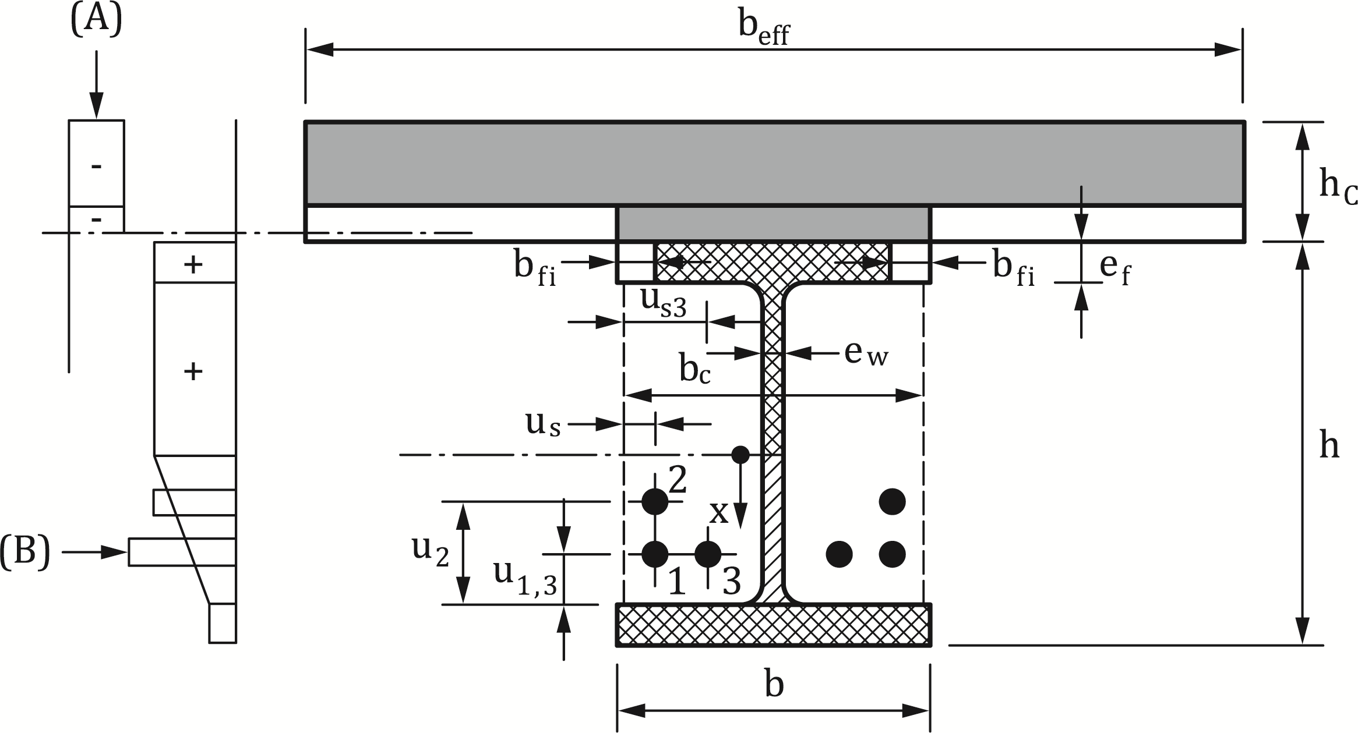

**Key**

|  |  |
| --- | --- |
| A | example of stress distribution in concrete |
| B | example of stress distribution in steel |

**Figure 7.4 — Elements of a cross-section for the calculation of sagging moment resistance**

(5) In a span of a continuous beam, the sagging moment resistance at any critical cross-section and the hogging moment resistance at each support shall respectively be calculated according to 7.4.2.3.3 and 7.4.2.3.4.

(6) When calculating the hogging moment resistance *M*Rd,fi , the elements of a cross-section shown in Figure 7.5 shall be considered.

(7) For the calculation of the moment resistance corresponding to the different fire classes, the following mechanical characteristics may be adopted:

* for the section, the yield point *f*ay reduced as a function of temperature if necessary;
* for the reinforcing bars, the reduced yield point *k*r *f*ry or *k*s *f*sy; and
* for the concrete, the compressive cylinder strength fck.

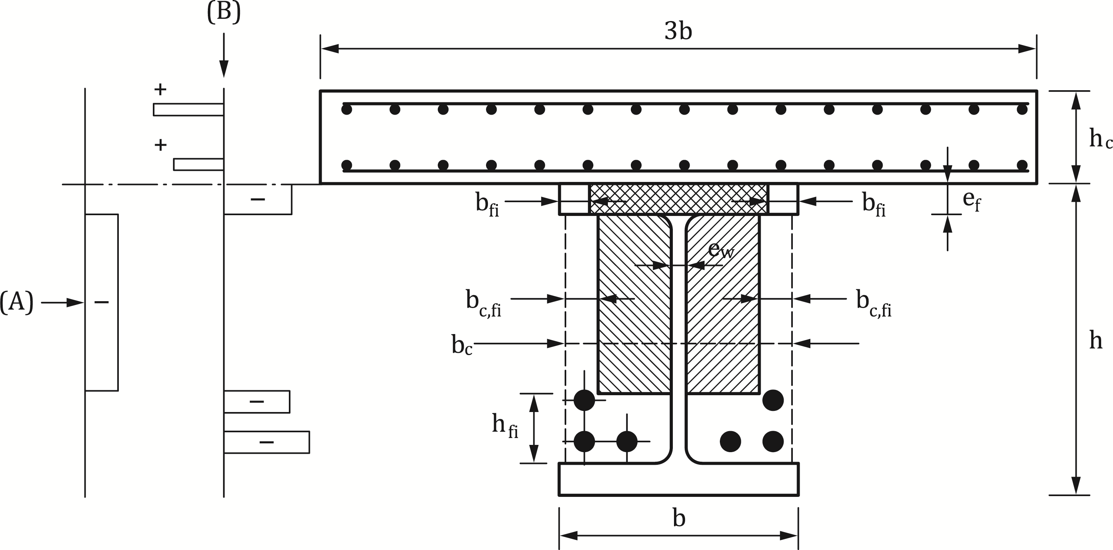

**Key**

|  |  |
| --- | --- |
| A | example of stress distribution in concrete |
| B | example of stress distribution in steel |

Figure 7.5 — Elements of a cross-section for the calculation of hogging moment resistance

(8) The design values of the mechanical characteristics given in (7) shall be obtained by applying the partial factors given in (1) of 4.5.

(9) Beams, which are considered as simply supported for normal temperature design, may be considered as continuous in the fire situation if (5) of 9.4.1 is fulfilled.

(10) If plastic hinges develop at supports, the principles of plastic global analysis shall apply for the combination of sagging and hogging moments.

(11) Composite beams comprising steel beams with partial concrete encasement may be assumed not to fail through lateral torsional buckling in the fire situation.

(12) If a partially encased steel beam supports a slab, without shear connection, rules given in 7.4.2.3.3 and 7.4.2.3.4 may be applied by ignoring the resistance of the slab.

##### Sagging moment resistance

(1) The width *b*eff of the slab considered for calculation of the sagging moment resistance MRd,fi+ should be equal to the effective width determined according to prEN 1994-1-1:2024, 7.4.1.2.

(2) In order to calculate the sagging moment resistance, the part of the slab in compression, the top flange of the section, the web of the section, the bottom flange of the section and the reinforcing bars should be taken into account. For each of these parts of the cross-section, a corresponding rule may define the effect of the temperature. The part of the slab in tension and the concrete between the flanges of the section should be ignored (see Figure 7.4).

(3) On the basis of the essential equilibrium conditions and, on the basis of plastic theory, the neutral axis may be defined and the sagging moment resistance may be calculated.

##### Hogging moment resistance

(1) The effective width of the concrete slab considered for calculation of hogging moment resistance MRd,fi- is reduced to three times the width of the steel section (see Figure 7.5). This effective width determines the reinforcing bars to be taken into account.

(2) In order to calculate the hogging moment resistance, the reinforcing bars in the slab, the top flange of the section except when (14) is applicable, and the concrete in compression between the flanges of the section should be taken into account. For each of these parts of the cross-section a corresponding rule may define the effect of temperature. The part of the slab in tension, the web and the bottom flange of the section should be ignored.

NOTE For the design of the web, regarding vertical shear, Annex D applies.

(3) The reinforcing bars situated between the flanges of the steel beam may participate in compression and be considered in the calculation of the hogging moment resistance, provided that:

* the corresponding stirrups fulfil the relevant requirements given in EN 1992-1-1, in order to restrain the reinforcing bars against local buckling; and
* either both the steel section and the reinforcing bars are continuous at the support or (5) of 9.4.1 is applicable.

(4) In the case of a simply supported beam according to (5) of 9.4.1, the top flange should not be taken into account if it is in tension.

(5) The neutral axis may be defined and the hogging moment resistance may be calculated on the basis of the essential equilibrium conditions and on the basis of plastic theory.

#### Composite shallow floor beams

(1) This clause applies to composite shallow floor beam configurations defined in EN 1994-1-1 and heated from below.

(2) The cross-sections of shallow floor beams should be classified at elevated temperatures as for normal temperature design with a value for εfi given by Formula (7.18):

 (7.18)

where

|  |  |
| --- | --- |
| fy | is the yield strength of the flange, plate or web [N/mm²]; |
| ❑ | is the temperature of the flange, plate or web [°C]; |
| kE, | is the reduction factor for Young’s modulus of the flange, plate or web at temperature  according to Table 5.3 [-]; |
| ky, | is the reduction factor for yield strength of the flange, plate or web at temperature  according to Table 5.3 [-]. |

(3) In case of sagging bending moment Formula (7.14) may be simplified with the coefficient for cross-sectional classification in the fire situation εfi given by Formula (7.19):

 (7.19)

(4) The rules for determination of plastic neutral axis and design moment resistance given in 7.2(3) and 7.2(4) respectively shall apply to composite shallow floor beams, except Class 4 sections.

(5) For shallow floor beams, the upper surface of each external part of the bottom plate (or flange) may be partially exposed to fire. Unless at least 85 % of this upper surface is in contact with the slab, this upper surface should be considered as totally exposed to fire.

NOTE Typical examples for the external parts of the bottom plate (or flange) of shallow floor beams are shown in Figure 7.6.

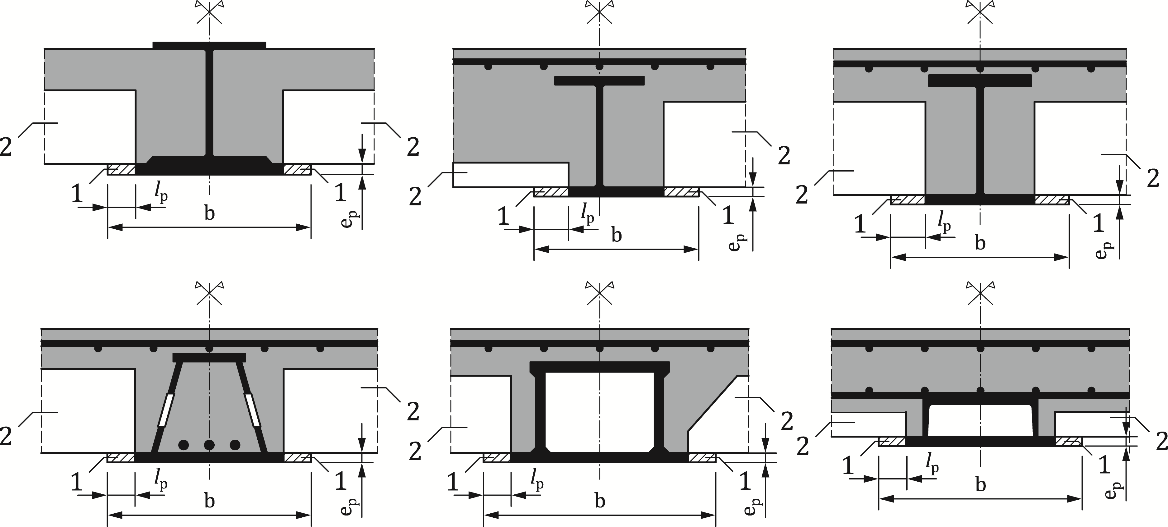

Key

|  |  |
| --- | --- |
| 1 | external part of the bottom plate (or flange) |
| 2 | solid concrete slab, prefabricated concrete slab or steel sheeting |

**Figure 7.6 — Typical examples of external parts of the bottom plate or flange of shallow floor beams**

(6) When plastic global analysis is used to determine the action effects of continuous composite shallow floor beams, adequate rotation capacity at the locations of the plastic hinges shall be verified.

(7) The contribution of reinforcing bars may be taken into account when they are subjected to tension. For reinforcing bars subjected to compression, 7.4.2.3.2(3) applies.

(8) Composite shallow floor beams may be assumed not to fail under lateral torsional buckling in the fire situation.

(9) The contribution of beam webs to the bending resistance of a cross-section should either be ignored or be reduced as a function of their utilisation in vertical shear.

(10) In case the load transfer from the concrete slab to the web of the composite shallow floor beam is achieved by bearing of the slab onto parts of the steel section (see 9.2.2(3)), the influence of transverse shear and bending should be taken into account when determining of the global bending resistance of the composite shallow floor beam.

(11) The reduced yield strength of the bottom flange (or plate) fy,red due to transverse vertical shear and bending should be calculated according to Formula (7.20):

 (7.20)

where

|  |  |
| --- | --- |
|  | is the load level of the plate (or flange) under transverse bending |
| *mEd,fi* | is the design transverse bending moment per unit length [kN.m/m] of the bottom plate (or flange) under fire conditions |
| *mpl,Rd,* | is the plastic bending resisting moment per unit length [kN.m/m] of the bottom plate (or flange) at temperature . |

(12) When the load level of the bottom plate (or flange) under transverse shear  calculated according to Formula (7.21) is higher than 0.05, the influence of transverse shear on reduction of yield strength of the bottom flange (or plate) shall be taken into account.

 (7.21)

where

|  |  |
| --- | --- |
|  | is the design transverse shear per unit length of the bottom plate for normal temperature [kN/m] |
|  | is the plastic shear resistance per unit length of the bottom plate for normal temperature for normal temperature [kN/m] |

(13) The design shear resistance in the fire situation of a headed stud welded to the upper flange of a composite shallow floor beam should be determined using 7.4.2.2.3(1) and 7.4.2.2.3(2).

(14) The design shear resistance in the fire situation of a headed stud welded to a web of a composite shallow floor beam should be determined using 7.4.2.2.3(1). The temperature *θ*v [°C] of the stud connector may be taken as equal to the temperature of the web at the height of the stud and the temperature of concrete *θ*c [°C] as 60 % of the temperature of the web at that position.

NOTE For the temperature of the web, Annex H applies.

(15) The design shear resistance in the fire situation of transverse bars acting as shear connectors and designed according to prEN 1994-1-1:2024, I.3.4.3 should be determined by replacing the partial factor *γ*v by *γ*M,v,fi and the yield strength of transverse bar fsk by fsy,*θ* according to Table 5.4. The temperature of the transverse bar may be taken as equal to the temperature of the web at the height of the transverse bar.

NOTE This rule applies only if the axis distance of the transverse bars satisfies the requirements stated in column 3 of FprEN 1992-1-2:2023, Table 6.10.

(16) The vertical and transverse deformations of the shallow floor beam should be compatible with the concrete slab.

(17) If the shallow floor beam supports a slab, without shear connection, rules given in 7.4.2.4 may be applied by ignoring the mechanical resistance of the slab.

## Composite columns

### General

(1) The simplified design method described below shall only be used for columns under pure axial compression in braced frames designed according to EN 1994-1-1. The columns are assumed to be uniformly heated around their cross-section.

NOTE prEN 1994-1-1:2024, 8.8.3.1(1), in all cases limits the relative slenderness  for normal design, to a maximum of 2.

(2) The design value in the fire situation, of the resistance of a composite column in pure axial compression (buckling load) should be obtained from Formula (7.22):

 (7.22)

where

|  |  |
| --- | --- |
| χ | is the reduction coefficient for buckling curve c of EN 1993-1-1:2022, 8.3.1.3(1) as a function of the relative slenderness ; |
| *N*fi,pl,Rd | is the design value of the plastic resistance to axial compression in the fire situation. |

(3) The design value of the plastic resistance to axial compression in the fire situation is given by Formula (7.23).

 (7.23)

where

|  |  |
| --- | --- |
| fay,i | is the nominal yield strength *f*ay for the elemental steel area A*i* at 20 °C; |
| fsy,j | is the nominal yield strength *f*sy for the elemental steel area A*j* at 20 °C; |
| *f*ck,k | is the characteristic strength for the elemental concrete area *A*k at 20 °C; |
| *k*y,θ,i, *k*y,θ,j and *k*c,θ,k | are as defined in Table 5.3, Table 5.4 and Table 5.5; |
| *A*i,θ, *A*j,θ and *A*k,θ | is the area of each element of the cross-section, which may be reduced for the fire conditions. |

(4) The effective flexural stiffness  is calculated using Formula (7.24).

 (7.24)

where

|  |  |
| --- | --- |
| *I*a,θ,i | is the second moment of area of the partially reduced part i of structural steel for bending around the weak or strong axis; |
| *I*s,θ,j | is the second moment of area of the partially reduced part j of reinforcing steel for bending around the weak or strong axis; |
| *I*c,θ,k | is the second moment of area of the partially reduced part k of concrete for bending around the weak or strong axis; |
| *φ*a,θ, *φ*s,θ, *φ*c,θ | are reduction coefficients taking into account the effect of thermal stresses; |
| *k*E,θ,i and *k*E,θ,j | are as defined in Table 5.3 and Table 5.4; and |
| Ec,sec,θ | is the characteristic value of the secant modulus of concrete in the fire situation, given by *f*c,θ divided by *ε*c1,θ (see Figure 5.8). |

NOTE For the evaluation of the reduction coefficients of partially encased steel sections, Annex E applies.

(5) The elastic critical load in the fire situation should be calculated using Formula (7.25).

 (7.25)

where

|  |  |
| --- | --- |
| *l*fi | is the buckling length of the column in the fire situation. |

(6) The relative slenderness should be calculated using Formula (7.26).

 (7.26)

where

|  |  |
| --- | --- |
| *N*pl,R,fi | Is the value of *N*pl,Rd,fi according to (4) when the factors γM,a,fi, γM,fi,s and γM,c,fi are taken as 1,0. |

(7) For the determination of the buckling length lfi of columns, the rules of EN 1994-1-1 apply, with the exceptions given below.

(8) A column in the storey under consideration, fully connected to the column above and below, may be considered as effectively restrained at such connections, provided the fire resistance of the building elements, which separate the levels under consideration, is at least equal to the fire resistance of the column.

(9) In the case of a composite frame, for which each of the storeys may be considered as a fire compartment with sufficient fire resistance, the buckling length lfi of a column subject to fire may be taken as 0,5 L in an intermediate storey and as 0,7 L in the top storey, where L is the system length in the relevant storey, see Figure 7.7.

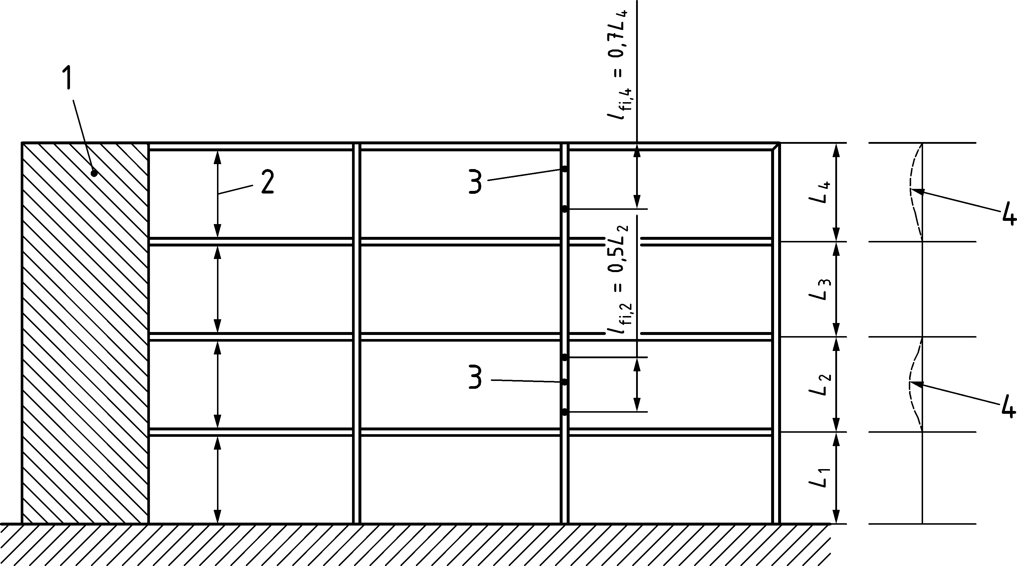

Key

|  |  |
| --- | --- |
| 1 | shear wall or other bracing system |
| 2 | separate fire compartments in each storey |
| 3 | columns length exposed to fire |
| 4 | deformation mode in fire |

**Figure 7.7 — Buckling lengths lfi of columns in braced frames**

### Partially encased steel sections

(1) The fire resistance of columns comprising steel sections with partial concrete encasement shall be determined according to Annex E.

NOTE For construction details, refer to 9.1, 9.3.1 and 9.4.

### Unprotected concrete filled hollow steel sections

(1) The fire resistance of columns comprising unprotected concrete filled square or circular hollow sections shall be determined according to Annex F.

NOTE For constructional details, refer to 9.1, 9.3.2 and 9.4.

### Protected concrete filled hollow steel sections

(1) An improvement in the fire resistance of a concrete filled hollow section may be obtained by using a protection system around the steel column, in order to decrease the heat transfer.

(2) The performance of the protection system used for concrete filled hollow steel sections should be assessed according to:

* EN 13381-2, for vertical sheatings; and
* EN 13381-6, for coatings or sprayed materials .

(3) The loadbearing criterion "R" may be assumed to be satisfied provided the temperature of the hollow section remains lower than 350 °C.

# Advanced design methods

## General

(1) Advanced design methods shall be based on fundamental physical behaviour, employing local equilibrium equations, which are satisfied at every point in the structure.

(2) Any potential failure mode not covered by the advanced design method shall be prevented in the physical structure by appropriate means, such as specific construction details for example.

(3) Advanced design methods may include separate calculation models for the determination of:

* the development and distribution of temperature within structural members (thermal response model); and
* the mechanical behaviour of the structure or of any part of it (mechanical response model).

(4) Advanced design methods may be used in association with any thermal action, provided the material properties are known for the relevant temperature history.

(5) Advanced design methods may be used with any type of cross-section.

(6) Advanced design methods may be used when information concerning stress and strain evolution, deformations and/or temperature fields are required.

## Thermal analysis

(1) Advanced design methods for thermal response shall be based on the acknowledged principles and assumptions of the theory of heat transfer.

(2) For composite shallow floor cross-sections, imperfect contact influencing conduction between steel parts may be taken into account in thermal analysis, if justified by test results.

(3) The thermal response model shall consider:

* the relevant thermal actions specified in EN 1991-1-2; and
* the temperature dependent thermal properties of the materials, see 5.2.

(4) The effects of non-uniform thermal exposure and of heat transfer to adjacent building components may be included where appropriate.

(5) The influence of moisture content and of migration of the moisture within materials may conservatively be neglected.

## Mechanical analysis

(1) Advanced design methods for mechanical analysis shall be based on the acknowledged principles and assumptions of the theory of structural mechanics.

(2) The mechanical response model shall consider:

* the material temperatures calculated according to 8.2; and
* the temperature dependent mechanical properties of the materials, see 5.3.

(3) The effects of thermally induced strains and stresses due to temperature rise and to temperature differentials shall be taken into account.

(4) The mechanical response model should also take account of:

* geometrical imperfections;
* geometrical non-linear effects; and
* non-linear material behaviour, including the effects of loading and unloading on the structural stiffness.

(5) The compatibility between all parts of the structure shall be taken into account by the design method.

(6) The deformations given by the design method shall not cause failure due to the loss of adequate support to one of the members.

(7) For the analysis of isolated members, a sinusoidal initial imperfection with a maximum value of *L/*1000 at mid-length should be used, unless otherwise specified by a relevant product standard, where *L* is the physical length of the member.

## Validation

(1) The design method should be validated on the basis of relevant test results.

(2) Calculation results may refer to temperatures, deformations and fire resistance times.

(3) The critical parameters should be checked to ensure that the model complies with established engineering principles, by means of a sensitivity analysis.

NOTE Critical parameters can refer, for example to the buckling length, the size of the elements, the load level.

# Detailing

## General

(1) If the required shear connection between steel and concrete of a composite member cannot be maintained by construction detailing under fire conditions, either the steel or the concrete part of the composite section shall fulfil the fire requirements independently.

(2) For concrete-filled hollow sections and partially encased sections, shear connectors should not be attached to any directly heated unprotected parts of the steel section. In case thick bearing blocks or sheat flats are welded to a steel section encased in concrete, this steel section is not considered as directly heated (see Figures 9.5 and 9.6).

(3) If welded steel sections are used, the parts directly exposed to fire should be attached to the protected parts by sufficiently strong welds.

(4) For fire exposed concrete surfaces, the concrete cover of reinforcing bars should be between 20 mm and 50 mm.

NOTE This rule aims to reduce the danger of spalling under fire exposure.

(5) In cases where concrete encasement provides only an insulation function, steel mesh with a maximum bar spacing of 250 mm and a minimum bar diameter of 4 mm in both directions should be placed around the section and should fulfil (4).

(6) When the concrete cover to reinforcing bars exceeds 50 mm, mesh should be placed near the exposed surface to satisfy (4).

## Composite beams

### Composite beams comprising steel beams with partial encasement

(1) For composite beams comprising steel beams with partial concrete encasement, the concrete between the steel flanges shall be reinforced and fixed to the web of the beam.

(2) The partial encasement concrete should be reinforced by stirrups with a minimum diameter s of 6 mm or by a reinforcing mesh with a minimum diameter of 4 mm. The concrete cover of the stirrups should not exceed 35 mm. The distance between the stirrups should not exceed 250 mm. In the corners of the stirrups a longitudinal reinforcement with a minimum diameter r of 8 mm should be placed (see Figure 9.1).

|  |  |  |
| --- | --- | --- |
|  |  |  |
| a) Welding of stirrups to the web | b) Bars through holes in the web, fixed to the stirrups | c) Welding of studs to the web |

Key

|  |  |
| --- | --- |
| 1 | welds |
| 2 | studs |

Figure 9.1 — Connection between a steel section and the encasing concrete

(3) The concrete between the steel flanges may be fixed to the web by welding the stirrups to the web with a fillet weld with a minimum throat thickness aw of 0,5 s and a minimum length  of 4 s (see Figure 9.1.a).

(4) The concrete between the steel flanges may be fixed to the web of the beam by means of bars, penetrating the web through holes, or studs welded to both sides of the web satisfying the following conditions:

* the bars have a minimum diameter b of 6 mm (see Figure 9.1 b));
* the studs have a minimum diameter d of 10 mm and a minimum length hv of 0,3b. Their head should be covered by at least 20 mm of concrete (see Figure 9.1 c)); and
* the bars or studs are arranged as given in Figure 9.2 a) for steel sections with a maximum depth h of 400 mm or as given in Figure 9.2 b) for steel sections with a depth h greater than 400 mm. When the height is greater than 400 mm, staggered rows of connectors should be used with a distance between them not exceeding 200 mm.

|  |  |
| --- | --- |
|  |  |
| a) height of steel section h ≤ 400 mm | b) height of steel section h > 400 mm |

Figure 9.2 — Arrangement of bars or studs providing connection between a steel section and the encasing concrete

### Composite shallow floor beams

(1) Load transfer from the concrete slab to the steel web of a composite shallow floor beam shall be verified.

(2) Load transfer from the concrete slab to the steel web of a composite shallow floor beam may be achieved by direct bearing onto the steel section or by reinforcement.

NOTE Typical examples of adequate detailing are given in Figure 9.3.

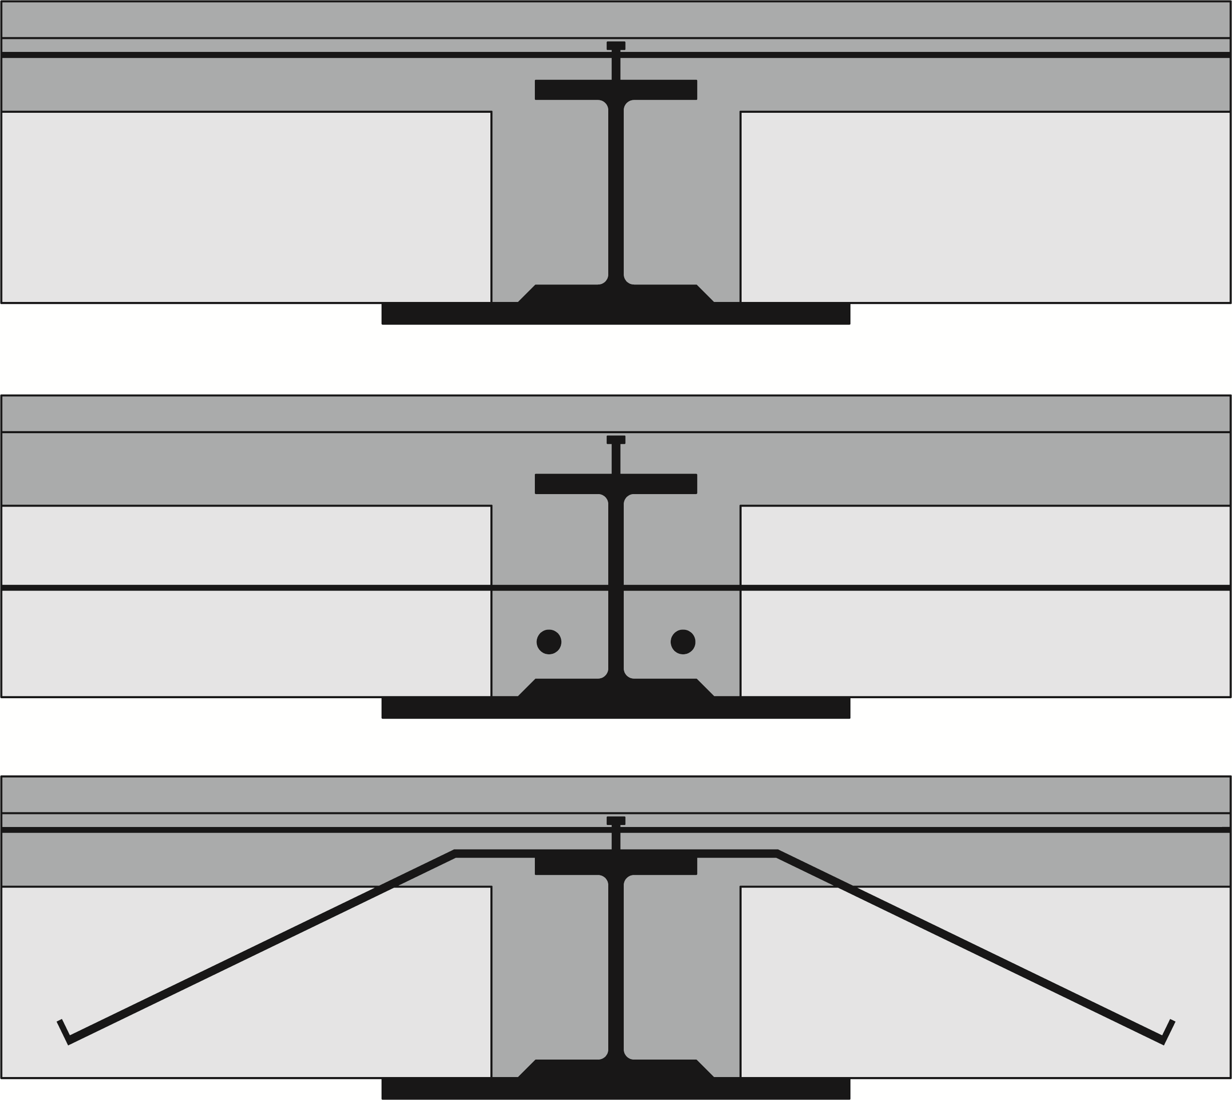

**Figure 9.3 — Typical construction details for load transfer from the concrete slab to the steel web of a composite shallow floor beam**

(3) When the load transfer from the concrete slab to the steel web of a composite shallow floor beam is achieved by additional reinforcement bars, the minimum diameter of the reinforcement bars is 10 mm and the maximum distance between the bars is 600 mm.

(4) When the load transfer from the concrete slab to the steel web of a composite shallow floor beam is achieved by additional reinforcement bars and the concrete slab is made of prefabricated elements, the minimum thickness of concrete topping is 50 mm.

(5) Transverse bars should be adequately anchored in the concrete slab.

(6) Composite shallow floor beams may be designed without mechanical connexion between the steel profile and the concrete between the flanges.

## Composite columns

### Composite columns comprising partially encased steel sections

(1) The concrete between the flanges of the steel section shall be fixed to the steel web either by means of stirrups or by studs (see Figure 9.4).

(2) The stirrups should be welded to the web or penetrate the web through holes. If studs are used, they should be welded to the web.

(3) The spacing of studs or stirrups along the column axis should not exceed 500 mm. In load introduction areas this spacing should be reduced according to EN 1994-1-1.

(4) The cover and spacing of longitudinal rebars should satisfy Figure 9.4.

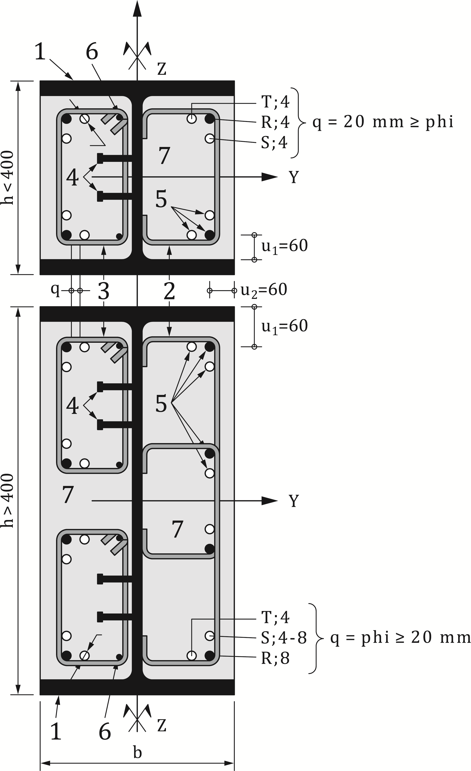

**Figure 9.4 — Construction details of composite columns comprising partially-encased steel sections**

### Composite columns comprising concrete filled hollow sections

(1) Shear connection shall be ensured by connectors situated at the level of the beam to column connection. There shall be no additional shear connection along the column, between the beam to column connections.

(2) Any longitudinal reinforcement should be held in place by means of stirrups and spacers.

(3) The spacing of stirrups along the column axis should not exceed 15 times the smallest diameter of the longitudinal reinforcing bars.

(4) The hollow steel section shall contain holes with a diameter of not less than 20 mm located at least one at the top and one at the bottom of the column length in every storey. The spacing of these holes should not exceed 5 m.

## Connections between composite beams and columns

### General

(1) The beam to column connections shall be designed and constructed in such a way that they support the applied forces and moments for the same fire resistance time as that of the member transmitting the actions.

(2) For fire protected members one way of achieving the requirement of (1) is to apply at least the same fire protection as that of the member transmitting the actions, and to ensure for the connection a load ratio which is not greater than that of the member.

NOTE For the design of fire protected connections, methods are given in FprEN 1993-1-2:2023, 7.1(7) and Annex D.

(3) Composite beams and columns may be connected using bearing blocks or shear flats welded to the steel section of the composite column. The beams shall be supported on the bearing blocks or their webs are bolted to the shear flats. If bearing blocks are used, appropriate constructional detailing should guarantee that the beam cannot slip from its support during the cooling phase.

(4) If connections are made in accordance with Figures 9.5 to 9.7, their fire resistance may be assumed to comply with the requirements of the adjacent structural members. Bearing blocks welded to composite columns may be used with protected steel beams.

(5) In the case of a beam simply supported for normal temperature design, a hogging moment may be developed at the support in the fire situation, provided the concrete slab is reinforced in such a way as to guarantee the continuity of the concrete slab. The transmitted axial force shall be limited to the resistance of the reinforcement, or that of the connection to the steel section, whichever is the lower. (see Figure 9.4).

(6) A hogging moment may always be developed according to (5) and Figure 9.5 in the fire situation if gap < 10 mm or 10 mm ≤ gap < 15 mm, for R30 up to R180 and a beam span larger than 5 m.

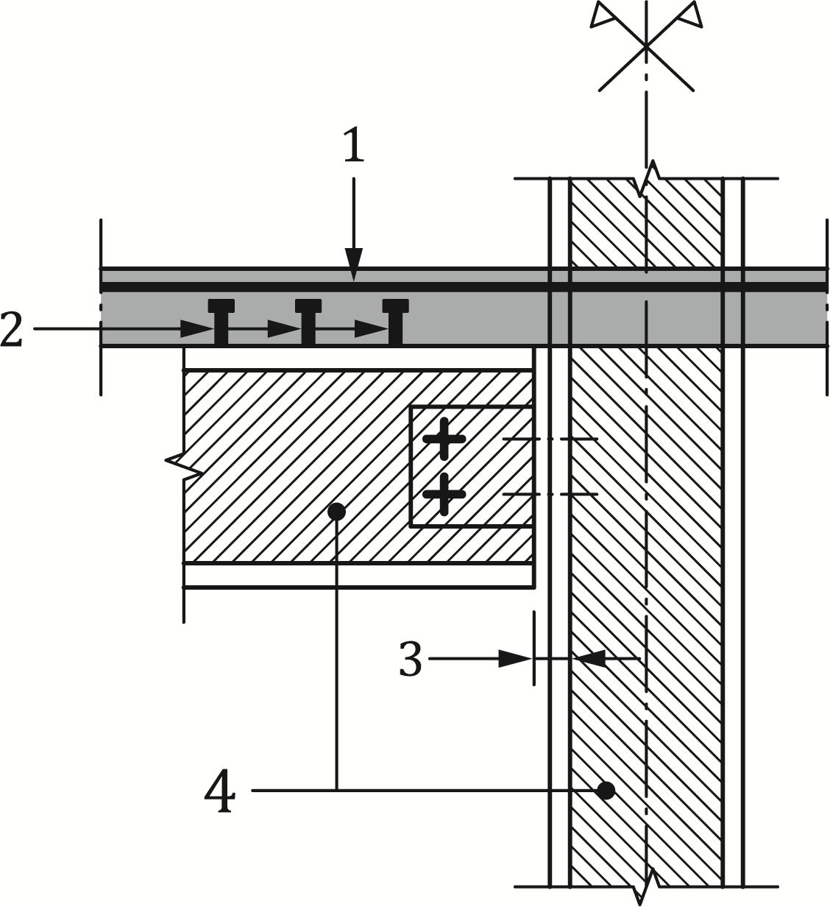

Key

|  |  |
| --- | --- |
| 1 | reinforcing bar |
| 2 | studs |
| 3 | gap |
| 4 | sections with infilled concrete |

**Figure 9.5 — Hogging moment joint for fire conditions**

### Connections between composite beams and composite columns comprising steel sections encased in concrete

(1) Bearing blocks or shear flats according to Figure 9.6 may be directly welded to the flange of the steel section of the composite column in order to support a composite beam.

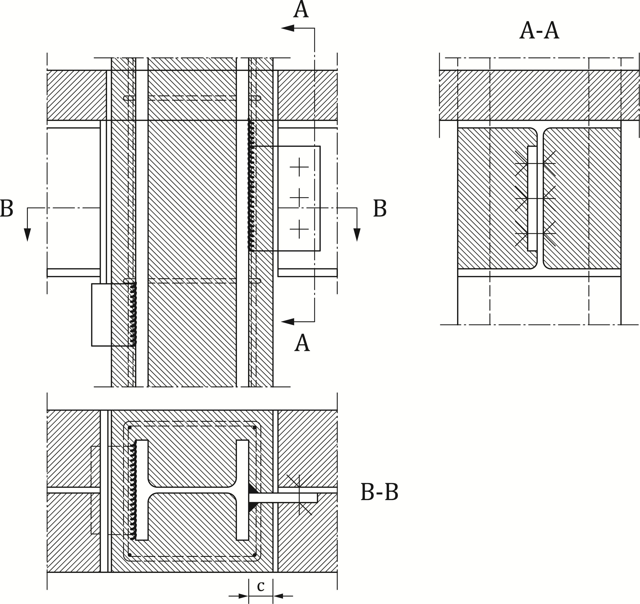

**Figure 9.6 — Examples of connections to a totally encased steel section column**

### Connections between composite beams and composite columns with partially encased steel sections

(1) Additional studs should be provided if unprotected bearing blocks are used (see Figure 9.7), and the fire exposed welds are not adequate to transfer the reaction force from the connected beam. The shear resistance of the studs should be checked according to 7.4.2.2.3(1) with a stud temperature equal to the average temperature of the bearing block.

(2) For fire resistance classes up to R 120 additional studs are not needed if the following conditions are satisfied (see Figure 9.7):

* the unprotected bearing block has a minimum thickness of at least 80 mm;
* it is continuously welded on four sides to the column flange; and
* the upper weld, protected against direct radiation, has a thickness of at least 1,5 times the thickness of the surrounding welds and should in normal temperature design support at least 40 % of the design shear load.

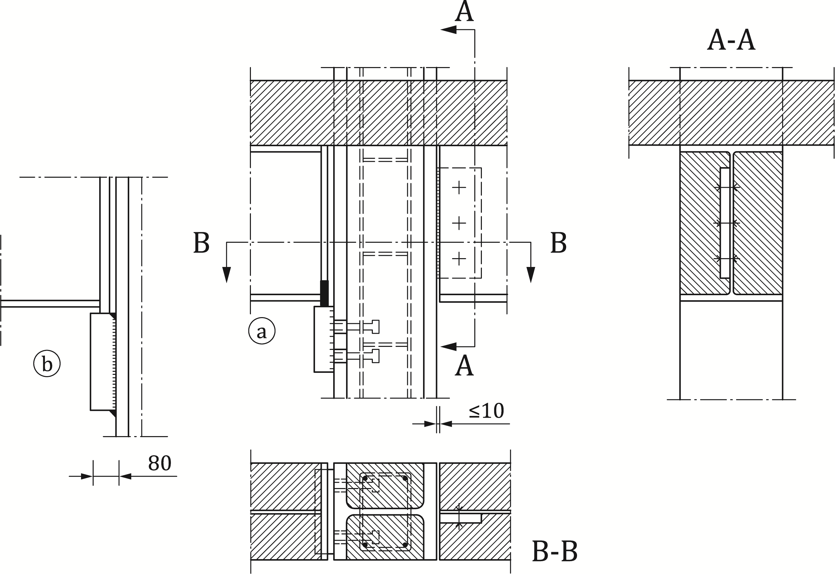

**Figure 9.7 — Examples of connections to a partially encased steel section column**

(3) If shear flats are used, additional protection to the remaining gap between the beam end and column may be neglected if not bigger than 10 mm (see Figure 9.7).

### Connections between composite beams and composite columns comprising concrete filled hollow sections

(1) Composite beams may be connected to composite columns comprising concrete filled hollow sections using either bearing blocks or shear flats (see Figure 9.8).

(2) Shear and tension forces shall be transmitted by adequate means from the beam to the reinforced concrete core of the column.

(3) If bearing blocks are used (see Figure 9.8 a)) the shear load transfer in case of fire should be ensured by means of additional studs. The shear resistance of the studs should be checked according to 7.4.2.2.3 (1) with a stud temperature equal to the average temperature of the bearing block.

(4) If shear flats are used (see Figure 9.8 b)), they should penetrate the column and they should be connected to both walls by welding.

|  |  |
| --- | --- |
|  |  |
| a) Bearing blocks with additional studs | b) Penetrating shear flats |

Figure 9.8 — Examples of connections to a concrete filled hollow section

1. (normative)  
     
   Strain-hardening of structural steel at elevated temperatures
   1. Use of this annex

(1) This Normative Annex contains additional provisions to the stress-strain relationships of structural steel defined in 5.3.1.2(1) and 5.3.1.2(2) for temperatures below 400 °C.

* 1. Scope and field of application

(1) This Normative Annex applies to steel grades S235, S275, S355, S420 and S460 in tension or compression.

(2) The effect of strain-hardening should only be taken into account if the analysis is based on advanced design methods according to Clause 8.

(3) If this Normative Annex A is applied, it should be proven that local failures (i.e. local buckling, shear failure, concrete spalling, etc) do not occur because of increased strains.

* 1. Stress-strain relationships at elevated temperatures for structural steel

(1) For temperatures below 400C, the alternative strain-hardening option mentioned in 5.3.1.2(4) may be used as follows:

  (A.1)

 (A.2)

  (A.3)

  (A.4)

where

|  |  |
| --- | --- |
| fau, | is the ultimate strength at elevated temperature, allowing for strain-hardening. |

NOTE The alternative stress-strain relationships for steel, allowing for strain-hardening, are illustrated in Figure A.1.

(2) The ultimate strength at elevated temperature, allowing for strain-hardening, should be determined as follows:

; (A.5)

;  (A.6)

; (A.7)

NOTE The variation of the alternative stress-strain relationship with temperature is illustrated in Figure A.2.

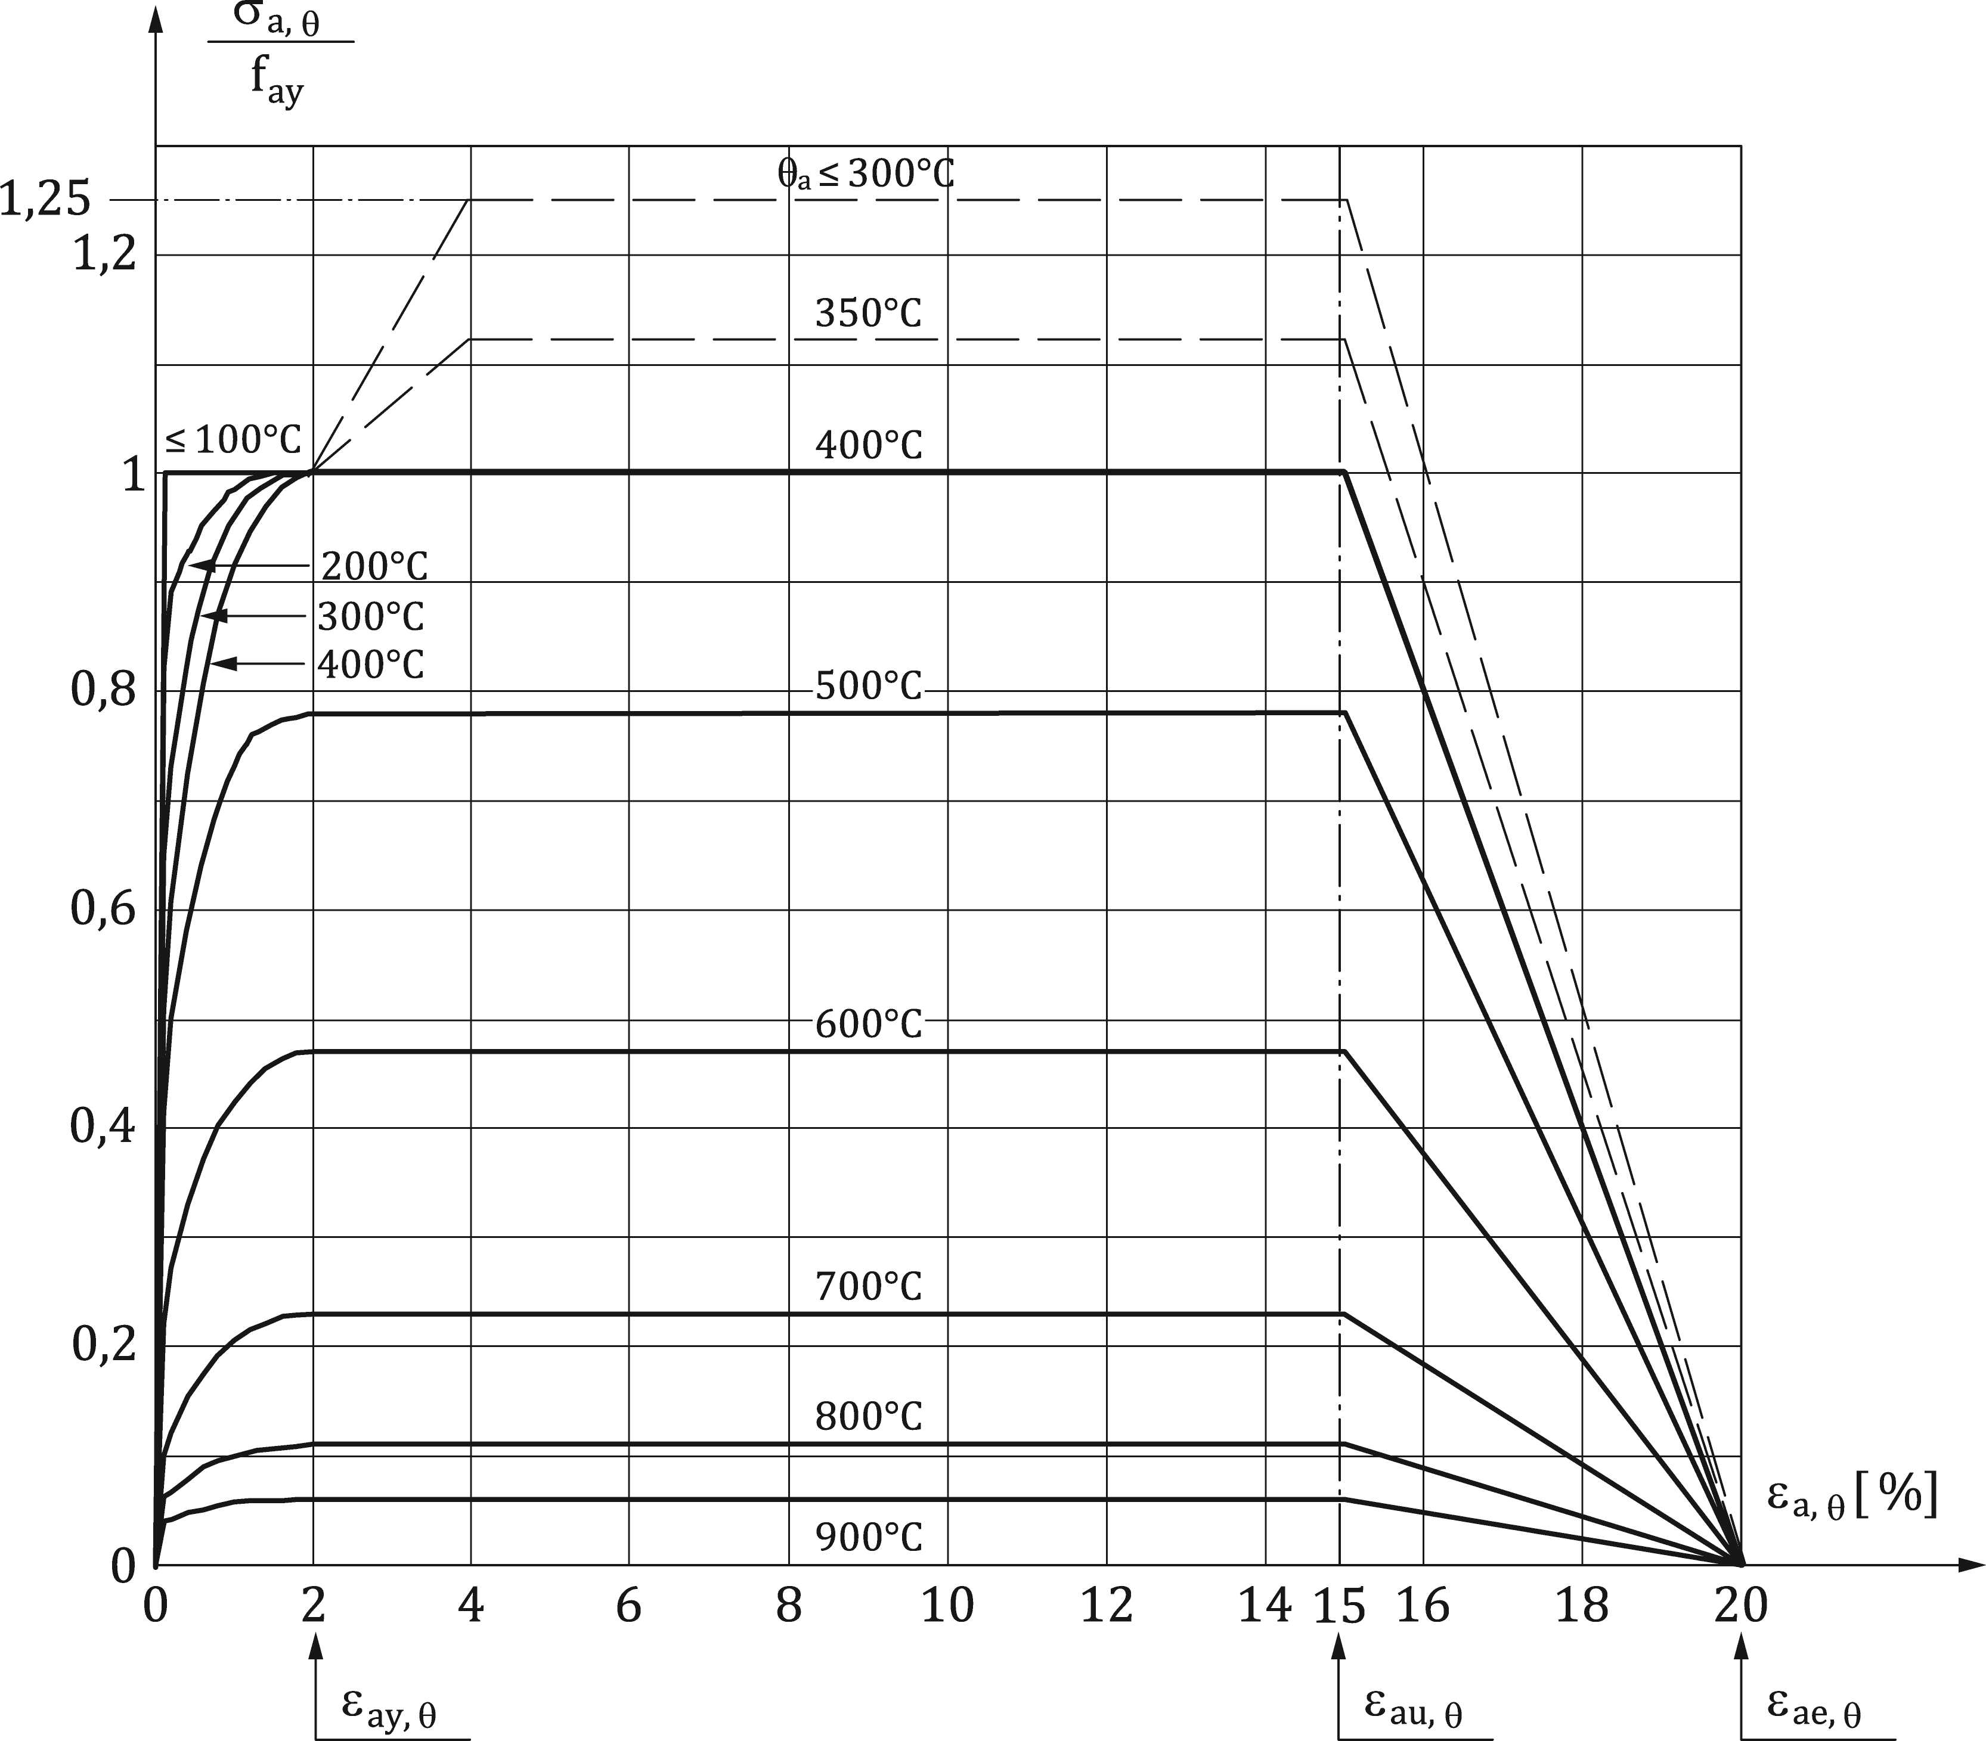

**Figure A.1 — Alternative stress-strain relationships for steel at elevated temperatures, allowing for strain-hardening**

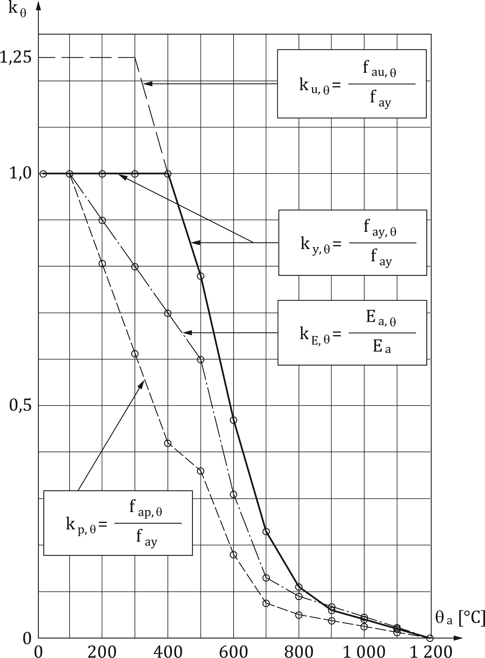

**Figure A.2 — Reduction factors k for stress-strain relationships allowing for strain-hardening of structural steel at elevated temperatures (see also Table 5.2 of 5.3.1.2)**

1. (informative)  
     
   Model for the calculation of the fire resistance of unprotected composite slabs
   1. Use of this annex

(1) This Informative Annex gives supplementary provisions to 7.3.1 for assessing the loadbearing criterion “R” and the criterion of thermal insulation “I” of unprotected composite slabs exposed to fire from underneath according to the standard temperature-time.

NOTE National choice on the application of this Informative Annex is given in the National Annex. If the National Annex contains no information on the application of this informative annex, it can be used.

* 1. Scope and field of application

(1) This Informative Annex applies to unprotected composite slabs with profiled steel sheetings covered by EN 1994-1-1 and respecting the conditions of Table B.1.

NOTE Notation is defined in Figures 7.1 and 7.2.

(2) This Informative Annex applies to composite slabs made of normal weight concrete (NC) or lightweight concrete (LC).

Table B.1 — Field of application

|  |  |
| --- | --- |
| for re-entrant steel sheeting | for trapezoidal steel sheeting |
| 77,0 ≤ ℓ1 ≤ 135,0 mm | 80,0 ≤ ℓ1 ≤ 155,0 mm |
| 110,0 ≤ ℓ2 ≤ 150,0 mm | 32,0 ≤ ℓ2 ≤ 132,0 mm |
| 38,5 ≤ ℓ3 ≤ 97,5 mm | 40,0 ≤ ℓ3 ≤ 115,0 mm |
| 50,0 ≤ h1 ≤ 130,0 mm | 50,0 ≤ h1 ≤ 125,0 mm |
| 30,0 ≤ h2 ≤ 60,0 mm | 50,0 ≤ h2 ≤ 100,0 mm |

* 1. Fire resistance with respect to thermal insulation

(1) The fire resistance with respect to both the average temperature rise (=140 °C) and the maximum temperature rise (=180 °C), criterion “I”, may be determined according to Formula (B.1):

 (B.1)

where

|  |  |
| --- | --- |
| *ti* | the fire resistance with respect to thermal insulation [min] |
| *ai* | factors for different values of concrete depth *h1,* for both normal and lightweight concrete, which should be derived from Figure B.1 and Table B.2; for intermediate values, linear interpolation may be undertaken |
| $$A$$ | concrete volume of the rib per metre of rib length [mm3/m] |
| *Lr* | exposed area of the rib per metre of rib length [mm2/m] |
| *A/Lr* | the rib geometry factor [mm] |
|  | the view factor of the upper flange [-] |
|  | the width of the upper flange (see Figure B.1) [mm] |

and

 (B.2)

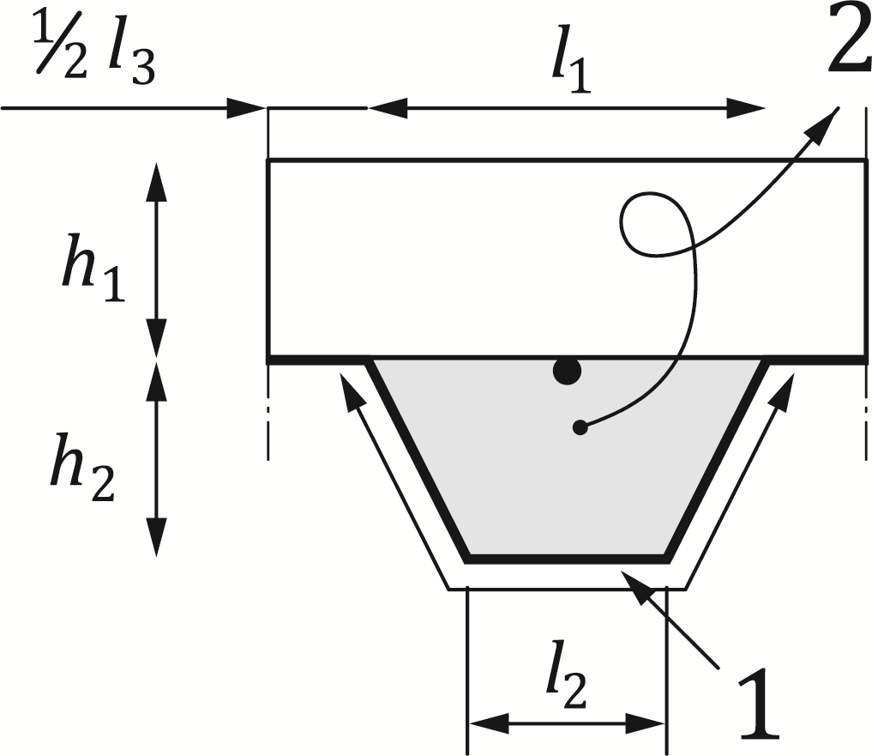

Key

|  |  |
| --- | --- |
| 1 | exposed surface: *Lr* |
| 2 | area: *A* |

**Figure B.1 — Definition of the rib geometry factor A/*Lr*for ribs of composite slabs**

Table B.2 — Coefficients for determination of the fire resistance with respect to thermal insulation

|  |  |  |  |  |  |  |
| --- | --- | --- | --- | --- | --- | --- |
|  | a0  [min] | a1  [min/mm] | a2  [min] | a3  [min/mm] | a4  [mm min] | a5  [min] |
| Normal weight concrete | -28,8 | 1,55 | -12,6 | 0,33 | -735 | 48,0 |
| Lightweight concrete | -79,2 | 2,18 | -2,44 | 0,56 | -542 | 52,3 |

(2) The view factor $Φ$ of the upper flange may be determined from Formula (B.3):

 [-] (B.3)

(3) In case of open trough sheetings with a top re-entrant stiffener (Figure B.2), the fire resistance with respect to criterion “I” may be determined from Formulae (B.1) and (B.2), where h1 and h2 should respectively be replaced by h1,mod and h2,mod, calculated according to Formulae (B.4) to (B.7).

 when  (B.4)

 when  (B.5)

 when  (B.6)

 when  (B.7)

where

|  |  |  |
| --- | --- | --- |
|  | height of the top re-entrant stiffener | [mm] |
| , | overall height of the profiled steel sheeting, excluding the height of the top re-entrant stiffener | [mm] |
|  | width of the upper flange of the steel sheeting, according to Figure B.2 | [mm] |
| , | width of the top re-entrant stiffener, according to Figure B.2 | [mm] |

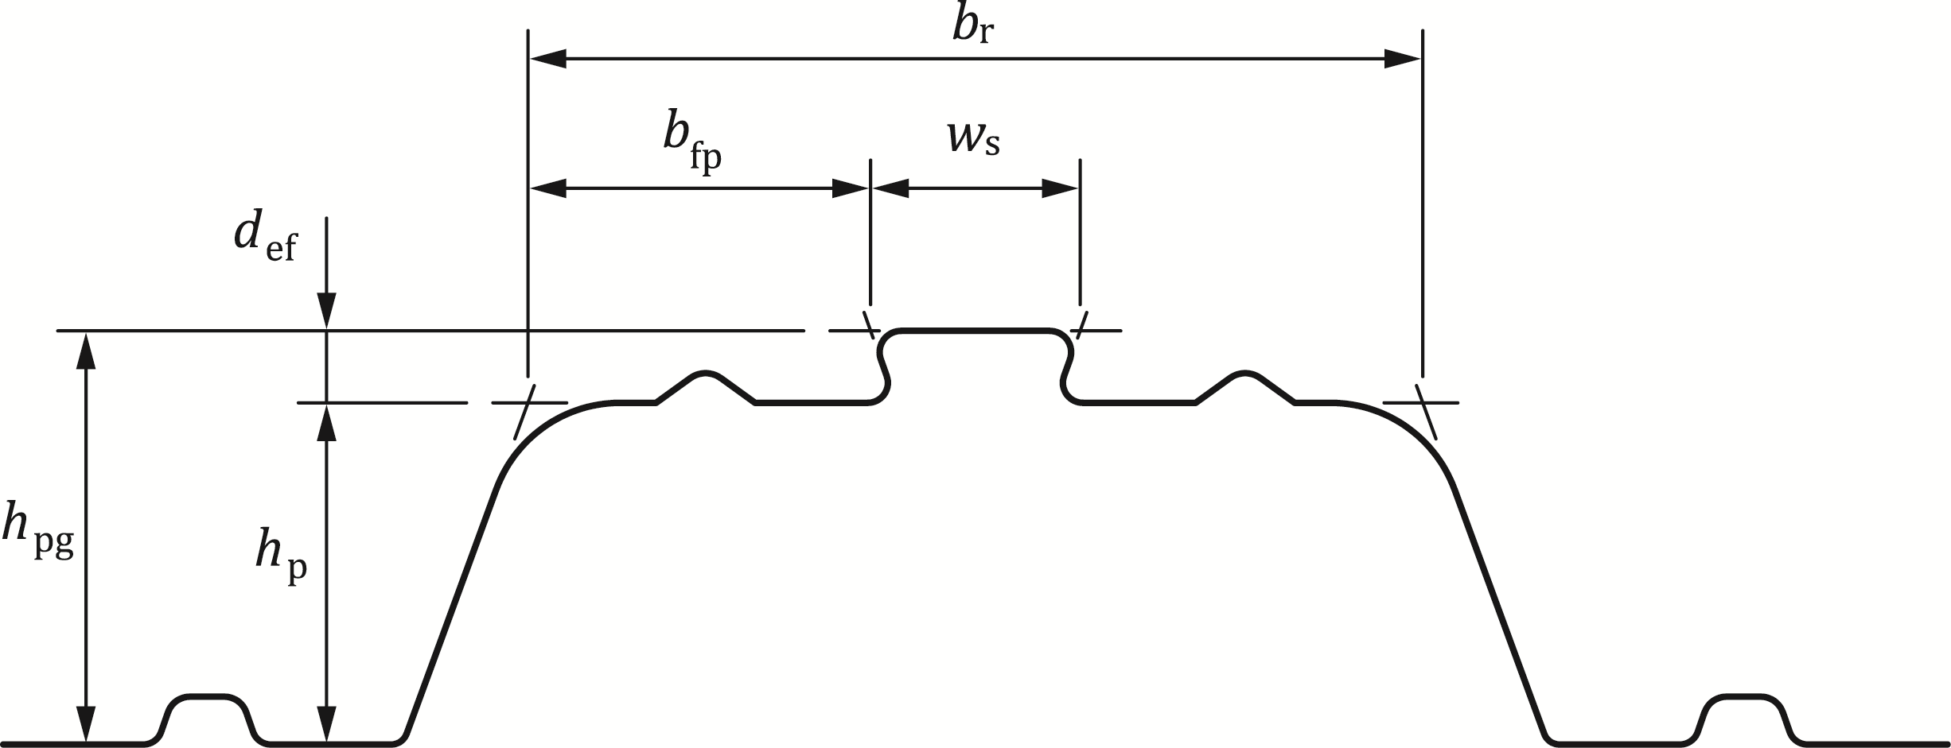

Figure B.2 — Open trough sheeting with a top re-entrant stiffener

* 1. Calculation of the sagging moment of resistance Mfi,Rd+

(1) The temperatures $θ_{a}$ of the lower flange, web and upper flange of the steel sheeting may be given by Formula (B.8):

 (B. 8)

where

|  |  |
| --- | --- |
| *bi* | factor for both normal and lightweight concrete, which should be derived from Table B.3; for intermediate values, linear interpolation may be undertaken. |

Table B.3 — Coefficients for the determination of the temperatures of the parts of the steel sheeting

|  |  |  |  |  |  |  |  |
| --- | --- | --- | --- | --- | --- | --- | --- |
| **Concrete** | **Fire resistance [min]** | **Part of the steel sheet** | ***b0***  **[oC]** | ***b1***  **[oC]. mm** | ***b2***  **[oC]. mm** | ***b3***  **[oC]** | ***b4***  **[oC]** |
| Normal weight concrete | 60 | Lower flange  Web  Upper flange | 951  661  340 | -1197  -833  -3269 | -2,32  -2,96  -2,62 | 86,4  537,7  1148,4 | -150,7  -351,9  -679,8 |
| 90 | Lower flange  Web  Upper flange | 1018  816  618 | -839  -959  -2786 | -1,55  -2,21  -1,79 | 65,1  464,9  767,9 | -108,1  -340,2  -472,0 |
| 120 | Lower flange  Web  Upper flange | 1063  925  770 | -679  -949  -2460 | -1,13  -1,82  -1,67 | 46,7  344,2  592,6 | -82,8  -267,4  -379,0 |
| Light weight concrete | 30 | Lower flange  Web  Upper flange | 800  483  331 | -1326  -286  -2284 | -2,65  -2,26  -1,54 | 114,5  439,6  488,8 | -181,2  -244,0  -131,7 |
| 60 | Lower flange  Web  Upper flange | 955  761  607 | -622  -558  -2261 | -1,32  -1,67  -1,02 | 47,7  426,5  664,5 | -81,1  -303,0  -410,0 |
| 90 | Lower flange  Web  Upper flange | 1019  906  789 | -478  -654  -1847 | -0,91  -1,36  -0,99 | 32,7  287,8  469,5 | -60,8  -230,3  -313,0 |
| 120 | Lower flange  Web  Upper flange | 1062  989  903 | -399  -629  -1561 | -0,65  -1,07  -0,92 | 19,8  186,1  305,2 | -43,7  -152,6  -197,2 |

(2) The view factor  of the upper flange and the rib geometry factor A/Lr may be established according to B.1.

(3) The temperature of the reinforcing bars in the rib (see Figure B.2) should be derived from Formula (B.9):

 (B.9)

where

|  |  |
| --- | --- |
| *u*3 | distance to lower flange [mm] |
| $$z$$ | value which defines the position of the bar in the rib (see (4)) [mm-0.5] |
|  | angle of the web [degrees] |
| *ci* | factors for both normal and lightweight concrete, which should be derived from Table B.4; for intermediate values, linear interpolation may be undertaken. |

Table B.4 — Coefficients for the determination of the temperature of the reinforcing bars in the rib

|  |  |  |  |  |  |  |  |
| --- | --- | --- | --- | --- | --- | --- | --- |
| **Concrete** | **Fire resistance [min]** | ***c0***  **[oC]** | ***c1***  **[oC]** | ***c2***  **[oC]. mm0.5** | ***c3***  **[oC].mm** | ***c4***  **[oC/o]** | ***c5***  **[oC].mm** |
| Normal weight concrete | 60 | 1191 | -250 | -240 | -5,01 | 1,04 | -925 |
| 90 | 1342 | -256 | -235 | -5,30 | 1,39 | -1267 |
| 120 | 1387 | -238 | -227 | -4,79 | 1,68 | -1326 |
| Light weight concrete | 30 | 809 | -135 | -243 | -0,70 | 0,48 | -315 |
| 60 | 1336 | -242 | -292 | -6,11 | 1,63 | -900 |
| 90 | 1381 | -240 | -269 | -5,46 | 2,24 | -918 |
| 120 | 1397 | -230 | -253 | -4,44 | 2,47 | -906 |

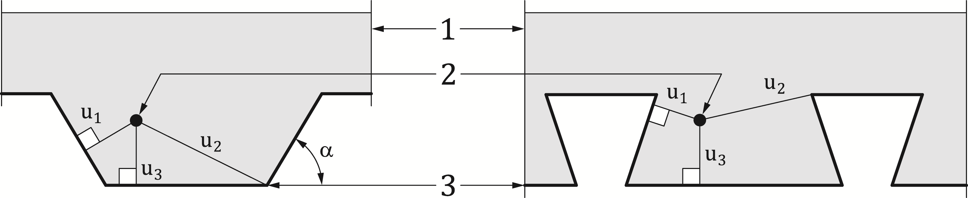

Key

|  |  |
| --- | --- |
| 1 | slab |
| 2 | reinforcing bar |
| 3 | steel sheeting |

Figure B.3 — Parameters defining the position of the reinforcing bars

(4) The z-factor which defines the position of the reinforcing bar should be derived from Formula (B.10):

 (B.10)

Where the distances $u_{1}$, $u_{2}$ and $u_{3}$ (see Figure B.3) are expressed in mm and are defined as follows:

|  |  |
| --- | --- |
| $u_{1}$, $u_{2}$ | shortest distance from the centre of the reinforcing bar to any point on a web of the steel sheet; |
| $$u_{3}$$ | distance from the centre of the reinforcing bar to the lower flange of the steel sheet. |

(5) Based on the temperatures given by (1) to (5), the strengths of the parts of the composite slab and the sagging moment resistance are calculated according to 7.2.

(6) In case of open trough sheetings with a top re-entrant stiffener, the beneficial effect of the presence of the stiffener should be neglected and the temperature of reinforcing bars situated in the rib may be calculated by ignoring the presence of the top stiffener.

* 1. Calculation of the hogging moment resistance MRd,fi-

(1) As a conservative approximation, the contribution of the steel sheeting to the hogging moment capacity may be ignored.

(2) The hogging moment resistance of the composite slab may be calculated by taking into account a reduced cross section.

NOTE 1 Parts of the cross section, with temperatures beyond a certain limiting temperature $θ_{lim}$, are neglected.

NOTE 2 The reduced cross section is considered as under normal temperature conditions.

(3) The reduced cross section is established, on the basis of the isotherm for the limiting temperature (see Figures B.4a and b). The isotherm for the limiting temperature, is schematised by means of 4 characteristic points, as follows:

|  |  |
| --- | --- |
| point I | is situated at the central line of the rib, at a distance above the lower flange of the steel sheet and calculated as a function of the limiting temperature according to Formulae (B.11) and (B.13) of B.3(4) and B.3(5); |
| point II | is situated on a line through point I, parallel to the lower flange of the steel sheet, at a distance from the nearer web of the steel sheet, equal to that from the lower flange; |
| point III | is situated on a line through the upper flange of the steel sheet, at a distance from the nearer web of the steel sheet, equal to the distance of point IV to the upper flange; |
| point IV | is situated at the central line between two adjacent ribs, at a distance above the upper flange of the steel sheet, calculated as a function of the limiting temperature according to Formulae (B.11) and (B.18) of B.3(4) and B.3(5). |

(4) The isotherm is obtained by linear interpolation between the points I, II, III and IV.

NOTE The limiting temperature is derived from equilibrium over the cross section and therefore is not a function of temperature gradients within the cross-section.

|  |  |
| --- | --- |
|  |  |
| a) Temperature distribution in a cross section | b) Schematisation specific isotherm |

**Figure B.4 — Key isotherm lines and establishment of isotherm**

(4) The limiting temperature, $θ_{lim}$ should be derived from Formula (B.7):

 (B.11)

where

|  |  |
| --- | --- |
| $$N_{s}$$ | is the force in the hogging reinforcement [N]; |
| $$d_{i}$$ | factors for both normal and lightweight concrete, which should be derived from Table B.5; for intermediate values, linear interpolation may be undertaken. |

Table B.5 — Coefficients for the determination of the limiting temperature

|  |  |  |  |  |  |  |
| --- | --- | --- | --- | --- | --- | --- |
| **Concrete** | **Fire resistance**  **[min]** | ***d0***  **[oC]** | ***d1***  **[oC] . N** | ***d2***  **[oC] . mm** | ***d3***  **[oC]** | ***d4***  **[oC] . mm** |
| Normal weight concrete | 60  90  120 | 867  1055  1144 | -1,9·10-4  -2,2·10-4  -2,2·10-4 | -8,75  -9,91  -9,71 | -123  -154  -166 | -1378  -1990  -2155 |
| Light weight concrete | 30  60  90  120 | 524  1030  1159  1213 | -1,6·10-4  -2,6·10-4  -2,5·10-4  -2,5·10-4 | -3,43  -10,95  -10,88  -10,09 | -80  -181  -208  -214 | -392  -1834  -2233  -2320 |

(5) The coordinates of the four points I to IV are given by:

 (B.12)

 (B.13)

 (B.14)

where

|  |  |
| --- | --- |
|  |  |

 (B.15)

where

|  |  |
| --- | --- |
| a |  |

 (B.16)

where

|  |  |
| --- | --- |
| b |  |

 (B.17)

where

|  |  |
| --- | --- |
| c | : |

 (B.18)

|  |  |
| --- | --- |
| c | ; |

(6) The parameter $z$ given in (5) may be derived from the equation for the determination of the rebar temperature (i.e. Formula (B.9)), assuming ${u_{3}}/{h_{2}}$ = 0,75 and using *θ****s*** *=θ****lim***.

(7) In the case of $Y_{I} > h_{2}$, the ribs of the composite slab may be neglected. Table B.5 may be used to obtain the location of the isotherm as a conservative approximation.

Table B.6 — Temperature distribution in a solid slab of 150 mm thickness comprising normal weight concrete and uninsulated

|  |  |  |  |  |  |  |
| --- | --- | --- | --- | --- | --- | --- |
| **Distance *x***  **[mm]** | **Temperature in the concrete slab *θ*c [ °C]** | | | | | **Key**  1 Heated lower face of slab |
| **30 min** | **60 min** | **90 min** | **120 min** | **180 min** |
| 2.5 | 675 | 831 | 912 | 967 | 1 042 |
| 10 | 513 | 684 | 777 | 842 | 932 |
| 20 | 363 | 531 | 629 | 698 | 797 |
| 30 | 260 | 418 | 514 | 583 | 685 |  |
| 40 | 187 | 331 | 423 | 491 | 591 |  |
| 50 | 135 | 263 | 349 | 415 | 514 |
| 60 | 101 | 209 | 290 | 352 | 448 |
| 70 | 76 | 166 | 241 | 300 | 392 |
| 80 | 59 | 133 | 200 | 256 | 344 |  |
| 90 | 46 | 108 | 166 | 218 | 303 |
| 100 | 37 | 89 | 138 | 186 | 267 |
| 110 | 31 | 73 | 117 | 159 | 236 |
| 120 | 27 | 61 | 100 | 137 | 209 |  |
| 130 | 24 | 51 | 86 | 119 | 186 |
| 140 | 23 | 44 | 74 | 105 | 166 |
| 150 | 22 | 38 | 65 | 94 | 149 |  |

(8) The hogging moment resistance is calculated considering the reduced cross section determined by (1) to (7) and by referring to 7.2.

(9) For lightweight concrete, the temperatures of Table B.5 are reduced to 90 % of the values given in (10) In case of open trough sheetings with a top re-entrant stiffener, the hogging moment resistance of the composite slab may be determined from Formulae (B.11) to (B.18), where h1 and h2 should respectively be replaced by h1,mod and h2,mod, calculated according to Formulae (B.19) and (B.20).

 (B.19)

 (B.20)

* 1. Effective thickness of a composite slab

(1) The effective thickness  should be calculated from Formulae (B.21) and (B.22) as relevant:

 for *h*2>/*h*1 >1,5 and *h*1> 40 mm (B.21)

 for *h*2>/*h*1 >1,5 and *h*1> 40 mm (B.22)

NOTE The cross-sectional dimensions of the composite slab , , ,  and  are given in Figures 7.1 and 7.2.

(2) lf , the effective thickness may be taken as equal to $h_{1}$.

(3) In case of open trough sheetings with a top re-entrant stiffener, the effective thickness $h_{eff}$ should be calculated from Formulae (B.21) and (B.22), where h1 and h2 should respectively be replaced by h1,mod and h2,mod, calculated according to Formulae (B.4) to (B.7).

(4) The relationship between the fire resistance with respect to the thermal insulation criterion and the minimum effective slab thickness $h_{eff}$ is given in Table B.7 for common classes of fire resistance, where $h_{3}$ is the thickness of any screed layer present on top of the concrete slab.

Table B.7 — Minimum effective thickness as a function of standard fire resistance.

|  |  |  |
| --- | --- | --- |
| **Standard fire resistance** | **Minimum effective thickness $h_{eff}$ [mm]** | |
| I 30 I 60 I 90 I 120 I 180 I 240 | 60 80 100 120 150 175 | - $h_{3}$  - $h_{3}$  - $h_{3}$  - $h_{3}$  - $h_{3}$  - $h_{3}$ |

1. (normative)  
     
   Model for the calculation of the sagging and hogging moment resistances of a steel beam connected to a concrete slab and exposed to fire from underneath
   1. Use of this annex

(1) This Normative Annex contains additional provisions to 7.4.2.2.1 for assessing the sagging and hogging moment resistances of composite beams with no concrete encasement.

(2) This Normative Annex contains additional provisions to 7.4.2.1.4 for assessing the local resistance at supports and vertical shear resistance of composite beams with no concrete encasement.

* 1. Scope and field of application

(1) This Normative Annex applies to steel beams with no concrete encasement connected to a normal weight or lightweight concrete slab and exposed from underneath to standard temperature-time curve, parametric temperature-time curve or other temperature-time curve generated from physically based models, as defined in EN 1991-1-2

(2) This Normative Annex applies to composite beams partially or fully connected to the slab under fire conditions and satisfying the conditions of minimum degree of shear connections given in prEN 1994-1-1:2024, 8.6.3.3 for normal temperature design.

(3) Classification of sections should be carried out according to FprEN 1993-1-2:2023, 7.2. This Normative Annex applies to sections of any class. For sections of class 3 and 4, C.4(7) and C.4(8) shall be taken into consideration for the calculation of the hogging moment resistance.

(4) The calculation of the sagging moment resistance MRd,fi+ is given in C.3 under the assumption that the plastic neutral axis is situated in the concrete slab. A similar approach may be used if the plastic neutral axis is in the steel section.

(5) The calculation of the hogging moment resistance MRd,fi- is given in C.4 under the assumption that the plastic neutral axis is located at the interface between concrete slab and the steel section. A similar approach may be used if the plastic neutral axis is within the steel section.

* 1. Calculation of the sagging moment resistance MRd,fi+

(1) According to Figure C.1 the tensile force *T*+ and its location *y*I may be obtained from Formula (C.1):

 (C.1)

 (C.2)

with  the maximum stress level according to 5.3.1.3 at temperature defined following 7.4.1.2.1.

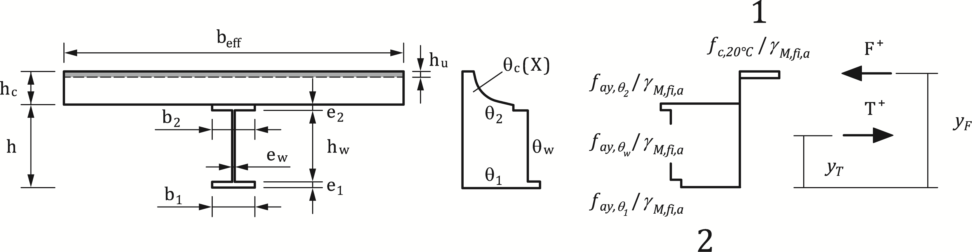

**Key**

|  |  |
| --- | --- |
| 1 | compression |
| 2 | tension |

Figure C.1 — Calculation of the sagging moment resistance

(2) In a simply supported beam, the value of the tensile force *T*+ obtained from (1) shall be limited by:

 (C.3)

where

|  |  |
| --- | --- |
| *N* | is the number of shear connectors related to the governing critical length of the beam and *PRd,fi* is the design shear resistance in the fire situation of a shear connector according to 7.4.2.2.3. |

NOTE Critical lengths are bounded by the end supports and the cross-section of maximum bending moment.

(3) The thickness of the compressive zone  is determined from Formula (C.4):

 (C.4)

where  is the effective width according to prEN 1994-1-1:2024, 7.4.1.2 and  is the compressive strength of concrete at normal temperature.

(4) If where  is the depth x according to Table B.5 corresponding to a concrete temperature below 250 °C,the value of *hu* according to Formula (C.4) applies.

Otherwise, some layers of the compressive zone of concrete are at a temperature higher than 250 °C and a decrease of the compressive strength of concrete should be considered according to 5.3.2.3. The hu value may be determined by iteration varying the index "n" and assuming on the basis of Table B.5 an average temperature for every slice of 10 mm thickness, such as:

 (C.5)

where

|  |  |
| --- | --- |
|  | =[mm]; |
|  | is the total number of concrete layers in compression, including the top concrete layerwith a temperature below 250 °C. |

(5) The point of application of this compressive force should be obtained from Formula (C.6):

 (C.6)

and the sagging moment resistance should be obtained from Formula (C.7):

 (C.7)

where

|  |  |
| --- | --- |
|  | is the tensile force given by the value of (C.5) while taking account of (C.3). |

(6) In case of composite slab with profiled steel sheeting, *hc* is replaced by *heff* as defined in (1) of B.4 and *hu* is limited by *h1* as defined in Figures 7.1 and 7.2.

(7) This calculation model established in combination with 7.4.2.2.1, may be used for the critical temperature model of 7.4.2.2.2 by assuming that .

* 1. Calculations of the hogging moment resistance MRd,fi-

(1) The effective width of the concrete slab in a region of hogging moment may be determined so that the plastic neutral axis does not lie in the concrete slab, i.e. the slab is assumed to be cracked over its entire thickness. This effective width should not be larger than that determined at normal temperature, according to prEN 1994-1-1:2024, 7.4.1.2.

(2) The longitudinal reinforcing bars may be assumed to have yielded, with a stresswhere $θ_{s}$ is the temperature in the concrete slab at the level where the reinforcing bars are located.

(3) The following rules assume that the plastic neutral axis is located just at the interface between the concrete slab and the steel section. A similar approach may be used if the plastic neutral axis is within the steel cross section, by changing the formulae accordingly.

(4) The hogging moment resistance of the composite section may be determined by considering the stress diagram shown in Figure C.2, with temperatures calculated according to 7.4.1.2.1.

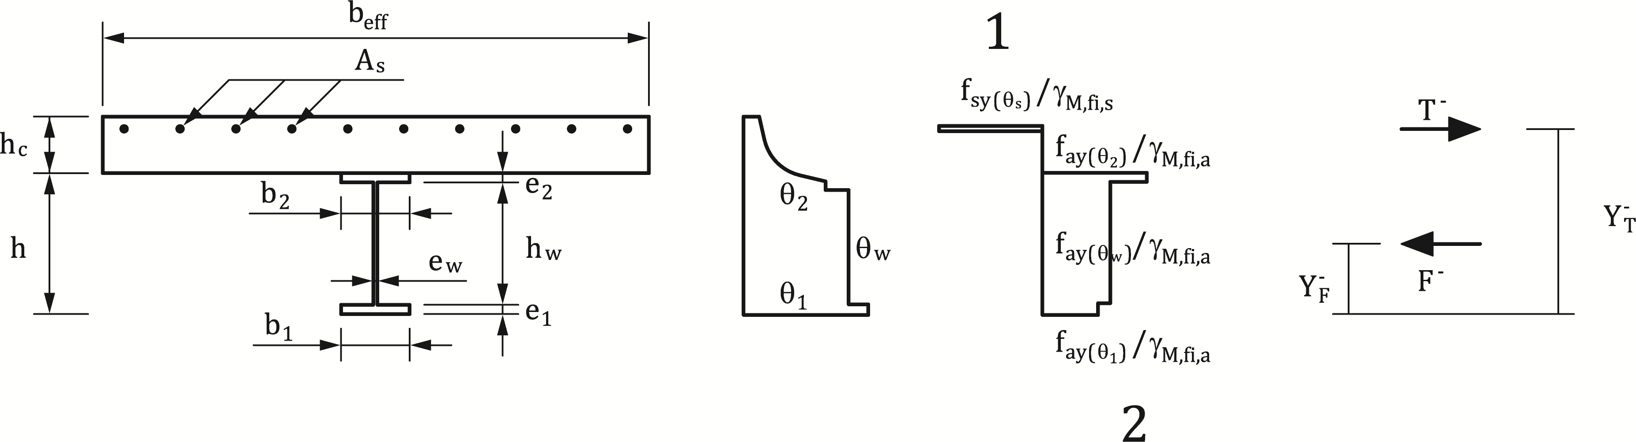

**Key**

|  |  |
| --- | --- |
| 1 | compression |
| 2 | tension |

Figure C.2 — Calculation of hogging moment resistance

(5) The hogging moment resistance should be calculated from (C.8):

 (C.8)

where

|  |  |
| --- | --- |
|  | is the total force of the reinforcing bars, equal to the compressive force in the steel section. |

(6) The value of the compressive force  in the concrete slab, at the critical cross section within the span, see (2) of E.1, may be derived from (C.9):

 (C.9)

where

|  |  |
| --- | --- |
| *N* | is the number of shear connectors related to the governing critical length of the beam |
| *PRd,fi* | is the design shear resistance in the fire situation of a shear connector according to 7.4.2.2.3. |

(7) When the steel web or the bottom steel flange of the composite section is of class 3 in the fire situation, its width may be reduced to an effective value determined from EN 1993-1-5, with  and  respectively replaced by and.

(8) When the steel web or the bottom steel flange of the composite section is of class 4 in the fire situation, its resistance may be neglected.

* 1. Local resistance at supports

(1) The local resistance of a steel section shall be verified at supports.

(2) The temperature of a stiffener $θ_{r}$ is calculated taking into account its section factor, , according to 7.4.1.2.1.

(3) The local resistance of a steel section at a support is taken as the lower value of the buckling or the crushing resistance.

(4) For the calculation of the buckling resistance a maximum width of web of 15 $ε e_{w}$ on each side of the stiffener (see Figure C.3) may be added to the effective cross section of the stiffener. The relative slenderness used to calculate buckling resistance should be as given in (C.10):

 (C.10)

where

|  |  |
| --- | --- |
| and | are given in Table 5.2, |
|  | is the relative slenderness at room temperature of the stiffener associated with part of the web as shown in Figure C.3, and *ε* is calculated according to FprEN 1993-1-2:2023, 7.2. |

(5) For the calculation of the yield resistance, the design yield resistance, of the web with the stiffeners should be calculated from (C.11):

 (C.11)

where

|  |  |
| --- | --- |
| and | are respectively the yield strengths of steel at the temperature of the web and of the stiffener ; |
| r | is equal to the root radius for a rolled section, or to  where  is the throat thickness of the fillet weld for a welded cross-section. |

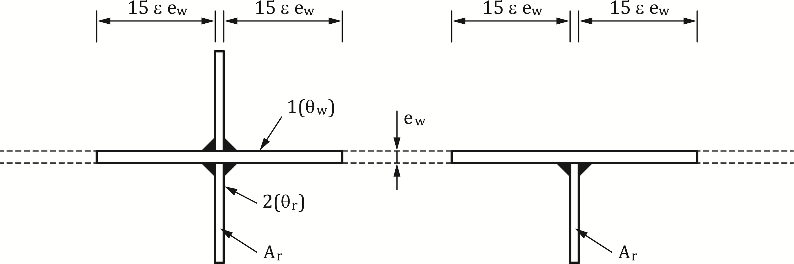

**Key**

|  |  |
| --- | --- |
| 1 | web |
| 2 | stiffener |

Figure C.3 — Stiffener at an intermediate support

* 1. Vertical shear resistance

(1) Rules in prEN 1994-1-1:2024, 8.2.2 may be used to check the vertical shear resistance of a composite beam in the fire situation by replacing ,  and  by ,  and  respectively as defined in Table 5.2 and 4.5(1).

1. (normative)  
      
   Model for the calclulation of the bending moment resistances of a partially encased steel beam connected to a concrete slab and exposed to fire
   1. Use of this annex

(1) This Normative Annex contains additional provisions to 7.4.2.3 for assessing the sagging and hogging moment resistances of composite beams with partial concrete encasement.

(2) This Normative Annex contains additional provisions to 7.4.2.1.4 for assessing the sagging and hogging moment resistances of composite beams with partial concrete encasement.

* 1. Scope and field of application

(1) This Normative Annex applies to steel beams with partial concrete encasement connected to a concrete slab and exposed to standard fire curve from underneath.

(2) This Normative Annex applies to composite beams partially or fully connected to the slab under fire conditions and satisfying the conditions of minimum degree of shear connections given in prEN 1994-1-1:2024, 8.6.3.3 for normal temperature design.

(3) This Normative Annex applies for any type of composite slabs or solid slabs.

(4) This Normative Annex does not apply to lightweight concrete slabs or lightweight concrete encasement.

(5) This Normative Annex should not be applied if the height h of the steel section, width bc and the area h bc is not less than the minimum values given in Table D.8.

NOTE The dimension bc is the minimum value of either the width b of the lower flange or the width of the concrete encasement between the flanges, including the web thickness ew (see Figure D.1).

Table D.1 — Minimum cross-section dimensions

|  |  |  |
| --- | --- | --- |
| Standard fire resistance | Minimum section height h  and  Minimum width bc | Minimum area h bc |
|  | [mm] | [mm²] |
| R30 | 120 | 17 500 |
| R60 | 150 | 24 000 |
| R90 | 170 | 35 000 |
| R120 | 200 | 50 000 |
| R180 | 250 | 80 000 |

(6) This Normative Annex should only be applied if the flange thickness ef is less than h/8, where h is the section height.

* 1. Reduced cross-section for sagging moment resistance $M_{\text{R}{\text{d}\text{,fi}}^{+}}$

(1) The area of the concrete slab should be reduced as shown in Figure D.1, considering a compressive concrete strength ${f_{c}}/{γ_{M,c,fi}}$. Values of the thickness reduction $h_{c,fi}$ of a solid concrete slab are given in Table D.1 for different fire classes.

Table D.1 — Thickness reduction  of the concrete slab.

|  |  |
| --- | --- |
| **Standard fire resistance class** | **Slab reduction $h_{c,fi}$ [mm]** |
| R 30 | 10 |
| R 60 | 20 |
| R 90 | 30 |
| R 120 | 40 |
| R 180 | 55 |

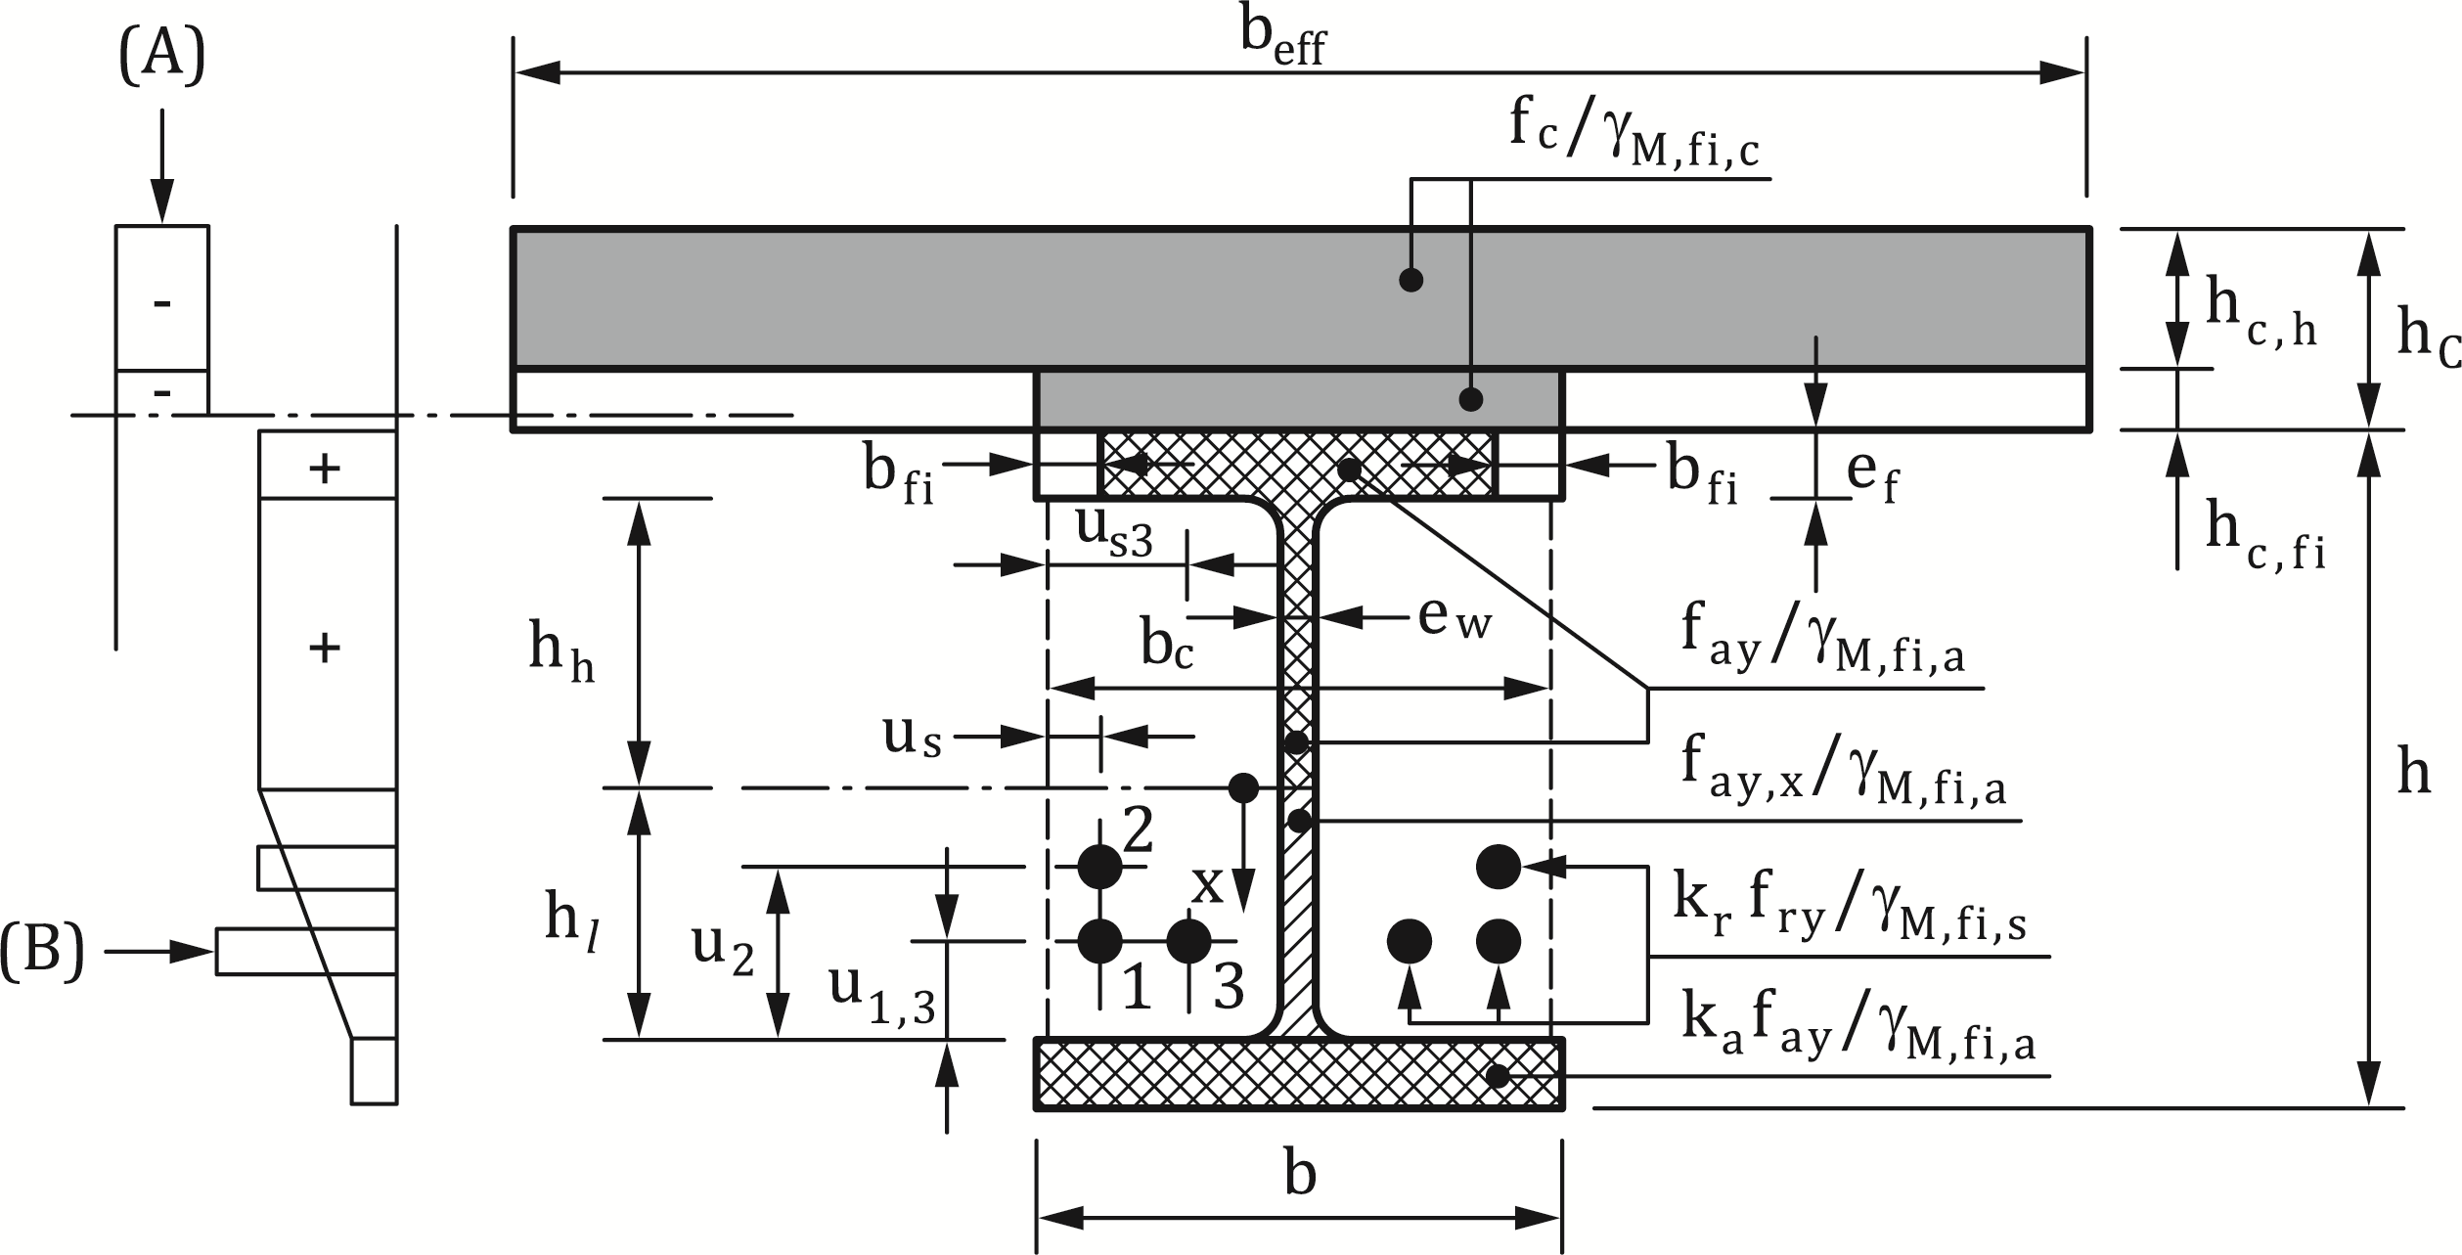

**Key**

|  |  |
| --- | --- |
| A | example of stress distribution in concrete |
| B | example of stress distribution in steel |

Figure D.1 — Effective cross-section for sagging moment resistance.

(2) For composite slabs and precast floor plates, the following rules apply:

* for trapezoidal steel sheets running transversally across the beam, the thickness reduction values from Table D.1 may be applied at the upper face of the sheeting (Figure D.2 a));
* for re-entrant sheetings running transversally across the beam, the thickness reduction values from Table D.1 may be applied at the lower face of the sheeting. However, the value of $h_{c,fi}$ should not be less than the height of the sheeting (Figure D.2 b));
* when precast floor plates are used, the thickness reduction values $h_{c,fi}$ from Table D.1 may be applied at the lower face of the floor plates, but should not be less than the height of the joint between precast elements, which is unable to transmit compression (Figure D.2 c));
* for re-entrant sheetings parallel to the beam, the thickness reduction values $h_{c,fi}$ from Table D.1 apply at the lower face of the sheeting;
* for trapezoidal steel sheets parallel to the beam, the thickness reduction values from Table D.1 may be applied to the effective height of the composite slab (see Figure D.2 d)), where the effective thickness of the composite slab  is given in Figures 4.1 and in B.4 of Annex B.

|  |  |
| --- | --- |
|  |  |
| a) | b) |
|  |  |
| c) | d) |

Figure D.2 — Thickness reduction *hc,fi*for various types of concrete slab

(3) The temperature $θ_{c}$ of the concrete layer $h_{c,fi}$ situated directly on top of the upper flange of the steel sheeting, may be assumed to be 20 °C.

(4) The effective width of the upper flange of the steel section (b-2bfi) varies as a function of the fire period, but the design value of the yield point of the steel is taken equal to ${f_{ay}}/{γ_{M,a,fi}}$. Values of the flange width reduction $b_{fi}$ are given in Table D.2 for the different fire classes.

Table D.2 — Width reduction bfi of the upper flange

|  |  |
| --- | --- |
| **Standard fire resistance** | **Width reduction bfi of the upper flange [mm]** |
| R 30 | (ef / 2) + (b - bc) / 2 |
| R 60 | (ef / 2) + 10 + (b - bc) / 2 |
| R 90 | (ef / 2) + 30 + (b - bc) / 2 |
| R 120 | (ef / 2) + 40 + (b - bc) / 2 |
| R 180 | (ef / 2) + 60 + (b - bc) / 2 |

(5) The web is divided into two parts, a top part of depth hh and a bottom part of depth $h_{l}$. Values of $h_{l}$ are given for the different fire classes by the formula = a1/bc+a2ew/(bch). Parameters a1 and a2 should be determined according to Table D.3 for h/bc≤1 or h/bc≥2.

The bottom part depth $h_{l}$ should be determined directly from Table D.3 for 1<h/bc<2.

Table D.3 — Web dimensions $h_{l}$ [mm] and $h_{l,min}$ [mm], with $h_{l,max}$ equal to (h - 2ef).

|  |  |  |  |  |
| --- | --- | --- | --- | --- |
|  | **Standard fire resistance** | **a1**  **[mm²]** | **a2**  **[mm²]** | **[mm]** |
|  | R 30 | 3 600 | 0 | 20 |
|  | R 60 | 9 500 | 20 000 | 30 |
| h / bc ≤ 1 | R 90 | 14 000 | 160 000 | 40 |
|  | R 120 | 23 000 | 180 000 | 45 |
|  | R 180 | 35 000 | 400 000 | 55 |
|  | R 30 | 3 600 | 0 | 20 |
|  | R 60 | 9 500 | 0 | 30 |
| h / bc ≥ 2 | R 90 | 14 000 | 75 000 | 40 |
|  | R 120 | 23 000 | 110 000 | 45 |
|  | R 180 | 35 000 | 250 000 | 55 |
|  | | | | |
|  | R 30 | $h_{l}$ = 3 600 / bc | | 20 |
|  | R 60 | $h_{l}$ = 9 500 / bc + 20 000 (ew / (bch)) (2 - h / bc) | | 30 |
| 1 < h / bc < 2 | R 90 | $h_{l}$ = 14 000 / bc + 75 000 (ew / (bch))  + 85 000 (ew / (bch)) (2 - h / bc) | | 40 |
|  | R 120 | $h_{l}$ = 23 000 / bc + 110 000 (ew / (bch))  + 70 000 (ew / (bch)) (2 - h / bc) | | 45 |
|  | R 180 | $h_{l}$ = 35 000 / bc + 250 000 (ew / (bch))  + 150 000 (ew / (bch)) (2 - h / bc) | | 55 |

(6) The depth of the bottom part $h_{l}$ of the web may be $h_{l}$ ≥ $h_{l,min}$ given in Table D.3.

(7) For the top part of the web, the design value of the yield strength should be taken as equal to $f_{ay}/γ_{M,a,fi}$. For the bottom part of the web, the design value of the yield strength should be taken as equal to , where the reduced yield strength may be obtained from: 

 (D.1)

where

|  |  |
| --- | --- |
|  | is the reduction factor of the yield point of the lower flange given in (8). This leads to a trapezoidal form of the stress distribution in the top part |
| x | is the distance measured from the lowest point of the top part of the web (see Figure D.1). |

(8) The area of the lower flange of the steel section may be considered as unchanged. Its yield point should be reduced by the factor $k_{a}$ given in Table D.4. The reduction factor $k_{a}$ should remain between the minimum and maximum values given in Table D.4.

Table D.4 — Reduction factor ka of the yield point of the lower flange, with a0 = (0,018 ef + 0,7).

|  |  |  |  |
| --- | --- | --- | --- |
| **Standard fire resistance** | **Reduction factor ka** | **ka,min** | **ka,max** |
| R 30 | [(1,12) - (84 / bc) + (h / (22bc))]a0 | 0,5 | 0,8 |
| R 60 | [(0,21) - (26 / bc) + (h / (24bc))]a0 | 0,12 | 0,4 |
| R 90 | [(0,12) - (17 / bc) + (h / (38bc))]a0 | 0,06 | 0,12 |
| R 120 | [(0,1) - (15 / bc) + (h / (40bc))]a0 | 0,05 | 0,10 |
| R 180 | [(0,03) - (3 / bc) + (h / (50bc))]a0 | 0,03 | 0,06 |

(9) The yield strength of the reinforcing bars should be reduced by application of reduction factor $k_{r}$ calculated according to Table D.5. The reduction factor *kr* should remain between the minimum and maximum values given in this Table D.5.

Table D.5 — Reduction factor kr of the yield point of a reinforcing bar

|  |  |  |  |  |  |
| --- | --- | --- | --- | --- | --- |
| $$k_{r}=\left(\text{u}{\text{a}}_{3}\text{+}{\text{a}}_{4}\right)a_{5}/\sqrt{\left(A_{m}\text{/V}\right)}$$ | | | | kr,min | kr,max |
| Standard fire resistance | a3 | a4 | a5 |  |  |
| R 30 | 0,062 | 0,16 | 0,126 |  |  |
| R 60 | 0,034 | - 0,04 | 0,101 | 0,1 | 1 |
| R 90 | 0,026 | - 0,154 | 0,090 |  |  |
| R 120 | 0,026 | - 0,284 | 0,082 |  |  |
| R 180 | 0,024 | - 0,562 | 0,076 |  |  |

where

 [mm]

[mm²]

 (D.2)

where

|  |  |
| --- | --- |
|  | is the distance [mm] from the axis of the reinforcing bar to the inner side of the flange; and |
|  | is the distance [mm] from the axis of the reinforcing bar to the outside border of the concrete (see Figure D.1). |

(10) The concrete cover of reinforcing bars should comply with 9.1.

(11) The shear resistance of the steel web may be verified using the distribution of design values of yield strength according to (7). If the resistance of the reinforced concrete may be taken into account.

* 1. Reduced cross-section for hogging moment resistance MRd,fi-

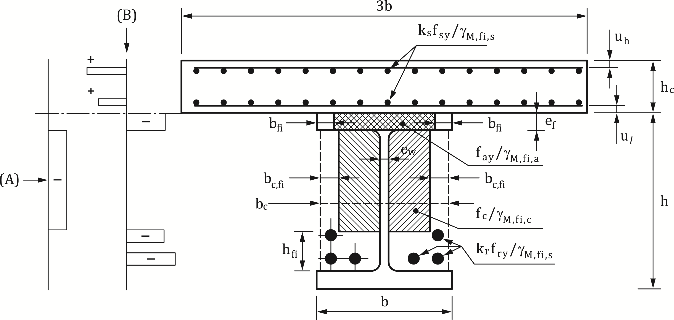

**Key**

|  |  |
| --- | --- |
| A | example of stress distribution in concrete |
| B | example of stress distribution in steel |

Figure D.3 — Effective cross-section for hogging moment resistance

(1) The yield strength of the reinforcing bars in the concrete slab should be multiplied by a reduction factor $k_{s}$ given in Table D.6. The reduction factor $k_{s}$ should remain between the minimum and maximum values given in this Table D.6.

Table D.6 — Reduction factor ks of the yield point of the reinforcing bars in the concrete slab with u, distance [mm] from the centre of the reinforcement to the lower slab edge, equal to $u_{l}$ or (hc - uh) (see Figure D.3)

|  |  |  |  |
| --- | --- | --- | --- |
| **Standard fire resistance** | **Reduction factor ks** | **ks,min** | **ks,max** |
| R 30 | 1 |  |  |
| R 60 | (0,022 u) + 0,34 |  |  |
| R 90 | (0,0275 u) - 0,1 | 0 | 1 |
| R 120 | (0,022 u) - 0,2 |  |  |
| R 180 | (0,018 u) - 0,26 |  |  |

(2) For the upper flange of the section, of D.3(4) should be applied.

(3) The area of the concrete between the flanges should be reduced as shown in Figure D.3 and the design value of the compressive concrete strength $f_{c}/γ_{M,c,fi}$ should be considered as unchanged. Values of the width reduction *bc,fi*and of the height reduction hfi of the encased concrete should be determined from Table D.7. The width and height reductions should not be smaller than minimum values given in Table D.7.

Table D.7 — Reduction of the area of the concrete encased between the flanges

|  |  |  |  |  |
| --- | --- | --- | --- | --- |
| **Standard fire resistance** | **hfi [mm]** | **hfi,min [mm]** | **bc,fi [mm]** | **bc,fi,min [mm]** |
| R 30 | 25 | 25 | 25 | 25 |
| R 60 | 165 - (0,4bc) - 8 (h / bc) | 30 | 60 - (0,15bc) | 30 |
| R 90 | 220 - (0,5bc) - 8 (h / bc) | 45 | 70 - (0,1bc) | 35 |
| R 120 | 290 - (0,6bc) - 10 (h / bc) | 55 | 75 - (0,1bc) | 45 |
| R 180 | 360 - (0,7bc) - 10 (h / bc) | 65 | 85 - (0,1bc) | 55 |

(4) For the reinforcing bars situated in the concrete encasement of the steel section, D.2(9) should be applied.

(5) The concrete cover of reinforcing bars should comply with 9.1.

(6) In areas with hogging bending moments, the shear force should be resisted by the steel web and the contribution of the web to the hogging bending moment resistance should be neglected.

(7) The shear resistance of the steel web may be verified using the distribution of the design values of yield strength according to of D.3(7).

1. (normative)  
     
   Model for the calculation of the axial buckling resistance about the weak axis of a partially encased composite column exposed to fire

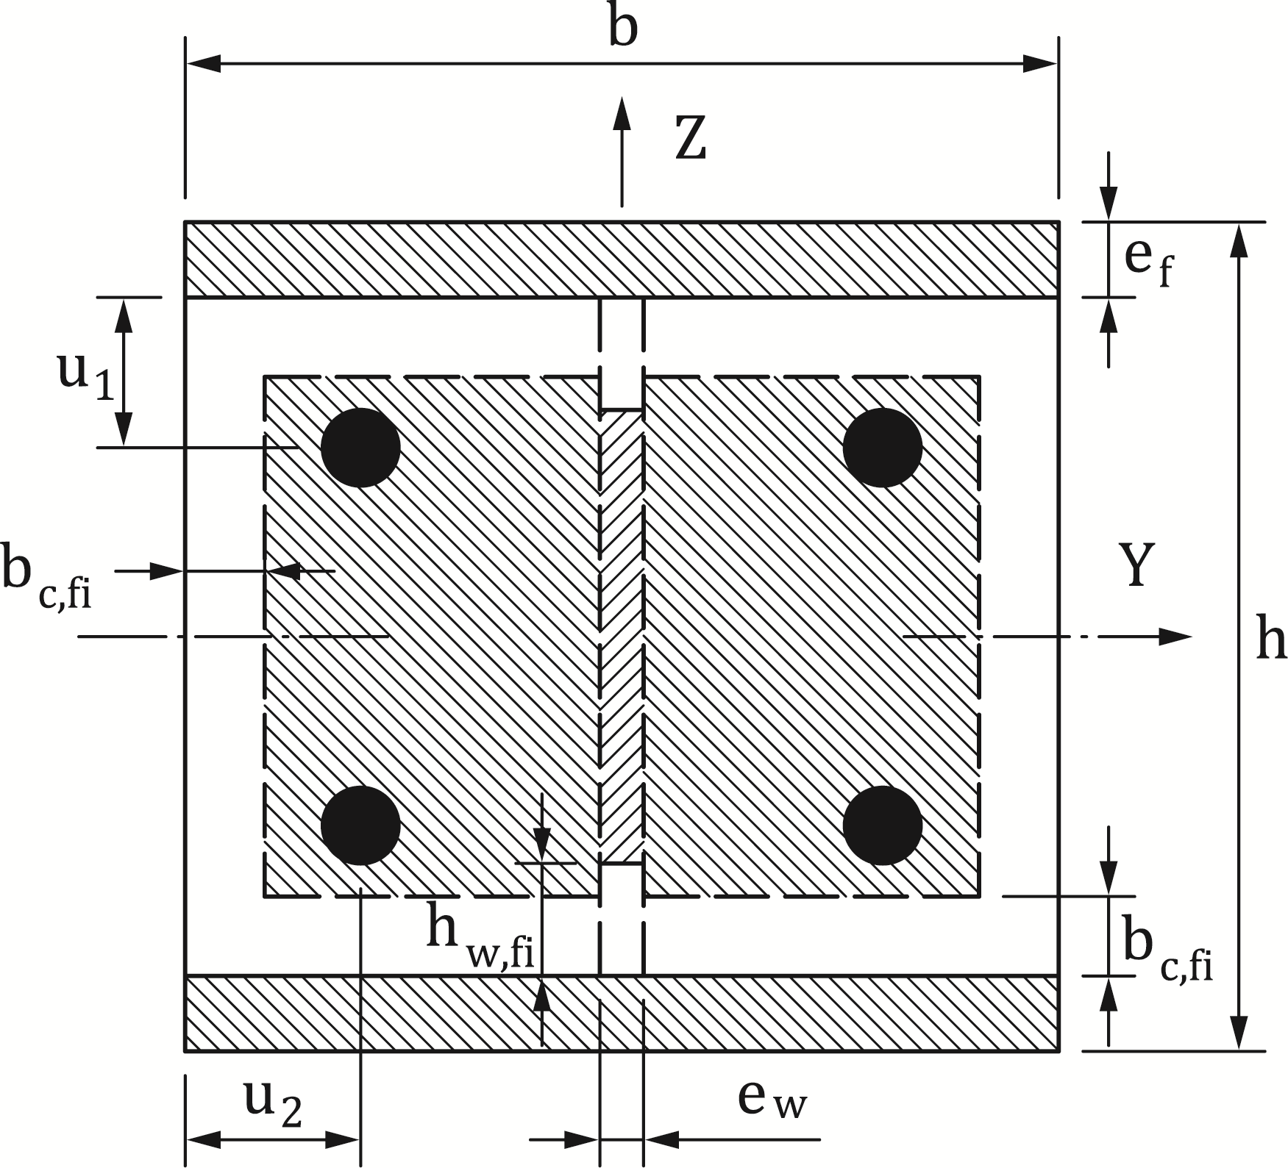

Figure E.1 — Reduced cross-section for structural fire design

* 1. Use of this annex

(1) This Normative Annex contains additional provisions to 7.5.2 for assessing axial buckling resistance about weak axis of a partially encased composite column exposed to standard fire curve.

* 1. Scope and field of application

(1) This Normative Annex applies to partial encased columns satisfying to the following conditions:

* buckling length lfi ≤ 13,5b;
* 230 mm ≤ height of cross section h ≤ 1100 mm;
* 230 mm ≤ width of cross section b ≤ 500 mm;
* 1 % ≤ *As/Ac* ≤ 6 % where As is the cross-section area of the reinforcing steel and Ac is the cross-sectional area of concrete encasement; and
* standard fire resistance ≤ 120 min.

(2) In addition to (1), the minimum cross-section dimensions *b* and *h* should be limited to 300 mm for the fire classes R90 and R120.

(3) In addition to (1), the maximum buckling length lfishould be limited to 10b in the following situations:

* for R60, if 230 mm ≤ b < 300 mm or if h/b > 3; and
* for R90 and R120, if h/b > 3.

(4) This Normative Annex applies to columns subjected to axial loads. Provisions are given in E.9 for loads applied with an eccentricity, but the application point of eccentric load shall remain within the cross-section of the composite column.

(5) This Normative Annex applies to columns exposed uniformly to standard fire curve on four sides.

(6) This Normative Annex does not apply to columns with lightweight concrete encasement.

* 1. General

(1) For the calculation of the design value of the plastic resistance to axial compression $N_{pl,Rd,fi}$ and of the effective flexural stiffness in the fire situation, the cross-section should be divided into the following four components:

* the flanges of the steel section;
* the web of the steel section;
* the concrete contained within the steel section; and
* the reinforcing bars.

(2) Each component may be evaluated on the basis of a reduced characteristic strength, a reduced modulus of elasticity and a reduced area as a function of the standard fire resistance R30, R60, R90 or R120.

(3) The design value of the plastic resistance to axial compression and the effective flexural stiffness of the cross-section may be obtained, according to 7.5.1(4) and (5).

(4) The strength and deformation properties of steel and concrete at elevated temperatures shall comply with the corresponding principles and rules of 5.3.1.3 and 5.3.2.3.

* 1. Flanges of the steel section

(1) The average flange temperature may be determined from:

 (E.1)

where

|  |  |
| --- | --- |
| *t* | is the duration in minutes of the fire exposure |
| *A*m*/V* | is the section factor in m-1, with  Am = 2 (h + b) in [m]  V = h*b in [m²] |
|  | is a temperature in °C given in Table E.1 |
|  | is an empirical coefficient given in Table E.1. |

Table E.1 — Parameters for the flange temperature

|  |  |  |
| --- | --- | --- |
| **Standard fire resistance** | [ °C] | [m °C] |
| R30 | 550 | 9,65 |
| R60 | 680 | 9,55 |
| R90 | 805 | 6,15 |
| R120 | 900 | 4,65 |

(2) For the temperaturethe corresponding maximum stress level and the modulus of elasticity should be determined from Formulae (E.2) and (E.3):

; and (E.2)

 with and following Table 5.2 of 5.3.1.3 (E.3)

(3) The design value of the plastic resistance to axial compression and the flexural stiffness of the two flanges of the steel section in the fire situation should be determined from Formulae (E.4) and (E.5):

; and (E.4)

 (E.5)

* 1. Web of the steel section

(1) The part of the web with height located adjacent to the inner edge of the flange may be neglected (see Figure E.1). The height of this part should be determined from Formula (E.6):

 (E.6)

where

|  |  |
| --- | --- |
| *Ht* | is given in Table E.2. |

Table E.2 — Parameter for height reduction of the web

|  |  |
| --- | --- |
| **Standard fire resistance** | $H_{t}$**[mm]** |
| R 30 | 350 |
| R 60 | 770 |
| R 90 | 1100 |
| R 120 | 1250 |

(2) The reduced strength of the web should be obtained from Formula (E.7):

 (E.7)

(3) The design values of the plastic resistance to axial compression and the flexural stiffness of the web of the steel section in the fire situation are determined from Formulae (E.8) and (E.9) respectively:

 (E.8)

 (E.9)

* 1. Concrete

(1) An exterior layer of concrete with a thickness $b_{c,fi}$ may be neglected in the calculation (see Figure E.1). The thickness $b_{c,fi}$ is given in Table E.3, with *Am /V* the section factor in m-1 of the entire composite cross-section.

Table E.3 — Thickness reduction of the concrete area

|  |  |
| --- | --- |
| **Standard fire resistance** | $b_{c,fi}$ [mm] |
| R 30 | 4,0 |
| R 60 | 15,0 |
| R 90 | 0,5 (*Am /V*) + 22,5 |
| R 120 | 2,0 (*Am /V*) + 24,0 |

(2) The average temperature in the concrete is given in Table E.4 as a function of the section factorof the entire composite cross-section and of the standard fire resistance classes.

Table E.4 — Average concrete temperature

|  |  |  |  |  |  |  |  |
| --- | --- | --- | --- | --- | --- | --- | --- |
| R30 | | R60 | | R90 | | R120 | |
| *Am /V*  [m-1] | [ °C] | *Am /V*  [m-1] | [ °C] | *Am /V*  [m-1] | [ °C] | *Am /V*  [m-1] | [ °C] |
| 4  23  46  -  -  -  - | 136  300  400  -  -  -  - | 4  9  21  50  -  -  - | 214  300  400  600  -  -  - | 4  6  13  33  54  -  - | 256  300  400  600  800  -  - | 4  5  9  23  38  41  43 | 265  300  400  600  800  900  1 000 |

(3) For the temperature the secant modulus of concrete is obtained from Formula (E.10):

 with and following Table 3.3 of 3.2.2 (E.10)

(4) The design values of the plastic resistance to axial compression and the flexural stiffness of the concrete in the fire situation are determined from Formulae (E.11) and (E.12) respectively:

 (E.11)

where

|  |  |
| --- | --- |
| As | is the cross-sectional area of the reinforcing bars, and 0,86 is a calibration factor. |

 (E.12)

where

|  |  |
| --- | --- |
|  | is the second moment of area of the reinforcing bars about the central axis Z of the composite cross-section. |

* 1. Reinforcing bars

(1) The reduction factor $k_{y,t}$ of the yield point and the reduction factor $k_{E,t}$ of the modulus of elasticity of the reinforcing bars should be determined from Tables E.5 and E.6.

Table E.5 — Reduction factor ky,t for the yield point fsy of the reinforcing bars

|  |  |  |  |  |  |
| --- | --- | --- | --- | --- | --- |
| **u[mm]**  **Standard**  **fire resistance** | **40** | **45** | **50** | **55** | **60** |
| R30 | 1 | 1 | 1 | 1 | 1 |
| R60 | 0,789 | 0,883 | 0,976 | 1 | 1 |
| R90 | 0,314 | 0,434 | 0,572 | 0,696 | 0,822 |
| R120 | 0,170 | 0,223 | 0,288 | 0,367 | 0,436 |

Table E.6 — Reduction factor kE,t for the modulus of elasticity Es of the reinforcing bars

|  |  |  |  |  |  |
| --- | --- | --- | --- | --- | --- |
| **u[mm]**  **Standard**  **fire resistance** | **40** | **45** | **50** | **55** | **60** |
| R30 | 0,830 | 0,865 | 0,888 | 0,914 | 0,935 |
| R60 | 0,604 | 0,647 | 0,689 | 0,729 | 0,763 |
| R90 | 0,193 | 0,283 | 0,406 | 0,522 | 0,619 |
| R120 | 0,110 | 0,128 | 0,173 | 0,233 | 0,285 |

(2) The geometrical average u of the distances  and  should be obtained from Formula (E.13):

 (E.13)

where

|  |  |
| --- | --- |
| *u1* | is the distance from the axis of the outer reinforcing bar to the inner flange edge [mm] |
| *u2* | is the distance from the axis of the outer reinforcing bar to the concrete surface [mm] |

NOTE If  mm, then, or if  mm, then .

(3) The design values of the plastic resistance to axial compression and the flexural stiffness of the reinforcing bars in the fire situation are obtained from Formulae (E.14) and (E.15) respectively:

 (E.14)

 (E.15)

* 1. Calculation of the acial buckling load at elevated temperatures

(1) According to (4) of E.1, the design values of the plastic resistance to axial compression and the effective flexural stiffness of the cross-section in the fire situation are determined from Formulae (E.16) and (E.17) respectively:

 (E.16)

 (E.17)

where is a reduction factor depending on the effect of thermal stresses. Values of  are given in Table E.7 should be used.

Table E.7 — Reduction coefficients for bending stiffness

|  |  |  |  |  |
| --- | --- | --- | --- | --- |
| **Standard Fire Resistance** |  |  |  |  |
| R30 | 1,0 | 1,0 | 0,8 | 1,0 |
| R60 | 0,9 | 1,0 | 0,8 | 0,9 |
| R90 | 0,8 | 1,0 | 0,8 | 0,8 |
| R120 | 1,0 | 1,0 | 0,8 | 1,0 |

(2) The elastic critical load given by Formula (E.18) should be used:

 (E.18)

where

|  |  |
| --- | --- |
| lfi | is the buckling length of the column in the fire situation. |

(3) The non-dimensional slenderness ratio should be calculated from Formula (E.19):

 (E.19)

where

|  |  |
| --- | --- |
|  | is the value of according to (1) when the factors , and are taken as 1,0. |

(4) Using and buckling curve c of EN 1993-1-1, the reduction coefficient may be calculated and the design axial buckling load in the fire situation should be derived from Formula (E.20):

 (E.20)

(5) Design values of the resistances of members to axial compression should be determined from Figures E.2 and E.3 as a function of the buckling length lfi for the section series HEA with S355 steel, C40/50 concrete, and B500 reinforcing bars, for the standard fire resistance classes R60, R90 and R120.

NOTE These design graphs are based on the partial material safety factors .

* 1. Eccentricity of loading

(1) For a column subjected to a load with an eccentricity δ, the design buckling load may be obtained from Formula (E.22):

 (E.21)

where

|  |  |
| --- | --- |
| and | represent the axial buckling load and the buckling load in case of an eccentric load calculated according to EN 1994-1-1, for normal temperature design. |

1. (normative)  
     
   Simple caculation model for concrete filled hollow sections exposed to the standard temperature-time curve
   1. Use of this annex

(1) This Normative Annex contains additional provisions to 7.5.3 for unprotected concrete filled hollow sections exposed to standard fire.

* 1. Scope and field of application

(1) This calculation model should only be applied when the following conditions are satisfied:

* For Circular Hollow Section (CHS) columns:







* For Square Hollow Section (SHS) columns:







* For Elliptical Hollow Section (EHS) columns:









* For Rectangular Hollow Section (RHS) columns:









where

|  |  |
| --- | --- |
| *D* | is the outer diameter of a circular cross-section [mm]; |
| *B* | is the shorter outer dimension of a rectangular or elliptical cross-section [mm]; |
| *H* | is the larger outer dimension of a rectangular or elliptical cross-section [mm]; |
| *e* | is the wall thickness of the hollow section [mm]; |
| *Am/V* | is the section factor, which for a composite column shall be calculated as the exposed perimeter divided by the total area, including all the components of the cross-section [m-1]; |
|  | is the reinforcement ratio of the concrete core, see (2); and |
| lfi | is the buckling length of the column in the fire situation [m], defined in 7.5.1(9) |

(2) The reinforcement ratio  = *As/(As + Ac)* shall be lower than 5 %.

(3) For concentrically loaded CHS and SHS columns with relative slenderness  over 0,5, a minimum amount of 2,5 % of reinforcement is required. For EHS and RHS columns, no minimum reinforcement is required.

(4) The relative load eccentricity,or shall be less than 1.

(5) The method can be used for standard fire periods between 30 and 240 minutes.

(6) This calculation model shall only be used to unprotected columns in braced frames.

(7) This calculation model does not cover biaxial bending. In case of bending about the strong axis, it is assumed that failure about the weak axis is prevented.

(8) This calculation model does not cover biaxial bending. In case of bending about the strong axis, the failure about the weak axis shall be prevented.

(9) This Normative Annex does not apply to hollow sections filled of lightweight concrete.

* 1. Steps

(1) The calculation model to determine the design value of the resistance of a concrete filled hollow section column in axial compression and in the fire situation, is divided into two independent steps:

* calculation of the temperatures in the composite cross-section after a given period of fire exposure (F.3); and
* calculation of the design axial buckling load *NRd,fi*for the temperatures previously obtained (F.4).
  1. Temperature distribution

(1) The temperature distribution may be calculated in accordance with 8.2

(2) As a simplified alternative for columns within the scope of this method, equivalent temperatures [ºC] are given for the concrete core, steel section and reinforcing bars:

Concrete core:

 (F.1)

Steel section:

 (F.2)

Reinforcing bars:

 (F.3)

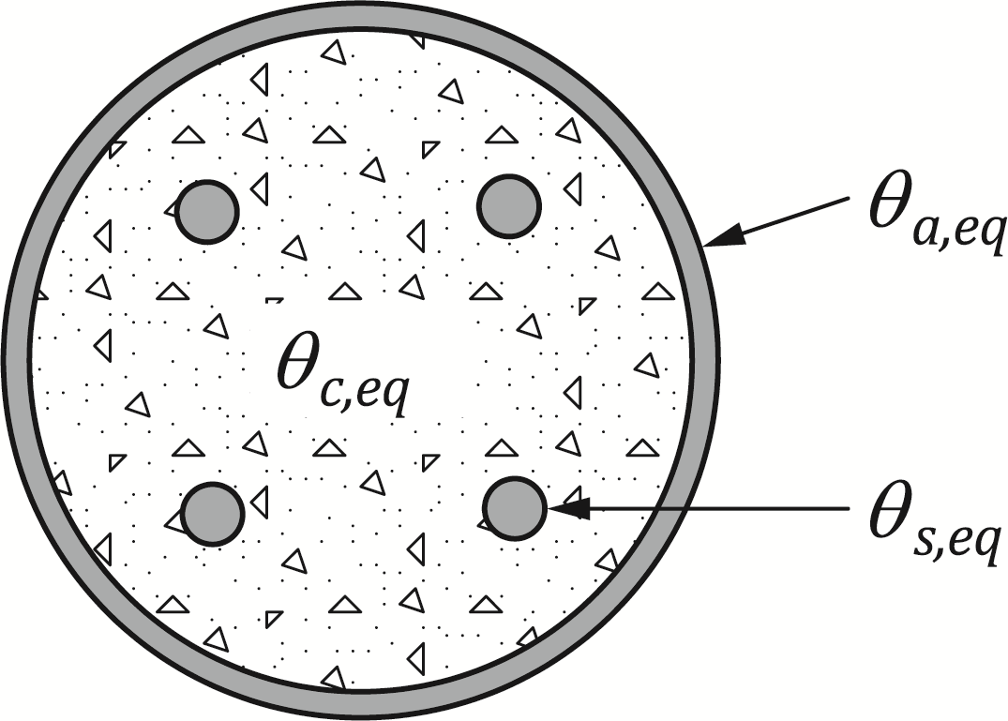

Figure F.1 — Equivalent temperatures in a concrete-filled hollow section

where

|  |  |
| --- | --- |
| *tfi* | is the period of fire exposure [min]; and |
| *us* | is the distance from the axis of the reinforcing bars to the concrete surface [mm]. |

(3) Values of the coefficients  given in Table F.1, should be used for different cross-section geometries. Linear interpolation may be used for intermediate values of *us*.

Table F.1 — Values of coefficients  for different cross-section geometries

|  |  |  |  |  |  |  |
| --- | --- | --- | --- | --- | --- | --- |
|  |  | *us*  [mm] |  |  |  |  |
| CHS |  | *20* | 7236.5 | -10458 | 5497.6 | 19.38 |
|  | *30* | 58714 | -41328 | 10910 | 11.179 |
|  | *35* | 0 | -12732 | 6518 | 91.208 |
|  | *50* | 0 | -55639 | 13768 | -19.897 |
|  | *55* | 0 | -43201 | 10790 | 24.229 |
|  | *70* | 0 | 0 | 8858 | 96.676 |
| SHS |  | *20* | 8151.3 | -11323 | 5595.4 | 93.392 |
|  | *30* | 85460 | -54898 | 12825 | -22.081 |
|  | *35* | 0 | -18802 | 8222.9 | 116.34 |
|  | *50* | 0 | -67134 | 15912 | 16.125 |
|  | *55* | 0 | -78597 | 14878 | -43.033 |
|  | *70* | 0 | 0 | 11922 | 23.258 |
| RHS |  | *20* | 7863.2 | -10978 | 5465.2 | 108.38 |
|  | *30* | 82790 | -53604 | 12626 | -8.4515 |
|  | *35* | 0 | -20109 | 8575.4 | 53.012 |
|  | *50* | 0 | -79340 | 17108 | -54.085 |
| EHS |  | *30* | 79543 | -51871 | 12481 | -45.483 |
|  | *40* | 304952 | -117159 | 18180 | -111.73 |
|  | *55* | 0 | -100810 | 18531 | -35.745 |
|  | *65* | 0 | -157800 | 23377 | -86.427 |

* 1. Design axial buckling load at elevated temperature

(1) This calculation model is based on the principles and rules given in 7.5.1.

(2) For the calculation of the design values of the plastic resistance to axial compression and the effective flexural stiffness in the fire situation, the cross-section of a concrete filled hollow section column is divided into three components: the steel section, the concrete core and the reinforcing bars.

(3) The design value of the plastic resistance to axial compression in the fire situation should be as given in Formula (F.4):

$N_{pl,Rd,fi}=A_{a}f_{y,θ}\left(θ_{a,eq}\right)/γ_{M,a,fi}+A_{c}f_{c,θ}\left(θ_{c,eq}\right)/γ_{M,c,fi}+A_{s}f_{s,θ}\left(θ_{s,eq}\right)/γ_{M,s,fi}$ (F.4)

where

|  |  |
| --- | --- |
| Ai | is the area of part i of the cross-section; |
| Subscripts "a", “c” and “s” | denote the steel section, the concrete core and the reinforcing bars, respectively; |
| *fi,θ*(*θi,eq*) | is the design strength of part i at the temperature *i*,*eq*, which can be calculated using the relevant reduction factors *k* from Tables 5.2, 5.3 and 5.4. |

(4) The effective flexural stiffness is calculated from Formula (F.5):

${\left(EI\right)}_{eff,fi}=φ_{a,θ}E_{a,θ}\left(θ_{a,eq}\right)I_{a}+φ_{c,θ}E_{c,θ}\left(θ_{c,eq}\right)I_{c}+φ_{s,θ}E_{s,θ}\left(θ_{s,eq}\right)I_{s}$ (F.5)

where

|  |  |
| --- | --- |
|  | is the reduction coefficient depending on the effect of thermal stresses of part *i*. Values of these coefficients are given in (5); |
| *I*i | is the second moment of area of part *i* of the cross-section; |
|  | is the modulus of elasticity of part *i* at temperature ,which can be calculated through the relevant reduction factors from Tables 5.2, 5.3 and 5.4. In the case of concrete, the secant modulus , shall be used. |

(5) Flexural stiffness correction factors *i,θ* for the different components of the cross-section should be as given below:

* Concrete core: 
* Steel section: see Table F.2:

Table F.2 — Flexural stiffness correction factors for steel section

|  |
| --- |
| **CHS** |
|  |
| **SHS** |
|  |
| **RHS & EHS \*** |
|  |
| Key  * When eccentricity is applied for bending about the major axis, B should be replaced by H. |

* Reinforcing bars: see Table F.3:

Table F.3 — Flexural stiffness correction factors for reinforcing bars

|  |
| --- |
| **CHS & SHS** |
|  |
| **RHS** |
|  |
| **EHS** |
|  |

where

|  |  |
| --- | --- |
| *tfi* | is the period of fire exposure [min]. |

(6) The elastic critical load in the fire situation should be calculated from Formula (F.6):

 (F.6)

(7) The relative slenderness at elevated temperature is obtained from:

 (F.7)

where

|  |  |
| --- | --- |
| *Npl,R,fi* | is the value of *Npl,Rd,fi* according to (3) when the factors,and are taken as 1,0. |

(8) The design value in the fire situation, of the resistance of a concrete filled hollow section column in axial compression should be obtained from:

 (F.8)

where

|  |  |
| --- | --- |
|  | is the reduction coefficient for the corresponding buckling curve as a function of the relative slenderness . For unreinforced columns, buckling curve “a” of EN 1993-1-12 should be used. For reinforced columns, buckling curve “b” shall be used. |

* 1. Eccentricity of loading

(1) The design value of the eccentric buckling load in the fire situation should be calculated according to prEN 1994-1-1:2024, 8.8.3.6 using the equivalent temperatures given in F.3(2).

(2) When evaluating the effective flexural stiffness for second-order analysis at elevated temperatures, Formula (F.9) should be used; this is an adaptation of the expression in prEN 1994-1-1:2024, 8.8.3.4(2):

 (F.7)

where

|  |  |
| --- | --- |
|  | is the reduction coefficient depending on the effect of thermal stresses of part *i*. Values of this coefficient are given in F.4(5); |
| *Ke,II* | is a correction factor which shall be taken as 0.5; |
| *Ko* | is a calibration factor which shall be taken as 0.9; |
|  | is a correction factor for elevated temperature, which shall be obtained from Table F.4 |

Table F.4 —Values of the correction factor Kθ

|  |  |
| --- | --- |
| *tfi* < 60 min |  |
| *tfi* ≥ 60 min | 0.9 |

where

|  |  |
| --- | --- |
|  | is the reinforcement ratio. |

NOTE It is assumed that *α*M is unaffected by temperature, therefore *α*M = 0.9 for steel grades between S235 and S355 inclusive, and *α*M = 0.8 for steel grades S420 and S460 (as given in prEN 1994-1-1:2024, 8.8.3.6).

(3) It should be noted that, in the calculation of initial imperfection to obtain the design bending moment, the system length should be used.

1. (normative)  
     
   Simple calculation method for fire resistance of steel and concrete composite floors under tensile membrane action
   1. Use of this annex

(1) This Normative Annex contains additional provisions to 4.8(6) for assessing the fire resistance of steel-concrete composite floors under tensile membrane action.

* 1. Scope and field of application

(1) This Normative Annex covers / applies to steel‑framed buildings with floors comprising primary steel or composite beams, secondary steel or composite beams, and composite slabs.

(2) To apply this method the following conditions should be satisfied:

* only uniformly distributed loads on the floor;
* connections are designed according to EN 1993-1-8;
* steel and composite beams are mechanically connected to the composite slab, and designed in accordance with EN 1993-1-1 or EN 1994‑1‑1 respectively;
* composite slabs should use normal or lightweight concrete and include at least a top layer of continuous reinforcing mesh designed in accordance with EN 1994-1-1; and
* detailing is in accordance with G.6.2.

NOTE The minimum reinforcing mesh is 142 mm2 per meter width of slab in both directions unless the National Annex gives a different value.

(2) The aspect ratio (longer span /shorter span) of each floor design zone should not exceed 2.5.

(3) The design method may be used with either isotropic or orthotropic reinforcing mesh. However, the ratio of the cross-sectional area of the reinforcing mesh per unit width between the two orthogonal directions should not exceed 3.

(4) The floor may be exposed to fire according to the standard temperature-time curve, the parametric temperature-time curve or other temperature-time curve generated from physically based models, as defined in EN 1991-1-2.

* 1. General rules

(1) Steel and concrete composite floor shall be divided into a number of rectilinear zones (floor design zones), each of which is vertically supported by edge and perimeter beams, as illustrated in Figure G.1. In each zone, the fire resistance shall be evaluated based on the loadbearing capacity of the zone under tensile membrane action. Load distribution to perimeter beams under tensile membrane action shall be taken into account.

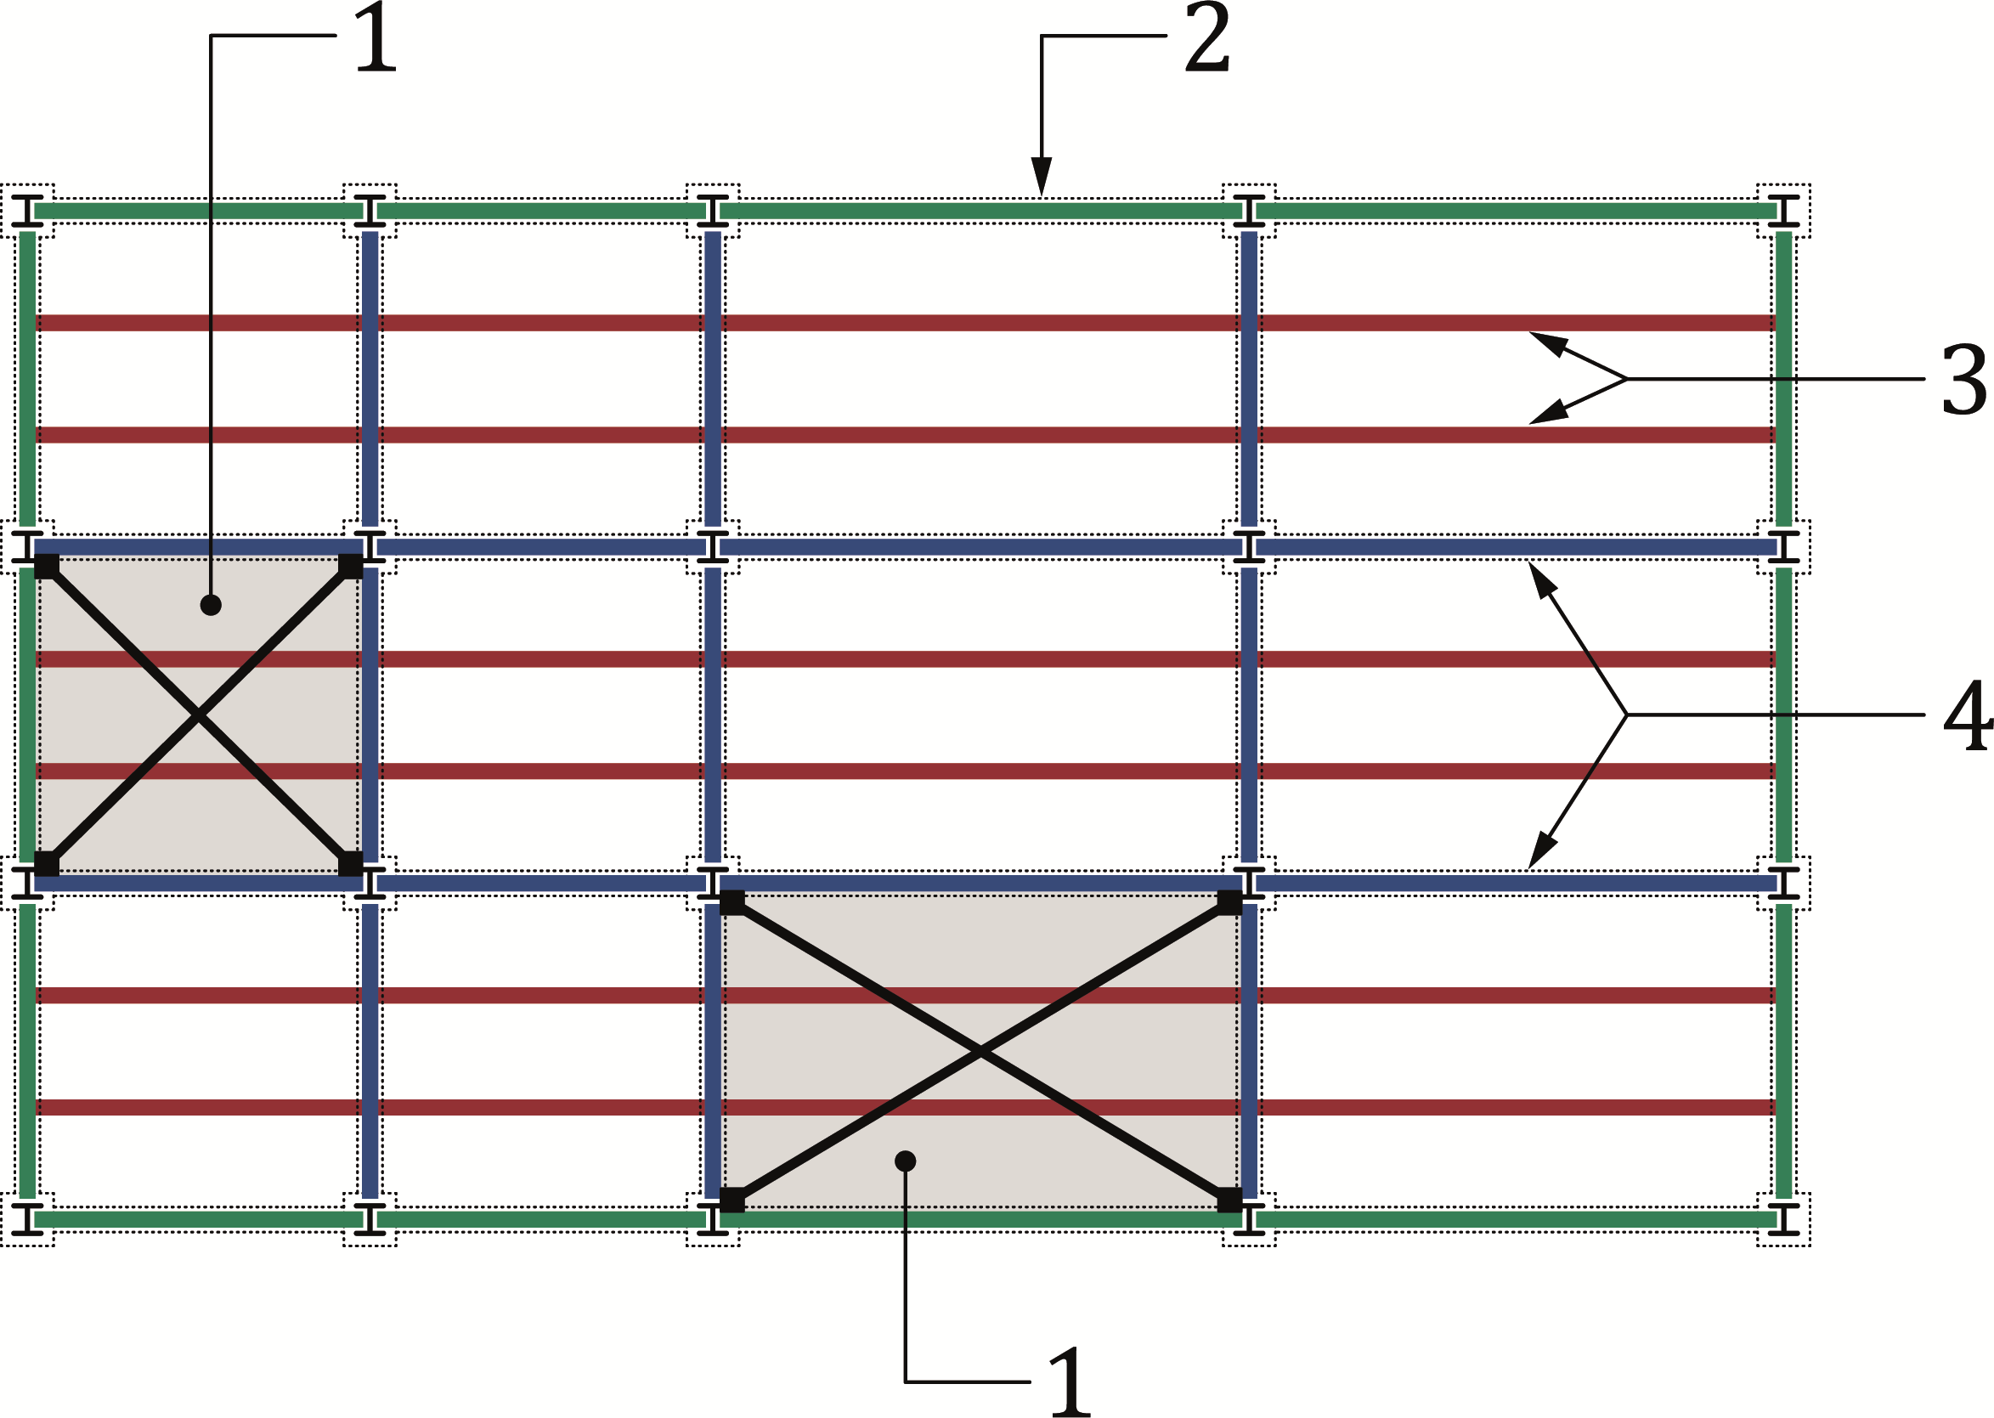

**Key**

|  |  |
| --- | --- |
| 1 | floor design zone |
| 2 | edge beams: Steel or composite, protected or encased |
| 3 | internal beams: Unprotected composite |
| 4 | perimeter beams: Steel or composite, protected or encased |

Figure G.1 — Division of a composite floor into design zones

(2) A floor design zone, as illustrated in Figure G.2, should satisfy the following conditions:

* The zone is rectangular and bounded on all sides by beams designed to achieve the fire resistance required for the floor;
* All the beams in a zone span in one direction only;
* No column is situated inside the zone;
* In each zone, there may be up to four openings provided that no side exceeds 250 mm. These openings should have a minimum spacing of 1 m measured between centres. If the steel reinforcing mesh is interrupted by an opening, additional steel reinforcement should be provided around this opening to ensure continuity of at least the same reinforcement quantity;
* For fire periods above R60, or when designing for a physically-based fire, all columns are restrained by at least one edge beam of a floor design zone, in each orthogonal direction.

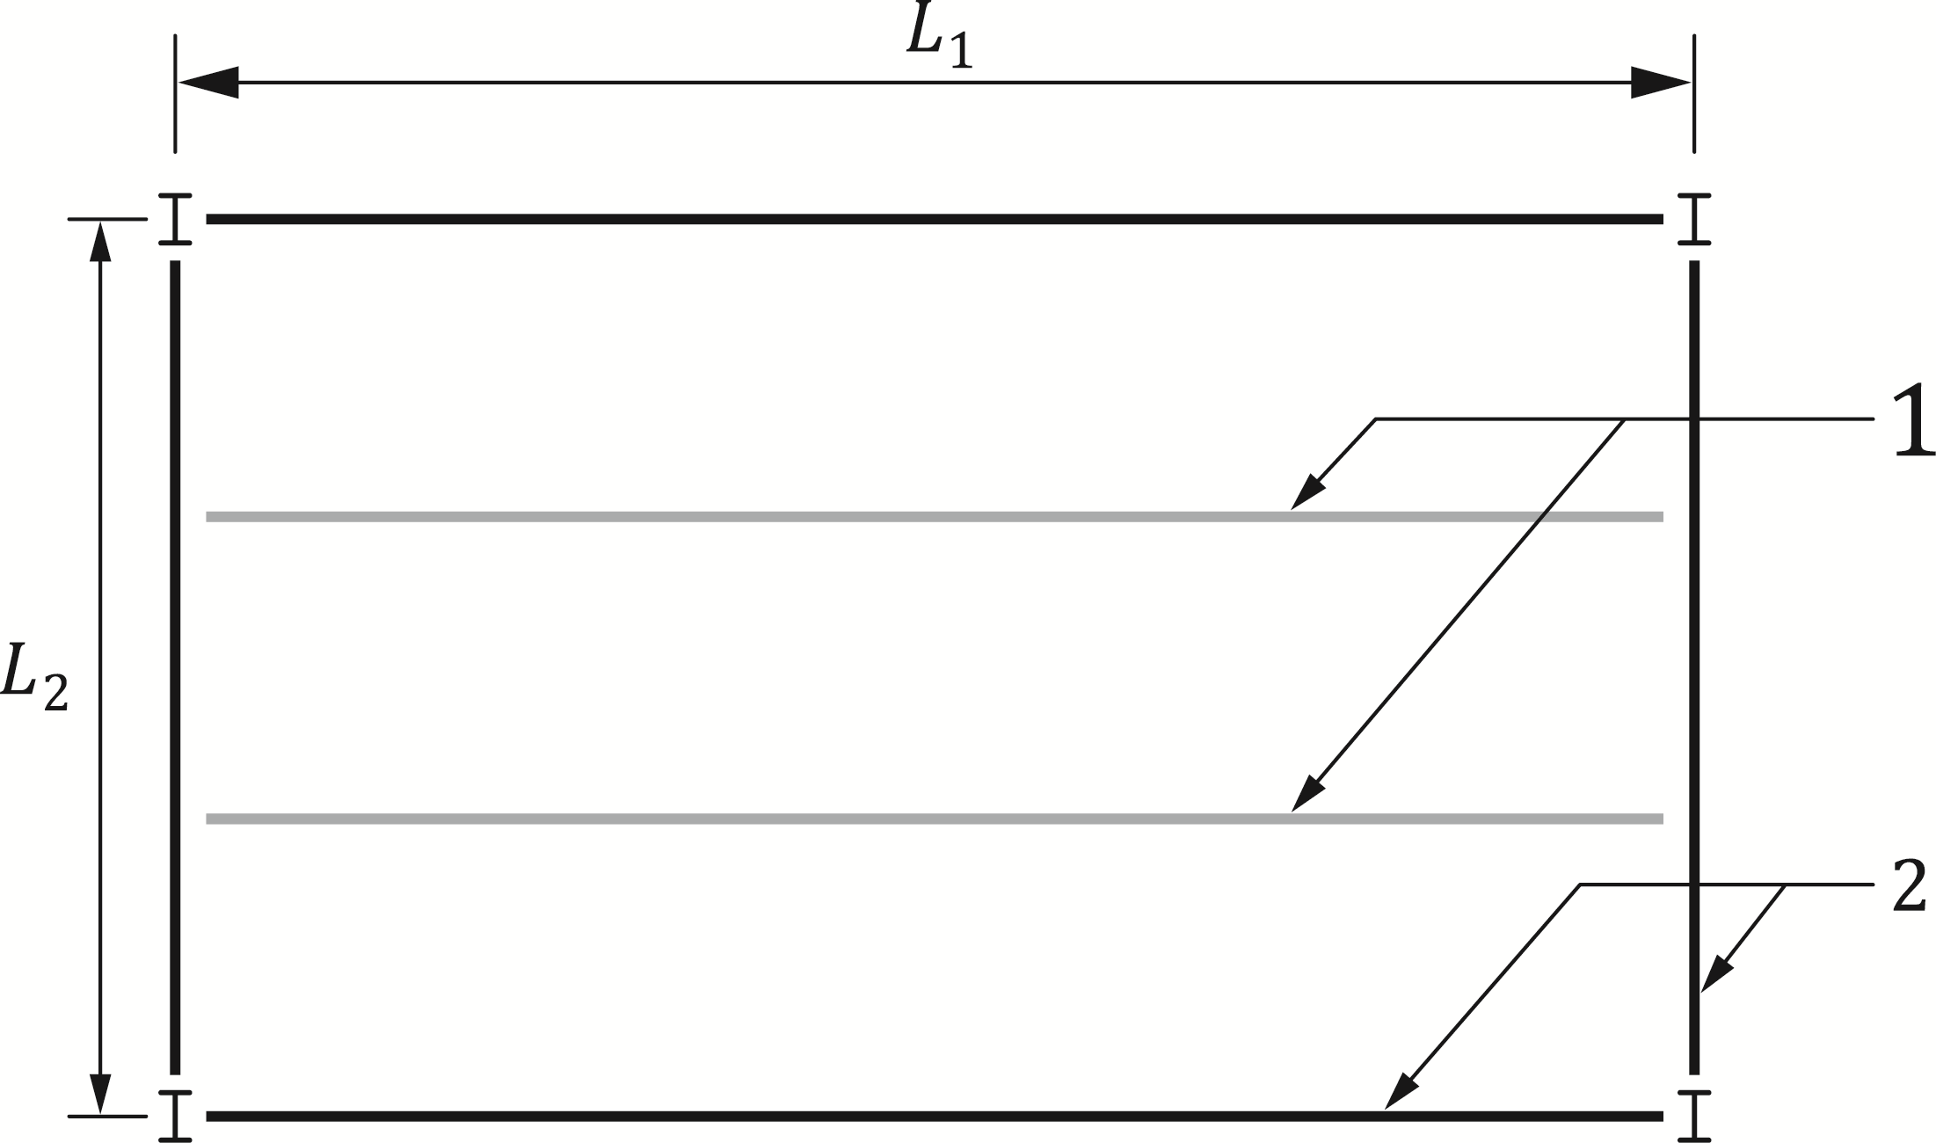

**Key**

|  |  |
| --- | --- |
| 1 | unprotected internal beams |
| 2 | protected perimeter beams or any other type of vertical support |

Figure G.2 — Floor design zone

(3) Satisfaction of insulation requirements should be demonstrated using the relevant clauses of EN 1992-1-2 and EN 1994-1-2.

(4) Integrity may be considered as satisfied provided detailing complies with G.6

* 1. Temperature distribution

(1) Non-uniform distribution of temperature through the depth of a composite slab should be taken into account when calculating the bending moment resistance of the slab as well as the total deflection of each floor design zone.

(2) The temperature distribution in a composite slab may be determined in accordance with 8.2.

(3) As an alternative to (2), Table B.5 may be used. The temperature of the reinforcement may be taken as that of the concrete at the same depth.

(4) Temperatures of protected and unprotected composite beams with no concrete encasement may be determined in accordance with 7.4.1.2.

(5) Temperatures of unprotected steel beams and cellular beams may be determined using the relevant clauses in EN 1993-1-2.

* 1. Calculation of floor loadbearing capacity under tensile membrane action
     1. General

(1) The total loadbearing capacity of the floor design zone qfi,Rd should be obtained from:

 (G.1)

where:

|  |  |
| --- | --- |
|  | is the loadbearing capacity of the composite slab under tensile membrane action, see G.5.1 |
|  | is the loadbearing capacity contribution of the unprotected internal secondary composite beams in bending, see G.5.2 |

* + 1. Calculation of composite slab loadbearing capacity

(1) The loadbearing capacity of the composite slab under tensile membrane action qfi,Rd,slab should be calculated from Formula (G.2):

 (G.2)

where

|  |  |
| --- | --- |
| *e* | is the overall enhancement factor under tensile membrane action, calculated according to (4). |

(2) The reference loadbearing capacity, based on a yield line solution, of the composite slab *qfi,Rd* should be calculated from Formula (G.3):

 (G.3)

where

|  |  |
| --- | --- |
| *M*0,fi | is the sagging moment resistance per unit width of the composite slab cross-section along the longer side of the floor design zone; |
| L | is the longer span dimension of the floor design zone (L= max(L1, L2)); |

*n* is a factor given by Formula (G.4):

 (G.4)

where

|  |  |
| --- | --- |
| *a* | is the aspect ratio of the floor design zone, defined as L/l with *a* ≤ 2.5; |
| *μ* | is a coefficient defining the ratio of sagging moment resistances of the composite slab in orthogonal directions. If the composite slab has equal reinforcement in both directions, *μ*=1 |

In other cases, it may be calculated by:

 (G.5)

where

|  |  |
| --- | --- |
| *K* | is the ratio of tensile force per unit width of the reinforcing mesh in the shorter side cross-section to tensile force per unit width of the reinforcing mesh in the longer side cross-section; |
| (g0)1,(g0)2 | are parameters defining the compressive stress block of concrete for sagging moment resistance of the composite slab per unit width in the shorter and the longer side cross-sections respectively (see Figure G.6); |

with

 and  (G.6)

where

|  |  |
| --- | --- |
| *As* | is the cross-sectional area of the reinforcing mesh per unit width, in the longer side cross-section of the floor design zone; |
| *f*sy,θs | is the effective yield strength of reinforcing steel at temperature θs; |
| *γ*M,s,fi | is the partial factor for the strength of reinforcing steel in the fire situation; |
| *f*ck | is the characteristic value of the compressive cylinder strength of concrete at 20 °C temperature; |
| *γ*M,fi,c | is the partial factor for the strength of concrete in the fire situation; |
| *d* | is the distance between the centre of the reinforcing mesh (median plane) and the top side of the composite slab, as illustrated in Figure G.4; |
| *α*slab | is a coefficient that allows for the assumption of a rectangular stress block when designing composite slabs, *α*slab = 0,85. |

|  |  |
| --- | --- |
|  |  |
| A) | B) |

**Key**

|  |  |
| --- | --- |
| A | shorter side cross-section (parallel to the shorter dimension of the floor design zone) |
| B | longer side cross-section (parallel to the longer dimension of the floor design zone) |

Figure G.3 — Forces and dimensions for the sagging moment resistance of a composite slab

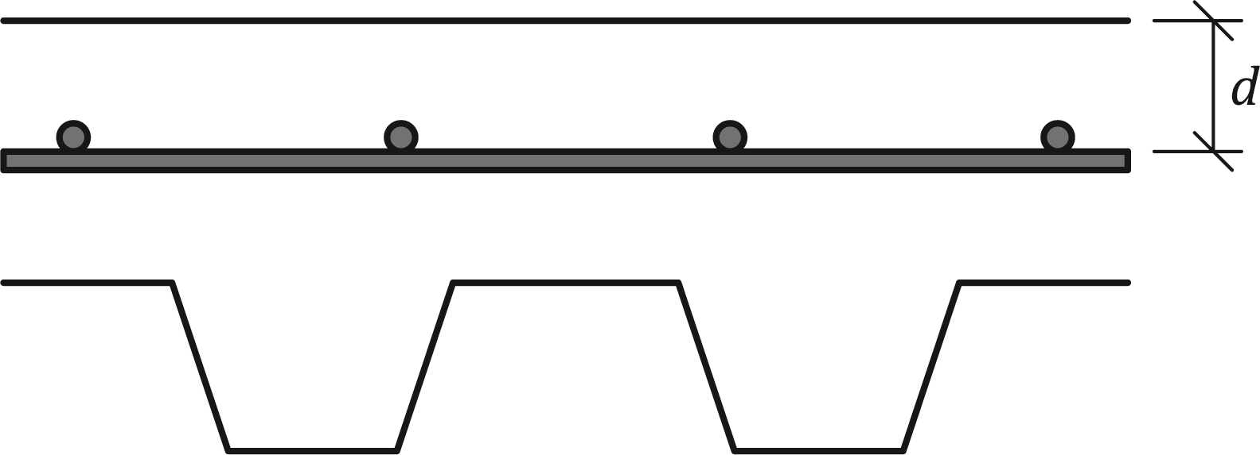

Figure G.4 — Definition of dimension *d*

(3) The sagging moment resistance of a composite slab per unit width under bending about the longer side cross-section of the floor design zone may be obtained from Formula (G.7):

 (G.7)

(4) The overall enhancement factor e due to activation of tensile membrane action should be determined from:

 (G.8)

where









in which









with











(5) The deflection limit of a composite floor in the fire situation under tensile membrane action should be determined from Formula (G.9):

 (G.9)

where

|  |  |
| --- | --- |
| *E*s | is the modulus of elasticity of the reinforcing steel at 20 °C; |
| *f*sy | is the nominal value for the yield strength of the reinforcing steel at 20 °C; |
| *h*eff | is the effective thickness of the composite slab, as defined in B.4; |
| αc | is the coefficient of thermal expansion of concrete according to 5.3.2.1; |
| *θ*1 | is the temperature of the unexposed side of the composite slab; |
| *θ*2 | is the temperature of the exposed side of the composite slab |

* + 1. Calculation of loadbearing capacity of unprotectedsecondary beams inside the floor design zone

(1) The loadbearing capacity contribution of the internal secondary composite beams should be obtained from Formula (G.10):

 (G.10)

where

|  |  |
| --- | --- |
| *M*Rd,j,fi | is the design value of the sagging moment resistance of the internal secondary composite beam j, calculated according to 7.4.2.2.1; |
| nub | is the total number of internal secondary composite beams; |
| bj | is the width of the composite slab supported by the internal composite beam j, according to EN 1994-1-1. |

(2) If the beam spacing is uniform and the internal composite beams are identical, the loadbearing capacity contribution of the internal secondary composite beams can be obtained from Formula (G.11):

 (G.11)

where

|  |  |
| --- | --- |
| *L*1, *L*2 | are the composite slab spans in both directions, defined in Figure G.2. |

* + 1. Calculation of the total loadbearing capacity of the floor design zone

(1) Under tensile membrane action, the perimeter secondary beams shall be capable of resisting the additional load from the load distribution path under tensile membrane action.

(2) The load applied in the fire situation to the two perimeter secondary beams may be calculated from Formulae (G.12) and (G.13):

 (G.12)

 (G.13)

where

|  |  |
| --- | --- |
| *q*Ed,fi | is the uniformly distributed load to be supported by the floor design zone in the fire; |
| *n*ub | is the total number of internal secondary beams; and |
| *M*Rd,j,fi | is the design value of the sagging moment resistance of the internal secondary beam *j*, calculated according to 7.4.2.2.1. |

*c*M is a factor given by:

|  |  |
| --- | --- |
| cM = 16 | If both secondary perimeter beams are edge beams |
| cM = 12 | In all other cases |

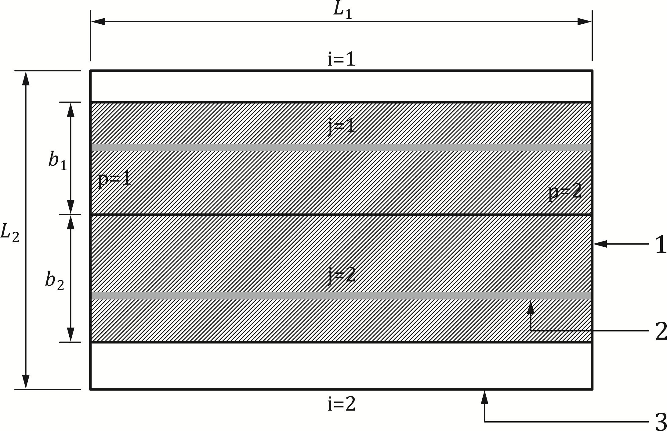

**Key**

|  |  |
| --- | --- |
| 1 | perimeter primary beam p |
| 2 | internal secondary beam j |
| 3 | perimeter secondary beam i |

Figure G.5 — Example of floor design zone with two internal secondary beams (*n*ub = 2)

(3) The internal forces in the fire situation in the primary perimeter beams may be calculated from Formulae (G14) and (G.15):

 (G.14)

 (G.15)

where cM is a factor given by:

|  |  |
| --- | --- |
| cM = 16 | If both primary perimeter beams are edge beams of the floor plate |
| cM = 12 | In all other cases |
|  | is the design value of bending moment in the fire situation in the perimeter primary beams |
|  | is the design value of shear force in the fire situation in the two perimeter secondary beams |

* 1. Detailing
     1. Reinforcing mesh

(1) The steel reinforcing mesh should not be located above the studs and the concrete cover should comply with EN 1992-1-1.

(2) Individual sheets of steel reinforcing mesh should be lapped in two orthogonal directions to ensure mesh continuity. Recommended lap lengths are given in FprEN 1992-1-1:2023, 11.5. The minimum lap length for reinforcing steel mesh should be 250 mm.

* + 1. Edge of the composite slab

(1) The ends of the reinforcing steel mesh should overlap with shear connectors, or additional U-shaped reinforcing bars passing around shear connectors should be provided to link the edge beams to the composite slab, as illustrated in figure G.6.

(2) In cases where an edge beam is designed as a steel beam, the composite slab should be adequately anchored to the beam by means of shear connectors with a maximum spacing of 300 mm.

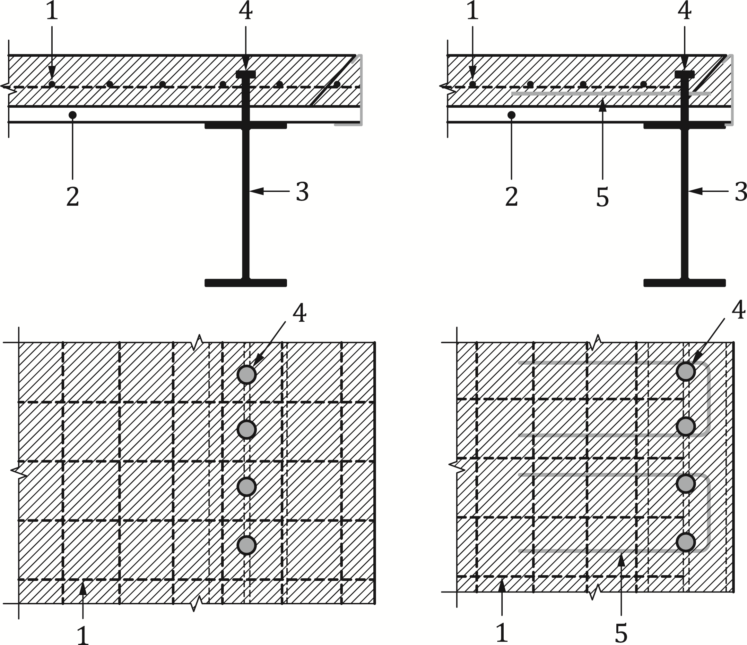

**Key**

|  |  |
| --- | --- |
| 1 | reinforcing mesh |
| 2 | steel sheeting |
| 3 | steel beam |
| 4 | shear connector |
| 5 | additional U-shaped reinforcing bar |

Figure G.6 — Example of composite slab edge details

* + 1. Fire protection

(1) In cases where structural members are fire protected, the fire protection should extend to the joints.

(2) Where an unprotected steel section is connected to a protected steel section, the passive fire protection should cover the entire connection zone plus a suitable length of the unprotected steel section, as illustrated in Figure G.7.

(3) Where a protected steel section is connected to the unprotected steel face of a composite column, the fire protection applied to the steel section should be extended to the connection zone of the column, over a height corresponding to the maximum height of all the members of the joint. The thickness of the fire protection should be the maximum thickness applied to the members of the joint connected steel sections.

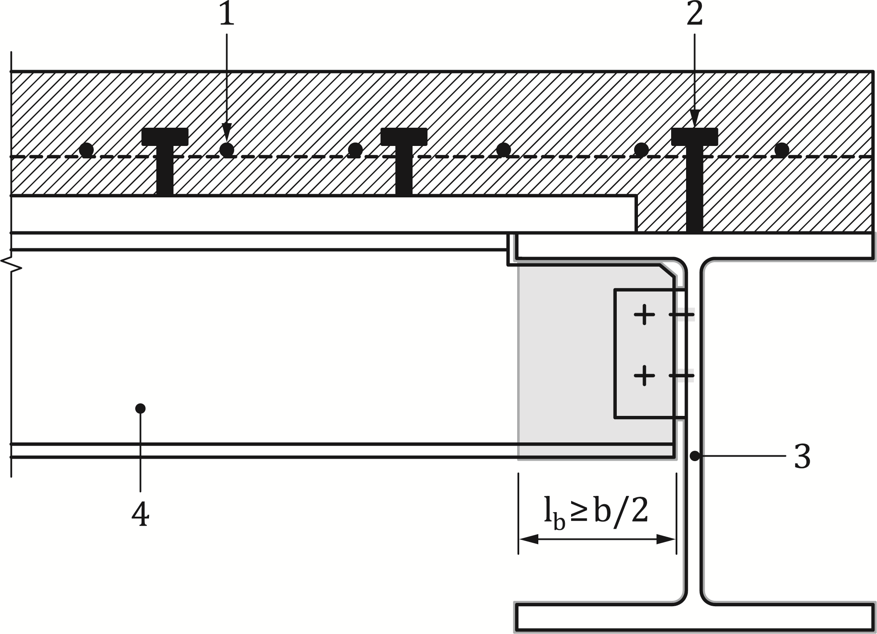

**Key**

|  |  |
| --- | --- |
| 1 | reinforcing mesh |
| 2 | shear connector |
| 3 | protected main steel beam |
| 4 | unprotected secondary steel beam |

Figure G.7 — Extent of fire protection along an unprotected steel section

1. (normative)  
     
   Calculation of the sagging moment of resistance Mfi,Rd+ of a shallow floor beam exposed to fire
   1. Use of this annex

(1) This Normative Annex contains additional provisions to 7.4.2.4 for assessment of the sagging moment resistance of a shallow floor beam exposed to standard fire curve.

* 1. Scope and field of application

(1) This Normative Annex applies to Type A and Type B shallow floor cross-sections satisfying the general geometries of Figure H.1 and geometrical conditions of Table H.1, subjected to the standard temperature-time curve of EN 1991-1-2.

|  |
| --- |
|  |
| a) |
|  |
| b) |

**Key**

|  |  |
| --- | --- |
| 1 | in-situ concrete |
| 2 | composite slab, prefabricated slab, in-situ concrete or void |
| 3 | longitudinal reinforcing bar |

Figure H.1 — General geometries of Type A (a) and Type B (b) cross-sections covered by Annex H

Table H.1 — Field of application

|  |  |  |
| --- | --- | --- |
| **Steel section** | **Concrete slab** | **Reinforcement** |
| 10 mm ≤ ep ≤ 40 mm (Type A)  10 mm ≤ eft ≤ 40 mm (Type B) | 30 mm ≤ cz ≤ 150 mm | ur = 30 mm |
| 8 mm ≤ ef ≤ 40 mm (Type A)  8 mm ≤ efb ≤ 40 mm (Type B) | bf + 60 mm ≤ bw (Type A)a  bft + 60 mm ≤ bw Type B)a | uc = 40 mm |
| 0.7 ≤ ep / ef ≤ 2 (Type A) | 20 mm ≤ hc,1 | uw = 40 mm |
| 6 mm ≤ ew ≤ 30 mm | 40 mm ≤ la | hs ≤ hw – 2 ⋅ ur |
| 160 mm ≤ h ≤ 450 mm  160 mm ≤ bf ≤ 450 mm (Type A)  160 mm ≤ bft ≤ 450 mm (Type B) |  |  |
| 160 mm ≤ bp – bf ≤ 250 mm (Type A)  110 mm ≤ bfb – bft ≤ 250 mm (Type B) |  |  |
| a The value of 60 mm may be reduced to 30 mm in case of a solid slab. | | |

(2) The structural steel section is an asymmetric rolled, or equivalent welded section. In particular, for Type A cross-section, a plate is welded to the bottom flange of a symmetric section. Different steel grades from S235 to S460 inclusive may be used for the plates and rolled sections constituting the cross-section. Cross-sections should be Class 1 or 2 according to prEN 1994-1-1:2024, I.2.3.

(3) The slab may be a solid slab (precast or in-situ concrete) or a composite slab but this Annex does not apply to slabs with lightweight concrete.

(4) Only reinforcing bars fulfilling the following conditions may be considered:

* Class B500B or B500C;
* Diameter between 6 mm and 32 mm; and
* Positioned in the region between the flanges of the steel section defined by dimensions hs and us according to Figure H.1 or H.2.

(5) This Normative Annex is limited to beam spans less than 12 m.

(6) This Normative Annex is applicable to shallow floor beams with full shear connection in the fire situation. In case of non-composite shallow floor beams or shallow floor beams with partial shear connection, the Annex may be used by ignoring the contribution of the reinforced concrete.

(7) The concrete slab should be flexible enough to accommodate beam deflections up to L / 20, where L is the beam span, in the fire situation without structural damage.

(8) This Normative Annex applies both to unprotected and protected shallow floor beams.

* 1. Calculation of the sagging moment resistance MRd,fi+

(1) The plastic neutral axis of a composite shallow floor beam may be determined from Formula (H.2):

 (H.2)

where

|  |  |
| --- | --- |
|  | is a coefficient that allows for the assumption of a rectangular stress block when designing concrete slabs and composite shallow floor beams,  = 0,85; |
| fy,i | is the nominal yield strength fy for the elemental steel area Ai at 20 °C, taken as positive on the compression side of the plastic neutral axis and negative on the tension side; |
| fck,j | is the characteristic strength of the elemental concrete area Aj at 20 °C. For concrete parts tension is ignored; |
| ky,θ,I and kc,θ,j | are as defined in Table 5.3 (or Table 5.4) and 5.5. |

(2) The design sagging moment resistance Mfi,Rd,+ may be determined from (H.3):

 (H.3)

where

|  |  |
| --- | --- |
| zi, zj | is the distance from the plastic neutral axis to the centroid of the elemental area Ai or Aj. |

(3) For the determination of the sagging bending resistance Mfi,Rd+, only the concrete above the top flange should be taken into account. The maximum design value of the concrete compressive force Nfi,c,Rd should be calculated using Formula (H.4):

 (H.4)

where

|  |  |
| --- | --- |
| kh | = 0.85 for ; |
| kh | 1.0 for all other cases; |
| cz | is the concrete cover above the top flange of the steel section, see Figure H.1 or H.2; and |
| Nt,Rd,fi | is the tensile resistance of the steel section, obtained by combining the tensile resistances of the n parts of the steel section. |

(4) The width of the bottom plate acting as support of the concrete slab welded to the structural steel section, or flange, should be reduced to bp,eff,fi (Type A) or bfb,eff,fi (Type B) using Formulae (H.5) and (H.6):

 for Type A (H.5)

 for Type B (H.6)

where

|  |  |
| --- | --- |
| kc | =0.5 for a solid slab covering 100 % of the upper surface of the bottom plate; |
| kc | =1.0 for all other cases. |

(5) Load transfer from the concrete slab to the web of the steel beam should be ensured by adequate reinforcement and slab detailing, in order to justify neglecting the influence of transversal shear and bending on the longitudinal moment resistance of the composite shallow floor beams.

(6) The temperature of the welded plate θp (Type A) or bottom flange θfb (Type B) should be assumed as constant over its cross-sectional area and calculated using Formulae (H.7) and (H.8): 

 for Type A (H.7)

 for Type B (H.8)

where

|  |  |
| --- | --- |
| Ai, Bi, Ci | are given in Table H.2. |

(7) The temperature of the bottom flange θf of a Type A cross-section should be assumed to be constant over its entire area and calculated using Formula (H.9):

 (H.9)

where

|  |  |
| --- | --- |
| kt | 0,85 for a thickness of the bottom flange ef > 15mm; |
| kt | 1,0 for all other cases; and |
| Ai, Bi, Ci | are given in Table H.2. |

(8) For the determination of the sagging moment resistance of the composite shallow floor beam, the temperature of the web θw should be assumed to be constant over its entire area and calculated using Formulae (H.10) and (H.11):

Type A:

 (H.10)

Type B:

 (H.11)

where

|  |  |
| --- | --- |
| Aw, Bw, Cw, Dw | are given in Table H.2. |

(9) Within the field of application defined in Table H.1, the top flange may be assumed to be unaffected by the fire exposure.

(10) The temperature of the reinforcement located within the zone determined by hs and us according to Figure H.1, θr should be calculated using Formula (H.12):

 (H.12)

where

|  |  |
| --- | --- |
| ueq | is the equivalent distance and should be calculated with:  (Type A)  or  (Type B) |
| Ar, Br, Cr | are given in Table H.2. |

Table H.2 — Parameters for determination of the bending resistance

|  |  |  |  |  |
| --- | --- | --- | --- | --- |
| Parameter | R30 | R60 | R90 | R120 |
| Ai | 0.113 | 0.130 | 0 | 0 |
| Bi | -12.50 | -11.80 | -2.60 | -1.25 |
| Ci | 760 | 980 | 990 | 1025 |
| Aw | -140.70 | -103.80 | -108.60 | -70.44 |
| Bw | 832.42 | 968.60 | 1146.70 | 1124.40 |
| Cw | 0.0317 | 0.0232 | 0.0198 | 0.0158 |
| Dw | -0.230 | -0.182 | -0.154 | -0.134 |
| Ar | 0 | 0.0954 | 0.0548 | 0.0381 |
| Br | 0 | -19.254 | -15.130 | -12.797 |
| Cr | 300 | 1105.4 | 1135.9 | 1138.1 |

(11) The reinforcing bars should satisfy the conditions of 9.1(4) and 9.1(6).

(12) The shear resistance of the steel web should be calculated using Formula (H.13): 

 (H.13)

where

|  |  |
| --- | --- |
|  | should be taken from Table H.3. |

Table H.3 — Reduction factor for shear resistance of the steel web

|  |  |  |  |  |
| --- | --- | --- | --- | --- |
|  | R30 | R60 | R90 | R120 |
|  | 0.95 | 0.85 | 0.70 | 0.55 |

(13) The interaction between bending moment and vertical shear force should be considered according to prEN 1994-1-1:2024, 8.2.2.5.

* 1. Protected shallow floor beams

(1) The distribution of temperature in protected composite shallow floor beams may be assumed to be uniform and the evolution of temperature may be calculated according to 7.4.1.2.1(6), where *A*p,i/*V*i is the section factor of the bottom plate (or flange) of the composite shallow floor beam.

(2) The section factor *A*p,i/*V*i should be calculated according to Formulae (H.14) to (H.17):

for configurations where the top surface of the bottom plate (or flange) exposed to fire is fully covered by the concrete slab:

 (H.14)

 (H.15)

for configurations where the top surface of the bottom plate (or flange) exposed to fire is covered partially by the concrete slab:

 (H.16)

 (H.17)

where

|  |  |
| --- | --- |
| *l*a | is the width of support of the concrete slab (see Figure H.1) |

(3) The evolution of temperature of a composite shallow floor beam where all the steel parts exposed to fire are protected should be assessed considering the section factors given in (2).

(4) The critical temperature *θ*cr of a composite shallow floor beam may be determined from the load level *η*fi,t applied to the member and from the strength of steel at elevated temperatures *f*ay,θcr according to Formula (H.18).

 (H.18)

where

|  |  |
| --- | --- |
| *η*fi,t | *=E*d,fi,t /*R*d |
| *E*d,fi,t | *=η*fi *E*d = according to 4.7 (1) |
|  | is the reduction factor for yield strength of the bottom flange (or plate) due to transversal vertical shear and bending, calculated according to (H.13) |

with

 (H.19)

where

|  |  |
| --- | --- |
| =*mEd,fi*/*mRd,pl,* | is the load level of the plate (or flange) under transverse bending; |
| *mEd,fi* | is the design transverse bending moment per unit length [kN.m/m] of the bottom plate (or flange) under fire conditions; and |
| *mpl,Rd,* | is the plastic bending resisting moment per unit length [kN.m/m] of the bottom plate (or flange) at temperature . |

(6) If the upper surface of an external part is considered as exposed to fire according to 7.4.2.4(4), the reduction of yield strength of the bottom flange (or plate) due to transverse bending should be determined by considering a specific temperature of the external part. The temperature of the external part should be calculated according to 7.4.1.2.1(6), where the section factor is given by Formula (H.20):

 (H.20)

1. (normative)  
     
   Beams with large web openings exposed to fire
   1. Use of this annex

(1) This Normative Annex contains additional provisions to 7.4.2.1.1(2) for the design of beam with large web openings exposed to fire.

* 1. Scope and field of application

(1) This Normative Annex applies to composite beams with large web openings within the scope of prEN 1994-1-1:2024, Annex D.

(2) This Normative Annex does not apply when concrete slabs are considered to be locally stiff according to prEN 1994-1-1:2024, Annex D.

(3) This Normative Annex applies to protected and unprotected beams subjected to nominal temperature-time curves of FprEN 1991-1-2:2023, 5.2, parametric temperature-time curves of FprEN 1991-1-2:2023, Annex A, or physically based models of FprEN 1991-1-2:2023, 5.3.

* 1. Thermal response

(1) Evolution of temperature of the steel section should be calculated according to FprEN 1993-1-2:2023, Annex E.

(2) Distribution of temperature in a solid slab or composite slab may be calculated according to 7.4.1.2.2 or in accordance with 8.2.

(3) As a simplification to (2), the temperature of the slab exposed to standard fire curve may be taken as 40 % of the temperature of the top flange of the beam for the calculation of resistance to local bending and vertical shear.

* 1. Mechanical response

(1) The verification of composite beams with large web openings in zones with no openings should be carried out according to rules for composite beams without web openings, see 7.4.2.1.1(1).

(2) The distribution of internal forces at opening locations is required for the verification of the beam.

(3) Any appropriate distribution may be used. It should be consistent and should be used without change for all the design checks. The distribution of internal forces in prEN 1994-1-1:2024, D.3.2 to D.3.4 may be used. When calculating resistance values Noc,Rd and Voc,Rd, the mechanical properties at elevated temperatures defined in (4) and (5) should be used.

(4) The cross-sections of beams with large web openings should be classified at elevated temperatures as for normal temperature design with a reduced value for εfi according to EN 1993-1-2, as given in Formula (I.1):

 (I.1)

(5) The resistance of the steel elements at an opening at a particular temperature θ should be obtained by application of EN 1993-1-13 and EN 1994-1-1, replacing fy by fyθ,Ea by Ea, θ and,  , by 

(6) The resistance of the concrete slab or layer of the concrete slab in compression and shear at an opening at a particular temperature θ should be obtained by application of EN 1992-1-1, replacing fc by fc, θ and  by .

(7) The effective widths for global bending beff and for local shear and bending beff,o should be obtained by application of prEN 1994-1-1:2024, Annex D.

(8) The effective width for local shear and bending beff,o should be calculated from Formula (I.2):

(I.2)

where

|  |  |
| --- | --- |
|  | =bf+0,75hc |
| *b*f | is the width of the top flange [mm]; and |
| *h*c | is the total thickness of the solid slab or composite slab [mm]. |

(8) The design shear resistance of stud connectors should be calculated according to 7.4.2.2.3.

(9) The reduction factor ka,fi to the *Vierendeel* bending resistance due to composite action may be taken as equal to 1.

Bibliography

**References contained in recommendations (i.e. “should” clauses)**

The following documents are referred to in the text in such a way that some or all of their content constitutes highly recommended choices or course of action of this document. Subject to national regulation and/or any relevant contractual provisions, alternative documents could be used/adopted where technically justified. For dated references, only the edition cited applies. For undated references, the latest edition of the referenced document (including any amendments) applies.

EN 13381‑1, Test methods for determining the contribution to the fire resistance of structural members — Part 1: Horizontal protective membranes

EN 13381‑2, Test methods for determining the contribution to the fire resistance of structural members — Part 2: Vertical protective membranes

EN 13381‑4, Test methods for determining the contribution to the fire resistance of structural members — Part 4: Applied passive protection to steel members

EN 13381‑5, Test methods for determining the contribution to the fire resistance of structural members — Part 5: Applied protection to concrete/profiled sheet steel composite member

EN 13381‑6, Test methods for determining the contribution to the fire resistance of structural members — Part 6: Applied protection to concrete filled hollow steel columns

EN 13381‑8, Test methods for determining the contribution to the fire resistance of structural members — Part 8: Applied reactive protection to steel members

EN 13381‑9, Test methods for determining the contribution to the fire resistance of structural members — Part 9: Applied fire protection systems to steel beams with web openings

prEN 1991-1-1, Eurocode 1 — Actions on structures — Part 1-1: Specific weight of materials, self-weight of construction works and imposed loads on buildings

FprEN 1992-1-2:2023, Eurocode 2 — Design of concrete structures — Part 1-2: Structural fire design

FprEN 1993-1-2:2023, Eurocode 3 — Design of steel structures — Part 1-2: Structural fire design

prEN 1993-1-12, Eurocode 3 — Design of steel structures — Part 1-12: Additional rules for steel grades up to S960

FprEN 1993-1-13, Eurocode 3 — Design of steel structures — Part 1-13: Beams with large web openings

**References contained in permissions (i.e. “may” clauses)**

The following documents are referred to in the text in such a way that some or all of their content expresses a course of action permissible within the limits of the Eurocodes. For dated references, only the edition cited applies. For undated references, the latest edition of the referenced document (including any amendments) applies.

prEN 1991-1-7:2023, Eurocode 3 — Design of steel structures — Part 1-7: Accidental actions

EN 1365‑3, Fire resistance tests for loadbearing elements — Part 3: Beams

FprEN 1993-1-5, Eurocode 3 — Design of steel structures — Part 1-5: Plated structural elements

**References given in possibilities (i.e. "can" clauses) and notes**

The following documents are cited informatively in the document, for example in "can" clauses and in notes.

EN ISO 1461, Hot dip galvanized coatings on fabricated iron and steel articles — Specifications and test methods (ISO 1461)

EN ISO 14713‑2:2020, Zinc coatings — Guidelines and recommendations for the protection against corrosion of iron and steel in structures — Part 2: Hot dip galvanizing (ISO 14713-2)