CEN/TC 250

Date: 2023-08-31

prEN 1994‑2

Secretariat: BSI

Eurocode 4 — Design of composite steel and concrete structures — Part 2: Bridges

Eurocode 4 – Bemessung und Konstruktion von Verbundtragwerken aus Stahl und Beton – Teil 2: Brücken

Eurocode 4 – Calcul des structures mixtes acier-béton – Partie 2: Ponts

ICS:

**Contents**

European foreword 3

0 Introduction 4

1 Scope 6

1.1 Scope of EN 1994‑2 6

1.2 Assumptions 6

2 Normative references 6

3 Terms, definitions and symbols 7

3.1 Terms and definitions 7

3.2 Symbols and abbreviations 7

4 Basis of design 9

4.1 General rules 9

4.2 Principles of limit states design 9

4.3 Basic variables 9

4.4 Verification by the partial factor method 10

4.4.1 Design values 10

4.4.2 Combination of actions 10

5 Materials 10

5.1 Concrete 10

5.2 Reinforcing steel 10

5.3 Structural steel 10

5.4 Connecting devices 10

5.5 Prestressing steel and devices 10

5.6 Tension components in steel 10

6 Durability 11

6.1 General 11

6.2 Corrosion protection at the steel-concrete interface 11

7 Structural analysis 11

7.1 Structural modelling for analysis 11

7.1.1 Structural modelling and basic assumptions 11

7.1.2 Joint modelling 11

7.1.3 Ground-structure interaction 11

7.2 Structural stability 11

7.3 Imperfections 11

7.4 Calculation of action effects 12

7.4.1 Methods of global analysis 12

7.4.2 Linear elastic analysis 12

7.4.3 Nonlinear global analysis 15

7.4.4 Combination of global and local action effects 15

7.5 Classification of cross-sections 15

7.5.1 General 15

7.5.2 Classification of composite sections without concrete encasement 16

7.5.3 Classification of sections of filler beam decks 16

8 Ultimate limit states 16

8.1 Beams 16

8.1.1 General 16

8.1.2 Effective width for verification of cross-sections 16

8.2 Resistances of cross-sections of beams 16

8.2.1 Bending resistance 16

8.2.2 Resistance to vertical shear 17

8.3 Filler beam decks 17

8.3.1 Scope 17

8.3.2 General 19

8.3.3 Bending moments 19

8.3.4 Vertical shear 20

8.3.5 Resistance and stability of steel beams during execution 20

8.4 Lateral-torsional buckling of composite beams 20

8.4.1 General 20

8.4.2 Verification of lateral-torsional buckling of continuous composite beams with uniform cross-sections in Class 1, 2 and 3 20

8.4.3 General methods for buckling of members and frames 20

8.5 Transverse forces on webs 21

8.6 Shear connection 21

8.6.1 Basis of design 21

8.6.2 General method using nonlinear analysis 21

8.6.3 Longitudinal shear force in beams 21

8.6.4 Other beams where plastic theory is used for the resistance of the cross-section 22

8.6.5 Beams in which elastic theory is used for the resistance of the cross-section 22

8.6.6 Beams in which nonlinear theory is used for the resistance of the cross-section 22

8.6.7 Local effects of concentrated longitudinal shear force 22

8.6.8 Headed stud connectors in solid slabs and concrete encasement 22

8.6.9 Design resistance of headed studs used with profiled steel sheeting 22

8.6.10 Detailing of the shear connection and influence of execution 22

8.6.11 Longitudinal shear in concrete slabs 23

8.7 Fatigue 23

8.7.1 General 23

8.7.2 Partial factors for fatigue verification 23

8.7.3 Fatigue strength 24

8.7.4 Internal forces and fatigue loadings 25

8.7.5 Stresses 25

8.7.6 Stress ranges 26

8.7.7 Fatigue assessment based on nominal stress ranges 27

8.8 Composite columns and composite compression members 29

8.9 Composite tension members 29

9 Serviceability limit states 30

9.1 General 30

9.2 Stresses 30

9.2.1 General 30

9.2.2 Stress limitation 30

9.2.3 Web breathing 31

9.2.4 Longitudinal shear force in beams 31

9.3 Deformations 31

9.3.1 Deflections 31

9.3.2 Vibrations 31

9.4 Cracking of concrete 31

9.4.1 General 31

9.4.2 Minimum reinforcement 32

9.4.3 Control of cracking due to direct loading 32

9.5 Filler beam decks 32

9.5.1 General 32

9.5.2 Cracking of concrete 32

9.5.3 Minimum reinforcement 32

9.5.4 Control of cracking due to direct loading 32

10 Precast concrete slabs 32

10.1 General 32

10.2 Actions 33

10.3 Design, analysis and detailing of the bridge slab 33

10.4 Interface between steel beam and concrete slab 33

10.4.1 Bedding and tolerances 33

10.4.2 Corrosion 33

10.4.3 Shear connection and transverse reinforcement 33

11 Composite plates 34

11.1 General 34

11.2 Design for local effects 34

11.3 Design for global effects 34

11.4 Design of shear connectors 35

Bibliography 37

European foreword

This document (prEN 1994‑2:2024) has been prepared by Technical Committee CEN/TC 250 “Structural Eurocodes”, the secretariat of which is held by BSI. CEN/TC 250 is responsible for all Structural Eurocodes and has been assigned responsibility for structural and geotechnical design matters by CEN.

This document is currently submitted to the CEN Enquiry.

This document will supersede EN 1994‑2:2005.

The first generation of EN Eurocodes was published between 2002 and 2007. This document forms part of the second generation of the Eurocodes, which have been prepared under Mandate M/515 issued to CEN by the European Commission and the European Free Trade Association.

The Eurocodes have been drafted to be used in conjunction with relevant execution, material, product and test standards, and to identify requirements for execution, materials, products and testing that are relied upon by the Eurocodes.

The Eurocodes recognize the responsibility of each Member State and have safeguarded their right to determine values related to regulatory safety matters at national level through the use of National Annexes.

The main changes compared to the previous edition are listed below:

• This document does not repeat rules that are already contained in EN 1994‑1‑1. Instead, reference is made to EN 1994‑1‑1.

• New rules for shear connectors under tension and under combined tension and shear in the case of fatigue have been added.

0 Introduction

**0.1 Introduction to the Eurocodes**

The Structural Eurocodes comprise of the following standards generally consisting of a number of Parts:

• EN 1990, Eurocode — Basis of structural and geotechnical design

• EN 1991, Eurocode 1 — Actions on structures

• EN 1992, Eurocode 2 — Design of concrete structures

• EN 1993, Eurocode 3 — Design of steel structures

• EN 1994, Eurocode 4 — Design of composite steel and concrete structures

• EN 1995, Eurocode 5 — Design of timber structures

• EN 1996, Eurocode 6 — Design of masonry structures

• EN 1997, Eurocode 7 — Geotechnical design

• EN 1998, Eurocode 8 — Design of structures for earthquake resistance

• EN 1999, Eurocode 9 — Design of aluminium structures

• New parts are under development, e.g. Eurocode for design of structural glass

The Eurocodes are intended for use by designers, clients, manufacturers, constructors, relevant authorities (in exercising their duties in accordance with national or international regulations), educators, software developers, and committees drafting standards for related product, testing and execution standards.

NOTE Some aspects of design are most appropriately specified by relevant authorities or, where not specified, can be agreed on a project-specific basis between relevant parties such as designers and clients. The Eurocodes identify such aspects making explicit reference to relevant authorities and relevant parties.

**0.2 Introduction to** **EN** **1994** **(all parts)**

EN 1994 (all parts) applies to the design of steel-concrete composite structures and members for buildings and civil engineering works. It complies with the rules for the safety and serviceability of structures, the basis of their design and verification that are given in EN 1990.

EN 1994 (all parts) is concerned only with requirements for resistance, serviceability, durability and fire resistance of steel-concrete composite structures. Other requirements, e.g. concerning thermal or sound insulation, are not considered.

EN 1994 is subdivided in various parts:

EN 1994‑1‑1, *Eurocode 4 — Design of composite steel and concrete structures — Part 1 1: General rules and rules for buildings*;

EN 1994‑1‑2, *Eurocode 4 — Design of composite steel and concrete structures — Part 1 2: Structural fire design;*

EN 1994‑2, *Eurocode 4 — Design of composite steel and concrete structures — Part 2: Bridges.*

**0.3 Introduction to** **EN** **1994‑2**

EN 1994‑2 refers to the rules for safety, serviceability and durability of composite steel and concrete structures, as described in EN 1994‑1‑1, and provides specific provisions for the design of steel-concrete composite bridges and composite members of bridges. It is based on the limit state concept used in conjunction with a partial factor method.

Numerical values for partial factors and other reliability parameters are provided as basic values that provide an acceptable level of reliability. They have been selected assuming that an appropriate level of workmanship and of quality management applies.

**0.4 Verbal forms used in the Eurocodes**

The verb “shall” expresses a requirement strictly to be followed and from which no deviation is permitted in order to comply with the Eurocodes.

The verb “should” expresses a highly recommended choice or course of action. Subject to national regulation and/or any relevant contractual provisions, alternative approaches could be used/adopted where technically justified.

The verb “may” expresses a course of action permissible within the limits of the Eurocodes.

The verb “can” expresses possibility and capability; it is used for statements of fact and clarification of concepts.

**0.5 National Annex for** **EN** **1994‑2**

National choice is allowed in this standard where explicitly stated within notes. National choice includes the selection of values for Nationally Determined Parameters (NDPs).

The national standard implementing EN 1994‑2 can have a National Annex containing all national choices to be used for the design of bridges to be constructed in the relevant country.

When no national choice is given, the default choice given in this standard is to be used.

When no national choice is made and no default is given in this standard, the choice can be specified by a relevant authority or, where not specified, agreed for a specific project by appropriate parties.

National choice is allowed in EN 1994‑2 through notes to the following clauses:

|  |  |  |  |
| --- | --- | --- | --- |
| 4.4.1.2(1) | 4.4.1.2(2) | 7.4.4(2) | 8.2.2(2) |
| 8.6.1(1) | 8.7.1(3) | 8.7.7.2(1) | 8.7.7.2(3) |
| 9.4.1(4) |  |  |  |

National choice is allowed in EN 1994‑2 on the application of the following informative annexes:

None.

The National Annex can contain, directly or by reference, non-contradictory complementary information for ease of implementation, provided it does not alter any provisions of the Eurocodes.

# Scope

## Scope of EN 1994‑2

EN 1994‑2 gives design rules for steel-concrete composite bridges or members of bridges, supplementary to the general rules given in EN 1994‑1‑1.

## Assumptions

(1) The assumptions of EN 1990 apply to this document.

(2) In addition to the general assumptions of EN 1990, the assumptions given in 1.2 to EN 1992‑1‑1, EN 1993‑1‑1 and EN 1994‑1‑1 apply to this document.

(3) EN 1994‑2 is intended to be used in conjunction with EN 1990, EN 1991 (all parts), EN 1992 (all parts), EN 1993 (all parts), EN 1994‑1‑1, EN 1997 (all parts), EN 1998 (all parts) when steel-concrete composite structures are built in seismic regions), EN 1090‑1, EN 1090‑2 and EN 13670.

# Normative references

The following documents are referred to in the text in such a way that some or all of their content constitutes requirements of this document. For dated references, only the edition cited applies. For undated references, the latest edition of the referenced document (including any amendments) applies.

NOTE See the Bibliography for a list of other documents cited that are not normative references, including those referenced as recommendations (i.e. through ‘should’ clauses) and permissions (i.e. through ‘may’ clauses).

EN 1990:2023,[1] Eurocode — Basis of structural and geotechnical design

EN 1991‑1‑6, Eurocode 1 — Actions on structures — Part 1-6: Actions during execution

EN 1991‑2:2023, Eurocode 1 — Actions on structures — Part 2: Traffic loads on bridges and other civil engineering works

EN 1992 (all parts), Eurocode 2 — Design of concrete structures

EN 1992‑1‑1:2023, Eurocode 2 — Design of concrete structures — Part 1-1: General rules and rules for buildings, bridges and civil engineering structures

EN 1993 (all parts), Eurocode 3 — Design of steel structures

EN 1993‑1‑1:2022, Eurocode 3 — Design of steel structures — Part 1-1: General rules and rules for buildings

prEN 1993‑1‑11:2024, Eurocode 3 — Design of steel structures — Part 1-11: Tension components

prEN 1993‑2:2024, Eurocode 3 — Design of steel structures — Part 2: Bridges

prEN 1994‑1‑1:2024, Eurocode 4 — Design of composite steel and concrete structures — Part 1-1: General rules and rules for buildings

# Terms, definitions and symbols

## Terms and definitions

For the purposes of this document, the terms and definitions given in EN 1990, EN 1992‑1‑1, EN 1993‑1‑1, EN 1994‑1‑1 and the following apply.

3.1.1

filler beam deck

deck consisting of a reinforced concrete slab and partially concrete-encased hot-rolled or welded steel beams, having their bottom flange on the level of the slab bottom

3.1.2

composite plate

composite member consisting of a flat bottom steel plate connected to a concrete slab, in which both the length and width are much larger than the thickness of the composite plate

## Symbols and abbreviations

For the purposes of this document, the symbols given in EN 1990, EN 1992‑1‑1, EN 1993‑1‑1, EN 1993‑2 and EN 1994‑1‑1 and the following apply.

*Latin upper-case letters*

|  |  |
| --- | --- |
| *A*c,eff | effective area of concrete |
| *A*s,min | minimum longitudinal top reinforcement per filler beam |
| *(EA*s*)*eff | effective longitudinal stiffness of the cracked concrete tension member |
| *F*d | component in the direction of the steel beam of the design force of a bonded or unbonded tendon applied after the shear connection has become effective |
| *I*eff | effective second moment of area of filler beams |
| *L*A-B | length of inelastic region, between points A and B, corresponding to *M*el,Rd and *M*Ed,max, respectively |
| *L*v | length of shear connection |
| *M*Ed,max | total design bending moment applied to the steel and composite member |
| *M*Ed,max,f | maximum bending moment or internal force due to fatigue loading |
| *M*Ed,min,f | minimum bending moment due to fatigue loading |
| *M*s,Rd | design plastic moment of resistance of the reinforcement |
| *N*cd | design compressive force in concrete slab corresponding to *M*Ed,max |
| *N*Ed,serv | normal force of concrete tension member for SLS |
| *N*Ed,ult | normal force of concrete tension member for ULS |
| *N*pl,a | design value of the plastic resistance of the structural steel section to normal force |
| *N*R | number of stress-range cycles |
| *N*s,el | tensile force in cracked concrete slab corresponding to *M*el,Rd taking into account the effects of tension stiffening |
| *P*Ed | longitudinal force on a connector at distance *x* from the nearest web |
| *V*L | longitudinal shear force, acting along the steel-concrete flange interface |
| *V*L,Ed | longitudinal shear force acting on length *L*A-B of the inelastic region |

*Latin lower-case letters*

|  |  |
| --- | --- |
| *a*w | steel flange projection outside the web of the beam |
| *c*st | concrete cover above the steel beams of filler beam decks |
| *d*eff | effective thickness of concrete |
| *e*d | either of 2*e*h or 2*e*v |
| *e*h | lateral distance from the point of application of force *F*d to the relevant steel web, if *F*d is applied to the concrete slab |
| *e*v | vertical distance from the point of application of force *F*d to the plane of shear connection concerned, if *F*d is applied to the steel element |
| *f*pd | limiting stress of prestressing tendons according to EN 1992‑1‑1:2023, 3.2.2 |
| *f*pk | characteristic value of yield strength of prestressing tendons |
| *n*0G | modular ratio (shear moduli) for short-term loading |
| *n*tot | reference should be made to 11.4 |
| *n*LG | modular ratio (shear moduli) for long term loading |
| *n*w | reference should be made to 11.4 |
| *k*M,s | calibration factor for validity of Miner’s rule in case of headed studs |
| *s*f | clear distance between the upper flanges of the steel beams of filler beam decks |
| *s*w | spacing of webs of steel beams of filler beam decks |
| *v*L,Ed | design longitudinal shear force per unit length at the interface between steel and concrete |
| *v*L, Ed,max | maximum design longitudinal shear force per unit length at the interface between steel and concrete |
| *x* | distance of a shear connector from the nearest web |
| *z*s | lever arm of the reinforcement |

*Greek upper-case letters*

|  |  |
| --- | --- |
| ∆*σ* | stress range |
| ∆*σ*c | reference value of the fatigue strength at 2 million cycles |
| ∆*σ*c,ten | reference value of the fatigue strength at 2 million cycles for headed studs subjected to tensile forces |
| ∆*σ*E | equivalent constant amplitude stress range |
| ∆*σ*E,glob | equivalent constant amplitude stress range due to global effects |
| ∆*σ*E,loc | equivalent constant amplitude stress range due to local effects |
| ∆*σ*E,2 | equivalent constant amplitude stress range related to 2 million cycles |
| ∆*σ*E,2,ten | equivalent constant amplitude tensile stress range related to 2 million cycles |
| ∆*σ*s | increase of stress in steel reinforcement due to tension stiffening of concrete |
| ∆*σ*s,equ  ∆*σten* | damage equivalent stress range  nominal stress range caused by the tension force |
| ∆*τ* | range of shear stress for fatigue loading |
| ∆*τ*c | reference value of the fatigue strength at 2 million cycles |
| ∆*τ*E | equivalent constant amplitude stress range |
| ∆*τ*E,2 | equivalent constant amplitude range of shear stress related to 2 million cycles |
| ∆*τ*R | fatigue shear strength |

*Greek lower-case letters*

|  |  |
| --- | --- |
| *η*lw,fc | coefficient related to fc in lightweight aggregate concrete |
| *η*st | degree of utilization for the fatigue assessment of headed studs exposed to shear and tension force |
| *λ*, *λ*v | damage equivalent factors |
| *λ*v,1 | factor to be used for the determination of the damage equivalent factor *λ*v for headed studs in shear |
| *λ*glob, *λ*loc | damage equivalent factors for global effects and local effects, respectively |
| *σ*max,f | maximum stress due to fatigue loading |
| *σ*min,f | minimum stress due to fatigue loading |
| *σ*s,max,f | stress in the reinforcement due to the bending moment *M*Ed,max,f |
| *σ*s,min,f, | stress in the reinforcement due to the bending moment *M*Ed,min,f |
| *σ*cp | normal stress in the concrete |
| *σ*cp,0 | recommended value for normal stress in the concrete (– 1,85 N/mm2) |
| *φ*s | diameter of the longitudinal reinforcement |
| *φ* | dynamic amplification factor |
| *ψ*N | reduction factor to account for unequally distributed tensile forces of headed studs |

# Basis of design

## General rules

(1) The design of steel-concrete composite bridges shall be in accordance with the general rules given in EN 1990, EN 1991‑2 and prEN 1994‑1‑1:2024, 4.1.1 if not otherwise stated.

(2) Rules in EN 1994‑1‑1, which are specific to buildings only, shall not be applied.

## Principles of limit states design

(1) The principles of limit states design given in EN 1990 and EN 1994‑1‑1 shall be used.

## Basic variables

(1) The rules given in EN 1994‑1‑1 shall be used.

## Verification by the partial factor method

### Design values

#### Design values of actions

(1) Partial factor for prestressing made by methods other than usual prestressing tendons such as prestressing arisen from imposed deformations at supports, pre-strain applied by tension components, etc. shall be as defined in prEN 1993‑1‑11:2024, 4.4 and Table 4.1.

#### Design values of material or product properties

(1) In addition to prEN 1994‑1‑1:2024, 4.4.1.2, for structural steel, steel sheeting and steel connecting devices, partial factors γM in accordance with EN 1993‑2 shall be applied. Unless otherwise stated, the partial factor for structural steel shall be taken as *γM0.*

(2) For fatigue verification of headed studs, partial factors *γ*Mf and *γ*Mf,s in accordance with EN 1993‑2 shall be applied.

NOTE  The value for *γ*Mf,s is 1,25 unless the National Annex gives a different value.

#### Design values of geometrical data

(1) The rules given in EN 1994‑1‑1 shall be used.

#### Design resistances

(1) The rules given in EN 1994‑1‑1 shall be used.

### Combination of actions

(1) The combinations of actions given in EN 1990 shall be used.

# Materials

## Concrete

(1) The rules given in EN 1994‑1‑1 shall be used.

## Reinforcing steel

(1) The rules given in EN 1994‑1‑1 shall be used.

## Structural steel

(1) Structural steel properties should be derived from EN 1993‑2.

(2) The nominal yield strength shall be lower than 460 N/mm2.

## Connecting devices

(1) The rules given in EN 1994‑1‑1 shall be used.

## Prestressing steel and devices

(1) Prestressing steel and devices shall be in accordance with EN 1992‑1‑1:2023, 5.3 and 5.4.

## Tension components in steel

(1) Tension components in steel shall be in accordance with EN 1993‑1‑11.

# Durability

## General

(1) The provisions on durability given in EN 1990, EN 1992 (all parts) and EN 1993 (all parts) shall be followed.

(2) Detailing of the shear connection should be in accordance with 8.6.10.

## Corrosion protection at the steel-concrete interface

(1) The corrosion protection of the steel element should extend into the steel-concrete interface at least 50 mm from any edge.

NOTE For additional rules for bridges with pre-cast deck slabs, see Clause 10.

# Structural analysis

## Structural modelling for analysis

### Structural modelling and basic assumptions

(1) The rules given in EN 1994‑1‑1 shall be used.

### Joint modelling

(1) In addition to prEN 1994‑1‑1:2024, 7.1.2, semi-continuous composite joints should not be used.

### Ground-structure interaction

(1) Effects due to settlements may be neglected in ultimate limit states other than fatigue for composite members where all cross sections are in class 1 or 2 and bending resistance is not reduced by lateral torsional buckling.

(2) Effects due to settlement should be considered where accurate determination of stress is required, where structural displacements are not small or the structure is not ductile.

## Structural stability

(1) prEN 1994‑1‑1:2024, 7.2.2(1) shall not be applied.

## Imperfections

(1) prEN 1994‑1‑1:2024, 7.3.2 shall not be applied.

(2) In addition to prEN 1994‑1‑1:2024, 7.3, equivalent geometric imperfections should be used with values that reflect the possible effects of system imperfections and also member imperfections unless these effects are included in the resistance formulae.

(3) The imperfections and design transverse forces for stabilizing transverse frames should be calculated in accordance with prEN 1993‑2:2024, 7.3 and Annex D where applicable.

(4) Imperfections within steel compression members should be considered in accordance with prEN 1993‑2:2024, 7.3.

## Calculation of action effects

### Methods of global analysis

(1) In addition to prEN 1994‑1‑1:2024, 7.4.1, for transient design situations during erection stages, uncracked global analysis and the distribution of effective width according to prEN 1994‑1‑1:2024, 7.4.1.2 may be used.

### Linear elastic analysis

#### General

(1) The rules given in EN 1994‑1‑1 shall be used.

#### Creep and shrinkage

(1) In addition to prEN 1994‑1‑1:2024, 7.4.2.2, the St. Venant torsional stiffness of box girders should be calculated for a transformed cross-section in which the concrete slab thickness is reduced by the modular ratio *n*0G = *G*a/*G*c where *G*a and *G*c are the elastic shear moduli of structural steel and concrete respectively.

(2) The effects of creep should be taken into account in accordance with prEN 1994‑1‑1:2024, 7.4.2.2(2) with the modular ratio *n*LG *= n*0G *(1+ψ*L*φ*t*)*.

#### Effects of cracking of concrete

(1) In addition to prEN 1994‑1‑1:2024, 7.4.2.3, unless a more precise method is used, in multiple beam decks where transverse composite members are not subjected to tensile forces, it may be assumed that the transverse members are uncracked throughout.

(2) The torsional stiffness of box girders should be calculated for a transformed cross-section. In areas where the concrete slab is assumed to be cracked due to bending, the calculation may be performed considering a slab thickness reduced to one half, unless the effect of cracking is considered in a more precise way.

(3) For ultimate limit states, the effect of cracking on the longitudinal shear forces at the interface between the steel and concrete section should be taken into account according to 8.6.3.

(4) For serviceability limit states, the longitudinal shear forces at the interface between the steel and concrete section should be calculated by uncracked analysis or cracked analysis.

(5) If the effects of cracking are taken into account, tension stiffening and over-strength of concrete in tension should be considered.

#### Stages and sequence of construction

(1) The rules given in EN 1994‑1‑1 shall be used.

(2) The dissipation of the hydration heat of the concrete results in constraint stresses in composite structures in construction stages, which may be taken into account in the design of the structure and the bearings as well as in the design of construction aids in case of unfavourable effects.

#### Temperature effects

(1) In addition to prEN 1994‑1‑1:2024, 7.4.2.5, for simplification in global analysis and for the determination of stresses for composite structures, the value of the coefficient of linear thermal expansion for structural steel may be taken as 10 × 10−6 per °C.

(2) For calculation of change in length of the bridge, the coefficient of thermal expansion should be taken as 10 × 10−6 per °C for all structural materials.

#### Pre-stressing by controlled imposed deformations

(1) The rules given in EN 1994‑1‑1 shall be used.

#### Prestressing by tendons

(1) Internal forces and moments due to prestressing by bonded tendons should be determined in accordance with EN 1992‑1‑1:2023, 7.6.1 and 7.6.5, taking into account the effects of creep and shrinkage of concrete and cracking of concrete where relevant.

(2) In global analysis, forces in unbonded tendons should be treated as external forces.

(3) For the determination of forces in permanently unbonded tendons, deformations of the whole structure should be taken into account.

#### Composite tension members

##### General

(1) In this clause, concrete tension member means either:

a) an isolated reinforced concrete tension member acting together with a tension member of structural steel, with shear connection only at the ends of the member, which causes a global tensile force in the concrete tension member; or

b) the reinforced concrete part of a composite member with shear connection over the member length (a composite tension member) subjected to longitudinal tension.

NOTE Typical examples occur in bowstring arches and trusses where the concrete or composite members act as tension members in the main composite system.

##### Internal forces and moments in a concrete tension member: simplified approach

(1) The effects of tension stiffening of concrete may be neglected, if in the global analysis the internal forces and moments of the concrete tension member are determined by uncracked analysis and the internal forces of structural steel members are determined by cracked analysis.

(2) In that case, the free shrinkage strain of the uncracked member should be used for the determination of secondary effects due to shrinkage.

(3) Where the simplification of (1) and (2) is not applied, the general approach provided in 7.4.2.8.3 should be used.

##### Internal forces and moments in a concrete tension member: general approach

(1) For the determination of the internal forces and moments in a tension member, the nonlinear behaviour due to cracking of concrete and the effects of tension stiffening of concrete shall be considered for the global analysis for ultimate and serviceability limit states and for the fatigue design situation.

(2) Account shall be taken of effects resulting from over-strength of concrete in tension.

(3) For the calculation of the internal forces and moments of a cracked concrete tension member, the effects of shrinkage of concrete between cracks should be taken into account. The effects of autogenous shrinkage may be neglected.

(4) The internal forces and moments in isolated reinforced concrete tension members with shear connection only at the ends of the member may be determined as follows:

• determination of the internal forces of the steel structure with an effective longitudinal stiffness (*EA*s)eff of the cracked concrete tension member according to Formula (7.1).

(7.1)



where

|  |  |
| --- | --- |
| *n*0 | is the modular ratio for short-term loading according to prEN 1994‑1‑1:2024, 7.4.2.2(2), |
| *A*s | is the longitudinal reinforcement of the concrete tension member within the effective width, |
| *ρ*s | is the reinforcement ratio *ρ*s = *A*s /*A*c determined with the effective concrete cross-section area *A*c, |

• the normal forces of the concrete tension member *N*Ed,serv for the serviceability limit state and *N*Ed,ult for the ultimate limit state are given by:

 (7.2)

 (7.3)

where

|  |  |
| --- | --- |
| *f*ct,eff | is the effective tensile strength of concrete. |

(5) Unless verified by more accurate methods, the effective tensile strength may be assumed as *f*ct,eff = 0,7 *f*ctm where the concrete tension member is simultaneously acting as a deck and is subjected to combined global and local effects.

NOTE Isolated reinforced concrete tension members typically occur at bowstring arches.

(6) For composite tension members subjected to normal forces and bending moments, the cross-section properties of the cracked section and the normal force of the reinforced concrete part of the composite member should be determined with the effective longitudinal stiffness of the reinforcement according to Formula (7.1).

(7) If the normal forces of the reinforced concrete part of the member do not exceed the values given by Formulae (7.2) and (7.3), these values should be used for design.

(8) Stresses in reinforcement should be determined with these forces but taking into account the actual cross-section area *A*s of reinforcement.

#### Filler beam decks

(1) Where the detailing is in accordance with 8.3, in longitudinal bending, the effects of slip between the concrete and the steel beams and effects of shear lag may be neglected.

(2) The contribution of formwork supported from the steel beams, which becomes part of the permanent construction, should be neglected.

(3) Where the distribution of loads applied after hardening of concrete is not uniform in the direction transverse to the span of the filler beams, the analysis should take account of the transverse distribution of forces due to the difference between the deformation of adjacent filler beams and of the flexural stiffness transverse to the filler beam, unless it is verified that sufficient accuracy is obtained by a simplified analysis assuming rigid behaviour in the transverse direction.

(4) Account may be taken of the effects described in (3) by using one of the following methods of analysis:

• modelling by an orthotropic slab by smearing of the steel beams;

• considering the concrete as discontinuous so as to have a plane grid with members having flexural and torsional stiffness where the torsional stiffness of the steel section may be neglected. For the determination of internal forces in the transverse direction, the flexural and torsional stiffness of the transverse concrete members may be assumed to be 50 % of the uncracked stiffness; or

• general methods according to 7.4.3.

(5) The nominal value of Poisson’s ratio of concrete may be assumed to be zero for ultimate limit states and 0,2 for serviceability limit states.

(6) Internal forces and moments should be determined by elastic analysis, neglecting redistribution of moments and internal forces due to cracking of concrete.

(7) Hogging bending moments of continuous filler beams with Class 1 cross-sections at internal supports may be redistributed for ultimate limit states other than fatigue by amounts not exceeding 15 % to take into account inelastic behaviour of materials.

(8) Effects of creep on deformations may be taken into account according to 7.4.2.2. The effects of shrinkage of concrete may be neglected.

(9) For the determination of deflections and precamber for the serviceability limit state, as well as for dynamic analysis, the effective flexural stiffness of filler beam decks may be determined from Formula (7.4):

 (7.4)

where

|  |  |
| --- | --- |
| *I*1 and *I*2 | are the uncracked and the cracked values of second moment of area of the composite cross-section subjected to sagging bending as defined in prEN 1994‑1‑1:2024, 3.2.1. |

(10) The second moment of area *I*2 should be determined with the effective cross-section of structural steel, reinforcement and concrete in compression.

(11) The area of concrete in compression may be determined from the plastic stress distribution.

(12) The influences of differences and gradients of temperature may be neglected, except for the determination of deflections of railway bridges without ballast bed or railway bridges with non-ballasted slab track.

### Nonlinear global analysis

(1) The rules given in EN 1994‑1‑1 shall be used.

### Combination of global and local action effects

(1) The interaction between horizontal shear stress and transverse bending in the concrete flange of a composite section should be addressed according to EN 1992‑1‑1.

(2) Global and local action effects should be added, taking into account a combination factor.

NOTE  The combination factor is 1,0 unless the National Annex gives a different value.

## Classification of cross-sections

### General

(1) The general rules given in EN 1994‑1‑1 shall be used.

### Classification of composite sections without concrete encasement

(1) The rules given in EN 1994‑1‑1 shall be used.

### Classification of sections of filler beam decks

(1) A steel outstand flange of a composite section should be classified in accordance with Table 7.1.

(2) A web in Class 3 that is encased in concrete may be represented by an effective web of the same cross-section in Class 2.

Table 7.1 — Maximum values c/t for steel flanges of filler beams

|  |  |  |  |
| --- | --- | --- | --- |
| Rolled section | | Welded section |  |
|  | |  |  |
| Stress distribution (compression positive) |
| Class | Type | Limit max (*c*/*t*) | with *f*y in N/mm2 |
| 1 | Rolled or welded | *c*/*t* ≤ 9*ε* |
| 2 | *c*/*t* ≤ 14*ε* |
| 3 |  | *c*/*t* ≤ 20*ε* |

# Ultimate limit states

## Beams

### General

(1) prEN 1994‑1‑1:2024, 8.1.1(2) shall not be applied.

### Effective width for verification of cross-sections

(1) The rules given in EN 1994‑1‑1 shall be used.

## Resistances of cross-sections of beams

### Bending resistance

#### General

(1) The rules given in EN 1994‑1‑1 shall be used.

#### Plastic moment resistance *M*pl,Rd of a composite cross-section

(1) The rules given in EN 1994‑1‑1 shall be used.

#### Additional rules for beams

(1) prEN 1994‑1‑1:2024, 8.2.1.3 shall not be applied.

(2) Where a composite beam is subjected to biaxial bending, combined bending and torsion, or combined global and local effects, prEN 1993‑1‑1:2023, 8.2.1(5) should be applied.

(3) Where elastic global analysis is used for a continuous beam, *M*Ed should not exceed 0,9 *M*pl,Rd at any cross-section in Class 1 or 2 in sagging bending with the concrete slab in compression where both:

• the cross-section in hogging bending at or near an adjacent support is in Class 3 or 4; and

• the ratio of lengths of the spans adjacent to that support (shorter/longer) is less than 0,6.

(4) Alternatively, a global analysis that takes account of inelastic behaviour should be used.

#### Elastic resistance to bending

(1) In addition to prEN 1994‑1‑1:2024, 8.2.1.4, for the calculation of the elastic resistance to bending based on the effective cross-section, the limiting stress in the prestressing tendons shall be taken as 0,8*f*pk under the characteristic load combination when the appearance of the structure is of importance, according to EN 1992‑1‑1:2023, Table 9.1.

(2) The stress due to initial pre-strain in prestressing tendons shall be applied in accordance with EN 1992‑1‑1:2023, Table 7.1.

#### Nonlinear resistance based on stress-strain relationships

(1) The rules given in EN 1994‑1‑1 shall be used.

#### Nonlinear resistance to bending

(1) In addition to prEN 1994‑1‑1:2024, 8.2.1.6, where the bending resistance of a composite cross-section is determined by nonlinear theory, the stresses in prestressing steel should be derived from the design curves in EN 1992‑1‑1:2023, 5.3.3.

(2) The design initial pre-strain in prestressing tendons should be applied when assessing the stresses in the tendons.

### Resistance to vertical shear

(1) In addition to prEN 1994‑1‑1:2024, 8.2.2, where only the steel part is connected to the support and no transverse beams or diaphragms are located at the supports, the contribution of the concrete should be neglected.

(2) For vertical shear in a concrete flange of a composite member, EN 1992‑1‑1:2023, 8.2.2 shall be applied unless more advanced methods are used.

NOTE More advanced methods for vertical shear in a concrete flange in tension can be given in the National Annex.

(3) When the load effects on the structure are determined from a finite element model and the slab is modelled using membrane elements, care should be taken as the resulting shear force applied to the web of the steel section can be underestimated.

## Filler beam decks

### Scope

(1) 8.3.1 to 8.3.5 are applicable to decks defined in 3.1.1. No application rules are given for fully encased beams.

NOTE 1 A typical cross-section of a filler beam deck with non-participating permanent formwork is shown in Figure 8.1.

NOTE 2 Steel beams can be rolled sections, or welded sections with a uniform cross-section.

NOTE 3 Spans can be simply supported or continuous. Supports can be square or skew.

(2) For welded sections, both the width of the flanges and the depth of the web should be within the ranges that are available for rolled H- or I- sections.

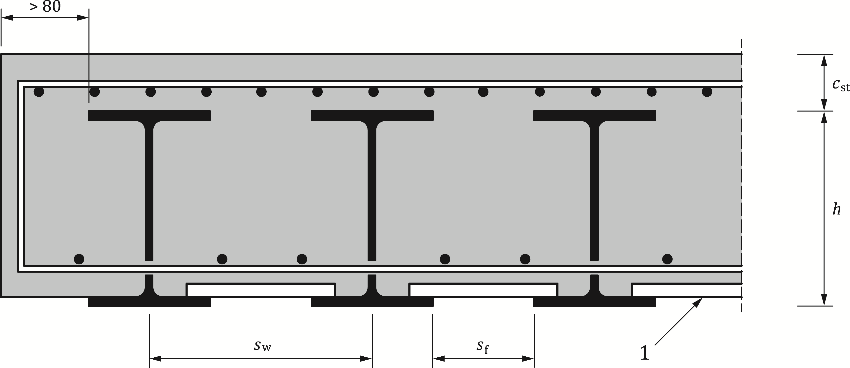

Key

|  |  |
| --- | --- |
| 1 | non-participating formwork |

Figure 8.1 — Typical cross-section of a filler beam deck

(3) The requirements of 8.3.1 apply to filler beam decks where the following apply:

• the steel beams are not curved in plan;

• the skew angle *θ* should not be greater than 30° (the value *θ* = 0 corresponding to a non-skew deck);

• the nominal depth *h* of the steel beams complies with: 210 mm ≤ *h* ≤ 1100 mm;

• the spacing *s*w of webs of the steel beams should not exceed the lesser of *h*/3 + 600 mm and 750 mm, where *h* is the nominal depth of the steel beams in mm;

• the concrete cover *c*st above the steel beams satisfies the conditions:

*c*st ≥ 70 mm, *c*st ≤ 150 mm, *c*st ≤ *h*/3, *c*st ≤ *x*pl – *t*f

where

|  |  |
| --- | --- |
| *x*pl | is the distance between the plastic neutral axis for sagging bending and the extreme fibre of the concrete in compression; |
| *t*f | is the thickness of the steel flange; |

• the concrete cover to the side of an encased steel flange is greater than 80 mm;

• the clear distance *s*f between the upper flanges of the steel beams is greater than 150 mm, so as to allow pouring and compaction of concrete;

• the soffit of the lower flange of the steel beams is not encased;

• a bottom layer of transverse reinforcement passes through the webs of the steel beams and is anchored beyond the end steel beams, and at each end of each bar, so as to develop its yield strength in accordance with EN 1992‑1‑1:2023, 11.4;

• ribbed bars in accordance with EN 1992‑1‑1:2023, 5.2.2 and Annex C.4 are used; their diameter is greater than 16 mm and their spacing is lower than 300 mm;

• normal-density concrete is used;

• the surface of the steel beams should be descaled. The soffit, the upper surfaces and the edges of the lower flange of the steel beams should be protected against corrosion;

• for road and railway bridges the holes in the webs of the steel section should be drilled.

(4) Additional requirements to 8.3.1 may be necessary for filler beam decks outside the scope of (3).

### General

(1) Filler beam decks covered in this section shall be designed for ultimate limit states according to 8.3.2 to 8.3.5 and for the serviceability limit state according to Clause 9.

(2) Steel beams with bolted connections and/or welding should be checked against fatigue.

(3) Composite cross-sections should be classified according to 7.5.3.

(4) Mechanical shear connection may be neglected.

### Bending moments

(1) The design resistance of composite cross-sections to bending moments shall be determined according to 8.2.1.

(2) Where the vertical shear force *V*a,Ed on the steel section exceeds half of the shear resistance given by 8.3.4, allowance should be made for its effect on the resistance moment in accordance with prEN 1994‑1‑1:2024, 8.2.2.5(2).

(3) The design resistance of reinforced concrete sections to transverse bending moments should be determined according to EN 1992‑1‑1.

(4) For single span beams with doubly symmetric cross-sections in Class 1 or 2 according to 7.5.3, the design resistance to sagging bending may be calculated on the basis of a plastic stress distribution, considering the reduction factor *β* of prEN 1994‑1‑1:2024, Figure 8.3 which may be taken equal to 0,95, provided that the following also apply:

• *t*f ≤ 80 mm;

• The steel sections are unpropped during the construction stage and they support the self-weight of the structural deck. Under self-weight in the characteristic load combination, the maximum bending stress shall be greater than:



where

|  |  |
| --- | --- |
| *σ*a,cs | is the maximum stress under sagging bending at the construction stage; |

• The contribution of the reinforcement to the sagging bending resistance is neglected.

### Vertical shear

(1) The resistance of the composite cross-section to vertical shear should be taken as the resistance of the structural steel section *V*pl,a,Rd unless the value of a contribution from the reinforced concrete part has been established in accordance with EN 1992‑1‑1.

(2) Unless a more accurate analysis is used, the part *V*c,Ed of the total vertical shear *V*Ed acting on the reinforced concrete part may be taken as *V*c,Ed = *V*Ed (*M*s,Rd/*M*pl,Rd), with *M*s,Rd = *N*s ⋅ *z*s = *A*s ⋅*f*sd⋅ *z*s.

NOTE The lever arm zs is shown in Figure 8.2 for a filler beam deck in Class 1 or 2.

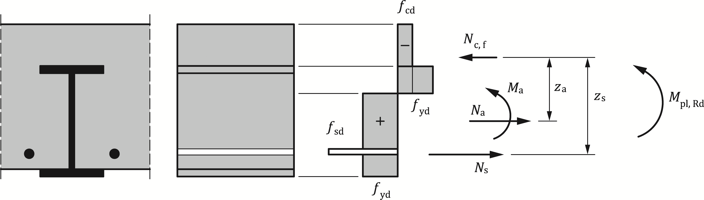

Figure 8.2 — Stress distribution at *M*Rd for part of a filler beam deck in Class 1 or 2

(3) The design resistance to vertical shear of reinforced concrete sections between filler beams should be verified according to EN 1992‑1‑1.

### Resistance and stability of steel beams during execution

(1) Steel beams before the hardening of concrete should be verified according to EN 1993‑1‑1 and EN 1993‑2.

## Lateral-torsional buckling of composite beams

### General

(1) The rules given in EN 1994‑1‑1 shall be used.

### Verification of lateral-torsional buckling of continuous composite beams with uniform cross-sections in Class 1, 2 and 3

(1) The rules given in EN 1994‑1‑1 shall be used.

### General methods for buckling of members and frames

#### General method

(1) For composite members outside the scope of prEN 1994‑1‑1:2024, 8.4.2(1) or 8.4.3 and for composite frames, the rules given in EN 1993‑1‑1:2022, 8.3.4 shall be applied.

(2) For the determination of *α*ult and *α*crit, appropriate resistances and stiffnesses of concrete and composite members should be used in accordance with EN 1992‑1‑1 and EN 1994‑1‑1.

#### Simplified method

(1) Clause 8.3.5 of prEN 1993‑2:2024 shall be applied to structural steel flanges of composite beams and chords of composite trusses.

(2) Where restraint is provided by concrete or composite members, appropriate elastic stiffnesses should be used, in accordance with EN 1992 and EN 1994.

## Transverse forces on webs

(1) The rules given in EN 1994‑1‑1 shall be used.

## Shear connection

### Basis of design

(1) In addition to prEN 1994‑1‑1:2024, 8.6.1, adjacent to cross frames and vertical web stiffeners, and for composite box girders, the effects of bending moments at the steel-concrete interface, about an axis parallel to the axis of the steel beam, as shown in Figure 8.3, caused by deformations of the slab or the steel member should be applied.

NOTE The National Annex can give further guidance.

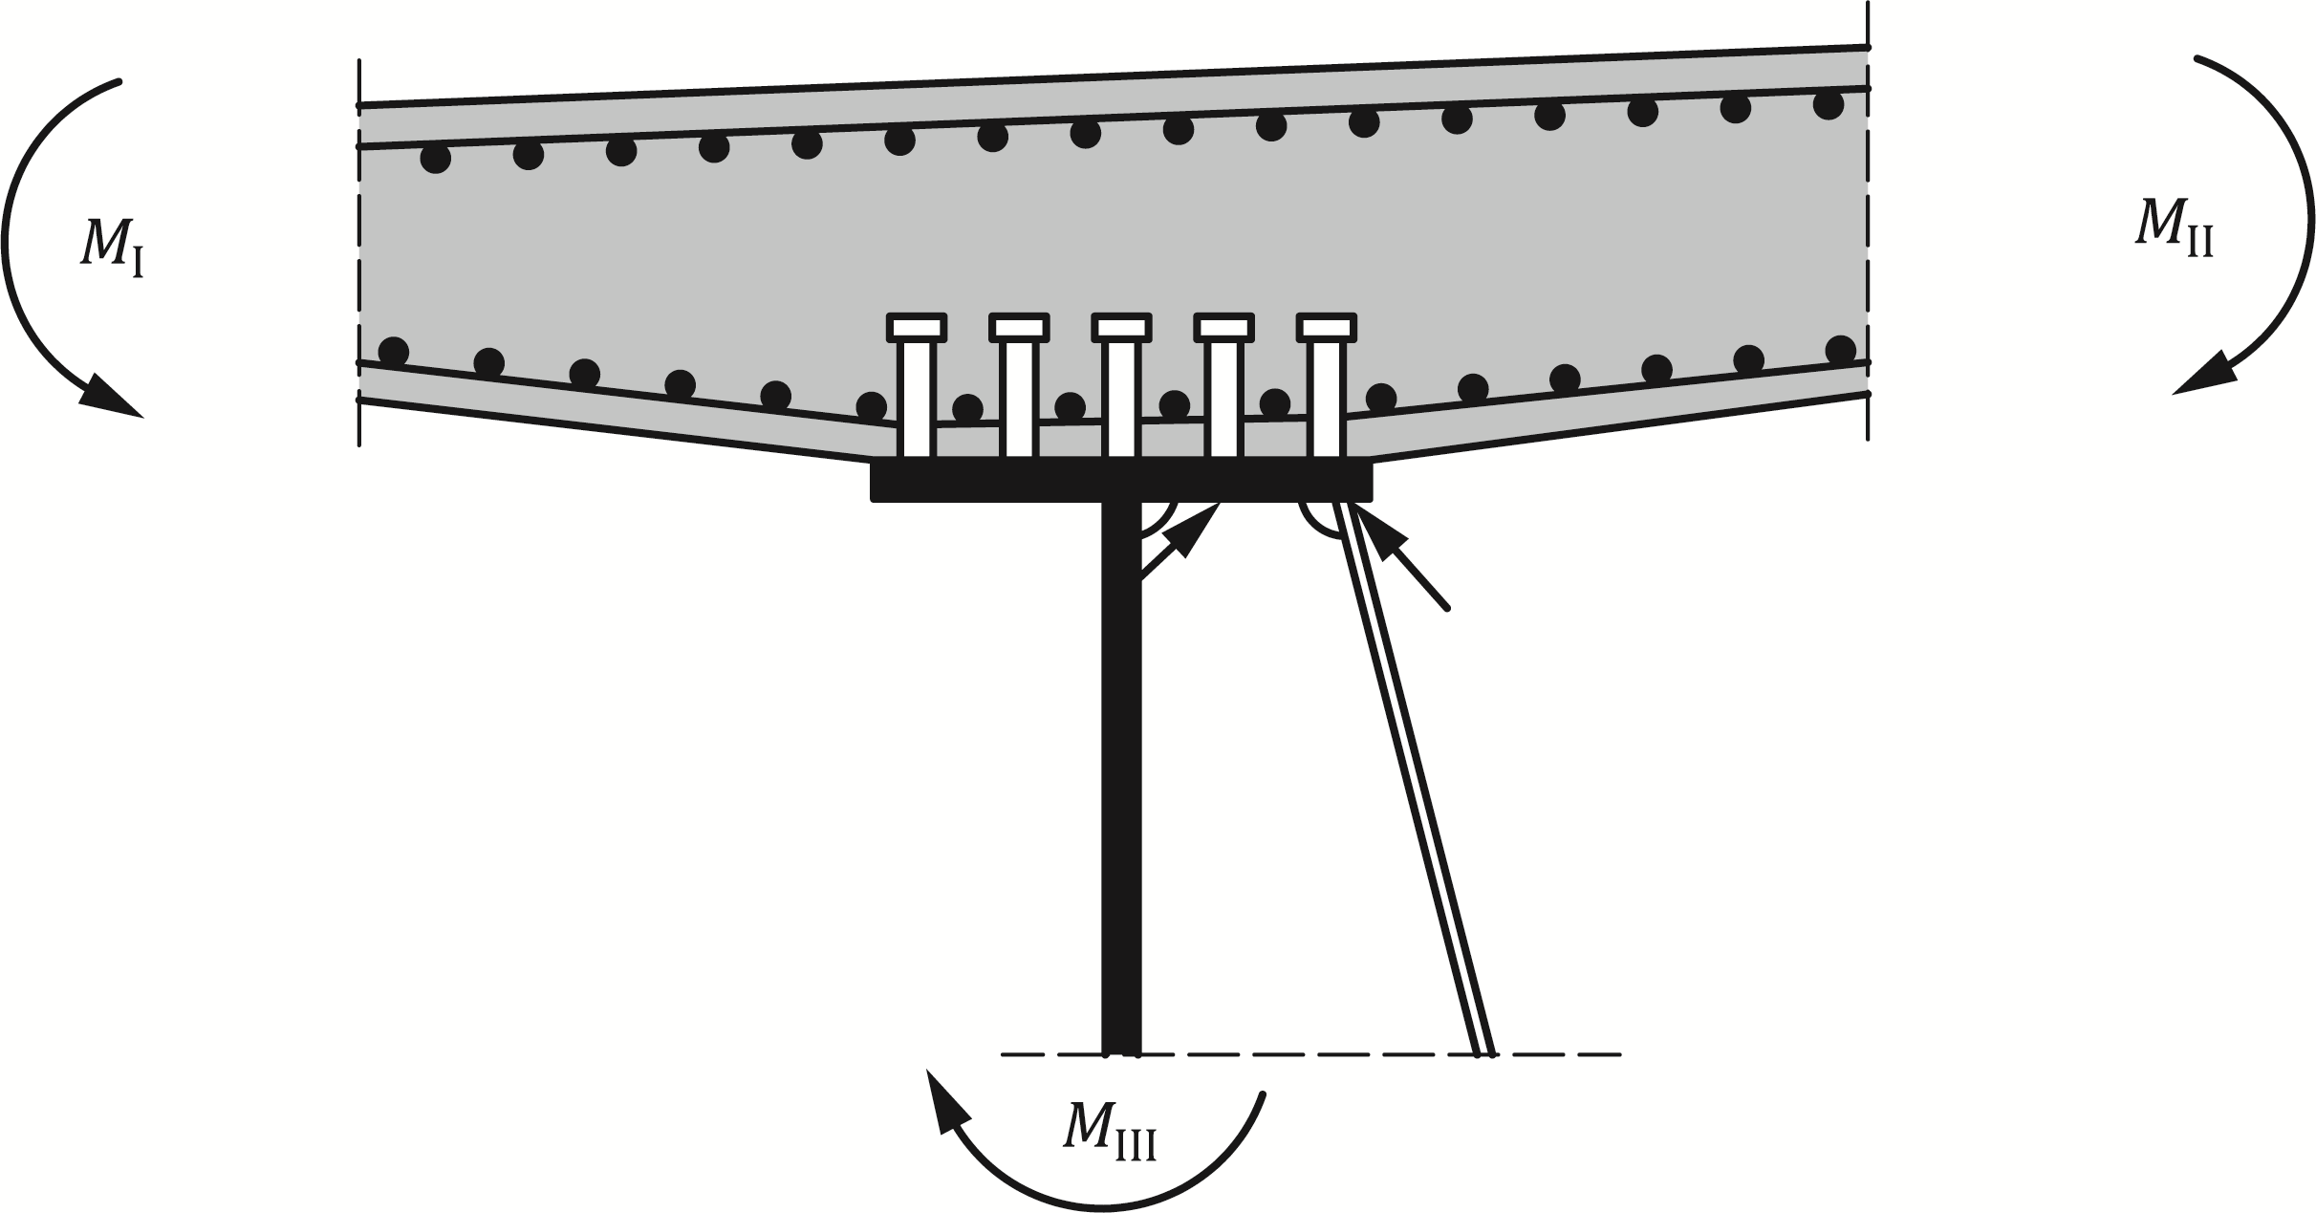

Figure 8.3 — Bending moments from frame action

(2) For verifications for ultimate limit states other than fatigue, the size and spacing of shear connectors may be kept constant over any length where the design longitudinal shear per unit length does not exceed the longitudinal design shear resistance by more than 15 %.

(3) Over every such length, the total design longitudinal shear force should not exceed the total design shear resistance.

NOTE For fatigue verification of shear connectors, no redistribution of longitudinal shear is possible.

### General method using nonlinear analysis

(1) The rules given in EN 1994‑1‑1 shall be used.

### Longitudinal shear force in beams

(1) In addition to prEN 1994‑1‑1:2024, 8.6.1, for composite box girders, the longitudinal shear force on the connectors should include the effects of bending and torsion, and also of distortion according to prEN 1993‑2:2024, 8.2.7, if appropriate.

(2) For box girders with a flange designed as a composite plate, reference shall be made to 11.4.

(3) Unless the method according to (4) is used, the longitudinal shear forces should be determined by elastic analysis with the cross-section properties of the uncracked section taking into account effects of sequence of construction.

(4) The effects of cracking of concrete on the longitudinal shear force may be taken into account, if in the global analysis and if the determination of the longitudinal shear force account is taken from the effects of tension stiffening and possible over-strength of concrete.

### Other beams where plastic theory is used for the resistance of the cross-section

(1) The rules given in prEN 1994‑1‑1:2024, 8.6.4 shall be used.

### Beams in which elastic theory is used for the resistance of the cross-section

(1) In addition to prEN 1994‑1‑1:2024, 8.6.5, for any load combination and arrangement of design actions, the longitudinal shear per unit length at the interface between steel and concrete in a composite member, *v*L,Ed, should be determined from the rate of change of the longitudinal force in either the steel or the concrete element of the composite section. Where elastic theory is used for calculating resistances of sections, the envelope of transverse shear force in the relevant direction may be used.

(2) The elastic properties of the uncracked section should be used for the determination of the longitudinal shear force, even where cracking of concrete is assumed in global analysis. The effects of cracking of concrete on the longitudinal shear force may be taken into account, if in global analysis account is taken from the effects of tension stiffening and possible over-strength of concrete.

(3) For composite box girders, the longitudinal shear force on the connectors should include the effects of bending and torsion, and also of distortion according to prEN 1993‑2:2024, 8.2.7 if appropriate. For box girders with a flange designed as a composite plate, see 11.4.

### Beams in which nonlinear theory is used for the resistance of the cross-section

(1) The rules given in EN 1994‑1‑1 shall be used.

### Local effects of concentrated longitudinal shear force

(1) The rules given in EN 1994‑1‑1 shall be used.

### Headed stud connectors in solid slabs and concrete encasement

(1) The rules given in EN 1994‑1‑1 shall be used.

### Design resistance of headed studs used with profiled steel sheeting

(1) prEN 1994‑1‑1:2024, 8.6.9 shall not be applied.

### Detailing of the shear connection and influence of execution

#### Resistance to separation

(1) The rules given in EN 1994‑1‑1 shall be used.

#### Cover and concreting

(1) In addition to prEN 1994‑1‑1:2024, 8.6.10.2, concrete cover over shear connectors should be not less than that required for reinforcement adjacent to the same surface of concrete.

#### Local reinforcement in the slab

(1) The rules given in EN 1994‑1‑1 shall be used.

#### Haunches other than formed by profiled steel sheeting

(1) The rules given in EN 1994‑1‑1 shall be used.

#### Spacing of connectors

(1) In addition to prEN 1994‑1‑1:2024, 8.6.10.5, connectors may be placed in groups, with the spacing of groups greater than that specified for individual shear connectors, provided that consideration is given in design to:

• the non-uniform flow of longitudinal shear;

• the greater possibility of slip and vertical separation between the slab and the steel member;

• buckling of the steel flange; and

• the local resistance of the slab to the concentrated force from the connectors.

#### Dimensions of the steel flange

(1) The rules given in EN 1994‑1‑1 shall be used.

#### Headed stud connectors

(1) The rules given in EN 1994‑1‑1 shall be used.

#### Headed studs used with profiled sheeting

(1) prEN 1994‑1‑1:2024, 8.6.10.8 shall not be applied.

### Longitudinal shear in concrete slabs

(1) The rules given in EN 1994‑1‑1 shall be used.

## Fatigue

### General

(1) The resistance of composite structures to fatigue shall be verified where the structures are subjected to repeated fluctuations of stresses.

(2) Structural members shall be designed for fatigue if there is an acceptable level of probability that their performance will be satisfactory throughout their design life.

(3) For headed stud shear connectors under characteristic combination of actions, the maximum longitudinal shear force per connector should not exceed *k*s∙*P*Rd where *P*Rd is determined according to 8.6.3.1.

NOTE The value of *k*s is 0,75 unless the National Annex gives a different value.

(4) When considering the longitudinal shear force due to concentrated loads in accordance with 8.6.7 for fatigue, the introduction length *L*v shall be taken as the greater of the two effective widths *b*ei defined in prEN 1994‑1‑1:2024, 7.4.1.2(5) and (6).

(5) For structural steel, no fatigue verification should be performed when prEN 1993‑2:2024, 10.1.1(3) applies.

(6) For concrete and reinforcement, no fatigue verification should be performed when EN 1992‑1‑1:2023, K.10.1 applies.

### Partial factors for fatigue verification

(1) Partial factors γMf for fatigue resistance given in prEN 1993‑2:2024, 4.4(2) for steel elements and in EN 1992‑1‑1:2023, 4.3.3 for concrete and reinforcement shall be used.

(2) For headed studs, a partial factor γMf,s should be applied.

NOTE  *γ*Mf,s is given in 4.4.1.2(3).

(3) Partial factors for fatigue loading γFf should be applied.

NOTE  Partial factors γFf are given in Notes in prEN 1993‑2:2024, 4.4(1).

### Fatigue strength

(1) The fatigue strength for structural steel and for welds should be taken from prEN 1993‑1‑9:2023, Clause 9.

(2) The fatigue strength of reinforcing steel and pre-stressing steel should be taken from EN 1992‑1‑1:2023, 10.4.

(3) The fatigue strength curve of an automatically welded headed stud in accordance with 8.6.8.1 (see Figure 8.4) should be calculated for normal weight concrete from Formula (8.1):

 (8.1)

where

|  |  |
| --- | --- |
| ∆*τ*R | is the fatigue shear strength related to the cross-sectional area of the shank of the stud, using the nominal diameter *d* of the shank; |
| ∆*τ*c | is the reference value at *N*C = 2 × 106 cycles with ∆*τ*c equal to 90 N/mm2; |
| *m* | is the slope of the fatigue strength curve with the value *m* = 8; |
| *N*R | is the number of stress-range cycles. |

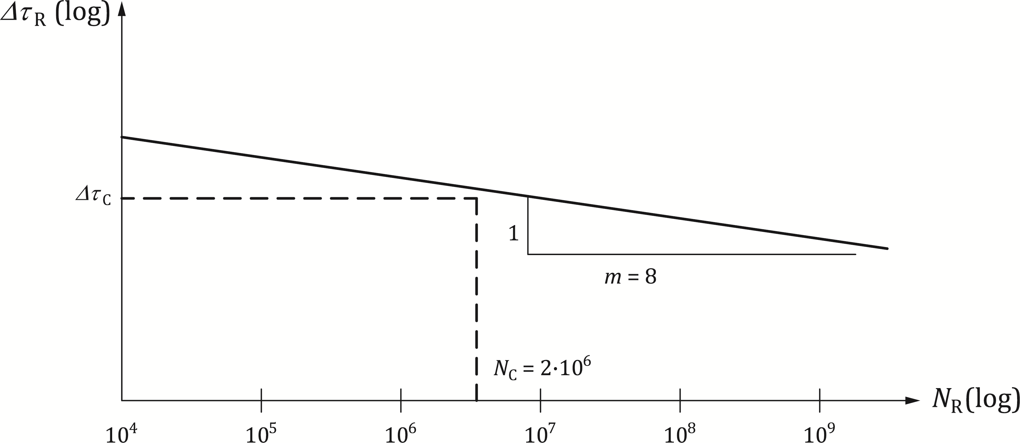

Key

|  |  |
| --- | --- |
| 1 | Fatigue resistance curve for constant amplitude loading |

Figure 8.4 — Fatigue strength curve for headed studs in solid slabs

(4) For studs in lightweight concrete with a density class according to EN 1992‑1‑1:2023, Annex M, the fatigue strength should be determined in accordance with (3) but with ∆*τ*R replaced by *η*lw,fc ∆τR and ∆*τ*c replaced by *η*lw,fc ∆*τ*c, where *η*lw,fc is given in EN 1992‑1‑1:2023, Table M.1.

### Internal forces and fatigue loadings

(1) Internal forces and moments shall be determined by elastic global analysis of the structure in accordance with 7.4.1 and 7.4.2.

NOTE The maximum and minimum internal bending moments and/or internal forces resulting from the load combination according to 8.7.4(1) are defined as *M*Ed,max,f and *M*Ed,min,f.

(2) Fatigue loading should be obtained from EN 1991‑2.

(3) For road bridges, simplified methods according to EN 1992‑1‑1 and EN 1993‑2, based on Fatigue Load Model 3 of EN 1991‑2:2023, 6.6 should be used for verifications of fatigue resistance.

(4) For railway bridges, EN 1991‑2:2023, 8.9 shall be applied.

(5) For more detailed fatigue verification, prEN 1993‑1‑9:2023, Annex A may be used.

### Stresses

#### General

(1) The calculation of stresses shall be based on 9.2.1.

(2) For the determination of stresses in cracked regions, the effect of tension stiffening of concrete on the stresses in reinforcement shall be applied.

(3) Unless a more accurate method is used, the effect of tension stiffening on the stresses in reinforcement should be applied according to 8.7.5.4. For the determination of stresses in structural steel, the effect of tension stiffening may be neglected.

(4) The effect of tension stiffening on the stresses in prestressing steel should be taken into account according to 8.7.5.6.

#### Concrete

(1) For the determination of stresses in concrete elements EN 1992‑1‑1:2023, Clause 10 shall apply.

#### Structural steel

(1) Where the bending moments *M*Ed,max,f and *M*Ed,min,f cause tensile stresses in the concrete slab, the stresses in structural steel for these bending moments may be determined based on the second moment of area *I*2 according to prEN 1994‑1‑1:2024, 3.2.1.

(2) Where the bending moments *M*Ed,min,f and *M*Ed,max,f cause compression in the concrete slab, the stresses in structural steel for these bending moments should be determined with the cross-section properties of the un-cracked section.

(3) Where *M*Ed,min,f causes compression in the concrete and *M*Ed,max.f causes tension, the stresses in the steel due to *M*Ed,min,f should be determined with the cross-section properties of the un-cracked section and those due to *M*Ed,max,f may be determined based on the second moment of area *I*2 according to prEN 1994‑1‑1:2024, 3.2.1.

#### Reinforcement

(1) Where the bending moment *M*Ed,max,f causes tensile stresses in the concrete slab and where no more accurate method is used, the effects of tension stiffening of concrete on the stress *σ*s,max,f in reinforcement due to *M*Ed,max,f may be determined from prEN 1994‑1‑1:2024, 9.4.3(3) Formulae (9.7) to (9.9). In prEN 1994‑1‑1:2024, 9.4.3(3) Formula (9.8) a factor 0,2 may be used, in place of the factor 0,4.

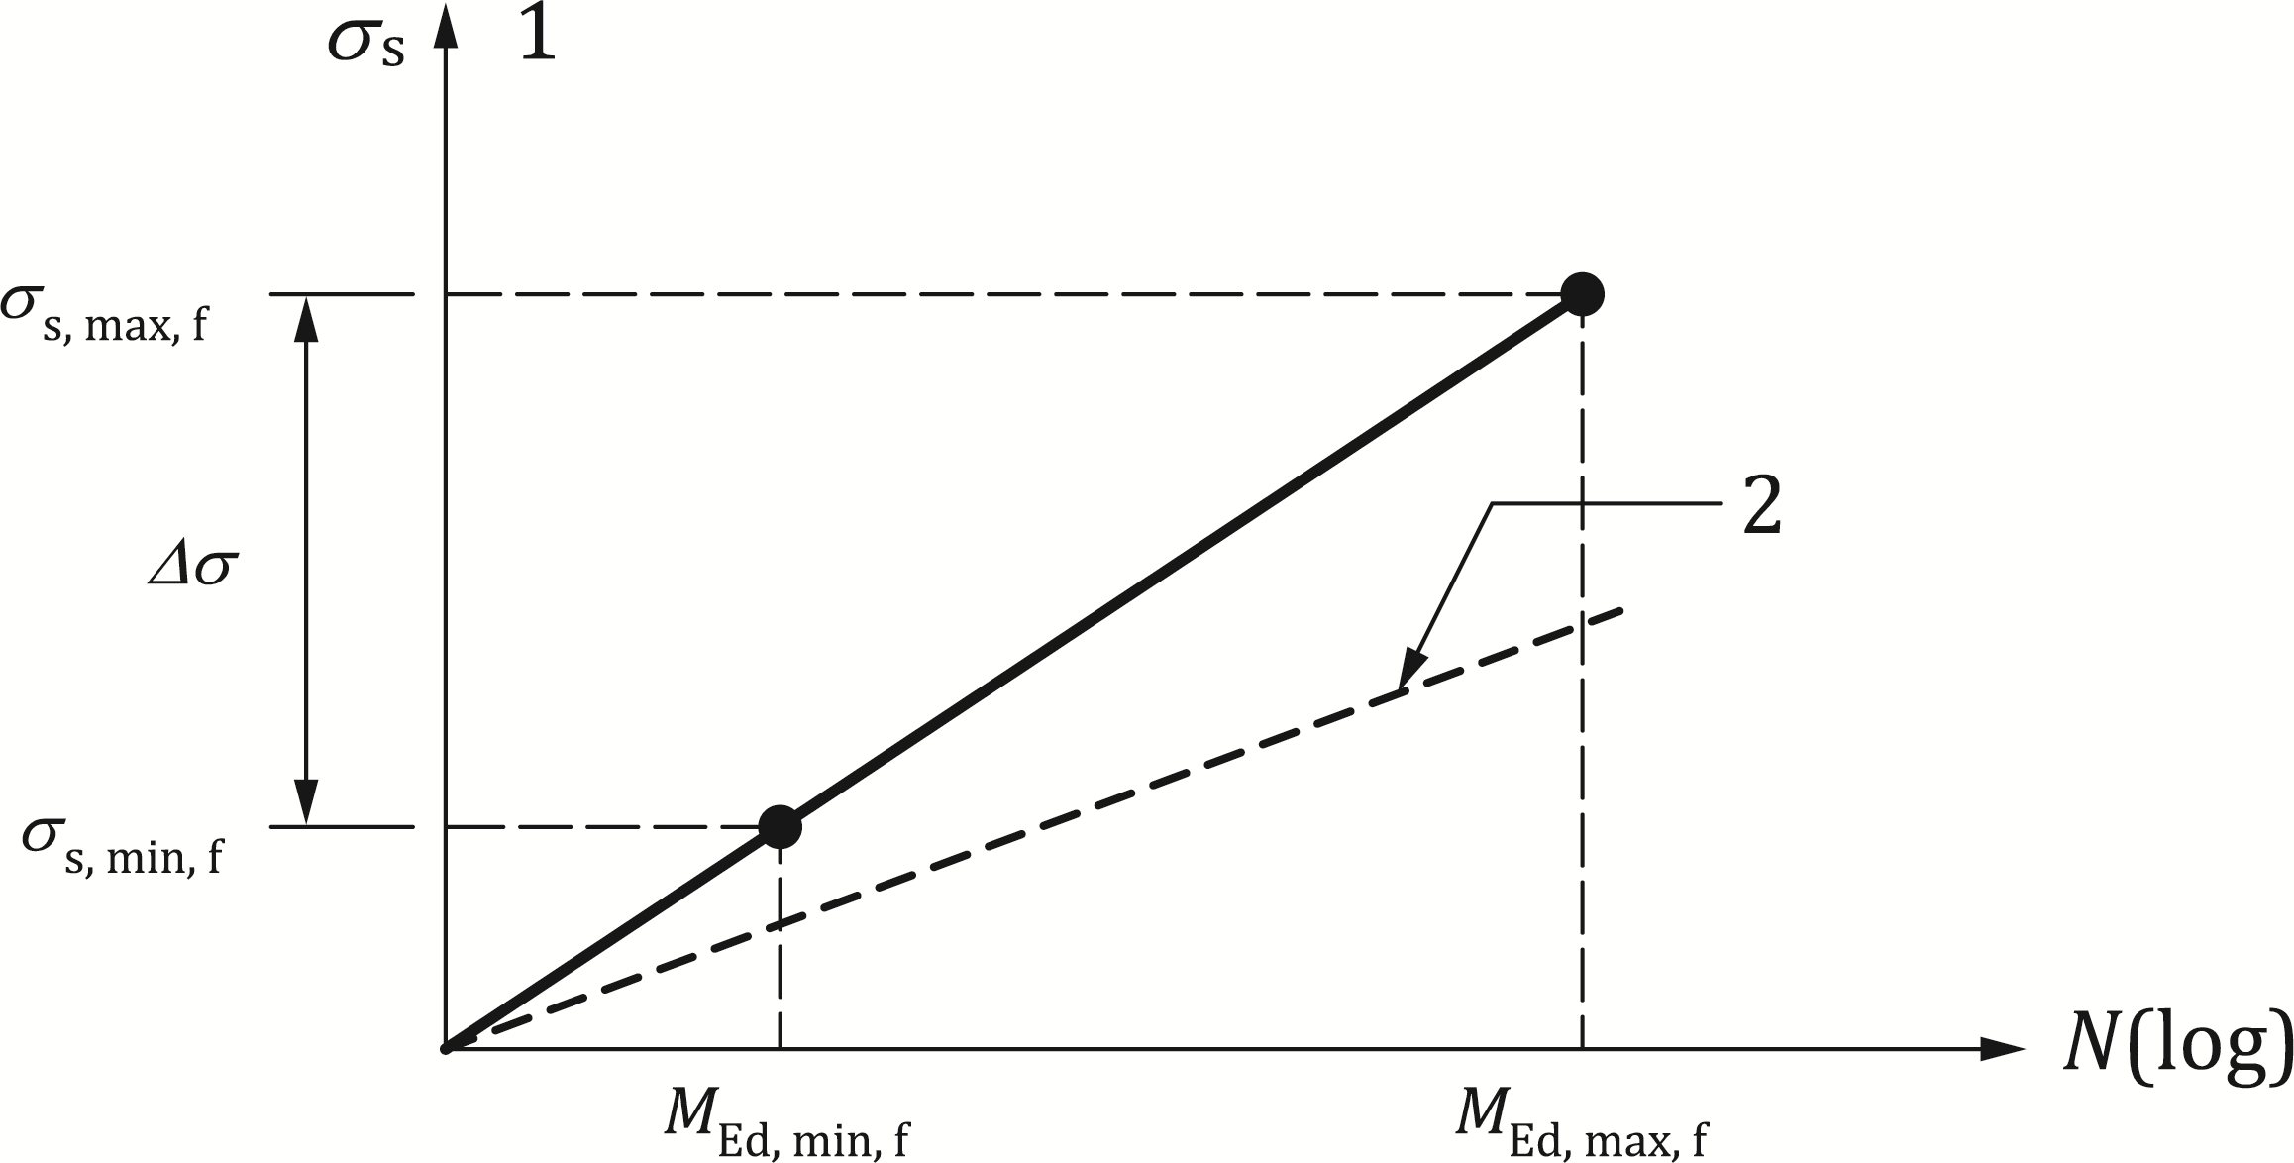

Key

|  |  |
| --- | --- |
| 1 | slab in tension |
| 2 | fully cracked section |

Figure 8.5 — Determination of the stresses *σ*s,max,f and *σ*s,min,f in cracked regions

(2) Where also the bending moment *M*Ed,min,f causes tensile stress in the concrete slab, the stress range ∆*σ* is given by Figure 8.5 and the stress *σ*s,min.f in reinforcement due to *M*Ed,min,f may be determined from Formula (8.2):

 (8.2)

(3) Where *M*Ed, min,f and *M*Ed,max,f or only *M*Ed,min,f cause compression in the concrete slab, the stresses in reinforcement for these bending moments should be determined with the cross-section properties of the un-cracked section.

#### Shear connection

(1) The longitudinal shear per unit length shall be calculated by elastic analysis.

(2) In members where cracking of concrete occurs, the effects of tension stiffening should be taken into account by an appropriate model.

(3) For simplification, the longitudinal shear forces at the interface between structural steel and concrete may be determined by using the properties of the uncracked section.

#### Stresses in reinforcement and prestressing steel in members prestressed by bonded tendons

(1) Stresses should be determined according to 8.7.5.4 with *σ*s,max,f according to 9.4.

### Stress ranges

#### Structural steel and reinforcement

(1) The stress ranges should be determined from the stresses determined in accordance with 8.7.4(3).

(2) Where the verification for fatigue is based on damage equivalent stress ranges, the range ∆*σ*E should be determined from Formula (8.3):

 (8.3)

where

|  |  |
| --- | --- |
| *σ*max,f and *σ*min,f | are the maximum and minimum stresses due to and ; |
| *λ* | is a damage equivalent factor; |
| *φ* | is a dynamic amplification factor. |

(3) Where a member is subjected to combined global and local effects, the separate effects shall be considered.

(4) Unless a more precise method is used, the equivalent constant amplitude stress due to global effects and local effects should be combined using Formula (8.4):

 (8.4)

in which subscripts “glob” and “loc” refer to global and local effects, respectively.

NOTE 1 The damage equivalent factor *λ* depends on the loading spectrum and the slope of the fatigue strength curve.

NOTE 2 The factor *λ* for structural steel elements is given in prEN 1993‑2:2024, 10.4.2 for road bridges and 10.4.3 for railway bridges.

NOTE 3 Factors *λ* = *λ*s for reinforcement and prestressing steel are given in EN 1992‑1‑1:2023, K.10.3.

(5) For railway bridges, the dynamic amplification factor *φ* defined in EN 1991‑2:2023, 8.4.5 shall be used.

(6) For road bridges, the dynamic amplification factor *φ* = 1,0 shall be used.

#### Shear connection

(1) For verification of stud shear connectors based on nominal stress ranges, the equivalent constant range of shear stress ∆*τ*E,2 for 2 million cycles given in Formula (8.5) should be used:

 (8.5)

where

|  |  |
| --- | --- |
| *λ*v | is the damage equivalent factor depending on the spectra and the slope *m* of the fatigue strength curve; |
| ∆*τ* | is the range of shear stress due to fatigue loading, related to the cross-sectional area of the shank of the stud using the nominal diameter *d* of the shank. |

(2) The equivalent constant amplitude shear stress range in welds of other types of shear connection should be calculated in accordance with prEN 1993‑1‑9:2023, Clause 7.

(3) For bridges, the damage equivalent factor *λ*v for headed studs in shear should be determined from *λ*v = *λ*v,1 *λ*v,2 *λ*v,3 *λ*v,4 where the factors *λ*v,1 to *λ*v,4 are defined in (4) and (5).

(4) For road bridges of span up to 100 m, the factor *λ*v,1 = 1,55 should be used. The factors *λ*v,2 to *λ*v,4 should be determined in accordance with prEN 1993‑2:2024, 10.4.2 and Annex F.3 to F.6 but using exponents 8 and 1/8 in place of those given, to allow for the relevant slope *m* = 8 of the fatigue strength curve for headed studs, given in 8.7.3.

(5) For railway bridges, the factor *λ*v,1 should be taken from Figure 8.6.

### Fatigue assessment based on nominal stress ranges

#### Structural steel, reinforcement and concrete

(1) For reinforcement, EN 1992‑1‑1:2023, E.4.2 shall be applied.

(2) For concrete in compression, EN 1992‑1‑1:2023, 10.5 shall be applied.

(3) For structural steel, prEN 1993‑2:2024, Clause 10 shall be applied.

(4) For prestressing steel, EN 1992‑1‑1:2023, E.4.2 shall be applied.

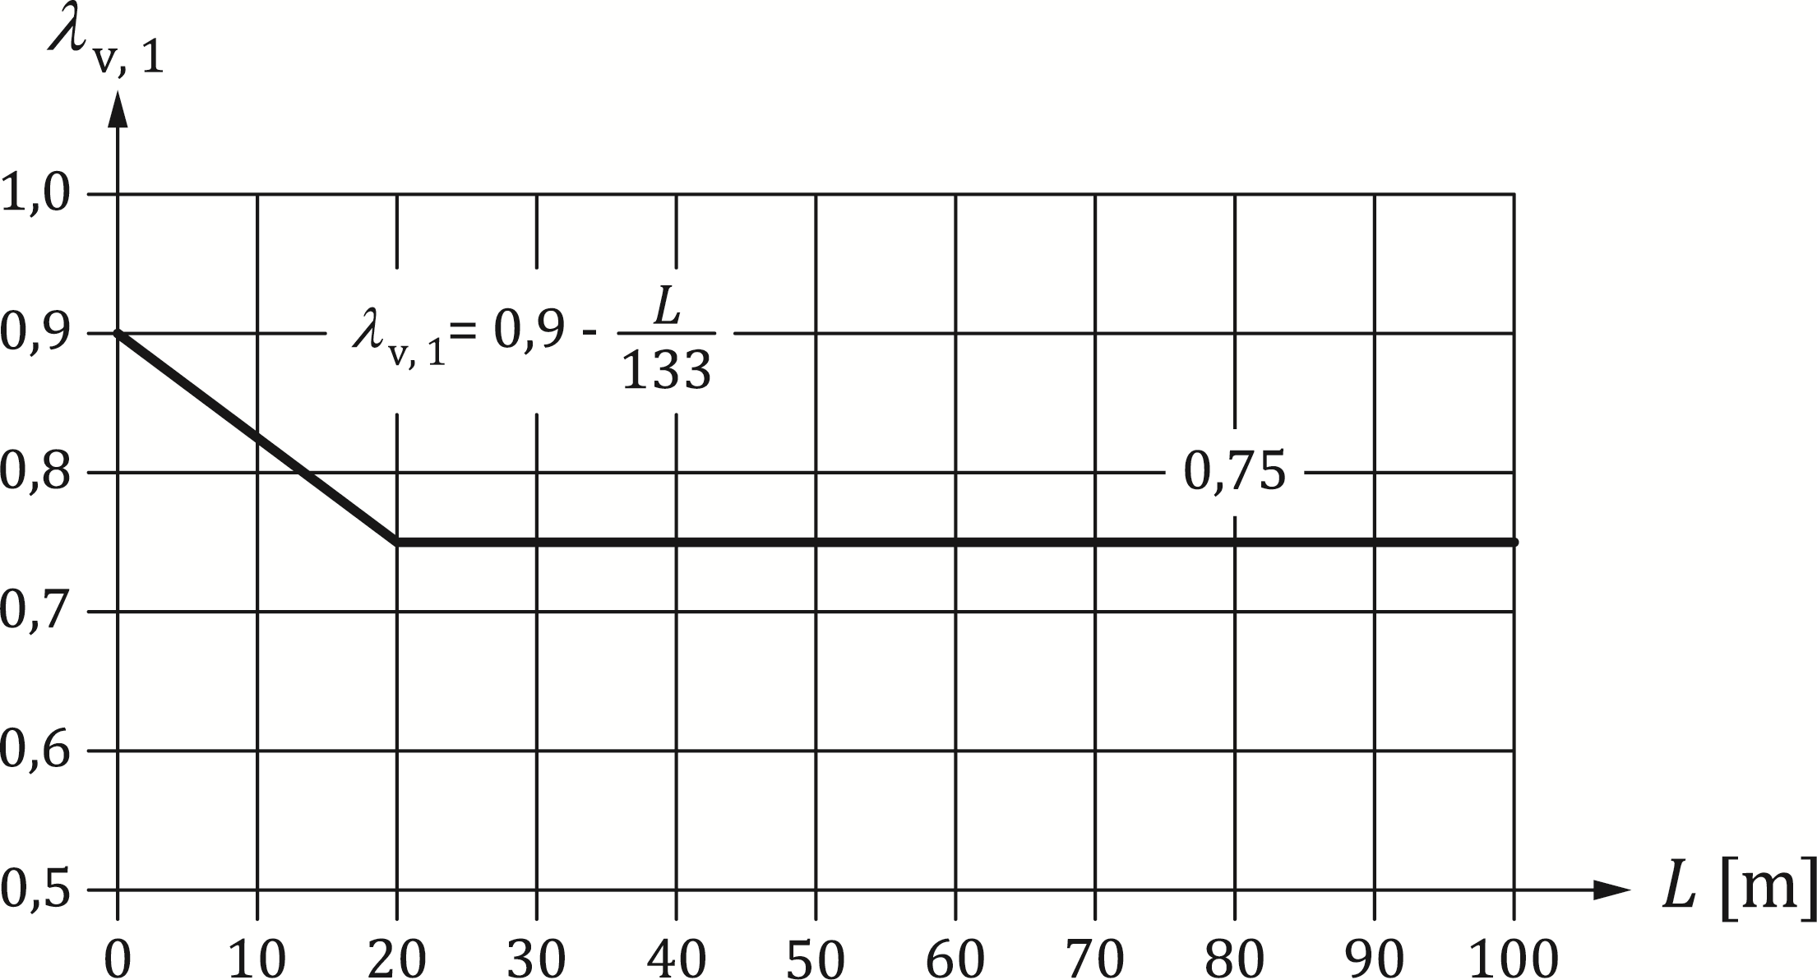

Key

|  |  |  |
| --- | --- | --- |
| *L* | span length [m] |  |

Figure 8.6 — Values *λ*v,1 as a function of the span length L for standard and heavy traffic for load model 71 according to EN 1991‑2

#### Shear connection

(1) For stud connectors welded to a steel flange that is always in compression under the relevant combination of actions 8.7.4.1, Formula (8.6) should apply.

 (8.6)

where

|  |  |
| --- | --- |
| ∆*τ*E,2 | is defined in 0; |
| ∆*τ*c | is the reference value of fatigue strength at 2 million cycles determined in accordance with 8.7.3. |
| *k*M,s | is a calibration factor to ensure the validity of Miner’s rule. |

NOTE The value of *k*M,s is 1,00 unless the National Annex gives a different value.

(2) The stress range ∆*τ* in the stud should be determined with the cross-sectional area of the shank of the stud using the nominal diameter *d* of the shank.

(3) Where a headed stud is subjected to predominantly non-static tensile and shear forces, and at ULS the tensile force is greater than 0,1 *P*Rd, Formulae (8.7) and (8.8) shall be applied.

 (8.7)

 (8.8)

where

|  |  |
| --- | --- |
| ∆*σ*E,2,ten | is the damage equivalent stress range in the shank of the stud due to the tension force and determined by Formula (8.9): |
| ∆*σ*c,ten | is the reference value of fatigue strength given in prEN 1993‑1‑9:2023, Clause 8, by applying detail category 100 with *m*1 = 3; |
| *ψ*N | is a reduction factor to account for unequal distribution of the tensile load; |

NOTE   The value of *ψ*N is 1,00 unless the National Annex gives a different value.

 (8.9)

where

|  |  |
| --- | --- |
| *λ* | damage equivalent factor determined in accordance with 8.7.6.1; |
| Δ*σ*ten | nominal stress range caused by the tension force (usually: ) |

(4) In addition, concrete cone failure according to EN 1992‑4:2018, 8.3.1 should be checked.

(5) Where the maximum stress in the steel flange to which stud connectors are welded is tensile under the relevant combination, the interaction at any cross-section between stress ranges ∆*τ*E and ∆*σ*E,ten in the weld of stud connectors and the normal stress range ∆*σ*E in the steel flange Formulae (8.10) and (8.11) shall be applied.

 (8.10)

 (8.11)

where

|  |  |
| --- | --- |
| ∆*σ*E,2 | is the stress range in the flange determined in accordance with 8.7.6.1; |
| ∆*σ*c | is the reference value of fatigue strength given in prEN 1993‑1‑9:2023, Table 10.5, detail category 80. |

(6) Formula (8.10) should be checked for the following:

• maximum value of ∆*σ*E,2 and the corresponding values ∆*τ*E,2 and ∆*σ*E,ten,

• the combination of the maximum value of ∆*τ*E,2 and the corresponding values ∆*σ*E,2 and ∆*σ*E,ten,

• the combination of the maximum value of ∆*σ*E,ten and the corresponding value ∆*τ*E,2 and ∆*σ*E,2.

(7) Unless taking into account the effect of tension stiffening of concrete by more accurate methods, the interaction criterion should be verified with the corresponding stress ranges determined with both cracked and uncracked cross-sectional properties.

## Composite columns and composite compression members

(1) The rules given in EN 1994‑1‑1 shall be used.

## Composite tension members

(1) An isolated reinforced concrete tension member according to 7.4.2.8(1)(a) should be designed in accordance with EN 1992‑1‑1:2023, Clauses 8 and 11.

(2) For members prestressed by tendons, the effect of the different bond behaviour of the prestressing and the reinforcing steel shall be designed in accordance with EN 1992‑1‑1:2023, 10.3(2).

(3) Where members of the deck structure are simultaneously acting as tension members and are therefore subjected to combined global and local effects, the design shear resistance for local vertical shear and for punching shear due to permanent loads and traffic loads should be verified.

(4) Unless a more precise method is used, the verification should be according to EN 1992‑1‑1:2023, 8.2, 8.4 and 8.2.2(1) by taking into account the normal force of the reinforced concrete element according to 7.4.2.8(7) and (8).

(5) At the ends of the reinforced concrete part of a composite tension member, a concentrated group of shear connectors designed according to 8.6 should be provided for the introduction of the normal force.

(6) The shear connection should be able to transfer the design value of the normal force over a length of 1.5 *b* from the point of application, where *b* is the greater of the outstand of the concrete member and half the distance between adjacent steel elements.

(7) Where the shear connectors are verified for a normal force determined by 7.4.2.8(8), Formula (7.3) should be used.

(8) Provision shall be made for the internal forces and moments from members connected to the ends of a composite tension member and shall be distributed between the structural steel and reinforced concrete elements.

(9) For composite tension members subjected to tension and bending, shear connection should be provided according to 8.6.

(10) For composite tension members such as diagonals in trusses, the introduction length for the normal force should not be assumed to exceed twice the minimum transverse dimension of the member.

NOTE Typically in case of half-through or through bridges and bowstring arch bridges, members of the deck structure are simultaneously acting as tension members.

# Serviceability limit states

## General

(1) In addition to EN 1994‑1‑1, verifications for serviceability limit states shall be performed for the persistent situations.

(2) Serviceability criteria during execution may be specified by the relevant authority or, where not specified, agreed for a specific project by the relevant parties.

(3) Serviceability requirements and criteria shall be in accordance with EN 1990:2023, A.2.9.

(4) Serviceability limit states for composite plates should be verified in accordance with Clause 11.

## Stresses

### General

(1) In addition to prEN 1994‑1‑1:2024, 9.2.1, stresses in the concrete slab and its reinforcement caused by simultaneous global and local actions shall be added, using the combination factor according to 7.4.4.

### Stress limitation

(1) prEN 1994‑1‑1:2024, 9.2.2 shall not be applied.

(2) Compressive stress in concrete shall be limited in accordance with EN 1992‑1‑1:2023, Table 9.2.

(3) Stresses in reinforcing steel and in tendons shall be limited in accordance with EN 1992‑1‑1:2023, 9.2.1.

(4) The stresses in structural steel should be in accordance with prEN 1993‑2:2024, 9.3.

(5) Cross sections designed by plastic theory for sagging bending in the ultimate limit state, according to 8.2.1.2 and prEN 1994‑1‑1:2024, 8.2.2.5, should be verified in the serviceability limit state for flange induced buckling, according to EN 1993‑1‑5 for the characteristic combination of actions.

### Web breathing

(1) The design against web breathing should be in accordance with prEN 1993‑2:2024, 9.4.

### Longitudinal shear force in beams

(1) The longitudinal shear forces at the interface between structural steel and concrete should be determined according 8.6.3(3).

## Deformations

### Deflections

(1) prEN 1994‑1‑1:2024, 9.3.1 shall not be applied.

(2) For the limit state of deformation, EN 1990:2023, A.2.9.2 and A.2.9.4 shall be applied, where relevant.

(3) Deflections should be calculated using elastic analysis in accordance with Clause 7.

(4) Deformations during construction should be controlled such that the concrete is not impaired during its placing and setting by uncontrolled displacements and the required long-term geometry is achieved.

### Vibrations

(1) prEN 1994‑1‑1:2024, 9.3.2 shall not be applied.

(2) For the limit state of vibration, EN 1990:2023, A2.9, EN 1991‑2:2023, 7.7 and 8.4 shall be applied, where relevant.

## Cracking of concrete

### General

(1) In addition to prEN 1994‑1‑1:2024, 9.4.1, where composite action becomes effective as concrete hardens, effects of heat of hydration of cement and corresponding thermal shrinkage should be taken into account only during the construction stage for the serviceability limit state to define areas where tension is expected.

(2) Unless specific measures are taken to limit the effects of heat of hydration of cement, for simplification, a constant temperature difference between the concrete section and the steel section (concrete cooler) should be assumed for the determination of the cracked regions and for limitation of crack width.

(3) For the determination of stresses in concrete, the short term modulus should be used.

(4) prEN 1994‑1‑1:2024, 9.4.1(4) shall not be applied.

NOTE 1 Unless the National Annex gives different values, the values of the limiting crack width and the combination of actions are given in EN 1992‑1‑1:2023, 9.2.1(6).

NOTE 2 The value of the constant temperature difference between the concrete section and the steel section is 20K unless the National Annex gives a different value.

### Minimum reinforcement

(1) In addition to prEN 1994‑1‑1:2024, 9.4.2, where bonded tendons are used, the contribution of bonded tendons to minimum reinforcement may be taken into account in accordance with EN 1992‑1‑1:2023, 9.2.2(3).

### Control of cracking due to direct loading

(1) In addition to prEN 1994‑1‑1:2024, 9.4.3, where bonded tendons are used, design shall follow EN 1992‑1‑1:2023, 9.2, where *σ*s should be determined, taking into account tension stiffening effects.

## Filler beam decks

### General

(1) The action effects for the serviceability limit states should be determined according to paragraphs (1) to (5) and (7) to (11) of 7.4.2.9.

### Cracking of concrete

(1) The rules of 9.4.1 should be applied.

(2) For the reinforcing bars in the direction of the steel beams within the whole thickness of the deck, 9.5.3 and 9.5.4 shall be applied.

### Minimum reinforcement

(1) Unless verified by more accurate methods, the minimum longitudinal top reinforcement *A*s,min per filler beam should be determined from Formula (9.1):

 (9.1)

where

|  |  |
| --- | --- |
| *A*c,eff | is the effective area of concrete given by *A*c,eff = *s*w *c*st ≤ *s*w *d*eff; |
| *d*eff | is the effective thickness of the concrete given by *d*eff = *c* + 7,5 *φ*s; |
| *φ*s | is the diameter of the longitudinal reinforcement in [mm] within the range 10 mm ≤ *φ*s ≤ 16 mm; |
| *c*, *c*st | is the concrete cover of the longitudinal reinforcement and the structural steel section (Reference should be made to Figure 8.1); |
| *s*w | is the spacing of webs of steel beams of filler beam decks (Figure 8.1). |

(2) The bar spacing *s* of the longitudinal reinforcement should fulfil the following condition: 100 mm ≤ *s* ≤ 150 mm.

### Control of cracking due to direct loading

(1) prEN 1994‑1‑1:2024, 9.4.3(1), shall be applied.

(2) Stresses in the reinforcement may be calculated by using the cross-section properties of the cracked composite section with the second moment of area *I*2 according to prEN 1994‑1‑1:2024, 3.1.17.

# Precast concrete slabs

## General

(1) prEN 1994‑1‑1:2024, Clause 10 shall not be applied*.*

(2) This clause deals with reinforced or prestressed precast concrete slabs, used either as full depth flanges of bridge decks or as partial depth slabs acting with *in situ* concrete.

(3) Precast bridge slabs should be designed in accordance with EN 1992‑1‑1 and also for composite action with the steel beam.

(4) Tolerances of the steel flange and the precast concrete element should be considered in the design.

## Actions

(1) EN 1991‑1‑6 shall be applied to precast elements acting as permanent formwork.

## Design, analysis and detailing of the bridge slab

(1) Where it is assumed that the precast slab acts with *in situ* concrete, they should be designed as continuous in both the longitudinal and the transverse directions.

(2) The joints between slabs should be designed to transmit in-plane forces as well as bending moments and shears.

(3) Compression perpendicular to the joint between precast slabs may be assumed to be transmitted by contact pressure if the joint is filled with mortar or glue, or if it is shown by tests that the mating surfaces are in sufficiently close contact.

(4) For the use of stud connectors in groups, reference should be made to 8.6.10.5(1).

## Interface between steel beam and concrete slab

### Bedding and tolerances

(1) Where precast slabs without bedding are used, any special requirements for the tolerances of the supporting steel work should be specified.

### Corrosion

(1) A steel flange under precast slabs without bedding should have the same corrosion protection as the rest of the steelwork.

### Shear connection and transverse reinforcement

(1) The shear connection and transverse reinforcement should be designed in accordance with Clauses 8 or 9, as relevant.

(2) If shear connectors are welded to the steel beam project into recesses within slabs or joints between slabs, which are filled with concrete after erection, the detailing and the properties of the concrete (e.g. size of the aggregate) should be such that it can be cast properly.

(3) The clear distance between the shear connectors and the precast element should be sufficient in all directions to allow for full compaction of the infill concrete, taking account of tolerances.

(4) If shear connectors are arranged in groups, reinforcement should be provided near each group to prevent premature local failure in either the precast or the *in situ* concrete.

(5) Where headed stud connectors are used in recesses, the clear distance between the connector and the side faces of the precast element *e* shall be at least 25 mm as shown in Figure 10.4. If profiled sheeting is used as formwork, the clear distance between the connector and the side faces of the precast element *e* shall be at least 50 mm.

(6) Transverse and longitudinal reinforcement should be provided in the slab above the concrete surface of the precast element as it is shown in Figure 10.4.

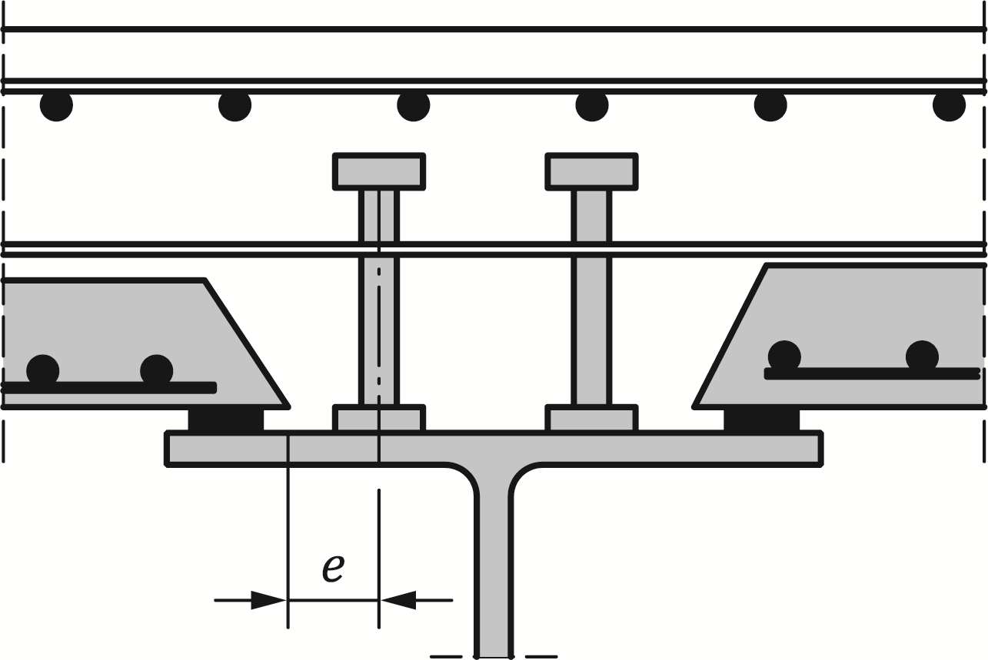

Figure 10.4 — Minimum clear distance between shear connector and precast element

NOTE The provisions of prEN 1994‑1‑1:2024, 8.6 can be considered, except prEN 1994‑1‑1:2024, 8.6.3 and 8.6.4.

# Composite plates

## General

(1) This clause is valid for composite plates consisting of a nominally flat plate of structural steel connected to a site cast concrete layer by headed studs for use as a flange in a bridge deck carrying transverse loads as well as in-plane forces, or as a bottom flange in a box girder. Double skin plates or other types of connectors are not covered.

(2) The steel plate should be supported during casting either permanently or by temporary supports in order to limit its deflection to less than 0,05 times the thickness of the concrete layer, unless the additional weight of concrete due to the deflection of the plate is taken into account in the design of the steel plate.

(3) The effective width should be determined according to prEN 1994‑1‑1:2024, 7.4.1.2, where *b*0 should be taken as 2*a*w with *a*w as defined in Figure 11.1

(4) For global analysis, 7.1 and 7.4 shall be applied.

## Design for local effects

(1) For the analysis of local effects, the composite plate may be assumed to be elastic and uncracked.

NOTE Local effects are considered to be bending moments and shear forces caused by transversely-spanning loads on the composite plate acting as a one- or two-way slab.

(2) The top flange of an I-girder shall not be designed as composite in the transverse direction.

(3) The concrete and the steel plate may be assumed to act compositely without slip.

(4) The resistance to bending and vertical shear force may be verified as a reinforced concrete slab where the steel plate is considered as reinforcement. The design resistance for vertical shear in 8.2.2(1) is applicable, where the distance, in longitudinal and transverse direction, between shear connectors does not exceed three times the thickness of the composite plate.

## Design for global effects

(1) The composite plate shall be designed to resist all forces from axial loads and global bending and torsion of all longitudinal girders or cross-girders of which it forms a part.

(2) The design resistance to in-plane compression may be taken as the sum of the design resistances of the concrete and the steel plate within the effective width.

(3) Reduction in strength due to second order effects should be considered according to EN 1992‑1‑1:2023, 7.4.

(4) For the design resistance for in-plane tension, the sum of the design resistances of the steel plate and the reinforcement within the effective width should be applied.

(5) Interaction with local load effects shall be considered for the shear connectors as stated in 11.4(1).

(6) Connectors designed for shear forces in both the longitudinal and transverse directions should be verified for the vector sum of the simultaneous forces on the connector.

## Design of shear connectors

(1) Resistance to fatigue and requirements for serviceability limit states shall be verified for the combined local and simultaneous global effect.

(2) The design strength of stud connectors in 8.6.4 and 8.7.3 may be used, provided that the concrete slab has bottom reinforcement with area not less than 0,002 times the concrete area in each of two perpendicular directions.

(3) The detailing rules of 8.6.10 shall be applied.

(4) For wide girder flanges, the distribution of longitudinal shear due to global effects for serviceability limit state and fatigue design situation may be determined as follows in order to account for slip and shear lag.

(5) The longitudinal force *P*Ed on a connector at distance *x* from the nearest web may be taken from Formula (11.1):

 (11.1)

where

|  |  |
| --- | --- |
| *v*L,Ed | is the design longitudinal shear per unit length in the concrete slab due to global effects for the web considered, determined using effective widths for shear lag; |
| *n*tot | is the total number of connectors of the same size per unit length of girder as shown in Figure 11.1, provided that the number of connectors per unit area does not increase with *x*; |
| *n*w | is the number of connectors per unit length placed within a distance from the web equal to the larger of 10 *t*f and 200 mm, where *t*f is the thickness of the steel plate. For these connectors *x* should be taken as 0; |
| *b* | is equal to half the distance between adjacent webs or the distance between the web and the free edge of the flange. |

(6) In case of a flange projecting distance *a*w outside the web according to Figure 11.1, the number of connectors *n*tot and *n*w may include connectors placed on this flange.

(7) Shear connectors should be concentrated in the region for *n*w according to Figure 11.1. The spacing of the connectors should fulfil the conditions in (10) to avoid premature local buckling of the plate.

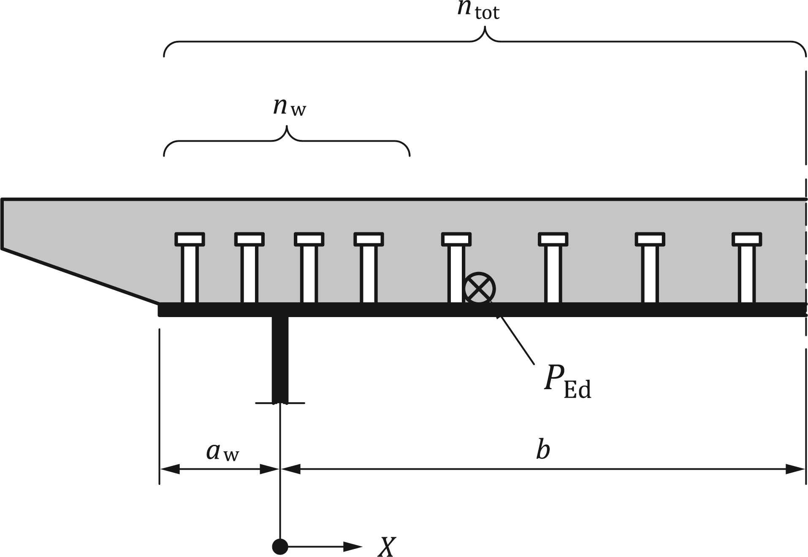

Figure 11.1 — Definition of notations in Formula (11.1)

(8) A more accurate determination of the distribution of longitudinal shear forces in composite bottom flanges of box sections according to (4) may be neglected, if the arrangement of the shear connectors is based on the following rules:

• Shear connectors should be concentrated in the corners of the box girder;

• At least 50 % of the total amount of shear connectors, which are responsible for the transfer of the longitudinal shear force from a web to the bottom concrete flange should be attached to the web and within the width *b*f of the steel bottom flange. The width *b*f of the steel bottom flange should be taken as the largest of

*b*f = 20 *t*f, *b*f = 0,2 *b*ei and *b*f = 400 mm

where

|  |  |
| --- | --- |
| *b*ei | is the effective width of the lower flange according to prEN 1994‑1‑1:2023, 7.4.1.2; |
| *t*f | is the thickness of the steel bottom flange. |

(9) For ultimate limit states, it may be assumed that all connectors within the effective width carry the same longitudinal force.

(10) Where restraint from shear connectors is relied upon to prevent local buckling of the steel element of a composite plate in compression, the centre-to-centre spacings of the connectors should not exceed the limits given in Table 11.1.

Table 11.1 — Upper limits to spacings of shear connectors in a composite plate in compression

|  |  |  |  |
| --- | --- | --- | --- |
|  |  | Class 2 | Class 3 |
| Transverse to the direction of compressive stress | outstand flange: | 14*tε* | 20*tε* |
|  | interior flange: | 45*tε* | 50*tε* |
| In the direction of compressive stress | outstand and interior flanges: | 22*tε* | 25*tε* |
| with *f*y in N/mm2 *t* – thickness of the steel flange | | | |

Bibliography

**References contained in recommendations (i.e. through “should” clauses)**

The following documents are referred to in the text in such a way that some or all of their content, although not requirements strictly to be followed, constitutes highly recommended choices or course of action of this document. Subject to national regulation and/or any relevant contractual provisions, alternative standards could be used/adopted where technically justified. For dated references, only the edition cited applies. For undated references, the latest edition of the referenced document (including any amendments) applies.

EN 1090‑1, Execution of steel structures and aluminium structures - Part 1: Requirements for conformity assessment of structural components

EN 1090‑2, Execution of steel structures and aluminium structures - Part 2: Technical requirements for steel structures

EN 1991 (all parts), Eurocode 1 — Actions on structures

EN 1992‑4:2018, Eurocode 2 - Design of concrete structures - Part 4: Design of fastenings for use in concrete

EN 1993‑1‑5, Eurocode 3 - Design of steel structures - Part 1-5: Plated structural elements

prEN 1993‑1‑9:2023, Eurocode 3 — Design of steel structures - Part 1-9: Fatigue

EN 1994 (all parts), Eurocode 4 — Design of composite steen and concrete structures

EN 1997 (all parts), Eurocode 7 — Geotechnical design

EN 1998 (all parts), Eurocode 8 — Design of structures for earthquake resistance

EN 13670, Execution of concrete structures

**References contained in permissions (i.e. through “may” clauses)**

The following documents are referred to in the text in such a way that some or all of their content, although not requirements strictly to be followed, expresses a course of action permissible within the limits of the Eurocodes. For dated references, only the edition cited applies. For undated references, the latest edition of the referenced document (including any amendments) applies.

None

**References given in possibilities (i.e. “can” clauses) and notes**

The following documents are cited informatively in the document, for example in “can” clauses and in notes.

None

1. As impacted by EN 1990:2023/prA1:2024.