CEN/TC 250

Date:  2020-09

prEN 1991‑1‑2:2021

Secretariat: BSI

Eurocode 1: Actions on Structures — Part 1‑2: General Actions — Actions on structures exposed to fire

Eurocode 1: Einwirkungen auf Tragwerke — Teil 1‑2: Allgemeine Einwirkungen — Einwirkungen im Brandfall

Eurocode 1: Actions sur les structures — Partie 1‑2: Actions Générales — Actions sur les structures exposées au feu

ICS:

Contents Page

European foreword 4

0 Introduction 5

1 Scope 9

1.1 Scope of prEN 1991‑1‑2 9

1.2 Assumptions 9

2 Normative references 9

3 Terms, definitions and symbols 10

3.1 Terms and definitions 10

3.2 Symbols and abbreviations 14

4 Structural fire design procedure 19

4.1 General 19

4.2 Design fire scenario 19

4.3 Design fire 19

4.4 Temperature analysis of members 19

4.5 Mechanical analysis of members 20

5 Thermal actions for temperature analysis 20

5.1 Heat flux 20

5.2 Nominal fire curves 22

5.3 Physically based models 23

6 Mechanical actions for structural analysis 24

6.1 General 24

6.2 Simultaneity of actions 24

6.3 Combination rules for actions 25

Annex A (informative) Parametric temperature-time curves 28

A.1 Use of this annex 28

A.2 Scope and field of application 28

A.3 Temperature-time curves in the heating phase 28

A.4 Temperature-time curves in the cooling phase 31

Annex B (informative) Thermal actions for external members — Simplified calculation method 32

B.1 Use of this annex 32

B.2 Scope and field of application 32

B.3 Conditions of use 32

B.4 Effects of wind 33

B.5 Characteristics of fire and flames 34

B.6 Overall configuration factors 40

Annex C (informative) Localised fires 41

C.1 Use of this annex 41

C.2 Scope and field of application 41

C.3 Virtual solid flame 41

Annex D (informative) Advanced fire models 47

D.1 Use of this annex 47

D.2 Scope and field of application 47

D.3 One-zone models 47

D.4 Two-zone models 48

D.5 Computational fluid dynamics models 49

Annex E (informative) Fire load densities, Fire Growth Rates and Rate of Heat Releases 50

E.1 Use of this annex 50

E.2 Scope and field of application 50

E.3 Design value of fire load density 50

E.4 Determination of fire load densities 53

E.5 Combustion behaviour 57

E.6 Rate of heat release Q 57

Annex F (informative) Equivalent time of fire exposure 60

F.1 Use of this annex 60

F.2 Scope and field of application 60

F.3 Equivalent time of standard fire exposure 60

Annex G (informative) Configuration factor 62

G.1 Use of this annex 62

G.2 Scope and field of application 62

G.3 General 62

G.4 Shadow effects 63

G.5 External members 63

G.6 Virtual solid flame 66

Bibliography 69

European foreword

This document (prEN 1991‑1‑2:2021) has been prepared by Technical Committee CEN/TC 250 “Structural Eurocodes”, the secretariat of which is held by BSI. CEN/TC 250 is responsible for all Structural Eurocodes and has been assigned responsibility for structural and geotechnical design matters by CEN.

This document is currently submitted to the CEN Enquiry.

This document will supersede EN 1991‑1‑2:2002.

The first generation of EN Eurocodes was published between 2002 and 2007. This document forms part of the second generation of the Eurocodes, which have been prepared under Mandate M/515 issued to CEN by the European Commission and the European Free Trade Association.

The Eurocodes have been drafted to be used in conjunction with relevant execution, material, product and test standards, and to identify requirements for execution, materials, products and testing that are relied upon by the Eurocodes.

The Eurocodes recognise the responsibility of each Member State and have safeguarded their right to determine values related to regulatory safety matters at national level through the use of National Annexes.

0 Introduction

**0.1 Introduction to the Eurocodes**

The structural Eurocodes comprise the following standards generally consisting of a number of Parts:

— EN 1990, *Eurocode: Basis of structural and geotechnical design*

— EN 1991, *Eurocode 1: Actions on structures*

— EN 1992, *Eurocode 2: Design of concrete structures*

— EN 1993, *Eurocode 3: Design of steel structures*

— EN 1994, *Eurocode 4: Design of composite steel and concrete structure*

— EN 1995, *Eurocode 5: Design of timber structures*

— EN 1996, *Eurocode 6: Design of masonry structures*

— EN 1997, *Eurocode 7: Geotechnical design*

— EN 1998, *Eurocode 8: Design of structures for earthquake resistance*

— EN 1999, *Eurocode 9: Design of aluminium structures*

— <New parts>

The Eurocodes are intended for use by designers, clients, manufacturers, constructors, relevant authorities (in exercising their duties in accordance with national or international regulations), educators, software developers, and committees drafting standards for related product, testing and execution standards.

NOTE Some aspects of design are most appropriately specified by relevant authorities or, where not specified, can be agreed on a project-specific basis between relevant parties such as designers and clients. The Eurocodes identify such aspects making explicit reference to relevant authorities and relevant parties.

**0.2 Introduction to EN 1991**

EN 1991 provides the actions to be considered for the structural design of buildings, bridges and other civil engineering works, or parts thereof, including temporary structures, in conjunction with EN 1990 and the other Eurocodes.

The actions on structures, including in some cases geotechnical structures in conjunction with EN 1997 as appropriate, provided in EN 1991 are intended to be applied in conjunction with the other Eurocodes for the verification of safety, serviceability and durability, as well as robustness of structures, including the execution phase.

EN 1991 does not cover actions for structures in seismic regions, unless explicitly prescribed by EN 1998.

EN 1991 is applicable to existing structures for their:

— structural assessment,

— retrofitting (strengthening, repair) design,

— assessment for changes of use.

NOTE 1 In this case, additional or amended provisions can be necessary.

EN 1991 is applicable to the design of structures where materials or actions outside the scope of the other Eurocodes are involved.

NOTE 2 In this case, additional or amended provisions can be necessary.

**0.3 Introduction to prEN 1991‑****1‑2**

prEN 1991‑1‑2 describes the thermal and mechanical actions for the structural design of buildings exposed to fire, including the following safety requirements and design procedures.

prEN 1991‑1‑2 is intended to be used with EN 1990, the other Parts of EN 1991 and EN 1992 to EN 1999 for the design of structures.

**0.3.1 Safety requirements**

The general objectives are to limit risks with respect to the individual and society, neighbouring property, and where required, environment or directly exposed property, in the case of fire.

Construction Products Regulation (EU) No 305/2011 gives the following requirement for the limitation of the consequence in case of fire:

“The construction works must be designed and built in such a way, that in the event of an outbreak of fire

— the load bearing capacity of the construction can be assumed for a specified period of time,

— the generation and spread of fire and smoke within the works are limited,

— the spread of fire to neighbouring construction works is limited,

— the occupants can leave the works or can be rescued by other means,

— the safety of rescue teams is taken into consideration”.

According to the Interpretative Document N°2 “Safety in Case of Fire”[1]) the essential requirement may be observed by following various possibilities for fire safety strategies prevailing in the Member States like conventional fire scenarios (nominal fires) or “natural” (physically based) fire scenarios, including passive and/or active fire protection measures.

Required functions and levels of performance can be specified either in terms of nominal (standard) fire resistance rating, generally given in national fire regulations or, where allowed by national fire regulations, by referring to fire safety engineering for assessing passive and active measures.

The fire parts of Structural Eurocodes deal with specific aspects of passive fire protection in terms of designing structures and parts thereof for adequate load bearing resistance and for limiting fire spread as relevant.

Numerical values for partial factors and other reliability elements are given to provide an acceptable level of reliability. They have been selected assuming that an appropriate level of workmanship and of quality management applies.

**0.3.2 Design procedures**

A full analytical procedure for structural fire design would take into account the behaviour of the structural system at elevated temperatures, the potential heat exposure and the beneficial effects of active and passive fire protection systems, together with the uncertainties associated with these three features and the importance of the structure (consequences of failure).

At the present time, it is possible to undertake a procedure for determining adequate performance which incorporates some, if not all, of the above parameters and to demonstrate that the structure, or its components, will give adequate performance in a real building fire. However, where the procedure is based on a nominal (standard) fire, the classification system, which calls for specific periods of fire resistance, takes into account (though not explicitly) the features and uncertainties described above.

Figure 1 illustrates the two design procedures provided by prEN 1991-1-2, i.e. the prescriptive approach and the performance-based approach. The prescriptive approach uses nominal (standard) fires to generate thermal actions. The performance-based approach, using fire safety engineering, refers to thermal actions based on physical and chemical parameters.

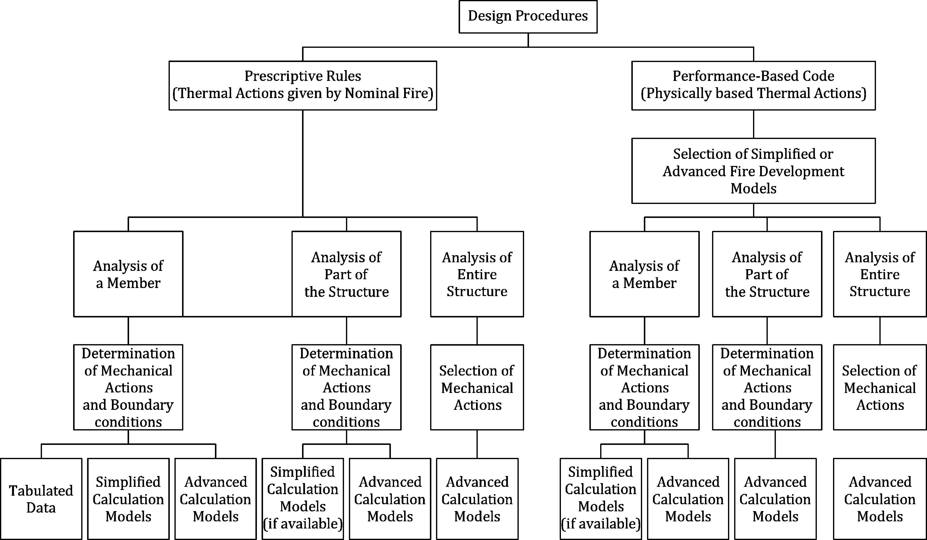

Figure 1 — Alternative design procedures

**0.4 Verbal forms used in the Eurocodes**

The verb “shall" expresses a requirement strictly to be followed and from which no deviation is permitted in order to comply with the Eurocodes.

The verb “should” expresses a highly recommended choice or course of action. Subject to national regulation and/or any relevant contractual provisions, alternative approaches could be used/adopted where technically justified.

The verb “may” expresses a course of action permissible within the limits of the Eurocodes.

The verb “can” expresses possibility and capability; it is used for statements of fact and clarification of concepts.

**0.5 National Annex for prEN 1991‑1-2**

National choice is allowed by this standard where explicitly stated within notes. National choice includes the selection of values for Nationally Determined Parameters (NDPs).

The national standard implementing prEN 1991-1-2 can have a National Annex containing all national choices to be used for the design of buildings and civil engineering works to be constructed in the relevant country.

When no national choice is given, the default choice given in this standard is to be used.

When no national choice is made and no default choice is given in this standard, the choice can be specified by the relevant authority or, where not specified, agreed for a specific project by the relevant parties.

National choice is allowed in prEN 1991‑1‑2 through the following clauses:

— 4.4(4)

— 6.2.2(2)

— 6.3.1(2)

— 6.3.2(3)

— 6.3.2(4)

National choice is allowed in this document on the use of the following informative annex:

Annex A (informative) Parametric temperature-time curves

Annex B (informative) Thermal actions for external members — Simplified calculation method

Annex C (informative) Localised fire

Annex D (informative) Advanced fire models

Annex E (informative) Fire load densities, Fire Growth Rates and Rate of Heat Releases

Annex F (informative) Equivalent time of fire exposure

Annex G (informative) Configuration factor

The National Annex can contain, directly or by reference, non-contradictory complementary information for ease of implementation, provided it does not alter any provisions of the Eurocodes.

# Scope

## Scope of prEN 1991‑1‑2

(1) The methods given in this Eurocode are applicable to buildings and civil engineering works, with a fire load related to the building and its occupancy.

(2) prEN 1991‑1‑2 deals with thermal and mechanical actions on structures exposed to fire. It is intended to be used in conjunction with the fire design Parts of EN 1992 to EN 1996 and EN 1999 which give rules for designing structures for fire resistance.

(3) prEN 1991‑1‑2 contains thermal actions either nominal or physically based. More data and models for physically based thermal actions are given in annexes.

(4) prEN 1991‑1‑2 does not cover the assessment of the damage of a structure after a fire.

(5) prEN 1991‑1‑2 does not cover supplementary requirements concerning, for example:

— the possible installation and maintenance of sprinkler systems;

— conditions on occupancy of building or fire compartment;

— the use of approved insulation and coating materials, including their maintenance.

## Assumptions

(1) In addition to the general assumptions of prEN 1990 the following assumptions apply:

— any active and passive fire protection systems taken into account in the design will be adequately maintained;

— the choice of the relevant design fire scenario is made by appropriate qualified and experienced personnel, or is given by the relevant national regulation.

# Normative references

The following documents are referred to in the text in such a way that some or all of their content constitutes requirements of this document. For dated references, only the edition cited applies. For undated references, the latest edition of the referenced document (including any amendments) applies.

prEN 1990:2020, Eurocode: Basis of structural and Geotechnical design

EN 1992 (all parts), Eurocode 2: Design of concrete structures

EN 1993 (all parts), Eurocode 3: Design of steel structures

EN 1994 (all parts), Eurocode 4: Design of composite steel and concrete structures

EN 1995 (all parts), Eurocode 5: Design of timber structures

EN 1996 (all parts), Eurocode 6: Design of masonry structures

EN 1999 (all parts), Eurocode 9: Design of aluminium structures

EN 13501‑2, Fire classification of construction products and building elements — Part 2: Classification using data from fire resistance tests, excluding ventilation services

# Terms, definitions and symbols

## Terms and definitions

For the purposes of this document, the terms and definitions given in prEN 1990 and the following apply.

ISO and IEC maintain terminological databases for use in standardization at the following addresses:

— IEC Electropedia: available at <https://www.electropedia.org/>

— ISO Online browsing platform: available at <https://www.iso.org/obp>

### Common terms used in Eurocode Fire parts

3.1.1.1

equivalent time of fire exposure

time of exposure to the standard fire curve supposed to have the same heating effect as a real fire in the compartment

3.1.1.2

external member

structural member located outside the building that may be exposed to fire through openings in the building enclosure

3.1.1.3

compartment, fire compartment

space within a building, extending over one or several floors, which is enclosed by separating elements such that fire spread beyond the compartment is prevented during the relevant fire exposure

3.1.1.4

fire resistance

ability of a structure, a part of a structure or a member to fulfil its required functions (load bearing function and/or fire separating function) for a specified load level, for a specified fire exposure and for a specified period of time

3.1.1.5

fully developed fire

state of full involvement of all combustible surfaces in a fire within a specified space

3.1.1.6

global structural analysis (for fire)

structural analysis of the entire structure, when either the entire structure, or only a part of it, are exposed to fire

Note 1 to entry: Indirect fire actions are considered throughout the structure.

3.1.1.7

indirect fire actions

internal forces and moments caused by thermal expansion

3.1.1.8

integrity

E

ability of a separating element of building construction, when exposed to fire on one side, to prevent the passage through it of flames and hot gases and to prevent the occurrence of flames on the unexposed side

3.1.1.9

insulation

I

ability of a separating element of building construction when exposed to fire on one side, to restrict the temperature rise of the unexposed face below specified levels

3.1.1.10

load bearing function

R

ability of a structure or a member to sustain specified actions during the relevant fire, according to defined criteria

3.1.1.11

member

basic part of a structure (such as beam, column, but also assembly such as stud wall, truss) considered as isolated with appropriate boundary and support conditions

3.1.1.12

member analysis (for fire)

thermal and mechanical analysis of a structural member exposed to fire in which the member is assumed as isolated, with appropriate support and boundary conditions

Note 1 to entry: Indirect fire actions are not considered, except those resulting from thermal gradients.

3.1.1.13

normal temperature design

ultimate limit state design for ambient temperatures according to Part 1‑1 of EN 1992 to EN 1996 or EN 1999

3.1.1.14

separating function

ability of a separating element to prevent fire spread (e.g. by passage of flames or hot gases — cf. integrity) or ignition beyond the exposed surface (cf. insulation) during the relevant fire

3.1.1.15

separating element

load bearing or non-load bearing element (e.g. wall) forming part of the enclosure of a fire compartment

3.1.1.16

standard fire resistance

ability of a structure or part of it (usually only members) to fulfil required functions (load-bearing function and/or separating function), for the exposure to heating according to the standard fire curve for a specified load combination and for a stated period of time

3.1.1.17

structural members

physically distinguishable part of a structure, e.g. column, beam, plate, foundation

3.1.1.18

temperature analysis

procedure of determining the temperature development in members based on the thermal actions (net heat flux) and the thermal material properties of the members and of protective surfaces, where relevant

3.1.1.19

thermal actions

actions on the structure described by the net heat flux to the members

### Special terms relating to design in general

3.1.2.1

advanced fire model

design fire based on mass conservation and energy conservation aspects

3.1.2.2

computational fluid dynamics model

fire model able to solve numerically the partial differential equations giving, in all points of the compartment, the thermo-dynamical and aero-dynamical variables

3.1.2.3

fire wall

separating element that is a wall separating two spaces (e.g. two buildings) that is designed for fire resistance and structural stability, and may include resistance to horizontal loading such that, in case of fire and failure of the structure on one side of the wall, fire spread beyond the wall is avoided

3.1.2.4

one-zone model

fire model where homogeneous temperatures of the gas are assumed in the compartment

3.1.2.5

simplified fire model

design fire based on a limited application field of specific physical parameters

3.1.2.6

two-zone model

fire model where different zones are defined in a compartment: the upper layer, the lower layer, the fire and its plume, the external gas and walls

Note 1 to entry: In the upper and lower layers, uniform temperature of the gas is assumed.

### Terms relating to thermal actions

3.1.3.1

combustion factor

factor representing the efficiency of combustion, varying between 1 for complete combustion to 0 for combustion fully inhibited

3.1.3.2

design fire

quantitative description of assumed fire characteristics within a design fire scenario specified

3.1.3.3

design fire load density

fire load density considered for determining thermal actions in fire design

3.1.3.4

design fire scenario

specific fire scenario on which an analysis will be conducted

3.1.3.5

external fire curve

nominal fire curve intended for the outside of separating (EI) external walls and parapets which can be exposed to fire from a compartment situated below or adjacent to the respective external wall

3.1.3.6

fire activation risk

parameter taking into account the probability of ignition, function of the compartment area and the occupancy

3.1.3.7

fire load density

fire load per unit area related to the floor area *q*f, or related to the surface area of the total enclosure, including openings, *q*t

3.1.3.8

fire load

quantity of energy which is released by complete combustion of all combustible materials in a compartment or a localised fire area (building contents and construction elements)

3.1.3.9

fire scenario

qualitative description of the course of a fire with time identifying key events that characterize the fire and differentiate it from other possible fires

Note 1 to entry: It typically defines the ignition and fire growth process, the fully developed stage and decay stage together as well as systems that impact the course of the fire and the nature of local environment.

3.1.3.10

flash-over

simultaneous ignition of all the fire loads in a compartment

3.1.3.11

hydrocarbon fire curve

nominal fire curve for representing effects of a hydrocarbon type fire

3.1.3.12

localised fire

fire involving only a limited area of the compartment

3.1.3.13

opening factor

factor representing the amount of ventilation depending on the area of openings in the compartment walls, on the height of these openings and on the total area of the enclosure surfaces

3.1.3.14

rate of heat release

heat (energy) released by a combustible product as a function of time

3.1.3.15

standard fire curve

nominal curve defined in EN 13501‑2 for representing a model of a fully developed fire in a compartment

3.1.3.16

fire curve

gas temperature in the environment of member surfaces as a function of time

Note 1 to entry: They can be:

— **nominal:** conventional curves, adopted for classification or verification of fire resistance, e.g. the standard temperature-time curve, external fire curve, hydrocarbon fire curve;

— **physically based:** determined on the basis of fire models and the specific physical parameters defining the conditions in the fire compartment.

### Terms relating to heat transfer analysis

3.1.4.1

configuration factor

for radiative heat transfer from surface A to surface B, fraction of diffusely radiated energy leaving surface A that is incident on surface B

3.1.4.2

convective heat transfer coefficient

convective heat flux to the member related to the difference between the bulk temperature of gas bordering the relevant surface of the member and the temperature of that surface

3.1.4.3

emissivity

equal to absorptivity of a surface, i.e. the ratio between the radiative heat absorbed by a given surface and that of a black body surface

3.1.4.4

net heat flux

energy, per unit time and surface area, definitely absorbed by members

## Symbols and abbreviations

For the purposes of this document, the following symbols apply.

### Latin upper case letters

|  |  |
| --- | --- |
| *A* | area of the fire compartment |
| *A*ind,d | design value of indirect action due to fire |
| *A*f | floor area of the fire compartment |
| *A*fi | fire area |
| *A*h | area of horizontal openings in roof of compartment |
| *A*h,v | total area of openings in enclosure |
| *A*j | area of enclosure surface *j*, openings not included |
| *A*t | total area of enclosure (walls, ceiling and floor, including openings) |
| *A*v | total area of vertical openings on all walls () |
| *A*v,i | area of window “*i*” |
| *C*i | protection coefficient of member face *i* |
| *D* | depth of the fire compartment, diameter of the fire |
| *E*d | design value of the relevant effects of actions from the fundamental combination according to prEN 1990 |
| *E*d,fi | constant design value of the relevant effects of actions in the fire situation |
| *E*d,fi,t | design value of the relevant effects of actions in the fire situation at time *t* |
| *E*g | internal energy of gas |
| *H* | distance between the fire source and the ceiling |
| *H*u | net calorific value including moisture |
| *H*u0 | net calorific value of dry material |
| *H*ui | net calorific value of material i |
| *L*c | length of the core |
| *L*f | flame length along axis |
| *L*H | horizontal projection of the flame (from the facade) |
| *L*h | horizontal flame length |
| *L*L | flame height (from the upper part of the window) |
| *L*x | axis length from window to the point where the calculation is made |
| *M*k,i | amount of combustible material i |
| *O* | opening factor of the fire compartment |
| *O*lim | reduced opening factor in case of fuel controlled fire |
| *P*int | the internal pressure |
| *Q* | rate of heat release of the fire |
| *Q*c | convective part of the rate of heat release *Q* |
| *Q*fi,k | characteristic fire load |
| *Q*fi,k,i | characteristic fire load of material i |
|  | heat release coefficient related to the diameter *D* of the local fire |
|  | heat release coefficient related to the height *H* of the compartment |
| *Q*k,1 | characteristic value of the leading variable action |
| *Q*max | maximum rate of heat release |
| *Q*in | rate of heat release entering through openings by gas flow |
| *Q*out | rate of heat release lost through openings by gas flow |
| *Q*rad | rate of heat release lost by radiation through openings |
| *Q*wall | rate of heat release lost by radiation and convection to the surfaces of the compartment |
| *R* | ideal gas constant (= 287 [J/kgK]) |
| *R*d | design value of the resistance of the member at normal temperature |
| *R*fi,d,t | design value of the resistance of the member in the fire situation at time *t* |
| *RHR*f | maximum rate of heat release per square meter |
| *T* | the temperature [K] |
| *T*amb | the ambient temperature [K] |
| *T*0 | initial temperature |
| *T*f | temperature of the fire compartment [K] |
| *T*g | gas temperature [K] |
| *T*w | flame temperature at the window [K] |
| *T*z | flame temperature along the flame axis [K] |
| *W* | width of wall containing window(s) |
| *W*1 | width of the wall 1, assumed to contain the greatest window area |
| *W*2 | width of the wall of the fire compartment, perpendicular to wall *W*1 |
| *W*a | horizontal projection of an awning or balcony |
| *W*c | width of the core |

### Latin lower case letters

|  |  |
| --- | --- |
| *b* | thermal absorptivity for the total enclosure () |
| *b*i | thermal absorptivity of layer *i* of one enclosure surface |
| *b*j | thermal absorptivity of one enclosure surface *j* |
| *c* | specific heat |
| *d*eq | geometrical characteristic of an external structural element (diameter or side) |
| *d*f | flame thickness |
| *d*i | cross-sectional dimension of member face *i* |
| *g* | the gravitational acceleration |
| *h*eq | weighted average of window heights on all walls |
| *h*i | height of window *i* |
|  | heat flux to unit surface area |
| net | net heat flux to unit surface area |
| net,c | net heat flux to unit surface area due to convection |
| net,r | net heat flux to unit surface area due to radiation |
| tot | total heat flux to unit surface area |
| i | heat flux to unit surface area due to fire *i* |
| *k* | correction factor |
| *k*b | conversion factor |
| *k*c | correction factor |
| *m* | mass, combustion factor |
|  | mass rate |
|  | rate of gas mass coming in through the openings |
|  | rate of gas mass going out through the openings |
|  | rate of pyrolysis products generated |
| *q*f | fire load per unit area related to the floor area *A*f |
| *q*f,d | design fire load density related to the floor area *A*f |
| *q*f,k | characteristic fire load density related to the surface area *A*f |
| *q*t | fire load per unit area related to the surface area *A*t |
| *q*t,d | design fire load density related to the surface area *A*t |
| *q*t,k | characteristic fire load density related to the surface area *A*t |
| *r* | horizontal distance between the vertical axis of the fire and the point along the ceiling where the thermal flux is calculated |
| *s*i | thickness of layer *i* |
| *s*lim | limit thickness |
| *t* | time |
| *t*e,d | equivalent time of fire exposure |
| *t*d,fi | design fire resistance (property of the member or structure) |
| *t*fi,requ | required fire resistance time |
| *t*lim | time for maximum gas temperature in case of fuel controlled fire |
| *t*max | time for maximum gas temperature |
| *t*α | fire growth rate coefficient |
| *u* | wind speed, moisture content |
| *w*i | width of window “*i*” |
| *w*t | sum of window widths on all walls ; ventilation factor referred to *A*t |
| *w*f | width of the flame; ventilation factor |
| *y* | coefficient parameter |
| *z* | height |
| *z*0 | virtual origin of the height *z* |
| *z*′ | vertical position of the virtual heat source |

### Greek upper case letters

|  |  |
| --- | --- |
| *Φ* | configuration factor |
| *Φ*f | overall configuration factor of a member for radiative heat transfer from an opening |
| *Φ*f,i | configuration factor of member face *i* for a given opening |
| *Φ*z | overall configuration factor of a member for radiative heat transfer from a flame |
| *Φ*z,*i* | configuration factor of member face *i* for a given flame |
| *Γ* | time factor function of the opening factor *O* and the thermal absorptivity *b* |
| *Γ*lim | time factor function of the opening factor *O*lim and the thermal absorptivity *b* |
| *Θ* | temperature [°C]; *Θ* [°C] = *T* [K] − 273 |
| *Θ*cr,d | design value of the critical material temperature [°C] |
| *Θ*d | design value of material temperature [°C] |
| *Θ*g | gas temperature in the fire compartment, or near the member [°C] |
| *Θ*m | temperature of the member surface [°C] |
| *Θ*max | maximum temperature [°C] |
| *Θ*r | effective radiation temperature of the fire environment [°C] |
| Ω |  |
| *Ψ*i | protected fire load factor |

### Greek lower case letters

|  |  |
| --- | --- |
| *α*c | coefficient of heat transfer by convection |
| *α*h | area of horizontal openings related to the floor area |
| *α*v | area of vertical openings related to the floor area |
| *δ*ni | factor accounting for the existence of a specific fire fighting measure *i* |
| *δ*q1 | factor taking into account the fire activation risk due to the size of the compartment |
| *δ*q2 | factor taking into account the fire activation risk due to the type of occupancy |
| *ε*m | surface emissivity of the member |
| *ε*f | emissivity of flames, of the fire |
| *η*fi | reduction factor |
| *η*fi,t | load level for fire design |
| *λ* | thermal conductivity |
| *ρ* | density |
| *ρ*g | internal gas density |
| *σ* | Stephan Boltzmann constant (= 5,67 ⋅ 10−8 [W/(m2K4)]) |
| *τ*F | free burning fire duration |
| *ψ*0 | combination factor applied to a variable action to determine its combination value |
| *ψ*1 | combination factor applied to a variable action to determine its frequent value |
| *ψ*2 | combination factor applied to a variable action to determine its quasi-permanent value |

# Structural fire design procedure

## General

(1) A structural fire design analysis shall include the following steps as relevant:

— selection of the relevant design fire scenarios;

— determination of the corresponding design fires;

— calculation of temperature evolution within the structural members;

— calculation of the mechanical behaviour of the structure exposed to fire.

NOTE Mechanical behaviour of a structure depends on:

— thermal actions and their effect on material properties;

— indirect fire actions;

— the direct and indirect effects of mechanical actions.

(2) Structural fire design should involve the application of actions for temperature analysis and actions for mechanical analysis according to this Part and other Parts of EN 1991.

(3) Actions on structures from fire exposure shall be classified as accidental actions, see prEN 1990:2020, 8.3.3.4.

## Design fire scenario

(1) To identify the accidental design situation, the relevant design fire scenarios and the associated design fires should be determined on the basis of a fire risk assessment.

(2) For structures where particular risks of fire arise as a consequence of other accidental actions, this risk should be considered when determining the overall safety concept.

(3) Time and load dependent structural behaviour prior to the accidental situation may be neglected, unless (2) applies.

## Design fire

(1) For each design fire scenario, a design fire, in a fire compartment, should be determined according to Clause 5 or with available physical models with justification.

(2) The design fire should be applied only to one fire compartment of the building at a time, unless otherwise specified in the design fire scenario.

(3) For structures, where the national authorities specify structural fire resistance requirements, it may be assumed that the relevant design fire is given by the standard fire, unless specified otherwise.

## Temperature analysis of members

(1) When performing temperature analysis of a member, the position of the design fire in relation to the member shall be taken into account.

(2) For external members, fire exposure through openings in facades and roofs should be considered.

(3) For separating external walls fire exposure from inside (from the respective fire compartment) and alternatively from outside (from other fire compartments) should be considered when required.

(4) Depending on the design fire chosen in Clause 5, the following procedures should be used:

— with a nominal fire curve, the temperature analysis of the structural members is made for a specified period of time, without any cooling phase;

NOTE 1 The specified period of time can be given in the national regulations. If allowed by the national regulations, the specified period of time can be obtained from Annex F following the specifications of the National Annex.

— with a physically based model, the temperature analysis of the structural members is made for the full duration of the fire, including the cooling phase.

NOTE 2 The National Annex can refer to national regulations in which limited periods of fire resistance are specified.

## Mechanical analysis of members

(1) The mechanical analysis shall be performed for the same duration as used in the temperature analysis.

(2) Verification of fire resistance should be carried out in the time domain:

 (4.1)

or in the strength domain:

 (4.2)

or in the temperature domain:

 (4.3)

where

|  |  |
| --- | --- |
| *t*d,fi | is the design value of the fire resistance; |
| *t*requ,fi | is the required fire resistance time; |
| *R*d,fi,t | is the design value of the resistance of the member in the fire situation at time *t*; |
| *E*d,fi,t | is the design value of the relevant effects of actions in the fire situation at time *t*; |
| *Θ*d | is the design value of material temperature; |
| *Θ*cr,d | is the design value of the critical material temperature. |

# Thermal actions for temperature analysis

## Heat flux

(1) Thermal actions shall be represented by the net heat flux  [W/m2] to the surface of the member.

(2) On the fire exposed surfaces, the net heat flux  should be determined by considering heat transfer by convection and radiation as shown in Formula (5.1):

|  |  |  |
| --- | --- | --- |
|  | [W/m2] | (5.1) |

where

|  |  |
| --- | --- |
|  | is the net convective heat flux component given by Formula (5.2) |
|  | is the net radiative heat flux component given by Formula (5.3) |

(3) The net convective heat flux component should be determined by Formula (5.2):

|  |  |  |
| --- | --- | --- |
|  | [W/m2] | (5.2) |

where

|  |  |
| --- | --- |
| *α*c | is the coefficient of heat transfer by convection [W/(m2K)]; |
| *Θ*g | is the gas temperature in the fire compartment near the member [°C]; |
| *Θ*m | is the surface temperature of the member, according to the fire design Parts of EN 1992 to EN 1996 and EN 1999, as relevant [°C]. |

(4) On the fire exposed surface, the coefficient of heat transfer by convection *α*c relevant for nominal temperature-time curves should be as indicated in 5.2.

(5) On the unexposed side of separating members, the net heat flux  should be determined by using Formula (5.1), with the coefficient of heat transfer *α*c as follows:

— *α*c = 9 W/(m2K) when assuming it contains the effects of heat transfer by radiation;

— *α*c = 4 W/(m2K)-in all other cases.

(6) The net radiative heat flux component per unit surface area is determined by Formula (5.3):

|  |  |  |
| --- | --- | --- |
|  | [W/m2] | (5.3) |

where

|  |  |
| --- | --- |
| *Φ* | is the configuration factor; |
| *ε*m | is the surface emissivity of the member; |
| *ε*f | is the emissivity of the fire; |
| *σ* | is the Stephan Boltzmann constant (= 5,67 ⋅ 10−8 W/(m2K4)); |
| *Θ*r | is the effective radiation temperature of the fire environment [°C]; |
| *Θ*m | is the surface temperature of the member [°C]. |

(7) Where this document or the fire Part of EN 1992 to EN 1996 and EN 1999 give no specific data, the configuration factor should be taken as *Φ* = 1,0. A lower value of the configuration factor may be chosen to take account of position and shadow effects.

NOTE For the calculation of the configuration factor *Φ* a method is given in Annex G. This Annex also clarifies position and shadow effects.

(8) Unless given in the material related fire design Parts of EN 1992 to EN 1996 and EN 1999, the value *ε*m = 0,8 should be used.

(9) The emissivity of the fire should be taken as *ε*f = 1,0.

(10) In case of fully fire engulfed members, the radiation temperature *Θ*r may be represented by the gas temperature *Θ*g around that member.

(11) Gas temperatures *Θ*g may be taken from nominal fire curves according to 5.2, or calculated according to the physically based fire models given in 5.3.

## Nominal fire curves

### Standard fire curve

(1) The standard fire curve is given by Formula (5.4):

|  |  |  |
| --- | --- | --- |
|  | [°C] | (5.4) |

where

|  |  |
| --- | --- |
| *Θ*g | is the gas temperature in the fire compartment [°C]; |
| *t* | is the time [min]. |

(2) The coefficient of heat transfer by convection *α*c for the standard fire curve should be taken as *α*c = 25 W/(m2K).

### External fire curve

(1) The external fire curve is given by Formula (5.5):

|  |  |  |
| --- | --- | --- |
|  | [°C] | (5.5) |

where

|  |  |
| --- | --- |
| *Θ*g | is the gas temperature near the member [°C]; |
| *t* | is the time [min]. |

(2) The coefficient of heat transfer by convection *α*c for the external fire curve should be taken as *α*c = 25 W/(m2K).

### Hydrocarbon fire curve

(1) The hydrocarbon fire curve is given by Formula (5.6):

|  |  |  |
| --- | --- | --- |
|  | [°C] | (5.6) |

where

|  |  |
| --- | --- |
| *Θ*g | is the gas temperature in the fire compartment [°C]; |
| *t* | is the time [min]. |

(2) The coefficient of heat transfer by convection for the hydrocarbon fire curve should be taken as *α*c = 50 W/(m2K).

## Physically based models

### Simplified fire models

#### General

(1) Simplified fire models are based on specific physical parameters with a limited field of application.

NOTE A method for the calculation of the design fire load density *q*f,d is given in Annex E.

(2) A uniform temperature distribution as a function of time should be assumed for compartment fires. A non-uniform temperature distribution as a function of time should be assumed in case of localised fires.

(3) When simplified fire models are used, the coefficient of heat transfer by convection should be taken as *α*c = 35 W/(m2K).

#### Compartment fires

(1) Gas temperatures should be determined on the basis of physical parameters considering at least the fire load density and the ventilation conditions.

NOTE 1 For internal members of fire compartments, a method for the calculation of the gas temperature in the compartment is given in Annex A and Annex E.

NOTE 2 For external members exposed to fire through openings in the facade, a method for the calculation of the heating conditions is given in Annex B.

#### Localised fires

(1) A localised fire should be taken into account in a compartment where flashover is unlikely to occur or in the early stage of a fire.

NOTE A method for the calculation of thermal actions from localised fires is given in Annex C.

### Advanced fire models

(1) Advanced fire models should take into account the following:

— gas properties;

— mass exchange;

— energy exchange.

NOTE For the calculation of the design fire load density *q*f,d, the fire growth rate and the rate of heat release *Q*, methods are given in Annex E.

(2) One of the following models should be used:

— one-zone models assuming a uniform, time dependent temperature distribution in the compartment;

— two-zone models assuming an upper layer with time dependent thickness and with time dependent uniform temperature, as well as a lower layer with a time dependent uniform and lower temperature;

— Computational Fluid Dynamics models giving the temperature evolution in the compartment in a completely time dependent and space dependent manner.

NOTE A method for the calculation of thermal actions in case of one-zone, two-zone or computational fluid dynamic models is given in Annex D.

(3) The coefficient of heat transfer by convection for advanced fire models should be taken as *α*c = 35 W/(m2K), unless more detailed information is available.

(4) In order to calculate more accurately the temperature distribution along a member, in case of a localised fire, a combination of results obtained with a two-zone model and a localised fire approach may be considered. The temperature field in the member may be obtained by considering the maximum effect at each location given by the two fire models~~.~~

# Mechanical actions for structural analysis

## General

(1) Imposed and constrained expansions and deformations caused by temperature changes due to fire exposure result in effects of actions, e.g. forces and moments, which shall be considered with the exception of those cases where they:

— can be recognized a priori to be either negligible or favourable;

— are accounted for by conservatively chosen support models and boundary conditions, and/or implicitly considered by conservatively specified fire safety requirements.

(2) For an assessment of indirect actions the following should be considered:

— constrained thermal expansion of the members themselves, e.g. columns in multi-storey frame structures with stiff walls;

— differing thermal expansion within statically indeterminate members, e.g. continuous floor slabs;

— thermal gradients within cross-sections giving internal stresses;

— thermal expansion of adjacent members, e.g. displacement of a column head due to the expanding floor slab, or expansion of suspended cables;

— thermal expansion of members affecting other members outside the fire compartment.

(3) Design values of indirect actions due to fire *A*ind,d should be determined on the basis of the design values of the thermal and mechanical material properties given in the fire design Parts of EN 1992 to EN 1996 and EN 1999 and the relevant fire exposure.

(4) Indirect actions from adjacent members should not be considered when fire safety requirements refer to members under standard fire conditions.

## Simultaneity of actions

### Actions from normal temperature design

(1) Actions that are likely to act in the fire situation shall be considered as for normal temperature design

(2) Representative values of variable actions, accounting for the accidental design situation of fire exposure, should be introduced in accordance with prEN 1990.

(3) Decrease of imposed loads due to combustion may be neglected.

(4) Cases where snow loads may be neglected in combination with fire, due to the melting of snow, should be assessed individually.

(5) Actions resulting from industrial operations should not be taken into account.

### Additional actions

(1) Simultaneous occurrence of fire with other independent accidental actions should not be considered.

(2) Depending on the accidental design situations to be considered, additional actions induced by the fire may need to be applied during fire exposure, e.g. impact due to collapse of a structural member or heavy machinery.

NOTE The choice of additional actions can be specified in the National Annex.

(3) Where it is required for fire walls to resist a horizontal impact load, this should be specified according to EN 1363‑2.

## Combination rules for actions

### General rule

(1) For obtaining the relevant effects of actions *E*fi,d,t during fire exposure, the mechanical actions shall be combined in accordance with prEN 1990 for accidental design situations.

(2) The representative value of the variable action *Q*1 may be considered as the quasi-permanent value *ψ*2,1 *Q*1, or as an alternative the frequent value *ψ*1,1 *Q*1.

NOTE The representative value of the variable action *Q*1 is the quasi-permanent value *ψ*2,1 *Q*1, unless the National Annex specifies the frequent value *ψ*1,1 *Q*1.

### Simplified rules

(1) Where indirect fire actions need not be explicitly considered, effects of actions may be determined by analysing the structure for combined actions according to 6.3.1 for *t* = 0 only. These effects of actions *E*fi,d may be applied as constant throughout fire exposure.

NOTE This clause applies, for example, to effects of actions at boundaries and supports, where an analysis of parts of the structure is performed in accordance with the fire design Parts of EN 1992 to EN 1996 and EN 1999.

(2) As a further simplification to (1), effects of actions may be deduced from those determined in normal temperature design using Formula (6.1):

*E*fi,d,t = *E*fi,d = *η*fi ⋅ *E*d (6.1)

where

|  |  |
| --- | --- |
| *E*d | is the design value of the relevant effects of actions for fundamental (persistent and transient) design situations according to prEN 1990; |
| *E*fi,d | is the corresponding constant design value in the fire situation; |
| *η*fi | is a reduction factor. |

(3) For the combination of actions given by prEN 1990:2020, Formula (8.12), the reduction factor *η*fi should be taken as:

 (6.2)

or, for the combinations of actions given by prEN 1990:2020, Formulae (8.13a) and (8.13b), as the smallest value given by Formulae (6.3) and (6.4):

 (6.3)

 (6.4)

where

|  |  |
| --- | --- |
| *Q*k,1 | is the characteristic value of the leading variable action 1; |
| *G*k | is the characteristic value of the permanent action; |
| *γ*G | is the partial factor for the permanent action; |
| *γ*Q,1 | is the partial factor for the leading variable action 1; |
| *ψ*fi | is the combination factor for variable actions in the fire situation, given either by *ψ*1,1 or *ψ*2,1, see 6.3.1(2); |
| *ξ* | is a reduction factor for the unfavourable permanent action *Gk*. |

NOTE 1 The choice of the combination of actions to be used is given in the National Annex of prEN 1990.

NOTE 2 An example of the variation of the reduction factor *η*fi versus the load ratio *Q*k,1/*G*k for different values of the combination factor *ψ*fi according to Formula (6.2) is shown in Figure 6.1 with the following assumptions: *γ*G = 1,35 and *γ*Q,1 = 1,5. Partial factors are specified in the relevant National Annex of prEN 1990. Formulae (6.3) and (6.4) give slightly higher values.

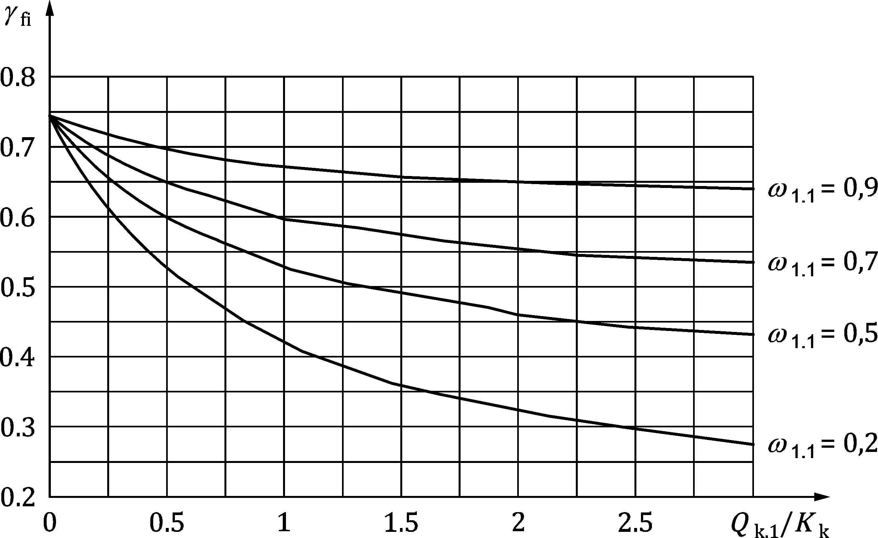

Figure 6.1 — Examples of reduction factor *η*fi versus load ratio *Q*k,1/*G*k according to Formula (6.2)

(4) As a simplification, values of *η*fi may be used as defined in the relevant material Eurocode.

NOTE 3 The choice of recommended values for the reduction factor *η*fi can be found in the National Annex of the relevant material Eurocode.

### Load level

(1) Where tabulated data are specified for a reference load level, this load level should be calculated from Formula (6.5):

Efi,d,t = ηfi,t ⋅ Rd (6.5)

where

|  |  |
| --- | --- |
| *R*d | is the design value of the resistance of the member at normal temperature, determined according to EN 1992 to EN 1996 and EN 1999; |
| *η*fi,t | is the load level for fire design. |

1. (informative)  
     
   Parametric temperature-time curves
   1. Use of this annex

(1) This informative Annex provides additional guidance to that given in 5.3.1.2.

NOTE National choice on the application of this Informative Annex is given in the National Annex. If the National Annex contains no information on the application of this informative annex, it can be used.

* 1. Scope and field of application

(1) The temperature-time curves given in this Annex are valid for fire compartments up to 500 m2 of floor area, without openings in the roof and for a maximum compartment height of 4 m. It is assumed that the fire load of the compartment is completely burnt out.

(2) If fire load densities are specified without specific consideration to the combustion behaviour (see Annex E), then this approach should be limited to fire compartments with mainly cellulosic type fire loads.

* 1. Temperature-time curves in the heating phase

(1) The temperature-time curves in the heating phase should be calculated from Formula (A.1):

 (A.1)

where

|  |  |
| --- | --- |
| *Θ*g | is the gas temperature in the fire compartment [°C] |

|  |  |  |
| --- | --- | --- |
|  | [h] | (A.2a) |

with

|  |  |  |
| --- | --- | --- |
| *t* | time; | [h] |
| *Γ* | = [*O*/*b*]2/(0,04/1 160)2; | [–] |
| *b* | thermal absorptivity for the total enclosure = ; |  |
|  | with the following limits: 100 ≤ *b* ≤ 2 200; | [J/m2s1/2K] |
| *ρ* | density of boundary of enclosure; | [kg/m3] |
| *c* | specific heat of boundary of enclosure; | [J/kgK] |
| *λ* | thermal conductivity of boundary of enclosure; | [W/(mK)] |
| *O* | opening factor: *A*v/*A*t ; | [m1/2] |
|  | with the following limits: 0,02 ≤ *O* ≤ 0,20 |  |
| *A*v | total area of vertical openings on all walls; | [m2] |
| *h*eq | weighted average of window heights on all walls; | [m] |
| *A*t | total area of enclosure (walls, ceiling and floor, including openings). | [m2] |

(2) For the calculation of the *b* factor, the density *ρ*, the specific heat *c* and the thermal conductivity *λ* of the boundary may be taken at ambient temperature.

(3) To account for an enclosure surface with different layers of material,  should be introduced as:

|  |  |
| --- | --- |
| — If *b*1 < *b*2, *b* = *b*1 | (A.3) |

— If *b*1 > *b*2, a limit thickness *s*lim is calculated for the exposed material according to:

|  |  |  |
| --- | --- | --- |
|  | [m] | (A.4) |
|  | | (A.4a) |
|  | | (A.4b) |

where

|  |  |
| --- | --- |
| index 1 represents the layer directly exposed to the fire, index 2 the next layer, etc.; | |
| *s*i | is the thickness of layer i; |
| *b*i | ; |
| *ρ*i | is the density of layer *i*; |
| *c*i | is the specific heat of layer *i*; |
| *λ* i | is the thermal conductivity of layer *i*. |

(4) To account for different *b* factors in walls, ceiling and floor,  should be calculated from Formula (A.5):

 (A.5)

where

|  |  |
| --- | --- |
| *A*j | is the area of enclosure surface j, openings not included; |
| *b*j | is the thermal property of enclosure surface j according to Formulae (A.3) and (A.4). |

(5) The maximum temperature *Θ*max in the heating phase happens for 

|  |  |  |
| --- | --- | --- |
|  | [h] | (A.6) |

with

|  |  |  |
| --- | --- | --- |
|  | [h] | (A.7) |

where

|  |  |
| --- | --- |
| *q*t,d | is the design value of the fire load density related to the total surface area *A*t of the enclosure whereby *q*t,d = *q*f,d ⋅ *A*f/*A*t [MJ/m2]. The following limits should be observed: 50 ≤ *q*t,d ≤ 1 000 [MJ/m2]; |
| *q*f,d | is the design value of the fire load density related to the surface area *A*f of the floor [MJ/m2] taken from Annex E; |
| *t*lim | is given by (10) expressed in [h]. |

NOTE 1 The time *t*max corresponding to the maximum temperature is given by *t*lim in case the fire is fuel controlled. If *t*max is given by (0,2 ⋅ 10−3 ⋅ *q*t,d/*O*), the fire is ventilation controlled.

(6) When *t*max = *t*lim,  used in Formula (A.1) is replaced by:

|  |  |  |
| --- | --- | --- |
|  | [h] | (A.2b) |

with

 (A.8)

where

 (A.9)

(7) If (*O* > 0,04 and *q*t,d < 75 and *b* < 1 160), *Γ*lim in Formula (A.8) has to be multiplied by *k* given by:

 (A.10)

(8) In case of slow fire growth rate, *t*lim = 25 min; in case of medium fire growth rate, *t*lim = 20 min and in case of fast fire growth rate, *t*lim = 15 min.

NOTE 2 For advice on fire growth rate, see Table E.6 in Annex E.

* 1. Temperature-time curves in the cooling phase

(1) The temperature-time curves in the cooling phase are given by:

 for  ≤ 0,5 (A.11a)

 for  (A.11b)

 for  (A.11c)

where

|  |  |
| --- | --- |
|  | is given by (A.2a). |

|  |  |
| --- | --- |
| if   if | (A.12) |

1. (informative)  
     
   Thermal actions for external members — Simplified calculation method
   1. Use of this annex

(1) This informative Annex provides additional guidance to that given in 5.3.1.2.

NOTE National choice on the application of this Informative Annex is given in the National Annex. If the National Annex contains no information on the application of this informative annex, it can be used.

* 1. Scope and field of application

(1) The method given in this informative annex allows the determination of:

— the maximum temperatures of a compartment fire;

— the size and temperatures of the flame from openings;

— radiation and convection parameters.

(2) This method considers steady-state conditions for the various parameters.

(3) The method is valid only for fire loads *q*f,d higher than 200 MJ/m2.

* 1. Conditions of use

(1) When there is more than one window in the relevant fire compartment, the weighted average height of windows *h*eq, the total area of vertical openings *A*v and the sum of window widths (*w*t = Σ*w*i) are used.

(2) The ratio *D*/*W* should be obtained as follows:

|  |  |  |
| --- | --- | --- |
|  | when there are windows in only wall 1 | (B.1) |
|  | when there are windows on more than one wall | (B.2) |

where

|  |  |
| --- | --- |
| *W*1 | is the width of the wall 1, assumed to contain the greatest window area; |
| *A*v1 | is the sum of window areas on wall 1; |
| *W*2 | is the width of the wall perpendicular to wall 1 in the fire compartment. |

(3) When there is a core in the fire compartment, the ratio *D*/*W* should be obtained as follows (limits given in (7) apply):

 (B.3)

where

|  |  |
| --- | --- |
| *L*c and *W*c | are the length and width of the core; |
| *W*1 and *W*2 | are the length and width of the fire compartment: |

(4) All parts of an external wall that do not have the fire resistance (REI) required for the stability of the building should be classified as window areas.

(5) The total area of windows in an external wall should be calculated as follows:

— the total area, according to (4), if it is less than 50 % of the area of the relevant external wall of the compartment;

— firstly the total area and secondly 50 % of the area of the relevant external wall of the compartment if, according to (5), the area is more than 50 %. These two situations should be considered for calculation. When using 50 % of the area of the external wall, the location and geometry of the open surfaces should be chosen so that the most severe case is considered.

(6) The size of the fire compartment should not exceed 70 m in length, 18 m in width and 5 m in height.

(7) The flame temperature should be taken as uniform across the width and the thickness of the flame.

* 1. Effects of wind
     1. Mode of ventilation

(1)P If there are windows on opposite sides of the fire compartment or if additional air is being fed to the fire from another source (other than windows), the calculation shall be done with forced draught conditions (see B.5.2). Otherwise, the calculation is done with no forced draught conditions (see B.5.1).

* + 1. Flame deflection by wind

(1) Flames from an opening should be assumed to be leaving the fire compartment (see Figure B.1):

— perpendicular to the facade;

— with a deflection of 45° due to wind effects.

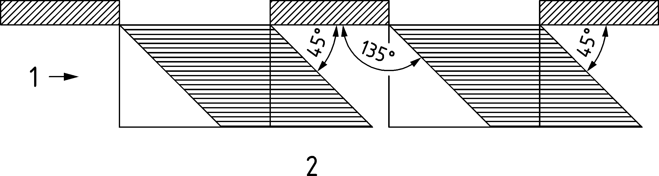

Key

|  |  |
| --- | --- |
| 1 | wind |
| 2 | horizontal cross section |

Figure B.1 — Deflection of flame by wind

* 1. Characteristics of fire and flames
     1. No forced draught

(1) The rate of burning or the rate of heat release should be calculated from Formula (B.4):

|  |  |  |
| --- | --- | --- |
|  | [MW] | (B.4) |

where

|  |  |
| --- | --- |
| *A*f | is the floor area of the fire compartment; |
| *q*f,d | is the design fire load density related to the floor area *A*f ; |
| *τ*F | is assumed to be equal to 1 200 [s]; |
| *A*v | is the total area of vertical openings on all walls ; |
| *h*eq | is the weighted average of window heights on all walls ; |
| *D*/*W* | ratio calculated in accordance with B.3. |

(2) The temperature of the fire compartment should be calculated from Formula (B.5):

 (B.5)

where

|  |  |
| --- | --- |
| *O* | is the opening factor of the fire compartment ; |
| *T*0 | is the initial temperature. |

(3) The flame height (see Figure B.2) should be calculated from Formula (B.6):

 (B.6)

Formula (B.6) may be simplified as follows when *ρ*g = 0,45 kg/m3 and *g* = 9,81 m/s2:

 (B.7)

|  |  |  |
| --- | --- | --- |
|  |  |  |
| **horizontal cross section** | **vertical cross section** | **vertical cross section** |
|  | |  |
| *L*f = *L*L + *L*1 | |  |
| *h*eq < 1,25*w*t and wall above | | no wall above or *h*eq > 1,25*w*t |

Figure B.2 — Flame dimensions, no through draught

(4) The flame width should be taken as the window width (see Figure B.2).

(5) The flame depth should be taken as 2/3 of the window height: 2/3 *h*eq (see Figure B.2).

(6) The horizontal projection of flames:

— in case of a wall existing above the window, should be taken as:

|  |  |  |
| --- | --- | --- |
| *L*H = *h*eq/3 | if *h*eq ≤ 1,25 *w*t | (B.8) |
| *L*H = 0,3 *h*eq (*h*eq/*w*t)0,54 | if *h*eq > 1,25 *w*t and distance to any other window > 4 *w*t | (B.9) |
| *L*H = 0,454 *h*eq (*h*eq/2*w*t)0,54 | in other cases | (B.10) |

— in case of a wall not existing above the window, should be taken as:

 (B.11)

(7) The flame length along axis should be taken as:

when

*L*L > 0

|  |  |  |
| --- | --- | --- |
| *L*f = *L*L + *h*eq/2 | if there is a wall above the window and if *h*eq ≤ 1,25 *w*t | (B.12) |
| *L*f = (*L*L 2 + (*L*H − *h*eq/3)2)1/2 + *h*eq/2 | if there is no wall above the window or if *h*eq > 1,25 *w*t | (B.13) |

when

*L*L = 0, then *L*f = 0

(8) The flame temperature at the window should be taken as:

|  |  |  |
| --- | --- | --- |
| *T*w = 520/(1 − 0,4725 (*L*f ⋅ *w*t/*Q*)) + *T*0 | [K] | (B.14) |

with

*L*f ⋅ *w*t/*Q* < 1

(9) The emissivity of flames at the window may be taken as *ε*f = 1,0

(10) The flame temperature along the axis should be taken as:

|  |  |  |
| --- | --- | --- |
| *T*z = (*T*w − *T*0) (1 − 0,4725 (*L*x ⋅ *w*t/*Q*)) + *T*0 | [K] | (B.15) |

with

*L*x ⋅ *w*t/*Q* < 1

|  |  |
| --- | --- |
| *L*x | is the axis length from the window to the point where the calculation is made. |

(11) The emissivity of flames may be taken as:

εf = 1 −  (B.16)

where

|  |  |
| --- | --- |
| *d*f | is the flame thickness [m]. |

(12) The convective heat transfer coefficient should be calculated from Formula (B.17):

αc = 4,67 (1/deq)0,4 (Q/Av)0,6 (B.17)

(13) If an awning or balcony (with horizontal projection: *W*a) is located at the level of the top of the window over its whole width (see Figure B.3), for the wall above the window and *h*eq ≤ 1,25 *w*t, the height and horizontal projection of the flame should be modified as follows:

— the flame height *L*L given in (3) should be decreased by ;

— the horizontal projection of the flame *L*H given in (6),should be increased by *W*a.

|  |  |
| --- | --- |
|  |  |
| **a) vertical cross section**  a b c = *L*f | **b) vertical cross section**  a b c d e = *L*f and *w*a = a b |

Figure B.3 — Deflection of flame by balcony

(14) With the same conditions for awning or balcony as mentioned in (13), in the case of no wall above the window or *h*eq > 1,25 *w*t, the height and horizontal projection of the flame should be modified as follows:

— the flame height *L*L given in (3) should be decreased by *W*a;

— the horizontal projection of the flame *L*H, obtained in (6) with the above mentioned value of *L*L should be increased by *W*a.

* + 1. Forced draught

(1) The rate of burning or the rate of heat release should be given by:

|  |  |  |
| --- | --- | --- |
|  | [MW] | (B.18) |

where

|  |  |
| --- | --- |
| *A*f | is the floor area of the fire compartment; |
| *q*f,d | is the design fire load density related to the floor area *A*f ; |
| *τ*F | is the free burning fire duration. |

(2) The temperature of the fire compartment should be given by:

 (B.19)

(3) The flame height (see Figure B.4) should be given by:

 (B.20)

NOTE 1 With *u* = 6 m/s, 

|  |  |
| --- | --- |
|  |  |
| a) horizontal cross section | b) vertical cross section |
| *w*f = *w*t + 0,4 *L*H | *L*f = (*L*L2 + *L*H2) 1/2 |

Figure B.4 — Flame dimensions, through or forced draught

(4) The horizontal projection of flames should be given by:

 (B.21)

NOTE 2 With *u* = 6 m/s, *L*H = 1,33 (*L*L + *h*eq)/*h*eq0,22

(5) The flame width should be given by:

 (B.22)

(6) The flame length along axis should be given by:

 (B.23)

(7) The flame temperature at the window should be given by:

|  |  |  |
| --- | --- | --- |
|  | [K] | (B.24) |

with *L*f (*A*v)1/2/*Q* < 1

(8) The emissivity of flames at the window may be taken as *ε*f = 1,0

(9) The flame temperature along the axis should be given by:

|  |  |  |
| --- | --- | --- |
|  | [K] | (B.25) |

where

|  |  |
| --- | --- |
| *L*x | is the axis length from the window to the point where the calculation is made |

(10) The emissivity of flames may be taken as:

 (B.26)

where *d*f is the flame thickness [m]

(11) The convective heat transfer coefficient should be given by:

*α*c = 9,8 (1/*d*eq)0,4 (*Q*/(17,5 *A*v) + *u*/1,6)0,6 (B.27)

NOTE 3 With *u* = 6 m/s the convective heat transfer coefficient is given by:

*α*c = 9,8 (1/*d*eq)0,4 (*Q*/(17,5*A*v) + 3,75)0,6

(12) Regarding the effects of balconies or awnings, see Figure B.5, the flame trajectory, after being deflected horizontally by a balcony or awning, is the same as before, i.e. displaced outwards by the depth of the balcony, but with a flame length *L*f unchanged.

|  |  |
| --- | --- |
|  |  |
| **a) vertical cross section** | **b) vertical cross section** |
| a b = *L*f | a b c = *L*f |

Key

|  |  |
| --- | --- |
| 1 | awning |

Figure B.5 — Deflection of flame by awning

* 1. Overall configuration factors

(1) The overall configuration factor *Φ*f of a member for radiative heat transfer from an opening should be determined from Formula (B.28):

 (B.28)

where

|  |  |
| --- | --- |
| *Φ*f,i | is the configuration factor of member face i for that opening, see Annex G; |
| *d*i | is the cross-sectional dimension of member face *i*; |
| *C*i | is the protection coefficient of member face *i* as follows: |

— for a protected face: *C*i = 0

— for an unprotected face: *C*i = 1

(2) The configuration factor *Φ*f,i for a member face from which the opening is not visible should be taken as zero.

(3) The overall configuration factor *Φ*z of a member for radiative heat transfer from a flame should be determined from Formula (B.29):

 (B.29)

where

|  |  |
| --- | --- |
| *Φ*z,i | is the configuration factor of member face i for that flame, see Annex G. |

(4) The configuration factors *Φ*z,i of individual member faces for radiative heat transfer from flames may be based on equivalent rectangular flame dimensions. The dimensions and locations of equivalent rectangles representing the front and sides of a flame for this purpose should be determined as given in EN 1993‑1‑2, B.2 for columns and B.3 for beams. For all other purposes, the flame dimensions given in B.4 should be used.

1. (informative)  
     
   Localised fires
   1. Use of this annex

(1) This informative Annex provides additional guidance to that given in 5.3.1.3.

NOTE National choice on the application of this Informative Annex is given in the National Annex. If the National Annex contains no information on the application of this informative annex, it can be used.

* 1. Scope and field of application

(1) The thermal action of a localised fire can be represented as a virtual solid flame, following the method described in this annex.

(2) The methodology given in this informative annex is valid if the following conditions are met:

a) diameter of the fire is limited by ;

b) rate of heat release of the fire is limited by 

NOTE The methodology does not consider the impact of the smoke layer, see 5.3.2 (4).

(3) Differences should be made regarding:

a) the relative height of the flame to the ceiling

b) the position of the structural element to the geometry of the flame

c) the position of the structural element to the ceiling level

* 1. Virtual solid flame
     1. Shape of the virtual solid flame

(1) The virtual solid flame representing the thermal action of a localised fire should be assumed conical.

(2) The height of the virtual solid flame  (see Figure C.1) is given by:

|  |  |  |
| --- | --- | --- |
|  | [m] | (C.1) |

where

|  |  |
| --- | --- |
| *D* | is the diameter of the fire [m]; |
| *Q* | is the rate of heat release [W]. |

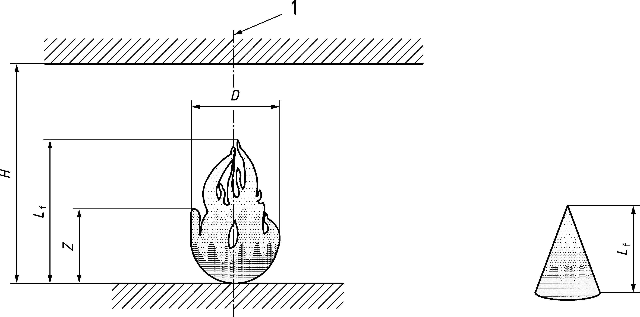

Figure C.1 — Height of the virtual flame *L*f

(3) When the virtual solid flame is impacting the ceiling, the shape of this virtual solid flame should be modified into a truncated cone (see Figure C.2).

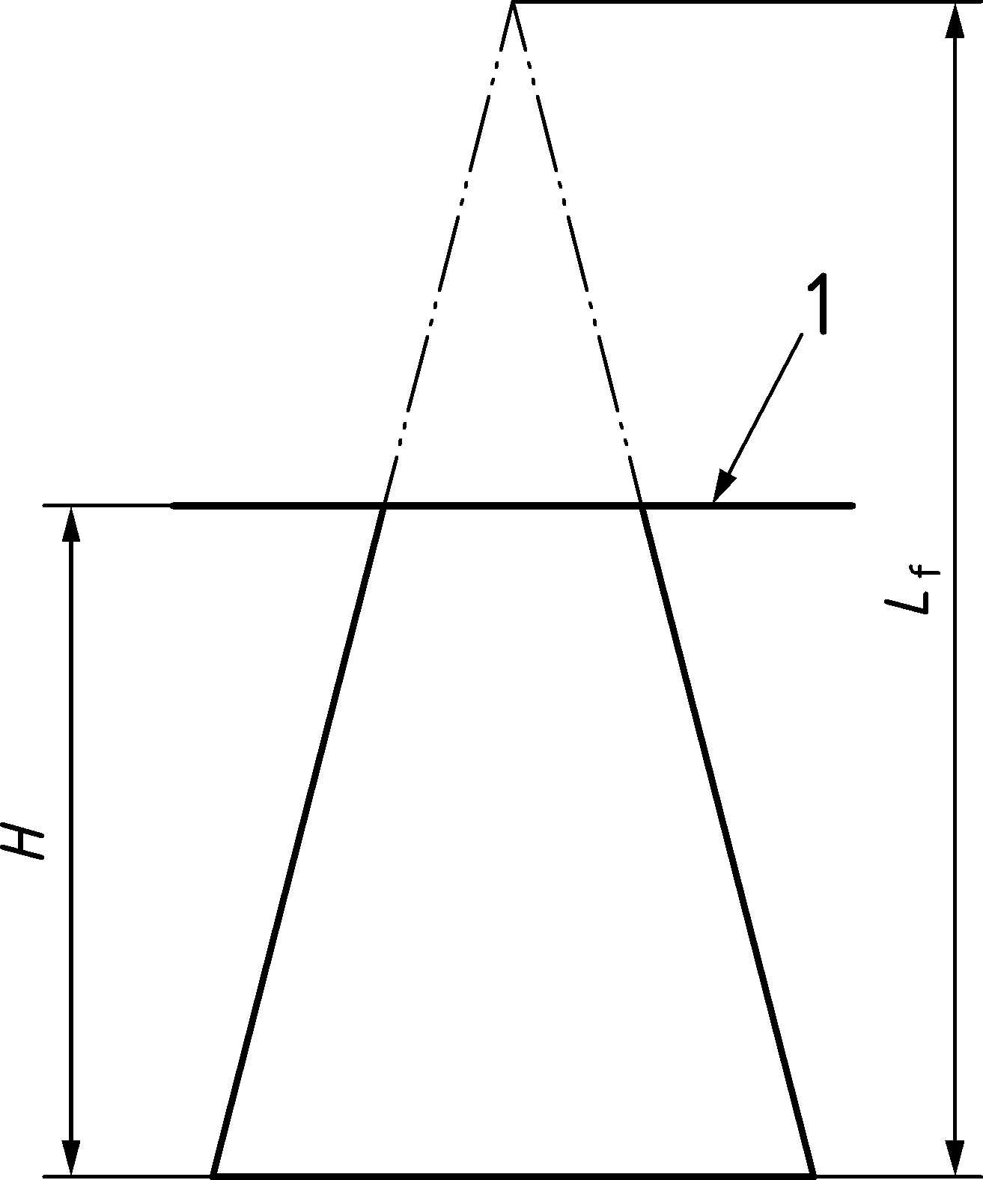

Key

|  |  |
| --- | --- |
| 1 | ceiling level |

Figure C.2 — Adapted shape of conical virtual solid flames after truncation

* + 1. Temperature of the virtual solid flame

(1) The temperature on the cone shall be constant at a vertical level z (see Figure C.3) and given by:

|  |  |  |
| --- | --- | --- |
|  | [°C] | (C.2) |

where

|  |  |
| --- | --- |
| *Q*c | is the convective part of the rate of heat release [W], with *Q*c = 0,8 *Q* by default; |
| z0 | is the virtual origin of the vertical axis. |

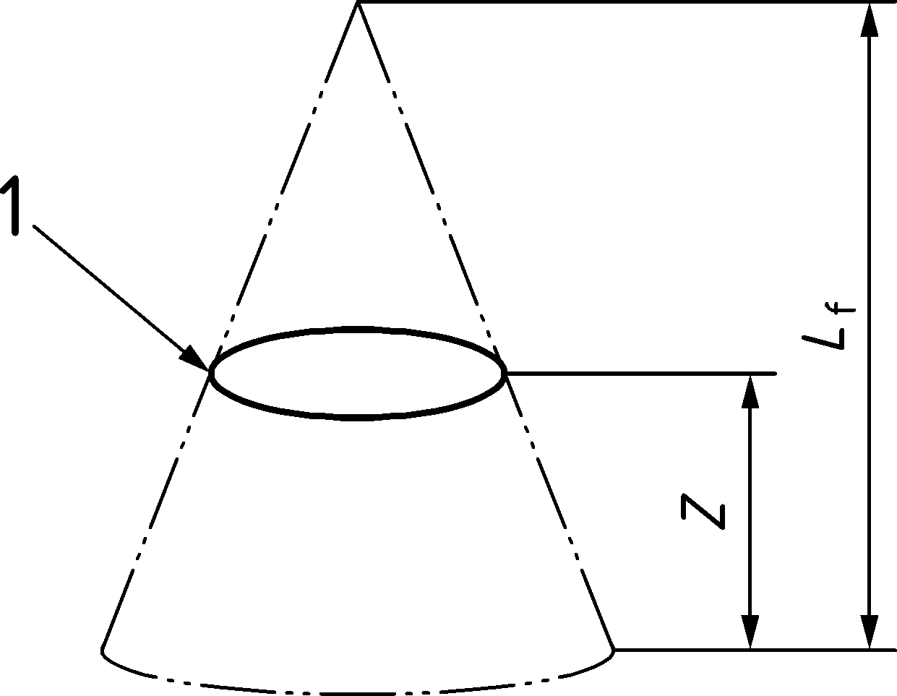

Key

|  |  |
| --- | --- |
| 1 | temperature Θ(z) |

Figure C.3 — Variation of temperature on the cone

(2) The virtual origin *z*0 of the vertical axis is given by:

|  |  |  |
| --- | --- | --- |
|  | [m] | (C.3) |

* + 1. Virtual solid flame position and extension

(1) A structural element is considered as engulfed into the localised fire if the vertical projection of this element is included into the virtual flame basis (see Figure C.4).

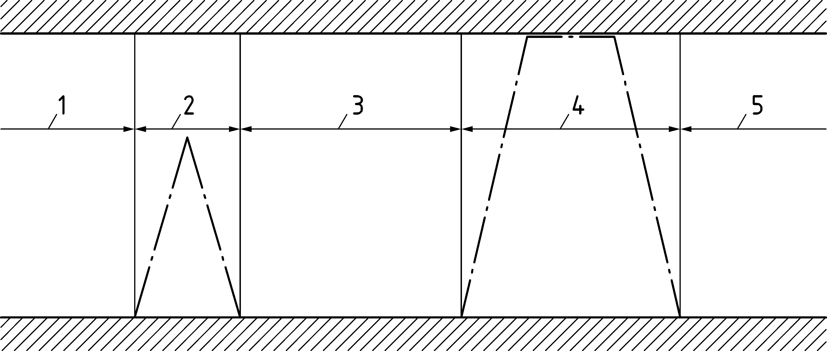

Key

|  |  |
| --- | --- |
| 1 | not engulfed |
| 2 | engulfed |
| 3 | not engulfed |
| 4 | engulfed |
| 5 | not engulfed |

Figure C.4 — Domains considered as engulfed and not engulfed

(2) If the structural element is engulfed into the localised fire and not situated at the ceiling level ( , see Figure C.6), the heat flux  [W/m2] received by the fire exposed unit surface area is the heat flux given by Formula C.4, where Θ(z) is the temperature of the virtual solid flame given by (C.2).

 (C.4)

The configuration factor *Φ* may be taken as 1.

(3) If the virtual solid flame is impacting the ceiling and the structural element is situated at the ceiling level (, see Figure C.6), the heat flux  [W/m2] received by the fire exposed unit surface area should be calculated as follows:

|  |  |  |
| --- | --- | --- |
|  | if *y* ≤ 0,30 |  |
|  | if 0,30 < *y* < 1,0 | (C.5) |
|  | if *y* ≥ 1,0 |  |

where

|  |  |
| --- | --- |
| *y* | is a parameter [–] given by: |
| *r* | is the horizontal distance [m] between the vertical axis of the fire and the structural where the thermal flux is calculated, see Figure C.5; |
| *H* | is the distance [m] between the fire source and the ceiling, see Figure C.5. |

where

|  |  |
| --- | --- |
| *z*′ | is the vertical position of the virtual heat source [m] and is given by: |

|  |  |
| --- | --- |
|  | (C.6) |

(4) In case the flame is impacting the ceiling, the horizontal flame length  is given by:

|  |  |  |
| --- | --- | --- |
|  | [m] | (C.7) |

where

|  |  |
| --- | --- |
| *H* | is the distance [m] between the fire source and the ceiling, see Figure C.5; |
|  | is a non-dimensional rate of heat release given by: |

|  |  |  |
| --- | --- | --- |
|  | [–] | (C.8) |

*D* is the diameter of the fire [m], see Figure C.5 and

|  |  |  |
| --- | --- | --- |
|  | [–] | (C.9) |

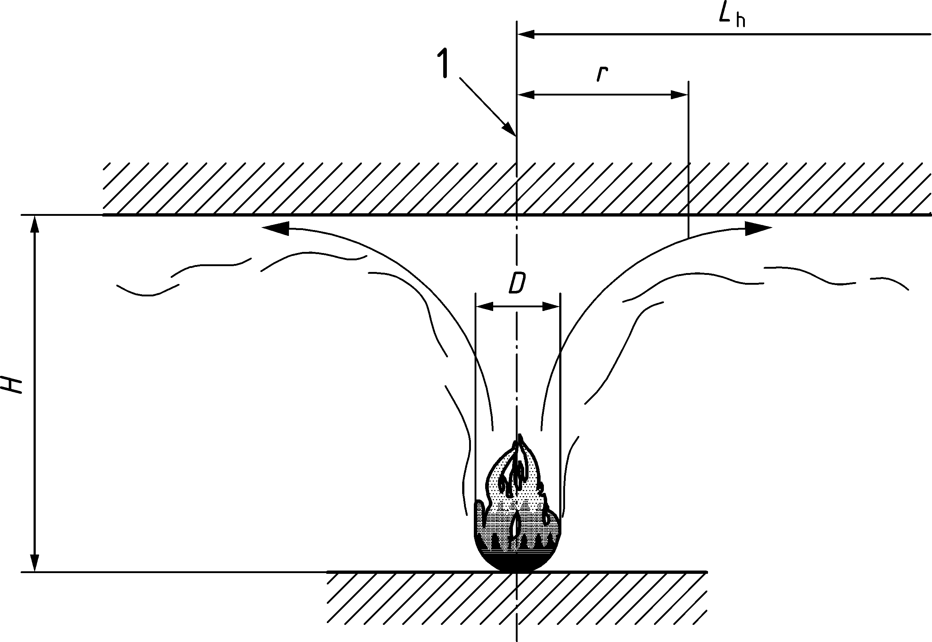

Key

|  |  |
| --- | --- |
| 1 | flame axis |

Figure C.5 — Flame impacting the ceiling

(5) If both conditions (2) and (3) are not fulfilled (see Figure C.6), the total heat flux  [W/m2] received by the fire exposed unit surface area is the radiative heat flux received from the external surface of the virtual solid flame.

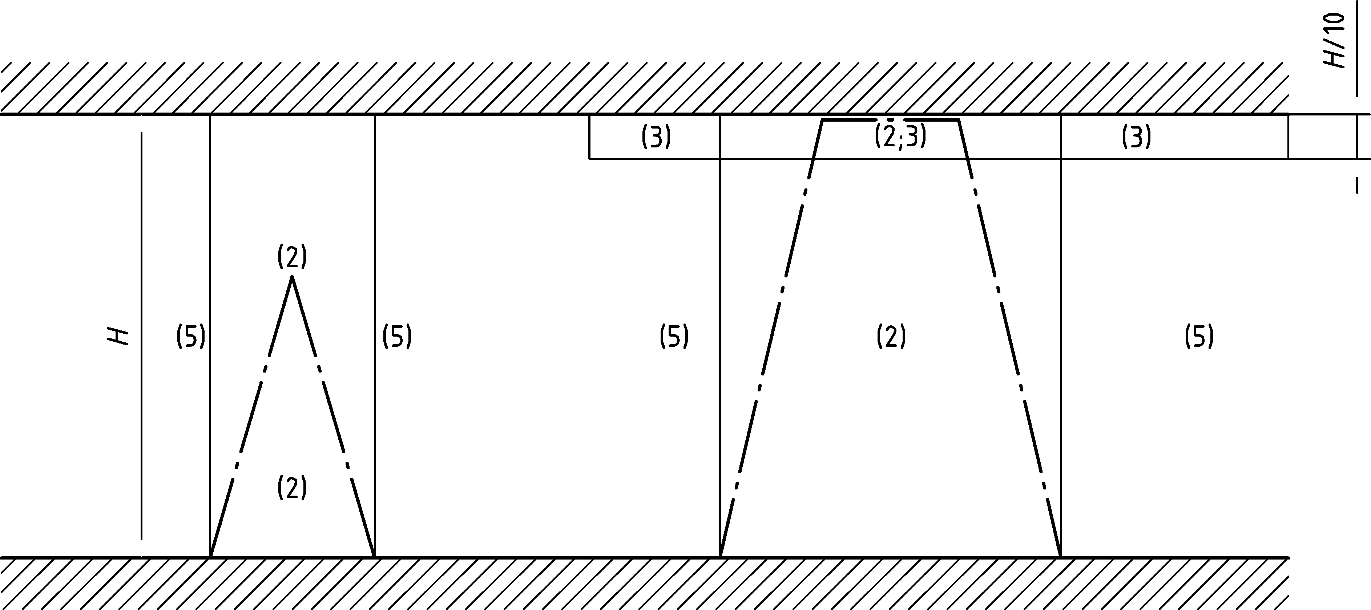

Figure C.6 — Domains of application of Clauses (2), (3) and (5)

(6) The application is not considered for flame height to diameter ratio below 0,625. For low heat release rate, fire diameter shall be reduced to fulfil this condition.

(7) The virtual solid flame shall be divided into the successive elementary cylinders with different diameters. At each time step, the radiative heat flux emitted by intermediate horizontal rings situated below the fire exposed unit surface (*z* > *z*ring,j, see Figure C.7) shall be considered (Formula C.10).

|  |  |
| --- | --- |
|  | (C.10) |

Where *n* is the number of elementary cylinders and *m* the number of visible rings

(8) The thickness of an elementary cylinder *b*j may not be larger than 0,5 m, see Figure C.7. The temperature *Θ*j of an elementary cylinder is the temperature at the mid-thickness level *z*j, using (C.2). If the virtual solid flame is considered as conical, the diameter of an elementary cylinder *D*j will be the maximal diameter of the cone in this flame slice (see Figure C.7). Only rings below the element (directly visible from its point of view) are used (see Figure C.7). A method for the calculation of the configuration factor *Φ* is given in Annex G.

Dimension in metres

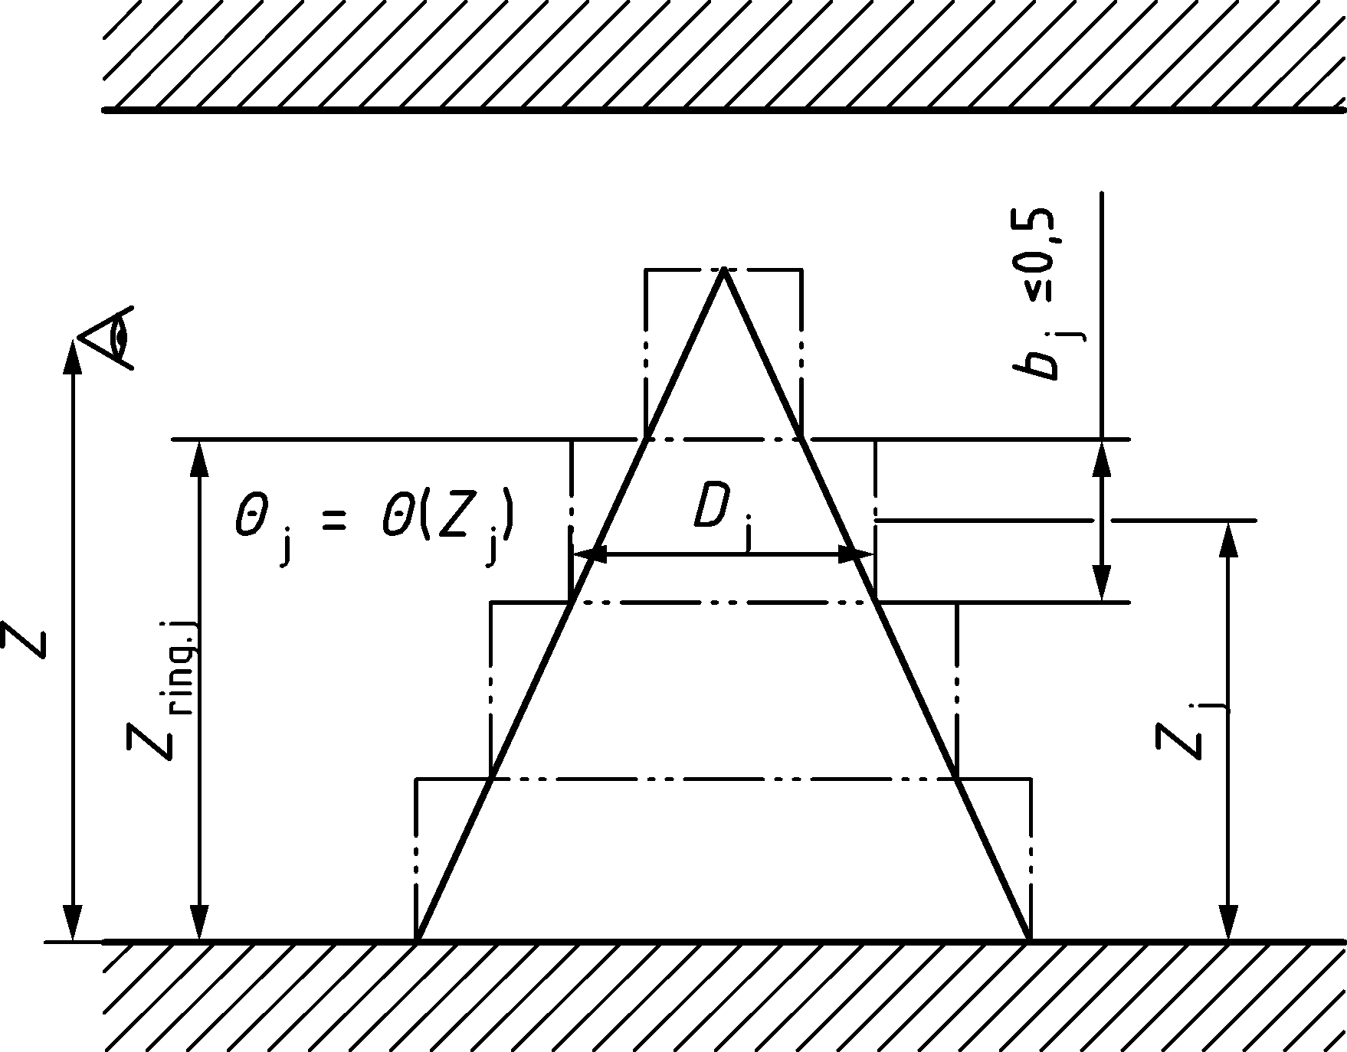

Figure C.7 — Subdivision of conical solid flame into elementary cylinders

* + 1. Net heat flux

(1) The net heat flux  [W/m2] received by the fire exposed unit surface area should be calculated from Formula (C.11):

 (C.11)

Where  is calculated according to C.3.3(2), C.3.3(3) or C.3.3(5).

(2) In case of separate localised fires, the total heat flux received by the fire exposed unit surface area may be calculated from Formula (C.12):

|  |  |  |
| --- | --- | --- |
|  | [W/m2] | (C.12) |

Where the different individual heat fluxes  received by the fire exposed unit surface area are calculated according to C.3.3(2), C.3.3(3) or C.3.3(5).

1. (informative)  
     
   Advanced fire models
   1. Use of this annex

(1) This informative Annex provides additional guidance to that given in 5.3.2.

NOTE National choice on the application of this Informative Annex is given in the National Annex. If the National Annex contains no information on the application of this informative annex, it can be used.

* 1. Scope and field of application

(1) This informative annex covers one-zone models, two zone models, and computational fluid dynamics models.

* 1. One-zone models

(1) A one-zone model should apply for post-flashover conditions. Homogeneous temperature, density, internal energy and pressure of the gas are assumed in the compartment.

(2) The temperature should be calculated considering:

— the resolution of mass conservation and energy conservation equations;

— the exchange of mass between the internal gas, the external gas (through openings) and the fire (pyrolysis rate);

— the exchange of energy between the fire, internal gas, walls and openings.

(3) The ideal gas law considered should be as follows:

|  |  |  |
| --- | --- | --- |
|  | [N/m2] | (D.1) |

(4) The mass balance of the compartment gases should be as follows:

|  |  |  |
| --- | --- | --- |
|  | [kg/s] | (D.2) |

where

|  |  |
| --- | --- |
|  | is the rate of change of gas mass in the fire compartment; |
|  | is the rate of gas mass going out through the openings; |
|  | is the rate of gas mass coming in through the openings; |
|  | is the rate of pyrolysis products generated. |

(5) The rate of change of gas mass and the rate of pyrolysis may be neglected. Thus

 (D.3)

These mass flows may be calculated based on static pressure due to density differences between air at ambient and high temperatures, respectively.

(6) The energy balance of the gases in the fire compartment may be taken as:

|  |  |  |
| --- | --- | --- |
|  | [W] | (D.4) |

where

|  |  |  |
| --- | --- | --- |
| *E*g | is the internal energy of gas | [J] |
| *Q* | is the rate of heat release of the fire | [W] |
|  |  | |
|  |  | |
|  | , is the loss of energy to the enclosure surfaces | |
|  | , is the loss of energy by radiation through the openings | |

with

|  |  |  |
| --- | --- | --- |
| *c* | is the specific heat | [J/kgK] |
|  | is given by expression (3.1) | |
|  | is the gas mass rate | [kg/s] |
| *T* | is the temperature | [K] |

* 1. Two-zone models

(1) A two-zone model is based on the assumption of accumulation of combustion products in a layer beneath the ceiling, with a horizontal interface. Different zones are defined: the upper layer, the lower layer, the fire and its plume, the external gas and walls.

(2) In the upper layer, uniform characteristics of the gas may be assumed.

(3) The exchanges of mass, energy and chemical substance may be calculated between these different zones.

(4) In a given fire compartment with a uniformly distributed fire load, a two-zone fire model may develop into a one-zone fire in one of the following situations:

— if the gas temperature of the upper layer exceeds 500 °C,

— if the upper grows and covers 80 % of the compartment height.

* 1. Computational fluid dynamics models

(1) A computational fluid dynamics model may be used to solve numerically the partial differential equations giving, in all points of the compartment, the thermo-dynamic and aero-dynamic variables.

NOTE Computational fluid dynamics (CFD) models analyse systems involving fluid flow, heat transfer and associated phenomena by solving the fundamental equations of the fluid flow. These equations represent the mathematical statements of the conservation laws of physics.

1. (informative)  
     
   Fire load densities, Fire Growth Rates and Rate of Heat Releases
   1. Use of this annex

(1) This informative Annex provides additional guidance to that given in 5.3.1.2 and 5.3.2.

NOTE National choice on the application of this Informative Annex is given in the National Annex. If the National Annex contains no information on the application of this informative annex, it can be used.

* 1. Scope and field of application

(1) This informative annex covers fire load densities, fire growth rates and rate of heat releases.

* 1. Design value of fire load density

(1) The fire load density used in calculations should be a design value, either based on measurements or based on occupancy statistical distribution as provided in this Annex.

(2) The design value may be determined:

— from a national fire load classification of occupancies; and/or

— specific for an individual project by performing a fire load survey.

(3) The design value of the fire load *q*f,d should be calculated using Formula (E.1):

|  |  |  |
| --- | --- | --- |
| *q*f,d = *q*f,k ⋅ *m* ⋅ *δ*q1 ⋅ *δ*q2 ⋅ *δ*n⋅ *δ*q3 | [MJ/m2] | (E.1) |

where

|  |  |
| --- | --- |
| *m* | is the combustion factor (see E.3); |
| *δ*q1 | is a factor taking into account the fire activation risk due to the size of the compartment (see Table E.1); |
| *δ*q2 | is a factor taking into account the fire activation risk due to the type of occupancy (see Table E.1); |
|  | is a factor taking into account the different active fire fighting measures i (sprinkler, detection, automatic alarm transmission, firemen …). These active measures are generally imposed for life safety reason (see Table E.2 and (4) and (5)); |
| *δ*q3 | is a factor taking into account the consequence class of the building, as defined in prEN 1990 (see Table E.3); |
| *q*f,k | is the characteristic fire load density per unit floor area [MJ/m2] (see e.g. Table E.4). |

Table E.1 — Factors *δ*q1, *δ*q2

| **Compartment floor area Af [m2]** | **Danger of Fire Activation *δ*q1** | **Danger of Fire Activation *δ*q2** | **Example of Occupancies** |
| --- | --- | --- | --- |
| 25 | 1,10 | 0,78 | Art gallery, museum, swimming pool |
| 250 | 1,50 | 1,00 | Offices, residence, hotel, paper industry |
| 2 500 | 1,90 | 1,22 | Manufactory for machinery & engines |
| 5 000 | 2,00 | 1,44 | Chemical laboratory, painting workshop |
| 10 000 | 2,13 | 1,66 | Manufactory of fireworks or paints |

Table E.2 — Factors *δ*ni

| **Automatic Fire Suppression** | | | | **Automatic Fire Detection & Alarm** | | | | **Manual Fire Suppression** | | | | | | | | |
| --- | --- | --- | --- | --- | --- | --- | --- | --- | --- | --- | --- | --- | --- | --- | --- | --- |
| Automatic Water Extinguishing System | Independent Water Supplies | | | Automatic Fire Detection & Alarm | | | Automatic Alarm Transmission To Fire Brigade | Fire Brigade | | Safe Access Route | | | Fire Fighting Device | | Smoke Exhaust System | |
| 0 | 1 | 2 | By heat | By smoke | By heat & smoke | Work FB | Off Site FB | Improved | Standard | Difficult | Present | Not present | Present | Not present |
| *δ*n1 | *δ*n3 | | | *δ*n3 | | | *δ*n4 | *δ*n5 | | *δ*n6 | | | *δ*n7 | | *δ*n8 | |
| 0,61 | 1 | 0,87 | 0,7 | 0,9 | 0,73 | 0,73 | 0,87 | 0,61 | 0,78/0,84 | 0,9 | 1 | 1,5 | 1 | 1,5 | 1 | 1,5 |

(4) For the normal firefighting measures required by national regulations, such as the safe access routes, firefighting devices, and smoke exhaust systems in staircases, the *δ*ni values of Table E.2 should be taken as 1,0. However, if these firefighting measures have not been foreseen but required by national regulations, the corresponding *δ*ni value should be taken as 1,5.

(5) If staircases are put under overpressure in case of fire alarm, the factor *δ*n8 of Table E.2 may be taken as 0,9.

(6) The factor *δ*n5 of Table E.2 corresponding to “off-site fire brigade” translates the effect of a professional fire brigade: it may be taken as 0,78 or 0,84 if the brigade acts in maximum 20 min or 30 min after the fire alarm, respectively.

(7) The preceding approach is based on the assumption that the requirements in the relevant European Standards on sprinklers, detection, alarm, smoke exhaust systems are met.

Table E.3 — Factor *δ*q3

| **Consequence Class** | **Examples of buildings** | ***δ*q3** |
| --- | --- | --- |
| CC3 | Grandstands, public buildings where consequences of failure are high (e.g. a concert hall) | 1,19 |
| CC2 | Residential and office buildings, public buildings where consequences of failure are medium (e.g. an office building) | 1 |
| CC1 | Agricultural buildings, buildings where people do not normally enter (e.g. storage buildings, greenhouses) | 0,83 |

* 1. Determination of fire load densities
     1. General

(1) The fire load should consist of all combustible building contents and the relevant combustible parts of the construction, including linings and finishing. Combustible parts of the combustion which do not char during the fire may be ignored.

(2) The following clauses apply for the determination of fire load densities:

— from a fire load classification of occupancies (see E.4.5); and/or

— specific for an individual project (see E.4.6).

(3) Where fire load densities are determined from a fire load classification of occupancies, fire loads are distinguished as:

— fire loads from the occupancy, given by the classification;

— fire loads from the building (construction elements, linings and finishing) which are generally not included in the classification and are then determined according to E.4.2, as relevant.

* + 1. Definitions

(1) The characteristic fire load is defined as:

|  |  |  |
| --- | --- | --- |
| *Q*fi,k = Σ *M*k,i ⋅ *H*ui ⋅ *Ψ*i = Σ *Q*fi,k,i | [MJ] | (E.2) |

where

|  |  |
| --- | --- |
| *M*k,i | is the amount of combustible material [kg], according to (3) and (4); |
| *H*ui | is the net calorific value of material i [MJ/kg], see (E.4.4); |
| [*Ψ*i] | is the optional factor for assessing protected fire loads, see (E.4.3). |

(2) The characteristic fire load density *q*f,k per unit area is defined as:

|  |  |  |
| --- | --- | --- |
| *q*f,k = *Q*fi,k/*A* | [MJ/m2] | (E.3) |

where

|  |  |
| --- | --- |
| *A* | is the floor area (*A*f) of the fire compartment or reference space, or inner surface area (*A*t) of the fire compartment, giving *q*f,k or *q*t,k |

(3) Permanent fire loads, which are not expected to vary during the service life of a structure, should be introduced with their expected values resulting from the survey.

(4) Variable fire loads, which may vary during the service life of a structure, should be represented by values, which are expected not to be exceeded during 80 % of the time.

* + 1. Protected fire loads

(1) Fire loads in containments which are designed to survive fire exposure may be neglected.

(2) Fire loads in non-combustible containments with no specific fire design, but which remain intact during fire exposure, may be considered as follows:

(3) The largest fire load, but at least 10 % of the protected fire loads, should be associated with *Ψ*i = 1,0.

(4) If this fire load plus the unprotected fire loads are not sufficient to heat the remaining protected fire loads beyond ignition temperature, then the remaining protected fire loads may be associated with *Ψ*i = 0,0.

(5) Otherwise, *Ψ*i values should be assessed individually.

* + 1. Net calorific values

(1) Net calorific values should be determined according to EN ISO 1716:2002.

(2) The moisture content of materials may be taken into account as follows:

|  |  |  |
| --- | --- | --- |
| *H*u = *H*u0 (1 − 0,01 *u*) − 0,025 *u* | [MJ/kg] | (E.4) |

where

|  |  |
| --- | --- |
| *u* | is the moisture content expressed as percentage of dry weight; |
| *H*u0 | is the net calorific value of dry materials. |

(3) Net calorific values of some solids, liquids and gases given in Table E.4 may be used.

Table E.4 — Net calorific values *H*u [MJ/kg] of combustible materials for calculation of fire loads

|  |  |
| --- | --- |
| **Solids** | |
| Wood | 17,5 |
| Other cellulosic materials  — Clothes  — Cork  — Cotton  — Paper, cardboard  — Silk  — Straw  — Wool | 20 |
| Carbon  — Anthracit  — Charcoal  — Coal | 30 |
| **Chemicals** | |
| Paraffin series  — Methane  — Ethane  — Propane  — Butane | 50 |
| Olefin series  — Ethylene  — Propylen  — Butene | 45 |
| Aromatic series  — Benzene  — Toluene | 40 |
| Alcohols  — Methanol  — Ethanol  — Ethyl alcohol | 30 |
| Fuels  — Gasoline, petroleum  — Diesel | 45 |
| Pure hydrocarbons plastics  — Polyethylene  — Polystyrene  — Polypropylene | 40 |
| **Other products** | |
| ABS (plastic) | 35 |
| Polyester (plastic) | 30 |
| Polyisocyanerat and polyurethane (plastics) | 25 |
| Polyvinylchloride, PVC (plastic) | 20 |
| Bitumen, asphalt | 40 |
| Leather | 20 |
| Linoleum | 20 |
| Rubber tyre | 30 |

* + 1. Fire load classification of occupancies

(1) The fire load densities should be classified according to occupancy, be related to the floor area, and be used as characteristic fire load densities *q*f,k [MJ/m2], as given in Table E.5.

Table E.5 — Fire load densities *q*f,k [MJ/m2] for different occupancies

| **Occupancy** | **Average** | **80 % Fractile** |
| --- | --- | --- |
| Dwelling | 780 | 948 |
| Hospital (room) | 230 | 280 |
| Hotel (room) | 310 | 377 |
| Library, Archives | 1 500 | 1824 |
| Densely loaded office (office including minimum 20 % archive’s surface) | 744 | 905 |
| Office | 420 | 511 |
| Sparsely loaded office (open space office with limited combustible furniture, paperless office without archives) | 206 | 250 |
| Classroom of a school | 285 | 347 |
| Commercial area | 600 | 730 |
| Theatre (cinema) | 300 | 365 |
| Public space: Circulation areas, walkways | 100 | 122 |
| NOTE Gumbel distribution is assumed. | | |

(2) The values of the fire load density *q*f,k given in Table E.5 are valid in case of a factor *δ*q2 equal to 1,0 (see Table E.1).

(3) The fire loads in Table E.5 are valid for ordinary compartments in connection with the here given occupancies. Special rooms are considered according to E.4.2.

(4) Fire loads from the building (construction elements, structures, linings and finishing) should be determined according to E.4.2. These should be added to the fire load densities of (1), if relevant.

* + 1. Individual assessment of fire load densities

(1) In the absence of occupancy classes, fire load densities may be specifically determined for an individual project by performing a survey of fire loads from the occupancy.

(2) The fire loads and their local arrangement should be estimated considering the intended use, furnishing and installations, variations with time, unfavourable trends and possible modifications of occupancy.

(3) Where available, a survey should be performed in a comparable existing project, such that only possible differences between the intended and existing project need to be specified by the client.

* 1. Combustion behaviour

(1) The combustion behaviour should be considered in depending on the occupancy and the type of fire load.

(2) For mainly cellulosic materials, the combustion factor may be assumed as *m* = 0,8.

* 1. Rate of heat release Q

(1) The growing phase may be defined by using Formula (E.5):

 (E.5)

where

|  |  |
| --- | --- |
| *Q* | is the rate of heat release in [W]; |
| *t* | is the time in [s]; |
| *t*α | is the time needed to reach a rate of heat release of 1 MW. |

(2) The parameter *t*α and the maximum rate of heat release *RHR*f, for different occupancies, given in Table E.6 should be used.

Table E.6 — Fire growth rate and *RHR*f for different occupancies

| **Max Rate of heat release *RHR*f** | | | |
| --- | --- | --- | --- |
| **Occupancy** | **Fire growth rate** | ***t*α** | ***RHR*f** |
| **s** | **kW/m2** |
| Dwelling | Medium | 300 | 250 |
| Hospital (room) | Medium | 300 | 250 |
| Hotel (room) | Medium | 300 | 250 |
| Library, Archives | Fast | 150 | 500 |
| Densely loaded office (office including minimum 20 % archive’s surface) | Medium | 300 | 250 |
| Office | Medium | 300 | 250 |
| Sparsely loaded office (open space office with limited combustible furniture, paperless office without archives) | Medium | 300 | 250 |
| Classroom of a school | Medium | 300 | 250 |
| Commercial area | Fast | 150 | 250 |
| Theatre (cinema) | Fast | 150 | 500 |
| Public space: Circulation areas, walkways | Slow | 600 | 250 |
| NOTE 1 The values of the fire growth rate and *RHR*f are valid in case of a factor *δ*q2 equal to 1,0.  NOTE 2 For an ultra-fast fire spread, *t*α corresponds to 75 s. | | | |

(3) The growing phase is limited by a horizontal plateau corresponding to the stationary state and to a value of *Q* given by (*RHR*f ⋅ *A*fi)

where

|  |  |
| --- | --- |
| *A*fi | is the maximum area of the fire [m2] which is the fire compartment in case of uniformly distributed fire load but which may be smaller in case of a localised fire. |
| *RHR*f | is the maximum rate of heat release produced by 1 m2 of fire in case of fuel controlled conditions [kW/m2] (see Table E.6). |

NOTE The horizontal plateau is limited by the decay phase which starts when 70 % of the total fire load has been consumed.

(4) The decay phase may be assumed to be a linear decrease starting when 70 % of the fire load has been burnt and completed when the fire load has been completely burnt.

(5) If the fire is ventilation controlled, this plateau level should be reduced following the available oxygen content, either automatically in case of the use of a computer program based on one zone model or by the simplified expression:

|  |  |  |
| --- | --- | --- |
|  | [MW] | (E.6) |

where

|  |  |
| --- | --- |
| *A*v | is the opening area [m2]; |
| *h*eq | is the mean height of the openings [m]; |
| *m*O2 | is the oxygen consumption factor with *m*O2 = 0,8. |

(6) When the maximum level of the rate of heat release is reduced in case of ventilation controlled condition, the curve of the rate of heat release should be extended to correspond to the available energy given by the fire load. If the curve is not extended, it is then assumed that there is external burning, which induces a lower gas temperature in the compartment.

(7) As an alternative to (2), design based on probabilistic methods may be used when specified by the relevant authority or, where not specified, as agreed for a specific project by the relevant parties.

The design value of the rate of heat release *Q*f,d should be calculated from Formula (E.7):

|  |  |  |
| --- | --- | --- |
| *Q*f,d = *Q*f,k ⋅ *δ*Q1 | [kW/m2] | (E.7) |

where

|  |  |
| --- | --- |
| *δ*Q1 | is a probabilistic factor applied on the Rate of Heat Release Rate. Without a statistical distribution of the Rate of Heat Release and without a specific authorization by the relevant authorities, this factor shall be taken as 1. |
| *Q*f,k | is the Rate of Heat Release density per unit floor area [kW/m2] (see e.g.. Table E.6) |

1. (informative)  
     
   Equivalent time of fire exposure
   1. Use of this annex

(1) This informative Annex provides additional guidance to that given in 4.4.

NOTE National choice on the application of this Informative Annex is given in the National Annex. If the National Annex contains no information on the application of this informative annex, it can be used.

* 1. Scope and field of application

(1) The method given in this informative annex applies for the design of members based on tabulated data or other simplified rules, related to the standard fire exposure.

(2) The method given in this annex is material dependent. It is not applicable to composite steel and concrete or timber constructions.

(3) If fire load densities are specified without specific consideration of the combustion behaviour (see Annex E), then this approach should be limited to fire compartments with mainly cellulosic type fire loads.

* 1. Equivalent time of standard fire exposure

(1) The equivalent time of standard fire exposure should be calculated as follows:

|  |  |  |
| --- | --- | --- |
| *t*e,d = (*q*f,d ⋅ *k*b ⋅ *w*f) *k*c or  *t*e,d = (*q*t,d ⋅ *k*b ⋅ *w*t) *k*c | [min] | (F.1) |

where

|  |  |
| --- | --- |
| *q*f,d | is the design fire load density according to Annex E, whereby *q*t,d = *q*f,d ⋅ *A*f/*A*t; |
| *k*b | is the conversion factor according to (2); |
| *w*f | is the ventilation factor according to (3), whereby *w*t = *w*f ⋅ *A*t/*A*f; |
| *k*c | is the correction factor function of the material of the structural cross-sections, defined in Table F.1. |

Table F.1 — Correction factor *k*c in order to cover various materials

|  |  |
| --- | --- |
| **Cross-section material** | **Correction factor *k*c** |
| Reinforced concrete | 1,0 |
| Protected steel | 1,0 |
| Not protected steel | 13,7 ⋅ *O* |
| NOTE *O* is the opening factor defined in Annex A. | |

(2) Where no detailed assessment of the thermal properties of the enclosure is made, the conversion factor *k*b may be taken as:

|  |  |  |  |
| --- | --- | --- | --- |
| *k*b = 0,07 | [min ⋅ m2/MJ] | when *q*d is given in [MJ/m2] | (F.2) |

otherwise *k*b may be related to the thermal property  of the enclosure according to Table F.2. For determining b for multiple layers of material or different materials in walls, floor, ceiling, see A.3 (3) and A.3 (4).

Table F.2 — Conversion factor *k*b depending on the thermal properties of the enclosure

|  | ***k*b** |
| --- | --- |
| **J/m2s1/2K** | **min ⋅ m2/MJ** |
| *b* > 2 500 | 0,04 |
| 720 ≤ *b* ≤ 2 500 | 0,055 |
| *b* < 720 | 0,07 |

(3) The ventilation factor *w*f may be calculated from Formula (F.3):

|  |  |  |
| --- | --- | --- |
| *w*f = (6,0/*H)*0,3 [0,62 + 90(0,4 − *α*v)4/(1 + *b*v *α*h)] ≥ 0,5 | [–] | (F.3) |

where

|  |  |  |
| --- | --- | --- |
| *α*v = *A*v/*A*f | is the area of vertical openings in the façade (*A*v) related to the floor area of the compartment (*A*f) where the limit 0,025 ≤ *α*v ≤ 0,25 should be observed | |
| *α*h = *A*h/*A*f | | is the area of horizontal openings in the roof (*A*h) related to the floor area of the compartment (*A*f) |
| *b*v = 12,5 (1 + 10 *α*v − *α*v2) ≥ 10,0 | | |
| *H* | | is the height of the fire compartment [m] |

For small fire compartments [*A*f < 100 m2] without openings in the roof, the factor *w*f may also be calculated as:

*w*f = *O*−1/2 ⋅ *A*f/*A*t (F.4)

where

|  |  |
| --- | --- |
| *O* | is the opening factor according to Annex A |

(6) It shall be verified that:

*t*e,d < *t*fi,d (F.5)

where

|  |  |
| --- | --- |
| *t*fi,d | is the design value of the standard fire resistance of the members, assessed according to the fire Parts of EN 1992 to EN 1996 and EN 1999. |

1. (informative)   
     
   Configuration factor
   1. Use of this annex

(1) This informative Annex provides additional guidance to that given in 3.1.4.1.

NOTE National choice on the application of this Informative Annex is given in the National Annex. If the National Annex contains no information on the application of this informative annex, it can be used.

* 1. Scope and field of application

(1) This informative Annex covers the configuration factor *Φ* for the net radiative heat flux.

* 1. General

(1) The configuration factor *Φ* in a mathematical form is given by:

 (G.1)

NOTE The configuration factor measures the fraction of the total radiative heat leaving a given radiating surface that arrives at a given receiving surface. Its value depends on the size of the radiating surface, on the distance from the radiating surface to the receiving surface and on their relative orientation (see Figure G.1).

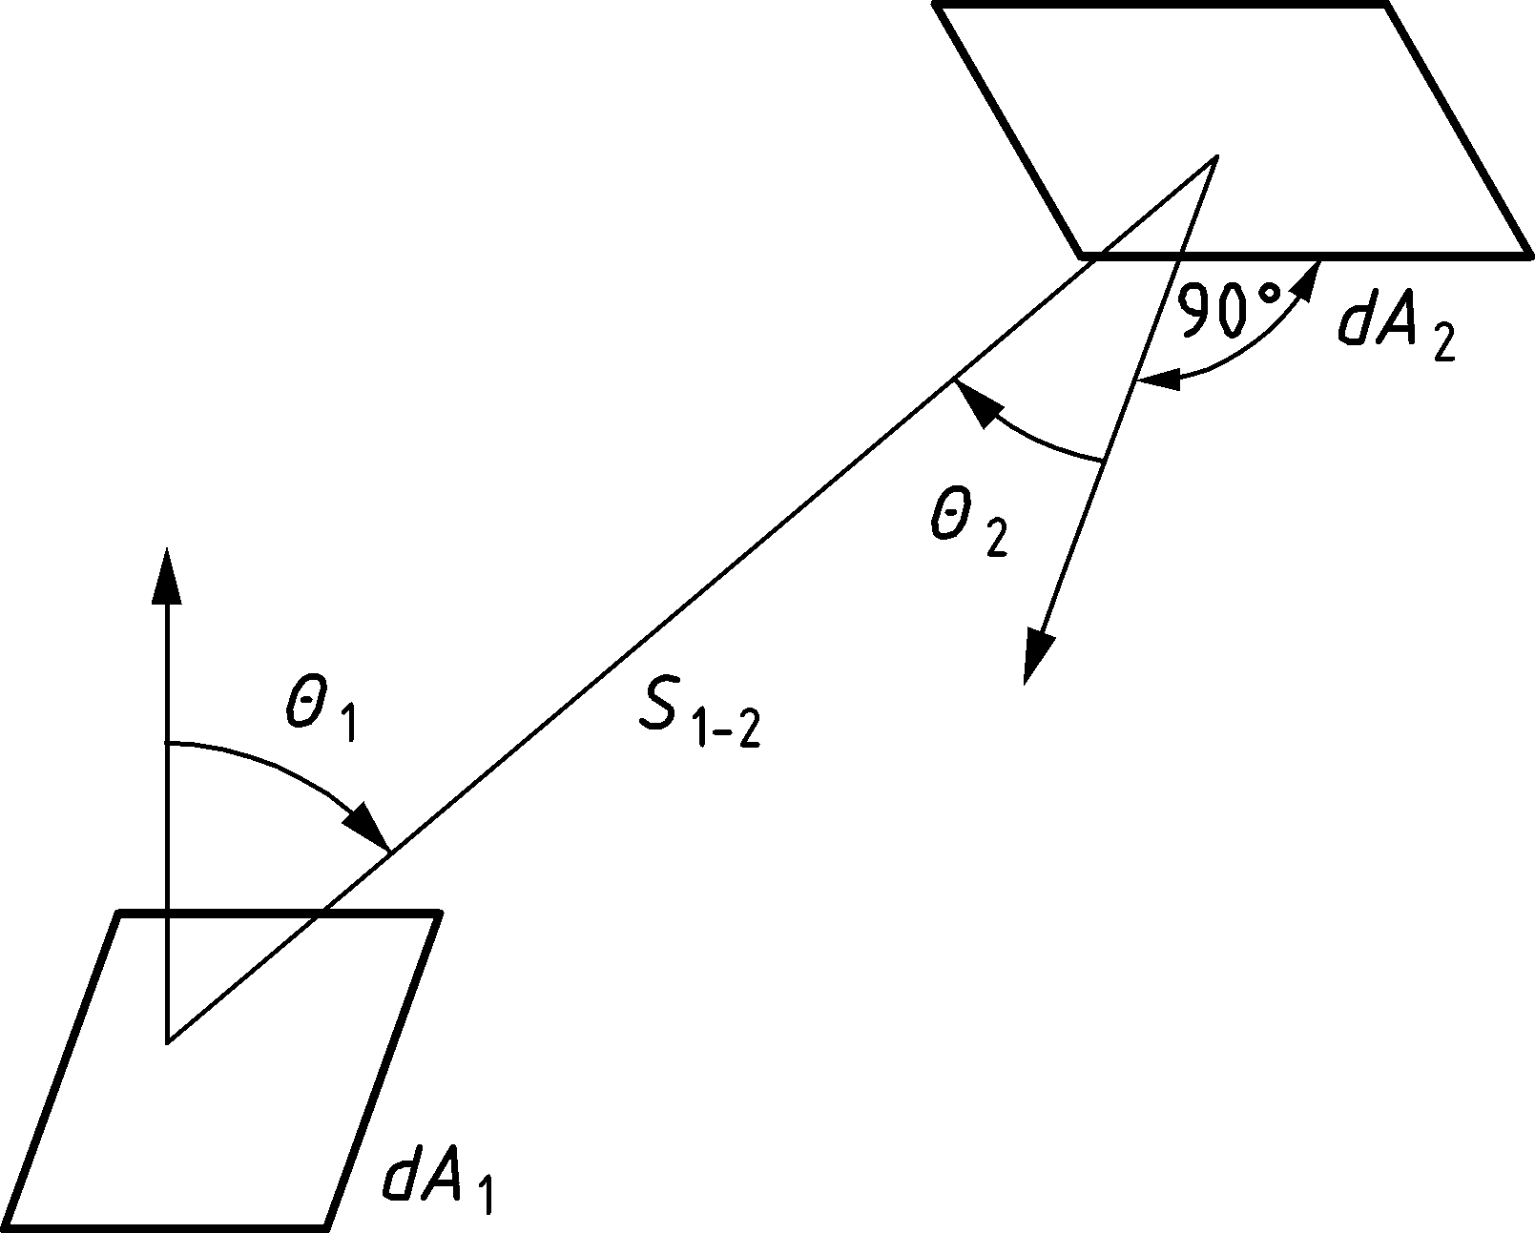

Figure G.1 — Radiative heat transfer between two infinitesimal surface areas

(2) In cases where the radiator has uniform temperature and emissivity, the definition can be simplified to: “the solid angle within which the radiating environment can be seen from a particular infinitesimal surface area, divided by 2π.”

(3) The radiative heat transfer to an infinitesimal area of a convex member surface is determined by the position and the size of the fire only (position effect).

(4) The radiative heat transfer to an infinitesimal area of a concave member surface is determined by the position and the size of the fire (position effect) as well as by the radiation from other parts of the member (shadow effects).

(5) Upper limits for the configuration factor *Φ* are given in Table G.1.

Table G.1 — Limits for configuration factor *Φ*

|  | | **Localised** | **Fully developed** |
| --- | --- | --- | --- |
| position effect | | *Φ* ≤ 1 | *Φ* = 1 |
| shadow effect | convex | *Φ* = 1 | *Φ* = 1 |
| concave | *Φ* ≤ 1 | *Φ* ≤ 1 |

* 1. Shadow effects

(1) Specific rules for quantifying the shadow effect are given in the material orientated parts of the Eurocodes.

* 1. External members

(1) For the calculation of temperatures in external members, all radiating surfaces may be assumed to be rectangular in shape. They comprise the windows and other openings in fire compartment walls and the equivalent rectangular surfaces of flames, see Annex B.

(2) In calculating the configuration factor for a given situation, a rectangular envelope should first be drawn around the cross-section of the member receiving the radiative heat transfer, as indicated in Figure G.2 (This accounts for the shadow effect in an approximate way). The value of *Φ* should then be determined for the mid-point P of each face of this rectangle.

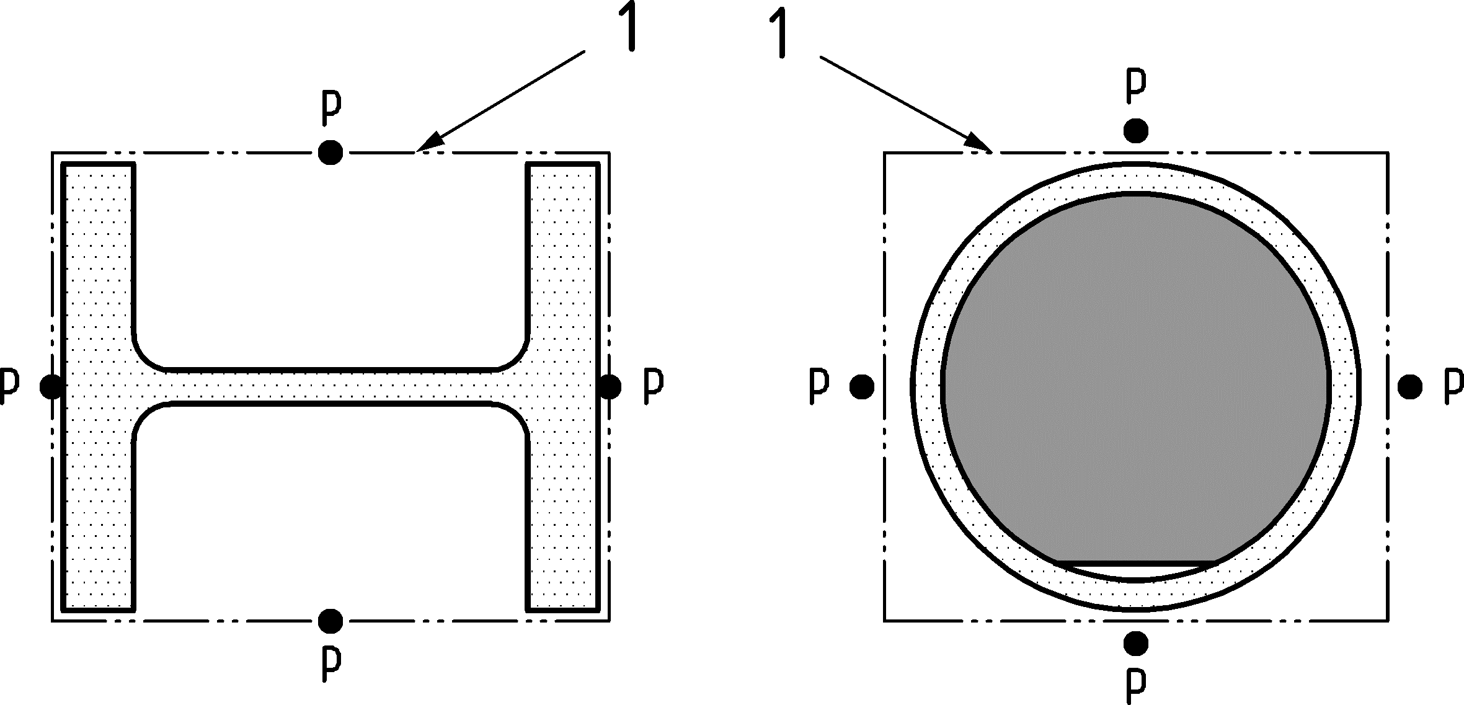

Key

|  |  |
| --- | --- |
| 1 | envelope |

Figure G.2 — Envelope of receiving surfaces

(3) The configuration factor for each receiving surface should be determined as the sum of the contributions from each of the zones on the radiating surface (normally four) that are visible from point P on the receiving surface, as indicated in Figure G.3 (when the receiving surface is parallel to radiating surface) and Figure G.4 (when the receiving surface is perpendicular to the radiating surface). These zones should be defined relative to the point X where a horizontal line perpendicular to the receiving surface meets the plane containing the radiating surface. No contribution should be taken from zones that are not visible from point P, such as the shaded zones in Figure G.4.

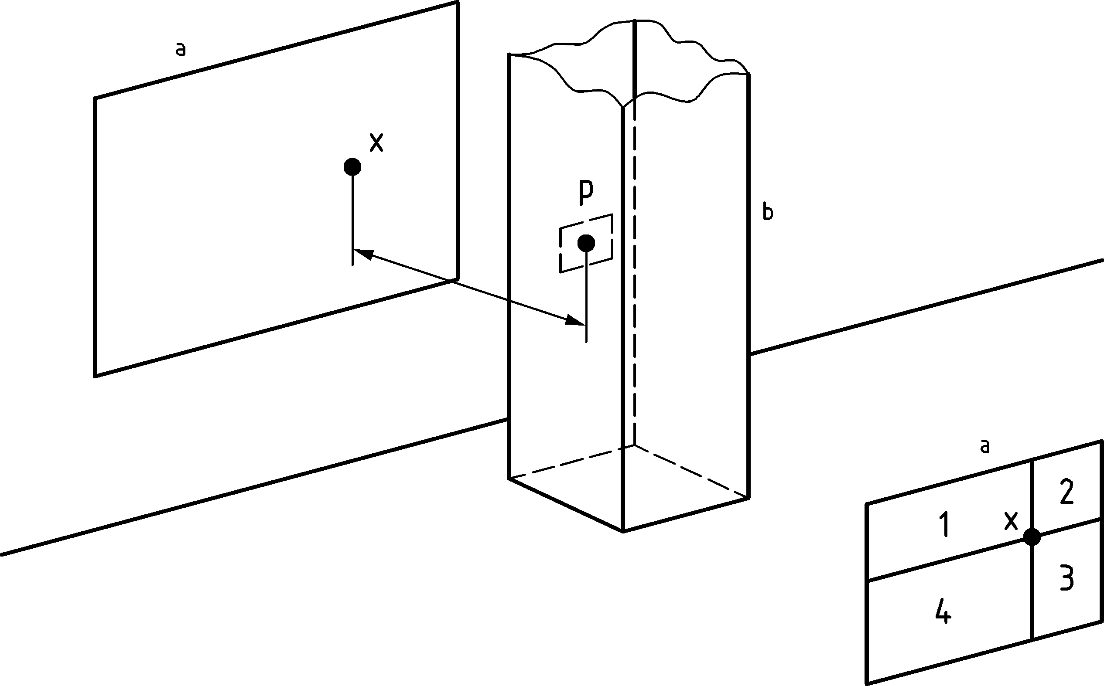

Key

|  |  |
| --- | --- |
| a | radiating surface |
| b | receiving surface |
|  |  |

Figure G.3 — Receiving surface in a plane parallel to that of the radiating surface

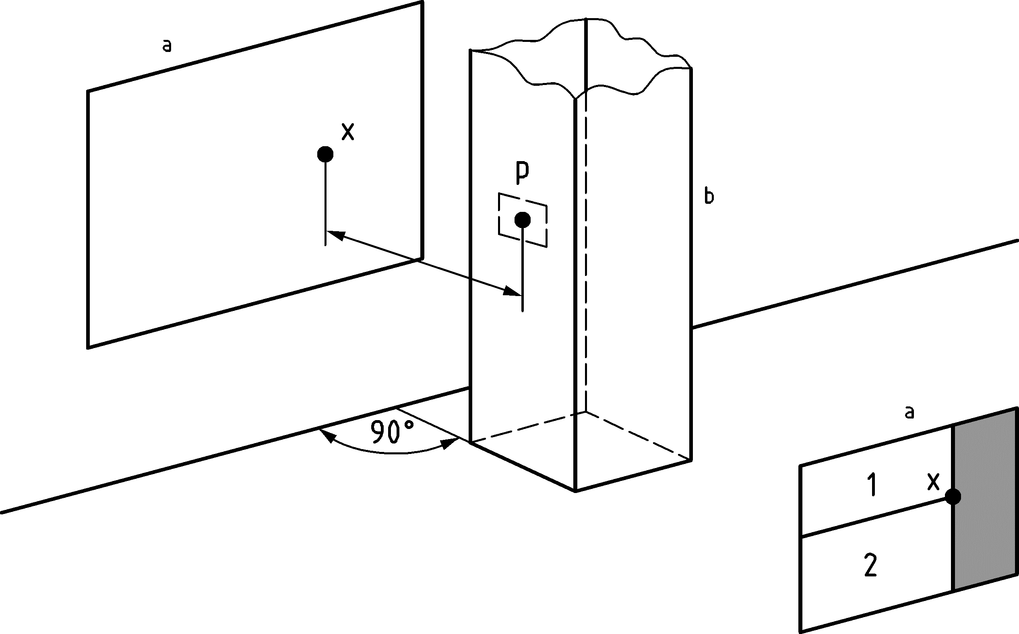

Key

|  |  |
| --- | --- |
| a | radiating surface |
| b | receiving surface |
|  |  |

Figure G.4 — Receiving surface perpendicular to the plane of the radiating surface

(4) If point X lies outside the radiating surface, the effective configuration factor should be determined by adding the contributions of the two rectangles extending from X to the farther side of the radiating surface, then subtracting the contributions of the two rectangles extending from X to the nearer side of the radiating surface.

(5) The contribution of each zone should be determined as follows:

a) receiving surface parallel to radiating surface (see Figure G.3):

 (G.2)

where

|  |  |
| --- | --- |
| *a* | = *h*/*s* |
| *b* | = *w*/*s* |
| *s* | is the distance from P to X; |
| *h* | is the height of the zone on the radiating surface; |
| *w* | is the width of that zone. |

b) receiving surface perpendicular to radiating surface (see Figure G.4):

 (G.3)

c) receiving surface in a plane at an angle *θ* to the radiating surface (see Figure G.5):

|  |  |
| --- | --- |
|  | (G.4) |

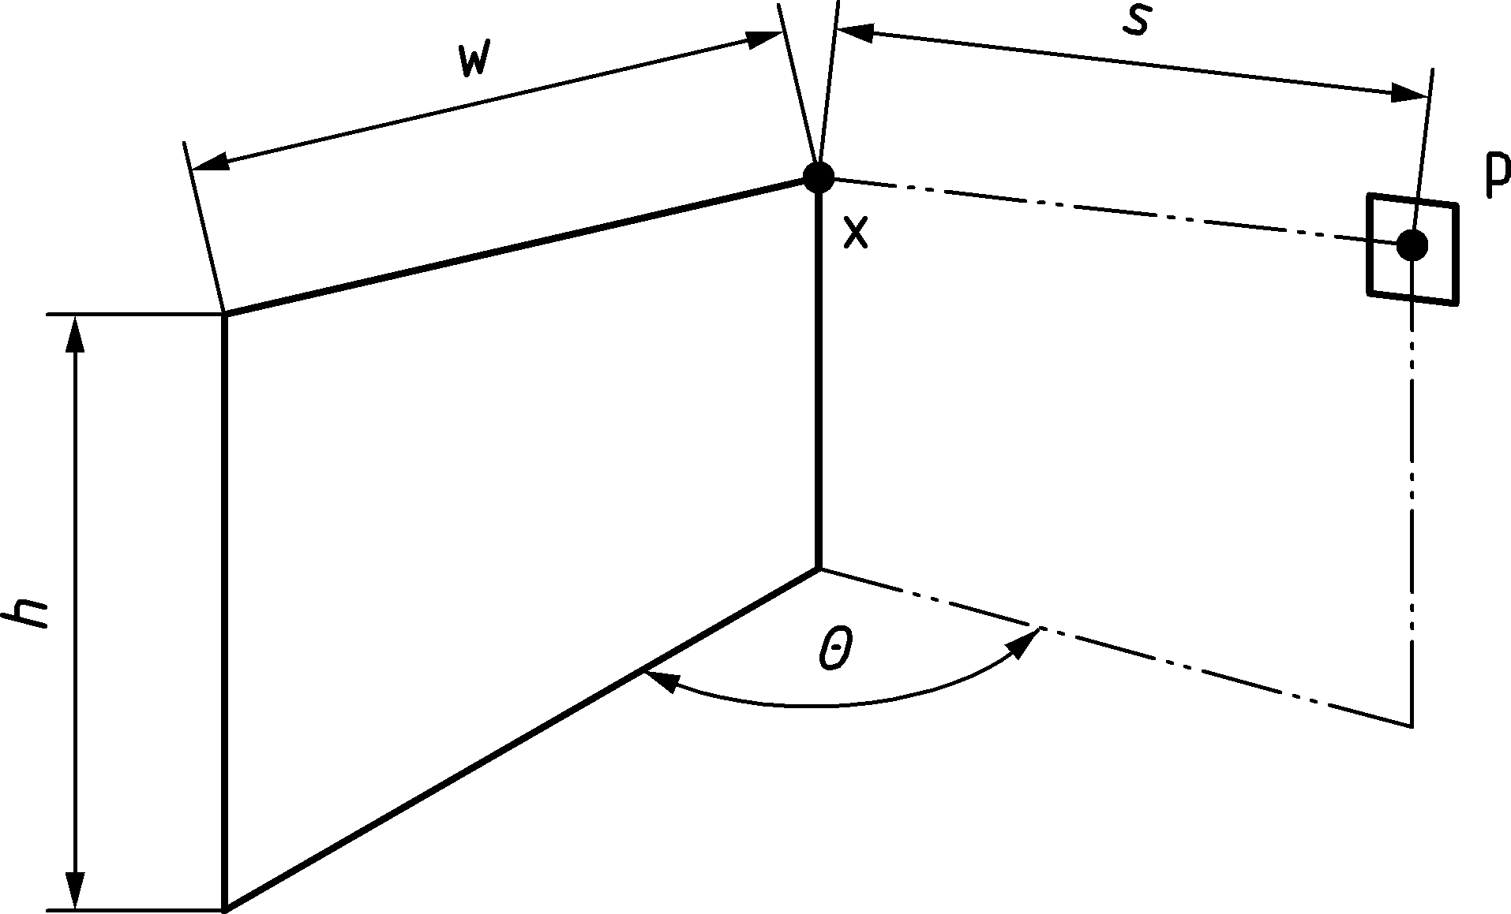

Key

|  |  |
| --- | --- |
| 1 | radiating surface |
| 2 | receiving surface |

Figure G.5 — Receiving surface in a plane at an angle *θ* to that of the radiating surface

* 1. Virtual solid flame

(1) As mentioned in Annex C, a localized fire may be represented by a succession of elementary cylinders having different diameters representing the cone and the total radiative flux [W/m2] is the sum of the radiative flux emitted by the lateral surface of the cylinders and the radiative flux emitted by the rings situated at the top surface of each cylinder, see Figure G.6.

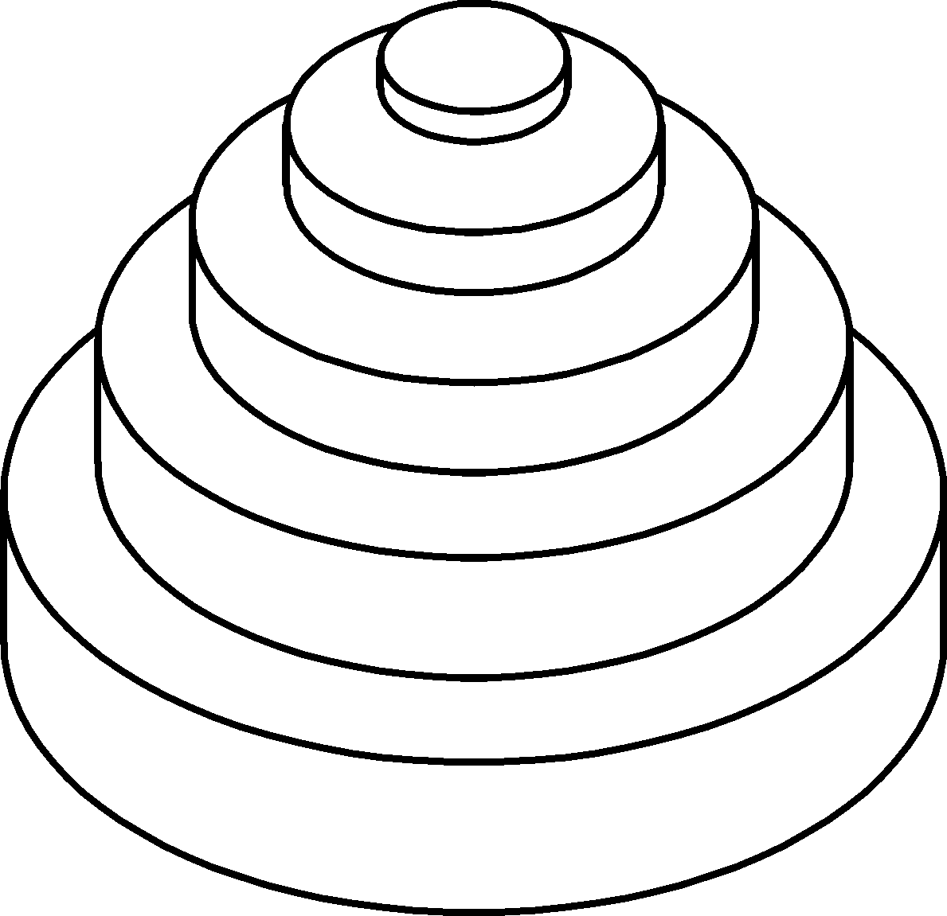

Figure G.6 — Division of a virtual solid flame into a succession of elementary cylinders and rings

(2) In calculating the configuration factor for a given localized fire, a rectangular envelope should first be drawn around the cross-section of the member receiving the radiative heat transfer, as indicated in Figure G.2. The value of *Φ* should then be determined for the mid-point P of each face of this rectangle.

(3) The contribution of each cylinder lateral surface should be determined using Formula (G.5). If the plane of the receiving surface does intersect the cylinder, this cylinder shall be reduced to the largest cylinder included in the initial cylinder and situated integrally in the visible domain (Figure G.8).

a) If the plane of the receiving surface does not intersect the cylinder (see Figure G.7):

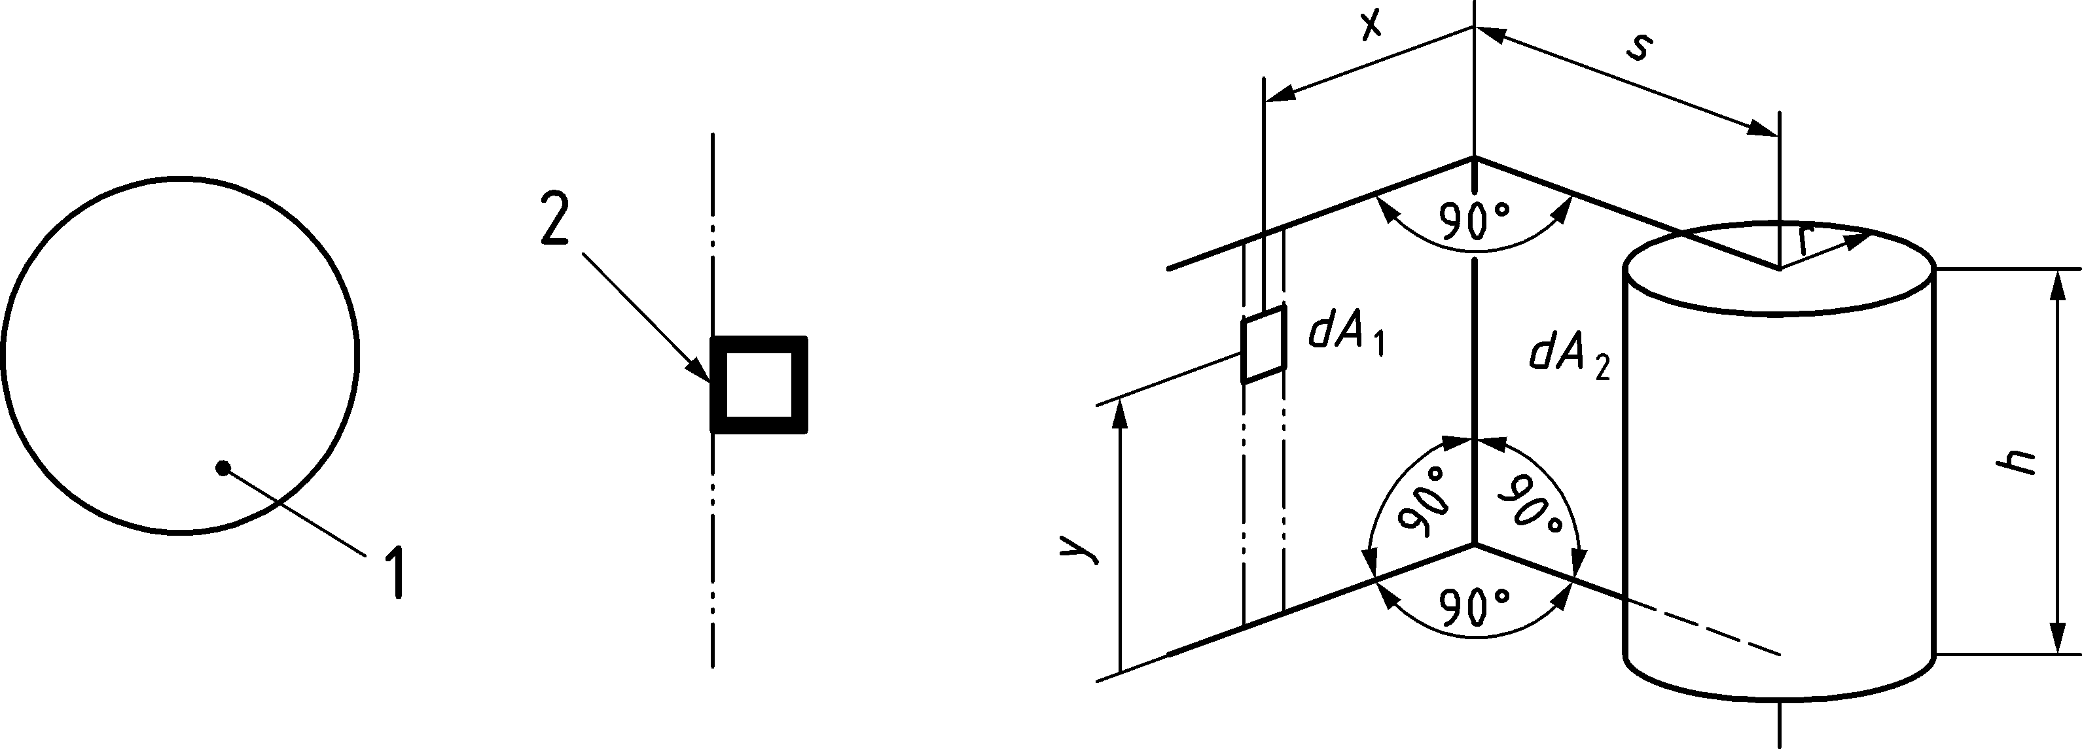

Key

|  |  |
| --- | --- |
| 1 | cylinder |
| 2 | receiving surface |

Figure G.7 — Plane of the receiving surface not intersecting the cylinder

 (G.5)

with



b) If the plane of the receiving surface does intersect the cylinder (see Figure G.8):

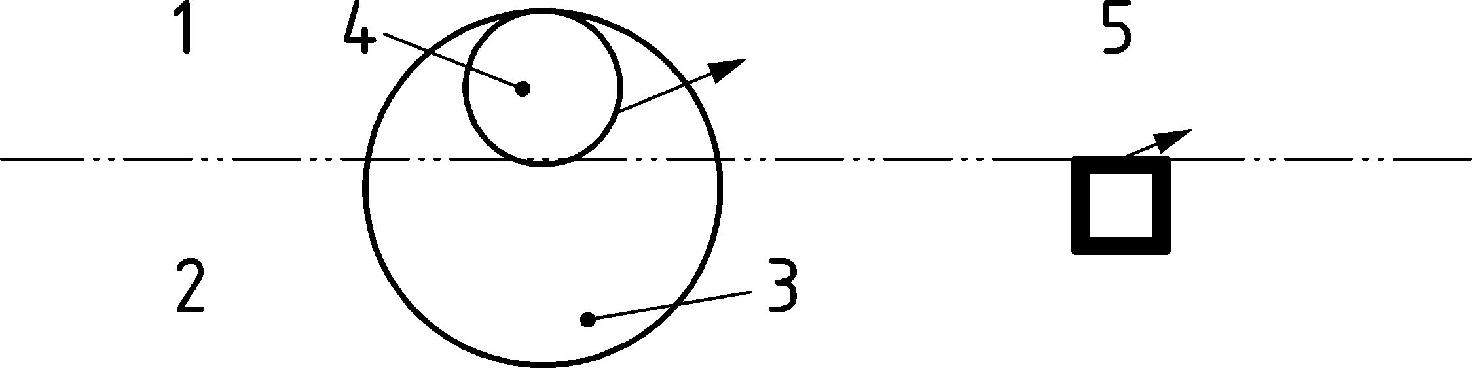

Key

|  |  |
| --- | --- |
| 1 | visible |
| 2 | not visible |
| 3 | cylinder |
| 4 | reduced cylinder |
| 5 | receiving surface |

Figure G.8 — Plane of the receiving surface intersecting the cylinder

(4) As a conservative simplification, the radiative heat flux [W/m2] received by a surface in a plane intersecting the cylinder may be evaluated as 50 % of the radiated heat flux received by the principal surface. The principal surface is characterized by a normal vector pointing to the centre of the cylinder (principal surface is Face 1 on Figure G.9).

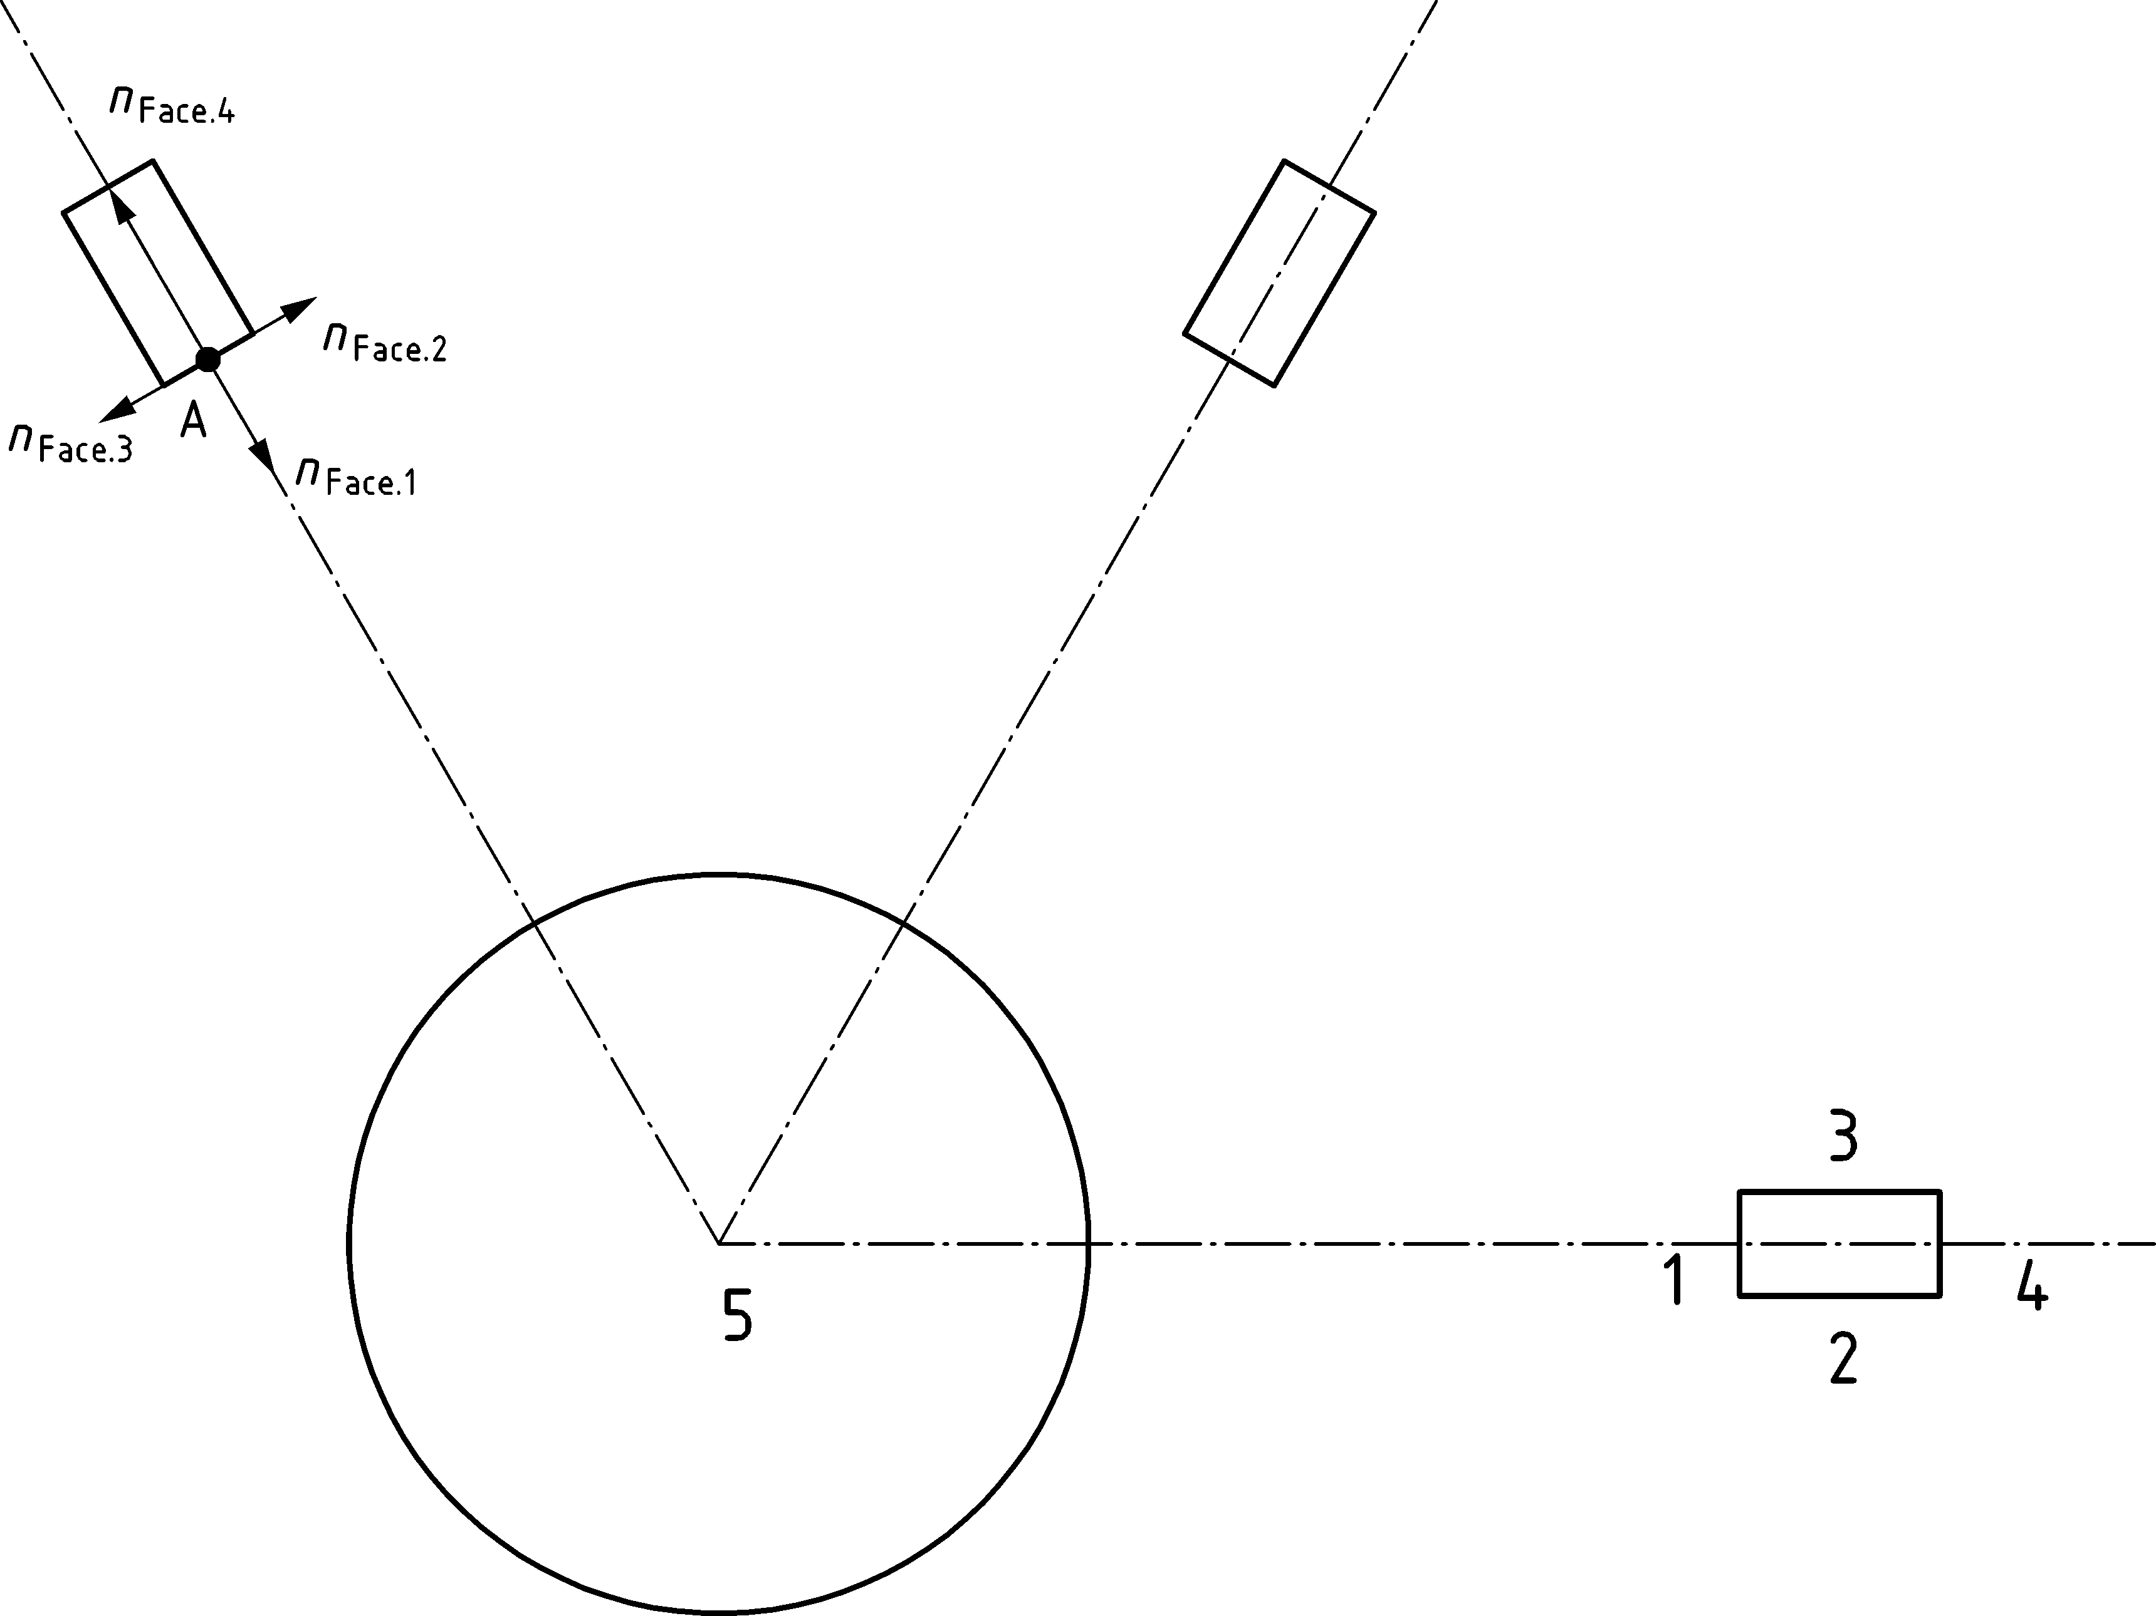

Key

|  |  |
| --- | --- |
| 1 | face 1 |
| 2 | face 2 |
| 3 | face 3 |
| 4 | face 4 |
| 5 | fire |

Figure G.9 — Principal surface for different positions of the receiving element

(5) The contribution of each ring should be determined using Formula (G.6), see Figure G.10.

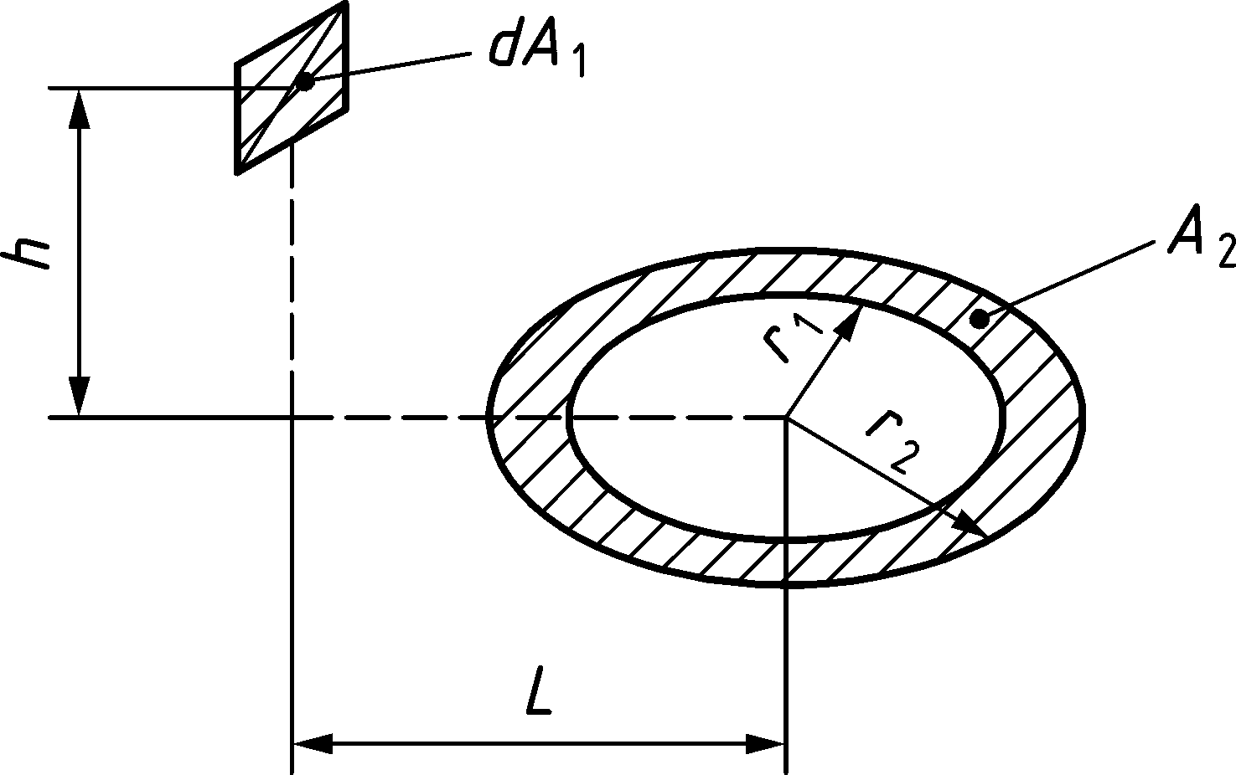

|  |  |
| --- | --- |
|  | (G.6) |

with



Figure G.10 — Relative position of the receiving surface and the ring

Bibliography

**References contained in recommendations (i.e. through “should” clauses)**

The following documents are referred to in the text in such a way that some or all of their content, although not requirements strictly to be followed, constitutes highly recommended choices or course of action of this document. Subject to national regulation and/or any relevant contractual provisions, alternative standards could be used/adopted where technically justified. For dated references, only the edition cited applies. For undated references, the latest edition of the referenced document (including any amendments) applies.

EN 1363‑2, Fire resistance tests — Part 2: Alternative and additional procedures

EN 1991 (all parts), Eurocode 1: Actions on structures

EN ISO 1716:2002[2]), Reaction to fire tests for building products — Determination of the heat of combustion (ISO 1716:2002)

1. ) See 2.2, 3.2(4) and 4.2.3.3 of ID N°2.
2. ) Document withdrawn; latest published document is from 2018.