CEN/TC 250

Date: 2021-01-05

prEN 1996-3:2021

Secretariat: BSI

Eurocode 6 — Design of Masonry structures — Part 3: Simplified calculation methods for unreinforced masonry structures

*Eurocode 6 — Bemessung und Konstruktion von Mauerwerksbauten — Teil 3: Vereinfachte Berechnungsmethoden für unbewehrte Mauerwerksbauten*

*Eurocode 6 — Calcul des ouvrages en maçonnerie — Partie 3: Méthodes de calcul simplifiées pour les ouvrages en maçonnerie non armée*

ICS:

Descriptors:

Contents Page

European foreword 4

0 Introduction 5

1 Scope 7

1.1 Scope of prEN 1996‑3 7

1.2 Assumptions 7

2 Normative references 7

3 Terms, definitions and symbols 8

3.1 Terms relating to wall types 8

3.2 Symbols 8

4 Basis of design 9

4.1 General rules 9

4.1.1 Basic requirements 9

4.2 Principles of limit state design 9

4.3 Basic variables 9

4.3.1 Actions 9

4.3.2 Material, and product properties 9

4.4 Verification by the partial factor method 10

4.4.1 Design values of actions 10

4.4.2 Design values of material properties 10

4.4.3 Combination of actions 10

4.4.4 Ultimate limit states 10

5 Materials 10

5.1 General 10

5.2 Characteristic compressive strength of masonry 11

5.3 Characteristic flexural strength of masonry 11

6 Design of unreinforced masonry walls using simplified calculation methods 11

6.1 General 11

6.2 Conditions for application 11

6.3 Walls subjected to vertical and wind loading 13

6.3.1 General 13

6.3.2 Effective height of walls 13

6.3.3 Vertical load resistance 15

6.3.4 Walls subjected to wind load 19

6.4 Walls subjected to concentrated loads 19

6.5 Walls subjected to inplane shear loading 20

6.6 Basement walls subjected to lateral earth pressure 20

6.7 Partition walls subjected to limited lateral load but no vertical loads 22

6.8 Walls subjected to uniform lateral load but no vertical loads 22

Annex A (informative) Simplified calculation method for shear walls 23

A.1 Use of this Informative Annex 23

A.2 Scope and field of application 23

A.3 Method 23

Annex B (informative) Simplified calculation method for the design of partition walls not designed for vertical loads and with limited lateral load 25

B.1 Use of this Informative Annex 25

B.2 Scope and field of application 25

B.3 Conditions for use 25

B.4 Minimum wall thickness and limiting dimensions 26

Annex C (informative) Simplified calculation method for the design of walls subjected to uniform lateral design load and no vertical loads 29

C.1 Use of this Informative Annex 29

C.2 Scope and field of application 29

C.3 Method 29

Annex D (normative) Simplified method of determining the characteristic strengths of masonry 35

D.1 Use of this annex 35

D.2 Scope and field of application 35

D.3 Characteristic compressive strength 35

D.4 Characteristic flexural strengths 38

Bibliography 40

European foreword

This document (prEN 1996-3:2021) has been prepared by Technical Committee CEN/TC 250 “Structural Eurocodes”, the secretariat of which is held by BSI. CEN/TC 250 is responsible for all Structural Eurocodes and has been assigned responsibility for structural and geotechnical design matters by CEN.

This document is currently submitted to the CEN Enquiry.

This document will supersede EN 1996-3:2006, including EN 1996-3:2006/AC:2009.

The first generation of EN Eurocodes was published between 2002 and 2007. This document forms part of the second generation of the Eurocodes, which have been prepared under a Mandate M/515 given to CEN by the European Commission and the European Free Trade Association.

The Eurocodes have been drafted to be used in conjunction with relevant execution, material, product and test standards, and to identify requirements for execution, materials, products and testing that are relied upon by the Eurocodes.

The Eurocodes recognize the responsibility of each Member State and have safeguarded their right to determine values related to regulatory safety matters at national level through the use of National Annexes.

0 Introduction

**0.1 Introduction to the Eurocodes**

The Structural Eurocodes comprise the following standards generally consisting of a number of Parts:

— EN 1990 Eurocode: Basis of structural and geotechnical design

— EN 1991 Eurocode 1: Actions on structures

— EN 1992 Eurocode 2: Design of concrete structures

— EN 1993 Eurocode 3: Design of steel structures

— EN 1994 Eurocode 4: Design of composite steel and concrete structures

— EN 1995 Eurocode 5: Design of timber structures

— EN 1996 Eurocode 6: Design of masonry structures

— EN 1997 Eurocode 7: Geotechnical design

— EN 1998 Eurocode 8: Design of structures for earthquake resistance

— EN 1999 Eurocode 9: Design of aluminium structures

— <New parts>

The Eurocodes are intended for use by designers, clients, manufacturers, constructors, relevant authorities (in exercising their duties in accordance with national or international regulations), educators, software developers, and committees drafting standards for related product, testing and execution standards.

NOTE Some aspects of design are most appropriately specified by relevant authorities or, where not specified, can be agreed on a project-specific basis between relevant parties such as designers and clients. The Eurocodes identify such aspects making explicit reference to relevant authorities and relevant parties.

**0.2 Introduction to** **EN** **1996** **Eurocode 6**

EN 1996 Eurocode 6 standards, applies to the design of building and civil engineering works, or parts thereof, in unreinforced, reinforced, prestressed and confined masonry.

EN 1996 deals only with the requirements for resistance, serviceability and durability of structures. Other requirements, for example, concerning thermal or sound insulation, are not considered.

EN 1996 does not cover the special requirements of seismic design. Provisions related to such requirements are given in EN 1998, which complements, and is consistent with EN 1996.

EN 1996 does not cover numerical values of the actions on building and civil engineering works to be taken into account in the design. They are provided in EN 1991.

**0.3 Introduction to** **prEN** **1996-3**

This document describes simplified calculation methods to facilitate the design of unreinforced masonry walls based on the principles from EN 1996-1-1.

This document is intended to be used, for direct application, together with EN 1990, EN 1991, EN 1996‑1-1, EN 1996-1-2 and EN 1996-2.

**0.4 Verbal forms used in the Eurocodes**

The verb “shall" expresses a requirement strictly to be followed and from which no deviation is permitted in order to comply with the Eurocodes.

The verb “should” expresses a highly recommended choice or course of action. Subject to national regulation and/or any relevant contractual provisions, alternative approaches could be used/adopted where technically justified.

The verb “may" expresses a course of action permissible within the limits of the Eurocodes.

The verb “can" expresses possibility and capability; it is used for statements of fact and clarification of concepts.

**0.5 National annex for** **prEN** **1996-3**

National choice is allowed in this standard where explicitly stated within notes. National choice includes the selection of values for Nationally Determined Parameters (NDPs).

The national standard implementing this document can have a National Annex containing all national choices to be used for the design of buildings and civil engineering works to be constructed in the relevant country.

When no national choice is given, the default choice given in this standard is to be used.

When no national choice is made and no default is given in this standard, the choice can be specified by a relevant authority or, where not specified, agreed for a specific project by appropriate parties.

National choice is allowed in prEN 1996-3 through notes to the following:

|  |  |  |  |
| --- | --- | --- | --- |
| 4.4.4 (1) | 6.2 (1) – 2 choices | D.1 (1) | D.2 (1) |

National choice is allowed in prEN 1996-3 on the application of the informative annexes:

|  |  |  |  |
| --- | --- | --- | --- |
| Annex A | Annex C | Annex D, D.3 (1) – 6 choices | Annex D, D.4 (1) – 2 choices |
| Annex B |  |  |  |

The National Annex can contain, directly or by reference, non-contradictory complementary information for ease of implementation, provided it does not alter any provisions of the Eurocodes.

# Scope

## Scope of prEN 1996‑3

(1) The scope of prEN 1996-1-1 applies also to this this document.

(2) This document provides simplified calculation methods to facilitate the design of the following unreinforced masonry walls, subject to certain conditions of application:

— walls subjected to vertical and wind loads;

— walls subjected to concentrated loads;

— shear walls;

— basement walls subjected to lateral earth pressure and vertical loads;

— walls subjected to lateral loads but not subjected to vertical loads.

NOTE For those types of masonry structures or parts of structures not covered by (2), the design can be based on prEN 1996-1-1.

(3) The rules given in this document are consistent with those given in prEN 1996-1-1, but are more conservative in respect of the conditions and limitations of their use.

(4) The rules given in this document assume that concrete floors are designed according to EN 1992‑1‑1.

(5) This document applies only to those masonry structures, or parts thereof, that are described in prEN 1996-1-1 and EN 1996-2.

(6) The simplified calculation methods given in this document do not cover the design of double-leaf walls.

(7) The simplified calculation methods given in this document do not cover the design for accidental situations.

## Assumptions

(1) The assumptions of prEN 1990 apply to this document.

# Normative references

The following documents are referred to in the text in such a way that some or all of their content constitutes requirements of this document. For dated references, only the edition cited applies. For undated references, the latest edition of the referenced document (including any amendments) applies.

NOTE See the Bibliography for a list of other documents cited that are not normative references, including those referenced as recommendations (i.e. in ‘should’ clauses), permissions (‘may’ clauses), possibilities ('can' clauses), and in notes.

prEN 1990, Eurocode — Basis of structural and geotechnical design

EN 1991 (all parts), Eurocode 1: Actions on structures

prEN 1996-1-1:2019, Eurocode 6 — Design of masonry structures — Part 1-1: General rules for reinforced and unreinforced masonry structures

EN 1996‑2, Eurocode 6 — Design of masonry structures - Part 2: Design considerations, selection of materials and execution of masonry

EN 1997‑1, Eurocode 7 — Geotechnical design - Part 1: General rules

# Terms, definitions and symbols

For the purposes of this document, the terms and definitions given in prEN 1990, prEN 1996-1-1 and the following apply.

## Terms relating to wall types

3.1.1

basement wall

retaining masonry wall constructed partly or fully below ground level

## Symbols

For the purposes of this document, the material-independent symbols given in prEN 1990, the material-dependent symbols given in prEN 1996-1-1 and the following material-dependent symbols apply.

**Latin upper case letters**

|  |  |
| --- | --- |
| *K*e | earth pressure coefficient; |
| *N*Ed,max | design value of the maximum vertical load at mid height of the fill; |
| *N*Ed,min | design value of the minimum vertical load at mid height of the fill. |

**Latin lower case letters**

|  |  |
| --- | --- |
| *c*t | constant; |
| *h* | clear storey height; |
| *h*a | average height of the building; |
| *h*e | vertical distance between the ground level and the face of the bottom support of the wall; |
| *h*m | maximum height of a building allowed with the simplified calculation method; |
| *l* | length of a wall in the horizontal direction; |
| *l*bx | plan dimension of a building in the x-direction; |
| *l*by | plan dimension of a building in the y-direction; |
| *l*cw | spacing of cross walls or other buttressing elements; |
| *l*f,ef | effective span of a floor; |
| *l*f,i | span of floor *i*; |
| *l*f,ix | span of floor *i* perpendicular to the considered wall; |
| *l*f,iy | span of floor *i* parallel to the considered wall; |
| *l*ref,c | reference value for the span of the floor; |
| *l*ref,t | reference value for the span of the floor; |
| *l*sx | length of a shear wall orientated in the x-direction; |
| *l*sy | length of a shear wall orientated in the y-direction; |
| *l*w | length of the analysed wall loaded by wind; |
| *t*b | bearing length of the floor or roof on the wall; |
| *w*Ek | characteristic wind load per unit area; |
| *w*Ed | design wind load per unit area; |

**Greek upper case letters**

|  |  |
| --- | --- |
| *Φ*s | capacity reduction factor; |

**Greek lower case letters**

|  |  |
| --- | --- |
| *α*r | is the ratio between the characteristic value of the permanent vertical load in a shear wall and the design value of the resistance *A* *f*d of a shear wall; |
| *β*e | constant accounting for uniaxial or biaxial load transfer in basement walls; |
| *ρ*e | density of the soil; |
| *ρ*sn | reduction factor for the effective height obtained from a simplified rule. |

# Basis of design

## General rules

### Basic requirements

(1) The design of masonry structures shall be in accordance with the general rules given in prEN 1990 and the specific design provisions for masonry structures given in prEN 1996-1-1.

## Principles of limit state design

(1) For masonry structures, the ultimate limit state and serviceability limit state shall be considered for all aspects of the structure including ancillary components in the masonry according to prEN 1996-1-1.

## Basic variables

### Actions

(1) The characteristic values of actions shall be obtained from the relevant parts of EN 1991.

### Material, and product properties

(1) Properties of materials and construction products and their geometrical data to be used for design should be those specified in the relevant European Standards (EN), European Technical Specifications (TS) or according to a transparent and reproducible assessment that complies with all the requirements of a European Assessment Document (EAD), unless otherwise indicated in this document.

## Verification by the partial factor method

### Design values of actions

(1) Partial factors for actions shall be obtained from prEN 1990.

(2) Design values of indirect actions arising from interacting components of other materials shall be determined using the relevant code and applicable partial safety factors.

(3) For serviceability limit states, imposed deformations should be introduced as estimated (mean) values.

### Design values of material properties

(1) The design value for a material property is obtained by dividing its characteristic or declared value by the relevant partial factor for materials, *γ*M.

### Combination of actions

(1) Combination of actions shall be in accordance with the general rules given in prEN 1990.

### Ultimate limit states

(1) The relevant values of the partial factor for materials *γ*M shall be specified for the ultimate limit state either for persistent or transient design situations, or for accidental design situations.

NOTE The value of *γ*M is given in Table 4.1 (NDP) unless the National Annex gives different values for use in a country.

Table 4.1 (NDP) — Partial factors on materials for masonry buildings

| **Material** | | *γ*M |
| --- | --- | --- |
| **Masonry made with:** | |
| A | Units of Category I, designed mortar a | 2,0 |
| B | Units of Category I, prescribed mortar b | 2,2 |
| C | Units of Category II, any mortar a, b, c | 2,5 |
| a Requirements for designed mortars are given in EN 998-2 and EN 1996-2.  b Requirements for prescribed mortars are given in EN 998-2 and EN 1996-2.  c When the coefficient of variation for Category II units is not greater than 25 %. | | |

# Materials

## General

(1) The materials used in the masonry walls referred to in this document shall be in accordance with prEN 1996-1-1:2019, Clause 5.

(2) Masonry units should be grouped as Group 1, Group 1S, Group 2, Group 3 or Group 4 according to prEN 1996-1-1:2019, 5.1.2.

NOTE Normally the manufacturer will state the grouping of units in the product declaration.

(3) Annex D provides a simplified method for the determination of material properties. These material properties may be used instead of those given in prEN 1996-1-1.

## Characteristic compressive strength of masonry

(1) The characteristic compressive strength of masonry should be determined according to prEN 1996‑1-1:2019, 5.7.1.

## Characteristic flexural strength of masonry

(1) The characteristic flexural strength of masonry should be determined according to prEN 1996‑1‑1:2019, 5.7.4.

# Design of unreinforced masonry walls using simplified calculation methods

## General

(1) The overall stability of a building, of which the wall forms a part, should be verified.

NOTE A method for verification of the stability is given in Annex A.

(2) A structure should have shear walls placed in two orthogonal directions. At least in one direction two shear walls not in the same plane should be present. When the eccentricity between the resultant of the wind load and the resulting shear force is smaller than 0,05 times the width of the area loaded by the wind, the torsional effect may be neglected.

(3) The slenderness ratio of a wall *h*ef/*t* should not be greater than 27.

(4) The detailing rules according to prEN 1996-1-1:2019, 10.1 and 10.5 should be taken into account.

(5) An analysis of bending moments in the walls may be omitted, because the simplified calculation methods take the effects of wind, earth pressure and floor-wall-interaction into account. If other horizontal loads act on a loadbearing wall or conditions regarding the loads are not fulfilled, the analysis shall be performed as specified in prEN 1996-1-1.

(6) In case of concrete floors, an increase in the eccentricity owing to a change in the position of the axis of a loadbearing wall from storey to storey due to a change in wall thickness may be neglected, if the cross-section of the thinner wall falls in plan within that of the thicker one.

(7) The analysis of free-standing walls shall be performed in accordance with prEN 1996-1-1.

## Conditions for application

(1) For use of the simplified method, the following conditions shall be complied with:

— the height of the building above ground level does not exceed *h*m; for buildings with a sloping roof the height *h*m shall be determined as average height *h*a indicated in Figure 6.1;

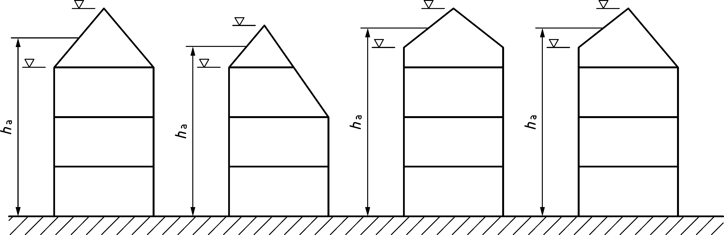

Figure 6.1 — Determination of average height

NOTE 1 The value of *h*m is 20 m, unless the National Annex gives a different value for use in a country.

— the characteristic values of the variable actions on the floors and the roof does not exceed 5,0 kN/m2;

— the span of the roof and the floors supported by the walls does not exceed 7,0 m, except in the case of a lightweight trussed roof structure where the span shall not exceed 14,0 m;

— the clear wall height of loadbearing walls does not exceed 4,0 m; for bearing lengths *t*b/*t* < 0,65 the clear wall height of loadbearing walls does not exceed 3,0 m;

— the minimum thickness is according to prEN 1996-1-1:2019, 10.1.2;

— the maximum clear height of walls acting as end support to floors or the roof is additionally limited depending on the bearing length *t*b of the floor or roof on the wall;

NOTE 2 The maximum clear heights of walls acting as end support to floors or roof assuming a modulus of elasticity of masonry E of at least 700 fk are given in Table 6.1 (NDP), unless the National Annex gives different values for use in a country.

Table 6.1 (NDP) — Maximum clear height of walls acting as end support to floors or roof

|  |  |  |
| --- | --- | --- |
| ***f*k (N/mm2)** | ***w*Ek ≤ 0,9 kN/m2** | **0,9 *< w*Ek ≤ 1,3 kN/m2** |
| *f*k = 1 | *h* ≤ 16 *t*b | *h* ≤ 14 *t*b |
| *f*k ≥ 5 | *h* ≤ 24 *t*b | *h* ≤ 22 *t*b |
| Linear interpolation may be carried out between *f*k = 1 N/mm2 and *f*k = 5 N/mm2. | | |

— the walls are laterally restrained by the floors and the roof in the horizontal direction at right angles to the plane of the wall, either by the floors and the roof themselves or by suitable methods, e.g. ring beams with sufficient stiffness according to prEN 1996-1-1:2019, 10.5.1.1;

— the walls are vertically aligned throughout their height;

— in case of walls acting as end support to floors or the roof, the bearing length *t*b on the wall is at least 0,65 *t,* but not less than 100 mm, except for walls with *t* ≥ 350 mm and *f*k ≥ 3 N/mm2, where the bearing length *t*b on the wall is at least 0,60 *t*;

— in case of inner walls supporting two non-continuous slabs, the bearing length on the wall of each slab is at least 0,4 *t* of the thickness of the wall;

— the final creep coefficient of the masonry *φ*∞ does not exceed 2,0;

NOTE 3 Values for *φ*∞ are given in prEN 1996-1-1:2019, Table 5.10.

— the thickness of the wall and the compressive strength of the masonry are checked at each storey level, unless these variables are the same at all storeys.

## Walls subjected to vertical and wind loading

### General

(1) Under the ultimate limit state, it shall be verified that:

*N*Ed ≤ *N*Rd (6.1)

where

|  |  |
| --- | --- |
| *N*Ed | is the design vertical load on the wall; |
| *N*Rd | is the design vertical load resistance of the wall according to 6.3.3. |

### Effective height of walls

(1) The effective height should be determined by Formula (6.2):

*h*ef = *ρ*sn *h* (6.2)

where

|  |  |
| --- | --- |
| *h* | is the clear storey height; |
| *ρ*sn | is a reduction factor obtained from a simplified rule given in 6.3.2(2), where *n* = 2, 3 or 4 depending on the edge restraint or stiffening of the wall. |

(2) The reduction factor *ρ*sn should be determined as follows:

(i) For walls laterally and rotationally restrained at top and bottom only, by reinforced or prestressed concrete floors or roofs (see Figure 6.2):

for intermediate walls:

*ρ*s2 = 0,75;

for walls, supporting floors spanning from one side only with a bearing equal to the thickness of the wall:

|  |  |
| --- | --- |
| *ρ*s2 = 0,75 | when *t* ≤ 150 mm; |
| *ρ*s2 = 0,75 + (*t* - 150)/600 | when 150 mm < *t* < 300 mm; |
| *ρ*s2 = 1,00 | when *t* ≥ 300 mm; |

for all other walls:

*ρ*s2 = 1,00;

for all walls containing courses of two types of masonry having significantly different stiffness properties:

*ρ*s2 = 1,00.

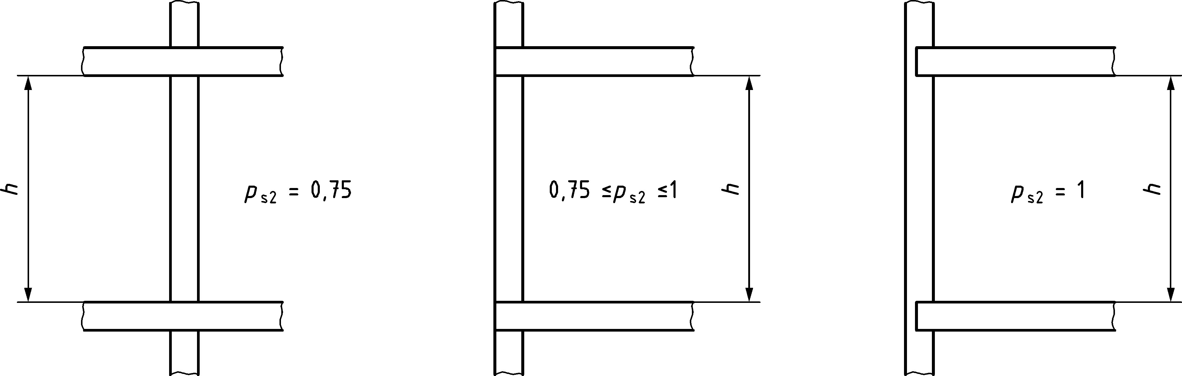

Figure 6.2 — Lateral and rotational restraint provided by floors or roof

(ii) For all walls laterally restrained at top and bottom only (e.g. by ring beams of appropriate stiffness or timber floors) but not rotationally restrained by the floors or roof (see Figure 6.3):

*ρ*s2 = 1,00

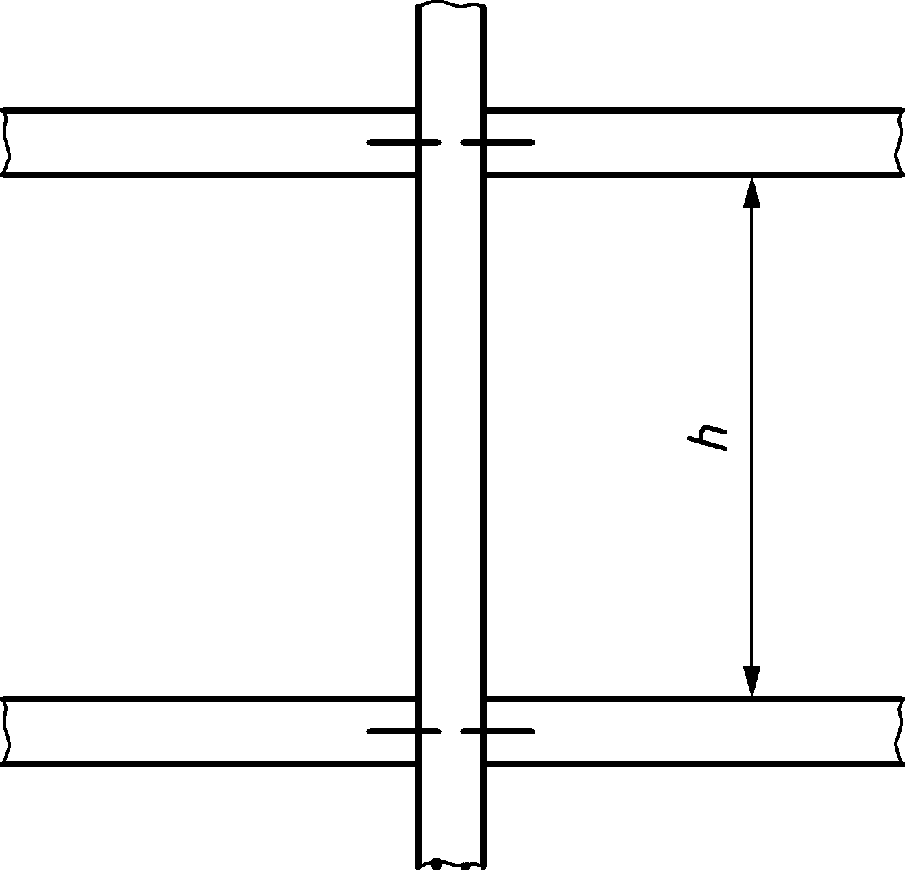

Figure 6.3 — No rotational restraint provided by floors or roof

(iii) For walls laterally restrained at top and bottom and at one vertical edge (see Figure 6.4):



where

|  |  |
| --- | --- |
| *h* | is the clear storey height; |
| *l* | is the distance from the vertically supported edge to the free edge. |

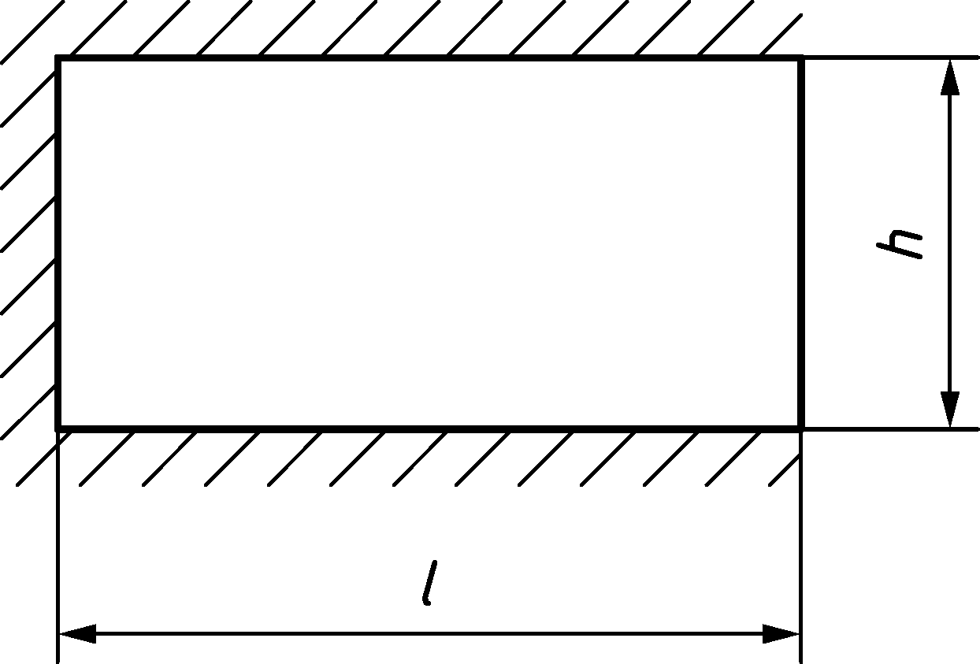

Figure 6.4 — Wall laterally restrained at top and bottom and at one vertical edge

(iv) For walls laterally restrained at top and bottom and at two vertical edges (see Figure 6.5):



where

|  |  |
| --- | --- |
| *h* | is the clear storey height; |
| *l* | is the distance between the vertical edges. |

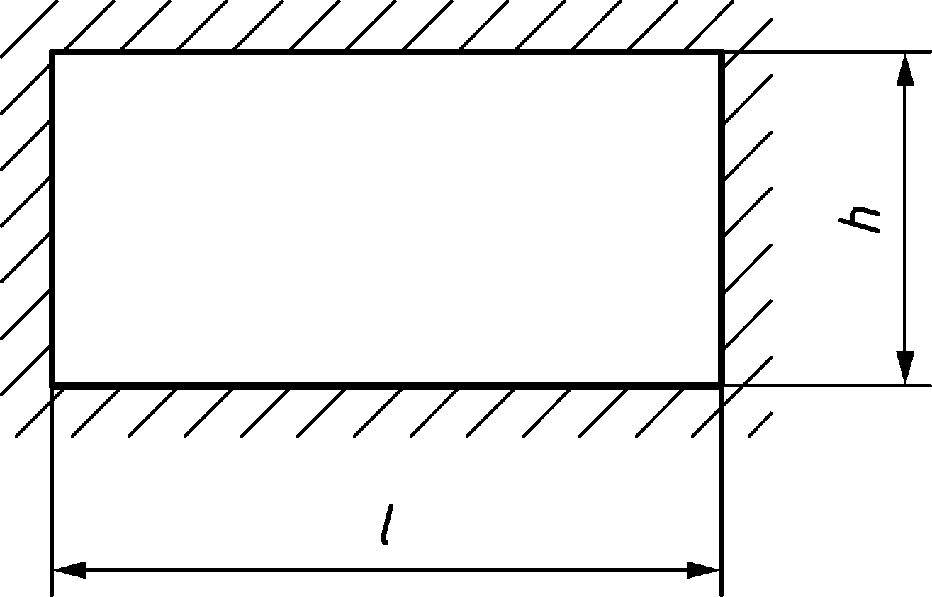

Figure 6.5 — Wall laterally restrained at top and bottom and two vertical edges

### Vertical load resistance

(1) The design value of the vertical load resistance *N*Rd should be determined from Formula (6.3):

*N*Rd = *Φ*s *f*d *t l* (6.3)

where

|  |  |
| --- | --- |
| *Φ*s | is the capacity reduction factor allowing for the effects of slenderness and eccentricity of the loading, obtained from 6.3.3 (2); |
| *f*d | is the design compressive strength of the masonry; |
| *t* | is the thickness of the wall; |
| *l* | is the length of the wall. |

(2) The capacity reduction factor *Φs* for intermediate walls should be calculated using Formula (6.4a) with the ratio *t*b/*t* equal to 1,0.

 (6.4a)

where

|  |  |
| --- | --- |
| *h*ef | is the effective height of the wall (see 6.3.2); |
| *t* | is the thickness of the wall; |
| *t*b | is the bearing length of the floor on the wall. |

(3) For walls acting as end support of intermediate floors and for intermediate walls supporting floors whose effective spa.n lengths on both sides differs more than 3,00 m, the capacity reduction factor *Φ*s should be determined from the lesser of the outcome of Formulae (6.4a), (6.4b) and (6.4c).

 (6.4b)

Formula (6.4c) should only be applied when:

*f*k < 2 N/mm2and

*h*/*t* < 2(*l*f,ef + 1) - *f*k (*f*k in N/mm2 and *l*f,ef in m).

 (6.4c)

For intermediate walls, the ratio *t*b/*t* should be taken as equal to 1,0.

where

|  |  |
| --- | --- |
| *f*k | is the characteristic compressive strength of the masonry; |
| *h*ef | is the effective height of the wall (see 6.3.2); |
| *t* | is the thickness of the wall; |
| *t*b | is the bearing length of the floor on the wall; |
| *l*f,ef | is the difference of the effective span of the floors (in metres) on both sides of the considered wall (see Figure 6.6) that should be calculated using Formula (6.5). |

*l*f,ef *= l*f,ef,1 *– l*f,ef,2 ≥ 3,00 m (6.5)

|  |  |
| --- | --- |
| *l*f,ef,i = 0,9 *l*f,i | for simply supported floors (see Figure 6.6 b); |
| *l*f,ef,i = 0,7 *l*f,i | for continuous floor structures when the span of the floor beyond the adjacent floors is at least one-third of the span of the adjacent floor and that it is spanning in the same direction (see Figure 6.6 a); |
| *l*f,ef,i *=* 0,7 *l*f,i | for simply supported two-way spanning floors where the span parallel to the wall *l*f,*i*y is not greater than two times the span perpendicular to the wall *l*f,*i*x (see Figure 6.6 d); |
| *l*f,ef,i = 0,5 *l*f,i | for continuous two-way spanning floors where the span parallel to the wall *l*f,*i*y is not greater than two times the span perpendicular to the wall *l*f,*i*x (see Figure 6.6  c) and the span of the floor beyond the adjacent floors is at least one-third of the span of the adjacent floor; |
| *l*f,1 | is the largest span of the floors supported by the wall; |
| *l*f,2 | is the smallest span of the floors supported by the wall (*l*f,2 = 0 m in case of walls acting as end support); |
| *l*ref,c, *l*ref,t | values depending on the characteristic compressive strength of masonry *f*k and the thickness of the wall *t* to be determined using Table 6.2. |

Table 6.2 — Reference values *l*ref,c, *l*ref,t for Formulae (6.4b) and (6.4c)

|  |  |  |  |
| --- | --- | --- | --- |
| ***f*k**  **(N/mm2)** | ***l*ref,c**  **(m)** | ***l*ref,t (m)** | |
| ***t* ≤ 300 mm** | ***t* = 500 mm** |
| *f*k = 1 | 8,00 | 2,8 | 3,7 |
| *f*k ≥ 5 | 9,50 | 4,4 | 8,1 |
| Linear interpolation may be carried out between 1 N/mm2 < *f*k < 5 N/mm2 as well as between 300 mm < t < 500 mm. | | | |

|  |  |
| --- | --- |
|  |  |
| *l*f,ef,1 = 0,7 *l*f,1  *l*f,ef,2 = 0,7 *l*f,2  wall (1): *l*f,ef = *l*f,ef,1 - *l*f,ef,2 ≥ 3,00 m  wall (2): *l*f,ef = 0,7 *l*f,1 | *l*f,ef,1 = 0,9 *l*f,1  wall (3): *l*f,ef,1 = 0,9 *l*f,1 |
| **a) one way spanning continuous slab** | **b) one way spanning simply supported slab** |
|  |  |
| *l*f,ef,1 = 0,5 *l*f,1  *l*f,ef,2 = 0,5 *l*f,2  wall (1): *l*f,ef = *l*f,ef,1 - *l*f,ef,2 ≥ 3,00 m  wall (2): *l*f,ef = 0,5 *l*f,1 | *l*f,ef,1 = 0,7 *l*f,1  wall (3): *l*f,ef,1 = 0,7 *l*f,1 |
| **c) two way spanning continuous slab (plan)** | **d) two way spanning simply supported slab (plan)** |

Key

|  |  |
| --- | --- |
| 1 | intermediate wall |
| 2, 3 | wall acting as end support |

Figure 6.6 — Effective span of floors

(4) For walls acting as end support to the top floor or roof *Φ*s should be determined from the lesser of the outcome of Formulae (6.4a) and (6.4d):

 (6.4d)

where

|  |  |
| --- | --- |
| *t*b/*t* | is the ratio between the bearing length of the floor on the wall and the thickness of the wall. |

### Walls subjected to wind load

(1) Walls acting as end supports to floors or roofs and that are subjected to lateral wind loads may be designed according to 6.3.3 only if:

 (6.6)

where

|  |  |
| --- | --- |
| *N*Ed,min | is the design value of the minimum vertical load at mid height of the wall; |
| *w*Ed | is the design value of the wind load on the wall per unit area of the wall (pressure or suction); |
| *h* | is the clear wall height; |
| *l*w | is the length of the analysed wall loaded by wind; |
| *t*b | is the bearing length of the floor or roof on the wall. |

(2) Out-of-plane shear due to wind loads may be neglected for walls acting as end supports to floors or roofs fulfilling the condition of Formula (6.6).

## Walls subjected to concentrated loads

(1) The design value of the vertical concentrated load resistance of a wall, *N*Rdc , should be calculated using:

(i) Formula (6.7) for masonry made with Group 1 units where *A*b/*A*ef < 1/3:

 (6.7)

(ii) Formula (6.8) for masonry made with Group 1 units where *A*b/*A*ef ≥ 1/3 or with Group 2, 3 or 4 units:

 (6.8)

where

|  |  |
| --- | --- |
| *A*b | is the loaded area; |
| *A*ef | is the effective area of bearing given by *l*efm *t*; |
| *l*efm | is the effective length of the bearing as determined at the mid-height of the wall or pier (see Figure 6.7). |

provided that:

— the loaded area under the concentrated load neither exceeds one-quarter of the cross sectional area of the wall, nor exceeds the value 2*t*2, where *t* is the thickness of the wall;

— the eccentricity of the load from the centre plane of the wall is not greater than *t*/4;

— the adequacy of the wall at its mid-height section is verified in accordance with 6.3.3, assuming the concentrated load spreads at an angle of 60°.

|  |  |
| --- | --- |
|  |  |
|  |  |
| 1) | 2) |

Key

|  |  |
| --- | --- |
| 1) | plan |
| 2) | section |

Figure 6.7 — Walls subjected to concentrated loads

## Walls subjected to inplane shear loading

(1) The design of shear walls may be based on a simplified method.

NOTE A simplified calculation method for shear walls is given in Annex A.

## Basement walls subjected to lateral earth pressure

(1) The following method should be used for designing basement walls subjected to lateral earth pressure (see Figure 6.8), providing the following conditions are fulfilled:

— the clear height of the basement wall, *h*, does not exceed 3,0 m, and the wall thickness, *t*, is at least 240 mm;

— the floor over the basement acts as a diaphragm and is capable of withstanding the forces resulting from the soil pressure;

— the characteristic imposed load on the ground surface in the area of influence of the soil pressure on the basement wall does not exceed 5 kN/m2 and no concentrated load within 1,5 m of the wall exceeds 15 kN, see Figure 6.8;

— the ground surface does not rise away from the wall and the depth of fill does not exceed 1,15 times the wall height;

— there is no hydrostatic pressure acting on the wall;

— either no slip plane is created, for example by a damp-proof course or measures are taken to resist the shear force;

— the coefficient of friction in the bed joint for out-of-plane shear is equal or larger than 0,6.

(2) The method may be used for a floor span and building height exceeding the limits defined in 6.2.

(3) The resistance of the wall is sufficient when the conditions according Formulae (6.9) and (6.10) are fulfilled:

 (6.9)

 (6.10)

where

|  |  |
| --- | --- |
| *N*Ed,max | is the design value of the vertical load on the wall giving the most severe effect at the mid-height of the fill; |
| *N*Ed,min | is the design value of the vertical load on the wall giving the least severe effect at the mid-height of the fill; |
| *t* | is the wall thickness (also in case of a partially supported slab); |
| *b* | is the width of the wall; |
| *f*d | is the design compressive strength of the masonry; |
| *K*e | is the earth pressure coefficient according to EN 1997-1; |
| *ρ*e | is the density of the soil; |
| *h* | is the clear height of the basement wall; |
| *h*e | is the vertical distance between the ground level and the face of the bottom support of the wall; |
| *β*e | is 1 when *l*cw ≥ 2*h*; |
|  | is 3 – *l*cw / *h* when *h* < *l*cw < 2*h*; |
|  | is 2 when *l*cw ≤ *h*; |
| *l*cw | is the spacing of cross walls or other buttressing elements. |

NOTE Formulae (6.9) and (6.10) include the verification of out-of-plane shear.

|  |  |
| --- | --- |
|  | |
| 1) | 2) |

Key

|  |  |
| --- | --- |
| 1) | concentrated load |
| 2) | imposed load on the ground |

Figure 6.8 — Variables for basement walls shown in cross section and plan

## Partition walls subjected to limited lateral load but no vertical loads

(1) Partition walls, not subjected to vertical loads other than self-weight, may be designed using a simplified method.

NOTE A simplified calculation method for determining the minimum thickness and limiting dimensions of partition walls, not subjected to vertical loads other than self-weight is given in Annex B.

## Walls subjected to uniform lateral load but no vertical loads

(1) Walls subjected to uniform lateral load and not subject to vertical loads other than self-weight may be designed using a simplified method.

NOTE A simplified calculation method for determining the minimum thickness and limiting dimensions of walls with various conditions of lateral restraint is given in Annex C for walls subject to a uniform lateral design load.

1. (informative)  
     
   Simplified calculation method for shear walls
   1. Use of this Informative Annex

(1) This Informative Annex provides additional guidance to 6.5 for the design of walls subjected to inplane shear.

NOTE National choice on the application of this Informative Annex is given in the National Annex. If the National Annex contains no information on the application of this Informative Annex, it can be used.

* 1. Scope and field of application

(1) This Informative Annex specifies a simplified method and its conditions for in plane shear design of masonry walls.

* 1. Method

(1) This Annex is applicable when the conditions in 6.2 and are fulfilled and units of Category I with designed mortar are used.

(2) Shear walls may be designed without verification of the wind load resistance if the arrangement of shear walls is sufficient to stiffen the building against horizontal forces in two perpendicular directions.

(3) The arrangement of shear walls may be considered sufficient if:

— there are two walls or more in two orthogonal directions;

— the centre lines of the shear walls do not meet in one point;

— at least two walls in each direction are not in the same plane;

— the shear walls are load bearing and the load resistance of the shear walls excluding wind loading is verified in accordance with 6.3 assuming a reduced compressive strength of masonry of 0,8 *f*d;

— the layout of the shear walls is approximately symmetrical in plan in both directions (see Figure A.1) and the shear walls are mainly located at the edges as well as continuously running to the foundations without major weakening or offsets;

— the sum of the areas of shear walls in each orthogonal direction, considering only walls with a length of more than 0,2 *h*tot, satisfies the conditions according to Formulae (A.1) and (A.2):

 ( A.1)

 ( A.2)

where

|  |  |
| --- | --- |
| *w*Ed | is the design wind load per unit area (sum of wind pressure and suction); |
| *l*bx, *l*by | are the plan dimensions of the building considered where *l*bx ≥ *l*by; |
| *l*sx,*l*sy | are the shear wall lengths (see Figure A.1) and shall not be taken greater than *h*tot; |
| *h*tot | is the height of the building; |
| *t* | is the thickness of a shear wall and shall be set to *t* = *t*b if the bearing length *t*b of a floor on the wall is less than *t*; |
| *c*t | is a dimensionless constant depending on *α*r, obtained from Table A.1 for a shear wall; |
| *α*r | is the ratio *N*Gk /(*A f*d) of a shear wall; |
| *N*Gk | is the characteristic value of the permanent vertical load in a shear wall; |
| *A* | is the cross-sectional area *l*s *t* of a shear wall; |
| *f*d | is the design compressive strength of masonry. |

Table A.1 — Values of *c*t

|  |  |  |  |  |  |  |  |
| --- | --- | --- | --- | --- | --- | --- | --- |
| ***h*tot/*l*sx or**  ***h*tot/*l*sy** | ***α*r ( - )** | | | | | | |
| **0** | **0,05** | **0,10** | **0,15** | **0,20** | **0,25** | **≥ 0,30** |
| 1,0 a | 0,000 | 0,011 | 0,022 | 0,031 | 0,038 | 0,045 | 0,050 |
| ≥ 2,0 | 0,000 | 0,023 | 0,043 | 0,061 | 0,077 | 0,090 | 0,101 |
| Linear interpolation may be carried out for *h*tot/*l*sx or *h*tot/*l*sy and also for *α*r. | | | | | | | |
| a Values lower than 1 cannot occur due to the definition of *l*sx, *l*sy. | | | | | | | |

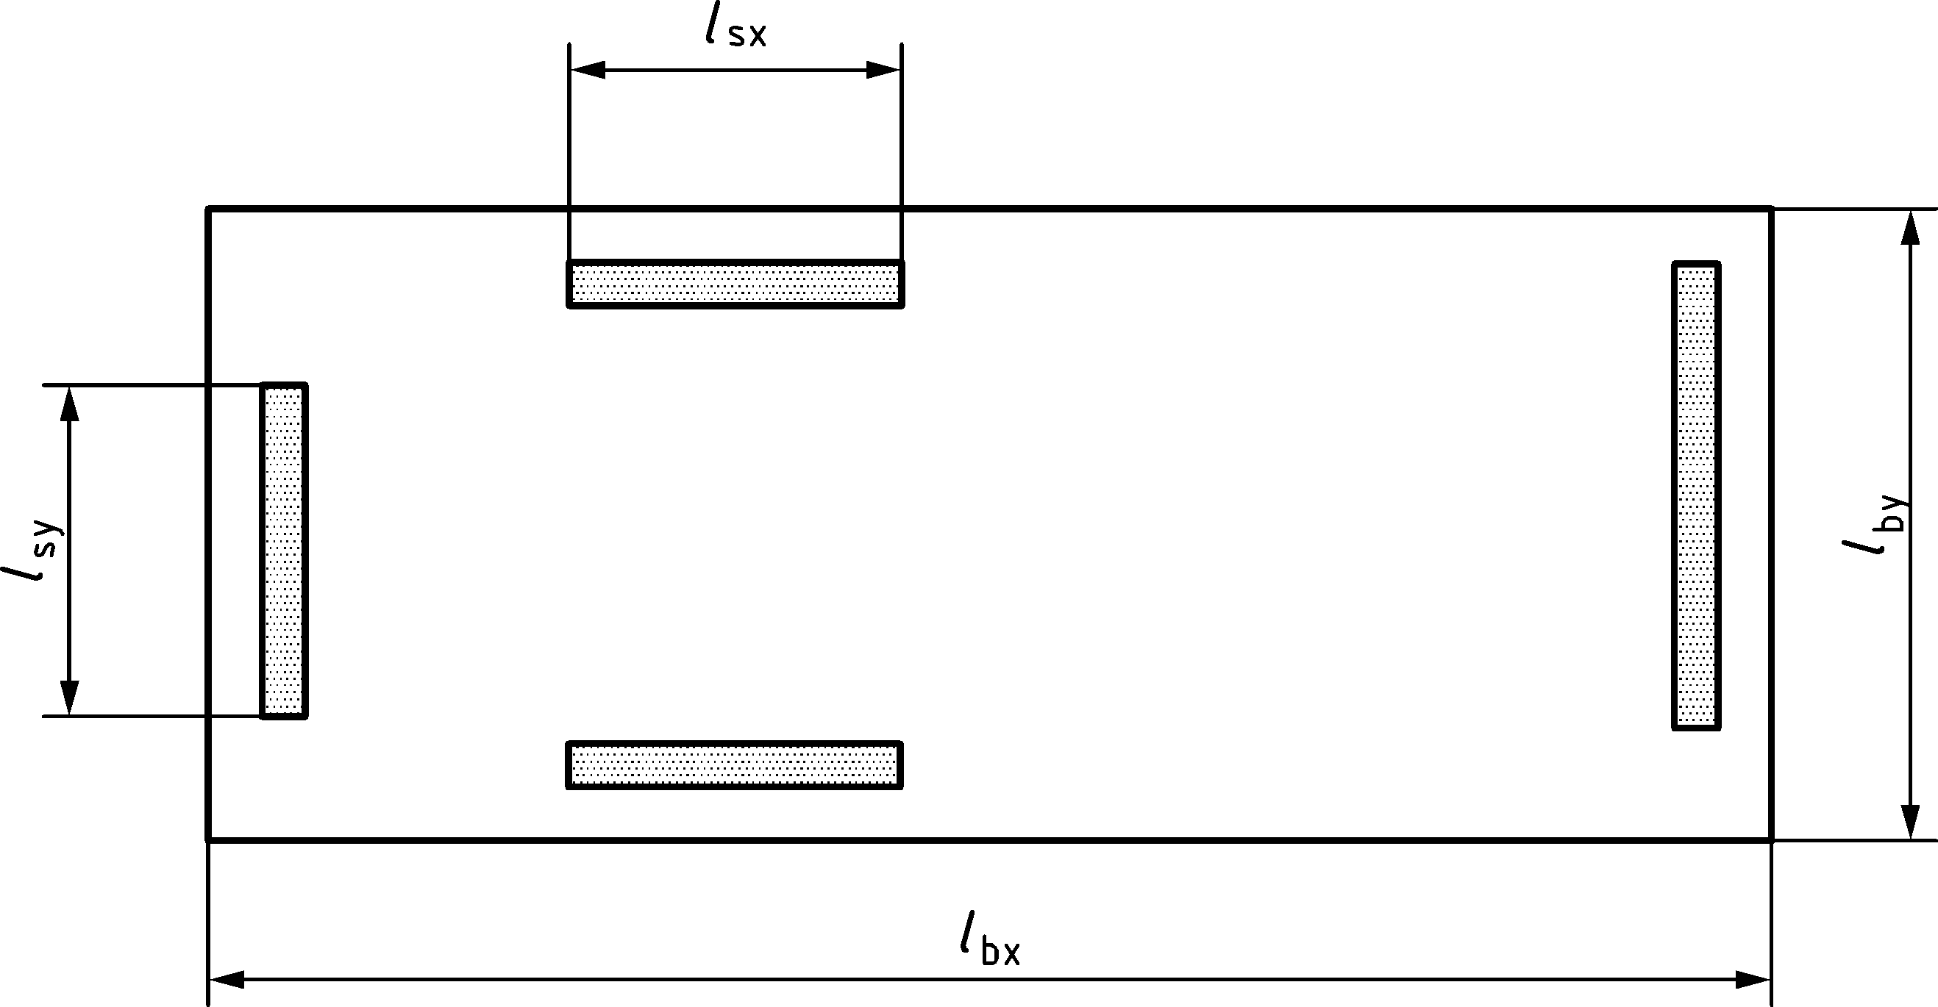

Figure A.1 — Layout of shear walls

1. (informative)  
     
   Simplified calculation method for the design of partition walls not designed for vertical loads and with limited lateral load
   1. Use of this Informative Annex

(1) This Informative Annex provides additional guidance to 6.7 for the design of partition walls subjected to limited lateral load.

NOTE National choice on the application of this Informative Annex is given in the National Annex. If the National Annex contains no information on the application of this Informative Annex, it can be used.

* 1. Scope and field of application

(1) This Informative Annex provides minimum wall thickness and limiting dimensions of partition walls not subjected to vertical loads other than self-weight and limited lateral loads, and the conditions for their use.

* 1. Conditions for use

(1) Use of the rules given in this annex depends on the following dimensional and constructional requirements being adhered to:

— the clear height *h* of the wall does not exceed 6,0 m;

— the clear length *l* of the wall between structural members that provide lateral restraint does not exceed 12,0 m;

— the thickness of the wall *t*, excluding any plaster, is not less than 50 mm.

(2) Lateral restraints at the top, or sides, or top and sides, of a wall should be designed to cope with time dependent movements of the connecting structural parts (e.g. deflection due to creep of a concrete floor).

(3) The rules given in this Annex apply only in circumstances where:

— the wall is situated inside a building;

— the external facade of the building is not pierced by a large door, or similar openings;

— the lateral loading on the wall is limited to loads from people and small furniture in rooms with small crowds of people (e.g. rooms and corridors in apartments, offices, hotels etc.);

— the wall is not subjected to any permanent or exceptional variable actions (including wind loading), other than that due to its self-weight;

— the wall is not used as a support for heavy objects such as furniture, sanitary or heating equipment;

— the stability of the wall is not adversely affected by the deformation of other parts of the building (e.g. by deflection of floors) or by operations within the building;

— the effect of any door or other openings formed in the wall is taken into account (see B.4(2) for methods of designing walls with openings);

— the effect of any chases in the wall is taken into account.

* 1. Minimum wall thickness and limiting dimensions

(1) The minimum thickness and limiting dimensions of the wall may be determined from Figure B.1 which provides for the following conditions of lateral restraint to the wall:

— type a: walls restrained along 4 edges;

— type b: walls restrained along all edges, except for one vertical edge;

— type c: walls restrained along all edges, except at the top edge;

— type d: walls restrained along the top and bottom edges only.

(2) For walls with openings, the minimum thickness and limiting dimensions may also be determined from Figure B.1 provided that the type of wall is derived from the basis illustrated in Figure B.2.

(3) The effect of openings in the wall may be ignored in the following circumstances:

— where the aggregated area of the openings is not greater than 2,5 % of the area of the wall;

and

— where the maximum area of any individual opening is not greater than 0,1 m2 and the length or width of an opening is not greater than 0,5 m.

(4) A type a wall with an opening should be considered as a type b wall, in which *l* is the greater of *l*1 and *l*2, see Figure B.2.

(5) For a type c wall with an opening, this annex is not applicable.

(6) For a type d wall with openings as in Figure B.3, this annex is applicable for the left, middle and the right part of the wall if *l*3 ≥ 2/3 *l* and *l*3 ≥ 2/3 *h*.

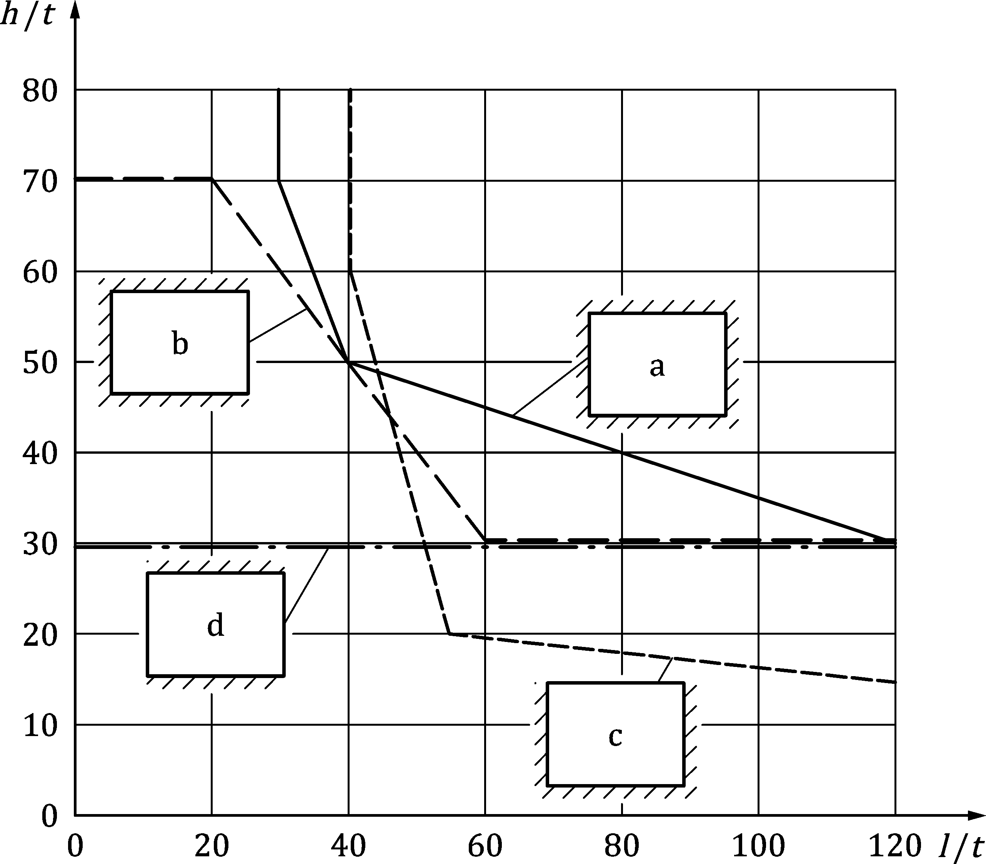

Key

|  |  |
| --- | --- |
|  | free end |
|  | restrained edge |
| a | type a wall |
| b | type b wall |
| c | type c wall |
| d | type d wall |

Figure B.1 — Limitation of size thickness ratio of internal walls  
not subject to vertical load but with limited lateral load

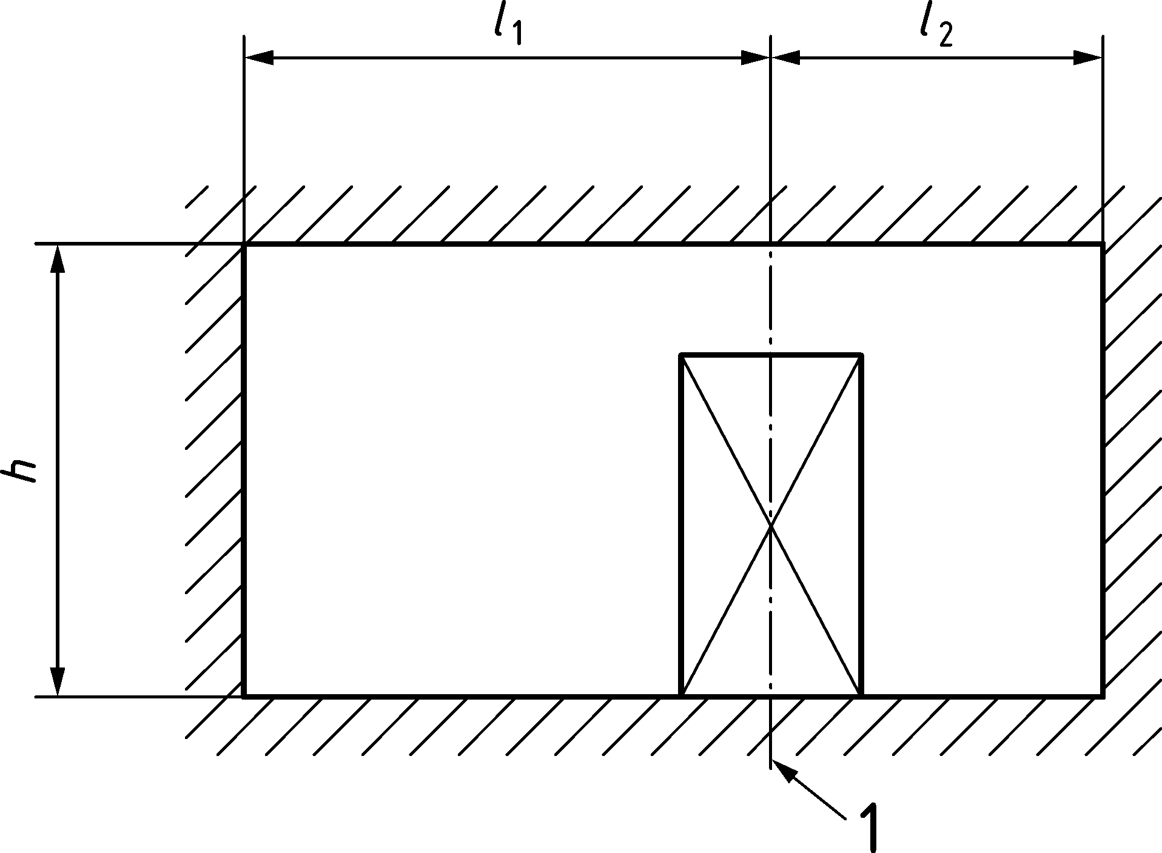

Key

|  |  |
| --- | --- |
| 1 | centre in line of opening |

Figure B.2 — Type a wall with an opening

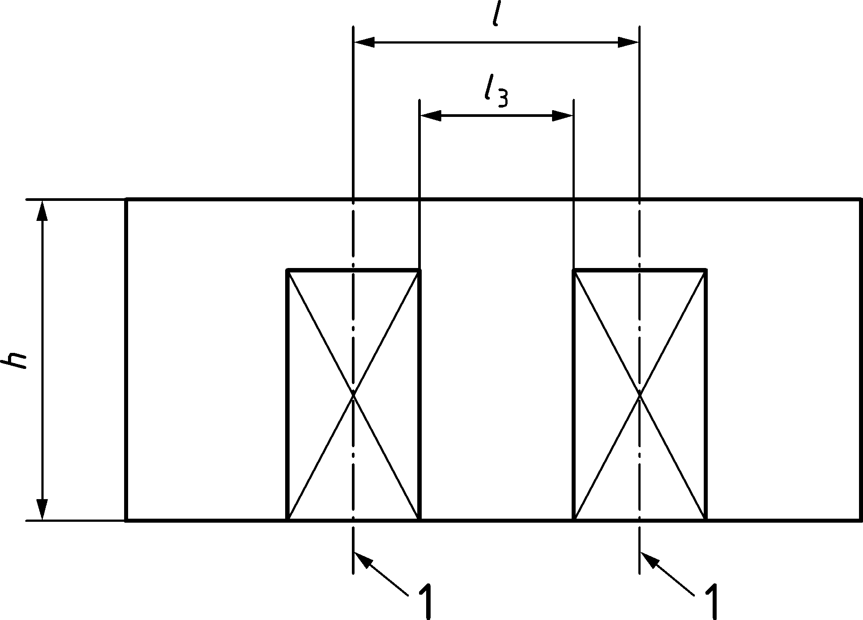

Key

|  |  |
| --- | --- |
| 1 | centre in line of opening |

Figure B.3 — Type d wall with openings

1. (informative)  
     
   Simplified calculation method for the design of walls subjected to uniform lateral design load and no vertical loads
   1. Use of this Informative Annex

(1) This Informative Annex provides additional guidance to 6.8 for the design of walls subjected to uniform lateral load.

NOTE National choice on the application of this Informative Annex is given in the National Annex. If the National Annex contains no information on the application of this Informative Annex, it can be used.

* 1. Scope and field of application

(1) This Informative Annex provides design graphs to verify the dimensions of mainly laterally loaded masonry walls and the conditions for their use.

* 1. Method

(1) The rules given in this clause apply only when the dimensions of the wall fulfil the requirements from B.4.

(2) The minimum thickness, in relation to the length and the height, for walls type a, b and c as described in B.4(3), may be determined from Figure C.1 to Figure C.9 where:

|  |  |
| --- | --- |
| *t* | is the thickness of the wall; |
| *l* | is the length of the wall; |
| *h* | is the height of the wall; |
| *f*xd1 | is the design flexural strength of masonry, with the plane of failure parallel to the bed joints; |
| *f*xd2 | is the design flexural strength of masonry, with the plane of failure perpendicular to the bed joints; |
| *p*Ed | is the design value of the lateral load on the wall according to prEN 1990 and EN 1991. |

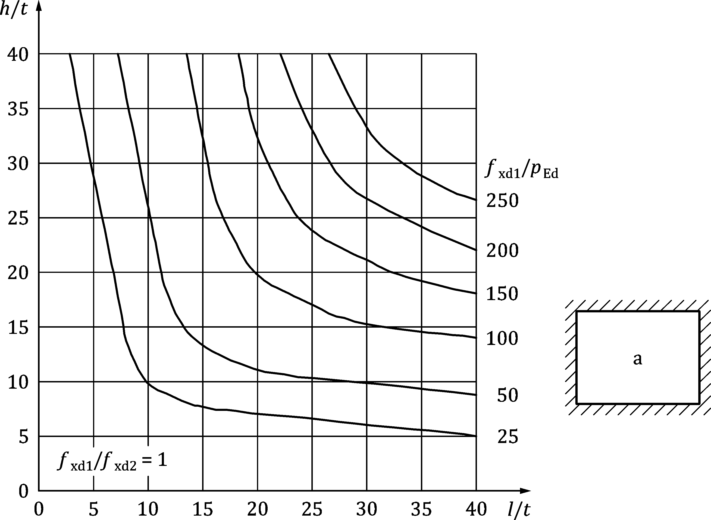

Figure C.1 — Thickness and size limitation of non-bearing walls with lateral loading.  
Wall type a – *f*xd1 / *f*xd2 = 1,0

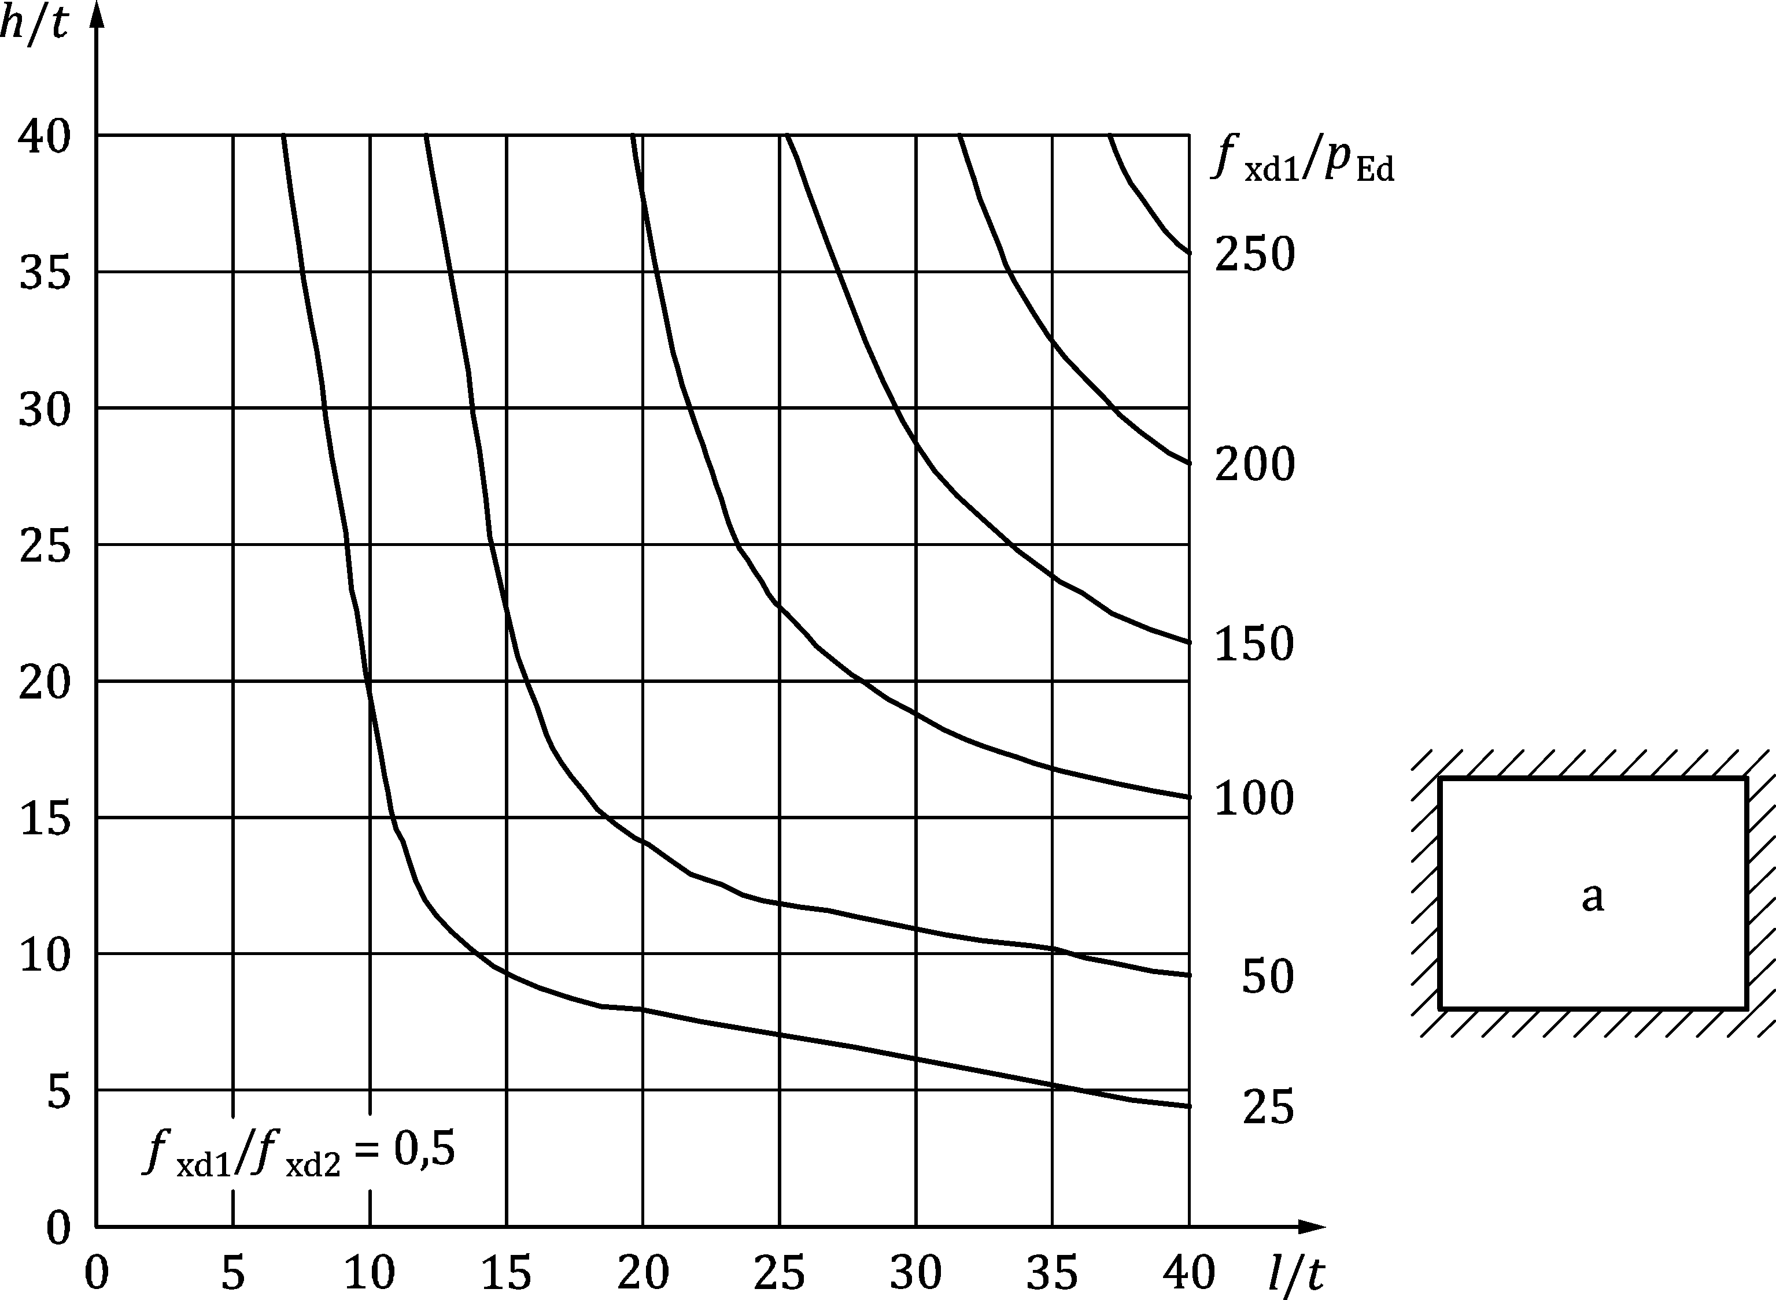

Figure C.2 — Thickness and size limitation of non-bearing walls with lateral loading.   
Wall type a – *f*xd1 / *f*xd2 = 0,5

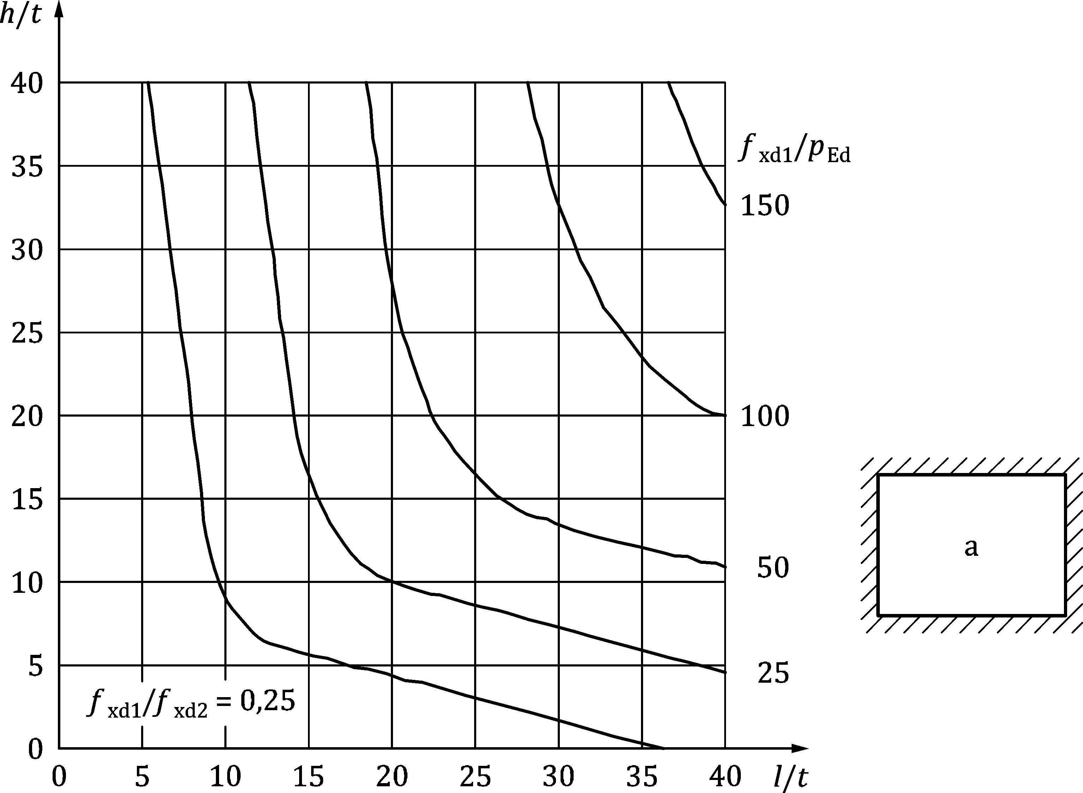

Figure C.3 — Thickness and size limitation of non-bearing walls with lateral loading.  
Wall type a – *f*xd1 / *f*xd2 = 0,25

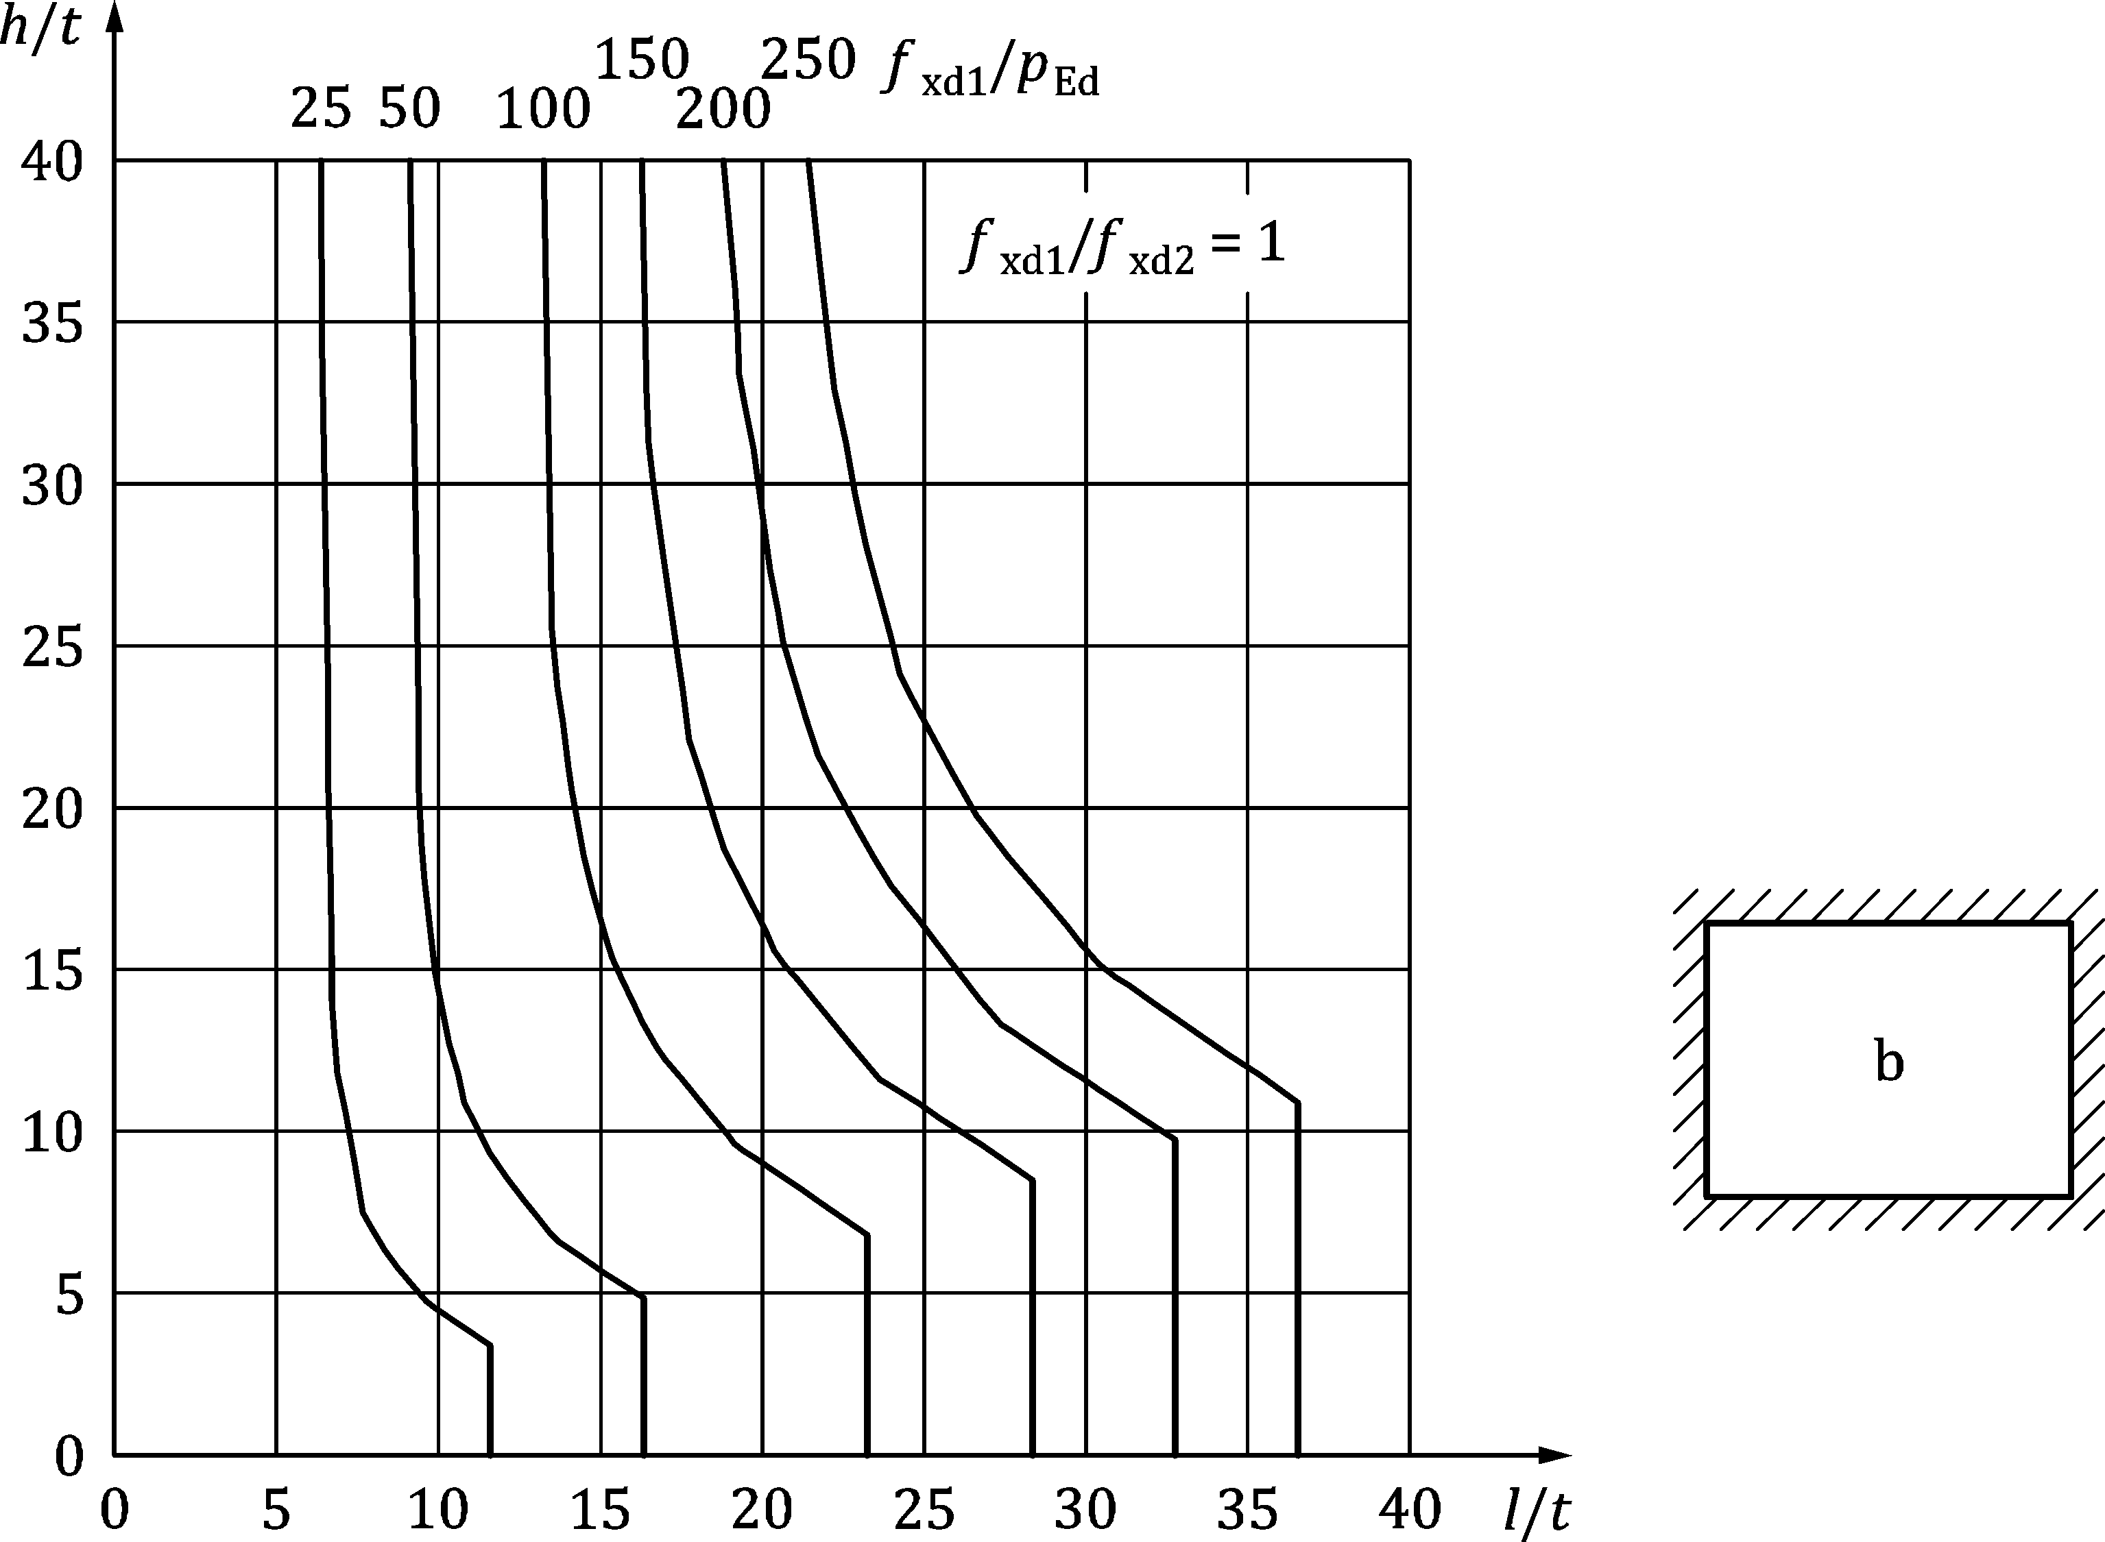

Figure C.4 — Thickness and size limitation of non-bearing walls with lateral loading.   
 Wall type b – *f*xd1 / *f*xd2 = 1,0

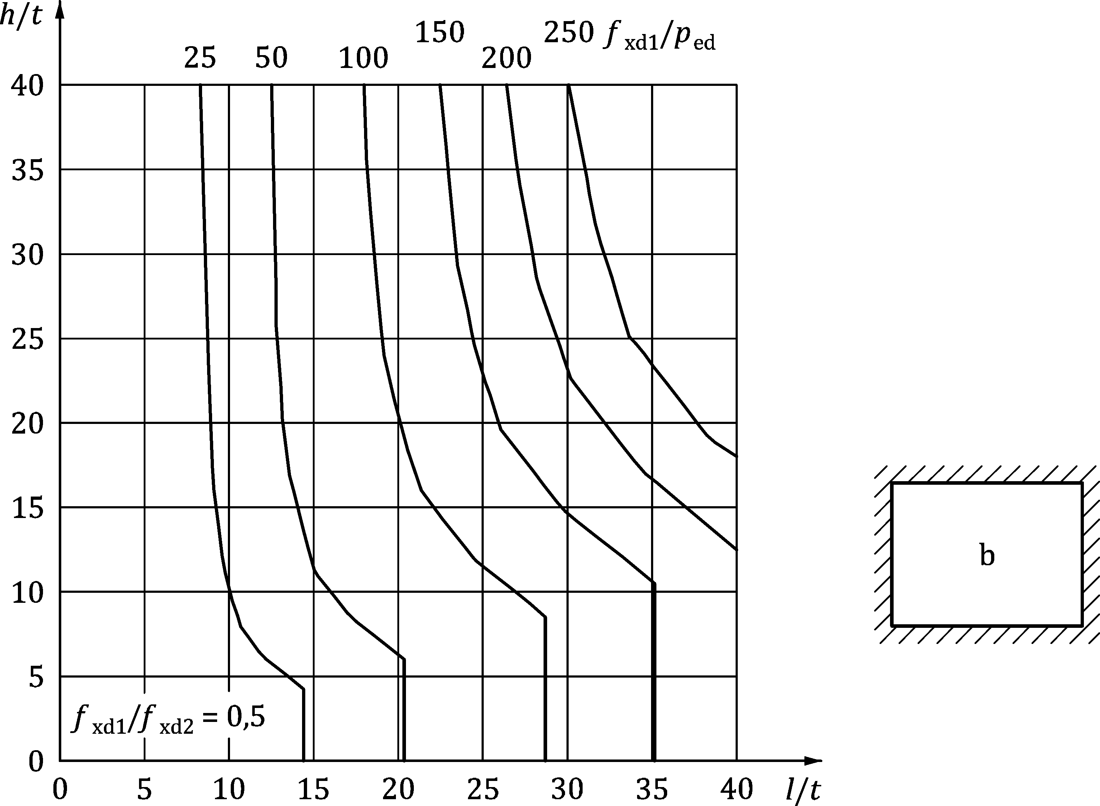

Figure C.5 — Thickness and size limitation of non-bearing walls with lateral loading.  
Wall type b – *f*xd1 / *f*xd2 = 0,5

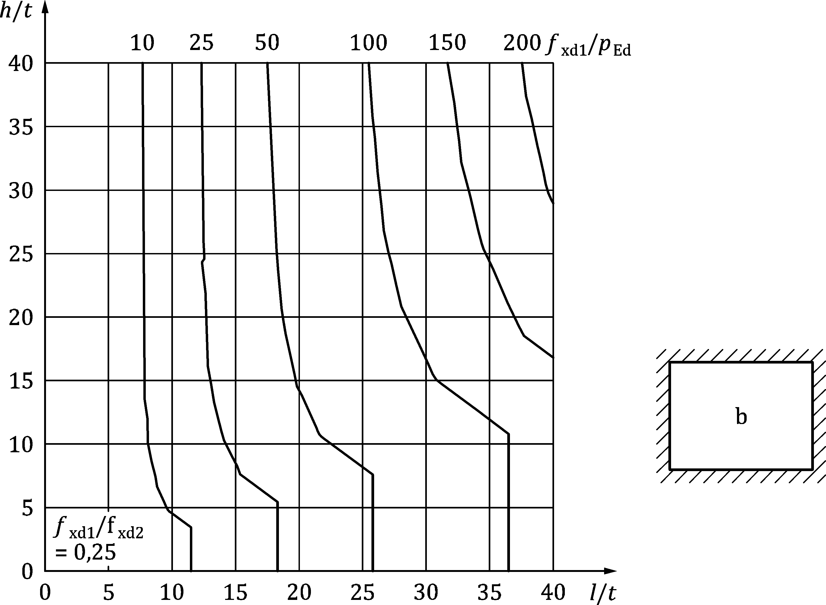

Figure C.6 — Thickness and size limitation of non-bearing walls with lateral loading.  
 Wall type b – *f*xd1 / *f*xd2 = 0,25

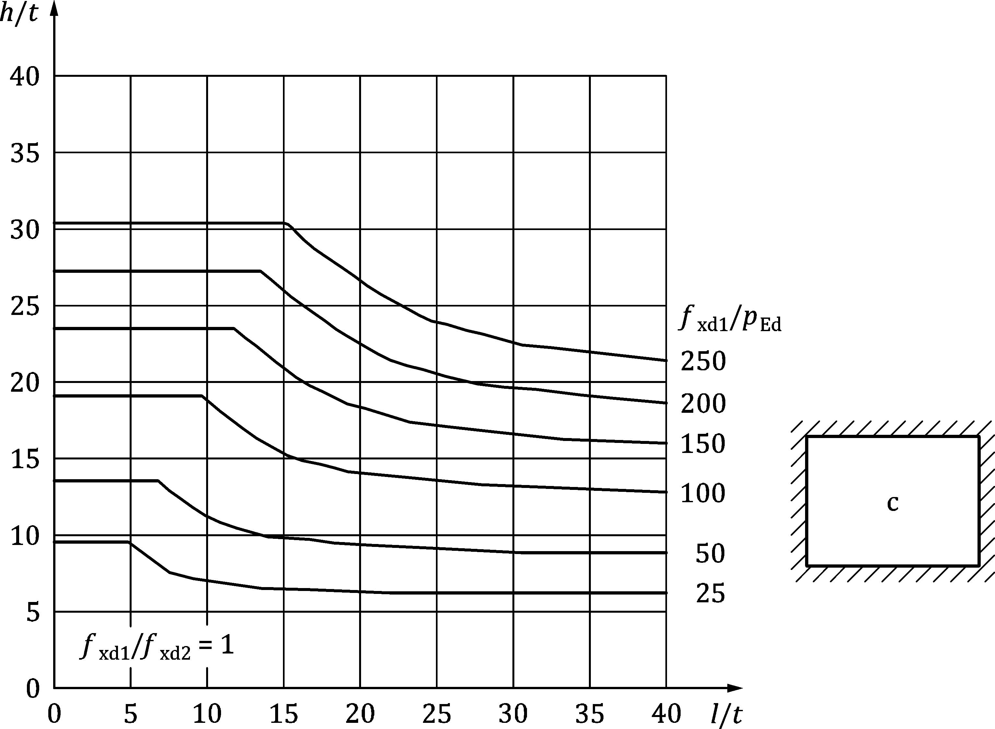

Figure C.7 — Thickness and size limitation of non-bearing walls with lateral loading.  
Wall type c – *f*xd1 / *f*xd2 = 1,0

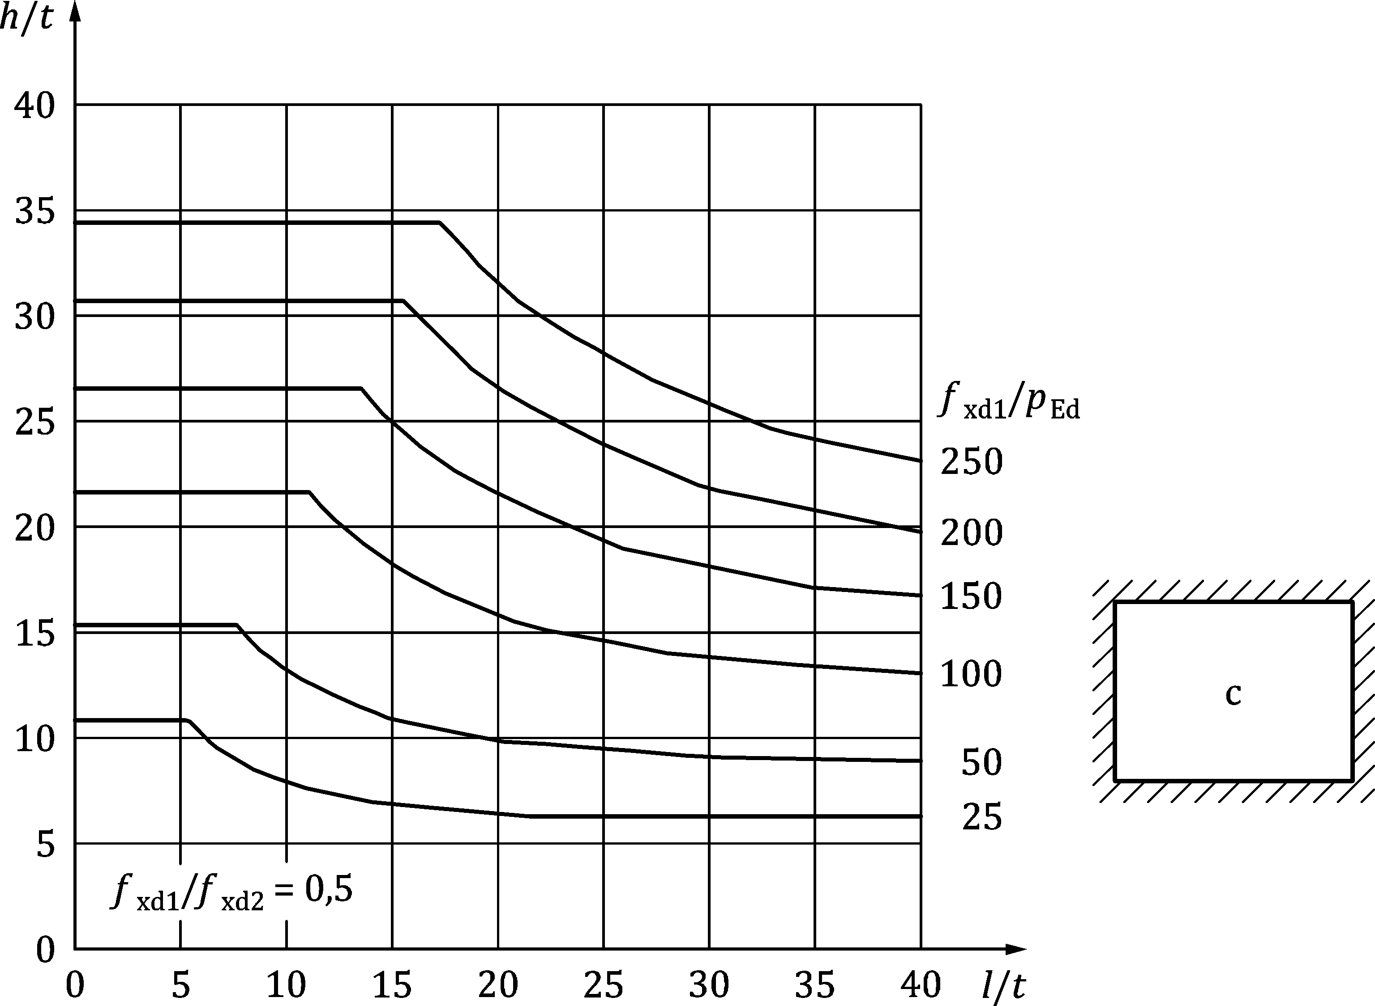

Figure C.8 — Thickness and size limitation of non-bearing walls with lateral loading.  
Wall type c – *f*xd1 / *f*xd2 = 0,5

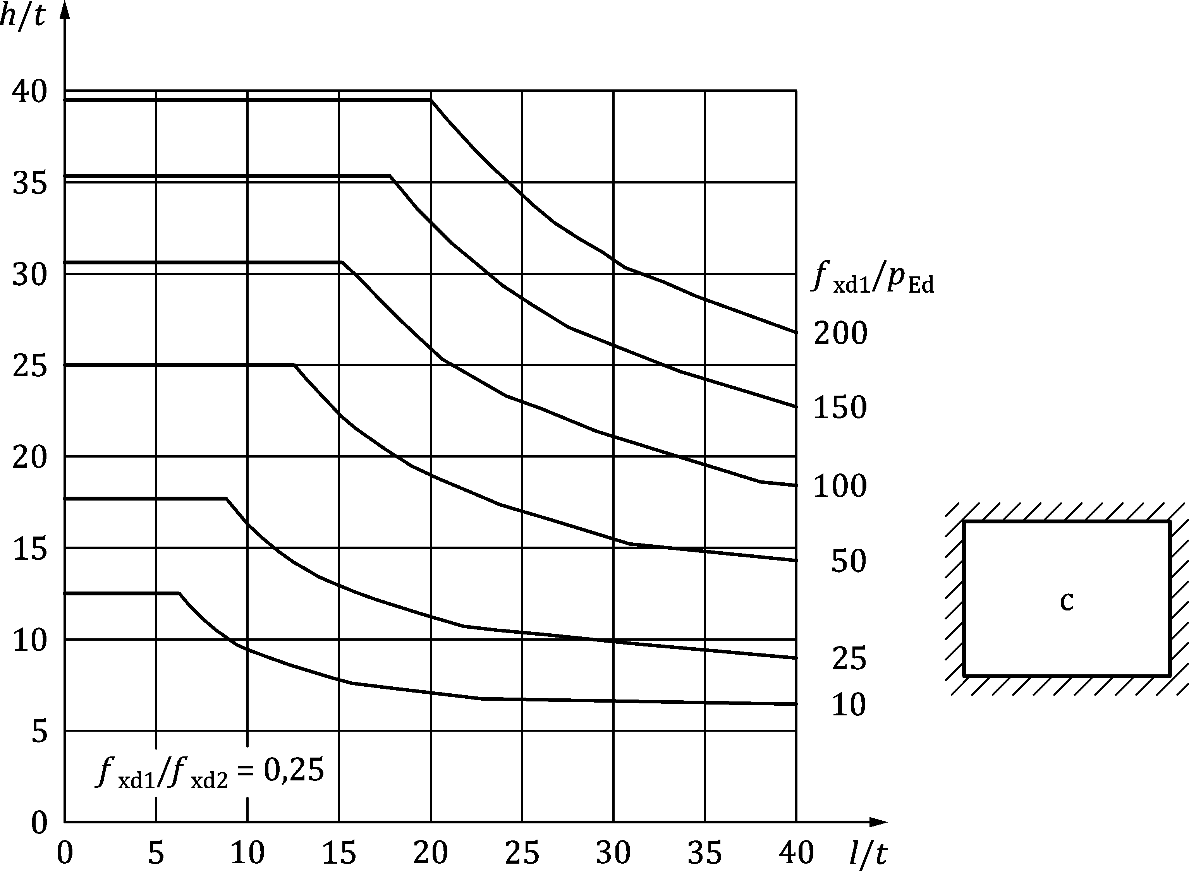

Figure C.9 — Thickness and size limitation of non-bearing walls with lateral loading.  
Wall type c – *f*xd1 / *f*xd2 = 0,25

1. (normative)  
     
   Simplified method of determining the characteristic strengths of masonry
   1. Use of this annex

(1) This Normative Annex contains additional provisions to 5.2 and 5.3 of this document for the determination of material properties

* 1. Scope and field of application

(1) This Normative Annex covers a limited number of combinations of masonry units and mortar types.

* 1. Characteristic compressive strength

(1) The characteristic compressive strength of masonry determined from a simplified method may be taken as *f*k.

NOTE 1 Values of *f*k in N/mm2 are given in Tables D.1 (NDP) to D.6 (NDP) unless the National Annex gives different values for use in a country.

NOTE 2 The tabulated values in Tables D.1 (NDP) to D.6 (NDP) are derived from 5.7.1(4) of prEN 1996‑1‑1:2019.

Table D.1 (NDP) — Values of *f*k in N/mm2 for Clay Units Group 1 and Group 1S

|  |  |  |  |  |  |  |  |  |
| --- | --- | --- | --- | --- | --- | --- | --- | --- |
| ***f*b (N/mm2)** | **General purpose mortar** | | | | **Thin joint** | **Light weight mortar** | | |
| **M2,5** | **M5** | **M10** | **M20** | **M2,5** | **M5** | **M10** |
| 2  4  6  8 | 1,2  1,9  2,5  3,1 | 1,4  2,4  3,1  3,8 | 1,4  2,7  3,8  4,7 | 1,4  2,7  4,1  5,4 | 1,4  2,4  3,4  4,4 | 0,6  1,0  1,4  1,7 | 0,7  1,3  1,7  2,1 | 0,7  1,5  2,1  2,6 |
| 10  12  16  20 | 3,6  4,1  5,0  5,9 | 4,5  5,1  6,2  7,3 | 5,5  6,2  7,6  8,9 | 6,8  7,7  9,4  11,0 | 5,3  6,2  7,9  9,6 | 2,0  2,2  2,8  3,2 | 2,4  2,8  3,4  4,0 | 3,0  3,4  4,2  4,9 |
| 25  30  50  75 | 6,9  7,8  11,2  14,9 | 8,5  9,6  13,8  18,3 | 10,4  11,9  17,0  22,5 | 12,9  14,6  20,9  27,7 | 11,6  13,5  20,9  20,9 | 3,8  4,3  6,1  8,1 | 4,6  5,3  7,5  10,0 | 5,7  6,5  9,3  12,3 |

Table D.2 (NDP) — Values of *f*k in N/mm2 for Clay Units Group 2

|  |  |  |  |  |  |  |  |  |
| --- | --- | --- | --- | --- | --- | --- | --- | --- |
| ***f*b (N/mm2)** | **General purpose mortar** | | | | **Thin joint** | **Light weight mortar** | | |
| **M2,5** | **M5** | **M10** | **M20** | **M2,5** | **M5** | **M10** |
| 2  4  6  8 | 1,0  1,6  2,1  2,5 | 1,1  1,9  2,6  3,1 | 1,1  2,2  3,1  3,8 | 1,1  2,2  3,3  4,4 | 1,1  1,8  2,5  3,0 | 0,5  0,9  1,2  1,4 | 0,6  1,1  1,4  1,7 | 0,6  1,2  1,7  2,1 |
| 10  12  16  20 | 3,0  3,4  4,1  4,8 | 3,7  4,2  5,1  5,9 | 4,5  5,1  6,3  7,3 | 5,5  6,3  7,7  9,0 | 3,5  4,0  4,9  5,7 | 1,6  1,9  2,3  2,7 | 2,0  2,3  2,8  3,3 | 2,5  2,8  3,5  4,1 |
| 25  30  50  75 | 5,6  6,4  9,2  12,2 | 6,9  7,9  11,3  15,0 | 8,5  9,7  13,9  18,4 | 10,5  12,0  17,1  22,7 | 6,7  7,6  10,8  10,8 | 3,1  3,6  5,1  6,8 | 3,9  4,4  6,3  8,3 | 4,7  5,4  7,7  10,2 |

Table D.3 (NDP) — Values of *f*k in N/mm2 for Clay Units Group 3 and 4

|  |  |  |  |  |  |  |  |  |  |
| --- | --- | --- | --- | --- | --- | --- | --- | --- | --- |
| ***f*b (N/mm2)** | **General purpose mortar** | | | | **Thin joint** | | **Light weight mortar** | | |
| **M2,5** | **M5** | **M10** | **M20** | **Group 3** | **Group 4** | **M2,5** | **M5** | **M10** |
| 2  4  6  8 | 0,7  1,2  1,6  2,0 | 0,9  1,5  2,0  2,4 | 0,9  1,7  2,4  3,0 | 0,9  1,7  2,6  3,4 | 0,8  1,3  1,8  2,1 | 0,6  1,1  1,6  2,0 | 0,4  0,7  0,9  1,1 | 0,5  0,9  1,1  1,4 | 0,5  1,0  1,4  1,7 |
| 10  12  16  20 | 2,3  2,6  3,2  3,8 | 2,8  3,2  4,0  4,6 | 3,5  4,0  4,9  5,7 | 4,3  4,9  6,0  7,0 | 2,5  2,8  3,5  4,1 | 2,5  2,9  3,7  4,5 | 1,3  1,5  1,8  2,1 | 1,6  1,8  2,3  2,6 | 2,0  2,3  2,8  3,2 |
| 25  30  50  75 | 4,4  5,0  7,1  9,5 | 5,4  6,1  8,8  11,6 | 6,6  7,6  10,8  14,3 | 8,2  9,3  13,3  17,7 | 4,8  5,4  7,7  7,7 | 5,4  6,3  9,7  9,7 | 2,5  2,8  4,1  5,4 | 3,1  3,5  5,0  6,7 | 3,8  4,3  6,2  8,2 |

Table D.4 (NDP) — Values of *f*k in N/mm2 for Calcium silicate, aggregate concrete and autoclaved aerated concrete units Group 1 and Group 1S

|  |  |  |  |  |  |  |  |  |
| --- | --- | --- | --- | --- | --- | --- | --- | --- |
| ***f*b (N/mm2)** | **General purpose mortar** | | | | **Thin joint** | **Light weight mortar (not for calcium silicate units)** | | |
| **M2,5** | **M5** | **M10** | **M20** | **M2,5** | **M5** | **M10** |
| 2  4  6  8 | 1,2  1,9  2,5  3,1 | 1,4  2,4  3,1  3,8 | 1,4  2,7  3,8  4,7 | 1,4  2,7  4,1  5,4 | 1,4  2,6  3,7  4,7 | 1,0  1,6  2,1  2,5 | 1,1  1,9  2,6  3,1 | 1,1  2,2  3,1  3,8 |
| 10  12  16  20 | 3,6  4,1  5,0  5,9 | 4,5  5,1  6,2  7,3 | 5,5  6,2  7,6  8,9 | 6,8  7,7  9,4  11,0 | 5,7  6,6  8,4  10,2 | 3,0  3,4  4,1  4,8 | 3,7  4,2  5,1  5,9 | 4,5  5,1  6,3  7,3 |
| 25  30  50 | 6,9  7,8  11,2 | 8,5  9,6  13,8 | 10,4  11,9  17,0 | 12,9  14,6  20,9 | 12,3  14,4  22,2 | 5,6  6,4  9,2 | 6,9  7,9  11,3 | 8,5  9,7  13,9 |

Table D.5 (NDP) — Values of *f*k in N/mm2 for Calcium silicate and aggregate concrete units Group 2

|  |  |  |  |  |  |  |  |  |
| --- | --- | --- | --- | --- | --- | --- | --- | --- |
| ***f*b (N/mm2)** | **General purpose mortar** | | | | **Thin joint** | **Light weight mortar (not for calcium silicate units)** | | |
| **M2,5** | **M5** | **M10** | **M20** | **M2,5** | **M5** | **M10** |
| 2  4  6  8 | 1,0  1,6  2,1  2,5 | 1,1  1,9  2,6  3,1 | 1,1  2,2  3,1  3,8 | 1,1  2,2  3,3  4,4 | 1,2  2,1  3,0  3,8 | 1,0  1,6  2,1  2,5 | 1,1  1,9  2,6  3,1 | 1,1  2,2  3,1  3,8 |
| 10  12  16  20 | 3,0  3,4  4,1  4,8 | 3,7  4,2  5,1  5,9 | 4,5  5,1  6,3  7,3 | 5,5  6,3  7,7  9,0 | 4,6  5,4  6,9  8,3 | 3,0  3,4  4,1  4,8 | 3,7  4,2  5,1  5,9 | 4,5  5,1  6,3  7,3 |
| 25  30  50 | 5,6  6,4  9,2 | 6,9  7,9  11,3 | 8,5  9,7  13,9 | 10,5  12,0  17,1 | 10,0  11,7  18,1 | 5,6  6,4  9,2 | 6,9  7,9  11,3 | 8,5  9,7  13,8 |

Table D.6 (NDP) — Values of *f*k in N/mm2 for Aggregate concrete units Group 3

|  |  |  |  |  |  |
| --- | --- | --- | --- | --- | --- |
| ***f*b (N/mm2)** | **General purpose mortar** | | | | **Thin joint** |
| **M2,5** | **M5** | **M10** | **M20** |
| 2  4  6  8 | 0,9  1,4  1,8  2,3 | 1,0  1,7  2,3  2,8 | 1,0  2,0  2,8  3,4 | 1,0  2,0  3,0  3,9 | 0,9  1,6  2,3  2,9 |
| 10  12  16  20 | 2,6  3,0  3,7  4,3 | 3,2  3,7  4,5  5,3 | 4,0  4,5  5,6  6,5 | 4,9  5,6  6,8  8,0 | 3,5  4,1  5,3  6,4 |
| 25  30  50 | 5,0  5,7  8,1 | 6,2  7,0  10,0 | 7,6  8,6  12,3 | 9,4  10,6  15,2 | 7,7  9,0  13,9 |

NOTE 3 EN 998-2 gives no limit for the thickness of joints made of thin layer mortar; the values in the above tables are based on a nominal thickness between 1 mm and 3 mm to ensure that the thin layer mortar has the enhanced properties required to achieve the given values.

NOTE 4 The thickness of the masonry is equal to the width or length of the unit, so that there is no mortar joint parallel to the face of the wall through all or any part of the length of the wall.

NOTE 5 The coefficient of variation of the compressive strength of the masonry units is not greater than 25 %.

(2) For masonry made of general purpose mortar where Group 2 and Group 3 aggregate concrete units are used with the vertical cavities filled completely with concrete, the value of *f*b should be obtained by considering the units to be Group 1 with a compressive strength corresponding to the compressive strength of the units or of the concrete infill, whichever is the lesser.

* 1. Characteristic flexural strengths

(1) The characteristic flexural strengths of masonry determined from a simplified method may be taken as *f*xk1 and *f*xk2.

NOTE 1 Values of *f*xk1 and *f*xk2 are given in Tables D.7 (NDP) and D.8 (NDP) unless the National Annex gives different values for use in a country.

NOTE 2 The tabulated values in Tables D.7 (NDP) and D.8 (NDP) are derived from prEN 1996‑1‑1:2019, 5.7.4(4).

Table D.7 (NDP) — Characteristic flexural strength fxk1

|  |  |  |  |  |
| --- | --- | --- | --- | --- |
| **Masonry unit** | ***f*xk1 (N/mm2)** | | | |
| **General purpose mortar** | | **Thin layer mortar ≥ M5** | **Light weight mortar ≥ M5** |
| **< M5** | **≥ M5** |
| Clay | 0,10 | 0,10 | 0,02 | 0,10 |
| Calcium silicate | 0,05 | 0,10 | 0,20 | not used |
| Aggregate concrete | 0,05 | 0,10 | 0,20 | not used |
| Autoclaved aerated concrete | 0,05 | 0,10 | 0,15 | 0,10 |

Table D.8 (NDP) — Characteristic flexural strength fxk2

|  |  |  |  |  |  |
| --- | --- | --- | --- | --- | --- |
| **Masonry unit** | | ***f*xk2 (N/mm2)** | | | |
| **General purpose mortar** | | **Thin layer mortar ≥ M5** | **Light weight mortar ≥ M5** |
| **< M5** | **≥ M5** |
| Clay | | 0,20 | 0,40 | 0,02 | 0,10 |
| Calcium silicate | | 0,20 | 0,40 | 0,30 | not used |
| Aggregate concrete | | 0,20 | 0,40 | 0,30 | not used |
| Autoclaved aerated concrete | *ρ* < 400 kg/m3 | 0,20 | 0,20 | 0,20 | 0,15 |
| *ρ* ≥ 400 kg/m3 | 0,20 | 0,40 | 0,30 | 0,15 |

(2) For masonry made with autoclaved aerated concrete units laid in thin layer mortar, *f*xk1 and *f*xk2 values may be taken from Table D.7 (NDP) or Table D.8 (NDP) or alternatvely taken as *f*xk1 = 0,035 *f*b, with filled and unfilled perpend joints and *f*xk2 = 0,035 *f*b with filled perpend joints or 0,025 *f*b with unfilled perpend joints.

Bibliography

**References contained in permissions (i.e. “can” clauses) and notes**

The following documents are cited informatively in the document, for example in "can" clauses and in notes.

[1] EN 998‑2, Specification for mortar for masonry — Part 2: Masonry mortar