CEN/TC 250

Date: 2020-11

prEN 1991‑2:2020

Secretariat: BSI

Eurocode 1 — Actions on structures — Part 2: Traffic loads on bridges and other civil engineering works

Eurocode 1 — Einwirkungen auf Tragwerke — Teil 2: Verkehrslasten auf Brücken und anderen Ingenieurbauwerken

Eurocode 1 — Actions sur les structures — Partie 2: Actions sur les ponts et autres ouvrages d’arts, dues au trafic

ICS:

Contents Page

European foreword 5

Introduction 6

1 Scope 10

2 Normative references 10

3 Terms and definitions 11

3.1 Terms and definitions 11

3.2 Symbols and abbreviations 14

4 Classification of actions 20

4.1 General 20

4.2 Variable actions 20

4.3 Accidental actions 22

5 Design situations 22

5.1 General 22

5.2 Simultaneity of traffic loads 22

6 Road traffic actions and other actions specifically for road bridges 23

6.1 Field of application 23

6.2 Representation of actions 23

6.2.1 Models of road traffic loads 23

6.2.2 Loading classes 24

6.2.3 Divisions of the carriageway into notional lanes 24

6.2.4 Location and numbering of the lanes for design 25

6.2.5 Application of the load models on the individual lanes 26

6.3 Vertical loads — Characteristic values 26

6.3.1 General 26

6.3.2 Load Model 1 27

6.3.3 Load Model 2 29

6.3.4 Load Model 3 (special vehicles) 30

6.3.5 Load Model 4 (crowd loading) 30

6.3.6 Dispersal of concentrated loads 31

6.4 Horizontal forces — characteristic values 32

6.4.1 Braking and acceleration forces 32

6.4.2 Centrifugal and other transverse forces 32

6.5 Groups of traffic loads on road bridges (multi component actions) 33

6.5.1 Characteristic values in persistent design situations 33

6.5.2 Other representative values 35

6.5.3 Groups of loads in transient design situations 35

6.6 Fatigue load models 35

6.6.1 General 35

6.6.2 Dynamic amplification factor 36

6.6.3 Fatigue Load Models location for global and local effects 37

6.6.4 Traffic category on the bridge 38

6.6.5 Fatigue Load Model 1 (similar to LM 1) 38

6.6.6 Fatigue Load Model 2 (set of “frequent” lorries) 39

6.6.7 Fatigue Load Model 3 (single vehicle model) 40

6.6.8 Fatigue Load Model 4 (set of “standard” lorries) 40

6.6.9 Fatigue Load Model 5 (based on recorded road traffic data) 43

6.7 Collision and other actions for accidental design situations 43

6.7.1 General 43

6.7.2 Collision forces from vehicles under the bridge 43

6.7.3 Actions from vehicles on the bridge 43

6.8 Actions on pedestrian parapets 47

6.9 Load model for geotechnical structures — characteristic values 47

6.9.1 General 47

6.9.2 Vertical loads 48

6.9.3 Horizontal force for abutments 48

7 Actions on footways, cycle ways and footbridges 49

7.1 Field of application 49

7.2 Representation of actions 49

7.2.1 Models of the loads 49

7.2.2 Application of the load models 50

7.3 Static models for vertical loads — characteristic values 50

7.3.1 General 50

7.3.2 Uniformly distributed load 50

7.3.3 Concentrated load 51

7.3.4 Service vehicle 51

7.4 Static model for horizontal forces — characteristic values (footbridges only) 51

7.5 Groups of traffic loads (footbridges only) 52

7.6 Collision and other actions for accidental design situations (footbridges only) 52

7.6.1 General 52

7.6.2 Collision forces from traffic under the footbridge 52

7.6.3 Accidental presence of vehicles on the footbridge 53

7.7 Dynamic models of pedestrian loads (footbridges only) 53

7.8 Actions on parapets 54

7.9 Load model for abutments and walls adjacent to bridges 54

8 Rail traffic actions and other actions specifically for railway bridges 54

8.1 Field of application 54

8.2 Representation of actions — nature of rail traffic loads 55

8.3 Vertical loads — characteristic values (static effects) and eccentricity and distribution of loading 55

8.3.1 General 55

8.3.2 Load Model 71 56

8.3.3 Load Models SW/0 and SW/2 57

8.3.4 Load Model “unloaded train” 58

8.3.5 Eccentricity of vertical loads (Load Models 71 and SW/0) 58

8.3.6 Distribution of point loads or axle loads by the rails, sleepers and ballast 59

8.3.7 Actions for non-public footways 63

8.4 Dynamic effects (including resonance) 63

8.4.1 General 63

8.4.2 Factors influencing dynamic behaviour 63

8.4.3 General design rules 64

8.4.4 Conditions for requiring additional dynamic analysis 64

8.4.5 Dynamic factor *Φ* (*Φ*2, *Φ*3) 67

8.4.6 Dynamic analysis 72

8.5 Horizontal forces — characteristic values 82

8.5.1 Centrifugal forces 82

8.5.2 Nosing force 87

8.5.3 Actions due to traction and braking 87

8.5.4 Combined response of structure and track to variable actions 88

8.6 Aerodynamic actions from passing trains 100

8.6.1 General 100

8.6.2 Simple vertical surfaces parallel to the track (e.g. noise barriers) 100

8.6.3 Simple horizontal surfaces above the track (e.g. overhead protective structures) 106

8.6.4 Simple horizontal surfaces adjacent to the track (e.g. platform canopies with no vertical wall) 108

8.6.5 Multiple-surface structures alongside the track with vertical and horizontal or inclined surfaces (e.g. bent noise barriers, platform canopies with vertical walls etc.) 109

8.6.6 Surfaces enclosing the structure gauge of the tracks over a limited length (up to 20 m) (horizontal surface above the tracks and at least one vertical wall, e.g. scaffolding, temporary constructions) 110

8.7 Derailment and other actions for railway bridges 110

8.7.1 General 110

8.7.2 Derailment actions from rail traffic on a railway bridge 111

8.7.3 Derailment under or adjacent to a structure and other actions for Accidental Design Situations 112

8.7.4 Other actions 113

8.8 Further application rules for traffic loads on railway bridges 113

8.8.1 General 113

8.8.2 Groups of Loads — Characteristic values of the multicomponent action 114

8.8.3 Groups of Loads — Other representative values of the multicomponent actions 116

8.8.4 Traffic loads in Transient Design Situations 117

8.9 Traffic loads for fatigue 117

8.10 Static load models for geotechnical structures — characteristic values 118

Annex A (informative) Models of special vehicles for road bridges 120

Annex B (informative) Fatigue life assessment for road bridges Assessment method based on recorded traffic 125

Annex C (normative) Dynamic factors 1 + *φ* for Real Trains 130

Annex D (normative) Basis for the fatigue assessment of railway structures 132

Annex E (informative) Limits of validity of Load Model HSLM 139

Annex F (informative) Load models for rail traffic loads in Transient Design Situations 143

Annex G (informative) Dynamic load models for footbridges 144

Bibliography 152

European foreword

This document (prEN 1991‑2:2021) has been prepared by Technical Committee CEN/TC 250 “Structural Eurocodes”, the secretariat of which is held by BSI. CEN/TC 250 is responsible for all Structural Eurocodes and has been assigned responsibility for structural and geotechnical design matters by CEN.

This document is currently submitted to the CEN Enquiry.

This document will supersede EN 1991‑2:2003.

The first generation of EN Eurocodes was published between 2002 and 2007. This document forms part of the second generation of the Eurocodes, which have been prepared under Mandate M/515 issued to CEN by the European Commission and the European Free Trade Association.

The Eurocodes have been drafted to be used in conjunction with relevant execution, material, product and test standards, and to identify requirements for execution, materials, products and testing that are relied upon by the Eurocodes.

The Eurocodes recognize the responsibility of each Member State and have safeguarded their right to determine values related to regulatory safety matters at national level through the use of National Annexes.

Introduction

**0.1 Introduction to the Eurocodes**

The structural Eurocodes comprise the following standards generally consisting of a number of Parts:

— EN 1990, *Eurocode: Basis of structural and geotechnical design*

— EN 1991, *Eurocode 1: Actions on structures*

— EN 1992, *Eurocode 2: Design of concrete structures*

— EN 1993, *Eurocode 3: Design of steel structures*

— EN 1994, *Eurocode 4: Design of composite steel and concrete structures*

— EN 1995, *Eurocode 5: Design of timber structures*

— EN 1996, *Eurocode 6: Design of masonry structures*

— EN 1997, *Eurocode 7: Geotechnical design*

— EN 1998, *Eurocode 8: Design of structures for earthquake resistance*

— EN 1999, *Eurocode 9: Design of aluminium structures*

— < New parts >

The Eurocodes are intended for use by designers, clients, manufacturers, constructors, relevant authorities (in exercising their duties in accordance with national or international regulations), educators, software developers, and committees drafting standards for related product, testing and execution standards.

NOTE Some aspects of design are most appropriately specified by relevant authorities or, where not specified, can be agreed on a project-specific basis between relevant parties such as designers and clients. The Eurocodes identify such aspects making explicit reference to relevant authorities and relevant parties.

**0.2 Introduction to the** **EN** **1991** **series**

The EN 1991 series provides the actions to be considered for the structural design of buildings, bridges and other civil engineering works, or parts thereof, including temporary structures, in conjunction with prEN 1990 and the other Eurocodes.

The actions on structures, including in some cases geotechnical structures in conjunction with the EN 1997 series as appropriate, provided in the EN 1991 series are intended to be applied in conjunction with the other Eurocodes for the verification of safety, serviceability and durability, as well as robustness of structures, including the execution phase.

EN 1991 does not cover actions for structures in seismic regions, unless explicitly prescribed by the EN 1998 series.

The EN 1991 series is applicable to existing structures for their:

— structural assessment,

— retrofitting (strengthening, repair) design,

— assessment for changes of use.

NOTE 1 In this case, additional or amended provisions can be necessary.

The EN 1991 series is applicable to the design of structures where materials or actions outside the scope of the other Eurocodes are involved.

NOTE 2 In this case additional or amended provisions can be necessary.

**0.3 Introduction to** **prEN** **1991‑2**

prEN 1991‑2 gives design guidance and actions due to road and railway traffic on bridges and civil engineering works

prEN 1991‑2 is addressed to all parties involved in construction activities (e.g. public authorities, clients, designers, contractors, producers, consultants, committees drafting standards for structural design and related product, testing and execution standards, etc.).

prEN 1991‑2 is intended to be used with prEN 1990, the other parts of the EN 1991 series and the EN 1992 series to EN 1999 series for the design of structures.

**Additional information specific to** **prEN** **1991‑2**

prEN 1991‑2 defines models of traffic loads for the design of road bridges, footbridges and railway bridges. For the design of new bridges, prEN 1991‑2 is intended to be used, for direct application, together with the Eurocodes.

The bases for combinations of traffic loads with non-traffic loads are given in prEN 1990:2021, A.2.

For road bridges, Load Models 1 and 2, defined in 6.3.2 and 6.3.3, and taken into account with adjustment factors *α* and *β* equal to 1, are deemed to represent the most severe traffic met or expected in practice, other than that of special vehicles requiring permits to travel, on the main routes of European countries. The traffic on other routes in these countries and in some other countries could be substantially lighter, or better controlled. However it should be noted that a great number of existing bridges do not meet the requirements of this prEN 1991‑2 and the associated Structural Eurocode series EN 1992 to EN 1999.

For railway bridges, Load Model 71 (together with Load Model SW/0 for continuous bridges), defined in 8.3.2, represent the static effect of standard rail traffic operating over the standard track gauge or wider than the standard track gauge European railway network. Load Model SW/2, defined in 8.3.3, represents the static effect of heavy rail traffic.

Provision is made for varying the specified loading to cater for variations in the type, volume and maximum weight of rail traffic on different railways, as well as for different qualities of track.

In addition two other load models are given for railway bridges:

— load model “unloaded train” for checking the lateral stability of bridges and

— load model HSLM to represent the loading from passenger trains at speeds exceeding 200 km/h.

Guidance is also given on aerodynamic actions on structures adjacent to railway tracks as a result of passing trains and on other actions from railway infrastructure.

Public authorities could also have responsibilities for the issue of regulations on authorized traffic (especially on vehicle loads) and for delivery and control dispensations when relevant, e.g. for special vehicles.

**0.4 Verbal forms used in the Eurocodes**

The verb “shall” expresses a requirement strictly to be followed and from which no deviation is permitted in order to comply with the Eurocodes.

The verb “should” expresses a highly recommended choice or course of action. Subject to national regulation and/or any relevant contractual provisions, alternative approaches could be used/adopted where technically justified.

The verb “may” expresses a course of action permissible within the limits of the Eurocodes.

The verb “can” expresses possibility and capability; it is used for statements of fact and clarification of concepts.

**0.5 National Annex for** **prEN** **1991‑2**

National choice is allowed in this document where explicitly stated within notes. National choice includes the selection of values for Nationally Determined Parameters (NDPs).

The national standard implementing prEN 1991‑2 can have a National Annex containing all national choices to be used for the design of buildings and civil engineering works to be constructed in the relevant country.

When no national choice is given, the default choice given in this document is to be used.

When no national choice is made and no default is given in this document, the choice can be specified by a relevant authority or, where not specified, agreed for a specific project by relevant parties.

National choice is allowed in EN 1991‑2 through notes to the following:

|  |  |  |  |
| --- | --- | --- | --- |
| 4.3(1) | 6.7.3.3(2) – 2 choices | 8.4.6.1.2(3) | 8.5.4.6 |
| 5.2(4) | 6.7.3.3(5) – 2 choices | 8.4.6.2(1) | 8.5.4.6.3(1) |
| 6.1(1) | 6.7.3.3(6) | 8.4.6.2(2) | 8.5.4.6.3(4) |
| 6.1(2) | 6.7.3.4 | 8.4.6.2(7) | 8.6.1(5) |
| 6.2.1(1) | 6.8(2) – 2 choices | 8.4.6.2(8) | 8.7.2(2) |
| 6.2.1(2) | 6.8(6) | 8.4.6.2(9) | 8.7.2(7) |
| 6.2.3(1) | 6.9.1(1) | 8.4.6.3.1(3) | 8.7.2(8) |
| 6.3.2(4) | 6.9.2(1) – 2 choices | 8.4.6.3.2(2) | 8.7.4(2) |
| 6.3.2(9) | 7.3.3(1) | 8.4.6.3.3(4) | 8.8.1(1) |
| 6.3.3(1) | 7.3.4(4) | 8.4.6.3.3(5) | 8.8.1(2) |
| 6.3.3(4) | 7.4(1) | 8.4.6.5(4) | 8.8.1(7) |
| 6.3.4(1) | 7.6.3(1) | 8.4.6.6(4) | 8.8.2(3) |
| 6.3.5(1) | 8.1(3) | 8.4.6.6(6) | 8.8.3.1(1) |
| 6.4.1(2) | 8.1(7) – 2 choices | 8.5.1(2) | 8.8.3.2(1) |
| 6.4.1(4) | 8.3.2(4) | 8.5.1(7) | 8.8.4(1) |
| 6.4.2(5) | 8.3.3(4) | 8.5.1(12) | 8.9(2) |
| 6.5.1 – 2 choices | 8.3.6.4(5) | 8.5.3(10) | 8.9(3) |
| 6.5.3(1) | 8.3.7(4) | 8.5.3(11) | 8.9(4) |
| 6.6.1(2) – 2 choices | 8.4.4(1) | 8.5.3(14) | 8.10(1) – 3 choices |
| 6.6.2(2) | 8.4.5.2(1) | 8.5.4.1(5) | 8.10(8) |
| 6.6.4(1) | 8.4.5.4(1) | 8.5.4.3(1) | C (3) – 2 choices |
| 6.6.7(4) | 8.4.6.1.1(2) | 8.5.4.3(2) – 2 choices | D.2(2) |
| 6.6.8(2) | 8.4.6.1.1(4) | 8.5.4.4(3) |  |
| 6.6.8(5) | 8.4.6.1.1(5) | 8.5.4.5 |  |
| 6.6.9(1) | 8.4.6.1.1(7) | 8.5.4.5.1(3) – 2 choices |  |

National choice is allowed in EN 1991‑2 on the application of the following informative annexes:

|  |  |  |  |
| --- | --- | --- | --- |
| Annex A | Annex B | Annex E | Annex F |
| Annex G |  |  |  |

The National Annex can contain, directly or by reference, non-contradictory complementary information for ease of implementation, provided it does not alter any provisions of the Eurocodes.

# Scope

(1) This document defines imposed loads (models and representative values) associated with road traffic, pedestrian actions and rail traffic which include, when relevant, dynamic effects and centrifugal, braking and acceleration actions and actions for accidental design situations.

(2) Imposed loads defined in this document are applicable for the design of new bridges, including piers, abutments, upstand walls, wing walls and flank walls, noise barriers, canopies etc., and their foundations. Where appropriate, the loads can also be considered as a basis for assessment or modification of existing structures in combination with complementary conditions if necessary.

(3) The load models and values given in this document are also applicable for the design of retaining walls adjacent to roads and railway lines and the design of earthworks subject to road or rail traffic actions. This document also provides applicability conditions for specific load models.

(4) This document is intended to be used with prEN 1990, the other parts of the EN 1991 series and the EN 1992 series to EN 1999 series for the design of structures.

# Normative references

The following documents are referred to in the text in such a way that some or all of their content constitutes requirements of this document. For dated references, only the edition cited applies. For undated references, the latest edition of the referenced document (including any amendments) applies.

NOTE See the Bibliography for a list of other documents cited that are not normative references, including those referenced as recommendations (i.e. in ‘should’ clauses), permissions (‘may’ clauses), possibilities ('can' clauses), and in notes.

prEN 1990:2021, Eurocode: Basis of Structural and Geotechnical Design

EN 1992 (all parts), Eurocode 2: Design of concrete structures

EN 1993 (all parts), Eurocode 3: Design of steel structures

EN 1994 (all parts), Eurocode 4: Design of composite steel and concrete structures

EN 1995 (all parts), Eurocode 5: Design of timber structures

EN 1997 (all parts), Eurocode 7: Geotechnical design

EN 1998 (all parts), Eurocode 8: Design of structures for earthquake resistance

EN 1999 (all parts), Eurocode 9: Design of aluminium structures

EN 15663, Railway applications — Vehicle reference masses

# Terms and definitions

For the purposes of this document, the terms and definitions given in prEN 1990 and the following apply.

## Terms and definitions

**3.1.1 Harmonized terms and common definitions**

3.1.1.1

deck

parts of a bridge which carry the traffic loading over piers, abutments and other walls, pylons being excluded

3.1.1.2

road restraint system

general name for vehicle restraint system and pedestrian restraint system used on the road

Note 1 to entry: Road restraint systems can be, according to use:

— permanent (fixed) or temporary (demountable, *i.e.* they are removable and used during temporary road works, emergencies or similar situations),

— deformable or rigid,

— single-sided (they can be hit on one side only) or double-sided (they can be hit on either side).

[SOURCE: EN 1317‑1:2010, definition 4.1]

3.1.1.3

safety barrier

road vehicle restraint system installed alongside, or on the central reserve, of a road

[SOURCE: EN 1317‑1:2010, definition 4.3]

3.1.1.4

vehicle parapet

safety barrier installed on the edge, or near the edge, of a bridge or on a retaining wall or similar structure where there is a vertical drop and which can include additional protection and restraint for pedestrians and other road users

[SOURCE: EN 1317‑1:2010, definition 4.6]

3.1.1.5

pedestrian restraint system

system installed to provide guidance for pedestrians

[SOURCE: EN 1317‑1:2010, definition 4.8]

3.1.1.6

pedestrian parapet

pedestrian or “other user” restraint system along a bridge or on top of a retaining wall or similar structure and which is not intended to act as a road vehicle restraint system

3.1.1.7

noise barrier

screen to reduce transmission of noise

3.1.1.8

footbridge

bridge intended mainly to carry pedestrian and/or cycle-track loads, and on which neither road traffic loads, except those permitted vehicles *e.g.* maintenance vehicles, nor any railway load are permitted

3.1.1.9

civil engineering work

comprising a structure, such as a bridge, road, railway, runway, utilities, or sewerage system, or the result of operations such as earthwork, geotechnical processes, but excluding a building and its associated site works

**3.1.2 Terms and definitions specifically for road bridges**

3.1.2.1

carriageway

area on the superstructure, that is located between the lesser of the width between kerbs or the inner limits of the vehicle restraint systems

3.1.2.2

hard shoulder

surfaced strip, usually of one traffic lane width, adjacent to the outermost physical traffic lane, intended for use by vehicles in the event of difficulty or during obstruction of the physical traffic lanes

3.1.2.3

hard strip

surfaced strip, usually less than or equal to 2 m wide, located alongside a physical traffic lane, and between this traffic lane and a safety barrier or vehicle parapet

3.1.2.4

central reservation

area separating the physical traffic lanes of a dual-carriageway road

Note 1 to entry: It generally includes a median strip and lateral hard strips separated from the median strip by safety barriers.

3.1.2.5

notional lane

strip of the carriageway, parallel to an edge of the carriageway, which in Clause 6 is deemed to carry a line of cars and/or lorries

3.1.2.6

remaining area

difference, where relevant, between the total area of the carriageway and the sum of the areas of the notional lanes

Note 1 to entry: See Figure 6.1.

3.1.2.7

tandem system

assembly of two consecutive axles considered to be simultaneously loaded

3.1.2.8

abnormal load

vehicle load which may not be carried on a route without permission from the relevant authority

3.1.2.9

kerb

for application of Clauses 6 and 7, a separation line of stone, concrete or another material forming an edge between the carriageway and the adjacent areas (shoulders, islands, cycle ways or footways)

Note 1 to entry: Kerbs can be of upstand type to provide a barrier and discourage vehicles from leaving the carriageway, or be of lower or mountable type which do not provide such barrier

**3.1.3 Terms and definitions specifically for railway bridges**

3.1.3.1

track

includes rails and sleepers and are laid on a ballast bed or are directly fastened to the decks of bridges

Note 1 to entry: The tracks may be equipped with expansion joints at one end or both ends of a deck. The position of tracks and the depth of ballast may be modified during the lifetime of bridges or for the maintenance of tracks.

3.1.3.2

resonant speed

traffic speed at which a frequency of loading (or a multiple of) matches a natural frequency of the structure (or a multiple of)

3.1.3.3

frequent operating speed

most probable speed at the site for a particular type of Real Train (used for fatigue considerations)

3.1.3.4

maximum line speed at the site

maximum permitted speed of traffic at the site specified for the individual project (generally limited by characteristics of the infrastructure or railway operating safety requirements)

3.1.3.5

maximum permitted vehicle speed

maximum permitted speed of Real Trains due to vehicle considerations and generally independent of the infrastructure

3.1.3.6

maximum nominal speed

generally the Maximum Line Speed at the Site; where specified for the individual project, a reduced speed may be used for checking individual Real Trains for their associated maximum permitted vehicle speed

3.1.3.7

maximum design speed

generally 1,2 × Maximum Nominal Speed

3.1.3.8

maximum train commissioning speed

maximum speed used for testing a new train before the new train is brought into operational service and for special tests etc

Note 1 to entry: The speed generally exceeds the Maximum Permitted Vehicle Speed and the appropriate requirements are to be specified for the individual project.

3.1.3.9

classified vertical load

rail traffic loads multiplied by the factor *α*

## Symbols and abbreviations

**3.2.1 General**

For the purposes of this document, the following symbols apply.

**3.2.2 Symbols specifically for** **Clauses 6 and 7**

*Latin upper case letters*

|  |  |
| --- | --- |
| *L* | In general, loaded length |
| *N*obs | Number of heavy vehicles |
| *P*j | Component of the force due to a single jogger |
| *P*w | Component of the force due to a single pedestrian |
| *Q*ak | Characteristic value of a single axle load (Load Model 2) for a road bridge (see 6.3.3) |
| *Q*ek | Load model of a single concentrated load corresponding to traffic on road surface (see 6.9.2) |
| *Q*flk | Characteristic horizontal force on a footbridge |
| *Q*fwk | Characteristic value of the concentrated load (wheel load) on a footbridge (see 7.3.3) |
| *Q*ik | Magnitude of characteristic axle load (Load Model 1) on notional lane number *i* (*i* = 1, 2...) of a road bridge |
| *Q*1k | Magnitude of the characteristic longitudinal forces (braking and acceleration forces) on a road bridge |
| *Q*serv | Load model corresponding to a service vehicle for footbridges (see 7.3.4) |
| *Q*sv1 | Characteristic value of the axle load group of a service vehicle (see 7.6.3) |
| *Q*tk | Magnitude of the characteristic transverse or centrifugal forces on road bridges |
| *Q*trk | Transverse braking force on road bridges |
| *S* | Area of loaded surface |
| *TC* | Pedestrian traffic class |
| *TS* | Tandem system for Load Model 1 |
| *UDL* | Uniformly distributed load for Load Model 1 |

*Latin lower case letters*

|  |  |
| --- | --- |
| *d* | Density of pedestrians |
| *f*s | Step frequency |
| *gr*i | Group of loads, *i* is a number (*i* = 1 to *n*) |
| *N* | Number of pedestrians on the loaded surface *S* |
| *n*′ | Equivalent number of pedestrians on the loaded surface *S* |
| *n*1 | Number of notional lanes for a road bridge |
| *p*w(t) | Uniformly distributed harmonic load for pedestrian stream |
| *q*ek | Load model of a uniformly distributed load corresponding to traffic on road surface (see 6.9.2) |
| *q*fk | Characteristic vertical uniformly distributed load on footways or footbridges |
| *q*ik | Magnitude of the characteristic vertical distributed load (Load Model 1) on notional lane number *i* (*i* = 1, 2...) of a road bridge |
| *q*rk | Magnitude of the characteristic vertical distributed load on the remaining area of the carriageway (Load Model 1) |
| *r* | Horizontal radius of a carriageway or track centreline,  Transverse distance between wheel loads |
| *v*j | Velocity of jogger |
| *v*w | Velocity of walking pedestrian |
| *w* | Carriageway width for a road bridge, including hard shoulders, hard strips and marker strips (see 6.2.3(1)) |
| *w*1 | Width of a notional lane for a road bridge |

*Greek upper case letters*

|  |  |
| --- | --- |
| Δ*φ*fat | Additional dynamic amplification factor for fatigue near expansion joints (see 6.6.2) |

*Greek lower case letters*

|  |  |
| --- | --- |
| *α*Qi, *α*qi | adjustment factors of some load models on lanes *i* (*i* = 1, 2...), defined in 6.3.2 |
| *α*qr | Adjustment factor of load models on the remaining area, defined in 6.3.2 |
| *β*Q | Adjustment factor of Load Model 2 defined in 6.3.3 |
| *φ*fat | Dynamic amplification factor for fatigue (see Annex B) |
| *ξ* | Structural damping ratio |
| *ψ*j | Reduction coefficient taking into account the probability that the footfall frequency (jogging) approaches the critical range of natural frequencies under consideration |
| *ψ*w | Reduction coefficient taking into account the probability that the footfall frequency (walking) approaches the critical range of natural frequencies under consideration |

**3.2.3 Symbols specifically for** **Clause 8**

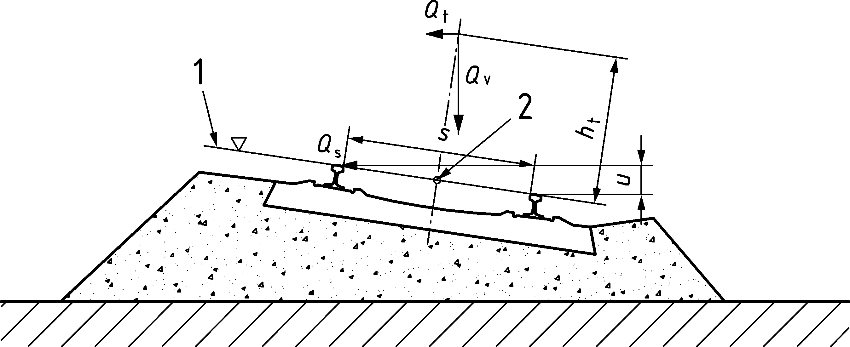

Key

|  |  |
| --- | --- |
| 1 | Running surface |
| 2 | Longitudinal forces *Q*la and *Q*lb acting along the centreline of the track |

Figure 3.1 — Notation and dimensions specifically for railways

*Latin upper case letters*

|  |  |
| --- | --- |
| *D* | Coach or vehicle length |
| *D*IC | Intermediate coach length for a Regular Train with one axle per coach |
| *E*cm | Secant modulus of elasticity of normal weight concrete |
| *F*L | Total longitudinal support reaction |
| *F*Qk | Characteristic longitudinal force per track on the fixed bearings due to deformation of the deck |
| *F*Tk | Longitudinal force on a fixed bearing due to the combined response of track and structure to temperature |
| *F*li | Individual longitudinal support reaction corresponding to the action i |
| *K* | Total longitudinal support stiffness |
| *L* | Length (general) |
| *L*T | Expansion length |
| *L*f | Influence length of the loaded part of curved track |
| *L*i | Influence length |
| *L*Φ | “determinant” length (length associated with *Φ*) |
| *M* | Number of point forces in a train |
| *N* | Number of regularly repeating coaches or vehicles, or  number of equal point forces |
| *P* | Point force (individual axle load) |
| *P*k | Axle load of the k-th axle |
| *Q* | Concentrated force or variable action (general) |
| *Q*A1d | Point load for derailment loading |
| *Q*h | Horizontal force (general) |
| *Q*k | Characteristic value of a concentrated force or a variable action |
| *Q*lak | Characteristic value of traction force |
| *Q*lbk | Characteristic value of braking force |
| *Q*r | Rail traffic action (general, e.g. resultant of wind and centrifugal force) |
| *Q*sk | Characteristic value of nosing force |
| *Q*tk | Characteristic value of centrifugal force |
| *Q*v | Vertical axle load |
| *Q*vi | Wheel load |
| *Q*vk | Characteristic value of vertical load (concentrated load) |
| Δ*T*D | Temperature variation of the deck |
| Δ*T*N | Temperature variation |
| Δ*T*R | Temperature variation of the rail |
| *V* | Speed in km/h  Maximum Line Speed at the Site in km/h |
| *Y* | Horizontal distance in metres between the track centreline and the surface |

*Latin lower case letters*

|  |  |
| --- | --- |
| *a* | Distance between rail supports, length of distributed loads (Load Models SW/0 and SW/2) |
| *b* | Length of the longitudinal distribution of a load by a sleeper and ballast |
| *c* | Space between distributed loads (Load Models SW/0 and SW/2) |
| *d* | Regular spacing of groups of axles  Spacing of axles within a bogie  Spacing of point forces in HSLM-B |
| *d*BA | Spacing of axles within a bogie |
| *d*BS | Spacing between centres of adjacent bogies |
| *e* | Eccentricity of vertical loads, eccentricity of resulting action (on reference plane) |
| *e*c | Distance between adjacent axles across the coupling of two individual regular trainsets |
| *i* | Number of axles of a subset of the tail, up to the total number of axles |
| *f* | Reduction factor for centrifugal force  first natural frequency of the wall system [Hz] |
| *f*ck | Concrete compressive cylinder/cube strength |
| *g* | Acceleration due to gravity |
| *h* | Height (general)  Height of cover including ballast from the top of the deck to the top of a sleeper  Height of wall above rail top [m] |
| *h*g | Vertical distance from the running surface to the underside of the structure above the track |
| *h*t | Height of centrifugal force over the running surface |
| *k* | Longitudinal plastic shear resistance of the track |
| *k*1 | Train shape coefficient |
| *k*2 | Multiplication factor for slipstream actions on vertical surfaces parallel to the tracks |
| *k*3 | Reduction factor for slipstream actions on simple horizontal surfaces adjacent to the track |
| *k*4 | Multiplication factor for slipstream actions on surfaces enclosing the tracks (horizontal actions) |
| *k*5 | Multiplication factor for slipstream actions on surfaces enclosing the tracks (vertical actions) |
| *n*0 | First natural bending frequency of the unloaded structure |
| *n*T | First natural torsional frequency of the structure |
| *q*1k | Characteristic value of equivalent distributed aerodynamic action |
| *q*A1d, *q*A2d | Distributed loading for derailment loading |
| *q*DS | quasi-static load for the air pressure wave due to a passing train at an elevation *z* above rail top considering the influence length, wall height and dynamic effects in kN/m2 |
| *q*lak | Characteristic value of distributed traction force |
| *q*lbk | Characteristic value of distributed braking force |
| *q*tk | Characteristic value of distributed centrifugal force |
| *q*v1, *q*v2 | Vertical load (uniformly distributed load) |
| *q*vk | Characteristic value of vertical load (uniformly distributed load) |
| *r* | Horizontal radius of a carriageway or track centre-line  Transverse distance between wheel loads |
| *s* | Track gauge |
| *s*DS | horizontal spacing between the two relevant load model positions of the air pressure wave for maximum structural reactions, in m |
| *u* | Cant, relative vertical distance between the uppermost surface of the two rails at a particular location along the track |
| *v* | Maximum Nominal Speed [m/s]  Maximum Permitted Vehicle Speed [m/s]  Speed [m/s] |
| *v*DS | Maximum Design Speed in m/s |
| *v*i | Resonant speed in m/s |
| *y*dyn, *y*stat | Maximum dynamic response and maximum corresponding static response at any particular point |
| *x*k | Distance between the first axle and the k-th axle |
| *z* | elevation above rail top in m, where the quasi-static equivalent load shall be calculated. For elevations *z* < 0 it is assumed that *z* = 0 |

*Greek upper case letters*

|  |  |
| --- | --- |
| *Θ* | End rotation of structure (general) |
| *Φ* (*Φ*2, *Φ*3) | Dynamic factor for railway Load Models 71, SW/0 and SW/2 |

*Greek lower case letters*

|  |  |
| --- | --- |
| *α* | Load classification factor  Coefficient for speed  Linear temperature coefficient for thermal expansion |
| *δ* | Deformation (general)  Vertical deflection |
| *δ*0 | Deflection at midspan due to permanent actions |
| *δ*B | Longitudinal relative displacement at the end of the deck due to traction and braking |
| *δ*H | Longitudinal relative displacement at the end of the deck due to deformation of the deck |
| *δ*h | Horizontal displacement  Horizontal displacement due to the longitudinal displacement of the foundations of the substructure |
| *δ*p | Horizontal displacement due to the longitudinal deformation of the substructure |
| *δ*V | Vertical relative displacement at the end of the deck |
| *δφ* | Horizontal displacement due to longitudinal rotation of foundation |
| *γ*Ff | Partial safety factor for fatigue loading |
| *γ*Mf | Partial safety factor for fatigue strength |
| *Φ, φ′, φ″* | Dynamic enhancement of static loading for Real Trains |
| *φ*dyn | dynamic factor — considering dynamic effects |
| *φ′*dyn | Dynamic enhancement of static loading for a Real Train determined from a dynamic analysis |
| *φ*L, *φ*H | dynamic length and height factor for noise barriers |
| *κ* | Coefficient relating to the stiffness of an abutment relative to the piers |
| *κ*t | relation between natural and applied frequency |
| *λ* | Damage equivalent factor for fatigue  Excitation wavelength |
| *ρ* | Density |
| *σ* | Stress |
| *σ*A, *σ*B, *σ*M | Pressure on the upper surface of the deck from rail traffic actions |
| Δ*σ*71 | Stress range due to the Load Model 71 (and where required SW/0) |
| Δ*σ*C | Reference value of fatigue strength |
| *ζ* | Lower limit of percentage of critical damping (%), or  ratio of critical damping |
| *ζ*TOTAL | Total damping (%) |
| Δ*ζ* | Additional damping (%) |

# Classification of actions

## General

(1) The relevant traffic actions and other specific actions on bridges should be classified in accordance with prEN 1990:2021, 6.1.1.

NOTE 1 Traffic actions on road bridges, footbridges and railway bridges consist of variable actions and actions for accidental design situations, which are represented by various models.

NOTE 2 Traffic actions are multi component actions

(2) All traffic actions should be classified as free actions within the limits specified in Clauses 6 to 8.

## Variable actions

(1) For normal conditions of use (*i.e.* excluding any accidental situation), the traffic loads (dynamic amplification included where relevant) should be considered as variable actions in their representative values.

NOTE 1 The representative values of a variable action are defined according to prEN 1990 as:

— characteristic values;

— frequent values;

— quasi-permanent values.

NOTE 2 In Table 4.1 (NDP), information is given on the basis of calibration of the main Load Models (fatigue excluded) presented in this document for road bridges, footbridges and railway bridges for characteristic, frequent and quasi-permanent values. Rail loading and the associated *γ* and *ψ* factors have been based on nominal values.

NOTE 3 For calculation of fatigue lives, separate models, associated values and (where relevant) specific requirements are given in 6.6 for road bridges, in 8.9 for railway bridges and in the relevant annexes.

Table 4.1 (NDP) — Bases for the calibration of the main Load Models (fatigue excluded) presented in this document

| **Traffic Load Models** | **Characteristic values** | **Frequent values** | **Quasi-permanent values** |
| --- | --- | --- | --- |
| Road Traffic |  |  |  |
| LM1  (6.3.2) | 1000 years return period (or probability of exceedance of 5 % in 50 years) for traffic on the main roads in Europe (*α* factors equal to 1, see 6.3.2). | 1 week return period for traffic on the main roads in Europe (*α* factors equal to 1, see 6.3.2). | Calibration in accordance with definition given in prEN 1990. |
| LM2  (6.3.3) | 1000 years return period (or probability of exceedance of 5 % in 50 years) for traffic on the main roads in Europe (*β* factor equal to 1, see 6.3.3). | 1 week return period for traffic on the main roads in Europe (*β* factor equal to 1, see 6.3.3). | a |
| LM3  (6.3.4) | Set of nominal values. Basic values defined in Annex A are derived from a synthesis based on various national regulations. | a | a |
| LM4  (6.3.5) | Nominal value deemed to represent the effects of a crowd. Defined with reference to existing national standards. | a | a |
| **Pedestrian Traffic** |  |  |  |
| Uniformly distributed load  (7.3.2) | Nominal value deemed to represent the effects of a crowd. Defined with reference to existing national standards. | Equivalent static force calibrated on the basis of 2 pedestrians/m2 (in the absence of particular dynamic behaviour). It can be considered, for footbridges in urban areas, as a load of 1 week return period. | Calibration in accordance with definition given in prEN 1990. |
| Concentrated load  (7.3.3) | Nominal value. Defined with reference to existing national standards. | a | a |
| Service vehicle  (7.3.4) | Nominal value. As specified or given in 7.6.3. | a | a |
| **Railway Traffic** |  |  |  |
| LM71  (8.3.2) | Nominal values deemed to represent the static effect of vertical loading due to normal rail traffic. | a | a |
| SW/0 and SW/2  (8.3.3) | Nominal values deemed to represent the static effect of vertical loading due to normal rail traffic on continuous beams (SW/0), and heavy rail traffic (SW/2). | a | a |
| HSLM (8.4.6.1.1) | Nominal values obtained as envelope of dynamic resonant effect of selected high-speed trains. | a | a |
| a To adjust the values to the specific return period see prEN 1990:2021, A.2. | | | |

## Accidental actions

(1) If appropriate protection is not provided, actions due to collision, or the accidental presence or location of road vehicles and trains, shall be considered for the structural design.

NOTE The term “appropriate protection” can be defined in the National Annex for use in a country.

(2) For common situations, the accidental actions described in this document should be used.

NOTE 1 They are represented by various load models defining design values in the form of static equivalent loads.

NOTE 2 For collision forces due to vehicles under road bridges, footbridges and railway bridges, see 6.7.2, 7.6.2 and 8.7.3.

NOTE 3 For actions due to vehicles on road bridges and footbridges, see 6.7.3 and 7.6.3 respectively.

NOTE 4 For actions due to derailment, see 8.7.

(3) Collision forces due to boats, ships or aeroplanes, for road bridges, footbridges and railway bridges (e.g. over canals and navigable water), should be defined where appropriate.

NOTE 1 Values for boat and ship impacts are given in EN 1991‑1‑7:2006, 5.7.

NOTE 2 Additional requirements can be specified for the special project.

# Design situations

## General

(1) Relevant design situations shall be selected and critical load cases identified.

(2) For each critical load case, the design values of the effects of actions in combination shall be determined.

## Simultaneity of traffic loads

(1) When using groups of loads, the various traffic loads acting simultaneously in combinations of action components should be considered in design calculations, where relevant.

NOTE For combinations of traffic actions, see Clauses 6, 7 and 8.

(2) The combination rules, depending on the calculation to be undertaken, shall be in accordance with prEN 1990.

NOTE For seismic combinations for bridges and associated rules, see EN 1998‑2.

(3) Specific rules for the simultaneity with other actions for road bridges, footbridges, and railway bridges are given in prEN 1990:2021, A.2.

(4) For bridges intended for both, road and rail traffic, the simultaneity of actions and the particular required verifications should be specified.

NOTE The particular rules can be defined in the National Annex for use in a country.

# Road traffic actions and other actions specifically for road bridges

## Field of application

(1) Load models defined in Clause 6 should be used for the design of road bridges with loaded lengths less than 200 m.

NOTE 1 200 m corresponds to the maximum length taken into account for the calibration of Load Model 1 (see 6.3.2). In general, the use of Load Model 1 is safe-sided for loaded lengths over 200 m.

NOTE 2 Load models for loaded lengths greater than 200 m can be defined in the National Annex for use in a country.

(2) The load models and associated rules provided in this clause cover all normally foreseeable traffic situations (*i.e.* traffic conditions in either direction on any lane due to the road traffic) to be taken into account for design.

NOTE 1 Specific load models can be defined in the National Annex for use in a country.

NOTE 2 Load models for geotechnical structures are defined in 6.9.

(3) The load models and associated rules provided in this clause do not cover the effects of loads on road construction sites or of loads specifically for inspection and tests which should be separately specified, where relevant.

(4) The load models and associated rules provided in this clause include dynamic amplification effect (fatigue excluded).

NOTE The dynamic amplification included in the models, was established for a medium pavement quality (see Annex B) and pneumatic vehicle suspension. However, it depends on various parameters and on the action effect under consideration. Therefore, it cannot be represented by a unique factor. In some unfavourable cases, it can reach 1,7 (local effects), but still more unfavourable values can be reached for poorer pavement quality, or if there is a risk of resonance. These cases can be avoided by appropriate quality and design measures.

(5) An additional dynamic amplification should be taken into account for particular calculations (see 6.3.3(2) and 6.6.1(6)) or when agreed for a specific project by the relevant parties.

NOTE This can be particularly relevant for local verification of a bridge deck, bearings and for supports under expansion joints.

## Representation of actions

### Models of road traffic loads

(1) Imposed loads due to the road traffic, consisting of cars, lorries and special vehicles (e.g. for industrial transport) should be taken into account as relevant.

NOTE 1 These loads give rise to vertical and horizontal, static and dynamic forces defined in Clause 6.

NOTE 2 The National Annex can define complementary load models, with associated combination rules for use in a country where traffic outside the scope of the load models specified in this clause needs to be considered.

(2) Where vehicles (including military or other special vehicles) which do not comply with national regulations are to be considered, they shall be defined.

NOTE The National Annex can define these models for special vehicles not compliant with the national regulations for use in a country. Guidance on standard models for special vehicles and their application is given in Annex A. See 6.3.4.

### Loading classes

(1) The actual loads on road bridges resulting from various categories of vehicles and from pedestrians shall be calculated.

(2) The differences between bridges in terms of:

— Vehicle traffic composition (e.g. percentages of lorries),

— density (e.g. average number of vehicles per year),

— conditions (e.g. jam frequency),

— extreme likely weights of vehicles and their axle loads, and, if relevant,

— in the influence of road signs restricting carrying capacity,

should be taken into account through the use of load models suited on relevant locations of a bridge and where appropriate, through the choice of adjustment factors *α* and *β* defined in 6.3.2 for Load Model 1 and in 6.3.3 for Load Model 2 respectively.

### Divisions of the carriageway into notional lanes

(1) The carriageway width, *w*, should be measured between the lesser of:

— the width between kerbs (where they have sufficient height)

— the anchored vehicle restraint system

— the pedestrian parapet

The width, *w*, should not include the distance between fixed vehicle restraint systems or kerbs of a central reservation nor the widths of these vehicle restraint systems.

NOTE The minimum value of the height of the kerbs to be taken into account is 100 mm unless the National Annex gives a different value for use in a country.

(2) If the height of the kerb exceeds a minimum value, it should be taken into account for the determination of the carriageway width *w*.

(3) The width *w*1 of notional lanes on a carriageway and the greatest possible whole (integer) number *n*1 of such lanes on this carriageway should be taken from Table 6.1.

Table 6.1 — Number and width of notional lanes

| Carriageway width ***w*** | Number of notional lanes | Width of a notional lane ***w*l** | Width of the remaining area |
| --- | --- | --- | --- |
| *w* < 5,4 m | *n*l = 1 | 3 m | *w* − 3 m |
| 5,4 m ≤ *w* < 6 m | *n*l = 2 |  | 0 |
| 6 m ≤ *w* |  | 3 m | *w* − 3 × *n*1 |
| NOTE For example, for a carriageway width equal to 11 m, , and the width of the remaining area is 11 − 3 × 3 = 2 m. | | | |

(4) Where the carriageway on a bridge deck is physically divided into two parts separated by a central reservation, then:

a) if the parts are separated by a permanent road restraint system, each part (including all hard shoulders or strips) should be separately divided into notional lanes;

b) if the parts are separated by a temporary road restraint system, the whole carriageway (central reservation included) should be divided into notional lanes.

(5) The rules given in 6.2.3(4) may be as agreed for a specific project by the relevant parties to allow for envisaged future modifications of the traffic lanes on the deck, e.g. for repair.

### Location and numbering of the lanes for design

(1) For each individual verification, the number of lanes to be taken into account as loaded, their location on the carriageway and their numbering should be so chosen that the effects from the load models are the most adverse.

(2) For fatigue representative values and models, the location and the numbering of the lanes should be selected depending on the traffic to be expected in normal conditions.

(3) The lane giving the most unfavourable effect should be numbered Lane Number 1, the lane giving the second most unfavourable effect Lane Number 2, etc. (see Figure 6.1).

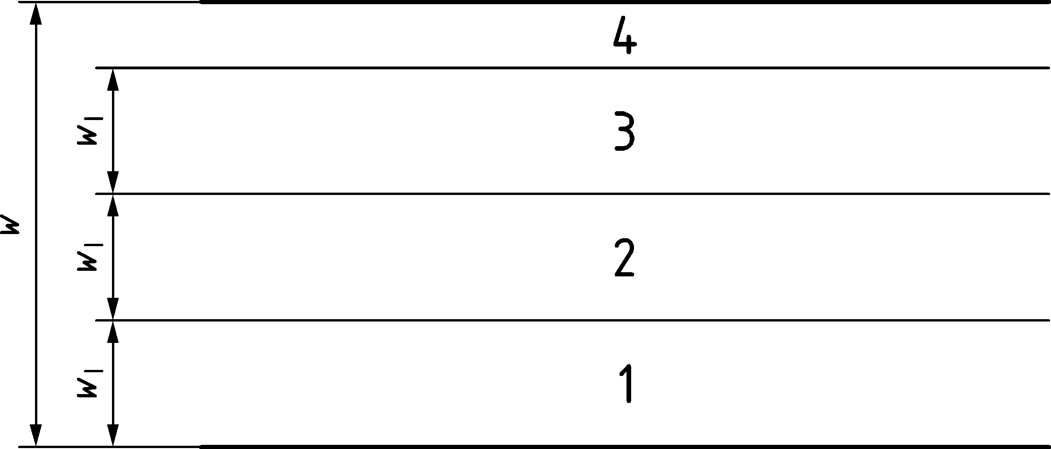

Key

|  |  |
| --- | --- |
| *w* | Carriageway width |
| *w*1 | Notional lane width |
| 1 | Notional Lane No. 1 |
| 2 | Notional Lane No. 2 |
| 3 | Notional Lane No. 3 |
| 4 | Remaining area |

Figure 6.1 — Example of the Lane Numbering in the most general case

(4) Where the carriageway consists of two separate parts on the same deck, only one numbering system should be used for the whole carriageway.

(5) Where the carriageway consists of two separate parts on two independent decks, each part shall be considered as a carriageway. Separate numbering system shall then be used for the design of each deck.

(6) Where the carriageway consists of two separate parts on two independent decks, supported by the same piers and/or abutments, there should be one numbering for the two parts together for the design of the piers and/or the abutments.

### Application of the load models on the individual lanes

(1) For each individual verification, the load models shall be applied on each notional lane on such a length and so longitudinally located that the most adverse effect is obtained, as far as this is compatible with the conditions of application defined below for each particular model.

(2) On the remaining area, the associated load model shall be applied on such lengths and widths in order to obtain the most adverse effect, as far as this is compatible with particular conditions specified in 6.3.

## Vertical loads — Characteristic values

### General

(1) The load models for vertical loads should represent the following road traffic effects:

a) Load Model 1 (LM1): Concentrated and uniformly distributed loads, which cover most of the effects of the traffic of lorries and cars. This model should be used for global and local verifications.

b) Load Model 2 (LM2): A single axle load applied on specific tyre contact areas which cover the dynamic effects of the normal traffic on short structural members.

NOTE As an order of magnitude, LM2 can be predominant in the range of loaded lengths up to 7 m.

a) Load Model 3 (LM3): A set of assemblies of axle loads representing special vehicles (e.g. for industrial transport) which can travel on routes permitted for abnormal loads. It is intended for global and local verifications.

b) Load Model 4 (LM4): A crowd loading intended only for global verifications.

### Load Model 1

(1) Load Model 1 consists of two partial systems:

a) Double-axle concentrated loads (tandem system: TS), each axle having the following weight:

*α*Q × *Q*k (6.1)

where

|  |  |
| --- | --- |
| *α*Q | is adjustment factor; |
| *Q*k | is the characteristic value of the axle load. |

b) Uniformly distributed loads (UDL system), having the following weight per square metre of notional lane:

*α*q × *q*k (6.2)

where

|  |  |
| --- | --- |
| *α*q | are adjustment factors; |
| *q*k | is the characteristic value of the uniformly distributed load. |

(2) Load Model 1 should be applied on each notional lane and on the remaining areas.

NOTE On notional lane Number *i*, the load magnitudes are referred to as *α*Qi × *Q*ik and *α*qi × *q*ik (see Table 6.2). On the remaining areas, the load magnitude is referred to as *α*qr × *q*rk.

(3) The characteristic values of *Q*ik and *q*ik should be taken from Table 6.2 (dynamic amplification included) based on their location on the bridge.

Table 6.2 — Load Model 1: characteristic values

| Location | Tandem system ***TS*** | ***UDL*** system |
| --- | --- | --- |
| Axle loads ***Q*ik** | ***q*ik** (or ***q*rk**) |
| (kN) | (kN/m2) |
| Lane Number 1 | 300 | 9 |
| Lane Number 2 | 200 | 2,5 |
| Lane Number 3 | 100 | 2,5 |
| Other lanes | 0 | 2,5 |
| Remaining area (*q*rk) | 0 | 2,5 |

(4) The values of adjustment factors *α*Qi, *α*qi and *α*qr should be selected depending on the expected traffic and possibly on different classes of routes. In all cases, for bridges without road signs restricting vehicle weights, the following should be taken as minimum values for the adjustment factors:

*α*Q1 ≥ 0,8 and (6.3)

for: *i* ≥ 2, *α*Q1 ≥ 1; this restriction being not applicable to *α*qr. (6.4)

NOTE In the absence of specification, the values of *α*Q1, *α*qi and *α*qr factors are equal to 1 unless the National Annex gives different values for use in a country. Values of adjustment factors equal to 1 correspond to heavy industrial international traffic, representing a large part of the total traffic of heavy vehicles.

(5) The following rules should be followed for the application of the tandem system:

— No more than one tandem system should be taken into account per notional lane.

— Only complete tandem systems should be taken into account.

— Each axle of the tandem system should be taken into account with two identical wheels, the load per wheel being therefore equal to 0,5 *α*Q × *Q*k.

— The contact surface of each wheel should be taken as square and of side 0,40 m (see Figure 6.2).

(6) The uniformly distributed loads *q*k should be applied only to unfavourable parts of the influence surface, longitudinally and transversally.

(7) The application of Load Model 1 is illustrated in Figure 6.2.

Dimensions in metres

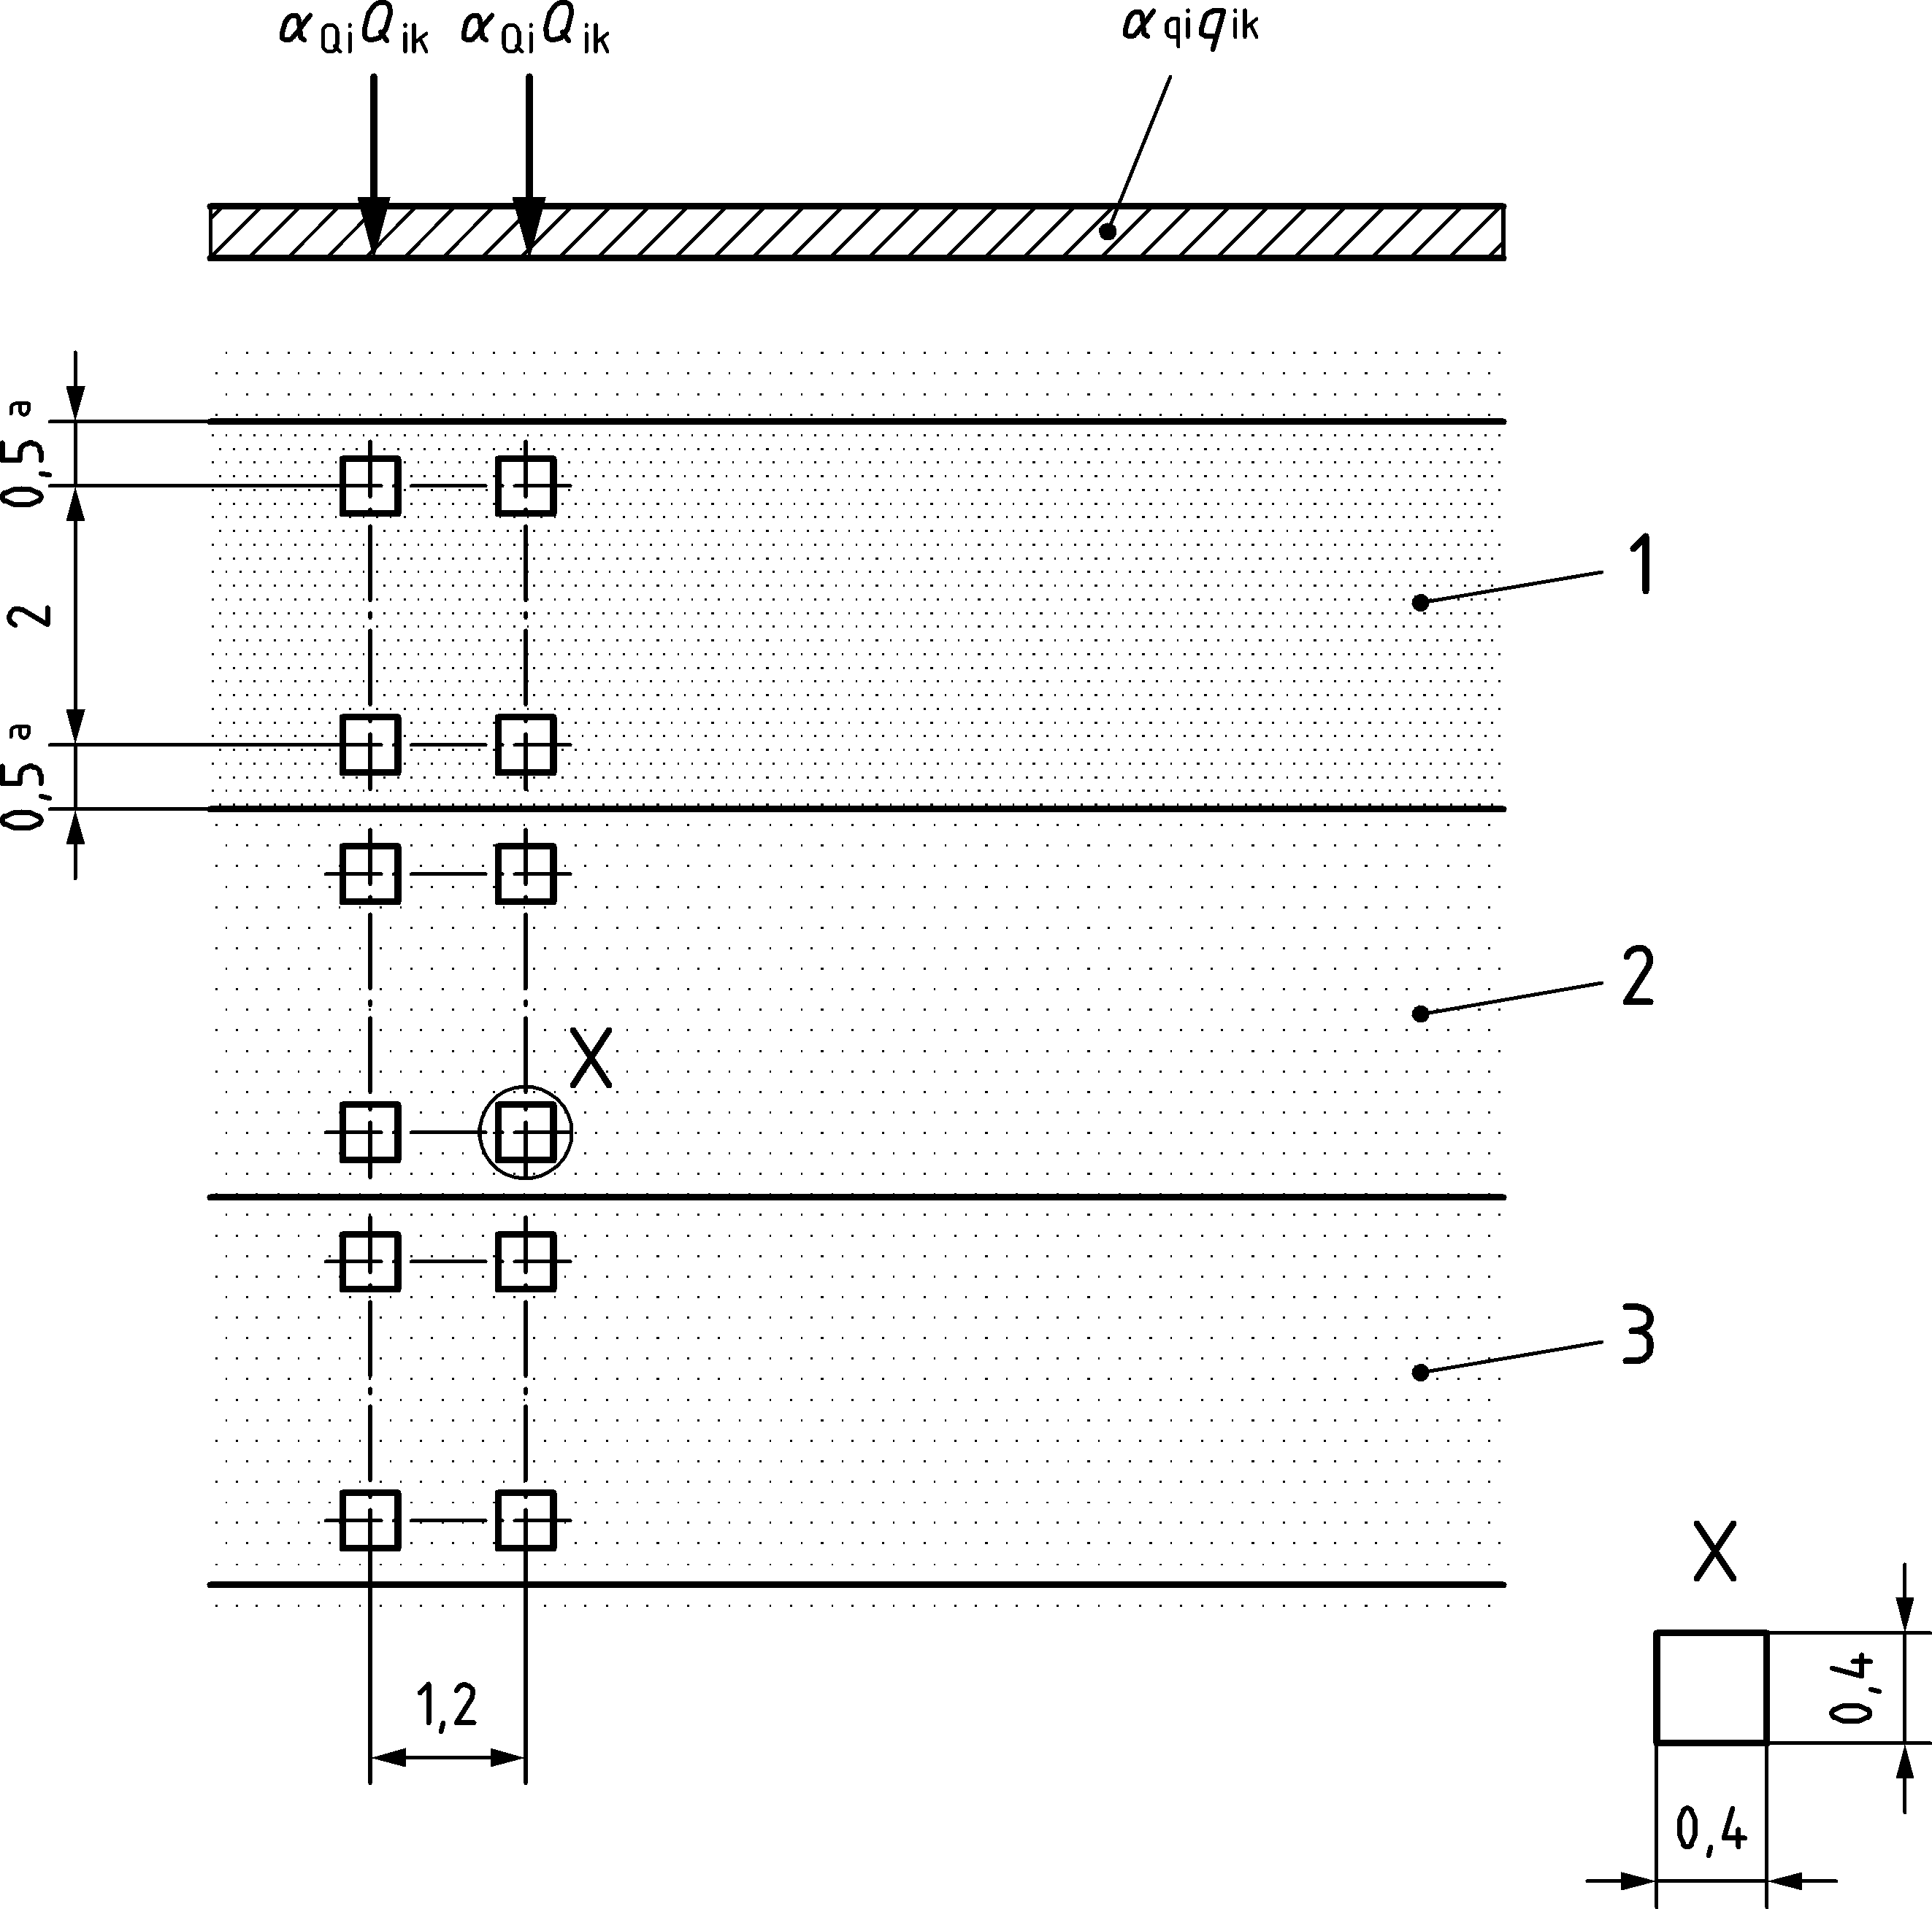

Key

|  |  |
| --- | --- |
| 1 | Lane No. 1: *Q*1k = 300 kN; *q*1k = 9 kN/m2 |
| 2 | Lane No. 2: *Q*2k = 200 kN; *q*2k = 2,5 kN/m2 |
| 3 | Lane No. 3: *Q*3k = 100 kN; *q*3k = 2,5 kN/m2  Tandem axle spacing = 1,2 m |
| a | For *w*1 = 3,00 m |

Figure 6.2 — Application of Load Model 1

(8) For global verifications, each tandem system should be assumed to travel centrally along the axes of notional lanes (see Figure 6.2).

(9) For local verifications, a tandem system shall be applied at the most unfavourable location. Where two tandem systems on adjacent notional lanes are taken into account, they should be brought closer, with a distance between wheel axles not below 0,50 m.

NOTE Alternative rules on the application of tandem systems for local verifications can be set in the National Annex for use in a country.

### Load Model 2

(1) Load Model 2 should be represented by a single axle load *β*Q × *Q*ak with *Q*ak equal to 400 kN, dynamic amplification included. However, when relevant, only one wheel of 200 *β*Q (kN) may be taken into account.

NOTE The value of *β*Q is equal to *α*Qi unless the National Annex gives a different value for use in a country.

(2) In the vicinity of expansion joints, an additional dynamic amplification factor equal to the value defined in 6.6.1(6) should be applied.

(3) Load Model 2 shall be applied at any location on the carriageway.

(4) The contact surface of each wheel should be taken into account as a rectangle of sides 0,35 m and 0,60 m (see Figure 6.3).

Dimensions in metres

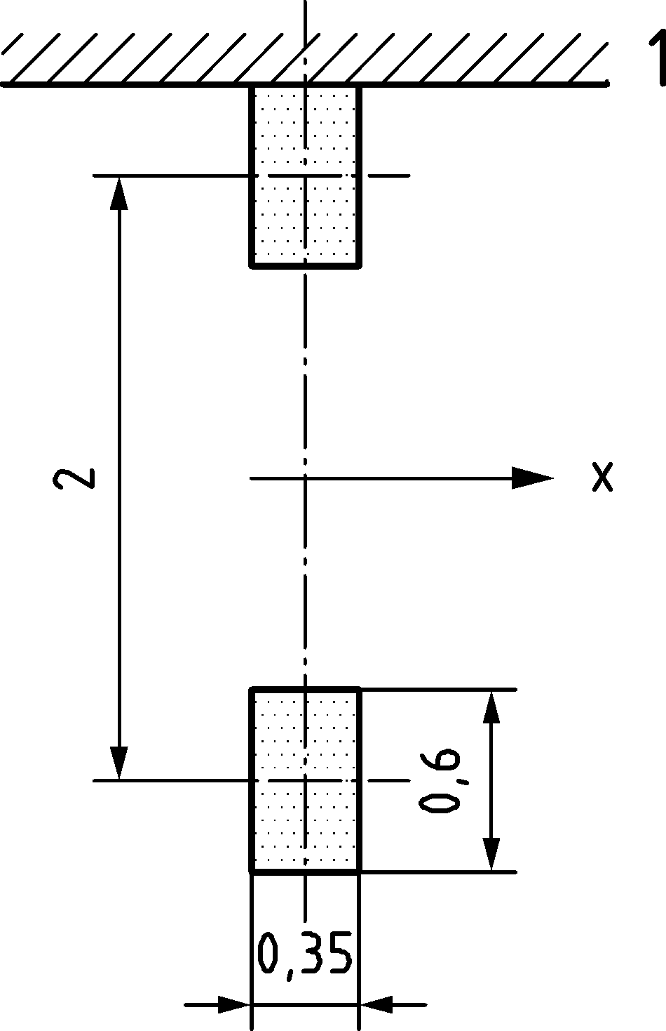

Key

|  |  |
| --- | --- |
| x | Bridge lane direction |
| 1 | Kerb |

Figure 6.3 — Application of Load Model 2

NOTE 1 The contact areas of Load Models 1 and 2 are different, and correspond to different tyre models, arrangements and pressure distributions. The contact areas of Load Model 2, corresponding to twin tyres, are normally relevant for orthotropic decks.

NOTE 2 For simplicity, the same square contact surface for the wheels of Load Models 1 and 2 can be set in the National Annex for use in a country.

### Load Model 3 (special vehicles)

(1) Where relevant, models of special vehicles (Load Model 3) should be defined and taken into account.

NOTE The definition of Load Model 3 and its conditions of use can be set by the National Annex for use in a country. Annex A gives guidance on standard models and their conditions of application.

### Load Model 4 (crowd loading)

(1) Where relevant, a crowd loading (Load Model 4), represented by a uniformly distributed load should be defined and taken into account.

NOTE The magnitude of LM 4 is 5 kN/m2 (dynamic amplification included), unless the National Annex gives a different value for use in a country.

(2) Load Model 4 should be applied on the relevant parts of the length and width of the road bridge deck, the central reservation being included where relevant.

NOTE The loading system LM4 is intended for global verifications.

### Dispersal of concentrated loads

(1) If the various concentrated loads associated with Load Models 1 and 2 are applied as patch loads, they should be taken as uniformly distributed on their whole contact area.

(2) The dispersal through the pavement and concrete slabs may be taken at a spread-to-depth ratio of 1 horizontally to 1 vertically down to the level of the centroid of the concrete slab (Figure 6.4).

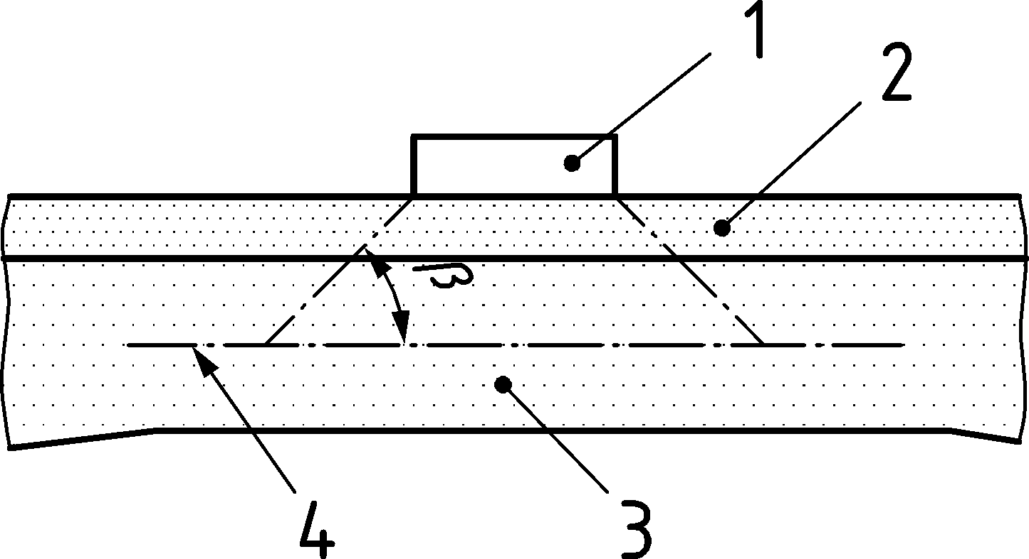

Key

|  |  |
| --- | --- |
| 1 | Wheel contact pressure |
| 2 | Pavement |
| 3 | Concrete slab |
| 4 | centroid of concrete slab |
| *β* | angle *β* see Table 6.3 |

Figure 6.4 — Dispersal of concentrated loads through pavement and a concrete slab

Table 6.3 — Dispersion angle *β* of concentrated loads for various materials

|  |  |  |
| --- | --- | --- |
| Pavement | | 45° |
| Boards and planks | | 45° |
| Concrete deck plates | | 45° |
| Laminated timber deck plates: | |  |
| — in the direction of the grain |  | 45° |
| — perpendicular to the grain |  | 75° |
| Plywood and cross-laminated deck plates | | 45° |

(3) The dispersal through the pavement and orthotropic decks may be taken at a spread-to-depth ratio of 1 horizontally to 1 vertically down to the level of the middle plane of the structural top plate (Figure 6.5).

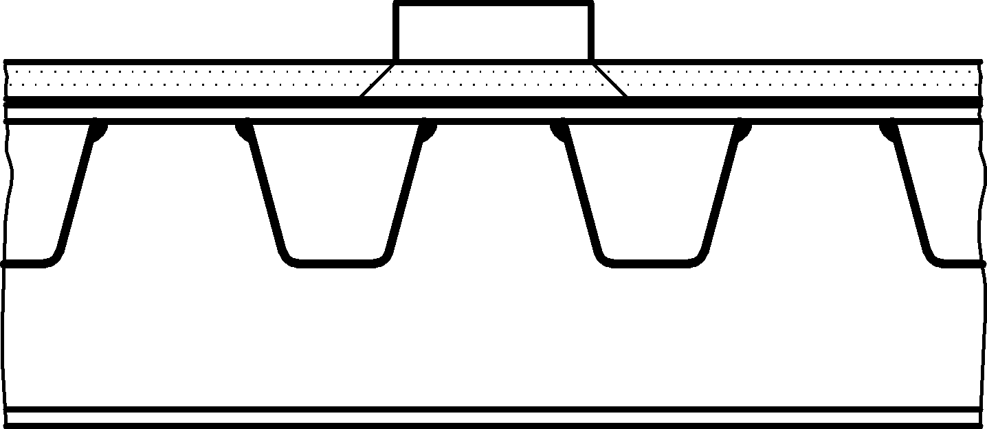

Figure 6.5 — Dispersal of concentrated loads through pavement and orthotropic decks

## Horizontal forces — characteristic values

### Braking and acceleration forces

(1) A braking force, *Q*Lk, shall be taken as longitudinal force acting at the surfacing level of the carriageway.

(2) The characteristic value of the braking force *Q*Lk should be calculated as a fraction of the total maximum vertical loads corresponding to the Load Model 1 likely to be applied on Lane Number 1, as indicated in Formula (6.5):

*Q*Lk = 0,6 × *α*Q1 (2 × *Q*1k) + 0,10 *α*q1 *q*1k *w*1 *L*

180 × *α*Q1 [kN] ≤ *Q*Lk ≤ 900 kN (6.5)

where

|  |  |
| --- | --- |
| *L* | is the length of the deck or of the part of it under consideration. |

NOTE 1 The upper limit *Q*Lk, max is equal to 900 kN unless the National Annex gives a different value for use in a country. *Q*Lk, max is normally intended to cover the maximum braking force of military vehicles according to STANAG.

NOTE 2 For example, for a lane width *w*1 = 3 m wide a loaded length *L* > 1,2 m and *α* factors are equal to unity, *Q*Lk = 360 + 2,7 × *L* (≤900 kN)

(3) Acceleration forces shall be taken into account with the same magnitude as braking forces, but in the opposite direction.

(4) Horizontal forces associated with Load Model 3 should be defined where appropriate.

NOTE Horizontal forces associated with other Load Models than LM 1 can be defined in the National Annex for use in a country.

(5) This force should be taken into account as located along the axis of any possible lane. However, if the eccentricity effects are not significant, the force may be considered to be applied only along the carriageway axis, and uniformly distributed over the loaded length.

(6) The horizontal force transmitted by expansion joints or applied to structural members that can be loaded by only one axle shall be *Q*Lk defined in Formula (6.6):

*Q*Lk = 0,6 *α*Q1 *Q*1k (6.6)

### Centrifugal and other transverse forces

(1) The centrifugal force *Q*tk shall be taken as a transverse force acting at the finished carriageway level and radially to the axis of the carriageway.

(2) The characteristic value of the centrifugal force *Q*tk, should be taken from Table 6.4 (dynamic effects included).

Table 6.4 — Characteristic values of centrifugal forces

|  |  |  |
| --- | --- | --- |
| *Q*tk = 0,2 *Q*v (kN) | | if *r* < 200 m |
| *Q*tk =  40 *Q*v/*r* (kN) | | if 200 ≤ *r* ≤ 1 500 m |
| *Q*tk = 0 | | if *r* > 1 500 m |
| where | | |
| *r* | is the horizontal radius of the carriageway centreline [m]; | |
| *Q*v | is the total vertical load of the tandem systems of LM1. | |

(3) *Q*tk should be assumed to act as a point load at any deck cross-section.

(4) Where relevant, lateral forces from skew braking or skidding shall be taken into account.

(5) If lateral forces from skew braking or skidding are taken into account, transverse braking force, *Q*trk, equal to 25 % of the longitudinal braking or acceleration force *Q*1k, should be considered to act simultaneously with *Q*1k at the finished carriageway level.

NOTE The National Annex can define a minimum transverse loading for use in a country. In most cases, forces resulting from wind effects and collisions on kerbs provide a sufficient transverse loading.

## Groups of traffic loads on road bridges (multi component actions)

### Characteristic values in persistent design situations

(1) The simultaneity of the loading systems defined in 6.3 and 6.4 and the loads defined in Clause 7 for footways should be taken into account by considering the groups of traffic loads defined in Table 6.5 (NDP), each group defining a single variable characteristic action for combination with non-traffic loads.

NOTE The group of loads indicated in Table 6.5 (NDP) are mutually exclusive.

Table 6.5 (NDP) — Assessment of groups of traffic loads (characteristic values of the multi-component action in persistent design situations)

|  | | CARRIAGEWAY | | | | | | FOOTWAYS AND CYCLE WAYS |
| --- | --- | --- | --- | --- | --- | --- | --- | --- |
| Load type | | Vertical forces | | | | Horizontal forces | | Vertical forces only |
| Reference | | 6.3.2 | 6.3.3 | 6.3.4 | 6.3.5 | 6.4.1 | 6.4.2 | 7.3.2 (1) |
| Load system | | LM1  (TS and UDL systems) | LM2  (Single axle) | LM3  (Special vehicles) | LM4  (Crowd loading) | Braking and acceleration forcesa | Centrifugal and transverse forcesa | Uniformly Distributed load |
| Groups of Loads | gr1a | Characteristic values |  |  |  |  |  | Combination valueb |
| gr1b |  | Characteristic value |  |  |  |  |  |
| gr2 | Frequent values |  |  |  | Characteristic value | Characteristic value |  |
| gr3d |  |  |  |  |  |  | Characteristic valuec |
| gr4 |  |  |  | Characteristic value |  |  | Characteristic value |
| gr5 | See Annex A |  | Characteristic value |  |  |  |  |
|  | Dominant component action (designated as component associated with the group) | | | | | | | |
| a These can be defined in the National Annex for use in a country (for the cases mentioned).  b This value is equal to 3 kN/m2 unless the National Annex gives a different value for use in a country.  c See 7.3.2. One footway only should be considered to be loaded if the effect is more unfavourable than the effect of two loaded footways.  d This group is irrelevant if gr4 is considered. | | | | | | | | |

### Other representative values

(1) The frequent action should consist only of either the frequent values of LM1 or the frequent value of LM2, or the frequent values of loads on footways or cycle-tracks (taking the more unfavourable), without any accompanying component, as defined in Table 6.6.

NOTE 1 For the individual components of the traffic action, these representative values are defined in prEN 1990:2021, A.2.

NOTE 2 For transient design situations see 6.5.3.

Table 6.6 — Assessment of groups of traffic loads (frequent values of the multi-component action in persistent design situations)

|  | | CARRIAGEWAY | | FOOTWAYS AND CYCLE WAYS |
| --- | --- | --- | --- | --- |
| Load type | | Vertical forces | | |
| Reference | | 6.3.2 | 6.3.3 | 7.3.2 |
| Load system | | LM1 (TS and UDL systems) | LM2 (single axle) | Uniformly distributed load |
| Groups of loads | gr1a | Frequent values |  |  |
| gr1b |  | Frequent value |  |
| gr3 |  |  | Frequent valuea |
| a One footway only should be considered to be loaded if the effect is more unfavourable than the effect of two loaded footways. | | | | |

(2) The quasi-permanent values should be derived in accordance with prEN 1990:2021, A.2.

NOTE Quasi-permanent values are generally equal to zero.

### Groups of loads in transient design situations

(1) In transient design situations the characteristic values of vertical loads from tandem system in LM 1 may be reduced to 0,8 *α*Qi × *Q*ik. Other loads, including horizontal loads should not be reduced.

NOTE The National Annex can define alternative characteristic values associated with the tandem system for use in a country.

## Fatigue load models

### General

(1) Traffic running on bridges produces a stress spectrum which could cause fatigue. The stress spectrum depends on the geometry of the vehicles, the axle loads, the vehicle spacing, the composition of the traffic and its dynamic effects.

(2) In the following, five fatigue load models of vertical forces are defined and given in 6.6.5 to 6.6.9.

NOTE 1 Horizontal forces might have to be taken into account simultaneously with vertical forces for the individual project: for example, centrifugal forces might occasionally need to be considered together with the vertical loads.

a) Fatigue Load Models 1, 2 and 3 are intended to be used to determine the maximum and minimum stresses resulting from the possible load arrangements on the bridge of any of these models; in many cases, only the algebraic difference between these stresses is used in the EN 1992 series to EN 1999 series.

b) Fatigue Load Models 4 and 5 are intended to be used to determine stress range spectra resulting from the passage of lorries on the bridge.

c) Fatigue Load Models 1 and 2 are intended to be used to check whether the fatigue life can be considered as unlimited when a constant stress amplitude fatigue limit is given. Therefore, they are appropriate for steel constructions and can be inappropriate for other materials. Fatigue Load Model 1 is generally conservative and covers multi-lane effects automatically. Fatigue Load Model 2 is more accurate than Fatigue Load Model 1 when the simultaneous presence of several lorries on the bridge can be neglected for fatigue verifications. If that is not the case, it should be used only if it is supplemented by additional data.

NOTE 2 The National Annex can set the conditions of use of fatigue load models 1 and 2 for use in a country.

d) Fatigue Load Models 3, 4 and 5 are intended to be used for fatigue life assessment by reference to fatigue strength curves defined in the EN 1992 series to EN 1999 series. They are not intended to be used to check whether fatigue life can be considered as unlimited. For this reason, they are not numerically comparable to Fatigue Load Models 1 and 2. Fatigue Load Model 3 can also be used for the direct verification of designs by simplified methods in which the influence of the annual traffic volume and of some bridge dimensions is taken into account by a material-dependent adjustment factor *λ*e.

e) Fatigue Load Model 4 is more accurate than Fatigue Load Model 3 for a variety of bridges and of the traffic when the simultaneous presence of several lorries on the bridge can be neglected. If that is not the case, it should be used only if it is supplemented by additional data, specified or as defined in the National Annex.

f) Fatigue Load Model 5 is the most general model, using actual traffic data.

NOTE 3 The load values given for Fatigue Load Models 1 to 3 are appropriate for typical heavy traffic on European main roads or motorways (traffic category Number 1 as defined in Table 6.7 (NDP)).

NOTE 4 The values of Fatigue Load Models 1 and 2 can be modified by the National Annex for use in a country when considering other categories of traffic. In this case, the modifications made to both models are supposed to be proportional. For Fatigue Load Model 3 a modification depends on the verification procedure.

### Dynamic amplification factor

(1) Fatigue Load Models 1 to 4 include dynamic load amplification appropriate for pavements of good quality (see Annex B).

(2) An additional amplification factor Δ*φ*fat given by Formula (6.7) should be taken into account near expansion joints and applied to all loads:

 (6.7)

where

|  |  |
| --- | --- |
| *D* | is the distance [m] of the cross-section under consideration from the expansion joint. See Figure 6.6. |

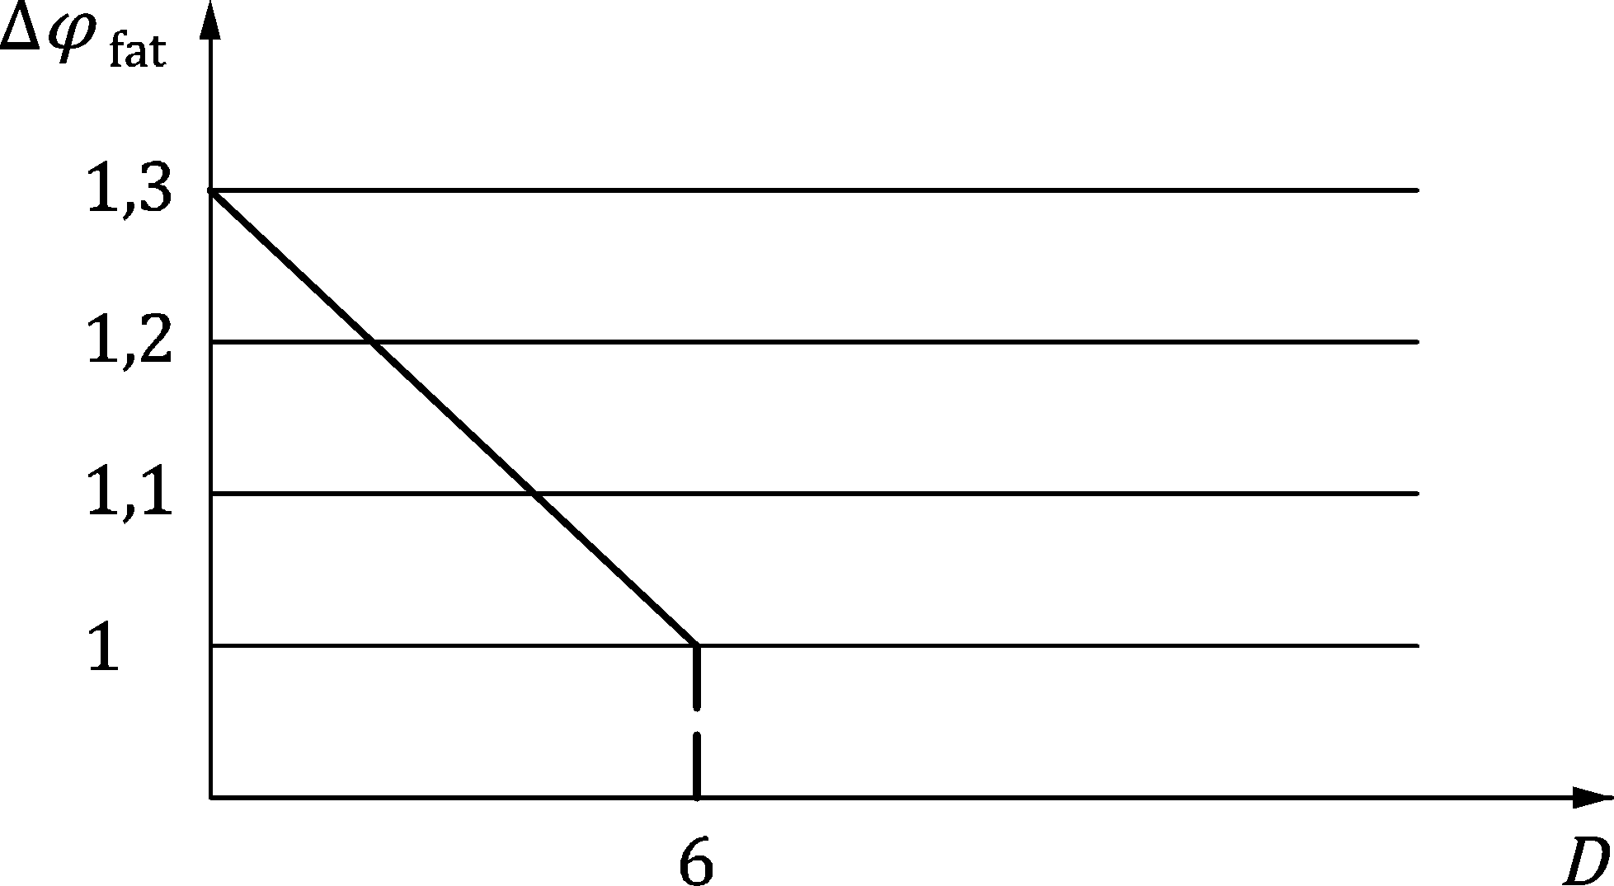

Key

|  |  |
| --- | --- |
| Δ*φ*fat | Additional amplification factor |
| *D* | Distance of the cross-section under consideration from the expansion joint [m] |

Figure 6.6 — Representation of the additional amplification factor

NOTE The dynamic additional amplification factor Δ*φ*fat can be set in the National Annex for use in a country.

### Fatigue Load Models location for global and local effects

(1) For the assessment of global action effects (e.g. in main girders) all fatigue load models should be placed centrally on the notional lanes defined in accordance with the principles and rules given in 6.2.4(1) and (2). The slow lanes (*i.e.* traffic lanes used predominantly by lorries) should be identified in the design.

(2) For the assessment of local action effects (e.g. in slabs) the models should be centred on notional lanes assumed to be located anywhere on the carriageway. However, where the transverse location of the vehicles for Fatigue Load Models 3, 4 and 5 is significant for the studied effects (e.g. for orthotropic decks), a statistical distribution of this transverse location should be taken into account in accordance with Figure 6.7.

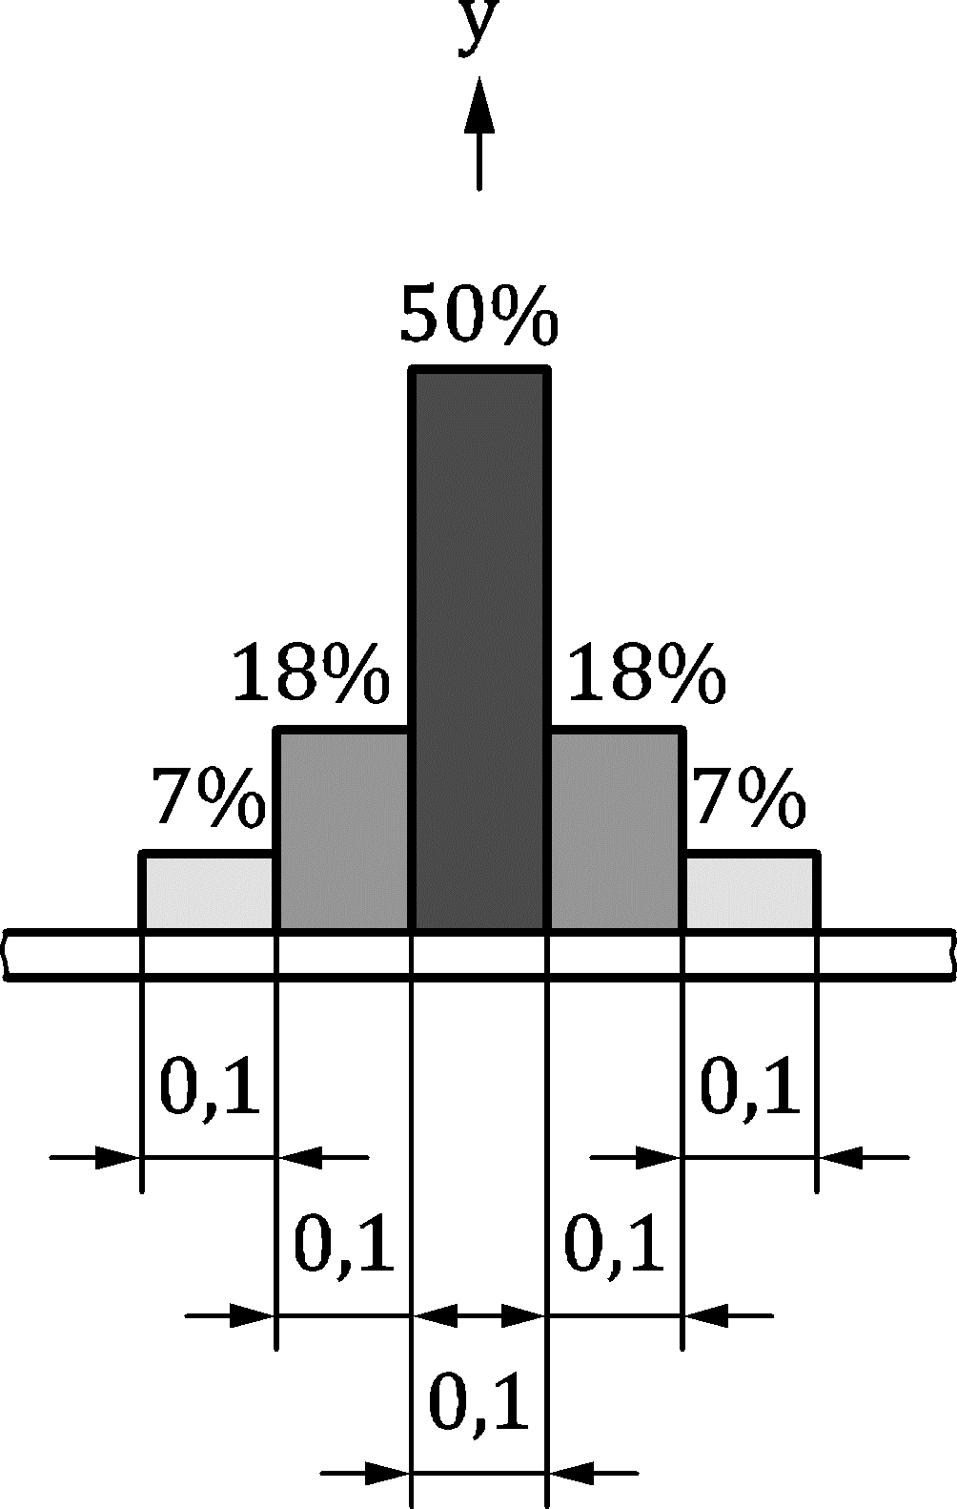

Figure 6.7 — Frequency distribution of transverse location of centre line of vehicle

(3) When the probability that traffic loading is located in the most adverse position is significantly less than 100 %, the spectra of effects of actions due to that traffic loading may be derived by considering less adverse (but nevertheless realistic) locations as specified by the relevant authority or, where not specified, agreed for a specific project by the relevant parties.

### Traffic category on the bridge

(1) For fatigue verifications, the traffic category on the bridge should be defined by considering, as a minimum:

— the number of slow lanes (*i.e.* a traffic lane used predominantly by lorries),

— the number *N*obs of heavy vehicles (maximum gross vehicle weight more than 100 kN), observed or estimated, per year and per slow lane.

NOTE 1 The traffic categories can be defined in the National Annex for use in a country.

NOTE 2 Indicative values for *N*obs are given in Table 6.7 (NDP) for a slow lane when using Fatigue Load Models 3 and 4. On each fast lane (*i.e.* a traffic lane used predominantly by cars), additionally, 10 % of *N*obs can be taken into account.

Table 6.7 (NDP) — Indicative number of heavy vehicles expected per year and per slow lane when using Fatigue Load Models 3 and 4

| Traffic categories | | ***N*obs** per year and per slow lane |
| --- | --- | --- |
| 1 | Roads and motorways with 2 or more lanes per direction with high flow rates of lorries | 2,0 × 106 |
| 2 | Roads and motorways with medium flow rates of lorries | 0,5 × 106 |
| 3 | Main roads with low flow rates of lorries | 0,125 × 106 |
| 4 | Local roads with low flow rates of lorries | 0,05 × 106 |

NOTE 3 Other parameters that might have to be considered to characterize the traffic for fatigue verifications include:

— percentages of vehicle types (see, e.g., Table 6.9 (NDP)), which depend on the “traffic type”,

— parameters defining the distribution of the weight of vehicles or axles of each type.

### Fatigue Load Model 1 (similar to LM 1)

(1) Fatigue Load Model 1 should have the configuration of the characteristic Load Model 1 defined in 6.3.2, with the values of the axle loads equal to 0,7 *Q*ik and the values of the uniformly distributed loads equal to 0,3 *q*ik for the notional lanes and (unless otherwise specified) 0,3 *q*rk for the remaining area of the carriageway

(2) The uniformly distributed loads *q*rk may be neglected when agreed for a specific project by the relevant parties.

NOTE The load values for Fatigue Load Model 1 are similar to those defined for the Load Model 1 with its frequent values. However adopting the Frequent Load Model without adjustment would have been excessively conservative by comparison with the other models, especially for large loaded areas.

(2) The maximum and minimum stresses (*σ*FLM,max and *σ*FLM,min) should be determined from the possible load arrangements of the model on the bridge.

### Fatigue Load Model 2 (set of “frequent” lorries)

(1) Fatigue Load Model 2 should be represented by a set of idealised lorries, called “frequent” lorries, (see Table 6.8).

(2) Each “frequent lorry” should be defined by:

— the number of axles and the axle spacing,

— the frequent load of each axle,

— the wheel contact areas and the transverse distance between wheels based on the wheel type as indicated in Table 6.10.

Table 6.8 — Set of “frequent” lorries

| 1 | 2 | 3 | 4 |
| --- | --- | --- | --- |
| LORRY SILHOUETTE | Axle spacing | Frequent axle loads | Wheel type (see Table 6.10) |
|  | m | kN |  |
|  | 4,5 | 90 | A |
|  | 190 | B |
|  | 4,20 | 80 | A |
| 1,30 | 140 | B |
|  | 140 | B |
|  | 3,20 | 90 | A |
| 5,20 | 180 | B |
| 1,30 | 120 | C |
| 1,30 | 120 | C |
|  | 120 | C |
|  | 3,40 | 90 | A |
| 6,00 | 190 | B |
| 1,80 | 140 | B |
|  | 140 | B |
|  | 4,80 | 90 | A |
| 3,60 | 180 | B |
| 4,40 | 120 | C |
| 1,30 | 110 | C |
|  | 110 | C |

(3) The maximum and minimum stresses (*σ*FLM, max and *σ*FLM, min) should be determined from the most severe effects of different lorries, separately considered, travelling alone along the appropriate lane. When some of these lorries are obviously the most critical, the others may be disregarded.

### Fatigue Load Model 3 (single vehicle model)

(1) The Fatigue Load Model 3 should be represented by four axles, each of them having two identical wheels (see Figure 6.8).

(2) The weight of each axle should be equal to 120 kN, and the contact surface of each wheel as a square of side 0,40 m.

Dimensions in metres

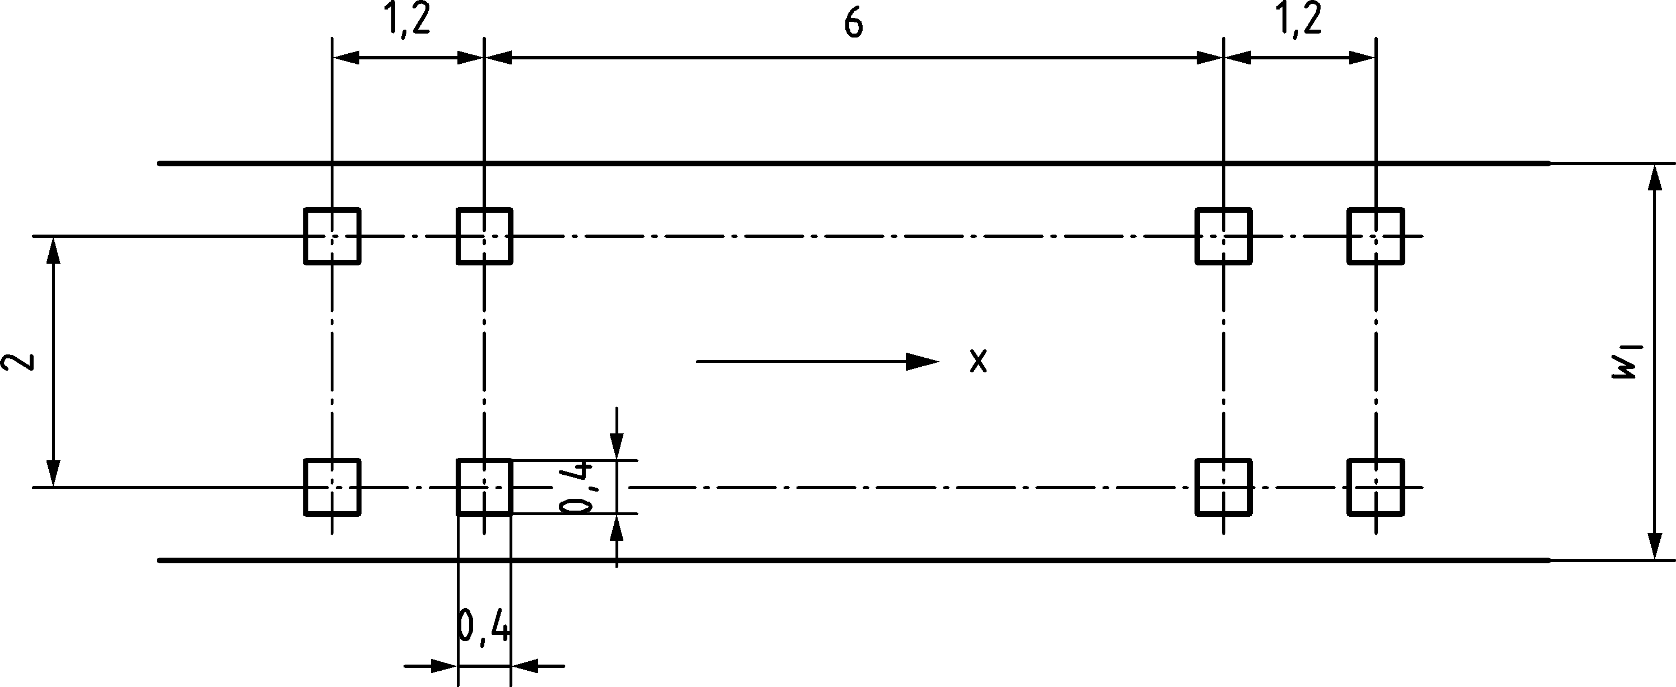

Key

|  |  |
| --- | --- |
| W1 | Lane width |
| X | Bridge lane direction |

Figure 6.8 — Fatigue Load Model 3

(3) The maximum and minimum stresses (*σ*FLM, max and *σ*FLM, min) and the stress ranges for each cycle of stress fluctuation, *i.e.* their algebraic difference, resulting from the transit of the model along the bridge should be calculated.

(4) Two vehicles representing Fatigue Load Model 3 may be taken into account in the same lane.

NOTE The conditions of application of this rule can be defined in the National Annex for use in a country. Possible conditions are given hereafter:

— one vehicle is as defined in 6.6.7 (1) above;

— the geometry of the second vehicle is as defined in 6.6.7 (1) above and the weight of each axle is equal to 36 kN (instead of 120 kN);

— the distance between the two vehicles, measured from centre to centre of vehicles, is not less than 40 m.

### Fatigue Load Model 4 (set of “standard” lorries)

(1) Fatigue Load Model 4 should be represented by sets of standard lorries which together produce effects equivalent to those of typical traffic on European roads.

(2) Each “standard” lorry should be defined by:

— the number of axles and the axle spacing,

— the equivalent load of each axle,

— the wheel contact areas and the transverse distances between wheels based on the wheel type as indicated in Table 6.10.

NOTE 1 This model, based on five standard lorries, simulates traffic which is deemed to produce fatigue damage equivalent to that due to actual traffic of the corresponding category defined in Table 6.7 (NDP).

NOTE 2 The National Annex can set other standard lorries and lorry percentages for use in a country.

Table 6.9 (NDP) — Set of equivalent lorries

| VEHICLE TYPE | | | TRAFFIC TYPE | | | Wheel type |
| --- | --- | --- | --- | --- | --- | --- |
| 1 | 2 | 3 | 4 | 5 | 6 | 7 |
|  |  |  | Long distance* | Medium distance* | Local traffic* |  |
| LORRY SILHOUETTE | Axle spacing | Equivalent loads of each axle | Lorry percentage | Lorry percentage | Lorry percentage |  |
|  | (m) | (kN) |  |  |  |  |
|  | 4,5 | 70 | 20,0 | 40,0 | 80,0 | A |
|  | 130 |  |  |  | B |
|  | 4,20 | 70 | 5,0 | 10,0 | 5,0 | A |
| 1,30 | 120 |  |  |  | B |
|  | 120 |  |  |  | B |
|  | 3,20 | 70 | 50,0 | 30,0 | 5,0 | A |
| 5,20 | 150 |  |  |  | B |
| 1,30 | 90 |  |  |  | C |
| 1,30 | 90 |  |  |  | C |
|  | 90 |  |  |  | C |
|  | 3,40 | 70 | 15,0 | 15,0 | 5,0 | A |
| 6,00 | 140 |  |  |  | B |
| 1,80 | 90 |  |  |  | B |
|  | 90 |  |  |  | B |
|  | 4,80 | 70 | 10,0 | 5,0 | 5,0 | A |
| 3,60 | 130 |  |  |  | B |
| 4,40 | 90 |  |  |  | C |
| 1,30 | 80 |  |  |  | C |
|  | 80 |  |  |  | C |
| * For the selection of a traffic type, it can broadly be considered that:  — “Long distance” means hundreds of kilometres,  — “Medium distance” means 50 km to 100 km,  — “Local traffic” means distances less than 50 km.  In reality, mixture of traffic types can occur. | | | | | | |

Table 6.10 — Geometrical definition of wheels and axles

Dimensions in millimetres

| WHEEL/AXLE TYPE | GEOMETRICAL DEFINITION |
| --- | --- |
| A |  |
| B |  |
| C |  |

(3) Standard lorries and lorry percentages other than those in Table 6.9 (NDP) may be used when agreed for a specific project by the relevant parties.

(4) A set of standard lorries appropriate to the mixture of traffic types traffic mixes predicted for the route should be identified.

(5) The calculations should be based on the following procedure:

— the percentage of each standard lorry in the traffic flow should be selected from Table 6.9 (NDP) columns 4, 5 or 6 as relevant ;

— the total number of vehicles per year to be considered for the whole carriageway Σ *N*obs should be defined;

NOTE The total number of vehicles per year is given in Table 6.7 (NDP) for Fatigue Load Models 3 and 4, unless the National Annex gives different values for use in a country.

— each standard lorry is considered to cross the bridge in the absence of any other vehicle.

(6) The stress range spectrum and the corresponding number of cycles from each fluctuation in stress during the passage of individual lorries on the bridge should be the Rainflow or the Reservoir counting method.

NOTE For verification rules, see the EN 1992 series to EN 1999 series

### Fatigue Load Model 5 (based on recorded road traffic data)

(1) Fatigue Load Model 5 should be represented by the direct application of recorded traffic data, supplemented, if relevant, by appropriate statistical and projected extrapolations.

NOTE The use of Fatigue Load Model 5 can be set in the National Annex for use in a country. Guidance for a complete specification and the application of Fatigue Load Model 5 is given in Annex B.

## Collision and other actions for accidental design situations

### General

(1) The following loads due to road vehicles in accidental design situations shall be taken into account where relevant:

— vehicle collision with bridge piers, soffit of bridge or decks (see 6.7.2),

— the presence of heavy wheels or vehicle on footways and cycle ways (see 6.7.3.1),

— vehicle collision with kerbs (see 6.7.3.2), vehicle restraint systems (see 6.7.3.3) and structural members (see 6.7.3.4).

(2) For bridges with weight limits indicated by road signs an accidental design situation should be considered with a load model corresponding to that representing the heaviest classes of vehicle permitted to use the bridge approach roads unless a physical obstacle prevents such vehicles from crossing the bridge.

### Collision forces from vehicles under the bridge

(1) Collision forces on piers, other supporting members, and on decks should be calculated in accordance with EN 1991‑1‑7.

### Actions from vehicles on the bridge

#### Vehicle on footways and cycle ways on road bridges

(1) If footways and cycle ways are not protected by a vehicle restraint system with appropriate containment level, effects of heavy wheels or vehicle on footways shall be considered.

(2) If a safety barrier of an appropriate containment level is provided to protect footways and cycle ways on road bridges, the following should apply:

— Wheel or vehicle loading beyond this protection should not be taken into account.

— One accidental axle load corresponding to *α*Q2 *Q*2k (see also 6.3.2) shall be placed and oriented on the unprotected parts of the deck to give the most adverse effect adjacent to the safety barrier (see for example Figure 6.9). The location of the axle load shall take into account the expected deformability of the restraint system.

— The accidental axle load should not be taken into account simultaneously with any other variable load on the deck; see also prEN 1990:2020, A.2.

— If geometrical constraints make a two wheel arrangement impossible, a single wheel alone should be taken into account.

— Beyond the vehicle restraint system, the characteristic variable concentrated load defined in 7.3.3 should be applied, if relevant, separately from the accidental load.

NOTE Containment levels for safety barriers are defined in EN 1317‑2.

Dimensions in metres

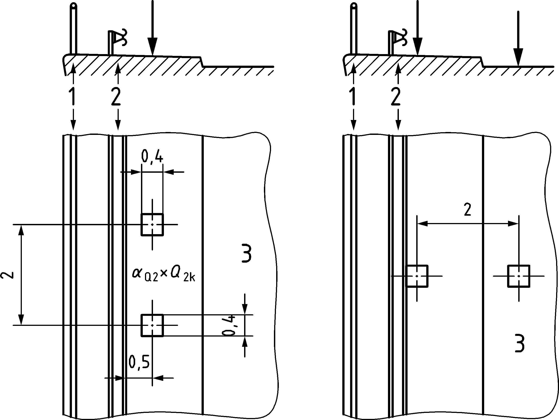

Key

|  |  |
| --- | --- |
| 1 | Pedestrian parapet (or vehicle parapet if a safety barrier is not provided) |
| 2 | Safety barrier |
| 3 | Carriageway |

Figure 6.9 — Examples showing locations of loads from vehicles on footways and cycle ways of road bridges

(3) If a safety barrier of an appropriate containment level is not provided, the rules given in (2) are applicable up to the edge of the deck where a vehicle parapet is provided.

#### Collision forces on kerbs

(1) Effects of vehicle collision with kerbs shall be considered in all cases.

(2) The action from vehicle collision with kerbs or pavement upstands should be taken as a lateral force equal to 100 kN acting at a depth of 0,05 m below the top of the kerb and on a line 0,5 m long (see Figure 6.10). This force should be considered to be transmitted by the kerbs to the structural members supporting them.

(3) In rigid structural members, the load should be assumed to have an angle of dispersal of 45° (see Figure 6.10).

(4) When unfavourable, a vertical traffic load acting simultaneously with the collision force equal to 0,75 *α*Q1 × *Q*1k (see Figure 6.10) should be taken into account.

Dimensions in metres

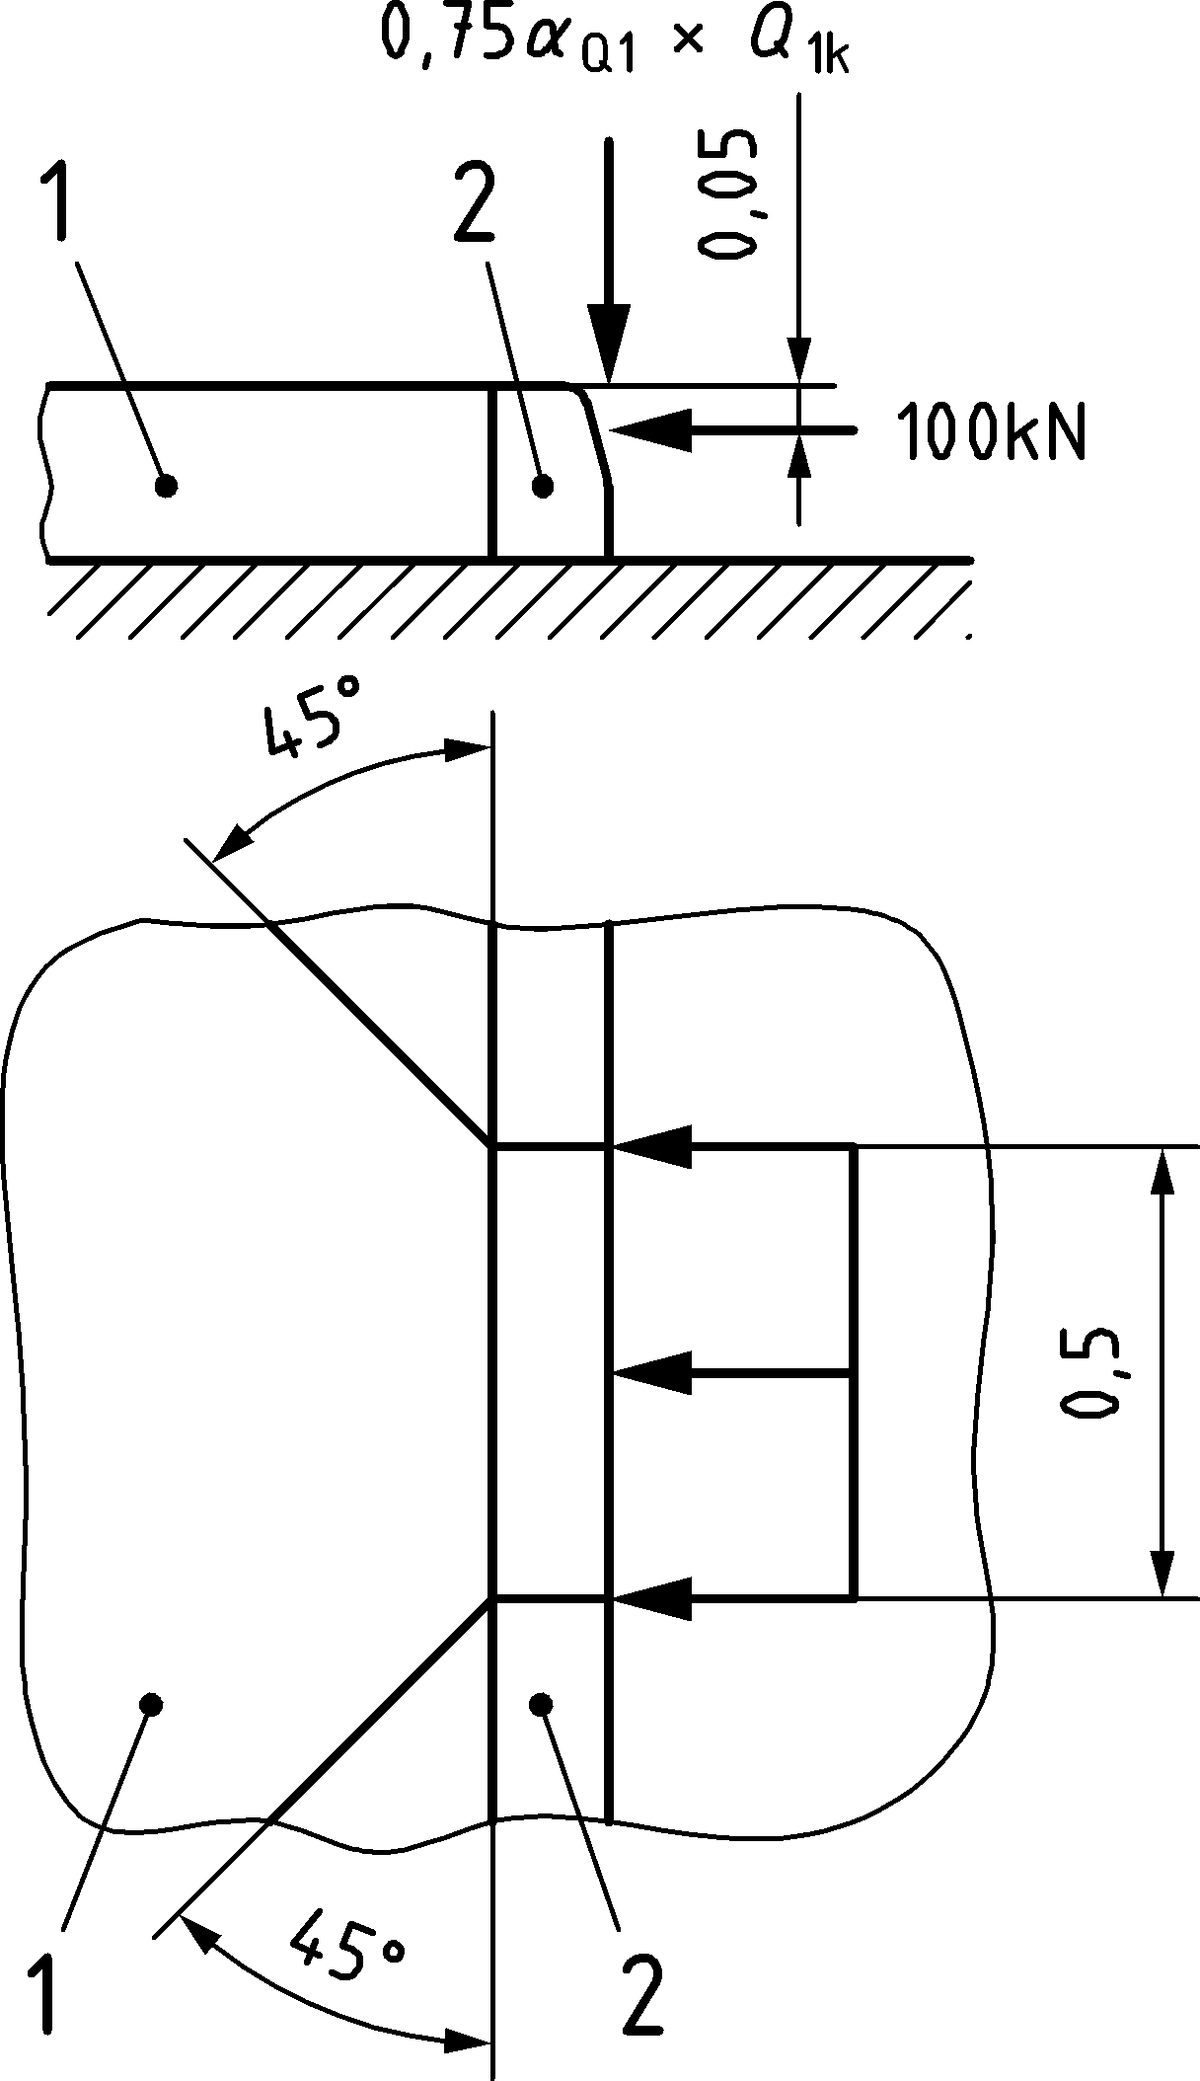

Key

|  |  |
| --- | --- |
| 1 | Footway |
| 2 | Kerb |

Figure 6.10 — Definition of vehicle collision forces on kerbs

#### Collision forces on vehicle restraint systems

(1) If vehicle parapets and safety barriers are provided on the bridge deck, effects of vehicle collision with such road restraints systems shall be considered.

NOTE The aim of the clauses in this chapter is to ensure adequate strength and robustness of anchorages, edge beams and bridge decks (cantilevered slabs) in order to prevent disproportionate damage caused by collision of road restraint systems that could require extensive repair and could cause unacceptable disturbance of the traffic operations.

(2) For local design, the structure supporting the vehicle parapet should be designed to sustain locally an accidental load effect arising from horizontal loading related to the characteristic local resistance of vehicle parapet (e.g. resistance of the connection of the parapet to the structure) and should not be combined with any other variable load.

NOTE Classes of characteristic capacities of restraint systems can be defined in the National Annex for use in a country.

(3) The accidental load effect should be at least 1,25 times the characteristic local resistance of vehicle parapet both transversely and longitudinally, unless otherwise specified in the National Annex for use in a country.

(4) For global design, the horizontal forces transferred to the bridge by restraint systems and the simultaneously acting vertical forces on the bridge shall be taken into account.

(5) There are classes defined for the recommended horizontal force transferred to the bridge deck by vehicle restraint systems.

NOTE 1 The values for the classes are given in Table 6.11 (NDP) unless the National Annex gives different classes, values and conditions of application.

Table 6.11 (NDP) — Classes for the recommended horizontal force transferred by vehicle restraint systems

| **Class** | **Recommended horizontal force** a |
| --- | --- |
| **(kN)** |
| A | 200 |
| B | 300 |
| C | 450 |
| D | 600 |
| a The horizontal force acts transversely. | |

NOTE 2 The horizontal force given in Table 6.11 (NDP) is applied 0,9 m above the level of the carriageway or footway and the reaction forces at the level of the fixation of the restraint system can be assumed to be distributed over a length of 4,0 m, unless the National Annex specifies different conditions for its application and distribution.

NOTE 3 There is no direct correlation between the values listed in Table 6.11 (NDP) and performance classes of vehicle restraint systems (according to EN 1317 series).

(6) The vertical force acting simultaneously (both for global and local verifications) with the horizontal collision force is taken equal to *ψ*1 *α*Q1 *Q*1k. The vertical force should be applied 500 mm from the railing post.

NOTE The National Annex can define a combination value instead of *ψ*1 for use in a country.

(7) The calculations taking account of horizontal and vertical forces may be replaced, when possible, by detailing measures (for example, design of reinforcement).

#### Collision forces on structural members

(1) The vehicle collision forces on unprotected structural members above or beside the carriageway levels should be taken into account.

NOTE The vehicle collision forces on structural members are the same as the collision forces on piers and other supporting members calculated to EN 1991‑1‑7:2006 (see 6.7.2), unless the National Annex establish different rules for their calculation for use in a country.

(2) If additional protective measures between the carriageway and the structural members are provided, the vehicle collision force may be reduced when agreed for a specific project by the relevant parties.

(3) Combinations of actions for accidental design situation should be in accordance with prEN 1990:2021, A.2.6.8.

(4) For some intermediate members where damage to one of them would not cause collapse (e.g. hangers or stays), smaller forces applied where agreed for a specific project by the relevant parties.

## Actions on pedestrian parapets

(1) For structural design, forces that are transferred to the bridge deck by pedestrian parapets should be taken into account as variable loads.

(2) Forces that are transferred to the bridge deck by pedestrian parapets should be defined, depending on the selected loading class of the parapet.

NOTE 1 For loading classes of pedestrian parapets, see CEN/TR 16949.

NOTE 2 The forces transferred to the bridge deck by pedestrian parapets can be defined with their classification in the National Annex for use in a country in accordance with CEN/TR 16949.

(3) For bridges, the minimum loading class of the parapet should be class C, unless the National Annex gives a different value for use in a country.

(4) The following values of the line force applied horizontally or vertically on the top of the pedestrian parapet should be taken as a minimum:

— 1,0 kN/m for footways or footbridges;

— 0,8 kN/m for service side paths.

NOTE Exceptional and accidental cases are not covered by these minimum values.

(5) For the design of the supporting structure, if pedestrian parapets are adequately protected against vehicle collision, the horizontal actions should be considered as simultaneous with the uniformly distributed vertical loads *q*fk defined in 7.3.2.

NOTE Pedestrian parapets can be considered as adequately protected only if the protection satisfies the requirements for the individual project.

(6) If pedestrian parapets cannot be considered as adequately protected against vehicle collisions, the structure supporting the pedestrian parapet should be designed to sustain an accidental load effect corresponding to at least 1,25 times the characteristic resistance of the parapet and should not be combined with any variable load.

NOTE A different value of the minimum accidental load effect (1,25) can be defined in the National Annex for use in a country.

## Load model for geotechnical structures — characteristic values

### General

(1) The load model specified in 6.9 should be used for calculating the load effects of road traffic on abutments, wing walls, side walls and other parts of bridges in contact with the ground.

NOTE 1 Additional application rules and application to other structure types, geotechnical structures and buried structures can be given in the National Annex for use in a country.

NOTE 2 For combination of load model presented in this clause with traffic load on bridge deck see EN 1990:2021, A.2 and Table A.2.7.

### Vertical loads

(1) The road traffic load model behind abutment or adjacent to wing walls, side walls and other parts of bridges should be represented by a single concentrated load *Q*ek and a uniformly distributed load *q*ek (see Figure 6.11).

Dimensions in metres

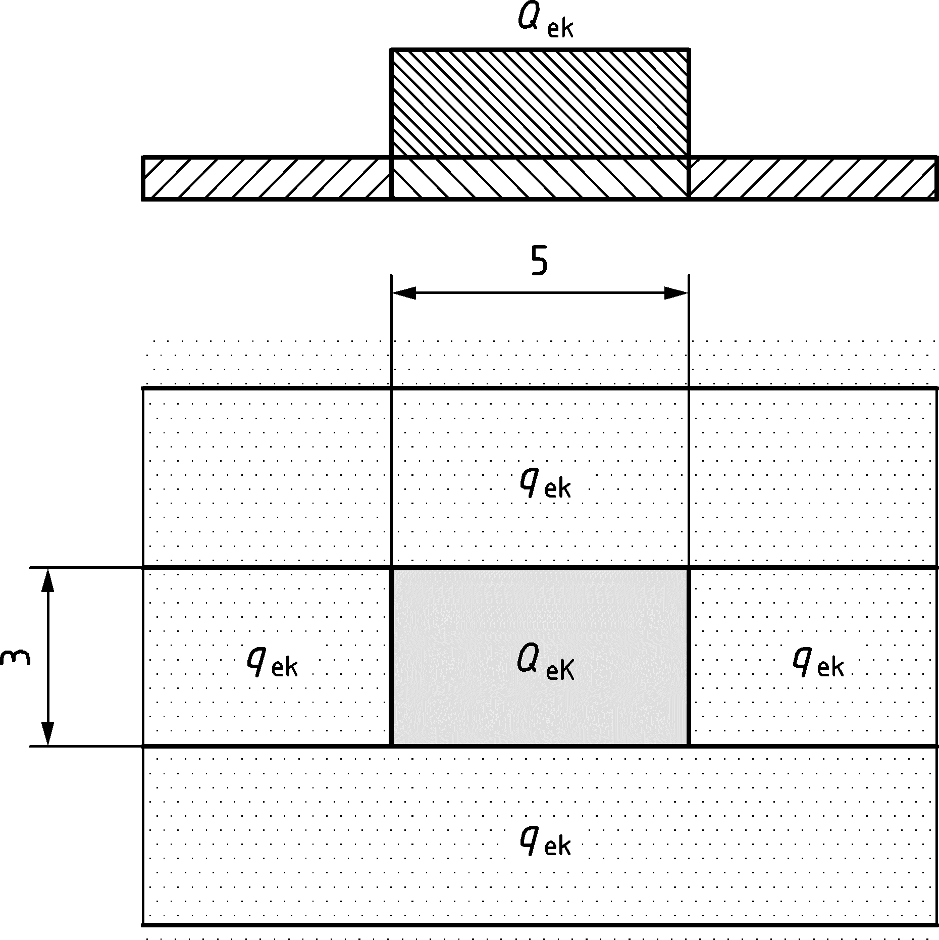

Figure 6.11 — Road traffic load model for geotechnical structures

NOTE 1 Unless the National Annex gives a different value and application rules for use in a country, the characteristic value of the concentrated load *Q*ek is 600 kN spread over rectangular surface area of 3 m × 5 m (i.e. 40 kN/m2).

NOTE 2 Unless the National Annex gives a different value and application rules for use in a country, the characteristic value of uniformly distributed load *q*ek is 9 kN/m2 applied on the remaining area of the carriageway.

NOTE 3 *Q*ek corresponds to LM 1 lane 1 tandem load and *q*ek corresponds to LM 1 lane 1 uniformly distributed load.

(2) The concentrated patch load should be placed so that it gives the most unfavourable effect on the structure.

### Horizontal force for abutments

(1) No horizontal force shall be taken into account at the surfacing level of the carriageway over the backfill.

(2) For the design of abutment upstand walls (see Figure 6.12), the following should apply:

— a longitudinal braking force should be taken into account according to Formula (6.6),

— the longitudinal braking force should act simultaneously with the *α*Q1*Q*1k axle loading of Load Model 1 and with the earth pressure from the backfill,

— the backfill should not be loaded simultaneously.

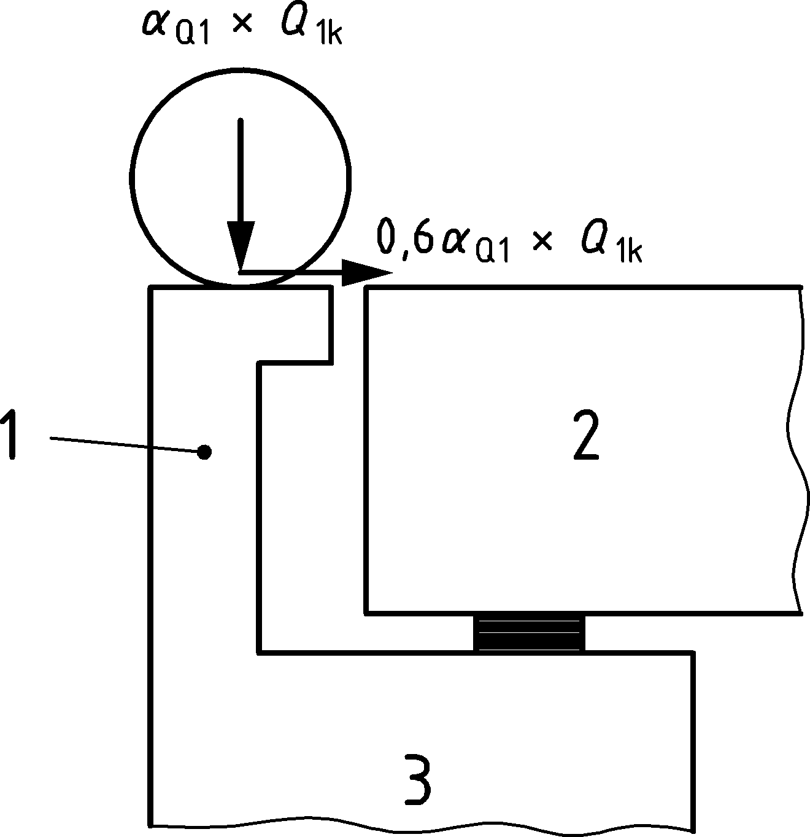

Key

|  |  |
| --- | --- |
| 1 | Upstand wall |
| 2 | Bridge deck |
| 3 | Abutment |

Figure 6.12 — Definition of loads on upstand walls

# Actions on footways, cycle ways and footbridges

## Field of application

(1) Load models defined in Clause 7 should be used for the design of footways, cycle ways and footbridges with the following limitations:

— The uniformly distributed load *q*fk (defined in 7.3.2) and the concentrated load *Q*fwk (defined in 7.3.3) should be used for footbridges, footways of road bridges and public footways on railway, where relevant (see 6.5, 6.7.3 and 8.3.7).

— All other variable actions and actions for accidental design situations defined in this clause are intended only for footbridges.

NOTE For loads on access steps, see EN 1991‑1‑1:2002, 8.3.

(2) Complementary load models and associated combination rules may be applied for wide footbridges as agreed for a specific project by the relevant parties.

(3) For the calculation of load effects to be performed for any bridge type, the variable actions given in Clause 7 should be treated as static since the load models and values include the dynamic amplification effects. Only exception is for the calculations relating to the vibration of footbridges, which should be carried out using dynamic analysis (see 7.7).

(4) The load models and values given in Clause 7 do not cover the effects of loads on construction sites, which should be separately specified, where relevant.

(5) Models and representative values given in this clause should be used for serviceability and ultimate limit state calculations excluding fatigue limit states.

## Representation of actions

### Models of the loads

(1) The following imposed actions should be taken into account as relevant

— pedestrian and cycle traffic,

— minor common construction and maintenance loads (e.g. service vehicles),

— actions for accidental design situations.

NOTE 1 These loads give rise to vertical and horizontal, static and dynamic forces defined in Clause 7.

NOTE 2 Loads on footbridges can differ depending on their location and on the possible traffic flow of some vehicles. These factors are mutually independent and are considered in various clauses given below.

(2) Special loads due to horses or cattle may be agreed for a specific project by the relevant parties.

### Application of the load models

(1) For each individual verification, the load models shall be applied anywhere within the relevant areas so that the most adverse effect is obtained.

(2) The actions used for footbridges shall be used on the footways of road bridges and public footways of railway bridges. The service vehicle (see 7.3.4) may be omitted from the design if agreed with the relevant parties for the individual project.

## Static models for vertical loads — characteristic values

### General

(1) The following models, mutually exclusive, should be taken into account as relevant:

— a uniformly distributed load *q*fk,

— a concentrated load *Q*fwk and

— concentrated loads representing service vehicles *Q*serv.

(2) The characteristic values of these load models should be used for both persistent and transient design situations.

### Uniformly distributed load

(1) For footbridges, a uniformly distributed load *q*fk should be defined.

NOTE Unless the National Annex gives different rules, the uniformly distributed load *q*fk can be calculated using Formula (7.1).



;  (7.1)

where

|  |  |
| --- | --- |
| *L* | is the length of the unfavourable part of influence surface in [m]. |

(2) On footways and cycle ways on road or railway bridges, the uniformly distributed load applied should be crowd loading defined in 6.3.5 unless otherwise agreed for a specific project by the relevant parties.

(3) The uniformly distributed load shall be applied only in the unfavourable parts of the influence surface of the footbridge, footway or cycle way.

### Concentrated load

(1) The concentrated load *Q*fwk should be defined.

NOTE The concentrated load *Q*fwk is equal to 10 kN acting on a square surface of sides 0,10 m unless the National Annex gives different values for use in a country.

(2) Where, in a verification, global and local effects can be distinguished, the concentrated load should be taken into account only for local effects and it is not combined with any other variable load.

(3) For footbridges, if a service vehicle is specified, *Q*fwk should not be considered.

### Service vehicle

(1) Service vehicle may be omitted if permanent provisions are made to prevent access of all vehicles to the footbridge.

(2) When service vehicles are to be carried on a footbridge or footway, one service vehicle *Q*serv shall be taken into account.

(3) Several service vehicles, mutually exclusive, may be taken into account when agreed for a specific project by the relevant parties.

(4) If no information is available and if no permanent obstacle prevents a vehicle being driven onto the bridge deck, the vehicle load model defined in 7.6.3 should be used to represent the service vehicle as a characteristic load.

NOTE This vehicle can be a vehicle for maintenance, emergencies (e.g. ambulance, fire) or other services. The characteristics of this vehicle (axle weight and spacing, contact area of wheels), the dynamic amplification and all other appropriate loading rules can be defined in the National Annex for use in a country.

## Static model for horizontal forces — characteristic values (footbridges only)

(1) A horizontal force *Q*flk should be taken into account, acting along the bridge deck axis at the pavement level.

NOTE The characteristic value of the horizontal force is equal to the greater of the following two values, unless the National Annex gives different values for use in a country:

— 10 per cent of the total load corresponding to the uniformly distributed load (7.3.2),

— 60 per cent of the total weight of the service vehicle, if relevant (7.3.4).

(2) The horizontal force shall be considered as acting simultaneously with the corresponding vertical load.

(3) Actions other than the horizontal force *Q*flk or appropriate design measures should be put in place to ensure horizontal transverse stability.

NOTE The horizontal force *Q*flk is normally sufficient to ensure the horizontal longitudinal stability of footbridges. However it does not ensure horizontal transverse stability.

## Groups of traffic loads (footbridges only)

(1) When relevant, the vertical loads and horizontal forces due to traffic should be taken into account by considering groups of loads defined in Table 7.1. Each of these groups defining a single variable characteristic action for combination with non–traffic loads.

NOTE The groups of loads indicated in Table 7.1 are mutually exclusive.

Table 7.1 — Definition of groups of loads (characteristic values)

| Load type | | Vertical forces | | | Horizontal forces |
| --- | --- | --- | --- | --- | --- |
| Load system | | Uniformly distributed load | Service vehicle | Concentrated load |  |
| Groups of loads | gr1 | *q*fk |  |  | *Q*flk |
| gr2 | 0 | *Q*serv |  | *Q*flk |
| gr3 |  |  | *Q*fvk |  |

(2) For any combination of traffic loads with actions specified in other parts of EN 1991, any such group should be considered as one action.

NOTE For the individual components of the traffic loads on footbridges, the other representative values are defined in prEN 1990:2021, A.2.

## Collision and other actions for accidental design situations (footbridges only)

### General

(1) Actions for accidental design situations should be represented by static equivalent loads covering:

— road traffic under the bridge (*i.e.* collision) or

— the accidental presence of a heavy vehicle on the bridge.

NOTE Other accidental actions (see 4.3) can be agreed for a specific project by the relevant parties.

### Collision forces from traffic under the footbridge

#### General

(1) The measures to protect a footbridge should be defined.

NOTE Footbridges (piers and decks) are generally much more sensitive to collision forces than road bridges. Designing them for the same collision load can be unrealistic. The most effective way to take collision into account generally consists of protecting the footbridges:

— by road restraint systems,

— by a higher clearance than for neighbouring road or railway bridges over the same road in the absence of intermediate access to the road.

#### Collision forces on piers

(1) Collision forces on piers should be calculated in accordance with EN 1991‑1‑7.

#### Collision forces on decks

(1) Collision forces on decks should be calculated in accordance with EN 1991‑1‑7.

### Accidental presence of vehicles on the footbridge

(1) If no permanent obstacle prevents a vehicle from being driven onto the bridge deck, the accidental presence of a vehicle on the bridge deck shall be taken into account in the most adverse position for the element under consideration.

NOTE 1 Unless otherwise set in the National Annex for use in a country, the following load model represents the accidental presence of vehicles on a footbridge:

— a two-axle load group of 80 kN and 40 kN, separated by a wheel base of 3 m (Figure 7.1);

— a track (wheel-centre to wheel-centre) of 1,3 m;

— square contact areas of side 0,2 m at coating level;

— the braking force associated with the load model is equal to 60 % of the vertical load.

Dimensions in metres

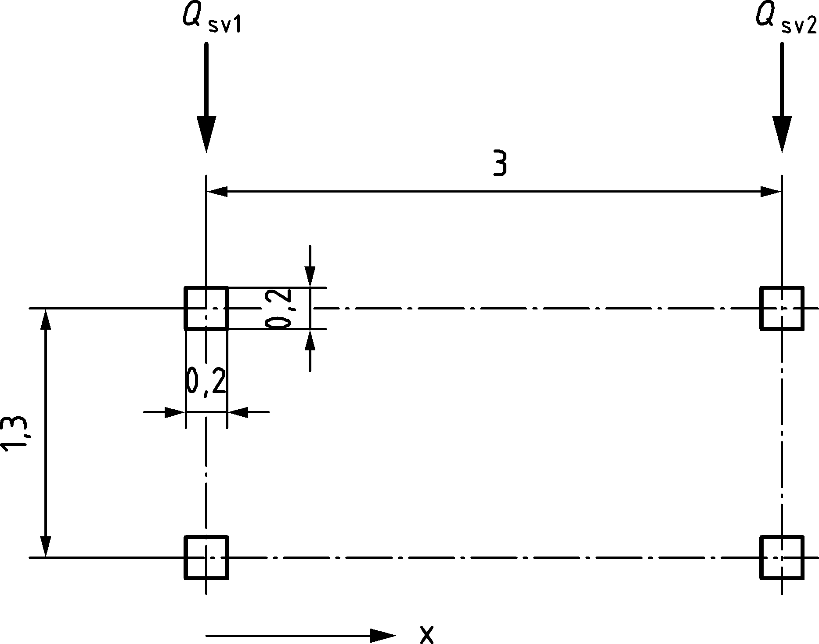

Key

|  |  |
| --- | --- |
| *Q*sv1 | = 80 kN |
| *Q*sv2 | = 40 kN |

Figure 7.1 — Accidental loading

NOTE 2 See NOTE in 7.3.4 (4).

(2) No variable action should be taken into account simultaneously with such load model representing the accidental presence of a vehicle on the bridge deck.

## Dynamic models of pedestrian loads (footbridges only)

(1) Dynamic load models of pedestrian loads should be defined where relevant.

NOTE Annex G provides guidance on dynamic load models.

## Actions on parapets

(1) Pedestrian parapets should be designed in accordance with 6.8.

## Load model for abutments and walls adjacent to bridges

(1) The area external to a carriageway and located behind abutments, wing walls, side walls and other parts of the bridge in contact with the ground should be loaded with a uniformly distributed vertical load of 5 kN/m2. Unless otherwise specified by the relevant authority or agreed for a specific project by the relevant parties 20 % of the concentrated load *Q*ek (see 6.9) may be used to take into account the service vehicle.

NOTE 1 This load does not cover the effects of heavy construction vehicles and other lorries commonly used for the placing of the backfill.

(2) The concentrated load is spread over a rectangular surface area of 3 m × 5 m and it shall be placed on the carriageway so that it gives the most unfavourable effect on the structure in question. Uniform load and concentrated load are placed on a carriageway as defined in 6.9.2.

# Rail traffic actions and other actions specifically for railway bridges

## Field of application

(1) The load models defined in Clause 8 should be used to model rail traffic on the standard track gauge and wider than the standard track gauge.

NOTE The load models defined in this clause do not describe actual loads. They have been selected so that their effects, with dynamic enhancements taken into account separately, represent the effects of service traffic.

(2) The load models defined in Clause 8 should not be used to model rail traffic on:

— narrow-gauge railways,

— tramways and other light railways,

— preservation railways,

— rack and pinion railways,

— funicular railways.

(3) Where traffic or structures outside the scope of the load models defined in Clause 8 or exceeding the actions specified in that clause, needs to be considered, then alternative load models, with associated combination rules, should be specified by the relevant authority or where not specified, agreed for a specific project by the relevant parties.

NOTE Alternative load models with associated combination rules can be set by the National Annex for use in a country.

(4) The load models defined in Clause 8 should be used to verify the deformation of structures carrying rail traffic to maintain the safety of operations and to ensure the comfort of passengers etc.

NOTE The deformation and acceleration limits are specified in prEN 1990:2021, A.2.8.4.

(5) The load models defined in Clause 8 should be used to verify the fatigue performance of structures carrying rail traffic.

NOTE Three standard mixes of rail traffic are given as a basis for calculating the fatigue life of structures (see Annex D).

(6) The self-weight of non-structural elements should be taken to include the weight of railway equipment and other items supported by the structure.

NOTE Non-structural elements include, for example, noise and safety barriers, signals, ducts, cables and overhead line equipment (except the forces due to the tension of the contact wire etc.).

(7) Alternative loading and design requirements for temporary bridges should be specified by the relevant authority or agreed for a specific project by the relevant parties.

NOTE 1 The loading requirements for the design of temporary railway bridges can be based on this document, unless the National Annex gives different loads for use in a country.

NOTE 2 Additional design requirements for temporary bridges depending upon the conditions in which they are used can be set by the National Annex for use in a country (e.g. special requirements can be needed for skew bridges).

(8) For temporary structures, particular attention should be given to their deformation behaviour, taking account of the planned operating conditions over the structure.

## Representation of actions — nature of rail traffic loads

(1) Imposed actions due to railway operations should be taken into account as relevant.

NOTE 1 These loads give rise to vertical and horizontal, static and dynamic forces and accidental design situations defined in Clause 8 as follows:

— vertical loads: Load Models 71, SW/0, SW/2, “unloaded train” and HSLM (8.3 and 8.4.6.1.1),

— vertical loading for geotechnical structures (8.10),

— dynamic effects (8.4),

— centrifugal forces (8.5.1),

— nosing force (8.5.2),

— traction and braking forces (8.5.3),

— aerodynamic actions from passing trains (8.6),

— actions due to overhead line equipment and other railway infrastructure and equipment (8.7.4).

NOTE 2 Guidance is given on the evaluation of the combined response of structure and track to variable actions (8.5.4).

NOTE 3 Derailment actions for Accidental Design Situations are given for the effect of rail traffic derailment on a structure carrying rail traffic (8.7.2).

NOTE 4 Derailment actions for derailment under a bridge are given in EN 1991‑1‑7.

## Vertical loads — characteristic values (static effects) and eccentricity and distribution of loading

### General

(1) Rail traffic actions are defined by means of load models. Five models of railway loading are given:

— Load Model 71 (and Load Model SW/0 for continuous bridges) to represent normal rail traffic on mainline railways,

— Load Model SW/2 to represent heavy loads,

— Load Model HSLM to represent the loading from passenger trains at speeds exceeding 200 km/h,

— Load Model “unloaded train” to represent the effect of an unloaded train.

NOTE Requirements for the application of these load models (except HSLM) are included in 8.3.2, 8.3.3 and 8.3.4. Requirements for the application of HSLM are included in 8.4.6.1. Further requirements for the application of load models are given in 8.8.1 and 8.8.2.

(2) Provision is made for varying the specified loading to allow for differences in the nature, volume and maximum weight of rail traffic on different railways, as well as different qualities of track.

### Load Model 71

(1) Load Model 71 (LM71) represents the static effect of vertical loading due to normal rail traffic.

(2) The load arrangement and the characteristic values for vertical loads shall be taken as shown in Figure 8.1.

Dimensions in metres

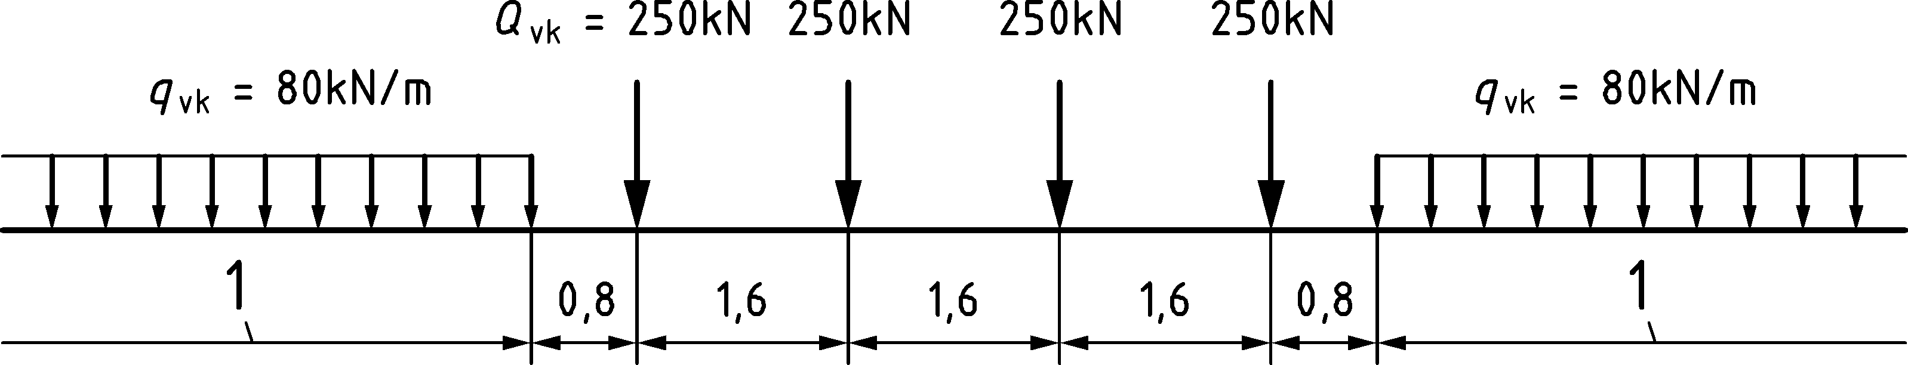

Key

|  |  |
| --- | --- |
| 1 | No limitation, see 8.8.1 |

Figure 8.1 — Load Model 71 and characteristic values for vertical loads

(3) “Classified vertical loads” shall be obtained by multiplying the characteristic values given in Figure 8.1 by a factor *α.*

NOTE The factor *α* can be used to represent load effects on lines carrying rail traffic which is heavier or lighter than normal rail traffic.

(4) The value of the factor *α* shall be one of the following as specified by the relevant authority or agreed for a specific project by the relevant parties:

0,75 — 0,83 — 0,91 — 1,00 — 1,10 — 1,21 — 1,33 — 1,46

NOTE The factor *α* can be set by the National Annex for use in a country.

(5) For international lines a value *α* ≥ 1,00 should be used.

(6) The actions listed below shall be multiplied by the factor *α*:

— centrifugal forces according to 8.5.1,

— nosing force according to 8.5.2 (multiplied by *α* for *α* ≥ 1 only),

— traction and braking forces according to 8.5.3,

— combined response of structure and track to variable actions according to 8.5.4,

— derailment actions for Accidental Design Situations according to 8.7.2(2),

— Load Model SW/0 for continuous span bridges according to 8.3.3.

— equivalent vertical loading for geotechnical structures and earth pressure effects according to 8.10,

(7) The same factor *α* should be used for the above mentioned actions; other values of factor *α* may be used for equivalent vertical loading for geotechnical structures.

(8) For checking limits of deflection classified vertical loads and other actions enhanced by *α* in accordance with 8.3.2(3) shall be used (except for passenger comfort where *α* shall be taken as unity).

(9) For geotechnical structures, the equivalent load arrangement and characteristic values for vertical loads given in 8.10 may be used.

(10) For the determination of the most adverse load effects from the application of Load Model 71:

— up to four of the individual concentrated loads *Q*vk shall be applied once per track and any number of lengths of the uniformly distributed load *q*vk shall be applied to a track in the most adverse load arrangement for the structural element in question,

— for structures carrying two tracks, Load Model 71 shall be applied to one track or both tracks,

— for structures carrying three or more tracks, Load Model 71 shall be applied to one track or to two tracks or 0,75 times Load Model 71 to three or more of the tracks.

### Load Models SW/0 and SW/2

(1) Load Model SW/0 should be used in addition to Load Model 71 to represent the static effect of vertical loading due to normal rail traffic on continuous decks.

(2) Load Model SW/2 should be used in addition to Load Model 71 to represent the static effect of vertical loading due to heavy rail traffic.

(3) The load arrangement for Load Models SW/0 and SW/2 shall be taken as shown in Figure 8.2, with the characteristic values of the vertical loads according to Table 8.1.

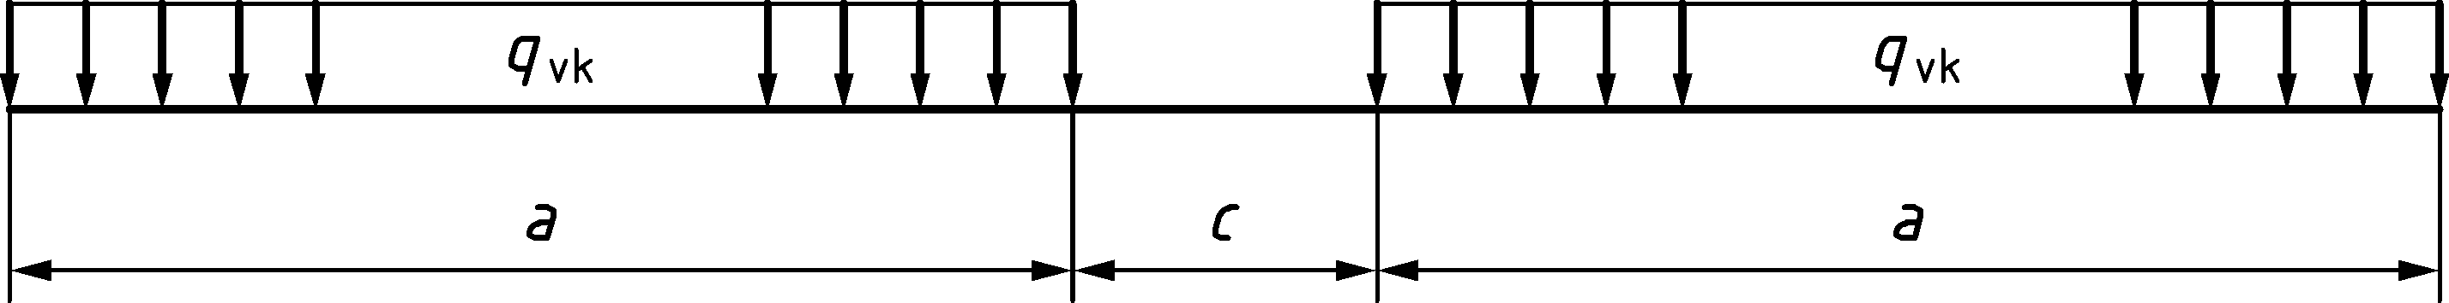

Figure 8.2 — Load Models SW/0 and SW/2

Table 8.1 — Characteristic values for vertical loads for Load Models SW/0 and SW/2

| Load Model | *q*vk | a | c |
| --- | --- | --- | --- |
|  | kN/m | m | m |
| SW/0 | 133 | 15,0 | 5,3 |
| SW/2 | 150 | 25,0 | 7,0 |

(4) Load Model SW/2 shall be taken into account on lines or sections of lines over which heavy rail traffic may operate as specified by the relevant authority or agreed for a specific project by the relevant parties.

NOTE Application of Load Model SW/2 on lines can be set by the National Annex for use in a country

(5) Load Model SW/0 shall be multiplied by the factor *α* in accordance with 8.3.2(3).

(6) For the determination of the most adverse load effects from the application of Load Model SW/0:

— the loading defined in Figure 8.2 and Table 8.1 shall be applied once per track,

— for structures carrying two tracks, Load Model SW/0 shall be applied to one track or both tracks,

— for structures carrying three or more tracks, Load Model SW/0 shall be applied to one track or to two tracks or 0,75 times Load Model SW/0 to three or more of the tracks.

(7) All continuous decks designed for Load Model 71 shall be checked additionally for Load Model SW/0.

(8) For the determination of the most adverse load effects from the application of Load Model SW/2:

— the loading defined in Figure 8.2 and Table 8.1 shall be applied once per track,

— for structures carrying more than one track, Load Model SW/2 shall be applied to one track only with Load Model 71 or Load Model SW/0 applied to one other track in accordance with 8.3.2 (10) and 8.3.3 (6).

NOTE The application of SW/2 is not needed if α ≥ 1,33 when the values for the partial factors (*γ*Q = 1,45 for LM71 “+” SW/0 and *γ*Q = 1,20 for SW/2) according to Table A.2.4(B) of prEN 1990 are taken into account.

### Load Model “unloaded train”

(1) The Load Model “unloaded train” should be used for some specific verifications.

NOTE The specific verifications are defined in prEN 1990:2021, A.2.6.6.3 (2) and Table A.2.9.

(2) The Load Model “unloaded train” shall be taken as a vertical uniformly distributed load with a characteristic value of 10 kN/m.

(3) For the determination of the most adverse load effects from the application of Load Model “unloaded train”:

— any number of lengths of the uniformly distributed load *q*vk shall be applied to a track,

— Load Model “unloaded train” shall only be applied to any one track.

### Eccentricity of vertical loads (Load Models 71 and SW/0)

(1) The effect of lateral displacement of vertical loads for Load Models 71 and SW/0 shall be considered by taking the ratio of loading between the rails as up to 1,25:1,00 on any one track. The resulting eccentricity *e* is shown in Figure 8.3.

(2) Eccentricity of vertical loads may be neglected when considering fatigue.

NOTE Requirements for taking into account the position and tolerance in position of tracks are given in 8.8.1.

|  |  |
| --- | --- |
|  | *q*v1, *q*v2, *Q*v1, *Q*v2 = (1)  *q*v1 + *q*v2, *Q*v1 + *Q*v2 = (2)  *q*v1, *q*v2, *Q*v1, *Q*v2 = (1)  *q*v2 ∕ *q*v1, *Q*v2 ∕ *Q*v1 = 1,25  *e* ≤ *r*∕18  *r* = (3) |

Key

|  |  |
| --- | --- |
| (1) | Uniformly distributed load and point loads on each rail as appropriate. |
| (2) | LM71 (and SW/0 where required) |
| (3) | Transverse distance between wheel loads |

Figure 8.3 — Eccentricity of vertical loads

### Distribution of point loads or axle loads by the rails, sleepers and ballast

#### General

(1) The distribution of point loads or axle loads by the rails, sleepers and ballast should be taken in accordance with 8.3.6.2 to 8.3.6.4 for Real Trains, Fatigue Trains, Load Models 71, SW/0, SW/2, the “unloaded train” and HSLM except where stated otherwise.

#### Longitudinal distribution of a point load or wheel load by the rail

(1) A point load in Load Model 71 (or classified vertical load in accordance with 8.3.2(3) where required) and HSLM (except for HSLM-B) or wheel load may be distributed over three rail support points as shown in Figure 8.4 below:

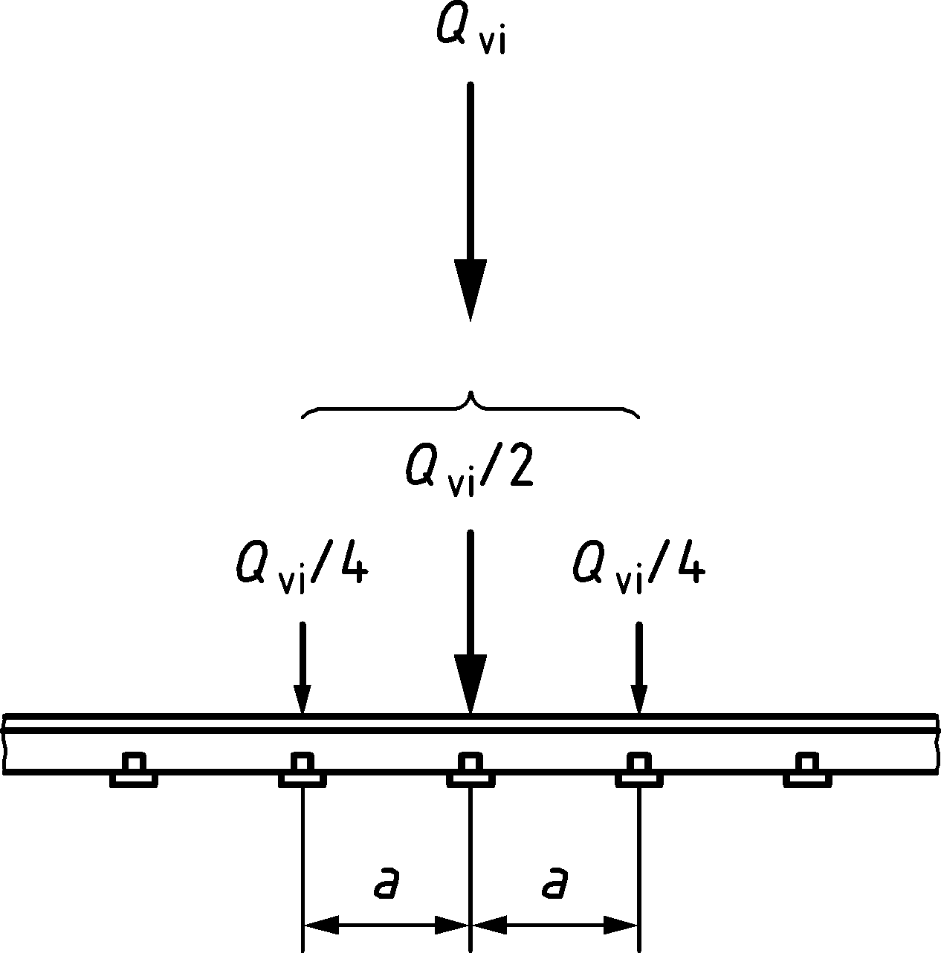

Key

|  |  |
| --- | --- |
| *Q*vi | is the point load on each rail due to Load Model 71 or a wheel load of a Real Train in accordance with 8.3.5, Fatigue Train or HSLM (except for HSLM-B); |
| *a* | is the distance between rail support points. |

Figure 8.4 — Longitudinal distribution of a point load or wheel load by the rail

#### Longitudinal distribution of load by sleepers and ballast

(1) The point loads of Load Model 71 only (or classified vertical load in accordance with 8.3.2(3) where required) or an axle load may be distributed uniformly in the longitudinal direction (except where local load effects are significant, e.g. for the design of local deck elements, etc.).

(2) For the design of local deck elements etc. (e.g. longitudinal and transverse ribs, rail bearers, cross girders, deck plates, thin concrete slabs, etc.), the longitudinal distribution beneath sleepers as shown in Figure 8.5 should be taken into account.

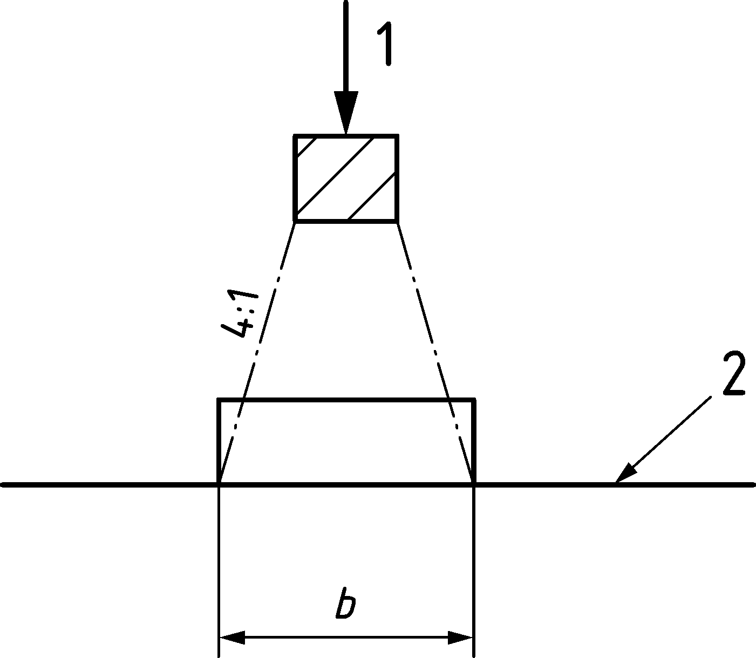

Key

|  |  |
| --- | --- |
| 1 | Load on sleeper; |
| 2 | Reference plane, defined as the upper surface of the deck supporting the ballast |

Figure 8.5 — Longitudinal distribution of load by a sleeper and ballast

#### Transverse distribution of actions by the sleepers and ballast

(1) On bridges with ballasted track without cant, the actions should be distributed transversely as shown in Figure 8.6.

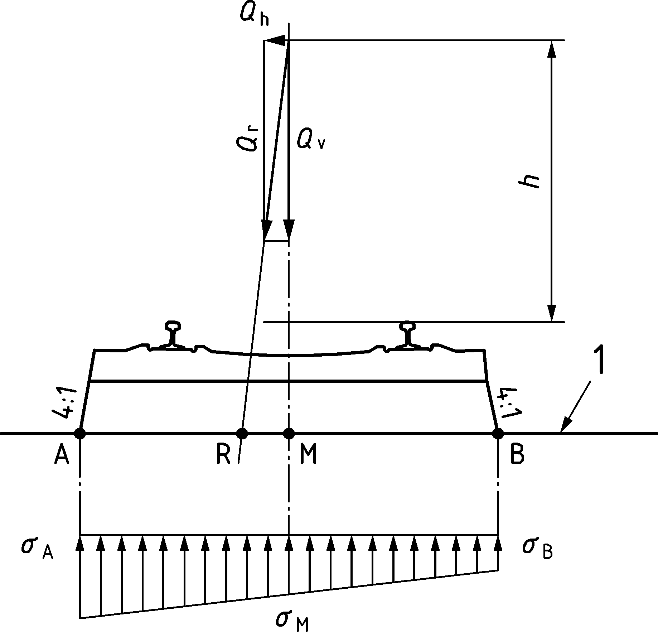

Key

|  |  |
| --- | --- |
| 1 | Reference plane. |

Figure 8.6 — Transverse distribution of actions by the sleepers and ballast, track without cant (effect of eccentricity of vertical loads not shown)

(2) On bridges with ballasted track without cant, and for full length sleepers where the ballast is only consolidated under the rails, or for duo-block sleepers, the actions should be distributed transversely as shown in Figure 8.7.

Dimensions in metres

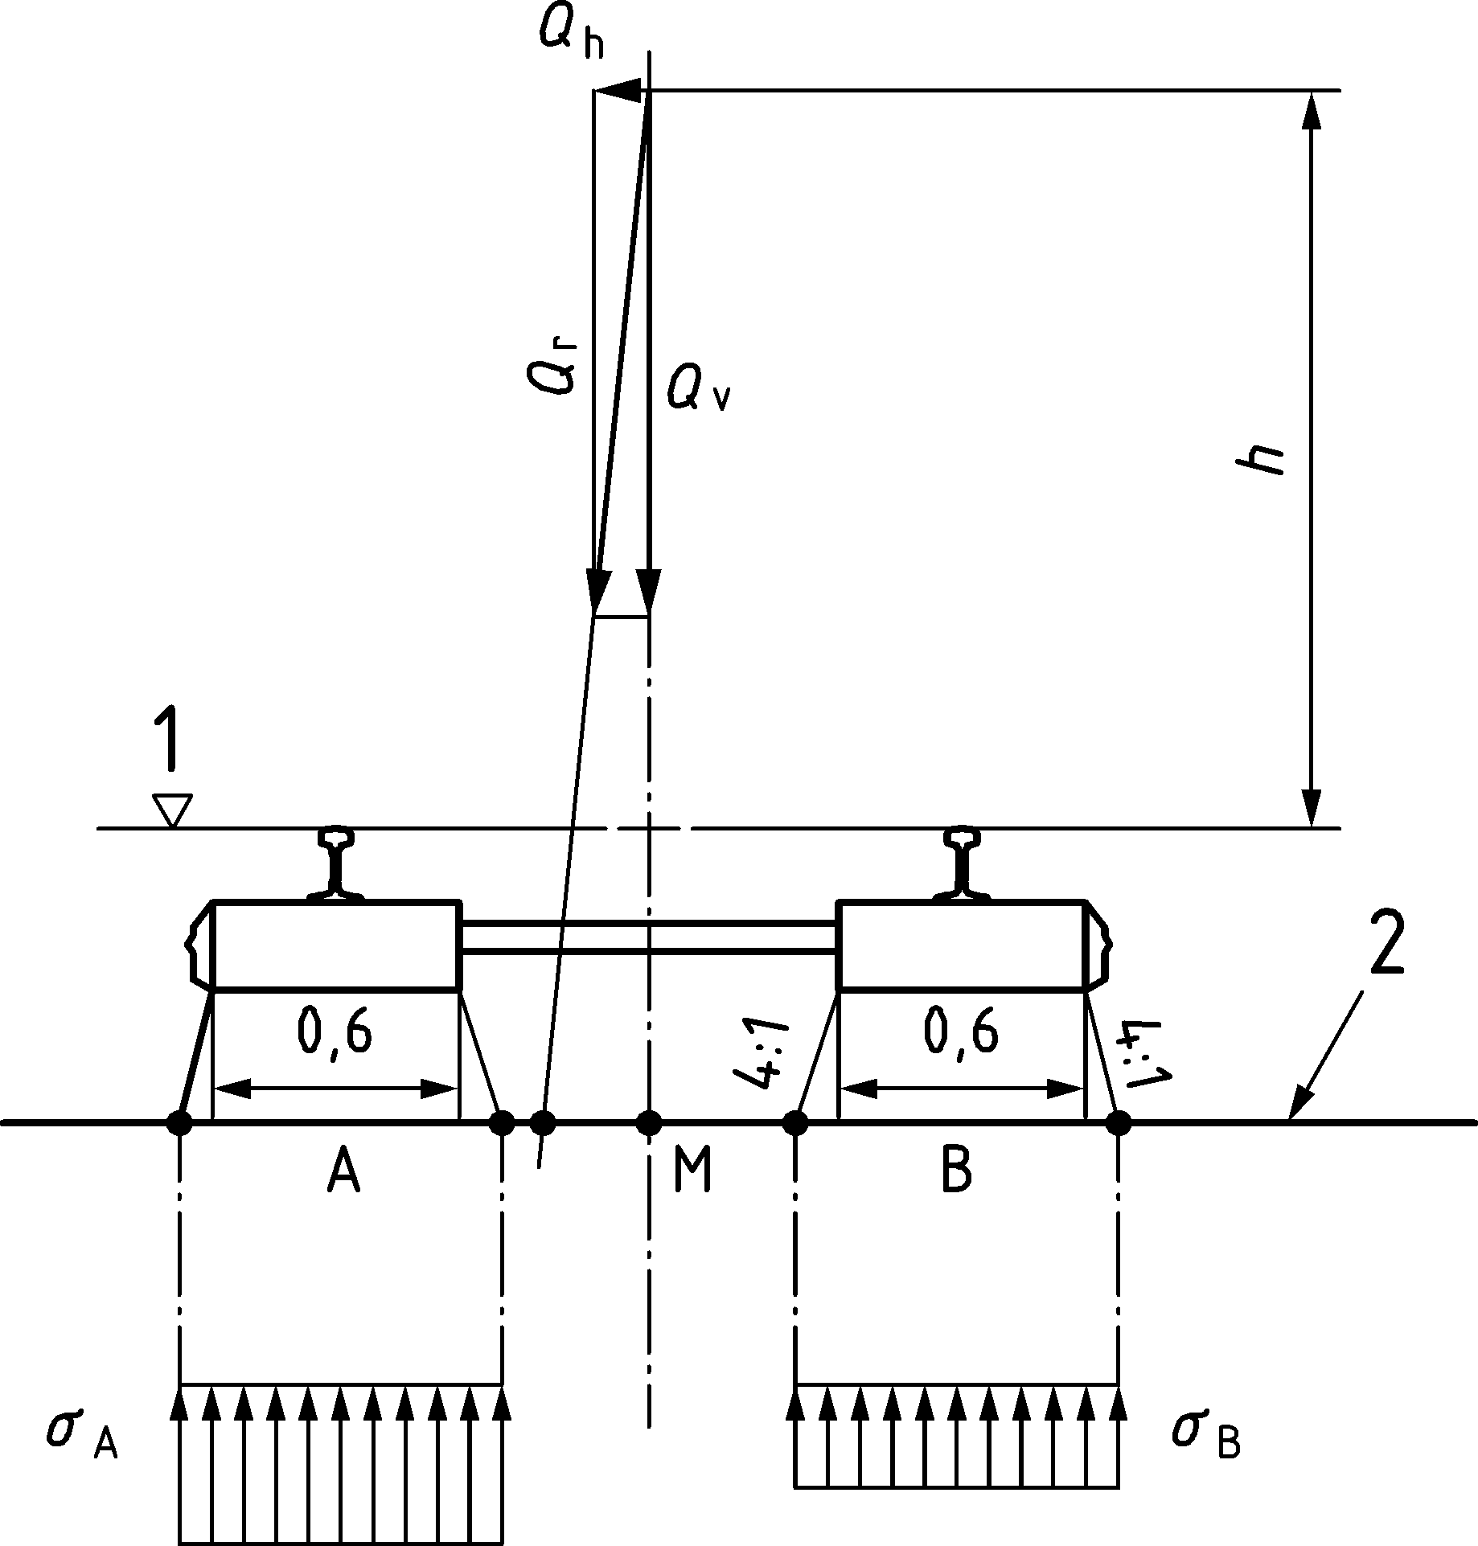

Key

|  |  |
| --- | --- |
| 1 | Running surface; |
| 2 | Reference plane. |

Figure 8.7 — Transverse distribution of actions by the sleepers and ballast, track without cant (effect of eccentricity of vertical loads not shown)

(3) On bridges with ballasted track with cant the actions should be distributed transversely as shown in Figure 8.8.

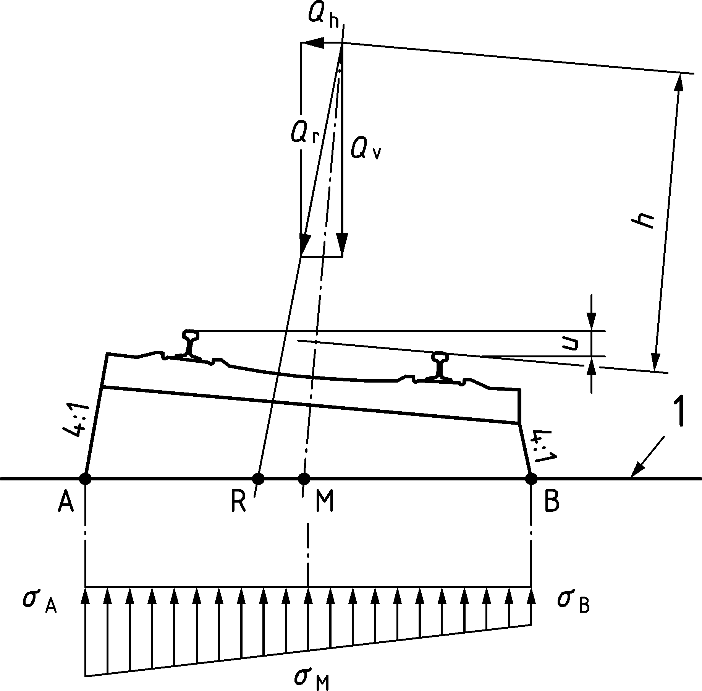

Key

|  |  |
| --- | --- |
| 1 | Reference plane. |

Figure 8.8 — Transverse distribution of actions by the sleepers and ballast, track with cant   
(effect of eccentricity of vertical loads not shown)

(4) On bridges with ballasted track with cant and for full length sleepers, where the ballast is only consolidated under the rails, or for duo-block sleepers, Figure 8.8 should be modified to take into account the transverse load distribution under each rail shown in Figure 8.7.

(5) The transverse distribution to be used should be specified by the relevant authority or where not specified, agreed for a specific project by the relevant parties.

NOTE The transverse distribution to be used can be set by the National Annex for use in a country.

### Actions for non-public footways

(1) Loads on non-public footways (including pedestrian, cycle and general maintenance loads) should be represented by a uniformly distributed load with a characteristic value *q*fk = 5 kN/m2.

NOTE Non-public footways are those designated for use by only authorized persons.

(2) For the design of local elements a concentrated load *Q*k = 2,0 kN acting alone should be taken into account and applied on a square surface with a 200 mm side.

(3) Horizontal forces on parapets, partition walls and barriers due to persons should be taken as category B and C1 of EN 1991‑1‑1:2002, 8.4.

(4) Alternative requirements for non-public footways, maintenance walkways or platforms etc. should be specified by the relevant authority or where not specified, agreed for a specific project by the relevant parties.

NOTE Alternative requirements for non-public footways, maintenance walkways or platforms etc. can be set by the National Annex for use in a country.

## Dynamic effects (including resonance)

### General

(1) For determining the effects (stresses, deflections, bridge deck acceleration etc.) of rail traffic actions the following effects shall be taken into account:

— the rapid rate of loading due to the speed of traffic crossing the structure and the inertial response (impact) of the structure,

— the passage of successive loads with approximately uniform spacing which can excite the structure and under certain circumstances create resonance,

— variations in wheel loads resulting from track or vehicle imperfections (including wheel irregularities.

NOTE The static stresses and deformations (and associated bridge deck acceleration) induced in a bridge are increased and decreased under the effects of moving traffic by the above effects.

### Factors influencing dynamic behaviour

(1) Dynamic effects should be taken into account in accordance with 8.4.3 to 8.4.6.

NOTE 1 The principal factors which influence dynamic behaviour are:

i) the speed of traffic across the bridge,

ii) the span *L* of the element and the influence line length for deflection of the element being considered,

iii) the mass of the structure,

iv) the natural frequencies of the whole structure and relevant elements of the structure and the associated mode shapes (eigenforms) along the line of the track,

v) the number of axles, axle loads and the spacing of axles,

vi) the damping of the structure,

vii) vertical irregularities in the track,

viii) the unsprung/sprung mass and suspension characteristics of the vehicle,

ix) the presence of regularly spaced supports of the deck slab and/or track (cross girders, sleepers etc.),

x) vehicle imperfections (wheel flats, out of round wheels, suspension defects etc.),

xi) the dynamic characteristics of the track (ballast, sleepers, track components etc.).

NOTE 2 There are no specific deflection limits specified for avoiding resonance and excessive vibration effects. See prEN 1990:2021, A.2.8.4 for deflection criteria for traffic safety and passenger comfort etc.

### General design rules

(1) A static analysis shall be carried out with the load models defined in 8.3 (LM71 and where required Load Models SW/0 and SW/2). The results of the static analysis shall be multiplied by the dynamic factor *Φ* defined in 8.4.5 (and if required multiplied by *α* in accordance with 8.3.2).

(2) An additional dynamic analysis should be carried out if the criteria given in 8.4.4 are met.

(3) Where a dynamic analysis is required:

— the additional load cases for the dynamic analysis shall be in accordance with 8.4.6.1.2.

— maximum peak deck acceleration shall be checked in accordance with 8.4.6.5.

— the results of the dynamic analysis shall be compared with the results of the static analysis multiplied by the dynamic factor *Φ* in 8.4.5 (and if required multiplied by *α* in accordance with 8.3.2). The most unfavourable values of the load effects shall be used for the bridge design in accordance with 8.4.6.5.

— a check shall be carried out according to 8.4.6.6 to ensure that the additional fatigue loading at high speeds and at resonance is covered by consideration of the stresses derived from the results of the static analysis multiplied by the dynamic factor *Φ*.

NOTE For passenger trains the allowances for dynamic effects in 8.4.3 to 8.4.6 are valid for Maximum Permitted Vehicle Speeds up to 350 km/h.

(4) All bridges where the Maximum Line Speed at the Site is greater than 200 km/h or where a dynamic analysis is required shall also be designed under static conditions with the load models defined in 8.3.2 and 8.3.3 (where required).

### Conditions for requiring additional dynamic analysis

(1) It shall be established whether an additional dynamic analysis is required.

NOTE Conditions for determining whether an additional dynamic analysis is required are given in Figure 8.9 unless the National Annex gives different requirements for use in a country.

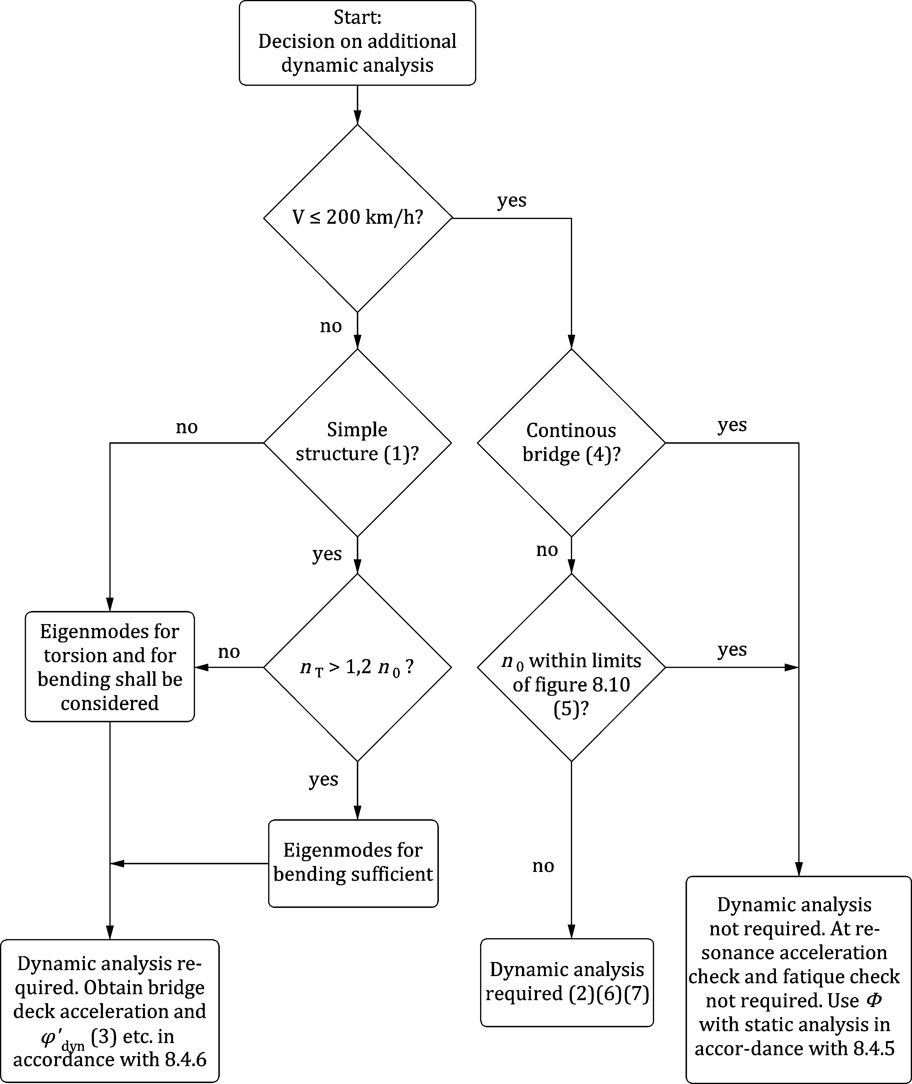

Key

|  |  |  |  |
| --- | --- | --- | --- |
| *V* | is the Maximum Line Speed at the Site [km/h]; | | |
| *L* | is the span length [m]; | | |
| *n*0 | is the first natural bending frequency of the bridge loaded by permanent actions [Hz]. For a simply supported bridge, subjected to bending only, the natural frequency can be estimated using the Formula (8.1): | | |
|  |  | | (8.1) |
|  | where | | |
|  | *δ*0 | is the deflection at mid span due to permanent actions [mm] and is calculated, using a short term modulus for concrete bridges or composite steel and concrete bridges, in accordance with a loading period appropriate to the natural frequency of the bridge. | |
| *n*T | is the first natural torsional frequency of the bridge loaded by permanent actions [Hz] | | |

NOTE 1 Valid for simply supported bridges with only longitudinal line beam or simple plate behaviour with negligible skew effects on rigid supports.

NOTE 2 A dynamic analysis is required where the Frequent Operating Speed of a Real Train equals a Resonant Speed of the structure. See 8.4.6.6.

NOTE 3 *φ*′dyn is the dynamic impact component for Real Trains for the structure given in 8.4.6.5(3).

NOTE 4 Valid providing the bridge meets the requirements for resistance, deformation limits given in prEN 1990:2021, A.2.8.4 and the maximum coach body acceleration (or associated deflection limits) corresponding to a very good standard of passenger comfort given in prEN 1990:2021, A.2.8.4.3.

NOTE 5 For bridges with a first natural frequency *n*0 within the limits given by Figure 8.10 and a Maximum Line Speed at the Site not exceeding 200 km/h, a dynamic analysis is not required.

NOTE 6 For bridges with a first natural frequency *n*0 exceeding the upper limit (1) in Figure 8.10, a dynamic analysis is expected to be carried out in accordance with Annex C. The dynamic analysis is expected to be consider the factors in 8.4.2(1) Note 1 (i) to (xi). It can be assumed that resonance will not occur.

NOTE 7 For bridges with a first natural frequency *n*0 below the limit (2) in Figure 8.10, a dynamic analysis is performed obtaining the bridge deck acceleration and *φ′*dyn (NOTE 3) etc. in accordance with 8.4.6. Also see 8.4.6.1.1(7).

Figure 8.9 — Flow chart for determining whether a dynamic analysis is required. Numbers indicated within parenthesis refer to the note numbers above.

|  |  |  |  |  |  |
| --- | --- | --- | --- | --- | --- |
| The upper limit of *n*0 is governed by dynamic enhancements due to track irregularities and is given by Formula (8.2): | | |  |  | |
| *n*0 = 94,76*L*−0,748 | | (8.2) |
| The lower limit of *n*0 is governed by dynamic impact criteria and is given by Formula (8.3): | | |
| *n*0 = 80/*L* | | |
| for 4 m ≤ *L* ≤ 20 m | | |
| *n*0 = 23,58*L*−0,592 | | |
| for 20 m < *L* ≤ 100 m | | (8.3) |
| where: | | |
| *n*0 | is the first natural frequency of the bridge taking account of mass due to permanent actions, | |
| *L* | is the span length for simply supported bridges or *L*Φ for other bridge types. | |
|  |  | |  | **Key** | |
|  |  | |  | 1 | Upper limit of natural frequency |
|  |  | |  | 2 | Lower limit of natural frequency |

Figure 8.10 — Limits of bridge natural frequency *n*0 [Hz] as a function of *L* [m]

### Dynamic factor *Φ* (*Φ*2, *Φ*3)

#### Field of application

(1) The results of a static analysis shall be multiplied by the dynamic factor *Φ* for Load Models 71, SW/0 and SW/2.

NOTE The dynamic factor *Φ* takes account of the dynamic magnification of stresses and vibration effects in the structure but does not take account of resonance and other excessive dynamic effects.

(2) If the criteria specified in 8.4.4 are not satisfied, a dynamic analysis shall be carried out to calculate impact and resonance effects.

NOTE 1 If the criteria specified in 8.4.4 are not satisfied, there is a risk that resonance or excessive vibration of the bridge could occur (with a possibility of excessive deck accelerations leading to ballast instability etc. and excessive deflections and stresses etc.).

NOTE 2 Quasi static methods, which use static load effects multiplied by the dynamic factor *Φ* defined in 8.4.5, are unable to predict resonance effects from high speed trains. Appropriate dynamic analysis techniques, which take into account the time dependant nature of the loading from the High Speed Load Model (HSLM) and Real Trains (e.g. by solving equations of motion), do predict dynamic effects at resonance.

(3) Structures carrying more than one track should be considered without any reduction of dynamic factor *Φ*.

(4) The dynamic factor *Φ* shall not be used with:

— the loading due to Real Trains,

— the loading due to Fatigue Trains (Annex D),

— Load Model HSLM (8.4.6.1.1(2)),

— the load model “unloaded train” (8.3.4).

#### Definition of the dynamic factor Φ

(1) The dynamic factor *Φ* shall be taken as either *Φ*2 or *Φ*3 as specified by the relevant authority or agreed for a specific project by the relevant parties. Where no dynamic factor is specified, then *Φ*3 shall be used.

NOTE The choice of *Φ*2 or *Φ*3 can be set by the National Annex for use in a country.

(2) *Φ*2 should be taken as shown in Formula (8.4).

NOTE *Φ*2 applies to carefully maintained track:

 (8.4)

with

1,00 ≤ *Φ*2 ≤ 1,67

where

|  |  |
| --- | --- |
| *L*Φ | is the “determinant” length (length associated with *Φ*) [m] (see 8.4.5.4). |

NOTE The dynamic factors were established for simply supported girders. The length *L*Φ allows these factors to be used for other structural members with different support conditions.

(3) *Φ*3 should be taken as shown in Formula (8.5).

 (8.5)

with

1,00 ≤ *Φ*3 ≤ 2,00

NOTE *Φ*3 applies to track with standard maintenance and to some types of structural elements identified in Table 8.2 (NDP).

#### Reduced dynamic effects

(1) In the case of arch bridges and concrete bridges of all types with a cover of more than 1,00 m, *Φ*2 and *Φ*3 may be reduced as follows in Formula (8.6):

 (8.6)

where

|  |  |
| --- | --- |
| *h* | is the height of cover including the ballast from the top of the deck to the top of the sleeper, (for arch bridges, from the crown of the extrados) [m]. |

(2) Dynamic effects may be neglected in calculating the effects of rail traffic actions on the following types of elements:

— columns with a slenderness (buckling length/radius of gyration) < 30,

— abutments,

— foundations,

— retaining walls,

— ground pressures.

#### Determinant length LΦ

The determinant lengths *LΦ* should be determined.

NOTE The values of *LΦ* are given in Table 8.2 (NDP) unless the National Annex gives different values for use in a country.

(2) If no value of *LΦ* is specified in Table 8.2 (NDP) or the National Annex, then the determinant length should be taken as the length of the influence line for deflection of the element being considered unless alternative values are specified by the relevant authority or where not specified, agreed for a specific project by the relevant parties.

(3) If the resultant stress in a structural member depends on several effects, each of which relates to a separate structural behaviour, then each effect should be calculated using the appropriate determinant length.

Table 8.2 (NDP) — Determinant lengths *L*Φ

| **Case** | **Structural element** | | **Determinant length *L*Φ c** | | | |
| --- | --- | --- | --- | --- | --- | --- |
| **Steel deck plate:** closed deck with ballast bed (orthotropic deck plate) (for local and transverse stresses) | | | | | | |
|  | Deck with cross girders and continuous longitudinal ribs: | |  | | | |
| 1.1 | Deck plate (for both directions) | | 3 times cross girder spacing | | | |
| 1.2 | Continuous longitudinal ribs (including small cantilevers up to 0,50 m)a | | 3 times cross girder spacing | | | |
| 1.3 | Cross girders | | 2 times cross girder spacing | | | |
| 1.4 | End cross girders | | 3,6 m b | | | |
|  | Deck plate with cross girders only: | |  | | | |
| 2.1 | Deck plate (for both directions) | | 2 times cross girder spacing + 3 m | | | |
| 2.2 | Cross girders | | 2 times cross girder spacing + 3 m | | | |
| 2.3 | End cross girders | | 3,6 m b | | | |
| **Steel grillage**: open deck without ballast bed b (for local and transverse stresses) | | | | | | |
| 3.1 | Rail bearers: | |  | | | |
|  | — as an element of a continuous grillage | | 3 times cross girder spacing | | | |
|  | — simply supported | | Cross girder spacing + 3 m | | | |
| 3.2 | Cantilever of rail bearer a | | 3,6 m b | | | |
| 3.3 | Cross girders (as part of cross girder/ continuous rail bearer grillage) | | 2 times cross girder spacing | | | |
| 3.4 | End cross girders | | 3,6 m b | | | |
| **Concrete deck slab with ballast bed** (for local and transverse stresses) | | | | | | |
| 4.1 | Deck slab as part of box girder or upper flange of main beam | |  | | | |
|  | — spanning transversely to the main girders | | 3 times span of deck plate | | | |
|  | — spanning in the longitudinal direction | | 3 times span of deck plate | | | |
|  | — cross girders | | 2 times cross girder spacing | | | |
|  | — transverse cantilevers supporting railway loading | |  | | | |
|  |  | | — *e* ≤ 0,5 m: 3 times the distance between the webs | | | |
|  |  | | — *e* > 0,5 m: a | | | |
|  |  | | **Figure 8.11 — Transverse cantilever supporting railway loading** | | | |
| 4.2 | Deck slab continuous (in main girder direction) over cross girders | | 2 times cross girder spacing | | | |
| 4.3 | Deck slab for half through and trough bridges: | |  | | | |
|  | — spanning perpendicular to the main girders | | 2 times span of deck slab + 3 m | | | |
|  | — spanning in the longitudinal direction | | 2 times span of deck slab | | | |
| 4.4 | Deck slabs spanning transversely between longitudinal steel beams in filler beam decks | | 2 times the determinant length in the longitudinal direction | | | |
| 4.5 | Longitudinal cantilevers of deck slab | | — *e* ≤ 0,5 m: 3,6 m b | | | |
|  |  | | — *e* > 0,5 m: a | | | |
| 4.6 | End cross girders or trimmer beams | | 3,6 m b, d | | | |
| **Main girders** | | | | | | |
| 5.1 | Simply supported girders and slabs (including steel beams embedded in concrete) | | Span in main girder direction | | | |
| 5.2 | Girders and slabs continuous over *n* spans with | | *LΦ* = *k* × *L*m, | | | (8.7) |
|  | *L*m = 1/*n* (*L*1 + *L*2 + .. + *L*n) | (8.8) | but not less than max *L*i (*i =* 1, ..., *n*) | | | |
|  |  | | *n* = 2 | 3 | 4 | ≥ 5 |
|  |  | | *k* = 1,2 | 1,3 | 1,4 | 1,5 |
| 5.3 | Portal frames and closed frames or boxes: | |  | | | |
|  | — single-span | | Consider as three-span continuous beam (use 5.2, with vertical and horizontal lengths of members of the frame or box) | | | |
|  | — multi-span | | Consider as multi-span continuous beam (use 5.2, with lengths of end vertical members and horizontal members) | | | |
| 5.4 | Single arch, archrib, stiffened girders of bowstrings | | Half span | | | |
| 5.5 | Series of arches with solid spandrels retaining fill | | 2 times the clear opening | | | |
| 5.6 | Suspension bars (in conjunction with stiffening girders) | | 4 times the longitudinal spacing of the suspension bars | | | |
| **Structural supports** | | | | | | |
| 6 | Columns, trestles, bearings, uplift bearings, tension anchors and for the calculation of contact pressures under bearings. | | Determinant length of the supported members | | | |
| a In general all cantilevers greater than 0,50 m supporting rail traffic actions need a specific dynamic analysis in accordance with 8.4.6.  b *Φ*3 should be applied.  c For Cases 1.1 to 4.6 inclusive *LΦ* is subject to a maximum of the determinant length of the main girders.  d This rule is also applicable for other construction types (e.g. rolled steel beams in concrete, composite structures, prestressed concrete). | | | | | | |

### Dynamic analysis

#### Loading and load combinations

##### Loading

(1) The dynamic analysis shall be undertaken using characteristic values of the loading from the Real Trains specified.

(2) The Real Trains to be applied in the dynamic analysis of a structure shall be specified by the relevant authority or agreed for a specific project by the relevant parties, taking into account:

— each permitted or envisaged train formation for every type of high speed train permitted or envisaged to use the structure at speeds over 200 km/h.

— where a dynamic analysis is required for a Maximum Line Speed at the Site less or equal to 200 km/h, considering Real Trains and Train Types 1 to 12 given in Annex D.

NOTE Conditions for the Real Trains to be applied can be set by the National Annex for use in a country.

(3) Characteristic values for the axle loads of Real Trains shall be determined based on the “Design mass under normal payload” as defined in EN 15663.

(4) The characteristic axle loads and spacings for each configuration of required Real Trains may be specified by the relevant authority or agreed for a specific project by the relevant parties.

NOTE The characteristic axle loads and spacings for configurations of Real Trains can be set by the National Annex for use in a country.

(5) The dynamic analysis shall also be undertaken using Load Model HSLM on bridges designed for lines where European high speed interoperability criteria are applicable.

NOTE The conditions for application of Load Model HSLM can be set by the National Annex for use in a country.

(6) Load Model HSLM comprises of two separate Universal Trains with variable coach lengths, HSLM-A and HSLM-B, which should be applied in accordance with the requirements of Table 8.3 (NDP):

NOTE HSLM-A and HSLM-B together represent the dynamic load effects of articulated, conventional and regular high speed passenger trains. E.1 defines the limits of validity of HSLM.

(7) Additional requirements relating to the application of HSLM-A and HSLM-B to continuous and complex structures may be specified by the relevant authority or agreed for a specific project by the relevant parties.

NOTE Additional requirements relating to the application of HSLM-A and HSLM-B to continuous and complex structures can be set by the National Annex for use in a country.

Table 8.3 (NDP) — Application of HSLM-A and HSLM-B

| Structural configuration | Span | |
| --- | --- | --- |
| *L* < 7 m | *L* ≥ 7 m |
| Simply supported spana | HSLM-Bb | HSLM-A |
|  |  | Trains A1 to A10 inclusivec |
| Continuous structurea | HSLM-A | HSLM-A |
| or | Trains A1 to A10 inclusivec | Trains A1 to A10 inclusivec |
| Complex structured | (HSLM-B)e | (HSLM-B)e |
| a Valid for bridges with only longitudinal line beam or simple plate behaviour with negligible skew effects on rigid supports.  b For simply supported spans with a span of up to 7 m any single critical Universal Train from HSLM-B can be used for the analysis in accordance with 8.4.6.1.1(5).  c All Trains A1 to A10 inclusive are used in the design.  d Any structure that does not comply with Note a above. For example a skew structure, bridge with significant torsional behaviour, half through structure with significant floor and main girder vibration modes etc.  e In addition, for complex structures with significant floor vibration modes (e.g. half through or through bridges with shallow floors) HSLM-B is also applied. | | |

(8) HSLM-A shall be taken as defined in Figure 8.12 and Table 8.4:

Dimensions in metres

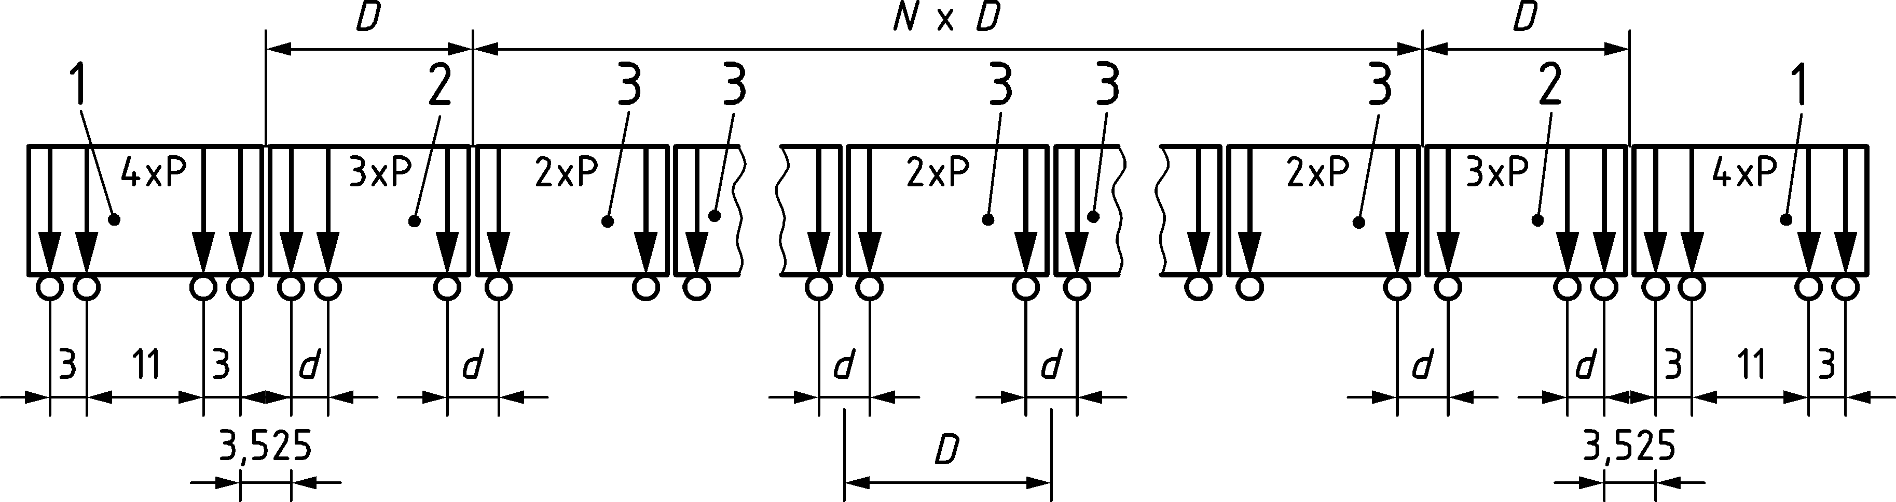

Key

|  |  |
| --- | --- |
| 1 | Power car (leading and trailing power cars identical); |
| 2 | End coach (leading and trailing end coaches identical); |
| 3 | Intermediate coach |

Figure 8.12 — HSLM-A

Table 8.4 — HSLM-A

| Universal Train | Number of intermediate coaches | Coach length | Bogie axle spacing | Point force |
| --- | --- | --- | --- | --- |
|  | N | D | d | P |
|  |  | [m] | [m] | [kN] |
| A1 | 18 | 18 | 2,0 | 170 |
| A2 | 17 | 19 | 3,5 | 200 |
| A3 | 16 | 20 | 2,0 | 180 |
| A4 | 15 | 21 | 3,0 | 190 |
| A5 | 14 | 22 | 2,0 | 170 |
| A6 | 13 | 23 | 2,0 | 180 |
| A7 | 13 | 24 | 2,0 | 190 |
| A8 | 12 | 25 | 2,5 | 190 |
| A9 | 11 | 26 | 2,0 | 210 |
| A10 | 11 | 27 | 2,0 | 210 |

(9) HSLM-B shall be taken as comprises of N number point forces of 170 kN at uniform spacing *d* [m] where N and *d* are defined in Figures 8.13 and 8.14:

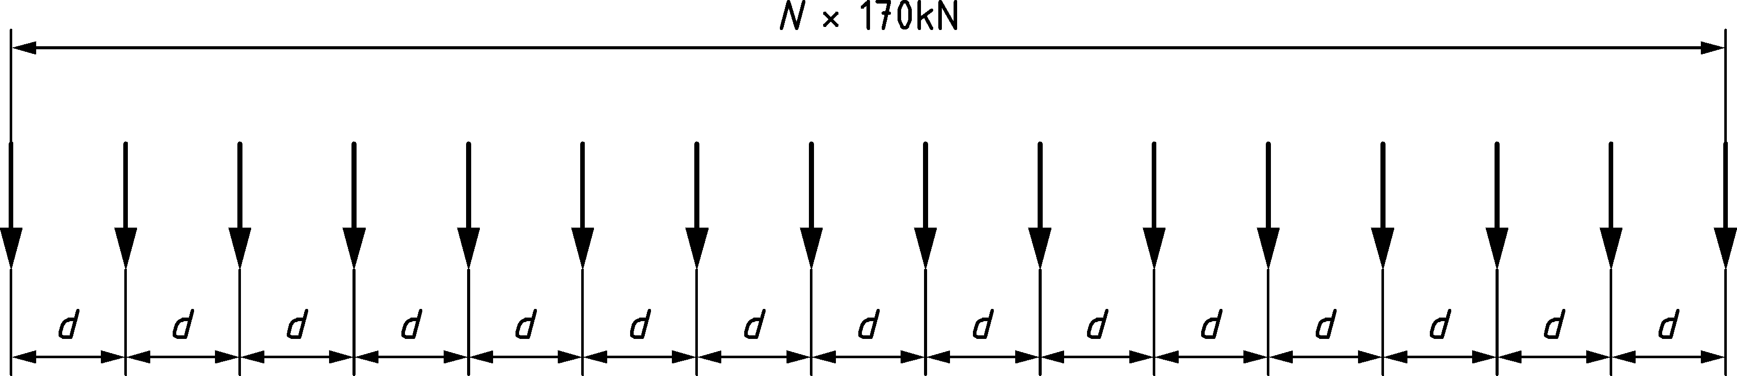

Figure 8.13 — HSLM-B

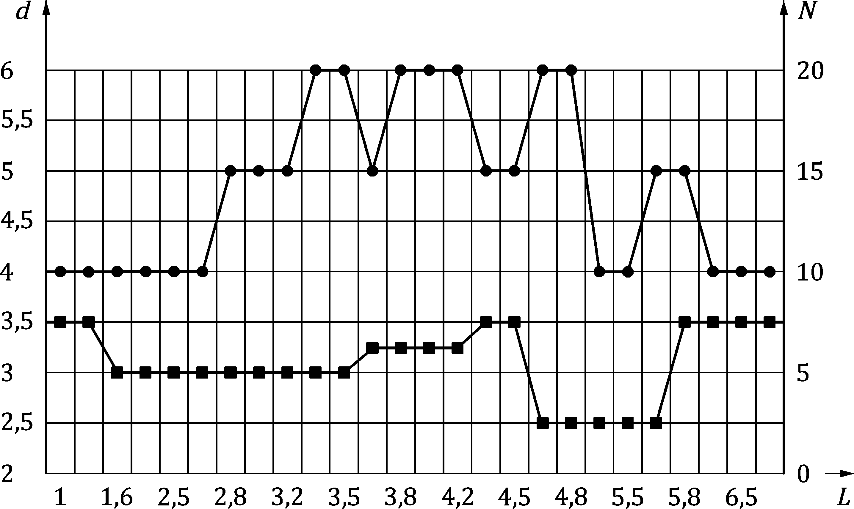

Key

|  |  |
| --- | --- |
| *L* | is the span length [m]. |
|  | *d* [m] |
|  | *N* |

Figure 8.14 — HSLM-B (nomogram)

##### Load combinations and partial factors for dynamic analysis

(1) The value of mass for calculation of self-weight and variable permanent loads (ballast etc.) should use nominal values of density.

(2) For the dynamic analysis of the structure only, with either one track or two tracks with trains normally travelling in opposite directions, one track (the most adverse) on the structure should be loaded in accordance with Table 8.5 (NDP).

(3) For cases not covered in Table 8.5 (NDP), the loading should be specified by the relevant authority or agreed for a specific project by the relevant parties. Such cases include:

— bridges carrying 2 tracks with trains normally travelling in the same directions;

— bridges carrying 3 or more tracks with a Maximum Line Speed at the Site exceeding 200 km/h.

NOTE Loading requirements for dynamic analysis not covered in Table 8.5 (NDP) can be set by the National Annex for use in a country.

Table 8.5 (NDP) — Summary of additional load cases depending upon number of tracks on bridge

| Number of tracks on a bridge | Loaded track | Loading for dynamic analysis |
| --- | --- | --- |
| 1 | one | Each Real Train and Load Model HSLM (if required) travelling in the permitted direction(s) of travel. |
| 2 (Trains normally travelling in opposite directions) | either track | Each Real Train and Load Model HSLM (if required) travelling in the permitted direction(s) of travel. |
| other track | None. |

(4) Where the load effects from a dynamic analysis exceed the effects from Load Model 71 (and Load Model SW/0 for continuous structures) in accordance with 8.4.6.5(3) on a track the load effects from a dynamic analysis should be combined with:

— the load effects from horizontal forces on the track subject to the loading in the dynamic analysis,

— the load effects from vertical and horizontal loading on the other track(s), in accordance with the requirements of 8.8.1 and Table 8.12.

(5) Where the load effects from a dynamic analysis exceed the effects from Load Model 71 (and Load Model SW/0 for continuous structures) in accordance with 8.4.6.5(3) the dynamic rail loading effects (bending moments, shears, deformations etc. excluding acceleration) determined from the dynamic analysis shall be enhanced by the partial factors given in prEN 1990:2021, Table A.2.10.

(6) Partial factors shall not be applied to the loading given in 8.4.6.1.1 when determining bridge deck accelerations. The calculated values of acceleration shall be directly compared with the design values in 8.4.6.5.

(7) For fatigue, a bridge should be designed for the additional fatigue effects at resonance from the loading in accordance with 8.4.6.1.1 on any one track. See 8.4.6.6.

#### Speeds to be considered

(1) The Maximum Line Speed at the site should be specified by the relevant authority or where not specified, agreed for a specific project by the relevant parties.

NOTE Criteria for the Maximum Line Speed can be set by the National Annex for use in a country.

(2) An increased Maximum Line Speed at the Site may be specified by the relevant authority or agreed for a specific project by the relevant parties to take into account potential modifications to the infrastructure and future rolling stock.

NOTE Criteria for an increased Maximum Line Speed can be set by the National Annex for use in a country.

(3) For each Real Train and Load Model HSLM a series of speeds up to the Maximum Design Speed shall be considered.

(4) Calculations should be made for a series of speeds from 33m/s (120 km/h) up to the Maximum Design Speed.

(5) Smaller speed steps should be made in the vicinity of Resonant Speeds (see (10)).

(6) The Maximum Design Speed should be at least 1,2 × Maximum Line Speed at the site.

(7) The Maximum Design Speed for checking individual Real Trains may be reduced as specified by the relevant authority or where not specified, agreed for a specific project by the relevant parties.

NOTE Criteria for reduced Maximum Design Speed for individual Real Trains can be set by the National Annex for use in a country.

(8) An additional factor for increasing the Maximum Design Speed may be specified by the relevant authority or where not specified, agreed for a specific project by the relevant parties to take into account a likelihood of train overspeed and exceeding either the Maximum Permitted Vehicle Speed or the current or envisaged Maximum Line Speed at the Site.

NOTE 1 Criteria for an additional factor for increasing the Maximum Design Speed can be set by the National Annex for use in a country.

NOTE 2 Structures can exhibit a highly peaked response due to resonance effects. An increased Maximum Design Speed can be specified to account for the risk of a train overspeed.

(9) If there is a requirement for a section of line to be suitable for commissioning tests of a Real Train, then:

— the Maximum Design Speed used for the Real Train should be at least *β* × Maximum Train Commissioning Speed, with *β =* 1,2 for structural forces and moments and *β* = 1,0 for deflections or accelerations.

— Calculations are required to demonstrate that safety considerations (maximum deck accelerations, maximum load effects, etc.) are satisfactory for structures at speeds in excess of 200 km/h.

— Fatigue and passenger comfort criteria need not be checked at 1,2 × Maximum Train Commissioning Speeds.

— Additional requirements for checking structures may be specified by the relevant authority or agreed for a specific project by the relevant parties.

NOTE Additional requirements for checking structures used for commissioning tests of a Real Train can be set by the National Annex for use in a country.

(10) For simply supported bridges that may be modelled as a line beam, the Resonant Speeds may be estimated using Formula (8.9).

*ν*i = *n*0 *λ*i (8.9)

and

33 m/s ≤ *v*i ≤ Maximum Design Speed,

where

|  |  |
| --- | --- |
| *v*i | is the Resonant Speed; |
| *n*0 | is the first natural frequency of the unloaded structure; |
| *λ*i | is the principal wavelength of frequency of excitation and may be estimated by Formula (8.10): |

 (8.10)

|  |  |
| --- | --- |
| *d* | is the regular spacing of groups of axles; |
| *i* | is equal to 1, 2, 3 or 4 |

#### Bridge parameters

##### Structural damping

(1) Structural damping should be taken into account in the dynamic analysis.

NOTE The peak response of a structure at traffic speeds corresponding to resonant loading is highly dependent upon damping.

(2) Only lower bound estimates of damping should be used.

(3) The values of damping shown in Table 8.6 (NDP) should be used in the dynamic analysis unless alternative safe lower bound values should be specified by the relevant authority or where not specified, agreed for a specific project by the relevant parties.

NOTE Safe lower bound values for damping can be set by the National Annex for use in a country.

Table 8.6 (NDP) — Values of damping to be assumed for design purposes

| Bridge Type | ***ζ*** Lower limit of percentage of critical damping | |
| --- | --- | --- |
| [%] | |
| Span *L* < 20 m | Span *L* ≥ 20 m |
| Steel and composite | *ζ* = 0,5 + 0,125 (20 − *L*) | *ζ* = 0,5 |
| Prestressed concrete | *ζ* = 1,0 + 0,07 (20 − *L*) | *ζ* = 1,0 |
| Filler beam and reinforced concrete | *ζ* = 1,5 + 0,07 (20 − *L*) | *ζ* = 1,5 |

##### Mass of the bridge

(1) Two specific cases for the mass of the structure including ballast and track shall be considered:

— a lower bound estimate of mass to predict maximum deck accelerations using the minimum likely dry clean density and minimum thickness of ballast,

— an upper bound estimate of mass to predict the lowest speeds at which resonant effects are likely to occur using the maximum saturated density of dirty ballast with allowance for future track lifts.

NOTE 1 Maximum dynamic load effects are likely to occur at resonant peaks when a multiple of the frequency of loading and a natural frequency of the structure coincide and any underestimation of mass will overestimate the natural frequency of the structure and overestimate the traffic speeds at which resonance occurs.

NOTE 2 At resonance the maximum acceleration of a structure is inversely proportional to the mass of the structure.

(2) The density of materials should be taken from EN 1991‑1‑1 unless specific test data are available as specified by the relevant authority or where not specified, agreed for a specific project by the relevant parties.

NOTE 1 Requirements for accepting alternative density values can be set by the National Annex for use in a country.

NOTE 2 Owing to the large number of parameters which can affect the density of concrete it is not possible to identify enhanced density values with sufficient accuracy for predicting the dynamic response of a bridge.

NOTE 3 Results for alternative density values can be confirmed by trial mixes and the testing of samples taken from site in accordance with prEN 1990, EN 1992 series and ISO 1920‑10.

##### Stiffness of the bridge

(1) A lower bound estimate of the stiffness throughout the structure shall be used.

NOTE Maximum dynamic load effects are likely to occur at resonant peaks when a multiple of the frequency of loading and a natural frequency of the structure coincide. Any overestimation of bridge stiffness will overestimate the natural frequency of the structure and speed at which resonance occurs.

(2) The stiffness of the whole structure including the determination of the stiffness of elements of the structure may be determined in accordance with the EN 1992 series to EN 1994 series.

(3) Values of Young′s modulus may be taken from the EN 1992 series to EN 1994 series.

(4) For concrete compressive cylinder strength *f*ck ≥ 50 N/mm2 (compressive cube strength *f*ck, cube ≥ 60 N/mm2) the value of static Young′s modulus (*E*cm) should be limited to the value corresponding to a concrete of strength of *f*ck = 50 N/mm2 (*f*ck, cube = 60 N/mm2), unless specific test data are available as specified by the relevant authority or agreed for a specific project by the relevant parties.

NOTE 1 Requirements for accepting enhanced *E*cm values can be set by the National Annex for use in a country.

NOTE 2 Owing to the large number of parameters which can affect *E*cm it is not possible to identify enhanced Young′s modulus values with sufficient accuracy for the dynamic response of a bridge.

NOTE 3 Results for enhanced *E*cm values can be confirmed by trial mixes and the testing of samples taken from site in accordance with prEN 1990, EN 1992 series and ISO 1920‑10.

(5) Other material properties can be used as specified by the relevant authority or agreed for a specific project by the relevant parties.

NOTE Requirements for other material properties can be set in the National Annex for use in a country.

#### Modelling the excitation and dynamic behaviour of the structure

(1) The dynamic effects of a Real Train may be represented by a series of travelling point forces.

(2) Vehicle/structure mass interaction effects may be neglected.

(3) The analysis should take into account variations throughout the length of the train in axle forces and the variations in spacing of individual axles or groups of axles.

(4) Where appropriate the analysis technique should allow for the following dynamic behaviours of the structure:

— for complex structures the proximity of adjacent frequencies and associated mode shapes of oscillation,

— interaction between bending and torsional modes,

— local deck element behaviour (shallow floors and cross girders of half-through type bridges or trusses etc.),

— the skew behaviour of slabs etc.

(5) The effects of load distribution by the rails, sleepers and ballast may be taken into account.

NOTE The representation of each axle by a single point force tends to overestimate dynamic effects for loaded lengths of less than 10 m.

(6) Notwithstanding 8.3.6.3(1) individual axle loads should not be distributed uniformly in the longitudinal direction for a dynamic analysis.

(7) Where the bridge satisfies the upper limit in Figure 8.10 the factors that influence dynamic behaviours (vii) to (xi) identified in 8.4.2 may be considered to be allowed for *Φ*, *φ*″/2 and *φ*″ given in 8.4.6.5 and Annex C.

#### Verifications of the limit states

(1) To ensure traffic safety:

— The verification of maximum peak deck acceleration shall be regarded as a traffic safety requirement checked at the serviceability limit state for the prevention of track instability.

— The dynamic enhancement of load effects shall be allowed for by multiplying the static loading (from load models LM71, SW/0 or SW/2) by the dynamic factor *Φ* defined in 8.4.5. If a dynamic analysis is necessary, the results of the dynamic analysis shall be compared with the results of the static analysis enhanced by *Φ* (and if required multiplied by *α* in accordance with 8.3.2) and the most unfavourable load effects shall be used for the bridge design.

— If a dynamic analysis is necessary, a check shall be carried out according to 8.4.6.6 to establish whether the additional fatigue loading at high speeds and at resonance is covered by consideration of the stresses due to load effects from *Φ* × LM71 (and if required *Φ* × Load Model SW/0 for continuous structures and classified vertical load in accordance with 8.3.2(3) where required). The most adverse fatigue loading shall be used in the design.

(2) The maximum permitted peak design values of bridge deck acceleration calculated along the line of a track shall not exceed the values given in prEN 1990:2021, A.2.8.4.2.1.

(3) A dynamic analysis (if required) should be used to determine the dynamic enhancement *φ*′dyn with respect to static calculations for stresses, stress resultants, reactions or deflections, in accordance with Formula (8.11):

*φ*′dyn = max |*y*dyn/*y*stat| – 1 (8.11)

where

|  |  |
| --- | --- |
| *y*dyn | is the maximum dynamic response; |
| *y*stat | is the corresponding maximum static response at any particular point in the structural element due to a Real Train or Load Model HSLM. |

For the design of the bridge, taking into account all the effects of vertical traffic loads, the most unfavourable value of Formulae (8.12) and (8.13) should be used.

 (8.12)

or

*Φ* × (LM71“+”SW/0) (8.13)

where

|  |  |
| --- | --- |
| *HSLM* | is the load model for high speed lines defined in 8.4.6.1.1(2); |
| LM71“+”SW/0 | is Load Model 71 and if relevant Load Model SW/0 for continuous bridges (or classified vertical load in accordance with 8.3.2(3) where required); |
| *RT* | is the loading due to all Real Trains defined in 8.4.6.1.1; |
| *φ*″/2 | is the increase in calculated dynamic load effects (stresses, stress resultants, deflections, bridge deck accelerations, etc.) resulting from track defects and vehicle imperfections in accordance with Annex C for carefully maintained track (*φ″* to be used instead of *φ*″/2 for track with standard maintenance); |
| *Φ* | is the dynamic factor in accordance with 8.4.5. |

(4) For bridge deck accelerations, the increase in calculated dynamic load effects due to track defects and vehicle imperfections may be estimated by multiplying the calculated accelerations by (1 + *φ*″/2) for carefully maintained track, ((1 + *φ*″) to be used for track with standard maintenance) as specified by the relevant authority or agreed for a specific project by the relevant parties.

NOTE The factor to be used for bridge deck accelerations can be set by the National Annex for use in a country.

#### Additional verification for fatigue where dynamic analysis is required

(1) The fatigue check of the structure shall allow for the stress range resulting from elements of the structure oscillating above and below the corresponding permanent load deflection due to:

— additional free vibrations set up by impact effects from axle loads travelling at high speed,

— the magnitude of dynamic live loading effects at resonance,

— the additional cycles of stress caused by the dynamic loading at resonance.

(2) Where the Frequent Operating Speed of a Real Train at a structure is near to a Resonant Speed the design shall allow for the additional fatigue loading due to resonance effects.

NOTE See 8.4.6.2 for estimation of the Resonant Speed

(3) Where the bridge is designed for Load Model HSLM in accordance with 8.4.6.1.1(2) the fatigue loading should be specified taking into account the best estimate of current and future traffic.

(4) The fatigue loading can be specified by the relevant authority or agreed for a specific project by the relevant parties.

NOTE 1 The fatigue loading can be set in the National Annex for use in a country.

NOTE 2 The fatigue loading can include, for example: details, annual tonnage and mix of Real Trains and associated Frequent Operating Speeds at the site to be taken into account in the design.

(5) For the verification for fatigue a series of speeds up to a Maximum Nominal Speed should be considered.

(6) An increased Maximum Nominal Speed should be specified by the relevant authority or where not specified, agreed for a specific project by the relevant parties to take into account potential modifications to the infrastructure and future rolling stock.

NOTE Requirements for an increased Maximum Nominal Speed can be set in the National Annex for use in a country.

## Horizontal forces — characteristic values

### Centrifugal forces

(1) Where the track on a bridge is curved over the whole or part of the length of the bridge, the centrifugal forces and the track cant shall be taken into account.

(2) The centrifugal forces should be taken to act outwards in a horizontal direction at a height *h*t of 1,80 m above the running surface (see Figure 3.1) unless an increased value of *h*t is specified by the relevant authority or agreed for a specific project by the relevant parties.

NOTE Requirements for an increased value of *h*t can be set in the National Annex for use in a country. For some traffic types, e.g. double stacked containers, an increased value of *h*t can be specified.

(3) The centrifugal forces shall always be combined with the vertical traffic load.

(4) The vertical effect of the centrifugal forces shall be taken into account.

(5) The centrifugal forces shall not be multiplied by the dynamic factor *Φ*2 or *Φ*3.

(6) The characteristic value of the centrifugal forces shall be determined according to the Formulae (8.14) and (8.15):

 (8.14)

 (8.15)

where

|  |  |
| --- | --- |
| *Q*tk, *q*tk | are the characteristic values of the centrifugal forces [kN, kN/m]; |
| *Q*vk, *q*vk | are the characteristic values of the vertical loads specified in 8.3 (excluding any enhancement for dynamic effects) for Load Models 71 (see Table 8.8), SW/0 (see Table 8.8), SW/2 and “unloaded train”. For load model HSLM the characteristic value of centrifugal forces should be determined using Load Model 71; |
| *f* | is the reduction factor (see below); |
| *v* | is the Maximum speed in accordance with 8.5.1(7 and 8) [m/s]; |
| *V* | is the Maximum speed in accordance with 8.5.1(7 and 8) [km/h]; |
| *g* | is the acceleration due to gravity [9,81 m/s2]; |
| *r* | is the radius of curvature [m]. In the case of a curve of varying radii, suitable mean values may be taken for the value *r*. |

(7) The calculations shall be based on the specified Maximum Line Speed at the Site (see 8.4.6.2) for Load Models 71, SW/0 and HSLM

(8) In the case of Load Model SW/2 a maximum speed of 80 km/h may be assumed, or as specified by the relevant authority or where not specified, agreed for a specific project by the relevant parties.

NOTE 1 A maximum speed for Load Model SW/2 for centrifugal effects can be set in the National Annex for use in a country.

NOTE 2 An increased Maximum Line Speed at the Site could be specified by the relevant authority or where not specified, agreed for a specific project by the relevant parties to take into account potential modifications to the infrastructure and future rolling stock.

(9) In addition, for bridges located in a curve, the case of the loading specified in 8.3.2 (Load Model 71) and, if applicable, 8.3.3 (Load Models SW/0, SW/2), shall also be considered without centrifugal forces.

(10) For Load Model 71 (and where required Load Model SW/0) and a Maximum Line Speed at the Site higher than 120 km/h, the following cases should be considered:

a) Load Model 71 (and where required Load Model SW/0) with its dynamic factor and the centrifugal force for *V* = 120 km/h according to Formulae (8.14) and (8.15) with *f* = 1.

b) Load Model 71 (and where required Load Model SW/0) with its dynamic factor and the centrifugal force according to Formulae (8.14) and (8.15) for the maximum speed *V* specified, with a value for the reduction factor *f* given by 8.5.1(11).

(11) For Load Model 71 (and where required Load Model SW/0) the reduction factor *f* should be calculated using Formula (8.16):

 (8.16)

subject to a minimum value of 0,35 where

|  |  |
| --- | --- |
| *L*f | is the influence length of the loaded part of curved track on the bridge, which is most unfavourable for the design of the structural element under consideration [m]; |
| *V* | is the Maximum Line Speed at the Site in accordance with 8.5.1(7 and 8). |

|  |  |  |  |
| --- | --- | --- | --- |
| *f* = 1 | for either *V* ≤ 120 km/h or *L*f ≤ 2,88 m | | |
| *f* < 1 | for 120 km/h < *V* ≤ 300 km/h  (see Table 8.7 or Figure 8.15 or Formula (8.16)) |  | and *L*f > 2,88 m |
| *f*(V) = *f*(300) for *V* > 300 km/h | |

For the load models SW/2 and “unloaded train” the value of the reduction factor *f* should be taken as 1,0.

Table 8.7 — Factor *f* for Load Model 71 and SW/0

| *L*f | Maximum speed in accordance with 8.5.1(7 and 8) | | | | |
| --- | --- | --- | --- | --- | --- |
| [m] | [km/h] | | | | |
|  | ≤ 120 | 160 | 200 | 250 | ≥ 300 |
| ≤ 2,88 | 1,00 | 1,00 | 1,00 | 1,00 | 1,00 |
| 3 | 1,00 | 0,99 | 0,99 | 0,99 | 0,98 |
| 4 | 1,00 | 0,96 | 0,93 | 0,90 | 0,88 |
| 5 | 1,00 | 0,93 | 0,89 | 0,84 | 0,81 |
| 6 | 1,00 | 0,92 | 0,86 | 0,80 | 0,75 |
| 7 | 1,00 | 0,90 | 0,83 | 0,77 | 0,71 |
| 8 | 1,00 | 0,89 | 0,81 | 0,74 | 0,68 |
| 9 | 1,00 | 0,88 | 0,80 | 0,72 | 0,65 |
| 10 | 1,00 | 0,87 | 0,78 | 0,70 | 0,63 |
| 12 | 1,00 | 0,86 | 0,76 | 0,67 | 0,59 |
| 15 | 1,00 | 0,85 | 0,74 | 0,63 | 0,55 |
| 20 | 1,00 | 0,83 | 0,71 | 0,60 | 0,50 |
| 30 | 1,00 | 0,81 | 0,68 | 0,55 | 0,45 |
| 40 | 1,00 | 0,80 | 0,66 | 0,52 | 0,41 |
| 50 | 1,00 | 0,79 | 0,65 | 0,50 | 0,39 |
| 60 | 1,00 | 0,79 | 0,64 | 0,49 | 0,37 |
| 70 | 1,00 | 0,78 | 0,63 | 0,48 | 0,36 |
| 80 | 1,00 | 0,78 | 0,62 | 0,47 | 0,35 |
| 90 | 1,00 | 0,78 | 0,62 | 0,47 | 0,35 |
| 100 | 1,00 | 0,77 | 0,61 | 0,46 | 0,35 |
| ≥ 150 | 1,00 | 0,76 | 0,60 | 0,44 | 0,35 |

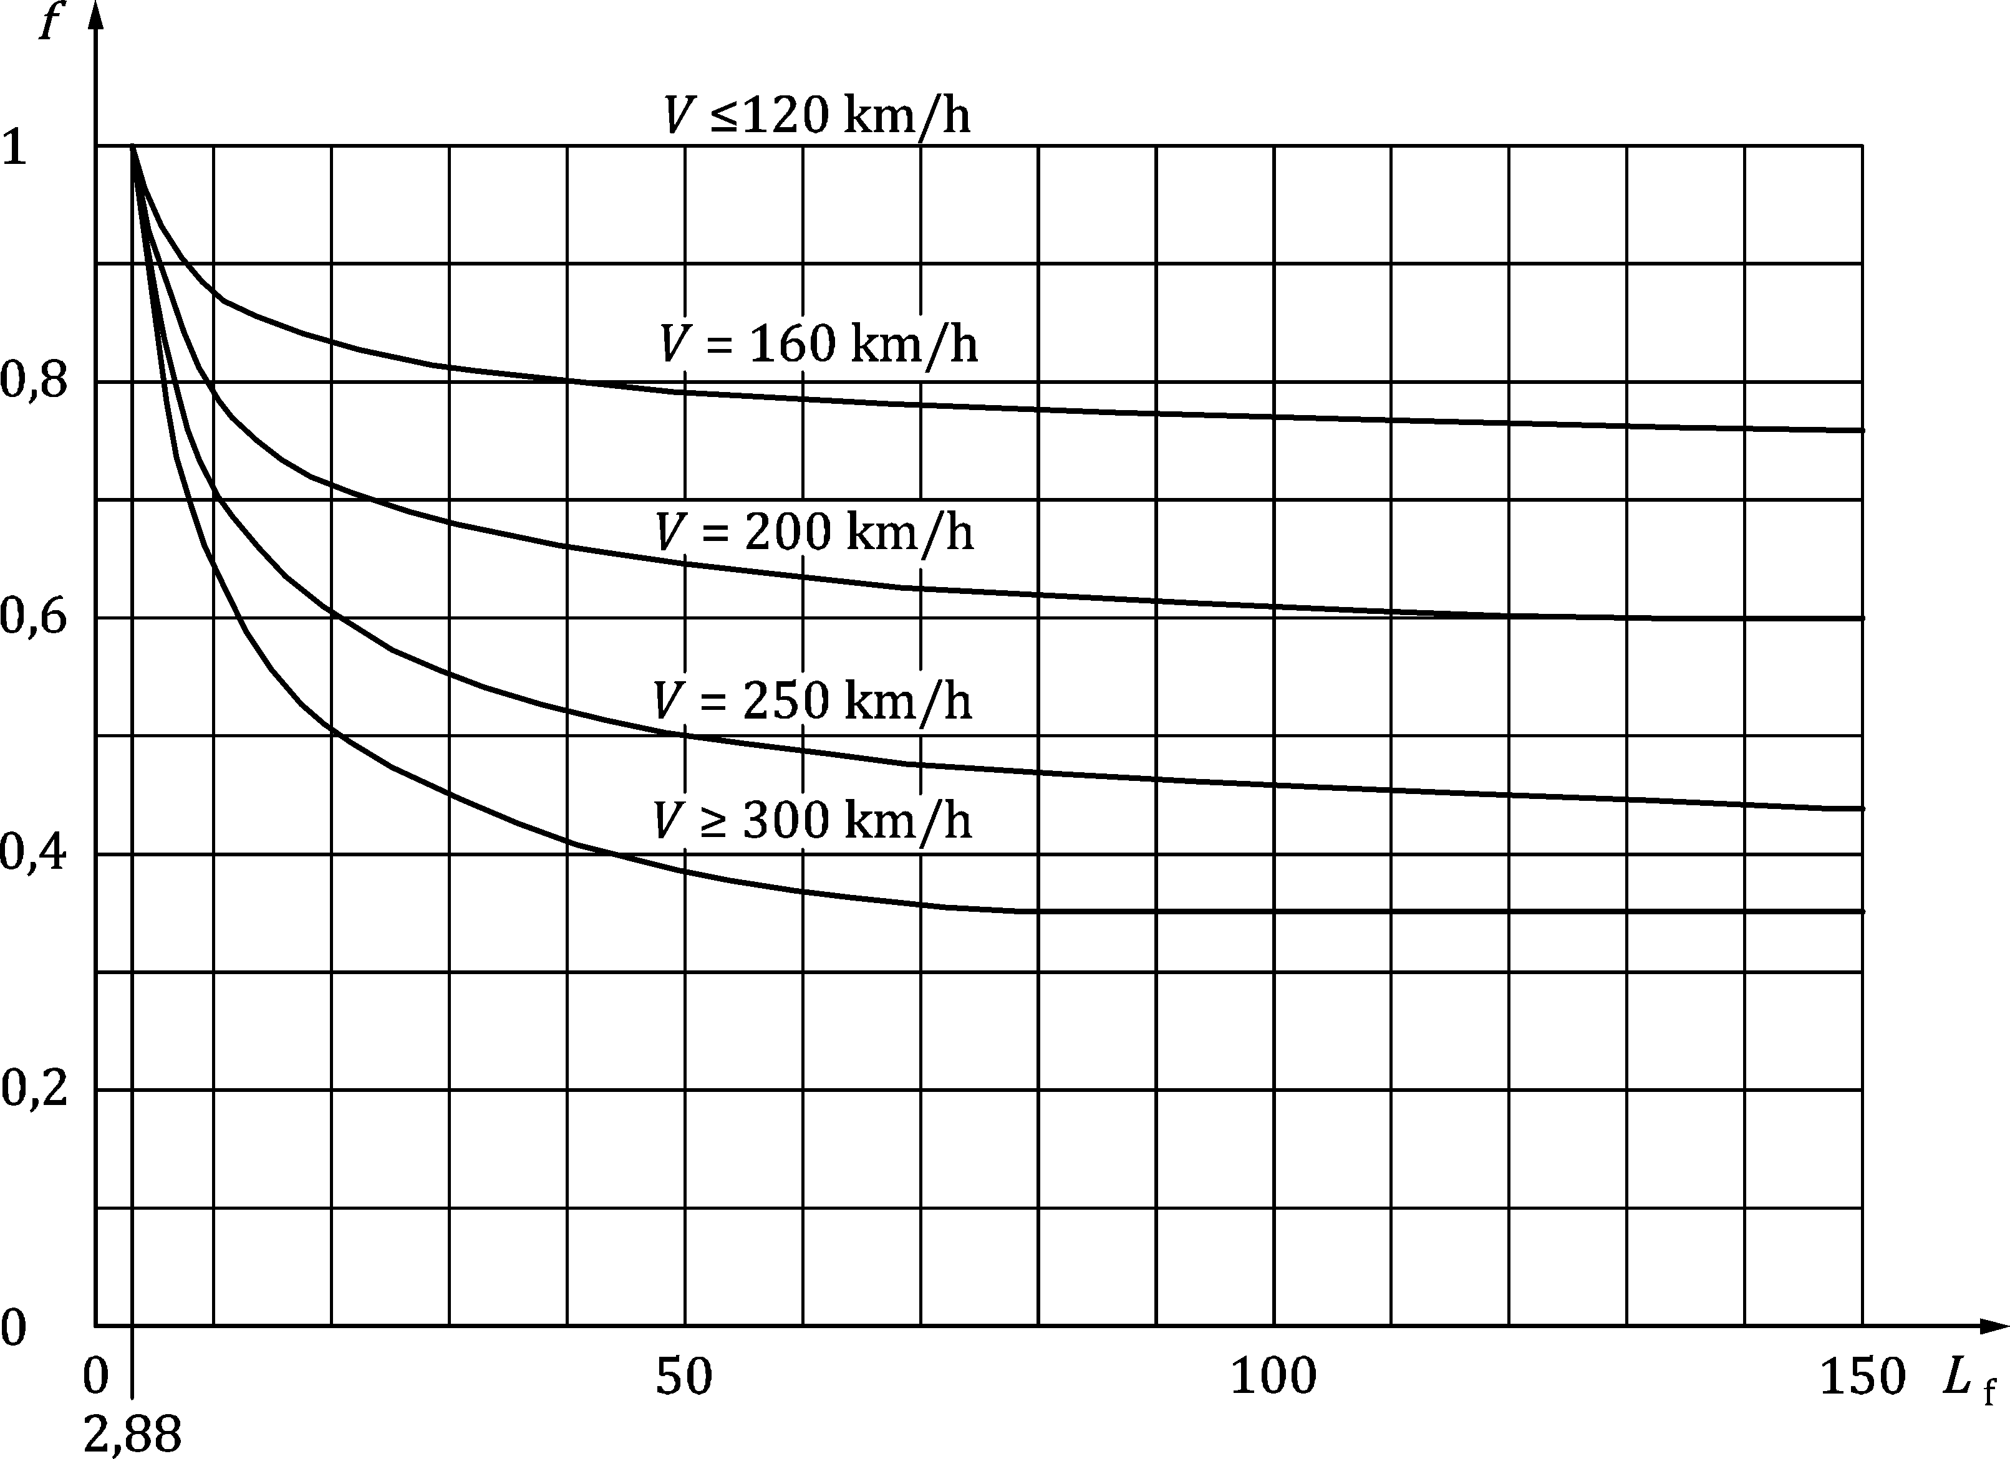

Key

|  |  |
| --- | --- |
| *f* |  |
| *L*f |  |

Figure 8.15 — Factor *f* for Load Model 71 and SW/0

(12) For LM71 and SW/0 centrifugal forces should be determined from Formulae (8.14) and (8.15) using classified vertical loads (see 8.3.2(3)) in accordance with the load cases given in Table 8.8:

Table 8.8 — Load Cases for centrifugal force corresponding to values of *α* and Maximum Line Speed at Site

| Value of *α* | Maximum Line Speed at Site | Centrifugal force based on: d | | | | Associated vertical traffic action based on: a |
| --- | --- | --- | --- | --- | --- | --- |
| V | α | f |  |
| [km/h] | [km/h] |  |  |  |
| *α* < 1 | > 120 | *V* | 1c | f | 1c × *f* ×  (LM71“+”SW/0)  for case 8.5.1(10)b | *Φ* × *α* × 1 × (LM71“+”SW/0) |
| 120 | *α* | 1 | *α* × 1 × (LM71“+”SW/0)  for case 8.5.1(10)a | *Φ* × *α* × 1 × (LM71“+”SW/0) |
| 0 | – | – | – |
| ≤ 120 | *V* | *α* | 1 | *α* × 1 × (LM71“+”SW/0) |
| 0 | – | – | – |
| *α* = 1 | > 120 | *V* | 1 | f | 1 × *f* ×  (LM71“+”SW/0)  for case 8.5.1(10)b | *Φ* × 1 × 1 × (LM71“+”SW/0) |
| 120 | 1 | 1 | 1 × 1 × (LM71“+”SW/0)  for case 8.5.1(10)a | *Φ* × 1 × 1 × (LM71“+”SW/0) |
| 0 | – | – | – |
| ≤ 120 | *V* | 1 | 1 | 1 × 1 × (LM71“+”SW/0) |
| 0 | – | – | – |
| *α* > 1 | > 120 b | *V* | 1 | f | 1 × *f* ×  (LM71“+”SW/0)  for case 8.5.1(10)b | *Φ* × 1 × 1 × (LM71“+”SW/0) |
| 120 | *α* | 1 | *α* × 1 × (LM71“+”SW/0)  for case 8.5.1(10)a | *Φ* × *α* × 1 × (LM71“+”SW/0) |
| 0 | – | – | – |
| ≤ 120 | *V* | *α* | 1 | *α* × 1 × (LM71“+”SW/0) |
| 0 | – | – | – |
| a 0,5 × (LM71“+”SW/0) instead of (LM71“+”SW/0) where vertical traffic actions favourable.  b Valid for heavy freight traffic limited to a maximum speed of 120 km/h.  c *α* = 1 to avoid double counting the reduction in mass of train with *f*.  d See 8.5.1(4) regarding vertical effects of centrifugal forces. Vertical load effect of centrifugal forces less any reduction due to cant should be enhanced by the relevant dynamic factor. When determining the vertical effect of centrifugal force, factor *f* to be included as shown above. | | | | | | |

where

|  |  |
| --- | --- |
| *V* | is the maximum speed in accordance with 8.5.1(7 and 8); |
| *f* | is the reduction factor in accordance with 8.5.1(10); |
| *α* | is the factor for classified vertical loads in accordance with 8.3.2(3); |
| LM71“+”SW/0 | is the Load Model 71 and if relevant Load Model SW/0 for continuous bridges. |

(13) For heavy freight traffic with a speed exceeding 120 km/h, additional requirements should be specified by the relevant authority or agreed for a specific project by the relevant parties.

NOTE 1 Additional requirements for centrifugal loads due to heavy freight traffic with a speed exceeding 120 km/h can be set in the National Annex for use in a country.

NOTE 2 The criteria in 8.5.1(7 and 8) and 8.5.1(10) to 8.5.1(12) are not valid for heavy freight traffic with a Maximum Permitted Vehicle Speed exceeding 120 km/h.

### Nosing force

(1) The nosing force shall be taken as a concentrated force acting horizontally, at the top of the rails, perpendicular to the centre-line of track.

(2) The nosing force shall be applied on both straight track and curved track.

(3) The nosing force shall always be combined with a vertical traffic load.

(4) The characteristic value of the nosing force shall be taken as *Q*sk = 100 kN.

(5) The characteristic value of the nosing force shall be multiplied by the factor *α* in accordance with 8.3.2(3) for values of *α* ≥ 1.

(6) The characteristic value of the nosing force shall not be multiplied by the factor *Φ* (see 8.4.5) or by the factor *f* in 8.5.1(11).

### Actions due to traction and braking

(1) Traction and braking forces shall be taken as acting at the top of the rails in the longitudinal direction of the track.

(2) Traction and braking forces shall be combined with the corresponding vertical loads.

(3) Traction and braking forces shall be considered as uniformly distributed over the corresponding influence length *L*a,b for traction and braking effects for the structural element considered.

(4) For Load Models SW/0 and SW/2 traction and braking forces should only be applied to those parts of the structure which are loaded according to Figure 8.2 and Table 8.1.

(5) The direction of the traction and braking forces shall take account of the permitted direction(s) of travel on each track.

(6) The characteristic values of traction and braking forces shall be calculated using Formulae (8.17) to (8.19) and are applicable to all types of track construction, *e.g*. continuous welded rails or jointed rails, with or without expansion devices:

Traction force:          *Q*lak = 33 [kN/m] × *L*a,b [m] ≤ 1000 [kN] (8.17)

for Load Models 71,

SW/0, SW/2 and HSLM

Braking force:           *Q*lbk = 20 [kN/m] × *L*a,b [m] ≤ 6000 [kN] (8.18)

for Load Models 71,

SW/0 and Load Model HSLM

*Q*lbk = 35 [kN/m] × *L*a,b [m] (8.19)

for Load Model SW/2

NOTE To allow for developments in the design of traction control and braking systems, the National Annex can set greater values for traction and braking forces for use in a country.

(7) Traction and braking may be neglected for the Load Model “unloaded train”.

(8) The above traction and braking forces for Load Models 71 and SW/0 shall be multiplied by the factor *α* in accordance with the requirements of 8.3.2(3).

(9) The characteristic values of traction and braking forces shall not be multiplied by the factor *Φ* (see 8.4.5.2) or by the factor *f* in 8.5.1(11).

(10) For loaded lengths greater than 300 m additional requirements for taking into account the effects of braking should be specified by the relevant authority or agreed for a specific project by the relevant parties.

NOTE Requirements for braking for loaded lengths greater than 300 m can be set by the National Annex for use in a country.

(11) For lines carrying special traffic (e.g. restricted to high speed passenger traffic) the traction and braking forces may be taken as equal to 25 % of the sum of the axle-loads (Real Train) acting on the influence length of the action effect of the structural element considered, with a maximum value of 1 000 kN for *Q*lak and 6 000 kN for *Q*lbk. The lines carrying special traffic and associated loading details may be specified by the relevant authority or agreed for a specific project by the relevant parties, taking into account other traffic permitted to use the line, e.g. trains for track maintenance etc.

NOTE The lines carrying special traffic and associated loading details could be set by the National Annex for use in a country.

(12) When the track is continuous at one or both ends of the bridge, the proportion of the force transferred through the deck to the bearings should be determined by taking into account the combined response of the structure and track in accordance with 8.5.4.

NOTE Only a proportion of the traction or braking force is transferred through the deck to the bearings, the remainder of the force being transmitted through the track where it is resisted behind the abutments.

(13) In the case of a bridge carrying two or more tracks the braking forces on one track shall be considered with the traction forces on one other track.

(14) Where two or more tracks have the same permitted direction of travel either traction on two tracks or braking on two tracks shall be taken with a combination factor *ψ*0 = 0,5 for the second track..

NOTE Alternative requirements for the application of traction and braking forces on bridges carrying two or more tracks with the same permitted direction of travel can be set in the National Annex for use in a country.

### Combined response of structure and track to variable actions

#### General principles

(1) Where the rails are continuous over discontinuities in the support to the track (e.g. between a bridge structure and an embankment) the structure of the bridge (bridge deck, bearings and substructure) and the track (rails, ballast etc.) jointly resist the longitudinal actions due to traction or braking. Longitudinal actions are transmitted partly by the rails to the embankment behind the abutment and partly by the bridge bearings and the substructure to the foundations.

NOTE References to embankment throughout 8.5.4 can also be taken as references to the track formation or ground beneath the track on the approaches to the bridge whether the track is on an embankment, level ground or in a cutting.

(2) Where continuous rails restrain the free movement of the bridge deck, deformations of the bridge deck (e.g. due to thermal variations, vertical loading, creep and shrinkage) produce longitudinal forces in the rails and in the fixed bridge bearings.

(3) The effects resulting from the combined response of the structure and the track to variable actions shall be taken into account for the design of the bridge superstructure, fixed bearings and the substructure and to estimate the contribution of the track-bridge interaction to the axial stress in the rails.

NOTE Track-bridge interaction also contributes to the axial stresses in the rails due to the effects of bending in the deck. An allowance for this effect is assumed to be included in the axial stress limit (see 8.5.4.5).

(4) The requirements of 8.5.4 are valid for ballasted track and for ballastless track.

(5) The requirements for other configurations of track should be specified.

NOTE The requirements for other configurations of track can be specified in either the National Annex or for the individual project. Further guidance is given in CEN/TR 17231.

#### Parameters affecting the combined response of the structure and track

(1) The following parameters influence the combined behaviour of the structure and track and shall be taken into account in the analysis:

a) Configuration of the structure:

— simply supported beam, continuous beams or a series of beams,

— number of individual decks and length of each deck,

— number of spans and length of each span,

— position of fixed bearings,

— position of the thermal fixed point (and use of devices to create “virtual” thermal fixed points),

— expansion length *L*T (see Figure 8.16) between the thermal fixed point and the (further) end of the deck,

— effective expansion length, *L*J (see Figure 8.16), at a structure movement joint, being the sum of the expansion lengths on the two sides of the joint.

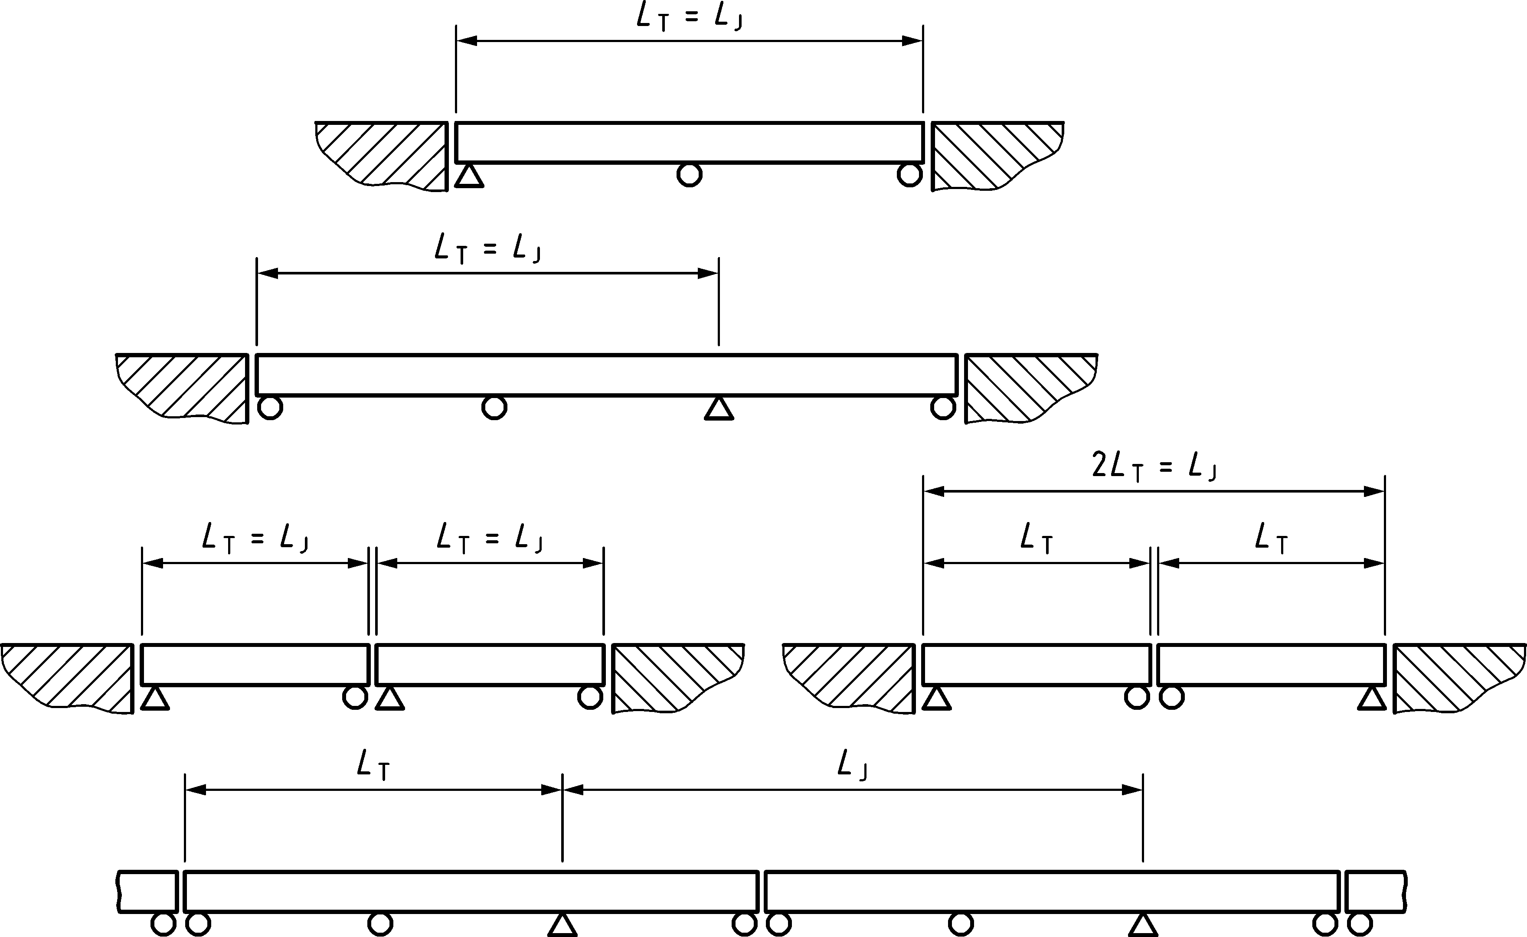

Figure 8.16 — Examples of expansion length *L*T and *L*J

b) Configuration of the track:

— ballasted track or ballastless track systems,

— vertical distance between the upper surface of the deck and the neutral axis of the rails,

— location of rail expansion devices, if needed,

— application of other devices for mitigation of longitudinal stresses (e.g. special rail fastenings),

— presence of switches and crossings.

NOTE The specific project, agreed by the relevant parties, can specify requirements regarding the location of rail expansion devices taking into account requirements to ensure such devices are effective whilst ensuring that the rail expansion devices are not adversely affected by bending effects in the rail due to the close proximity of the end of a bridge deck, etc.

c) Properties of the structure:

— vertical stiffness of the deck,

— vertical distance between the neutral axis of the deck and the upper surface of the deck,

— vertical distance between the neutral axis of the deck and the axis of rotation of the bearing,

— structural configuration at supports generating longitudinal displacement of the end of the deck from angular rotation of the deck,

— longitudinal stiffness of the structure defined as the total stiffness which can be mobilised by the substructure against actions in the longitudinal direction of the tracks taking into account the stiffness of the bearings, substructure and foundations.

For example the total longitudinal stiffness of a single pier is given by Formula (8.20):

 (8.20)

for the case represented in Figure 8.17 as an example.

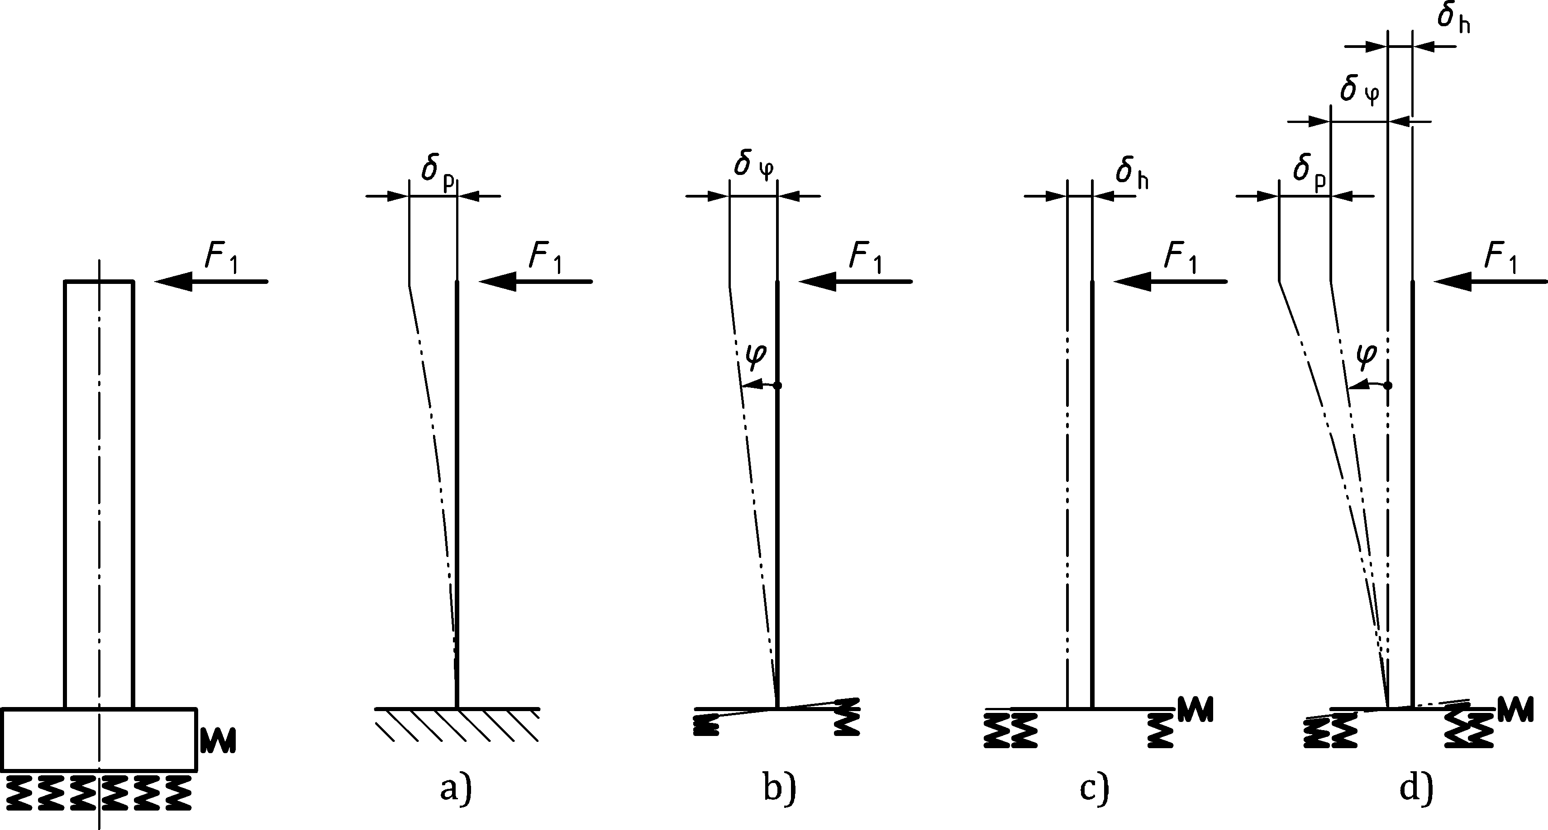

Key

|  |  |
| --- | --- |
| a) | Bending of the pier |
| b) | Rotation of the foundation |
| c) | Displacement of the foundation |
| d) | Total displacement of the pier head |

Figure 8.17 — Example of the determination of equivalent longitudinal stiffness at bearings

d) Properties of the track:

— axial stiffness of the rail,

— resistance of the track or the rails against longitudinal displacement considering either:

— resistance against displacement of the track (rails and sleepers) in the ballast relative to the underside of the ballast, or

— resistance against displacement of the rails from rail fastenings and supports *e.g.* with frozen ballast or with directly fastened rails,

where the resistance against displacement is the force per unit length of the track that acts against the displacement as a function of the relative displacement between rail and the supporting deck or embankment.

#### Actions to be considered

(1) The following actions shall be taken into account:

— traction and braking forces as defined in 8.5.3,

— Thermal effects in the combined structure and track system.

— Classified vertical traffic loads in accordance with 8.3.2 and 8.3.3 (including SW/0 and SW/2 where required). Associated dynamic effects in accordance with 8.4.5 may be neglected.

NOTE The combined response of the structure and track to the “unloaded train” and load model HSLM can be neglected. Alternative requirements can be specified in the National Annex for use in a country.

— Other actions such as creep, shrinkage, temperature gradient etc. shall be taken into account for the determination of rotation and associated longitudinal displacement of the end of the decks, where relevant.

(2) Temperature variations in the bridge should be taken as the overall range of the uniform bridge temperature component, Δ*T*N (see EN 1991‑1‑5), with *γ* and *ψ* taken as 1,0.

For simplified calculations a temperature variation of the superstructure of Δ*T*N =  ± 35 Kelvin may be taken into account.

NOTE 1 The National Annex can specify alternative values of Δ*T*N for use in a country.

NOTE 2 Other values for simplified calculations can be specified in the National Annex for use in a country.

(3) When determining the combined response of track and structure to traction and braking forces, the traction and braking forces should not be applied on the adjacent embankment unless a complete analysis of the track/structure system is carried out. Such an analysis should consider the approach, passage over and departure from the bridge of rail traffic on the adjacent embankments, in order to evaluate the most adverse load effects.

#### Modelling and calculation of the combined track/structure system

(1) For the determination of load effects in the combined track/structure system a model based upon Figure 8.18 may be used.

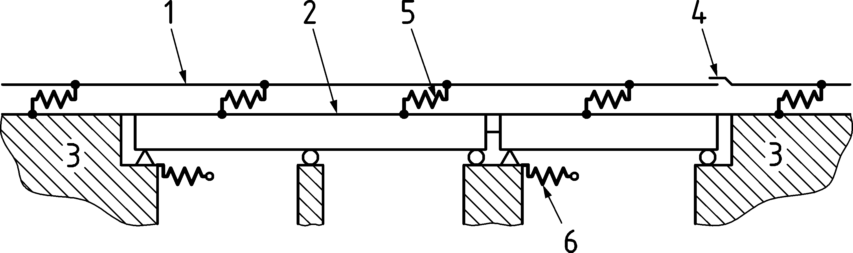

Key

|  |  |
| --- | --- |
| 1 | Track |
| 2 | Superstructure (a single deck comprising two spans and a single deck with one span shown) |
| 3 | Embankment |
| 4 | Rail expansion device (if present) |
| 5 | Longitudinal non-linear springs reproducing the longitudinal load/displacement behaviour of the track |
| 6 | Longitudinal springs reproducing the longitudinal stiffness *K* of a fixed support to the deck taking into account the stiffness of the foundation, piers and bearings etc. |

Figure 8.18 — Example of a model of a track/structure system

(2) The longitudinal load-displacement behaviour of the track or rail supports may be determined experimentally. It may be modelled as a complete load-displacement diagram or it may be represented by the relationship shown in Figure 8.19 with an initial elastic shear resistance [kN/mm of displacement per m of track] and then a plastic shear resistance *k* [kN/m of track]. The relevant characteristics of the rail fastening system in its unloaded condition may be determined using the method described in EN 13146‑1.

NOTE 1 In general, these characteristics would be determined as a part of the fastening system type approval process and would be known for each type of fastening system.

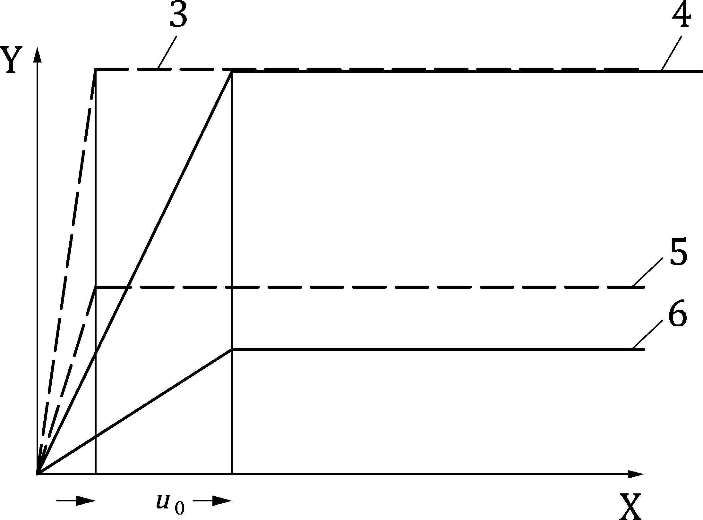

Key

|  |  |
| --- | --- |
| X | Displacement of the rail relative to the supporting deck |
| Y | Longitudinal shear force in the track per unit length |
| 1 | Resistance of the rail fastening system (loaded track) (frozen ballast or track without ballast with conventional fastenings) |
| 2 | Resistance of sleeper in ballast (loaded track) |
| 3 | Resistance of the rail fastening system (unloaded track) (frozen ballast or track without ballast with conventional fastenings) |
| 4 | Resistance of sleeper in ballast (unloaded track) |

Figure 8.19 — Variation of longitudinal shear force with longitudinal track displacement for one track

NOTE 2 The behaviour described in Figure 8.19 is valid in most cases (but not for embedded rails without conventional rail fastenings etc.).

(3) As in many cases the characteristics of the track and fastening system are unknown when the bridge design calculations are undertaken, and will vary over the design service life, typical values of the plastic shear resistance of the track, *k* [kN/mm] and limiting elastic displacement, *u*0 [mm] may be taken from Table 8.9 (NDP).

NOTE Alternative values of the plastic shear resistance of the track, *k* [kN/mm] and limiting elastic displacement, *u*0 [mm] can be given in the National Annex for use in a country.

Table 8.9 (NDP) — Examples of values to be used in Figure 8.19 when actual values are unknown

|  |  | *u*0 | k |
| --- | --- | --- | --- |
| [mm] | [kN per metre length of track] |
| Ballasted track | Unloaded | 2,0 | 20 |
| Unloaded: Frozen ballast | 0,5 | 30 |
| Loaded | 2,0 | 60 |
| Loaded: Frozen ballast | 0,5 | 60 |
| Ballastless track | Unloaded | 0,5 | 40 |
| Loaded | 0,5 | 60 |

(4) If a system is used in which the value of *k* is lower than the value in Table 8.9 (NDP) a calculation shall be made to ensure that the gap which would result from a broken rail is less than the limiting value set by the responsible infrastructure manager.

(5) A method for calculating the rail break gap is given in CEN/TR 17231.

(6) Where it can be reasonably foreseen that the track characteristics may change in the future, this shall be taken into account in the calculations in accordance with the specified requirements. Additional requirements may be specified by the relevant authority or, where not specified, agreed for a specific project by the relevant parties.

(7) For the calculation of the total longitudinal support reaction *F*L and in order to compare the global equivalent rail stress with permissible values, the global effect shall be calculated as follows in Formula (8.21):

*F*L = Σ*ψ*0i *F*li (8.21)

where

|  |  |
| --- | --- |
| *F*li | is the individual longitudinal support reaction corresponding to the action *i*; |
| *ψ*0i | is the combination factor defined in prEN 1990:2021, A.2 which shall be used for the calculation of load effects in the superstructure, bearings and substructures; |
| *ψ*0i | is 1,0 for the calculation of rail stresses. |

(8) When determining the effect of each action the nonlinear behaviour of the track stiffness e.g. shown in Figure 8.19 should be taken into account.

(9) The longitudinal forces in the rails and bearings resulting from each action may be combined using linear superimposition.

NOTE Nonlinear methods are discussed in CEN/TR 17231. In general, linear superposition over-estimates the stress in the rails but under-estimates the forces in the bearings.

#### Design criteria

NOTE Alternative requirements can be specified in the National Annex for use in a country.

##### Track

(1) The effects of track-bridge interaction on the track are controlled, principally, by limiting the “additional stress” or force in the rail due to thermal and vehicle loading (traction, braking and bridge deck bending forces) effects, attributable to the presence of the bridge. This is the additional axial tensile stress or compressive force in the rail which shall be added to the axial tensile stress or compressive force that would be expected with the same track system and the same vehicle loading but not on the bridge.

(2) For rails on the bridge and on the adjacent abutment the permissible additional stress in the rail due to the combined response of the structure and track to variable actions should be limited to the design value of 112 N/mm2 in tension or compression with the following exception:

— For ballasted track, in order to take into account the possibility of lateral track buckling, the design value shall be further reduced to 72 N/mm2 in compression. (The design value in tension is not affected).

— For ballasted track in which lateral buckling is constrained e.g. by rigidly attached guard rails a design value greater than 72 N/mm2 are permissible.

NOTE This permission is subject to the agreement of the relevant authority specified in the National Annex.

(3) The limiting values for the rail stresses given in 8.5.4.5.1(1) are valid for track complying with:

— rail profile 60E1 or 60E2 of Grade R260 or better according to EN 13674‑1,

— straight track or track radius *r* ≥ 1500 m,

NOTE 1 For ballastless tracks or for ballasted tracks with additional lateral restraints this minimum value of track radius can be reduced if specified by the relevant authority. Further guidance is given in CEN/TR 17231.

— for ballasted tracks with concrete sleepers of mass ≥ 250 kg at a spacing not exceeding 650 mm, or equivalent track construction,

— for ballasted tracks with at least 300 mm consolidated ballast under the sleepers,

— if the track is ballastless track incorporating rail fastenings which have a longitudinal shear stiffness no greater than that used for standard ballasted track.

When the above criteria are not satisfied special studies should be carried out or additional measures provided.

NOTE 2 For other track construction standards (in particular those that affect lateral resistance) and other types of rail the maximum additional rail stresses can be specified in the National Annex for use in a country. Further information on this subject is given in CEN/TR 17231.

##### Limiting values for the deformation of the structure

(1) For ballasted track, the displacement due to traction and braking, *δ*B [mm] shall not exceed the following values:

— 5 mm across the joint for continuous welded rails without rail expansion devices or with a rail expansion device at one end of the deck,

— 30 mm for rail expansion devices at both ends of the deck if the ballast is continuous at the ends of the deck.

NOTE Movements exceeding 30 mm are acceptable where the ballast is provided with a movement gap and rail expansion devices are provided.

where

|  |  |
| --- | --- |
| *δ*B [mm] | is the relative longitudinal displacement between the end of a deck and the adjacent abutment or;  is the relative longitudinal displacement between two consecutive decks |

For ballastless track, the displacement due to traction and braking, *δ*B [mm] shall be limited in order to ensure compatibility with design characteristics of the rail fastening system. In the absence of any specific data, limiting values for ballasted track should be applied to ballastless track.

(2) For ballasted track, the longitudinal displacement due to vertical traffic actions (up to two tracks loaded with Load Model 71 (and where required SW/0)) *δ*H [mm] shall not exceed the following values:

— 8 mm when the combined behaviour of structure and track is taken into account (valid when there is only one or no expansion devices per deck),

— 10 mm when the combined behaviour of the structure and track is neglected.

and *δ*H [mm] is the relative longitudinal displacement at the level of the bottom surface of the ballast layer, due to vertical deformation of the bridge deck, measured

— between the end of the deck and the adjacent abutment, or

— between two consecutive decks.

For ballastless track, the longitudinal displacement due to vertical traffic actions, *δ*H [mm] shall be limited in order to ensure compatibility with the design characteristics of the rail fastening system. In the absence of any specific data, limiting values for ballasted track should be applied to ballastless track.

NOTE Where either the permissible additional stresses in the rail in 8.5.4.5.1(1) are exceeded or the longitudinal displacement of the deck in 8.5.4.5.2(1) or 8.5.4.5.2(2) is exceeded either change the structure or provide other mitigation measures in the track design e.g. rail expansion devices, special rail fastenings, etc.

(3) The vertical displacement of the upper surface of a deck relative to the adjacent construction (abutment or another deck) *δ*V [mm] due to variable actions shall not exceed the following values:

— 3 mm for a Maximum Line Speed at the site of up to 160 km/h,

— 2 mm for a Maximum Line Speed at the site over 160 km/h.

(4) For ballastless track the uplift forces (under vertical traffic loads) on rail supports and fastening systems shall be checked against the relevant limit state (including fatigue) performance characteristics of the rail supports and fastening systems.

NOTE The resistance of fastening systems to uplift forces can be determined using the test methods described in EN 13146‑7.

#### Calculation methods

##### General

(1) The design criteria set out in 8.5.4.5 is primarily applicable to ballasted track and is appropriate for track components with specified properties (e.g. UIC60 rail)

NOTE Alternative calculation methods can be specified in the National Annex for use in a country.

##### General approach

(1) Calculation methods should enable the combined response of the track and structure to be checked against the design criteria given in 8.5.4.5. The design criteria may be summarized as:

a) Longitudinal relative displacement at the end of the deck split into two components to enable comparison with the permitted values: *δ*B due to braking and traction and *δ*H due to vertical deformation of the deck,

b) Maximum additional stresses in the rails,

c) Maximum vertical relative displacement at the end of the deck, *δ*V,

d) for ballastless tracks, if *δ*V is greater than 0,5 mm an additional check on uplift forces is required in accordance with 8.5.4.5.2(4).

(2) In 8.5.4.6.3 a simplified method is given for estimating the combined response of a simply supported or a continuous structure consisting of a single bridge deck and track to variable actions for structures with an expansion length *L*T of up to 40 m.

(3) For any other track or structural configurations, an analysis shall be carried out in accordance with the requirements of 8.5.4.2 to 8.5.4.5.

##### Simplified calculation method for a single deck

(1) For a superstructure comprising of a single deck (simply supported, continuous spans with a fixed bearing at one end or continuous spans with an intermediate fixed bearing) it is not necessary to check the rail stresses providing that

— the substructure has sufficient stiffness, *K,* to limit *δ*B, the displacement of the deck in the longitudinal direction due to traction and braking, to a maximum of 5 mm under the longitudinal forces due to traction and braking (classified in accordance with 8.3.2(3) where required). For the determination of the displacements the configuration and properties of the structure given in 8.5.4.2(1) should be taken into account,

— for vertical traffic actions *δ*H, the longitudinal displacement at the upper surface of the deck at the end of the deck due to deformation of the deck does not exceed 5 mm,

— the effective expansion length, *L*J, at the joint is less than 40m.

The criteria given in this clause are recommended.

NOTE Alternative criteria can be specified in the National Annex for use in a country.

(2) The limits of validity of the calculation method in 8.5.4.6.3 are:

— the track complies with the construction requirements given in 8.5.4.5.1(3).

— longitudinal plastic shear resistance *k* of the track is:

unloaded track: *k* = 20 to 40 kN per m of track,

loaded track: *k* = approximately 60 kN per m of track.

— vertical traffic loading:

Load Model 71 (and where required Load Model SW/0) with *α* = 1 in accordance with 8.3.2(3),

Load Model SW/2,

NOTE The method is valid for values of *α* where the load effects from *α* × LM71 are less than or equal to the load effects from SW/2.

— actions due to braking for:

Load Model 71 (and where required Load Model SW/0) and Load Model HSLM:

*q*lbk = 20 kN/m,

Load Model SW/2:

*q*lbk = 35 kN/m.

— actions due to traction:

*q*lak = 33 kN/m, limited to a maximum of *Q*lak = 1 000 kN.

— actions due to temperature:

Temperature variation Δ*T*D of the deck: Δ*T*D ≤ 35 Kelvin,

Temperature variation Δ*T*R of the rail: Δ*T*R ≤ 50 Kelvin,

Maximum difference in temperature between rail and deck:

∣Δ*T*D — Δ*T*R∣ ≤ 20 Kelvin. (8.22)

(3) The longitudinal forces due to traction and braking acting on the fixed bearings may be obtained by multiplying the traction and braking forces by the reduction factor *ξ* given in Table 8.10.

Table 8.10 — Reduction factor *ξ* for the determination of the longitudinal forces in the fixed bearings of a single deck due to traction and braking

| Overall length of structure | Reduction factor ***ξ*** | | |
| --- | --- | --- | --- |
| [m] | Continuous track | Rail expansion devices at one end of deck | Rail expansion devices at both ends of deck |
| ≤ 40 | 0,60 | 0,70 | 1,00 |

For portal frames and closed frames or boxes the reduction factor *ξ* may be taken as unity. Alternatively an analysis in accordance with 8.5.4.2 to 8.5.4.5 may be used.

(4) The characteristic longitudinal forces *F*Tk per track due to temperature variation (according to 8.5.4.3) acting on the fixed bearings may be obtained as follows:

— for bridges with continuous welded rails at both deck ends and fixed bearings at one end of the deck:

*F*Tk [kN] = ± 0,6 *k* × *L*T (8.23)

where

|  |  |
| --- | --- |
| *k* [kN/m] | is the longitudinal plastic shear resistance of the track per unit length according to 8.5.4.4(2) for unloaded track and *L*T [m] the expansion length according to 8.5.4.2(1). |

— for bridges with continuous welded rails at both deck ends and fixed bearings situated in a distance *L*1 from one end of the deck and *L*2 from the other end:

*F*Tk [kN] = ± 0,6 *k ×* (*L*2 *— L*1) (8.24)

where

|  |  |
| --- | --- |
| *k* [kN/m] | is the longitudinal plastic shear resistance of the track per unit length according to 8.5.4.4(2) for unloaded track and *L*1 [m] and *L*2 [m] according to Figure 8.20. |

|  |  |
| --- | --- |
|  | N.B. (1) Deck corresponding to either *L*1 or *L*2 may comprise of one or more spans. |

Figure 8.20 — Deck with fixed bearings not located at one end (1)

— for bridges with continuous welded rails at the deck end with fixed bearings and rail expansion devices at the free deck end:

*F*Tk [kN] = ± 20 *L*T, but *F*Tk ≤ 1100 kN (8.25)

where

|  |  |
| --- | --- |
| *L*T [m] | is the expansion length according to 8.5.4.2(1). |

— for bridge decks with rail expansion devices at both ends:

*F*Tk = 0 (8.26)

NOTE Alternative values of *k* can be specified in the National Annex for use in a country.

(5) The characteristic longitudinal forces *F*Qk per track on the fixed bearings due to deformation of the deck may be obtained as follows in Formulae (8.27) and (8.28):

— for bridges with continuous welded rails at both deck ends and fixed bearings on one end of the deck and with rail expansion devices at the free end of the deck:

*F*Qk [kN] = ±20 *L* (8.27)

where

|  |  |
| --- | --- |
| *L* [m] | is the length of the first span near the fixed bearing. |

— for bridges with rail expansion devices at both ends of the deck:

*F*Qk [kN] = 0 (8.28)

(6) The vertical displacement of the upper surface of a deck relative to the adjacent construction (abutment or another deck) due to variable actions may be calculated ignoring the combined response of the structure and track and checked against the criteria in 8.5.4.5.2(3).

## Aerodynamic actions from passing trains

### General

(1) Aerodynamic actions from passing trains shall be taken into account when designing structures adjacent to, or spanning over, railway tracks.

NOTE 1 The actions defined in this section are in accordance to EN 14067‑4, which can be used for more detailed information.

NOTE 2 The passing of rail traffic subjects any structure situated near the track to a travelling wave of alternating pressure and suction (see Figures 8.21 to 8.24). The magnitude of the action depends mainly on:

— the square of the speed of the train,

— the aerodynamic shape of the train,

— the shape of the structure,

— the position of the structure, particularly the clearance between the vehicle and the structure.

(3) The aerodynamic actions may be approximated by equivalent loads at the head and rear ends of a train, when checking ultimate and serviceability limit states and fatigue.

(4) Assessment of pressures may also be done by numerical simulations, following the requirements defined in EN 14067‑4:2013+A1:2018, 6.1.2.4.

(5) Characteristic values of the equivalent loads are given in 8.6.2 to 8.6.6. Additional characteristic values of the equivalent loads may be based on measurements, calculations or simulations, as specified by the relevant authority or, where not specified, agreed for a specific project by the relevant parties.

NOTE Alternative values can be set by the National Annex for use in a country.

(6) In 8.6.2 to 8.6.6 the train speed *V*tr is applicable up to 350 km/h and should be taken as the Maximum Line Speed at the Site, except for cases covered by prEN 1990:2021, A.2.6.6.3(5).

(7) At the start and end of structures adjacent to the tracks, for a length of 5 m from the start and end of the structure measured parallel to the tracks the equivalent loads in 8.6.2 to 8.6.6 should be multiplied by a dynamic amplification factor which may be larger than 2,0, due to the alternating positive-negative pressure pulses.

NOTE For dynamically sensitive structures, there is a significant risk that the above dynamic amplification factor is insufficient. The dynamic amplification factor and the extent of application along the structure can be determined by a special study, taking into account the dynamic characteristics of the structure including: support and end conditions; the speed of the adjacent rail traffic and associated aerodynamic actions; the dynamic response of the structure, including the speed of a deflection wave induced in the structure. In addition, for dynamically sensitive structures, a dynamic amplification factor can be necessary for parts of the structure between the start and the end of the structure..

### Simple vertical surfaces parallel to the track (e.g. noise barriers)

#### General

(1) The characteristic values of the actions, ± *q*1k, may be determined from Formula (8.29), with graphical representation in Figure 8.21.

Dimensions in metres

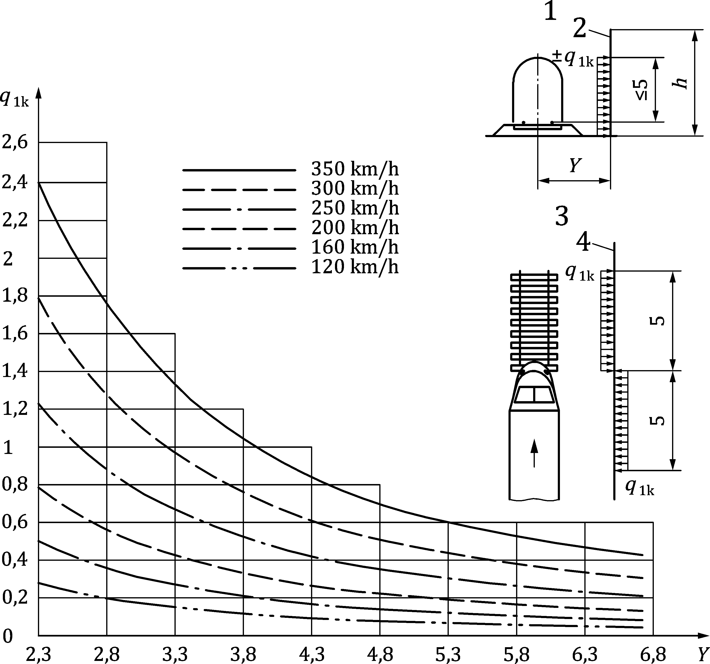

Key

|  |  |
| --- | --- |
| 1 | Section; |
| 2 | Surface of structure; |
| 3 | Plan view; |
| 4 | Surface of structure. |

Figure 8.21 — Characteristic values of actions *q*1k for simple vertical surfaces parallel to the track

 (8.29)

where

|  |  |
| --- | --- |
| *ρ* | is the density of air, which may be taken generally as 1,25 kg/m3; |
| *v*tr | is the train speed [m/s]; |
| *C*p1 | is the aerodynamic coefficient depending on the distance from track axis *Y*, defined in Formula (8.30); |

 (8.30)

where

|  |  |
| --- | --- |
| Y | is the horizontal distance in metres between the track centreline and the vertical surface. This formula is valid for *Y* ≥ 2,3 m, for shorter distances a specific study should be made. |

*q*1k from Formula (8.29) should be multiplied by factor *k*1, shape coefficient of the train, whose values are as follows:

|  |  |
| --- | --- |
| *k*1 = 1,00 | for freight trains; |
| *k*1 = 0,85 | for passenger trains; |
| *k*1 = 0,60 | for high-speed trains with a train speed equal to or greater than 250 km/h that are very well shaped aerodynamically. |

(2) If a small part of a wall with a height ≤ 1,00 m and a length ≤ 2,50 m is considered, e.g. an element of a noise protection wall, the actions *q*1k should be increased by a factor *k*2 =  1,3.

#### Quasi-static equivalent load model for noise barriers

##### Application requirements

(1) The air pressure wave due to a passing train may be determined according to the defined quasi-static equivalent load model for noise barriers presented in this clause, provided the following criteria are met:

— statically determined post-and-panel structure;

— post spacing ≤ 7,50 m;

— wall height above rail top ≤ 5,00 m;

— there is negligible torsion of panels;

— there are no additional dynamic actions.

(2) If these requirements are not fulfilled, additional data shall be obtained by numerical methods (e.g. dynamic analysis with an appropriate load model).

##### Quasi-static equivalent load

(1) The quasi-static equivalent load shall be calculated by Formula (8.31):

±*q*DS = *φ*L × *φ*H × *φ*dyn × *q*1k (8.31)

where

|  |  |
| --- | --- |
| ±*q*DS | is the quasi-static load for the air pressure wave of a passing train at an elevation z above the rail top considering the influence length, the wall height and the dynamic factor; |
| *φ*L | is the length factor — considering the influence length of the air pressure wave; |
| *φ*H | is the height factor — considering wall height and elevation above the rail top; |
| *φ*dyn | is the dynamic factor — based on consideration of the dynamic response of statically determined post-and-panel structures; |
| *q*1k | is the loading according to 8.6.2, without considering the factor *k*2.  Depending on the shape of the train, *q*1k can be multiplied by the factor *k*1. |

(2) The load *q*DS shall always be applied, as with the load *q*1k, in the form of a line load with a horizontal length of 5 m on each side in different directions according to 8.6.2, in the relevant load position for calculation of maximum forces and moments in the main structural elements of a post and panel noise barrier. It is important to note that, in contrast to *q*1k, the load *q*DS has a variable value related to the elevation above the rail top.

(3) The relevant load model position for ± *q*DS is given in prEN 16727‑2‑2:20XX, 5.2 to 5.5.

##### Length factor

(1) The length factor is presented in Table 8.11.

(2) For intermediate values of *L*i and *h* in Table 8.11, the value of *φ*L shall be determined on the basis of linear interpolation.

Table 8.11 — Length factor *φ*L

| Influence length | Wall height ***h*** above rail top | | | | |
| --- | --- | --- | --- | --- | --- |
| (m) | (m) | | | | |
| *L*i | 1 | 2 | 3 | 4 | 5 |
| 0,0 | 0,97 | 1,12 | 1,27 | 1,42 | 1,56 |
| 2,5 | 0,95 | 1,10 | 1,25 | 1,40 | 1,54 |
| 5,0 | 0,92 | 1,06 | 1,20 | 1,35 | 1,49 |
| 7,5 | 1,02 | 1,18 | 1,33 | 1,49 | 1,65 |
| 10,0 | 1,21 | 1,40 | 1,59 | 1,78 | 1,97 |
| 12,5 | 1,44 | 1,66 | 1,88 | 2,11 | 2,33 |
| 15,0 | 1,69 | 1,95 | 2,21 | 2,47 | 2,73 |
| For the panels:  Influence length *L*i = span length, in m.  For the posts:  Influence length *L*i = sum of the adjacent panel span lengths parallel to the track, in m. | | | | | |

##### Height factor

(1) The height factor is presented in Table 8.12.

(2) For intermediate values of *z*/*h* and *h* in Table 8.12, the value of *φ*H shall be determined on the basis of linear interpolation.

Table 8.12 — Height factor *φ*H

|  | Wall height ***h*** above rail top | | | | |
| --- | --- | --- | --- | --- | --- |
|  | (m) | | | | |
| z/h | 1 | 2 | 3 | 4 | 5 |
| 1,0 | 0,69 | 0,65 | 0,60 | 0,55 | 0,51 |
| 0,9 | 0,75 | 0,71 | 0,68 | 0,64 | 0,60 |
| 0,8 | 0,80 | 0,77 | 0,74 | 0,71 | 0,68 |
| 0,7 | 0,85 | 0,83 | 0,80 | 0,78 | 0,76 |
| 0,6 | 0,89 | 0,87 | 0,86 | 0,84 | 0,82 |
| 0,5 | 0,92 | 0,91 | 0,90 | 0,89 | 0,88 |
| 0,4 | 0,95 | 0,94 | 0,94 | 0,93 | 0,92 |
| 0,3 | 0,97 | 0,97 | 0,96 | 0,96 | 0,96 |
| 0,2 | 0,99 | 0,99 | 0,98 | 0,98 | 0,98 |
| 0,1 | 1,00 | 1,00 | 1,00 | 1,00 | 1,00 |
| 0,0 | 1,00 | 1,00 | 1,00 | 1,00 | 1,00 |
| *z* = elevation above rail top in m, where the quasi-static equivalent load is calculated.  For elevations *z <* 0 it is assumed that *φ*H = 1,00. | | | | | |

(3) The values in Table 8.12 are based on Formula (8.32) that can alternatively be used to determine the height factor:

*φ*H = 1 − (1 − *φ*H1) × (*z*/*h*)2 (8.32)

where

|  |  |
| --- | --- |
| *φ*H1 | is the value of *φ*H for the ratio *z*/*h* = 1,0. |

##### Dynamic factor

(1) The dynamic factor *φ*dyn is presented in Figure 8.22.

(2) The dynamic factor *φ*dyn shall be evaluated to two decimal digits.

|  |  |
| --- | --- |
| For 0 ≤ *κ*t ≤ 0,5: | *φ*dyn = 3,25 |

For 0,5 ≤ *κ*t ≤ 1,5:          *φ*dyn = 1,10 + 2,15 × (0,735 × *κ*t2 − 2,470 × *κ*t + 2,051) (8.33)

|  |  |
| --- | --- |
| For *κ*t > 1,5: | *φ*dyn = 1,10 |

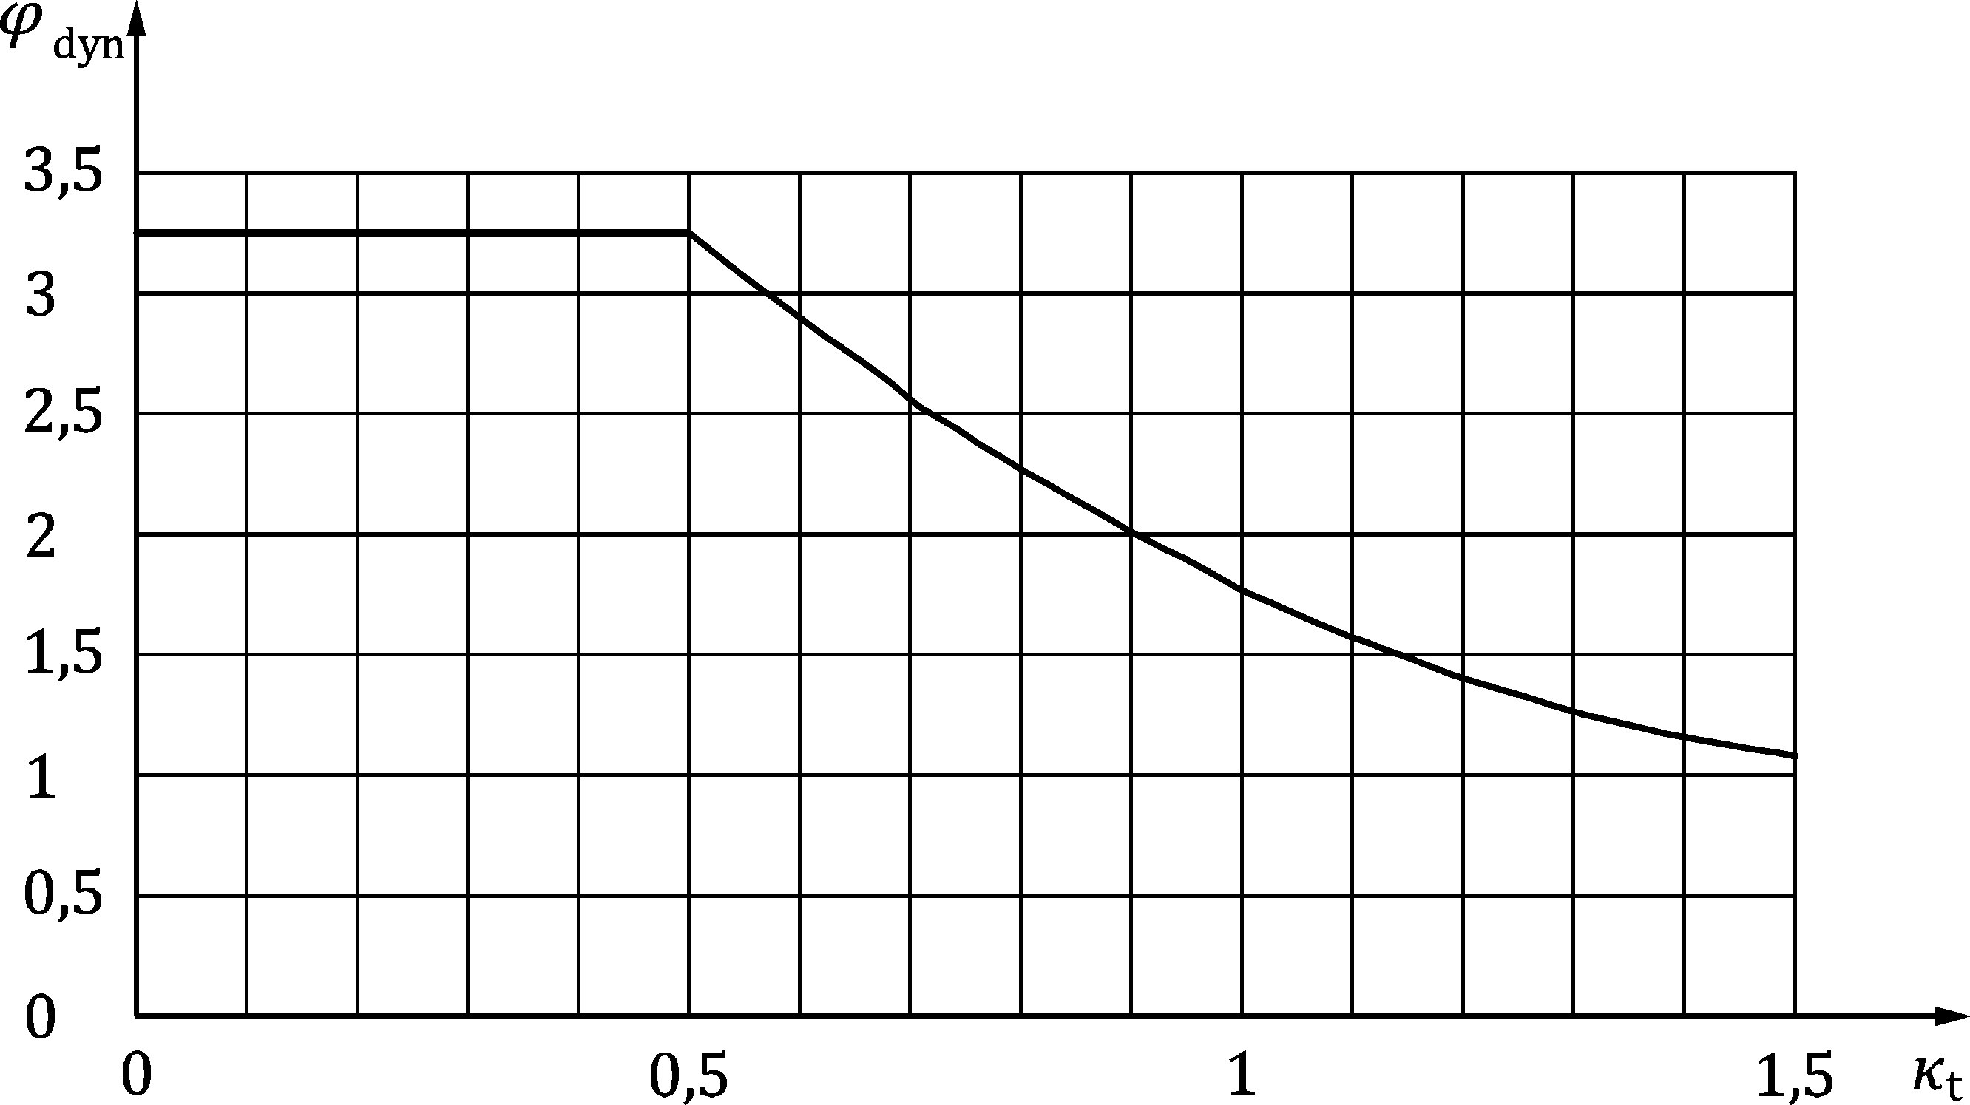

Figure 8.22 — Dynamic factor *φ*dyn

(3) The ratio *κ*t is given by Formula (8.34):

*κ*t = *s*DS × *f*/*v*DS (8.34)

where

|  |  |
| --- | --- |
| *s*DS | is the horizontal spacing between the two relevant load model positions of the air pressure wave for maximum structural reactions, in metres. It depends on the influence length as shown in Table 8.13; |

Table 8.13 — Parameter *s*DS

|  |  |  |  |  |  |  |  |
| --- | --- | --- | --- | --- | --- | --- | --- |
| ***L*i [m]** | 0,0 | 2,5 | 5,0 | 7,5 | 10,0 | 12,5 | 15,0 |
| ***s*DS [m]** | 8,3 | 8,4 | 8,8 | 9,3 | 10,0 | 10,8 | 11,8 |
| For the panels:  influence length *L*i = span length [m].  For the posts:  influence length *L*i = sum of the adjacent and track-parallel span lengths of panels [m]. | | | | | | | |

|  |  |
| --- | --- |
| *v*DS | is the train velocity [m/s] (design speed of the line); |
| *f* | is the first natural frequency of the wall system [Hz]. |

(4) The first natural frequency of the wall system shall be determined by considering all relevant parameters.

(5) The dynamic factor *φ*dyn shall be calculated for the various structural segments using the natural frequency of the wall system and the influence length *L*i of the wall segment in question.

(6) For the calculation the following shall be considered:

a) For vertical variation of the horizontal dynamic soil modulus, it shall be assumed that the modulus has a value of zero at the ground surface, increasing linearly to its maximum value at a depth of 3 m, and then remaining constant at its maximum value for depths greater than 3 m. Piled foundations used on slopes will require a specific analysis to take account of the changing direction of loading and the inclination of the ground.

b) The dynamic foundation parameters for design, as well as guidance on the possible loss of soil restraint to the upper part of the pile, and how this should be taken into account, shall be obtained from the soil report.

c) The degree of restraint to noise barriers provided by adjacent structures (e.g. noise barrier on retaining walls) shall be assessed by considering the stiffness of the combined structural system and the anchorage details.

d) Noise barriers made of concrete shall be checked to establish whether they will change from an uncracked to a cracked condition under loading. The influence of cracking on the stiffness of the structure shall be considered.

e) For the calculation of claddings attached to rigid structures the natural frequency of the single element shall be used rather than the natural frequency of the whole system.

(7) Due to of the importance of the natural frequency for calculation of the dynamic amplification of the structure, it is recommended that the dimensions of the noise barrier be established for a range of *κ*t values.

NOTE 1 Determination of the natural frequency by calculation can be avoided by using the maximum value of the dynamic factor *φ*dyn = 3,25, representing an extreme case.

NOTE 2 Useful information about the application of this chapter can be found in prEN 16727‑2‑2.

### Simple horizontal surfaces above the track (e.g. overhead protective structures)

(1) The characteristic values of the actions, ± *q*2k, may be determined from Formula (8.35), with graphical representation in Figure 8.23.

(2) The loaded width for the structural member under investigation should be taken as extending up to 10 m to either side from the centre-line of the track.

Dimensions in metres

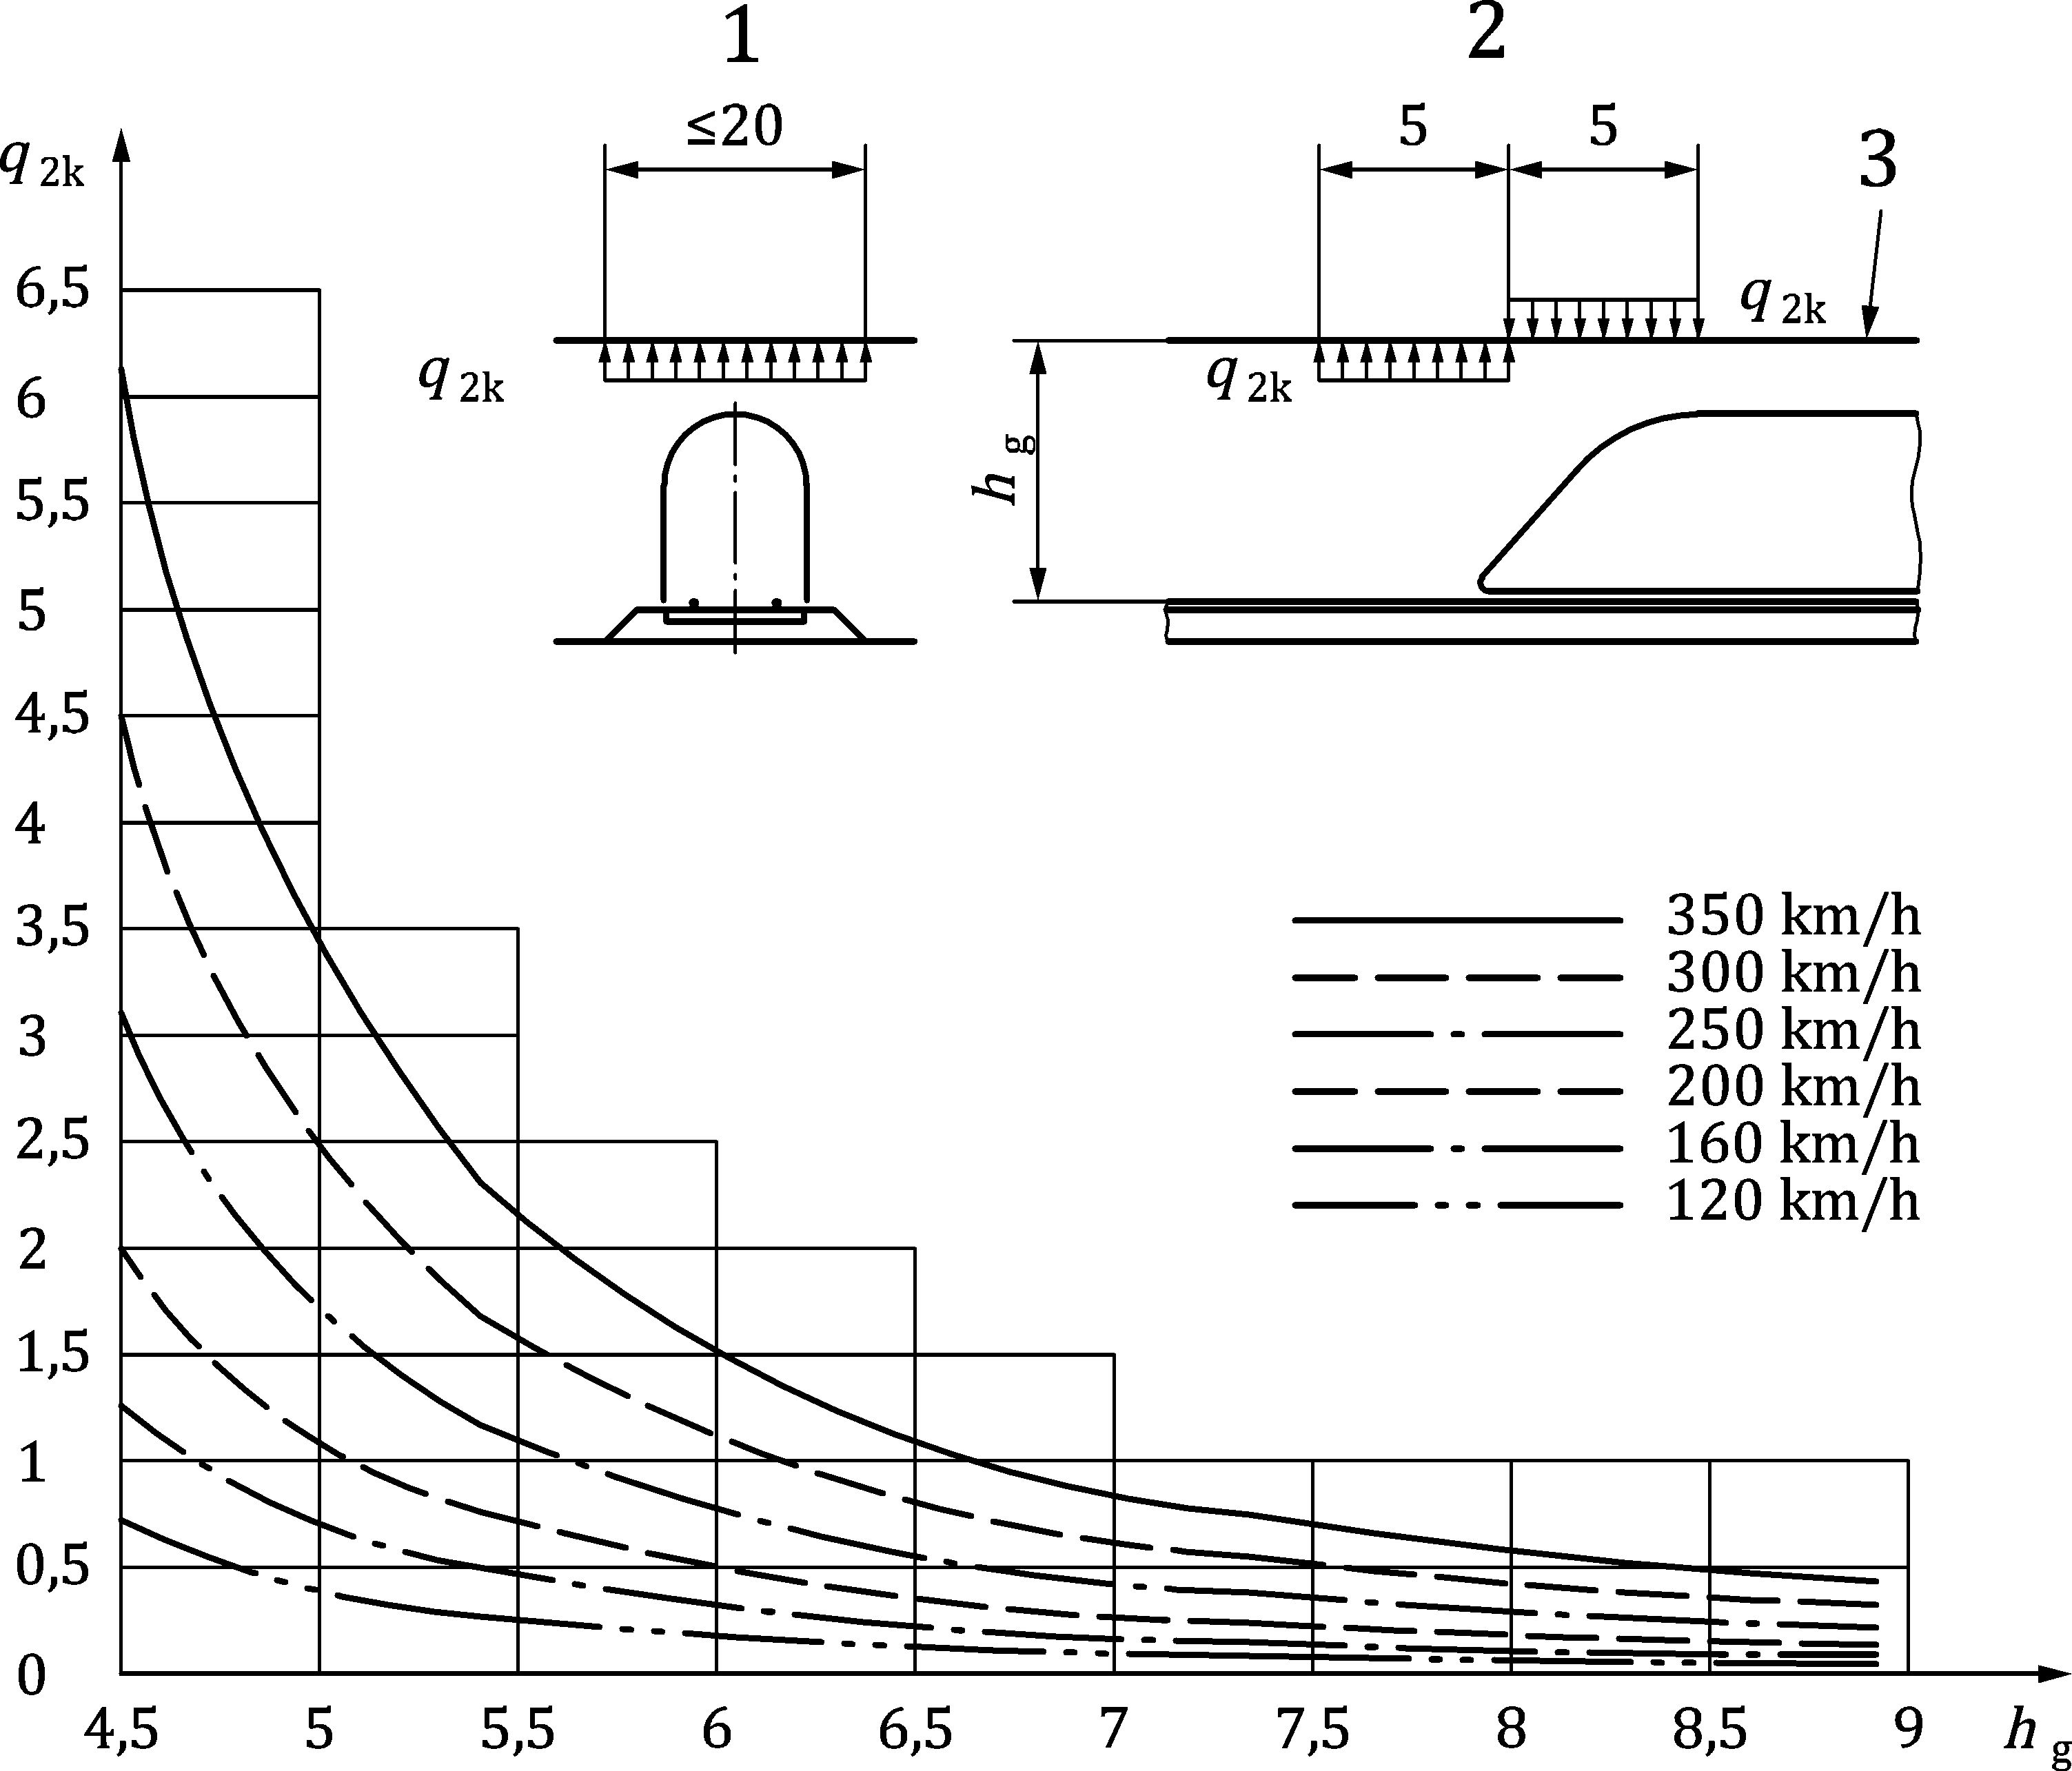

Key

|  |  |
| --- | --- |
| 1 | Section; |
| 2 | Elevation; |
| 3 | Underside of the structure. |

Figure 8.23 — Characteristic values of actions *q*2k for simple horizontal surfaces above the track

 (8.35)

where

|  |  |
| --- | --- |
| *C*p2 | is the aerodynamic coefficient, depending on the height of the surface above the top of the rail *h*, defined in Formula (8.36); |

 (8.36)

where

|  |  |
| --- | --- |
| h | is the height of the surface above the top of the rails in metres. |

*q*2k from Formula (8.35) should be multiplied by factor *k*1.

(3) For trains passing each other in opposite directions the actions should be added, for trains on up to two tracks.

(4) The actions acting on the edge strips of a wide structure which cross the track may be multiplied by a factor of 0,75 over a width up to 1,50 m.

### Simple horizontal surfaces adjacent to the track (e.g. platform canopies with no vertical wall)

(1) The characteristic values of the actions, ± *q*3k, may be determined from Formula (8.37), with graphical representation in Figure 8.24 and apply irrespective of the aerodynamic shape of the train.

 (8.37)

where

|  |  |
| --- | --- |
| *C*p3 | is given by Formula (8.38); |

 (8.38)

where

|  |  |
| --- | --- |
| *Y* | is the horizontal distance in metres between the track centreline and the surface. |

*q*3k from Formula (8.37) should be multiplied by factor k3, which is dependent upon *h*, the distance from the top of the rail to the underside of the structure, as follows:

*k*3 = 1,00       for *h* ≤ 3,8 m;

       for 3,8 < *h* < 7,5 m;

*k*3 = 0       for *h* ≥ 7,5 m

(2) For every position along the structure to be designed, *q*3k should be determined as a function of the distance *Y* from the nearest track. The actions should be added, if there are tracks on either side of the structural member under consideration.

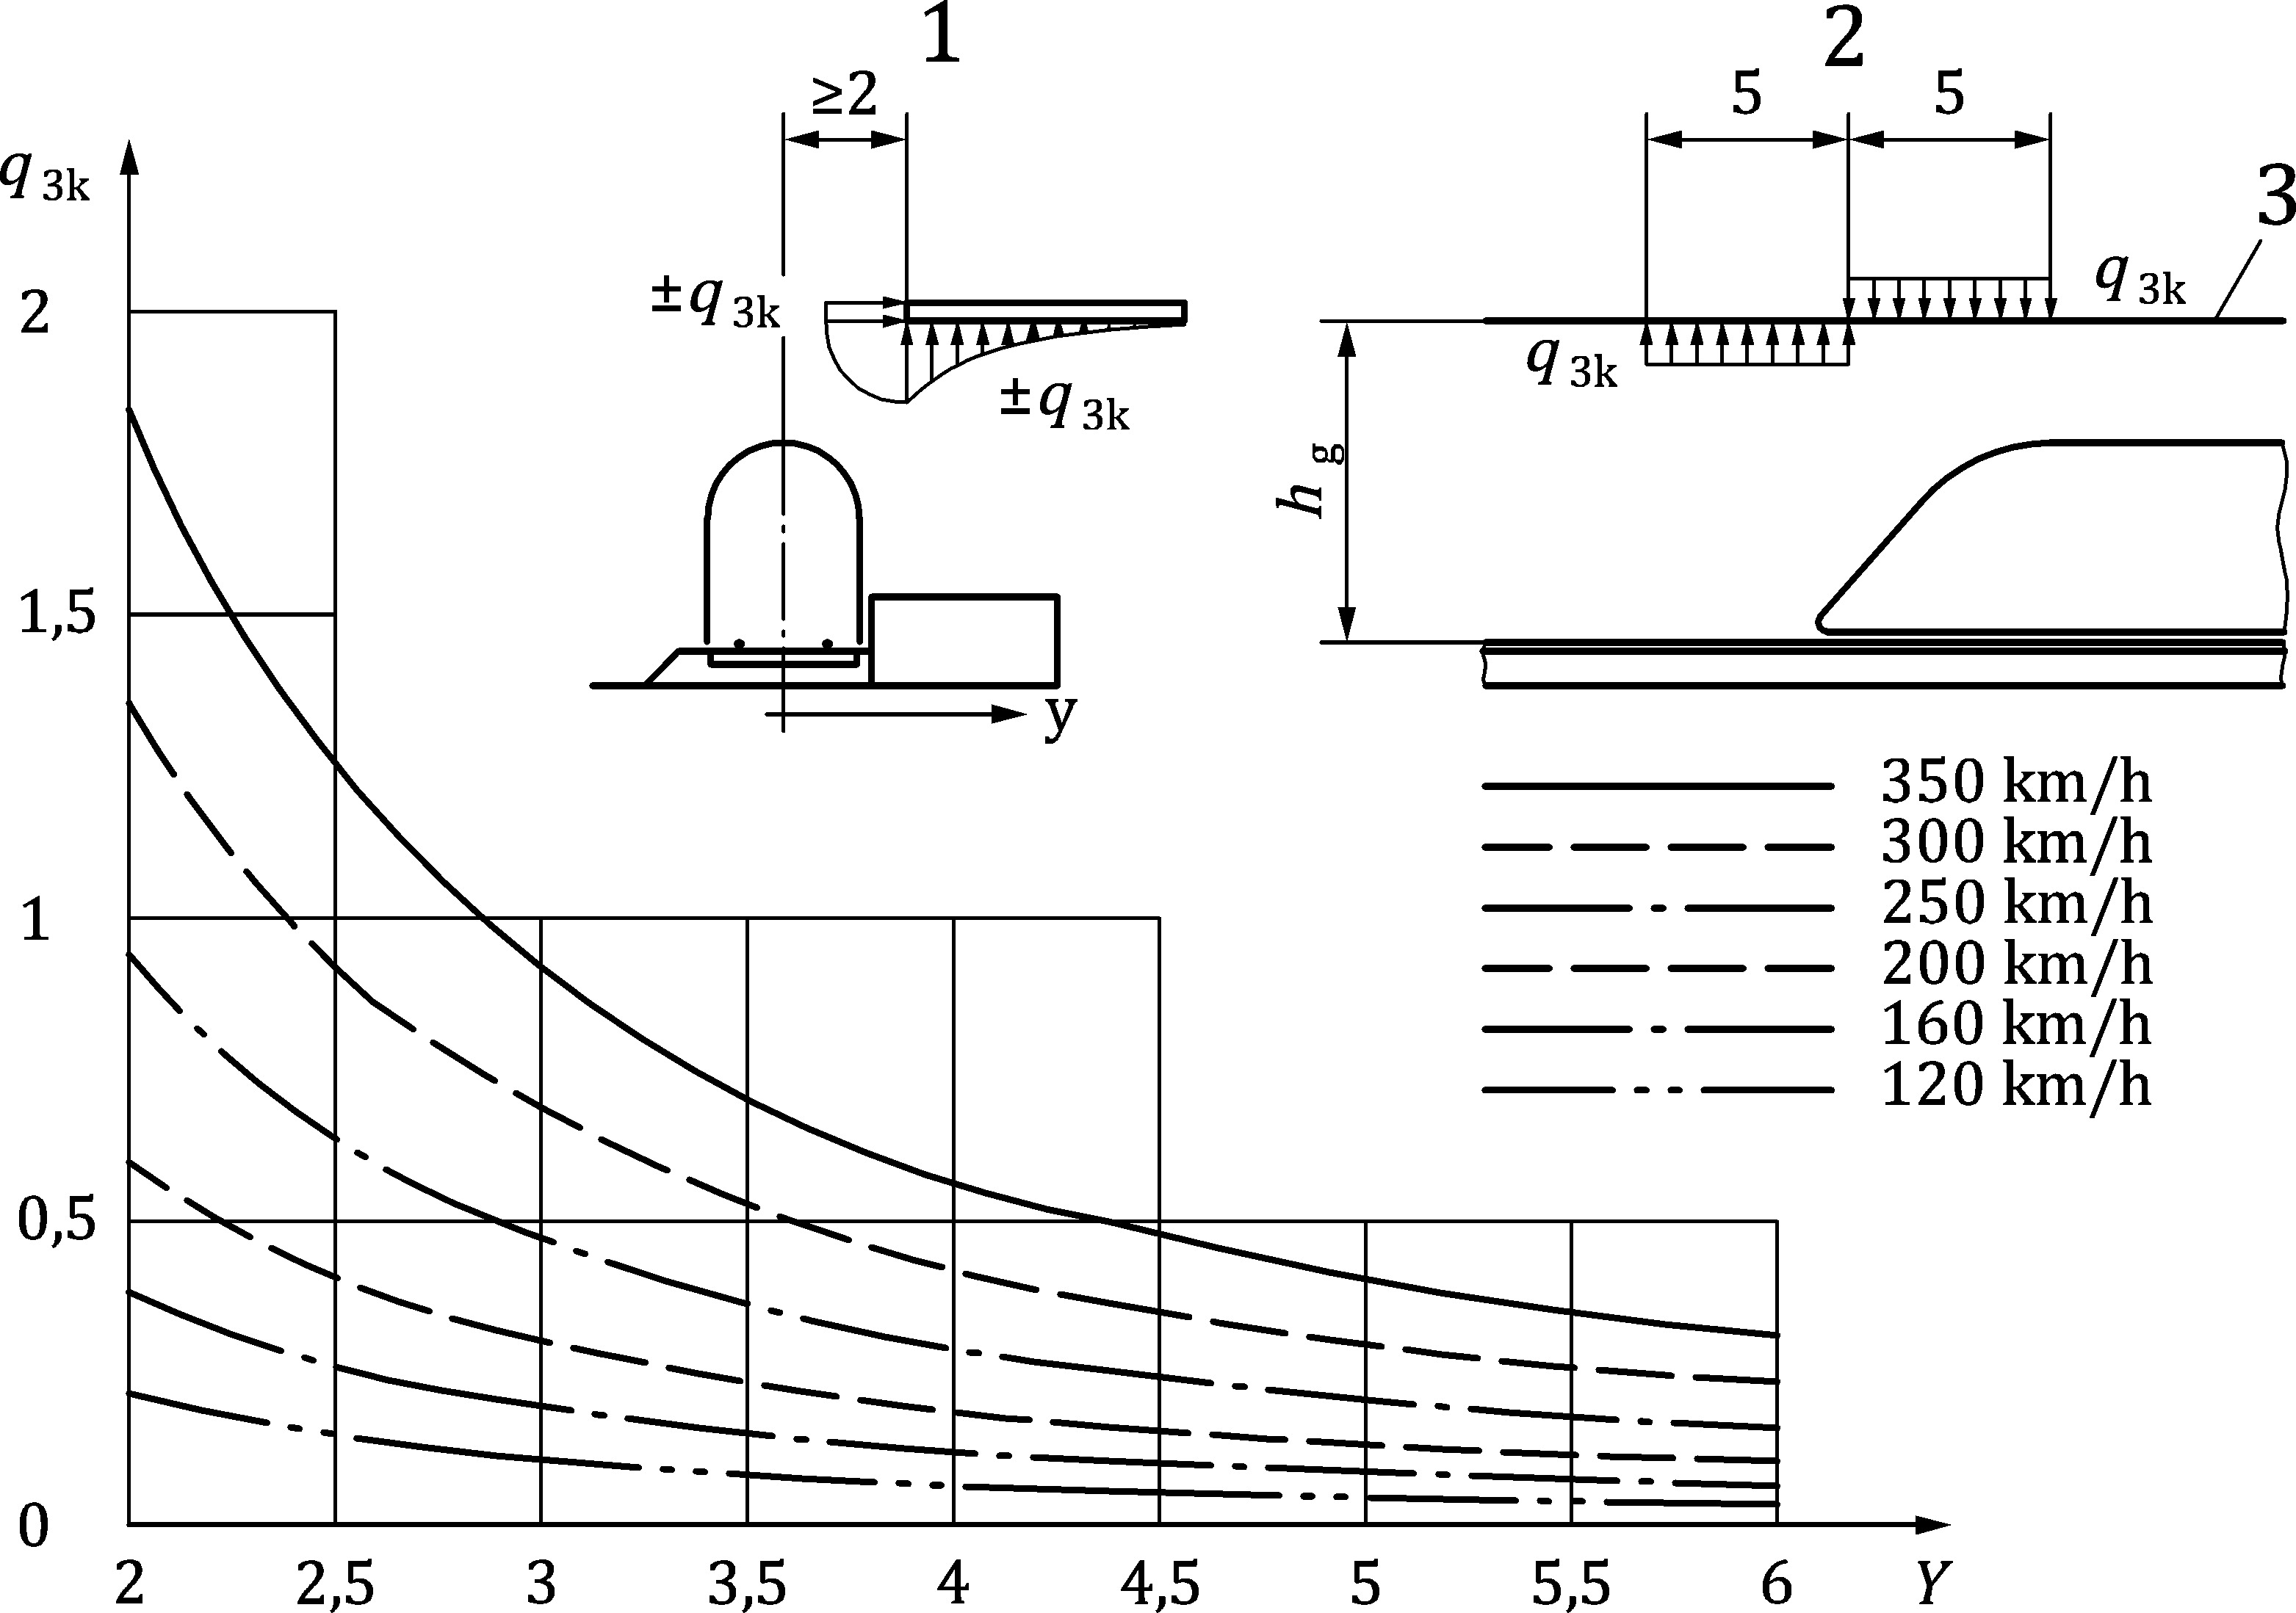

Key

|  |  |
| --- | --- |
| 1 | Section; |
| 2 | Elevation; |
| 3 | Underside of the structure. |

Figure 8.24 — Characteristic values of actions *q*3k for simple horizontal surfaces adjacent to the track

### Multiple-surface structures alongside the track with vertical and horizontal or inclined surfaces (e.g. bent noise barriers, platform canopies with vertical walls etc.)

(1) The characteristic values of the actions, ± *q*4k, as given in Figure 8.25 should be applied normal to the surfaces considered. The actions should be taken from the graphs in Figure 8.21 adopting a track distance the lesser of:

*Y* = 0,6 *Y*min + 0,4 *Y*max        or 6 m (8.39)

where distances *Y*min and *Y*max are shown in Figure 8.25.

(2) If *Y*max > 6 m the value *Y*max = 6 m should be used.

(3) The factors *k*1 and *k*2 defined in 8.6.2 should be used.

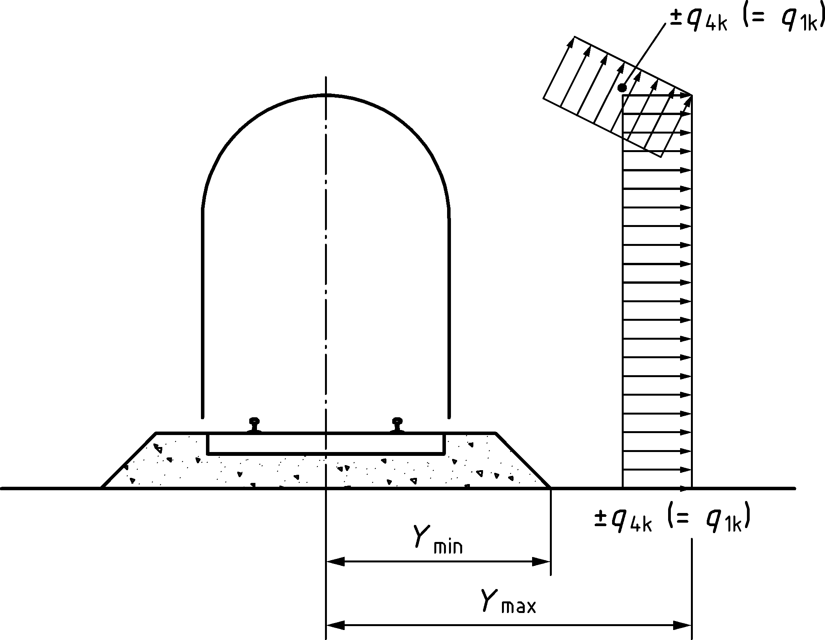

Figure 8.25 — Definition of the distances *Y*min and *Y*max from centre-line of the track

### Surfaces enclosing the structure gauge of the tracks over a limited length (up to 20 m) (horizontal surface above the tracks and at least one vertical wall, e.g. scaffolding, temporary constructions)

(1) All actions should be applied irrespective of the aerodynamic shape of the train:

— to the full height of the vertical surfaces:

±*k*4 *q*1k (8.40)

where

|  |  |
| --- | --- |
| *q*1k | is determined according to 8.6.2; |
| *k*4 | is equal to 2 |

— to the horizontal surfaces:

±*k*5 *q*2k (8.41)

where

|  |  |
| --- | --- |
| *q*2k | is determined according to 8.6.3 for only one track; |
| *k*5 | is 2,5 if one track is enclosed;  is 3,5 if two tracks are enclosed. |

## Derailment and other actions for railway bridges

### General

(1) Railway structures should be designed in such a way that, in the event of a derailment, the resulting damage to the bridge (in particular overturning or the collapse of the structure as a whole) is limited to a minimum.

### Derailment actions from rail traffic on a railway bridge

(1) Derailment of rail traffic on a railway bridge shall be considered as an Accidental Design Situation.

(2) Two design situations shall be considered, unless other design situations are specified by the relevant authority or agreed for a specific project by the relevant parties:

— Design Situation I: Derailment of railway vehicles, with the derailed vehicles remaining in the track area on the bridge deck with vehicles retained by the adjacent rail or an upstand wall.

— Design Situation II: Derailment of railway vehicles, with the derailed vehicles balanced on the edge of the bridge and loading the edge of the superstructure (excluding non-structural elements such as walkways).

NOTE Design situations for derailment can be set by the National Annex for use in a country.

(3) For Design Situation I, collapse of a major part of the structure shall be avoided. Local damage, however, may be tolerated. The parts of the structure concerned shall be designed for the following design loads in the Accidental Design Situation:

*α* × 1,4 × LM71 (both point loads and uniformly distributed loading, *Q*A1d and *q*A1d) parallel to the track in the most unfavourable position inside an area of width 1,5 times the track gauge on either side of the centre-line of the track:

No dynamic factor should be applied to the design loads in Design Situation I (see Figure 8.26).

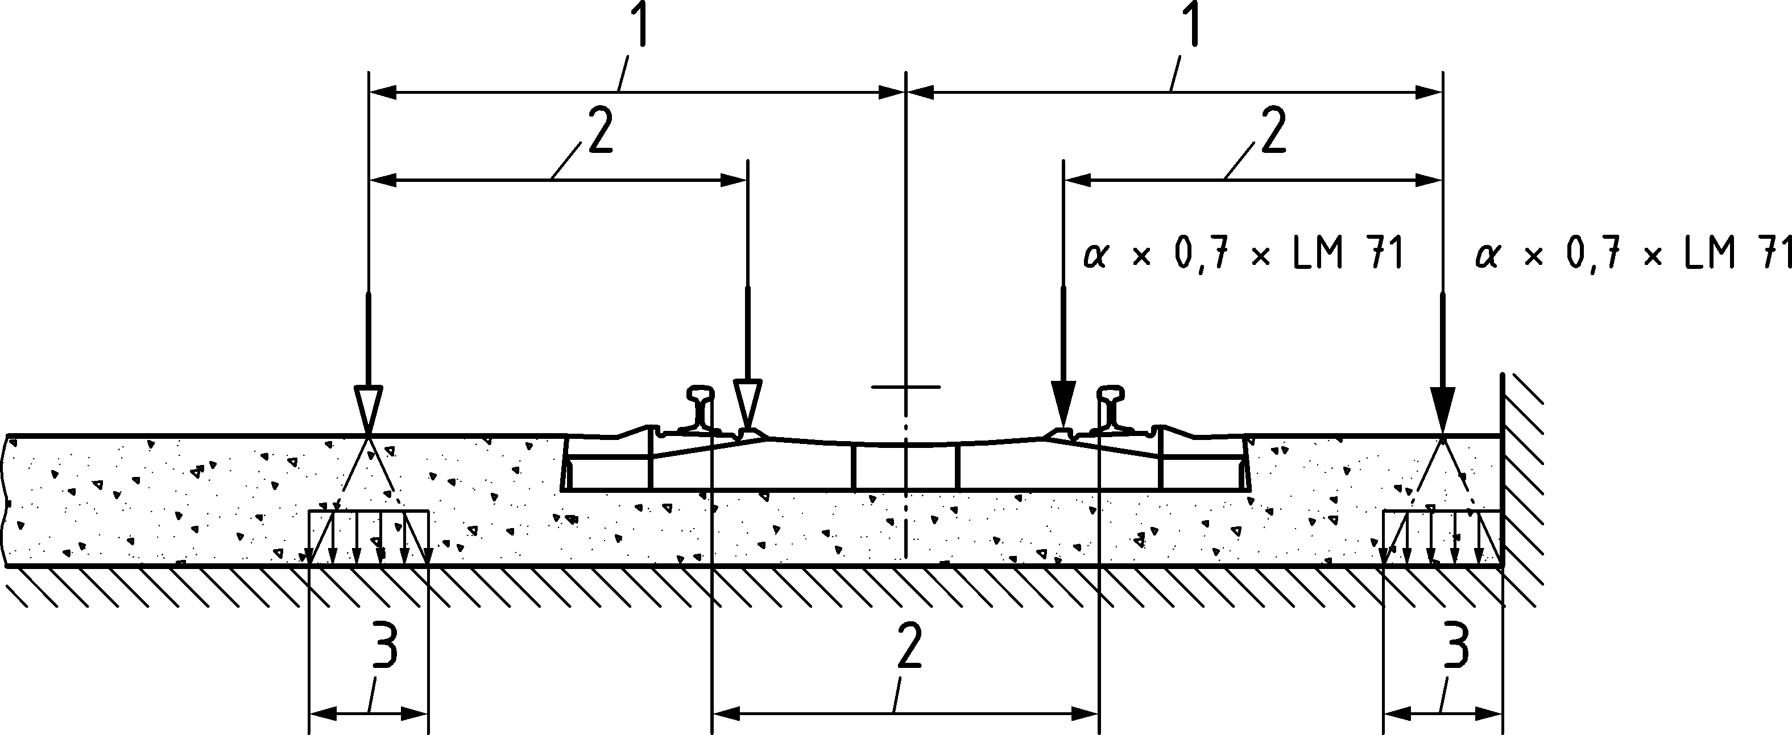

Key

|  |  |
| --- | --- |
| 1 | max. 1,5 *s* or less if against wall; |
| 2 | Track gauge *s*; |
| 3 | For ballasted decks the point forces may be assumed to be distributed on a square of side 450 mm at the top of the deck. |

Figure 8.26 — Design Situation I — equivalent load *Q*A1d and *q*A1d

(4) For Design Situation II, the bridge should not collapse or lose its static equilibrium. For the determination of overall stability a maximum total length of 20 m of *q*A2d = *α* × 1,4 × LM71 shall be taken as a uniformly distributed vertical line load acting on the edge of the structure under consideration.

No dynamic factor should be applied to the design loads in Design Situation II (see Figure 8.27).

Dimensions in metres

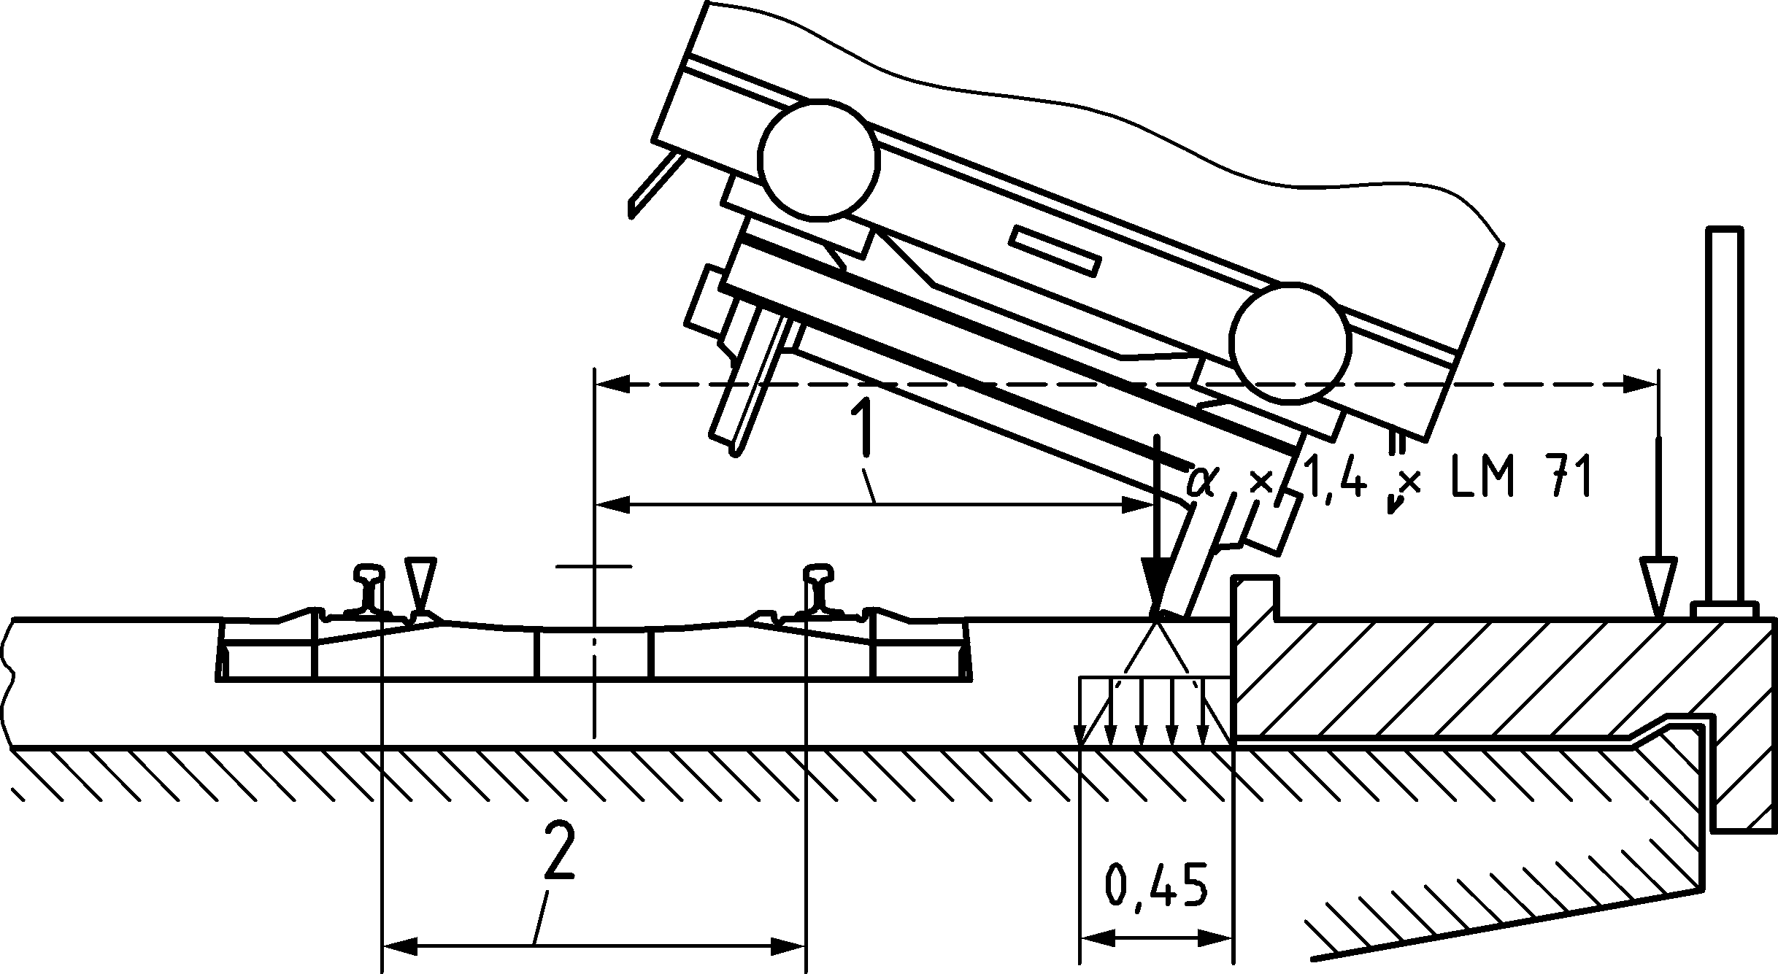

Key

|  |  |
| --- | --- |
| 1 | Load acting on edge of structure (see NOTE 1); |
| 2 | Track gauge *s*. |

Figure 8.27 — Design Situation II — equivalent load *q*A2d

NOTE 1 Where measures are not provided to prevent a derailed vehicle from loading the cantilever or footway area, the edge of the structure can be assumed to be the edge of the cantilever or footway.

NOTE 2 The above-mentioned equivalent load is only to be considered for determining the ultimate strength or the stability of the structure as a whole.

(5) Design Situations I and II shall be examined separately. A combination of these loads shall not be considered.

(6) For Design Situations I and II other rail traffic actions should be neglected for the track subjected to derailment actions.

NOTE See prEN 1990:2021, A.2.6.8(4) for the requirements for application of traffic actions to other tracks.

(7) Measures to mitigate the consequences of a derailment on structural elements which are situated above the level of the rails should be specified by the relevant authority or where not specified, agreed for a specific project by the relevant parties.

NOTE Measures to mitigate the consequences of a derailment on structural elements situated above the level of the rails can be set by the National Annex for use in a country

(8) Measures to retain a derailed train on the structure should be specified by the relevant authority or where not specified, agreed for a specific project by the relevant parties.

NOTE Requirements to retain a derailed train on the structure can be set by the National Annex for use in a country.

### Derailment under or adjacent to a structure and other actions for Accidental Design Situations

(1) Actions for Accidental Design Situations including derailment under or adjacent to a structure and other accidental actions should be taken into account.

NOTE 1 The requirements for collision loading and other design requirements are specified in EN 1991‑1‑7.

NOTE 2 When a derailment occurs, there is a risk of collision between derailed vehicles and structures over or adjacent to the track.

### Other actions

(1) The following actions shall also be taken into account in the design of the structure:

— effects due to inclined decks or inclined bearing surfaces,

— longitudinal anchorage forces from stressing or de-stressing rails in accordance with the specified requirements.

— longitudinal forces due to the accidental breakage of rails in accordance with the specified requirements.

— actions from catenaries and other overhead line equipment attached to the structure in accordance with the specified requirements.

— actions from other railway infrastructure and equipment in accordance with the specified requirements.

(2) Requirements for other actions and Accidental Design Situations may be specified by the relevant authority or agreed for a specific project by the relevant parties.

NOTE Requirements for other actions and Accidental Design Situations can be set by the National Annex for use in a country.

## Further application rules for traffic loads on railway bridges

### General

NOTE See 8.3.2 for the application of the factor *α* and 8.4.5 for the application of the dynamic factor *Φ*.

(1) The structure shall be designed for the required number and position(s) of the tracks in accordance with the track positions and tolerances, as specified by the relevant authority or agreed for a specific project by the relevant parties.

NOTE The track positions and tolerances can be set by the National Annex for use in a country.

(2) Each structure should also be designed for the greatest number of tracks geometrically and structurally possible in the least favourable position, irrespective of the position of the intended tracks taking into account the minimum spacing of tracks and structural gauge clearance requirements as specified by the relevant authority or agreed for a specific project by the relevant parties.

NOTE The minimum spacing of tracks and structural gauge clearance requirements can be set by the National Annex for use in a country.

(3) The effects of all actions shall be determined with the traffic loads and forces placed in the most unfavourable positions. Traffic actions which produce a relieving effect shall be neglected.

(4) Where a dynamic analysis is required in accordance with 8.4.4 all bridges shall also be designed for the loading from Real trains and Load Model HSLM where required by 8.4.6.1.1. The determination of the most adverse load effects from Real Trains and the application of Load Model HSLM shall be in accordance with 8.4.6.1.1(6) and 8.4.6.5(3).

(5) For the verification of deformations and vibrations the vertical loading to be applied shall be:

— Load Model 71 and where required Load Models SW/0 and SW/2,

— Load Model HSLM where required by 8.4.6.1.1,

— Real Trains when determining the dynamic behaviour in the case of resonance or excessive vibrations of the deck where required by 8.4.6.1.1.

(6) For bridge decks carrying one or more tracks the checks for the limits of deflection and vibration shall be made with the number of tracks loaded with all associated relevant traffic actions in accordance with Table 8.14 (NDP). Where required by 8.3.2(3) classified loads shall be taken into account.

(7) Requirements for the number of tracks to be considered loaded when checking drainage and structural clearance requirements may be specified by the relevant authority or agreed for a specific project by the relevant parties.

NOTE Requirements for the number of tracks to be considered loaded when checking drainage and structural clearance requirements can be set by the National Annex for use in a country.

Table 8.14 (NDP) — Number of tracks to be loaded for checking limits of deflection  
and vibration

| Limit State and associated acceptance criteria | Number of tracks on the bridge | | |
| --- | --- | --- | --- |
| 1 | 2 | ≥ 3 |
| **Traffic Safety Checks:** |  |  |  |
| Deck twist (prEN 1990:2021, A.2.8.4.2.2) | 1 | 1 or 2a | 1 or 2 or 3 or moreb |
| Vertical deformation of the deck (prEN 1990:2021, A.2.8.4.2.3) | 1 | 1 or 2a | 1 or 2 or 3 or moreb |
| Transverse deformation and vibration of the deck (prEN 1990:2021, A.2.8.4.2.4) | 1 | 1 or 2a | 1 or 2 or 3 or moreb |
| Combined response of structure and track to variable actions including limits to vertical and longitudinal displacement of the end of a deck (8.5.4) | 1 | 1 or 2a | 1 or 2a |
| Vertical acceleration of the deck (8.4.6 and prEN 1990:2021, A.2.8.4.2.1) | 1 | 1 | 1 |
| **SLS Checks:** |  |  |  |
| Passenger comfort criteria (prEN 1990:2021, A.2.8.4.3) | 1 | 1 | 1 |
| **ULS Checks:** |  |  |  |
| Uplift at bearings (prEN 1990:2021, A.2.8.4.1(2)) | 1 | 1 or 2a | 1 or 2 or 3 or moreb |
| a Whichever is critical  b The number of tracks to be loaded (including for groups of loads) should be in accordance with Table 8.15 (NDP). | | | |

### Groups of Loads — Characteristic values of the multicomponent action

(1) The simultaneity of the loading defined in 8.3 to 8.5 and 8.6 may be taken into account by considering the groups of loads defined in Table 8.15 (NDP). Each of these groups of loads, which are mutually exclusive, should be considered as defining a single variable characteristic action for combination with non-traffic loads. Each Group of Loads should be applied as a single variable action.

(2) In some cases it is necessary to consider other appropriate combinations of unfavourable individual traffic actions. See prEN 1990:2021, A.2.6.6(4).

(3) The characteristic values of the different actions considered in each Group of Loads should be multiplied by a relevant factor.

NOTE Relevant factors for actions in Groups of Loads are given in Table 8.15 (NDP) unless the National Annex gives different values for use in a country.

(4) Where groups of loads are not taken into account rail traffic actions shall be combined in accordance with prEN 1990:2021, Table A.2.9.

Table 8.15 (NDP) — Assessment of Groups of Loads for rail traffic (characteristic values of the multicomponent actions)

| number of tracks on structure | | | | Groups of loads | | | Vertical forces | | | Horizontal forces | | | Comment |
| --- | --- | --- | --- | --- | --- | --- | --- | --- | --- | --- | --- | --- | --- |
| Reference prEN 1991‑2 | | | 8.3.2/8.3.3 | 8.3.3 | 8.3.4 | 8.5.3 | 8.5.1 | 8.5.2 |
| 1 | | 2 | ≥ 3 | number of tracks loaded | Load Grouph | Loaded track | LM71a  SW/0a,b  HSLMf,g | SW/2a,c | Unloaded train | Traction, Brakinga | Centrifugal forcea | Nosing forcea |
|  | |  |  | 1 | gr11 | T1 | 1 |  |  | 1e | 0,5e | 0,5e | Max. vertical 1 with max. longitudinal |
|  | |  |  | 1 | gr 12 | T1 | 1 |  |  | 0,5e | 1e | 1e | Max. vertical 2 with max. transverse |
|  | |  |  | 1 | gr 13 | T1 | 1d |  |  | 1 | 0,5e | 0,5e | Max. longitudinal |
|  | |  |  | 1 | gr 14 | T1 | 1d |  |  | 0,5e | 1 | 1 | Max. transverse |
|  | |  |  | 1 | gr 15 | T1 |  |  | 1 |  | 1e | 0,5e | Lateral stability with “unloaded train” |
|  | |  |  | 1 | gr 16 | T1 |  | 1 |  | 1e | 0,5e | 0,5e | SW/2 with max. longitudinal |
|  | |  |  | 1 | gr 17 | T1 |  | 1 |  | 0,5e | 1e | 1e | SW/2 with max. transverse |
|  | |  |  | 2 | gr 21 | T1 | 1 |  |  | 1e | 0,5e | 0,5e | Max. vertical 1 with max longitudinal |
| T2 | 1 | 1e | 0,5e | 0,5e |
|  | |  |  | 2 | gr 22 | T1 | 1 |  |  | 0,5e | 1e | 1e | Max. vertical 2 with max. transverse |
| T2 | 1 | 0,5e | 1e | 1e |
|  | |  |  | 2 | gr 23 | T1 | 1d |  |  | 1 | 0,5e | 0,5e | Max. longitudinal |
| T2 | 1d | 1 | 0,5e | 0,5e |
|  | |  |  | 2 | gr 24 | T1 | 1d |  |  | 0,5e | 1 | 1 | Max. transverse |
| T2 | 1d | 0,5e | 1 | 1 |
|  | |  |  | 2 | gr 26 | T1 |  | 1 |  | 1e | 0,5e | 0,5e | SW/2 with max. longitudinal |
| T2 | 1 |  | 1e | 0,5e | 0,5e |
|  | |  |  | 2 | gr 27 | T1 |  | 1 |  | 0,5e | 1e | 1e | SW/2 with max. transverse |
| T2 | 1 |  | 0,5e | 1e | 1e |
|  | |  |  | ≥ 3 | gr 31 | Ti | 0,75 |  |  | 0,75e | 0,75e | 0,75e | Additional load case |
| 0,75 |
|  | Dominant component action as appropriate | | | | | | | | | | | | |
|  | to be considered in designing a structure supporting one track (Load Groups 11–17) | | | | | | | | | | | | |
|  | to be considered in designing a structure supporting two tracks (Load Groups 11–27 except 15). Each of the two tracks shall be considered as either T1 (Track one) or T2 (Track 2) | | | | | | | | | | | | |
|  | to be considered in designing a structure supporting three or more tracks; (Load Groups 11 to 31 except 15. Any one track shall be taken as T1, any other track as T2 with all other tracks unloaded. In addition the Load Group 31 has to be considered as an additional load case where all unfavourable lengths of track *T*i are loaded. | | | | | | | | | | | | |
| a All relevant factors (*α*, *Φ*, *f*, ...) are to be taken into account.  b SW/0 is only taken into account for continuous beam structures.  c SW/2 is only taken into account if it is stipulated for the line.  d Factor may be reduced to 0,5 if favourable effect, it cannot be zero.  e In favourable cases these non-dominant values are taken equal to zero.  f HSLM and Real Trains where required in accordance with 8.4.4 and 8.4.6.1.1.  g If a dynamic analysis is required in accordance with 8.4.4 see also 8.4.6.5(3) and 8.4.6.1.2.  h See also prEN 1990:2021, Table A.2.9 | | | | | | | | | | | | | |

### Groups of Loads — Other representative values of the multicomponent actions

#### Frequent values of the multicomponent actions

(1) Where Groups of Loads are taken into account the same rule as in 8.8.2(1) above is applicable by applying the factors for each Group of Loads to the frequent values of the relevant actions considered in each Group of Loads.

NOTE The factors applied to frequent values of the multicomponent actions are given in Table 8.15 (NDP) unless the National Annex gives different values for use in a country.

(2) Where Groups of Loads are not used rail traffic actions shall be combined in accordance with prEN 1990:2021, Table A.2.9.

#### Quasi-permanent values of the multicomponent actions

(1) Quasi-permanent traffic actions for Groups of Loads should be based on the quasi-permanent values of the relevant actions considered in each Group of Loads.

NOTE The quasi-permanent values of the multicomponent actions is 0,0 unless the National Annex gives different values for use in a country.

### Traffic loads in Transient Design Situations

(1) Traffic loads for Transient Design Situations should be specified by the relevant authority or where not specified, agreed for a specific project by the relevant parties.

NOTE 1 The traffic loads for Transient Design Situations can be set by the National Annex for use in a country.

NOTE 2 Annex F (informative) provides guidance.

## Traffic loads for fatigue

(1) A fatigue damage assessment shall be carried out for all structural elements, which are subjected to fluctuations of stress.

NOTE Additional requirements for the fatigue assessment of bridges where a dynamic analysis is required in accordance with 8.4.4 when dynamic effects are likely to be excessive are given in 8.4.6.6.

(2) For normal traffic based on characteristic values of Load Model 71, including the dynamic factor *Φ*, the fatigue assessment should be carried out on the basis of the rail traffic mixes which are specified by the relevant authority or agreed for a specific project by the relevant parties, as follows:

— Details of the service trains and rail traffic mixes considered and the dynamic enhancement to be applied are given in Annex D.

— The rail traffic mixes are “standard traffic mix”, “heavy traffic mix” or “light traffic mix” depending on whether the structure carries mixed traffic, predominantly heavy freight traffic or lightweight passenger traffic.

NOTE 1 The rail traffic mix can be set by the National Annex for use in a country.

NOTE 2 Each of the mixes is based on an annual traffic tonnage of 25 × 106 tonnes passing over the bridge on each track.

NOTE 3 The “heavy traffic mix” is based on a maximum of 250 kN axle loads.

(3) Alternatively, the fatigue assessment may be carried out on the basis of a special rail traffic mix as specified by the relevant authority or agreed for a specific project by the relevant parties.

NOTE A special rail traffic mix can be set by the National Annex for use in a country.

(4) Where the rail traffic mix does not represent the real traffic an alternative rail traffic mix should be specified by the relevant authority or agreed for a specific project by the relevant parties, including in the following situation:

— for traffic requiring a value of *α* greater than unity in accordance with 8.3.2(3) in special situations where a limited number of vehicle type(s) dominate the fatigue loading.

NOTE The alternative rail traffic mix can be set by the National Annex for use in a country

(5) For structures carrying multiple tracks, the fatigue loading shall be applied to a maximum of two tracks in the most unfavourable positions.

(6) The fatigue damage should be assessed over the design service life of the structure.

NOTE See prEN 1990:2021, A.2.4 for the design service life.

(7) Vertical rail traffic actions including dynamic effects and centrifugal forces should be taken into account in the fatigue assessment.

(8) Nosing and longitudinal traffic actions may be neglected in the fatigue assessment, other than in special situations.

(9) In some special situations, for example bridges supporting tracks at terminal stations, the effect of longitudinal actions should be taken into account in the fatigue assessment.

## Static load models for geotechnical structures — characteristic values

(1) For geotechnical structures, the load arrangement and characteristic values of vertical loads for Load Model 71 applied at a level 0,70 m below the running surface of the track may be taken as the more onerous arrangement (a) or (b) as shown in Figure 8.28.

NOTE 1 The more onerous load arrangement depends on the applicable ground conditions. Further guidance is provided in the EN 1997 series.

NOTE 2 The width *b* in Figure 8.28 is 3 m unless the National Annex gives a different value for use in a country.

NOTE 3 Unless the National Annex gives a different value and application rules, the characteristic value of the concentrated load *Q*ek is 1000 kN spread over rectangular surface area of 6,4 m × *b*.

NOTE 4 Unless the National Annex gives a different value and application rules for use in a country, the characteristic value of uniformly distributed load *q*ek is 80 kN/m spread over a width of *b* applied on the remaining area of the carriageway.

(2) For geotechnical structures, the load arrangement and characteristic values of vertical loads for Load Model SW/2 applied at a level 0,70 m below the running surface of the track may be taken as shown in Figure 8.28 for the uniformly distributed loads set out in Figure 8.2. This load is distributed over a width *b*, as defined in NOTE 2 of (1).

Dimensions in metres

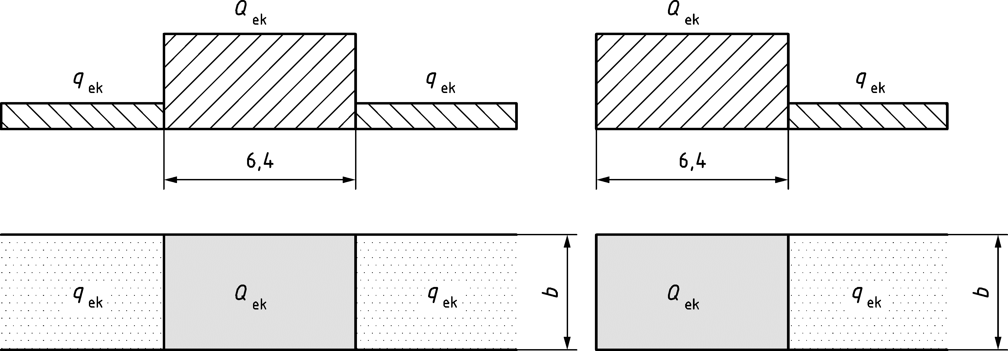

Figure 8.28 — Equivalent load arrangement for Load Model 71 for geotechnical structures (a, left) Single concentrated patch load and uniformly distributed load on both sides (b, right) Single concentrated patch load and uniformly distributed load on one side only

(3) The concentrated patch loads should be placed so that they give the most unfavourable effect on the structure.

(4) The characteristic values of loads given in Figure 8.28 shall be multiplied by the factor *α* specified in 8.3.2 to obtain the “classified vertical loads”.

(5) No dynamic factor or enhancement should be applied to the above uniformly distributed load.

(6) For the design of local elements close to a track (e.g. ballast retention walls), a special calculation should be carried out taking into account the maximum local vertical, longitudinal and transverse loading on the element due to rail traffic actions.

(7) Where multiple tracks are loaded simultaneously, the load shall be applied in accordance with 8.3.2(10) or 8.3.3(8).

(8) Traction and braking force effects on buried structures, retaining walls, and other geotechnical structures may be designed by analysing their effects on the structure.

NOTE Unless the National Annex gives a different value and application rules for use in a country, the traction and braking forces can be used as in 8.5.3.

1. (informative)  
     
   Models of special vehicles for road bridges
   1. Use of this informative Annex

(1) This Informative Annex provides complementary/additional guidance to that given in 6.3.4 for standardized models of special vehicles.

NOTE The way in which this informative Annex can be used in a Country is given in the National Annex. If the National Annex is silent on the use of this informative Annex, it can be used.

* 1. Scope and field of application

(1) This Informative Annex defines standardized models of special vehicles that may be used for the design of road bridges.

(2) The special vehicles defined in this informative Annex are intended to produce global as well as local effects such as are caused by vehicles which do not comply with the national regulations concerning limits of weights and, possibly, dimensions of normal vehicles.

NOTE The consideration of special vehicles for bridge design is intended to be limited to particular cases.

(3) This Informative Annex also provides guidance in case of simultaneous application on a bridge carriageway of special vehicles and normal road traffic represented by Load Model 1 defined in 6.3.2.

* 1. Basic models of special vehicles

(1) Basic models of special vehicles are conventionally defined in Tables A.1 and A.2, and in Figure A.1.

NOTE 1 The basic models of special vehicles correspond to various levels of abnormal loads that can be authorized to travel on particular routes of the European highway network.

NOTE 2 Vehicle widths of 3,00 m for the 150 kN and 200 kN axle-lines, and of 4,50 m for the 240 kN axle-lines are assumed.

Table A.1 — Classes of special vehicles

| **Total weight** | **Composition** | **Notation** |
| --- | --- | --- |
| 600 kN | 4 axle-lines of 150 kN | 600/150 |
| 900 kN | 6 axle-lines of 150 kN | 900/150 |
| 1 200 kN | 8 axle-lines of 150 kN | 1 200/150 |
|  | or 6 axle-lines of 200 kN | 1 200/200 |
| 1 500 kN | 10 axle-lines of 150 kN | 1 500/150 |
|  | or 7 axle-lines of 200 kN + 1 axle line of 100 kN | 1 500/200 |
| 1 800 kN | 12 axle-lines of 150 kN | 1 800/150 |
|  | or 9 axle-lines of 200 kN | 1 800/200 |
| 2 400 kN | 12 axle-lines of 200 kN | 2 400/200 |
|  | or 10 axle-lines of 240 kN | 2 400/240 |
|  | or 6 axle-lines of 200 kN (spacing 12 m)  + 6 axle-lines of 200 kN | 2 400/200/200 |
| 3 000 kN | 15 axle-lines of 200 kN | 3 000/200 |
|  | or 12 axle-lines of 240 kN + 1 axle-line of 120 kN | 3 000/240 |
|  | or 8 axle-lines of 200 kN (spacing 12 m)  + 7 axle-lines of 200 kN | 3 000/200/200 |
| 3 600 kN | 18 axle-lines of 200 kN | 3 600/200 |
|  | or 15 axle-lines of 240 kN | 3 600/240 |
|  | or 9 axle-lines of 200 kN (spacing 12 m)  + 9 axle-lines of 200 kN | 3 600/200/200 |
|  | or 8 axle-lines of 240 kN (spacing 12 m)  + 7 axle-lines of 240 kN | 3 600/240/240 |

Table A.2 — Description of special vehicles

|  | **Axle-lines of 150 kN** | **Axle-lines of 200 kN** | **Axle-lines of 240 kN** |
| --- | --- | --- | --- |
| 600 kN | *n* = 4 × 150  *e* = 1,50 m |  |  |
| 900 kN | *n* = 6 × 150  *e* = 1,50 m |  |  |
| 1 200 kN | *n* = 8 × 150  *e* = 1,50 m | *n* = 6 × 200  *e* = 1,50 m |  |
| 1 500 kN | *n* = 10 × 150  *e* = 1,50 m | *n* = 1 × 100 + 7 × 200  *e* = 1,50 m |  |
| 1 800 kN | *n* = 12 × 150  *e* = 1,50 m | *n* = 9 × 200  *e* = 1,50 m |  |
| 2 400 kN |  | *n* = 12 × 200  *e* = 1,50 m | *n* = 10 × 240  *e* = 1,50 m |
|  |  | *n* = 6 × 200 + 6 × 200  *e* = 5 × 1,5 + 12 + 5 × 1,5 |  |
| 3 000 kN |  | *n* = 15 × 200  *e* = 1,50 m | *n* = 1 × 120 + 12 × 240  *e* = 1,50 m |
|  |  | *n* = 8 × 200 + 7 × 200  *e* = 7 × 1,5 + 12 + 6 × 1,5 |  |
| 3 600 kN |  | *n* = 18 × 200  *e* = 1,50 m | *n* = 15 × 240  *e* = 1,50 m |
|  |  | *n* = 9 × 200 + 9 × 200  *e* = 8 × 1,5 + 12 + 8 × 1,5 | *n* = 8 × 240 + 7 × 240  *e* = 7 × 1,5 + 12 + 6 × 1,5 |
| NOTE  *n* number of axles multiplied by the weight [kN] of each axle in each group  *e* axle spacing [m] within and between each group. | | | |

Dimensions in metres

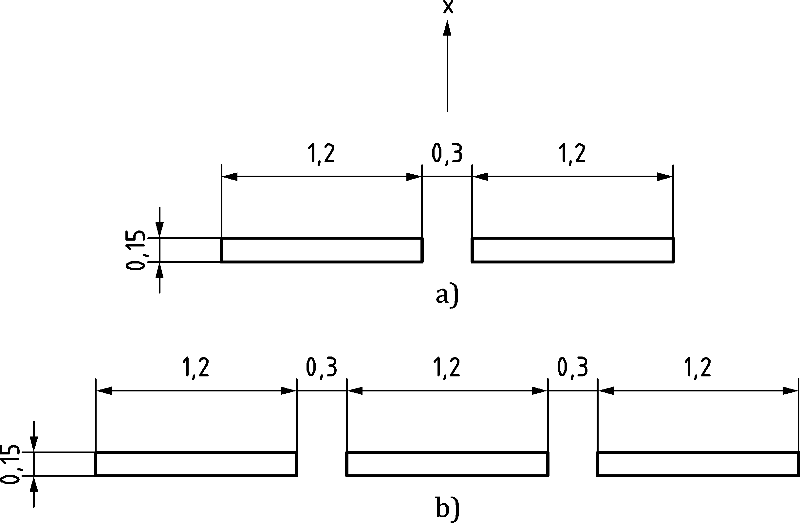

Key

|  |  |
| --- | --- |
| x | Bridge axis direction |
| a) | 100 kN to 200 kN axle-lines |
| b) | 240 axle-lines |

Figure A.1 — Arrangement of axle-lines and definition of wheel contact areas

(2) One or more of the models of special vehicles may have to be taken into account.

NOTE The effects of the 600/150 standardized model are covered by the effects of Load Model 1 where applied with *α*Qi and *α*qi factors all equal to 1.

(3) The models and the load values and dimensions should be specified by the relevant authority or where not specified, agreed for a specific project by the relevant parties.

(4) Particular models, especially to cover the effects of exceptional loads with a gross weight exceeding 3600 kN, should be specified by the relevant authority or where not specified, agreed for a specific project by the relevant parties.

(5) The characteristic loads associated with the special vehicles should be taken as nominal values and should be considered as associated solely with transient design situations.

* 1. Application of special vehicle load models on the carriageway

(1) Each standardized model should be applied:

— on one notional traffic lane as defined in 3.1.2 and 6.2.3 (considered as Lane Number 1) for the models composed of 150 kN or 200 kN axle-lines, or

— on two adjacent notional lanes (considered as Lanes Number 1 and 2 — see Figure A.2) for models composed of 240 kN axle-lines.

(2) The notional lanes should be located as unfavourably as possible in the carriageway. For this case, the carriageway width may be defined as excluding hard shoulders, hard strips and marker strips.

Dimensions in metres

|  |  |
| --- | --- |
|  |  |
| Axle-lines of 150 or 200 kN (*b* = 2,70 m) | Axle-lines of 240 kN (*b* = 4,20 m) |

Key

|  |  |
| --- | --- |
| X | Bridge axis direction; |
| 1 | Lane 1; |
| 2 | Lane 2. |

Figure A.2 — Application of the special vehicles on notional lanes

(3) Depending on the models under consideration, these models may be assumed to move at low speed (not more than 5 km/h) or at normal speed (70 km/h).

(4) Where the models are assumed to move at low speed, only vertical loads without dynamic amplification should be taken into account.

(5) Where the models are assumed to move at normal speed, a dynamic amplification should be taken into account. The following formula may be used:



where

|  |  |
| --- | --- |
| *L*i [m] | is the influence length. |

(6) Where the models are assumed to move at low speed, each notional lane and the remaining area of the bridge deck should be loaded by Load Model 1 with its frequent values defined in 6.3.2 and in prEN 1990:2021, A.2. On the lane(s) occupied by the standardized vehicle, this system should not be applied at less than 25 m from the outer axles of the vehicle under consideration (see Figure A.3).

Dimensions in metres

|  |  |
| --- | --- |
|  |  |
| Axle-lines of 150 kN or 200 kN | Axle-lines of 240 kN |

Key

|  |  |
| --- | --- |
| x | Bridge axis direction; |
| 1 | Lane 1; |
| 2 | Lane 2. |
|  | Standardized vehicle |
|  | Area loaded with the frequent model of LM1 |

A more favourable transverse position for some special vehicles and a restriction of simultaneous presence of general traffic should be specified by the relevant authority or where not specified, agreed for a specific project by the relevant parties.

Figure A.3 — Simultaneity of Load Model 1 and special vehicles

(7) Where special vehicles are assumed to move at normal speed, a pair of special vehicles should be used in the lane(s) occupied by these vehicles. On the other lanes and the remaining area the bridge deck should be loaded by Load Model 1 with its frequent values defined in 6.5 and in prEN 1990:2021, A.2.

1. (informative)  
     
   Fatigue life assessment for road bridges Assessment method based on recorded traffic
   1. Use of this informative Annex

(1) This informative Annex provides additional guidance to that given in 6.6 for fatigue life assessment of road bridges.

NOTE The way in which this informative Annex can be used in a Country is given in the National Annex. If the National Annex is silent on the use of this informative Annex, it can be used.

* 1. Scope and field of application

(1) This Informative Annex covers fatigue life assessment for road bridges assessment method based on recorded traffic (Fatigue load model 5) and the dynamic amplification factor.

* 1. Fatigue life assessment for road bridges

(1) A stress history should be obtained by analysis using recorded representative real traffic data, multiplied by a dynamic amplification factor *φ*fat.

(2) This dynamic amplification factor should take into account the dynamic behaviour of the bridge and depends on the expected roughness of the road surface and on any dynamic amplification already included in the records.

NOTE In accordance with ISO 8608, the road surface can be classified in terms of the power spectral density (PSD) of the vertical road profile displacement *G*d, *i.e.* of the roughness. *G*d is a function of the spatial frequency *n*, *G*d(*n*), or of the angular spatial frequency of the path *Ω*, *G*d*(Ω)*, with *Ω* = 2π*n*. The actual power spectral density of the road profile are expected to be smoothed and then fitted, in the bi-logarithmic presentation plot, by a straight line in an appropriate spatial frequency range. The fitted PSD can be expressed in a general form as

 or 

where

|  |  |
| --- | --- |
| *n*0 | is the reference spatial frequency [0,1 cycle/m]; |
| *Ω*0 | is the reference angular spatial frequency [1 rd/m]; |
| *w* | is the exponent of the fitted PSD. |

Often, instead of displacement PSD, *G*d, it is convenient to consider velocity PSD, *G*v, in terms of change of the vertical ordinate of the road surface per unit distance travelled. Since the relationships between *G*v and *G*d are:

 and 

When *w* = 2 the two expressions of velocity PSD are constant.

Considering constant velocity PSD, 8 different classes of roads (A, B, …, H) with increasing roughness are considered in ISO 8608. The class limits are graphed versus the displacement PSD in Figure B.1. For road bridge pavement classification only the first 5 classes (A, B, …, E) are relevant.

Quality surface can be assumed very good for road surfaces in class A, good for surfaces in class B, medium for surfaces in class C, poor for surfaces in class D and very poor for surfaces in class E.

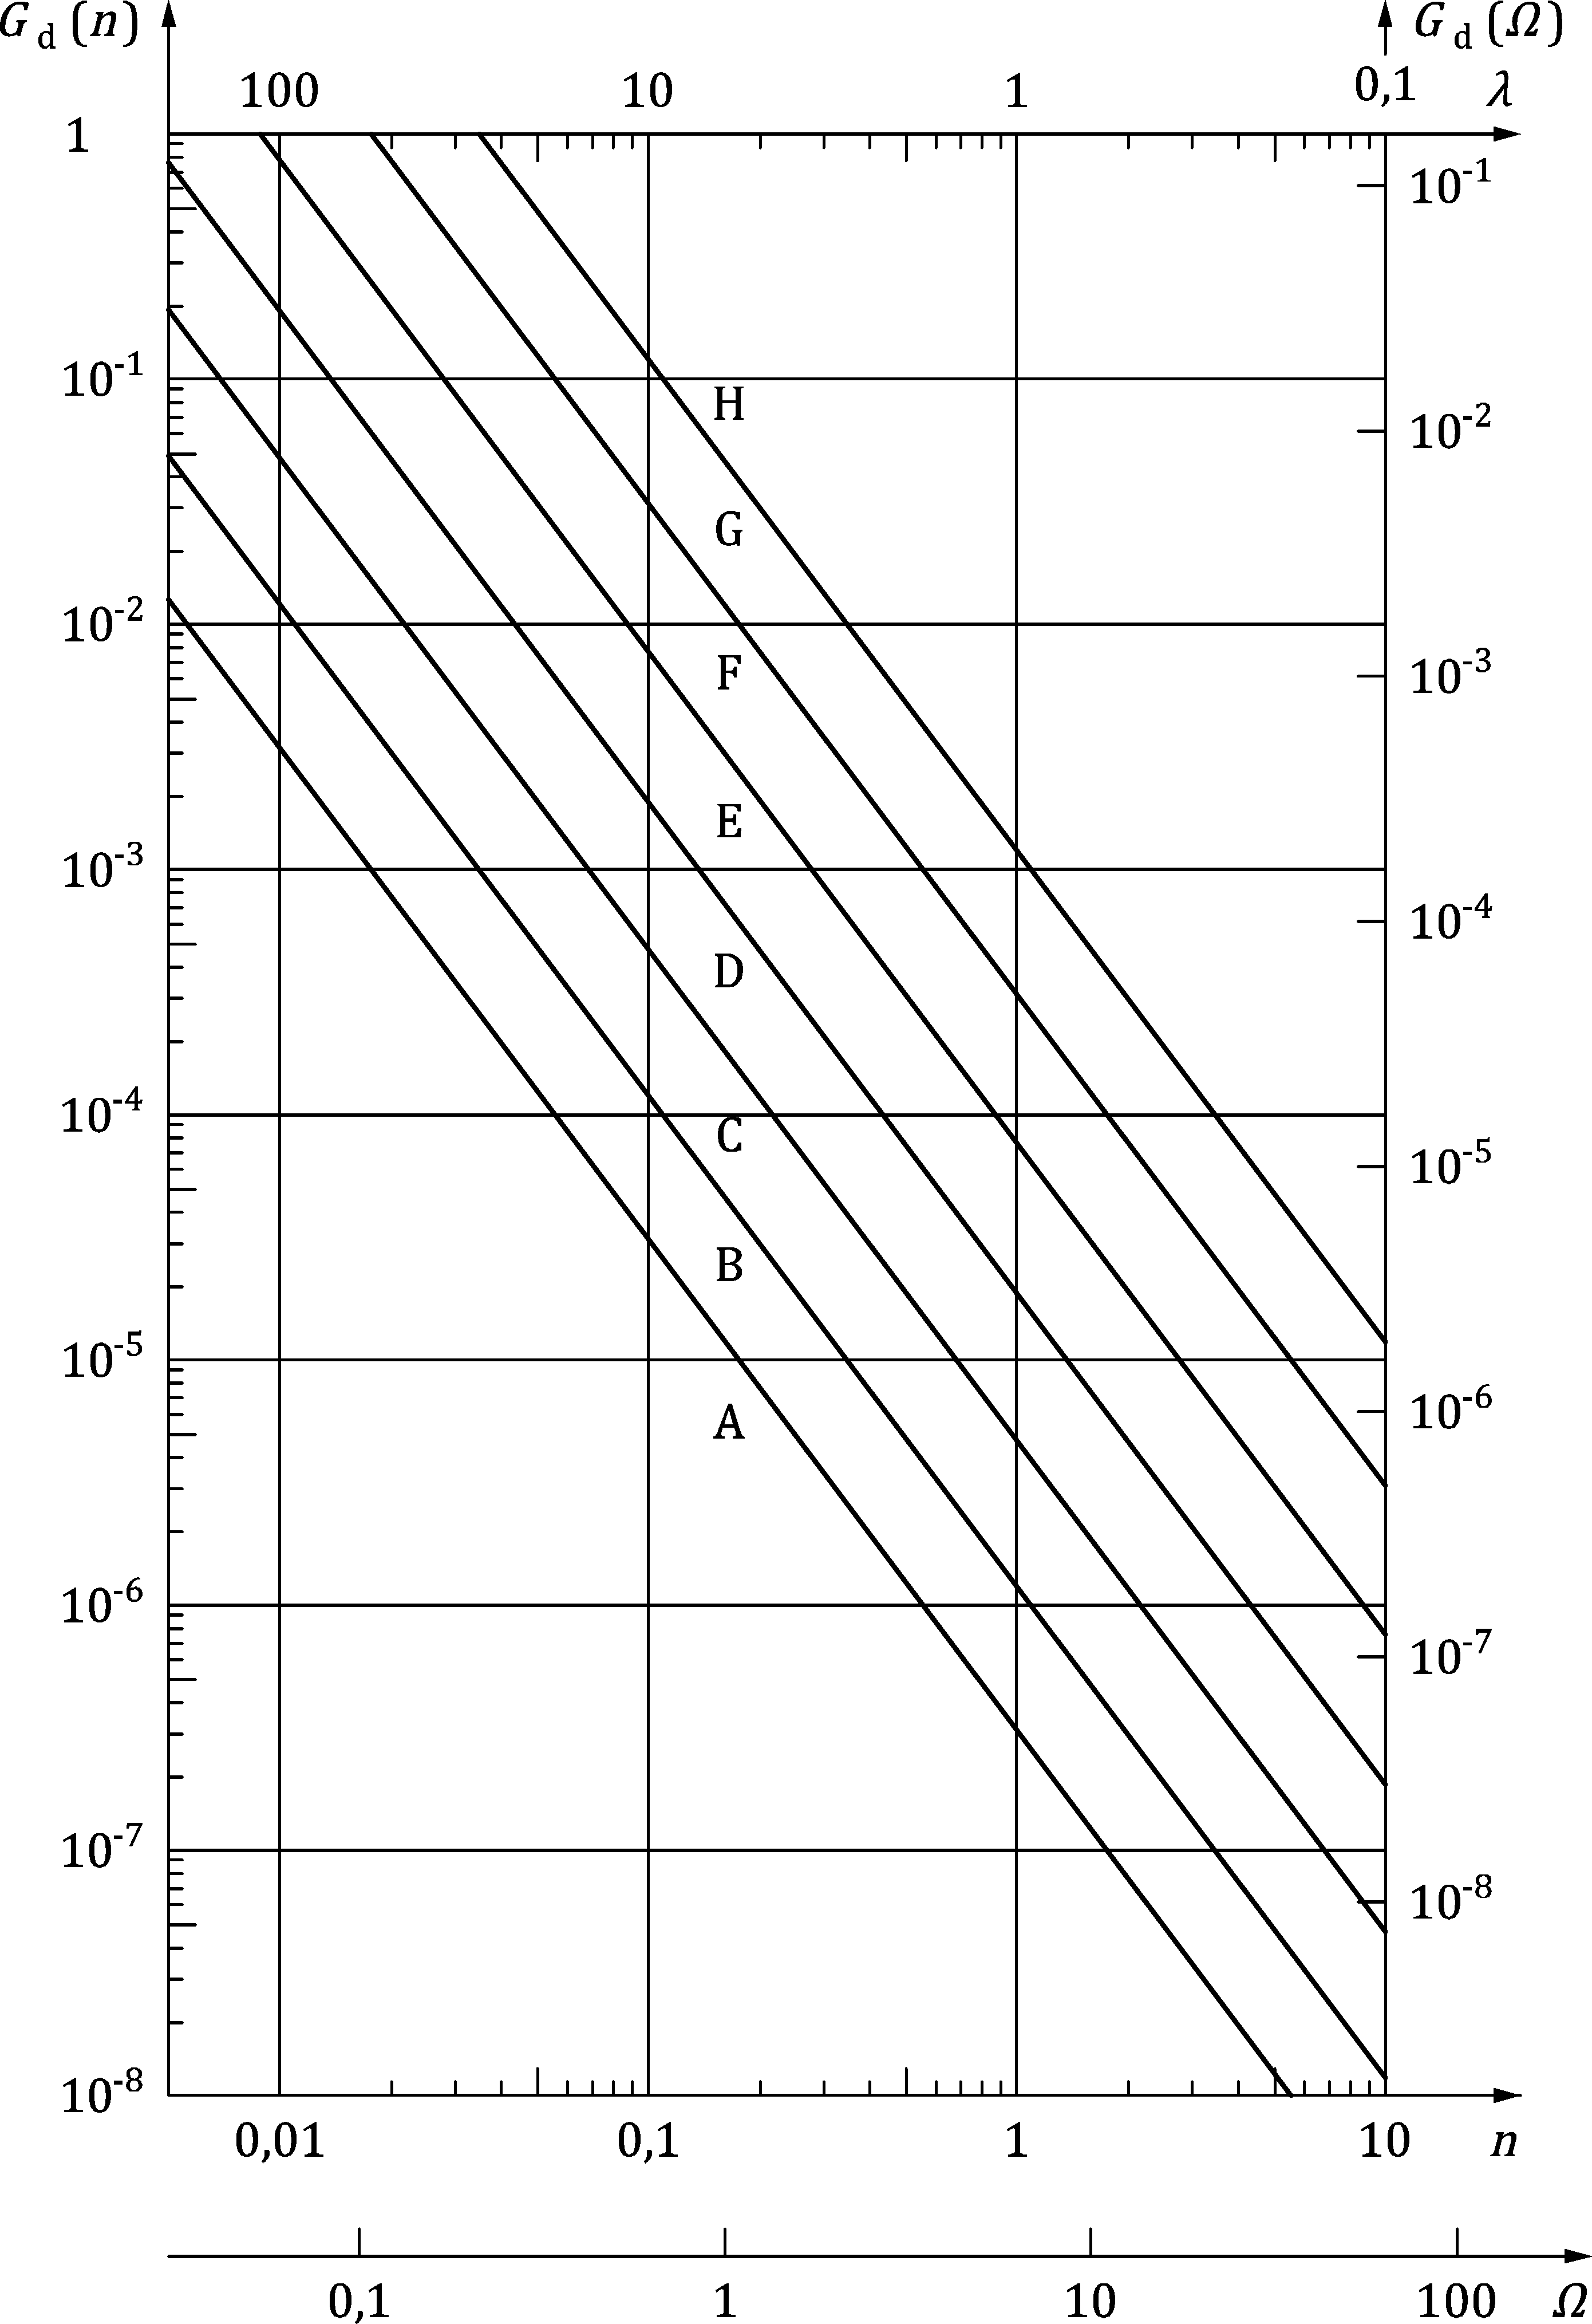

Key

|  |  |
| --- | --- |
| *G*d(*n*) [m3] | Displacement power spectral density; |
| *λ* [m] | Wavelength; |
| *G*d(*Ω*) [m3] | Displacement power spectral density; |
| *n* | Spatial frequency [cycles/m]; |
| *Ω* | Angular spatial frequency [rad/m]. |

Figure B.1 — Road surface classification (ISO 8608)

The limit values of *G*d and *G*v for the first 5 road surface classes in terms of *n* and *Ω* are given in Tables B.1 and B.2, respectively.

Table B.1 — Degree of roughness expressed in terms of spatial frequency units, *n*

|  | Degree of roughness | | | | |
| --- | --- | --- | --- | --- | --- |
| Road class | Pavement quality | *G*d (*n*0)a [10−6 m] | | | *G*v (*n*) [10−6 m] |
| Lower limit | Geometric mean | Upper limit | Geometric mean |
| A | Very good | – | 16 | 32 | 6,3 |
| B | Good | 32 | 64 | 128 | 25,3 |
| C | Medium | 128 | 256 | 512 | 101,1 |
| D | Poor | 512 | 1 024 | 2 048 | 404,3 |
| E | Very poor | 2 048 | 4 096 | 8 192 | 1 617,0 |
| a *n*0 = 0,1 cycle/m | | | | | |

Table B.2 — Degree of roughness expressed in terms of angular spatial frequency units, *Ω*

|  | Degree of roughness | | | | |
| --- | --- | --- | --- | --- | --- |
| Road class | Pavement quality | *G*d (*Ω*0)a [10−6 m] | | | *G*v (*Ω*) [10−6 m] |
| Lower limit | Geometric mean | Upper limit | Geometric mean |
| A | Very good | – | 1 | 2 | 1 |
| B | Good | 2 | 4 | 8 | 4 |
| C | Medium | 8 | 16 | 32 | 16 |
| D | Poor | 32 | 64 | 128 | 64 |
| E | Very poor | 128 | 256 | 512 | 256 |
| a *Ω*0 = 1 rad/m | | | | | |

(3) Unless otherwise specified, the recorded axle loads should be multiplied by:

*φ*fat = 1,2 for surface of good roughness

*φ*fat = 1,4 for surface of medium roughness.

(4) In addition, when considering a cross-section within a distance of 6,00 m from an expansion joint, the load should be multiplied by the additional dynamic amplification factor Δ*φ*fat derived from Figure 6.6.

(5) The classification of roadway roughness may be taken in accordance with ISO 8608.

(6) For a rough and quick estimation of the roughness quality, the following guidance is given:

— new roadway layers, such as, for example, asphalt or concrete layers, may be assumed to have a good or even a very good roughness quality;

— old roadway layers which are not maintained may be classified as having a medium roughness;

— roadway layers consisting of cobblestones or similar material may be classified as medium (“average”) or bad (“poor”, “very poor”).

(7) The wheel contact areas and the transverse distances between wheels should be taken as described in Table 6.9 (NDP), where relevant.

(8) If the data are recorded on one lane only, assumptions should be made concerning the traffic on other lanes. These assumptions may be based on records made at other locations for a similar type of traffic.

(9) The stress history should take into account the simultaneous presence of vehicles recorded on the bridge in any lane. A procedure should be developed to allow for this when records of individual vehicle loadings are used as a basis.

(10) The numbers of cycles should be counted using the Rainflow method or the Reservoir method.

(11) If the duration of recordings is less than a full week, the records and the assessment of the fatigue damage rates may be adjusted taking into account observed variations of traffic flows and mixes during a typical week. An adjustment factor should also be applied to take into account any future changes on the traffic

(12) The cumulative fatigue damage calculated by use of records should be multiplied by the ratio between the design service life and the duration considered on the histogram. In the absence of detailed information, a factor 2 for the number of lorries and a factor 1,4 for the load levels are considered.

1. (normative)  
     
   Dynamic factors 1 + *φ* for Real Trains
   1. Use of this Annex

(1) This normative Annex contains additional provisions to 8.4 dynamic effects for the Dynamic factors 1 + *φ* for Real Trains.

* 1. Scope and field of application

(1) This Normative Annex covers the factor appropriate to the Maximum Permitted Vehicle Speed to take account of dynamic effects resulting from the movement of actual service trains at speed, the forces and moments calculated from the specified static loads. They shall be multiplied by this factor.

(2) The dynamic factors 1 + *φ* are also used for fatigue damage calculations.

(3) The static load due to a Real Train at *v* [m/s] shall be multiplied by:

either, 1 + *φ* = 1 + *φ*′ + *φ*″ for track with standard maintenance (C.1)

or, 1 + *φ* = 1 + *φ*′ + 0,5 *φ*″ for carefully maintained track (C.2)

NOTE 1 The National Annex can decide between the application of Formulae (C.1) or (C.2) for use in a country.

with:

          for *K* < 0,76 (C.3)

and

*φ*′ = 1,325          for *K* ≥ 0,76 (C.4)

where

 (C.5)

and

 (C.6)

*φ*″ ≥ 0

with:

          if *v* ≤ 22 m/s (C.7)

*α* = 1          if *v* > 22 m/s

where

|  |  |
| --- | --- |
| *V* | is the Maximum Permitted Vehicle Speed [m/s]; |
| *n*0 | is the first natural bending frequency of the bridge loaded by permanent actions [Hz]; |
| *LΦ* | is the determinant length [m] in accordance with 8.4.5.4; |
| *〈* | is a coefficient for speed. |

The limit of validity for *φ*′ defined by Formulae (C.3) and (C.4) is the lower limit of natural frequency in Figure 8.10 and 200 km/h. For all other cases *φ*′ should be determined by a dynamic analysis in accordance with 8.4.6.

The method used should be agreed with the relevant authority or where not specified, agreed for a specific project by the relevant parties.

NOTE 2 The relevant authority is specified in the National Annex.

The limit of validity for *φ*″ defined by Formula (C.6) is the upper limit of natural frequency in Figure 8.10. For all other cases *φ*″ may be determined by a dynamic analysis taking into account mass interaction between the unsprung axle masses of the train and the bridge in accordance with 8.4.6.

(4) The values of *φ*′ + *φ*″ shall be determined using upper and lower limiting values of *n*0, unless it is being made for an individual bridge of known first natural frequency.

The upper limit of *n*0 is given by:

 (C.8)

and the lower limit is given by:

          for 4 m ≤ *LΦ* ≤ 20 m (C.9)

          for 20 m < *LΦ* ≤ 100 m (C.10)

1. (normative)  
     
   Basis for the fatigue assessment of railway structures
   1. Use of this Annex

(1) This normative Annex contains additional provisions to subclauses 8.4.6 and 8.9 for the fatigue assessment of railway structures.

* 1. Scope and field of application

(1) This normative Annex covers the fatigue assessment of railway structures.

* 1. Assumptions for fatigue actions

(1) The dynamic factors *Φ*2 and *Φ*3 which are applied to the static Load Model 71 and SW/0 and SW/2, when 8.4.5 applies, represent the extreme loading case to be taken into account for detailing bridge members. These factors would be unduly onerous if they were applied to the Real Trains used for making an assessment of fatigue damage.

(2) To take account of the average effect over the assumed 100 years design service life of the structure, the dynamic enhancement for each Real Train may be reduced to:

1 + ½(*φ*′ + ½*φ*″) (D.1)

where *φ*′ and *φ*″ are defined below in Formulae (D.2) and (D.5).

(3) Formulae (D.2) and (D.5) are simplified forms of Formulae (C.3) and (C.6) which are sufficiently accurate for the purpose of calculating fatigue damage and are valid for Maximum Permitted Vehicle Speeds up to 200 km/h:

 (D.2)

with:

          for *L* ≤ 20 m (D.3)

          for *L* > 20 m (D.4)

and

 (D.5)

where

|  |  |
| --- | --- |
| *v* | is the Maximum Permitted Vehicle Speed [m/s]; |
| *L* | is the determinant length *LΦ* [m] in accordance with 8.4.5.4. |

NOTE Where dynamic effects including resonance might be excessive and a dynamic analysis is required in accordance with 8.4.4 additional requirements for the fatigue assessment of bridges are given in 8.4.6.6.

* 1. General design method

(1) The fatigue assessment, in general a stress range verification, shall be carried out according to the EN 1992 series, EN 1993 series and EN 1994 series.

(2) The stress range safety verification shall be carried out by ensuring that the following condition is satisfied:

 (D.6)

where

|  |  |
| --- | --- |
| *γ*Ff | is the partial safety factor for fatigue loading (see prEN 1990:2021, A.2); |
| NOTE The value for *γ*Ff = 1,00 is used unless the National Annex gives a different value for the use in a country. | |
| λ | is the damage equivalence factor for fatigue which takes account of the service traffic on the bridge and the span of the member. Values of *λ* are given in the design codes (see the EN 1992 series to EN 1999 series); |
| *Φ*2 | is the dynamic factor (see 8.4.5); |
| Δ*σ*71 | is the stress range due to the Load Model 71 (and where required SW/0) but excluding *α* being placed in the most unfavourable positions for the element under consideration; |
| Δ*σ*C | is the reference value of the fatigue strength (see relevant material codes/EN 1992 series and EN 1993 series); |
| *γ*Mf | is the partial safety factor for fatigue strength in the design codes (see EN 1992 series to EN 1999 series). |

* 1. Train types for fatigue

The fatigue assessment should be carried out based on the rail traffic mixes, “standard rail traffic mix”, “heavy rail traffic mix” or “light rail traffic mix”, depending on whether the structure carries standard traffic, predominantly heavy freight traffic or light traffic. Details of the service trains and rail traffic mixes are given below.

NOTE For the heavy rail traffic mix only traffic with a maximum axle load of 250 kN are considered.

(1) Standard and light rail traffic train types (Figures D.1 to D.10):

|  |  |  |  |
| --- | --- | --- | --- |
| ∑*Q* = 6 630 kN | *V* = 200 km/h | *L* = 262,10 m | *q* = 25,3 kN/m‘ |

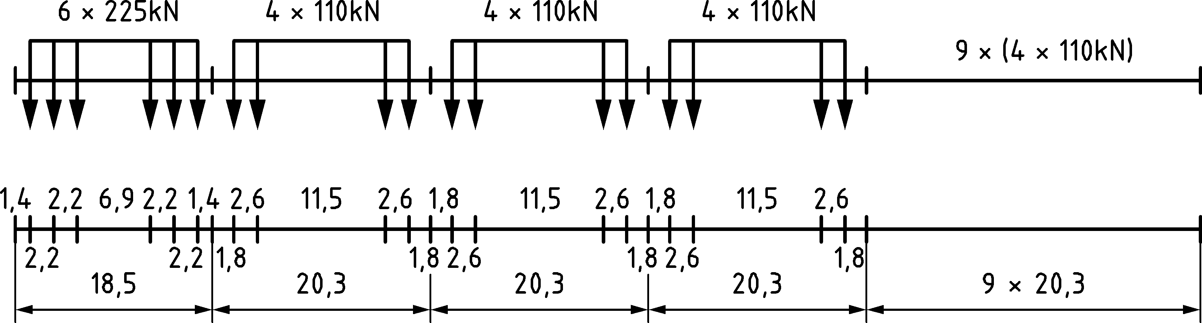

Figure D.1 — Type 1 — Locomotive-hauled passenger train

|  |  |  |  |
| --- | --- | --- | --- |
| ∑*Q* = 5 300 kN | *V* = 160 km/h | *L* = 281,10 m | *q* = 18,9 kN/m‘ |

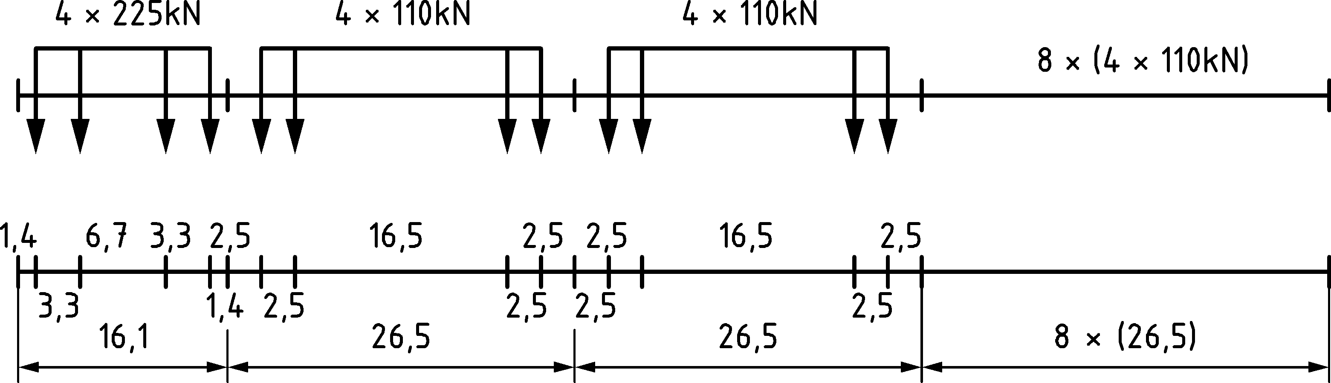

Figure D.2 — Type 2 — Locomotive-hauled passenger train

|  |  |  |  |
| --- | --- | --- | --- |
| ∑*Q* = 9 400 kN | *V* = 250 km/h | *L* = 385,52 m | *q* = 24,4 kN/m‘ |

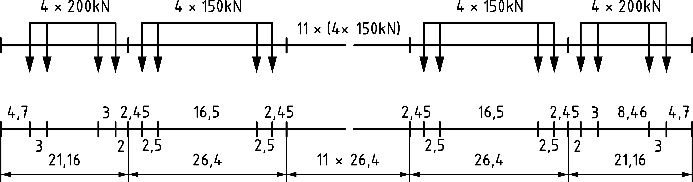

Figure D.3 — Type 3 — High speed passenger train

|  |  |  |  |
| --- | --- | --- | --- |
| ∑*Q* = 5 100 kN | *V* = 250 km/h | *L* = 237,60 m | *q* = 21,5 kN/m‘ |

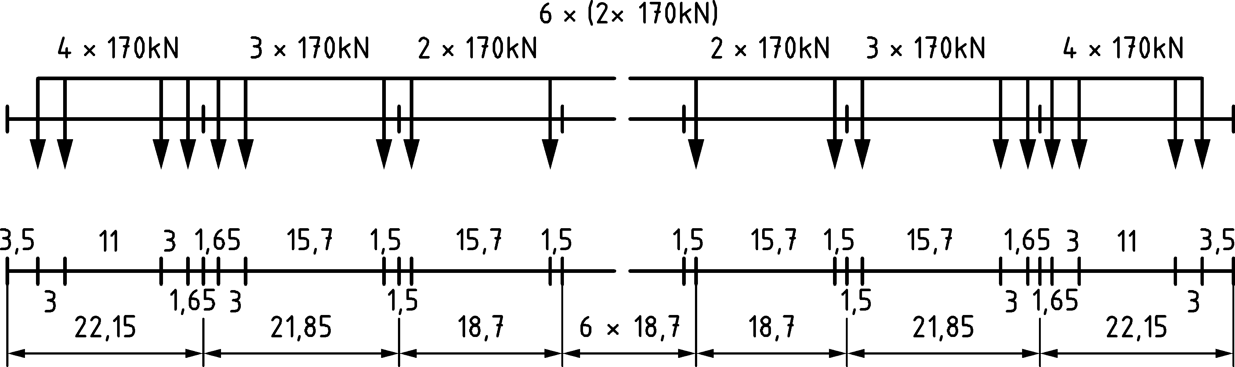

Figure D.4 — Type 4 — High speed passenger train

|  |  |  |  |
| --- | --- | --- | --- |
| ∑*Q* = 21 600 kN | *V* = 80 km/h | *L* = 270,30 m | *q* = 80,0 kN/m‘ |

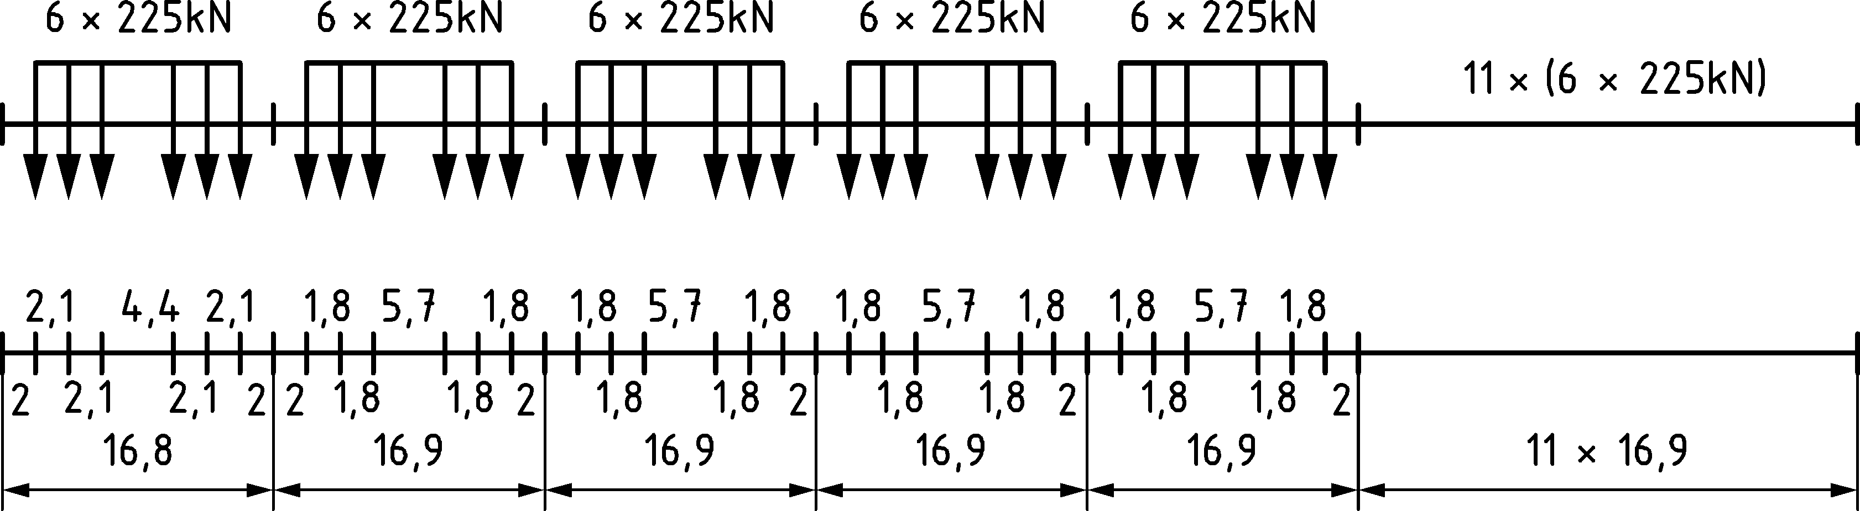

Figure D.5 — Type 5 — Locomotive-hauled freight train

|  |  |  |  |
| --- | --- | --- | --- |
| ∑*Q* = 14 310 kN | *V* = 100 km/h | *L* = 333,10 m | *q* = 43,0 kN/m‘ |

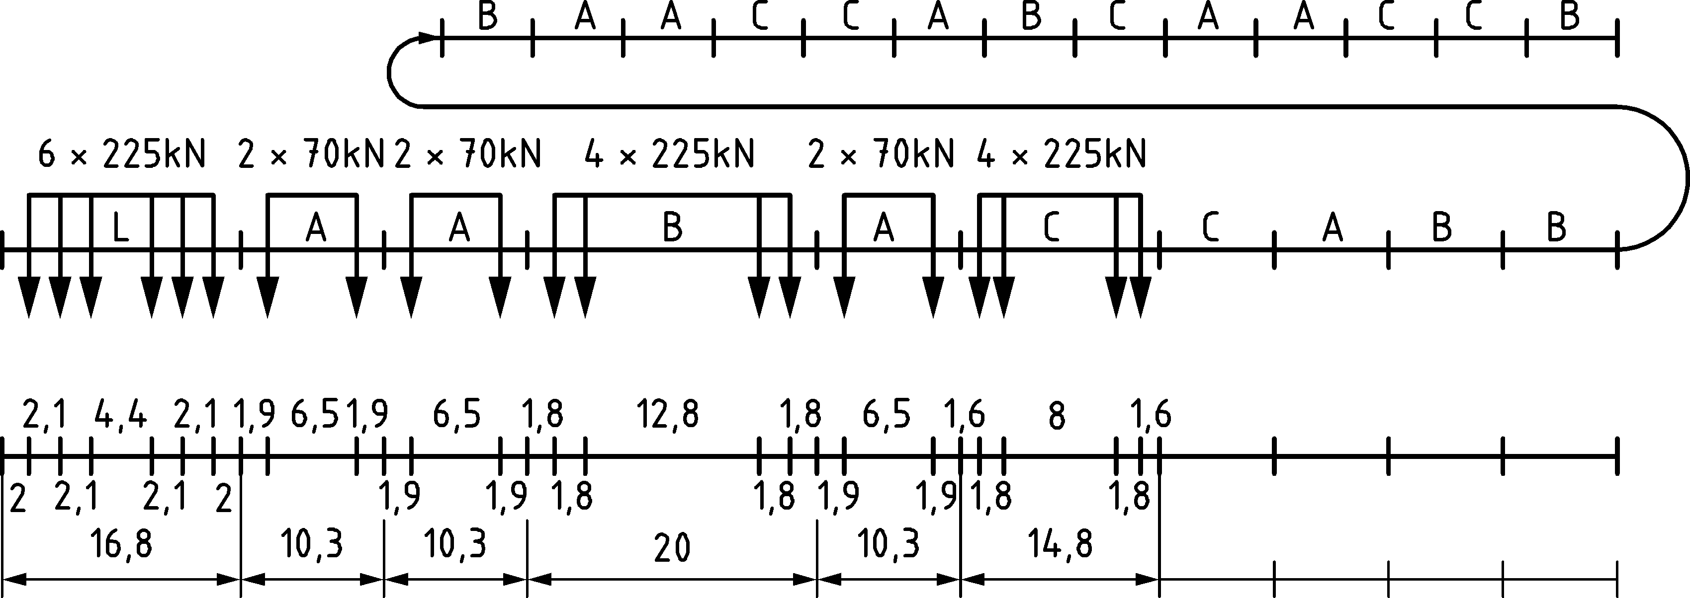

Figure D.6 — Type 6 — Locomotive-hauled freight train

|  |  |  |  |
| --- | --- | --- | --- |
| ∑*Q* = 10 350 kN | *V* = 120 km/h | *L* = 196,50 m | *q* = 52,7 kN/m‘ |

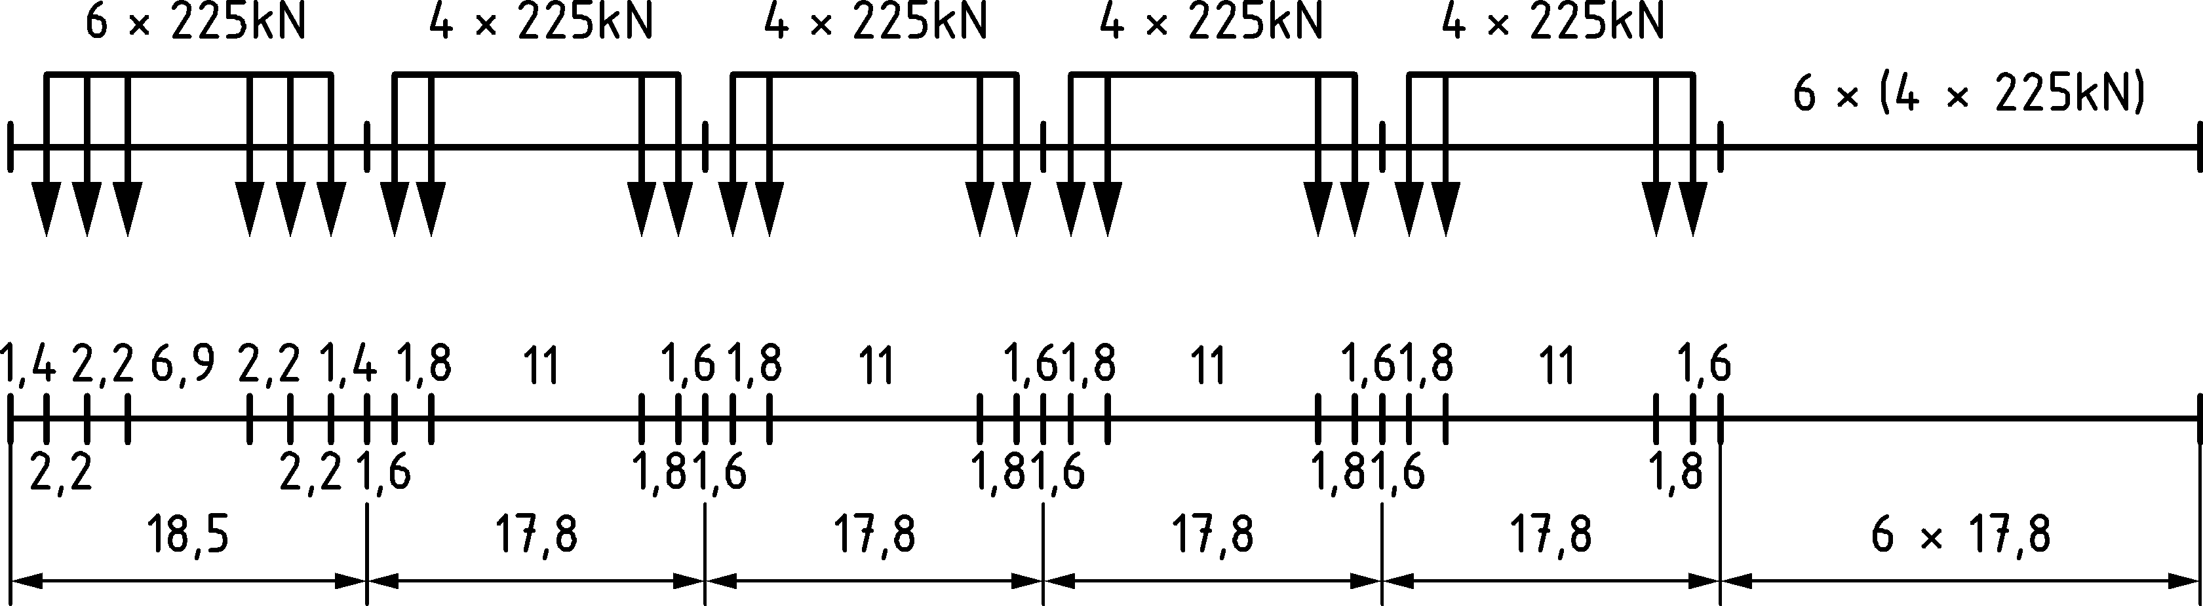

Figure D.7 — Type 7 — Locomotive-hauled freight train

|  |  |  |  |
| --- | --- | --- | --- |
| ∑*Q* = 10 350 kN | *V* = 100 km/h | *L* = 212,50 m | *q* = 48,7 kN/m‘ |

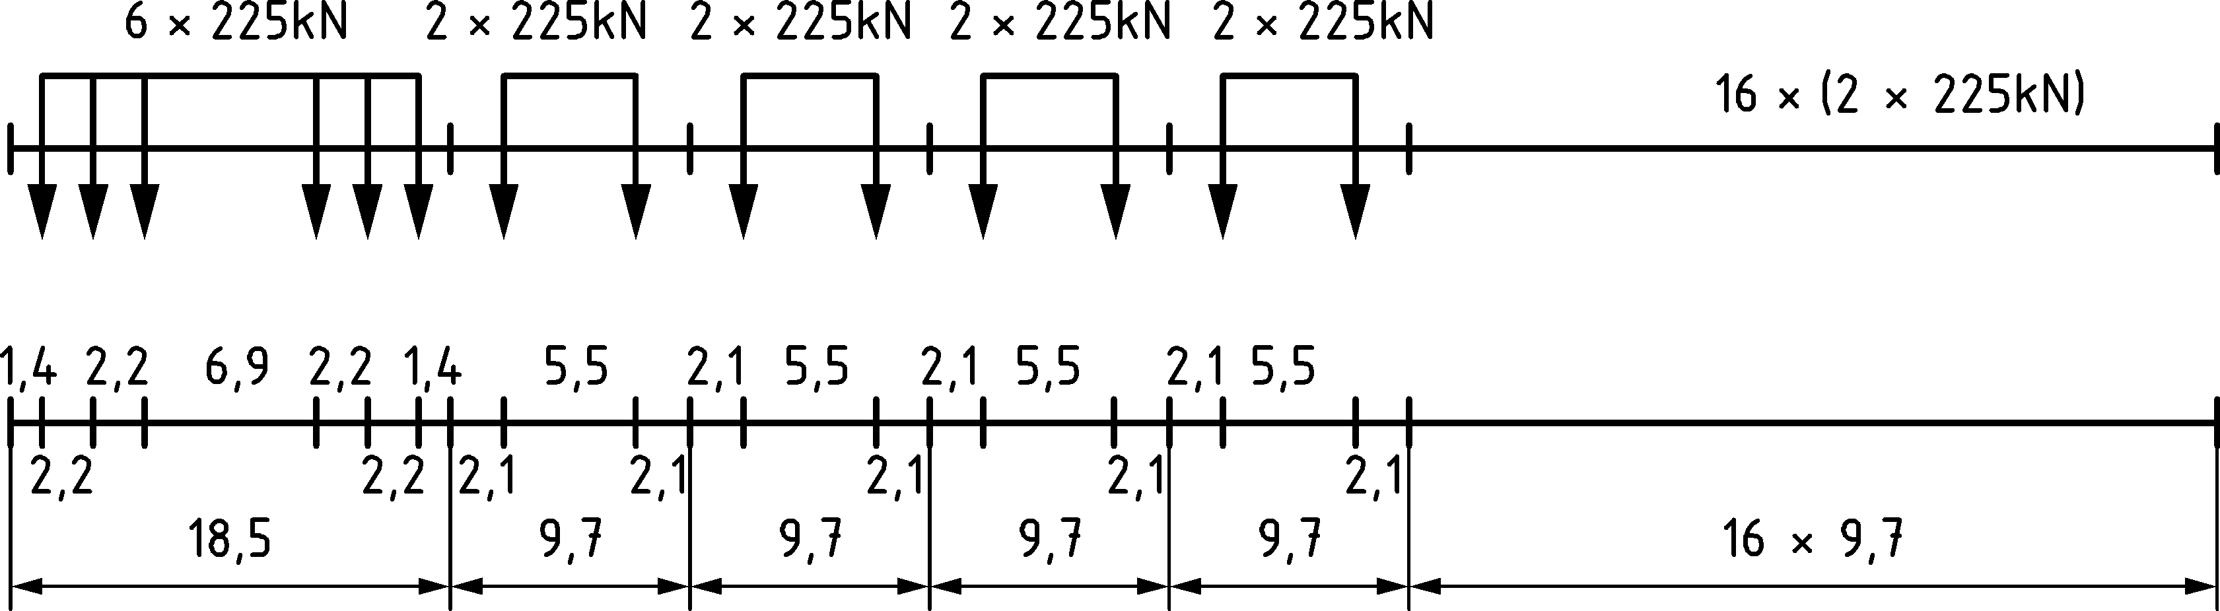

Figure D.8 — Type 8 — Locomotive-hauled freight train

|  |  |  |  |
| --- | --- | --- | --- |
| ∑*Q* = 2 960 kN | *V* = 120 km/h | *L* = 134,80 m | *q* = 22,0 kN/m‘ |

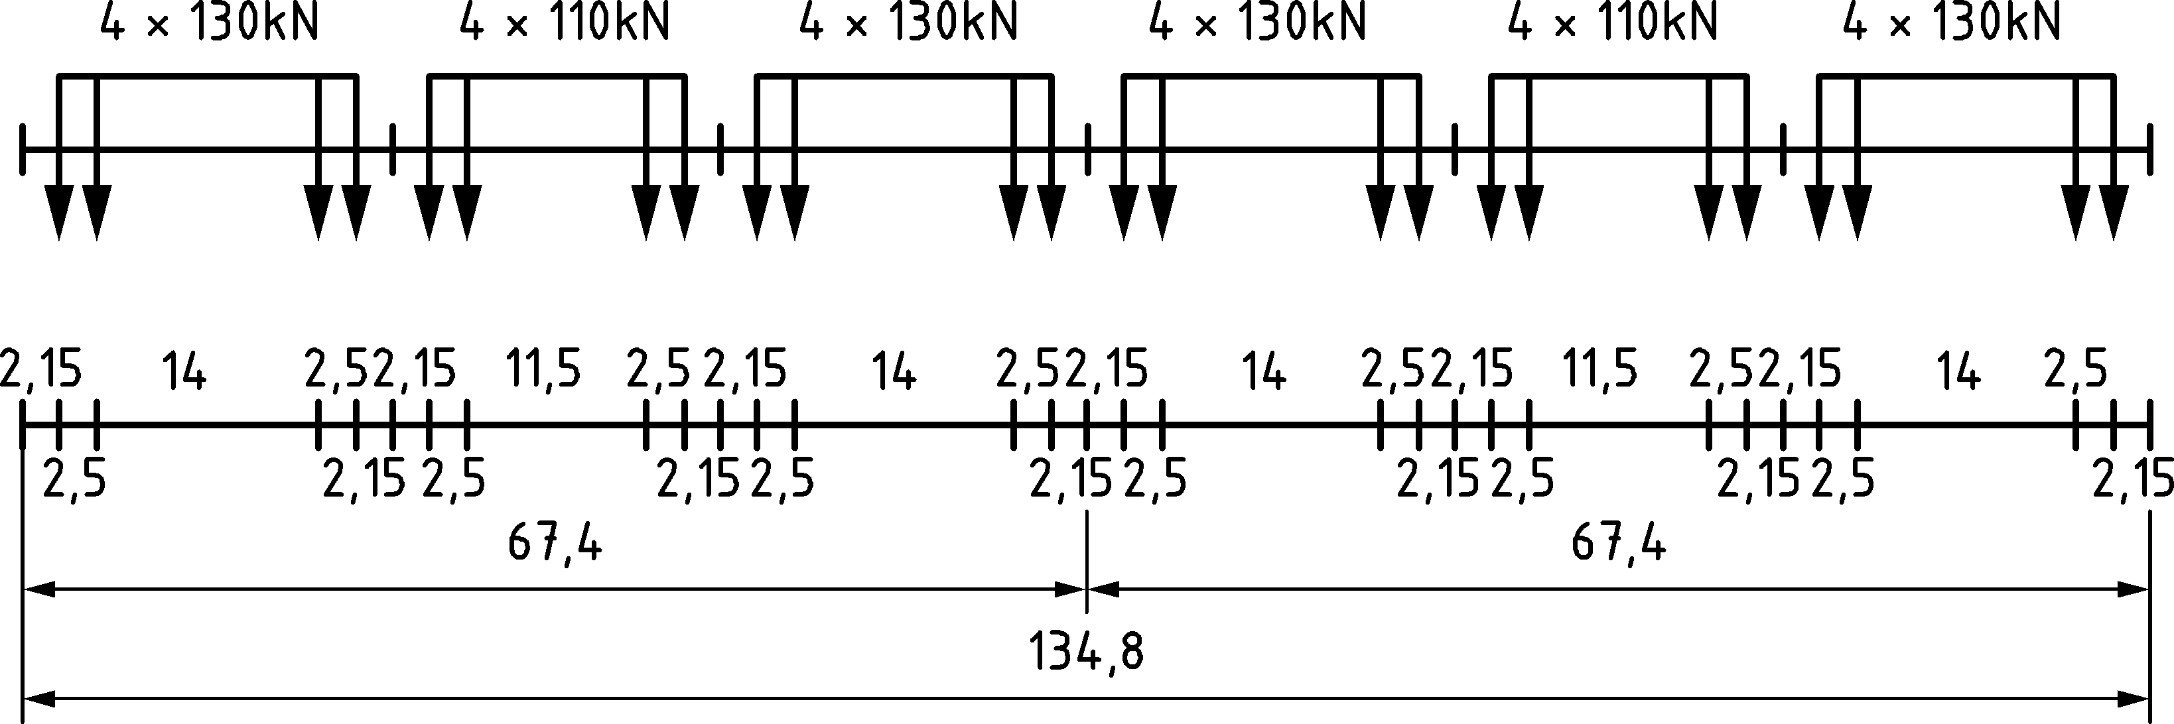

Figure D.9 — Type 9 — Surburban multiple unit train

|  |  |  |  |
| --- | --- | --- | --- |
| ∑*Q* = 3 600 kN | *V* = 120 km/h | *L* = 129,60 m | *q* = 27,8 kN/m‘ |

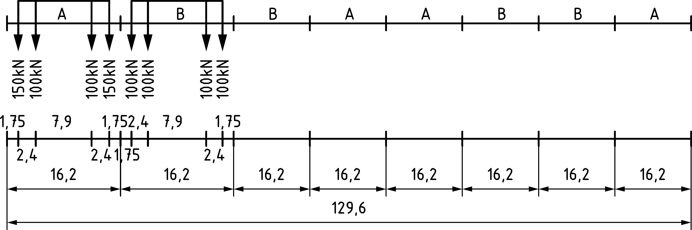

Figure D.10 — Type 10 — Underground

(2) Heavy rail traffic train types (Figures D.11 to D.12):

|  |  |  |  |
| --- | --- | --- | --- |
| ∑*Q* = 11 350 kN | *V* = 120 km/h | *L* = 198,50 m | *q* = 57,2 kN/m‘ |

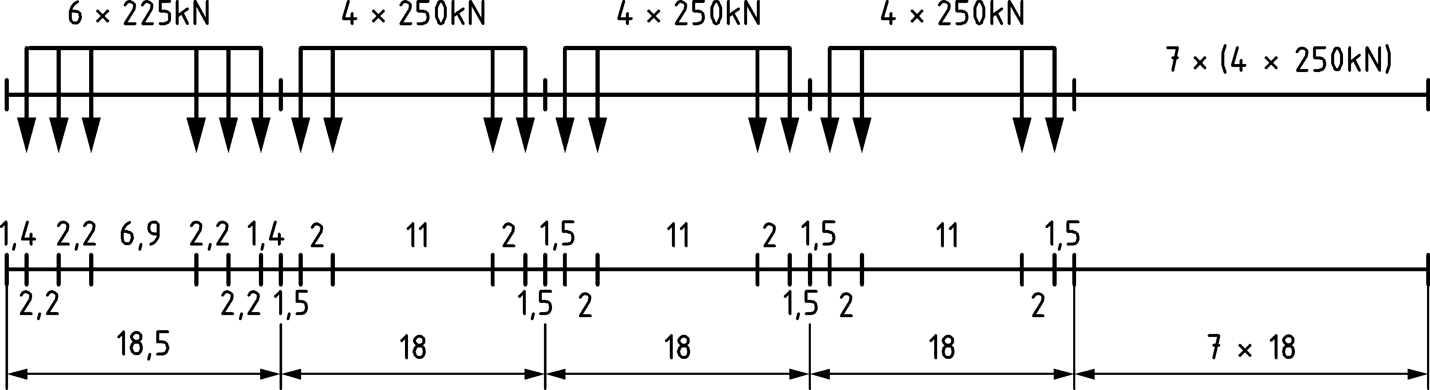

Figure D.11 — Type 11 — Locomotive-hauled freight train

|  |  |  |  |
| --- | --- | --- | --- |
| ∑*Q* = 11 350 kN | *V* = 100 km/h | *L* = 212,50 m | *q* = 53,4 kN/m‘ |

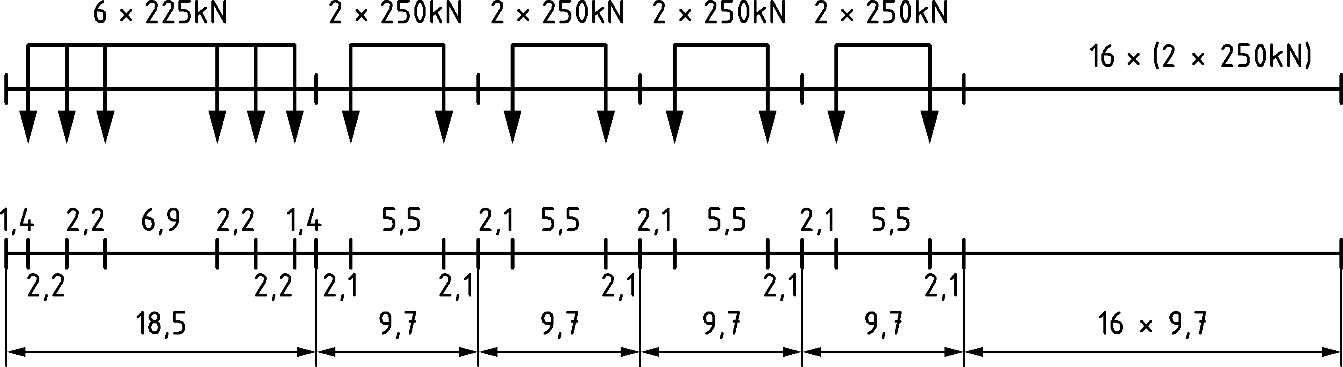

Figure D.12 — Type 12 — Locomotive-hauled freight train

(3) Rail traffic mix as in Tables D.1 to D.3:

Table D.1 — Standard rail traffic mix

| Train type | Number of trains/day | Mass of train | Traffic volume |
| --- | --- | --- | --- |
| [t] | [106t/year] |
| 1 | 12 | 663 | 2,90 |
| 2 | 12 | 530 | 2,32 |
| 3 | 5 | 940 | 1,72 |
| 4 | 5 | 510 | 0,93 |
| 5 | 7 | 2160 | 5,52 |
| 6 | 12 | 1431 | 6,27 |
| 7 | 8 | 1035 | 3,02 |
| 8 | 6 | 1035 | 2,27 |
| **Sum of trains/day** | 67 | **Total traffic volume/year** | 24,95 |

Table D.2 — Heavy rail traffic mix

| Train type | Number of trains/day | Mass of train | Traffic volume |
| --- | --- | --- | --- |
| [t] | [106t/year] |
| 5 | 6 | 2160 | 4,73 |
| 6 | 13 | 1431 | 6,79 |
| 11 | 16 | 1135 | 6,63 |
| 12 | 16 | 1135 | 6,63 |
| **Sum of trains/day** | 51 | **Total traffic volume/year** | 24,78 |

Table D.3 — Light rail traffic mix

| Train type | Number of trains/day | Mass of train | Traffic volume |
| --- | --- | --- | --- |
| [t] | [106t/year] |
| 1 | 10 | 663 | 2,4 |
| 2 | 5 | 530 | 1,0 |
| 5 | 2 | 2160 | 1,4 |
| 9 | 190 | 296 | 20,5 |
| **Sum of trains/day** | 207 | **Total traffic volume/year** | 25,3 |

1. (informative)  
     
   Limits of validity of Load Model HSLM
   1. Use of this informative Annex

(1) This informative Annex provides additional guidance to that given in 8.4.6 for the validity of Load Model HSLM

NOTE The way in which this informative Annex can be used in a Country is given in the National Annex. If the National Annex is silent on the use of this informative Annex, it can be used.

* 1. Scope and field of application

(1) This Informative Annex covers the limits of validity of Load Model HSLM.

* 1. Limits of validity of Load Model HSLM

(1) Load Model HSLM is valid for passenger trains conforming to the following criteria:

— individual axle load *P* [kN] limited to 170 kN, determined as “Design mass under normal payload” as defined in EN 15663, and for conventional trains also limited to the value in accordance with Formula (E.2),

— the distance *D* [m] corresponding to the length of the coach or to the distance between regularly repeating axles in accordance with Table E.1,

— the spacing of axles within a bogie, *d*BA [m] in accordance with:

2,5 m ≤ *d*BA ≤ 3,5 m (E.1)

— for conventional trains the distance between the centres of bogies between adjacent vehicles *d*BS [m] in accordance with Formula (E.2),

— for regular trains with coaches with one axle per coach the intermediate coach length *D*IC [m] and distance between adjacent axles across the coupling of two individual trainsets *e*c [m] in accordance with Table E.1,

— *D*/*d*BA and (*d*BS − *d*BA)/*d*BA should not be close to an integer value,

— maximum total weight of train of 10,000 kN,

— maximum train length of 400 m between extreme axles,

— maximum unsprung axle mass of 2 000 kg,

Table E.1 — Limiting parameters for high speed passenger trains conforming to Load Model HSLM

| Type of train | P | D | *D*IC | *e*c |
| --- | --- | --- | --- | --- |
|  | [kN] | [m] | [m] | [m] |
| Articulated | 170 | 18 ≤ *D* ≤ 27 | – | – |
| Conventional | Lesser of 170 or value corresponding to Formula (E.2) below. | 18 ≤ *D* ≤ 27 | – | – |
| Regular | 170 | 10 ≤ *D* ≤ 14 | 8 ≤ *D*IC ≤ 11 | 7 ≤ *e*c ≤ 10 |

where

 (E.2)

where

*P*HSLMA, *d*HSLMA and *D*HSLMA are the parameters of the Universal Trains in accordance with Figure 8.12 and Table 8.4 corresponding to the coach length *D*HSLMA for:

— a single Universal Train where *D*HSLMA equals the value of *D*,

— two Universal Trains where *D* does not equal *D*HSLMA with *D*HSLMA taken as just greater than *D* and just less than *D*,

and *D*, *D*IC, *P*, *d*BA, *d*BS and *e*C are defined as appropriate for articulated, conventional and regular trains in Figures E.1 to E.3:

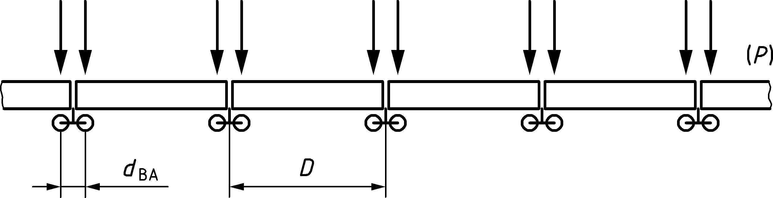

Figure E.1 — Articulated train

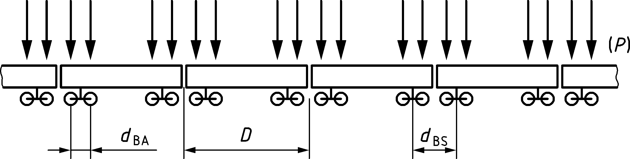

Figure E.2 — Conventional train

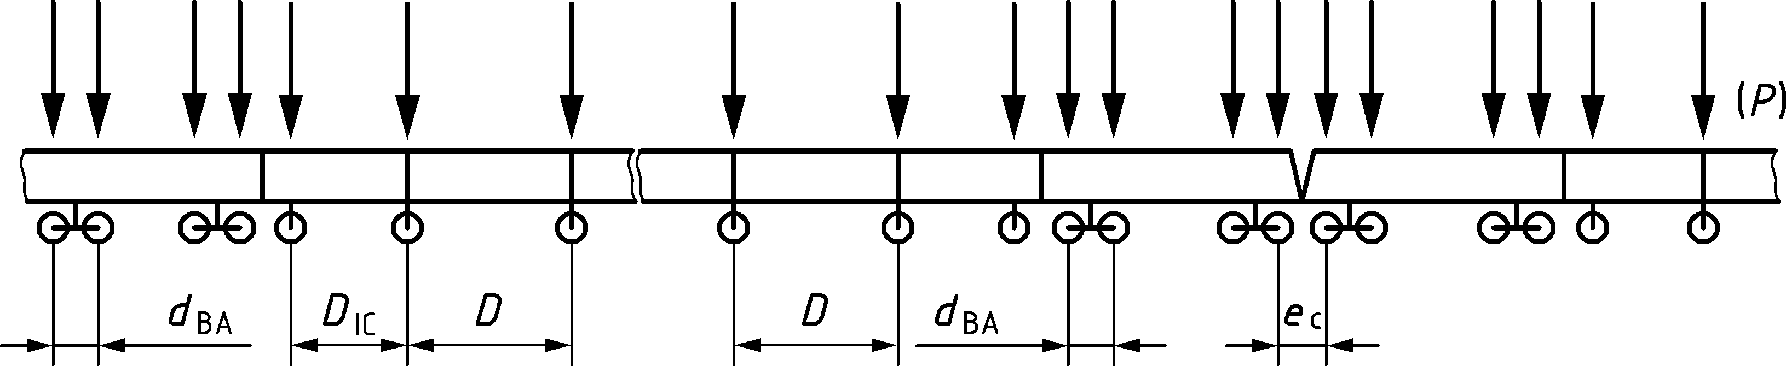

Figure E.3 — Regular train

(2) The point forces, dimensions and lengths of the Universal Trains defined in 8.4.6.1.1 do not form part of the real vehicle specification unless referenced in E.3(1).

(3) Background to load model HSLM is contained in ERRI D 214.2/RP 1, by the European Railway Research Institute, 2000. Annex E of this report defines the trains covered within this envelope. It shall be considered that some existing high speed trains originally envisaged to be within this envelope (some of them were already used for the definition of the load model HSLM) may not be covered if axle loads are determined as “Design mass under normal payload” as defined in EN 15663.

* 1. Dynamic train signature

(1) The background for load model HSLM employed in ERRI D 214.2/RP 1 relies on the spectral *decomposition of the excitation at resonance* (DER), described in detail in ERRI D 214/RP 9. This method is an approximation which among other simplifications retains only the resonant terms of the bridge vibration, assuming simply supported beam-type bridges. The method allows the response of the trains to be established as a spectral coefficient, which in the limit case of zero damping (ζ = 0) is called dynamic signature.

(2) The resulting function for dynamic train signature, considers the train as a sequence of moving loads and for the simplifying assumptions considered (i.e. simply supported bridges with beam bending behaviour, only the first mode of vibration of the bridge is taken into account, not valid for non-resonant conditions where it is not an upper bound, and not valid for short trains where dynamic excitation does not arise from fully developed resonance) provides an upper bound of the response under resonant conditions. The dynamic signature is a spectral definition of the train, in terms of the wavelength 𝜆, given by (Formula 8.11 of ERRI D 214/RP 9):

 (E.3)

where

|  |  |
| --- | --- |
| *i* | is the number of axles of a subset of the train, up to the total number of axles of the train *M*; |
| *P*k | is the axle load of the *k*-th axle; |
| *x*k | is the distance between the *k*-th axle and the first one; |
| *λ* | is the wavelength, defined following. |

(3) A train with a lower signature than a reference train, considering the above limitations, should in principle produce lower dynamic response in resonance of a simple bridge for a given wavelength *λ* = *v/n0*, where *v* is the train speed and *n*0 [Hz] the fundamental frequency of vibration of the bridge.

(4) The high-speed load model HSLM-A was designed as an envelope for wavelengths between 4 and 30 m for a representative set of existing or envisaged high speed trains in ERRI D 214.2/RP 1. A first appraisal of the dynamic effect of a given train under resonant conditions on simply supported bridges may be performed by computing its signature. If is within the envelope defined by the HSLM-A load model, its resonant effects may be covered by this dynamic load model, assuming that the simplifications adopted are valid. For convenience, the signatures of each individual HSLM-A train together with the envelope, computed according to the above Formula (E.3), are shown in Figure E.4.

(5) Determination of the dynamic train signature is therefore a useful method for comparing the dynamic effects at resonance of different trains on a bridge. However, it is not a substitute for design and determination of the load effects acting on a particular bridge is still necessary.

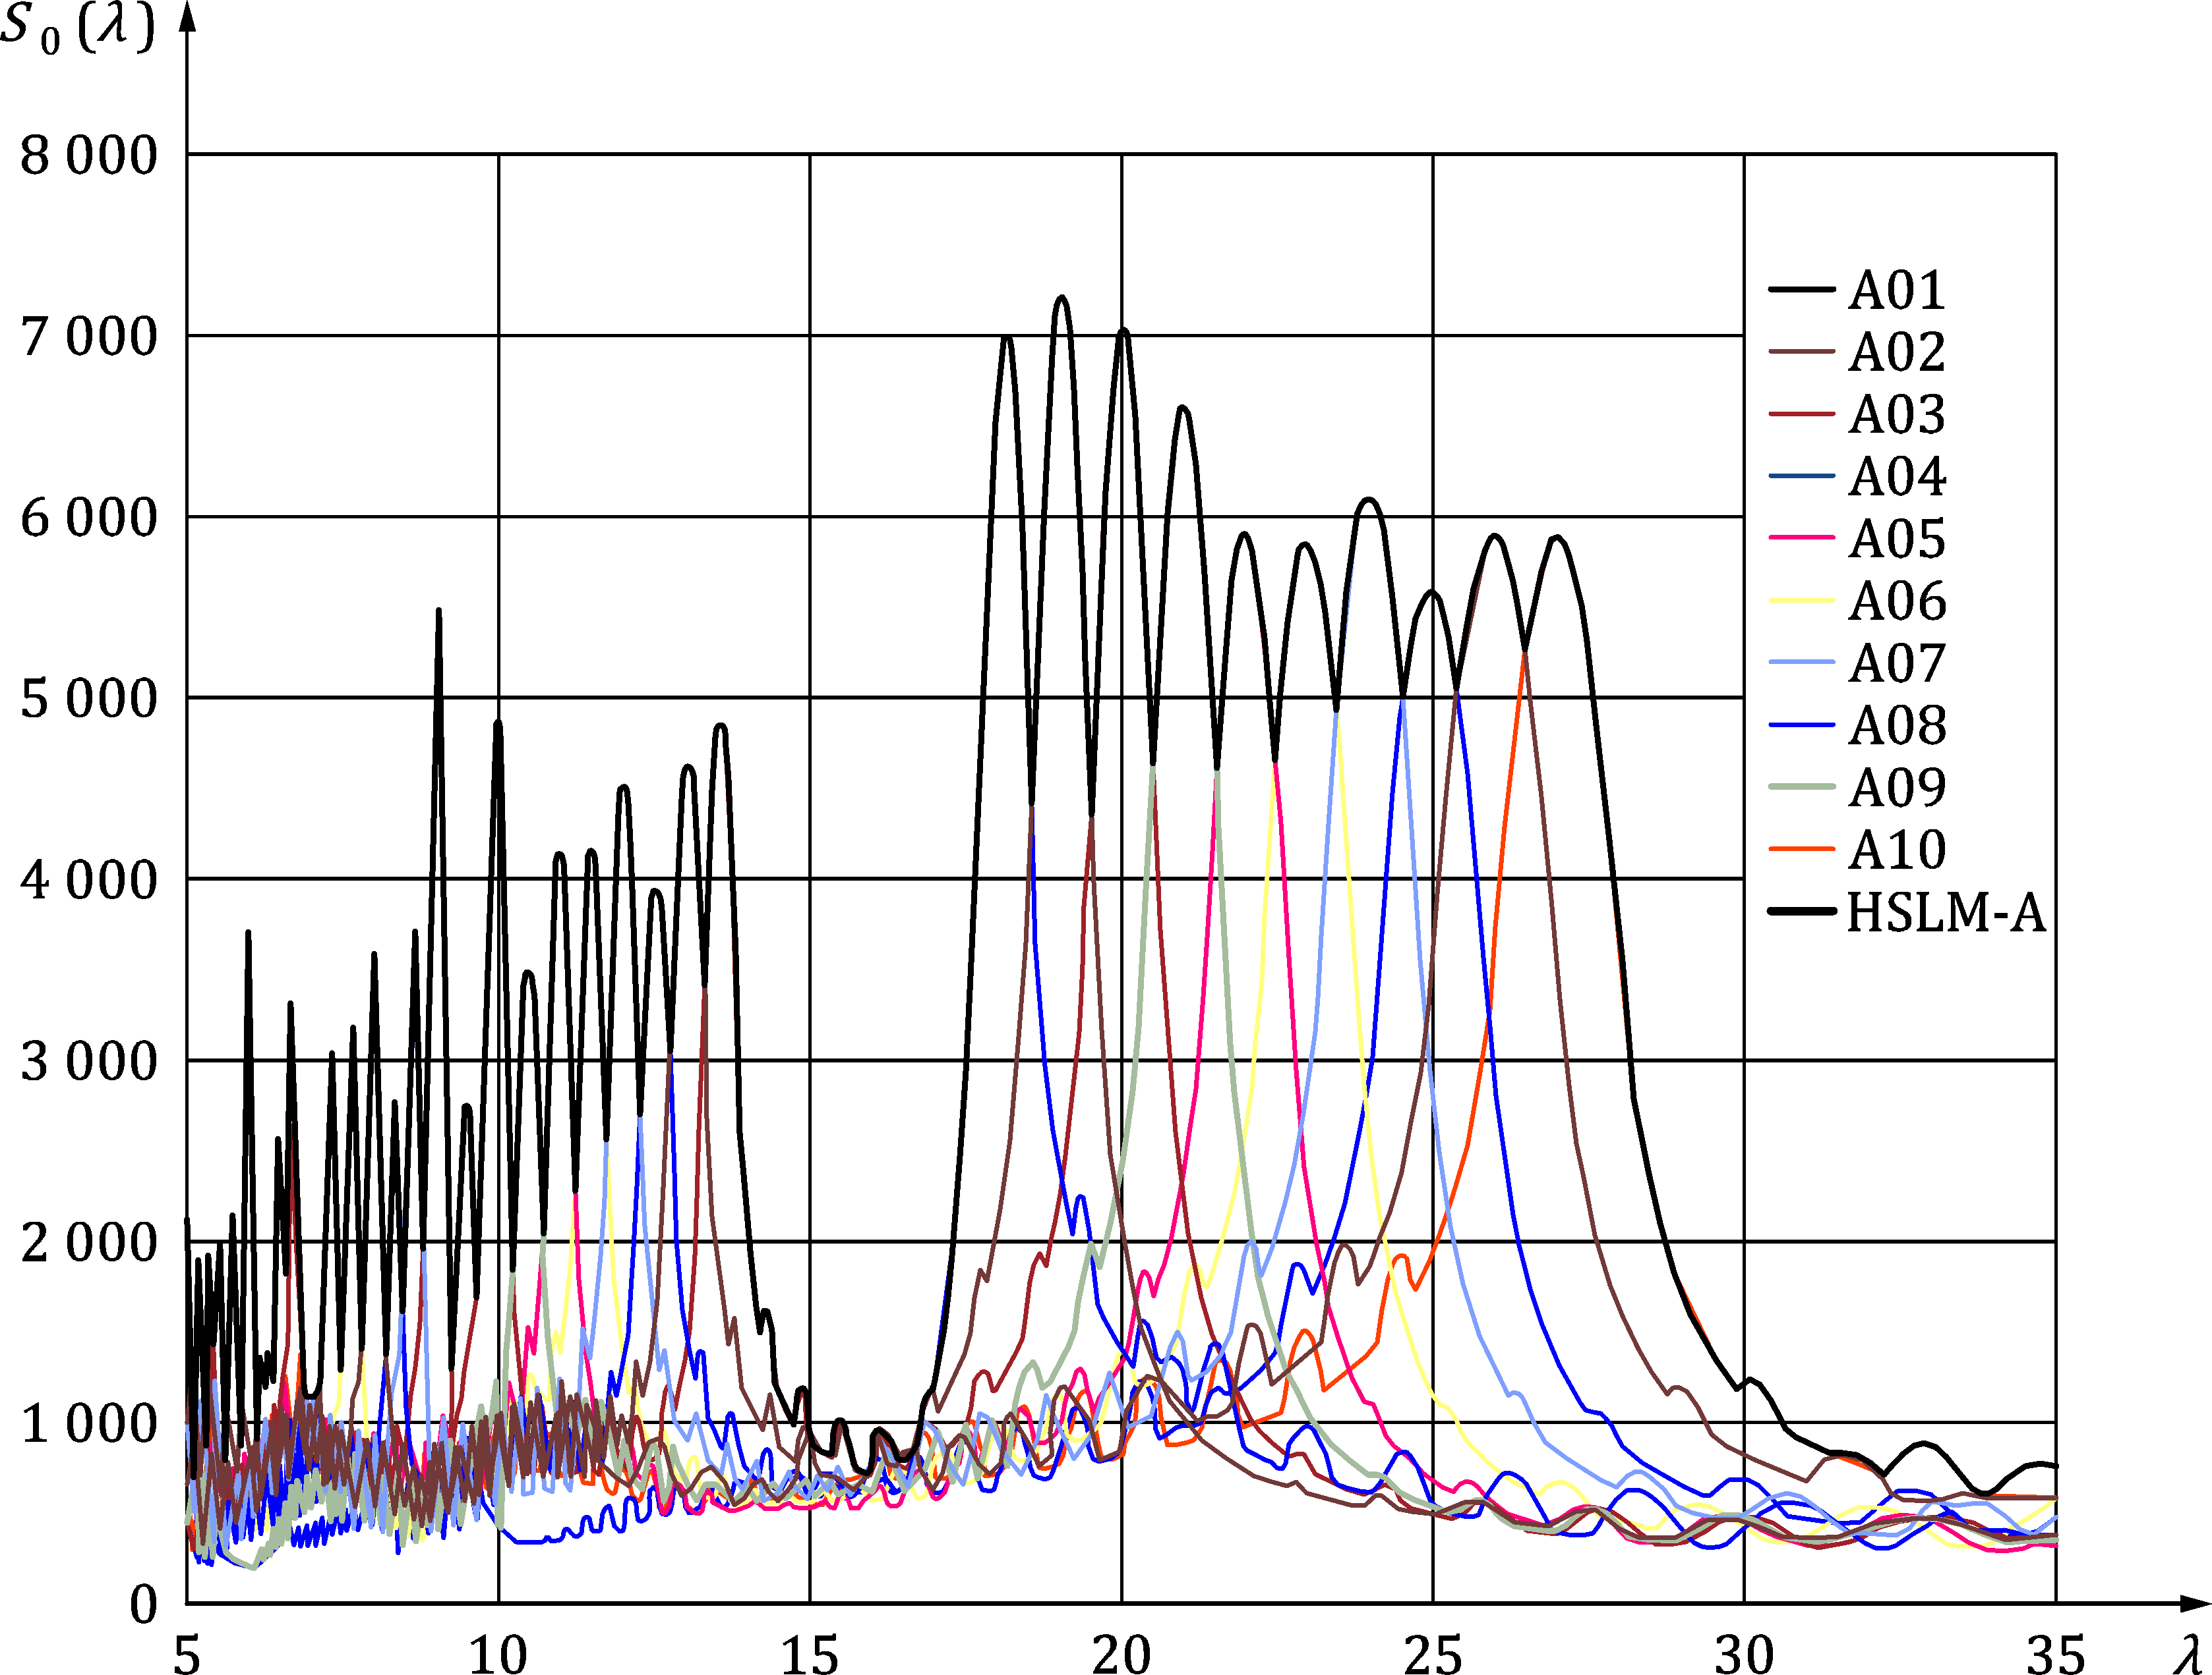

Key

|  |  |
| --- | --- |
| *S*0(*λ*) | [kN] |
| *λ* | wavelength [m] |

Figure E.4 — Envelope of signatures for HSLM-A

1. (informative)  
     
   Load models for rail traffic loads in Transient Design Situations
   1. Use of this informative Annex

(1) This informative Annex provides additional guidance to that given in 8.8.4 for rail traffic loads in Transient Design Situations.

NOTE The way in which this informative Annex can be used in a Country is given in the National Annex. If the National Annex is silent on the use of this informative Annex, it can be used.

* 1. Scope and field of application

(1) This Informative Annex covers load models for rail traffic loads in Transient Design Situations.

* 1. Load models for rail traffic loads in Transient Design Situations

(1) When carrying out design checks for Transient Design Situations due to track or bridge maintenance, the characteristic values of Load Model 71, SW/0, SW/2, “unloaded train” and HSLM and associated rail traffic actions should be taken equal to the characteristic values of the corresponding loading given in Clause 8 for the Persistent Design Situation.

1. (informative)  
     
   Dynamic load models for footbridges
   1. Use of this informative Annex

(1) This informative Annex provides additional guidance to that given in 7.7 for dynamic load models for footbridges.

NOTE The way in which this informative Annex can be used in a country is given in the National Annex. If the National Annex is silent on the use of this informative Annex, it can be used.

* 1. Scope and field of application

(1) The dynamic load models specified in this Informative Annex for each traffic class (TC 1 to TC 5) are used in accordance with the design situations and application rules specified in prEN 1990:2021, A.2.8.3 and Annex H.

(2) This Informative Annex defines four different dynamic load models:

— Load model for pedestrian stream (G.4)

— Load model for single pedestrian or group of pedestrians (G.5)

— Load model for single jogger or group of joggers (G.6), and

— Load model for intentional excitation (G.7)

* 1. Traffic classes

(1) A set of design situations, combinations of traffic classes and harmonic load models, shall be formed to be used in further calculations as specified in prEN 1990:2021, A.2.8.3 and Annex H.

Table G.1 — Traffic classes and harmonic load models

|  |  | (G.4) | (G.5) | (G.6) |
| --- | --- | --- | --- | --- |
| Traffic Class | Description | Pedestrian stream | Pedestrian group | Jogging group |
|  |  | [P/m2] | *n*w | *n*j |
|  |  | (A) | (B) | (C) |
| TC 1 | Very weak traffic | 0,1 | 1 | 0 |
| TC 2 | Weak traffic | 0,2 | 2 | 0 |
| TC 3 | Dense traffic | 0,5 | 4 | 1 |
| TC 4 | Very dense traffic | 1,0 | 8 | 2 |
| TC 5 | Exceptionally dense traffic | 1,5 | 16 | 4 |
| *d* = density [P/m2 = pedestrians on loaded surface]  *n*w = number of pedestrians in a group  *n*j = number of joggers in a group | | | | |
| NOTE 1 As an example:  TC 2(A) = load model of pedestrian stream with pedestrian density of 0,2 × P/m2  TC 4(B) = load model of group of 8 pedestrians  TC 3(C) = load model of a single jogger  NOTE 2 Further guidance for the selection of design situations, depending on the usage and location of the bridge, is presented in prEN 1990:2021, A.2.8.3 and Annex H.  For pedestrian stream load model minimum of 15 persons on the bridge deck should be assumed unless otherwise defined in the National Annex or for the individual project. | | | | |

* 1. Harmonic load models for pedestrian stream

(1) Verification of comfort criteria for pedestrian excitation is carried out for stream of pedestrians as specified in prEN 1990:2021, A.2.8.3 and Annex H.

(2) There are two different load models to calculate the response of the footbridge due to pedestrian streams depending on their density:

— Load model for TC 1 to TC 3 (density *d* < 1,0 P/m2)

— Load model for TC 4 and TC 5 (density *d* ≥ 1,0 P/m2)

Both load models share a uniformly distributed harmonic load *p*w(t) [N/m2] that represents the equivalent pedestrian stream for further calculations.

*p*w(t) = Pw × cos(2 × π × *f*s × t) × n′ × *ψ*w (G.1)

where

|  |  |
| --- | --- |
| *P*w × cos(2 × π × *f*s × t) | is the harmonic load due to a single pedestrian; |
| Pw | is the component of the force due to a single pedestrian with a walking step frequency *f*s; |
| *f*s | is the step frequency, which is assumed equal to the footbridge natural frequency under consideration; |
| *n*′ | is the equivalent number of pedestrians on the loaded surface *S*; |
| *ψ*w | is the reduction coefficient taking into account the probability that the footfall frequency (walking) approaches the critical range of natural frequencies under consideration. |

The amplitude of the single pedestrian load *P*w, equivalent number of pedestrians *n*′ (95th percentile) and reduction coefficient *ψ*w are defined in Table G.2, considering the excitation in the first harmonic or second harmonic of the pedestrian load.

Table G.2 — Parameters for load model of TC 1 to TC 5

|  |  |  |  |  |  |  |  |
| --- | --- | --- | --- | --- | --- | --- | --- |
| ***P*w [N]** | | | | | | | |
| Vertical | | | | Longitudinal | | Lateral | |
| 280 | | | | 140 | | 35 | |
| Reduction coefficient *ψ*w | | | | | | | |
| Vertical and longitudinal | | | | | Lateral | | |
|  | | | | |  | | |
| **Key** | | | | | | | |
|  | | 1. Harmonic | | | | | |
|  | | 2. Harmonic | | | | | |
| X | | frequency | | | | | |
| Equivalent number *n*′ of pedestrians on the loaded surface *S* for traffic classes TC1 to TC5: | | | | | | | |
| TC 1 to TC 3 (density *d* < 1,0 P/m2): | | | | | | | |
| [1/m2] | | | | | | | (G.2) |
| TC 4 to TC 5 (density *d* ≥ 1,0 P/m2): | | | | | | | |
| [1/m2] | | | | | | | (G.3) |
| where | | | | | | | |
|  | *ξ* | | is the structural damping ratio; | | | | |
|  | *d* | | is the density of pedestrians [P/m2] (see Table G.1); | | | | |
|  | *n* | | is the number of pedestrians on the loaded surface *S* (*n* = *d* × *S*); | | | | |
|  | *S* | | is the area of loaded surface. | | | | |

(3) A minimum value of *ψ*w = 0,25 should be used when the natural frequency (1st vertical) of the footbridge is between 2,25 and 3.

(4) The resulting uniform harmonic load of stream of pedestrians is applied to the structure to excite a particular mode shape.

(5) The application of harmonic load should be in such a way that the sign of the harmonic uniform load changes when the sign of the mode shape changes.

* 1. Harmonic load models for pedestrians

(1) Verification of comfort criteria for pedestrian excitation is carried out for single pedestrian or pedestrian group as specified in prEN 1990:2021, A.2.8.3 and Annex H.

(2) The load model is a single load *P*w(t,*v*w) [N] which is moving across the bridge with a velocity   
*v*w = 1,7 m/s.

*P*w(t,*v*w) = *P*w × cos(2 × π × *f*s × t) × *ψ*w (G.4)

where

|  |  |
| --- | --- |
| *P*w × cos(2 × π × *f*s × t) | is the harmonic load due to pedestrians; |
| *P*w | is the component of the force due to a single pedestrian with a walking step frequency *f*s. The components of the force in Table G.2 should be used; |
| *f*s | is the step frequency, which is assumed equal to the footbridge natural frequency under consideration; |
| *ψ*w | is the reduction coefficient taking into account the probability that the footfall frequency (walking) approaches the critical range of natural frequencies under consideration. The reduction value in Table G.2 should be used. |

(3) When group of pedestrians, according to Table G.1, is used for verification of comfort criteria the component of the force *P*w, due to single pedestrian may be multiplied with the equivalent number of pedestrian *n*′w = √*n*, unless otherwise defined in the National Annex. The equivalent number of pedestrians is assumed to be perfectly synchronized in frequency and phase with the footbridge natural frequency.

NOTE 1 As a conservative approach, it is sufficient to place the load *P*w(t,*v*w = 0) at the maximum displacement amplitude of the shape modes.

NOTE 2 The duration of the loading can be reduced to the time that the pedestrian is on the structure.

NOTE 3 The National Annex can define additional application rules.

* 1. Harmonic load model for single jogger or group of joggers

(1) Verification of comfort criteria for jogger excitation is carried out for single jogger or group of joggers as specified in prEN 1990:2021, A.2.8.3 and Annex H.

(2) The load model is a single load *P*j(t,*v*j) which is moving across the bridge with a velocity *v*j = 3,0 m/s.

*P*j(t,*v*j) = *P*j × cos(2 × π × *f*s × t) × *ψ*j (G.5)

where

|  |  |
| --- | --- |
| *P*j × cos(2 × π × *f*s × t) | is the harmonic load due to joggers; |
| *P*j | is the component of the force due to a single jogger with a step frequency *f*s; (see Table G.3) |
| *f*s | is the step frequency, which is assumed equal to the footbridge natural frequency under consideration; |
| *ψ*j | is the reduction coefficient taking into account the probability that the footfall frequency (jogging) approaches the critical range of natural frequencies under consideration. |

Table G.3 — Parameters for load model of single jogger

|  |  |  |  |
| --- | --- | --- | --- |
| ***P*j [N]** (jogging) | | | |
| Vertical | | Longitudinal | Lateral |
| 1250 N | | – | – |
| Reduction coefficient *ψ*j (jogging) | | | |
|  | | | |
| **Key** | | | |
| X | Freq structure | | |

(3) When group of joggers, according to Table G.1, is used for verification of comfort criteria, the component of the force due to single jogger is multiplied with the equivalent number of joggers , unless otherwise defined in the National Annex. The equivalent number of joggers is to be perfectly synchronized in frequency and phase with the footbridge natural frequency.

NOTE 1 As a conservative approach, it is sufficient to place the load *P*j(t,*v*j = 0) at the maximum displacement amplitude of the shape modes.

NOTE 2 The duration of the loading can be reduced to the time that the jogger is on the structure.

NOTE 3 The National Annex can define additional application rules.

* 1. Harmonic load for intentional excitation

(1) A footbridge should be designed so that forced vertical vibrations caused by coordinated jumping do not cause failure or damage to the bridge in ultimate limit state.

NOTE Additional guidance can be given in the National Annex or for the individual project.

(2) Coordinated jumping should be assumed to take place at the most critical position of the bridge with a frequency in the interval 1,7 Hz to 3,0 Hz. The component of the force is 1 280 N. Depending on the location and use of the bridge *N* = 2…5P (2 to 5 persons) in total may be assumed. The load from persons should be considered perfectly synchronized in frequency and phase with the footbridge natural frequency.

NOTE 1 280 N corresponds to the weight of person of 800 N and dynamic factor of 1,6.

(3) For larger bridges a pedestrian stream load class TC4A or TC5A (see Table G.1) may be used for the ultimate limit state design instead of harmonic load model for intentional excitation.

(4) In case it can be verified that no unacceptable vibrations from coordinated jumping are generated within a period of 20 s, this load case may be ignored.

NOTE The reason is that the attempt to produce forced vibrations will be abandoned, because it requires too much effort.

* 1. Guidance for analysis
     1. Evaluation of natural frequencies and modes

(1) When assessing the footbridge natural frequencies, an allowance should be made for possible differences observed on the constructed structure, which often occur due to different than predicted boundary conditions or to other modelling insufficiencies. In the absence of a sensitivity test, a frequency variation of 5 % can be considered.

(2) The natural frequencies and associated mode shapes of the model should be computed using accepted structural dynamics methods:

— Analytical solutions obtained from closed-form expressions directly or from iterative methods

— Numerical solutions obtained from discretized models such as Finite Element Models

* + 1. Assessment of mass

(1) The mass of the model shall consider the best estimates of structural and non-structural mass.

(2) It is recommended that the mass of pedestrians be considered when calculating the natural frequencies when the modal mass of the pedestrians is more than 5 % of the modal mass of the footbridge.

* + 1. Assessment of stiffness

(1) The stiffness of the structural elements in the model should be considered using the elastic parameters of the materials for a sufficiently small strain range corresponding to the vibrations under service loads, and rate of loading as defined in prEN 1990:2021, A.2.8.3.2, i.e. between 1,25 Hz and 2,3 Hz. Reference values of Elastic modulus and other material parameters are defined in material Eurocodes EN 1991‑1‑1, EN 1992‑1‑1, EN 1993‑1‑1, EN 1994‑1‑1, EN 1995‑1‑1, EN 1996‑1‑1.

(2) At the low amplitude vibrations expected of footbridges non-structural components may have a significant effect on stiffness and should be considered.

* + 1. Assessment of structural damping

(1) In the absence of other information, damping ratios for serviceability conditions with average amplitudes of vibration may be taken in accordance with Table G.4 below.

(2) A sensitivity analysis should be performed in order to consider the uncertainty in the damping ratio. Experimental measurements and existing knowledge of the behaviour of similar structures may be used to determine more accurate damping ratios.

(3) A sensitivity analysis should also be performed for the effect of damping.

Table G.4 — Ratio of critical damping *ζ*

| Construction material | ζ |
| --- | --- |
| **Aluminium** | **0,4 %** |
| Reinforced concrete | 1,3 % |
| Prestressed concrete | 1,0 % |
| Composite steel-concrete | 0,6 % |
| Steel | 0,4 % |
| Timber | 1,5 % |
| Stress-ribbon | 1,0 % |

NOTE The amount of damping present is important in the evaluation of the amplitude of oscillations induced by pedestrians. The attenuation of vibrations, i.e. the energy dissipation within the structure, depends both on the intrinsic damping of construction materials, which is of distributed nature and on the local effect of bearings, mechanical connections and or other control devices (dampers). Additional damping is also provided by non-structural elements, like handrails and surfacing. In general, the amount of damping depends on the vibration level, as higher amplitudes of vibration cause more friction between structural and non-structural elements and bearings.

(4) As it is not possible to determine structural properties as e.g. frequencies and damping without uncertainties, there is also uncertainty on the calculated system response.

(5) If large vibrations are attained, as could be the case for coordinated jumping or other exceptional design situations, larger damping ratios may be observed. For such cases, alternative values of damping may be used as agreed for the specific project by the relevant parties.

* + 1. Determination of maximum acceleration

(1) The limits of maximum accelerations shall be considered for frequencies up to 20 Hz. For modal analysis, the contribution of modes with higher frequencies may be neglected. For other analyses a low pass filter for 20 Hz may be performed.

* + 1. Check criteria for lateral lock-in

(1) The triggering number of pedestrians for lateral lock-in, that is the number of pedestrians *N*L that could lead to a vanishing of the overall damping producing a sudden amplified response, can be defined as:

 (G.6)

where

|  |  |
| --- | --- |
| *ζ* | is the structural ratio of critical damping (unit value); |
| *m\** | is the modal mass; |
| *f* | is the natural frequency; |
| *k* | is a constant (300 Ns/m approximately over the range 0,5–1,0 Hz). |

(2) Another approach is to define the trigger acceleration amplitude when the phenomenon begins: lock-in may occur when lateral accelerations greater than 0,10–0,15 m/s2 are produced.

(3) In such cases, adequate measures should be taken to introduce vibration control or to modify the structure in order to avoid this phenomenon. Further guidance is contained in Technical Report [2].

* + 1. Control of vibration

(1) Control of vibration may be introduced by special devices or techniques, including the following:

— Viscous dampers, friction dampers and similar. These introduce a passive dissipative action, which shall be considered as discrete elements in the dynamic analysis model.

— Tuned mass dampers. The effectiveness of these devices is generally limited to a narrow range of frequencies, it will be carefully checked that these include the structure response and no significant variations are to be expected.

— Other devices such as active or semi-active damping systems, magnetorheological dampers, etc. may be employed if adequately justified

(2) Longitudinal vibrations should be prevented by establishing sufficiently rigid supporting structures and providing fixed bearings. As a general precaution, the bearings need to be of robust construction with adequate provision to resist upward or lateral movement.

Bibliography

References contained in recommendations (i.e. “should” clauses)

The following documents are referred to in the text in such a way that some or all of their content constitutes highly recommended choices or course of action of this document. Subject to national regulation and/or any relevant contractual provisions, alternative documents could be used/adopted where technically justified. For dated references, only the edition cited applies. For undated references, the latest edition of the referenced document (including any amendments) applies.

[1] EN 1991 (all parts), Eurocode 1: Actions on structures

References contained in permissions (i.e. “may” clauses)

The following documents are referred to in the text in such a way that some or all of their content expresses a course of action permissible within the limits of the Eurocodes. For dated references, only the edition cited applies. For undated references, the latest edition of the referenced document (including any amendments) applies.

[2] Design of Lightweight Footbridges for Human Induced Vibrations, JRC No. 53442, 2009

[3] EN 13146‑1, Railway applications - Track - Test methods for fastening systems - Part 1: Determination of longitudinal rail restraint

[4] ISO 8608, Mechanical vibration — Road surface profiles — Reporting of measured data

References contained in permissions (i.e. “can” clauses) and notes

The following documents are cited informatively in the document, for example in “can” clauses and in notes.

[5] EN 1317‑1:2010, Road restraint systems - Part 1: Terminology and general criteria for test methods

[6] EN 1317‑2, Road restraint systems - Part 2: Performance classes, impact test acceptance criteria and test methods for safety barriers including vehicle parapets

[7] EN 13146‑7, Railway applications - Track - Test methods for fastening systems - Part 7: Determination of clamping force and uplift stiffness

[8] EN 13674‑1, Railway applications - Track - Rail - Part 1: Vignole railway rails 46 kg/m and above

[9] EN 14067‑4:2013+A1:2018, Railway applications - Aerodynamics - Part 4: Requirements and test procedures for aerodynamics on open track

[10] prEN 16727‑2‑2:20XX, *Railway applications - Track - Noise barriers and related devices acting on airborne sound propagation - Non-acoustic performance - Part 2-2: Mechanical performance under dynamic loadings caused by passing trains - Calculation method*

[11] CEN/TR 16949, Road restraint system - Pedestrian restraint system - Pedestrian parapets

[12] CEN/TR 17231, Eurocode 1: Actions on Structures - Traffic Loads on Bridges - Track-Bridge Interaction

[13] ISO 1920‑10, Testing of concrete — Part 10: Determination of static modulus of elasticity in compression

[14] ISO 6707‑1, Buildings and civil engineering works — Vocabulary — Part 1: General terms

[15] STANAG 2021, Military Load Classification of Bridges, Ferries, Rafts and Vehicles

[16] ERRI D 214/RP 9, Final Report — Part A: Synthesis of the results of D 214 research, Part B: Proposed UIC Leaflet, 1999, UIC/ERRI

[17] ERRI D 214.2/RP 1, Summary of results of D 214.2 (Final Report), 2000, UIC/ERRI