CEN/TC 250

Date:  2021-01

prEN 1992‑1‑1:2021

Secretariat: BSI

Eurocode 2: Design of concrete structures — Part 1‑1: General rules — Rules for buildings, bridges and civil engineering structures

Eurocode 2: Bemessung und Konstruktion von Stahlbeton- und Spannbetontragwerken — Teil 1‑1: Allgemeine Regeln — Regeln für Hochbauten, Brücken und Ingenieurbauwerke

Eurocode 2: Calcul des structures en béton — Partie 1‑1: Règles générales — Règles pour les bâtiments, règles pour les bâtiments, les ponts et les ouvrages de génie civil

ICS:

Contents Page

European foreword 11

0 Introduction 12

1 Scope 15

1.1 Scope of Part 1‑1 of EN 1992 15

1.2 Assumptions 15

2 Normative references 16

3 Terms, definitions and symbols 17

3.1 Terms and definitions 17

3.2 Symbols and abbreviations 29

3.3 Symbols in Annex A 49

3.4 Symbols in Annex I 50

3.5 Symbols in Annex J 51

3.6 Symbols in Annex JA 54

3.7 Symbols in Annex L 55

3.8 Abbreviations 56

3.9 Units 57

3.10 Sign conventions 57

4 Basis of design 57

4.1 General rules 57

4.1.1 Basic requirements 57

4.1.2 Structural reliability and quality management 57

4.1.3 Design service life 57

4.2 Basic variables 58

4.2.1 Actions and time-dependent effects 58

4.2.2 Geometric data 59

4.3 Verification by the partial factor method 60

4.3.1 Partial factor for shrinkage action 60

4.3.2 Partial factors for prestress action 60

4.3.3 Partial factors for materials 60

4.4 Requirements for fastenings and post-installed reinforcing steel 61

5 Materials 62

5.1 Concrete 62

5.1.1 General 62

5.1.2 Properties and related conditions 62

5.1.3 Strength 62

5.1.4 Elastic deformation 63

5.1.5 Creep and shrinkage 64

5.1.6 Design assumptions 66

5.2 Reinforcing steel 68

5.2.1 General 68

5.2.2 Properties 68

5.2.3 Welding of reinforcing bars 69

5.2.4 Design assumptions 69

5.2.5 Reinforcement bar couplers 70

5.2.6 Headed bars for reinforcement 70

5.3 Prestressing steel 70

5.3.1 General 70

5.3.2 Properties 71

5.3.3 Design assumptions 72

5.4 Prestressing systems 72

5.4.1 General 72

5.4.2 Anchorage zones 73

6 Durability 74

6.1 General 74

6.2 Requirements for durability 74

6.3 Environmental exposure conditions 75

6.4 Exposure resistance classes 79

6.5 Concrete cover 79

6.5.1 Nominal cover 79

6.5.2 Minimum cover 80

6.5.3 Allowance in design for deviation 84

7 Structural analysis 86

7.1 General 86

7.2 Structural modelling for analysis 86

7.2.1 Geometric imperfections 86

7.2.2 Idealisation of the structure 90

7.2.3 Geometric data 90

7.3 Methods of analysis 92

7.3.1 Linear elastic analysis 92

7.3.2 Linear elastic analysis with redistribution 93

7.3.3 Plastic analysis 95

7.3.4 Non-linear analysis 95

7.4 Second order structural analysis of members and systems with axial force 96

7.4.1 General 96

7.4.2 Creep 96

7.4.3 Methods of analysis 97

7.4.4 Compression member with biaxial bending 98

7.5 Lateral instability of slender beams 99

7.6 Prestressed members and structures 100

7.6.1 General 100

7.6.2 Prestressing force 100

7.6.3 Immediate losses of prestress 101

7.6.4 Time dependent losses of prestress 103

7.6.5 Effects of prestressing at ultimate limit state 104

8 Ultimate Limit States (ULS) 105

8.1 Bending with or without axial force 105

8.1.1 General 105

8.1.2 Stress distribution in the compression zones 106

8.1.3 Bending in slabs 107

8.1.4 Confined concrete 107

8.2 Shear 110

8.2.1 General verification procedure 110

8.2.2 Detailed verification for members not requiring design shear reinforcement 113

8.2.3 Members requiring design shear reinforcement 116

8.2.4 In-plane shear and transverse bending 122

8.2.5 Shear between web and flanges 122

8.2.6 Shear at interfaces 124

8.3 Torsion and combined actions 128

8.3.1 General considerations for torsion 128

8.3.2 Internal forces due to torsion in compact or closed sections 128

8.3.3 Internal forces due to torsion in open sections 129

8.3.4 Torsional resistance of compact or closed sections 130

8.3.5 Design procedure for combination of actions 131

8.3.6 Interaction formula 131

8.4 Punching 131

8.4.1 General 131

8.4.2 Shear-resisting effective depth, control perimeter and shear stress 132

8.4.3 Punching shear resistance of slabs without shear reinforcement 136

8.4.4 Punching shear resistance of slabs with shear reinforcement 138

8.5 Design with strut-and-tie models and stress fields 140

8.5.1 General 140

8.5.2 Struts and compression fields 142

8.5.3 Ties 144

8.5.4 Nodes 144

8.5.5 Spreading of struts 147

8.6 Partially loaded areas 149

9 Serviceability Limit States (SLS) 152

9.1 General 152

9.2 Crack control 152

9.2.1 General considerations 152

9.2.2 Minimum reinforcement areas for crack control 157

9.2.3 Simplified control of cracking 159

9.2.4 Refined control of cracking 160

9.3 Deflection control 164

9.3.1 General consideration 164

9.3.2 Simplified deflection control by span/depth-ratio 164

9.3.3 Simplified calculation of long-term deflections for reinforced concrete building structures 166

9.3.4 General method for deflection calculations 167

9.4 Vibrations 168

10 Fatigue 169

10.1 General 169

10.2 Combination of actions 169

10.3 Internal forces and stresses for fatigue verification 169

10.4 Simplified verification of reinforcing or prestressing steel 171

10.5 Simplified verification of concrete under compression or compression-tension 171

10.6 Simplified verification of concrete under shear 172

10.7 Simplified verification of shear at interfaces 172

11 Detailing of reinforcement and post-tensioning tendons 173

11.1 General 173

11.2 Spacing of bars 173

11.3 Permissible mandrel diameters for bent bars 173

11.4 Anchorage of reinforcing steel in tension and compression 175

11.4.1 General 175

11.4.2 Anchorage of straight bars 176

11.4.3 Anchorage of bundles 179

11.4.4 Anchorage of bars with bends and hooks 179

11.4.5 Anchorage of bars with welded transverse reinforcement 180

11.4.6 Anchorage of U-bar loops 181

11.4.7 Anchorage of headed bars 181

11.4.8 Anchorage of bonded post-installed reinforcing steel 182

11.5 Laps of reinforcing steel in tension and compression and mechanical couplers 184

11.5.1 General 184

11.5.2 All types of laps 184

11.5.3 Laps of bundles 187

11.5.4 Laps using U-bar loops 188

11.5.5 Laps using headed bars 190

11.5.6 Mechanical couplers 192

11.5.7 Full penetration butt weld and fillet weld splices 192

11.6 Post-tensioning tendons 193

11.6.1 General 193

11.6.2 Minimum spacing of ducts 193

11.6.3 Minimum radius of curvature and straight length of tendons adjacent to the anchorages 193

11.6.4 Anchorages, couplers and deviators of post-tensioning tendons 194

11.7 Deviation forces due to curved tensile and compressive chords 195

12 Detailing of members and particular rules 196

12.1 General 196

12.2 Minimum reinforcement rules 196

12.3 Beams 198

12.3.1 General 198

12.3.2 Longitudinal reinforcement 199

12.3.3 Shear and torsion reinforcement 200

12.3.4 Suspension reinforcement for indirect support 202

12.4 Slabs 202

12.4.1 General 202

12.4.2 Shear reinforcement 204

12.5 Slab-column connections and column bases 204

12.5.1 Punching shear reinforcement 204

12.5.2 Integrity reinforcement against progressive collapse of flat slabs 207

12.6 Columns 207

12.7 Walls and deep beams 209

12.8 Foundations 209

12.9 Tying systems for robustness of buildings 211

12.9.1 General 211

12.9.2 Dimensioning of ties 211

12.9.3 Required resistances for ties 212

12.10 Supports, bearings and expansion joints 213

12.11 Surface reinforcement for large diameter bars 214

13 Additional rules for precast concrete elements and structures 216

13.1 General 216

13.2 Specific requirements 216

13.3 Concrete 216

13.3.1 Strength for heat curing 216

13.3.2 Creep and shrinkage 216

13.4 Structural analysis 217

13.4.1 General 217

13.4.2 Losses of prestress during heat curing 217

13.5 Design and detailing of pre-tensioning tendons 218

13.5.1 Arrangement of tendons 218

13.5.2 Anchorage zones 219

13.5.3 Transfer of prestress 219

13.5.4 Anchorage of tensile force at ULS 220

13.5.5 Shear resistance of precast members without shear reinforcement 221

13.6 Floor systems for buildings 222

13.6.1 Transverse distribution of loads 222

13.6.2 Diaphragm action 223

13.7 Connections and supports 223

13.7.1 General 223

13.7.2 Supports 226

13.7.3 Pocket foundations for buildings 227

13.7.4 Tying systems for buildings 228

14 Plain and lightly reinforced concrete structures 229

14.1 General 229

14.2 Concrete 229

14.3 Structural analysis 229

14.4 Ultimate limit states 229

14.4.1 General 229

14.4.2 Design resistance to bending with axial force 230

14.4.3 Shear 230

14.4.4 Torsion 231

14.4.5 Ultimate limit states induced by structural deformation (buckling) 231

14.5 Serviceability limit states 233

14.6 Detailing of members and particular rules 234

14.6.1 Structural members 234

14.6.2 Construction joints 234

14.6.3 Strip and pad footings 234

Annex A (normative) Adjustment of partial factors for materials 235

A.1 Use of this annex 235

A.2 Scope and fields of application 235

A.3 General 235

Annex B (normative) Time dependent behaviour of materials: Creep, shrinkage and elastic strain of concrete and relaxation of prestressing steel 243

B.1 Use of this annex 243

B.2 Scope and field of application 243

B.3 General 243

B.4 Development of concrete strength and stiffness with time 244

B.5 Basic formulae for determining the creep coefficient 245

B.6 Basic formulae for determining the shrinkage strain 248

B.7 Tests on elastic deformations, creep and shrinkage 249

B.8 Detailed analysis for creep at variable loading 251

B.9 Relaxation of prestressing steel 251

Annex C (normative) Requirements to materials 253

C.1 Use of this annex 253

C.2 Scope and field of application 253

C.3 Concrete 253

C.4 Reinforcing Steel 254

C.5 Prestressing steel 256

C.6 Couplers 259

C.7 Headed bars 260

C.8 Post-installed reinforcing steel systems 260

C.9 Fibre Reinforced Polymer Reinforcement 261

Annex D (informative) Evaluation of early-age and long-term cracking due to restraint 263

D.1 Use of this annex 263

D.2 Scope and field of application 263

D.3 General 263

D.4 Assessment of temperature history 264

D.5 Stress calculations 266

D.6 Crack width calculations 267

Annex E (normative) Additional rules for fatigue verification 268

E.1 Use of this annex 268

E.2 Scope and field of application 268

E.3 General 268

E.4 Verification using damage equivalent stress range 268

E.5 Explicit verifications using *Palmgren-Miner* Rule 270

Annex F (informative) Non-linear analyses procedures 273

F.1 Use of this annex 273

F.2 Scope and field of application 273

F.3 General 273

F.4 Partial factor method (PFM) 274

F.5 Global factor method (GFM) 274

F.6 Full probabilistic method 276

F.7 Model uncertainty 276

Annex G (normative) Design of membrane-, shell- and slab elements 278

G.1 Use of this annex 278

G.2 Scope and field of application 278

G.3 Design of membrane elements in ULS 278

G.4 Design of shell- and slab elements in ULS 280

G.5 Refined control of cracking in membrane elements in SLS 283

Annex H (informative) Guidance on design of concrete structures for water-tightness 285

H.1 Use of this annex 285

H.2 Scope and field of application 285

H.3 General 285

H.4 Tightness classes 285

Annex I (informative) Assessment of Existing Structures 288

I.1 Use of this annex 288

I.2 Scope and field of application 288

I.3 General 288

I.4 Basis of assessment 289

I.5 Materials 290

I.6 Durability - Minimum cover for bond 293

I.7 Structural analysis 293

I.8 Ultimate Limit States (ULS) 294

I.9 Serviceability Limit States (SLS) 299

I.10 Fatigue 300

I.11 Detailing of reinforcement and post-tensioning tendons 300

I.12 Detailing of members and particular rules - Minimum reinforcement rules 303

Annex J (informative) Strengthening of Existing Concrete Structures with CFRP 304

J.1 Use of this annex 304

J.2 Scope and field of application 304

J.3 General 304

J.4 Basis of design - Partial factors for materials 304

J.5 Materials - Properties and related conditions 305

J.6 Durability - Environmental exposure conditions 306

J.7 Structural analysis 306

J.8 Ultimate limit states (ULS) 307

J.9 Serviceability limit stateS (SLS) 311

J.10 Fatigue 311

J.11 Bond and anchorage of CFRP systems 312

J.12 Detailing of Members and Particular rules – Detailing of CFRP 317

Annex JA (informative) Embedded FRP Reinforcement 320

JA.1 Use of this annex 320

JA.2 Scope and field of application 320

JA.3 General 320

JA.4 Verification- Partial Factors for FRP reinforcement 320

JA.5 Materials - FRP reinforcement 321

JA.6 Durability - Concrete cover - Special rules for FRP reinforcement 322

JA.7 Structural analysis - Special rules for FRP reinforcement 322

JA.8 Ultimate Limit States (ULS) - Special rules for FRP reinforcement 323

JA.9 Serviceability Limit States (SLS) - Special rules for FRP reinforcement 324

JA.10 Fatigue 324

JA.11 Detailing of FRP reinforcement 324

JA.12 Additional rules for precast concrete elements and structures 326

JA.13 Lightly reinforced concrete structures 326

Annex K (normative) Bridges 327

K.1 Use of this annex 327

K.2 Scope and field of application 327

K.3 Normative References 327

K.4 Terms, definitions and symbols 327

K.5 Basis of design 327

K.6 Materials 327

K.7 Durability 327

K.8 Structural analysis 329

K.9 Ultimate limit states (ULS) 329

K.10 Serviceability limit states (SLS) 329

K.11 Fatigue verification using damage equivalent stress range 329

K.12 Detailing of reinforcement and post-tensioning tendons 336

K.13 Detailing of members and particular rules 336

K.14 Additional rules for precast concrete elements and structures 338

K.15 Plain and lightly reinforced concrete structures 339

K.16 Annexes A to O 339

Annex L (informative) Steel Fibre Reinforced Concrete Structures 340

L.1 Use of this annex 340

L.2 Scope and field of application 340

L.3 General 340

L.4 Basis of design - Verification by the partial factor method - Partial factors for materials 340

L.5 Materials - Steel Fibre Reinforced Concrete 341

L.6 Durability - Concrete cover - Minimum cover 344

L.7 Structural analysis - Plastic analysis - Special rules for SFRC structures 344

L.8 Ultimate Limit States (ULS) 345

L.9 Serviceability Limit States (SLS) - Crack control 348

L.10 Fatigue 349

L.11 Detailing of reinforcement and post-tensioning tendons 349

L.12 Detailing of members and particular rules 349

L.13 Additional rules for precast concrete elements and structures 350

L.14 Lightly reinforced SFRC structures 351

Annex M (normative) Lightweight aggregate concrete structures 353

M.1 Use of this annex 353

M.2 Scope and field of application 353

M.3 General 353

Annex N (informative) Recycled aggregates concrete structures 356

N.1 Use of this annex 356

N.2 Scope and field of application 356

N.3 General 356

Annex O (informative) Simplified approaches for second order effects 359

O.1 Use of this Informative Annex 359

O.2 Scope and field of application 359

O.3 Critical load of building structures 359

O.4 Critical load of isolated members 360

O.5 Slenderness ratio and effective length of isolated members 361

O.6 Slenderness criteria for isolated members 361

O.7 Simplified analysis of isolated members based on nominal curvature 362

O.8 Second order elastic method 365

Annex P (informative) Alternative cover approach for durability 367

P.1 Use of this Informative Annex 367

P.2 Scope and field of application 367

P.3 Minimum cover for durability 367

P.4 Indicative strength classes for durability 369

Annex Q (normative) Stainless reinforcing steel 371

Q.1 Use of this annex 371

Q.2 Scope and field of application 371

Q.3 General 371

Q.4 Minimum cover for durability 372

Q.5 Fatigue verification 373

Bibliography 374

European foreword

This document (prEN 1992‑1‑1:2021) has been prepared by Technical Committee CEN/TC 250 “Structural Eurocodes”, the secretariat of which is held by BSI. CEN/TC 250 is responsible for all Structural Eurocodes and has been assigned responsibility for structural and geotechnical design matters by CEN.

This document is currently submitted to the CEN Enquiry.

This document will supersede EN 1992‑1‑1:2004, EN 1992‑2:2005 and EN 1992‑3:2006 and their amendments and corrigenda.

The first generation of EN Eurocodes was published between 2002 and 2007. This document forms part of the second generation of the Eurocodes, which have been prepared under Mandate M/515 issued to CEN by the European Commission and the European Free Trade Association.

The Eurocodes have been drafted to be used in conjunction with relevant execution, material, product and test standards, and to identify requirements for execution, materials, products and testing that are relied upon by the Eurocodes.

The Eurocodes recognize the responsibility of each Member State and have safeguarded their right to determine values related to regulatory safety matters at national level through the use of National Annexes.

0 Introduction

**0.1 Introduction to the Eurocodes**

The Structural Eurocodes comprise the following standards generally consisting of a number of Parts:

* EN 1990, *Eurocode: Basis of structural and geotechnical design*
* EN 1991, *Eurocode 1: Actions on structures*
* EN 1992, *Eurocode 2: Design of concrete structures*
* EN 1993, *Eurocode 3: Design of steel structures*
* EN 1994, *Eurocode 4: Design of composite steel and concrete structures*
* EN 1995, *Eurocode 5: Design of timber structures*
* EN 1996, *Eurocode 6: Design of masonry structures*
* EN 1997, *Eurocode 7: Geotechnical design*
* EN 1998, *Eurocode 8: Design of structures for earthquake resistance*
* EN 1999, *Eurocode 9: Design of aluminium structures*
* <New parts>

The Eurocodes are intended for use by designers, clients, manufacturers, constructors, relevant authorities (in exercising their duties in accordance with national or international regulations), educators, software developers, and committees drafting standards for related product, testing and execution standards.

NOTE Some aspects of design are most appropriately specified by relevant authorities or, where not specified, can be agreed on a project-specific basis between relevant parties such as designers and clients. The Eurocodes identify such aspects making explicit reference to relevant authorities and relevant parties.

**0.2 Introduction to EN 1992 Eurocode 2**

(1) EN 1992 applies to the design of buildings, bridges and civil engineering structures in plain, reinforced and prestressed concrete. It complies with the principles and requirements for the safety and serviceability of structures, the basis of their design and verification that are given in prEN 1990, *Basis of structural and geotechnical design*.

(2) EN 1992 is only concerned with the requirements for resistance, serviceability, durability and fire resistance of concrete structures. Other requirements, e.g. concerning thermal or sound insulation, are not considered.

(3) EN 1992 is subdivided into the following parts:

* *Part 1‑1: General rules — Rules for buildings, bridges and civil engineering structures*,
* *Part 1‑2: General rules — Structural fire design*,
* *Part 4: Design of fastenings for use in concrete*.

**0.3 Introduction to prEN 1992‑1‑1**

(1) prEN 1992‑1‑1 describes the principles and requirements for safety, serviceability and durability of concrete structures. It is based on the limit state concept used in conjunction with a partial factor method.

(2) prEN 1992‑1‑1 also serves as a reference document for other CEN TCs concerning structural matters.

(3) Numerical values for partial factors and other reliability parameters are recommended as basic values that provide an acceptable level of reliability. They have been selected assuming that an appropriate level of workmanship and of quality management applies. When prEN 1992‑1‑1 is used as a base document by other CEN/TCs the same values need to be taken.

**0.4 Verbal forms used in the Eurocodes**

The verb “shall" expresses a requirement strictly to be followed and from which no deviation is permitted in order to comply with the Eurocodes.

The verb “should” expresses a highly recommended choice or course of action. Subject to national regulation and/or any relevant contractual provisions, alternative approaches could be used/adopted where technically justified.

The verb “may" expresses a course of action permissible within the limits of the Eurocodes.

The verb “can" expresses possibility and capability; it is used for statements of fact and clarification of concepts.

**0.5 National Annex for prEN 1992‑1‑1**

This Eurocode gives values with notes indicating where national choices may be made. Therefore, the national standard implementing prEN 1992‑1‑1 should have a National Annex containing all Nationally Determined Parameters to be used for the design of buildings and civil engineering works to be constructed in the relevant country.

A National Annex can contain, directly or by reference, non-contradictory complementary information (NCCI). To assist the user in applying the Eurocode, provided it does not alter any provisions of the Eurocodes.

National choice is allowed in prEN 1992‑1‑1 through the following clauses:

4.2.1.5(3)

4.2.2(1)

4.3.1.1(1)

4.3.1.2(1)

4.3.1.2(2)

4.3.1.3(1)

4.3.3(3)

5.1.3(3)

5.1.4(2)

5.1.5(4)

5.1.6(1)

5.1.6(2)

5.2.1(4)

5.2.2(4)

5.3.1(3)

5.3.2(2)

6.3(3)

6.4(1)

6.5.2.1(2)

6.5.2.2(1)

6.5.2.2(2)

6.5.2.2(3)

6.5.2.2(7)

6.5.2.2(8)

6.5.2.2(9)

6.5.2.2(10)

6.5.3(1)

7.3.2(4)

7.8.3(3)

8.2.1(3)

8.2.1(4)

8.2.2(5)

8.4.2(1)

8.4.4(3)

9.2.1(5)

9.2.4(2)

11.4.2(2)

11.4.2(3)

12.3.1(1)

12.4.1(1)

12.6.1(1)

12.7.1(2)

12.9.3(1)

14.2(1)

14.4.5.2(1)

A(1)

A(3)

A(6)

B.6(1)

C.4(1)

C.6(3)

C.7(2)

C.8(2)

E.4.2(1)

F.5.2(1)

F.7(2)

F.7(8)

H.4.2(4)

I.4.2.1(2)

I.5.2.1(3)

I.5.2.2(1)

I.8.3.1(1)

I.9.1(2)

J.4(1)

JA.4(1)

K.7(2)

K.7(3)

K.14(2)

L.4 (1)

L.5.2(2)

L.5.5.2(1)

L.11.2(1)

L.12.3.1(2)

O.1(1)

P.1(3)

P.2(1)

P.2(2)

P.2(3)

P.3(1)

Q.4(2)

National choice is allowed in prEN 1992‑1‑1 on the application of the following informative annexes:

* Annex D (informative) Evaluation of early-age and long-term cracking due to restraint
* Annex F (informative) Non-linear analyses procedures
* Annex H (informative) Guidance on design of concrete structures for water-tightness
* Annex I (informative) Assessment of existing concrete structures
* Annex J (informative) Strengthening of existing concrete structures with CFRP
* Annex JA (informative) Embedded FRP-reinforcement
* Annex L (informative) Steel fibre reinforced concrete structures
* Annex N (informative) Recycled aggregate concrete structures
* Annex O (informative) Simplified approaches for second order effects,
* Annex P (informative) Alternative cover approach for durability.

NOTE A country can permit the use of an Informative Annex, can prohibit its use or can make use of it as a national requirement.

# Scope

## Scope of Part 1‑1 of EN 1992

(1) This document gives the general basis for the design of structures in plain, reinforced and prestressed concrete made with normal weight, lightweight and heavyweight aggregates together with specific rules for buildings, bridges and civil engineering structures, including temporary structures, under temperature conditions between −40 °C and +100 °C generally. It complies with the principles and requirements for the safety, serviceability, durability and robustness of structures, the basis of their design and verification that are given in prEN 1990:2021 Basis of structural and geotechnical design.

(2) prEN 1992 is only concerned with the requirements for resistance, serviceability, durability, robustness and fire resistance of concrete structures. Other requirements, e.g. concerning thermal or sound insulation, are not considered.

(3) Specific rules or information are covered in Annexes:

* for Assessment of Existing Structures in Annex I,
* for Strengthening of Existing Concrete Structures with CFRP in Annex J and Annex C.
* for embedded FRP reinforcement in Annex JA and Annex C.
* for Steel Fibres Reinforced Concrete in Annex L and Annex C.
* for Stainless Steel Reinforcement in Annex Q and Annex C.

(4) This Part 1‑1 does not cover:

* resistance to fire (see EN 1992‑1‑2),
* fastenings in concrete (see EN 1992‑4),
* seismic design (see EN 1998 (all parts)),
* particular aspects of special types of civil engineering works (such as dams, pressure vessels),
* structures made with no-fines concrete, aerated or cellular concrete, lightweight aggregate concrete with open structure components,
* structures containing structural steel sections (see EN 1994 (all parts)) for composite steel-concrete structures),
* Structural parts made of concrete with a smallest value of the upper sieve aggregate size *D*lower < 8 mm, unless otherwise stated in the code.

## Assumptions

(1) The following assumptions apply:

* Structures are designed by appropriately qualified and experienced personnel.
* Construction materials and products are used as specified in this Eurocode or in the relevant material or product specifications.
* Structures are built by appropriately qualified and experienced personnel and construction is inspected by appropriately qualified and experienced inspectors.
* Structures will be adequately maintained.
* Structures will be used in accordance with the design assumptions.
* Requirements for execution and workmanship given in EN 13670 are complied with.

# Normative references

The following documents are referred to in the text in such a way that some or all of their content constitutes requirements of this document. For dated references, only the edition cited applies. For undated references, the latest edition of the referenced document (including any amendments) applies.

NOTE See the Bibliography for a list of other documents cited that are not normative references, including those referenced as recommendations (i.e. in ‘should’ clauses), permissions (‘may’ clauses), possibilities ('can' clauses), and in notes.

EN 197‑1, *Cement: Composition, specification and conformity criteria for common cements*

EN 206, *Concrete: Specification, performance, production and conformity*

EN 1504‑4, *Products and systems for the protection and repair of concrete structures — Definitions, requirements, quality control and evaluation of conformity — Part 4: Structural bonding*

prEN 1991:2021, *Basis of structural and geotechnical design*

prEN 1991 (all parts), *Actions on structures*

prEN 1992‑1‑2:2021, *Eurocode 2: Design of concrete structures — Part 1‑2: General rules — Structural fire design*

EN 1992‑4, *Eurocode 2: Design of concrete structures — Part 4: Design of fastenings for use in concrete*

prEN 1993 (all parts), *Eurocode 3: Design of steel structures*

prEN 1997 (all parts), *Geotechnical design*

EN 10080, *Steel for the reinforcement of concrete — Weldable reinforcing steel — General*

prEN 10138 (all parts), *Steel for the prestressing of concrete*

prEN 10370, *Steel for the reinforcement of concrete — Stainless steel*

EN 13670, *Execution of concrete structures*

EN 13791:2019, *Assessment of in-situ compressive strength in structures and pre-cast concrete components*

EN 14651, *Test method for metallic fibre concrete — Measuring the flexural tensile strength (limit or proportionality (LOP), residual)*

EN 14889‑1, *Fibres for concrete — Steel fibres — Definitions, specifications and conformity*

EN ISO 17660, *Welding — Welding of reinforcing steel*

ISO 10406 (all parts), *Fibre-reinforced polymer (FRP) reinforcement of concrete — Test methods*

# Terms, definitions and symbols

## Terms and definitions

For the purposes of this document, the terms and definitions given in prEN 1990:2021 and the following apply.

3.1.1

anchoring mortar

mortar based on organic or inorganic binder, or a mixture of these, installed at a fluid or paste consistency with the aim to anchor reinforcing steel bars in a drilled hole in concrete structures and to transfer the axial forces in the reinforcing steel bar to the concrete structure

3.1.2

beam

linear member subject primarily to flexure and shear with cross section width not exceeding 4 times its thickness (otherwise it should be considered as a slab) and an effective span of not less than 3 times the overall depth

3.1.3

biaxial bending

simultaneous bending about two principal axis

3.1.4

braced members or systems

structural members or subsystems, which in analysis and design are assumed *not* to contribute to the overall horizontal stability of a structure

3.1.5

bracing members or systems

structural members or subsystems, which in analysis and design are assumed to contribute to the overall horizontal stability of a structure

3.1.6

buckling

failure due to instability of a member or structure under perfectly axial compression and without transverse load

3.1.7

buckling load

load at which buckling occurs; for isolated elastic members, it is synonymous with the Euler load

3.1.8

Carbon steel

weldable steel reinforcement in accordance with EN 10080

3.1.9

chord

compression or tension part of a member idealised as having a narrow width and which interacts with adjacent membrane elements through longitudinal shear

3.1.10

column

linear member subjected primarily to axial compression forces, with cross section depth not exceeding 4 times its width (otherwise it should be considered as a wall) and the length is at least 3 times the section depth

3.1.11

compression field

region of a stress field where concrete is subjected to uniaxial compressive stresses

3.1.12

confinement reinforcement

reinforcement which can increase the uniaxial concrete compressive strength and the deformation capacity through the favourable effect of transverse compressive stresses (8.1.4) or can reduce the required anchorage length by preventing cover spalling (11.4.2(6))

Note 1 to entry: It can consist of stirrups, links, U-bars, headed bars or hoops placed perpendicular or at an angle to the axis of the member.

Note 2 to entry: Confinement reinforcement can reduce the design anchorage length if it is perpendicular to the free surface and anchored into the body of the section.

3.1.13

couplers

steel reinforcement products used for the mechanical splicing of steel reinforcing bars

3.1.14

cover, concrete

distance between the surface of a reinforcement bar or tendon (including links and stirrups and surface reinforcement where relevant) and the nearest concrete surface

3.1.15

cover, minimum

minimum value of the concrete cover provided in order to ensure (i) safe transmission of bond forces, (ii) protection of the steel against corrosion (durability)

3.1.16

cover, nominal

specified value of the concrete cover defined as a minimum cover plus an allowance in design for deviation

3.1.17

crack formation phase

phase of the cracking process which occurs when forces are close to the cracking forces and in which the full crack pattern is not yet developed. It is typical of the type of cracking due to imposed deformations with large crack spacings. An increase in the imposed strain will not increase cracks width. Instead it will form new cracks

3.1.18

crack width, calculated

calculated crack width at surface of member

3.1.19

creep, basic

creep occurring in concrete when there is no moisture transfer with the surrounding environment

3.1.20

creep, drying

creep, additional to basic creep, occurring in concrete when there is moisture transfer with the surrounding environment. The total creep is the sum of basic and drying creep

3.1.21

deep beam

beam for which the span *l*eff is less than 3 times the overall section depth *h*

3.1.22

deformation capacity

ability of a member or part of it or a structure to deform while maintaining its resistance

3.1.23

design specification (or project basis)

document which gives all assumptions taken for design of a particular project in particular including those for which Eurocodes leave options or which deviate from Eurocodes

3.1.24

damp patch

area which, when touched, might leave a light film of moisture on the hand but no droplets of water (i.e. beading)

3.1.25

diaphragm

planar member able to resist in-plane forces

3.1.26

effective tension area

concrete area in tension around reinforcement within which the crack opening is effectively controlled by the reinforcement (area of concrete that needs to be tensioned up to the tensile resistance of concrete to produce a new crack)

3.1.27

effective depth

in a cross section, distance from the extreme compression fibre to geometrical centroid of longitudinal tension reinforcement

3.1.28

effective length

length used to account for the shape of the deflection curve; it can also be defined as buckling length, i.e. the length of a pin-ended column with constant normal force, having the same cross section and buckling load as the actual member

3.1.29

European Technical Product Specification

— a European Product Standard (EN),

— or a European Technical Assessment (ETA) based on a European Assessment Document (EAD),

— or a transparent and reproducible assessment that complies with all requirements of the relevant EAD

3.1.30

execution specification

document covering all drawings, technical data and requirements necessary for the execution of a particular project

3.1.31

external tendon

tendon external to the concrete, either within the depth of the cross section or on the surface of the cross section, encased inside protective sheath filled with suitable filler

3.1.32

first order effects

action effects calculated without consideration of the effect of structural deformations, but including geometric imperfections

3.1.33

flat slab

slab supported directly by columns, may be solid, ribbed or waffle

3.1.34

general anchorage zone

zone in which the tendon force is dispersed over the member cross section until a linear stress distribution may be assumed

3.1.35

headed bar

reinforcing bar with head attached at one or both ends

3.1.36

hook

end part of a reinforcement bar, bent at not less than 135°

3.1.37

hoop

closed reinforcement bar or spiral reinforcement enclosing longitudinal reinforcement in compression members

3.1.38

indented reinforcement

reinforcing steel with at least two rows of indentations, which are uniformly distributed over the entire length according to EN 10080

3.1.39

internal forces

resultant of stresses in cross section of a member (axial force, shear force, bending moment, torsion)

3.1.40

internal tendon

tendon which is placed inside the concrete either with bond or without bond to the concrete

3.1.41

isolated member

member for which no load redistribution to adjacent members is possible

3.1.42

isolated precast element

precast element for which no load redistribution to adjacent members is possible

3.1.43

lightweight aggregate concrete

concrete having a closed structure and a density of not more than 2 200 kg/m3, consisting of or containing a proportion of artificial or natural lightweight aggregates having a particle dry density of less than 2 000 kg/m3

3.1.44

linear member

structural element, straight or curved, with one dimension significantly larger than the others (such as beams and columns)

3.1.45

link

reinforcement bent to form single or multiple legs that surrounds longitudinal reinforcement. Links may be closed or open with sufficient anchorage at their ends

Note 1 to entry: See also “Stirrup” which has a similar definition as “Link”, but does not include single leg Z‑ or C‑shaped reinforcement.

3.1.46

local anchorage zone

zone in the immediate vicinity of the tendon anchorage or coupling device in which the tendon force is transmitted from the anchorage or coupling device to the concrete

3.1.47

loop

U-shaped reinforcement bar where both legs transmit their forces to other reinforcement or to concrete through bond

3.1.48

main reinforcement

in one-way slabs, the bending reinforcement placed in the direction perpendicular to the supports

3.1.49

membrane

planar member subjected primarily to in plane forces

3.1.50

nodal region

region of a stress field where the force is transferred amongst concurrent compression fields and/or ties

3.1.51

node

point of intersection of struts and/or ties transferring forces amongst them

3.1.52

nonlinear analysis

analysis method using models that account for mechanical and geometrical non-linear behaviour

3.1.53

ordinary reinforcement

reinforcement which is not prestressed. Where not specified otherwise, it is made of reinforcement steel

3.1.54

plain reinforcement

reinforcement with a smooth surface

3.1.55

plain or lightly reinforced concrete members

structural concrete members having no reinforcement (plain concrete) or less reinforcement than the minimum amounts as defined in Clause 14

3.1.56

planar member

structural element with the dimension *h* in one direction significantly smaller than those in the other directions *b* with *b*/*h* > 4 (such as slabs, walls and shells)

3.1.57

pocket (or socket) foundation

element (precast, cast-in-situ or partly precast) comprising a foundation slab and four ‘walls’ forming a tight pit for embedding the bottom of a precast column, fixed with infilled cast-in-situ concrete

3.1.58

post-installed reinforcing steel system

deformed straight reinforcing steel bar and anchoring mortar installed using tools for drilling and preparing the hole (e.g. roughening and cleaning) as well as for injection of the mortar (e.g. dispenser, nozzles, piston plug, if applicable)

3.1.59

post-tensioning

prestress technique which consists in applying the prestress to tendons positioned in a hardened concrete member within a complete assembly of anchorages, sheathing with coating (for unbonded applications) or ducts to be grouted (for bonded applications)

3.1.60

precast concrete element

factory produced or site manufactured element cast and cured in a place other than its final location in the structure

3.1.61

precast concrete product

concrete element manufactured in accordance with a product standard by an industrial process under a factory production control system and protected from weather conditions during production

3.1.62

precast structure

structure assembled from precast concrete elements, connected to ensure the required structural integrity

3.1.63

prestress

effect of prestressing process, namely, internal forces in the sections and the deformations of the structure

3.1.64

prestressing process

the process of prestressing consists in applying forces to the concrete structure and the tendons by stressing the latter against the former

3.1.65

prestressed reinforcement

reinforcement made of strands, wires or bars according to prEN 10138 (all parts) subjected to a prestressing process. Where not specified otherwise, it is made of prestressing steel

3.1.66

pre-tensioning

process by which tendons are stressed before and remain stressed during their embedment in cast concrete

3.1.67

pre-tensioning tendon

tendon in which the prestressed reinforcement is embedded in and bonded directly to concrete

3.1.68

reinforcement

assembly of bars and/or tendons, prestressed (prestressed reinforcement) or not (ordinary reinforcement), embedded in or connected to concrete members. Where not specified otherwise, it is made of steel and is bonded to the concrete

3.1.69

ribbed reinforcement

reinforcement bars according to EN 10080 with at least two rows of ribs uniformly distributed over the entire length

3.1.70

ribbed slab

slab with narrow ribs spanning in one direction

3.1.71

second order effects

additional action effects caused by structural deformations

3.1.72

secondary reinforcement

in one-way slabs, the bending reinforcement placed in the direction parallel to the supports

3.1.73

shear reinforcement, shear assemblies

stirrups, links, headed bars or bent-up bars specifically placed to resist action effects caused by shear and torsion

3.1.74

shell

planar member, either plane or curved, that carries both in-plane and out of plane forces. Cylindrical shells are simply curved, spherical shells are double curved

3.1.75

shrinkage, basic

shrinkage occurring in concrete when there is no humidity transfer with the surrounding environment. Also known as autogenous shrinkage

3.1.76

shrinkage, drying

shrinkage, additional to basic shrinkage, occurring in concrete when there is humidity transfer with the surrounding environment. The total shrinkage is the sum of basic and drying shrinkage

3.1.77

slab

planar member loaded primarily perpendicularly to its plane for which the minimum panel dimension is not less than 4 times the overall thickness, possibly acting also as diaphragm

3.1.78

slab, solid

slab without voids or ribs within its full depth

3.1.79

spiral reinforcement

continuously wound reinforcement in form of a helix, cylindrical or prismatic

3.1.80

stabilized cracking

phase of the cracking process in which the crack pattern is fully developed. An increase in the actions will normally result in an increase in the crack opening. This type of cracking is typically associated with applied external loads, when such loads are sensibly above the cracking loads

3.1.81

stainless steel

stainless steel reinforcement in accordance with prEN 10370

3.1.82

stirrup

reinforcement bent to form double or multiple legs that surrounds longitudinal reinforcement. Stirrups may be closed or open with sufficient anchorage at their ends

3.1.83

stress field

stress state in a structure equilibrating the external actions

3.1.84

strut

resultant of a compression field, part of a Strut-and-tie model

3.1.85

strut-and-tie model

model composed of the resultant forces of a stress field with struts for the compression fields and ties for the tension reinforcement

3.1.86

support, indirect

support with local tensile stresses in the supporting member caused by applied loads

3.1.87

technical documentation of post-tensioning system

documentation containing all information relevant for design and construction of post-tensioned structures in accordance with this Eurocode. European Technical Assessment (ETA) documents are considered suitable

3.1.88

tendon

in post-tensioned applications, the tendon is a complete assembly consisting of anchorages, prestressing steel (strand, wire, bar), and sheathing with coating for unbonded applications or ducts with grout for bonded applications. In pre-tensioned applications, the tendon is an individual element of prestressed reinforcement

3.1.89

tendon protection level

designation of a class or level of corrosion protection provided to tendons

3.1.90

tie

tension member as part of a strut-and-tie model representing concentrated or distributed reinforcements

3.1.91

transverse reinforcement

reinforcement arranged perpendicular to the bar considered

Note 1 to entry: In linear members it can consists of stirrups, links or hoops enclosing the longitudinal reinforcement considered; in planar member it consists of straight reinforcement parallel to the free surface.

3.1.92

unbonded tendon

tendon for post-tensioned members where bond of the prestressed reinforcement to the member is permanently prevented by encasing it in sheathing with soft filler or by placing the tendon outside the concrete section (see external tendon)

3.1.93

waffle slabs

slab with narrow ribs spanning in both directions

3.1.94

wall

planar member subjected primarily to in plane forces, with cross section width exceeding 4 times its thickness (otherwise it should be considered as a column) and the height is at least 3 times the section thickness

Terms and definitions in Annex I

3.1.95

corrosion penetration depth

loss in cross radius of a bar due to homogeneous corrosion

3.1.96

pitting corrosion

form of localised corrosion that leads to the creation of cavities or holes in the metal

**Terms and definitions in Annex J**

3.1.97

adhesive

material that possesses enough adhesive strength to join CFRP reinforcement to a concrete surface

3.1.98

adhesively bonded CFRP reinforcement (ABR CFRP)

externally bonded or Near Surface Mounted CFRP reinforcement bonded to concrete using adhesive to provide a longitudinal shear connection

3.1.99

CFRP Bar

thermally hardened, unidirectional CFRP reinforcement prefabricated through pultrusion in various cross sectional shapes used as NSM reinforcement

3.1.100

Carbon Fibre Reinforced Polymer (CFRP)

fibre-polymer composite material comprising industrially manufactured carbon fibres embedded in a polymer matrix

3.1.101

Carbon Fibre Reinforced Polymer (CFRP) System

composite comprising a CFRP material with an accompanying adhesive material that is bonded to an adequately prepared concrete strata for the purpose of strengthening a structural concrete component

3.1.102

concrete cover separation

failure mode occurring at the end of adhesively bonded reinforcement, where a shift in tensile force may detach the concrete cover and the entire adhesively bonded reinforcement

3.1.103

externally bonded reinforcement

EBR

adhesively bonded CFRP reinforcement installed externally to a concrete surface

3.1.104

externally bonded stirrups

externally bonded CFRP system, embracing the member in closed or U-shaped form

3.1.105

Fibre Reinforced Polymer

FRP

composite material comprising industrially manufactured fibres embedded in a polymer matrix

3.1.106

Near Surface Mounted reinforcement

NSM

adhesively bonded CFRP bar installed in slots cut into the existing concrete cover zone

3.1.107

sheets

textile surface structure comprising dry parallel fibre bundles arranged in one or more directions

3.1.108

slot

small recesses cut into the concrete cover zone with predetermined dimensions along the member filled with adhesive in which adhesively bonded strips or bars (NSM) are embedded

3.1.109

strip

thermally hardened, unidirectional CFRP reinforcement industrially prefabricated in various rectangular flat shapes used as NSM or EBR reinforcement

**Terms and definitions in Annex JA**

3.1.110

Fibre Reinforced Polymer (FRP)

fibre-polymer composite material comprising industrially manufactured fibres embedded in a polymer matrix

3.1.111

Fibre Reinforced Polymer Reinforcement

assembly of profiled or roughened fibre reinforced polymer reinforcement bars, embedded in or connected to concrete members

**Terms and definitions in Annex L**

3.1.112

Steel Fibre Reinforced Concrete (SFRC)

concrete specified in accordance to EN 206, to which steel fibres are included into the concrete matrix to achieve post cracking residual strength, which is determined in accordance with EN 14651

3.1.113

Residual Flexural Strength

stress at the outer most tension layer of a SFRC cross section in bending corresponding to a certain crack width determined using linear elastic material behaviour and the assumption that plane sections remain plane during bending

3.1.114

Residual Tensile Strength

uniaxial tensile stress corresponding to a certain crack opening derived from the residual flexural strength using design rules provided in Annex L

3.1.115

Residual Strength Class

classification that defines the response of a SFRC beyond the cracking strain of concrete. This class defines the strength of the SFRC concrete without additional reinforcing bars or prestressing

3.1.116

Ductility Class

classification that is defined by the ratio between the residual flexural strengths at CMOD1 and CMOD3

## Symbols and abbreviations

For the purposes of this document, the following symbols apply.

**3.2.1 Latin upper case letters**

|  |  |  |
| --- | --- | --- |
| A | Cross sectional area |  |
| Ab0 | Area inside the control perimeter for punching shear verification | Figure 8.21 |
| Ac | Cross sectional area of concrete |  |
| Acc | Compressive area | 14.4.2(3) |
| Ac,conf | Area of the concrete confined zone | 8.1.4(4) |
| Ac,eff | Effective concrete area | 9.2.1 (7), 9.2.1 (8) |
| Ap | Cross sectional area of prestressed reinforcement | 7.5(2), 8.2.2(6), 9.2.3 (1), 9.2.4(3) |
| As | Cross sectional area of ordinary reinforcement | 8.2.2(2), 8.5.3(1) |
| Asc | Cross sectional area of longitudinal reinforcement in the compression chord | 8.2.3(6) |
| As,conf | Cross sectional area of one leg of confinement reinforcement | 8.1.4(3) |
| As,conf,x, Asconf,y | Value of As,conf in the x and y-directions, respectively | 8.1.4(3) |
| Asf | Cross sectional area of the transverse reinforcement in a flange | 8.2.5(4) |
| As,min | Minimum cross sectional area of reinforcement | 12.1.1(1),12.1.1(2), 12.5.2(1), 12.7(2) |
| As,min,w1 | Area of minimum reinforcement to be placed at the most tensioned face of the section part under consideration to control cracking; | 9.2.2 (3) |
| As,min,w2 | Area of minimum reinforcement to be placed at the least tensioned face of the section part under consideration to control cracking; | 9.2.2 (3) |
| As,min,h | Minimum amount of horizontal reinforcement | 12.6.2(1) |
| As,min,v | Minimum amount of vertical reinforcement | 12.6.2(1) |
| As,skin | Reinforcement area to be provided in the web in a height limited by the neutral axis and d at a spacing not exceeding 300 mm, to control cracking. | 9.2.2(5) |
| Ast | Cross sectional area of longitudinal reinforcement in the tension chord | 8.2.3(6), 8.2.5(5) |
| Asw | Cross sectional area of shear reinforcement | 8.2.3(4) |
| Asw,min | Minimum cross sectional area of shear reinforcement | 12.4.2(3) |
| As,v | Amount of vertical reinforcement | 12.6.2 |
| As,req,span | Amount of required flexural non-prestressed reinforcement | 12.3.1 |
| Cm | Coefficient used to obtain an equivalent constant moment to calculate second order effects in elements with differing end moments. | O.7.2(2) |
| Dlower | Smallest value of the upper sieve size D in an aggregate for the coarsest fraction of aggregates in the concrete permitted by the specification of concrete [EN 206] | 5.1.2 |
| Dh | Diameter of a circular hoop or spiral reinforcement (defined by the bar’s axis) | 8.2.3(9) |
| Dmax | Declared value of the upper sieve size D of the coarsest fraction of aggregates actually used in the concrete [EN 206] |  |
| Dupper | Largest value of the upper sieve size D in an aggregate for the coarsest fraction of aggregates in the concrete permitted by the specification of concrete [EN 206] | 5.1.2 |
| E | Effect of action |  |
| Ec,eff | Effective modulus of elasticity of concrete accounting for creep deformations | 9.1 (3) |
| Ecd | Design value of modulus of elasticity of concrete | 7.8.3.3(3) |
| Ecm | Secant modulus of elasticity of concrete | 5.1.4(2) |
| Ed | Design value of the action effect | F.3(3) |
| Ep | Design value of modulus of elasticity of prestressing steel | 5.3.3(3) |
| Es | Design value of modulus of elasticity of ordinary reinforcing steel | 5.2.4(3) |
| EΙ | Bending stiffness | O.3(1) |
| FH,0Ed | First order horizontal force due to wind, imperfections etc. | O.3(2), O.8.2(2) |
| Fcd | Design value of the compression force in a compression chord or in a strut (compression positive) | 8.2.3(6), 8.2.3(8) |
| FEd,2 | Fictitious magnified horizontal force to account for global second order effects | O.8.2(2) |
| FEd,sup | Design support reaction due to the loads applied on the beam or the slab | 7.3.2.2(3) |
| ΔFd | Design value of the change of the normal force in the flange over the length Δx | 8.2.5(1) |
| Ftd | Design value of the tension force in a tie or in the transverse reinforcement | 8.2.3(6), 8.2.3(8), 8.5.5(2-3) |
| Ftie,col | Force for vertical ties | 12.9.2.3, 12.9.3(1) |
| Ftie,per | Force for peripheral ties | 12.9.3(1) |
| Ftie,int | Force for internal ties | 12.9.3(1) |
| FVB | Buckling load of the bracing structure | 7.8.1(3), O.3(1) |
| FVBB | Flexural buckling load of a cantilever, restricted by the floors, with base rotation | O.3(1) |
| FVBS | Buckling load due to localised lateral storey deformations | O.3(1) |
| FVEd | Total design vertical load on the bracing structure and the members braced by it | 7.8.1(3) |
| FRd | Design value of the resistance of a tie or of a tension chord | 8.5.3(1) |
| Gcd | Design value of the elastic shear modulus | O.3(1) |
| Hi | Transverse force representing a geometrical imperfection | 7.2.2(5), 7.2.2(6) |
| H | Distance between the points of application of two aligned forces | 8.5.5(2) |
| Ι | Second moment of area of concrete section | 13.5.5(2) |
| Ig | Second moment of area of the gross concrete cross section | 9.3.3(2) |
| J(t,t0) | Creep function or creep compliance, representing the total stress-dependent strain per unit stress | B.7(1) |
| L | Total height of the building above the base | O.3(1) |
| M | Bending moment in linear members |  |
| M01, M02 | first order end moments, including effect of imperfections such that |M02| ≥ |M01| | O.6(1) |
| M0Ed | Maximum first order moment due to the fundamental load combination, including the effect of imperfections | 7.8.2(2) |
| M0Eqp | Maximum first order moment due to the quasi-permanent load combination | 7.8.2(2) |
| M2 | Nominal 2nd order moment | O.7.2(1),O.7.2(3) |
| Mcr | Cracking moment of the section in presence of the simultaneous axial force NEd, which may be calculated on the basis of the concrete tensile strength fctm | 7.3.2, 12.1.1  Tab. 5.1 |
| MEd | Design value of the applied internal bending moment |  |
| MEdy | Design moment about y-axis, including second order moment, where relevant | 7.8.4(5) |
| MEdz | Design moment about z-axis, including second order moment, where relevant | 7.8.4(5) |
| MRdy,N | Moment resistance about y-axis for the given axial load | 7.8.4(5) |
| MRdz,N | Moment resistance about z-axis for the given axial load | 7.8.4(5) |
| MR,min | Bending strength of the section with As,min in presence of the simultaneous axial force NEd | 12.1.1 |
| ΔMEd | Reduction in the design support moment for a beam or slab continuous over a support that can be considered to provide no restraint to rotation. | 7.3.2.2(3) |
| N | Axial force in linear members (tension positive and compression negative) | 7.2.2(5) |
| Na | Axial force in column above floor or diaphragm | 7.2.2(6) |
| NB | Elastic buckling load (Euler) | O.4(1) |
| Nb | Axial force in column below floor or diaphragm | 7.2.2(6) |
| NEd | Design value of the applied axial force (tension positive and compression negative) |  |
| NEdw | Design value of the axial force in the web | 8.2.3(11) |
| NVd | Design value of the sum of the additional axial forces in the tension and in the compression chords due to shear in a cross section | 8.2.3(8), 8.2.3(12) and 8.2.3(13), Figure 8.9 |
| NRd | Design value of axial resistance | 14.4.1(3), 14.4.5.2(1) |
| NRd,c | Design value of axial resistance related to concrete failure in laps using U-bar loops | 11.5.4(2) |
| P | Prestressing force |  |
| P0 | Initial force at the active end of the tendon immediately after stressing | 13.5.2(1) |
| Pd | Design value of the prestressing force | 8.2.1(8), Figure 8.4 |
| Qk | Characteristic variable action | 10.2 |
| Qfat | Characteristic relevant fatigue load (e.g. traffic load as defined in EN 1991 or other cyclic load) | 10.2 |
| Q∞ | Total amount of hydration heat | D.4.2(1) |
| R | Resistance |  |
| Rax | Restraint factor, equal to 1,0 minus the ratio between the strain which develops in the restrained element and the value of the imposed strain. It may be estimated according to linear elastic analysis, and may account for staged construction, if relevant. At the base of a wall, Rax may normally be taken as 0,75. | 9.2.3(1), 9.2.4(3) |
| Rax,1 | Restraint factor corresponding to the boundary conditions present after concreting | D.5(4), D.6(3) |
| Rax,2 | Restraint factor corresponding to the boundary conditions present when the maximum temperature drop is expected to occur | D.5(4), D.6(3) |
| Rax,3 | Restraint factor corresponding to the boundary conditions prevalent during the development of drying shrinkage | D.5(4), D.6(3) |
| Rcr | Cracking risk | D.5( 2) |
| Rea,cr | Project parameter related to the admissible risk of cracking | D.5(2) |
| Rd | Design value of the resistance | F.3.(3) |
| RHeq | Internal relative humidity of concrete at equilibrium, accounting for self-desiccation in high performance concrete | B.5(3) |
| RH | Relative humidity of the ambient environment in % | B.4(3) |
| Rk | Structural resistance based on a non-linear verification performed using the characteristic value of the material properties and the nominal geometrical data |  |
| Rm | Structural resistance based on a non-linear verification performed using the mean values of the material properties and the nominal geometrical dimensions | F.5.1(1) |
| Rmin | Minimum radius of curvature of tendons | 11.6.3 |
| S | First moment of area above and about the centroidal axis | 13.5.5(2) |
| Ewc | Force or stress assuming the structure was built without changes in the support conditions | 7.4(7) |
| Et=0 | Force or stress at time t | 7.4(7) |
| E0 | Force or stress at the end of construction with no consideration for creep | 7.4(7) |
| Ss | First order moment of area of the required tension and compression reinforcements with respect to the centroid of the gross cross section | 9.3.3(2) |
| T | Torsional moment |  |
| T0 | Temperature of the restraining structure | D.3(3) |
| Tci | Temperature of fresh concrete | D.3(3) |
| TEd | Design value of the applied torsional moment |  |
| Tc,max | Maximum temperature in concrete due to hydration heat | D.3(3) |
| ΔTmin | Long term maximum temperature drop | D.3(4) |
| V | Shear force in linear members |  |
| Vbcd | Design shear force carried by the bottom chord | 8.2.1(7) |
| VEd | Design shear force in the section considered |  |
| ΔVEd | Portion of shear force which may be subtracted from VEd due to favorable circumstances | 8.2.2(8) |
| VRd | Design value of the shear resistance | 8.2.3(4), 8.2.3(12), 8.2.3(13) |
| VRdm | Design value of the shear resistance in presence of transverse bending | 8.2.4(2) |
| Vtcd | Design shear force carried by the top chord | 8.2.1(7) |

**3.2.2 Latin lower case letters**

|  |  |  |
| --- | --- | --- |
| a | Distance; geometrical data | 8.5.5(2) |
| acs | Effective shear span with respect to the control section | 8.2.2(3) |
| aF | Projection of a foundation from the column face | 14.6.3(1) |
| ai | Amplitude of buckling shape to be considered as an imperfection for bucking analysis of arches | 7.2.2(4) |
| aN | Exponent governing the shape of the simplified skew bending interaction diagram | 7.8.4(5) |
| ap | Distances between the centre of the support area and the point of contraflexure in slabs under concentrated loads | 8.4.3(2) |
| apd | Parameter for calculating the punching shear resistance based on ap | 8.4.3(2) |
| ap,x, ap,y | Maximum distances from the centre of the support area to the two points (on the x‑ and on the y‑axis, respectively) where the bending moments mEd,x, respectively mEd,y, are zero | 8.4.3(2) |
| aq | Distance between concentrated forces pushing against each other | 8.2.1(11); 8.2.2(9) |
| av | Mechanical shear span | 8.2.2(3) |
| b | Overall width of a cross section, or actual flange width in a T or L beam | 8.5.2(2) |
| b0 | Length of the control perimeter | 8.4.2(2) |
| b0,out | b0 for the verification outside the shear reinforced area | 8.4.4(4), Fig 8.24 |
| bb | Equivalent diameter of control perimeter which corresponds to the diameter of a circle with the same surface as the area inside the control perimeter | 8.4.2(8), Fig 8.21 |
| bc | Width of a strut | 8.5 |
| bcs | Maximum width of the confined concrete core at confinement reinforcement | 8.1.4(3) |
| bcsx, bcsy | Value of bcs in the x and y-directions, respectively | 8.1.4(3) |
| beff | Effective width of flange in T, L or box sections | 7.3.2.1(3) |
| bi | Distance between longitudinal reinforcement bars fixed by confinement reinforcement | 8.1.4(4), Fig 8.3 |
| bw | Minimum width of the cross section between tension and compression chords | Fig. 7.3 and 8.10 |
| bw,nom | Nominal web width due to the disturbance of ducts | 8.2.3(10) |
| c | Concrete cover of reinforcement (to the surface of the bar, ≥ cnom). In 9.2 it refers to the bar which is closest to the concrete surface | 6, 9.2.2(3), 9.2.4(5) |
| cd | Nominal value of the concrete cover for designing the anchorage length | Figure 11.3c |
| cd,conf | Nominal value of cd in presence of confinement | 11.4.2(5) |
| Δcdev | Allowance in design for deviation of the concrete cover | 6.4.3 |
| cmin | Minimum concrete cover c provided to ensure sufficient bond strength, protection against corrosion and adequate fire resistance | 6.4.2 |
| cmin,b | Minimum concrete cover c due to bond requirement | 6.4.2(3) |
| cmin,dur | Minimum concrete cover c due to durability requirement | 6.4.2(5) |
| cnom | Nominal value of the concrete cover c which shall be specified in drawings | 6.4.1(1) |
| cs | Clear distance between parallel reinforcement bars | 11.2(2), Fig 11.3c |
| cx, cy | Concrete covers to reinforcement measured in x and y direction, respectively | Figure 11.3c |
| cu | Effective width of concrete area carrying tensile forces due to the deviation of curved chords | 11.7(3) |
| cv1, cv2 | Coefficients for the shear resistance at interfaces | 8.2.6 |
| d | Effective depth of a cross section |  |
| *d*d | Design value of the effective depth | 4.3.3(2), 8.2.1(4), 8.2.2(2), A(6) |
| ddg | Size parameter describing the crack and the failure zone roughness taking account of concrete type and its aggregate properties | 8.2.1(4), 8.1.4(2), 8.2.1(4), 8.2.2(3), 8.4.3(1), 11.5.4(2) |
| *d*nom | Nominal value of the effective depth determined on the basis of *c*nom | 8.2.1(4), 8.2.2(2), 8.4.1(6), A(6) |
| dp | Effective depth of the prestressed reinforcement | 8.2.2(6) |
| ds | Effective depth of the ordinary reinforcement | 8.2.2(6) |
| dv | Shear-resisting effective depth of the reinforcement | 8.4.2 |
| dvx, dvy | Shear-resisting effective depth of the reinforcement in x and y direction, respectively | 8.4.2 |
| dv,out | dv outside the shear reinforced area | 8.4.2(1) |
| dx, dy | Effective depth of the reinforcement in x and y direction, respectively | 8.2.1(5) |
| e | Eccentricity |  |
| e0 | First order eccentricity | 14.4.5.2(1) |
| e2 | Second order eccentricity | O.7.2(3) |
| eb | Eccentricity of the resultant of shear forces with respect to the centroid of the control perimeter | 8.4.2(8), Figure 8.21 |
| eb,x, eb,y | Components of eb in x and y direction, respectively | Figure 8.21 |
| ed,min | Minimum eccentricity due to uncertainties related to modelling and analysis | 8.1.1(5) |
| ei | Additional eccentricity covering the effects of geometrical imperfections | 14.4.5.2(1) |
| ep | Eccentricity of the normal forces related to the centroid of the section at control section, positive when the eccentricity is on the side of the flexural reinforcement in tension | 8.2.1(7) |
| etot | Total eccentricity | 14.4.5.2(1) |
| ey | Eccentricity along the y-axis | 7.8.4(4) |
| ez | Eccentricity along the z-axis | 7.8.4(4) |
| eφ | Eccentricity due to creep | 14.4.5.2(1) |
| fc | Compressive strength of concrete |  |
| fcd | Design value of concrete compressive strength | 5.1.6(1) |
| fcd,fat | Design value of concrete fatigue strength | 10.4 |
| Δfcd | Design value of strength increase due to transverse compressive stress or confinement | 8.1.4(2) |
| fck | Characteristic concrete cylinder compressive strength at age tref | EN 206, 5.1.3(3), 9.2.1 (5) |
| fcm | Mean concrete cylinder compressive strength at age tref | Table (5.1) |
| fcm(t) | Mean concrete cylinder compressive strength at age t | B.8(1) |
| fct | Tensile strength, highest stress reached under concentric tensile loading |  |
| fcd,pl | Design value of plain concrete compressive strength | 14.2(1) |
| fctd,pl | Design value of plain concrete tensile strength | 14.2(1) |
| fct,eff | Mean value of the tensile strength of the concrete effective at the time when cracking may first be expected to occur; | 9.1 (2), 9.2.2(3), 9.2.2(5), 9.2.4(3), 9.2.5(6), B.4(2), B.4(3), B.5(2), D.3(2) |
| fctk;0,05 | Characteristic axial tensile strength of concrete (5 % fractile) | Table (5.1) |
| fctk;0,95 | Characteristic axial tensile strength of concrete (95 % fractile) | Table (5.1) |
| fctm | Mean axial tensile strength of concrete at age tref | Table (5.1), 9.1(2), 9.3.4(3) |
| fctm,fl | Mean flexural tensile strength of concrete | 9.3.4(3) |
| fctd | Design value of the tensile strength of concrete | 5.1.6(2) |
| fp | Tensile strength of prestressing steel | B.9 |
| fP | Relative indentation area | 5.2.2 |
| fP,min | Minimum relative indentation area |  |
| fpd | Design yield strength of prestressing steel | 7.5(2) |
| fpk | Characteristic tensile strength of prestressing steel | Table 5.6 |
| fp0,1 | 0,1 % proof-stress of prestressing steel | Table 5.6 |
| fp0,1k | Characteristic 0,1 % proof-stress of prestressing steel | Table 5.6 |
| fR | Relative rib area of reinforcement | 5.2.2 |
| f0,2k | Characteristic 0,2 % proof-stress of reinforcement | 5.2.2(1) |
| fr | Relative flexibility of rotational restraints at the ends of a support | O.5(2) |
| fR,min | Minimum relative rib area of reinforcement | Table 5.4 |
| ft | Tensile strength of reinforcement |  |
| ftie,fac | tensile force per metre of the façade | 12.9.2.3, 12.9.3(1) |
| ftk | Characteristic tensile strength of reinforcement | 5.2.2(1) |
| fy | Yield strength of reinforcement |  |
| fyd | Design yield strength of reinforcement | 5.2.4(1) |
| fyk | Characteristic value of yield strength of reinforcement or, if yield phenomenon is not present, the characteristic value of 0,2 % proof strength | Table 5.4, 9.2.2(2), (8), 11.3(3) |
| fywd | Design yield strength of shear reinforcement | 8.2.3(4), 8.4.4(1)  9.2.2 (1), 9.2.4(5), 9.3.3(2) |
| h | Overall depth of a cross section or of a part of a cross section |  |
| hc,eff | Height of the effective concrete area around reinforcement | 9.2.1 (7), 9.2.2 (3) |
| hD | Hydrostatic head | H.4.2(2) |
| hfound | Foundation depth; | 14.6.3(1) |
| hf | Thickness of a flange at the junction with the web | 8.2.5(1) |
| hn | Notional size of concrete member | B.4(3) Table 5.2, Table 5.3(NDP) |
| i | Radius of gyration | 14.4.5.1(1), Annex O |
| iy | Radius of gyration with respect to y-axis | 7.8.4(4) |
| iz | Radius of gyration with respect to z-axis | 7.8.4(4) |
| k | Coefficient; Factor |  |
| k | Ratio related to strain hardening of reinforcement | Table 5.7 |
| kb,pi | bond efficiency factor | 11.4.8(5) |
| kc | Coefficient reflecting the extent of cracking and the effect of non-linear material properties in the bracing system | O.3(1) |
| kcip | Factor considering increased uncertainty and variability in γC for concrete geotechnical members | 4.3.3(3) |
| kconf | Effectiveness factor depending on the reinforcement detail providing confinement to bars to be anchored or spliced | 11.4.2(6) |
| kduct | Coefficient for calculating the nominal web width due to the disturbance of ducts | 8.2.3(10) |
| kh | Coefficient which allows for the effect of non-uniform self -equilibrating stresses, which lead to a reduction of the apparent tensile strength. | 9.2.2 (3) |
| kI | Coefficient to accounting for the effect of cracking, for tension stiffening and for the fact that creep deformations are less than proportional to the creep coefficient in cracked sections | 9.3.3(2) |
| kIbs | Factor for calculating the design anchorage length | 11.4.2(2-3) |
| kpb | Shear gradient enhancement coefficient for punching | 8.4.3(1) |
| kpm | Coefficient accounting for the influence of membrane forces due to restrained deformations on the shear slenderness of slabs submitted to concentrated forces | 8.4.3(5) |
| kpp | Coefficient accounting for the influence of normal forces on the shear slenderness of slabs submitted to concentrated forces | 8.4.3(4) |
| kr | In the context of second order effects, correction coefficient for equilibrium curvature depending on axial load | O.7.3(1), O.7.3(3) |
| ks | Coefficient accounting for the effect of cracking on the shrinkage deflection |  |
| kst | Resistance factor of the transverse reinforcement in laps using U-bar loops | 11.5.4(2) |
| kt | Coefficient accounting for the effect of the nature and duration of the load on tension stiffening effects for cracking | 9.2.4(3) |
| ktc | Coefficient considering the effect of high sustained loads on concrete compressive strength | 5.1.6(1) |
| kTemp | Coefficient accounting for the reduction in temperature from t1 to t2 | D.5(4) |
| ktt | Coefficient considering the effect of high sustained loads on concrete tensile strength | 5.1.6(2) |
| kθ | Sum of rotational restraint stiffnesses at the base of the bracing members | O.3(1) |
| kλ | Correction factor to basic value of allowable rotation to account for shear slenderness | 7.6.3(4) |
| kμ | Unintentional angular displacement for internal tendons (per unit length) | 7.10.3.1(1) |
| kρ | Exponent to model the evolution of relaxation with time | B.9(3) |
| kσ | Ratio of concrete stress to 0,4fcm, used to account for non-linear creep | B.4(6) |
| kφ | In the context of second order effects, correction coefficient for equilibrium curvature accounting for creep | O.7.3(1), O.7.3(4) |
| kω | Coefficient to account for the effect of over-reinforcement on deflections | 9.3.3(2) |
| l (or L) | Length; span |  |
| l0 | Effective length of the member | 14.4.5.1(1), O.5(1), O.5(3) |
| l0b | Distance l0b between points of zero moment | 7.3.2.1(2), 7.3.2.1(3) |
| l0t | Distance between torsional restraints | 7.9(3) |
| law | Half wavelength of the buckling mode with the lowest buckling load | 7.2.2(4) |
| lb | Anchorage length | 11.4 |
| lbd | Design value of lb which is required at ULS | 11.4 |
| lbdn | Part of the anchorage length in the nodal region | Figure 8.28c |
| lbd,pi | Design anchorage length of post-installed reinforcing steel | 11.4.8(5) |
| ls | Lap length | Table 11.2, 11.7(4), 12.1.2(3) |
| lsd | Design value of lap length which is required at ULS | 11.5, 11.7(4) |
| lw | Clear height of the member | 14.4.5.1(1) |
| lw,p | Length of passing crack | H.4.2(7) |
| m | Number of load bearing members in one storey that bear a significant part of the vertical load | 7.2.2(2), 7.2.2(3) |
| mEd | Design value of the applied internal bending moment per unit width in planar members | 8.1.3 |
| mEdx, mEdy | Value of mEd in the x and y-directions, respectively | 8.1.3 |
| mEdxy | Design value of the applied internal torsion moment per unit width in planar members | 8.1.3 |
| mRd | Design value of the flexural strength per unit width of a planar member resisting positive moments | 8.1.3 |
| mRd’ | Design value of the flexural strength per unit width of a planar member resisting negative moments (value positive) | 8.1.3 |
| mRdx, mRdy | Value of mRd in the x and y-directions, respectively (without the influence of torsion moments) | 8.1.3 |
| mRdx′, mRdy′ | Value of mRd′ in the x and y-directions, respectively (without the influence of torsion moments) | 8.1.3 |
| n | Non-dimensional normal force | O.7.3(3) |
| ns | Number of storeys | O.3(1) |
| Δp | Water pressure difference between the ends of a passing crack | H.4.2(7) |
| p | Water pressure | H.4.2(2) |
| q | Leakage rate through cracks | H.4.2(7) |
| rm | Ratio of end moments |rm| ≤ 1,0 | O.6(1) |
| rsup | Factor to account for variation in prestress in serviceability and fatigue verifications when prestressing is unfavourable | 4.2.1.5(3) |
| rinf | Factor to account for variation in prestress in serviceability and fatigue verifications when prestressing is favourable | 4.2.1.5(3) |
| 1/r | Curvature at a particular section | O.7.2(3), O.7.3(1) |
| s | Spacing of the shear reinforcement or confinement reinforcement measured along the longitudinal axis of the member; | 8.1.4(3), 8.2.3(4), 12.1.1(2) |
| sC | Coefficient for different early strength development of concrete and concrete strength | Table B.2 |
| sl | Centre-to-centre spacing of longitudinal bars | 9.2.3 (1) |
| smax,bu | Maximum longitudinal spacing of bent-up bars | 12.2.1(2) |
| smax.col | Maximum spacing of transverse reinforcement along the column | 12.5.2(1) |
| smax,l | Maximum longitudinal spacing of shear assemblies/stirrups | 12.2.1(2) |
| smax,slab | Maximum spacing of bars for slabs | 12.3.1(1) |
| smax,tr | Maximum transverse spacing of shear legs | 12.2.1(2) |
| sr | Spacing of shear links in the radial direction | 12.4.2(3) |
| sr,m,cal | Calculated mean crack spacing when all cracks have formed or where not all cracks have formed, the maximum length along which there is slip between concrete and steel adjacent to a crack | 7.3.2, 9.2.4(2), 9.2.4(5) |
| sr,m,cal,x | Calculated mean crack spacing in the *x* direction | G.5 |
| sr,m,cal,y | Calculated mean crack spacing in the *y* direction | G.5 |
| st | Spacing of shear links in the tangential direction | 12.4.2(3) |
| t | Thickness | 8.5.2(2) |
| t | Time being considered, age of the concrete in days |  |
| t0 | Age of concrete when the event under consideration occurs (prestressing, settlement, start of drying, loading age) | 7.4(6), 7.4(7), 7.8.2(2), 7.10.4(2), B.4, |
| t0,adj | Concrete age at loading adjusted for strength class of cement and temperature | B.4(2) |
| t0,T | Temperature-adjusted concrete age at loading | B.4(2) |
| t1 | Time when the maximum concrete temperature due to heat hydration is reached | D.3(4), Figure D1, Figure D.2 |
| t2 | Time when concrete starts to develop tensile stresses | D.3(4), Figure D1, Figure D.2 |
| tc | Age of concrete when support conditions change | 7.4 (7) |
| tcrit | Critical time for early-age cracking. Time at which thermal equilibrium with the restraining structure is achieved (within 2 °C) and the greater part of basic shrinkage has already developed | D.3(4), Figure D1, Figure D.2 |
| tdor | Dormant time, e.g. time from concreting until stresses begin to develop | D.4.1(1), Figure D.1, Figure D.2 |
| tref | Age of concrete at which the concrete strength is determined in days | 5.1.3(1) |
| ts | Age of concrete at the beginning of drying | B.5(1) |
| tT | Temperature-adjusted concrete age in days | B.4(5) |
| u | Perimeter of concrete cross section, having area Ac | B.4(3) |
| wk,lim,1 | Limiting crack width for water-tightness | H.4.2(1) |
| wlim,cal | Limiting crack width to be compared with the calculated crack width wk,cal | 9.2.1 (5), 9.2.2(3) |
| wk,cal | Calculated crack width | 9.2.4(2) |
| wk,cal,1 | Crack width at end of a through-crack, where the crack is wider | H.4.2(7) |
| wk,cal,2 | Crack width at end of a through-crack, where the crack is thinner | H.4.2(7) |
| wk,cal,e | Equivalent width of a passing crack, of variable width | H.4.2(7) |
| vEd | Principal out of plane shear force per unit width in planar members | 8.2.1(5) |
| vEd,x, vEd,y | Out of plane shear force in planar members on the cross sections perpendicular to the x and y direction, respectively | 8.2.1(5) |
| x | Depth of concrete in compression | 9.2.1(8), 9.2.2(5), 9.2.4(5) |
| xtend | Distance along the tendon from the point where the prestressing stress is equal to σmax | 7.10.2, 7.10.3.1, 7.10.5(2) |
| xcs | Distance between the neutral axis and the axis of confinement reinforcement | 8.1.4(3), Figure 8.3 |
| x, y, z | Coordinates |  |
| xmin | Minimum depth of the compression zone to guarantee water-tightness in elements subjected to flexure | H.4.2(3) |
| xsb | Depth of the compression zone assuming a stress block | 8.2.3(9), Figure 8.10 |
| xu | Depth of the neutral axis at the ultimate limit state after redistribution | 7.3.2, 8.1.2 |
| z | Inner lever arm of internal forces | For shear design: 8.2.3(2) |
| zcp | Distance between the centroid of the concrete section and the tendons. | 7.10.4(2) |

**3.2.2 Greek letters**

|  |  |  |
| --- | --- | --- |
| α | Angle; ratio |  |
| αbs | Coefficient accounting for the effect of the strength class of cement on basic shrinkage | B.5(2) |
| αds1, αds2 | Coefficients accounting for the effect of the strength class of cement on drying shrinkage | B.5(3) |
| αe | modular ratio, αe = Es/Ec | 9.2.4 (3) |
| αe,eff | modular ratio, αe,eff = Es/Ec,eff | 9.1 (3) |
| αfcm | Coefficient accounting for the effect of concrete strength on time evolution of drying creep | B.4(3) |
| αh | Reduction coefficient for length or height | 7.2.2(2) |
| αlb | cracked concrete factor | 11.4.8(5) |
| αm | Reduction coefficient for number of members | 7.2.2(2) |
| αp | Sum of the angles of the curved sectors of the control perimeter | 8.4.3(1) |
| αR | Sensitivity factor for the reliability of the resistance | F.3.2(1) |
| αSC | Exponent accounting for the strength class of cement on the adjusted loading age | B.4(4) |
| αs,th | Coefficient of thermal expansion of reinforcement | 5.2(5) |
| αc,th | Coefficient of thermal expansion of concrete | 5.1.4(5) |
| αv | Angle between the principal shear force and the x-axis | 8.2.1(5) |
| αw | Angle between shear reinforcement and the member axis perpendicular to the shear force (measured positive as shown in Figure 8.9b)) | 8.2.3(13), Figure 8.11b, 8.4.4(2) |
| αδ | Deformation parameter considered which may be, for example, a strain, a curvature, or a rotation or even a deflection | 9.3.4(3) |
| αμ | Sum of the absolute values of angular displacements over a distance for the calculation of prestressing losses due to friction | 7.10.3.1(1) |
| αI | Value of αδ calculated for uncracked conditions | 9.3.4(3) |
| αII | Value of αδ calculated for fully cracked conditions | 9.3.4(3) |
| β | Reliability index | F.3.2(1) |
| βincl | Angle of inclined cross sections for determining the shear resistance in case of direct strutting in deep beams or in presence of concentrated loads near to the support | 8.2.3(12), Figure 8.11a |
| βbc,fcm | Coefficient accounting for the effect of concrete strength on the basic creep coefficient | B.4(2) |
| βbc,t-t0 | Coefficient describing the evolution with time of basic creep and accounting for age of loading | B.4(2) |
| βbs ,t | Coefficient describing the evolution with time of basic shrinkage |  |
| βc | Coefficient which depends on the distribution of 1st and 2nd order moments | O.8.2(1) |
| βcc(t) | Coefficient for determining the compressive concrete strength which depends on the age of the concrete t | B.8(1) |
| βdc,fcm | Coefficient accounting for the effect of concrete strength on the drying creep coefficient | B.4(3) |
| βdc,RH | Coefficient accounting for the effect of relative humidity on the drying creep coefficient | B.4(3) |
| βdc,to | Coefficient accounting for the effect of age of loading on the drying creep coefficient | B.4(3) |
| βdc,t-t0 | Coefficient describing the evolution with time of drying creep and accounting for the effect of notional size and age at loading | B.4(3) |
| βds,t-ts | Coefficient describing the evolution with time of drying shrinkage and accounting for the effect of notional size | B.5(1) |
| βe | Coefficient accounting for concentrations of the shear forces along a control perimeter | 8.4.2(6-9 |
| βfck | Coefficient accounting for concrete strength and slenderness, used in the nominal curvature method | O.7.3(4) |
| βh | Coefficient accounting for the effect of notional size and concrete strength on the time development of drying creep | B.4(3) |
| βp | Angle between the tendon and the axis of the member, for the sign, the angle indicated in Figure 8.4 is positive | 8.2.1(8), Figure 8.4 |
| βRH | Coefficient accounting for the effect of relative humidity on drying shrinkage | B.5(1) |
| βw | Factor converting the mean crack width into a design crack width | 9.2.2, 9.2.3 |
| γ | Partial factor (safety and serviceability) |  |
| n(t0,adj) | Exponent accounting for the influence of age of loading in the time development of drying creep | B.4(3) |
| γC | Partial factor for concrete | 4.3.1.3(1) |
| γCE | Partial factor for the modulus of elasticity of concrete | 7.8.3.3(3) |
| γC,fat | Partial factor for fatigue of concrete | 10.5(1) |
| γF | Partial factor for actions, also accounting for model uncertainties and dimensional variations |  |
| γP | Partial factor for prestressing actions P | 4.3.1.2(1) |
| γΔP,sup, γΔP,inf | Partial factors for change in stress in unbonded prestressing tendons associated with deformation of the member | 4.3.1.2(2)  4.3.1.2(2) |
| γQ | Partial factor for variable actions Q; also accounting for model uncertainties and dimensional variations |  |
| γR | Global resistance factor accounting for the uncertainties related to the material properties, geometrical dimensions and the resisting model | F.5.1(1) |
| γ*r | Global resistance factor accounting for the uncertainties related to the material properties and geometrical dimensions | F.5.1(1) |
| γRd | Partial factor associated with the uncertainty of the resistance model | F.5.1(1) |
| γS | Partial factor for reinforcing or prestressing steel | 4.3.1.3(1) |
| γS,fat | Partial factor for reinforcing or prestressing steel under fatigue loading | E.4.2(1) |
| γm | Partial factor for a material property |  |
| γV | Partial factor for shear and punching resistance without shear reinforcement | 8.2.1(4), 8.2.2(2), 8.4.3(1), A(2), I.8.3, I.8.5 |
| γwater | Specific weight of water | H.4.2(2) |
| δ | Deflection | 9.3.3(2) |
| δ0,Eqp | Maximum short-term horizontal deflection due to the quasi permanent load combination determined assuming uncracked cross sections | 7.8.2(2) |
| δEd | Maximum short-term horizontal deflection due to the fundamental load combinations from a first order analysis determined assuming uncracked cross sections | 7.8.2(2) |
| δloads | Linear elastic deflection due to the relevant combination of actions | 9.3.3(2) |
| δM | Ratio of the redistributed moment to the elastic bending moment | 7.5(2) |
| δεcs | Linear elastic deflection due to shrinkage | 9.3.3(2) |
| εc | Compressive strain in the concrete | 5.1.6(1) |
| εc2 | Compressive strain in the concrete at the peak stress fc | 8.1.2(1) |
| εc2,c | Value of εc2 in case of confined concrete | 8.1.4(5) |
| εcbs | Basic shrinkage strain | B.5(1) |
| εcbs,fcm | Notional basic shrinkage coefficient, accounting for the effect of concrete strength and strength class of cement on basic shrinkage | B.5(1) |
| εcσ(t,t0) | Time-dependent strain due to a constant stress σc(t0) applied at time t0 | B.7(1) |
| εcσ(t,σc) | Time-dependent strain due to a stress history σc(t) | B.7(1) |
| εci(t0) | Elastic strain due to a constant stress σc(t0) applied at time t0 | B.7(1) |
| εcc(t,t0) | Creep strain due to a constant stress σc(t0) applied at time t0 | B.7(1), 5.1.5(1) |
| εcm | Mean strain in the concrete between cracks at the same level of εsm | 9.2.4(2) |
| εcs | Shrinkage strain | B.5(1), Table 5.3 |
| εcu | Ultimate compressive strain in the concrete | 8.1.2(1) |
| εcu,c | Value of εcu in case of confined concrete | 8.1.4(5) |
| εcds | Drying shrinkage strain | B.5(1) |
| εcds,fcm | Notional drying shrinkage coefficient, accounting for the effect of concrete strength and strength class of cement on drying shrinkage | B.5(1) |
| εfree | Imposed strain | 9.2.4(3), D.6(3) |
| εp | Strain in the prestressing steel |  |
| εp(0) | Strain difference between prestressing steel and surrounding concrete | Figure 8.1 |
| Δεp | Strain increase in the prestressing steel | Figure 8.1 |
| εsm | Mean strain in the reinforcement closest to the most tensioned concrete surface under the relevant combination of actions, including the effect of imposed deformations and taking into account the effects of tension stiffening. Only the additional tensile strain beyond the state of zero strain of the concrete at the same level is considered | 9.2.4(2) |
| εx, εy, εz | Strain in x, y and z directions, respectively | 8.2.3(6) |
| εu | Strain of reinforcement or prestressing steel at maximum load |  |
| εud | Design strain of reinforcing and prestressing steel at maximum load |  |
| εuk | Characteristic strain of reinforcement or prestressing steel at maximum load | Table 5.5 |
| εyd | Design yield strain of reinforcement | O.7.3(1) |
| ε1 | Value of the maximum principal tensile strain in concrete | 8.5.2(5), G.3(6) |
| ζ | Distribution coefficient allowing for tension stiffening at a section | 9.3.4(3) |
| ηvisc | Dynamic viscosity | H.4.2(7) |
| η | Ratio of strains used to define stress strain model | 5.1.6(1) |
| ηc | Strength reduction coefficient for shear resistance τRd,c | 8.4.4(1) |
| ηcc | Factor to account for the difference between the undisturbed compressive strength of a cylinder and the effective compressive strength that can be developed in the structural component | 5.1.6(1) |
| ηlw,fc | Coefficient related to fc in lightweight aggregate concrete | Table M.1 |
| ηlw,fct | Coefficient related to fct in lightweight aggregate concrete | Table M.1 |
| ηlw,Ec | Coefficient related to Ec in lightweight aggregate concrete | Table M.1 |
| ηr | Factor to account for the effect of shrinkage in increase of crack width with time, equal to 0 for short-term loading, and for long term loading in the crack formation phase and equal to Rax in other cases | 9.2.4(2) |
| ηs | Strength reduction coefficient for the contribution of the shear reinforcement | 8.4.4(1) |
| ηsys | Coefficient accounting for the performance of punching shear reinforcing systems | 8.4.4(3) |
| θ | Angle between the compression field and the member axis | Figures 8.9 and 8.11, 8.2.3(3) |
| θcf | Spreading angle of a concentrated force | 8.5.5, Figure 8.30 |
| θcs | Angle between the compression field and a tie | 8.5.4, Figure 8.26 |
| θi | Inclination representing a geometrical imperfection | 7.2.2(2) |
| θf | Angle between the compression field in a flange and the longitudinal axis | 8.2.5(3), Figure 8.13 |
| θmin | Minimum allowed value of θ | 8.2.3(2) |
| θpl,d | Basic value of allowable rotation | 7.6.3(1), 7.6.3(4) |
| θs | Calculated rotation | 7.6.3(1), 7.6.3(3) |
| λ | Slenderness ratio l0/i | 14.4.5.1(1), O.7.3(4) |
| λlim | Limiting slenderness for isolated members below which second order effects may be neglected | O.6(1) |
| λlim,simpl | Simplified conservative value for λlim | O.6(1) |
| λV | Shear slenderness | 7.6.3(4) |
| λy | Slenderness ratio, l0/iy with respect to the y-axis | 7.8.4(4) |
| λz | Slenderness ratio, l0/iz with respect to the z-axis | 7.8.4(4) |
| μ | Coefficient of friction between the tendons and their ducts | 7.10.3.1(1) |
| μp | Coefficient accounting for the shear force gradient and bending moments in the region of the control perimeter around a support area | 8.4.3(1) |
| μv | Coefficient of friction at concrete interfaces | 8.2.6 |
| ν | Strength reduction factor for concrete cracked due shear or other actions | 8.2.3(5-6), 8.2.5(4) 8.3.4(3-4), 8.5.2(3-5), G.3(5-6) |
| ξ | Ratio of bond strength of prestressing and reinforcing steel | 10.8.3 (2), 9.2.2(4) |
| ξ1 | Adjusted ratio of bond strength taking into account the different diameters of prestressing and reinforcing steel | 9.2.2 (4) |
| ξbc1 | Adjustment parameter for basic creep to account for test results | B.6(5) |
| ξbc2 | Adjustment parameter for time development function of basic creep to account for test results | B.6(5) |
| ξdc1 | Adjustment parameter for drying creep to account for test results | B.6(5) |
| ξdc2 | Adjustment parameter for time development function of drying creep to account for test results | B.6(5) |
| ξcbs1 | Adjustment parameter for basic shrinkage to account for test results | B.6(5) |
| ξcbs2 | Adjustment parameter for time development function of basic shrinkage to account for test results | B.6(5) |
| ξcds1 | Adjustment parameter for drying shrinkage to account for test results | B.6(5) |
| ξcds2 | Adjustment parameter for time development function of drying shrinkage to account for test results | B.6(5) |
| ξv | Effective damping ratio (vibrations) | 9.4(3) |
| ξv,st | Structural component of effective damping ratio (vibrations) | 9.4(3) |
| ξv,furn | Furniture component of effective damping ratio (vibrations) | 9.4(3) |
| ξv,fin | Ceiling and floor finishing component of effective damping ratio (vibrations) | 9.4(3) |
| ρc | Oven-dry density of concrete in kg/m3 | Table M.1 |
| ρ | Reinforcement ratio |  |
| ρ100 | Value of relaxation loss (in %), at 100 hours after tensioning and at a mean temperature of 20 °C | B.9(3) |
| ρ1000 | Value of relaxation loss (in %), at 1 000 hours after tensioning and at a mean temperature of 20 °C | B.9(3) |
| ρconf | Ratio of the reinforcement providing confinement referred to the diameter of the bar to be anchored or spliced | 11.4.2(5) |
| ρl | Reinforcement ratio for bonded longitudinal reinforcement in the tensile zone due to bending referred to the nominal concrete area d ∙ bw | 8.2.2(2), 8.2.2(6-7), 8.4.3(1) |
| ρl,x, ρl,y | Value of ρl in x- and y-directions, respectively | 8.2.2(7) |
| ρmin | Minimum reinforcement ratio |  |
| ρp | Tensile reinforcement ratio accounting for the different bond properties of reinforcing bars and prestressing tendons | 9.2.3(1) |
| ρp,eff | Tensile reinforcement ratio accounting for the different bond properties of reinforcing bars and prestressing tendons, referred to the effective concrete area | 9.2.4(2) |
| ρw | Shear reinforcement ratio | 8.2.3(4), 8.4.4(1) |
| ρw,min | Minimum shear reinforcement ratio | 12.1.1, 12.7(2) |
| ρw,stir | Minimum ratio of shear and torsion reinforcement in the form of stirrups | 12.2.1.(2) |
| σ1 | Maximum tensile stress in uncracked concrete | D1.2 |
| σad | Design stress in reinforcing steel for dimensioning the anchorage or a lap splice | 12.1.2(2) |
| σc | Compressive stress in the concrete | 5.1.6(1) |
| σcd | Design value of compressive stress in the concrete | 8.1.2, 8.2.3(4), 8.2.3(13), 8.2.5(4), 8.5.2(2-3) |
| σc2d | Design value of the transverse stress in concrete due to confinement or minimum transverse compression stress due to external actions (compression positive). | 8.1.4 |
| σc,lim | Limited compressive stress for shear strength in plain concrete | 14.4.3(3) |
| σctd | Design value of the mean compression stress perpendicular to a free surface near bars to be anchored or spliced | 11.4.2(6) |
| σcp,QP | Stress in the concrete adjacent to the tendons, due to self-weight and initial prestress and other quasi-permanent actions where relevant. | 7.10.4(2) |
| σd | Design value of the average stress, tension positive | 8.4.3(4) |
| *σ*gd | Design value of ground pressure | 8.4.2(6), 14.6.3(1) |
| σp,max | Maximum prestressing stress imposed at the active end by the jack | 7.10.2(1) |
| σpd | Design value of the stress in the tendon | 11.6.3 |
| σpi | Initial stress in prestressing steel | B.9(3) |
| σpk,sup | Upper characteristic value of prestress | 4.2.1.5(3) |
| σpk,inf | Lower characteristic value of prestress | 4.2.1.5(3) |
| σp,m0(0) | Mean value of the prestressing stress after accounting for immediate losses at the active end. | 7.10.2(1) |
| σp,mt(x) | Mean value of the prestressing stress after accounting for the immediate losses and the time-dependent losses at time t and a distance x from the active end. | 7.10.2(1) |
| σp,m∞ | Long-term stress level in prestressing tendons at the state of zero (elastic) strain of the concrete at the same level | 7.5(2) |
| σs | Serviceability value of steel stress, determined on the basis of a cracked section | 9.2.4(3) |
| σsd | Design value of the reinforcing steel stress at the cross section | Figure 11.2, 11.4, 11.5, 12.1.2(2) |
| σs,lim | Limiting value of the serviceability steel stress in order to comply with a given limiting crack width | 9.2.2 (2), 9.2.2 (3), 9.2.2 (4) |
| σsr | Stress in the tension reinforcement calculated on the basis of a cracked section under the loading conditions causing first cracking | 9.3.4(3) |
| σswd | Design value of the stress in the shear reinforcement | 8.2.3(12) |
| Δσp,el | Prestressing losses due to elastic deformation of concrete | 7.10.3(1), 7.10.3.3(2) |
| Δσcp | Variation of stress in concrete at the centre of gravity of the tendons when a number of n tendons are stressed at time t | 7.10.3.3(2) |
| Δσpr | Absolute value of the variation of stress in the tendons at location x, at time t, due to the relaxation of the prestressing steel | 7.10.3(1),7.10.4(2), B.9 |
| Δσp,ULS | Increase of the stress from the effective prestress to the stress in the ultimate limit state for prestressed members with permanently unbonded tendons | 7.10.5 (3) |
| Δσp,sl | Prestressing losses due to anchorage seating | 7.10.3(1) |
| Δσp,μ | Prestressing losses due to friction | 7.10.3(1), 7.10.3.1(1) |
| τcp | Shear stress in the concrete from acting shear force | 14.4.3(3) |
| τEd | Average acting shear stress over a cross section | 8.2.1(3), 8.2.5(1) |
| τEd,i | Design value of the shear stress at interfaces | 8.2.6 |
| τRd,c | Shear stress resistance of members without shear reinforcement (average shear stress over a cross section) | 8.2.2(3), 8.4.3(1) |
| τRdc,min | Minimum shear stress resistance allowing to avoid a detailed verification for shear (average shear stress over a cross section) | 8.2.1(4) |
| τRd,cs | Shear stress resistance of planar members with shear reinforcement subjected to concentrated forces | 8.4.1(2), 8.4.4(1) |
| τRd,i | Shear stress resistance at interfaces | 8.2.6 |
| τRd,max | Maximum shear stress resistance of planar members with shear reinforcement subjected to concentrated forces | 8.4.1(2), 8.4.4(3) |
| τRd,pl | Design strength of plain concrete in shear | 14.4.2 |
| ϕ | Diameter of a reinforcing bar |  |
| ϕb | Equivalent diameter of a bundle of reinforcing bars | 11.4.2(8) |
| ϕduct | Outer diameter of a post-tensioning duct | 8.2.3(10) |
| ϕeq | Equivalent bar diameter for bond calculations when tensile reinforcement is composed by bars of different diameters | 9.2.2 (4) |
| ϕmand | Mandrel diameter for bent reinforcement bars | 11.3 |
| ϕmand,min | Minimum value of ϕmand | 11.3 |
| ϕmand,test | Value of ϕmand resulting from the tests according to EN ISO 15630‑1 | 11.3(2) |
| ϕmin, trans | Minimum bar diameter for transverse reinforcement | 12.5.2(1) |
| ϕp | Nominal diameter of the tendon | 13.5.1(3), 13.5(3) |
| *φ*p,eq | Equivalent diameter of tendons | 10.3(2) |
| ϕw,max | Maximum diameter of punching shear reinforcement | 12.5.1(3) |
| Φ | Factor taking into account eccentricity, including second order effects | 14.4.5.2(1) |
| φ(t,t0) | Creep coefficient, defining creep between times t and t0, related to elastic deformation at 28 days |  |
| φ (50y,t0) | Creep coefficient after 50 years of loading | Table 5.2 |
| φ0,05 | Lower-bound value of creep coefficient corresponding to a 5 % cut-off, based on a normal distribution | B.6(2) |
| φ0,10 | Lower-bound value of creep coefficient corresponding to a 10 % cut-off, based on a normal distribution | B.6(2) |
| φ0,90 | Upper-bound value of creep coefficient corresponding to a 90 % cut-off, based on a normal distribution | B.6(2) |
| φ0,95 | Upper-bound value of creep coefficient corresponding to a 95 % cut-off, based on a normal distribution | B.6(2) |
| φbc(t,t0) | Basic creep coefficient | B.4(1), B.4(2) |
| φdc(t,t0) | Drying creep coefficient | B.4(1), B.4(3) |
| φeff,b | Effective creep ratio for local second order effects | 7.8.2(2) |
| φeff,s | Effective creep ratio for global second order effects | 7.8.2(2) |
| φσ(t,t0) | Creep coefficient, adjusted for non-linearity due to concrete stresses above 0,4fcm | B.6(6) |
| χ | Aging coefficient which may be taken equal to 0,8 for long term calculations | 7.4(6) |
| ω | Mechanical reinforcement ratio | O.6(1) |
| ωcr | Mechanical reinforcement ratio, below which, the structure is not expected to crack under the characteristic combination of actions | 9.3.3(2) |
| ωprov | Mechanical tension reinforcement ratio actually provided |  |
| ωr | Required mechanical tension reinforcement ratio at mid-span to resist the moment due to the design loads (at support for cantilevers) | 9.3.3(2) |

## Symbols in Annex A

**3.3.1 Latin upper case letters**

|  |  |  |
| --- | --- | --- |
| *X*i,m | mean value of the variable *i* |  |
| *X*i,k | characteristic or nominal value of the variable i used in a design formula |  |
| *V*i | coefficient of variation of the variable *i* | A(3) |

**3.3.2 Lower upper case letters**

|  |  |  |
| --- | --- | --- |
| *f*c,ais | actual in-situ concrete compressive strength in the structure | A(2) |
| *f*c,is | compressive strength of a core taken at a test location within a structural element or precast concrete component expressed in terms of the strength of a 2:1 core of diameter ≥ 75 mm | A(2) |

**3.3.3 Greek lower case letters**

|  |  |  |
| --- | --- | --- |
| *μ*i | bias factor of the variable *i* defined as ratio *X*i,m / *X*i,k |  |
| *η*is | in-situ factor of the concrete compressive strength defined as ratio *f*c,ais / *f*c |  |

## Symbols in Annex I

**3.4.1 Latin upper case letters**

|  |  |  |
| --- | --- | --- |
| *AAR* | Alkali-aggregate reaction | I.4.1.2 |
| $$A_{sq}$$ | Area of the cross section of a square section plain bar | I.11.4.1(4) |
| *DEF* | Delayed ettringite formation | I.4.1.2 |
| $$P_{x}$$ | Corrosion penetration depth | I.8.1 |
| $$V_{fc,is}$$ | Coefficient of variation of $f_{c,is}$ | I.4.2.1(2) |
| $$V_{fc,is,lim}$$ | Limit value of $V_{fc,is}$ for the adjustment of the partial factors for concrete | I.4.2.1(2) |
| $$V_{x}$$ | Coefficient of variation of the material property $X$ | I.5.3, 1.5.4 |
| *X*k | Characteristic value of the material property | I.5.3, 1.5.4 |

**3.4.2 Latin lower case letters**

|  |  |  |
| --- | --- | --- |
| $b_{w,i}$*, $b_{w,i-1}$, $b_{w,i+1}$* | Coefficients to evaluate $b_{w}$ for shear resistance in case of shear reinforcement not fulfilling the maximum longitudinal spacing of shear assemblies/stirrups or bent-up bars given in clause 12 | I.8.3.2(4) |
| $$c_{f}$$ | additional distance with respect to concentrated loads of reaction forces acting on compression flanges | I.8.3.2(5) |
| $$c_{min,xy}$$ | Minimum value of concrete cover between $c_{x}$ and $c_{y}$ for designing the anchorage in case of low concrete cover | I.11.4.1(7) |
| $$f_{ck,is}$$ | Characteristic in‐situ compressive strength of concrete cores expressed in terms of the strength of a 2:1 core of diameter ≥ 75 mm (5 % fractile) and assessed according to EN 13791:2019, Clause 8 | I.5.2.1 |
| $$f_{ctk,is;0,05}$$ | Characteristic measured in-situ axial tensile strength of concrete (5% fractile | I.11.4.1(11) |
| $$k_{lbs,c}$$ | Coefficient for bond calculation in case of low concrete cover | I.11.4.2(7) |
| $$k_{n}$$ | Characteristic fractile factor for a sample size $n$ | I.5.2.1 and I.5.3,  I.5.4 |
| $$k_{μfc}$$ | Parameter to be used to evaluate $f_{ck}$ from $f_{ck,is}$ and that account for the representativeness of the in-situ compressive concrete strength assessed according to EN 13791:2019, Clause 8 | I.5.2.1(3) |
| $$mtssl$$ | Maximum value of the transverse spacing of shear legs given in in 12.3.1 and 12.4.1 for beams and slabs respectively | I.8.3.2(4) |
| $$m_{x}$$ | Mean value of the variable $X$ from $n$ sample results | I.5.3, I.5.4 |
| $$n$$ | Number of test results | I.5.3, I.5.4 |
| $$s_{X}$$ | Estimated value of the standard deviation of the variable $X$ from $n$ sample results | I.5.3, I.5.4 |
| $$x_{i}$$ | Basic variable $i$ | I.5.3, I.5.4 |

**3.4.3 Greek lower case letters**

|  |  |  |
| --- | --- | --- |
| $δ_{1}$, $δ_{2}$ | Coefficients for the design value of the reinforcement stress at the cross section to be anchored by bond over $l_{bd}$ in case of bends and hooks | I.11.4.2(1) |
|   | Coefficients for the design anchorage length $l_{bd}$ for plain bars | I.11.4.1(3) |
| $$σ_{sd}^{'}$$ | Design value of the reinforcement stress at the cross section to be anchored by bond over $l_{bd}$ in case of bends and hooks | I.11.4.2(1) |
| $${∆σ}_{sd}^{'}$$ | Design value of the reinforcement stress at the cross section developed by bends and hooks | I.11.4.2(1) |
| $$ϕ_{sq,eq}$$ | Equivalent bar diameter for bond calculation of square cross section bars | I.11.4.1(4) |

## Symbols in Annex J

**3.5.1 Latin upper case letters**

|  |  |
| --- | --- |
| $$A_{f}$$ | Cross sectional area of a CFRP ABR |
| $$D$$ | Diameter of circular column section |
| $$E_{f}$$ | Mean modulus of elasticity in longitudinal direction of ABR CFRP |
| $$E_{A}$$ | Modulus of elasticity of the adhesive |
| $$F_{bfRd}$$ | Design bond force resistance of the ABR CFRP |
| $$F_{fEd,cr}$$ | Force in CFRP at first crack in the strengthened area |
| $$F_{f,NSM,max}$$ | The maximum force in the NSM CFRP system, taking the shift of the tension envelope into account |
| $${∆F}_{f,min}$$ | Minimum value of ${∆F}_{f}$ under the fatigue load combination |
| $${∆F}_{f,max}$$ | Maximum value of ${∆F}_{f}$ under the fatigue load combination |
|  | Force change in CFRP under the fatigue load combination |
|  | Difference in FRP tension force between cracks |
|  | Design difference in the change in force in the CFRP system between cracks |
|  | Fatigue resistance limited by an elastic response in the bond of the CFRP to the concrete surface |
|  | Fatigue resistance of the CFRP system subject to N* stress cycles |
|  | Bond resistance between cracks |
|  | Maximum difference in CFRP stress under the relevant load combination between cracks |
|  | Number of stress cycles |
|  | Design shear force in adhesively bonded CFRP stirrups for shear induced crack separation |
|  | Design resistance against concrete cover separation |
|  | Design value of shear resistance of a member with shear strengthening |
|  | Design value of ABR CFRP shear strengthening |

**3.5.2 Latin lower-case letters**

|  |  |
| --- | --- |
|  | Centre-to-centre spacing of adhesively bonded CFRP reinforcement |
|  | Distance of strip from end support or deep beam support |
|  | Maximum centre-to-centre spacing of adhesively bonded CFRP reinforcement |
|  | Distance of adhesively bonded CFRP reinforcement from free edge |
|  | Width of the adhesively bonded CFRP reinforcement sheets or strips or square bars |
|  | Width of slot for NSM CFRP reinforcement |
|  | Reduction factor taking into account the stress cycles |
|  | Minimum distance from the slot to the edge for near surface mounted strip or bar |
|  | Maximum design bond strength of a CFRP EBR system |
|  | Design bond strength of the anchorage |
|  | Mean surface tensile strength of concrete |
|  | Characteristic compressive strength of the adhesive |
|  | Characteristic tensile strength of the adhesive |
|  | Limiting design strength of the bond |
|  | Limiting design strength of the bond |
|  | Ultimate design short-term tensile strength of the ABR CFRP |
|  | Characteristic short-term tensile strength of the ABR CFRP |
|  | Design shear strength of the CFRP system |
|  | Basic value of adhesive bond strength between cracks |
|  | Increase of bond strength between cracks resulting from clamping from curvature of the beam |
|  | Increase of bond strength between cracks resulting from bond friction |
|  | Bond resistance between adjacent cracks |
|  | Factor considering member width utilised for bond |
|  | Confinement effectiveness factor for rectangular columns |
|  | Confinement effectiveness factor for helical wrapping |
|  | Exponent for determining factor for stress cycles |
|  | Factor considering corner radius |
|  | Product-specific system factor |
|  | Product-specific system factor |
|  | Bond length of the adhesively bonded CFRP reinforcement |
|  | Maximum value of effective bond length of ABR CFRP |
|  | Characteristic value effective bond length |
|  | Cantilever length |
| *n*f | Number of CFRP layers |
|  | Corner radius |
|  | Clear spacing between discrete ABR CFRP in partial wrapping |
|  | Maximum bond slip |
|  | Minimum spacing of bending cracks |
|  | Maximum spacing of bending cracks |
|  | Nominal thickness of the adhesively bonded reinforcement |
|  | Depth of slot for NSM CFRP reinforcement bar or strip |
|  | The height of CFRP crossed by the shear crack |

**3.5.3 Greek lower-case letters**

|  |  |
| --- | --- |
|  | Product-specific system factor for long-term behaviour of concrete |
|  | Product-specific system factor for long-term behaviour of the adhesive |
|  | Angle formed between the CFRP system and longitudinal axis of a member in bending |
|  | Reduction factor for fatigue |
|  | Reduction factor for bond capacity taking account of anchorage length |
|  | Angle formed between the CFRP system and the transverse axis of a column strengthened by CFRP confinement |
|  | Partial factor for adhesively bonded CFRP reinforcement for bond |
|  | Partial factor for tensile strength of adhesively bonded CFRP reinforcement |
|  | Long-term design strain of adhesively bonded CFRP reinforcement |
|  | Characteristic ultimate strain for the adhesively bonded CFRP reinforcement |
|  | Reduction factor applied to the tensile stress of the EBR CFRP sheet or strip |
|  | Stress range of an NSM CFRP reinforcement subjected to fatigue |
|  | Difference in CFRP tension stress between adjacent flexural cracks |
|  | Maximum difference in CFRP tension stress between adjacent flexural cracks |
|  | Bond strength of concrete with NSM CFRP reinforcement strips |
|  | Bond strength of adhesive with NSM CFRP reinforcement strips |
|  | Design value of the shear stress resistance of adhesive |
|  | Design value of the shear stress resistance of NSM CFRP reinforcement strips |
|  | Maximum bond strength of adhesively bonded CFRP reinforcement |
|  | Design shear resistance |
|  | Diameter of NSM CFRP bars |

## Symbols in Annex JA

**3.6.1 Latin upper case letters**

|  |  |
| --- | --- |
|  | Long term strength reduction factor to account for temperature |
|  | Long term strength reduction factor for creep |
|  | Long term strength reduction factor for environmental conditions |
|  | Design value of modulus of elasticity of FRP-reinforcement |

**3.6.2 Latin lower case letters**

|  |  |
| --- | --- |
|  | Modified characteristic compressive strength for determination of basic anchorage length of FRP reinforcement |
|  | Design tensile strength of FRP reinforcement |
|  | Design tensile strength of FRP reinforcement at a bend in the bar |
|  | Tensile strength of FRP reinforcement at the rupture strain |
|  | Long term tensile strength of FRP reinforcement |
|  | Long term bond strength of FRP reinforcement |
|  | Design tensile strength of FRP shear reinforcement |
|  | Diameter of a FRP reinforcement bar |
|  | Bend radius of a FRP reinforcement bar |

**3.6.3 Greek letters**

|  |  |
| --- | --- |
|  | Partial factor for FRP reinforcing material |
|  | Strain of FRP reinforcement at design tensile strength |
|  | Long term rupture strain of FRP reinforcement |
|  | Rupture strain of FRP reinforcement |
|  | Shear resistance of a member with FRP reinforcement |
|  | Longitudinal reinforcement ratio for FRP reinforcement |
|  | Stress in the FRP bar |

## Symbols in Annex L

**3.7.1 Latin upper case letters**

|  |  |
| --- | --- |
| *CMOD*1 | = 0,5 mm is the crack width (Crack Mouth Opening Displacement) for which the characteristic residual flexural strength, *f*R,1k, is determined (defined in EN 14651). |
| *CMOD*3 | = 2,5 mm is the crack width (Crack Mouth Opening Displacement) for which the characteristic residual flexural strength, *f*R,3k, is determined (defined in EN 14651). |
| *A*ct | area of thetension zone (in m²) of the cross section involved in the failure of an equilibrium system |

**3.7.2 Latin lower case letters**

|  |  |
| --- | --- |
| *f*R,1k | characteristic residual flexural strength at *CMOD*1 = 0,5 mm representing the residual strength class |
| *f*R,1k* | characteristic residual flexural strength at *CMOD*1 = 0,5 mm factored to account for variability associated with casting methods on site |
| *f*R,1m | mean residual flexural strength at *CMOD*1 = 0,5 mm |
| *f*R,3k | characteristic residual flexural strength at *CMOD*3 = 2,5 mm representing the performance class |
| *f*R,3k* | characteristic residual flexural strength at *CMOD*3 = 2,5 mm factored to account for variability associated with casting methods on site |
| *f*R,3m | mean residual flexural strength at *CMOD*3 = 2,5 mm |
| *f*Ftsk | characteristic residual tensile strength for crack widths at the serviceability limit state |
| *f*Fts,ef | effective residual tensile strength for crack widths at the serviceability limit state accounting for fibre orientation |
| *f*Ft1,ef | effective residual tensile strength for crack width = 0,5 mm accounting for fibre orientation to be used in the constitutive law for bi-linear stress distribution |
| *f*Ftsd | design residual tensile strength for crack widths at the serviceability limit state accounting for fibre orientation |
| *f*Ft1d | design residual tensile strength for crack width = 0,5 mm accounting for fibre orientation to be used for bi-linear stress distribution |
| *f*Ftuk | characteristic residual tensile strength in a rigid plastic approach |
| *f*Ftu,ef | effective residual tensile strength for a given crack width accounting for fibre orientation according to a stress-block approach |
| *f*Ft3,ef | effective residual tensile strength for crack width = 2,5 mm accounting for fibre orientation to be used in the constitutive law for bi-linear analysis |
| *f*Ftud | design value of the residual tensile strength accounting for fibre orientation |
| *f*Ft3d | design residual tensile strength for crack width = 2,5 mm accounting for fibre orientation to be used for bi-linear stress distribution |
| *k*AS | parameter that limits the replacement of minimum longitudinal reinforcement by fibres |
| *l*cs | structural length used to convert the stress-crack width relationship of SFRC to a stress-strain relationship compatible with concrete design |
| *w*u | maximum crack opening accepted in the structural design |

**3.7.3 Greek letters**

|  |  |
| --- | --- |
| *γ*SF | the partial factor for SFRC in tension |
| ,, | parameters expressing that the shear capacity contributions from steel fibres and ordinary reinforced concrete are not 100 % additive |
| *ε*Ftu | ultimate tensile strain for SFRC |
| *ε*Ftud | design tensile strain limit used for SFRC cross sections with or without axial force according to 5.1.7 and 8.1.5 |
|  | equivalent strain value used to define the post-cracking constitutive law for non-linear analysis |
| *κ*G | factor taking into account the size of the tensile zone involved in the failure state |
|  | factor defining the upper limit of the ratio between characteristic and mean residual flexural strengths |
| *κ*O | factor taking into account the orientation of the steel fibres in the concrete matrix in relation to the orientation of the principal tensile stress arising from the action effects |
| *ρ*Fw,min | minimum shear reinforcement area |
|  | design value of the shear strength of SFRC |
|  | design value of the shear strength of SFRC with shear reinforcement |
|  | design value of the torsional resistance in the transversal direction |
|  | design value of the torsional resistance in the longitudinal direction |

## Abbreviations

|  |  |
| --- | --- |
| AVCP | Assessment and Verification of Constancy of Performance. |
| CS, CN, CR | Classes of Concrete with Slow/Normal/Rapid strength development |
| CFRP | Carbon Fibre Reinforced Polymer reinforcement adhesively bonded to the concrete surface |
| ERC | Exposure Resistance Class |
| FPC | Factory Production Control |
| FRP | profiled or roughened glass or carbon Fibre Reinforced Polymer reinforcement |
| LWAC | Leigthweight Aggregate Concrete |
| PE | Polyethylene |
| n. a. | not applicable |
| SFRC | Steel Fibre Reinforced Concrete |
| SLS | Serviceability Limit State |
| SSRC | Stainless Steel Resistance Class |
| ULS | Ultimate Limit State |

## Units

|  |  |
| --- | --- |
| Stresses and material strengths | For unit dependent, MPa shall be used. |
| E-Modulus | For unit dependent, MPa shall be used. |
| Geometric data | For unit dependent, mm shall be used. |
| Relative humidity | % |
| Time | Days, unless otherwise stated |
| Temperature | °C, K |
| Angle | Degrees |

## Sign conventions

(1) In general, forces, stresses and strains which result in an elongation of material have a positive and those which result in shortening have a negative sign. When compressive or tensile forces are indicated in a figure by a vector they have a positive sign when they are acting in the direction described by the vector.

(2) All tensile and compressive material strengths have to be used with a positive sign.

# Basis of design

## General rules

### Basic requirements

(1) The basis of design for concrete structures shall be in accordance with the general rules given in prEN 1990, supplemented by the provisions for basis of design for concrete structures given in this document.

(2) The basic requirements of prEN 1990:2021, Clause 4 are deemed to be satisfied for concrete structures when the following are applied together:

* limit state design in conjunction with the partial factor method in accordance with prEN 1990,
* actions in accordance with prEN 1991 (all parts) and prEN 1997 (all parts),
* combination of actions in accordance with prEN 1990 and
* resistances, robustness, durability and serviceability in accordance with all relevant parts of EN 1992 (including fire design).

### Structural reliability and quality management

(1) The rules for structural reliability and quality management given in prEN 1990 shall be followed.

### Design service life

(1) The design service life of structures or members of structures shall be specified.

NOTE For values of design service life, see prEN 1990.

(2) Structures or members of structures shall be designed consistently with respect to all time-dependent effects including durability, serviceability and fatigue.

## Basic variables

### Actions and time-dependent effects

#### General

(1) Actions to be used in design shall be obtained from the relevant parts of prEN 1991 (all parts) or prEN 1997 (all parts). Where relevant, other actions not covered by prEN 1991 (all parts) or prEN 1997 (all parts) shall be in accordance with prEN 1990 and as specified by the relevant authority or agreed for a specific project by the relevant parties.

NOTE Actions specific to this Eurocode (such as prestress, creep and shrinkage) are given in the relevant Clauses.

#### Time-dependent effects

(1) Time dependent effects, including relaxation of prestress, shrinkage and creep, should be accounted for in design, where relevant.

(2) Where creep is taken into account its design effects should be evaluated under the quasi-permanent combination of actions, and applied in all relevant combinations of actions.

#### Effects resulting from restrained, imposed deformations

(1) Effects resulting from restrained, imposed deformations shall be quantified and included when verifying serviceability limit states and fatigue.

NOTE 1 Effects resulting from restrained, imposed deformations can be caused by temperature differentials, shrinkage of concrete, differential settlements or other imposed deformations.

NOTE 2 Effects resulting from restrained, imposed deformations can be reduced, when necessary, using various methods such as varying the composition of the concrete mix (guidance is given in D.3(3)) and adjusting the stiffness of integral structural restraints. The use of bearings and joints can also reduce these effects.

(2) The effects of restrained, imposed deformations may be neglected at ultimate limit states where it can be demonstrated or has been shown by experience with similar structures that:

(i) there is sufficient deformation capacity to allow the respective movements to occur and fulfil the ultimate limit state, and

(ii) the structures behaviour is not sensitive to second order effects caused by large displacements.

In all other cases, the effects of restrained imposed deformations should be considered.

In ULS imposed deformations should be calculated for a design service life t ≥ 50 years.

NOTE For a detailed analysis, see Annex D.

#### Ground-structure interaction

(1) Where ground-structure interaction has significant influence on the action effects in the structure, the properties of the ground and the effects of the interaction shall be taken into account in accordance with prEN 1997‑1.

(2) Where differential settlements/movements of the structure due to ground subsidence are taken into account, predicted values should be estimated in accordance with prEN 1997‑1.

#### Prestress

(1) The design prestress action shall be determined.

NOTE 1 The prestress considered in this Eurocode is applied by tendons made of high-strength steel (wires, strands or bars).

NOTE 2 Internal tendons can be pre-tensioned and bonded or post-tensioned and bonded or unbonded.

NOTE 3 Tendons can be external to the structure with points of contact at possible deviators, at anchorages, or with continuous contact on curved surfaces.

(2) When considered in accordance with 7.6.1(1) b), the design prestress action at ultimate limit states should be taken as the mean value of the prestressing force (as calculated in 7.6.3 and 7.6.4) multiplied by the partial factor for prestress.

(3) For serviceability and fatigue verifications, allowance shall be made for possible variations in prestress. Upper and lower characteristic values of the prestressing stress at the serviceability limit state and in fatigue design shall be estimated from the mean value σpm(x,t) according to Formulae (4.1) and (4.2).

|  |  |
| --- | --- |
| $$σ_{pk,sup}\left(x , t\right)=r_{sup}⋅σ_{pm}\left(x , t\right)$$ | (4.1) |
| $$σ_{pk,inf}\left(x , t\right)=r_{inf}⋅σ_{pm}\left(x , t\right)$$ | (4.2) |

where

|  |  |
| --- | --- |
| σpk,sup(x,t) | is the upper characteristic value of prestress at position x and time t; |
| σpk,inf(x,t) | is the lower characteristic value of prestress at position x and time t; |
| σpm(x,t) | is the mean value of prestress at position x and time t (see 7.10.3). |

NOTE The values of rsup and rinf given in Table 4.1(NDP) apply unless a National Annex gives different values.

Table 4.1(NDP) — Factors for calculating the upper and lower characteristic values of the prestress action

| Type of prestress | rsup | rinf |
| --- | --- | --- |
| Pre-tensioning | 1,05 | 0,95 |
| Post-tensioning with unbonded tendons | 1,05 | 0,95 |
| Post-tensioning with bonded tendons | 1,10 | 0,90 |

#### Effect of water or gas pressure

(1) In structures exposed to high fluid or gas pressure the effect of potential pressure build up in pores and cracks shall be accounted for in the reinforcement design where it increases the action effects or reduces the resistance by more than 10 %.

### Geometric data

(1) Geometric tolerances shall comply with EN 13670, Tolerance Class 1, or where other tolerances are permitted they shall be specified in the execution specification and suitable allowances shall be made in the design.

NOTE Allowances to be made in design where different tolerances are applicable to certain members can be provided in a National Annex. Examples of such members could include cast-in-place bored piles where the steel casing is pulled, or concrete piles driven through rock. This standard offers no guidance on what allowance is adequate, but engineering practice in the various countries could. Allowance can be made either by a reduced cross section, an assumed deformation or a reduced resistance.

## Verification by the partial factor method

### Partial factor for shrinkage action

(1) Where consideration of shrinkage actions is required for ultimate limit state a partial factor, γSH, shall be used.

NOTE The value of γSH is 1,0 unless a National Annex gives a different value.

### Partial factors for prestress action

(1) The partial factors γP,fav or γP,unfav shall be applied to the prestress force for ultimate limit state verifications when considered in accordance with 7.6.1(1) b).

NOTE  The values of γP,fav or γP,unfav given in Table 4.2(NDP) apply unless a National Annex gives different values.

Table 4.2(NDP) — Partial factors for prestress action for ultimate limit states

| Factor for prestress | Value | Applied to | ULS verification type |
| --- | --- | --- | --- |
| γP,fav | 1,00 | Prestress force for bonded and unbonded tendons | Verifications where an increase in prestress would be favourable. |
| γP,unfav | 1,20 | Verifications where an increase in prestress would be unfavourable. |
| γΔP,sup | 0,80 | Change in stress in unbonded tendons | Verifications where increase in stress would be favourable |
| γΔP,inf | 1,20 | Verifications where increase in stress would be unfavourable |
| γΔP,sup  γΔP,inf | 1,0 | Verifications where linear analysis with uncracked sections, i.e. assuming a lower limit of deformations, is applied |

(2) Partial factors γΔP,sup or γΔP,inf shall be applied to the change in stress in unbonded prestressing tendons associated with the deformation of the member for ultimate limit state verifications (see 7.6.5(4)).

NOTE The values of γΔP,sup and γΔP,inf given in Table 4.2(NDP) apply unless a National Annex gives different values.

### Partial factors for materials

(1) Partial factors for materials γC and γS shall be used.

NOTE 1 The values of γC and γS are given in Table 4.3(NDP) unless a National Annex gives different values.

NOTE 2 For fire design the partial factors are obtained from prEN 1992‑1‑2. For seismic design the partial factors are obtained from prEN 1998 (all parts).

Table 4.3(NDP) — Partial factors for materials

|  |  |  |  |
| --- | --- | --- | --- |
| Design situations — Limit states | γS for reinforcing and prestressing steel | γC and γCE for concrete | γV for shear and punching resistance without shear reinforcement |
| Persistent and transient design situation | 1,15 | 1,50a | 1,40 |
| Fatigue design situation | 1,15 | 1,50 | 1,40 |
| Accidental design situation | 1,00 | 1,15 | 1,15 |
| Serviceability limit state | 1,00 | 1,00 | – |
| NOTE The partial factors for materials correspond to geometrical deviations of Tolerance Class 1 and Execution Class 2 in EN 13670. | | | |
| a The value for γCE apply when the indicative value for the elastic modulus according 5.1.4(2) is used. A value γCE = 1,3 apply when the elastic modulus is determined according to 5.1.4(1). | | | |

(2) Lower values of partial factor γS for the verification of the ULS in case of persistent, transient and accidental design situations may be used according to A(6) if a design value of the effective depth *d*d is considered.

(3) Lower values of γC and γS may be used if justified by measures reducing the uncertainty in the calculated resistance, as specified in Annex A.

(4) To allow for increased uncertainty and variability of concrete strength in cast-in-place concrete members, cast in the ground at significant depth without permanent casing, the partial factor γC should be multiplied by a factor kcip.

NOTE The value of kcip is 1,1 in general and 1,0 for cast-in-place concrete members built in accordance with EN 1536, EN 1538 or EN 14199, unless a National Annex gives different values.

## Requirements for fastenings and post-installed reinforcing steel

(1) Reinforcement which is either cast-in or drilled-in and grouted into hardened concrete extending out of a member and/or connecting a member to an adjacent member, shall be properly anchored into the concrete member.

(2) For reinforcement under tension for which concrete breakout or blowout is prevented or not relevant according to EN 1992-4 and for reinforcement under compression, the capacity in bond and the transfer of forces to the reinforcement of the member shall be verified according to the provisions in Clause 11. Otherwise, the connection shall be verified according to EN 1992-4.

(3) The local and global structural effects of fastenings shall be considered in the design of the parent member in accordance with this Eurocode. Fastenings shall be designed in accordance with   
EN 1992-4.

NOTE For requirements to post-installed reinforcing steel systems, see also C.8.

# Materials

## Concrete

### General

(1) The Clauses in 5.1 give provisions for normal weight and heavy weight concrete.

NOTE 1 Specific rules for steel fibres reinforced concrete are given in Annex L.

NOTE 2 Specific rules for lightweight concrete are given in Annex M.

NOTE 3 Specific rules for concrete using recycled aggregates are given in Annex N.

(2) Concrete used for structures designed in accordance with this Eurocode shall comply with EN 206.

### Properties and related conditions

(1) Specified properties and related conditions of concrete that are required for design to this Eurocode should include at least:

* concrete strength class according to 5.1.3(3);
* aggregate sizes (Dupper and Dlower) in accordance with EN 206;
* exposure class related to environmental conditions according to Clause 6;
* chloride class in accordance with EN 206;
* execution class in accordance with EN 13670, see Clause 6.

(2) The following properties may either be derived in accordance with the provisions of 5.1, or may be determined by testing, or may be specified for special cases:

* tensile strength (fctm, fctk0,05, fctk0,95);
* modulus of elasticity (Ecm);
* Poisson’s ratio;
* coefficient of thermal expansion (αc,th);
* creep coefficient (φ) according to 5.1.5 or Annex B;
* shrinkage value (εcs) according to 5.1.5 or Annex B;
* density of concrete according to 5.1.6 or Annex M and Annex N.

(3) The design properties of concrete may be used for service temperatures in the range from −40 °C to +100 °C.

(4) Experimental verification should be used in cases where a member or a structure is sensitive to any of these properties and there is no previous experience or established practice showing that such verifications are not necessary.

NOTE For guidance to experimental determination of creep and shrinkage values, see Annex B.

### Strength

(1) The compressive strength of concrete shall be denoted by concrete strength classes which relate to the characteristic (5 %) cylinder strength fck of the concrete in accordance with EN 206, determined at an age tref.

(2) The value for tref

(i) should be taken as 28 days in general or

(ii) may be taken between 28 and 91 days when specified for a project.

(3) The compressive and tensile strength characteristics necessary for design should be taken from Table 5.1.

Table 5.1 — Compressive and tensile strength of concrete [MPa]

| f | Strength classes for concrete [EN 206] | | | | | | | | | | | | | | | Analytical formulae |
| --- | --- | --- | --- | --- | --- | --- | --- | --- | --- | --- | --- | --- | --- | --- | --- | --- |
| C12/ 15 | C16/ 20 | C20/ 25 | C25/ 30 | C30/ 37 | C35/ 45 | C40/ 50 | C45/ 55 | C50/ 60 | C55/ 67 | C60/ 75 | C70/ 85 | C80/ 95 | C90/ 105 | C100/ 115 |
| fck | 12 | 16 | 20 | 25 | 30 | 35 | 40 | 45 | 50 | 55 | 60 | 70 | 80 | 90 | 100 | – |
| fcm | 20 | 24 | 28 | 33 | 38 | 43 | 48 | 53 | 58 | 63 | 68 | 78 | 88 | 98 | 108 | fcm = fck + 8 MPa |
| fctm | 1,6 | 1,9 | 2,2 | 2,6 | 2,9 | 3,2 | 3,5 | 3,8 | 4,1 | 4,2 | 4,3 | 4,5 | 4,7 | 4,9 | 5,1 | fctm = 0,3fck2/3 (fck ≤ 50 MPa)  fctm = 1,1fck1/3 (fck > 50 MPa) |
| fctk;0,05 | 1,1 | 1,3 | 1,5 | 1,8 | 2,0 | 2,2 | 2,5 | 2,7 | 2,9 | 2,9 | 3,0 | 3,2 | 3,3 | 3,5 | 3,6 | fctk;0,05 = 0,7fctm (5 %‑fractile) |
| fctk;0,95 | 2,0 | 2,5 | 2,9 | 3,3 | 3,8 | 4,2 | 4,6 | 4,9 | 5,3 | 5,4 | 5,6 | 5,9 | 6,2 | 6,4 | 6,6 | fctk;0,95 = 1,3fctm (95 %‑fractile) |

NOTE 1 All strength classes apply unless a National Annex excludes specific classes.

NOTE 2 Intermediate strength classes can be used, if included in a National Annex.

NOTE 3 The relationship between cube strength and cylinder strength is covered in EN 206.

NOTE 4 For restrictions on the scope of application of Table 5.1 to lightweight concrete or recycled aggregate concrete refer to Annex M and Annex N, respectively.

NOTE 5 The design clauses of SLS and for minimum reinforcement make allowance for an over-strength of tensile strength in a class between fctk;0,05 and fctk;0,95.

(4) If required, the concrete compressive strength fck(t), should be specified for times t that can be before or after tref for a number of stages (e.g. demoulding, removal of propping, transfer of prestress).

(5) Where concrete tensile strength is tested and documented at the same frequency as for compressive strength, a statistical analysis of test results may be used as a basis for the evaluation of the tensile strength fctk,0,05, fctk,0,95 and fctm, as an alternative to Table 5.1.

(6) Unless verified by testing, the development of concrete strength with time should be estimated according to Annex B.

### Elastic deformation

(1) The values of the elastic modulus of concrete should be specifically assessed if the structure is likely to be sensitive to deviations from the approximate indicative values given in (2).

NOTE The elastic deformations of concrete largely depend on its composition (especially the aggregates).

(2) Approximate indicative values for the modulus of elasticity Ecm may be taken as:

|  |  |
| --- | --- |
| Ecm = kE ⋅ fcm1/3 | (5.1) |

For concrete with quartzite aggregates kE = 9 500 may be assumed. For other types of aggregates kE can vary between 5 000 and 13 000.

NOTE 1 A Country’s National Annex can provide additional information for the value kE.

NOTE 2 Ecm is based on the secant modulus between σc = 0 and σc = 0,4fcm.

(3) Poisson’s ratio may be taken equal to 0,2 for uncracked concrete and 0 for concrete cracked in tension.

### Creep and shrinkage

(1) The creep deformation of concrete εcc(t,t0) at time t for a constant compressive stress σc applied at the concrete age t0, shall be given by:

|  |  |
| --- | --- |
| εcc(t,t0) = φ(t,t0) ⋅ (σc/Ec) | (5.2) |

where

Ec is the tangent modulus of elasticity, which may be taken as 1,05Ecm or calculated more accurately from Formula (B.21).

NOTE Creep and shrinkage of the concrete depend on the ambient humidity, the dimensions of the element, the composition of the concrete and curing conditions. Creep is also influenced by the maturity of the concrete when the load is first applied and depends on the duration and magnitude of the loading.

(2) If the compressive stress of concrete at an age t0 does not exceed 0,40fcm(t0) under the quasi-permanent combination of actions and where great accuracy is not required, the values found from Table 5.2 may be considered as the creep coefficient φ(50y,t0) for plain concrete. Where a more accurate creep prediction is required, Annex B should be used.

NOTE Annex B provides further information and guidance, including the development of the modulus of elasticity with time and the development of creep with time.

Table 5.2 — Creep coefficient φ(50y,t0) of plain concrete after 50 years of loading

| Age at loading | | | Dry atmospheric conditions (RH = 50 %) | | | | Humid atmospheric conditions (RH = 80 %) | | | |
| --- | --- | --- | --- | --- | --- | --- | --- | --- | --- | --- |
| t0 | | |
| [d] | | | hnb | | | | hnb | | | |
| for strength development classes of concretea | | | [mm] | | | | [mm] | | | |
| CS | CN | CR | 100 | 200 | 500 | 1 000 | 100 | 200 | 500 | 1 000 |
| **3** | **1** | **1** | 4,2 | 3,8 | 3,4 | 3,1 | 3,0 | 2,8 | 2,6 | 2,5 |
| **10** | **7** | **3** | 3,1 | 2,8 | 2,5 | 2,3 | 2,2 | 2,1 | 2,0 | 1,9 |
| **32** | **28** | **23** | 2,4 | 2,2 | 1,9 | 1,8 | 1,7 | 1,6 | 1,6 | 1,5 |
| **91** | **91** | **91** | 1,9 | 1,7 | 1,5 | 1,4 | 1,4 | 1,3 | 1,2 | 1,2 |
| **365** | **365** | **365** | 1,4 | 1,3 | 1,1 | 1,0 | 1,0 | 0,9 | 0,9 | 0,8 |
| **Correction factor A** | | | 0,82 | 0,79 | 0,75 | 0,72 | 0,71 | 0,68 | 0,66 | 0,64 |
| NOTE 1 For geometries outside the given range of notional size, Annex B should be used.  NOTE 2 The values of the creep coefficient apply to fck,28 = 35 MPa. For other strength in the range of 12 MPa ≤ fck,28 ≤ 100 MPa, the values should be multiplied by the factor 35/fck,28 A, where A is the correction factor in the table.  NOTE 3 The creep coefficients are mean values with a coefficient of variation of about 30 %. | | | | | | | | | | |
| a Classes CS, CN and CR stand for slow, normal and rapid strength development of concrete, respectively, see B.3(1).  b hn is the notional size = 2Ac/u, where Ac is the concrete cross sectional area and u is the perimeter of that part which is exposed to drying. | | | | | | | | | | |

(3) When the compressive stress at age t0 exceeds the value 0,40fcm(t0) under the quasi-permanent combination of actions then creep non-linearity should be considered. In such cases the non-linear notional creep coefficient shall be obtained according to Annex B.

(4) Values for total shrinkage after 50 years may be taken from Table 5.3(NDP) for plain concrete. Where a more accurate shrinkage prediction is required, Annex B should be used.

Table 5.3(NDP) — Nominal total shrinkage values εcs,50y [‰] for concrete after a duration of drying of 50 years

| Strength development of concretea | fck,28 | Dry atmospheric conditions (RH = 50 %) | | | | Humid atmospheric conditions (RH = 80 %) | | | |
| --- | --- | --- | --- | --- | --- | --- | --- | --- | --- |
| hn | | | | hn | | | |
| [mm] | | | | [mm] | | | |
| 100 | 200 | 500 | 1 000 | 100 | 200 | 500 | 1 000 |
| **Class CS** | **20** | 0,57 | 0,56 | 0,48 | 0,36 | 0,33 | 0,32 | 0,28 | 0,21 |
| **35** | 0,53 | 0,51 | 0,45 | 0,35 | 0,31 | 0,31 | 0,27 | 0,22 |
| **50** | 0,49 | 0,48 | 0,43 | 0,35 | 0,30 | 0,29 | 0,27 | 0,23 |
| **Class CN** | **20** | 0,67 | 0,65 | 0,56 | 0,41 | 0,38 | 0,37 | 0,32 | 0,24 |
| **35** | 0,60 | 0,59 | 0,51 | 0,39 | 0,34 | 0,34 | 0,30 | 0,24 |
| **50** | 0,55 | 0,54 | 0,48 | 0,37 | 0,31 | 0,31 | 0,28 | 0,23 |
| **80** | 0,48 | 0,48 | 0,43 | 0,36 | 0,30 | 0,30 | 0,28 | 0,25 |
| **Class CR** | **35** | 0,76 | 0,74 | 0,65 | 0,48 | 0,42 | 0,41 | 0,36 | 0,28 |
| **50** | 0,67 | 0,66 | 0,58 | 0,44 | 0,36 | 0,35 | 0,32 | 0,26 |
| **80** | 0,55 | 0,54 | 0,49 | 0,39 | 0,31 | 0,30 | 0,28 | 0,25 |
| NOTE 1 The values in table 5.3(NDP) apply unless a National Annex gives different values.  NOTE 2 The values are mean values with a coefficient of variation of about 30 %.  NOTE 3 The notional size hn is defined in the notes to Table 5.2. | | | | | | | | | |
| a Classes CS, CN and CR stand for slow, normal and rapid strength development of concrete, respectively, see B.3(1). | | | | | | | | | |

### Design assumptions

(1) The value of the design compressive strength shall be taken as:

|  |  |
| --- | --- |
| $$f_{cd}=η_{cc}⋅k_{tc}\frac{f_{ck}}{γ_{C}}$$ | (5.3) |

where

|  |  |  |
| --- | --- | --- |
| ηcc | is a factor to account for the difference between the undisturbed compressive strength of a cylinder and the effective compressive strength that can be developed in the structural member. It shall be taken as: | |
|  | $$η_{\text{cc}}={\left(\frac{40}{f_{\text{ck}}}\right)}^{\frac{1}{3}}≤1,0$$ | (5.4) |
| ktc | is a factor considering the effect of high sustained loads and of time of loading on concrete compressive strength. | |

NOTE The value is ktc = 1,00 for tref ≤ 28 days for concretes with classes CR and CN and tref ≤ 56 days for concretes with class CS, and ktc = 0,85 for other cases including when fck(t) is determined in accordance with 5.1.3(4), unless a National Annex gives different values.

(2) The value of the design tensile strength fctd shall be taken as:

|  |  |
| --- | --- |
| $$f_{ctd}=k_{\text{tt}}\frac{f_{\text{ctk,0,05}}}{γ_{\text{C}}}$$ | (5.5) |

where

|  |  |
| --- | --- |
| ktt | is a factor considering the effect of high sustained loads and of time of loading on concrete tensile strength. |

NOTE The value is ktt = 0,80 for tref ≤ 28 days for concretes with classes CR an CN and tref ≤ 56 days for concretes with class CS, and ktt = 0,70 for other cases including when fck(t) is determined in accordance with 5.1.3(4), unless a National Annex gives different values.

(3) The relation between compressive σc and εc shown in Figure 5.1 and described by the Formula (5.6) may be used to model the response of concrete to short term uniaxial compression.

|  |  |
| --- | --- |
| $$\frac{σ_{c}}{f_{cm}}=\frac{kη-η^{2}}{1+\left(k-2\right)η}$$ | (5.6) |

where

|  |  |
| --- | --- |
| fcm | is determined according to Table 5.1; |

|  |  |
| --- | --- |
| k = 1,05 Ecm ⋅ εc1/fcm | (5.7) |
| η = εc/εc1 | (5.8) |
| εc1 [‰] = 0,7fcm1/3 ≤ 2,8 ‰ | (5.9) |
| εc < εcu1 [‰] = 2,8 + 14 ⋅ (1 − fcm/108)4 ≤ 3,5 ‰ | (5.10) |

NOTE Simplified stress distributions in cross sections used to determine the resistance to axial and flexural effects at the ultimate limit state are provided in 8.1.2.

(4) Other idealised stress-strain relations may be applied, if they adequately represent the behaviour of the concrete considered.

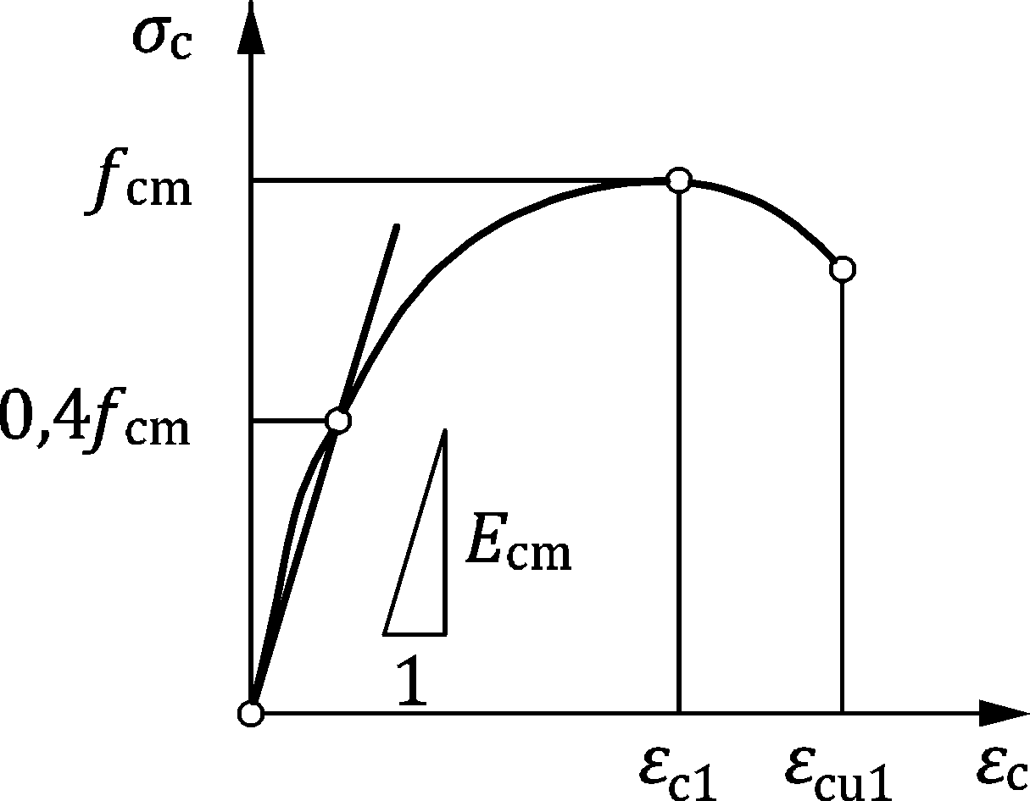

**Figure 5.1 — Stress-strain relation for concrete in compression**

(5) Unless more precise values are available, the mean density of normal weight reinforced concrete for the purposes of design may be taken as 2 500 kg/m³, and for plain normal weight concrete as 2 400 kg/m³.

(6) Unless more accurate information is available, the linear coefficient of thermal expansion αc,th may be taken equal to 10 ⋅ 10−6 °C−1.

## Reinforcing steel

### General

(1) The clauses in 5.2 give provisions for the following types of reinforcing steels suitable for design of concrete structures in accordance with this Eurocode:

* weldable ribbed and indented reinforcing steel, in the form of bars including de-coiled bars,
* weldable ribbed and indented reinforcing steel in the form of welded fabric and lattice girders.

NOTE Annex I gives information for assessment of existing structures with plain (smooth) bars. These rules can be used also for new structures, where plain shear or plain confinement reinforcement is used.

(2) The rules in this Eurocode may be used for bar diameters

* of ribbed reinforcement with ϕ ≤ 50 mm,
* indented reinforcement with ϕ ≤ 14 mm.

(3) The requirements for the properties of the reinforcement apply for the material as placed in the finished structure, and for service temperatures in the range from −40 °C to +100 °C. If workshop processing or site operations can affect the properties of the reinforcement, then those properties shall be verified after such operations.

(4) Steels used for structures designed in accordance with this Eurocode shall comply with EN 10080 for carbon reinforcing steel.

NOTE 1 For requirements for reinforcing steel material according to steel classes see C.4. For additional or modified rules for stainless reinforcing steel see Annex Q.

NOTE 2 As long as the harmonized product standards EN 10080 and prEN 10370 are not published, a National Annex can refer to other technical specifications, e.g. national product standards for reinforcing steel.

NOTE 3 For other reinforcing steel products which are to be used with Eurocode 2, a National Annex can give additional or modified design and detailing rules referring to relevant technical product specifications and national practice.

### Properties

(1) Specified properties of reinforcing steel that are required for design to this Eurocode shall include at least:

* strength class in accordance with Table 5.4 and Table C.1,
* ductility class in accordance with Table 5.5 and Table C.2,
* diameter or size,
* execution class in accordance with EN 13670.

(2) The following properties of reinforcing steel may be derived in accordance with the provisions of 5.2.2:

* yield strength fyk or f0,2k,
* stress ratio (ft/fy)k,
* elongation at maximum load εuk,
* S-N curves for fatigue, see Annex E.

(3) Reinforcing steel suitable for design of concrete structures in accordance with this Eurocode shall satisfy the requirements of C.4.

(4) Reinforcing steel shall be clearly identifiable with respect to strength and ductility class according to Tables 5.4 and 5.5. For requirements to classify steel products based on declared properties see C.4.

Table 5.4 — Strength classes of reinforcing steel

| Properties for stress-strain-diagram (Fig. 5.2) | Reinforcing steel strength class | | | | | |
| --- | --- | --- | --- | --- | --- | --- |
| B400 | B450 | B500 | B550 | B600 | B700 |
| characteristic value fyk [MPa] | 400 | 450 | 500 | 550 | 600 | 700 |
| NOTE All strength classes apply unless a National Annex excludes specific classes. Intermediate strength classes can be used, if included in a National Annex. | | | | | | |

Table 5.5 — Ductility classes of reinforcing steel

| Properties for stress-strain-diagram (Fig. 5.2) | Reinforcing steel ductility class | | |
| --- | --- | --- | --- |
| A | B | C |
| Characteristic value of k = (ft/fy)k | 1,05 | 1,08 | 1,15 to 1,35 |
| Characteristic strain at maximum force εuk | 2,5 % | 5,0 % | 7,5 % |

### Welding of reinforcing bars

(1) Welding of reinforcing bars shall be designed and detailed, and welds shall be specified in the execution specification.

(2) When the loading is predominantly static, the welding shall be carried out in accordance with EN ISO 17660.

(3) When the loading is not predominantly static, or where fatigue is considered, the welds shall be designed and detailed in compliance with prEN 1993 (all parts).

NOTE Further provisions regarding welding of reinforcement can be given in a National Annex.

### Design assumptions

(1) Design should be based on the nominal cross section area of the reinforcement and the design values derived from the characteristic values given in 5.2.2 with:

|  |  |
| --- | --- |
| fyd = fyk/γS and fyd = f0,2k/γS, respectively | (5.11) |

(2) For design either of the following assumptions may be made (see Figure 5.2):

1. an inclined post-elastic branch with a strain limit of εud ≤ 0,9εuk and a maximum stress of k ⋅ fyk/γS at εuk, where k = (ft/fy)k;
2. a horizontal post-elastic branch without strain limit.

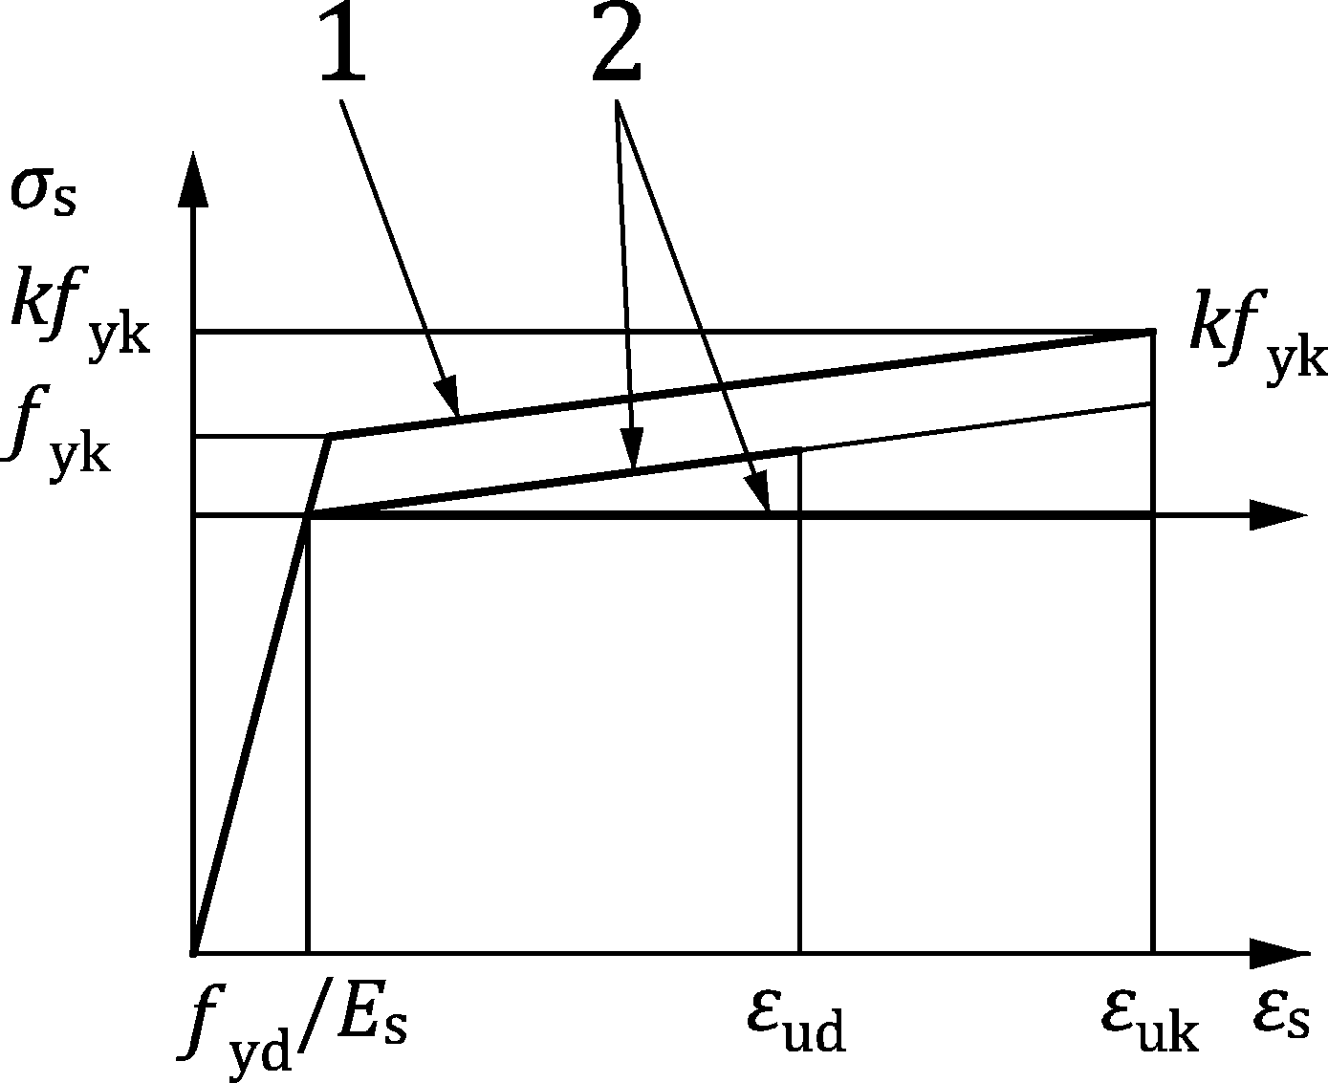

Key

|  |  |
| --- | --- |
| 1 | nominal diagram for reference |
| 2 | design diagrams |

Figure 5.2 — Stress-strain diagrams for reinforcing steel (for tension and compression)

(3) The design value of the modulus of elasticity Es may be assumed to be 200 000 MPa for weldable reinforcing steel, unless more precise values are known.

(4) The mean density of reinforcing steel for the purposes of design may be taken as 7 850 kg/m3.

(5) The coefficient of thermal expansion αs,th may be taken as 10 ⋅ 10−6 °C−1 for weldable reinforcing steel, unless more precise values are known.

### Reinforcement bar couplers

(1) Couplers for splicing of reinforcing bars shall be capable of developing the static strength and ductility of the spliced reinforcement.

(2) Couplers meeting the requirements of C.6 may be assumed to satisfy the requirement of (1).

### Headed bars for reinforcement

(1) Anchor heads of headed bars shall be capable of developing the strength and ductility of the reinforcing bar when tested, and the anchor head shall be fixed to the reinforcing bar in a way that can be demonstrated to provide adequate robustness.

(2) Headed bars meeting the requirements of C.7 for the appropriate category may be assumed to satisfy the requirements of (1).

## Prestressing steel

### General

(1) The clauses in 5.3 give provisions for prestressing steel in the form of wires, strands and bars suitable for design of concrete structures in accordance with this Eurocode.

(2) The requirements for the properties of the prestressing steel apply for the material as placed in the finished structure and for service temperatures in the range of −40 °C to +100 °C except for relaxation as noted in Table 5.6.

(3) Prestressing steel used for structures designed in accordance with this Eurocode shall comply with prEN 10138 (all parts) (see C.5).

NOTE As long as the harmonized product standard prEN 10138 (all parts) is not published, a National Annex can refer to other technical specifications, e.g. national product standards for prestressing steel.

### Properties

(1) Specified properties of prestressing steel that are required for design to this Eurocode shall include at least:

* strength class in accordance with Table 5.6,
* product type wire, strand or bar,
* diameter or size,
* execution class in accordance with EN 13670.

(2) The following properties of prestressing steel may be derived in accordance with the provisions of 5.3:

* 0,1 % proof stress fp0,1k,
* Tensile strength fpk,
* Stress ratio (fpk/fp0,1k),
* Elongation at maximum load εuk,
* S-N curves for fatigue, see Annex E.

Table 5.6 — Strength classes of prestressing steel

| Properties in stress-strain-diagram (Fig. 5.3) (characteristic values) | (a) Wiresa | | | |
| --- | --- | --- | --- | --- |
| Y1570 | Y1670 | Y1770 | Y1860 |
| proof stress fp0,1k [MPa] | 1380 | 1470 | 1550 | 1650 |
| tensile strength fpk [MPa] | 1570 | 1670 | 1770 | 1860 |
|  | (b) Strandsa | | | |
| Y1770 | Y1860 | Y1960 | Y2060 |
| proof stress fp0,1k [MPa] | 1550 | 1650 | 1740 | 1810 |
| tensile strength fpk [MPa] | 1770 | 1860 | 1960 | 2060 |
|  | (c) Barsa | | | |
| Y1030 | Y1050 | Y1100 | Y1230 |
| proof stress fp0,1k [MPa] | 830 | 950 | 890 | 1080 |
| tensile strength fpk [MPa] | 1030 | 1050 | 1100 | 1230 |
| NOTE 1 All strength classes apply unless a National Annex excludes specific classes. Intermediate strength classes can be used, if included in a National Annex.  NOTE 2 For requirements to classify steel products see C.5. | | | | |
| a In all strength classes, ductility value of k = (fpk/fp0,1k) = 1,1 and characteristic strain at maximum force εuk = 3,5 %. | | | | |

(3) Prestressing steel suitable for design of concrete structures in accordance with this Eurocode shall satisfy the requirements of C.5.

(4) More accurate information based on production data of the prestressing steel may be used in design such as e.g. stress-strain diagrams, modulus of elasticity and isothermal stress relaxation.

### Design assumptions

(1) Design should be based on the nominal cross section area of the prestressing steel and the design values derived from the characteristic values given in 5.3.2 with:

|  |  |
| --- | --- |
| fpd = fp0,1k/γS | (5.12) |

(2) For design, either of the following assumptions may be made (see Figure 5.3):

1. an inclined post-elastic branch, with a strain limit εud ≤ 0,9εuk and a maximum stress of fpk/γS at εuk.
2. or a horizontal post-elastic branch without strain limit.

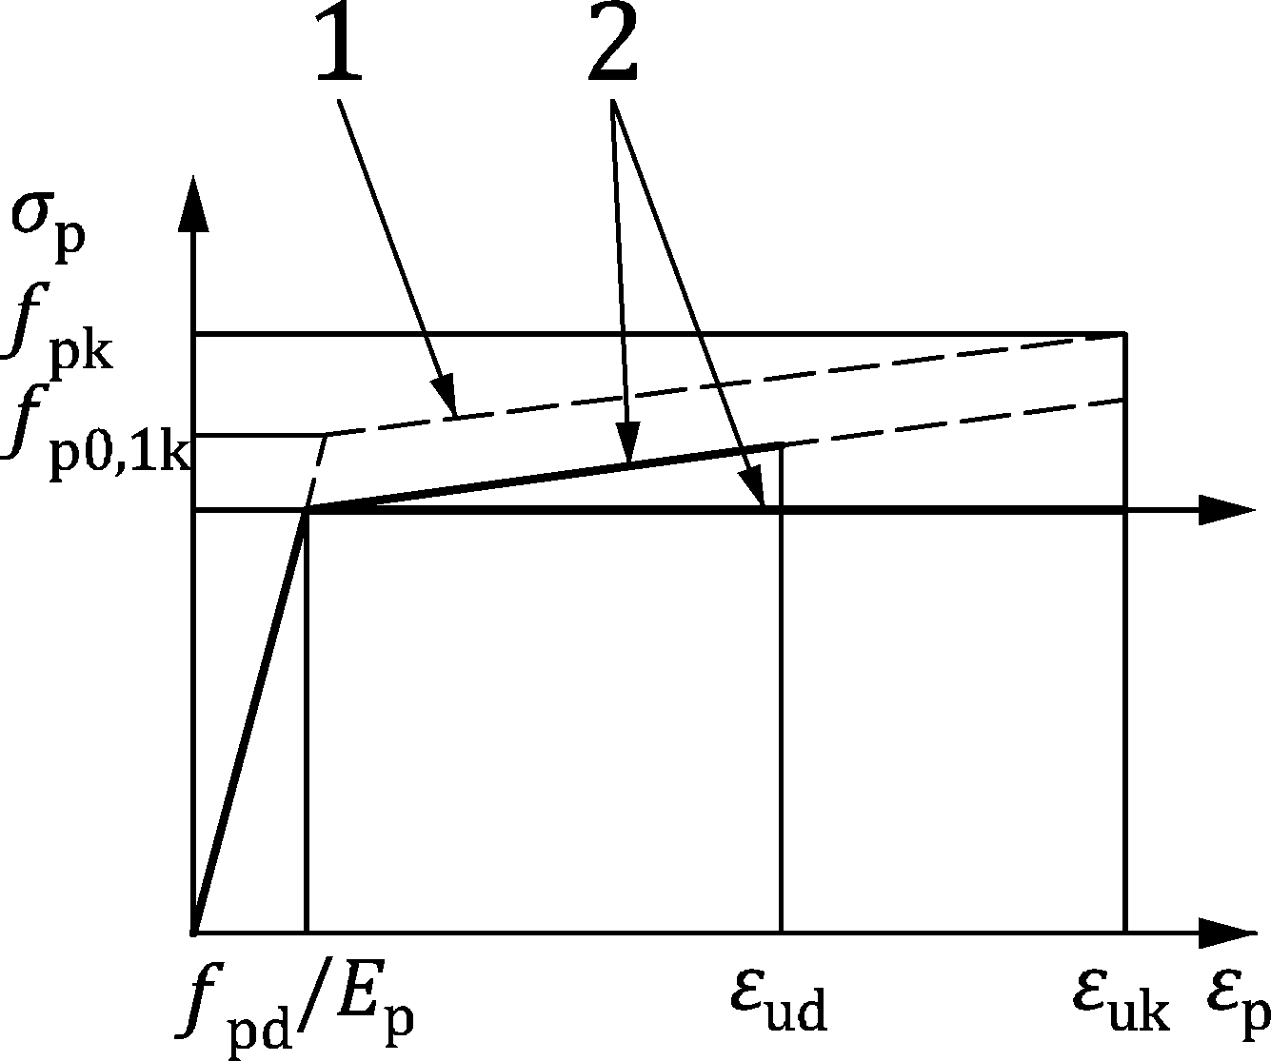

Key

|  |  |
| --- | --- |
| 1 | nominal diagram for reference |
| 2 | design diagrams |

Figure 5.3 — Stress-strain diagrams for prestressing steel (only tension)

(3) The design value for the modulus of elasticity Ep may be assumed to be 200 000 MPa. If more accurate values are required, values from test certificates should be used.

NOTE The actual value of the E-modulus for wires is 205 000 MPa. For strands it can range from 190 000 MPa to 200 000 MPa, depending on the manufacturing process and the geometrical configuration of the prestressing steel. For bars, the modulus is 205 000 MPa however, the secant modulus between 0 and 0,7fpk. may be as low as 170 000 MPa depending on the manufacturing process.

(4) The mean density of prestressing steel for the purposes of design may be taken as 7 850 kg/m³.

(5) The coefficient of thermal expansion αs,th may be taken as 10 ⋅ 10−6 °C−1 for prestressing steel unless more precise values are known.

(6) The relaxation loss may be obtained either from Table B.4 or from the manufacturer’s test certificates adapted for the effects of initial stress and time in accordance with Annex B.

## Prestressing systems

### General

(1) Prestressing systems including tendon anchorage assemblies and tendon coupler assemblies suitable for design of concrete structures in accordance with this Eurocode should have resistance to static load and elongation, resistance to fatigue and load transfer to structure characteristics in accordance with the European Assessment Document EAD 160004‑00‑0301.

(2) As a minimum the following information shall be provided in the technical documentation of the post-tensioning systems as basis for the design of concrete structures in accordance with this Eurocode:

* product type and properties of prestressing steel,
* types of applications of tendons,
* types and dimensions of ducts, anchorages and tendon couplers,
* arrangement and detailing of tendon supports,
* minimum spacing and edge distances of anchorages and tendon couplers with corresponding local anchorage zone reinforcement as a function of concrete strength,
* minimum radii of tendon curvature,
* friction coefficients,
* anchorage seating,
* details for corrosion protection as a function of the tendon protection level.

(3) Prestressing tendons shall be adequately and permanently protected against corrosion along the tendon length and at anchorages.

(4) Internal bonded post-tensioning tendons may be provided with different levels of corrosion protection:

* Protection Level 1: Tendon grouted within a metal duct.
* Protection Level 2: Tendon fully encapsulayed within a grouted polymer duct and anchorage caps.
* Protection Level 3: Tendon fully encapsulated within a grouted polymer duct and anchorage caps and encapsulation monitorable with electrical resistance measurement or equivalent methods.

NOTE Guidance for the assessment of tendon protection levels and polymer ducts can be found in fib Bulletin 75.

### Anchorage zones

(1) The strength of the anchorage and coupling devices and anchorage zones shall be sufficient for the transfer of the tendon force to the concrete. The formation of cracks in the anchorage zones shall not impair the function of the anchorage and coupling device. These requirements may be assumed to be complied with if:

* Detailing of the local anchorage zones is in accordance with the technical documentation of a post-tensioning system which complies with 5.4.1(1),
* Design and detailing of the general anchorage zones is in accordance with 11.6.4.

# Durability

## General

(1) A durable structure shall meet the requirements of serviceability, strength and stability throughout its design service life, without significant loss of utility, with anticipated maintenance but without major repair being necessary, in line with the general requirements of prEN 1990.

(2) The required protection against deterioration of the structure shall be established by considering environmental conditions, intended use, design service life, maintenance programme and actions.

(3) Concrete structures complying with the provisions of this standard, EN 206 and EN 13670 are assumed to be sufficiently durable. Requirements for durability should be considered in addition to SLS and ULS.

NOTE 1 For the purpose of assessing durability, end of design service life is considered to have been reached when there is corrosion attack in the reinforcement and/or loss of concrete thickness or strength of the structural element, to an extent that impairs its performance.

NOTE 2 Corrosion attack can be judged by loss of bar diameter in the case of carbonation attack and pitting depth in the reinforcement in the case of chloride attack.

(4) The possible significance of direct and indirect actions (like temperature, shrinkage and creep) environmental conditions and consequential effects shall be considered.

(5) Corrosion protection of steel reinforcement depends on quality, thickness and extent of cracking of the concrete in the cover zone.

(6) Where metal fastenings are not fully embedded in concrete, they should be of corrosion resistant material. Where it is possible to inspect and replace or repair them, fastenings with protective coating may be used in exposed conditions.

(7) Further requirements to those given in this Clause should be considered for special situations (e.g. for structures of temporary or monumental nature, structures subjected to extreme or unusual actions or extraordinary exposure conditions, etc.)

## Requirements for durability

(1) In order to achieve the required design service life of the structure, adequate measures shall be taken to protect each concrete member against the relevant environmental actions.

(2) The requirements for durability shall be considered at all stages, including:

* structural conception,
* material selection,
* construction details,
* execution,
* quality management,
* life-time maintenance.

(3) Where appropriate, special measures should be considered (e.g. coatings of concrete surface, cathodic protection, corrosion inhibitors or reinforcing steel with metallic or non-metallic coatings). For such situations, the effects on all relevant material properties and design parameters should be considered, including bond. For stainless steel, the provisions in Annex Q shall be used.

## Environmental exposure conditions

(1) The environmental exposure conditions are those chemical, physical and biological conditions to which the structure is exposed (additional to the mechanical actions). The exposure conditions can be different on the various faces or elevations of a concrete member, and consequently while the concrete shall meet the relevant requirements, the requirements for cover to the reinforcement and the limitation of cracking may be different.

(2) All relevant forms of attack on the structure shall be taken into account. The forms of attack include:

* Alkali-aggregate reaction (AAR),
* Biological attacks arising from e.g.:
* algae,
* vegetation,
* Chemical attacks arising from e.g. the use of the building or the structure (storage of liquids, etc.):
* acid solutions,
* soft water,
* sulfates,
* other chemicals,
* Delayed ettringite formation (DEF),
* Physical attack, arising from e.g.:
* abrasion,
* temperature change (including freeze/thaw),
* water penetration,
* Reinforcement corrosion due to carbonation or chlorides ingress,
* Reinforcement corrosion due to chlorides present in the mix,
* Stress corrosion cracking,
* Thaumasite formation.

(3) Table 6.1 defines Exposure Classes X for the most common environmental exposure conditions.

NOTE Guidance for the selection of the exposure classes (e.g. the duration of the exposure, limits for RH in the XC classes or limits for the chloride contents in the XD and XS classes as well as classification of the freeze/thaw climate in the XF classes) can be found in the place of use of the concrete, based on local geographical and climatic conditions, the way of life and levels of protection at national level.

Table 6.1 — Exposure classes related to environmental conditions

| Class | Description of the environment | Informative examples where exposure classes may occur (NDP) |
| --- | --- | --- |
| **1. No risk of corrosion or attack** | | |
| For concrete without reinforcement or embedded metal: | | |
| X0 | All exposures except where there is freeze/thaw, abrasion or chemical attack. | Pure concrete members without any reinforcement. |
| **2. Corrosion of embedded metal induced by carbonation** | | |
| Where concrete containing steel reinforcement or other embedded metal is exposed to air and moisture, the exposure shall be classified as follows: | | |
| XC1 | Dry | Concrete inside buildings with low air humidity, where the corrosion rate will be insignificant. |
| XC2 | Wet or permanent high humidity, rarely dry | Concrete surfaces subject to long-term water contact or permanently submerged in water or permanently exposed to high humidity;  many foundations; water containments (not external).  NOTE 1 Leaching could also cause corrosion (see (5), XA classes). |
| XC3 | Moderate humidity | Concrete inside buildings with moderate humidity and not permanent high humidity;  External concrete sheltered from rain. |
| XC4 | Cyclic wet and dry | Concrete surfaces subject to cyclic water contact (e.g. external concrete not sheltered from rain as walls and facades). |
| **3. Corrosion of embedded metal induced by chlorides** | | |
| Where concrete containing steel reinforcement or other embedded metal is subject to contact with water containing chlorides, including de-icing salts, from sources other than from sea water, the exposure shall be classified as follows: | | |
| XD1 | Moderate humidity | Concrete surfaces exposed to airborne chlorides. |
| XD2 | Wet, rarely dry | Swimming pools;  Concrete components exposed to industrial waters containing chlorides.  NOTE 2 If the chloride content of the water is sufficiently low then XD1 applies. |
| XD3 | Cyclic wet and dry | Parts of bridges exposed to water containing chlorides;  Concrete roads, pavements and car park slabs in areas where de-icing agents are frequently used. |
| **4. Corrosion of embedded metal induced by chlorides from sea water** | | |
| Where concrete containing steel reinforcement or other embedded metal is subject to contact with chlorides from sea water or air carrying salt originating from sea water, the exposure shall be classified as follows: | | |
| XS1 | Exposed to airborne salt but not in direct contact with sea water | Structures near to or on the coast. |
| XS2 | Permanently submerged | Parts of marine structures and structures in seawater. |
| XS3 | Tidal, splash and spray zones | Parts of marine structures and structures temporarily or permanently directly over sea water. |
| **5. Freeze/Thaw Attack** | | |
| Where concrete is exposed to significant attack by freeze/thaw cycles whilst wet, the exposure shall be classified as follows. A XF-classification is not necessary in cases where freeze/thaw cycles are rare. | | |
| XF1 | Moderate water saturation, without de-icing agent | Vertical concrete surfaces exposed to rain and freezing. |
| XF2 | Moderate water saturation, with de-icing agent | Vertical concrete surfaces of road structures exposed to freezing and airborne de-icing agents. |
| XF3 | High water saturation, without de-icing agents | Horizontal concrete surfaces exposed to rain and freezing. |
| XF4 | High water saturation with de-icing agents or sea water | Road and bridge decks exposed to de-icing agents;  concrete surfaces exposed to direct spray containing de-icing agents and freezing;  splash zone of marine structures exposed to freezing. |
| **6. Chemical attack** | | |
| Where concrete is exposed to chemical attack from natural soils and ground water, the exposure shall be classified as follows: | | |
| XA1 | Slightly aggressive chemical environment | Natural soils and ground water according to Table 6.2. |
| XA2 | Moderately aggressive chemical environment | Natural soils and ground water according to Table 6.2. |
| XA3 | Highly aggressive chemical environment | Natural soils and ground water according to Table 6.2. |
| **7. Mechanical attack of concrete by abrasion** | | |
| Where concrete is exposed to mechanical abrasion, the exposure shall be classified as follows: | | |
| XM1 | Moderate abrasion | Members of industrial sites frequented by vehicles with pneumatic tyres. |
| XM2 | Heavy abrasion | Members of industrial sites frequented by fork lifts with pneumatic or solid rubber tyres. |
| XM3 | Extreme abrasion | Members of industrial sites frequented by fork lifts with elastomer or steel tyres or track vehicles. |
| NOTE 3 A National Annex can give different or additional informative examples in Table 6.1. | | |

(4) In addition to the exposure conditions in Table 6.1, the other particular forms of aggressive or indirect action according to (2) shall be considered.

(5) Classification of the exposure with respect to natural chemical attack from the soil and ground water shall refer to Table 6.2, the validity of which is ensured in the case of natural soil and ground water at water/-soil temperatures between 5 °C and 25 °C and a water velocity sufficiently slow to approximate to static conditions. The most onerous value for any single chemical characteristic determines the class. Where two or more aggressive characteristics lead to the same class, the environment shall be classified into the next higher class, unless a special study for this specific case proves that it is not necessary.

(6) In the case of chemical attack, a special study may be needed to establish the relevant exposure conditions and appropriate protective measures, where there is:

* values outside the limiting values of Table 6.2,
* leaching, e.g. due to long-term contact to (soft) water or other liquids (see also XC2),
* other aggressive chemicals,
* chemically polluted ground or water,
* high water velocity in combination with the chemicals in Table 6.2.

Table 6.2 — Limiting values for exposure classes for chemical attack from natural soil and ground water

|  |  |  |  |  |
| --- | --- | --- | --- | --- |
| Chemical characteristic | Reference test method | XA1 | XA2 | XA3 |
| **Groundwater** | | | | |
| SO42− [mg/l] | EN 196‑2 | ≥ 200 and ≤ 600 | > 600 and ≤ 3 000 | > 3 000 and ≤ 6 000 |
| pH | ISO 4316 | ≤ 6,5 and ≥ 5,5 | < 5,5 and ≥ 4,5 | < 4,5 and ≥ 4,0 |
| CO2 [mg/l] | EN 13577 | ≥ 15 and ≤ 40 | > 40 and ≤ 100 | > 100 up to saturation |
| NH4+ [mg/l] | ISO 7150‑1 | ≥ 15 and ≤ 30 | > 30 and ≤ 60 | > 60 and ≤ 100 |
| Mg2+ [mg/l] | EN ISO 7980 | ≥ 300 and ≤ 1 000 | > 1 000 and ≤ 3 000 | > 3 000 up to saturation |
| **Soil** | | | | |
| SO42− [mg/kg]a total | EN 196‑2b | ≥ 2 000 and ≤ 3 000c | > 3 000c and ≤ 12 000 | > 12 000 and ≤ 24 000 |
| Acidity according to Baumann Gully [ml/kg] | EN 16502 | > 200 | Not encountered in practice | |
| a Clay soils with a permeability below 10−5 m/s may be moved into a lower class.  b The test method prescribes the extraction of SO42− by hydrochloric acid; alternatively, water extraction may be used, if experience is available in the place of use of the concrete.  c The 3 000 mg/kg limit shall be reduced to 2 000 mg/kg, where there is a risk of accumulation of sulfate ions in the concrete due to drying and wetting cycles or capillary suction. | | | | |

## Exposure resistance classes

(1) Exposure resistance classes ERC should be used to classify concrete with respect to resistance against corrosion induced by carbonation (class XRC) or by chlorides (class XRSD) and damage caused by freeze/thaw attack (XRF). Selection of concrete to resist deterioration and protect against corrosion for all those exposure classes (EC) that are relevant, should be based on the exposure resistance classes given in EN 206.

NOTE 1 As specified in EN 206, complemented by the provisions valid in the place of use, the ERC may be satisfied by compliance with relevant limiting values and/or, for some ERCs, by proving the performance in meeting specification of relevant physical characteristics determined using standardized test methods. In the event EN 206 does not refer to ERC, a National Annex or National Application Document to EN 206 can provide the necessary advice on how to implement ERC rules in a country.

NOTE 2 An informative Annex P provides an alternative approach to design cover for durability without use of Exposure Resistance Classes (ERC) based on EN 1992‑1‑1:2004. A National Annex can choose between use of ERC according to 6.4 or use of Annex P.

(2) The structural design should be based on a realistic strength class consistent with the required exposure resistance class ERC.

NOTE The composition of the concrete, e.g. the type of binder and the water-binder ratio, affects both the protection of the reinforcement and the resistance of the concrete to attack and may lead to the choice of higher strength classes than required for the structural design.

(3) Adequate durability may be assumed against corrosion caused by carbonation or chloride ingress where cover to reinforcement is selected appropriate to the exposure class, exposure resistance class and the design service life and not less than the minimum cover for durability cmin,dur given in Table 6.3(NDP) and Table 6.4(NDP).

(4) Concrete shall be specified with a maximum permitted chloride content in accordance with the chloride content classes (Cl) in EN 206.

(5) Concrete to resist freeze-thaw attack shall be specified using XRF classes according to EN 206.

(6) Adequate durability against chemical attack may be assumed when concrete with a composition documented to be resistant against the potential deterioration mechanisms for the intended design service life is used. Otherwise additional protective measures should be taken, such as linings or durable/replaceable coating.

NOTE Rules on concrete composition to resist the chemical attacks detailed in Table 6.2 are given in EN 206.

(7) Adequate durability against mechanical attack may be assumed when concrete with a composition documented to be resistant against the potential abrasion for the intended design service life is used. Otherwise additional protective measures should be taken, such as sacrificial layers according to 6.5.2.2(6).

NOTE Rules on concrete composition to resist the mechanical attacks detailed in Table 6.2 may be given in EN 206 or in its national application document.

## Concrete cover

### Nominal cover

(1) The nominal cover shall be specified on the execution specification. It is defined as a minimum cover, cmin (see 6.5.2), plus an allowance in design for deviation, Δcdev (see 6.5.3):

|  |  |
| --- | --- |
| cnom = cmin + Δcdev | (6.1) |

(2) Sufficient concrete cover shall be provided in order to ensure:

* the safe transmission of bond forces,
* the protection of the steel against corrosion (durability),
* an adequate fire resistance (see prEN 1992‑1‑2, where axis distance is used).

(3) For bored piles and for diaphragm walls the nominal cover values for durability and bond of this Eurocode apply. The cover values according EN 1536 and EN 1538 considering the type and deviations of execution should be checked additionally. The largest value according to this Eurocode and EN 1536 or EN 1538 applies.

### Minimum cover

#### General

(1) The value for cmin shall satisfy the requirements for both bond and durability:

|  |  |
| --- | --- |
| cmin = max {cmin,dur − Δcdur,red + Δcdur,abr; cmin,b; 10 mm} | (6.2) |

where

|  |  |
| --- | --- |
| cmin,dur | minimum cover required for environmental conditions, see 6.5.2.2; |
| ∆cdur,red | eduction of minimum cover for use of additional concrete protection or use of special measures for protection of reinforcing steel, see 6.5.2.2(5) and 6.5.2.2(10) |
| ∆cdur,abr | additional minimum cover for abrasion, see 6.5.2.2(6); |
| cmin,b | minimum cover for bond requirement, see 6.5.2.3. |

(2) For concrete cast directly against soil surface, the minimum cover should be increased by ∆cmin considering the increased uncertainty and variability of concrete and the reduced compaction against soil.

NOTE Unless a National Annex gives other values the following values can be used:

∆cmin = +5 mm for casting against a lateral soil surface, ∆cmin = 0 mm for a horizontal soil ground surface.

(3) Minimum cover to post-installed reinforcing bars with respect to the transfer of bond forces and durability is given in 6.5.2 and with respect to drilling and installation in 11.4.8(3).

#### Minimum cover for durability

(1) The minimum concrete covers cmin,dur dependent on design service life, exposure class and exposure resistance class (ERC) are given in Table 6.3(NDP) and Table 6.4(NDP).

NOTE 1 The recommended minimum covers apply unless a National Annex gives other values.

NOTE 2 Additional and intermediate or a selection of exposure resistance classes can be applied according to a National Annex with correspondingly adjusted minimum cover for durability, provided they are based on the same methodology and give protection against deterioration consistent with that inherent in Table 6.3(NDP) and Table (6.4(NDP).

Table 6.3(NDP) — Minimum concrete cover cmin,dur for carbon steel — Carbonation

| ERC | Exposure class (carbonation) | | | | | | | |
| --- | --- | --- | --- | --- | --- | --- | --- | --- |
| XC1 | | XC2 | | XC3 | | XC4 | |
| Design service life (years) | | | | | | | |
| 50 | 100 | 50 | 100 | 50 | 100 | 50 | 100 |
| **XRC 0,5** | **10** | 10 | **10** | 10 | **10** | 10 | **10** | 10 |
| **XRC 1** | **10** | 10 | **10** | 10 | **10** | 15 | **10** | 15 |
| **XRC 2** | **10** | 15 | **10** | 15 | **15** | 25 | **15** | 25 |
| **XRC 3** | **10** | 15 | **15** | 20 | **20** | 30 | **20** | 30 |
| **XRC 4** | **10** | 20 | **15** | 25 | **25** | 35 | **25** | 40 |
| **XRC 5** | **15** | 25 | **20** | 30 | **25** | 45 | **30** | 45 |
| **XRC 6** | **15** | 25 | **25** | 35 | **35** | 55 | **40** | 55 |
| **XRC 7** | **15** | 30 | **25** | 40 | **40** | 60 | **45** | 60 |
| NOTE 1 The designation of XRC classes for resistance against corrosion induced by carbonation is derived from the carbonation depth [mm] (characteristic value 90 % fractile) assumed to be obtained after 50 years under reference conditions (400 ppm CO2 in a constant 65 %-RH environment and at 20 °C). XRC has the dimension of a carbonation rate [mm/√(years)].  NOTE 2 The recommended minimum concrete cover values cmin,dur assume execution and curing according to EN 13670 with at least Execution Class 2 and Curing Class 2.  NOTE 3 The minimum covers can be increased by an additional safety element ∆cdur,γ considering special requirements (e.g. more extreme environmental conditions). | | | | | | | | |

Table 6.4(NDP) — Minimum concrete cover cmin,dur for carbon steel — Chlorides

| ERC | Exposure class (chlorides) | | | | | | | | | | | |
| --- | --- | --- | --- | --- | --- | --- | --- | --- | --- | --- | --- | --- |
| XS1 | | XS2 | | XS3 | | XD1 | | XD2 | | XD3 | |
| Design service life (years) | | | | | | Design service life (years) | | | | | |
| 50 | 100 | 50 | 100 | 50 | 100 | 50 | 100 | 50 | 100 | 50 | 100 |
| **XRDS 0,5** | **20** | 20 | **20** | 30 | **30** | 40 | **20** | 20 | **20** | 30 | **30** | 40 |
| **XRDS 1** | **20** | 25 | **25** | 35 | **35** | 45 | **20** | 25 | **25** | 35 | **35** | 45 |
| **XRDS 1,5** | **25** | 30 | **30** | 40 | **40** | 50 | **25** | 30 | **30** | 40 | **40** | 50 |
| **XRDS 2** | **25** | 30 | **35** | 45 | **45** | 55 | **25** | 30 | **35** | 45 | **45** | 55 |
| **XRDS 3** | **30** | 35 | **40** | 50 | **55** | 65 | **30** | 35 | **40** | 50 | **55** | 65 |
| **XRDS 4** | **30** | 40 | **50** | 60 | **60** | 80 | **30** | 40 | **50** | 60 | **60** | 80 |
| **XRDS 5** | **35** | 45 | **60** | 70 | **70** | — | **35** | 45 | **60** | 70 | **70** | — |
| **XRDS 6** | **40** | 50 | **65** | 80 | — | — | **40** | 50 | **65** | 80 | — | — |
| **XRDS 8** | **45** | 55 | **75** | — | — | — | **45** | 55 | **75** | — | — | — |
| **XRDS 10** | **50** | 65 | **80** | — | — | — | **50** | 65 | **80** | — | — | — |
| NOTE 1 The designation of XRDS classes for resistance against corrosion induced by chloride ingress is derived from the depth of chlorides penetration [mm] (characteristic value 90 % fractile), corres-ponding to a reference chlorides concentration (0,6 % by mass of bindercement + type II additions), assumed to be obtained after 50 years on a concrete exposed to one-sided penetration of reference seawater (30 g/l NaCl) at 20 °C. XRDS has the dimension of a diffusion coefficient [10−13 m²/s].  NOTE 2 The recommended minimum concrete cover values cmin,dur assume execution and curing according to EN 13670 with at least Execution Class 2 and Curing Class 2.  NOTE 3 The minimum covers can be increased by an additional safety element ∆cdur,γ considering special requirements (e. g. more extreme environmental conditions). | | | | | | | | | | | | |

(2) For temporary structures or for structures with a design service life of 30 years or less, cmin,dur for a design service life of 50 years according to Table 6.3(NDP) and Table 6.4(NDP) may be reduced by −Δcmin,30.

NOTE The reduction of the cover is −Δcmin,30 ≤ 5 mm unless a National Annex gives a different value.

(3) The values of cmin,dur given in Table 6.3(NDP) and Table 6.4(NDP) may be reduced −Δcmin,exc under the following conditions:

(i) superior compaction of concrete can be ensured by geometrical characteristics, placement and curing (e.g. members with slab geometry with positions of reinforcement not affected by construction process);

(ii) or curing complies with at least curing Class 3 of EN 13670.

NOTE The reduction of the cover is –Δcmin,exc ≤ 5 mm unless a National Annex gives a different value.

(4) For prestressing tendons, pre- or post-tensioned, the cover values in Table 6.3(NDP) and Table 6.4(NDP) should be increased by +10 mm, except where the internal bonded post-tensioning systems are provided with protection level 2 or 3 according to 5.4.1, and internal unbonded prestressing tendons are encased in corrosion resistant sheaths.

(5) Where the concrete is provided with an additional protection (e.g. surface coating) the minimum cover may be reduced by Δcdur,red. The value to be used shall be established based on experience or testing in line with provisions valid in the project.

NOTE The reduction of the cover is Δcdur,red ≤ 10 mm, unless a National Annex gives a different value.

(6) For concrete abrasion according to XM classes according to Table 6.1, special attention should be given on the requirements to concrete mixes in EN 206. Optionally concrete abrasion may be allowed for by increasing the concrete cover (sacrificial layer) with ∆cdur,abr.

NOTE The following values of ∆cdur,abr as optional sacrificial layer apply, unless a National Annex gives different values:

* for XM1: ∆cdur,abr = +5 mm,
* for XM2: ∆cdur,abr = +10 mm,
* for XM3: ∆cdur,abr = +15 mm.

(7) For concrete surfaces subjected to abrasion from moving objects like vehicles and wheels and not protected by asphalt, the selection of XM class and optionally increase of concrete cover for abrasion should be considered based on an assessment taking account of factors such as annual daily traffic load, type of traffic, use of studded tyres as well as the concrete composition.

NOTE Provisions for assessment of abrasion valid in a country can be given in a National Annex.

(8) Where in-situ concrete is placed against other concrete elements (precast or in-situ) the minimum concrete cover of the reinforcement to the interface may be reduced to a value corresponding to the requirement for bond provided that:

* the concrete strength is at least fck ≥ 25 MPa,
* the interface is rough see 8.2.6(6).

(9) Where concrete is exposed to freeze/thaw attack or chemical attack (classes XF and XA) in addition to classes XC, XD or XS, cover in accordance with Table 6.3(NDP), Table 6.4(NDP) and Table 6.5(NDP) may be considered sufficient.

(10) Where special measures according to 6.2(3) are taken, the minimum cover may be reduced by Δcdur,red. The value to be used shall be established based on experience or testing in line with provisions valid in the project.

NOTE The reduction of the cover Δcdur,red is given in a National Annex.

#### Minimum cover for bond

(1) In order to transmit bond forces safely and to ensure adequate compaction of the concrete, the minimum cover should not be less than cmin,b given in Tables 6.5 and 6.6.

NOTE 1 The minimum concrete cover values cmin,b assume execution and curing according to EN 13670 with at least Execution Class 2 and Curing Class 2.

NOTE 2 For minimum concrete cover values cmin,b of pre-tensioning tendons see 13.5.1, Table 13.1.

Table 6.5 — Minimum cover cmin,b for reinforcing steel

| Steel type | cmin,ba |
| --- | --- |
| Separated bars | Diameter of bar |
| Bundled bars | Equivalent diameter ϕb (see 11.4.3) |
| a Where the specified maximum aggregate size Dupper is > 32 mm, the minimum cover cmin,b should be increased by 5 mm. | |

Table 6.6 — Minimum cover cmin,b for post-tensioning ducts

| Duct type | cmin,b | |
| --- | --- | --- |
| with transverse reinforcementa | without transverse reinforcementa |
| circular duct | 0,5ϕduct ≤ 80 mm | 1,0ϕduct ≤ 80 mm |
| rectangular duct | ≥ max{a; b/3}b ≤ 80 mm | ≥ max{a; b/2}b ≤ 80 mm |
| a in cover  b where a ≤ b | | |

### Allowance in design for deviation

(1) To calculate the nominal cover cnom, an addition to the minimum cover cmin shall be made in design to allow for the deviation Δcdev which shall be taken as the absolute value of the accepted negative deviation specified in the execution specification, e.g. given on the construction drawings (see EN 13670). Values for Δcdev are given in Table 6.7(NDP).

NOTE Cases and values of Table 6.7(NDP) apply, unless a National Annex gives different cases and values.

Table 6.7(NDP) — Allowance for deviation Δcdev

|  | Case | Δcdev |
| --- | --- | --- |
| 1 | In general: for execution in Tolerance class 1 according to EN 13670 | 10 mm |
| 2 | For execution in Tolerance class 2 according to EN 13670 | 5 mm |
| 3 | Where fabrication is subjected to a quality assurance system, in which the systematic monitoring includes measurements of the cover | 5 mm |
| 4 | Where it can be assured that an accurate measurement device is used for systematic monitoring and non conforming members are rejected (e.g. precast elements) | 0 mm |
| 5 | For concrete members in exposure class XC1, where the risk of corrosion is insignificant | 5 mm |
| 6 | For concrete cast against surfaces with exposed aggregate (e.g. interfaces) | 5 mm |
| 7 | For concrete cast against unevenness due to formwork or excavation sheeting (e.g. ribbed finishes or architectural textures) | 10 mm + dimension of unevenness |
| 8 | Concrete cast against prepared ground (including uneven blinding layer)a | 40 mma |
| 9 | Concrete cast directly against unprepared soila | 75 mma |
| 10 | Post-installed reinforcing bars | 5 mm or according to project specification |
| a These allowances for deviation Δ*c*dev apply for the nominal cover according to this Eurocode also for bored piles and for diaphragm walls unless a National Annex gives other special values. | | |

# Structural analysis

## General

NOTE In Clause 7, compressive normal forces are considered with positive value.

(1) The purpose of structural analysis is to establish the distribution of either internal forces, or stresses, strains and displacements, over the whole or part of a structure.

(2) Analyses shall be carried out using idealisations of both the structure and its geometry (see 7.2) and the behaviour of the structure (see 7.3). The idealisations selected shall be appropriate to the problem being considered.

(3) The effect of the geometry and properties of the structure on its behaviour at each stage of construction shall be considered in the design.

(4) Common idealisations in behaviour of the structure used for analysis are:

* linear elastic behaviour (see 7.3.1),
* linear elastic behaviour with limited redistribution (see 7.3.2),
* plastic behaviour (see 7.3.3), including strut and tie models and stress field models (see 7.3.3.4),
* non-linear behaviour (see 7.3.4).

(5) Imperfections and second order effects shall be considered where they are significant (see 7.4).

(6) Structural analysis shall be performed consistently with the design. A specific stiffness (e.g. torsional) or restraint at supports (e.g. moment) may be reduced or neglected in the analysis for both ultimate and serviceability limit states if the member is designed consistently with these assumptions and the minimum reinforcement provisions for crack control and robustness are fulfilled.

(7) Local analyses may be necessary where the assumption that plane sections remain plane (linear strain distribution) is not valid.

NOTE Examples of such cases are:

* in the vicinity of supports,
* in the vicinity of concentrated loads,
* in beam-column intersections,
* in anchorage zones,
* at changes in cross section.

## Structural modelling for analysis

### Geometric imperfections

#### General

(1) The unfavourable effects of possible deviations in the geometry of the structure and the position of loads shall be considered in the analysis of members and structures.

(2) Deviations in cross section dimensions comply with tolerance class 1 of EN 13670 are considered in the partial factors for materials and generally may be neglected in structural analysis.

(3) Maximum deviations from theoretical geometry may be specified by the relevant authority or agreed for a specific project by the relevant parties. Where project specific execution specifications define stricter maximum deviations (e.g. when carrying out the assessment of an existing structure) as described in 7.2.1.2(1), the effect of imperfections should be based on these maximum deviations multiplied by 1,2.

(4) For members with an axial load, other than internal prestressing, imperfections and their effects shall be considered in ultimate limit states to determine the first order effects where relevant.

(5) Imperfections may be neglected for serviceability limit state.

#### Representation of imperfections

(1) The following provisions apply for members and structures with an axial load and execution deviations according to EN 13670. If project-specific execution specifications for maximum deviations apply, these provisions should be modified in accordance with 7.2.1.1(3).

(2) Imperfections may be represented by an inclination θi (see Figure 7.1), given by Formula (7.1):

|  |  |
| --- | --- |
| $$θ_{i}=α_{h}⋅α_{m}⋅\frac{1}{200}$$ | (7.1) |

where

|  |  |  |
| --- | --- | --- |
| αh | is the reduction coefficient for length or height: | |
|  | $$0,4 ≤α_{h}=\frac{2}{\sqrt{l}} ≤1,0;$$ | (7.2) |
| αm | is the reduction coefficient for the number of members: | |
|  | $$α_{m}=\sqrt{0,5 \left(1+\frac{1}{m}\right)};$$ | (7.3) |
| l | is the length or height [m], see (3); | |
| m | is the number of load bearing members in one section that bear a significant part of the vertical load and that, due to their inclination, contribute to the effect considered. | |

(3) In Formula (7.2) and (7.3), the values of l and m should be taken as follows, depending on the effect considered (see also Figure 7.1):

* effect on isolated member: l = actual length of member, m =1;
* effect on bracing system: l = height of the structure, m = number of vertical members between two adjacent levels contributing to the horizontal force on the bracing system;
* effect on intermediate or end diaphragms distributing the horizontal loads: l = storey height, m = number of vertical braced elements between tow adjacent levels contributing to the total horizontal force on the section.

(4) Alternatively (e.g. arches), the imperfection of the structural geometry may be determined from the governing buckling mode. Each mode shape may be idealized by a sinusoidal profile. The amplitude should be taken as ai = θi ⋅ law/2, where law is half of the wavelength.

(5) For isolated members, the effect of imperfections may be taken into account in two alternative ways:

1. For statically determined members, as an eccentricity ei given by

|  |  |
| --- | --- |
| $$e_{i}=θ_{i}⋅\frac{l_{0}}{2}$$ | (7.4) |

where l0 is the effective length.

For walls and isolated columns in braced systems, ei = l0/400 may always be used as a simplification, corresponding to αh = 1,0.

1. For both statically determinate and indeterminate members as a fictitious transverse force FH,i in the position that gives maximum moment:

for unbraced members (see Figure 7.1 a1)):

|  |  |
| --- | --- |
| $$F_{H,i}=θ_{i}⋅F_{V,i}$$ | (7.5) |

for braced members (see Figure 7.1 a2)):

|  |  |
| --- | --- |
| $$F_{H,i}=2⋅θ_{i}⋅F_{V,i}$$ | (7.6) |

where FV is the vertical load.

For walls and isolated columns in braced systems θi = 1/200 may always be used as a simplification, corresponding to αh = 1.

The force FH,i may be substituted by some other equivalent transverse action. Since the force FH,i is fictitious, it should not be added to the forces transmitted by the isolated member to other members of the structure.

|  |  |  |
| --- | --- | --- |
|  |  |  |
| a1) unbraced | a2) braced |  |
| a) Isolated members with eccentric axial force or lateral force | | |
|  |  |  |
| b) Bracing system  (*m*1 = 3 i.e. 2 columns plus 1 bracing wall) | c1) Intermediate diaphragm (*m*2 = number of columns in section; l = height between diaphragms) | c2) Top diaphragm (*m*2  = number of columns in section; l = height between diaphragms) |

**Key**

|  |  |
| --- | --- |
| *m*1 | 3 i.e. 2 columns plus 1 bracing wall |
| *m*2 | number of columns in section |
| l | height between diaphragms |

Figure 7.1 — Examples of the effect of geometric imperfections

(6) For structures, the effect of the inclination θi may be represented by the fictitious transverse forces, indicated in Formulae (7.7), (7.8) and (7.9), to be included in the analysis together with other actions. Equal and opposite forces should be applied at the level of foundations so that no reactions are transmitted to the foundations due to these fictitious forces.

Effect on bracing system (see Figure 7.1 b)):

|  |  |
| --- | --- |
| $$F_{H,i}=θ_{i}⋅\left(N_{b}-N_{a}\right)$$ | (7.7) |

The overall effect of geometrical imperfections may be addressed by designing the structure to take account of equivalent horizontal loads acting at the centroid of the individual intermediate diaphragms. In this case, the load is determined according to Formula (7.7) by replacing (Nb − Na) with the total vertical load acting on the actual intermediate diaphragm.

Effect on intermediate diaphragm (see Figure 7.1, c1)):

|  |  |
| --- | --- |
| $$F_{H,i}=θ_{i}⋅\left(N_{b}+N_{a}\right)/2$$ | (7.8) |

Effect on top diaphragm (see Figure 7.1, c2)):

|  |  |
| --- | --- |
| $$F_{H,i}=θ_{i}⋅N_{a}$$ | (7.9) |

where Na and Nb are axial forces contributing to FH,i.

In the determination of the first order internal forces due to the combination of actions in the persistent and transient or the accidental design situation the horizontal forces FH,i should be considered in the same load case as the corresponding axial force N.

### Idealisation of the structure

(1) The structure should be idealized with suitable models considering static and geometrical boundary conditions as well as the transfer of support reactions.

(2) Significant asymmetry in geometry or loading should be considered either by a 3D-model or by adjusted planar models.

(3) Interaction of soil and structure should be considered appropriately and consistently with 4.2.1.4. Non-linear behaviour in the soil-structure interaction should be considered.

(4) Ribbed or waffle or void enclosing slabs may be treated as solid members for the purposes of analysis, provided that the flange or structural topping and transverse ribs have sufficient torsional stiffness. This may be assumed provided that:

* the rib spacing does not exceed 1 500 mm,
* the depth of the rib below the flange does not exceed 4 times its width, or the space between voids,
* transverse ribs are provided at a clear spacing not exceeding 10 times the overall depth of the slab. This applies also to the biggest horizontal void dimension, and
* the flange thickness is at least 1/10 of the clear distance between ribs, the smallest horizontal void dimension or 50 mm, whichever is the greater. The minimum flange thickness of 50 mm may be reduced to 40 mm where permanent blocks are incorporated between the ribs.

(5) Where a beam or slab is monolithic with its supports, the critical design moment at the support may be taken as that at the face of the support. The design moment and reaction transferred to the supporting element (e.g. column, wall, etc.) should be generally taken as the greater of the elastic or redistributed values.

### Geometric data

(1) The effect of non-uniform stress distribution across wide flanges in T-beams should be considered at ULS where brittle behaviour may be expected and at SLS where relevant (stress limitations, deflections).

(2) In the absence of a more detailed analysis, the effective width of the flange may be calculated based on the distance l0b between points of zero moment. The length l0b may be obtained from Figure 7.2 if all of the following conditions are fulfilled:

* loading is predominantly uniform,
* the cross section is constant,
* the length of the cantilever, l3, is less than half the adjacent span and
* the ratio of adjacent spans lies between 2/3 and 1,5.

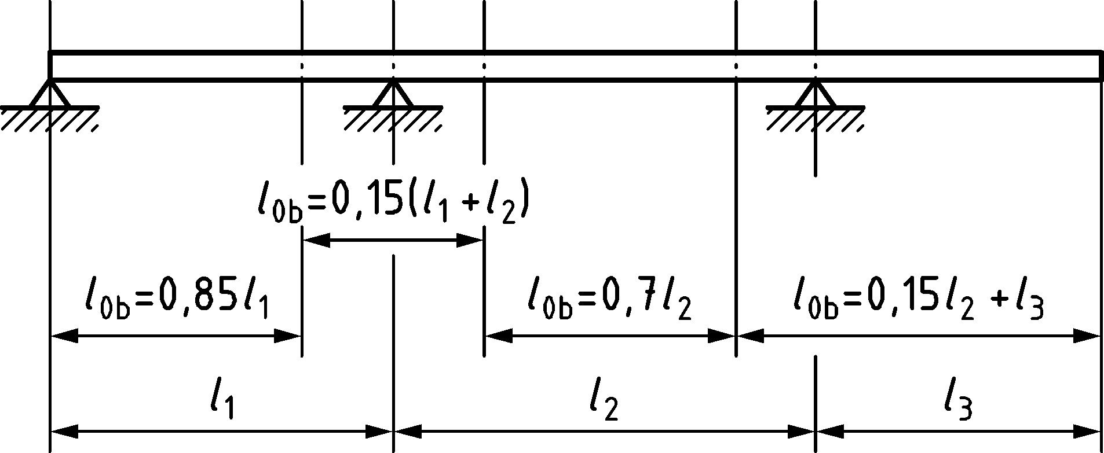

Figure 7.2 — Definition of l0b for calculation of effective flange width

(3) In the absence of a more detailed analysis, the effective flange width beff for a T beam or L beam may be derived as:

|  |  |
| --- | --- |
| $$b_{eff}=∑b_{eff,i}+b_{w}≤b$$ | (7.10) |

where

|  |  |
| --- | --- |
| $$b_{eff,i}=\text{min}\left\{{{0,2b}_{i}+0,1l}_{0b}; {0,2l}_{0b}; b_{i}\right\}$$ | (7.11) |

(for the notations see Figures 7.2 and 7.3)

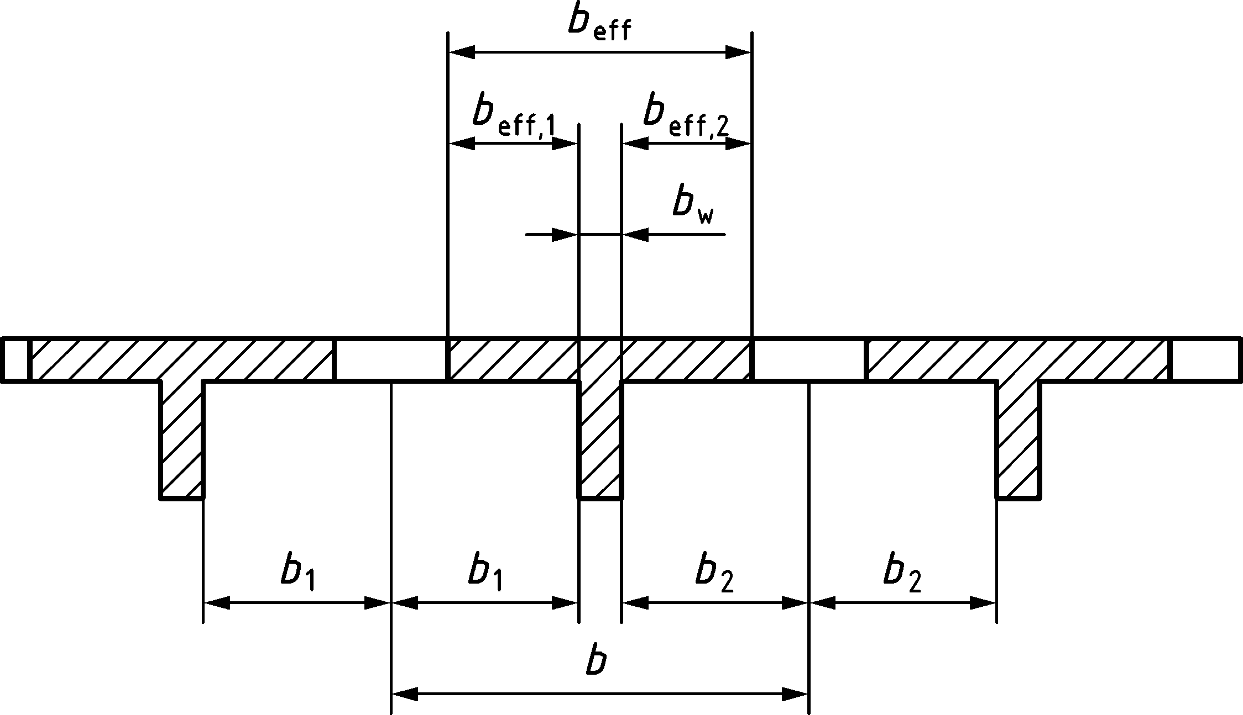

Figure 7.3 — Effective flange width parameters

(4) For structural analysis, where a great accuracy is not required, a constant width of the effective flange may be assumed over the whole span. In this case, the value applicable to the span section should be adopted.

(5) The span of a beam or slab should be the distance between centrelines of supporting members or bearings, in general. Reductions of this length may be permitted accounting for the support dimensions if the resulting eccentricities are accounted for in the design of supporting elements. Generally, the support reaction may be assumed to be distributed in a length equal to the minimum of the support width or the beam or slab height. For elastomeric bearings the stress should be assumed to be evenly distributed over the whole area of the support.

(6) Continuous beams and one-way slabs may be analysed assuming that the supports provide no rotational restraint.

(7) Where a supporting member is modelled as line or point support, the peak bending moment at the line or point support may be reduced based on the assumed distribution of the support reaction. For a uniformly distributed support reaction, the peak moment, may be reduced by an amount ΔMEd as follows:

|  |  |
| --- | --- |
| $$ΔM_{Ed}=\frac{F_{Ed,sup}⋅t}{8}$$ | (7.12) |

where

|  |  |
| --- | --- |
| FEd,sup | is the design support reaction due to the loads applied on the beam or the slab; |
| t | is the width of the supporting member or of the bearing. |

## Methods of analysis

### Linear elastic analysis

(1) Linear analysis of structures and members based on the theory of elasticity may be used for the calculation of internal forces in both serviceability and ultimate limit states.

(2) Except when specified otherwise as e.g. in (3), (4) and (5), and for structures designed for earthquake resistance, linear elastic analysis may be carried out for the determination of the action effects assuming:

i) uncracked cross sections,

ii) linear stress-strain relationships,

iii) a mean value of the modulus of elasticity.

(3) A reduced stiffness may be considered in the analysis in member regions where cracking is expected under the relevant load combination. The assumed reduction of stiffness should be consistent with the amount of reinforcement provided in these regions. In case of continuous structures with prestressed and non-prestressed sections, the difference in stiffness between the prestressed and the non-prestressed areas should be considered in SLS.

(4) For the determination of the effect of imposed deformations at the serviceability limit state (SLS), cracking should be considered.

(5) When the effect of imposed deformations has to be considered at the ultimate limit state (ULS) (see 4.2.1.3 (2)), a reduced stiffness due to cracking and creep and non-linear material behaviour may be assumed.

(6) Forces or stresses due to differential settlements or shrinkage obtained by linear elastic analysis should be reduced to Et, to account for creep relaxation:

|  |  |
| --- | --- |
| $$E_{t}=\frac{E_{t=0}}{1+χφ\left(t , t_{0}\right)}$$ | (7.13) |

where

|  |  |
| --- | --- |
| Et | is the internal force or stress at time t; |
| Et=0 | is the internal force or stress at the end of construction with no consideration for creep; |
| χ | is the aging coefficient which may be taken equal to 0,8 for long term calculations; |
| φ | is the creep coefficient; |
| t | is the age of concrete when stresses are being evaluated; |
| t0 | is the age of concrete when the settlement occurred or when curing ended, as appropriate. |

(7) Creep redistribution of internal forces or stresses due to a change in the support conditions may be accounted for by Formula (7.14):

|  |  |
| --- | --- |
| $$E_{t}=E_{t=0}+\left(E_{wc}-E_{t=0}\right)\frac{φ\left(t , t_{0}\right)-φ\left(t_{c} , t_{0}\right)}{1+χφ\left(t , t_{c}\right)}$$ | (7.14) |

where

|  |  |
| --- | --- |
| Et and Et=0 see (5); | |
| Ewc | is the internal force or stress assuming the structure was built without changes in the support conditions; |
| t0 | is the age of concrete when the loads producing the force or stress considered are applied; |
| tc | is the age of concrete when support conditions change. |

### Linear elastic analysis with redistribution

(1) Limited redistribution is allowed for braced slender structures. When redistribution of moments is applied its effects shall be considered on all aspects of design. The resulting distribution of internal forces after redistribution shall remain in equilibrium with the applied loads.

(2) Linear analysis with limited redistribution without explicit check on the rotation capacity may be applied to the analysis of structural members for the verification of ULS provided that the following conditions are fulfilled:

* all members are predominantly subjected to flexure (second order effects are negligible),
* in case of continuous beams or slabs, the ratio of lengths of adjacent spans is in the range of 0,5 to 2,0,
* the ratio δM of the moment after redistribution to the elastic bending moment complies with the value given by Formula (7.15):

|  |  |
| --- | --- |
| $$δ_{M}≥\frac{1}{1+0,7ε_{cu}⋅E_{s}/f_{yd}}+\frac{x_{u}}{d}$$ | (7.15) |

≥ 0,7 where Class B or Class C reinforcement is used (see Table 5.5);

≥ 0,8 where Class A reinforcement is used (see Table 5.5).

In case of prestressed members, fyd in Formula (7.15) shall be replaced by:

|  |  |
| --- | --- |
| $$f=\frac{\left(f_{pd}-σ_{pm,∞}\right)A_{p}+f_{yd}A_{s}}{A_{p}+A_{s}}$$ | (7.16) |

where

|  |  |
| --- | --- |
| σpm,∞ | is the long-term stress level in prestressing tendons at the state of zero (elastic) strain of the concrete at the same level. |

All values refer to the section of the redistributed moment.

(3) The arrangement of reinforcement in flat slabs should reflect the behaviour under service conditions, normally leading to a concentration of reinforcement over the columns. The requirements for maximum spacing of flexural reinforcement for solid slabs in 12.3.1 apply.

(4) Linear analysis with redistribution with an explicit check on the rotation capacity may be applied for the verification of ULS provided that the rotation demand θEd for the section with the plastic moment resistance is smaller than or equal to the rotation capacity θRd of the section considered.

The rotation demand follows from the integral of the curvatures where cracking of concrete should be considered and the tensile strength and tension stiffening may be considered.

The rotation capacity may be derived from Formula (7.17).

|  |  |
| --- | --- |
| $$θ_{Rd}=$$ | (7.17) |

where

|  |  |
| --- | --- |
| $$k_{l,pl}=$$ | (7.18) |
|  | (7.19) |
| $${TS}_{Mu}=1-\frac{1}{2α}⋅\left(1-\frac{ε_{yd}}{ε_{ud,ef}}\right) \text{when} α≥1$$ | (7.20) |
| $${TS}_{Mu}=\frac{α}{2}⋅ε_{ud,ef}+ε_{yd}\left(1-\frac{α}{2}+\left(\frac{f_{s,ef}}{f_{yd}}-1\right)⋅\left(2-\frac{1}{α}-α\right)\right) \text{when} α<1$$ | (7.21) |
| $${TS}_{My}=1-0,6\left[\frac{M_{cr}}{M_{y}}\right]≥0,4$$ | (7.22) |
| $$α=\frac{\left(f_{s,ef}-f_{yd}\right)⋅A_{s}}{π⋅ϕ⋅\frac{s_{m}}{2}⋅0,3⋅f_{cm}^{\frac{2}{3}}}$$ | (7.23) |

where

|  |  |
| --- | --- |
| lcf | is the distance between the two adjacent points of contraflexure; |
| fs,ef | Is the tensile stress in the reinforcement when MRd is found, assuming a stress-strain-relation for the rebar, see Figure 5.2, with a second ascending branch; |
| *ε*ud,ef | is the strain in the reinforcement with a stress equal to *f*s,ef; |
| *M*y | is the internal moment when the strain in the tension reinforcement equals *ε*yd |
| *k*y | = 1 |
| *k*d | = 1 |
| *α*ε | = 1 |
| *γ* | is a safety factor for model uncertainty. |

NOTE The value of *γ* = 3,0 applies unless the National Annex gives a different value.

### Plastic analysis

#### General

(1) Methods based on plastic analysis may be used for the check at ULS only, except for analysis with stress fields and strut and tie models (see 7.3.3.4) which may also be used in SLS in certain conditions (see 9.2.4(7)).

(2) Plastic analysis should in general be based on the lower bound theorem of limit analysis. Plastic methods based on the upper bound theorem of limit analysis may be used, if it is known by experience that the type of assumed mechanisms can develop.

(3) The plastic deformation capacity of the critical sections shall be sufficient for the envisaged mechanism to be formed.

(4) The effects of previous applications of loading may be ignored, and a monotonic increase of the intensity of actions may be assumed.

(5) Plastic analysis shall only be used for reinforcement steel in Class B or C. Prestressing steel may be considered as Class B steel.

(6) For plastic analysis the horizontal branch of the stress-strain diagram for the reinforcement (see Figures 5.2 and 5.3) shall be used when determining the sectional capacity of the cross sections.

#### Analysis for beams, frames and slabs without verification of rotation capacity

(1) Plastic analysis without any direct check of rotation capacity may be used for the ultimate limit state if all the following conditions are fulfilled:

i) the area of tensile reinforcement is limited such that, at any section where plastic hinges are expected to occur xu/d ≤ 0,25;

ii) the ratio of the moments at intermediate supports to the moments in the span is between 0,5 and 2,0.

#### Analysis with stress fields and strut-and-tie models

(1) Stress fields and strut-and-tie models may be used to determine the action effects in structures and members. This includes deep beams, walls and zones of discontinuities.

(2) Internal forces in struts and ties may be calculated based on linear elastic analysis, non-linear analysis or plastic analysis.

### Non-linear analysis

(1) Where non-linear methods of analysis are used for verification of ULS or SLS, equilibrium and compatibility shall be satisfied and realistic non-linear behaviour of materials should be considered.

(2) The general rules for non-linear analysis procedures given in prEN 1990.

If non-linear methods of analysis are used for verification by numerical simulations, the specific provisions given in Annex F shall be followed.

(3) The constitutive material models for concrete, reinforcement and their interaction should capture all relevant features of material behaviour for the specific problem to be considered. Time-dependent material properties of concrete (such as shrinkage and creep), should be considered if necessary.

(4) Non-linear material models and numerical procedures should be validated for each field of application by tests, analytical solutions and/or benchmark test results, including basic tests on materials, structural reference tests and mesh sensitivity studies.

(5) If material characteristics, such as tensile strength or fracture energy of concrete, have an important influence on the results, a sensitivity analysis of the structural behaviour with respect to such characteristics should be performed.

(6) When analysis and verification are combined, the resistance against bending and axial forces of reinforced or prestressed concrete cross sections shall not depend on the tensile strength of concrete.

(7) A proper description of multi-axial states of stress in concrete should be considered, particularly when tension and compression are combined in the same finite element response.

(8) Modelling of cracking should consider the direction of the reinforcement able to control the crack opening.

## Second order structural analysis of members and systems with axial force

### General

(1) The provisions of 7.4 should be applied to members (e.g. columns, walls, piles, arches and shells) or structures (e.g. those with a flexible bracing system) in which the structural behaviour is significantly influenced by second order effects.

(2) Where second order effects are considered, equilibrium and resistance shall be verified in the deformed state. Deformations shall be calculated considering the relevant effects of cracking, non-linear material properties and creep.

(3) Second order effects may be ignored if they are not more than 10 % of the corresponding first order effects.

For global second order effects this condition may be considered satisfied if Formula (7.24) is satisfied:

|  |  |
| --- | --- |
| $$\frac{F_{VB}}{F_{VEd}}≥10$$ | (7.24) |

where

|  |  |
| --- | --- |
| FVEd | is the total design vertical load on the bracing structure and the members braced by it; |
| FVB | is the buckling load of the bracing structure determined from a set of forces proportional to FVEd. |

NOTE FVB can be determined according to Formula (O.1). For local second order effects (isolated members), simplified criteria are given in O.4.

(4) The design moment for ultimate limit state verification shall be the larger of the first order moment and the total design moment including second order effects.

(5) Where relevant, analysis shall include the effect of flexibility of adjacent members and foundations (soil-structure interaction).

(6) The structural behaviour shall be considered in the direction in which deformations can occur, and biaxial bending shall be considered when necessary.

### Creep

(1) The effect of creep shall be considered in second order analysis, with due regard to both the general conditions for creep (see 5.1.5 and B.5) and the duration of different loads in the load combination considered.

(2) The duration of loads may be considered in a simplified way by means of an effective creep coefficient, which, used together with the design load, gives a creep deformation corresponding to the quasi-permanent load. For global second order effects, φeff,s may be taken from Formula (7.25). For isolated members and local second order effects, φeff,b may be taken from Formula (7.26).

|  |  |
| --- | --- |
| $$φ_{eff,s}=φ\left(∞,t_{0}\right)\frac{δ_{0Eqp}}{δ_{Ed}}$$ | (7.25) |
| $$φ_{eff,b}=φ\left(∞,t_{0}\right)\frac{M_{0Eqp}}{M_{0Ed}}$$ | (7.26) |

where

|  |  |
| --- | --- |
| φ(∞,t0) | is the final creep coefficient according to Table 5.2 or B.5; |
| δ0Eqp | is the maximum short-term horizontal deflection due to the quasi permanent load combination determined assuming uncracked cross sections; |
| δEd | is the maximum short-term horizontal deflection due to the relevant load combinations from a first order analysis determined assuming uncracked cross sections. At least two combinations should be considered: the one corresponding to the combination with dominant horizontal load and the one corresponding to the combination with dominant vertical imposed load, the largest resulting value of φef,b should be used; |
| M0Eqp | is the maximum first order moment due to the quasi-permanent load combination including the effect of the imperfections as described in 7.2.1; |
| M0Ed | is the maximum first order moment due to the relevant load combination. |

(3) As an approximation the ratio between the moments (M0Eqp/M0Ed) may be replaced by the ratio of vertical loads in the quasi permanent and design situations

(4) Where global and local analysis are combined, φeff should be taken as the maximum of φeff,s and φeff,b unless it is demonstrated that local second order effects are not determining, in which case φeff = φeff,s.

### Methods of analysis

#### General

(1) Either one of the following three methods of analysis may be used:

* a simplified method based on nominal curvature, which only accounts for local second order effects (see 7.4.3.2),
* a second order linear elastic analysis method based either on a reduced stiffness values (see 7.4.3.2), or on a moment magnification factor and
* a general, fully non-linear analysis method (see 7.4.3.3).

NOTE An example of a method based on:

* nominal curvature is given in O.7.
* a reduced stiffness value is given in O.8.
* a moment magnification factor is given in O.6.2.

#### Simplified methods based on nominal curvature and second order linear analysis

(1) The methods based on the nominal curvature and on second order linear elastic analysis should use an effective stiffness. This stiffness may conservatively be taken as the stiffness corresponding to the situation where yielding occurs (see Figure 7.4a)). For global effects, when yielding takes place successively at different locations, the stiffness corresponding to the situation for which the last plastic hinge develops may be conservatively used (see Figure 7.4b)). Other less conservative estimates may also be used where justified.

|  |  |
| --- | --- |
|  |  |
| a) local effects | b) global effects |

Figure 7.4 — Possible equivalent stiffness

NOTE Annex O provides complementary guidance to simplified methods for second order structural analysis of members and systems.

#### General non-linear analysis method

(1) For the general method based on full non-linear analysis, including geometric non-linearity i.e. second order effects, the general rules for non-linear analysis given in 7.3.4 shall apply.

(2) Stress-strain curves for concrete and reinforcement suitable for overall analysis shall be used. The effect of creep shall be considered.

(3) Stress-strain relationships given in 5.1.6, (Formula (5.6)) for concrete and in 5.2.4 (Figure 5.2) for reinforcing steel and in 5.3.3 (Figure 5.3) for prestressing steel may be used. With stress-strain diagrams based on design values, a design value of the ultimate load is obtained directly from analysis.

When Formula (5.6) is used to determine the stress-strain relationships for concrete, fcm shall be substituted by the design compressive strength fcd (except in Formulae (5.9) and (5.10) for εc1 and εcu1) and Ecm shall be substituted by Ecd given in Formula (7.27):

|  |  |
| --- | --- |
| $$E_{cd}=\frac{E_{cm}}{γ_{cE}}$$ | (7.27) |

(4) In the absence of more refined models, creep may be taken into account by multiplying all strain values in the concrete stress-strain diagram according to 7.4.3.3(3) with a factor (1 + φeff), where φeff is the effective creep ratio according to 7.4.2 (4).

(5) The favourable effect of tension stiffening may be considered in the determination of the stiffness provided that 7.3.4(6) is fulfilled.

(6) Normally, conditions of equilibrium and strain compatibility should be satisfied in a number of cross sections. As a simplification, this condition may be imposed only at the critical cross section(s), assuming a relevant variation of the curvature in between, e.g. similar to the first order moment or simplified in another appropriate way.

### Compression member with biaxial bending

(1) The general method in 7.4.3.3 may be used for biaxial bending. If simplified methods are used, provisions (3) and (4) apply.

(2) The cross section of the member with the critical combination of moments should be used for verifications.

(3) Separate design in each principal direction taking into account second order effects, disregarding biaxial bending interaction, may be used as a first step. Imperfections should be considered only in the direction where they will have the most unfavourable effect.

(4) Further checks may be omitted if the slenderness ratio satisfies the following condition:

|  |  |
| --- | --- |
| $$0,5≤\frac{λ_{y}}{λ_{z}}≤2$$ | (7.28) |

and if the ratio of the dimensionless eccentricities e′y and e′z (see Figure 7.5) satisfy one the following conditions:

|  |  |
| --- | --- |
| $$\frac{e'_{y}}{e'_{z}}≤0,2 \text{or} \frac{e'_{y}}{e'_{z}}≥5$$ | (7.29) |

where

|  |  |
| --- | --- |
| λy, λz | are the slenderness ratios l0/i with respect to y- and z-axis respectively; |
| iy, iz | are the radii of gyration with respect to y- and z-axis respectively; |
| e′z= MEdy/|(NEd ⋅ b)| | is the dimensionless eccentricity along the z-axis; |
| e′y = MEdz/|NEd ⋅ h)| | is the dimensionless eccentricity along the y-axis; |

For non-rectangular sections, b and h shall be replaced by $b_{eq}=i_{y}\sqrt{12} \text{and} h_{eq}=i_{z}\sqrt{12}$.

(5) If all of the conditions of formulae (7.28) and (7.29) are not fulfilled, biaxial bending should be taken into account including second order effects in each direction.

|  |  |
| --- | --- |
|  |  |
| a) rectangular | b) general cross section |

Figure 7.5 — Definition of eccentricities ey and ez

## Lateral instability of slender beams

(1) Lateral instability of slender beams shall be considered where necessary, e.g. for precast beams during transport and erection, for beams without sufficient lateral bracing in the finished structure, etc. geometric imperfections shall be considered in the calculation of effects due to lateral instability.

(2) In absence of project-specific execution specifications which define maximum deviations, a lateral deflection of l/300 should be assumed as a geometric imperfection in the verification of beams in unbraced conditions, with l = total length of beam. In finished structures, bracing from connected members may be considered.

(3) Second order effects in connection with lateral instability may be ignored if the following conditions are fulfilled:

— persistent design situations:

|  |  |
| --- | --- |
| $$\frac{l_{0t}}{b}≤\frac{50}{{\left(h / b\right)}^{1/3}}$$ | (7.30) |

— transient design situations:

|  |  |
| --- | --- |
| $$\frac{l_{0t}}{b}≤\frac{70}{{\left(h / b\right)}^{1/3}}$$ | (7.31) |

where

|  |  |
| --- | --- |
| l0t | is the distance between torsional restraints; |
| h | is the total depth of the beam in central part of l0t; |
| b | is the width of the compression flange. |

(4) Torsion associated with lateral instability should be considered in the design of members supporting slender beams.

## Prestressed members and structures

### General

(1) The effects of prestressing may be considered by one of the following equivalent approaches:

1. self-equilibrated state of stresses in the concrete and the tendons (approach also known as prestressing considered on the side of resistance). In this case, the internal forces due prestressing are due only to external restraints (statically indeterminate component of prestressing);

NOTE In this case the effect of prestressing can be modelled by imposing on the sections of the structure an axial strain equal to the prestressing force divided by the axial stiffness of the section and a curvature equal to the prestressing force times the eccentricity of prestressing with respect to the centroid divided by the flexural stiffness of the section.

1. set of self-equilibrated system of forces (anchorage, deviation and friction forces) exerted by the tendons on the concrete member (approach also known as prestressing considered as external action). In this case, the internal forces include both the statically determined and the statically indeterminate components of prestressing.

(2) Since the internal forces resulting from the two approaches are different, the resistance of sections and members shall be verified consistently, according to 7.6.5(1).

### Prestressing force

(1) At a given time t and distance x (or arc length) from the active end of the tendon the mean prestress stress σp,mt(x) should be taken equal to the maximum stress σp,max imposed at the active end, minus the immediate losses (see 7.6.3) and the time dependent losses (see 7.6.4), using absolute values for all losses.

(2) Short-term prestressing stresses shall be limited to the values given in Table 7.1.

Table 7.1 — Limits to short-term prestressing stresses

|  |  |
| --- | --- |
| Stress being limited | Stress limit |
| Maximum stressing stress σp,max | ≤ 0,8fpk |
| ≤ 0,9fp0,1k |
| Overstressinga (e.g. for the occurrence of unexpectedly high friction) | ≤ 0,95fp0,1k |
| Maximum stress after prestress transfer/anchoringb σp,m0(x) | ≤ 0,75fpk |
| ≤ 0,85fp0,1k |
| a Overstressing is permitted only if the force in the jack can be measured to an accuracy of ±5 % of the final value of the prestressing force.  b The stress after transfer/anchoring is determined by subtracting the immediate losses (see 7.6.3) from the stress imposed at the active end. | |

(3) The mean value of the prestress stress σp,mt(x) at the time t > t0 should be determined taking into account the prestressing method. In addition to the immediate losses Δσp,i given in 7.6.3 time-dependent losses of prestress Δσp,c+s+r(x) given in 7.6.4 as a result of creep and shrinkage of the concrete and long-term relaxation of the prestressing steel should be considered:

|  |  |
| --- | --- |
| σp,mt (x) = σp,m0(x) − Δσp,c+s+r(x) | (7.32) |

### Immediate losses of prestress

#### General

(1) When determining the immediate losses Δσp,i(x) the following influences should be considered for pre-tensioning and post-tensioning where relevant:

* during the stressing process: losses due to friction between the prestressing steel and duct or deviation devices Δσp,μ(x), see 7.6.3.2,
* during the stressing process: losses due to anchorage seating (e.g. wedge draw-in) Δσp,sl, see 7.6.3.3,
* at the transfer of prestress to concrete: losses due to instantaneous deformation of concrete Δσp,el, see 7.6.3.4,
* losses due to short-term relaxation of the pretensioning tendons during the period which elapses between the tensioning of the tendons and prestressing of the concrete Δσpr (where relevant), see B.9. In case of heat curing, losses due to shrinkage and relaxation are modified and should be assessed accordingly; direct thermal effect should also be considered (see 13.4.2).

#### Losses due to friction

(1) The losses due to friction Δσp,μ (x) in prestressing tendons should be estimated from:

|  |  |
| --- | --- |
| $$Δσ_{p,μ}=σ_{p,max}\left[{1-exp\left(-μ\left(α_{μ}+k_{μ}x\right)\right)}^{}\right]$$ | (7.33) |

where

|  |  |
| --- | --- |
| αμ | is the sum of the absolute values of angular deviations over a distance x; |
| μ | is the coefficient of friction between the tendon and its duct or deviation device; |
| kμ | is an unintentional angular deviation for internal post-tensioning tendons -per unit length- (curvature), and |
| x | is the distance along the tendon from the point where the prestressing stress is equal to σp,max (the force at the active end during tensioning). |

NOTE 1 The values μ and kμ can be found in the technical documentation of post-tensioning system.

NOTE 2 The value μ depends on the surface characteristics of the tendons and the duct or deviation device, on the presence of rust, on the elongation of the tendon and on the tendon profile.

NOTE 3 The value kμ for unintentional angular deviation depends on the quality of workmanship, on the distance between tendon supports, on the type of duct or sheath employed, and on the degree of vibration used in placing the concrete.

(2) In the absence of more precise data, the values for μ given in Table 7.2 may be used, in Formula (7.33).

(3) In the absence of more precise data, values for unintentional angular deviation for internal post-tensioning tendons will generally be in the range 0,005 < kμ < 0,01 per metre. For pre-tensioning tendons and external tendons, the losses of prestress due to unintentional angular displacement may be ignored.

Table 7.2 — Coefficients of friction μ of internal post-tensioning tendons and external tendons to be used in the absence of more precise data

| Type of prestressing steel | Internal tendons | | Greased and sheathed strand | External tendons |
| --- | --- | --- | --- | --- |
| metal duct | polymer duct | PE duct | PE duct |
| cold drawn wire | 0,17 | 0,12 | — | 0,10 |
| strand | 0,19 | 0,14 | 0,05 | 0,12 |
| deformed bar | 0,65 | — | — | — |
| smooth round bar | 0,33 | — | — | — |

#### Losses due to anchorage seating

(1) Account should be taken of the losses due to anchorage seating, during the operation of anchoring the prestressing steel after tensioning.

NOTE Values for anchorage seating are given in the technical documentation of post-tensioning system

#### Losses due to the instantaneous deformation of concrete

(1) Where relevant, account should be taken of the loss in tendon force corresponding to the deformation of concrete Δσp,el, considering the tensioning programme in which the tendons are stressed.

(2) This loss Δσp,el may be assumed as a mean loss in each tendon as follows:

|  |  |
| --- | --- |
| $${Δσ}_{p,el}=E_{p}∑j\frac{Δσ_{cp}\left(t\right)}{E_{cm}\left(t\right)}$$ | (7.34) |

where

|  |  |
| --- | --- |
| Δσcp(t) | is the variation of stress in concrete at the centroid of the tendons when n tendons are stressed at time t; |
| j | is a coefficient equal to: |
|  | — j = (n − 1)/2n for variations due to prestressing where n is the number of identical tendons successively stressed (typical for post-tensioning), |
|  | — j = 1 for variations due to prestressing where n is the number of identical tendons simultaneously stressed (typical for pre-tensioning) or due to permanent actions applied after prestressing. |

### Time dependent losses of prestress

(1) The time dependent losses should be calculated by considering the following two reductions of stress:

1. That due to the reduction of strain, caused by the deformation of concrete due to creep and shrinkage, under the quasi-permanent loads, and
2. That due to the reduction of stress in the steel due to the relaxation under tension (see B.9).

The interaction between the relaxation of prestressing steel and the concrete deformation due to creep and shrinkage may generally and approximately be considered by applying a reduction factor of 0,8 on the stress relaxation. More refined methods may be used for the calculation of relaxation losses, taking into account the variation of the tendon elongation due to creep and shrinkage of concrete.

(2) Time dependent losses of stress in the tendons due to creep, shrinkage and relaxation at location x, at time t under the quasi-permanent combination of actions for members with a non-composite cross section may be evaluated by Formula (7.35).

|  |  |
| --- | --- |
| $$Δσ_{p,c+s+r}=\frac{ε_{cs}E_{p}+0,8Δσ_{pr}+\frac{E_{p}}{E_{cm}}φ\left(t , t_{0}\right)σ_{cp,QP}}{1+\frac{E_{p}}{E_{cm}}\frac{A_{p}}{A_{c}}\left(1+\frac{A_{c}}{I_{c}} z_{cp}^{2}\right)\left[1+0,8φ \left(t , t_{0}\right)\right]}$$ | (7.35) |

where

|  |  |
| --- | --- |
| Δσpr | is the absolute value of the variation of stress in the tendons at location x, at time t, due to the relaxation of the prestressing steel. It should be determined for the initial stress in the tendons due to initial prestress and quasi-permanent combination of actions σpr = σpr(G + Pm0 + ψ2Q); |
| σcp,QP | is the stress in the concrete adjacent to the tendons, due to self-weight and initial prestress and other quasi-permanent actions where relevant. The value of σcp,QP can be the effect of part of self-weight and initial prestress or the effect of a full quasi-permanent combination of actions [σcp ⋅ (G + Pm0 + ψ2Q)], depending on the stage of construction considered (see B.8); |
| zcp | is the distance between the centroid of the concrete section and the tendons. |

NOTE It is conservative to adopt a value of 1,0 for the denominator of Formula (7.35).

(3) Formula (7.35) applies to bonded tendons when local values of stresses are used and to unbonded tendons when mean values of stresses are used. The mean values should be calculated between straight sections limited by the idealised deviation points for external tendons or along the entire length in case of internal tendons.

### Effects of prestressing at ultimate limit state

(1) The statically determinated component of prestressing may be considered either as an external action or as a resistance when verifying the Ultimate Limit State for flexural resistance (see 7.6.1(1)). In the first case, when determining the flexural capacity of the section, the resistance of the tendon shall be limited to fpd − σpd. In the second case it shall be limited to fpd.

(2) In general, the design value of the prestressing stress as external action may be determined as σpd,t(x) = γPσp,mt(x).

(3) For prestressed members with unbonded tendons, the deformation of the whole member should generally be taken into account, when calculating the increase of the stress in the prestressing steel. If no detailed calculation is made and if the distance between fixed points does not exceed one span, it may be assumed that the increase of the stress at ultimate limit state due to the deformation of the member before reaching failure is Δσp,ULS = 100 MPa.

(4) If the stress increase in unbonded tendons is calculated for prestressed members using the deformation state of the whole member the mean values of the material properties should be used. The design value of the stress increase Δσpd = Δσp ⋅ γΔP should be determined by applying partial safety factors γΔP,sup or γΔP,inf, according to 4.3.2.

(5) For external prestressing tendons, the strain in the prestressing steel between two subsequent fixed points may be assumed to be constant. The strain in the prestressing steel should then be taken equal to the initial strain, determined just after completion of the prestressing operation, increased by the strain resulting from the structural deformation between the contact points considered, considering time-dependent losses. A deviator in an external tendon may be considered as a fixed point if the difference of tendon force between the two ends of the deviation point is smaller than the friction loss of the tendon in the deviation point.

# Ultimate Limit States (ULS)

## Bending with or without axial force

### General

(1) 8.1 applies to undisturbed regions of beams, slabs and similar types of members for which plane sections remain approximately plane before and after loading. The discontinuity regions of beams and other members in which plane sections do not remain plane may be designed and detailed according to the general approach provided in 8.5.

(2) When determining the ultimate moment resistance of reinforced or prestressed concrete cross sections, the following assumptions shall be made:

* plane sections remain plane,
* the change in strain in bonded reinforcement or bonded prestressing tendons, whether in tension or in compression, is the same as the change in strain in the surrounding concrete,
* the tensile strength of concrete is ignored,
* the stresses in the concrete in compression are derived from the design stress distributions given in 8.1.2,
* the stresses in the reinforcing or prestressing steel are derived from the design stress-strain relationships in 5.2 (Figure 5.2) and 5.3 (Figure 5.3),
* the strain difference between prestressing steel and surrounding concrete is considered when assessing the stresses in the tendons with due regard to time-dependent losses at the time considered.

(3) The compressive strain in the concrete shall be limited to εcu, see 8.1.2(1), unless the concrete is confined, see 8.1.4.

(4) The strains in the reinforcing steel and the prestressing steel shall be limited to εud (where applicable); see 5.2.4(2) and 5.3.3(2) respectively.

(5) Cross sections loaded by an axial compression force NEd, unless second order effect and the effect of imposed deformations have been accounted for, should be designed for a minimum moment of at least

|  |  |
| --- | --- |
| MEd,min = ±NEd ⋅ ed,min | (8.1) |

where

|  |  |
| --- | --- |
| ed,min = max{h/30; 20 mm} |  |

(6) Limiting strain distributions in a cross section should be those shown in Figure 8.1.

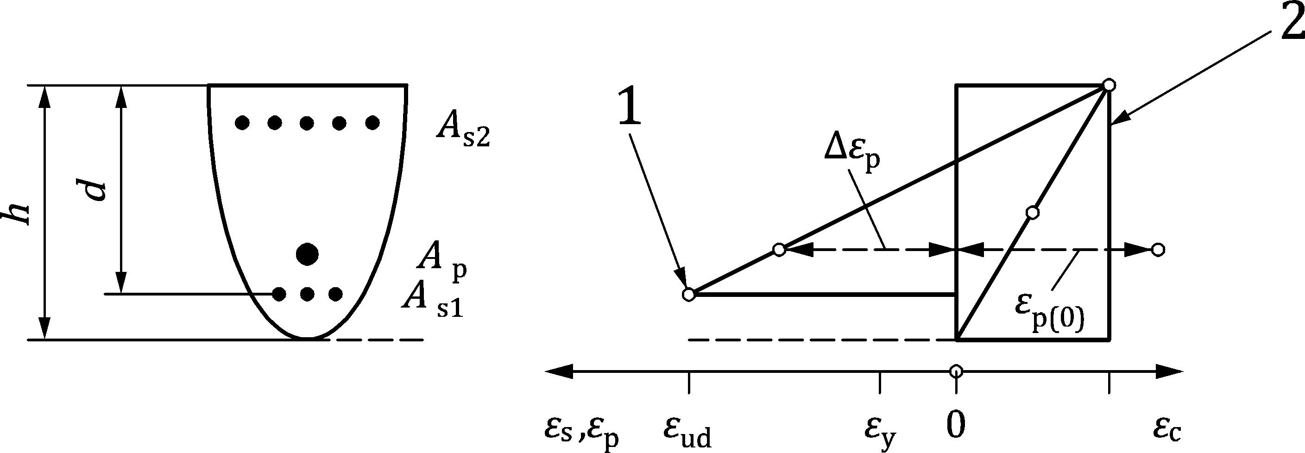

Key

|  |  |
| --- | --- |
| 1 | tensile strain limit of reinforcing steel |
| 2 | compressive strain limit of concrete |

Figure 8.1 — Possible strain distributions in the ultimate limit state

(7) For prestressed members with permanently unbonded tendons, 7.6.5 applies.

(8) In the absence of an accurate cross section design for biaxial bending, the following simplified criterion may be used:

|  |  |
| --- | --- |
|  | (8.2) |

where

|  |  |  |  |  |  |  |  |
| --- | --- | --- | --- | --- | --- | --- | --- |
| MEdz/y | is the design moment about the respective axis, including a 2nd order moment; | | | | | | |
| MRdz/y,N | is the moment resistance in the respective direction for the given axial compression force; | | | | | | |
| aN | is the exponent whose value is determined as follows: | | | | | | |
|  | — for circular and elliptical cross sections: aN = 2 | | | | | | |
|  | — for rectangular cross sections: | | | | | | |
|  |  | |NEd|/NRd,0 | 0,1 | 0,7 | 1,0 |  | |
|  |  | aN | 1,0 | 1,5 | 2,0 |  | |
|  | with linear interpolation for intermediate values; | | | | | | |
| NRd,0 | is the design value of axial resistance under compression without consideration of confinement: | | | | | | |
|  | NRd,0 = Acfcd + Asfyd | | | | | | (8.3) |

### Stress distribution in the compression zones

(1) For the design of cross sections, the following stress distribution may be used, see Figure 8.2c) (compressive strain shown positive):

|  |  |  |
| --- | --- | --- |
| $$σ_{cd}=f_{cd} \left[1 - {\left(1 - \frac{ε_{c}}{ε_{c2}}\right)}^{2}\right]$$ | $$for 0≤ε_{c}≤ε_{c2}$$ | (8.4a) |
| $$σ_{cd}=f_{cd}$$ | $$\text{for} ε_{c2}≤ε_{c}≤ε_{cu}$$ | (8.4b) |

where

|  |  |
| --- | --- |
| εc2 | = 0,002 |
| εcu | = 0,0035 |

|  |
| --- |
|  |
| a) cross section  b) assumed strain distribution  c) parabola-rectangle stress distribution  d) rectangular stress distribution |

Figure 8.2 — Stress distributions within the compression zone

(2) Alternatively, a rectangular stress block distribution as given in Figure 8.2d) may be assumed.

### Bending in slabs

(1) Orthogonally reinforced solid slab elements with bending and torsional moments where the thickness of the compression zone x ≤ 0,25d and the torsional moment is not larger than 0,5 times the largest bending moment, may be designed using the following formulae:

|  |  |
| --- | --- |
|  | (8.5a) |
|  | (8.5b) |
|  | (8.5c) |
|  | (8.5d) |

where x and y are local axes parallel to the reinforcement.

(2) Alternatively, or in cases not complying with the requirements of (1), the Formula (G.18) in G.4(5) may be used.

### Confined concrete

(1) The concrete compressive design strength may be enhanced by the favourable effect of confinement reinforcement or of triaxial compressive stresses.

(2) The compressive strength increase of a concrete with ddg ≥ 32 mm due to a transverse compressive stress σc2d may be calculated according to:

|  |  |  |
| --- | --- | --- |
| $$Δf_{cd}=4⋅σ_{c2d}$$ | $$for σ_{c2d}≤0,6f_{cd}$$ | (8.6a) |
| $$Δf_{cd}=3,5⋅σ_{c2d}^{3/4}⋅f_{cd}^{1/4}$$ | $$for σ_{c2d}>0,6f_{cd}$$ | (8.6b) |

In case of concrete with ddg < 32 mm, the strength increase Δfcd according to Formulae (8.6) shall be reduced by factor ddg/32 mm.

where

|  |  |
| --- | --- |
| ddg | is defined in 8.2.1(4), |
| σc2d | refers to the absolute value of the minimum principal transverse compressive stress. |

NOTE Provided that the strength increase Δfcd is reduced by factor ddg/32 mm, Formulae (8.6) apply also for concrete and mortar with ddg < 24 mm.

(3) The confinement stress σc2d resulting from confinement reinforcement may be calculated as:

|  |  |  |
| --- | --- | --- |
| $$σ_{c2d}=\frac{2A_{s,conf}⋅f_{yd}}{b_{cs}⋅s}$$ | (8.7a) | for circular and square members in compression with single confinement reinforcement (Figure 8.3a) and b)) |
| $$σ_{c2d}=\frac{2A_{s,conf}⋅f_{yd}}{max\left\{b_{csx};b_{csy}\right\}⋅s}$$ | (8.7b) | for rectangular members in compression with single confinement reinforcement (bcsx and bcsy according to Figure 8.3c)) |
| $$σ_{c2d}=min\left\{\frac{ΣA_{s,confx}}{b_{csy}}; \frac{ΣA_{s,confy}}{b_{csx}}\right\}⋅\frac{f_{yd}}{s}$$ | (8.7c) | for members in compression with multiple confinement reinforcement (Figure 8.3c)) |
| $$σ_{c2d}=min\left\{\frac{ΣA_{s,confx}}{b_{csy}}; \frac{A_{s,confy}}{x_{cs}}\right\}⋅\frac{f_{yd}}{s}$$ | (8.7d) | for compression zones (Figure 8.3d)) |

where

|  |  |
| --- | --- |
| As,conf | is the cross sectional area of one leg of confinement reinforcement; |
| bcs | is the width of the confinement core (to its centreline, see Figure 8.3); |
| s | is the spacing of confinement reinforcement. |

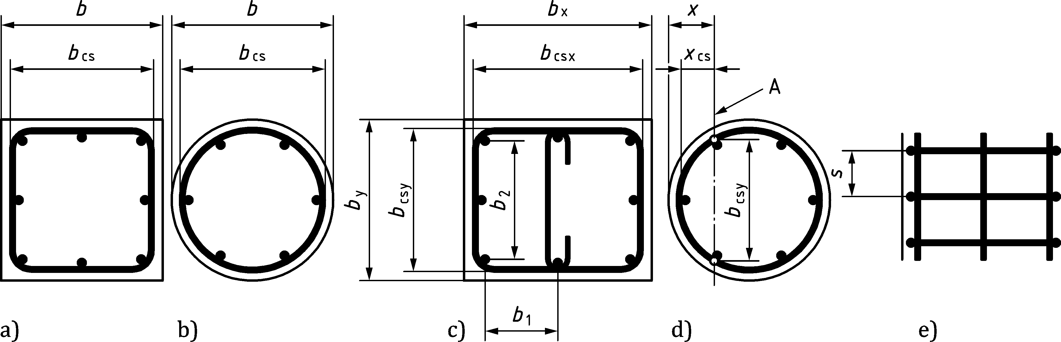

Key

|  |  |
| --- | --- |
| A | neutral axis |

Figure 8.3 — Definition of dimensions of confinement reinforcement

(4) The strength increase in the confined zones shown in Figure 8.3 may be smeared over the compression zone by considering following average strength:

|  |  |
| --- | --- |
| $$f_{cd,c}=f_{cd}+k_{conf,b}⋅k_{conf,s}⋅Δf_{cd}$$ | (8.8) |

where the effectiveness factors kconf,b and kconf,s are defined in Table 8.1.

Table 8.1 — Effectiveness factors kconf,b and kconf,s for confinement reinforcement

|  | Shape of compression zone and confinement reinforcement | kconf,b | kconf,s |
| --- | --- | --- | --- |
| a) | square members in compression with single confinement reinforcement (Figure 8.3a)) | $$k_{conf,b}=\frac{1}{3}{\left(\frac{b_{cs}}{b}\right)}^{2}$$ | $$k_{conf,s}={\left(1 - \frac{s}{2b_{cs}}\right)}^{2}$$ where $$1-\frac{s}{2b_{cs}}≥0$$ |
| b) | circular member in compression with circular confinement reinforcement (Figure 8.3b)) | $$k_{conf,b}={\left(\frac{b_{cs}}{b}\right)}^{2}$$ |
| c) | — for square and rectangular members in compression with multiple confinement reinforcement,  — for rectangular sections with single confinement reinforcement or  — for a refined calculation of square sections with single confinement reinforcement (Figure 8.3c)),  bi refer to all spaces between longitudinal reinforcement bars fixed by confinement reinforcement  ( $Σb_{i}^{2}=4b_{1}^{2}+2b_{2}^{2}$ in the example of Figure 8.3c)) | $$k_{conf,b}=\frac{b_{csx}⋅b_{csy}-\frac{1}{6}Σb_{i}^{2}}{b_{x}⋅b_{y}}$$ | $$k_{conf,s}=\left(1 - \frac{s}{2b_{csx}}\right)\left(1 - \frac{s}{2b_{csy}}\right)$$ where $$1-\frac{s}{2b_{csx}}≥0 \text{and} 1-\frac{s}{2b_{csy}}≥0$$ |
| d) | compression zones due to bending and axial force (Figure 8.3d)) | According to a), b) or c) depending on the shape of the confinement reinforcement | $$k_{conf,s}=\left(1 - \frac{s}{4x_{cs}}\right)\left(1 - \frac{s}{2b_{csy}}\right)$$ where xcs should not be taken $$>{b_{csx}}/2, 1-\frac{s}{4x_{cs}}≥0 \text{and} 1-\frac{s}{2b_{csy}}≥0$$ |

(5) The effect of confinement on the strain limitations in concrete may be determined in accordance with Formula (8.9). However, if these enhancements to the strains are included in design, then the concrete area between the free surface and the axis of the confinement reinforcement should not be included in any strength verifications.

|  |  |
| --- | --- |
| $$ε_{c2,c}=ε_{c2}\left(1+5\frac{Δf_{cd}}{f_{cd}}\right)$$ | (8.9a) |
| $$ε_{cu,c}=ε_{cu}+0,2\frac{σ_{c2d}}{f_{cd}}$$ | (8.9b) |

## Shear

### General verification procedure

(1) The shear resistance of linear members and the out-of-plane shear resistance of planar members shall be verified according to the following procedure:

(i) Detailed verification of the shear resistance may be omitted, provided that

τEd ≤ τRdc,min

according to 8.2.1(4)

(ii) No calculated shear reinforcement is required in regions of the members where

τEd ≤ τRd,c

according to 8.2.2 and 8.4.3

(iii) Otherwise, shear reinforcement shall be designed according to 8.2.3 and 8.4.4:

τEd ≤ τRd

(2) When, on the basis of the design shear calculation, no shear reinforcement is required, minimum shear reinforcement may nevertheless be necessary according to Clause 12.

For statically determined linear members with d > 500 mm, minimum shear reinforcement shall be provided. In exceptions where this were not possible, the verification methods according to I.8.3.1(3) shall be used.

(3) In regions of members without geometric discontinuities, the average shear stress over the cross section τEd is defined as:

|  |  |
| --- | --- |
| $$τ_{Ed}=\frac{V_{Ed}}{b_{w}⋅z}$$ | (8.10a) |

or

|  |  |
| --- | --- |
| $$τ_{Ed}=\frac{v_{Ed}}{z}$$ | (8.10b) |

where

|  |  |
| --- | --- |
| VEd | is the design shear force in linear members, |
| vEd | is the design shear force per unit width in planar members, |
| bw | is the width of the cross section of linear members. The width bw for cross sections with variable width and for circular cross sections is defined in 8.2.3(9); |
| z | is the lever arm for the shear stress calculation defined as z = 0,9d; where d refers to the centroid of tensile reinforcement. |

NOTE For d the nominal effective depth dnom or the design value dd can be used (see A(6)). A National Annex can give advice for using dd.

(4) The minimum shear stress resistance may be calculated as:

|  |  |
| --- | --- |
| $$τ_{Rdc,min}=\frac{11}{γ_{V}}⋅\sqrt{\frac{f_{ck}}{f_{yd}}⋅\frac{d_{dg}}{d}}$$ | (8.11) |

where

|  |  |
| --- | --- |
| *γ*V | is the partial factor for shear design according to Table 4.3(NDP) or Table A.1(NDP), |
| fyd | is the design value of the yield strength which has been used to design the flexural reinforcement, |
| d | is the effective depth of the flexural reinforcement (mm) for prestressed members see 8.2.2(6), |

NOTE 1 For *d* the nominal effective depth *d*nom or the design value *d*d can be used (see A(6)). A National Annex can give advice for using *d*d.

|  |  |
| --- | --- |
| ddg | is a size parameter describing the failure zone roughness, which depends on the concrete type and its aggregate properties. ddg (mm) may be taken as: |
|  | — 16 mm + Dlower ≤ 40 mm for concrete with fck ≤ 60 MPa, |
|  | — 16 mm + Dlower (60/fck)4 ≤ 40 mm for concrete with fck > 60 MPa. |

NOTE 2 The definition of D via Dlower in EN 12620 can lead to a range of aggregate gradings. Similarly EN 206 does not specify a minimum coarse aggregate content. The model is calibrated against tests carried out with typical gradings. The use of non-typical aggregate gradings where the percentage of larger aggregate sizes in relation to Dlower is small can result in different behaviour. This can be avoided by specifying grading parameters in addition to Dlower.

In case of prestressed members without ordinary reinforcement, fyd in Formula (8.11) may be replaced by fpd − σp∞ where σp∞ refers to the prestress of the tendons after losses.

(5) In planar members (such as solid slabs and shells) with out-of-plane shear forces vEd,x and vEd,y acting on the cross sections perpendicular to the x and y directions, the design shear force per unit length (vEd) should be calculated as:

|  |  |
| --- | --- |
| $$v_{Ed}=\sqrt{v_{Ed,x}^{2}+v_{Ed,y}^{2}}$$ | (8.12) |

The effective depth d may be taken as a function of the ratio of the shear forces vEd,y/vEd,x:

|  |  |  |
| --- | --- | --- |
| — d = dx | for vEd,y/vEd,x ≤ 0,5 | (8.13a) |
| — d = 0,5 ⋅ (dx + dy) | for 0,5 < vEd,y/vEd,x < 2 | (8.13b) |
| — d = dy | for vEd,y/vEd,x ≥ 2 | (8.13c) |

Alternatively, the effective depth d may be taken as:

|  |  |
| --- | --- |
| d = dx ⋅ cos²αv + dy ⋅ sin²αv | (8.14) |

where the angle αv between the principal shear force and x-axis may be taken as

|  |  |
| --- | --- |
| αv = arctan(vEd,y/vEd,x) | (8.15) |

(6) When the shear force in planar members is not constant along the control section, it may be averaged over a width not larger than 2d on both sides from the peak of the shear force. If other internal forces are required for calculation of the shear resistance, they may be also averaged over the same width.

(7) In members with inclined chords, the design shear force in the web shall account for the influence of inclined forces according to Figure 8.4, replacing VEd by VEd − Vtcd − Vbcd.

The favourable effect of Vtcd and Vbcd should only be considered for members with shear reinforcement.

|  |  |
| --- | --- |
|  |  |
| a) internal forces at cross section | b) compression field, chord and prestressing forces |

Key

|  |  |
| --- | --- |
| 1 | design shear force in web |

Figure 8.4 — Shear components for members with inclined chords and/or prestressing

(8) In members where the statically determinate part of prestressing is considered as an internal action (i.e. considered as resistance and that prestressing effect is not included in the load combination used to determine VEd):

* the design shear force in the web should account for the transversal component of the prestressing force according to Figure 8.4, replacing VEd by VEd − Pd ∙ sinβp,
* and where the shear resistance depends on the acting axial force and the bending moment, NEd and MEd should be replaced by NEd − Pd ∙ cosβp and MEd − Pd ∙ ep ∙ cosβp, respectively.

(9) When a load is applied through the depth of the member (i.e. at the intersection of primary and secondary beams) or applied in tension to the face of the member (i.e. hanging loads), sufficient reinforcement, in addition to that required for shear, shall be provided to carry the load to the face opposite to the direction of load (i.e. the top face in the case of gravity loads).

(10) In linear members, regions with geometric discontinuities should be designed according to 8.5. In planar members,

* regions with variation of cross sections shall be reinforced according to 12.3.1(2) or designed according to 8.5;
* regions with inserts shall be verified according to 8.2.2(11) or designed according to 8.5.

(11) Regions where significant concentrated loads are applied at a distance aq less than d from a support (Figure 8.5) should be designed as discontinuity regions, by using strut-and-tie models or stress fields as in 8.5 or by accounting for a reduced value of τEd using the method in 8.2.2(9). In linearly supported planar members without shear reinforcement, further shear verification between the load and the support (aq < d ) may be omitted, provided that:

* τEd ≤ 2τRdc,min and
* the flexural reinforcement is fully anchored at the support and at the load introduction.

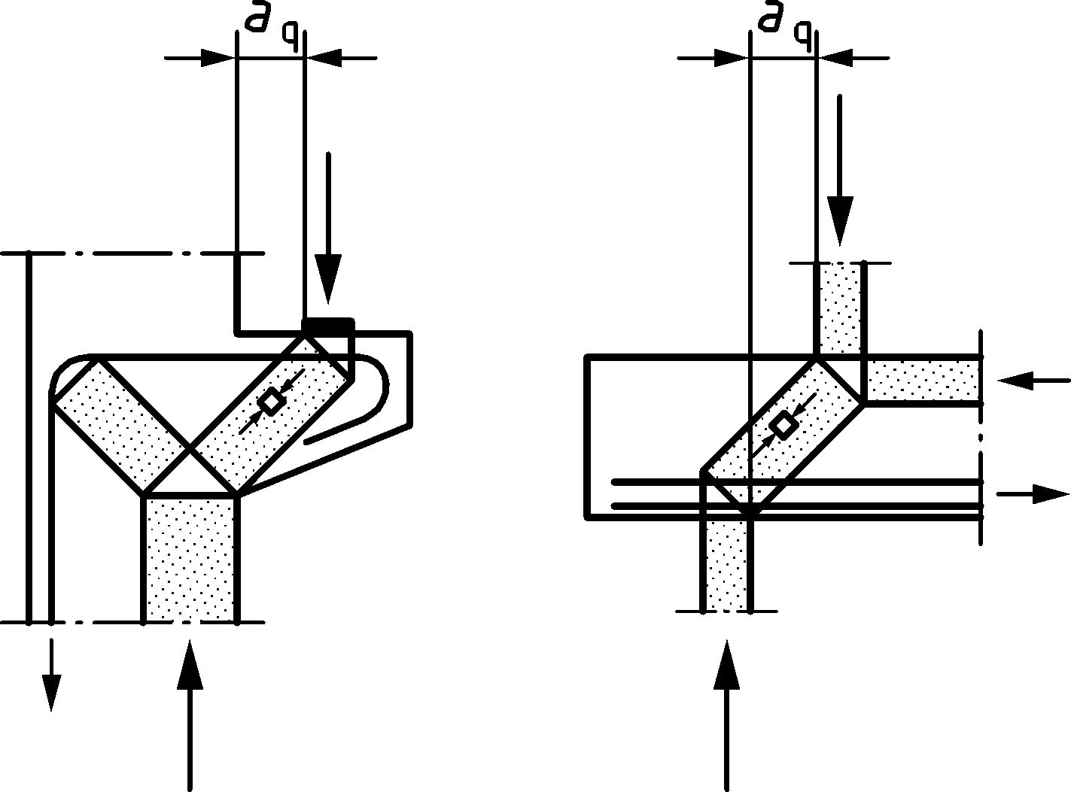

Figure 8.5 — Examples of loads near supports

### Detailed verification for members not requiring design shear reinforcement

(1) The detailed verification of the shear resistance may be omitted for cross sections that are closer than d from the face of the support or from a significant concentrated load (see Figure 8.6). When significant concentrated loads are applied closer than 2d from the face of the support, a control section located at a distance d from the face of the support should be verified.

|  |  |
| --- | --- |
|  |  |
| a) distributed loads | b) concentrated loads |

Key

|  |  |
| --- | --- |
| 1 | regions where shear strength verification may be omitted |

Figure 8.6 — Regions where shear strength verification may be omitted (cases of predominantly loads)

(2) The design value of the shear stress resistance should be taken as:

|  |  |
| --- | --- |
| $$τ_{Rd,c}=\frac{0,66}{γ_{V}}⋅{\left(100ρ_{l}⋅f_{ck}⋅\frac{d_{dg}}{d}\right)}^{\frac{1}{3}}≥τ_{Rdc,min}$$ | (8.16) |

where

|  |  |  |
| --- | --- | --- |
| $$ρ_{l}=\frac{A_{sl}}{b_{w}d}$$ | | (8.17) |
| Asl | is the effective area of tensile reinforcement at the distance d beyond the section considered (see Figure 8.7); | |
| ddg | is defined in 8.2.1(4); | |
| d | is the nominal effective depth dnom. The value d may be refined according to (3) and (4) for non-slender members and members with axial force. | |

The value *d* may be refined according to (3) and (4) for non-slender members and members with axial force.

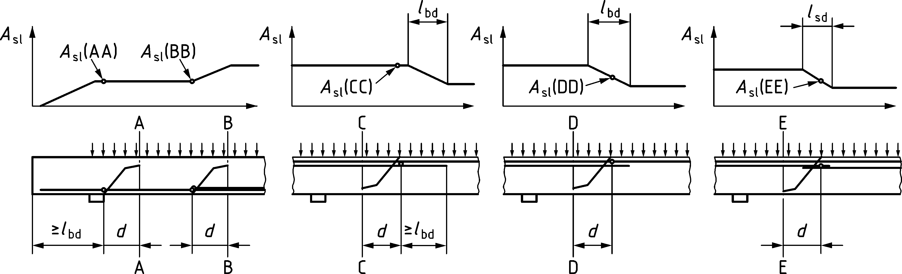

Key

|  |  |
| --- | --- |
| Control sections A–A and C–C: | Cases where anchored and curtailed reinforcement may be fully accounted for |
| Control section B–B: | Case where curtailed reinforcement may not be accounted for |
| Control sections D-D and E–E: | Cases where curtailed or spliced reinforcement may be partially accounted for |

Figure 8.7 — Definition of Asl in Formula (8.13)

(3) In members with an effective shear span acs shorter than 4d, the value of dnom in Formula (8.16) may be replaced by:

|  |  |
| --- | --- |
| $$a_{v}=\sqrt{\frac{a_{cs}}{4}⋅d}$$ | (8.18) |

Where acs is the effective shear span with respect to the control section. For reinforced concrete members without axial force, it may be calculated as a function of the internal forces at control section:

|  |  |
| --- | --- |
|  | (8.19) |

Only the load case giving maximum shear with coexistent bending and that giving maximum bending with coexistent shear need to be considered.

(4) In presence of axial forces NEd, acting at the control section, the value of d in Formula (8.16) or av in Formula (8.18) should be multiplied by coefficient kvp according to Formula (8.20):

|  |  |
| --- | --- |
|  | (8.20) |

(5) Alternatively to Formulae (8.16) to (8.20) the approach considering the effect of compressive normal forces according Formula (8.21) may be used:

|  |  |
| --- | --- |
|  | (8.21) |

where

|  |  |
| --- | --- |
| *σ*cp | *= N*Ed/ *A*c< 0,2 *f*cd [MPa]; |
| *N*Ed | is the compressive axial force in the cross section due to loading or prestressing; |
| *A*c | is the area of concrete cross section. |

NOTE The factor *k*1 can be calculated according to Formula (8.22) unless a National Annex gives another value.

|  |  |
| --- | --- |
|  | (8.22) |

where

|  |  |
| --- | --- |
| *e*p | is the eccentricity of the tendons with respect to the centre of gravity of the cross section considered as positive for tendons on the tensile side. For statically indeterminate members, the effect of hyperstatic moments due to prestressing should be considered by modifying the tendons eccentricity accordingly. |

(6) Prestressing effects according to 8.2.1(8) should be considered in the values of MEd, VEd and NEd to be used in Formula (8.20). For prestressed members with bonded tendons, the effective depth d and the reinforcement ratio ρl may be calculated as follows:

|  |  |
| --- | --- |
| $$d=\frac{d_{s}^{2}⋅A_{s}+d_{p}^{2}⋅A_{p}}{d_{s}⋅A_{s}+d_{p}⋅A_{p}}$$ | (8.23) |
| $$ρ_{l}=\frac{d_{s}⋅A_{s}+d_{p}⋅A_{p}}{b_{w}⋅d^{2}}$$ | (8.24) |

The area of prestressed reinforcement Ap may be omitted in the calculation of d and ρl if the influence of the tendon on the shear resistance becomes unfavourable due to the reduced effective depth.

NOTE The effect of unbonded and external tendons is considered on action side.

(7) In planar members with different reinforcement ratios in both directions, ρl should be calculated as a function of the ratio of the shear forces vEd,y/vEd,x:

|  |  |  |
| --- | --- | --- |
| — ρl = ρl,x | for vEd,y/vEd,x ≤ 0,5 | (8.25a) |
| — ρl = ρl,x ⋅ cos4αv + ρl,y ⋅ sin4αv | for 0,5 < vEd,y/vEd,x < 2 | (8.25b) |
| — ρl = ρl,y | for vEd,y/vEd,x ≥ 2 | (8.25c) |

where αv is defined in 8.2.1(5).

(8) In case of distributed loads (except high water- or gas pressure) pushing against the member on the tension side (e.g. distributed gravity loads on the top face of continuous members near intermediate supports, see Figure 8.8, or on cantilevers), the design shear force at the control section may be reduced by ΔVEd calculated as the sum of the distributed loads acting closer than d from the control section, but not larger than ¼ of the design shear force due to the corresponding distributed load.

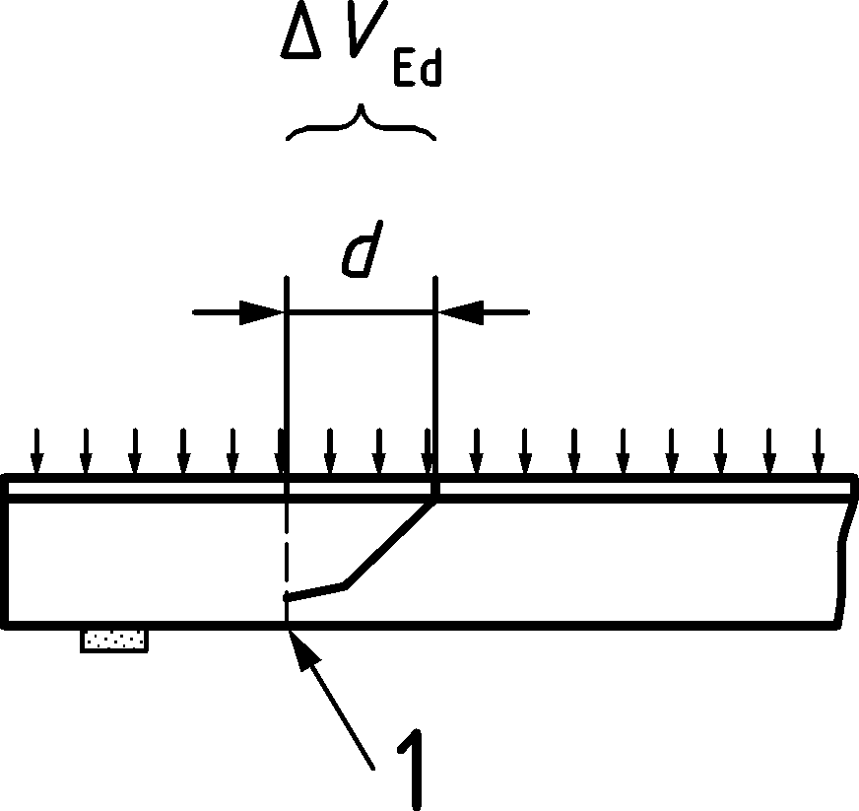

Key

|  |  |
| --- | --- |
| 1 | control section |

Figure 8.8 — Distributed loads pushing on the tension side of the member that may be subtracted from the design shear force VEd

(9) In case of concentrated forces pushing against each other within a clear distance d ≤ aq ≤ 2d (e.g. loads and support forces, see Figure 8.5 for the definition on aq), the contribution of these forces to the design shear force between them may be multiplied by 0,5aq/d.

(10) For the design of longitudinal reinforcement, the MEd-line should be shifted by a distance d in the unfavourable direction. Alternatively, the bending moment may be increased by d ∙ |VEd|.

(11) Concreted-in pipes, pipe bundles or slab inserts in plane of member not perpendicular to the cross section:

* may be neglected if the width and height are less than d/6,
* should be taken into account if their width or height is larger than d/6. In that case, the effective shear-resisting depth d should be reduced by the highest value of width and depth.

Pipe bundles with clear distance smaller than 0,25d should be considered as a single opening.

### Members requiring design shear reinforcement

(1) The design of members with shear reinforcement should be based on a compression field (Figure 8.9). Limiting values for the angle θ of the inclined compression field in the web are given in (3). Provisions for inclined shear reinforcement are given in (13).

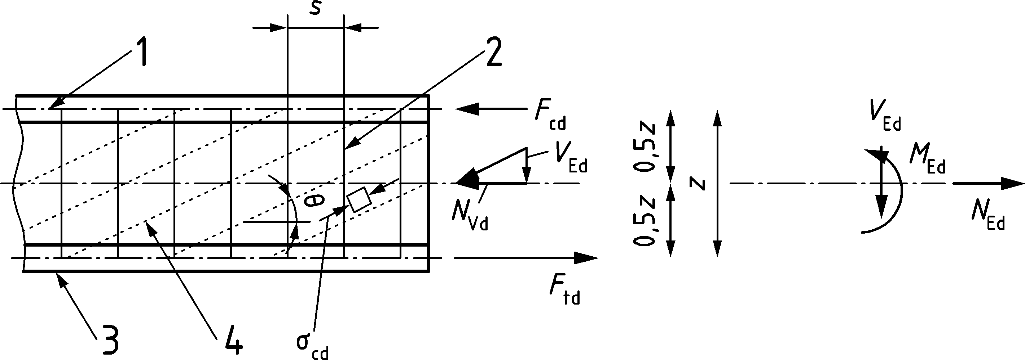

Key

|  |  |
| --- | --- |
| 1 | compression chord |
| 2 | shear reinforcement |
| 3 | tension chord |
| 4 | struts (compression field) |

Figure 8.9 — Model and notation for shear reinforced members

(2) The lever arm z for the shear calculation (Figure 8.9) may be assumed as in 8.2.1(3).

Prestressed tendons away from the tension chord may be neglected in calculating the centroid of tensile reinforcement, provided that the reinforcement in the tension chord is sufficient to carry the tensile force Ftd according to (8).

(3) The inclination of the compression field in the web carrying shear may be selected within the following range:

|  |  |
| --- | --- |
| 1 ≤ cotθ ≤ cotθmin | (8.26) |

where the cotangens of the minimal inclination of the compression field θmin should be for shear reinforcement of ductility class B or C:

* cotθmin = 2,5 for ordinary reinforced members without axial force;
* cotθmin = 3,0 for members subjected to significant axial compressive force (average axial compressive stress ≥ |3 MPa|) and provided that the depth of the compression chord x determined from a sectional analysis according to 8.1.1 and 8.1.2 is less than 0,25d. Interpolated values between 2,5 and 3,0 may be adopted for intermediate cases. For very high compressive forces (x > 0,25d), (11) applies;
* cotθmin = 2,5 − 0,1 ⋅ NEd/|VEd| ≥ 1,0 for members subjected to axial tension.

For shear reinforcement of ductility class A, cotθmin shall be reduced by 20 %.

(4) The shear stress resistance perpendicular to the longitudinal member axis in case of yielding of the shear reinforcement shall be calculated according to:

|  |  |
| --- | --- |
| $$τ_{Rd,sy}=ρ_{w}⋅f_{ywd}⋅cotθ$$ | (8.27) |

where the shear reinforcement ratio ρw is defined as:

|  |  |
| --- | --- |
| $$ρ_{w}=\frac{A_{sw}}{b_{w}⋅s}$$ | (8.28) |

The stress in the compression field in all cross sections shall be verified according to:

|  |  |
| --- | --- |
| $$σ_{cd}=τ_{Ed}\left(cotθ+tanθ\right)≤ν⋅f_{cd}$$ | (8.29) |

NOTE For the case with simultaneous yielding of the shear reinforcement and failure of the compression field, the shear stress resistance results from the solution of Formulae (8.27) and (8.29) as:

|  |  |
| --- | --- |
| $$τ_{Rd}=ρ_{w}⋅f_{ywd}⋅cotθ≤\frac{ν⋅f_{cd}}{2}$$ | (8.30) |

where cotθ is taken from:

|  |  |
| --- | --- |
| $$cotθ_{min}≥cotθ=\sqrt{\frac{ν⋅f_{cd}}{ρ_{w}⋅f_{ywd}}-1}≥1$$ | (8.31) |

For the case with simultaneous yielding of the tension chord and failure of the compression field, the shear stress resistance results from the solution of formulae (8.27) and (8.37) with Ftd = Ast ⋅ fyd.

(5) A value ν = 0,5 may be adopted when using the angles of the compression field given in (3).

(6) Angles of the compression field inclination to the member axis lower than θmin given in (3) or values of factor ν higher than according to (5) may be adopted provided that the ductility class of the reinforcement is B or C and that the value of factor ν is calculated on the basis of the state of strains of the member according to:

|  |  |
| --- | --- |
| $$ν=\frac{1}{1,0+110⋅\left(ε_{x} + \left(ε_{x}+0,001\right)⋅\cot^{2}θ\right)}≤1,0$$ | (8.32) |

where εx is the average strain of the bottom and top chords calculated at a cross section not closer than 0,5 ⋅ z ⋅ cotθ from a support or a concentrated load:

|  |  |
| --- | --- |
| $$ε_{x}=\frac{ε_{xt}+ε_{xc}}{2}≥0$$ | (8.33) |

where, assuming elastic behaviour,

|  |  |  |
| --- | --- | --- |
| $$ε_{xt}=\frac{F_{td}}{A_{st}E_{s}}$$ | | (8.34) |
| $$ε_{xc}=\frac{F_{cd}}{A_{cc}E_{c}}$$ | if the flexural compression chord is in compression and | (8.35a) |
| $$ε_{xc}=\frac{-F_{cd}}{A_{sc}E_{s}}$$ | if the flexural compression chord is in tension (Fcd < 0) | (8.35b) |

where

|  |  |
| --- | --- |
| Ftd and Fcd | are the chord forces according to Figure 8.9 and Formulae (8.37) to (8.38); |
| Ast and Asc | are the areas of the longitudinal reinforcement in the flexural tension chord and flexural compression chord, respectively; |
| Acc | is the area of the flexural compression chord. |

In prestressed members with bonded tendons, the areas of the longitudinal reinforcement Ast and Asc may be increased by Ap(1/2+ep/z) and Ap(1/2–ep/z), respectively, where the eccentricity of the tendon ep is positive on the side of the tension chord.

NOTE For high values of cotθ, the cracking state of the web under serviceability conditions can be governing (see 9.2.4(6)).

(7) In regions where there is no discontinuity of VEd (e.g. for uniformly distributed loading applied at the top) the shear reinforcement in any length increment l = z ⋅ cotθ may be calculated using the smallest value of VEd in the increment (except in members under high water- or gas pressure).

(8) The additional tensile axial force, NVd, due to shear VEd may be calculated from:

|  |  |
| --- | --- |
|  | (8.36) |

This force may be added to both chords so that the chord forces Ftd and Fcd (Figure 8.9) are:

|  |  |
| --- | --- |
| $$F_{td}=\frac{M_{Ed}}{z}+\frac{N_{Vd}+N_{Ed}}{2}≤\frac{M_{Ed,max}}{z}+\frac{N_{Ed}}{2}$$ | (8.37) |
| $$F_{cd}=\frac{M_{Ed}}{z}-\frac{N_{Vd}+N_{Ed}}{2}$$ | (8.38) |

where MEd,max is the maximum moment along the member and the internal forces (NEd, VEd and MEd) are applied in the centre of the web with a depth z as shown in Figure 8.9. Alternatively, the tension chord may be designed by shifting the MEd-line according to 12.3.3.

The force NVd may also be carried totally or partially by a longitudinal web reinforcement. In this case, the term NVd in Formulae (8.37) to (8.38) may be reduced accordingly.

(9) For sections with variable width:

* bw is the smallest width of the cross section between the tension chord and the neutral axis (Figures 8.10a and b)
* the area Asw to be used in Formula (8.28) shall be multiplied by cosδ (refer to Figure 8.10a)).

For circular cross sections:

* the area Asw should be multiplied by the ratio bw/Dh (refer to Figure 8.10c)), where Dh is the hoop diameter;
* z is based on a section fitted into the circular section as given in Figure 8.10c) where the circular segment with depth xsb is the area of the compression chord and the tension bars within bw define the tension chord. The width bw can be chosen freely fulfilling equilibrium and resistance conditions, however not larger than Dh.

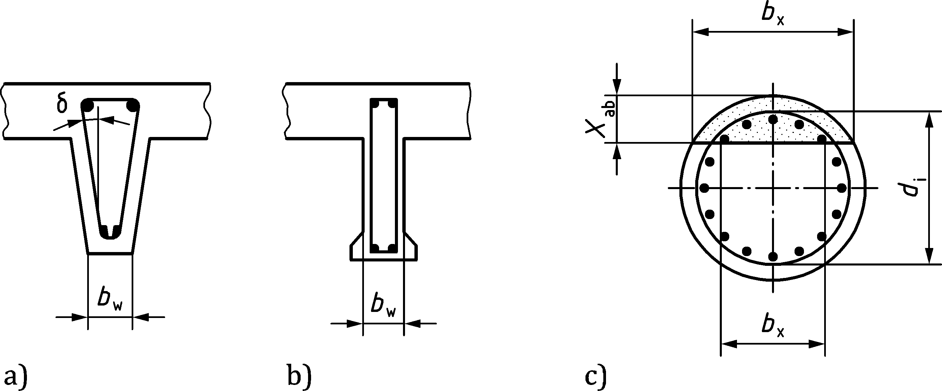

Figure 8.10 — Definition of bw for sections with variable width

(10) Where the web contains ducts with a diameter ϕduct > Σbw/8, the stress in the compression field according to Formula (8.29) and the shear resistance VRd according to Formulae (8.30) to (8.31) shall be calculated on the basis of a nominal web width given by:

|  |  |
| --- | --- |
| $$b_{w,nom}=b_{w}-k_{duct}{∑ϕ}_{duct}$$ | (8.39) |

where ϕduct is the outer diameter of the duct and Σϕduct is determined for the most unfavourable level. The value of coefficient kduct should be evaluated depending on the material and filling of the duct as:

* kduct = 0,5 for grouted steel ducts;
* kduct = 0,8 for grouted plastic ducts with a wall thickness ≤ max(0,035ϕduct; 2 mm);
* kduct = 1,2 for non-grouted ducts, for grouted plastic ducts with a wall thickness > max(0,035ϕduct; 2 mm) or for ducts injected with soft filling material.

The effect of ducts does not need to be considered when checking shear resistance without shear reinforcement unless ducts are not grouted.

(11) For members subjected to design axial compression forces NEd, a portion of the axial force denoted as NEdw can be resisted by the shear zone (web). If –NEdw ≤ |VEd ⋅ cotθ |, and cotθ fulfils the recommended values in (3), the shear zone should be calculated as specified in (4) to (6) while Formula (8.36) be used for calculating the chord forces according to Formulae (8.37) to (8.38) should be replaced by Nvd = VEd cotθ + NEdw. Otherwise, the design method specified in Annex G should be used for the shear zone.

For members subjected to high design axial forces, NEdw should be chosen so that the depth of the compression chords (i.e. xsb) carrying NEd + NVd and MEd is not higher than 0,25d.

(12) In cases where concentrated loads are applied at a distance av = z ∙ cotβ less than z ∙ cotθ from a support (Figure 8.11), the shear resistance stress may be enhanced according to:

|  |  |
| --- | --- |
| $$τ_{Rd}=ν⋅f_{cd}\frac{cotθ-cotβ}{1+\cot^{2}θ}+ρ_{w}⋅cotβ⋅f_{ywd}≤ν⋅f_{cd}\frac{cotθ}{1+\cot^{2}θ}$$ | (8.40) |

NOTE 1 The maximum shear resistance can be calculated by optimization varying cotθ. For the case of a constant value ν according to (5), the optimum is obtained with

|  |
| --- |
| $$cotθ=cotβ+\sqrt{1+\cot^{2}β}≤cotθ_{min};$$ |

for the case of a variable ν according to (6), a reasonable approximation is obtained assuming

|  |
| --- |
| cotθ = 1,3 ⋅ a/z, |

but should not be larger than cotθ according to Formula (8.31).

Compression field inclinations with cotθ < 1 are allowed if the yield strength fywd in Formulae (8.40) and (8.42) is replaced by the stress σswd in the shear reinforcement according to:

|  |  |
| --- | --- |
| $$σ_{swd}=E_{s}\left[\cot^{2} θ ⋅ \left(ε_{x}+0,001\right)-0,001\right]≤f_{ywd}$$ | (8.41) |

where the longitudinal strain εx may be calculated according to (6) for a cross section located midway between the support and the load.

In addition to the axial tensile force, NVd, due to shear VEd according to Formula (8.36), also following moment ΔMEd should be added to MEd to be used in Formulae (8.37) to (8.38):

|  |  |
| --- | --- |
| $$ΔM_{Ed}=\left(V_{Ed}-\frac{A_{sw}}{s}{⋅z⋅f}_{ywd}⋅cotθ\right)\left(\frac{a}{2}+x\right)$$ | (8.42) |

where

|  |  |
| --- | --- |
| a | is the distance between the axis of the support and the concentrated force (see Figure 8.11a); |
| x | is the distance between the support and the investigated cross section. |

NOTE 2 The increase of chord forces Ftd and Fcd due to shear according to Formulae (8.36) and (8.42) is based on the assumption of a constant compression field inclination θ in the support region. Other solutions respecting equilibrium conditions can be designed according to 8.5 (see Figure 8.26b)).

In case of two or more concentrated forces in the distance z∙cotθ, all potential critical inclinations β according to Figure 8.11a) shall be verified.

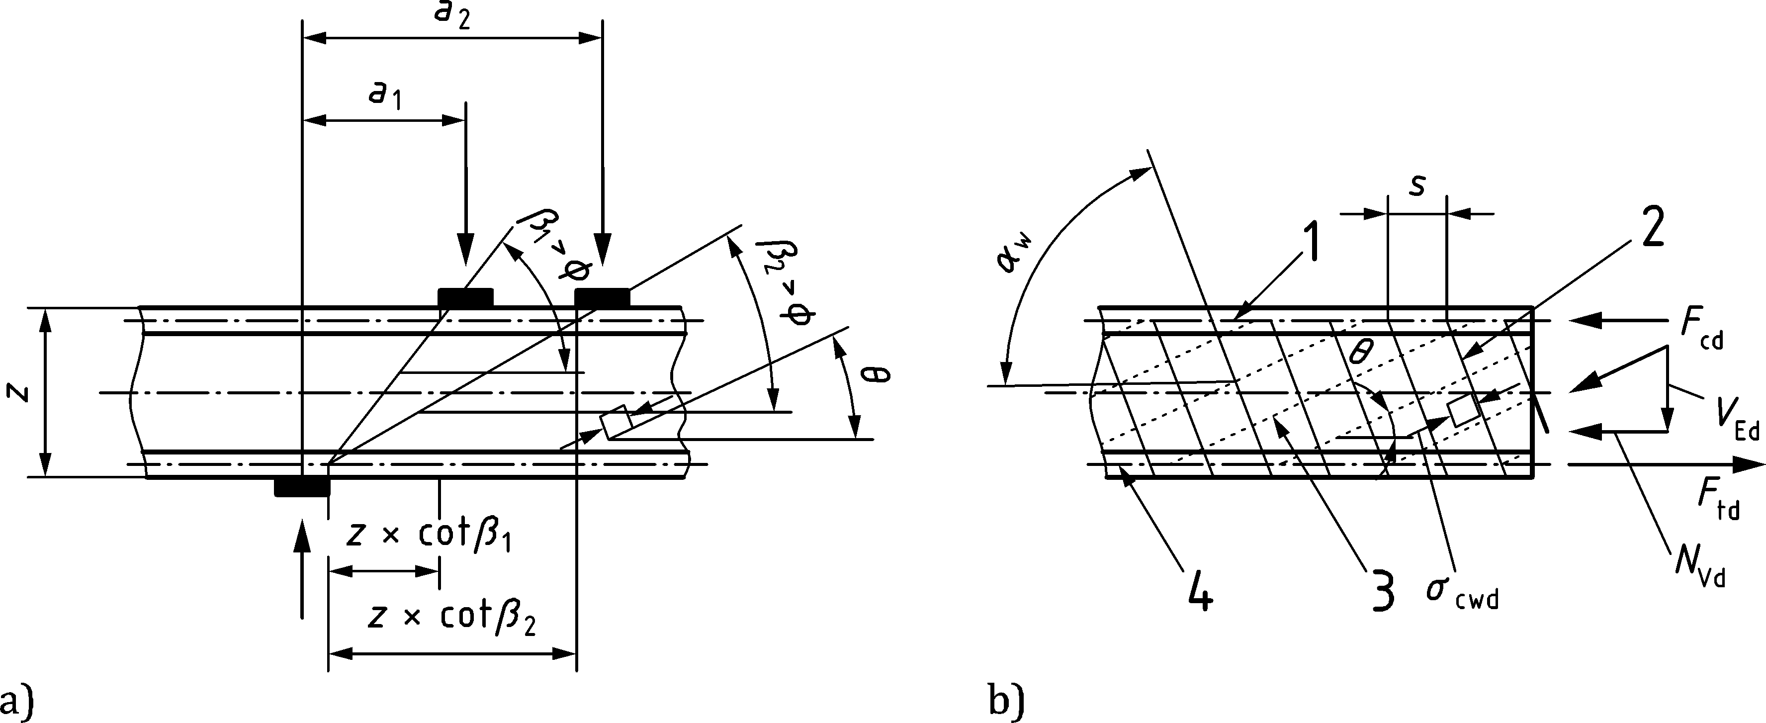

a) in presence of concentrated loads near the supports

b) truss model and notation for members with inclined shear reinforcement

Key

|  |  |
| --- | --- |
| 1 | compression chord |
| 2 | shear reinforcement |
| 3 | struts (compression field) |
| 4 | tension chord |

Figure 8.11 — Definition of inclinations β

(13) For members with inclined shear reinforcement (45° ≤ αw < 90° where αw is measured positive as shown in Figure 8.11b), Formulae (8.26), (8.27), (8.29) and (8.36) should be replaced respectively by:

|  |  |
| --- | --- |
| $$tan\frac{α_{w}}{2}≤cotθ≤cotθ_{min}$$ | (8.43) |
| $$τ_{Rd,sy}=ρ_{w}⋅f_{ywd}⋅\left(cotθ+cotα_{w}\right)⋅sinα_{w}$$ | (8.44) |
| $$σ_{cd}=τ_{Ed}\frac{1+\cot^{2}θ}{cotθ+cotα_{w}}≤ν⋅f_{cd}$$ | (8.45) |
| $$N_{Vd}=V_{Ed}⋅\left(cotθ+cotα_{w}\right)$$ | (8.46) |

Angles αw > 90° should be avoided. For spiral reinforcement, αw may be assumed as the average angle of both legs, provided that the difference of the both leg inclinations is not larger than 20°.

Formula (8.40) should be replaced by:

|  |  |
| --- | --- |
| $$τ_{Rd}=ν⋅f_{cd}\frac{cotθ-cotβ}{1+\cot^{2}θ}+ρ_{w}⋅f_{ywd}⋅\left(cotβ+cotα_{w}\right)sinα_{w}≤ν⋅f_{cd}\frac{cotθ+cotα_{w}}{1+\cot^{2}θ}$$ | (8.47) |

Compression field inclinations with cot* *< tan(**w/2) are allowed if the yield strength *f*ywd in Formula (8.47) is replaced by the stress **swd in the shear reinforcement according to:

|  |  |
| --- | --- |
| $$σ_{swd}=E_{s}\left[\left(ε_{x}+0,001\right)⋅\frac{{\left(cotθ+cotα_{w}\right)}^{2}}{1+\cot^{2}α_{w}}-0,001\right]≤f_{ywd}$$ | (8.48) |

### In-plane shear and transverse bending

(1) The interaction between shear stress τEd and transverse bending mEd (see Figure 8.12) may be disregarded if τEd/τRd < 0,2 or mEd/mRd < 0,1

where

|  |  |
| --- | --- |
| τRd | is the shear resistance stress limited by crushing of the inclined compression field in the web according to Formula (8.30); |
| mRd | is the bending resistance without interaction with shear. |

(2) The shear resistance stress τRdm reduced by the influence of transverse bending, in case of vertical symmetric shear reinforcement, may be assumed as:

|  |  |
| --- | --- |
| $$τ_{Rdm}=τ_{Rd}\sqrt{1-\frac{m_{Ed}}{m_{Rd}}}$$ | (8.49) |

Alternatively, Annex G may be used.

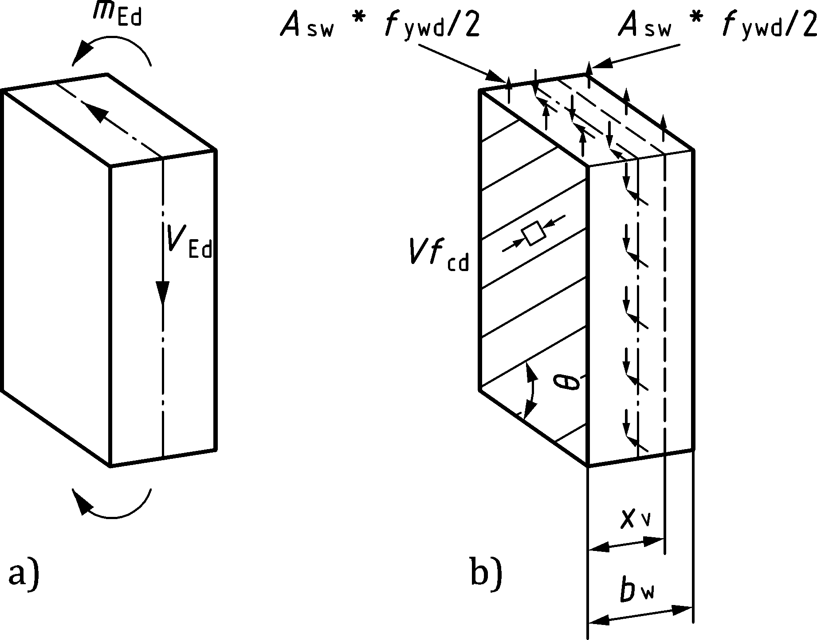

Key

|  |  |
| --- | --- |
| a) | web with shear force VEd and transverse bending moment mEd |
| b) | eccentric compression field carrying shear and transverse bending |

Figure 8.12 — Interaction between shear and transverse bending

### Shear between web and flanges

(1) The longitudinal shear stress, τEd, at the junction between one side of a flange and the web may be determined by the change of the axial (longitudinal) force in the part of the flange considered, according to:

|  |  |
| --- | --- |
| $$τ_{Ed}=\frac{ΔF_{d}}{h_{fl}⋅Δx}$$ | (8.50) |

where

|  |  |
| --- | --- |
| hfl | is the thickness of the flange at the junctions; |
| Δx | is the length under consideration, see Figure 8.13; |
| ΔFd | is the change of the axial force in the flange over the length Δx. |

The maximum value that may be assumed for Δx is half the distance between the section where the moment is 0 and the section where it is maximum. Where point loads are applied, the length Δx may not exceed the distance between point loads.

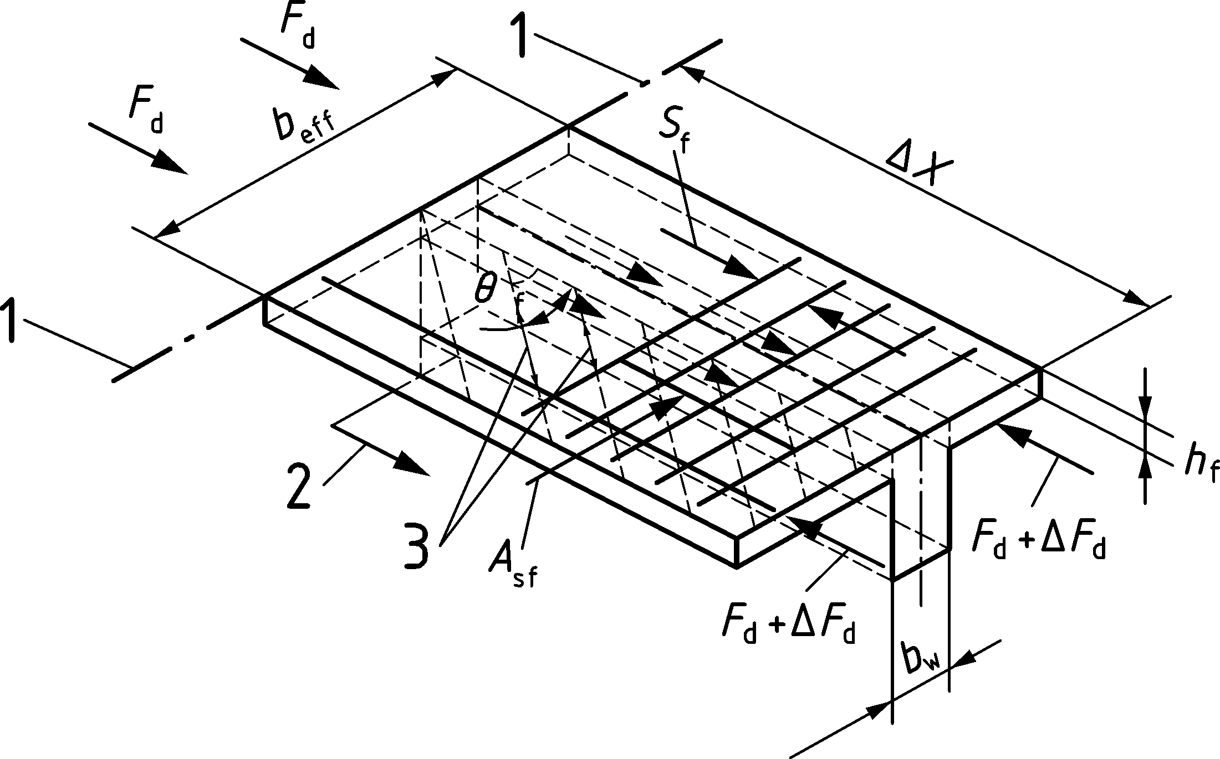

Key

|  |  |
| --- | --- |
| 1 | section cut |
| 2 | longitudinal bar anchored beyond this projected point (see 8.2.4(7)) |
| 3 | struts |

Figure 8.13 — Notations for the connection between flange and web

(2) In case the following condition is satisfied, further verification of the shear between web and flanges may be omitted and no extra reinforcement above that for transverse bending is required:

|  |  |
| --- | --- |
| $$τ_{Ed}≤\frac{A_{s,min}}{s_{f}⋅h_{f}}⋅f_{yd}$$ | (8.51) |

where As,min is the minimum transverse reinforcement according to Table 12.1(NDP).

(3) In cases not complying with Formula (8.51), the shear strength of the flange may be calculated by considering the flange as a system of compressive field combined with ties in the form of tensile reinforcement (see Figure 8.13). The inclination of the compression field in the flanges with respect to the longitudinal axis may be selected within the following range:

|  |  |  |
| --- | --- | --- |
| — 1 ≤ cotθf ≤ 3,0 | in compression flanges | (8.52a) |
| — 1 ≤ cotθf ≤ 1,25 | in tension flanges | (8.52b) |

(4) The transverse reinforcement in the flange Asf may be determined as follows:

|  |  |
| --- | --- |
| $$τ_{Ed}≤\frac{A_{sf}}{s_{f}⋅h_{f}}⋅f_{yd}⋅cotθ_{f}$$ | (8.53) |

To prevent crushing of the compression field in the flange, the following condition should be satisfied:

|  |  |
| --- | --- |
| $$σ_{cd}=τ_{Ed}\left(cotθ_{f}+tanθ_{f}\right)≤ν⋅f_{cd}$$ | (8.54) |

where the following strength reduction factor may be used:

|  |  |
| --- | --- |
| ν = 0,5 | (8.55) |

(5) Lower angles of the inclined compression field in the tensile flange than those given in (3) may be adopted provided the value of factor ν is calculated on the basis of the state of strains of the member according to Formula (8.32) where εx is the longitudinal strain in the tensile flange and may be estimated as:

|  |  |
| --- | --- |
| $$ε_{x}=\frac{F_{td}}{A_{st}E_{s}}≥0$$ | (8.56) |

where Ast and Ftd are the area of the longitudinal reinforcement and the force in the tension chord, respectively (refer to 8.2.3(8)).

(6) The influence of transverse bending may be addressed according to 8.2.4 or Annex G. Alternatively, the reinforcement in the flange may be designed as follows:

* if reinforcement is placed only in the tension zone due to transverse bending, the area of the steel should be the greater among that required for bending and that required for shear;
* if the reinforcement is symmetrically distributed (stirrups with two branches), the area of each branch should be the greater among that required for bending and that required for shear.

(7) Longitudinal tension reinforcement in the flange should be anchored beyond the strut required to transmit the force back to the web at the section where this reinforcement is required (see section cut 1–1 of Figure 8.13).

### Shear at interfaces

(1) This clause shall be applied where the static equilibrium depends on shear transfer across a given interface, such as: an interface between two concretes cast at different times or an interface between concrete and a similar material (e.g. concrete cast on rock surfaces).

(2) For very rough interfaces with sufficiently anchored minimum reinforcement according to 12.2.2 crossing the interface at an angle according to Figure 8.15b), the verification may be omitted. The roughness of the interfaces is defined in (6).

(3) The shear stress at the interface should satisfy the following condition:

|  |  |
| --- | --- |
| τEdi ≤ τRdi | (8.57) |

where

|  |  |
| --- | --- |
| τRdi | is the design shear resistance at the interface. If no reinforcement across the interface is required or if the required reinforcement across the interface is sufficiently anchored, τRdi should be calculated by Formula (8.60). In other cases according to (7), Formula (8.61) should be used. |

(4) The design value of the shear stress in an interface should be taken as:

|  |  |
| --- | --- |
| $$τ_{Edi}=\frac{V_{Edi}}{A_{i}}$$ | (8.58) |

where

|  |  |
| --- | --- |
| VEdi | is the shear force acting parallel to the interface; |
| Ai | is the area of the interface according to Figure 8.14. For keyed interfaces, Ai should be based on either the key area A1 or (A2 + A3) according to Figure 8.14 whichever is critical. |

The longitudinal shear stress between concrete interfaces due to composite action may be taken as:

|  |  |
| --- | --- |
| $$τ_{Edi}=\frac{β⋅V_{Ed}}{z⋅b_{i}}$$ | (8.59) |

where

|  |  |
| --- | --- |
| β | is the ratio of the longitudinal force in the new concrete area and the total longitudinal force either in the compression or tension zone, both calculated for the section considered; |
| VEd | is the shear force acting perpendicular to the interface; |
| z | is the lever arm of composite section; |
| bi | is the width of the interface. |

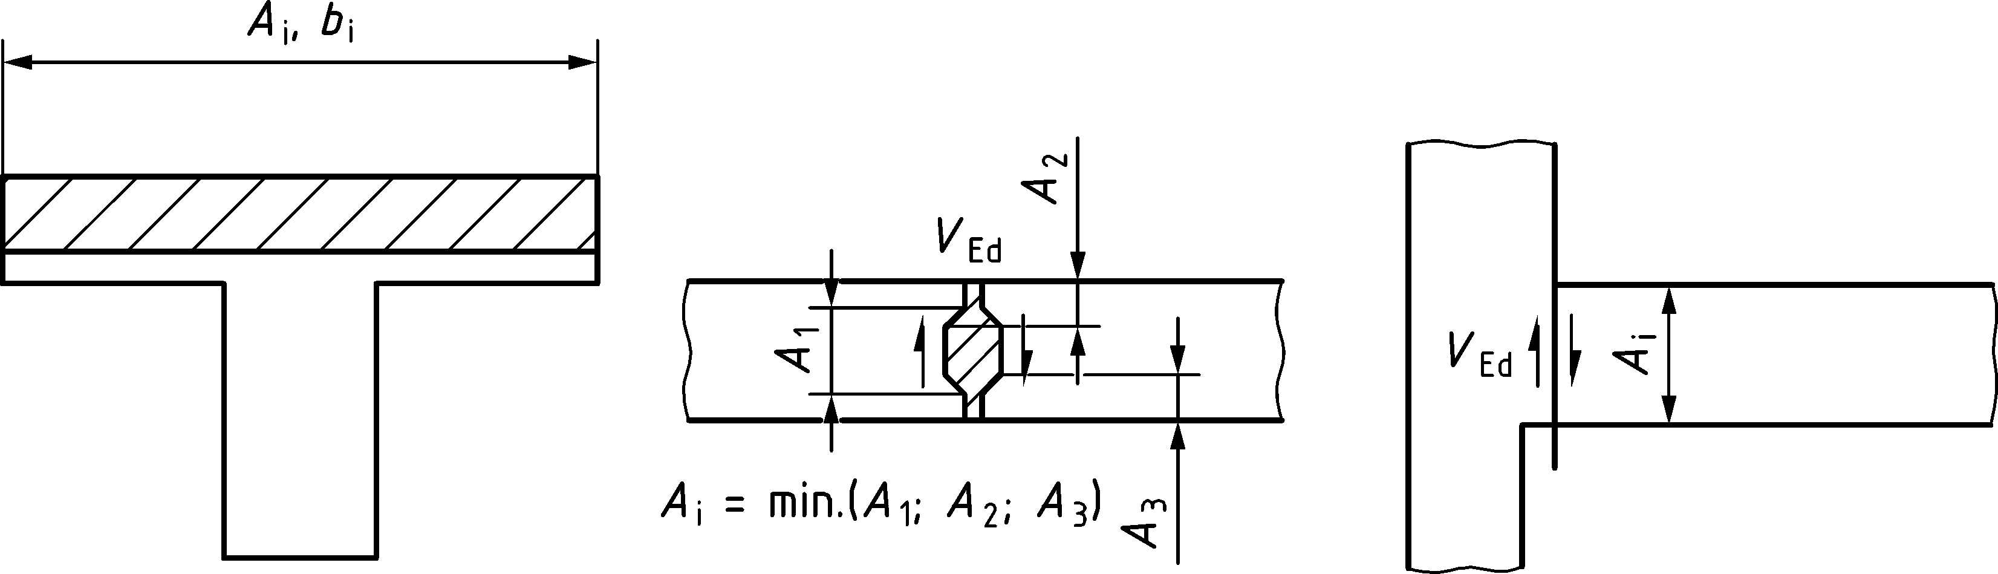

Figure 8.14 — Examples of interfaces

(5) The design shear stress resistance at the interface for situations without reinforcement across the interface or if the required reinforcement across the interface is anchored for σsd = fyd may be taken as:

|  |  |
| --- | --- |
| τRdi = cv1 √(fck)/γC + μv σn + ρi fyd (μv sinα + cosα) ≤ 0,25fcd | (8.60) |

where

|  |  |
| --- | --- |
| fck | is the lowest compressive strength of the concretes at the interface; |
| σn | is the compressive stress over the interface area Ai caused by the minimum external axial force across the interface that acts simultaneously with the shear force. Permanent stresses caused by confinement of surrounding structural parts may be taken into account. When σn is a compressive stress σn shall not be taken larger than 0,60fcd. |
|  | When σn is a tensile stress μv ⋅ σn shall be taken as 0; |
| ρi | = Asi/Ai; |
| Asi | is the cross sectional area of bonded reinforcement crossing the interface and anchored for *σ*sd= *f*yd, including ordinary shear reinforcement (if any), with adequate anchorage according to 11.4 at both sides of the interface. Tensile forces across interfaces shall be carried by reinforcement placed additional to the interface reinforcement Asi; |
| αi | is defined in Figure 8.15b), and is limited to 35° ≤ α ≤ 90°; except for very smooth surfaces, where 35° ≤ α ≤ 90°; |
| cv1 and μv | are factors which depend on the roughness of the interface (see Table 8.1 and (6)). The formula assumes the contact surface to be clean and free of laitance, dust or other adhesion-reducing particles. |

Table 8.1 — Coefficients depending on the roughness of the surface

|  | Formula (8.60) | | Formula (8.61) | | |
| --- | --- | --- | --- | --- | --- |
| Surface roughness | cv1 | μv | cv2 | kv | kdowel |
| very smooth | 0,009 5a | 0,5 | 0 | 0 | 1,5 |
| smooth | 0,075a | 0,6 | 0 | 0,5 | 1,1 |
| rough | 0,15a | 0,7 | 0,075a | 0,5 | 0,9 |
| very rough | 0,19a | 0,9 | 0,15a | 0,5 | 0,9 |
| keyed b | 0,37 | 0,9 | — | — | — |
| a When the interface is subjected to tensile stresses caused by external axial force in perpendicular direction: cv1 = 0 or cv2 = 0.  b The factors for keyed interfaces shall be applied for the area of each key considering its concrete strength. | | | | | |

(6) The roughness of the concrete interfaces may be classified as follows:

|  |  |
| --- | --- |
| very smooth: | a surface cast against steel, plastic or specially prepared wooden moulds; |
| smooth: | a surface with less than 3 mm roughness (from peak to valley), e.g. a free surface left without further treatment after compacting; |
| rough: | a surface with at least 3 mm roughness (from peak-to-valley maximum 40 mm spacing), achieved by raking, exposing of aggregate or other methods according to Figure 8.15a); |
| very rough: | a surface with at least 6 mm roughness (from peak-to-valley maximum 40 mm spacing), achieved by raking, exposing of aggregate or other methods according to Figure 8.15a); |
| keyed: | a surface with shear keys complying with Figure 8.15c). |

Dimensions in millimetres

|  |  |
| --- | --- |
|  |  |
|  | Shear reinforcement: 45° ≤ α ≤ 90° |
|  | Interface reinforcement: 35° ≤ α ≤ 90° |
| a) Rough/very rough interfaces | b) Shear/interface reinforcement |
|  | |
| c) Keyed interfaces | |

**Key**

|  |  |
| --- | --- |
| a | roughness by raking |
| b | roughness by exposed aggregates |
| c | anchorage |

0,5 ≤ h1/h2 ≤ 2,0; Area of key: Ai = bi,eff ⋅ li,eff

Figure 8.15 — Classification of interfaces and definition of interface reinforcement

(7) If yielding of the required reinforcement crossing the interface is not ensured, due to insufficient anchorage (e.g. toppings) the shear stress resistance is given by:

|  |  |
| --- | --- |
| τRdi = cv2 √(fck)/γC + μv σn + kv ρi fyd μv + kdowel ρi √(fyd fcd) ≤ 0,25fcd | (8.61) |

where

|  |  |
| --- | --- |
| cv2, kv, kdowel | are factors which depend on the roughness of the interface (see Table 8.1 and (6)); |
| μv, σn ν | as defined in (6). |

If the distance of an intersecting reinforcing bar to an edge in the direction of the acting shear force is less than 10ϕ, the coefficient for dowel action of reinforcement (last term in Formula (8.61)) should be taken as kdowel = 0. The interface reinforcement should be anchored for a stress of at least 0,5fyd with a minimum length of embedment of 8ϕ if no other methods of anchorage than by straight bars are applied.

In the case of horizontal shear transfer in slab members with cast-in-place toppings and rough or very rough interfaces, the coefficient cv2 may be increased by a factor of 1,2 for determining the design value τRdi of the interface shear resistance.

(8) The longitudinal shear resistance of grouted joints between (precast) slab or wall elements may be calculated from Formula (8.60). However, in cases where the joint can be significantly cracked, for very smooth, smooth and rough interfaces, cv1 should be taken as zero, for very rough interfaces cv1 = 0,19 and for keyed joints cv1 = 0,37 according to Table 8.1 (see also 10.7 in case of fatigue).

(9) If interface reinforcement in composite slabs is required, the spacing between the reinforcing bars crossing the interface shall not exceed the following:

* shear transfer direction: 2,5h ≤ 300 mm, where h is the depth of the slab,
* perpendicular to shear transfer direction: 5h ≤ 750 mm (≤ 375 mm to the edge).

Along edges of composite slabs where delamination of the topping cannot be prevented by permanent loads (e.g. from walls), the minimum interface reinforcement per unit length along the edge should be calculated by:

|  |  |
| --- | --- |
| as,min = tmin fctm/fyk | (8.62) |

where

|  |  |
| --- | --- |
| tmin | smaller value of the thickness of new and old concrete layer; |
| fctm | tensile strength of respective concrete layer. |

(10) When reinforcement is required across the interface to satisfy Formulae (8.60) or (8.61), a simplified “step approach” may be used, taking care that each step has a maximum length of 2d for linear and 3d for planar members. The spacing of the bars should be designed to ensure that τRdi > τEdi calculated in the central point of each step, complying with the spacing requirements defined above.

## Torsion and combined actions

### General considerations for torsion

(1) Where a specific stiffness has been considered in the analysis according to 7.1(6), the corresponding internal forces shall be considered in design. If a specific stiffness was neglected in the analysis, e.g. torsional stiffness, then normally the corresponding internal forces, e.g. torque, may be neglected at the ultimate limit state. In such cases, a minimum reinforcement, given in 12.2 and 12.5, in the form of stirrups and longitudinal bars should be provided in order to prevent excessive cracking.

(2) Solid sections may be modelled as equivalent thin-walled sections. Complex shapes, such as T-sections, may be divided into a series of sub-sections, each one of which is modelled as an equivalent thin-walled section. Each thin-walled section may be designed separately according to 8.3.2.

(3) For the purpose of reinforcement design, the distribution of the acting torsional moments over the sub-sections may be in proportion to their uncracked torsional stiffnesses or, alternatively, in proportion to their maximum possible torsional capacity according to Formula (8.68) assuming the same strut inclination for all sub-sections.

### Internal forces due to torsion in compact or closed sections

(1) For closed thin-walled sections and solid sections, warping torsion may normally be ignored.

(2) The shear stress in a wall of a section subject to a pure torsional moment TEd may be calculated from:

|  |  |
| --- | --- |
| $$τ_{t,i} = \frac{T_{Ed}}{2A_{k}⋅t_{eff,i }}$$ | (8.63) |

where

|  |  |
| --- | --- |
| Ak | is the area enclosed by the centre-lines of the connecting walls, including inner hollow areas; |
| τt,i | is the torsional shear stress in wall i; |
| teff,i | is the effective wall thickness. It may be taken as A/u, but should not be taken as less than twice the distance between the outer concrete surface and the centre of the longitudinal reinforcement. For hollow sections the real thickness is an upper limit; |
| A | is the total area of the cross section within the outer perimeter, including inner hollow areas; |
| u | is the outer perimeter of the cross section. |

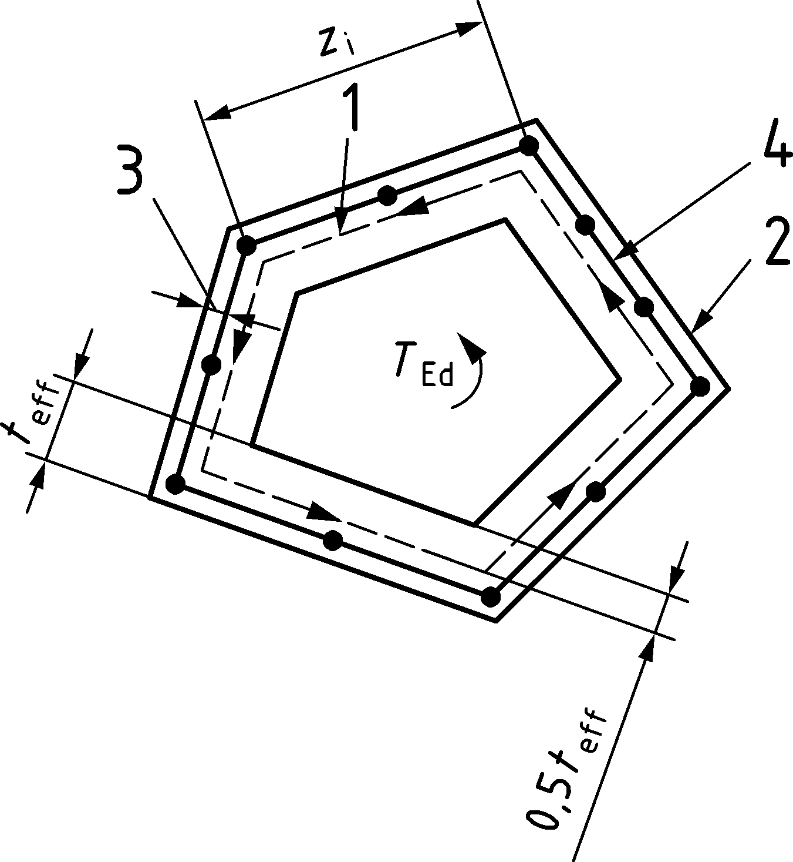

Key

|  |  |
| --- | --- |
| 1 | centre line |
| 2 | outer edge of effective cross section, circumference u |
| 3 | cover |
| 4 | torsional web reinforcement Asw |

Figure 8.16 — Notations and definitions used in 8.3

(3) The shear force VEd,i in a wall element i due to torsion may be taken as:

|  |  |
| --- | --- |
| $$V_{Ed,i}=τ_{t,i }t_{eff,i} z_{i}$$ | (8.64) |

where

|  |  |
| --- | --- |
| zi | is the side length of wall i defined by the distance between the intersection points with the adjacent walls. |

### Internal forces due to torsion in open sections

(1) In open thin walled members it may be necessary to consider warping torsion. In this case the different parts of the section should be designed according to the rules for bending and longitudinal axial force in 8.1 and shear in 8.2.

### Torsional resistance of compact or closed sections

(1) For a single cell, thin-walled section or a sub-section with constant effective wall thickness teff, the design torsional capacity may be calculated as:

|  |  |
| --- | --- |
| $$τ_{t,Rd}=min\left\{τ_{t,Rd,sw};τ_{t,Rd,sl}; τ_{t,Rd,max}\right\}$$ | (8.65) |

where τRd,sl, τRd,sw and τt,Rd,max are torsional sresses given by Formulae (8.65) to (8.68) and determined on the basis of Annex G.

(2) The torsional capacity when governed by yielding of the longitudinal reinforcement τt,Rd,sl or the shear reinforcement τt,Rd,sw may be calculated as

|  |  |
| --- | --- |
| $$τ_{t,Rd,sw} =cotθ\frac{A_{sw }}{t_{eff}⋅s}f_{ywd}$$ | (8.66) |

and

|  |  |
| --- | --- |
| $$τ_{t,Rd,sl}=\frac{∑A_{sl }f_{yd}}{t_{eff}u_{k}cotθ}$$ | (8.67) |

where

|  |  |
| --- | --- |
| uk | is the perimeter of the area Ak; |
| fyd | is the design yield stress of the longitudinal reinforcement Asl; |
| ΣAslfyd | is the yield force of the longitudinal reinforcement, that may be included in the calculation of the torsional capacity. The amount of longitudinal reinforcement considered in Formula (8.60) should have a resultant tensile force that acts at the centroid of the equivalent thin-walled closed cross section. The reinforcement should generally be distributed according to 12.2.3(9); |
| fywd | is the design yield stress of the shear reinforcement; |
| Asw | is the cross sectional area of the shear reinforcement within the effective wall thickness in Figure 8.16; |
| s | is the spacing (in the longitudinal direction) between the shear reinforcement Asw; |
| θ | is the angle of compression field with respect to the longitudinal axis. |

(3) The torsional strength, when governed by crushing of the compression field in concrete, may be calculated from:

|  |  |
| --- | --- |
| $$τ_{t,Rd,max}=\frac{ν⋅f_{cd}}{cotθ+tanθ}$$ | (8.68) |

where ν may be determined by the formulae in Annex G. A value of ν = 0,40 may be used generally.

(4) The inclination of the concrete strut to be used in Formulae (8.66) to (8.68) should for usual cases, and when ν = 0,40 is adopted, be chosen within the following range:

|  |  |
| --- | --- |
| $$\frac{1}{cotθ_{min}}≤cotθ≤cotθ_{min}$$ | (8.69) |

where cotθmin is defined in 8.2.3(3).

(5) When at the same time bmax/bmin < 1,5 and c > 0,07∙ bmin calculations of the torsional capacity should be based on a reduced cross section with reduced cover equal to 0,07bmin.

where

|  |  |
| --- | --- |
| c | is the concrete cover to stirrups; |
| bmin; bmax | are the minimum and maximum side lengths of the section (sub-section) in Figure 8.16. |

NOTE This reduction accounts for a risk for partial spalling of the cover.

### Design procedure for combination of actions

(1) Design for combined action of torsion, bending, shear and axial forces may follow:

* the procedure of designing individual wall elements according to (2) or, alternatively,
* a simplified procedure based on interaction formulae as presented in 8.3.6.

(2) The design procedure for combination of actions may be based on a thin-walled closed section complying with 8.3.2, in which the sectional forces and moments are replaced by a statically equivalent set of normal- and shear stress distributions. The distribution of normal and shear stresses may be determined by conventional elastic or plastic methods. Calculation of the reinforcement and check of compression in the concrete struts in each individual wall may use the formulae of Annex G, or 8.2.3.

(3) For solid sections, if beneficial, a portion of the axial force and the shear force may also be distributed to the solid core inside the thin-walled section.

### Interaction formula

(1) A simplified and conservative verification of the resistance of cross sections subjected to combination of internal forces may be performed based on the following linear criterion:

|  |  |
| --- | --- |
| $${∑\left(\frac{S_{Ed}}{S_{Rd}}\right)}_{i}≤1,0$$ | (8.70) |

(2) The SEd/SRd-ratios for shear actions and for the corresponding bending moments need not be inserted simultaneously in Formula (8.70) provided that the bending moment capacity is based on the area of reinforcement that does not include allowance for resisting Nvd according to 8.2.3(8). In this case, two separate verifications may be carried out considering the following combinations:

1. bending, torsion and axial force; and
2. shear, torsion and axial force.

(3) Alternatively, other safe approximations of the interaction diagram established on the basis of 8.3.5(2) are allowed.

## Punching

### General

(1) The rules in 8.4 complement those given in 8.2 and cover punching shear in solid slabs and waffle slabs with solid areas over supporting areas (columns, capitals, shearheads, walls). The rules presented hereafter for supporting areas apply by analogy to loaded areas of planar members and foundations (column bases).

(2) The punching shear resistance shall be verified according to the following procedure:

(i) Detailed verification of the punching shear resistance may be omitted, provided that the following condition is satisfied outside the control perimeter:

|  |  |  |
| --- | --- | --- |
| τEd ≤ τRdc,min | according to 8.2.1(4) | (8.71) |

(ii) Punching shear reinforcement may be omitted when the following condition is satisfied:

|  |  |  |
| --- | --- | --- |
| τEd ≤ τRd,c | according to 8.4.3 | (8.72) |

(iii) Where τEd > τRd,c punching shear reinforcement is required and the maximum punching shear resistance at the control perimeter may not be exceeded:

|  |  |  |
| --- | --- | --- |
| τEd ≤ τRd,max | according to 8.4.4(3) | (8.73) |

(iv) The punching shear reinforcement should be provided to satisfy the following condition:

|  |  |  |
| --- | --- | --- |
| τEd ≤ τRd,cs | according to 8.4.4 and complying with the detailing rules of 12.4.2. | (8.74) |

(v) If shear reinforcement is required, a further control perimeter where shear reinforcement is no longer required shall be checked according to 8.4.4(4).

### Shear-resisting effective depth, control perimeter and shear stress

(1) The shear-resisting effective depth of the slab dv should be taken as the distance from the supporting area to the average level of the reinforcement layers, see Figure 8.17.

|  |  |
| --- | --- |
| $$d_{v}=\frac{d_{vx}+d_{vy}}{2}$$ | (8.75) |

NOTE 1 For *d*vx and *d*vy the nominal effective depth *d*nom or the design value *d*d can be used (see A(6)). A National Annex can give advice for using *d*d.

|  |  |  |
| --- | --- | --- |
|  | | |
| a) Direct support | b) Hanging support with penetration | c) Penetration by direct support |

Key

|  |  |
| --- | --- |
| 1 | control perimeter |

Figure 8.17 — Shear-resisting effective depth of the slab dv considering effective level of supporting area

NOTE 2 Figure 8.17c) shows the case where the column penetrates into the slab. This is only to account for in the punching shear calculation when the penetration is larger than d/20 (see also tolerance according to EN 13670).

(2) The control perimeter may normally be taken at a distance 0,5dv from the face of supporting area and should be constructed so as to minimise its length b0,5 (see Figure 8.18). For the calculation of the punching shear resistance, also the perimeter b0 at column edge minimised according to Figures 8.18(c), (d) and (e) is used.

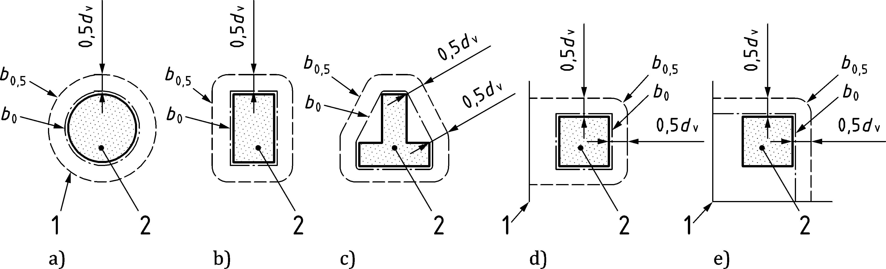

Key

|  |  |
| --- | --- |
| 1 | control perimeter |
| 2 | supporting area |
| 3 | slab edge |

Figure 8.18 — Typical control perimeters b0,5 and perimeters b0 around supporting areas

(3) The effect of concentration of the shear forces at the corners of large supporting areas may be taken into account by reducing the control perimeter assuming that the length of its straight segments does not exceed 3dv for each edge (refer to reduced control perimeter length shown in Figure 8.19a). In large columns, without a detailed analysis, only the reduced control perimeter according to Figure 8.19a) should be accounted for. In wall ends and wall corners, the load carried by the supporting areas defined in Figures 8.19b) and c) should be verified for punching resistance whereas the load carried outside the supporting areas should be verified for shear according to 8.2.1 and 8.2.2.

|  |  |  |  |  |
| --- | --- | --- | --- | --- |
|  |  |  |  |  |
| a) column | b) wall end | c) wall corner | d) with opening | e) with inserts |

Key

|  |  |
| --- | --- |
| 1 | control perimeter |
| 2 | supporting area |
| 3 | inserts |

Figure 8.19 — Length of control perimeter b0,5 around large supporting areas and near openings and inserts

(4) The effect of openings or inserts at a shortest distance to the control perimeter > 5dv may be neglected. Otherwise, the part of the control perimeter contained between the two tangents drawn to the outline of the opening from the centre of the loaded area should be considered to be ineffective (refer to Figures 8.19d) and e)).

(5) In the case of slabs with variable depth, control perimeters at a greater distance from the supported area should be checked and the one leading to the lowest strength should be selected. The corresponding shear-resisting effective depth dv may be determined according to Figure 8.20.

|  |  |
| --- | --- |
|  |  |
| a) flat slabs | b) ground slabs |

Key

|  |  |
| --- | --- |
| 1 | control perimeter 1 |
| 2 | control perimeter 2 |

Figure 8.20 — Control perimeter and shear-resisting effective depth of members with variable depth

(6) The design shear stress τEd may be calculated as:

|  |  |
| --- | --- |
| $$τ_{Ed}=β_{e}\frac{V_{Ed}}{b_{0,5}⋅d_{v}}$$ | (8.76) |

where

|  |  |
| --- | --- |
| VEd | is the design shear force at the relevant control perimeter (all favourable loads acting on the tensile side of the planar member, soil reactions on foundations and ground slabs and the deviation forces in post-tensioned slabs inside the control perimeter may be deducted from the shear force at centre of supported area to calculate the design shear force at control perimeter VEd). In the case of foundations or ground slabs without shear reinforcement, the soil reaction *σ*gd may be deduced up to a distance of 0,67*d*v from the column; |
| βe | is a coefficient accounting for concentrations of the shear forces, which may be adopted from Table 8.3. The approximated values for internal, edge and corner columns may be used only if all following conditions are fulfilled: |
|  | — the lateral stability does not depend on frame action of slabs and columns, |
|  | — the adjacent spans do not differ in length more than 25 %, |
|  | — the slab is only under uniformly distributed loads, |
|  | — the moment transferred to the edge and corner columns are not larger than Mtd,max = 0,25be ⋅ d2 ⋅ fcd where width be is defined in Figure 8.21c). |
|  | Otherwise, the refined values should be adopted. The refined values may also be applied in cases complying with the conditions above for a more refined calculation; |
| b0,5 | is the length of the control perimeter. |

NOTE For dv according to Formula (8.75) the nominal effective depth dnom or the design value dd for dvx and dvy can be used (see A(6)). A National Annex can give advice for using dd.

Table 8.3 — Coefficients βe accounting for concentrations of the shear forces

|  |  |  |  |  |  |
| --- | --- | --- | --- | --- | --- |
| Support | | | Approximated | Refineda | |
| internal columns | | | βe = 1,15 | $$β_{e}=1+1,1\frac{e_{b}}{b_{b}}$$ | where $e_{b}=\sqrt{e_{b,x}^{2}+e_{b,y}^{2}}$ |
| edge columns | | | βe = 1,4 | where |
| corner columns | | | βe = 1,5 | where  ≤0,45∙ bb |
| ends of walls | | | βe = 1,4 | | |
| corners of walls | | | βe = 1,2 | | |
| a | eb,x, eb,y | are the components of the eccentricity of the resultant of shear forces with respect to the centroid of the control perimeter which may be simplified replacing parts of circles by corners (see Figure 8.21a)) and where the straight segments are not limited to 3dv according to (3); | | | |
|  | bb | is the geometric mean of the minimum and maximum overall widths of the control perimeter shown in Figure 8.21b): | | | |
|  |  | $$b_{b}=\sqrt{b_{b,min}⋅b_{b,max}}$$ | | | |

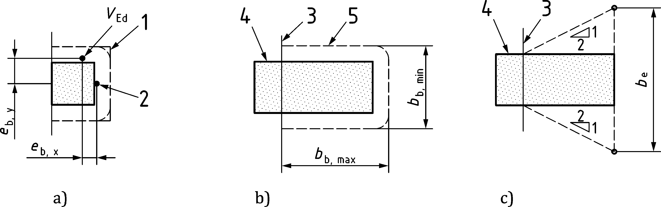

a) definition of eccentricity eb

b) definition of overall widths of control perimeter bb,min and bbmax

c) definition of width be for an edge columns

**Key**

|  |  |
| --- | --- |
| *V*Ed | resultant of shear forces |
| 1 | simplified control perimeter for calculating its centroid |
| 2 | centroid of full control perimeter |
| 3 | slab edge |
| 4 | column |
| 5 | control perimeter |

Figure 8.21 — Eccentricity and control perimeter at edge columns for Table 8.3

(7) The design shear stress τEd may also be calculated directly from a detailed analysis of the shear stress distribution along the control perimeter as:

|  |  |
| --- | --- |
| $$τ_{Ed}=\frac{v_{Ed}}{d_{v}}$$ | (8.77) |

where the shear force per unit width vEd may be averaged according to 8.2.1(6).

NOTE For dv see 8.4.2(6).

(8) In cases where significant concentrated loads (≥ 0,2VEd) are applied near the supported area (closer than 3dv from the control perimeter) or for cases not covered by (6) to (7), the design shear stress τEd (average value over the depth) may be calculated at the location of the control perimeter by using a method accounting for equilibrium and compatibility conditions of the slab (for instance, linear elastic analysis).

(9) In case of concentrations of shear forces, the maximum value may be averaged over a width not larger than 2dv on both sides from the peak of the shear force.

### Punching shear resistance of slabs without shear reinforcement

(1) The design punching shear stress resistance shall be calculated as follows:

|  |  |
| --- | --- |
| $$τ_{Rd,c}=\frac{0,6}{γ_{V}}⋅k_{pb}{\left(100 ρ_{l}⋅f_{ck}⋅\frac{d_{dg}}{d_{v}}\right)}^{\frac{1}{3}}≤\frac{0,6}{γ_{V}}⋅\sqrt{f_{ck}}$$ | (8.78) |

where

|  |  |  |
| --- | --- | --- |
| $$ρ_{l}=\sqrt{ρ_{l,x}⋅ρ_{l,y}}$$ | | (8.79) |
| ρl,x, ρl,y | are reinforcement ratios of bonded flexural reinforcement in the x- and y-directions respectively. The values of ρl,x and ρl,y should be calculated as mean values over the width bs defined in Figure 8.22. | |
| ddg | is defined in 8.2.1(4); | |
| kpb | is the punching shear gradient enhancement coefficient that may be calculated as: | |
|  | $$1≤k_{pb}=3,6\sqrt{1-\frac{b_{0}}{b_{0,5}}}≤2,5$$ | (8.80) |
| dv | is calculated according to 8.4.2(1). | |

|  |  |  |
| --- | --- | --- |
|  |  |  |
| a) internal | b) edge | c) corner columns |

Figure 8.22 — Definition of width bs

(2) For distances between the centre of the support area and the point of contraflexure in the considered load combination ap smaller than 8d, the value of dv in Formula (8.78) may be replaced by:

|  |  |
| --- | --- |
| $$a_{pd}=\sqrt{\frac{a_{p}}{8}⋅d_{v}}$$ | (8.81) |

where

|  |  |  |
| --- | --- | --- |
| $$a_{p}=\sqrt{a_{p,x}⋅a_{p,y}}≥d_{v}$$ | | (8.82) |
| ap,x, ap,y | are the maximum distances from the centroid of the control perimeter (which may be simplified according to Figure 8.21a) to the two points (on the x- and on the y-axis, respectively) where the bending moments mEd,x, respectively mEd,y, are zero. The distances apx and apy may be calculated according to (3) or using a linear elastic (uncracked) model. The local coordinate system (x,y) has its origin at the centre of the support area and coincides with the reinforcement directions (principal directions in case of layers which are not orthogonal). | |

(3) For regular flat slabs where the lateral stability does not depend on frame action between the slabs and the columns and that respect the condition 0,5 ≤ Lx/Ly ≤ 2, the value of ap may be approximated as apx ≈ 0,22Lx or apy ≈ 0,22Ly for the x- and y directions, respectively. For different span lengths in continuous slabs, the largest span length of the bays adjacent to the considered column should be accounted for. For corner columns and for the direction perpendicular to the edge in case of edge columns, a safe estimate of ap may be obtained considering the spans in both directions of the edge bay.

(4) For slabs with axial forces and for prestressed slabs, the value of kpb of Formula (8.80) may be multiplied by the coefficient kpp:

|  |  |  |
| --- | --- | --- |
| kpp = kN | for compressive axial forces (e.g. prestressing) | (8.83) |
| kpp = 1/kN | for tensile axial forces | (8.84) |
|  | | (8.85) |

where σd is the average normal stress over the width bs defined in Figure 8.22.

In case different axial stresses act in two directions, an average value

|  |  |
| --- | --- |
| $$k_{pp}=\sqrt{k_{pp,x}⋅k_{pp,y}}$$ | (8.86) |

may be adopted, where kpp,x and kpp,y are the coefficients accounting for the presence of axial stresses in the x- and y-directions.

For prestressed slabs with eccentric tendons, the beneficial effect of the tendon’s eccentricity on the tensile side of the planar member may be considered with:

|  |  |
| --- | --- |
|  | (8.87) |

where ep is the eccentricity of the tendons at axis of the supported area with the respect to the centre of gravity of the cross section to be considered as positive for tendons on the tensile side. For statically indeterminate slabs, the effect of hyperstatic moments due to prestressing should be considered by reducing the tendons eccentricity accordingly.

For prestressed slabs with bonded tendons, the effective depth dv and the flexural reinforcement ratio ρl to be used in Formula (8.78) should be calculated according to 8.2.2(6) in both directions and averaged using Formulae (8.75) and (8.79).

The negative influence of tensile forces in the slab shall be accounted for (kpp < 1,0).

### Punching shear resistance of slabs with shear reinforcement

(1) Where shear reinforcement is required, it should be calculated in accordance to:

|  |  |
| --- | --- |
| $$τ_{Rd,cs}=η_{c}⋅τ_{Rd,c}+η_{s}⋅ρ_{w}⋅f_{ywd}≥ρ_{w}⋅f_{ywd}$$ | (8.88) |

where

|  |  |  |
| --- | --- | --- |
|  | $$η_{c}=\frac{τ_{Rd,c}}{τ_{Ed}}$$ | (8.89) |
|  | $$η_{s}=\frac{d_{v}}{150ϕ_{v}}+{\left(15\frac{d_{dg}}{d_{v}}\right)}^{1/2}⋅{\left(\frac{1}{η_{c}⋅k_{pb}}\right)}^{3/2}≤0,8$$ | (8.90) |

Where $d_{dg}$ is defined in 8.2.1(4)

|  |  |  |  |
| --- | --- | --- | --- |
|  | $$ρ_{w}=\frac{A_{sw}}{s_{r}⋅s_{t}}$$ | is the shear reinforcement ratio at the investigated control perimeter | (8.91) |
| Asw | is the area of one leg of shear reinforcement; | | |
| sr | is the radial spacing of shear reinforcement (sr = s1, see Figure 8.24); for evenly distributed shear reinforcement fulfilling the requirements of 12.4.2, ρw may be calculated directly on the basis of the spacing in both directions. Where single bent up bars are used, sr = 0,67dv may be assumed; | | |
| st | is the average tangential spacing of perimeters of shear reinforcement measured at the investigated control perimeter (length of control perimeter divided by number of intersecting rows in case of shear reinforcement placed in cruciform or radial arrangement). | | |

(2) Where inclined shear reinforcement is used:

* term ρw in Formula (8.89) may be multiplied by the factor (sinαw + cosαw);
* coefficient ηs calculated according to Formula (8.91) may be multiplied by the factor (sinαw + cosαw) ⋅ sinαw (but respecting that ηs ≤ 0,8).

(3) The punching shear resistance shall be limited to a maximum of:

|  |  |
| --- | --- |
| τRd,max = ηsys ⋅ τRd,c | (8.92) |

where a coefficient ηsys according to Formula (8.93) accounting for the performance of punching shear reinforcing systems may be used:

|  |  |
| --- | --- |
| $$η_{sys}=1,15\frac{d_{sys}}{d_{v}}+0,63{\left(\frac{b_{0}}{d_{v}}\right)}^{1/4}-0,85\frac{s_{0}}{d_{sys}}$$ | (8.93) |

where dsys and s0 are defined in Figure 8.23. For variable distance s0, the average over the control perimeter should be used in Formula (8.93).

Where specific products are used as shear reinforcement, ηsys shall be determined by testing in accordance with the applicable European Assessment Document (EAD).

The maximum punching shear resistance **Rd,max of internal columns may be multiplied by **pb considering compressive membrane action provided that:

* no significant openings, inserts or slab edges are present at a distance less than 5*d*v from the control perimeter *b*0,5; and
* coefficient **pb is not already considered in **Rd,c according to I.8.5.1(1).

NOTE The factor is *η*pb =1,0 for new structures and *η*pb according to I.8.5.1(1) for existing structures unless a National Annex gives different values.

|  |  |  |  |
| --- | --- | --- | --- |
|  | | | |
| a) See details in b) to d) | b) Top of head | c) Level of axis of reinforcement inside the bend | d) Limit of bend |

Figure 8.23 — Definition of parameter dsys

(4) The outer control perimeter at which shear reinforcement is not required (b0,5,out, see Figure 8.24) should be calculated as:

|  |  |
| --- | --- |
| $$b_{0,5,out}=b_{0,5}⋅{\left(\frac{d_{v}}{d_{v,out}}⋅\frac{1}{η_{c}}\right)}^{3/2}$$ | (8.94) |

where

|  |  |
| --- | --- |
| dv,out | is the outer shear-resisting effective depth according to Figure 8.24; |
| ηc | as defined in Formula (8.89). |

The outermost perimeter of shear reinforcement should be placed at a distance not greater than 0,5dv,out from the outer control perimeter according to Figure 8.24.

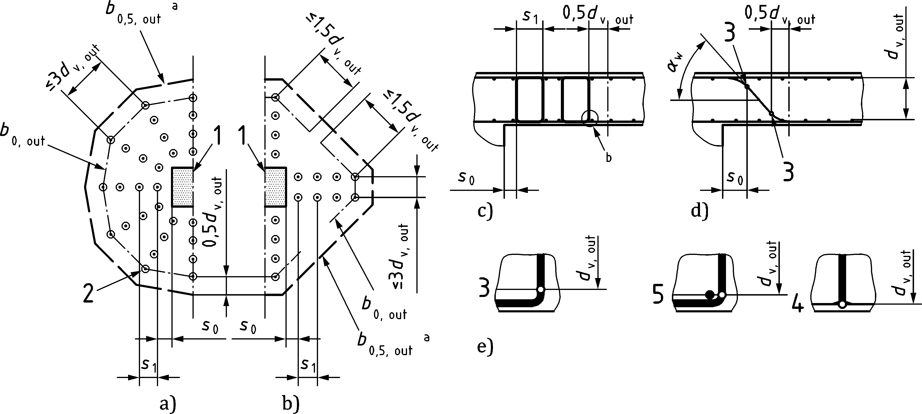

a) radial arrangements

b) cruciform arrangements

c) shear-resisting effective depth for stirrups and studs

d) shear-resisting effective depth for bent up bars

e) details of the levels where dv,out should be measured

Key

|  |  |  |  |
| --- | --- | --- | --- |
| X | outer control perimeter | 3 | limit of bends |
| 1 | supporting area (column or wall end) | 4 | bottom of head |
| 2 | transverse reinforcement | 5 | level of axis of reinforcement inside the bend |

Figure 8.24 — Control perimeters outside of the shear reinforcement region

## Design with strut-and-tie models and stress fields

### General

(1) Strut-and-tie models or stress fields should be used for design and verification of discontinuity regions (i.e. regions where the strain state distribution is not linear such as near concentrated loads or geometric discontinuities) in absence of specific provisions elsewhere in this code or of alternative refined analyses.

NOTE All provisions of 8.2.3 to 8.2.5 and 8.3 and Annex G are consistent with the rules given of 8.5. Linear members with shear reinforcement and without discontinuities can thus also be designed for bending, shear and torsion with the provisions of 8.5.

(2) The provisions in 8.5 are applicable without a verification of the deformation capacity provided that the following conditions are fulfilled:

* the member contains a minimum reinforcement according to Clause 12 or the development of uncontrolled cracks is avoided by other means;
* the reinforcement complies with the details according to Clauses 11 and 12;
* the reinforcing steel is either ductility Class B or C.

(3) Strut-and-tie models and stress fields aim at a representation of the stress state in a cracked concrete structure. They shall be in equilibrium with the external actions and shall satisfy strength conditions. They consist of:

* struts in strut-and-tie models which are idealisations of the compression fields in the stress fields (refer to 8.5.2);
* ties representing the reinforcement (refer to 8.5.3);
* nodal regions where the forces are transferred between the struts or between compression fields and/or the ties (refer to 8.5.4)

NOTE Strut-and-tie models and stress fields are consistent in terms of hypotheses and complementary in terms of use. Strut-and-tie models are idealizations of stress fields aiming at a representation of the force resultants of the compression fields (struts) and ties in the tension fields (see Figure 8.25b) and d)).

(4) Compression fields and ties in stress fields can be distributed (Figure 8.25a)) or concentrated (Figure 8.25c)). Both cases may be designed with the provisions of 8.5. Alternatively, for an element fully occupied by a distributed and uniform compression field and with distributed reinforcement (refer for instance to Figure 8.25a), the formulae of Annex G may be used for its design. In this latter case, the forces in any chord at the boundaries of the membrane element shall be designed accordingly.

|  |  |
| --- | --- |
|  |  |
| a) distributed stress field | b) corresponding strut-and-tie model |
|  |  |
| c) concentrated stress field | d) corresponding strut-and-tie model |

Key

|  |  |  |  |
| --- | --- | --- | --- |
| 1 | distributed compression field | 7 | tie |
| 2 | distributed tie | 8 | node |
| 3 | concentrated tie | 10 | strut |
| 4 | triangular nodal region | 11 | concentrated compression field |
| 5 | concentrated compression field |  |  |

Figure 8.25 — Examples of stress fields and strut-and-tie models

### Struts and compression fields

(1) The width of the struts and of the compression fields near member edges or openings shall be verified to respect the strength condition of (3). For the conditions at the ends of struts, 8.5.4 applies.

(2) The stresses in the concrete struts and in the compression fields may generally be assumed as uniformly distributed over its cross section, so that its value may be calculated as:

|  |  |
| --- | --- |
|  | (8.95) |

where

|  |  |
| --- | --- |
| Fcd | is the compressive force of the strut; |
| t | is the thickness of the strut which can be limited by the thickness of the member; |
| bc | is the width of the strut. |

(3) The stress σcd in a strut or in a compression field developing within the concrete shall fulfil the following condition:

|  |  |
| --- | --- |
| $$σ_{cd}≤ν⋅f_{cd}$$ | (8.96) |

where ν is the strength reduction factor defined in (4) and (5).

(4) Unless a more refined approach is used, the value of factor ν may be determined as a function of the presence of a tie and the minimum angle θcs between the strut representing the resultant of the compression field and any tie as defined in Figure 8.26.

NOTE In the example of Figure 8.26b), **cs can be calculated form Formula (8.97):

|  |  |
| --- | --- |
|  | (8.97) |

1. for compression fields and struts crossed or deviated by a tie at an angle:

|  |  |  |
| --- | --- | --- |
| — 20°≤ θcs < 25° | ν = 0,4 | (8.98a) |
| — 25°≤ θcs < 35° | ν = 0,5 | (8.98b) |
| — 35°≤ θcs < 45° | ν = 0,6 | (8.98c) |
| — 45°≤ θcs < 90° | ν = 0,7 | (8.98d) |

1. for compression fields and struts in a region with transverse compressive stress or without ties

|  |  |  |
| --- | --- | --- |
|  | ν = 1,0 | (8.98e) |

Alternatively, the value of factor ν may be determined as:

|  |  |
| --- | --- |
| $$ν=\frac{1}{1,11+0,22⋅\cot^{2}θ_{cs}}≤1,0$$ | (8.99) |

|  |  |
| --- | --- |
|  |  |
| a) constant width | b) variable width |

Figure 8.26 — Definition of angle θcs for a compression field (example of end support of beams)

(5) More refined values for factor ν may also be used for compression fields in cracked zones. They may be determined from the principal tensile strain in the concrete, based on a cracked analysis of the member neglecting the tensile strength of the concrete. In this case, factor ν may be evaluated as:

|  |  |
| --- | --- |
| $$ν=\frac{1}{1,0+110ε_{1}}≤1,0$$ | (8.100) |

where ε1 is the value of the maximum principal tensile strain.

(6) In zones with confinement reinforcement, the compressive strength may be increased according to 8.1.4. The confinement stress σc2d to be used in 8.1.4(2) is the minimum of the two principal compressive stresses perpendicular to the strut (in planar members without confinement reinforcement perpendicular to the plane, σc2d is thus null).

(7) The contribution of compression reinforcement to the strength of a strut may be taken into account up to its yield strength, provided that:

* it is in the same direction as the strut,
* the strength of member according to 8.1 is respected,
* buckling of the reinforcement is prevented according to the rules in 12.5.2 and
* detailing is performed according to the rules of Clauses 11 and 12.

### Ties

(1) The resistance of a tie FRd shall fulfil the following condition:

|  |  |
| --- | --- |
| $$F_{td}≤F_{Rd}=A_{s}⋅f_{yd}+A_{p}⋅f_{pd}$$ | (8.101) |

where As and Ap are the cross sectional areas of the reinforcements of the tie. If prestressed reinforcement is considered as an external action, then fpd should be replaced by fpd − σpd according to 7.10.5(1).

(2) Formula (8.101) may be used only when ties are suitably anchored at the nodes according to the rules given in 8.5.4. Otherwise, the force in the ties should be limited to the force that can be effectively anchored.

### Nodes

#### Definitions

(1) Nodes shall ensure the transfer of forces amongst the different struts and ties (see Figure 8.25).

(2) For nodes with three concurrent struts and ties, four cases can be distinguished:

* CCC nodes, when only struts reach the node (refer to 8.5.4.2),
* CCT nodes, when only one tie is present in the node (refer to 8.5.4.3),
* CTT nodes, when only one strut is equilibrating the reinforcement forces (refer to 8.5.4.4),
* TTT nodes, where only ties reach the node. TTT nodes may be used only if consistent values of the strength reduction factor ν in the node are adopted accounting for anchorage, detailing and strains according to 8.5.2(5).

(3) Nodes with four or more concurrent struts and ties may be treated as a combination of two or more nodes, each of them with three intersecting strut and ties according to (2).

#### CCC nodes

(1) In a CCC node, verification of the stress state within the nodal region may be omitted as long as the adjoining struts all comply with their stress limits.

(2) The value of coefficient ν at the ends of the converging struts may be taken as 1,0 or increased according to 8.1.4 or 8.6. The widths of the struts bc may be adapted accordingly. If the converging struts have different stresses, the geometry of the node may be adapted according to Figure 8.27b.

(3) For CCC nodes at the surface of partially loaded areas, the strength increase of 8.6 may be accounted for.

|  |  |
| --- | --- |
|  |  |
| a) identical stresses | b) different stresses |

Figure 8.27 — CCC node with three struts

#### CCT nodes

(1) The tension force F2d shown in Figure 8.28a) shall be anchored:

* outside of the nodal region according to Figure 8.28b) or
* partly or completely inside of the nodal region according to Figure 8.28c).

(2) The following methods may be used for anchoring the tie force:

* straight bars according to 11.4.2 where the design anchorage length lbd should not be less than the width of the nodal region (lbdn in Figure 8.28c),
* bends, hooks (11.4.3) and loops (11.4.4) should not start their bend before the centre of the node nor the radius of the bend before the end of the node. The heads of headed bars (11.4.5) should be placed outside the nodal region. An additional length according to Figures 8.28d) to e) should be provided to allow spreading the anchored force over the width bs and the thickness t (where $b_{s}⋅t≥F_{2d,b}/f_{cd}$, F2d,b being the reinforcement force to be anchored at the backside of the node).

(3) If necessary, the reinforcement carrying the tie force may be distributed or a distributed reinforcement may be added according to Figure 8.28e). In case of distributed stirrups carrying the tie force, 12.2.3 applies.

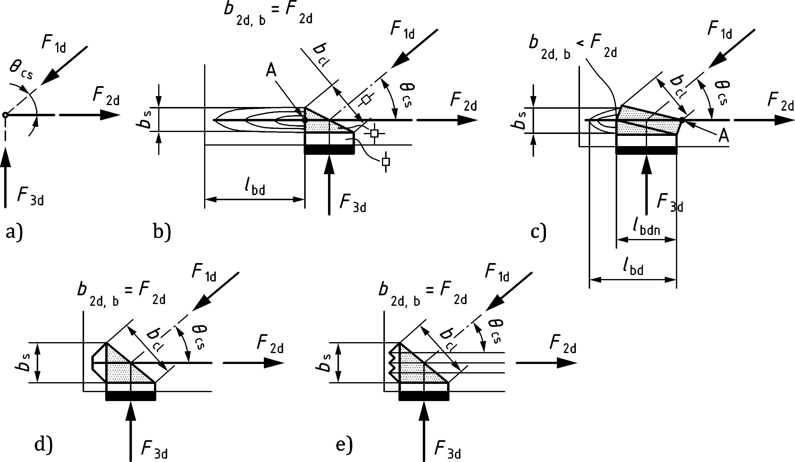

a) strut-and-tie model

b) with anchorage outside the nodal region

c) anchorage partly inside the nodal region

d) example of anchorage using headed bars

e) example of anchorage using loops

Key

|  |  |
| --- | --- |
| A | cross section where the reinforcement force is fully transferred to concrete in compression |

Figure 8.28 — CCT nodes and stress fields

(4) The strength reduction factor ν of concrete in nodes may be assumed as:

* according to 8.5.2(4) in case the tie is fully anchored inside the nodal region as shown in Figure 8.28c) (case with lbdn = lbd),
* ν = 1,0 in case the tie is fully anchored outside of the nodal region as shown in Figures 8.28b), d) and e),
* a linear interpolation between the previous values depending on the ratio between the required anchorage length outside of the nodal region and the total required anchorage length.

#### CTT nodes

(1) CTT nodes (Figure 8.29) should be designed according to one of following alternatives:

* with bent bars as shown in Figure 8.29b);
* with anchorages outside of the nodal region as shown in Figure 8.29c) or partly inside of the nodal region in a similar manner as in Figure 8.28c). In case the force is anchored with bends, hooks, loops or headed bars, 8.5.4.3(2) applies;
* with straight bars inside the nodal region as shown in Figure 8.29d).

|  |  |
| --- | --- |
|  |  |
| a) strut-and-tie model and equilibrium of forces | b) strut-and-tie model and stress field for the deviation force of a bent bar |
|  |  |
| c) strut-and-tie model and stress field for anchorages outside the node | d) strut-and-tie model and stress field for anchorages inside the node |

Key

|  |  |
| --- | --- |
| A | cross section where the reinforcement force is fully transferred to concrete in compression |

Figure 8.29 — CTT node and corresponding stress field

(2) The strength reduction factor ν of concrete at the end of the strut may be assumed as:

* according to 8.5.2(4) in the case of bent bars shown in Figure 8.29b), provided that the requirements of the mandrel diameter of 11.3 are fulfilled, or in the case that the ties are anchored inside of the nodal region as shown in Figure 8.29d);
* ν = 1,0 in case the tie is fully anchored outside of the nodal region as shown in Figure 8.29c).

### Spreading of struts

(1) Unless a detailed analysis is performed on the serviceability and ultimate limit state conditions (according for instance to 7.7), the transverse reinforcement for concentrated forces applied in a plane stress state and spreading into a member shall satisfy the rules provided in 8.5.5.

(2) The reinforcement for carrying spreading forces may be dimensioned and arranged according to the stress fields or the strut-and-tie model shown in Figure 8.30:

|  |  |
| --- | --- |
| $$F_{td}=\frac{F_{d}}{2}tanθ_{cf}$$ | (8.102) |

where the spreading angle θcf may be assumed as:

|  |  |
| --- | --- |
| $$tanθ_{cf}=\frac{1-a/b}{2}$$ | (8.103) |

where a and b are defined in Figure 8.30a). For the case shown in Figures 8.30c) and d) (b > a + H/2), the ratio a/b should be assumed equal to 0.

Alternative approaches for design of the reinforcement may be used, provided that the spreading angles and corresponding reinforcement layout are derived from a stress field fulfilling the requirements of 8.5.2 to 8.5.4.

|  |  |
| --- | --- |
|  |  |
| **a) and b) narrow element** | **c) and d) wide element** |

Figure 8.30 — Spreading of concentrated forces, stress fields and strut-an-tie models

(3) In case of concentrated forces acting close to an edge, transverse reinforcement should be placed, to take the force according to the concentrated stress field in Figure 8.31:

|  |  |
| --- | --- |
| $$F_{td}=F_{d}⋅tanθ_{cf}$$ | (8.104) |

where tanθcf ≥ 1/4 may be assumed. The nodal region, in this case may be considered as a CCT node.

|  |  |
| --- | --- |
|  | |
| **a) stress field** | **b) corresponding strut-and-tie model** |

Figure 8.31 — Concentrated forces near an edge

## Partially loaded areas

(1) For partially loaded areas, local crushing according to (2) and transverse tension forces according to (3) and 8.5 shall be considered. The formulae given in (2) and (3) below are valid where there is no risk of punching failure. Possible punching failure shall be checked independently according to 8.4.

(2) For a uniform distribution of stresses on an area Ac0 (see Figure 8.32), resistance to crushing may be verified as follows:

|  |  |
| --- | --- |
| $$σ_{Rdu}=f_{cd}\sqrt{\frac{A_{c1}}{A_{c0}}}≤ν_{part}f_{cd}$$ | (8.105) |

where

|  |  |  |  |
| --- | --- | --- | --- |
| νpart | is a confinement factor: | | |
|  | νpart = 7,0 if there are no external tensile forces which can induce cracking in the direction parallel to the direction of the load and no known pre-existing cracks or restraints in this direction, | | |
|  | νpart = 3,0 otherwise; | | |
| Ac0 | is the loaded area (see Figure 8.32). | | |
|  | Ac0 = a0 ⋅ b0 | | (8.106a) |
|  | For eccentric loading Ac0 should be taken as Ac0,red (see Figure 8.34): | | |
|  | Ac0,red = a0,red ⋅ b0,red | | (8.106b) |
|  | where | | |
|  | a0,red = a0 − 2ea and b0,red = b0 − 2eb, | | |
|  | ea | is the eccentricity of the load parallel to a0, | |
|  | eb | is the eccentricity of the load parallel to b0. | |
| Ac1 | is the contributing concrete area which may be determined as follows (see Figure 8.32 for a single loaded area and Figure 8.33 for two loaded areas of different size): | | |
|  | Ac1 = a1 ⋅ b1 | | (8.107) |
|  | where | | |
|  | a1 = min{c1; c2}; | | |
|  | b1 = min{b0 + (a1 − a0); max{c1; c2}} with a1 ≤ b1; | | |
|  | The minimum height of block should be h ≥ a1 (see Figure 8.32c)). | | |

Formula (8.105) is only valid under the assumption of the same diffusion of load in both transverse directions (geometric similarity of Ac1 and Ac0).

|  |  |
| --- | --- |
|  |  |
| **a) 3-dimensional load distribution** | **b) 2-dimensional load distribution** |

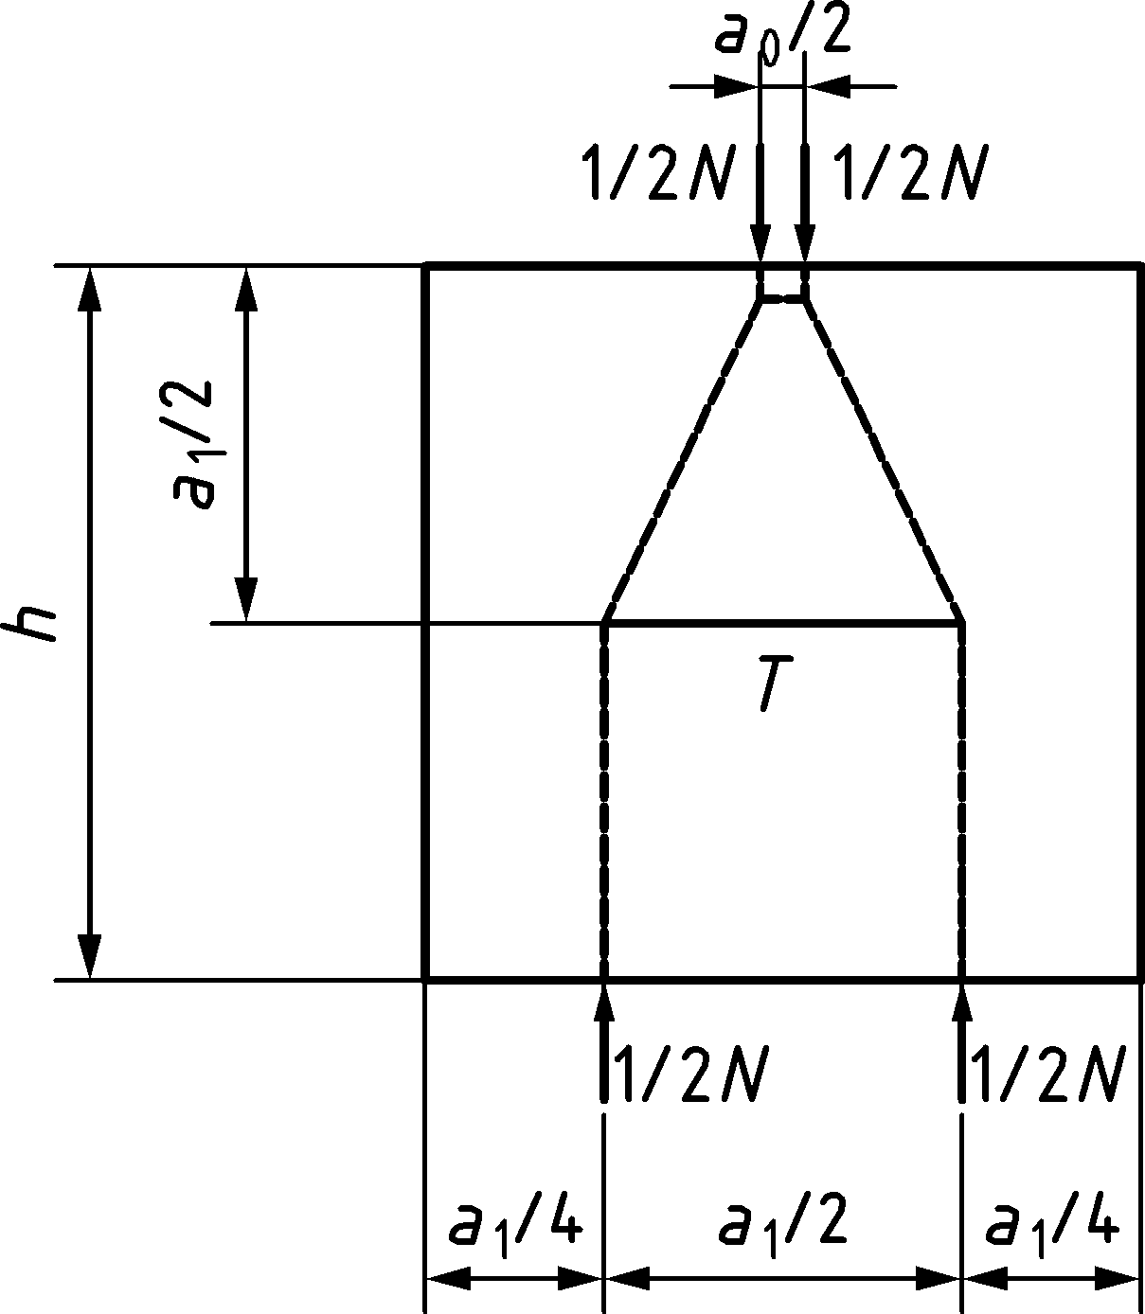

**c) Assumed strut-and-tie model with spread/inclination of 1/2 with h ≤ a1**

Figure 8.32 — Dimensions of loaded area and contributing concrete area

|  |  |
| --- | --- |
|  | $$c_{{2,F}_{1}}=s+\frac{a_{0,F_{1}}- a_{0,F_{2}}}{2}$$ $$c_{{2,F}_{2}}=s+\frac{a_{0,F_{2}}- a_{0,F_{1}}}{2}$$ |

Figure 8.33 — Side lengths for loaded areas of different size

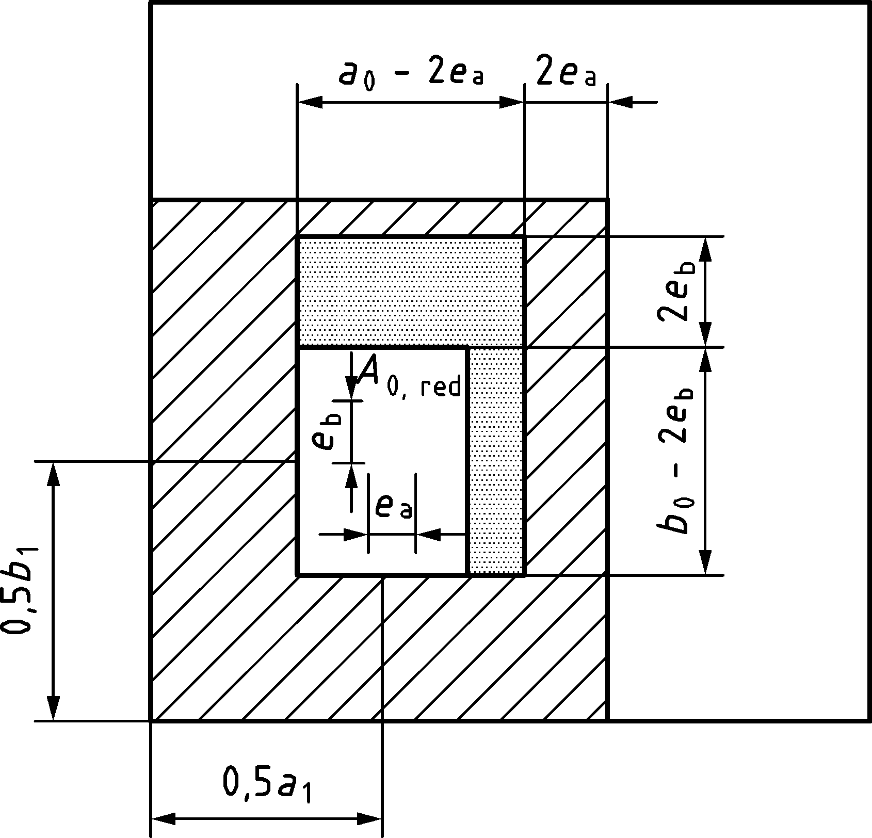

Figure 8.34 — Definition of A0,red and eccentricities e

(3) If there are no external tensile forces nor restraint which can induce cracking in the direction parallel to the direction of the load, and no known pre-existing cracks in this direction, tensile reinforcement may be omitted, provided that the design stress applied on the loaded area does not exceed σRd,t:

|  |  |
| --- | --- |
| $$σ_{Rd,t}=\frac{\sqrt{f_{ck}}}{γ_{C}}⋅k_{part}$$ | (8.108) |

* if max{a0; b0} ≤ 3d0:

|  |  |
| --- | --- |
| $$k_{part}=\frac{A_{c1}}{A_{c0}}⋅\frac{1}{1-\sqrt{\frac{A_{c0}}{A_{c1}}}}$$ | (8.109a) |

* if max{a0; b0} > 3d0:

|  |  |
| --- | --- |
| $$k_{part}=\frac{d_{1}}{d_{0}}⋅\frac{1}{1-\frac{d_{0}}{d_{1}}}$$ | (8.109b) |

where

|  |  |
| --- | --- |
| d0 | = min{a0; b0}; |
| d1 | block dimension parallel to d0. |

Otherwise, tension reinforcement shall be provided according to 8.5.5.

(4) The beneficial effect of confinement reinforcement may be accounted for according to 8.1.4. If the area of the confinement core Acs, delimited by the confinement reinforcement, is more than twice as large as the loaded area, the confinement stress obtained from Formula (8.6) shall be reduced by the factor $\sqrt{2A_{c0}/A_{cs}}≤1$.

The beneficial effects of confinement reinforcement according to 8.1.4 shall not be superimposed with Formulae (8.105) and (8.108).

(5) More refined methods, such as three-dimensional stress fields accounting for the beneficial effect of confinement by geometry and by reinforcement may be used for the design of partially loaded areas.

(6) Additional rules for design in footings and pile caps without shear reinforcement accounting for a concentrated compression zone and the resulting reduced level arm are given in 12.8(3).

# Serviceability Limit States (SLS)

## General

(1) Clause 9 covers the common serviceability limit states. These are:

* stress limitation and crack control (see 9.2),
* deflection control (see 9.3),
* vibration control (see 9.4).

(2) In the calculation of stresses and deflections, cross sections may be assumed to be uncracked provided that the tensile stress under the characteristic combination of actions does not exceed fct,eff. If the section is assumed to be uncracked a calculation of crack widths is not required. For the purpose of calculating crack widths and tension stiffening fct,ef should be taken equal to fctm. For the calculation of deflections under predominantly flexural stresses, the value of fct,eff may be taken as fctm or fctm,fl (see Formula (9.34)), provided that the calculation of minimum reinforcement areas for crack control is also based on the same value.

NOTE Cracking can be observed for lower values of tensile stresses. This is attributed to non-uniform self-equilibrating stresses due to shrinkage strains, early thermal stresses, sustained loading and to the effective tension area (see Figure 9.1).

(3) For the calculation of stresses and deflections, an effective modulus of elasticity, Ec,eff, may be used for concrete to estimate long term effects due to quasi-permanent actions, according to Formula (9.1):

|  |  |
| --- | --- |
| $$E_{c,eff}=\frac{1,05⋅E_{cm}}{1+φ}$$ | (9.1) |

If compressive stresses due to quasi-permanent combination of actions exceed 0,40fcm, the value of φ should account for non linear creep according to B.4(4).

(4) As a simplified approach for the calculation of stresses, valid for crack width calculations only,a modular ratio Es/Ec,eff equal to 15 may be used for both permanent and variable loads.

## Crack control

### General considerations

NOTE 1 Cracking is normal in reinforced concrete structures resulting from either direct loading or restrained imposed deformations.

NOTE 2 Cracks can also arise from other causes such as plastic shrinkage or expansive chemical reactions within the hardened concrete. Such cracks can be unacceptably large but their avoidance and control lie outside the scope 9.2.

(1) Cracking shall be limited to an extent that will not impair the proper functioning or durability of the structure or cause its appearance to be unacceptable.

(2) Cracks may be permitted to form without any attempt to control their width, provided they do not impair the functioning of the structure. In cases where crack width is not critical for appearance and crack width limits for durability are not relevant, verification according to 9.2.2, 9.2.3 and 9.2.4 may be omitted and crack control may be assumed to be covered by the provision of minimum reinforcement for robustness according to 12.1.

NOTE There are particular risks of large cracks (wk > 0,4 mm) occurring in member locations where there are sudden changes of stress, e.g.

* at changes of section,
* near concentrated loads,
* positions where bars are curtailed,
* areas of high bond stress, particularly at the end of laps.

(3) If crack width control is required, minimum reinforcement according to 9.2.2 should be placed in all sections whose reinforcement is not determined from ULS forces and in which tension is expected to develop. Sections whose reinforcement is determined from ULS forces should be checked for cracking according to either 9.2.3, which is conservative, or 9.2.4.

(4) When lapping large diameter bars (ϕ > 32 mm), special measures should be taken, such as the provision of transverse reinforcement and additional longitudinal skin reinforcement along the length of the lap. By applying a sufficient web surface reinforcement according to 12.11 a verification of the crack width by calculation may be omitted.

(5) The measures for limiting the crack widths should be adapted to the causes of cracking, for instance by:

* choosing an appropriate structural concept,
* prestressing,
* limiting the reinforcement stresses and the concrete stresses,
* appropriate detailing,
* appropriate selection of concrete properties,
* curing of concrete.

(6) A limiting value wlim,cal for the calculated crack width wk,cal on the member surface should be established taking into account the proposed function and nature of the structure and the costs of limiting cracking.

NOTE 1 Unless a National Annex gives different values, the limits on stresses and crack widths wlim,cal are given in:

* Table 9.1(NDP) for requirements related to appearance,
* Table 9.2(NDP) for requirements related to durability.

NOTE 2 See Annex H for additional conditions related to water-tightness.

Table 9.1(NDP) — Verifications, stress and crack width limits for appearance

| Verification | Calculation of minimum reinforcement for crack control according to 9.2.2 under imposed deformation | Maximum bar diameter or maximum bar spacing according to 9.2.3  or alternatively  Verification of crack width according to 9.2.4 | Verification of reinforcement stresses to avoid yielding at SLS |
| --- | --- | --- | --- |
| Combination of actions for calculating σs | Cracking forces according to 9.2.2 | Quasi-permanent combination of actions | Characteristic combination of actions |
| Limiting value of crack width wlim,cal or stress σs | σs ≤ fyk  or  σs ≤ σs,lim a | wlim,cal = 0,4 mm  σs ≤ fyk  or σs ≤ σs,lim a | σs ≤ 0,8fyk  σp ≤ 0,8fpk |
| NOTE wlim,cal = 0,4 mm applies unless a National Annex gives different values. | | | |
| a A lower value σs < fyk may be needed to satisfy the crack width limits according to the maximum bar size (see Formula (9.5)). | | | |

Table 9.2(NDP) — Verifications, stress and crack width limits for durability

| Exposure Class | Reinforced members; prestressed members with unbonded tendons and with bonded tendons with Protection Levels 2 or 3 according to 5.4.1(3) | | Prestressed members with bonded tendons with Protection Level 1 according to 5.4.1(3) and pretensioned elements. | | |
| --- | --- | --- | --- | --- | --- |
| combination of actions | | combination of actions | | |
| quasi-permanent | characteristic | quasi-permanent | frequent | characteristic |
| **X0, XC1** | – | – | – | wlim,cal = 0,2 mm ⋅ ksurf | – |
| **XC2, XC3, XC4** | wlim,cal = 0,3 mm ⋅ ksurf | Decom­pression b | wlim,cal = 0,2 mm ⋅ ksurf |
| **XD1, XD2, XD3**  **XS1, XS2, XS3** | σc ≤ 0,6fck a,c | – | Decompressionb | σc ≤ 0,6fck a,c |
| **XF1, XF3**  **XF2, XF4** | – |
| NOTE 1 The specified values of wlim,cal apply unless a National Annex gives different values.  NOTE 2 The factor ksurf considers the difference between an increased crack width at the member surface and the required mean crack width i according to durability performance of the minimum cover: 1,0 ≤ ksurf = cact/(10 mm + cmin,dur) ≤ 1,5.  cact is a specified actual cover ≥ cnom due to detailing or execution reasons. | | | | | |
| a No limitation in serviceability conditions is necessary for stresses under bearings, partially loaded areas and plates of headed bars.  b The decompression limit requires that all parts of the bonded tendons or duct lie at least 25 mm within concrete in compression.  c The compressive stress σc may be increased to 0,66fck if the cover is increased by 10 mm or confinement by transverse reinforcement is provided. | | | | | |

(7) Reinforcement should be considered as effective in controlling crack width only within a given area of concrete around the reinforcement bars. This area, Ac,eff, is referred to as the effective tension area.

NOTE The effective tension area is also the area of concrete that needs to be tensioned up to the tensile resistance of concrete to produce a new crack and therefore affects crack spacing.

(8) The effective tension area should be taken as in Figure 9.1. The width of the effective area around a bar should not be taken greater than 10ϕ.

|  |
| --- |
|  |
| a) Group of bars |
|  |
| b)Isolated bars |
|  |
| c) Circular cross section |
|  |
| d) Group of bars, distributed along perimeter |
|  |
| e) Group of bars |
|  |
| f) Isolated bars |

Key

|  |  |
| --- | --- |
| For a single layer of bars: |  |
| For n layers of bars spaced sy: |  |

|  |
| --- |
|  |

Figure 9.1 — Effective tension area - Members in bending with or without normal force (a) to c)) and Members in tension, with or without bending (d) to f))

### Minimum reinforcement areas for crack control

(1) Crack width values and combination of actions according to Tables 9.1(NDP) and 9.2(NDP) are appropriate.

(2) The required minimum area of reinforcement for crack control shall be calculated by applying the principle that the reinforcement, working at a target stress σs,lim, should balance the moment that cracks the section acting together with the relevant axial force NEd.

(3) Unless a more refined calculation shows lesser areas to be adequate, the required minimum areas of reinforcement may be calculated as follows. In profiled cross sections like T-beams and box girders, minimum reinforcement should be determined for the individual parts of the section (webs, flanges). The reinforcement necessary in the part of the cross section under consideration may be determined by Formulae (9.2), (9.3) or (9.4), as appropriate.

(i) For pure bending:

|  |  |
| --- | --- |
| $$\begin{aligned}A_{s,min,w1}=\frac{0,8\frac{h-h_{c,eff}}{h}f_{ct,eff}A_{c,eff}}{σ_{s,lim}}≥\frac{0,2k_{h}f_{ct,eff}A_{c}}{f_{yk}} \\ A_{s,min,w2}=0\end{aligned}$$ | (9.2) |

(ii) For pure tension:

|  |  |
| --- | --- |
| $$A_{s,min,w1}=A_{s,min,w2}=\frac{f_{ct,eff}A_{c,eff}}{σ_{s,lim}}≥\frac{0,5k_{h}f_{ct,eff}A_{c}}{f_{yk}}$$ | (9.3) |

(iii) For a combination of bending and axial force:

|  |  |
| --- | --- |
| $$A_{s,min,w1}=\frac{0,3N_{Ed}+0,8\frac{h-h_{c,eff}}{h}f_{ct,eff}A_{c,eff}}{σ_{s,lim}}\left\{\begin{aligned}≥\frac{0,3N_{Ed}+0,2k_{h}f_{ct,eff}A_{c}}{f_{yk}} \\ ≥0 \\ ≤max\left\{\frac{f_{ct,eff}A_{c,eff}}{σ_{s,lim}};\frac{0,5k_{h}f_{ct,eff}A_{c}}{f_{yk}}\right\}\end{aligned}\right. \\ A_{s,min,w2}=\frac{N_{Ed}}{σ_{s,lim}}-A_{s,min,w1}\left\{\begin{aligned}≤A_{s,min,w1} \\ ≥0\end{aligned}\right.$$ | (9.4) |

where

|  |  |  |
| --- | --- | --- |
| Ac | is the area of the part of the section under consideration; | |
| As,min,w1 | is the area of minimum reinforcing steel to be placed at the most tensioned face of the part of the section under consideration to control cracking; | |
| As,min,w2 | is the area of minimum reinforcing steel to be placed at the least tensioned face of the part of the section under consideration to control cracking; | |
| NEd | is the design axial force at the serviceability limit state acting on the part of the section under consideration (tensile force positive). NEd should be determined considering the characteristic values of prestress and axial forces under the relevant combination of actions; | |
| σs,lim | is the maximum stress permitted in the reinforcement immediately after formation of the crack. σs,lim may be taken as the yield stress or a lower stress according to Formula (9.5), if necessary, to limit the crack width. In absence of other methods, for ribbed or indented reinforcing steel, σs,lim may be taken as: | |
|  | $$σ_{s,lim}≤\frac{2,4f_{ct,eff}}{\left({h-h}_{c,eff}\right)}⋅\frac{h}{ϕ}\left(- c + \sqrt{c^{2}+1,5\frac{\left(1-\frac{h_{c,eff}}{h}\right)⋅E_{s}⋅w_{lim,cal}⋅ϕ}{k_{w}⋅k_{\frac{1}{r},simpl}⋅f_{ct,eff}}}\right) \\ k_{\frac{\text{1}}{\text{r}}\text{,simpl}}=\left\{\begin{aligned}1,00 \text{for} \text{pure} \text{tension} \\ \text{(1,2}\frac{h}{d}-0,1) \text{for} \text{other} \text{situations}\end{aligned}\right.$$ | (9.5) |
| kw | is a factor converting the mean crack width into a calculated crack width, see 9.2.4(2); | |
| fct,eff | is the mean value of the tensile strength of the concrete effective at the time when the cracks may first be expected to occur: fct,eff = fctm for t ≥ tref or fct,eff = fctm(t), if cracking is expected at t < tref (see Annex D); | |

NOTE For more information, see Annex D.

|  |  |  |
| --- | --- | --- |
| kh | is a coefficient which allows for the effect of non-uniform self -equilibrating stresses, which lead to a reduction of the apparent tensile strength which may be taken as: | |
|  | $$k_{h}=0,8-0,6\left(min \left\{b ; h\right\} - 0,3\right)\left\{\frac{≤0,8}{≥0,5}\right.$$ | (9.6) |
|  | where h and b [m] are the dimensions of the part of the section under consideration. | |

(4) For a section with n1 bars of diameter ϕ1 and n2 bars of diameter ϕ2, an equivalent bar diameter ϕeq with Formula (9.7) should be used instead of ϕ:

|  |  |
| --- | --- |
| $$ϕ_{eq}=\frac{n_{1}ϕ_{1}^{2}+n_{2}ϕ_{2}^{2}}{n_{1}ϕ_{1}+n_{2}ϕ_{2}}$$ | (9.7) |

(5) Bonded tendons in the tension zone may be assumed to contribute to crack control within a distance ≤ 150 mm from the centre of the tendon. This may be taken into account by deducting the term ξ1ApΔσp/σs,lim from the area of minimum reinforcement corresponding to the tensioned face where the prestressing is placed.

where

|  |  |  |
| --- | --- | --- |
| Ap | is the area of pre-tensioning or bonded post-tensioning tendons within the tensile zone; | |
| ξ1 | is the adjusted ratio of bond strength taking into account the different diameters of prestressing and reinforcing steel, according to Formula (9.8): | |
|  | $$ξ_{1}=ξ\frac{ϕ}{ϕ_{p}}$$ | (9.8) |

where

|  |  |
| --- | --- |
| ξ | ratio of bond strength of prestressing and reinforcing steel, according to Table 10.1 in 10.3(1); |
| ϕ | is the diameter of the reinforcing steel bar; |
| ϕp | diameter of tendon according to 10.3(1). If only prestressing steel is used to control cracking, ξ1 = ξ; |
| Δσp | stress variation in prestressing tendons from the state of zero strain of the concrete at the same level. |

(6) Beams with a downstand depth of more than 600 mm, where the main tension reinforcement is concentrated at the most tensioned fibre, should be provided with additional longitudinal reinforcement given by Formula (9.9), at a spacing not exceeding 300 mm, to control cracking on the side faces of the beam. This reinforcement should be evenly distributed between the level of the reinforcement layer closest to the neutral axis and the neutral axis.

|  |  |
| --- | --- |
| $$A_{s,web}=0,2\frac{f_{ct,eff}}{f_{yk}}b_{w}\left(d-x-a_{1}\right)$$ | (9.9) |

where

|  |  |
| --- | --- |
| *A*s,web | is the longitudinal reinforcement to be provided distributed on the two surfaces of the web in a height limited by the neutral axis and (*d – a*1)at a spacing not exceeding 300 mm to control cracking; |
| *a*1 | equal to 150 mm. |

(7) In prestressed members, no minimum reinforcement for crack control is required in sections where, under the characteristic combination of actions and the characteristic value of prestress, the tensile stress in the concrete is below fct,eff.

### Simplified control of cracking

NOTE 9.2.3 is a simplification of 9.2.4. A conservative value is assumed for the effective tension area and tension stiffening effects are estimated as a 10 % reduction in the steel stress obtained considering a fully cracked section.

(1) The rules given in 9.2.4 may be complied with by restricting either the bar diameter ϕ according to Formula (9.10) or the bar spacing sl according to Formula (9.11).

|  |  |
| --- | --- |
| $$ϕ≤\frac{2,1⋅ρ_{p}}{\frac{r}{d}⋅k_{fl,simpl}⋅k_{b,simpl}}\left(\frac{w_{lim,cal}}{k_{w}⋅k_{\frac{1}{r},simpl}⋅0,9\frac{σ_{s}}{E_{s}}}-1,5⋅c\right)$$ where $$k_{fl,simpl}=\left\{\begin{aligned}\left(1-3,5\frac{a_{y}}{h}\right) \text{if} \text{one} \text{face} \text{is} \text{in} \text{compresion} \\ 1,00 \text{if} \text{both} \text{faces} \text{are} \text{in} \text{tension}\end{aligned}\right. \\ k_{\text{1/r,simpl}}=25\left(\frac{h}{d}-1\right)⋅ρ_{p}+1,15⋅\frac{h}{d}-0,15 \\ k_{\text{b,simpl}}=\left\{\begin{aligned}0,9 \text{for} \text{good} \text{bond} \text{conditions} \\ 1,2 \text{for} \text{poor} \text{bond} \text{conditions}\end{aligned}\right.$$ | (9.10) |
| $$s_{l}≤\frac{3,45⋅ρ_{p}}{\frac{r^{2}}{d}⋅k_{fl,simpl}^{2}⋅k_{b,simpl}^{2}}{\left(\frac{w_{lim,cal}}{k_{w}⋅k_{1/r,simpl}⋅0,9⋅\frac{σ_{s}}{E_{s}}}-1,5⋅c\right)}^{2}$$ | (9.11) |

where

|  |  |
| --- | --- |
| $$ρ_{p}=\frac{\left(A_{s} + ξ_{1} A_{p}\right)}{b⋅d}$$ | is the reinforcement ratio corresponding to the tensioned face under consideration. When considering the least tensioned face of an element with both faces in tension, k1/r,simpl may be set equal to 1,0 conservatively; |
| r | is the distance from the concrete surface to the centre of the first layer of bars; |
| sl | is the bar spacing; |
| σs | is the stress permitted in the reinforcement closest to the most tensioned concrete surface after formation of all cracks. σs may be taken as the calculated stress according to loads or a lower stress σs,lim according to Formula (9.5); |
| kw | is a factor converting the mean crack width into a calculated crack width, see 9.2.4(2). |

(2) Cracking due to shear and torsion may be assumed to be controlled if the detailing rules given in 12.2.2, 12.2.3 and 12.3.2 are observed.

### Refined control of cracking

(1) The calculated crack width wk,cal given in 9.2.4 should only be considered as a nominal value for the crack width at the member surface, to be compared with wlim,cal, and not as values actually measured on site.

(2) The calculated surface crack width wk,cal may be determined from Formula (9.12):

|  |  |
| --- | --- |
| $$w_{k,cal}=k_{w}⋅s_{rm,cal}\left(ε_{sm}-ε_{cm}\right)$$ | (9.12) |

where

|  |  |
| --- | --- |
| kw | is a factor converting the mean crack width into a calculated crack width; |

NOTE The value of kw is 1,7 unless a National Annex gives a different value.

|  |  |
| --- | --- |
|  | |
| sr,m,cal | is the calculated mean crack spacing when all cracks have formed or where not all cracks have formed, the maximum length along which there is slip between the concrete and the steel adjacent to a crack; |
| εsm | is the mean strain in the reinforcement closest to the most tensioned concrete surface under the relevant combination of actions, including the effect of imposed deformations and taking into account the effects of tension stiffening. Only the additional tensile strain beyond the state of zero strain of the concrete at the same level is considered; |
| εcm | is the mean strain in the concrete between cracks at the same level of εsm. |

(3) For elements subjected to direct loads (stabilized cracking) or subjected to imposed strains (crack formation phase) where end restraint dominates (see (4) and Figure 9.3), εsm − εcm may be calculated from Formula (9.13):

|  |  |
| --- | --- |
| $$ε_{sm}-ε_{cm}=k_{1/r}\frac{σ_{s}-k_{t}\frac{f_{ct,eff}}{ρ_{p,eff}}\left(1+α_{e} ρ_{p,eff}\right)}{E_{s}}≥0,6\frac{σ_{s}}{E_{s}}$$ | (9.13) |

where

|  |  |  |
| --- | --- | --- |
| σs | is the stress in the tension reinforcement closest to the tensioned concrete surface assuming a cracked section. For members with bonded tendons, σs may be replaced by Δσp, i.e., the stress variation in prestressing tendons from the state of zero strain of the concrete at the same level; | |
| αe | is the ratio Es/Ecm; | |
| $$ρ_{p,eff}=\frac{A_{s}+ξ_{1}A_{p}}{A_{c,eff}}$$ | | (9.14) |
| Ap and Ac,eff | are as defined in 9.2.2(5) and 9.2.1(7), respectively; | |
| kt | is a coefficient dependent on the duration and nature of the load: | |
| kt = 0,6: | a) for short term loading or, | |
|  | b) instantaneous loading or, | |
|  | c) long term and crack formation stage or, | |
|  | d) repeated loading and crack formation stage, | |
| kt = 0,4: | e) long term and stabilised cracking stage or, | |
|  | f) repeated loading and stabilised cracking stage. | |
| k1/r | is a coefficient to account for the increase of crack width due to curvature, defined in accordance with Figure 9.2 as: | |
|  | $$k_{1/r}=\frac{h-x}{h-a_{y,i}-x}$$ | (9.15) |

When considering the least tensioned face of an element with both faces in tension, the effect of the curvature is favourable and therefore:

|  |  |
| --- | --- |
|  | (9.16) |

Expression (9.13) does not explicitly account for the effect of shrinkage. For stabilized cracking only, in cases where crack limitation is critical, and when reinforcement ratios are low, concrete strengths are high or concrete is loaded early, the effects of shrinkage should be accounted for.

For elements subjected to restrained imposed strains (crack formation phase) and restrained at the edges (see (4) and Figure 9.3), (εsm − εcm) may be calculated from Formula (9.17):

|  |  |
| --- | --- |
| $$ε_{sm}-ε_{cm}=R_{ax}ε_{free}-k_{t}\frac{f_{ct,eff}}{E_{cm}}≥0$$ | (9.17) |

where

|  |  |  |
| --- | --- | --- |
| Rax | is the restraint factor: | |
|  | $$R_{ax}=1-\frac{ε_{restr}}{ε_{imp}}$$ | (9.18) |
|  | For the very common case of the base of a wall a simplified value of 0,5 can be assumed for Rax; | |
| εrestr | the strain which develops in the restrained element; | |
| εimp | the value of the imposed strain (i.e. free shrinkage, free temperature strain. The ratio εrestr /εimp may be estimated according to linear elastic analysis, and may account for staged construction, if relevant; | |
| εfree | is the imposed strain which develops after the construction stage when restraint is applied (e.g. precast elements). | |

NOTE Elements subjected to imposed strains can be restrained along the edges (see Figure 9.3a)) or at the ends (see Figure 9.3b)). In an element which is restrained along the edges cracking only changes forces locally and crack widths depend on the applied strain. In an element which is restrained at the ends, cracking changes forces globally and crack widths depend on the tensile strength of concrete, but not on the applied strain.

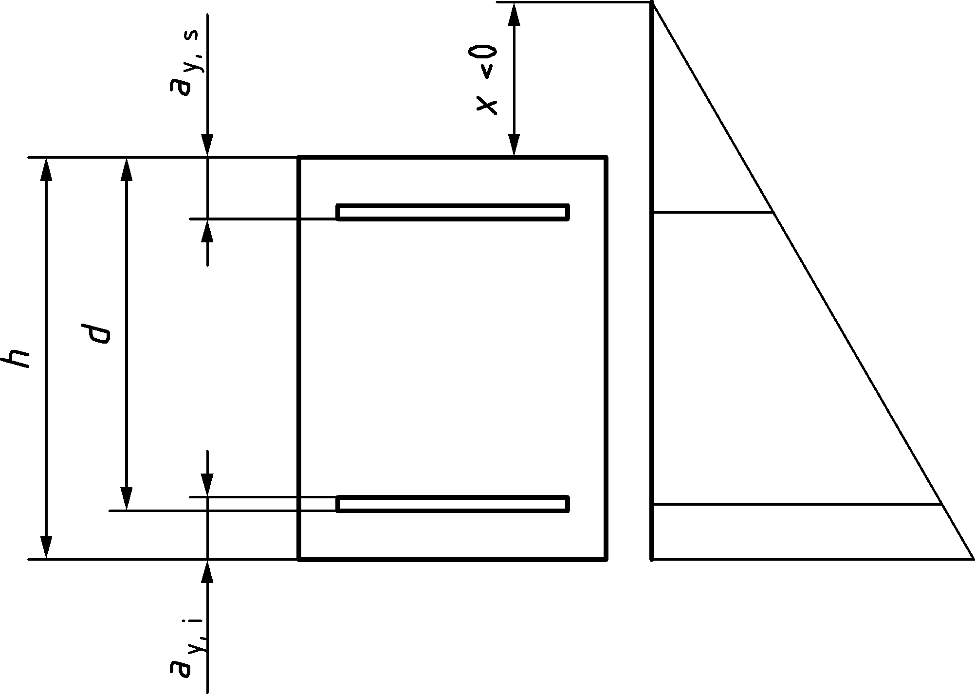

Fig. 9.2 — Notation for definition of k1/r in Formulae (9.15) and (9.16)

(4) If an element is restrained both at the ends and at the edges the criterion defined in Figure 9.3c) may be applied.



a) Element restrained at an edge (e.g. jointless wall) — only first crack is represented

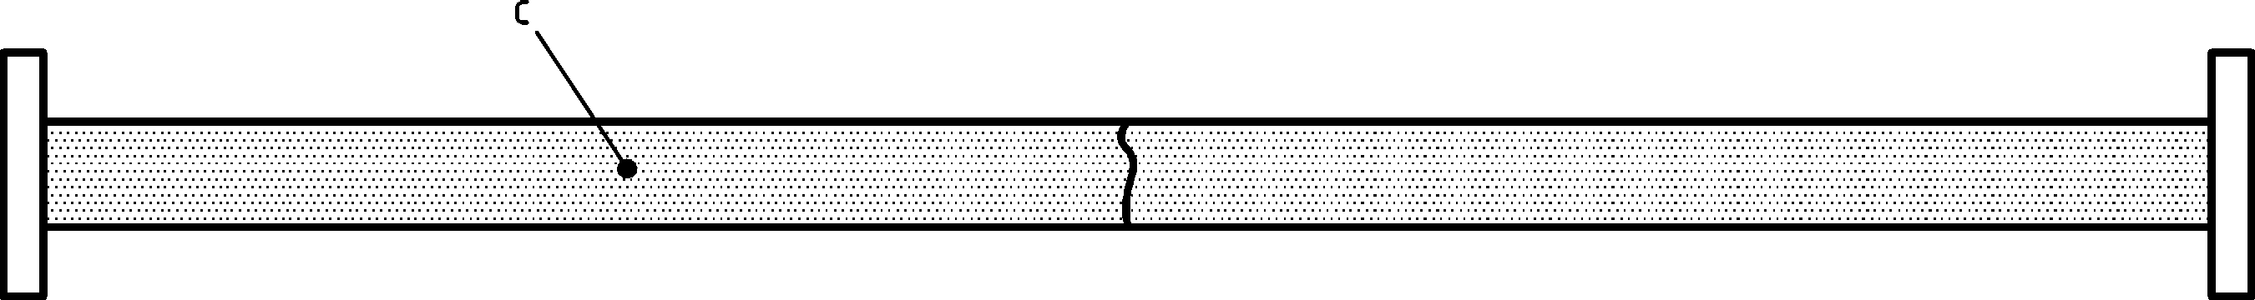

b) Element restrained at the ends (typical tie) — only first crack is represented

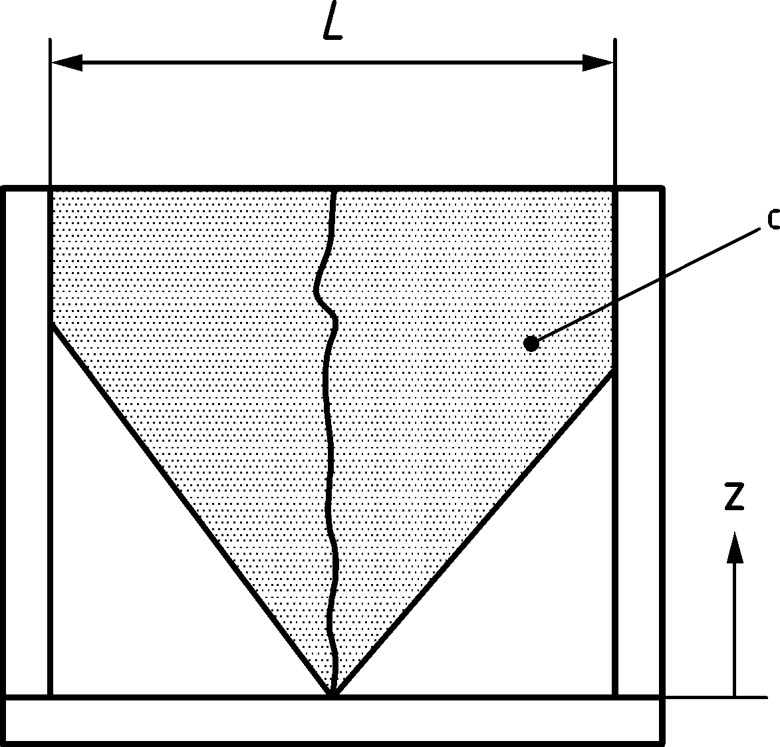

If z > L/2, apply formulation for end restraint (Formula (9.13))

If z ≤ L/2, apply formulation for edge restraint (Formula (9.17))

c) Element restrained at edge and ends (e.g. wall grid) — only first crack is represented

Key

|  |  |
| --- | --- |
| C | area where forces are affected by crack development |

Figure 9.3 — Types of restraint

(5) The mean final crack spacing sr,m,cal may be calculated as:

a) where spacing of bonded reinforcement in the tension zone is s ≤ 10ϕ:

|  |  |
| --- | --- |
| $$s_{r,m,cal}=1,5⋅c+\frac{k_{fl}⋅k_{b}}{7,2}⋅\frac{ϕ}{ρ_{ρ,eff}}≤1,3\left(h-x\right)$$ | (9.19) |

where

|  |  |  |  |
| --- | --- | --- | --- |
| — For a rectangular cross section subjected to pure bending: | | | |
|  | $$k_{fl}=\frac{h-h_{c,eff}}{h}$$ | | (9.20) |
| — In general: | | | |
|  | $$k_{fl}=\frac{1}{2}\left(1 + \frac{\left(h - x_{g} - h_{c,eff}\right)}{h-x_{g}}\right)$$ | | (9.21) |
|  | xg | is depth of the neutral axis of the uncracked section; | |
|  | $$k_{\text{b}}=\left\{\begin{aligned}0,9+0,6\frac{ϕ}{c_{v}}\text{for} \text{elements} \text{cast} \text{in} \text{poor} \text{casting} \text{position} \\ 0,9 \text{for} \text{elements} \text{cast} \text{in} \text{good} \text{casting} \text{position}\end{aligned}\right.$$ | | (9.22) |
|  | cv | is the clear vertical cover of the bar to the top concrete surface | |
|  | c | is the clear cover of the bar. For corner bars, the maximum value of the cover applies. | |
| — For pure tension: | | | |
|  | kfl = 1,00 | | (9.22a) |

b) where spacing of bonded reinforcement in the tension zone is s > 10ϕ or where there is no bonded reinforcement within the tension zone, the maximum crack spacing is:

|  |  |
| --- | --- |
| sr,m,cal = 1,3 ⋅ (h − x) | (9.23) |

(6) If in members reinforced in two orthogonal directions the angle θ between the axes of principal compressive strain and the direction of the reinforcement in the x-direction is larger than 15° the crack width may be calculated according to G.5.

(7) When using strut-and-tie models or stress field models with the struts or compression fields oriented according to the compressive stress trajectories in the elastic state (cracked or uncracked), Formula (9.12) may be used to evaluate the crack widths by considering the tensioned reinforcement as a tie with the corresponding effective area around it. The cover to be considered in Formula (9.19) should be taken as the distance from the concrete surface to the edge of the nearest bar, even if the bar is not part of the strut-and-tie or stress field model (e.g. skin reinforcement, according to 9.2.2(5)).

## Deflection control

### General consideration

(1) The deformation of a member or structure should be such that it does not adversely affect its proper functioning or appearance. Appropriate limiting values of deflection taking into account the nature of the structure, of the finishes, partitions and fixings and upon the function of the structure should be established. Alternatively, it may be assumed that an acceptable function can be achieved if the requirements of (2) are met.

(2) With reference to prEN 1990:2020, Annex A1.7, limits for vertical deflections according to Figure A1.1 should be specified for each project and agreed with the client. Indicative design values are given in prEN 1990:2020, Annex A.

(3) In reinforced concrete beams or slabs in buildings, deflections may be controlled indirectly by limiting the span-to-effective depth ratio as in 9.3.2, or by explicit verification as in 9.3.3. The general method of 9.3.4 may be applied to any type of concrete structure.

NOTE The actual deformations can differ from the estimated values (either according to 9.3.3 or 9.3.4), particularly if the values of applied moments are close to the cracking moment. The differences will depend on the scatter of the material properties, on the environmental conditions, on the load history, on the restraints at the supports, ground conditions, etc.

### Simplified deflection control by span/depth-ratio

(1) Provided that reinforced concrete beams or slabs in buildings, subjected to predominantly uniformly distributed loads, are dimensioned in compliance with the limits of span to effective depth ratio given in Table 9.3, their deflections may be considered as not exceeding the limits set out in 9.3.1(2). In such cases explicit verification of the deflections may be omitted.

Table 9.3 — Limiting span/effective depth ratios l/d

|  | Structural system | Required mechanical reinforcement ratioa | | | | | | | | |
| --- | --- | --- | --- | --- | --- | --- | --- | --- | --- | --- |
| ωr = 0,3 | | | ωr = 0,2 | | | ωr = 0,1 | | |
| LL/TLb | | | LL/TLb | | | LL/TLb | | |
| 60 % | 45 % | 30 % | 60 % | 45 % | 30 % | 60 % | 45 % | 30 % |
| 1 | Simply supported beam, one-way spanning simply supported slab | 15 | 14 | 13 | 17 | 16 | 14 | 24 | 22 | 21 |
| 2 | End span of continuous beam or one-way spanning slab | 20 | 18 | 17 | 22 | 21 | 18 | 31 | 29 | 27 |
| 3 | Interior span of beam or one-way spanning slab | 23 | 21 | 20 | 26 | 24 | 21 | 36 | 33 | 32 |
| 4 | Cantilever | 6 | 5 | 5 | 6 | 6 | 5 | 9 | 8 | 8 |
| NOTE This table assumes the quasi-permanent value of the live load with ψ2 = 0,3 and that the deflection limit for total deflection is l/250, where l is the span of the beam or slab. | | | | | | | | | | |
| a ωr is the required mechanical tension reinforcement ratio to resist the moment due to the design loads, at mid span for continuous or simply supported elements and at the support for cantilevers, see 9.3.3(2). Between values may be interpolated.  b Characteristic values of: LL = live load (imposed or variable); TL = total load. Intermediate values may be interpolated. | | | | | | | | | | |

(2) For a different maximum total deflection of l/a, the l/d-values of Table 9.3 should be multiplied by ka = 250/a, where a is the deflection ratio factor different from 250.

(3) The values of Table 9.3 may be extrapolated to other support conditions by multiplying them by the cubic root of the ratio of the linear elastic deflection of a simply supported beam of the same span and the linear elastic deflection of the actual structure.

(4) The values of Table 9.3 may be extrapolated to rectangular 2-way flat slabs supported on columns by multiplying them by the following ratio:

|  |  |
| --- | --- |
| $$\sqrt[4]{\frac{1}{1+{\left(\frac{l_{min}}{l_{max}}\right)}^{4}}}$$ | (9.24) |

where

|  |  |
| --- | --- |
| lmin | is the minimum span of the slab; |
| lmax | is the maximum span of the slab. |

For the use of Table 9.3 the slenderness ratio should be determined, in this case, as lmax/d.

(5) The values of Table 9.3 may be extrapolated to rectangular 2-way flat slabs supported on walls on all four sides by multiplying them by the following ratio:

|  |  |
| --- | --- |
| $$\sqrt[4]{\frac{1}{1-0,65\frac{l_{min}}{l_{max}}}}$$ | (9.25) |

For the use of Table 9.3 the slenderness ratio should be determined, in this case, as lmin/d.

### Simplified calculation of long-term deflections for reinforced concrete building structures

(1) The simplified method detailed in 9.3.3 assumes that the deflections are determined for the quasi-permanent combination of actions with ψ2 = 0,3 and that the verification is made for the long term. Cracking of the sections and tension stiffening effects are assessed on the basis of the characteristic combination of actions.

(2) Long-term deflections may be determined from linear elastic analysis using gross concrete sections and assuming long-term properties (i.e. Ec,eff) according to Formula (9.26).

|  |  |
| --- | --- |
| $$δ=\frac{1}{k_{I}}{\left(\frac{h}{d}\right)}^{3}\left[k_{ω} δ_{loads} + k_{s} δ_{εcs}\right]$$ | (9.26) |

where

|  |  |  |  |
| --- | --- | --- | --- |
| δloads | is the linear elastic deflection, determined for uncracked conditions, due to the quasi-permanent combination of actions; | | |
| δεcs | is the linear elastic deflection, determined for uncracked conditions, due to differential shrinkage determined by applying, on the linear elastic model, the curvature given by Formula (9.27) | | |
|  | $${\left(\frac{1}{r}\right)}_{ε_{cs}}=\frac{E_{s}}{E_{c,eff}}ε_{cs}\frac{S_{s}}{I_{g}}$$ | | (9.27) |
|  | where | | |
|  | Ss | is the first moment of area of the required tension and compression reinforcements with respect to the centroid of the gross concrete cross section; | |
|  | Ig | is the second moment of area of the gross concrete cross section; | |
|  | kI | is an adjustment coefficient to account for the effect of cracking, for tension stiffening and for the fact that creep deformations are less than proportional to the creep coefficient in cracked sections. kI may be estimated from Formula (9.28): | |
|  | $$k_{I}=\left\{\begin{matrix}1,00 \text{if} ω_{r}≤ω_{cr} \\ \left(0,045 f_{cd} + 1,80\right)ω_{r}-5×{10}^{-3}f_{cd}+0,7 \\ 0,022f_{cd}+1,6 \text{if} ω_{r}>0,5\end{matrix}\right. \text{if} ω_{cr}≤ω_{r}≤0,5$$ | | (9.28) |
| with | | | |
|  | $$ω_{cr}=1-\sqrt{1-\frac{1,05}{3}\frac{f_{ctm}}{f_{cd}}\left(γ_{G} + \left(γ_{Q} - γ_{G}\right) \frac{LL}{TL}\right){\left(\frac{h}{d}\right)}^{2}}$$ | | (9.29) |
| where | | | |
| ωr | is the required mechanical tension reinforcement ratio related to (b ⋅ d) to resist the moment due to the design loads, at mid span for continuous or simply supported elements and at the support for cantilevers; | | |
| ωcr | is the mechanical reinforcement ratio, below which, the structure is not expected to crack under the characteristic combination of actions; | | |
| ks | is coefficient to account for the effect of cracking on the shrinkage deflection. ks may be estimated from Formula (9.30): | | |
|  | $$k_{s}=\left\{\begin{matrix}1,00 \text{if} ω_{r}≤ω_{cr} \\ 455ρ_{l}^{2}-35ρ_{l}+1,6 \text{if} ω_{r}>ω_{cr}\end{matrix}\right.$$ | | (9.30) |
| kω | is a coefficient to account for the effect of over-reinforcement on the deflection and may be taken as | | |
|  | $$k_{ω}={\left(\frac{ω_{r}}{ω_{prov}}\right)}^{0,7}$$ | | (9.31) |
|  | where ωprov is the mechanical tension reinforcement ratio actually provided. | | |

### General method for deflection calculations

(1) For a detailed deflection control the deformations should be calculated under load conditions which are appropriate to the purpose of the check, see prEN 1990.

(2) Members which are not expected to be stressed above the level which would cause the tensile strength of the concrete to be exceeded anywhere within the member may be considered to be uncracked. The assessment should allow for tensile stresses induced by restraint of early age thermal and long-term shrinkage strains.

(3) Members which are expected to crack, but may not be fully cracked, should be taken to behave in a manner intermediate between the uncracked and fully cracked conditions. For members subjected mainly to flexure Formula (9.32) may be used:

|  |  |
| --- | --- |
| $$α_{δ}=\left(1-ζ\right)α_{I}+ζα_{II}$$ | (9.32) |

where

|  |  |  |
| --- | --- | --- |
| αδ | is the deformation parameter considered which may be, for example, a strain, a curvature, or a rotation (as a simplification αδ may also be taken as a deflection, see (9); | |
| αI, αII | are the values of the deformation parameter calculated for the uncracked and fully cracked conditions respectively; | |
| ζ | is a distribution coefficient (allowing for tension stiffening at a section) which may be taken from Formula (9.33): | |
|  | $$ζ=1-β_{t}{\left(\frac{σ_{sr}}{σ_{s}}\right)}^{2}≥0$$ | (9.33) |
|  | ζ = 0 for uncracked sections; | |
| βt | is a coefficient taking into account the influence of the duration of loading or of repeated loading on the average strain; it may be taken equal to: | |
|  | βt = 1,0 for a single short-term loading, | |
|  | βt = 0,5 for sustained loads or many cycles of repeated loading; | |
| σs | is the highest stress having occurred due to the moment being analysed in the tension reinforcement calculated on the basis of a cracked section; | |
| σsr | is the stress in the tension reinforcement calculated on the basis of a cracked section under the loading conditions causing first cracking. | |

(4) For the calculation of deflections under predominantly flexural stresses, the value of fct,eff may be taken as fctm,fl (see Formula (9.34) with h [mm]) provided that the calculation of minimum reinforcement for crack control is based on the same value.

|  |  |
| --- | --- |
| $$f_{ctm,fl}=max\left\{\left(1,6-\frac{h}{1000}\right) f_{ctm} ; f_{ctm}\right\}$$ | (9.34) |

(5) For loads with a duration causing creep, the total deformation including creep may be calculated by using an effective modulus of elasticity for concrete according to Formula (9.1).

(6) Shrinkage curvatures may be assessed using Formula (9.27). In this case, S and Ι should be calculated for the uncracked condition and the fully cracked condition, the final curvature being assessed by use of Formula (9.32) and the deflection due to shrinkage determined by double integration of the curvature.

(7) For a rigorous calculation of deflections using the method given in (3) the curvatures should be computed at frequent sections along the member and then, the deflection calculated by numerical integration. In most cases the deflection may be computed once, assuming the whole member to be uncracked and secondly assuming a fully cracked condition, and then interpolate using Formula (9.32).

## Vibrations

(1) Measures should be taken to prevent vibrations that cause discomfort to people or limit the functional effectiveness of the structure.

(2) Verification of vibrations of concrete structures should be considered following indications in prEN 1990:2020, A1.7.3, A2 and prEN 1991‑1‑4, Annex E, as relevant.

(3) For the verification of vibrations of concrete structures, in absence of more refined methods, the effective damping ratio ξv may be taken as the sum of the effective structural damping (ξv,st), the effective damping due to furniture (ξv,furn), and the effective damping due to ceiling and floor finishing (ξv,fin). Table 9.4 provides values for the three effective damping components.

Table 9.4 — Suggested values for effective damping components

|  |  |  |
| --- | --- | --- |
| **Structural Damping (ξv,st) in general** | | |
| 1 | Reinforced concrete | 2 % |
| 2 | Prestressed concrete | 1 % |
| **Damping due to furniture (ξv,furn) in buildings** | | |
| 3 | Typical office for 1 to 3 people with division panels | 2 % |
| 4 | Office with computer-workplaces and few bookshelves and cabinets | 0 % |
| 5 | Open-plan office | 1 % |
| 6 | Library | 1 % |
| 7 | House | 1 % |
| 8 | School | 0 % |
| 9 | Gymnasium | 0 % |
| **Damping from ceiling and floor finishing (ξv,fin) in buildings** | | |
| 10 | Suspended ceiling | 1 % |
| 11 | “swimming” floor (e.g. laminate) | 0 % |
| 12 | swimming floor screed | 1 % |

# Fatigue

## General

(1) Structures and structural components subjected to repeated load or deformation cycles shall be verified to endure the expected cyclic actions during the required design life.

(2) A fatigue verification may generally be omitted for the following structures and members:

1. common buildings not subjected to a total number of significant load cycles ≤ 2 ⋅ 104,
2. reinforcing steel bars if the steel stress under the fatigue load combination according to 10.2(1) is limited to 200 MPa in unwelded and 40 MPa in welded reinforcing steel bars, respectively;
3. footbridges, with the exception of structural components with wind induced vibrations;
4. buried arch and frame structures with a minimum earth cover of 1,00 m for road bridges and 1,50 m for railway bridges, respectively;
5. foundations of bridges;
6. piers and columns which are not rigidly connected to superstructures;
7. retaining walls of embankments for roads and railways;
8. abutments of road and railway bridges which are not rigidly connected to superstructures, except for deck slabs of abutments;
9. prestressing and reinforcing steel, in sections where, under the frequent combination of actions and Pk, only compressive stresses occur at the extreme concrete fibres;
10. external and unbonded tendons, lying within the depth of the concrete section.

(3) The verification shall be performed separately for reinforcement and concrete by:

* simplified methods given in 10.4 to 10.7 or
* refined methods using damage equivalent stresses in E.4 or
* explicit method using Palmgren-Miner Rule in E.5.

## Combination of actions

(1) The fatigue-inducing cyclic action shall be combined with other actions according to prEN 1990:

|  |  |
| --- | --- |
| $$\sum{F_{d}}=\sum_{i}{G_{k,i}} \text{+ }\sum_{j}{ψ_{2,j}}Q_{k,j} \text{+}\left(P_{k}\right)\text{+ }Q_{fat}$$ | (10.1) |

NOTE Qk,i are non-cyclic, non-permanent actions, these should include temperature *Q*k,temp to determine whether cracked or uncracked sections should be considered. Qfat is the relevant fatigue load (e.g. traffic load or other cyclic load) as defined in prEN 1991.

(2) For the verification according to 10.4 to 10.6, Qfat should be taken as the frequent fatigue load as defined in prEN 1991. For road bridges, Qfat should be taken as the frequent fatigue load of load model 1 according to prEN 1991‑2. For railway bridges, Qfat should be taken as the frequent fatigue load of load model 71 according to prEN 1991‑2.

## Internal forces and stresses for fatigue verification

(1) When determining forces and stresses of the reinforcement, the tensile strength of concrete shall be ignored and a linear stress-strain relationship for concrete under compression shall be used, satisfying compatibility of strains of the two materials.

(2) The effect of different bond behaviour of prestressing and reinforcing steel shall be taken into account. This may be done by calculating the steel stress range with an equivalent area of reinforcement for the prestressing tendons considering the ratio of bond stress ξ:

|  |  |
| --- | --- |
| $$A_{e}=A_{p }\sqrt{ξ\frac{ϕ}{ϕ_{p}}}$$ | (10.2) |

where

|  |  |  |
| --- | --- | --- |
| Ae | is the equivalent area of reinforcement; | |
| Ap | is the area of prestressing tendon or tendons; | |
| ϕ | is the largest diameter of reinforcing steel; | |
| ϕp | is the diameter or equivalent diameter ϕp,eq of prestressing steel: | |
|  | ϕp,eq = 1,60 $\sqrt{A_{p}}$ | for bundles, |
|  | ϕp,eq = 1,75ϕwire | for single 7 wire strands, |
|  | where ϕwire | is the wire diameter, |
|  | ϕp,eq = 1,20ϕwire | for single 3 wire strands; |
| ξ | is the ratio of bond strength between bonded tendons and ribbed or indented reinforcing steel in concrete. Unless more precise data is available the values given in Table 10.1 may be used. | |

Table 10.1 — Ratio of bond strength ξ between tendons and reinforcing steel

| prestressing steel | Ratio of bond strength ξ | | |
| --- | --- | --- | --- |
| pre-tensioned | bonded, post-tensioned | |
| fck ≤ 50 MPa | fck ≥ 70 MPa |
| smooth bars and wires | not applicable | 0,30 | 0,15 |
| strands | 0,60 | 0,50 | 0,25 |
| indented wires | 0,70 | 0,60 | 0,30 |
| ribbed bars | 0,80 | 0,70 | 0,35 |
| NOTE Intermediate values may be interpolated between 50 MPa < fck < 70 MPa. | | | |

(3) The redistribution of stresses in concrete in the compression zone may be accounted for by verifying the compression stress at a distance of 100 mm (but not more than 1/3 of the cross section depth) from the outermost compressed fibre. The stress should not be taken less than 2/3 of the maximum compressive stress.

(4) In the design of the shear reinforcement the inclination of the compressive struts θfat should be calculated using the compression field inclination θ at ULS from 8.2.3 in Formula (10.3):

|  |  |
| --- | --- |
| $$cotθ_{fat }=\sqrt{cotθ}≥1,0$$ | (10.3) |

A more refined calculation of cotθfat according to Annex G may be used.

(5) In prestressing and reinforcing steel exposed to fatigue loads, the maximum stresses under the relevant fatigue load combination shall not exceed the design yield strength.

## Simplified verification of reinforcing or prestressing steel

(1) Adequate fatigue resistance may be assumed under tension, if the stress range under the fatigue load combination according to (10.2) with the frequent cyclic load with a maximum of 108 load cycles complies with:

1. reinforcing steel bars (for bent bars footnote a) of Table E.1(NDP) should be applied):

* Δσsd ≤ 90 MPa unwelded reinforcing bars ϕ ≤ 12 mm,
* Δσsd ≤ 73 MPa unwelded reinforcing bars ϕ > 12 mm,
* Δσsd ≤ 40 MPa welded reinforcing bars ϕ ≤ 12 mm,
* Δσsd ≤ 30 MPa welded reinforcing bars ϕ > 12 mm,

1. prestressing steel for pre-tensioning

* Δσpd ≤ 95 MPa

1. prestressing steel for post-tensioning

* Δσpd ≤ 95 MPa single strands in plastic ducts,
* Δσpd ≤ 80 MPa straight tendons and curved tendons in plastic ducts,
* Δσpd ≤ 55 MPa curved tendons in steel ducts.

NOTE These limits for the design stress ranges (including partial factor γF,f according to prEN 1990) in the reinforcement are based on 108 assumed load cycles and γS = 1,15.

(2) Where welded reinforcing bars or coupling devices of tendons are used in prestressed concrete, no tension may appear in the concrete section over the depth of the prestressing tendons or reinforcing steel bar under the fatigue load combination according to 10.2 with the frequent fatigue load.

## Simplified verification of concrete under compression or compression-tension

(1) Adequate fatigue resistance of concrete under compression or compression-tension may be assumed to be met, if the following condition is satisfied:

|  |  |
| --- | --- |
|  | (10.4) |

where

|  |  |  |  |
| --- | --- | --- | --- |
| σcd,max | is the maximum compressive stress at a fibre under the fatigue load combination according to 10.2 with the frequent fatigue load; | | |
| σcd,min | is the minimum compressive stress at the same fibre where σc,max occurs. If σc,min is a tensile stress, then σcd,min should be taken as 0. | | |
| fcd,fat | is the design fatigue strength of concrete according to Formula (10.5) | | |
|  | $$f_{cd,fat}=β_{cc}(t_{0})⋅\frac{f_{ck}}{γ_{C}}⋅k_{tc}⋅η_{cc,fat}$$ | | (10.5) |
|  | where | | |
|  | βcc(t0) | is a coefficient for concrete strength at first load application (see B.4(1)); | |
|  | t0 | is the time of the start of the cyclic loading on concrete in days; | |
|  | ηcc,fat | = min{0,85ηcc; 0,8}; | |
|  | ηcc | according to 5.1.6(1). | |

## Simplified verification of concrete under shear

(1) For members requiring design shear reinforcement at the ultimate limit state, Formula (10.4) may be applied to the struts of members subjected to shear. In this case the design fatigue reference strength of concrete fcd,fat should be reduced by the strength reduction factor ν (see 8.2.3(5)).

(2) For members not requiring design shear reinforcement at the ultimate limit state it may be assumed that the concrete resists fatigue due to shear effects where the following formulae are complied with:

for τEd,min/τEd,max ≥ 0:

|  |  |
| --- | --- |
|  | (10.6) |

for τEd,min/τEd,max < 0:

|  |  |
| --- | --- |
|  | (10.7) |

where

|  |  |
| --- | --- |
| τEd,max | is the design shear stress due to the maximum applied shear force under the fatigue load combination; |
| τEd,min | is the design shear stress due to the minimum applied shear force under the fatigue load combination according to 10.2 with the frequent fatigue load in the cross section where τEd,max occurs; |
| τRd,c | is the design value for shear resistance stress without shear reinforcement according to Formula (8.16). |

## Simplified verification of shear at interfaces

(1) Interfaces subjected to fatigue actions should be rough, very rough or keyed.

(2) In verification with Formula (10.8) without reinforcement crossing the interface, the values for cv1,fat and μv,fat in Table 10.2 should be applied.

|  |  |
| --- | --- |
|  | (10.8) |

(3) The fatigue verification of reinforcement crossing the interface may be omitted in members with shear reinforcement crossing the interface and fulfilling the minimum requirements according to 12.2, if:

* the interface is very rough or keyed as defined in 8.2.6(6) and
* the interface reinforcement is sufficiently anchored and crosses the interface at an angle according to Figure 8.15b).

(4) If reinforcement crossing the interface is required, it should be anchored and the shear strength verified according to Formula (10.9) with μv,fat from Table 10.2:

|  |  |
| --- | --- |
|  | (10.9) |

where the stress range ΔτEdi is defined by upper and lower load combination of Formula (10.1).

The value of ΔσRsk should be taken from Table E.1(NDP) or from a technical documentation.

Table 10.2 — Coefficients cv1,fat and μv,fat for different interface roughness

| Surface roughness | without interface reinforcement Formula (10.8) | | with interface reinforcement Formula (10.9) |
| --- | --- | --- | --- |
| cv1,fat | μv,fat | μv,fat |
| rough | 0,075 | 0,7 | 0,7 |
| very rough | 0,095 | 0,9 | 0,9 |
| keyed | 0,185 | 0,9 | 0,9 |

# Detailing of reinforcement and post-tensioning tendons

## General

(1) The rules given in Clause 11 apply to ribbed and indented reinforcement, mesh and post-tensioning tendons.

NOTE Additional information for plain reinforcement is given in Annex I.

## Spacing of bars

(1) The clear distance between parallel bars and their arrangement should be sufficient to allow access for vibrators if needed for good compaction of the concrete. Where bars are positioned in separated horizontal layers, there should be sufficient space between the resulting columns of bars to allow access for vibrators and good compaction of concrete.

(2) The clear distance cs (horizontal and vertical) between individual parallel bars should be not less than max{ϕ; Dupper + 5 mm; 20 mm}.

(3) Bars may be arranged in bundles with a maximum of 3 contacting parallel bars. For bundles of vertical bars in compression and for bars in a lapped joint, a maximum of 4 contacting parallel bars may be used. Bars in bundles of 3 and 4 should be arranged so that every bar is in contact with at least two other bars. Clear distance between bundles of bars should be not less than the equivalent diameter ϕb defined in 11.4.3(1).

(4) The clear distance between the face of already poured concrete and a bar parallel to it should be at least 5 mm.

(5) The minimum clear spacing between post-installed reinforcing steel bars or between post-installed reinforcing steel bars and cast-in reinforcing steel bars is given in 11.4.8.

## Permissible mandrel diameters for bent bars

(1) The minimum diameter to which a bar may be bent shall be such as to avoid:

* damaging the reinforcement (see (2)) and
* failure of the concrete inside the bend of the bar (crushing, splitting or spalling of reinforcement cover), see (4) and (5).

(2) The mandrel diameter of bars and wires without welds or of bars, wires and fabrics with welds at least 3ϕ

away from the bent should be at least:

* ϕmand,min = 4ϕ for ϕ ≤ 16 mm
* ϕmand,min = 7ϕ for ϕ > 16 mm

For bars, wires and fabrics with welded transverse bars at least 3ϕ away from start of bend where the welding is carried out in accordance with EN ISO 17660, the mandrel diameter should not be less than:

* ϕmand,min = 5ϕ for ϕ ≤ 16 mm where ϕ is the diameter of the bent bar
* ϕmand,min = 7ϕ for ϕ > 16 mm

Reinforcement that has been tested according to EN ISO 15630‑1 and documented to be bendable to smaller mandrel diameters may be bent to not less than ϕmand,min = ϕmand,test + ϕ.

(3) Reinforcement that is intended to be re-bent (straightened) shall in the first bending operation be bent with mandrels that are at least 1,5 times larger than ϕmand,min according to (2) and shall be of ductility class B or class C.

(4) Provided that fyd ≤ 25fcd and γC ≤ 1,5, verification of the concrete inside the bend may be omitted for:

* stirrups in compliance with 12.3.4(4),
* standard hook and bend anchorages complying with Figure 11.6 at a clear distance cx ≥ 1,5ϕ from an edge parallel to the bent and a clear distance between bars cs ≥ 3ϕ according to Figure 11.6c and
* all bends with an angle αbend ≤ 45° at a clear distance cx ≥ 2,5ϕ from an edge parallel to the bent, a clear distance between bars cs ≥ 5ϕ and the length of the straight segments between multiple bends is not shorter than 2ϕ+cd.

(5) In cases not complying with (4), the design value of the steel stress σsd should be verified to avoid concrete failures inside the bend according to Formula (11.1):

|  |  |
| --- | --- |
| $$σ_{sd}≤0,65f_{cd}\frac{ϕ_{mand}}{ϕ}+\frac{\sqrt{f_{ck}}}{γ_{C}}{\left(\frac{d_{dg}}{ϕ}\right)}^{1/3}\left(\frac{c_{d}}{ϕ}+\frac{1}{2}\right)\left(k_{bend}+0,7∙\frac{ϕ_{mand}}{ϕ}\right)$$ | (11.1) |

where

|  |  |
| --- | --- |
| ϕmand | is the mandrel diameter; |
| cd | is the cover or half the clear space between bars according to Figure 11.6c); |
| kbend | is a parameter considering the bend angle αbend: |
|  | kbend = 32 for αbend = 45°, |
|  | kbend = 16 for αbend = 90°, |
|  | kbend = 12 for αbend = 135°, |
|  | kbend = 8 for 180° loops, |
|  | kbend = 32 ⋅ (45°/αbend) for intermediate bend angles (αbend defined in Figure 11.6). |

In case of multiple bends, the length of the straight sections between bends shall not be shorter than 2ϕ+cd.

NOTE Practical bending can require longer straight sections.

## Anchorage of reinforcing steel in tension and compression

### General

(1) Reinforcing steel bars, wires or welded mesh fabrics shall be anchored so that their longitudinal forces are safely transmitted to concrete in compression (see Figure 11.2) or are transferred to another reinforcement according to 11.5.

NOTE For consideration of possible local concrete breakout or blowout, see also 4.4.

(2) Potential cracking parallel to the anchored reinforcement should be controlled by appropriate transverse or confinement reinforcement. Generally, minimum transverse or shear reinforcement according to Clause 12 will suffice.

(3) In linear members, stirrups enclosing the bars as shown in Figures 11.1a) and b) should be provided to control longitudinal cracking as well as delamination cracking parallel to the anchored reinforcement.

(4) In planar members, transverse bars parallel to the concrete surface placed above or below the anchored reinforcement as shown in Figures 11.1c) and d) should be provided to control longitudinal cracks. Shear reinforcement, bends in the anchored reinforcement as shown in Figure 11.1c) or edge reinforcement according to Figure 12.4 should be provided to control delamination cracks.

NOTE Longitudinal cracking in the plane of the anchored reinforcement can considerably reduce the anchorage performance.

|  |  |  |  |
| --- | --- | --- | --- |
|  |  |  |  |
| a) | b) | c) | d) |

**Key**

|  |  |
| --- | --- |
| a | potential delamination crack |
| b | potential longitudinal crack |

Figure 11.1 — Examples of reinforcement controlling delamination and longitudinal cracks

(5) Methods of anchorage as shown in Figure 11.2 may be used for reinforcing steel in tension and in compression. However, for methods b) and c) used in compression, only the first straight segment may be considered as anchorage, except as given in 11.4.4(3).

(6) The start of anchorage as shown in Figure 11.2 refers to the cross section where the reinforcement force is fully transferred to the concrete in compression (examples are shown in Figures 8.28 and 8.29). For force transfer to other reinforcements, see 11.5.

|  |  |  |  |
| --- | --- | --- | --- |
|  |  |  |  |
| a) | Anchorage of straight bars 11.4.2 | d) | Anchorage of headed bars 11.4.6 |
|  |  |  |  |
| b) | Anchorage of bends and hooks 11.4.4 | e) | Anchorage of welded reinforcement bars 11.4.7 |
|  |  |  |  |
| c) | U-bar loops 11.4.5 | f) | Anchorage of bonded post-installled reinforcing steel 11.4.8 |

Key

|  |  |  |
| --- | --- | --- |
| lbd | design anchorage length |  |
| X | start of anchorage |  |

Figure 11.2 — Methods of anchorage (shown for tensile forces)

### Anchorage of straight bars

(1) A design anchorage length lbd (Figure 11.3) shall at least be provided to safely transfer the forces from a bar to the surrounding concrete without spalling or bond failures.

|  |  |  |
| --- | --- | --- |
|  |  |  |
| a) tension | b) compression | c) conditions for cd |

Key

|  |  |
| --- | --- |
| 1 | edge bar |
| 2 | interior bar |
| Nominal cover cd = min{0,5cs; cx; cy} | |

Figure 11.3 — Definition of design anchorage length for straight anchorage

(2) For ribbed bars with ϕ ≤ 32 mm and indented bars with ϕ ≤ 14 mm in common cases the design anchorage length lbd divided by diameter in tension and compression in persistent and transient design situations may be taken from Table 11.1(NDP).

Table 11.1 (NDP) — Anchorage length of straight bars divided by diameter lbd/ϕ

| ϕ | Anchorage length lbd/ϕ | | | | | | | |
| --- | --- | --- | --- | --- | --- | --- | --- | --- |
| [mm] | fck | | | | | | | |
|  | 20 | 25 | 30 | 35 | 40 | 45 | 50 | 60 |
| ≤ 12 | 47 | 42 | 38 | 36 | 33 | 31 | 30 | 27 |
| 14 | 50 | 44 | 41 | 38 | 35 | 33 | 31 | 29 |
| 16 | 52 | 46 | 42 | 39 | 37 | 35 | 33 | 30 |
| 20 | 56 | 50 | 46 | 42 | 40 | 37 | 35 | 32 |
| 25 | 60 | 54 | 49 | 46 | 43 | 40 | 38 | 35 |
| 28 | 63 | 56 | 51 | 47 | 44 | 42 | 40 | 36 |
| 32 | 65 | 58 | 53 | 49 | 46 | 44 | 41 | 38 |
| NOTE The values of table 11.1(NDP) are derived from Formula (11.2). This table is valid for cd ≥ 1,5ϕ; σsd = 435 MPa and for bars in good bond conditions. For bars in poor bond conditions in concrete members the values should be multiplied by 1,2. For σsd < 435 MPa the values may be multiplied by (σsd/435), but consider lbd/ϕ ≥ 10. | | | | | | | | |

(3) In cases not complying with the limitations of Table 11.1(NDP), or for a more detailed calculation, the design anchorage length in tension lbd should be calculated as:

|  |  |
| --- | --- |
| $$l_{bd}=k_{lb}⋅k_{cp}⋅ϕ⋅{\left(\frac{σ_{sd}}{435}\right)}^{n_{σ}}⋅{\left(\frac{25}{f_{ck}}\right)}^{\frac{1}{2}}⋅{\left(\frac{ϕ}{20}\right)}^{\frac{1}{3}}⋅{\left(\frac{1,5ϕ}{c_{d}}\right)}^{\frac{1}{2}}≥10ϕ$$ | (11.2) |

where

|  |  |
| --- | --- |
| nσ = 1,0 | for σsd ≤ 435 MPa, |
| nσ = 1,5 | for σsd > 435 MPa; |
| kcp | coefficient accounting for casting effects on bond conditions: |
|  | — kcp = 1,0 for bars with good bond conditions according to Figure 11.4; |
|  | — kcp = 1,2 for poor bond conditions and for all bars used in slipform construction unless it is shown that the vertical bars cannot move during casting; |
|  | — kcp = 1,4 for all bars executed under bentonite or similar slurries unless data is available for the specific slurry to be used. |

NOTE The following values for klb apply, unless a National Annex gives different values:

klb = 50 for persistent and transient design situations, and

klb = 39 for accidental design situations.

Ratios in Formula (11.2) with bar diameter shall be limited as (ϕ/20 mm) ≥ 0,6 and as (1,5ϕ/cd) ≥ 0,4.

(4) Good bond conditions are defined as:

1. bars with an inclination of 45° to 90° to the horizontal during concreting, and
2. bars with an inclination less than 45° to the horizontal which are up to 300 mm from the bottom of the formwork or at least 300 mm from the free surface during concreting.

Otherwise poor bond conditions should be assumed (see Figure 11.4).

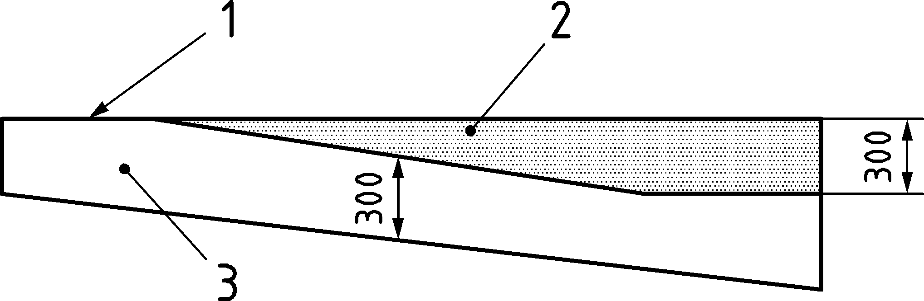

Key

|  |  |
| --- | --- |
| 1 | top surface during concreting |
| 2 | zone with poor bond conditions for bars with an inclination less than 45° to the horizontal |
| 3 | zone with good bond conditions |

Figure 11.4 — Description of bond conditions as a function of member depth

(5) In presence of confinement reinforcement (Figure 11.5a)) or of transverse reinforcement arranged between the bar to be anchored and the free surface (Figure 11.5b)) or/and of external pressure (Figure 11.5c)), the design anchorage length may be reduced by replacing parameter cd in Formula (11.4) by:

|  |  |
| --- | --- |
| $$c_{d,conf}=c_{d}+\left(30k_{conf}⋅ρ_{conf}+\frac{8⋅σ_{ctd}}{\sqrt{f_{ck}}}\right)⋅ϕ≤3,75ϕ$$ | (11.3) |

where

|  |  |  |
| --- | --- | --- |
| ρconf | is the ratio of the reinforcement providing confinement referred to the diameter of the bar to be anchored or spliced: | |
|  | $$ρ_{conf}=\frac{n_{t}⋅π⋅ϕ_{t}^{2}}{4⋅n_{b}⋅ϕ⋅s}$$ | (11.4) |
| ϕ | is the diameter of the bar to be anchored or spliced; | |
| ϕt | is the diameter of the reinforcement providing confinement; | |
| nt | is the number of legs of reinforcement providing confinement and crossing the potential splitting failure surface (see Figures 11.5a) and b)); | |
| nb | is the number of anchored bars or pairs of lapped bars in the potential splitting failure surface; | |
| s | is the spacing of reinforcement providing confinement along the bar to be anchored; | |
| kconf | is an effectiveness factor depending on the reinforcement detail; it may be taken as: | |
|  | — kconf = 1,0 for confinement reinforcement crossing the potential splitting surface and fulfilling the requirement of Figure 11.5a) (net distance ≤ 5ϕ), | |
|  | — kconf = 0,25 for transverse reinforcement within the cover cy and fulfilling the requirement of Figure 11.5b) (cs ≥ 8cy), | |
|  | — kconf = 0 in other circumstances; | |
| σctd | is the design value of the mean compression stress perpendicular to the potential splitting failure (see Figure 11.5c)). | |

|  |  |  |
| --- | --- | --- |
|  | | |
| nt=1, nb=2, | nt=2, nb=1, |  |
| a) confinement reinforcement | b) transverse reinforcement | c) external pressure |

Key

|  |  |
| --- | --- |
| 1 | potential splitting surface |

Figure 11.5 — Definition of cases where the design anchorage length may be reduced due to confinement or transverse reinforcement

(6) For anchorages in compression with a free surface perpendicular to the bar at a distance ≥ 3,5ϕ, the design anchorage length lbd calculated according to (2) to (5) may be reduced by 15ϕ, but shall not be shorter than 10ϕ.

### Anchorage of bundles

(1) All provisions for anchorage of straight bars may be used also for bundles of bars anchored in one cross section according to (3) with parameter ϕ replaced by an equivalent diameter of the bundle defined as:

|  |  |
| --- | --- |
| $$ϕ_{b}=\sqrt{\frac{4}{π}A_{s}}$$ | (11.5) |

where As is the total area of all bars contained in the bundle.

(2) When anchoring one bar in a bundle, the design anchorage length should be based on its own diameter and covers. When anchoring more than one bar of a bundle, the design anchorage length of those bars should be based on their equivalent diameter and covers, see Figure 11.6. Values klb are according to Formula (11.2).

### Anchorage of bars with bends and hooks

(1) The design anchorage length of in 11.4.2(2) or (3) may be reduced by 15ϕ for standard hook and bend anchorages in tension complying with Figure 11.6 (but with lbd ≥ 10ϕ).

Parameter cd to be used in 11.4.2 is defined in Figure 11.6c).

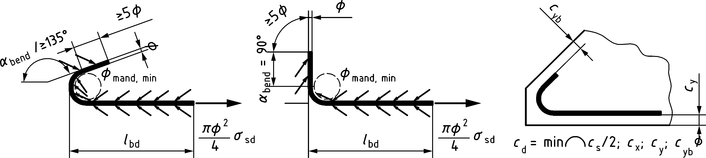

a) standard hook

b) standard 90° bend anchorages in tension

c) definition of nominal cover cd (definition of cs and cx, see Figure 11.3c))

Figure 11.6 — Anchorage with standard hook and bend

(2) For bend and hook anchorages in tension not complying with Figures 11.6a) or b), the total design anchorage length lb,tot measured along the centre-line of the bar as defined in Figure 11.7a) may be calculated using 11.4.2.

Parameter cd to be used in 11.4.2 is defined in Figure 11.6c).

(3) For bend and hook anchorages in compression, only the first straight segment (lbd in Figure 11.7b)) may generally be taken to contribute to anchorage, except when all free surfaces perpendicular to the bar are at a distance ≥ 3,5ϕ. The design anchorage length lbd may be reduced by 15ϕ, but shall not be shorter than 10ϕ.

|  |  |
| --- | --- |
|  |  |
| a) bend or hook in tension | b) bend or hook in compression |

Figure 11.7 — Definition of design anchorage length lbd or lbd,tot for bars with non-standard hooks and bends and for bars in compression

### Anchorage of bars with welded transverse reinforcement

(1) The design anchorage length in 11.4.2(2) or (3) with welded transverse reinforcement in tension and compression complying with Figure 11.8 (e.g. fabric) may be reduced by 15ϕ, (but with lbd ≥ 10ϕ) under the condition that:

* when ϕt ≥ 0,6ϕ at least one transverse bar is to be located within the anchorage length (Figure 11.8a)),
* when ϕt ≤ 0,6ϕ a minimum of two transverse bars are to be located within the anchorage length with 50 mm ≤ s ≤ 100 mm and for ϕ ≤ 16 mm (Figure 11.8b)).

NOTE For minimum weld strength, see C.4.1(2).

|  |  |
| --- | --- |
|  |  |
| a) one transverse bar within the anchorage length | b) two transverse bars within the anchorage length |

Figure 11.8 — Methods of anchorage with welded transverse reinforcement

### Anchorage of U-bar loops

(1) For U-bar loops subject to pure tension, anchorage may be considered to be provided if the loop details comply with 11.3.

(2) Alternatively, the design anchorage length in 11.4.2(2) or (3) with U-bar loops in tension with the minimum mandrel diameter may be reduced by 20ϕ (but with lbd ≥ 10ϕ).

### Anchorage of headed bars

(1) A tensile stress in the reinforcing steel bar σsd = 435 MPa may be considered to be developed without additional anchorage length for heads ϕh ≥ 3ϕ with fck ≥ 25 MPa and

* ca, cb ≥ 3ϕ + 0,5ϕh;
* sa ≥ 2ca;
* sb ≥ 2cb

where

|  |  |  |
| --- | --- | --- |
| ca, cb, sa, sb | according to Figure 11.9b); | |
| ϕh | is the nominal head diameter or is the diameter of a circle with the same area as that of the actual head | |
|  | $$ϕ_{h}=2\sqrt{\frac{A_{h}}{π}}$$ | (11.6) |
|  | where Ah is the area of the head. | |
| ah and bh | shall not be taken larger than 4 times the thickness of the head plate. | |

The bearing surface of heads should be flat and at 90 degrees to the bar unless justified by testing appropriate to the design situation under consideration.

|  |  |
| --- | --- |
|  |  |
| a) tension | b) definition of plate dimensions (ah, bh, ϕh, Ah),  bar spacing (sa, sb) and nominal bar covers (ca, cb) |

Figure 11.9 — Definition of design anchorage length for headed bars

(2) In cases not complying with the requirements of (1) or for a more detailed calculation, the maximum tensile stress in the reinforcing steel developed by the head should be calculated as:

|  |  |
| --- | --- |
| $$σ_{sd}'=min\left\{\frac{\sqrt{f_{ck}}}{γ_{C}⋅A_{s}}⋅\frac{a_{eff}⋅b_{eff}}{1-\sqrt{\frac{A_{h}}{a_{eff}⋅b_{eff}}}} ; f_{cd}⋅\left(1-\frac{A_{s}}{A_{h}}\right)⋅min \left\{\sqrt{\frac{a_{eff}⋅b_{eff}}{A_{h}-A_{s}}} ; 7,0\right\}\right\}$$ | (11.7) |

where

|  |  |
| --- | --- |
| aeff | = min{2ca;sa}; |
| beff | = min{2cb; sb; bh + aeff}; |
| Ah, ca, cb, sa, sb, σ′sd | are defined in Figure 11.9. |

(3) For tensile forces larger than the anchorage capacity of the head, both forces in the head and in the anchorage length of the bar may be accounted for. The design length in the reinforcing bar lbd to develop the remaining stress σsd − σ′sd should be calculated according to Formula (11.8) as:

|  |  |
| --- | --- |
| $$l_{bd}=l_{bd}\left(σ_{sd}\right)-l_{bd}\left(σ_{sd} '\right)$$ | (11.8) |

(4) When used for shear or confinement reinforcement, anchorage should rely on the head only.

### Anchorage of bonded post-installed reinforcing steel

(1) This Eurocode applies to post-installed reinforcing steel bars comprising a (de-coiled) straight reinforcing steel bar with properties according to C.4 and an anchoring mortar with established suitability and properties according to C.8 for the intended application, exposure condition and temperature, see C.8(4).

NOTE The suitability of the post-installed reinforcing steel bars is stated in a relevant European Technical Product Specification. It is assumed that the European Technical Product Specifications provide all information required for design of post-installed reinforcing steel bars to this Eurocode.

(2) The design of post-installed reinforcing bars according to this Eurocode assumes that the installation is performed according to the manufacturer’s installation instructions by qualified personnel and inspection of the installation is carried out by appropriately qualified personnel.

(3) Unless differently specified in a European Technical Product Specification, the minimum concrete cover cmin,b for the bond of post-installed reinforcing bars in all directions should be detailed in accordance with Table 11.2, as a function of the intended drilling method and of the execution procedure.

Table 11.2 — Minimum concrete cover cmin,b for post-installed reinforcing steel bars

| Drilling method | Bar diameter | cmin,b | |
| --- | --- | --- | --- |
| without drilling aid | with drilling aid |
| Hammer drilling and diamond coring/drilling | ϕ**<**25 mm | 30 mm + 0,06lbd,pi ≥ 2ϕ | 30 mm + 0,02lbd,pi ≥ 2ϕ |
| ϕ ≥ 25 mm | 40 mm + 0,06 lbd,pi ≥ 2ϕ | 40 mm + 0,02lbd,pi ≥ 2ϕ |
| Compressed air drilling | ϕ < 25 mm | 50 mm + 0,08lbd,pi | 50 mm + 0,02lbd,pi |
| ϕ ≥ 25 mm | 60 mm + 0,08lbd,pi ≥ 2ϕ | 60 mm + 0,02lbd,pi ≥ 2ϕ |

(4) Unless specified differently in a European Technical Product Specification, the minimum clear spacing between individual post-installed parallel bars should be cs,pir = max{4d0; 40 mm + d0 – ϕ; 2Dupper + 5mm}, where d0 is the diameter of the drilled hole.

The minimum clear spacing cs between post-installed reinforcing and cast-in reinforcing bars shall not be less than cs,pir ≥ max{2d0; 20 mm + 0,5(d0 – ϕ); 2Dupper + 5mm}.

For compressed air drilling the values for minimum clear spacings given above shall be multiplied by the factor 1,5.

(5) The anchorage of post-installed reinforcing steel bars shall be designed considering the requirements of 11.4.1 and 11.4.2. The design anchorage length lbd,pi of post-installed reinforcing steel bars in tension should be calculated as:

|  |  |
| --- | --- |
| $$l_{bd,pi}=\frac{l_{bd}}{k_{b,pi}}≥max\left\{10ϕ⋅α_{lb};100 \text{mm}\right\}$$ | (11.9) |

where

|  |  |
| --- | --- |
| lbd | calculated according to 11.4.2, where the concrete strength considered in Formulae(11.3) and (11.5) shall be limited to fck ≤ 50 MPa or fck,is ≤ 60 MPa or the value stated in the European Technical Product Specification (whichever is larger), and the design stress in the reinforcing bar be limited to σsd ≤ 435 MPa, unless tested to higher values. |
| kb,pi | bond efficiency factor 0,7 ≤ kb,pi ≤ 1,0 of the specified bond efficiency class, see C.8; |
| αlb | cracked concrete factor which may be taken as αlb = 1,5 in general or as given in the European Technical Product Specification. |

(6) The design anchorage length lbd,pi of post-installed reinforcing steel bars in compression shall be determined according to Formula (11.9) but should not be reduced according to 11.4.2(6) unless confirmed by testing in accordance with C.8.

(7) Post-installed reinforcing steel bars may be lapped using lsd,pi with straight cast-in deformed bars according to 11.5.2 and 11.5.3 where the design anchorage length lbd is replaced by lbd,pi, calculated according to Formula (11.9) (see also Table 11.3). The lap length lsd,pi should be designed for the minimum concrete cover of either cast-in or post-installed reinforcing steel bars and the bond conditions of the cast-in reinforcing steel bars.

(8) For shear forces across interfaces with post-installed reinforcing steel bars see 8.2.6.

## Laps of reinforcing steel in tension and compression and mechanical couplers

### General

(1) Tension and compression forces may be transmitted from one bar to another by:

* lapping of bars anchored with a method described in Table 11.3 (see 11.5.2);
* mechanical couplers ensuring load transfer in tension and compression or compression only (see 11.5.6);
* full penetration butt welds or fillet welds (see 11.5.7).

(2) Mechanical couplers and welds shall be designed for the minimum design yield strength of the reinforcing steel at both sides of the connection. In this case, they may take place at the same section, without staggering.

### All types of laps

(1) The detailing of laps between bars shall be such that:

* the transfer of forces from one bar to the next is ensured,
* spalling of the concrete in the vicinity of the lap does not occur,
* large cracks parallel to the lapped bars which affect the performance of the structure do not develop.

(2) A design lap length lsd between two bars in tension or in compression should be provided, at least equal to the anchorage lengths lbd given in 11.4, where the clear distance cs = cs1 + cs2 should be taken according to Figure 11.10.

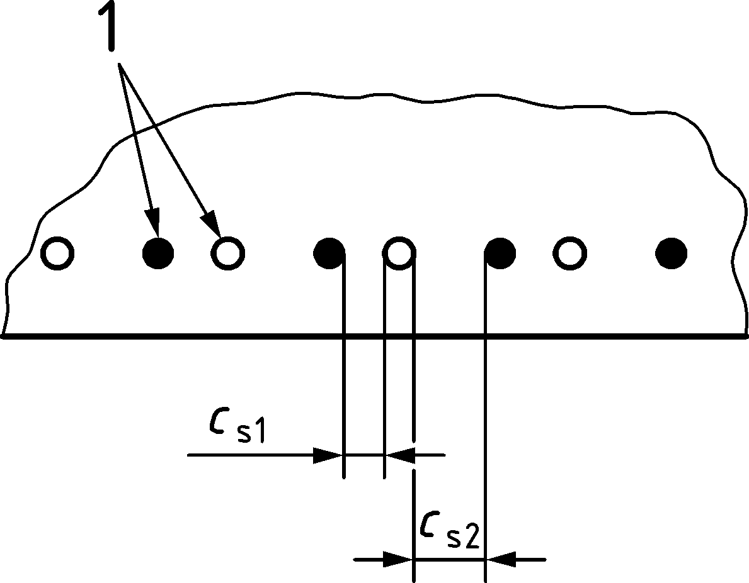

Key

|  |  |
| --- | --- |
|  | lapping bars |

Figure 11.10 — Definition of clear distance cs in lap splices

(3) All bars in compression may be lapped in one section and the lap length designed for σsd.

(4) Away from plastic hinge locations, tension laps may be detailed with up to 100 % of bars lapped at any section and the lap length may be designed for σsd.

NOTE It is good practice to place laps away from potential plastic hinge locations such as fixed/cast-in ends, points of support of continuous beams or mid span of linear members.

(5) Where tension laps are located across plastic hinge locations, tension lap length may be designed for σsd if

* a confinement reinforcement is arranged according to 11.5.2(1) or
* if they are staggered so that the area of lapped bars ≤ 35 % of the total cross section area of the reinforcement in linear members (beams and columns) or ≤ 50 % in planar members (slabs, walls and shells).

Otherwise, tension lap lengths should be designed for 1,2σsd.

NOTE For laps in links, see 12.3.3.

(6) If staggering of laps is chosen as an option according to (5), the distance between adjacent laps is at least 0,3lsd (see Figure 11.11b)).

|  |  |
| --- | --- |
|  |  |
| a) 100 %-lap with clear distances between adjacent laps and lapped bars | b) 50 %-lap with clear distances between adjacent laps and lapped bars |

Figure 11.11 — Examples of laps in planar members

(7) In cases of different methods of anchorage according to Table 11.3, the larger value of the design lap length lsd calculated for both methods shall be used.

Table 11.3 — Types of laps and design lap lengths lsd

| Type of lap splice | | Design lap length lsd | |
| --- | --- | --- | --- |
| Tension laps | Compression laps |
|  | straight bars | lsd = lbd ≥ 15ϕ | |
| where lbd is calculated according to 11.4.2, see also 11.5.3 | |
|  | bends and hooks (tension only) | lsd = lbd ≥ 15ϕ  where lbd is calculated according to 11.4.3, see also 11.5.3 | – |
|  | loops (tension only) | lsd is calculated according to 11.5.4, with the limit  lsd ≥ ϕmand + 4ϕ | – |
|  | headed bars | lsd is calculated according to 11.5.5 | |
|  | intermeshed fabric | lsd = lbd ≥ max{15ϕ; 250 mm}  where lbd is calculated according to 11.4.5 | |
|  | layered fabric | lsd = lbd + 2ϕ ≥ max{15ϕ; 250 mm}  where lbd is calculated according to 11.4.5 | |
|  | bonded post-installed reinforcement | lsd,pi = lbd,pi ≥ max{15ϕ; 250 mm}  where lbd,pi is calculated according to 11.4.8 | |

(8) The distance between lapped bars should be as small as possible, generally touch one another. In case the clear distance exceeds the smaller of 50 mm or 4ϕ, the design lap length shall be shifted by the axis distance and additional transverse forces due to the distance between lapped bars shall be resisted by adequate transverse reinforcement.

(9) Where confinement or transverse reinforcement in the lap zone is used to reduce the design lap length according to 11.4.2(5) and/or 11.5.2(2), at least 5 bars fulfilling the requirement of Figure 11.13a) or 11.13c) should be distributed over the lap length, or alternatively, 3 bars over a length of 0,3lsd at both ends of the lap according to Figure 11.12b) and 11.12d).

The minimum amount of confinement according to 11.5.2(4) should be dimensioned so that cd,conf according to Formula (11.3) is not less than 3ϕ.

(10) For compression laps, at least one transverse bar or confinement link should be placed at each end of the lap within a maximum of 50 mm or 2ϕ of the ends of the lap where ϕ is the diameter of the smaller lapped bar. These bars or links may be one of the 5 or 3 bars under (9) above or additional, see Figure 11.12b) or 11.12d).

|  |  |
| --- | --- |
|  | |
| a) transverse reinforcement, tension laps | b) transverse reinforcement, compression laps |
| c) confinement reinforcement, tension laps | d) confinement reinforcement, compression laps |

Key

|  |  |
| --- | --- |
| 1 | transverse reinforcement |
| 2 | confinement reinforcement |

Figure 11.12 — Transverse and confinement reinforcement for lapped splices

### Laps of bundles

(1) In bundles consisting of two bars, lap splices may be used without staggering of individual bar interruptions as shown in Figure 11.13a). Design splice lengths may be calculated on the basis of 11.4.2 and with the equivalent bar diameter ϕb according to 11.4.2(9), where As is the total area of the two bars.

For bundles which consist of three bars, lap splices without staggering of individual bar interruptions shall not be used.

(2) Design lap length lsd of bundles with 2 or 3 bars may be calculated on the basis of the individual bar diameterϕ if laps are staggered with a gap between individual laps ≥ 0,3lsd according to Figure 11.13b) or with an additional bar as shown in Figure 11.13c).

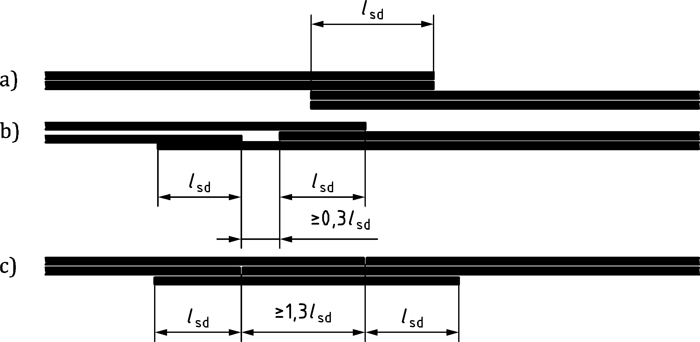

a) without staggering

b) with staggering

c) with an additional bar

Figure 11.13 — Lap splices of bundles

(3) Bundles which consist of 4 bars shall not be lapped.

### Laps using U-bar loops

(1) Transfer of tension between reinforcing steel bars may be achieved by overlapping U-bar loops (Figure 11.14). Overlapping U-bars may be single (Figure 11.14b)) or multiple (Figure 11.14c)) and both legs of each U-bar should be anchored outside the connection for the larger of the two design tension forces T1 and T2 (also when T1 or T2 = 0).

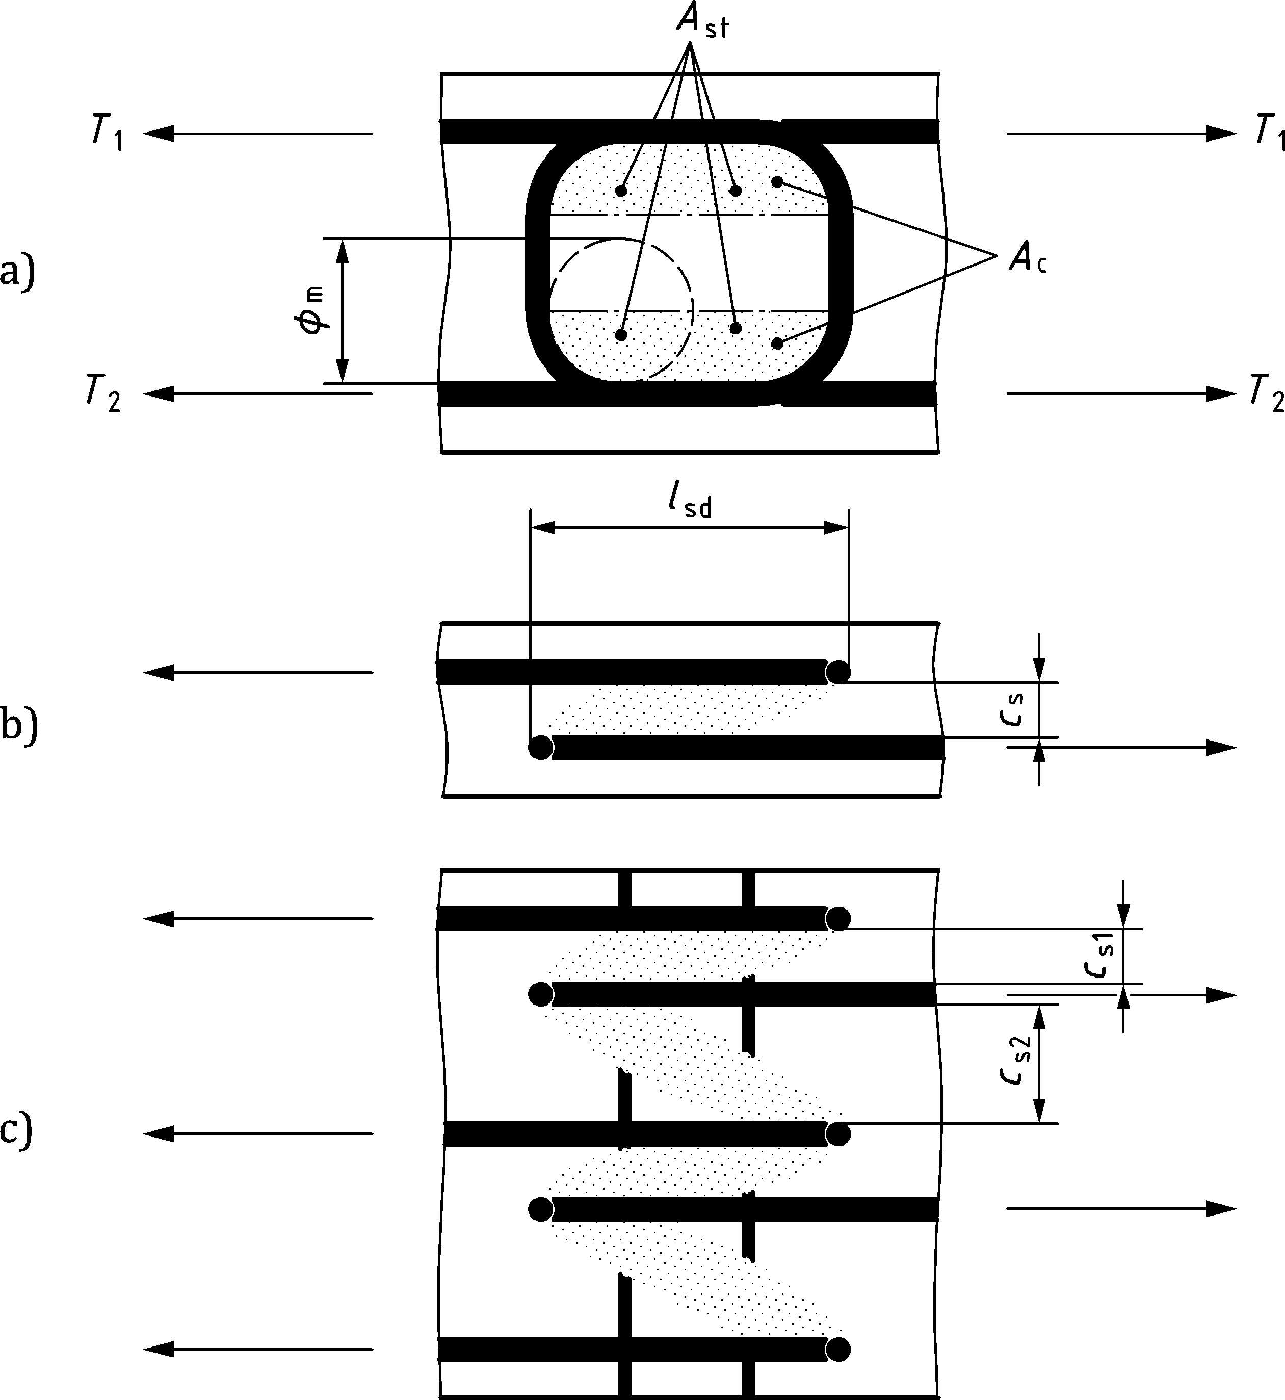

a) elevation view

b) single lap

c) multiple laps

Key

|  |
| --- |
| Design tension forces T1 = T2 when the lap transfers pure tension. T1 will according to a sectional analysis differ from T2 when the lap transfers combinations of normal forces and bending moments. |

Figure 11.14 — Laps using U-bar loops

(2) The resistance of a single lap splice shown in Figure 11.14b) should be checked using as criterion the crushing strength of the concrete between the two loops. For cs ≤ 0,5ls crushing of the concrete is prevented when the larger of the two design tension forces T1 and T2 (see Figure 11.14a) is smaller than TRd,c, which may be calculated as:

|  |  |
| --- | --- |
| $$T_{Rd,c}=0,2f_{cd}⋅A_{c}⋅{\left(\frac{d_{dg}}{l_{sd}}\right)}^{\frac{1}{3}}⋅\left(\sqrt{k_{st}+{\left(\frac{c_{s}}{l_{sd}}\right)}^{2}}-\left(\frac{c_{s}}{l_{sd}}\right)\right)$$ | (11.10) |

where

|  |  |  |
| --- | --- | --- |
| Ac | is the total effective concrete area within the curved parts of the overlapping U-bars (Figure 11.14a)): | |
|  | Ac = (ϕm + ϕ) ⋅ [ls − 0,21(ϕm + ϕ)] | (11.11) |
| lsd | is the overlapping length (Figure 11.14); | |
| ddg | is a coefficient that takes into account the concrete type and its aggregate properties according to 8.2.1(4); | |
| cs | is the clear spacing of U-bars; | |
| kst | is the resistance factor of the confinement reinforcement, which may be taken equal to kst = 1when ω ≥ 0,5 and to kst = 4ω(1 − ω)for lower values of | |
|  | $$ω=\frac{A_{st}⋅f_{yd}}{0,85{\left(\frac{d_{dg}}{l_{sd}}\right)}^{\frac{1}{3}}⋅A_{c}⋅f_{cd}};$$ | (11.12) |
| Ast | is the total area of the fully anchored confinement reinforcement positioned within Ac. | |

(3) In case of multiple U-bars as shown in Figure 11.14c), the resistance of Formula (11.10) may be calculated using an average net spacing cs = 0,5(cs1 + cs2) (see Figure 11.14c)) and multiplied by (ns − 1) where ns is the total number of U-bars (ns = 5 in the example of Figure 11.14c)). Multiple overlaps may also be treated as an assembly of single overlaps where cs is taken as the smaller of cs1 and cs2.

(4) To avoid brittle behaviour, a minimum amount of confinement reinforcement should be placed in a double symmetric configuration within Ac (see e.g. Figure 11.14a)):

|  |  |
| --- | --- |
| $$A_{st}≥0,5\sqrt{f_{ck}}⋅\frac{A_{c}}{f_{yk}}$$ | (11.13) |

### Laps using headed bars

(1) Transfer of tension between reinforcing steel bars may be achieved by overlapping headed bars (Figure 11.15). Overlapping headed bars may be single (Figure 11.15b)) or multiple (Figure 11.15c)) and should be anchored for the design force outside the connection.

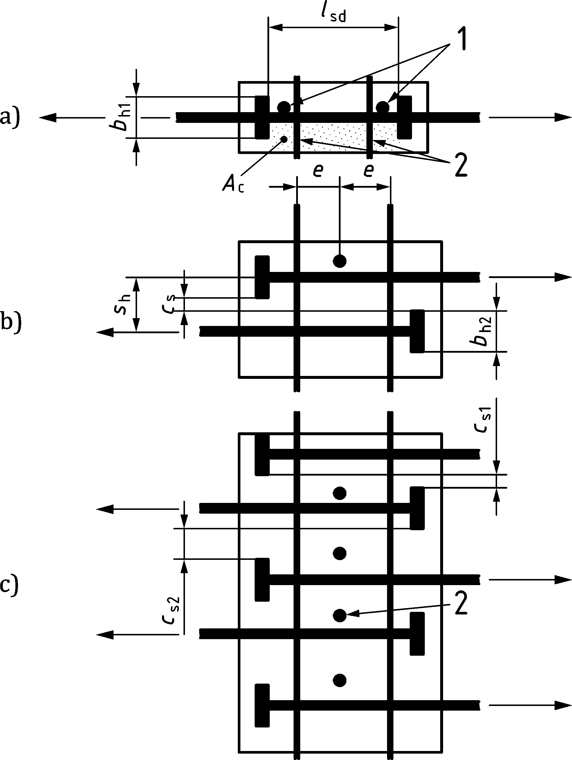

a) elevation view

b) plan view of single lap

c) plan view of multiple laps

Key

|  |  |
| --- | --- |
| 1 | transverse reinforcement Ast |
| 2 | tie down reinforcement Astd |

Figure 11.15 — Laps using headed bars

(2) The geometry of the heads of the headed bars should comply with 11.4.5(1).

(3) The maximum tensile force developed in each bar should be limited by 11.4.5(2).

(4) The resistance of a single headed bar lap splice shown in Figure 11.15b) should be checked using as criterion the crushing strength TRd,c of the concrete between the two heads. For 0 ≤ cs ≤ 0,5lsd, TRd,c may be calculated as:

|  |  |
| --- | --- |
| $$T_{Rd,c}=0,6f_{cd}⋅A_{c}⋅{\left(\frac{d_{dg}}{l_{sd}-2ϕ}\right)}^{\frac{1}{3}}⋅\left(\sqrt{k_{st}+{\left(\frac{c_{s}}{l_{sd}-2ϕ}\right)}^{2}} - \left(\frac{c_{s}}{l_{sd}-2ϕ}\right)\right)$$ | (11.14) |

where

|  |  |  |
| --- | --- | --- |
| Ac | is the effective concrete area within the heads of the over lapping bars (Figure 11.15a)): | |
|  | Ac = (lsd − 2ϕ) ⋅ bh1 | (11.15) |
| lsd | is the overlapping length (Figure 11.15a)); | |
| ddg | is a coefficient that takes into account the concrete type and its aggregate properties according to 8.2.1(4); | |
| bh1 | is effective width of the head perpendicular to the plane of the lap (for circular head with diameter ϕh: | |
|  | $$b_{h1}=0,5ϕ_{h}⋅\sqrt{π}$$ | (11.16) |
| cs | is the clear spacing of headed bars; | |
| kst | is the resistance factor of the transverse reinforcement, which may be taken equal to kst = 1 when ω ≥ 0,5 and to kst = 4ω(1 − ω)for lower values of | |
|  | $$ω=\frac{A_{st}⋅f_{yd}}{1,3{\left(\frac{d_{dg}}{l_{sd}-2ϕ}\right)}^{\frac{1}{3}}⋅A_{c}⋅f_{cd}}$$ | (11.17) |
| Ast | is the total area of the fully anchored transverse reinforcement positioned within Ac. | |

(5) In case of multiple headed bars as shown in Figure 11.15c), the resistance of Formula (11.14) may be calculated using an average net spacing cs = 0,5(cs1 + cs2) (see Figure 11.15c)) and multiplied by (ns − 1) where ns is the total number of headed bars (ns = 5 in the example of Figure 11.15c)). Multiple overlaps may also be treated as an assembly of single overlaps where cs is taken as the smaller of cs1 and cs2.

(6) To avoid brittle behaviour, a minimum amount of transverse reinforcement should be placed:

|  |  |
| --- | --- |
| $$A_{st}≥max\left\{0,75⋅A_{c}⋅\frac{\sqrt{f_{ck}}}{f_{yk}}; \frac{π}{8}ϕ^{2}\right\}$$ | (11.18) |

where ϕ is the maximum diameter of the lapped headed bars.

(7) To enhance ductility of laps designed for reinforcement yield, tie down reinforcement with total area Astd per single lap should be provided perpendicular to the plane of the headed bars within Ac (Figure 11.15a). The tie down reinforcement should be fully anchored outside Ac and placed symmetrically between the headed bars. The tie down reinforcement may be provided in the form of either double headed shear studs or links. For lsd ≤ 200 mm, Astd may be provided by a single double headed shear stud (Figure 11.15c). The minimum area of tie down reinforcement equals:

|  |  |
| --- | --- |
| Astd ≥ 0,12ϕ² | (11.19) |

### Mechanical couplers

(1) The clear distance (horizontal and vertical) between couplers and between couplers and adjacent bars should be not less than Dupper + 5 mm and the maximum diameter of the bars. Additional requirements related to installation should be accounted for.

(2) For cover requirements, couplers should be treated as single bars with the cover defined as the minimum clear distance between the outside surface of the coupler and the concrete surface.

### Full penetration butt weld and fillet weld splices

(1) Splices with full penetration butt welds or fillet welds shall be detailed according to EN ISO 17660‑1.

## Post-tensioning tendons

### General

(1) Additional provisions for external post-tensioning are given in K.13.3.

### Minimum spacing of ducts

(1) The minimum spacing for placing and compacting of concrete and for safe transfer of deviation forces should be in accordance with Figure 11.16. Minimum vertical spacing may be reduced below ϕduct if adequate transverse reinforcement is provided to cope with the deviation forces from the tendon. Other arrangements may be used provided that satisfactory behaviour in service and at ultimate limit states may be demonstrated. Other requirements for durability are given in Clause 6 and for fire design in prEN 1992‑1‑2.

(2) The minimum spacing between bundled tendons should be s ≥ 100 mm.

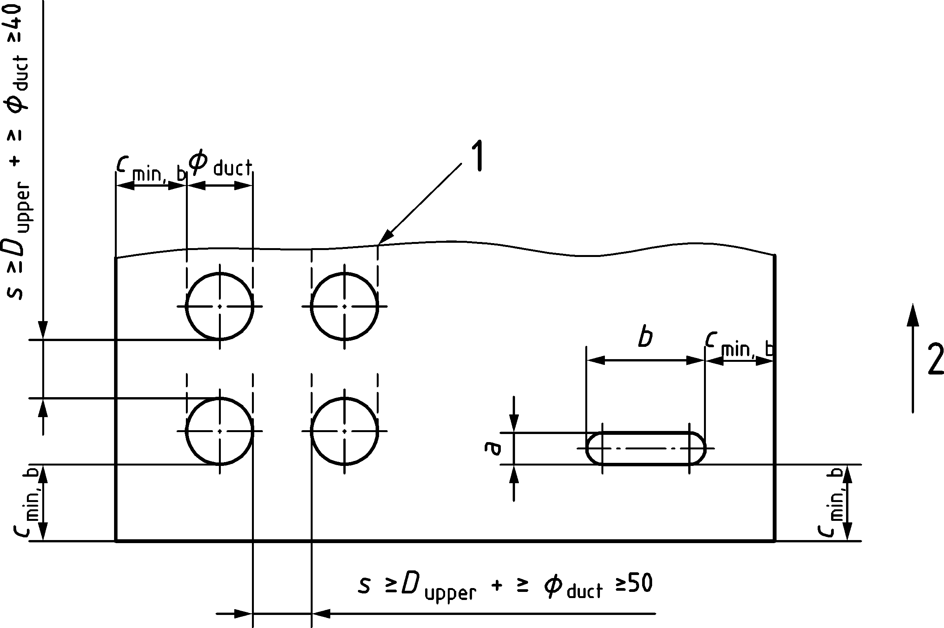

Key

|  |  |
| --- | --- |
| 1 | Assumed plane of tendon curvature |
| 2 | vertical |

NOTE Spacing shown for round ducts applies also to flat ducts. Values of cmin,b are given in 6.5.2.3.

Figure 11.16 — Minimum clear spacing for internal tendons for post-tensioning

(3) Outside the anchorage zone, up to two tendon ducts and up to four greased and sheathed strands may be bundled transversally to the plane of the tendon curvature or in case of straight tendons. The effect of possible deviation forces due to tendon curvature shall be considered according to 11.7. Tendons with flat ducts shall not be bundled.

### Minimum radius of curvature and straight length of tendons adjacent to the anchorages

(1) The minimum radius of curvature of tendons and the minimum straight length of tendons adjacent to the anchorage devices shall comply with the requirements in the technical documentation of the post-tensioning system depending on the type of duct (metal duct, polymer duct, polymer pipe, steel pipe, polymer sheathing). These values shall not be smaller than those given in (2) unless demonstrated by testing in accordance with EAD‑160004‑00‑0301.

(2) Unless other values are given in the technical documentation of the post-tensioning system, the minimum radius of curvature of tendons to prevent damage of the unconfined concrete on the inside of the tendon curvature during prestressing and to avoid a reduction of the axial tensile strength of the tendon may be taken as:

|  |  |
| --- | --- |
| $$R_{min}=\frac{σ_{pd}}{p_{Rd}}\sqrt{A_{p}}$$ | (11.20) |

where

|  |  |
| --- | --- |
| σpd | is the tendon design stress (at the time of tensioning, considering partial factors for prestress, see Table 4.2(NDP); |
| pRd | is the maximum transverse bearing stress on the prestressing tendon which may be taken from Table 11.5. |

(3) For tendon loops in U-shape, unless more restrictive rules are given in the technical documentation of the post-tensioning system, the following detailing rules should be observed:

* minimum cover transverse to the plane of the tendon loop ≥ 1,0ϕD;
* reinforcement transverse to the plane of the tendon loop should be provided for the deviation forces along the inside of the loop;
* Half of the deviation forces in the plane of the loop transferred by reinforcement to the concrete on the outside of the loop. This reinforcement should be anchored at the centreline of the loop and may be combined with the bursting reinforcement in the form of U-shaped bars;
* the bearing stress on the confined concrete inside the tendon curvature should be checked according to (2).

Table 11.5 — Maximum transverse bearing stress on the prestressing tendon and additional requirements

| Case | maximum transverse bearing stress on the prestressing tendon | additional requirements |
| --- | --- | --- |
| internal tendons with corrugated ducts | pRd = 0,75fcd ≤ 12 MPa | – |
| internal tendons inside a loop in U-shape with duct or pipe without relative movement between tendon and duct (i.e. the tendon fix point during stressing is located in the centre of the U and is not subject to fatigue loading) | pRd = 55 MPa | see (3) |
| External tendons with smooth pipe with relative movement between tendon and duct | pRd = 24 MPa | The bearing stress on the concrete inside the pipe shall be verified. |

### Anchorages, couplers and deviators of post-tensioning tendons

(1) Anchorage devices and couplers used for post-tensioning tendons as well as the zone immediately around and in front of the tendon anchorage where the prestressing force is transmitted to the concrete shall be checked for minimum spacing, minimum edge distance and local anchorage zone reinforcement to be in accordance with the technical documentation of the post-tensioning system.

(2) The zone where the prestressing force is dispersed over the full cross section of the member should be designed using a strut-and-tie model according to 8.5, or other appropriate representation.

(3) If post-tensioning tendons are anchored in a section away from the ends of a member (e.g. at a construction joint, a blister or cast into the member section), compressive stresses should generally be present in the entire section in the direction of the anchored prestressing force under frequent load combination. The effect of anchoring or coupling several tendons at or close to the minimum spacing between anchorages or couplers in a single cross section on the strain distribution in the member should be assessed.

NOTE The assumption of linear strain distribution may not apply locally where several tendons are anchored or coupled at or close to the minimum spacing in a single cross section inside a member. It is considered good practice if at least 25 % of the tendon force is transferred with reinforcement (parallel to the tendon) to the member sections behind the anchorage or coupler. Compression forces acting in the member sections behind the anchorage or coupler reduce the required amount of reinforcement.

## Deviation forces due to curved tensile and compressive chords

(1) In the case of curved or kinked tension or compression chords, the effects of the deviation forces shall be accounted for. The same provisions apply for curved post-tensioning tendons near the concrete surface.

(2) Deviation forces in equilibrium with transverse tensile forces as shown in Figure 11.17 should in general be resisted by means of additional transverse reinforcement.

(3) If no specific transverse reinforcement is provided to carry deviation forces, it shall be verified that the deviation forces due to the longitudinal reinforcement force or due to a curved post-tensioning tendon can be resisted by the concrete in tension:

|  |  |
| --- | --- |
| $$\frac{F_{td}}{r⋅c_{u}}≤\frac{0,125}{γ_{C}}\sqrt{f_{ck}}$$ | (11.21) |

where

$$c_{u}=min\left\{c_{s} ; 2 \sqrt{3} \left(c_{y}+0,5ϕ\right)\right\}$$

cs and cy are defined in Figure 11.3c). For post-tensioning tendons, ϕ shall be replaced by ϕD.

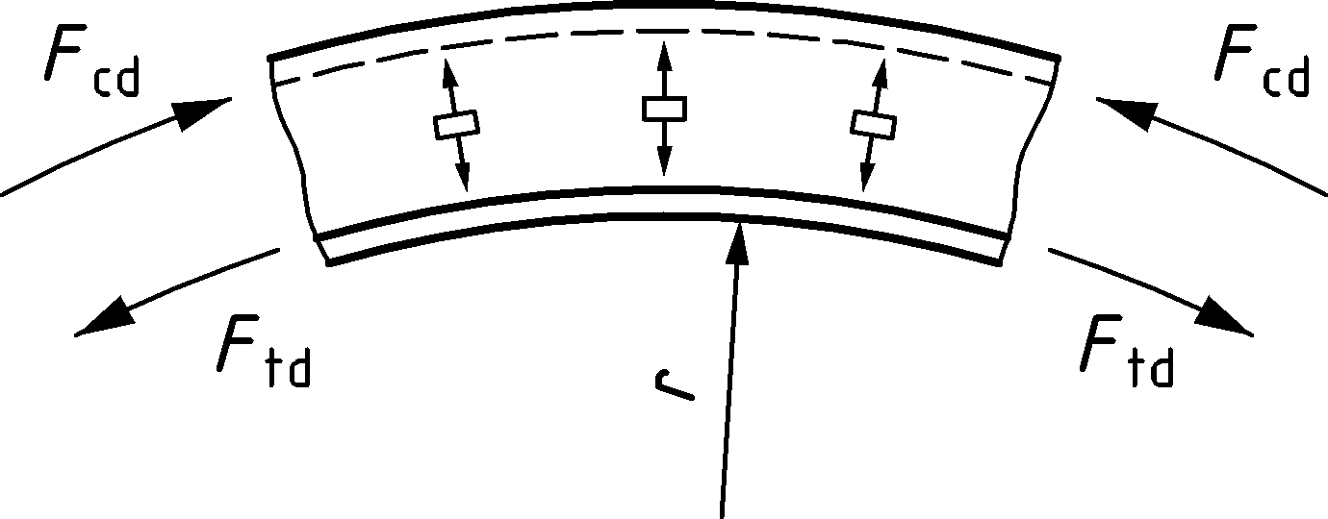

Figure 11.17 — Deviation forces and transverse tensile forces in curved members

(4) In case of lap splices of curved tensile reinforcing steel bars in regions without transverse reinforcement, the interaction between bond and transverse tensile stresses due to deviation forces should be accounted for by means of:

|  |  |
| --- | --- |
| $$\frac{γ_{C}⋅8⋅F_{td}}{r⋅c_{u}⋅\sqrt{f_{ck}}}+\frac{l_{sd}}{l_{s}}≤1$$ | (11.22) |

where

|  |  |
| --- | --- |
| ls | is the actual lap length; |
| lsd | is the design lap length. |

Calculation of parameter cu according to (3) should account for the presence of additional bars in the splice region potentially reducing net spacing cs as indicated in Figure 11.10a).

# Detailing of members and particular rules

## General

(1) The rules in Clause 12 are intended to detail concrete structures and concrete members such that the assumptions for the behaviour with respect to structural safety, serviceability, durability and robustness inherent in the rules of this Eurocode are met.

(2) Detailing of members shall be consistent with the design models adopted.

(3) Concrete members shall be detailed with due consideration to the constructability and concreting operations.

(4) Sufficient reinforcement shall be provided at all sections to resist the envelope of the acting internal forces taking into account effects such as shear on longitudinal reinforcement. The area of reinforcement in zones of tension shall not be taken less than As,min.

(5) For cable supported members the relevant rules of Annex K may be used.

## Minimum reinforcement rules

(1) In members designed as parts of reinforced concrete structures, minimum reinforcement As,min shall be provided to:

1. ensure distributed cracking and to handle forces from restrained deformations where not considered explicitly in the design ((2) and (4));
2. ensure sufficient deformation capacity to contribute to structural robustness by allowing alternative load paths ((2) and (4));
3. avoid failures due to unpredicted cracking (3);
4. ensure applicability of design models in Clauses 8 and 9 and Annex G;
5. ensure constructability

NOTE 1 Additional provisions for crack control at SLS are given in 9.2.2.

NOTE 2 The area of minimum reinforcement As,min can include prestressed and ordinary reinforcement when bonded to the concrete.

(2) The area of minimum reinforcement As,min shall provide nominal section strength which is at least equal to the effect causing cracking:

a) In members subjected to bending without or with axial force and any form of cross section, minimum reinforcement shall be provided so that:

|  |  |
| --- | --- |
| MR,min (NEd) ≥ Mcr(NEd) | (12.1) |

where

|  |  |
| --- | --- |
| MR,min | is the bending strength of the section with As,min in presence of the simultaneous axial force NEd. NEd may be derived from the load case providing the least compression in the member; |
| Mcr | is the cracking moment of the section in presence of the simultaneous axial force NEd, which may be calculated on the basis of the concrete tensile strength fctm according to Table 5.1. |

For sections prestressed with internal permanently unbonded tendons or with external tendons the contribution of the tendons to NEd, MR,min and Mcr should be calculated using the σp,mt(x) (see Formula (7.32)).

b) In members with pure tension As,min may be calculated as:

|  |  |
| --- | --- |
| As,min = Ac ⋅ fctm/fyk | (12.2) |

(3) Where MEd < Mcr(NEd), the member is designed as statically determinate and where no distribution of cracking is required, a sudden collapse after cracking may also be avoided with a minimum reinforcement designed for following resistance:

|  |  |
| --- | --- |
| $$M_{Rd,min}\left(N_{Ed}\right)=k_{dc}⋅M_{Ed}$$ | (12.3) |

where MRd,min is the design bending strength of the section in the presence of the simultaneous axial force NEd, MEd is the ULS bending force and kdc is a coefficient which depends on the ductility class of the reinforcement:

* kdc = 1,3 for ductility class A,
* kdc = 1,1 for ductility class B,
* kdc = 1,0 for ductility class C.

The area of reinforcement calculated need not be taken as greater than determined from Formula (12.1).

NOTE Use of Formula (12.3) can result in wide cracks in SLS.

(4) In beams and slabs requiring shear or torsion reinforcement a minimum ratio of such reinforcement ρw,min shall be placed. ρw,min should be calculated as:

|  |  |
| --- | --- |
| $$ρ_{w,min}=\frac{A_{sw,min}}{s⋅b_{w}⋅sinα}≥0,08\frac{\sqrt{f_{ck}}}{f_{yk}}$$ | (12.4) |

where

|  |  |
| --- | --- |
| ρw,min | is the minimum reinforcement ratio; |
| Asw,min | is the area of minimum shear reinforcement within the spacing s; |
| s | is the spacing of the shear reinforcement measured along the longitudinal axis of the member; |
| bw | is the width of the web of the member; |
| α | is the angle between shear reinforcement and the longitudinal axis. |

The value of *w*,min given by Formula (12.4) may be reduced

* by 10 % when ductility class B reinforcement,
* by 20 % when ductility class C reinforcement

is used.

Formula (12.4) ensures that the shear model in Clause 8 is valid and that behaviour is reasonably ductile, where alternative shear models are used alternative values may be appropriate.

(5) Members having less longitudinal reinforcement than As,min given in Clause 12 shall be designed in accordance with Clause 14.

(6) For members where brittle failure due to tensile stresses is excluded such as members in compression and members with no structural function, (2) to (5) may be disregarded.

(7) Minimum reinforcement shall generally be anchored and lapped according to Clause 11 for a design stress of σsd = fyd. Reinforcement provided only to satisfy minimum steel requirements may have its anchorage length reduced providing that it is ≥ 10ϕ past the inner edge of the support.

## Beams

### General

(1) Reinforcement in beams, longitudinal and transverse, should be detailed in accordance with the requirements of Table 12.1(NDP).

NOTE The values in Table 12.1(NDP) apply, unless a National Annex gives other values.

Table 12.1(NDP) — Detailing requirements for reinforcement in beams

| Description | | Symbol | Requirement |
| --- | --- | --- | --- |
| 1 | Minimum longitudinal reinforcement, in those parts of the section where tension may occur | As,min | 12.2(2), see also 12.2(3), 12.2(6) |
| 2 | Minimum shear and transverse torsional reinforcement, when required. Minimum torsion reinforcement should be provided to the full perimeter including features not counted part of the thin walled section. | ρw,min | 12.2(4) |
| 3 | Minimum bottom reinforcement at inner supports taking account of unforeseen effects at supports |  | 0,25 As,req span |
| 4 | Maximum longitudinal spacing of shear assemblies/stirrupsa | smax,l | 0,75d (1 + cotα) |
| 5 | Maximum longitudinal spacing of bent-up barsa | smax,bu | 0,6d (1 + cotα) |
| 6 | Maximum transverse spacing of shear legsa | smax,tr | 0,75d ≤ 600 mm |
| 7 | Minimum ratio of shear reinforcement in the form of stirrups with respect to the required reinforcement ratio (taking account of unforeseen effect’s e.g. compatibility torsion) | ρw,stir | ≥ 0,5ρw,req |
| 8 | Minimum ratio of torsion reinforcement in the form of closed stirrups with respect to the required reinforcement ratio | ρw,stir | ≥ 0,2ρw,req |
| 9 | Maximum spacing for torsion assemblies/stirrups (u defined in 8.3.2(2)). | smax,stir | u/8 ≤ min{b; h} |
| 10 | Minimum area and spacing of longitudinal surface reinforcement in beams with downstand ≥ 600 mm to avoid coarse cracks in SLS. | As,web  smax,l,surf | 9.2.2(6)  300 mm |
| 11 | Minimum transverse reinforcement in flanges (those part of flanges where tension in the transverse direction may occur) | Ast,min | 12.2(2) see 8.2.5, Figure 8.13 |
| a These spacings are consistent with the shear model in 8.2.3. Where alternative models are used alternative spacings may be required. | | | |

### Longitudinal reinforcement

(1) Sufficient reinforcement should be provided at all sections to resist the envelope of the acting tensile force, including the effect of shear in webs and flanges and to fulfil the minimum reinforcement requirements.

(2) For members with shear reinforcement, the additional tensile force due to shear, Nvd, according to 8.2.3 (8) should be considered.

Alternatively, for members with constant depth, the moment curve should be shifted at a distance al according to:

|  |  |
| --- | --- |
| al = z (cotθ − cotα)/2 | (12.5) |

as indicated in Figure 12.1.

For members without shear reinforcement, it may be assumed:

|  |  |
| --- | --- |
| al = d | (12.6) |

(3) The resistance of bars within their anchorage lengths may be taken into account, assuming a linear variation of force, see Figure 12.1.

(4) The tensile reinforcement required in flanged cross sections may be spread over the effective width of the flange or part of it may be concentrated over the web. The tensile reinforcement located outside the web should be extended by a length equal to its distance from the web times cotθfl (see 8.2.5).

(5) The anchorage length of a bent-up bar which contributes to the resistance to shear should be not less than 1,3lbd in the tension zone and 0,7lbd in the compression zone. It is measured from the point of intersection of the axes of the bent-up bar and the longitudinal reinforcement.

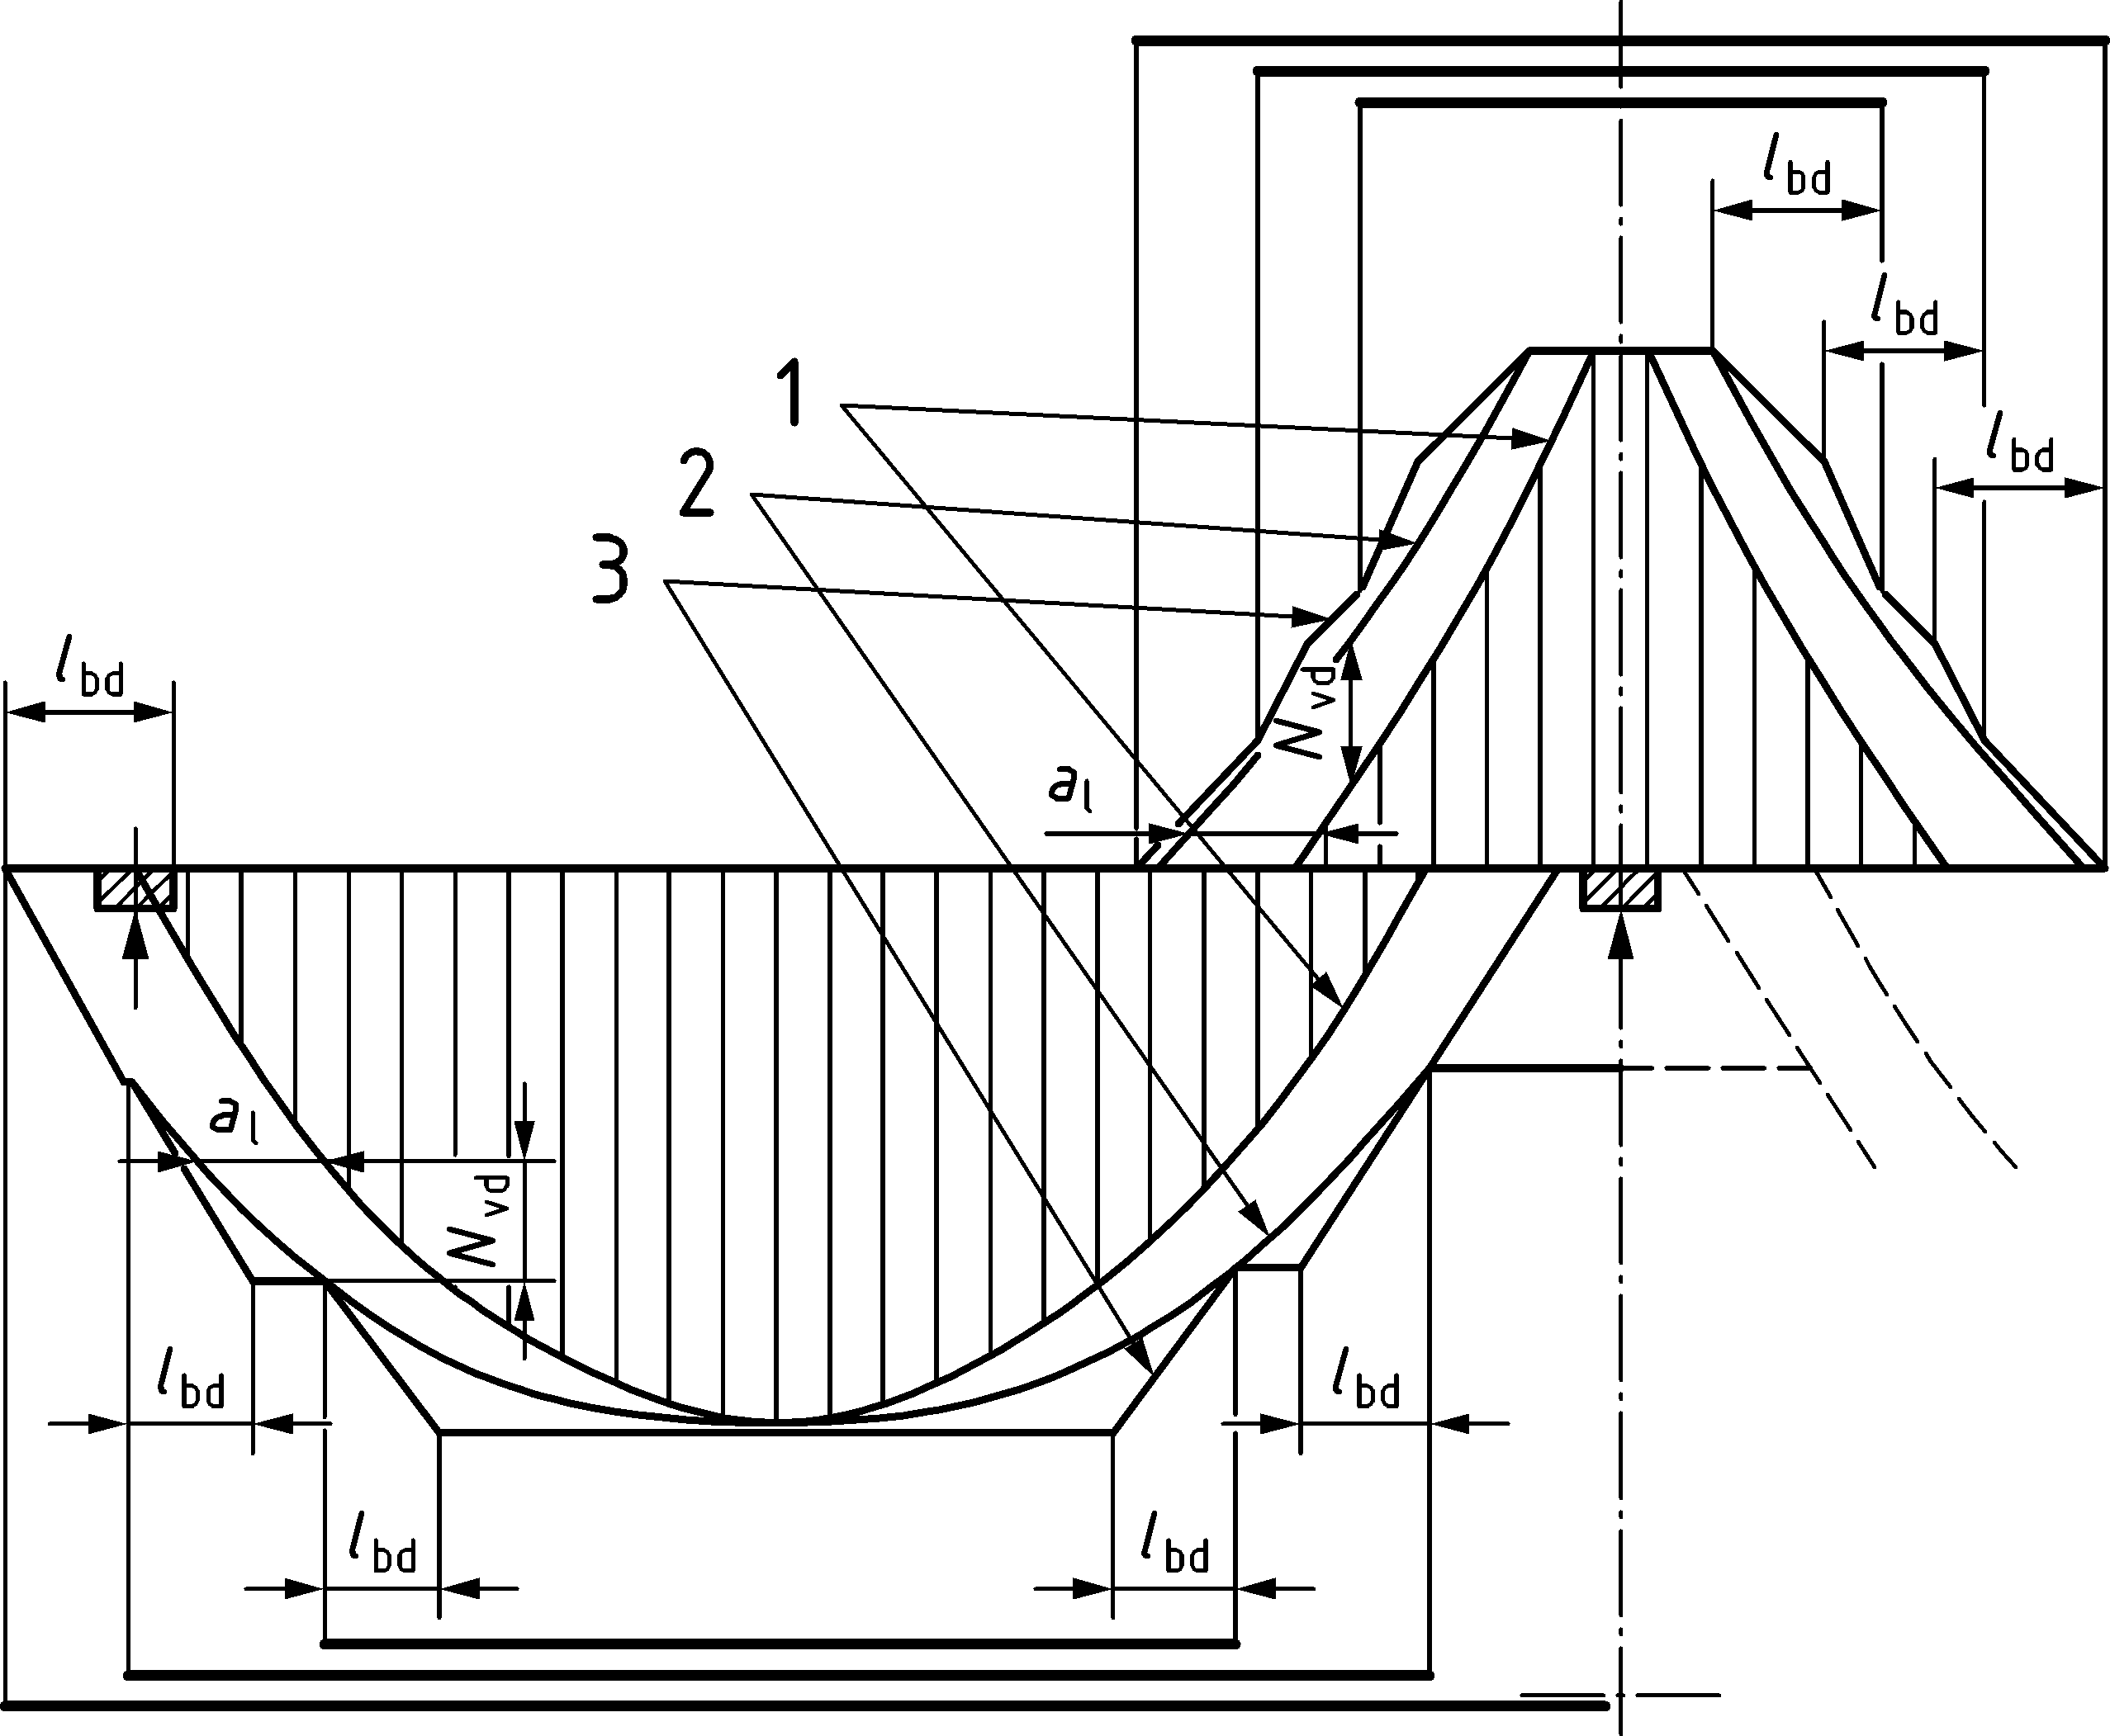

Key

|  |  |
| --- | --- |
| 1 | envelope of MEd/z + 0,5NEd |
| 2 | acting tensile force Fs |
| 3 | resisting tensile force FRs |

Figure 12.1 — Illustration of the curtailment of longitudinal reinforcement in members with constant depth, taking into account the effect of shear and the resistance of reinforcement within anchorage lengths

(6) Bottom reinforcement at intermediate supports should, as a minimum, extend by 10ϕ into the support if there is no tensile force in the reinforcement. In case there could be tension due to settlement of the support, accidental actions or due to other considerations, the reinforcement should be detailed for adequate capacity and continuity.

(7) Any compression longitudinal reinforcement which is included in the resistance calculation should be confined by transverse reinforcement with spacing not greater than the limits given in Table 12.3(NDP) and 12.6(3).

### Shear and torsion reinforcement

(1) The shear reinforcement may consist of a combination of:

* stirrups/links enclosing the longitudinal tension reinforcement and the compression zone according to Figure 12.2a) and b);
* bent-up bars;
* cages, ladders, etc. which are cast in without enclosing the longitudinal reinforcement but are properly anchored in the compression and tension zones according to Figure 12.2c) and d)
* continuous stirrups (spirals);
* headed bars as in Figure 12.2e).

(2) When, based on shear design, no shear reinforcement is required, minimum shear reinforcement should nevertheless be provided according to 12.2(4). Minimum shear reinforcement may be omitted in members of minor importance (e.g. lintels with span ≤ 2,0 m) which do not contribute to the overall resistance and stability of the structure.

(3) The shear reinforcement shall enclose the tension reinforcement or shall be effectively anchored in the tension zone at one end and in the compression zone at the other. Links and shear reinforcement should normally be anchored by means of bends, hooks, heads or welded transverse reinforcement, see Figure 12.2. A longitudinal bar of minimum diameter equal to not less than the diameter of the stirrup or link should be provided at each corner of stirrup/link and inside end hooks.

(4) Closing of stirrups according to Figure 12.2f) g) and h) may be used in the tension and compression zone of a section. The anchorage of single-leg shear links or of open stirrups according to Figure 12.2b) to d) should be placed in the compression zone of the member. Welding should be carried out in accordance with 5.2.3 and have a weld capacity in accordance with 11.4.7.

(5) Headed bars according to Figure 12.2e) should be designed according to 11.4.6.

|  |  |  |  |  |  |  |
| --- | --- | --- | --- | --- | --- | --- |
|  |  | |  |  | |  |
| a) with standard hook | b) with 90°-bend | | c) with 2 welded transverse bars | d) with 1 welded transverse bar | | e) with head |
|  | |  | | |  | |
| f) stirrup with 135°-bends | | g) stirrup with 90°-bends | | | h) closed with 90°-bended U‑stirrups | |

Key

|  |
| --- |
| s ≥ max{2ϕ; 20 mm} and ≤ 50 mm |
| a ≥ 10 mm |
| c ≥ max{3ϕ; 50 mm} |

Figure 12.2 — Anchorage of links a)–e) and closing of stirrups f)–h)

(6) Laps on legs of stirrups in shear reinforcement may be used provided they ensure yielding of the stirrup (see Figure 12.3d)). Laps shall be designed according to 11.5 for σsd = 1,2fyd.

(7) When static equilibrium assumed in the analysis depends on the torsional resistance of elements of a structure, the torsion reinforcement shall comply with the rules given 12.3.3(7) and Figure 12.3. and shall enclose the whole section. When torsion arises only from compatibility and the structure is not dependent on torsional resistance for its equilibrium, minimum torsional reinforcement shall be provided according to Table 12.1(NDP).

(8) Torsion links shall be closed and anchored by means of laps or hooked ends (see Figure 12.3), and should be at an angle that does not deviate more than 10o from the ideal angle of 90° to the axis of the structural element. In case of different inclinations, torsion reinforcement should be designed using appropriate stress fields.

|  |  |  |  |
| --- | --- | --- | --- |
|  | | | |
| a) closed stirrup with hooks bended ≥ 135° | b) closed stirrup with 90°-hooks | c) open U-stirrups closed by transversal reinforcement in the flange | d) U-stirrups closed by laps in the height of flanges with lsd to be designed for 1,2fyd |

NOTE The alternative b2) has a full lap length lsd along the shortest side.

Figure 12.3 — Examples of shapes for torsion links

(9) The longitudinal bars should be arranged so that there is at least one bar at each corner, the others being distributed uniformly around the inner periphery of the links, with a spacing not greater than permitted in Table 12.1(NDP).

### Suspension reinforcement for indirect support

(1) Where applied loads are introduced in a manner that causes local tensile stresses in the supporting member in accordance with 8.2.1(9), the additional suspension reinforcement should consist of stirrups or links surrounding the principal reinforcement of the supporting/supported member, whichever is at a lower level, unless a suitable stress field model demonstrates otherwise. The stirrups/links may be located inside the volume of concrete common to the two beams or distributed also outside that volume, provided a consistent strut and tie model is applied.

## Slabs

### General

(1) Reinforcement in slabs should be detailed in accordance with the requirements of Table 12.2(NDP).

NOTE The recommended values in Table 12.2(NDP) apply unless a National Annex gives other values.

Table 12.2(NDP) — Detailing requirements for reinforcement in slabs

| Description | | Symbol | Requirement |
| --- | --- | --- | --- |
| 1 | Minimum longitudinal reinforcement in those parts of the cross section where tension may occur | As,min | 12.2(2)  see also 12.2(3), (6) |
| 2 | Minimum shear reinforcement, when required | ρw,min | 12.2(4)  12.4.2(3) |
| 3 | Minimum secondary reinforcementa |  | 0,2As,req,spanc |
| 4 | Minimum longitudinal bottom reinforcement at inner supports, taking account of unforeseen effects at supports |  | 0,25As,req,spanc |
| 5 | Minimum longitudinal bottom reinforcement at end supports |  | 0,5As,req,spanc ≥ As,min |
| 6 | Minimum top reinforcement at end supports in buildings, without bearings where unintentional restraint may occur.  The reinforcement should extend 0,2lspan from the end support. |  | 0,25As,req,spanc  (but ≥ As,min according to 12.2(2)) |
| 7 | Maximum spacing of bars for concrete in tension | smax,slab | 3h ≤ 400 mm |
| 8 | Maximum longitudinal spacing of shear assemblies/stirrups | smax,l | 0,75d ⋅ (1 + cotα) |
| 9 | Maximum longitudinal spacing of bent-up bars | smax,bu | d |
| 10 | Maximum transverse spacing of shear legsb | smax,tr | 1,5d |
| 11 | Along a free (unsupported) edge, a slab should normally contain longitudinal and transverse reinforcement, generally arranged as shown in Figure 12.5 in order to accommodate torsional moments near the edge. | | |
| a To ensure a minimum ability to locally redistribute sectional forces transverse to the span direction, secondary reinforcement is to be placed in areas of slabs which can be considered to behave as one-way slabs.  b These spacing are consistent with the shear model in 8.2.3. Where alternative models are used alternative spacings may be required.  c As,req span is the required reinforcement for positive bending moments at the span. | | | |

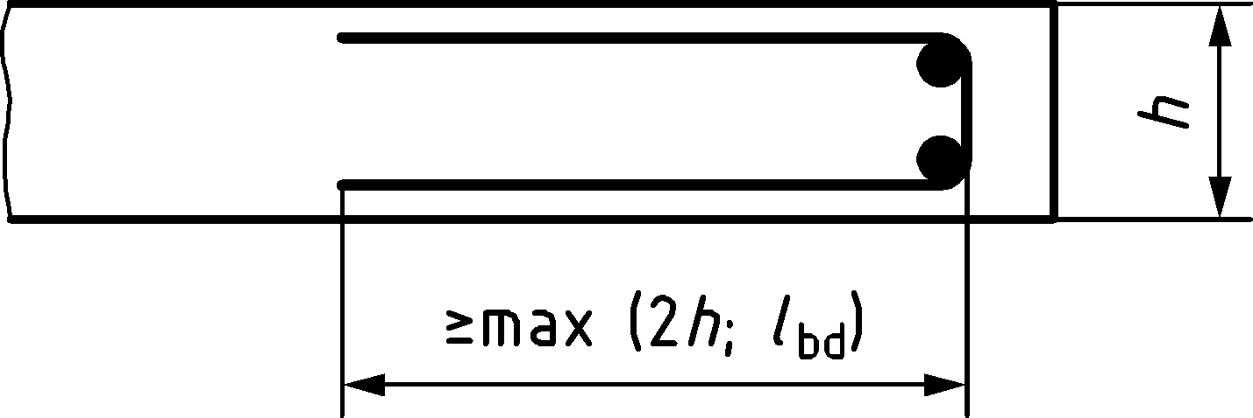

Figure 12.4 — Edge reinforcement for a slab

(2) Any compression longitudinal reinforcement which is included in the resistance calculation should be confined by transverse reinforcement in accordance with 12.7(3).

(3) Where lifting of a slab-corner is restrained suitable reinforcement shall be provided.

(4) In case of slabs with depth discontinuities on the tension side, the flexural reinforcement should be detailed as shown in Figure 12.6, or alternatively, by using 8.5.

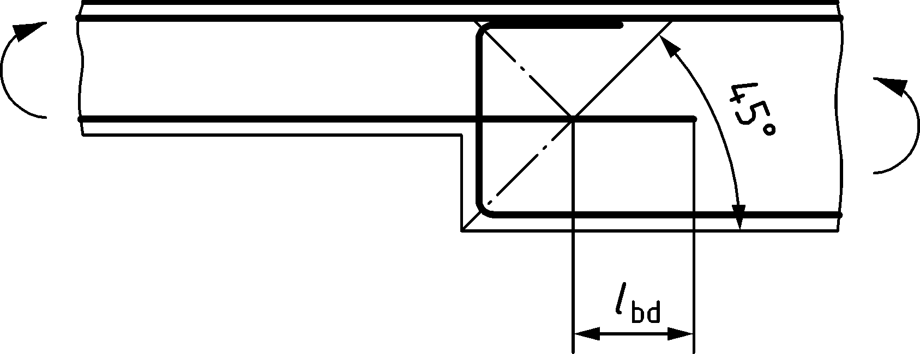

Figure 12.5 — Example of reinforcement detailing in case of slabs with depth discontinuities on the tension side and without shear reinforcement

### Shear reinforcement

(1) Shear reinforcement according to 12.2.3(1) may be used.

(2) A slab in which shear reinforcement is provided should have a depth h not less than 200 mm with stirrups, links or headed bars, or 160 mm with bent up bars.

(3) The minimum shear reinforcement according to 12.2(4) may be omitted in solid, ribbed or hollow core slabs where transverse redistribution of loads is possible.

(4) Shear reinforcement should be detailed to enclose all except the outermost layers of reinforcement as shown in Figure 12.7.

(5) In slabs, where τEd ≤ 0,08fcd the shear reinforcement may consist entirely of bent up bars or of shear reinforcement assemblies.

(6) The diameter of shear reinforcement assemblies ϕsw shall not exceed a maximum value according to 12.5.1(3).

## Slab-column connections and column bases

### Punching shear reinforcement

(1) If punching shear reinforcement is required (see 8.4), the following types of shear reinforcement may be placed to increase the punching shear capacity:

* stirrups (Figure 12.7a)) with anchorage according Figure 12.2a) or b));
* double-headed studs (Figure 12.7b) with anchorage according to Figure 12.2e);
* bent-up bars (Figure 12.7c));
* single-leg shear links ((Figure 12.7d) with anchorage according Figure 12.2a) or b)).

|  |  |  |
| --- | --- | --- |
|  | | |
| a) Stirrups |  |  |
| b) Double-headed studs |  |  |
| c) Bent-up bars |  |  |
| d) single-leg shear links | | |

Key

|  |  |
| --- | --- |
| 1 | center line |
| 2 | compression zone |

Figure 12.6 — Examples of shear and punching shear reinforcement in flat slabs

(2) Where punching shear reinforcement is required it should be placed between the loaded area/column Aload and 0,5dv,out inside the control perimeter at which shear reinforcement is no longer required (see Figure 8.24). If stirrups, links or double-headed studs are provided, the shear reinforcement should be installed along at least two perimeters. For bent-up bars anchored as in Figure 12.8 one perimeter may be considered sufficient. The spacing of the shear reinforcement in radial and tangential directions shall satisfy the provisions in Figure 12.8.

The tangential spacing of shear reinforcement located at a distance ≤ 2*d*v from the column edge should not exceed 1,5*d*v (see Figure 12.8c)).

|  |
| --- |
|  |
| a) Radial spacing rules for flat slabs |
|  |
| b) Radial spacing rules for column bases |
|  |
| c) Tangential spacing rules |

Key

|  |  |
| --- | --- |
| a | within 2d |
| b | outside 2d |
| 1 | radial layout |
| 2 | orthogonal layout |

Figure 12.7 — Spacing of punching shear reinforcement

NOTE Figure 12.8a) and b) show the position vertical leg of punching shear reinforcement simplified without anchorage elements.

(3) The maximum effective area of one leg of shear reinforcement should be limited to that of a bar of diameter ϕw,max of:

* for single leg links and open stirrups $ϕ_{w,max}=10\sqrt{d/200}$,
* for closed stirrups or bars with similar anchorage: $ϕ_{w,max}=11\sqrt{d/200}$,
* for bent up bars and headed bars: $ϕ_{w,max}=16\sqrt{d/200}$.

(4) Bent-up bars passing through the loaded area or being at a distance not exceeding 0,25d from this area may be used as punching shear reinforcement (see Figure 12.8a)). For single bent-up bars, the horizontal projection of the bars has to be used for the value of sr to calculate ρsw.

### Integrity reinforcement against progressive collapse of flat slabs

(1) For buildings in CC2 (refer prEN 1990) and higher, an integrity reinforcement of at least two bars in each orthogonal direction should be provided at all columns without punching shear reinforcement or with punching shear reinforcement not fulfilling the requirement of (2).

These bars should be:

* of ductility class B or C,
* anchored in the column or pass through it and
* placed on the compression side of the slab within the vertical column reinforcement.

For robustness reasons, they should be designed for a resistance:

|  |  |
| --- | --- |
| $$V_{Rd,int}=∑A_{s,int}⋅f_{yd}⋅k_{int}≥V_{Ed}$$ | (12.7) |

where

|  |  |
| --- | --- |
| VEd | is the design value of the acting shear force for the accidental design situation |
| As,int | is the sum of the cross sections of all reinforcement bars crossing a column edge (the same bar may be counted twice if it passes through the column and is fully anchored on both sides outside the column edges) |
| kint | is a coefficient equal to: |
|  | — 0,37 for bars of ductility class B |
|  | — 0,49 for bars of ductility class C |

(2) Integrity reinforcement according to (1) should also be provided in slabs with shear reinforcement if:

|  |  |
| --- | --- |
| $$V_{Rd,w,int}=ρ_{w}⋅f_{ywd}⋅sinα_{w}⋅b_{0}⋅d_{v}≤V_{Ed}$$ | (12.8) |

where the shear reinforcement ratio ρw is defined in 8.4.4.

In this case, the integrity reinforcement should be designed according to Formula (12.7) where VEd may be replaced by VEd − VRd,w,int.

## Columns

(1) Longitudinal and hoop reinforcement of columns shall be detailed in accordance with the requirements of Table 12.3(NDP).

NOTE The recommended values in Table 12.3(NDP) apply unless a National Annex gives other values.

(2) Every longitudinal bar or bundle of bars placed at a corner shall be restrained by transverse reinforcement.

(3) No bar within a compression zone with a compressive strain exceeding 2 ‰ should be further than 150 mm from a restrained bar. Where additional transverse reinforcement to that required by Table 12.3(NDP) is required only to restrain a longitudinal bar the spacing may be twice the maximum spacing according to Table 12.3 (NDP).

(4) Where longitudinal bars are bent by more than 5° (tanθ ≈ 1/12), with respect to the axis of the column, the transverse splitting forces produced should be resolved by transverse reinforcement in accordance with a strut and tie model or stress field model.

Table 12.3(NDP) — Detailing requirements for reinforcement in columns

| Description | | Symbol | Requirement |
| --- | --- | --- | --- |
| 1 | Minimum amount of longitudinal reinforcement for robustness and to avoid risk of compressive yielding of reinforcement due to creep and shrinkage in SLS  When all longitudinal reinforcement is prestressed the 0,1NEd/fyd limit may be ignored. | As,min,long | $$max\left\{0,1 \frac{N_{Ed}}{f_{yd}} ; 0,002 A_{c}\right\}$$ |
| 2 | Minimum number of longitudinal barsa: | nmin,l |  |
| — polygonal cross section |  | 1 at each corner with a spacing ≤ 200 mm |
| — circular cross section |  | 6 evenly distributed with a spacing ≤ 200 mm |
| 3 | Maximum longitudinal spacing of transverse reinforcement (stirrups/hoops) for columns with dimensions h and b: | smax |  |
| — intermediate region between the two end regionsb |  | 15ϕmax,l c  ≤ min{h; b; 300 mm} |
| — intermediate region between the two end regions, when longitudinal bars are not accounted for column resistance |  | min{h; b; 400 mm} |
| — end regions, over a length equal to the larger dimension of the column. For concrete with fck > 50 MPa the transverse reinforcement shall provide a minimum confinement of k ⋅ fcd in accordance with 8.1.4, Formula (8.7)d |  | 0,6smax.col |
| — at lap area where ϕl ≥ 14 mm |  | 0,6smax.col |
| 4 | Minimum bar diameter for transverse reinforcement (bars in stirrups, wires in welded mesh) | ϕmin,trans | ≥ 0,25ϕmax,l a |
| a For constructability, the diameter of longitudinal bars ϕ,max,l should be at least 12 mm.  b Where all bars are prestressed a spacing of min{h; b; 300 mm} may be used.  c ϕ,max,l – maximum diameter of longitudinal bars.  d This requirement is to provide a minimum level of ductility to higher strength concrete columns. k = 0,02 unless a National Annex gives a different value. | | | |

## Walls and deep beams

(1) For walls subjected predominantly to out-of-plane bending, the rules for slabs apply (see 12.3).

(2) Vertical, horizontal and orthogonal-to-the-surface reinforcement in walls, shall be detailed in accordance with the requirements of Table 12.4(NDP).

NOTE The recommended values in Table 12.4(NDP) apply unless a National Annex gives other values.

Table 12.4(NDP) — Detailing requirements for reinforcement in walls and deep beams

| Description | | Symbol | Requirement |
| --- | --- | --- | --- |
| 1 | Minimum amount of vertical reinforcement (each surface): | As,min,v |  |
| — where the member carries in-plane normal and shear stresses and designed/verified by use of 8.5 or Annex G. |  | $$0,25A_{c}⋅\frac{f_{ctm}}{f_{yk}}$$ |
| — where the member is only loaded by vertical in-plane compression and out of plane bending |  | 0,001Ac |
| 2 | Minimum amount of horizontal reinforcement (each face): | As,min,h |  |
| — where the member carries in-plane normal and shear stresses and designed/verified by use of 8.5 or Annex G. |  | $$0,25A_{c}⋅\frac{f_{ctm}}{f_{yk}}$$ |
| — where the member is only loaded by vertical in-plane compression and out of plane bending. |  | 0,25As,v |
| 3 | Maximum spacing of vertical reinforcement |  | min{3ha; 400 mm} |
| 4 | Maximum spacing of horizontal reinforcement |  | 400 mm |
| 5 | Maximum spacing of orthogonal-to-the-surface reinforcement where As,v exceeds 0,02Ac and is utilised in compression (end region is taken as ≥ 4h a) |  | see 12.6. |
| a h – thickness of wall | | | |

(3) Where the longitudinal reinforcement is utilized in compression at ULS and is placed outside the horizontal reinforcement a minimum of number of stirrups with 4 legs per m2 of wall area, perpendicular to the surface, should be provided unless welded wire mesh or bars of diameter ϕ ≤ 16 mm are used with concrete cover larger than 2ϕ.

## Foundations

(1) Foundations shall be detailed with due regard to possible deviations in geometry and position of piles, supporting bedrock or soil.

(2) The main tensile reinforcement in pile caps may be designed using strut and tie models according to 8.5 or it may also be designed for bending and shear by considering the foundation as a slab if the main reinforcement near to piles is:

* designed according to 8.2(11) or 8.2.3(8) and
* placed within the width bs defined in Figure 12.9a).

In the area confined by the pile reaction according to Figure 12.9a), the anchorage length of main reinforcement may be reduced according to 11.4.2(5).

The main reinforcement perpendicular to free edges outside the widths bs may also be activated if the vertical component of the corresponding struts can be carried to the piles by the system according to Figure 12.9b).

|  |  |
| --- | --- |
|  |  |
| a) Definition of width bs | b) load carrying system with bent-up of main reinforcement outside widths bs as suspension reinforcement |

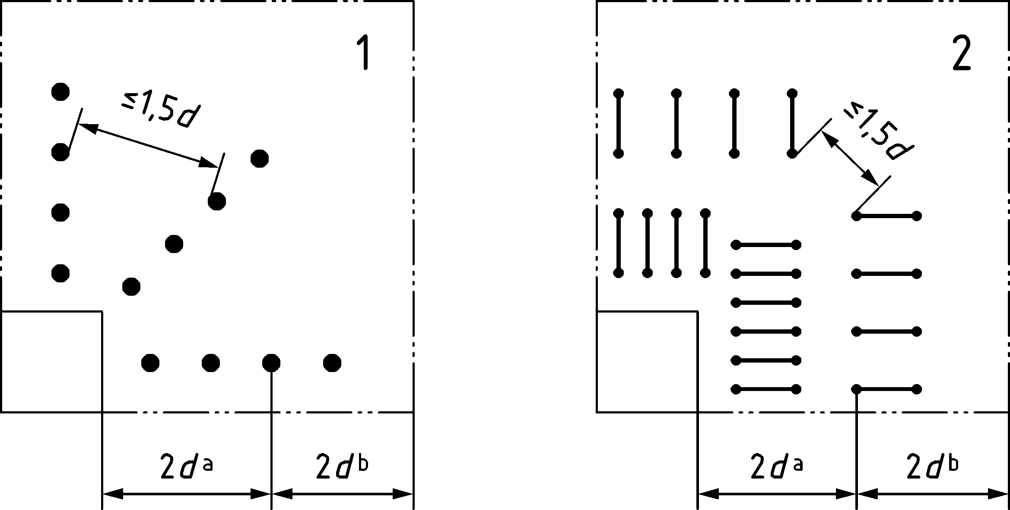

c) definition of anchorage zones with and without confinement due to pile compression

Key

|  |  |
| --- | --- |
| 1 | main reinforcement in the width bs and anchored behind the pile |
| 2 | main reinforcement outside the width bs |
| 3 | struts carrying shear |
| 4 | bent-up part of main reinforcement acting as suspension reinforcement |
| 5 | anchorage of the suspension reinforcement |
| 6 | anchorage zone of main reinforcement with confinement due to pile compression |
| 7 | anchorage zone without confinement due to pile compression |

Figure 12.8 — Anchorage of main reinforcement in pile caps

(3) The main reinforcement in footings and pile caps without shear reinforcement should be designed accounting for the concentrated compression zone and the resulting reduced lever arm of the internal forces under the column according to Figure 12.10a) and b). The increase of concrete strength in vertical direction under the column due to confinement according to 8.4 may be accounted for. Without detailed verification, a concrete strength in horizontal direction under the column up to 1,25fcd may be assumed.

|  |  |
| --- | --- |
|  |  |
| a) compression field carrying shear | b) concentration of compression zone under the column and resulting reduced level arm z |

Figure 12.9 — Concentrated compression zones in pile caps and footings

(4) Top surface and sides of pile caps and footings may be designed without surface reinforcement if there is no tension developing in these areas.

## Tying systems for robustness of buildings

### General

(1) Structures requiring an adequate level of robustness appropriate to the consequences of failure. Structures with normal consequences of failure should have a suitable tying system, to prevent progressive collapse by providing alternative load paths after local damage.

(2) In the absence of detailed analysis, the following ties should be provided as applicable:

1. peripheral ties,
2. internal ties,
3. horizontal column and wall ties,
4. vertical column and wall ties.

(3) Where a building is divided by expansion joints into structurally independent sections, each section should have an independent tying system.

(4) In the design of the ties the reinforcement may be assumed to be acting at its characteristic strength and shall be capable of carrying tensile forces defined in the following subclauses. Reinforcement of ductility classes B or C shall be used.

(5) Reinforcement provided for other purposes in columns, walls, beams and floors may be regarded as providing part of or the whole of these ties.

### Dimensioning of ties

#### Peripheral ties

(1) At each floor and roof level of a structure an effectively continuous peripheral tie within 1,2 m from the edge should be provided according to Table 12.5(NDP). The tie may include reinforcement used as part of the internal tie.

#### Internal ties

(1) Internal ties should be at each floor and roof level in two directions approximately at right angles. They should be effectively continuous throughout their length and should be anchored to the peripheral ties at each end, unless continuing as horizontal ties to columns or walls.

(2) The internal ties may, in whole or in part, be spread evenly in the slabs or may be grouped at or in beams, walls or other appropriate positions. In walls they should be within 0,5 m from the top or bottom of floor slabs.

(3) In each direction, internal ties should be capable of resisting a design value of tensile force according to Table 12.5(NDP).

#### Horizontal ties to columns and/or walls

(1) Columns and walls should be tied horizontally to the structure at each floor and roof level.

(2) The ties should be capable of resisting a tensile force tfac per metre of the wall. For columns the force need not exceed Tcol. Connections between columns and/or walls and the structure at each floor and roof level shall – without beneficial effects from external loads – be capable of transferring the specified tie forces.

(3) Corner columns should be tied in two directions. Bonded and unbonded reinforcement provided for the peripheral tie may be used as the horizontal tie in this case.

#### Vertical ties

(1) Where a column or wall is supported at its lowest level by an element other than a foundation (e.g. by a beam or flat slab) accidental loss of this element should be considered in the design and a suitable alternative load path should be provided.

### Required resistances for ties

(1) Ties (see Figure 12.11) should be capable of resisting a tensile force given in Table 12.5(NDP).

NOTE The recommended values in Table 12.5(NDP) apply unless a National Annex gives other values.

Table 12.5(NDP) — Resistances for reinforcement in ties

| Description | | Symbol | Requirement |
| --- | --- | --- | --- |
| 1 | Peripheral ties | Tp | EN 1991‑1‑7 |
| 2 | Internal ties | Ti | EN 1991‑1‑7 |
| 3 | Vertical ties | Tv | EN 1991‑1‑7 |
| 4 | Horizontal ties to walls | tfac | ≥ 20 kN/m |
| 5 | Horizontal ties to columns | Tcol | ≥ 150 kN |

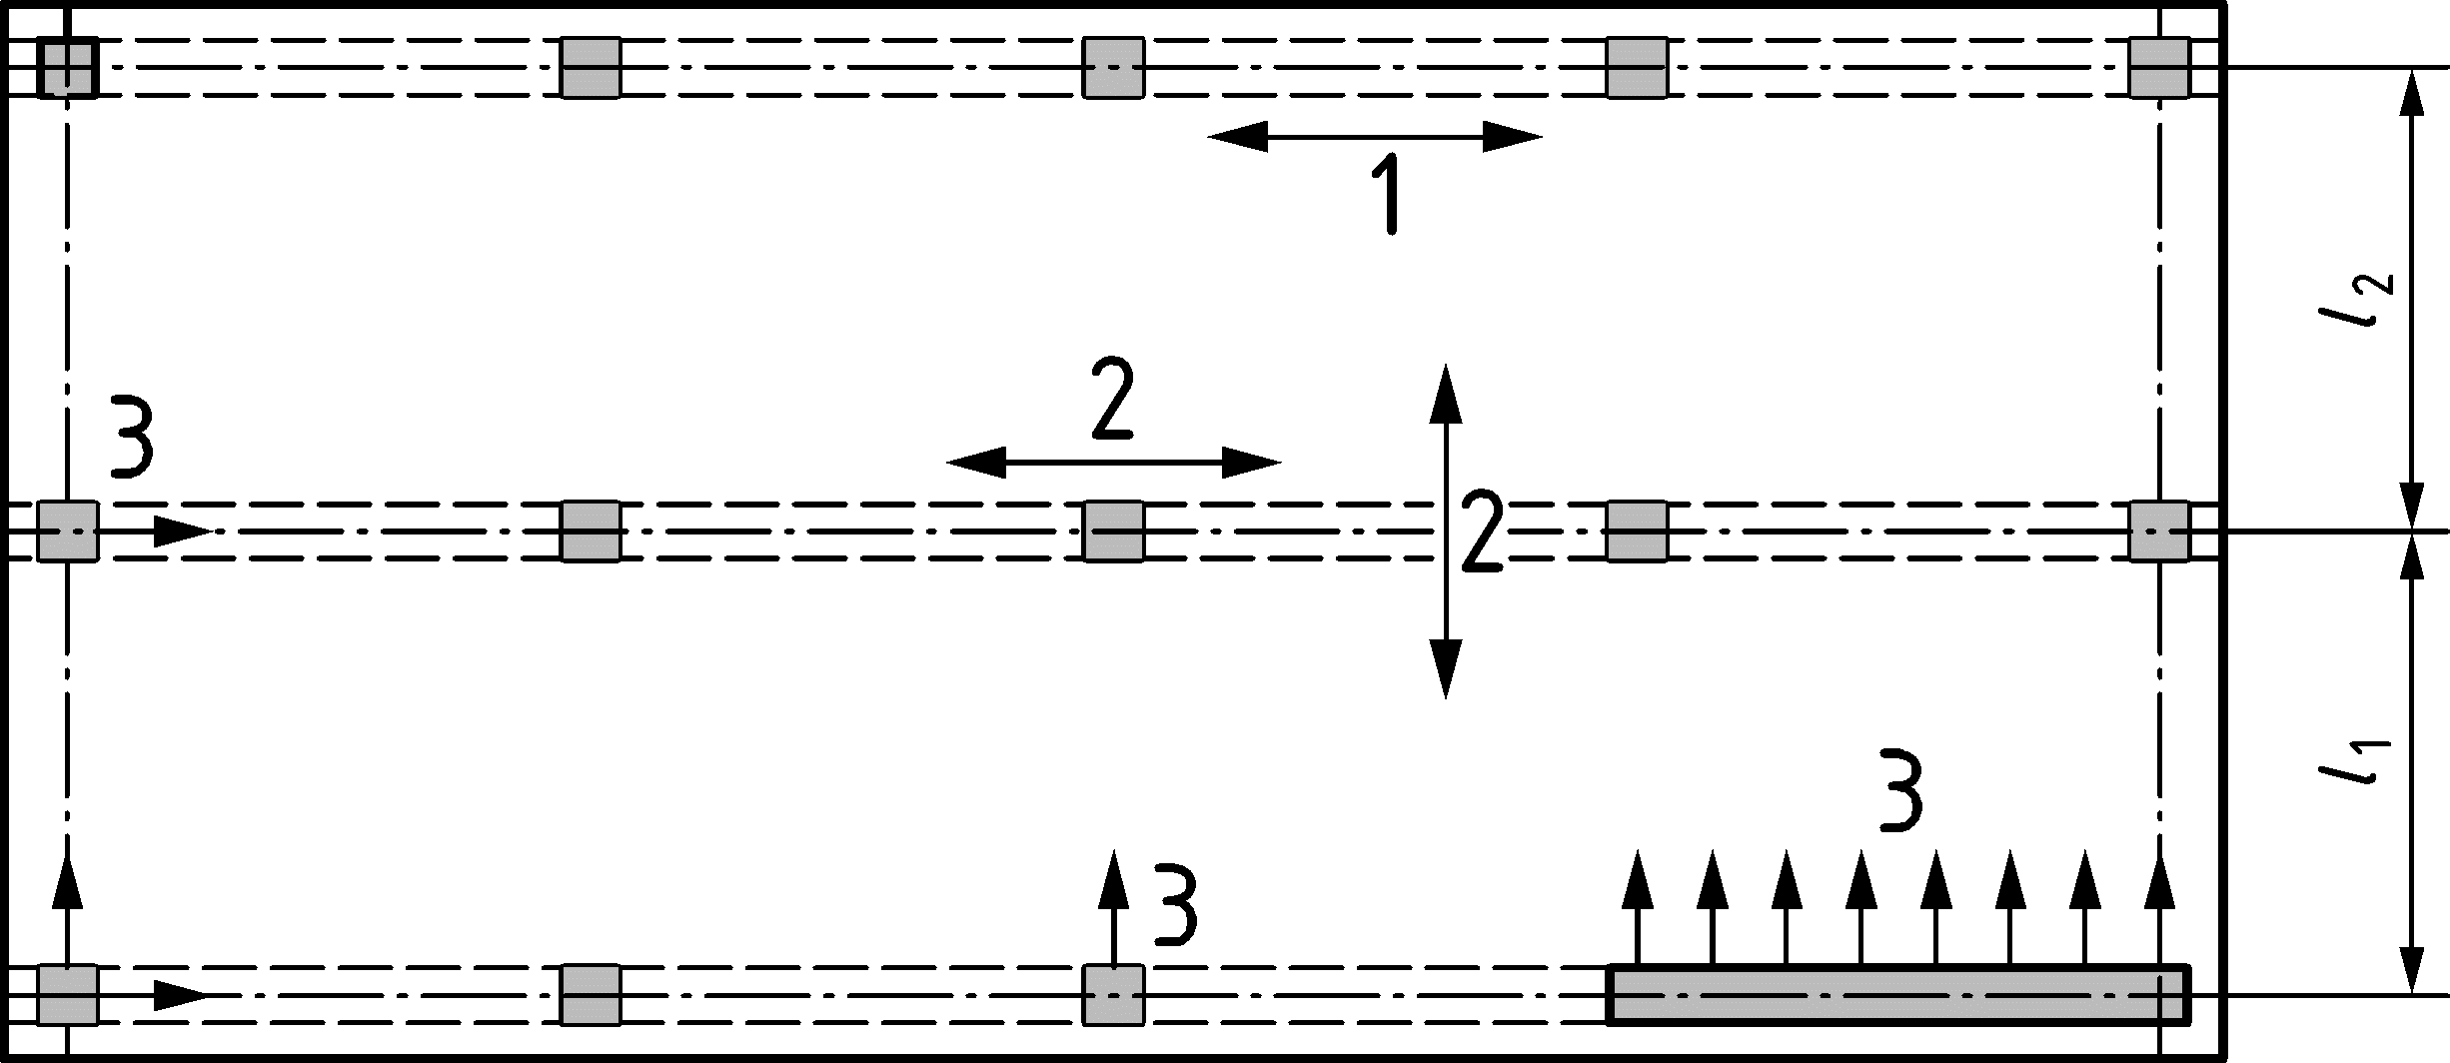

Key

|  |  |
| --- | --- |
| 1 | peripheral tie |
| 2 | internal tie |
| 3 | horizontal column or wall tie |

Figure 12.10 — Ties for robustness

## Supports, bearings and expansion joints

(1) Supports and bearings shall be designed and detailed for the relevant actions (loads, movements, rotations) to ensure correct positioning of the bearing reaction in accordance with the design model, taking into account construction deviations.

(2) For supports and bearings which permit movements, the shift of the bearing reaction should be taken into account in the design of the adjacent members.

(3) For supports which do not permit movements or rotation without overcoming significant restraint, actions due to restrained movements of the adjacent members (elastic, creep, shrinkage, temperature) and misalignment, lack of plumb, etc. shall be taken into account in the design of these members.

(4) Positioning and sizing of supports and bearings as well as detailing of reinforcement in supporting and supported members shall ensure effective transfer of forces compatible with the assumed action effects in the members and in the respective nodes of stress field or struts and ties, see Figure 8.28. Ties in the form of bent bars should effectively enclose the node.

(5) The nominal length a1 of a simple support or bearing as shown in Figure 12.12 should be detailed accounting for:

* the net support or bearing length a1 with regard to bearing capacity as defined in (6),
* anticipated movements where relevant,
* edge distances of supported and supporting members that may be considered ineffective due to, for example, the possibility of spalling or crumbling or due to incompatible stiffness,
* the allowances for construction deviations Δa2 and Δa3 in geometry and position of the supported and supporting members.

Detailing of members and supports should respect the following conditions, see Figure 12.12:

* di = ci + Δai with horizontal U-bar loops or otherwise anchored bars,
* di = ci + Δai + ri with vertically bent bars,
* cv,i ≤ di level of horizontal U-bar loops.

Where measures are taken to prevent spalling of concrete outside of the vertical bend, dimension *d* may be reduced, but a1/2 + di ≥ ci + Δai + ri.

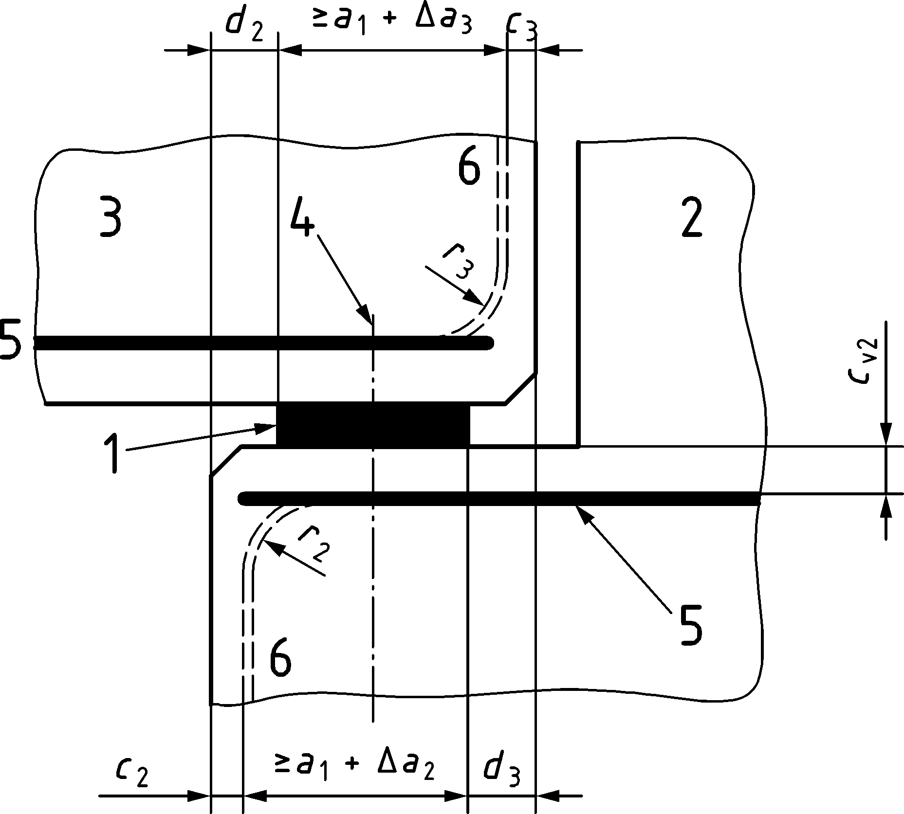

Key

|  |  |  |  |
| --- | --- | --- | --- |
| a1 | bearing length | 1 | bearing |
| ci | nominal cover | 2 | support |
| Δai | deviations | 3 | supported member |
| ri | bend radius | 4 | centre-line of support |
|  |  | 5 | horizontal U-bar loop |
|  |  | 6 | vertical bent bar |

Figure 12.11 — Example of bearing and lengths definitions

(6) Supported and supporting members shall be verified for the effects of the support or bearing reactions in accordance with 8.6.

(7) The choice of the type of bearing and expansion joints should be compatible with the structural system assumed in the design of the structure and suitable for the anticipated movements.

(8) The arrangement of bearings should be such that restraints of the adjacent members are avoided or minimised.

(9) Where the design service life of the bearing or expansion joint is less than the design service life of the member, bearings and expansion joints shall be designed to be replaceable.

## Surface reinforcement for large diameter bars

(1) If a verification of the crack width for large diameter bars by calculation has been omitted, a constructive web surface reinforcement should be used.

(2) This surface reinforcement to limit crack widths or to resist spalling should be used where the main reinforcement is made up of:

* bars with diameter ϕ > 32 mm or
* bundled bars with equivalent diameter ϕb > 32 mm.

(3) This surface reinforcement As,surf should consist of wire mesh or small diameter bars in the two directions parallel and orthogonal to the tension reinforcement in the beam and be placed outside the links in the cover as indicated in Figure 12.13.

|  |  |
| --- | --- |
| As,surf ≥ 0,01Act,ext (in each direction) | (12.9) |

Dimensions in millimetres

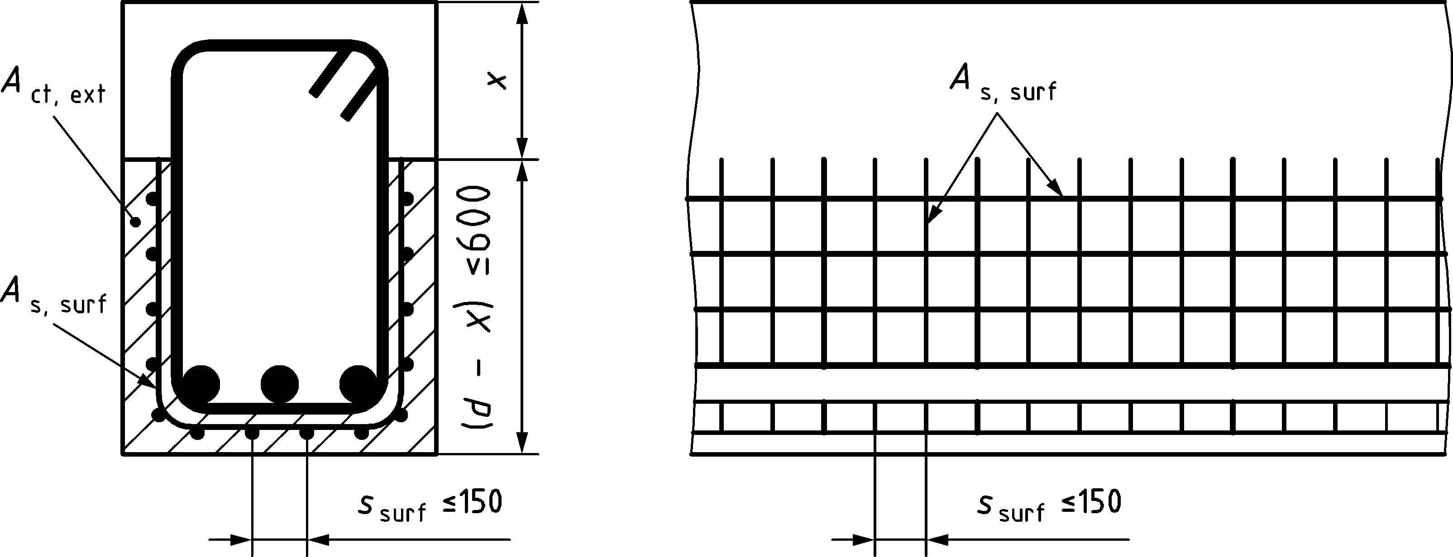

Key

|  |  |
| --- | --- |
| x | is the depth of the neutral axis at ULS |

Figure 12.12 — Surface reinforcement confining large diameter bars and bundles

(4) Where the cover to reinforcement is greater than 70 mm, for enhanced durability similar surface reinforcement should be used, with an area of 0,005Act,ext in each direction.

(5) The longitudinal bars of the surface reinforcement may be taken into account as longitudinal bending reinforcement and the transverse bars as shear reinforcement provided that they meet the requirements for the arrangement and anchorage of these types of reinforcement.

# Additional rules for precast concrete elements and structures

## General

(1) The rules in Clause 13 apply to structures made partly or entirely of precast concrete elements and are supplementary to other rules in this Eurocode.

(2) Further development of the provisions for specific precast concrete products – related to design, detailing, tolerances and production – is given in EN 13369 and in the respective European product standards. Provisions for assembly are given in EN 13670.

(3) Execution class in accordance with EN 13670 shall be specified.

## Specific requirements

(1) In design and detailing, the following shall be considered specifically:

* bearings (temporary and permanent), joints and connections;
* transient situations like demoulding, transfer of prestress, transports, storage, erection and assembly.

(2) Where relevant, dynamic effects in transient situations should be taken into account. In the absence of an accurate analysis, static effects may be multiplied by an appropriate factor (for precast products, directions may be provided in specific product standards).

## Concrete

### Strength for heat curing

(1) In the case of heat curing, the mean compressive strength of concrete at an age t less than tref, fcm(t), may be estimated from Formula (B.1), replacing the concrete age t with the temperature adjusted concrete age obtained by Formula (B.18), where the coefficient βcc(t) should be limited to 1,0.

For the effect of heat curing, Formula (13.1) may be used:

|  |  |
| --- | --- |
| $$f_{cm}\left(t\right)=f_{cmp}+\frac{f_{cm}(t_{ref})-f_{cmp}}{lg(t_{ref}-t_{p}+1)}lg(t-t_{p}+1)$$ | (13.1) |

where

|  |  |
| --- | --- |
| fcmp | is the mean compressive strength after the heat curing (i.e. at tendon release), measured by testing samples at the time tp (tp < tref) subject to the same heat treatment as the precast concrete product; |
| tref | is defined in 5.1.3. |

### Creep and shrinkage

(1) In case of heat cured precast concrete elements, the values of creep deformations may be estimated according to the maturity function of Formula (B.14) in Annex B, in which the age of concrete at loading t0 (in days) in Formula (B.9) should be replaced by the equivalent concrete age obtained by Formulae (B.17) and (B.18).

(2) In elements subjected to heat curing, drying shrinkage strain and basic shrinkage strain during heat curing may be assumed negligible.

## Structural analysis

### General

(1) The analysis shall account for:

* the behaviour of the structural elements at all stages of construction, using the appropriate geometry and properties for each stage, and their interaction with other elements (e.g. composite action with in-situ concrete or other precast units);
* the influence of the behaviour of the connections, with particular regard to their actual deformability and strength;
* the uncertainties affecting restraints and force transmission between elements, arising from deviations in geometry and in positioning of elements and bearings;
* the influence of the flexibility of members supporting precast floor elements on the load distribution between the precast floor elements.

(2) In bearings of beams and slabs, beneficial effects of horizontal restraint caused by friction due to gravity loads may be taken into account only in non-seismic situations (using γG,inf) and where

* friction is not solely relied upon for overall stability of the structure;
* bearing arrangements preclude the possibility of accumulation of sliding of the elements;
* risk of significant impact loading is excluded.

(3) The effects of relative movements of elements on bearings should be considered in design with respect to the resistance of the structure and the integrity of the connections.

### Losses of prestress during heat curing

#### Relaxation losses

(1) For pre-tensioned members, the effect of heat treatment on the relaxation losses shall be considered.

(2) This effect of heat treatment on the relaxation losses may be accounted for by the simplified method given in Formula (13.2). In this case, an equivalent time teq should be added to the time after tensioning t used in Annex B.

|  |  |
| --- | --- |
| $$t_{eq}=\frac{{1,14}^{T_{max}-20}}{T_{max}-20}\sum_{i=1}^{n}{\left(T_{\left({Δt}_{i}\right)} - 20\right)} Δt_{i}$$ | (13.2) |

where

|  |  |
| --- | --- |
| teq | is the equivalent time (in hours); |
| $$T_{\left({Δt}_{i}\right)}$$ | is the temperature during the time interval Δti; |
| Tmax | is the maximum temperature during the heat treatment. |

#### Thermal losses

(1) A specific thermal loss Δσθ induced by heat treatment should be avoided or taken into account. The thermal loss may be estimated by Formula (13.3):

|  |  |
| --- | --- |
| Δσθ = 0,5Ep ⋅ αc,th ⋅ (Tmax − T0) | (13.3) |

where (Tmax − T0) is the difference between maximum and initial concrete temperature near the tendons.

## Design and detailing of pre-tensioning tendons

### Arrangement of tendons

(1) The spacing and concrete cover of pre-tensioning tendons shall be such as to ensure that placing and compacting concrete will be carried out satisfactorily and that sufficient bond will be attained between the concrete and the tendons.

(2) The minimum spacing and cover for bond stress and to avoid splitting should be in accordance with Figure 13.1 and Table 13.1. Depending on, for example, the production method, the level of pre-stressing or the level of release strength, other values of spacing and cover may be used, provided that satisfactory behaviour in service and at ultimate is demonstrated by testing or permitted by the specific European product standard with factory production control.

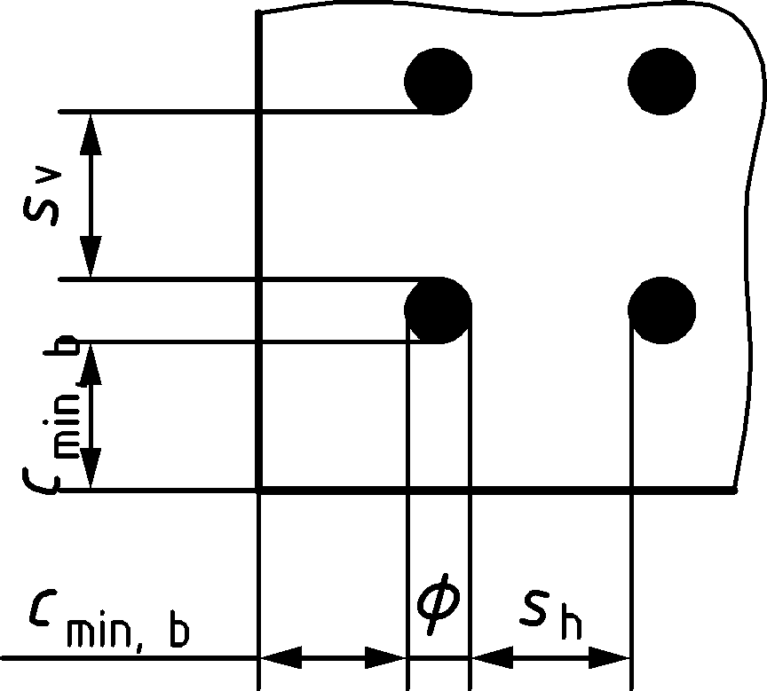

with sv = max{2ϕ; Dupper} and sh = max{2ϕ; Dupper + 5 mm; 20 mm}

NOTE For cmin,b, see 6.5.2.3.

Figure 13.1 — Minimum clear spacing and cover for bond for pre-tensioning tendons

Table 13.1 — Minimum concrete cover cmin,b for pre-tensioning tendons

| clear spacing | Minimum cover | |
| --- | --- | --- |
| s | cmin,b | |
|  | Strand | Indented wire |
| s = 2ϕp | 3,0ϕp | 4,5ϕp |
| s ≥ 2,5ϕp | 2,5ϕp | 4,0ϕp |

(3) Bundling of tendons should not occur in the anchorage zones without taking special provisions to cover splitting forces. Outside the anchorage zone up to three tendons may be bundled.

(4) Tendon ends shall be protected for durability. Methods of protection for durability may be given by the specific European product standard with factory production control or applied otherwise provided that satisfactory behaviour is demonstrated.

### Anchorage zones

(1) In anchorage zones of tendons, the following length parameters should be considered, see Figure 13.2 and Figure 13.3:

* Transmission length lpt, over which the prestressing force P0 is fully transmitted to the concrete, see 13.5.3(1)
* Dispersion length ldisp, over which the concrete stresses gradually disperse to a linear distribution across the concrete section, see 13.5.3(3)
* Anchorage length lbpd, over which the tendon force Ppd, in the ultimate limit state is fully anchored in the concrete, see 13.5.4(2).

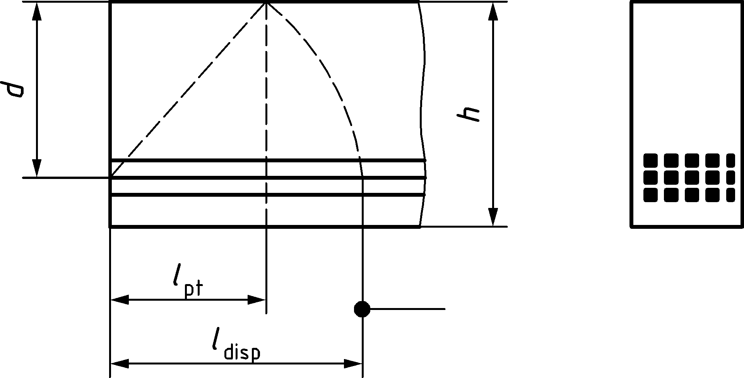

Figure 13.2 — Transfer of prestress in pre-tensioned member; length parameters

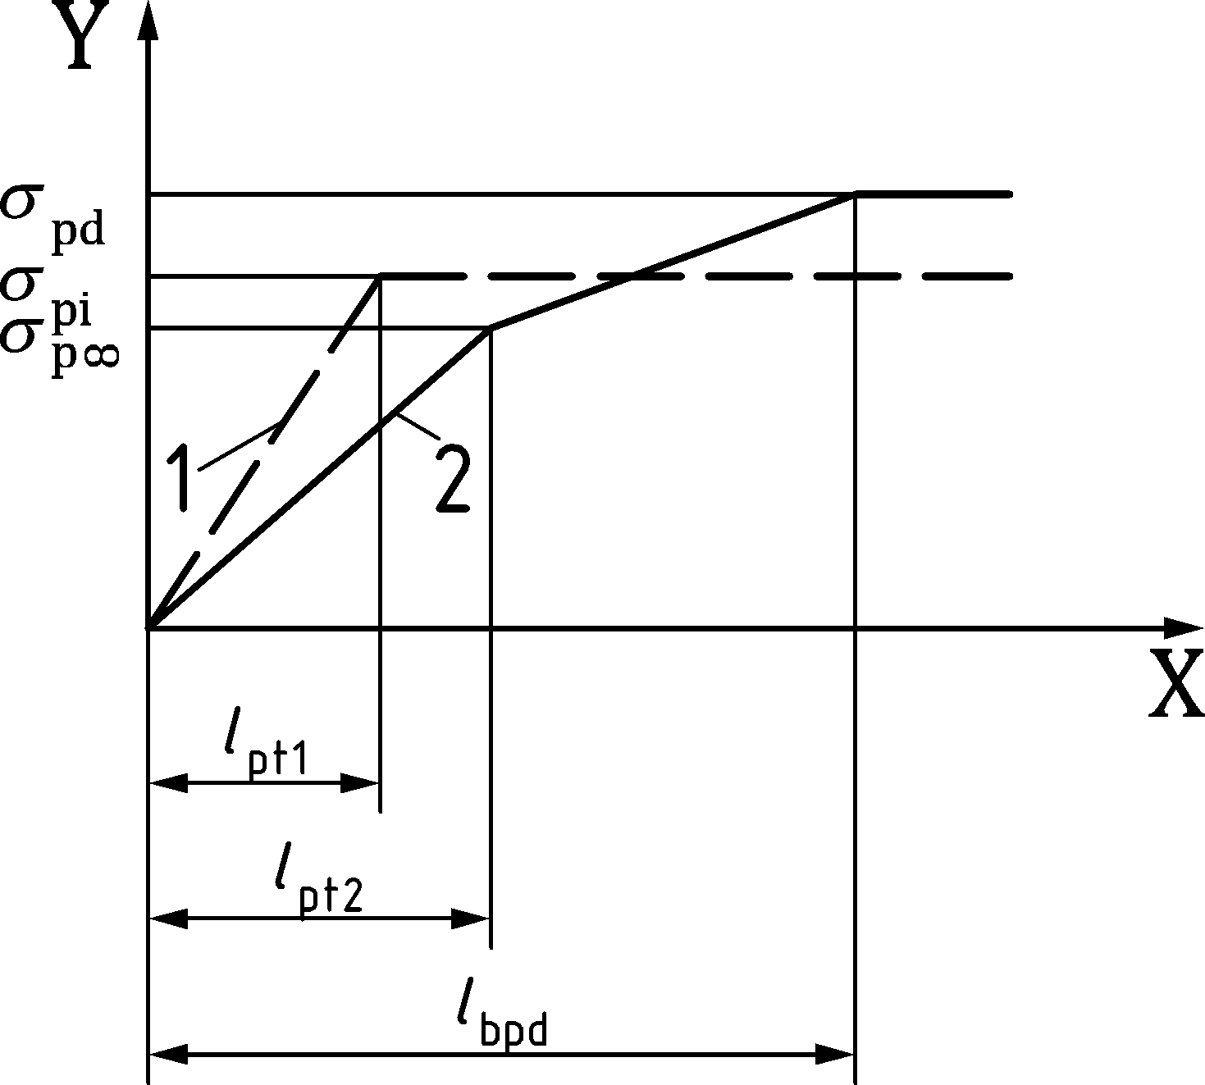

Key

|  |  |
| --- | --- |
| Y | tendon stress |
| X | distance from end |
| 1 | at release |
| 2 | at ULS |

Figure 13.3 — Tendon stresses

### Transfer of prestress

(1) The basic value of the transmission length lpt may be taken as:

|  |  |
| --- | --- |
| $$l_{pt}=\frac{γ_{C}}{1,5}⋅\frac{α_{1}⋅α_{2}⋅σ_{pm0}}{η_{1}⋅\sqrt{f_{ck}\left(t\right)}}⋅ϕ_{p}$$ | (13.4) |

where

|  |  |  |
| --- | --- | --- |
| α1 | = 1,0 for gradual release, | |
|  | = 1,25 for sudden release; | |
| α2 | = 0,40 for indented wires, | |
|  | = 0,26 for 3- and 7-wire strands; | |
| ϕp | is the nominal diameter of the tendon; | |
| σpm0 | is the tendon stress just after release; | |
| η1 | = 1,0 for tendons located in favourable positions during concreting (see 11.4.2(4)), | |
|  | = 0,7 otherwise, unless a higher value can be justified with regard to special circumstances in execution; | |
| fck(t) | is the concrete compressive strength at time of release which may be taken as: | |
|  | fck(t) = [βcc(t)]2/3 ∙ fck | (13.5) |

Other values of transmission length may be used, provided that satisfactory behaviour in service is demonstrated by testing or permitted by the specific European product standard with factory production control.

(2) Depending on the design situation, the design value of the transmission length should be taken as:

|  |  |
| --- | --- |
| lpt1 = 0,8lpt for the verification of local stresses at release | (13.6) |
| lpt2 = 1,2lpt for ultimate limit states (shear, anchorage, etc.) | (13.7) |

(3) Concrete stresses may be assumed to have a linear distribution in the member cross section outside the dispersion length, ldisp, see Figure 13.2:

|  |  |
| --- | --- |
| $$l_{disp}=\sqrt{{l_{pt}}^{2}+d^{2}}$$ | (13.8) |

(4) Alternative models for the transfer of prestressing force may be used, if adequately justified and if the transmission length is modified accordingly.

### Anchorage of tensile force at ULS

(1) The anchorage of tendons shall be checked in sections where the concrete tensile stress determined for the characteristic combination of actions exceeds fctk,0,05.

The tendon stress σpd shall be calculated for a cracked section, including the effect of shear according to Formula (8.36).

(2) If concrete is uncracked all along the transmission length, the total anchorage length for anchoring a tendon at ultimate limit state with stress σpd may be taken as:

|  |  |
| --- | --- |
| $$l_{bpd}=l_{pt2}+\frac{γ_{C}}{1,5}⋅\frac{2⋅α_{2}⋅α_{3}⋅\left(σ_{pd}-σ_{pm∞}\right)}{η_{1}⋅\sqrt{f_{ck}}}⋅ϕ_{p}$$ | (13.9) |

where

|  |  |
| --- | --- |
| lpt2 | is the upper design value of transmission length, see 13.5.3(2); |
| α2 | is as defined in 13.5.3(1); |
| α3 | = 1,5 in cases where fatigue verification is required, see 10.1, |
|  | = 1,0 in all other cases; |
| σpm∞ | is the tendon stress after all losses; |
| η1 | is as defined in 13.5.3(1). |

Tendon stresses in the anchorage zone are illustrated in Figure 13.3.

### Shear resistance of precast members without shear reinforcement

(1) Except for the conditions described in (2), 8.2.2 applies.

(2) Provided that following conditions are fulfilled:

* the member is prestressed and simply supported,
* the effective depth is not larger than 500 mm,
* the investigated region is uncracked in bending (where the flexural tensile stress for the characteristic combination of actions, including effects of imposed deformations is smaller than fctk,0,05/γC).

The shear resistance may be checked by the verification of the principal stresse:

|  |  |
| --- | --- |
| $σ_{1d}\left(y\right)≤\frac{f_{ctk,0,05}}{γ_{c}}$ | (13.10) |

where

|  |  |
| --- | --- |
| $$σ_{1d}\left(y\right)$$ | is the maximum value of the principal tensile stress in the concrete cross section, |

|  |  |
| --- | --- |
|  | (13.11) |

|  |  |
| --- | --- |
| *σ*x,Ed(*y*) | is the normal stress in the longitudinal direction of the structure determined in a fibre at distance *y* from the centroidal axis, assuming linear stress distribution over the depth. For cross sections within the transmission length of pre-tensioning tendons *l*pt2 according to Formula (13.7), the contribution of the related prestressing force to *N*Ed and *M*Ed should be considered with a linear distribution according to Figure 13.3; |
| *τ*Ed(*y*) | is the shear stress in a fibre at distance *y* from the centroidal axis: |

|  |  |
| --- | --- |
|  | (13.12) |

|  |  |
| --- | --- |
| *I* | is the second moment of area of the concrete cross section; |
| *b*(*y*) | is the width of the concrete cross section at a distance *y* from the centroidal axis; |
| *S*(*y*) | is the first moment of area of the concrete cross section above the fibre at distance *y* for the centroidal axis taken about the centroidal axis; |
| *y* | is the distance from the considered fibre considered to centroidal axis of the concrete cross section, *y* should be choose so that the maximum value of *σ*1,Ed is found, |

Shear stresses due to transverse bending, for example near flexible supports, and/or due to the dispersion of tendon anchorage forces should be considered.

## Floor systems for buildings

### Transverse distribution of loads

(1) Where transverse load distribution between adjacent elements has been taken into account, appropriate shear connections shall be provided across the longitudinal joints.

(2) Transverse shear transfer across longitudinal joints between precast elements may be achieved as shown by examples in Figure 13.4.

|  |  |  |
| --- | --- | --- |
|  |  |  |
| a) longitudinal key infilled with mortar or concrete | b) welded or bolted anchored plates | c) structural reinforced concrete topping |

Figure 13.4 — Connections for vertical shear transfer between parallel precast units

(3) Transverse distribution of vertical loads between adjacent elements should be based on analysis or tests taking into account the likely load variation between precast elements and the strength of the interface.

(4) For building floors with uniformly distributed load and in the absence of a more accurate analysis, the shear force acting in joints to adjacent precast elements per unit length of longitudinal joint may be taken as:

|  |  |
| --- | --- |
| vEd = qEd ⋅ be/3 | (13.13) |

where

|  |  |
| --- | --- |
| qEd | is the design value of variable load; |
| be | is the width of the element. |

(5) Precast concrete elements with a topping at least 40 mm thick may be designed as composite elements, if shear at the interface is verified according to 8.2.6.

(6) Transverse reinforcement for bending and other action effects may be placed within the topping.

(7) Building floor slabs combining parallel beams with unreinforced blocks in between without topping may be analysed in shear and bending as solid slabs, if

(i) cast-in-situ transverse ribs are provided with a continuous reinforcement through the longitudinal ribs and

(ii) the spacing sT of such transverse ribs complies with the limits in Table 13.2.

Table 13.2 — Maximum spacing of transverse ribs sT

|  |  |  |
| --- | --- | --- |
| Type of actions | sL ≤ lL/8 | sL > lL/8 |
| residential, snow | not required | sT ≤ 12h |
| other | sT ≤ 10h | sT ≤ 8h |
| where  sL spacing of longitudinal ribs;  h depth of the floor  lL length (span) of longitudinal ribs, h = thickness of ribbed floor. | | |

(8) Webs or ribs in isolated slab elements should be provided with shear reinforcement as for beams.

(9) The effects of possible restraints of precast units shall be considered.

### Diaphragm action

(1) Where precast concrete floors in buildings are assumed to act as horizontal diaphragms transferring horizontal forces to vertical bracing units:

* the diaphragm should form part of a realistic structural model, taking into account the deformation compatibility with bracing units;
* the effects of horizontal deformations should be taken into account for all parts of the structure involved in the transfer of horizontal loads;
* the diaphragm should be reinforced and connected for the tensile forces derived from the analysis;
* stress concentrations at openings and connections should be taken into account in the detailing of the reinforcement.

(2) If tie bars with diameter ϕ are anchored in the concrete infilled in longitudinal joints between parallel elements, the joint width should be tj ≥ 3ϕ. Such solution shall not be adopted in structures designed for earthquake resistance.

(3) Transverse reinforcement provided across longitudinal joints as part of the tying system may be concentrated along the elements’ supports and shall be consistent with the structural model.

(4) In diaphragm action provided by untopped building floors made of precast slab elements with concreted or grouted longitudinal joints, their shear resistance should be determined according to shear-friction mechanisms, accounting for the transverse compressive force on the joint surface and for its roughness or presence of keys. For shear at the interface, reference should be made to 8.2.6 or to design assisted by testing.

## Connections and supports

### General

(1) Materials for connections shall be:

* stable and durable for the design service life of the structure,
* chemically and physically compatible.

(2) Connections shall be designed to resist all action effects consistent with design assumptions, to accommodate the necessary deformations and ensure robust behaviour of the structure.

(3) The verification of resistance and stiffness of connections may be based on numerical analysis, possibly assisted by testing.

(4) Except in exposure classes X0 and XC1, fasteners for claddings shall be made of corrosion resistant material unless adequately protected against environmental actions.

(5) Shear forces may be ignored in compression connections if they are less than 10 % of the compressive force.

(6) At connections with bedding materials like mortar, concrete or polymeric pads, relative movement between the connected surfaces shall be prevented during hardening of the material.

(7) Connections for compressive force without bedding material or mortar bed may only be used where appropriate quality of workmanship can be achieved. The average stress between plane surfaces should not exceed 0,4fcd.

(8) Transverse tensile stresses near the ends of adjacent precast concrete elements should be considered. They may be due to concentrated compression according to Figure 13.5a), or due to the expansion of a soft padding according to Figure 13.5b). Reinforcement in case a) may be designed and located according to 8.5.5. Reinforcement in case b) should be placed close to the surfaces of the adjacent elements.

(9) In absence of more accurate models, reinforcement in Figure 13.5b) may be calculated as:

|  |  |
| --- | --- |
| $$A_{s}=0,25\frac{t}{h}⋅\frac{F_{Ed}}{f_{yd}}$$ | (13.14) |

where

|  |  |
| --- | --- |
| As | is the reinforcement area in each surface; |
| t | is the thickness of padding; |
| h | is the dimension of padding in the direction of the reinforcement; |
| FEd | is the compressive force in the connection. |

(10) The maximum capacity of compression connections should be determined according to 8.6, or should be based on design assisted by testing.

|  |  |
| --- | --- |
|  |  |
| a) concentrated bearing | b) expansion of soft padding |

Figure 13.5 — Transverse tensile stresses at connections transmitting compression

(11) In building wall elements installed over floor slabs, reinforcement should normally be provided for possible eccentricities and concentrations of the vertical load at the end of the wall.

(12) Specific reinforcement in building walls over a connection may be omitted, if the vertical load satisfies

|  |  |
| --- | --- |
| FEd ≤ 0,5h ⋅ fcd | (13.15) |

where h is the wall thickness (see Figure 13.6).

(13) FEd in Formula (13.15) may be increased to

|  |  |
| --- | --- |
| FEd = 0,6h ⋅ fcd | (13.16) |

in presence of reinforcement as in Figure 13.6, having diameter ϕ ≥ 6 mm and spacing s not greater than the lesser of h and 200 mm. For higher loads, reinforcement should be designed according to Formula (13.14). A separate check should be made for the lower wall.

|  |  |
| --- | --- |
|  |  |
| a) transverse view | b) longitudinal view |

Figure 13.6 — Example of reinforcement in a building wall over a connection between floor slabs

(14) Reinforcement for transferring bending moments or tensile forces shall be continuous across the connection and anchored in the adjacent precast concrete elements.

### Supports

(1) Bearings shall be designed and detailed to ensure correct positioning, taking into account production and assembling deviations.

(2) For bearings which do not permit sliding or rotation without significant restraint, actions due to creep, shrinkage, temperature, misalignment, lack of plumb etc. shall be taken into account in the design of supported and adjacent members.

(3) Reinforcement in supporting and supported members shall be detailed to ensure effectiveness in the respective nodes, allowing for deviations, see 12.10.

(4) The nominal length a of a simple support bearing as shown in Figure 13.7 should be calculated accounting for:

* the net bearing length a1 with regard to bearing strength as defined in (5),
* the distances a2 and a3 assumed beyond bearings,
* the allowances for deviations Δa2 and Δa3 in length of both members and of their distance.

Indications for evaluating the distances a2 and a3 and the deviations Δa2 and Δa3 as function of the tolerances are given in EN 13369.

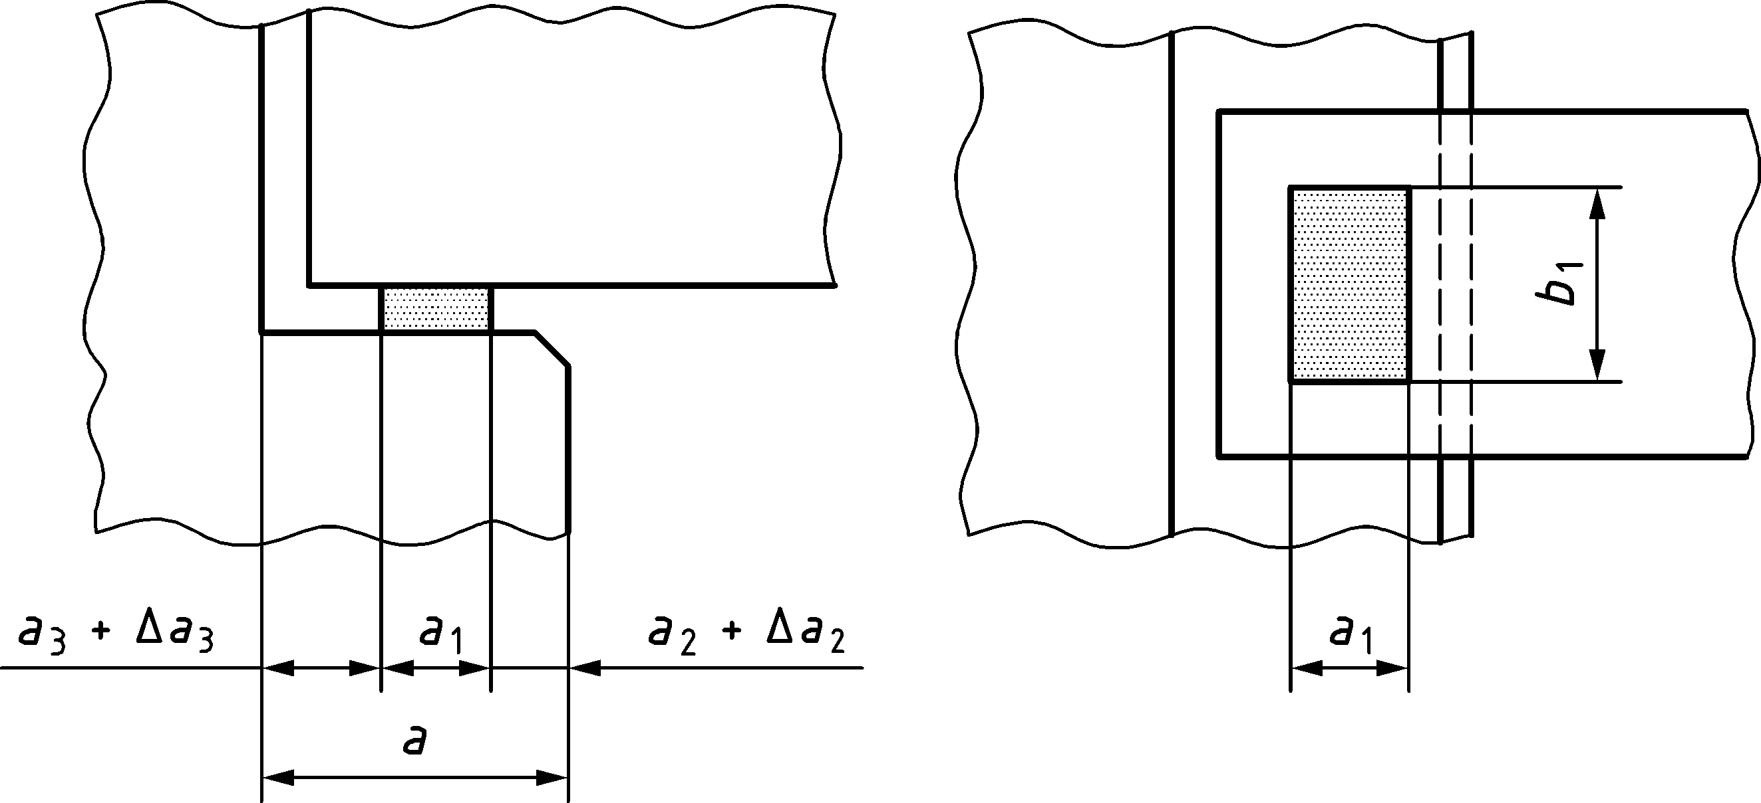

Figure 13.7 — Example of bearing and lengths definitions

(5) In the absence of more detailed specifications, the following values may be used for the bearing strength:

|  |  |
| --- | --- |
| fRd = 0,4fcd for dry connections, see 13.7.1(7) | (13.17) |
| fRd = fbed ≤ 0,85fcd for all other cases | (13.18) |

where

|  |  |
| --- | --- |
| fcd | is the lower value of the design strengths of supported and supporting members; |
| fbed | is the appropriate design resistance of the bedding material, consistent with the design model and the limit state being checked. |

(6) For isolated elements, e.g. beams or single slab elements, the nominal length shall be 20 mm greater than for non-isolated elements.

(7) If the bearing of isolated elements allows longitudinal movements, the net bearing length shall be increased to cover possible movements.

(8) If an isolated element is tied other than at the level of its bearing, the net bearing length a1 shall be increased to cover the effect of possible rotation around the tie.

(9) If a uniform distribution of the bearing pressure can be obtained, e.g. by mortar, neoprene or other pads, the design bearing width may be taken as the actual bearing width. Otherwise b1 should not be taken greater than 600 mm.

### Pocket foundations for buildings

#### General

(1) Pocket foundations, embedding a precast column base within side walls infilled with in-situ concrete (see Figs. 13.8 and 13.9, where only the main reinforcement is sketched) and transferring member action effects by shear and bending, may be considered to provide full restraint of the column in the pocket.

NOTE Depending on soil properties, soil-structure interaction can however result in lower restraints than available between column and pocket.

(2) Pockets should be large enough to enable a good concrete filling below and around the column.

(3) Pocket foundations may host members other than a single column, e.g., twin columns, short walls, etc.; in these cases, specific adequate provisions should be devised for ensuring the assumed restraint for these elements.

#### Pocket foundations with keyed surface

(1) Pocket and hosted column, both provided with adequate keys able to mobilise strut mechanisms (Figure 13.8), may be considered monolithically connected with overlapped reinforcements.

(2) The lap length between the reinforcement of the column and of the pocket according to 11.5.2 should be increased by at least the distance s between the lapped bars. Adequate confinement reinforcement at the lapped splice should be provided (see Figure 13.8).

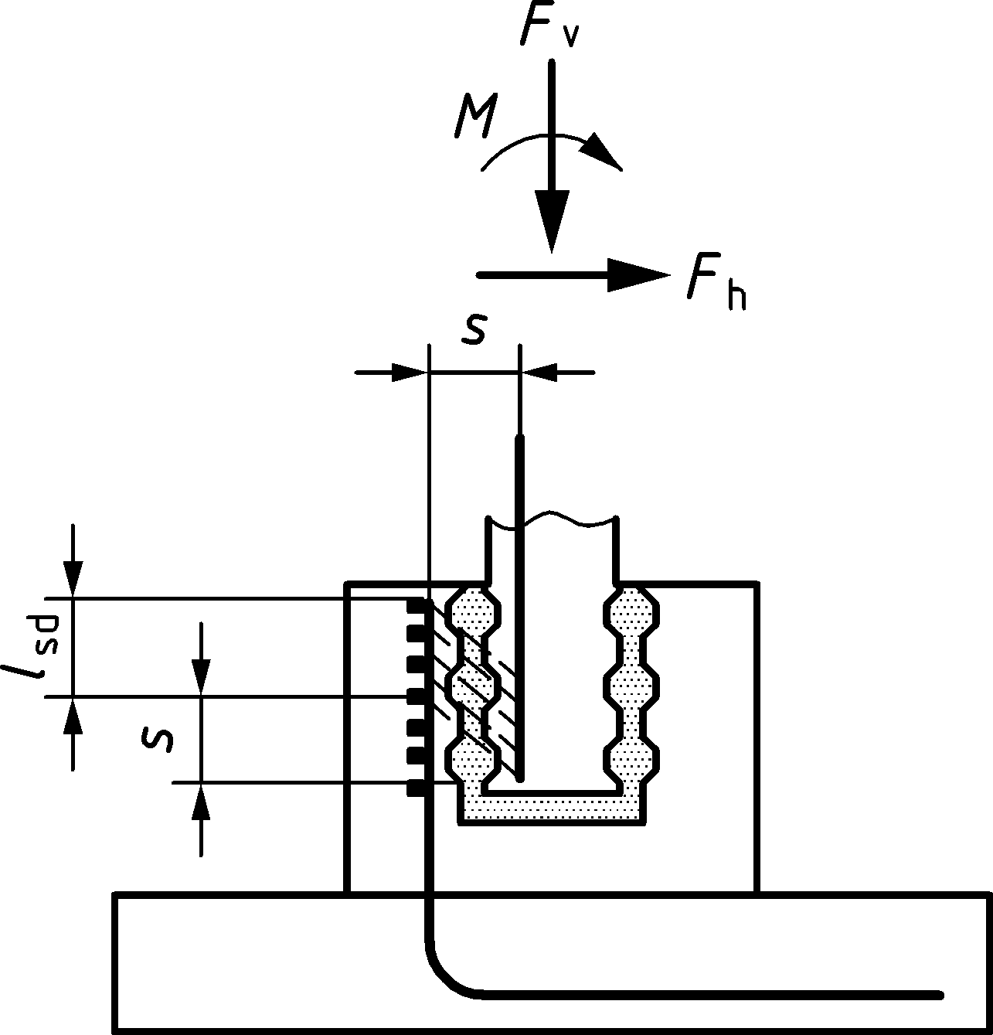

Figure 13.8 — Pocket foundations with keyed surfaces

#### Pocket foundations with smooth or rough surfaces

(1) In case of pocket and column with smooth or rough surfaces (non-keyed), the action effects from the column may be assumed to be transferred through the concrete filling by the compressive forces F1, F2, F3 and the corresponding friction forces μvF1, μvF2, μvF3, as shown in Figure 13.9 a).

(2) With the assumption of (1) above, the minimum embedded length l should be

|  |  |
| --- | --- |
| l ≥ 1,2hcol for MEd/NEd ≤ 0,15hcol | (13.19) |
| l ≥ 2,0hcol for MEd/NEd ≥ 2,0hcol | (13.20) |

where C is the largest side of the column’s section.

l may be interpolated for 0,15hcol < MEd/NEd < 2,0hcol.

(3) The coefficient of friction μv should be taken from Table 8.1, according to the relevant type of surface.

(4) The transfer of forces to the base slab may be checked at ULS by assuming a strut-and-tie model in accordance with 8.5.

(5) The position of F1 should be chosen with a ≥ 0,1l.

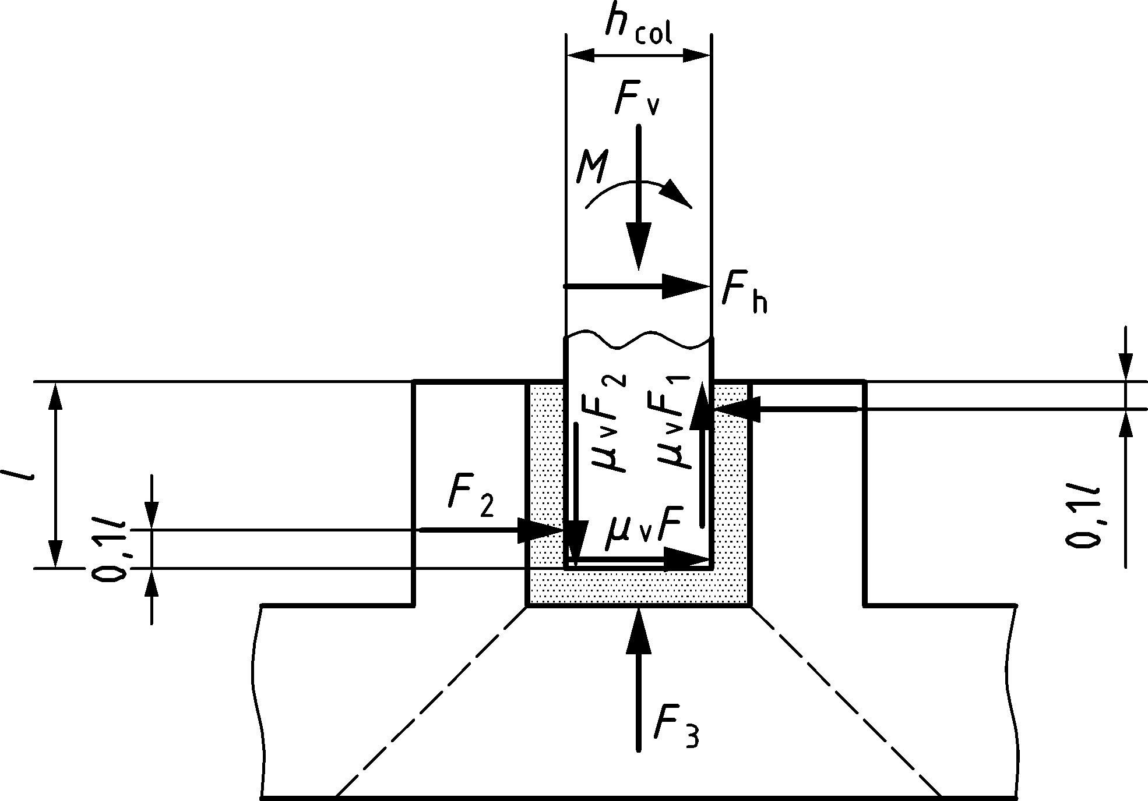

Figure 13.9 — Pocket foundations with smooth or rough joint surface

### Tying systems for buildings

(1) Precast structures should be provided with a tying system to secure robustness of the structure according to the rules of 12.9. For building structures the following additional provisions apply.

(2) In planar elements loaded in their own plane, e.g. in multi-storey walls and floor diaphragms composed of precast elements, the necessary interaction among elements for the overall resistance may be obtained by tying them together with peripheral and/or internal ties.

(3) The same ties may also be relied upon to provide overall robustness of the structure, according to 12.9.

(4) Horizontal ties may be provided wholly within the in situ concrete topping or at connections of precast members. Where ties are not continuous in one plane, the bending effects resulting from the eccentricities should be considered.

(5) Ties should not be lapped in narrow joints between precast elements. Mechanical anchorage shall be used in these cases.

(6) If internal ties are grouped along lines, surrounding members should be designed to distribute the tying forces within the slab.

# Plain and lightly reinforced concrete structures

## General

(1) Clause 14 provides additional rules for plain concrete structures or where the reinforcement provided is less than the minimum required for reinforced concrete according to Clause 12.

(2) It should be ensured that brittle failure of these members does not lead to collapse of the structure.

(3) Clause 14 applies to members mainly subjected to compression other than that due to prestressing such as:

* walls, columns, arches, vaults, and tunnels;
* strip and pad footings for foundations;
* gravity retaining walls;
* piles with diameter ≥ 600 mm and where NEd/Ac ≤ 0,30fck.

Clause 14 does not apply to members affected by dynamic actions (other than seismic) such as those from rotating machines and traffic loads.

(4) For members made of lightweight aggregate concrete with closed structure according to Annex M or for precast concrete elements and structures covered by this Eurocode, the design rules should be modified accordingly.

(5) Plain concrete members may include steel reinforcement to satisfy serviceability, or partial reinforcement. Such reinforcement may be taken into account for local verification of ultimate limit states and for verification of serviceability limit states.

(6) Members subject to imposed deformations except as noted in 14.4.2 should be designed as reinforced members or constructed with joints to avoid uncontrolled cracking.

## Concrete

(1) For the verification of plain concrete members at ULS, the values for fcd,pl and fctd,pl shall be taken as:

|  |  |
| --- | --- |
| fcd,pl = kc,pl ∙ fcd | (14.1a) |
| fctd,pl = kt,pl ∙ fctd | (14.1b) |

NOTE The values of kc,pl and kt,pl are both 0,8 unless a National Annex gives other values.

(2) When tensile stresses are considered for the design resistance of plain concrete members, the stress strain diagram (see 8.1.1) may be extended linearly up to the tensile design strength fctd,pl.

## Structural analysis

(1) Since plain concrete members have limited deformation capacity, analysis methods according to Clause 7 such as stress fields, strut-and-tie or FE should be used which permit neglecting the tensile strength of concrete, in general.

## Ultimate limit states

### General

(1) Beams, slabs and other structural members without axial compression or axial restraint and with predominantely bending moments should not be designed as plain concrete members taking into account concrete tensile strength. In cases of axially loaded members and shear forces 14.4.3 may be used. Strip and pad footings are allowed to be designed according to 14.6.3.

### Design resistance to bending with axial force

(1) In the case of walls, subject to the provision of adequate construction details and curing, the imposed deformations due to temperature or shrinkage may be ignored.

(2) The general provisions of 8.1 apply for determining the ultimate resistance of sections to bending with axial force.

(3) The axial resistance NRd of a rectangular cross section with a uniaxial eccentricity e in the direction of h, may be taken as:

|  |  |
| --- | --- |
| NRd = fcd,pl ⋅ b ∙ hw (1 − 2 e/hw) | (14.2) |

where

|  |  |
| --- | --- |
| b | is the overall width of the cross section (see Figure 14.1); |
| hw | is the overall depth of the cross section; |
| e | is the eccentricity of NEd in the direction of h. |

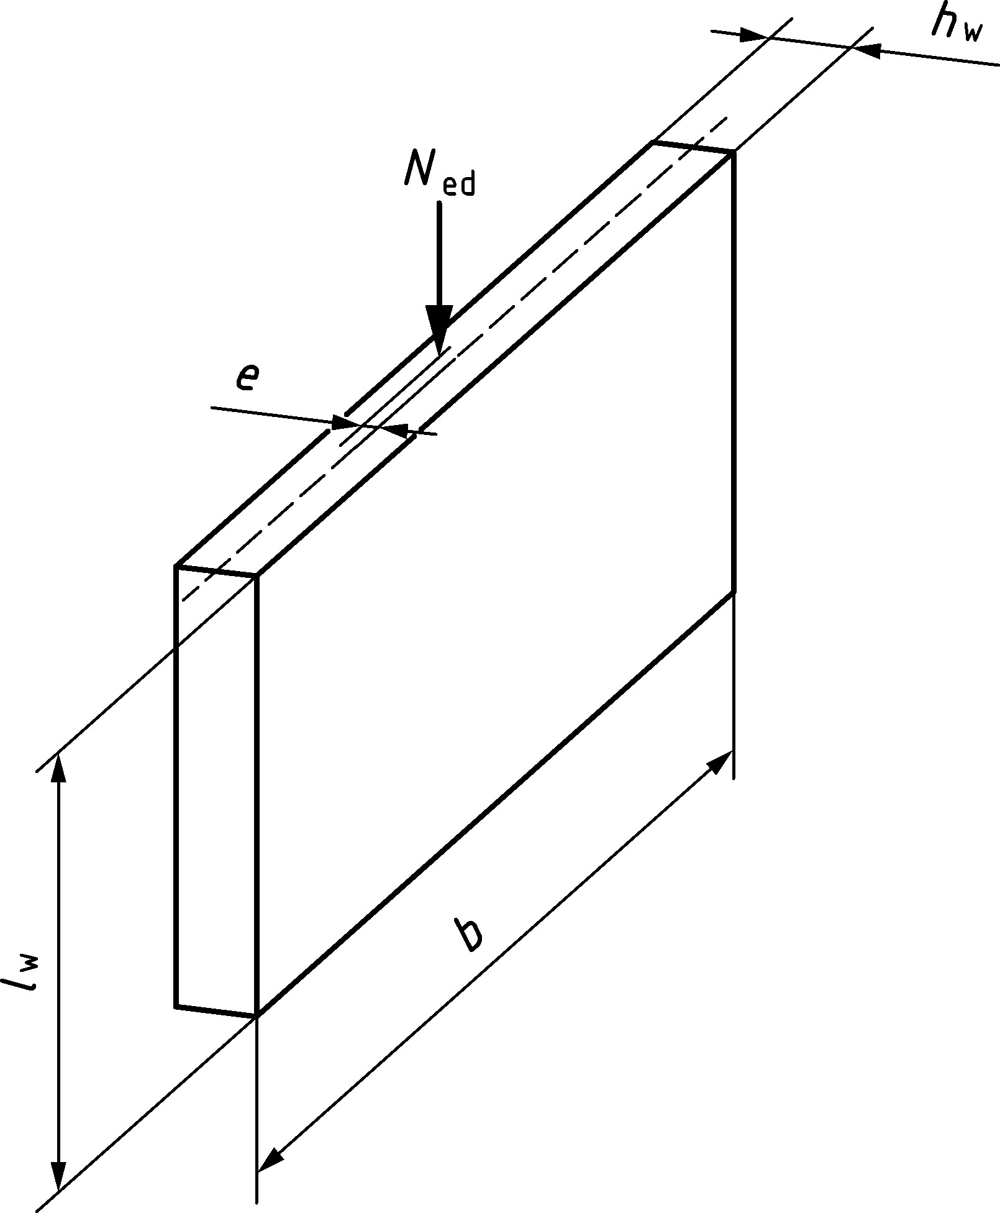

Key

|  |  |
| --- | --- |
| NEd | resultant force of the actions |

Figure 14.1 — Notation for plain walls

### Shear

(1) In members with axial compression, approaches based on compression fields without ties according to 8.5 should be used to calculate shear resistance.

(2) In plain concrete members account may be taken of the concrete tensile strength in the ultimate limit state for shear, provided that either by calculations or by experience, brittle failure may be excluded and adequate resistance is ensured.

(3) For a section subject to a shear force VEd and a normal compressive force |NEd| acting over a compressive area Acc the absolute value of the components of design stress may be taken as:

|  |  |
| --- | --- |
| σcp = |NEd |/Acc | (14.3) |
| τcp = 1,5 ∙ VEd/Acc (for rectangular sections) | (14.4) |

and the following should be satisfied:

τcp ≤ τRd,pl

where

|  |  |  |
| --- | --- | --- |
| if σcp ≤ σc,lim: | $$τ_{Rd,pl}=\sqrt{f_{ctd,pl}^{2}+σ_{cp}f_{ctd,pl}}$$ | (14.5) |
| or |  | |
| if σcp > σc,lim: | $$τ_{Rd,pl}=\sqrt{f_{ctd,pl}^{2}+σ_{cp}f_{ctd,pl}-{\left(\frac{σ_{cp}-σ_{c,lim}}{2}\right)}^{2}}$$ | (14.6) |
| $$σ_{c,lim}=f_{ctd,pl}-2\sqrt{f_{ctd,pl}⋅\left(f_{ctd,pl}+f_{cd,pl}\right)}$$ | | (14.7) |

where τRd,pl is the plain concrete design strength in shear.

(4) A concrete member may be considered to be uncracked at the ultimate limit state if either it remains completely under compression or if the absolute value of the principal concrete tensile stress does not exceed fctd,pl.

(5) Shear forces in construction joints should be verified according to 8.2.6.

### Torsion

(1) Cracked members should not be designed to resist torsional moments unless it can be justified otherwise.

### Ultimate limit states induced by structural deformation (buckling)

#### Slenderness of columns and walls

(1) The effective length of a column or wall should be calculated as:

|  |  |
| --- | --- |
| l0 = βEul ⋅ lw | (14.8) |

where

|  |  |
| --- | --- |
| lw | clear height of the member; |
| βEul | Euler-coefficient which depends on the support conditions (Euler-cases). For walls supported on 3 or more sides βEul‑values may be taken from Table 14.1. |

(2) The βEul ‑values should be increased appropriately if the transverse bearing capacity is affected by chases or recesses.

(3) A transverse wall may be considered as a bracing wall if:

* its total thickness is not less than 0,5hw, where hw is the overall thickness of the braced wall;
* it has the same height lw as the braced wall under consideration;
* its length is at least equal to lw/5, where lw denotes the clear height of the braced wall;
* within the length lw/5 the transverse wall has no openings.

(4) In the case of a wall connected along the top and bottom in a flexurally rigid manner by in situ concrete and reinforcement, so that the end moments can be fully resisted, the values for βEul given in Table 14.1 may be factored by 0,85.

(5) The slenderness of walls in plain concrete cast in situ should generally not exceed λ = 86 (i.e. l0/hw = 25).

Table 14.1 — Values of βEul for different support conditions

|  |  |  |  |  |
| --- | --- | --- | --- | --- |
| Lateral bearing | Elevation of wall | Formula | Factor βEul | |
| along three sides |  | $$β_{Eul}=\frac{1}{1+{\left(\frac{l_{w}}{3b}\right)}^{2}}$$ | b/lw | βEul |
| 0,2 | 0,26 |
| 0,4 | 0,59 |
| 0,6 | 0,76 |
| 0,8 | 0,85 |
| 1,0 | 0,90 |
| 1,5 | 0,95 |
| 2,0 | 0,97 |
| 5,0 | 1,00 |
| along four sides |  | if b ≥ lw: $$β_{Eul}=\frac{1}{1+{\left(\frac{l_{w}}{b}\right)}^{2}}$$ if b < lw: $$β_{Eul}=\frac{b}{2l_{w}}$$ | b/lw | βEul |
| 0,2 | 0,10 |
| 0,4 | 0,20 |
| 0,6 | 0,30 |
| 0,8 | 0,40 |
| 1,0 | 0,50 |
| 1,5 | 0,69 |
| 2,0 | 0,80 |
| 5,0 | 0,96 |
| 1 – floor slab;  2 – free edge;  3 – transverse wall with thickness ≥ 0,5hw and with a length ≥ lw/5 | | | | |
| NOTE The information in Table 14.1 assumes that the wall has no openings with a height exceeding 1/3 of the wall height lw or with an area exceeding 1/10 of the wall area. In walls laterally restrained along 3 or 4 sides with openings exceeding these limits, the parts between the openings should be considered as laterally restrained along 2 sides only and be designed accordingly. | | | | |

#### Simplified design method for walls and columns

(1) In the absence of a more rigorous approach according to 7.4.3.3, the design resistance in terms of axial force for a braced wall or column in plain concrete with fck < 55 MPa, may be calculated as follows:

|  |  |
| --- | --- |
| NRd = b ⋅ h ⋅ fcd,pl ⋅ Φ | (14.9) |

where

|  |  |  |  |
| --- | --- | --- | --- |
| NRd | is the axial force resistance; | | |
| Φ | is the factor taking into account eccentricity, including second order effects | | |
|  | $$Φ=1,15-2,35⋅\frac{e_{tot}}{h_{w}}-0,016⋅\frac{l_{0}}{h_{w}}+\frac{f_{ck}}{1 000}⋅\left(9⋅\frac{e_{tot}}{h_{w}}-4\right)-Φ_{φ} \\ ≤0,98-1,96\frac{e_{tot}}{h_{w}}+\frac{f_{ck}}{1000}⋅\left(3⋅\frac{e_{tot}}{h_{w}}-2\right)$$ | | (14.10) |
|  | where | |  |
|  | etot = e0 + ei | | (14.11) |
|  | e0 | is the first order eccentricity including, where relevant, the effects of floors (e.g. possible clamping moments transmitted to the wall from a slab) and horizontal actions. To determine e0 an equivalent first order end moment, M0Ed may be used, see O.7.2; | |
|  | ei | is the additional eccentricity covering the effects of geometrical imperfections, see 7.2.1; | |
|  | Φφ | is a reduction part of Φ by creep effects. | |

NOTE Formula (14.12) for Φφ apply unless a National Annex give a different formula:

|  |  |
| --- | --- |
| $$Φ_{φ}=0,12φ_{eff}⋅\frac{l_{0}}{h_{w}}⋅\left(0,075-0,1\frac{e_{tot}}{h_{w}}\right)≥0$$ | (14.12) |

In some cases, depending on slenderness, the end moment(s) (M02) can be more critical for the structure than the equivalent first order end moment M0Ed. In such cases Formula (14.2) should be used for the ultimate limit state.

(2) Other simplified methods may be used provided that they are not less conservative than a rigorous method in accordance with 7.8.5.

## Serviceability limit states

(1) Stresses should be checked where structural restraint is expected to occur.

(2) The following measures to ensure adequate serviceability should be considered:

1. with regard to crack formation:

* limitation of concrete tensile stresses according to Clause 9;
* provision of subsidiary structural reinforcement (surface reinforcement, tying system where necessary);
* provision of joints;
* choice of concrete technology (e.g. appropriate concrete composition, curing);
* choice of appropriate method of construction.

1. with regard to limitation of deformations:

* a minimum section size (see 14.6);
* limitation of slenderness in the case of compression members.

(3) Any reinforcement provided in plain concrete members, although not taken into account for load bearing purposes, should comply with durability requirements according to Clause 6.

## Detailing of members and particular rules

### Structural members

(1) The overall thickness of a cast in-situ plain concrete wall should not be less than 120 mm.

(2) Local reinforcement may need to be added at chases and recesses to control cracking.

### Construction joints

(1) Construction joints should be designed according to 8.2.6.

(2) Where tensile stresses are expected to occur in concrete at constructions joints, reinforcement shall be detailed to provide required strength and to control cracking.

### Strip and pad footings

(1) In the absence of more detailed data, axially loaded strip and pad footings may be designed and constructed as plain concrete provided that:

|  |  |
| --- | --- |
| $$\frac{0,85⋅h_{F}}{a_{F}}≥\sqrt{\frac{3σ_{gd}}{f_{ctd,pl}}}$$ | (14.13) |

As a simplification, the relation in Formula (14.14) may be used:

|  |  |
| --- | --- |
| $$\frac{h_{F}}{a_{F}}≥2$$ | (14.14) |

where

|  |  |
| --- | --- |
| hF | is the footing depth; |
| aF | is the distance from the footing edge to the column face (see Figure 14.2); |
| σgd | is the design value of ground pressure. |

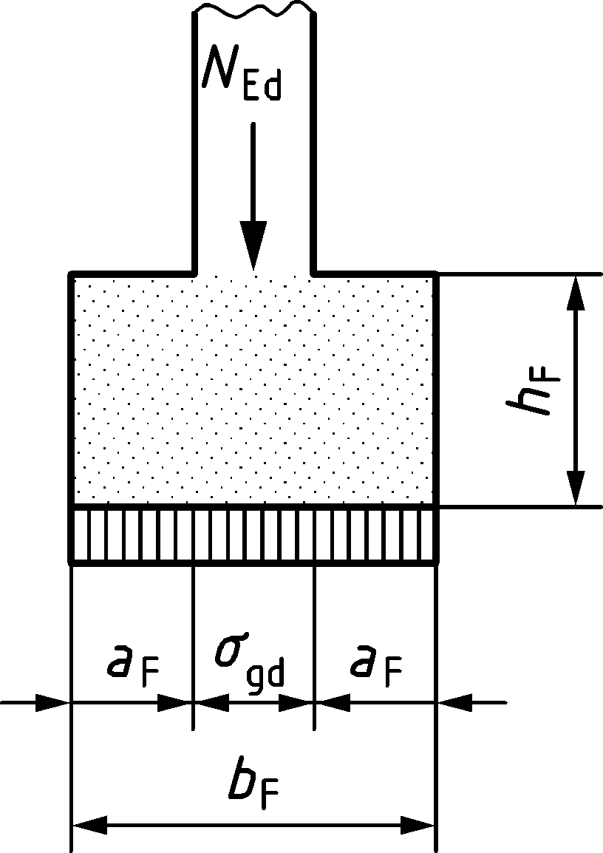

Figure 14.2 — Unreinforced pad footings; notations

1. (normative)  
     
   Adjustment of partial factors for materials
   1. Use of this annex

(1) This Normative Annex contains information on the basis of the recommended partial factors for materials and provisions for adjustment of partial factors for materials for different reliability levels.

* 1. Scope and fields of application

(1) This Normative Annex applies to all clauses and annexes of this standard.

* 1. General

(1) The partial factors for materials given in Table 4.3(NDP) may be adjusted according to this Annex A if at least one of the conditions defined in Table A.1(NDP) applies.

(3) If there is an evidence that the actual statistical data of at least one of following variables:

* material strength,
* dominant geometrical value or
* model uncertainty

is more unfavourable than the values defined in Table A.2, the partial factors for materials given in Table 4.3(NDP) shall be adapted according to (3).

Table A.1a (NDP) — Values of adjusted material factors - General

| Condition for adjusted material factors | persistent and transient design situations | | | accidental design situations | | | |
| --- | --- | --- | --- | --- | --- | --- | --- |
| γS | γC | γV | γS | | γC | γV |
| a) if the execution ensures that geometrical deviations of Tolerance Class 2 according to EN 13670 are fulfilled | 1,08 | 1,48 | 1,33 | 0,97 | | 1,15 | 1,11 |
| according to (3) and (3)  if also other conditions are fulfilled | | | | | | |
| b) if the calculation of design resistance is based on the value of the dominant geometrical data measured in the finished structure and the CoV of the measurement is not larger than the values given in (5) | 1,04 | 1,48 | 1,29 | 0,95 | | 1,15 | 1,08 |
| according to (3) and (5)  if also other conditions are fulfilled | | | | | | |
| c) if the calculation of design resistance is based on the design value of the effective depth according to (6) | 1,03 | – | 1,29 | | 0,94 | – | 1,07 |
| according to (3) and (6)  if also other conditions are fulfilled | | | | | | |
| d) if the in-situ concrete strength in the finished structure is assessed according to EN 13791:2019, Clause 8 | γC according to (7) | | | | | | |
| e) if the verification of the structure or of the member is conducted according to more refined methods ensuring reduced uncertainties of the resistance model. | γS and γC according to (3) where the statistical values describing the model uncertainties in Table A.2 are replaced by the actual ones | | | | | | |
| f) if the verification of the structure or of themember is conducted using non-linear analysis and the model uncertainty is considered separately according to F.4(1). | 1,20 | 1,46 | 1,31b | | 1,09 | 1,16 | 1,16b |
| g) if the target value for the reliability index βtgt given in Table A.3 is modified in accordance with the relevant authority | γS and γC according to (3) with the statistical values in Table A.2 | | | | | | |
| h) if it can be shown that the statistical data of either material strengtha, dominant geometrical value or resistance model are more favourable (smaller coefficient of variation or larger bias factor) than the values given in Table A.2 | γS and γC according to (3) where the corresponding statistical values in Table A.2 are replaced by the actual ones | | | | | | |
| NOTE 1 The values given in Table A.1(NDP) apply unless the National Annex gives different values. | | | | | | | |
| a If the partial safety factor is applied to the characteristic value of the material strength, the advantage of a reduced coefficient of variation of the material strength is compensated by the reduction of ratio fym/fyk defined in Table A.2.  b These values apply for failures modes similar to punching and shear failures in members without shear reinforcement. | | | | | | | |

Table A.1b(NDP) – Values of adjusted material factors – Additional provisions for precast members

|  |  |  |  |  |  |  |
| --- | --- | --- | --- | --- | --- | --- |
| **Condition for adjusting material factors**  **for precast members** | **persistent and**  **transient design**  **situations** | | | **accidental design**  **situations** | | |
| **S | **C | **V | **S | **C | **V |
| (i) In case (a) is fulfilled and System of AVCP 2+ is applied | 1,10 | 1,40 | 1,30 | 0,95 | 1,05 | 1,05 |
| (j) In case System of AVCP 2+ is applied and the calculation of design resistance is based on critical dimensions, including effective depth which are either:   * reduced by tolerances, or * measured in the finished structure | 1,05 | 1,35 | 1,28 | 0,90 | 1,05 | 1,05 |

Table A.2 — Statistical data assumed for the calculation of partial factor defined in Table 4.3(NDP)

|  | Coefficient of variation | Bias factor a |
| --- | --- | --- |
| **Partial factor for reinforcement γS** | | |
| Yield strength fy | Vfy = 0,045 | fym/fyk = exp(1,645Vfy) |
| Effective depth d | Vd = 0,050 b | μd = 0,95 b |
| Model uncertainty | Vθs = 0,045 c | μθs = 1,09 c |
| Coefficient of variation and bias factor of resistance for reinforcement | $$V_{RS}=0,081c^{i}$$ | $$μ_{RS}={1,115}^{i}$$ |
| **Partial factor for concrete γC** | | |
| Compressive strength fc (control specimen) | Vfy = 0,100 | fcm/fck = exp(1,645Vfc) d |
| In-situ factor ηis = fc,ais/fc e | Vηis = 0,120 | μηis = 0,95 |
| Concrete area Ac | VAc = 0,040 | μAc = 1,00 |
| Model uncertainty | Vθc = 0,060 f | μθc = 1,02 f |
| Coefficient of variation and bias factor of resistance for concrete | $$V_{RC}={0,176}^{i}$$ | $$μ_{RC}={1,142}^{i}$$ |
| **Partial factor for shear and punching γV (see 8.2.2, 8.4, I.8.3.1, I.8.5)** | | |
| Compressive strength fc (control specimen) | Vfc = 0,100 | fcm/fck = exp(1,645Vfc) d |
| In-situ factor ηis = fc,ais/fc e | Vηis = 0,120 | μηis = 0,95 |
| Effective depth d | Vd = 0,050 b | μd = 0,95 b |
| Model uncertainty | Vθs = 0,107 g | μθs = 1,10 g |
| Residual uncertainties | Vres,v = 0,046 h | – |
| Coefficient of variation and bias factor of resistance for shear and punching (members without shear reinforcement) | $$V_{RV}={0,137}^{i}$$ | $$μ_{RV}={1,085}^{i}$$ |
| a The values in this column refer to ratio between mean value and values used in the design formulae (characteristic or nominal).  b These values are valid for d = 200 mm. For other effective depths: Vd = 0,05(200/d)2/3 and μd = 1 − 0,05(200/d)2/3.  c The partial factor γS is calibrated for the case of pure bending according to 5.2.4 and 8.1.  d This formula replaces relationship given in Table 5.1 for the purpose of Annex A.  e In-situ factor ηis accounts for the difference between the actual in-situ concrete strength in the structure fc,ais and the strength of the control specimen fc. For strength fc,is assessed on extracted 2:1 cores according to EN 13791, see (7).  f The partial factor γC is calibrated for the case of axial compression according to 5.1.6 and 8.1.  g The partial factor γV is calibrated for the case of punching according to 8.4 and applies also for the case of shear without shear reinforcement according to 8.2.2 (similar statistical values).  h The residual uncertainties refer to aggregate size, reinforcement area and spacing and column size.  i Based on the statistical values above and calculated using Formulae (A.2) and (A.3). | | |

(4) The adjusted partial factors may be calculated as:

|  |  |
| --- | --- |
| $$γ_{M}=\frac{exp\left(α_{R}⋅β_{tgt}⋅V_{RM}\right)}{μ_{RM}}$$ | (A.1) |

where

|  |  |  |
| --- | --- | --- |
| index M | is S for reinforcement, C for concrete in compression and V for shear; | |
| αR | is the sensitivity factor for resistance according to Table A.3(NDP); | |
| βtgt | is the target value for the 50-year reliability index according to Table A.3(NDP); | |
| VRM | is the coefficient of variation of the resistance which may be calculated from | |
|  |  | (A.2a) |
|  |  | (A.2b) |
|  |  | (A.2c) |
|  | where the coefficients of variation of each uncertainty are defined in Table A.2 or updated (for conditions, see Table A1(NDP)); | |
| μRM | is the bias factor of the resistance and may be calculated from: | |
|  |  | (A.3a) |
|  |  | (A.3b) |
|  |  | (A.3c) |
|  | where the bias factors of each uncertainty are defined in Table (A.2) or updated (for conditions, see Table A.1(NDP)). | |

NOTE According to prEN 1990:2020, C.4.3.2, the approximated Formula (A.1) can be used for VRM < 0,20. The exact Formula to be used for higher coefficients of variation VRM can be found in prEN 1990:2020, Formula (C.17) (which provides 3 % higher values of γM for VRM = 0,30).

Table A.3 (NDP) — Sensitivity factors for resistance αR and target values for the 50-year reliability index βtgt

|  |  |  |
| --- | --- | --- |
| Design situations/Limit states | Sensitivity factors for resistance αR | target value for the 50-year reliability index βtgt |
| Persistent or transient design situation | 0,8 | 3,8 |
| Fatigue design situation | 0,8 | 3,8 |
| Accidental design situation | 0,8 | 2,0 |
| NOTE 1 These values refer to CC2. For others Consequence Classes, refer to prEN 1990:2002, Clause 4.  NOTE 2 The values for the target value of the reliability index given in Table A.2(NDP) apply unless a National Annex gives different values. | | |

(4) If the execution is subjected to a quality control system, which ensures that geometrical deviations of Tolerance Class 2 according to EN 13670 are fulfilled, the statistical data of the geometrical values in Table A.2 may be replaced by:

* effective depth d of the reinforcement:

Vd = 0,025 for d ≥ 200 mm or Vd = 0,025(200/d)2/3 otherwise; μd = 0,975;

* concrete area: VAc = 0,02 and μAc = 1,00.

(5) If the calculation of design resistance is based on the value of the dominant geometrical data (e.g. the effective depth for bending or the concrete area for axial compressive force) measured in the finished structure at the governing cross section, the statistical data of the geometrical values in Table A.2 may be replaced by:

* effective depth d of the reinforcement: Vd = 0,015 and μd = 1,00;
* concrete area: VAc = 0,015 and μAc = 1,00.

The measurements of the effective depth and of the concrete area should be conducted to allow for the coefficients of variation defined above. If this is not possible, the statistical values should be adapted accounting for the actual uncertainties of the measurements.

(6) The statistical data of the effective depth in Table A.2 may be replaced by Vd = 0,00 and μd = 1,00 if the calculation of the design resistance is based on the design value of the effective depth dd:

|  |  |
| --- | --- |
| dd = dnom − Δd | (A.4) |

where

|  |  |
| --- | --- |
| Δd | is the deviation value of the effective depth: |
|  | Δd = 15 mm for reinforcing and post-tensioning steel, |
|  | Δd = 5 mm for pre-tensioning steel. |

NOTE The design value of the effective depth dd can be used unless a National Annex gives limitations.

(7) If the compressive concrete strength is assessed according to EN 13791:2019, Clause 8, the partial safety factor γC may be adjusted using Formula (A.1), where Formulae (A.2b), (A.2c), (A.3b) and (A.3c) should be replaced by Formulae (A.5) and (A.6), respectively:

|  |  |
| --- | --- |
| $$V_{RC}=\sqrt{V_{fc,is,corr}^{2}+V_{Ac}^{2}+V_{θc}^{2}}$$ | (A.5a) |
| $$V_{RV}=\sqrt{{\left(\frac{V_{fc,is,corr}}{3}\right)}^{2}+V_{d}^{2}+V_{θv}^{2}+V_{res,v}^{2}}$$ | (A.5b) |

and

|  |  |
| --- | --- |
| $$μ_{RC}=μ_{fc,is}⋅μ_{Ac}⋅μ_{θc}$$ | (A.6a) |
| $$μ_{RV}=μ_{fc,is}^{1/3}⋅μ_{d}⋅μ_{θv}$$ | (A.6b) |

where

|  |  |  |
| --- | --- | --- |
| VAc, Vθc, μAc and μθc are taken from Table A.2 or updated considering the cases (b), (c), (e), (g) or (h) defined in Table A.1; | | |
| $$V_{fc,is,corr}=\frac{k_{d,n}}{α_{R}⋅β_{tgt}}V_{fc,is}$$ | | (A.7) |
| $$μ_{fc,is}=exp\left(k_{n}⋅V_{fc,is}\right)$$ | | (A.8) |
| kd,n | is a parameter which depends on the number of samples according to Table A.4; | |
| Vfc,is | is the coefficient of variation of the core strength according to EN 13791, but not smaller than 0,08; | |
| kn | is the parameter which depends on the number of samples and has been used to calculate fck,is according to EN 13791:2019, Table 6 (see also Table A.4). | |

Table A.4 — Values of kn and kd,n as function of the number of sample n

|  |  |  |  |  |  |  |  |
| --- | --- | --- | --- | --- | --- | --- | --- |
| **n** | **8** | **10** | **12** | **16** | **20** | **30** | **∞** |
| kn | 2,00 | 1,92 | 1,87 | 1,81 | 1,76 | 1,73 | 1,645 |
| kd,n(for *α*R · *β*tgt = 3,04) | 5,07 | 4,51 | 4,19 | 3,85 | 3,64 | 3,44 | 3,04 |

1. (normative)  
     
   Time dependent behaviour of materials: Creep, shrinkage and elastic strain of concrete and relaxation of prestressing steel
   1. Use of this annex

(1) This Normative Annex contains more detailed provisions for the time dependent behaviour of materials, i.e. creep, shrinkage and elastic strains and relaxation of prestressing steel.

* 1. Scope and field of application

(1) This Normative Annex applies to all types of members and structures. For members and structures very sensitive to deformations, testing of the elastic modulus, creep and shrinkage should be carried out. For more accurate prediction of relaxation losses, results of relaxation tests on the prestressing steel should be considered.

* 1. General

NOTE 1 Both creep and shrinkage are subdivided into two components, basic creep and drying creep or basic shrinkage and drying shrinkage, respectively, due to the pronounced effect of the ambient climate conditions on the magnitude and the kinetics of the time-dependent deformations.

NOTE 2 The drying shrinkage strain develops slowly, since it is a function of the migration of the water through the hardened concrete. The basic shrinkage strain develops during hardening of the concrete: the major part therefore develops in the early days after casting. Basic shrinkage is a function of the water/cement ratio and thus of the concrete strength. It should be considered specifically when new high strength concrete is cast against hardened concrete. For normal strength concrete εcbs is rather low. For bond between old and new/young concrete total shrinkage should always be considered (risk of cracking).

NOTE 3 The data base behind the models represents most of the creep and shrinkage investigations conducted around the world within the years 1960 and 2000. New binder type concretes like for instance concretes with a high amount (close or beyond the maximum values defined in EN 206 or national annexes) of fly ash or ground granulated blast-furnace slag (GGBS) are not sufficiently represented by the models.

NOTE 4 The indizes “cm” or “ck” of values *f*cm = *f*cm,ref or *f*ck = *f*ck,ref means any specified value between 28 days and 91 days.

(1) The early strength development of concrete with time (slow, normal, rapid) is subdivided into the Classes CS, CN and CR according to Table B.1, which are subsequently defined from the cement/binder characteristics and compositions (see Formulae (B.2) and (B.17) or Tables B.2, B.4 and D.3):

Table B.1 — Strength development classes of concrete

|  |  |  |  |
| --- | --- | --- | --- |
| **Class** | **Composition and properties of the binder** | | |
| **Type of cement** | **Cement strength class**a**, e.g.** | **Composition of the binder**  **(cement und SCM** b**)** |
| **CS** | CEM III  CEM II/B | 32,5 N  42,5 N | Portland cement (CEM I) and more than 65 M.-% of ground granulated blast furnace slag (ggbs) or more than 35 M.-% of fly ash (fa) |
| **CN** | CEM II CEM I | 42,5 N  32,5 R | Portland cement (CEM I) and more than 35 M.-% but less than 65 M.-% of ground granulated blast furnace slag (ggbs) or more than 20 M.-% but less than 35 M.-% of fly ash (fa) |
| **CR** | CEM I | 42,5 R  52,5 N; 52,5 R | — |
| a According to EN 197-1.  b Considered as binder for the water-binder-ratio according to EN 206. | | | |

(2) The relations for creep and shrinkage given in Annex B predict the time-dependent mean cross section behaviour of an unreinforced member moist cured at normal temperature for not longer than 14 days. These values should be used in conjunction with 7.3.1(6), 7.3.1(7), 7.4.2, 7.6.4, 9.1(3) and 9.3.3(2).

(3) Unless special provisions are given, the relations are valid for structural concrete (12 MPa ≤ fck ≤ 100 MPa) subjected to a constant compressive stress σc ≤ 0,40fcm(t0) at an age at loading t0 (unless corrected by Formula (B.17)) and exposed to a mean relative humidity in the range of 20 % to 100 % at a mean temperature in the range of 5 °C to 30 °C. The age at loading should be at least 1 day. The relations consider shrinkage deformation beginning from a concrete age of 1 day. For variable stresses see B.8.

(4) The relations may be applied as well to concrete in tension.

(5) Both basic and drying shrinkage are isotropic strains. Creep is an anisotropic strain. For uncracked concrete, Poisson’s ratio may be taken as 0,2 for basic and for drying creep.

* 1. Development of concrete strength and stiffness with time

NOTE The compressive strength of concrete at an age t depends on the composition of the concrete, the composition and properties of the binder, temperature and curing conditions.

(1) For a mean temperature of 20 °C and curing in accordance with EN 13670 the compressive strength of concrete at various ages fcm(t) may be estimated from Formulae (B.1) and (B.2). For other temperatures, concrete age may be considered according to Formula (B.18).

|  |  |
| --- | --- |
| $$f_{cm}\left(t\right)=β_{cc}\left(t\right)⋅f_{cm}$$ | (B.1) |

with

|  |  |
| --- | --- |
| $$β_{cc}\left(t\right)=exp\left[s_{C}\left(1 - \sqrt{\frac{t_{ref}}{t}}\right)\sqrt{\frac{28}{t_{ref}}}\right]$$ | (B.2) |

where

|  |  |
| --- | --- |
| sC | is a coefficient which depends on early strength development of the concrete and the concrete strength as defined in Table B.2. |

The values of sC in Table B.2 are valid for concrete covered by the data considered, see B.3, Note 3. In other cases, e.g. where there is a high content of pozzolanic binder, experimental verification should be carried out for structures which are sensitive to the development of compressive stress.

Table B.2 — Values of the coefficient sC for different early strength development of concrete and concrete strength

| Concrete strength | Development of concrete strengtha | | |
| --- | --- | --- | --- |
| Class CS | Class CN | Class CR |
| fck ≤ 35 MPa | 0,6 | 0,5 | 0,3 |
| 35 MPa < fck < 60 MPa | 0,5 | 0,4 | 0,2 |
| fck ≥ 60 MPa | 0,4 | 0,3 | 0,1 |
| a See B.3(1). | | | |

NOTE The development of tensile strength with time is strongly influenced by the early strength cement class, curing and drying conditions as well as by the dimensions of the structural members.

(2) It may be assumed that the tensile strength fctm(t) is equal to:

|  |  |
| --- | --- |
| fctm(t) = βcc0,6 ⋅ fctm | (B.3) |

where βcc follows from Formula (B.2) and the values for fctm are given in Table 5.1.

(3) Where the development of the tensile strength with time is important, tests should be carried out considering the exposure conditions and the dimensions of the structural member.

(4) The development of the modulus of elasticity with time may be estimated by:

|  |  |
| --- | --- |
| Ecm(t) = βcc1/3Ecm | (B.4) |

where βcc follows from Formula (B.2) and Ecm from Formula (5.1).

* 1. Basic formulae for determining the creep coefficient

(1) The total mean creep coefficient φ(t,t0) may be calculated from Formula (B.5). For characteristic values of the creep coefficient, see (8).

|  |  |
| --- | --- |
| $$φ\left(t , t_{0}\right)=φ_{bc}\left(t , t_{0}\right)+φ_{dc}\left(t , t_{0}\right)$$ | (B.5) |

where

|  |  |
| --- | --- |
| φbc (t,t0) | is the basic creep coefficient, Formula (B.6); |
| φdc (t,t0) | is the drying creep coefficient, Formula (B.9); |
| t | is the age of concrete in days at the moment considered; |
| t0 | is the age of concrete at loading in days adjusted according to Formulae (B.17). |

(2) The basic creep coefficient φbc (t,t0) may be estimated from:

|  |  |
| --- | --- |
| $$φ_{bc}(t,t_{0})=β_{{bc,f}_{cm}}⋅β_{{bc,t-t}_{0}}$$ | (B.6) |

where

|  |  |  |
| --- | --- | --- |
| $$β_{{bc,f}_{cm}}$$ | is a function to describe the effect of concrete strength on basic creep, see Formula (B.7); | |
| $$β_{{bc,t-t}_{0}}$$ | is a function to describe the time development of basic creep, see Formula (B.8) | |
|  | $$β_{{bc,f}_{cm}}=\frac{1,8}{{\left(f_{cm,28}\right)}^{0,7}}$$ | (B.7) |
|  | $$β_{{bc,t-t}_{0}}=ln\left({\left(\frac{30}{t_{0,adj}}+0,035\right)}^{2} \left(t - t_{0}\right) + 1\right)$$ | (B.8) |
|  | where t0,adj is the adjusted age at loading in days according to Formula (B.17). | |

(3) The drying creep coefficient φdc may be estimated from:

|  |  |
| --- | --- |
| $$φ_{dc}(t,t_{0})=β_{{dc,f}_{cm}}⋅β_{dc,RH}⋅β_{{dc,t}_{0}}⋅β_{{dc,t-t}_{0}}$$ | (B.9) |

where

|  |  |  |
| --- | --- | --- |
| $$β_{{dc,f}_{cm}}$$ | is a function to describe the effect of concrete strength on drying creep, see Formula (B.10); | |
| $$β_{dc,RH}$$ | is a function to describe the effect of relative humidity and notional size on drying creep, see Formula (B.11); | |
| $$β_{{dc,t}_{0}}$$ | is a function to describe the effect of the adjusted concrete age at loading on drying creep, see Formula (B.12); | |
| $$β_{{dc,t-t}_{0}}$$ | is a function to describe the time development of drying creep, see Formula (B.13); | |
|  | $$β_{{dc,f}_{cm}}=\frac{412}{{f_{cm,28}}^{1,4}}$$ | (B.10) |
|  | $$β_{dc,RH}=\frac{1-\frac{RH}{100}}{\sqrt[3]{0,1\frac{h_{n}}{100}}}$$ | (B.11) |
|  | $$β_{{dc,t}_{0}}=\frac{1}{0,1+t}$$ | (B.12) |
|  | $$β_{{dc,t-t}_{0}}={\left[\frac{\left(t - t_{0}\right)}{β_{h}+\left(t - t_{0}\right)}\right]}^{γ\left(t_{0,adj}\right)}$$ | (B.13) |
| with |  |  |
|  | $$γ\left(t_{0,adj}\right)=\frac{1}{2,3+\frac{3,5}{\sqrt{t_{0,adj}}}}$$ | (B.14) |
|  | $$β_{h}=1,5h_{n}+250α_{f_{cm}}≤1 500α_{f_{cm}}$$ | (B.15) |
| and |  |  |
|  | $$α_{f_{cm}}={\left(\frac{35}{f_{cm,28}}\right)}^{0,5}$$ | (B.16) |
| where |  |  |
| RH | is the relative humidity [ %] of the ambient environment; | |
| hn | = 2Ac/u, is the notional size [mm] of the member, where Ac is the cross section area and u is the perimeter of the structural member in contact with the atmosphere; | |
| t0,adj | is the adjusted age at loading in days adjusted according to Formula (B.17); | |
| $$t-t_{0}$$ | Is the non-adjusted duration of loading [ d]. | |

(4) The effect of early strength development of concrete on the creep coefficient of concrete may be considered by modifying the age at loading t0 to t0,adj according to Formula (B.17):

|  |  |
| --- | --- |
| $$t_{0,adj}=t_{0,T}{\left[\frac{9}{2+t_{0,T}^{1,2}} + 1\right]}^{α_{SC}}≥0,5$$ | (B.17) |

where

|  |  |  |
| --- | --- | --- |
| t0,T | is the age of concrete at loading in days adjusted according to the concrete temperature as given in Formula (B.18). For T = 20 °C, t0,T corresponds to t0; | |
| αSC | is a coefficient which depends on the strength development of concrete (see B.3(1)): | |
|  | αSC = −1 | for class CS; |
|  | αSC = 0 | for class CN; |
|  | αSC = 1 | for class CR. |

(5) The effect of elevated or reduced concrete temperatures within the range of 0 °C ≤ T ≤ +80 °C on the maturity of concrete may be considered by adjusting the concrete age according to Formula (B.18):

|  |  |
| --- | --- |
| $$t_{T}=\sum_{i=1}^{n}{Δt_{i}⋅{exp\left(13,65 - \frac{4000}{273+T\left(Δt_{i}\right)}\right)}^{}}$$ | (B.18) |

where

|  |  |
| --- | --- |
| tT | is the temperature-adjusted concrete age in days which replaces t in the corresponding formulae; |
| Δti | is the number of days where a temperature T prevails; |
| T(Δti) | is the mean concrete temperature in °C during the time period Δti. |

(6) For high stress levels in the range of 0,4fcm (t0) < σc  < 0,6fcm (t0) the non‑linearity of creep may be considered by adjusting the creep coefficient according to Formula (B.19):

|  |  |
| --- | --- |
| $$φ_{σ}\left(t , t_{0}\right)=φ\left(t , t_{0}\right)⋅{exp\left[1,5\left(k_{σ} - 0,4\right)\right]}^{}\text{ for} 0,4<k_{σ}≤0,6$$ | (B.19) |

where

|  |  |
| --- | --- |
| φσ (t,t0) | is the non-linear notional creep coefficient; |
| $$k_{σ}=\frac{σ_{c}}{f_{cm}\left(t_{0}\right)}$$ | is the stress-strength ratio. |

(7) Creep strains may be calculated by means of the Formula (B.20):

|  |  |
| --- | --- |
| $$ε_{cc}\left(t , t_{0}\right)=φ\left(t , t_{0}\right)\frac{σ_{c}}{E_{c}}$$ | (B.20) |

where

|  |  |
| --- | --- |
| Ec = αc ⋅ Ecm | (B.21) |
| $$α_{c}=\frac{1}{0,8+0,2\frac{f_{cm,28}}{88}}≥1,0$$ | (B.22) |

where Ec is the tangent and Ecm is the secant modulus of elasticity.

(8) Lower and upper characteristic values of the creep coefficient φk may be taken as:

* φk;0,10 = 0,6φ(t,t0) and φk;0,05 = 0,5φ(t,t0),
* φk;0,90 = 1,4φ(t,t0) and φk;0,95 = 1,5φ(t,t0).
  1. Basic formulae for determining the shrinkage strain

(1) The total mean shrinkage or swelling strain εcs (t,ts) may be calculated from Formula (B.23). For characteristic values of shrinkage or swelling strain, see (4).

|  |  |
| --- | --- |
| $$ε_{cs}\left(t , t_{s}\right)=ε_{cbs}\left(t\right)+ε_{cds}\left(t-t_{s}\right)$$ | (B.23) |

where shrinkage is subdivided into the basic shrinkage εcbs (t) which occurs even if no moisture loss is possible:

|  |  |
| --- | --- |
| $$ε_{cbs}(t)=ε_{{cbs,f}_{cm}}⋅β_{bs,t}⋅α_{NDP,b}$$ | (B.24) |

and the drying shrinkage εcds (t,ts) giving the additional shrinkage if moisture loss occurs:

|  |  |
| --- | --- |
| $$ε_{cds}(t-t_{s})=ε_{{cds,f}_{cm}}⋅β_{RH}⋅β_{{ds,t-t}_{s}}⋅α_{NDP,d}$$ | (B.25) |

where

|  |  |
| --- | --- |
| $$ε_{{cbs,f}_{cm}}$$ | is the notional basic shrinkage coefficient, see Formula (B.26); |
| $$ε_{{cds,f}_{cm}}$$ | is the notional drying shrinkage coefficient, see Formula (B.28); |
| $$β_{bs,t}$$ | is a function to describe the time development of basic shrinkage, see Formula (B.27); |
| $$β_{RH}$$ | is a coefficient to consider the effect of relative humidity on drying shrinkage, see Formula (B.29); |
| $$β_{{ds,t-t}_{s}}$$ | is a function to describe the time development of drying shrinkage, see Formula (B.31); |
| ts | is the concrete age at the beginning of drying [d]; |
| t − ts | is the real (non-adjusted) duration of drying [d]. |

NOTE The values of αNDP,b and αNDP,d are 1,0 unless a National Annex gives different values.

(2) The basic shrinkage εcbs (t) according to Formula (B.24) may be estimated by applying Formulae (B.26) and (B.27):

|  |  |
| --- | --- |
| $$ε_{{cbs,f}_{cm}}=-α_{bs}{\left(\frac{f_{cm,28}}{60+f_{cm,28}}\right)}^{2,5}⋅{10}^{-6}$$ | (B.26) |
| $$β_{bs,t}=1-{exp\left(-0,2\sqrt{t}\right)}^{}$$ | (B.27) |

where

|  |  |
| --- | --- |
| αbs | is a coefficient which depends on the early strength development of concrete, see Table B.3. |

Table B.3 — Coefficients αbs and αds used in Formulae (B.26) and (B.28), respectively

|  |  |  |
| --- | --- | --- |
| Early strength development of concretea | αbs | αds |
| Low early strength: Class CS | 800 | 3 |
| Ordinary early strength: Class CN | 700 | 4 |
| High early strength: Class CR | 600 | 6 |
| a See B.3(1). | | |

(3) For drying shrinkage εcds (t-ts) according to Formula (B.25), Formulae (B.28) to Formula (B.31) may be applied:

|  |  |  |
| --- | --- | --- |
| $$ε_{{cds,f}_{cm}}=\left(220 + 110 α_{ds}\right)⋅{exp\left(-0,012f_{cm,28}\right)}^{}⋅{10}^{-6}$$ | | (B.28) |
| $$β_{RH}=-1,55 ⋅ \left[1 - {\left(\frac{RH}{RH_{eq}}\right)}^{3}\right]$$ | for 20 % ≤ RH ≤ RHeq | (B.29a) |
| $$β_{RH}=-1,55 ⋅ \left[1 - {\left(\frac{RH}{RH_{eq}}\right)}^{2}\right]$$ | for RHeq < RH < 100 % | (B.29b) |
| $$β_{RH}=-1,55 ⋅ \left[1 - {\left(\frac{RH}{RH_{eq}}\right)}^{2}\right]+0,25$$ | for RH = 100 % | (B.29c) |
| $$RH_{eq}=99⋅{\left(\frac{35}{f_{cm,28}}\right)}^{0,1}≤99$$ | | (B.30) |
| $$β_{{ds,t-t}_{s}}={\left[\frac{\left(t - t_{s}\right)}{0,035h_{n}^{2}+\left(t - t_{s}\right)}\right]}^{0,5}$$ | | (B.31) |

where

|  |  |
| --- | --- |
| αds | is a coefficient depending on the early strength development of concrete, see Table B.3; |
| RHeq | is the internal relative humidity of concrete [ %] at equilibrium. It considers self-desiccation (relevant for high performance concrete). |

(4) Lower and upper characteristic values of total shrinkage or swelling strain εcs may be taken as:

* εk;0,10 = 0,6εcs (t,ts) and εk;0,05 = 0,5εcs (t,ts),
* εk;0,90 = 1,4εcs (t,ts) and εk;0,95 = 1,5εcs (t,ts).
  1. Tests on elastic deformations, creep and shrinkage

(1) If a member or a structure is very sensitive to deformations (e.g. long span prestressed concrete girder bridges) testing of elastic modulus, creep and shrinkage behaviour should be carried out.

(2) Tests should also be carried out, for sensitive structures only, if:

* the design with upper and lower bound values of the creep coefficient (see B.5(8)) and of the total shrinkage or swelling strain (see B.6(4)) of

*ϕ*k;0,10 = 0,6*ϕ*(*t,t*0);*ϕ*k;0,05 = 0,5*ϕ*(*t,t*0),

*ϕ*k;0,90 = 1,3*ϕ*(*t,t*0); *ϕ*k;0,95 = 1,4*ϕ*(*t,t*0),

*ε*k;0,10 = 0,6*ε*(*t,t*s); *ε*k;0,05 = 0,5*ε*(*t,t*s),

*ε*k;0,90 = 1,3*ε*(*t,t*s); *ε*k;0,95 = 1,4*ε*(*t,t*s),

gives no satisfactory results with respect to the limit states;

* if concrete is used for which the prediction models considered does not apply, see B.3, NOTE 3;
* the environmental conditions at the structure are not covered by the prediction models given in B.5 and B.6.

(3) For the tests, the guidelines given below should be followed:

* elastic deformation, modulus of elasticity: EN 12390‑13,
* creep: EN 12390‑15,
* shrinkage: EN 12390‑16.

(4) For creep and shrinkage tests a minimum duration of loading and drying, respectively, of 3 months shall be kept.

(5) From the test results an adapted creep or shrinkage model is obtained by means of the subsequent procedure.

The creep coefficient should be derived as:

|  |  |
| --- | --- |
| $$φ\left(t , t_{0}\right)=ξ_{bc1}⋅φ_{bc}\left(t , t_{0}\right)+ξ_{dc1}⋅φ_{dc}\left(t , t_{0}\right)$$ | (B.32) |

where the adapted time development functions (see B.5) may be obtained from:

|  |  |
| --- | --- |
| $$β_{{bc,t-t}_{0}}=ln\left({\left(\frac{30}{t_{0,adj}} + 0,035\right)}^{2} \frac{\left(t - t_{0}\right)}{ξ_{bc2}}+1\right)$$ | (B.33) |
| $$β_{{dc,t-t}_{0}}={\left[\frac{\left(t-t_{0}\right)}{β_{h}ξ_{dc2}+\left(t-t_{0}\right)}\right]}^{γ\left(t_{0,adj}\right)}$$ | (B.34) |

The shrinkage strain should be derived from:

|  |  |
| --- | --- |
| $$ε_{cs}\left(t , t_{s}\right)=ξ_{bs1}⋅ε_{cbs}\left(t\right)+ξ_{ds1}⋅ε_{cds}\left(t-t_{s}\right)$$ | (B.35) |

where the adapted time development functions (see B.6) result from:

|  |  |
| --- | --- |
| $$β_{bs,t}=1-{exp\left(-0,2ξ_{bs2}\sqrt{t}\right)}^{}$$ | (B.36) |
| $$β_{{ds,t-t}_{s}}=\sqrt{\frac{\left(t-t_{s}\right)}{0,035ξ_{ds2}⋅h_{n}^{2}+\left(t-t_{s}\right)}}$$ | (B.37) |

Parameters ξbc1, ξbc2, ξdc1 and ξdc2 for creep as well as parameters ξbs1, ξbs2, ξds1 and ξds2 for shrinkage should be determined such as to minimise the sum of the squares of the differences between the model estimation and the experimental results. The strain readings from the experimental results to be used for the calibration should be taken at constant intervals in the logarithmic time scale, i.e. in a geometric progression of reading times, in accordance with the test guidelines.

Once the parameters are obtained, the inputs of the model may be varied to meet the in-situ conditions as long as these conditions remain within the validity of the prediction models according to B.3.

NOTE Calibrating the models with experimental results reduces the coefficient of variation from 30 % to 10 % but does not make the variation disappear.

* 1. Detailed analysis for creep at variable loading

(1) A constant stress σc(t0) applied at time t0 lead to the subsequent stress-dependent strain εcσ(t,t0) at time t, which corresponds to the sum of the elastic strain εci(t0) and the creep strain εcc(t,t0) and may be expressed as:

|  |  |
| --- | --- |
| $$ε_{cσ}\left(t , t_{0}\right)=ε_{ci}\left(t_{0}\right)+ε_{cc}\left(t , t_{0}\right)=σ_{c}\left(t_{0}\right)\left[\frac{1}{E_{c}\left(t_{0}\right)}+\frac{φ\left(t , t_{0}\right)}{E_{c}\left(28\right)}\right]=σ_{c}\left(t_{0}\right)J\left(t , t_{0}\right)$$ | (B.38) |

where

|  |  |
| --- | --- |
| J(t,t0) | is the creep function or creep compliance, representing the total stress-dependent strain per unit stress; |
| Ec(t0) | is the tangent modulus of elasticity at the time of loading t0; |
| Ec(28) | is the tangent modulus of elasticity at the concrete age of 28 days. |

(2) Within the range of service stresses σc ≤ 0,40fcm, creep may be assumed to be linearly related to stress. Superposition may be applied. The strain caused by the stress history σc(t) may be obtained by decomposing the stress history to small increments Δσc applied at times τi, and summing up the corresponding strains (see Formula (B.39)):

|  |  |
| --- | --- |
| $$ε_{cσ}\left(t , σ_{c}\right)=σ_{c}\left(t_{0}\right)⋅J\left(t , t_{0}\right)+\sum_{i=1}^{n}{Δσ_{c}\left(τ_{i}\right)⋅J\left(t , τ_{i}\right)}$$ | (B.39) |

If σc(t) is a continuous function the expression Δσc(τi) may be replaced by $\frac{∂σ_{\text{c}}\left(τ\right)}{∂τ}⋅dτ$.

With t as the age of concrete at the moment considered and the time τ as the integration variable ranging from t0 ≤ τ ≤ t, Formula (B.39) may then be expressed as follows:

|  |  |
| --- | --- |
|  | (B.40) |

* 1. Relaxation of prestressing steel

(1) The design calculations for the loss of tendon stress due to relaxation of the prestressing steel should be based on the value of ρ1000, the relaxation loss [ %] at 1 000 hours after tensioning to an initial load of either 70 % or 80 % of the actual strength of the prestressing steel and at a mean temperature of 20 °C.

(2) The values for ρ1000 may either be taken from Table B.4 or may be taken from test certificates from the manufacturer of the specific fabrication lot of prestressing steel for the same type of prestressing steel.

Table B.4 — Relaxation of prestressing steel

| Maximum relaxation at 1 000 hours a | ρ1000 | | |
| --- | --- | --- | --- |
| Type of prestressing steel | Wires and Strands | Bars | Bars |
| ϕ ≤ 15 mm | ϕ > 15 mm |
| for initial stress σpi of 50 % of actual tensile strength fp | 0 % | 0 % | 0 % |
| for initial stress σpi of 70 % of actual tensile strength fp | 2,5 % | 6,0 % | 4,0 % |
| for initial stress σpi of 80 % of actual tensile strength fp | 4,5 % | – | – |
| NOTE 1 Values apply for all prestressing steel strength classes.  NOTE 2 In the absence of more detailed information, the relaxation loss can be interpolated linearly between the initial stress values.  NOTE 3 fp = fpk can be assumed if the actual strength of prestressing steel is not known.  NOTE 4 Relaxation losses are very sensitive to the temperature of the prestressing steel. | | | |
| a Relaxation losses apply at a mean temperature of 20 °C. | | | |

(3) The evolution of relaxation loss over time may be assumed to be according to Formula (B.41):

|  |  |
| --- | --- |
| $$\frac{Δσ_{pr}}{σ_{pi}}=ρ_{1000}{\left(\frac{24⋅t}{1 000}\right)}^{k_{ρ}}$$ | (B.41) |

where

|  |  |
| --- | --- |
| Δσpr | is the absolute value of loss of stress in the prestressing steel; |
| σpi | is the initial stress in the prestressing steel; |
| kρ | is a coefficient which describes the evolution of relaxation losses over time, a value of kρ = 0,16 may be assumed; |
| ρ1000 | is the relaxation loss [ %] after 1 000 hours at initial stress σpi. |

(4) If relaxation loss is taken from test certificates based on testing in accordance with EN ISO 15630‑3 up to a duration of at least 1 000 hours, the evolution of relaxation loss Δσpr over time at initial stress σpi may be assumed as best fit curve of the actual test results according to Formula (B.42):

|  |  |
| --- | --- |
| (Δσpr/σpi) = b ⋅ ta | (B.42) |

where a and b are coefficients of the best fit curve of relaxation tests performed at initial stress σpi.

(5) The long term (final) value of the relaxation loss may be estimated for a time t equal to the design service life of the structure using Formulae (B.41) or (B.42).

(6) In cases where the mean temperature of prestressing steel is 30 °C or higher the relaxation loss should be determined based on testing in accordance with EN ISO 15630‑3 at initial stress σpi and assumed actual mean temperature up to a duration of at least 1 000 hours and then extrapolated over time in accordance with Formulae (B.42).

NOTE Where prestressed concrete members are subjected to heat treatment (e.g. by steam), refer to Clause 13 for relaxation losses during heat treatment.

1. (normative)  
     
   Requirements to materials
   1. Use of this annex

(1) This Normative Annex contains additional provisions for material properties with minimum or maximum values or an interval of values for which the design provisions of this Eurocode apply. This Normative Annex gives these requirements as information to producers, manufacturers and inspection engineers.

* 1. Scope and field of application

(1) This Normative Annex applies to materials and products in accordance with Clause 5 and Annexes J, JA, L, and M.

* 1. Concrete
     1. Normalweight (C) and Lightweight Aggregate (LWAC) Concrete

(1) In the design according to this Eurocode concrete strength classes and concrete resistance classes according to EN 206 shall be used. Intermediate strength fck may be used in design.

* + 1. Steel Fibre Reinforced Concrete (SFRC)

(1) In L.5.2 residual strength classes for concrete reinforced with steel fibres according to EN 14889-1 are defined, which are based on the characteristic residual flexural strength fR,1k (1,0; 1,5; 2,0; 2,5; 3,0; 4,0; 5,0; 6,0; 8,0). Ductility classes a) to e) are defined according to Figure C.1.

NOTE 1 The classification is denominated according to fR,1k and the ratio fR,3k/fR,1k denominated by a letter. The letter defines the ductility class which is illustrated in Figure L.1a).

NOTE 2 Values of characteristic residual flexural strength used in this Eurocode correspond to those determined using EN 14651 at the age tref defined in 5.1.3(2).

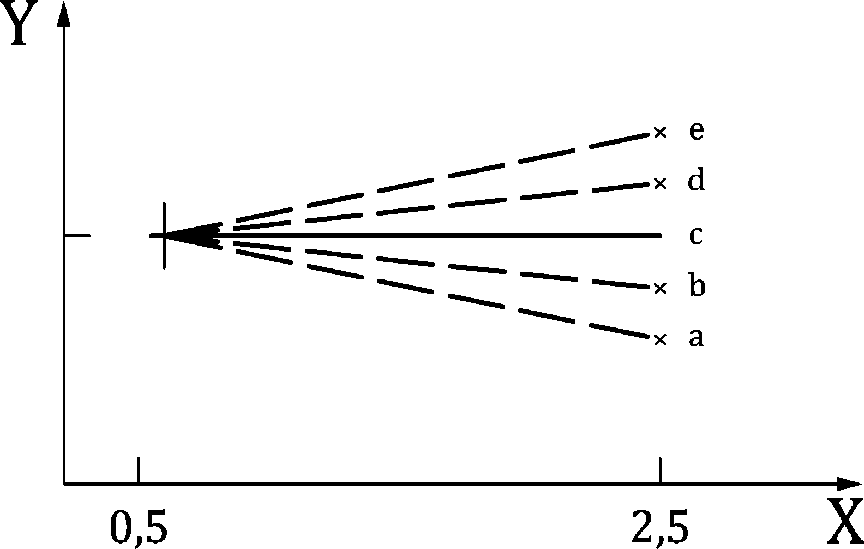

Key

|  |  |
| --- | --- |
| X | crackwidth |
| Y | fR,ik/fR,1k |

Figure C.1 — Illustration of the ductility classes

(2) The test report of a SFRC shall contain the load-CMOD curve or the load Deflection curve and the limit of proportionality LOP.

(3) If the steel fibre content is to be determined, it must be added to the report printout at the mixing plant or, in the absence of a recording device, the production records in connection with the mixing instructions for charge can be removed. The steel fibre content is defined by a minimum value mf,min.

(4) If a new steel fibre concrete mix is used, an initial test must be carried out by the producer in order to obtain a mixture design that meets the specified characteristic residual flexural strength according (1).

(5) The initial assessment shall demonstrate, that the documented procedures a uniform fibre distribution in the load is achieved.

(6) The sample body shall have at least six bars of the dimensions 150 mm/150 mm/700 mm according to EN 14651. The dimensions of the sample body apply up to a nominal value of the maximum grain size the aggregate of 16 mm for round grain and 22 mm for crushed grain. For a higher nominal value of the maximum grain size, the dimensions of the sample body require special consideration. The length of the steel fibres should not be less than 1,5 times the maximum grain size. For the production of test specimens from normal concrete, EN 14651 shall be observed.

(7) For determination of *f*r1,k and *f*r3,k, the value of **k,max in EN 206 shall be taken as 0,6.

* 1. Reinforcing Steel
     1. Carbon Reinforcing Steel

(1) In the design reinforcing steel classes are be used. Carbon reinforcing steel products according to EN 10080 fulfilling the following requirements may be classified in strength classes B as in Table C.1a and in ductility classes as in Table C.1b.

Table C.1a — Strength properties of reinforcing steel according to EN 10080

| Property | Reinforcing steel strength classa | | | | | |
| --- | --- | --- | --- | --- | --- | --- |
| B400 | B450 | B500 | B550 | B600 | B700 |
| Bars including de-coiled bars  Yield strength Re or Rp0,2 [MPa] (5 % quantile) | ≥ 400 | ≥ 450 | ≥ 500 | ≥ 550 | ≥ 600 | ≥ 700 |
| Fatigue stress range 2σa in testing [MPa] for N ≥ 2 × 106 cycles based on an upper stress limit of 0,6fyk (10 % quantile)b | 160 for bars and de-coiled bars ϕ ≤ 12 mm  140 for bars and de-coiled bars 12 mm < ϕ ≤ 16 mm  130 for bars and de-coiled bars 16 mm < ϕ ≤ 20 mm  130 for straight bars ϕ > 20 mm  100 for wire fabrics ϕ ≤ 12 mm  80 for wire fabrics ϕ > 12 mm | | | | | |
| Minimum relative rib area fR,min or relative indentation area fP,min (5 % quantile) | 0,035 for ϕ ≤ 6 mm  0,040 for 6 mm < ϕ ≤ 12 mm  0,056 for ϕ > 12 mm | | | | | |
| a All strength classes apply unless a National Annex excludes specific classes.  b Different fatigue properties can be set in a National Annex, if increased margins are required to the S-N curve parameters given in Annex E, by specifying higher values of the fatigue stress range and/or the number of cycles are confirmed by testing in accordance with EN 10080. No specific fatigue properties are required if the reinforcement is used only for predominantly static loading. | | | | | | |

Table C.1b — Ductility properties of reinforcing steel according to EN 10080

| Properties for weldable reinforcement | Ductility Class | | |
| --- | --- | --- | --- |
| A | B | C |
| Value of Rm /Re  (10 % quantile) | ≥ 1,05 | ≥ 1,08 | ≥ 1,15  < 1,35 |
| Value of Re,act/Re,nom  (10 % quantile) | – | ≤ 1,3 | ≤ 1,3 |
| Characteristic strain at maximum force Agt [ %]  (10 % quantile) | ≥ 2,5 | ≥ 5,0 | ≥ 7,5 |
| Bendability | Pass bend and/or rebend test according to EN 10080. For rebending of reinforcing steel on site see requirements in EN 13670. | | |

NOTE EN 10080 refers to a yield strength Re, which relates to the characteristic, minimum and maximum values based on the long-term quality level of production. In contrast fyk is the characteristic yield stress based on only that reinforcement used in a particular structure. There is no direct relationship between fyk and the characteristic Re or Rp0,2. However, based on the methods of evaluation and verification the yield strength Re given in EN 10080 may be taken as fyk.

(2) In welded fabric the declared shear force shall be not lower than the specified minimum value of the shear force Fs of welded joints. The specified minimum value is

|  |  |
| --- | --- |
| Fs ≥ 0,25 ⋅ Re,nom ⋅ An | (C.1) |

where Re,nom is the nominal characteristic yield strength and An is the nominal cross sectional area of either:

1. the larger wire at the joint in a single wire welded fabric or
2. one of the twin wires in a twin wire welded fabric (twin wires in one direction).
   * 1. Stainless Reinforcing Steel

(1) In the design reinforcing steel classes are be used. Stainless reinforcing steel products according to prEN 10370 and designed with Annex Q fulfilling the following requirements may be classified in strength classes B as in Table C.2a and in ductility classes as in Table C.2b.

NOTE prEN 10370 refers to a 0,2 % proof strength Rp0,2k, which relates to the characteristic, lower or upper limit of the statistical tolerance interval values. In contrast f0,2k is the characteristic 0,2 % proof strength based on only that reinforcement used in a particular structure. There is no direct relationship between f0,2k and the characteristic Rp0,2k. However the methods of evaluation and verification of 0,2 % proof strength given in prEN 10370 provide a sufficient check for obtaining f0,2k.

Table C.2a — Strength properties of reinforcing steel according to prEN 10370

| Property | Reinforcing steel strength class a | | | | | |
| --- | --- | --- | --- | --- | --- | --- |
| B400 | B450 | B500 | B550 | B600 | B700 |
| Bars and de-coiled products  Yield strength Rp0,2k [MPa] (5 % quantile)b | ≥ 400 | ≥ 450 | ≥ 500 | ≥ 550 | ≥ 600 | ≥ 700 |
| Fatigue stress range 2σa in testing [MPa] for N ≥ 5 × 106 cycles based on a stress ratio 𝜎min/𝜎max = 0,2 for strength class B500 only for stainless steel (10 % quantile)b) | 200 for ϕ ≤ 16 mm  185 for 16 mm < ϕ ≤ 20 mm  170 for 20 mm < ϕ ≤ 25 mm  160 for 25 mm < ϕ ≤ 32 mm  150 for 32 mm < ϕ ≤ 50 mm | | | | | |
| Minimum relative rib area fR,min or relative indentation area fP,min (5 % quantile) | 0,039 for ϕ ≤ 6 mm  0,045 for 6,5 mm ≤ ϕ ≤ 8,5 mm  0,052 for 9 mm ≤ ϕ ≤ 10,5 mm  0,056 for 11 mm ≤ ϕ ≤ 50 mm | | | | | |
| a All strength classes apply unless a National Annex excludes specific classes.  b Different fatigue properties can be set in a National Annex, if increased margins are required to the S-N curve parameters given in Annex E, by specifying higher values of the fatigue stress range and/or the number of cycles are confirmed by testing in accordance with prEN 10370. | | | | | | |

Table C.2b — Ductility properties of reinforcing steel according to prEN 10370

| Properties for weldable reinforcement | Ductility Class | | |
| --- | --- | --- | --- |
| A | B | C |
| Value of Rm /Rp0,2k, where Rm should be limited to stress at 7 % elongation (10 % quantile) | ≥ 1,05 | ≥ 1,08 | ≥ 1,15  < 1,35 |
| Value of Re,act/Rp0,2,nom (10 % quantile) | – | ≤ 1,3 | ≤ 1,3 |
| Characteristic strain at maximum force Agt [ %]  (10 % quantile) | ≥ 2,5 | ≥ 5,0 | ≥ 7,5 |
| Bendability | Pass bend and/or rebend test according to prEN 10370. For rebending of reinforcing stainless steel on site see requirements in EN 13670. | | |

* 1. Prestressing steel

(1) In the design Prestressing steel classes are be used. Prestressing steel products fulfilling the following requirements may be classified in strength classes Y as in Tables C.3 to C.5.

NOTE prEN 10138 (all parts) refers to the characteristic, minimum and maximum values of proof force based on the long-term quality level of production. In contrast fp0,1k and fpk are the characteristic proof stress and tensile strength based on only that prestressing steel required for the structure. There is no direct relationship between the two sets of values. However, based on the methods for evaluation and verification the characteristic values for 0,1 % proof force divided by the cross section area Sn, given in prEN 10138 (all parts) may be taken as fp0,1k.

(2) Each consignment of prestressing steel shall be accompanied by a certificate containing all the information necessary for its identification in accordance with 5.3.2(1).

Table C.3 — Strength, fatigue, ductility and relaxation properties of prestressing wires according to prEN 10138 (all parts)

| Property | | Wires — strength class | | | |
| --- | --- | --- | --- | --- | --- |
| Y1570 | Y1670 | Y1770 | Y1860 |
| **Strength** | Characteristic yield strength Rp0,1k [MPa], 5 % quantile | ≥ 1380 | ≥ 1470 | ≥ 1550 | ≥ 1650 |
| Characteristic tensile strength Rpk [MPa], 5 % quantile | ≥ 1570 | ≥ 1670 | ≥ 1770 | ≥ 1860 |
| Value of actual tensile strength [MPa] for each individual test-specimen | ≤ 1800 | ≤ 1920 | ≤ 2030 | ≤ 2140 |
| **Fatigue**a | Fatigue stress range in testing [MPa] for N ≥ 2 × 106 cycles with an upper limit of 0,7 fpk (10 % quantile) | 200 for plain wire  180 for indented wire | | | |
| **Ductility** | Value of k = (fpk/fp0,1k)  (10 % quantile) | ≥ 1,10 | | | |
| Characteristic strain at maximum force, εuk [ %] (10 % quantile) | ≥ 3,5 | | | |
| Bendability | Pass minimum number of reverse bends according to prEN 10138 (parts) | | | |
| **Relaxation**b | Relaxation at 1 000 hours for initial stress of 70 % of actual tensile strength, ρ1000 | ≤ 2,5 % | | | |
| Relaxation at 1 000 hours for initial stress of 80 % of actual tensile strength, ρ1000 | ≤ 4,5 % | | | |
| NOTE  All strength classes apply unless a National Annex excludes specific classes. | | | | | |
| a Different fatigue properties can be set in a National Annex, if increased margins are required to the S-N curve parameters given in Annex E, by specifying higher values of the fatigue stress range and/or the number of cycles are confirmed by testing in accordance with prEN 10138 (all parts). No specific fatigue properties are required if the reinforcement is used only for predominantly static loading.  b Relaxation losses apply at a mean temperature of 20 °C. Relaxation losses are very sensitive to the temperature of the prestressing steel, see B.9. | | | | | |

Table C.4 — Strength, fatigue, ductility and relaxation properties of prestressing strands according to prEN 10138

| Property | | Strands — strength class | | | |
| --- | --- | --- | --- | --- | --- |
| Y1770 | Y1860 | Y1960 | Y2060 |
| **Strength** | Characteristic yield strength Rp0,1k [MPa], 5 % quantile | ≥ 1550 | ≥ 1650 | ≥ 1740 | ≥ 1810 |
| Characteristic tensile strength Rpk [MPa], 5 % quantile | ≥ 1770 | ≥ 1860 | ≥ 1960 | ≥ 2060 |
| Value of actual tensile strength [MPa] for each individual test-specimen | ≤ 2030 | ≤ 2140 | ≤ 2250 | ≤ 2370 |
| **Fatigue**a | Fatigue stress range in testing [MPa] for N ≥ 2 × 106 cycles with an upper limit of 0,7 fpk (10 % quantile) | 190 for plain strand  170 for indented strand | | | |
| **Ductility** | Value of k = (fpk/fp0,1k)  (10 % quantile) | ≥ 1,10 | | | |
| Characteristic strain at maximum force, εuk [ %] (10 % quantile) | ≥ 3,5 | | | |
| Bendability | Pass minimum number of reverse bends according to prEN 10138 (all parts) | | | |
| **Relaxation**b | Relaxation at 1 000 hours for initial stress of 70 % of actual tensile strength, ρ1000 | ≤ 2,5 % | | | |
| Relaxation at 1 000 hours for initial stress of 80 % of actual tensile strength, ρ1000 | ≤ 4,5 % | | | |
| NOTE All strength classes apply unless a National Annex excludes specific classes. | | | | | |
| a Different fatigue properties can be set in a National Annex, if increased margins are required to the S-N curve parameters given in Annex E, by specifying higher values of the fatigue stress range and/or the number of cycles are confirmed by testing in accordance with prEN 10138 (all parts). No specific fatigue properties are required if the reinforcement is used only for predominantly static loading.  b Relaxation losses are very sensitive to the temperature of the prestressing steel, see B.9. Relaxation losses apply at a mean temperature of 20 °C. | | | | | |

Table C.5 — Strength, fatigue, ductility and relaxation properties of prestressing bars according to prEN 10138 (all parts)

| Property | | Bars — Strength class | | | |
| --- | --- | --- | --- | --- | --- |
| Y1030 | Y1050 | Y1100 | Y1230 |
| **Strength** | Characteristic yield strength Rp0,1k [MPa], 5 % quantile | ≥ 835 | ≥ 950 | ≥ 900 | ≥ 1080 |
| Characteristic tensile strength Rpk [MPa], 5 % quantile | ≥ 1030 | ≥ 1050 | ≥ 1100 | ≥ 1230 |
| Value of actual tensile strength [MPa] for each individual test-specimen | ≤ 1180 | ≤ 1210 | ≤ 1260 | ≤ 1370 |
| **Fatigue**a | Fatigue stress range in testing [MPa] for N ≥ 2 × 106 cycles with an upper limit of 0,7 fpk (10 % quantile) | 200 for plain bars ϕp ≤ 40 mm  150 for plain bars ϕp > 40 mm  180 for ribbed bars ϕp ≤ 40 mm  120 for ribbed bars ϕp > 40 mm | | | |
| **Ductility** | Value of k = (fpk/fp0,1k)  (10 % quantile) | ≥ 1,10 | | | |
| Characteristic strain at maximum force, εuk [ %] (10 % quantile) | ≥ 3,5 | | | |
| Bendability | Not applicable | | | |
| **Relaxation**b | Relaxation at 1 000 hours for initial stress of 70 % of actual tensile strength, ρ1000 | ≤ 6 % for ϕp ≤ 15 mm  ≤ 4 % for ϕp > 15 mm | | | |
| Maximum Relaxation at 1 000 hours for initial stress of 80 % of actual tensile strength, ρ1000 | Value to be determined by testing if stressing intended to ≥ 0,7 fpk. | | | |
| NOTE All strength classes apply unless a National Annex excludes specific classes. | | | | | |
| a Different fatigue properties can be set in a National Annex, if increased margins are required to the S-N curve parameters given in Annex E, by specifying higher values of the fatigue stress range and/or the number of cycles are confirmed by testing in accordance with prEN 10138 (all parts). No specific fatigue properties are required if the reinforcement is used only for predominantly static loading.  b Relaxation losses are very sensitive to the temperature of the prestressing steel, see B.9. Relaxation losses apply at a mean temperature of 20 °C. | | | | | |

* 1. Couplers

(1) Couplers for splicing of reinforcing steel bars shall be capable of developing the maximum tensile strength Rm, the maximum compressive force with yield strength Re, and the percentage total elongation at maximum load Agt.

(2) The permanent slip measured after unloading the specimen shall not exceed 0,10 mm.

(3) If couplers are used in fatigue design the requirements of Tables C.1a and C.1b apply.

NOTE The required properties can be found in European Technical Product Specification (based on EAD 160129‑00‑0301). A National Annex can provide further requirements (e.g. regarding fatigue strength) and advice to couplers.

* 1. Headed bars

(1) Heads at the end of reinforcing steel bars shall be connected with a strength for Fyd of the bar diameter ϕ. The head shall have the same steel strength as the bar. The head diameter ϕh should be ϕh ≥ 3ϕ.

(2) If double-headed studs are designed as punching shear reinforcement, the requirements of Table C.6 should be fulfilled.

Table C.6 — Properties of double-headed studs

| Property | Requirement |
| --- | --- |
| Steel strength of heads | Re of reinforcing steel |
| Diameter of heads ϕh (related to bar diameter ϕ) | ϕh ≥ 3ϕ |
| Increasing factor for punching shear resistance of monotonic slabs | ηsys ≥ 1,8 |
| Characteristic resistance to fatigue loading ΔσRsk in testing for N ≥ 2 × 106 cycles based on an upper stress limit of 0,6fyk | ΔσRsk ≥ 70 MPa |

NOTE The required properties of double-headed studs can be found in European Technical Product Specification (based on EAD 160003‑00‑0301). A National Annex can give further requirements.

(3) The bearing surface of heads should be flat and at 90° to the bar unless justified by testing appropriate to the design situation under consideration.

* 1. Post-installed reinforcing steel systems

(1) A post-installed reinforcing steel system comprises a deformed straight reinforcing steel bar with properties according to C.4 and an anchoring mortar. The performance of the post-installed reinforcing steel system depends on the tools for drilling and preparing the hole (e.g. roughening and cleaning) as well as for injection of the mortar (e.g. dispenser, nozzles and piston plug, if applicable). Its suitability should be stated in a European Technical Product Specification.

(2) Anchoring mortars for post-installed reinforcing steel systems are for the purpose of this Eurocode grouped in bond efficiency classes which should develop a minimum mean bond strength fbm,req according to Table C.7, when tested and assessed in accordance with EAD 330087-00-0601 and accounting for the conditions in C.8(3).

NOTE A National annex can give further specifications.

Table C.7 — Required minimum mean bond strength fbm,rqd [MPa]

| Bond efficiency class | Bond efficiency factor kb,pi | Required minimum mean bond strength as a function of concrete strength fck (MPa) | | | | | |
| --- | --- | --- | --- | --- | --- | --- | --- |
| 12 | 16 | 20 | 30 | 40 | ≥ 50 |
| **CPI‑1,0** | 1,0 | 7,7 | 8,9 | 10,0 | 12,2 | 14,1 | 15,8 |
| **CPI‑0,9** | 0,9 | 7,0 | 8,0 | 9,0 | 11,0 | 12,7 | 14,2 |
| **CPI‑0,8** | 0,8 | 6,2 | 7,2 | 8,0 | 9,8 | 11,3 | 12,6 |
| **CPI‑0,7** | 0,7 | 5,4 | 6,3 | 7,0 | 8,6 | 9,9 | 11,1 |
| NOTE 1 Values for intermediate concrete strength may be interpolated linearly.  NOTE 2 Post-installed reinforcing bars with factor kb,pi < 0,7 are not covered by this Eurocode. | | | | | | | |

(3) The specification of the mean bond strength fbm,pi should take into account the following influencing factors:

1. Environmental conditions: corrosion resistance (accounting for the maximum allowable chloride content of the concrete for the intended application according to EN 206), alkalinity and possible sulphurous atmosphere, in-service temperature conditions, freeze/thaw conditions, creep behaviour under sustained loads;
2. Installation conditions: drilling method, drilling tools including drilling aids, hole preparation tool (e.g. roughening tool), cleaning devices, mortar injection devices (dispenser, nozzle, etc.), concrete condition at installation (dry, wet), installation direction (downward, horizontal, overhead), concrete temperature at installation, working and curing time of the anchoring mortar and robustness of installation;
3. Intended uses: range of reinforcing steel bar diameters (for each drilling method), concrete strength classes and types of loading (static, quasi-static, fatigue).

The European Technical Product Specification should provide the allowed intended use conditions, installation conditions and in-service temperature conditions together with the corresponding bond efficiency factor as well as the maximum embedment depth for each drilling and installation method.

Suitable protection of the reinforcing steel bar against corrosion taking into account relevant environmental factors should be demonstrated with respect to the maximum allowable chloride content of the concrete for the intended application according to EN 206.

Proof of corrosion resistance is not required if post-installed reinforcing steel bars are used in concrete members in environmental conditions according to exposure classes X0 and XC1 (see Table 6.1) or if they are produced from corrosion resistant steel.

(4) Detailed manufacturer’s installation instructions should be given in the European Technical Product Specification.

* 1. Fibre Reinforced Polymer Reinforcement
     1. CFRP reinforcement

(1) For the design to this Eurocode, CFRP strengthening systems complying with the following minimum values or range of values of properties, determined in accordance with ISO 10406 or a European Technical Product Specification unless otherwise noted, shall be used.

(2) Annex JA provides design rules for member strengthened with CFRP reinforcement within the following limits of declared properties:

* interlaminar shear strength of CFRP reinforcement shall be equal or larger than the adhesive bond strength for any system or kit,
* mean modulus of elasticity: 150 kN/mm² ≤ $E_{f}$ ≤ 230 kN/mm²,
* elastic stiffness: 20 N/mm ≤ $E_{f}∙A_{f}$ ≤ 400 N/mm,
* total CFRP cross section per unit width of CFRP sheets in the total of all layers:   
  100 mm²/m ≤ $A_{f}$/*b*sheet ≤ 1 800 mm²/m.

(3) The characteristic tensile strength of the adhesive 𝑓Atk, determined in accordance with EN 1504-4 shall be 𝑓Atk ≥ 14 N/mm² for design with Annex J.

(4) CRP reinforcement used in accordance with this Eurocode shall be subjected to a verification of constancy of performance system AVCP 1+.

(5) CFRP strips shall be bonded in no more than two layers. The maximum thickness of the CFRP strip cross section excluding the adhesive shall not exceed 3 mm.

(6) No more than a single NSM strip or bar shall be bonded into one slot.

* + 1. Embedded FRP reinforcement

(1) For the design to this Eurocode, embedded FRP reinforcement complying with the following minimum values or range of values of properties, determined in accordance with ISO 10460 in or a European Technical Product Specification unless otherwise noted, shall be used.

(2) Annex JA provides design rules for member reinforced with embedded FRP reinforcement within the following limits of declared properties:

* minimum long term tensile strength of $f_{ftk,100a}≥300 MPa$,
* minimum modulus of elasticity of $E_{fR}≥40MPa$,
* ratio of ${f_{ftk,100a}}/{E_{fR}}≤0,005$,
* minimum value of *f*bd,100a ≥ 1,5 MPa,
* bended FRP-shear stirrups shall be capable of resisting a long term tensile capacity which will accommodate 0,4 % strain.

(3) Embedded FRP reinforcement used in accordance with this Eurocode shall be subjected to a verification of constancy of performance system AVCP 1+.

1. (informative)  
     
   Evaluation of early-age and long-term cracking due to restraint
   1. Use of this annex

(1) This Informative Annex provides complementary guidance on the evaluation of early-age and long-term cracking due to restraint in general with special emphasis on through-cracking.

NOTE National choice on the application of this Informative Annex is given in a National Annex. If a National Annex contains no information on the application of this Informative Annex, it can be used.

* 1. Scope and field of application

(1) This Informative Annex applies to all types of members and structures.

* 1. General

(2) The main objective of the analysis is to evaluate the cracking risk, Rcr, or provide guidance on crack calculations if cracking is expected to occur. The cracking risk may be expressed in terms of the ratio between the maximum tensile stress, σct, and the tensile resistance of concrete at the moment which is being considered fct,eff(t), reduced by a factor of 0,8 in order to account for the effects of sustained loading (see Formula (D.1)):

|  |  |
| --- | --- |
| $$R_{cr}\left(t\right)=\frac{σ_{ct}\left(t\right)}{0,8f_{ct,eff}\left(t\right)}$$ | (D.1) |

where fct,eff(t) may be taken as fctm(t) according to B.4(2).

(3) The amount of through-cracking may be reduced by using concretes with low heat production during hydration, concretes with low coefficient of thermal expansion, cooling pipes in the hardening concrete, heating cables in the restraining structural elements, reduced fresh concrete temperature, or by reducing the degree of restraint for the hardening concrete structural element (i.e. if possible, break the bond between the hardening concrete and restraining structure in order to reduce the degree of restraint)

NOTE Figure D.1 shows the assumed temperature history for a structural concrete member where

* Tci is the fresh concrete temperature,
* Tc,max is the maximum concrete temperature due to hydration heat,
* T0 is the temperature of the restraining structure, and
* ΔTmin is long term maximum temperature drop.

Correspondingly, Figure D.2 shows the resulting diagram of stresses in concrete.

(4) Compression in concrete due to favourable effects from the heating phase may be considered.

NOTE Assuming that there are no additional external actions, the most unfavourable moment in time for early-age cracking is tcrit, corresponding to the moment when thermal equilibrium with the restraining structure is achieved (within 2 ºC) and the greater part of basic shrinkage has already developed.

(5) For long-term cracking, the effects of temperature variation (ΔTmin) and drying shrinkage should be considered. In Figure D.2, t2 is the time when the stresses in the critical position change from compression to tension (determined from the temperature history). Alternatively *t*2 may be assumed with 1 day .

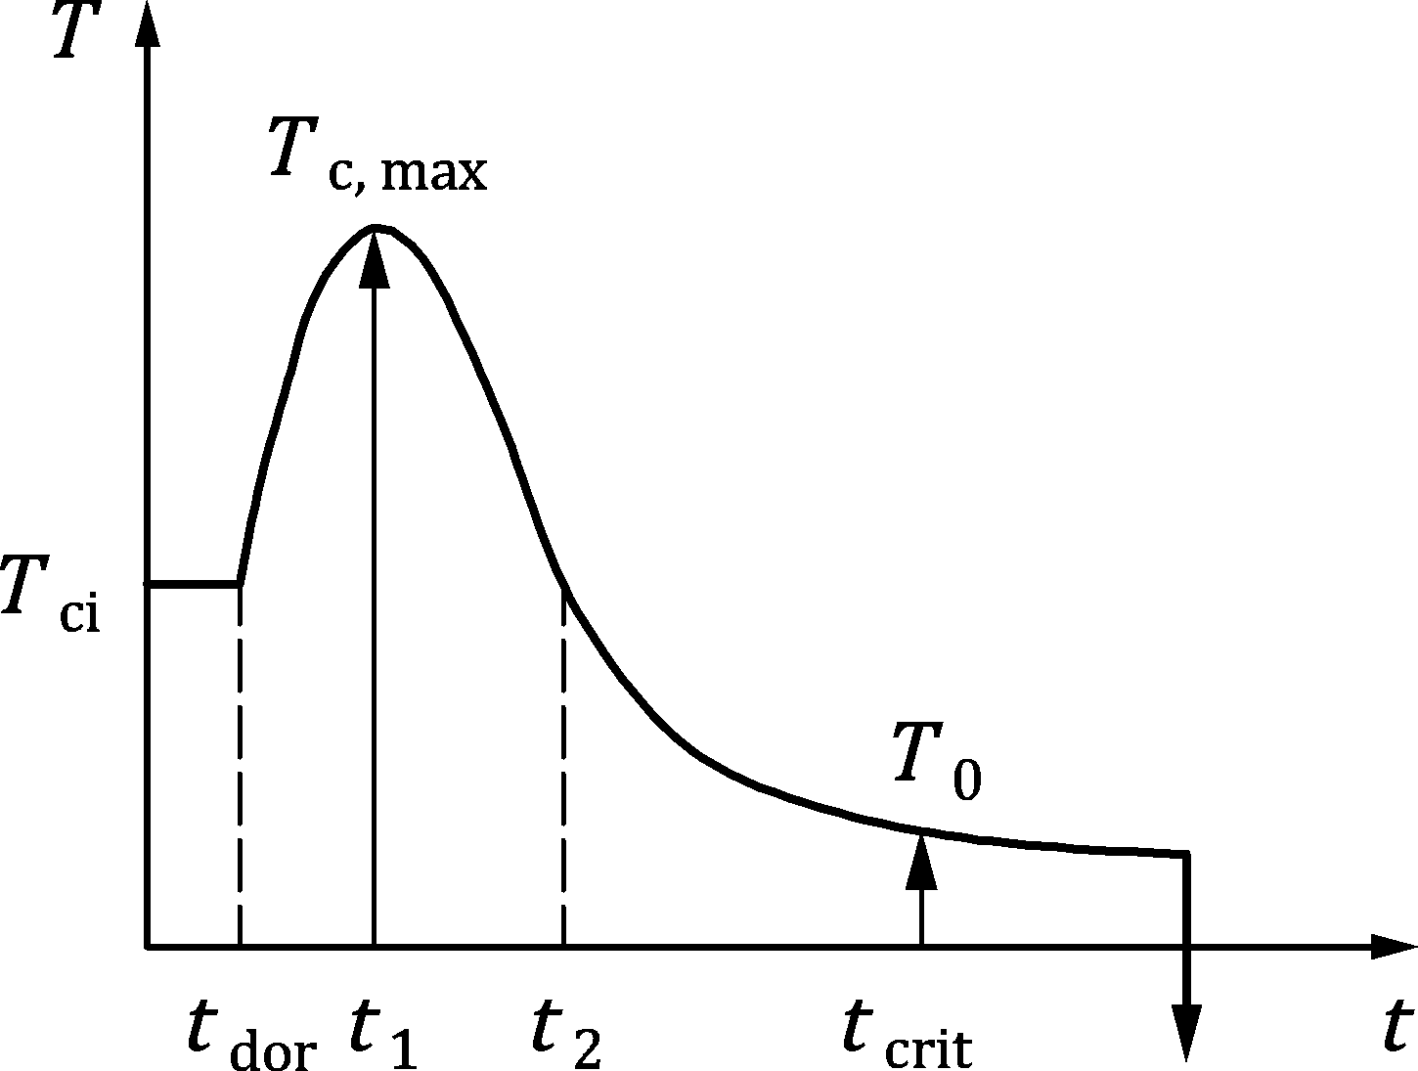

**Key**

|  |  |
| --- | --- |
| *T* | temperature |
| *t* | time |

Figure D.1 — Assumed temperature history for a structural concrete member

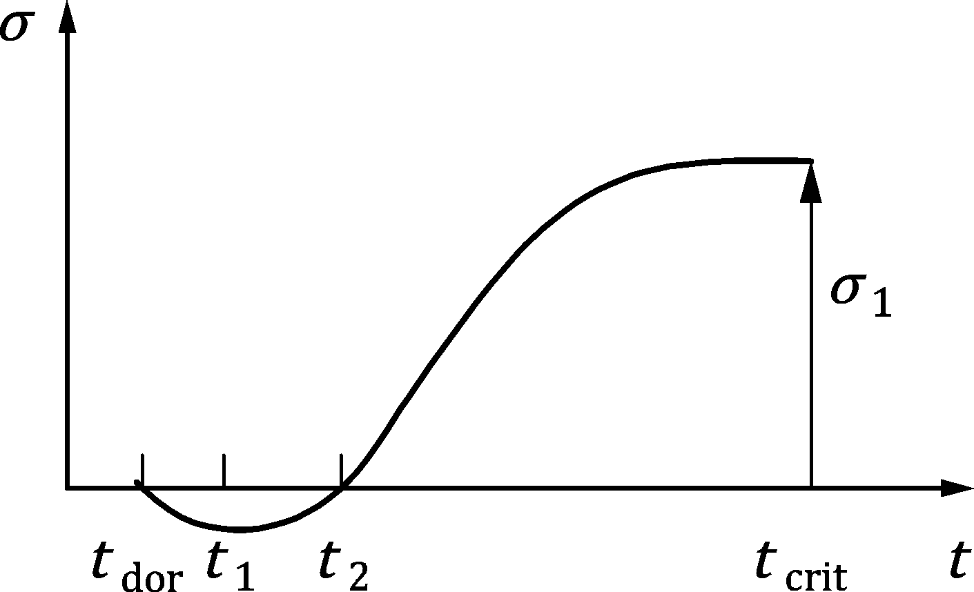

Key

|  |  |
| --- | --- |
| *𝜎* | stress |
| *t* | time |
| *y* | tension |

Figure D.2 — Corresponding stress diagram due to hydration heat and shrinkage of concrete

* 1. Assessment of temperature history
     1. General

(1) A reliable temperature calculation or estimate should be made to achieve accurate stress/strain or crack width calculation. For this purpose, computer programs, hand calculations and diagrams from handbooks and guidelines may be used.

NOTE The most decisive parameters, referred to Figure D.1 are:

* the fresh concrete temperature (Tci),
* the start time for stress development (tdor),
* ambient temperature history,
* insulation conditions,
* climatic conditions, such as wind velocity and solar radiation,
* temperature of the restraining structure (T0), and
* the additional, long-term maximum temperature drop (ΔTmin).

where tdor marks the end of the dormant phase. Typically, it varies between 8 and 13 maturity hours, the default value being 10 hours. This parameter may be strongly influenced by admixtures, and it is important that its value be taken into consideration when evaluating the mechanical properties of concrete (tensile strength and modulus of elasticity) as well as the value of shrinkage and the temperature development curves.

(2) tdor may be determined from the compressive strength development, from ultrasonic stiffness or heat release measurements, or from restrained shrinkage-tests. In absence of more accurate values those provided in Table D.1 may be used.

Table D.1 — Values for the start time of stress development tdor

| Concrete strength fck | Start time of stress development tdor [days] | | |
| --- | --- | --- | --- |
| Development of concrete strength | | |
| Class CRa | Class CNa | Class CSa |
| ≤ 35 MPa | 0,35 | 0,45 | 0,50 |
| > 35 MPa  < 60 MPa | 0,30 | 0,40 | 0,45 |
| ≥ 60 MPa | 0,30 | 0,35 | 0,40 |
| a See B.3(1). | | | |

(3) In absence of better data, T0 may generally be taken as the ambient temperature.

* + 1. Material properties related to temperature development

(1) In order to determine the temperature history of concrete due to cement hydration, the following material properties should be known:

* Total amount of hydration heat (Q(t) (kJ/kg binder)) released during hydration and its development with time. Q(t) may be determined in accordance with EN 12390‑14 or EN 12390‑15;
* Heat conductivity: The values for the heat conductivity may vary within the range 1,2 to 3,0 J/(s ⋅ m ⋅ K). In absence of better data, a default value of 2,5 J/(s ⋅ m ⋅ K) may be adopted.
* Surface convectivity: The surface convectivity may vary in the range from about 3,3J/(s ⋅ m² ⋅ K) for 18 mm plywood formwork and no wind to 15 J/(s m² ⋅ K) for a free concrete surface with 5 m/s wind.
* Heat capacity: The heat capacity corresponds to the specific heat multiplied by the concrete density. The specific heat varies typically in the range 0,85 to 1,15 kJ/(kg ⋅ K), and the default value may be assumed as 1,0 kJ/(kg ⋅ K).

NOTE The amount of heat hydration and development with time are strongly dependent on binder fineness and composition and on the water/binder (w/b)-ratio. Furthermore, the early strength class of cement strongly influences the binder content, and therefore also the amount of hydration heat.

* 1. Stress calculations

(1) The following stress calculations are relevant when aiming to limit the risk of cracking.

(2) It may be assumed that the risk that the element will crack is sufficiently low if Formula (D.2) is met:

|  |  |
| --- | --- |
| $$R_{cr}\left(t\right)<R_{ea,cr}$$ | (D.2) |

where Rea,cr is a project specific parameter related to the admissible risk of cracking, where Rea,cr may be assumed as 1,0.

(3) When assessing Rcr(t), the dormant time, tdor, should be subtracted from the concrete age to determine the tensile resistance and the modulus of elasticity of concrete. Coefficient βcc, describing the evolution of concrete properties with time (see Formula (B.2)) should then be corrected as follows (Formula (D.3)):

|  |  |
| --- | --- |
| $$β_{cc}\left(t\right)=e^{s\left(1 - \sqrt{\frac{t_{ref}-t_{dor}}{t_{T}-t_{dor}}}\right)⋅\sqrt{\frac{28-t_{dor}}{t_{ref}-t_{dor}}}}$$ | (D.3) |

NOTE Formula (B.2) is a simplified version of Formula (D.3) which assumes that tdor = 0.

(4) Rcr(t) should be determined at least for the following situations:

* At the time when temperature equilibrium between the recently cast element and the restraining structure is achieved. For this verification, it is not necessary to consider drying shrinkage or long-term temperature variations.

The maximum tensile stress to be considered for this verification may be determined using Formula (D.4):

|  |  |
| --- | --- |
| $$σ_{1}=R_{ax,1}\frac{E_{c}\left(t_{2}\right)}{1+χφ_{st}}\left(k_{Temp}α_{T}\left(T_{max}-T_{0}\right)+\left[ε_{cbs} \left(t_{crit}\right)-ε_{cbs}\left(t_{2}\right)\right]\right)$$ | (D.4) |

where

|  |  |
| --- | --- |
| Rax,1 | is the restraint factor (see 9.2.4 (3)) corresponding to the boundary conditions present after concreting; |
| Ec(t2) | is the modulus of elasticity of concrete at time t2 (see Figure D.2); |
| Tmax | is the maximum temperature in concrete after casting due to hydration heat; |
| T0 | is the temperature of the restraining structure; |
| kTemp | is a factor accounting for the reduction in temperature from t1 to t2 (see Figure D.1) and may be taken as 0,9; |
| χφst | accounts for short term creep relaxation which is significant, in spite of the short time, due to the low maturity of concrete and the presence of hydration heat. Its value may be estimated as 0,55. |

* Long term analysis. For this verification, the effects of long-term temperature variation and drying shrinkage should be considered. The maximum tensile stress may be determined using Formula (D.5):

|  |  |
| --- | --- |
| $$σ_{1}=R_{ax,1}\frac{E_{c,28}}{1+χφ\left(t , t_{2}\right)}\left(k_{T}α_{T}\left(T_{max} - T_{0}\right)+\left[ε_{cbs}\left(t\right)-ε_{cbs}\left(t_{2}\right)\right]\right) \\ + R_{ax,2}E_{c,28}α_{T}ΔT_{min} \\ + R_{ax,3}\frac{E_{c,28}}{1+χφ\left(t , t_{s}\right)}⋅\left[ε_{cds} \left(t\right)-ε_{cds}\left(t_{2}\right)\right]$$ | (D.5) |

where

|  |  |
| --- | --- |
| Rax,2 | is the restraint factor (see 9.2.4 (3)) corresponding to the boundary conditions present when the maximum temperature drop is expected to occur; |
| Rax,3 | is the restraint factor (see 9.2.4 (3)) corresponding to the boundary conditions prevalent during the development of drying shrinkage; |
| ΔTmin | is the maximum characteristic temperature drop with respect to the temperature considered at casting T0; |
| χ | is the aging coefficient which may be taken as 0,8; |
| Ec,28 | is the tangent modulus of elasticity of concrete at an age of 28 days; |

* 1. Crack width calculations

(1) If cracking due to the imposed deformations does occur (Rcr > Rea,cr), the crack width may be determined according to 9.2.4.

(2) For elements restrained at the ends Formula (9.13) applies.

(3) For elements restrained at the edges, in Formula (9.17), Raxεfree may be taken as:

* for early-age cracking:

|  |  |
| --- | --- |
| $$R_{ax}ε_{free}=R_{ax,1}\left(k_{T} α_{T} \left(T_{max} - T_{0}\right) + \left[ε_{cbs} \left(t_{crit}\right) - ε_{cbs} \left(t_{2}\right)\right]\right)$$ | (D.6) |

* for long-term cracking:

|  |  |
| --- | --- |
| $$R_{ax}ε_{free}=R_{ax,1}\left(k_{T}α_{T}\left(T_{max} - T_{0}\right)+\left[ε_{cbs}\left(t\right)ε_{cbs}\left(t_{2}\right)\right]\right) \\ + R_{ax,2}α_{T}ΔT_{min}+R_{ax,3}⋅\left[ε_{cds}\left(t\right)-ε_{cds}\left(t_{2}\right)\right]$$ | (D.7) |

1. (normative)  
     
   Additional rules for fatigue verification
   1. Use of this annex

(1) This Normative Annex contains additional provisions for fatigue verification of structures.

* 1. Scope and field of application

(1) This annex gives covers fatigue verification of structures using:

— damage equivalent stresses according to E.4 or

— explicit verifications using Palmgren-Miner Rule according to E.5.

* 1. General

(1) For explicit verifications of bridges according to Annex E, the fatigue load models defined in prEN 1991-2 shall be used. For other structures, the fatigue load should be defined according to prEN 1990 on a project-specific basis.

* 1. Verification using damage equivalent stress range
     1. General

(1) In the method of damage equivalent stress range the actual operational loading is represented by N* cycles of a single equivalent stress range under the equivalent fatigue load models.

* + 1. Verification for reinforcement

(1) For reinforcing or prestressing steel and couplers adequate fatigue resistance may be assumed if Formula (E.1) is satisfied:

|  |  |
| --- | --- |
| $$γ_{F,fat}⋅Δσ_{S,equ}(N^{*})≤\frac{Δσ_{Rsk}(N^{*})}{γ_{S,fat}}$$ | (E.1) |

where

|  |  |
| --- | --- |
| ΔσRsk(N*) | is the stress range at N* cycles from the appropriate S-N curves given in Figure E.1 and Tables E.1(NDP) and E.2(NDP); |
| ΔσS,equ(N*) | is the damage equivalent stress range for different types of reinforcement and considering the number of loading cycles N*. For buildings ΔσS,equ(N*) may be approximated by ΔσS,max; |
| ΔσS,max | is the maximum reinforcing steel stress range under the relevant load combinations. |

NOTE 1 Tables E.1(NDP) and E.2(NDP applies. If other values of the fatigue stress range and/or the number of cycles are confirmed by testing in accordance with EN 10080 (see Table C.1) or prEN 10138 (all parts) different fatigue properties can be given in a National Annex.

NOTE 2 For road and railway bridges ΔσS,equ(N*) is given in K.11.2.

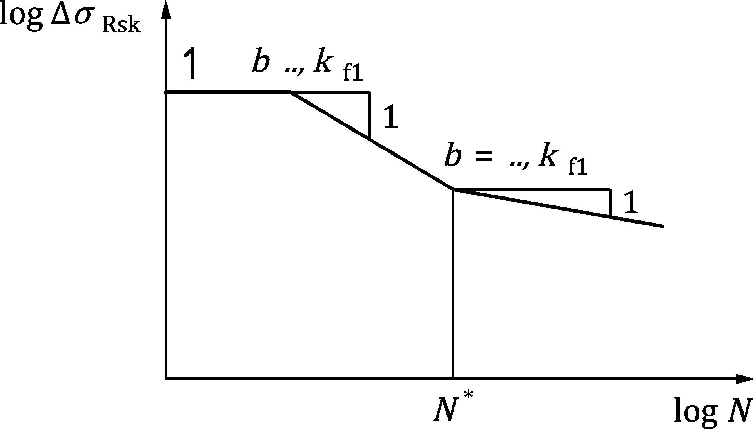

Key

|  |  |
| --- | --- |
| 1 | reinforcement at yield |

Figure E.1 — Shape of the characteristic fatigue strength curve (S-N curves for reinforcing and prestressing steel)

Table E.1(NDP) — Design parameters for S-N curves for carbon reinforcing steel

| Type of reinforcing steel | Diameter | ΔσRsk 5 %-quantile (Test σmax 0,6fyk) | | | |
| --- | --- | --- | --- | --- | --- |
| ΔσRsk [MPa] | N* | stress exponent | |
| kf1 | kf2 |
| Bars (including de-coiled bars)a | ϕ ≤ 12 mm | 160 | 2 ⋅ 106 | 5 | 9 |
| 12 mm < ϕ ≤ 16 mm | 140 |
| 16 mm < ϕ ≤ 20 mm | 130 |
| Straight bars a,b | ϕ > 20 mm | 130 |
| Tack welded barsc,d and welded wire fabrics | ϕ ≤ 12 mm | 100 | 3 | 5 |
| ϕ > 12 mm | 80 |
| Couplerse | – | 35 | 107 | 3 | 5 |
| a Values for bent parts of bars should be obtained using a reduction factor ξ = 0,35 + 0,026 ⋅ ϕmand /ϕ. The reduction factor ξ may be omitted for shear reinforcement with 90° stirrups ϕ ≤ 16 mm and depth h ≥ 600 mm.  b Values for ΔσRsk only to be applied for straight bars and not for de-coiled bars.  c Values for ΔσRsk of tack welded apply for a distance of 5ϕ at each side of the weld.  d Values for ΔσRsk of tack welded apply only for CO2-welded bars.  e Values for couplers apply unless more accurate S-N curves are available based on an European Technical Product Specification. | | | | | |

Table E.2(NDP) — Parameters for S-N curves for prestressing steel

| S-N curve of prestressing steel | N* | stress exponent | | ΔσRsk [MPa]  at N* cycles a |
| --- | --- | --- | --- | --- |
| kf1 | kf2 |
| **pre-tensioning** | 106 | 5 | 9 | 185 |
| **post-tensioning** | | | | |
| — single strands in plastic ducts | 106 | 5 | 9 | 185 |
| — straight tendons or curved tendons in plastic ducts | 106 | 5 | 9 | 150 |
| — curved tendons in steel ducts | 106 | 3 | 7 | 120 |
| — anchoring devices and couplers | 106 | 5 | 5 | 80 |
| NOTE Values in Table E.2(NDP) apply for prestressing steel complying with Table C.4 to C.6 and prestressing systems complying with 5.4. | | | | |
| a Values correspond to prestressing steel embedded in concrete. | | | | |

* + 1. Verification for concrete

(1) A satisfactory fatigue resistance may be assumed for concrete under compression, if the following condition in Formula (E.2) is fulfilled:

|  |  |
| --- | --- |
|  | (E.2) |

where

|  |  |
| --- | --- |
| fcd,fat | is the design fatigue strength of concrete according to Formula (10.5); |
| |σcd,max,equ| | is the upper stress of the damage equivalent stress amplitude for N = 106 cycles; |
| |σcd,min,equ| | is the lower stress of the damage equivalent stress amplitude for N = 106 cycles. |

NOTE For road and railway bridges, σcd,equ,max and σcd,equ,min are given in K.11.3.

* 1. Explicit verifications using *Palmgren-Miner* Rule
     1. Verification conditions

(1) Calculation of design service life at varying stress amplitudes may be based on linear damage theory (Palmgren-Miner Rule) according to Formula (E.3). Action effects due to cyclic loads may be arranged in design stress-levels (action effect-levels) each with constant amplitude and a corresponding number of load cycles, ni.

|  |  |
| --- | --- |
| $$\sum_{i=1}^{m}{\frac{n_{i}}{N_{i}}}≤1$$ | (E.3) |

where

|  |  |
| --- | --- |
| ni | is the number of acting stress cycles for each design stress-level “i”; |
| Ni | is the number of cycles to fatigue failure according to Figure E.1 and Table E.1 for each design stress-level “i” with constant amplitude; |
| m | is the number of design stress-levels with constant amplitude. |

* + 1. Verification procedure for reinforcing and prestressing steel

(1) The damage of a single stress range Δσ may be determined by using the corresponding S-N curves (Figure E.1) for reinforcement.

|  |  |
| --- | --- |
| $$N_{i}\left(Δ σ_{Ed,s}\right)={\left(\frac{Δσ_{Rsk}\left(N^{*}\right)}{γ_{S,fat}⋅γ_{F,fat}⋅Δσ_{s}}\right)}^{k_{f}}⋅N^{*}$$ | (E.4) |

where

|  |  |  |
| --- | --- | --- |
| $$\text{if }Δσ_{s}≥\frac{Δσ_{Rsk}}{γ_{S,fat}⋅γ_{F,fat}}:$$ | kf = kf1 | (E.5) |
| $$\text{if }Δσ_{s}<\frac{Δσ_{Rsk}}{γ_{S,fat}⋅γ_{F,fat}}:$$ | kf = kf2 | (E.6) |

NOTE The parameters for reinforcement are given in Table E.1 and Table E.2 respectively.

* + 1. Verification procedure for concrete under compression or compression-tension

(1) For multiple cycles with variable amplitudes the damage may be calculated by using Formula (E.3).

(2) The number of cycles to fatigue failure Ni may be calculated for each stress-level using the S/N-curves for concrete under pure compressive fatigue loading in Figure E.2, Formula (E.7).

|  |  |
| --- | --- |
| N = 10k | (E.7) |

where

|  |  |
| --- | --- |
|  | (E.8) |

where

|  |  |
| --- | --- |
| σcd,max | is the maximum compressive stress in stress-level “i”,σcd,max = γF,fat ⋅ σc,max; |
| σcd,min | is the minimum compressive stress in stress-level “i”, σcd,min = γF,fat ⋅ σc,min; |
| fcd,fat | is the design fatigue strength of concrete according to Formula (10.5). |

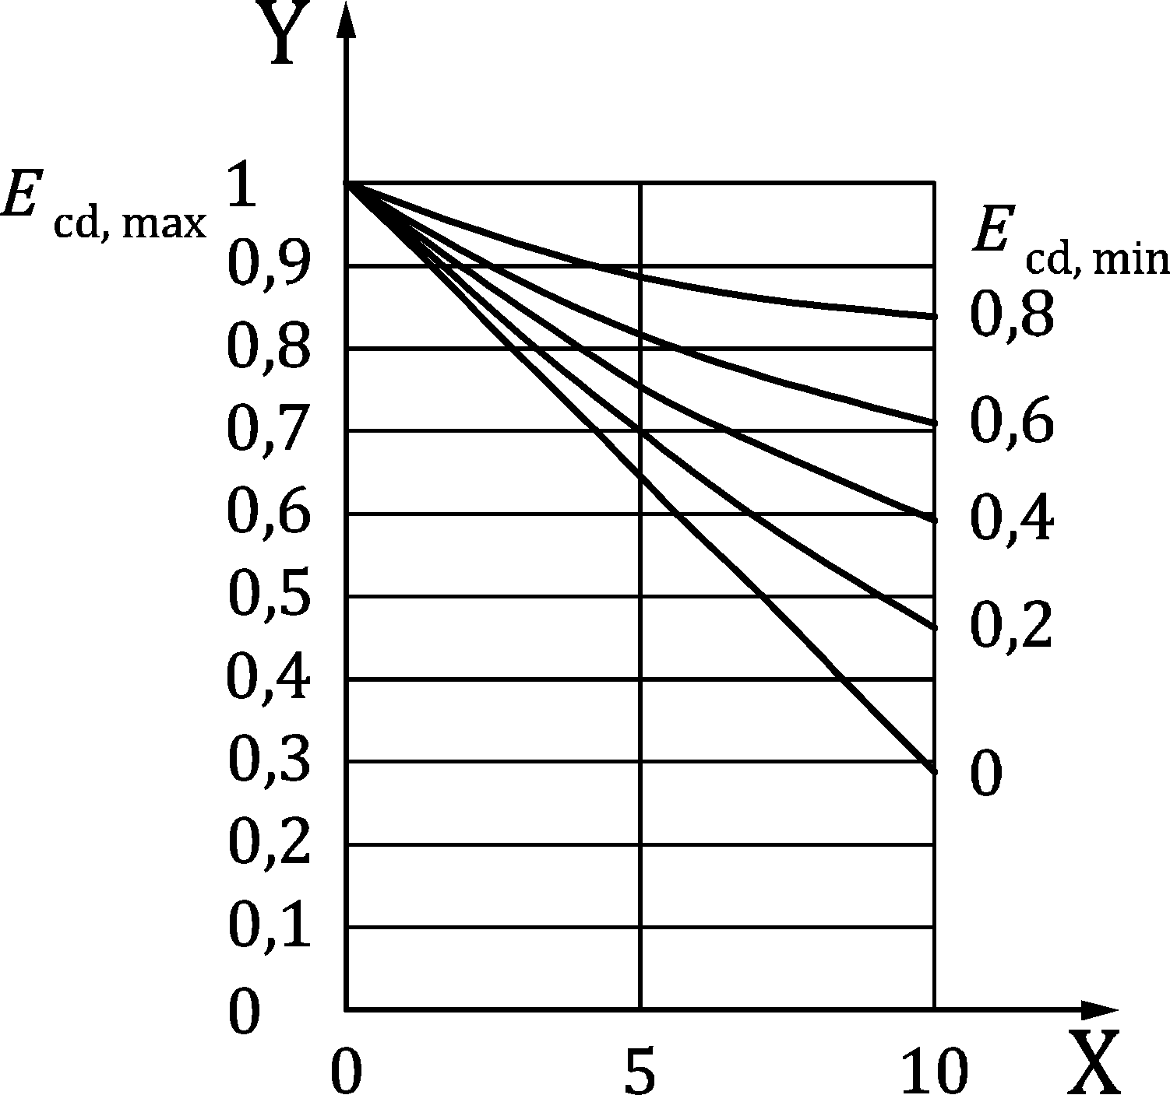

Key

|  |  |
| --- | --- |
| x | logarithmic number of cycles to failure log N [-] |
| y | compressive stress level |

|  |  |
| --- | --- |
|  |  |
|  |  |

Figure E.2 — Shape of the characteristic fatigue strength curves (S-N-curves for concrete under pure compression)

1. (informative)  
     
   Non-linear analyses procedures
   1. Use of this annex

(1) This Informative Annex provides supplementary guidance to non-linear analyses procedures for concrete structures.

NOTE National choice on the application of this Informative Annex is given in a National Annex. If a National Annex contains no information on the application of this Informative Annex, it can be used.

* 1. Scope and field of application

(1) This Informative Annex covers the use of the partial factor method, the global factor method and full probabilistic method for non-linear analyses of concrete structures.

* 1. General

(1) Verification of ultimate limit states by non-linear analysis is performed by numerical simulations in compliance with the requirements of 7.3.4 and of prEN 1990:2020, 7.2.2.

(2) Annex F shall be applied consistently to prEN 1990:2020, 8.2.

(3) The software used in non-linear verification of the ultimate limit state should be validated by comparison between numerical and experimental or benchmark results. Similarly, the choices made with respect to the specific numerical model should be tested by sensitivity analysis.

This covers general validation attempts:

* basic material tests,
* structural tests with the characterization of relevant failure modes;

and project specific attempts:

* mesh sensitivity tests;
* solution method tests.

(4) The loading process adopted by a non-linear simulation in order to evaluate the structural resistance shall be defined according to engineering judgement consistently with the considered combination of the actions at ultimate limit state.

NOTE The loading process may account for the loading sequence due to staged construction methods.

(5) The verification requires that the design value of the actions in the considered combination, determined according to prEN 1990, shall not be greater than the design value of the associated structural resistance (see Formula (F.1)):

|  |  |
| --- | --- |
| Fd ≤ Rd | (F.1) |

where

|  |  |
| --- | --- |
| Fd | is the design value of the actions; |
| Rd | is the design value of the structural resistance. |

(6) The design value of the structural resistance may be determined by using one of the following safety formats, which are described in F.4 and F.5:

* Partial factor method (PFM) – F.4;
* Global factor method (GFM) – F.5;

Alternatively, structural reliability analysis may be performed according to full probabilistic method (FPM) as described in F.6.

* 1. Partial factor method (PFM)

(1) The design value of the structural resistance is obtained as

|  |  |
| --- | --- |
| $$R_{d}=\frac{R\left\{X_{d} ; a_{d}\right\}}{γ_{Rd}}$$ | (F.2) |

where

|  |  |
| --- | --- |
| R{…} | is the structural resistance based on the numerical simulation; |
| Xd | is the design value of the material property calculated adopting partial safety factors according to Table A.1 line (e) accounting for materials and geometric uncertainties; |
| ad | is the design value of the geometric property according to Annex A or prEN 1990, if not accounted for in Xd; |
| γRd | is the partial safety factor which accounts for model uncertainty according to F.7. |

NOTE The structural resistance R{…} can be evaluated for different levels of appropriate actions which can be increased from their initial values by incremental steps, such that the design values of the actions in the considered combination are reached in the same step. The incremental process of the actions should be continued until structural failure is reached. The structural resistance R{…} corresponds to the values of the actions which lead to structural failure.

(2) In case the concrete tensile strength is neglected, the design value of the resistance may also be calculated on the basis of the design values fcd and fyd according to 5.1.6 and 5.2.4. If the statistic values of the model uncertainties according to F.7 are more favourable than the values given in Table A.2, then the partial safety factors γC and γS defined in Table 4.3(NDP) may be used. Otherwise, they shall be adapted according to Annex A.

* 1. Global factor method (GFM)
     1. General

(1) The design value of structural resistance is obtained as

|  |  |
| --- | --- |
| $$R_{d}=\frac{R_{m}\left\{X ; a\right\}}{γ_{R}^{*}⋅γ_{Rd}}$$ | (F.3) |

where

|  |  |  |
| --- | --- | --- |
| Rm{...} | is the mean value of structural resistance based on the numerical simulation and shall be estimated by means of a probabilistic analysis including uncertainties related to material X and geometric a properties. | |
|  | Alternatively, the approximated value derived by formula (F.4) can be adopted: | |
|  | $$R_{m}\left\{X ; a\right\}≅R\left\{X_{m}; a_{nom}\right\}$$ | (F.4) |
|  | where | |
|  | — R{∙} is the structural resistance based on the numerical simulation; | |
|  | — Xm is the mean value of the material property; | |
|  | — anom is the nominal value of the geometric property according to prEN 1990; | |
| fm | is the mean value of the material property; | |
| γR* | is the global resistance factor for the uncertainties of materials properties and geometry according to F.5.2; | |
| γRd | is the partial safety factor accounting for the model uncertainty according to F.7. | |

NOTE The structural resistance R{…} can be evaluated for different levels of appropriate actions which can be increased from their initial values by incremental steps, such that the design values of the actions in the considered combination are reached in the same step. The incremental process of the actions should be continued until structural failure is reached. The structural resistance R{…} corresponds to the values of the actions which lead to structural failure.

* + 1. Determination of the global resistance factor

(1) The global resistance factor may be evaluated with Formula (F.5):

|  |  |
| --- | --- |
| $$γ_{R}^{*}=exp\left(α_{R}⋅β_{tgt}⋅V_{R}^{*}\right)$$ | (F.5) |

where

|  |  |  |  |
| --- | --- | --- | --- |
| αR | is the sensitivity factor for dominant resistance variable: αR = 0,8; | | |
| βtgt | is the target value of the reliability index according to Table A.3; | | |
| $$V_{R}^{*}$$ | is thecoefficient of variation of structural resistance. It accounts for material and geometrical uncertainties and shall be estimated by means of a probabilistic analysis of the structural resistance. | | |
|  | Alternatively, the approximated value derived by Formula (F.6) can be adopted: | | |
|  | $$V_{R}^{*}=\sqrt{V_{R,M}^{2}+V_{R,G}^{2}}$$ | | (F.6) |
|  | where | | |
|  | VR,M | is the coefficient of variation of structural resistance accounting for uncertainties of material properties evaluated according to Formula (F.7): | |
|  |  | $$V_{R,M}=\frac{1}{1,65}ln\left(\frac{R\left\{X_{m}; a_{nom}\right\}}{R\left\{X_{k}; a_{nom}\right\}}\right)$$ | (F.7) |
|  |  | where Xk is the characteristic value of the material property; | |
|  | VR,G | is the coefficient of variation of structural resistance related to geometrical uncertainties evaluated in line with Annex A. | |

NOTE 1 As a further simplification, in absence of a numerical estimation of the value of VR,M on the safety side, it can be VR,M = 0,15 unless a National Annex gives other specifications.

NOTE 2 The bias factor in Formula (F.4) is equal to 1,00 assuming that the bias factors related to geometric and material uncertainties are considered in the mean and characteristic values of material parameters.

NOTE 3 Formulae (F.4) and (F.6) are based on the assumption of lognormal probabilistic distribution for structural resistance.

NOTE 4 According to prEN 1990:2020, Table C.4.1, the approximated Formula (F.5) may be used for VR* < 0,20. The exact formula to be used for higher coefficients of variation VR* can be found in prEN 1990:2020, C.4.4 (which provides 3 % higher values of γR* for VR* = 0,30).

* + 1. Additional material parameters

(1) Information to be used for the description of the mean values of the material properties can be found in Annex A.

(2) For prestressing steel, a ratio of 1,02 to 1,03 can be found between the mean value and the characteristic value of the 0,1 % proof stress.

(3) Other material properties used in the analysis should be included in the evaluation of the model uncertainty determined according to F.7.

* 1. Full probabilistic method

(1) The full probabilistic method shall be according to prEN 1990:2020 Annex C.

(2) The uncertainties of the random variables which are taken into account shall be consistent with prEN 1990 and Annex A.

(3) The model uncertainty random variable shall be characterised according to F.7.

* 1. Model uncertainty

(1) The partial safety factor γRd should be derived by probabilistic calibrations.

NOTE 1 The value of γRd can be different depending on the adopted software, choices made with respect to the analysis and also depends on the relevant failure modes.

(2) If probabilistic calculation according to (1) is not performed, γRd should be set to fixed value.

NOTE 2 Unless a National Annex gives different values, the value of γRd can be taken as:

* γRd = 1,30 for numerical models in general accounting for also statistical uncertainty;
* γRd = 1,06 when 1D-elements are used and bending failure is the determining failure mode.

The proposed values for γRd refer to a reliability index βtgt = 3,8 for a 50-years reference period.

(3) In case of probabilistic calibration, the model uncertainty is described by the ratio θi:

|  |  |
| --- | --- |
| $$θ_{i}=\frac{R_{exp,i}}{R_{num,i}}$$ | (F.8) |

where

|  |  |
| --- | --- |
| Rexp,i | is the structural resistance obtained from experiment i; |
| Rnum,i | is the structural resistance obtained from non-linear numerical simulation of experiment i. |

(4) The material parameters for the material models used in the non-linear analyses shall be derived from the mean parameters available from benchmark experiments. If their derivation from known measured parameters is not available, default values should be used throughout the validation study.

(5) The statistical parameters of model uncertainty may be represented by its mean value (or bias factor) μθ and coefficient of variation Vθ based on a lognormal distribution. The statistical uncertainty should be reflected in the methods used for estimation of the statistical parameters μθ and Vθ.

(6) The partial factor γRd for model uncertainty can be obtained assuming a lognormal probabilistic distribution as:

|  |  |
| --- | --- |
| $$γ_{Rd}=\frac{exp\left(α_{R}⋅β_{tgt}⋅V_{θ}\right)}{μ_{θ}}$$ | (F.8) |

where

|  |  |
| --- | --- |
| αR | is the sensitivity factor for non-dominant variables: αR = 0,32; |
| βtgt | is the reliability index according to prEN 1990 or Annex A. |

(7) When the design structural resistance is evaluated according to F.4 and F.5, in case the response of the non-linear numerical model of the structure turns out to be sensitive to influence of the probabilistic distributions of materials properties, the partial safety factor γRd derived according to (1) or (2) shall be increased.

(8) The sensitivity of the response of non-linear numerical model to influence of the probabilistic distributions of materials properties may be assessed by means of three preliminary non-linear numerical simulations using:

1. mean concrete properties combined to design reinforcement properties;
2. design concrete properties combined to mean reinforcement properties;
3. design concrete properties combined to design reinforcement properties.

If the results in terms of structural resistance of (a) and/or (b) are unfavourable with respect to the one of (c), the response of the non-linear numerical model is sensitive.

NOTE Unless more detailed probabilistic investigation of structural resistance is performed or a National Annex gives other specifications, the partial safety factor γRd may be increased by 15 %.

1. (normative)  
     
   Design of membrane-, shell- and slab elements
   1. Use of this annex

(1) This Normative Annex contains additional provisions for the design of planar members. The formulations presented in G.3 and G.4 are consistent with the clauses and design provisions in Clause 8 and G.5 gives additional provisions to 9.2.

* 1. Scope and field of application

(1) This Normative Annex covers the design of planar members without discontinuities.

* 1. Design of membrane elements in ULS

(1) In locations where σEdx and σEdy are both compressive and σEdx ⋅ σEdy > τEdx², design of reinforcement is not required. However, the maximum principal compressive stress should not exceed fcd. Otherwise, the membrane forces are carried by tensile reinforcements in x- and y directions and a compression field inclined at an angle θ to x-axis as shown in Figure G.1 with a strength of ν ⋅ fcd.

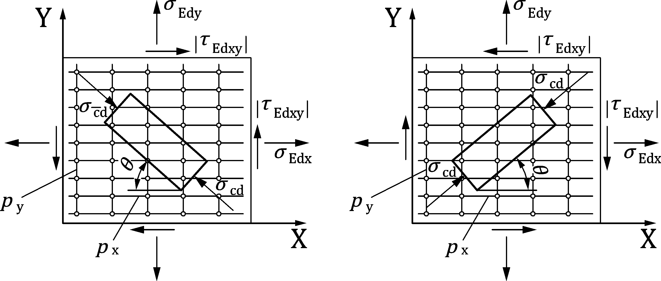

Figure G.1 — In-plane stresses in membrane element and definition of compression stress field inclination θ

(2) The tensile strengths provided by reinforcement are:

|  |  |  |
| --- | --- | --- |
| ftdx = ρx | fyd,x | (G.1) |
| ftdy = ρy | fyd,x | (G.2) |

where ρx and ρy are the geometric reinforcement ratios along the x- and y-axes, respectively.

NOTE The yield strength can be different in the x- and y-directions.

(3) The necessary reinforcement and the compressive concrete stress may be determined by:

|  |  |
| --- | --- |
|  | (G.3) |
|  | (G.4) |
|  | (G.5) |

where cotθ should be chosen to avoid negative values of ftdx and ftdy.

The choice of cotθ to obtain the least amount of required reinforcement resistances ftdx* and ftdy* (optimum reinforcement) is given in Table G.1,

where

|  |  |
| --- | --- |
| θ* | is the strut inclination corresponding to the optimal reinforcement for membrane elements; |
| ftdx*, ftdy* | are the tensile strength along the x- and y-axes, respectively, corresponding to the optimal reinforcement for membrane elements; |
| σcd* | is the compression stress in the concrete inclined at the angle θ* corresponding to the optimal reinforcement for membrane elements. |

In order to ensure the required deformation capacity, and unless more refined calculations are performed, the reinforcement derived from Formulae (G.3) and (G.4) for each direction should not deviate significantly from the reinforcement resistances ftdx* and ftdy* determined according to Table G.1. These limitations may be expressed by:

|  |  |
| --- | --- |
| 0,4ftdx* ≤ ftdx ≤ 2,5 ftdx*and | (G.6) |
| 0,4ftdy* ≤ ftdy ≤ 2,5 ftdy*. | (G.7) |

Table G.1 — Optimum reinforcement, concrete stress and strut inclination for membrane elements

| Conditions | cot θ* | ftdx* | ftdy* | σcd* |
| --- | --- | --- | --- | --- |
|  | 1 |  |  |  |
|  |  | 0 |  |  |
|  |  |  | 0 |  |

(4) The reinforcement should be fully anchored at free edges, e.g. by headed bars, U-bars or similar.

(5) In absence of a refined calculation, the reduction factor of concrete may be assumed as:

|  |  |
| --- | --- |
| ν = 0,4 | (G.8) |

(6) A more refined calculation of the reduction factor of concrete may be performed using:

|  |  |
| --- | --- |
| $$ν=\frac{1}{1,0+110⋅ε_{1}}≤1,0$$ | (G.9) |

where ε1 is the principal strain transverse to the direction of the concrete stress field accounting for strain compatibility and considering concrete as cracked without tensile strength.

(7) The value of the principal strain ε1 in Formulae (G.9) may be estimated from one of the two following formulae:

|  |  |
| --- | --- |
| $$ε_{1}=ε_{x}+(ε_{x}+0,001)\cot^{2}θ$$ | (G.10) |
| $$ε_{1}=ε_{y}+\frac{\left(ε_{y}+0,001\right)}{\cot^{2}θ}$$ | (G.11) |

where εx and εy are the normal strains (positive as tension) in the x- and y-axes. A simple estimate of ε1 may be obtained by using the following guidelines in cases where cotθ is known:

1. Formulae (G.10), with εx taken as fyd/ESd, may be used in cases where ftdy = 0.   
   Formulae (G.11), with εy taken as fyd/ESd, may be used in cases where ftdx = 0.
2. ε1 is the larger of Formulae (G.10) and (G.11), with εx and εy taken as fyd/ESd, in cases where reinforcement is required in both directions.
3. ε1 may be taken as fctd/Ecd if ftdx and ftdy according to calculations are smaller than fctd, and provided the member is not cracked due to other types of action.
4. In (a) and (b) above, fyd/ESd may be replaced by fyd/(λESd); if the reinforcement in both directions is increased by a factor of λ > 1 beyond the required amount.

where λ is the ratio between the provided amount and the required amount.

* 1. Design of shell- and slab elements in ULS

(1) Tension reinforcement to resist combinations of in-plane forces, bending moments and torsional moments in shell elements (Figure G.2a)) may be determined by adopting a sandwich model (Figure G.2b)), where the sectional forces are transformed into a set of statically equivalent in-plane stresses acting in the top and bottom layer of the sandwich model. The design tension reinforcement in each of the two layers may then be calculated by the method outlined above for in-plane stress conditions (membrane elements, see G.3).

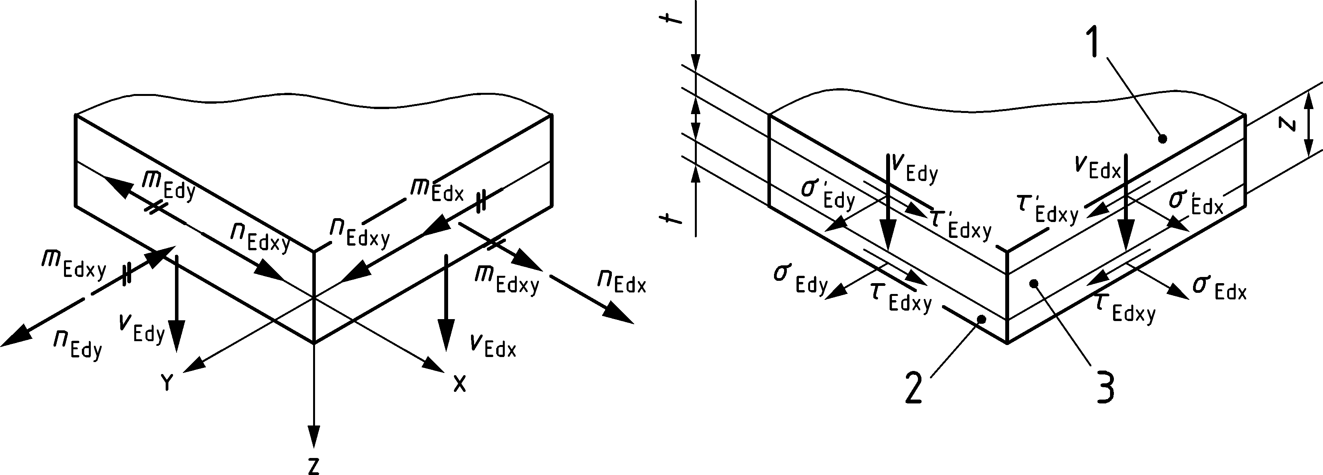

Key

|  |  |
| --- | --- |
| 1 | top layer |
| 2 | bottom layer |
| 3 | intermediate layer |

|  |  |
| --- | --- |
| mEdx; mEdy | Design bending moments per unit length |
| mEdxy | Design torsional moment per unit length |
| nEdx; nEdy | Design in-plan normal force per unit length |
| nEdxy | Design in-plan shear force per unit length |
| vEdx; vEdy | Design out of plan shear force per unit length |

All design actions are positive as shown.

Figure G.2 — (a) Shell element and (b) sandwich model with statically equivalent set of in-plane stresses

(2) The set of statically equivalent in-plane stresses may be calculated as follows:

1. Stresses in bottom layer:

|  |  |
| --- | --- |
| $$σ_{Edx}=\frac{\frac{1}{2}n_{Edx}}{t}+\frac{m_{Edx}}{t⋅z}$$ | (G.12) |
| $$σ_{Edy}=\frac{\frac{1}{2}n_{Edy}}{t}+\frac{m_{Edy}}{t⋅z}$$ | (G.13) |
| $$τ_{Edxy}=\frac{\frac{1}{2}n_{Edxy}}{t}-\frac{m_{Edxy}}{t⋅z}$$ | (G.14) |

1. Stresses in top layer:

|  |  |
| --- | --- |
| $$σ'_{Edx}=\frac{\frac{1}{2}n_{Edx}}{t}-\frac{m_{Edx}}{t⋅z}$$ | (G.15) |
| $$σ'_{Edy}=\frac{\frac{1}{2}n_{Edy}}{t}-\frac{m_{Edy}}{t⋅z}$$ | (G.16) |
| $$τ'_{Edxy}=\frac{\frac{1}{2}n_{Edxy}}{t}+\frac{m_{Edxy}}{t⋅z}$$ | (G.17) |

where

|  |  |
| --- | --- |
| t | is the thickness of the top and bottom layer; |
| z | is the internal lever arm between the top and bottom layer. |

(3) If beneficial, the intermediate layer may also be utilized to carry portions of the in-plane forces (nEdx, nEdy and nEdxy). In that case, the set of equivalent stresses in the layers should be modified accordingly.

(4) Out of plane shear forces, vEdx and vEdy, shall be verified according to 8.2 using the design shear force according to Formula (8.12).

(5) The particular case where nEdx = nEdy = nEdxy = 0 (slabs without membrane forces) may be treated according to 8.1.3; Tables G.2 and G.3 giving the least amount of required reinforcement (optimum reinforcement). Alternatively, and provided that the thickness of the compression zone x ≤ 0,25d and the torsional moment is not larger than 0,5 times the largest bending moment, the following formulae may be used:

|  |  |
| --- | --- |
|  | (G.18a) |
|  | (G.18b) |
|  | (G.18c) |
|  | (G.18d) |

Where θtop and θbot denote the inclination of the compression stress fields in the top and the bottom layers carrying torsion, respectively. The values for cotθtop and cotθbot are positive and may be chosen freely, but should for each of the four formulae lead to a required moment capacity that is between 0,4 to 2,5 times the corresponding optimum moment capacity (see Tables G.2 and G.3).

Table G.2 — Optimum tension reinforcement in bottom layer expressed as required design moment capacities for slab elements

| Conditions | Required capacity mRdx | Required capacity mRdy |
| --- | --- | --- |
|  |  |  |
|  | 0 |  |
|  |  | 0 |
| $$\begin{aligned}m_{Edx}<0 \\ m_{Edy}<0 \\ m_{Edx}m_{Edy}>m_{Edxy}^{2}\end{aligned}$$ | 0 | 0 |
| NOTE Hogging moments with negative sign. | | |

Table G.3 — Optimum tension reinforcement in top layer expressed as required design moment capacities for slab elements

| Conditions | Required capacity m′Rdx | Required capacity m′Rdy |
| --- | --- | --- |
|  |  |  |
|  | 0 |  |
|  |  | 0 |
|  | 0 | 0 |
| NOTE Hogging moments with negative sign. | | |

* 1. Refined control of cracking in membrane elements in SLS

(1) If in members reinforced in two orthogonal directions the angle θ between the axes of principal compressive strain and the direction of the reinforcement in the x-direction is larger than 15°, the crack width may be calculated with Formula (9.12), where the maximum crack spacing sr,max may be used according to Formula (G.19) and the strain difference (εsm − εcm) according to Formula (9.13):

|  |  |
| --- | --- |
| $$s_{r,m,cal}=\frac{1}{\frac{sinθ}{s_{r,m,cal,x}}+\frac{cosθ}{s_{r,m,cal,y}}}$$ | (G.19) |

where

|  |  |
| --- | --- |
| sr,m,cal,x, sr,m,cal,y | are the crack spacings calculated in the x and y directions respectively, according to 9.2.4 (5), |

where ε1 is taken from Formulae (G.10) or (G.11) with the following additional conditions:

* εx is taken as σs,x/Es where σs,x is the stress in the reinforcement in the direction of the member axis (x) for the relevant combination of actions;
* εy is taken as σs,y/ Es where σs,y is the stress in the reinforcement in the y direction for the relevant combination of actions;
* Conservatively, θ may be determined from linear elastic analysis.
* A better approximation may be obtained by solving Formula (G.20) for θ.

|  |  |
| --- | --- |
| $$\frac{τ}{ρ_{x}}\cot^{4}θ+\frac{σ_{x}}{ρ_{x}}\cot^{3}θ-\frac{σ_{y}}{ρ_{y}}cotθ-\frac{τ}{ρ_{y}}=0$$ | (G.20) |

where

|  |  |
| --- | --- |
| τ | is the shear stress at the point where the crack is being determined. |

1. (informative)  
     
   Guidance on design of concrete structures for water-tightness
   1. Use of this annex

(1) This informative annex provides supplementary guidance on the design of concrete structures that shall be tight against leakage either from water inside storage volumes, or external water like ground water.

NOTE National choice on the application of this Informative Annex is given in a National Annex. If a National Annex contains no information on the application of this Informative Annex, it can be used.

* 1. Scope and field of application

(1) This Informative Annex applies mainly to water tightness of concrete structures. It may be used also for other liquids if it can be shown that the liquid behaviour is similar to water.

* 1. General

(1) Concrete in watertight structures should have an adequate composition to obtain low permeability i.e. should have a low water-cement ratio, be rich in fines and meet limitation of maximum aggregate size when the dimensions are close to the minimum values given in (3).

(2) Minimum thickness of members where tightness class TC 0 (see Table H.1) is satisfactory should be 120 mm. A minimum thickness of 150 mm should be provided for other tightness classes.

(3) The concrete sections shall be designed with adequate reinforcement to ensure good crack distribution and limitation of crack-widths in accordance with 9.2.

NOTE Fibre reinforced concrete (FRC) or post-tensioning can be more sustainable alternatives to large reinforcement ratios to limit crack width.

* 1. Tightness classes
     1. Classification

(1) Water retaining structures may be classified in relation to the degree of required protection against leakage according to Table H.1.

NOTE 1 All concretes permit the passage of small quantities of liquids and gases by diffusion.

Table H.1 — Classification of tightness

| Tightness Class | Requirements for leakage |
| --- | --- |
| TC 0 | Some degree of leakage acceptable, or leakage of water irrelevant |
| TC 1 | Leakage to be limited to a small amount. Some surface staining or damp patches acceptable. |
| TC 2 | Leakage to be minimal. Appearance not to be impaired by staining. |
| TC 3 | No leakage is permitted. |

NOTE 2 The tightness classes can be defined quantitatively on a project-specific basis by specifying the leakage rate and relating it to the crack opening by using H.4.2 (7).

* + 1. Tightness requirements

(1) Appropriate limits to cracking depending on the tightness class of the element considered should be selected, paying due regard to the required function of the structure. In the absence of more specific requirements, the following may be adopted:

|  |  |
| --- | --- |
| TC 0 – | the provisions of 9.2.1 may be adopted. |
| TC 1 – | the width of any cracks expected to pass through the full thickness of the section should be limited to wk,lim1 given in (2). 9.2.1 applies where the full thickness of the section is not cracked. |
| TC 2 – | cracks which may be expected to pass through the full thickness of the section should generally be avoided unless appropriate measures (e.g. liners or water barriers) have been incorporated. |
| TC 3 – | generally, special measures (e.g. liners or prestress) will be required to ensure water-tightness. |

(2) The values of wk,lim1 may be defined on a project-specific basis. They may be defined as a function of the ratio of the hydrostatic head hD to the thickness of the member hD/h, as follows:

* for hD/h ≤ 5: wk,lim,1 = 0,20 mm;
* for hD/h ≥ 35: wk,lim,1 = 0,05 mm.

For intermediate values of hD/h, linear interpolation may be used.

(3) Limitation of the crack widths to these values typically results in the effective sealing of the cracks within a relatively short time. To account for pressurized structures, in the previous expressions hD can to be substituted by the ratio of the pressure to the specific weight of water (p/γwater).

(4) To provide adequate assurance for structures of classes TC 2 or TC 3 that cracks do not pass through the full width of a section, the design value of the depth of the compression zone should be at least xmin under the quasi-permanent combination of actions. Where a section is subjected to alternate actions, cracks should be considered to pass through the full thickness of the section unless it can be shown that some part of the section thickness will always remain in compression. This thickness of concrete in compression should normally be at least xmin under all appropriate combinations of actions. The action effects may be calculated on the assumption of linear elastic material behaviour assuming that concrete in tension is neglected.

NOTE 1 xmin is the lesser of 50 mm or 0,2h where h is the element thickness unless a National Annex gives different values.

(5) Cracks through which water flows may be expected to heal in members which are not subjectted to significant changes of loading or temperature during service. In the absence of more reliable information, healing may be assumed where the expected range of strain in the reinforcement, assuming cracked properties, at a section under service conditions is less than 150 ⋅ 10−6.

NOTE If self-healing is unlikely to occur, any crack which passes through the full thickness of the section can lead to leakage, regardless of the crack width.

(6) Design of members that are subjected to tensile stresses due to the restraint of shrinkage or thermal movements should account for these effects according to Annex D.

NOTE Annex D gives information on the evaluation of early-age and long-term cracking due to restraint.

(7) Acceptance criteria for water retaining structures may include maximum level of leakage. The leakage rate q may be approximately estimated on the basis of an equivalent crack width under the assumption of a laminar flow given by:

|  |  |
| --- | --- |
| q = wk,cal,e3 ⋅ Δp ⋅ lw,p/(96 h ⋅ η) | (H.1) |

where the equivalent crack width is

|  |  |  |
| --- | --- | --- |
| $$w_{k,cal,e}=\sqrt[3]{\frac{2w_{k,cal,1}^{2}⋅w_{k,cal,2}^{2}}{w_{k,cal,1}+w_{k,cal,2}}}$$ | | (H.2) |
| Δp | is the pressure difference [N/m²]; | |
| lw,p | is the length of the passing crack [m]; | |
| η | is dynamic viscosity (η = 1,3 ⋅ 10−3 Ns/m2 for water); | |
| h | is depth of the cross section [m]. | |

wk,cal,1 and wk,cal,2 are the crack widths on the two surfaces calculated for the nominal concrete cover.

NOTE As the leakage rate depends on the crack width, which exhibits a large scatter both in itself as well as in the actual cracking pattern which will form in a real structure, real values of leakage will deviate from the calculated values.

1. (informative)  
     
   Assessment of Existing Structures
   1. Use of this annex

(1) This informative annex supplements provisions in this Eurocode for the assessment of existing structures in plain, reinforced and prestressed concrete. Annex I covers also the assessment of the retained parts of existing concrete structures, that are being modified, extended, strengthened or retrofitted, in case of projects where new structural members are to be combined with retained parts of existing concrete structures.

* 1. Scope and field of application

(2) This informative annex covers:

— additional rules for materials and system not defined in Clause 5 (e.g. plain bars);

— additional rules for assessing existing structures where detailing does not comply

— with the provisions in Clauses 11 and 12;

— additional rules for anchorage of plain bars;

— considerations for deterioration of existing structures.

* 1. General

NOTE Unless noted otherwise, in Annex I all section/sub-section numbers and titles are similar as the relevant of the main part of this Eurocode. The prefix ‘I’ is added to clauses numbers to distinguish content that pertain to assessment of existing concrete structures. Annex I contains only sections/subsections of the main part of this Eurocode that include specific clauses for the assessment of existing concrete structures.

(1) All clauses of this Eurocode are generally applicable to the assessment of existing concrete structures, unless substituted by the provisions given in Annex I.

(2) Annex I does not provide predictive methods for estimating deterioration rates associated with the various deterioration mechanisms for concrete structures. These should be undertaken using methods specified by the relevant authority or, where not specified, as agreed for a specific assessment by the relevant parties.

(3) Design values determined in accordance with this Eurocode may be interpreted as assessment values for the purpose of Annex I.

(4) The following assumptions apply for the assessment of existing concrete structures:

* Reasonable skill and care appropriate to the circumstances is exercised in the assessment, based on the knowledge and good practice generally available at the time the structure is assessed.
* The assessment of the structure is made by appropriately qualified and experienced personnel.
* Adequate supervision and quality control is provided during the assessment process.
* The structure will be used and maintained in accordance with the assessment assumptions.
  1. Basis of assessment
     1. General rules
        1. Basic requirements

(1) For details not fulfilling the requirements of this Eurocode, the consequence for the structural safety should be identified. In these cases, assessment based on adequate models and testing (in accordance with prEN 1990) may be used.

* + - 1. Effects to be considered in the assessment of deteriorated structures

(1) In case of concrete structures affected by deterioration, where applicable the assessment should take into account the following effects:

— reduced concrete section due to delamination and spalling;

— reduction of cross sectional area and ductility of the reinforcement;

— stress concentration due to localized corrosion (e.g. prestressing steel);

— stress corrosion (e.g. prestressing steel);

— reduced concrete-steel bond;

— loss of mechanical properties of concrete (e.g. sulphate attack, AAR and DEF, frost attack, leaching and acid attack);

— cracking or expansion of concrete (swelling due to AAR and DEF).

NOTE 1 The most common deterioration mechanisms which can affect concrete structures are:

— reinforcement corrosion;

— external sulphate attack;

— Alkali-Aggregate Reaction (AAR) and other expansive reactions (e.g. Delayed Ettringite Formation, DEF);

— frost attack;

— leaching and acid attack.

NOTE 2 Formulae given in this Eurocode can be invalid in case of deterioration (e.g. Young modulus of concrete in case of AAR, steel ductility in case of pitting corrosion).

NOTE 3 Pitting corrosion due to chlorides is often not accompanied by other types of corrosion and hence it can be hardly detected by visual inspection of the structural member surface.

NOTE 4 Some older quenched and tempered steel and bars can have a lower toughness and a higher risk for stress corrosion.

NOTE 5 The effect of corrosion influences also model uncertainties and, hence, the resistance models.

* + 1. Verification by the partial factor method
       1. Partial factors for assessment

(1) In the absence of tests made on the existing structures to assess the mechanical characteristics of materials, the partial factors for materials given in Table 4.3(NDP) should be used for assessment.

(2) If tests are made on the existing structure to assess the mechanical characteristics of materials, the partial factors for materials given in Table 4.3(NDP) may be adjusted according to Annex A by using the actual mean values and coefficients of variation derived by tests, unless the coefficient of variation of concrete core strength $V_{fc,is}$ is greater than $V_{fc,is,lim}$, in which case the partial factors for concrete should be adjusted according to Annex A by using the actual mean values and coefficients of variation derived by tests. The results of tests undertaken during the construction may also be used for this purpose. $V_{fc,is,lim}$ is a parameter which depends on the number of test results according to Table I.1(NDP).

NOTE 1 The values of $V_{fc,is,lim}$ given in Table I.1(NDP) apply unless a National Annex gives different values.

NOTE 2 Information from test results can be combined with prior information if available.

Table I.1 (NDP) — Values of $V_{fc,is,lim}$ as function of the number of sample n

|  |  |  |  |  |  |  |  |
| --- | --- | --- | --- | --- | --- | --- | --- |
| n | 8 | 10 | 12 | 16 | 20 | 30 | ∞ |
| $$V_{fc,is,lim}$$ | 0,13 | 0,15 | 0,17 | 0,20 | 0,21 | 0,23 | 0,29 |

* 1. Materials
     1. General

(1) For materials not meeting the requirements of normative documents included in Clause 2, the mechanical characteristics to be used according to this Eurocode, should be derived from tests and/or design and construction records and the use of the provisions in this Eurocode or of alternative approaches present in technical and scientific literature should be justified.

(2) Testing of materials should be undertaken in accordance with normative documents included in Clause 2. If such tests cannot be performed, alternative test methods may be used when specified by the relevant authority or, where not specified, agreed for a specific assessment by the relevant parties. The effect of the alternative test method should be taken into account when deriving the mechanical characteristics to be used according to this Eurocode.

* + 1. Concrete
       1. General

(1) EN 13791:2019, Clause 8 should be used for the determination of the characteristic value $f_{ck,is}$ in-situ compressive strength of concrete cores.

(2) The investigation of concrete should aim mainly to determine the compressive strength in specific areas of the structure. If deterioration does not significantly influence the other mechanical properties (e.g. modulus of elasticity, tensile strength), these may be determined indirectly based on the compressive strength, by using the formulae included in 5.1, if no specific investigation is conducted.

(3) If $f_{ck}$ is assessed by using in-situ testing, this may be estimated from $f_{ck,is}$ according to Formula (I.1):

|  |  |
| --- | --- |
| $$f_{ck}=\frac{f_{ck,is}}{k_{μfc}}$$ | (I.1) |

where the values of $k_{μfc}$ are given in Table I.2(NDP).

Table I.2(NDP) — Parameter $k_{μfc}$ considering the representativeness of the in-situ compressive concrete strength assessed according to EN 13791:2019, Clause 8 in Formula (I.1)

|  |  |
| --- | --- |
| Regions and conditions of the structural member where the cores are extracteda | $$k_{μfc}$$ |
| a) Cores extracted only from the bottom parts of the concrete masses during casting (lower 70 % of the depth of concrete during casting) not necessarily representing the governing region for the verification | 0,95 |
| b) Cores extracted from different regions representing all conditions in the structural member, but not necessarily representing the governing region for the verification | 0,90 |
| c) Cores extracted from the region governing for the verification | 0,85 |
| NOTE The parameters given in Table I.2(NDP) apply unless a National Annex gives different values. | |
| a The in-situ concrete compressive strength can exhibit significant variations depending on the location (strength typically smaller in the upper part of the element during casting) | |

(4) If $D_{lower}$ and/or $D_{upper}$ are not known, they may be replaced by $D_{max}$. $D_{max}$ may be assessed by testing on the existing structure and or by using original design and construction records.

* + - 1. Assessment assumptions

(1) When the concrete strength is assessed in an existing structure, the factor $k_{tc}$ in 5.1.6(1) shall take into account the effects of stress level and duration of loading.

NOTE The following value of $k_{tc}$ applies unless a National Annex gives different values:

* $k_{tc}=0,85$ in case the effect of the permanent action (and/or variable actions of duration > 1 hour) represents 100 % of the total effect at assessment level;
* $k_{tc}=1,00$ when the effect of rapid variable actions (actions of duration < 1 hour) represents at least 20 % of the total effect at assessment level;

for intermediate cases (effect of rapid actions between 0 % and 20 % of the total load effect at design level), $k_{tc}$ is determined by linear interpolation between 0,85 and 1,00.

* + 1. Reinforcing steel

(1) Where the characteristic values of the properties of reinforcing steel are assessed from testing, the number, location and size of the test specimens should be selected to be representative of the elements being assessed. In this case, the properties of reinforcing steel should be tested in accordance with EN ISO 15630 (all parts). Shorter samples may be tested if:

— the test results give no grounds for justified doubts;

— no signs of deterioration are discerned;

— the ultimate resistance is not sensitive to length of specimens.

NOTE 1 The strengths of different size and types of steel component can have significantly different probability distributions.

NOTE 2 As it is not usually known which reinforcing steel originates from a single batch, there can be a need to investigate the possibility of multiple batches being used within the location being assessed. This would involve a larger number of specimens being tested and some engineering judgement to be used regarding the data analysis and the scope of application of the resulting strengths.

NOTE 3 Information from test results can be combined with prior information if available.

(2) Where the characteristic value of the properties of reinforcing steel is calculated based on sample testing, the characteristic value $X_{k}$ should be determined as given in Formula (I.2):

|  |  |
| --- | --- |
| $$X_{k}=e^{\left(m_{X}-k_{n}{∙s}_{X}\right)}$$ | (I.2) |

where

|  |  |
| --- | --- |
| $$m_{X}=\frac{1}{n}\sum{\ln{x_{i}}}$$ | (I.3) |

the value of $k_{n}$ may be taken from Tables I.3 and I.4 for 5 % and 10 % characteristic value respectively.

For the evaluation of $s_{X}$ and when using Tables I.3 and I.4, one of two cases should be considered:

* **Case 1:** The row ‘ $V_{X}$ known’ should be used if the coefficient of variation $V_{X}$, or a realistic upper bound of it, is known from prior knowledge; in this case $s_{X}$ should be taken from Formula (I.4):

|  |  |
| --- | --- |
| $$s_{X}=\sqrt{\ln\left(V_{X}^{2}+1\right)}$$ | (I.4) |

NOTE 4 Prior knowledge might come from the evaluation of previous tests in comparable situations. Engineering judgment may be used to determine what can be considered as ‘comparable’.

* **Case 2:** The row ‘ $V_{X}$ unknown’ should be used if the coefficient of variation $V_{X}$ is not known from prior knowledge and so needs to be estimated from the sample; in this case $s_{X}$ and $V_{X}$ should be taken from Formulae (I.5) and (I.6), respectively:

|  |  |
| --- | --- |
| $$s_{X}=\sqrt{\frac{1}{n-1}\sum{{\left(\ln{x_{i}-m_{x}}\right)}^{2}}}$$ | (I.5) |
| $$V_{X}=\frac{s_{X}}{m_{X}}$$ | (I.6) |

Table I.3 — Values of $k_{n}$ for the 5 % characteristic value

|  |  |  |  |  |  |  |  |  |  |  |  |  |
| --- | --- | --- | --- | --- | --- | --- | --- | --- | --- | --- | --- | --- |
| N | 1 | 2 | 3 | 4 | 5 | 6 | 8 | 10 | 15 | 20 | 30 | ∞ |
| $$V_{X}$$ Known | 2,31 | 2,01 | 1,89 | 1,83 | 1,80 | 1,77 | 1,74 | 1,72 | 1,70 | 1,68 | 1,67 | 1,64 |
| $V_{X}$ unknown | – | – | 3,37 | 2,63 | 2,33 | 2,18 | 2,00 | 1,92 | 1,82 | 1,76 | 1,73 | 1,64 |

Table I.4 — Values of $k_{n}$ for the 10 % characteristic value

|  |  |  |  |  |  |  |  |  |  |  |  |  |
| --- | --- | --- | --- | --- | --- | --- | --- | --- | --- | --- | --- | --- |
| n | 1 | 2 | 3 | 4 | 5 | 6 | 8 | 10 | 15 | 20 | 30 | ∞ |
| $$V_{X}$$ known | 1,81 | 1,57 | 1,48 | 1,43 | 1,40 | 1,38 | 1,36 | 1,34 | 1,32 | 1,31 | 1,30 | 1,28 |
| $$V_{X}$$ unknown | – | – | 2,18 | 1,83 | 1,68 | 1,59 | 1,50 | 1,45 | 1,39 | 1,36 | 1,33 | 1,64 |

(3) If sufficient information is available, the mechanical characteristics of ribbed bars may be determined based on marking on the bar surface.

* + 1. Prestressing steel

(1) I.5.3 applies also for prestressing steel.

* 1. Durability - Minimum cover for bond

(1) If the actual cover is less than $c_{min,b}$ the effect on the anchorage and lap length may be determined according to I.11.4.1.

NOTE The actual cover to evaluate the anchorage and lap length can be assessed by using original design and construction records and/or testing on the existing structure.

(2) $c_{min,b}$ for square section plain bars should be taken equal to $ϕ_{sq,eq}$ defined in I.11.4.1.

* 1. Structural analysis
     1. Methods of analysis
        1. General

(1) When linear analysis with limited redistribution, plastic analysis or non-linear analysis is performed, the effect of reduced ductility of deteriorated concrete and reinforcement should be taken into account.

* + - 1. Linear elastic analysis with limited redistribution

(1) In addition to 7.3.2, linear elastic analysis with limited redistribution under the ultimate limit state may be carried out if shear forces and support reactions used in assessment are taken as the greater of those calculated either prior to, or after redistribution.

* + 1. Prestressed members and structures
       1. General

(1) When tendon corrosion is encountered in the assessment, the normal rules for prestressed concrete should be modified by taking into account the following:

a) Strands, wires or bars which have suffered sectional loss that has resulted in them being unable to sustain their prestress force should be considered ineffective at that section. The strength of a section at the ultimate limit state should be based on the remaining cross sectional area of the effective strands, wires or bars only.

b) Bonded post-tensioning tendons which are ineffective locally can re-anchor and become fully effective elsewhere. Such tendons should be considered in the assessment only if the quality of grouting in the ducts allows anchorage of the design strength of the prestressing steel.

c) Where there is evidence of extensive inadequate grouting, the possible re-anchorage of tendons should not be considered in the assessment without further investigation. If the grouting is too poor to allow re-anchorage of tendons, the member should be treated as unbonded and assessed accordingly.

d) The reduction of ductility due to corrosion should be taken into account.

* + - 1. Prestressing force

(1) The maximum prestressing force assumed to be applied should be derived from the original design and construction records or, if not available from documented information for the applied prestressing system valid at the time of construction. If the prestressing level is not known, the effect of variation in the prestressing force should be subject to sensitivity analysis. The actual prestressing force may be measured by in-situ testing.

* 1. Ultimate Limit States (ULS)
     1. General

(1) The section properties used to assess section resistance of deteriorated structures should be consistent with those used in the analysis where relevant.

(2) The following should be considered as possible consequences of reinforcement corrosion, causing cracking and spalling of concrete cover, on cross sectional dimensions:

* for corrosion penetration depth $P_{x}≥0,2/0,4 mm$, a reduced concrete section may be considered due to spalling ignoring the cover depth around the corroded bars;
* for low/medium $P_{x}$ (i.e. $P_{x}<0,2/0,4 mm$), it may be assumed that the complete concrete section contributes to the resistance with a reduced compressive strength of concrete due to cracking.

NOTE 1 For the definition of corrosion penetration depth $P_{x}$ see I.3.1.

NOTE 2 Concrete spalling does not only depend on the level of corrosion but also on the ratio of longitudinal and transverse reinforcement, diameter of the bars, etc.

(3) The following should be considered as possible consequences of corrosion on ordinary reinforcement:

* for compressed ordinary reinforcement, a reduced reinforcement strength should be considered due to possible bar buckling before the maximum load is reached, if stirrups are heavily corroded (relevant $P_{x}$ or pits);
* in shear the possibility of premature failure of stirrups due to pitting corrosion should be considered;
* for $P_{x}≥0,2÷0,4 mm$ and/or pitting corrosion:
* a reduction of elongation at maximum stress can be expected and should be considered for the verifications at ULS;
* a concentration of the active stress at pits should be considered;
* low/medium $P_{x}$ (i.e. $P_{x}<0,2÷0,4 mm$) may be assumed not to affect the stress-strain deformation relationships of ordinary reinforcement.
  + 1. Bending with or without axial force

(1) Where aspects of detailing are present that do not comply with the provisions of this Eurocode the effects on the resistance should be assessed.

NOTE In addition to the effects on bond, low concrete cover can be relevant for other effects such as buckling of bars in compression.

* + 1. Shear
       1. Detailed verification of members not requiring design shear reinforcement

(1) As an alternative to 8.2.2(2) to (5), the design value of the shear stress resistance of members without shear reinforcement may be calculated as follows:

|  |  |
| --- | --- |
| $$τ_{Rd,c}=\frac{0,33}{γ_{V}}∙\frac{γ_{def}^{2/3}}{γ_{v}^{2}}⋅\frac{\sqrt{f_{ck}}}{1+24γ_{def}⋅ε_{v}⋅\frac{d}{d_{dg}}}$$ | (I.7) |

where

|  |  |
| --- | --- |
| εv | is the strain in the longitudinal reinforcement according to (2) which considers implicitly all effects covered by 8.2.2(3) to (4); |
| γdef | is a partial safety factor which covers the uncertainties related to the calculation of the deformation. |

NOTE γdef = 1,33 unless a National Annex gives a different value.

The shear stress resistance τRd shall be not smaller than the design value of the shear stress τEd calculated according to 8.2.1(3) for a cross section defined with the principles of 8.2.2(1), but located not closer than d/2 from a support, a concentrated load or a discontinuity.

(2) The strain in the longitudinal tensile reinforcement εv at control section should be calculated according to the assumptions of 8.1.1 where a non-linear analysis of the structure may be performed. For planar members, it refers to the principal direction of the shear force according to 8.2.1(5) and may be averaged over the same width defined in 8.2.1(6).

(3) For linear members with an effective depth d > 500 mm, the approach described in (1) and (2) should be used instead of the method of 8.2.2 or, alternatively, the resistances according to Formula (8.16) should be multiplied with following coefficient:

|  |  |
| --- | --- |
|  | (I.8) |

* + - 1. Detailed verification of members requiring design shear reinforcement

(1) The assessment of members requiring design shear reinforcement may be conducted stepwise as follows:

i. with the simplified method according to 8.2.3(1) to (5) without explicit calculation of strains;

ii. with the refined method according to 8.2.3(6) with explicit calculation of strains;

iii. according to Annex G where the strain compatibility is accounted for;

iv. with a refined nonlinear analysis according to 7.3.4.

(2) For members with shear reinforcement of ductility class B or C not complying with the requirement of minimum reinforcement ratio ρw,min according to 12.2(4) (e.g. designed according to previous standards or for cases where the actual fck is higher than assumed during the design), the shear resistance may be calculated according to:

|  |  |
| --- | --- |
| $$τ_{Rd}=τ_{Rd,c}+\frac{ρ_{w}}{ρ_{w,min}}\left(τ_{Rd,w}-τ_{Rd,c}\right)≥τ_{Rd,c}$$ | (I.9) |

where τRd,w is the shear resistance calculated according to 8.2.3 of the member with ρw = ρw,min.

(3) For members not complying with the requirement of maximum longitudinal spacing s of shear reinforcement according to Table 12.1, unless more refined models are used, the shear resistance τRd,sy according to Formula (8.27) should be multiplied with coefficient kns and the stress in the compression field σcd according to Formula (8.29) should be divided by coefficient kns which can be calculated as follows:

|  |  |
| --- | --- |
| $$k_{ns}=1-\frac{s}{zcotθ}$$ | (I.10) |

(4) If the transverse spacing of shear legs in an existing member is larger than the maximum value given in 12.3.1 and 12.4.1 for beams and slabs respectively, and if both 8.2.1(1)(i) and 8.2.1(1)(ii) are not fulfilled, the shear resistance should be evaluated by considering the value for the width of the cross section $b_{w}$ given in formula (I.11) unless more refined models that consider the existing shear legs are used to evaluate shear resistance.

|  |  |
| --- | --- |
| $$b_{w}=\sum_{i=1}^{n}{b_{w,i}}$$ | (I.11) |

where

|  |  |  |
| --- | --- | --- |
| n | is the number of legs in the cross section; | |
| $${b_{w,i}=b}_{w,i-1}+b_{w,i+1}$$ | | (I.12) |
| $$b_{w,i-1}≤\left\{\begin{aligned}\frac{b_{i-1}}{2} \\ \frac{mtssl}{2}\end{aligned}\right.$$ | | (I.13) |
| $$b_{w,i+1}≤\left\{\begin{aligned}\frac{b_{i+1}}{2} \\ \frac{mtssl}{2}\end{aligned}\right.$$ | | (I.14) |
| mtssl | is the maximum value of the transverse spacing of shear legs given in in 12.3.1 and 12.4.1 for beams and slabs respectively; | |
| $b_{w,i-1}$ and $b_{w,i+1}$ are defined in Figure I.1. | | |

|  |  |
| --- | --- |
|  |  |
| a) edge leg | b) interior leg |

Figure I.1 — Definition of $b_{w,i}$ (beam/slab cross section)

(5) The favourable effect of the presence of compression flanges may be accounted for by determining the location of the governing control section considering an additional distance cf with respect to concentrated loads of reaction forces acting on compression flanges as shown in Figure I.2:

|  |  |
| --- | --- |
| $$c_{f}=3t_{f}\sqrt{\frac{A_{f}}{A_{w}}}$$ | (I.15) |

where Af = min{bf ∙ tf; 6tf 2} and Aw = min{bw ∙ z; 8bw2}.

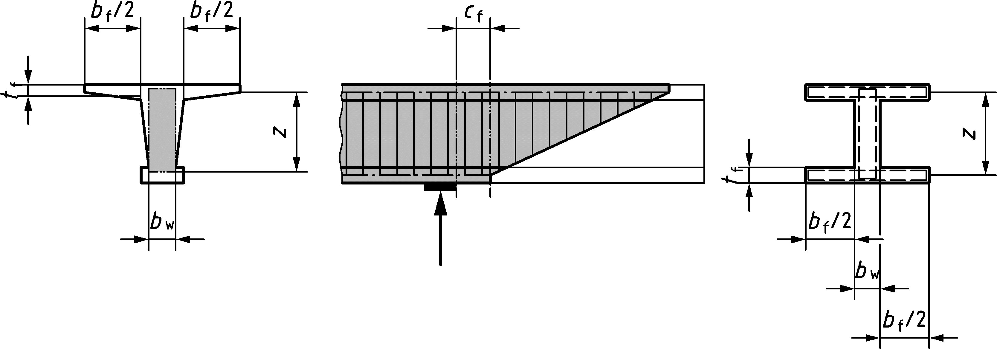

**Key**

|  |  |
| --- | --- |
| 1 | control section |

Figure I.2 — Location of control section in presence of compression flanges

* + - 1. Shear at interfaces

(1) In the parts of a composite slab where the spacing between interface reinforcement in the shear transfer direction does not fulfil 8.2.6(9), the interface reinforcement should be considered in interface shear verifications only for the parts of the slab (in the shear transfer direction) that have length, for each reinforcing bar crossing the interface, equal to $1,25h≤150 mm$ per each side (in the shear transfer direction) of the bar, unless more refined models that consider the existing interface reinforcement are used to evaluate shear resistance at the interface.

(2) In the parts of a composite slab where the spacing between interface reinforcement perpendicular to the shear transfer direction does not fulfil 8.2.6(9), the interface reinforcement should be considered in shear at interface verifications only for that part of the slab that has a width, for each reinforcing bar crossing the interface, equal to $2,5h≤375 mm$ (≤ the distance from the edge for an edge bar) per each side of the bar, unless more refined models that consider the existing interface reinforcement are used to evaluate shear resistance at interface.

* + 1. Torsion and combined actions

(1) Unless more refined methods of analysis are used, stirrups having spacing larger than the minimum of u/8, b ⋅ h, shall not be considered in the evaluation of torsional resistance.

* + 1. Detailed verification of punching
       1. Punching shear resistance of slabs without shear reinforcement

(1) The favourable effect of compressive membrane action around internal columns without significant openings, inserts or slab edges at a distance less than 5*d*v from the control perimeter *b*0,5, may be considered by multiplying parameter ap in Formula (8.73) by the following enhancement factor:

|  |  |
| --- | --- |
|  | (I.16) |

(2) As an alternative to 8.4.3, the design punching shear stress resistance τRd of slabs without shear reinforcement to be compared with τEd according to 8.4.2(6) or (7) may be calculated as follows:

|  |  |
| --- | --- |
| $$τ_{Rd,c}=\frac{0,75}{γ_{v}}∙\frac{γ_{def}^{2/3}}{γ_{v}^{2}}⋅\frac{\sqrt{f_{ck}}}{1+15γ_{def}⋅ψ⋅\frac{d_{v}}{d_{dg}}}$$ | (I.17) |

where

|  |  |
| --- | --- |
| ψ | in radians is the maximum rotation of the slab around the supported area according to (3) which considers explicitly all effects covered by 8.4.3(2) to (5). |

NOTE For γdef see I.8.3.1(1).

(3) The rotation ψ may be calculated on the basis of a non-linear analysis of the structure and accounting for cracking, tension-stiffening effects, yielding of the reinforcement, membrane action and any other non-linear effects relevant for providing an accurate assessment of the structure. The governing value of ψ is the maximum relative rotation between centre of the supported area and a distance 2dv from the control perimeter.

* + - 1. Punching shear resistance of slabs with shear reinforcement

(1) For the calculation of design punching shear stress resistance of slabs with shear reinforcement according to 8.4.4(1), in case the strain-based approach described in (3) is used, coefficients ηc and ηs in Formula (8.89) may be calculated as:

|  |  |
| --- | --- |
| $$η_{c}=1,0$$ | (I.18) |

and

|  |  |
| --- | --- |
| $$η_{s}=\frac{E_{s}⋅ψ}{7,5⋅f_{ywd}}⋅\left(1+\frac{f_{bd}}{f_{ywd}}⋅\frac{d_{v}}{ϕ_{w}}\right)≤0,8$$ | (I.19) |

where

|  |  |
| --- | --- |
| ϕw | is the diameter of the shear reinforcement; |
| fbd | is the design value of the average bond strength of the shear reinforcement and can be assumed as fbd = 3,0 MPa for ribbed bars and 0 for plain bars. |

(2) For slabs with shear reinforcement consisting of plain bars, the first term in Formula (8.91) (dv/150ϕv) should be disregarded.

(3) The punching shear resistance of slabs with shear reinforcement shall be limited to a maximum of:

|  |  |
| --- | --- |
| $$τ_{Rd,max}=k_{sys}⋅τ_{Rd,c}$$ | (I.20) |

where

|  |  |
| --- | --- |
| $$τ_{Rd,c}$$ | is calculated according to Formula (I.17) using rotation ** due to the external actions or with the actions which correspond to **Rd,max (in this case, an iteration is needed), |
|  | and |
| ksys | may be assumed as a function of ηsys according to 8.4.4(3): |

|  |  |
| --- | --- |
|  | (I.21) |

(4) The verification for punching outside the shear reinforced zone, in case the strain-based approach described in (3) is used, may be conducted alternatively to 8.4.4(4) in a similar manner as slabs without shear reinforcement by considering the shear resistant effective depth dv,out and the outer control perimeter defined in 8.4.4(4).

* + - 1. Verification of punching in slabs with shear reinforcement not complying with the detailing rules of Clause 12

(1) The maximum punching shear resistance of slabs with shear reinforcement not complying with the requirements of 12.5.1 may be calculated according to 8.4.4(3) with following modifications:

* if the distance s0 between the column edge and the first reinforcement unit is smaller than the lower limit according to Figure 12.8: the distance s1 instead of s0 should be used in Formula (8.93),
* if the distance s0 between the column edge and the first reinforcement unit is larger than the upper limit according to Figure 12.8: Formula (8.93) is applicable
* if the shear reinforcement doesn’t enclose at least the 3rd layer of longitudinal reinforcement according to Figure 12.7, coefficient 1,15 in Formula (8.93) should be replaced by 0,85.
  1. Serviceability Limit States (SLS)
     1. General

(1) Assessment of serviceability limit states by calculation according to Clause 9 should be performed when:

(i) investigating existing serviceability problems;

(ii) the assessment of structural safety relies on particular serviceability criteria being satisfied;

(iii) required by I.9(2).

In the other cases the serviceability limit state verifications may be performed using site-based observations and/or measurements.

(2) If the target value for reliability index $β$ for ultimate limit states is reduced to a value lower than that given in prEN 1990, the reinforcement and the concrete stresses at the characteristic combination of actions should be limited.

NOTE The limits on reinforcement and the concrete stresses at the characteristic combination of actions are given in Table I.7(NDP) unless a National Annex gives different values.

Table I.7 (NDP) — Limits on reinforcement and the concrete stresses at the characteristic combination of actions

|  |  |  |
| --- | --- | --- |
|  |  |  |

* + 1. Crack control

(1) For plain bars, Formula (9.19) shall not be applied and formula (I.22) may be used.

|  |  |
| --- | --- |
|  | (I.22) |

* 1. Fatigue

(1) Where there is a particular concern regarding the fatigue performance of the structure, the need for a fatigue verification should be specified by the relevant authority or, where not specified, agreed for a specific assessment by the relevant parties.

NOTE 1 Examples of particular concerns regarding the fatigue performance can include:

(i) fatigue-sensitive members where it is known that there is:

* welded reinforcement;
* corroded reinforcement;
* mechanically connected reinforcing bars;
* radius of curvature of bars smaller than the minimum values according to specifications;
* reduced cross sectional area and/or reduced bond area of bars which can cause stress concentrations.

(ii) inadequately restrained external tendons can vibrate excessively and be susceptible to fatigue failure.

NOTE 2 The influence of the surface quality of reinforcement (e.g. corrosion, notches) on the fatigue strength can be considered by taking into consideration the loading history and stress concentration arising from deterioration.

(2) When the rules of Annex E are used for the assessment of an existing structure, once corrosion has started the fatigue resistance may be determined by reducing the stress exponent in Tables E.1(NDP) and E.2(NDP) to $k_{f2}=5$ for straight and bent bars.

* 1. Detailing of reinforcement and post-tensioning tendons
     1. General

(1) Provisions of Clause 11 apply also to plain bars, unless Annex I gives different provisions.

NOTE Annex I gives further information to plain bars.

* + 1. Spacing of bars

(1) For the calculation of anchorage and lap length, if the clear distance $c_{s}$ (horizontal and vertical) between individual parallel bars is lower than $D_{upper}+5mm$, the bars should be considered as arranged in bundles.

NOTE The actual $c_{s}$ to evaluate the anchorage and lap length can be assessed by using original design and construction records and/or testing on the existing structure.

(2) For the calculation of anchorage and lap length, if the clear distance $c_{s}$ is less than $2ϕ$ the effect on the anchorage and lap length may be determined according to I.11.4.1.

(3) 11.2(4) may be neglected in existing structures.

* + 1. Permissible bar diameter for bent bars

NOTE For bars that don’t comply with EN 10080, the minimum mandrel diameter to satisfy 11.3(1) can be found in the national technical standards in force at the time of the original design.

* + 1. Anchorage of reinforcing steel in tension and compression
       1. Anchorage of straight bars

(1) The nominal cover, as defined by Figure 11.3c), may be assessed by using original design and construction records and/or updated based on testing on the existing structure.

(2) The minimum value of $l_{bd}$ in Formula (11.2) and in 11.4.2(6) (i.e. $10ϕ$) may be reduced to $5ϕ$ if visual inspections demonstrate that the area where anchorage develops is uncracked in the present condition.

(3) For plain straight bars with $σ_{sd}≤300MPa$, the design anchorage length $l_{bd}$ may be taken from Formula (I.23):

|  |  |
| --- | --- |
| $$\frac{l_{bd}}{ϕ}=\left(130η_{1}\right)∙{\left(\frac{γ_{c}}{1,5}\right)}^{\frac{3}{2}η_{2}}{∙\left(\frac{σ_{sd}}{435 }\right)}^{\frac{5}{4}η_{3}}{∙\left(\frac{25 }{f_{ck}}\right)}^{\frac{2}{3}η_{4}}∙\left(\frac{1,5ϕ}{c_{d}}\right)≥10ϕ$$ | (I.23) |

where

* the ratio $\frac{1,5ϕ}{c_{d}}$ should not be taken smaller than 0,5;
* $η_{1}, η_{2}, η_{3}$ and $η_{4}$ are coefficients that take account of the position of the bars during concreting and in particular:
* $η_{1}=η_{2}=η_{3}=η_{4}=1,0$ for bars in good bond conditions;
* $η_{1}=3,1$, $η_{2}=1,6$, $η_{3}=0,9$ and $η_{4}=3/5$ in all other cases.

NOTE 1 For details on good bond conditions, see Figure 11.4.

NOTE 2 Some studies on small diameter (i.e. $ϕ≤16 mm$) cold drawn plain reinforcement demonstrate that such bars have a much smoother surface and exhibit lower bond strengths attained at higher slips compared with hot rolled bars. Thus, the design anchorage length of small diameter cold drawn plain bars is longer than that evaluated by using Formula (I.23).

(4) All provisions for anchorage of plain bars may be used also for square section plain bars with parameter $ϕ$ replaced by an equivalent diameter of the square bar $ϕ_{sq,eq}$ given by Formula (I.24):

|  |  |
| --- | --- |
| $$ϕ_{sq,eq}=\sqrt{\frac{4}{π}A_{sq}}$$ | (I.24) |

where $A_{sq}$ is the area of the square cross section of the plain bar.

(5) 11.4.2(5) and 11.4.2(6) shall not be applied to plain bars.

(6) 11.4.2(5) should not be applied to ribbed and indented bars if $c_{d}<ϕ$.

(7) If $c_{d}<ϕ$ all provisions for anchorage of ribbed, indented and plain bars may be used with parameter $c_{d}$ replaced by $ϕ$ and by increasing $l_{bd}$ in Formulae (11.2) and (I.23) by a factor $k_{lbs,c}$. $k_{lbs,c}$ should be taken from Table I.8.

NOTE Edge and interior bars are defined in Figure 11.3c).

Table I.8 — Parameter $k_{lbs,c}$ for $l_{bd}$ when $c_{d}<ϕ$

| Case | Position of bar | $$c_{s}/2$$ | $$c_{x}$$ | $$c_{y}$$ | $$k_{lbs,c}$$ |
| --- | --- | --- | --- | --- | --- |
| 1 | edge | ≥ ϕ | ≥ ϕ | < ϕ | $$\frac{1}{\left(0,5+0,5\frac{c_{y}}{ϕ}\right)}$$ |
| 2b | edge | < ϕ | ≥ ϕ | < ϕ |
| 3 | interior | ≥ ϕ | – | < ϕ |
| 4b | interior | < ϕ | – | < ϕ |
| 5 | edge | ≥ ϕ | < ϕ | ≥ ϕ | $$\frac{1}{\left(0,5+0,5\frac{c_{x}}{ϕ}\right)}$$ |
| 6b | edge | < ϕ | < ϕ | ≥ ϕ |
| 7a | edge | ≥ ϕ | < ϕ | < ϕ | $$\frac{1}{\frac{c_{min,xy}}{ϕ}}\text{ if }\frac{1}{3}≤\frac{c_{min,xy}}{ϕ}<1$$ $$\frac{1}{\left(0,1+0,7\frac{c_{min,xy}}{ϕ}\right)}\text{ if }\frac{c_{min,xy}}{ϕ}<\frac{1}{3}$$ |
| 8 | interior | < ϕ | – | ≥ ϕ | $$\frac{1}{\left(0,5+0,5\frac{c_{s}}{2ϕ}\right)}$$ |
| a In case 7 $c_{min,xy}=min\left(c_{x};c_{y}\right)$ b In cases 2, 4 and 6, bars having $c_{s}/2<ϕ$ shall be considered as bundled. | | | | | |

(8) For ribbed bars having $f_{R}$ lower than values $f_{R,min}$ of Table C.1, $l_{bd}$, evaluated according to 11.4.2, should be increased depending on the actual $f_{R}$.

(9) The reduction in bond strength due to corrosion, where relevant, which highly depends on the confinement to the bar, concrete quality and environment, should be assessed and $l_{bd}$ in Formulae (11.2) and (I.23) increased accordingly.

(10) For corroded reinforcement, in addition to (9), the effect on bond of concrete cover spalling should be considered and it may be taken into account by using the reduced cover thickness in Formulae (11.2) and (I.23).

(11) The effect of surface scaling on bond due to frost attack may be accounted for by use of the reduced cover in Formulae (11.2) and (I.23).

Residual bond capacity of ribbed bars not confined by links and of plain bars in freeze-thaw damaged concrete may be assessed using tensile strength measurements on cores taken from the affected structure. Concrete compressive strength $f_{ck}$ in Formulae (11.2) and (I.23) may be substituted by residual characteristic compressive cylinder strength of concrete after freeze-thaw attack $f_{ck,ft}$ given by Formula (I.25):

|  |  |
| --- | --- |
| $$f_{ck,ft}=3,3∙f_{ctk,is;0,05}^{1,5}$$ | (I.25) |

where

|  |  |
| --- | --- |
| $$f_{ctk,is;0,05}$$ | is the characteristic measured in-situ tensile strength of concrete (5 % fractile). |

NOTE Bond strength of ribbed bars is not degraded as severely where bars are properly confined by secondary reinforcement.

* + - 1. Anchorage of bars with bends and hooks

(1) For existing structures, the provisions of 11.4.4 for standard hook and bend anchorage in tension complying with Figure 11.6 should be substituted by the following.

The design value of the reinforcement stress at the cross section $σ_{sd}^{'}$ to be anchored by bond over $l_{bd}$ may be taken from Formula (I.26):

|  |  |
| --- | --- |
| $${σ'}_{sd}=σ_{sd}-∆σ_{sd}≥0$$ | (I.26) |

where

|  |  |
| --- | --- |
| $$∆σ_{sd}=38∙δ_{1} {∙\left(\frac{γ_{c}}{1,5}\right)}^{-δ_{2}}∙{\left(\frac{f_{ck}}{\text{25 }}\right)}^{\frac{1}{2}}{∙\left(\frac{c_{d}}{ϕ}\right)}^{\frac{1}{4}}$$ | (I.27) |

$$the ratio \frac{c_{d}}{ϕ} should be limited to 3,0;$$

$δ_{1}$ and $δ_{2}$ are coefficients that take account of the position of the bars during concreting and in particular:

* $δ_{1}=δ_{2}=1,0$ for bars in good bond conditions;
* in all other cases:

$δ_{1}=0,8$ and $δ_{2}=1,0$ for ribbed and indented bars;

$δ_{1}=0,3$ and $δ_{2}=2,0$ for plain bars.

Formulae (I.26) and (I.27) apply if:

|  |  |  |
| --- | --- | --- |
| — | for ribbed bars: | |
|  | $$\frac{l_{bd}}{ϕ}≥5$$ | if the provision of I.11.4.1(2) is fulfilled; |
|  | $$\frac{l_{bd}}{ϕ}≥10$$ | in all other cases; |
| — | $$\frac{l_{bd}}{ϕ}≥10$$ | for plain bars; |

NOTE For the definition of good bond conditions, see 11.4.2(7).

* + 1. Laps of reinforcing steel in tension and compression and mechanical couplers

(1) The minimum values of the design lap length given in Table 11.3 may be reduced to:

* $5ϕ$ for ribbed and indented bars if the laps are made with straight bars or with bends and hooks (tension only) and if the provision of I.11.4.1(2) is fulfilled;
* 10 $ϕ$ for plain bars if the laps are made with straight bars or with bends and hooks (tension only).
  1. Detailing of members and particular rules - Minimum reinforcement rules

(1) For existing structures, the provisions of 12.2(5) may be ignored. However, for members having less longitudinal reinforcement than $A_{s,min}$ given in 12.2 the consequence for the structural safety should be identified.

(2) If the provisions of 12.2(7) are not fulfilled, the reinforcement resistance should be evaluated by using the actual anchorage length.

1. (informative)  
     
   Strengthening of Existing Concrete Structures with CFRP
   1. Use of this annex

(1) Annex J contains rules for strengthening of existing structures assessed in accordance with this Eurocode comprising plain, reinforced, and/or prestressed normal weight concrete with Carbon Fibre Reinforced Polymer (CFRP) reinforcement adhesively bonded to the concrete surface.

NOTE 1 The reinforcement can be externally bonded to the surface (EBR) or near surface mounted in the concrete (NSM).

NOTE 2 The reinforcement material can be in the form of

— Prefabricated carbon FRP (CFRP) strips (EBR or NSM) or bars (NSM),

— In-situ lay-up carbon fibre (CF) sheets (EBR).

NOTE 3 National choice on the application of this Informative Annex is given in a National Annex. If a National Annex contains no information on the application of this Informative Annex, it can be used.

* 1. Scope and field of application

(1) All clauses of this Eurocode apply unless specifically omitted or supplemented in Annex J.

NOTE For general aspects of existing structures, Annex I can be considered.

* 1. General

NOTE Unless noted otherwise, in Annex J all section/sub-section numbers and titles are similar as the relevant of the main part of this Eurocode. The prefix ‘J’ is added to subclauses/clauses numbers to distinguish content that pertain to strengthening of existing concrete structures with CFRP. Annex J contains only sections/subsections of the main part of this Eurocode that include specific clauses for the strengthening of existing concrete structures with CFRP.

* 1. Basis of design - Partial factors for materials

(1) Partial factors for ABR CFRP reinforcement $γ_{f}$ and $γ_{BA}$ shall be applied.

NOTE The values $γ_{f}$ and $γ_{BA}$ are those given in Table J.1(NDP) unless a National Annex gives different values.

Table J.1(NDP) — Partial factors for ABR CFRP strengthening

| Design situation | Tensile strength | | Bond strength |
| --- | --- | --- | --- |
| CFRP strips and bars | In-situ lay-up CF sheets | Failure in concrete or adhesive |
| Designation | $$γ_{f}$$ | | $$γ_{BA}$$ |
| Persistent and transient | 1,30 | 1,40 | 1,50 |
| Accidental | 1,05 | 1,10 | 1,20 |
| Serviceability | 1,00 | 1,00 | 1,00 |
| Fatigue | 1,30 | 1,40 | 1,30 |

* 1. Materials - Properties and related conditions

(1) Specified properties and related conditions of adhesively bonded CFRP reinforcement systems that are required for design to this Eurocode shall include at least:

For CFRP polymer:

* characteristic short-term tensile strength of the ABR CFRP $f_{fuk}$, determined in accordance with ISO 10406 (all parts);
* mean modulus of elasticity in longitudinal direction of adhesively bonded CFRP $E_{f}$, determined in accordance with ISO 10406 (all parts);

For adhesive:

* characteristic compressive strength of the adhesive $f_{Ack}$ determined in accordance with EN 1504‑4;
* characteristic tensile strength of the adhesive $f_{Atk}$, determined in accordance with EN 1504‑4; which shall be $f_{Atk}$ ≥ 14 N/mm2 for design to Annex J.

NOTE 1 Variations in material properties with temperature may occur. The producer should be informed of the maximum and minimum temperatures for the design life of the CFRP system, calculated in accordance with prEN 1991‑4 for the application of the system to be used for execution.

NOTE 2 Variations in material properties with environmental conditions may occur. The producer should be informed of the environmental conditions that will be encountered through the design life of the CFRP for the application of the system to be used for execution.

NOTE 3 Variations in alkali resistance between CFRP systems may occur. The producer should be informed where exposure to an alkali -environment is probable through the design life of the CFRP.

(2) The value of design tensile strength of adhesively bonded CFRP reinforcement shall be taken as:

|  |  |
| --- | --- |
| $$f_{fud}=\frac{η_{f}∙f_{fuk}}{γ_{f}}$$ | (J.1) |

where

|  |  |
| --- | --- |
| $$η_{f}$$ | is a reduction factor applied to the tensile strength of the ABR CFRP reinforcement calculated in accordance with ISO 10406 (all parts) as appropriate. |

(3) $η_{f}$ may be taken as 0,7 unless more accurate information is available based on test data for the CFRP reinforcement.

(4) The strain corresponding to the short-term design strength, $ε_{fud}$, shall be calculated according to the following Formula (J.2):

|  |  |
| --- | --- |
| $$ε_{fud}=\frac{f_{fud}}{E_{f}}$$ | (J.2) |

(5) The mean modulus of elasticity, $E_{f}$, of the CFRP reinforcement strips shall be in a range of 150 000 MPa to 230 000 MPa for design to Annex J.

(6) The elastic stiffness $E_{f}∙A_{f}$ per unit width for CFRP reinforcement sheets for design to this Annex J shall be limited to values from 20 N/mm to 400 N/mm, and the total CFRP cross section per unit width of CFRP reinforcement sheets in the total of all layers shall be between 100 mm2/m and 1 800 mm2/m.

(7) The design stress-strain diagram for CFRP reinforcement should be taken as in Figure J.1.

(8) ABR CFRP shall not be used for concrete where deterioration is present.

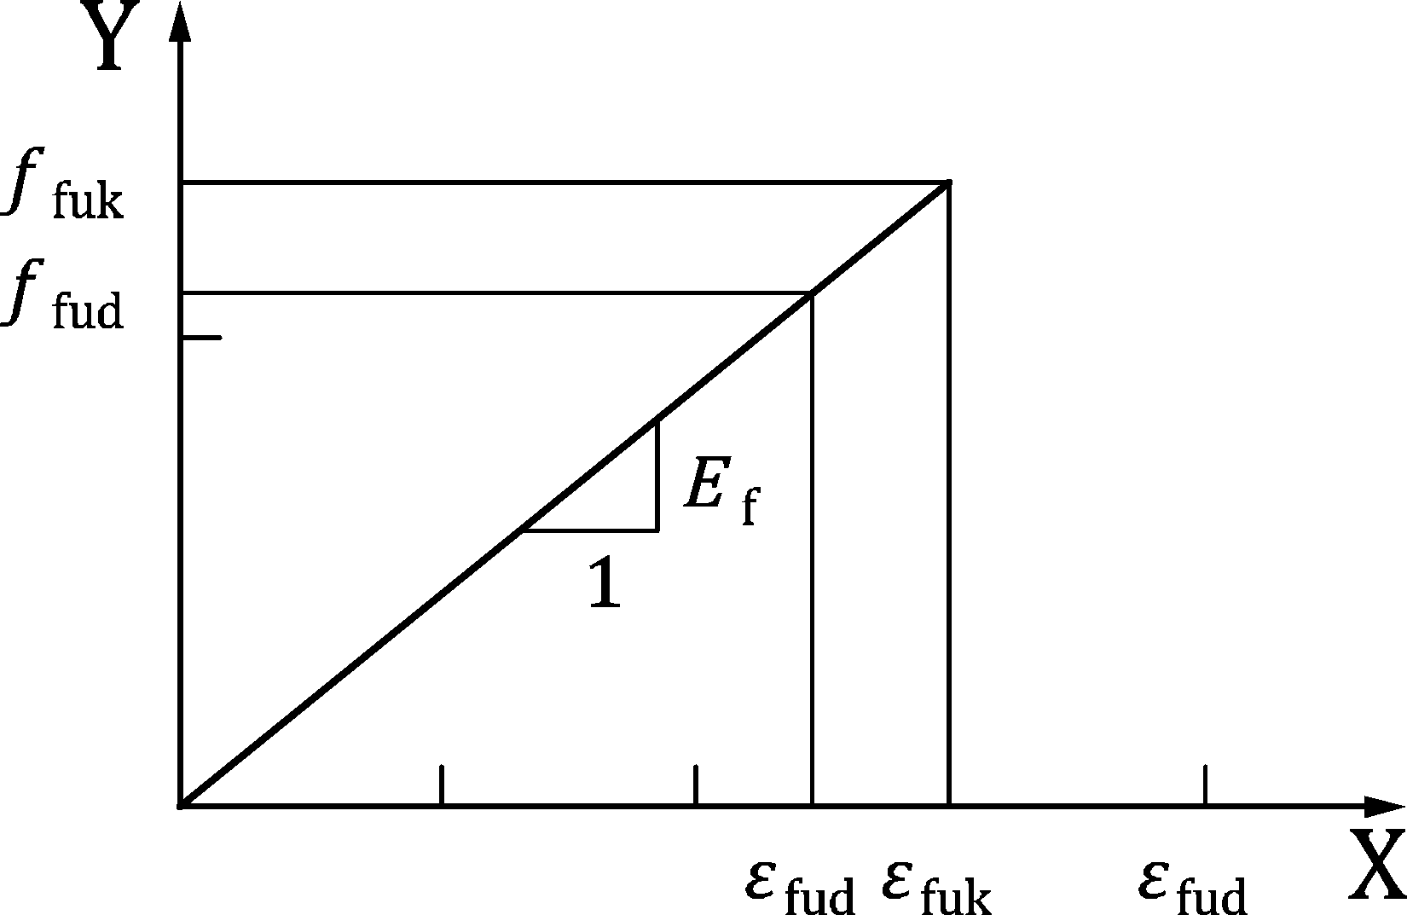

Key

|  |  |
| --- | --- |
| x | strain |
| y | stress |

Figure J.1 — Design stress- strain diagram for CFRP reinforcement

* 1. Durability - Environmental exposure conditions

(1) Without additional measures to protect the CFRP system and its adhesive, for the design life of the structure, strengthening with adhesively bonded CFRP reinforcement should only be applied in exposure classes X0, XC1 (dry), XC3, XC4, or XF1 in accordance with Table 6.1. In addition, ABR CFRP reinforcement should not be exposed to direct UV radiation (direct sun radiation or indirect sun from snow or water reflection) or alternating or permanent penetration of moisture. Thermal effects shall be considered from e.g. asphalt on a strengthened bridge deck.

* 1. Structural analysis

(1) Unless more rigorous analysis is undertaken, members strengthened with CFRP should not be analysed using linear elastic analysis with limited redistribution or plastic analysis.

(2) A member should be assessed against accidental loss of adhesively bonded CFRP reinforcement, including the following situations:

* The FRP should not be designed to withstand permanent action effects in a manner that the structure would not be able to withstand collapse without FRP, unless the following is addressed in design:
* The ABR CFRP strengthening is detailed in a manner that protects it against damage from vandalism or accidental mechanical damage;
* Member collapse will not result in progressive collapse of the structure;
* Protection from fire damage is provided.
  1. Ultimate limit states (ULS)
     1. Bending with or without axial force
        1. General

(1) When determining the ultimate moment resistance of reinforced or prestressed concrete cross sections strengthened in flexure with adhesively bonded CFRP reinforcement, the following assumptions in addition to 8.1.1(2) should be made:

* the compressive strength of ABR CFRP is ignored;
* the slip between CFRP reinforcement and the concrete substrate is neglected.

(2) The strain state of the existing reinforcement and concrete members being strengthened shall be determined prior to strengthening under the relevant effects of actions. Strains arising from additional action effects after strengthening should be superimposed to these when verifying the capacity of the strengthened member.

(3) Unless more rigorous analysis is undertaken, the provisions in this Eurocode should not be applied to concrete with $f_{ck}≤12$ MPa or $f_{ck}>50$ MPa.

(4) Subject to the provisions of 8.1 and J.11 being satisfied, the tension contribution of the adhesively bonded CFRP should be included in calculation of ultimate moment resistance using the limiting strain distribution shown in 8.1.1(6) where the strain limit in the ABR CFRP is limited by the bond capacity determined in J.11.

* + - 1. Concrete columns confined with fully wrapped CFRP

(1) The confining effect provided by adhesively bonded CFRP may be considered in design of axially-loaded members under the following conditions, where:

* the characteristic concrete strength $f_{ck}$ is less than 50 MPa;
* the diameter of a circular column, D, or effective diameter of a rectangular or square column, Deq is greater than 150 mm;
* the first order eccentricity satisfies the condition $\frac{e_{0}}{D_{eq}}≤0,25$;
* the slenderness of satisfies the condition ${l_{0}}/{D_{eq}≤40};$
* the corner radius for rectangular cross sections is *r*c ≥ 20 mm;
* *t*f.eff = *n*faf ⋅ *t*f, with *a*f = 0,85 for *n*f > 3, or 1 otherwise.

The increase in compressive strength from FRP confinement shall be considered in determining slenderness effects.

(2) The increase in compressive strength of concrete ${∆f}_{cd}$ in columns resulting from confinement using FRP may be calculated as follows:

**For circular columns:**

|  |  |  |
| --- | --- | --- |
| $${∆f}_{cd}=0$$ | $$\text{for} \frac{{2t}_{f,eff}{∙f}_{fud}}{D∙f_{cd}}<0,07$$ | (J.3) |
| $${∆f}_{cd}=3,3∙\frac{2{∙t}_{f}}{D}{∙k}_{r}∙f_{fud}$$ | $$\text{for} \frac{{2t}_{f,eff}{∙k_{r}∙f}_{fud}}{D∙f_{cd}}≥0,07$$ | (J.4) |

where $D$ is the diameter of the circular column.

|  |  |
| --- | --- |
| $$k_{r}=\left\{\begin{matrix}0,5∙\left(\frac{r_{c}}{50}\right)∙\left(2-\frac{r_{c}}{50}\right) & \text{for} r_{c}<50 \text{mm} \\ 0,5 & \text{for} r_{c}≥50 \text{mm}\end{matrix}\right.$$ | (J.5) |
| $$r_{c}=0,5∙D$$ | (J.6) |

**For rectangular columns:**

|  |  |  |
| --- | --- | --- |
| $${∆f}_{cd}=0$$ | $$\text{for} {\left(\frac{b}{h}\right)}^{2}k_{e}\frac{2t_{f,eff}{∙k_{r}∙f}_{fud}}{D_{eq}{∙f}_{cd}}<0,07$$ | (J.7) |
| $${∆f}_{cd}=3,3∙{\left(\frac{b}{h}\right)}^{2}{∙k}_{e}∙\frac{2t_{f}}{D_{eq}}{{∙k}_{r}∙f}_{fud}$$ | $${\text{for} \left(\frac{b}{h}\right)}^{2}k_{e}\frac{2t_{f}{∙k_{r}∙f}_{fud}}{D_{eq}{∙f}_{cd}}≥0,07$$ | (J.8) |

where

|  |  |
| --- | --- |
| $$D_{eq}=\frac{2∙b∙h}{b+h}$$ | (J.9) |
| $$k_{e}=1-\frac{{(b-2∙r_{c})}^{2}+{(h-2∙r_{c})}^{2}}{3∙b∙h}$$ | (J.10) |

Where helical wrapping is used on rectangular or square columns (see Figure J.2), the value of $k_{e}$ calculated in Formula (J.10) should be factored by $k_{h}$ in Formula (J.11), where geometrical parameters are defined in Figure J.2a) and b).

|  |  |
| --- | --- |
| $$k_{h}=\left(1-\frac{\left(s_{f}-b_{f}\right)}{2∙b}\right)∙\left(1-\frac{\left(s_{f}-b_{f}\right)}{2∙h}\right)∙\left(\frac{1}{1+{\left(tanβ_{f}\right)}^{2}}\right)$$ | (J.11) |

(3) The confining effect of CFRP may be ignored in creep calculations for concrete columns.

|  |  |
| --- | --- |
|  |  |
| a) cross sectional dimensions of rectangular column | b) helical wrapping configuration |

Figure J.2 — Configuration of CFRP wrapping

* + 1. Shear
       1. General verification procedure

(1) The shear resistance of a section strengthened with CFRP may be taken as:

|  |  |
| --- | --- |
| $$V_{Rd, CFRP}=V_{Rd}+V_{Rd,f}≤\frac{ν_{f_{cd}}}{2}b_{w}⋅z≤\left(0,5⋅ν⋅f_{cd}\right)⋅b_{w}⋅z$$ | (J.12) |

where

|  |  |  |
| --- | --- | --- |
| $$V_{Rd}=τ_{Rd}⋅b_{w}⋅z$$ | | (J.13) |
| $$V_{Rd,f}=\frac{A_{f}}{s_{f}}⋅z_{f}⋅f_{fwd}⋅\left(cotθ+cotα_{f}\right)sinα_{f}$$ | | (J.14) |
| $$\frac{A_{f}}{s_{f}}=\left\{\begin{matrix}\frac{2⋅t_{f}⋅b_{f}}{s_{f}} & \text{for} \text{discreet} \text{CFRP} \text{strips} \\ 2⋅t_{f} & \text{for} \text{CFRP} \text{sheets}\end{matrix}\right.$$ | | (J.15) |
| $$α_{f}$$ | is the angle formed between the CFRP system; | |
| $$z_{\text{f}}$$ | is the height of CFRP crossed by the shear crack. | |
| $$f_{\text{fwd}}$$ | is design shear strength of the CFRP system calculated in accordance with *J.8.2.2 and J.8.2.3*. | |

Unless more rigorous analysis is undertaken, $θ$ should be taken as 45 degrees for the calculation of and .

* + - 1. Fully Wrapped CFRP Systems

(1) The following may be used to determine the design shear strength of fully wrapped CFRP systems as defined in Figure J.3.

|  |  |
| --- | --- |
| $$f_{fwd}=0,8∙k_{r}∙f_{fud}$$ | (J.16) |

where

|  |  |
| --- | --- |
| $$f_{fud}$$ | should be determined using Formula (J.1) and $k_{r}$ should be determined using Formula (J.5). |



Figure J.3 — Illustration of fully wrapped CFRP system covered by this code

* + - 1. Open CFRP Systems

(1) The following may be used to determine the design shear strength of open CFRP systems as defined in Figure J.4.

Where the anchorage length into the compression zone of the member of all CFRP strips, $l_{bf}$, is less than $l_{bf,max,k}$, $f_{fwd}$ should be determined using the Formula (J.17), where $θ$ and $α_{f}$ are defined in Figure J.5.

|  |  |
| --- | --- |
| $$f_{fwd}=\frac{2}{3}\frac{(n{∙s}_{f}/[\left(cotθ+cotα_{f}\right)sinα_{f}]}{l_{bf,max,k}}f_{bfRd}$$ | (J.17) |

Where the anchorage length into the compression zone of the member of some CFRP strips, $l_{bf}$, is less than $l_{bf,max,k}$, $f_{fwd}$ should be determined using Formula (J.18):

|  |  |
| --- | --- |
| $$f_{fwd}=\left[1-\left(1-\frac{2m{∙s}_{f}}{3∙l_{bf,max,k}}\right)\frac{m}{n}\right]f_{bfRd}$$ | (J.18) |

Where the parameters $α_{f}$, $m$ and $n$ are defined in Figure J.5 and $f_{bfRd}$ shall be determined using 11.1.1.

(2) Formulae (J.17) and (J.18) may be applied with CFRP sheets by substituting $s_{f}$ with $b_{f}/sinα$.

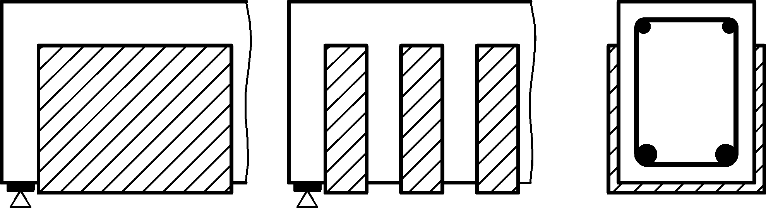

Figure J.4 — Illustration of open CFRP shear strengthening systems covered by this code

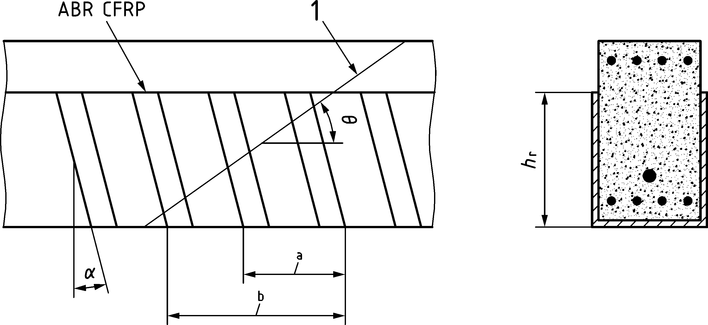

**Key**

|  |  |
| --- | --- |
| 1 | shear crack |
| a | m stirrups with ${ l}_{bl}$ < $l_{bl,k.max}$ |
| b | n stirrups intersecting shear crack |

Figure J.5 — Illustration of ABR CFRP stirrups intersecting shear crack

* + 1. Punching

(1) This Eurocode does not apply for strengthening for punching shear with CFRP.

* + 1. Design with strut-and-tie models and stress fields

(1) ABR CFRP systems may be used as tension reinforcing in ties according to the provisions of 8.5 and J.11 subject to strain compatibility being demonstrated.

* 1. Serviceability limit stateS (SLS)

(1) Deflections of beams or slabs strengthened with CFRP may be estimated by ignoring the slip between the CFRP and concrete and transforming the area of CFRP to steel by taking account of the modular ratio. Pre-existing deflections shall be considered by using the appropriate provisions of prEN 1990.

* 1. Fatigue
     1. Basic fatigue analysis for externally bonded CFRP systems

(1) A fatigue check for externally bonded CFRP systems may be omitted where the following condition is satisfied:

|  |  |
| --- | --- |
| $${∆F}_{fE,equ}≤{∆F}_{fRd,fat1}=0,25∙{f_{ctm,surf}}^{1/4}∙f_{bfRd}∙b_{f}∙t_{f}$$ | (J.19) |

where

|  |  |  |
| --- | --- | --- |
| $${∆F}_{fRd,fat1}$$ | is the basic fatigue resistance; | |
| $$f_{fRd}$$ | is the limiting design strength of the bond in the area being considered calculated in accordance with J.11; | |
| $$f_{ctm,surf}$$ | is defined by Formula (J.36); | |
| $${∆F}_{fE,equ}=max⁡\left\{b_{f}∙t_{f}∙∆f_{fEd,max},;F_{fEd,cr}\right\}$$ | | (J.20) |
| $$∆f_{fEd,max}$$ | is the maximum difference in CFRP stress under the relevant load combination between cracks (refer to Figure J.5) within the strengthened area. $F_{fEd,cr}$ is the force in CFRP at first crack in the strengthened area. | |

* + 1. Refined fatigue analysis for externally bonded CFRP systems

(1) If the condition in Formula (J.19) cannot be satisfied, the following condition shall be assessed under the frequent combination stated in Clause 10 according to:

|  |  |
| --- | --- |
| $${∆F}_{fEd,fat} ≤ {∆F}_{fRd,fat2}= α_{fat2}∙\frac{{∆F}_{fk,B}}{γ_{BA}}$$ | (J.21) |

where

|  |  |
| --- | --- |
| $${∆F}_{fEd,fat}$$ | is the design force range due to forces at the crack edge, ${∆F}_{f,max}-{∆F}_{f,min}$, and; |
| $${∆F}_{f,min}$$ | is the minimum value of $b_{f}{∙t}_{f}{∙∆f}_{fEd}$ under the relevant fatigue load combination specified in 10.2; |
| $${∆F}_{f,max}$$ | is the maximum value of $b_{f}{∙t}_{f}{∙∆f}_{fEd}$ under the relevant fatigue load combination specified in 10.2. |

The difference in CFRP tension stress between cracks $∆f_{fEd}$ calculated according to Formula (J.22) is defined in Figure J.6.

|  |  |
| --- | --- |
| $$∆f_{fEd}= \frac{F_{fEd,b}-F_{fEd,a}}{b_{f}⋅t_{f}}$$ | (J.22) |

where

|  |  |  |
| --- | --- | --- |
| ${{∆F}_{fk,B}=b_{f}∙t_{f}∙∆f}_{fk,B}$ and ${∆f}_{fk,B}$ is calculated according to Formula (J.39); | | |
| $$α_{fat2}=-c_{fat}∙\frac{{∆F}_{f,max}}{{∆F}_{fRd}}+c_{fat}$$ | | (J.23) |
| $${∆F}_{f,max}$$ | is the maximum value of ${∆F}_{f}$ under the fatigue load combination according to 10.2; | |
| $$c_{fat}=0,35∙{\left(\frac{N^{*}}{2∙{10}^{6}}\right)}^{- \frac{1}{k_{f3}}}$$ | | (J.24) |
| $$N^{*}$$ | the number of stress cycles; | |
| $$k_{f3}=23,2$$ | for ; | |
|  | for . | |

* + 1. Near surface mounted CFRP strips

(1) Near surface mounted strips that satisfy the following conditions under the frequent combination stated in Clause 10 may be deemed adequate in fatigue.

1. The number of stress cycles is less than 2 ∙ 106;

2. The maximum force in the NSM CFRP system, taking the shift of the tension envelope into account, does not exceed $F_{f,NSM,max}$, where $F_{f,NSM,max}$ is calculated using Formula (J.25);

3. The strip stress range ${∆σ}_{f}$ complies with the provisions stated in Formula (J.26).

|  |  |
| --- | --- |
| $$F_{f,NSM,max}=0,6∙f_{bfRd}∙b_{f}∙t_{f}$$ | (J.25) |
| $${∆σ}_{f}≤\frac{500}{t_{f}}$$ | (J.26) |

where

|  |  |
| --- | --- |
|  | (J.27) |

* 1. Bond and anchorage of CFRP systems
     1. Anchorage of ABR CFRP strengthening systems
        1. Basic anchorage resistance — CFRP to concrete for EBR CFRP strengthening
           1. General

(1) The required anchorage length of externally bonded CFRP reinforcement, calculated in accordance with J.11.1.1, should be curtailed as described in J.11.1.2.

* + - * 1. Simplified method

(1) The following simplified method may be used to determine the anchorage resistance for externally bonded CFRP.

|  |  |
| --- | --- |
| $$f_{bfRd}=\frac{0,17}{γ_{BA}}k_{b}β_{1}\sqrt{\frac{{2E}_{f}}{t_{f}}f_{cm}^{2/3}}$$ | (J.28) |

where

|  |  |
| --- | --- |
| $$k_{b}=\sqrt{\frac{2-{b_{f}}/b}{1+{b_{f}}/b}}$$ | (J.29) |
| $$β_{1}=\left\{\begin{matrix}\frac{l_{bf}}{l_{bf,max,k}}\left(2-\frac{l_{bf}}{l_{bf,max,k}}\right)<1 & \text{if}{ l}_{bf}<l_{bf,max,k} \\ 1 & \text{if}{ l}_{bf}≥l_{bf,max,k}\end{matrix}\begin{matrix} \\ \end{matrix}\right.$$ | (J.30) |
|  | (J.31) |

* + - * 1. Refined method

(1) If more accurate data for the EBR CFRP reinforcement system is known based on production data, the following more refined analysis may be used to determine anchorage resistance. The design bond strength of the anchorage, of the EBR CFRP reinforcement system may be taken as the following:

|  |  |
| --- | --- |
| $$f_{bfRd}=\frac{\sqrt{η_{cc}∙k_{tc}∙k_{tt} }}{γ_{BA}}∙\left\{\begin{matrix}f_{bfk,max}∙\frac{l_{bf}}{l_{bf,max}}\left(2-\frac{l_{bf}}{l_{bf,max}}\right) & \text{where}{ l}_{bf}<l_{bf,max} \\ f_{bfk,max} & \text{where} { l}_{bf}≥l_{bf,max}\end{matrix}\right.$$ | (J.32) |

where

|  |  |
| --- | --- |
| $$l_{bf,max}=\frac{π}{2}∙\frac{\sqrt{E_{f}∙t_{f}∙s_{f0k} }}{τ_{f1k}}$$ | (J.33) |
| $$f_{bfk,max}=\sqrt{\frac{E_{f}∙τ_{f1k}∙s_{f0k}}{t_{f}}}$$ | (J.34) |
| $$s_{f0k}=0,2∙k_{sys,b2}$$ | (J.35) |
| $$τ_{f1k}=0,37∙k_{sys,b1}∙{\left(f_{cm}∙f_{ctm,surf}\right)}^{0,5}$$ | (J.36) |
| $$f_{ctm,surf}=0,7∙f_{ctm}$$ | (J.37) |

NOTE 1 The value of $k_{sys,b1}$ can be taken as 1,0 unless the more accurate information is available based on production data of EBR CFRP sheets or strips.

NOTE 2 The value of $k_{sys,b2}$ can be taken as 1,0 unless the more accurate information is available based on production data of EBR CFRP sheets or strips.

NOTE 3 The value of $f_{ctm,surf}$ from Formula (J.37) can only be used where it cannot be obtained using EN 1542.

* + - 1. EBR CFRP anchorage requirements — flexure
         1. General

(1) Anchorage of the strengthening system to the concrete surface of a member in flexure shall be provided to avoid the following failure mechanisms:

* End Anchorage as described in J.11.1.2.2;
* Intermediate Crack Debonding as described in J.11.1.2.3;
* End Cover Separation as described in J.11.1.2.4;
* Shear Induced Crack Separation as described in J.11.1.2.5.
  + - * 1. End anchorage

(1) The CFRP strengthening shall be anchored by an anchorage length beyond the section where the design resistance of the unstrengthened existing section is at least as great as the design effects resulting from the relevant limit state.

(2) Externally bonded CFRP reinforcement shall be curtailed according to one of the following conditions:

* where member strengthening is undertaken, the curtailment shall take account of *a*l, calculated in accordance with 12.3.3;
* where local strengthening is undertaken, the CFRP strengthening should extend a distance *l*bf + *h* beyond the section where it is needed.

(3) The anchorage resistance $f_{bfRd}$ shall be calculated using Formulae (J.28) or (J.32).

* + - * 1. Intermediate crack debonding

(1) Where J.11.1.1.3 is used to determine the anchorage length of adhesively bonded CFRP, the capacity of the anchorage capacity between flexural cracks shall be sufficient to resist the difference in tensile forces in the system between cracks.

(2) Formula (J.38) may be used to determine the capacity of the CFRP strengthening system between adjacent flexural cracks.

(3) Formula (J.38) should not be applied where the strain in the CFRP exceeds 10 mm/m.

|  |  |
| --- | --- |
| $$Δf_{fEd}≤Δf_{fRd}$$ | (J.38) |

where

|  |  |
| --- | --- |
| $$Δf_{fEd}$$ | is calculated according to Formula (J.22); |
| $$Δf_{fRd}$$ | is the bond resistance between adjacent cracks. |

(4) Unless a more accurate analysis is undertaken, $Δf_{fRd}$ and $Δf_{fEd}$ should be calculated using the minimum crack spacing, $s_{cr,min}$, where $s_{cr,min}=0,75{∙s}_{cr,max}$ (see Figure J.6).

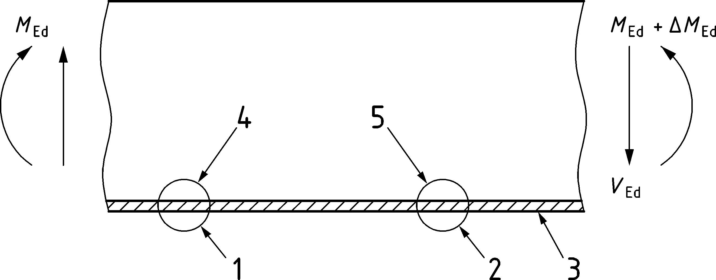

Key

|  |  |
| --- | --- |
| 1 | $$f_{fEd,a }in FRP at Crack A$$ |
| 2 | $$f_{fEd,b }in FRP at Crack B$$ |
| 3 | FRP |
| 4 | Crack A |
| 5 | Crack B |

Figure J.6 — CFRP Between Flexural Cracks

(5) The bond resistance between adjacent cracks, ${∆f}_{fRd}$ may be determined using Formula (J.39) by taking account of the beneficial effects of bond friction, ${∆f}_{fk,F}$, and clamping from curvature of the beam, ${∆f}_{fk,C}$, in addition to the adhesive bond resistance between the cracks, ${∆f}_{fk,B}$ as follows:

|  |  |
| --- | --- |
| $${∆f}_{fRd}=1/{γ_{BA}}∙\left({\left(η_{cc}·k_{tc}·k_{tt}\right)}^{0,5}∙{∆f}_{fk,B}+{∆f}_{fk,F}+{∆f}_{fk,C}\right)$$ | (J.39) |
| $${∆f}_{fk,B}=0,84∙k_{sys,b1}∙\sqrt{f_{cm}∙f_{ctm,surf}}∙\frac{\sqrt{s_{cr,min}}}{t_{f}}$$ | (J.40) |
| $${∆f}_{fk,F}={{0,1∙f}_{cm}}^{0,9}∙\frac{{s_{cr,min}}^{4/3}}{t_{f}}$$ | (J.41) |
| $${∆f}_{fk,C}=\frac{κ_{h}}{h_{f}}∙\frac{{s_{cr,min}}^{1/3}}{t_{f}}$$ | (J.42) |

where

|  |  |
| --- | --- |
| $$κ_{h}=2 000$$ | for reinforced concrete members; |
| $$κ_{h}=0$$ | for prestressed concrete members; |
| $h_{f }=\min\left\{100 \text{mm}, h\right\}$. | |

(6) Unless a more accurate analysis is undertaken, $Δf_{fEd}$ may be calculated by ignoring slip of the CFRP.

* + - * 1. End cover separation

(1) The maximum design shear force ($V_{ED}$) at the support of the member subjected to strengthening shall be less than the design resistance value against concrete cover separation $V_{Rd,cfE}$ calculated in accordance to Formula (J.43):

|  |  |
| --- | --- |
| $$V_{ED}≤ V_{Rd,cfE} =0,75∙\left(1+19,6∙\frac{{\left(100ρ_{l}\right)}^{0,15}}{a_{fE}}\right)∙τ_{Rd,c}{∙b}_{w}∙z$$ | (J.43) |

Where the condition in Formula (J.43) is not met, shear strengthening at the end of the longitudinal strengthening shall be provided in accordance with Formula (J.44) with anchorage satisfying the provisions of this Eurocode.

|  |  |
| --- | --- |
| $$f_{fwd}≤f_{bfRd}∙tanθ$$ | (J.44) |

where $f_{bfRd}$ is the CFRP anchorage capacity for the flexural strengthening system being designed.

Stirrups for end cover separation shall be detailed as shown in Figure J.7.

Dimensions in millimetres

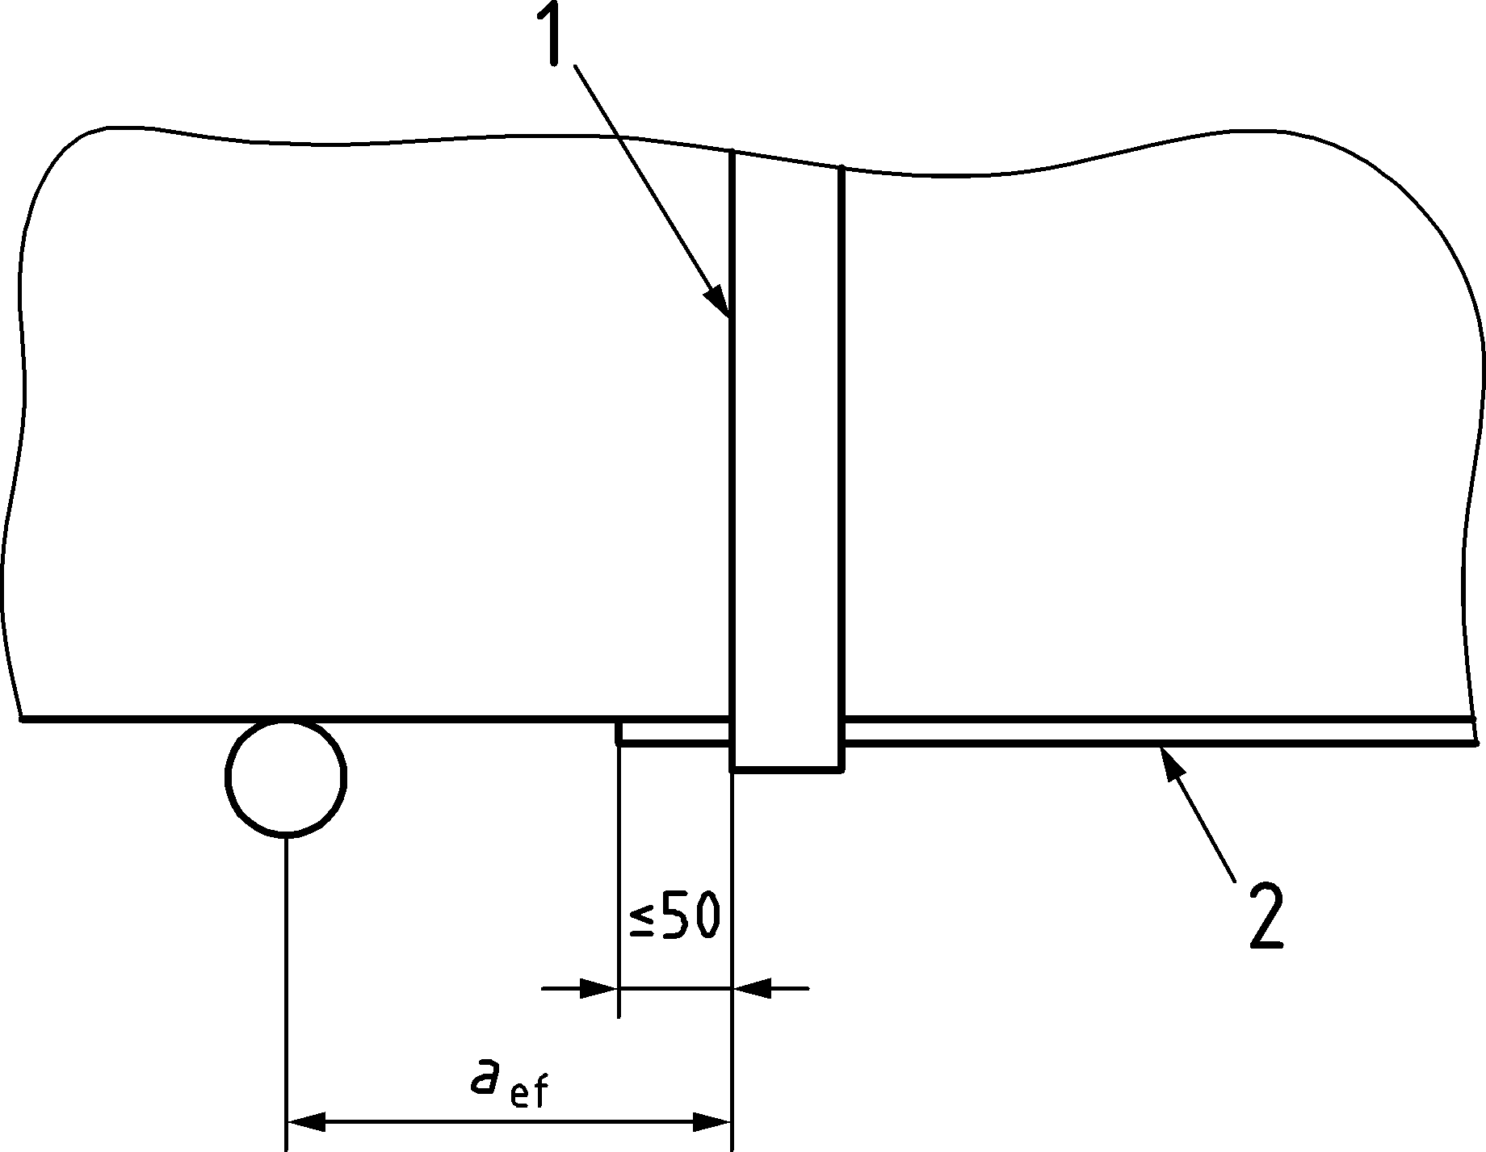

Key

|  |  |
| --- | --- |
| 1 | end stirrup |
| 2 | flexural strengthening |

Figure J.7 — CFRP shear stirrup arrangement to avoid end cover separation

* + - * 1. Shear Induced Crack Separation

(1) Where the limits in Formula (J.45) or (J.46) are exceeded for members strengthened with EBR in flexure, additional CFRP stirrups shall be provided.

|  |  |
| --- | --- |
| $$\frac{V_{Ed}⋅σ_{sw}}{τ_{Rd}∙b∙d_{w}}≤\left\{\begin{matrix}\text{75 MPa} & \text{ for ribbed steel bars} \\ \text{25 MPa} & \text{for plain round steel bars}\end{matrix}\right.$$ | (J.45) |

${where τ}_{\text{Rd}}$ is calculated according to Formula (8.47).

|  |  |
| --- | --- |
| $$V_{Ed}≤0,33{⋅f}_{ck}^{\frac{2}{3}}{⋅b}_{w}⋅z$$ | (J.46) |

Where stirrups are required in accordance with Formulae (J.45) or (J.46), additional transverse EBR CFRP stirrups should be provided to resist the shear force in Formula (J.47) with adequate anchorage.

|  |  |
| --- | --- |
|  | (J.47) |

* + - 1. Basic anchorage resistance — CFRP to concrete for NSM CFRP strengthening

(1) The design bond load capacity per strip shall be according to Formula (J.48) or (J.49) for anchorage lengths according to Formula (J.48) or (J.50).

For $l_{\text{bf}}≤115\text{mm}:$

|  |  |
| --- | --- |
| $$F_{bfRd}={0,95⋅b}_{f}⋅τ_{bfd}⋅\sqrt[4]{a_{r}}⋅l_{bf}⋅\left(0,4-0,0015⋅l_{bf}\right)$$ | (J.48) |

For $l_{\text{bf}}>115\text{mm:}$

|  |  |
| --- | --- |
| $$F_{bfRd}={0,95⋅b}_{f}⋅τ_{bAd}⋅\sqrt[4]{a_{r}}⋅\left(26,2+0,065⋅tan h\left(\frac{a_{r}}{70}\right)⋅\left(l_{bf}-115\right)\right)$$ | (J.49) |

where

|  |  |
| --- | --- |
| $$a_{r}= \max\left\{100 \text{mm}, a_{r}\right\}.$$ | (J.50) |

The maximum design strength of the adhesive according for NSM CFRP systems may be obtained from Formula (J.51):

|  |  |
| --- | --- |
| $$τ_{bAd}=\frac{1}{γ_{BE}}⋅\min\left\{\begin{matrix}τ_{bAk}⋅α_{bA} \\ τ_{bck}⋅α_{bc}\end{matrix}\right.$$ | (J.51) |

where the maximum characteristic bond strength of the adhesive may be obtained from Formula (J.52), where the definitions of $f_{Ack}$ and $f_{Atk}$ are given in *J.5.1.2.1*.

|  |  |
| --- | --- |
| $$τ_{bAk}=0,6∙\sqrt{\left(2∙f_{Atk}-2∙\sqrt{f_{Atk}^{2}+f_{Ack}∙f_{Atk}}+f_{Ack}\right)∙f_{Atk}}$$ | (J.52) |
| $$τ_{bck}=4,5∙{f_{cm}}^{0,5}$$ | (J.53) |

The value of $α_{bA}$ may be taken as 0,5 unless the more accurate information is available based on production data of EBR CFRP sheets or strips.

The value of $α_{bc}$ may be taken as ${\left(η_{cc}⋅k_{tc}⋅k_{tt}\right)}^{0,5}$ unless the more accurate information is available based on production data of EBR CFRP sheets or strips.

* 1. Detailing of Members and Particular rules – Detailing of CFRP
     1. Flexural strengthening with externally bonded CFRP

(1) The following should be applied to the centre-to-centre spacing ($a_{\text{f}}$), in mm, of ABR CFRP strips:

|  |  |
| --- | --- |
| $$a_{f,max}≤0,2$$ | times distance between points of zero moments; |
| $$a_{f,max}≤4$$ | times slab thickness; |
| $$a_{f,max}≤0,4$$ | times cantilever length. |

(2) The distance of the longitudinal edge of the strip from the member edge should be at least equivalent to the nominal concrete cover $c_{\text{nom}}$ of the internal reinforcement.

* + 1. Flexural strengthening with NSM reinforcement bars

(1) Where slots are cut into the cover concrete for bonding of NSM CFRP systems, they should be located such that the cover is not adversely compromised when considering the accuracy of installation equipment along with adequate tolerance for installation.

(2) The geometrical limits for slots and edge distances and spacing [mm], for NSM CFRP bars and strips shall be in accordance with Table (J.2).

Table J.2 — Geometrical limits for slots and edge distances and spacing, in mm.

| Geometrical limits | Square NSM CFRP bars | Round NSM CFRP bars | NSM CFRP bars or strips |
| --- | --- | --- | --- |
| The slot width $b_{slot}$ [mm] | $$t_{f}+2 \text{mm}≤ \\ b_{slot}≤t_{f}+4 \text{mm}$$ | $$∅_{s}+\text{2 mm}≤ \\ b_{slot}≤∅_{s}+\text{4 mm}$$ | — |
| The slot depth $t_{\text{slot}}$ [mm] | $$b_{f}+1 \text{mm}≤t_{slot} \\ ≤b_{f}+2 \text{mm} \\ t_{f}≤b_{f}$$ | $$∅_{s}+\text{1 mm}≤ \\ t_{slot}≤∅_{s}+1 \text{mm}$$ | — |
| Distance from slot to edge in accordance with Figure J.8 | $$a_{r}≥4∙b_{f}$$ | $$a_{r}≥4∙b_{f}$$ | $$e_{f,min}≥1,5∙t_{slot}$$ |
| The centre-to-centre spacing of adhesively bonded CFRP reinforcement $a_{\text{f}}$ | — | — | $$3∙t_{slot}≤a_{f}≤ \\ min\left\{0,2∙l_{0b};4∙h\right\} \\ l_{0b}=2{∙l}_{k}$$ |

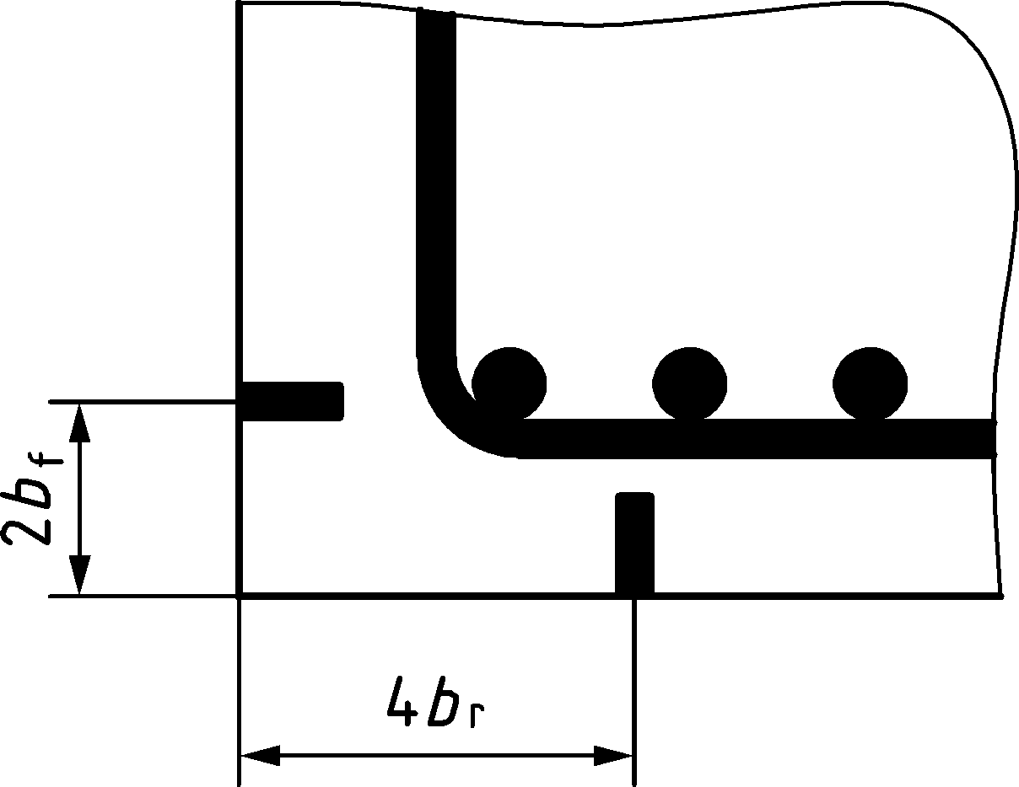

Figure J.8 — Edge distances in arrangement of strips on both sides of an edge

(3) Near curved edges of slabs and beams with ABR CFRP bars, a minimum edge distance of 150 mm in the direction of centre of curvature should be maintained. For all other cases, the radius of curvature of the near surface mounted CFRP strips shall be at least 2 m.

* + 1. Permissible mandrel diameters for bending of FRP

(1) Straight prefabricated ABR CFRP bars should not be designed to be arranged at a radius that is less than 1 000 times their thickness, unless stresses that arise from the bending process are considered in the design.

* + 1. Permissible layers of bonded CFRP sheets and strips

(1) CF sheets shall be bonded in no more than five layers for flexural or shear strengthening and a maximum of ten layers for strengthening columns.

(2) CFRP strips shall be bonded in no more than two layers. The maximum thickness of the CFRP strip cross section excluding the adhesive shall not exceed 3 mm.

(3) No more than a single NSM strip or bar shall be bonded into one slot.

Annex JA  
(informative)  
  
Embedded FRP Reinforcement

JA.1 Use of this annex

(1) This Informative Annex contains supplementary guidance for the design of new structures reinforced with non-prestressed glass and carbon fibre reinforcement. The provisions of this Eurocode apply for concrete members with FRP reinforcement unless modified in this Annex JA.

NOTE National choice on the application of this Informative Annex is given in a National Annex. If a National Annex contains no information on the application of this Informative Annex, it can be used.

JA.2 Scope and field of application

(1) This Informative Annex applies to profiled or roughened fibre reinforced polymer (FRP) reinforcement bars and mesh.

(2) This Informative Annex does not apply to lightweight aggregate and to recycled aggregate concrete structures, i.e. Annexes M and N do not apply to members with FRP reinforcement.

(3) This Informative Annex applies to members with FRP reinforcement subjected to predominantly static loads, i.e. Clause 10 and Annex E do not apply to members with FRP reinforcement.

JA.3 General

NOTE Unless noted otherwise, in Annex JA all clauses/subclauses numbers and titles are similar as the relevant of the main part of this Eurocode. The prefix ‘JA’ is added to section/sub-sections numbers to distinguish content that pertain embedded FRP reinforcement. Annex JA contains only sections/subsections of the main part of this Eurocode that include specific clauses for embedded FRP reinforcement.

JA.4 Verification- Partial Factors for FRP reinforcement

(1) The partial factor for material γFRP shall be used for FRP reinforcement.

NOTE The values of the partial factors for FRP reinforcement are those in Table JA.1(NDP), unless a National Annex gives different values.

Table JA.1 (NDP) — Partial Factors for FRP Reinforcing

| Design Situation | γFRP |
| --- | --- |
| Ultimate Limit States (Persistent and transient design situation) | 1,50 |
| Accidental Actions | 1,10 |
| Serviceability | 1,00 |

JA.5 Materials - FRP reinforcement

JA.5.1 General

(1) Annex JA provides design rules for member reinforced with embedded FRP reinforcement within the following limits of applicability:

* Minimum long term tensile strength of $f_{ftk,100a}≥300 MPa$,
* Minimum modulus of elasticity of $E_{fR}≥40 000 MPa$,
* Ratio of ${f_{ftk,100a}}/{E_{fR}}≥0,005$,
* characteristic compressive strength of concrete $f_{ck}≥20 MPa$,
* members with $ρ_{lf}≤0,05$.

JA.5.2 Properties

(1) Specified properties and related conditions of fibre reinforced polymer systems that are required for design to this Eurocode shall include at least the following:

* $f_{ftk0}$ determined in accordance with ISO 10406‑1,
* $E_{fR}$ determined in accordance with ISO 10406‑1,
* diameter and size.

(2) The following properties of the FRP reinforcement should be provided to the FRP reinforcement supplier to ensure a performance as assumed in design:

* section sizes and tolerance on size,
* minimum characteristic short-term tensile strength,
* minimum long-term characteristic tensile strength,
* Youngs modulus,
* long term bond strength $f_{bd,100a}$,
* installation temperature,
* maximum temperature of the FRP reinforcement for the design life of the structure,
* minimum temperature of the FRP reinforcement for the design life of the structure,
* exposure classification, in accordance with Table 6.1,
* durability requirements.

JA.5.3 Design assumptions

(1) Design should be based on the nominal cross section area of the reinforcement.

(2) The stress-strain relationship should be taken as illustrated in Figure JA.1 and Formula (JA.1).

|  |  |
| --- | --- |
| $$f_{ftd}=\frac{ f_{ftk,100a0}}{ γ_{FRP}}$$ | (JA.1) |

where

|  |  |
| --- | --- |
| $$f_{ftk,100a}=C_{t}∙C_{C}∙C_{ e}∙f_{ftk0}$$ | (JA.2) |

Ct is the influence factor for temperature. Unless more accurate information is available from production data, or more accurate values are determined in accordance with ISO 10406‑1, the following values may be used for Ct:

* Ct = 1,0 for indoor and underground environments,
* Ct = 0,8 for exterior environments where the FRP reinforcement is subject to large temperature variations;

Cc is the influence factor for service life which may be taken as Cc = 0,35 unless more accurate values are determined in accordance with ISO 10406‑1;

Ce is the influence factor for environmental attack which may be taken as Ce = 0,7 unless more accurate values are determined in accordance with ISO 10406‑1.

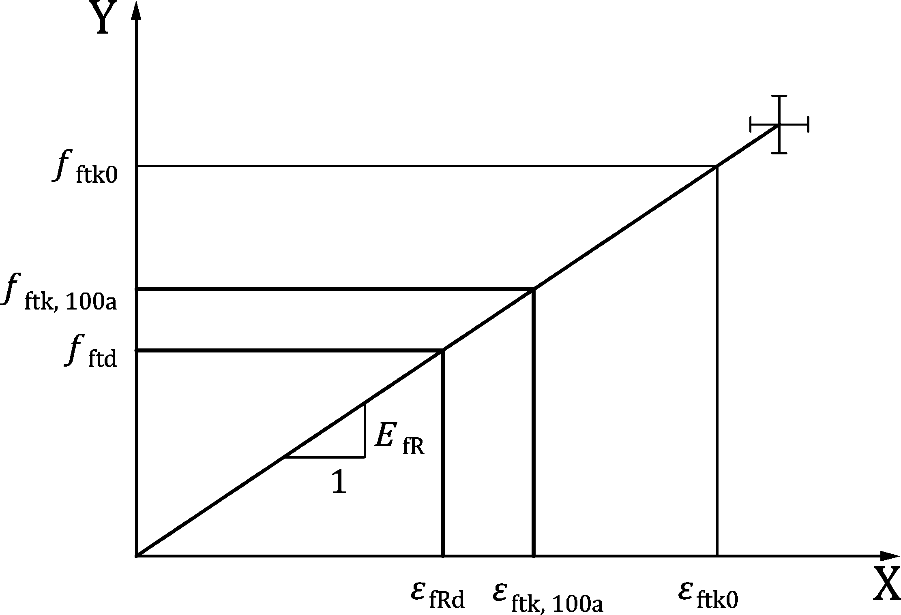

Key

|  |  |
| --- | --- |
| x | strain |
| y | stress |

Figure JA.1 — Design stress-strain-diagram for FRP Reinforcement

(3) FRP reinforcement shall be used as tension reinforcement only.

(4) The mean density of FRP for the purposes of design may be taken as 2 000 kg/m3.

(5) The coefficient of thermal expansion αFRP,th in longitudinal direction may be taken as 5 ⋅ 10−6 K−1 for GFRP bars and 0 for CFRP bars.

JA.6 Durability - Concrete cover - Special rules for FRP reinforcement

(1) The value of $c_{min,dur}$ for FRP reinforcement in Formula (6.2) may be taken as zero.

(2) Unless more accurate information is available based on test data, the cover for bond for FRP reinforcement should be taken as cmin,b ≥ 2ϕ. But at least the minimum cover for FRP reinforcement shall be taken as cmin,b ≥ 1,5ϕ.

(3) Direct contact of carbon FRP reinforcement bars with steel reinforcement should be avoided.

JA.7 Structural analysis - Special rules for FRP reinforcement

(1) For straight FRP-bars installed in a curved shape the bending stress shall be taken into account as permanent action.

(2) Linear elastic analysis with limited redistribution according to 7.3.2 shall not be undertaken for members with FRP reinforcement.

(3) Plastic analysis according to 7.3.3 shall not be undertaken for members with FRP reinforcement.

(4) Non-linear analysis according to 7.3.4 may be undertaken using the model outlined in Figure JA.1 with design strength, $f_{ftd}$, and corresponding design rupture strain, $ε_{fRd}$.

JA.8 Ultimate Limit States (ULS) - Special rules for FRP reinforcement

JA.8.1 Bending with or without axial forces

(1) The tensile strain in FRP reinforcement shall be limited to the design rupture strain, $ε_{fRd}$.

(2) Unless more rigorous analysis is undertaken the benefit of the confining effect of FRP reinforcement should be reduced by the ratio ${E_{fR}}/{E_{s}}$ in any direction that confinement is considered.

JA.8.2 Shear

(1) For members reinforced with FRP reinforcement, the minimum shear resistance in 8.2.1(4) may be calculated as:

|  |  |
| --- | --- |
| $$τ_{Rdc,min}= \frac{0.29}{γ_{c}}\sqrt{f_{ck}∙\frac{E_{fR}}{E_{s}}∙\frac{d_{dg}}{d}}$$ | (JA.3) |

(2) The provisions in 8.2.2 may be used provided that the $ρ_{l}$ of longitudinal FRP reinforcement in Formula (8.17) is reduced by the ratio ${E_{fR}}/{E_{s}}$.

(3) The provisions outlined in 8.2.3 of this Eurocode may be used subject to the following modifications:

* Formula (8.26) for the inclination of the compression field shall be replace by:

|  |  |
| --- | --- |
| $$cotθ=0,8$$ | (JA.4) |

* Formula (8.28) shall be replaced by

|  |  |
| --- | --- |
| $$τ_{Rd,f}=τ_{Rd,c}+ρ_{w}∙f_{fwRd}∙cotθ≤{0,17∙f}_{cd}$$ | (JA.5) |

where

|  |  |
| --- | --- |
| $$f_{fwRd}=min\left\{0,004∙E_{f};{f_{ftd}}^{*}\right\}$$ | (JA.6) |

where ${f_{ftd}}^{*}$ is calculated in accordance with *JA.11.4.3*.

(4) The provision outlined in 8.2.5 may be used subject to the following alterations:

* $f_{yd}$ is replaced by $f_{ftd},$
* $cotθ$ is taken as 1,0,
* $ν$ is taken as 0,35.

(5) For members reinforced with FRP reinforcement, the shear resistance at an interface may be calculated as:

|  |  |
| --- | --- |
| $$τ_{Rdi}=c_{v1}∙f_{ctd}+μ_{v}∙σ_{n}≤0,5∙ν∙f_{cd}$$ | (JA.7) |

where $ν$ may be taken as 0,35.

JA.8.3 Torsion

(1) The provisions of 8.3.4 may be used for members with FRP reinforcement subject to the following alterations:

* $f_{yd}$ is replaced by $f_{ftd},$ where $f_{ftd}$ should be limited by $f_{ftd}≤0,004∙E_{f},$
* $cotθ$ is taken as 1,0,
* $ν$ is taken as 0,35,
* $ρ_{i}$ is factored by the ratio ${E_{F}}/{E_{s}}$.

JA.8.4 Punching

(1) The provisions in 8.4.3 may be used provided that $ρ_{l}$ of longitudinal FRP reinforcement in Formula (8.78) is reduced by the ratio ${E_{fR}}/{E_{s}}$.

(2) The provisions in 8.4.4 shall not be applied to concrete members with FRP reinforcement.

JA.8.5 Design with strut-and-tie models and stress fields

(1) Design with strut and tie models and stress fields for concrete structure reinforced with FRP reinforcement are not covered by this Eurocode.

JA.9 Serviceability Limit States (SLS) - Special rules for FRP reinforcement

JA.9.1 Crack control

(1) Table 9.2(NDP) in 9.2.1(6) does not apply for members reinforced only with FRP reinforcement. A crack limit of $w_{lim,cal}=0,4 mm$ should be used in such members.

(2) The provisions relevant to steel reinforcement in 9.2.2(6), 9.2.3(3), 9.2.4(8) may be applied to concrete with FRP reinforcement where the value of $E_{s}$ is replaced by $E_{fR}$, and $A_{s}$ is replaced by $A_{f}∙\left({E_{fR}}/{E_{s}}\right)$ in all relevant formulae in these clauses.

JA.9.2 Deflection control

(1) Table 9.3 in 9.3.2(1) should not be used for structures with FRP reinforcement.

(2) The provisions relevant to steel reinforcement in 9.3.3(3), 9.3.4(8) may be applied to concrete with FRP reinforcement where the value of $E_{s}$ is replaced by $E_{fR}$ in all relevant formulae in these clauses.

JA.10 Fatigue

(1) This Eurocode does not provide rules for fatigue utilising FRP reinforcement.

JA.11 Detailing of FRP reinforcement

JA.11.1 Spacing of bars

(1) Where the clear distance between FRP reinforcement bars $c_{s}<7,5∙ϕ$, concrete cover spalling shall be prevented by limiting the design strain to $ε_{fRd}≤0,0035$ in straight bars.

JA.11.2 Permissible mandrel diameters for bent bars

(1) The minimum diameter to which a bar may be bent shall be such as to avoid:

* damaging the reinforcement (see (2)) and
* failure of the concrete inside the bend of the bar (crushing, splitting or spalling of reinforcement cover), see (3) and (4).

(2) The mandrel diameter of FRP reinforcement is given by the supplier. Bending on site is not permitted.

The mandrel diameter should be at least:

* *φ*mand,min = 4*φ* for *φ* ≤ 16 mm
* *φ*mand,min = 7*φ* for *φ* > 16 mm

(3) Provided that *f*ftd ≤ 25*f*cd and *γ*C ≤ 1,5, verification of the concrete inside the bend may be omitted for :

* stirrups in compliance with 12.3.3(4),
* standard hook and bend anchorages complying with Figure 11.6 at a clear distance
* *c*x ≥ 1,5*φ* from an edge parallel to the bent and a clear distance between bars *c*s ≥ 3*φ* according to Figure 11.6c and
* all bends with an angle *α*bend ≤ 45° at a clear distance *c*x ≥ 2,5*φ* from an edge parallel to the bent, a clear distance between bars *c*s ≥ 5*φ* and a length ≥ 2*φ* of the straight segments between multiple bends.

(4) In cases not complying with (3) the stress in the FRP bar *σ*ftd should be verified to avoid concrete failures inside the bend according to Formula (JA.8):

|  |  |
| --- | --- |
| *σ*f ≤ 25 ⋅ *f*cd | (JA.8) |

JA.11.3 Anchorage of FRP reinforcement in tension and compression

(1) Provisions for anchorage in 11.4 may be applied to determining the anchorage lengths of FRP reinforcement only where additions and modifications in Annex JA are used in the determination of relevant parameters.

(2) Only the methods of anchorage according to Figure 11.2a), b) and c) in 11.4.1(6) may be used for FRP reinforcement.

(3) Formula (JA.9) may be applied to determine the anchorage length of FRP reinforcement:

|  |  |
| --- | --- |
| $$l_{bd}=k_{lb}⋅k_{cp}⋅∅⋅{\left(\frac{σ_{ftd}}{217}\right)}^{η_{σ}}⋅{\left(\frac{25}{f_{{ck}^{*}}}\right)}^{\frac{1}{2}}⋅{\left(\frac{ϕ}{20}\right)}^{\frac{1}{3}}⋅{\left(\frac{1,5.ϕ}{c_{d}}\right)}^{\frac{1}{2}}≥10ϕ$$ | (JA.9) |

Where

|  |  |
| --- | --- |
| $$f_{ck}^{*}={\left(\frac{f_{bd,100a}}{0,315}\right)}^{1,5}≤1,1∙f_{ck}^{}$$ | (JA.10) |

$l_{bd}$ shall be limited also to

|  |  |
| --- | --- |
| $$l_{bd}≥ \left(ϕ/4\right)∙\left({σ_{ftd}}/{f_{bd,100a}}\right)$$ | (JA.11) |

NOTE The value of $f_{bd,100a}$ may be taken as 1,5 MPa unless the more accurate information is available based on production data.

(4) The reduction according to Formula (JA.12) in design tensile strength should be considered at a bend bar or if anchoring of FRP reinforcement with bends or hooks according to 11.4.4:

|  |  |
| --- | --- |
| $${f_{ftd}}^{*}= \left(0,3+0,05∙\frac{r_{f}}{d_{f}}\right)∙f_{ftd}≤f_{ftd}$$ | (JA.12) |

Provisions of Formula (JA.12) shall only be applied where:

* the bend radius is within the range ${3∙d_{f}≤r}_{f}≤4∙d_{f}$ and
* the bar diameter $d_{f}≤25mm$.

(5) Following clauses should not be used for FRP reinforcement: 11.4.4, 11.4.5, 11.4.6, 11.4.7.

(6) Provisions for laps in 11.5 should only be used for FRP reinforcement within the provisions stated in Annex JA.

(7) Laps of FRP reinforcement to FRP reinforcement or other reinforcement types shall be situated in zones where the stress in the reinforcement at ultimate limit state is less than 80 % of the design strength and the strain of the FRP reinforcement is less than 0,006.

(8) Table 11.3 should only be applied to members with FRP reinforcement within the provisions stated in Annex JA.

JA.12 Additional rules for precast concrete elements and structures

(1) Unless information is available from production data, Clause 13 for steel reinforcement is not applicable to FRP reinforcement.

JA.13 Lightly reinforced concrete structures

(1) This Eurocode does not provide rules for lightly reinforced concrete structures utilising FRP reinforcement.

1. (normative)  
     
   Bridges
   1. Use of this annex

(1) This Normative Annex contains additional provisions for bridges.

* 1. Scope and field of application

(1) The provisions of Clauses 1 to 14 and Annexes A to Q apply to bridges unless otherwise stated in this Normative Annex.

* 1. Normative References

NOTE See Clause 2.

* 1. Terms, definitions and symbols

NOTE See Clause 3.

* 1. Basis of design

NOTE See Clause 4.

* 1. Materials

NOTE See Clause 5.

* 1. Durability

(1) The following clauses supplement Clause 6 with provisions specific to bridges.

(2) Where de-icing salts are used, exposed concrete surfaces above, adjacent to and in the ground below the carriageway should be considered as being affected by de-icing salts according to Figure K.1.

NOTE The dimensions and distances of Zones I and II are as given in Figure K.1 unless a National Annex gives different values.

Dimensions in metres

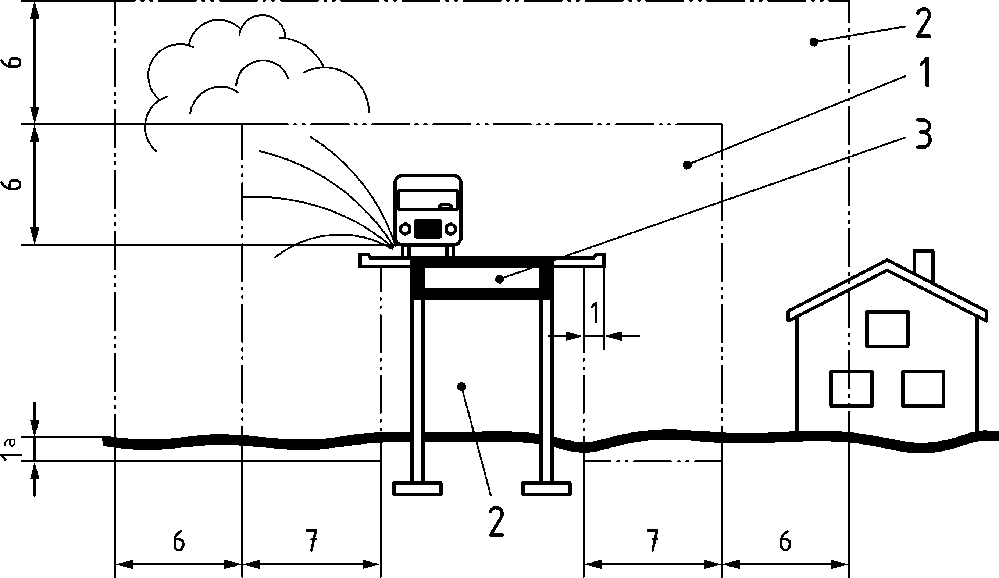

a) Road bridges

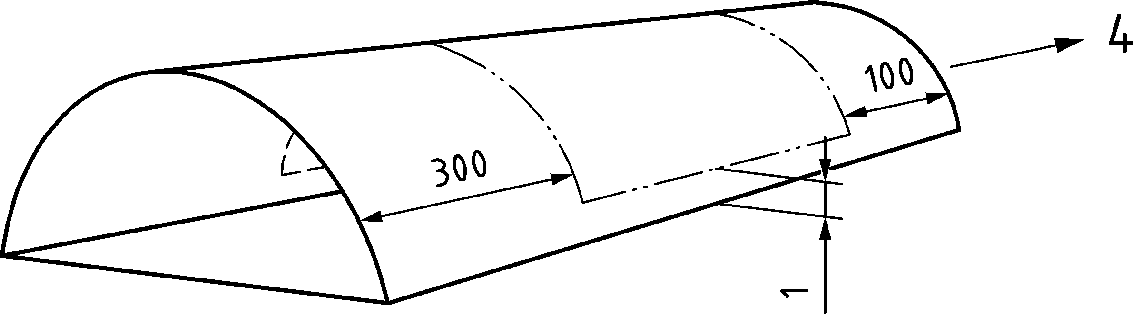

b) Road tunnels, with Zone I and Zone II



Key

|  |  |
| --- | --- |
| 1 Zone I: | XD3 + XF4 |
| 2 Zone II: | XD1 + XF2 |
| 3 Zone III: | XC3 |
| 4 | Traffic direction |
| a | Distance to ground surface in a) |

Figure K.1 — Exposure classes XD for constructions along roads

(3) For bridge decks exposed to chlorides from de-icing salts, a waterproofing membrane should be arranged. Bridge decks protected by waterproofing membranes may be considered with following exposure classes:

* XD1: bridge deck top surface;
* XD3: inside, top side and outside of curbs;
* XD3: surfaces under expansion joints directly affected by water containing de-icing salts.

NOTE Horizontal and vertical surfaces located inside Zone I are considered XD3 and XF4, horizontal and vertical surfaces located inside Zone II are considered XD1 and XF2, surfaces inside a box girder section in Zone III are considered XC3 and the dimensions and distances of Zones I and II are as given in Figure K.1 unless a National Annex gives different values.

* 1. Structural analysis

(1) 7.2.2(4) and 7.2.3(6) shall not be applied.

* 1. Ultimate limit states (ULS)

NOTE See Clause 8.

* 1. Serviceability limit states (SLS)

(1) 9.3.2 and 9.3.3 and values for buildings in Table 9.4 shall not be applied. In addition to Clause 9, the following paragraphs specific to bridges shall be applied.

(2) For temporary phases (construction or maintenance) crack widths should be limited to 0,5 mm for quasi-permanent load combination. Where decompression needs to be checked under frequent combination of actions according to Table 9.2(NDP), either decompression should be checked or the tensile stress limited to fctm.

(3) Additional to Table 9.4 for bridges, additional damping effected by pavement, railings and other non-structural components may be considered on the basis of experimental evidence.

* 1. Fatigue verification using damage equivalent stress range

(1) The following clauses supplement Clause 10 and E.4 with provisions for damage equivalent fatigue verification specific to bridges.

* + 1. General

(1) prEN 1991‑2 gives relevant fatigue load models for fatigue verification of bridges using the method of damage equivalent stress range (FLM3 for road bridges, LM71 for railway bridges) and prEN 1990 procedures for the calculation of the equivalent stress range ΔσS,equ for superstructures of road and railway bridges.

* + 1. Verification for reinforcement

(1) For road and railway bridges the damage equivalent stress range for reinforcement verification in Formula (E.1) should be calculated according to Formula (K.1):

|  |  |
| --- | --- |
| Δσs,equ = Δσs,Ec ⋅ λs | (K.1) |

where

|  |  |
| --- | --- |
| Δσs,Ec | is the reinforcement stress range caused by the following fatigue load models: |
|  | For road bridges: based on the load combination given in 10.2 with fatigue load model 3 (FLM3) according to prEN 1991‑2 with the axle loads increased by the following factors: |
|  | — 1,75 for verification at intermediate supports in continuous bridges, |
|  | — 1,40 for verification in other areas. |
|  | For railway bridges: load model 71 (and where required SW/0) according to prEN 1991‑2; |
| λs | is the damage equivalent factor for fatigue. |

(2) The correction factor λs reflects the influence of span, annual traffic volume, design service life, multiple lanes/tracks, and may be calculated by Formula (K.2):

|  |  |
| --- | --- |
| λs = φ ⋅ λs,1 ⋅ λs,2 ⋅ λs,3 ⋅ λs,4 | (K.2) |

where

|  |  |
| --- | --- |
| λs,1 | is a factor accounting for element type (e.g. continuous beam) and takes into account the damaging effect of traffic depending on the critical length of the influence line or area; |
| λs,2 | is a factor that takes into account the traffic volume; |
| λs,3 | is a factor that takes into account the design service life of the bridge; |
| λs,4 | is a factor to be applied when the structural element is loaded by more than one lane/track; |
| φ | equals the damage equivalent impact factor φfat controlled by the surface roughness |

according to prEN 1991‑2, Annex B for road bridges and the dynamic factor 𝜙 according to prEN 1991‑2 for railway bridges, respectively.

(3) For road bridges λs,1 should be determined from Figures K.3 and K.4 to take into account the critical length of the influence line and the shape of S-N-curve.

Verification in the intermediate support area

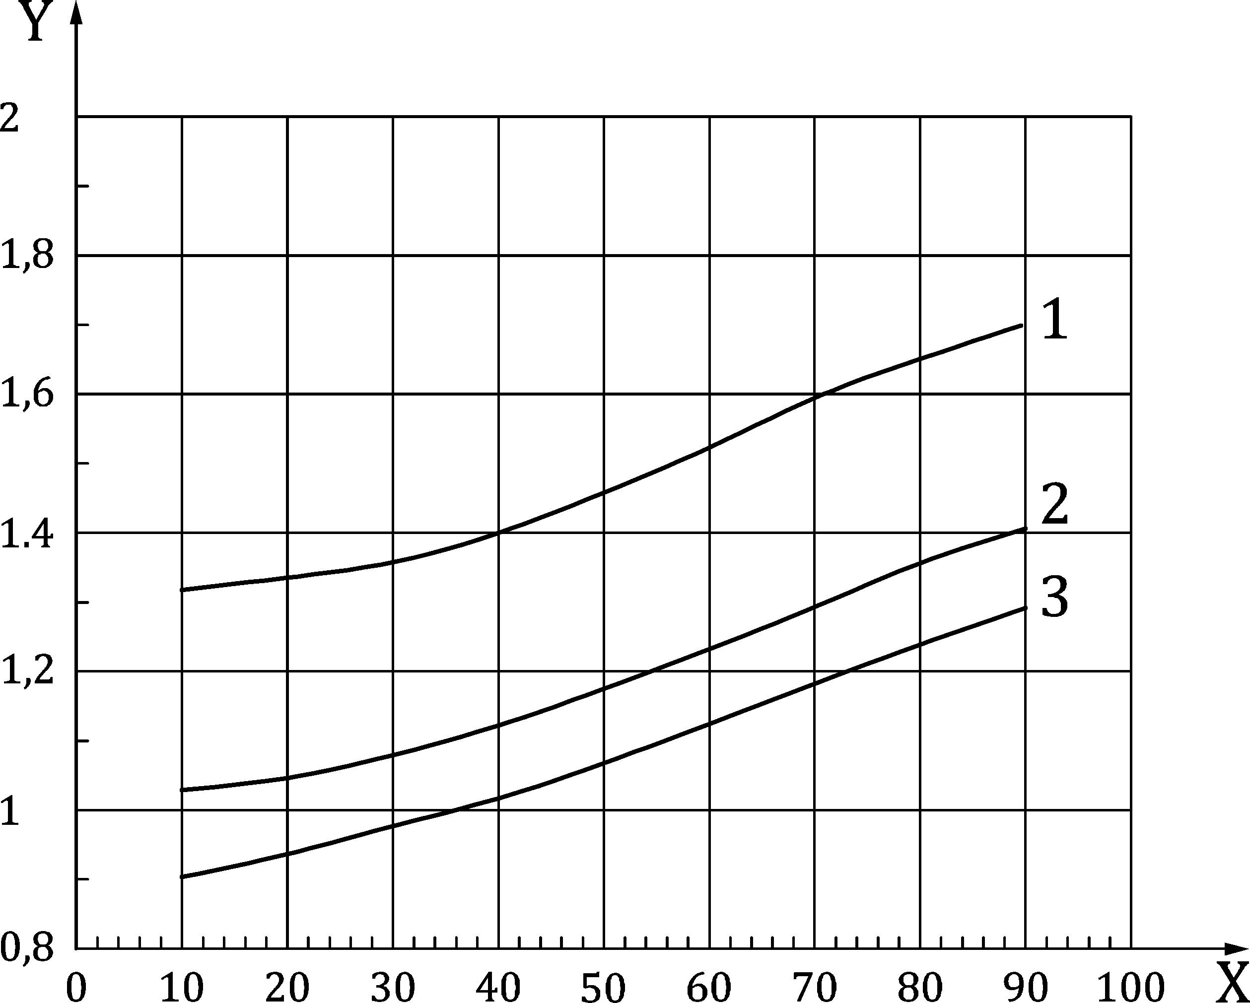

Key

|  |  |
| --- | --- |
| 1 | couplers for reinforcing steel |
| 2 | curved tendons in steel ducts |
| 3 | reinforcing steel (straight and bent); pre-tensioning (all); post-tensioning (strand in plastic ducts or straight tendons in steel ducts) |
| X | critical length of influence line [m] |

NOTE λs1-values for intermediate ΔσRsk can be interpolated.

Figure K.2 — λs,1 value for fatigue verification in the intermediate support area of road bridges

Verification in span and for carriageway slab

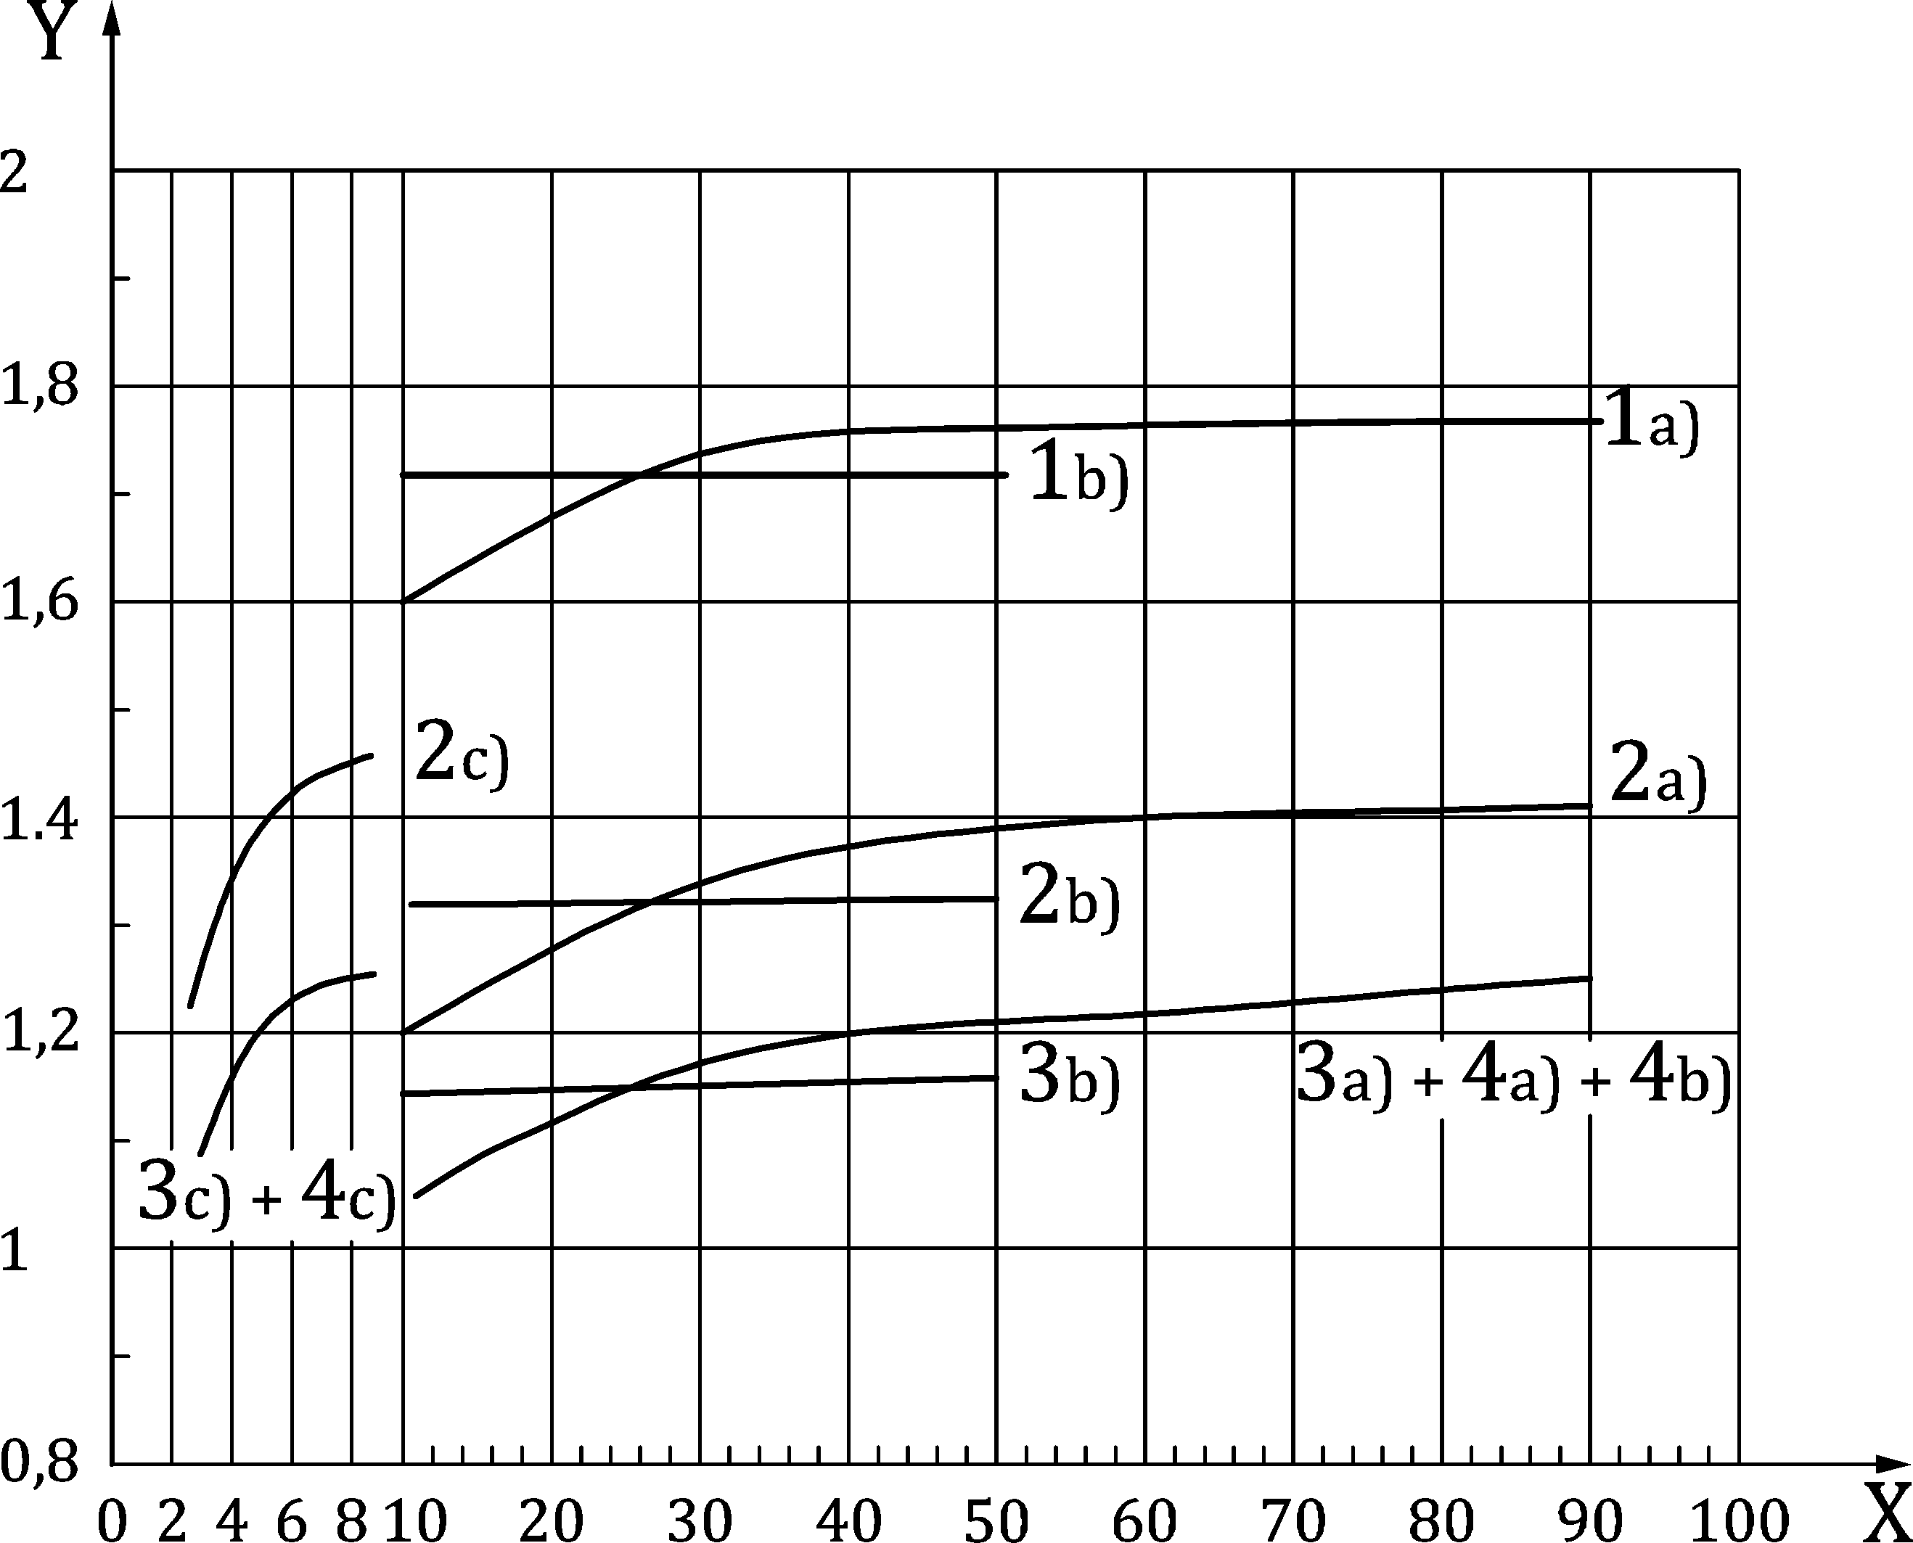

Key

|  |  |  |  |
| --- | --- | --- | --- |
| 1) | couplers for reinforcing steel | a) | continuous beam |
| 2) | curved tendons in steel ducts | b) | single span beam |
| 3) | reinforcing steel (straight and bent); pre-tensioning (all); post-tensioning (strand in plastic ducts or straight tendons in steel ducts) | c) | carriageway slab |
| 4) | shear reinforcement |  |  |
| X | critical length of influence line [m] |  |  |
| Y | λs1 |  |  |

NOTE λs1-values for intermediate ΔσRsk can be interpolated.

Figure K.3 — λs,1 value for fatigue verification in span and for local elements of road bridges

(4) For railway bridges, λs,1 accounts for the critical length of the influence line and the traffic mix. The values of λs,1 for standard traffic mix and heavy traffic mix may be taken from Table K.1. The values have been calculated on the basis of a constant ratio of bending moments to stress ranges.

The values given for mixed traffic correspond to the combination of train types given in Annex F of prEN 1991‑2.

Values of λs,1 for a critical length of influence line between 2 m and 20 m may be obtained from the Formula (K.3):

|  |  |
| --- | --- |
| λs,1(L) = λs,1(2 m) + [λs,1(20 m) − λs,1(2 m)] ⋅ (lg L − 0,3) | (K.3) |

where

|  |  |
| --- | --- |
| L | is the critical length [m] of the influence line; |
| λs,1(2 m) | is the λs,1 value for L = 2 m; |
| λs,1(20 m) | is the λs,1 value for L = 20 m. |

Table K.1 — λs,1 values for simply supported and continuous members of railway bridges

| **a) simply supported members** | | | | **b) continuous members (interior span)** | | | |
| --- | --- | --- | --- | --- | --- | --- | --- |
|  | L [m] | STM | HTM |  | L [m] | STM | HTM |
| (1) | ≤ 2 | 0,90 | 0,95 | (1) | ≤ 2 | 0,95 | 1,05 |
| ≥ 20 | 0,65 | 0,70 | ≥ 20 | 0,50 | 0,55 |
| (2) | ≤ 2 | 1,00 | 1,05 | (2) | ≤ 2 | 1,00 | 1,15 |
| ≥ 20 | 0,70 | 0,70 | ≥ 20 | 0,55 | 0,55 |
| (3) | ≤ 2 | 1,25 | 1,35 | (3) | ≤ 2 | 1,25 | 1,40 |
| ≥ 20 | 0,75 | 0,75 | ≥ 20 | 0,55 | 0,55 |
| (4) | ≤ 2 | 0,80 | 0,85 | (4) | ≤ 2 | 0,75 | 0,90 |
| ≥ 20 | 0,40 | 0,40 | ≥ 20 | 0,35 | 0,30 |
| **c) continuous members (end span)** | | | | **d) continuous members (intermediate support area)** | | | |
|  | L [m] | STM | HTM |  | L [m] | STM | HTM |
| (1) | ≤ 2 | 0,90 | 1,00 | (1) | ≤ 2 | 0,85 | 0,85 |
| ≥ 20 | 0,65 | 0,65 | ≥ 20 | 0,70 | 0,75 |
| (2) | ≤ 2 | 1,05 | 1,15 | (2) | ≤ 2 | 0,90 | 0,95 |
| ≥ 20 | 0,65 | 0,65 | ≥ 20 | 0,70 | 0,75 |
| (3) | ≤ 2 | 1,30 | 1,45 | (3) | ≤ 2 | 1,10 | 1,10 |
| ≥ 20 | 0,65 | 0,70 | ≥ 20 | 0,75 | 0,80 |
| (4) | ≤ 2 | 0,80 | 0,90 | (4) | ≤ 2 | 0,70 | 0,70 |
| ≥ 20 | 0,35 | 0,35 | ≥ 20 | 0,35 | 0,40 |
| STM standard traffic mix  HTM heavy traffic mix  (1) reinforcing steel, pre-tensioning (all), post-tensioning (tendons in plastic ducts and straight tendons in steel ducts);  (2) post-tensioning (curved tendons in steel ducts); S-N curve with kf1 = 3, kf2 = 7 and N* = 106 (values may be changed due to changes in kf1 and kf2 or N*);  (3) couplers (prestressing steel); S-N curve with kf1 = 5, kf2 = 5 and N* = 106 (values may be changed due to changes in kf1 and kf2 or N*);  (4) couplers (reinforcing steel); welded bars including tack welding and butt joints; S-N curve with kf1 = 3, kf2 = 5 and N* = 107 (values may be changed due to changes in kf1 and kf2 or N*). | | | | | | | |
| NOTE Interpolation between the given L-values according to Formula (K.4) may be carried out. | | | | | | | |

(5) No values of λs,1 for a light traffic mix are given in Table K.1. For bridges designed to carry a light traffic mix the values for λs,1 to be used may be based either on the values given in Table K.1 for standard traffic mix or on values determined from detailed calculations.

(6) For road bridges λs,2 reflects the influence of the annual traffic volume and may be calculated by Formula (K.4) also depending on the traffic type:

|  |  |
| --- | --- |
| $$λ_{s,2}=\overline{Q}⋅\sqrt[k_{f2}]{\frac{N_{obs}}{2,0⋅{10}^{6}}}$$ | (K.4) |

where

|  |  |
| --- | --- |
| Nobs | is the number of lorries per year according to prEN 1991‑2:2018, Table 6.5; |
| kf2 | is the slope of the appropriate S-N-Line to be taken from Tables K.1 and K.2; |
| $$\overline{Q}$$ | is a factor for traffic type according to Table K.2. |

Table K.2 — Factors for traffic type of road bridges

| slope of S-N curve | $\overline{Q}$-factor for traffic type (see EN 1991‑2:2003 + AC:2010, Table 4.7) | | |
| --- | --- | --- | --- |
| long distance | medium distance | local traffic |
| kf2 = 5 | 1,0 | 0,90 | 0,73 |
| kf2 = 7 | 1,0 | 0,92 | 0,78 |
| kf2 = 9 | 1,0 | 0,94 | 0,82 |

(7) For railway bridges λs,2 reflects the influence of the annual traffic volume. λs,2 may be calculated by Formula (K.5):

|  |  |
| --- | --- |
| $$λ_{s,2}=\sqrt[k_{f2}]{\frac{Vol}{25⋅{10}^{6}}}$$ | (K.5) |

where

|  |  |
| --- | --- |
| Vol | is the volume of traffic (tonnes/year/track); |
| kf2 | is the slope of the appropriate S-N line to be taken from Tables K.1 and K.2. |

(8) λs,3 reflects the influence of the service life and may be calculated from Formula (K.6):

|  |  |
| --- | --- |
| $$λ_{s,3}=\sqrt[k_{f2}]{\frac{N_{years}}{100}}$$ | (K.6) |

where

|  |  |
| --- | --- |
| Nyears | is the design service life of the bridge; |
| kf2 | is the slope of appropriate S-N line to be taken from Tables K.1 and K.2. |

(9) For road bridges λs,4 reflects the influence of multiple lanes/tracks and may be calculated by Formula (K.7):

|  |  |
| --- | --- |
| $$λ_{s,4}=\sqrt[k_{f2}]{\frac{∑N_{obs,i}}{N_{obs,1}}}$$ | (K.7) |

where

|  |  |
| --- | --- |
| Nobs,i | is the number of lorries expected on lane i per year; |
| Nobs,1 | is the number of lorries on the slow lane per year. |

(10) For railway structures carrying multiple tracks, the fatigue loading should be applied to a maximum of two tracks in the most unfavourable positions (see prEN 1991‑2). The effect of loading from two tracks may be calculated by Formula (K.8):

|  |  |
| --- | --- |
| $$λ_{s,4}=\sqrt[k_{f2}]{n_{st}+\left(1 - n_{st}\right)⋅s_{1}^{k_{f2}}+\left(1-n_{st}\right)⋅s_{2}^{k_{f2}}}$$ | (K.8) |

where

|  |  |
| --- | --- |
| $$s_{1}=\frac{Δσ_{1}}{Δσ_{1+2}}$$ | (K.9) |
| $$s_{2}=\frac{Δσ_{2}}{Δσ_{1+2}}$$ | (K.10) |

where

|  |  |
| --- | --- |
| nst | is the proportion of traffic that crosses the bridge simultaneously (suggested value n = 0,12); |
| Δσ1, Δσ2 | is the stress range due to load model 71 on one track at the section to be checked; |
| Δσ1+2 | is the stress range at the same section due to the load model LM71 on any two tracks, according to prEN 1991‑2; |
| kf2 | is the slope of the appropriate S-N line from Tables K.1 and K.2. |

If only compressive stresses occur under traffic loads on a track, the corresponding value should be sj = 0.

* + 1. Verification for concrete

(1) For railway bridges, the upper and lower stresses of the damage equivalent stress amplitude used in Formula (E.7) should be calculated according to Formula (K.11)

|  |  |
| --- | --- |
| σcd,max,equ = γF,f ⋅ (σc,perm + λc (σc,max,71 − σc,perm))  σcd,min,equ = γF,f ⋅ (σc,perm − λc (σc,perm − σc,min,71)) | (K.11) |

where

|  |  |
| --- | --- |
| σc,perm | is the compressive concrete stress caused by the characteristic combination of actions, without load model 71; |
| σc,max,71 | is the maximum compressive stress caused by the characteristic combination including load model 71 and the dynamic factor Φ according to prEN 1991‑2; |
| σc,min,71 | is the minimum compressive stress under the characteristic combination including load model 71 and the dynamic factor Φ according to prEN 1991‑2; |
| λc | is a correction factor to calculate the upper and lower stresses of the damage equivalent stress spectrum from the stresses caused by load model 71. |

NOTE σc,perm, σc,max,71 and σc,min,71 do not include other variable actions (e.g. wind, temperature etc.).

(2) The correction factor λc accounts for the permanent stress, the span, annual traffic volume, design service life and multiple tracks. It should be calculated from Formula (K.12):

|  |  |
| --- | --- |
| λc = λc,0 ⋅ λc,1 ⋅ λc,2,3 ⋅ λc,4 | (K.12) |

where

|  |  |
| --- | --- |
| λc,0 | is a factor to take account of the permanent stress; |
| λc,1 | is a factor accounting for element type (e.g. continuous beam) that takes into account the damaging effect of traffic depending on the critical length of the influence line or area; |
| λc,2,3 | is a factor to account for the traffic volume and the design service life of the bridge; |
| λc,4 | is a factor to be applied when the structural element is loaded by more than one track. |

(3) λc,0 reflects the influence of the permanent stress and may be calculated from Formula (K.13)

|  |  |  |
| --- | --- | --- |
| $$λ_{c,0}=0,94+0,2\frac{σ_{c,perm}}{f_{cd,fat}}≥1$$ | for the compression zone | (K.13) |

λc,0 = 1 for the precompressed tensile zone (including prestressing effect)

(4) λc,1 is a function of the critical length of the influence line and the traffic. For standard traffic mix and heavy traffic mix it may be taken from Table K.3.

Values of λc,1 for critical lengths of influence lines between 2 m and 20 m may be obtained by applying Formula (K.3) with λs,1 replaced by λc,1.

(5) λc,2,3 reflects the influence of annual traffic volume and design service life and may be calculated from Formula (K.14):

|  |  |
| --- | --- |
| $$λ_{c,2,3}=1+\frac{1}{8}lg\left[\frac{Vol}{25⋅{10}^{6}}\right]+\frac{1}{8}lg\left[\frac{N_{years}}{100}\right]$$ | (K.14) |

where

|  |  |
| --- | --- |
| Vol | is the volume of traffic (tonnes/years/track); |
| Nyears | is the design service life of the bridge. |

(6) λc,4 reflects the effect of loading from more than one track. For structures carrying multiple tracks, the fatigue loading should be applied to a maximum of two tracks in the most unfavourable positions (see prEN 1991‑2). The effect of loading from two tracks may be calculated from Formula (K.15):

|  |  |  |
| --- | --- | --- |
| λc,4 = 1 + (1/8) lg nst ≥ 0,54 | for a ≤ 0,8 | (K.15a) |
| λc,4 = 1 | for a > 0,8 | (K.15b) |
|  | | (K.16) |

where

|  |  |
| --- | --- |
| nst | is the proportion of traffic crossing the bridge simultaneously (recommended value n = 0,12); |
| σc1, σc2 | is the compressive stress caused by load model 71 on one track, including the dynamic factor for load model 71 according to prEN 1991‑2; |
| σc1+2 | is the compressive stress caused by load model 71 on two tracks, including the dynamic factor for load model 71 according to prEN 1991‑2. |

(7) No values of λc,1 are given in Table K.3 for a light traffic mix. For bridges designed to carry a light traffic mix the values for λc,1 to be used may be based either on the values given in Table K.3 for standard traffic mix or on values derived from detailed calculations.

Table K.3 — λc,1 values for simply supported and continuous members of railway bridges

|  |  |  |  |  |  |  |  |
| --- | --- | --- | --- | --- | --- | --- | --- |
| **a) simply supported members** | | | | **b) continuous members (interior span)** | | | |
|  | L [m] | STM | HTM |  | L [m] | STM | HTM |
| (1) | ≤ 2 | 0,70 | 0,70 | (1) | ≤ 2 | 0,75 | 0,90 |
| ≥ 20 | 0,75 | 0,75 | ≥ 20 | 0,55 | 0,55 |
| (2) | ≤ 2 | 0,95 | 1,00 | (2) | ≤ 2 | 1,05 | 1,15 |
| ≥ 20 | 0,90 | 0,90 | ≥ 20 | 0,65 | 0,70 |
| **c) Continous members (end span)** | | | | **d) Continuous members (intermediate support area)** | | | |
|  | L [m] | STM | HTM |  | L [m] | STM | HTM |
| (1) | ≤ 2 | 0,75 | 0,80 | (1) | ≤ 2 | 0,70 | 0,75 |
| ≥ 20 | 0,70 | 0,70 | ≥ 20 | 0,85 | 0,85 |
| (2) | ≤ 2 | 1,10 | 1,20 | (2) | ≤ 2 | 1,10 | 1,15 |
| ≥ 20 | 0,70 | 0,70 | ≥ 20 | 0,80 | 0,85 |
| STM – standard traffic mix,  HTM – heavy traffic mix  (1) compression zone  (2) precompressed tensile zone | | | | | | | |
| NOTE Interpolation between the given L-values according to Formula (K.3) is allowed, with λs,1 replaced by λc,1. | | | | | | | |

* 1. Detailing of reinforcement and post-tensioning tendons

NOTE See Clause 11.

* 1. Detailing of members and particular rules
     1. General

(1) 12.9 shall not be applied. The following clauses supplement Clause 12 with provisions specific to bridges and particular types of bridges.

(2) Voids in structural members should be drained.

* + 1. Minimum reinforcement rules

(1) Brittle failure of bridges due loss of cross section of prestressing tendons (e.g. due to corrosion) should be prevented. Methods a) or b) below may be applied:

1. Check that the structure with the remaining prestressing has sufficient strength for the traffic load combination. The requirement may be verified by the following procedure:

(i) Calculate the maximum sagging and hogging bending moments in each span due to the frequent combination of actions, MEd,freq.

(ii) Determine the reduced cross sectional area of prestressing, Ap,red, and corresponding prestressing load resultants that make the tensile stress reach fctm at the extreme tension fibre when the section is subject to MEd,freq. Immediate and long-term prestressing losses should be taken into consideration.

(iii) Calculate the ultimate flexural capacity, MRd,red, of the section with reduced cross sectional area of prestressing, AP,red, and ordinary reinforcement using material partial safety factors for accidental design situations.

(iv) Check that MRd,red ≥ MEd,freq.

1. Ensure that there is sufficient longitudinal reinforcement to compensate for the loss of resistance when the tensile strength of the concrete is exceeded and the section cracks.

If tensile stresses occur anywhere in the section for characteristic load combination (statically determinated effects of prestressing ignored, but indeterminated effects included, see 7.6.1(1)), longitudinal reinforcement should be at least:

|  |  |
| --- | --- |
| $$A_{s,min}=\frac{M_{rep}}{z⋅f_{yk}}$$ | (K.17) |

where

|  |  |
| --- | --- |
| Mrep | cracking moment with extreme fibre tension σc = fctm, for section without prestressing. At the joint of segmental precast elements Mrep = 0; |
| z | lever arm at the ultimate limit state related to the reinforcing steel. |

* + 1. Bridges with external or unbonded internal tendons

(1) External prestressing tendons should be inspectable and replaceable. For internal unbonded tendons, the anchorages should be inspectable and the project design specification (project basis) should identify if the tendons should be replaceable as defined in (2).

(2) Bridges should be verified to ensure that any one tendon of the external and if identified in the project basis any one of the unbonded tendons can be replaced. A project specific load combination with permissible live loads (traffic) should be defined for the replacement.

(3) When designing members for anchorage and deviation of external tendons, deviation forces accounting for an angular tolerance of Δα = ±3° should be taken into account.

(4) The risk of vibration of external tendons induced between tendon fix points by traffic loads should be controlled by adequate detailing of tendon supports. Without more detailed analysis, spacing of tendon support points should be limited to 12 m for railway bridges and 18 m for road bridges.

* + 1. Cable stayed, Extradosed and Suspension bridges

(1) For stay cables and extradosed cables for cable supported members and structures, the general provisions of prEN 1990:2020, Annex A.2, should be applied.

(2) For ultimate limit state verifications, the design value of tension resistance should be assumed in accordance with prEN 1993‑1‑11.

(3) The following rules apply to prestressing cables which extend above or below the bridge deck and in which

* the variations of tensile stress under frequent traffic loads are less than 100 MPa,
* the vibrations caused by wind are negligible.

(4) The maximum tensile stress under the characteristic combinations at SLS should be

|  |  |  |
| --- | --- | --- |
| max σcable ≤ 0,60σuk | if Δσfreq ≤ 50 MPa | (K.18) |
| $$max σ_{cable}≤0,46⋅{\left(\frac{Δσ_{freq}}{140 \text{MPa}}\right)}^{-0,25}⋅σ_{uk}$$ | if 50 MPa < Δσfreq ≤ 100 MPa | (K.19) |

where

|  |  |
| --- | --- |
| σuk | is the characteristic breaking strength of the cable: σuk = Fuk/Am; |
| Δσfreq | is the variation of the tensile stress under frequent traffic loads. |

(5) When cables are used as hangers to suspend the deck of bow-string bridges, the sequence of tensioning and the level of pretensioning after losses should ensure that under the characteristic combination at SLS a residual stress of at least 100 MPa is present in all hangers.

* 1. Additional rules for precast concrete elements and structures

(1) 13.6, 13.7.1(9)(11)(12)(13), 13.7.3 and 13.7.4 do not apply. The following clauses supplement Clause 13 with provisions specific to bridges.

(2) In the case of segmental construction with precast elements and without internal bonded tendons in the tension chord, the effect of opening of the joint at ULS shall be considered. In these conditions, in the absence of a more detailed analysis, the force in the tension chord should be assumed to remain unchanged after the joints have opened. In consequence, as the applied load increases and the joints open (Figure K.4), the concrete stress field inclination θ within the web increases. The depth of concrete section available for the flow of the web compression field decreases to a value of zred (see Formula (K.20)). The shear capacity may be evaluated in accordance with 8.2.3 by assuming a value of θ derived from the minimum value of residual depth zred.

|  |  |
| --- | --- |
| $$z_{red}=\frac{V_{Ed}}{b_{w}⋅ν⋅f_{cd}}\left(cotθ+tanθ\right)$$ | (K.20) |

The prestressing force should be increased, if necessary, so that, at ULS under the combination of bending moment and shear, the joint opening is limited to the value h − zred as calculated above.

NOTE The minimum value of zred is 0,5h unless a National Annex gives a different value.

(3) Shear reinforcement should be provided within a distance zred ⋅ cotθ, but not greater than the segment length, from both edges of the joint, having the area per unit length according to Formula (K.21):

|  |  |
| --- | --- |
| $$\frac{A_{sw}}{s}=\frac{V_{Ed}}{z_{red}⋅f_{ywd}⋅cotθ}$$ | (K.21) |

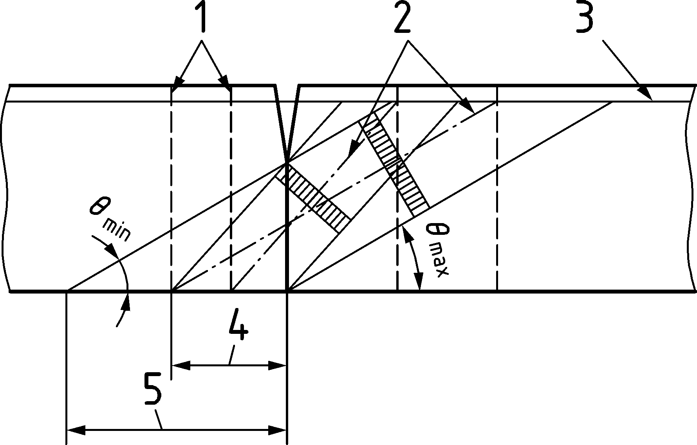

Key

|  |  |
| --- | --- |
| 1 | Axes of theoretical tie |
| 2 | Axes of theoretical struts |
| 3 | Tension chord of truss (external tendon) |
| 4 | Field A: arrangement of stirrups with θmax (cot θ = 1,0) |
| 5 | Field B: arrangement of stirrups with θmin (cot θ = 2,5) |

Figure K.4 — Diagonal stress fields across the joint web

(4) In the case of segmental construction with precast box elements and no internal bonded prestressing in the tension region, the opening of a joint to an extent greater than the thickness of the corresponding flange should not be permitted unless a sufficient strength can be demonstrated with refined design models accounting for this opening of the joint.

NOTE Such amount of joint opening induces a substantial modification of the torsional resisting mechanism.

* 1. Plain and lightly reinforced concrete structures

NOTE See Clause 14.

* 1. Annexes A to O

NOTE See Annexes A to O.

1. (informative)  
     
   Steel Fibre Reinforced Concrete Structures
   1. Use of this annex

(1) This Informative Annex provides supplementary rules for structures which comprise steel fibre reinforced concrete (SFRC). The provisions of this Eurocode apply for concrete members with SFRC unless modified in this Annex L.

NOTE National choice on the application of this Informative Annex is given in a National Annex. If a National Annex contains no information on the application of this Informative Annex, it can be used.

* 1. Scope and field of application

(1) This Informative Annex covers the design of concrete structures which comprise steel fibre reinforced concrete (SFRC) with or without reinforcing steel, pretensioning or post-tensioning tendons.

(2) This Informative Annex applies to normal weight and heavy weight, precast or cast in place concrete in accordance with 5.1.1.

NOTE Slabs on ground which are not required for the structural stability (e.g. industrial floors) can be designed to these provisions.

* 1. General

NOTE Unless noted otherwise, in Annex L all clauses/subclauses numbers and titles are similar to the relevant of the main part of this Eurocode. The prefix ‘L’ is added to section/sub-sections numbers to distinguish content that pertain Steel Firbre Reinforced Concrete (SFRC). Annex L contains only clauses/subclauses of the main part of this Eurocode that include specific clauses for SFRC.

* 1. Basis of design - Verification by the partial factor method - Partial factors for materials

(1) Partial factors for SFRC in tension γSF shall be applied for ultimate and serviceability limit states. For SFRC in compression, the values γC given in Table 4.3(NDP) apply.

NOTE The values of γSF given in Table L.1(NDP) apply unless a National Annex gives different values

Table L.1(NDP) — Partial factors for SFRC in tension

| Design situations — Limit states | γSF |
| --- | --- |
| Persistent and transient design situations | 1,50 |
| Accidental design situation | 1,20 |
| Serviceability limit states | 1,00 |

* 1. Materials - Steel Fibre Reinforced Concrete
     1. Properties

(1) In addition to the properties to be defined according to 5.1.2(1), properties that need to be specified for design of SFRC in accordance with this Eurocode include the characteristic residual flexural strengths fR,1k and fR,3k.

* + 1. Strength

(1) The residual strength classes in this annex are based on the characteristic residual flexural strength fR,1k and fR,3k that should be taken from Table L.2.

NOTE 1 The classification is denominated according to fR,1k and the ratio fR,3k/fR,1k denominated by a letter. The letter defines the ductility class which is illustrated in Figure L.1a).

NOTE 2 Values of characteristic residual flexural strength used in this Eurocode correspond to those determined using EN 14651 at the age tref defined in 5.1.3(2).

(2) If required, the strength of SFRC should be specified for times t that can be before or after tref for a number of stages (e.g. demoulding, removal of propping, transfer of prestress).

Table L.2 — Residual strength classes for SFRC

|  |  |  |  |  |  |  |  |  |  |  |
| --- | --- | --- | --- | --- | --- | --- | --- | --- | --- | --- |
| Ductility classes | Characteristic residual flexural strength fR,1k | | | | | | | | | Analytical formulae |
| 1,0 | 1,5 | 2,0 | 2,5 | 3,0 | 4,0 | 5,0 | 6,0 | 8,0 |
| a | 0,5 | 0,8 | 1,0 | 1,3 | 1,5 | 2,0 | 2,5 | 3,0 | 4,0 | fR,3k = 0,5fR,1k |
| b | 0,7 | 1,1 | 1,4 | 1,8 | 2,1 | 2,8 | 3,5 | 4,2 | 5,6 | fR,3k = 0,7fR,1k |
| c | 0,9 | 1,4 | 1,8 | 2,3 | 2,7 | 3,6 | 4,5 | 5,4 | 7,2 | fR,3k = 0,9fR,1k |
| d | 1,1 | 1,7 | 2,2 | 2,8 | 3,3 | 4,4 | 5,5 | 6,6 | 8,8 | fR,3k = 1,1fR,1k |
| e | 1,3 | 2,0 | 2,6 | 3,3 | 3,9 | 5,2 | 6,5 | 7,8 | 10,4 | fR,3k = 1,3fR,1k |

NOTE 1 All strength classes apply unless a National Annex excludes specific classes.

NOTE 2 Intermediate classes can be used, if included in a National Annex.

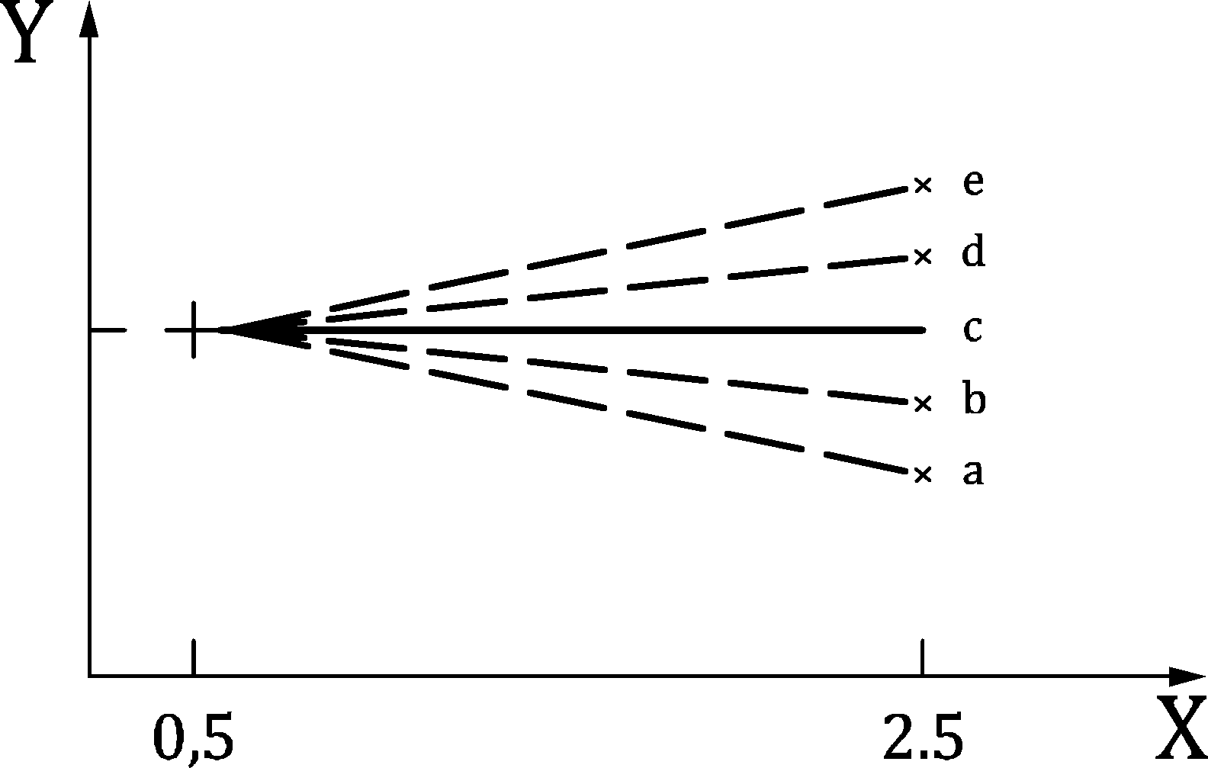

a) Illustration of the ductility classes

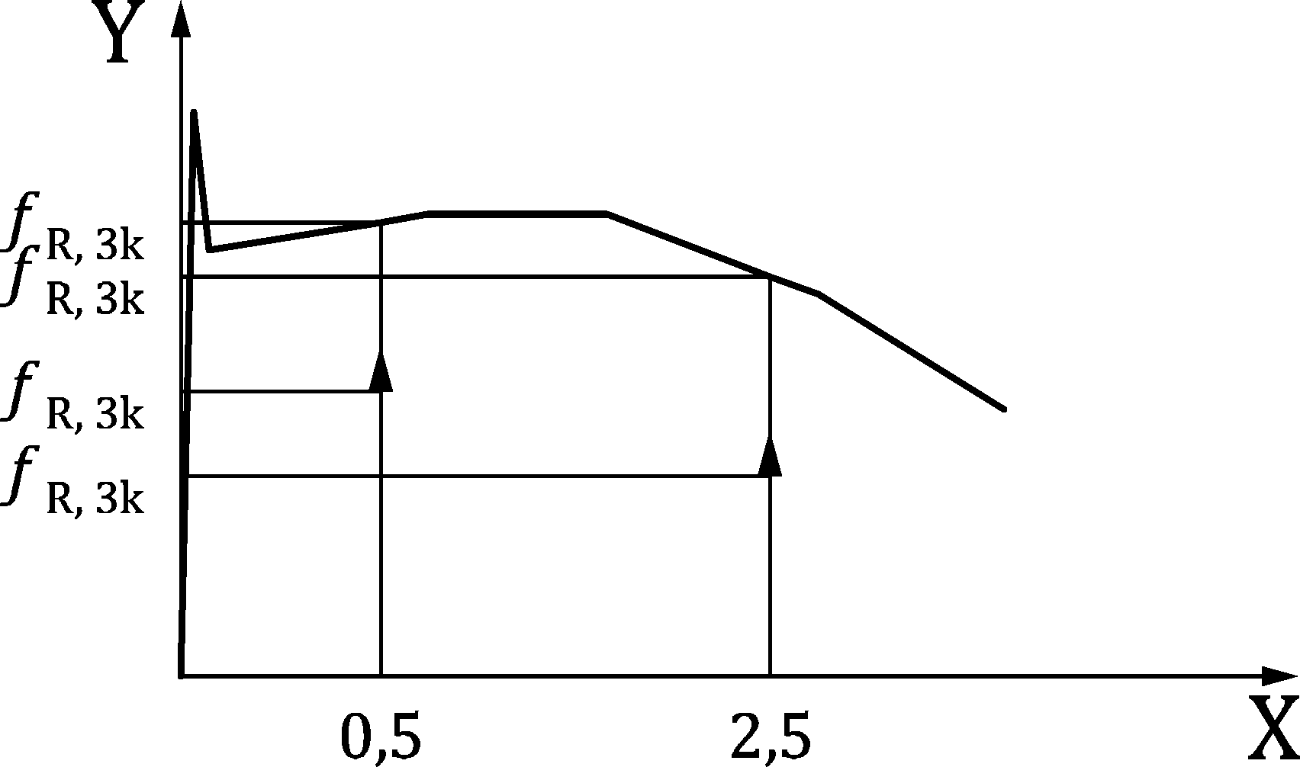

b) Typical relation between residual flexural strengths and crack widths

Key

|  |  |
| --- | --- |
| X | crackwidth |
| Y | fR,ik/fR,1k in a) |

Figure L.1 — SFCR classification according to characteristic residual flexural strength

* + 1. Elastic deformation

(1) The values of the modulus of elasticity, the Poisson’s ratio and the thermal expansion coefficient may be taken according to 5.1.

(2) Values of the modulus of elasticity and Poisson’s ratio may be subject to higher variation than for ordinary concrete when steel fibres are introduced into the mix. Where they are a significant component of action effects, they should be determined by testing.

* + 1. Creep and shrinkage

(1) Creep and shrinkage properties may be taken according to 5.1. However, if these values have a significant impact on the action effects, they should be determined by testing.

(2) Values of creep and shrinkage may be subject to higher variation than for ordinary concrete when steel fibres are introduced into the mix. Where they are a significant component of action effects, they should be determined by testing.

* + 1. Design assumptions
       1. Design residual tensile strengths

(1) For design according to Annex L, Formula (L.1) should be satisfied:

|  |  |
| --- | --- |
| $${f_{R,1k}}/{f_{ctk,0,05}}≥0,5$$ | (L.1) |

(2) The values of the design residual tensile strength, fFtsd and fFtud should be taken as follows:

|  |  |
| --- | --- |
| $$f_{Ftsd}=κ_{O}∙0,40∙f_{R,1k}/γ_{SF}$$ | (L.2) |
| $$f_{Ftuk}dκ_{O}∙0,37∙f_{R,3k}/γ_{SF}$$ | (L.3) |

(3) The factor accounting for fibre orientation should be taken as $κ_{O}=0,5$ unless otherwise specified in Annex L or verified by testing.

(4) For bending moments, shear forces and torsion in slabs and beams made of concrete with consistency classes S2–S4 in accordance with EN 206, $κ_{O}=1,0$ may be used.

(5) More accurate information based on production of SFRC and well-founded theoretical approaches may be used to establish more accurate values for $κ_{O}$.

(5) For self compacting concrete, $κ_{O}$ in every direction should be experimentally determined by using specimens and casting methods representative for the real structure. For design the value of κO shall not exceed 2,0.

(6) Formulae in 5.1.6 may be used for determination of ηcc unless more accurate values are obtained from testing.

* + - 1. Stress-strain relation for structural analysis

(1) For structural analysis the constitutive law given in Figure L.2 may be used. The parameters should be determined as:

|  |  |
| --- | --- |
| $$f_{Ft1,ef}=κ_{O}∙ 0,37f_{R,1k}$$ | (L.4) |
| $$f_{Ft3,ef}=κ_{O}⋅\left(0,57f_{R,3k}-0,26 f_{R,1k}\right)$$ | (L.5) |
| $$ε_{Ftu}={w_{u}}/{l_{cs}}≤{2,5 mm}/{l_{cs}}≤ε_{Ftud}$$ | (L.6) |
| lcs = min {h; srm} | (L.7) |
| srm = 0,75 ∙ sr,max,cal (sr,max,cal according to L.9.3). | (L.8) |
| $$ε_{ctm}={f_{ctm}}/{E_{cm}}and ε_{F,0}=2∙ε_{ctm}$$ | (L.9) |

As a simplification a constant value of lcs = 125 mm may be used.

NOTE 1 The value of $ε_{Ftud}$ is 0,02 unless a National Annex gives a different value.

NOTE 2 Simplified stress distributions in cross sections used to determine the resistance to bending with axial force at the ultimate limit states are provided in L.8.1.

(2) The relation between σc and εc in compression in Formula (5.6) may be modified:

|  |  |
| --- | --- |
| εc1 = 0,7 fcm1/3 (1 + 0,03 fR1,k) | (L.10) |
| εcu1 = k ⋅ εc1 | (L.11) |

where

|  |  |
| --- | --- |
| $$k=1+\frac{20}{\sqrt{82-2,2f_{R1,k}}}$$ | (L.12) |

In millimetres

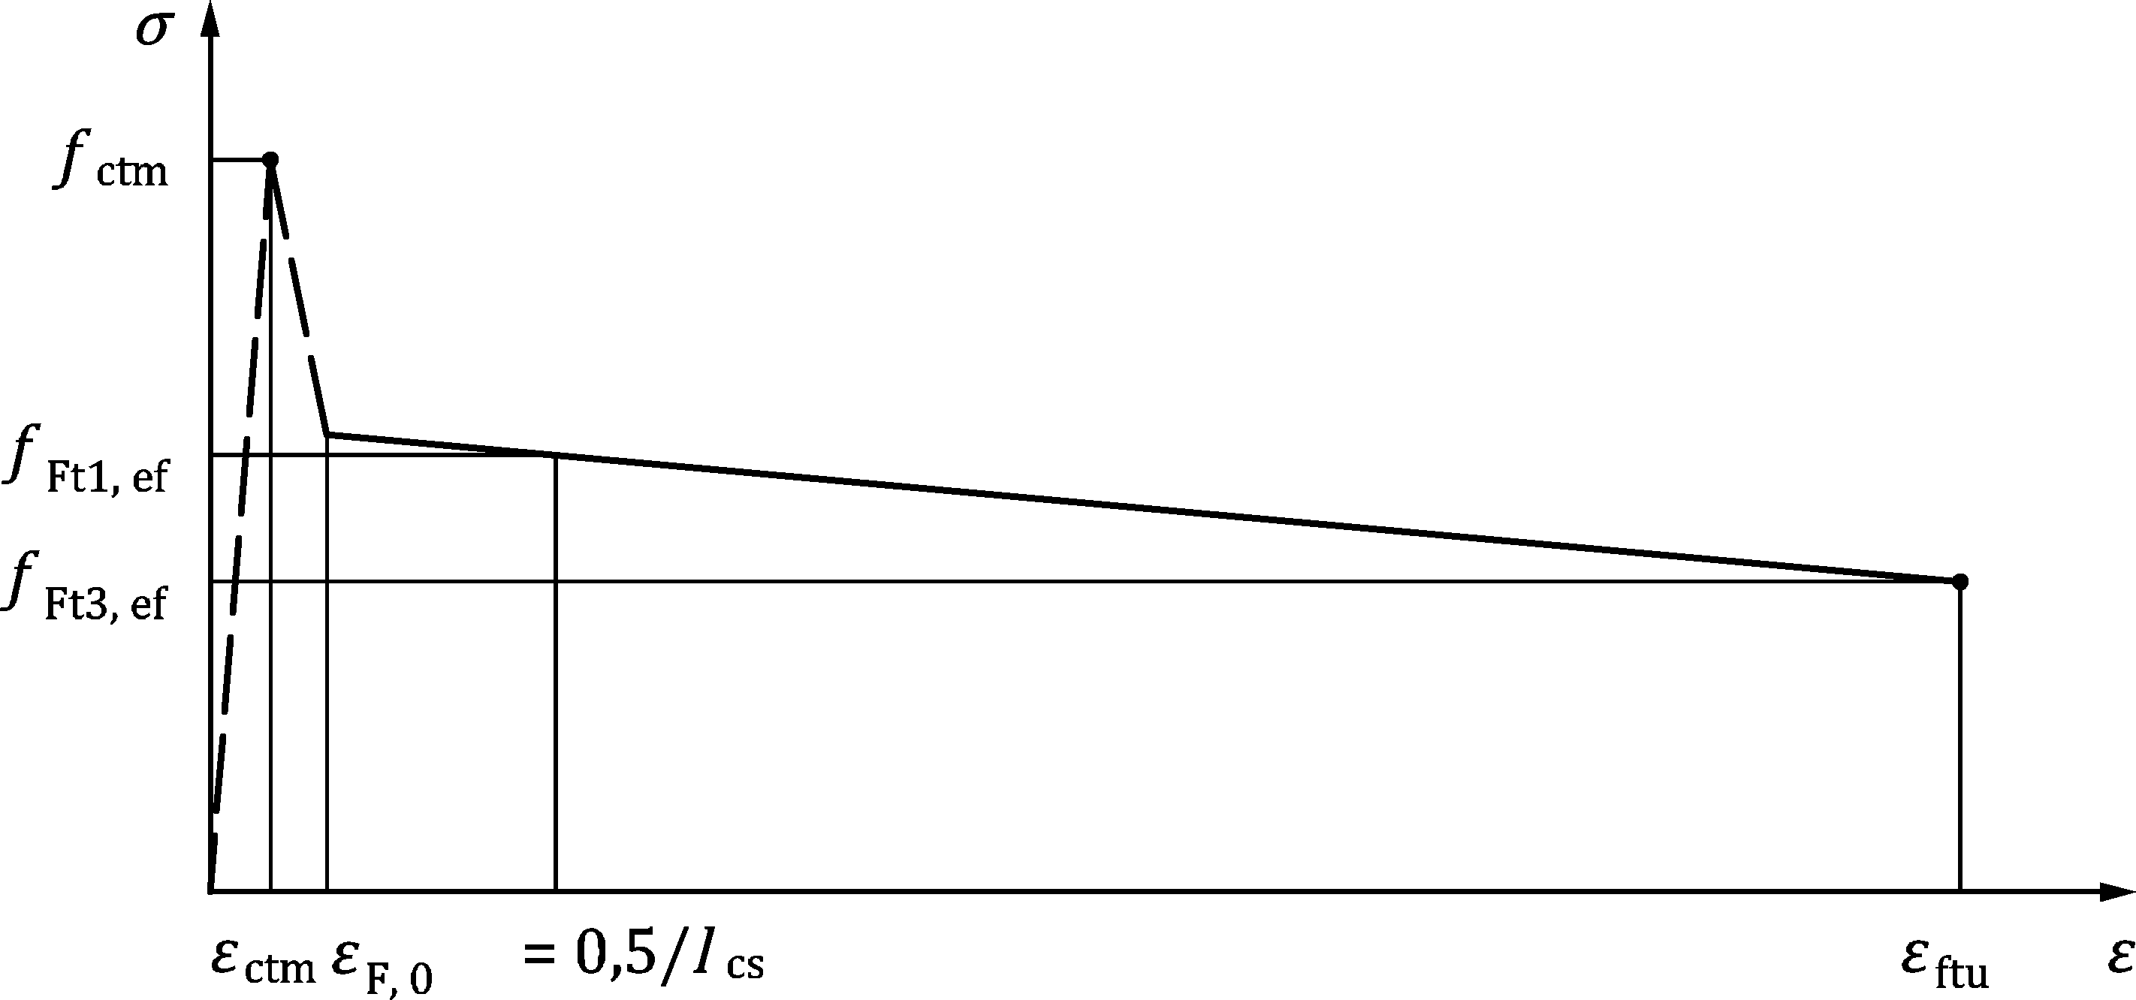

Figure L.2 — Constitutive law of SFRC for structural analysis

* 1. Durability - Concrete cover - Minimum cover

(1) For SFRC, the concrete cover due to durability requirements cmin,dur according to 6.5.2.2 shall only apply to the embedded reinforcement, not to the steel fibres.

(2) To avoid fibre accumulation, a minimum cover of cmin = 20 mm to embedded reinforcement shall be used for all SFRC members.

(3) For design of SFRC in exposure classes XC2-XC4, XD1-XD3, and XS1-XS3, designed to be uncracked, the tensile strength in the outer most tension fibres shall be disregarded within a layer of cf,dur = 10 mm from the exposed surface.

(4) For design of SFRC in exposure classes XC2-XC4, XD1-XD3, and XS1-XS3 designed to be cracked, the residual tensile strength in the outer most tension fibres shall be disregarded with a distance of $c_{min,dur}$ from the exposed surface, unless provisions (5) or (6) are satisfied.

If the characteristic crack width calculated in accordance with 9.2 is less than the crack width limit wlim,cal stated in Table 9.2(NDP) and L.9, the values of cf,dur may be reduced as follows:

|  |  |
| --- | --- |
| $$c_{f,dur} =c_{min,dur}\frac{w_{k,cal}}{w_{lim,cal}}≥10 \text{mm}$$ | (L.13) |

(5) If stainless steel fibres are used, the residual tensile strength of the outermost tension fibres within depth *c*f,dur may be used.

(6) The residual tensile strength of fibres in the layer cf,dur may be used in temporary situations such as during the construction phase.

* 1. Structural analysis - Plastic analysis - Special rules for SFRC structures

(1) Plastic analysis of SFRC structures without any direct check of rotation capacity may be used for the ultimate limit state analysis of the following structure types:

* Foundations and slabs supported directly on ground.
* For statically indeterminate rafts and slabs on piles subject to the following conditions:
* the ductility class is at least c and
* if the member is needed for structural stability ${f_{R,3k}}/{f_{ct,flm}}≥1,0$.
* For statically indeterminate elevated slabs subject to the following conditions:
* the ductility class is at least c,

${f_{R,3k}}/{f_{ct,flm}}≥1,0$

(2) For members not fulfilling the requirements of (1), methods based on plastic analysis, or linear analysis with limited redistribution, shall only be applied where the deformation capacity of the critical sections is demonstrated to be sufficient by calculation for the envisaged failure mechanisms to be formed.

NOTE Due to possible localisation effects occurring at yielding of longitudinal reinforcement, minimum reinforcement as prescribed in L.12.1 is not sufficient to generally allow plastic analysis without verification of the deformation capacity.

(3) Methods to be used for verification of plastic deformation capacity shall take local variations in residual tensile strength into account.

* 1. Ultimate Limit States (ULS)
     1. Bending with or without axial force - Stress distribution for SFRC in tension

(1) A simplified rigid plastic approach for the residual tensile strength according to Figure L.3a) may be used for ultimate limit state design of a member subjected to bending with or without axial compression, for ductility classes a, b and c.

For classes d and e this approach should only be used to determine the ULS moment capacity at the design tensile strain limit.

(2) The tensile strain limit relevant to the simplified rigid plastic approach should be calculated from Formula (L.14) with $ε_{Ftud}$ as defined in *L.5.1.7*:

|  |  |
| --- | --- |
| εFtu = εFtud | (L.14) |

(3) For the design of steel fibre reinforced cross sections a bi-linear residual tensile stress distribution according to Figure L.3b) may be used with parameters as defined in *L.5.1.7* and:

|  |  |
| --- | --- |
| $$f_{Ft1d}={f_{Ft1,ef}}/{γ_{SF}}$$ | (L.15) |
| $$f_{Ft3d}={f_{Ft3,ef}}/{γ_{SF}}$$ | (L.16) |

(4) The stress distribution according to Formula (8.4) may be modified for SFRC by applying εc2 = 0,0025 and εcu = 0,006.

(5) For ultimate limit state design in flexure of statically indeterminate slabs, the design strengths, $f_{Ftud}$, $f_{Ft1d}$ and $f_{Ft3d},$ may be increased by multiplying with factor $κ_{G}:$

|  |  |
| --- | --- |
| $$κ_{G}=1,0+A_{ct}∙0,5≤1,5$$ | (L.17) |

where

|  |  |
| --- | --- |
| Act | area of the tension zone (in m²) of the cross section involved in the failure of an equilibrium system. |

Dimensions in millimetres

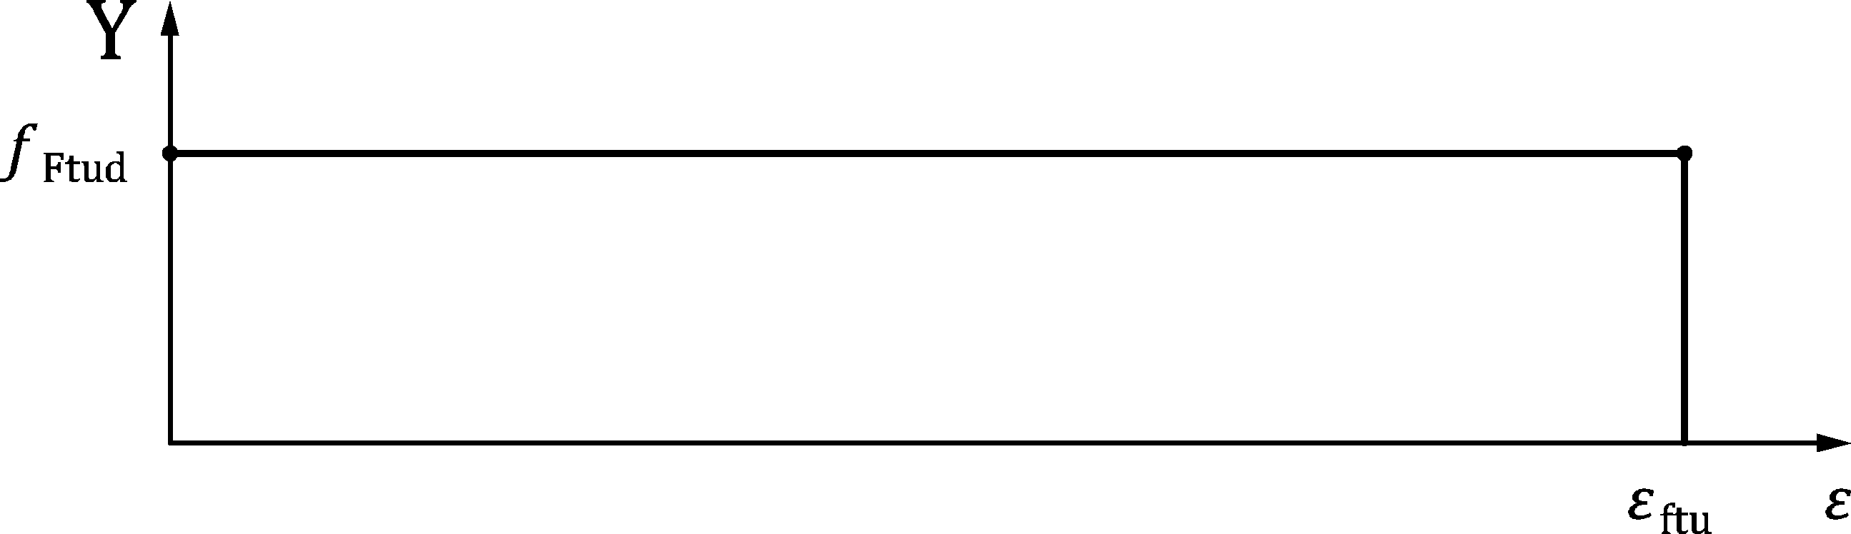

a) Plastic distribution

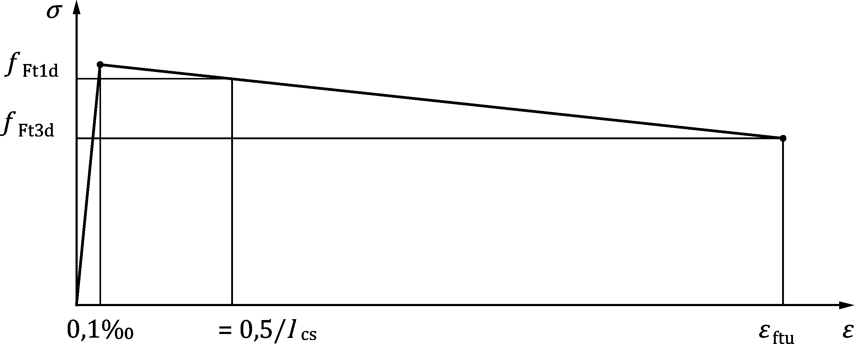

b) bi-linear distribution

Figure L.3 — Simplified stress distributions for SFRC

* + 1. Shear
       1. General verification procedure

(1) Shear reinforcement may be omitted in regions of the SFRC member where τEd ≤ τRD,cF according to L.8.2.2.

(2) If (1) is not met, shear reinforcement shall be designed according to L.8.2.3.

(3) Steel fibres shall not be taken into account for members resisting shear in combination with axial tension.

* + - 1. Detailed verification for members not requiring design shear reinforcement

(1) For SFRC with longitudinal bars in the tensile zone, the design value of the shear strength should be taken as:

|  |  |
| --- | --- |
| $$τ_{Rd,cF}=η⋅\frac{0,6}{γ_{c}}{\left(100ρ_{l}{⋅f}_{ck}\frac{d_{dg}}{d}\right)}^{1/3}+f_{Ftud}≥η⋅τ_{Rdc,min}+f_{Ftud}$$ | (L.18) |
| $$η=max\{\frac{1}{1+0,43f_{Ftuk}^{2,85}};0,4\}$$ | (L.19) |

(2) When, on the basis of the design shear calculation, no shear reinforcement is required, minimum shear reinforcement may be needed according to L.12.

* + - 1. Members requiring design shear reinforcement

(1) For members with SFRC that require design shear reinforcement, and have steel fibres and longitudinal bars in the tensile zone, the design value of the shear strength should be taken as:

|  |  |
| --- | --- |
| $$τ_{Rd,sF}= η_{ss}ρ_{w}f_{yd}+η_{F}f_{Ftud}$$ | (L.20) |

where

|  |
| --- |
| . |

* + 1. Torsion - Torsional resistance of compact or closed sections

(1) The torsional resistance in the transverse and longitudinal directions of SFRC members should be taken as:

|  |  |
| --- | --- |
| $$τ_{Rd,swF}= {η_{ss}τ}_{Rd,sw}+ η_{F}{ f}_{Ftud}≥τ_{Rd,sw}$$ | (L.21) |
| $$τ_{Rd,slF}= {η_{ss}τ}_{Rd,sl}+ η_{F} f_{Ftud}≥τ_{Rd,sl}$$ | (L.22) |

where

|  |  |
| --- | --- |
| $$η_{F}=1,0 \text{and} η_{ss}=0,75$$ |  |

(2) Where a member is subject to torsion in combination with shear and bending, fibre contribution to design resistances should only be as one of the two approaches:

— the fibre contribution is used to resist torsional action effects only

— the fibre contribution is used to resist tensile forces arising from shear and bending action effects, with fibre contribution to sectional resistance disregarded in determining axial tension and torsional resistances

(3) Minimum reinforcement according to L.12.1 shall always be provided for beams.

* + 1. Punching
       1. Punching shear resistance of FRC slabs without shear reinforcement

(1) The design punching shear stress resistance of FRC slabs with flexural reinforcement complying with *L.12.1.1* should be calculated as follows:

|  |  |
| --- | --- |
| $$τ_{Rd,cF}=η_{c}⋅τ_{Rd,c}+η_{F}⋅f_{Ftud}≥η_{c} τ_{Rdc,min}+f_{Ftud}$$ | (L.23) |

where

|  |  |
| --- | --- |
| ηc | = τRd,c/τEd ≤ 1,0; |
| τRd,c | is given in 8.4.3(1); |
| ηF | = 1,0. |

(2) Formula (L.23) shall not be applied to members subject to punching shear in combination with axial tension.

* + - 1. Punching shear resistance of FRC slabs with shear reinforcement

(1) Where shear reinforcement is required in FRC slabs with flexural reinforcement complying with 12.1.1, Formula (8.88) may be replaced by Formula (L.24):

|  |  |
| --- | --- |
| $$τ_{Rd,cs}=η_{c}⋅τ_{Rd,c}+η_{s}⋅ρ_{w}⋅f_{ywd}+η_{F}⋅f_{Ftud}≥ρ_{w}⋅f_{ywd}+η_{F}⋅f_{Ftud}$$ | (L.24) |

where

|  |  |
| --- | --- |
| ηc and ηs | are defined in 8.4.4(1); |
| ηF | = 1,0. |

* + 1. Design with strut-and-tie models - Ties

(1) Fibres may be used in place of the transverse reinforcement.

(2) Fibres may substitute the main longitudinal reinforcement only up to 30 % of the total required amount. A maximum stress of fFts,ef and fFtud may be assumed for serviceability and ultimate limit state respectively in the concrete areas involved.

* + 1. Partially loaded areas

(1) Fibres may be used to replace the transverse reinforcement required to resist transverse tensile stresses arising from action effects in partially loaded areas. For the design, the idealised tensile post-cracking behaviour (see *L.5.1.7* and L.8.1) may be used.

* 1. Serviceability Limit States (SLS) - Crack control
     1. General considerations

(1) The stress and crack width limits in Table 9.1(NDP) and Table 9.2(NDP) may be applied to members reinforced with steel fibres.

(2) In determining stresses and crack widths for use of Table 9.1(NDP) and Table 9.2(NDP), cf,dur shall be disregarded from the concrete section in accordance with *L.6.5(2)*.

* + 1. Minimum reinforcement areas for crack control

(1) The reinforcement areas calculated by Formulae (9.3) to (9.5) may be adjusted for the fibre contribution in accordance with *L.12.1.1*.

* + 1. Refined control of cracking

(1) The maximum crack spacing for members reinforced with steel fibres and longitudinal bars should be calculated as:

|  |  |
| --- | --- |
| sr,max,cal = (2c + 0,28 ⋅ ϕ/ρp,ef) ⋅ (1 − fFts,ef/fctm) | (L.25) |

where fFts,ef is the effective residual tensile strength for the serviceability limit states, and the remaining parameters are as defined in 9.2.4.

(2) The stress in the tensile reinforcement σs in Formula (9.13), should be calculated using the provisions of L.8.1.

* 1. Fatigue

(1) For fatigue verification of SFRC members, the contribution of fibres should be neglected.

* 1. Detailing of reinforcement and post-tensioning tendons
     1. General

(1) Steel fibres shall not be used to replace reinforcement across a construction joint.

(2) The residual tensile strength of SFRC shall be disregarded at construction joints.

* + 1. Spacing of bars

(1) A clear bar distance ≥ kF times the fibre length should be used.

NOTE The value of kF is 20  unless a National Annex gives a different value.

* 1. Detailing of members and particular rules
     1. Minimum reinforcement rules

(1) In members reinforced with steel fibres with or without axial force, minimum reinforcement shall be provided so that:

|  |  |
| --- | --- |
| MR,min(NEd) ≥ k ⋅ Mcr(NEd) | (L.26) |

where

|  |  |
| --- | --- |
| MR,min | is the bending strength of the section with As,min in presence of the co-existing axial force NEd, the effects of the fibres included by the effective residual tensile strength fFtu,ef and the stress distributions in L.8.1 used. The reduction in As,min due to the fibre-contribution should fulfil the limits described in the subsequent clauses. |

(2) In members subjected to axial tension, As,min, shall meet the following requirement:

|  |  |
| --- | --- |
| NR,min ≥ k ⋅ Ncr | (L.27) |

Similarly as above the effects of the fibres are included by the residual tensile strength, and the reduction As,min due to the fibre-contribution should fulfil limits described in the subsequent clauses.

(3) The minimum shear reinforcement area ρFw,min for members reinforced with steel fibres requiring shear or torsion reinforcement may be taken as:

|  |  |
| --- | --- |
| $$ρ_{Fw,min}=ρ_{w,min}-{f_{Ftu,ef}}/{f_{yk}}≥0$$ | (L.28) |

where

|  |  |
| --- | --- |
|  | (L.29) |

* + 1. Beams
       1. Longitudinal reinforcement

(1) The minimum longitudinal reinforcement in beams should not be replaced by steel fibres.

* + - 1. Shear and torsion reinforcement

(1) The shear and torsion reinforcement in beams may be fully replaced by steel fibres if the provisions in L.12.1 are fulfilled.

* + 1. Slabs
       1. General

(1) The longitudinal reinforcement in slabs may be partly replaced by steel fibres subject to the provisions in L.12.1.

(2) The replacement of minimum longitudinal tensile reinforcement should be limited to a fraction kAS of As,min.

NOTE The value of kAS is 0,50 unless a National Annex gives a different value for use in a Country.

(3) The minimum secondary tensile reinforcement in one-way slabs may be fully replaced by steel fibres.

* + - 1. Shear reinforcement

(1) The shear reinforcement in slabs may be fully replaced by steel fibres if Formula (L.30) is fulfilled:

|  |  |
| --- | --- |
| $${f_{Ftu,ef}}/{f_{yk}}≥ρ_{w,min}$$ | (L.30) |

where $f_{Ftu,ef}$ according to Formula (L.29).

(2) The minimum depth given in 12.3.2(2) does not apply for SFRC slabs with fibres as the only shear reinforcement.

* + 1. Walls and deep beams

(1) Vertical and horizontal minimum reinforcement in walls As,min,v and As,min,h may be fully replaced by the steel fibres, taking into account the post cracking tensile strength fFtu,ef in accordance with *L.12.1.1*.

* + 1. Tying systems for robustness of buildings

(1) Fibre reinforcement shall not be considered in the calculation of tie reinforcement.

* 1. Additional rules for precast concrete elements and structures
     1. Concrete - Strength of SFRC

(1) Where quality control measures in accordance with the relevant execution standard are applied, the characteristic values $f_{R,1k}$ and $f_{R,3k}$ may be determined using $κ_{k,max}=1,0$ if $κ_{G}=1,0$. In this case residual strength and ductility classes according to Table L.2 may be neglected.

* + 1. Connections and supports

(15) 8.5.3 or 8.6 should be used to determine the capacity of connection in compression without considering steel fibres of SFRC.

* 1. Lightly reinforced SFRC structures
     1. General

(1) This clause provides additional rules for steel fibre reinforced structural members where the minimum reinforcement provided is less than the requirements in L.12.

(2) For members constructed with joints to avoid uncontrolled cracking, it should be ensured that brittle failure of these members does not lead to collapse of the structure.

(3) Members using SFRC and designed in accordance with this clause do not preclude the provision of steel reinforcement needed to satisfy serviceability, nor reinforcement in certain parts of the members. Any reinforcement may be taken into account for the local verification of ultimate limit states as well as for the checks of the serviceability limit states.

(4) Members subject to imposed deformations should comply with provisions of L.12.

* + 1. Concrete

(1) When tensile stresses are considered for the design resistance of steel fibre reinforced concrete members, linear elastic analysis may be applied with the post cracking tensile design strength using Formula (L.10) in *L.5.1.7* as stress limit.

(2) For design of steel fibre reinforced concrete members according to L.14, tensile stresses according to the stress strain diagrams in L.8.1 may be considered in the design.

* + 1. Ultimate limit states (ULS) - Shear resistance of SFRC members without longitudinal reinforcement

(1) For SFRC without longitudinal bars or prestressing tendons in the tensile zone, the design value of the shear strength should be taken as:

|  |  |
| --- | --- |
|  | (L.31) |

* + 1. Serviceability limit states (SLS)

(1) For SFRC members without longitudinal bars, and structural hardening behaviour under bending with or without axial compression, the maximum crack spacing can be determined as:

|  |  |
| --- | --- |
| sr,max,cal = h | (L.32) |

* + 1. Detailing of members and particular rules
       1. SFRC Column footing on rock

(1) For design of SFRC, $f_{Ftsd}$ and $f_{Ftud}$ may be taken into account in accordance with *L.5.1.7*.

* + - 1. Foundations directly on ground

(1) For continuously ground supported rafts and foundation beams a minimum residual strength and ductility class of 1b according to Table L.2 should be applied.

* + - 1. Foundations on piles

(1) For rafts and slabs on piles a minimum residual strength and ductility class of 2c according to Table L.1 or Formula (L.26), should be applied.

* + - 1. Segmental Lining

(1) For segmental lining without additional longitudinal reinforcement, a minimum performance according to class 4c should replace Formula (L.26).

1. (normative)  
     
   Lightweight aggregate concrete structures
   1. Use of this annex

(1) This Normative Annex contains additional provisions for all concretes made with natural or artificial mineral lightweight aggregates with closed structure. The provisions of this Eurocode apply for concrete members with lightweight aggregates unless modified in this Annex M.

* 1. Scope and field of application

(1) This Normative Annex applies to all concretes made with natural or artificial mineral lightweight aggregates with closed structure, unless reliable experience indicates that provisions different from those given can be adopted safely.

(2) This Normative Annex does not apply to aerated concrete either autoclaved or normally cured nor to lightweight aggregate concrete with an open structure

* 1. General

(1) In EN 206, lightweight aggregate concrete is classified according to:

* its density as shown in Table M.1. Alternatively, the density may be specified as a target value;
* its compressive strength fck = 12 MPa to 80 MPa according to LC12/13 to LC80/88.

(2) All clauses of this code are generally applicable, unless they are substituted by special provisions given in Table M.2.

Table M.1 — Density classes and corresponding design densities of LWAC according to EN 206

|  | Density class | | | | | | Analytical formula | |
| --- | --- | --- | --- | --- | --- | --- | --- | --- |
| D1,0 | D1,2 | D1,4 | D1,6 | D1,8 | D2,0 |
| **Density** (kg/m3) | 801 | 1 001 | 1 201 | 1 401 | 1 601 | 1 801 | – | |
| −1 000 | −1 200 | −1 400 | −1 600 | −1 800 | −2 000 |
| **Coefficient** ηlw,fc | 0,45 | 0,55 | 0,64 | 0,73 | 0,82 | 0,91 | $$η_{lw,fc} =\frac{ρ}{2 200}$$ | (M.1) |
| **Coefficient** ηlw,fct | 0,67 | 0,73 | 0,78 | 0,84 | 0,89 | 0,95 | $$η_{lw,fct} = 0,40+0,60\frac{ρ}{2 200}$$ | (M.2) |
| **Coefficient** ηlw,Ec | 0,21 | 0,30 | 0,40 | 0,53 | 0,67 | 0,83 | $$η_{lw,Ec} = {\left(\frac{ρ}{2 200}\right)}^{2}$$ | (M.3) |

Table M.2 — Special provisions for LWAC

| Reference to original clause | Values and terms to be modified for lightweight aggregate concrete | Provisions and formulae for lightweight aggregate concrete | |
| --- | --- | --- | --- |
| 5.1.3(3) | Maximum compressive strength | fck ≤ 80 MPa | |
| Table 5.1 | Mean value of concrete cylinder compressive strength fcm | fcm = 17 MPa for fck = 12 MPa;  fcm = 22 MPa for fck = 16 MPa;  values given in Table 5.1 for fck ≥ 20 MPa. | |
| Table 5.1 | Concrete tensile strength fctm, fctk,0,05, fctk,0,95 | The tensile strength may be obtained by multiplying the values given in Table 5.1 by coefficient ηlw,fct given in Table M.1. | |
| 5.1.4 | Modulus of elasticity Ecm | An estimate of the mean values of the secant modulus Ecm may be obtained by multiplying the values for normal density concrete according to 5.1.4 by coefficient ηlw,Ec given in Table M.1. | |
| 5.1.6(5) | Linear coefficient of thermal expansion | Unless more accurate information is available, the linear coefficient of thermal expansion may be taken equal to 8 ⋅ 10−6 °C−1 | |
| 5.1.5(2), Table 5.2 | Creep coefficient | The creep coefficient φ may be assumed equal to the value of normal density concrete multiplied by:  — 1,3 ∙ ηlw,Ec for fck ≤ 16 MPa,  — ηlw,Ec for fck ≥ 20 MPa. | |
| 5.1.5(4), Table 5.3 | Total shrinkage | The final shrinkage values may be obtained by multiplying the values for normal density concrete in Table 5.4 by:  — 1,5 for fck ≤ 16 MPa,  — 1,2 for fck ≥ 20 MPa. | |
| 5.1.6(1) | Design value of concrete compressive strength fcd | The influence of the increased brittleness of lightweight concrete on the design strength fcd shall be accounted by replacing Formula (5.4) by Formula (M.4): | |
| $$η_{cc} = {\left(η_{lw,fc} \frac{40}{f_{ck}}\right)}^{1/3}≤1$$ | (M.4) |
| where coefficient ηlw,fc is given in Table M.1 | |
| Tables 6.3(NDP), 6.4(NDP), 6.5(NDP) | Minimum clear cover cmin,dur due to durability requirement | The values of cmin,dur given in Tables 6.3(NDP), 6.4(NDP) and 6.5(NDP) should be increased by 5 mm. | |
| 8.1.4(2) | Confined concrete | Formulae (8.6a) and (8.6b) shall be replaced by Formula (M.5): | |
| $$Δf_{cd} = σ_{c2d}$$ | (M.5a) |
| $$Δf_{cd} = 0,88σ_{c2d}^{3/4}⋅f_{cd}^{1/4}$$ | (M.5b) |
| 8.1.4(2), 8.2.1(4), 8.2.2(2) 8.4.3(1) | Parameter ddg affecting the resistance of confined concrete, the shear resistance of members not requiring design shear reinforcement and the punching shear resistance | The parameter ddg taking account of concrete type and its aggregate properties shall be assumed as ddg = 16 mm. | |
| 8.6(2) | Partially loaded areas | Formula (8.105) shall be replaced by Formula (M.6): | |
| $$σ_{Rdu}=f_{cd}⋅\left[A_{c1} / A_{c0}\right] ^{\frac{η_{lw,fc}}{2}} ≤ 3,0⋅η_{lw,fc}⋅f_{cd}$$ | (M.6) |
| 9.3.2(1), Table 9.2 | Deflection control | The basic ratios of span/effective depth for reinforced concrete members given in Table 9.2, should be reduced by a factor ηlw,Ec0,15. | |
| 11.3(4) and 11.3(5) | Permissible mandrel diameter for bent bars | The required minimum mandrel diameter to avoid concrete failures according to 11.3(4) shall be increased by factor 1/ηlw,fct (coefficient ηlw,fct according to Table M.1) | |
| 11.4.2, 11.5.2 | Anchorages and laps of bars | The design anchorage lengths ℓbd,req according to 11.4.2 and the design lengths of lap splices ℓsd,req according to 11.5.2 shall be increased by factor 1/ηlw,fct (coefficient ηlw,fct according to Table M.1) | |
| B.4(1) | Creep coefficient | The creep coefficient for normal weight concrete φ(t,t0) should be multiplied by ηlw,Ec. For concrete grades LC12/13 and LC16/18 the creep coefficient shall be additionally multiplied by a factor 1,3. | |
| B.5(1) | Shrinkage strain | The shrinkage strain of normal weight concrete, εcs (t,ts), should be multiplied by a factor of 1,5 for LC8/9, LC12/13, LC16/18 and of 1,2 for LC20/22 and higher. | |

1. (informative)  
     
   Recycled aggregates concrete structures
   1. Use of this annex

(1) This Informative Annex provides supplementary rules for structures made of recycled aggregates concrete. The provisions of this Eurocode apply for concrete members with recycled aggregates concrete unless modified in this Annex N.

NOTE National choice on the application of this Informative Annex is given in a National Annex. If a National Annex contains no information on the application of this Informative Annex, it can be used.

* 1. Scope and field of application

(1) This Informative Annex applies to structures made of recycled aggregates concrete.

* 1. General

(1) Concrete with recycled aggregates may be used where the use of recycled aggregates will not impair durability, service performance like appearance or wear, or represents a risk of polluting water or air. Recycled aggregates may be used in normal concrete production without any particular consent if done in accordance with the provisions of EN 206.

(2) If the percentage of recycled aggregates exceeds the limits given in EN 206 and if the properties listed in 5.1.2(2) for concrete with recycled aggregates are relevant to the design in accordance with this Eurocode, these properties should be determined by testing in accordance with EN 206. The exposure resistance class should be determined based on durability performance testing.

(3) In order to facilitate recycling, the following may be assumed or type A recycled aggregate as defined in EN 206. For type B recycled aggregate, the substitution rate limits provided below should be decreased by 50 %.

1. For reinforced concrete:

* when the substitution rate of recycled aggregates (quantity of fine and coarse recycled aggregates/total quantity of aggregates) αRA ≤ 0,20 there is no change in the mechanical properties,
* when 0,20 < αRA ≤ 0,40 the values of properties of Table N.1 should be used or values should be measured,
* when αRA > 0,40 the properties should be measured using an identified batch of aggregates.

1. For prestressed concrete:

* when 0 < αRA ≤ 0,20 the values of properties of Table N.1 should be used or values should be measured,
* when αRA > 0,20 the properties should be measured using an identified batch of aggregate.

Table N.1 — Special provisions for recycled aggregates concrete

| Reference to original clause | Values and terms to be modified for recycled aggregates concrete | Provisions and formulae for recycled aggregates concrete a) |
| --- | --- | --- |
|  | Density | $$ρ=2,5-0,22α_{RA}$$ |
| 5.1.3(2) | Maximum compressive strength | fck ≤ 50 MPa |
| Table 5.1 | Mean value of concrete cylinder compressive strength fcm | No change. |
| Table 5.1 | Concrete tensile strength fctm, fctk,0,05, fctk,0,95 | Determine by testing if relevant.  Alternatively may be used the following: $f_{ctm}=0,3⋅f_{ck}^{2/3}$ |
| 5.1.4 | Modulus of elasticity Ecm | Determine by testing if relevant.  Alternatively may be used the following: $E_{cm}=η_{ERA}⋅f_{cm}^{1/3}$ where $η_{ERA}=k_{E}⋅\left(1-0,25⋅α_{RA}\right)$ |
| 5.1.6(5) | Linear coefficient of thermal expansion | Unless more accurate information is available, the linear coefficient of thermal expansion may be taken equal to 10 ⋅ 10−6 K−1 |
| 5.1.5(3), Table 5.3 | Creep coefficient | Determine by testing if relevant.  Alternatively the creep coefficient for basic and drying creep should be multiplied by a factor $η_{cRA}=1+0,6⋅α_{RA}$ |
| 5.1.5(8), Table 5.4 | Total shrinkage | Determine by testing if relevant.  Alternatively the basic and drying shrinkages should be multiplied by a factor $η_{shRA}=1+0,8⋅α_{RA}$ |
| 5.1.7(1) | Design value of concrete compressive strength fcd | No change. |
| Tables 6.3(NDP), 6.4(NDP), 6.5(NDP) | Minimum clear cover cmin,dur due to durability requirement | Determine ERC by testing if relevant.  For concrete including recycled aggregate, the same minimum cover depth for durability cmin,dur applies provided the material pertains the same exposure resistance class (ERC) as concrete including natural aggregate only. Adaptation of the limiting values and/or performance thresholds ensuring compliance with ERCs for concrete including recycled aggregate are given in EN 206 complemented by the provisions valid in the place of use.  If the ERC is not determined for reinforced or prestressed concrete when αRA > 0,20 and for prestressed concrete when αRA > 0, the values of cmin,dur given in 6.5.2 should be increased by +5 mm in case of XC-exposure classes and by +10 mm in case of XD/XS-exposure classes. |
| Clause 7 | Rotation capacity | Multiply in 5.1.6(3), Formula (5.6) by $η_{εc}=1+0,33⋅α_{RA}$: $$ε_{c1}\left(‰\right)=η_{εc}\left(0,7f_{cm}^{\frac{1}{3}}\right)≤2,8 ‰$$ $$ε_{cu1}\left(‰\right)=η_{εc}\left(2,8+14{\left(1-\frac{f_{cm}}{108}\right)}^{4}\right)≤3,5 ‰$$ |
| 8.1.4(2) | Confined concrete | No change. |
| 8.1.4(2), 8.2.1(5), 8.2.2(3), 8.4.3(1) | Parameter ddg affecting the resistance of confined concrete, the shear resistance of members not requiring design shear reinforcement and the punching shear resistance | The parameter ddg taking account of concrete type and its aggregate properties shall be assumed as ddg = 16 mm.  Shear strength without shear reinforcement: Multiply in 8.2.1(4), Formula (8.11) and in 8.2.2(2), Formula (8.16) by $η_{τ}=1-0,2⋅α_{RA}$. |
| 8.6(2) | Partially loaded areas | No change. |
| 9.3.2(2), Table 9.2 | Deflection control | $$ς=1-β_{tRA}{\left(\frac{σ_{sr}}{σ_{s}}\right)}^{2}≥0$$ with 𝛽tRA = 1,0 for a single short term loading and  𝛽tRA = 0,25 for sustained loads or many cycles of repeated loading; |
| 11.3(4) and (5) | Permissible mandrel diameter for bent bars | No change. |
| 11.4.2, 11.5.2 | Anchorages and laps of bars | No change. |
| B.4(1) | Creep coefficient | Determine by testing if relevant.  Alternatively the creep coefficient for basic and drying creep should be multiplied by a factor $η_{ccRA}=1+0,6⋅α_{RA}$ (high dispersion of the results). |
| B.5(1) | Shrinkage strain | Determine by testing if relevant.  Alternatively the basic and drying shrinkages should be multiplied by a factor $η_{shRA}=1+0,8⋅α_{RA}$ (high dispersion of the results). |
| a In Formulae is αRA the substitution rate of recycled concrete aggregates (varying from 0 to 1): $$α_{RA}=\frac{\text{quantity of recycled sand and gravel}}{\text{total quantity of aggregates}}$$ | | |

1. (informative)  
     
   Simplified approaches for second order effects
   1. Use of this Informative Annex

(1) Annex O provides complementary guidance to 7.4 for second order structural analysis of members and systems.

NOTE National choice on the application of this Informative Annex is given in a National Annex. If a National Annex contains no information on the application of this Informative Annex, it can be used.

* 1. Scope and field of application

(1) Annex O provides conservative simplified methods for design against second order effects, including:

* a formulation for the determination of the buckling load for reasonably symmetrical building structures (see O.3) and isolated members (see O.4);
* a slenderness criterion for isolated members to below which second order effects may be neglected (see O.5);
* a conservative simplified method to evaluate the second order effects of isolated elements based on a nominal curvature (see O.7); and
* simplified criteria to determine stiffnesses for the evaluation of second order effects by the second order elastic method or by a moment magnification factor (see O.8).
  1. Critical load of building structures

(1) For multilevel, reasonably symmetrical building structures having distinct bracing members (typically shear walls) with reasonably constant bending stiffness along the height, and with approximately equal loading on each level and negligible global torsional action, the global buckling load, FVB, may be taken as:

When shear deformations may be neglected:

|  |  |
| --- | --- |
| $$F_{VB}=F_{VBB}$$ | (O.1) |

When shear deformations may not be neglected:

|  |  |
| --- | --- |
| $$F_{VB}={\left(\frac{1}{F_{VBB}}+\frac{1}{F_{VBS}}\right)}^{-1}$$ | (O.2) |

where

|  |  |  |  |
| --- | --- | --- | --- |
| FVBB | is the buckling load of a cantilever (with no shear deformation), restricted by the floors, with base rotation that may be taken as: | | |
|  | $$F_{VBB}=\frac{7,8n_{s}}{n_{s}+1,6} \frac{1}{1+3,9k_{θ}} \frac{EI}{L^{2}}$$ | | (O.3) |
| FVBS | is the buckling load due to localised lateral storey deformations, to be included when significant. For solid shear walls it may be taken as the cracked shear stiffness: | | |
|  | $$F_{VBS}=\frac{k_{c}⋅G_{cd}⋅A_{c}}{1,2}$$ | | (O.4) |
|  | where | | |
|  | ns | is the number of storeys; | |
|  | L | is the total height of the building above the base (foundation or top of a rigid basement); | |
|  | EI | = (ΣkcEcdIc )/(1+φef,s) is the sum of the bending stiffnesses of all bracing members; | |
|  | Ic | is the second moment of area of the gross concrete cross section; | |
|  | Ecd | is the design value of the modulus of elasticity, see 7.4.3.3(3); | |
|  | φef,s | is the effective creep coefficient for global second order effects, see 7.4.2(2); | |
|  | Gcd | ≈ 0,4Ecd is the design value of the elastic shear modulus; | |
|  | kc | reflects the extent of cracking and the effect of non-linear material properties and may be taken as: | |
|  |  | kc = 0,4 in the general case; | |
|  |  | kc = 0,8 if it can be shown that the tensile stress in the bracing members under the effect characteristic combination of actions at the critical sections is less than fctd. | |
|  | kθ | is the sum of rotational restraint stiffnesses at the base of the bracing members; | |
|  |  | $$k_{θ}=\frac{θ}{M}⋅\frac{EI}{L}$$ | (O.5) |
|  | θ | is the rotation for bending moment M. | |

(2) In cases where the global buckling load FV,B is not well defined, the Formula (O.6) may be used:

|  |  |
| --- | --- |
| $$F_{V,B}=\frac{F_{H,0Ed}}{F_{H,1Ed}}F_{V,Ed}$$ | (O.6) |

where

|  |  |
| --- | --- |
| FH,1Ed | is a fictitious horizontal force, giving the same bending moments as the vertical load FV,Ed acting on the deformed structure, with deformation caused by FH,0Ed and calculated with an effective stiffness according to 7.4.3.2(1); |
| FH,0Ed | is the first order horizontal force due to wind, imperfections, etc. |

* 1. Critical load of isolated members

(1) For use in simplified second order analyses, the elastic buckling load (NB) and effective length l0 of a compression member are defined by:

|  |  |
| --- | --- |
| $$N_{B}=\frac{π^{2}EI}{l_{0}^{2}}$$ | (O.7) |

where

|  |  |
| --- | --- |
| EI | is a representative effective stiffness, in the considered plane of bending; |
| l0 | is the effective length that may be determined using Formulae (O.9) or (O.10). |

* 1. Slenderness ratio and effective length of isolated members

(1) The slenderness ratio is defined as follows:

|  |  |
| --- | --- |
| λ = l0/i | (O.8) |

where

|  |  |
| --- | --- |
| $$i=\sqrt{\frac{I_{c}}{A_{c}}}$$ | is the radius of gyration of the uncracked concrete section. |

(2) In the definition of effective length l0, the stiffness of restraining members should include the effect of cracking, unless they can be shown to be uncracked in ULS.

(3) For compression members in regular frames the effective length l0 may be determined in the following way:

For braced members:

|  |  |
| --- | --- |
| $$l_{0}=0,5l\sqrt{\left(1 + \frac{f_{r1}}{0,45+f_{r1}}\right)⋅\left(1 + \frac{f_{r2}}{0,45+f_{r2}}\right)}$$ | (O.9) |

For unbraced members:

|  |  |
| --- | --- |
| $$l_{0}=l\frac{\sqrt{\left(1+2,4f_{r1}+2,4f_{r2}\right)⋅\left(1+2,4f_{r1}\right)⋅\left(1+2,4f_{r2}\right)}}{1+1,2f_{r1}+1,2f_{r2}}$$ | (O.10) |

where

|  |  |  |  |
| --- | --- | --- | --- |
| fr1, fr2 | are the relative flexibilities of rotational restraints at ends 1 and 2 respectively; since fully rigid restraint is rare in practice, a minimum value of 0,1 should be taken for fr1 and fr2 | | |
|  | $$f_{r}=\frac{θ}{M}⋅\frac{EI}{l}$$ | | (O.11) |
|  | θ | is the rotation of restraining members for bending moment M, see also (2); | |
|  | EI | is the bending stiffness of the compression member, see also (4); | |
|  | l | is the clear height of the compression member between end restraints. | |

NOTE fr = 0 is the theoretical limit for rigid rotational restraint and fr = ∞ represents the limit for no rotational restraint at all.

(4) If an adjacent compression member (column) in a node is likely to contribute to the rotation at buckling, the (EI/l) in the definition of fr should be replaced by [(EI/l)a + (EI/l)b], with a and b representing the compression member above and below the node.

* 1. Slenderness criteria for isolated members

(1) As an alternative to 7.4.1(3) second order effects may be ignored if the slenderness λ is smaller than or equal to λlim,simpl (see Formula (O.12)), or, if not, smaller than λlim (see Formula (O.13)):

|  |  |
| --- | --- |
| $$λ_{lim,simpl}=\frac{10,8}{\sqrt{n}}$$ | (O.12) |
| $$λ_{lim}=20\frac{A B C}{\sqrt{n}}$$ | (O.13) |

where

|  |  |  |
| --- | --- | --- |
| A | = 1/(1 + 0,2φeff,b) | (if φeff is not known, A = 0,7 may be used); |
| B | = $\sqrt{1+2ω}$ | (if ω is not known, B = 1,1 may be used); |
| C | = 1,7 − rm | (if rm is not known, C = 0,7 may be used); |
| φeff,b | is the effective creep ratio for local effects, see 7.4.2(2); | |
| ω | = As fyd/(Ac fcd) | is the mechanical reinforcement ratio; |
| As | is the total area of longitudinal reinforcement; | |
| n | = NEd/(Ac fcd) | is the non-dimensional normal force; |
| rm | = 1,0 for unbraced members and for braced members in which the first order moments arise only from or predominantly from imperfections or transverse loading, otherwise = M01/M02; moment ratio (see Figure O.1); | |

(2) In cases with biaxial bending, the slenderness criterion may be checked separately in each principal plane of bending.

* 1. Simplified analysis of isolated members based on nominal curvature
     1. General

(1) This method is primarily suitable for isolated members with constant normal force and a well defined effective length l0 (see O.5). The method gives a nominal second order moment based on a deflection, which in turn is based on the effective length and an estimated maximum curvature (see also Figure 7.7a).

* + 1. Design moments

(1) The design moment should be taken as:

|  |  |
| --- | --- |
|  | (O.14) |

where

|  |  |
| --- | --- |
| M0Ed | is the 1st order moment, including the effect of imperfections, see (2); |
| M2 | is the nominal 2nd order moment, see (3). |

M01, M02 are the first order moments at both supports 1 and 2, see Figure O.1.

The maximum value of MEd depends on the distributions of M0Ed and M2 over the member length; the latter may be taken as parabolic or sinusoidal over the effective length.

|  |  |  |
| --- | --- | --- |
|  | | |
| a) First order moments for “stocky” columns | b) Additional second order moments for “slender” columns | c) Envelope of design moments for a slender column |

Figure O.1 — First order moments, additional second order moments and moment envelope in a braced column

(2) For unbraced single compression members and for compression members in braced frame systems, with significant transverse loads on the member:

|  |  |
| --- | --- |
| M0Ed = M02 | (O.15) |

For compression members in braced frame systems, without significant transverse loads on the member:

|  |  |
| --- | --- |
| M0Ed = Cm ⋅ M02 | (O.16) |

where

|  |  |
| --- | --- |
| Cm = 0,6 + 0,4rm ≥ 0,4 | (O.17) |
| rm = 1 in case M02 < 0,05 NEd ⋅ h | (O.18) |

CmM02 is an equivalent moment assumed to be constant over the length and therefore c1/r = 8 (corresponding to constant moment).

(3) The nominal second order moment M2 at the critical section should be taken as:

|  |  |
| --- | --- |
| M2 = NEd ⋅ e2 | (O.19) |

where

|  |  |  |
| --- | --- | --- |
| $$e_{2}=\frac{l_{0}^{2}}{c_{1/r}}\frac{1}{r}$$ | | (O.20) |
| c1/r | is a total curvature distribution factor; | |
| 1/r | is the member’s equilibrium curvature including second order effects (1/r = (εc + εs)/d). In the absence of more accurate design, 1/r may be taken equal to the nominal curvature in O.7.3. | |

(4) The c1/r factor depends on the total curvature distribution along the member (due to first plus second order moments and the non-linear moment-curvature relationship of the cross sections). For single unbraced members with constant cross section, c1/r = 10 may be used, if more accurate values are not justified. For braced members, c1/r = 8 may be adopted.

* + 1. Nominal curvature

(1) For members with constant symmetrical cross sections (incl. reinforcement), the following curvature may be used:

|  |  |
| --- | --- |
| $$\frac{1}{r}=k_{r}∙k_{φ}∙\frac{1}{r_{0}}$$ | (O.21) |

where

|  |  |
| --- | --- |
| kr | is a coefficient depending on the axial load, see O.7.3(3); |
| kφ | is a coefficient accounting for creep, see O.7.3(4); |
| 1/r0 | = 2 εyd/(d − d′); |
| εyd | = fyd/Es; |
| d | is the effective depth; see also O.7.3(2); |
| d′ | is the cover measured to the centroid of the compression reinforcement. |

(2) If all reinforcement is not concentrated on opposite sides, but part of it is distributed parallel to the plane of bending, d − d′ is defined as

|  |  |
| --- | --- |
| d − d’ = 2is | (O.22) |

where

|  |  |
| --- | --- |
| is | is the radius of gyration of the total reinforcement area. |

(3) kr in Formula (O.21) may be taken as 1,0 as a first approximation. If a more refined calculation is needed, kr may be taken as:

|  |  |
| --- | --- |
| $$k_{r}=\frac{n_{u}-n}{n_{u}-n_{bal}}≤1$$ | (O.23) |

where

|  |  |
| --- | --- |
| n | = NEd/(Ac fcd), is the non dimensional axial force; |
| NEd | is the design value of axial force; |
| nu | = 1+ω; |
| nbal | is the value of n at maximum moment resistance; the value nbal = 0,4 may be used; |
| ω | = Asfyd/(Acfcd); |
| As | is the total area of the reinforcement; |
| Ac | is the area of the concrete cross section. |

(4) kφ in Formula (O.21) should be taken as:

|  |  |
| --- | --- |
| $$k_{φ}=1+β_{f_{ck}}φ_{eff,b}≥1$$ | (O.24) |

where

|  |  |
| --- | --- |
| φeff,b | is the effective creep ratio for local effects, see 7.4.2(2); |
| $$β_{f_{ck}}$$ | = 0,35 + fck /200 − λ/150. |

* 1. Second order elastic method
     1. General

(1) The determination of the second order effects may be carried out using either a second order (geometric non-linear) elastic analysis or a theoretical solution based on the magnification factor, both satisfying the general principles of 7.4.1. Non-linear material behaviour (cracking, non-linear materials, creep and tension stiffening) shall be taken into account by means of an effective stiffness.

(2) Member stiffnesses may in principle be chosen within relatively wide limits provided equilibrium and compatibility are satisfied as described in (3) and (4).

NOTE Optimal design will require several iterations.

(3) For compression members with approximately constant axial force, constant section and reinforcement along the member length, it suffices to satisfy equilibrium and curvature compatibility at the most critical section.

(4) In other cases, equilibrium and curvature compatibility shall be satisfied at a sufficient number of sections to ensure a safe design, i.e., the member sections shall be designed for corresponding values of NEd, MEd and curvature (1/r = MEd/EI) obtained with the assumed bending stiffness values EI at these sections.

(5) For global analysis as a simplification, the value of the stiffnesses may be taken as:

where

|  |  |
| --- | --- |
| $$EI=0,4E_{cd}I_{c}$$ | for walls and columns; |
| $$EI=0,3E_{cd}I_{c}$$ | for reinforced concrete beams and slabs; |
| $$EI=E_{cd}I_{c}$$ | for uncracked concrete beams and slabs. due to prestressing. |

When using such an approximation, and in order to prevent false force redistributions, the stiffness of restraining elements should be reduced in the same proportion.

Where simplified properties are used for global analysis, local 2nd order effects in slender members shall be accounted for either by a local analysis using O.8.2, by the simplified method in O.7, or with an effective stiffness that fulfils (2).

* + 1. Moment magnification method

(1) In case of a global or a local analysis the total design moment, including the second order moment, may be expressed as a magnification of the bending moment from a first order linear analysis, namely:

|  |  |
| --- | --- |
| $$M_{Ed}=M_{0Ed}\left[1+\frac{β_{c}}{\left(N_{B} / N_{Ed}\right)-1}\right]$$ | (O.25) |

where

|  |  |
| --- | --- |
| M0Ed | is the first order moment; |
| βc | is a coefficient which depends on the distribution of first and second order moments, see (3); |
| NEd | is the design value of axial load; |
| NB | is the buckling load based on the effective stiffness. |

NOTE 1 Magnification factors applicable to specific situations can be found in literature.

(2) Alternatively, for global analysis, second order effects may be obtained by fictitious magnification of the horizontal forces according to Formula (O.26)

|  |  |
| --- | --- |
| $$F_{Ed,2}=F_{H,0Ed}\left[\frac{1}{1-\left(N_{Ed} / N_{B}\right)}\right]$$ | (O.26) |

(3) For isolated members with constant cross section and axial load, the second order moment may normally be assumed to have a sinusoidal shaped distribution. Then

|  |  |
| --- | --- |
| βc = π2/c1/r | (O.27) |

where

|  |  |
| --- | --- |
| c1/r | is a coefficient which depends on the distribution of first and second order moments (for instance, c1/r = 8 for a constant first order moment distribution, c1/r = 9,6 for a parabolic distribution and 12 for a triangular distribution etc.). |

(4) For members without transverse load, differing first order end moments M01 and M02 may be replaced by an equivalent constant first order moment according to O.7(2). Consistent with the assumption of a constant first order moment, c1/r = 8 should be used.

NOTE 2 The value of c1/r = 8 also applies to members bent in double curvature. In some cases, depending on slenderness and axial force, the end moments can be greater than the magnified equivalent moment.

(5) Where O.8.2(3) or (4) is not applicable, βc = 1 may be used.

NOTE 3 This is also applicable to the global analysis of certain types of structures, e.g. structures braced by shear walls and similar, where the principal action effect is bending in bracing units.

1. (informative)  
     
   Alternative cover approach for durability
   1. Use of this Informative Annex

(1) This Informative Annex provides an alternative approach to design cover for durability without use of Exposure Resistance Classes (ERC) according to Clause 6. In this case, the resistance of the cover depends on the value of concrete cover and the concrete mix requirements based on Deemed-to-Satisfy values for concrete mixes according to EN 206:2014, Annex F (see P.3).

NOTE National choice on the application of this Informative Annex is given in a National Annex. If a National Annex contains no information on the application of this Informative Annex, it can be used.

* 1. Scope and field of application

(1) This Informative Annex applies to the design of cover for durability of concrete without the use of Exposure Resistance Classes (ERC) according to Clause 6.

(2) Except for 6.4 and 6.5.2.2, all provisions of Clause 6 apply.

* 1. Minimum cover for durability

(1) The minimum cover values for reinforcement and prestressing tendons in normal weight concrete taking account of the exposure classes and the structural classes is given by cmin,dur.

NOTE 1 Structural classification and values of cmin,dur for use in a Country may be found in its National Annex. The recommended Structural Class (design working life of 50 years) is S4 for the indicative concrete strengths given in Table P.4(NDP) and the recommended modifications to the structural class is given in Table P.1(NDP). The recommended values of cmin,dur are given in Table P.2(NDP) (reinforcing steel) and Table P.3(NDP) (prestressing steel).

Table P.1(NDP) — Recommended structural classification

| Criterion | Exposure Class according to Table 6.1 | | | | | | |
| --- | --- | --- | --- | --- | --- | --- | --- |
| X0 | XC1 | XC2/XC3 | XC4 | XD1 | XD2/XS1 | XD3/XS2/XS3 |
| Design Working Life of 100 years | increase class by 2 | increase class by 2 | increase class by 2 | increase class by 2 | increase class by 2 | increase class by 2 | increase class by 2 |
| Strength Classa,b | ≥ C30/37 reduce class by 1 | ≥ C30/37 reduce class by 1 | ≥ C35/45 reduce class by 1 | ≥ C40/50 reduce class by 1 | ≥ C40/50 reduce class by 1 | ≥ C40/50 reduce class by 1 | ≥ C45/55 reduce class by 1 |
| Member with slab geometry (position of reinforcement not affected by construction process) | reduce class by 1 | reduce class by 1 | reduce class by 1 | reduce class by 1 | reduce class by 1 | reduce class by 1 | reduce class by 1 |
| Special Quality Control of the concrete production ensured | reduce class by 1 | reduce class by 1 | reduce class by 1 | reduce class by 1 | reduce class by 1 | reduce class by 1 | reduce class by 1 |
| a The strength class and w/c ratio are considered to be related values. A special composition (type of cement, w/c value, fine fillers) with the intent to produce low permeability may be considered.  b The limit may be reduced by one strength class if air entrainment of more than 4 % is applied. | | | | | | | |

Table P.2(NDP) — Values of minimum cover cmin,dur [mm] for reinforcing steel according to EN 10080

| Structural Class | Exposure Class according to Table 6.1 | | | | | | |
| --- | --- | --- | --- | --- | --- | --- | --- |
| X0 | XC1 | XC2/XC3 | XC4 | XD1/XS1 | XD2/XS2 | XD3/XS3 |
| **S1** | 10 | 10 | 10 | 15 | 20 | 25 | 30 |
| **S2** | 10 | 10 | 15 | 20 | 25 | 30 | 35 |
| **S3** | 10 | 10 | 20 | 25 | 30 | 35 | 40 |
| **S4** | 10 | 15 | 25 | 30 | 35 | 40 | 45 |
| **S5** | 15 | 20 | 30 | 35 | 40 | 45 | 50 |
| **S6** | 20 | 25 | 35 | 40 | 45 | 50 | 55 |

Table P.3(NDP) — Values of minimum cover cmin,dur [mm] for prestressing steel according to prEN 10138 (all parts)

| Structural Class | Exposure Class according to Table 6.1 | | | | | | |
| --- | --- | --- | --- | --- | --- | --- | --- |
| X0 | XC1 | XC2/XC3 | XC4 | XD1/XS1 | XD2/XS2 | XD3/XS3 |
| **S1** | 10 | 15 | 20 | 25 | 30 | 35 | 40 |
| **S2** | 10 | 15 | 25 | 30 | 35 | 40 | 45 |
| **S3** | 10 | 20 | 30 | 35 | 40 | 45 | 50 |
| **S4** | 10 | 25 | 35 | 40 | 45 | 50 | 55 |
| **S5** | 15 | 30 | 40 | 45 | 50 | 55 | 60 |
| **S6** | 20 | 35 | 45 | 50 | 55 | 60 | 65 |

(2) The concrete cover should be increased by the additive safety element ∆cdur,γ.

NOTE 2 The value of Δcdur,γ for use in a country can be found in its National Annex. The recommended value is 0 mm.

(3) Where stainless steel is used or where other special measures have been taken, the minimum cover may be reduced by Δcdur,st. For such situations the effects on all relevant material properties should be considered, including bond.

NOTE 3 The value of Δcdur,st for use in a country can be found in its National Annex. The recommended value, without further specification, is 0 mm.

* 1. Indicative strength classes for durability

(1) The choice of adequately durable concrete for corrosion protection of reinforcement and protection of concrete attack, requires consideration of the composition of concrete. This may result in a higher compressive strength of the concrete than is required for structural design. The relationship between concrete strength classes and exposure classes (see Table 6.1) may be described by indicative strength classes.

NOTE Values of indicative minimum strength classes for use in a country can be found in its National Annex. The recommended values are given in Table P.4(NDP).

Table P.4(NDP) — Indicative minimum strength classes

| **Corrosion** | | | | | | | | | | |
| --- | --- | --- | --- | --- | --- | --- | --- | --- | --- | --- |
|  | **Carbonation-induced** | | | | **Chloride-induced** | | | **Chloride-induced from sea-water** | | |
| 1 | XC1 | XC2 | XC3 | XC4 | XD1 | XD2 | XD3 | XS1 | XS2 | XS3 |
| 2 | C20/25 | C25/30 | C30/37 | | C30/37 | | C35/45 | C30/37 | C35/45 | |
| **Concrete damage** | | | | | | | | | | |
|  | **No risk** | **Freeze/Thaw Attack** | | | | | | **Chemical Attack** | | |
| 3 | X0 | XF1 | XF2 | | XF3 | | | XA1 | XA2 | XA3 |
| 4 | C12/15 | C30/37 | C25/30 | | C30/37 | | | C30/37 | | C35/45 |
| NOTE For Exposure Classes see Table 6.1. | | | | | | | | | | |

1. (normative)  
     
   Stainless reinforcing steel
   1. Use of this annex

(1) This Normative Annex contains additional provisions for stainless steel reinforcing steel.

* 1. Scope and field of application

(1) This Normative Annex applies to ribbed and indented stainless steel reinforcing steel. The provisions of this Eurocode apply to stainless steel reinforcing steel unless modified in this Annex Q.

(2) This Normative Annex does not cover cast-in fastenings used to anchor steel plates or members to the surface of concrete structures.

NOTE Fastenings can be designed according to EN 1992-4, and exposed steel members in accordance with prEN 1993-1-1.

* 1. General

(1) Special provisions for stainless reinforcing steel are given in Table Q.1.

Table Q.1 — Special provisions for stainless reinforcing steel

| Reference to original clause | Values and terms to be modified for stainless reinforcing steel | Provisions and formulae for stainless reinforcing steel |
| --- | --- | --- |
| 5.2.2(4) | New term f0,2k in Tables 5.4 and 5.5 introduced. | characteristic value of k = (ft/f0,2)k [MPa] |
| 5.2.3(2) | New note added. | NOTE Further guidance for welding of stainless steel is given in prEN 10370:2019, E.1. |
| 5.2.4(2) | New terms f0,2k introduced. | (2) For design either of the following assumptions may be made (see Figure 5.2):  a) an inclined post-elastic branch with a strain limit of εud ≤ 0,9εuk and a maximum stress of k ⋅ f0,2k/γS at εuk, where k = (ft/f0,2)k; |
| 5.2.4(3) | New terms added. | (3) The design value of the modulus of elasticity Es for stainless steel may be assumed to be 200 000 MPa, unless more precise values are known.  NOTE The E-moduli of stainless steel depends on the alloy and can be between 150 000 MPa and 200 000 MPa. The actual E‑modulus of a stainless steel product can be found in a European Technical Product Specification. |
| 5.2.4(5) | New terms added. | (5) For design purposes, the coefficient of thermal expansion αs,th for stainless steel may be taken as 10 ⋅ 10−6 °C−1, unless more precise values are known.  NOTE The thermal expansion coefficient of stainless steel depends on the alloy and can be up to 15 ⋅ 10−6 °C−1. The actual thermal expansion coefficient of a stainless steel product can be found in a European Technical Product Specification. |
| 6.5.2.2 | New rules added. | See Q.4. |
| C.4 | New chapter C.4.2. | Requirements to producers of stainless steel partly different to carbon steel reinforcement.  Between f0,2k and the characteristic Rp0,2k. However the methods of evaluation and verification of 0,2 % proof strength given in prEN 10370 provide a sufficient check for obtaining f0,2k. |

* 1. Minimum cover for durability

(1) For durability design with stainless steel reinforcement, Stainless Steel Resistance Classes SSRC are defined in Table Q.2.

NOTE For an alternative approach to design cover for durability without use of Exposure Resistance Classes (ERC) see Annex P.

Table Q.2. Classification of corrosion resistance of stainless steel dependent on the Pitting Resistance Eqvivalent PRE

| Stainless steel Resistance Class | Pitting Resistance Equivalent PREa | Description | Informative examples EN 10088‑1 | | |
| --- | --- | --- | --- | --- | --- |
| Ferritic | Duplex | Austenitic |
| **SSRC0** | 0 to 9 | Carbon steel reinforcement | – | – | – |
| **SSRC1** | 10 to 16 | Chromium steels | 1.4003 | – | – |
| **SSRC2** | 17 to 22 | Chromium Nickel steels | – | 1.4482 | 1.4301  1.4307 |
| **SSRC3** | 23 to 30 | Chromium Nickel steels with Molybdenum | – | 1.4362 | 1.4401  1.4404  1.4571 |
| **SSRC4** | ≥ 31 | Steels with increased content of Chromium and Molybdenum | – | 1.4462 | 1.4529 |
| a Calculation of the Pitting Resistance Equivalent: PRE = Cr + 3,3 ⋅ Mo + n ⋅ N; Cr, Mo and N in M.- %. With: n = 0 for ferritic steels, n = 16 for Duplex steels and n = 30 for austenitic steels. | | | | | |

(2) Where stainless steel reinforcement is used, the minimum cover cmin,dur in Table Q.3(NDP) may be used. For such situations the effects on all relevant material properties and design parameters should be considered, including bond.

Table Q.3(NDP) — Minimum concrete cover cmin,dur to stainless steel reinforcement

| Exposure Class | Exposure resistance class ERC | Stainless steel resistance classa | | | |
| --- | --- | --- | --- | --- | --- |
| SSRC1 | SSRC2 | SSRC3 | SSRC4 |
| XC1 | ≤ XRC9 | 0 | 0 | 0 | 0 |
| XC2 | 0 | 0 | 0 | 0 |
| XC3 | ≤ XRC5 | 0 | 0 | 0 | 0 |
| ≤ XRC9 | 15 | 0 | 0 | 0 |
| XC4 | ≤ XRC5 | 15 | 0 | 0 | 0 |
| ≤ XRC9 | 20 | 0 | 0 | 0 |
| XD1, XS1 | ≤ XRDS1,5 | 20 | 15 | 0 | 0 |
| ≤ XRDS3,5 | 30 | 20 | 15 | 0 |
| ≤ XRDS5,5 | 35 | 25 | 20 | 0 |
| XD2, XD3, XS2, XS3 | ≤ XRDS1,5 | 35 | 25 | 20 | 0 |
| ≤ XRDS3,5 | 45 | 35 | 25 | 15 |
| ≤ XRDS5,5 | 55 | 45 | 35 | 25 |
| NOTE 1 The tabulated cover values apply for a design service life of 50 years unless a National Annex excludes some classes or gives other values.  NOTE 2 For a design service life of 100 years cmin,dur in Table Q.3(NDP) should be increased by +10 mm for all ERC classes unless a National Annex excludes some classes or gives other values.  NOTE 3 In case of combined action of carbonation and chloride induced corrosion, cmin,dur in Table Q.3(NDP) should be increased by 20 mm or a higher stainless steel resistance class should be chosen unless a National Annex gives other values. | | | | | |
| a For stainless steel corrosion resistance classes see Table Q.2. | | | | | |

(3) If welding of stainless steels is necessary, the sensitivity of intercrystalline corrosion (stress corrosion cracking) shall be taken into account for the selection of the appropriate stainless steel.

* 1. Fatigue verification

(1) The values given in 10.4(1) may be used for stainless steel complying with the provisions of C.4.2.

(2) The values given in Table E.1(NDP) may be used for stainless steel complying with the provisions of C.4.2.

Bibliography

**References contained in recommendations (i.e. “should” clauses)**

The following documents are referred to in the text in such a way that some or all of their content constitutes highly recommended choices or course of action of this document. Subject to national regulation and/or any relevant contractual provisions, alternative documents could be used/adopted where technically justified. For dated references, only the edition cited applies. For undated references, the latest edition of the referenced document (including any amendments) applies.

[1] EN 12390-13, *Testing hardened concrete — Part 13: Determination of secant modulus of elasticity in compression*

[2] EN 12390-15, *Testing hardened concrete — Part 15: Adiabatic method for the determination of heat released by concrete during its hardening process*

[3] EN 12390-16, *Testing hardened concrete — Part 16: Determination of the shrinkage of concrete*

[4] EN ISO 15630 (all parts), *Steel for the reinforcement and prestressing of concrete — Test methods*

[5] EAD 160004-00-0301, *Post-tensioning kits for prestressing of structures*

[6] EAD 330087-00-0601, *Systems for post-installed rebar connections with mortar*

[7] EN 1536, *Execution of special geotechnical work — Bored piles*

[8] EN 1538, *Execution of special geotechnical work — Diaphragm walls*

**References contained in permissions (i.e. “may” clauses)**

The following documents are referred to in the text in such a way that some or all of their content expresses a course of action permissible within the limits of the Eurocodes. For dated references, only the edition cited applies. For undated references, the latest edition of the referenced document (including any amendments) applies.

[1] EN 196-2, *Method of testing cement — Part 2: Chemical analysis of cement*

[2] EN 12390-14, *Testing hardened concrete — Part 14: Semi-adiabatic method for the determination of heat released by concrete during its hardening process*

[3] EN 13577, *Chemical attack on concrete — Determination of aggressive carbon dioxide content in water*

[4] EN 16502, *Test method for the determination of the degree of soil acidity according to B aumann-Gully*

[5] EN ISO 7980, *Water quality — Determination of calcium and magnesium — Atomic absorption spectrometric method* (ISO 7980:1986);

[6] ISO 4316, *Surface active agents — Determination of pH of aqueous solutions — Potentiometric method*

[7] ISO 7150-1, *Water quality — Physical, chemical and biochemical methods — Determination of ammonium: manual spectrometric method*

**References contained in permissions (i.e. “can” clauses) and notes**

The following documents are cited informatively in the document, for example in "can" clauses and in notes.

[1] EN 1542, *Products and systems for the protection and repair of concrete structures — Test methods — Measurement of bond strength by pull-off*

[2] EN 1998 (all parts), *Design of structures for earthquake resistance, when concrete structures are built in seismic regions*

[3] EN 12620, *Aggregates for concrete*

[4] EN 14199, *Execution of special geotechnical work — Micropiles*

[5] EAD 160129‑00‑0301

**Other**

[1] EN 1504‑2, *Products and systems for the protection and repair of concrete structures — Definitions, requirements, quality control and evaluation of conformity — Part 2: Surface protection systems for concrete*

[2] EN 12504, *Testing concrete in structures*

[3] fib Bulletin 75: Polymer-duct systems for internal bonded post-tensioning. Recommendation (172 pages, ISBN 978‑2‑88394‑115‑1, December 2014.)

[4] EN 10088‑1, *Stainless steels — Part 1: List of stainless steels*

[5] EN 13369, *Common rules for precast concrete products*