CEN/TC 250

Date: 2021-01

prEN 1992‑1‑2:2021

Secretariat: BSI

Eurocode 2: Design of concrete structures — Part 1‑2: General rules — Structural fire design

Eurocode 2: Bemessung und Konstruktion von Stahlbeton- und Spannbetontragwerken — Teil 1‑2: Allgemeine Regeln — Tragwerksbemessung für den Brandfall

Eurocode 2: Calcul des structures en béton — Partie 1‑2: Règles générales — Calcul du comportement au feu

ICS:

Contents Page

European foreword 4

0 Introduction 5

1 Scope 8

1.1 Scope of prEN 1992‑1‑2 8

1.2 Assumptions 8

2 Normative references 8

3 Terms, definitions and symbols 9

3.1 Terms and definitions 9

3.2 Symbols 9

4 Basis of design 14

4.1 General rules 14

4.2 Nominal fire exposure 14

4.3 Physically based fire exposure 15

4.4 Actions 15

4.5 Design values of material properties 15

4.6 Verification methods 16

4.7 Member analysis 16

4.8 Analysis of parts of the structure 16

4.9 Global structural analysis 17

4.10 Detailing 17

4.11 Spalling 17

4.12 Protective layers 17

5 Material properties 17

5.1 General 17

5.2 Concrete thermal properties 18

5.2.1 Emissivity coefficient 18

5.2.2 Thermal conductivity 18

5.2.3 Specific heat 18

5.2.4 Density 19

5.3 Mechanical properties 20

5.3.1 Concrete 20

5.3.2 Reinforcing steel 23

5.3.3 Prestressing steel 25

6 Tabulated design data 26

6.1 General 26

6.2 General design rules 27

6.3 Columns 29

6.3.1 General 29

6.3.2 Method A 30

6.3.3 Method B 32

6.4 Walls 33

6.4.1 Non load-bearing walls (partitions) 33

6.4.2 Load-bearing solid walls 33

6.5 Tensile members 34

6.6 Beams 35

6.6.1 General 35

6.6.2 Simply supported beams exposed to fire on one, two or three sides 36

6.6.3 Continuous beams exposed to fire on one, two or three sides 37

6.6.4 Beams exposed on all sides 39

6.7 Slabs 39

6.7.1 General 39

6.7.2 Simply supported slabs 40

6.7.3 Continuous solid slabs 40

6.7.4 Flat slabs 41

6.7.5 Ribbed slabs 41

7 Simplified design methods 43

7.1 General 43

7.2 Temperature profiles 43

7.2.1 General 43

7.2.2 Basic solution for one side exposure 43

7.2.3 Walls, slabs and rectangular cross-sections 45

7.2.4 Circular cross-sections 47

7.3 Structural analysis 48

7.3.1 General 48

7.3.2 Reduction of cross-section 48

7.3.3 Bending 51

7.3.4 Bending and axial load 53

7.3.5 Shear and torsion 57

8 Advanced design methods 58

8.1 General 58

8.2 Thermal analysis 59

8.3 Mechanical analysis 59

8.4 Validation of advanced design methods 60

9 Detailing 60

9.1 General 60

9.2 Detailing of reinforcing and prestressing steel 60

9.3 Detailing of members 60

9.4 Joints 62

9.5 Connections 62

9.6 Fire protection systems 62

10 Rules for spalling 63

Annex A (normative) Properties at high temperature of Steel Fibres Reinforced Concrete 65

Annex B (informative) Recycled Aggregate Concrete Structures 66

Annex C (normative) Buckling of columns under fire Conditions 67

Bibliography 75

European foreword

This document (prEN 1992‑1‑2:2021) has been prepared by Technical Committee CEN/TC 250 “Structural Codes”, the secretariat of which is held by BSI. CEN/TC 250 is responsible for all Structural Eurocodes and has been assigned responsibility for structural and geotechnical design matters by CEN.

This document is currently submitted to the CEN Enquiry.

This document will supersede EN 1992‑1‑2:2004 and its amendments and corrigenda.

The first generation of EN Eurocodes was published between 2002 and 2007. This document forms part of the second generation of the Eurocodes, which have been prepared under Mandate M/515 issued to CEN by the European Commission and the European Free Trade Association.

The Eurocodes have been drafted to be used in conjunction with relevant execution, material, product and test standards, and to identify requirements for execution, materials, products and testing that are relied upon by the Eurocodes.

The Eurocodes recognize the responsibility of each Member State and have safeguarded their right to determine values related to regulatory safety matters at national level through the use of National Annexes.

0 Introduction

**0.1 Introduction to the Eurocodes**

The Structural Eurocodes comprise the following standards generally consisting of a number of Parts:

— EN 1990, *Eurocode: Basis of structural and geotechnical design*

— EN 1991, *Eurocode 1: Actions on structures*

— EN 1992, *Eurocode 2: Design of concrete structures*

— EN 1993, *Eurocode 3: Design of steel structures*

— EN 1994, *Eurocode 4: Design of composite steel and concrete structures*

— EN 1995, *Eurocode 5: Design of timber structures*

— EN 1996, *Eurocode 6: Design of masonry structures*

— EN 1997, *Eurocode 7: Geotechnical design*

— EN 1998, *Eurocode 8: Design of structures for earthquake resistance*

— EN 1999, *Eurocode 9: Design of aluminium structures*

— <New parts>

The Eurocodes are intended for use by designers, clients, manufacturers, constructors, relevant authorities (in exercising their duties in accordance with national or international regulations), educators, software developers, and committees drafting standards for related product, testing and execution standards.

NOTE Some aspects of design are most appropriately specified by relevant authorities or, where not specified, can be agreed on a project-specific basis between relevant parties such as designers and clients. The Eurocodes identify such aspects making explicit reference to relevant authorities and relevant parties.

**0.2 Introduction to EN 1992 Eurocode 2**

(1) EN 1992 applies to the design of buildings, bridges and civil engineering structures in plain, reinforced and prestressed concrete. It complies with the principles and requirements for the safety and serviceability of structures, the basis of their design and verification that are given in prEN 1990:2021 *Basis of structural and geotechnical design*.

(2) EN 1992 is only concerned with the requirements for resistance, serviceability, durability and fire resistance of concrete structures. Other requirements, e.g. concerning thermal or sound insulation, are not considered.

(3) EN 1992 is subdivided into the following parts:

— *Part 1‑1: General rules and rules for buildings, bridges and civil engineering structures*

— *Part 1‑2: Structural fire design*

— *Part 4: Fastenings*

**0.3 Introduction to prEN 1992‑1‑2**

(1) prEN 1992‑1‑2 describes the requirements and rules for the structural design of buildings exposed to fire.

(2) prEN 1992‑1‑2 is intended for clients (e.g. for the formulation of their specific requirements), designers, contractors and relevant authorities.

(3) The general objectives of fire protection are to limit risks with respect to the individual and society, neighbouring property, and where required, environment or directly exposed property, in the case of fire.

(4) The fire parts of the Structural Eurocodes deal with specific aspects of passive fire protection in terms of designing structures and parts thereof for adequate load bearing resistance and for limiting fire spread as relevant.

(5) Required functions and levels of performance can be specified either in terms of nominal (standard) fire resistance rating, generally given in national fire regulations or by referring to fire safety engineering for assessing passive and active measures, see prEN 1991‑1‑2.

(6) Supplementary requirements concerning, e.g.:

— the possible installation and maintenance of sprinkler systems,

— conditions on occupancy of building or fire compartment,

— the use of approved insulation and coating materials, including their maintenance,

are not given in this standard, because they are subject to specification by the competent authority.

**0.4 Verbal forms used in the Eurocodes**

The verb “shall" expresses a requirement strictly to be followed and from which no deviation is permitted in order to comply with the Eurocodes.

The verb “should” expresses a highly recommended choice or course of action. Subject to national regulation and/or any relevant contractual provisions, alternative approaches could be used/adopted where technically justified.

The verb “may” expresses a course of action permissible within the limits of the Eurocodes.

The verb “can” expresses possibility and capability; it is used for statements of fact and clarification of concepts.

**0.5 National annex for prEN 1992‑1‑2**

National choice is allowed in this standard where explicitly stated within notes. National choice includes the selection of values for Nationally Determined Parameters (NDPs).

The national standard implementing prEN 1992‑1‑2 can have a National Annex containing all national choices to be used for the design of buildings and civil engineering works to be constructed in the relevant country.

When no national choice is given, the default choice given in this standard is to be used.

When no national choice is made and no default is given in this standard, the choice can be specified by a relevant authority or, where not specified, agreed for a specific project by appropriate parties.

National choice is allowed in prEN 1992‑1‑2 through the following clauses:

— 4.5 (1)

— 4.7 (1)

— 9.2 (1)

— 10 (10)

The National Annex can contain, directly or by reference, non-contradictory complementary information for ease of implementation, provided it does not alter any provisions of the Eurocodes.

# Scope

## Scope of prEN 1992‑1‑2

(1) This document deals with the design of concrete structures for the accidental situation of fire exposure and is intended to be used in conjunction with prEN 1992‑1‑1 and prEN 1991‑1‑2. This document identifies differences from, or supplements to, normal temperature design.

(2) This document applies to concrete structures required to fulfil a loadbearing function, separating function or both.

(3) This document gives principles and application rules for the design of structures for specified requirements in respect of the aforementioned functions and the levels of performance.

(4) This document applies to structures, or parts of structures, that are within the scope of prEN 1992‑1‑1 and are designed accordingly.

(5) The methods given in this document are applicable to normal weight concrete up to strength class C100/115 and lightweight concrete up to strength class LC50/60.

## Assumptions

(1) In addition to the general assumptions of prEN 1990 the following assumptions apply:

— the choice of the relevant design fire scenario is made by appropriate qualified and experienced personnel or is given by the relevant national regulation;

— any fire protection measure taken into account in the design will be adequately maintained.

# Normative references

The following documents are referred to in the text in such a way that some or all of their content constitutes requirements of this document. For dated references, only the edition cited applies. For undated references, the latest edition of the referenced document (including any amendments) applies.

NOTE See the Bibliography for a list of other documents cited that are not normative references, including those referenced as recommendations (i.e. in ‘should’ clauses), permissions (‘may’ clauses), possibilities ('can' clauses), and in notes.

EN 1363‑2, Fire resistance tests — Part 2: Alternative and additional procedures

prEN 1990:2021, Eurocode: Basis of structural and geotechnical design

prEN 1991‑1‑2:2021, Eurocode 1: Actions on structures — Part 1‑2: General actions — Actions on structures exposed to fire

prEN 1992‑1‑1:2021, Eurocode 2: Design of concrete structures — Part 1.1: General rules and rules for buildings

EN 1991‑1-7:2006[1]) , Eurocode 1: Actions on structures — Part 1-7: General actions — Accidental actions

# Terms, definitions and symbols

## Terms and definitions

For the purposes of this document, the terms and definitions given in prEN 1990, prEN 1991‑1‑2 and prEN 1992‑1‑1 and the following apply.

3.1.1

axis distance

distance between the axis of the reinforcing bar and the nearest edge of concrete

3.1.2

critical temperature of reinforcement

temperature of reinforcement at which loadbearing failure of the member in fire situation is expected to occur at a given stress level

3.1.3

maximum stress level

for a given temperature, the stress level at which the stress-strain relationship of steel is truncated to provide a yield plateau

3.1.4

part of structure

isolated part of a structure with appropriate support and boundary conditions

3.1.5

fire protection material

any material or combination of materials applied to a structural member for the purpose of increasing its fire resistance

3.1.6

reduced cross-section

cross-section of the member used in structural fire design when parts of the cross-section with assumed zero strength and stiffness are removed

3.1.7

spalling

fire induced spalling of concrete consists of the breaking off of layers or fragments of concrete from the surface of a structural element

Note 1 to entry: Depending on the severity of the phenomenon, it may or may not influence the performance of the structural member.

## Symbols

For the purposes of this document, the following symbols and units apply.

**3.2.1 Latin upper case letters**

|  |  |  |
| --- | --- | --- |
|  |  | **Refer to** |
| *A*s0 | Cross-sectional area of longitudinal reinforcement at axis distance *a* from the column’s most compressed side | 7.3.4.2 (4), Annex B |
| *A*s1 | Cross sectional area of longitudinal reinforcement at axis distance *a* from the column’s tensile/least compressed side | 7.3.4.2 (4), Annex B |
| *A*st,prov | Provided cross-sectional area of longitudinal reinforcement in the tension chord | 7.3.3.2 (4) |
| *A*st,req | Required cross-sectional area of longitudinal reinforcement in the tension chord for the design at ambient temperature according to prEN 1992‑1‑1 | 7.3.4.2 (4) |
| *A*s,prov | Required cross-sectional area of reinforcement for ultimate limit state according to prEN 1992‑1‑1 | 6.2 (3) |
| *A*s,req | Provided area of reinforcement | 6.2 (3) |
| *E*d,fi | Design effect of actions in fire situation |  |
| *E*s,θ | Slope of the linear elastic range in the stress-strain relationship of reinforcing steel | 5.3.2.1 |
| *E*p,θ | Slope of the linear elastic range in the stress-strain relationship of prestressing steel | 5.3.3.1 |
| *F*sd,0,fi | Resisting compression force of longitudinal reinforcement at axis distance *a* from the column’s most compressed side | 7.3.4.2 (4) |
| *F*sd,1t,fi | Resisting tensile force of longitudinal reinforcement at axis distance *a* from the column’s tensile side | 7.3.4.2 (4) |
| *F*sd,1c,fi | Resisting compression force of longitudinal reinforcement at axis distance *a* from the column’s least compressed side | 7.3.4.2 (4) |
| *M*0Ed,fi | Design value of first order moment in fire situation including the effect of imperfections | 6.3.2 (2) |
| *M*d,fi | Design value of the bending moment under fire conditions | 7.3.4.2 (5) |
| *N*Ed.fi | Design value of the axial load under fire conditions | 6.3.1 (2), 7.3.4.2 (5) |
| *R* | Fire resistance time | 6.3.2 (3) |
| *R*fi | Design resistance for the load-bearing criterion under fire conditions | 7.3.2 |

**3.2.2 Latin lower case letters**

|  |  |  |
| --- | --- | --- |
|  |  | **Refer to** |
| *a* | Nominal axis distance measured between the centre of the reinforcement and the exposed surface |  |
| *a*c | Dimension of corner zone affected by two-sided heat transfer | 7.2.3 |
| *A*cij | Elemental concrete area for refined assessment of members subjected to bending and axial load | 7.3.4.3, Figure 7.9 |
| *a*fi | Reduced axis distance of the reinforcement | 7.3.4.2 (2) |
| *a*eff | Increased nominal axis distance | 6.6.1 (6), |
| *a*sd | Nominal axis distance measured between the centre of the reinforcement and lateral surface exposed to fire | Table 6.7, Table 6.8, Table 6.12, Table 6.13 |
| *a*z | Thickness of rim zone used to define a strength-equivalent cross-section for simplified design methods | 7.3.2 |
| *b*fi | Overall reduced width of a cross-section under fire conditions | 7.3.2 (2) |
| *b*min | Minimum member width/minimum beam width | 6.5 (3), 6.6.1 (5), 6.6.1 (6), 6.6.1 (7), Table 6.6, Table 6.7, 7.3.3.2 (2), 7.3.3.3 (1) |
| *c*p | Specific heat of concrete | 5.2.3 |
| *d*eff | Effective height of the bottom flange of I‑shaped beams | 6.6.1 (5), 6.6.1 (6) |
| *d*fi | Reduced effective depth of a cross-section under fire conditions | 7.3.4.2 (2) |
| *e*d | Maximum distance between the compression resultant and the deformed axis of the compression member | 7.3.4.2 (6) |
| *e*thermal | Eccentricity attributed to thermal effects | 7.3.4.2 (6), 7.3.3.2 (7) |
| *f*c,θ | Characteristic value of compressive strength of concrete at temperature *θ* | 5.3.1.1 |
| *f*ct,θ | Characteristic value of tensile strength of concrete at temperature *θ* | 5.3.1.2 |
| *f*sp,θ | Proportionality limit of reinforcing steel at temperature *θ* | 5.3.2.1 |
| *f*sy,θ | Maximum stress level of reinforcing steel at temperature *θ* | 5.3.2.1 |
| *f*se,θ | Strength between the proportional limit and the yield strength at temperature *θ* | 5.3.2.1 |
| *f*pp,θ | Proportionality limit of prestressing steel at temperature *θ* | 5.3.3.1 |
| *f*py,θ | Maximum stress level of prestressing steel at temperature *θ* | 5.3.3.1 |
| *f*pe,θ | Strength between the proportional limit and the yield strength at temperature *θ* | 5.3.3.1 |
| *h*′ | Depth of T‑beam and I‑beam webs for the evaluation of shear resistance |  |
| *h*fi | Overall reduced depth of a cross-section used under fire conditions | 7.3.2 (2) |
| *k* | Coefficient for one-dimensional heat transfer | 7.2.2 |
| *l*0,fi | Effective length of a column or wall for the fire design situation | 6.3.1, 6.4.2 |
| *l*x and *l*y | Spans of a two-way slab (two directions at right angles) where *l*y is the longer span | Table 6.9 |
| *n*sc | Number of effective reinforcing bars in the compression zone | 7.3.4.2 (4) |
| *n*st | Number of effective reinforcing bars in the tension reinforcing layer | 7.3.3.2 (4), 7.3.4.2 (7) |
| *u* | Moisture content | 5.2.3 |
| *w* | Reduced cross-section depending on the fire exposure | 7.3.2 |
| *x*fi | Reduced depth of concrete in compression under fire conditions | 7.3.3.3 (4), Figure 7.7, 7.3.4.2 (2), Figure 7.8, 7.3.4.2 (4) |
| *x*e,fi | Effective depth of concrete in compression under fire conditions | 7.3.3.3 (4), Figure 7.7, 7.3.4.2 (2), Figure 7.8 |
| *y*ij | Horizontal coordinate of centroid of elemental concrete area for refined assessment of members subjected to bending and axial load | 7.3.4.3, Figure 7.9 |
| *y*′ | Local coordinate for evaluating the temperature at corners of sections exposed to fire on two sides | 7.2.3, Figure 7.3 |
| *y*fi | Distance of centroid of compression zone of concrete to neutral axis under fire conditions | 7.3.3.3 (4), Figure 7.7, 7.3.4.2 (2), Figure 7.8 |
| *z*ij | Vertical coordinate of centroid of elemental concrete area for refined assessment of members subjected to bending and axial load | 7.3.4.3, Figure 7.9 |
| *z*′ | Local coordinate for evaluating the temperature at corners of sections exposed to fire on two sides | 7.2.3, Figure 7.3 |

**3.2.3 Greek lower case letters**

|  |  |  |
| --- | --- | --- |
|  |  | **Refer to** |
| *ε*c0 | Concrete strain at the member’s most compressed side | 7.3.3.3 (4), Figure 7.7, 7.3.4.2 (2), Figure 7.8 |
| *ε*c(*θ*c) | Concrete thermal strain due to thermal elongation | 5.3.1.3 |
| *ε*c1,θ | Concrete strain at maximum stress at temperature *θ* | 5.3.1.1 |
| *ε*cu1,θ | Ultimate limit concrete strain at temperature *θ* | 5.3.1.1 |
| *ε*p(*θ*p) | Prestressing steel thermal strain due to thermal elongation | 5.3.3.2 |
| *ε*s(*θ*s) | Reinforcing steel thermal strain due to thermal elongation | 5.3.2.2 |
| *ε*s0 | Compressive strain in the longitudinal reinforcement in the compression zone | 7.3.4.2 (4) |
| *ε*s1 | Compressive strain in the longitudinal reinforcement in the tension zone or in the compression zone | 7.3.4.2 (4) |
| *ε*sp,θ | Steel strain corresponding to the proportional limit at temperature *θ* | 5.3.2.1 |
| *ε*sy,θ | Steel strain corresponding to the maximal stress level at the beginning of the plastic plateau at temperature *θ* | 5.3.2.1 |
| *ε*st,θ | Steel strain corresponding to the maximal stress level at the end of the plastic plateau at temperature *θ* | 5.3.2.1 |
| *ε*su,θ | Ultimate steel strain at temperature *θ* | 5.3.2.1 |
| *ε*pp,θ | Prestressing steel strain corresponding to the proportional limit at temperature *θ* | 5.3.3.1 |
| *ε*py,θ | Prestressing steel strain corresponding to the maximal stress level at the beginning of the plastic plateau at temperature *θ* | 5.3.3.1 |
| *ε*pt,θ | Prestressing steel strain corresponding to the maximal stress level at the end of the plastic plateau at temperature *θ* | 5.3.3.1 |
| *ε*pu,θ | Ultimate prestressing steel strain at temperature *θ* | 5.3.3.1 |
| *ε*s,fi | Strain of reinforcing steel in cross-sectional analysis |  |
| *γ*s,fi | Partial factor for reinforcing or prestressing steel under fire conditions | 7.3.3.2 (4) |
| *η*fi | Reference load level | 4.7 (1), 6.2 (1) |
| *λ*c | Thermal conductivity of concrete | 5.2.2 |
| *μ*fi | Degree of utilisation in the fire situation | 6.3.1 (2) |
| *θ*c | Temperature in concrete | 5.2.2, 5.2.3, 5.2.4, 5.3.1 |
| *θ*c,max | Maximum temperature in concrete | 5.3.1.1 |
| *θ*s | Temperature of reinforcement (reinforcing steel and prestressing steel) | 5.3.2, 5.3.3 |
| *θ*1 | Temperature increase in rectangular sections exposed to fire on one side | 7.2.2 |
| *θ*2 | Temperature increase in rectangular sections exposed to fire on two sides | 7.2.3 |
| Δ*θ* | Local temperature increase at corners of members expose on two sides | 7.2.3 |
| Δ*θ*M | Temperature increase in circular sections | 7.2.3 |
| *θ*i | Average temperature of each parallel zone | 7.3.2 (4), |
| *θ*ij | Average temperature of each zone | 7.3.2 (5), |
| *θ*M | Temperature in the centroid of the cross-section | 7.3.2 (4), 7.3.2 (5) |
| *θ*sc | Average temperature of all effective reinforcing bars in the compression zone | 7.3.4.2 (4) |
| *θ*st | Average temperature of all effective reinforcing bars in the tension zone | 7.3.4.2 (7) |
| *θ*P | Concrete temperature in the reference point P |  |
| *θ*T | Concrete temperature in the reference point T | 7.3.4.2 (7) |
| *σ*s,fi | Steel stress for actions in fire situation | 6.2 (4) |
| ⌀sl | Diameter of a reinforcing bar in longitudinal direction | Annex B |
| *ω*mod | Modified mechanical reinforcement degree | Annex B |

**3.2.4 Units**

|  |  |
| --- | --- |
| Stresses and material strengths | For unit dependent formulae, MPa is used |
| Geometric data | For unit dependent formulae, mm is used |
| Relative humidity | % |
| Time | Days, unless otherwise stated |
| Temperature | °C and °K |
| Angle | Degrees |

**3.2.5 Sign conventions**

— Tension forces, tension stresses, elongations and strains are considered positive

— Compression forces, tension stresses, elongations and strains are considered negative

— All material strengths (both tension and compression) are considered positive

— Forces are positive when acting in the direction defined by the vectors shown in the respective figures.

# Basis of design

## General rules

(1) Where mechanical resistance in the case of fire is required, concrete structures shall be designed and constructed in such a way that they maintain their load bearing function during the relevant fire exposure.

(2) Where compartmentation is required, the elements forming the boundaries of the fire compartment, including joints, shall be designed and constructed in such a way that they maintain their separating function during the relevant fire exposure. This shall ensure that:

— integrity failure does not occur;

— insulation failure does not occur.

(3) Deformation criteria shall be applied where the means of protection require consideration of the deformation of the loadbearing structure.

(4) Consideration of the deformation of the loadbearing structure may be omitted, when the efficiency of the means of protection has been evaluated according to Clause 9.

(5) Deformation criteria shall be applied where the design criteria for separating elements require consideration of the deformation of the loadbearing structure.

(6) Consideration of the deformation of the load bearing structure may be omitted, when the separating elements fulfil requirements of a nominal fire exposure.

(7) Concrete structures designed in accordance with prEN 1992-1-1 should be considered to have sufficient minimum robustness for the accidental fire design case. Where additional requirements are necessary the procedures of EN 1991-1-7:2006, Annex A apply.

## Nominal fire exposure

(1) For standard fire exposure, elements shall comply with the following functions or combination of function defined in prEN 1991‑1‑2 during the required time of fire exposure:

— load bearing function only: load bearing capacity (R);

— separating function only: integrity (E) and, when requested, insulation (I);

— separating and loadbearing functions: R, E and, when requested, I.

(2) The load bearing function is assumed to be satisfied when load bearing capacity is maintained.

(3) The separating function is assumed to be satisfied when integrity and when requested insulation are maintained.

(4) Integrity function is assumed to be maintained when a separating element of building construction, exposed to fire on one side, prevents the passage through it of flames and hot gases and the occurrence of flames on the unexposed side.

(5) Insulation function is assumed to be maintained when the average temperature rise over the whole of the non-exposed surface is limited to 140 K, and the maximum temperature rise at any point of that surface does not exceed 180 K.

(6) With the external fire exposure curve the same functions (R, E, I) shall apply, however the reference to this specific curve shall be identified by the letters “ef”.

(7) With the hydrocarbon fire exposure curve the same functions (R, E, I) shall apply, however the reference to this specific curve shall be identified by the letters “HC”.

(8) Where a vertical separating element with or without load bearing function has to comply with impact resistance requirement (function M), the element shall resist a transverse concentrated load as specified in EN 1363‑2.

## Physically based fire exposure

(1) The load bearing function shall be maintained during the complete duration of the fire, including the cooling phase, or during a required period of time according to of prEN 1991‑1‑2:2021, 4.4 (4).

(2) For the verification of the separating function the following applies, assuming that the normal temperature is 20 °C:

— the average temperature rise of the unexposed side of the construction should be limited to 140 K and the maximum temperature rise of the unexposed side should not exceed 180 K during the heating phase until the maximum temperature in the fire compartment is reached;

— the average temperature rise of the unexposed side of the construction should be limited to 200 K and the maximum temperature rise of the unexposed side should not exceed 240 K during the cooling phase.

## Actions

(1) Thermal and mechanical actions shall be taken from prEN 1991‑1‑2.

## Design values of material properties

(1) Design values of mechanical (strength and stiffness) material properties for the fire situation *X*d,θ should be calculated from Formula (4.1):

|  |  |
| --- | --- |
| *X*d,θ = *k*θ *X*k/*γ*M,fi | (4.1) |

where

|  |  |
| --- | --- |
| *X*k | is the characteristic value of a strength or stiffness property (generally *f*k or *E*k) for normal temperature design according to prEN 1992‑1‑1; |
| *k*θ | is the temperature-dependent reduction factor (*X*k,θ/*X*k) for a strength or stiffness property, see 5.3; |
| *γ*M,fi | is the partial factor for the relevant mechanical material property for the fire situation. |

NOTE The value of *γ*M,fi is 1,0 unless the National Annex gives a different value.

(2) The design values of thermal material properties for the fire situation should be taken equal to their characteristic values.

NOTE The characteristic values of thermal properties correspond to mean values.

## Verification methods

(1) The model of the structural system adopted for design shall reflect the performance of the structure in the fire situation.

(2) Mechanical resistance shall be verified for the required duration of fire exposure *t* according to Formula (4.2):

|  |  |
| --- | --- |
| *E*d,fi ≤ *R*d,t,fi | (4.2) |

where

|  |  |
| --- | --- |
| *E*d,fi | is the design effect of actions for the fire situation, determined in accordance with prEN 1991‑1‑2, including effects of thermal expansions and deformations; |
| *R*d,t,fi | is the corresponding design resistance in the fire situation. |

(3) The structural analysis for the fire situation should be carried out according to prEN 1990:2021, 7.1.5.

NOTE For verifying resistance requirements based on the standard fire curve, unless otherwise specified, a member analysis is sufficient.

(4) Where application rules given in this document are valid only for the standard fire curve, this is identified in the relevant clauses.

(5) The following design methods may be used in order to satisfy 4.6 (2):

— Use of tabulated design data for specific types of member, see Clause 6;

— Use of simplified design methods for specific types of members, see Clause 7;

— Use of advanced design methods for the analysis of members, parts of the structure or the entire structure, see Clause 8.

(6) As an alternative to design by calculation, fire design may be based on the results of fire tests, or on fire tests in combination with calculations.

## Member analysis

(1) The design effect of actions should be determined for time *t* = 0 using combination factors according to prEN 1991‑1‑2:2021, 6.3.

(2) As a simplification, the value of *η*fi = 0,7 should be used.

(3) The effects of thermal curvature resulting from thermal gradients across the cross-section shall be considered.

(4) The effects of axial or in-plane thermal expansions may be neglected.

(5) The kinematic boundary conditions at supports and ends of members, applicable at time *t* = 0, may be assumed to remain unchanged throughout the fire exposure.

(6) Tabulated design data, simplified or advanced design methods given in Clause 6, Clause 7 and Clause 8 respectively are suitable for verifying members under fire conditions.

## Analysis of parts of the structure

(1) The effect of actions should be determined for time *t* = 0 using combination factors according to prEN 1991‑1‑2:2021, 6.3.

(2) Within the part of the structure to be analysed, the relevant failure mode in fire, the temperature-dependent material properties and member stiffness, effects of thermal expansions and deformations (indirect fire actions) shall be taken into account.

(3) The part of the structure to be analysed should be specified on the basis of the potential thermal expansions and deformations such that their interaction with other parts of the structure can be approximated by time-independent support and boundary conditions during fire exposure.

(4) As an alternative to 4.8 (1), the reactions at supports and internal forces and moments at boundaries of part of the structure may be obtained from structural analysis for normal temperature design as given in 4.7.

## Global structural analysis

(1) A global structural analysis for the fire situation shall take into account:

— The relevant failure mode in fire exposure;

— The temperature-dependent material properties and member stiffness;

— Effects of thermal expansions and deformations (indirect fire actions).

## Detailing

(1) Requirements related to detailing of reinforcing and prestressing steel, detailing of members, joints and fire protection systems given in Clause 9 shall be considered.

## Spalling

(1) Severe spalling shall be avoided, or its influence on performance (R and/or EI) shall be taken into account.

NOTE Fire induced spalling can be influenced by several inter-related parameters including the thermal exposure, the external load and restraint conditions, the geometry, the concrete composition and properties. Examples of composition and properties are aggregate (type and size), additions (type and amount), air content, fibres content, moisture content, permeability and strength properties.

(2) Clause 10 shall be considered for requirements related to spalling when the standard temperature/time curve or any curve with equivalent or lower temperature-time rate are used. For any other curve, especially hydrocarbon curves or other tunnel fire curves, experimental evidence should be provided.

## Protective layers

(1) Required fire performance may also be provided by the application of protective layers.

(2) The properties and performance of the material for protective layers should be assessed using appropriate European test standards (see 9.6).

# Material properties

## General

(1) Unless given as design values, the values of material properties given in Clause 5 shall be treated as characteristic values.

(2) The properties given in Clause 5 should be used for tabulated data, simplified or advanced design methods.

NOTE Where applicable, mechanical properties are specified according to the relevant verification methods.

(3) Alternative formulations of material laws may be applied, provided the solutions are within the range of experimental evidence.

(4) When needed, thermal properties of reinforcing steel may be defined according to EN 1993‑1‑2.

Note These properties can be used in 8.2 (5).

(5) The properties given should be considered to apply for temperatures up to 1 200 °C.

(6) For the properties of stainless steel reinforcement at elevated temperatures, EN 1993‑1‑2:2005+AC:2009, Annex C may be applied.

(7) Properties of steel fibres reinforced concrete (SFRC) at high temperature may be taken according to Annex A.

(8) Properties of recycled aggregates concrete at high temperature may be taken according to Annex B.

## Concrete thermal properties

### Emissivity coefficient

(1) In reference to prEN 1991‑1‑2:2021, 5.1, Note, the emissivity related to the concrete surface should be taken as 0,7.

### Thermal conductivity

(1) The thermal conductivity *λ*c of concrete may be taken as:

|  |  |  |
| --- | --- | --- |
| *λ*c = 2 − 0,2451 (*θ*c/100) + 0,0107 (*θ*c/100)2 W/(m K) | for *θ*c ≤ 140 °C | (5.1a) |
| *λ*c = −0,02604 *θ*c + 5,324 W/(m K) | for 140 < *θ*c < 160 °C | (5.1b) |
| *λ*c = 1,36 − 0,136 (*θ*c/100) + 0,0057 (*θ*c/100)2 W/(m K) | for 160 °C ≤ *θ*c ≤ 1 200 °C | (5.1c) |

(2) The thermal conductivity *λ*c of lightweight aggregate concrete may be taken as:

|  |  |  |
| --- | --- | --- |
| *λ*c = 1 − (*θ*c/1 600) W/(m K) | for *θ*c ≤ 800 °C | (5.2a) |
| *λ*c = 0,5 W/(m K) | for *θ*c > 800 °C | (5.2b) |

### Specific heat

(1) The specific heat *c*p(*θ*c) of normal and lightweight aggregate dry concrete (moisture content *u* = 0%) should be taken as, (see Figure 5.1):

|  |  |  |
| --- | --- | --- |
| *c*p(*θ*c) = 900 (J/(kg K)) | for 20 °C ≤ *θ*c ≤ 100 °C | (5.3a) |
| *c*p(*θ*c) = 900 + (*θ*c − 100) (J/(kg K)) | for 100 °C < *θ*c ≤ 200 °C | (5.3b) |
| cp(*θ*c) = 1 000 + (*θ*c − 200)/2 (J/(kg K)) | for 200 °C < *θ*c ≤ 400 °C | (5.3c) |
| cp(*θ*c) = 1100 (J/(kg K)) | for 400 °C < *θ*c ≤ 1 200 °C | (5.3d) |

where

|  |  |
| --- | --- |
| *θ*c | is the concrete temperature (°C) (see Figure 5.1). |

(2) Where the moisture content is not considered explicitly in the calculation method, the function given for the specific heat of concrete may be modelled by a constant value, *c*p.peak, between 100 °C and 115 °C (see Figure 5.1)

*c*p.peak = 900 J/(kg K) for moisture content of *u* = 0 % of concrete weight (5.4a)

*c*p.peak = 1 470 J/(kg K) for moisture content of *u* = 1,5 % of concrete weight (5.4b)

*c*p.peak = 2 020 J/(kg K) for moisture content of *u* = 3,0 % of concrete weight (5.4c)

and a linear relationship between (115 °C, *c*p.peak) and (200 °C, 1 000 J/(kg K)). For *θ*c > 200 °C, *c*p(*θ*c) may be taken according to (1). For other moisture contents a linear interpolation may be done. A moisture content of *u* = 1,5 % may be assumed for thermal analysis.

NOTE For lightweight concrete aggregate, the moisture content can reach higher values, In this case, *C*p, peak = 5 600 J/(kg K) can be taken for moisture content *u* = 10% of concrete weight.

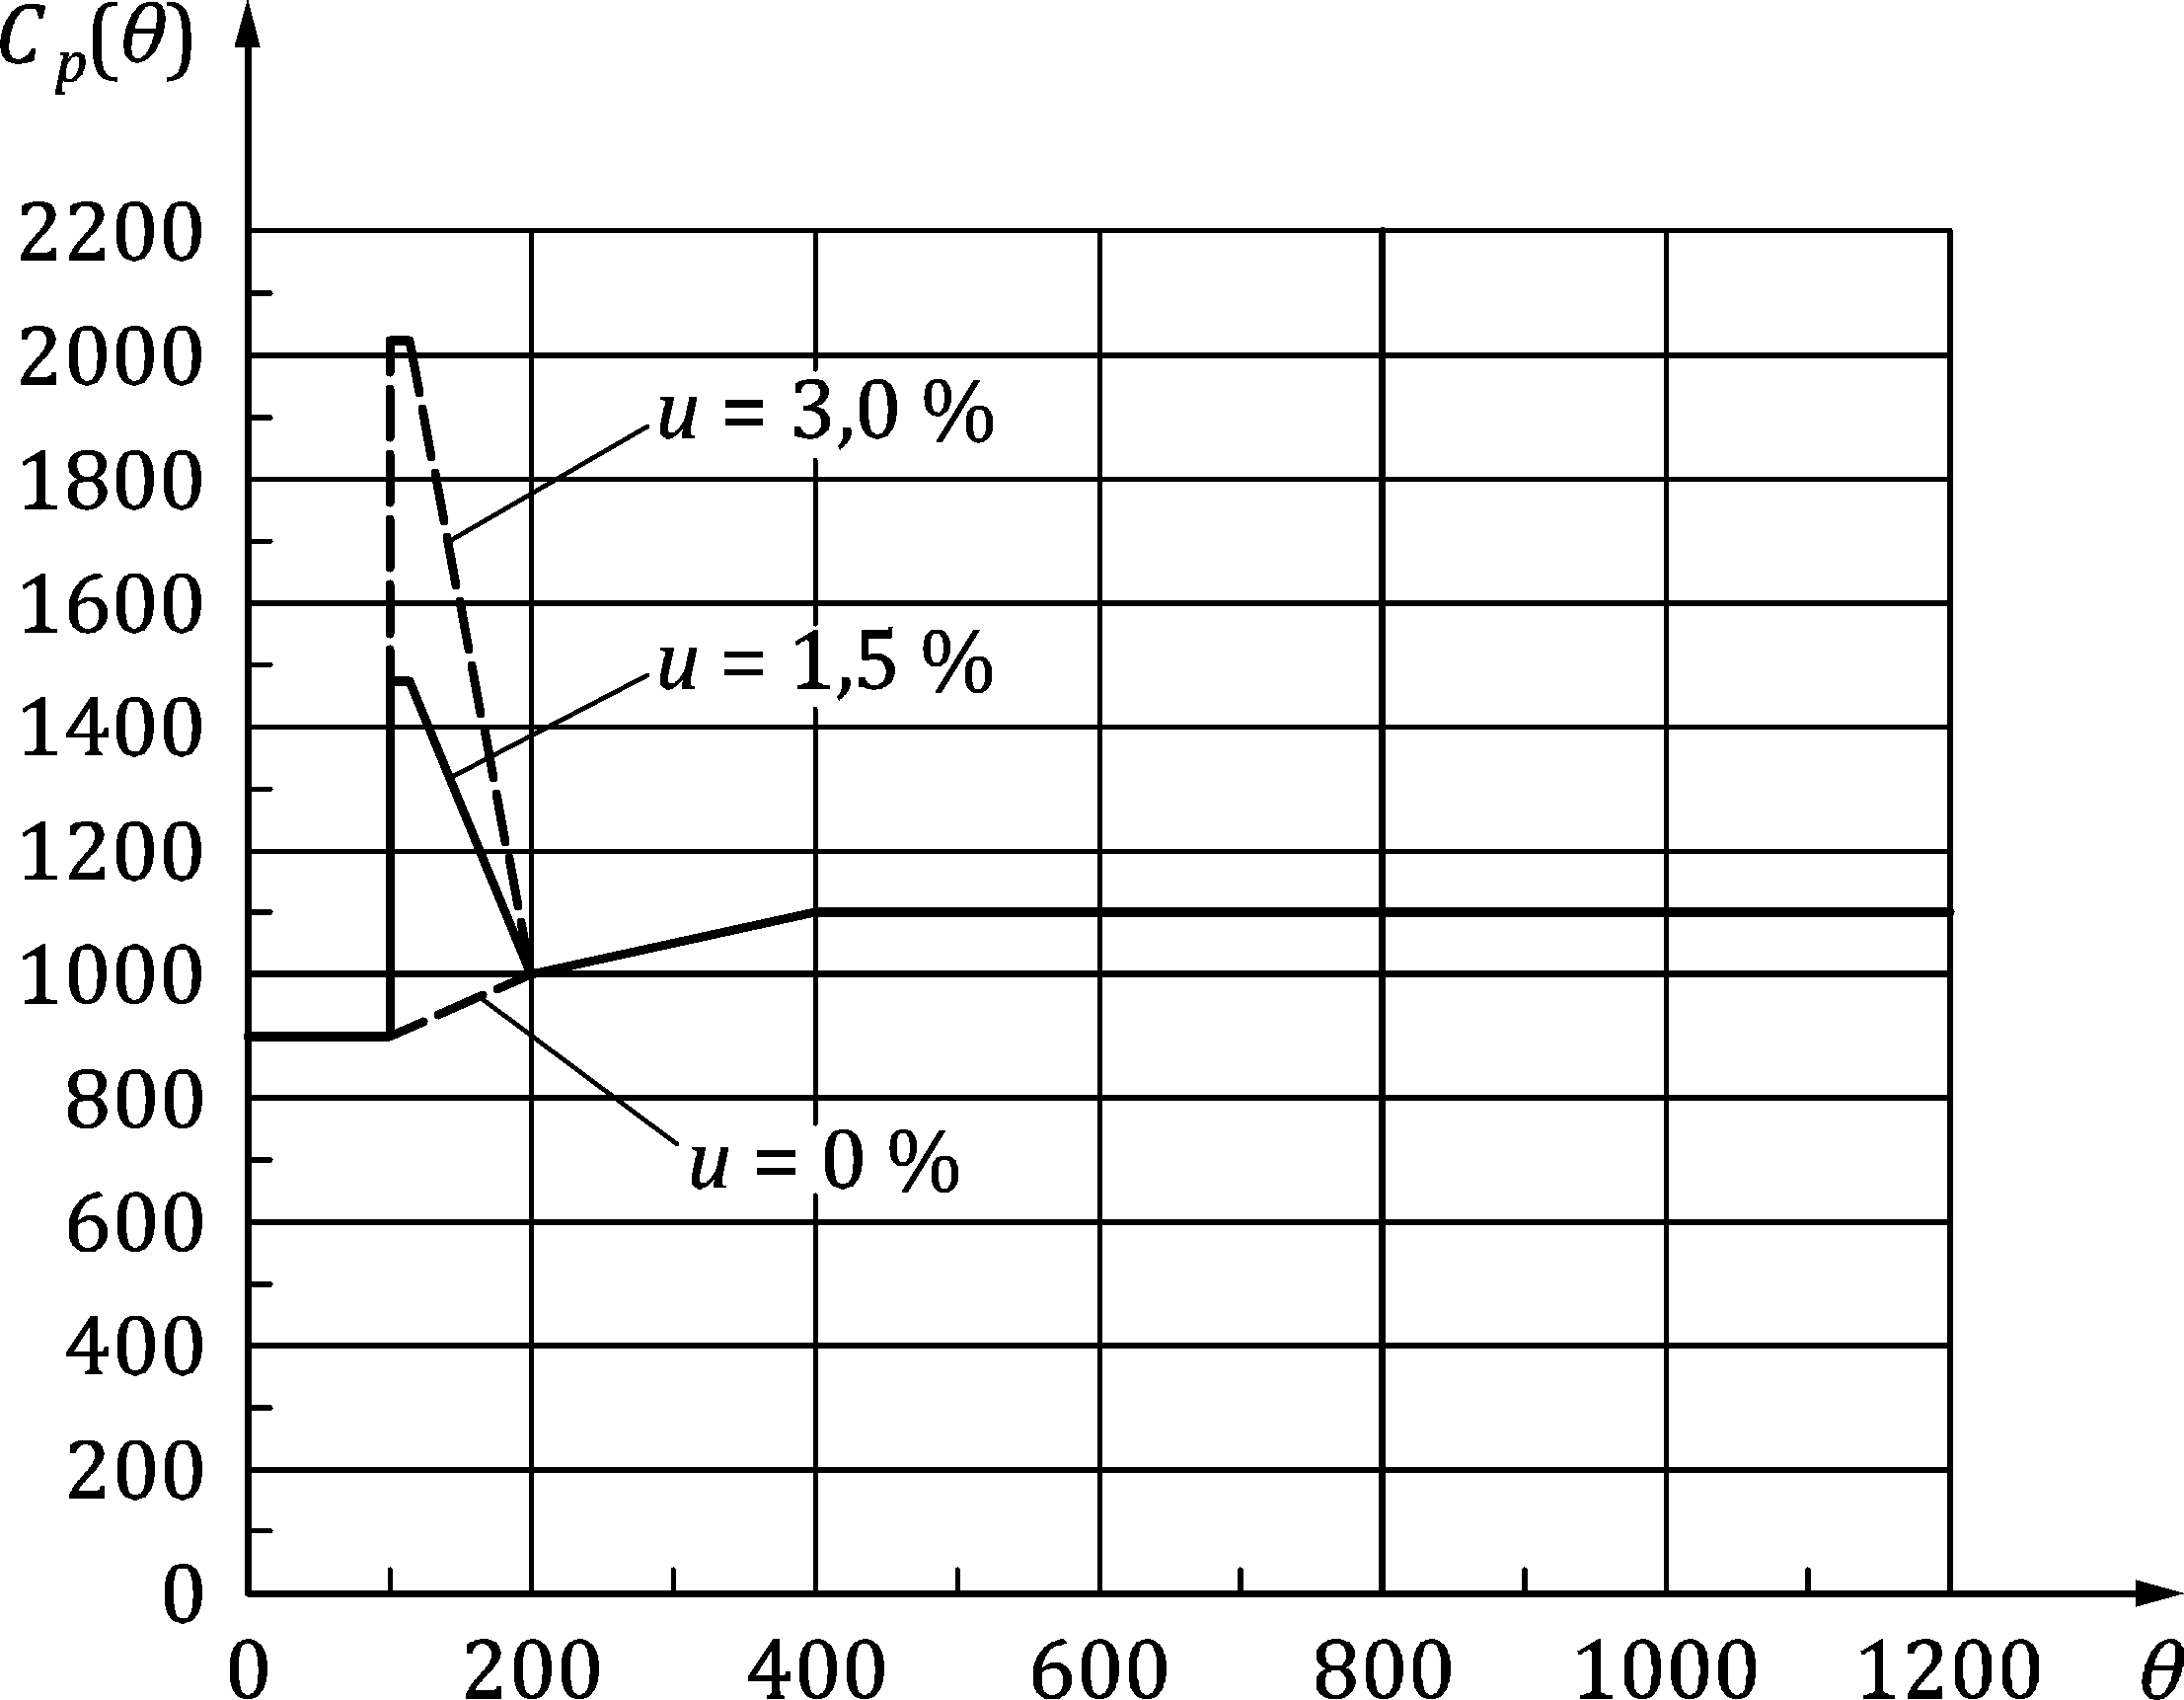

Figure 5.1 — Specific heat, *c*p(*θ*c), as function of temperature at 3 different moisture contents, *u*, of 0 %, 1,5 % and 3 % by weight of concrete

### Density

(1) The variation of concrete density with temperature is influenced by water loss and should be taken as follows

|  |  |  |
| --- | --- | --- |
| *ρ*(*θ*c) = *ρ*(20 °C) (kg/m3) | for 20 °C ≤ *θ*c ≤ 115 °C | (5.6a) |
| *ρ*(*θ*c) = *ρ*(20 °C)⋅(1 − 0,02(*θ*c − 115)/85) (kg/m3) | for 115 °C < *θ*c ≤ 200 °C | (5.6b) |
| *ρ*(*θ*c) = *ρ*(20 °C)⋅(0,98 − 0,03(*θ*c − 200)/200) (kg/m3) | for 200 °C < *θ*c ≤ 400 °C | (5.6c) |
| *ρ*(*θ*c) = *ρ*(20 °C)⋅(0,95 − 0,07(*θ*c − 400)/800) (kg/m3) | for 400 °C < *θ*c ≤ 1 200 °C | (5.6d) |

(2) The density of lightweight aggregate concrete for structural fire design shall be in the range of:

*ρ*LC(20 °C) = 1 200 to 2 000 (kg/m3) (5.7)

## Mechanical properties

### Concrete

#### Concrete under compression

(1) The strength and deformation properties of uniaxially stressed concrete at elevated temperatures should be obtained from stress-strain relationships as presented in Figure 5.2.

(2) The stress-strain relationships given in Figure 5.2 should be defined by three parameters:

— the compressive strength *f*c,θ

— the strain *ε*c1,θ corresponding to *f*c,θ

— the ultimate strain *ε*cu1,θ.

(3) Values for each of these parameters should be taken from Table 5.1 as a function of concrete temperatures. For intermediate values of the temperature, linear interpolation may be used.

(4) The parameters specified in Table 5.1 for *f*ck < 70 MPa and for *f*ck ≥ 70 MPa should be used for normal weight concrete with siliceous or calcareous (containing at least 80 % calcareous aggregate by weight) aggregates.

(5) Parameters for lightweight aggregate concrete should be based on testing.

Table 5.1 — Values for the main parameters of the stress-strain relationships of normal weight concrete with siliceous or calcareous aggregates concrete at elevated temperatures

| **Concrete temp.** | ***k*c,θ = *f*c,θ/*f*ck** | | | ***ε*c1,θ** | ***ε*cu1,θ** |
| --- | --- | --- | --- | --- | --- |
| ***θ*** | *f*ck < 70 MPa | | *f*ck ≥ 70 MPa |
|  | **Siliceous aggregates** | **Calcareous aggregates** | **any type of aggregates** |
| **[°C]** | **[–]** | **[–]** | **[–]** | **[–]** | **[–]** |
| **1** | **2** | **3** | **4** | **5** | **6** |
| 20 | 1,00 | 1,00 | 1,00 | 0,0025 | 0,0200 |
| 100 | 1,00 | 1,00 | 1,00 | 0,0040 | 0,0225 |
| 200 | 0,95 | 0,97 | 0,75 | 0,0055 | 0,0250 |
| 300 | 0,85 | 0,91 | 0,75 | 0,0070 | 0,0275 |
| 400 | 0,75 | 0,85 | 0,75 | 0,0100 | 0,0300 |
| 500 | 0,60 | 0,74 | 0,60 | 0,0150 | 0,0325 |
| 600 | 0,45 | 0,60 | 0,45 | 0,0250 | 0,0350 |
| 700 | 0,30 | 0,43 | 0,30 | 0,0250 | 0,0375 |
| 800 | 0,15 | 0,27 | 0,15 | 0,0250 | 0,0400 |
| 900 | 0,08 | 0,15 | 0,08 | 0,0250 | 0,0425 |
| 1 000 | 0,04 | 0,06 | 0,04 | 0,0250 | 0,0450 |
| 1 100 | 0,01 | 0,02 | 0,01 | 0,0250 | 0,0475 |
| 1 200 | 0,00 | 0,00 | 0,00 | – | – |

(6) For thermal actions in accordance with prEN 1991‑1‑2:2021, 5.3 (Physically based models), when considering the cooling phase, the strength of concrete heated to a maximum temperature *θ*c,max and having cooled down to 20 °C may be taken according to Formula (5.8):

*f*c,θ,20 °C = *φ f*ck (5.8)

where for:

— *f*ck < 70 MPa

|  |  |  |
| --- | --- | --- |
| *φ* = *f*c,θmax/*f*ck | for 20 °C ≤ *θ*max < 100 °C | (5.8a) |
| *φ* = (−0,0005 × *θ*max +1,05) (*f*c,θmax/*f*ck) | for 100 °C ≤ *θ*max < 300 °C | (5.8b) |
| *φ* = 0,9 (*f*c,θmax/*f*ck) | for *θ*max ≥ 300 °C | (5.8c) |

— *f*ck ≥ 70 MPa

|  |  |  |
| --- | --- | --- |
| *φ* = *f*c,θmax/*f*ck | for 20 °C ≤ *θ*max < 1 200 °C | (5.8d) |

The reduction factor (*f*c,θmax/*f*ck) which corresponds to the coefficient (*f*c,θ/*f*ck) at the maximum temperature *θ*c,max, should be taken according to Table 5.1.

The values of *ε*c1,θ and *ε*cu1,θ of the stress-strain relationship may both be maintained equal to the corresponding value for *θ*max.

During the cooling down of concrete with *θ*max ≥ *θ* ≥ 20 °C, the corresponding compressive cylinder strength *f*c,θ may be interpolated in a linear way between *f*c,θmax and *f*c,θ,20 °C.

During the cooling down of concrete with *θ*max ≥ *θ* ≥ 20 °C, the corresponding compressive cylinder strength *f*c,θ may be interpolated linearly between *f*c,θmax and *f*c,θ,20 °C

(7) The relation between *σ*c(*θ*) and *ε*c shown in Figure 5.2 and described by Formula (5.9) may be used to model the response of concrete to uniaxial compression at elevated temperatures.

 (5.9)

For numerical purposes a descending branch may be used. Linear or non-linear models may be used for 

NOTE The model implicitly includes effects from creep strain and transient state strain developed during heating. It can have some limitations in case of loading-unloading scenarios or cooling phase.

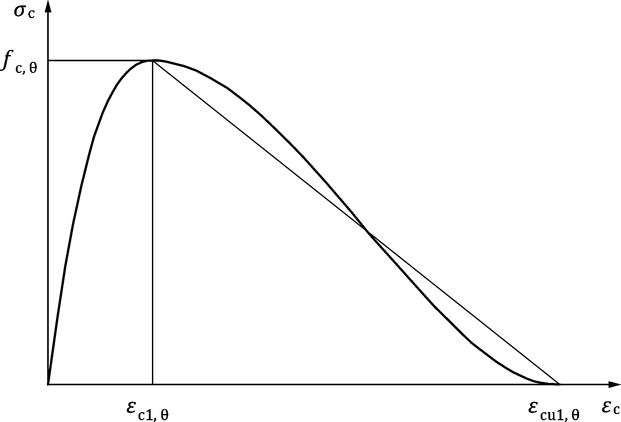

Figure 5.2 — Mathematical model for stress-strain relationships of concrete under compression at elevated temperatures

#### Tensile strength

(1) Unless otherwise specified, the tensile strength of concrete should be ignored.

(2) If the tensile strength is taken into account when using the simplified or advanced calculation method, the reduction of the characteristic tensile strength of concrete may be obtained by the coefficient *k*ct,θ = *f*ct,θ/*f*ct. In absence of more accurate information the following values should be used:

|  |  |  |
| --- | --- | --- |
| *k*ct,θ = 1,0 | for 20 °C ≤ *θ*c ≤ 100 °C | (5.10a) |
| *k*ct,θ = (600 − *θ*c)/500 | for 100 °C < *θ*c ≤ 600 °C | (5.10b) |

#### Thermal expansion

(1) The thermal strain *ε*c(*θ*c) of concrete should be determined from the following with reference to the length at 20 °C regardless of the concrete strength:

Siliceous aggregates:

|  |  |  |
| --- | --- | --- |
| *ε*cth(*θ*c) = ‑1,8 × 10−4 + 9 × 10−6*θ*c + 2,3 × 10−11*θ*c3 | for 20 °C ≤ *θ*c ≤ 700 °C | (5.11a) |
| *ε*cth(*θ*c) = 14 × 10−3 | for 700 °C < *θ*c ≤ 1 200 °C | (5.11b) |

Calcareous aggregates:

|  |  |  |
| --- | --- | --- |
| *ε*cth(*θ*c) = −1,2 × 10−4 + 6 × 10−6*θ*c + 1,4 × 10−11*θ*c3 | for 20 °C ≤ *θ*c ≤ 805 °C | (5.12a) |
| *ε*cth(*θ*c) = 12 × 10−3 | for 805 °C < *θ*c ≤ 1 200 °C | (5.12b) |

Lightweight aggregate concrete:

|  |  |  |
| --- | --- | --- |
| *ε*cth(*θ*c) = 8 × 10−6 (*θ*c − 20) | for 20 °C ≤ *θ*c ≤ 1 200 °C | (5.13) |

### Reinforcing steel

#### Strength and deformation properties

(1) The strength and deformation properties of reinforcing steel at elevated temperatures shall be obtained from the stress-strain relationships in Figure 5.3 and Table 5.2.

(2) The stress-strain relationships given in Figure 5.3 should be defined by three parameters:

— the slope of the linear elastic range *E*s,θ

— the proportional limit *f*sp,θ

— the maximum stress level *f*sy,θ

(3) Values for the parameters in (2) for hot rolled and cold worked reinforcing steel at elevated temperatures should be obtained from Table 5.3. For intermediate values of the temperature, linear interpolation may be used.

(4) If the manufacturing process, i.e. hot rolled or cold worked, is not known, the values for cold worked should be considered.

(5) The formulation of stress-strain relationships may also be applied for reinforcing steel in compression.

(6) The equivalent strength, *f*se,θ is the steel strength for values of strain between the proportionality limit (*ε*sp,θ) and the maximum stress limit (*ε*sy,θ = 2%). The values of *f*se,θ derived from Column 6 of Table 5.3 may be used in Clause 6 to evaluate the critical temperature of reinforcing steel and may be used in 7.3.4.2 to describe the reinforcing steel strength.

(7) The values *f*pe,θ given in Column 6 and 7 of Table 5.4 may be used in Clause 6 to evaluate the critical temperature of prestressing steel.

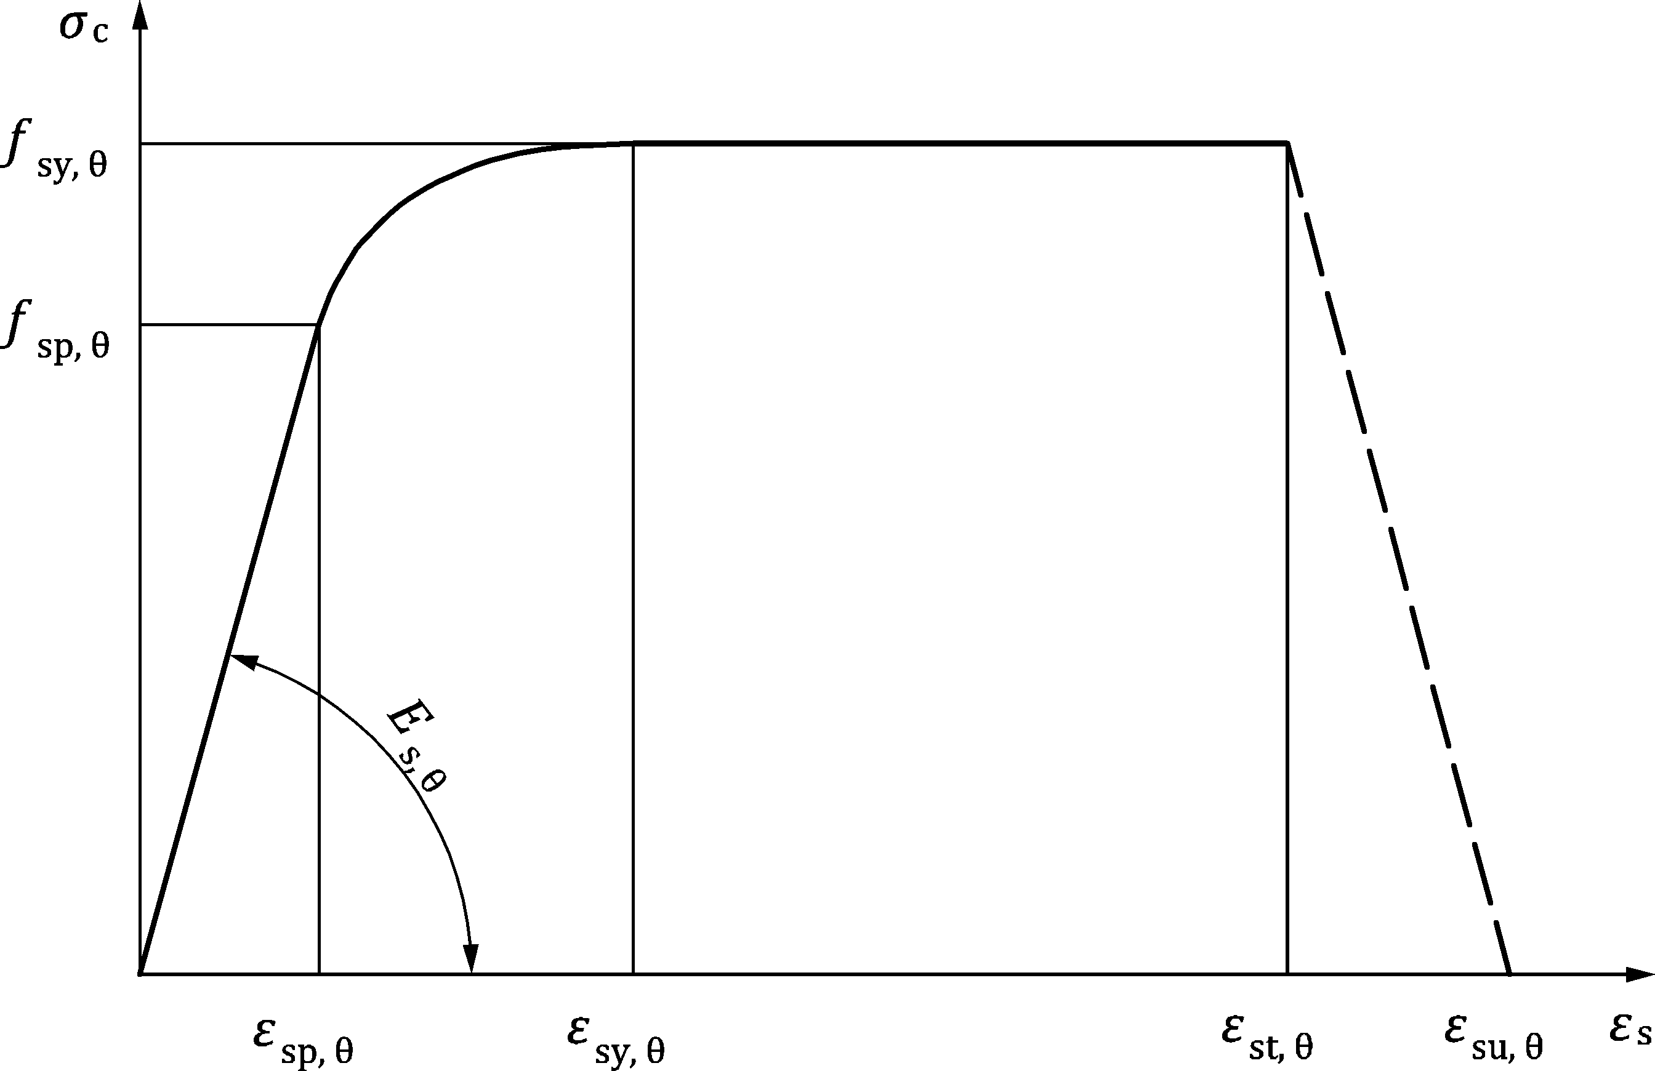

Figure 5.3 — Mathematical model for stress-strain relationships of reinforcing and prestressing steel at elevated temperatures (notations for prestressing steel “p” instead of “s”)

Table 5.2 — Formulae for stress *σ*(*θ*) and tangent modulus *E*t depending on the strain range.

| **Range** | | **Stress** | |
| --- | --- | --- | --- |
| 1 | *ε*sp,θ | *σ*s(*θ*) = *ε*s *E*s,θ | |
| 2 | *ε*sp,θ ≤ *ε*s ≤ *ε*sy,θ | *σ*s(*θ*) = *f*sp,θ − *c* + (*b*/*a*)[*a*2 − (*ε*sy,θ − *ε*s)2]0,5 | |
| 3 | *ε*sy,θ ≤ *ε*s ≤ *ε*st,θ | *σ*s(*θ*) = *f*sy,θ | |
| 4 | *ε*st,θ ≤ *ε*s ≤ *ε*su,θ | *σ*s(*θ*) = *f*sy,θ [1 − (*ε*s − *ε*st,θ)/(*ε*su,θ − *ε*st,θ)] | |
| 5 | *ε*s = *ε*su,θ | *σ*s(*θ*) = 0,00 | |
| **Parametera** | | **Class A reinforcement:** | **Class B and C reinforcement:** |
| 6 | *ε*sy,θ | 0,02 | |
| 7 | *ε*st,θ | 0,05 | 0,15 |
| 8 | *ε*su,θ | 0,10 | 0,20 |
| **Functions** | | | |
| 9 | *a*2 = (*ε*sy,θ − *ε*sp,θ)(*ε*sy,θ − *ε*sp,θ + *c*/*E*s,θ) | | |
| 10 | *b*2 = *c* (*ε*sy,θ − *ε*sp,θ) *E*s,θ + *c*2 | | |
| 11 |  | | |
| a Values for the parameters *ε*pt,θ and *ε*pu,θ for prestressing steel may be taken from Table 5.4. Class A, B and C reinforcement are defined in prEN 1992‑1‑1:2021, Annex C. | | | |

Table 5.3 — Values for the parameters of the stress-strain relationship of hot rolled and cold worked reinforcing steel at elevated temperatures

| **Steel temperature** | ***k*sy,θ = *f*sy,θ/*f*yk** | | ***k*sp,θ = *f*sp,θ/*f*yk** | | ***k*se,θ = *f*se,θ/*f*yk** | ***k*Es,θ = *E*s,θ/*E*s** | |
| --- | --- | --- | --- | --- | --- | --- | --- |
| ***θ*** | **hot rolled** | **cold worked** | **hot rolled** | **cold worked** | **hot rolled or cold worked** | **hot rolled** | **cold worked** |
| **[°C]** |
| **1** | **2** | **3** | **4** | **5** | **6** | **7** | **8** |
| 20 | 1,00 | 1,00 | 1,00 | 1,00 | 1,00 | 1,00 | 1,00 |
| 100 | 1,00 | 1,00 | 1,00 | 0,96 | 1,00 | 1,00 | 1,00 |
| 200 | 1,00 | 1,00 | 0,81 | 0,92 | 0,95 | 0,90 | 0,87 |
| 300 | 1,00 | 1,00 | 0,61 | 0,81 | 0,85 | 0,80 | 0,72 |
| 400 | 1,00 | 0,94 | 0,42 | 0,63 | 0,80 | 0,70 | 0,56 |
| 500 | 0,78 | 0,67 | 0,36 | 0,44 | 0,60 | 0,60 | 0,40 |
| 600 | 0,47 | 0,40 | 0,18 | 0,26 | 0,35 | 0,31 | 0,24 |
| 700 | 0,23 | 0,12 | 0,07 | 0,08 | 0,10 | 0,13 | 0,08 |
| 800 | 0,11 | 0,11 | 0,05 | 0,06 | 0,08 | 0,09 | 0,06 |
| 900 | 0,06 | 0,08 | 0,04 | 0,05 | 0,06 | 0,07 | 0,05 |
| 1 000 | 0,04 | 0,05 | 0,02 | 0,03 | 0,04 | 0,04 | 0,03 |
| 1 100 | 0,02 | 0,03 | 0,01 | 0,02 | 0,02 | 0,02 | 0,02 |
| 1 200 | 0,00 | 0,00 | 0,00 | 0,00 | 0,00 | 0,00 | 0,00 |

(8) In case of thermal actions according to prEN 1991‑1‑2:2021, 5.3 for natural fire simulation, particularly when considering the descending temperature branch, the values specified in Table 5.3 for the stress-strain relationships of reinforcing steel may be used as a sufficient approximation.

#### Thermal elongation

(1) The thermal strain *ε*s(*θ*s) of reinforcing steel may be determined from the following with reference to the length at 20 °C:

|  |  |  |
| --- | --- | --- |
| *ε*s(*θ*s) = −2,416 × 10−4 + 1,2 × 10−5 *θ*s + 0,4 × 10−8 *θ*s2 | for 20 °C ≤ *θ*s ≤ 750 °C | (5.23a) |
| *ε*s(*θ*s) = 11 × 10−3 | for 750 °C < *θ*s ≤ 860 °C | (5.23b) |
| *ε*s(*θ*s) = −6,2 × 10−3 + 2 × 10−5 *θ*s | for 860 °C < *θ*s ≤ 1 200 °C | (5.23c) |

### Prestressing steel

#### Strength and deformation properties

(1) The strength and deformation properties of prestressing steel at elevated temperatures should be obtained by the same mathematical model as that presented in 5.3.2.1 for reinforcing steel.

(2) Values for the parameters for cold worked (wires and strands) and quenched and tempered (bars) prestressing steel at elevated temperatures should be taken as *f*py,θ/*f*p0,1k, *f*pp,θ/*f*p0,1k, *f*pe,θ/*f*p0,1k*, E*p,θ/*E*p, *ε*pt,θ [–], *ε*pu,θ [–] (see Table 5.4). For intermediate values of the temperature, linear interpolation may be used.

Table 5.4 — Values for the parameters of the stress-strain relationship of cold worked (wires and strands) and quenched and tempered (bars) prestressing steel at elevated temperatures

| **Steel temp.** | *k*py,θ = *f*py,θ/*f*p0,1k | | *k*pp,θ = *f*pp,θ/*f*p0,1k | | *k*pe,θ = *f*pe,θ/*f*p0,1k | | *k*Ep,θ = *E*p,θ/*E*p | | *ε*pt,θ | *ε*pu,θ |
| --- | --- | --- | --- | --- | --- | --- | --- | --- | --- | --- |
| [–] | [–] |
| *θ*s | wires and strands | bars | wires and strands | bars | wires and strands | bars | wires and strands | bars | wires, strands and bars | wires, strands and bars |
| [°C] |
| 1 | 2 | 3 | 4 | 5 | 6 | 7 | 8 | 9 | 10 | 11 |
| 20 | 1,00 | 1,00 | 1,00 | 1,00 | 1,00 | 1,00 | 1,00 | 1,00 | 0,050 | 0,100 |
| 100 | 0,98 | 0,98 | 0,68 | 0,77 | 1,00 | 1,00 | 0,98 | 0,76 | 0,050 | 0,100 |
| 200 | 0,87 | 0,92 | 0,51 | 0,62 | 0,85 | 0,925 | 0,95 | 0,61 | 0,050 | 0,100 |
| 300 | 0,70 | 0,86 | 0,32 | 0,58 | 0,70 | 0,85 | 0,88 | 0,52 | 0,055 | 0,105 |
| 400 | 0,50 | 0,69 | 0,13 | 0,52 | 0,50 | 0,60 | 0,81 | 0,41 | 0,060 | 0,110 |
| 500 | 0,30 | 0,26 | 0,07 | 0,14 | 0,20 | 0,20 | 0,54 | 0,20 | 0,065 | 0,115 |
| 600 | 0,14 | 0,21 | 0,05 | 0,11 | 0,10 | 0,10 | 0,41 | 0,15 | 0,070 | 0,120 |
| 700 | 0,06 | 0,15 | 0,03 | 0,09 | 0,075 | 0,075 | 0,10 | 0,10 | 0,075 | 0,125 |
| 800 | 0,04 | 0,09 | 0,02 | 0,06 | 0,05 | 0,05 | 0,07 | 0,06 | 0,080 | 0,130 |
| 900 | 0,02 | 0,04 | 0,01 | 0,03 | 0,025 | 0,025 | 0,03 | 0,03 | 0,085 | 0,135 |
| 1 000 | 0,00 | 0,00 | 0,00 | 0,00 | 0,00 | 0,00 | 0,00 | 0,00 | 0,090 | 0,140 |
| 1 100 | 0,00 | 0,00 | 0,00 | 0,00 | 0,00 | 0,00 | 0,00 | 0,00 | 0,095 | 0,145 |
| 1 200 | 0,00 | 0,00 | 0,00 | 0,00 | 0,00 | 0,00 | 0,00 | 0,00 | 0,100 | 0,150 |

(3) When considering thermal actions according to prEN 1991‑1‑2:2021, 5.3 for natural fire simulation, particularly when considering the decreasing temperature branch, the values for the stress-strain relationships of prestressing steel specified in (2) may be used as a sufficiently precise approximation.

#### Thermal elongation

(1) The thermal strain *ε*p(*θ*s) of prestressing steel may be determined from the following with reference to the length at 20 °C:

|  |  |  |
| --- | --- | --- |
| *ε*p(*θ*s) = −2,016 × 10−4 + 10−5 *θ*s + 0,4 × 10−8 *θ*s2 | for 20 °C ≤ *θ*s ≤ 1 200 °C | (5.24) |

# Tabulated design data

## General

(1) The tabulated design data relate to member analysis according to 4.7. They shall be used only for the standard fire exposure. The temperature distribution should be assumed to be the same along the length of the structural members.

(2) Tabulated design data may be used to obtain recognised design solutions generally in relation to member typology (dimensions, axis distance, reinforcement ratio etc.) without recourse to any form of equilibrium equation.

NOTE Tabulated data are derived from tests, calculation models or some combination of the two and can be presented either in the form of a table or a formula.

(3) Tabulated design data may be considered to generally give safe-sided results compared to relevant tests or simplified or advanced design methods. Extrapolation outside the range of application shall not be applied.

(4) In case of geometric discontinuity regions the cross sectional dimensions of Clause 6 may only be applied if the minimum dimensions of Clause 6 are respected. For holes through the web of beams, 6.6.1 (8) may be applied.

(5) The values given in the tables of Clause 6 may be used for normal weight concrete (density 2 000 kg/m3 to 2 600 kg/m3) made with siliceous and calcareous aggregates. If calcareous aggregates are used the minimum dimensions of the cross-section of columns may be reduced by 10 %. For lightweight aggregate concrete used in beams or slabs the minimum dimension of the cross-section may be reduced by 10 %.

(6) For *f*ck ≥ 70 MPa, tabulated design data should not be used for R ≥ 180.

(7) The risk of severe spalling shall be taken into account according to Clause 10.

(8) When minimum dimensions given in Clause 6 are followed, further checks for shear, torsion and anchorage may be omitted.

(9) Axis distances *a* (Figure 6.1) to a reinforcing steel bar, prestressing steel wire or tendon should be considered as nominal values.

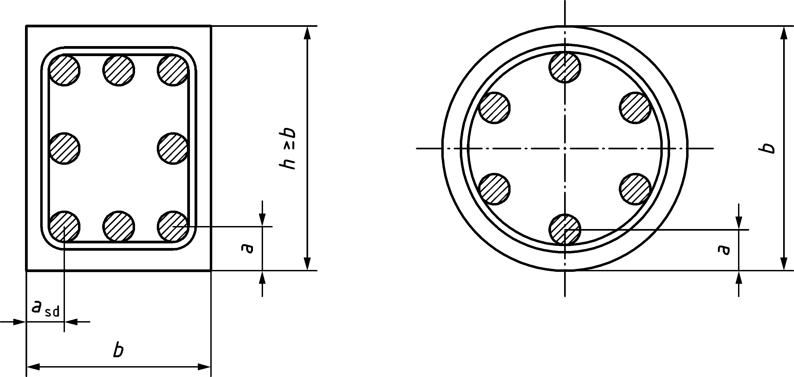

Figure 6.1 — Sections through structural members, showing nominal axis distance *a*

(10) Values given in the tables of Clause 6 should be considered as minimum dimensions for fire resistance in addition to the detailing rules found in prEN 1992‑1‑1. Some values of the axis distance of the reinforcing steel bar in the tables are less than those specified by prEN 1992‑1‑1 and should be used for interpolation only.

(11) Linear interpolation between the values given in the tables of Clause 6 may be carried out.

## General design rules

(1) Before using the tabulated data in Clause 6, they should be corrected depending on the values adopted for the partial factors for actions.

NOTE 1 The tabulated data in Clause 6 are based on a reference load level *η*fi = 0,7 in 4.7 (1) and in prEN 1991‑1‑2:2021, 6.3, Formulae (6.1), (6.5), unless otherwise stated in the relevant clauses.

NOTE 2 If the partial safety factors specified in the National Annexes to prEN 1990 deviate from the default values given in prEN 1991‑1‑2, the above value *η*fi = 0,7 is not valid. In such circumstances, the value of *η*fi for use in a member state can be found in its National Annex.

NOTE 3 Tabulated data cannot be used where material factors have been modified in accordance with Annex A.

NOTE 4 In order to ensure the required axis distance in tensile zones of simply supported beams and slabs, Table 6.7 and Table 6.10, Column 3 (one way), are based on a critical steel temperature of *θ*cr = 500 °C. This assumption corresponds approximately to *E*d,fi = 0,7*E*d and *γ*s = 1,15 (stress level *σ*s,fi/*f*yk = 0,60, see Formula (6.1)) where *E*d denotes the design effect of actions according to prEN 1992‑1‑1.

(2) Since for prestressing tendons the critical temperature is assumed to be 400 °C for bars and 350 °C for strands and wires, corresponding approximately to *E*d,fi = 0,7 *E*d, and *γ*s = 1,15 (stress level *σ*s,fi/*f*p0,1k = 0,60), and, if no special check according to (5) is made in prestressed tensile members, the required axis distance *a* (Figure 6.2) for beams and slabs should be increased by:

• 10 mm for prestressing steel bars, corresponding to *θ*cr = 400 °C

• 15 mm for prestressing steel wires and strands, corresponding to *θ*cr = 350 °C.

(3) For tensile and simply supported members subject to bending (except those with unbonded tendons), in which the critical temperature is different from 500 °C, the axis distance given in Tables 6.7, 6.10 and 6.12 may be modified as follows:

a) evaluate the steel stress *σ*s,fi for the actions in a fire situation (*E*d,fi) using Formula (6.1).

|  |  |
| --- | --- |
|  | (6.1) |

where

|  |  |
| --- | --- |
| *γ*s | is the partial safety factor for reinforcement (see in prEN 1992‑1‑1:2021, 4.3.1.3); |
| *A*s,req | is the area of reinforcement required for ultimate limit state according to prEN 1992‑1‑1; |
| *A*s,prov | is the area of reinforcement provided; |
| *E*d,fi/*E*d | may be estimated using prEN 1991‑1‑2:2021, 6.3.2. |

b) evaluate the critical temperature of reinforcement *θ*cr, corresponding to the reduction factor, where:

• σs,fi = *f*se,θ(*θ*cr) using Table 5.3, column 6 for reinforcing steel or

• σp,fi = *f*pe,θ(*θ*cr) using Table 5.4, columns 6 and 7 for prestressing steel.

c) adjust the axis distance given in the tables, for the new critical temperature, *θ*cr, using the approximate Formula (6.2), where Δ*a* is the change in the axis distance in millimetres:

|  |  |
| --- | --- |
| Δ*a* = 0,1 (500 − *θ*cr) (mm) | (6.2) |

(4) The above approximation may be applied for 350 °C < *θ*cr < 700 °C and for modification of the axis distance given in the tables only. For temperatures outside these limits, and for more accurate results, temperature profiles should be used. For prestressing steel, Formula (6.1) may be applied analogously.

(5) For unbonded tendons critical temperatures greater than 350 °C may only be used where more accurate methods are used to determine the effects of deflections.

(6) For tensile members or beams where the design requires *θ*cr to be below 400 °C the cross sectional dimensions should be increased to *b*mod by increasing the minimum width of the tensile member or tensile zone of the beam according to Formula (6.3).

*b*mod ≥ *b*min + 0,8 (400 − *θ*cr) (mm) (6.3)

where

|  |  |
| --- | --- |
| *b*min | is the minimum dimension *b* given in the tables, related to the required standard fire resistance. |

(7) An alternative to increasing the width according to Formula (6.3) may be to adjust the axis distance of the reinforcement in order to obtain the temperature required for the actual stress. A thermal analysis according to 8.2 should be carried out to find that temperature.

(8) When reinforcement is arranged in several layers as shown in Figure 6.2, and where it consists of either reinforcing or prestressing steel with the same characteristic strength *f*yk and *f*pk respectively, the average axis distance *a*m should be at least equal to the axis distance *a* given in the Tables. The average axis distance may be determined by Formula (6.4).

 (6.4)

where

|  |  |
| --- | --- |
| *A*si | is the cross sectional area of reinforcement “i”; |
| *a*i | is the axis distance of reinforcement “i” from the nearest exposed surface. |

When reinforcement consists of steels with different characteristic strength *A*si should be replaced by *A*si *f*yki (or *A*si *f*p0,1ki) in Formula (6.4).

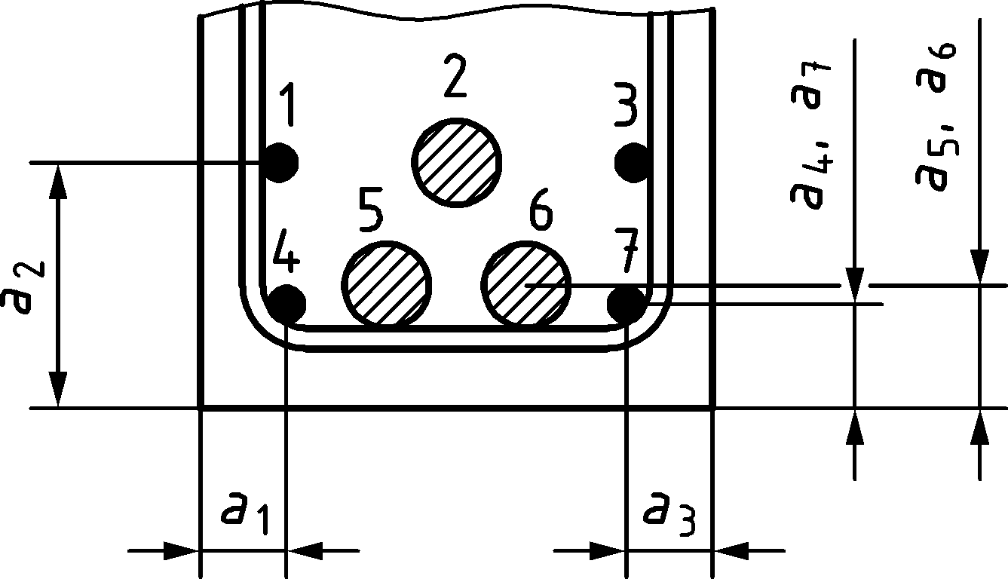

Figure 6.2 — Dimensions used to calculate average axis distance *a*m

(9) Where reinforcing and prestressing steel is used simultaneously (e.g. in a partially prestressed member), the axis distances of reinforcing and prestressing steel should be determined separately.

(10) The axis distance for any individual reinforcement should not be less than either that required for R 30 for reinforcement in a single layer or half the average axis distance for reinforcement in multiple layers (see Formula (6.4)).

## Columns

### General

(1) For assessing the fire resistance of columns, two methods, Method A and Method B may be used. Method A shall be used for braced structures only, see 6.3.2. Method B may be also used for unbraced structures, see 6.3.3.

(2) The degree of utilization in the fire situation, *μ*fi calculated from Formula (6.5), may be used for fire design with tabulated data to account for the load combinations, compressive strength of the column and bending including second order effects.

|  |  |
| --- | --- |
| *μ*fi = *N*Ed.fi/*N*Rd | (6.5) |

where

|  |  |
| --- | --- |
| *N*Ed.fi | is the design value of the axial load under fire conditions; |
| *N*Rd | is the design value of axial resistance of the column at ambient temperature conditions, calculated according to prEN 1992‑1‑1 using the values of *γ*M for ambient temperature design, including second order effects and an initial eccentricity equal to the eccentricity of *N*Ed.fi. |

(3) The reduction factor *η*fi may be used instead of *μ*fi for the design load level (see 4.7 (1)) as a safe simplification since *η*fi assumes that the column is fully loaded at ambient temperature design.

(4) The effective length *l*0,fi of a column in the fire design situation should generally be determined as for ambient temperature design.

(5) In a braced structure in which the resistance to fire of the building elements, which separate the levels under consideration, is at least equal to the fire resistance of the column, the effective length *l*0,fi may be taken as 0,5 *l* at an intermediate storey and as 0,7 *l* in the top storey where *l* is the length of the column, see Figure 6.3. Where the rotational rigidity in the fire condition of the connection at the top or bottom of the column is not ensured, the effective length *l*0,fi should be calculated, or *l*0,fi = *l*0 may be taken.

(6) Tables 6.1 and 6.2 apply where *l*0,fi/*l*0 = 0,5 (see Figure 6.3 where *l*0 = *l*). The tables may be used for other values of this ratio, but μfi should be calculated according to Formula (6.5) using the value of axial resistance of the column at ambient temperature conditions *N*Rd for an effective length *l*0’ = 2 *l*0,fi.

|  |  |  |
| --- | --- | --- |
| Braced structure | Deformation mode at ambient temperature | Deformation mode in fire situation |
|  |  |  |

Figure 6.3 — Effective lengths of columns in braced structures

### Method A

#### Columns exposed to fire on four sides

(1) Fire resistance of reinforced and prestressed concrete columns in braced structures, subject mainly to compression, may be considered adequate if the conditions in (2) are met and the column width is at least equal to *b*min and the distance of the centre of any vertical bar from the nearest exposed surface is at least equal to *a*min in Table 6.1.

(2) The minimum values *b*min and the axis distance of longitudinal reinforcement *a* in Table 6.1 may be considered to apply if conditions a) to c) are met:

a) the effective length *l*0 ≤ 6 m under ambient temperature conditions and the effective length *l*0,fi in the fire situation (see 6.3.1(5) and Figure 6.3) is *l*0,fi ≤ 3 m with *l*0,fi/*l*0 = 0,5 for rectangular cross-sections and *l*0 ≤ 5 m and *l*0,fi ≤ 2,5 m with *l*0,fi/*l*0 = 0,5 for circular cross-sections;

b) the first order eccentricity in the fire situation, *e* = *M*0Ed,fi/*N*Ed,fi does not exceed 25 % of the dimension of the section in the same direction of the eccentricity;

c) the longitudinal reinforcement does not exceed 0,04 *A*c.

NOTE The first order eccentricity in fire situation can be assumed as equal to that in ambient temperature design.

Table 6.1 — Minimum column dimensions and axis distances for columns with rectangular or circular section exposed to fire on four sides

| **Standard fire resistance** | **Minimum dimensions** | | |
| --- | --- | --- | --- |
| **(mm)** | | |
| **Column width *b*min/axis distance *a* of the main reinforcement** | | |
| ***μ*fi = 0,2** | ***μ*fi = 0,5** | ***μ*fi = 0,7** |
| **1** | **2** | **3** | **4** |
| R 30 | 200/25 | 200/25 | 200/32 |
|  |  |  | 300/27 |
| R 60 | 200/25 | 200/36 | 250/46 |
|  |  | 300/31 | 350/40 |
| R 90 | 200/31 | 300/45 | 350/53 |
|  | 300/25 | 400/38 | 450/40a |
| R 120 | 250/40 | 350/45a | 350/57a |
|  | 350/35 | 450/40a | 450/51a |
| R 180 | 350/45a | 350/63a | 450/70a |
| R 240 | 350/61a | 450/75a | – |
| NOTE 1 For prestressed columns, the increase of axis distance according to 6.2 (2) should be noted.  NOTE 2 Table 6.1 has been generated from Formula (6.6) with *l*0,fi = 3 m.  NOTE 3 Table 6.1 can be used for columns exposed on two parallel sides | | | |
| a Minimum 8 bars | | | |

(3) Alternatively to the values of Table 6.1, but with the same limitations as given in (2), the fire resistance of reinforced and prestressed concrete columns exposed on four sides, subject mainly to compression in braced structures may be calculated using Formula (6.6) only for columns with an effective length *l*0 ≤ 6 m under ambient temperature conditions and an effective length *l*0,fi ≤ 3 m in fire situation with *l*0,fi/*l*0 = 0,5 (see 6.3.1 (5) and Figure 6.3) for rectangular cross-sections and *l*0 ≤ 5 m and *l*0,fi ≤ 2,5 m with *l*0,fi/*l*0 = 0,5 for circular cross-sections. Values corresponding to *l*0,fi = 2 m may be assumed for columns with *l*0,fi < 2 m.

*R* = 120 ((*R*μfi + *R*a + *R*l + *R*b + *R*n)/120)1,8 ≤ 240 min (6.6)

where

|  |  |  |
| --- | --- | --- |
|  | | (6.7a) |
| *R*a = 1,60 (*a* − 30) | | (6.7b) |
| *R*l = 9,60 (5 − *l*0,fi) | | (6.7c) |
| *R*b = 0,09 *b*′ | | (6.7d) |
| *R*n = 0 for *n* = 4 (corner bars only), *R*n = 12 for *n* > 4 | | (6.7e) |
| 25 mm ≤ *a* ≤ 80 mm | | |
| *b*′ = 2*A*c/(*b* + *h*) for rectangular cross-sections or the diameter of circular cross-sections, with 200 mm ≤ *b*′ ≤ 450 mm; *h* ≤ 1,5 *b*. | | |
|  | denotes the mechanical reinforcement ratio at ambient temperature conditions. | |

NOTE In calculation of *A*s, lap splices are not included.

#### Columns exposed to fire on one side

(1) Adequate fire resistance of reinforced concrete columns in braced structures exposed to fire on one side only may be assumed if the cross-sectional geometry satisfies the minimum values given in Tables 6.2.

(2) The minimum values *b*min and the axis distance of longitudinal reinforcement a in Table 6.2 may be considered to apply if conditions a) to c) are met:

a) the effective length under ambient temperature conditions is *l*0 ≤ 6 m and the effective length under fire conditions is *l*0,fi ≤ 3 m with *l*0,fi/*l*0 = 0,5;

b) the first order eccentricity in the fire situation, *e* = *M*0Ed,fi/*N*Ed,fi does not exceed 25 % of the dimension in the same direction of the cross-section;

c) the longitudinal reinforcement does not exceed 0,04 *A*c.

Table 6.2 — Minimum column dimensions and axis distances for rectangular columns exposed on one side with *l*0 ≤ 6 m for ambient temperature conditions and *l*0,fi ≤ 3 m for fire situations

| **Standard fire resistance** | **Minimum dimensions** | | |
| --- | --- | --- | --- |
| **(mm)** | | |
| **Column width *b*min/axis distance *a* of the main reinforcement** | | |
|  |  |  |
| **1** | **2** | **3** | **4** |
| R 30 | 100/10 | 120/15 | 130/25 |
| R 60 | 110/10 | 130/15 | 140/25 |
| R 90 | 120/20 | 140/25 | 155/25 |
| R 120 | 150/25 | 160/30 | 175/35 |
| R 180 | 185/45 | 200/50 | 230/55 |
| R 240 | 230/60 | 240/65 | 290/70 |

### Method B

(1) Adequate fire resistance of reinforced concrete columns may be assumed to be provided if the design tables in Annex B are used.

## Walls

### Non load-bearing walls (partitions)

(1) Where the fire resistance of a partition is only required to meet the thermal insulation criterion I and the integrity criterion E, the minimum wall thickness should not be less than that given in Table 6.4.

(2) To avoid excessive thermal deformation and subsequent failure of integrity between wall and slab, the ratio of clear height of wall to wall thickness should not exceed 40.

Table 6.4 — Minimum wall thickness of non load-bearing walls (partitions)

| **Standard fire resistance** | **Minimum wall thickness** |
| --- | --- |
| **(mm)** |
| **1** | **2** |
| EI 30 | 60 |
| EI 60 | 80 |
| EI 90 | 100 |
| EI 120 | 120 |
| EI 180 | 150 |
| EI 240 | 175 |

### Load-bearing solid walls

(1) Adequate fire resistance of load-bearing reinforced concrete walls may be assumed to be provided if the data given in Table 6.5 and Table 6.6 are used and the following rules are met:

a) The structure is braced;

b) 6.3.1 (2) also applies for load-bearing walls;

c) the first order eccentricity in the fire situation, *e* = *M*0Ed,fi/*N*Ed,fi does not exceed 25 % of the parallel dimension of the cross-section.

(2) The effective length *l*0,fi of a wall may be determined according to 6.3.1 (5).

(3) Table 6.5 may be used only for walls with an effective length of *l*0 ≤ 4,5 m for ambient temperature conditions and *l*0,fi ≤ 2,25 m for fire situations with *l*0,fi/*l*0 = 0,5.

(4) Table 6.6 may be used only for walls with an effective length of *l*0 ≤ 2,5 m for ambient temperature conditions and *l*0,fi ≤ 1,25 m for fire situations with *l*0,fi/*l*0 = 0,5.

(5) Tables 6.5 and 6.6 apply where *l*0,fi / *l*0 =0,5 (see Figure 6.3 where *l*0=*l*). The tables may be used for other values of this ratio, but μfi should be calculated according to Formula (6.5) using the value of axial resistance of the wall at ambient temperature conditions *N*Rd for an effective length *l*0’ = 2 *l*0,fi.

(6) Tables 6.5 and 6.6 may be used for walls with a ratio of clear height to thickness not higher than 40, in order to limit the thermal deformations of the wall and avoid loss of integrity at its connection to the slab.

Table 6.5 — Minimum dimensions and axis distances for load-bearing reinforced concrete walls exposed on one long side (left) or on both long sides (right) with *l*0 ≤ 4,5 m for ambient temperature conditions and *l*0,fi ≤ 2,25 m for fire situations

| **Standard fire resistance** | **Minimum dimensions** | | | **Standard fire resistance** | **Minimum dimensions** | | |
| --- | --- | --- | --- | --- | --- | --- | --- |
| **(mm)** | | | **(mm)** | | |
| **Wall thickness *h*w/axis distance *a*** | | | **Wall thickness *h*w/axis distance *a*** | | |
|  |  |  |  |  |  |
| **1** | **2** | **3** | **4** | **5** | **6** | **7** | **8** |
| REI 30 | 100/10 | 110/10 | 120/10 | R 30 | 100/10 | 120/10 | 130/10 |
| REI 60 | 110/10 | 120/15 | 130/20 | R 60 | 120/15 | 155/20 | 170/25 |
| REI 90 | 120/20 | 135/25 | 140/30 | R 90 | 140/20 | 185/30 | 210/35 |
| REI 120 | 135/25 | 150/30 | 160/35 | R 120 | 165/30 | 210/40 | 240/45 |
| REI 180 | 155/35 | 170/40 | 180/45 | R 180 | 200/45 | 250/50 | 280/55 |
| REI 240 | 180/40 | 200/45 | 210/50 | R 240 | 250/50 | 305/55 | 340/60 |

Table 6.6 — Minimum dimensions and axis distances for load-bearing reinforced concrete walls exposed on one long side (left) or on both long sides (right) with *l*0 ≤ 2,5 m for ambient temperature conditions and *l*0,fi ≤ 1,25 m for fire situations

| **Standard fire resistance** | **Minimum dimensions** | | | **Standard fire resistance** | **Minimum dimensions** | | |
| --- | --- | --- | --- | --- | --- | --- | --- |
| **(mm)** | | | **(mm)** | | |
| **Wall thickness *h*w/axis distance a** | | | **Wall thickness *h*w/axis distance a** | | |
|  |  |  |  |  |  |
| 1 | 2 | 3 | 4 | 5 | 6 | 7 | 8 |
| REI 30 | 80/10 | 90/10 | 100/10 | R 30 | 90/10 | 100/10 | 110/10 |
| REI 60 | 90/10 | 100/10 | 110/15 | R 60 | 110/10 | 125/15 | 140/20 |
| REI 90 | 100/10 | 110/15 | 120/20 | R 90 | 125/15 | 155/25 | 170/30 |
| REI 120 | 120/15 | 120/20 | 130/25 | R 120 | 140/25 | 175/35 | 200/40 |
| REI 180 | 150/20 | 150/25 | 150/30 | R 180 | 175/30 | 215/40 | 240/45 |
| REI 240 | 170/25 | 175/30 | 175/35 | R 240 | 200/35 | 250/45 | 280/50 |

## Tensile members

(1) Fire resistance of reinforced or prestressed concrete tensile members may be assumed adequate if the dimensional restrictions for simply supported beams, 6.6.2, Table 6.7, and the rules in (2) and (3) are met.

(2) Where excessive elongation of a tensile member affects the load bearing capacity of the structure, the steel temperature in the tensile member should be limited to 400 °C, by increasing the axis distances in Table 6.7 according to Formula (6.2) in 6.2 (3). For the assessment of the reduced elongation, the material properties in Clause 5 should be used.

(3) The cross-section of tensile members should not be less than 2*b*2min, where *b*min is the minimum member width in Table 6.7.

## Beams

### General

(1) Adequate fire resistance of reinforced and prestressed concrete beams may be assumed if the dimensional restrictions in Tables 6.7 to 6.9 and the rules in (3) to (9) are met.

(2) Tables 6.7 to 6.9 may be used for beams exposed to fire on three sides, i.e. the upper side is insulated by slabs or other elements which continue their insulating function during the whole fire resistance period. For beams exposed to fire on all sides, 6.6.4 should be used.

(3) If Tables 6.7 to 6.9 are used, the definition of dimensions shown in Figure 6.4 should be applied.

|  |  |  |
| --- | --- | --- |
|  |  |  |
| a) Constant width | b) Variable width | c) I – section |

Figure 6.4 — Definition of dimensions for different types of beam sections

(4) For beams of variable width (Figure 6.4b) the minimum value *b* should be taken at the centroid of the tensile reinforcement.

(5) The effective height *d*eff of the bottom flange of I‑shaped beams of variable flange width (Figure 6.4c) should not be less than:

|  |  |
| --- | --- |
| *d*eff = *d*1 + 0,5 *d*2 ≥ *b*min | (6.7) |

where *b*min is the minimum value of beam width according to Table 6.8.

(6) The restriction in (5) may be neglected if the minimum requirements with regard to fire resistance are met in an imaginary cross section inside the actual cross section (C in Figure 6.5) which includes the whole reinforcement.

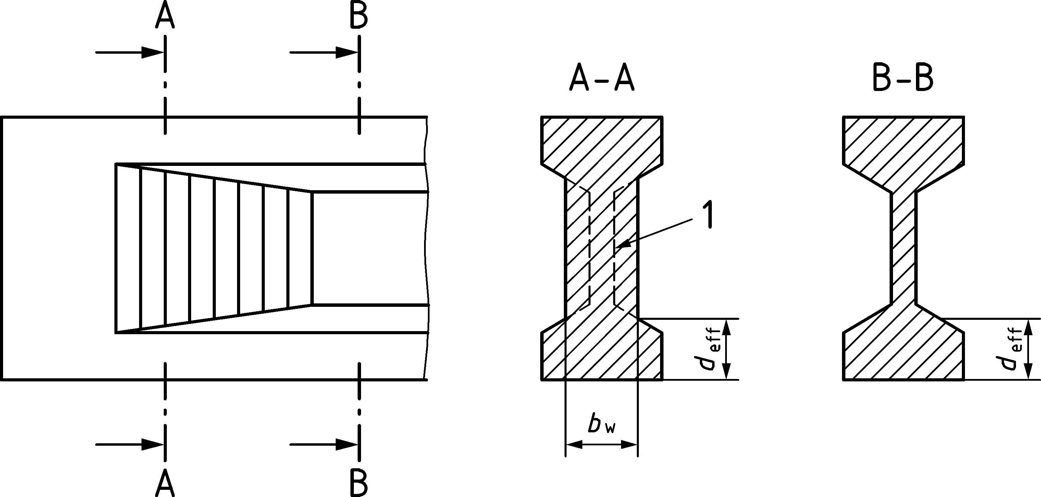

Key

|  |  |
| --- | --- |
| 1 | imaginary cross section |

Figure 6.5 — I‑shaped beam with increasing web width *b*w satisfying the requirements of an imaginary cross-section

(7) Where the actual width of the bottom flange *b* exceeds 1,4 *b*w (*b*w denotes the actual width of the web, see Figure 6.4(c)), and *b* *d*eff < 2*b*2min the effective axis distance, *a*eff, to the reinforcing or prestressing steel from the exposed surface should be increased to:

 (6.8)

where

|  |  |
| --- | --- |
| *a* | is the axis distance defined in Tables 6.7 and 6.8; |
| *d*eff | is given by Formula (6.7); |
| *b*min | is the minimum beam width given in Table 6.7. |

(8) Holes through the webs of beams may be assumed to not affect the bending resistance provided that the remaining cross-sectional area of the member in the tensile zone is not less than *A*c = 2*b*2min, where *b*min is given by Table 6.7.

(9) For prestressed beams the increase of axis distance *a* according to 6.2 (2) should be applied.

### Simply supported beams exposed to fire on one, two or three sides

(1) For simply supported beams the axis distance *a* to the soffit and sides and the width of the beam *b*min and *b*w,min should not be less than the minimum values in Table 6.7 for standard fire resistances of R 30 to R 240.

(2) Unless the width of the beam is greater than *b*min given in Column 4 of Table 6.7, the axis distance of the corner reinforcement to the side of the beam for beams with only one reinforcement layer should be taken as given in Formula (6.9):

*a*sd = *a* + 10 mm (6.9)

Table 6.7 — Minimum dimensions and axis distances for simply supported reinforced or prestressed concrete beams

| **Standard fire resistance** | **Minimum** **dimensions** | | | | |
| --- | --- | --- | --- | --- | --- |
| **(mm)** | | | | |
| **Possible combinations of *a* and *b*min where *a* is the average axis distance and *b*min the width of beam** | | | | **Web thickness *b*w,min** |
| **1** | **2** | **3** | **4** | **5** | **6** |
| R 30 | *b*min = 80 | 120 | 160 | 200 | 80 |
|  | *a* = 25 | 20 | 15a | 15a |  |
| R 60 | *b*min = 120 | 160 | 200 | 300 | 100 |
|  | *a* = 40 | 35 | 30 | 25 |  |
| R 90 | *b*min = 150 | 200 | 300 | 400 | 110 |
|  | *a* = 55 | 45 | 40 | 35 |  |
| R 120 | *b*min = 200 | 240 | 300 | 500 | 120 |
|  | *a* = 65 | 60 | 55 | 50 |  |
| R 180 | *b*min = 240 | 300 | 400 | 600 | 140 |
|  | *a* = 80 | 70 | 65 | 60 |  |
| R 240 | *b*min = 280 | 350 | 500 | 700 | 160 |
|  | *a* = 90 | 80 | 75 | 70 |  |
| NOTE For tensile and simply supported members subject to bending (except those with unbonded tendons), in which the critical temperature is different from 500 °C, see 6.2 (3). | | | | | |
| a Normally the cover required by prEN 1992‑1‑1 will be larger. | | | | | |

### Continuous beams exposed to fire on one, two or three sides

(1) For continuous beams values of axis distance *a* and the width of the beam *b*min and *b*w should not be less than the values in Table 6.8, for standard fire resistance of R 30 to R 240.

(2) Table 6.8 may be used only if:

a) the detailing rules in 9.3 are observed;

b) the redistribution of bending moment required for the design at ambient temperature according to prEN 1992‑1‑1 does not exceed 15 %; and

c) for unbonded tendons if the total hogging moment over intermediate supports under fire conditions is resisted by bonded reinforcement.

Otherwise, the beams should be treated as simply supported.

NOTE Table 6.8 can be used for continuous beams where moment redistribution is more than 15 %, provided that there is sufficient rotation capacity at the supports for the required fire resistance.

(3) Unless the width of the beam is greater than *b*min given in Column 3 of Table 6.8, the axis distance of the corner reinforcement to the side of the beam for beams with only one reinforcement layer should be taken as given in Formula (6.9).

(4) The web thickness of I‑shaped continuous beams *b*w (see Figure 6.4) should not be less than the minimum value *b*min in Table 6.8, Column 7, for a length of 2*h* from an intermediate support unless it is checked experimentally according to Clause 10 (9) that the required performance is met, or polypropylene fibres are specified in the concrete mix according to Clause 10 (10).

Table 6.8 — Minimum dimensions and axis distances for continuous reinforced or prestressed concrete beams (see also Table 6.9)

| **Standard fire resistance** | **Minimum dimensions** | | | | | |
| --- | --- | --- | --- | --- | --- | --- |
| **(mm)** | | | | | |
| **Possible combinations of *a* and *b*min where *a* is the average axis distance and *b*min is the width of beam** | | | | **Web thickness *b*w,min** | **Web thickness *b*w,min for a length of 2*h* from an intermediate support** |
| **1** | **2** | **3** | **4** | **5** | **6** | **7** |
| R 30 | *b*min = 80 | 160 | — | — | 80 | 80 |
|  | *a* = 15a | 12a | — | — | — | — |
| R 60 | *b*min = 120 | 200 | — | — | 100 | 120 |
|  | *a* = 25 | 12a | — | — | — | — |
| R 90 | *b*min = 150 | 250 | — | — | 110 | 150 |
|  | *a* = 35 | 25 | — | — | — | — |
| R 120 | *b*min = 200 | 300 | — | 500 | 120 | 200 |
|  | *a* = 45 | 35 | — | 30 | — | — |
| R 180 | *b*min = 240 | 400 | 550 | 600 | 140 | 240 |
|  | *a* = 60 | 50 | 45 | 40 | — | — |
| R 240 | *b*min = 280 | 500 | 650 | 700 | 160 | 280 |
|  | *a* = 75 | 60 | 60 | 50 | — | — |
| NOTE For tensile and simply supported members subject to bending (except those with unbonded tendons), in which the critical temperature is different from 500 °C, see 6.2 (3). | | | | | | |
| a Normally the cover required by prEN 1992‑1‑1 will be larger. | | | | | | |

(5) In order to prevent a concrete compression or shear failure of a continuous beam at the first intermediate support, the beam width and web thickness should be increased for standard fire resistances R 120 to R 240 in accordance with Table 6.9, only if both the following conditions are met:

a) No bending resistance is provided at the end support, and

b) *𝜏*Ed > 2/3*𝜈*Rd,max or *F*td > 2/3 *F*Rd at the first intermediate support, where *V*Ed in ambient temperature design according to prEN 1992‑1‑1:2021, 8.2.3.

Table 6.9 — Increased beam width and web thickness for reinforced and prestressed concrete continuous I‑beams according to 6.6.3 (6)

| **Standard fire resistance** | **Minimum beam width *b*min and web thickness *b*w** |
| --- | --- |
| **(mm)** |
| 1 | 2 |
| R 120 | 220 |
| R 180 | 380 |
| R 240 | 480 |

### Beams exposed on all sides

(1) In addition to the rules in 6.6.1 to 6.6.3, the following conditions should be met:

— the beam depth should not be less than the minimum width for the required fire resistance,

— the cross-sectional area of the beam should not be less than

*A*c = 2*b*2min (6.9a)

where

|  |  |
| --- | --- |
| *b*min | is given by Tables 6.7 to 6.9. |

## Slabs

### General

(1) Fire resistance of reinforced and prestressed concrete slabs may be considered adequate if the dimensional restrictions in Table 6.10 and the following rules are met.

(2) Slab thickness *h* at least equal to the values given in Table 6.10 may be considered to provide adequate separating function (Criteria E and I). Floor-finishes may be assumed to contribute to the separating function in proportion to their thickness, i.e. *h* = *h*1 + *h*2 (see Figure 6.6).

(3) 6.7.2 and 6.7.3 also apply to the flanges of T‑ or TT‑shaped beams.

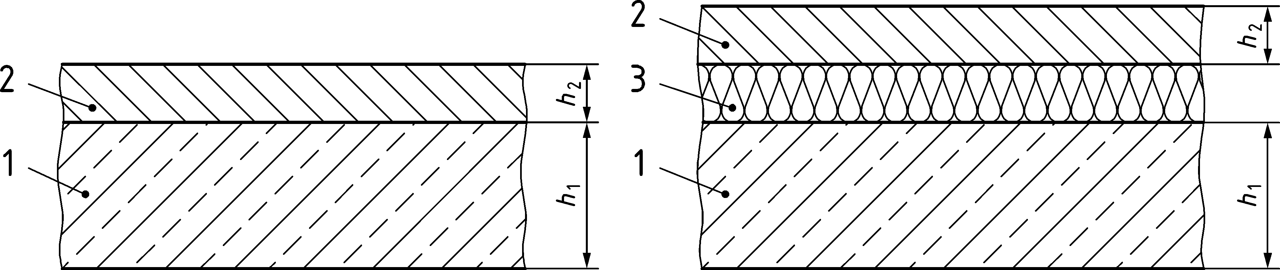

Key

|  |  |
| --- | --- |
| 1 | concrete slab |
| 2 | flooring (non-combustible) |
| 3 | sound insulation (possibly combustible) |

Figure 6.6 — Concrete slab with floor finishes

(4) In two-way slabs the rules concerning the axis distance refer to the outer reinforcement layer.

(5) For prestressed slabs the increase of axis distance according to 6.2 (2) should be applied.

### Simply supported slabs

(1) For simply supported slabs the minimum values of thickness and of the axis distance should not be less than the minimum values given in Table 6.10 to provide standard fire resistances of R 30 to R 240.

(2) The load bearing function of simply supported slabs may be considered satisfied with cross-sectional dimensions required for the design at ambient temperature according to prEN 1992‑1‑1.

Table 6.10 — Minimum thickness and axis distances for reinforced or prestressed concrete simply supported one-way or two-way solid slabs

| **Standard fire resistance** | **Minimum dimensions** | | | |
| --- | --- | --- | --- | --- |
| **(mm)** | | | |
| **slab thickness *h*** | **axis distance *a*** | | |
| **(mm)** | **one-way** | **two-way:** | |
|  | ***l*y/*l*x ≤ 1,5** | **1,5 < *l*y/*l*x ≤ 2** |
| **1** | **2** | **3** | **4** | **5** |
| REI 30 | 60 | 10a | 10a | 10a |
| REI 60 | 80 | 20 | 10a | 15a |
| REI 90 | 100 | 30 | 15a | 20 |
| REI 120 | 120 | 40 | 20 | 25 |
| REI 180 | 150 | 55 | 30 | 40 |
| REI 240 | 175 | 65 | 40 | 50 |
| NOTE Columns 4 and 5 concern slabs which are supported along all four edges; if they are not, slabs should be treated as one-way (Column 3). | | | | |
| a Normally the cover required by prEN 1992‑1‑1 will be larger. | | | | |

### Continuous solid slabs

(1) Columns 2 and 4 of Table 6.10 may also be taken to apply to one-way or two-way continuous slabs.

(2) The provisions for continuous solid slabs should be used only if:

a) the detailing rules in 9.3 are observed; and

b) the redistribution of bending moment required for the design at ambient temperature conditions for reinforcement ductility class A; and

c) the redistribution of bending moment required for the design at ambient temperature conditions does not exceed 15 % for ductility classes B and C.

Otherwise, the slabs should be treated as simply supported.

NOTE The provisions for continuous solid slabs can be used for continuous beams where moment redistribution is more than 15 %, provided that there is sufficient rotation capacity at the supports for the required fire resistance.

### Flat slabs

(1) Adequate fire resistance of reinforced and prestressed solid flat slabs may be assumed if the minimum values of thickness *h* and of the axis distance *a* given in Table 6.11 for R 30 to R 240 are met.

(2) If the redistribution of bending moment required for the design at ambient temperature according to prEN 1992‑1‑1 exceeds 15 %, the axis distance should be taken as for one-way slab (Column 3 in Table 6.10).

(3) Minimum slab-thicknesses should not be reduced (e.g. by taking floor finishes into account).

Table 6.11 — Minimum thickness and axis distances for reinforced or prestressed concrete solid flat slabs

| **Standard fire resistance** | **Minimum dimensions** | |
| --- | --- | --- |
| **(mm)** | |
| **slab-thickness *h*** | **axis-distance *a*** |
| **1** | **2** | **3** |
| REI 30 | 150 | 10a |
| REI 60 | 180 | 15a |
| REI 90 | 200 | 25 |
| REI 120 | 200 | 35 |
| REI 180 | 200 | 45 |
| REI 240 | 200 | 50 |
| NOTE For tensile and simply supported members subject to bending (except those with unbonded tendons), in which the critical temperature is different from 500 °C, see 6.2 (3). | | |
| a Normally the cover required by prEN 1992‑1‑1 will be larger. | | |

### Ribbed slabs

(1) For ribbed slabs with reinforcement in several layers, 6.2 (8) applies.

(2) For one-way reinforced or prestressed ribbed slabs, 6.6.2 and 6.6.3 may be used for the ribs and 6.7.3, Table 6.10, Columns 2 and 5, for the flanges.

(3) For two-way reinforced or prestressed ribbed slabs under predominantly uniform loading, adequate fire resistance may be assumed to be provided, if the minimum values in Tables 6.12 and 6.13 are met, together with the rules given in 6.7.5 (4) and (5).

(4) Table 6.12 may be used for simply supported, two-way ribbed slabs.

(5) Table 6.13 may be used for two-way ribbed slabs with one or more restrained edges for all standard fire resistances if detailing of their top reinforcement meets 9.3 (1) and 9.3 (4). Otherwise, the two-way ribbed slabs should be treated as simply supported.

(6) The axis distance of the corner reinforcement in the rib to the lateral surface of the rib should be taken as given in Formula (6.9):

Table 6.12 — Minimum thickness and axis distance for two-way, simply supported ribbed slabs in reinforced or prestressed concrete

| **Design effect of actions in fire situation** | **Minimum dimensions** | | | |
| --- | --- | --- | --- | --- |
| **(mm)** | | | |
| **Combinations of width of ribs *b*min and axis distance *a*** | | | **Slab thickness *h* and minimum axis distance *a* in flange** |
| **1** | **2** | **3** | **4** | **5** |
| REI 30 | *b*min = 80 | — | — | *h* = 80 |
|  | *a* = 15a | — | — | *a* = 10a |
| REI 60 | *b*min = 100 | 120 | ≥ 200 | *h* = 80 |
|  | *a* = 35 | 25 | 15a | *a* = 10a |
| REI 90 | *b*min = 120 | 160 | ≥ 250 | *h* = 100 |
|  | *a* = 45 | 40 | 30 | *a* = 15a |
| REI 120 | *b*min = 160 | 190 | ≥ 300 | *h* = 120 |
|  | *a* = 60 | 55 | 40 | *a* = 20 |
| REI 180 | *b*min = 220 | 260 | ≥ 410 | *h* = 150 |
|  | *a* = 75 | 70 | 60 | *a* = 30 |
| REI 240 | *b*min = 280 | 350 | ≥500 | *h* = 175 |
|  | *a* = 90 | 75 | 70 | *a* = 40 |
| a Normally the cover required by prEN 1992‑1‑1 will be larger. | | | | |

Table 6.13 — Minimum thickness and axis distances for two-way ribbed slabs in reinforced or prestressed concrete with at least one restrained edge

| **Standard fire resistance** | **Minimum dimensions** | | | |
| --- | --- | --- | --- | --- |
| **(mm)** | | | |
| **Combinations of width of ribs, *b*min, and axis distance *a*** | | | **Slab thickness *h* and axis distance *a* in flange** |
| **1** | **2** | **3** | **4** | **5** |
| REI 30 | *b*min = 80 | — | — | *h* = 80 |
|  | *a* = 10a | — | — | *a* = 10a |
| REI 60 | *b*min = 100 | 120 | ≥ 200 | *h* = 80 |
|  | *a* = 25 | 15a | 10a | *a* = 10a |
| REI 90 | *b*min = 120 | 160 | ≥ 250 | *h* = 100 |
|  | *a* = 35 | 25 | 15a | *a* = 15a |
| REI 120 | *b*min = 160 | 190 | ≥ 300 | *h* = 120 |
|  | *a* = 45 | 40 | 30 | *a* = 20 |
| REI 180 | *b*min = 310 | 600 | — | *h* = 150 |
|  | *a* = 60 | 50 | — | *a* = 30 |
| REI 240 | *b*min = 450 | 700 | — | *h* = 175 |
|  | *a* = 70 | 60 | — | *a* = 40 |
| a Normally the cover required by prEN 1992‑1‑1 will be larger. | | | | |

# Simplified design methods

## General

(1) Simplified design methods may be used to determine a temperature field in a section, a temperature in part of it or a loadbearing capacity of a section or a member.

(2) The risk of severe spalling shall be taken into account according to Clause 10.

## Temperature profiles

### General

(1) Simplified analytical formulae given in 7.2 may be used to determine the temperature profiles in concrete members:

a) exposed to fire on one side (Formula 7.1), or

b) exposed to fire on two sides (Formulae 7.6 and 7.7) and

c) for rectangular (Formulae 7.8 and 7.10) and

d) circular cross-sections (Formula 7.11).

NOTE 1 The simplified formulae are primarily intended for calculations concerning the loadbearing capacity (R).

NOTE 2 The simplified analytical model can underestimate the value of the temperature on the unexposed side for insulation assessment.

NOTE 3 The simplified formulae are based on the following assumptions:

— The emissivity related to the concrete surface is 0,7 (see 5.2.1);

— The thermal conductivity of concrete is as given in 5.2.2;

— The specific heat of concrete is as given in 5.2.3 with moisture content of 1,5 %. (The formulae are conservative for moisture contents greater than 1,5 %);

— The density of concrete is as given in 5.2.4; the reference value at 20 °C is 2 300 kg/m3;

— The convection factor is 25 W/(m2·K).

(2) Formulae (7.1) to (7.11) cover common sections of reinforced concrete members. Geometric discontinuities (such as dapped ends, recesses or holes) may require advanced thermal analysis.

### Basic solution for one side exposure

(1) In a concrete member exposed to standard fire on one side, the temperature field may be calculated from Formula (7.1) provided that the thickness is larger than the minimum values given in Table 7.1 as a function of the standard fire resistance:

 (7.1)

where the temperature increase during fire,, is given by:

|  |  |  |
| --- | --- | --- |
|  | | (7.2) |
| *R*fi | is the duration of the standard fire (in seconds)*,* ; | |
| *x* | is the distance from the exposed surface (in m); | |
| Δ*R*fi = 720 s | represents a delay between the temperature in the fire compartment and the concrete surface temperature as an approximation for the effects of convection and radiation. | |
|  | | (7.3) |

NOTE 1 The value of *k* is coming from a back-calibration to fit the temperature curves.

Table 7.1 — Minimum thickness of one-side exposed concrete members for the application of Formulae (7.1) and (7.2)

| **Fire resistance** | **R 30** | **R 60** | **R 90** | **R 120** | **R 180** | **R 240** |
| --- | --- | --- | --- | --- | --- | --- |
| Minimum thickness of one-side exposed concrete members (mm) | 60 | 70 | 100 | 120 | 150 | 200 |

NOTE 2 Figure 7.1 shows the temperature profiles obtained by means of Formula (7.1) for a one-side exposed member (thickness = 200 mm) for fire durations between 30 min and 240 min.

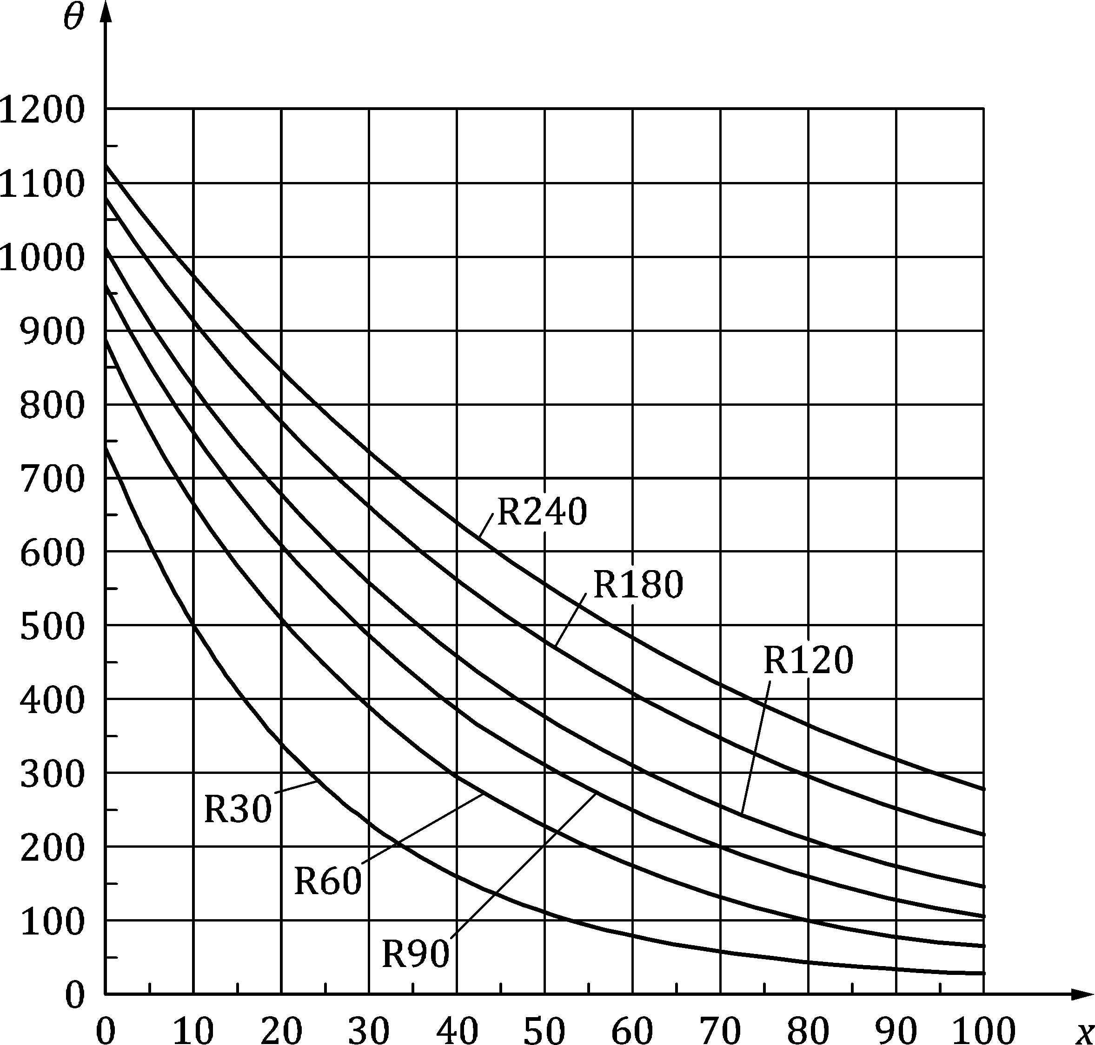

**Key**

|  |  |
| --- | --- |
|  | °C |
| *x* | mm |

Figure 7.1 — Temperature profiles for a one-side exposed member (thickness = 200 mm) for R 30 to R 240

### Walls, slabs and rectangular cross-sections

(1) The temperature increase in a concrete member exposed to fire on two opposite surfaces (Figure 7.2) may be calculated from Formulae (7.4) and (7.5):

|  |  |
| --- | --- |
|  | (7.4) |
|  | (7.5) |

(2) The resulting temperature field in a concrete member exposed to fire on two opposite surfaces (see Figure 7.2) is:

for the situation shown as case A:

 (7.6)

for the situation shown as case B:

 (7.7)

|  |  |
| --- | --- |
|  |  |
| Case A | Case B |

Key

|  |  |
| --- | --- |
|  | fire |

Figure 7.2 — Coordinate systems for members exposed to fire on two sides

(3) In a concrete member exposed to fire on four sides (Case C in Figure 7.3) the resulting temperature may be calculated from Formula (7.8):

 (7.8)

(4) The contribution , a local effect at the corners where the effects of convection and radiation at the beginning of the fire are reduced (i.e. for *y*′ and *z*′ ≤ *a*c) may be calculated from Formula (7.9):

 (7.9)

(5) The dimension of the corner zone should be taken as equal to

*a*c = 0,04 m for fire durations up to 60 min

*a*c = 0,10 m for fire durations longer than 60 min

|  |  |
| --- | --- |
|  |  |
| Case C | Local corner system |

Key

|  |  |
| --- | --- |
|  | fire |

Figure 7.3 — Concrete member exposed to fire on four sides (Case C) and local coordinate system for corner zones

(6) In a concrete member exposed to fire on three sides (Case D in Figure 7.4) the resulting temperature may be calculated from Formula (7.10):

 (7.10)

by applying the corner contributions, ) only at the corners (*y*,*z*) = (0,0) and (*y*,*z*) = (*b*,0), where both sides adjacent to the corner are exposed to fire.

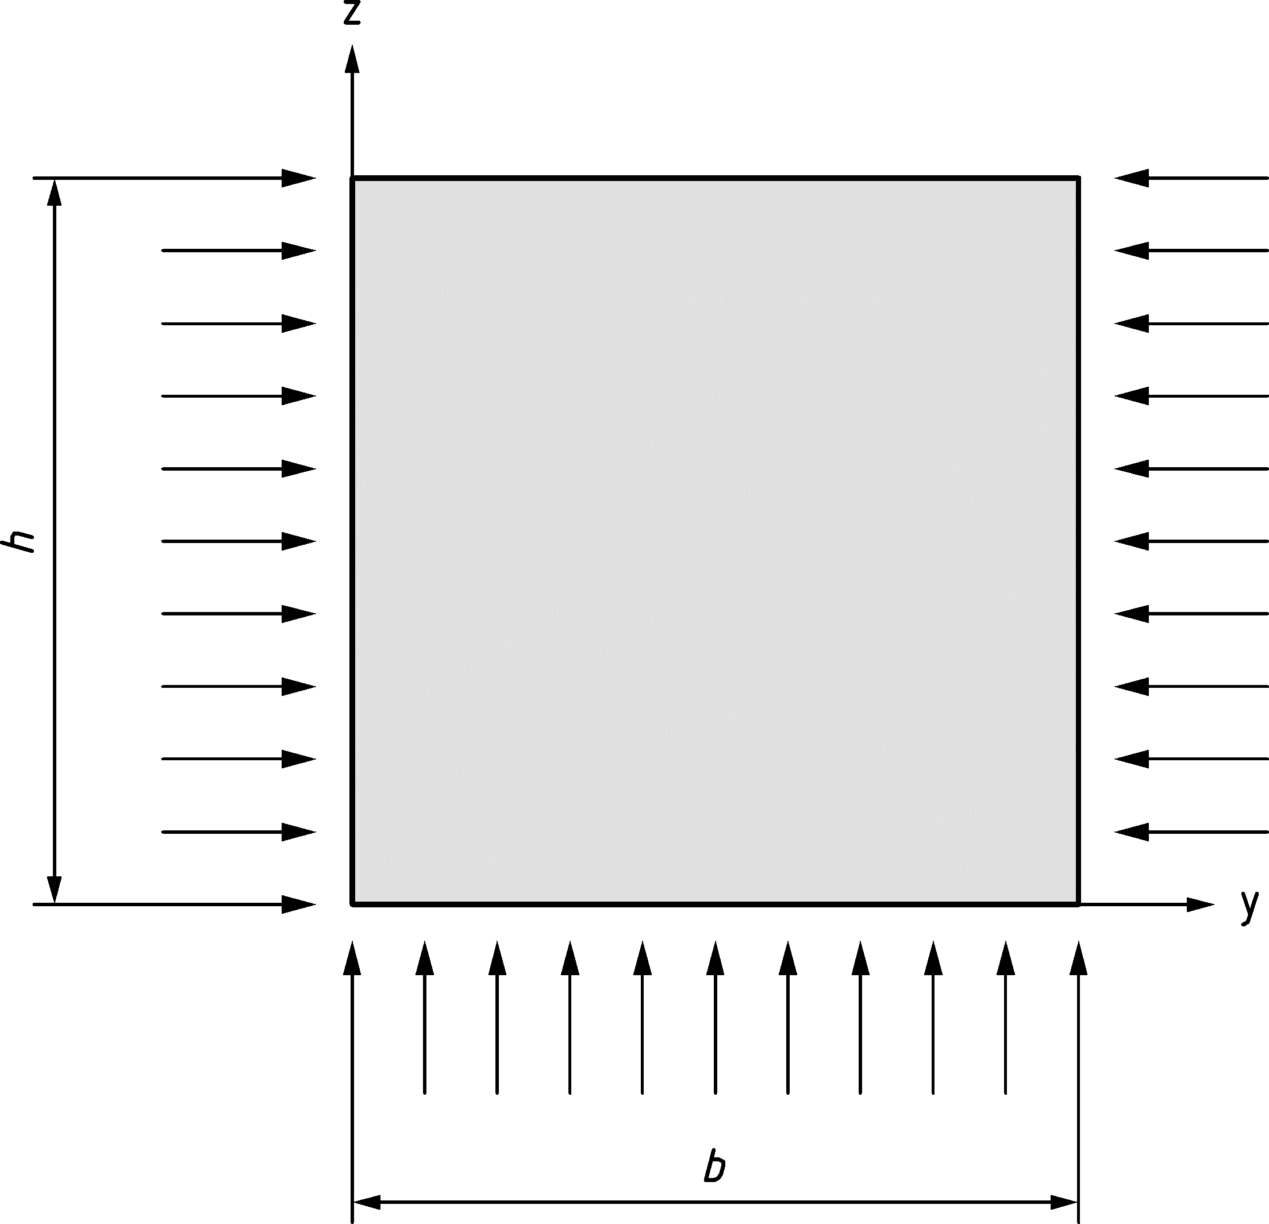

Case D

Key

|  |  |
| --- | --- |
|  | fire |

Figure 7.4 — Concrete member exposed to fire on three sides (Case D)

(7) For cross-sections characterized by *b*/*b*w > 2 (e.g. I‑shaped cross-sections) or *h*/*b* > 2, the cross-section may be subdivided into rectangles and Formulae (7.4) to (7.10) may be used.

### Circular cross-sections

(1) For circular cross-sections subjected to the standard fire from all sides, the temperature at a distance *x* from the surface along a radius can be calculated from Formula (7.11):

 (7.11)

where the temperature increase at the surface is given in Formula (7.12):

 (7.12)

and the contributions  and  are given by Formulae (7.13) and (7.14):

 (7.13)

 (7.14)

where *b* is the diameter of the cross-section (in m) and *k* is defined by Formula (7.3).

## Structural analysis

### General

(1) The strength and deformation properties from 5.3 should be applied.

(2) The temperature of the concrete cross-section and of the reinforcement may be calculated by means of simplified methods, such as the formulae provided in 7.2, or by means of advanced design methods. The temperature of the reinforcement should be calculated at the position of its centre.

(3) The temperature profile may be determined without taking into account the steel and ascribing to the reinforcement the temperature in the concrete at the same point.

(4) Structural analysis for bending with or without axial load (7.3.3 and 7.3.4) applies to undisturbed regions of structural members for which plane sections remain approximately plane before and after loading. The discontinuity regions of members subjected to bending with or without axial load may be designed and detailed according to the general approach provided in prEN 1992-1-1:2021, 8.5 if the reduction of the cross-section given in 7.3.2 and the reduction of the strength properties given in 7.3.3.3 (1) and (2) are applied.

### Reduction of cross-section

(1) For the methods presented in 7.3.3.2 (5), 7.3.3.3, 7.3.4.2 and 7.3.5, a reduction of the cross-section due to fire should be assumed with a rim zone as presented in 7.3.2.

(2) The reduced cross-sectional dimensions  and  may be determined by ignoring a rim zone of thickness *a*z at the fire exposed sides.

(3) For cross-sections with b/bw > 2 (e.g. I-shaped) or h/b > 2 (e.g. T-shaped cross-sections), the cross-section may be subdivided to determine the rim zone az.

NOTE 7.3.2 (5) to (7) can be used for subdivided cross-sections according to 7.3.2 (3).

(4) When using concrete with *f*ck ≥ 70 MPa, either Formulae (7.16) or (7.17) should be applied or the effective rim zone determined with Formulae (7.15) should be increased by a factor of 1,15.

(5) For rectangular cross-sections and circular-sections or rectangular parts of cross-sections according to 7.3.2 (3), the thickness of the rim zone, *a*z [m], may be determined using Formula (7.15).

 (7.15)

where

|  |  |
| --- | --- |
| *R*fi [min] | is the design resistance for the load-bearing criterion in fire situations and |
| *w* [m] | is a cross-sectional dimension used to obtain the reduced cross-section depending on the fire exposure defined as (see Figure 7.5): |
|  | — the member dimension perpendicular to the surface exposed to fire on one side or two non-opposite sides, |
|  | — half the member dimension perpendicular to the surface exposed to fire for members exposed to fire on at least two opposite sides, and |
|  | — half of the member dimension for circular cross-sections. |

NOTE Formula (7.15) can be used for general forms of cross-sections if the thickness of the rim zone *a*z is calculated with the largest dimension orthogonal to surfaces exposed to fire and assumed to be the same value for all sides.

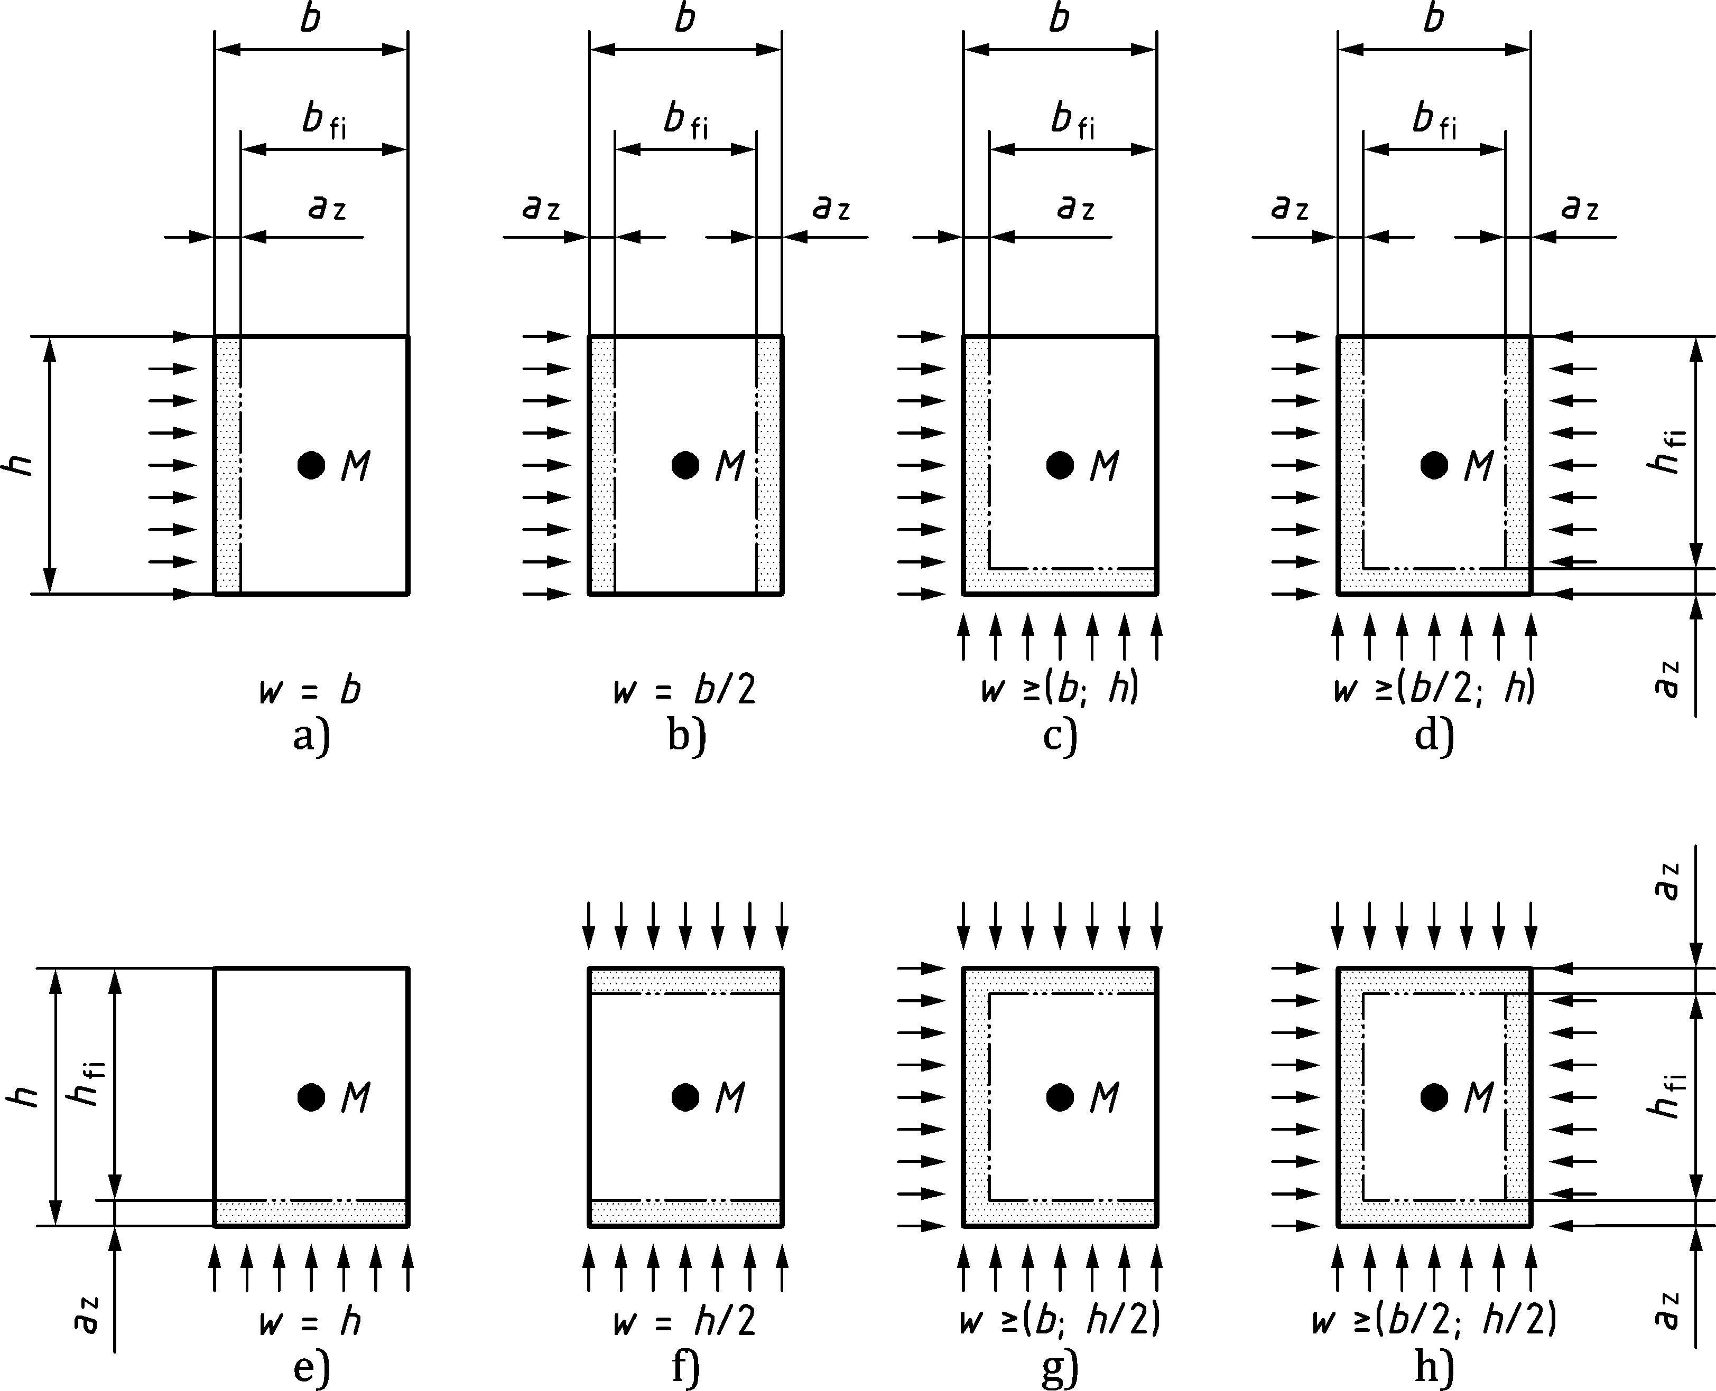

Key

|  |  |
| --- | --- |
|  | fire |

Figure 7.5 — Reduction of cross-section for sections exposed to fire

(6) For more detailed analysis or other forms of cross-sections than rectangular or circular exposed to fire on one or two opposite sides, the thickness of the rim zone, *az* [m], may be calculated using Formula (7.16) after dividing the cross-section into parallel zones of equal thickness (see Figure 7.6):

 (7.16)

where

|  |  |
| --- | --- |
| *w* [m] | is the cross-sectional dimension according to 7.3.2 (5) |
|  | is the number of parallel zones in width *w*, with n ≥ 3 |
|  | is the average temperature of each parallel zone |
|  | is the temperature in the centroid of the cross-section |

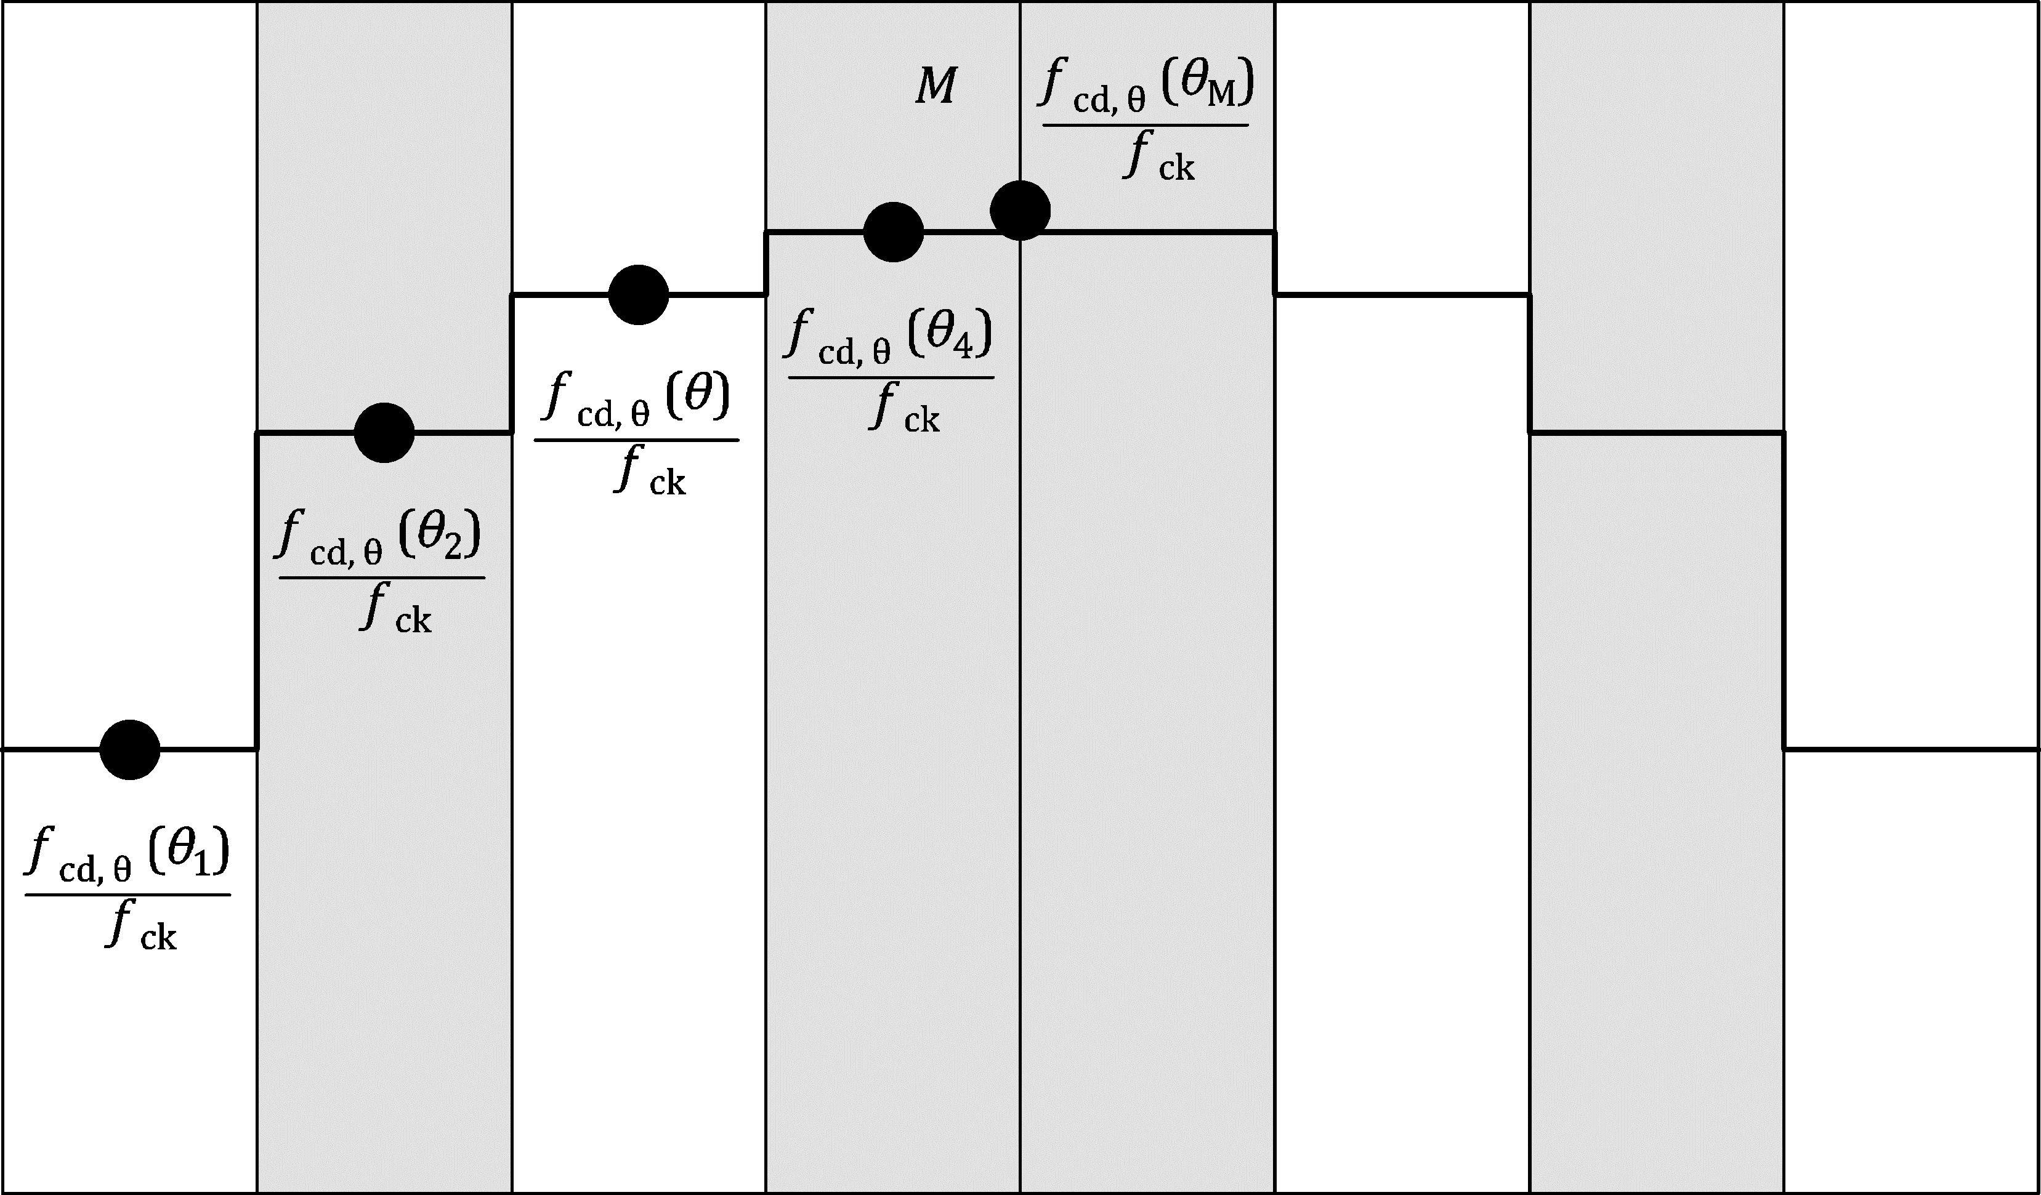

Figure 7.6 — Division of a wall, with both sides exposed to fire, into zones for use in calculation of strength reduction and *a*z values

(7) For more detailed analysis or other forms of cross-sections than rectangular or circular exposed to fire on two non-parallel sides, three sides or four sides, the thickness of the rim zone, *az* [m], may be calculated using Formula (7.17) after dividing the cross-section into zones of equal area:

 (7.17)

where

|  |  |
| --- | --- |
| *w* [m] | is the cross-sectional dimension according to 7.3.2 (5); |
| *n* | is the number of zones in width *w*, with *n* ≥ 3; |
|  | is the average temperature of each zone; |
|  | is the temperature in the centroid of the cross-section. |

### Bending

#### General

(1) The assessment of members subjected to bending under fire conditions may be carried out by using the simplified assessment (see 7.3.3.2) or using the refined assessment with a broader range of application (see 7.3.3.3).

(2) For tension reinforcement of members mainly loaded in bending (beams and slabs), the strength may be used as given by *f*sy,θ in Table 5.3 for reinforcing steel and as given by *f*py,θ and *f*pp,θ in Table 5.4 for prestressing steel.

(3) Slabs and beams whose concrete on the compression side of the cross-section is exposed to fire should have minimum cross-sectional dimensions (*b*min, *h*) given in Tables 6.8, 6.9 and 6.13. The width *b*min or *b*w, should be larger than 200 mm and the height *h*s should be larger than 2*b*, where *b*min is the value given in Column 5 of Table 5.5, for continuous beams in the areas of negative moment.

#### Simplified assessment

(1) The simplified assessment in 7.3.3.2 may be applied for slabs and beams provided that the neutral axis depth of concrete in compression is limited to *x* < 0,25*d* at ambient conditions.

(2) For slabs and beams whose tension side only is exposed to fire, the bending resistance may be calculated by disregarding the strength reduction of concrete and by considering the full cross-section. The strength properties of the reinforcement at elevated temperatures shall be considered. The strength of each reinforcing bar may be determined by using column (2) and (3) of Table 5.3. The strength of each prestressing wire, strand or bar may be determined by using column (2) and (3) of Table 5.4

(3) If only one layer of reinforcement is used, Formula (7.18) may be used to calculate the bending resistance of slabs and beams whose tension side of the cross-section is exposed to fire.

 (7.18)

where

|  |  |
| --- | --- |
|  | is the number of effective reinforcing bars or prestressing wire, strand or bar in the tensile reinforcement layer; |
|  | is the strength of each reinforcing bar or prestressing wire, strand or bar at elevated temperatures; |
| *A*st,prov | is the cross sectional area of longitudinal reinforcement provided in the tensile reinforcement layer; |
| *A*st,req | is the cross sectional area of longitudinal reinforcement in the tensile reinforcement layer required for the design at ambient temperature according to prEN 1992‑1‑1. |

(4) For slabs and beams whose compression side of the cross-section is exposed to fire, the bending resistance is calculated as given in 7.3.3.2 (2), but multiplied with the factor (*d*-*az*)/*d.*

#### Refined assessment

(1) The strength properties of the reinforcement at elevated temperatures shall be considered. The strength of each reinforcing bar may be determined by using column (2) and (3) of Table 5.3. The strength of each prestressing wire, strand or bar may be determined by using column (2) and (3) of Table 5.4.

(2) The reduced cross-sectional dimensions  and should be determined according to 7.3.2. The compression strength of concrete should be assumed to be equivalent to *f*c,θ(θ*M*) where θ*M* is the temperature in the centre *M* of the cross-section, see Figure 7.7.

(3) For the design of cross-sections of members subjected to bending, Formulae (7.19) to(7.21) may be used for rectangular, T-shaped or I-shaped cross-sections (see Figure 7.7):

 (7.19)

 (7.20)

 (7.21)

where

|  |  |
| --- | --- |
|  | is the concrete strain at the member’s most compressed side; |
|  | is the effective depth of concrete in compression under fire conditions; |
|  | is the distance of the centroid of the compression zone of concrete to the member’s neutral axis. |

NOTE General solutions or simplified formulae for the effective depth of the compression zone, *x*e,fi, and the distance of centroid of compression zone of concrete to neutral axis, *y*fi, can be found by using the relation between *σ*c(*θ*) and *ε*c from 5.3.1.1 (7).

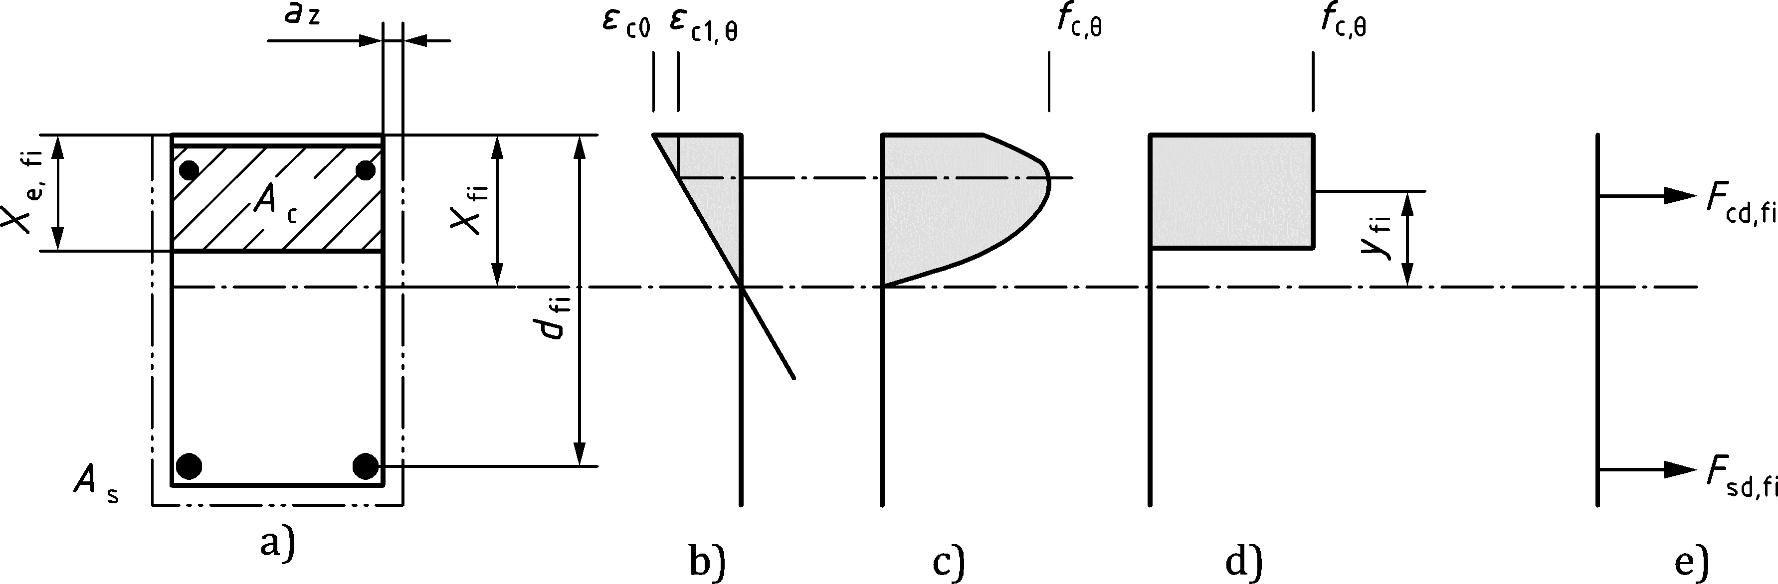

Key

|  |  |
| --- | --- |
| a) | cross-section |
| b) | assumed strain distribution |
| c) | general concrete compression stress distribution |
| d) | simplified concrete compression stress distribution used in 7.3.3.3 |
| e) | resisting cross-sectional forces |

Figure 7.7 — Stress and strain distribution within the compression zone

### Bending and axial load

#### General

(1) The following clauses should be applied for members subjected to bending and axial load when the structural behaviour is significantly influenced by second order effects under fire conditions.

(2) Second order effects should always be considered for columns exposed to fire.

NOTE Under fire conditions, the damage of the outer layers of the member due to high temperatures, combined with the drop of the modulus of elasticity at the inner layers, results in a decrease of the stiffness of structural members under fire conditions. Because of this, second order effects can be significant for columns in the fire situation although at ambient temperature conditions their effect is negligible.

(2) The simplified assessment (see 7.3.4.2) or the refined assessment (see 7.3.4.3) may be used based on the assumption of a nominal curvature.

#### Simplified assessment

(1) The reduced cross-sectional dimensions  and  should be determined according to 7.3.2. The compression strength of concrete should be assumed to be equivalent to *f*c,θ(θM) where *θ*M is the temperature in the centre *M* of the cross-section, see Figure 7.8.

(2) For of the design of cross-sections of members subjected to bending and axial load, the following formulae may be used for rectangular cross-sections with the reduced depth of concrete in compression under fire conditions for (see Figure 7.8):

 (7.24)

 (7.25)

 (7.26)

 (7.27)

where

|  |  |
| --- | --- |
|  | is the concrete strain at the member’s most compressed side; |
|  | is the effective depth of concrete in compression under fire conditions; |
|  | is the distance of the centroid of the compression zone of concrete to the member’s neutral axis; |
|  | is the reduced depth of a cross-section; |
|  | is the reduced axis distance of the reinforcement. |

NOTE General solutions or simplified formulae for the effective depth of the compression zone, *x*e,fi, and the distance of centroid of compression zone of concrete to neutral axis, *y*fi, can be found by using the relation between *σ*c(*θ*) and *ε*c from 5.3.1.1 (8).

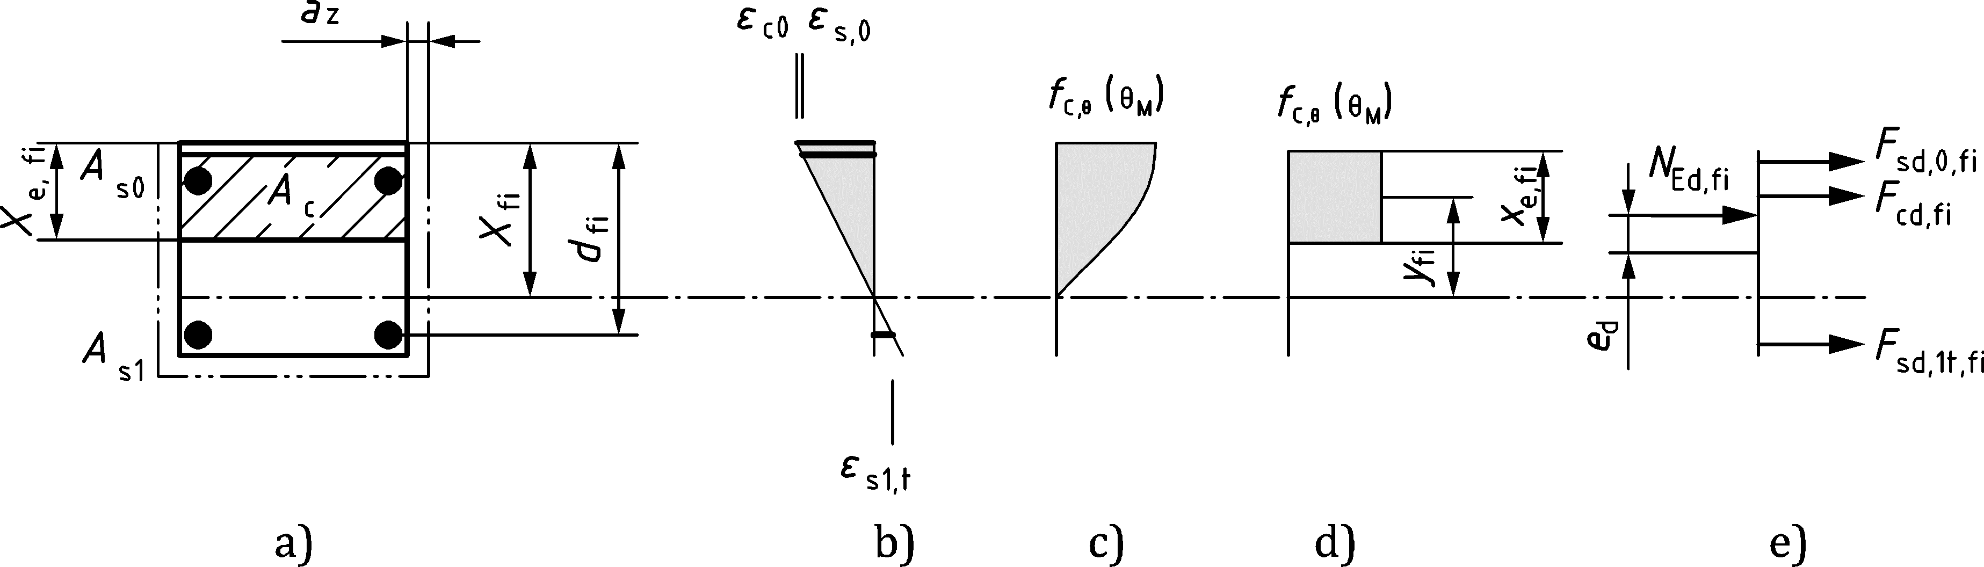

Key

|  |  |
| --- | --- |
| a) | cross-section |
| b) | assumed strain distribution |
| c) | general concrete compression stress distribution |
| d) | simplified concrete compression stress distribution used in 7.3.4.2 |
| e) | acting and resisting cross-sectional forces |

Figure 7.8 — Stress and strain distribution within the cross section for 

(3) The resisting forces  (compression) and  () or  (), respectively, of the longitudinal reinforcement at axis distance *a* (see Figure 7.8) should be determined by using Formulae (7.28) and (7.29) or (7.30).

 (7.28)

 (7.29)

 (7.30)

where

|  |  |
| --- | --- |
|  | are the compression strains in the relevant reinforcing layers; |
|  | is the tension strain in the relevant reinforcing layer; |
|  | correspond to the cross-sectional area of longitudinal reinforcement in the relevant reinforcing layer; |
|  | represents the average temperature of all effective reinforcing bars in the compression zone with  being the number of effective reinforcing bars in the compression zone. |

(4) The design value of the bending moment is

 (7.31)

(5) The maximum eccentricity , i.e. the maximum distance between the compression resultant and the deformed axis of the compression member, should be determined from Formula (7.32):

 (7.32)

where

|  |  |
| --- | --- |
|  | is the first order eccentricity; |
|  | is the additional eccentricity accounting for the effects of geometrical imperfections (see prEN 1992‑1‑1); |
|  | is the eccentricity due to the deformation of the compression member (second order effects); |
|  | is a total curvature distribution factor (see prEN 1992‑1‑1:2021, O.7.2(4)). |

(6) The eccentricity  attributed to thermal effects should be determined from Formula (7.33):

 (7.33)

where

|  |  |
| --- | --- |
|  | is the concrete temperature at the reference point T located at  from the edge of the tension side of the cross-section, where *d* is the effective depth of a cross-section and *a* is the axis distance; |
|  | represents the average temperature of all effective reinforcing bars in the tension zone with  being the number of effective reinforcing bars in the tension zone. |

(7) The member’s equilibrium curvature 1/*r* should be determined including second order effects by basic equilibrium equations based on a plane strain distribution. The member’s equilibrium curvature may be estimated from Formula (7.34):

 (7.34)

prEN 1992‑1‑1:2021, O.7.3 should not be used to determine 1/*r*.

#### Refined assessment

NOTE This method is primarily suited for isolated members with constant normal force *N*Ed,fi and an effective length *l*0,fi.

(1) The cross-section of the member should be discretized into a grid of small elemental zones (see Figure 7.9) each characterized by area *A*cij, coordinates *x*ij *y*ij of the centroid and temperature θij.

(2) The temperature of each reinforcing bar should be evaluated from the temperature profiles in Formulae 7.1 to 7.14 as the temperature in the centre of the reinforcement.

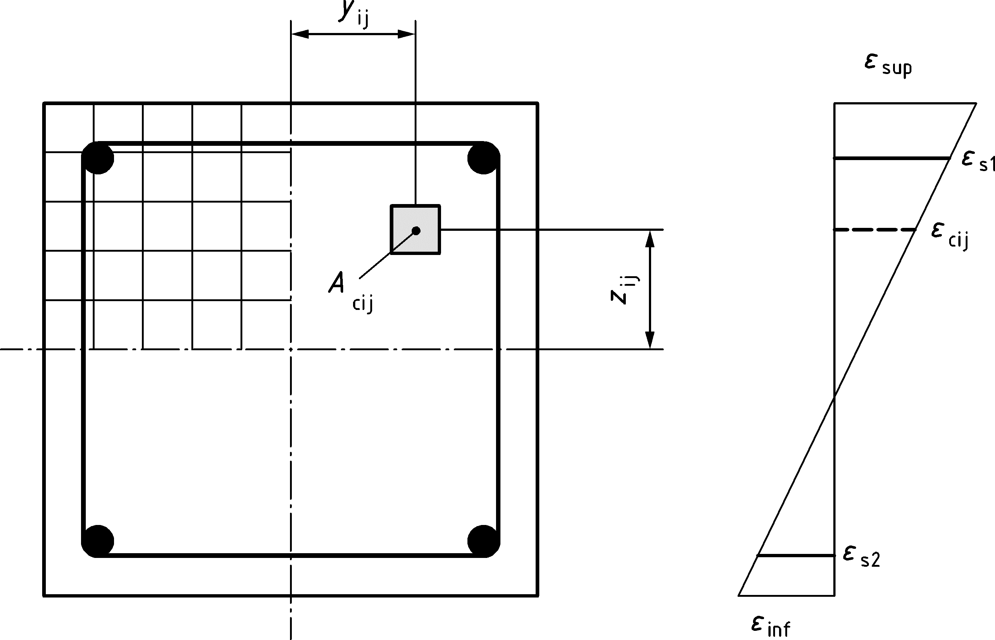

Figure 7.9 — Discretisation of the cross-section of column into elements

(3) The moment-curvature diagram for *N*Ed,fi should be determined by using the relevant stress-strain diagram for each reinforcing bar and for each concrete element according to 5.3.1.1, 5.3.1.3, 5.3.2.1, 5.3.2.2 and where appropriate 5.3.3.1, 5.3.3.2 and 5.3.1.2.

(4) The ultimate first order moment capacity, *M*0Rd,fi, for the specified fire exposure and the design axial load under fire conditions, *N*Ed,fi, is determined as the difference between the ultimate moment capacity, *M*Rd,fi, and nominal second order moment, *M*2,fi (Figure 7.10) from Formula (7.35):

*M*0Rd,fi = *M*Rd,fi − *M*2,fi (7.35)

where

|  |
| --- |
| *M*2,fi = *N*ed,fi/1/*r*) *l*20/*c* |
| *c* ≈ 10 depending on the curvature distribution (see prEN 1992‑1‑1:2021, 7.8) |
| *M*0Rd,fi ≥ *M*0Ed,fi and *M*0Rd,fi ≥ *M*0Ed,fi |

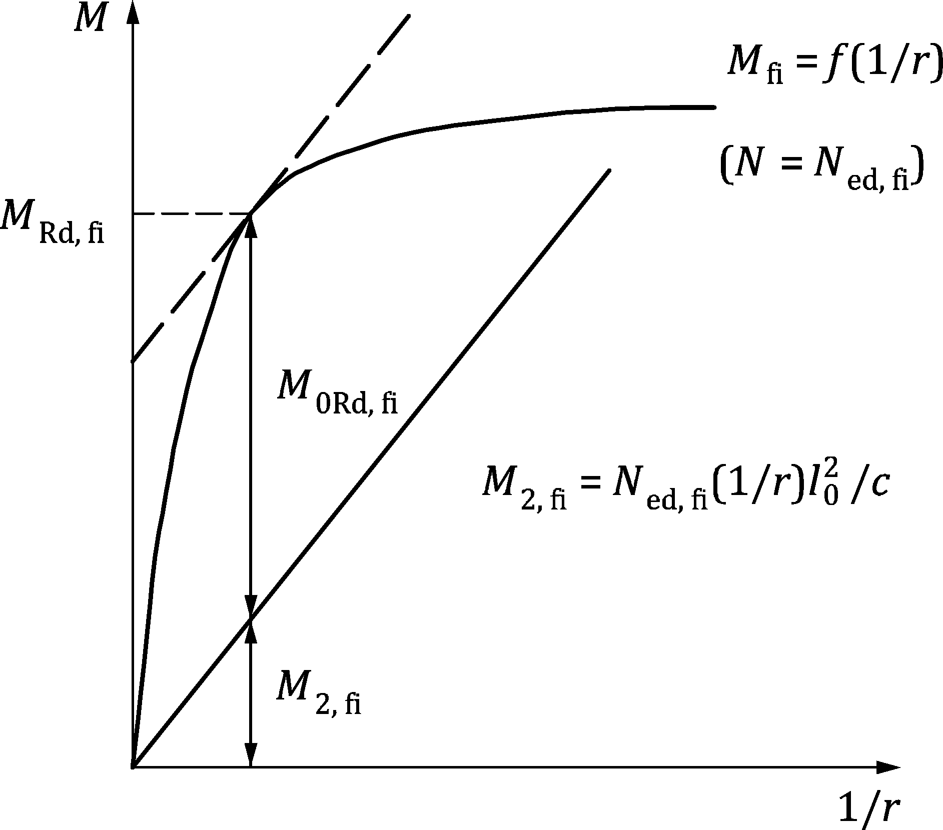

Figure 7.10 — Determination of ultimate moment capacity (*M*Rd,fi), second order moment (*M*2,fi) and ultimate first order moment capacity (*M*0Rd,fi)

### Shear and torsion

#### General

(1) The shear, punching shear and torsion capacity of reinforced concrete members without or with transverse reinforcement may be calculated according to the methods given in prEN 1992-1-1 using reduced material properties and reduced prestress for each part of the cross section.

(2) When using the simplified calculation method of 7.3.3.2, the rules of prEN 1992‑1‑1 may be applied.

#### Shear resistance of members dependant on concrete tensile strength

(1) In prestressed members and in plain and lightly reinforced concrete members, where the shear strength depends on concrete tensile strength (prEN 1992-1-1:2021, 13.5.5 and 14.4.3), special consideration should be given to tensile stresses caused by non-linear temperature distributions (e.g. in voided slabs, thick beams, etc.).

(2) The reduction of the tensile strength *k*ct of concrete should be taken from 5.3.1.2.

#### Shear resistance of members with shear reinforcement

(1) The reduced geometry of the cross section should be computed according to 7.3.2.

(2) The reduced compression strength of concrete should be determined as *f*c,θ = *f*c,θ(*θ*M), where *θ*M is the temperature at Point M as shown in Figure 7.11.

(3) The reference temperature, 𝜃P in links should be determined as the temperature at Point P (intersection of Section a-a with the link), as shown in Figure 7.11.

(4) The reduction of design strength of reinforcing steel in links should be taken with respect to the reference temperature *θ*P as *f*sd,θ = *f*sy,θP.

(5) Calculation methods for design and assessment for shear, as in prEN 1992-1-1, should be applied directly to the reduced cross-section by using reduced strength of steel and concrete as indicated above.

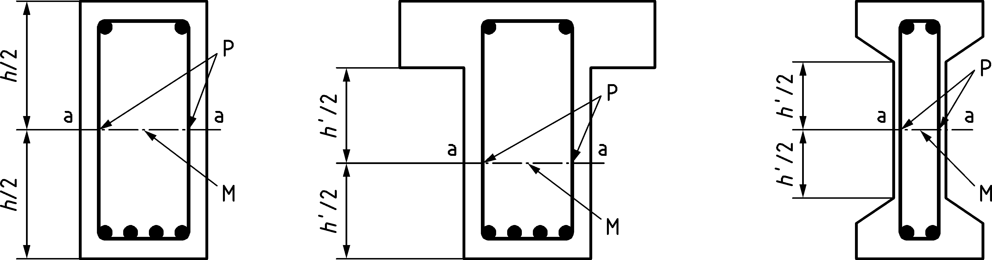

Figure 7.11 — Reference temperature *θ*M and *θ*p evaluated at points M and P along the line ‘a – a’ for the calculation of the shear resistance.

(6) Vertical links or studs of flat slabs shall be considered only if they intersect the control failure surface (8.4.2 of prEN 1992-1-1:2021) evaluated with reference to the reduced geometry. The reference temperature 𝜃P shall be evaluated at the intersection between the vertical links or studs and the control failure surface.

NOTE The approximation of ascribing to the reinforcement the temperature in the concrete at the same point can be retained for links, as they pass through zones with different temperatures and distribute the heat from the warmer zones to the cooler ones. Hence, the temperature of a link is lower than that of the surrounding concrete and tends to become uniform along its whole length. In members reinforced with stirrups having more than two legs, the increase of the shear force due to bending moment redistribution should be taken into account.

#### Torsion resistance of members with shear reinforcement

(1) Provisions given in 7.3.4.2 (1) to (2) should be applied.

(2) The reference temperature, θP in links should be determined as the temperature at Point P (intersection of Section a-a with the link) as shown in Figure 7.12. The steel temperature may be calculated by means of the formulae provided in 7.2 or by means of advanced design methods.

(3) The reduction of design strength of steel in links should be taken with respect to the reference temperature θ*P* as *f*sd,θ = *f*sy,θP.

(4) Calculation methods for design and assessment for torsion, as in prEN 1992-1-1, may be applied directly to the reduced cross-section by using reduced strength of steel and concrete as described above.

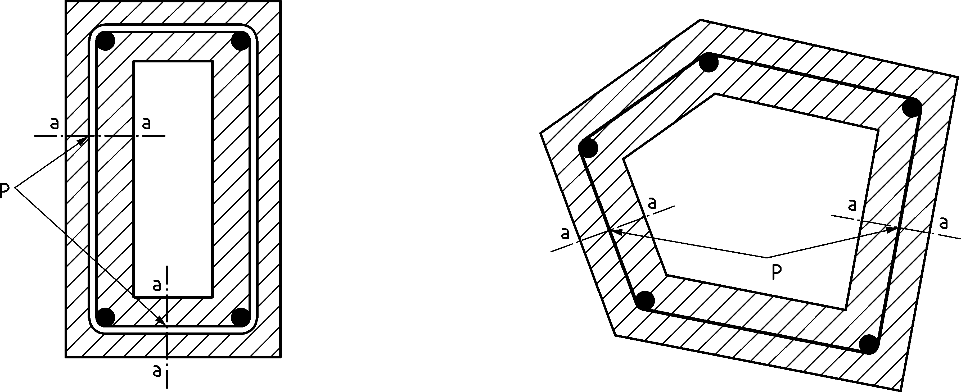

Figure 7.12 — Reference temperature *θ* p evaluated at point P along the line ‘a – a’ for the calculation of torsion resistance.

# Advanced design methods

## General

(1) Advanced design methods shall be based on fundamental physical behaviour, employing local equilibrium equations which are satisfied at every point in the structure.

NOTE Calculations are undertaken using numerical models based on finite element analyses or other appropriate advanced procedures. Solving the equations of an advanced design method results in the determination of a quantity in a large number of points or nodes: e.g. the temperatures in a section, the displacements along a member.

(2) Any potential failure mode not covered by the advanced design method (e.g. insufficient rotation capacity, spalling, local buckling of compressed reinforcement, shear and bond failure, damage to anchorage devices) shall be prevented by appropriate means.

(3) Advanced design methods may include separate calculation models for the determination of:

— The development and temperature distribution within structural members (thermal response model);

— The mechanical behaviour of the structure or of any part of it (mechanical response model).

(4) Advanced design methods may be used in association with any thermal action, provided the material properties are known for the relevant temperature history.

(5) Advanced design methods may be used with any type of cross-section.

(6) Advanced calculation models may be used when information concerning stress and strain evolution, deformations and/or temperature fields are required.

## Thermal analysis

(1) Advanced design methods for thermal response shall be based on the acknowledged principles and assumptions of the theory of heat transfer.

(2) The thermal response model shall consider:

— the relevant thermal actions specified in prEN 1991‑1‑2;

— the temperature dependent thermal properties of the materials, see 5.2.

(3) The effects of non-uniform thermal exposure and of heat transfer to adjacent building components may be included where appropriate.

(4) The influence of moisture content and of migration of the moisture within the materials may be neglected.

(5) The temperature profile in a reinforced concrete element may be assessed omitting the presence of reinforcement when the rebar diameter is less than 50 mm.

## Mechanical analysis

(1) Advanced design methods for mechanical analysis shall be based on the acknowledged principles and assumptions of the theory of structural mechanics.

(2) The mechanical response model shall consider:

— The material temperatures calculated according to 8.2.

— The temperature dependent mechanical properties of the materials, see 5.3.

(3) The effects of thermally induced strains and stresses due to temperature rise and temperature differentials shall be considered.

(4) The total strain ε may be assumed to be equal to the contribution of the thermal strain (εth), the instantaneous stress-dependent strain (εθ), the creep strain (εcreep) and the transient state strain (εtr).

(5) The mechanical response model should also take account of:

— geometrical imperfections;

— geometrical non-linear effects;

— the non-linear material behaviour, including the effects of loading and unloading on the structural stiffness.

(6) The compatibility between all parts of the structure shall be taken into account by the design method.

(7) It shall be verified that the deformations given by the design method do not cause failure due to the loss of adequate support to one of the members.

(8) The load bearing capacity of individual members, sub-assemblies or entire structures exposed to fire may be assessed by plastic analysis methods (see prEN 1992‑1‑1:2021, 7.3.3).

(9) The plastic rotation capacity of reinforced concrete sections should be estimated taking into account the increased ultimate strains *ε*cu and *ε*su in the hot condition, and the effect of confinement reinforcement on *ε*cu.

(10) The compressive zone of a section, especially if directly exposed to fire (e.g. hogging in continuous beams), should be checked and detailed with particular regard to spalling or falling-off of concrete cover (see Clause 10).

(11) In the analysis of individual members or sub-assemblies the boundary conditions should be checked and detailed in order to avoid failure due to the loss of adequate support of the members.

(12) For the analysis of isolated members subjected to a concentric axial compressive load, a sinusoidal initial imperfection with a maximum value of *l*/1000 at mid-length should be used when not specified by relevant product standards, where *l* is the length of the member. For eccentrically loaded members, an imperfection may be neglected.

## Validation of advanced design methods

(1) A verification of the accuracy of the design methods should be made on the basis of relevant test results.

(2) Calculation results may refer to temperatures, deformations and fire resistance times.

(3) The critical parameters should be checked to ensure that the model complies with sound engineering principles, by means of a sensitivity analysis.

NOTE Critical parameters refer, for example to the buckling length, the size of the elements and the load level.

# Detailing

## General

(1) When undertaking a design to this part, the detailing rules in EN1992-1-1 should be followed.

(2) Complementary detailing rules related to the fire design are given in this section.

(3) The reinforcement detailing should reflect the changing pattern of the structural behaviour and ensure that both individual members and the structure as a whole possess adequate supports, ties, bonds and anchorages for the required fire resistance.

## Detailing of reinforcing and prestressing steel

(1) The anchorage length *l*bd,fi and the lap length *l*sd,fi for reinforcement required under fire conditions may be considered equal to *l*bd and *l*sd respectively, as specified in prEN 1992‑1‑1, with the coefficient *k*lb considered for the characteristic anchorage length. If minimum shear reinforcement is not provided, poor bond conditions should be assumed under fire conditions independent of the actual casting position of the reinforcement.

NOTE The coefficient for the determination of the characteristic anchorage length is *k*lb = 36 unless the National Annex gives a different value.

## Detailing of members

(1) The detailing rules given in 9.3 apply for any relevant member designed with a design method not accounting for actions originating from thermal effects.

(2) For continuous beams or slabs, the area of top reinforcement for a distance up to 0,3*l* from the centre line of each intermediate support should be at least (see Figure 9.1):

*A*s,req(*x*) = *A*s,req(0) × (1 − 2,5*x*/*l*) (9.1)

where

|  |  |
| --- | --- |
| *x* | is the distance from the section considered to the centre line of the support (*x* ≤ 0,3*l*); |
| *A*s,req(0) | is the area of top reinforcement required over the support, according to prEN 1992‑1‑1; |
| *A*s,req(*x*) | is the minimum area of top reinforcement required in the section at distance *x* from the centreline of the support considered but not less than *A*s(*x*) required by prEN 1992‑1‑1; |
| *l* | is the maximum effective span length on either side of the support. |

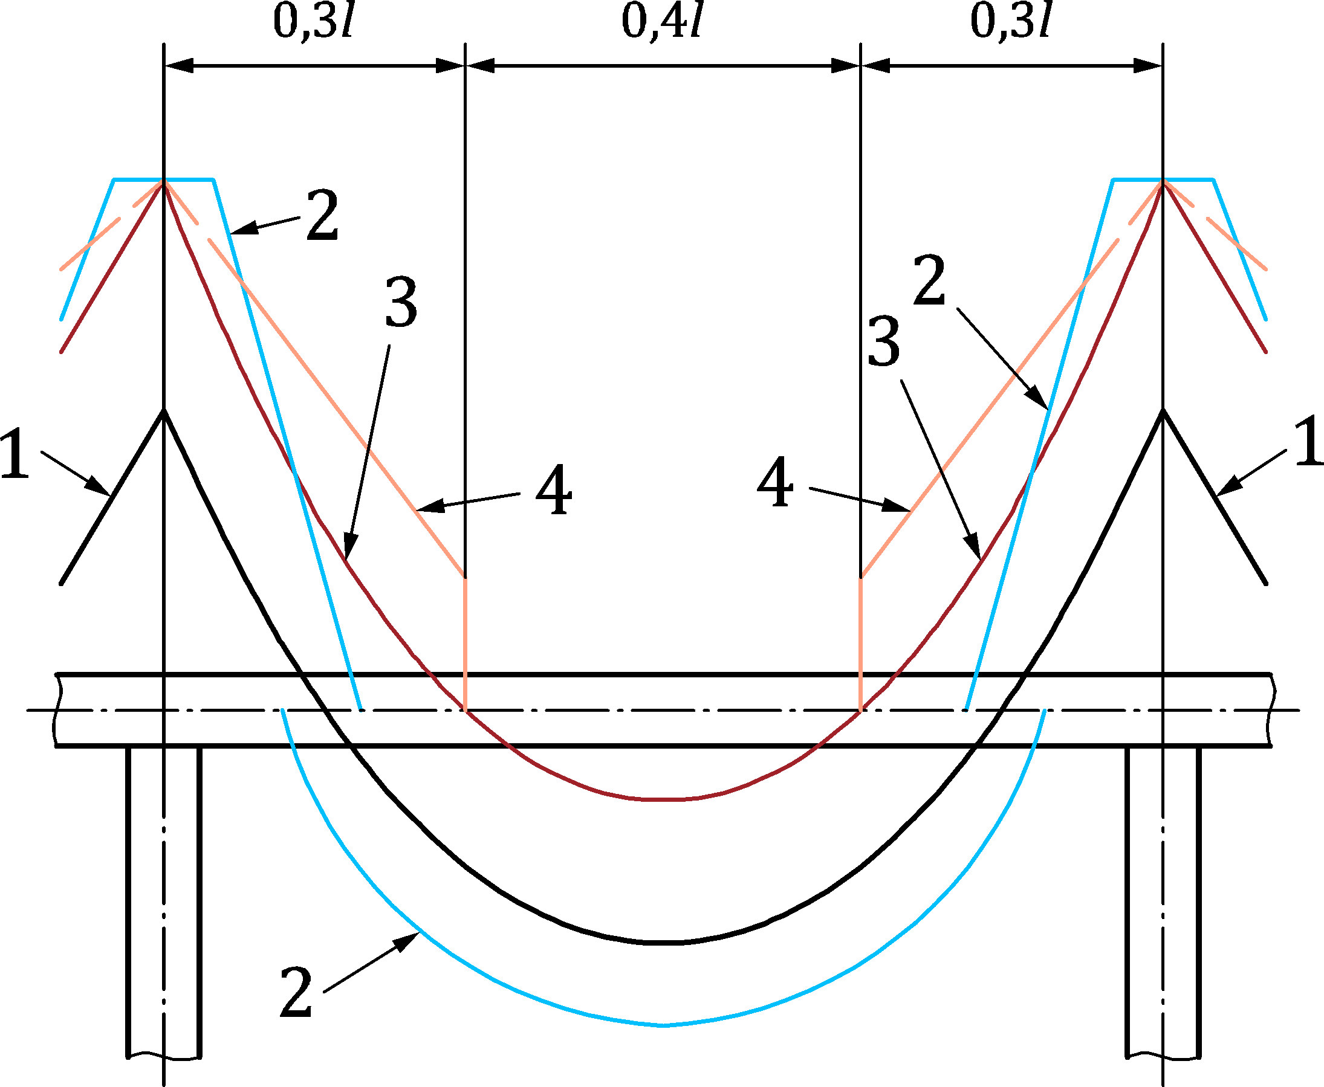

Key

|  |  |
| --- | --- |
| 1 | diagram of bending moments for the actions in a fire situation (*E*d,fi) at *t* = 0 |
| 2 | envelope of required resistance of tensile reinforcement for design at ambient conditions |
| 3 | diagram of bending moments under fire conditions including restraint moments due to thermal curvature of members |
| 4 | envelope of required resistance of tensile reinforcement according to Formula (9.1) |

Figure 9.1 — Envelope of required resistance of tensile reinforcement of continuous beams or slabs for fire design.

(3) For continuous slabs and continuous ribbed slabs, a minimum top reinforcement area *A*s ≥ 0,005 *A*c over the intermediate support should be provided if any of the following conditions apply:

a) Reinforcing steel of ductility class A is used.

b) One-way continuous slabs.

(3) For flat slabs with fire ratings of REI 90 and above, at least 20 % of the total top reinforcement in each direction over intermediate supports required for the design at ambient temperature according to prEN 1992‑1‑1, should be continuous as top reinforcement over the full span. This reinforcement should be placed in the column strip which may be taken as 25 % of the transverse span between columns on either side of the column.

NOTE In statically indeterminate systems shear forces can increase due to the effects of restrained thermal curvatures which can lead to a lack of ultimate load resistance if no shear reinforcement is provided.

(4) In continuous ribbed slabs, the top reinforcement should be placed in the upper half of the flange.

## Joints

(1) The design of joints shall be based on an overall assessment of the structural behaviour in fire.

(2) Joints shall be detailed in such a way that they comply with the load bearing (R) and integrity and insulation (EI) functions required for the connected structural members and ensure sufficient stability of the total structure.

(3) Joint components of structural steel should be designed for fire resistance in accordance with EN 1993‑1‑2.

(4) With reference to the insulation (I)-criterion, the width of gaps in joints should not exceed the limit of 20 mm and should not be deeper than half the overall depth *h* of the actual separating component, see Figure 9.2.

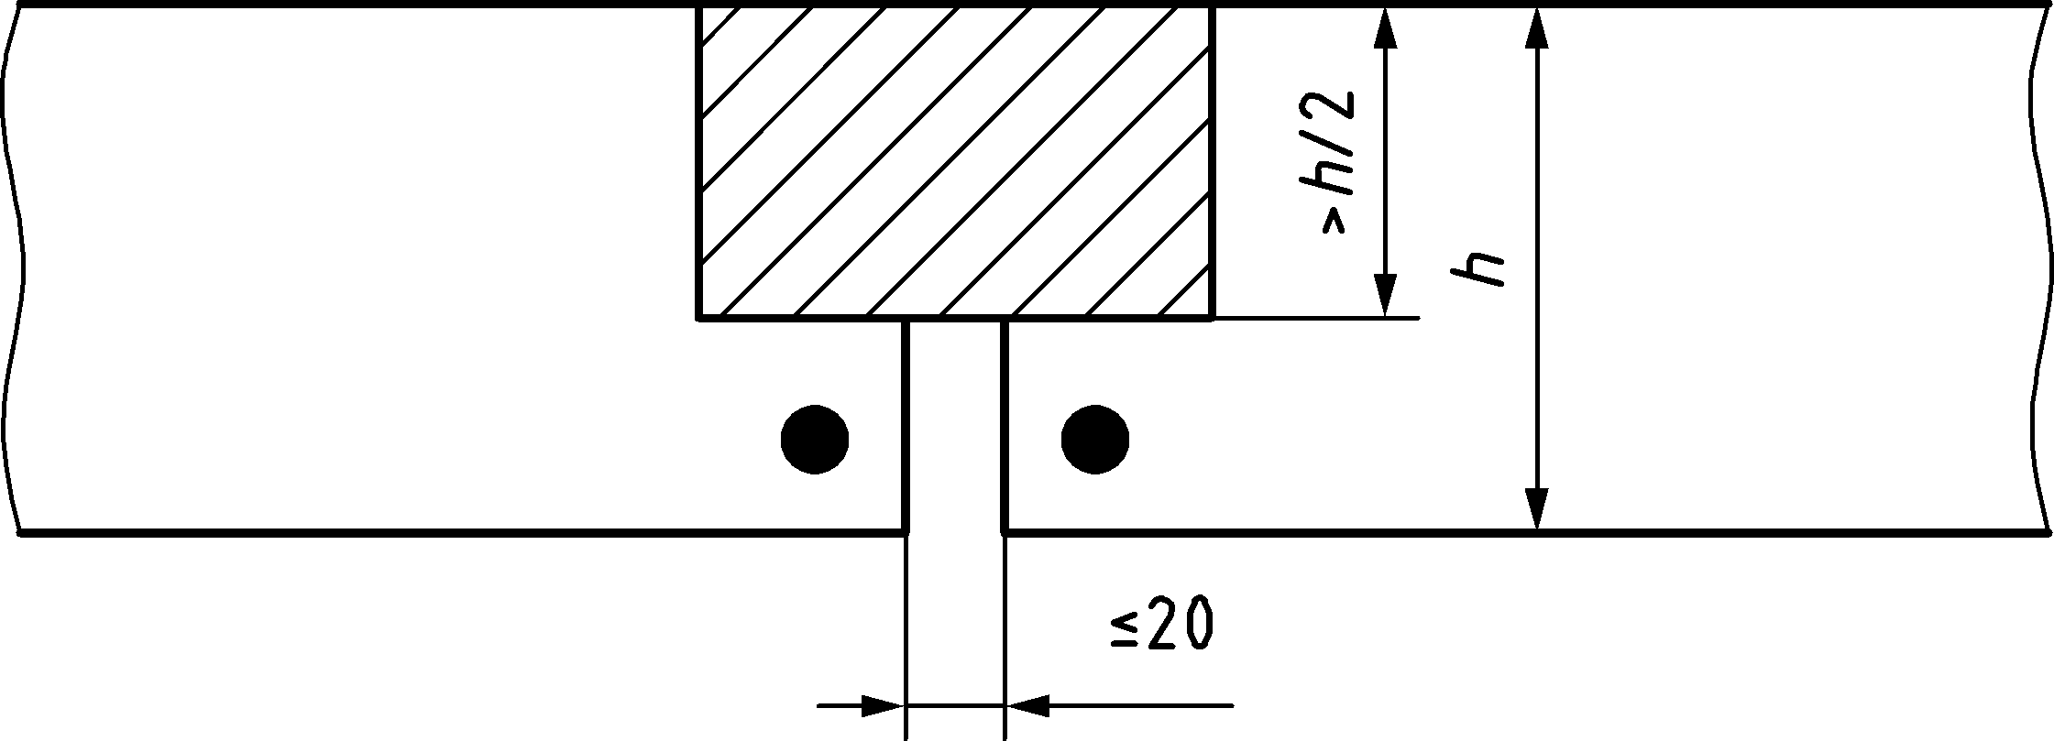

Figure 9.2 — Dimensions of gap at joints

(5) When rules from 9.4 (4) are followed, the gap may be disregarded when verifying the axis distance of reinforcement in the zones close to the gap with respect to the provisions for corner bars in tabulated design data.

(6) For gaps with larger depth and, if necessary, with the addition of a sealing product, the fire resistance should be documented on the basis of an appropriate test procedure.

## Connections

(1) Connections shall be designed, constructed and maintained in such a way that they continue to fulfil their functions in the event of a fire.

(2) Detailing of the reinforcement at the connections of restrained continuous structures shall take account of an increase in the support moment due to restrained thermal expansion.

(3) The rotational capacity of the connection between edge columns and beams or floor slabs should take account of the additional forces induced by thermal expansion during the heating phase and potential tensile forces induced during the cooling phase.

## Fire protection systems

(1) Manufacturer’s instructions with regard to the method of fixing and application of fire protection systems should be followed.

NOTE 1 EN 13381‑3 specifies a test method for determining the contribution of fire protection systems to the fire resistance of structural concrete members. The test method is applicable to all fire protection materials used for concrete members and includes sprayed materials, reactive coatings, cladding protection systems and multi-layer or composite fire protection materials, with or without a gap between the fire protection material and concrete member.

NOTE 2 The fire test methodology makes provision for the collection and presentation of data which can be used as direct input to the calculation of fire resistance of concrete members in accordance with the procedures given in this document.

# Rules for spalling

(1) Table 10.1 gives an overview of the rules for spalling given in the present Clause.

NOTE Where the actual characteristic strength of concrete is likely to be of a higher class than that specified in design, it can result in higher susceptibility to spalling.

Table 10.1 — Overview of the rules for spalling

|  | **Verification for spalling may be omitted** | **Specific assessment of spalling should be undertaken or polypropylene fibres should be specified** |
| --- | --- | --- |
| R15 | Applies  See Clause 10 (2) for exception | Not applicable |
| — lightweight aggregate concrete;  — structures in a water saturated environment  — insulating permanent formwork which prevents concrete from drying | Not applicable | Applies  See Clause10 (7), (8), (9) or (10) |
| *f*ck < 70 MPa and silica fume content < 6 % by weight of cement | Applies  See Clause 10 (4) and (5) for exception | Not applicable |
| *f*ck < 70 MPa and silica fume content ≥ 6 % by weight of cement  or  *f*ck ≥ 70 MPa | Not applicable | See Clause 10 (7), (8), (9) or (10) |

(2) For performance requirements R15, verification for spalling may be omitted except for isolated members with webs thinner than 80 mm and *f*ck ≥ 70 MPa.

(3) A specific assessment of spalling should be undertaken (see (7), (8) or (9)), or polypropylene fibres should be specified for the concrete mix according to (10), under any one of the following conditions due to the expected high moisture content or specific behaviour:

— lightweight aggregate concrete;

— structures in a water saturated environment;

— insulating permanent formwork which prevents concrete from drying.

(4) When using tabulated design data verification of spalling may be omitted for *f*ck < 70 MPa, provided that the maximum content of silica fume is less than 6 % by weight of cement except for (3) above.

NOTE Tabulated data have been developed based on fire tests or on calculations calibrated against full scale fire resistance tests, including tests where spalling occurred. Hence the effects of spalling are covered by tabulated data.

(5) When using simplified design methods or advanced design methods, verification of spalling may be omitted for *f*ck < 70 MPa, provided that the maximum content of silica fume is less than 6 % by weight of cement except in the case of (3) and in the case of isolated members with three sides exposed, whose dimensions do not comply with Table 10.2. In these cases, a specific assessment of spalling should be undertaken (see (7), (8) or (9)), or polypropylene fibres should be specified for the concrete mix according to (10).

NOTE When columns are highly loaded, it can result in higher susceptibility to spalling.

Table 10.2 — Minimum web thickness of isolated members below which specific assessment of spalling should be undertaken or polypropylene fibres should be specified

| **Standard fire resistance** | **Minimum web thickness *b*w,min** | **Minimum web thickness *b*w,min for a distance of 2*h* from an intermediate support in continuous isolated members** |
| --- | --- | --- |
| (mm) |
| R 30 | 80 | 80 |
| R ≥ 60 | 100 | 120 |

(6) For *f*ck ≥ 70 MPa or contents of silica fume above 6 % by weight of cement, a specific assessment of spalling should be undertaken (see (7), (8) or (9)), or polypropylene fibres should be specified for the concrete mix according to (10).

(7) The application of protective layers may be used to mitigate severe spalling (see 4.12).

(8) The effect on performance (R and/or EI) due to severe spalling may be taken into account by considering the loss of strength either at member or at structure level. This loss of strength may be assessed using a reduced effective cross-section, where the spalled layer of concrete is omitted when calculating the strength. The extent of the spalled layer of concrete may be based on experimental assessment according to (9).

(9) When assessment based on experimental evidence is required, it should be obtained from tests representative of the conditions of the structural member in terms of geometry, stress and moisture content.

(10) When polypropylene fibres are used to mitigate severe spalling, a minimum content *k*pp of monofilament fibres with diameter less than or equal to 50 µm should be specified for the concrete mix. Alternative contents or diameters may be specified if experimental evidence according to (9) is provided.

NOTE The value of *k*pp is 2 kg/m3 unless the National Annex gives a different value.

1. (normative)  
     
   Properties at high temperature of Steel Fibres Reinforced Concrete
   1. Use of this annex

(1) This Normative Annex contains additional provisions to prEN 1992‑1‑1:2021, Annex L.

* 1. Scope and field of application

(1) This Normative Annex applies to properties at high temperature of steel fibre reinforced concrete (SFRC) as specified in prEN 1992‑1‑1:2021, Annex L.

(2) The following design methods should be used for steel fibres reinforced concrete structures:

— design rules described in prEN 1992-1-1:2021, Annex L taking into account the properties at high temperature given in Annex A;

— advanced design methods (according to Clause 8) taking into account the properties at high temperature given in Annex A.

NOTE Design methods given in Clause 6 and Clause 7 are not applicable unless the effect of fibres is neglected.

(3) Thermal properties of SFRC may be taken according to 5.2.

(4) The strength and deformation properties of uniaxially stressed concrete at elevated temperatures in compression may be obtained from the stress-strain relationships and parameters given in 5.3.1.1.

(5) The strength and deformation properties of uniaxially stressed concrete at elevated temperatures in tension may be obtained from the stress-strain relationships presented in prEN 1992-1-1:2021, Figure L.2. The strength parameters (*f*ctm, *f*Ft1,ef, *f*Ft3,ef) are affected by a reduction coefficient *f*ct,θ/*f*ctk,0,05.

(6) The reduction coefficient *f*ct,θ/*f*ctk,0,05 may be obtained from 5.3.1.2 (3).

(7) Alternative formulations of material laws may be applied, provided the solutions are within the range of experimental evidence.

(8) To define a more precise evolution of tensile strength of SFRC at elevated temperatures, a design by testing approach may be carried out on specimens according to EN 14651 at high temperature or on specimens according to Rilem recommendation TC 129 MHT-part 4.

1. (informative)  
     
   Recycled Aggregate Concrete Structures
   1. Use of this annex

(1) This Informative Annex provides complementary / supplementary guidance to prEN 1992-1-1:2021, Annex N for recycled aggregate concrete structures.

NOTE National choice on the application of this Informative Annex is given in the National Annex. If the National Annex contains no information on the application of this informative annex, it can be used.

* 1. Scope and field of application

(1) This Informative Annex covers recycled concrete aggregate as specified in prEN 1992-1-1:2021, Annex N.

(2) The design methods given in Clauses 6, 7 and 8 may be used for recycled aggregate concrete provided the following paragraphs are fulfilled.

(3) When the substitution rate of recycled concrete aggregates αRA ≤ 0,2, materials properties described in Clause 5 may be used. For higher substitution rates, materials properties should be based on testing.

(4) Specific assessment of spalling should be undertaken (see Clause 10 (7), (8), or (9)), or polypropylene fibres should be specified for the concrete mix according to Clause 10 (10) for structural members subjected to compression on the fire exposed surfaces regardless of concrete strength.

(5) Provisions of Clause 9 should be followed.

1. (normative)  
     
   Buckling of columns under fire Conditions
   1. Use of this annex

(1) This Normative Annex contains additional provisions to EN 1992-1-1, 12.6.

* 1. Scope and field of application

(1) This Normative Annex covers the assessment of reinforced columns with rectangular and circular cross-section in braced or unbraced structures giving the maximum permissible effective column length, *l*0, under ambient conditions, to ensure the required standard fire resistance of the column in the fire situation.

(2) The tables in this annex may be applied if *l*0,fi = *l*0 or *l*0,fi = 0,7 *l*0 (see 6.3.1 (5) and Figure 6.3).

(3) The following parameters are needed to use the tables in this annex:

|  |  |
| --- | --- |
| *b*, *h* | Dimensions of column cross-section, *b* ≤ *h* |
| *μ*fi | Degree of utilisation in the fire situation: |
| *e*0 | Total first order eccentricity of the normal forces, equal for *N*Rd and *N*Ed,fi |
| *a* | Axis distance of the main reinforcing steel bars |
| *ω*mod | Modified mechanical reinforcement degree , while *A*s0 and *A*s1 are defined in (5) |
| *N*Ed,fi | The design axial load in the fire condition |
| *N*Rd | The design axial load resistance under ambient condition |

(4) The tables may be used for columns with 0,1 ≤ *ω*mod ≤ 1,0.

(5) *A*s0 is the cross-sectional area of longitudinal reinforcement at axis distance *a* from the column’s most compressed side, and *A*s1 is the cross-sectional area of longitudinal reinforcement at axis distance *a* from the column’s tensile/least compressed side. Other reinforcing bars in the cross-section are disregarded (see Figure C.1).

(6) Buckling around *y*-axis and *z*-axis should be examined. The tables may be used for buckling around both the *z*-axis and the *y*-axis as defined in Figure C.1. For buckling around both the *z*-axis or the y-axis, the smaller cross-sectional dimension *b* shall be used as the parameter in the tables.

(7) For columns with asymmetric reinforcement arrangements, the minimum values of *A*s0 and *A*s1 shall be used.

|  |
| --- |
|  |

Key

|  |  |
| --- | --- |
| ◯ | Reinforcing bars to be disregarded |
| ● | Reinforcing bars |

Figure C.1 — Rectangular cross-sections

(8) For rectangular cross-sections, the minimum number of reinforcing bars in both the tensile and the compressive side of the column should be taken from Table C.1.

Table C.1 — Minimum number of reinforcing bars

|  | Minimum dimension of column section, *b* | | | | | | |
| --- | --- | --- | --- | --- | --- | --- | --- |
| **600 mm** | **500 mm** | **400 mm** | **350 mm** | **300 mm** | **250 mm** | **200 mm** |
| *ω*mod ≤ 0,5 | 3 | 3 | 3 | 3 | 2 | 2 | 2 |
| 0,5 < *ω*mod ≤ 1,0 | 5 | 4 | 3 | 3 | 2 | 2 | 2 |

(9) In accordance with prEN 1992‑1‑1, the axis distance for the reinforcing bars in the cross-section shall fulfil *a* ≥ 1,5⋅⌀sl, where ⌀sl is the diameter of a reinforcing bar in longitudinal direction (direction x in Figure C.1).

(10) Using the tables within this annex, linear interpolation may be used.

(11) For circular columns with diameter *b*, the tables may be used when the main reinforcement is distributed evenly along the perimeter with at least 6 reinforcing bars, all with the axis distance *a*.

Table C.2 — Maximum permissible effective column length *l*0 for braced and unbraced columns: R 30

|  |  |  |  |  |  |  |  |  |  |  |  |  |  |  |  |  |  |  |  |
| --- | --- | --- | --- | --- | --- | --- | --- | --- | --- | --- | --- | --- | --- | --- | --- | --- | --- | --- | --- |
| *R*FI = 30 min | | *l*0,fi = 1,0 *l*0 | | | 0,1 < *ω* < 1,0 | | |  | | | | | | | | | | | |
|  | *b* (mm): | ≥ 600 | | | 500 | | | 400 | | | 300 | | | 250 | | | 200 | | |
|  | *μ*FI: | 0,3 | 0,5 | 0,7 | 0,3 | 0,5 | 0,7 | 0,3 | 0,5 | 0,7 | 0,3 | 0,5 | 0,7 | 0,3 | 0,5 | 0,7 | 0,3 | 0,5 | 0,7 |
| *e*0 | *a* | *l*0,max (m) | | | *l*0,max (m) | | | *l*0,max(m) | | | *l*0,max (m) | | | *l*0,max (m) | | | *l*0,max (m) | | |
|  | (mm) |
| 20 mm | 25 | 12,3 | 10,9 | 9,5 | 10,0 | 8,8 | 7,8 | 7,7 | 6,7 | 5,8 | 5,2 | 4,6 | 3,7 | 4,0 | 3,3 | 2,7 | 2,9 | 2,4 | 1,9 |
| 20 mm | 30 | 13,0 | 11,1 | 9,9 | 10,5 | 8,9 | 7,9 | 8,1 | 6,9 | 6,1 | 5,5 | 4,6 | 3,9 | 4,3 | 3,5 | 3,0 | 3,1 | 2,5 | 2,0 |
| 20 mm | 40 | 16,3 | 12,3 | 11,1 | 13,1 | 10,1 | 8,9 | 10,0 | 7,9 | 6,9 | 6,1 | 5,1 | 4,4 | 5,1 | 4,0 | 3,4 | 3,5 | 2,7 | 2,3 |
| 20 mm | 55 | 20,6 | 14,2 | 12,1 | 16,3 | 11,4 | 9,7 | 12,0 | 8,5 | 7,4 | 8,0 | 5,9 | 5,0 | 5,6 | 4,3 | 3,6 | 3,5 | 2,7 | 2,3 |
| 0,5 *b* | 25 | 24,0 | 10,8 | 4,7 | 20,0 | 8,8 | 3,6 | 16,0 | 6,7 | 2,3 | 8,3 | 3,5 | - | 6,5 | 2,6 | - | 4,6 | 1,5 | - |
| 0,5 *b* | 30 | 24,0 | 15,1 | 7,8 | 20,0 | 12,1 | 6,2 | 16,0 | 9,1 | 4,5 | 12,0 | 4,8 | - | 10,0 | 3,6 | - | 6,7 | 2,4 | - |
| 0,5 *b* | 40 | 24,0 | 24,0 | 10,9 | 20,0 | 20,0 | 9,3 | 16,0 | 16,0 | 7,4 | 12,0 | 8,1 | 3,8 | 10,0 | 5,8 | 2,6 | 8,0 | 3,5 | - |
| 0,5 *b* | 55 | 24,0 | 24,0 | 20,4 | 20,0 | 20,0 | 15,9 | 16,0 | 16,0 | 11,1 | 12,0 | 12,0 | 6,4 | 10,0 | 10,0 | 3,8 | 8,0 | 4,0 | - |
| 1,0 *b* | 25 | 24,0 | 18,2 | 8,1 | 20,0 | 14,7 | 6,5 | 16,0 | 11,3 | 4,8 | 12,0 | 5,9 | - | 10,0 | 4,6 | - | 8,0 | 3,2 | - |
| 1,0 *b* | 30 | 24,0 | 24,0 | 12,1 | 20,0 | 20,0 | 9,8 | 16,0 | 15,6 | 7,4 | 12,0 | 8,3 | - | 10,0 | 6,4 | - | 8,0 | 4,4 | - |
| 1,0 *b* | 40 | 24,0 | 24,0 | 21,0 | 20,0 | 20,0 | 16,6 | 16,0 | 16,0 | 12,4 | 12,0 | 12,0 | 6,0 | 10,0 | 10,0 | 4,5 | 8,0 | 6,4 | - |
| 1,0 *b* | 55 | 24,0 | 24,0 | 24,0 | 20,0 | 20,0 | 20,0 | 16,0 | 16,0 | 16,0 | 12,0 | 12,0 | 11,0 | 10,0 | 10,0 | 6,6 | 8,0 | 7,6 | - |

|  |  |  |  |  |  |  |  |  |  |  |  |  |  |  |  |  |  |  |  |
| --- | --- | --- | --- | --- | --- | --- | --- | --- | --- | --- | --- | --- | --- | --- | --- | --- | --- | --- | --- |
| *R*FI = 30 min | | *l*0,fi = 0,7 *l*0 | | | 0,1 < *ω*mod < 1,0 | | |  | | | | | | | | | | | |
|  | *b* (mm): | ≥ 600 | | | 500 | | | 400 | | | 300 | | | 250 | | | 200 | | |
|  | *μ*FI: | 0,3 | 0,5 | 0,7 | 0,3 | 0,5 | 0,7 | 0,3 | 0,5 | 0,7 | 0,3 | 0,5 | 0,7 | 0,3 | 0,5 | 0,7 | 0,3 | 0,5 | 0,7 |
| *e*0 | *a* | *l*0,max (m) | | | *l*0,max (m) | | | *l*0,max (m) | | | *l*0,max (m) | | | *l*0,max (m) | | | *l*0,max (m) | | |
|  | (mm) |
| 20 mm | 25 | 24,0 | 17,1 | 15,3 | 20,0 | 14,0 | 12,2 | 16,0 | 10,9 | 9,4 | 8,7 | 7,1 | 6,1 | 7,2 | 5,3 | 4,5 | 5,3 | 3,7 | 3,1 |
| 20 mm | 30 | 24,0 | 18,8 | 16,6 | 20,0 | 15,3 | 13,4 | 16,0 | 11,5 | 10,2 | 12,0 | 7,7 | 6,4 | 10,0 | 6,0 | 5,1 | 8,0 | 4,2 | 3,5 |
| 20 mm | 40 | 24,0 | 24,0 | 20,5 | 20,0 | 20,0 | 16,5 | 16,0 | 16,0 | 12,4 | 12,0 | 9,5 | 7,9 | 10,0 | 7,2 | 6,1 | 8,0 | 5,2 | 4,0 |
| 20 mm | 55 | 24,0 | 24,0 | 24,0 | 20,0 | 20,0 | 20,0 | 16,0 | 16,0 | 16,0 | 12,0 | 12,0 | 11,6 | 10,0 | 10,0 | 7,2 | 8,0 | 5,0 | 4,0 |
| 0,5 *b* | 25 | 24,0 | 24,0 | 14,1 | 20,0 | 20,0 | 11,1 | 16,0 | 16,0 | 8,1 | 12,0 | 9,6 | - | 10,0 | 6,9 | - | 8,0 | 4,3 | - |
| 0,5 *b* | 30 | 24,0 | 24,0 | 24,0 | 20,0 | 20,0 | 20,0 | 16,0 | 16,0 | 16,0 | 12,0 | 12,0 | 5,7 | 10,0 | 10,0 | 3,6 | 8,0 | 8,0 | - |
| 0,5 *b* | 40 | 24,0 | 24,0 | 24,0 | 20,0 | 20,0 | 20,0 | 16,0 | 16,0 | 16,0 | 12,0 | 12,0 | 12,0 | 10,0 | 10,0 | 10,0 | 8,0 | 8,0 | 5,4 |
| 0,5 *b* | 55 | 24,0 | 24,0 | 24,0 | 20,0 | 20,0 | 20,0 | 16,0 | 16,0 | 16,0 | 12,0 | 12,0 | 12,0 | 10,0 | 10,0 | 10,0 | 8,0 | 8,0 | 8,0 |
| 1,0 *b* | 25 | 24,0 | 24,0 | 17,3 | 20,0 | 20,0 | 14,3 | 16,0 | 16,0 | 11,1 | 12,0 | 12,0 | - | 10,0 | 10,0 | - | 8,0 | 7,5 | - |
| 1,0 *b* | 30 | 24,0 | 24,0 | 24,0 | 20,0 | 20,0 | 20,0 | 16,0 | 16,0 | 16,0 | 12,0 | 12,0 | 8,2 | 10,0 | 10,0 | 5,6 | 8,0 | 8,0 | - |
| 1,0 *b* | 40 | 24,0 | 24,0 | 24,0 | 20,0 | 20,0 | 20,0 | 16,0 | 16,0 | 16,0 | 12,0 | 12,0 | 12,0 | 10,0 | 10,0 | 10,0 | 8,0 | 8,0 | 8,0 |
| 1,0 *b* | 55 | 24,0 | 24,0 | 24,0 | 20,0 | 20,0 | 20,0 | 16,0 | 16,0 | 16,0 | 12,0 | 12,0 | 12,0 | 10,0 | 10,0 | 10,0 | 8,0 | 8,0 | 8,0 |

Table C.3 — Maximum permissible effective column length *l*0 for braced and unbraced columns: R 60

|  |  |  |  |  |  |  |  |  |  |  |  |  |  |  |  |  |  |  |  |
| --- | --- | --- | --- | --- | --- | --- | --- | --- | --- | --- | --- | --- | --- | --- | --- | --- | --- | --- | --- |
| *R*FI = 60 min | | *l*0,fi = 1,0 *l*0 | | | 0,1 < *ω*mod < 1,0 | | |  | | | | | | | | | | | |
|  | *b* (mm): | ≥ 600 | | | 500 | | | 400 | | | 300 | | | 250 | | | 200 | | |
|  | *μ*FI: | 0,3 | 0,5 | 0,7 | 0,3 | 0,5 | 0,7 | 0,3 | 0,5 | 0,7 | 0,3 | 0,5 | 0,7 | 0,3 | 0,5 | 0,7 | 0,3 | 0,4 | 0,5 |
| *e*0 | *a* | *l*0,max (m) | | | *l*0,max (m) | | | *l*0,max (m) | | | *l*0,max (m) | | | *l*0,max (m) | | | *l*0,max (m) | | |
|  | (mm) |
| 20 mm | 25 | 10,6 | 8,0 | 5,4 | 8,4 | 6,4 | 3,3 | 6,0 | 4,2 |  | 3,5 | 1,4 |  | 2,4 |  |  |  |  |  |
| 20 mm | 35 | 10,9 | 9,5 | 7,6 | 8,7 | 7,5 | 5,9 | 6,2 | 5,3 | 3,8 | 3,7 | 3,1 |  | 2,7 | 2,2 |  |  |  |  |
| 20 mm | 45 | 11,6 | 9,7 | 8,3 | 9,2 | 7,8 | 6,5 | 6,9 | 5,7 | 4,6 | 4,2 | 3,5 | 2,5 | 3,1 | 2,5 |  | 2,0 |  |  |
| 20 mm | 60 | 13,3 | 11,1 | 9,7 | 10,5 | 8,7 | 7,5 | 8,0 | 6,4 | 5,3 | 4,7 | 3,7 | 2,9 | 3,3 | 2,6 |  | 2,0 |  |  |
| 0,5 *b* | 25 | 5,0 |  |  | 3,8 |  |  | 2,2 |  |  |  |  |  |  |  |  |  |  |  |
| 0,5 *b* | 35 | 14,5 | 5,7 |  | 11,5 | 4,2 |  | 8,4 | 2,1 |  | 3,6 |  |  | 2,4 |  |  |  |  |  |
| 0,5 *b* | 45 | 24,0 | 10,6 | 3,3 | 20,0 | 8,2 |  | 16,0 | 5,8 |  | 6,9 | 2,0 |  | 4,6 |  |  | 2,4 |  |  |
| 0,5 *b* | 60 | 24,0 | 20,6 | 8,8 | 20,0 | 15,3 | 6,5 | 16,0 | 9,9 | 3,9 | 12,0 | 3,9 |  | 8,7 | 1,8 |  | 2,5 |  |  |
| 1,0 *b* | 25 | 8,2 |  |  | 6,6 |  |  | 4,8 |  |  |  |  |  |  |  |  |  |  |  |
| 1,0 *b* | 35 | 24,0 | 10,2 |  | 20,0 | 7,9 |  | 15,0 | 5,8 |  | 6,8 |  |  | 4,9 |  |  |  |  |  |
| 1,0 *b* | 45 | 24,0 | 18,7 | 8,3 | 20,0 | 14,6 |  | 16,0 | 10,6 |  | 12,0 | 4,9 |  | 9,0 |  |  | 5,3 |  |  |
| 1,0 *b* | 60 | 24,0 | 24,0 | 13,0 | 20,0 | 20,0 | 10,1 | 16,0 | 16,0 | 7,6 | 12,0 | 7,7 |  | 10,0 | 4,5 |  | 5,3 |  |  |
| *R*FI = 60 min | | *l*0,fi = 0,7 *l*0 | | | 0,1 < *ω* < 1,0 | | |  | | | | | | | | | | | |
|  | *b* (mm): | ≥ 600 | | | 500 | | | 400 | | | 300 | | | 250 | | | 200 | | |
|  | *μ*FI: | 0,3 | 0,5 | 0,7 | 0,3 | 0,5 | 0,7 | 0,3 | 0,5 | 0,7 | 0,3 | 0,5 | 0,7 | 0,3 | 0,5 | 0,7 | 0,3 | 0,4 | 0,5 |
| *e*0 | *a* | *l*0,max (m) | | | *l*0,max (m) | | | *l*0,max (m) | | | *l*0,max (m) | | | *l*0,max (m) | | | *l*0,max (m) | | |
|  | (mm) |
| 20 mm | 25 | 15,4 | 12,6 | 8,9 | 12,2 | 9,9 | 5,6 | 8,9 | 6,6 |  | 4,9 | 2,2 |  | 3,5 |  |  | 2,1 |  |  |
| 20 mm | 35 | 16,8 | 14,4 | 12,6 | 13,4 | 11,3 | 9,9 | 10,1 | 8,1 | 6,4 | 5,7 | 4,7 | 2,1 | 4,2 | 3,4 |  | 2,6 | 2,3 |  |
| 20 mm | 45 | 23,5 | 16,1 | 13,9 | 17,5 | 12,8 | 10,9 | 12,2 | 9,2 | 7,8 | 6,9 | 5,3 | 4,2 | 4,9 | 3,8 | 2,7 | 3,1 | 2,6 | 2,2 |
| 20 mm | 60 | 24,0 | 20,3 | 16,8 | 20,0 | 15,3 | 13,2 | 16,0 | 11,5 | 9,4 | 8,7 | 6,2 | 4,9 | 5,8 | 4,1 | 3,0 | 3,1 | 2,6 | 2,1 |
| 0,5 *b* | 25 | 10,9 |  |  | 8,5 |  |  | 5,6 |  |  |  |  |  |  |  |  |  |  |  |
| 0,5 *b* | 35 | 24,0 | 14,8 |  | 20,0 | 10,9 |  | 16,0 | 7,1 |  | 9,9 |  |  | 6,2 |  |  | 2,4 |  |  |
| 0,5 *b* | 45 | 24,0 | 24,0 | 13,9 | 20,0 | 20,0 |  | 16,0 | 16,0 |  | 12,0 | 6,7 |  | 10,0 |  |  | 8,0 | 2,6 |  |
| 0,5 *b* | 60 | 24,0 | 24,0 | 24,0 | 20,0 | 20,0 | 20,0 | 16,0 | 16,0 | 16,0 | 12,0 | 12,0 |  | 10,0 | 10,0 |  | 8,0 | 2,9 |  |
| 1,0 *b* | 25 | 16,1 |  |  | 12,8 |  |  | 9,1 |  |  |  |  |  |  |  |  |  |  |  |
| 1,0 *b* | 35 | 24,0 | 23,3 |  | 20,0 | 17,9 |  | 16,0 | 12,5 |  | 12,0 |  |  | 10,0 |  |  | 6,4 |  |  |
| 1,0 *b* | 45 | 24,0 | 24,0 | 21,3 | 20,0 | 20,0 |  | 16,0 | 16,0 |  | 12,0 | 12,0 |  | 10,0 |  |  | 8,0 | 7,2 |  |
| 1,0 *b* | 60 | 24,0 | 24,0 | 24,0 | 20,0 | 20,0 | 20,0 | 16,0 | 16,0 | 16,0 | 12,0 | 12,0 |  | 10,0 | 10,0 |  | 8,0 | 8,0 |  |

Table C.4 — Maximum permissible effective column length *l*0 for braced and unbraced columns: R 90

|  |  |  |  |  |  |  |  |  |  |  |  |  |  |  |  |  |  |  |  |
| --- | --- | --- | --- | --- | --- | --- | --- | --- | --- | --- | --- | --- | --- | --- | --- | --- | --- | --- | --- |
| *R*FI = 90 min | | *l*0,fi = 1,0 *l*0 | | | 0,1 < *ω* < 1,0 | | |  | | | | | | | | | | | |
|  | *b* (mm): | ≥ 600 | | | 500 | | | 400 | | | 350 | | | 300 | | | 250 | | |
|  | *μ*FI: | 0,3 | 0,5 | 0,7 | 0,3 | 0,5 | 0,7 | 0,3 | 0,5 | 0,7 | 0,3 | 0,5 | 0,7 | 0,3 | 0,5 | 0,7 | 0,3 | 0,4 | 0,5 |
| *e*0 | *a* | *l*0,max (m) | | | *l*0,max (m) | | | *l*0,max (m) | | | *l*0,max (m) | | | *l*0,max (m) | | | *l*0,max (m) | | |
|  | (mm) |
| 20 mm | 30 | 8,9 | 6,6 | 3,1 | 6,9 | 5,1 |  | 4,8 | 2,8 |  | 3,7 | 1,9 |  | 2,3 |  |  |  |  |  |
| 20 mm | 40 | 9,2 | 7,8 | 5,4 | 7,2 | 6,0 | 3,5 | 5,1 | 4,2 |  | 4,0 | 3,2 |  | 2,8 |  |  |  |  |  |
| 20 mm | 55 | 10,4 | 8,8 | 7,3 | 8,2 | 6,8 | 5,5 | 5,9 | 4,7 | 3,5 | 4,6 | 3,7 | 2,5 | 3,4 | 2,6 |  | 2,2 |  |  |
| 20 mm | 70 | 12,0 | 9,7 | 8,3 | 9,2 | 7,5 | 6,2 | 6,5 | 5,2 | 3,9 | 5,1 | 4,0 | 2,8 | 3,6 | 2,7 |  | 2,2 |  |  |
| 0,25 *b* | 30 | 5,4 | 4,0 |  | 4,2 | 2,9 |  | 2,9 |  |  | 2,1 |  |  |  |  |  |  |  |  |
| 0,25 *b* | 40 | 7,1 | 5,0 | 3,1 | 5,5 | 3,9 |  | 3,8 | 2,5 |  | 3,0 | 1,8 |  | 1,6 |  |  |  |  |  |
| 0,25 *b* | 55 | 11,4 | 7,1 | 5,4 | 8,5 | 5,3 | 3,9 | 5,7 | 3,6 | 2,0 | 4,4 | 2,7 |  | 2,8 |  |  |  |  |  |
| 0,25 *b* | 70 | 24,0 | 8,8 | 6,6 | 20,0 | 6,6 | 4,8 | 8,1 | 4,3 | 2,5 | 6,0 | 3,1 |  | 3,4 | 2,0 |  |  |  |  |
| 0,50 *b* | 30 |  |  |  |  |  |  |  |  |  |  |  |  |  |  |  |  |  |  |
| 0,50 *b* | 40 | 7,4 |  |  | 5,6 |  |  | 3,6 |  |  | 2,2 |  |  |  |  |  |  |  |  |
| 0,50 *b* | 55 | 21,5 | 8,0 |  | 15,9 | 5,8 |  | 10,4 | 3,1 |  | 7,9 |  |  | 4,0 |  |  |  |  |  |
| 0,50 *b* | 70 | 24,0 | 12,5 | 5,4 | 20,0 | 9,5 |  | 16,0 | 5,7 |  | 14,0 | 3,7 |  | 6,2 |  |  |  |  |  |

|  |  |  |  |  |  |  |  |  |  |  |  |  |  |  |  |  |  |  |  |
| --- | --- | --- | --- | --- | --- | --- | --- | --- | --- | --- | --- | --- | --- | --- | --- | --- | --- | --- | --- |
| *R*FI = 90 min | | *l*0,fi = 0,7 *l*0 | | | 0,1 < *ω* < 1,0 | | |  | | | | | | | | | | | |
|  | *b* (mm): | ≥ 600 | | | 500 | | | 400 | | | 350 | | | 300 | | | 250 | | |
|  | *μ*FI: | 0,3 | 0,5 | 0,7 | 0,3 | 0,5 | 0,7 | 0,3 | 0,5 | 0,7 | 0,3 | 0,5 | 0,7 | 0,3 | 0,5 | 0,7 | 0,3 | 0,4 | 0,5 |
| *e*0 | *a* | *l*0,max (m) | | | *l*0,max (m) | | | *l*0,max (m) | | | *l*0,max (m) | | | *l*0,max (m) | | | *l*0,max (m) | | |
|  | (mm) |
| 20 mm | 30 | 12,9 | 10,4 | 5,2 | 10,1 | 7,8 |  | 7,1 | 4,3 |  | 5,5 | 3,0 |  | 3,5 |  |  | 2,2 |  |  |
| 20 mm | 40 | 13,6 | 11,9 | 8,9 | 10,5 | 9,1 | 6,0 | 7,4 | 6,3 |  | 5,9 | 5,1 |  | 4,1 | 1,9 |  | 2,8 | 2,2 |  |
| 20 mm | 55 | 17,3 | 13,9 | 11,9 | 14,0 | 10,7 | 9,1 | 9,6 | 7,4 | 5,9 | 7,6 | 5,8 | 4,3 | 5,1 | 4,0 | 2,0 | 3,4 | 3,0 | 2,4 |
| 20 mm | 70 | 24,0 | 16,6 | 14,1 | 20,0 | 12,6 | 10,5 | 11,5 | 8,4 | 6,8 | 8,9 | 6,5 | 4,9 | 5,7 | 4,3 | 2,6 | 3,6 | 3,1 | 2,5 |
| 0,25 *b* | 30 | 8,4 | 5,7 |  | 6,4 | 4,1 |  | 4,3 | 2,5 |  | 3,2 |  |  |  |  |  |  |  |  |
| 0,25 *b* | 40 | 13,1 | 7,9 | 5,7 | 9,9 | 6,0 |  | 6,4 | 3,8 |  | 4,9 | 2,7 |  | 2,4 |  |  |  |  |  |
| 0,25 *b* | 55 | 24,0 | 17,3 | 9,4 | 20,0 | 12,4 | 6,8 | 16,0 | 6,8 | 4,0 | 14,0 | 4,6 | 2,5 | 6,8 | 2,5 |  | 3,0 | 1,9 |  |
| 0,25 *b* | 70 | 24,0 | 24,0 | 17,3 | 20,0 | 20,0 | 11,3 | 16,0 | 16,0 | 5,4 | 14,0 | 14,0 | 3,6 | 12,0 | 3,3 |  | 4,6 | 2,4 |  |
| 0,50 *b* | 30 |  |  |  |  |  |  |  |  |  |  |  |  |  |  |  |  |  |  |
| 0,50 *b* | 40 | 18,6 |  |  | 13,4 |  |  | 8,4 |  |  | 5,9 |  |  |  |  |  |  |  |  |
| 0,50 *b* | 55 | 24,0 | 24,0 |  | 20,0 | 20,0 |  | 16,0 | 10,7 |  | 14,0 | 6,4 |  | 12,0 |  |  | 6,9 |  |  |
| 0,50 *b* | 70 | 24,0 | 24,0 | 24,0 | 20,0 | 20,0 |  | 16,0 | 16,0 |  | 14,0 | 14,0 |  | 12,0 |  |  | 10,0 |  |  |

Table C.5 — Maximum permissible effective column length *l*0 for braced and unbraced columns: R 120

|  |  |  |  |  |  |  |  |  |  |  |  |  |  |  |  |  |  |  |  |
| --- | --- | --- | --- | --- | --- | --- | --- | --- | --- | --- | --- | --- | --- | --- | --- | --- | --- | --- | --- |
| *R*FI = 120 min | | *l*0,fi = 1,0 *l*0 | | | 0,1 < *ω* < 1,0 | | |  | | | | | | | | | | | |
|  | *b* (mm): | ≥ 600 | | | 500 | | | 450 | | | 400 | | | 350 | | | 300 | | |
|  | *μ*FI: | 0,3 | 0,5 | 0,7 | 0,3 | 0,5 | 0,7 | 0,3 | 0,5 | 0,7 | 0,3 | 0,5 | 0,7 | 0,3 | 0,5 | 0,65 | 0,3 | 0,45 | 0,55 |
| *e*0 | *a* | *l*0,max (m) | | | *l*0,max (m) | | | *l*0,max (m) | | | *l*0,max (m) | | | *l*0,max (m) | | | *l*0,max (m) | | |
|  | (mm) |
| 20 mm | 35 | 8,0 | 5,9 |  | 6,1 | 4,2 |  | 5,2 | 2,6 |  | 4,2 |  |  | 3,1 |  |  |  |  |  |
| 20 mm | 45 | 8,3 | 6,8 | 3,8 | 6,2 | 5,2 |  | 5,2 | 3,8 |  | 4,3 | 2,9 |  | 3,4 | 1,8 |  | 2,3 |  |  |
| 20 mm | 60 | 9,4 | 7,8 | 6,2 | 7,2 | 5,9 | 4,5 | 6,1 | 4,9 | 3,1 | 5,0 | 3,9 | 2,1 | 3,9 | 2,9 | 1,8 | 2,7 | 2,1 |  |
| 20 mm | 75 | 10,6 | 8,7 | 7,1 | 7,9 | 6,5 | 5,1 | 6,8 | 5,3 | 3,9 | 5,4 | 4,3 | 2,8 | 4,1 | 3,1 | 2,1 | 2,9 | 2,2 |  |
| 0,25 *b* | 35 | 4,8 | 3,5 |  | 3,6 | 2,3 |  | 2,9 |  |  | 2,2 |  |  |  |  |  |  |  |  |
| 0,25 *b* | 45 | 5,9 | 4,2 |  | 4,5 | 2,9 |  | 3,6 | 2,2 |  | 2,8 |  |  | 2,0 |  |  |  |  |  |
| 0,25 *b* | 60 | 8,8 | 5,9 | 4,2 | 6,5 | 4,3 | 2,3 | 5,5 | 3,4 |  | 4,3 | 2,5 |  | 3,1 | 1,7 |  | 1,8 |  |  |
| 0,25 *b* | 75 | 12,3 | 7,3 | 5,4 | 9,4 | 5,2 | 3,3 | 7,3 | 4,2 | 2,1 | 5,4 | 3,1 |  | 3,8 | 2,1 |  | 2,3 |  |  |
| 0,50 *b* | 35 |  |  |  |  |  |  |  |  |  |  |  |  |  |  |  |  |  |  |
| 0,50 *b* | 45 | 3,8 |  |  |  |  |  |  |  |  |  |  |  |  |  |  |  |  |  |
| 0,50 *b* | 60 | 14,0 | 4,5 |  | 10,2 |  |  | 8,3 |  |  | 6,4 |  |  | 4,5 |  |  |  |  |  |
| 0,50 *b* | 75 | 24,0 | 9,4 |  | 20,0 | 6,4 |  | 16,0 | 4,7 |  | 11,3 | 2,5 |  | 7,3 |  |  | 3,2 |  |  |

|  |  |  |  |  |  |  |  |  |  |  |  |  |  |  |  |  |  |  |  |
| --- | --- | --- | --- | --- | --- | --- | --- | --- | --- | --- | --- | --- | --- | --- | --- | --- | --- | --- | --- |
| *R*FI = 120 min | | *l*0,fi = 0,7 *l*0 | | | 0,1 < *ω* < 1,0 | | |  | | | | | | | | | | | |
|  | *b* (mm): | ≥ 600 | | | 500 | | | 450 | | | 400 | | | 350 | | | 300 | | |
|  | *μ*FI: | 0,3 | 0,5 | 0,7 | 0,3 | 0,5 | 0,7 | 0,3 | 0,5 | 0,7 | 0,3 | 0,5 | 0,7 | 0,3 | 0,5 | 0,65 | 0,3 | 0,45 | 0,55 |
| *e*0 | *a* | *l*0,max (m) | | | *l*0,max (m) | | | *l*0,max (m) | | | *l*0,max (m) | | | *l*0,max (m) | | | *l*0,max (m) | | |
|  | (mm) |
| 20 mm | 35 | 11,4 | 9,2 |  | 8,8 | 6,6 |  | 7,4 | 4,1 |  | 5,9 | 2,6 |  | 4,5 |  |  | 2,5 |  |  |
| 20 mm | 45 | 11,9 | 10,4 | 6,4 | 9,1 | 7,8 |  | 7,8 | 5,9 |  | 6,3 | 4,5 |  | 4,9 | 3,0 |  | 3,2 |  |  |
| 20 mm | 60 | 15,1 | 12,1 | 10,1 | 11,3 | 9,1 | 7,4 | 9,5 | 7,6 | 5,6 | 7,6 | 6,1 | 3,8 | 5,9 | 4,5 | 3,0 | 4,0 | 3,1 | 2,2 |
| 20 mm | 75 | 17,8 | 14,1 | 11,9 | 14,0 | 10,5 | 8,5 | 11,3 | 8,5 | 6,7 | 8,9 | 6,8 | 4,8 | 6,6 | 4,9 | 3,5 | 4,3 | 3,3 | 2,5 |
| 0,25 *b* | 35 | 7,2 | 4,9 |  | 5,4 | 3,3 |  | 4,3 |  |  | 3,1 |  |  |  |  |  |  |  |  |
| 0,25 *b* | 45 | 9,6 | 6,2 |  | 7,0 | 4,3 |  | 5,8 | 3,3 |  | 4,3 |  |  | 3,0 |  |  |  |  |  |
| 0,25 *b* | 60 | 24,0 | 10,6 | 7,2 | 20,0 | 7,2 | 4,7 | 18,0 | 5,6 |  | 16,0 | 4,0 |  | 6,9 | 2,7 |  | 2,7 |  |  |
| 0,25 *b* | 75 | 24,0 | 24,0 | 10,1 | 20,0 | 20,0 | 6,4 | 18,0 | 10,8 | 4,8 | 16,0 | 5,9 |  | 14,0 | 3,6 |  | 4,6 | 2,1 |  |
| 0,50 *b* | 35 |  |  |  |  |  |  |  |  |  |  |  |  |  |  |  |  |  |  |
| 0,50 *b* | 45 | 9,4 |  |  | 6,0 |  |  |  |  |  |  |  |  |  |  |  |  |  |  |
| 0,50 *b* | 60 | 24,0 | 13,1 |  | 20,0 | 7,8 |  | 18,0 |  |  | 16,0 |  |  | 14,0 |  |  | 3,3 |  |  |
| 0,50 *b* | 75 | 24,0 | 24,0 |  | 20,0 | 20,0 |  | 18,0 | 18,0 |  | 16,0 | 12,7 |  | 14,0 |  |  | 12,0 |  |  |

Table C.6 — Maximum permissible effective column length *l*0 for braced and unbraced columns: R 180

|  |  |  |  |  |  |  |  |  |  |  |  |  |  |  |  |  |  |  |  |
| --- | --- | --- | --- | --- | --- | --- | --- | --- | --- | --- | --- | --- | --- | --- | --- | --- | --- | --- | --- |
| *R*FI = 180 min | | *l*0,fi = 1,0 *l*0 | | | 0,1 < *ω* < 1,0 | | |  | | | | | | | | | | | |
|  | *b* (mm): | ≥ 600 | | | 550 | | | 500 | | | 450 | | | 400 | | | 350 | | |
|  | *μ*FI: | 0,2 | 0,4 | 0,6 | 0,2 | 0,4 | 0,6 | 0,2 | 0,4 | 0,6 | 0,2 | 0,4 | 0,6 | 0,2 | 0,4 | 0,55 | 0,2 | 0,3 | 0,45 |
| *e*0 | *a* | *l*0,max (m) | | | *l*0,max (m) | | | *l*0,max (m) | | | *l*0,max (m) | | | *l*0,max (m) | | | *l*0,max (m) | | |
|  | (mm) |
| 20 mm | 40 | 7,4 | 5,9 |  | 6,5 | 4,8 |  | 5,5 | 3,9 |  | 4,5 | 2,5 |  | 3,6 |  |  | 2,6 |  |  |
| 20 mm | 50 | 7,6 | 6,4 | 3,5 | 6,7 | 5,6 | 1,7 | 5,6 | 4,6 |  | 4,7 | 3,2 |  | 3,8 | 2,1 |  | 2,8 |  |  |
| 20 mm | 65 | 8,7 | 7,1 | 5,2 | 7,6 | 6,2 | 4,3 | 6,5 | 5,2 | 3,3 | 5,3 | 4,2 |  | 4,3 | 3,2 |  | 3,2 | 2,5 |  |
| 20 mm | 80 | 9,9 | 7,8 | 6,2 | 8,7 | 6,8 | 5,2 | 7,4 | 5,8 | 4,2 | 6,1 | 4,5 | 3,1 | 4,7 | 3,5 | 2,4 | 3,5 | 2,6 |  |
| 0,1 *b* | 40 | 6,4 | 5,2 |  | 5,6 | 4,6 |  | 4,8 | 3,8 |  | 3,9 | 2,2 |  | 3,1 |  |  | 2,3 |  |  |
| 0,1 *b* | 50 | 6,9 | 5,5 | 3,1 | 6,0 | 4,9 |  | 5,2 | 4,0 |  | 4,3 | 3,1 |  | 3,5 | 2,0 |  | 2,5 |  |  |
| 0,1 *b* | 65 | 8,3 | 6,4 | 4,8 | 7,1 | 5,6 | 4,0 | 6,2 | 4,8 | 3,0 | 5,1 | 3,8 |  | 4,0 | 3,0 |  | 3,0 | 2,3 |  |
| 0,1 *b* | 80 | 10,0 | 7,3 | 5,7 | 8,7 | 6,4 | 4,8 | 7,4 | 5,3 | 3,8 | 6,0 | 4,3 | 2,6 | 4,6 | 3,2 | 2,0 | 3,4 | 2,5 |  |
| 0,20 *b* | 40 | 5,4 | 3,8 |  | 4,6 | 3,2 |  | 3,8 | 2,5 |  | 3,0 | 1,6 |  | 2,2 |  |  | 1,4 |  |  |
| 0,20 *b* | 50 | 6,1 | 4,3 |  | 5,2 | 3,7 |  | 4,5 | 2,9 |  | 3,5 | 2,1 |  | 2,7 |  |  | 1,8 |  |  |
| 0,20 *b* | 65 | 8,0 | 5,4 | 3,8 | 6,8 | 4,6 | 3,0 | 5,8 | 3,8 | 2,3 | 4,7 | 2,9 |  | 3,6 | 2,1 |  | 2,5 |  |  |
| 0,20 *b* | 80 | 11,6 | 6,6 | 5,0 | 9,7 | 5,6 | 4,0 | 7,9 | 4,6 | 3,0 | 6,2 | 3,6 | 1,8 | 4,6 | 2,7 |  | 3,2 |  |  |

|  |  |  |  |  |  |  |  |  |  |  |  |  |  |  |  |  |  |  |  |
| --- | --- | --- | --- | --- | --- | --- | --- | --- | --- | --- | --- | --- | --- | --- | --- | --- | --- | --- | --- |
| *R*FI = 180 min | | *l*0,fi = 0,7 *l*0 | | | 0,1 < *ω* < 1,0 | | |  | | | | | | | | | | | |
|  | *b* (mm): | ≥ 600 | | | 550 | | | 500 | | | 450 | | | 400 | | | 350 | | |
|  | *μ*FI: | 0,2 | 0,4 | 0,6 | 0,2 | 0,4 | 0,6 | 0,2 | 0,4 | 0,6 | 0,2 | 0,4 | 0,6 | 0,2 | 0,4 | 0,55 | 0,2 | 0,3 | 0,45 |
| *e*0 | *a* | *l*0,max (m) | | | *l*0,max (m) | | | *l*0,max (m) | | | *l*0,max (m) | | | *l*0,max (m) | | | *l*0,max (m) | | |
|  | (mm) |
| 20 mm | 40 | 10,6 | 8,9 |  | 9,3 | 7,3 |  | 7,8 | 5,8 |  | 6,5 | 3,7 |  | 5,1 | 1,8 |  | 3,8 |  |  |
| 20 mm | 50 | 11,1 | 9,2 | 5,4 | 9,8 | 7,9 | 2,7 | 8,2 | 6,8 |  | 6,9 | 5,0 |  | 5,4 | 3,3 |  | 4,0 | 2,6 |  |
| 20 mm | 65 | 13,4 | 10,4 | 8,4 | 11,6 | 9,1 | 7,0 | 9,9 | 7,6 | 5,4 | 8,0 | 6,1 | 2,0 | 6,3 | 4,8 | 1,8 | 4,8 | 3,8 | 2,5 |
| 20 mm | 80 | 17,3 | 11,9 | 9,9 | 14,7 | 10,2 | 8,4 | 12,2 | 8,5 | 6,6 | 9,6 | 6,9 | 4,8 | 7,4 | 5,3 | 3,6 | 5,3 | 4,0 | 3,0 |
| 0,1 *b* | 40 | 9,4 | 7,4 |  | 8,2 | 6,6 |  | 7,0 | 5,6 |  | 5,8 | 3,3 |  | 4,5 |  |  | 3,3 |  |  |
| 0,1 *b* | 50 | 10,4 | 8,2 | 4,9 | 9,1 | 7,0 |  | 7,6 | 6,0 |  | 6,3 | 4,8 |  | 4,9 | 3,1 |  | 3,8 | 2,5 |  |
| 0,1 *b* | 65 | 13,6 | 9,6 | 7,9 | 11,8 | 8,4 | 6,6 | 9,7 | 7,0 | 4,9 | 8,0 | 5,6 |  | 6,1 | 4,3 |  | 4,5 | 3,3 | 2,3 |
| 0,1 *b* | 80 | 24,0 | 11,9 | 9,4 | 22,0 | 10,0 | 7,9 | 15,7 | 8,2 | 6,2 | 10,8 | 6,5 | 4,3 | 7,8 | 4,9 | 3,1 | 5,3 | 3,8 | 2,7 |
| 0,20 *b* | 40 | 7,9 | 5,4 |  | 6,8 | 4,5 |  | 5,6 | 3,5 |  | 4,5 | 2,4 |  | 3,3 |  |  | 2,0 |  |  |
| 0,20 *b* | 50 | 9,4 | 6,2 |  | 8,2 | 5,2 |  | 6,8 | 4,1 |  | 5,4 | 3,0 |  | 4,0 | 2,0 |  | 2,6 |  |  |
| 0,20 *b* | 65 | 24,0 | 8,4 | 6,2 | 18,1 | 7,0 | 5,2 | 12,0 | 5,6 | 3,7 | 8,5 | 4,3 |  | 5,9 | 3,0 |  | 3,9 | 2,2 |  |
| 0,20 *b* | 80 | 24,0 | 13,1 | 7,9 | 22,0 | 10,4 | 6,6 | 20,0 | 7,8 | 5,2 | 18,0 | 5,8 | 3,5 | 16,0 | 4,0 | 2,1 | 6,4 | 2,9 | 2,2 |

Table C.7 — Maximum permissible effective column length *l*0 for braced and unbraced columns: R 240

|  |  |  |  |  |  |  |  |  |  |  |  |  |  |  |  |  |  |  |  |
| --- | --- | --- | --- | --- | --- | --- | --- | --- | --- | --- | --- | --- | --- | --- | --- | --- | --- | --- | --- |
| *R*FI = 240 min | | *l*0,fi = 1,0 *l*0 | | | 0,1 < *ω* < 1,0 | | |  | | | | | | | | | | | |
|  | *b* (mm): | ≥ 600 | | | 550 | | | 500 | | | 450 | | | 400 | | | 350 | | |
|  | *μ*FI: | 0,2 | 0,4 | 0,6 | 0,2 | 0,4 | 0,55 | 0,2 | 0,35 | 0,5 | 0,2 | 0,3 | 0,4 | 0,2 | 0,3 | 0,35 | 0,2 | 0,25 | 0,3 |
| *e*0 | *a* | *l*0,max (m) | | | *l*0,max (m) | | | *l*0,max (m) | | | *l*0,max (m) | | | *l*0,max (m) | | | *l*0,max (m) | | |
|  | (mm) |
| 20 mm | 40 | 6,4 | 3,5 |  | 5,6 | 2,5 |  | 4,6 | 2,5 |  | 3,6 | 2,3 |  | 2,7 |  |  |  |  |  |
| 20 mm | 50 | 6,6 | 5,0 |  | 5,6 | 3,8 |  | 4,8 | 3,8 |  | 3,8 | 3,1 |  | 2,9 | 1,7 |  |  |  |  |
| 20 mm | 65 | 7,1 | 5,9 | 2,4 | 6,2 | 5,1 | 2,2 | 5,2 | 4,3 | 2,2 | 4,2 | 3,6 | 2,3 | 3,1 | 2,7 | 1,7 | 2,2 |  |  |
| 20 mm | 80 | 8,0 | 6,4 | 4,3 | 6,8 | 5,4 | 4,1 | 5,8 | 4,8 | 3,8 | 4,7 | 4,0 | 3,4 | 3,6 | 3,0 | 2,7 | 2,4 |  |  |
| 0,1 *b* | 40 | 5,5 | 2,9 |  | 4,8 | 1,9 |  | 3,9 | 2,2 |  | 3,1 | 2,1 |  | 2,3 |  |  |  |  |  |
| 0,1 *b* | 50 | 5,9 | 4,7 |  | 5,1 | 3,7 |  | 4,2 | 3,5 |  | 3,4 | 2,9 |  | 2,5 |  |  |  |  |  |
| 0,1 *b* | 65 | 6,6 | 5,2 | 2,1 | 5,6 | 4,3 | 1,7 | 4,6 | 3,8 | 2,0 | 3,8 | 3,1 | 2,1 | 2,8 | 2,3 |  | 1,9 |  |  |
| 0,1 *b* | 80 | 7,6 | 5,9 | 4,0 | 6,5 | 4,9 | 3,7 | 5,5 | 4,3 | 3,2 | 4,4 | 3,6 | 3,1 | 3,2 | 2,7 | 2,4 | 2,2 |  |  |
| 0,20 *b* | 40 | 4,0 |  |  | 3,2 |  |  | 2,5 |  |  | 1,7 |  |  |  |  |  |  |  |  |
| 0,20 *b* | 50 | 4,7 | 3,1 |  | 4,0 | 2,5 |  | 3,2 | 2,0 |  | 2,3 |  |  |  |  |  |  |  |  |
| 0,20 *b* | 65 | 5,5 | 3,6 |  | 4,8 | 3,0 |  | 3,9 | 2,5 |  | 2,9 | 2,1 |  | 2,0 |  |  |  |  |  |
| 0,20 *b* | 80 | 7,3 | 4,7 | 2,9 | 6,2 | 3,8 | 2,9 | 5,1 | 3,3 | 2,5 | 3,9 | 2,9 | 2,2 | 2,7 | 1,8 |  |  |  |  |

|  |  |  |  |  |  |  |  |  |  |  |  |  |  |  |  |  |  |  |  |
| --- | --- | --- | --- | --- | --- | --- | --- | --- | --- | --- | --- | --- | --- | --- | --- | --- | --- | --- | --- |
| *R*FI = 240 min | | *l*0,fi = 0,7 *l*0 | | | 0,1 < *ω* < 1,0 | | |  | | | | | | | | | | | |
|  | *b* (mm): | ≥ 600 | | | 550 | | | 500 | | | 450 | | | 400 | | | 350 | | |
|  | *μ*FI: | 0,2 | 0,4 | 0,6 | 0,2 | 0,4 | 0,55 | 0,2 | 0,35 | 0,5 | 0,2 | 0,3 | 0,4 | 0,2 | 0,3 | 0,35 | 0,2 | 0,25 | 0,3 |
| *e*0 | *a* | *l*0,max (m) | | | *l*0,max (m) | | | *l*0,max (m) | | | *l*0,max (m) | | | *l*0,max (m) | | | *l*0,max (m) | | |
|  | (mm) |
| 20 mm | 40 | 9,2 | 5,2 |  | 7,7 | 3,6 |  | 6,4 | 3,7 |  | 5,2 | 3,5 |  | 3,8 |  |  | 2,5 |  |  |
| 20 mm | 50 | 9,4 | 7,7 |  | 8,2 | 5,9 |  | 6,8 | 5,6 |  | 5,4 | 4,6 |  | 4,1 | 2,6 |  | 2,7 | 1,7 |  |
| 20 mm | 65 | 10,4 | 8,4 | 4,2 | 8,8 | 7,3 | 3,6 | 7,4 | 6,2 | 3,5 | 5,9 | 5,2 | 3,5 | 4,5 | 3,8 | 2,6 | 3,0 | 2,7 | 1,6 |
| 20 mm | 80 | 12,1 | 9,4 | 7,2 | 10,4 | 7,9 | 6,6 | 8,7 | 7,0 | 5,6 | 6,9 | 5,8 | 5,0 | 5,1 | 4,3 | 4,0 | 3,5 | 3,2 | 2,7 |
| 0,1 *b* | 40 | 7,9 | 4,5 |  | 6,6 | 2,9 |  | 5,6 | 3,1 |  | 4,3 | 3,0 |  | 3,1 |  |  | 2,0 |  |  |
| 0,1 *b* | 50 | 8,4 | 6,7 |  | 7,3 | 5,7 |  | 6,0 | 4,9 |  | 4,8 | 4,1 |  | 3,5 | 2,5 |  | 2,3 |  |  |
| 0,1 *b* | 65 | 9,6 | 7,4 | 3,2 | 8,2 | 6,4 | 2,9 | 6,8 | 5,4 | 3,1 | 5,4 | 4,5 | 3,3 | 4,0 | 3,3 | 2,5 | 2,7 | 2,3 |  |
| 0,1 *b* | 80 | 12,4 | 8,7 | 6,4 | 10,4 | 7,3 | 5,9 | 8,5 | 6,4 | 4,9 | 6,5 | 5,4 | 4,6 | 4,8 | 3,8 | 3,5 | 3,2 | 2,7 | 2,5 |
| 0,20 *b* | 40 | 5,7 |  |  | 4,5 |  |  | 3,5 |  |  | 2,2 |  |  |  |  |  |  |  |  |
| 0,20 *b* | 50 | 6,9 | 4,5 |  | 5,7 | 3,4 |  | 4,5 | 2,9 |  | 3,3 | 2,2 |  | 2,0 |  |  |  |  |  |
| 0,20 *b* | 65 | 8,7 | 5,4 |  | 7,3 | 4,3 |  | 5,8 | 3,7 |  | 4,3 | 3,0 |  | 2,8 |  |  |  |  |  |
| 0,20 *b* | 80 | 24,0 | 7,2 | 4,9 | 12,7 | 5,9 | 4,3 | 9,1 | 5,2 | 3,5 | 6,5 | 4,3 | 3,2 | 4,1 | 2,6 | 2,1 | 2,3 |  |  |

Bibliography

**References contained in recommendations (i.e. “should” clauses)**

The following documents are referred to in the text in such a way that some or all of their content constitutes highly recommended choices or course of action of this document. Subject to national regulation and/or any relevant contractual provisions, alternative documents could be used/adopted where technically justified. For dated references, only the edition cited applies. For undated references, the latest edition of the referenced document (including any amendments) applies.

EN 1993‑1-2, Eurocode 3: Design of steel structures — Part 1-2: General rules — Structural fire design

**References contained in permissions (i.e. “may” clauses)**

The following documents are referred to in the text in such a way that some or all of their content expresses a course of action permissible within the limits of the Eurocodes. For dated references, only the edition cited applies. For undated references, the latest edition of the referenced document (including any amendments) applies.

EN 14651, Test method for metallic fibre concrete — Measuring the flexural tensile strength (limit or proportionality (LOP), residual)

RILEM TC 129-MHT, *Test methods for mechanical properties of concrete at high temperatures*

**References contained in permissions (i.e. “can” clauses) and notes**

The following documents are cited informatively in the document, for example in "can" clauses and in notes.

EN 13381‑3, Test methods for determining the contribution to the fire resistance of structural members — Part 3: Applied protection to concrete members

**Other references**

EN 1363‑1, Fire resistance tests — Part 1: General requirements

EN 10080, Steel for the reinforcement of concrete — Weldable reinforcing steel — General

EN 10370, Steel for the reinforcement of concrete — Stainless steel (DE 010)

EN 10138‑2, Prestressing steels — Part 2: Wire

EN 10138‑3, Prestressing steels — Part 3: Strand

EN 10138‑4, Prestressing steels — Part 4: Bar

EN 13501‑2, Fire classification of construction products and building elements — Part 2: Classification using data from fire resistance tests, excluding ventilation services

1. ) Under revision.