CEN/TC 250
Date: 2020-02
prEN 1993-1-8:2021
CEN/TC 250
Secretariat: BSI
Eurocode 3 — Design of steel structures — Part 1-8: Design of joints
Eurocode 3 — Bemessung und Konstruktion von Stahlbauten — Teil 1-8: Bemessung von Anschlüssen
Eurocode 3 — Calcul des structures en acier — Partie 1-8 : Calcul des assemblages

ICS:
Descriptors:

Contents Page
European foreword 7
Introduction 8
1 Scope 11
1.1 Scope of EN 1993-1-8 11
1.2 Assumptions 11
2 Normative references 11
3 Terms, definitions and symbols 12
3.1 Terms and definitions 12
3.2 Symbols and abbreviations 14
4 Basis of design 34
4.1 General requirements 34
4.2 Design assumptions 34
4.3 Structural properties of joints 35
4.3.1 General 35
4.3.2 Partial factors 35
4.4 Fasteners with different stiffness 36
4.5 Joints loaded in shear subject to impact, vibration and/or load reversal 36
4.6 Eccentricity at intersections 36
5 Connections using bolts, rivets or pins 37
5.1 Bolts, nuts and washers 37
5.1.1 Property classes 37
5.1.2 Preloaded bolts 37
5.2 Rivets 38
5.3 Anchor bolts 38
5.4 Bolted connections 38
5.4.1 Categories of bolted connections 38
5.4.2 Injection bolts 39
5.4.3 Hybrid connections 39
5.4.4 Pin connections 39
5.4.5 Connections with lug angles 40
5.5 Design checks 41
5.5.1 Design checks for bolted connections 41
5.5.2 Design checks for connections with injection bolts 43
5.5.3 Design checks for pin connections 44
5.6 Positioning of holes for bolts and rivets 45
5.7 Design resistance of individual fasteners subjected to shear, bearing and/or tension 48
5.7.1 Bolts and rivets in normal round, oversize or slotted holes 48
5.7.2 Fit bolts 53
5.7.3 Long joints 53
5.7.4 Bolts in threaded holes 54
5.7.5 Injection bolts 55
5.7.6 Prying forces 56
5.8 Design resistance of a group of fasteners loaded in bearing and shear 57
5.9 Design slip resistance 57
5.9.1 General 57
5.9.2 Combined tension and shear 58
5.10 Design block tearing resistance 58
5.11 Design resistance of angles connected by one leg and other asymmetrically connected members in tension 60
5.12 Distribution of forces between fasteners at ultimate limit states 61
6 Welded connections 62
6.1 General 62
6.2 Welding consumables 62
6.3 Geometry and dimensions 62
6.3.1 Type of weld 62
6.3.2 Fillet welds 63
6.3.3 Fillet welds all round 64
6.3.4 Butt welds 64
6.3.5 Plug welds 65
6.3.6 Flare groove welds 65
6.4 Welds with packings 65
6.5 Design resistance of fillet welds 66
6.5.1 Length of welds 66
6.5.2 Design throat thickness 66
6.5.3 Design resistance of fillet welds 67
6.6 Design resistance of fillet welds all round 70
6.7 Design resistance of butt welds 70
6.7.1 Full penetration butt welds 70
6.7.2 Partial penetration butt welds 70
6.7.3 T-butt joints 71
6.8 Design resistance of plug welds 72
6.9 Distribution of forces 72
6.10 Connections to unstiffened flanges 73
6.11 Design resistance of long joints 74
6.12 Eccentrically loaded single fillet or single-sided partial penetration butt welds 75
6.13 Angles connected by one leg 75
6.14 Welding in cold-formed zones 76
7 Structural analysis 76
7.1 Global analysis 76
7.1.1 General 76
7.1.2 Elastic global analysis 76
7.1.3 Rigid-plastic global analysis 77
7.1.4 Elastic-plastic global analysis 78
7.1.5 Global analysis of hollow section lattice girders 78
7.2 Modelling of beam-to-column joints 80
7.2.1 Scope of application 80
7.2.2 General approach 81
7.2.3 Simplified approach 82
7.2.4 Design moment-rotation curve 84
7.2.5 Moment resistance 84
7.2.6 Rotational stiffness 85
7.2.7 Rotation capacity 85
7.3 Classification of joints 86
7.3.1 General 86
7.3.2 Classification by rotational stiffness 86
7.3.3 Classification by moment resistance 88
8 Structural joints connecting H or I sections 89
8.1 General 89
8.2 Structural properties 92
8.3 Equivalent T-stub in tension 93
8.3.1 Application 93
8.3.2 Modes of failure 94
8.3.3 Total effective length 94
8.3.4 Design tension resistance 94
8.3.5 Individual bolt rows, bolt groups and groups of bolt rows 97
8.4 Equivalent T-stub in compression 97
8.4.1 Application 97
8.4.2 Total effective length and width 97
8.4.3 Design compression resistance 98
9 Hollow section joints 99
9.1 General 99
9.1.1 Scope 99
9.1.2 Field of application 100
9.2 Design 101
9.2.1 General 101
9.2.2 Failure modes for hollow section joints 102
9.2.3 Definition of joint type for design 105
9.3 Welds 107
9.3.1 Design resistance 107
9.4 Welded joints between brace members and CHS chords 107
9.4.1 General 107
9.4.2 Uniplanar joint configurations 108
9.4.3 Multiplanar joint configurations 115
9.5 Welded joints between CHS or RHS brace members, and RHS chord members 116
9.5.1 General 116
9.5.2 Uniplanar joint configurations 117
9.5.3 Multiplanar joint configurations 128
9.6 Welded joints between CHS or RHS brace members, and I or H section chords 130
9.7 Welded overlap joints between CHS or RHS brace members, and CHS, RHS, I, H or channel section chord members 133
Annex A (normative) Structural properties of basic components 138
A.1 Use of this annex 138
A.2 Scope and field of application 138
A.3 General 138
A.4 Column web panel in shear 138
A.5 Column web in transverse compression 141
A.6 Column web in transverse tension 145
A.7 Column flange in bending 147
A.8 End plate in bending 151
A.9 Flange cleat in bending 154
A.10 Beam or column flange and web in compression 155
A.11 Beam web in tension 156
A.12 Plate in tension or compression 156
A.13 Bolts in tension 156
A.14 Bolts in shear 156
A.15 Bearing at bolt holes 157
A.16 Concrete and base plate in compression 159
A.17 Base plate in bending under tension 159
A.18 Anchor bolt in tension 160
A.19 Anchoring components in tension 161
A.20 Anchor bolts in shear 162
A.21 Anchoring components in shear 162
A.22 Welds 162
A.23 Beam haunch 163
Annex B (normative) Design of moment-resisting beam-to-column joints and splices 164
B.1 Use of this annex 164
B.2 Scope and field of application 164
B.3 Design resistance 164
B.4 Rotational stiffness 170
B.5 Rotation capacity 173
Annex C (Normative) Design of nominally pinned connections 176
C.1 Use of this annex 176
C.2 Scope and field of application 176
C.3 Ductility and rotation capacity requirements 177
C.4 Design resistances 179
Annex D (normative) Design of column bases 192
D.1 Use of this annex 192
D.2 Scope and field of application 192
D.3 Design resistance 192
D.4 Rotational stiffness 195
Bibliography 197

European foreword
This document (prEN 1993-1-8:2021) has been prepared by Technical Committee CEN/TC 250 “Structural Eurocodes”, the secretariat of which is held by BSI. CEN/TC 250 is responsible for all Structural Eurocodes and has been assigned responsibility for structural and geotechnical design matters by CEN.
This document is currently submitted to the CEN Enquiry.
This document will supersede EN 1993-1-8:2005.
The first generation of EN Eurocodes was published between 2002 and 2007. This document forms part of the second generation of the Eurocodes, which have been prepared under Mandate M/515 issued to CEN by the European Commission and the European Free Trade Association.
The Eurocodes have been drafted to be used in conjunction with relevant execution, material, product and test standards, and to identify requirements for execution, materials, products and testing that are relied upon by the Eurocodes.
The Eurocodes recognize the responsibility of each Member State and have safeguarded their right to determine values related to regulatory safety matters at national level through the use of National Annexes.
Introduction
0.1 Introduction to the Eurocodes
The Structural Eurocodes comprise the following standards generally consisting of a number of Parts:
- EN 1990 Eurocode: Basis of structural and geotechnical design
- EN 1991 Eurocode 1: Actions on structures
- EN 1992 Eurocode 2: Design of concrete structures
- EN 1993 Eurocode 3: Design of steel structures
- EN 1994 Eurocode 4: Design of composite steel and concrete structures
- EN 1995 Eurocode 5: Design of timber structures
- EN 1996 Eurocode 6: Design of masonry structures
- EN 1997 Eurocode 7: Geotechnical design
- EN 1998 Eurocode 8: Design of structures for earthquake resistance
- EN 1999 Eurocode 9: Design of aluminium structures
- New parts are under development, e.g. Eurocode for design of structural glass

0.2 Introduction to EN 1993
EN 1993 (all parts) applies to the design of buildings and civil engineering works in steel. It complies with the principles and requirements for the safety and serviceability of structures, the basis of their design and verification that are given in EN 1990 – Basis of structural design.
EN 1993 (all parts) is concerned only with requirements for resistance, serviceability, durability and fire resistance of steel structures. Other requirements, e.g. concerning thermal or sound insulation, are not covered.
EN 1993 is subdivided in various parts:
EN 1993-1, Design of Steel Structures — Part 1: General rules and rules for buildings;
EN 1993-2, Design of Steel Structures — Part 2: Steel bridges;
EN 1993-3, Design of Steel Structures — Part 3: Towers, masts and chimneys;
EN 1993-4, Design of Steel Structures — Part 4: Silos and tanks;
EN 1993-5, Design of Steel Structures — Part 5: Piling;
EN 1993-6, Design of Steel Structures — Part 6: Crane supporting structures;
EN 1993-7, Design of steel structures — Part 7: Design of sandwich panels.
EN 1993-1 in itself does not exist as a physical document, but comprises the following 14 separate parts, the basic part being EN 1993-1-1:
EN 1993-1-1, Design of Steel Structures — Part 1-1: General rules and rules for buildings;
EN 1993-1-2, Design of Steel Structures — Part 1-2: Structural fire design;
EN 1993-1-3, Design of Steel Structures — Part 1-3: Cold-formed members and sheeting;
NOTE Cold formed hollow sections supplied according to EN 10219 are covered in EN 1993-1-1.
EN 1993-1-4, Design of Steel Structures — Part 1-4: Stainless steels;
EN 1993-1-5, Design of Steel Structures — Part 1-5: Plated structural elements;
EN 1993-1-6, Design of Steel Structures — Part 1-6: Strength and stability of shell structures;
EN 1993-1-7, Design of Steel Structures — Part 1-7: Strength and stability of planar plated structures transversely loaded;
EN 1993-1-8, Design of Steel Structures — Part 1-8: Design of joints;
EN 1993-1-9, Design of Steel Structures — Part 1-9: Fatigue strength of steel structures;
EN 1993-1-10, Design of Steel Structures — Part 1-10: Selection of steel for fracture toughness and through-thickness properties;
EN 1993-1-11, Design of Steel Structures — Part 1-11: Design of structures with tension components made of steel;
EN 1993-1-12, Design of Steel Structures — Part 1-12: Additional rules for steel grades up to S960;
EN 1993-1-13, Design of Steel Structures — Part 1-13: Beams with large web openings;
EN 1993-1-14, Design of Steel Structures — Part 1-14: Design assisted by finite element analysis.
All subsequent parts EN 1993-1-2 to EN 1993-1-14 treat general topics that are independent from the structural type like structural fire design, cold-formed members and sheeting, stainless steels, plated structural elements, etc.
All subsequent parts numbered EN 1993-2 to EN 1993-7 treat topics relevant for a specific structural type like steel bridges, towers, masts and chimneys, silos and tanks, piling, crane supporting structures, etc. EN 1993-2 to EN 1993-7 refer to the generic rules in EN 1993-1 and supplement, modify or supersede them.
0.3 Introduction to EN 1993-1-8
EN 1993-1-8 gives guidance and recommendations for the design of joints and connections in steel structures. It has been assumed that the execution of its provisions follows the requirements given in EN 1090.
0.4 Verbal forms used in the Eurocodes
The verb “shall" expresses a requirement strictly to be followed and from which no deviation is permitted in order to comply with the Eurocodes.
The verb “should” expresses a highly recommended choice or course of action. Subject to national regu-lation and/or any relevant contractual provisions, alternative approaches could be used/adopted where technically justified.
The verb “may" expresses a course of action permissible within the limits of the Eurocodes.
The verb “can" expresses possibility and capability; it is used for statements of fact and clarification of concepts.
0.5 National Annex for EN 1993-1-1
National choice is allowed in this standard where explicitly stated within notes. National choice includes the selection of values for Nationally Determined Parameters (NDPs).
The national standard implementing EN 1993-1-8 can have a National Annex containing all national choices to be used for the design of buildings and civil engineering works to be constructed in the relevant country.
When no national choice is given, the default choice given in this standard is to be used.
When no national choice is made and no default is given in this standard, the choice can be specified by a relevant authority or, where not specified, agreed for a specific project by appropriate parties.
National choice is allowed in EN 1993-1-8 through the following clauses:
- 4.2(4) NOTE
- 4.3.2(1) NOTE 1
- 5.1.1(3) NOTE
- 5.2(1) NOTE
- 5.7.4(1) NOTE 1 and NOTE 2
- 5.7.4(3) NOTE
- 6.2(3) NOTE
- 7.3.1(2) NOTE
- 9.1.1(4) Note 1 and Note 2
- B.3.2.2(9) NOTE
- C.2(4) NOTE
The National Annex can contain, directly or by reference, non-contradictory complementary information for ease of implementation, provided it does not alter any provisions of the Eurocodes.

Scope

Scope of EN 1993-1-8
(1) This document gives design methods for the design of joints subject to predominantly static loading using all steel grades from S235 up to and including S700 unless otherwise stated in individual clauses.

Assumptions
(1) The assumptions of EN 1990 and EN 1993-1-1 apply to this document.
(2) The design methods given in this part of EN 1993 are applicable when the quality of construction is as specified in EN 1090-2 or EN 1090-4, and that the construction materials and products used are those specified in the relevant parts of EN 1993, or in the relevant material and product specifications.

Normative references
The following documents are referred to in the text in such a way that some or all of their content constitutes requirements of this document. For dated references, only the edition cited applies. For undated references, the latest edition of the referenced document (including any amendments) applies.
NOTE See the Bibliography for a list of other documents cited that are not normative references, including those referenced as recommendations (i.e. through ‘should’ clauses) and permissions (i.e. through ‘may’ clauses).
EN 1090-2:2018, Execution of steel structures and aluminium structures — Part 2: Technical requirements for steel structures
EN 1090-4, Execution of steel structures and aluminium structures — Part 4: Technical requirements for cold-formed steel elements and structures for roof, ceiling, floor and wall applications
EN 1990, Eurocode: Basis of structural and geotechnical design
prEN 1993-1-1:2020, Eurocode 3: Design of steel structures — Part 1-1: General rules and rules for buildings
EN 1993-1-9, Eurocode 3: Design of steel structures — Part 1-9: Fatigue

Terms, definitions and symbols

Terms and definitions
For the purposes of this document, the terms and definitions given in EN 1993-1-1 and the following apply.
3.1.1
joint
zone where two or more members are interconnected
3.1.2
joint configuration
type or layout of the joint or joints in a zone within which the axes of two or more inter-connected members intersect
Note 1 to entry: See Figure 3.1 and Figure 8.1.
Note 2 to entry: A planar major-axis beam-to-column joint consists of a web panel and either one connection (single-sided joint configuration) or two connections (double-sided joint configuration).
Joint = web panel in shear + connection | Left Joint = web panel in shear + left connection  Right joint = web panel in shear + right connection
a) Single-sided joint configuration | b) Double-sided joint configuration
Key
1 | web panel in shear
2 | connection
3 | components (e.g. bolts, endplate)
4 | connected member
Figure 3.1 — Parts of a major-axis beam-to-column joint configuration
3.1.3
connection
set of components used to transfer forces and/or moments between two or more members at the location at which two or more members meet
3.1.4
connected member
any member that is joined to another member or element
3.1.5
basic component (of a joint)
part of a joint that makes a contribution to one or more of its structural properties
3.1.6
structural properties (of a joint)
resistance to internal forces and moments in the connected members, rotational stiffness and rotation capacity
3.1.7
rotational stiffness
moment required to produce a unit rotation in a joint
3.1.8
rotation capacity
angle through which the joint can rotate for a given resistance level
3.1.9
injection bolt
special fastener that allows filling of the clearance between the bolt and the inside surface of the hole by injecting resin through a small hole in the head of the bolt
Note 1 to entry: After injection and complete curing of the resin, the behaviour of the connection is identical to that of a connection with bolts in fitted holes depending on deformation property of the confined injected material.
3.1.10
uniplanar joint
joint that connects members in a lattice structure that are situated in a single plane
3.1.11
multiplanar joint
joint that connects members in a lattice structure that are situated in more than one plane
3.1.12
concentric shear load
internal axial or shear load that does not produce a bending moment on a group of fasteners

Symbols and abbreviations
For the purposes of this document, the following symbols apply.
Clause 4
γM0 | partial factor for resistance of cross-sections;
γM1 | partial factor for resistance of members to instability;
γM2 | partial factor for resistance of cross-sections in tension to fracture;
γM2 | partial factor for resistance of bolts, rivets, pins, welds and plates in bearing;
γM3 | partial factor for slip resistance at ultimate limit state (Category C);
γM3,ser | partial factor for slip resistance at serviceability limit state (Category B);
γM4 | partial factor for bearing resistance of an injection bolt;
γM5 | partial factor for resistance of joints in hollow section lattice girders;
γM6,ser | partial factor for resistance of pins at serviceability limit state;
γM7 | partial factor for preload of high strength bolts;
γM5 | partial factor for resistance of joints in hollow section lattice girder;
γMu | partial factor for tying resistance;
Clause 5
A | gross cross-section area of bolt;
A0 | area of the rivet hole;
Agv | gross area subjected to shear;
Anet | net area;
Ant | net area subjected to tension;
Anv | net area subjected to shear;
As | tensile stress area of the bolt or of the anchor bolt;
Bp,Rd | design punching shear resistance of the bolt head and the nut;
d | nominal bolt diameter, diameter of the pin or diameter of the fastener;
d0 | hole diameter for a bolt, a rivet or a pin;
e1 | end distance from the centre of a fastener hole to the adjacent end of any part, measured in the direction of load transfer, see Figure 5.3;
e2 | edge distance from the centre of a fastener hole to the adjacent edge of any part, measured at right angles to the direction of load transfer, see Figure 5.3;
e3 | distance from the axis of a slotted hole to the adjacent end or edge of any part, see Figure 5.3;
e4 | distance from the centre of the end radius of a slotted hole to the adjacent end or edge of any part, see Figure 5.3;
Fb,Ed | design bearing force per bolt;
Fb,Ed,ser | design force to be transferred in bearing, under the characteristic load combination for serviceability limit states;
Fb,Rd | design bearing resistance per bolt;
$$F_{b,Ed}^{(1)}, F_{b,Ed}^{(2)}$$ | orthogonal components of Fb,Rd;
Fb,Rd,resin | design bearing resistance of the resin;
fH,Rd | design value of the Hertz pressure;
Fp,C | preloading force for a bolt;
Fp,Cd | design preloading force for a bolt;
Fs,Rd | design slip resistance per bolt at ultimate limit state;
Fs,Rd,ser | design slip resistance per bolt at serviceability limit state;
Ft,Ed | design tensile force per bolt for ultimate limit state;
Ft,Rd | design tension resistance per bolt;
fu | nominal tensile strength;
fub | nominal tensile strength of bolt;
fup | nominal tensile strength of pin;
fur | specified ultimate tensile strength of rivet;
Fv,Ed | design shear force per bolt for ultimate limit state;
Fv,Ed,ser | design shear force per bolt for serviceability limit state;
Fv,Rd | design shear resistance per bolt;
fyb | nominal yield strength of a bolt;
fyp | nominal yield strength of a pin;
kb | reduction factor to compute the bearing resistance per bolt in slotted hole;
km | material reduction factor to compute bearing resistance per bolt;
ks | reduction factor for holes;
kt | factor taking account of the rheology of the resin;
L | minimum distance between adjacent fasteners in staggered rows;
Lj | distance between end fasteners in a joint, measured in the direction of the force;
Lt | thread engagement length;
m | difference (in mm) between the normal round hole and oversize or slotted hole;
n | number of the friction surfaces or number of fastener holes on the shear face;
p1 | spacing between centres of fasteners in a line in the direction of force transfer, see Figure 5.3;
p1,0 | spacing between centres of fasteners in an outer line in the direction of force transfer, see Figure 5.3;
p1,i | spacing between centres of fasteners in an inner line in the direction of force transfer, see Figure 5.3;
p2 | spacing measured perpendicular to the force transfer direction between adjacent lines of fasteners, see Figure 5.3;
t | plate thickness;
tb,resin | resin thickness;
tmin | thickness of thinner plate in connection;
tp | thickness of plate under bolt or nut;
tpp | thickness of packing plates;
x | distance of shear plane to the beginning of transition region between bolt shank and threads;
αb | factor to compute design bearing resistance per bolt;
αv | factor to compute design shear resistance per bolt;
βLf | reduction factor for long joints;
μ | slip factor;
ΣFRd | design resistance of a group of fasteners;
σH,Ed,ser | contact bearing stress at serviceability limit state;
Clause 6
a | throat thickness;
Aw | design throat area;
bp | width of the plate welded to I or H section;
f u,p | ultimate strength of plate welded to I or H section;
f y,f | yield strength of flange of I or H section;
f y,p | yield strength of plate welded to I or H section;
fu | nominal ultimate tensile strength of the part joined, which is of lower strength grade;
fu,FM | nominal ultimate tensile strength of filler metal;
fy,PM | nominal yield strength of the parent metal;
fu,PM | nominal ultimate tensile strength of parent metal (weaker part joined);
fvw.d | design shear strength of a weld;
Fw,Ed | design weld force per unit length;
Fw,Rd | design weld resistance per unit length;
leff,w | effective length of a fillet weld;
Lj | overall length of the lap in the direction of force transfer;
r | internal corner radius due to cold forming
t | thickness of cold formed part
βLw,i | reduction factor for long welds;
βw | appropriate correlation factor taken from relevant table;
βw,mod | modified correlation factor that depends on the filler metal strength;
σ∥ | normal stress along the axis of weld;
σ⏊ | normal stress perpendicular to throat section;
τ∥ | shear stress acting in the throat section parallel to axis of the weld;
τ⏊ | shear stress acting in the throat section perpendicular to axis of the weld;
Clause 7
d0 | diameter of a chord;
E | modulus of elasticity;
e | eccentricity of a joint in hollow section lattice girder;
h0 | depth of a chord in the plane of a lattice girder;
I | moment of inertia;
Ib | moment of inertia of a beam cross-section;
Ic | moment of inertia of a column cross-section;
Kb | mean value of Ib/Lb for all beams at a storey;
Kc | mean value of Ic/Lc for all columns in a storey;
l | buckling length of member;
L | system length of a member;
Lb | span of a beam (centre-to-centre of columns);
Lc | storey height of a column;
Mb,Ed | design value of the bending moment in a beam at the periphery of a web panel;
Mb,pl,Rd | design plastic moment resistance of a beam;
Mc,pl,Rd | design plastic moment resistance of a column;
Mj | bending moment applied to a joint;
Mj,b1,Ed | design value of the bending moment at the intersection from the right hand beam;
Mj,b2,Ed | design value of the bending moment at the intersection from the left hand beam;
Mj,Ed | design value of the bending moment in a joint;
Mj,Rd | design moment resistance of a joint;
Qf | chord stress factor;
Sj | secant rotational stiffness of a joint;
Sj,ini | initial rotational stiffness of a joint;
Vc,Ed | design value of the shear force in the column at the periphery of the web panel;
Vwp,Ed | design value of the shear force in the column web panel;
ys | distance from the neutral axis to the outside web face of an UPN or UPE section;
z | lever arm;
β | transformation parameter;
ϕ | joint rotation;
ϕCd | design joint rotation capacity;
ϕEd | design value of joint rotation;
ϕXd | joint rotation at which Mj,Ed first reaches Mj,Rd;
γM | partial factor;
η | stiffness modification coefficient;
$${\overline{λ}}_{0}$$ | slenderness of a column in which both ends are assumed to be pinned;
µ | stiffness ratio;
ψ | coefficient;
NOTE For section types UPN, CH, UPE, PFC see symbols of Clause 9.
Clause 8
beff | effective width of a T-stub flange;
c | additional bearing width;
dw | diameter of the washer, or width across points of bolt head or nut;
Fb,Ed | design bearing force per bolt;
Fc,Ed | design compression force;
FC,Rd | design compression resistance of a T-stub flange;
fjd | design bearing strength of a joint;
FRdu | concentrated design resistance force given in EN 1992;
FT,1,Rd | design tension resistance of a T-stub flange in mode 1;
FT,1-2,Rd | design tension resistance of a T-stub flange in mode 1-2;
FT,2,Rd | design tension resistance of a T-stub flange in mode 2;
FT,3,Rd | design tension resistance of a T-stub flange in mode 3;
Ft,Ed | design tensile force;
FT,Rd | design tension resistance of a T-stub flange;
Ft,Rd | design tension resistance of a bolt, or an anchor bolt;
Fv,Ed | design shear force per shear plane;
fy | yield strength of a T-stub flange;
fy,bp | yield strength of backing plates;
Lb | bolt elongation length;
leff | effective length of a T-stub flange;
Mb,Ed | design bending moment in a beam at the periphery of the web panel;
nb | number of bolt rows (with 2 bolts per row);
Q | prying force;
tbp | thickness of backing plates;
tf | thickness of a T-stub flange;
Vwp,Ed | design shear force in a column web panel;
βj | foundation joint material coefficient;
γM0 | partial factor for resistance
∑Ft,Rd | total value of Ft,Rd for all the bolts in a T stub;
∑leff | total effective length of an equivalent T-stub;
∑leff,1 | total effective length of an equivalent T-stub for mode 1;
∑leff,2 | total effective length of an equivalent T-stub for mode 2;
Clause 9
$$h_{i}$$ | overall in-plane depth of the cross-section of member $i$ ($i=0, 1, 2$ or 3);
$$h_{z}$$ | distance between centres of gravity of the effective width parts of a rectangular section beam connected to an I or H section column, see Figure 3.2;

Figure 3.2 — Definition of $h_{z}$
$$A_{i}$$ | cross-sectional area of member $i$ ($i=0, 1, 2$ or 3);
$$A_{v, 0,gap}$$ | effective shear area of a chord in gap region;
$$A_{v}$$ | shear area of a chord;
$$C_{1}$$ | exponent for a chord stress factor;
$$C_{ui}$$ | ratio of ultimate stress to yield stress for steel grade of overlapping member;
$$C_{uj}$$ | ratio of ultimate stress to yield stress for steel grade of overlapped member;
$$C_{f}$$ | material factor;
$$M_{ip,i,Ed}$$ | design in-plane internal moment in member $i$ ($i=0, 1, 2$ or 3);
$$M_{ip,i,Rd}$$ | design resistance of the joint, expressed in terms of the in-plane internal moment in member $i$ ($i=0, 1, 2$ or 3);
$$M_{op,i,Ed}$$ | design out-of-plane internal moment in member i (I = 0, 1, 2 or 3);
$$M_{op,i,Rd}$$ | design resistance of the joint, expressed in terms of the out-of-plane internal moment in member $i$ ($i=0, 1, 2$ or 3);
$$N_{0,Ed}$$ | design axial force in the chord which gives the lowest value of Qf;
$$N_{0,gap,Ed}$$ | design axial force in the chord at the gap of a K joint;
$$N_{0,Rd}$$ | design axial resistance of the chord;
$$N_{i,Ed}$$ | design internal axial force in member $i$ ($i=0, 1, 2$ or 3);
$$N_{i,Rd}$$ | design resistance of the joint, expressed in terms of the internal axial force in member i (i = 0, 1, 2 or 3);
$$N_{s,Rd}$$ | design shear resistance of the brace(s) at the connection with the chord;
$$N_{0,V,Rd}$$ | design axial resistance of the chord section reduced due to the shear force V_{0,gap,Ed};
$$V_{0,gap,Ed}$$ | design internal shear force in the chord at the gap of a K joint;
$$V_{0,gap,Rd}$$ | design shear resistance of chord at the gap of a K joint;
$$W_{ip,el,0}$$ | elastic section modulus of chord in the plane of the joint;
$$W_{ip,pl,0}$$ | plastic section modulus of chord in the plane of the joint;
$$W_{op,el,0}$$ | elastic section modulus of chord out of the plane of the joint;
$$W_{op,pl,0}$$ | plastic section modulus of chord out of the plane of the joint;
$$b_{e,ov}$$ | effective width for an overlapping brace to overlapped brace connection;
$$b_{e,p}$$ | effective width for punching shear;
$$b_{eff}$$ | effective width for a RHS brace member to chord connection;
$$b_{i}$$ | overall out-of-plane width of RHS member $i$ ($i=0, 1, 2$ or 3);
$$b_{p}$$ | width of a plate;
$$b_{w}$$ | effective width for the web of the chord;
$$c_{s}$$ | is factor considering the condition (welded or unwelded) at the hidden toe of a overlapped brace;
$$d_{e,ov}$$ | effective width of an overlapping CHS brace member at the connection to a overlapped brace;
$$d_{eff}$$ | effective width for a CHS brace member to chord connection;
$$d_{i}$$ | overall diameter of CHS member $i$ ($i=0, 1, 2$ or 3);
$$f_{b}$$ | buckling strength of the chord side wall;
$$f_{ui}$$ | ultimate tensile strength of overlapping brace;
$$f_{uj}$$ | ultimate tensile strength of overlapped brace;
$$f_{y}$$ | yield strength (general)
$$f_{y0}$$ | yield strength of a chord member;
$$f_{yi}$$ | yield strength of member $i$ ($i=0, 1, 2$ or 3);
$$g_{t}$$ | gap between the toes of the braces in two planes of a TT and KK joint;
$$h_{w}$$ | depth of the web of an I or H section chord member;
$$l_{b,eff}$$ | effective perimeter for brace failure in overlapping brace;
n0 | chord stress ratio
$$t_{f}$$ | flange (here used as web) thickness of a channel section;
$$t_{i}$$ | wall thickness of member $i$ ($i=0, 1, 2$ or 3);
$$t_{p}$$ | thickness of a plate;
$$t_{w}$$ | web thickness of an I or H section;
$$y_{s}$$ | distance from the neutral axis to the outside web face of an UPN, CH or UPE, PFC section;
$$θ_{i}$$ | included angle between brace member i and the chord ($i=1, 2$ or 3), see Figure 3.3;
$$θ_{i}$$ | acute angle between overlapping brace $i$ and the chord;
$$θ_{j}$$ | acute angle between overlapped brace $j$ and the chord;
Qf | chord stress factor;
$$L$$ | system length of a member;
$$e$$ | eccentricity of a joint;
$$g$$ | gap between the brace members in a K or N joint (negative values of $g$ represent an overlap $q$); the gap $g$ is measured along the length of the connecting face of the chord, between the toes of the adjacent brace members, see Figure 3.4(a);
$$α$$ | factor defined in the relevant clause;
β | ratio of the mean diameter or width of the brace members, to that of the chord:
 | - for T, Y and X joints: | $$\frac{d_{1}}{d_{0}}; \frac{d_{1}}{b_{0}} or \frac{b_{1}}{b_{0}}$$
 | - for K and N joints: | $$\frac{d_{1}+ d_{2}}{\text{ 2}d_{0}}; \frac{d_{1}+ d_{2}}{2b_{0}} or \frac{b_{1}+ b_{2} + h_{1} + h _{2} }{4b_{0}}$$
 | - or KT joints: | $$\frac{d_{1}+ d_{2}+ d _{3} }{3d_{0}}; \frac{d_{1}+ d_{2}+ d_{3} }{3b_{0}} or \frac{b_{1} + b_{2}+ b_{3}+ h_{1}+ h_{2}+ h_{3} }{6 b_{0}}$$
$$β_{p}$$ | ratio ${b_{i}}/{b_{p}}$
$$γ$$ | ratio of the chord width or diameter to twice its wall thickness: |  | $$\frac{d_{0}}{2t_{0}}; \frac{b_{0}}{2t_{0}} or \frac{b_{0}}{2t_{f}}$$
$$η$$ | ratio of the brace member depth to the chord diameter or width: |  | $$\frac{h_{i}}{d_{0}} or \frac{h_{i}}{b_{0}}$$
$$η_{p}$$ | ratio ${h_{i}}/{b_{p}}$;
$$κ$$ | factor defined in Table 9.11 and in Table 9.19;
$$λ_{ov}$$ | overlap ratio, expressed as a percentage ($λ_{ov}=\left(q/p\right)∙100 \%$) as shown in Figure 3.4(b);
$$λ_{ov,lim}$$ | overlap for which shear between braces and chord face may become critical for local buckling of the chord face.
$$μ$$ | factor defined in the relevant table;
$$φ$$ | angle between planes in a multiplanar joint;
CHS | for Circular Hollow Sections;
RHS | for Rectangular Hollow Sections, which includes square hollow sections;
UPN | for European channels with tapered flanges;
UPE | for European channels with parallel flanges;
CH | for British channels with tapered flanges;
PFC | for British channels with parallel flanges;

The integer subscripts used in Clause 9 are defined as follows:
 | $$i$$ | is an integer subscript used to designate a member of a joint, $i=0$ denoting a chord and $i=1, 2$ or 3 the brace members. In joints with two brace members, $i=1$ normally denotes the compression brace and $i=2$ the tension brace, see Figure 3.3(c) for K gap joints. For a single brace $i=1$ whether it is subject to compression or tension, see Figure 3.3(a, b);
 | $i$ and $j$ | are integer subscripts used in overlap type joints, $i$ to denote the overlapping brace member and $j$ to denote the overlapped brace member, see Figure 3.3(d) for K overlap joints.
(a) T and Y joints |  |  | (b) X joint
(c) K gap joint |  |  | (d) K overlap joint
NOTE The direction of the arrow of the braces indicates the direction of the design axial force and moment.
Figure 3.3 — Dimensions of hollow section joints
(a) Definition of gap $g$ | (b) Definition of overlap $λ_{ov}=\left(q/p\right)∙100 \%$
Figure 3.4 — Gap and overlap joints
Annex A
$${ \overline{S}}_{b}$$ | relative bearing stiffness;
$${\overline{λ}}_{p}$$ | plate slenderness;
$${\overline{σ}}_{b}$$ | on-dimensional average bearing stress;
$${\overline{σ}}_{Ed}$$ | non-dimensional design bearing stress;
$$u/d\left({\overline{σ}}_{b}={\overline{σ}}_{Ed}\right)$$ | non-dimensional bolt hole elongation at non-dimensional design bearing stress ${\overline{σ}}_{Ed}$;
a | throat thickness of a fillet weld;
Avc | shear area of a column;
beff,b,fc | effective width of a column flange in bending;
beff,c,wc | effective width of an column web subject to transverse compression;
beff,t,wb | effective width of a beam web in tension;
beff,t,wc | effective width of an column web subject to transverse tension;
bfc | width of a column flange;
bs | width of a supplementary web plate;
d | bolt diameter;
dM16 | nominal diameter of an M16 bolt;
ds | distance between the centrelines of the stiffeners;
e1 | distance from the centre of the holes in the end row to the adjacent free end of the column flange measured in the direction of the axis of the column profile;
E | modulus of elasticity of steel;
Ecm | secant modulus of elasticity of concrete;
Fb,Rd | design bearing resistance per bolt;
Fc,bp,Rd | design resistance of concrete and base plate in compression;
Fc,fb,Rd | design resistance of a beam flange and web in compression;
Fc,wc,Rd | design resistance of a column web in transverse compression;
FT,Rd | design tension resistance of a T-stub flange;
Ft,bp,Rd | design resistance of a base plate in bending under tension;
Ft,cl,Rd | design resistance of a bolted angle flange cleat in bending;
Ft,ep,Rd | design resistance of an end plate in bending;
Ft,fc,Rd | design resistance of a column flange in bending;
Ft,wb,Rd | design resistance of a beam web in tension;
Ft,wc,Rd | design resistance of a column web subject to transverse tension;
fu | ultimate tensile strength of steel;
Fv,Ed | design shear force per bolt;
Fvb,Rd | design shear resistance of an anchor bolt;
fy | yield strength;
fy,fc | yield strength of a column flange;
fy,st | yield strength of an end-plate stiffener;
fy,wb | yield strength of a beam web;
fy,wc | yield strength of a column web;
h | depth of a beam;
hst | height of an end-plate stiffener;
hwc | clear depth of the column web measured between the flanges;
kb | stiffness coefficient for bolts in bearing;
kc,bp | stiffness coefficient of concrete and base plate in compression;
kc,fb | stiffness coefficient of a beam flange and web in compression;
kc,p | stiffness coefficient of a plate in compression;
kc,wc | stiffness coefficient for a column web in transverse compression;
khb | stiffness coefficient of a beam haunch;
kt | stiffness coefficient for bolts in tension, for a single bolt row;
ktb | stiffness coefficient of anchor bolts in tension;
kt,bp | stiffness coefficient of a base plate in bending under tension;
kt,cl | stiffness coefficient of a bolted angle flange cleat in bending;
kt,ep | stiffness coefficient of an end plate in bending;
kt,fc | stiffness coefficient for a column flange in bending;
kt,p | stiffness coefficient of a plate in tension;
kt,wb | stiffness coefficient of a beam web in tension;
kt,wc | stiffness coefficient for a column web in transverse tension;
kv | stiffness coefficient for bolts in shear, for a single bolt row;
kw | stiffness coefficient of welds;
kwp | stiffness coefficient for a column web panel in shear;
Lb | anchor bolt elongation length;
leff | effective length of an equivalent T-stub flange;
leff,cp | effective length of an equivalent T-stub flange for circular patterns;
leff,nc | effective length of an equivalent T-stub flange for non-circular patterns;
ls | length of a supplementary web plate;
lst | length of an end-plate stiffener;
Mc,Rd | design moment resistance of the beam cross-section;
n | number of bolts;
nb | number of bolt rows (with two bolts per row);
ss | length of the stiff bearing;
tcl | thickness of an angle flange cleat;
tfb | thickness of a beam flange;
tfc | thickness of a column flange;
tj | thickness of component j;
tp | thickness of a base plate;
ts | thickness of a supplementary web plate;
tw,eff | effective thickness of a column web;
twb | thickness of a beam web;
twc | thickness of a column web;
u | bolt hole elongation;
Vwp,add,Rd | additional design shear resistance of a column web panel;
Vwp,Ed | design shear force in a column web panel;
Vwp,Rd | design shear resistance of an unstiffened column web panel;
z | lever arm;
β | transformation parameter;
ρ | reduction factor for plate buckling;
σcom,Ed | maximum longitudinal compressive stress due to axial force and bending moment in a column;
ω | reduction factor for interaction with shear in the column web panel;
Annex B
d | nominal diameter of a bolt;
E | modulus of elasticity of steel;
Fc,fb,Rd | design resistance of beam flange and web in compression;
Fc,wc,Rd | design resistance of a column web in transverse compression;
Ft,Rd | design tension resistance of a bolt, or an anchor bolt;
Ft,ep,Rd | design resistance of an end plate in bending;
Ft,fc,Rd | design resistance of a column flange in bending;
Ft,r,Rd | effective design tension resistance in bolt row r;
Ft,wb,Rd | design resistance of a beam web in tension;
Ft,wc,Rd | design resistance of a column web in transverse tension;
Ft,x,Rd | effective design tension resistance in bolt row x;
fub | ultimate tensile strength of the bolt material;
fy | yield strength;
h | depth of a beam;
hb | depth of a beam;
hc | depth of a column;
hr | distance from bolt row r to the centre of compression;
hx | distance from bolt row x to the centre of compression;
kb | stiffness coefficient for bolts in bearing;
kc,wc | stiffness coefficient for a column web in transverse compression;
keff,r | effective stiffness coefficient for bolt row r;
keq | equivalent stiffness coefficient;
ki | stiffness coefficient for basic component i;
ki,r | stiffness coefficient representing component i relative to bolt row r;
kt | stiffness coefficient for bolts in tension, for a single bolt row;
kt,cl | stiffness coefficient of a bolted angle flange cleat in bending;
kt,ep | stiffness coefficient of an end plate in bending;
kt,fc | stiffness coefficient for a column flange in bending;
kt,wc | stiffness coefficient for a column web in transverse tension;
kv | stiffness coefficient for bolts in shear, for a single bolt row;
kwp | stiffness coefficient for a column web panel in shear;
Mj,Ed | design bending moment in a joint;
Mj,Rd | design moment resistance of a joint;
Mpl,Rd | design plastic resistance to bending moment of the connected member;
NEd | design axial force in a connected member;
Nj,Ed | design axial force in a joint;
Nj,Rd | design axial resistance of the joint;
Npl,Rd | design plastic resistance to normal force of the gross cross-section;
r | bolt row number;
Sj,ini | initial rotational stiffness of a joint;
t | thickness of either a column flange or an end plate or a flange cleat;
tfb | thickness of a beam flange;
Vj,Ed | design shear force in a joint;
Vj,Rd | design shear resistance of the joint;
Vwp,Rd | design shear resistance of an unstiffened column web panel;
x | bolt row farthest from the centre of compression that has a design tension resistance greater than 1,9 Ft,Rd;
z | lever arm;
zeq | equivalent lever arm;
β | transformation parameter;
$$γ_{ov}$$ | material overstrength factor;
$$γ_{sh}$$ | strain hardening factor;
ϕCd | design joint rotation capacity;
Annex C
Fb,Rd | design bearing resistance per bolt;
Ft,ep,Rd | design resistance of an end plate in bending;
Ft,wb,Rd | design resistance of a beam web in tension;
fu | nominal ultimate tensile strength of the part joined, which is of the lower strength grade;
Fv,Rd | design shear resistance per bolt;
fyp | yield strength of partial depth end plate/fin plate;
MEd | design bending moment;
tp | thickness of partial depth end plate/fin plate;
VEd | design shear force;
Vg,Rd | design shear resistance of the gross section;
Vu,Rd | design shear resistance of the net section;
z | eccentricity of action relative to group of fasteners;
βw | appropriate correlation factor taken from relevant table;
ϕCd | rotation of a connection at which contact starts;
ϕEd | design ultimate rotation at the connection;
Annex D
Cf,d | coefficient of friction between base plate and grout layer;
E | modulus of elasticity;
FC,Rd | design compressive resistance in one side of the joint;
Fc,bp,Rd | design resistance of concrete and base plate in compression under one column flange;
Fc,fb,Rd | column flange and web in compression;
Ff,Rd | design friction resistance;
fjd | design bearing strength of a joint;
FT,Rd | design tension resistance in one side of the joint;
Ft,bp,Rd | design resistance of base plate in bending under the column flange;
Ft,wc,Rd | design resistance of column web in tension under the column flange;
Fv,Rd | design shear resistance between a column base plate and a grout lay;
Fvb,Rd | design shear resistance of an anchor bolt;
kC | compression stiffness coefficient of one side of the joint;
kcbp | stiffness coefficient concrete and base plate in compression
kT | tension stiffness coefficient of one side of the joint;
kt,b | stiffness coefficient of anchor bolts in tension;
kt,bp | stiffness coefficient of a base plate in bending under tension;
Mj,Rd | design moment resistance of a joint;
n | number of anchor bolts in a base plate;
Nc,Ed | design value of the normal compressive force in a column;
Nj,Rd | design axial resistance of a joint;
Sj,ini | initial rotational stiffness of a joint;
z | lever arm;
Other symbols are specified in appropriate clauses when they are used.

Basis of design

General requirements
(1)P The design of steel structures shall be in accordance with the general rules given in EN 1990 and the specific design provisions for steel structures given in EN 1993-1-1.
(2)P Steel structures designed according to EN 1993 shall be executed according to EN 1090-2 and/or EN 1090-4.
(3)P All joints shall have a design resistance such that the structure is capable of satisfying all the basic design requirements given in this document and in EN 1993-1-1.
(2)P Joints subject to fatigue shall also satisfy the principles given in EN 1993-1-9.

Design assumptions
(1)P The forces and moments applied to joints shall be determined according to the principles in EN 1993-1-1.
(2)P Joints shall be designed on the basis of a realistic assumption of the distribution of internal forces and moments.
(3) The following assumptions should be used to determine the distribution of forces:
- the internal forces and moments assumed in the analysis are in equilibrium with the forces and moments applied to the joint(s),
- the deformations implied by this distribution do not exceed the deformation capacity of the basic components, see Table 8.1 for the list of basic components,
- the assumed distribution of internal forces should be realistic with regard to relative stiffness within the connection or joint,
- the deformations assumed in any design model based on elastic-plastic analysis are based on rigid body rotations and/or in-plane deformations which are physically possible, and
- any model used is in compliance with the evaluation of test results (see EN 1990).
NOTE The application rules given in this document satisfy (3).
(4) Linear elastic, or elastic-plastic analysis may be used in the design of joints. For steel grades higher than S460, elastic distribution of forces within the joint should be assumed.
NOTE Rules for elastic-plastic analysis in the design of joints and plastic global structural analysis for steel grades higher than S460 can be set by the National Annex. In that case, relevant clauses such as 8.1(4) and B.5.1(2) can be changed accordingly.

Structural properties of joints

General
(1) The resistance of a joint should be based on the resistances of its components.
(2) The structural properties of joints may be determined analytically (see Clauses 8 and 9) or by design-oriented finite element analysis.
NOTE EN 1993-1-14 gives a finite element based method for determining the structural properties of joints.
(3) If material nonlinearity is taken into account in design-oriented finite element analysis, in accordance with EN 1993-1-14, where the small deformations are defined as the first derivation of displacements, the maximum allowed principal tensile strain in the elastic-plastic material model in steel plates that are part of the joint should not exceed 5 % for verification at the Ultimate Limit State.

Partial factors
(1)P The partial factors γM listed in Table 4.1 shall be used for the calculation of the design resistance of different components in joints.
Table 4.1 — Partial factors
Structural component | Partial factor
Resistance of members and cross-sections | γM0, γM1 and γM2, see EN 1993-1-1
Resistance of bolts | γM2
Resistance of rivets
Resistance of pins
Resistance of welds
Resistance of plates in bearing
Slip resistance
— at ultimate limit state (Category C) | γM3
— at serviceability limit state (Category B) | γM3,ser
Bearing resistance of an injection bolt | γM4
Resistance of joints in hollow section lattice girder | γM5
Resistance of pins at serviceability limit state | γM6,ser
Preload of high strength bolts | γM7
Resistance of concrete | γc, see EN 1992
Tying resistance | γMu

NOTE 1 The values for γM are as follows: γM2 = 1,25; γM3 = 1,25 and γM3,ser = 1,1; γM4 = 1,0; γM5 = 1,0; γM6,ser = 1,0; γM7 = 1,1; γMu= 1,1, unless the National Annex gives different values.
NOTE 2 In the design formulae for hollow section joints in Clause 9 γM5 = 1,0 is used because in the determination of the design strengths the characteristic resistances taking account of the scatter in test data and the variations in influencing variables, are already divided by a γM factor which depends on the failure mode, i.e:
— γM0 = 1,0 for a design resistance based on an analytical analysis with a ductile failure mode which gives a lower bound of the test data;
— γM1 = 1,1 for a design resistance based on an (semi) empirical analysis with a ductile failure mode;
— γM2 = 1,25 applied to fu to give 0,8 fu if it is lower than fy for a design resistance based on a less ductile failure mode leading to cracking or fracture, e.g. chord punching shear or brace effective width.

Fasteners with different stiffness
(1) Where fasteners with different stiffnesses are available to carry a shear force, the fasteners with the highest stiffness should be designed to carry the design force.
NOTE An exception to this design method is given in 5.4.3.

Joints loaded in shear subject to impact, vibration and/or load reversal
(1) Where a joint loaded in shear is subject to impact or significant vibration one of the following connecting methods should be used:
- welding;
- bolts with locking devices;
- preloaded bolts;
- injection bolts;
- other types of bolt which effectively prevent movement of the connected parts;
- rivets.
(2) Where slip is not acceptable in a joint (e.g. because it is subject to reversal of shear load), preloaded bolts in a Category B or C connection (see 5.4), fit bolts (see 5.7.2), rivets or welding should be used.
(3) For wind and/or stability bracings, bolts in Category A connections (see 5.4) may be used.

Eccentricity at intersections
(1) Where there is eccentricity at intersections, the joints and members should be designed for the resulting moments and forces, except in the case of particular types of structures where it has been demonstrated that this is not necessary, see 7.1.5.
(2) In the case of a joint where angles or tees are attached by either a single or double line of bolts, any eccentricity should be taken into account in accordance with 4.6(1). In-plane and out-of-plane eccentricities should be determined by considering the relative positions of the centroidal axis of the member and of the setting out line in the plane of the joint, see Figure 4.1. For a single angle in tension connected by bolts on one leg the simplified design method given in 5.11 may be used.
NOTE The effect of eccentricity on angles used as web members in compression is given in prCEN/TR 1993-1-103:20XX.
Key
1 centroidal axes
2 fasteners
3 setting out lines
Figure 4.1 — Setting out lines

Connections using bolts, rivets or pins

Bolts, nuts and washers

Property classes
(1) The properties of bolts, nuts and washers should be in accordance with all Parts of EN 14399, Parts 1 and 2 of EN 15048 and the standards given in EN 1090-2.
(2) The rules given in this document are valid for bolts of the property classes given in Table 5.1.
(3) The nominal values of yield strength fyb and tensile strength fub of bolts given in Table 5.1 should be adopted as characteristic values in design calculations.
Table 5.1 — Nominal values of yield strength fyb and tensile strength fub of bolts
Property class | 4.6 | 4.8 | 5.6 | 5.8 | 6.8 | 8.8 | 10.9
fyb (N/mm2) | 240 | 320 | 300 | 400 | 480 | 640 | 900
fub (N/mm2) | 400 | 400 | 500 | 500 | 600 | 800 | 1000

NOTE The National Annex can exclude certain property classes of bolts.

Preloaded bolts
(1) Bolting assemblies of property classes 8.8 and 10.9 conforming to the requirements given in the relevant parts of EN 14399, with controlled tightening in accordance with the requirements given in 8.5 of EN 1090-2:2018 should be used as preloaded bolts.

Rivets
(1) The material properties, dimensions and tolerances of steel rivets should be specified.
NOTE The material properties, dimensions and tolerances of steel rivets can be given in the National Annex.
(2) For rivets of steel grade S235 in shear only, the specified tensile strength fur may be taken as 400 N/mm2.
(3) Single rivets should not be used in single lap joints.

Anchor bolts
(1) The following materials should be used for anchor bolts:
- steel grades conforming to Parts 1 to 6 of EN 10025, as relevant;
- steel grades conforming to all Parts of EN 14399, Parts 1 and 2 of EN 15048 and the standards given in EN 1090-2;
- steel grades used for reinforcing bars conforming to EN 10080;
provided that the nominal yield strength does not exceed 640 N/mm2 when the anchor bolts are required to act in shear, and 900 N/mm2 otherwise.

Bolted connections

Categories of bolted connections
(1) Bolted connections loaded in shear (shear connections) should be designed as one of the following:
- Category A: Bearing type
Bolts from property class 4.6 up to and including property class 10.9 should be used. Preloading or special provisions for contact surfaces are not required. Bolts in normal round holes, or slotted holes, where the longitudinal axis of the slotted hole is perpendicular to the direction of the force, should be used. The hole dimensions should not exceed those specified in 6.6 of EN 1090-2:2018.
- Category B: Slip-resistant at serviceability limit state
Preloaded bolts with controlled tightening in accordance with 5.1.2(1) should be used. Bolts in normal round holes, or slotted holes, where the longitudinal axis of the slotted hole is perpendicular to the direction of the force, should be used. The hole dimensions should not exceed those specified in 6.6 of EN 1090-2:2018.
- Category C: Slip-resistant at ultimate limit state
Preloaded bolts with controlled tightening in accordance with 5.1.2(1) should be used.
(2) Bolted connections loaded in tension (tension connections) should be designed as one of the following:
- Category D: non-preloaded
Bolts from property class 4.6 up to and including property class 10.9 should be used. Preloading is not required. This category should not be used where the connections are frequently subjected to variations of tensile loading. However, they may be used in connections designed to resist wind loads.
- Category E: preloaded
Preloaded bolts with controlled tightening in accordance with 5.1.2(1) should be used.

Injection bolts
(1) Injection bolts may be used as an alternative to ordinary bolts and rivets for category A, B and C connections specified in 5.4.1.
NOTE Fabrication and erection details for injection bolts are given in Annex J of EN 1090-2:2018.

Hybrid connections
(1) As an exception to 4.4(1), preloaded bolts in category C connections may be assumed to share shear load with welds, provided that the final tightening of the bolts is carried out after the welding is complete.

Pin connections
(1) All pins should be secured.
(2) Pin connections in which no rotation is required may be designed as single bolted connections, provided that the length of the pin is less than 3 times the diameter of the pin, see 5.7.1. Otherwise, pin connections should be designed using the method given in 5.5.3.
(3) In members connected with pins, the geometry of the unstiffened element that contains a hole for the pin should satisfy the dimensional requirements given in Table 5.2. Members connected with pins should be arranged to avoid eccentricity.
Table 5.2 — Geometrical requirements for pin ended members
Type A: Thickness t | $$a≥\frac{F_{Ed}γ_{M0}}{2 t f_{y}}+\frac{2 d_{0}}{3}$$  $$c≥\frac{F_{Ed}γ_{M0}}{2 t f_{y}}+\frac{d_{0}}{3}$$
Type B: Geometry | $$t≥0,7\sqrt{\frac{F_{Ed}γ_{M0}}{f_{y}}}$$  $$d_{0}≤2,5 t$$

Connections with lug angles
(1) The lug angle shown in Figure 5.1 connects angle members and their fasteners to a supporting part and should be designed to transmit a force at least equal to 1,2 times the force in the outstand of the angle connected.
(2) The fasteners connecting the lug angle to the outstand of the angle member should be designed to transmit a force equal to 1,4 times the force in the outstand of the angle member.
(3) Lug angles connecting a channel or a similar member should be designed to transmit a force equal to 1,1 times the force in the channel flanges to which they are attached.
(4) The fasteners connecting the lug angle to the channel or similar member should be designed to transmit a force equal to 1,2 times the force in the channel flange which they connect.
(5) There should be a minimum of two fasteners to connect a lug angle to a supporting part.
(6) The connection of a lug angle to a supporting part should terminate at the end of the member connected. The connection of the lug angle to the member should run from the end of the member to a point beyond the direct connection of the member to the supporting part.
(7) The rules given in 5.4.5 are not applicable to steel grades higher than S460.
Key
1 angle member
2 supporting part
3 lug angle
Figure 5.1 — Lug angles

Design checks

Design checks for bolted connections
(1) The design checks for shear and tension connections of categories A to E should follow Table 5.3.
(2) Bolts subjected to a combination of shear force and tensile force should also satisfy the criteria given in Table 5.7.
Table 5.3 — Design checks for bolted connections
Category | Criteria | Remarks
Shear connections
A  bearing type | Fv,Ed ≤ Fv,Rd  Fv,Ed ≤ Fb,Rd | Property classes from 4.6 to 10.9 should be used;  Preloading is not required;  The design shear resistance per bolt Fv,Rd should be obtained from 5.7;  The design bearing resistance of a fastener Fb,Rd should be obtained from 5.7.  The design resistance of a group of fasteners should be obtained from 5.8.
B  slip-resistant at serviceability limit state | Fv,Ed ≤ Fv,Rd  Fv,Ed ≤ Fb,Rd  Fv,Ed,ser ≤ Fs,Rd,ser | Preloaded bolting assemblies 8.8 or 10.9 should be used;  Design shear resistance per bolt Fv,Rd should be obtained from 5.7;  The design bearing resistance of a fastener Fb,Rd should be obtained from 5.7;  The design resistance of a group of fasteners should be obtained from 5.8.  The slip resistance at serviceability limit state Fs,Rd,ser should be obtained from 5.9.
C  slip-resistant at ultimate limit state | Fv,Ed ≤ Fs,Rd | Preloaded bolting assemblies 8.8 or 10.9 should be used;  The slip resistance at ultimate limit state Fs,Rd should be obtained from 5.9.
Tension connections
D  non-preloaded | Ft,Ed ≤ Ft,Rd  Ft,Ed ≤ Bp,Rd | Property classes from 4.6 to 10.9 should be used;  Preloading is not required;  The design tension resistance Ft,Rd should be obtained from Table 5.7;  For design punching shear resistance Bp,Rd see Table 5.7.
E  preloaded | Ft,Ed ≤ Ft,Rd  Ft,Ed ≤ Bp,Rd | Preloaded bolting assemblies 8.8 or 10.9 should be used;  The design tension resistance Ft,Rd should be obtained from Table 5.7;  The design punching shear resistance Bp,Rd should be obtained from Table 5.7.
Fv,Ed design ultimate shear force, per fastener.
Ft,Ed design ultimate tensile force, per fastener, including any force due to prying action, see 5.7.6.
The design ultimate resistance of the net cross-section considering holes should be verified according to 8.2.3(2) of prEN 1993-1-1:2020 for Categories A, B or C.

Design checks for connections with injection bolts
(1) The design methods given in 5.7.5 should be used for connections with injection bolts of property class 8.8 or 10.9.
(2) Bolt assemblies should conform to the appropriate requirements given in the relevant Parts of EN 14399, Parts 1 and 2 of EN 15048, and the standards given in EN 1090-2.
(3) Preloaded bolts in accordance with 5.1.2(1) should be used for category B and C connections.
(4) The design resistance of injection bolts in categories A, B and C connections should be determined from Table 5.4.
Table 5.4 — Design checks for connections with injection bolts
Category | Criteria | Remarks
A  bearing type | $$F_{v,Ed}≤F_{v,Rd}$$  $$F_{v,Ed}≤F_{b,Rd,resin}$$  $$F_{v,Ed}≤F_{b,Rd}$$ | Property classes 8.8 or 10.9 should be used;  Preloading is not required;  The design shear resistance per bolt Fv,Rd should be obtained from 5.7;  The design bearing resistance of a resin Fb,Rd,resin should be obtained from 5.7.5(1);  The design resistance of a group of fasteners should be obtained from 5.8.
B  slip-resistant at serviceability | $$F_{v,Ed}≤F_{v,Rd}$$  $$F_{v,Ed}≤F_{b,Rd}$$  $$F_{v,Ed,ser}≤F_{s,Rd,ser}+F_{b,Rd,resin}$$ | Preloaded bolting assemblies 8.8 or 10.9 should be used;  Design shear resistance per bolt Fv,Rd should be obtained from 5.7;  The design bearing resistance of a fastener Fb,Rd should be obtained from 5.7;  The design resistance of a group of fasteners should be obtained from 5.8.  The design bearing resistance of the resin Fb,Rd,resin should be obtained from 5.7.5(1);  For slip resistance at serviceability limit states Fs,Rd,ser see 5.9.
C  slip-resistant at ultimate | $$F_{v,Ed}≤F_{s,Rd}+F_{b,Rd,resin}$$  $$F_{v,Ed}≤F_{v,Rd}$$ | Preloaded bolting assemblies 8.8 or 10.9 should be used;  Design shear resistance per bolt Fv,Rd should be obtained from 5.7;  Design bearing resistance of the resin Fb,Rd,resin should be obtained from 5.7.5(1);  For slip resistance at ultimate limit states Fs,Rd see 5.9.
The design ultimate resistance of the net cross-section considering holes should be verified according to 8.2.3(2) of prEN 1993-1-1:2020 for Categories A, B or C.

Design checks for pin connections
(1) The design checks for solid circular pins should follow Table 5.5.
(2) Moments in a pin should be calculated on the basis that the connected parts form simple supports. It should be generally assumed that the reactions between the pin and the connected parts are uniformly distributed along the length in contact on each part as indicated in Figure 5.2.
Table 5.5 — Design checks for pin connections
Failure mode | Design requirements
Design checks for non-replaceable pins
Shear resistance of the pin | $$F_{v,Rd}=\frac{0,6 A f_{up}}{γ_{M2}}≥F_{v,Ed}$$
Bearing resistance of the plate and the pin | $$F_{b,Rd}=\frac{1,5 d t f_{y}}{γ_{M0}}≥F_{b,Ed}$$
Bending resistance of the pin | $$M_{Rd}=\frac{1,5 W_{el} f_{yp}}{γ_{M0}}≥M_{Ed}$$
Combined shear and bending resistance in a cross-section of the pin | $${\left[\frac{M_{Ed}}{M_{Rd}}\right]}^{2} + {\left[\frac{F_{v,Ed}}{F_{v,Rd}}\right]}^{2}≤ 1$$
Additional design checks for replaceable pins
Bearing resistance of the plate and the pin | $$F_{b,Rd,ser}=\frac{0,6 d t f_{y}}{γ_{M6,ser}}≥F_{b,Ed,ser}$$
Bending resistance of the pin | $$M_{Rd,ser}=\frac{0,8 W_{el} f_{yp}}{γ_{M6,ser}}≥M_{Ed,ser}$$
Contact bearing stress | $$f_{H,Rd}=\frac{2,5f_{y}}{γ_{M6,ser}}≥σ_{H,Ed,ser}$$  $$σ_{H,Ed,ser}=0,591\sqrt{\frac{E F_{b,Ed,ser} \left(d_{0} - d\right)}{d^{2 } t}}$$
d diameter of the pin;
d0 diameter of the pin hole;
fy lower of the yield strengths of the pin and the connected part;
fup ultimate tensile strength of the pin;
fyp yield strength of the pin;
t thickness of the connected part;
A cross-sectional area of a pin;
Fb,Ed,ser design force to be transferred in bearing, under the characteristic load combination for serviceability limit states.

Figure 5.2 — Bending moment in a pin

Positioning of holes for bolts and rivets
(1) Minimum and maximum spacing, and end and edge distances for bolts and rivets should follow Table 5.6.
(2) For structures subject to fatigue, the minimum spacing, end and edge distances should follow EN 1993-1-9.
Table 5.6 — Minimum and maximum spacing, end and edge distances
Distances and spacings  (see Figure 5.3) | Minimum | Maximuma,b,c
 |  | Structures made of steels conforming to EN 10025 series except steels conforming to EN 10025-5 |  | Structures made from steels conforming to EN 10025-5
 |  | Steel exposed to the weather or other corrosive influences | Steel not exposed to the weather or other corrosive influences | Steel used unprotected
End distance e1 | 1,2d0 | 4t + 40 mm | N/A | The larger of 8t or 125 mm
Edge distance e2 | 1,2d0 | 4t + 40 mm | N/A | The larger of 8t or 125 mm
Distance e3 in slotted holes | 1,5d0 d | N/A | N/A | N/A
Distance e4 in slotted holes | 1,5d0 d | N/A | N/A | N/A
Spacing p1 | 2,2d0 | The smaller of 14t or 200 mm | The smaller of 14t or 200 mm | The smaller of 14tmin or 175 mm
Spacing p1,0 | 2,2d0 | The smaller of 14t or 200 mm | N/A | N/A
Spacing p1,i | 2,2d0 | The smaller of 28t or 400 mm | N/A | N/A
Spacing p2 e | 2,4d0 | The smaller of 14t or 200 mm | The smaller of 14t or 200 mm | The smaller of 14tmin or 175 mm
a Maximum values for spacings, edge and end distances are unlimited, except in the following cases:
— for exposed members in order to prevent corrosion (the limiting values are given in the table) and;
— for plates transferring compression forces that could induce buckling between fasteners (the limiting values are given in the table).
b The buckling resistance of the plate in compression between the fasteners may be determined using a strut analogy, and should be obtained from 8.3.1 of prEN 1993-1-1:2020 using 0,6p1 as buckling length, and assuming buckling curve c. Buckling between the fasteners needs not be checked if p1/t is smaller than 9ε, with $ε=\sqrt{235/f_{y}}$. The edge distance e2 should not exceed the buckling requirements for an outstand element in the compression members, see Table 7.2 in prEN 1993-1-1:2020. The end distance is not affected by this requirement.
c t is the thickness of the thinner outer connected part.
d The dimensional limits for slotted holes are specified in 6.6 of EN 1090-2:2018.
e For staggered rows of fasteners a minimum line spacing of p2 = 1,2d0 may be used, provided that the minimum distance, L, between any two fasteners is greater than or equal to 2,4d0, see Figure 5.3(b).

 | Staggered rows of fasteners
a) Symbols for spacing of fasteners | b) Symbols for staggered spacing
c) Staggered spacing in compression members | d) Staggered spacing in tension members
e) End and edge distances for slotted holes
Key
1 outer row
2 inner row
Figure 5.3 — Symbols for end and edge distances and spacing of fasteners

Design resistance of individual fasteners subjected to shear, bearing and/or tension

Bolts and rivets in normal round, oversize or slotted holes
(1) The design resistance of an individual fastener in normal round holes subjected to shear and/or tension should be determined from Table 5.7.
(2) The design resistance for tension and for shear through the threaded portion of a bolt given in Table 5.7 should be used for bolts conforming to all Parts of EN 14399, Parts 1 and 2 of EN 15048 and the standards given in EN 1090-2.
(3) For anchor bolts or tie rods fabricated from round steel bars:
- where suitability tests are performed, according to EN 15048 series, EN 14399 series or equivalent, the relevant values for the design resistance from Table 5.7 should be used;
- where no suitability tests have been done, the relevant values for the design resistance from Table 5.7 should be multiplied by a factor of 0,85.
Table 5.7 — Design resistance for individual fasteners in normal round holes subjected to shear and/or tension
Failure mode | Bolts |  |  |  | Rivets
Shear resistance, per shear planea | If the threads are not excluded from the shear plane (As is the tensile stress area of the bolt):  $$F_{v,Rd}=\frac{α_{v} f_{ub} A_{s}}{γ_{M2}}$$  — for property classes 4.6, 5.6 and 8.8: αv = 0,6  — for property classes 4.8, 5.8, 6.8 and 10.9: αv = 0,5 |  |  |  | $$F_{v,Rd}=\frac{\text{0,6 }f_{ur} A_{0}}{γ_{M2}}$$  (A0 is the area of the rivet hole)
If the threads are excluded from the shear plane (A is the gross cross-section of the bolt):
$$F_{v,Rd}=\frac{\text{0,6 }f_{ub} A}{γ_{M2}}$$
Bearing resistanceb, c, d, e | $$F_{b,Rd}=\frac{k_{m}α_{b} f_{u} d t}{γ_{M2}}$$  where:
 | — for end bolts: | $$α_{b}=\min\left(\begin{matrix}\begin{matrix}\frac{e_{1}}{d_{0}}; & 3\frac{f_{ub}}{f_{u}};\end{matrix} & 3\end{matrix}\right)$$
 | — for inner bolts: | $$α_{b}=\min\left(\begin{matrix}\begin{matrix}\frac{p_{1}}{d_{0}}-\frac{1}{2}; & 3\frac{f_{ub}}{f_{u}};\end{matrix} & 3\end{matrix}\right)$$
For steel grades equal to or higher than S460 km = 0,9
Otherwise km = 1

Tension resistanceb | $$F_{t,Rd}=\frac{\text{0,9 }f_{ub}A_{s} }{γ_{M2}}$$ |  |  |  | $$F_{t,Rd}=\frac{\text{0,6 }f_{ur} A_{0}}{γ_{M2}}$$  Ft,Rd should be multiplied by 0,7 for countersunk rivets.
Punching shear resistance | For countersunk bolts | $$B_{p,Rd}=\frac{0,3π\left(d_{0}+t_{p}\right)t_{p} f_{u}}{γ_{M2}}$$ |  |  | For countersunk rivets, see bolts.
 | Otherwise | $$B_{p,Rd}=\frac{0,6π{ d}_{m }t_{p} f_{u}}{γ_{M2}}$$ |  |  | Otherwise, no check is needed.
Combined shear and tensionf | $$\left(\frac{F_{v,Ed}}{F_{v,Rd}} \right)+\left(\frac{F_{t,Ed}}{{1,4 F}_{t,Rd}} \right)≤1$$ |  | but | $$\frac{F_{t,Ed}}{F_{t,Rd}}≤1$$
a See also 5.7.1(11), 5.7.1(13) and 5.7.3.
b For countersunk bolt:
— the bearing resistance Fb,Rd should be based on a plate thickness t equal to the thickness of the connected plate minus half the depth of the countersinking;
— for the calculation of the tension resistance of countersunk bolts Ft,Rd the angle and depth of countersinking should conform to the relevant standards: all Parts of EN 14399, Parts 1 and 2 of EN 15048 and the standards given in EN 1090-2, otherwise the tension resistance Ft,Rd should be adjusted accordingly by replacing 0,9 in the tension resistance Ft,Rd by 0,63.
c For staggered holes, p1 should be replaced by minimum between p1 and distance L that is given in Figure 5.3.
d See also 5.7.1(9), 5.7.1(15) and 5.7.1(16).
e For edge bolts in connections the design bearing resistance should not exceed the design ultimate resistance determined from Formula (5.16).
f Riveted connections should be designed to transfer shear forces. If tension is present the design tension force Ft,Ed, should not exceed the design tension resistance for rivets Ft,Rd.

(4) Where ductility at the ultimate limit states is provided by the bearing deformation, the design shear resistance of the bolt Fv,Rd, taking into account the number of shear planes, should be greater than 0,8 times the design bearing resistance Fb,Rd, obtained from Table 5.7.
NOTE Yielding at the bolt hole advances when the bearing force exceeds 0,8 times the design bearing resistance Fb,Rd, obtained from Table 5.7. The increase of the bearing force above this value is related to plastic deformation of the bolt hole.
(5) Where bearing deformations of the bolt hole need to be limited, the bearing resistance Fb,Rd obtained from Table 5.7 should be reduced. In those cases αb, obtained from Table 5.7, should be replaced by αb,red, where αb,red is obtained from:
αb,red = min(0,8 αb; 2) | (5.1)
NOTE This limits the deformations at the bolt holes to d/6 (see A.15.2(2)). The bearing deformations can for example be a concern in cases where stability is governing, in moment resisting joints (see 7.2.4(4) and 7.2.4(5)), in connections designed for easy demounting and/or reuse.
(6) For preloaded bolts in accordance with 5.1.2(1) the design preloading force, Fp,Cd should be obtained from
$$F_{p,Cd}=F_{p,C}/γ_{M7}$$ | (5.2)
where
Fp,C preloading force for bolts conforming to the requirements given in EN 14399, see Formula (5.11).
(7) The influence of preloading on the variation of the bolt force is not considered in the design of tension connections under static loading but may need to be accounted for in fatigue loading.
(8) Bolts M12 and M14 may also be used in 2 mm clearance holes provided that the following two conditions are met:
- the design bearing resistance of the bolt group does not exceed the design shear resistance of the bolt group;
- for property class 4.8, 5.8, 6.8, 8.8 and 10.9 bolts, the design shear resistance Fv,Rd should be taken as 0,85 times the value given in Table 5.7.
(9) In single lap joints with one row of bolts in the direction of the force, see Figure 5.4, the bolts should be provided with washers under both the head and the nut. The design bearing resistance Fb,Rd for each bolt should not exceed the following:
$$F_{b,Rd}=\frac{1,5 d t f_{u}}{γ_{M2}}$$ | (5.3)
(10) In the case of property class 8.8 or 10.9 bolts, hardened washers should be used for single lap joints with one row of bolts, see Figure 5.4.
Figure 5.4 — Single lap joint with one row of bolts
(11) The total thickness of steel packing tpp at a shear plane should not exceed 4d/3, where d is the nominal diameter of the bolts or rivets. Where bolts or rivets transmitting load in shear and bearing pass through packing of total thickness tpp greater than d/3, see Figure 5.5, the design shear resistance Fv,Rd obtained from Table 5.7, should be multiplied by a factor βp given by:
$$β_{p}=\frac{9d}{8d + 3t_{pp}} but β_{p}≤1$$ | (5.4)
(12) For double shear connections with packing on both sides of the splice, tpp should be taken as the thickness of the thicker packing.
Key
1 packing plates
Figure 5.5 — Fasteners through packings
(13) The shear resistance may be based on the gross cross-section of the bolt (A, see Table 5.7) if the shaft of the bolt extends past the shear plane by at least x = max (0,1 d; 0,5 t2), where x is the distance of the shear plane to the beginning of the transition region, d is the bolt diameter and t2 is the plate thickness, see Figure 5.6. The transition region of the bolt is the region between the gross cross-section of the bolt (A) and the tensile stress area of the bolt (As).
Key
1 shear plane
Figure 5.6 — Length x – distance of the shear plane to the beginning
of the transition region in a single shear connection
(14) As a general rule, the grip length of rivets should not exceed 4,5d for hammer riveting and 6,5d for press riveting, where d is the nominal diameter of the rivets.
(15) The design bearing resistance Fb,Rd for bolts in slotted holes, where the longitudinal axis of the slotted hole is perpendicular to the direction of the force transfer should be multiplied by a factor kb, given by:
$$k_{b}=0,9$$ | for short slotted holes | (5.5)
$$k_{b}=0,375α_{b}+0,15 but k_{b}≤0,9$$ | for long slotted holes (overall length not more than 2,5d)
$$k_{b}=0,375α_{b} but k_{b}≤0,9$$ | for extra-long slotted holes (overall length not more than 3,5d)
NOTE 1 The coefficient αb is given in Table 5.7.
NOTE 2 For dimensions of the holes, see 6.6 of EN 1090-2:2018.
(16) When the resultant force on a bolt or a rivet is neither parallel nor perpendicular to the plate edge, the design bearing resistance should satisfy the following:
$${\left[\frac{F_{b,Ed}^{(1)}}{F_{b,Rd}^{(1)}}\right]}^{2} + {\left[\frac{F_{b,Ed}^{(2)}}{F_{b,Rd}^{(2)}}\right]}^{2}≤ 1,0$$ | (5.6)
where the force is resolved into orthogonal components, see Figure 5.7. The design bearing resistances in the orthogonal directions should be determined from Table 5.7.
a direction 1
b direction 2
Figure 5.7 — Bearing force in two directions

Fit bolts
(1) Fit bolts should be designed using the methods given for bolts in normal round holes, see 5.7.1.
(2) The threads of fit bolts should be excluded from the shear plane. The length of the threaded portion of fit bolts included in the bearing length should not exceed 1/3 of the thickness of the plate, see Figure 5.8.
Figure 5.8 — Threaded portion of the shank in the bearing length for fit bolts
(3) For fit bolts, the hole tolerance used should conform to 6.6 of EN 1090-2:2018.

Long joints
(1) Where the distance Lj between the centres of the end fasteners in a joint, measured in the direction of force transfer, see Figure 5.9, is greater than 15d, the design resistance of a group of fasteners, obtained from 5.8(1), should be multiplied by a factor βLf given by:
$$β_{Lf}=1 - \frac{L_{j} - 15 d}{200 d} but 0,75≤β_{Lf}≤1,0$$ | (5.7)
(2) The provision of 5.7.3(1) does not apply if the distribution of force transfer over the length of the joint, e.g. the transfer of shear force between the web and the flange of a section, is uniform.
Figure 5.9 — Long joints

Bolts in threaded holes
(1) The minimum ratio of thread engagement length Lt to bolt diameter d for bolts used in threaded blind holes or threaded through holes should satisfy the values given in Table 5.8.
NOTE 1 The National Annex can specify more precise design methods for the calculation of the minimum thread engagement length Lt.
Table 5.8 — Minimum thread engagement lengths Lt to bolt diameter d ratio for bolts M12 to M36
Steel grade/Bolt property | Lt/d for steel of grade
 | S235 | S355 | ≥ S460
4.6 | 1,00 | 1,00 | 1,00
5.6 | 1,02 | 1,00 | 1,00
8.8 | 1,34 | 1,11 | 1,06
10.9 | 1,58 | 1,26 | 1,19

NOTE 2 The minimum thread engagement length values Lt can be set by the National Annex
(2) The design resistances for individual bolts in threaded blind hole or threaded through hole subjected to shear and/or tension should be obtained from Table 5.7.
(3) Fabrication of the threaded blind holes or threaded through holes should comply with the requirements given in 5.7.4(4) to 5.7.4(6).
NOTE Additional requirements for execution can be set by the National Annex.
(4) For the fabrication of threaded holes, the pilot holes should have a diameter less than the nominal diameter of the bolt minus the pitch of the thread. For blind holes, the total depth of the pilot hole should allow the execution of the engagement length with complete threading, taking the tooling possibilities into account. The maximum deviation with an orthogonal axis is 1°. Burrs, created by the machining operations, should be removed.
(5) For uncoated bolts, the threads should comply with the tolerance class 6H in accordance with ISO 261 and ISO 965-2. If coating is provided on bolt or nut (e.g. galvanizing), threads should comply with the tolerance class 6H or 6AZ in accordance with ISO 261 or ISO 965-5, depending on the specification of the coating. Bolts should comply with the requirements given in EN 1090-2.
(6) The assembly of bolts in threaded holes should conform to the requirements of:
- the EN 15048 series for non-preloaded applications;
- EN 14399-2 for preloaded applications.
a) Bolt in threaded through hole | b) Bolt in threaded blind hole
Figure 5.10 — Engagement lengths for bolt in threaded blind and threaded through hole

Injection bolts
(1) The design bearing resistance of the resin Fb,Rd.resin should be obtained from:
$$F_{b,Rd,resin}=\frac{k_{t} k_{s} d t_{b,resin} β f_{b,resin}}{γ_{M4}}$$ | (5.8)
where
β is a coefficient depending on the thickness ratio of the connected plates as given in Table 5.9 and Figure 5.11;
fb,resin is the bearing strength of the resin to be determined according to Annex J of EN 1090-2:2018;
tb, resin is the effective bearing thickness of the resin, given in Table 5.9;
kt should be taken as 1,0 for serviceability limit states (long duration), and 1,2 for ultimate limit states;
ks should be taken as 1,0 for holes with normal clearances or (1,0 − 0,1m), for oversized holes;
m is the difference (in mm) between the normal round and oversized hole dimensions; in the case of short slotted holes as specified in 6.6 of EN 1090-2:2018, m = 0,5 × (the difference (in mm) between the hole length and width).
Figure 5.11 — Factor β as a function of the thickness ratio of the connected plates
Table 5.9 — Values of β and tb,resin
tl/t2 | β | tb,resin
≥ 2,0 | 1,0 | $$min\left(\begin{matrix}2t_{2}; & 1,5d\end{matrix}\right)$$
1,0 < tl/t2 < 2,0 | 1,66 − 0,33 (t1/t2) | $$min\left(\begin{matrix}2t_{1}; & 1,5d\end{matrix}\right)$$
≤ 1,0 | 1,33 | $$min\left(\begin{matrix}2t_{1}; & 1,5d\end{matrix}\right)$$

(2) When calculating the design bearing resistance of injection bolts with a clamping length exceeding 3d, the effective bearing thickness tb,resin should not be taken as more than 3d, see Figure 5.12.
Figure 5.12 — Limiting effective length for long injection bolts

Prying forces
(1) Fasteners required to carry an applied tensile force should be designed to resist the additional force due to prying action, where this may occur.
NOTE The rules given in 8.3 on the equivalent T-stub in tension implicitly account for prying forces.

Design resistance of a group of fasteners loaded in bearing and shear
(1) The design resistance of a group of fasteners ΣFRd should be taken as follows:
- if the design shear resistance Fv,Rd of each individual fastener is greater than or equal to its design bearing resistance Fb,Rd then ΣFRd should be taken as the sum of the design bearing resistances of the individual fasteners, considering the reduction factor for long joints βLF given in 5.7.3 if relevant;
- otherwise, ΣFRd should be taken as the number of fasteners multiplied by the smallest design resistance of any individual fasteners, considering the reduction factor for long joints βLF given in 5.7.3 if relevant.

Design slip resistance

General
(1) The design slip resistance of preloaded bolts should be taken as:
- At ultimate limit state | $$F_{s,Rd}=\frac{k_{s} n μ}{γ_{M3}} F_{p,C}$$ | (5.9)
- At serviceability limit state | $$F_{s,Rd,ser}=\frac{k_{s} n μ}{γ_{M3,ser}} F_{p,C}$$ | (5.10)
where
ks see Table 5.10;
n is the number of friction planes;
µ is the slip factor obtained either by specific tests for the friction surface in accordance with Annex G of EN 1090-2:2018, or when relevant as given in Table 5.11;
Fp,C is the preloading force for bolts, conforming to the requirements given in EN 14399 series, with controlled tightening in accordance with the requirements given in 8.5 of EN 1090-2:2018, and given by:
$$F_{p,C}=0,7f_{ub}A_{s}$$ | (5.11)
NOTE For ease of use, values given in Table 17 of EN 1090-2:2018 are summarized in Table 5.11.
Table 5.10 — Values of ks
Description | ks
Bolts in normal round holes. | 1,0
Bolts in either oversized holes or short slotted holes with the axis of the slot perpendicular to the direction of force transfer. | 0,85
Bolts in long slotted holes with the axis of the slot perpendicular to the direction of force transfer. | 0,7
Bolts in short slotted holes with the axis of the slot parallel to the direction of force transfer. | 0,76
Bolts in long slotted holes with the axis of the slot parallel to the direction of force transfer. | 0,63

Table 5.11 — Slip factor µ for preloaded bolts
Class of friction surfaces (see Table 17 of EN 1090-2:2018) | Slip factor µ
A | 0,5
B | 0,4
C | 0,35 / 0,3
D | 0,2
NOTE 1 The requirements for testing and inspection are given in 8.4 and 12.5.2 of EN 1090-2:2018.
NOTE 2 The classification of any other surface treatment is based on test specimens representative of the surfaces used in the structure, using the procedure set out in 10 of EN 1090-2:2018.
NOTE 3 The definitions of the class of friction surface without test are given in Table 17 of EN 1090-2:2018.
NOTE 4 Loss of preload can occur over time with painted surface treatments.

Combined tension and shear
(1) For bolts in slip-resistant connection that are subjected to tension, Ft,Ed or Ft,Ed,ser, as well as shear, Fv,Ed or Fv,Ed,ser, tending to produce slip, the design slip resistance per bolt should be obtained from:
for a category B connection: | $$F_{s,Rd,ser}=\frac{k_{s} n μ \left(F_{p,C} - 0,8 F_{t,Ed,ser} \right)}{γ_{M3,ser}}$$ | (5.12)
for a category C connection: | $$F_{s,Rd}=\frac{k_{s} n μ \left(F_{p,C} - 0,8 F_{t,Ed} \right)}{γ_{M3}}$$ | (5.13)
(2) The reduction in slip resistance may be neglected in moment-resisting joints, if a contact force on the compression side balances the applied tension force.

Design block tearing resistance
(1) Block tearing should be avoided.
NOTE Block tearing consists of failure in shear at the line of bolt holes on the shear face of the bolt group, accompanied by tensile rupture along the line of bolt holes on the tension face of the bolt group, see Figure 5.13 and Figure 5.14.
(2) Deduction for holes in members should be made according to 8.2.2.2 of prEN 1993-1-1:2020.
(3) For a bolt group where the tension stress on the tension area is uniform, see Figure 5.13, the design block tearing resistance Veff,1,Rd should be obtained from:
$$V_{eff,1,Rd}={\left[{A_{nt}f}_{u}+min⁡\left(\frac{{A_{gv}f}_{y}}{\sqrt{3}}; \frac{{A_{nv}f}_{u}}{\sqrt{3}}\right)\right]}/{γ_{M2}}$$ | (5.14)
where
Ant net area subjected to tension;
Agv gross area subjected to shear;
Anv net area subjected to shear.
Key
1 net area subjected to tension
2 net area subjected to shear
a hot rolled sections
b welded sections
The shear area should be determined from 8.2.6(3) in prEN 1993-1-1:2020.
Figure 5.13 — Examples of block tearing, where the tension stress on the tension area is uniform
(4) For a bolt group where the tension stress on the tension area is non-uniform, see Figure 5.14, the design block shear tearing resistance Veff,2,Rd should be obtained from:
$$V_{eff,2,Rd}={\left[{{0,5A}_{nt}f}_{u}+min⁡\left(\frac{{A_{gv}f}_{y}}{\sqrt{3}}; \frac{{A_{nv}f}_{u}}{\sqrt{3}}\right)\right]}/{γ_{M2}}$$ | (5.15)

Key
1 net area subjected to tension
2 net area subjected to shear
a hot rolled sections
b welded sections

The shear area should be determined from 8.2.6(3) in prEN 1993-1-1:2020.
Figure 5.14 — Examples of block tearing, where the tension stress on the tension area is non-uniform

Design resistance of angles connected by one leg and other asymmetrically connected members in tension
(1) The eccentricity in joints, see 4.6, and the effects of spacing and edge distances of the bolts, see 5.5.3, should be taken into account in determining the design resistance of:
- asymmetrical members;
- symmetrical members that are connected asymmetrically, such as angles connected by one leg.
(2) A single angle in tension connected by a single row of bolts in one leg, see Figure 5.15a), may be treated as loaded by concentric shear for which the design ultimate resistance should be determined as follows:
with one bolt | $$N_{u,Rd}=\frac{2,0 \left(e_{2} - 0,5d_{0} \right) t f_{u}}{γ_{M2}}$$ | (5.16)
with more bolts | $$N_{u,Rd}=\min\left(\begin{matrix}\frac{0,75 A_{net} f_{u}}{γ_{M2}}; & V_{eff,1,Rd}\end{matrix}\right)$$ | (5.17)
Anet is the net area of the angle, for an unequal-leg angle connected by its smaller leg, Anet should be taken as the net section area of an equivalent equal-leg angle of leg size equal to that of the smaller leg;
Veff,1,Rd is the design block tearing resistance, given by Formula (5.14).
a) angle connected by a single row of bolts | b) angle connected by a single row of bolts
Figure 5.15 — Angles connected by one leg

Distribution of forces between fasteners at ultimate limit states
(1) Where a moment is applied to a joint, the distribution of internal forces may be assumed to be linear elastic, or partial / full plastic. If linear elastic distribution is assumed, the forces on fasteners should be proportional to the distance from the centre of rotation. Any distribution that is in equilibrium is acceptable for the plastic distribution, provided that the resistances of the components are not exceeded, and the ductility of the components is sufficient.
(2) Where bending moment is applied to a joint, elastic linear distribution of internal forces within the joint should be assumed in the following cases:
- bolts in category C connections;
- shear connections where the design shear resistance Fv,Rd of a fastener is not greater than the design bearing resistance Fb,Rd;
- connections subject to impact, vibration or load reversal (except wind loads).
(3) Where a connection is loaded by concentric shear only, see 3.1.12, the force may be assumed to be uniformly distributed amongst the fasteners, if the size and the property class of fasteners is the same.

Welded connections

General
(1) The provisions in Clause 6 apply to weldable structural steels conforming to EN 1993-1-1 and to material thickness of equal to or greater than 3 mm.
NOTE 1 Guidance for welds in thinner material is given in EN 1993-1-3.
NOTE 2 For welds in structural hollow sections in material thicknesses of 1,5 mm and over, guidance is given in Clause 9.
NOTE 3 Guidance for stud welding is given in EN 1994-1-1.
NOTE 4 Further guidance on stud welding can be found in EN ISO 14555 and EN ISO 13918.
(2) Welds subject to fatigue should also satisfy the principles in EN 1993-1-9.
(3) The quality level of welds according to EN ISO 5817 should be determined according to EN 1090-2 depending on the relevant execution class. The execution class should be determined according to Annex A of prEN 1993-1-1:2020. The design rules given in this standard are based on Quality level C according to EN ISO 5817. For the quality level of welds used in fatigue loaded structures, see EN 1993-1-9.
(4) Lamellar tearing should be avoided.
NOTE Guidance on lamellar tearing is given in EN 1993-1-10.

Welding consumables
(1) All welding consumables should conform to the standards given in EN 1090-2.
(2) For steel grades up to S460, the specified yield strength, ultimate tensile strength, elongation at fracture and minimum Charpy V notch energy value of the filler metal, should be equivalent to, or better than that specified for the weaker parent metal. The meaning of parent metal is the same as constituent material in EN 1090-1.
(3) For steel grades equal to or higher than S460, the filler metal may have lower strength than the parent metal. The elongation at fracture and minimum Charpy-V notch energy value of the filler metal, should be equivalent to, or better than that specified for the parent metal.
NOTE Restrictions to the use of such undermatched filler metals can be set by the National Annex .

Geometry and dimensions

Type of weld
(1) This Standard gives rules for the design of fillet welds, fillet welds all round, butt welds, plug welds, and flare groove welds.
NOTE 1 Butt welds can be either full penetration or partial penetration, see 6.3.4.
NOTE 2 Fillet welds all round and plug welds can be either in circular holes or in elongated holes, see 6.3.3 and 6.3.5.
NOTE 3 The most common types of joints and welds are illustrated in EN ISO 17659.

Fillet welds

Angles between the fusion faces
(1) Fillet welds may be used for connecting parts where the fusion faces form an angle of between 60° and 120°, see Figure 6.1.
NOTE For eccentricity of single-sided fillet welds, see 6.12.
(2) End returns should be indicated on the drawings.
(3) For angles smaller than 60° and greater than 120°, see Figure 6.1, the resistance of fillet welds may be determined by testing in accordance with prEN 1990:2020, Annex D: Design by testing.
Figure 6.1 — Angle between attached plates

End returns
(1) Fillet welds finishing at the ends or sides of parts should be returned continuously, full size, around the corner for a distance of at least twice the leg length of the weld, unless access or the configuration of the joint renders this impracticable.
NOTE In the case of intermittent welds this rule applies only to the last intermittent fillet weld at corners.

Intermittent fillet welds
(1) Intermittent fillet welds should not be used in corrosive conditions.
(2) In intermittent fillet welds, the gaps (L1 or L2 ) between the ends of each length of weld Lw should meet the requirement given in Figure 6.2.
(3) In intermittent fillet welds, the gap (L1 or L2) should be taken as the smaller of the distances between the ends of the welds on opposite sides and the distance between the ends of the welds on the same side.
(4) In any run of intermittent fillet welds, there should always be a length of weld at each end of the part connected, Lwe.
(5) In built-up members in which the plates are connected by means of intermittent fillet welds, a continuous fillet weld should be provided on each side of the plate for a length at each end equal to at least three-quarters of the width of the narrower plate concerned, see Figure 6.2.
The smaller of
Lwe ≥ 0,75 b and 0,75 b1
For built-up members in tension:
The smaller of
L1 ≤ 16 t and 16 t1 and 200 mm
For built-up members in compression or shear:
The smaller of
L2 ≤ 12 t and 12 t1 and 0,25 b and 200 mm
Figure 6.2 — Intermittent fillet welds

Fillet welds all round
(1) Fillet welds all round, in normal round or elongated holes, may only be used to transmit shear, or to prevent the buckling or separation of lapped parts.
(2) The diameter of normal round holes, or the width of elongated holes, for a fillet weld all round should not be less than four times the thickness of the part containing it.
(3) The ends of elongated holes should be semi-circular, except for those ends which extend to the edge of the part concerned.
(4) The centre-to-centre spacing of fillet welds all round should not exceed the value necessary to prevent local buckling, see Table 5.6.

Butt welds
(1) Full penetration butt welds should have complete penetration and fusion of filler and parent metal throughout the thickness of the joint.
(2) Partial penetration butt welds should have joint penetration less than the full thickness of the parent metal.
NOTE For eccentricity in single-sided partial penetration butt welds, see 6.12.
(3) Intermittent butt welds should not be used.

Plug welds
(1) Plug welds may be used:
- to transmit shear,
- to prevent the buckling or separation of lapped parts, or
- to inter-connect the components of built-up members.
(2) Plug welds should not be used to resist externally applied tension.
(3) The diameter of normal round holes, or the width of elongated holes, for a plug weld should be at least 8 mm larger than the thickness of the part containing it.
(4) The ends of elongated holes should either be semi-circular or else should have corners which are rounded to a radius greater than the thickness of the part containing the slot, except for those ends which extend to the edge of the part concerned.
(5) The thickness of a plug weld in parent metal up to 16 mm thick should be equal to the thickness of the parent metal. The thickness of a plug weld in parent metal over 16 mm thick should be at least half the thickness of the parent metal, and not less than 16 mm.
(6) The centre-to-centre spacing of plug welds should not exceed the value necessary to prevent local buckling, see Table 5.6.

Flare groove welds
(1) For solid bars, the effective throat thickness of flare groove welds, when fit flush to the surface of the solid section of the bars, should be at least as shown in Figure 6.3. For definition of the throat thickness of flare groove welds in rectangular hollow sections is given in the Note to 9.3.1(4).
Key
a smallest cross-section of weld
Figure 6.3 — Throat thickness of flare groove welds in solid sections

Welds with packings
(1) Where two parts connected by welding are separated by packing having a thickness not greater than the leg size of the weld necessary to transmit the design force, see Figure 6.4 a):
- the packing should be trimmed flush with the edges of the outer connected part, and;
- the required leg size should be increased by the thickness of the packing.
(2) Where two parts connected by welding are separated by packing having a thickness equal to, or greater than, the leg size of the weld necessary to transmit the design force, see Figure 6.4 b):
- the packing should extend beyond the edges of the outer connected part, and;
- the packing should be connected to each of the parts by welds capable of transmitting the design force without overstressing the packing.
a) packing having a thickness not greater than the leg size of the weld | b) packing having a thickness equal to, or greater than, the leg size of the weld
Key
1 packing plate
Figure 6.4 — Welds with packings

Design resistance of fillet welds

Length of welds
(1) The effective length of a fillet weld leff,w should be taken as the length over which the fillet is full-size. This may be taken as the overall length of the weld reduced by twice the throat thickness, a. Provided that the weld is full size throughout its length, including starts and terminations, reduction in effective length may be omitted for either the start or the termination of the weld.
(2) A fillet weld with an effective length less than 30 mm or less than 6 times its throat thickness, whichever is larger, should not be designed to carry any force.

Design throat thickness
(1) The design throat thickness a of a fillet weld should be taken as the height of the largest triangle, with equal or unequal legs, that can be inscribed within the fusion faces and the weld surface, measured perpendicular to the outer side of this triangle, see Figure 6.5.
(2) The design throat thickness of a fillet weld should not be less than 3 mm.
(3) In determining the design resistance of a penetration fillet weld, account may be taken of its additional throat thickness, see Figure 6.6, provided that the required penetration can be consistently achieved.
Figure 6.5 — Throat thickness of a fillet weld
Figure 6.6 — Throat thickness of a penetration fillet weld

Design resistance of fillet welds

General
(1) The design resistance of fillet welds should be determined using either the Directional Method, see 6.5.3.2, or the Simplified Method, see 6.5.3.3.

Directional method
(1) In this method, the forces transmitted by a unit length of weld should be resolved into components parallel and transverse to the longitudinal axis of the weld, and normal and transverse to the plane of its throat.
(2) The design throat area Aw should be taken as Aw = ∑a leff,w.
(3) The location of the design throat area should be assumed to be concentrated in the root.
A uniform distribution of stress is assumed on the throat section of the weld, leading to the normal stresses and shear stresses shown in Figure 6.7, as follows:
- σ⏊ normal stress perpendicular to the throat section;
- σ∥ normal stress along the axis of the weld;
- τ⏊ shear stress acting in the throat section perpendicular to the axis of the weld;
- τ∥ the shear stress acting in the throat section parallel to the axis of the weld.
Figure 6.7 — Stresses on the throat section of a fillet weld
(4) The normal stress σ∥ parallel to the axis should be ignored when verifying the design resistance of welds.
(5) The design resistance of a fillet weld should be taken as sufficient if the following are both satisfied:
$$\sqrt{σ_{⊥}^{2}+3\left(τ_{⊥}^{2}+τ_{∥}^{2}\right)}≤\frac{f_{u}}{β_{w}γ_{M2}} and σ_{⊥}≤\frac{0,9f_{u}}{γ_{M2}}$$ | (6.1)
where
fu nominal ultimate tensile strength of the part joined, which is of lower strength grade;
βw appropriate correlation factor from Table 6.1.
(6) Welds between parts with different material strength grades should be designed using the properties of the material with the lower strength grade.
(7) Alternatively, the design resistance of a fillet weld in connections of steel grades equal to or higher than S460, and with different parent and filler metal strength, should be taken as sufficient if the following is satisfied:
$$\sqrt{σ_{⊥}^{2}+3\left(τ_{⊥}^{2}+τ_{∥}^{2}\right)}≤\frac{0,25f_{u,PM}+0,75f_{u,FM}}{β_{w,mod}γ_{M2}} and σ_{⊥}≤\frac{0,9f_{u,PM}}{γ_{M2}}$$ | (6.2)
where
fu,PM nominal ultimate tensile strength of the parent metal, which is of lower strength grade;
fu,FM nominal ultimate tensile strength of the filler metal according to Table 6.2, and according to EN ISO 2560, EN ISO 14341, EN ISO 16834, EN ISO 17632, and EN 18276;
βw,mod modified correlation factor that depends on the filler metal strength from Table 6.2.
Table 6.1 — Correlation factor βw for fillet welds
Standard and steel grade |  |  |  | Correlation factor  βw
EN 10025 series | EN 10210-1 | EN 10219-1 | EN 10149-2
S 235  S 235 W | S 235 H | S 235 H |  | 0,80
S 275  S 275 N/NL  S 275 M/ML | S 275 H  S 275 NH/NLH | S 275 H  S 275 NH/NLH  S 275 MH/MLH |  | 0,85
S 355  S 355 N/NL  S 355 M/ML  S 355 W | S 355 H  S 355 NH/NLH | S 355 H  S 355 NH/NLH  S 355 MH/MLH |  | 0,90
S 420 N/NL  S 420 M/ML | S 420 NH/NLH | S 420 NH/NLH  S 420 MH/MLH |  | 0,88
S 450 |  |  |  | 1,05
S 460 N/NL  S 460 M/ML  S 460 Q/QL/QL1 | S 460 NH/NLH | S 460 NH/NLH  S 460 MH/MLH |  | 0,85
S 500 Q/QL/QL1 |  |  | S 500 MC | 0,90
S 550 Q/QL/QL1 |  |  | S 550 MC | 0,95
S 620 Q/QL/QL1 |  |  | S 600 MC | 1,05
S 690 Q/QL/QL1 |  |  | S 650 MC  S 700 MC | 1,10

Table 6.2 — Ultimate strength of filler metals fu,FM and modified correlation factor βw,mod
Filler metal strength class | 42 | 46 | 69 | 89
Ultimate strength fu,FM [N/mm2] | 500 | 530 | 770 | 940
Correlation factor βw,mod [−] | 0,89 | 0,85 | 1,09 | 1,19
For filler metals different to those given in Table 6.2 the correlation factor should be taken conservatively according to the given values.

Simplified method for design resistance of fillet weld
(1) Alternatively to 6.5.3.2, the design resistance of a fillet weld should be taken as sufficient if, at every point along its length, the resultant of all the forces per unit length transmitted by the weld satisfy the following criterion:
$$F_{w,Ed}≤F_{w,Rd}$$ | (6.3)
where
Fw,Ed design value of the weld force per unit length;
Fw,Rd design weld resistance per unit length.
(2) Irrespective of the orientation of the weld throat plane to the applied force, the design resistance per unit length Fw,Rd should be determined from:
$$F_{w,Rd}=f_{vw,d} a$$ | (6.4)
where fvw.d is the design shear strength of a weld.
(3) The design shear strength of a weld should be determined from:
$$f_{vw,d}=\frac{f_{u}}{\sqrt{3}β_{w}γ_{M2}}$$ | (6.5)
where fu and βw are defined in 6.5.3.2(5).
(4) Alternatively, the design shear strength of a weld in connections of steel grades equal to or higher than S460, and with different parent and filler metal strength, should be determined from:
$$f_{vw,d}=\frac{0,25f_{u\text{,}PM} + 0,75f_{u\text{,}FM}}{{\sqrt{3} β}_{w,mod}γ_{M2}}$$ | (6.6)
where fu,PM, fu,FM and βw,mod are defined in 6.5.3.2(7).

Design resistance of fillet welds all round
(1) The design resistance of fillet welds all round should be determined using one of the methods given in 6.5 for fillet welds.

Design resistance of butt welds

Full penetration butt welds
(1) The design resistance of full penetration butt welds should be taken as equal to the design resistance of the weaker of the parts connected, provided that the weld is made with a suitable consumable that will produce all-weld tensile specimens having both a minimum yield strength and a minimum tensile strength not less than those specified for the parent metal.
(2) The resistance of butt welded connections in steel grades equal to or higher than S460, using undermatching filler metals may be based on the strength of the filler metal, see Table 6.2.

Partial penetration butt welds
(1) The design resistance of partial penetration butt welds should be determined using the method for fillet welds given in 6.5.3.
(2) The thickness of partial penetration butt welds (see Figure 6.8) should not be greater than the depth of penetration that can be consistently achieved, see 6.5.2(3).
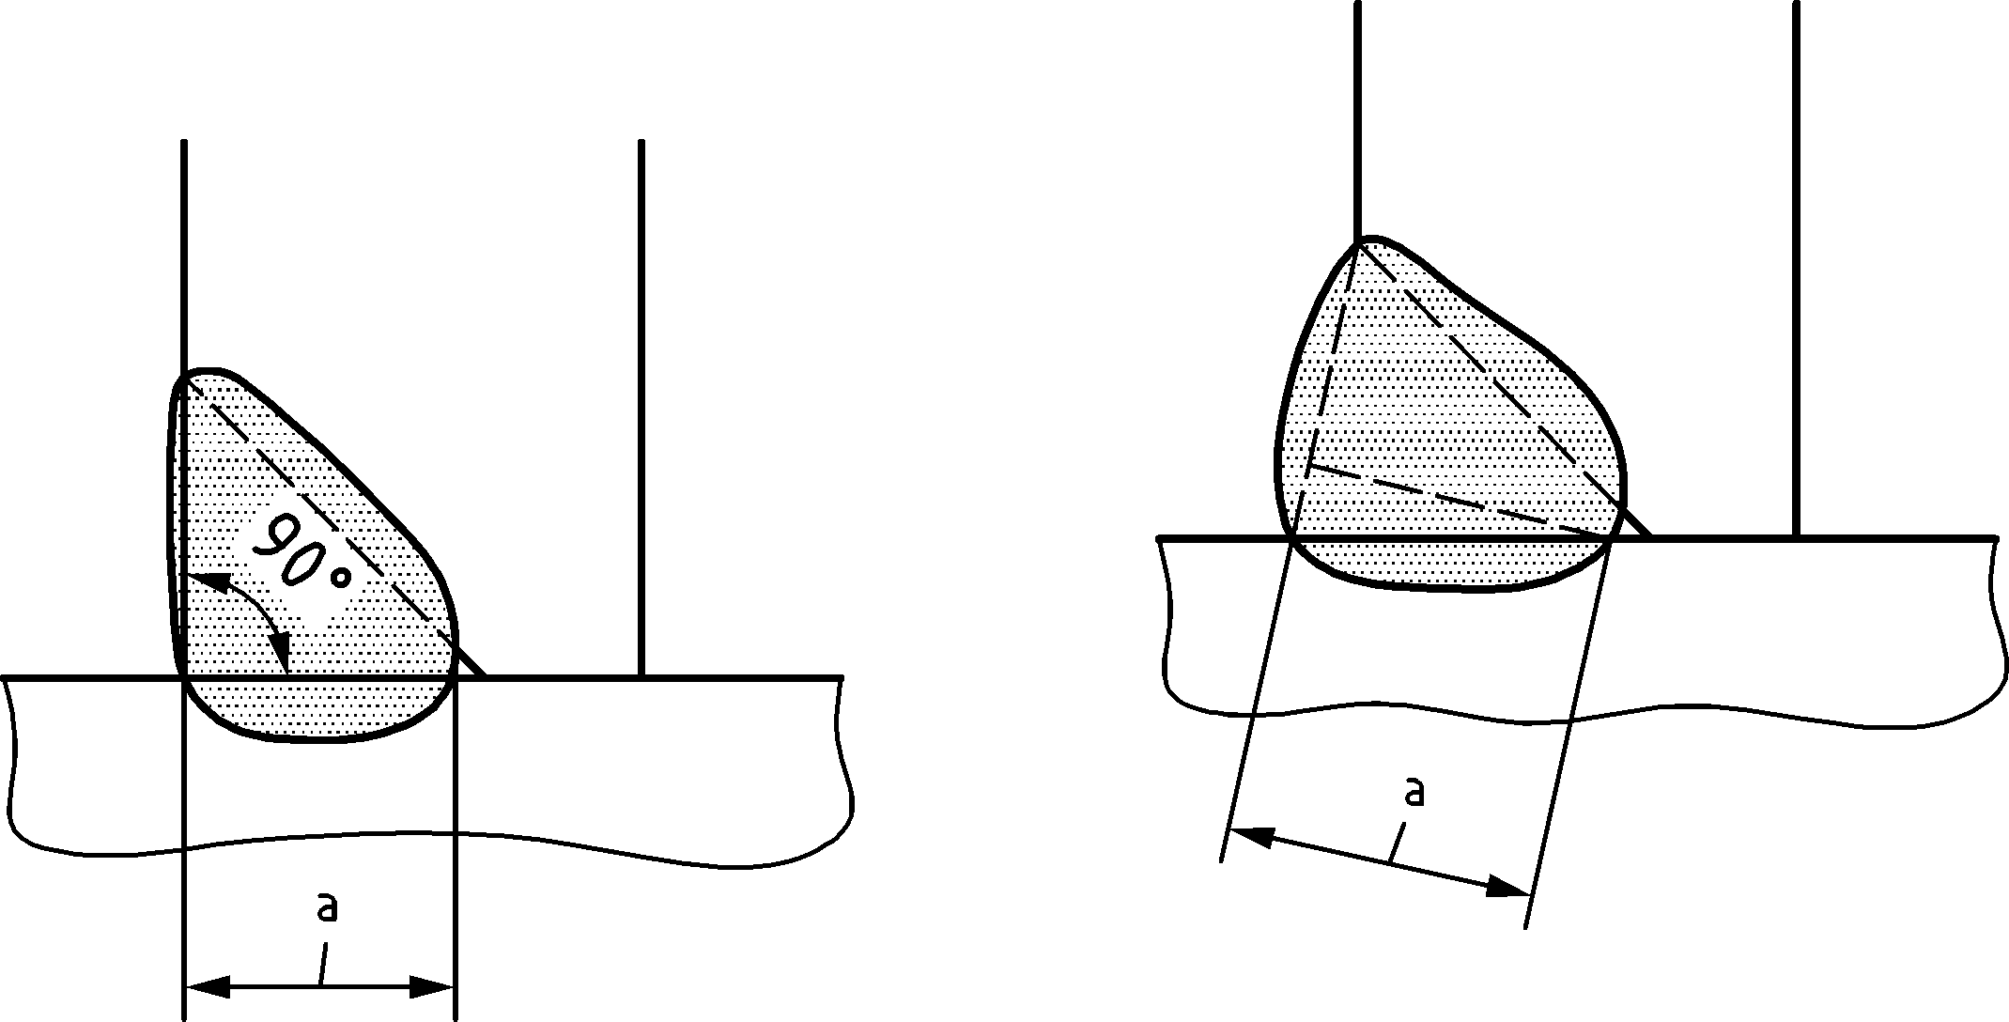
Figure 6.8 — Throat thickness of a partial penetration weld

T-butt joints
(1) The design resistance of T-butt joints, consisting of a pair of partial penetration butt welds reinforced by superimposed fillet welds, may be determined as for a full penetration butt weld, see 6.7.1:
- if the total nominal throat thickness, exclusive of the unwelded gap, is not less than the thickness t of the part forming the stem of the tee joint, and;
- provided that the unwelded gap is not more than t/5 or 3 mm, whichever is less, see Figure 6.9.
(2) The design resistance of T-butt joints that do not meet the requirements given in 6.7.3(1) should be determined using the method for fillet welds or penetration fillet welds, see 6.5, depending on the amount of penetration. The throat thickness should be determined in accordance with the provisions for fillet welds, see 6.5.2, or partial penetration butt welds, see 6.7.2, as relevant.
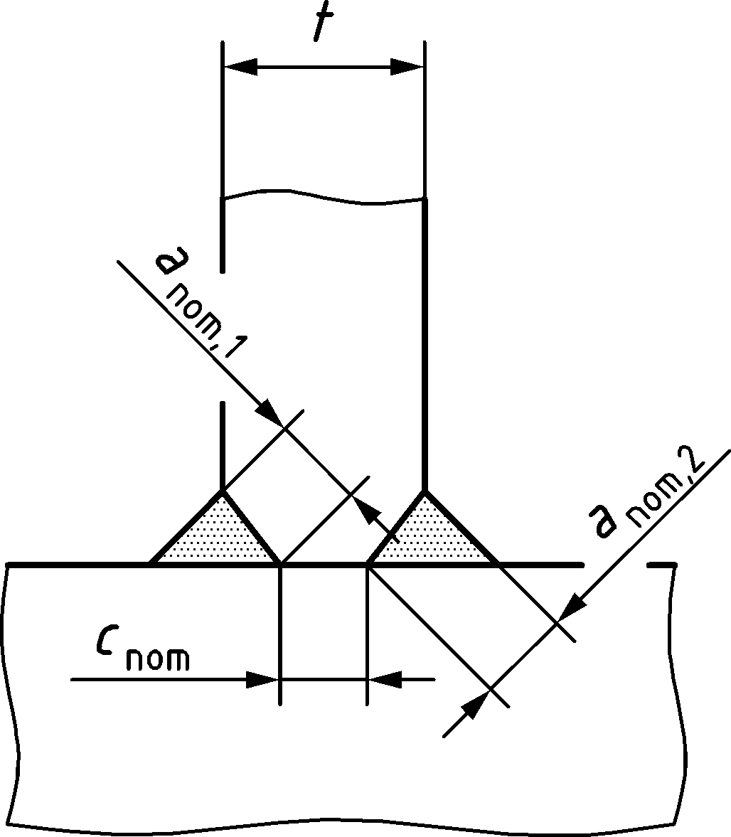
anom,1 + anom,2 ≥ t cnom should be the smaller of t/5 and 3 mm
Figure 6.9 — Effective full penetration of T-butt welds

Design resistance of plug welds
(1) The design resistance Fw,Rd of plug welds should be obtained from:
$$F_{w,Rd}=f_{vw,d} A_{w}$$ | (6.7)
where
fvw,d design shear strength of a weld given in 6.5.3.3(3);
Aw design throat area, equal to the area of the hole.

Distribution of forces
(1) The distribution of forces in a welded connection may be calculated on the assumption of either elastic or plastic behaviour in accordance with 4.2.
NOTE A simplified force distribution can be assumed within the welds.
(2) Residual stresses, and stresses not subjected to transfer of force may be ignored when checking the resistance of a weld. This applies specifically to the normal stress parallel to the axis of a weld.
(3) Welded joints should be designed to have adequate deformation capacity. However, ductility of the welds should not be relied upon.
(4) In joints where plastic hinges may form, the welds should be designed to provide at least the same design resistance as the weakest of the connected parts.
(5) In joints where deformation capacity for joint rotation is required due to the possibility of large plastic strains, the welds should have sufficient strength not to rupture before general yielding in the adjacent parent metal. For steel grades equal to or lower than S355, this may be considered to be satisfied if the design resistance of the weld is not less than 0,80 times the design resistance of the weakest of the connected parts. For steel grades higher than S355, the welds should be designed to have a resistance equal to at least 1,1fy,PM/fu,PM times the design resistance of the weakest of the connected parts, but not more than the ultimate strength of the weakest of the connected parts.
(6) If the design shear resistance of an intermittent weld is determined by using the total length ltot, it should be verified against a weld shear force per unit length Fw,Ed, multiplied by the factor (e + l)/l, see Figure 6.10.
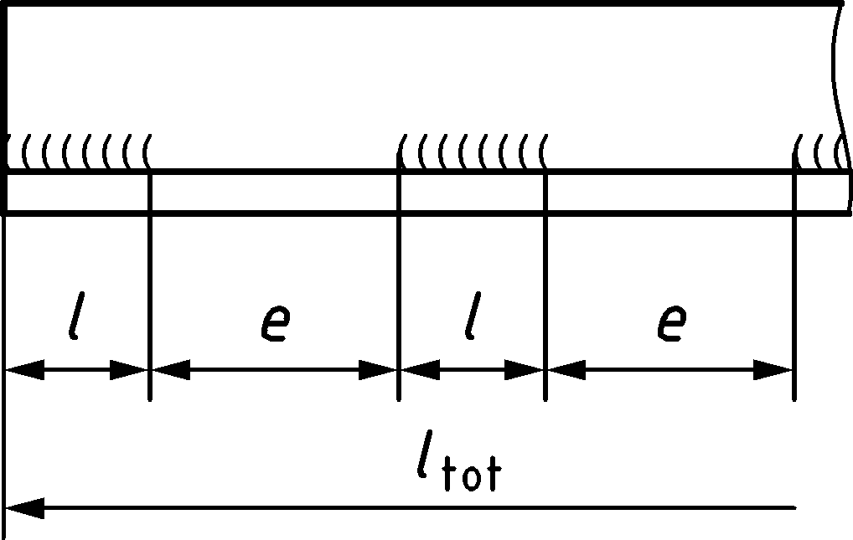
Figure 6.10 — Calculation of weld forces for intermittent welds

Connections to unstiffened flanges
(1) Where a transverse plate, or a beam flange, is welded to a supporting unstiffened flange of an I, H or other section, see Figure 6.11, and provided that the condition given in 6.10(3) is met, the applied force perpendicular to the unstiffened flange should not exceed any of the relevant design resistances as follows:
- that of the web of the supporting member of I or H sections as given in A.5.1 or A.6.1, as appropriate;
- those for a transverse plate on a RHS member as given in Table 9.16.
- that of the supporting flange as given by A.10.1(1) calculated assuming the applied force is concentrated over an effective width beff of the flange as given in 6.10(2) or 6.10(4) as relevant.
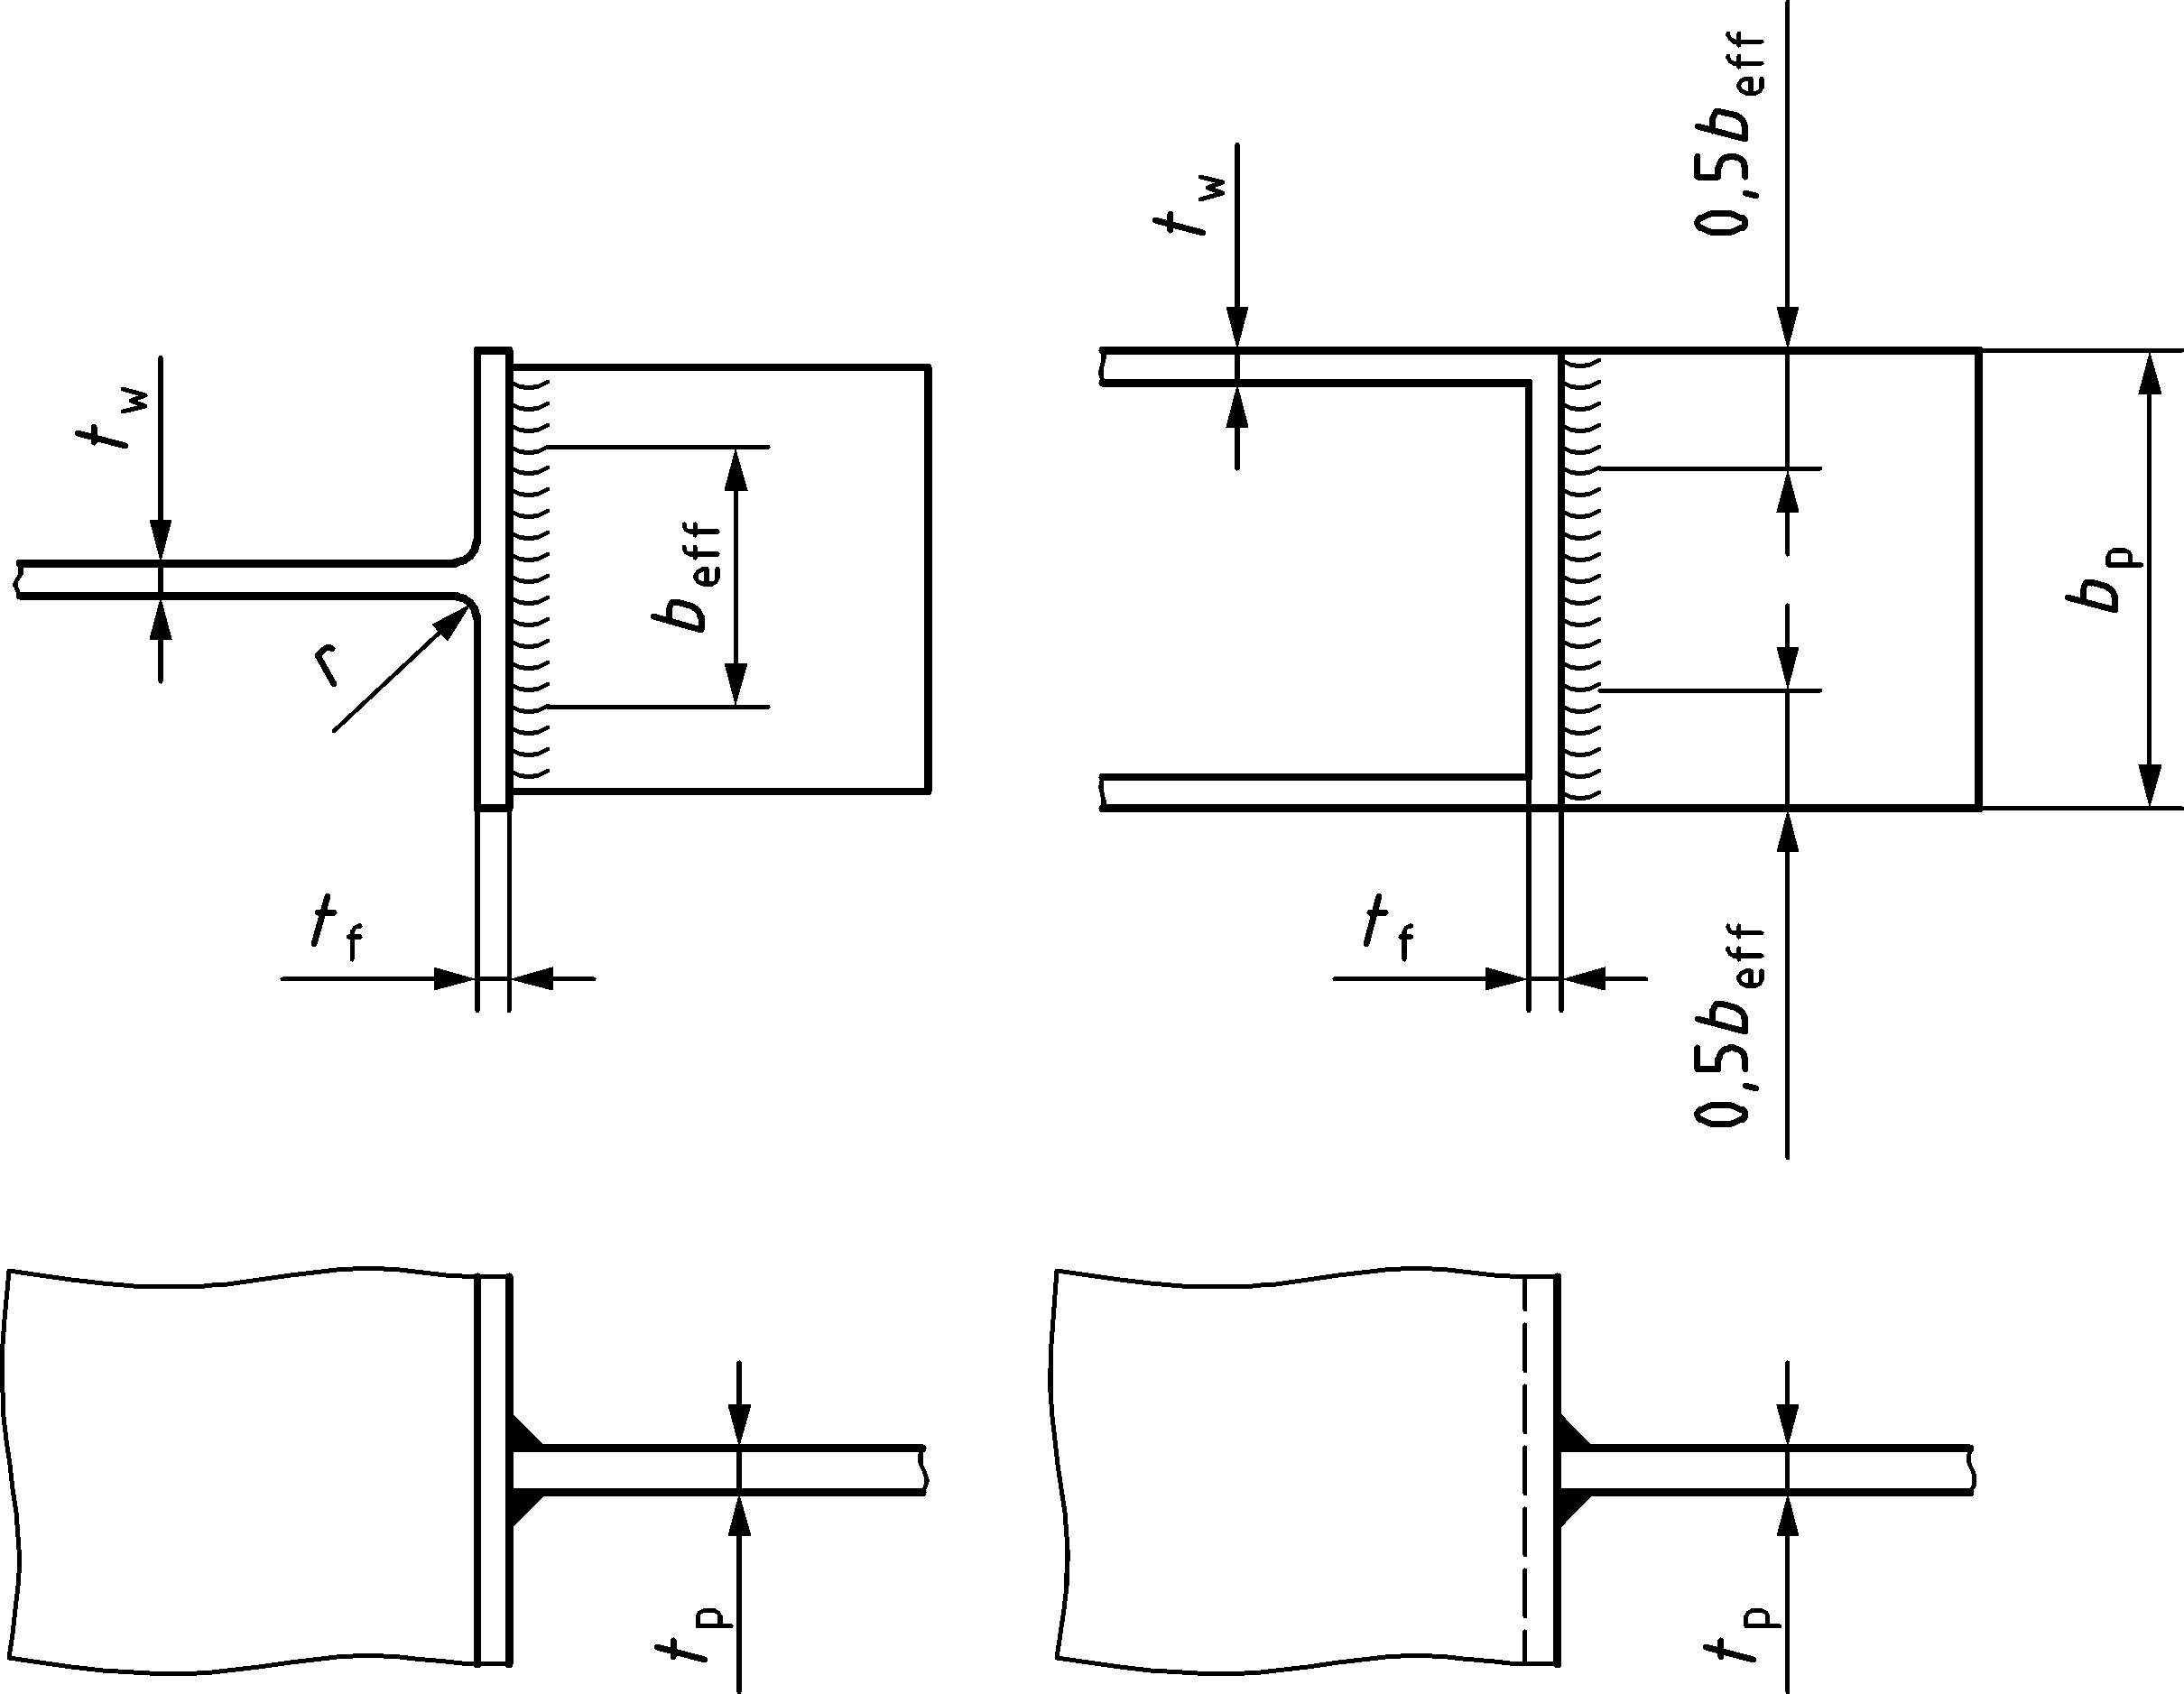
Figure 6.11 — Effective width of an unstiffened T-joint
(2) For unstiffened I or H sections, the effective width beff should be obtained from (see Figure 6.11):
$$b_{eff}=t_{w}+2s+7kt_{f}$$ | (6.8)
where
$$k=\frac{t_{f}}{t_{p}}\frac{f_{y,f}}{f_{y,p}} but k≤1$$ | (6.9)
where
fy,f yield strength of the flange of the I or H section;
fy,p yield strength of the plate welded to the I or H section.
The dimension s should be obtained from:
- for a rolled I or H section: | s = r | (6.10)
- for a welded I or H section: | $$s=\sqrt{2} a$$ | (6.11)
(3) For unstiffened flanges of I or H sections, the following criterion should be satisfied:
$$b_{eff}≥\frac{f_{y,p}}{f_{u,p}}b_{p}$$ | (6.12)
where
f u,p ultimate strength of the plate welded to the I or H section;
bp width of the plate welded to the I or H section.
Otherwise the joint should be stiffened.
(4) For other sections, such as box sections or channel sections, where the width of the connected plate is similar to the width of the flange, the effective width beff should be obtained from:
$$b_{eff}=2t_{w}+5t_{f} but b_{eff}≤2t_{w}+5kt_{f}$$ | (6.13)
NOTE For hollow sections, see Table 9.16.
(5) The welds connecting the plate to the flange should be designed to transmit the design resistance of the plate bp tp fy,p/γM0 assuming a uniform stress distribution.

Design resistance of long joints
(1) In lap joints longer than the limits in (2) and (3), the design resistance of a fillet weld should be reduced by multiplying it by a factor βLw to allow for the effects of non-uniform distribution of stress along its length.
NOTE The provisions given in (1) do not apply when the stress distribution along the weld corresponds to the stress distribution in the adjacent parent metal, as, for example, in the case of a weld connecting the flange and the web of a plate girder.
(2) In lap joints longer than 150a the reduction factor βLw should be taken as βLw,1 obtained from:
$$β_{Lw,1}=1,2-\frac{0,2L_{j}}{150a} but β_{Lw,1}≤1,0$$ | (6.14)
where Lj is the overall length of the lap in the direction of the force transfer.
NOTE For fillet welded connections of high strength steel with grades equal to or higher than S460, see (4).
(3) For fillet welds longer than 1,7 m connecting transverse stiffeners in plated members, the reduction factor βLw may be taken as βLw,2 obtained from:
$$β_{Lw,2}=1,1-\frac{L_{w}}{17} but 0,6≤β_{Lw,2}≤1,0$$ | (6.15)
where Lw is the length of the weld (in m).
(4) For steel grades equal to or higher than S460, the length of longitudinal fillet welds in lap joints should not be taken longer than 150a.

Eccentrically loaded single fillet or single-sided partial penetration butt welds
(1) Local eccentricity should be avoided where possible.
(2) Local eccentricity (relative to the line of action of the force to be resisted) should be taken into account in the following cases:
- where a bending moment transmitted about the longitudinal axis of the weld produces tension at the root of the weld, see Figure 6.12(a);
- where a tensile force transmitted perpendicular to the longitudinal axis of the weld produces a bending moment, resulting in a tension force at the root of the weld, see Figure 6.12(b);
In both cases the weld should be designed according to elastic design rules.
(3) Local eccentricity may be omitted for a weld around the perimeter of a structural hollow section.
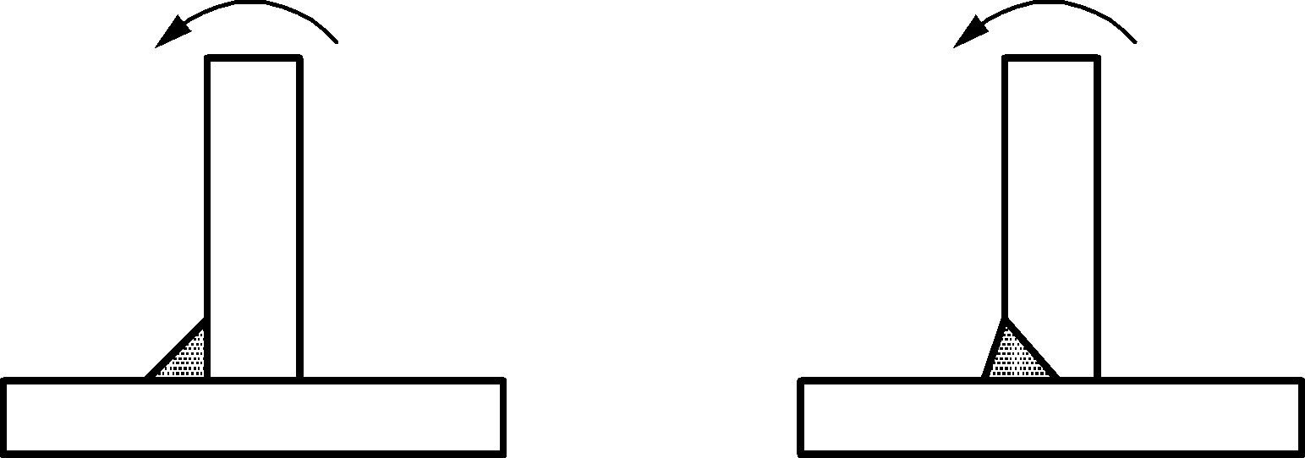 | 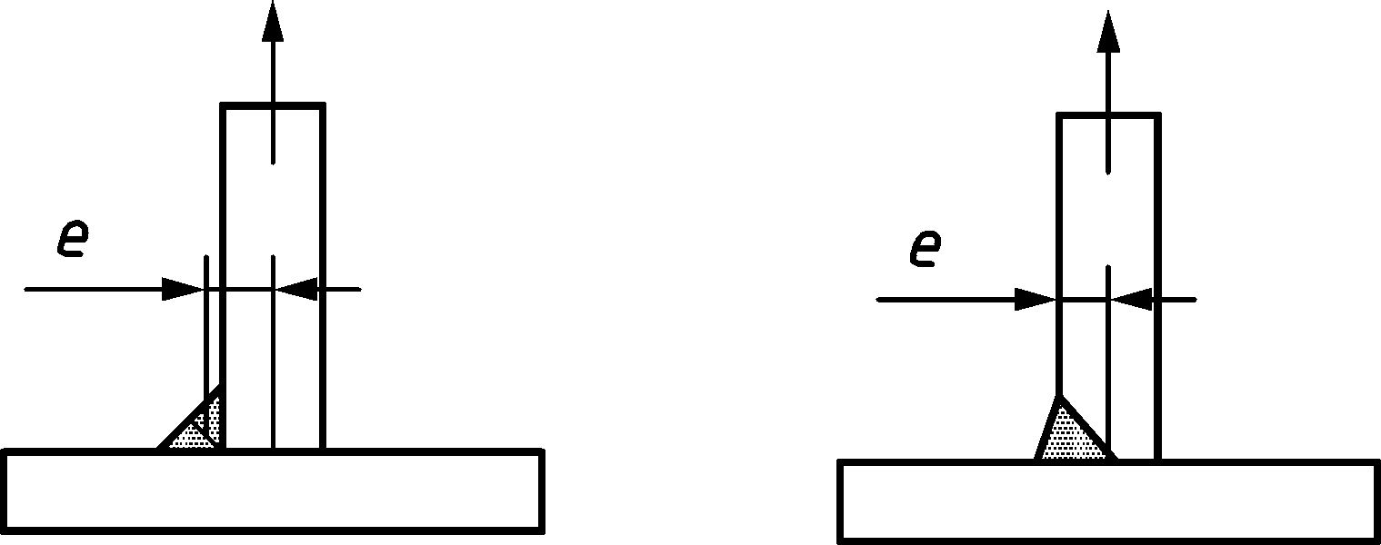
(a) Bending moment produces tension at the root of the weld | (b) Tensile force produces tension at the root of the weld
Figure 6.12 — Single fillet welds and single-sided partial penetration butt welds

Angles connected by one leg
(1) In angles connected by one leg, the eccentricity of welded lap joint end connections may be taken into account by adopting an effective cross-sectional area and then treating the member as concentrically loaded. Figure 6.13 gives examples of eccentricities e that may be ignored and e’ that should be taken into account in design.
(2) For an equal-leg angle, or an unequal-leg angle connected by its larger leg, the effective area may be taken as equal to the gross area.
(3) For an unequal-leg angle connected by its smaller leg:
- when determining the design resistance of the cross-section, the effective area should be taken as the gross cross-sectional area of an equivalent equal-leg angle of leg size equal to that of the smaller leg.
- when determining the design buckling resistance of a compression member the actual gross cross-sectional area should be used.
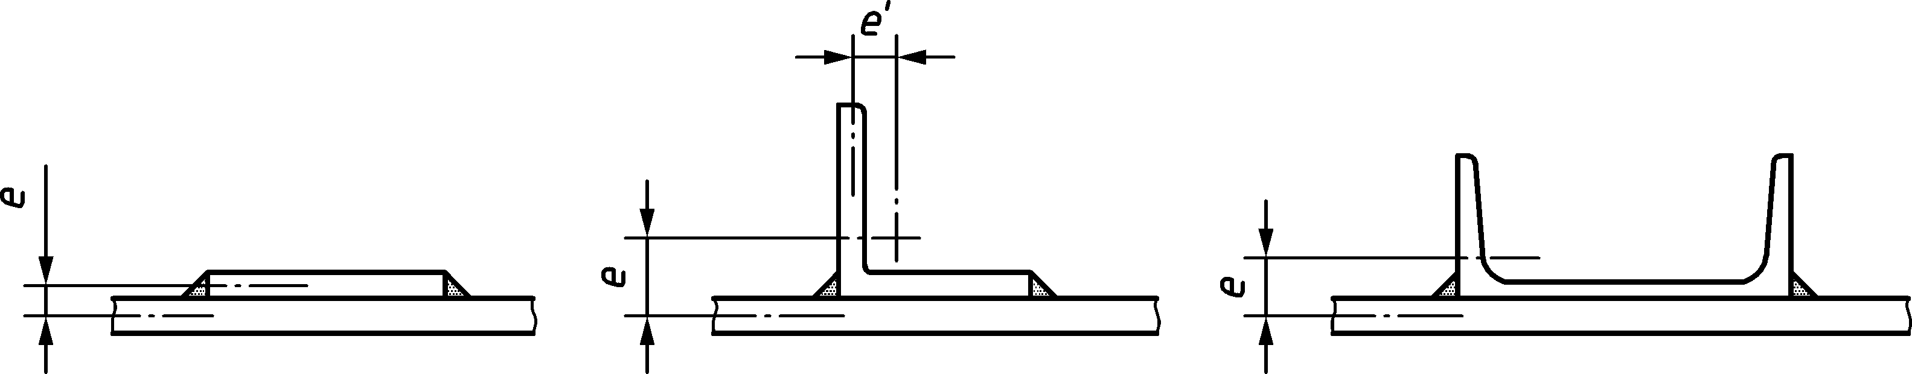
Figure 6.13 — Examples of eccentricities

Welding in cold-formed zones
(1) For welding in cold-formed zones, the rules given in EN 1993-1-10 should be followed.

Structural analysis

Global analysis

General
(1) The effects of the properties of the joints on the distribution of internal forces and moments within a structure, and on the overall deformations of the structure, should be taken into account unless they are sufficiently small.
(2) The appropriate type of joint model should be determined from Table 7.1, depending on the classification of the joint (see 7.3), and on the chosen method of global analysis (see 7.1.2 to 7.1.4).
(3) For simple joint model, the joint may be assumed not to transmit bending moments.
(4) For semi-continuous joint model, the behaviour of the joint should be taken into account in the analysis.
(5) For continuous joint model, the behaviour of the joint may be assumed to have no effect on the analysis.
(6) The design moment-rotation curve for a joint to be used in the analysis (see 7.2.4) may be simplified by adopting any appropriate approximation, including a linearized approximation, e.g. bi-linear or tri-linear, provided that the approximate curve lies wholly below the design moment-rotation curve.
NOTE In 7.1.2, 7.1.3 and 7.1.4 application rules are provided for joints where the connections are mainly subjected to bending (see B.3.2.1(2)).
Table 7.1 — Type of joint model
 | Method of global analysis |  |  | Type of joint model
 | Elastic | Rigid-plastic | Elastic-plastic
Classification of joint | Nominally pinned | Nominally pinned | Nominally pinned | Simple
 | Rigid | Full-strength | Rigid and full-strength | Continuous
 | Semi-rigid | Partial-strength | Semi-rigid and partial-strength  Semi-rigid and full-strength  Rigid and partial-strength | Semi-continuous
NOTE For steels with grades higher than S460, see 8.1(4)

Elastic global analysis
(1)P Joints shall have sufficient resistance to transmit the forces and moments acting at the joints resulting from the analysis.
(2) Joints should be classified according to their rotational stiffness, see 7.3.2.
(3) In the case of semi-rigid joints (see 7.3.2.4), the rotational secant stiffness Sj corresponding to the bending moment Mj,Ed should be used in the analysis, see 7.2.6(2). If Mj,Ed does not exceed 2/3 Mj,Rd, then the initial rotational stiffness Sj,ini may be used in the global analysis, see Figure 7.1(a).
(4) As a simplification to 7.1.2(3), the rotational stiffness may be taken as Sj,ini /η in the analysis, for all values of the moment Mj,Ed, as shown in Figure 7.1(b), where η is the stiffness modification coefficient from Table 7.2.
(5) For joints connecting H or I sections (see Clause 8), the initial rotational stiffness Sj,ini should be determined from B.4.
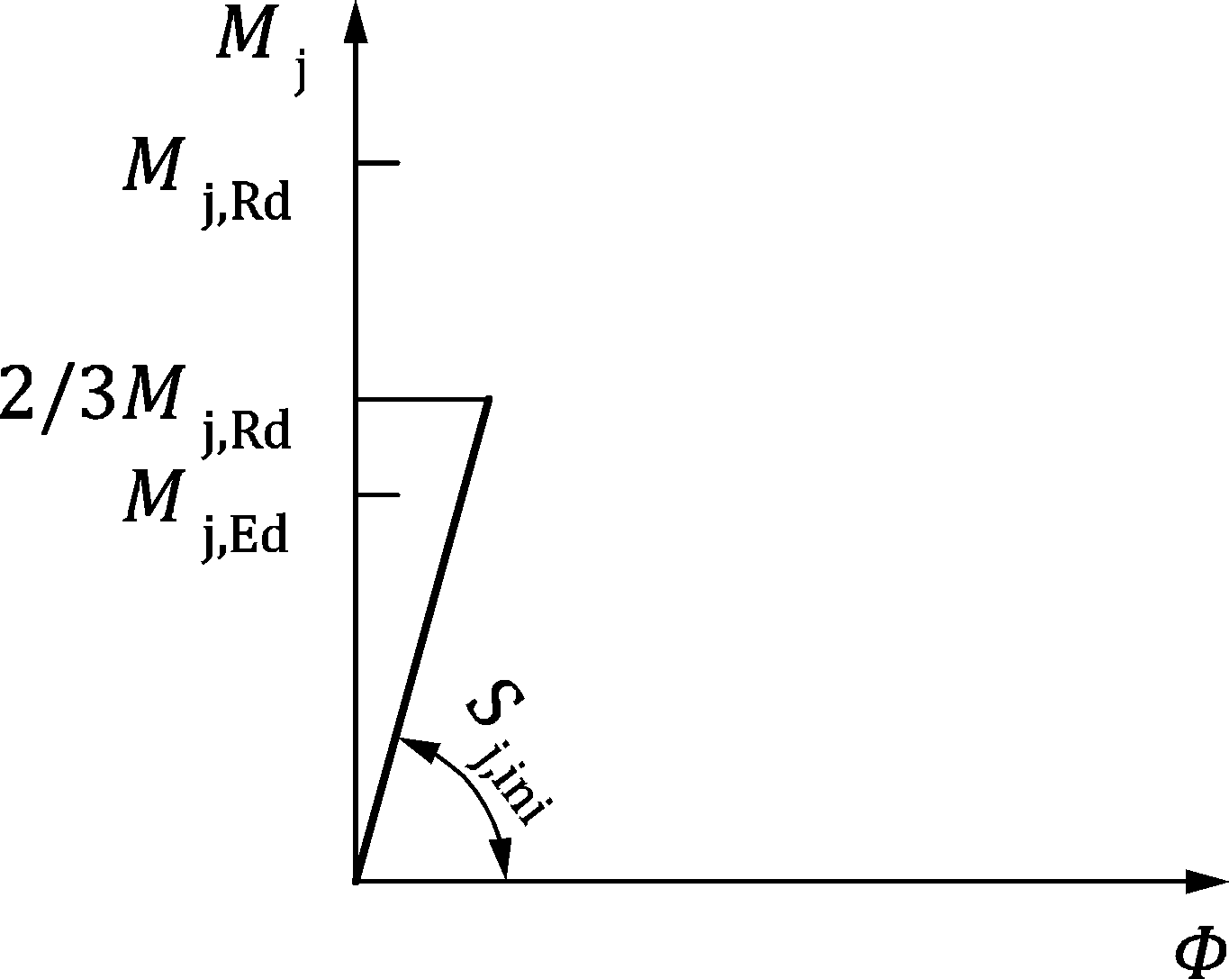 | 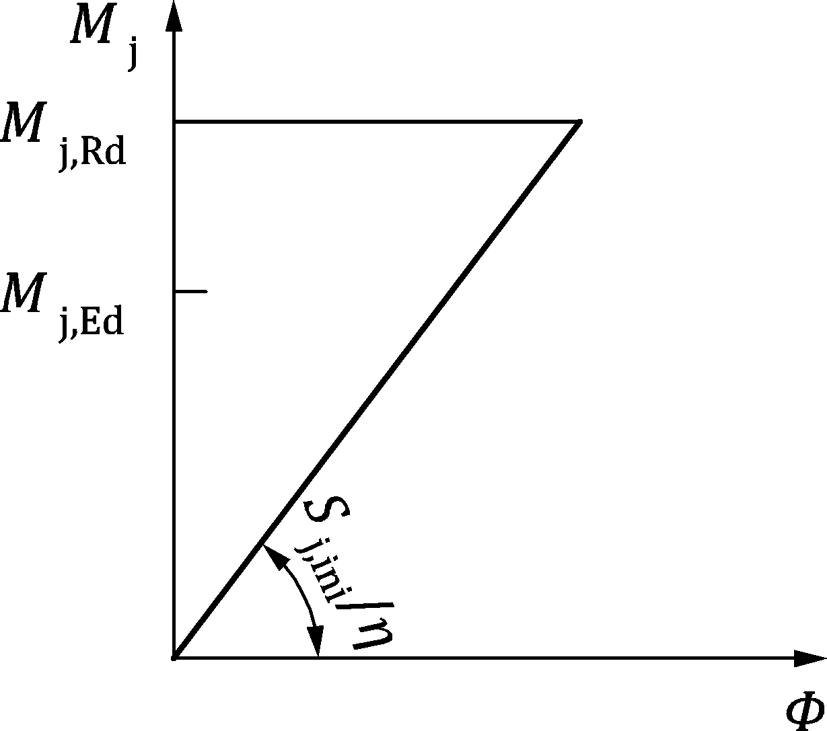
a) Mj,Ed ≤ 2/3 Mj,Rd | b) 2/3 Mj,Rd < Mj,Ed ≤ Mj,Rd
Figure 7.1 — Joint rotational stiffness to be used in elastic global analysis
Table 7.2 — Stiffness modification coefficient η
Type of connection | Beam-to-column joints | Other types of connections (beam-to-beam connections, beam splices, column bases)
Welded | 2 | 3
Bolted end plates | 2 | 3
Bolted flange cleats | 2 | 3,5
Base plates | — | 3

Rigid-plastic global analysis
(1) Joints should be classified according to their moment resistance, see 7.3.3.
(2) For joints connecting H or I sections, the design moment resistance Mj,Rd should be determined from B.3.2.
(3) For joints connecting hollow sections, the design resistance may be determined using the method given in Clause 9.
(4) The rotation capacity of joints should be sufficient to accommodate the rotations resulting from the analysis.
(5) For joints connecting H or I sections (see Clause 8), the rotation capacity should be determined from B.5.

Elastic-plastic global analysis
(1) Joints should be classified according to both rotational stiffness, see 7.3.2, and resistance relative to that of the connected members, see 7.3.3.
(2) For joints connecting H or I sections (see Clause 8), the design resistance Mj,Rd should be determined from B.3.2, Sj,ini should be determined from B.4 and ϕCd should be determined from B.5.
(3) For joints connecting hollow sections, the design resistance may be determined using the method given in Clause 9.
(4) The moment-rotation curve defined according to 7.2.4 should be used to determine the distribution of internal forces and moments within a structure.
(5) As a simplification, the bi-linear design moment-rotation curve shown in Figure 7.2 may be adopted. The stiffness modification coefficient η should be obtained from Table 7.2.
Figure 7.2 — Simplified bi-linear design moment-rotation curve

Global analysis of hollow section lattice girders
(1) This clause applies to structures with joints designed to Clause 9.
(2) The distribution of axial forces in a lattice girder may be determined on the assumption that the members are connected by pinned joints (see also 4.6).
(3) Secondary moments at the joints, developed by the rotational stiffness of the joints and the non-uniform stiffness distribution in the joint, may be neglected both in the design of the members, and in the design of the joints, provided that the following conditions are satisfied:
- the joint geometry meets the provisions in Table 9.5, Table 9.7, Table 9.8, Table 9.13, Table 9.23 or Table 9.26 as appropriate;
- the ratio of the system length to the depth of the member in the plane of the lattice girder in buildings is larger than 6;
- the eccentricity is within the limits specified in (5).
NOTE It is assumed that the material factors in Table 9.1 account for these effects.
(4) The moments resulting from transverse loads, whether in-plane or out-of-plane, that are applied between panel points, should be taken into account in the design of the members to which they are applied. If the conditions detailed in (3) are satisfied, then:
- the brace members may be considered as pin-connected to the chords, so that moments resulting from loads applied to chord members need not be distributed into brace members;
- for brace members made from steel grade equal to or higher than S460, the effect of transverse loading on braces may be conservatively taken into account for the joints by assuming a rigid connection;
the chords may be considered as continuous beams, simply supported at panel points. (5) Moments resulting from eccentricities may be neglected in the design of brace members if the eccentricities are within the following limits:
$-0,55d_{0}≤e≤0,25d_{0}$ | for CHS | (7.1)
$$-0,55h_{0}≤e≤0,25h_{0}$$ | for RHS | (7.2)
$${-y}_{s}≤e≤0$$ | for channel sections | (7.3)
where
e eccentricity defined in Figure 7.3;
d0 diameter of the chord;
h0 depth of the chord, in the plane of the lattice girder;
$y_{s}$ distance from the neutral axis to the outside web face (used here as flange) of a channel section.
(6) When the eccentricities are within the limits given in (5), the moments produced by the eccentricity should be distributed between the chord members on each side of the joint, on the basis of their relative stiffness I/L, where L is the system length of the member, measured between panel points.
(7) When the eccentricities are outside the limits given in (5), the moments resulting from the eccentricities should be taken into account in the design of the joints and the members. In this case the moments produced by the eccentricity should be distributed between all the members meeting at the joint, on the basis of their relative stiffness I/L.
(8) The stresses in a chord resulting from moments (produced by eccentricities and/or transverse loading) taken into account in the design of the chord, should also be taken into account in determining the factor $Q_{f}$ used in the design of the joints, see 9.4.1.
(9) The cases where moments should be taken into account for joints in lattice girders are summarized in Table 7.3.

Figure 7.3 — Eccentricity of joints
Table 7.3 — Bending moments to be considered in truss design for Clause 9
Component | Source of the bending moment
 | Secondary effects caused by the rotation stiffness of the joints | Transverse member loading | Nodal eccentricity
Chords | No, if 7.1.5(3) is satisfied | Yes | Yes
Braces |  |  | No, if 7.1.5(3) is satisfied
Joints |  | Yes, for Qf only | Where 7.1.5(3) is satisfied, in Qf only, otherwise, see 7.1.5(7)

Modelling of beam-to-column joints

Scope of application
(1) The rotational deformation of the connection(s), and the shear deformation of the column web panel, produced by the internal moments and forces in the members should be considered in the modelling of the structural behaviour of joints.
(2) Beam-to-column joints may be modelled for global structural analysis using the general approach in 7.2.2 or the simplified approach in 7.2.3.
(3) The simplified approach in 7.2.3 may be used if the internal forces and moments are proportional throughout the analysis, in which case the β factor in 7.2.3 is constant. If the internal forces and moments are not proportional throughout the analysis, the general approach in 7.2.2 should be used.
NOTE Forces and moments can be non-proportional when they are determined using plastic analysis.
(4) Rules given in 7.1, 7.2.4, 7.3 and Annex B of this Standard are directly applicable to the simplified approach of modelling beam-to-column joints.

General approach
(1) To model a joint configuration in a way that closely reproduces the expected behaviour, the web panel in shear and each of the connections should be modelled separately, taking account of the internal moments and forces in the members, acting at the periphery of the web panel, see Figure 7.4 and Figure 7.5.
(2) The design shear force Vwp,Ed in the column web panel, see Figure 7.4 and Figure 7.5(a), should be obtained from:
$$V_{wp,Ed}=(M_{b1,Ed}-M_{b2,Ed})/z-(V_{c1,Ed}-V_{c2,Ed})/2$$ | (7.4)
where z is the lever arm, see Table B.1 in B.3.2.
NOTE Forces and moments in Formula (7.4) are taken as positive if they have the directions shown in Figure 7.4.
Figure 7.4 — Forces and moments acting on the joint at periphery of web panel
a) Shear forces in web panel | b) Connections, with forces and moments in beams
Figure 7.5 — Forces and moments acting on the web panel and the connections

Simplified approach
(1) As a simplified alternative to 7.2.2, a single-sided joint configuration may be modelled using a single joint represented by rotational spring, and a double-sided joint configuration may be modelled as two separate but interacting joints represented by rotational springs, one on each side, see Figure 7.6.
NOTE A double-sided beam-to-column joint configuration has two moment-rotation curves, one for the right-hand joint and another for the left-hand joint. Each joint has a moment-rotation curve that takes into account the behaviour of the relevant connection, as well as the influence of the web panel in shear.
(2) When determining the design moment resistance and rotational stiffness for each of the joints, any influence of the web panel in shear should be taken into account by means of the transformation parameter β given in (3) and (4).
NOTE The transformation parameter β is used directly in B.3.2.2 and A.4.2. It is also used in A.5.1 and A.6.1 in connection with Table A.1 to obtain the reduction factor ω for shear.
(3) Approximate values for β based on the values of the beam moments Mb1,Ed and Mb2,Ed at the periphery of the web panel, see Figure 7.4, may be obtained from Table 7.4.
(4) As an alternative to 7.2.3(3), more accurate values of β based on the values of the beam moments Mj,b1,Ed and Mj,b2,Ed at the intersection of the member centrelines, may be determined from the simplified model shown in Figure 7.7 as follows:
$$β=1-\frac{M_{j,b1,Ed}}{M_{j,b2,Ed}} if \left|M_{j,b1,Ed}\right|≤\left|M_{j,b2,Ed}\right|$$  $$β=1-\frac{M_{j,b2,Ed}}{M_{j,b1,Ed}} if \left|M_{j,b1,Ed}\right|>\left|M_{j,b2,Ed}\right|$$ | (7.5)
where
β transformation parameter;
Mj,b1,Ed moment at the intersection with the right hand beam;
Mj,b2,Ed moment at the intersection with the left hand beam.
(5) In the case of an unstiffened double-sided beam-to-column joint configuration in which the depths of the two beams are not equal, the actual distribution of shear stresses in the column web panel should be taken into account when determining the design moment resistance.
a) Single-sided joint configuration | b) Double-sided joint configuration
Key
1 joint represented by rotational spring
2 joint represented by rotational spring 2: left side
3 joint represented by rotational spring 1: right side
Figure 7.6 — Simplified modelling of beam-to-column joints
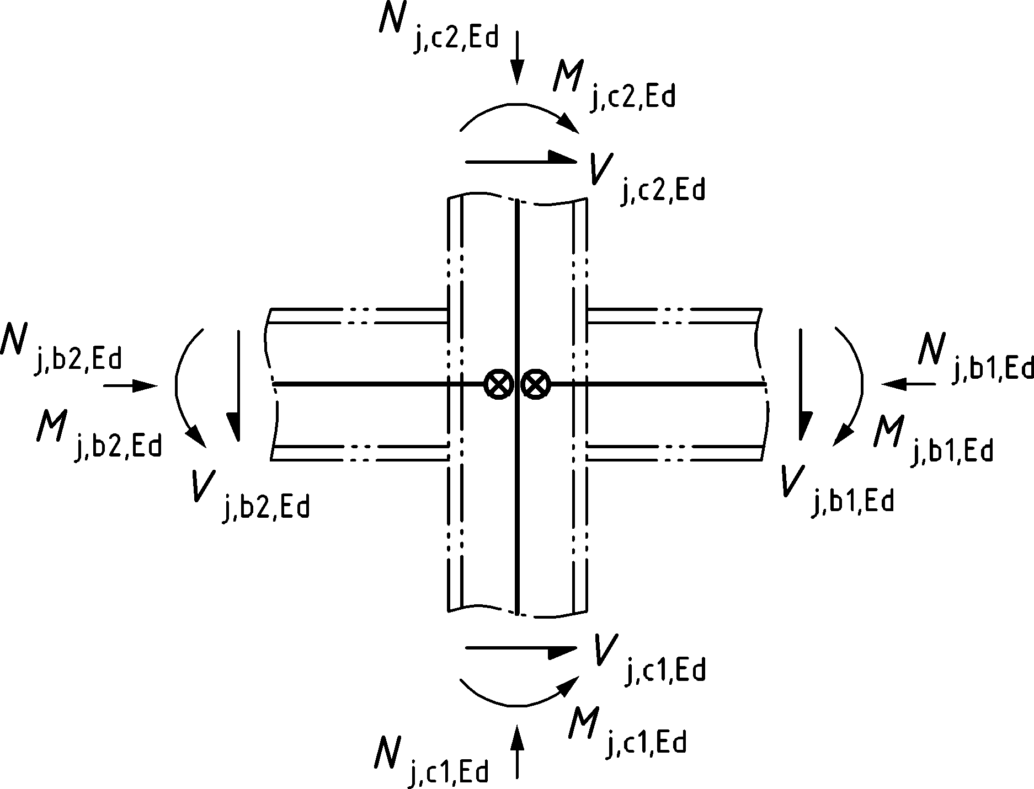
Figure 7.7 — Forces and moments acting on the joint at intersection of member centrelines
Table 7.4 — Approximate values for the transformation parameter β
Joint configuration |  | Action | Value of β
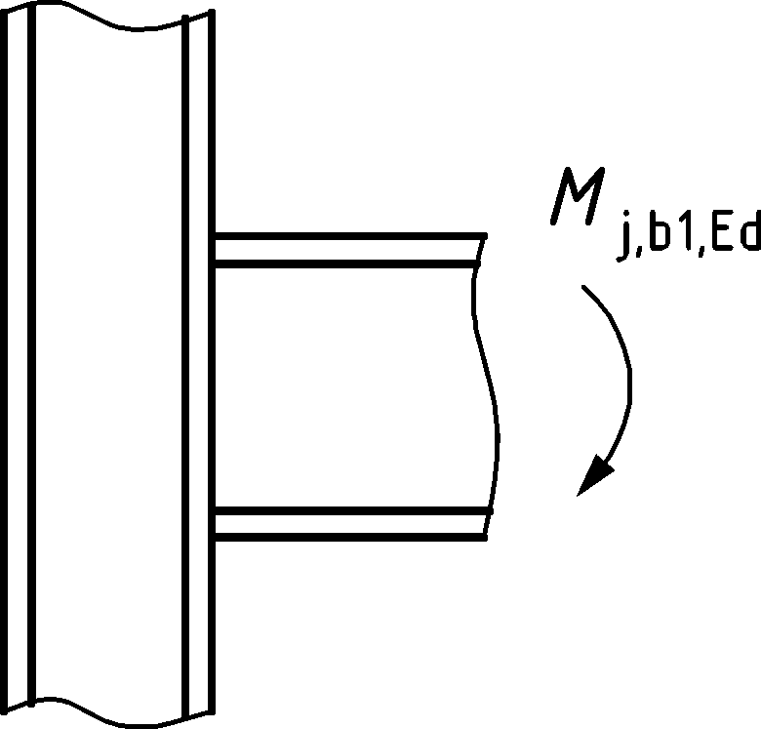 | 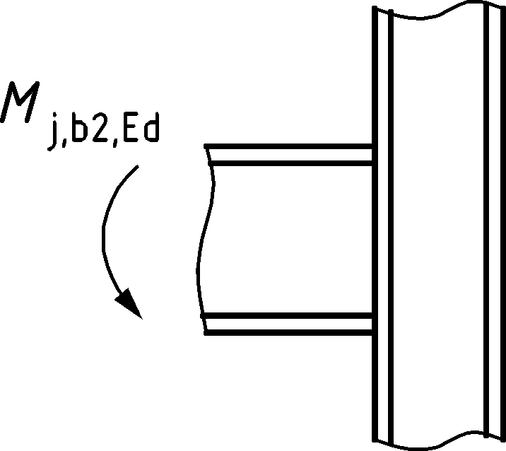 | Mj,b1,Ed (Mj,b2,Ed = 0)  or  Mj,b2,Ed (Mj,b1,Ed = 0) | β = 1a
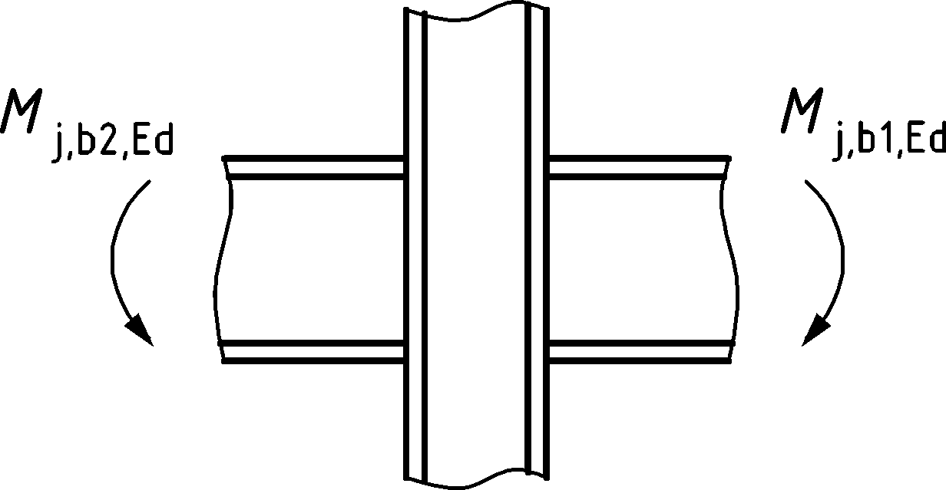 | 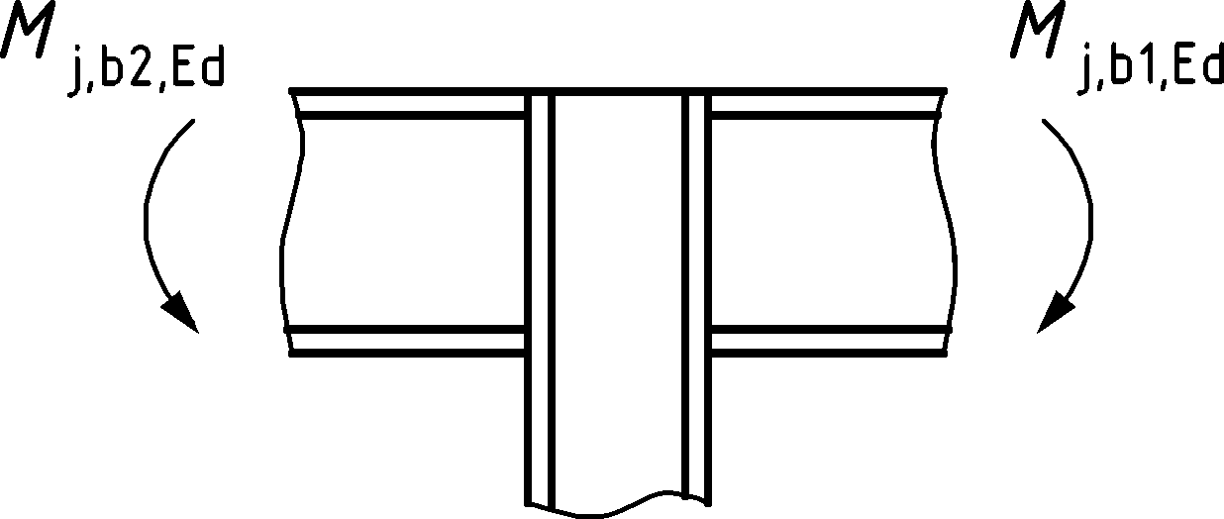 | Mj,b1,Ed = Mj,b2,Ed | β = 0a
 |  | Mj,b1,Ed / Mj,b2,Ed > 0 | β ≈ 1
 |  | Mj,b1,Ed / Mj,b2,Ed < 0 | β ≈ 2
 |  | Mj,b1,Ed + Mj,b2,Ed = 0 | β = 2a
a In this case the value of β is the exact value rather than an approximation.

Design moment-rotation curve
(1) When the simplified approach in 7.2.3 is adopted, joints may be represented by rotational springs that connect the centre lines of the connected members at the point of intersection, as shown in Figure 7.8(a) and (b) for a single-sided beam-to-column joint configuration.
(2) The structural properties of the spring should be expressed by a moment-rotation curve that describes the relationship between the bending moment applied to the joint Mj, and the corresponding rotation ϕ between the connected members, see Figure 7.8(c).
(3) The design moment-rotation curve, see Figure 7.8(c), should define the following three main structural properties:
- moment resistance, see 7.2.5;
- rotational stiffness, see 7.2.6;
- rotation capacity, see 7.2.7.
(4) When effects such as bolt slip, lack of fit, and foundation-soil interactions (in the case of column bases), results in a significant initial joint rotation, it should be included in the design moment rotation curve.
(5) The design moment-rotation curve for beam-to-column joints should be consistent with the assumptions made in the global analysis of the structure, and with the assumptions made in the design of the members, see EN 1993-1-1.
(6) The design moment-rotation curve for joints and column bases of I and H sections, as obtained from 7.2.4 may be assumed to satisfy the provisions of 7.1.1(6) for simplification in global analysis.
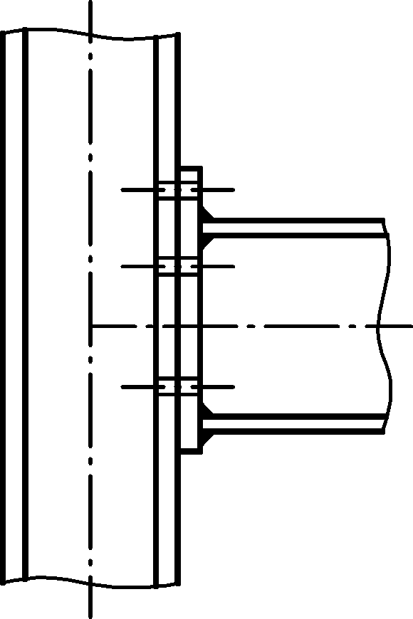 | 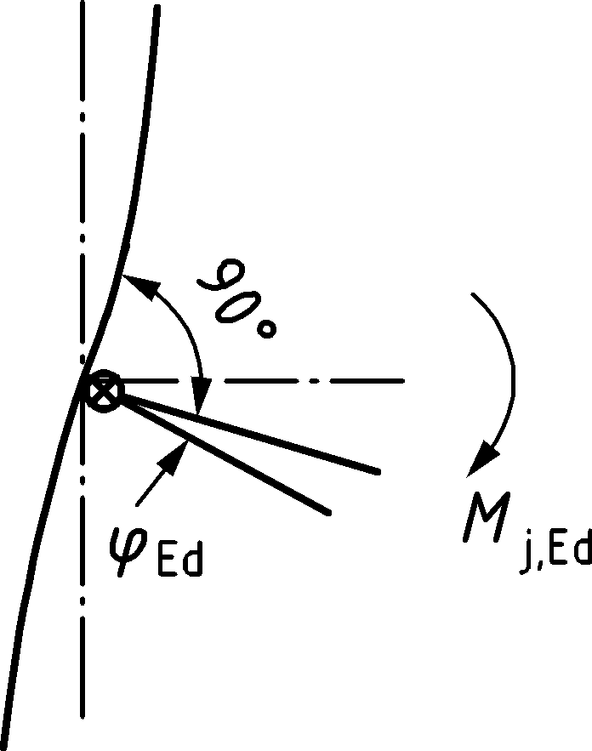 | 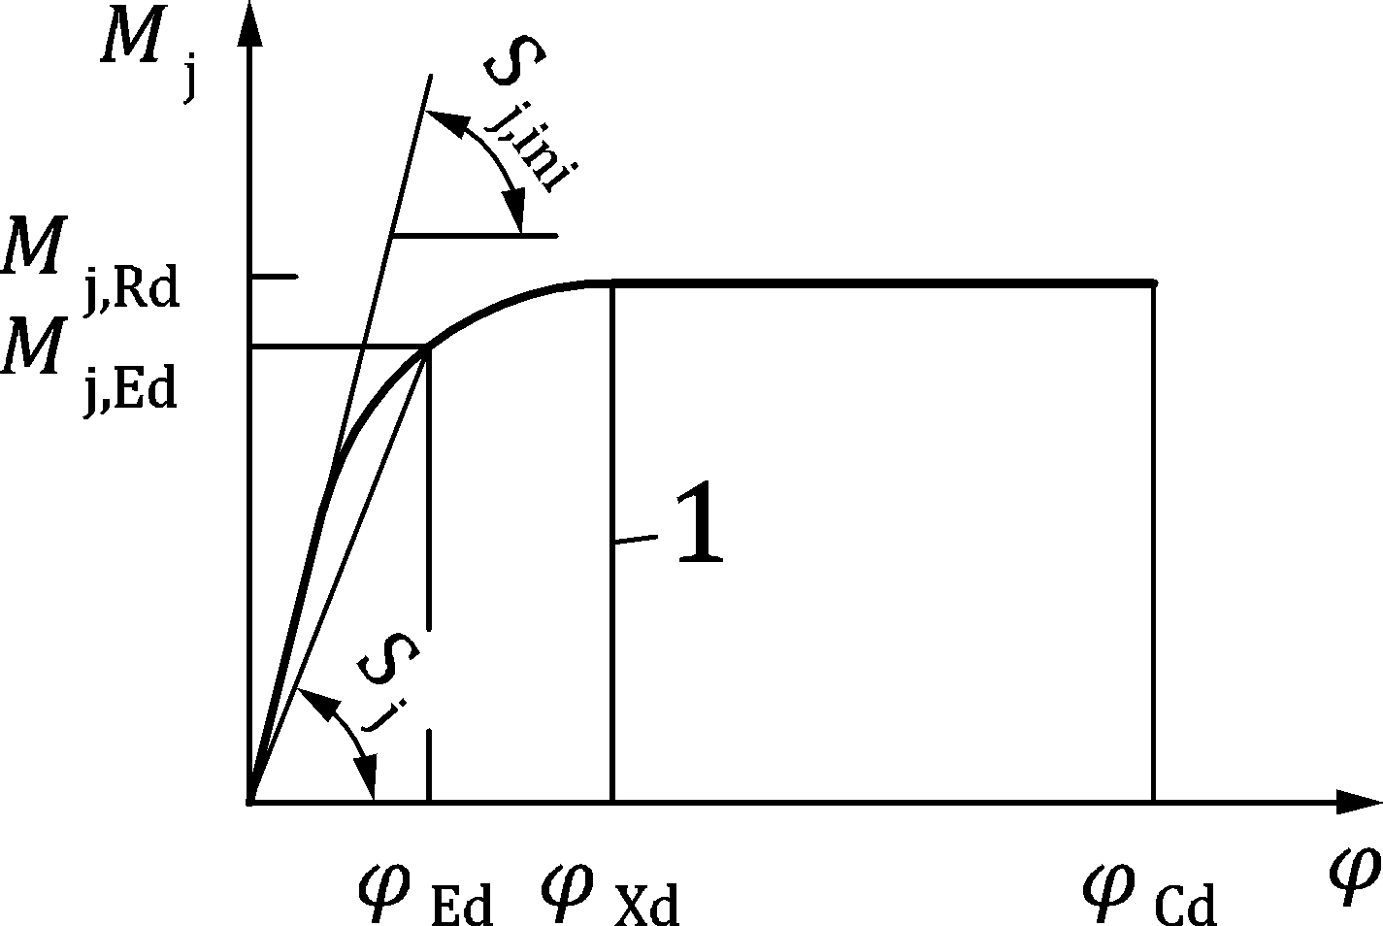
a) Joint | b) Model | c) Design moment-rotation curve
Key
1 limit for Sj
Figure 7.8 — Design moment-rotation curve of a joint

Moment resistance
(1) The design moment resistance of a joint Mj,Rd should be used as the maximum moment of the design moment-rotation curve, see Figure 7.8(c).
(2) The design moment resistance of a joint may be determined from the distribution of internal forces within that joint and the design resistances of its basic components to these forces, see Table 8.1.

Rotational stiffness
(1) The initial rotational stiffness Sj,ini should be used as the slope of the elastic part of the design moment-rotation curve, see Figure 7.8(c).
(2) The secant rotational stiffness Sj from Formula (7.6) may be used as the relevant property of joint rotational stiffness:
$$S_{j}=\frac{S_{j,ini}}{μ}$$ | (7.6)
where µ is the stiffness ratio, see 7.2.6(4).
(3) The definition of secant rotational stiffness in (2) should be applied to joint rotations not exceeding ϕXd, which is the joint rotation at which Mj,Ed first reaches Mj,Rd, see Figure 7.8(c).
(4) The stiffness ratio µ should be determined from the following:
- if Mj,Ed ≤ 2/3 Mj,Rd:
µ = 1 | (7.7)
- if 2/3 Mj,Rd < Mj,Ed ≤ Mj,Rd:
µ = (1,5 Mj,Ed/Mj,Rd)ψ | (7.8)
where the coefficient ψ should be obtained from Table 7.5.
Table 7.5 — Value of the coefficient ψ
Type of connection | ψ
Welded | 2,7
Bolted end plate | 2,7
Bolted angle flange cleats | 3,1
Base plate connections | 2,7

Rotation capacity
(1) The design rotation capacity ϕCd should be taken as the maximum rotation of the design moment-rotation curve, see Figure 7.8(c).

Classification of joints

General
(1) The details of all joints should comply with the assumptions made in the relevant design method, without adversely affecting any other part of the structure.
(2) Joints should be classified by their rotational stiffness, see 7.3.2, and by their bending moment resistance, see 7.3.3, relative to the connected member(s). Classification of joints by their rotational stiffness and bending moment resistance affects the type of joint model for global analysis, see 7.1.
NOTE Additional information on the classification of joints by their stiffness and resistance can be set by the National Annex.

Classification by rotational stiffness

General
(1) Joints should be classified as nominally pinned, rigid, or semi-rigid according to their rotational stiffness, by comparing the initial rotational stiffness Sj,ini (see 7.2.6(1)) with the classification boundaries in 7.3.2.5.
NOTE 1 Rules for the determination of Sj,ini for joints connecting H or I sections are given in B.4, and for column bases in D.4.
NOTE 2 Rules for the determination of Sj,ini for joints connecting hollow sections are not given in this document.
(2) Joints may be classified on the basis of experimental evidence, experience of previous satisfactory performance in similar cases or by calculations based on test evidence.

Nominally pinned joints
(1)P Nominally pinned joints shall be capable of transmitting the internal forces, without developing significant moments which might adversely affect the members or the structure as a whole.
(2) Nominally pinned joints should be capable of sustaining the rotations due to the combinations of actions at ultimate limit states.

Rigid joints
(1) Joints classified as rigid should be assumed to have sufficient rotational stiffness to justify analysis based on full continuity.

Semi-rigid joints
(1) Joints that do not meet the criteria for rigid joints or nominally pinned joints should be classified as semi-rigid.
NOTE Semi-rigid joints provide a predictable degree of interaction between members, based on the design moment-rotation curves for joints.
(2)P Semi-rigid joints shall be capable of transmitting the internal forces and moments.

Classification boundaries
(1) Classification boundaries for joints other than column bases should be taken as shown in Figure 7.9.
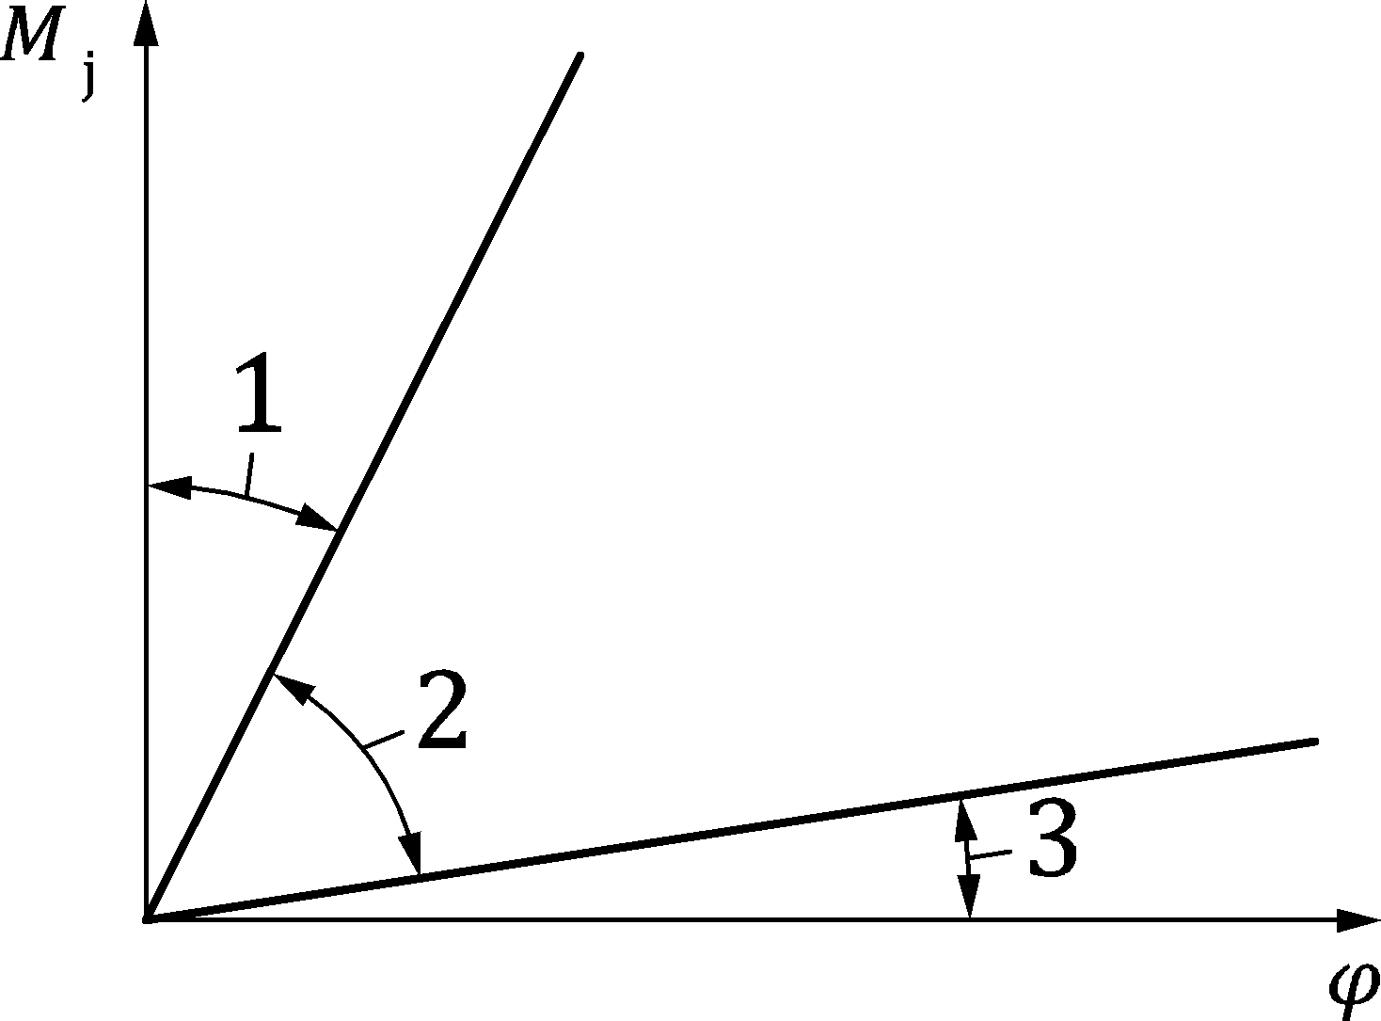 | Zone 1: rigid, if Sj,ini ≥ kb EIb / Lb  where  - kb = 8 for frames where the bracing system reduces the horizontal displacement by at least 80 %  - kb = 25 for other frames, provided that in every storey Kb/Kc ≥ 0,1a  Zone 2: semi-rigid  All joints in zone 2 should be classified as semi-rigid. Joints in zones 1 or 3 may optionally also be treated as semi-rigid.  Zone 3: nominally pinned, if Sj,ini ≤ 0,5 EIb/Lb
Key
Kb mean value of Ib/Lb for all the beams at the top of that storey
Kc mean value of Ic/Lc for all the columns in that storey
Ib moment of inertia of a beam
Ic moment of inertia of a column
Lb span of a beam (centre-to-centre of columns)
Lc storey height of a column
a For frames where Kb/Kc < 0,1 the joints should be classified as semi-rigid.
Figure 7.9 — Classification of joints other than column bases by rotational stiffness
(2) Column bases may be classified as rigid provided the following conditions are satisfied:
- in frames where the bracing system reduces the horizontal displacement by at least 80 % and where the effects of deformation may be neglected:
if ${\overline{λ}}_{0}≤0,5;$ | (7.9)
if ${0,5<\overline{λ}}_{0}<3,93 and S_{j,ini}≥7\left(2 {\overline{λ}}_{0}-1\right)EI_{c}/L_{c};$ | (7.10)
if ${\overline{λ}}_{0}≥3,93 and S_{j,ini}≥48 EI_{c}/L_{c}$ | (7.11)
- otherwise:
if $S_{j,ini}≥30 EI_{c}/L_{c}.$ | (7.12)
where
${\overline{λ}}_{0}$ slenderness of a column in which both ends are assumed to be pinned;
Ic, Lc as given in the key to Figure 7.9.

Classification by moment resistance

General
(1) Joints should be classified as full-strength, nominally pinned, or partial-strength by comparing their design moment resistance Mj,Rd with the design moment resistance of the members that are connected.
(2) When classifying joints, the design resistance of a member should be taken as of the member’s section adjacent to the joint.

Nominally pinned joints
(1) Nominally pinned joints should be capable of transmitting the internal forces, without developing significant moments which might adversely affect the members or the structure as a whole.
(2) Nominally pinned joints should be capable of sustaining the resulting rotations under the combinations of actions at ultimate limit states.
(3) Joints should be classified as nominally pinned if their design moment resistance Mj,Rd is not greater than 0,25 times the design moment resistance required for full-strength joints, provided that they also develop sufficient rotation capacity.

Full-strength joints
(1) Joints should be classified as full-strength if the criteria given in Figure 7.10 are met.
(2) The design resistance of full-strength joints should not be less than that of the connected member.
- Top of column |  | Mj,Rd | either Mj,Rd ≥ Mb,pl,Rd  or Mj,Rd ≥ Mc,pl,Rd
- Within column height | 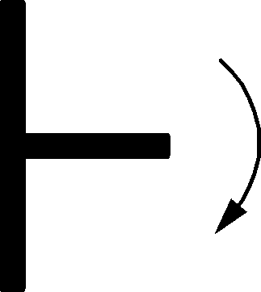 | Mj,Rd | either Mj,Rd ≥ Mb,pl,Rd  or Mj,Rd ≥ 2 Mc,pl,Rd
Key
Mb,pl,Rd design plastic moment resistance of a beam
Mc,pl,Rd design plastic moment resistance of a column
Figure 7.10 — Full-strength joints

Partial-strength joints
(1) Joints that do not meet the criterion for full-strength joints or nominally pinned joints should be classified as partial-strength ones.

Structural joints connecting H or I sections

General
(1) The design methods in Clause 8 should be used to determine the structural properties of joints connecting H or I sections. To apply these methods, joints should be modelled as an assembly of basic components.
(2) The basic components identified in Table 8.1 should be used. Their properties should be determined in accordance with the provisions given in Annex A. Other basic components may be used provided their properties are based on tests, or analytical and numerical methods supported by tests, see Annex D of prEN 1990:2020.
Table 8.1 — Basic joint components
Component | Designation | Graphical representation | Reference to application rules
Column web panel in shear | wp | 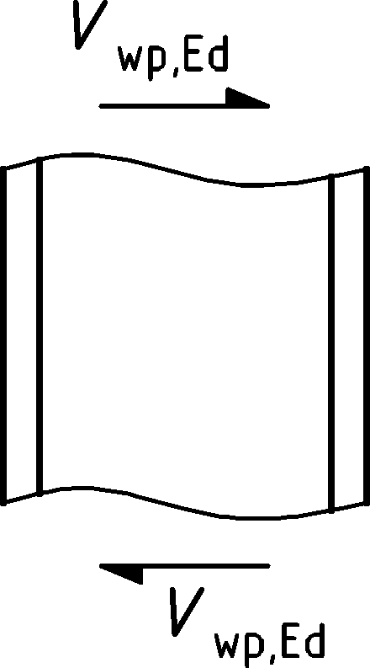 | A.4
Column web in transverse compression | c,wc | 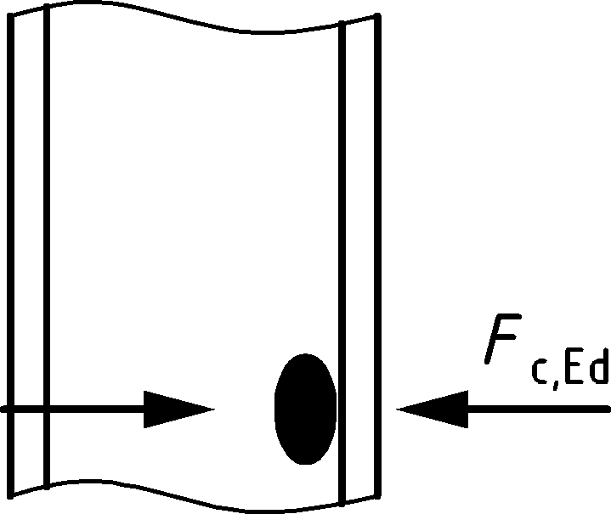 | A.5
Column web in transverse tension | t,wc | 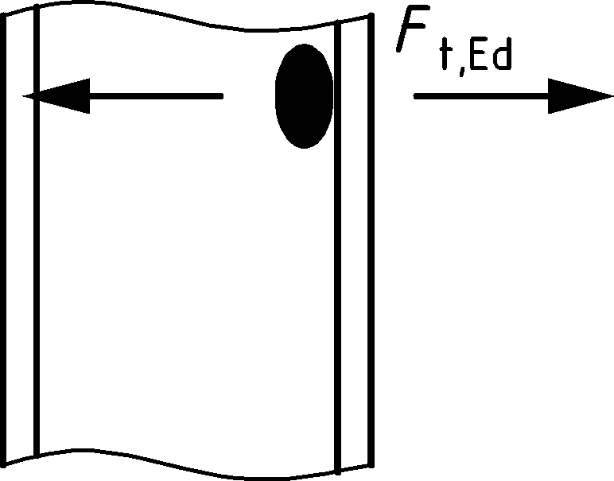 | A.6
Column flange in bending | t,fc | 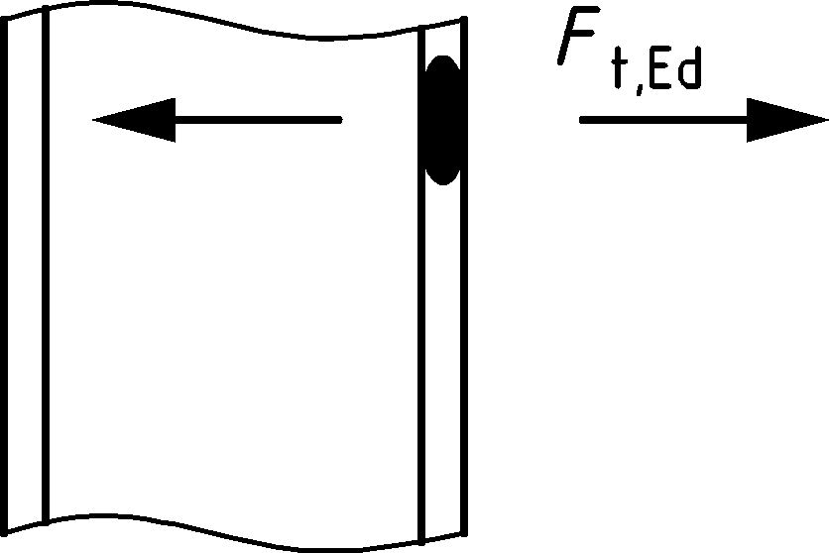 | A.7
End plate in bending | t,ep | 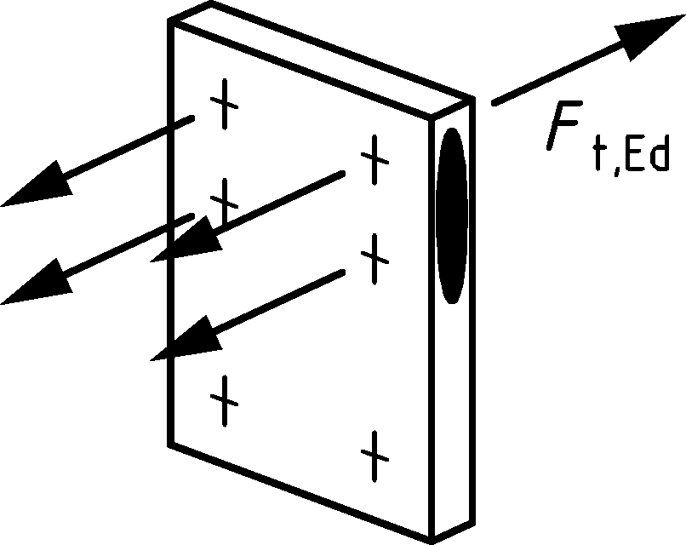 | A.8
Flange cleat in bending | t,cl | 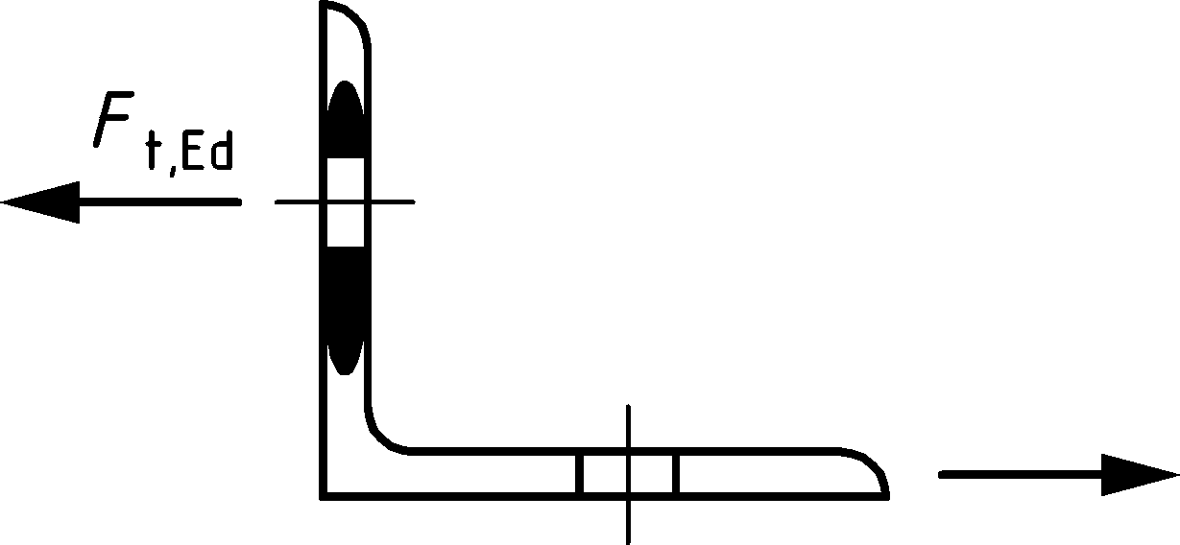 | A.9
Beam or column flange and web in compression | c,fb | 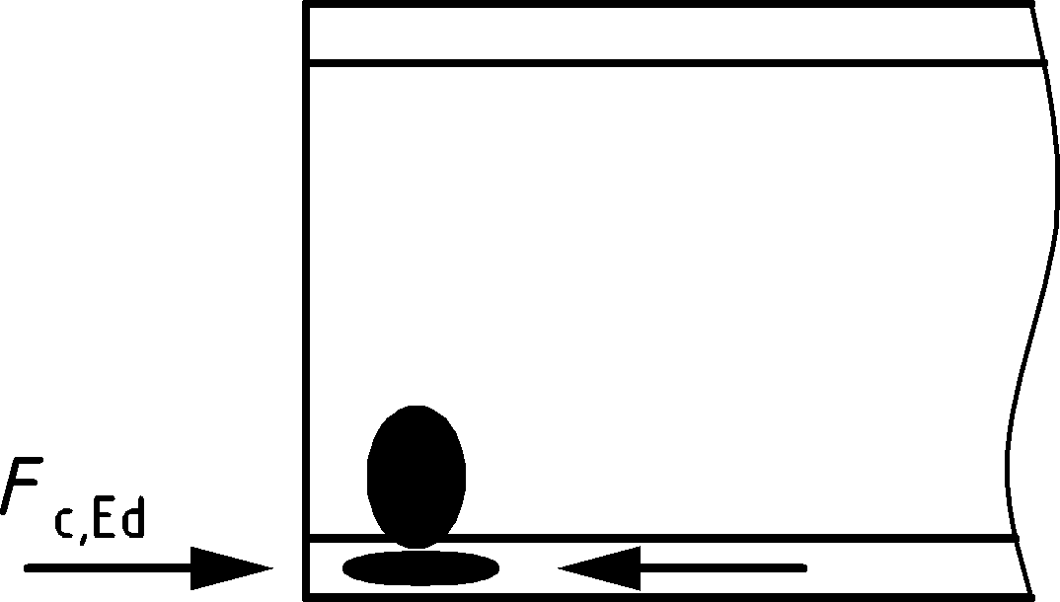 | A.10
Beam web in tension | t,wb | 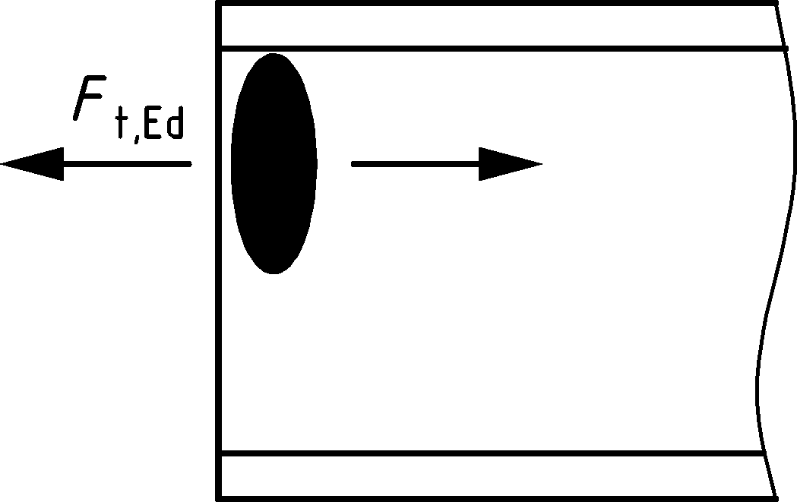 | A.11
Plate in tension | t,p |  | A.12
Plate in compression | c,p |  | A.12
Bolts in tension | t | 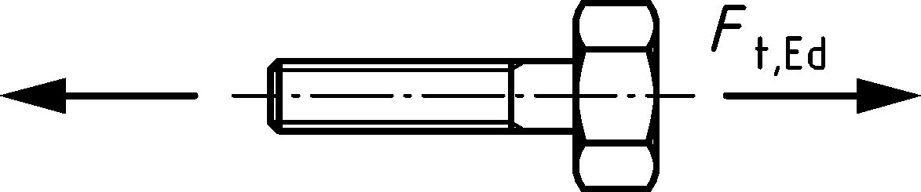 | A.13
Bolts in shear | v | 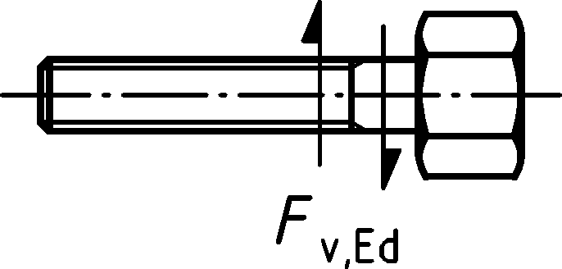 | A.14
Bearing at bolt holes | b | 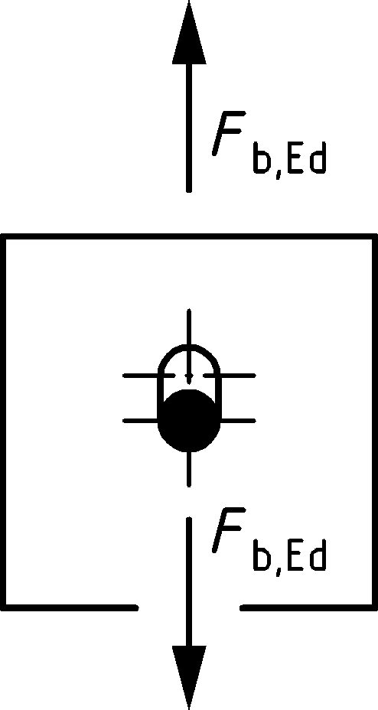 | A.15
Concrete and base plate in compression | c,bp |  | A.16
Base plate in bending under tension | t,bp |  | A.17
Anchor bolts in tension | tb |  | A.18
Anchoring components in tension | ta |  | A.19
Anchor bolts in shear | vb |  | A.20
Anchoring components in shear | va |  | A.21
Welds | w |  | A.22
Beam haunch | hb | 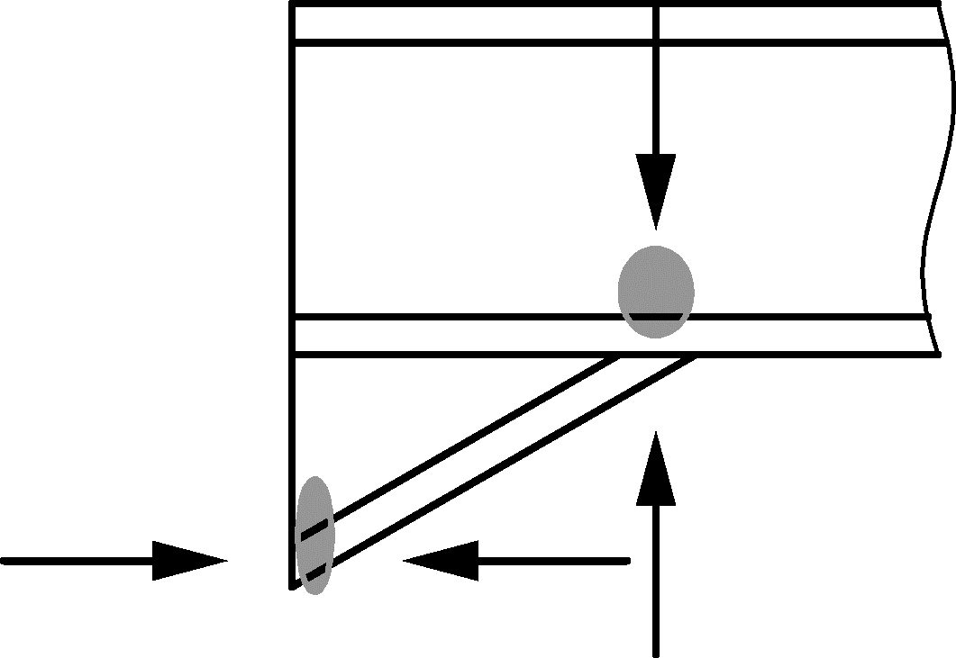 | A.23

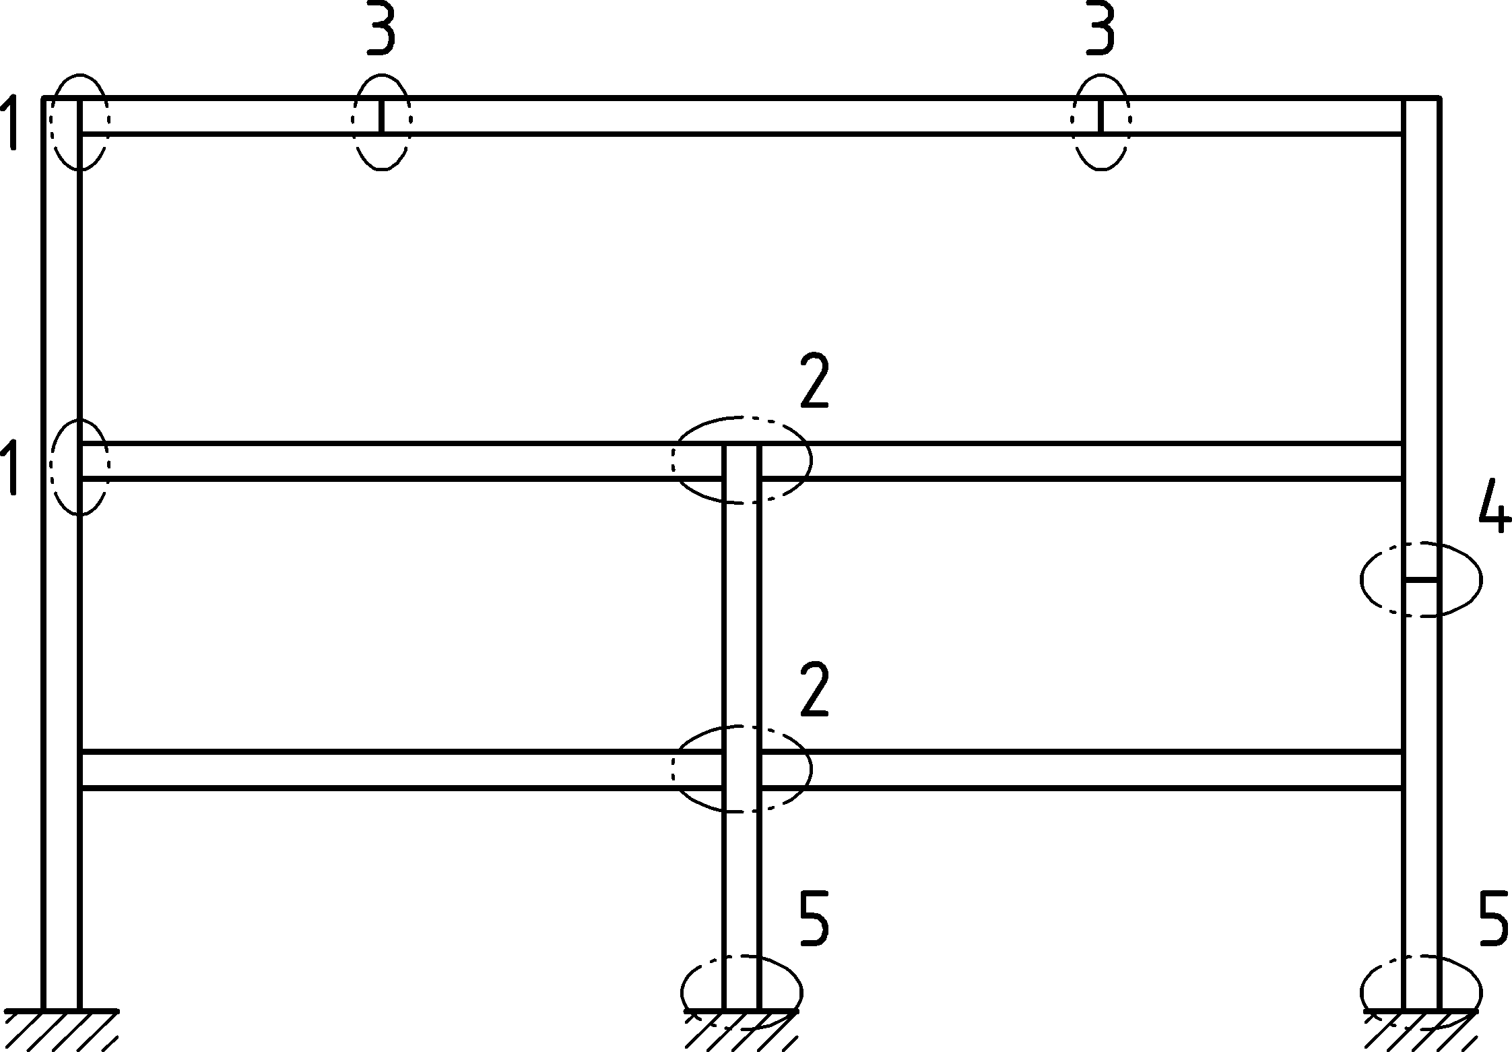
a) Major-axis joint configuration
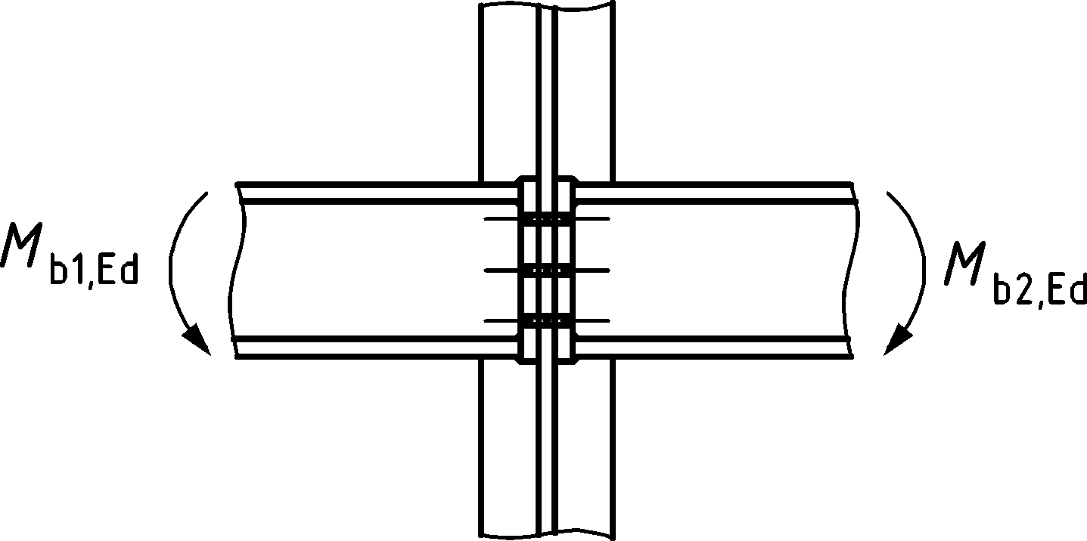 | 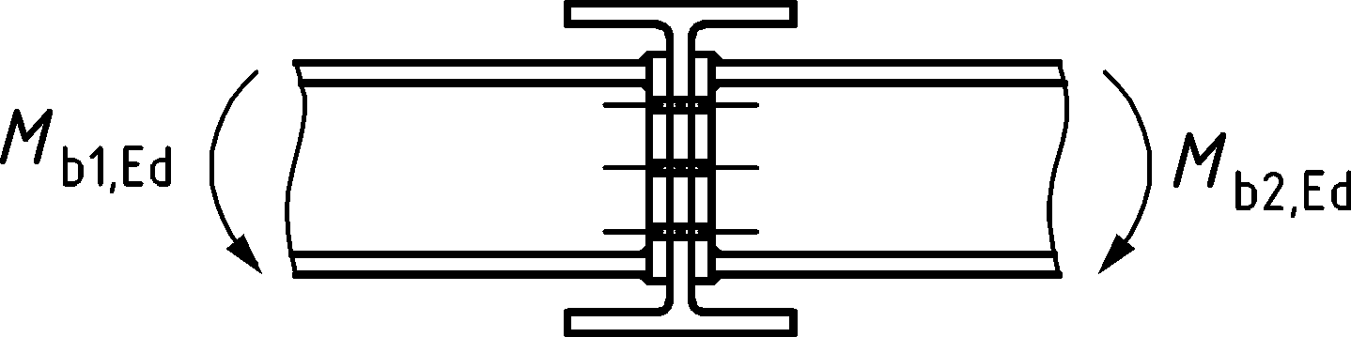
Double-sided beam-to-column joint configuration | Double-sided beam-to-beam joint configuration
b) Minor-axis joint configuration (to be used only for balanced moments Mb1,Ed = Mb2,Ed)
Key
1 single-sided beam-to-column joint configuration
2 double-sided beam-to-column joint configuration
3 beam splice
4 column splice
5 column base
Figure 8.1 — Structural joints connecting H or I sections
(3) The design methods for basic joint components given in this Standard are of general application and may also be applied to similar components in other type of joint configurations. However, the specific design methods for determining the design moment resistance, rotational stiffness and rotation capacity of a joint are based on an assumed distribution of internal forces for the joint configurations indicated in Figure 8.1. For other joint configurations, design methods for determining these properties should be based on appropriate assumptions for the distribution of internal forces.
(4) For steels with grades higher than S460:
a) if plastic global analysis is used (see 7.1.3 and 7.1.4), joints should be full-strength;
b) if elastic global analysis is used, partial-strength joints may be used, provided that their resistance exceeds the internal forces and moments acting on the joint.
(5) For steels with grades higher than S460, the resistance of joints should be determined based on elastic distribution of internal forces in the joint.

Structural properties
(1) The structural properties of joints should be based on the properties of its relevant components, which should be chosen among those in Table 8.1.
(2) The relationships between the properties of the basic components of a joint obtained from Annex A and the structural properties of the joint should be in accordance with:
- Annex B for moment-resisting beam-to column joint configurations, beam and column splices;
- Annex C for nominally pinned connections;
- Annex D for column bases.
NOTE Figure 8.2 illustrates the basic components of an extended end plate beam-to-column joint with two bolt rows in tension, as well as the mechanical model used to derive the simplified model with rotational spring representing the design moment-rotation curve of the joint.
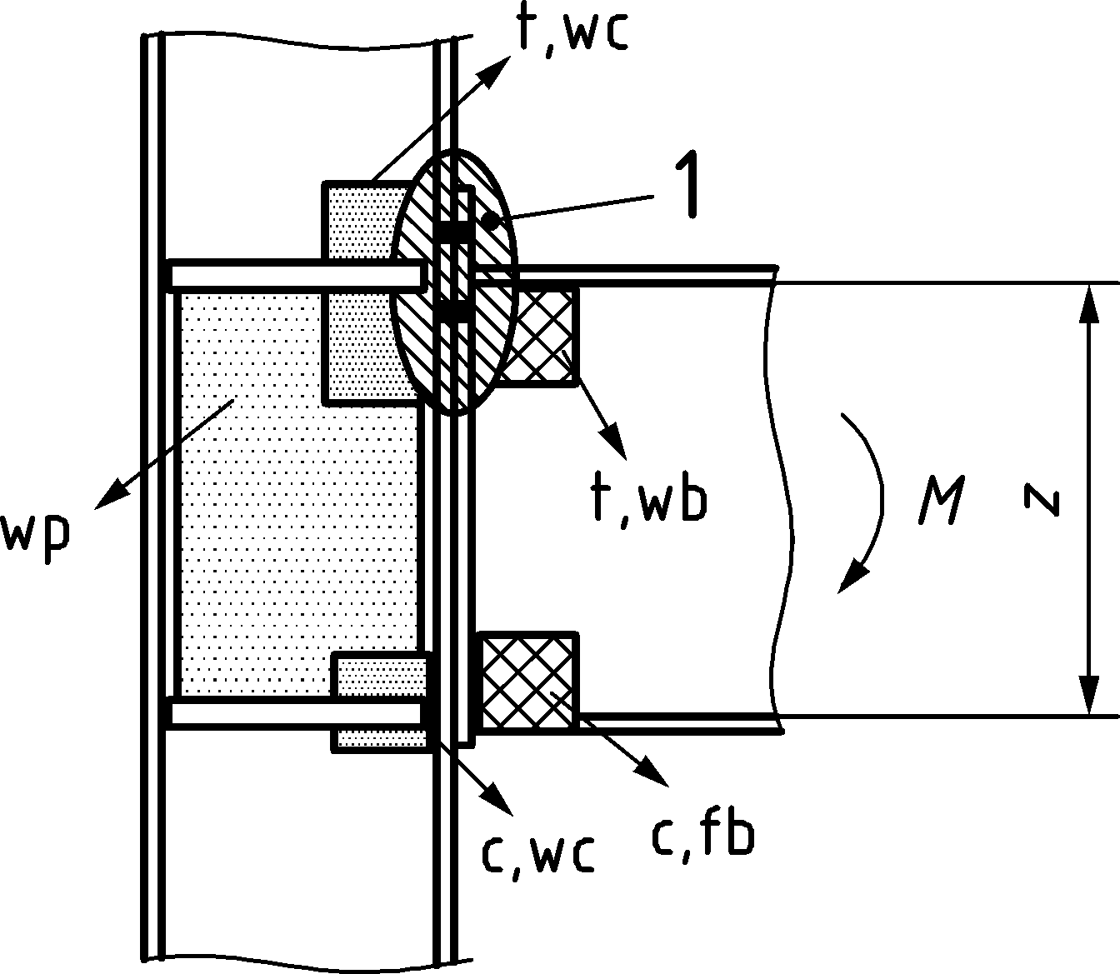 | 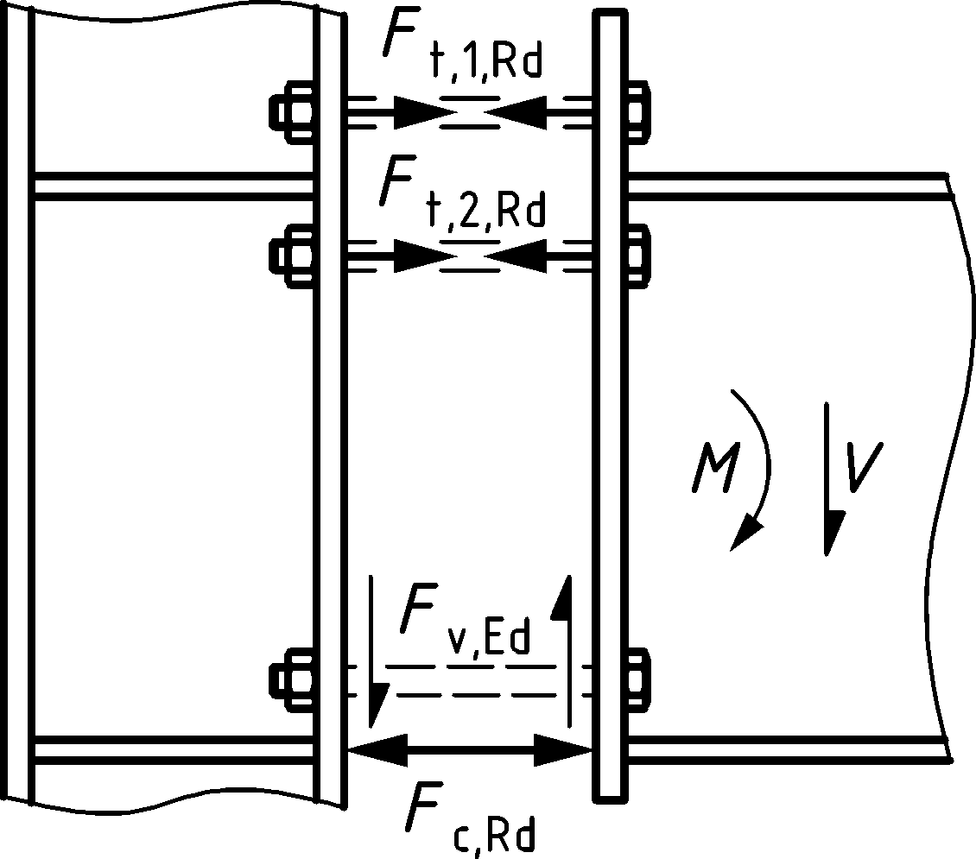
a) joint | b) resistance model
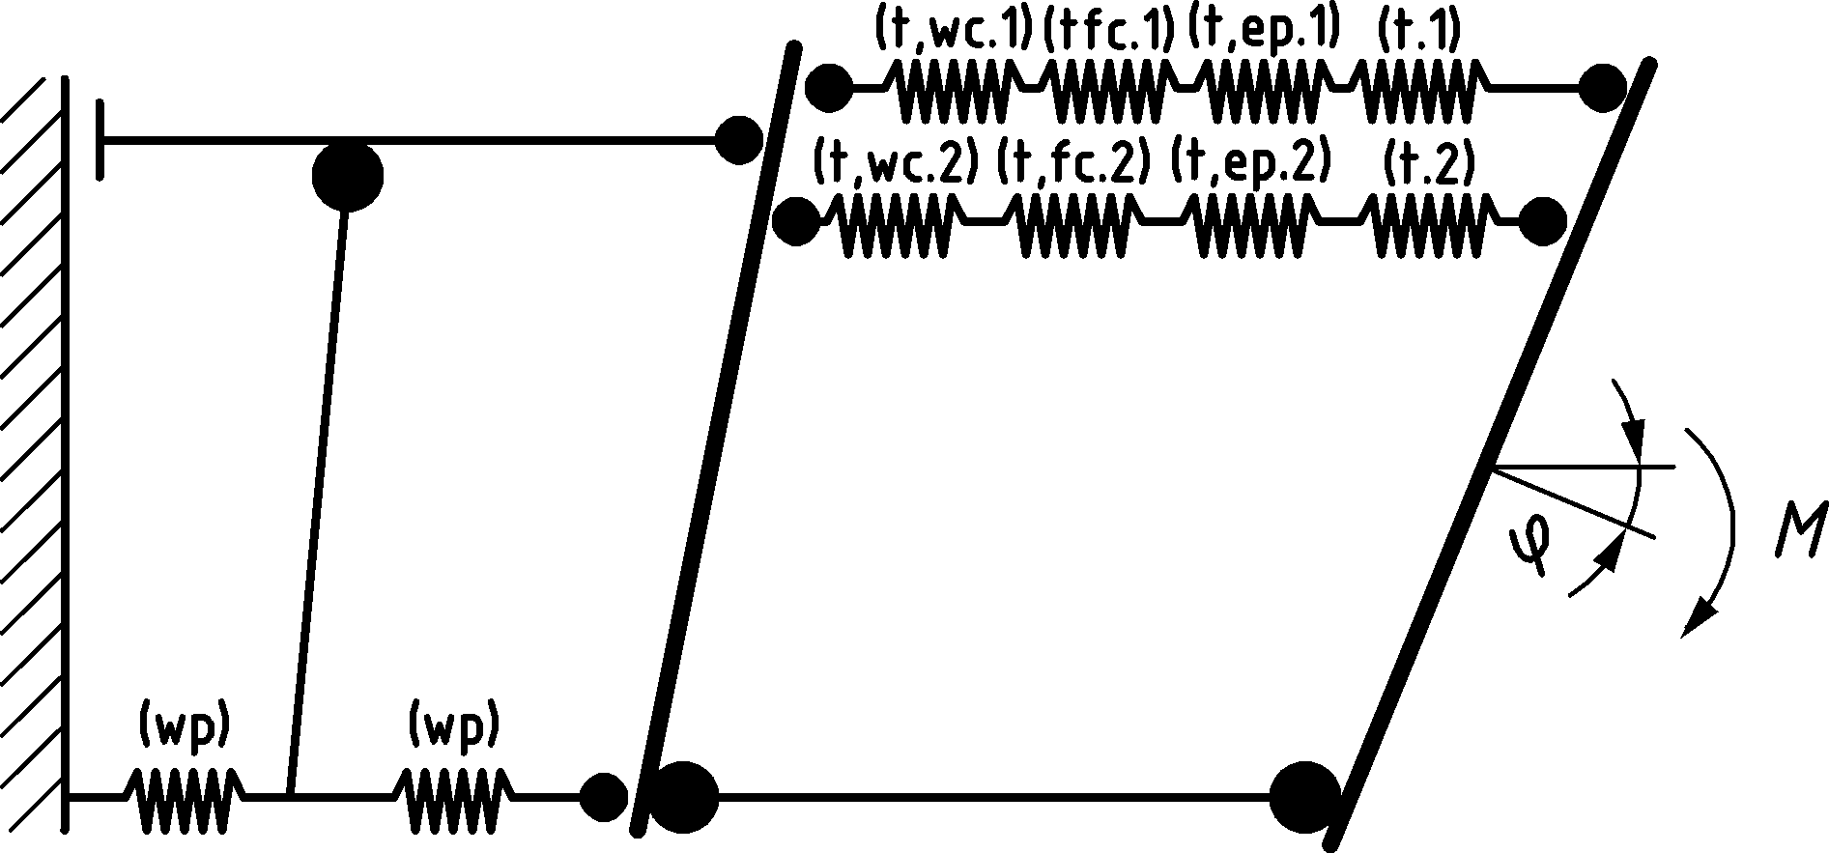 | 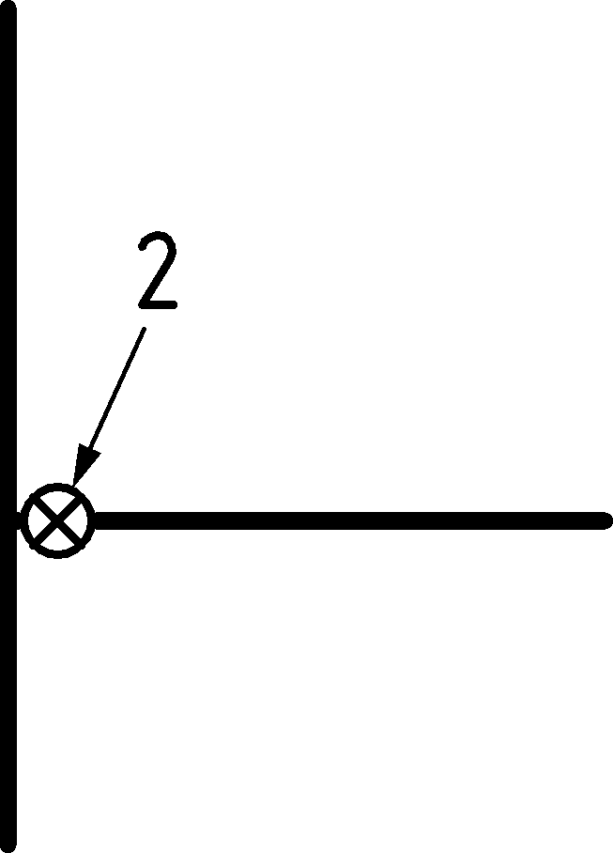
c) mechanical model | d) simplified model with rotational spring based on c) (see also Figure 7.8)
Key
1 T-stub idealisation for t,ep and t,fc
2 limit for Sj
Figure 8.2 — Example of basic components, resistance model, mechanical and simplified model for a single-sided beam‐to‐column joint configuration with bolted end plate connection with two bolt rows in tension

Equivalent T-stub in tension

Application
(1) The equivalent T-stub in tension may be used to model the design resistance of the following basic components in bolted joints:
- column flange in bending;
- end plate in bending;
- flange cleat in bending;
- base plate in bending under tension.
NOTE Annex A gives methods for modelling these basic components as equivalent T-stub flanges, including the values to be used for emin, leff and m.

Modes of failure
(1) The possible modes of failure of the flange of the equivalent T-stub may be assumed to be similar to those expected to occur in the basic component that it represents.

Total effective length
(1) The total effective length ∑leff of the equivalent T-stub, see Figure 8.3, should be such that the design resistance of its flange is equivalent to that of the basic joint component that it represents.
NOTE The effective length of the equivalent T-stub is a notional length and does not necessarily correspond to the physical length of the basic joint component that it represents.

Design tension resistance
(1) The design tension resistance of a T-stub flange should be determined from Table 8.2.
NOTE 1 Prying effects are implicitly taken into account when determining the design tension resistance according to Table 8.2.
NOTE 2 In method 1 the force applied to the T-stub flange by a bolt is assumed to be concentrated at the centre line of the bolt. In method 2, the force applied to the T-stub flange by a bolt is assumed to be uniformly distributed under the washer, the bolt head or the nut, as appropriate, see Figure 8.4. This assumption leads to a higher value for mode 1, but leaves the values for F_{T,1-2,Rd} and modes 2 and 3 unchanged, see Table 8.2.

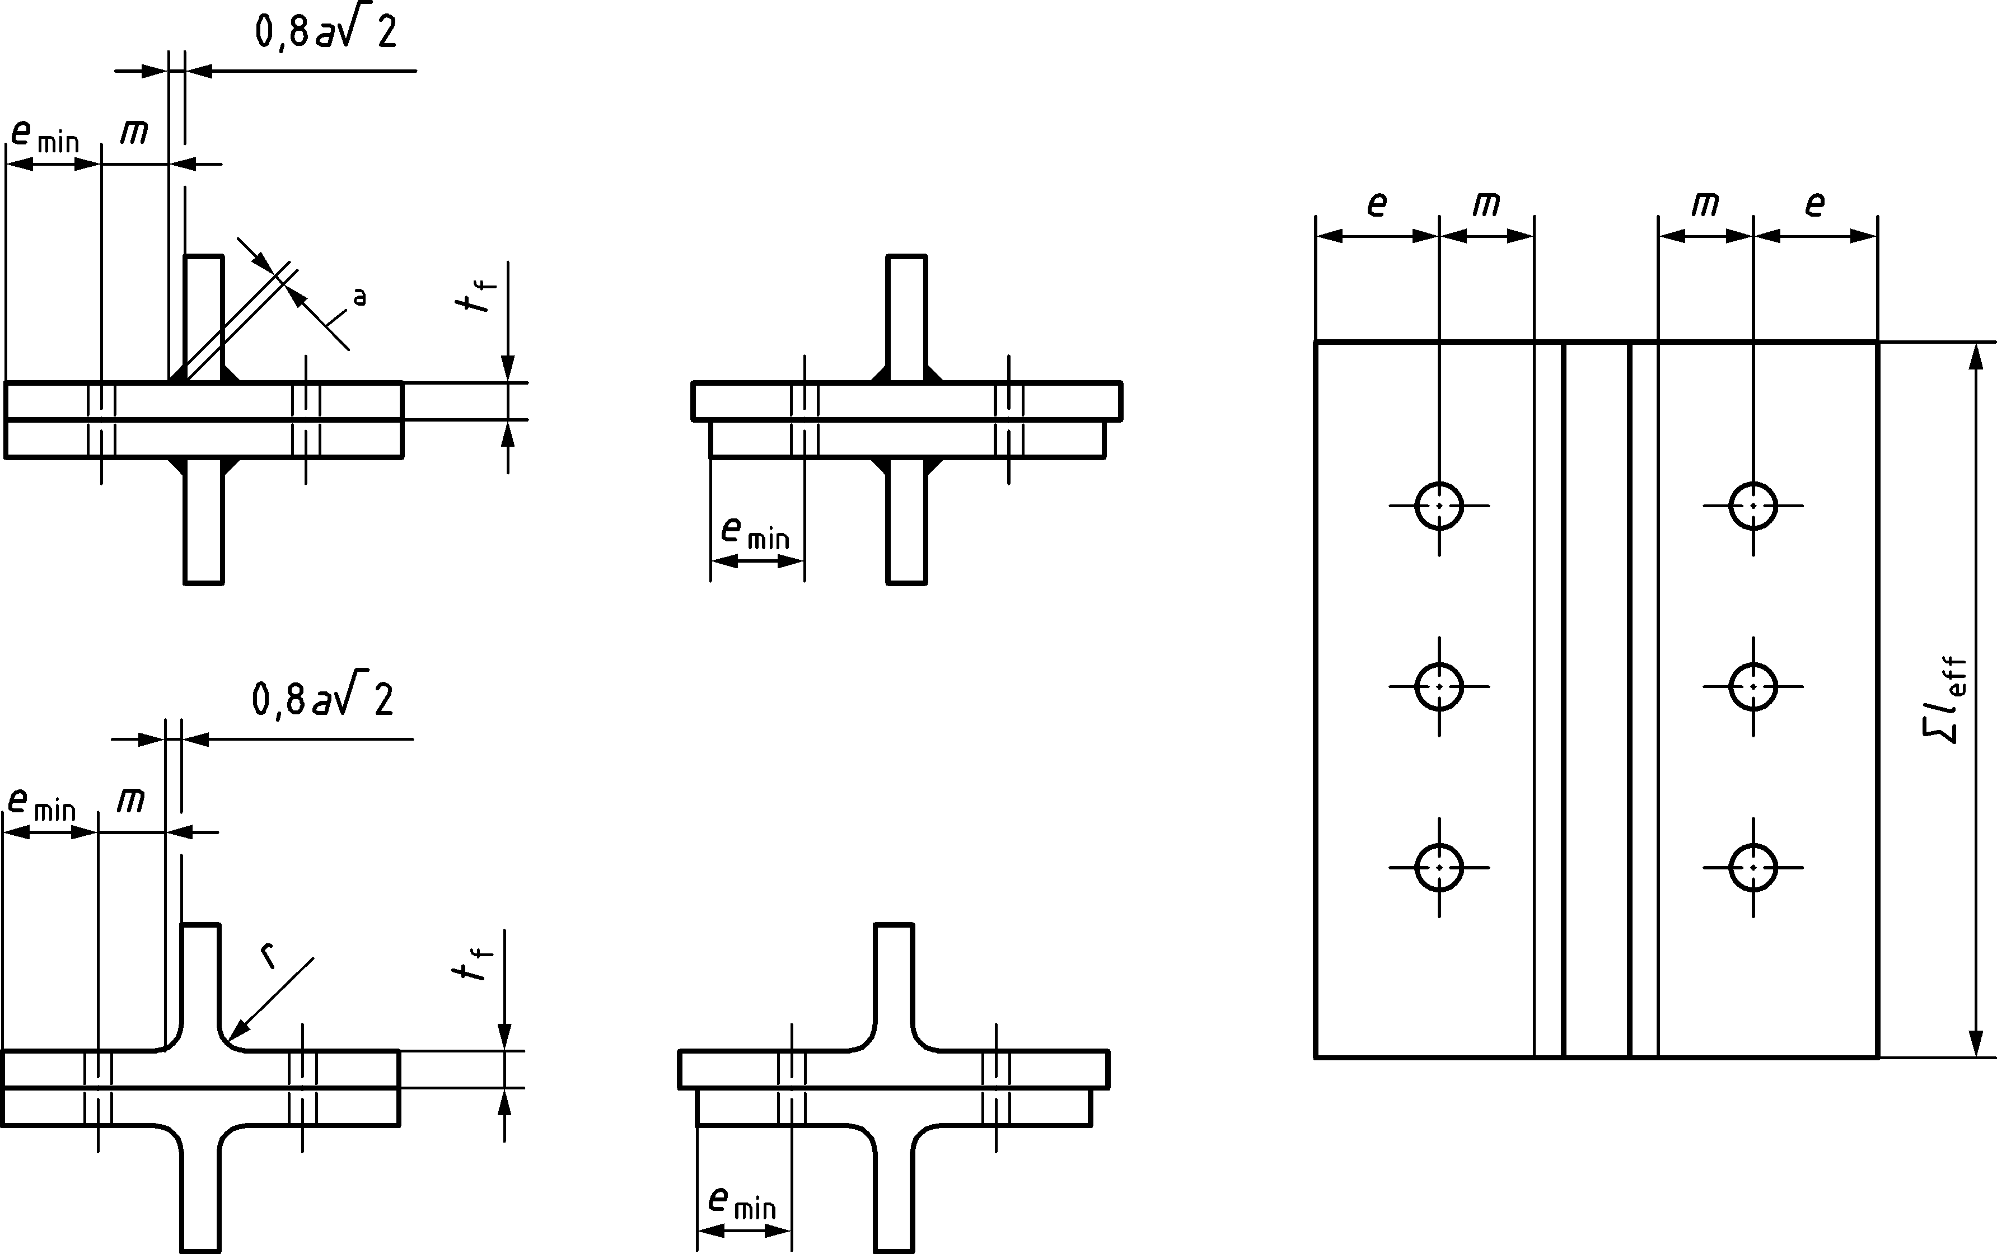
Figure 8.3 —Dimensions of an equivalent T-stub flange
(2) In cases where prying forces may develop, see Table 8.2, the design tension resistance of a T-stub flange FT,Rd should be taken as the smallest value for the three possible failure modes 1, 2 and 3.
(3) In cases where prying forces may not develop the design tension resistance of a T-stub flange FT,Rd should be taken as the smallest value for the two possible failure modes 1-2 and 3 according to Table 8.2.
(4) In bolted beam-to-column joints or beam splices it should be assumed that prying forces will develop.
(5) The rules given for determining the resistance of the equivalent T-stub in tension may be used for non-preloaded bolts as well as for preloaded bolts, irrespective of the value of the preload.
NOTE The rules given for determining the stiffness of the equivalent T-stub in tension are influenced by the presence of a preload in the bolts. The stiffness coefficients of the relevant components for non-preloaded bolts and for preloaded bolts in accordance with 5.1.2(1) are given in Annex A.
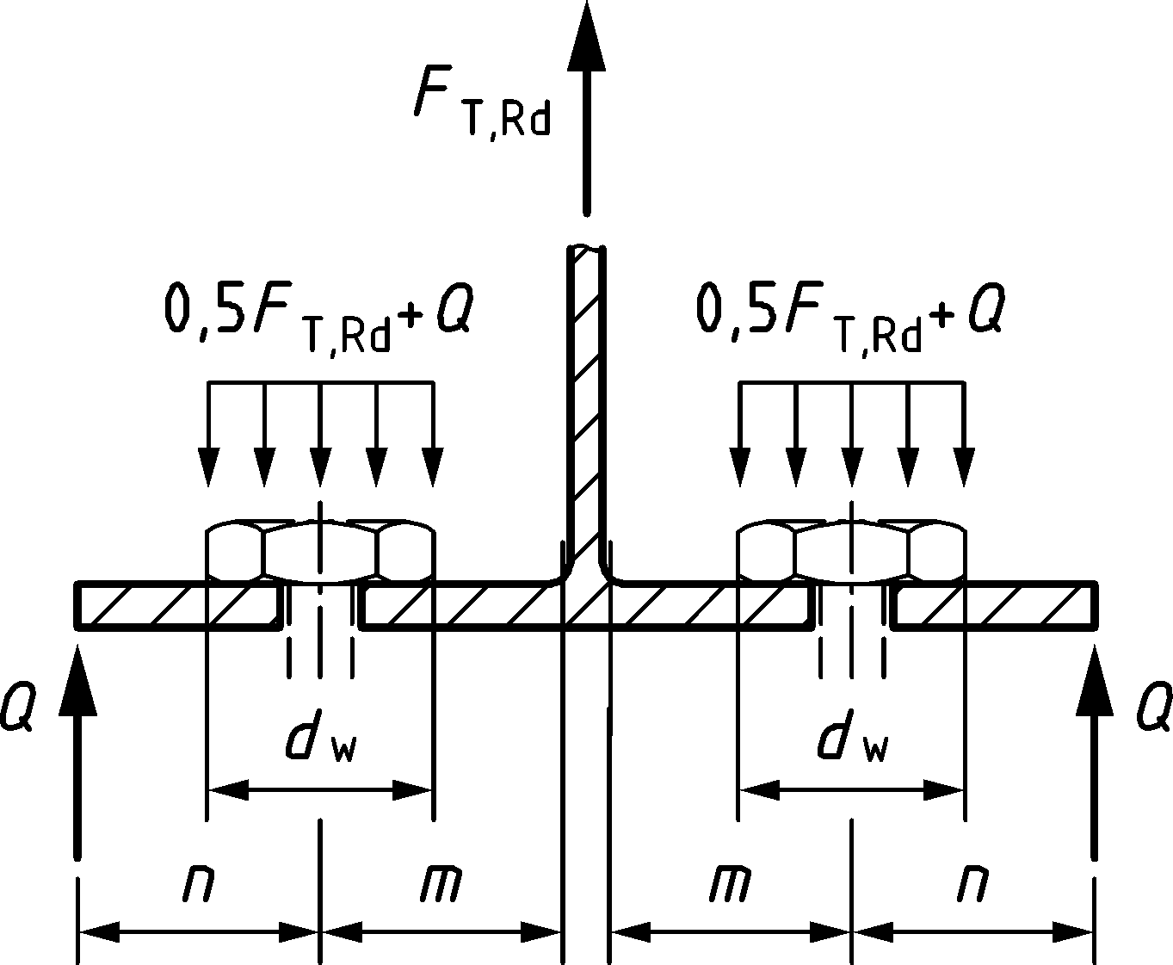
Figure 8.4 — Notations for method 2
Table 8.2 — Design tension resistance FT,Rd of a T-stub flange
 | Prying forces may develop, i.e. $L_{b}≤L_{b}^{*}$ |  | No prying forces
Mode 1 | Method 1 | Method 2 (alternative method) | $$F_{T,1-2,Rd}=\frac{2M_{pl,1,Rd}}{m}$$
without backing plates | $$F_{T,1,Rd}=\frac{4M_{pl,1,Rd}}{m}$$ | $$F_{T,1,Rd}=\frac{\left(8n-2e_{w}\right) M_{pl,1,Rd}}{2mn-e_{w }\left(m+n\right)}$$
with backing plates | $$F_{T,1,Rd}=\frac{4M_{pl,1,Rd}+2M_{bp,Rd}}{m}$$ | $$F_{T,1,Rd}=\frac{\left(8n-2e_{w}\right)M_{pl,1,Rd}+4nM_{bp,Rd}}{2mn-e_{w}\left(m+n\right)}$$
Mode 2 | $$F_{T,2,Rd}=\frac{2M_{pl,2,Rd}+nΣF_{t,Rd}}{m+n}$$
Mode 3 | $$F_{T,3,Rd}=ΣF_{t,Rd}$$
Mode 1: Complete yielding of the flange
Mode 2: Bolt failure with yielding of the flange
Mode 3: Bolt failure
Lb bolt elongation length, taken equal to the grip length (total thickness of material and washers), plus half the sum of the height of the bolt head and the height of the nut, or the anchor bolt elongation length, taken equal to the sum of 8 times the nominal bolt diameter, the grout layer, the plate thickness, the washer and half the height of the nut.
$$L_{b}^{*} =\frac{8,8 m^{3}A_{s}n_{b}}{Σl_{eff,1} {t_{f}}^{3}}$$
FT,Rd design tension resistance of a T-stub flange
Q = ∑Ft,Rd − FT,Rd prying force
Mpl,1,Rd = 0,25 Σleff,1 tf2 fy/γM0
Mpl,2,Rd = 0,25 Σleff,2 tf2 fy/γM0
Mbp,Rd = 0,25 Σleff,1 tbp2 fy,bp/γM0
n = min(emin; 1,25 m)
m distance from the centre of the bolt to 20% distance into profile root or weld
nb number of bolt rows (with 2 bolts per row)
Ft,Rd design tension resistance of a bolt, see Table 5.7, or an anchor bolt, see A.18.1.
∑Ft,Rd total value of Ft,Rd for all the bolts in the T-stub;
∑leff,1 = min(∑leff,cp; ∑leff,nc) is the value of ∑leff for mode 1;
∑leff,2 = ∑leff,nc is the value of ∑leff for mode 2;
∑leff,cp and ∑leff,nc are given in Annex A;
emin, m and tf are shown in Figure 8.43.
fy,bp yield strength of the backing plates;
tbp thickness of the backing plates;
ew = dw/4;
dw diameter of the washer, or width across points of the bolt head or nut, as relevant.

Individual bolt rows, bolt groups and groups of bolt rows
(1) Although in an actual T-stub flange the forces at each bolt row are generally equal, when an equivalent T-stub flange is used to model a basic component listed in 8.3.1(1) the difference in forces at each bolt row should be taken into account.
(2) When using the equivalent T-stub approach to model a group of bolt rows the group may be divided into separate bolt rows and equivalent T-stubs may be used to model each separate bolt row.
(3) When using the T-stub approach to model a group of bolt rows the following conditions should be satisfied:
- the force at each bolt row should not exceed the design resistance determined considering only that individual bolt row;
- the total force on each group of bolt rows, comprising two or more adjacent bolt rows within the same bolt group, should not exceed the design resistance of that group of bolt rows.
(4) When determining the design tension resistance of a basic component represented by an equivalent T-stub flange, the following parameters should be calculated:
- the design resistance of an individual bolt row, determined considering only that bolt row;
- the contribution of each bolt row to the design resistance of two or more adjacent bolt rows within a bolt group, determined considering only those bolt rows.
(5) In the case of an individual bolt row, ∑leff should be taken as equal to the effective length leff given in Annex A for that bolt row taken as an individual bolt row.
(6) In the case of a group of bolt rows, ∑leff should be taken as the sum of the effective lengths leff given in Annex A for each relevant bolt row taken as part of a bolt group.

Equivalent T-stub in compression

Application
(1) The flange of the equivalent T-stub in compression may be used to model the design resistance of the following basic components in steel-to-concrete connections:
- the steel base plate in bending under the bearing pressure on the foundation;
- the concrete and/or grout in bearing.

Total effective length and width
(1) The total effective length leff and the total effective width beff of the equivalent T-stub should be such that the design compression resistance of the T-stub is equivalent to that of the basic component it represents.
NOTE The effective length and width of the equivalent T-stub are notional values and do not necessarily correspond to the physical dimensions of the basic joint component that it represents.

Design compression resistance
(1) The design compression resistance of a T-stub flange FC,Rd should be determined as follows:
$$F_{C,Rd}=f_{jd} b_{eff} l_{eff}$$ | (8.1)
where
beff is the effective width of the T-stub flange, see 8.4.3(3) and 8.4.3(4);
leff is the effective length of the T-stub flange, see 8.4.3(3) and 8.4.3(4);
fjd is the design bearing strength of the joint, see 8.4.3(5).
(2) The forces transferred through a T-stub should be assumed to spread uniformly, as shown in Figure 8.5(a) and (b). The pressure on the resulting bearing area should not exceed the design bearing strength fjd, and the additional bearing width c should not exceed the following value:
$$c=t_{f}\sqrt{\frac{f_{y}}{3f_{jd}γ_{M0}}}$$ | (8.2)
where
tf is the thickness of the T-stub flange;
fy is the yield strength of the T-stub flange.
(3) Where the projection of the physical length of the basic joint component represented by the T-stub is less than c, see Formula (8.2), the effective area should be taken according to Figure 8.5(a).
(4) Where the projection of the physical length of the basic joint component represented by the T-stub exceeds c on any side, the part of the additional projection beyond the width c should be neglected, see Figure 8.5 (b).
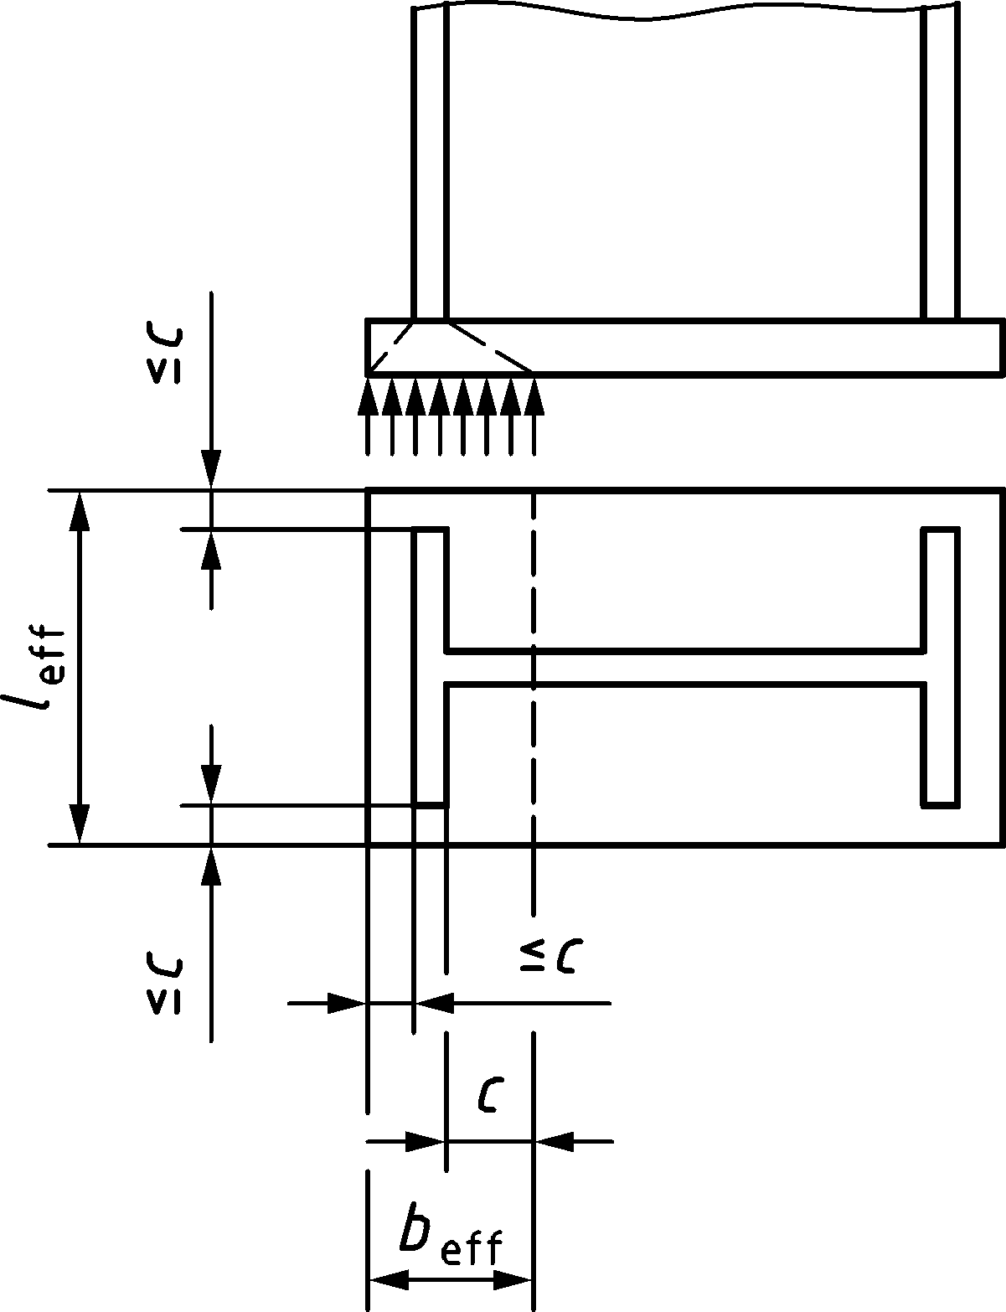 | 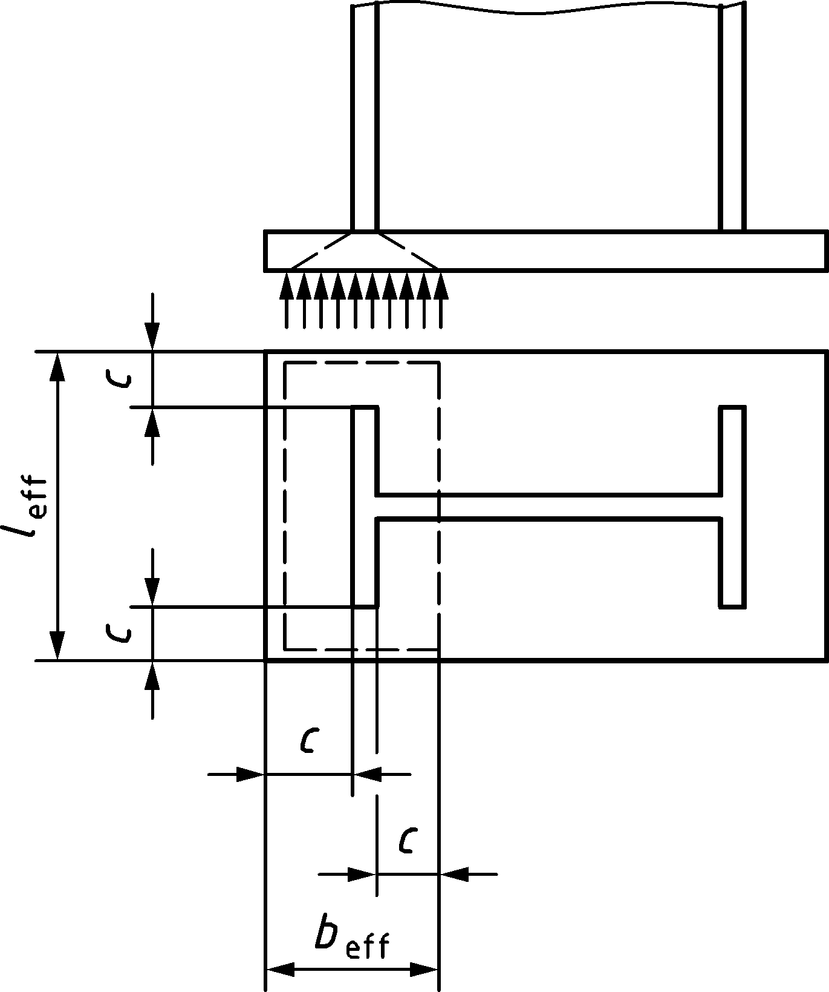
(a) Short projection | (b) Large projection
Figure 8.5 — Area of equivalent T-Stub in compression
(5) The design bearing strength of the joint fjd should be obtained from:
$$f_{jd}=β_{j}F_{Rdu} / (b_{eff} l_{eff})$$ | (8.3)
where
βj foundation joint material coefficient, which may be taken as 2/3 provided that the characteristic strength of the grout is not less than 0,2 times the characteristic strength of the concrete foundation and the thickness of the grout is not greater than 0,2 times the smallest width of the steel base plate. If the thickness of the grout is more than 50 mm, the characteristic strength of the grout should be at least the same as that of the concrete foundation.
FRdu concentrated design resistance force given in EN 1992, where Ac0 is to be taken as beffleff.

Hollow section joints

General

Scope
(1) Clause 9 gives application rules to determine the design resistances of uniplanar and multiplanar joints in lattice structures composed of circular, square or rectangular hollow sections, and of uniplanar joints in lattice structures composed of combinations of hollow sections with open sections.
(2) The design resistance of the joints should be expressed in terms of the maximum design axial and/or moment resistances of the brace members.
(3) The application rules given in Clause 9 apply both to hot finished hollow sections conforming to EN 10210 and for cold formed hollow sections conforming to EN 10219 that meet the geometrical limits given in Clause 9.
(4) The joint design resistance values should be multiplied by a material factor $C_{f}$. In the cases of chord punching shear failure and tension brace failure, in addition to multiplying by the material factor $C_{f}$, the design yield strength $f_{y0}$ and $f_{yi}$ should not exceed ${0,8f}_{u0}$ and$0,8f_{ui}$ respectively.
NOTE 1 The values for the material factor $C_{f}$ are given in Table 9.1 unless the National Annex gives different valuesf.
Table 9.1 (NDP) — Material factors to resistance
$$f_{y}≤355 N/{mm}^{2}$$ | $$C_{f}=1,00$$
$$355 N/{mm}^{2}<f_{y}≤460 N/{mm}^{2}$$ | $C_{f}=0,9$0
$$460 N/{mm}^{2}<f_{y}≤550 N/{mm}^{2}$$ | $$C_{f}=0,86$$
$$550 N/{mm}^{2}<f_{y}≤700 N/{mm}^{2}$$ | $C_{f}=0,8$0

NOTE 2 The choice of failure modes where the design yield strength is limited to 0,8fu0 or 0,8fui can be modified by the National Annex.
(5) The nominal wall thickness of hollow sections should not be less than 1,5 mm.
(6) If fatigue is a design criterion, the rules given in EN 1993-1-9 should be followed.

Field of application
(1) The application rules for hollow section joints given in Clause 9 may be used only if all the conditions given in (2) to (10) are satisfied.
(2) The compression members should satisfy the rules for Class 1 or Class 2 in Table 7.2 of prEN 1993-1-1:2020 for the condition of axial compression.
(3) The angles $θ_{i}$ between the chords and the brace members, and between adjacent brace members, should be $θ_{i}≥{30}^{o}$. For angles $θ_{i}<{30}^{o}$ the fabricator should show that proper welds can be made. Hollow section joints with angles $θ_{i}<{30}^{o}$ should be designed assuming an angle $θ_{i}={30}^{o}$.
(4) The ends of members that meet in a joint configuration should be prepared in such a way that their cross-sectional shape is not modified.
NOTE Flattened end connections and cropped end connections are not covered in Clause 9.
(5) In K gap joint configurations, in order to ensure that the clearance is adequate for forming satisfactory welds, the gap between the brace members should not be less than $\left(t_{1}+t_{2}\right)$. A N joint configuration may be considered as a K joint configuration with $θ_{i}={90}^{o}$.
(6) In overlap joint configurations, the overlap $λ_{ov}$ should be large enough to ensure that the interconnection of the brace members is sufficient for adequate shear transfer from one brace to the other. The overlap should be at least 25 %. 100 %-overlap joint configurations with overlap large enough to allow for welding should be considered as being 100 %-overlap joint configurations for resistance calculations.
(7) The connection between the braces i and j and the chord face should be checked for shear according to 9.7.
(8) Where overlapping brace members have different thicknesses and/or different strength grades, the member with the lowest $t_{i} f_{yi}$ value should overlap the other member.
(9) Where overlapping brace members are of different widths, the narrower member should overlap the wider one.
(10) For joint configurations with a chord end not connected to other members, the chord end should be at a distance of at least $(2γ/10{)d}_{0}$ from the heel or toe of the closest brace, with a minimum distance of $2,5d_{0}$, see Figure 9.1. For Rectangular Hollow Section (RHS) chords, $d_{0}$ should be replaced by the larger of $h_{0}$ or $b_{0}$. Otherwise, the end should be welded to a cap plate with a thickness of at least ${1,5t}_{0}$, at a minimum distance of $0,5d_{0}\left(1-β\right)$ or $0,5b_{0}\left(1-β\right)$ from the brace toe or heel of the joint.

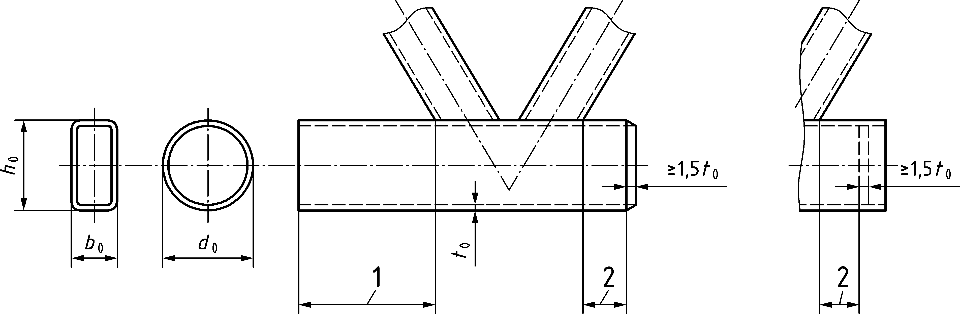
1 | $$≥\frac{2γ}{10} d_{0}≥2,5{ d}_{0}$$ | for RHS chords replace d0 by the maximum of b0 and h0
2 | $$≥0,5 d_{0} (1-β)$$ | for RHS chords replace d0 by b0

Figure 9.1 — Minimum open chord end requirements

Design

General
(1) The design values of the internal axial forces both in the brace members and in the chords at the ultimate limit state should not be more than the design resistance of the members obtained from 8.2 and 8.3 in prEN 1993-1-1:2020.
(2) The design values of the internal axial forces in the brace members at the ultimate limit state should be less than the design resistances of the joints given in 9.4, 9.5, 9.6 or 9.7 as appropriate.
(3) The chord stress ratio n0 for the chord stress function $Q_{f}$ of class 1 or 2 chord sections should be obtained at the connection from (9.1) taking account of the signs of the stresses:
$$n_{0}=\frac{N_{0,Ed}}{A_{0}f_{y0}}±\frac{M_{ip,0,Ed}}{W_{ip,pl,0}f_{y0}}$$ | (9.1)
where
- the chord compression stress $\left(n_{0}<0\right)$ should be taken as negative;
- the chord tension stress $\left(n_{0}≥0\right)$ should be taken as positive;
NOTE n0 refers to the position at the weld toe taking into account the actual stresses from normal force and local in-plane bending moment in the chord.
(4) The chord stress function Qf should be obtained with the value of n0 from (3) and should be taken at the chord side of the joint that gives the most punitive value of Qf:
$Q_{f}={\left(1-\left|n_{0}\right|\right)}^{C_{1}}$ | (9.2)
(5) For chords subjected to tension at the connection but which do not meet class 2 limits the subscript in (9.1) should be changed from “pl” to “el”. For chords subjected to compression at the connection the chord section should be class 1 or 2.

Failure modes for hollow section joints
(1) The design resistances of joints between hollow sections or between hollow and open sections, should be based on the following failure modes as applicable:
- Chord (face) failure, (plastic failure of the RHS chord face or plastic failure of the CHS chord cross-section);
- Chord side wall failure by yielding, crushing or instability (crippling or buckling of the chord side wall or chord web) under the compression brace member;
- Chord shear failure;
- Punching shear failure of a hollow section chord face (crack initiation leading to rupture of a brace member from the chord member);
- Brace failure with reduced effective width (cracking in a brace member);
- Local buckling failure of a brace member or of a hollow section chord member at the joint location;
- Brace shear failure, in overlap joint configurations.
NOTE 1 The phrases printed in boldface type in this list are used to describe the various failure modes in the tables of design resistances given in 9.4 to 9.7.
NOTE 2 Failure modes (a) to (g) are shown in Table 9.2 for joints between CHS brace and chord members, in Table 9.3 for those between RHS brace and chord members and in Table 9.4 for joints between CHS or RHS brace members and I or H section chord members.
Table 9.2 — Failure modes for joints between CHS members
Mode | Brace axial loading | Brace in-plane bending moment
a | 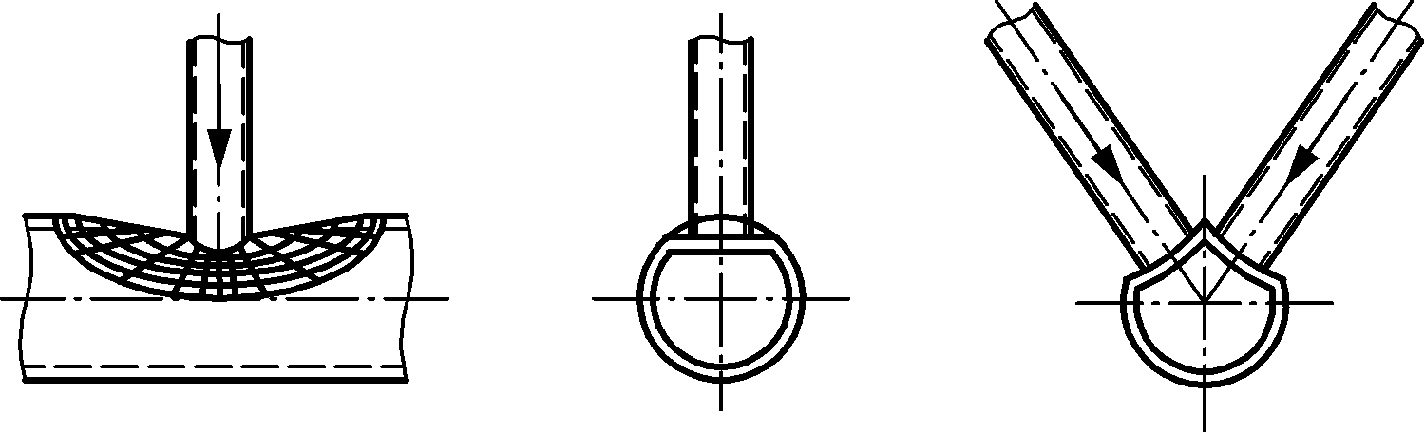 | 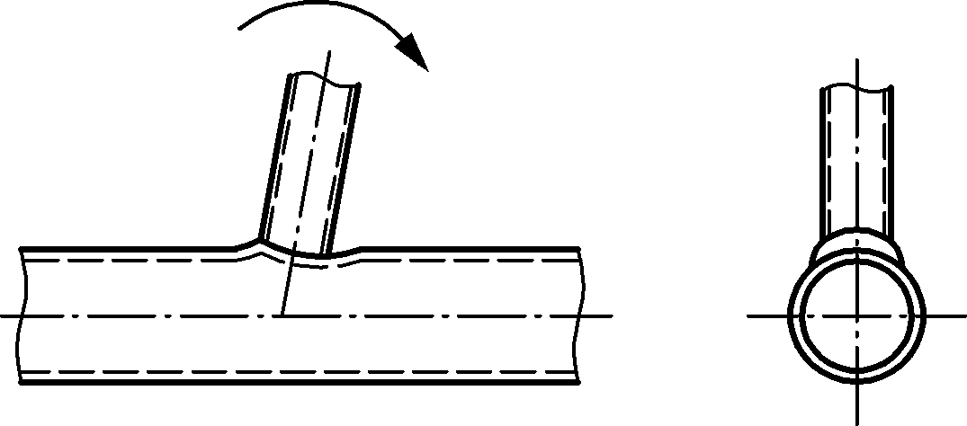
b | 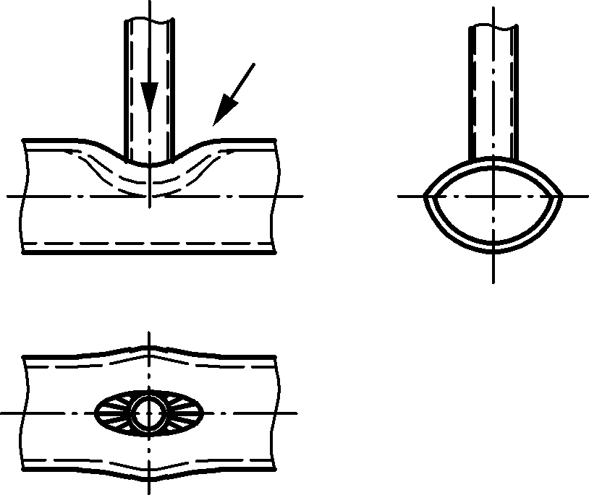 | 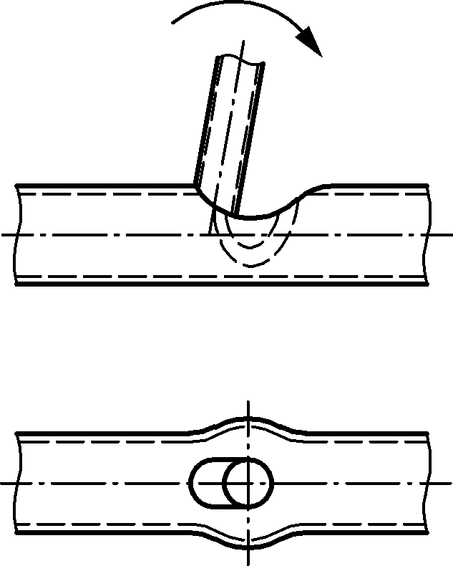
c | 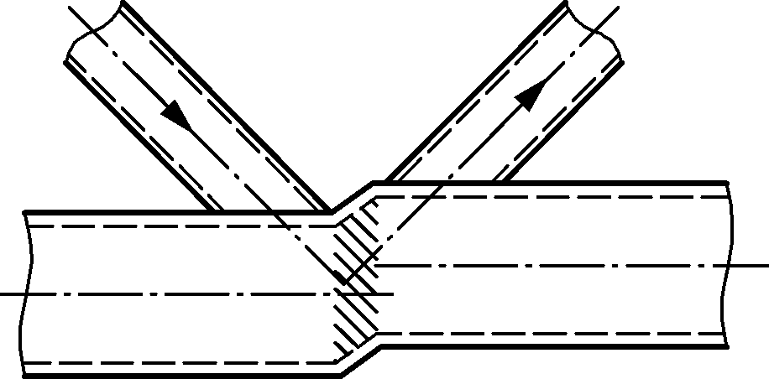 | 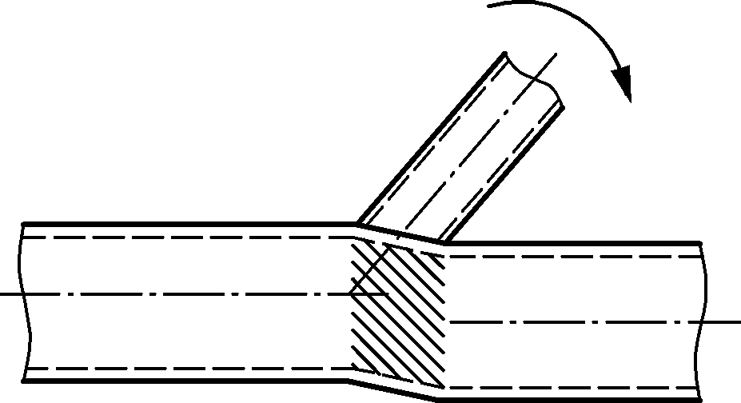
d | 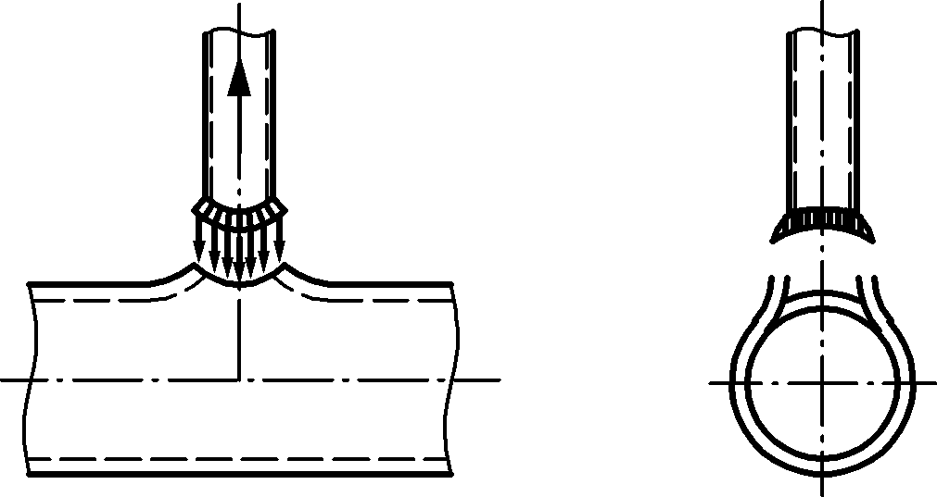 | 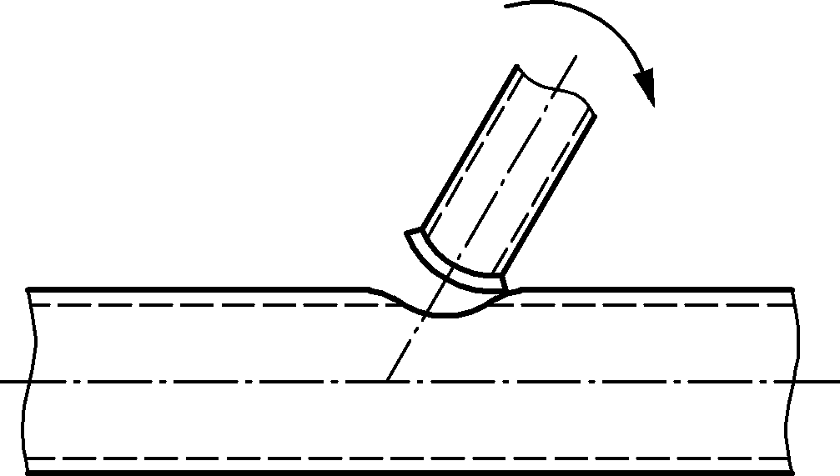
e | 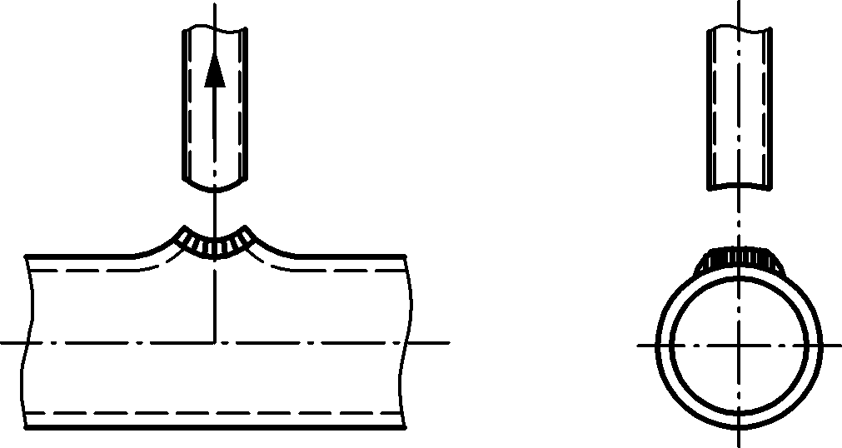 | 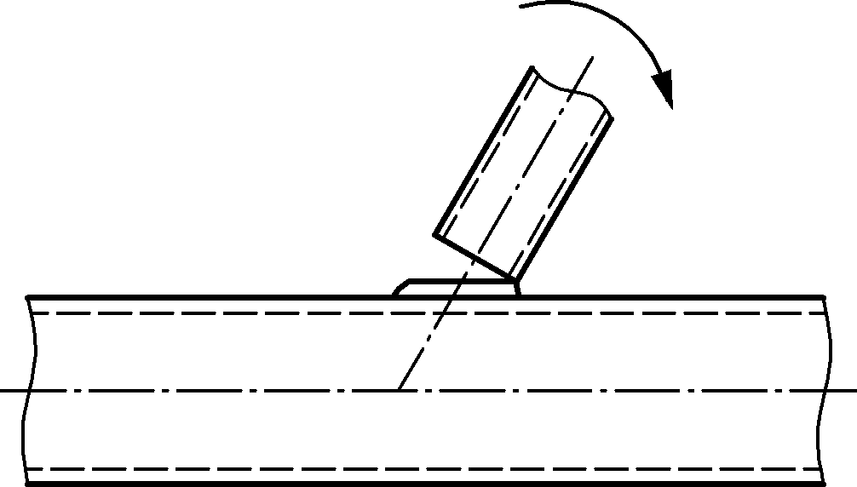
f | 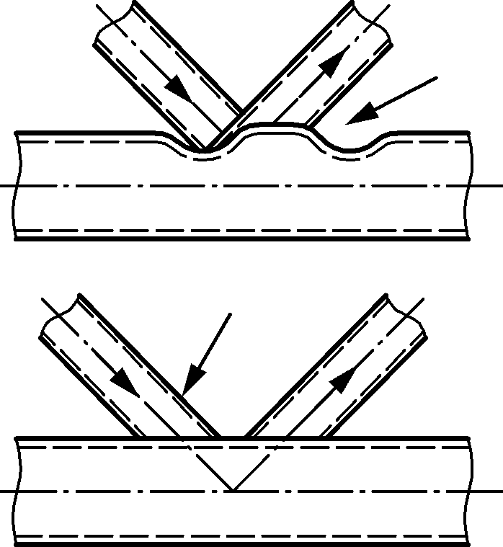 | 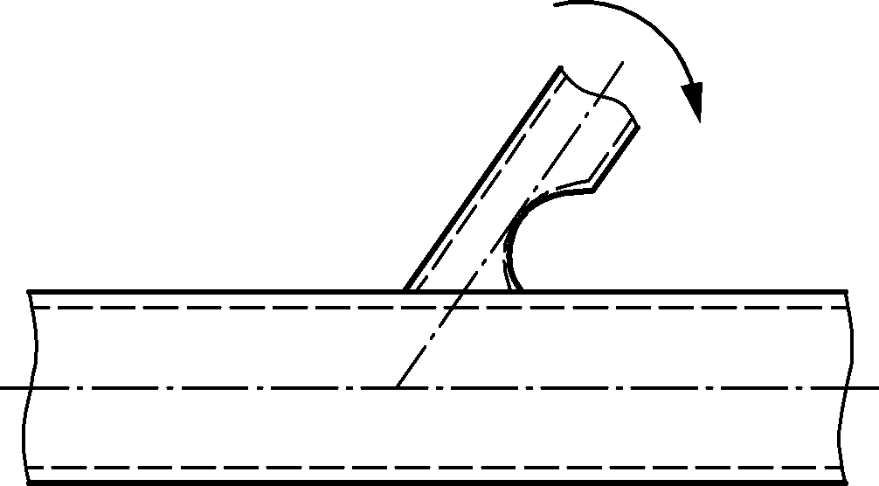
g | 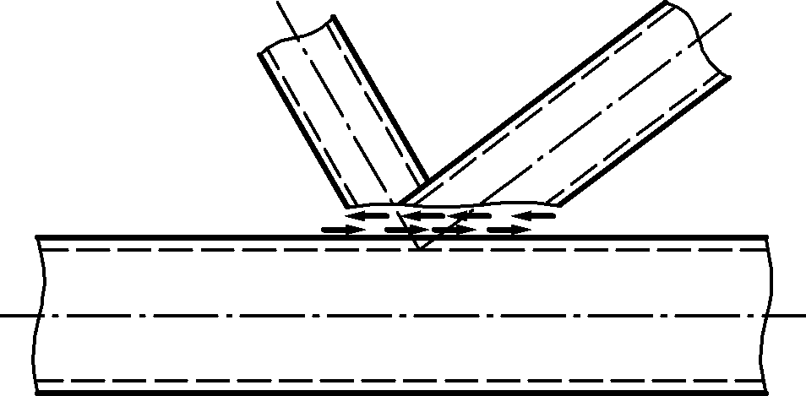 | Not applicable

Table 9.3 — Failure modes of joints between RHS brace members and RHS chord members
Mode | Brace axial loading | Brace in-plane bending moment
a | 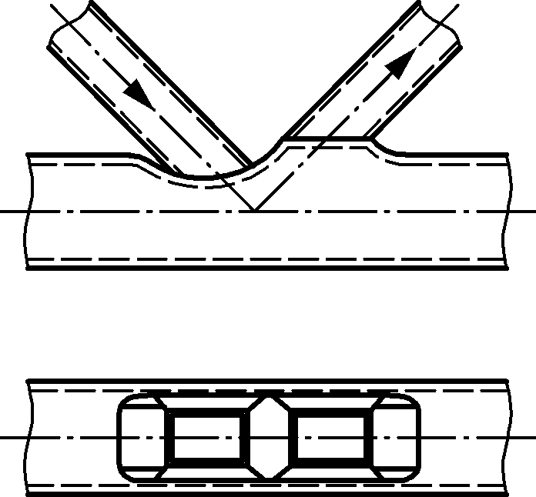 | 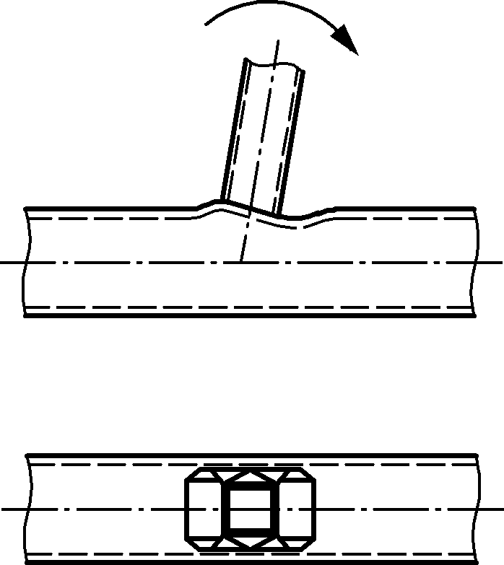
b | 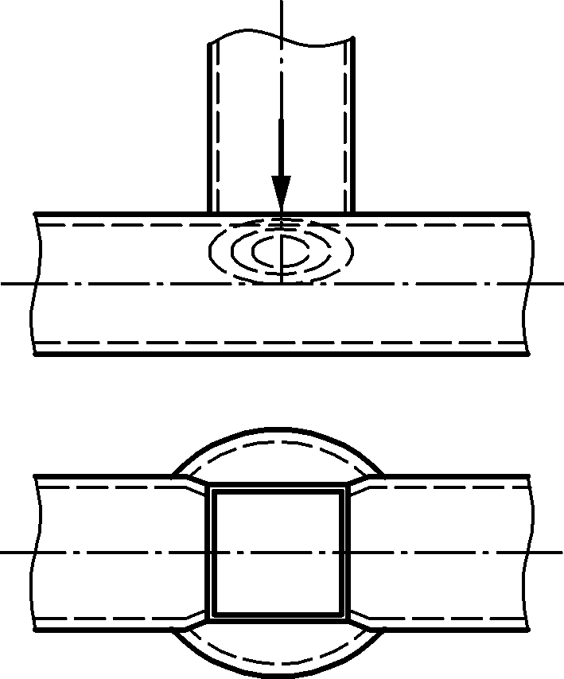 | 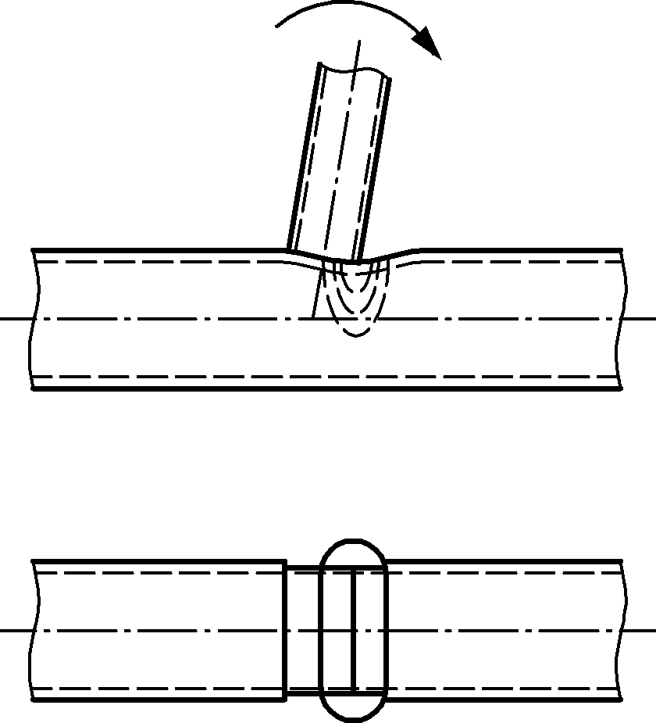
c | 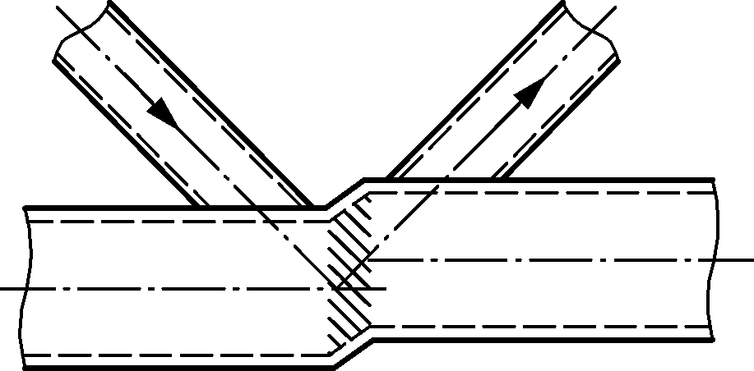 | 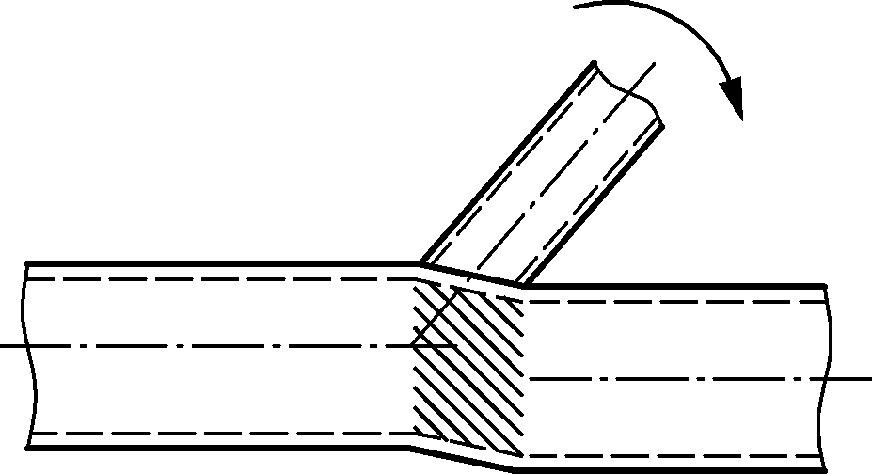
d | 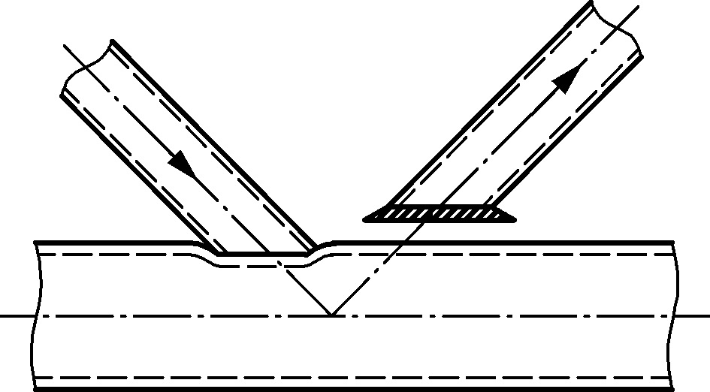 | 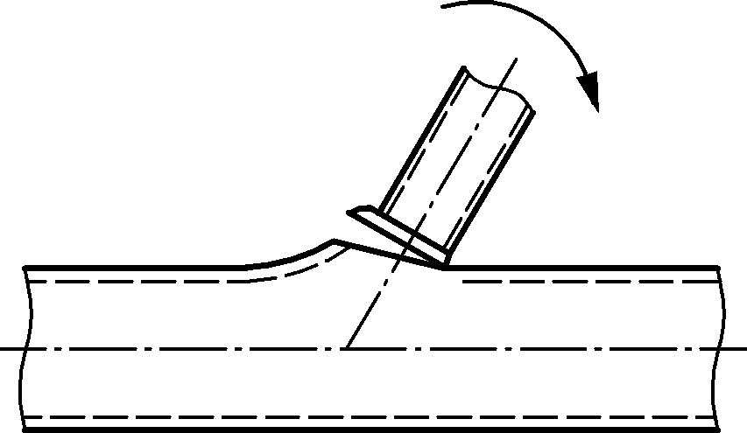
e | 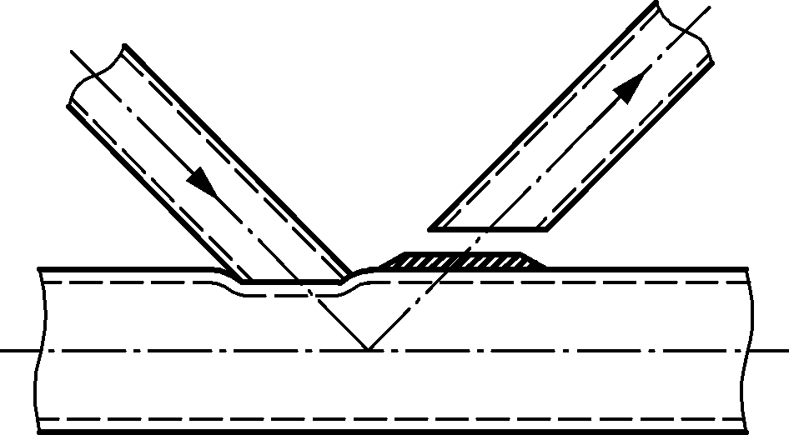 | 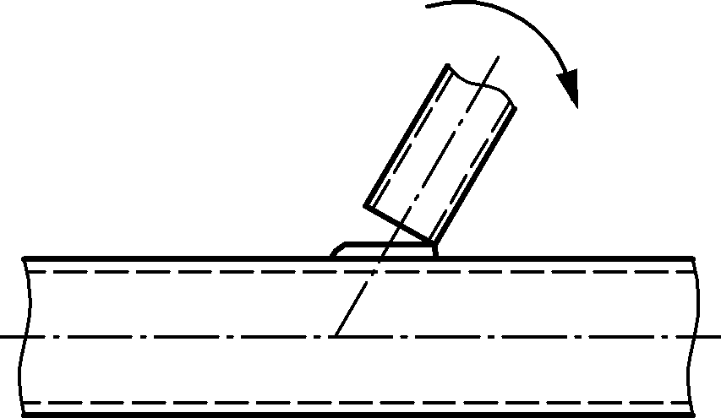
f | 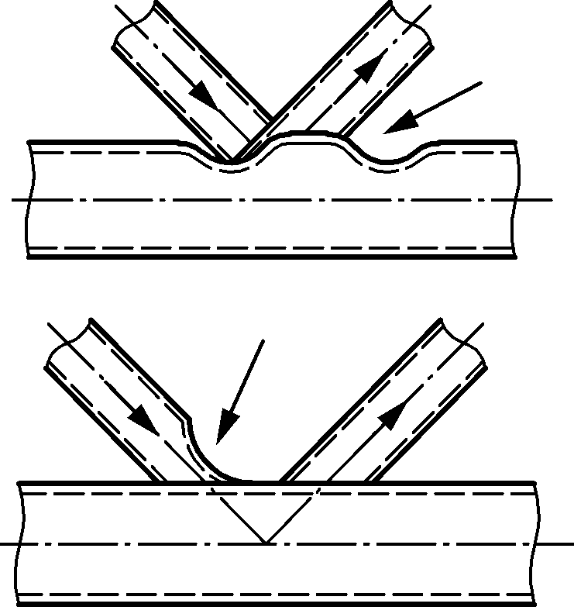 | 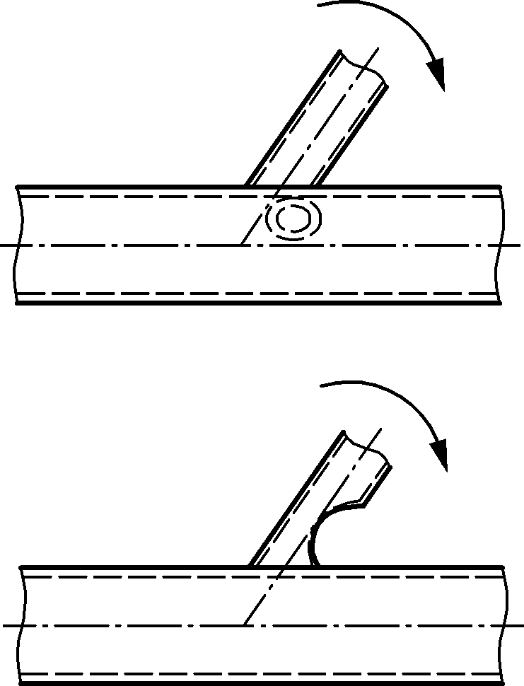
g | 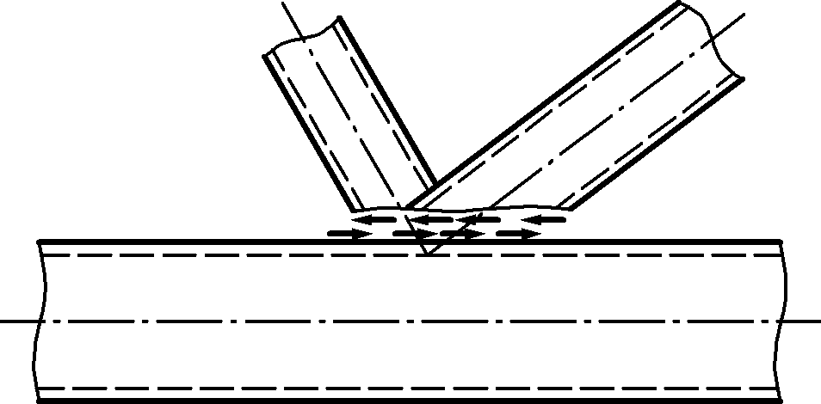 | Not applicable

Table 9.4 — Failure modes of joints between CHS or RHS brace members and I or H section chord members
Mode | Brace axial loading | Brace in-plane bending moment
a | Not applicable | Not applicable
b | 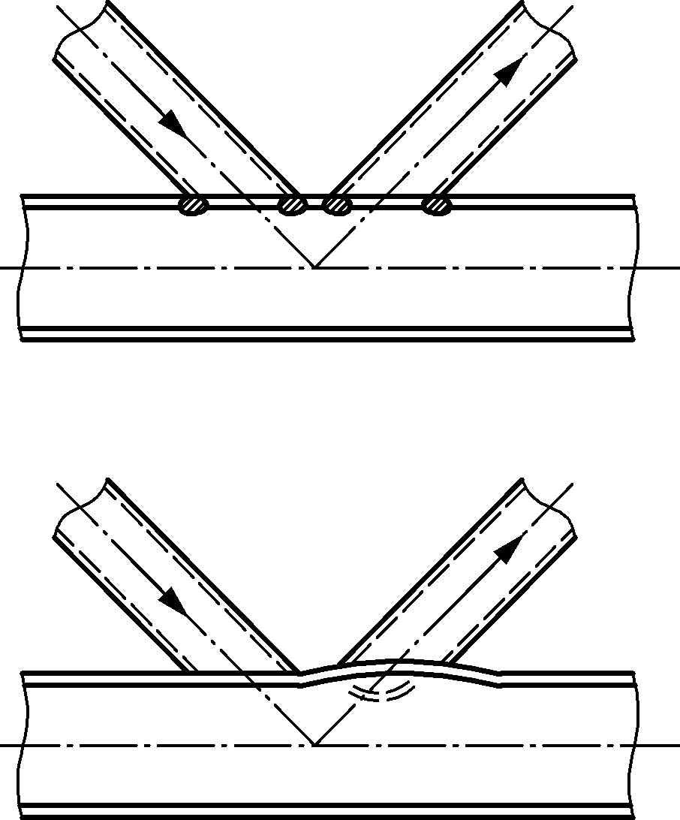 | 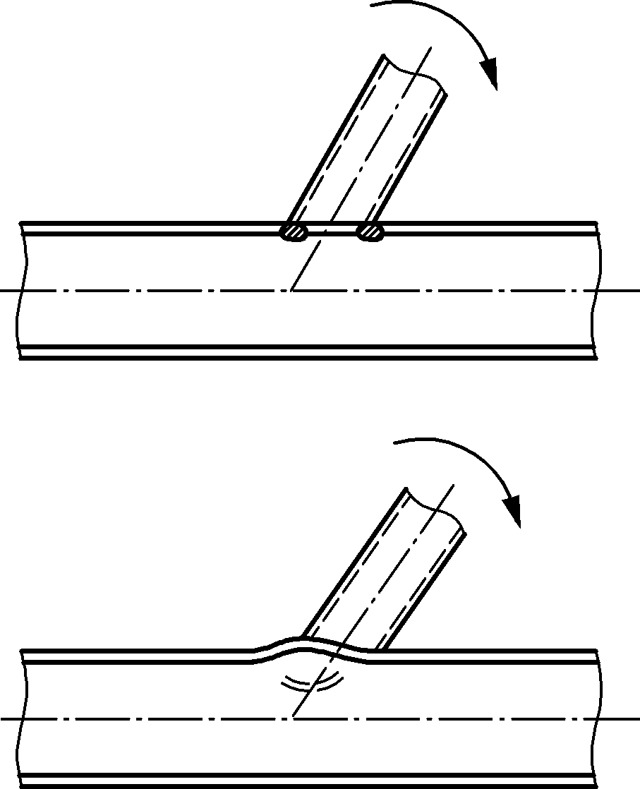
c | 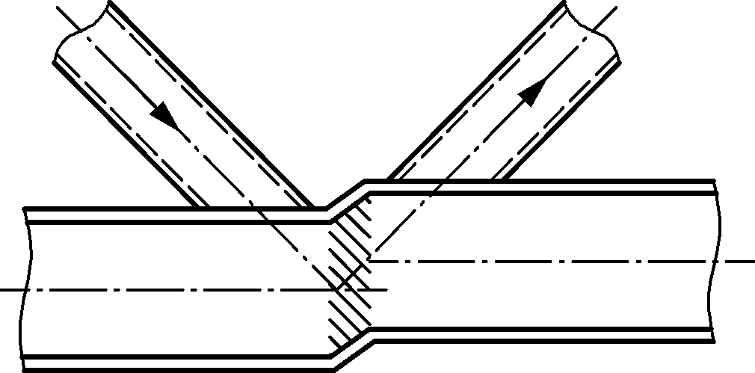 | 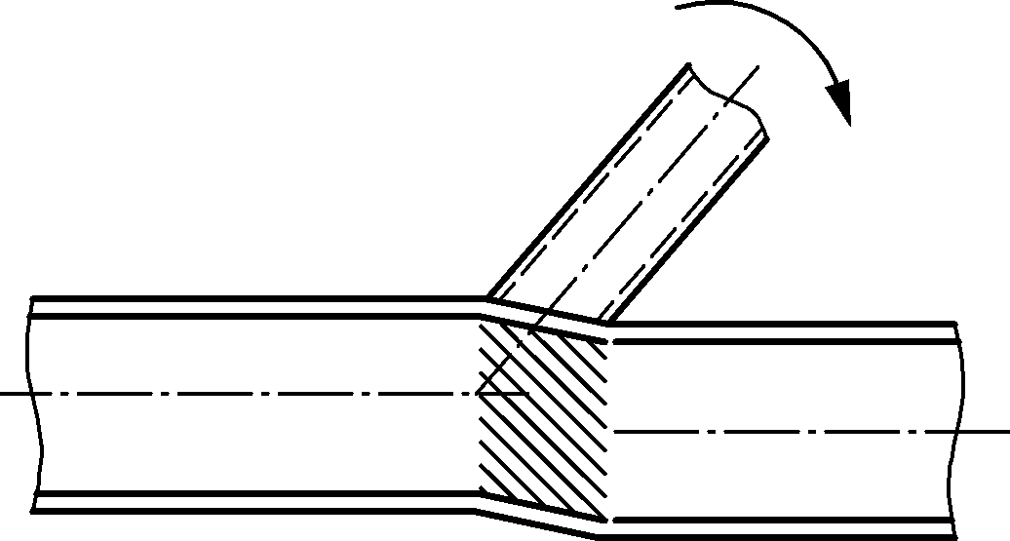
d | Not applicable | Not applicable
e | 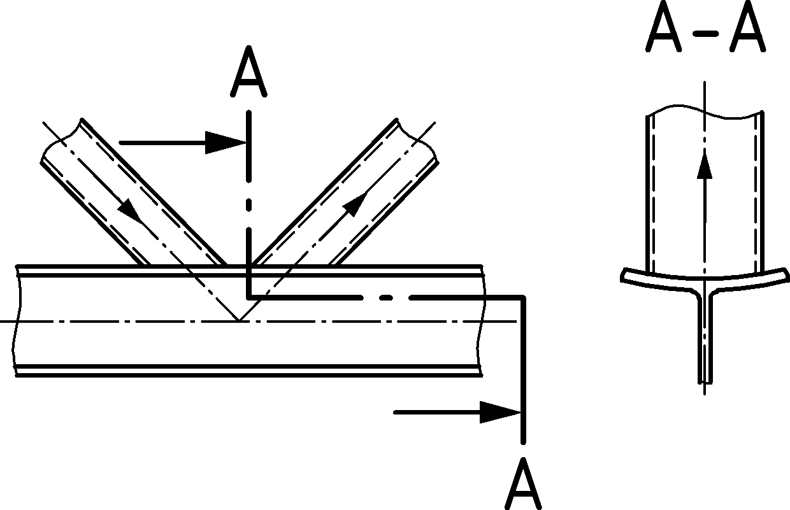 | 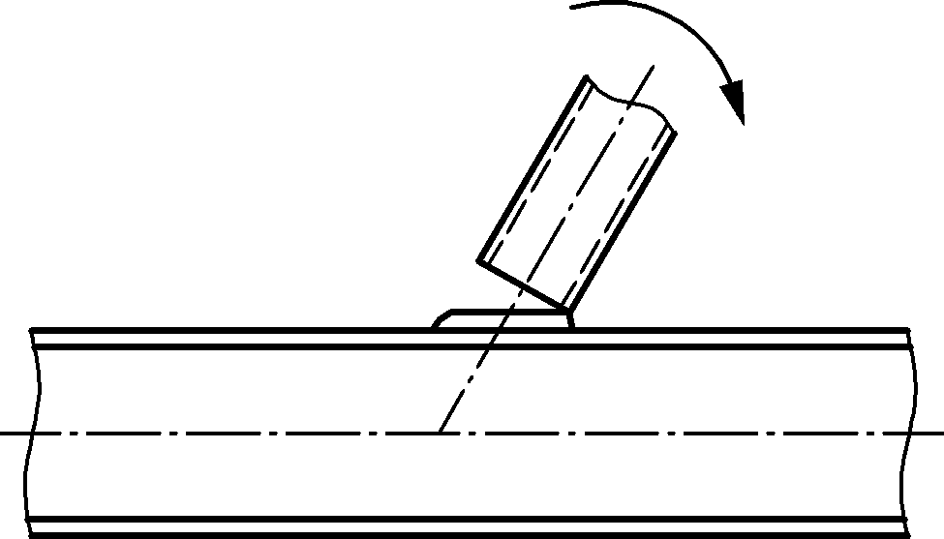
f | 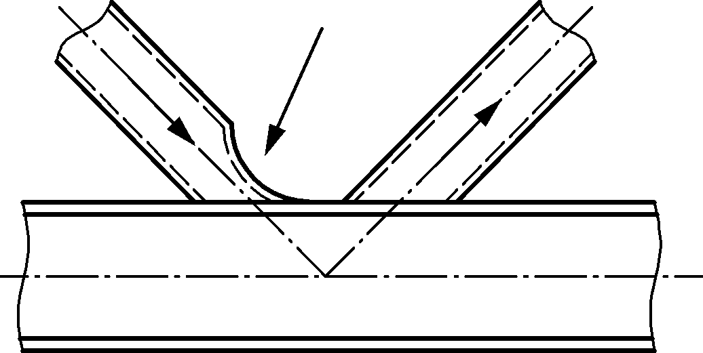 | 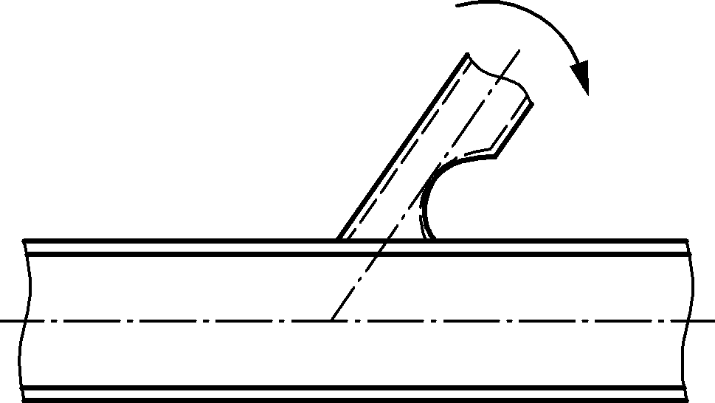
g | 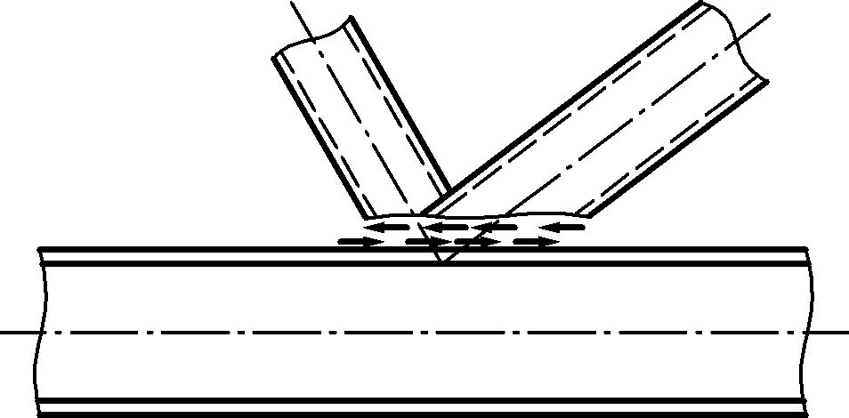 | Not applicable

Definition of joint type for design
(1) The definition of hollow section truss joint configurations as T, Y, X or K gap (which includes N) joint configuration should be based on the method of force transfer in the joints, not on the physical appearance of the joint configuration.
(2) Joint configurations should be defined as follows, see Figure 9.2:
- When the force component normal to the chord in a brace member $\left(N_{i}\sin{θ_{i}}\right)$ is equilibrated by beam shear in the chord member, the joint configuration should be defined as a T joint configuration when the brace is perpendicular to the chord, otherwise it should be defined as a Y joint configuration.
- When the force component normal to the chord in a brace member $\left(N_{i} sinθ_{i}\right)$ is equilibrated (within 20 %) by loads in other brace member(s) on the same side of the joint configuration , the joint configuration should be defined as a K joint configuration . The gap is between the primary brace members whose loads equilibrate. A N joint configuration is to be considered as a K joint configuration with one brace at 90°.
- When the force component normal to the chord $\left(N_{i }\sin{θ_{i}}\right)$ is transmitted through the chord member and is equilibrated by brace member(s) on the opposite side, the joint configuration should be defined as an X joint configuration.
(3) When brace members transmit part of their load as K joint configuration and part of their load as T, Y, or X joint configuration , the joints should be designed by linear interaction of the proportion of the brace force involved in each type of load transfer, with the exception of shear between the brace(s) and the chord face (see example in Figure 9.2).

(4) Figure 9.2 shows a number of possible cases for different type of joint configurations as a reference. More types are possible.
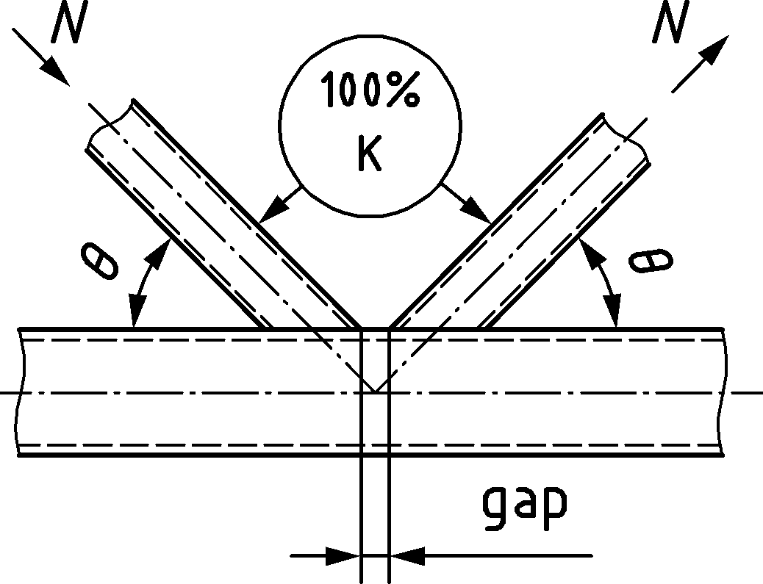 | 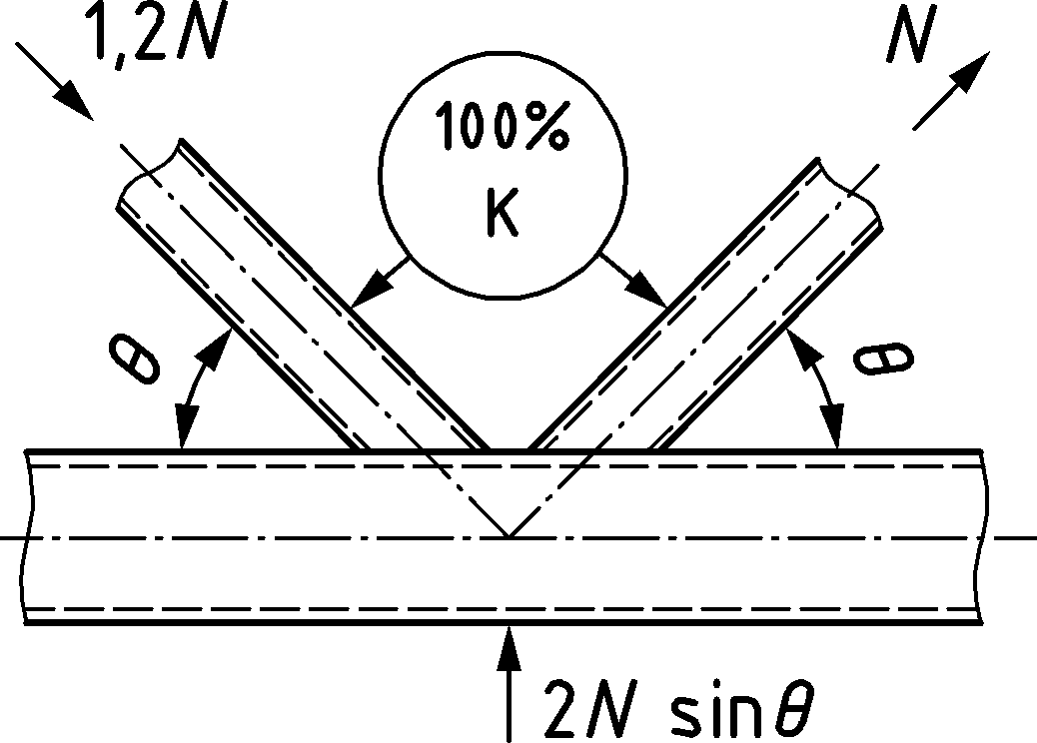 | 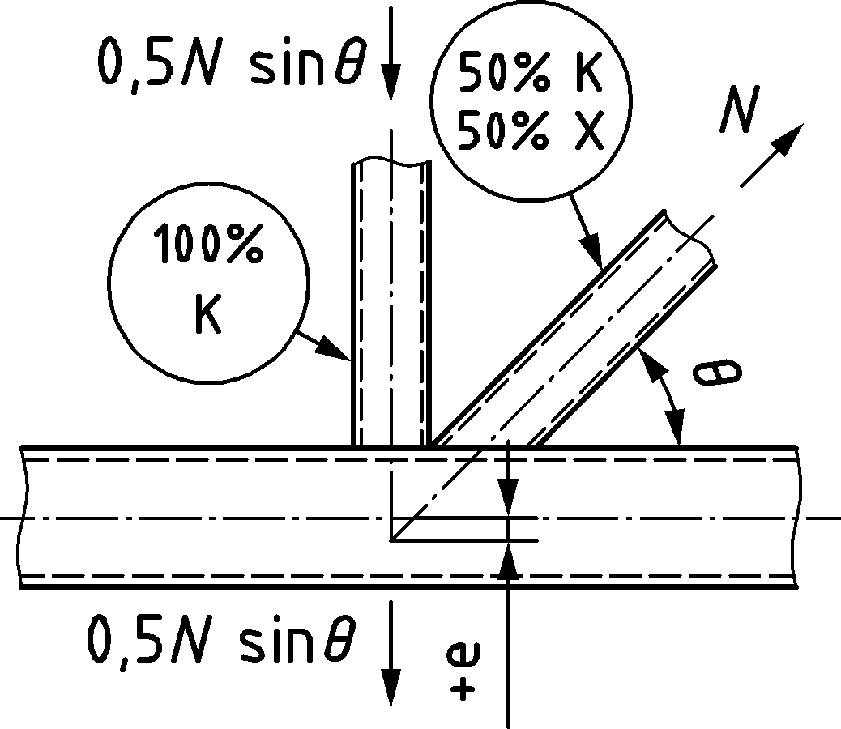
(a) | (b) | (c)
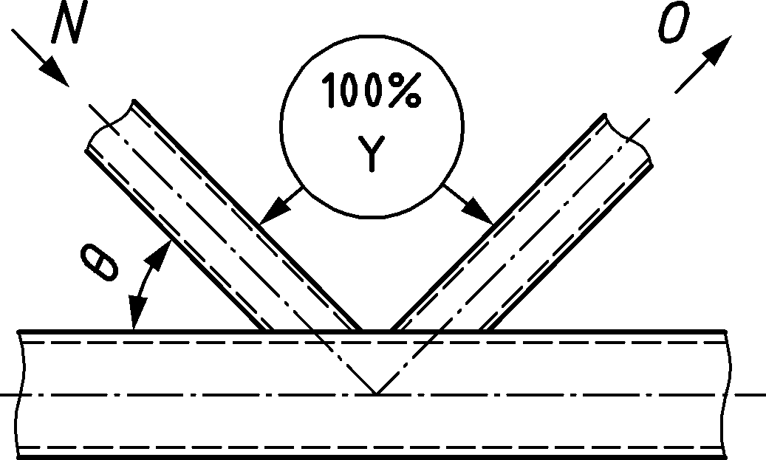 | 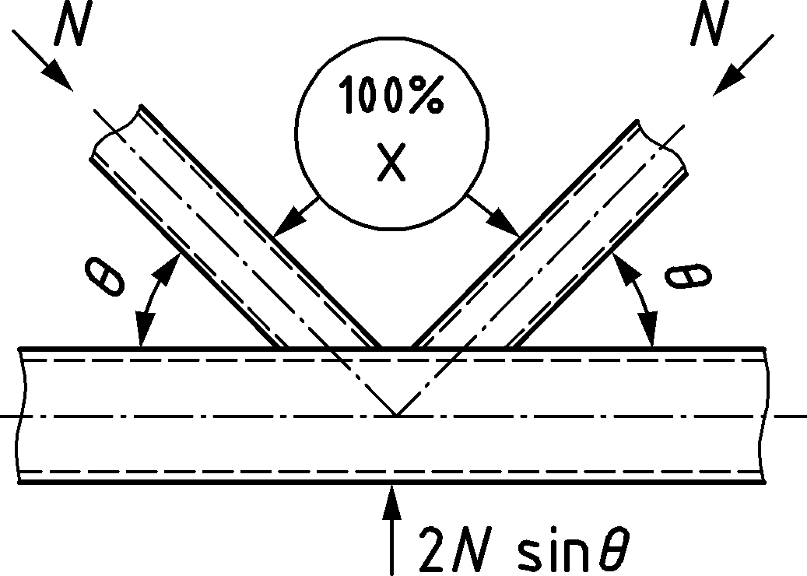 | 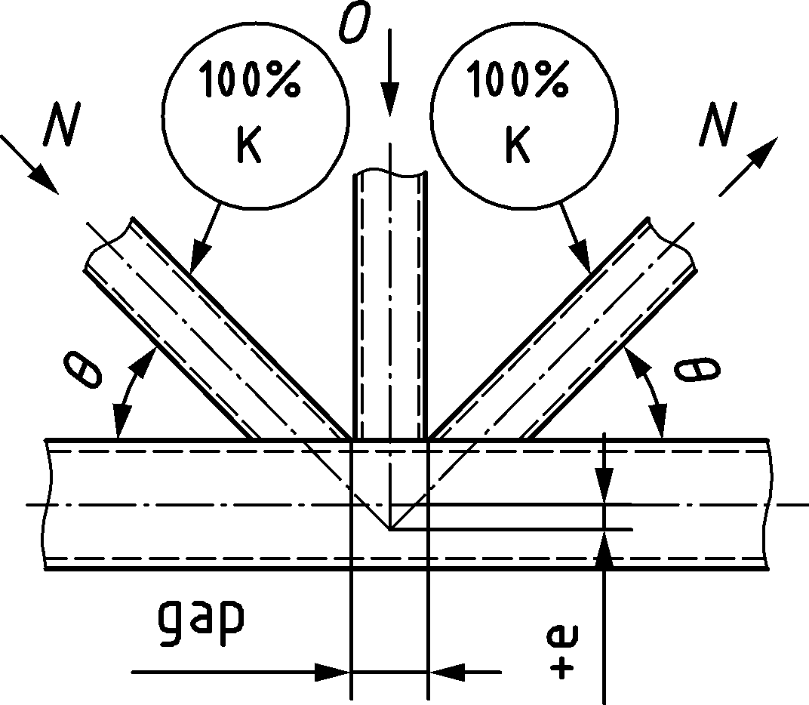
(d) | (e) | (f)
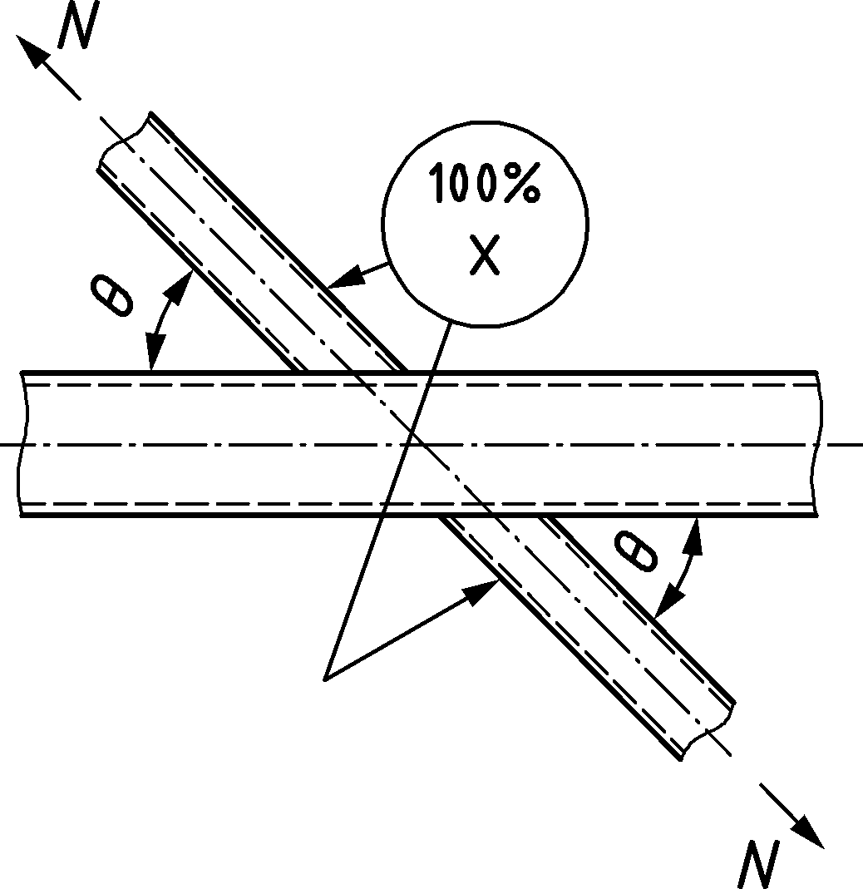 | 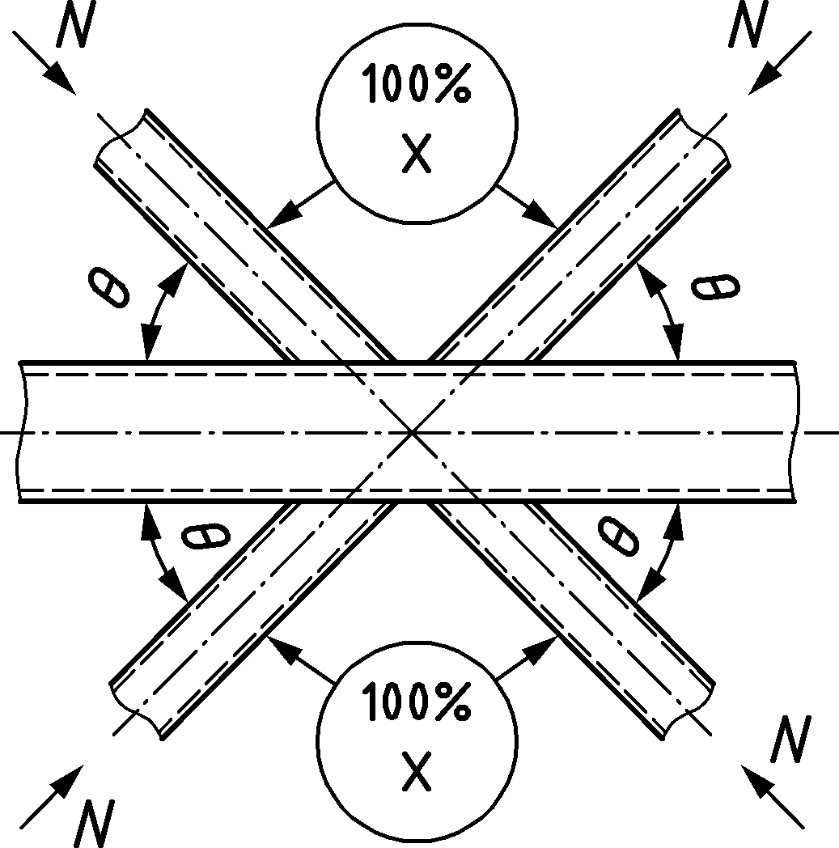 | 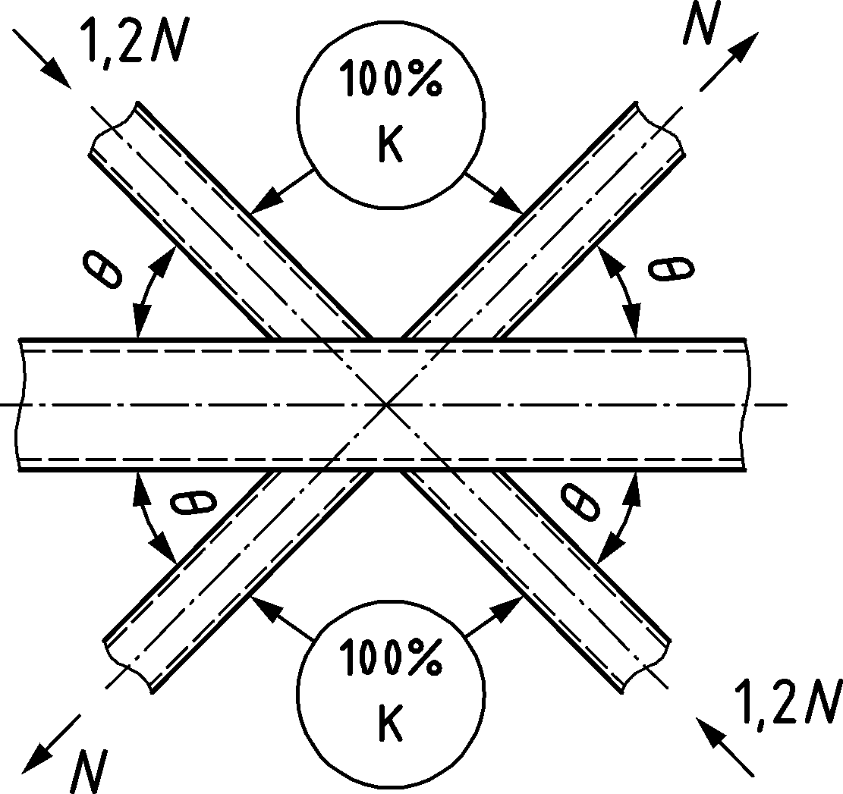
(g) | (h) | (i)
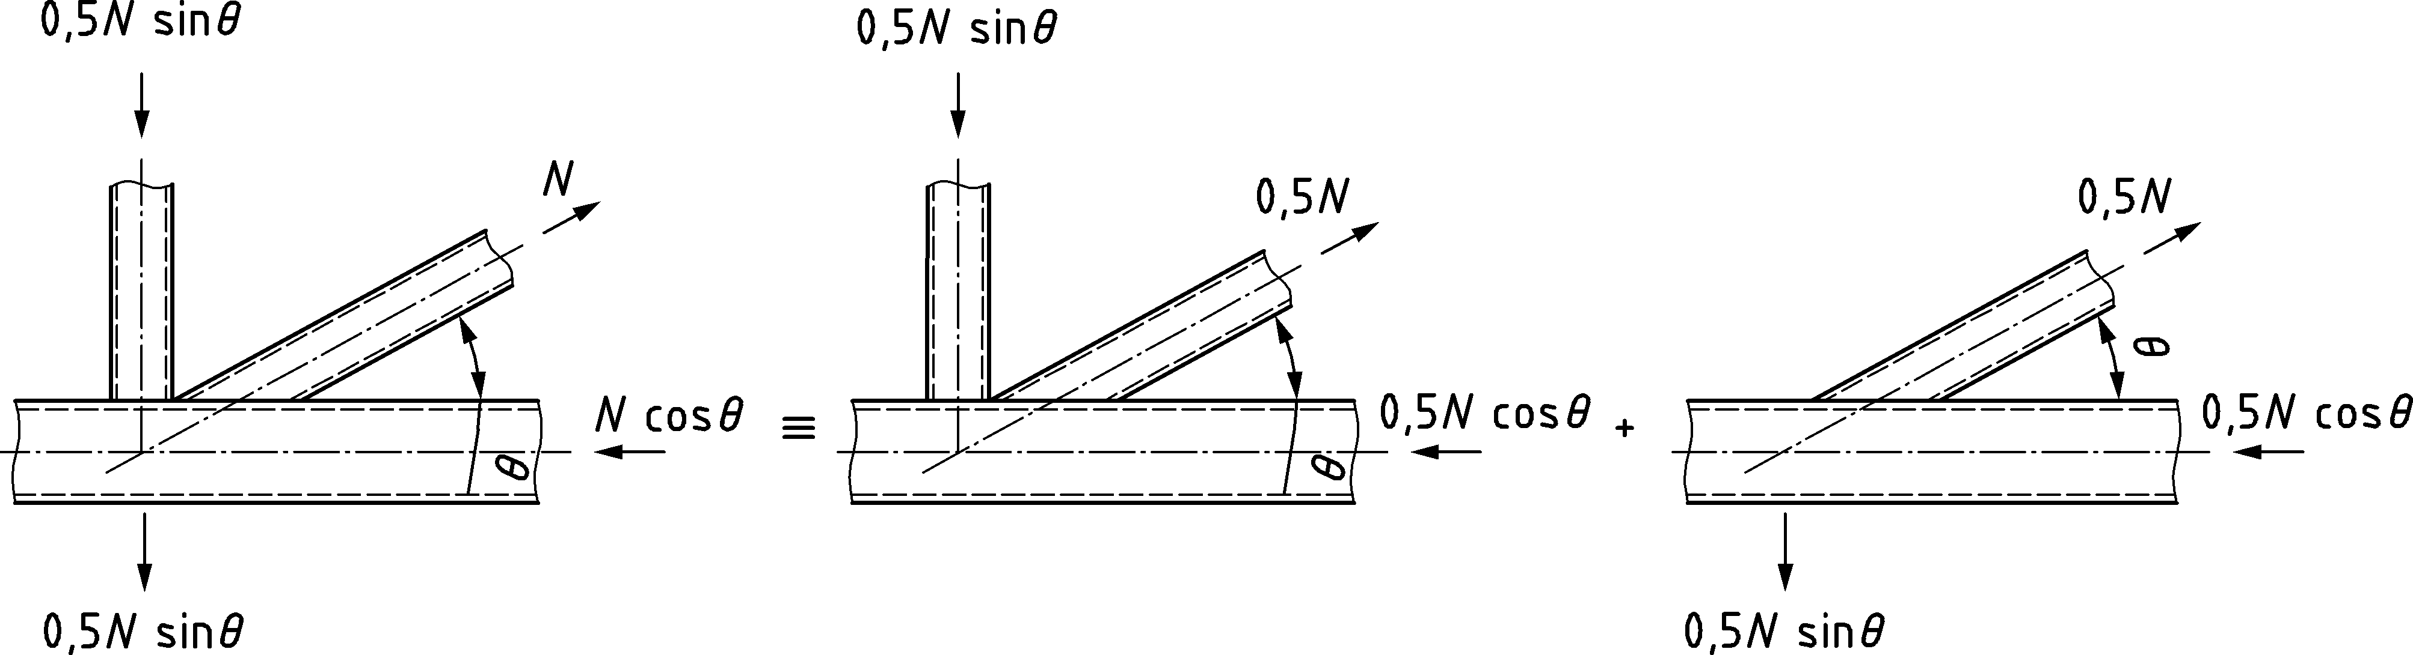
(j) Example: checking of an N joint configuration with unbalanced brace member loads
Figure 9.2 — Examples of hollow section joint classification

Welds

Design resistance
(1)P The welds connecting the brace members to the chords shall be designed to have sufficient resistance to allow for non-uniform stress-distributions and sufficient deformation capacity to allow for redistribution of bending moments.
(2) In welded joints, the connection should be formed around the entire perimeter of the hollow section by means of a butt weld, a fillet weld, or combinations of the two. However, in partially overlapping joint configurations welding of the hidden part of the connection may be omitted, provided that the axial forces in the brace members are such that their components perpendicular to the axis of the chord do not differ by more than 20% of the higher value.
NOTE Typical weld details are indicated in Annex E of EN 1090-2:2018.
(3) To satisfy (1) the design resistance of the weld, per unit length of perimeter of a brace member, should exceed the design resistance of the cross-section of that member per unit length of perimeter.
(4) The required throat thickness should be determined from Clause 6.
NOTE For RHS the design throat thickness of flare groove welds is defined in Figure 9.3.
(5) For welding in cold-formed zones 6.14 applies.
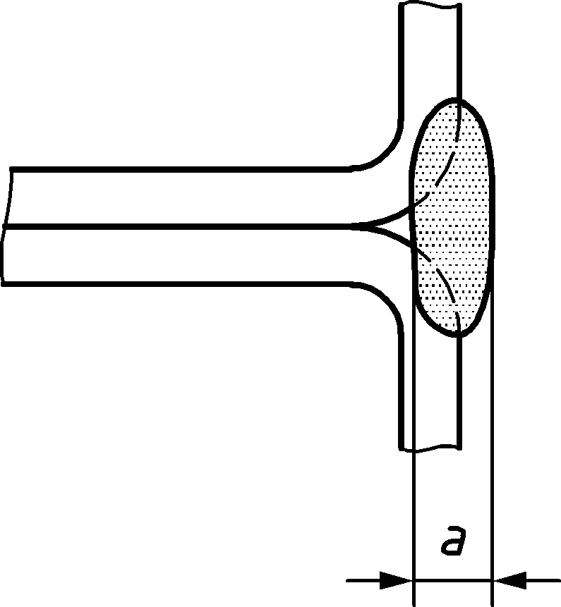
Figure 9.3 — Design throat thickness of flare groove welds in RHS

Welded joints between brace members and CHS chords

General
(1) Provided that the geometry of the joints is within the limits given in Table 9.5, the design resistance of welded joints between brace members and CHS chords should be obtained from 9.4.2 and 9.4.3.
(2) For joints complying with Table 9.5, only the following failure modes should be considered:
- chord (face) failure;
- punching shear failure.
The design resistance of the joint should be taken as the minimum value for these two modes.
(3) For joints not complying with Table 9.5, all failure modes listed in 9.2.2(1) should be considered. In addition, the secondary moments in the joints caused by their rotational stiffness should be taken into account.
(4) The design resistance of overlap joint configurations should be obtained from 9.7.
Table 9.5 — Range of validity for welded joints between CHS, RHS, I or H section brace members and connecting plates and CHS chords
General | $$0,2≤β≤1,0$$ | $$θ_{i}≥30°$$  $${60}^{o}≤φ≤{90}^{o}$$ |  | $$g≥t_{1}+t_{2}$$  $g≥2t_{1}$ and $g≥2t_{2}$ | $$\frac{e}{d_{0}}≤0,25$$
Chord | Compression | Class 1 or 2 | ${d_{0}}/{t_{0}≤50}$ (but for X joint configurations ${d_{0}}/{t_{0}≤40}$)
 | Tension
CHS braces | Compression | Class 1 or 2 | $${d_{i}}/{t_{i}≤50}$$
 | Tension
RHS braces | Compression | Class 1 or 2 | ${b_{i}}/{t_{i}≤35}$ and ${h_{i}}/{t_{i}≤35}$
 | Tension |  | $$0,6≤η={h_{1}}/{d_{0}}≤2,5$$
Plates | Tension and Compression | Transverse plate: | $β={b_{1}}/{d_{0}}≥0,25$
 |  | Longitudinal plate: | $$0,6≤η={h_{1}}/{d_{0}}≤4$$
I, H and RHS section braces | Compression | Class 1 or 2 | $0,6≤η={h_{1}}/{d_{0}}≤2,5$
 | Tension

Uniplanar joint configurations
(1) In uniplanar joint configurations subject only to axial forces, the design internal axial force $N_{i,Ed}$ should not exceed the design axial resistance of the welded joint $N_{i,Rd}$ obtained from Table 9.6, Table 9.7 or Table 9.8, as appropriate.
(2) Joints of the brace members subjected to combined bending and axial force should satisfy:
$$\frac{\left|N_{i,Ed}\right|}{N_{i,Rd}}+{\left(\frac{M_{ip,i,Ed}}{M_{ip,i,Rd}}\right)}^{2}+\frac{\left|M_{op,i,Ed}\right|}{M_{op,i,Rd}}≤1,0$$ | (9.3)
where
$M_{ip,i,Rd}$ design in-plane moment resistance;
$M_{ip,i,Ed}$ design in-plane internal moment;
$M_{op,i,Rd}$ design out-of-plane moment resistance;
$M_{op,i,Ed}$ design out-of-plane internal moment.
(3) The design internal moment $M_{ip,i,Ed}$ and $M_{op,i,Ed}$ from (2) may be taken as the value at the point where the centreline of the brace member meets the face of the chord member.
(4) The design in-plane moment resistance $M_{ip,i,Rd}$and the design out-of-plane moment resistance $M_{op,i,Rd}$ should be obtained from Table 9.7, Table 9.8 or Table 9.9, as appropriate.
(5) The special types of welded joint configurations indicated in Table 9.10 and Table 9.11 should satisfy the appropriate design criteria specified for each joint configuration in these tables.
Table 9.6 — Design axial resistance of welded joints between CHS brace members and CHS chords
T and Y joint configurations | Chord (face) failure
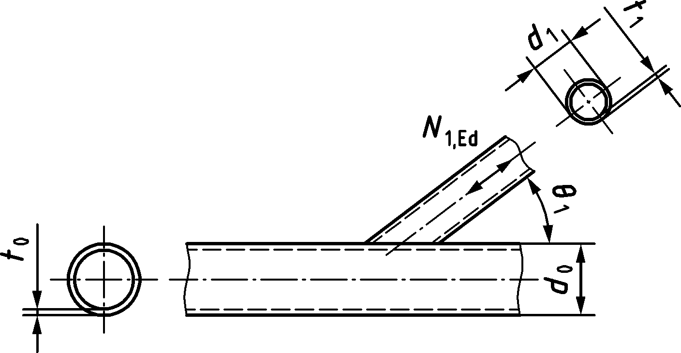 | $$N_{1,Rd}={C_{f}\frac{f_{y0}t_{0}^{2}}{\sin{θ_{1}}}\left(2,6+17,7β^{2}\right)γ^{0,2}Q_{f}}/{γ_{M5}}$$
X joint configurations | Chord (face) failure
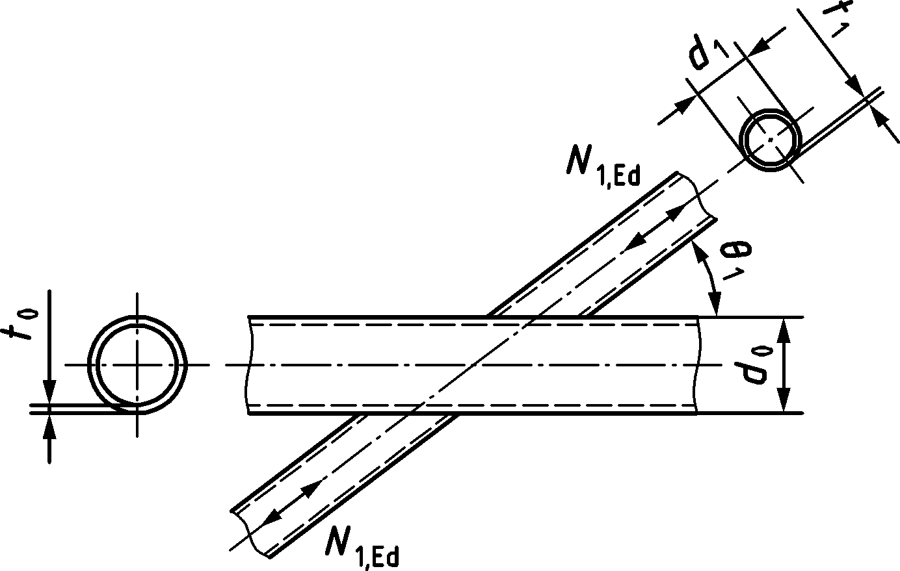 | $$N_{1,Rd}={C_{f}\frac{f_{y0}t_{0}^{2}}{sin{ θ}_{1}}\left(\frac{2,6+2,6β}{1-0,7β}\right)γ^{0,15}Q_{f}}/{γ_{M5}}$$
 | Chord shear (for X joints, only if cos $θ_{1}>β$)
$$N_{1,Rd}={\frac{f_{y0}}{\sqrt{3}}\frac{\left(2/π\right)A_{0}}{\sin{θ_{1}}}}/{γ_{M5}}$$
$$N_{0,gap,Rd}={A_{0}f_{y0}\sqrt{1-{\left(\frac{N_{1,Ed}\sin{θ_{1}}}{\frac{f_{y0}}{\sqrt{3}}\left(2/π\right)A_{0}}\right)}^{2}}}/{γ_{M5}}$$
K and N gap joint configurations | Chord failure
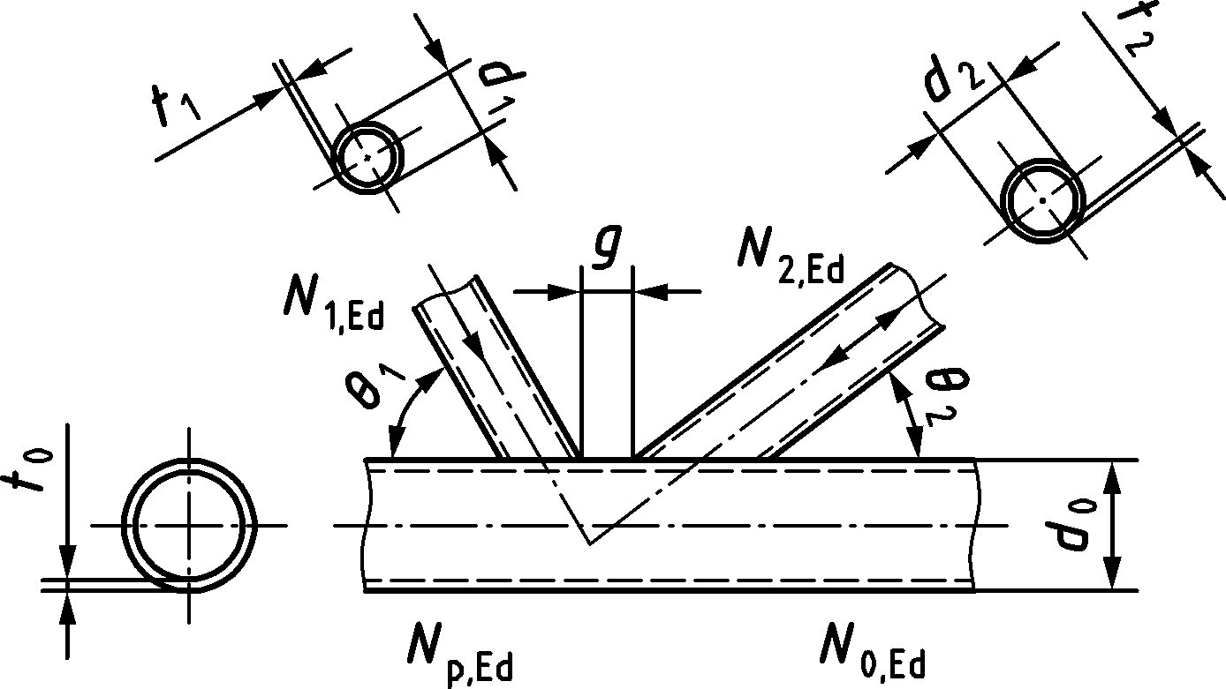 | $$N_{1,Rd}=={C_{f}\frac{f_{y0}t_{0}^{2}}{\sin{θ_{1}}}\left(1,65+13,2β^{1,6}\right)γ^{0,3}\left[1+\frac{1}{1,2+{\left(g/{t_{0}}\right)}^{0,8}}\right]Q_{f}}/{γ_{M5}}$$  $$N_{2,Rd}=\frac{sin{ θ}_{1}}{\sin{θ_{2}}}N_{1,Rd}$$
General | Chord punching shear (for $d_{i}≤d_{0}-2t_{0}$)
 | $$N_{i,Rd}={C_{f}\frac{f_{y0}}{\sqrt{3}}πd_{i}t_{0}\frac{1+\sin{θ_{i}}}{2\sin^{2}θ_{i}}}/{γ_{M5}}$$
 |  | $$n_{0}<0$$  (for compression) | $$n_{0}≥0$$  (for tension)
Chord stress factor acc. to 9.2.1(4) with $Q_{f}={\left(1-\left|n_{0}\right|\right)}^{C_{1}}$ but $Q_{f}≥0,4$  And chord stress ratio n0 acc. to 9.2.1(3) | T, Y and X joint configuration | $$C_{1}=0,45-0,25β$$ | $$C_{1}=0,20$$
 | K gap joint configuration | $$C_{1}=0,25$$
NOTE For material factor$C_{f}$ see 9.1.1(4).

Table 9.7 — Design resistance of welded T joints connecting plates, I, H sections or RHS to CHS chords
Transverse plates | Chord failure
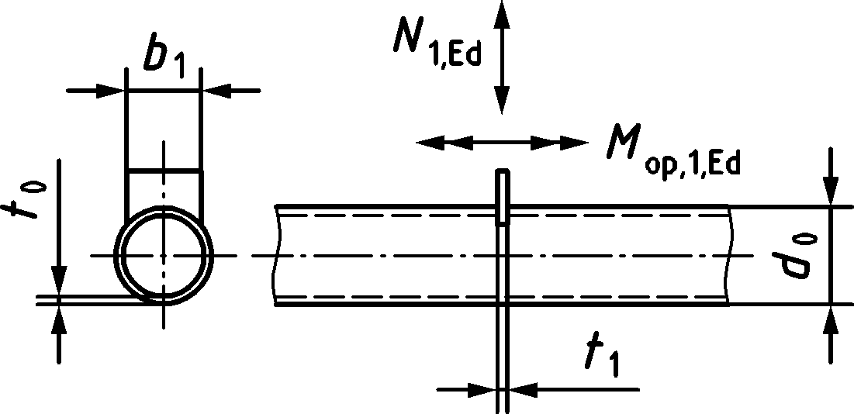 | $$N_{1,Rd}={2,3C_{f}f_{y0}t_{0}^{2}\left(1+3β^{2}\right)γ^{0,35}Q_{f}}/{γ_{M5}}$$ |  |  | $$M_{ip, 1,Rd}=0$$  $$M_{op, 1,Rd}=0,5b_{1}N_{1,Rd}$$
Longitudinal plates | Chord failure
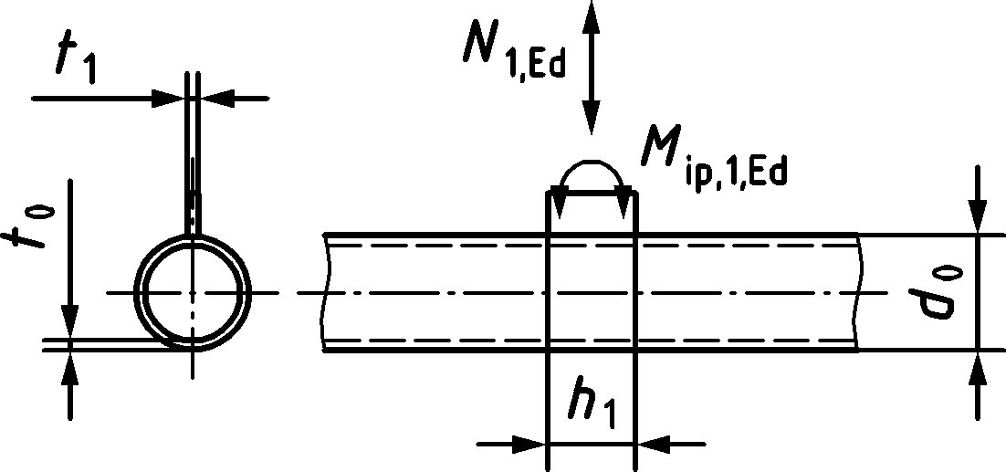 | $$N_{1,Rd}={7,1C_{f}f_{y0}t_{0}^{2}\left(1+0,4η\right)Q_{f}}/{γ_{M5}}$$ |  |  | $$M_{ip, 1,Rd}=0,7h_{1}N_{1,Rd}$$  $$M_{op, 1,Rd}=0$$
Through plates | Chord failure
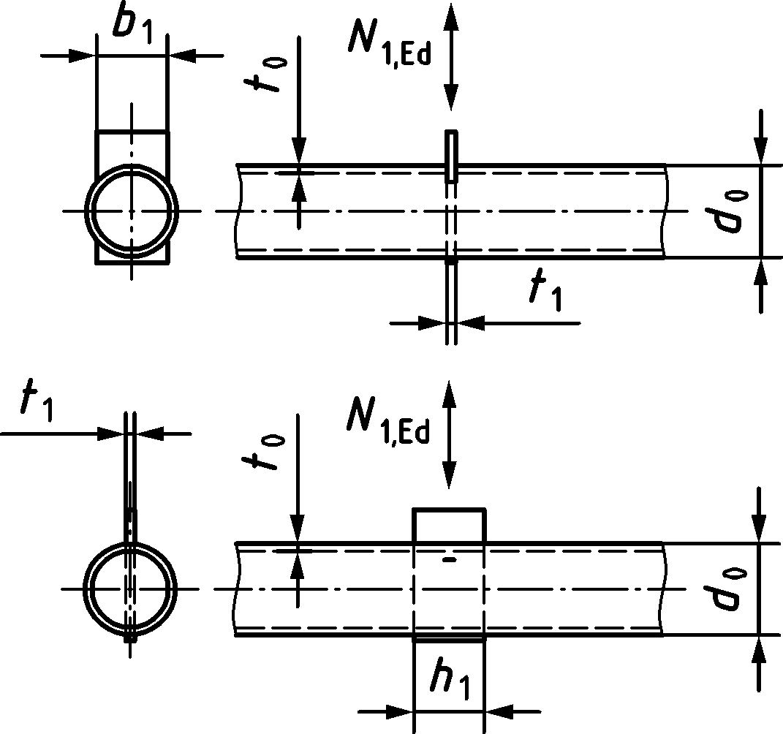 | $N_{1,Rd}$ for a through plate is two times the design resistance $N_{1,Rd}$  for a respective T joint configuration with a transverse or a longitudinal plate
I, H or RHS braces | Chord failure
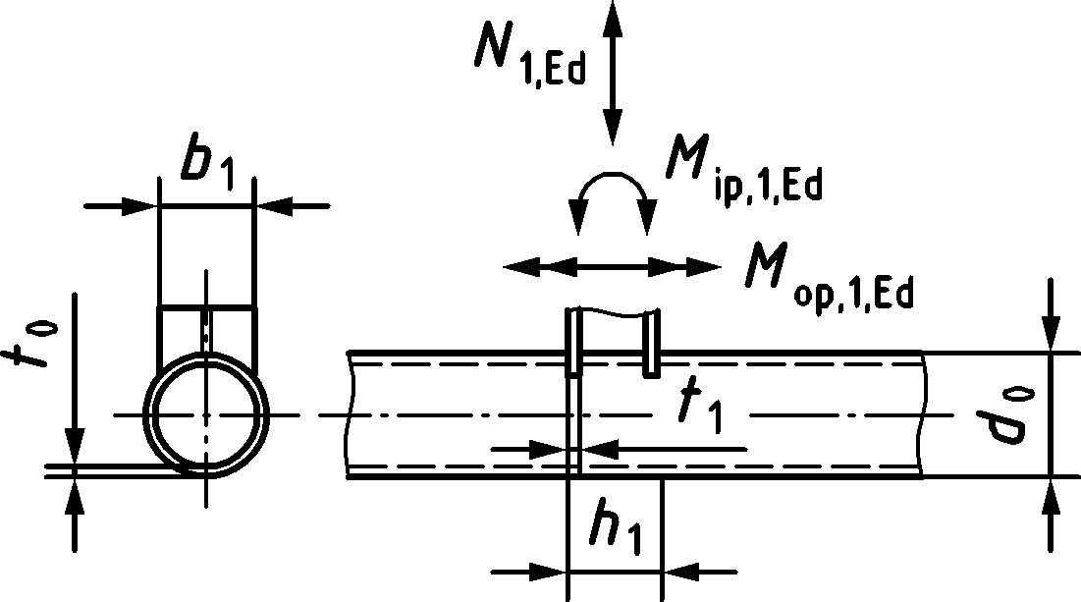 | $N_{1,Rd}=N_{Rd}^{*}\left(1+0,4η\right)$ but $≤{2N}_{Rd}^{*}$  with  $N_{Rd}^{*}=N_{1,Rd}$ for a transverse plate T joint configuration |  |  | $$M_{ip, 1,Rd}={(h_{1}-t_{1})N_{1,Rd}}/{\left(1+0,4η\right)}$$  $$M_{op, 1,Rd}=0,5b_{1}N_{1,Rd}$$
General | Chord punching shear (for $b_{1}≤d_{0}-2t_{0}$ and longitudinal plate)
I or H section bracea (with axial loading and/or out-of-plane bending) and RHS brace. | $$\frac{N_{1,Ed}}{A_{1}}+\frac{M_{ip,1,Ed}}{W_{ip,el,1}}+\frac{M_{op,1,Ed}}{W_{op,el,1}}≤0,58C_{f}\frac{f_{y0}}{γ_{M5}}\frac{t_{0}}{t_{1}}$$  where $t_{1}$ is flange thickness of I or H section brace or wall thickness of RHS brace
All other cases | $$\frac{N_{1,Ed}}{A_{1}}+\frac{M_{ip,1,Ed}}{W_{ip,el,,1}}+\frac{M_{op,1,Ed}}{W_{op,el,1}}≤1,16C_{f}\frac{f_{y0}}{γ_{M5}}\frac{t_{0}}{t_{1}}$$  where $t_{1}$ is plate thickness
Chord stress factor acc. to 9.2.1(4) with  $Q_{f}={\left(1-\left|n_{0}\right|\right) }^{C_{1}}$ but ≥ 0,3 and chord stress ratio n0 acc. to 9.2.1(3) |  | $$n_{0}<0$$  (for compression) |  |  | $$n_{0}≥0$$  (for tension)
 | T joint configurationss | $$C_{1}=0,25$$ |  |  | $$C_{1}=0,20$$
Range of validity (in addition to the limits given for CHS T and X joint configurations)
General | $$θ_{1}=90°$$
Plates | Transverse plate: $β=\frac{b_{1}}{d_{0}}≥0,25$ |  | Longitudinal plate: $0,6≤η=\frac{h_{1}}{d_{0}}≤4$
I, H and RHS sections |  |  | $$0,6≤η≤2,5$$
Material factor $C_{f}$ | According to 9.1.1.(4)
NOTE For material factor$C_{f}$ see 9.1.1(4).
a For I and H sections the contribution of the web should be neglected for Wip,el,1 and Wop,el,1.
Table 9.8 — Design resistances of welded X joints connecting plates, I, H or RHS sections to CHS chords
Transverse plates | Chord failure
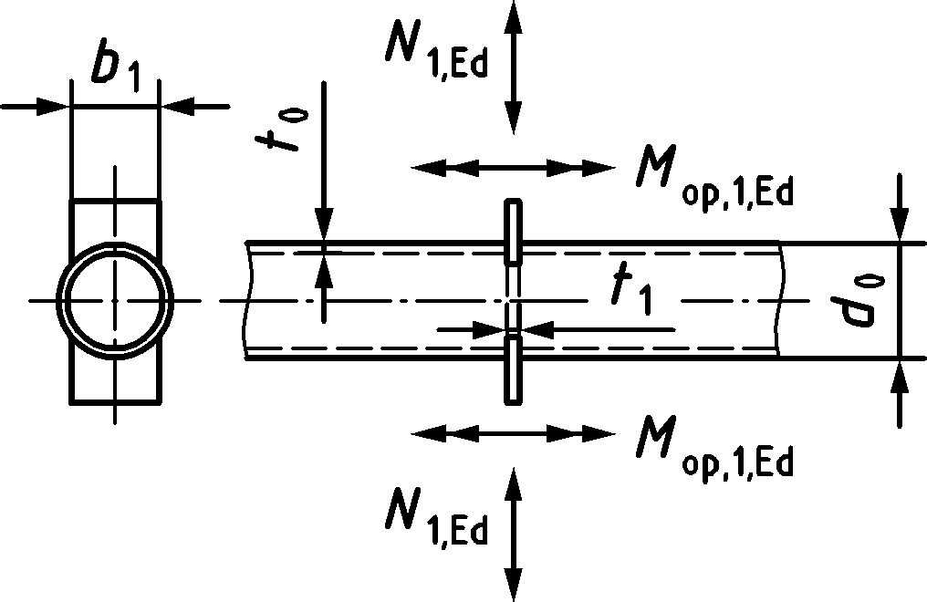 | $$N_{1,Rd}={2,1C_{f}f_{y0}t_{0}^{2}\left(1+3β^{2}\right)γ^{0,25}Q_{f}}/{γ_{M5}}$$ |  |  | $$M_{ip, 1,Rd}=0$$  $$M_{op, 1,Rd}=0,5b_{1}N_{1,Rd}$$
Longitudinal plates | Chord failure
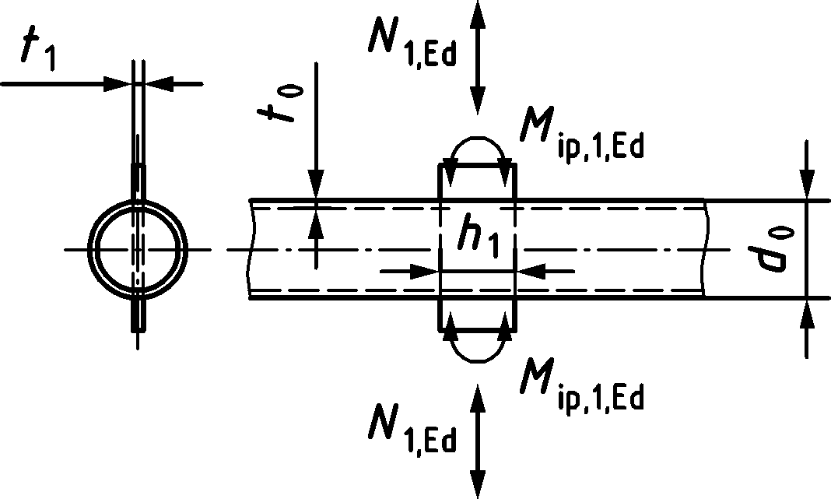 | $$N_{1,Rd}={4,4C_{f}f_{y0}t_{0}^{2}\left(1+0,4η\right)Q_{f}}/{γ_{M5}}$$ |  |  | $$M_{ip, 1,Rd}=0,7h_{1}N_{1,Rd}$$  $$M_{op, 1,Rd}=0$$
I, H or RHS braces | Chord failure |  |  | I, H or RHS brace
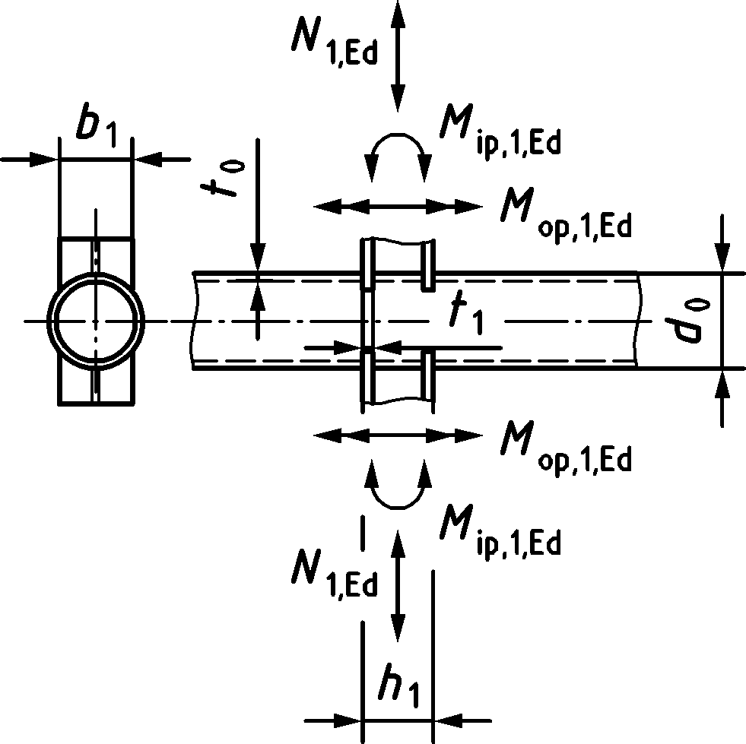 | $N_{1,Rd}=N_{Rd}^{*}\left(1+0,4η\right)$ but $≤{2N}_{Rd}^{*}$  with  $N_{Rd}^{*}= N_{1,Rd}$ for a transverse plate X joint configuration |  |  | $$M_{ip, 1,Rd}={{(h}_{1}-t_{1})N_{1,Rd}}/{\left(1+0,4η\right)}$$  $$M_{op, 1,Rd}=0,5b_{1}N_{1,Rd}$$
General | Chord punching shear (for $b_{1}≤d_{0}-2t_{0}$ and longitudinal plate)
I section bracea (with axial loading or out-of-plane bending) and RHS brace | $$\frac{N_{1,Ed}}{A_{1}}+\frac{M_{ip,1,Ed}}{W_{ip,el,1}}+\frac{M_{op,1,Ed}}{W_{op,el,1}}≤0,58C_{f}\frac{f_{y0}}{γ_{M5}}\frac{t_{0}}{t_{1}}$$  where $t_{1}$ is flange thickness of I or H section brace or wall thickness of RHS brace
All other cases | $$\frac{N_{1,Ed}}{A_{1}}+\frac{M_{ip,1,Ed}}{W_{ip,el,1}}+\frac{M_{op,1,Ed}}{W_{op,el,1}}≤1,16C_{f}\frac{f_{y0}}{γ_{M5}}\frac{t_{0}}{t_{1}}$$  where $t_{1}$ is plate thickness
Chord stress factor acc. to 9.2.1(4) with  $Q_{f}={\left(1-\left|n_{0}\right|\right) }^{C_{1}}$ but ≥ 0,3 and chord stress ratio n0 acc. to 9.2.1(3) |  | $n_{0}<0$  (for compression) |  |  | $$n_{0}≥0$$  (for tension)
 | X joint configuration | $$C_{1}=0,25$$ |  |  | $$C_{1}=0,20$$
Range of validity (in addition to the limits given for CHS T and X joint configurations)
General | $$θ_{1}=90°$$
Plates | For transverse plate:  $$β=\frac{b_{1}}{d_{0}}≥0,25$$ |  | For longitudinal plate:  $$0,6≤η=\frac{h_{1}}{d_{0}}≤4$$
I, H and RHS sections |  |  | $$0,6≤η≤2,5$$
Material factor $C_{f}$ | According to 9.1.1.(4)
a For I and H sections the contribution of the web should be neglected for Wip,el,1 and Wop,el,1.

Table 9.9 — Design moment resistance of welded T, Y and X joints between CHS brace members and CHS chords
In-plane bending | Chord failure
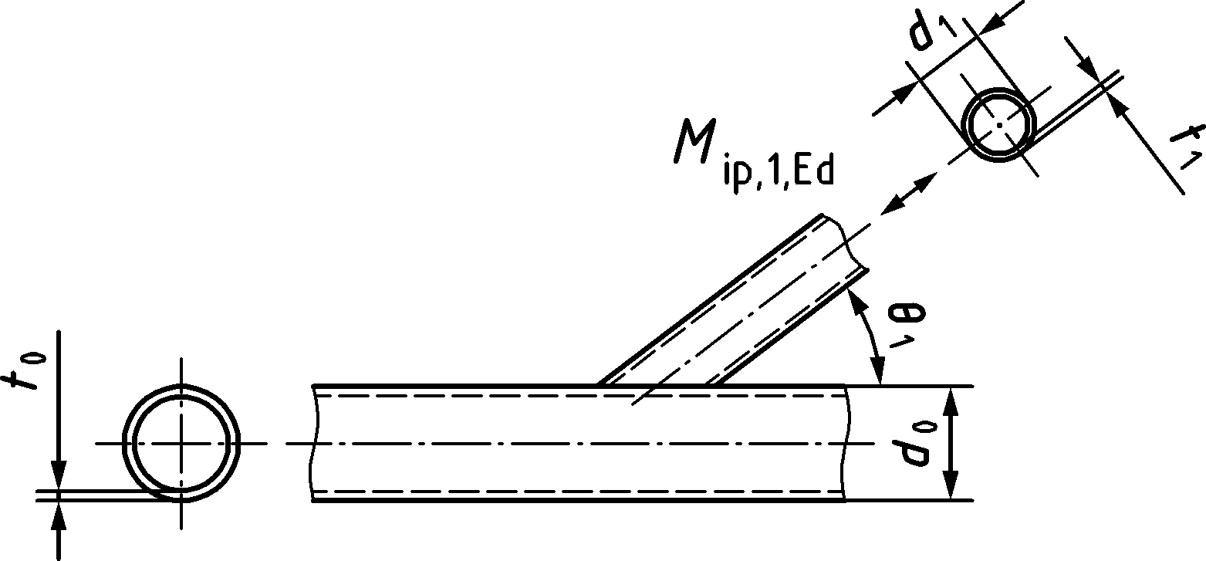 | $$M_{ip,1,Rd}={4,3C_{f}\frac{f_{y0}t_{0}^{2}d_{1}}{\sin{θ_{1}}}βγ^{0,5}Q_{f}}/{γ_{M5}}$$
 | Chord punching shear (for $d_{1}≤d_{0}-2t_{0}$)
 | $$M_{ip,1,Rd}={C_{f}\frac{f_{y0}}{\sqrt{3}}t_{0}d_{1}^{2}\frac{1+3 sinθ_{1}}{4 \sin^{2}θ_{1}}}/{γ_{M5}}$$
Out-of-plane bending | Chord failure
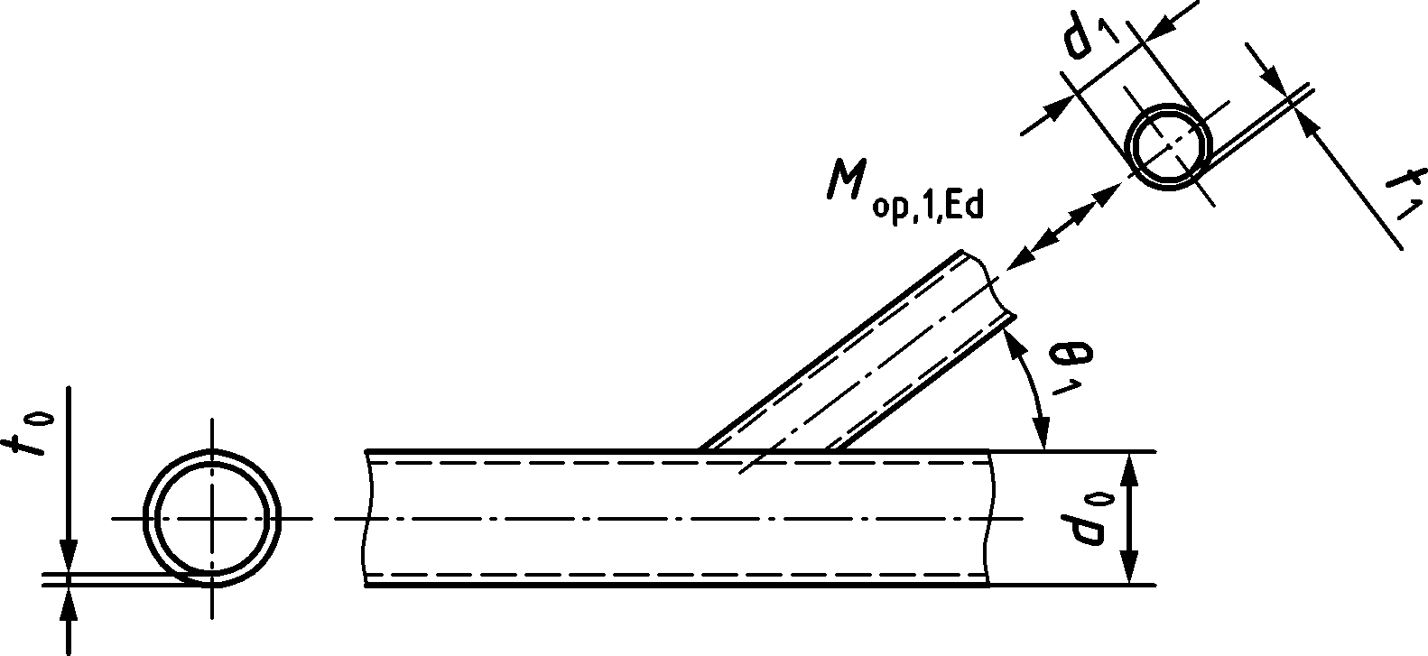 | $$M_{op,1,Rd}={C_{f}\frac{f_{y0}t_{0}^{2}d_{1}}{sin{ θ}_{1}}\left(\frac{1,3+1,3β}{1-0,7β}\right)γ^{0,15}Q_{f}}/{γ_{M5}}$$
 | Chord punching shear (for $d_{1}≤d_{0}-2t_{0}$)
 | $$M_{op,1,Rd}={C_{f}\frac{f_{y0}}{\sqrt{3}}t_{0}d_{1}^{2}\frac{3+sin{ θ}_{1}}{4\sin^{2}θ_{1}}}/{γ_{M5}}$$
Chord stress factor acc. to 9.2.1(4) with  $Q_{f}={\left(1-\left|n_{0}\right|\right) }^{C_{1}}$ but ≥ 0,4 and chord stress ratio n0 acc. to 9.2.1(3) |  | $$n_{0}<0$$  (for compression) | $$n_{0}≥0$$  (for tension)
 | T, Y and X joint configurations | $$C_{1}=0,45-0,25β$$ | $$C_{1}=0,20$$
Range of validity | Same as in Table 9.5
NOTE For material factor$C_{f}$ see 9.1.1(4).

(6) The formulae in Table 9.9 should also be used for K gap joint configurations if brace moments have to be considered, use C1 value for T,Y and X joint configurations. The sum of the brace unity checks due to bending and axial load should not exceed 0,8.
Table 9.10 — Design axial resistance of special types of welded joints between CHS brace members and CHS chordsa, b
DY joint configurations
All brace member forces act in the same sense (compression or tension). | 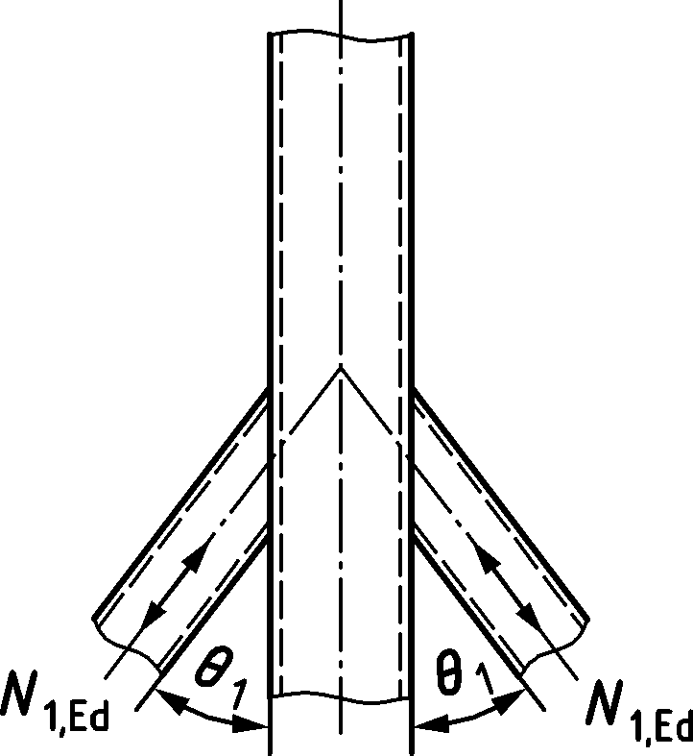 | $$N_{1,Ed}≤N_{1,Rd}$$  with $N_{1,Rd}$ for X joint given in Table 9.6.  No check for chord shear.
DX gap joint configurations
All brace member forces act in the same sense (compression or tension). | 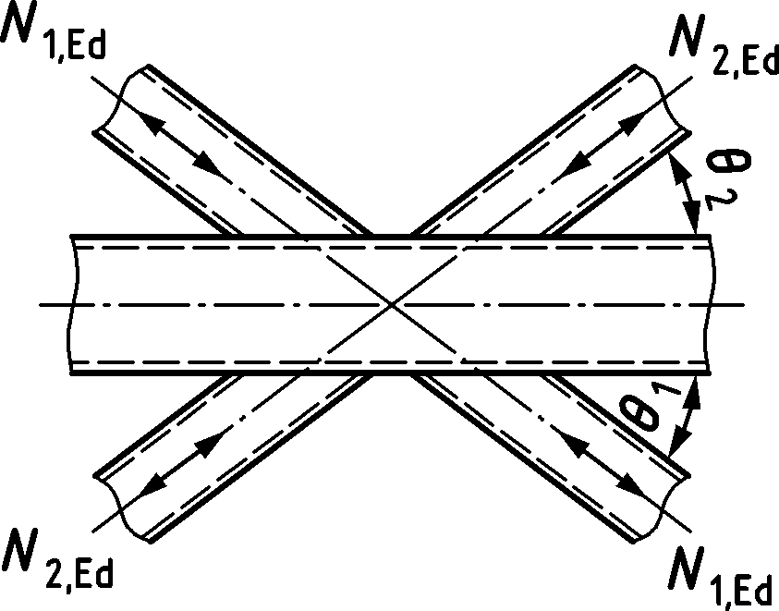 | $$N_{1, Ed} sinθ_{1}+N_{2,Ed} sinθ_{2}≤N_{x,Rd }sinθ_{x}$$  with $N_{x,Rd }sinθ_{x}$ for X joint given in Table 9.6, being the larger of the values of $\left|N_{1, Rd}\sin{θ_{1}}\right|$ and $\left|N_{2,Rd}\sin{θ_{2}}\right|$.
DK gap joint configurations
Forces in members 1 are in compression and members 2 in tension. | 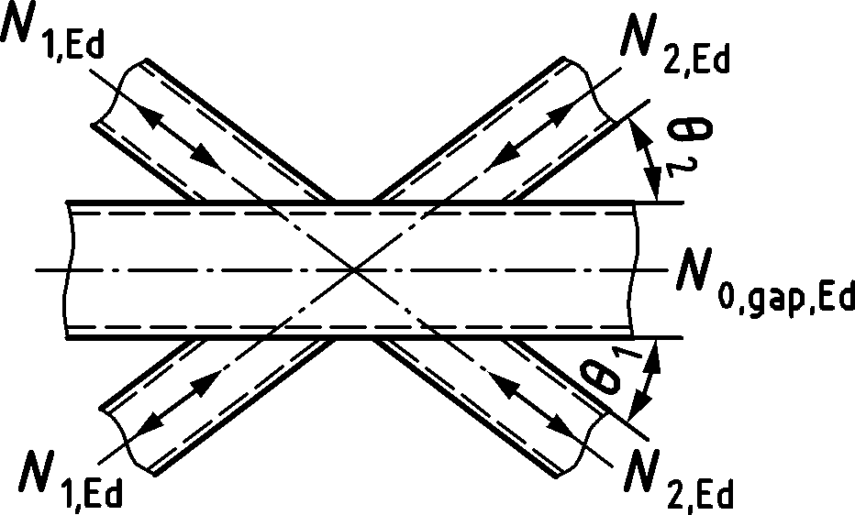 | $N_{i,Ed}≤N_{i,Rd}$ ($i=1$ or 2)  with $N_{i,Rd}$ for K joint given in Table 9.6, but with the actual chord force.
Forces in members 1 are in compression and members 2 in tension. | 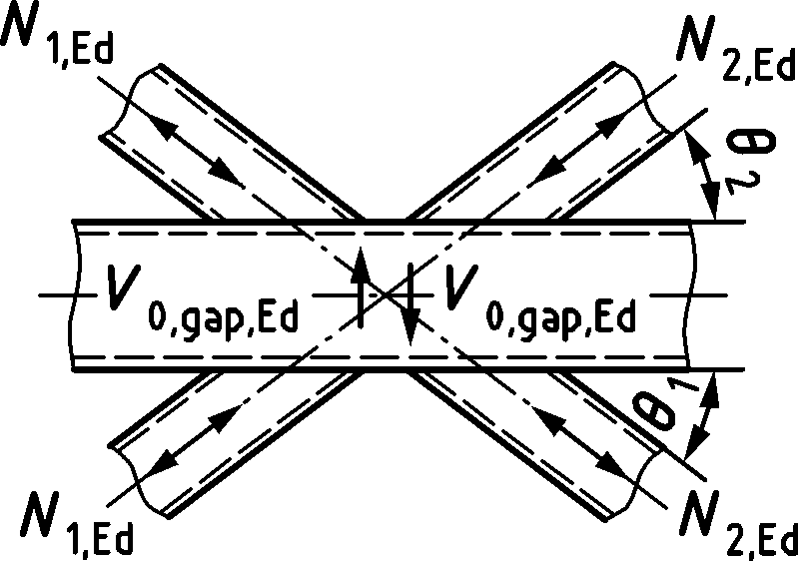 | $N_{i,Ed}≤N_{i,Rd}$ ($i=1$ or 2)  with $N_{i,Rd}$ for K joint given in Table 9.6 but with the actual chord force, provided that the chord cross-section 1-1 in the gap satisfies the following:  $${\left(\frac{N_{0,gap,Ed}}{N_{0,Rd}}\right)}^{2}+{\left(\frac{V_{0,gap,Ed}}{V_{0,gap,Rd}}\right)}^{2}≤1,0$$  where:  $$N_{0,Rd}={A_{0}f_{y0}}/{γ_{M5}}$$  $V_{0,gap,Rd}={\frac{2}{π}\frac{f_{y0}}{\sqrt{3}}A_{0}}/{γ_{M5}}$
KT gap joint configurations (one example only)
Members 1 and 3 are here in compression and member 2 is here in tension. | 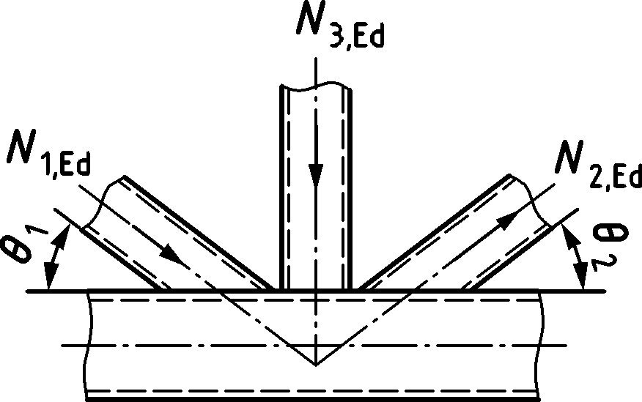 | $$N_{1,Ed}sin{ θ}_{1}+N_{3,Ed}sin{ θ}_{3}≤N_{1,Rd}\sin{θ_{1}}$$  $$N_{2,Ed}sin{ θ}_{2}≤N_{1,Rd}\sin{θ_{1}}$$  where $N_{1,Rd}$ is the value of $N_{1,Rd}$ for a K gap joint from Table 9.6 but with:  $$β=\frac{d_{1}+d_{2}+d_{3}}{3d_{0}}$$
a Design resistance related to chord failure in Table 9.6
b Each brace should be checked individually for punching shear.

Table 9.11 — Design criteria for welded knee joints in CHS members
Knee joint configuration

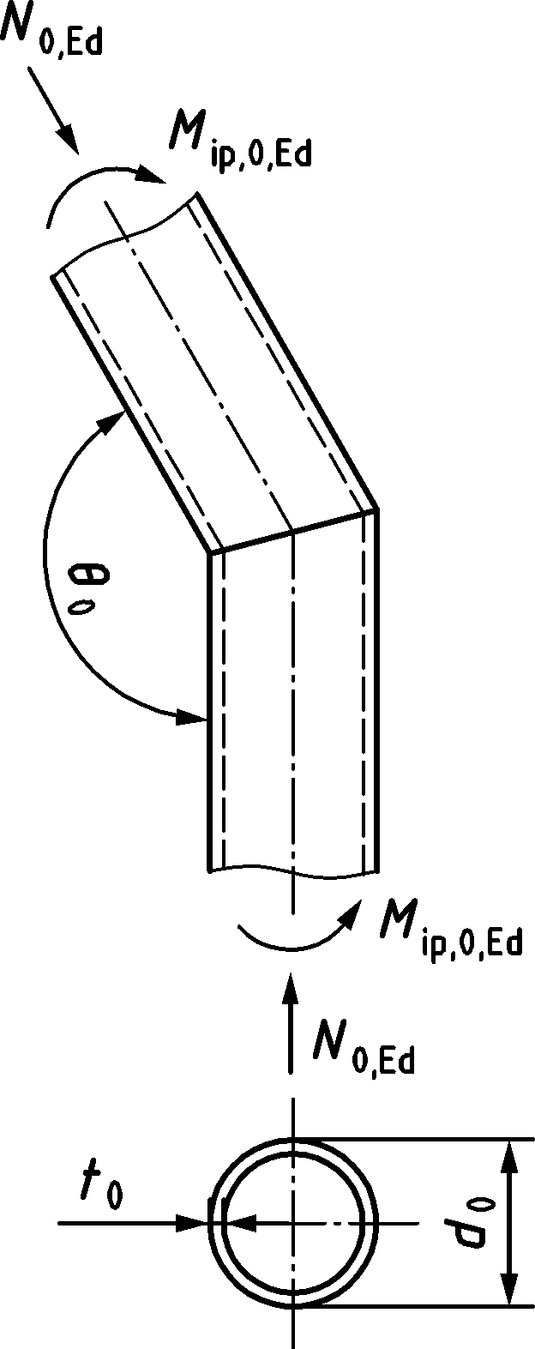 | The cross-section should be class 1 for axial loading, see  EN 1993-1-1.  $$N_{0,Ed}≤0,2{ N}_{0,Rd}$$  $V_{0,Ed}≤0,5{ V}_{0,Rd}$ and  $$\frac{\left|N_{0,Ed}\right|}{N_{0,Rd}}+\frac{\left|M_{ip,0,Ed}\right|}{M_{ip,0,Rd}}≤κ$$  For ${90}^{o}≤θ_{0}≤{135}^{o}$ $κ={\left(0,05{d_{0}}/{t_{0}+0,77}\right)}^{-1,2}ε$  with $= \sqrt{\frac{235}{f_{y0}}}$
Knee joint configuration with inserted plate
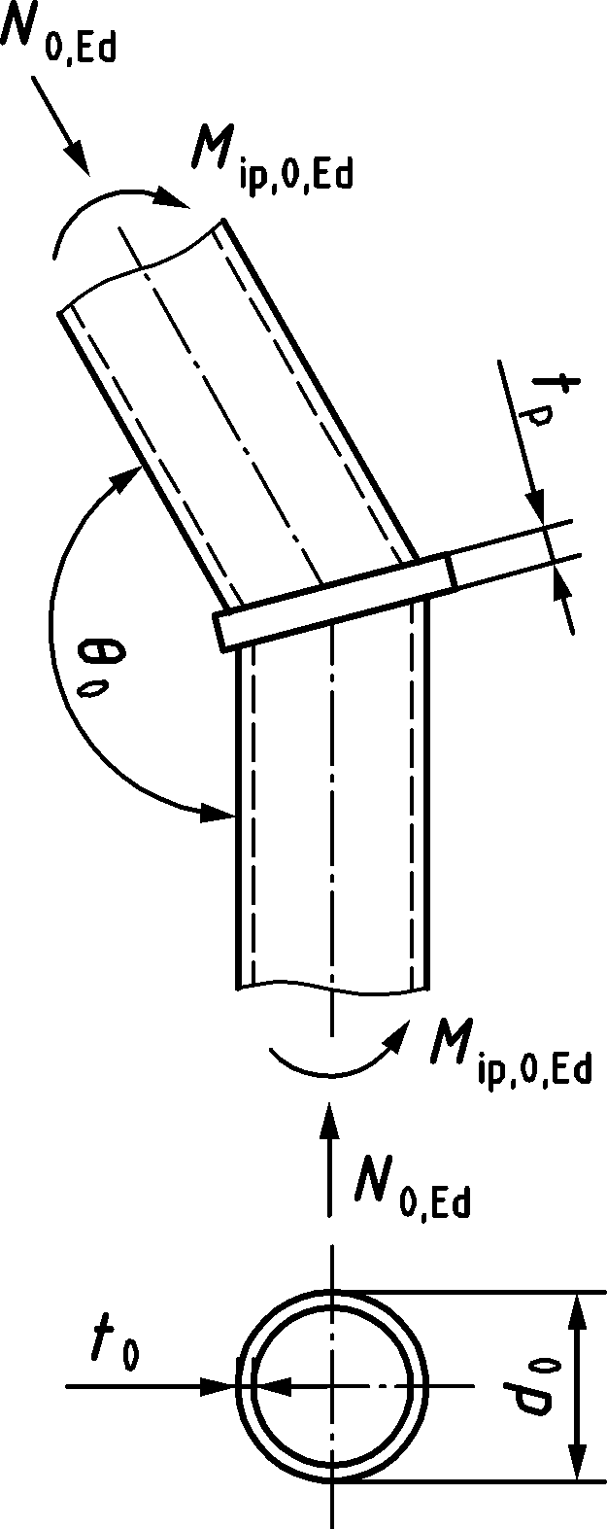 | The cross-section should be class 1 or 2 for axial loading,  see EN 1993-1-1.  $t_{p}≥1,5t_{0}$ but $≥10 mm$  $$\frac{\left|N_{0,Ed}\right|}{N_{0,Rd}}+\frac{\left|M_{ip,0,Ed}\right|}{M_{ip,0,Rd}}≤1,0$$

Multiplanar joint configurations
(1) The design resistance for each relevant plane of a multiplanar joint configuration primarily loaded by axial forces should be determined according to 9.4.2 and applying the multiplanar factor $μ$ from Table 9.12 to the resistance for chord failure. For KK joint configurations the gap should also be checked for the interaction of shear and axial load taking account of the actual chord force.
Table 9.12 — Multiplanar factors $μ$ for the design resistance of joints with CHS members in multiplanar joint configurations
TT joint configurations (members 1 may be either in tension or compression)
Members 1 may be either in tension or compression  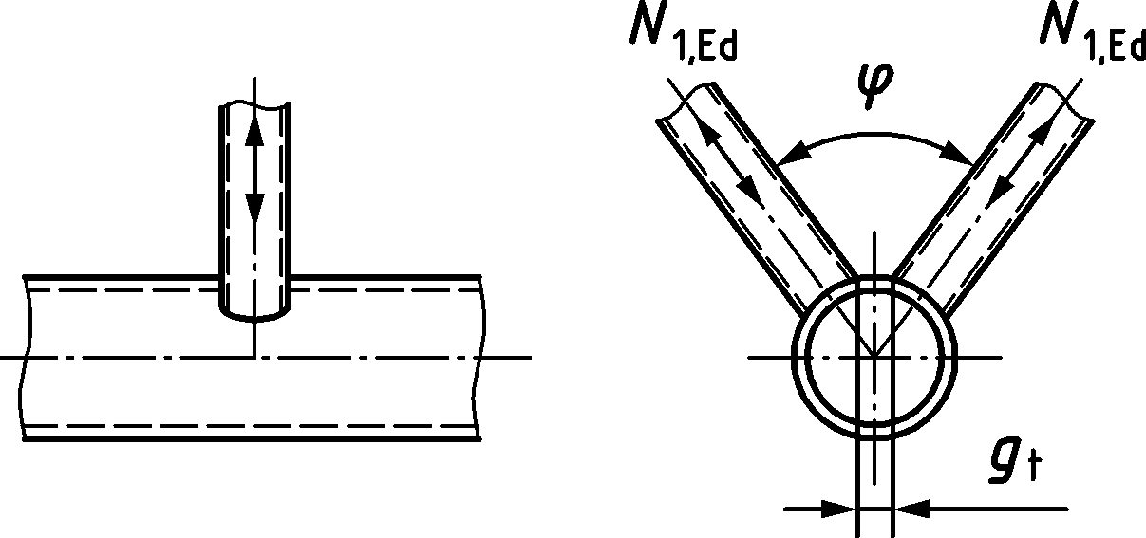 | $$μ=1,0$$
XX joint configurations (members 1 and 2 can be either in compression or tension)
Members 1 and 2 can be either in compression or tension.  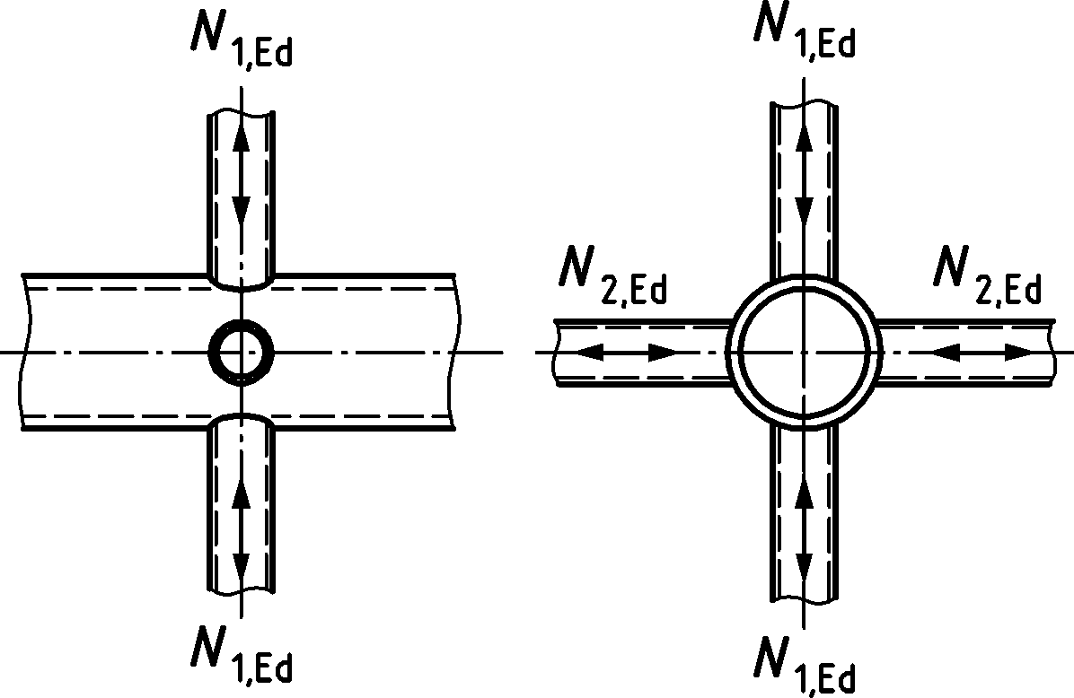 | $$μ=1+0,35 \frac{N_{2,Ed}}{N_{1,Ed}}$$  Take account of the sign of $N_{1,Ed}$ and $N_{2,Ed}$, with $\left|N_{2,Ed}\right|≤\left|N_{1,Ed}\right|$.  ${N_{2,Ed}}/{N_{1,Ed}}$ is negative if the members in one plane are in tension and in the other plane in compression.
KK gap joint configurations (members 1 in compression and members 2 in tension)
Members 1: compression and  Members 2: tension  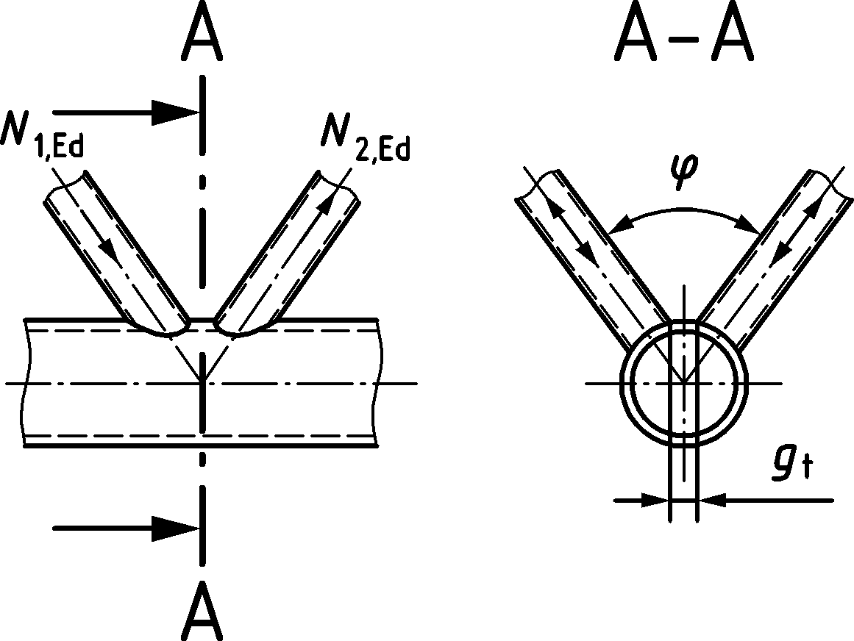 | $$μ=1,0$$  In a KK gap joint configuration, the chord cross-section in the gap should be checked for shear failure:  $${\left(\frac{N_{0,gap,Ed}}{N_{0,Rd}}\right)}^{2}+{\left(\frac{V_{0,gap,Ed}}{V_{0,gap,Rd}}\right)}^{2}≤1,0$$  where:  $$N_{0,Rd}={A_{0}f_{y0}}/{γ_{M5}}$$  $$V_{0,gap,Rd}=\frac{2}{π}{\frac{f_{y0}}{\sqrt{3}}A_{0}}/{γ_{M5}}$$

Welded joints between CHS or RHS brace members, and RHS chord members

General
(1) Provided that the geometry of the joints is within the limits in Table 9.13, the design resistance of welded joints between brace members and rectangular or square hollow section chord members should be obtained from 9.5.2 and 9.5.3.
(2) For joints complying with Table 9.13, failure modes other than those covered in the appropriate table may be ignored. The design resistance of a joint should be taken as the minimum value for all applicable failure modes.
(3) For joints not complying with Table 9.13, all failure modes listed in 9.2.2(1) should be considered. In addition, the secondary moments in the joints caused by their rotational stiffness should be taken into account.
(4) The design resistance of overlap joint configurations should be obtained from 9.7.
(5) K joint configurations should also be checked as two separate T or Y joint configurations when $g>1,5\left(1-β\right)b_{0}$ and $g>\left(t_{1 }+t_{2}\right)$, but with an additional chord shear check in the gap as given in Table 9.15 with $= 0$.
Table 9.13 — Range of validity for welded joints between CHS or RHS brace members and RHS chord members
 |  | T, Y or X joint configurations | K gap joint configurations
General |  | $θ_{i}≥{30}^{o}$; $e/{h_{0}}≤0,25$
$$0,5\left(1-β\right)≤g/{b_{0}≤1,5\left(1-β\right)}$$
but as minimum $g≥t_{1}+t_{2}$
RHS chord | Compression | Class 1 and 2 and ${b_{0}}/{t_{0}≤35}$ and ${h_{0}}/{t_{0}≤35}$
 | Tension | ${b_{0}}/{t_{0}≤35}$ and ${h_{0}}/{t_{0}≤35}$
RHS braces | General | $${b_{i}}/{b_{0}}≥0,1+0,01{b_{0}}/{t_{0}}but ≥0,25 and 0,5≤{h_{i}}/{b_{i}≤2,0}$$
 | Compression | Class 1 and 2 and ${b_{i}}/{t_{i}≤35}$ and ${h_{i}}/{t_{i}≤35}$
 | Tension | ${b_{i}}/{t_{i}≤35}$ and ${h_{i}}/{t_{i}≤35}$
CHS braces | General | ${d_{i}}/{b_{0}}≥0,1+0,01{b_{0}}/{t_{0}}$ and $0,25≤{d_{i}}/{b_{0}}≤0,80$
 | Compression | Class 1 and 2 and ${d_{i}}/{t_{i}≤50}$
 | Tension | ${d_{i}}/{t_{i}≤50}$
Transversal plates | Compression and tension | ${b_{1}}/{b_{0}}≥0,4$ and $2γ≤30$ and $θ=90°$
Longitudinal plates | Compression and tension | ${{1≤h}_{1}}/{b_{0}}≤4$ and $θ=90°$

Uniplanar joint configurations

Unreinforced joints
(1) In uniplanar joint configurations subject only to axial forces, the design internal axial force $N_{i,Ed}$ should not exceed the design axial resistance of the welded joint $N_{i,Rd}$, obtained from 9.5.2.1(2) or 9.5.2.1(3) as appropriate.
(2) The design axial resistances of welded joints between brace members and RHS chords, within the range of validity of Table 9.13, should be obtained from the Formulae in Table 9.14, Table 9.15 or Table 9.16, as appropriate.
(3) Joints of the brace members subjected to combined bending and axial force should satisfy the following requirement:
$$\frac{\left|N_{i,Ed}\right|}{N_{i,Rd}}+\frac{\left|M_{ip,i,Ed}\right|}{M_{ip,i,Rd}}+\frac{\left|M_{op,i,Ed}\right|}{M_{op,i,Rd}}≤1,0$$ | (9.4)
where
$M_{ip,i,Rd}$ design in-plane moment resistance
$M_{ip,i,Ed}$ design in-plane internal moment
$M_{op,i,Rd}$ design out-of-plane moment resistance
$M_{op,i,Ed}$ design out-of -plane internal moment
(4) The design internal moment $M_{i,Ed}$may be taken as the value at the point where the centreline of the brace member meets the face of the chord member.
(5) For unreinforced joints, the design in-plane moment resistance $M_{ip,i,Rd}$ and design out-of-plane moment resistance $M_{op,i,Rd}$should be obtained from Table 9.16 or Table 9.17, as appropriate. For reinforced joints, see ‎9.5.2.2.
(6) The special types of welded joint configurations in Table 9.18 and Table 9.19 should satisfy the appropriate design criteria specified for each configuration in those tables.
Table 9.14 — Design axial resistance of welded T, Y and X joints between RHS or CHS brace members and RHS chord membersa, b
T, Y and X joint configurations |  | Chord face failure $β≤0,85$
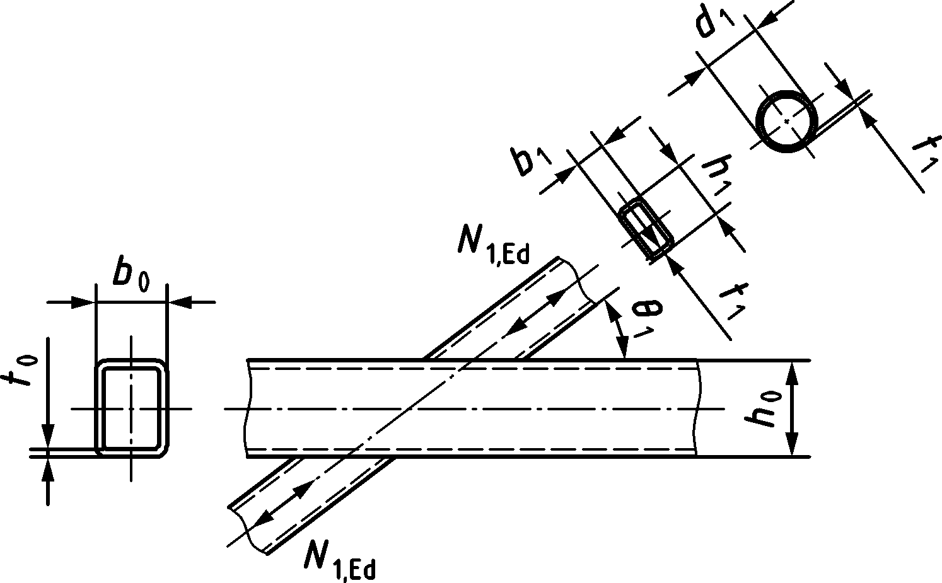 |  | $$N_{1,Rd}={C_{f}\frac{f_{y0}t_{0}^{2}}{sin{ θ}_{1}}\left(\frac{2η}{\left(1-β\right)\sin{θ_{1}}}+\frac{4}{\sqrt{1-β}}\right)Q_{f}}/{γ_{M5}}$$
 |  | Chord side wall failure $β=1,0$ b
 |  | $$N_{1,Rd}={\frac{f_{b}t_{0}}{sin{ θ}_{1}}\left(\frac{2h_{1}}{sin{ θ}_{1}}+10t_{0}\right)Q_{f}}/{γ_{M5}}$$
 |  | Brace failure
 |  | $$N_{1,Rd}={C_{f}f_{y1}t_{1}\left(2h_{1}-4t_{1}+2b_{eff}\right)}/{γ_{M5}}$$
 |  | Punching shear failure $b_{i}≤\left(b_{0}-{2t}_{0}\right)$
 |  | $$N_{1,Rd}=C_{f}{\frac{f_{y0}t_{0}}{\sqrt{3}\sin{θ_{1}}}\left(\frac{2h_{1}}{sin{ θ}_{1}}+2b_{e,p}\right)}/{γ_{M5}}$$
For circular braces, the above resistances should be multiplied by π/4, b1 and h1 should be replaced with d1, b2 and h2 with d2, and beff and be,p with deff and de,p.
For tension: $f_{b}=f_{y0}$  For compression:  T and Y joint configurations $f_{b}={χf}_{y0}$  X joint configurations $f_{b}=0,8{χf}_{y0}\sin{θ_{1}}$  where  $χ$ is the reduction factor for flexural buckling obtained from EN 1993-1-1 and a normalised slenderness$\overline{λ}$ determined from:  $$\overline{λ}=3,46\frac{\left(\frac{h_{0}}{t_{0}}-2\right)\sqrt{\frac{1}{sin{ θ}_{1}}}}{π\sqrt{E/{f_{y0}}}}$$ |  | $$b_{eff}=\frac{10}{{b_{0}}/{t_{0}}}\frac{f_{y0}t_{0}}{f_{y1}t_{1}}b_{1} but b_{eff}≤b_{1}$$  $$d_{eff}=\left(\frac{10}{{b_{0}}/{t_{0}}}\right)\left(\frac{f_{y0}t_{0}}{f_{y1}t_{1}}\right)d_{1 } but d_{eff}≤d_{1}$$
$$b_{e,p}=\frac{10}{{b_{0}}/{t_{0}}}b_{1} but b_{e,p}≤b_{1}$$
$$d_{e,p}=\frac{10}{{b_{0}}/{t_{0}}}d_{1 } but d_{e,p}≤d_{1 }$$
 |  | For material factor $C_{f}$, see 9.1.1(4)
Chord stress factor acc. to 9.2.1(4) with  $Q_{f}={\left(1-\left|n_{0}\right|\right) }^{C_{1}}$ but ≥ 0,4 and chord stress ratio n0 acc. to 9.2.1(3) |  |  | $$n_{0}<0$$  (for compression) | $$n_{0}≥0$$  (for tension)
 | T, Y and X joint configurations |  | $$C_{1}=0,6-0,5β$$ | $$C_{1}=0,10$$
a For X joint configurations with $cos{ θ}_{1}>{h_{1}}/{h_{0}}$ the design chord shear resistance should be checked using Table 9.15 assuming that $=0$.
b For $0,85<β<1,0$ linear interpolation may be applied between the governing resistances at $β=0,85$ (chord face failure, brace failure and punching shear) and $β=1,0$ (chord side wall failure, brace failure and chord shear).

Table 9.15 — Design axial resistance of welded K joints between RHS or CHS brace members and RHS chord membersa
K gap joint configurations | Chord face failure
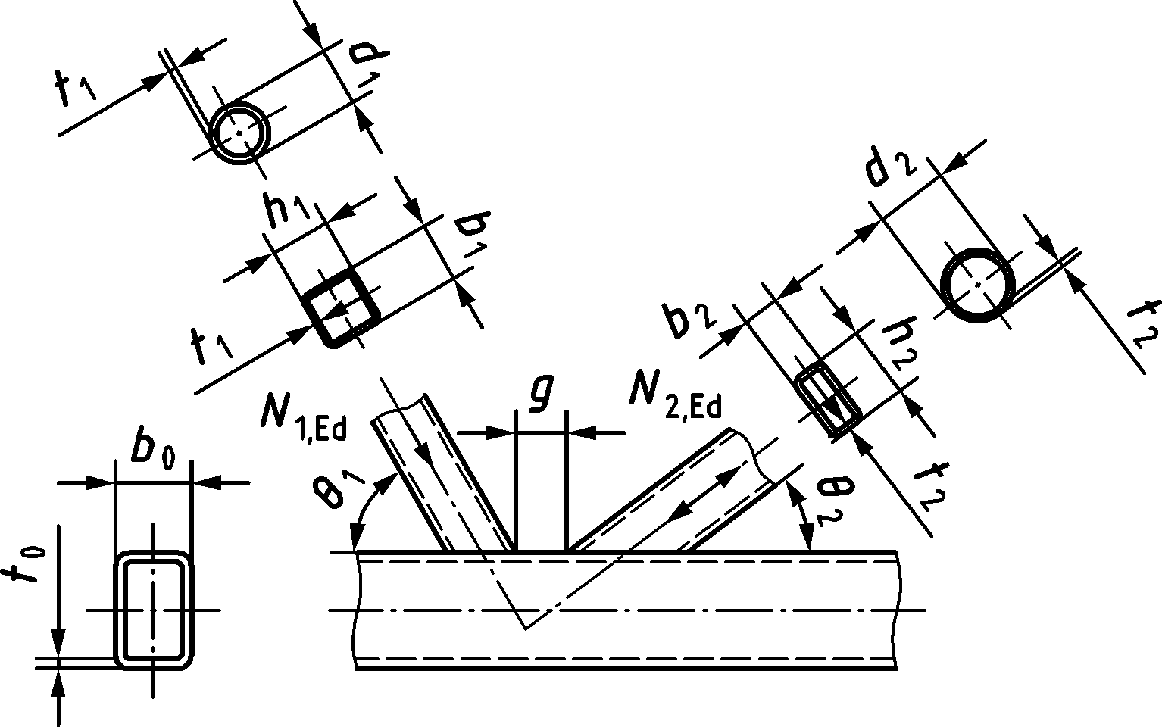 | $$N_{i,Rd}={8,9C_{f}βγ^{0,5}\frac{f_{y0}t_{0}^{2}}{\sin{θ_{i}}}Q_{f}}/{γ_{M5}}$$
 | Chord shear failure
$$N_{i,Rd}={\frac{f_{y0}A_{v,0,gap}}{\sqrt{3} sinθ_{i}}}/{γ_{M5}}$$
$$N_{0,V,Rd}={\left[\left(A_{0}-A_{v,0,gap}\right)f_{y0}+A_{v,0,gap}f_{y0}\sqrt{1-{\left(\frac{V_{0,gap,Ed}}{V_{0,gap,Rd}}\right)}^{2}}\right]}/{γ_{M5}}$$
 | Brace failure
 | $N_{i,Rd}=C_{f}f_{yi}t_{i}{\left(2h_{i}-4t_{i}+b_{i}+b_{eff}\right)}/{γ_{M5}}$
 | Punching shear failure $b_{i}≤\left(b_{0}-{2t}_{0}\right)$
 | $$N_{i,Rd}=C_{f}{\frac{f_{y0}t_{0}}{\sqrt{3}\sin{θ_{i}}}\left(\frac{2h_{1}}{\sin{θ_{i}}}+b_{i}+b_{e,p}\right)}/{γ_{M5}}$$
For circular braces, the above resistances should be multiplied by π/4, b1 and h1 should be replaced with d1, b2 and h2 with d2, and beff and be,p with deff and de,p, except for chord shear.
$$A_{V,0,gap}=\left(2h_{0}+αb_{0}\right)t_{0}$$  For a square or rectangular brace member:  $$α=\sqrt{\frac{1}{1+\frac{4g^{2}}{3t_{0}^{2}}}}$$  where g is the gap, see Figure 3.4a.  For a circular brace member: $α=0$  $$V_{0,gap,Ed}={\left(N_{i,Ed} sin{ θ}_{i}\right)}_{max}$$  $$V_{0,gap,Rd}=\frac{f_{y0}}{\sqrt{3}}A_{v,0,gap}/γ_{M5}$$ | $$b_{eff}=\frac{10}{{b_{0}}/{t_{0}}}\frac{f_{y0}t_{0}}{f_{yi}t_{i}}b_{i} but { b}_{eff}≤b_{i}$$  $$d_{eff}=\frac{10}{{b_{0}}/{t_{0}}}\frac{f_{y0}t_{0}}{f_{yi}t_{i}}d_{i} but { d}_{eff}≤d_{i}$$
$$b_{e,p}=\frac{10}{{b_{0}}/{t_{0}}}b_{i} but b_{e,p}≤b_{i}$$
$$d_{e,p}=\frac{10}{{b_{0}}/{t_{0}}}d_{i} but d_{e,p}≤d_{i}$$
 | For material factor $C_{f}$, see 9.1.1(4)
Chord stress factor acc. to 9.2.1(4) with  $Q_{f}={\left(1-\left|n_{0}\right|\right) }^{C_{1}}$ but ≥ 0,4 and chord stress ratio n0 acc. to 9.2.1(3) |  | $$n_{0}<0$$  (for compression) | $$n_{0}≥0$$  (for tension)
 | K joint configurations with gap | $$C_{1}=0,5-0,5β$$  $$but ≥0,1$$ | $$C_{1}=0,10$$
a Design resistances: i=1 or 2

Table 9.16 — Design resistances of plate or I-to-RHS chord members
T and X joint configurations – transverse platea | Chord face failure $β≤0,85$
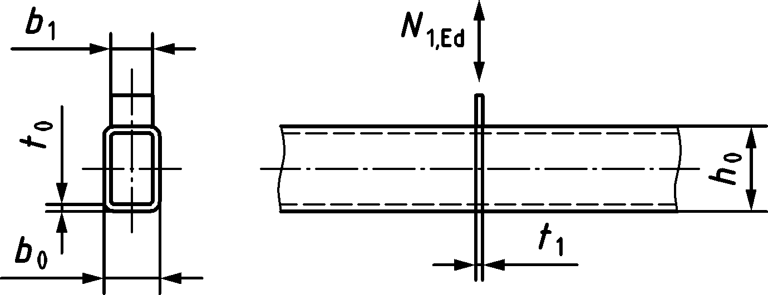 | $$N_{1,Rd}={C_{f}f_{y0}t_{0}^{2}\left[\frac{2+2,8β}{\sqrt{1-0,9β}}\right]Q_{f}}/{γ_{M5}}$$
 | Chord side wall failure (for $β=1,0$) a
 | $$N_{1,Rd}={2C_{f}f_{y0}t_{0}\left(t_{1}+5t_{0}\right)Q_{f}}/{γ_{M5}}$$
 | Chord punching shear failure $b_{1}≤\left(b_{0}-{2t}_{0}\right)$
 | $$N_{1,Rd}=C_{f}{\frac{f_{y0}}{\sqrt{3}}t_{0}\left(2t_{1}+2b_{e,p}\right)}/{γ_{M5}}$$
 | Plate failure (for all β)
 | $$N_{1,Rd}={C_{f}f_{y1}t_{1}b_{eff}}/{γ_{M5}}$$
T and X joint configurations – longitudinal plate | Chord face failure
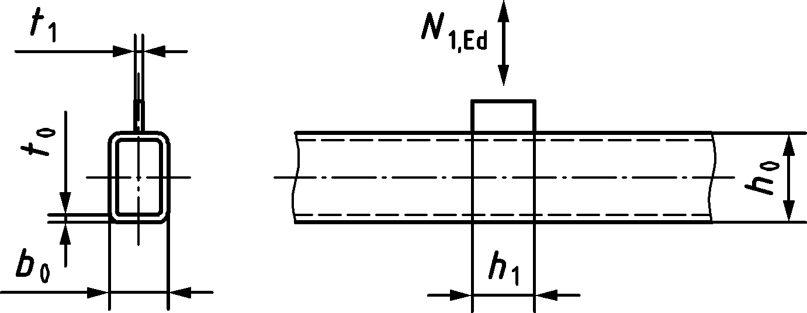 | $$N_{1,Rd}=2C_{f}f_{y0}t_{0}^{2}\left[η+2\sqrt{1-\frac{t_{1}}{b_{0}}}\right]{Q_{f}}/{γ_{M5}}$$
 | Punching shear failure
 | $$N_{1,Rd}={\frac{C_{f}f_{y0}}{\sqrt{3}}t_{0}\left(2h_{1}+2t_{1}\right)}/{γ_{M5}}$$
T joint configurations – longitudinal through-plate | Chord face failure
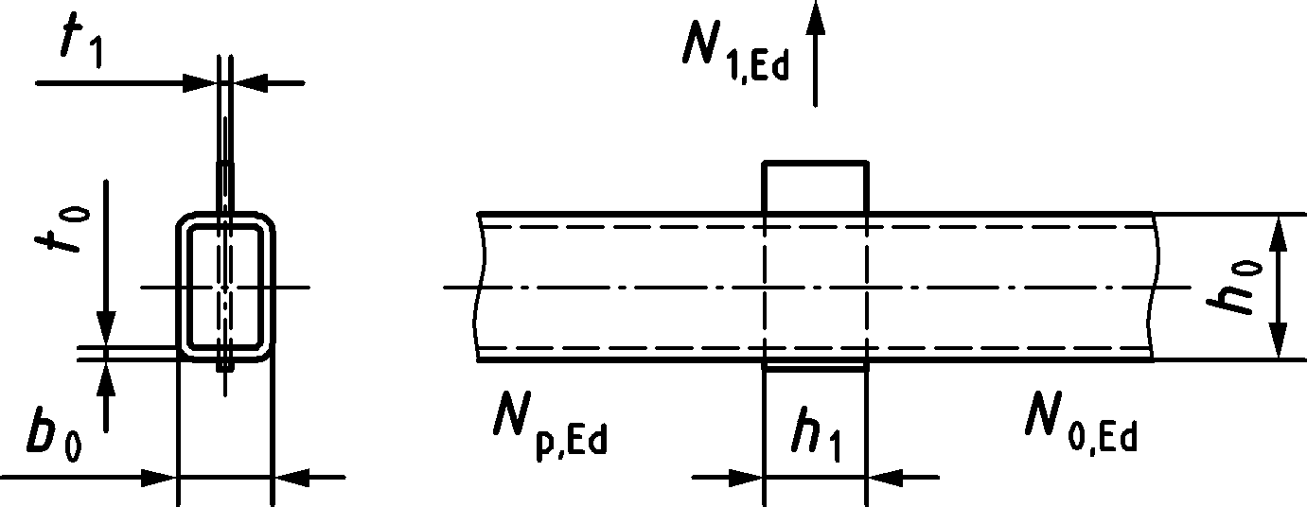 | $$N_{1,Rd}=4C_{f}f_{y0}t_{0}^{2}\left[η+2\sqrt{1-\frac{t_{1}}{b_{0}}}\right]{Q_{f}}/{γ_{M5}}$$
 | Punching shear failure
 | $$N_{1,Rd}={2\frac{C_{f}f_{y0}}{\sqrt{3}}t_{0}\left(2h_{1}+2t_{1}\right)}/{γ_{M5}}$$
T joint configurations | Design resistance
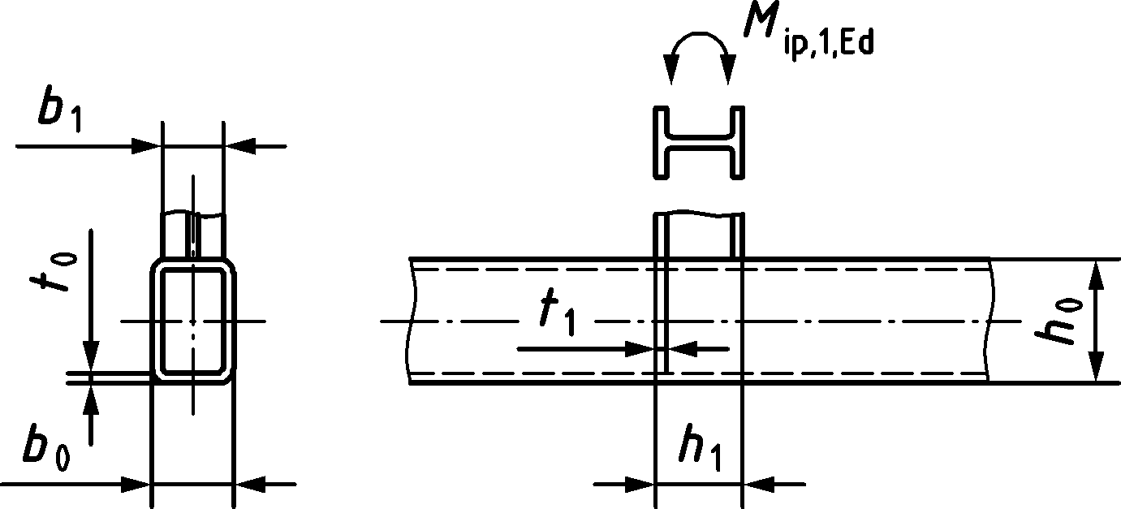 | If $η≥2\sqrt{1-β}$ and $h_{1} 2t_{1}+5t_{0}$, $N_{1,Rd}$ for an I or H section may be assumed to be equal to the design resistance of two transverse plates of similar dimensions to the flanges of the I or H section, determined according to Table 9.16  $$M_{ip,1,Rd}=N_{1,Rd}\left(h_{1}-t_{1}\right)$$  $N_{1,Rd}$ is the capacity of one flange; β is the ratio of the width of the flange of the I or H brace section and the width of the RHS chord.

Chord stress factor acc. to 9.2.1(4) with  $Q_{f}={\left(1-\left|n_{0}\right|\right) }^{C_{1}}$ but ≥ 0,3 and chord stress ratio n0 acc. to 9.2.1(3) |  | $$n_{0}<0$$  (for compression) |  | $$n_{0}≥0$$  (for tension)
 | Transverse plate | $$C_{1}=0,03γ$$ |  | $$C_{1}=0,10$$
 | Longitudinal plate | $$C_{1}=0,20$$
Material factor $C_{f}$ | According to 9.1.1(4)
Factors $b_{eff}$ and $b_{e,p}$ | $$b_{eff}=\left(\frac{10}{{b_{0}}/{t_{0}}}\right)\left(\frac{f_{y0}t_{0}}{f_{y1}t_{1}}\right)b_{1 }\text{ but} ≤b_{1}$$  $$b_{e,p}=\left(\frac{10}{{b_{0}}/{t_{0}}}\right)b_{1} \text{ but} ≤b_{1}$$
Range of validity: In addition to the limits given in Table 9.13
Transverse plate:  $β={b_{1}}/{b_{0}≥0,4}$ $2γ≤30$ | Longitudinal plate:  $$1≤η={h_{1}}/{b_{0}≤4}$$ |  | Plate angle:  $$θ=90°$$
a For $0,85<β<1,0$, linear interpolation may be applied between the governing resistance at $β=0,85$ (chord face failure, chord punching shear failure and plate failure) and that at $β=1,0$ (chord side wall failure and plate failure).

Table 9.17 — Design moment resistances of welded joints between RHS brace members and RHS chords
T and X joint configurations – in-plane bending | Chord face failure (for $β≤0,85$)
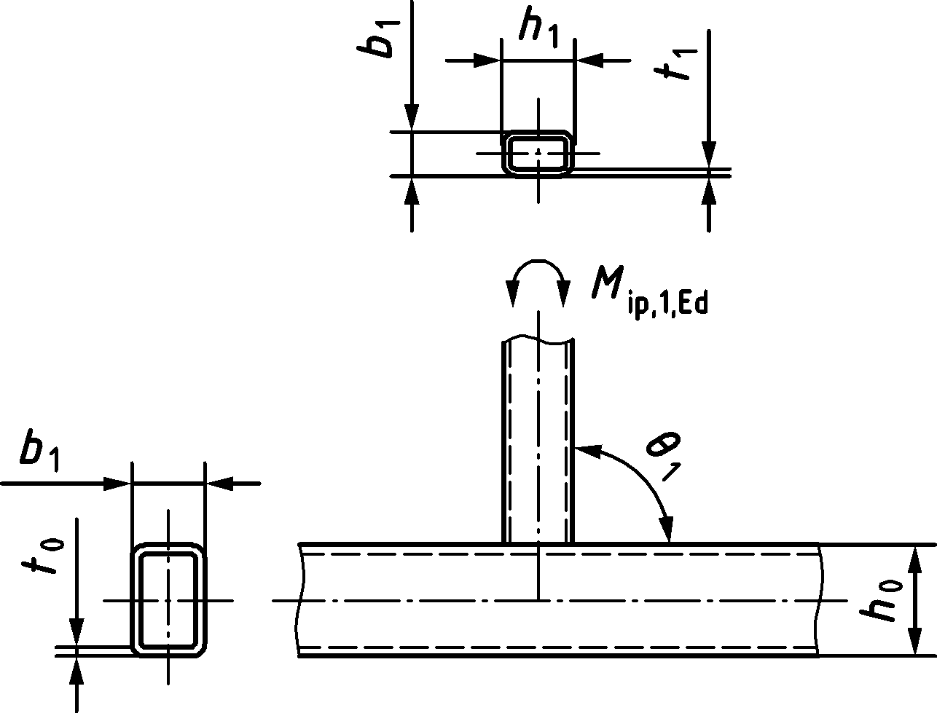 | $$M_{ip,1,Rd}={C_{f}f_{y0}t_{0}^{2}h_{1}\left(\frac{1}{2η}+\frac{2}{\sqrt{1-β}}+\frac{η}{1-β}\right)Q_{f}}/{γ_{M5}}$$
 | Chord side wall failurea (for $β=1,0$)
 | $$M_{ip,1,Rd}={0,5C_{f}f_{b}t_{0}{\left(h_{1}+5t_{0}\right)}^{2}Q_{f}}/{γ_{M5}}$$
 | Brace failure
 | $$M_{ip,1,Rd}={C_{f}f_{y1}\left[W_{ip,pl,1}-\left(1-\frac{b_{eff}}{b_{1}}\right)b_{1}\left(h_{1}-t_{1}\right)t_{1}\right]}/{γ_{M5}}$$
 | Punching shear failure
 | $$M_{ip,1,Rd}=C_{f}\frac{f_{y0}}{\sqrt{3}}t_{0}\left(0,33h_{1}^{2}+b_{e,p}h_{1}\right)/γ_{M5}$$
T and X joint configurations – out-of-plane bending | Chord face failure (for $β≤0,85$)
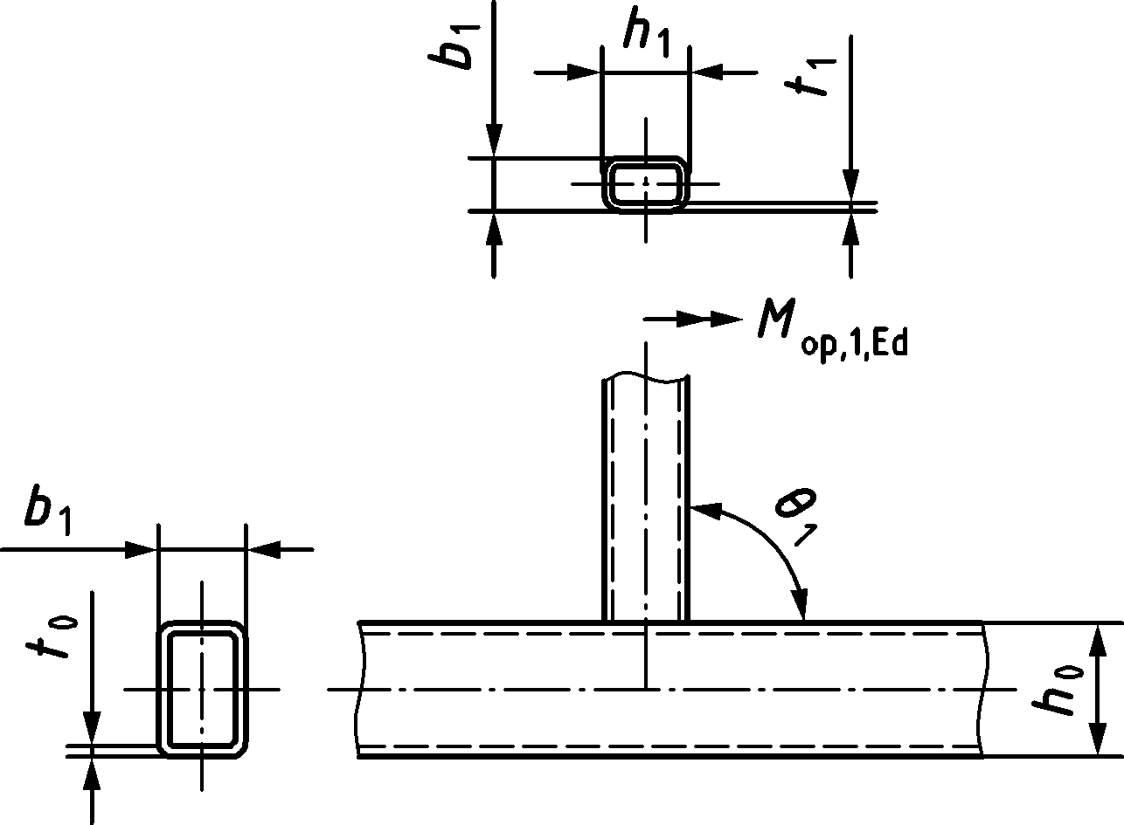 | $$M_{op,1,Rd}={C_{f}f_{y0}t_{0}^{2}b_{1}\left[\frac{h_{1}\left(1+β\right)}{{2b}_{1}\left(1-β\right)}+\sqrt{\frac{2\left(1+β\right)}{β\left(1-β\right)}}\right]Q_{f}}/{γ_{M5}}$$
 | Chord side wall failurea (for $β=1,0$)
 | $$M_{op,1,Rd}={{C_{f}f}_{b}t_{0}\left(b_{0}{-t}_{0}\right)\left(h_{1}+5t_{0}\right)Q_{f}}/{γ_{M5}}$$
 | Distortion of the chord due to out-of-plane moments should be prevented
 | Brace failure
 | $$M_{op,1,Rd}={C_{f}f_{y1}\left[W_{op,pl,1}-0,5t_{1}{\left(b_{1}-b_{eff}\right)}^{2}\right]}/{γ_{M5}}$$
 | Punching shear failure
 | $$M_{op,1,Rd}=C_{f}\frac{f_{y0}}{\sqrt{3}}t_{0}\left[h_{1}b_{1}+0,33\left(b_{1}^{2}-{\left(b_{1}-b_{e,p}\right)}^{2}\right)\right]/γ_{M5}$$
Chord stress factor acc. to 9.2.1(4) with  $Q_{f}={\left(1-\left|n_{0}\right|\right) }^{C_{1}}$ but ≥ 0,3 and chord stress ratio n0 acc. to 9.2.1(3) |  | $$n_{0}<0$$  (for compression) |  | $$n_{0}≥0$$  (for tension)
 | T, Y and X joint configurations | $$C_{1}=0,6-0,5β$$ |  | $$C_{1}=0,10$$
Material factor $C_{f}$ | According to 9.1.1(4)
Factors $b_{eff}$ and $f_{b}$
$$b_{eff}=\left(\frac{10}{{b_{0}}/{t_{0}}}\right)\left(\frac{f_{y0}t_{0}}{f_{y1}t_{1}}\right)b_{1} \text{but} ≤b_{1}$$ | Brace in-plane bending |  | Brace out-of-plane bending
 | T and Y joint configurations |  | X joint configurations
 | $$f_{b}={χf}_{y0}$$ |  | $$f_{b}=0,8{χf}_{y0}$$
 | where $χ$ is a reduction factor for flexural buckling, see Table 9.14
Range of validity | Same as in Table 9.16, but with $θ_{1}={90}^{o}$b
a For $0,85<β<1,0$, linear interpolation may be applied between the governing resistances at β = 0,85 (chord face failure and brace failure) and that at $β=1,0$ (brace failure and chord side wall failure).
b The equations are safe-sided for $θ_{1}<{90}^{o}$.

Table 9.18 — Design axial resistance of special types of welded joints between RHS brace members and RHS chordsa, b
DY joint configurations
All brace member forces act in the same sense (compression or tension). | 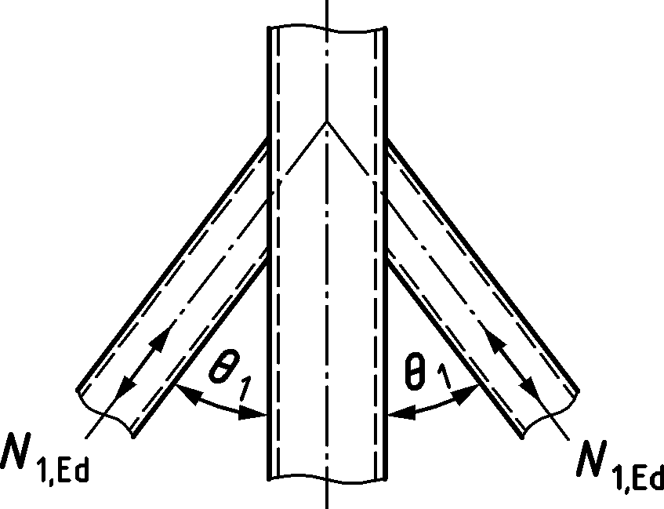 | $$N_{1,Ed}≤N_{1,Rd}$$  with $N_{1,Rd}$ for X joint configurations given in Table 9.14.  Check for chord shear not required
DX joint configurations
All brace member forces act in the same sense (compression or tension). | 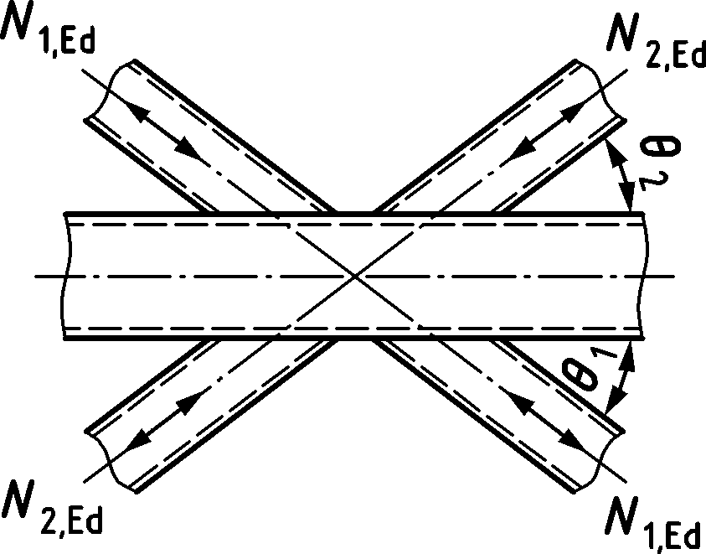 | $$N_{1,Ed}\sin{θ_{1}}+N_{2,Ed}\sin{θ_{2}}≤N_{x,Rd} sin{ θ}_{x}$$  with $N_{x,Rd}\sin{θ_{x}}$ for X joint configurations given in Table 9.14 being the larger of the values of $\left|N_{1,Rd}\sin{θ_{1}}\right|$ and $\left|N_{2,Rd}\sin{θ_{2}}\right|$
DK gap joint configurations (Forces N1 are in compression and N2 in tension.)
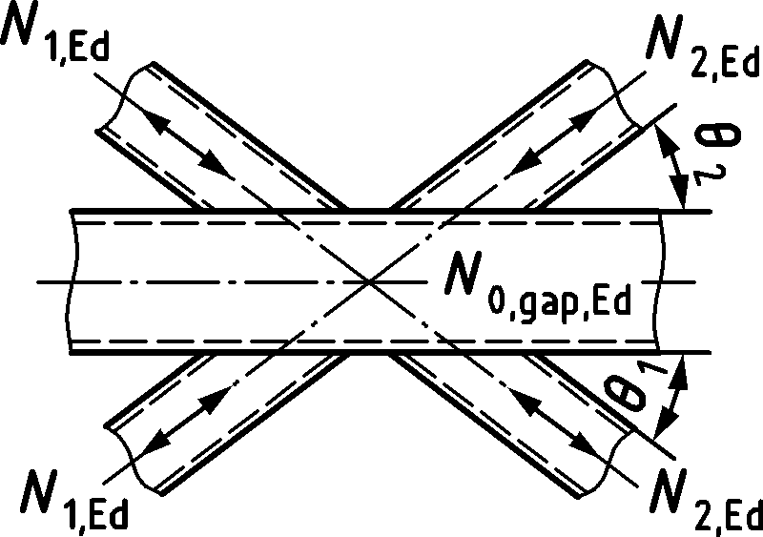 |  | $N_{i,Ed}≤N_{i,Rd}$ ($i=1$ or 2)  with $N_{i,Rd}$ for K joint configurations given in Table 9.15.
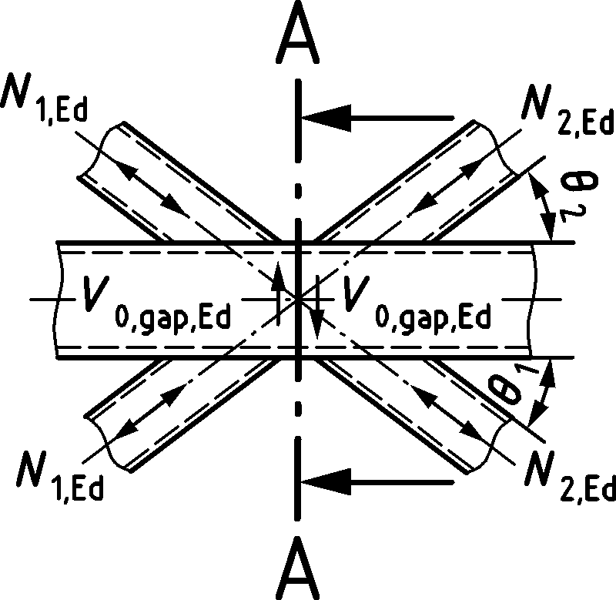 |  | $N_{i,Ed}≤N_{i,Rd}$ ($i=1$ or 2)  with $N_{i,Rd}$ for K gap joint configurations given in Table 9.15. Additionally, the chord cross-section 1-1 in the gap should satisfy:  $$V_{0,gap,Ed}≤{\frac{f_{y0}}{\sqrt{3}}A_{v,0,gap}}/{γ_{M5}}$$  $$N_{0,V,Rd}={\left[\left(A_{0}-A_{v,0,gap}\right)f_{y0}+A_{v,0,gap}f_{y0}\sqrt{1-{\left(\frac{V_{0,gap,Ed}}{V_{0,gap,Rd}}\right)}^{2}}\right]}/{γ_{M5}}$$  $$V_{0,gap,Rd}=\frac{f_{y0}}{\sqrt{3}}A_{v,0,gap}/γ_{M5} \text{with} A_{v,0,gap}=2h_{0}t_{0}+2αb_{0}t_{0}$$
KT gap joint configurations (one example only)
Members 1 and 3 are in compression and member 2 is in tension.  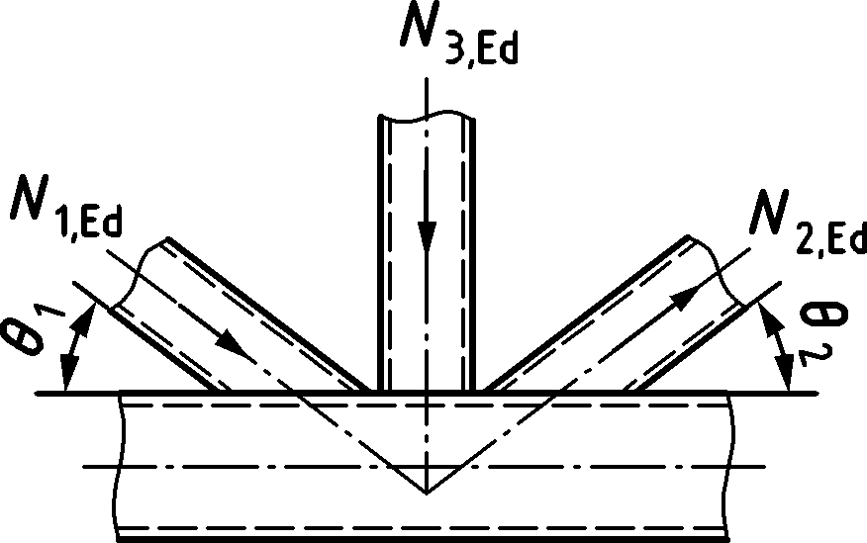 |  | $$N_{\text{1,Ed}} \text{sin} θ_{1}+N_{\text{3,Ed}} \text{sin} θ_{3}≤N_{1,Rd} \text{sin}{ θ}_{1}$$  $$N_{\text{2,Ed}} \text{sin} θ_{2}≤N_{\text{1,Rd}} \text{sin} θ_{1}$$  where $N_{1,Rd}$ is the value of $N_{1,Rd}$ for a K gap joint configuration Table 9.15, but with:  $$β=\frac{b_{1}+b_{2}+b_{3}+h_{1}+h_{2}+h_{3}}{6b_{0}}$$
a Design resistance related to the equations in Table 9.14 and Table 9.15
b Each brace should be checked individually for punching shear.

Table 9.19 — Design resistance for welded knee joints and cranked-chord joints in RHS members
Knee joint configurations
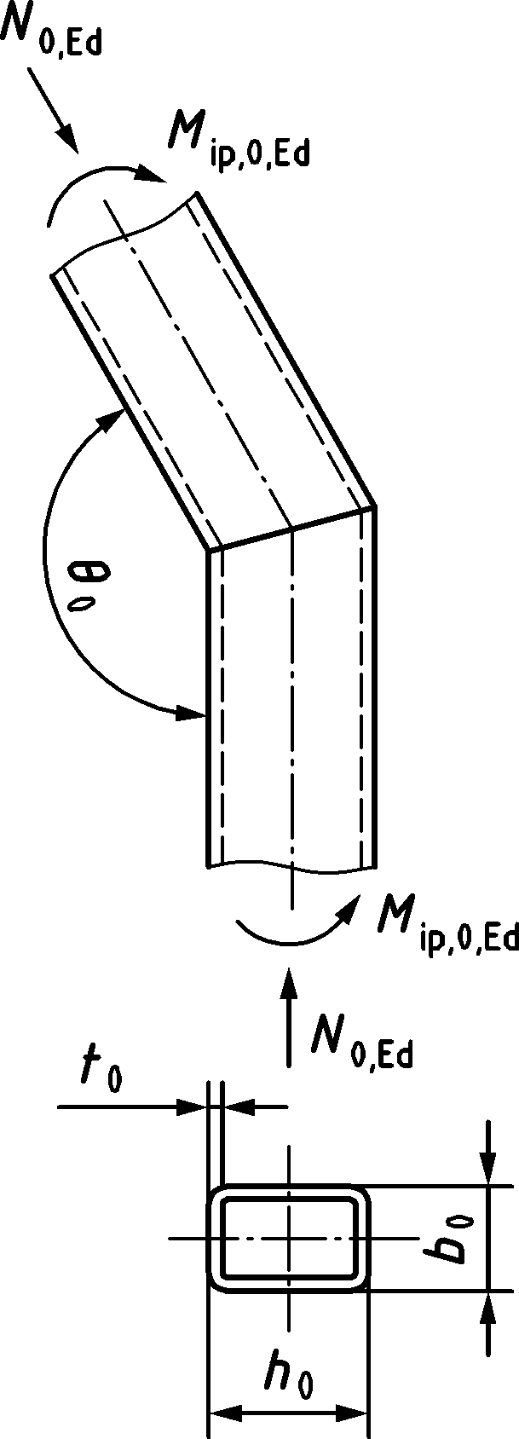 | The cross-section should be class 1 for axial loading.  $N_{0,Ed}≤0,2N_{0,Rd}$  $V_{0,Ed}≤0,5V_{0,Rd}$ and  $$\frac{\left|N_{0,Ed}\right|}{N_{0,Rd}}+\frac{\left|M_{ip,0,Ed}\right|}{M_{ip,0,Rd}}≤κ$$  $$For θ_{0}={90}^{o} κ_{90}=\left(\frac{3\sqrt{{b_{0}}/{h_{0}}}}{{\left[{b_{0}}/{t_{0}}\right]}^{0,8}}+\frac{1}{1+2{b_{0}}/{h_{0}}}\right)ε$$  $$For {{90}^{o}<θ}_{0}<{180}^{o}$$  $$κ=1-\left(\sqrt{2} cos\left({θ_{0}}/2\right)\right)\left(1-κ_{90}\right)$$  $κ_{90}$ is the value of κ for $θ_{0}={90}^{o}$ and $=\sqrt{\frac{235}{f_{y0}}}$
Knee joint configurations with inserted plate
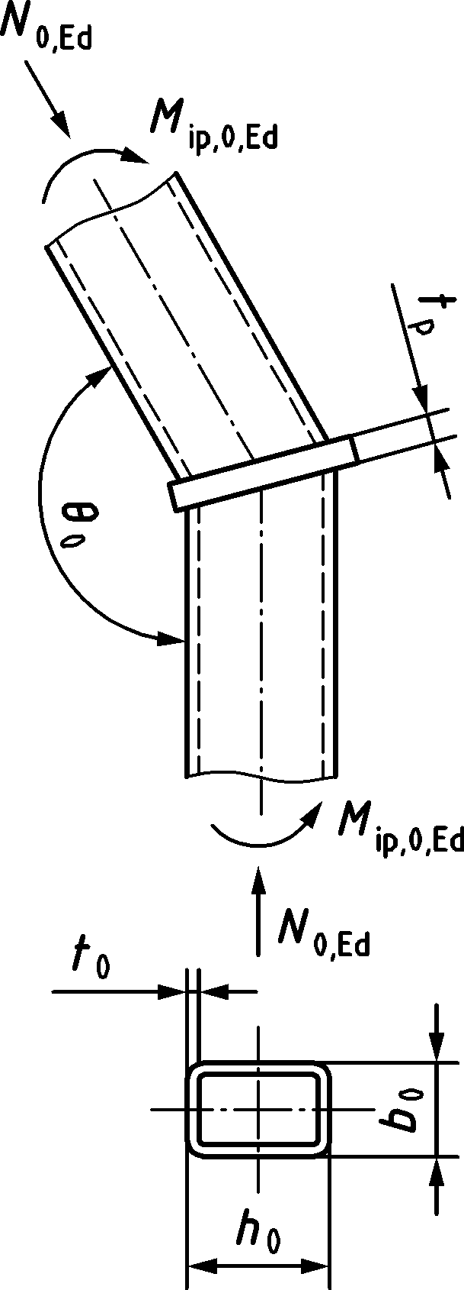 | The cross-section should be class 1 or 2 for axial loading.  $$t_{p}≥1,5t_{0} but ≥10 mm$$  $$\frac{\left|N_{0,Ed}\right|}{N_{0,Rd}}+\frac{\left|M_{ip,0,Ed}\right|}{M_{ip,0,Rd}}≤1,0$$
Cranked-chord joint configurations
Imaginary extension of chord  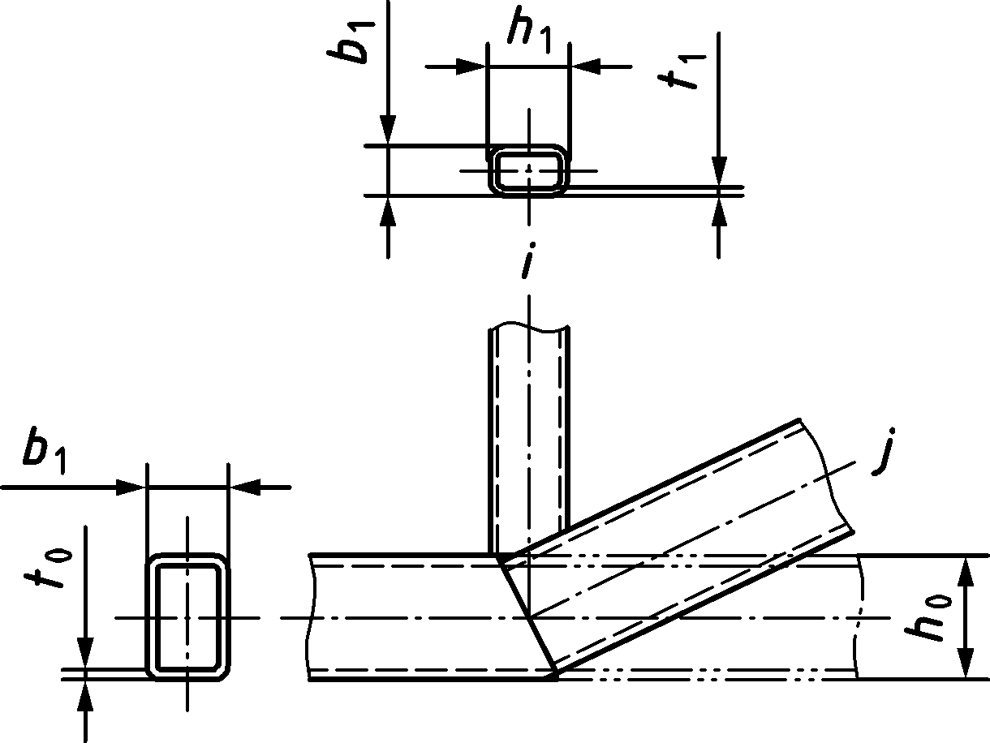 | The cross-section should be class 1 for axial loading,  $$N_{i,Ed}≤N_{i,Rd}$$  where $N_{i,Rd}$ is the value of $N_{i,Rd}$ for a K overlap joint configuration from Table 9.27.  The cranked chord should also satisfy the resistance of an unreinforced knee joint configuration, see above.

Reinforced joints
(1) Various types of joint reinforcement may be used, depending on the failure mode that, in the absence of reinforcement, governs the design resistance of the joint.
(2) Flange reinforcing plates may be used to increase the resistance of the joint to chord face failure, punching shear failure or brace failure with reduced effective width.
(3) A pair of side plates may be used to reinforce a joint against chord side wall failure or chord shear failure.
(4) In order to avoid partial overlapping of brace members in a K joint configuration, the brace members may be welded to a division plate.
(5) Any combinations of these types of joint reinforcement may also be used.
(6) The grade of steel used for the reinforcement should not be lower than that of the chord member.
(7) The design resistance of reinforced joints should be obtained from Table 9.20 and Table 9.21.
Table 9.20 — Design resistances of reinforced welded T, Y and X joints between RHS or CHS brace members and RHS chords
Reinforced with flange plates
Tension loading  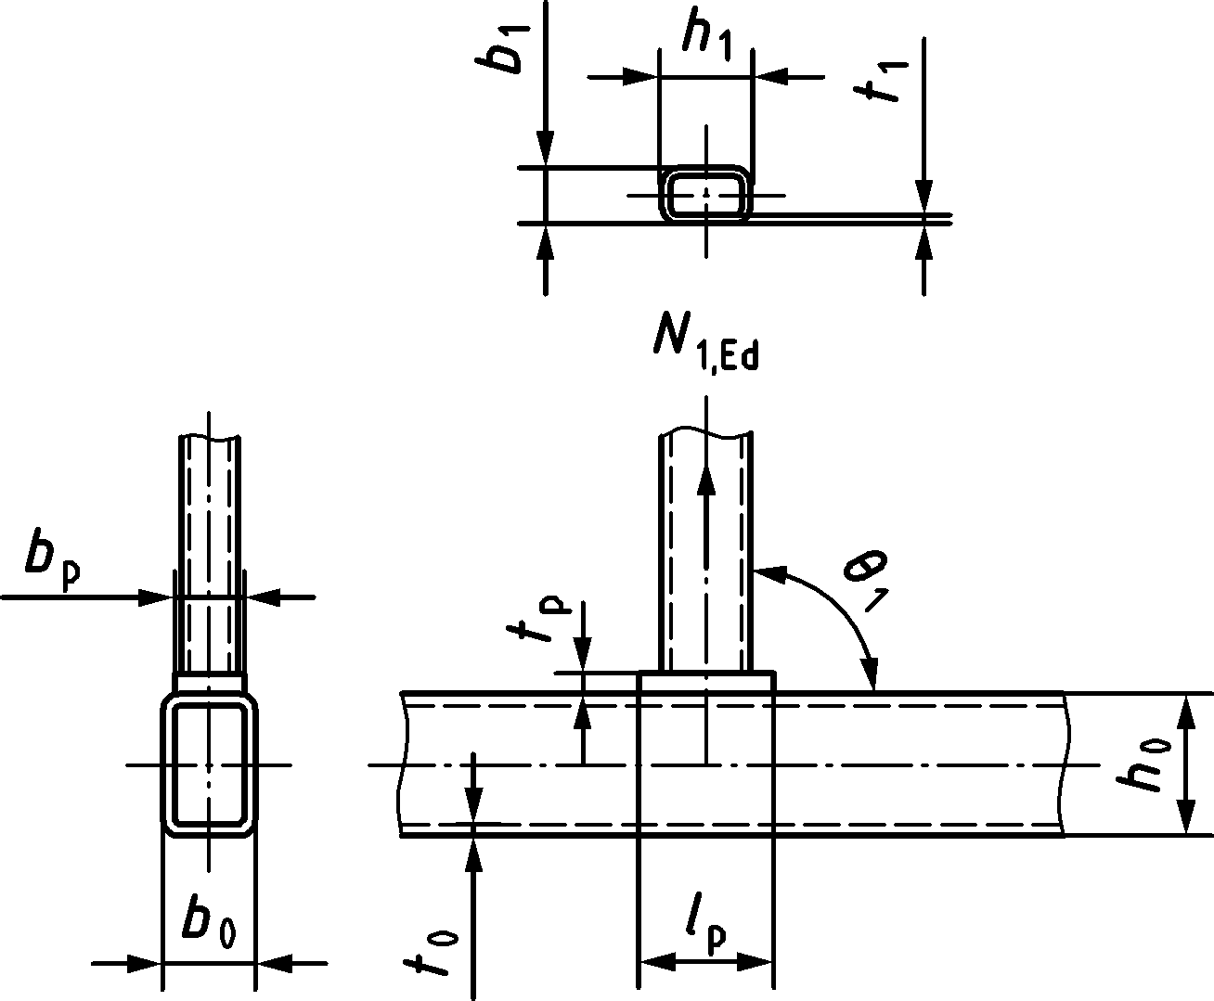 | $$l_{p}≥\frac{h_{1}}{\sin{θ_{1}}}+\sqrt{b_{p}\left(b_{p}-b_{1}\right)} but ≥1,5\left(\frac{h_{1}}{\sin{θ_{1}}}\right)$$  and $b_{p}≥b_{0}-2t_{0}$  $N_{1,Ed}≤N_{1,Rd}$  with $N_{1,Rd}$ from Table 9.14.  For chord face failure, brace failure and punching shear the resistances $N_{1,Rd}$ for T, Y or X joint configurations from Table 9.14 should be used with:  - $Q_{f}=1,0$  - $f_{y0}$ should be replaced with $f_{yp}$  - $t_{0}$ should be replaced with $t_{p}$  - for $b_{eff}$ and $b_{e,p}$, ${b_{0}}/{t_{0}}$ should be replaced with d by ${b_{p}}/{t_{p}}$  - β should be replaced with ${{β_{p}=b}_{1}}/{b_{p}}$  - η should be replaced with ${{η_{p}=h}_{1}}/{b_{p}}$
Compression loading  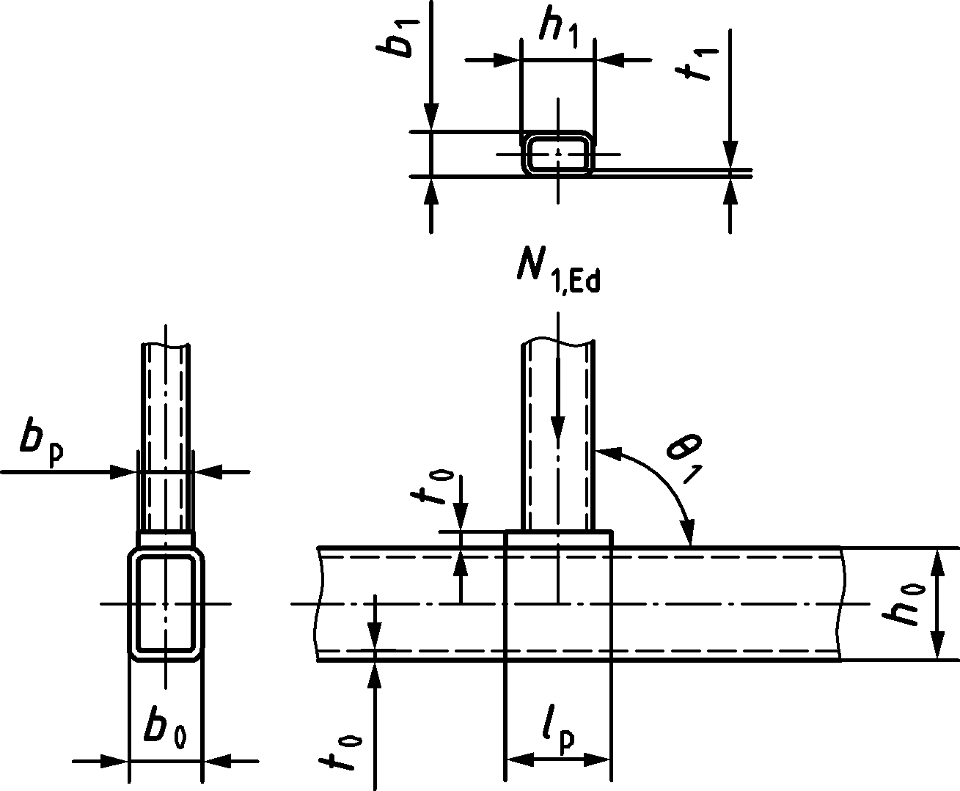 | $$l_{p}≥\frac{h_{1}}{\sin{θ_{1}}}+\sqrt{b_{p}\left(b_{p}-b_{1}\right)} but ≥1,5\frac{h_{1}}{\sin{θ_{1}}}$$  and $b_{p}≥b_{0}-2t_{0}$  For chord face and side wall check:  $N_{1,Ed}≤N_{1,Rd}$ with $N_{1,Rd}$ from Table 9.14.  For flange plate contribution:  For chord face failure, brace failure and punching shear the resistances $N_{1,Rd}$ for T, Y or X joint configurations from Table 9.14 should be used with:  - $Q_{f}=1,0$  - $f_{y0}$ should be replaced with ${ f}_{yp}$  - $t_{0}$ should be replaced with $t_{p}$  - for $b_{eff}$ and $b_{e,p}$, ${b_{0}}/{t_{0}}$ should be replaced with ${b_{p}}/{t_{p}}$  - β should be replaced with ${{β_{p}=b}_{1}}/{b_{p}}$  - η should be replaced with ${{η_{p}=h}_{1}}/{b_{p}}$
Reinforced with side plates
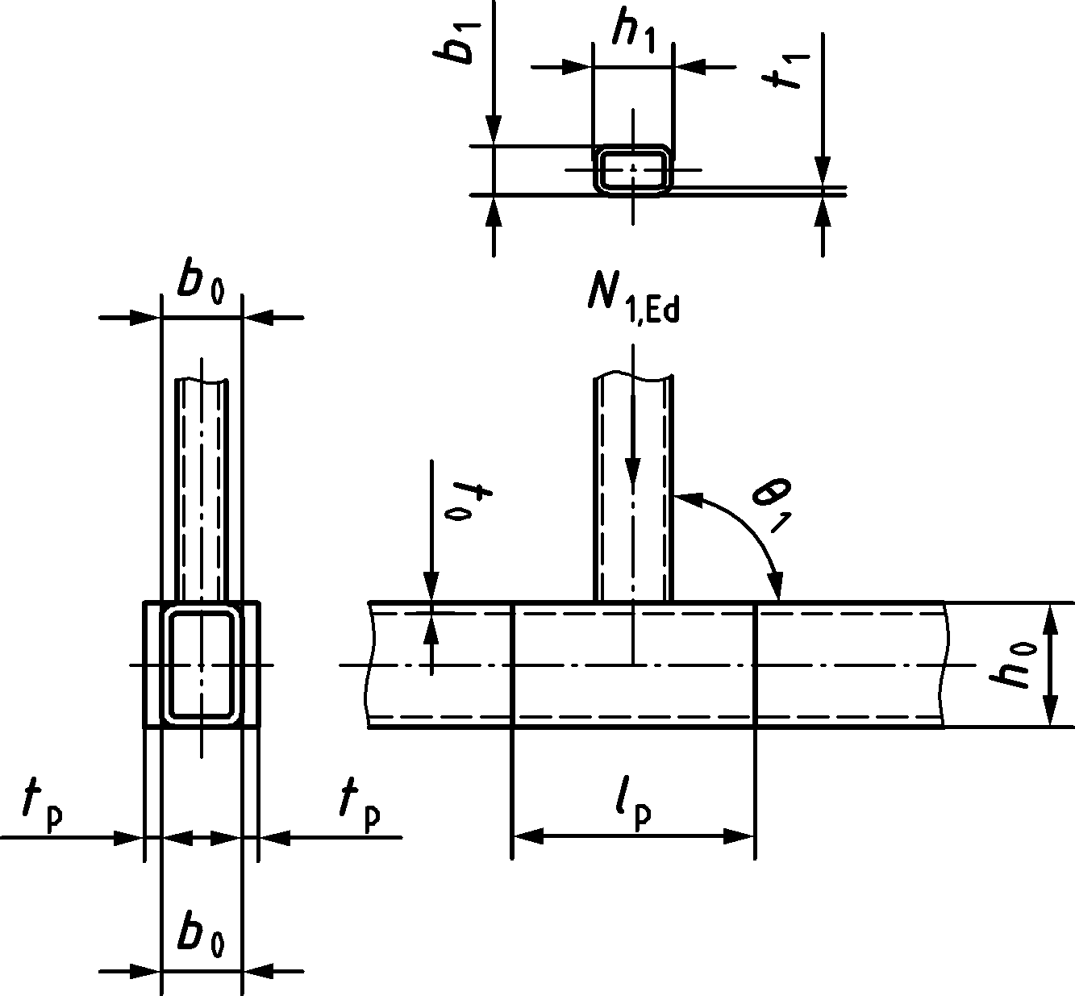 | For T and Y joint configurations: $l_{p}≥1,5\left(\frac{h_{1}}{\sin{θ_{1}}}\right)$  For X joint configurations: $l_{p}≥1,5\left(\frac{h_{1}}{sin{ θ}_{1}}+\frac{h_{0}}{\tan{θ_{1}}}\right)$  Check chord face failure, chord side wall failure, brace failure, punching shear and chord shear resistance, $N_{1,Rd}$ for T, Y or X joint configurations from Table 9.14 where for chord side wall failure:  - $f_{b}$ $t_{0}$ is replaced by the minimum of $f_{b}\left(t_{0}+t_{p}\right)$ and $f_{bp}\left(t_{0}+t_{p}\right)$ where $f_{b}$ is calculated using $t_{0}$ and ${ f}_{y0}$  - $f_{bp}$ is the buckling resistance of the reinforcing plate, calculated using the formula for $f_{b}$ but with $t_{0}$ replaced by $t_{p}$ and ${ f}_{y0}$ replaced by ${ f}_{yp}$  The chord shear check of an X joint configuration with cos θ1 > h1/h0 should be checked with the plate shear resistance added to the chord side wall resistance from Table 9.14.
NOTE 1 For chord face failure and punching shear add the resistance of the chord face contribution and the flange plate contribution, as above, assuming unconnected elements.
NOTE 2 For circular braces, $b_{1}$ and $h_{1}$ should be replaced by $d_{1}$ in the Formulae above and the design resistance of Table 9.14 and Table 9.15 (for chord shear) should be used.

Table 9.21 — Design resistances of reinforced welded K joints between RHS or CHS brace members and RHS chords
Gap joint configurations reinforced with flange plates
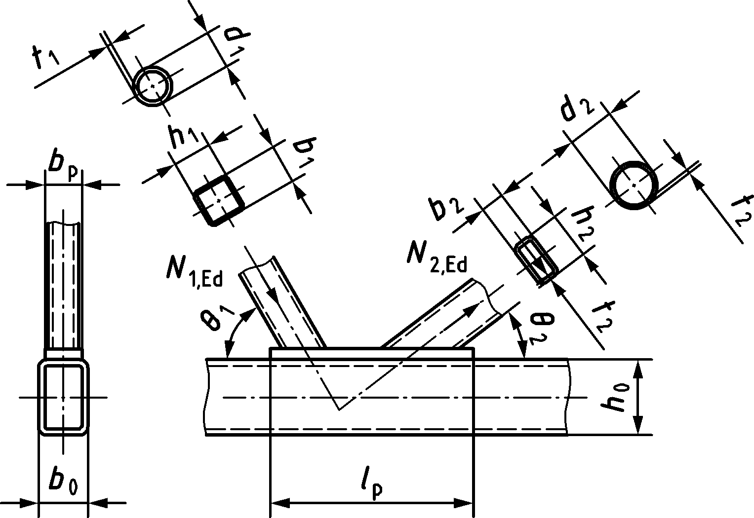 | $$l_{p}≥ 1,5\left(\frac{h_{1}}{sin{ θ}_{1}}+g+\frac{h_{2}}{sin{ θ}_{2}}\right)$$  $$b_{p}≥b_{0}-2t_{0}$$  $N_{i,Rd}$ should be taken equal to the value of $N_{i,Rd}$ for a K gap joint configuration from Table 9.15.  For chord face failure, brace failure and punching shear:  - $f_{y0}$ should be replaced with $f_{yp}$  - $t_{0}$ should be replaced with $t_{p}$  - For β and η, $b_{0}$ should be replaced with $b_{p}$
Gap joint configurations reinforced with a pair of side plates
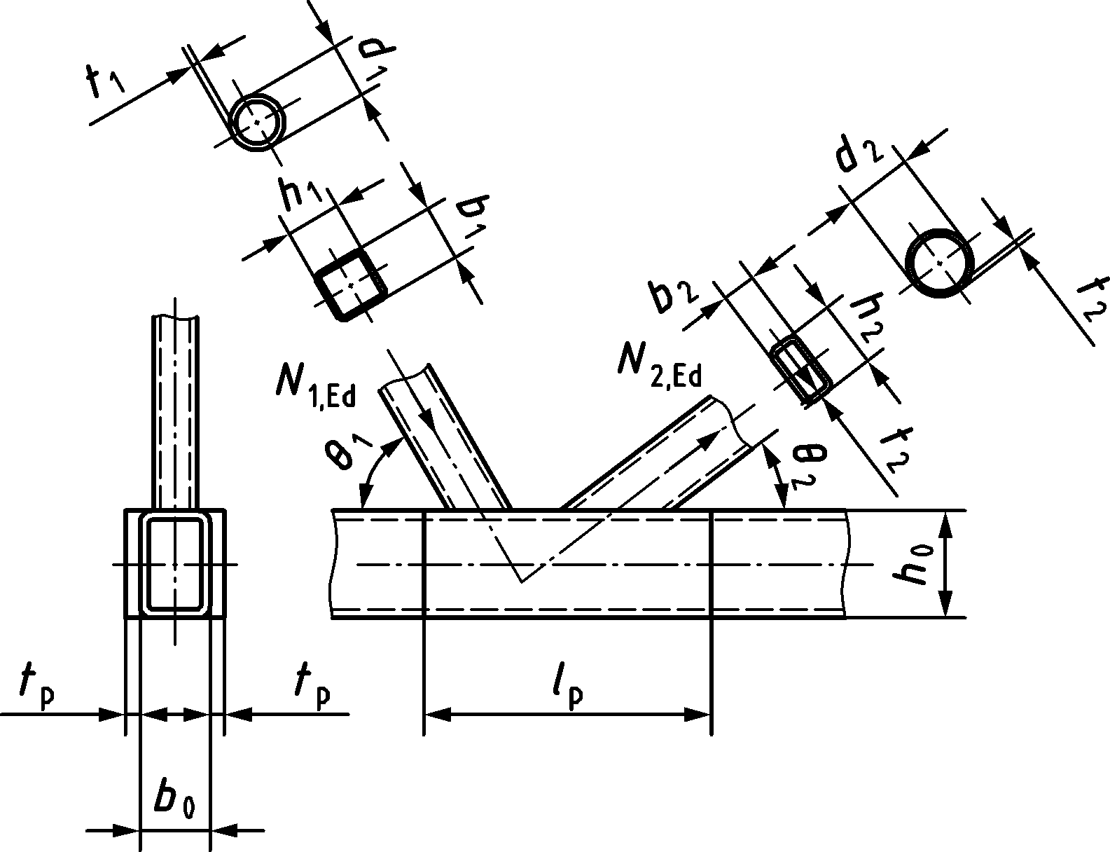 | $$l_{p}≥ 1,5\left(\frac{h_{1}}{\sin{θ_{1}}}+g+\frac{h_{2}}{\sin{θ_{2}}}\right)$$  $N_{i,Rd}$ should be taken equal to the value of $N_{i,Rd}$ for a K joint configuration from Table 9.15 for chord shear failure:  - $f_{y0}$ should be replaced with the lowest of $f_{y0}$ and ${ f}_{yp}$  - $A_{0}$should be replaced with $A_{0}+2h_{0}t_{p}$  - $A_{V,0,gap}$ should be replaced with  $$2h_{0}\left({t_{0}+t}_{p}\right)+αb_{0}t_{0}$$
Division plate between the brace members for overlap joint configurations
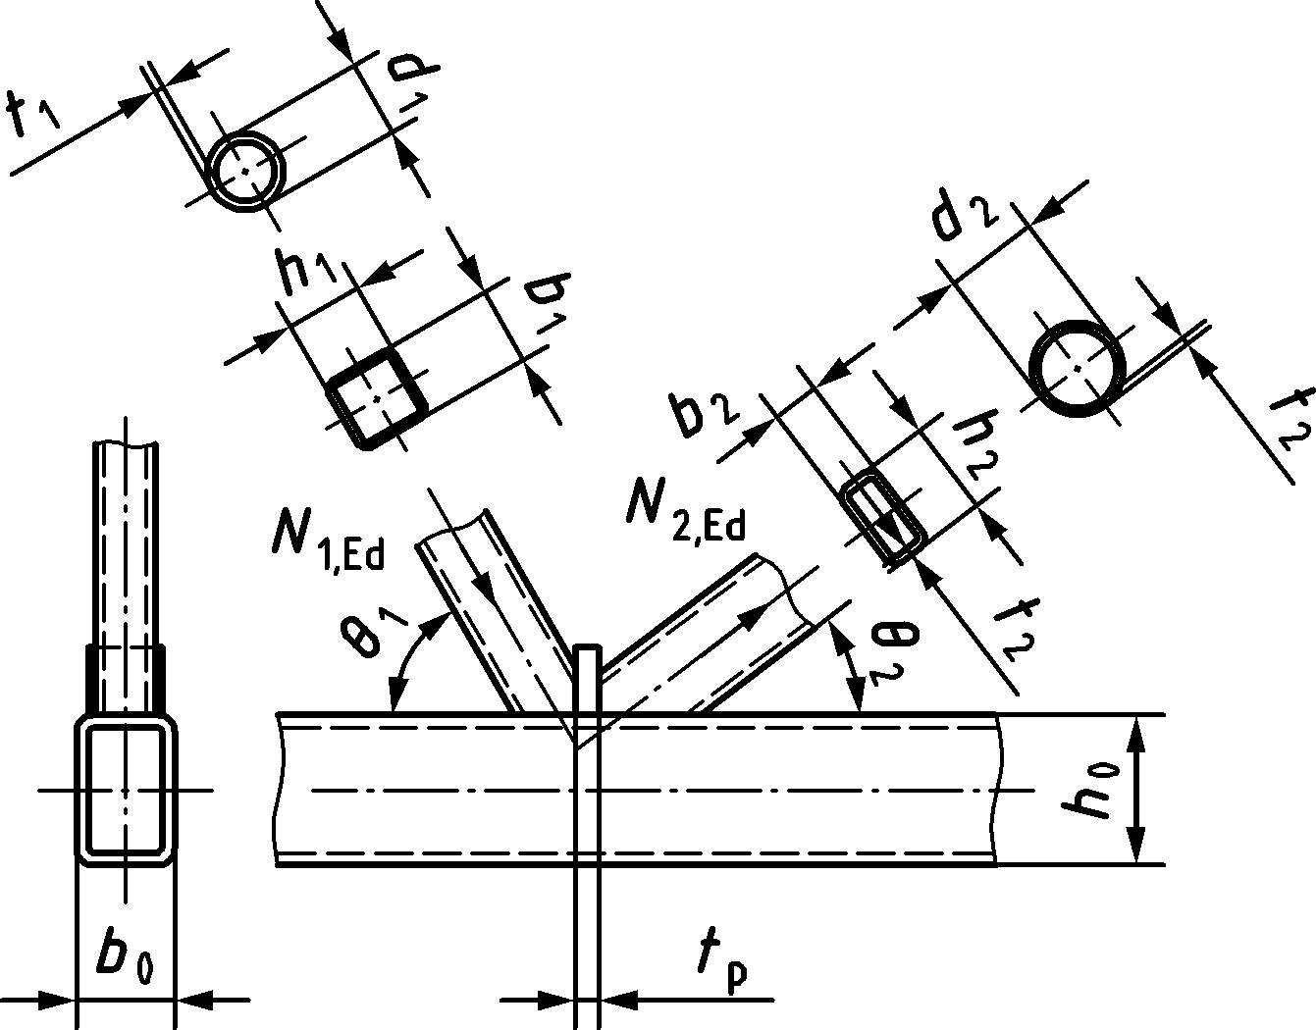 | $t_{p}≥2t_{1}$ and $t_{p}≥2t_{2}$  $N_{i,Rd}$ should be taken equal to the value of $N_{i,Rd}$ for a K overlap joint configuration with λOV > 25 %, but check both braces with bi, ti replaced by b1, t1 and b2, t2, and fyi replaced by fy1 and fy2. For the overlapped plate bj, tj and fyj are to be replaced by bp, tp and fyp.
NOTE For circular braces, $b_{1}$ and $h_{1}$ should be replaced with $d_{1}$, $b_{2}$ and $h_{2}$ by $d_{2}$ in the Formulae above and the design resistance of Table 9.15 or Table 9.27 should be used.

Multiplanar joint configurations
(1) The design resistance for each relevant plane of a multiplanar joint configuration primarily loaded by axial forces should be obtained from 9.5.2, applying the multiplanar factor µ from Table 9.22 to the resistance for chord face failure. For KK joint configurations the gap should also be checked for the interaction of shear and axial load taking account of the actual chord force.
Table 9.22 — Multiplanar factors μ for the chord face failure for joints with square hollow sections in multiplanar joint configurations
TT joint configurations (members 1 may be either in tension or compression)
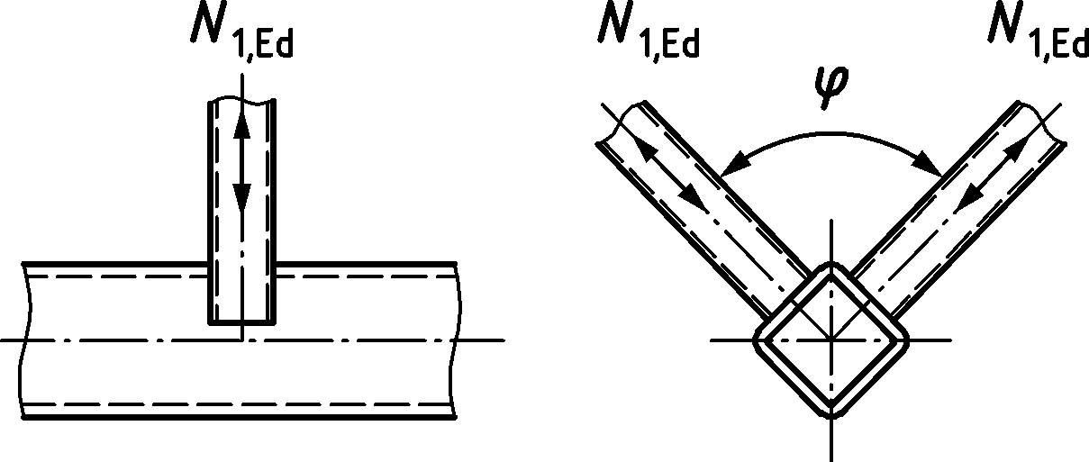 | μ = 1,0
XX joint configurations (members 1 and 2 can be either in compression or in tension)
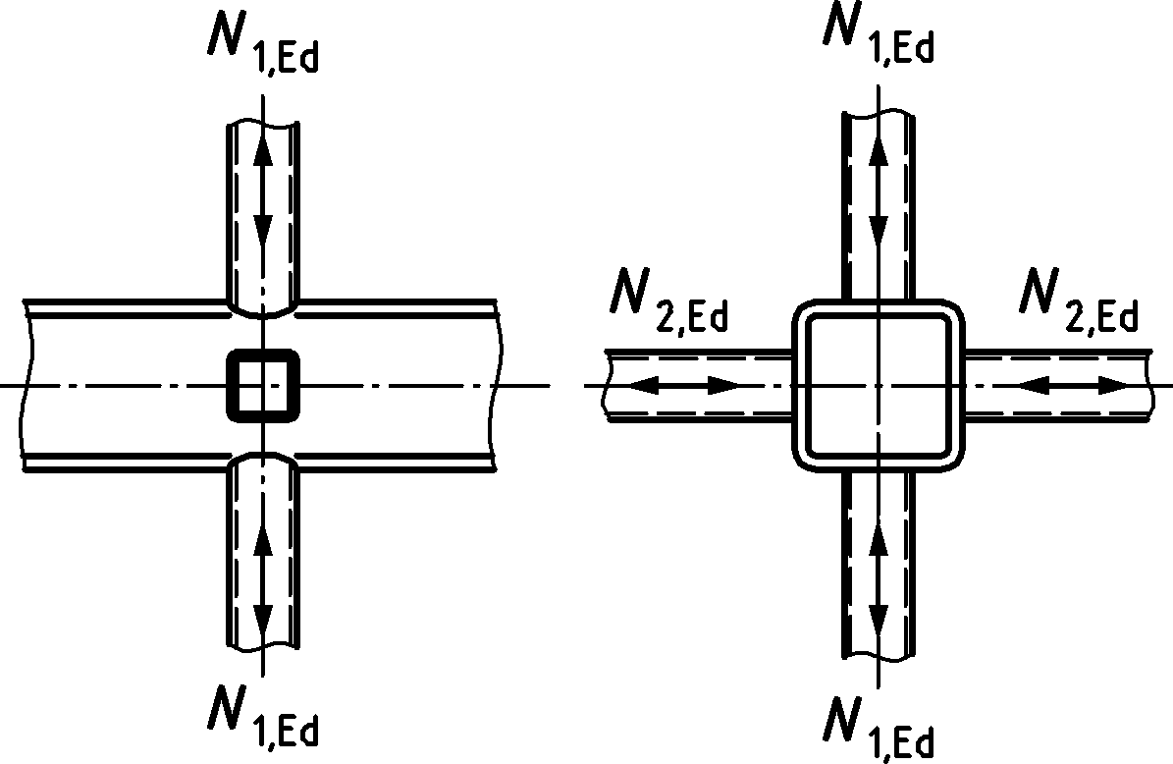 | $$μ=1+0,35\frac{N_{2,Ed}}{N_{1,Ed}}$$  Take account of the sign of $N_{1,Ed}$ and $N_{2,Ed}$, with  $$\left|N_{2,Ed}\right|≤\left|N_{1,Ed}\right|$$  ${N_{2,Ed}}/{N_{1,Ed}}$ is negative if the members in one plane are in tension and in the other plane in compression.
KK gap joint configurations (members 1 in compression and members 2 in tension)
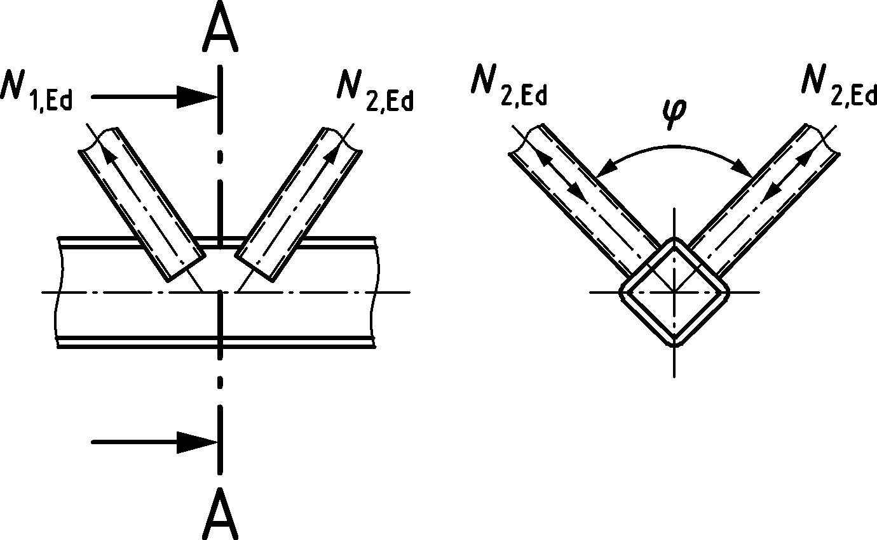 | $$μ=1,0$$  provided that, in a KK gap joint configuration, at cross-section 1-1 in the gap the chord satisfies:  $${\left(\frac{N_{0,gap,Ed}}{N_{0,Rd}}\right)}^{2}+{\left(\frac{V_{0,gap,Ed}}{V_{0,gap,Rd}}\right)}^{2}≤1,0$$  where  $$N_{0,Rd}={A_{0}f_{y0}}/{γ_{M5}}$$  $$V_{0,gap,Ed}=2N_{i,Ed}sin{ θ}_{i}cos\left(φ/2\right)$$  $$V_{0,gap,Rd}=0,71{\frac{f_{y0}}{\sqrt{3}}A_{0}}/{γ_{M5}}$$  Where $N_{1,Ed}$ in the two adjacent planes are both in compression and of equal magnitude and $N_{2,Ed}$ in the two adjacent planes are both in tension and of equal magnitude.
General | Other failure modes $μ=1,0$  (see Table 9.14, Table 9.15 and Table 9.27)
NOTE For angles $φ≠90°$ a numerical calculation can be used.

Welded joints between CHS or RHS brace members, and I or H section chords
(1) Provided that the geometry of the joints is within the limits in Table 9.23, the design resistances of the joints should be obtained from Table 9.24 or Table 9.25, as appropriate.
(2) For joints complying with Table 9.23, failure modes other than those covered in the appropriate table may be ignored. The design resistance of a connection should be taken as the minimum value for all failure modes.
(3) For joints not complying with Table 9.23, all failure modes in 9.2.2 should be considered. In addition, the secondary moments in the joints caused by their rotational stiffness should be taken into account.
(4) In brace member connections subjected only to axial forces, the design axial force $N_{i,Ed}$ should not exceed the design axial resistance of the welded joint $N_{i,Rd}$, obtained from Table 9.24.
(5) Joints of the brace members subjected to combined bending and axial force should satisfy:
$$\frac{\left|N_{\text{i,Ed}}\right|}{N_{\text{i,Rd}}}+\frac{\left|M_{\text{ip,i,Ed}}\right|}{M_{\text{ip,i,Rd}}}≤1,0$$ | (9.5)
where
$M_{ip,i,Rd}$ is the design in-plane moment resistance;
$M_{ip,i,Ed}$ is the design in-plane internal moment.
(6) The design internal moment $M_{\text{ip,1,}\text{Ed}}$ from (5) may be taken as the value at the section where the centreline of the brace member meets the face of the chord member.
(7) The design in-plane moment resistance $M_{\text{ip,1,Rd}}$ should be obtained from Table 9.25.
(8) If stiffeners in the chord are used, see Figure 9.4, then the design brace failure resistance $N_{\text{i}\text{,Rd}}$ for T, Y, X and K gap joint configurations (Table 9.24) should be determined as follows:
$$N_{i,Rd}={2f_{yi}t_{i}\left(b_{eff}+b_{eff,s}\right)}/{γ_{M5}}$$ | (9.6)
and $b_{eff}=t_{w}+2r+{7t}_{0}{f_{y0}}/{f_{yi}} but ≤ b_{i}+h_{i}-{2t}_{i}$
$$b_{eff,s}=t_{s}+2a+{7t}_{0}{f_{y0}}/{f_{yi}} but ≤ b_{i}+h_{i}-{2t}_{i}$$
$${b_{eff}+b}_{eff,s}≤ b_{i}+h_{i}-{2t}_{i}$$
where
$a$ is stiffener weld throat thickness, '$2a$' becomes '$a$' if single-sided fillet welds are used;
$s$ this subscript refers to the stiffener.
(9) The stiffeners should be at least as thick as the I-section web.
Table 9.23 — Range of validity for welded joints between CHS or RHS brace members and I or H section chord members
Joint configuration | Joint parameters
 | $$e/{h_{0}≤0,25}$$
 | $${h_{w}}/{t_{w}}$$ | ${b_{i}}/{t_{i}}$ and ${h_{i}}/{t_{i}}$ or ${d_{i}}/{t_{i}}$ |  | $${h_{i}}/{b_{i}}$$ | $${b_{0}}/{t_{0}}$$ | g
 |  | Compression | Tension
X | Class 1 and  $$h_{w}≤400 mm$$ | Class 1 or 2 and |  | $$0,5≤{h_{i}}/{b_{i}≤2,0}$$ | Class 1 or 2 | —
T or Y | Class 1 or 2 and  $$h_{w}≤400 mm$$ | $$\frac{h_{i}}{t_{i}}≤35$$  $$\frac{b_{i}}{t_{i}}≤35$$  $$\frac{d_{i}}{t_{i}}≤50$$ | $$\frac{h_{i}}{t_{i}}≤35$$  $$\frac{b_{i}}{t_{i}}≤35$$  $$\frac{d_{i}}{t_{i}}≤50$$
K gap |  |  |  |  |  | $$g≥t_{1}+t_{2}$$

Table 9.24 — Design resistances of welded joints between RHS or CHS brace members and I or H section chords
T, Y, Xa and K gap joint configurations b
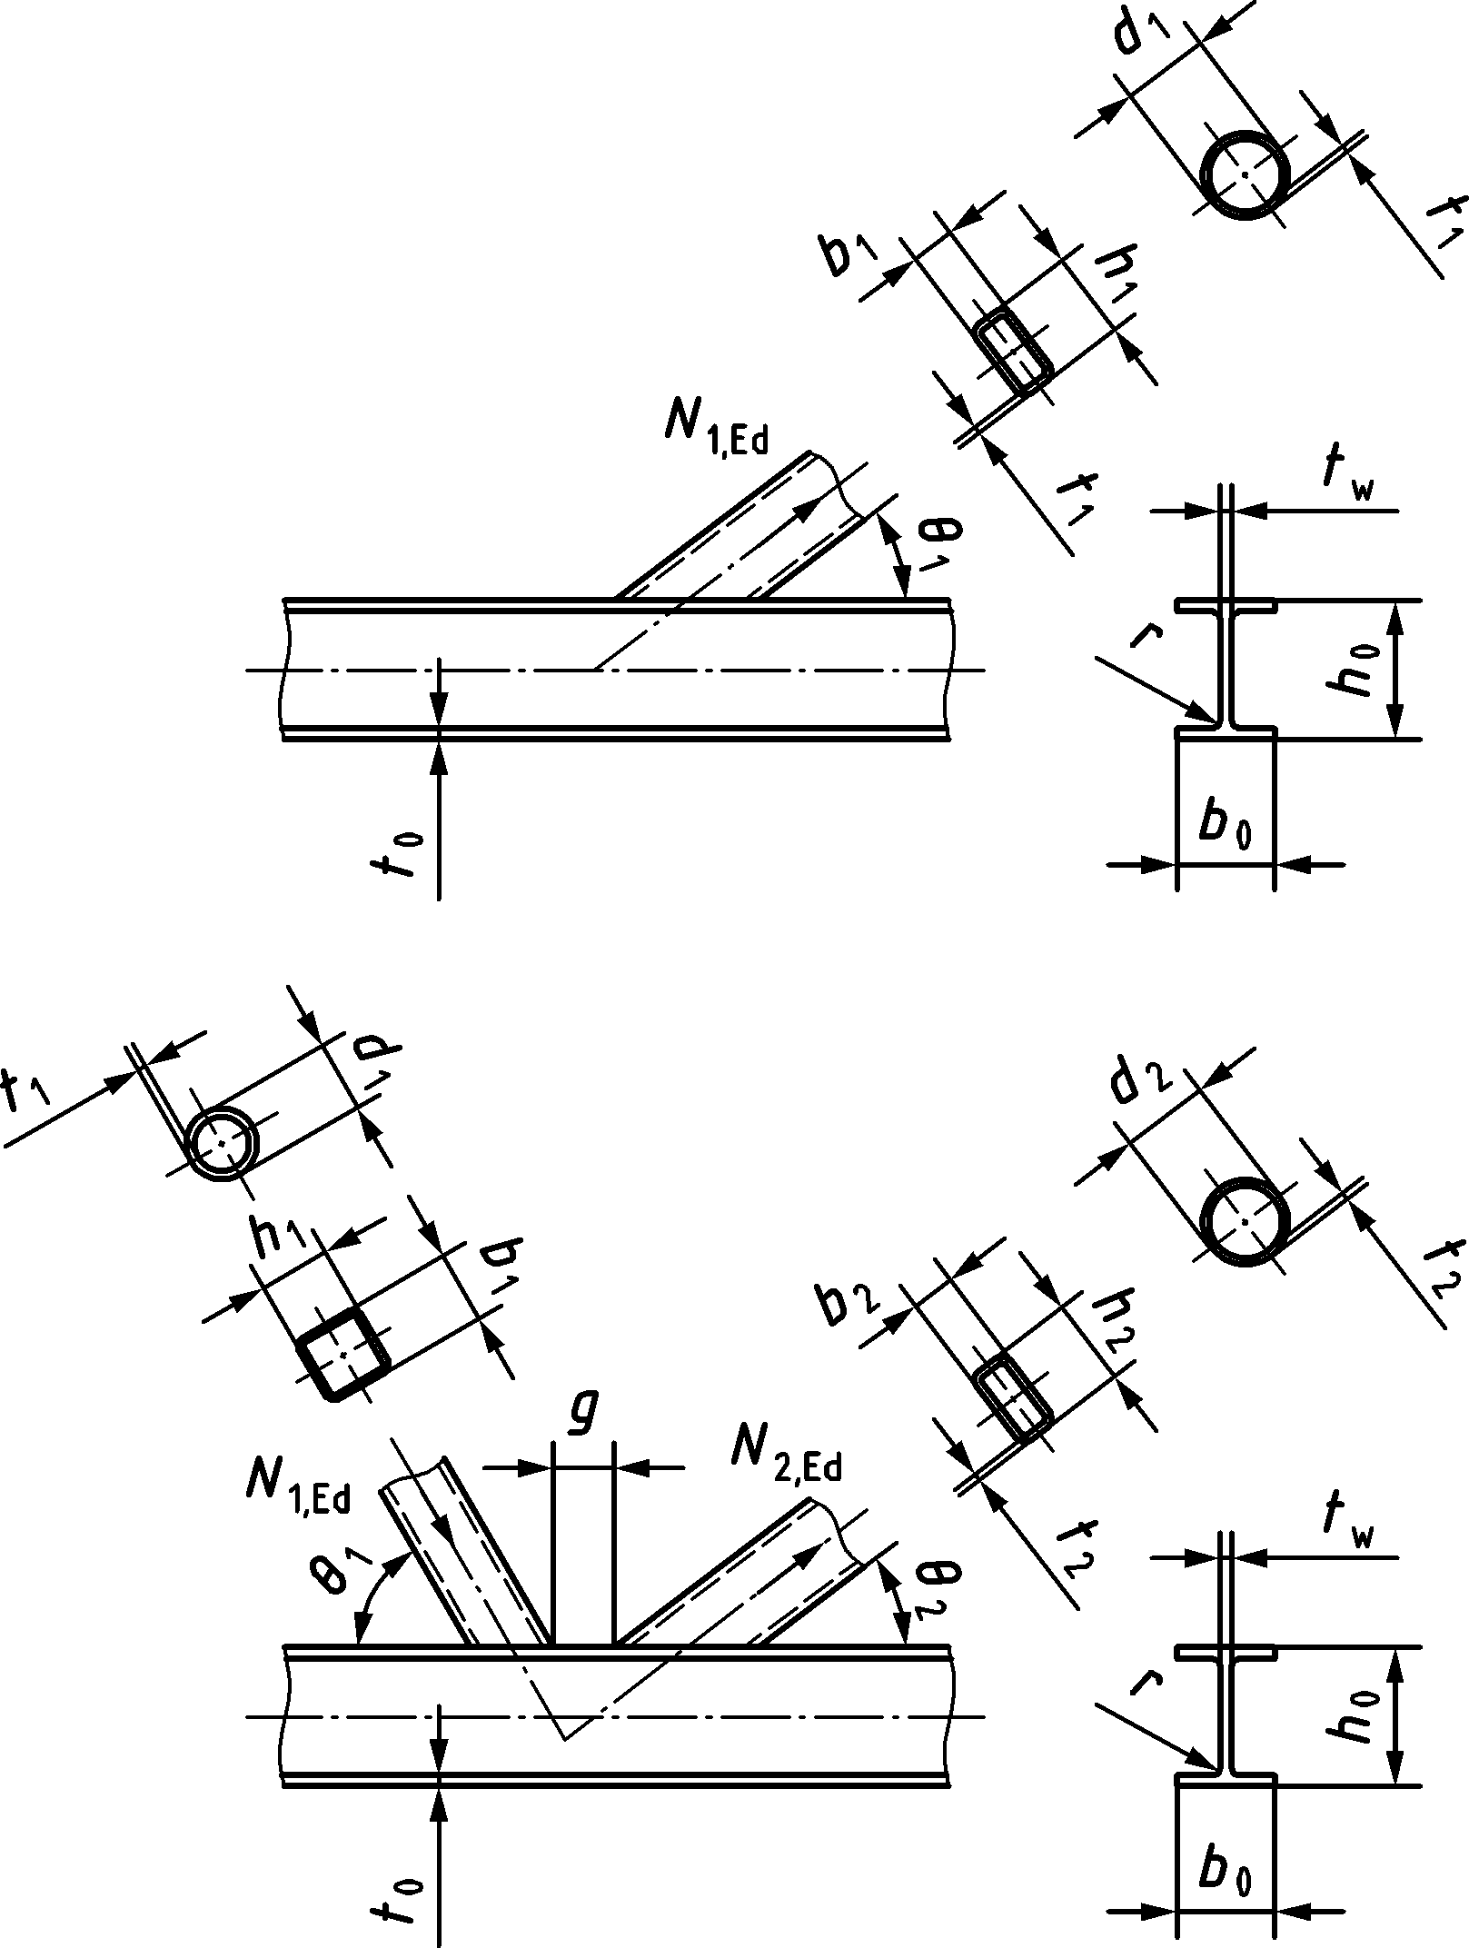 |  |  | Brace failure: $N_{i,Rd}={2C_{f}f_{yi}t_{i}b_{eff}}/{γ_{\text{M5}}}$
 |  |  | Chord web failure a b: |  |  | $$N_{i,Rd}={\frac{f_{y0}t_{w}b_{w}}{\sin{θ_{i}}}}/{γ_{\text{M5}}}$$
Chord shear failure: (K gap and X joint configurations with $\cos{θ_{i}>{h_{i}}/{h_{0}}}$ )
$$N_{i,Rd}={\frac{f_{y0}A_{v,0,gap}}{\sqrt{3 }sin{θ_{i}}}}/{γ_{\text{M5}}}$$
$N_{0,V,Rd} {=\left[\left(A_{0}-A_{v,0,gap}\right)f_{y0}+A_{v,0,gap}f_{y0}\sqrt{1-{\left(\frac{V_{0,gap,Ed}}{V_{0,gap,Rd}}\right)}^{2}}\right]}/{γ_{M5}}$
Factors
 | RHS braces |  |  | CHS braces
$$b_{eff}$$ | $$b_{eff}=t_{w}+2r+{7t}_{0}\frac{f_{y0}}{f_{yi}} \text{but } ≤ b_{i}+h_{i}-{2t}_{i}$$ |  |  | $$b_{eff}=t_{w}+2r+{7t}_{0}\frac{f_{y0}}{f_{yi}} but ≤ 0,5π\left(d_{i}-t_{i}\right)$$
$$b_{w}$$ | $$b_{w}=\frac{h_{i}}{\sin{θ_{i}}}+5\left(t_{0}+r\right) \text{but} ≤ \frac{{2t}_{i}}{\sin{θ_{i}}}+10\left(t_{0}+r\right)$$ |  |  | $$b_{w}=\frac{d_{i}}{\sin{θ_{i}}}+5\left(t_{0}+r\right) \text{but} ≤ \frac{{2t}_{i}}{\sin{θ_{i}}}+10\left(t_{0}+r\right)$$
$$A_{v,0,gap}$$ | $$A_{v,0,gap}=A_{0}-\left(2-α\right)b_{0}t_{0}+\left(t_{w}+2r\right)t_{0}$$
 | For K gap joint configurations:  $$α=\sqrt{\frac{1}{1+{\left({4g}^{2}\right)}/{\left(3t_{0}^{2}\right)}}}$$ | For X joint configurations:  α = 0 |  |  | α = 0
$$V_{0,gap,Rd}$$ | $$V_{0,gap,Rd}=\frac{f_{y0}}{\sqrt{3}}A_{v,0,gap}/γ_{M5}$$
Material factor $C_{f}$ |  |  | According to 9.1.1(4)
a In case of chord web in compression web and out-of-plane instability should be avoided, see A.5.
b In case of joints with welded I-section chords the material factor $C_{f}$ should also be included for the chord web failure criterion.

Table 9.25 — Design moment resistances of welded joints between rectangular hollow section brace members (beams) and I or H section chords
T joint configurations $\left(θ_{1}=90°\right)$
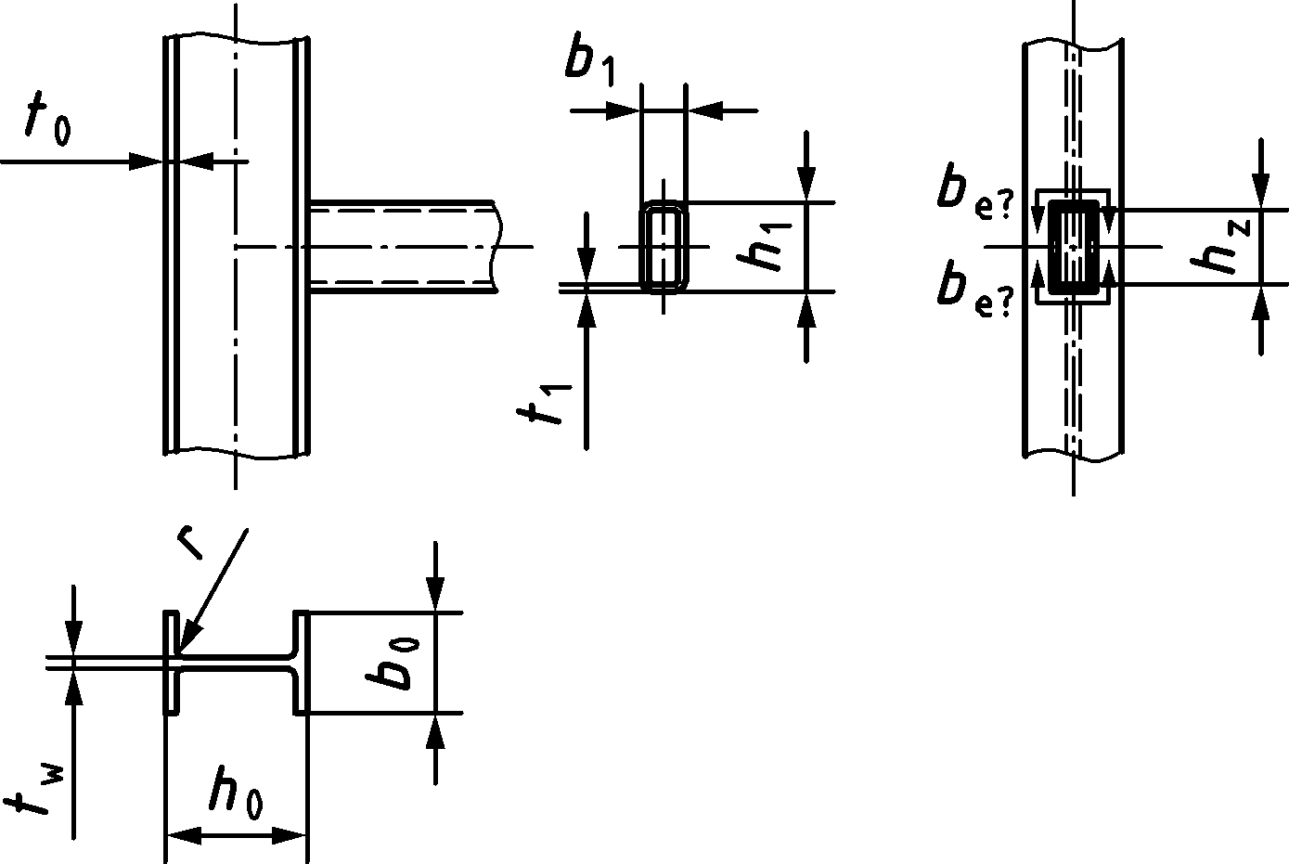 | Brace failure:$M_{ip,1,Rd}={C_{f}f_{y1}t_{1}b_{eff}h_{z}}/{γ_{M5}}$
Chord web failurea b:
$$M_{ip,1,Rd}={0,5f_{y0}t_{w}b_{w}\left(h_{1}-t_{1}\right)}/{γ_{M5}}$$
Factors
$$b_{eff}$$ | $$b_{eff}=t_{w}+2r+{7t}_{0}\frac{f_{y0}}{f_{y1}} but b_{eff}≤ b_{1}+h_{1}-{2t}_{1}$$
$$b_{w}$$ | $$b_{w}=h_{1}+5\left(t_{0}+r\right) but {2t}_{1}+10\left(t_{0}+r\right)$$
Material factor $C_{f}$ | According to 9.1.1(4)
a In case of chord web in compression web and out-of-plane instability should be avoided, see A.5.
b In case of joints with welded I-section chords the material factor Cf should also be included for the chord web failure criterion.

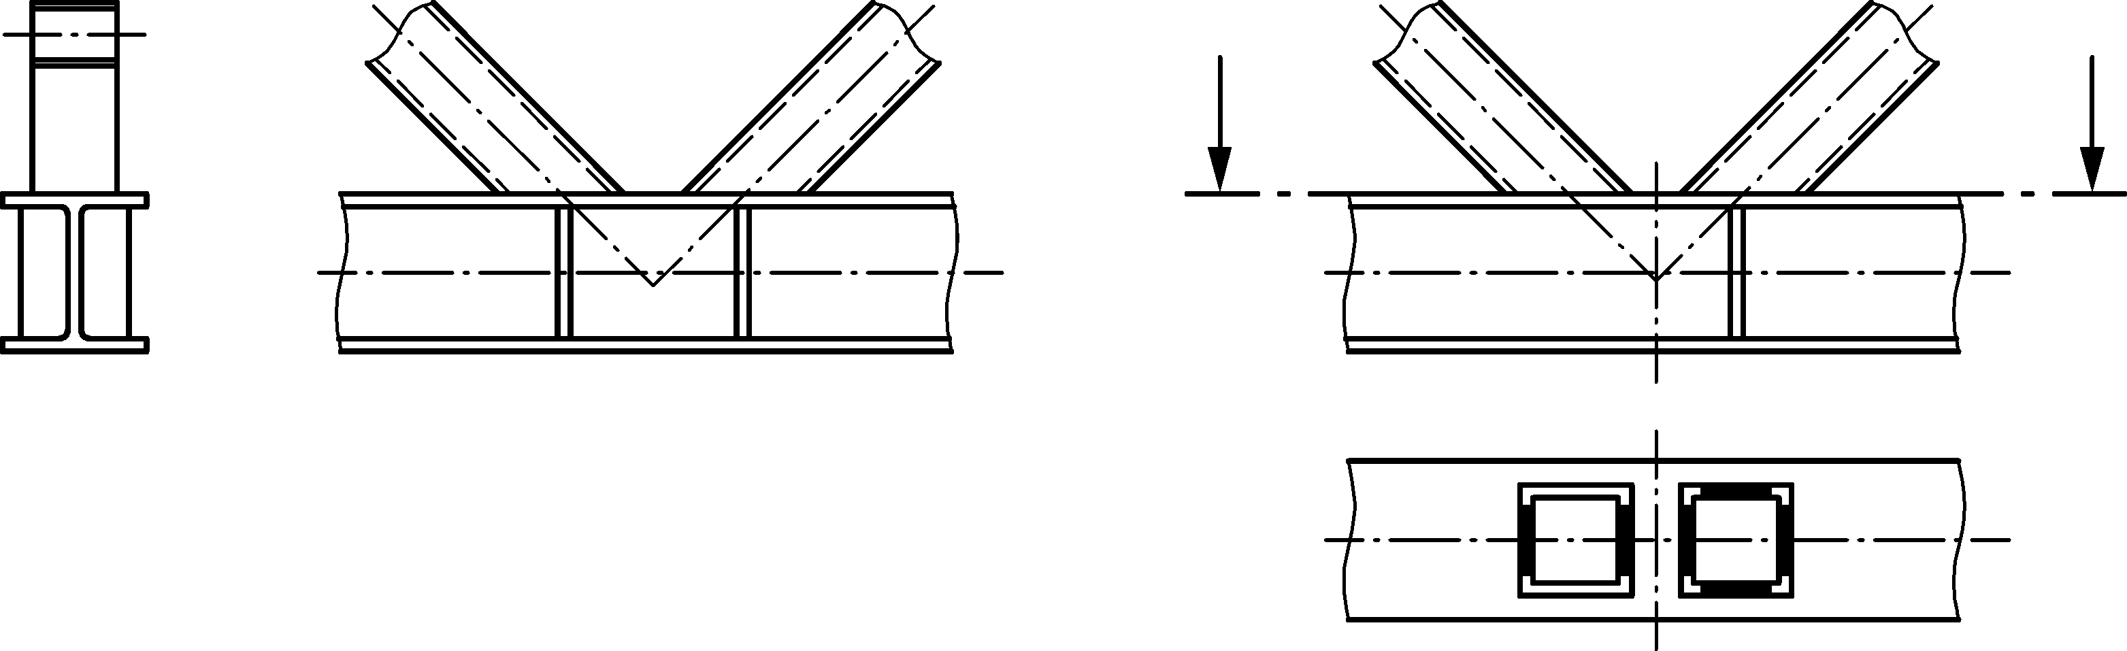
Brace effective perimeter, without (left) and with (right) stiffeners
Figure 9.4 — Stiffeners for I-section chord

Welded overlap joints between CHS or RHS brace members, and CHS, RHS, I, H or channel section chord members
(1) Provided that the geometry of the joints is within the limits in Table 9.26, the design resistance of welded joint in overlap joint configurations between hollow section brace members and CHS, RHS, I, H or channel (UPN, CH or UPE, PFC) section chord members should be obtained from Table 9.27 to Table 9.29.
(2) For brace failure only the overlapping brace member i should be checked. The efficiency (i.e. the design resistance of the joint divided by the design plastic resistance of the brace member) of the overlapped brace member j should be taken as equal to that of the overlapping brace member.
(3) The connection between the braces i and j and the chord face should be checked for shear if either of the following conditions apply:
- $λ_{ov}≥60 \%$ and the hidden seam of the overlapped brace is not welded,
- $λ_{ov}≥80 \%$and the hidden seam of the overlapped brace is welded,
- the braces are rectangular sections with $h_{i}<b_{i}$ and/or $h_{j}<b_{j}$.
NOTE The eccentricity is defined in 7.1.5 and Table 9.26.
(4) For joints not complying with Table 9.26, all failure modes listed in 9.2.2(1) should be considered. In addition, the secondary moments in the joints caused by their rotational stiffness should be taken into account.
Table 9.26 —Range of validity for the design axial resistance of welded uniplanar overlap joints with a CHS, RHS, I, H, or channel section chord
Range of validity
General |  | ${d_{i}}/{d_{0} \text{and} }$ ${d_{j}}/{d_{0}≥0,20}$  ${b_{i}}/{b_{0} and }$ ${b_{j}}/{b_{0}≥0,25}$  ${d_{i}}/{b_{0} and }$ ${d_{j}}/{b_{0}≥0,25}$ |  | $${d_{i}}/{d_{j} ≥0,75 }$$  $${b_{i}}/{b_{j} ≥0,75 }$$ | $$θ_{i} and θ_{j}≥30°$$ | $$f_{yi} t_{i}≤f_{yj}t_{j}≤f_{y0}t_{0}$$
 |  |  |  |  | $$λ_{ov}≥25\%$$
$-0,55≤e/{d_{0}}$ (CHS chords)
$-0,55h_{0}≤e/{h_{0}}$ (RHS, I or H chords)
${-y}_{s}≤e≤0$ (channel section chords)
Chord | CHS | Compression |  | Class 1 or 2 and ${d_{0}}/{t_{0}≤50 }$
 |  | Tension |  | $${d_{0}}/{t_{0}≤50 }$$
 | RHS | Compression |  | Class 1 or 2 and ${b_{0}}/{t_{0}≤35 and }{h_{0}}/{t_{0}≤35}$
 |  | Tension |  | $${b_{0}}/{t_{0}≤35 and }{h_{0}}/{t_{0}≤35}$$
 |  | Aspect ratio |  | $${{0,5≤h}_{0}}/{b_{0}≤2,0}$$
 | I or H section | Compression | Flange | Class 1 or 2
 |  |  | Web | Class 1 or 2 and $h_{w}≤400 mm$
 |  | Tension |  | None
 | channel section | Compression |  | Class 1 or 2
 |  | Tension |  | None
Braces | CHS | Compression |  | Class 1 or 2 and ${d_{i}}/{t_{i} and }{d_{j}}/{t_{j}≤50}$
 |  | Tension |  | $${d_{i}}/{t_{i} and }{d_{j}}/{t_{j}≤50}$$
 | RHS | Compression |  | Class 1 or 2 and ${b_{i}}/{t_{i}, }{{ h}_{i}}/{t_{i}, }{{ b}_{j}}/{t_{j} and }{h_{j}}/{t_{j}≤35}$
 |  | Tension |  | $${b_{i}}/{t_{i}, }{{ h}_{i}}/{t_{i}, }{{ b}_{j}}/{t_{j} and }{h_{j}}/{t_{j}≤35}$$
 |  | Aspect ratio |  | $${{0,5≤h}_{i}}/{b_{i}≤2,0} and {{0,5≤h}_{j}}/{b_{j}≤2,0}$$

Table 9.27 — Design axial resistance of welded uniplanar overlap joints with a CHS or RHS section chord, or welded to the flange of an I or H section, or to the web of a channel sectiona
Axially loaded overlap joint configuration | Overlapping brace failure | Overlapped brace failure
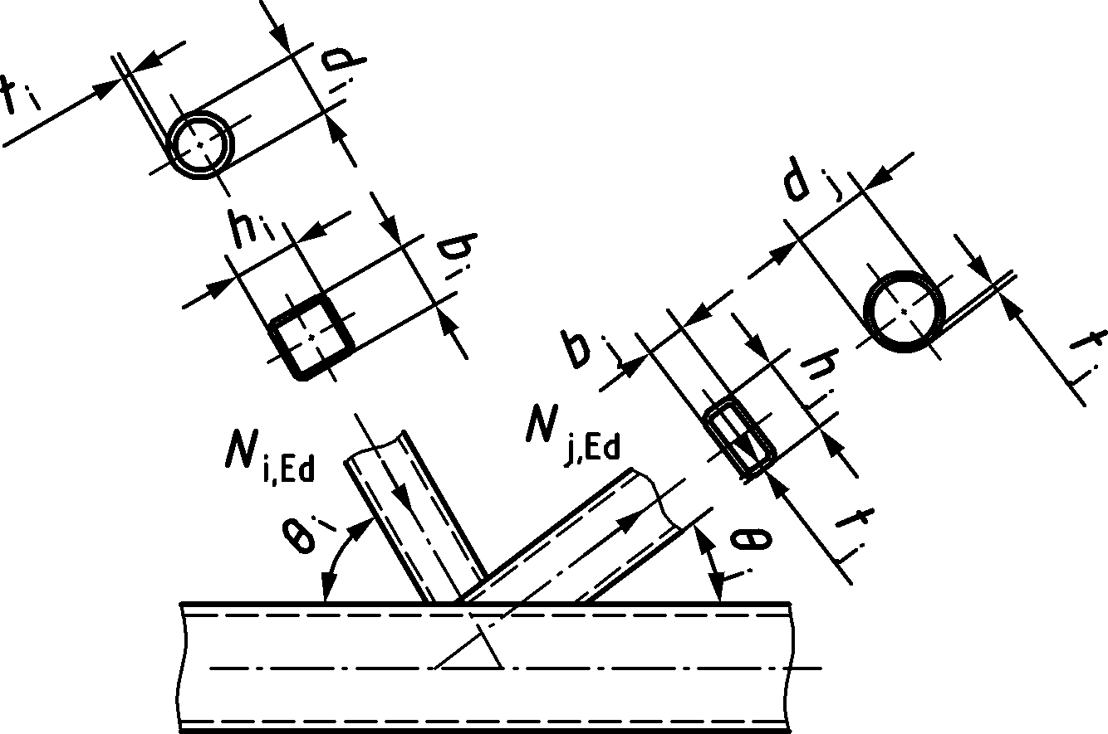  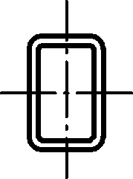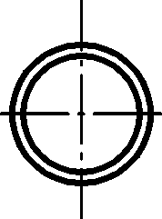 | $$N_{i,Rd}={C_{f}f_{yi}t_{i}l_{b,eff}}/{γ_{\text{M5}}}$$  (for $l_{b,eff}$, see Table 9.28) | $$N_{j,Rd}=N_{i,Rd}\left(\frac{A_{j}f_{yj}}{A_{i}f_{yi}}\right)$$
 | Chord member failure
 | $${\left(\frac{\left|N_{\text{0,Ed}}\right|}{N_{\text{0,Rd}}}\right)}^{c}+\frac{\left|M_{\text{ip,0,Ed}}\right|}{M_{\text{ip,0,Rd}}}≤1,0$$ | c = 1,7 for CHS chord
 |  | c = 1,0 for RHS, I or H, or channel section chord
 | Brace shear failure (valid for $λ_{ov,lim}<λ_{ov }$)b
$λ_{ov,lim }=60 \%$ if hidden toe of the overlapped brace is not welded.
$λ_{ov,lim }=80 \%$ if hidden toe of the overlapped brace is welded.
 | $N_{i,Ed}\cos{θ_{i}+}N_{j,Ed}\cos{θ_{j}}≤N_{S,Rd}$ (for $N_{S,Rd}$ see Table 9.29)
Material factor Cf | According to 9.1.1(4)
a Braces can be in tension or compression but one of them in tension and the other in compression.
b If the braces are rectangular sections with $h_{i}<b_{i}$ and/or $h_{j}<b_{j}$, the connection between the braces and chord face should be checked for shear.

Table 9.28 — Effective perimeter length lb,eff for overlapping brace failure
 | CHS braces |  | RHS braces
$$25\% { λ}_{ov}<50 \%$$ | $$l_{b,eff}=\frac{π}{4}\left({2d}_{i}+d_{eff}+d_{e,ov}{-4t}_{i}\right)$$ |  | $$l_{b,eff}=\left(\frac{λ_{ov}}{50}\right){2h}_{i}+b_{eff}+b_{e,ov}{-4t}_{i}$$
$$50\% { λ}_{ov}<100 \%$$ |  |  | $$l_{b,eff}={2h}_{i}+b_{eff}+b_{e,ov}{-4t}_{i}$$
$${ λ}_{ov}= 100 \%$$ | $$l_{b,eff}=\frac{π}{4}\left({2d}_{i}+2d_{e,ov}{-4t}_{i}\right)$$ |  | $$l_{b,eff}={2h}_{i}+b_{i}+b_{e,ov}{-4t}_{i}$$
Factors for CHS braces
Overlapping CHS brace to CHS chord  $$d_{eff}=\left(\frac{12}{{d_{0}}/{t_{0}}}\right)\left(\frac{f_{y0}t_{0}}{f_{yi}t_{i}}\right)d_{i} but ≤ d_{i}$$ |  | Overlapping CHS brace to RHS chord  $$d_{eff}=\left(\frac{10}{{b_{0}}/{t_{0}}}\right)\left(\frac{f_{y0}t_{0}}{f_{yi}t_{i}}\right)d_{i} but ≤ d_{i}$$
Overlapping CHS brace to overlapped CHS brace  $$d_{e,ov}=\left(\frac{12}{{d_{j}}/{t_{j}}}\right)\left(\frac{f_{yj}t_{j}}{f_{yi}t_{i}}\right)d_{i} but ≤ d_{i}$$ |  | Overlapping CHS brace to I section chord  $$d_{eff}=t_{w}+2r+{7t}_{0}\frac{f_{y0}}{f_{yi}} but ≤ d_{i}$$
Overlapping CHS brace to channel section chord
$$d_{eff}=\left(\frac{10}{{b_{0}^{*}}/{t_{0}}}\right)\left(\frac{f_{y0}t_{0}}{f_{yi}t_{i}}\right)d_{i} but ≤d_{i}$$
$$with b_{0}^{*}=b_{0}-3t_{f}$$
Factors for RHS braces
Overlapping RHS brace to RHS chord
$$b_{eff}=\left(\frac{10}{{b_{0}}/{t_{0}}}\right)\left(\frac{f_{y0}t_{0}}{f_{yi}t_{i}}\right)b_{i} but ≤ b_{i}$$
Overlapping RHS brace to overlapped  RHS brace  $$b_{e,ov}=\left(\frac{10}{{b_{j}}/{t_{j}}}\right)\left(\frac{f_{yj}t_{j}}{f_{yi}t_{i}}\right)b_{i} but ≤ b_{i}$$ |  | Overlapping RHS brace to I section chord  $$b_{eff}=t_{w}+2r+{7t}_{0}\frac{f_{y0}}{f_{yi}} but ≤ b_{i}$$
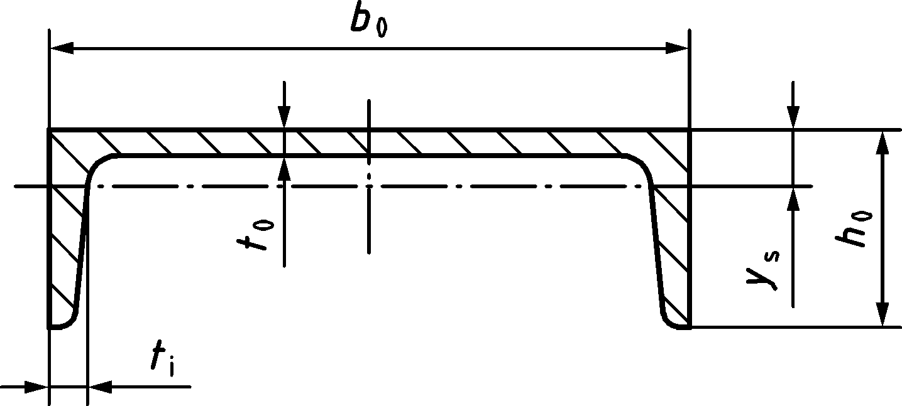 |  | Overlapping RHS brace to channel section chord  $$b_{eff}=\left(\frac{10}{{b_{0}^{*}}/{t_{0}}}\right)\left(\frac{f_{y0}t_{0}}{f_{yi}t_{i}}\right)b_{i} but ≤b_{i} with b_{0}^{*}=b_{0}-3t_{f}$$

Table 9.29 — Design brace shear resistance of uniplanar overlap joints with a CHS, RHS, I or H and channel section chord
$N_{S,Rd}$ for brace shear criteriona b (it should be verified that ${ λ}_{ov,lim}{<λ}_{ov}<100 \%$ and ${h_{i}}/{b_{i}}$ and/or ${h_{j}}/{b_{j}}$ < 1,0)
CHS braces | $${ λ}_{ov,lim}{<λ}_{ov}<100\%$$ | $$N_{S,Rd}={\left[\frac{π}{4}\left[0,58C_{ui}f_{yi}t_{i}\frac{\left[\left(\frac{100-λ_{ov}}{100}\right)2d_{i}+7,2t_{i}\right]}{\sin{θ_{i}}}+0,58C_{uj}f_{yj}t_{j}\frac{\left(2d_{j}+c_{s}{7,2t}_{j}\right)}{\sin{θ_{j}}}\right]\right]}/{γ_{M5}}$$
 | $$λ_{ov}=100 \%$$ | $$N_{S,Rd}={\left[0,58C_{uj}f_{yj}t_{j}\frac{π}{4}\frac{\left(3d_{j}+7,2t_{j}\right)}{\sin{θ_{j}}}\right]}/{γ_{M5}}$$
RHS braces | $${ λ}_{ov,lim}{<λ}_{ov}<100 \%$$ | $$N_{S,Rd}={\left[0,58C_{ui}f_{yi}t_{i}\frac{\left[\left(\frac{100-λ_{ov}}{100}\right)2h_{i}+6t_{i}\right]}{\sin{θ_{i}}}+0,58C_{uj}f_{yj}t_{j}\frac{\left(2h_{j}+c_{s}{6t}_{j}\right)}{\sin{θ_{j}}}\right]}/{γ_{M5}}$$
 | $$λ_{ov}=100 \%$$ | $$N_{S,Rd}={\left[0,58C_{uj}f_{yj}t_{j}\frac{\left(2h_{j}+b_{j}+6t_{j}\right)}{\sin{θ_{j}}}\right]}/{γ_{M5}}$$
a $C_{ui}={f_{ui}}/{f_{yi}}$; $C_{uj}={f_{uj}}/{f_{yj}}$
b cs = 1 when hidden toe of the overlapped brace is not welded and cs = 2 when hidden toe of the overlapped brace is welded.

- (normative)
Structural properties of basic components
- Use of this annex
(1) This normative Annex contains the design resistance and the stiffness coefficients of the basic joint components summarized in Table 8.1.
- Scope and field of application
(1) This normative Annex covers the application range as given in 8.1 (3).
- General
(1) Certain joint components may be reinforced. Details of the different methods of reinforcement are given in this Annex.
- Column web panel in shear
- Design resistance
- General
(1) The design methods given in the A.4.1.2, A.4.1.3, and A.4.1.4 are valid provided that the column web slenderness satisfies the following condition:
$$\frac{h_{wc}}{t_{wc}}≤72\frac{ε}{η}$$ | (A.1)
where
hwc clear depth of the column web measured between the flanges;
twc column web thickness;
$$ε= \sqrt{\frac{235}{f_{y}\left[N/{mm}^{2}\right]}}$$
For the value of η see EN 1993-1-5. For the criterion (A.1), η = 1,2 may be assumed.
- Unstiffened column web
(1) For single-sided joint configurations, or for double-sided joint configurations in which the beam depths are similar, the design shear resistance Vwp,Rd of an unstiffened column web panel, subject to a design shear force Vwp,Ed, see 7.2.2(2), should be determined as follows:
$$V_{wp,Rd}=\frac{0,9f_{y,wc}A_{vc}}{\sqrt{3} γ_{M0}}$$ | (A.2)
where Avc is the shear area of the column, see 8.2.6 in prEN 1993-1-1:2020.
(2) The design shear resistance may be increased by using stiffeners or supplementary web plates.
NOTE In double-sided beam-to-column joint configurations without diagonal stiffeners on the column webs, the two beams are assumed to have similar depths.
- Column web stiffeners
(1) If transverse web stiffeners are used in both compression and tension zones, the design shear resistance of the column web panel Vwp,Rd may be increased by Vwp,add,Rd obtained from:
$$V_{wp,add,Rd}=\frac{b_{fc}t_{fc}^{2}f_{y,fc}}{d_{s}γ_{M0}}$$ | (A.3)
where
ds distance between the centrelines of the stiffeners;
bfc column flange width;
tfc column flange thickness;
fy,fc column flange yield strength.
(2) If diagonal web stiffeners are used to increase the design shear resistance of the column web panel, they should be designed to resist the tension and compression forces transmitted to the column by the flanges of the beam. The design resistance of these stiffeners should be determined according to 8.2.3 and 8.2.4 of prEN 1993-1-1:2020, and in EN 1993-1-5, as appropriate.
- Supplementary web plates
(1) If a column web is reinforced by adding supplementary web plates welded to the column flanges, see Figure A.1, the shear area Avc may be increased by $b_{s}\sum{t_{s}}$.
(2) If a column web is reinforced by adding a supplementary web plate welded to the column web only, the shear area Avc may be increased by bs twc. The thickness ts of the supplementary web plate should be not less than the column web thickness twc. If a further supplementary web plate is added on the other side of the web, no further increase of the shear area should be made.
(3) The steel grade of the supplementary web plate should be equal to that of the column.
(4) Supplementary web plates may be placed in contact with the column web, or may be spaced away from the web.
- If the plates are placed in contact with the column web, see Figure A.1(b), the width bs should be such that the supplementary web plate extends at least to the toe of the root radius, or of the weld.
- If the plates are spaced away from the web, see Figure A.1(c), the width bs should be such that the supplementary web plate extends to the column flange, and the plates should be placed symmetrically in pairs, on opposite sides of the column web.
(5) The length ls should be such that the supplementary web plate extends throughout the effective width of the web in tension and compression, see Figure A.1 a).
(6) The welds between the supplementary web plate and the column should be designed for the applied design forces.
(7) The thickness of each supplementary web plate should be such that its slenderness satisfies the condition:
$$t_{s}≥\frac{h_{wc}}{40ε}$$ | (A.4)
where
hwc is the clear depth of the column web measured between the flanges;
ts is the thickness of a supplementary web plate;
$$ε= \sqrt{\frac{235}{f_{y}\left[N/{mm}^{2}\right]}}$$
(8) Alternatively, when local buckling of the column web panel and supplementary web plate is prevented by using plug welds joining them, the total web panel thickness should satisfy Formula (A.4). A minimum of four plug welds conforming to the requirements in 6.3.5(1) to 6.3.5(5) should be provided. The individual thickness of column web panel and supplementary web plates should satisfy (A.1) and (A.4) respectively, with hwc replaced with the largest of the horizontal or vertical distance between two plug welds, or a plug weld and the edge of the plate.
(9) Discontinuous welds may be used in non-corrosive environments.
(10) Weldability at the corner should be taken into account, see Figure A.1.
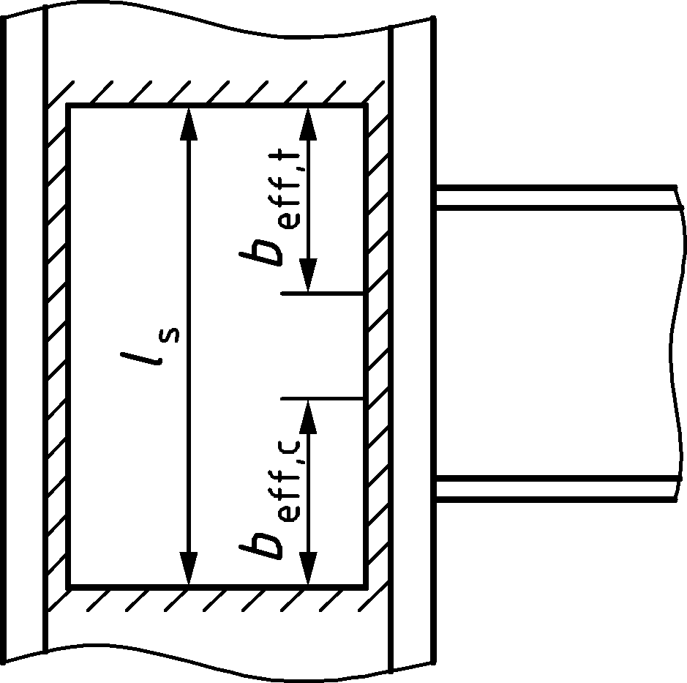 | 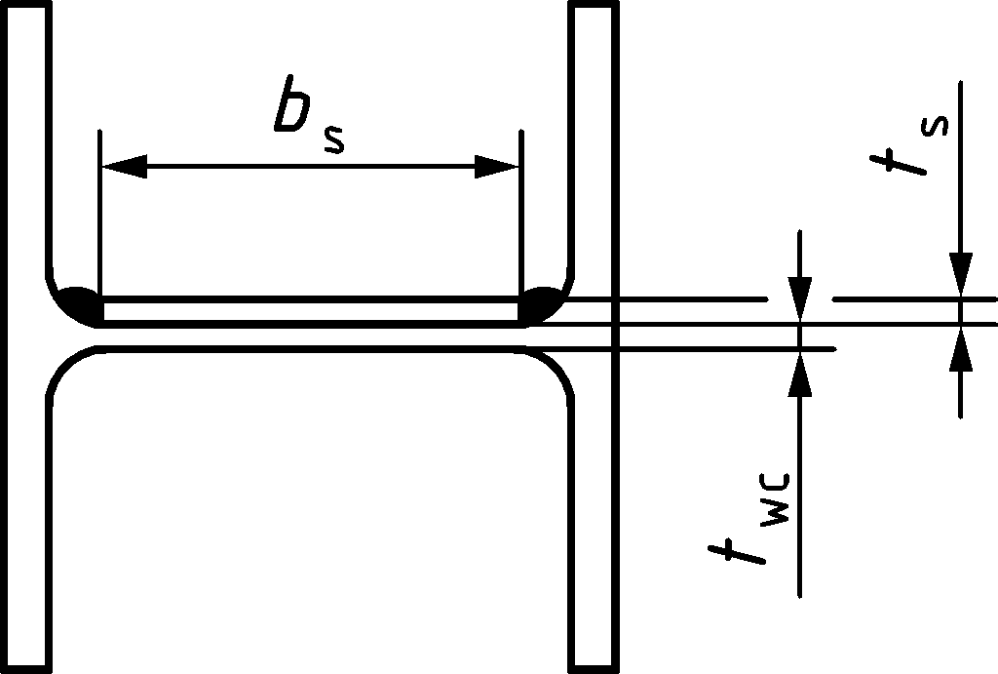 | 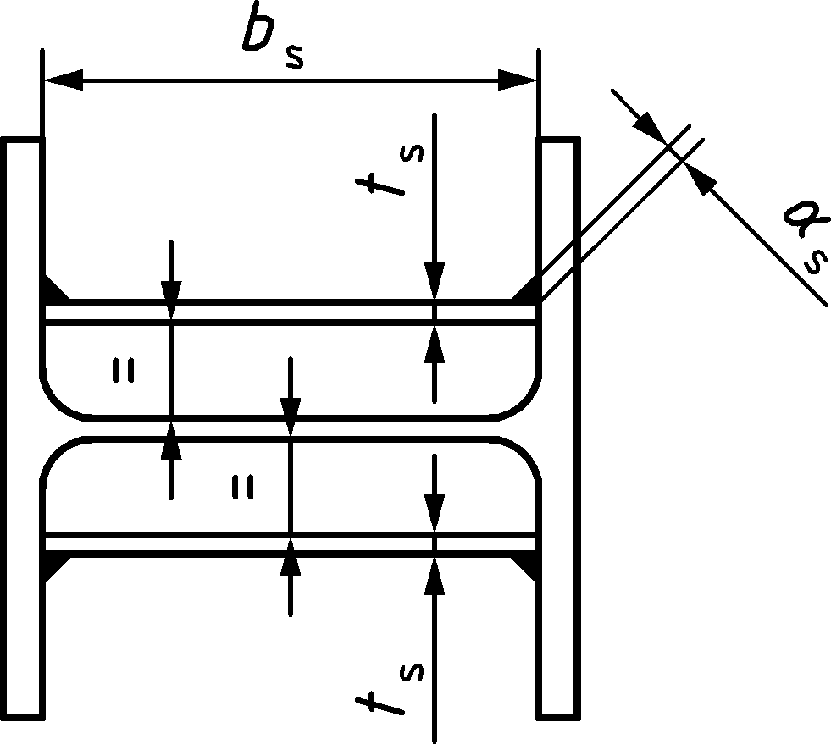
a) Layout | b) Example of supplementary web plates placed in contact with the column web | c) Example of supplementary web plates spaced away from the column web
Figure A.1 — Examples of supplementary web plates
- Stiffness coefficient
(1) The stiffness coefficient for a column web panel in shear, in the case of single-sided joint configurations or double-sided joint configurations, in which the beam depths are similar, should be obtained from:
- for webs without diagonal stiffeners | - $k_{wp}=\frac{0,38A_{vc}}{β z}$ | (A.5)
- for webs with diagonal stiffeners | - $k_{wp}=∞$ | (A.6)
where
z lever arm from Table B.1;
β transformation parameter from 7.2.3.
(2) Where a column web is reinforced by adding supplementary web plates, the stiffness coefficient for the column web panel in shear should be obtained from Formula (A.5) based on the increased shear area Avc from A.4.1.4.
- Column web in transverse compression
- Design resistance
- Unstiffened column web
(1) The design resistance of an unstiffened column web subject to transverse compression should be determined as follows:
$$F_{c,wc,Rd}=\frac{ω k_{wc}b_{eff,c,wc}t_{wc}f_{y,wc}}{γ_{M0}}$$ | but | $$F_{c,wc,Rd}≤\frac{ω k_{wc} ρ b_{eff,c,wc} t_{wc} f_{y,wc} }{γ_{M1}}$$ | (A.7)
(2) For welded connections, the effective width beff,c,wc of a column web in compression should be taken as:
$${b_{eff,c,wc}=t}_{fb}+2\sqrt{2} a_{b}+5\left(t_{fc}+s\right)$$ | (A.8)
where
- for a rolled I or H section column: s = $r_{c}$
- for a welded I or H section column: s = $\sqrt{2}a_{c}$
- and ac, rc and ab are as indicated in Figure A.2.
(3) For bolted end plate connections, the effective width beff,c,wc of a column web in compression should be taken as:
$$b_{eff,c,wc}=t_{fb}+2\sqrt{2} a_{p}+5\left(t_{fc}+s\right)+s_{p}$$ | (A.9)
where
sp length obtained by dispersion at 45° through the end plate, taken at least equal to tp and, provided that the length of end plate below the flange is sufficient, up to 2tp
ap as indicated in Figure A.2.
(4) For bolted connections with angle flange cleats, the effective width beff,c,wc of a column web in compression should be taken as:
$$b_{eff,c,wc}=2t_{cl}+0,6r_{cl}+5\left(t_{fc}+s\right)$$ | (A.10)
where rcl is as in Figure A.2.
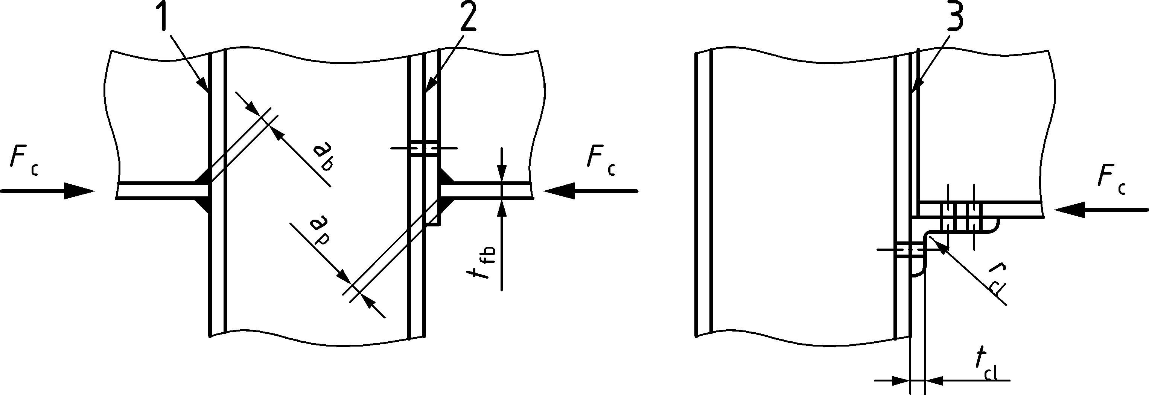
a) Elevation
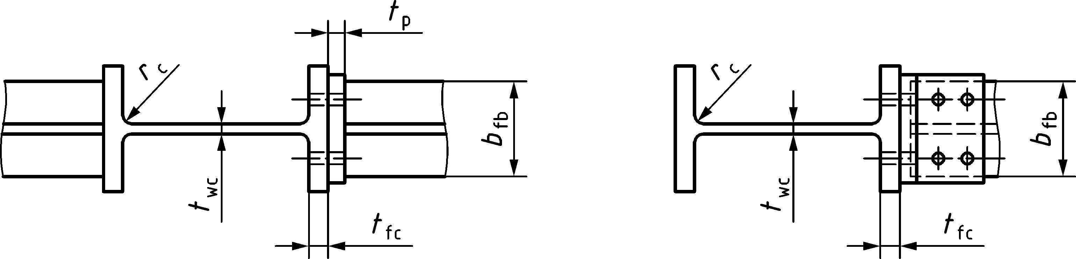
b) Rolled column
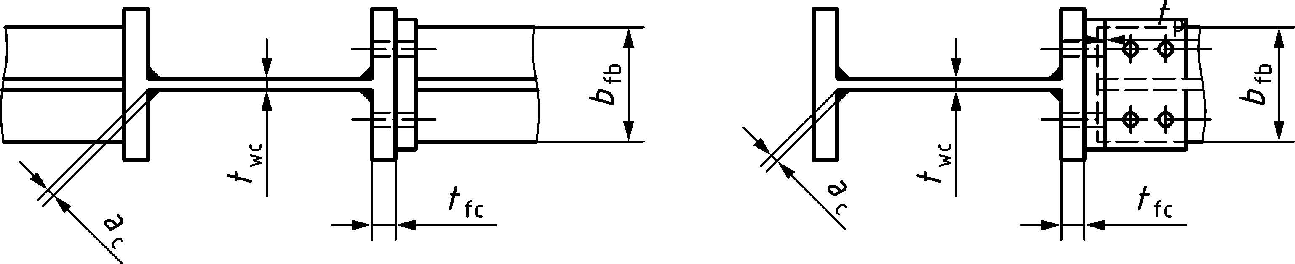
c) Welded column
Key
1 | welded joint
2 | joint with end plate
3 | joint with angle flange cleats
Figure A.2 — Transverse compression on an unstiffened column
(5) The reduction factor ω to allow for the possible effects of interaction with shear in the column web panel should be determined from Table A.1.
Table A.1 — Reduction factor ω for interaction with shear
Transformation parameter β | Reduction factor ω
0 ≤ β ≤ 0,5 | ω = 1
0,5 < β < 1 | ω = ω1 + 2 (1 − β) (1 − ω1)
β = 1 | ω = ω1
1 < β < 2 | ω = ω1 + (β − 1) (ω2 − ω1)
β = 2 | ω = ω2
Avc shear area of the column, see A.4;
β transformation parameter, see 7.2.3;
ω1 and ω2 should be determined from (A.11) and (A.12).

(6) The factors $ω_{1}$ and $ω_{2}$ should be determined from:
$$ω_{1}=\frac{1}{\sqrt{1+1,3{\left(\frac{b_{eff,c,wc} t_{wc} }{A_{vc}}\right)}^{2}}}$$ | (A.11)
$$ω_{2}=\frac{1}{\sqrt{1+5,2{\left(\frac{b_{eff,c,wc} t_{wc}}{A_{vc}}\right)}^{2}}}$$ | (A.12)
(7) The reduction factor for plate buckling ρ should be obtained from:
- if ${\overline{λ}}_{p}$ ≤ 0,673: ρ = 1,0 | (A.13)
- if ${\overline{λ}}_{p}$ > 0,673: ρ = (${\overline{λ}}_{p}$ − 0,22) / ${\overline{λ}}_{p}$2 | (A.14)
$where {\overline{λ}}_{p}$ is the plate slenderness, taken as:
$${\overline{λ}}_{p}=0,932\sqrt{\frac{b_{eff,c,wc}d_{wc}f_{y,wc}}{E{t_{wc}}^{2}}}$$ | (A.15)
- for a rolled I or H section column: dwc = hc − 2 (tfc + rc)
- for a welded I or H section column: dwc = hc − 2 (tfc + $\sqrt{2}a_{c}$)
(8) The reduction factor kwc should be obtained from the following:
- when σcom,Ed ≤ 0,7 fy,wc: kwc = 1  - when σcom,Ed > 0,7 fy,wc: kwc = 1,7 − σcom,Ed / fy,wc | (A.16)
where σcom,Ed is the maximum longitudinal compressive stress due to axial force and bending moment in the column.
NOTE Generally the reduction factor kwc is 1,0 and no reduction is necessary. It can therefore be omitted in preliminary calculations when the longitudinal stress is unknown and checked later.
(9) The ‘column-sway’ buckling mode of an unstiffened column web in compression illustrated in Figure A.3 should be prevented by constructional restraints.
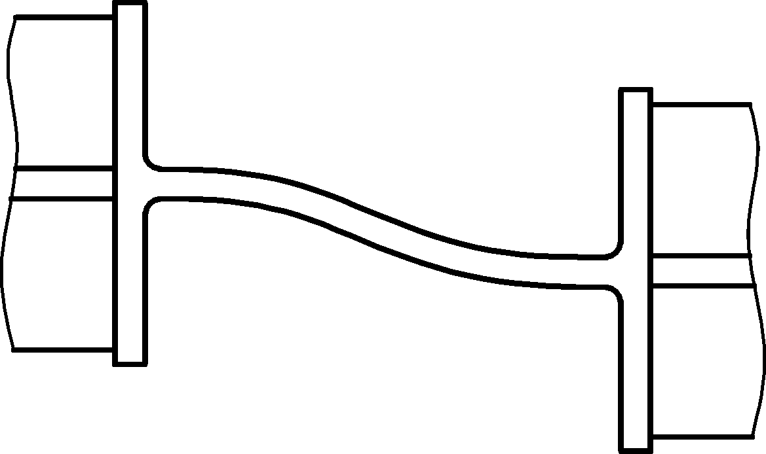
Figure A.3 — Column-sway’ buckling mode of an unstiffened web
(10) The design resistance of a column web in transverse compression may be increased by using stiffeners or supplementary web plates.
- Column web stiffeners
(1) Transverse stiffeners or appropriate arrangements of diagonal stiffeners may be used (in association with or as an alternative to transverse stiffeners) to increase the design resistance of the column web in compression.
(2) In welded connections, the transverse stiffeners should be aligned with the corresponding beam flange. In bolted connections, the stiffener in the compression zone should be aligned with the centre of compression as defined in Table B.1.
- Supplementary web plates
(1) If a column web is reinforced by a supplementary web plate welded to the column flanges, the design resistance of the column web in compression may be increased by the design resistance of the supplementary web plate, obtained as in A.5.1.1 for a welded column web. The factors $ω_{1}$ and $ω_{2}$ should be obtained using (A.11) and (A.12), by replacing the effective area $b_{eff,c,wc} t_{wc}$ with the sum of the effective areas of the column web and of the supplementary web plates.
(2) If a column web is reinforced by adding supplementary web plates welded to the column web only, as a simplification, the effective thickness of the web may be taken as 1,5 twc if one supplementary web plate is added, or 2 twc if supplementary web plates are added to both sides of the web.
(3) The supplementary web plates should conform to A.4.1.4. In calculating the reduction factor ω for the possible effects of shear stress, the shear area Avc of the web may be increased only to the extent permitted when determining its design shear resistance, see A.4.1.4.
- Stiffness coefficient
(1) The stiffness coefficient for a column web in transverse compression should be obtained from:
- for unstiffened webs | $$k_{c,wc}=\frac{0,7 b_{eff,c,wc} t_{wc}}{d_{wc}}$$ | (A.17)
- for stiffened webs | $$k_{c,wc}=∞$$ | (A.18)
where beff,c,wc is the effective width from A.5.1.1(2), A.5.1.1(3), or A.5.1.1(4), as appropriate.
(2) Where supplementary web plates are used, the stiffness coefficient for the column web in compression should be obtained from Formula (A.17) based on the sum of the effective areas of the column web and of the supplementary web plates, see A.5.1.3.
- Column web in transverse tension
- Design resistance
- Unstiffened column web
(1) The design resistance of an unstiffened column web subject to transverse tension should be determined as follows:
$$F_{t,wc,Rd}=\frac{ω b_{eff,t,wc}{\text{t}}_{\text{wc}} f_{y,wc}}{γ_{M0}}$$ | (A.19)
where ω is the reduction factor for the interaction with shear in the column web panel, see A.5.1.1(5).
(2) For welded connections, the effective width beff,t,wc of the column web in tension should be taken as:
$${b_{eff,t,wc}=t}_{fb}+2\sqrt{2} a_{b}+5\left(t_{fc}+s\right)$$ | (A.20)
where
- for rolled I or H section columns: s = rc;
- for welded I or H section columns: s = $\sqrt{2}a_{c}$;
and ac and rc are as shown in Figure A.4 and ab is as indicated in Figure A.2.
(3) For bolted connections, the effective width beff,t,wc of the column web in tension for a row or a group of bolt rows should be taken as equal to the effective length of equivalent T-stub representing the column flange, see A.7.1.1(3).
(4) The reduction factor ω for the effects of shear on the column web panel should be determined from Table A.1, using the value of beff,t,wc given in A.6.1.1(2), or A.6.1.1(3), as appropriate.
(5) The design resistance of a column web in transverse tension may be increased by using stiffeners or supplementary web plates.
- Column web stiffeners
(1) Transverse stiffeners and/or appropriate arrangements of diagonal stiffeners may be used to increase the design resistance of the column web in tension.
(2) In welded connections, the transverse stiffeners should be aligned with the corresponding beam flange.
(3) The welds connecting diagonal stiffeners to the column flange should be fill-in welds with a sealing run providing a combined throat thickness equal to the thickness of the stiffeners.
- Supplementary web plates
(1) If a column web is reinforced by a supplementary web plate welded to the column flanges, the design resistance of the column web in tension may be increased by the design resistance of the supplementary web plate, obtained as in A.6.1.1 for a welded column web. The factors $ω_{1}$ and $ω_{2}$ should be obtained using (A.11) and (A.12), by replacing the effective area $b_{eff,twc} t_{wc}$ with the sum of the effective areas of the column web and of the supplementary web plates.
(2) If a column web is reinforced by adding supplementary web plates welded to the column web, the design tension resistance depends on the throat thickness of the longitudinal welds connecting the supplementary web plates. When the longitudinal welds are fillet welds with a throat thickness a ≥ ${t_{s}}/{\sqrt{2}}$ then, for either one or two supplementary web plates, the effective thickness of the web tw,eff should be taken as follows:
- for steel grades S 235, S 275 or S 355 tw,eff = 1,4 twc | (A.21)
- for steel grades S 420 to S 460 tw,eff = 1,3 twc | (A.22)
(3) The supplementary web plates should conform to A.4.1.4. In calculating the reduction factor ω for the possible effects of shear stress, the shear area Avc of the web may be increased only to the extent permitted when determining its design shear resistance, see A.4.1.4.
- Stiffness coefficient
(1) For bolted connections, the stiffness coefficient for the effective width beff,t,wc of the column web in transverse tension for a single bolt row should be obtained from:
$$k_{t,wc}=\frac{0,7 b_{eff,t,wc} t_{wc}}{d_{c}}$$ | (A.23)
where beff,t,wc is determined from A.6.1.1(3) and should be taken as equal to the smaller of the effective lengths leff for this bolt row (individually or as part of a group of bolt rows), given in Table A.2.
(2) For unstiffened welded connections, the stiffness coefficient of the column web in transverse tension should be determined from Formula (A.23), with the effective width obtained from A.6.1.1(2).
(3) For stiffened welded connections, the stiffness coefficient of the column web in transverse tension should be taken as infinity.
- Column flange in bending
- Design resistance
- Unstiffened column flange in bolted connections
(1) The design resistance Ft,fc,Rd and failure mode of an unstiffened column flange in transverse bending, together with the associated bolts in tension, should be taken as those of an equivalent T-stub flange, see 8.3, for:
- each individual bolt row required to resist tension;
- each group of bolt rows required to resist tension.
(2) The dimensions emin and m for use in Table 8.2, see 8.3, should be determined from Figure A.4.
(3) The effective length of the equivalent T-stub flange leff should be determined for the individual bolt rows and the bolt group in accordance with 8.3.5 from the values given for each bolt row in Table A.2. In the case of non-equidistant bolt rows, the spacing p should be replaced with half spacing each side of the bolt.
(4) The design resistance of the column flange in bending may be increased by using transverse stiffeners and/or appropriate arrangements of diagonal stiffeners.
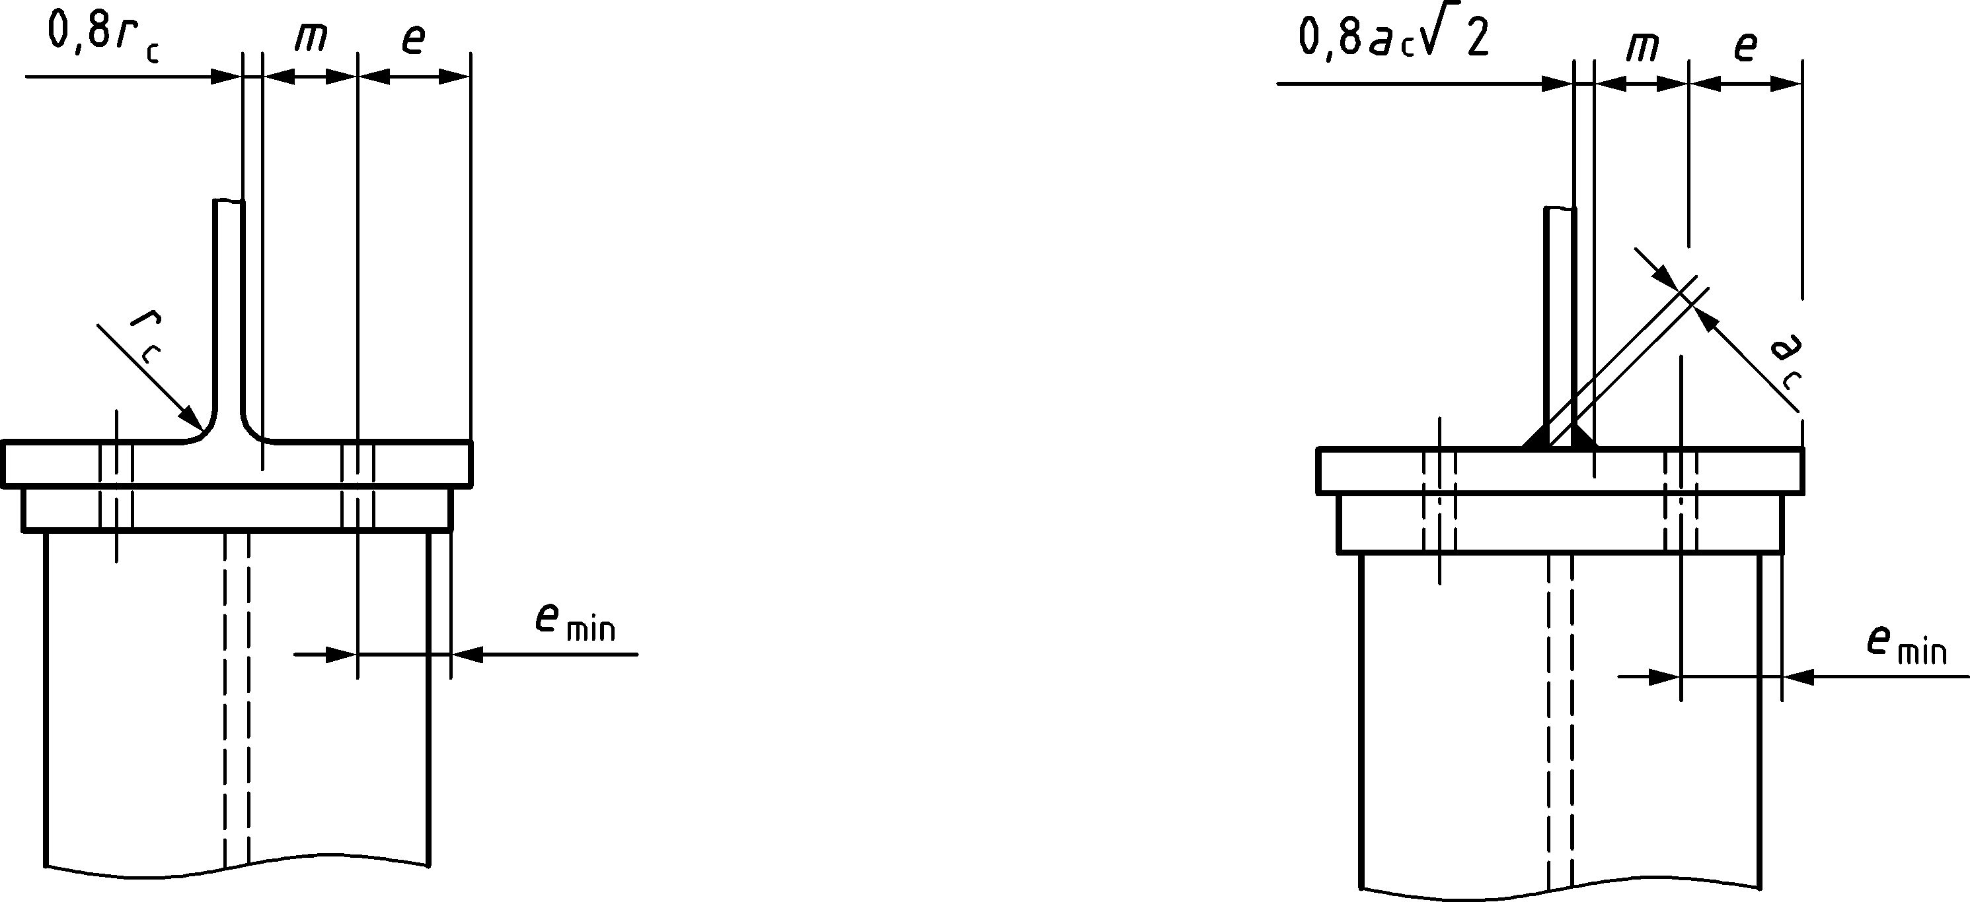
a) Welded end plate narrower than column flange
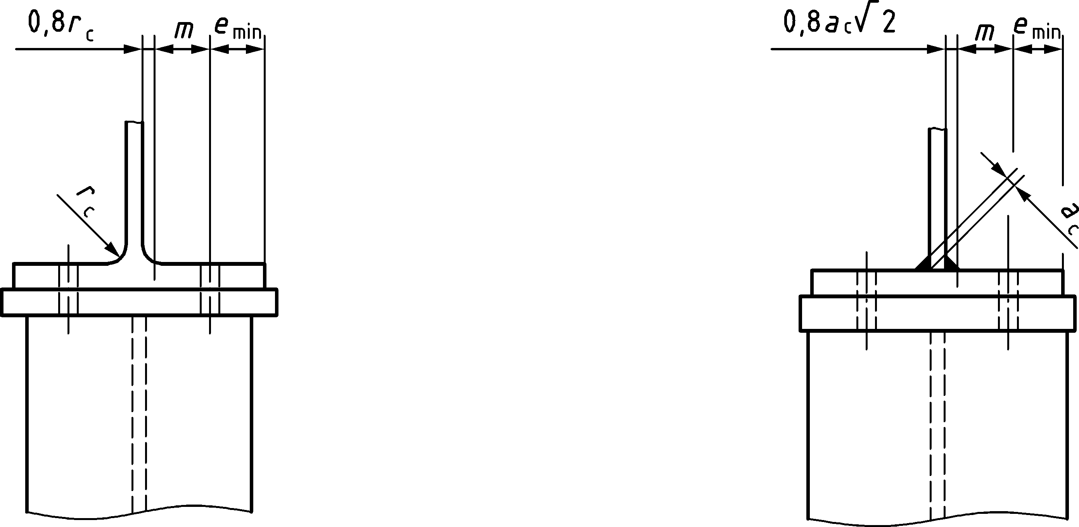
b) Welded end plate wider than column flange
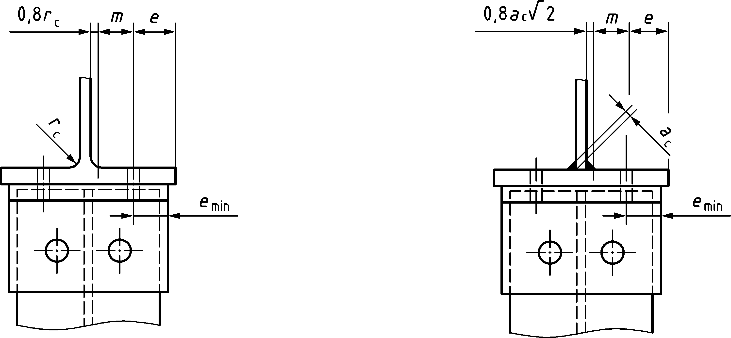
c) Angle flange cleats
Figure A.4 — Definitions of e, emin, rc and m
Table A.2 — Effective lengths for a column flange
 | Bolt row location | Bolt row location within the bolt group | leff,cp  (circular patterns) | leff,nc  (non-circular patterns)
Bolt row considered individually | Inner bolt row | not relevant | 2πm | 4m + 1,25e
 | Inner bolt row adjacent to a stiffener | not relevant | 2πm | αm
 | End bolt row | not relevant | The smaller of:  2πm  πm + 2e1 | The smaller of:  4m + 1,25e  2m + 0,625e + e1
 | End bolt row adjacent to a stiffener | not relevant | The smaller of:  2πm  πm + 2e1 | The smaller of:  αm  αm − (2m + 0,625e) + e1
Bolt row considered as part of a group of bolt rows | Inner bolt row | First/last bolt row | πm + p | 2m + 0,625e + 0,5p
 |  | Internal bolt row | 2p | p
 | Inner bolt row adjacent to a stiffener | First/last bolt row | πm + p | 0,5p + αm − (2m + 0,625e)
 | End bolt row | First/last bolt row | The smaller of:  πm + p  2e1 + p | The smaller of:  2m + 0,625e + 0,5p  e1 + 0,5p
Bolt row location for stiffened and unstiffened column flange, and bolt row location within the bolt group are given in Figure A.5.
α should be obtained from A.7.1.2(5).
e1 is the distance from the centre of the holes in the end row to the adjacent free end of the column flange measured in the direction of the axis of the column profile (see row 1 and row 2 in Figure A.5(a) and Figure A.5(b).

- Stiffened column flange in joints with bolted end plate or flange cleats
(1) The design resistance Ft,fc,Rd and failure mode of a stiffened column flange in transverse bending, together with the associated bolts in tension, should be taken as those of an equivalent T-stub flange, see 8.3, for:each individual bolt row required to resist tension;
- each group of bolt rows required to resist tension.
(2) The groups of bolt rows on either side of a stiffener should be modelled as separate equivalent T-stub flanges, see Figure A.5(c). The design resistance and failure mode should be determined separately for each equivalent T-stub.
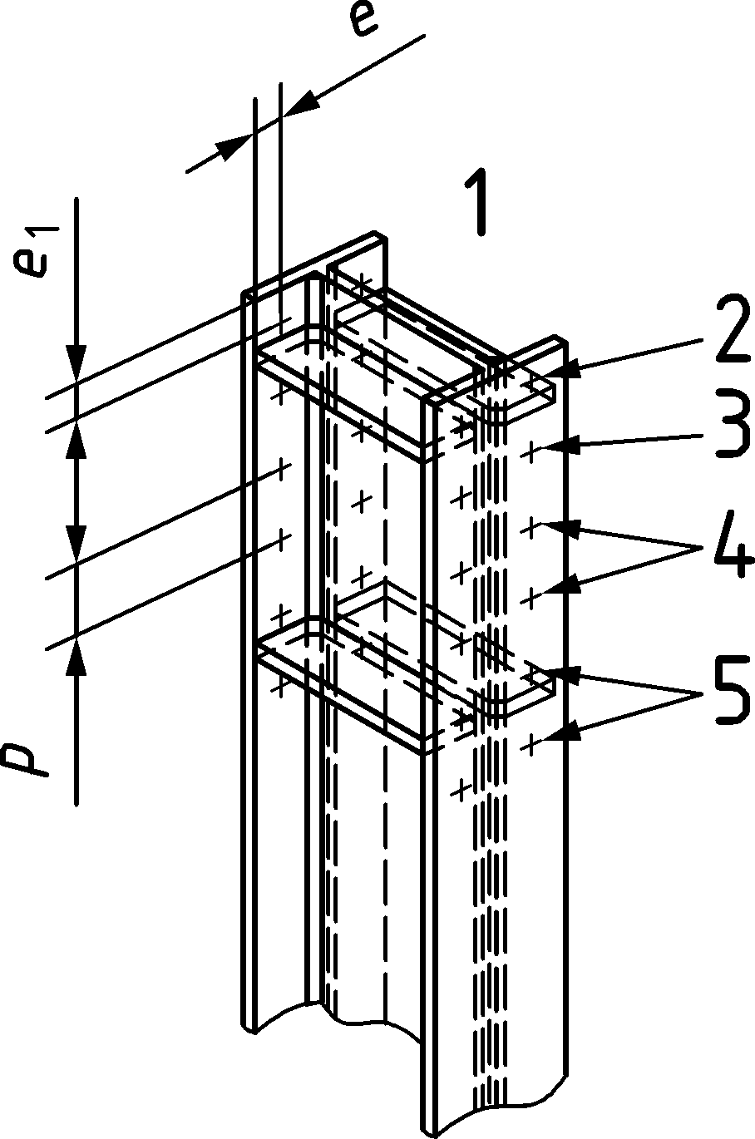 | 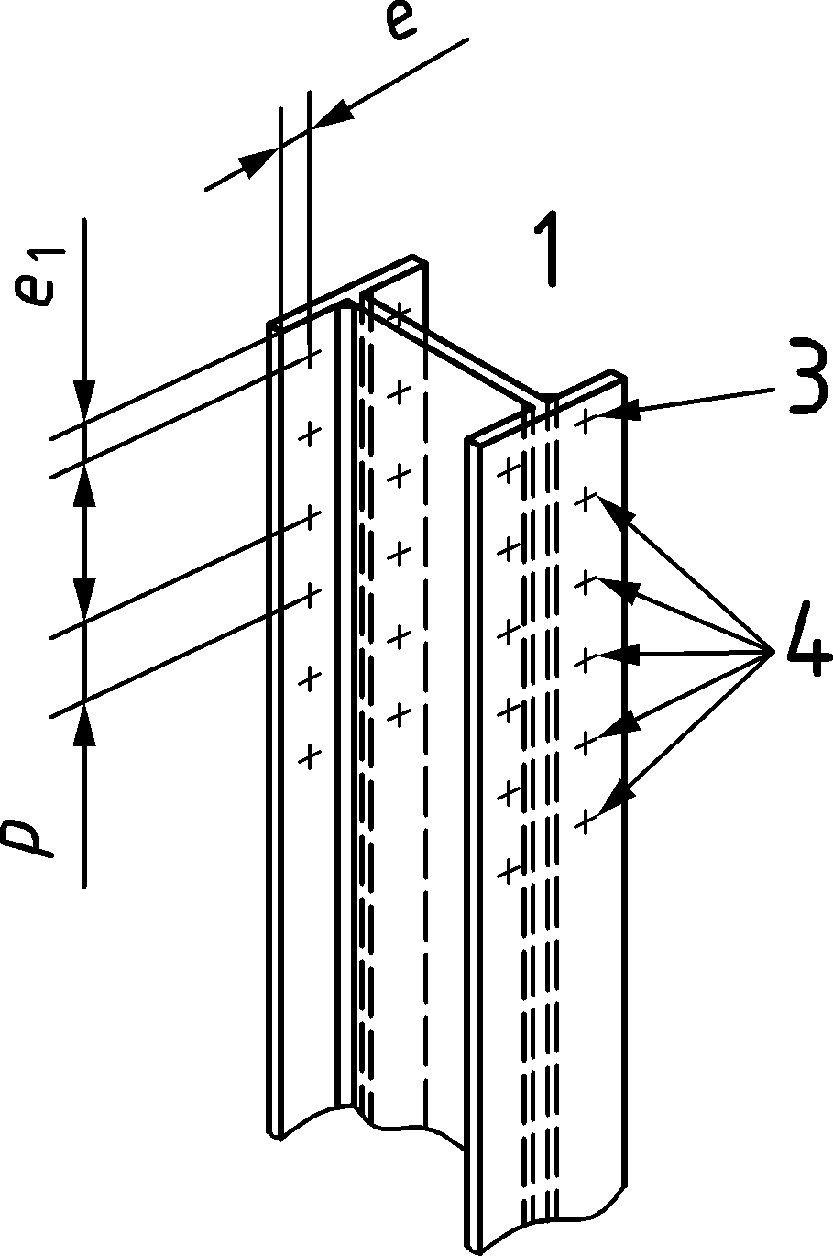 | 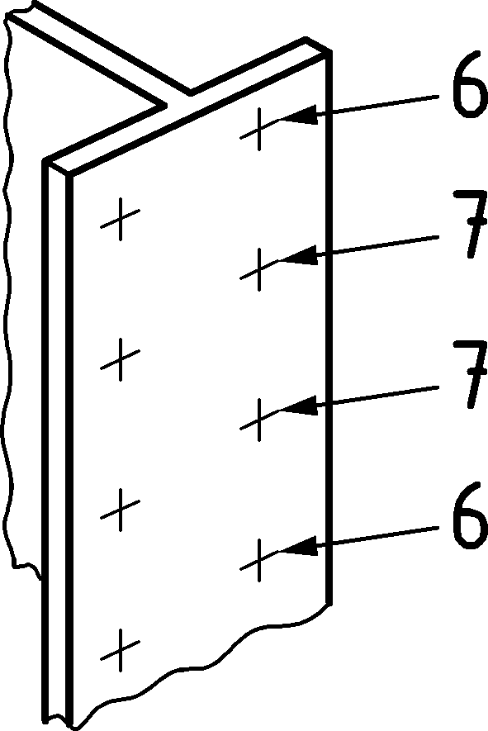
(a) | (b) | (c)
Key
1 end of the column
2 end bolt row adjacent to a transverse stiffener
3 end bolt row
4 inner bolt row
5 inner bolt row adjacent to a transverse stiffener
6 first/last bolt row
7 internal bolt row
Figure A.5 — Bolt row location for stiffened (a) and unstiffened (b) column flange, and bolt row location within the bolt group (c)
(3) The dimensions emin and m for use in Table 8.2, see 8.3, should be determined from Figure A.4.
(4) The effective lengths of the equivalent T-stub flange leff should be determined in accordance with 8.3.5 using the values for each bolt row given in Table A.2.
(5) The value of α for use in Table A.2 should be obtained from:
$$α=4+1,67\frac{e}{m}{\left(\frac{m}{m_{2}}\right)}^{0,67}$$ | but | $$α≥4+1,25\frac{e}{m}$$ | and | $$α≤8$$ | (A.24)
The dimensions m, e and m2 for use in (A.24) should be determined from Figure A.6.
(6) The stiffeners should meet the provisions of A.5.1.2.
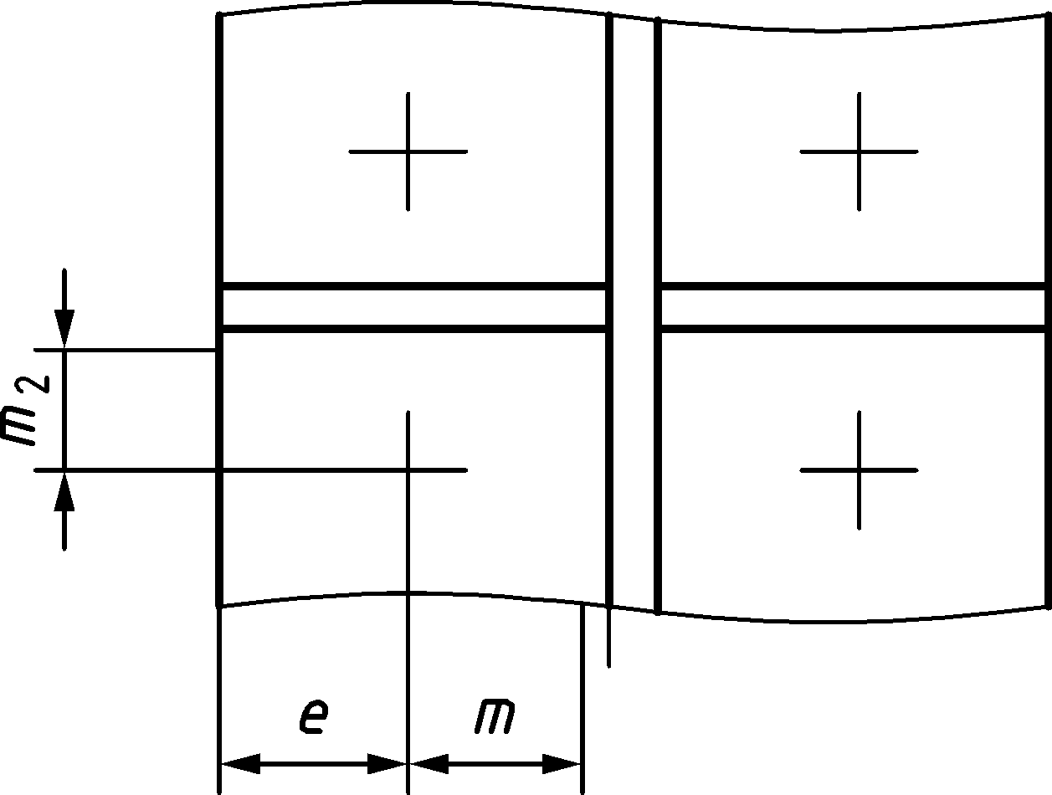
Figure A.6 — Definitions of m, e and m2 for a bolt row adjacent to stiffener
- Backing plates
(1) Backing plates may be used to reinforce a column flange in bending as indicated in Figure A.7.
(2) Each backing plate should extend at least to the edge of the column flange, and to within 3 mm of the toe of the root radius or of the weld.
(3) The backing plate should extend beyond the furthermost bolt rows active in tension as defined in Figure A.7.
(4) Where backing plates are used, the design resistance of the T-stub FT,Rd should be determined using the method given in Table 8.2, see 8.3.
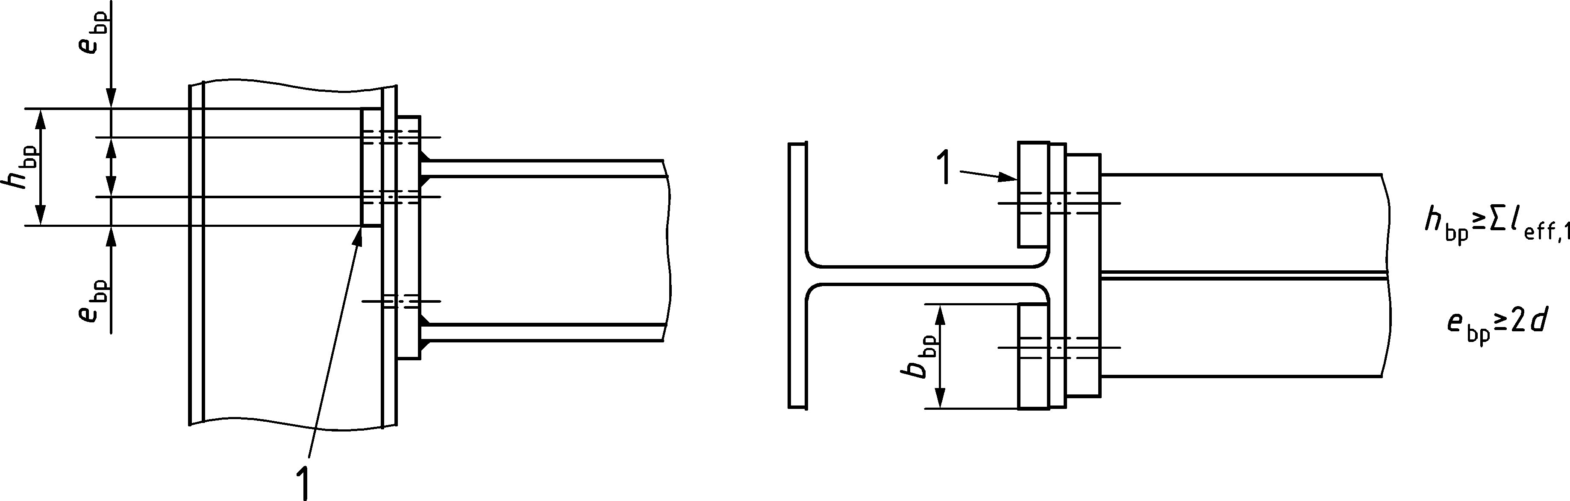
Key
1 backing plate
Figure A.7 — Column flange with backing plates
- Unstiffened column flange in welded connections
(1) In welded connections, the design resistance Ft,fc,Rd of an unstiffened column flange in bending, due to tension or compression from a beam flange, should be determined as follows:
Ft,fc,Rd = beff,b,fc tfb fγ,fb / γM0 | (A.25)
where
beff,b,fc is the effective width beff defined in 6.10 where the beam flange is considered as a plate.
NOTE See also the requirements specified in 6.10.
- Stiffness coefficient
(1) The stiffness coefficient for a column flange in bending, for a single bolt row, should be obtained from:
$$k_{t,fc}=\frac{0,9l_{eff} {t_{fc}}^{3}}{m^{3}}$$ | (A.26)
where
leff is the smaller of the effective lengths (individually or as part of a bolt group) for this bolt row given in Table A.2;
m is defined in Figure A.4.
NOTE The stiffness coefficient for a column flange in bending is not modified by backing plates.
- End plate in bending
- Design resistance
(1) The design resistance Ft,ep,Rd and failure mode of an end plate in bending, together with the associated bolts in tension, should be taken as those of an equivalent T-stub flange, see 8.3 for:
- each individual bolt row required to resist tension;
- each group of bolt rows required to resist tension.
(2) The groups of bolt rows on either side of any stiffener connected to the end plate should be treated as separate equivalent T-stubs. The extension of the end plate and the portion between the beam flanges should be modelled as two separate equivalent T-stub flanges, see Figure A.8. The design resistance and failure mode should be determined separately for each equivalent T-stub. In the case of non-equidistant bolt rows, the spacing p should be replaced with half spacing each side of the bolt.
(3) For the end plate extension, ex and mx should be used in place of e and m when determining the design resistance of the equivalent T-stub flange, see Figure A.8.
(4) The dimension emin required for use in Table 8.2, see 8.3, should be obtained from Figure A.4 for the part of the end plate located between the beam flanges. For the end plate extension, emin should be taken as equal to ex, see Figure A.8.
(5) The effective length of an equivalent T-stub flange leff should be determined in accordance with 8.3.5 using the values for each bolt row given in Table A.3.
(6) The values of mx for use in Table A.3 should be obtained from Figure A.8.
(7) When designing a stiffened end plate extension, the stiffener should conform to the following, see Figure A.9:
- the height of the stiffener h_{st} should be equal to the height of the end plate extension;
- the minimum length of the stiffener l_{st} should be taken as hst/tan(30°);
- the thickness of the stiffener should not be less than $t_{wb}\frac{f_{y,wb}}{f_{y,st}}$;
- the welds should be designed to provide at least the same resistance as the stiffener;
where
fy,wb yield strength of the beam web;
fy,st yield strength of the stiffener.
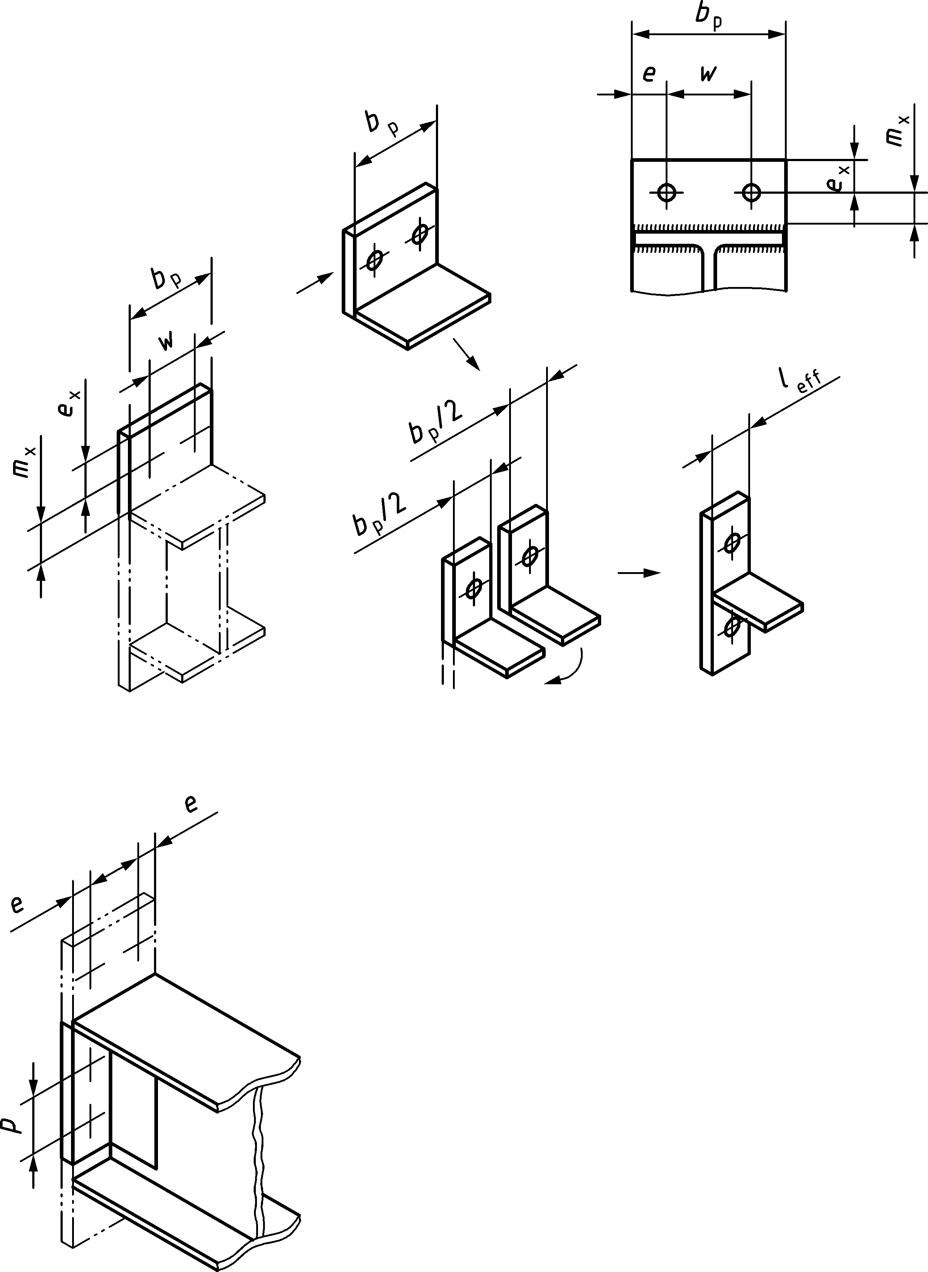
Figure A.8 — Modelling an extended end plate as separate T-stubs
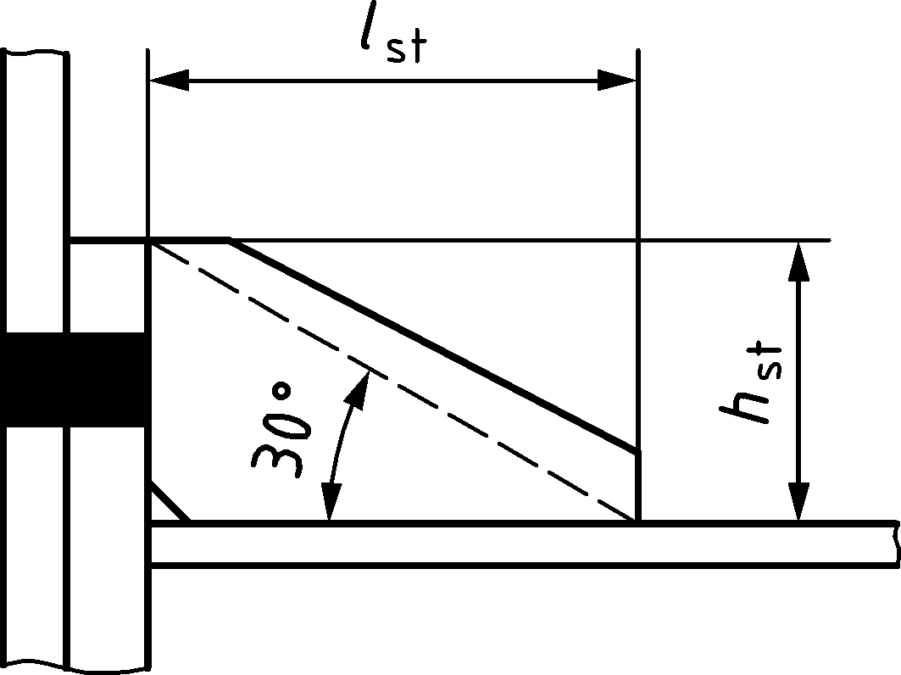
Figure A.9 — Dimensions of end plate stiffener
Table A.3 — Effective lengths for an end plate
 | Bolt row location | Bolt row location within the bolt group | leff,cp  (circular patterns) | leff,nc  (non-circular patterns)
Bolt row considered individually | Bolt row outside tension flange of beam, unstiffened | not relevant | The smaller of:  2πmx  πmx + w  πmx + 2e | The smaller of:  4mx + 1,25ex  e + 2mx + 0,625ex  0,5bp  0,5w + 2mx + 0,625ex
 | Bolt row outside tension flange of beam, stiffened | not relevant | The smaller of:  2πm  πm + 2e_{x} | The smaller of:  αm − (2m + 0,625e) + e_{x}  αm
 | First bolt row below tension flange of beam | not relevant | 2πm | αm
 | Other bolt row | not relevant | 2πm | 4m + 1,25 e
Bolt row considered as part of a group of bolt rows | First bolt row below tension flange of beam | First/last bolt row | πm + p | 0,5p + αm − (2m + 0,625e)
 | Other bolt row | First/last bolt row | πm + p | 2m + 0,625e + 0,5p
 |  | Internal bolt row | 2p | p
α should be obtained from A.8.1(8).

(8) The value of α for use in Table A.3 for the first bolt row below tension flange of beam should be obtained from (A.24). The value of α for use in Table A.3 for a stiffened bolt row outside tension flange of beam should be obtained from (A.24) with m2 replaced with mx. The dimensions m, e, m2 and mx for use in (A.24) should be determined from Figure A.10.
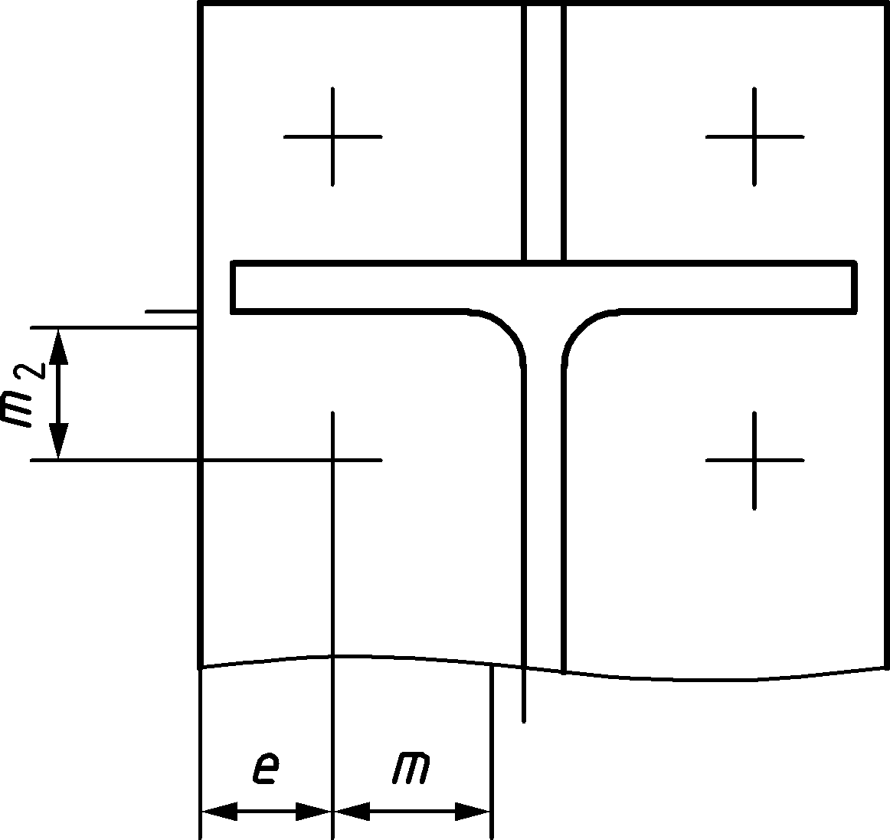 | 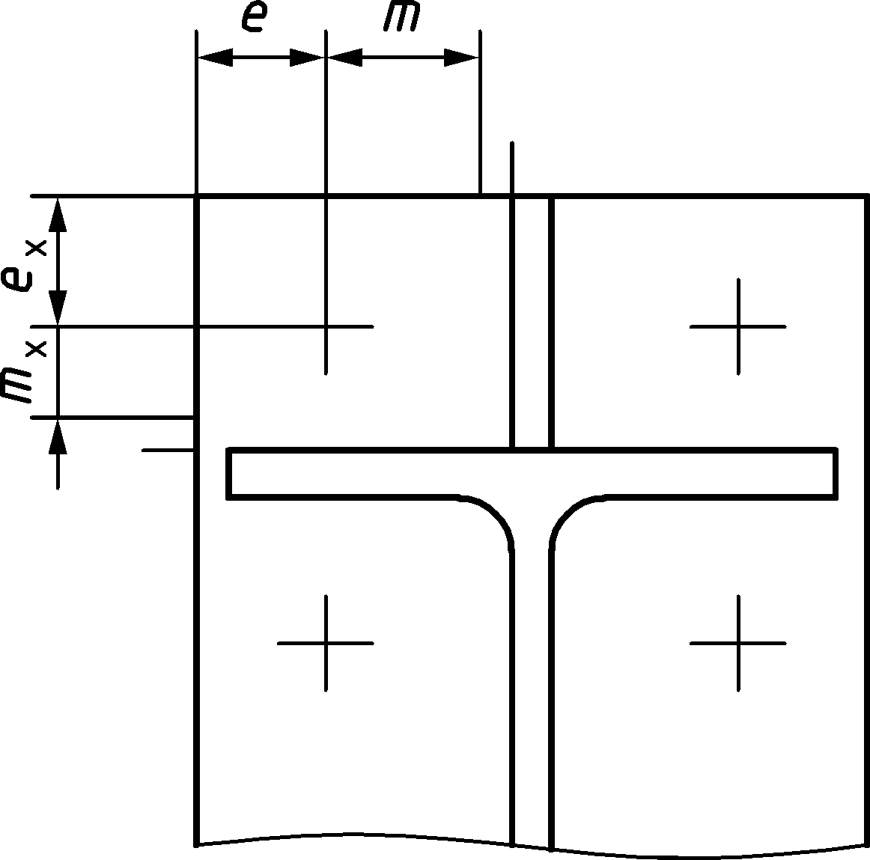
a) | b)
Figure A.10 — Definitions of m, e and m2 for the first bolt row below tension flange of beam (a) and m, e and mx for a stiffened bolt row outside tension flange of beam (b).
- Stiffness coefficient
(1) The stiffness coefficient of an end plate in bending, for a single bolt row, should be obtained from:
$$k_{t,ep}=\frac{0,9l_{eff} {t_{p}}^{3}}{m^{3}}$$ | (A.27)
where
leff smaller of the effective lengths (individually or as part of a group of bolt rows) given for this bolt row in Table A.3;
m (generally) defined in Figure A.4, but for a bolt row located in the extended part of an extended end plate m = mx, where mx is defined in Figure A.8.
NOTE The stiffness coefficient for an end plate in bending is not modified by backing plates.
- Flange cleat in bending
- Design resistance
(1) The design resistance Ft,cl,Rd and failure mode of a bolted angle flange cleat in bending, together with the associated bolts in tension, should be taken as those of an equivalent T-stub flange, see 8.3.
(2) The effective length leff of the equivalent T-stub flange should be taken as 0,5bcl where bcl is the length of the angle cleat, see Figure A.11.
(3) The dimensions emin and m for use in Table 8.2, see 8.3, should be determined from Figure A.12.
(4) The number of bolt rows connecting the cleat to the column flange should be limited to one (see Figure A.12).
(5) The number of bolt rows connecting the cleat to the beam flange is not limited (see Figure A.12).
(6) The length bcl of the cleat may be different from both the width of the beam flange and the width of the column flange.
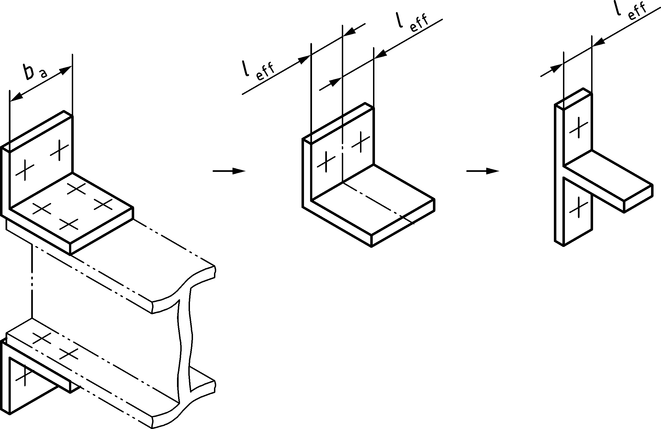
Figure A.11 — Effective length leff of an angle flange cleat
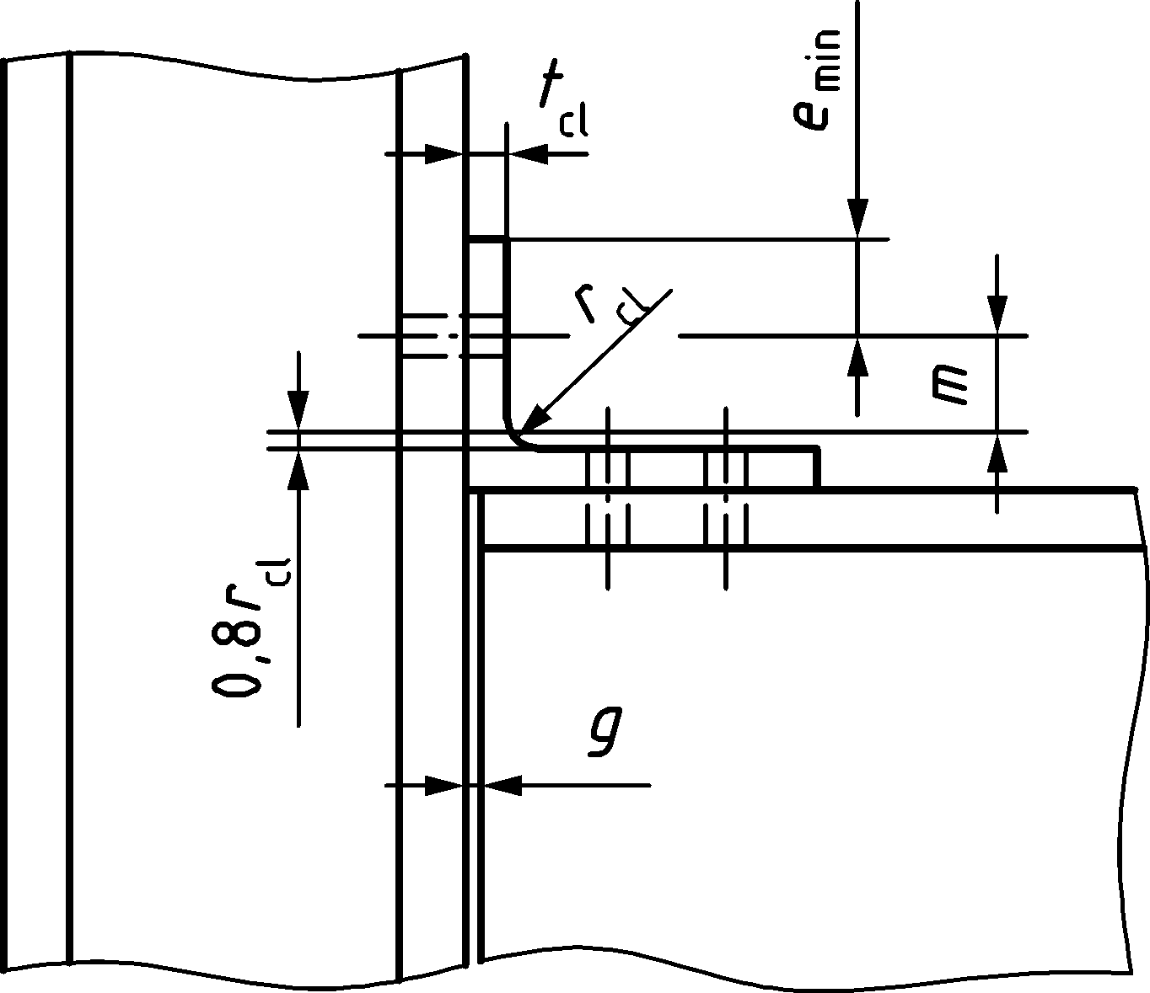 | 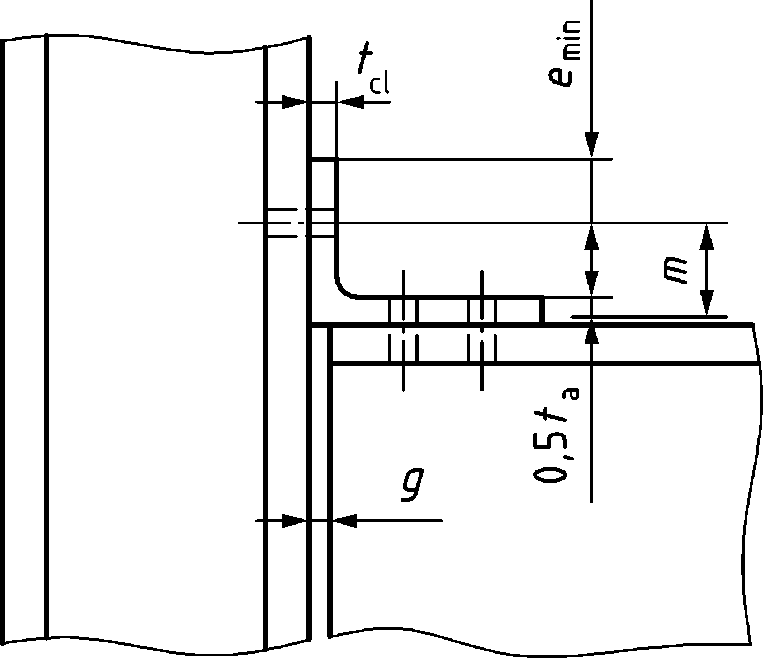
a) Gap g ≤ 0,4 tcl | b) Gap g > 0,4 tcl
Figure A.12 — Dimensions emin and m for a bolted angle cleat
- Stiffness coefficient
(1) The stiffness coefficient of a flange cleat in bending, for a single bolt row, should be obtained from:
$$k_{t,cl}=\frac{0,9l_{eff} {t_{cl}}^{3}}{m^{3}}$$ | (A.28)
where
leff effective length of the flange cleat from Figure A.11;
m form Figure A.12.
NOTE The stiffness coefficient for a flange cleat in bending is not modified by backing plates.
- Beam or column flange and web in compression
- Design resistance
(1) The resultant design compression resistance of a beam flange and the adjacent beam web may be assumed to act at the level of the centre of compression, see Table B.1 in B.3.2.1, and should be determined as follows:
$$F_{c,fb,Rd}=M_{c,Rd} / (h-t_{fb})$$ | (A.29)
where
h depth of the connected beam;
Mc,Rd design moment resistance of the beam cross-section, reduced if necessary to allow for shear, see 8.2.5 and 8.2.8 in prEN 1993-1-1:2020; for a haunched beam Mc,Rd may be calculated neglecting the intermediate flange;
tfb flange thickness of the connected beam.
- Stiffness coefficient
(1) The stiffness coefficient of a beam flange and web in compression, kc,fb, should be taken equal to infinity.
- Beam web in tension
- Design resistance
(1) In a bolted end plate connection, the design resistance of the beam web in tension should be determined as follows:
$$F_{t,wb,Rd}=b_{eff,t,wb}{t_{wb}f}_{y,wb} / γ_{M0}$$ | (A.30)
(2) The effective width beff,t,wb of the beam web in tension should be taken equal to the effective length of the equivalent T-stub representing the end plate in bending, obtained from A.8.1 for an individual bolt row or a bolt group.
- Stiffness coefficient
(1) The stiffness coefficient of beam web in tension, kt,wb, should be taken as equal to infinity.
- Plate in tension or compression
- Design resistance
(1) The design resistance of a plate in tension or compression should be determined according to 8.2.3 and 8.2.4 in prEN 1993-1-1:2020. For plate buckling reference should be made to Clause 4 in EN 1993-1-5:2006.
- Stiffness coefficient
(1) The stiffness coefficient of a plate in tension or compression, kt,p or kc,p, should be taken as equal to infinity.
- Bolts in tension
- Design resistance
(1) The design tension resistance of bolts should be obtained from Table 5.7, see 5.7.1.
- Stiffness coefficient
(1) The stiffness coefficient for bolts in tension, for a single bolt row, should be determined as follows:
- for non-preloaded bolts: | $$k_{t}=\frac{1,6A_{s}}{Lb}$$ | (A.31)
- for preloaded bolts: | $$k_{t}=∞$$ | (A.32)
where
Lb is the bolt elongation length, see Table 8.2.
- Bolts in shear
- Design resistance
(1) The design shear resistance of bolts should be obtained from Table 5.7, see 5.7.1.
- Stiffness coefficient
(1) The stiffness coefficients of bolts in shear, for a single bolt row, should be obtained from:
- for non-preloaded bolts: | $$k_{v}=\frac{16n_{b}d^{2}f_{ub}}{Ed_{M16}}$$ | (A.33)
- for bolts in slip-resistant connections: | $$k_{v}=∞$$ | (A.34)
where
dM16 is the nominal diameter of an M16 bolt;
nb is the number of bolt rows (with two bolts per row).
- Bearing at bolt holes
- Design resistance
(1) The design bearing resistance at bolt holes should be obtained from Table 5.7, see 5.7.1.
- Stiffness coefficient
(1) The stiffness coefficient for bearing should be obtained from:
$$k_{b}=\frac{24n_{b}{ k}_{d}{{ k}_{td}f}_{u} }{E}$$ | (A.35)
- For non-preloaded bolts
k_{d} = k_{b1} but k_{b} ≤ k_{b2}
k_{d1} = 0,25e_{b}/d + 0,5 but k_{d1}≤1,25
k_{d2} = 0,25p_{b}/d + 0,375 but k_{d2} ≤ 1,25
k_{t} = 1,5t_{j}/d_{M16} but k_{t} ≤ 2,5
e_{b} is the distance from the bolt row to the free edge of the plate in the direction of load transfer
f_{u} is the ultimate tensile strength of the steel on which the bolt bears
p_{b} is the spacing of the bolt-rows in the direction of load transfer
t_{j} is the thickness of the steel plate on which the bolt bears
n_{b} is the number of bolts
d_{M16} is the nominal diameter of an M16 bolt
- For preloaded bolts
k_{b} = ∞
(2) Alternatively, provided that the design shear force per bolt F_{v,Ed} is (i) less than 0,8Fb,Rd for grades up to S460 and (ii) less than Fb,Rd for higher grades, the stiffness coefficient should be obtained from:
- for non-preloaded bolts | $$k_{b}=\frac{{ \overline{S}}_{b}n{ t}_{j}{ f}_{u} }{E}$$ |  | (A.36)
- for bolts in slip-resistant connections | $$k_{b}=∞$$ | (A.37)
where
n number of bolts;
fu ultimate tensile strength of the steel on which the bolt bears;
tj thickness of that component;
${ \overline{S}}_{b}$ relative bearing stiffness, which may be obtained from:
$${\overline{S}}_{b}=\frac{{\overline{σ}}_{b,Ed}}{\frac{u}{d}\left({\overline{σ}}_{b}={\overline{σ}}_{b,Ed}\right)}$$ | (A.38)
$${\overline{σ}}_{b,Ed}=\frac{F_{v,Ed}}{dt_{j}f_{u}}$$ | (A.39)
$${\overline{σ}}_{b}=\frac{126u/d}{{\left(1+\sqrt{30u/d}\right)}^{2}}$$ | (A.40)
where
${\overline{σ}}_{b,Ed}$ is the non-dimensional average bearing stress
$\frac{u}{d}({\overline{σ}}_{b}={\overline{σ}}_{b,Ed})$ is the non-dimensional bolt hole elongation at non-dimensional design bearing stress;
u is the bolt hole elongation, see Figure A.13;
d is the bolt diameter;
${\overline{σ}}_{b}$. non-dimensional average bearing stress, see Figure A.13;
$F_{v,Ed}$ is the design shear force per bolt.
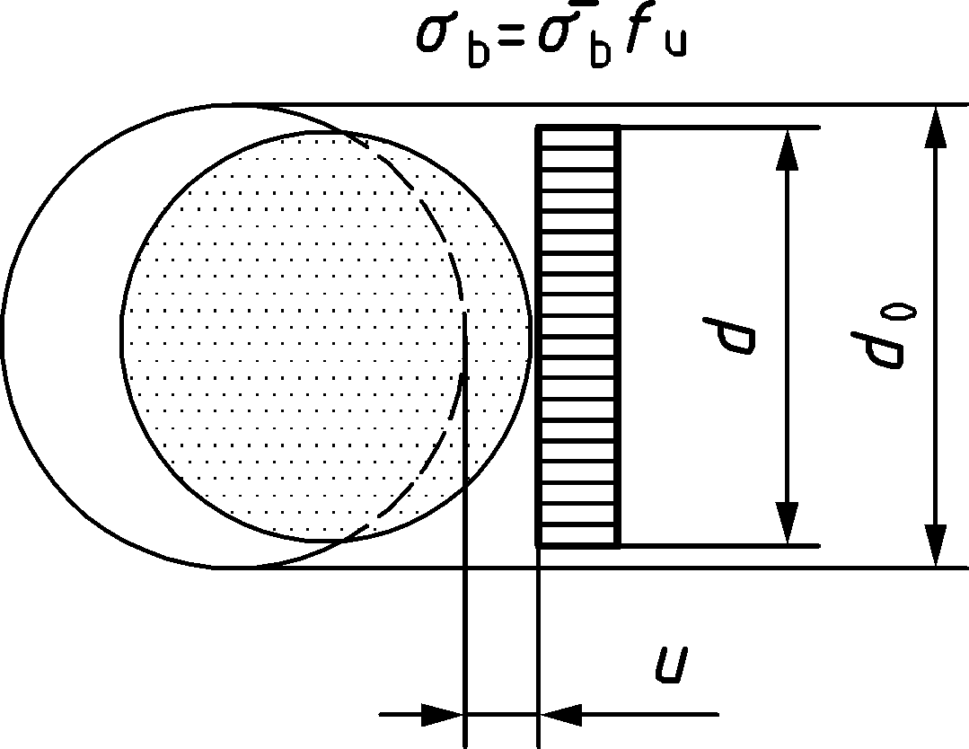
Figure A.13 — Non-dimensional load-deformation behaviour for plate in bearing
- Concrete and base plate in compression
- Design resistance
(1) The design bearing resistance of the base plate and its concrete support should be determined by taking account of the material properties and dimensions of both the grout and the concrete support. The concrete support should be designed according to EN 1992-1-1.
(2) The design resistance of concrete, including grout, and base plate in compression Fc,bp,Rd, should be taken similar to those of an equivalent T-stub, see 8.4.
- Stiffness coefficient
(1) The stiffness coefficient of concrete and base plate in compression should be obtained from:
$$k_{c,bp}= \frac{E_{cm}\sqrt{b_{eff}l_{eff}}}{1,275 E}$$ | (A.41)
where
beff effective width of the T-stub flange, see 8.4.3, with c taken as 1,25 times the base plate thickness;
leff effective length of the T-stub flange, see 8.4.3, with c taken as 1,25 times the base plate thickness;
E modulus of elasticity of steel;
Ecm secant modulus of elasticity of concrete.
- Base plate in bending under tension
- Design resistance
(1) The design resistance and failure mode of a base plate in bending under tension, together with the associated anchor bolts in tension Ft,bp,Rd, may be determined using the rules given in A.8.1. The design tension resistance of anchor bolts should be obtained from A.18.1.
(2) In the case of a column base plate,
- prying forces may be neglected; and
- failure modes 1, 2 and 3 according to Table 8.2 should be considered.
- Stiffness coefficient
(1) The stiffness coefficient of a base plate in bending under tension, for a single bolt row, should be obtained from:
- with prying forces | $$k_{t,bp}=\frac{0,85l_{eff}{t_{p}}^{3}}{m^{3}}$$ | (A.42)
- without prying forces | $$k_{t,bp}=\frac{0,425l_{eff}{t_{p}}^{3}}{m^{3}}$$ | (A.43)
where
leff effective length of the T-stub flange, see A.8.1;
tp thickness of the base plate;
m distance according to Figure 8.3.
(2) Prying forces may develop if:
$$Lb ≤ \frac{8,8m^{3}A_{s}}{l_{eff}t^{3}}$$ | (A.44)
where
Lb is the bolt elongation length, see Table 8.2.
- Anchor bolt in tension
- Design resistance
(1) The design resistance of an anchor bolt in tension should be taken as the smaller of the design tension resistance of the steel components, see 5.7, and the design resistance of anchoring components in tension, see A.18.
(2) One of the following methods should be used to secure anchor bolts into the foundation:
- a hook, see Figure A.14 a);
- a washer plate, see Figure A.14 b);
- another appropriate load distributing member embedded in the concrete;
- another fixing which has been adequately tested and approved.
(3) When the anchor bolts are fit with a washer plate or other load distributing member, the contribution of bond should not be taken into account. The total force should be transferred through the load distributing device.
(4) The design bond resistance of the concrete on anchor bolts should be determined according to EN 1992-1-1.
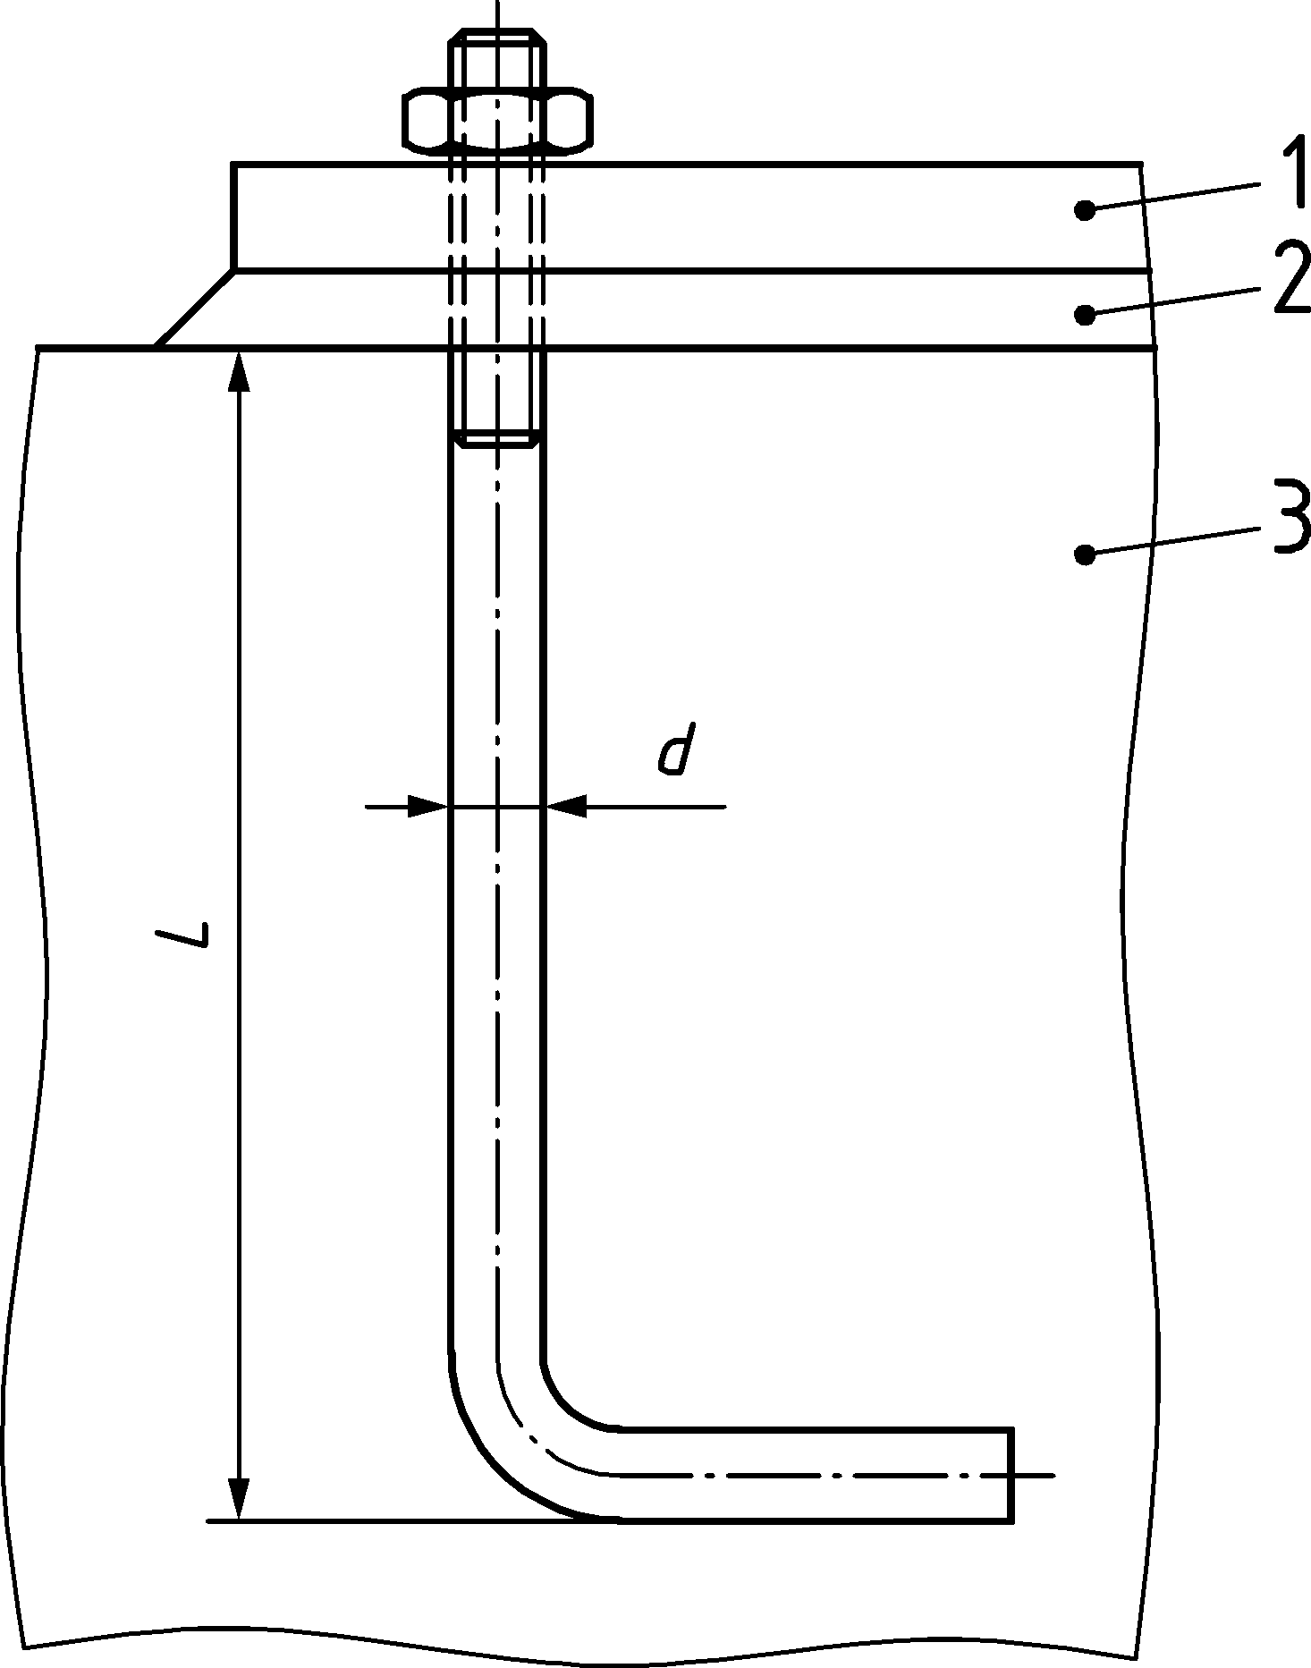 | 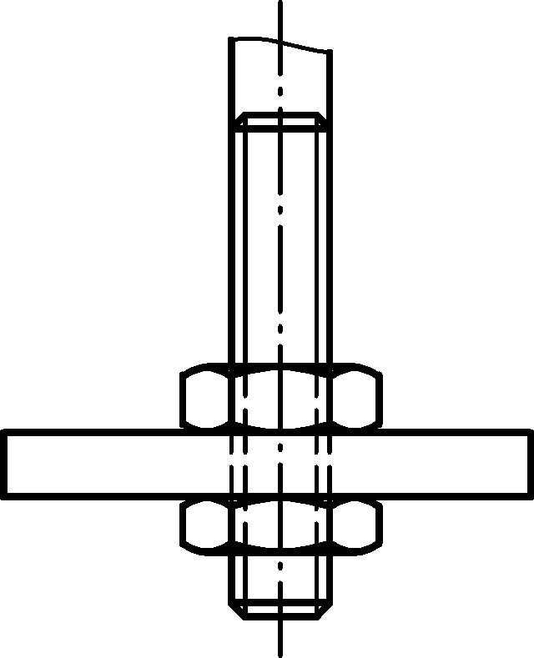
a) Hook | b) Washer plate
Key
1 base plate
2 grout
3 concrete foundation
Figure A.14 — Fixing of anchor bolts
- Stiffness coefficient
(1) The stiffness coefficient of anchor bolts in tension should be obtained from (see also A.17.2(2)):
- with prying forces | ktb = 1,6 As/Lb | (A.45)
- without prying forces | ktb = 2,0 As/Lb | (A.46)
- Anchoring components in tension
(1) The design resistance of the anchoring components in tension for steel-to-concrete connections may be obtained from EN 1992-4. The verification of the anchoring components in tension should be made for the ultimate limit state for the following failure modes:
- Concrete cone failure;
- Pull-out failure;
- Concrete splitting failure;
- Concrete blow-out failure;
- Steel failure of reinforcement;
- Anchorage failure of reinforcement.
(2) The design resistance of the anchoring components in tension may be increased by taking into account the contribution of concrete and the supplementary reinforcement next to the fasteners. The load transfer due to the reinforcement and the concrete may be determined by an appropriate stiffness model for the anchoring components.
(3) Further failure modes such as concrete break out between the supplementary reinforcement should be considered, when the contribution of concrete and reinforcement is taken into account.
- Anchor bolts in shear
(1) The design shear resistance of an anchor bolt Fvb,Rd in column base plates with normal round holes should be determined as follows:
$$F_{vb,Rd}=\frac{α_{bc} f_{ub} A_{s}}{γ_{M2}}$$ | (A.47)
where
αbc = 0,44 − 0,000 3 fyb;
fyb yield strength of the anchor bolt, where 235 N/mm2 ≤ fyb ≤ 640 N/mm2.
(2) The design resistance of an anchor bolt for shear should be taken as the smaller of the design shear resistance, Fvb,Rd, see Formula (A.47), and the design resistance of anchoring components in shear, see A.21.
- Anchoring components in shear
(1) The design resistance of the anchoring components in shear for steel-to-concrete connections may be determined from EN 1992-4. The verification of anchoring components in shear should be made for the ultimate limit state for the following failure modes:
- Concrete pry-out failure
- Concrete edge failure
- Steel failure of supplementary reinforcement
- Anchorage failure of supplementary reinforcement
- Welds
- Design resistance
(1) The design resistance of welds should be determined from Clause 6.
- Stiffness coefficient
(1) The stiffness coefficient of welds, k_{w}, should be taken equal to infinity.
- Beam haunch
- Design resistance
(1) If a beam is reinforced with haunches:
- the steel grade of the haunch should be identical to that of the member;
- the flange size and the web thickness of the haunch should not be less than that of the member;
- the angle of the haunch flange to the flange of the member should not be greater than 45°.
(2) If a beam is reinforced with haunches, the design resistance of beam web in compression should be determined from A.5. The length of the stiff bearing ss should be taken equal to the thickness of the haunch flange parallel to the beam.
- Stiffness coefficient
(1) The stiffness coefficient of a beam haunch, khb, should be taken equal to infinity.
- (normative)
Design of moment-resisting beam-to-column joints and splices
- Use of this annex
(1) This normative Annex contains additional provisions for the design of moment-resisting beam-to-column joints and splices as given in relation to Clauses 7 and 8.
- Scope and field of application
(1) This normative Annex covers the design resistance, the rotational stiffness and the rotation capacity of moment-resisting joints and splices connecting H- or I-sections based on components according to Annex A.
.
- Design resistance
- General
(1) Joints should be designed to resist the bending moments, axial forces, and shear forces applied to the joints by the connected members, see Figure 7.4.
(2) The stresses due to internal forces and moments in a member may be assumed not to affect the design resistances of the basic components of a joint, except as specified in A.5 and A.6.
- Bending moment
- General
(1) The applied design moment of a joint Mj,Ed should satisfy:
$$\frac{M_{j,Ed}}{M_{j,Rd}}≤1,0$$ | (B.1)
(2) Provided that the axial force NEd in the connected member does not exceed 5 % of the design plastic resistance of its gross cross-section Npl,Rd, the design moment resistance Mj,Rd of a beam-to-column joint or beam splice may be determined using the methods given in B.3.2.
(3) The design moment resistance of a joint using welded connections joint should be determined using the force distribution in Table B.1(a).
(4) The design moment resistance of a joint using bolted connections with angle flange cleats should be determined using the force distribution in Table B.1(b).
(5) The design moment resistance of a joint using bolted flush end plate connections that has only one bolt row in tension, or in which only one bolt row in tension is considered, see B.3.2.1(7), should be determined using the force distribution in Table B.1(c).
(6) The design moment resistance of a joint using bolted connections with end plate connection with more than one row of bolts in tension should be determined as specified in B.3.2.2.
(7) In a joint with bolted connections, and more than one bolt row in tension, the contribution of any bolt row may be neglected, provided that the contributions of all other bolt rows closer to the centre of compression are also neglected.
(8) Conservativly, the design moment resistance of a joint with extended end plates with only two rows of bolts in tension may be approximated as indicated in Figure B.1, provided that the total design resistance FRd does not exceed 3,8Ft,Rd, where Ft,Rd is given in Table 5.7. In this case, the whole tension region of the end plate may be treated as a single basic component. Provided that the two bolt rows are approximately equidistant on either side of the beam flange, this part of the end plate may be treated as a T-stub to determine the bolt row force F1,Rd. The value of F2,Rd may then be assumed to be equal to F1,Rd, and FRd may be taken as equal to 2F1,Rd.
(9) The centre of compression should be taken as the centre of the stress block of the compression forces. As a simplification the centre of compression may be taken as shown in Table B.1 for the various types of joints.
(10) A splice in a member or part subject to tension should be designed to transmit all the moments and forces to which the member or part is subjected at that point.
Table B.1 — Centre of compression, lever arm z and force distributions for deriving the design moment resistance Mj,Rd
Type of connection | Centre of compression | Lever arm | Force distributions
a) Welded connection  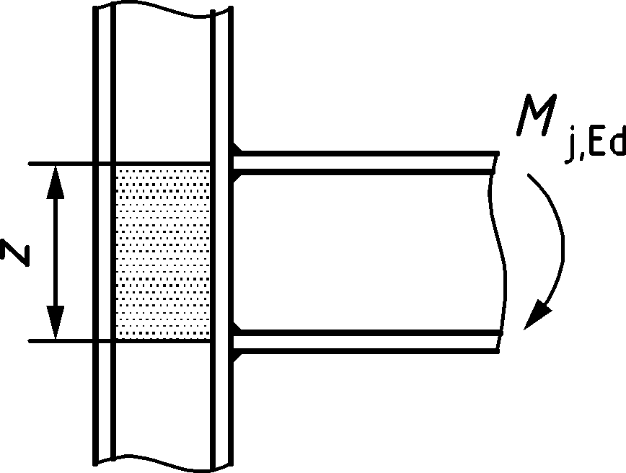 | In line with the mid-thickness of the compression flange | z = h − tfb  h depth of the connected beam  tfb thickness of the beam flange | 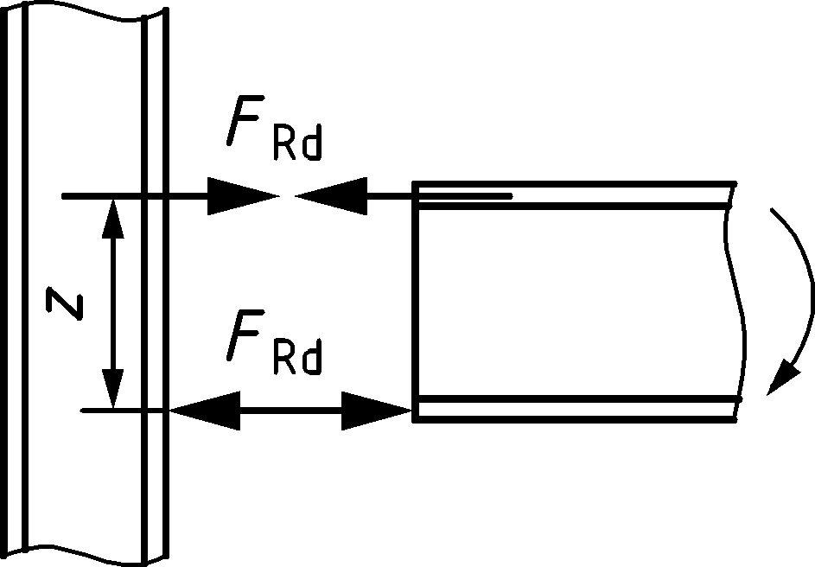
b) Bolted connection with angle flange cleats  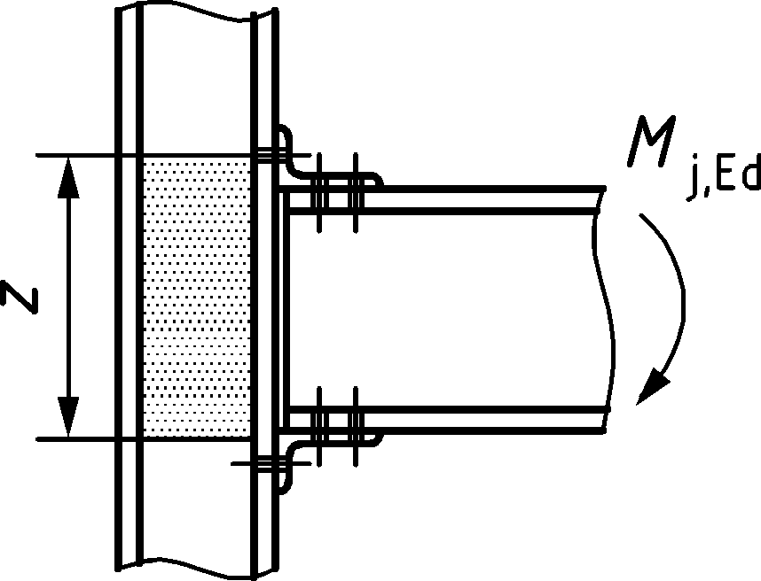 | In line with the mid-thickness of the leg of the angle cleat on the compression flange | Distance from the centre of compression to the bolt row in tension | 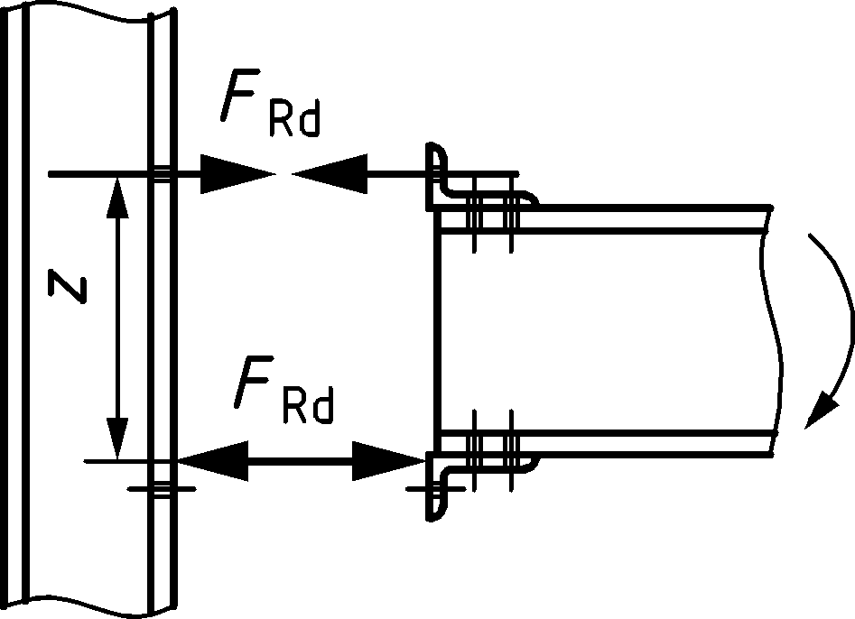
c) Bolted end plate connection with only one bolt row active in tension  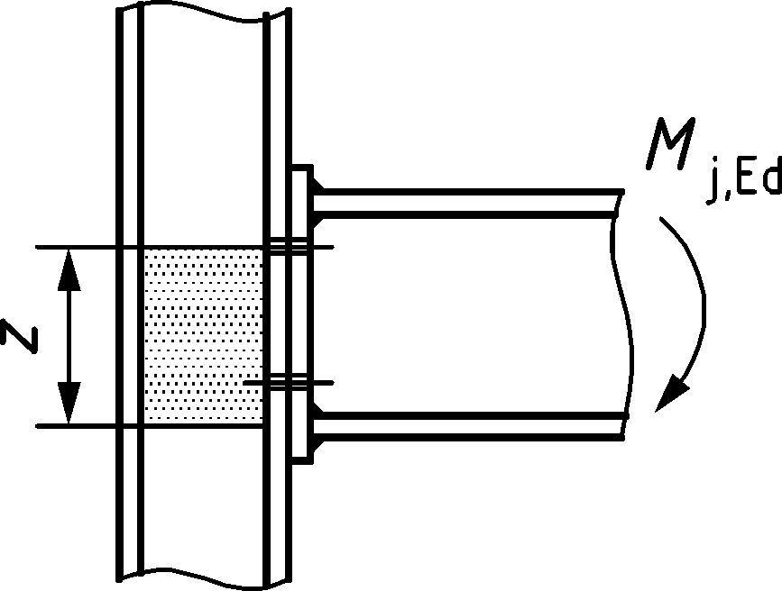 | In line with the mid-thickness of the compression flange | Distance from the centre of compression to the bolt row in tension | 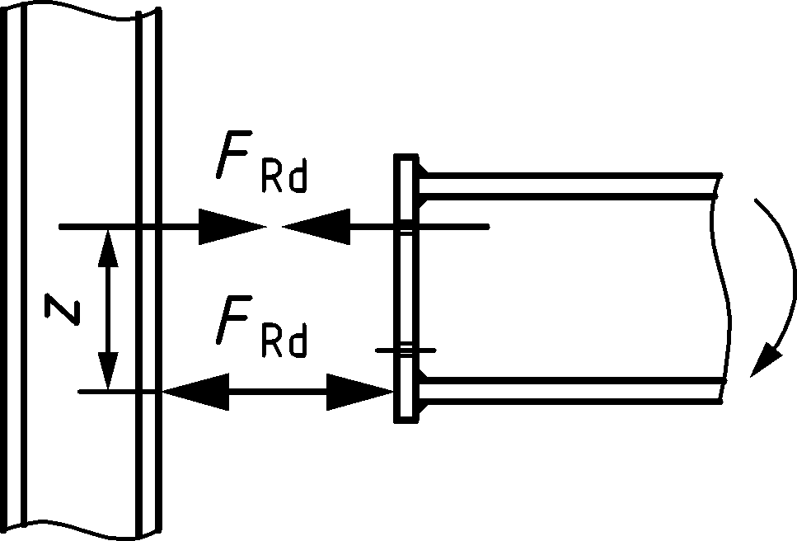
d) Bolted extended end plate connection with only two bolt rows active in tension  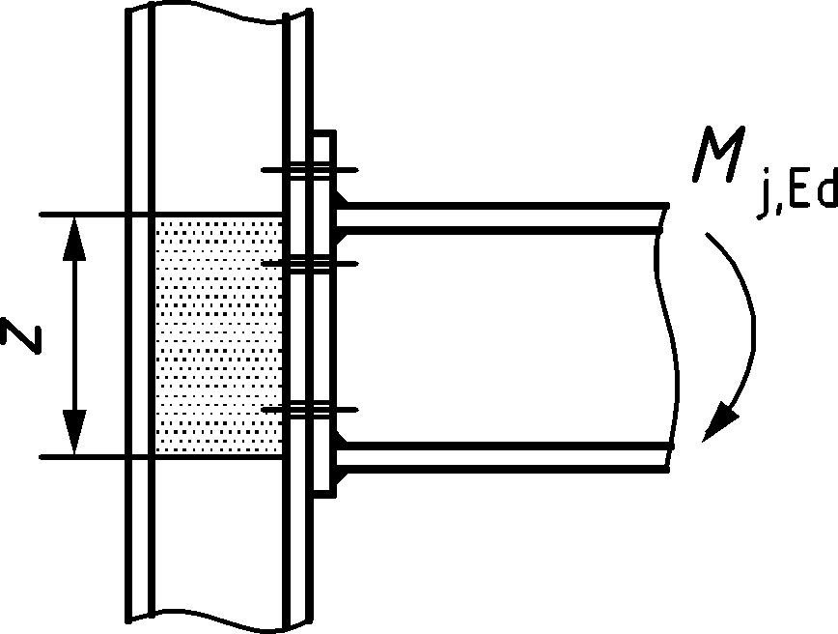 | In line with the mid-thickness of the compression flange | Conservatively z may be taken as the distance from the centre of compression to a point midway between these two bolt rows
e) Other bolted end plate connection with two or more bolt rows in tension  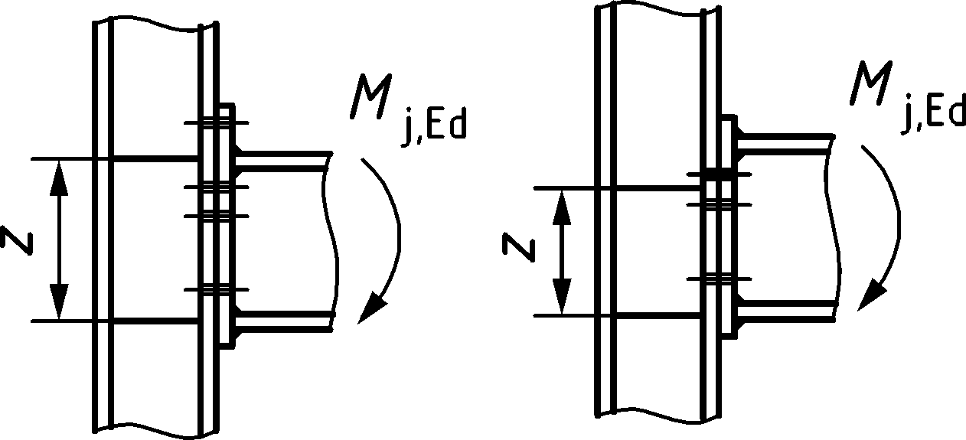 | In line with the mid-thickness of the compression flange | An approximate value of z is the distance from the centre of compression to a point midway between the farthest two bolt rows in tension | A more accurate value of z is zeq obtained using the method given in B.4.2.1.

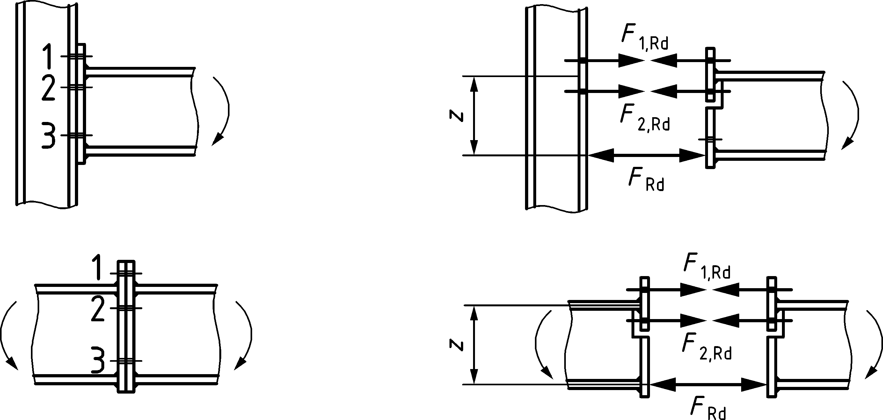
Figure B.1 — Conservative method for bolted joints with extended end plates
(11) Splices should be designed to hold the connected members in place. Friction forces between contact surfaces should not be relied upon to hold connected members in place in a bearing splice.
(12) Wherever practicable, the members should be arranged so that the centroidal axis of any splice material coincides with the centroidal axis of the member. If eccentricity is present, then the resulting forces should be taken into account.
(13) Where the members are not prepared for full contact in bearing, splice material should be provided to transmit the internal forces and moments in the member at the spliced section, including the moments due to applied eccentricity, initial imperfections and second-order deformations. The internal forces and moments should be taken as not less than a moment equal to 25 % of the moment capacity of the weaker section about both axes, and a shear force equal to 2,5 % of the normal force capacity of the weaker section in the directions of both axes.
(14) Where the members are prepared for full contact in bearing, splice material should be provided to transmit at least 25 % of the maximum compressive force in the column.
(15) The alignment of the abutting ends of members subjected to compression should be maintained by cover plates or other means. The splice material and its fastenings should be dimensioned to carry forces at the abutting ends, acting in any direction perpendicular to the axis of the member. Second order effects should be taken into account in the design of splices.
(16) Splices in flexural members should comply with the following:
- Compression flanges should be treated as compression members;
- Tension flanges should be treated as tension members;
- Parts subjected to shear should be designed to transmit the following effects acting together:
  - the shear force at the splice;
  - the moment resulting from the eccentricity, if any, of the centroids of the groups of fasteners on each side of the splice;
  - the proportion of moment, deformation or rotations carried by the web or part, irrespective of any shedding of stresses into adjoining parts assumed in the design of the member or part.
- Beam-to-column joints with bolted end plate connections
(1) The design moment resistance Mj,Rd of a beam-to-column joint with a bolted end plate connection should be determined as follows:
$$M_{j,Rd}=\sum_{r}{h_{r} F_{t,r,Rd}}$$ | (B.2)
where
Ft,r,Rd effective design tension resistance in bolt row r;
hr distance from bolt row r to the centre of compression (see Table B.1, second column);
r bolt row number.
NOTE In a bolted joint with more than one bolt row in tension, the bolt rows are numbered starting from the bolt row farthest from the centre of compression.
(2) For bolted end plate joints, the centre of compression should be assumed to be in line with the centre of the compression flange of the connected member.
(3) The effective design tension resistance Ft,r,Rd in each bolt row should be determined in sequence, starting from bolt row 1, the bolt row farthest from the centre of compression, then progressing to bolt row 2, and so forth.
(4) When determining the effective design tension resistance Ft,r,Rd in bolt row r, the effective design tension resistance of all other bolt rows closer to the centre of compression should be ignored.
(5) The effective design tension resistance Ft,r,Rd in bolt row r should be taken as its design tension resistance as an individual bolt row determined from B.3.2.2(6), reduced if necessary according to B.3.2.2(7), B.3.2.2(8) and B.3.2.2(9).
(6) The effective design tension resistance Ft,r,Rd in bolt row r, taken as an individual bolt row, should be taken as the smaller value of the design tension resistance in an individual bolt row of the following basic components:
- the column web in transverse tension | Ft,wc,Rd | — | see A.6.1;
- the column flange in bending | Ft,fc,Rd | — | see A.7.1;
- the end plate in bending | Ft,ep,Rd | — | see A.8.1;
- the beam web in tension | Ft,wb,Rd | — | see A.11.1.
(7) The effective design tension resistance Ft,r,Rd in bolt row r should be reduced below the value of Ft,r,Rd obtained from (6), if necessary to ensure that the total design resistance ∑Ft,r,Rd of all bolt rows up to and including bolt row r is not greater than or equal to the smaller of:
- the design resistance of the column web panel in shear divided by the transformation parameter β, see 7.2.3(2), Vwp,Rd /β — see A.4.1;
- the design resistance of the column web in transverse compression Fc,wc,Rd — see A.5.1;
- the design resistance of the beam flange and web in compression Fc,fb,Rd — see A.10.1.
(8) The effective design tension resistance Ft,r,Rd in bolt row r should be reduced below the value of Ft,r,Rd obtained from (7), if necessary to ensure that the sum of the design resistances ΣFt,r,Rd of bolt rows that are part of the same group, is not greater than the design resistance of that group as a whole . This should be checked for the following basic components:
- the column web in transverse tension | Ft,wc,Rd | — | see A.6.1;
- the column flange in bending | Ft,fc,Rd | — | see A.7.1;
- the end plate in bending | Ft,ep,Rd | — | see A.8.1;
- the beam web in tension | Ft,wb,Rd | — | see A.11.1.
(9) Where the effective design tension resistance Ft,x,Rd in one of the previous bolt rows x is greater than 1,9 Ft,Rd, then the effective design tension resistance Ft,r,Rd in bolt row r should be reduced, if this is necessary, in order to satisfy:
$$F_{t,r,Rd}≤F_{t,x,Rd} h_{r} / h_{x}$$ | (B.3)
where
hx distance from bolt row x to the centre of compression;
x bolt row farthest from the centre of compression that has a design tension resistance greater than 1,9 Ft,Rd.
NOTE: Further information on the use of Formula (B.3) can be set by the National Annex.
(10) The method described in B.3.2.2(1) to B.3.2.2(9) may be applied to a bolted beam splice with welded end plates, see Figure B.2, by omitting the components relating to the column.
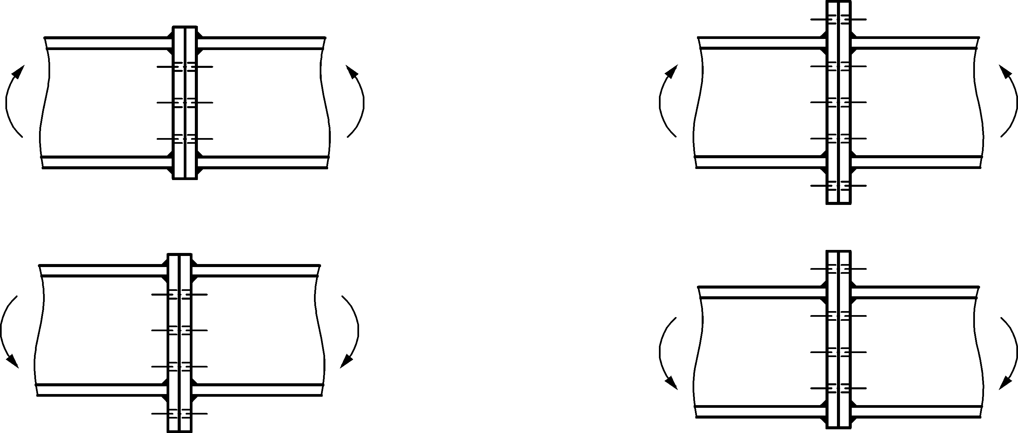
Figure B.2 — Bolted beam splices with end plates
- Bending moment and axial force
(1) If the design axial force NEd in the connected beam exceeds 5 % of the design plastic resistance of the gross cross-section Npl,Rd, the following interaction formula for combined bending and axial force may be used:
$$\frac{M_{j,Ed}}{M_{j,Rd}}+\frac{N_{j,Ed}}{N_{j,Rd}}≤ 1,0$$ | (B.4)
where
Mj,Rd design moment resistance of the joint, assuming no axial force;
Nj,Rd design axial resistance of the joint, assuming no applied moment.
- Shear force
(1) The applied design shear force Vj,Ed should satisfy the following formula:
$$\frac{V_{j,Ed}}{V_{j,Rd}}≤ 1,0$$ | (B.5)
where Vj,Rd is the design shear resistance of the joint.
(2) The design shear resistance of a joint may be derived from the distribution of internal forces within that joint, and the design resistance of its basic components to these forces, see Table 8.1.
(3) In welded joints, and in bolted joints with end plate connections, the welds connecting the beam web should be designed to transfer the shear force from the connected beam to the joint, without any contribution of the welds connecting the beam flanges.
(4) In bolted joints with end plates, the design resistance in each bolt row to combined shear and tension should be verified using the criterion given in Table 5.7, taking into account the total tension force in the bolt, including any force due to prying action. As a simplification, bolts required to resist in tension may be assumed to provide their full design resistance in tension when it can be shown that the design shear force does not exceed the sum of:
- the total design shear resistance of those bolts that are not required to resist tension and;
- (0,4/1,4) times the total design shear resistance of those bolts that are also required to resist tension.
(5) In bolted joints with angle flange cleat connections, the cleat connecting the compression flange of the beam may be assumed to transfer the shear force in the beam to the column, provided that:
- the gap g between the end of the beam and the face of the column does not exceed the thickness tcl of the angle cleat;
- the force does not exceed the design shear resistance of the bolts connecting the cleat to the column;
- the web of the beam satisfies 6 of EN 1993-1-5:2006.
- Welds
(1) If the design resistance of the joint Mj,Rd is determined using a plastic distribution of internal forces within the joint, see B.3.2, the design resistance of the welds should not limit the design moment resistance of the joint.
(2) In a beam-to-column joint or beam splice in which a plastic hinge is required to form and rotate under any relevant load case, the welds should be designed to resist the effects of a moment at least equal to the smaller of:
- the design plastic moment resistance of the connected member Mpl,Rd
- α times the design moment resistance of the joint Mj,Rd
where
α = 1,4 for frames in which the first buckling mode is classified as non-sway, see 7.2.1(4) in prEN 1993-1-1:2020;
α = 1,7 for all other cases.
- Rotational stiffness
- General
(1) The rotational stiffness of a joint should be determined from the flexibilities of its basic components, each represented by an elastic stiffness coefficient ki obtained from Annex A.
(2) For bolted end plate joints with more than one row of bolts in tension, the stiffness coefficients ki for the related basic components should be combined, see B.4.2.
(3) In bolted end plate joints with more than one bolt row in tension, and as a simplification, the contribution of any bolt row may be neglected, provided that the contributions of all other bolt rows closer to the centre of compression are also neglected. The number of bolt rows considered may be different from that used for the determination of the design moment resistance.
(4) Provided that the axial force NEd in the connected member does not exceed 5 % of the design plastic resistance of its cross-section Npl,Rd, the initial rotational stiffness Sj,ini of a beam-to-column joint or beam splice, should be determined as follows:
$$S_{j,ini}=\frac{Ez^{2}}{\sum_{i}{\frac{1}{k_{i}}}}$$ | (B.6)
where
ki stiffness coefficient for basic joint component i;
z lever arm, see Table B.1.
(5) The basic components that should be taken into account when calculating the stiffness of welded joints and bolted joints with angle flange cleats are given in Table B.2 and Table B.3. In both of these tables the stiffness coefficients, ki, for the basic components are defined in Annex A.
(6) To determine the stiffness of beam-to-column joints with end plate connections the equivalent coefficient, keq, and the equivalent lever arm, zeq, of the connection should be obtained from B.4.2. The stiffness of the joint should then be obtained from B.4.1(4) based on the stiffness coefficient, keq, (for the connection), kwp (for the column web panel in shear), and kc,wc (for the column web in compression) with the lever arm, z, taken equal to the equivalent lever arm, zeq, of the connection.
Table B.2 — Stiffness coefficients for moment-resisting beam-to-column joints with welded connections or bolted angle flange cleat connections
Beam-to-column joint with  welded connections |  | Stiffness coefficients ki
Single-sided joint configurations |  | kwp; kc,wc; kt,wc
Double-sided joint configurations — moments equal and opposite |  | kc,wc; kt,wc
Double-sided joint configurations — moments unequal |  | kwp; kc,wc; kt,wc
Beam-to-column joint with  bolted angle flange cleat connections |  | Stiffness coefficients ki
Single-sided joint configurations |  | kwp; kc,wc; kt,wc; kt,fc; kt,cl; kt; kva; kbb
Double-sided joint configurations — moments equal and opposite |  | kc,wc; kt,wc; kt,fc; kt,cl; kt; kva; kbb
Double-sided joint configurations — moments unequal |  | kwp; kc,wc; kt,wc; kt,fc; kt,cl; kt; kva; kbb
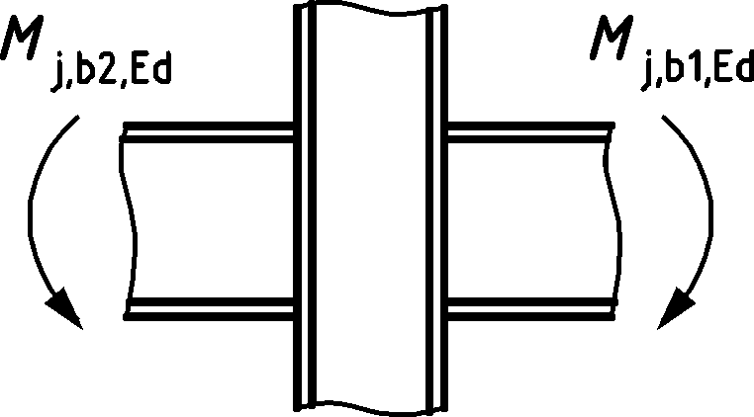  Moments equal and opposite | 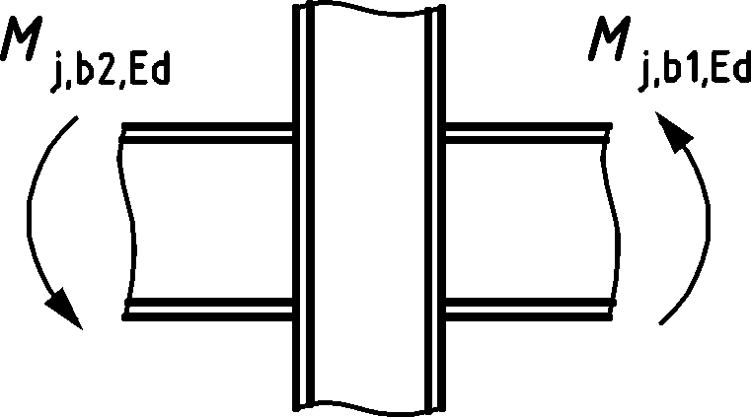  Moments unequal
a Two kv coefficients, one for each flange;
b Four kb coefficients, one for each flange and one for each cleat.

Table B.3 — Stiffness coefficients for moment-resisting beam-to-column joints with bolted end plate connections
Beam-to-column joint with  bolted end plate connections | Number of bolt rows in tension | Stiffness coefficients ki
Single-sided joint configurations | One | kwp; kc,wc; kt,wc; kt,fc; kt,ep; kt
 | Two or more | kwp; kc,wc; keq
Double sided joint configurations — moments equal and opposite | One | kc,wc; kt,wc; kt,fc; kt,ep; kt
 | Two or more | kc,wc; keq
Double sided joint configurations — moments unequal | One | kwp; kc,wc; kt,wc; kt,fc; kt,ep; kt
 | Two or more | kwp; kc,wc; keq
Beam splice with bolted end plates | Number of bolt rows in tension | Stiffness coefficients ki
Double sided joint configurations — moments equal and opposite | One | kt,ep [left]; kt,ep [right]; kt
 | Two or more | keq

- End plate joints with two or more bolt rows in tension
- General method
(1) For end plate joints with two or more bolt rows in tension, the basic components related to all bolt rows should be represented by a single equivalent stiffness coefficient keq determined as follows:
$$k_{eq}=\frac{\sum_{r}{k_{eff,r}h_{r}}}{z_{eq}}$$ | (B.7)
where
hr distance between bolt row r and the centre of compression;
keff,r effective stiffness coefficient for bolt row r taking into account the stiffness coefficients ki for the basic components listed in B.4.2.1(4) or B.4.2.1(5), as appropriate;
zeq equivalent lever arm, see B.4.2.1(3).
(2) The effective stiffness coefficient keff,r in bolt row r should be determined as follows:
$$k_{eff,r}=\frac{1}{\sum_{i}{\frac{1}{k_{i,r}}}}$$ | (B.8)
where
ki,r is the stiffness coefficient representing component i relative to bolt row r.
(3) The equivalent lever arm zeq should be determined as follows:
$$z_{eq}=\frac{\sum_{r}{k_{eff,r} h_{r}^{2}}}{\sum_{r}{k_{eff,r} h_{r}}}$$ | (B.9)
(4) In the case of a beam-to-column joint with an end plate connection, keq should be based upon (and replace) the stiffness coefficients ki for:
- the column web in transverse tension | kt,wc | — | see A.6.2;
- the column flange in bending | kt,fc | — | see A.7.2;
- the end plate in bending | kt,ep | — | see A.8.2;
- the beam web in tension | kt | — | see A.13.2.
(5) In the case of a beam splice with bolted end plates, keq should be based upon (and replace) the stiffness coefficients ki for:
- the end plates in bending | kt,ep | — | see A.8.2;
- the bolts in tension | kt | — | see A.13.2.
- Simplified method for extended end plates with two bolt rows in tension
(1) The initial rotational stiffness of extended end plate connections with two bolt rows in tension, one in the extended part of the end plate, and the other between the flanges of the beam, see Table B.1, d), may be determined as for a connection with a single bolt row in tension, using modified stiffness coefficients. The modified values of the stiffness coefficients ki, see Table B.3, should be taken as twice the values of the corresponding stiffness coefficients for the bolt row in the extended part of the end plate.
NOTE This approximation leads to a slightly lower estimate of the rotational stiffness.
(2) When using this simplified method, the lever arm z should be taken as equal to the distance from the centre of compression to a point midway between the two bolt rows in tension, see Figure B.1.
- Rotation capacity
- General
(1) Plastic hinges at joint locations should have sufficient rotation capacity for plastic global analysis to be applied.
(2) The rotation capacity of bolted or welded joints should be determined using the provisions in B.5. The methods are only valid for steel grades up to and including S460 and for joints in which the design value of the axial force NEd in the connected member does not exceed 5 % of the design plastic resistance of its cross-section Npl,Rd.
(3) A beam-to-column joint in which the design moment resistance of the joint Mj,Rd is governed by the design resistance of the column web panel in shear, may be assumed to have adequate rotation capacity for plastic global analysis, provided that (A.1) is satisfied.
(4) In cases not covered in B.5, the rotation capacity may be determined by testing in accordance with prEN 1990:2020, Annex D. Alternatively, appropriate calculation models may be used, provided that they are based on the results of tests in accordance with EN 1990.
(5) Where it is required that plastic hinges occur in the members, the adjacent joints should be designed for bending moments and forces accounting for the yield strength at plastic hinge locations being equal to γ_{rm}f_{y}, where:
$γ_{rm}$ material overstrength factor, determined as the ratio between the mean and nominal values of yield strength of structural steel at the plastic hinge location. The values for $γ_{rm}$ are given in Table B.4;
f_{y} the nominal value of the yield strength..
(6) When determining the design moment resistance of a joint for the purpose of B.5.1(5), if a plastic hinge is required to form at the end of the beam adjacent to the joint, the design resistance of the beam flange and web in compression Fc,fb,Rd may be omitted in B.3.2.2(7).
Table B.4 — Material overstrength factors
Steel grade | $$γ_{rm}$$
S235 | 1,45
S275 | 1,35
S355 | 1,25
S460 | 1,20

(7) Where it is required that plastic hinges occur in the joints, the members should be designed for bending moments and forces accounting for the yield strength at plastic hinge locations being equal to γ_{rm}f_{y}, where:
$γ_{rm}$ material overstrength factor given in Table B.4, determined as the ratio of the mean and nominal values of yield strength of steel for the basic components which are designed to provide the required rotation capacity, see B.5.2 and B.5.3.
f_{y} the nominal value of the yield strength of the basic components of the joints which are designed to provide the required rotation capacity.
- Bolted joints
(1) A joint with either a bolted end plate or angle flange cleat connection may be assumed to have sufficient rotation capacity for plastic analysis, provided that both of the following conditions are satisfied:
- the design moment resistance of the joint is governed by the design resistance of either:
  - the column flange in bending or;
  - the end plate or tension flange cleat in bending.
- the thickness t of either the column flange or the end plate or tension flange cleat – not necessarily the same basic component as in (a) – satisfies:
$$t≤0,36 d\sqrt{{f_{ub}}/{f_{y}}}$$ | (B.10)
where
d nominal diameter of the bolt;
fub ultimate tensile strength of the bolt material;
fy yield strength of the relevant basic component.
(2) A joint with a bolted connection in which the design moment resistance Mj,Rd is governed by the design resistance of its bolts in shear, may not be assumed to have sufficient rotation capacity for plastic global analysis.
- Welded joints
(1) The rotation capacity φCd of a welded beam-to-column connection may be obtained from the Formula (B.11) provided that its column web is stiffened in compression, but unstiffened in tension, and its design moment resistance is not governed by the design shear resistance of the column web panel, see B.5.1(3):
$$Cd = 0,025\frac{hc}{hb} [rad]$$ | (B.11)
where
hb depth of the beam;
hc depth of the column.
(2) Unstiffened welded beam-to-column joints designed in conformity with the provisions of this Annex, may be assumed to have a rotation capacity φCd of at least 0,015 radians.
- (Normative)
Design of nominally pinned connections
- Use of this annex
(1) This normative Annex contains additional provisions for the design of nominally pinned connections as given in relation to Clauses 7 and 8 .
- Scope and field of application
(1) This Annex applies to the design of nominally pinned connections, connecting H and I sections (from hot-rolled or welded profile with similar dimensions) with double angle web cleats, fin plates, and partial depth end plates, see Figure C.1.
(2) This Annex does not cover connections to hollow sections.
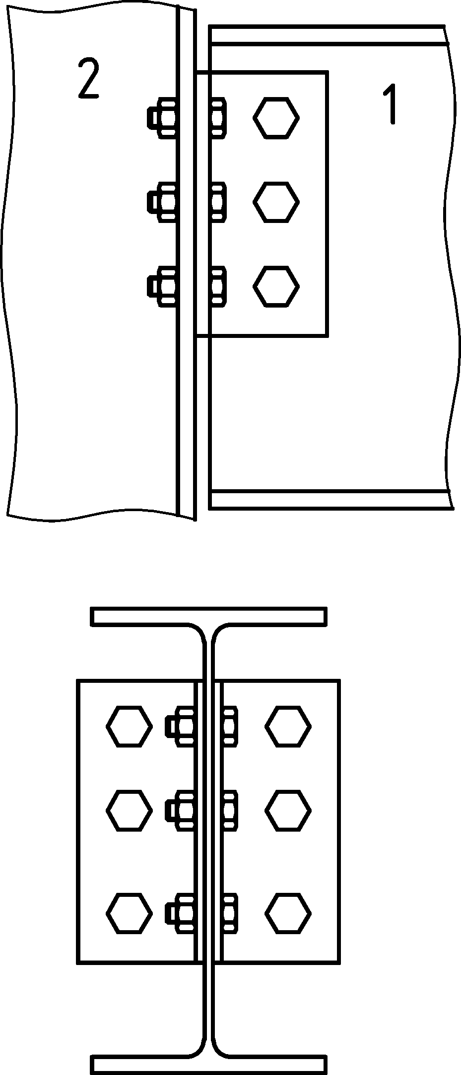 | 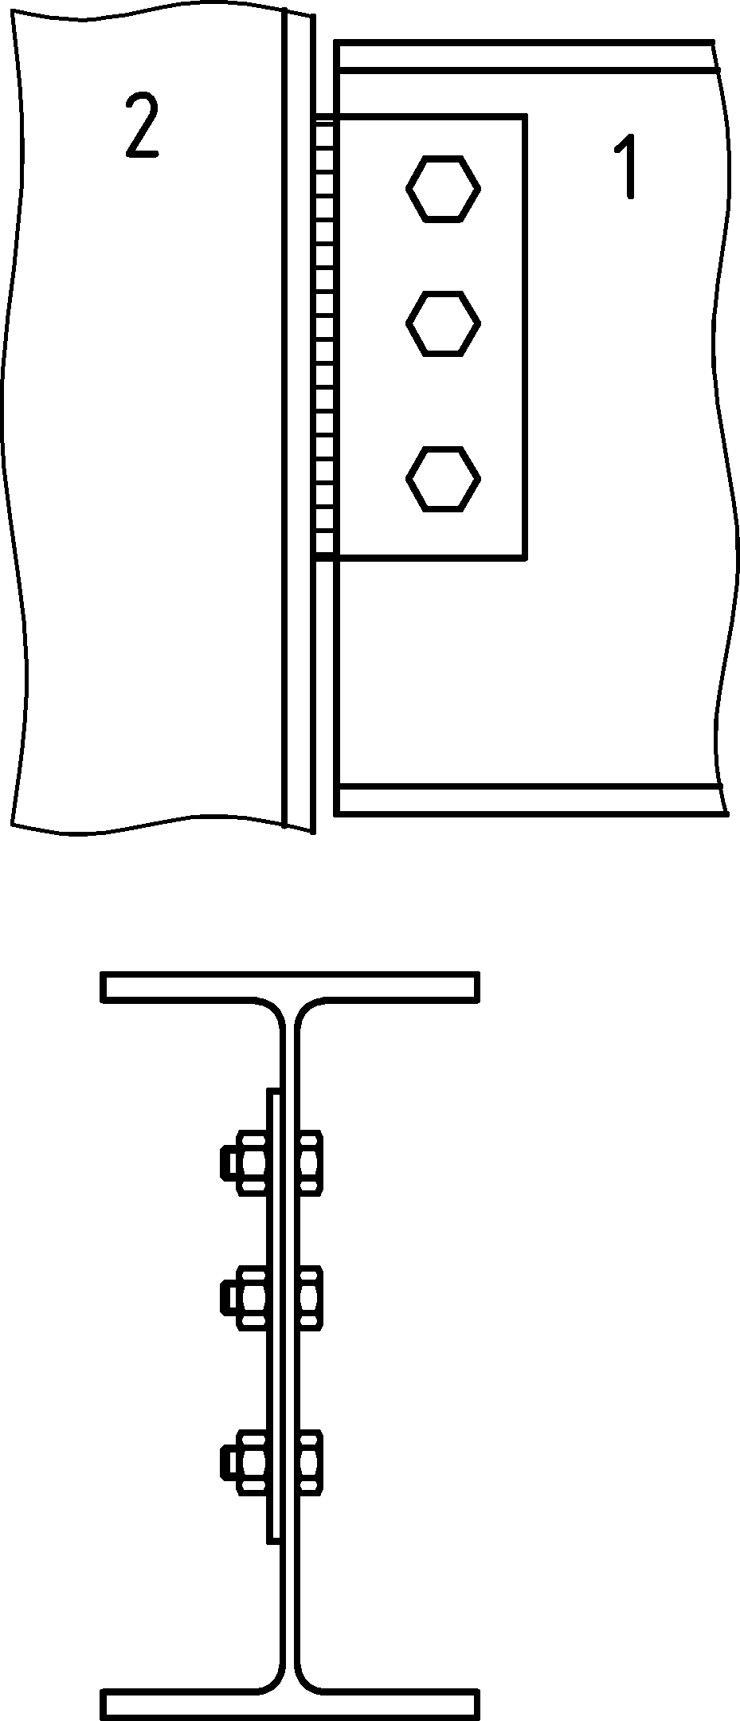 | 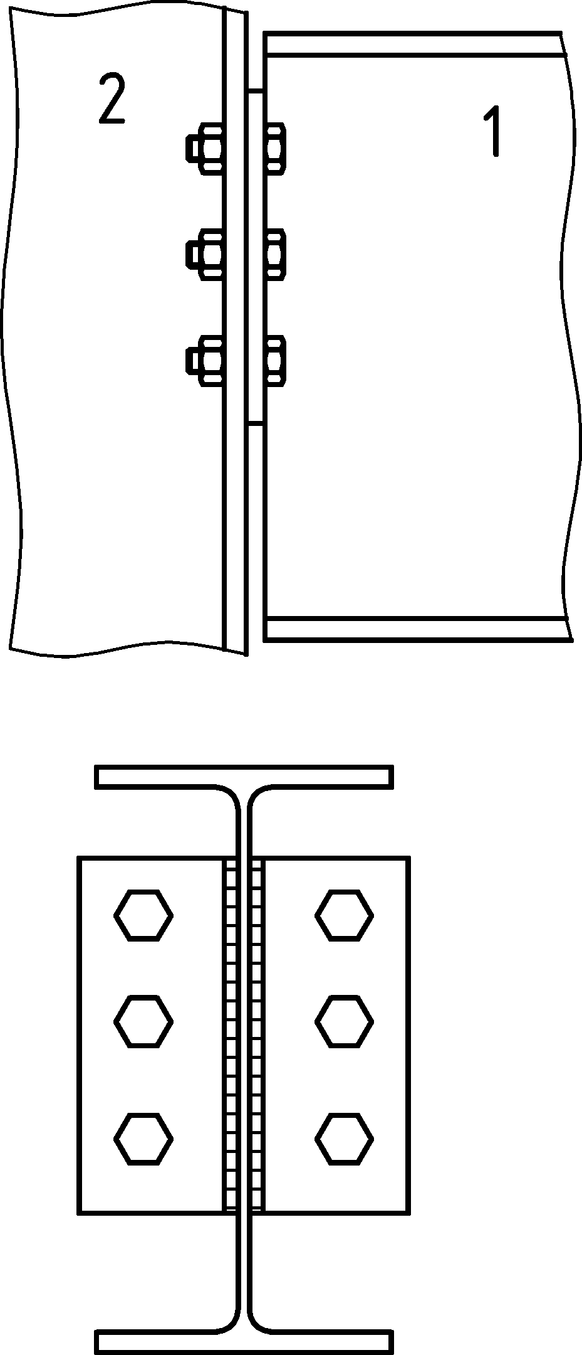
a) Double angle web cleats | b) Fin plate | c) Partial depth end plate
Key
1 supported member
2 supporting member
Figure C.1 — Nominally pinned connections
(2) The connections designed in accordance with this Annex may be classified as nominally pinned joints and are able to transmit shear forces without developing significant bending moments. This Annex does not cover the design of nominally pinned connections subjected to axial forces other than those associated with tying.
(3) This Annex does not give the specific design procedures for notched supported beams, which include the resistance at a notch, and the local and overall stability of the notched beam.
(4) This Annex gives design rules for determining the following properties of double angle web cleats, fin plates and partial depth end plate connections:
- Shear resistance at the ultimate limit state, see C.4.1;
- Tying resistance when structural integrity is required according to prEN 1991-1-7:20XX, C.3.2;
provided that the requirements for sufficient ductility and rotation capacity, see C.3, are fulfilled.
NOTE The National Annex can give alternative rules for the design of nominally pinned connections.
- Ductility and rotation capacity requirements
- Double angle web cleat connections
(1) Double angle web cleat connections may be assumed to have sufficient ductility provided that the following conditions are satisfied:
- The thickness t of the cleat, the supporting member (column or beam web), or the supporting beam web should comply with Formula (B.10), and
- The design shear resistance Fv,Rd of a single bolt should be equal or to greater than its smallest design bearing resistance Fb,Rd (horizontal and vertical) obtained from 5.7.1, of the cleats or the single beam web, where the reduction of the bearing resistance according to 5.7.1(4) may be taken into account. If the provisions given in 5.7.1(4) are taken into account, then the bearing resistances in C.4.1.1 should be reduced accordingly.
NOTE For definition of supporting member and supported member, see Figure C.1.
(2) Double angle web cleat connections may be assumed to have sufficient rotation capacity provided that the following conditions are satisfied:
- The depth hcl of the cleat is less than the clear depth of the supported beam web dw, and
- The design joint rotation capacity ϕCd should satisfy:
$$ϕ_{Cd}≥ϕ_{Ed}$$ | (C.1)
where
ϕEd design value of joint rotation;
ϕCd rotation of the connection at which contact starts, given in Table C.1.
- Fin plate connections
(1) Fin plate connections will have sufficient ductility provided that the following conditions are satisfied:
- The minimum weld throat thickness required should be obtained from:
$$a_{min}=\frac{f_{y,p}}{f_{u}}\frac{β_{w}γ_{M2}}{\sqrt{2}γ_{M0}}t_{p}$$ | (C.2)
where
fy,p nominal yield strength of the supported beam;
f_{u} nominal ultimate tensile strength of the part joined, which is of the lower strength grade;
tp thickness of the fin plate;
βw appropriate correlation factor from Table 6.1.
- The design shear resistance Fv,Rd of a single bolt should be equal or to greater than its smallest design bearing resistance Fb,Rd (horizontal and vertical) obtained from 5.7.1, where the reduction of the bearing resistance according to 5.7.1(4) may be taken into account. If the provisions given in 5.7.1(4) are taken into account, then the bearing resistances in C.4.1.1 should be reduced accordingly.
(2) Fin plate connections may be assumed to have sufficient rotation capacity provided that the following conditions are satisfied:
- The depth hp of the fin plate is less than the clear depth of the supported beam web dw, and
- The design joint rotation capacity φCd should satisfy Formula (C.1) and is given in Table C.1.
- Partial depth end plate connections
(1) End plate connections may be assumed to have sufficient rotation capacity provided that the following conditions are satisfied:
- The thickness t of the end plate, the supporting member (column or beam web), or the supporting beam web should comply with Formula (B.10), and
- The minimum weld throat thickness required should be obtained from:
$$a_{min}=\frac{f_{y,wb}}{f_{u}}\frac{β_{w}γ_{M2}}{\sqrt{2}γ_{M0}}t_{wb}$$ | (C.3)
where
fy,wb | nominal yield strength of the supported beam web;
fu | nominal ultimate tensile strength of the part joined, which is of the lower strength grade;
twb | thickness of the supported beam web;
βw | appropriate correlation factor from Table 6.1.
(2) End plate connections may be assumed to have sufficient rotation capacity provided that the following conditions are satisfied:
- The depth hep of the end plate is less than the clear depth of the supported beam web dw, and
- The design joint rotation capacity φCd should satisfy Formula (C.1) and is given in Table C.1.
Table C.1 — Rotation capacity of nominally pinned connections
Double angle web cleats | Fin plates | Partial depth end plates
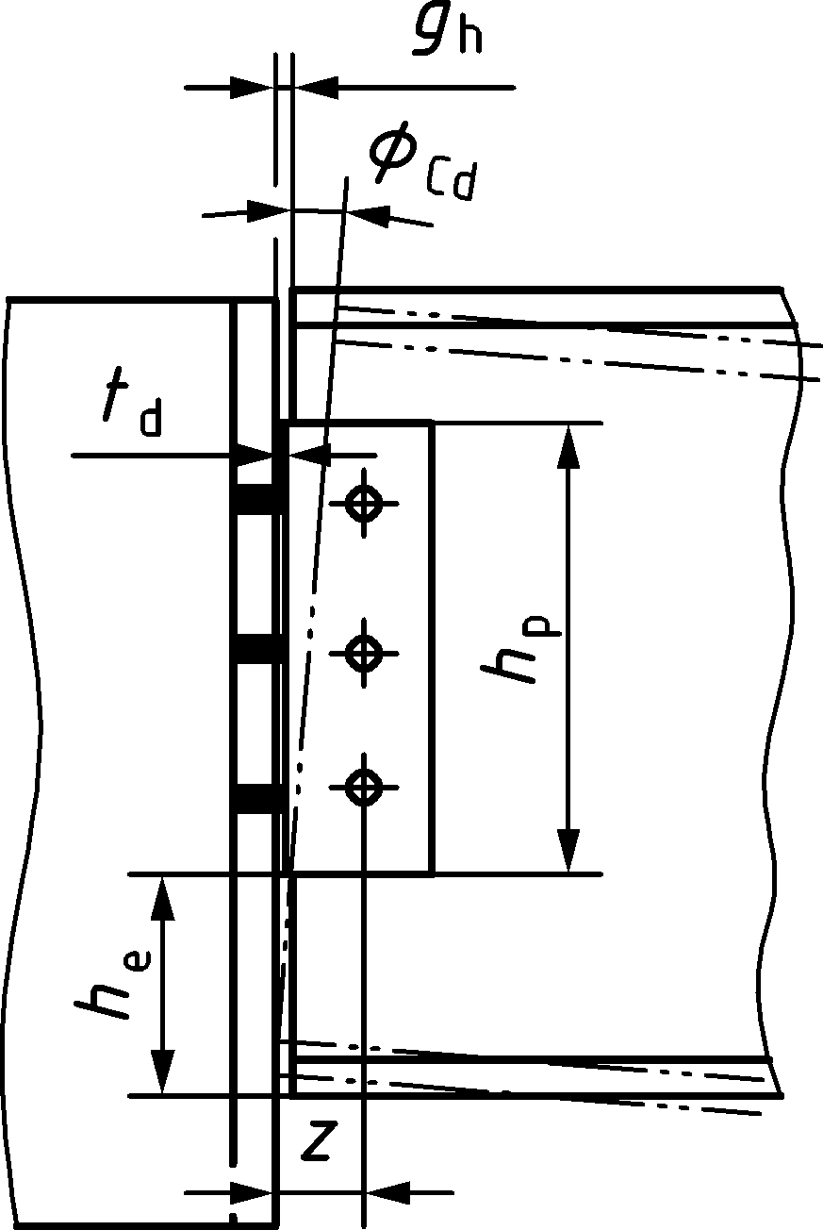 | 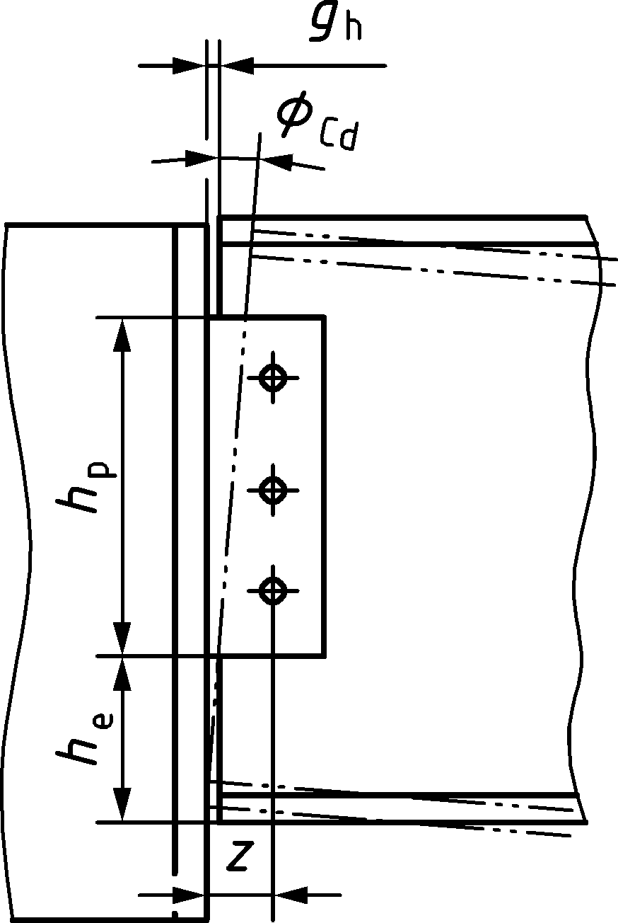 | 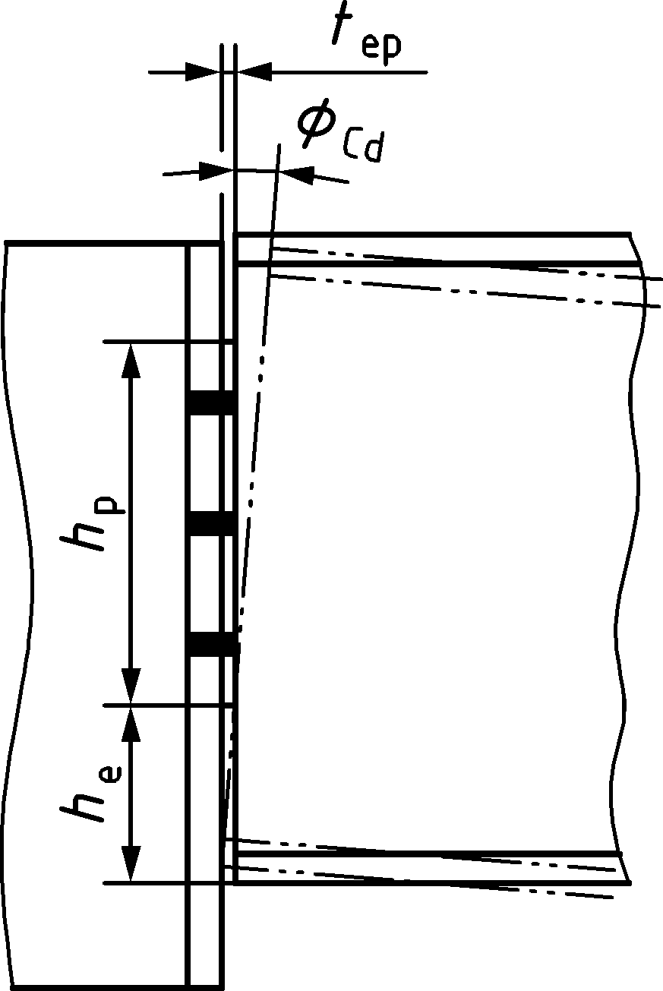
— if z ≤ z₀:$ϕ_{\text{Cd}}=arcsin\left(\frac{z}{z_{0}}\right)-\text{arctan}\left(\frac{z-g_{\text{h}}}{\frac{h_{\text{p}}}{2}+h_{\text{e}}}\right)$  — if z > z₀:$ϕ_{\text{Cd}}=∞$ |  | $$ϕ_{\text{Cd}}=\frac{t_{\text{ep}}}{h_{\text{e}}}$$
$$z_{\text{0}}=\sqrt{{(z-g_{\text{h}})}^{2}+{\left(\frac{h_{\text{p}}}{2}+h_{\text{e}}\right)}^{2}}$$

- Design resistances
- Design shear resistance
- Double angle web cleats
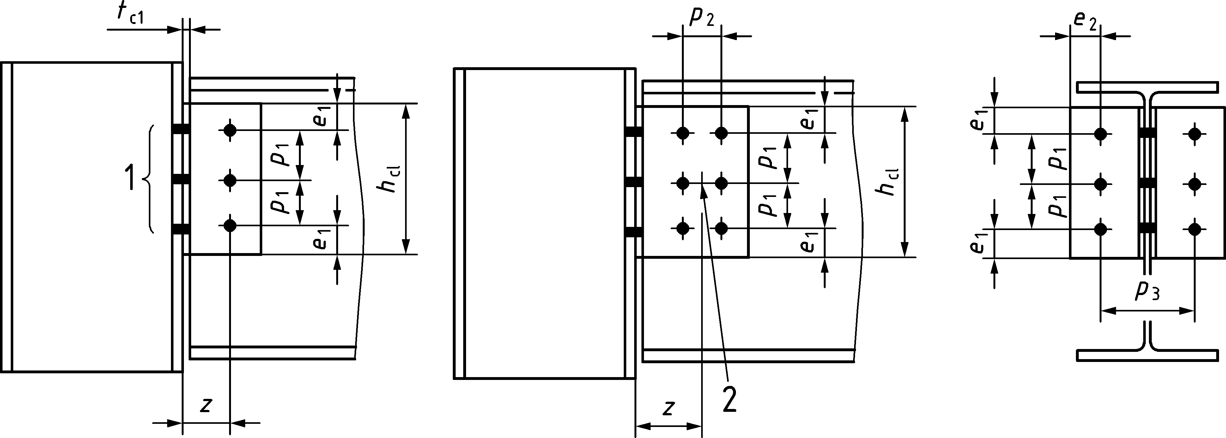
Key
1 n1: number of horizontal bolt rows
2 center of bolt group
Figure C.2 — Double angle web cleat connections
(1) The design shear resistance of a double angle web cleat connection should be taken as the smaller of the design resistances given in Table C.2. For notation, see Figure C.2.
Table C.2 — Design resistances of a double angle web cleat connection
Ductility and rotation capacity | Clause No.
Ductility and rotation capacity | C.3.1
Design resistance | Clause No.
Bearing resistance of the bolt group on the supported beam web:  - legs of cleats connected to the supported beam,  - supported beam | C.4.1.1(2)
Bearing resistance of the bolt group on the supporting beam or column:  - legs of cleats connected to the supporting beam or column,  - supporting member | C.4.1.1(3)
Shear resistance of the legs of cleats connected to the supported beam or the supporting member | C.4.1.1(4), C.4.1.1(5) and C.4.1.1(6)
Shear resistance of the supported beam or the supporting member | C.4.1.1(7) and C.4.1.1(8)
Bending resistance of the supported beam | C.4.1.1(9)

(2) The design bearing resistance of the group of bolts per cleat on the supported beam web, for each individual failure mode from Table C.2, should be obtained from:
$$V_{Rd}=\frac{n}{\sqrt{{\left(\frac{1+αn}{F_{b,ver,Rd}}\right)}^{2}+{\left(\frac{βn}{F_{b,hor,Rd}}\right)}^{2}}}$$ | (C.3)
where
$F_{b,ver,Rd}$ is the vertical bearing resistance for a single bolt, see 5.7.1;
$F_{b,hor,Rd}$ is the horizontal bearing resistance for a single bolt, see 5.7.1;
n is the total number of bolts;
$α and β$ are parameters given by:
- For a single vertical line of bolts n₂ = 1: $α=0 and β=\frac{6z}{n_{1}\left(n_{1}+1\right)p_{1}}$
- For two vertical lines of bolts n₂ = 2: $α=\frac{zp_{2}}{2I} and β=\frac{zp_{1}}{2I}\left(n_{1}-1\right)$
$$I=\frac{n_{1}}{2}p_{2}^{2}+\frac{1}{6}n_{1}\left(n_{1}^{2}-1\right)p_{1}^{2}$$
where
z is the assumed eccentricity of the shear force, see Figure C.2;
$n_{1}$ is the number of horizontal bolt rows;
$n_{2}$ is the number of vertical bolt rows;
$p_{1}$ is the spacing between centres of bolts in a line in the direction of force transfer;
$p_{2}$ is the spacing measured perpendicular to the force transfer direction between adjacent lines of bolts.
NOTE 1 This clause also applies to fin plate connections, see C.4.1.2.
NOTE 2 Formula (C.3) is a simplified formulation and is consistent with 5.7, Formula (5.6) that can be used in more general case.
(3) The design bearing resistance of the group of bolts per cleat on the supporting member, for each individual failure mode from Table C.2, should be obtained from:
- If $F_{b,Rd}≤0,8F_{v,Rd}$ then $V_{Rd}=nF_{b,Rd}$ | (C.4)
- If $F_{b,Rd}>0,8F_{v,Rd} t$hen $V_{Rd}=0,8nF_{v,Rd}$ | (C.5)
where
$F_{b,Rd}$ is the bearing resistance for a single bolt, see 5.7.1;
$F_{v,Rd}$ is the shear resistance for a single bolt, see 5.7.1;
n is the total number of bolts.
NOTE This clause also applies to partial depth end plate connections, see C.4.1.3.
(4) The design shear resistance of the leg of the cleat connected to the supported beam or the supporting member should be taken as the smaller of the following design resistances:
- gross section in shear — see C.4.1.1(5)
- net section in shear — see C.4.1.1(6)
- block tearing — see 5.10
(5) The design shear resistance of the gross section of a leg of a web cleat should be determined as follows:
$$V_{\text{v,cl,Rd}}=\frac{A_{\text{v,cl}}f_{\text{y,cl}}}{1,27\sqrt{3}γ_{\text{M0}}}$$ | (C.6)
where
Av,cl = hcltcl is the shear area of the cleat;
hcl is the depth of the cleat;
tcl is the thickness of the cleat;
fy,cl is the yield strength of the cleat.
(6) The design shear resistance of the net section of a leg of a web cleat should be determined as follows:
$$V_{\text{u,cl,Rd}}=\frac{A_{\text{v,net,cl}}f_{\text{u,cl}}}{\sqrt{3}γ_{\text{M2}}}$$ | (C.7)
where
$A_{v,net,cl}=A_{v,cl}-n_{1}d_{0}t_{cl}$ is the net shear area of the cleat;
fu,cl is the nominal ultimate tensile strength of the cleat.
(7) The design shear resistance of the the supported beam or the supporting member should be taken as the smaller of the following design resistances:
- gross section in shear — see 8.2.6 of prEN 1993-1-1:2020
- net section in shear — see C.4.1.1(8)
- block tearing — see 5.10
(8) The design shear resistance of the net section of the supported beam or the supporting member should be determined as follows:
$$V_{\text{u,Rd}}=\frac{A_{\text{v,net}}f_{\text{u}}}{\sqrt{3}γ_{\text{M2}}}$$ | (C.8)
where
$A_{v,net}=A_{v}-n_{1}d_{0}t$ is the net shear area of the supported beam or the supporting member;
Av is the shear area of the supported beam or the supporting member, see 8.2.6 of prEN 1993-1-1:2020;
t is the thickness of the supported beam or the supporting member;
fu is the nominal ultimate tensile strength of the supported beam or the supporting member.
(9) The design bending resistance of the supported beam should be determined in accordance with 8.2.8 of prEN 1993-1-1:2020.
- Fin plates
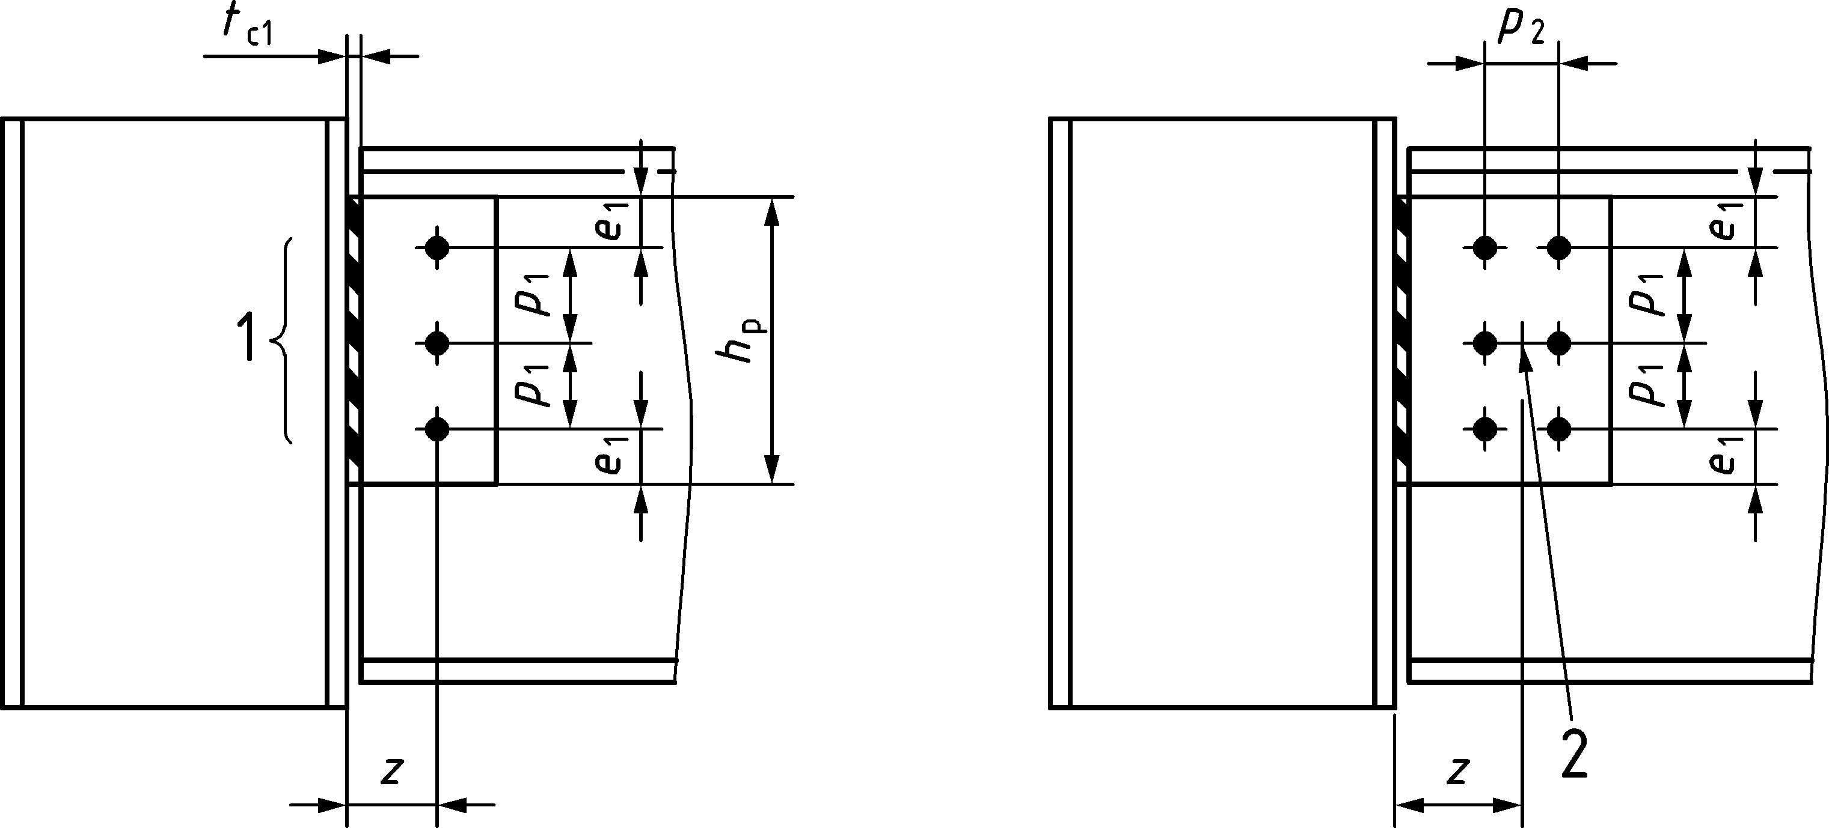
Key
1 n1: number of horizontal bolt rows
2 center of bolt group
Figure C.3 — Fin plate connections
(1) The design shear resistance of a fin plate connection should be taken as the smaller of the design resistances given in Table C.3. For notation, see Figure C.3.
Table C.3 — Design resistances of a fin plate connection
Ductility and rotation capacity | Clause No.
Ductility and rotation capacity | C.3.2
Design resistances | Clause No.
Bearing resistance of the bolt group on:  - fin plate, and  - supported beam | C.4.1.1(2)
Shear resistance of the fin plate | C.4.1.2(2), C.4.1.2(3) and C.4.1.2(4)
Bending resistance of the fin plate | C.4.1.2(5)
Buckling resistance of the fin plate | C.4.1.2(6)
Shear resistance of the supported beam web or the supporting member | C.4.1.1(7), C.4.1.1(8) and C.4.1.1(9)
Bending resistance of the supported beam | C.4.1.1(9)
(2) The design shear resistance of the fin plate should be taken as the smaller of the following design resistances:
- gross section in shear — see C.4.1.3(3)
- net section in shear — see C.4.1.3(4)
- block tearing — see 5.10
(3) The design shear resistance of the gross section of the fin plate should be determined as follows:
$$V_{\text{v,p,Rd}}=\frac{A_{\text{v,p}}f_{\text{y,p}}}{1,27\sqrt{3}γ_{\text{M0}}}$$ | (C.9)
where
Av,p = hptp is the shear area of the fin plate;
hp is the depth of the fin plate;
tp is the thickness of the fin plate;
fy,p is the yield strength of the fin plate.
(4) The design shear resistance of the net section of the fin plate should be determined as follows:
$$V_{\text{u,p,Rd}}=\frac{A_{\text{v,net,p}}f_{\text{u,p}}}{\sqrt{3}γ_{\text{M2}}}$$ | (C.10)
where
$A_{v,net,p}=A_{v,p}-n_{1}d_{0}t_{p}$ is the net shear area of the fin plate;
fu,p is the nominal ultimate tensile strength of the fin plate.
(5) The design shear resistance from bending of the fin plate should be obtained from:
- If $h_{p}≥2,73z$ then this failure mode is not relevant
- If $h_{p}<2,73z$ then $V_{c,p,Rd}=\frac{t_{p}h_{p}^{2}}{6z}\frac{f_{y,p}}{γ_{M0}}$ | (C.11)
(6) The design shear resistance from buckling of the fin plate should be obtained from:
- If $z_{p}>\frac{t_{p}}{0,15}$ then $V_{b,p,Rd}=\frac{t_{p}h_{p}^{2}}{6z}\frac{χ_{LT}f_{y,p}}{0,6γ_{M1}}but V_{b,p,Rd}≤\frac{t_{p}h_{p}^{2}}{6z_{p}}\frac{f_{y,p}}{γ_{M0}}$ | (C.12)
- If $z_{p}≤\frac{t_{p}}{0,15}$ then $V_{b,p,Rd}=\frac{t_{p}h_{p}^{2}}{6z}\frac{f_{y,p}}{γ_{M0}}$ | (C.13)
where
$z_{p}$ is the horizontal distance from the supporting beam or column to the first vertical bolt-row (zp = z for n2 = 1 and zp = z − 0,5p2 for n2 = 2);
$χ_{LT}$ is the reduction factor for lateral torsional buckling of the fin plate obtained from 8.3.1.4 of prEN 1993-1-1:2020, using the imperfection factor corresponding to buckling curve d and a slenderness${\overline{λ}}_{LT}=\frac{2,8}{λ_{1}}\sqrt{\frac{z_{p}h_{p}}{1,5t_{p}^{2}}}$ and $λ_{1}=π\sqrt{\frac{E}{f_{y,p}}}$.
- Partial depth end plates
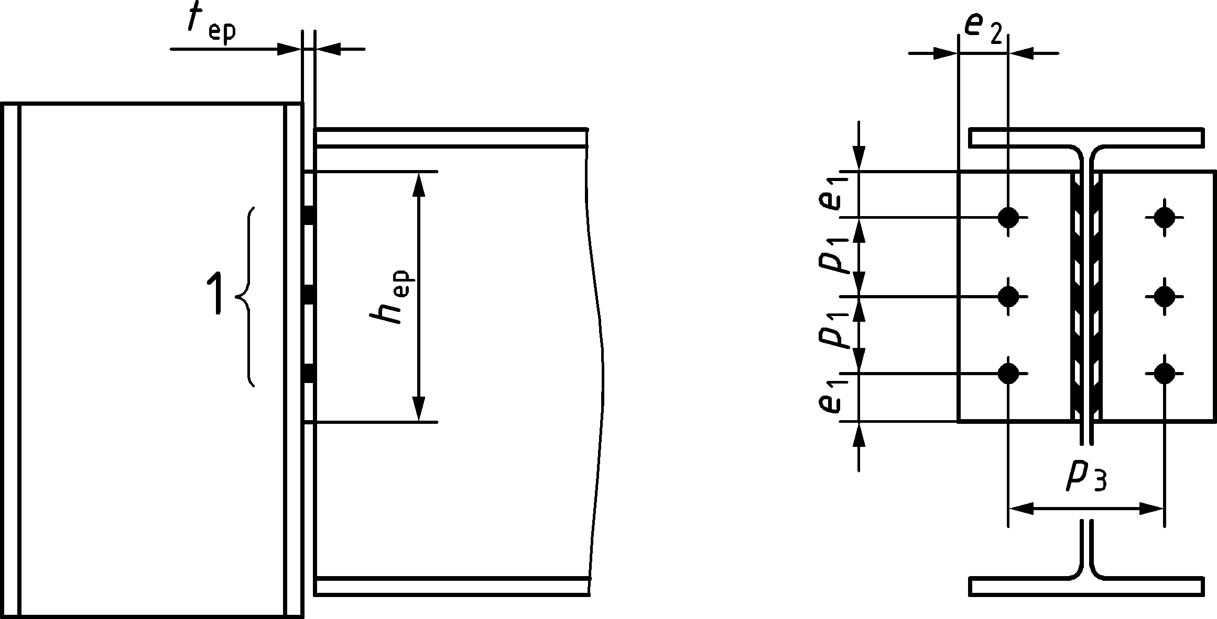
Key
1 | n₁: Number of horizontal bolt rows
Figure C.4 — Partial depth end plate connections
(1) The design shear resistance of a partial depth end plate connection should be taken as the smaller of the design resistances given in Table C.4. For notation, see Figure C.4.
Table C.4 — Design resistances of a partial depth end plate connection
Ductility and rotation capacity | Clause No.
Ductility and rotation capacity | C.3.3
Design resistances | Clause No.
Bearing resistance of bolts on  - end plate, and  - supporting member | C.4.1.1(3)
Shear resistance of the end plate | C.4.1.3(2), C.4.1.3(3) and C.4.1.3(4)
Shear resistance from bending of the end plate | C.4.1.3(5)
Shear resistance of the supported beam | C.4.1.3(6)

(2) The design shear resistance of the partial depth end plate should be taken as the smaller of the following design resistances:
- gross section in shear — see C.4.1.3(3)
- net section in shear — see C.4.1.3(4)
- block tearing — see 5.10
(3) The design shear resistance of the gross section of the end plate should be determined as follows:
$$V_{\text{v,ep,Rd}}=\frac{A_{\text{v,ep}}f_{\text{y,ep}}}{1,27\sqrt{3}γ_{\text{M0}}}$$ | (C.14)
where
Av,ep = 2heptep is the shear area of the end plate;
h_{ep} is the depth of the end plate;
t_{ep} is the thickness of the end plate;
fy,ep is the yield strength of the end plate.
(4) The design shear resistance of the net section of the end plate should be determined as follows:
$$V_{\text{u,ep,Rd}}=\frac{A_{\text{v,net,ep}}f_{\text{u,ep}}}{\sqrt{3}γ_{\text{M2}}}$$ | (C.15)
where
$A_{v,net,ep}=A_{v,ep}-2n_{1}d_{0}t_{ep}$ is the net shear area of the end plate;
fu,ep is the nominal ultimate tensile strength of the end plate.
(5) The design shear resistance from bending of the end plate should be obtained from:
- If $h_{ep}≥1,36p_{3}$then this failure mode is not relevant | (C.16)
- If $h_{ep}<1,36p_{3}$ then $V_{c,ep,Rd}=\frac{2t_{ep}h_{ep}^{2}f_{y,ep}}{3\left(p_{3}-t_{w}\right)γ_{M0}}$ | (C.17)
where
$t_{ep}$ is the thickness of the end plate;
$h_{ep}$ is the depth of the endplate;
$p_{3}$ is the bolt gauge (cross centres);
$t_{w}$ is the thickness of the supported beam web.
(6) The design shear resistance of the beam web welded to a partial depth end plate should be determined as follows:
$$V_{\text{v,wb,Rd}}=\frac{h_{\text{ep}}t_{\text{wb}}f_{\text{y,wb}}}{\sqrt{3}γ_{\text{M0}}}$$ | (C.18)
where
twb thickness of the beam web;
fy,wb yield strength of the beam web.
- Tying resistance
- General
(1) This section provides requirements to determine the tying resistance when structural integrity is required according to EN 1991-1-7.
(2) The design resistances of components considered in C.4.2.2, C.4.2.3 and C.4.2.4 should be obtained by substituting:
- fy for fu except for the net section area subject to shear in block-tearing;
- γM0 and γM2 for γMu.
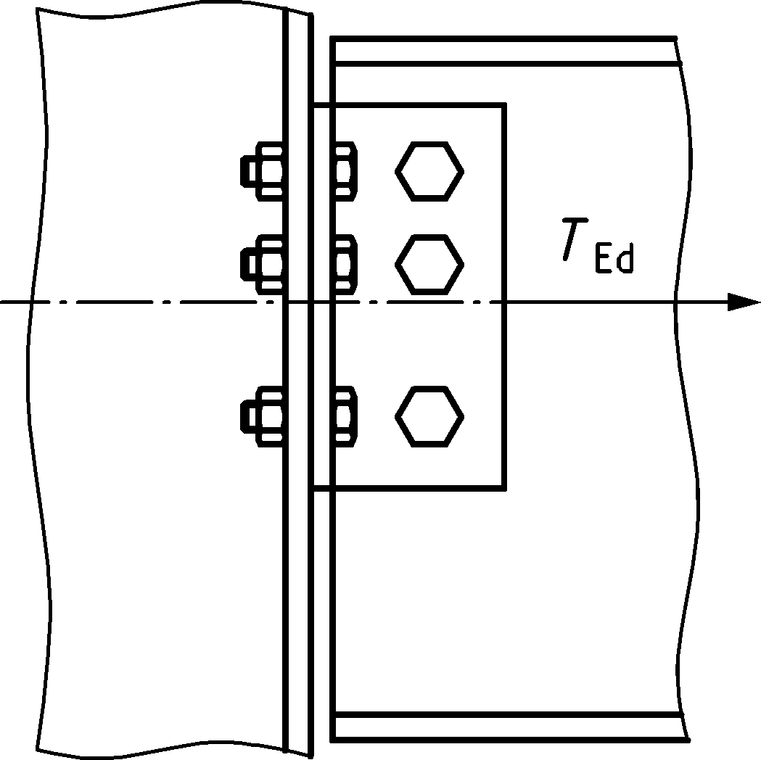 | 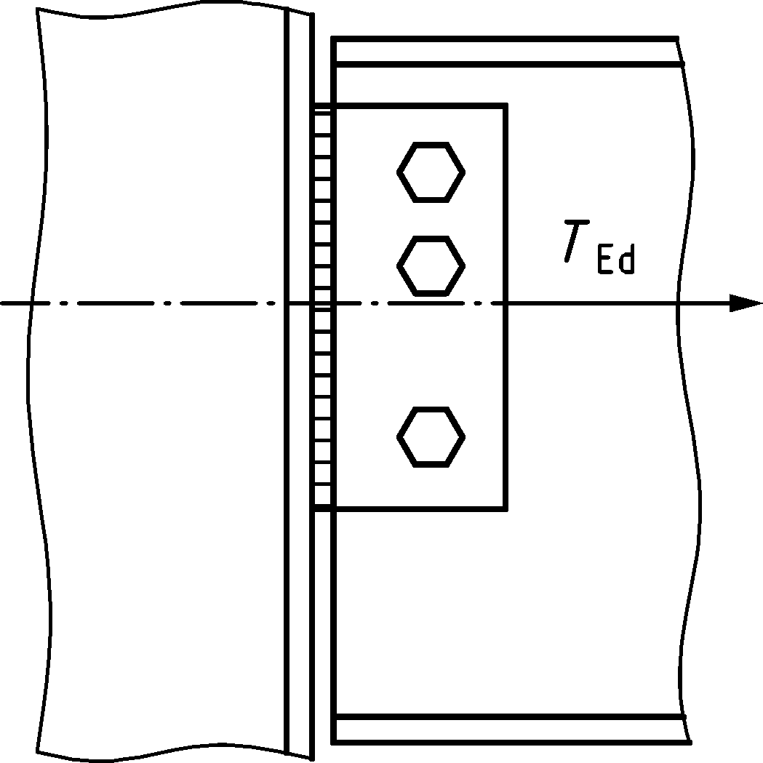 | 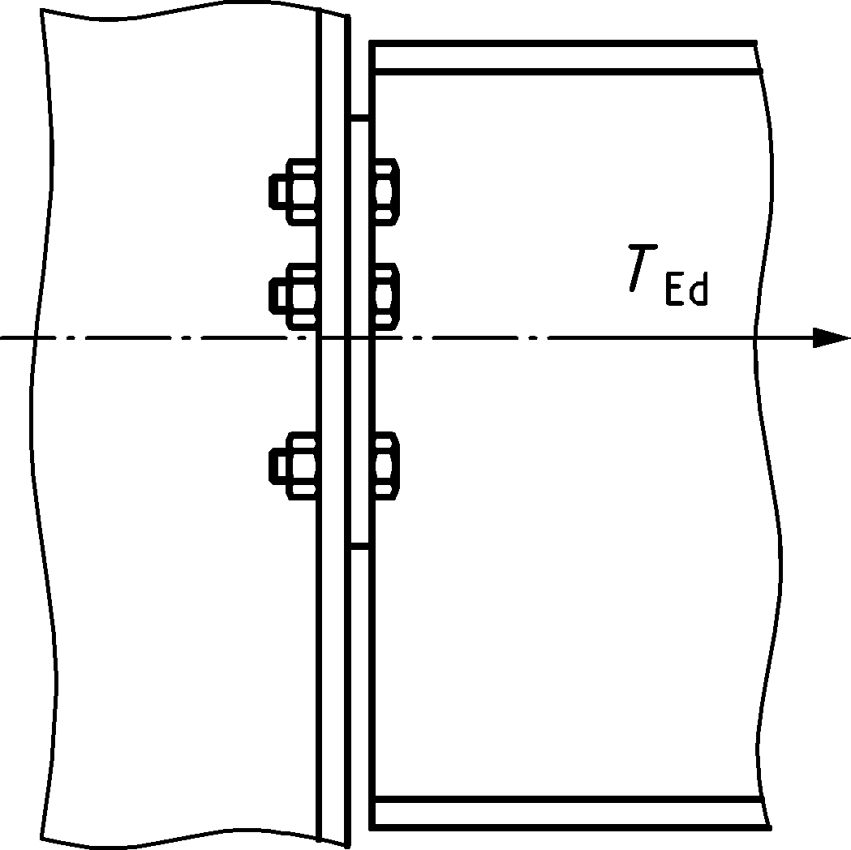
a) web cleat | b) fin plate | c) partial depth end plate
Figure C.5 — Simple connections subject to tying force
- Double angle web cleats
(1) The design tying resistance of a double angle web cleat connection should be taken as the smaller of the design resistances given in Table C.5.
Table C.5 — Design tying resistance of a double angle web cleat connection
Design resistance | Clause No.
Shear resistance of the bolt group connecting the legs of cleats to the supported member, | 5.7.1 and 5.8
Bearing resistance of bolts on  - legs of cleats connected to the supported beam, and  - supported beam web | 5.7.1 and 5.8
Tension resistance of the legs of cleats connected to the supported beam | C.4.2.2(2)
Tension resistance of the supported beam web | C.4.2.2(2)
Tension resistance of the legs of the cleats connected to the supporting member | C.4.2.2(3)
Tension resistance of the supporting member:
- Column flange,  - Column web or beam web | C.4.2.2(3)  C.4.2.2(4)

(2) The design tension resistance of the legs of cleats connected to the supported beam, or the supported beam web should be taken as the smaller of the following design resistances:
- Net tension resistance, see 8.2.3 of prEN 1993-1-1:2020
- Block tearing tension resistance, see 5.10
(3) The design tension resistance of the legs of the cleats connected to the supporting member, and of the supporting column flange should be calculated based on the principles of the equivalent T-stub in tension model, see 8.3, using the following effective lengths:
- Legs of the cleats (see Figure C.2): $\sum{l_{eff,1}}=\sum{l_{eff,2}=2e_{e}+\left(n_{1}-1\right)}p_{e}$;
- $e_{e}=e_{1} but ≤e_{2}$ $p_{e}=p_{1} but ≤2e_{2}$;
- Supporting column flange: $\sum{l_{eff,1}}and\sum{l_{eff,2}}$ can be obtained from Table A.2 for the bolt group.
(4) The design tension resistance of a supporting web (see Figure C.6) is given by:
$$T_{u,w,Rd}=\frac{2f_{u,2}t_{w,2}^{2}}{\left(1-β_{1}\right)γ_{M,u}}\left(η_{1}+1.5\sqrt{1-β_{1}}\sqrt{1-γ_{1}}\right)$$ | (C.19)
where
$$η_{1}=\frac{\left(n_{1}-1\right)p_{1}-0,5n_{1}d_{0}}{d_{2}}$$
$$β_{1}=\frac{p_{3}}{d_{2}}$$
$$γ_{1}=\frac{d_{0}}{d_{2}}$$
$d_{2}$ is the clear depth of the supporting column web or beam web;
$d_{0}$ is the bolt hole diameter;
$t_{w,2}$ is the thickness of the supporting column web or beam web;
$p_{3}$ is the bolt gauge (cross centres);
$n_{1}$ is the number of horizontal bolt rows.
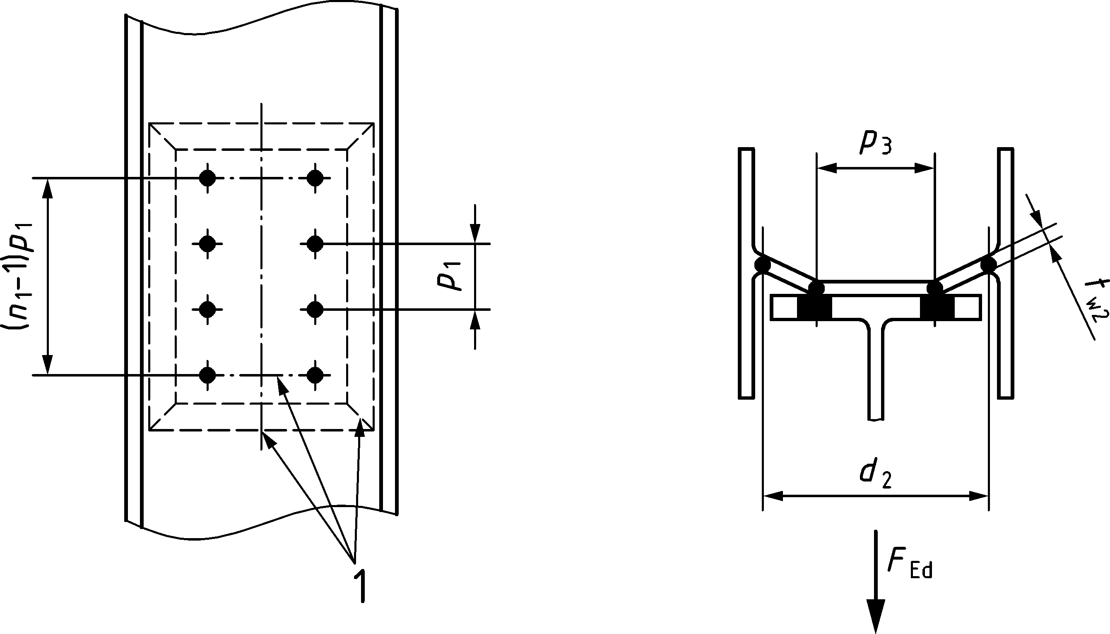
Key
1 yield lines
Figure C.6 — Notation for supporting web (e.g. column web)
- Fin plates
(1) The design tying resistance of a fin plate connection should be taken as the smaller of the design design resistances given in Table C.6.
Table C.6 — Design tying resistance of a fin plate connection
Design resistances | Clause No.
Shear resistance of the bolt group connecting the end plate to the supporting beam or column, | 5.7.1 and 5.8
Bearing resistance of bolts on  - fin plate, and  - supported beam web | 5.7.1 and 5.8
Tension resistance of the fin plate | C.4.2.3(2)
Tension resistance of the supported beam web | C.4.2.3(2)
Tension resistance of the supporting column web or beam web | C.4.2.3(3)

(2) The design tension resistance of the fin plate, or the supported beam web should be taken as the smaller of the following design resistances:
- Net tension resistance, see 8.2.3 of prEN 1993-1-1:2020;
- Block tearing tension resistance, see 5.10.
(3) The design tension resistance of a supporting web (see Figure C.7) is given by:
- $T_{u,w,Rd}=\frac{2f_{u,2}t_{w,2}^{2}}{\left(1-β_{1}\right)γ_{M,u}}\left(η_{1}+1.5\sqrt{1-β_{1}}\right)$ | (C.20)
where
$$η_{1}=\frac{h_{p}}{d_{2}}$$
$$β_{1}=\frac{t_{p}+\sqrt{2}a}{d_{2}}$$
$d_{2}$ is the clear depth of the supporting column web or beam web;
$h_{p}$ is the depth of the fin plate;
$t_{w,2}$ is the thickness of the supporting column web or beam web;
$t_{p}$ is the thickness of the fin plate;
$a$ s the weld throat thickness.
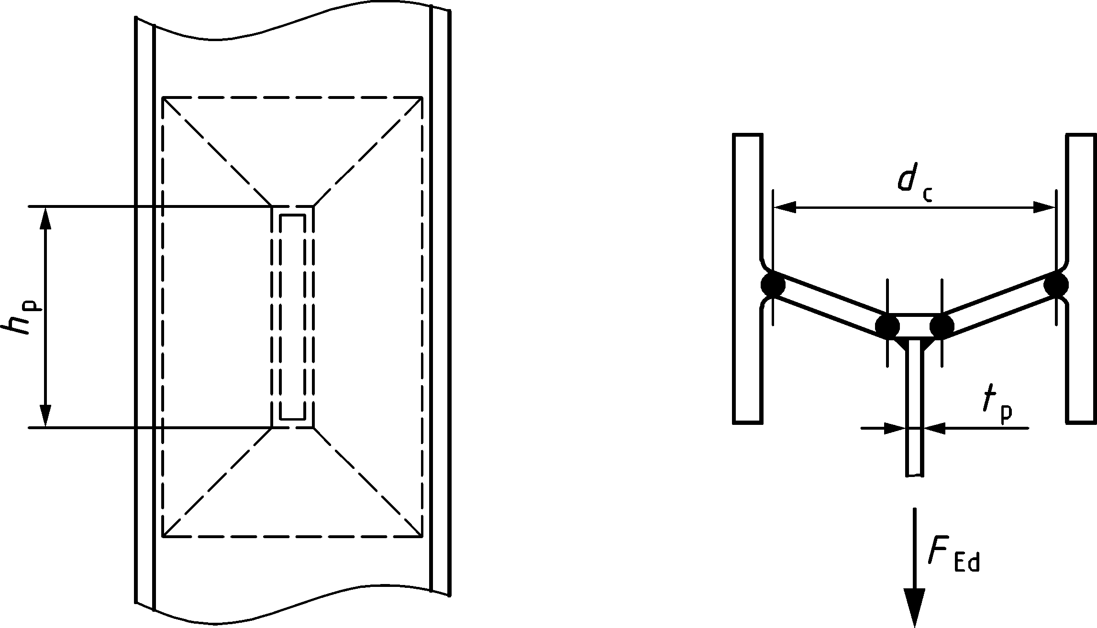
Fin plate connecting to column web
Figure C.7 — Notation for supporting web (e.g. column web)
- Partial depth end plates
(1) The design tying resistance of a partial depth end plate connection should be taken as the smaller of the design resistances given in Table C.7.
Table C.7 — Design tying resistance of a partial depth end plate connection
Design resistances | Clause
Tension resistance of the end plate and bolt assembly | C.4.2.4(2)
Tension resistance of the supported beam web | C.4.2.4(3)
Tension resistance of the supporting member
- column flange  - column web or beam web | C.4.2.2(3)  C.4.2.2(4)

(2) The design tension resistance of the an end plate and bolt assembly connected to the supporting member, and the design tension resistance of the supporting column flange should be calculated based on the principles of the equivalent T-stub in tension model, see 8.3, using the following effective lengths:
- Assembly end plate and bolts (see Figure C.5): $\sum{l_{eff,1}}=\sum{l_{eff,2}=2e_{e}+\left(n_{1}-1\right)}p_{e}$;
- $e_{e}=e_{1} but ≤e_{2}$ $p_{e}=p_{1} but ≤2e_{2}$;
- Supporting column flange: $\sum{l_{eff,1}}and\sum{l_{eff,2}}$ can be obtained from Table A.2 for the bolt group.
(3) The tension resistance of the supported beam web should be obtained from:
$$T_{u,wb,Rd}=\frac{t_{wb}h_{ep}f_{u,wb}}{γ_{Mu}}$$ | (C.21)
where
fu,wb is the nominal ultimate tensile strength of the supported beam web.
- (normative)
Design of column bases
- Use of this annex
(1) This normative Annex contains additional provisions for the design of column base plate connections as given in relation to Clauses 7 and 8.
- Scope and field of application
(1) The methods of calculating the design resistance, and the bending stiffness given in this Annex may be applied to symmetric column bases as given in Figure D.1.
(2) The design principles given in this Annex may be extended to any base plate design, including asymmetric and complex shapes of the base plate and the column.

- Design resistance
- General
(1) Column bases should be of sufficient size, stiffness and resistance to transmit the axial forces, bending moments and shear forces in columns to their foundations or other supports, without exceeding the load carrying capacity of these supports.
(2) The design resistance of anchor bolts and anchoring components should be determined from A.18.1, A.19, A20 and A.21 of this Standard and EN 1992-4.
(3) Rules for a plastic design of joints with multiple rows of anchor bolts and anchoring components are given in CEN/TR 17081.
(4) The design bearing resistance between the base plate and its support may be determined on the basis of a uniform distribution of compressive force over the bearing area. For concrete foundations the bearing stress should not exceed the design bearing strength, fjd, given in 8.4.3(5).
(7) The forces between the base plate and its support may be assumed according to one of the following distributions, depending on the relative magnitude of the applied axial force and bending moment:
- in the case of a dominant compressive force, full compression develops under both column flanges as shown in Figure D.1(a);
- in the case of a dominant tensile force, full tension develops under both column flanges as shown in Figure D.1(b);
- in the case of a dominant bending moment, compression develops under one column flange and tension under the other as shown in Figure D.1(c).

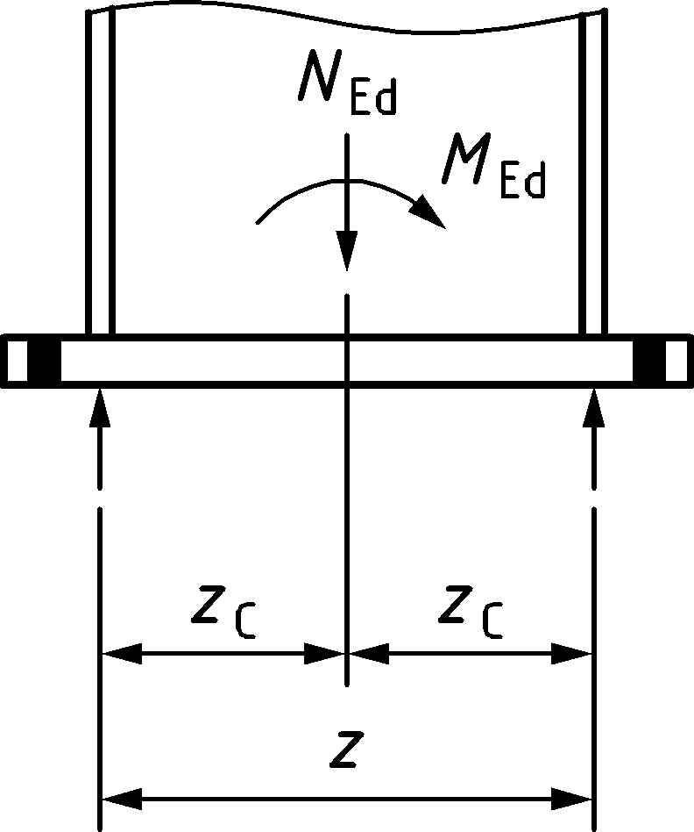 | 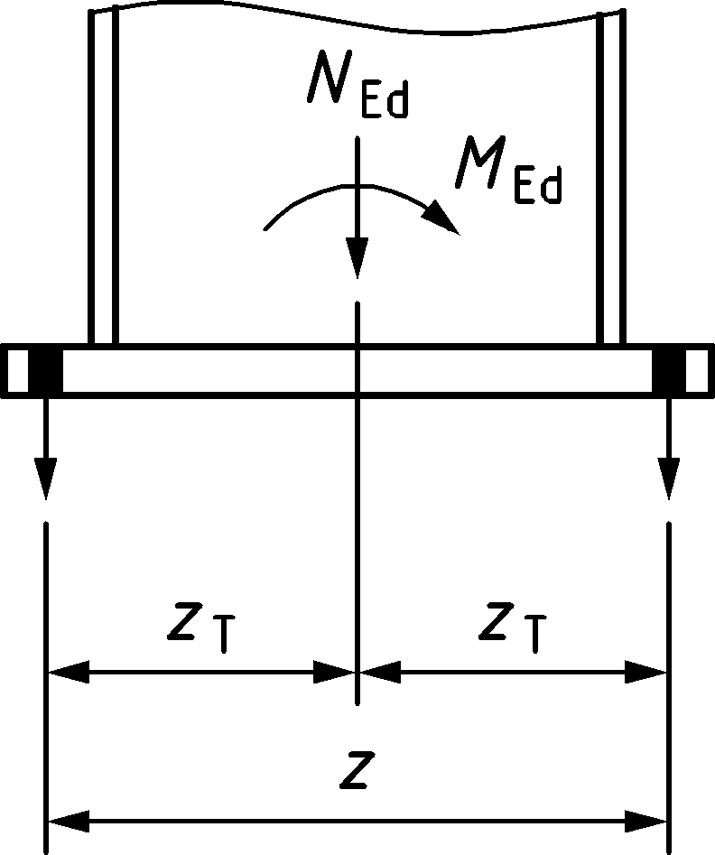 | 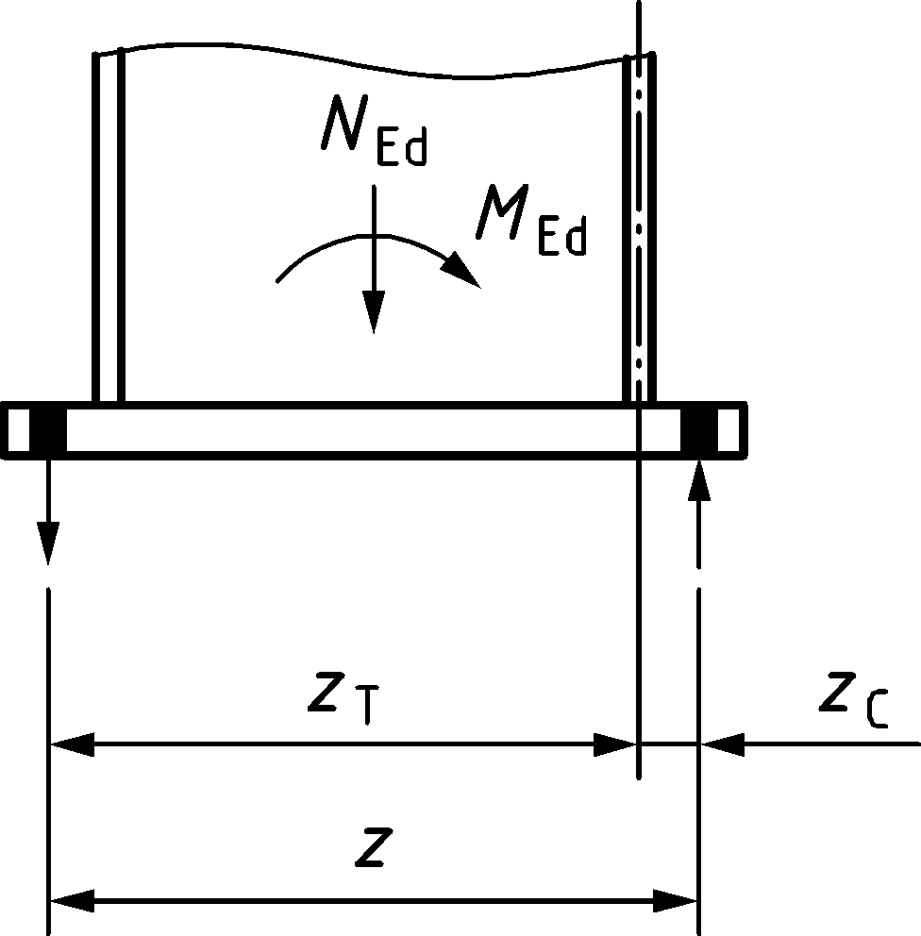
a) Dominant compressive force | b) Dominant tensile force | c) Dominant bending moment
Figure D.1 — Determination of the lever arm z for a symmetric column base plate
- Axial compressive resistance
(1) The design resistance Nj,Rd of a symmetric column base plate subjected to an axial concentric compressive force may be taken as the sum of the individual design resistance FC,Rd of the three equivalent T-stubs shown in Figure D.2: two T-stubs under the column flanges (1 and 3), and one T-stub under the column web (2). These three T-stubs should not be overlapping, see Figure D.2. The design resistance of each of these individual T-stubs in compression should be determined from the method in 8.4.
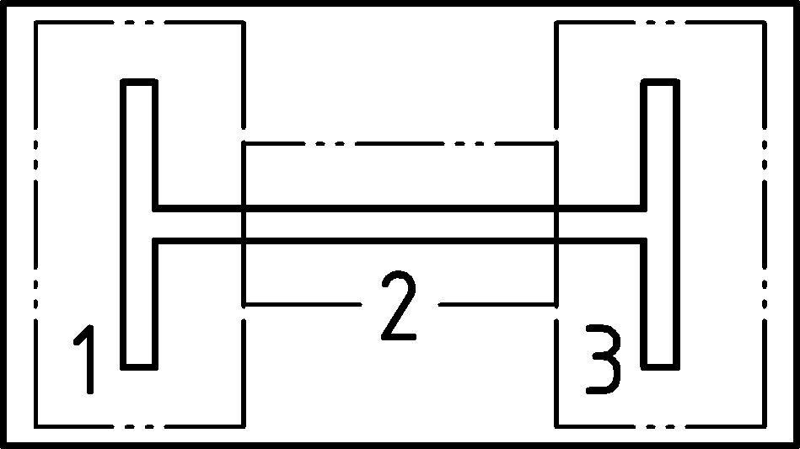
Key
1 T-stub 1
2 T-stub 2
3 T-stub 3
Figure D.2 — Non overlapping T-stubs
- Bending moment resistance
(1) The design moment resistance Mj,Rd of a symmetric column base plate subjected to combined axial force and bending moment should be determined using the method in Table D.1 where the contribution of the concrete portion just under the column web, T-stub 2 in Figure D.2, to the compressive resistance is not taken into account. The following parameters are used in this methodology:
- Design tension resistance on one side of the joint, FT,Rd — see (2);
- Design compressive resistance on one side of the joint, FC,Rd — see (3).
(2) The design tension resistance FT,Rd on one side of the joint should be taken as the smaller of the design resistance of following basic components:
- the column web in tension under the column flange Ft,wc,Rd— see A.11.1, where this procedure is used for the beam web in tension;
- the base plate in bending under the column flange Ft,bp,Rd— see A.17.1.
(3) The design compression resistance FC,Rd on one side of the joint should be taken as the smaller of the design resistance of the following basic components:
- the concrete and base plate in compression under one column flange Fc,bp,Rd — see A.16.1;
- the column flange and web in compression Fc,fb,Rd — see A.10.1.
(4) The lever arms zT and zC should be obtained from D.3.1(7) and Figure D.1.
Table D.1 — Design moment resistance Mj,Rd of a symmetric column base plate
Loading case | Lever arm  z | Design moment resistance Mj,Rd
Dominant bending moment | z = zT + zC | NEd > 0 and e ≥ zT |  | NEd < 0 and e ≤ −zC
 |  | The smaller of | $$\frac{F_{T,Rd} z}{\frac{z_{C} }{ e}+1} and \frac{-F_{C,Rd} z}{\frac{z_{T} }{e}-1}$$
Dominant tensile force | z = zT + zT |  | NEd > 0 and 0 < e ≤ z_{T}
 |  |  | $$\frac{F_{T,Rd} z}{\frac{z_{T} }{e}+1}$$
Dominant compressive force | z = zC + zC |  | NEd < 0 and −zC ≤ e < 0
 |  |  | $$\frac{{-F}_{C,Rd} z}{\frac{z_{C} }{e}-1}$$
MEd > 0 is clockwise, NEd > 0 is tension
$$e=\frac{{∣M}_{Ed}∣}{N_{Ed}}$$

- Shear resistance
(1) The design shear resistance between the base plate and its support should be taken as:
- the sum of the design resistance for friction between the base plate and its support, and the design shear resistance of the anchor bolts, see (3);
- the design bearing resistance of the block or bar shear connector obtained from EN 1992.
(2) The design resistance Ff,Rd for friction between the base plate and the grout should be obtained from:
$$F_{f,Rd}=C_{f,d} N_{c,Ed}$$ | (D.1)
where
Cf,d is the coefficient of friction between the base plate and the grout layer, which should be taken equal to 0,3;
Nc,Ed is the design value of the normal compressive force in the column.
NOTE If the column is loaded by a tensile normal force, Ff,Rd = 0.
(3) The design resistance Fv,Rd for shear between the base plate and the grout layer should be obtained from:
$$F_{v,Rd}=F_{f,Rd} +n F_{vb,Rd}$$ | (D.2)
where
n is the number of anchor bolts;
Fvb,Rd is the design shear resistance of an anchor bolt, see A.20(1).
NOTE This method assumes that all anchor bolts are surrounded by concrete.
(4) The concrete and reinforcement used in the base should be designed to EN 1992.
- Rotational stiffness
(1) The initial rotational stiffness, Sj,ini, of a symmetric column base plate subject to combined axial force and bending moment should be obtained from Table D.2 with the following stiffness coefficients:
- kT tension stiffness coefficient of one side of the joint; its inverse should be taken as the sum of the inverses of the stiffness coefficients kt,bp and ktb, obtained from A.17.2 and A.18.2;
- kC compression stiffness coefficient of one side of the joint; it should be taken equal to the stiffness coefficient kc,bp, obtained from A.16.2.
Table D.2 — Initial rotational stiffness Sj,ini of symmetric column base plate
Loading case | Lever arm  z | Initial rotational stiffness Sj,ini
Dominant bending moment | z = zT + zC | NEd > 0 and e ≥ zT | NEd < 0 and e ≤ −zC
 |  | $$Sj,ini= \frac{E z^{2}}{\left(\frac{1}{k_{T}}+\frac{1}{k_{C}}\right)} \frac{e}{e+e_{k}} where e_{k} =\frac{z_{C}k_{C}- z_{T}k_{T}}{k_{T}+k_{C}}$$
Dominant tensile force | z = zT + zT | NEd > 0 and 0 < e ≤ zT
 |  | $$Sj,ini=\frac{E z^{2}k_{T}}{2}$$
Dominant compressive force | z = zC + zC | NEd < 0 and −zC ≤ e < 0
 |  | $$Sj,ini=\frac{E z^{2}k_{C}}{2}$$
MEd > 0 is clockwise, NEd > 0 is tension.
$$e=\frac{∣M_{Ed }∣}{N_{Ed}}$$
Bibliography
References contained in recommendations (i.e. through “should” clauses)
The following documents are referred to in the text in such a way that some or all of their content, although not requirements strictly to be followed, constitutes highly recommended choices or course of action of this document. Subject to national regulation and/or any relevant contractual provisions, alternative standards could be used/adopted where technically justified. For dated references, only the edition cited applies. For undated references, the latest edition of the referenced document (including any amendments) applies.
EN 1992-1-1, Eurocode 2: Design of concrete structures — Part 1-1: General rules and rules for buildings
EN 1992-4, Design of concrete structures — Part 4: Design of fastenings for use in concrete
EN 1993-1-5:2006, Eurocode 3 - Design of steel structures — Part 1-5: Plated structural elements
EN 10025 (all parts), Hot rolled products of structural steels
EN 10080, Steel for the reinforcement of concrete — Weldable reinforcing steel — General
EN 14399 (all parts), High strength structural bolting assemblies for preloading
EN 15048 (all parts), Non-preloaded structural bolting assemblies
Other references
The following documents are those not included in the above categories but are cited informatively in the document, for example in notes.
EN 1090-1, Execution of steel structures and aluminium structures — Part 1: Requirements for conformity assessment of structural components
EN 1991-1-7, Eurocode 1: Actions on structures - Part 1-7: General actions — Accidental actions
EN 1993-1-14, Eurocode 3: Design of steel structures — Part 1-14: Design assisted by finite element analysis
EN 10210-1, Hot finished structural hollow sections of non-alloy and fine grain steels — Part 1: Technical delivery conditions
EN 10219-1, Cold formed welded structural hollow sections of non-alloy and fine grain steels — Part 1: Technical delivery conditions
EN 10149-2, Hot rolled flat products made of high yield strength steels for cold forming — Part 2: Technical delivery conditions for thermomechanically rolled steels
FprCEN/TR 17081, Design of concrete structures — Plastic design of fastenings with headed and post-installed fasteners
CEN/TR 1993-1-103, Eurocode 3 - Design of steel structures — Part 1-103 Elastic critical buckling of members
EN 1993-1-10, Eurocode 3: Design of steel structures — Part 1-10: Material toughness and through-thickness properties
EN 1994-1-1, Eurocode 4: Design of composite steel and concrete structures — Part 1-1: General rules and rules for buildings
EN ISO 2560, Welding consumables — Covered electrodes for manual metal arc welding of non-alloy and fine grain steels — Classification
EN ISO 5817, Welding — Fusion-welded joints in steel, nickel, titanium and their alloys (beam welding excluded) — Quality levels for imperfections
EN ISO 13918, Welding — Studs and ceramic ferrules for arc stud welding
EN ISO 14341, Welding consumables — Wire electrodes and weld deposits for gas shielded metal arc welding of non alloy and fine grain steels — Classification
EN ISO 14555, Welding — Arc stud welding of metallic materials
EN ISO 16834, Welding consumables — Wire electrodes, wires, rods and deposits for gas shielded arc welding of high strength steels - Classification
EN ISO 17632, Welding consumables — Tubular cored electrodes for gas shielded and non-gas shielded metal arc welding of non-alloy and fine grain steels — Classification
EN ISO 17659, Welding — Multilingual terms for welded joints with illustrations
EN ISO 18276, Welding consumables — Tubular cored electrodes for gas-shielded and non-gas-shielded metal arc welding of high strength steels — Classification
ISO 1891, Fasteners — Terminology

