CEN/TC 250

Date: 2023-08

prEN 1993‑3:2024

Secretariat: BSI

Eurocode 3 — Design of steel structures — Part 3: Towers, masts and chimneys

Eurocode 3 — Bemessung und Konstruktion von Stahlbauten — Teil 3: Türme, Maste und Schornsteine

Eurocode 3 — Calcul des structures en acier — Partie 3: Tours, mâts et cheminées

ICS:

Contents Page

European foreword 5

0 Introduction 6

1 Scope 9

2 Normative references 10

3 Terms, definitions and symbols 10

3.1 Terms and definitions 10

3.2 Symbols 14

3.2.1 General 14

3.2.2 Latin upper-case letters 14

3.2.3 Latin lower-case letters 15

3.2.4 Greek upper-case symbols 16

3.2.5 Greek lower-case symbols 16

3.3 Convention for cross-section axes 17

4 Basis of design 17

4.1 General rules 17

4.2 Actions and environmental influences 18

4.2.1 Permanent actions 18

4.2.2 Variable actions 18

4.2.3 Other actions 20

4.3 Ultimate limit state verifications 21

4.4 Design assisted by testing 21

5 Materials 21

5.1 Structural steel 21

5.1.1 General 21

5.1.2 Material properties 21

5.2 Connection devices 21

5.3 Guys and fittings 21

6 Durability 21

6.1 General 21

6.2 Corrosion 22

6.3 Corrosion allowance for chimneys 22

6.3.1 External corrosion allowance 22

6.3.2 Internal corrosion allowance 23

6.4 Guys 23

7 Structural analysis 23

7.1 Modelling for determining action effects 23

7.1.1 General 23

7.1.2 Chimneys 24

7.2 Modelling of connections 24

7.3 Imperfections 25

7.4 Analysis of the structural shell 25

8 Ultimate limit states 26

8.1 General 26

8.2 Resistance of cross-sections and members 27

8.2.1 General 27

8.2.2 Special provisions for angle sections and members 27

8.2.3 Special provisions for members with polygonal sections 28

8.2.4 Special provisions for structural shells 28

8.3 Joints 30

8.3.1 General 30

8.3.2 Bolted flange plate joint configurations 30

8.3.3 Connection of the main structure to the foundation or supporting structure 32

8.3.4 Special connections 33

9 Serviceability limit states 35

9.1 Basis 35

9.2 Deflections and rotations 35

9.2.1 Requirements 35

9.2.2 Limiting values of deflection 35

9.3 Vibrations 36

9.3.1 Requirements 36

9.3.2 Limiting values 36

10 Fatigue 36

10.1 General 36

10.2 Fatigue loading 37

10.2.1 In-line vibrations 37

10.2.2 Global effects of cross-wind vibrations 37

10.2.3 Individual member response 37

10.3 Safety assessment 38

Annex A (normative) Dampers including aerodynamic measures 39

A.1 Use of this Annex 39

A.2 Scope and field of application 39

A.3 General 39

A.4 Vibration absorbers 39

A.5 Aerodynamic damping measures 40

A.6 Design of dampers assisted by testing 41

Annex B (normative) Guys, insulators, ancillaries and other items 42

B.1 Use of this annex 42

B.2 Scope 42

B.3 Guys 42

B.4 Insulators 43

B.5 Ancillaries and other items 43

Annex C (normative) Buckling of components of towers and masts 44

C.1 Use of this annex 44

C.2 Scope and field of application 44

C.3 Buckling resistance of compression members 44

C.4 Effective slenderness factor *K* 45

C.5 Leg members 49

C.6 Bracing members 50

C.7 Notional forces for bracing members 58

C.8 Shell structures 59

Annex D (normative) Guy rupture 60

D.1 Use of this Annex 60

D.2 Scope and field of application 60

D.3 General 60

D.4 Analysis during guy rupture 60

D.5 Analysis after a guy rupture 63

Annex E (normative) Execution 64

E.1 Use of this annex 64

E.2 Scope and field of application 64

E.3 General 64

E.4 Bolted connections 64

E.5 Welded connections 65

E.6 Tolerances 65

E.7 Pre-stretching of guys 66

Annex F (informative) Supplementary rules for the resistance of equal leg angle sections and built-up members 67

F.1 Use of this Annex 67

F.2 Scope and field of application 67

F.3 Special provisions for equal leg angle section members 67

F.4 Special provisions for closely spaced built-up members 72

Bibliography 76

European foreword

This document (prEN 1993‑2:2024) has been prepared by Technical Committee CEN/TC 250 “Structural Eurocodes”, the secretariat of which is held by BSI. CEN/TC 250 is responsible for all Structural Eurocodes and has been assigned responsibility for structural and geotechnical design matters by CEN.

This document is currently submitted to the CEN Enquiry.

This document will supersede EN 1993‑3‑1:2006, EN 1993‑3‑2:2006 and their corrigenda.

The first generation of EN Eurocodes was published between 2002 and 2007. This document forms part of the second generation of the Eurocodes, which have been prepared under Mandate M/515 issued to CEN by the European Commission and the European Free Trade Association.

The Eurocodes have been drafted to be used in conjunction with relevant execution, material, product and test standards, and to identify requirements for execution, materials, products and testing that are relied upon by the Eurocodes.

The Eurocodes recognize the responsibility of each Member State and have safeguarded their right to determine values related to regulatory safety matters at national level through the use of National Annexes.

0 Introduction

**0.1 Introduction to the Eurocodes**

The Structural Eurocodes comprise the following standards generally consisting of a number of Parts:

— EN 1990, *Eurocode — Basis of structural and geotechnical design*

— EN 1991, *Eurocode 1 — Actions on structures*

— EN 1992, *Eurocode 2 — Design of concrete structures*

— EN 1993, *Eurocode 3 — Design of steel structures*

— EN 1994, *Eurocode 4 — Design of composite steel and concrete structures*

— EN 1995, *Eurocode 5 — Design of timber structures*

— EN 1996, *Eurocode 6 — Design of masonry structures*

— EN 1997, *Eurocode 7 — Geotechnical design*

— EN 1998, *Eurocode 8 — Design of structures for earthquake resistance*

— EN 1999, *Eurocode 9— Design of aluminium structures*

— New parts are under development, e.g. Eurocode for design of structural glass

The Eurocodes are intended for use by designers, clients, manufacturers, constructors, relevant authorities (in exercising their duties in accordance with national or international regulations), educators, software developers, and committees drafting standards for related product, testing and execution standards.

NOTE Some aspects of design are most appropriately specified by relevant authorities or, where not specified, can be agreed on a project-specific basis between relevant parties such as designers and clients. The Eurocodes identify such aspects making explicit reference to relevant authorities and relevant parties.

**0.2 Introduction to the EN** **1993** **series**

(1) EN 1993 applies to the design of buildings and civil engineering works in steel. It complies with the principles and requirements for the safety and serviceability of structures, the basis of their design and verification that are given in EN 1990 — Basis of structural and geotechnical design.

(2) EN 1993 is concerned only with requirements for resistance, serviceability, durability and fire resistance of steel structures. Other requirements, e.g. concerning thermal or sound insulation, are not covered.

(3) EN 1993 is subdivided in various parts:

EN 1993‑1, *Design of Steel Structures — Part 1: General rules and rules for buildings;*

EN 1993‑2, *Design of Steel Structures — Part 2: Bridges;*

EN 1993‑3, *Design of Steel Structures — Part 3: Towers, masts and chimneys;*

EN 1993‑4, *Design of Steel Structures — Part 4: Silos and tanks;*

EN 1993‑5, *Design of Steel Structures — Part 5: Piling;*

EN 1993‑6, *Design of Steel Structures — Part 6: Crane supporting structures;*

EN 1993‑7, *Design of steel structures — Part 7: Sandwich panels.*

(4) EN 1993‑1 in itself does not exist as a physical document, but comprises the following 14 separate parts, the basic part being EN 1993‑1‑1:

EN 1993‑1‑1, *Design of Steel Structures — Part 1-1: General rules and rules for buildings;*

EN 1993‑1‑2, *Design of Steel Structures — Part 1-2: Structural fire design;*

EN 1993‑1‑3, *Design of Steel Structures — Part 1-3: Cold-formed members and sheeting;*

NOTE Cold formed hollow sections supplied according to EN 10219 are covered in EN 1993‑1‑1.

EN 1993‑1‑4, *Design of Steel Structures — Part 1-4: Stainless steel structures;*

EN 1993‑1‑5, *Design of Steel Structures — Part 1-5: Plated structural elements;*

EN 1993‑1‑6, *Design of Steel Structures — Part 1-6: Strength and stability of shell structures;*

EN 1993‑1‑7, *Design of Steel Structures — Part 1-7: Plate assemblies with elements under transverse loads;*

EN 1993‑1‑8, *Design of Steel Structures — Part 1-8: Joints;*

EN 1993‑1‑9, *Design of Steel Structures — Part 1-9: Fatigue;*

EN 1993‑1‑10, *Design of Steel Structures — Part 1-10: Material toughness and through-thickness properties;*

EN 1993‑1‑11, *Design of Steel Structures — Part 1-11: Tension components;*

EN 1993‑1‑12, *Design of Steel Structures — Part 1-12: Additional rules for steel grades up to S960;*

EN 1993‑1‑13, *Design of Steel Structures — Part 1-13: Beams with large web openings;*

EN 1993‑1‑14, *Design of Steel Structures — Part 1-14: Design assisted by finite element analysis.*

(5) All subsequent parts EN 1993‑1‑2 to EN 1993‑1‑14 treat general topics that are independent from the structural type like structural fire design, cold-formed members and sheeting, stainless steels, plated structural elements, etc.

(6) All subsequent parts numbered EN 1993‑2 to EN 1993‑7 treat topics relevant for a specific structural type like steel bridges, towers, masts and chimneys, silos and tanks, piling, crane supporting structures, etc. EN 1993‑2 to EN 1993‑7 refer to the generic rules in EN 1993‑1 and supplement them.

**0.3 Introduction to EN 1993‑3**

EN 1993‑3 describes the principles and application rules for the safety, serviceability and durability of steel structures for towers, masts and chimneys.

EN 1993‑3 gives design rules in supplement to the generic rules in the EN 1993‑1 series.

EN 1993‑3 is intended to be used with EN 1990, the EN 1991 series and the parts of EN 1992 to EN 1998 when steel structures or steel components for towers and masts, chimneys are referred to.

Matters that are already covered in those documents are not repeated.

EN 1993‑3 is intended for use by

— committees drafting design related product, testing and execution standards,

— clients (e.g. for the formulation of their specific requirements),

— designers and constructors,

— relevant authorities.

Numerical values for partial factors and other reliability parameters in EN 1993‑3 are recommended as basic values that provide an acceptable level of reliability. They have been selected assuming that an appropriate level of workmanship and quality management applies.

Provisions have been included to allow for the possible use of a different partial factor for resistance in the case of those structures or elements the design of which has been the subject of an agreed type testing programme.

**0.4 Verbal forms used in the Eurocodes**

The verb “shall” expresses a requirement strictly to be followed and from which no deviation is permitted in order to comply with the Eurocodes.

The verb “should” expresses a highly recommended choice or course of action. Subject to national regu-lation and/or any relevant contractual provisions, alternative approaches could be used/adopted where technically justified.

The verb “may” expresses a course of action permissible within the limits of the Eurocodes.

The verb “can” expresses possibility and capability; it is used for statements of fact and clarification of concepts.

**0.5 National Annex for** **EN** **1993‑3**

National choice is allowed in this standard where explicitly stated within notes. National choice includes the selection of values for Nationally Determined Parameters (NDPs).

The national standard implementing EN 1993‑3 can have a National Annex containing all national choices to be used for the design of buildings and civil engineering works to be constructed in the relevant country.

When no national choice is given, the default choice given in this standard is to be used.

When no national choice is made and no default is given in this standard, the choice can be specified by a relevant authority or, where not specified, agreed for a specific project by appropriate parties.

National choice is allowed in EN 1993‑3 through notes to the following clauses:

|  |  |  |  |
| --- | --- | --- | --- |
| 4.1(3) | 4.2.3(2) | 6.3.1(2) | 7.2(4) |
| 7.4(4) | 8.1(1) | 8.2.4.1(7) | 8.3.1(2) |
| 8.3.3(2) | 8.3.4.2(2) | 10.3(5) | B.3.2(3) |
| B.3.3(3) | B.5.1(1) | B.5.2(3) | B.5.3(1) |
| B.5.4(1) | C.3(3) | C.5(8) | D.5(2) |
| E.4(5) | E.6.2.1(1) | E.6.2.2(3) |  |

National choice is allowed in EN 1993‑3 on the application of the following informative annex:

Annex F

The National Annex can contain, directly or by reference, non-contradictory complementary information for ease of implementation, provided it does not alter any provisions of the Eurocodes.

# Scope

(1) This document provides rules for structural design of towers, masts and chimney structures, that fall into any of the following classifications, with the exceptions given in (3), (4) and (5).

(2) This document is applicable to:

a) self-supporting towers and guyed masts with or without attachments. The shafts of towers and masts can be of lattice type or of circular or polygonal cross-section.

b) chimney structures of circular cross-section that are cantilevered, supported at intermediate levels or guyed.

NOTE 1 The structures are mainly exposed to wind loading.

NOTE 2 For overhead transmission line towers see also the EN 50341 series.

(3) This document does not apply to:

a) polygonal and circular lighting columns covered by the EN 40 series;

NOTE The EN 40 series specifies the requirements and dimensions for lighting columns and it applies to post top columns not exceeding 20 m height and to post top lanterns and columns with brackets not exceeding 18 m height for side entry lanterns.

b) wind turbine towers (see the EN 61400 series)

c) overhead line towers covered by the EN 50341 series.

(4) This document does not cover special provisions for seismic design, which are given in the EN 1998 series.

(5) Special measures that might be necessary to limit the consequences of accidents are not covered in this document. For resistance to fire, see EN 1993‑1‑2.

(6) Provisions for the guys of guyed structures are given in EN 1993‑1‑11 and supplemented in this document.

(7) For provisions concerning aspects such as chemical attack, thermo-dynamical performance or thermal insulation of chimneys see EN 13084‑1. For the design of liners see EN 13084‑6.

NOTE 1 Foundations are covered in the EN 1997 series. See also EN 13084‑1.

NOTE 2 Wind loads and procedures for the wind response of structures are specified in EN 1991‑1‑4.

**Assumptions**

(1) Unless specifically stated, EN 1990, EN 1991 (relevant parts) and EN 1993‑1 (relevant parts) apply.

(2) The design methods given in this document are applicable if

— the execution quality is as specified in Annex E and EN 1090‑2 and for the execution of chimneys, also in EN 13084‑6,

and

— the construction materials and products used are as specified in the relevant parts of the EN 1993 series or, for materials other than steel, in the relevant material and product specifications.

NOTE Execution is covered in this document to the extent that is necessary to indicate the quality of the construction materials and products and the standard of workmanship on site needed to comply with the assumptions of the design rules.

# Normative references

The following documents are referred to in the text in such a way that some or all of their content constitutes requirements of this document. For dated references, only the edition cited applies. For undated references, the latest edition of the referenced document (including any amendments) applies.

NOTE See the Bibliography for a list of other documents cited that are not normative references, including those referenced as recommendations (i.e. through ‘should’ clauses) and permissions (i.e. through ‘may’ clauses).

EN 1090‑2, Execution of steel structures and aluminium structures — Part 2: Technical requirements for steel structures

EN 1090‑4, Execution of steel structures and aluminium structures — Part 4: Technical requirements for cold-formed structural steel elements and cold-formed structures for roof, ceiling, floor and wall applications

EN 1990:2023,[1] Eurocode — Basis of structural and geotechnical design

EN 1991 (all parts), Eurocode 1 — Actions on structures

EN 1993 (all parts), Eurocode 3 — Design of steel structures

EN 13084‑9, Free-standing chimneys — Part 9: Lifetime management — Monitoring, inspection, maintenance, remedial and reporting; Operations and actions required

EN ISO 5817:2023, Welding — Fusion-welded joints in steel, nickel, titanium and their alloys (beam welding excluded) — Quality levels for imperfections (ISO 5817:2023)

# Terms, definitions and symbols

## Terms and definitions

For the purposes of this document, the terms in EN 1990 and EN 1993‑1‑1 and the following terms apply.

3.1.1

aerodynamic measures

surface features to forestall coordinated vortex shedding that could generate intolerable resonant oscillation

Note 1 to entry: Aerodynamic measures can be spoiler, helical strakes, shrouds or slats.

3.1.2

anchor bolt

bolt for the connection of the structure to the foundation

3.1.3

base plate

horizontal plate fixed to the base of a structural shell or shaft or leg

3.1.4

chimney

construction work or building component that conducts waste gases, or other flue gases, supply or exhaust air to the atmosphere

Note 1 to entry: See also EN 13084‑1. Where the term “chimney” is used in this standard, only the loadbearing part (structural shell) is meant.

3.1.5

damper

device that supplements the structural damping and thus limits the response of a structure or of a guy

Note 1 to entry: This definition of damper refers to a vibration damper, which is different from a flow damper that is an internal gas flow regulation device in liners.

3.1.6

discrete ancillary item

any non-structural component that is concentrated within a short vertical distance, such as dish reflectors, aerials, lighting, platforms, handrails, insulators and other items

3.1.7

double-wall chimney

chimney consisting of an outer steel structural shell and one inner liner which carries the flue gases

3.1.8

flanges

plate welded transverse to the member to enable connection to other members using bolts

Note 1 to entry: Flanges are used both between structural sections and in liners and the flanges are in contact with each other. For chimneys the term “flange” is referred to as “junction flange” in the EN 13084 series.

3.1.9

global analysis

determination of a consistent set of internal forces and moments in a structure, that are in equilibrium with a particular set of actions on the structure

3.1.10

guy

tension-only member providing lateral support in conjunction with two or more counterparts at the same level

Note 1 to entry: Guys are also known as stay. One guy with a termination at each end constitutes a guy assembly. The lower end of the guy assembly is anchored to the ground or on a structure and generally incorporates a means of adjusting the tension in the guy. Specific definitions of guys, their make-up and fittings, are specified in Annex B.

3.1.11

guyed structure

steel structure stabilized at discrete intervals in its height by guys that are anchored to the ground or to a permanent structure

Note 1 to entry: The shaft of a guyed structure can be of lattice type or of circular or polygonal closed cross-section.

3.1.12

initial guy tension

tension in the guy at its anchorage to the ground, in the absence of meteorological actions and at an agreed reference temperature

3.1.13

leg members

steel members forming the main load-bearing components of the lattice structure

3.1.14

linear ancillary item

any non-structural components that extend over several panels, such as waveguides, feeders, ladders and pipework

3.1.15

liner

element supporting the lining system, contained within the structural shell

3.1.16

lining system

total system separating the flue gases from the structural shell in a chimney

Note 1 to entry: This comprises a liner and its supports, the space between the liner and structural shell and insulation, where existing.

3.1.17

local analysis

structural analysis of a part of the structure, including fatigue analysis

3.1.18

mast

guyed steel structure

3.1.19

multi-flue chimney

group of two or more chimneys structurally interconnected or a group of two or more liners within a structural shell

3.1.20

panel (of a tower or mast)

any convenient portion of a lattice tower or mast of lattice type that is subdivided vertically for the purpose of determining projected areas and wind drag

Note 1 to entry: Panels are typically, but not necessarily, taken between intersections of legs and primary bracings.

3.1.21

primary bracing members

members other than legs, carrying forces due to the loads imposed on the lattice structure

3.1.22

projected area

area of the element considered, when projected on to a plane normal to the wind direction considered, including ice where relevant

Note 1 to entry: For wind blowing other than normal to one face of the structure, a reference face is used for the projected area (see prEN 1991‑1‑4:2024, Annex E).

3.1.23

secondary bracing members

members used to reduce the buckling lengths of other lattice members

3.1.24

self-supported structure

cantilevered steel structure whose supporting shaft is not connected with any other construction above the base level

3.1.25

shaft

vertical steel structure of a tower or a mast, which can be of lattice type with triangular, square or rectangular cross-section or of closed circular or polygonal cross-section (monopole)

3.1.26

single-wall chimney

chimney whose structural shell also conducts the flue gases

Note 1 to entry: It can be fitted with thermal insulation and/or internal lining. The term can also refer to a chimney with a liner that conducts the flue gases and a surrounding lattice structure.

3.1.27

structural shell

main load-bearing steel structure of a chimney, excluding any flanges (referred to as “windshield” in the EN 13084 series)

3.1.28

tower

self-supported cantilevered steel structure

3.1.29

wind drag

resistance to the flow of wind offered by the elements of a tower, mast or chimney and any ancillary items that it supports, given by the product of the drag coefficient and the reference projected area

## Symbols

### General

(1) In addition to those symbols given in EN 1993‑1‑1, the following symbols apply.

(2) Further symbols are defined where they first occur.

### Latin upper-case letters

|  |  |
| --- | --- |
| *C*1 | factor accounting for the bending moment diagram for the calculation of the elastic critical moment for lateral torsional buckling |
| *C*u, *C*v | equivalent uniform moment factors |
| *D* | diameter of structure |
| *F*h,Ed | force |
| *F*h,dyn,Ed | dynamic force |
| *F*h,stat,Ed | static force |
| *F*t,Rd | design tension resistance of a bolt |
| *H* | height of structure |
| *I*pp | moment of inertia of the effective part of the packing plate |
| *I*v | moment of inertia about the v-v axis |
| *I*v,ch | moment of inertia about the v-v axis of one chord of the built-up section |
| *K* | effective slenderness factor |
| *K*1 | modification factor for horizontal members of *K*- and *X*-brace without plan bracing |
| *L*d | length of diagonal member |
| *L*h | length of horizontal member |
| *L*o | critical system length |
| *M*j,Ed | design bending moment |
| *M*j,Rd | design moment resistance |
| *M*u,Rk | characteristic value of the resistance to bending moment about u-u axis |
| *M*v,Rk | characteristic value of the resistance to bending moment about v-v axis |
| *N*c | axial compression force |
| *N*c,Rd | design compressive resistance |
| *N*cr,Sv | elastic critical axial force for built-up sections accounting for the shear stiffness |
| *N*j,Ed | design value of the axial force |
| *N*j,Rd | design axial resistance |
| *N*t | axial tension force |
| *N*t,Rd | design tension resistance |
| *N*t,b,Rd | design tension resistance of bolts |
| *N*t,f,Rd | design tension resistance from bending of the flange |
| *P*m,W(*z*) | force in the tower leg member at height *z* due to mean-wind load (see prEN 1991‑1‑4:2024, J.2.2.3(1)) |
| *P*t,W(*z*) | force in the tower leg member at height *z* due to along-wind gust buffeting (see prEN 1991‑1‑4:2024, J.2.2.3(1)) |
| *R*b | radius to centre of ring flange bolt holes |
| *R*f | radius of ring flange outer edge |
| *R*m | average radius of shell |
| SP | total effective load effect of the patch loads for masts (see prEN 1991‑1‑4:2024, J.3.3.2.4(3)) |
| *T*life | design life of the structure in years |
| *W*u | section modulus for bending about u-u axis |
| *W*eff,u | effective section modulus for bending about u-u axis |
| *W*el,u | elastic section modulus for bending about u-u axis |
| *W*v | section modulus for bending about v-v axis |
| *W*eff,v | effective section modulus for bending about v-v axis |
| *W*el,v | elastic section modulus for bending about v-v axis |

### Latin lower-case letters

|  |  |
| --- | --- |
|  | width of compression leg |
| *c*ext | external corrosion allowance |
| *c*int | internal corrosion allowance |
| *e* | eccentricity |
| *f*y,f | yield strength of flange |
| *h*s | pitch of strakes |
| *i*v | radius of gyration about the v-v axis |
| *k*b | factor to increase the tensile stresses of shells calculated with beam theory |
| *k*2 | coefficient to calculate the design tension resistance of a bolted circular flange connection |
| *k*3 | coefficient to calculate the design tension resistance of a bolted circular flange connection |
| *k*uu, *k*vu, *k*vu, *k*vv | interaction factors for angle section members in bending and axial compression |
| *l*s | length of strakes |
| *m* | negative inverse slope of the fatigue strength curve |
| *m*pl,Rd | plastic bending moment resistance of the flange |
| *m*y | circumferential bending moments per unit length |
| *p* | percentage of the axial force |
| *q*p | peak wind pressure |
| *r*1 | radius of the convex part of the bearing |
| *r*2 | radius of the concave part of the bearing |
| *t*f | ring flange thickness |
| *t*s | depth of strakes |
| *u* | deflection |
| *u*dyn | dynamic deflection |
| *u*stat | static deflection |

### Greek upper-case symbols

|  |  |
| --- | --- |
| C | reference value of fatigue strength at *N*C = 2 × 106 stress cycles |
| E | stress range associated to *N* cycles |
| *θ*1 | auxiliary angle in spherical pinned connections |
| *θ*2 | auxiliary angle in spherical pinned connections |
|  | inclination of the mast axis at its base |
|  | impact factor |

### Greek lower-case symbols

|  |  |
| --- | --- |
| *α*2,u, *α*3,u, *α*4,u | resistance factors for angle sections for bending about u-u axis depending on the class of the cross section |
| *α*2,v, *α*3,v, *α*4,v | resistance factors for angle sections for bending about v-v axis depending on the class of the cross section |
| *γ*Ff | partial factor for fatigue |
| *γ*Mt | partial factor for resistance of guys and their terminations |
| *δ*s | logarithmic decrement of structural damping |
| *χ*min | minimum reduction factor for flexural buckling of angle section members |
| *χ*u, *χ*v | reduction factor due to flexural buckling about u-u axis and v-v axis, respectively |
|  | slenderness for the relevant buckling mode |
|  | relative slenderness for plate buckling |
|  | relative slenderness for flexural buckling of built-up members accounting for the shear stiffness |
|  | relative slenderness for v-v axis |
|  | effective relative slenderness |
|  | relative slenderness parameter for plate buckling |
|  | equivalence factor to transfer Δ*σ* to *N*C = 2 × 106 cycles |
|  | exponent of the interaction equations for angle section members |
| *ρ* | reduction factor |
| *ρ*u | reduction factor to determine the resistance of class 4 angle sections for bending about u-u axis |
| *ρ*v | reduction factor to determine the resistance of class 4 angle sections for bending about v-v axis |
| *ψ* | ratio of the end moments |
| 1 | coefficient |
| ω | reduction factor of buckling strength of single angle members |

## Convention for cross-section axes

(1) The convention for axes of standard member sections adopted in this document is as shown in EN 1993‑1‑1:2022, Figure 3.1.

(2) For built-up members the convention for axes is that of EN 1993‑1‑1:2022, 8.4.

(3) For Schifflerized angles, see Figure 3.1.

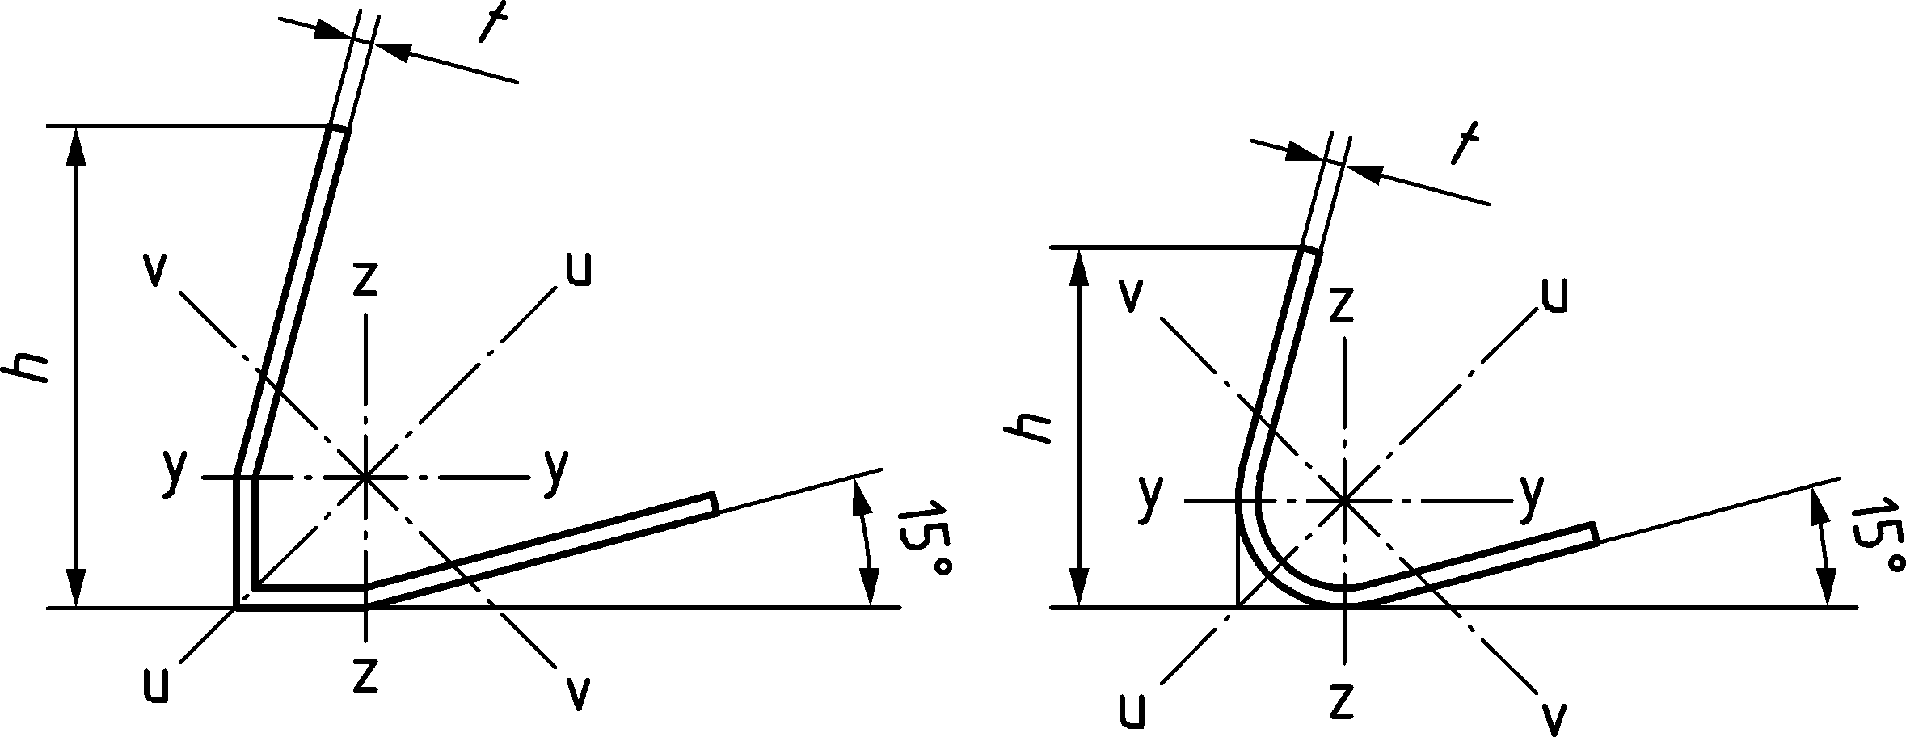

Figure 3.1 — Dimensions and axes for Schifflerized angle sections

# Basis of design

## General rules

(1) The design of towers, masts and chimneys shall be in accordance with the general rules given in EN 1990 and the EN 1991 series and the specific design provisions for steel structures given in the EN 1993‑1 series.

(2) Structures designed according to this document shall be executed according to EN 1090‑2, EN 1090‑4 and Annex E with construction materials and products used as specified in the relevant parts of EN 1993 or, for materials other than steel, in the relevant material and product specifications.

(3) For design, construction and maintenance of chimneys the fundamental requirements specified in EN 13084‑9 shall apply, additionally to the requirements in EN 1993‑1‑1:2022, Clause 4.

(3) Structures guyed at two or more levels and classified as consequence class 3 (as defined in EN 1990:2023, Clause A.3) should be designed to withstand the rupture of one guy without collapsing. Use Annex D (normative) for checking of guyed masts for guy rupture.

NOTE The National Annex can give information on guy rupture.

## Actions and environmental influences

### Permanent actions

#### Self-weights

(1) Self-weight should be determined in accordance with EN 1991‑1‑1.

(2) Self-weight of guys should be determined in accordance with EN 1993‑1‑11.

(3) The permanent actions should include the estimated self-weight of all permanent structures and other elements, including fittings, coatings and other loads.

(4) The self-weight of chimneys and their lining should be determined taking account of insulation and long-term effects of dust loads, clinging ash, fluids, or moisture on the density of linings if relevant.

(5) In calculating self-weight, the full thickness of the structure should be considered, with no loss due to corrosion. Where self-weight acts favourably, thickness reduction due to corrosion should be considered.

#### Initial guy tensions

(1) The initial guy tensions should be considered as permanent forces, equivalent to pretension of the guy, see EN 1993‑1‑11.

(2) Adjustment for initial guy tensions should be provided. If not, the range of initial tensions that might arise should be considered adequately in the design, see EN 1993‑1‑11.

(3) See E.6.2.3 for recommendations on values of initial guy tensions.

### Variable actions

#### Wind actions

(1) Wind actions should be taken from EN 1991‑1‑4.

(2) Wind loads should be applied on the external surfaces of the structure and on wind exposed ancillary components, for example a ladder.

(3) Vortex shedding that cause cross wind vibrations should be considered.

(4) Uneven wind pressure distribution (ovalling) or interference effects should be considered if the relevant criteria are exceeded, see 7.4.

(5) Interference galloping, classical galloping and rain-wind induced vibrations should be considered if the relevant criteria are exceeded, see EN 1991‑1‑4.

(6) Wind induced vibrations can be reduced by installing damping devices or aerodynamic measures. Use damping devices according to Annex A (normative) when vibrations can lead to damage or to exceeding the criteria of serviceability limit state.

(7) Reductions for temporary use may be applied according to EN 1991‑1‑4.

#### Atmospheric ice loads

(1) Ice load should be taken from EN 1991‑1‑9.

(2) Actions from ice should be considered both by their gravity effects and their effect on wind actions.

NOTE For sites exposed to ice loads, ice formation on structures can grow to considerable thicknesses, and combined with wind, the increased wind drag due to iced members can govern the design.

(3) Wind load on iced structures should be taken from EN 1991‑1‑4.

(4) When estimating the weight of the ice on a lattice structures, it may normally be assumed that all structural members, components of ladders, ancillaries, etc. are covered with ice having the same thickness over the whole surface of the member, see Figure 4.1.

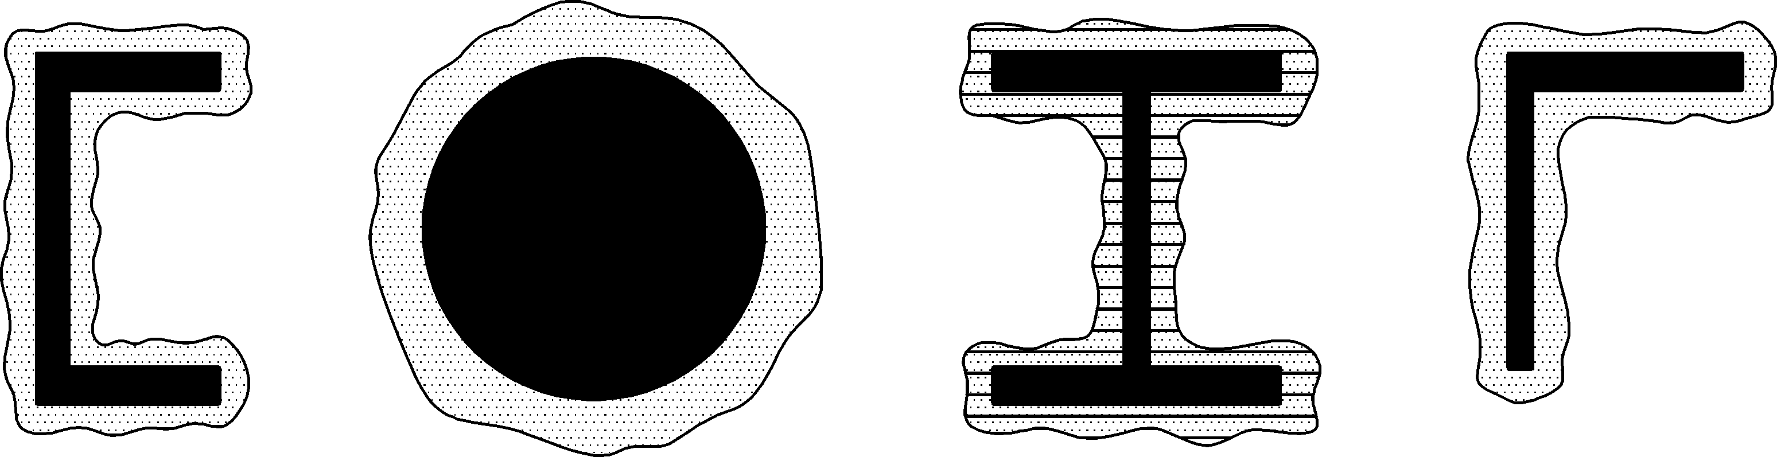

Figure 4.1 — Ice thickness on structural members

(5) As the ice can deposit asymmetrically on towers and masts, this should be considered.

NOTE Asymmetrical icing can be of particular interest for masts where icing on the different guys can vary considerably causing bending effects in the mast column. Asymmetrical ice on the guys can partly be caused by asymmetrical ice accretion depending on wind direction and partly caused by unequal shedding of ice from the guys.

(6) Asymmetric icing on a mast should be taken into consideration by applying the appropriate ice to the mast shaft and to all guys apart from:

— the guy or guys in one lane of the top guy level; and as a separate case:

— the guy or guys in two lanes of the top guy level.

(7) When placing a structure, on which icing is expected, near to passing traffic or buildings, the danger of damage from the impact of falling ice should be considered according to EN 1991‑1‑9.

#### Temperature actions

(1) Temperature actions should be determined from EN 1991‑1‑5 for environmental temperatures.

(2) In chimneys, temperatures from operational effects should be considered, see EN 13084‑1.

(3) The temperature action should be composed of a temperature uniformly distributed over the structure and differential temperature action caused by meteorological and operational effects including those arising from an imperfect gas flow.

#### Live loads

(1) Publicly accessible towers should be treated as buildings, with variable actions as prescribed by EN 1991‑1‑1.

(2) Members that are within 30° to the horizontal should be designed to carry the weight of a person which for this purpose may be taken as a concentrated vertical load of 1,0 kN.

(3) Temporary equipment load should be considered.

(4) Personal loads on platforms and railing should be considered.

(5) The following personal and equipment loads should be used on the structure, if no higher loads are specified.

a) For ladders and similar accessible elements: a vertical point load of 1,5 kN.

b) For platforms and similar accessible elements: a distributed vertical load of 2,0 kN/m2 or a vertical point load of 1,5 kN in unfavourable position, whatever is relevant for the respective verification.

c) For platforms carrying temporary equipment loads should be considered, if higher loads are not specified: a vertical point load of 3 kN at the most unfavourable position.

d) For all platforms, ladders and similar: Horizontal loads from a person due to movement and wind on that person: a horizontal load of 0,5 kN.

e) For railings: a horizontal load of 0,5 kN/m.

(6) If access to the structure in strong wind or ice cover conditions is prohibited, the respective combination factor of temporary personal and equipment loads in the presence of wind or ice may be set to 0.

NOTE For climbing ladders, platforms and railings used to access stationary machinery, the EN ISO 14122 series can be considered.

#### Special actions for chimneys

(1) For chimneys the following actions should be considered (see EN 13084‑1, EN 13084‑6 and EN 13084‑7):

— direct or indirect chemical action of the flue gases on the supporting steel structure

— influence of the internal pressure from the flue gases

— fire in the flue

— explosion and implosion

(2) The load bearing structure should not fail due to fire action, and any other parts near the chimney should not be heated to their ignition temperature.

### Other actions

(1) Seismic actions should be determined from EN 1998.

(2) Actions during execution should be considered taking due account of the construction scheme and transient design situations. The appropriate load combinations and reduction factors may be obtained from EN 1991‑1‑6.

NOTE The National Annex can give information on the choice of load combinations, loads and combination factors during different phases of construction.

(3) In case that accidental and collision actions should be considered, see EN 1991‑1‑7.

(4) Where considered necessary, actions from settlement of foundations should be assessed. Special considerations should be required for lattice towers founded on individual leg foundations and for differential settlement between the mast base and any guy foundations.

(5) Actions arising from the fitting and anchoring of safety access equipment may be determined according to EN 795. Where the proposed safe method of working requires the use of Work Positioning Systems or mobile fall arrest systems points of attachment should be adequate, see EN 365.

## Ultimate limit state verifications

(1) For design values of actions, combination and partial factors see EN 1990. The partial factors for gravity loads and mean value of the initial tensions in guys should be taken as specified in EN 1990:2023, Clause A.3.

## Design assisted by testing

(1) For structures or elements that are subject to an agreed full-scale testing programme, the general requirements specified in EN 1990 should be satisfied.

(2) The logarithmic decrement of structural damping may be determined by testing.

NOTE Guidance for the determination of *δ*s is given in A.6.2.

# Materials

## Structural steel

### General

(1) For requirements and properties of structural steel, see EN 1993‑1‑1, EN 1993‑1‑3, EN 1993‑1‑4 and EN 1993‑1‑11.

### Material properties

(1) Due account should be taken of the variation of mechanical properties of the steels due to ambient and operational temperatures, see 5.1.2(5) and 5.1.2(6).

(2) For toughness requirements of structural carbon steel, see EN 1993‑1‑1:2022, 5.2.3 and EN 1993‑1‑10. If the structure can be exposed to ice accumulation during its lifetime, the resulting low temperatures should be considered to specify toughness requirements.

(3) For toughness requirements of stainless steel, see prEN 1993‑1‑4:2023, 2.1.4 and EN 1993‑1‑10.

(4) For chimneys, where temperatures exceed 400 °C, the effects of temperature creep should be considered to avoid creep rupture, see EN 13084‑6.

(5) For properties of structural carbon and stainless steel of chimneys at high temperatures, see EN 13084‑7. Temperature due to flue gases should be considered where they directly impact the temperature of the structural elements of the structure. Also, EN 13084‑6 provides guidance.

## Connection devices

(1) For requirements and properties for bolts and welding consumables, see EN 1993‑1‑8.

## Guys and fittings

(1) For requirements and properties of ropes, strands, wires and fittings, use EN 1993‑1‑11 and Annex B (normative).

# Durability

## General

(1) Durability should be satisfied by complying with the verification of the fatigue design situation (see Clause 10) and appropriate corrosion protection.

(2) The design service life should be as specified by the relevant authority or, where not specified, agreed for a specific project by the relevant parties, see EN 1990:2023, Clause A.3.3.

## Corrosion

(1) Suitable corrosion protection, appropriate to the location of the structure, its design life and maintenance regime, should be provided.

NOTE Additional information of corrosion protection can be found in EN 1090‑2.

(2) In unsealed hollow structures sufficient ventilation should be provided to prevent condensation, see EN ISO 12944‑3.

(3) All connections should be designed to eliminate or minimize moisture retention, especially for weathering steel.

NOTE The following measures can be used as good practice:

a) for example, orientation of members, edge and pitch distance, etc., are taken into consideration, or detailed protection of these connections is provided;

b) vegetation at the ground line is maintained clear of the structure; and

c) direct embedment into the soil is avoided and foundation attachments are coated to minimize the potential for corrosion due to contact with soil and exposure to constant moisture.

## Corrosion allowance for chimneys

(1) Allowance for corrosion should be the sum of external (*c*ext) and internal allowances (*c*int). Where relevant these allowances should be applied in all or part of each 10-year period defined in Table 6.1.

(2) This total allowance should be added to the thickness needed to satisfy the requirements for strength and stability of the members.

### External corrosion allowance

(1) External corrosion allowance should be appropriate to the environmental conditions.

(2) For corrosivity categories C2 to C4 according to EN ISO 12944‑2 the values of external corrosion allowance in Table 6.1 are recommended.

NOTE 1 The National Annex can give different values for the external allowance *c*ext than those given in Table 6.1.

NOTE 2 Additional information of material loss for hot dip galvanised steel can be found in EN ISO 12944‑2:2017, Table 1.

Table 6.1 (NDP) — External corrosion allowance *c*ext in mm

| **Protection system** | **Upper part**a  **Exposure time** | | **Lower Part**  **(full exposure time)**b |
| --- | --- | --- | --- |
| **First 10 years** | **Each additional 10 years period** |
| painted carbon steel (with no planned programme for repainting) | 0 | 1 | 0 |
| painted carbon steel (with a planned programme for repainting) | 0 | 0 | 0 |
| painted carbon steel protected by insulation and waterproof cladding | 0 | 1 | 1 |
| unprotected carbon steel | 1,5 | 1 | 3 |
| unprotected weathering steel | 0,5 | 0,3 | 1 |
| unpainted weathering steel protected by insulation and waterproof cladding | 0 | 0 | 0 |
| unprotected stainless steel | 0 | 0 | 0 |
| a The upper part applies to the top 5*D* of the chimney, where *D* is the external diameter of the chimney.  b Lower values may be used for short service life if justified. | | | |

(3) When a chimney is sited in an environment of corrosivity category C5 or CX according to EN ISO 12944‑2, consideration should be given to increasing the allowances or taking protective measures.

### Internal corrosion allowance

(1) The values of internal corrosion allowance (*c*int) for a structural shell used as liner should be in accordance with EN 13084‑7.

(2) Internal corrosion allowance of unprotected inner surface of the structural shell and unprotected outer surface of the liner in a double skin or multi-flue chimney (for carbon or weathering steel) should be 0,2 mm for the first 10 years and hereafter 0,1 mm per additional 10 years period.

## Guys

(1) Special corrosion protection requirements should be considered for the guys compared to the rest of the structure. For guidance on the corrosion protection of guys see EN 1993‑1‑11.

(2) When assessing the need of possible protection measures, the design service life of the structure as well as the eventual replacement of guys should be considered (see 6.1(2)).

# Structural analysis

## Modelling for determining action effects

### General

(1) The internal forces and moments should be determined using elastic global analysis, see EN 1993‑1‑1.

(2) Gross cross-sectional properties may be used in the analysis.

(3) Account should be taken of the soil-structure interaction where significant.

NOTE EN 1997 can give guidance for calculation of soil-structure interaction.

(4) The global analysis of guyed structures should consider the effect of deformations on the equilibrium conditions (second order theory), see EN 1993‑1‑1:2022, 7.2.1, and the geometrically nonlinear behaviour of the guys, see EN 1993‑1‑11.

NOTE Self-supported structures can in general be analysed using the undeformed geometry (first order theory).

(5) For members of triangulated lattice towers the slenderness limits defined in Annex C shall be satisfied and a truss model may be used.

(6) In general, the loads along the member length including wind or permanent loading on the other members framing into the member should be considered.

(7) In triangulated lattice towers that are not prone to fatigue loads may be applied as point loads on the nodes (see also 7.2(2)).

### Chimneys

(1) Possible composite action between the structural shell and the liner should generally be disregarded for ultimate limit state verifications of chimneys. Restraints of the liner that can adversely affect the safety of the shell should however be considered.

(2) If damping effects from interaction of the structural shell and the liner are considered in the design, they should be verified by measurements. Otherwise, values given in EN 1991‑1‑4 may be used.

(3) The strength and stability of the liner should then be assessed with due regard to the deformations imposed from the structural shell.

(4) Due regard should be given to the temperature effects on the stiffness and strength of the steels used in a chimney structure, see 5.1.2.

(5) Corroded thickness should be used in calculations of the structural response, including fatigue. Due account of both the external and internal corrosion should be considered in accordance with 6.3. In case uncorroded thickness can give more unfavourable stress conditions, it should be considered as a separate design situation.

## Modelling of connections

(1) The behaviour of the connections should be considered in the global and local analysis of the structure.

NOTE The procedure for the analysis of connections can be found in EN 1993‑1‑1:2022, 7.1.2.

(2) In fully triangulated structures with simple framing that are not prone to fatigue, the connections between the members may be assumed not to develop moments. In the global analysis, members may be assumed to be effectively pin connected. The connections should satisfy the requirements for nominally pinned connections, see FprEN 1993‑1‑8:2023, 7.3.2.

(3) Elastic analysis of triangulated structures where continuity is considered (continuous or semi-continuous framing), should be based on reliably predicted design moment-rotation or force-displacement characteristics for the connections used.

(4) Elastic analysis of non-triangulated structures with continuous framing should assume full continuity, with rigid connections which satisfy the requirements given in FprEN 1993‑1‑8:2023, 7.3.2.3.

NOTE The National Annex can give further requirements to the modelling of connections.

## Imperfections

(1) Guyed structures may be analysed without initial global imperfections if erection tolerances according to E.6.2.2 are met.

(2) Self-supporting structures may be analysed without global imperfection.

(3) Local shell imperfections of the structural shell are included in the strength formulae for the buckling resistance given in EN 1993‑1‑6 and may be neglected in the global analysis.

(4) Local imperfection of members with axial compression are included in the strength formulae for the buckling resistance, see Annex C, and may be neglected in the global analysis.

## Analysis of the structural shell

(1) For the calculation of action effects in the structural shell see EN 1993‑1‑6.

(2) In general, linear shell analysis (LA), either by analytical tools or by finite elements, may be used.

NOTE Rules and formulae for LA analysis of cylindrical and conical shells can be found in EN 1993‑1‑6.

(3) When the structural shell is calculated as a beam, the use of global first or second order beam theory, is as described in 7.1.1(4).

(4) For unstiffened vertical circular cylindrical shells with stiffeners in both ends the membrane stresses from external actions may be determined from membrane theory, treating the cylinder as a global beam, where shell bending effects may be neglected, apart from the circumferential bending moments due to non-uniform wind pressure distribution around the circumference.

NOTE 1 For unstiffened vertical circular cylindrical shells with a ratio of *H*/*R*m ≥ 50, stresses can be safely calculated assuming beam theory, flexural stresses being added vectorially to ovalling stresses from circumferential bending moments due to non-uniform wind pressure.

NOTE 2 For unstiffened vertical circular cylindrical shells (i.e. shells without stiffening rings or substantial flanged joints) having *H*/*R*m < 50, shell theory or finite element modelling can be used, considering flexural and ovalling stresses simultaneously. This can lead to reduction in compression stress at the base of the shell or immediately above changes in diameter of the shell but can increase compression stresses elsewhere. Similarly, this can lead to increases in tensile stresses at the base and immediately above a change in diameter, which can be important in deriving bolt tensions.

NOTE 3 The criteria for neglecting shell effects can be given in the National Annex.

(5) If beam theory is used, the increase in tensile stress at the base and immediately above a change in diameter may be approximated by multiplying the resulting stresses by the factor, *k*b:

 (7.1)

where

|  |  |
| --- | --- |
| *H* | is the total shell height; |
| *R*m | is the average radius of the shell (i.e. in the middle of the shell thickness); |
| *t* | is the shell thickness (after corrosion). |

(6) If beam theory is used, the circumferential bending moments per unit length may be approximately determined from:

 (7.2)

where

|  |  |
| --- | --- |
| *q*p | is the peak wind pressure, acting on the external surface of a structure, determined from EN 1991‑1‑4 taking *z* as the height of the shell. |

(7) Circumferential bending moments due to wind pressure (for basic wind velocities up to 25 m/s, see EN 1991‑1‑4) may be neglected in unstiffened cylindrical shells where:

 (7.3)

(8) For ring-stiffened cylindrical shells and for assemblies of ring-stiffened cylindrical and conical shells the membrane stresses may, independently of the — and -ratios, be determined from membrane theory treating the structure as a global beam.

(9) Shell bending effects may be neglected, provided that the following conditions are fulfilled:

— ring stiffeners provided to carry wind pressure should be designed for the circumferential bending moments;

— ring stiffeners provided at the intersections between cylinders and cones should be designed for the equilibrium forces resulting from deviating the meridional membrane forces.

(10) The action effects resulting from the above calculations should be used for both the strength verification and the shell buckling verification, see 8.2.3.

# Ultimate limit states

## General

(1) The following partial factors *γ*M apply:

— resistance of cross-sections (whatever the class is): *γ*M0

— resistance of members to instability assessed by member checks: *γ*M1

— resistance of net cross-sections in tension to fracture: *γ*M2

— resistance of connections: see EN 1993‑1‑8

— resistance of guys and their terminations: *γ*Mt, see EN 1993‑1‑11

— resistance of insulating material: *γ*Mi

The following values are recommended:

*γ*M0 = 1,00

*γ*M1 = 1,10 for shell structures and *γ*M1 = 1,00 for other structures

*γ*M2 = 1,25

*γ*Mt = 1,50

*γ*Mi = 2,00

NOTE 1 The National Annex can give different values for partial factors *γ*M.

NOTE 2 The factor *γ*Mt applies to the guy and its socket (or other termination). The associated steel pins, linkages and plates are designed for compatibility with the guy and its socket and can require an enhanced value of *γ*Mt. For details see EN 1993‑1‑11.

## Resistance of cross-sections and members

### General

(1) For structures and structural elements, classification of cross-sections as given in EN 1993‑1‑1:2022, 7.5 should be used.

(2) The effective cross-section properties of members should be calculated according to FprEN 1993‑1‑5:2023, 4.3 and to the specific rules provided in this standard.

(3) Compression members in lattice towers and masts should be designed according to the provisions of Annex C.

NOTE 1 For cold formed members see EN 1993‑1‑3.

NOTE 2 For the strength of guys and fittings see EN 1993‑1‑11 and Annex B. Special provisions are also given in 8.3.4.1.

NOTE 3 The strength of the guy assembly (guy with end fittings) can decrease when bending guy wire around the fittings (wedge clamp, thimble etc.).

### Special provisions for angle sections and members

(1) The class of the cross-section should be determined according to EN 1993‑1‑1:2022, Table 7.4 using the width to thickness ratio (*h*-2*t*)/*t*.

(2) For class 4 angles the reduction factor *ρ* according to EN 1993‑1‑5 should be determined with the slenderness  considering the width  of the compression leg as follows:

a) for equal leg angles:

 (8.1)

b) for unequal leg angles:

 (8.2)

and

 (8.3)

NOTE For *k*σ see EN 1993‑1‑5. For a leg of an angle in compression, *k*σ = 0,43.

(3) In the case of angles connected by one leg the reduction factor, *ρ*, should only apply to the connected leg. Special provisions for angles connected by one leg, are also given in FprEN 1993‑1‑8:2023, 5.11 (if bolted) or 6.13 (if welded).

(4) For equal legged angle sections in compression:

a) flexural buckling should be checked according to the provisions given in EN 1993‑1‑1;

b) torsional-flexural buckling may be disregarded.

NOTE If equal legged angle sections and built-up members are exposed to a combination of compression forces and bending moments Annex F can be used.

(5) For unequal legged angle sections in compression flexural and torsional-flexural buckling should be checked according to EN 1993‑1‑1 and EN 1993‑1‑3.

### Special provisions for members with polygonal sections

(1) The class of the polygonal cross-section should be determined according to EN 1993‑1‑1:2022, Table 7.3 (internal compression parts).

(2) The effective cross-section properties of class 4 polygonal sections should be determined according to EN 1993‑1‑5.

(3) The provisions given in EN 50341‑1 for class 4 polygonal sections may also be applied.

(4) Flexural buckling of members with polygonal sections should be verified based on buckling curve c defined in EN 1993‑1‑1:2022, 8.3.1.3.

### Special provisions for structural shells

#### Resistance verifications

(1) The strength of the structural shell and liner should be verified against the ultimate limit state of plastic collapse, tensile rupture and stability.

(2) When the structural shell or liner is designed for external actions as a beam, see 7.4(4), it should be verified according to EN 1993‑1‑1, taking due account of the class of the cross-section.

(3) In all other cases the structural shell or liner should be verified according to the methods given in EN 1993‑1‑6.

(4) Weakening of the cross-section components by openings (e.g. manholes, flue openings, etc.) should be trimmed with suitably proportioned reinforcing members (e.g. “stiffeners” as illustrated in Figure 8.1) to compensate for loss of cross-section.

NOTE Local shell stability and fatigue effects can require stiffeners around the edges of the opening.

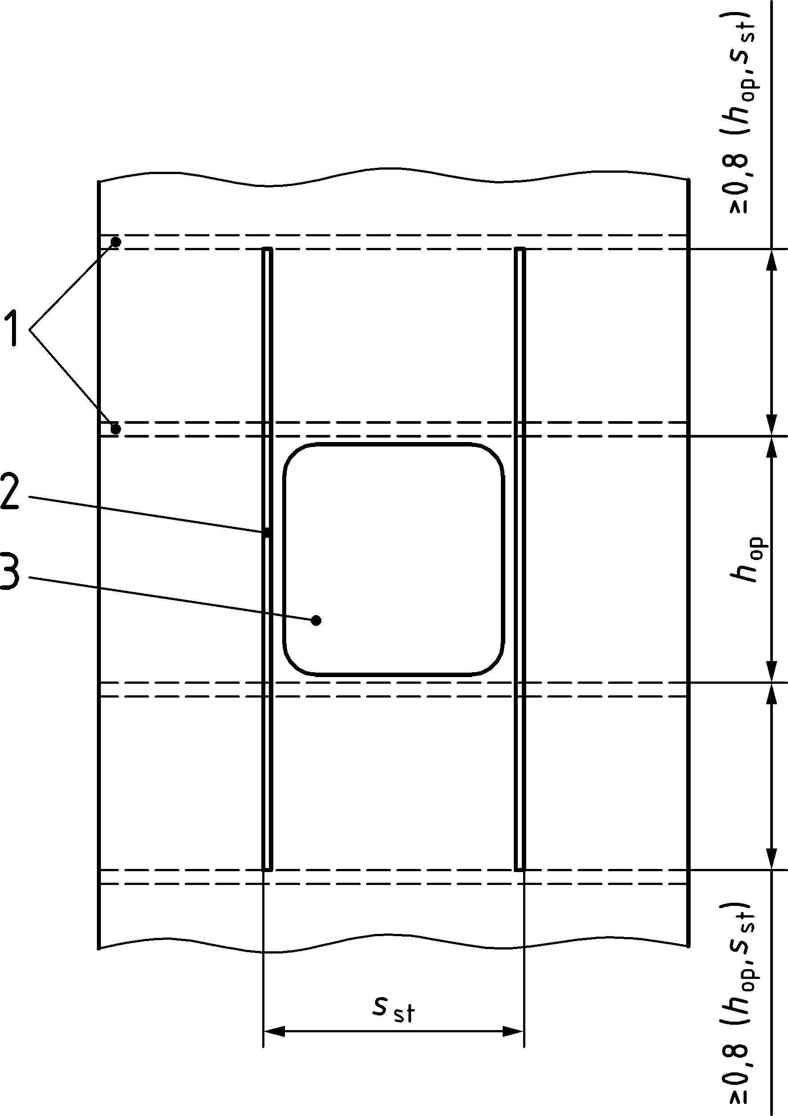

Key

|  |  |
| --- | --- |
| 1 | Possible stiffening rings |
| 2 | Longitudinal stiffener |
| 3 | Opening |

Figure 8.1 — Stiffening openings

(5) When longitudinal stiffeners are used, care should be taken to ensure that any circumferential bending stresses of the shell walls, occurring in the vicinity above and below the respective openings, are taken into account, if load distribution of the meridional (longitudinal) stresses is considered.

(6) The longitudinal stiffeners should be chosen long enough to be capable of distributing stresses into the shell.

(7) Local stress distribution may generally be deemed to be satisfied if the stiffeners extend above and below the opening over a distance of at least 0,8 times the spacing of the stiffeners or 0,8 times the height of the opening, whichever is the greatest and the maximum angle of the opening, measured in a horizontal section, should be less than or equal to 120°.

NOTE The National Annex can define limits for the opening.

(8) Additional ring stiffeners attached at the hole’s edge, and at the end of the longitudinal stiffeners, may be used for the absorption of the circumferential bending stresses.

(9) Ring stiffeners should be checked according to prEN 1993‑1‑6:2023, Annex C.

#### Stability verification

(1) The stability of the structural shell should be verified by checking it for the ultimate limit state of local shell buckling, using the methods given in prEN 1993‑1‑6:2023, Clause 8.

(2) When the structural shell is calculated for external actions as a global beam, see 7.4(4), the stress design concept in EN 1993‑1‑6 should be applied.

(3) When global second order beam theory needs to be applied, see 7.4, the shell buckling check should be carried out with meridional compressive membrane stresses which include second order effects.

#### Design of other structural elements of a shell structure

(1) If the load bearing system of the shell is connected to other structural elements, the strength and stability of such elements and their connections should be verified in accordance with 8.3, 8.2.1 and 8.2.2.

(2) The strength and stability of liners of double-wall chimneys or multi-flue chimneys should be verified in the same manner as the structural shell, see 8.2.4.1.

(3) If relevant, the shell buckling check of a liner may be handled as a serviceability check, see Clause 9.

## Joints

### General

(1) For joints see EN 1993‑1‑8.

(2) The partial factors for different components of joints in structures covered by this standard are given in FprEN 1993‑1‑8:2023, Table 4.1.

NOTE 1 The National Annex can define different values of partial factors.

NOTE 2 For execution see Annex E.

Note 3 For steel shells used as liners and/or connecting flue-pipes, information on gas tightness and insulation of joints is given in EN 13084‑6 and EN 13084‑7.

### Bolted flange plate joint configurations

(1) The following rules apply to the connection between two leg members in lattice sections using either circular hollow sections or solid round bars.

(2) Where there is a possibility of tension across the connection preloaded bolts, or bolts tightened in accordance with E.4(5) should be used.

(3) Where significant fatigue loading is expected, preloaded bolts should be used. Where significant fatigue loading is not expected (e.g. bolts only go into tension during erection, or for short durations), non-preloaded bolts may be used provided that they are secured against loosening with locking devices according to EN 1090‑2.

(4) The design tension resistance *N*t,Rd of a bolted circular flange joint configuration with 3 or more bolts should be taken as the smallest of the following design resistances:

— Flange yielding in bending see a)

— Bolt failure see b)

— Weld failure see EN 1993‑1‑8

For dimensions of a bolted circular flange in tension see Figure 8.2.

a) The design tension resistance from bending of the flange should be determined as follows:

 (8.4)

where

|  |  |
| --- | --- |
|  | |
| *f*y,f | is the yield strength of the flange; |
|  | |
| *n*b | is the number of bolts |
|  | |
| *a*ws | is the throat thickness of the weld |
|  | |

b) The design tension resistance of bolts should be obtained from:

 (8.5)

where

|  |  |
| --- | --- |
|  | is the total value of  for all the bolts in the connection; |
|  | is the design tension resistance of a bolt, see EN 1993‑1‑8; |
|  | |
|  | |

(5) In presence of an axial force and a global bending moment, the following conservative method may be used:

 (8.6)

where

|  |  |
| --- | --- |
| *M*j,Rd | is the minimum of design moment resistance of the connection, assuming no axial force: |
|  |  |
| *N*t,Rd | is the design tension resistance of the bolted circular flange connection (see (4)). |
| *N*c,Rd | is the design compressive resistance of the connection, equal to the design resistance of the welds connecting the circular hollow section or solid round bar to the ring flange; |
| *N*j,Rd | is the design axial resistance of the joint, assuming no applied moment. |

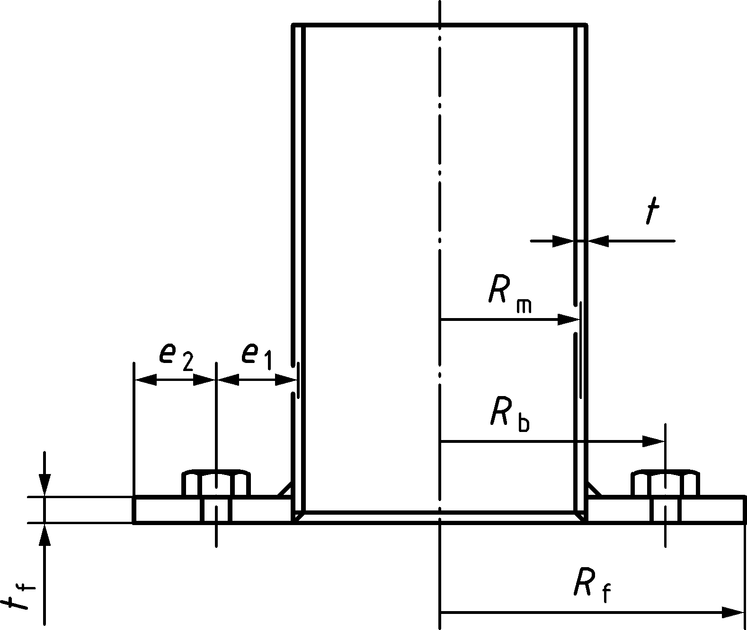



Figure 8.2 — Bolted circular flange in tension

(6) In case of different diameters on the two sides of the flange, both sides should be verified according to the rules given in 8.3.2.

### Connection of the main structure to the foundation or supporting structure

(1) The connection of a steel shell to the concrete foundation or to the supporting structure shall resist the overturning moment, normal force and shear force developed at the shell base and transmitted to the foundation.

(2) When a steel shell is connected using a base plate and anchor bolts, the load in the bolts should be calculated taking into consideration the eccentricity of the loading transmitted by the shell.

NOTE The National Annex can give further information on the design of the connections to foundations.

(3) Where fatigue needs to be considered, anchor bolts should be preloaded. In such cases appropriate steel materials should be used, see EN 1993‑1‑8.

NOTE 1 For verification of the fatigue design situation see Clause 10.

NOTE 2 For the choice of the preload see also rules for prying force eccentricity, stress levels, etc. in EN 1993‑1‑8.

NOTE 3 Non-preloaded bolts can meet the fatigue requirements if oscillations are significantly reduced by using aerodynamic or damping devices.

(4) Where openings are close to the connection of the structure to the foundation, the effect of the stress distribution around the opening and in proximity to the foundation should be taken into account in the design of the connection (see 7.4).

### Special connections

#### Guy connections

(1) All connections of the guys to the structure or to guy foundations should allow the guy to rotate freely about axes perpendicular to the line of the guy, see EN 1993‑1‑11.

NOTE Generally for connections with pins the freedom for rotations about an axis perpendicular to the guy, in the plane containing the guy can be obtained by rounding the edges of the hole in the centre plate for the pin. Spherical bearings can be used in exceptional circumstances.

(2) Account should be taken in the design and detailing of the guy connections to prevent twist under tensile loading in guys that are not torque balanced.

(3) All pins should be adequately secured against lateral movement.

NOTE The use of a nut combined with a split pin can adequately secure the pin against lateral movement.

(4) The guy attachment plate on the mast and the steel anchor plate projecting from the guy foundation should both be designed for the lateral force from the guy due to the wind loading component normal to the vertical plane containing the guy.

(5) Wherever practicable welded connections should be detailed to enable visual and non-destructive inspections to be undertaken in service.

#### Spherical pinned connection

(1) The design bearing stress on a spherical pinned connection should be based on the design rules for rocker bearings, see EN 1337‑6.

(2) To verify that the area of the compression zone is within the boundaries of the bearing parts taking due account of the true rotation angle of the mast base section (see Figure 8.3) and to determine the bending moments caused by the resulting eccentricities for designing the bearing and the bottom section of the mast the following rules for determining eccentricity should be used:

If the mast base rests on a spherical bearing the point of contact should be assumed to move in the direction of any inclination of the mast axis by rolling over the bearing surface.

The eccentricities  and  (see Figure 8.3) should be determined as follows:

 (8.7)

 (8.8)

 (8.9)

 (8.10)

If *r*2 is infinite (i.e. a flat surface),  should be taken as 

where

|  |  |
| --- | --- |
| *r*1 | is the radius of the convex part of the bearing |
| *r*2 | is the radius of the concave part of the bearing (note: |
| *ϕ* | is the inclination from vertical of the mast axis at its base (in radians) |
| *e*u | is the radial distance from the mast axis when *ϕ* = 0 to the centroid of the compression zone area for an inclination of the mast axis of *ϕ* |
| *ψ*1 | is the angle between the mast axis when *ϕ* = 0 and the centroid of the compression zone area (in radians) |
| *ψ*2 | is the angle between the mast axis when rotated by *ϕ* and the centroid of the compression zone area (in radians) |

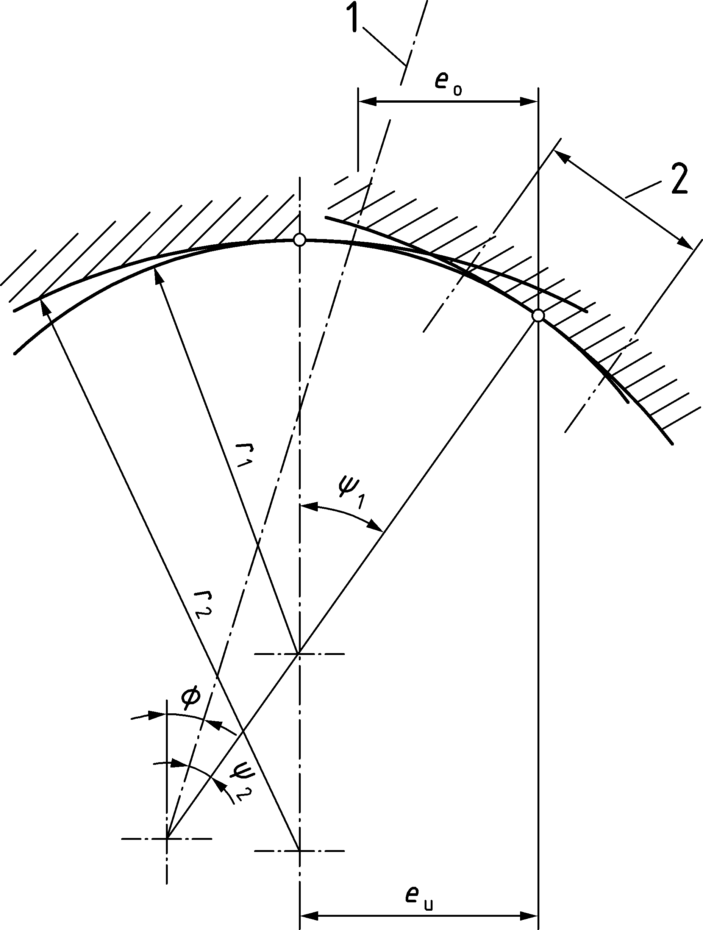

Key

|  |  |
| --- | --- |
| 1 | mast axis |
| 2 | area of compression zone |

Figure 8.3 — Eccentricities due to the inclination of the mast base

NOTE The National Annex can give information on eccentricities and limit values for the Hertz pressure.

(3) It should be verified that the compression zone is within the boundaries of the bearing parts.

(4) Any system for suppressing twisting of a pinned mast base joint should be designed to permit rotation of the mast base section about the horizontal axes.

# Serviceability limit states

## Basis

(1) Relevant serviceability limit states connected with the appearance or effective use of the structure should be considered according to EN 1990:2023, A.3.5.2, including:

— the proper functioning of aerials or services;

— loss of transmitted signals;

— alarm among bystanders;

— damage to non-structural elements.

(2) The following serviceability limit states should be considered relevant for design:

— deformations, deflections or rotations;

— vibration.

(3) The serviceability criteria should be specified for each project and agreed with the relevant authority.

NOTE The client can consider the following:

For the duration of exceedance of such limits, see prEN 1991‑1‑4:2024, Clause F.8. Alternatively, where appropriate records are available the statistical distribution of speeds appropriate to the site can be obtained by analysis of validated wind records obtained in open terrain as near as possible to the site.

## Deflections and rotations

### Requirements

(1) Vertical and horizontal deflections and rotations should be calculated according to EN 1990:2023, A.3.7.2.

### Limiting values of deflection

(1) Limiting values should be specified according to EN 1990:2023, A.3.7.2.

(2) For telecommunication and floodlighting structures, the limiting values to be considered should be taken as those for flexural and torsional rotation at the top of the structure. For directional antennae, the limiting values should be taken at the point of the attachment of the directional antenna.

(3) For self-supporting structures, the limit value of maximum displacement should be *h*/50, if no stronger requirements are applicable.

(4) In a double skin or multi-flue chimney, the influence of deformations or displacements of the structural shell on the distribution of bending moments in the liner should be taken into account.

## Vibrations

### Requirements

(1) Structures and structural elements should be examined for relevant vibrations (see EN 1990:2023, A.3.7.3), which are:

— gust induced vibrations;

— vortex induced vibrations (VIV) of structures containing prismatic cylindrical, bluff elements or shrouds;

— galloping instability;

— rain-wind induced vibrations.

NOTE 1 Vibrations can cause rapid development of fatigue damage, see Clause 10.

NOTE 2 If structures are predicted to be subjected to excessive wind vibrations damping devices can be used, unless other measures are taken to reduce these in the design.

NOTE 3 Galloping and rain-wind induced vibrations can be minimized by good design practice. Guidance on VIV, galloping and rain-wind can be found in EN 1991‑1‑4.

### Limiting values

(1) Limits for the overall vibration deflections are given by Client’s requirements. If there are no requirements from the Client, the requirements in 9.2.2 may be used.

(2) Limiting values from prEN 1991‑1‑4:2024, Annex E should be considered.

# Fatigue

## General

(1) Possible fatigue action that arise from stress ranges induced by in-line and cross wind dynamic responses should be considered.

NOTE 1 Vortex induced vibrations (VIV) can cause significant fatigue damage.

NOTE 2 In structures that comply with the criteria for use of the equivalent static methods in EN 1991‑1‑4, aerodynamic damping is usually sufficiently high to limit fatigue damage from gust induced vibrations.

(2) For verification of the fatigue design situation, the provisions of EN 1993‑1‑9 and detail categories in prEN 1993‑1‑9:2023, Table 9.11 should be applied.

(3) Consideration should be given to the effects on fatigue resistance of the possible existence of secondary moments in lattice towers and masts.

NOTE See 7.2 (2), (3) and (4).

(4) For chimneys which are used at temperatures higher than 400°C, the addition of the temperature induced damage with the fatigue damage should be duly accounted for.

## Fatigue loading

### In-line vibrations

(1) Fatigue loading of self-supporting structures due to gust induced vibrations (without cross-wind vibrations) induced by gusty wind may normally be neglected.

(2) The fatigue life of masts subject to gust induced vibrations only (without cross-wind vibrations) induced by gusty wind may be assumed to be greater than 50 years, provided that:

— bolts are tightened (see E.4(5))

— detail categories of the structural details are greater than 71 MPa.

(3) Where conditions in (2) do not apply due account should be taken of the details adopted, and verification of the fatigue design situation should be undertaken. For the verification of the fatigue design situation due to in-line vibrations see EN 1991‑1‑4. The following simplified method may be used:

a) The fatigue stress history due to wind gusts is evaluated by determining the annual durations of different mean wind speeds from different directions from meteorological records for the site. The fluctuations about the mean values can then be assumed to have a statistically normal distribution with a standard deviation in stress corresponding to 1/4 times the member load effect. The appropriate member load effect can be found in prEN 1991‑1‑4:2024, Annex J:

For towers: *P*t,W(*z*) − *P*m,W(*z*) (see prEN 1991‑1‑4:2024, J.2.2.3)

For masts: SP (see prEN 1991‑1‑4:2024, J.3.3.2.4(3))

b) The stress range, Δ*σ*S, can be assumed to be 1,1 times the difference between the stress arising from that incorporating the gust response factor and that due to the 10-min mean wind speed. An equivalent number of cycles *N* can then be obtained from:

 (10.1)

where

|  |  |
| --- | --- |
| *T*life | is the design life of the structure in years. |

### Global effects of cross-wind vibrations

(1) The fatigue loading of towers and masts consisting of supporting or containing prismatic or cylindrical elements should be determined from the amplitude for the relevant vibration mode and the number of stress cycles *N*.

NOTE For the fatigue actions see prEN 1991‑1‑4:2024, Annex H.

### Individual member response

(1) Slender individual members of structures should be assessed for cross-wind excitation according to EN 1991‑1‑4.

NOTE 1 Although the restriction of slenderness does not exclude the possibility of cross-wind vibrations, the limitations on slenderness given in C.5(1) and C.6(1) can generally be sufficient to prevent such excitation. Out of plane vibrations of tubular diagonals behind tubular legs of larger diameter can be excessive, especially if the diagonal diameter to thickness ratio (*D*/*t*) is larger than 40 or the inclination of the diagonal is larger than 45deg with a horizontal plan - even if slenderness criteria of Annex C are respected. For further information see prEN 1991‑1‑4:2024, H.4.4.

NOTE 2 In the absence of measurements, logarithmic decrement (*δ*s) can be found in prEN 1991‑1‑4:2024, Table I.2. For individual bracing members with bolted connections *δ*s = 0,015 can be applied. For other members *δ*s = 0,010 can be applied.

NOTE 3 An increase of damping (friction, additional dampers) can be practical means of reducing such vibrations.

## Safety assessment

(1) See EN 1993‑1‑9 for resistances of details typical for structures and EN 1993‑1‑11 for guy elements.

(2) If there is a corrosion allowance for the plate thickness instead of a corrosion protection system, the details should be classified one detail category lower than the value given in the tables of the detail categories except for the lowest, for which a reduction of 10 % should be considered.

(3) The minimum quality level for the welds of shells structures subjected to fatigue should be quality level C according to EN ISO 5817.

(4) Fatigue in foundations should be considered taking into account the stress variation of the anchor bolts.

NOTE A nut under the flange plate can increase the stress variation of the anchor bolts significantly.

(5) The partial factors for fatigue should be taken as specified EN 1993‑1‑9. For *γ*Ff the value *γ*Ff = 1,00 is recommended. For *γ*Mf the values in prEN 1993‑1‑9:2023, Table 5.1 are recommended.

NOTE The National Annex can give different numerical values for *γ*Ff and *γ*Mf.

1. (normative)  
     
   Dampers including aerodynamic measures
   1. Use of this Annex

(1) This Normative Annex contains additional provisions for dampers including aerodynamic measures.

* 1. Scope and field of application

(1) This Annex describes the damping devices to reduce the vibration of the structures.

(2) These damping devices should be used when vibrations can lead to damage or to exceeding the criteria of serviceability limit state.

* 1. General

(1) Damping devices may consist of:

— vibration absorbers;

— aerodynamic devices, such as helical strakes, spoilers or shrouds;

— cables with damping devices; and

— damping against a fixed point.

(2) Their effect should be verified by means of theoretical and/or experimental methods.

(3) Tests to verify the capability of function, frequency adaption and damping of the system may be undertaken. A certificate should be prepared, which, in the light of the tests, verifies that the achieved damping agrees with the furnished analysis. These tests may be tests on the structure or factory acceptance tests.

(4) When dampers are installed an inspection and a maintenance program should be prepared for the dampers.

* 1. Vibration absorbers
     1. Structure dampers

(1) A dynamic vibration absorber may be used to reduce vibrations.

(2) The damper should be designed considering the mass, natural frequency, damping and other relevant parameters, to enhance the damping of the structure.

(3) The required magnitude of the effective damping should be determined from the analysis of the cross-wind vibration, including fatigue effects, see EN 1990:2023, A.3.8.3.

* + 1. Direct damping

(1) Direct damping may be provided for the mode under consideration by mounting a damping element between the structure and the fixed point, if a fixed point near the structure is available at a sufficient height.

For coupled identical structures with the same natural frequency an increase of structural damping is not allowed because of the coupling.

* + 1. Guy dampers
       1. General

(1) To suppress the possible vibrations that can occur in guys under wind, one of the following procedures should be followed:

a) Dampers may be mounted on guys in all cases where the initial tension is greater than 10 % of the rated breaking strength of the guy.

b) Where guy dampers are not fitted the guys should be carefully observed during the first years of service to ensure that excessive frequency and/or amplitude of oscillations are not occurring. Otherwise dampers as described in a) should be fitted.

NOTE For vibrations see prEN 1991‑1‑4:2024, Annex J.

(2) The efficiency of dissipation measures should be proven by appropriate tests conducted on the completed structure.

* + - 1. Dampers to reduce vortex excitation

(1) Appropriate dampers should be installed in all cases where unacceptable vortex-excited vibrations are predicted or have been observed. Dampers should conform to appropriate technical specifications. A frequency band of vibration should be specified.

* + - 1. Dampers to prevent galloping (including rain/wind induced vibrations)

(1) Partial control of galloping and rain/wind induced vibrations may be obtained by the attachment of a rope from guy to guy, connecting the points of maximum amplitude of two or more guys. The effect of this under high wind conditions should be considered in the design of the connections to the guy.

NOTE Hanging chains can also be used to provide partial control of galloping, if the chains will operate over the relevant frequency range.

* 1. Aerodynamic damping measures

(1) Aerodynamic measures, such as strakes, shrouds, or slats, which disturb the regular vortex shedding may be used to reduce the exciting force. Steel shells with helical strakes may be designed using the following criteria provided the Scruton number is larger than 8 (see prEN 1991‑1‑4:2024, Annex E). For other aerodynamic measures, independent verification as to the effectiveness of such measures should be provided, such as results from wind tunnel tests.

(2) The geometry of such helical strakes should follow:

— three start strakes;

— pitch of the strakes

*h*s = 4,5 *D* to 5,0 *D*; (A.1)

— depth of the strakes

*t*s = 0,10 *D* to 0,12 *D*; and (A.2)

— strakes extend over a length *Ɩ*s of at least 0,3 *H*, and normally between 0,3 *H* and 0,5 *H*. However, a top portion not exceeding 1,0 *D* with no strakes is permitted and may be included in the length *Ɩ*s.

Where *D* is the diameter of the structure.

(3) For two or more similar circular structures located close to each other, the strakes may prove less effective than indicated in Formula (A.1). If the centre distance between cylindrical structures is less than 5 *D*, either a special investigation of the effects of strakes with respect to vortex shedding should be made, or else the strakes should be assumed to be ineffective.

(4) The provision of strakes or shrouds will increase the drag factor of the circular section on which they are mounted (see EN 1991‑1‑4).

* 1. Design of dampers assisted by testing
     1. General

(1) When the values for the logarithmic decrement of damping given in EN 1991‑1‑4 are considered inappropriate or when after the installation of damping measures the effects of these dampers need to be verified, the following guidance should be used to determine the logarithmic damping decrement for structures from test.

* + 1. Procedure for measuring the logarithmic damping decrement

(1) Higher modes than the fundamental might be significant, particularly for guyed structures, so due account of this should be taken in determining the appropriate logarithmic decrement of structural damping.

(2) Account should be taken of the fact that the frequencies of vibration vary according to the loading condition considered for instance in still air, under wind, or under ice loading.

(3) The signal of the measurement may be obtained from acceleration, deflection, forces or strain of the structure.

(4) Different measurement methods may be used, such as decay curve method, auto-correlation method or half-band-width method.

(5) It should be ensured that the measurement includes the total vibration energy, thus the measurement should be undertaken in two orthogonal directions simultaneously.

(6) The dependency of vibration amplitudes should be considered in the analysis of the measured data.

(7) The amplitude in the test should be in the range of the estimated amplitude of the design due to vortex shedding or it should be ensured that the damping of this estimated amplitude is on the safe side.

(8) The influence of the aerodynamic damping should be subtracted from the measured value if there is wind blowing during the test. For the definition of aerodynamic damping see EN 1991‑1‑4.

1. (normative)  
     
   Guys, insulators, ancillaries and other items
   1. Use of this annex

(1) This Annex contains additional provisions for the use of guys, insulators, ancillaries and other items that can be used in the structure.

* 1. Scope

(1) This Annex describes the use of guys, insulators, ancillaries and other items that can be used in the structure.

* 1. Guys
     1. General

(1) Each guy assembly should incorporate a linkage system to enable adjustments to be made to the tension and to facilitate installation or replacement.

(2) Due consideration should be given to lateral movements of the guy in service when sizing link plates and pins, and in the design of attachments to the mast.

(3) Terminations for guys and their bearing elements within the structure should be proportioned such that their load carrying capacity and the fatigue resistance are compatible with that of the actual guy.

NOTE Guys used in masts comply with this clause, if their design resistance can be taken as the minimum of the design resistance of the guy and the design resistance of the termination.

* + 1. Metallic guys and tension elements

(1) For metallic guys and tension elements, see EN 1993‑1‑11.

(2) Filling material in the sockets should be metallic.

(3) Termination of tension elements should not be done using U-bolt wire ropes grips like in EN 13411‑5.

NOTE The National Annex can give further information on guys and tension elements.

* + 1. Non-metallic guys

(1) Materials other than steel may be used for guys if they have an acceptable modulus of elasticity and provided that appropriate measures are taken to prevent vibrations in higher frequencies.

(2) The ends of such ropes should be sealed to prevent entrance of moisture which might otherwise lead to the discharge of lightning. Partial factors for non-metallic guys should be higher than for steel guys.

(3) Non-metallic guys should comply with the relevant technical specification. In this case time-dependant effects should be considered in the maintenance program.

NOTE 1 In the selection of synthetic materials the low modulus of elasticity of some products can require a higher initial tension to compensate for their lower stiffness, which can lead to possible high frequency vibrations.

NOTE 2 The National Annex can give further information on non-metallic guys.

* 1. Insulators

(1) Insulators should be selected dependent on electrical and mechanical requirements.

(2) The minimum ultimate strength should be taken from relevant technical specifications.

(3) Each guy insulator fitting should be designed such that even if an insulator suffers electrical failure the stability of the mast is still ensured. This can be achieved, for example using failsafe insulators or insulators in parallel.

(4) Arcing arrangements should be made such that arcing will not occur along the surface of the insulating materials adjacent to the steel fitting.

(5) Jacking facilities should be provided to enable replacement of units, where insulators are used at the base of the mast.

(6) Mechanical loading and unloading for ceramic insulating material (during mechanical tests and/or during construction) should be carried out in accordance with the relevant technical specifications.

NOTE For electrical properties see EN 60060‑1 and EN 60060‑2.

(7) During tensioning and detensioning the application of force should be done slowly and free of impacts. The speed of the force application should not exceed 5 % of the maximum force per minute.

* 1. Ancillaries and other items
     1. Ladders, platforms, etc.

(1) Ladders, platforms, safety rails and other ancillaries should comply with the relevant specifications.

NOTE The National Annex can give further information on ladders, platforms etc.

* + 1. Lightning protection

(1) Structures and guys should be effectively earthed for protection against lightning. This can be achieved by a metallic tape ring around the base connected to metallic plates and rods embedded in the soil. Guy anchors should be similarly protected.

(2) The earthing system should be completed before erection of the steelwork, and connections should be made to the guy earthing system as erection work proceeds.

(3) Further bonding should be incorporated if all the structural joints are not electrically continuous.

NOTE The National Annex can give further information on lightning protection.

* + 1. Aircraft warning

(1) Structures that constitute a hazard to aerial navigation should be marked.

NOTE The National Annex can give further information on aircraft warning.

* + 1. Protection against vandalism

(1) Suitable protective measures should be installed to restrict access by unauthorized persons.

NOTE The National Annex can give further information on protection against vandalism.

1. (normative)  
     
   Buckling of components of towers and masts
   1. Use of this annex

(1) This Normative Annex contains additional provisions for the methods to be used for buckling verification of components.

* 1. Scope and field of application

(1) This Annex describes the methods to be used for buckling verification of components.

* 1. Buckling resistance of compression members

(1) The design buckling resistance of a compression member in a lattice tower or mast should be determined according to EN 1993‑1‑1.

(2) For constant axial compression in members of constant cross-section, the reduction factor *χ* and the factor *Φ* to determine *χ* should both be determined with the effective relative slenderness  instead of . The effective relative slenderness  is defined as:

 (C.1)

where

|  |  |
| --- | --- |
| *K* | is the effective slenderness factor obtained from C.4; and |

 (C.2)

|  |  |
| --- | --- |
| *λ*1 | is defined in EN 1993‑1‑1; |
| *λ* | is the slenderness for the relevant buckling mode. |

NOTE The effective slenderness considers the support conditions of the compression member.

(3) For single angle members which are not connected rigidly at both ends (at least with two bolts, if bolted), the design buckling resistance defined in C.3(1) should be reduced by a reduction factor *𝜔*.

NOTE Unless the National Annex gives different values, the reduction factor *w* is

— *𝜔* = 0,8 for single angle members connected by one bolt at each end;

— *𝜔* = 0,9 for single angle members connected by one bolt at one end and continuous or rigidly connected at the other end.

* 1. Effective slenderness factor *K*

(1) In order to calculate the appropriate effective slenderness of the member, the effective slenderness factor *K* may be determined according to the structural configurations.

a) *Leg members*

*K* should be obtained from Table C.1.

b) *Diagonal bracing members*

*K* should be determined taking account of both the bracing pattern (see Figure C.1) and the connections of the bracing to the legs. In the absence of more accurate information values of *K* should be obtained from Table C.2.

c) *Horizontal bracing members*

In the case of horizontal members of *K*-bracing without plan bracing (see C.6.10) that have compression in one half of their length and tension in the other, the effective slenderness factor *K* for buckling transverse to the frame determined from Table C.2, should be multiplied by the factor *K*1 given in Table C.3 depending on the ratio of the tension force, *N*t, to the compression force, *N*c.

Table C.1 — Effective slenderness factor *K* for leg members

| Symmetrical bracing | | | | Unsymmetrical bracing | | | |
| --- | --- | --- | --- | --- | --- | --- | --- |
| Section |  | a |  | Section |  | a |  |
| Axis | v-v | | y-y | Axis | v-v | y-y | y-y |
| **Case (a)**  Primary bracing at both ends | but ≥ 0,9  and ≤ 1,0 | | 1,0 b | Discontinuous top end with horizontals  **Case (d)**  Primary bracing at both ends | but ≥ 1,08  and ≤ 1,2  on *L*2 c | but ≥ 1,08  and ≤ 1,2  on *L*1 | 1,0  on *L*1 b |
| asymmetric  symmetric  **Case (b)**  Primary bracing at one end and secondary bracing at the other | but ≥ 0,9  and ≤ 1,0 | | 1,0 b |
| **Case (e)**  Primary bracing at both ends | but ≥ 0,9  and ≤ 1,0  on *L*2 c | but ≥ 0,9  and ≤ 1,0  on *L*1 | 1,0  on *L*1 b |
| **Case (c)**  Secondary bracing at both ends | but ≥ 0,9  and ≤ 1,0 | | 1,0 |
| NOTE For the definition of axes see EN 1993‑1‑1. | | | | | | | |
| a The above values only apply to 90° angles.  b A reduction factor can be justified by analysis.  c Only critical if unequal angle section is used. | | | | | | | |

Table C.2 — Effective slenderness factor *K* for bracing members, single and double bolted angles

| Type of restraint | Examples | Axis | *K* |
| --- | --- | --- | --- |
| Discontinuous both end  (i.e. single bolted at both ends of member) |  | v-v |  |
| y-y |  |
| z-z |  |
| Continuous one end  (i.e. single bolted at one end and either double bolted or continuous at other end of member) |  | v-v |  |
| y-y |  |
| z-z |  |
| Continuous both ends  (i.e. double bolted at both ends, double bolted at one end and continuous at other end, or continuous at both ends of the member) |  | v-v |  |
| y-y |  |
| z-z |  |
| NOTE 1 Above details are shown for illustrative purposes only and might not reflect practical design aspects.  NOTE 2 Details are shown for connections to angle legs. The factor *K* applies equally to connections to tubular or solid round legs through welded gusset plates. | | | |

Table C.3 — Effective slenderness factor *K* for bracing members, circular hollow sections and rods

|  | Type | | Axis | *K*a, b |
| --- | --- | --- | --- | --- |
| Legs of circular hollow section or rods | single bolted tube | | in plane | 0,95 c |
| out of plane | 0,95 c |
| tube connected with 2 bolts | welded tubes with end plates | in plane | 0,85 |
| out of plane | 0,95 c |
| welded tubes d and rods with welded gussets | | in plane | 0,70 |
| out of plane | 0,85 |
| directly welded tubes and rods | | in plane | 0,70 |
| out of plane | 0,70 |
| welded bent rods | | in plane | 0,75 |
| out of plane | 0,75 |
| Where leg members are angles bars, a value of “*K*” = 1,0 should be used.  Details are shown for illustrative purposes only and do not reflect practical design aspects. | | | | |
| a Where ends are not the same, the average value of the “*K*” may be used.  b For members with intermediate secondary bracing, the buckling length equals the distance between the end connection and the bracing point and values of 1,0 may be used for “*K*” – unless a smaller value is justified by tests.  c Reduction should be applied to the actual length only (distance between nodes). The resulting buckling length should not be less than the distance between end bolts.  d A connection with two preloaded bolts can qualify for this condition subject to analysis. | | | | |

Table C.4 — Modification factor (*K*1) for horizontal members of *K*- and *X*-brace without plan bracing

| **Ratio** | **Modification factor** |
| --- | --- |
|  | *K*1 |
| 0,0 | 0,73 |
| 0,2 | 0,67 |
| 0,4 | 0,62 |
| 0,6 | 0,57 |
| 0,8 | 0,53 |
| 1,0 | 0,50 |
| A value of *K*1 = 1,0 applies when both members are in compression. | |

* 1. Leg members

(1) The effective slenderness for leg members should generally be not more than *Kλ* = 150.

(2) For single angles, tubular sections or solid rounds used for leg sections with axial compression braced symmetrically in two normal planes, or planes 60° apart in the case of triangular structures, the slenderness should be determined from the system length between nodes.

(3) Shorter buckling length of legs may be justified by analysis taking due account of the continuity of the legs and the distribution of the axial force in the structure.

(4) Where bracing is staggered in two normal planes or planes 60° apart in the case of triangular structures, the system length should be taken as the length between nodes. The slenderness for the case shown in Table C.1, case (d) should be determined from Formula (C.3) or Formula (C.4) as appropriate. The slenderness should be taken as:

 for angles; (C.3)

 for hollow sections (C.4)

*L*1 and *L*2 see Table C.1

NOTE The value  can be conservative in relation to a more refined analysis taking account of realistic end conditions.

(5) Built-up members for legs may be formed with two angles in cruciform section or of two angles back to back.

(6) Built-up members consisting of two angles back to back (forming a T) may be separated by a small distance and connected at intervals by spacers and stitch bolts. They should be checked for buckling about both rectangular axes. For the maximum spacing of stitch bolts, see EN 1993‑1‑1:2022, 8.4.5.

(7) Stitch bolts should not be assumed to provide full composite action where the gap between the angles exceeds 1,5 *t*, and the properties should be calculated assuming a gap equal to the true figure or 1,5 *t*, whichever is the lesser where *t* is the thickness of the angle. If batten plates are used in addition to stitch bolts the properties corresponding to the full gap should be taken. See EN 1993‑1‑1:2022, 6.4.4.

(8) Battens should prevent relative sliding of the two angles; if bolted connections of categories A and B are used, see FprEN 1993‑1‑8:2023, 3.4, the bolt hole diameter should be reduced.

NOTE 1 The rules (6) to (8) can also apply to built-up members in bracings.

NOTE 2 The National Annex can give further information on slenderness factors.

* 1. Bracing members
     1. General

(1) The following rules should be used for the typical primary bracing patterns shown in Figure C.1. Secondary bracings may be used to subdivide the primary bracing or main leg members as shown, for example, in Figure C.1 (IA, IIA, IIIA, IVA) and Figure C.4.

(2) The slenderness *λ* for bracing members should be taken as:

 for angles; (C.5)

 for hollow sections; (C.6)

where

|  |  |
| --- | --- |
| *L*di | is specified in Figure C.1. |

NOTE The value  can be conservative in relation to a more refined analysis taking account of realistic end conditions.

(3) The effective slenderness *Kλ* for primary bracing members should generally be not more than 180 and for secondary bracing not more than 250. For multiple lattice bracing (Figure C.1(V)) the overall effective slenderness should generally be not more than 350.

NOTE The use of high relative slenderness can lead to the possibility of individual members vibrating and can make them vulnerable to damage due to bending from local loads.

* + 1. Single lattice

(1) A single lattice may be used where the loads are light and the lengths relatively short, as for instance near the top of towers or in light masts (see Figure C.1(I)).

|  |  |  |  |  |  |  |  |
| --- | --- | --- | --- | --- | --- | --- | --- |
| Typical primary spacing patterns | | | | | | | |
| parallel or tapering | | | usually tapering | | | usually parallel | |
|  | | |  | | | Tension member | |
| I | II | III | IV | V | | VI | |
| Single lattice | Cross bracing | K-bracing | Discontinuous bracing with continuous horizontal intersections | Multiple lattice bracing | | Tension bracing | |
| *L*di = *L*d | *L*di = *L*d2 | *L*di = *L*d2 | *L*di = *L*d2 |  | |  | |
| Typical secondary bracing patterns (see also Figure C.3) | | | | NOTE The tension members in pattern VI are designed to carry the total shear in tension, e.g. | | | |
|  | | | |
|  | or | |  |
| IA | IIA | IIIA | IVA |
| Single lattice | Cross bracing | K-bracing | Cross bracing with secondary members |
|  | *L*di = *L*d1 | *L*di = *L*d1  *L*di = *L*d2 on rectangular axis | *L*di = *L*d1 |

Figure C.1 — Typical bracing patterns

* + 1. Cross bracing

(1) Provided that the load is equally split into tension and compression, the members are connected where they cross, and provided also that both members are continuous (see Figure C.1(II)), the centre of the cross may be considered as a point of restraint both transverse to and in the plane of the bracing and the critical system length becomes *L*d2 on the minor axis.

(2) Where the load is not equally split into tension and compression and provided that both members are continuous, the compression members should be checked in the same way for the largest compressive force. In addition, it should be checked that the sum of the buckling resistances of both members in compression is at least equal to the algebraic sum of the axial forces in the two members. For the calculation of the buckling resistances, the system length should be taken as *L*d and the radius of gyration as that about the axis parallel to the plane of the bracing. The slenderness may be taken as:

 for angles; (C.7)

 for hollow sections or solid rounds (C.8)

This recommendation also applies when secondary members in the plane containing them, and the primary cross-bracing are present.

NOTE Where either member cannot be continuous, the centre of the connection can only be considered as a restraint in the transverse direction if the detailing of the centre connection is such that the effective lateral stiffness of both members can be maintained through the connection and the longitudinal axial stiffness can be similar in both members.

* + 1. Tension bracing

(1) Each diagonal member of a pair of tension bracing members and the horizontals should be capable of carrying the full bracing shear load (see Figure C.1(VI)).

(2) Any contribution from diagonal compression members should be disregarded.

NOTE 1 Tension systems can be very sensitive to methods of erection and to modifications or relative movements. Detailing to give an initial tension within the bracing and to provide mutual support at the central cross can be required to minimize deflection.

NOTE 2 Light prestress can help minimize movement.

* + 1. Cross bracing with secondary members

(1) Where secondary members are inserted to stabilize the legs or bracing (see Figure C.1 and Figure C.2), the buckling length on the minor axis should be taken as *L*d1.

(2) Buckling should also be checked over length *L*d2 on the rectangular axis for buckling transverse to the bracing and then over length *L*d for the algebraic sum of the axial forces, see C.6.3.

* + 1. Discontinuous cross bracing with continuous horizontal at centre intersection

(1) The horizontal member should be sufficiently stiff in the transverse direction to provide restraints for the load cases where the compression in one member exceeds the tension in the other or where both members are in compression, see Figure C.1(IV).

(2) This criterion is satisfied by ensuring that the horizontal member withstands (as a compression member over its full length on the rectangular axis) the algebraic sum of the axial force in the two members of the cross-brace, resolved in the horizontal direction.

NOTE Additional allowance can be necessary for the bending stresses induced in the edge members by local loads transverse to the frame, such as wind.

* + 1. Cross bracing with diagonal corner members

(1) In some patterns of cross bracing a corner member may be inserted to reduce the buckling length transverse to the plane of bracing (see Figure C.2). A similar procedure to that used for C.6.3 may be used to determine whether this will provide a satisfactory restraint.

(2) In this case five buckling checks should be carried out as follows:

a) buckling of member against the maximum load over length *L*d1 on the minor axis;

b) buckling of member against the maximum load over length *L*d2 on the transverse rectangular axis;

c) buckling of two members in cross brace against the algebraic sum of loads in cross brace over the length *L*d3 on the transverse axis;

d) buckling of two members (one in each of two adjacent faces) against the algebraic sum of the loads in the two members connected by the diagonal brace over length *L*d4 on the transverse axis.

NOTE For this case the total resistance can be calculated as the sum of the buckling resistances of both members in compression (see C.6.3(2)).

e) Buckling of four members (each member of cross brace in two adjacent faces) against the algebraic sum of loads in all four members over length Ld on the transverse axis.

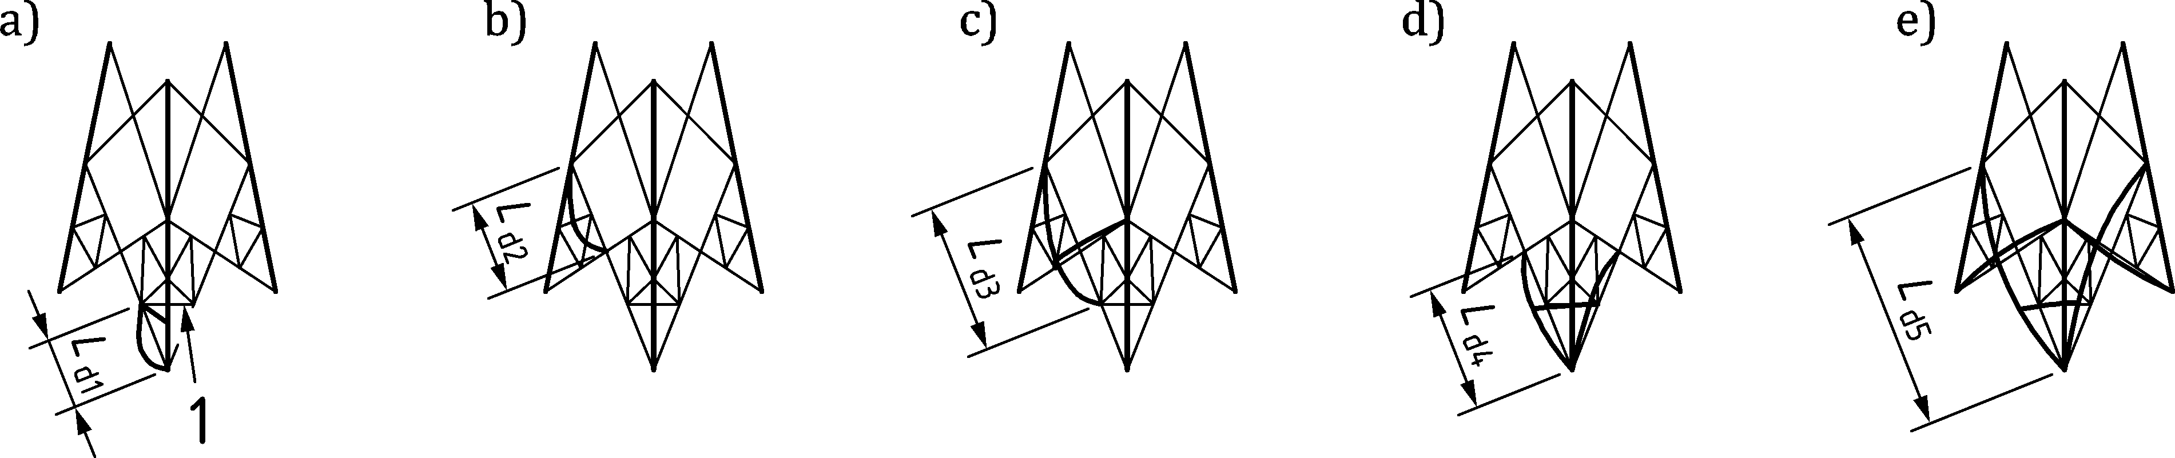

Key

|  |  |
| --- | --- |
| 1 | corner member (of limited effect if both braces are in compression) |

Figure C.2 — Cross bracing with diagonal corner members

* + 1. Diagonal members of K-bracing

(1) In the absence of any secondary members (see Figure C.1(III)) the critical system length may be taken as *L*d2 on the minor axis.

(2) Where secondary bracing in the faces is provided but no hip bracing (see Figure C.1(IIIA) the critical system length should be taken as *L*d2 on the appropriate rectangular axis. Thus, the slenderness should be taken as:

 (C.9)

(3) Where secondary bracing and triangulated hip bracing is provided (see Figure C.3), then

a) the appropriate system length between such hip members *L*d4 should be used for checking buckling transverse to the face bracing on the appropriate rectangular axis. Thus, the slenderness may be taken as:

 for all types of section (C.10)

b) buckling of two members (one in each of two adjacent faces) against the algebraic sum of the loads in the two members connected by the diagonal brace over length *L*d2 on the transverse axis.

 for all types of section (C.11)

NOTE For this case the total resistance can be calculated as the sum of the buckling resistances of both members in compression (see C.6.3(2)).

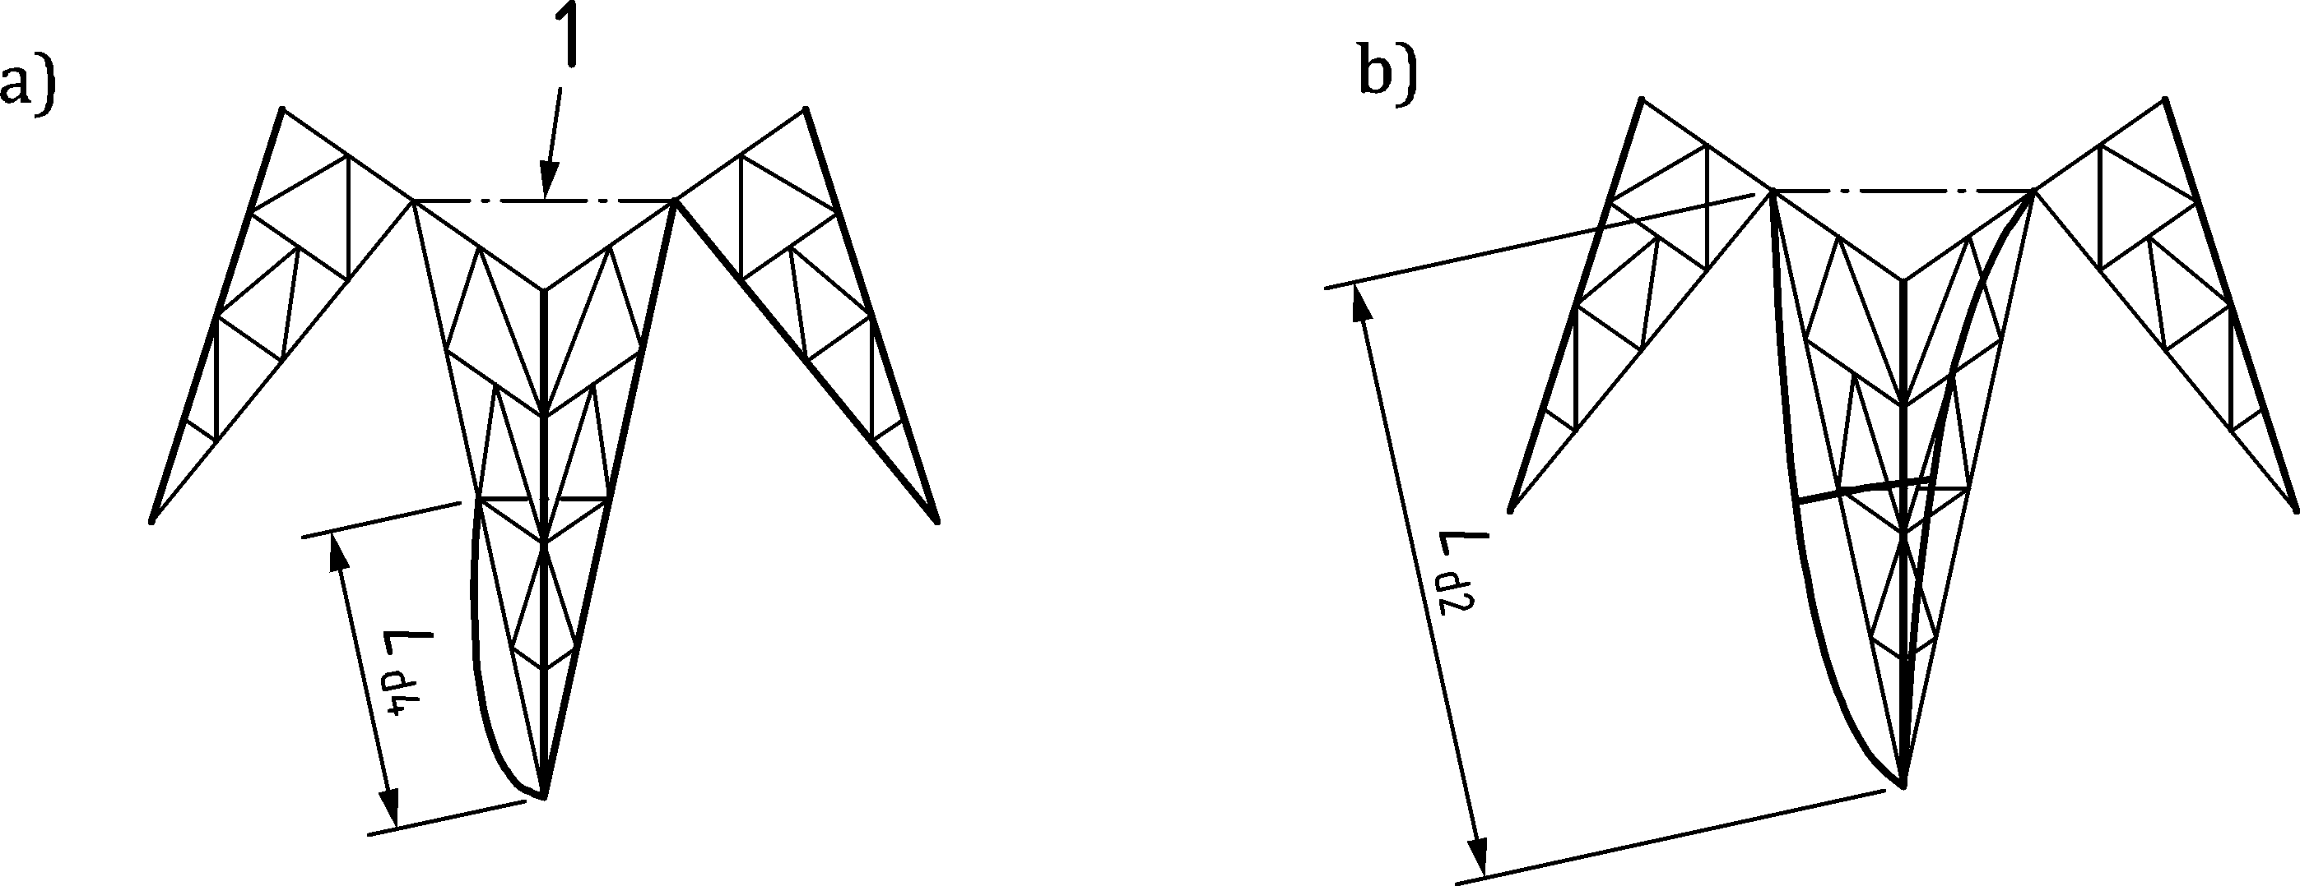

Key

|  |  |
| --- | --- |
| 1 | fully triangulated hip bracing |

Figure C.3 — Use of secondary bracing systems

NOTE In Figure C.3a) is *l*d4 the relevant length of all subsections.

* + 1. Horizontal face members with horizontal plan bracing

(1) Plan bracing may be employed to reduce the effective buckling length of horizontal brace members.

(2) The system length of the horizontal member for buckling should be taken as the distance between intersection points in the plan bracing for buckling transverse to the frame, and the distance between supports in plan for buckling in the plane of the frame.

(3) Care should be taken in the choice of the vv or rectangular axes for single angle members. The vv axis should be used unless suitable restraint by bracing is provided at or about the mid-point of the system length. In this case buckling should be checked about the vv axis over the intermediate length and about the appropriate rectangular axis over the full length between restraints on that axis.

NOTE This procedure can be conservative in relation to a more refined analysis taking account of realistic end conditions.

(4) Where the bracing is not fully triangulated the resistance to buckling relies on bending action. Additionally, bending stresses induced in the edge members by loads, such as wind transverse to the frame, should be taken into account, see Figure C.5.

(5) To avoid buckling the horizontal plan bracing should be designed to resist a concentrated horizontal force of *p* × *N*c applied at the middle of the member where *p* is the percentage of the maximum axial compression force, *N*c, in the members of the horizontal plan bracing (see C.7 and Figure C.4);

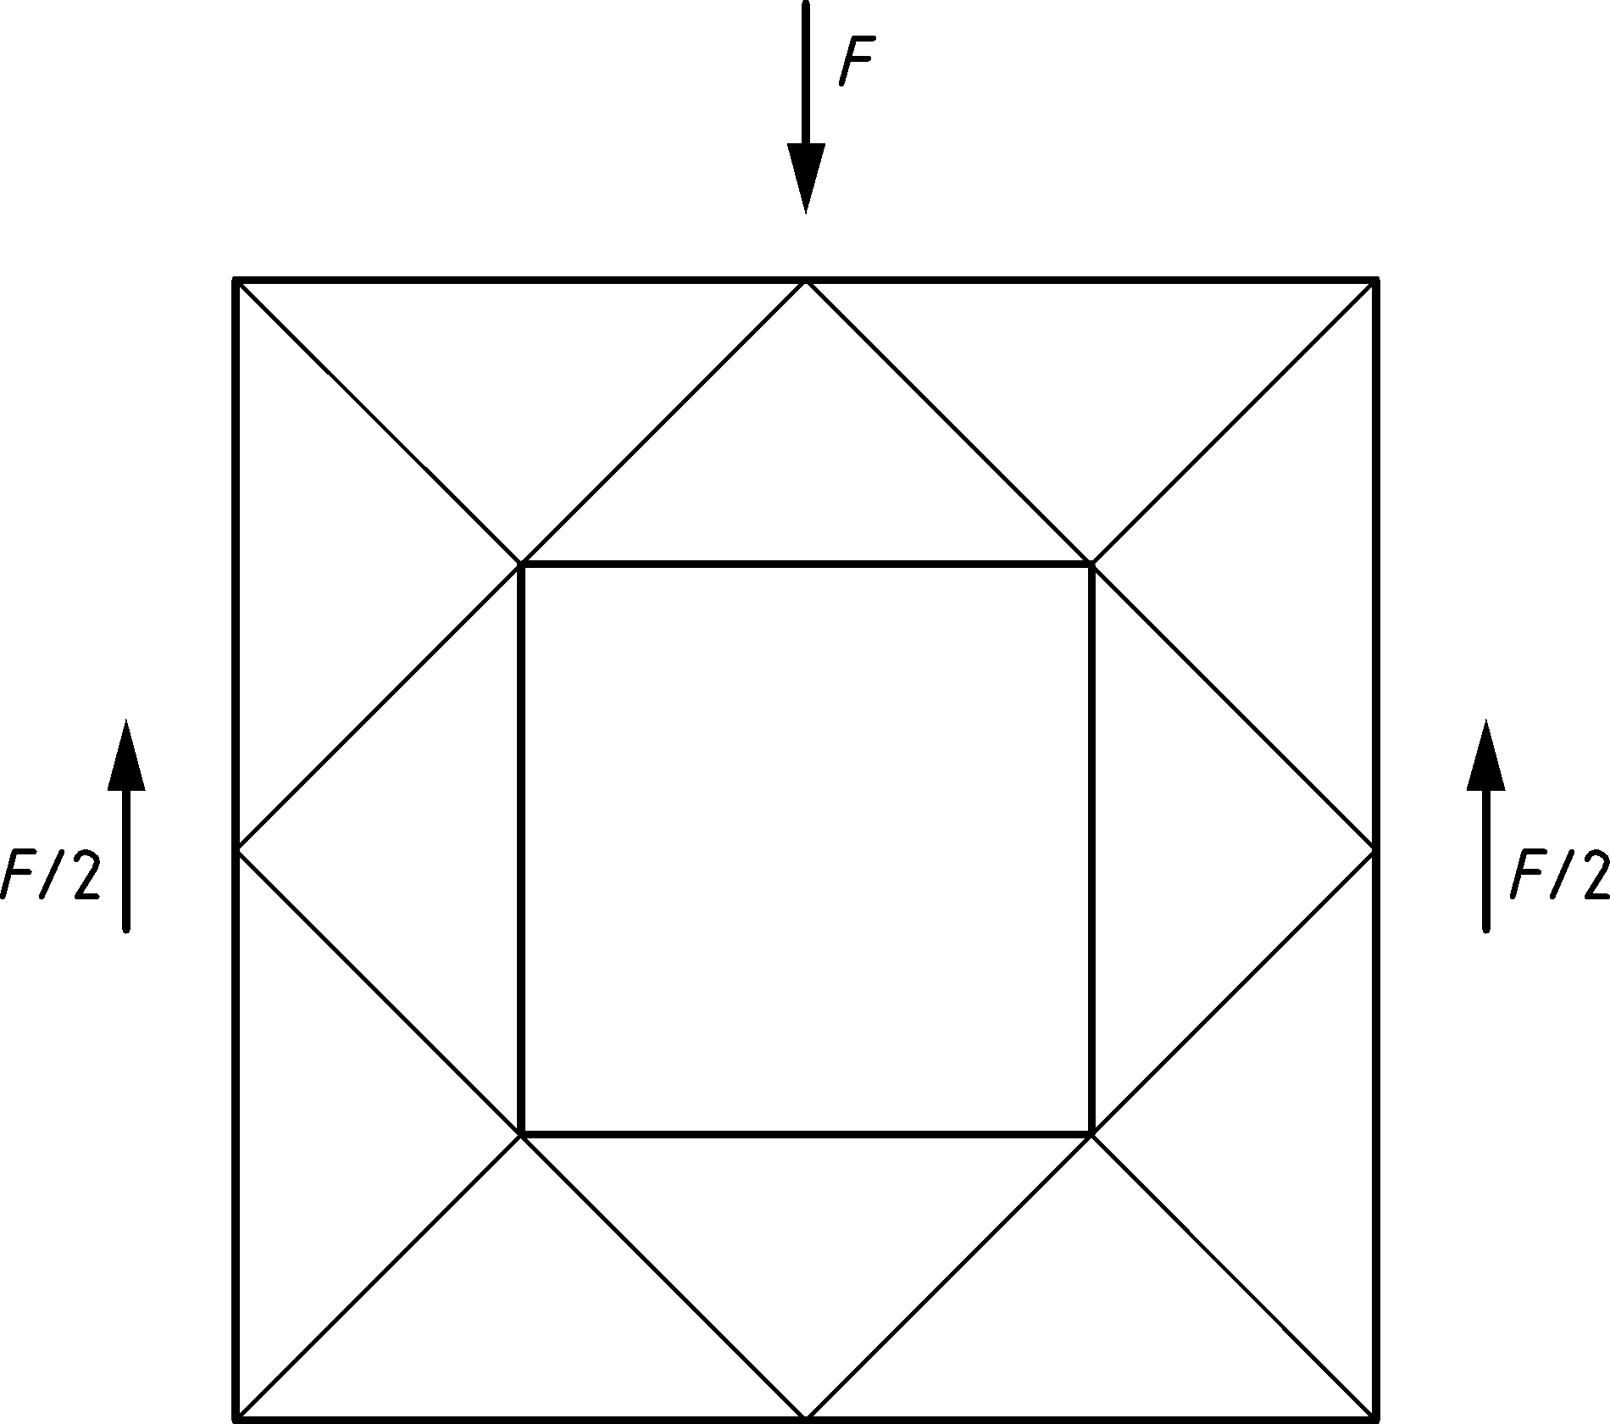

Figure C.4 — Force *F* = *p* × *N*c applied to typical plan bracing for design

(6) In the case of not fully triangulated bracing, the deflection of horizontal plan bracing under the force in (5) should not exceed *L*/500.

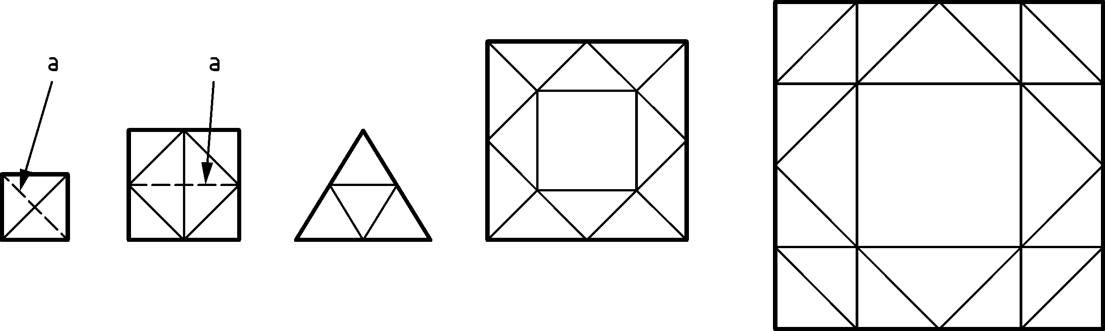

a) Triangulated

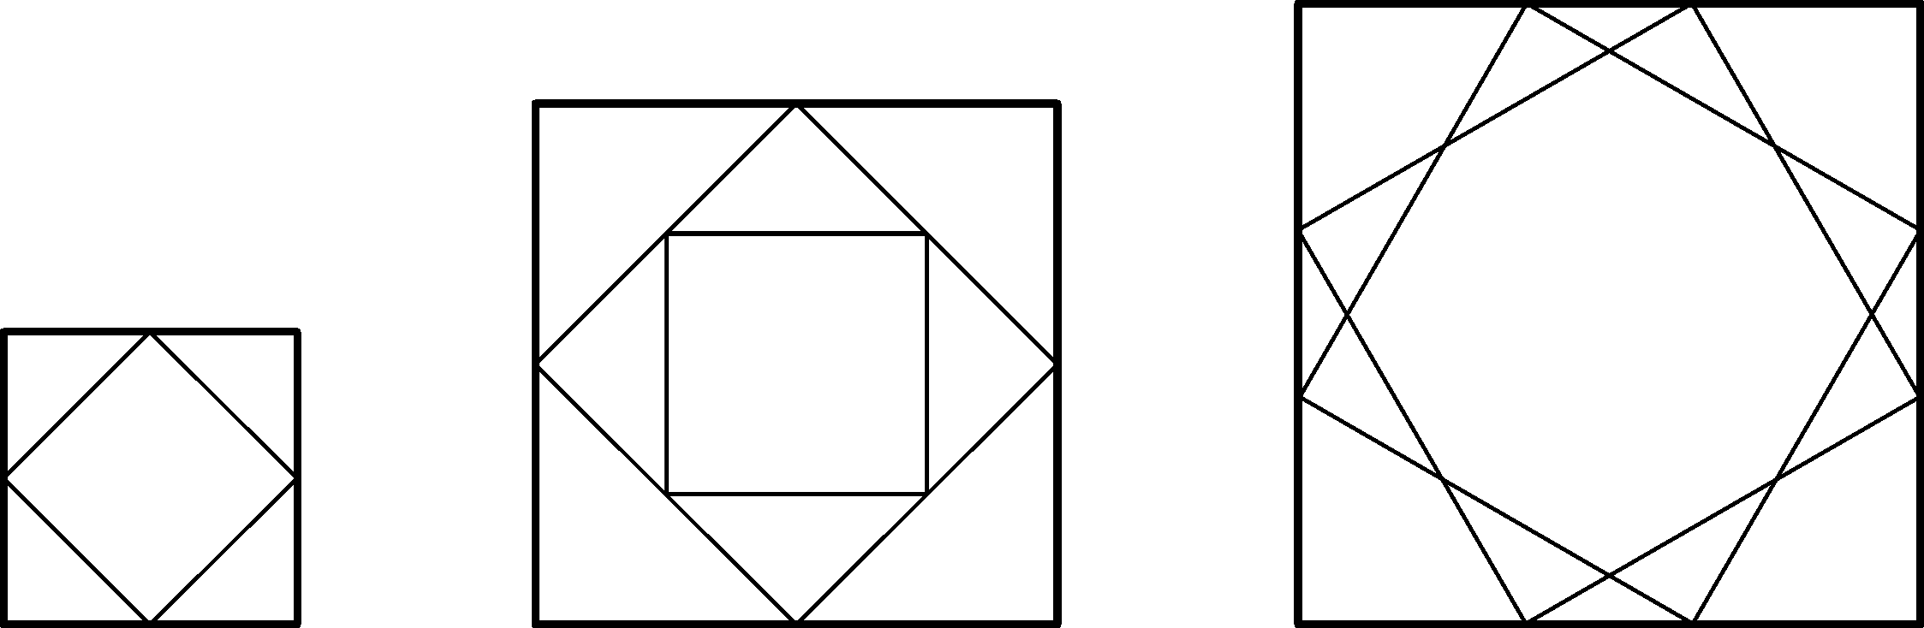

b) Not fully triangulated

Key

|  |  |
| --- | --- |
| a | If there are two diagonals, they may be designed as tension members. |

Figure C.5 — Typical plan bracing

(7) The not fully triangulated plan bracing is not recommended for design, unless careful attention is given to bending effects and to calculation of buckling length.

* + 1. Horizontal members without plan bracing

(1) For towers and masts plan bracing may be omitted in appropriate cases with due justification.

(2) The radius of gyration about the y-y axis should be used for slenderness calculation and for buckling transverse to the frame over length *L*h (see Figure C.6(a)). In addition, for single angle members, the radius of gyration about the vv axis should be used over length *L*h2 unless restraint by secondary bracing at intervals along the length is provided in which case the system length should be taken as *L*h1, see Figure C.6(b) (see also C.2(1.c) and Table C.4)).

NOTE 1 This procedure can be conservative in relation to a more refined analysis taking account of realistic end conditions.

NOTE 2 Additional considerations can be necessary for the bending stresses induced in the edge members by local loads transverse to the frame, such as wind.

|  |  |  |  |
| --- | --- | --- | --- |
|  | | | |
| *λ* = *L*h2/*i*v  and *λ* = *L*h/*i*z | for angles | *λ* = *L*h1/*i*v  and *λ* = *L*h/*i*z | for angles |
| *λ* = *L*h/*i*y | For hollow sections | *λ* = *L*h/*i*y | for hollow sections |

Figure C.6 — *K*-bracing horizontals without plan bracing

* + 1. Cranked *K*-bracing

(1) For large tower widths, a crank or bend may be introduced into the main diagonals (see Figure C.7), which has the effect of reducing the length and size of the secondary members. As this produces high stresses in the members meeting at the bend, transverse support should be provided at the joint. Diagonals and horizontals should be designed as for *K*-bracing, system lengths of diagonals being related to the lengths to the knee joint.

* + 1. Portal frame

(1) A horizontal member may be introduced at the bend to turn the panel into a portal frame, see Figure C.8. Because this leads to a lack of articulation in the *K*-brace, special consideration should be given to the effects of foundation differential settlement (if more than three legs) and/or horizontal spread of feet.

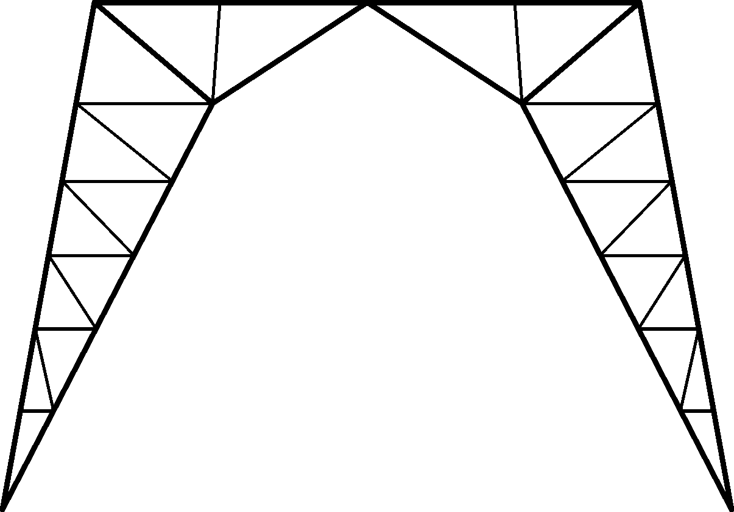

Figure C.7 — Cranked K-bracing

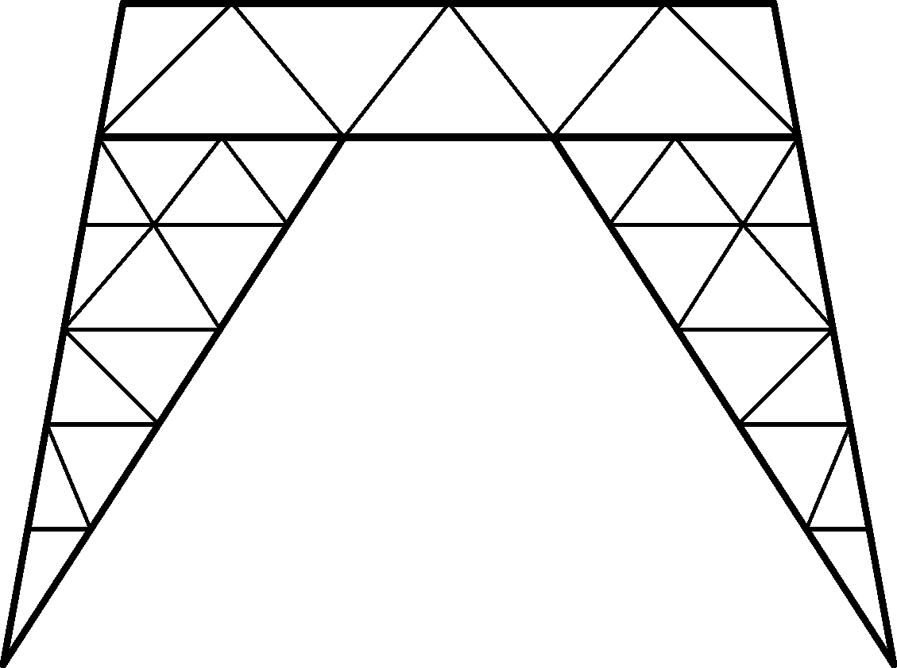

Figure C.8 — Portal frame

* + 1. Multiple lattice bracing

(1) In a multiple lattice configuration, the bracing members that are continuous and connected at all intersections should be designed as secondary members (see C.5) on a system length from leg to leg with the appropriate radius of gyration *i*y or *i*z, see Figure C.9. For the stability of the panel the overall slenderness  should be less than 350. For single angle members  should be greater than 1,50 where *i*y is the radius of gyration about the axis parallel to the plan of the lattice.

(2) The stability of the member A-B shown in Figure C.9 should be checked under the applied force on the critical system length *L*o for the slenderness:

 for angles; (C.12)

 for hollow sections and solid rounds (C.13)

NOTE The value of  can be conservative in relation to a more refined analysis taking account of realistic end conditions.

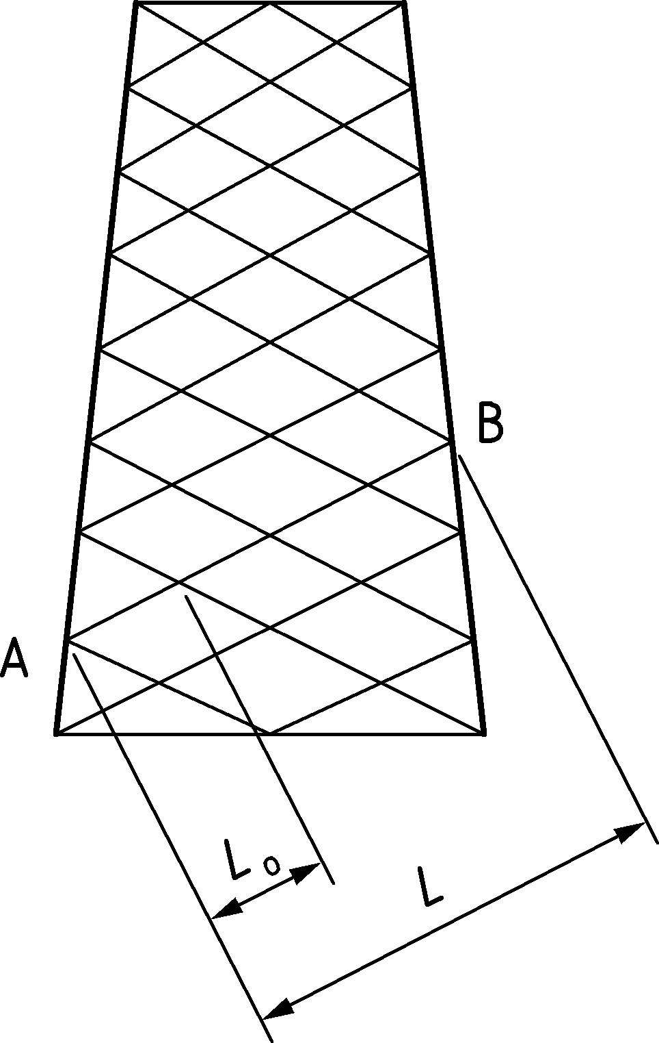

Figure C.9 — Multiple lattice bracing

* 1. Notional forces for bracing members

(1) In order to allow for imperfections in leg members, and for the design of secondary bracing members, a notional force should be introduced acting transverse to the leg member (or other chord if not a leg) being stabilized at the node point of the attachment of the secondary bracing member. Depending on the slenderness of the leg member being stabilized, the value of the notional force to be used for the design of any member should be obtained from (2) and (3).

(2) The force to be applied at each node in turn in the plane of bracing, expressed as a percentage, *p*, of the axial force in the leg for various values of the slenderness *λ* of the leg may be taken as:

*p* = 1,41 when *λ* < 30; (C.14)

 when 30 ≤ *λ* ≤ 135; (C.15)

*p* = 3,5 when *λ* > 135 (C.16)

(3) When there is more than one intermediate node in a panel then the secondary bracing system should be checked separately for 2,5 % of the axial force in the leg shared equally between all the intermediate node points. These notional forces should be assumed to act together and in the same direction, at right angles to the leg and in the plane of the bracing system.

(4) In both cases (2) and (3) the distribution of forces within the triangulated bracing panel should be determined by linear elastic analysis.

(5) Primary bracing can also provide restraint and sub-divide members into shorter buckling lengths. In such instances, the effects of this notional force should generally be added to the primary force as calculated from the global analysis for the design of any primary member. Exceptionally for lattice towers of conventional configuration the addition of the notional forces to the primary forces may be omitted, provided that the primary bracing is checked for the effects of the notional force, when the primary force is smaller than the notional force.

The effects of the combination of the primary and notional forces should be considered for masts due to the axial force from the guy ropes.

(6) Provided that it is designed for notional forces as described in (1) to (5) it may be assumed that the stiffness of the secondary bracing system will be sufficient.

(7) If the main member is eccentrically loaded or the angle between the main diagonal of a *K-*brace and the leg is less than 25° then the above value of the notional force may be insufficient, and a more refined value should be obtained by considering the eccentricity moment and secondary stresses arising from leg deformation.

(8) Where the direction of buckling is not in the plane of the bracing, then the values given by Formulae (C.14) to (C.16) should be divided by a factor of .

* 1. Shell structures

(1) For the strength and stability of shell structures see EN 1993‑1‑6.

1. (normative)  
     
   Guy rupture
   1. Use of this Annex

(1) This Normative Annex contains additional provisions for checking of guyed masts for guy rupture.

* 1. Scope and field of application

(1) This Annex describes the methods of analysis to be used when masts are checked for guy rupture.

* 1. General

(1) Guy rupture is an accidental action. For partial factors see EN 1990.

(2) Immediate measures should be taken to replace the ruptured guy.

* 1. Analysis during guy rupture
     1. General

(1) One of the three methods given in D.4.2 to D4.4 should be used.

(2) No other load than the dynamic load and the permanent load should be applied.

* + 1. Full dynamic analysis

(1) The full dynamic analysis should be in the time domain and consider a sudden rupture of a guy. The following factors should be included in the analysis:

— the behaviour of the mast immediately after failure of the guy;

— the character of the rupture of the guy;

— the damping of the guys and the mast;

— the vibration of the guys and the mast.

* + 1. Simplified dynamic model

(1) For the simplified analysis of a mast due to the rupture of a guy, the dynamic forces should be assumed to be equivalent to a static force acting on the mast at the level of the set of guys where rupture has been assumed to have occurred.

(2) For the calculation of this static equivalent force *F*h,dyn,Ed described below, it may be assumed that:

— the rupture is a simple cut through the guy;

— the elastic energy stored in guy 1 (see Figure D.1) before the rupture occurs is neglected;

— damping is not considered;

— the wind loading when calculating the equivalent force is neglected.

|  |  |
| --- | --- |
|  | |
| Elevation | Section at top level |

Key

|  |  |
| --- | --- |
| 1 | Guy 1 |
| 2 | Guy 2 |
| 3 | Guy 3 |
| 4 | Deflection, *u* |

The rupture could be in all guy levels.

Figure D.1 — Guy rupture

(3) For a given deflection, *u,* guys 2 and 3 act on the mast shaft with a force *F*h,Ed. The relation is shown in Figure D.2 as curve 1. It will be seen that *F*h,Ed decreases with increasing deflection owing to slackening of the guys.

(4) For the mast system, except for the set of guys at the considered level, the relation between an external horizontal force and the deflection of the node can be shown as well. In Figure D.2 this relation is shown in curve 2. Where the two curves 1 and 2 intersect, the two forces are equal, i.e. there is static equilibrium. The force acting on the joint is *F*h,stat,Ed.

(5) At the moment that rupture occurs, energy is stored in guys 2 and 3. When the mast starts deflecting, this energy will partially be transformed into kinetic energy.

(6) At the maximum deflection, the kinetic energy will be zero, because the energy lost in guys 2 and 3 has been transferred to the mast as elastic strain energy in the shaft and the guys. Damping has not been taken into consideration.

(7) The energy lost in guys 2 and 3 should be assumed to be equal to the area A2 below curve 1 in Figure D.2.

(8) The deflection resulting in the two areas A1 and A2 being equal, should be taken as the dynamic deflection *u*dyn.

(9) The dynamic force *F*h,dyn,Ed corresponds to this dynamic deflection. The impact factor *Ψ* may be determined using:

 (D.1)

|  |  |
| --- | --- |
|  |  |
| a) Modelling guy 2 and 3 at the level of the ruptured guy rope | b) Modelling the mast system except for the set of guys at the considered level |

Key

|  |  |
| --- | --- |
| 1 | Guy 2 and 3 |

Figure D.2 — Modelling the analysis in the simplified dynamic model

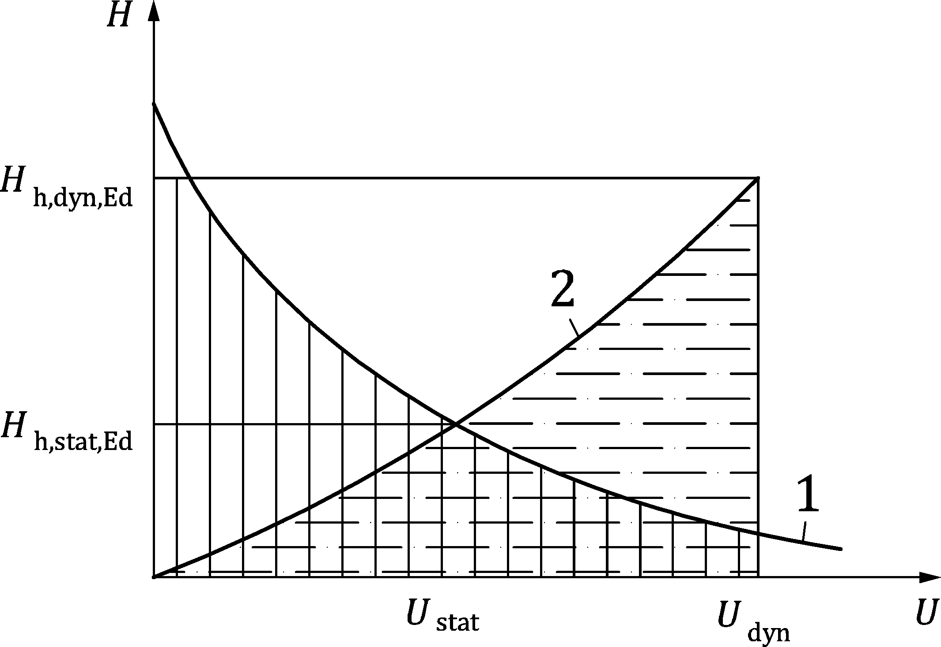

Key

|  |  |
| --- | --- |
| 1 | Curve 1: Guy 2 and 3 |
| 2 | Curve 2: Mast excluding guy 1, 2 and 3 |
|  | Area A1 under curve 2 |
|  | Area A2 under curve 1 |

Figure D.3 — Force deflection diagram

(10) The above procedure for the analysis of a mast just after a possible guy rupture has occurred applies to a mast guyed in 3 directions. For masts guyed in 4 (or more) directions similar procedures based on the same principles should be adopted.

* + - 1. Analysis method

(1) The remaining guys (guy 2 and 3) at the level of the ruptured guy (guy 1) are analysed as a system, with the mast column replaced by a vertical-only support. A horizontal force “*H*” is applied, acting in the direction of the broken guy, as shown in Figure D.2a. The initial value of “*H*” equals the horizontal component of the initial guy tension prior to rupture.

(2) Curve 1 (Figure D.3) is generated by analysing this system for incrementally reducing values of “*H*” and determining the corresponding deflection “*u*” of the guy system at the ruptured guy level from its position under the initial guy tension condition.

(3) The mast is analysed with all guys removed at the ruptured guy level for incrementally increasing values of “*H*”, acting in the opposite direction to the broken guy, see Figure D.2b. Curve 2 (Figure D.3) is generated for different values of “*H*” and plotted with the corresponding deflections “*u*”.

(4) The area under curve 1 represents the energy that is lost in the non-ruptured guys (guy 2 and 3) as the mast deflects away from the ruptured guy. The area under curve 2 represents the energy absorbed by the mast and the guys at other levels, as it deflects due to an external force.

(5) The equivalent static force for the dynamic guy rupture condition “*H*dyn” corresponds to the magnitude of the applied horizontal force “*H*” when the areas under curves 1 and 2 are equal (Figure D.3).

(6) *H*dyn is applied to the structure (with a load factor equal to 1,0) with all guys (guy 1, 2 and 3) removed at the level of the ruptured guy and in the opposite direction to the ruptured guy (Figure D.1). Note that under this condition, the structure absorbs the energy lost in the non-ruptured guy system under the movement associated with the guy rupture. This conservation of energy is required to maintain equilibrium of the structure. The resulting member forces in the structure therefore simulate the member forces that would occur under a ruptured guy condition.

(7) Referring to Figure D.3 *u*stat is the deflection at which static equilibrium is achieved after the rupture of a single guy and *u*dyn is the peak dynamic deflection after rupture of the guy.

* + 1. Simplified static procedure

(1) The dynamic forces in the mast column and the guys caused by a guy rupture may be conservatively estimated using the following static calculations.

(2) The horizontal component of the guy force acting in the guy before the rupture should be used as an additional force acting on the mast in direction 4 of Figure D.1 without the broken guy. No other load than the dynamic load resulting from guy rupture and the permanent load should be applied.

(3) The resulting guy forces should be increased by the factor 1,3 in the case of masts with 2 stay levels or if the rupture of a top guy is considered.

* 1. Analysis after a guy rupture

(1) The mast should be able to withstand wind loads for a short period immediately after the rupture of a guy until temporary guying can be arranged.

(2) If no other requirements are given, the mast without the ruptured guy should be able to withstand a reduced wind load, acting as a static load, and without patch wind loading. The reduced wind loading should be taken as 50 % of the characteristic mean wind loading, acting in the most adverse condition. Ice loading should not be considered. The reduced wind load should be applied to the mast in the static equilibrium position *u*stat.

NOTE The magnitude of the reduced wind loading can be set by the National Annex.

1. (normative)  
     
   Execution
   1. Use of this annex

This Normative Annex contains execution rules for towers, masts and chimneys in addition to those given in EN 1090‑2. It is planned to incorporate the content of this Annex into EN 1090‑2 as soon as possible. When this is accomplished this annex will be removed from this document.

* 1. Scope and field of application

(1) This Annex covers execution rules for towers, masts and chimneys in addition to those given in EN 1090‑2.

* 1. General

(1) The execution of towers, masts and chimneys should be according to EN 1090‑2 and according to the rules of this Annex.

(2) The execution class should be at least EXC2.

NOTE See EN 1993‑1‑1:2022, Annex A for guidance on selection of the execution class, in particular when fatigue is a consideration.

(3) Specific requirements for chimneys provided in EN 13084‑6 should be applied.

NOTE The strength and stability rules in this document are based on the assumption that the particular execution tolerances given in E.6.2 are achieved.

(4) When fitted together before bolting, any gap between the flanges should not exceed 1,5 mm.

(5) Flanges should be flat to a tolerance of 0,5 mm per 100 mm width and the total tolerance across the circumference should not exceed 1,0 mm.

(6) For structures fabricated with a base plate and anchor bolts, non-shrinking grout should be used between the plate and the foundation.

NOTE 1 A sufficiently large stretch length can decrease fatigue action in anchor bolts.

NOTE 2 Using a bandage or a sheath can ensure a large stretch length.

* 1. Bolted connections

(1) All bolting assemblies should be provided with suitable measures to avoid any loosening of nuts in service. These may include locking devices or preloaded bolts; see EN 1090‑2. They may also include non-preloaded bolts, tightened in accordance with the recommendations in (5).

(2) Untreated punched holes are not permitted where fatigue effects can occur. See EN 1090‑2

(3) The nominal clearances given in EN 1090‑2:2018, Table 11 may be used without reduction for towers and masts, if the deflections from the increased clearances are not critical.

(4) Fitted or friction grip bolts, or closer tolerances on bolt holes than those given in EN 1090‑2 may be used where displacements are critical (see E.6.2).

(5) Bolts should be tightened to 50 % of the torque reference value  given in EN 1090‑2

NOTE 1 This recommendation can be applied to stainless steel bolts according to EN ISO 3506‑1 and EN ISO 3506‑2.

NOTE 2 Bolts according to the EN 15048 series and the EN 14399 series can be tightened using this recommendation with .

NOTE 3 The National Annex can give special requirements for bolted connections, including a different percentage of the torque reference value  to achieve the tightened condition.

NOTE 4 Tightening can be achieved using a torque wrench complying with the requirements of EN 1090‑2:2018, 8.5.1.

(6) Non-preloaded bolts tightened using the recommendation in (5) shall have a tensile strength of at least 800 MPa.

* 1. Welded connections

(1) The quality of welds assumed in selecting the appropriate fatigue class of a structural detail, see 10.3, should be specified on the drawings for the fabrication of the structure.

(2) The minimum quality level for the welds of shells subjected to fatigue shall be quality level C according to EN ISO 5817. The additional requirements in EN ISO 5817:2023, Annex B for welds subject to fatigue should also be taken into account.

* 1. Tolerances
     1. General

(1) The tolerances given in EN 1090‑2 should be satisfied in fabrication but the Special Tolerances given in this Clause supersede those provided in EN 1090‑2:2018, Table B.24.

(2) Tighter tolerances should be used where tolerances from EN 1090‑2 do not satisfy the requirements for the function of the structure.

* + 1. Erection tolerances
       1. Self-supporting structure

(1) The maximum deviation from verticality (the theoretical position of the tower top) should be less than 1/500 of the height of the tower.

NOTE The National Annex can give further information on the maximum deviation from verticality.

(2) This tolerance should also apply to the centreline of the structural shell for chimneys.

(3) Final plumbing should be done in calm conditions.

* + - 1. Guyed structures

(1) The sensitivity to the structure to varying wind speeds for final plumbing and guy tensioning should be determined in design.

NOTE Generally if such operations can be undertaken in wind speed more than 5 m/s calculations are required to compensate for the effects of wind, taking due account of any temperature effects.

(2) Final plumbing and tensioning of guys should normally proceed from the lowest guy level upward.

(3) The following criteria are valid for the guyed structure:

a) The final position of the centre line of the structure should lie within a vertical cone with its apex at the base of the structure and with a radius equal to the maximum of 1/1 500 of the height above the base of the structure; but not less than 35 mm. This does not apply to halyards or aerial array wires.

b) The resultant horizontal component of the initial guy tensions of all the guys at a given level should not exceed 5 % of the average horizontal component of the initial guy tension for that level. The initial tension in any individual guy at a given level should in no case vary more than 10 % from the design value, see EN 1993‑1‑11.

c) Maximum initial deflection of the centreline of the structure column between two guy levels, where *L* is the distance between the two consecutive guy levels in question, should be *L*/1 000.

d) After erection the tolerance on the alignment of the centreline of the structure between 3 consecutive guy levels is limited to (*L*1 + *L*2)/2 000, where *L*1 and *L*2 are the lengths of the two consecutive spans of the shaft.

NOTE The National Annex can give limits for the tolerances on the alignment of the centreline of the structure.

(4) The effect of differential thermal expansion due to solar gain on the straightness of closed steel cross-sections (e.g. cylinders or folded plate) forming mast shafts or chimney structural shells should be taken into account when setting initial guy tensions.

* + - 1. Tensioning constraints

(1) After erection, the guys should be tensioned in accordance with the design calculations, taking due account of the actual temperature on the site, see EN 1993‑1‑11.

(2) To minimize the possibility of guy vibrations still air tensions should be selected such that for each guy the initial tension is less than 10 % of its breaking load.

NOTE 1 The recommendation for an initial guy tension of 10 % of breaking load or less is based on the assumption of a wire strength of 1 570MPa.

NOTE 2 Low still air tensions can give rise to galloping of guys.

(3) Loading and unloading of guys with insulators should be undertaken at a rate of approximately 5 % of the expected load in steps of approximately 1 minute, such that any loading or unloading will take not less than 20 min, unless otherwise specified.

* 1. Pre-stretching of guys

(1) To ensure that the rope is in a truly elastic condition guys should be pre-stretched preferably prior to terminating. This may be done at the supplier's works or, if suitable facilities exist, at the erection site, see EN 1993‑1‑11.

NOTE The need for pre-stretching can be dependent on the planned programme for re-tensioning, the type and size of the rope used and the sensitivity to deflections.

(2) Pre-stretching should be carried out according prEN 1993‑1‑11:2024, 5.3.2. However, this process should not be carried out by passing the loaded guy around a sheave wheel.

1. (informative)  
     
   Supplementary rules for the resistance of equal leg angle sections and built-up members
   1. Use of this Annex

(1) This Informative Annex provides supplementary rules for the resistance of equal leg angle sections and built-up members.

NOTE National choice on the application of this Informative Annex is given in the National Annex. If the National Annex contains no information on the application of this informative annex, it can be used.

* 1. Scope and field of application

(1) Clause F.3 covers the determination of the resistance of equal leg angle section members subjected to a combination of axial force and bending moments provided that the ratio *c*/*t* is equal to or less than 30*ε* (see Table F.1 for the definition of the ratio *c*/*t*).

(2) Clause F.4 covers the determination of the resistance of built-up members composed of equal leg angle sections subjected to a combination of axial force and bending moments provided that the ratio *c*/*t* is equal to or less than 14*ε* (see Table F.1 for the definition of the ratio *c*/*t*).

(3) Bending moments can arise from eccentricities at the connections and continuity of members. These bending moments are covered by this Annex.

NOTE If the structure (lattice tower or mast) is modelled as fully triangulated using truss elements for the global analysis, the members are only subjected to axial forces and hence the provisions of 8.2.1 and of Annex C can be applied without considering bending moments.

* 1. Special provisions for equal leg angle section members
     1. Cross section resistance

(1) The class of equal leg angle cross-sections may be determined according to Table F.1. In case of combined loading, the class and the resistance of the cross-section may be determined for each individual internal force and moment separately. The interaction Formulae (F.11) and (F.12) may be used to check the resistance of the equal leg angle section to the combined effect of axial force and bi-axial bending.

Table F.1 — Maximum width-to-thickness ratios for compression parts of angle sections

|  | Section under compression | Section under strong axis bending | Section under weak axis bending | |
| --- | --- | --- | --- | --- |
| Tip in tension | Tip in compression |
| Class 1 |  | — | — | — |
| Class 2 |  |  |  |
| Class 3 |  | — |  |

NOTE See 8.2.2 for the determination of the class of sections subjected to an axial force.

(2) The design resistance of equal leg angle sections for bending about the major axis should be determined with:

 (F.1)

The section modulus  depends on the class of the cross-section and should be determined by:

 (F.2)

where

|  |  |
| --- | --- |
|  | for class 1 or 2 |
|  | for class 3 |
|  | for class 4 |

The reduction factor  should be determined with Formula (F.4) using the relative slenderness  obtained with:

 (F.3)

 (F.4)

(3) The design resistance of angle sections for bending about the minor axis should be determined with:

 (F.5)

The section modulus *W*v depends on the class of the cross-section and should be determined by:

 (F.6)

where

|  |  |
| --- | --- |
|  | for class 1 or 2 |
|  | for class 3 |
|  | for class 4 |

The reduction factor  should be determined with Formula (F.4) using the relative slenderness  obtained with:

 (F.7)

* + 1. Buckling resistance of members subjected to a combination of axial force and bending moments

(1) For members of equal leg angle section, flexural buckling should be checked according to the provisions given in EN 1993‑1‑1 and EN 1993‑1‑3.

(2) Torsional-flexural buckling may be disregarded for equal leg angle sections.

(3) For class 4 sections, the relative slenderness  used to calculate the effective area *A*eff may be determined according to EN 1993‑1‑5 using the modified slenderness:

 (F.8)

where

|  |  |
| --- | --- |
| *χ*min | is the minimum of the reduction factors obtained for flexural buckling about the minor axis *χ*v and for flexural buckling about the major axis *χ*u. |

(4) Lateral torsional buckling of angle sections subjected to major axis bending should be checked according to EN 1993‑1‑1 and EN 1993‑1‑3. For equal leg angle sections, the reduction factor *χ*LT may be obtained with:

 (F.9)

with





where

|  |  |
| --- | --- |
| *M*cr | is the elastic critical moment for lateral torsional buckling. |

(5) For angle section members with fork end supports subjected to a linear varying bending moment diagram, the elastic critical moment for lateral torsional buckling may be determined with Formula (F.10).

 (F.10)

where

|  |  |
| --- | --- |
| *C*1 | is a factor depending on the moment diagram and end restraint conditions |
| *I*T | is the torsion constant; |
| *L* | is the member length; |
| *E* | is the modulus of elasticity; |
| *G* | is the shear modulus; |
| *I*v | is the moment of inertia about the v-v (minor) axis. |

The value of the factor *C*1 may be determined with Formula (F.11).

 (F.11)

where

|  |  |
| --- | --- |
| *ψ* | is the ratio between end moments according to Table F.2. |

NOTE For other load cases and end restraint conditions, CEN/TR 1993‑1‑103:—[2] can be used for the calculation of *M*cr.

(6) For values of the relative slenderness  or for  lateral torsional buckling may be neglected for equal leg angle sections.

(7) For class 4 sections of equal leg angle sections, the relative slenderness  according to Formula (F.4) may be modified as follows:

 (F.12)

(8) The resistance of members of hot rolled equal leg angle section may be checked with the interaction Formulae (F.13) and (F.14). For cold formed angle sections EN 1993‑1‑3 should be applied.

 (F.13)

 (F.14)

where

|  |  |  |
| --- | --- | --- |
| *N*Ed, *M*u,Ed and *M*v,Ed | are the design value of the compression force and the design values of the maximum bending moments acting along the member about the u-u axis and v-v axis, respectively; | |
| *N*Rk, *M*u,Rk and *M*v,Rk | are the characteristic value of the axial force and the characteristic values of the maximum bending moments acting along the member about the u-u axis and v-v axis, respectively: | |
|  | *N*Rk = *Af*y | for cross-sections of class 1,2 and 3; |
|  | *N*Rk = *A*eff*f*y | for cross-sections of class 4; |
|  | *M*u,Rk = *W*u*f*y; | |
|  | *M*v,Rk = *W*v*f*y; | |
| *χ*u, *χ*v, *χ*LT | are the reduction factors for flexural buckling according to F.3.2(1) and lateral torsional buckling according to F.3.2(4), respectively; | |
| *k*uu, *k*uv, *k*vu, *k*vv | are interaction factors according to Table F.2; | |
|  | is the exponent according to Table F.2. | |

Table F.2 — Interaction factors and exponent  for Formulae (F.13) and (F.14)

|  |  |  |  |
| --- | --- | --- | --- |
| Interaction factors |  | |  |
|  | |  |
| Equivalent uniform moment factor *C*i | Linear varying bending moments: | |  |
| Exponent | If: : |  | |
| If: : |  | |
| If: : |  | |
| with: |  | |
| and: |  | |

* 1. Special provisions for closely spaced built-up members

(1) The resistance of closely spaced built-up members should be verified according to EN 1993‑1‑1.

(2) As an alternative to (1), the resistance of closely spaced built-up members shown in Figure F.1, may be verified according to the provisions given hereafter.

|  |  |  |
| --- | --- | --- |
|  |  | |
| **Back-to-back connected angle sections** | **Star-battened angle sections with equal chords** | **Star-battened angle sections with unequal chords** |

Figure F.1 — Closely-spaced built-up members covered by F.3

(3) The reduction factor *χ*z of closely spaced back-to-back connected angle sections for buckling about the z-z axis and *χ*u of star battened members for buckling about the u-u axis may be obtained using buckling curve *b* from EN 1993‑1‑1 based on the relative slenderness  given by:

 (F.15)

where

|  |  |
| --- | --- |
| *N*Rk | is the characteristic value of the resistance to an axial compression force of the built-up member; |
| *N*cr,Sv | is the critical axial force of the built-up member about the buckling axis considering the effect of the shear stiffness (see (4). |

(4) The critical axial force of the built-up member *N*cr,Sv may be determined depending on the connection type as follows:

 (F.16)

with



|  |  |
| --- | --- |
|  | for members connected through fit bolts |
|  | for members connected through preloaded bolts |

where

|  |  |  |
| --- | --- | --- |
| *I* | is the moment of inertia about the buckling axis (z-z for back-to-back connected angles and u-u for star battened angles) of the built-up member neglecting the influence of the shear stiffness; | |
| *I*v,ch | is the moment of inertia of the individual angle section about its v-v axis; | |
| *L*cr | is the buckling length of the built-up member about the buckling axis; | |
| *a* | is the distance between the connections of the built-up member; | |
| *h*0 | is the distance between the centroids of the two individual angle sections; | |
| *I*pp | is the moment of inertia of the effective part of the packing plate given by: | |
|  |  | for back-to-back connected angle sections; |
|  |  | for star battened angle sections; |
| *B* | is the inside diameter of the bolt head (noted width across flats (s) in EN 14399‑1); | |
| *t* | is the thickness of the angle section; | |
| *t*p | is the thickness of the packing plate; | |
| *d* | is the diameter of the bolt. | |

NOTE 1 *S*v2 can also be applied for connections if the design slip resistance *F*s,Rd for non fully preloaded bolt connections is higher than the shear force to be transmitted – see (5) for the shear force.

NOTE 2 The effect of the shear stiffness is not relevant for buckling about the y-y-axis for back-to-back connected angle sections and for buckling about the v-v axis for star battened angle sections and the provision of EN 1993‑1‑1 can be applied considering the member as integral.

(5) The resistance of the connections between the two chords of the built-up member should be checked according to EN 1993‑1‑8 based on the shear force *V*Ed transmitted by the connection given by:

 (F.17)

where

|  |  |
| --- | --- |
| *L* | is the member length; |
|  | |
| *N*Ed | is the design value of the axial force applied to the built-up member; |
|  | is the design value of the shear force at the member end (not considering second order effects); |
|  | is the design value of the bending moment applied to the member (not considering second order effects). |

NOTE For star battened angle sections *V*Ed can be distributed over two bolts in one connection.

(7) The reduction factor for lateral torsional buckling of star battened members with class 1 and class 2 cross-section subjected to bending about the u-u axis should be determined according to EN 1993‑1‑1:2022, 8.3.2.3 using buckling curve *a* and the relative slenderness obtained from:

 (F.18)

where

|  |  |
| --- | --- |
| *W*u | is the plastic section modulus of the built-up member for bending about the u-u axis |

NOTE The factor of 0,9 accounts for the reduction in the cross-section resulting from the bolt hole.

(8) Star battened angle section members of class 1 and class 2 cross-section subject to combined bending and axial force should satisfy the interaction Formulae (F.13) and (F.14). The effect of the shear stiffness should be accounted for by:

— Replacing the critical axial force *N*cr,u by *N*cr,Sv.

— Calculating the reduction factor *χ*u based on the relative slenderness 

— Accounting for the reduction of the bolt holes when calculating the bending resistances *M*u,Rk and *M*v,Rk of the built-up member

— Using a value of  = 1,5 for star battened members with two equal chords and  = 1,1 for star battened members with two different chords

NOTE A reduction factor of 0,9 can be applied to the moduli *W*u and *W*v of the built-up member to account for the reduction of the section due to bolt holes.

Bibliography

**References contained in recommendations (i.e. through “should” clauses)**

The following documents are referred to in the text in such a way that some or all of their content, although not requirements strictly to be followed, constitutes highly recommended choices or course of action of this document. Subject to national regulation and/or any relevant contractual provisions, alternative standards could be used/adopted where technically justified. For dated references, only the edition cited applies. For undated references, the latest edition of the referenced document (including any amendments) applies

EN 13084‑1, Free-standing chimneys — Part 1: General requirements

EN 1998 (all parts), Eurocode 8 — Design of structures for earthquake resistance

EN ISO 12944‑3, Paints and varnishes — Corrosion protection of steel structures by protective paint systems — Part 3: Design considerations (ISO 12944-3)

EN 13084‑6, Free-standing chimneys — Part 6: Steel liners — Design and execution

EN 13084‑7, Free-standing chimneys — Part 7: Product specifications of cylindrical steel fabrications for use in single wall steel chimneys and steel liners

**References contained in permissions (i.e. through “may” clauses)**

The following documents are referred to in the text in such a way that some or all of their content, although not requirements strictly to be followed, expresses a course of action permissible within the limits of the Eurocodes. For dated references, only the edition cited applies. For undated references, the latest edition of the referenced document (including any amendments) applies

EN 795, Personal fall protection equipment — Anchor devices

**References contained in possibilities (i.e. “can” clauses) and notes**

The following documents are cited informatively in the document, for example in “can” clauses and in notes.

EN 40 (all parts), Lighting columns

EN 365, Personal protective equipment against falls from a height — General requirements for instructions for use, maintenance, periodic examination, repair, marking and packaging

EN 1337‑6, Structural bearings — Part 6: Rocker bearings

CEN/TR 1993‑1‑103:—2, Eurocode 3 — Design of steel structures — Part 1-103: Elastic critical buckling of members

EN ISO 3506‑1, Fasteners — Mechanical properties of corrosion-resistant stainless steel fasteners — Part 1: Bolts, screws and studs with specified grades and property classes (ISO 3506-1)

EN ISO 3506‑2, Fasteners — Mechanical properties of corrosion-resistant stainless steel fasteners — Part 2: Nuts with specified grades and property classes (ISO 3506-2)

EN ISO 12944‑2:2017, Paints and varnishes — Corrosion protection of steel structures by protective paint systems — Part 2: Classification of environments (ISO 12944-2)

EN 13411‑5, Terminations for steel wire ropes — Safety — Part 5: U-bolt wire rope grips

EN ISO 14122 (all parts), Safety of machinery — Permanent means of access to machinery

EN 14399 (all parts), High-strength structural bolting assemblies for preloading

EN 15048 (all parts), Non-preloaded structural bolting assemblies

EN 50341 (all parts), Overhead electrical lines exceeding AC 1 kV

EN 60060‑1, High-voltage test techniques — Part 1: General definitions and test requirements

EN 60060‑2, High-voltage test techniques — Part 2: Measuring systems

EN 61400 (all parts), Wind energy generation systems

1. As impacted by EN 1990:2023/prA1:2024
2. Under preparation