CEN/TC 250

Date: 2023‑08-18

prEN 1993‑4‑1:2024

Secretariat: BIS

Eurocode 3 — Design of steel structures — Part 4‑1: Silos

Eurocode 3 — Bemessung und Konstruktion von Stahlbauten — Teil 4-1: Silos

Eurocode 3 — Calcul des structures en acier — Partie 4-1: Silos

CCMC will prepare and attach the official title page.

Contents Page

European foreword 5

0 Introduction 6

1 Scope 9

1.1 Scope of EN 1993‑4‑1 9

1.2 Assumptions 10

2 Normative references 11

3 Terms, definitions, symbols, sign conventions and units 11

3.1 Terms and definitions 11

3.2 Symbols used in Part 4.1 of Eurocode 3 15

3.3 Sign conventions 20

4 Basis of design 28

4.1 Basic requirements 28

4.2 Units 28

4.3 Silo classifications 29

4.4 Verification by the partial factor method 32

4.5 Actions and environmental effects 33

4.6 Geometrical data 33

4.7 Modelling of the silo for determining action effects 34

4.8 Design assisted by testing 34

4.9 Action effects for limit state verifications 34

4.10 Durability 34

4.11 Fire resistance 34

5 Properties of materials 34

5.1 General 34

5.2 Structural steels 35

5.3 Stainless steels 35

5.4 Special alloy steels 35

5.5 Toughness requirements 35

6 Basis for structural analysis 36

6.1 Ultimate limit states 36

6.2 Serviceability limit states 37

6.3 Analysis of the structure of a shell silo 37

6.4 Analysis of the box structure of a plate assembly silo 40

6.5 Analysis treatment of corrugated sheeting 41

7 Ultimate limit state design of cylindrical shell walls 44

7.1 Basis 44

7.2 Distinctions between cylindrical shell forms 45

7.3 Resistance of isotropic welded or bolted cylindrical walls 46

7.4 Resistance of isotropic cylindrical walls under axial compression 48

7.5 Resistance of isotropic cylindrical walls under external pressure, internal partial vacuum and wind 55

7.6 Interactions between axial compression, circumferential compression and membrane shear in isotropic walls 62

7.7 Isotropic walls under cyclic loads 62

7.8 Resistance of isotropic walls with vertical stiffeners 62

7.9 Resistance of horizontally corrugated cylindrical walls 66

7.10 Vertically corrugated cylindrical walls with ring stiffeners 75

7.11 Detailing for openings in cylindrical walls 76

8 Support conditions for cylindrical walls 78

8.1 Shell with its base fully supported 78

8.2 Isotropic shell supported by a skirt 78

8.3 Isotropic cylindrical shell wall with engaged columns 78

8.4 Framework support beneath an isotropic walled silo 79

8.5 Discretely supported isotropic cylindrical shell without a ring girder 81

8.6 Discretely supported isotropic cylindrical shell with a ring girder 82

8.7 Discretely supported isotropic cylindrical shell with an intermediate ring 83

8.8 Discretely supported isotropic silo with columns beneath the hopper 87

8.9 Local support details and ribs for load introduction in isotropic cylindrical walls 87

8.10 Anchorage at the base of an isotropic walled silo 89

8.11 Isotropic walled cylindrical shells with vertical stiffeners with the base fully supported 90

8.12 Corrugated stiffened cylindrical shells with the base fully supported 90

9 Ultimate limit state design of isotropic conical hoppers 91

9.1 Basis 91

9.2 Isotropic hopper wall design 91

9.3 Resistance of isotropic conical hoppers 92

9.4 Considerations for special hopper structures 99

10 Ultimate limit state design of transition junctions and supporting ring girders in circular silos 100

10.1 Basis 100

10.2 Analysis of the transition junction 103

10.3 Structural resistances for isotropic junctions 112

10.4 Limit state verifications for isotropic transition junctions 117

10.5 Considerations concerning support arrangements for the junction 120

11 Ultimate limit state design of circular conical roof structures 120

11.1 Basis 120

11.2 Distinctions between roof structural forms 120

11.3 Resistance of circular conical isotropic silo roofs 121

12 Ultimate limit state design of rectangular and planar-sided silos 122

12.1 Basis 122

12.2 Classification of planar sided structural forms 122

12.3 Resistance of unstiffened vertical walls 123

12.4 Resistance of silo walls composed of stiffened or corrugated plates 124

12.5 Silos with internal ties 127

12.6 Strength of pyramidal hoppers 133

12.7 Vertical stiffeners on box walls 133

12.8 Support requirements for plate assemblies 133

13 Serviceability requirements 134

13.1 General 134

13.2 Cylindrical isotropic and isotropic stiffened shell walls 134

13.3 Cylindrical corrugated and corrugated stiffened walls 135

13.4 Conical hoppers 135

13.5 Rectangular and planar-sided silos 135

Annex A (informative) Simplified rules for isotropic walled circular silos in Silo Group 1 137

A.1 Use of this Annex 137

A.2 Scope and field of application 137

A.3 Action combinations for Silo Group 1 137

A.4 Action effect assessment 137

A.5 Ultimate limit state assessment 137

Annex B (informative) Simplified rules for transition junction ring girders in circular silos with horizontally corrugated wall and vertical stiffeners 144

B.1 Use of this Annex 144

B.2 Scope and field of application 144

B.3 Evaluation of the circumferential force in the transition ring 144

B.4 Evaluation of the circumferential force in the transition ring 145

B.5 Determination of the buckling resistance of the transition ring 147

Annex C (informative) Expressions for membrane stress resultants in conical hoppers 149

C.1 Use of this Annex 149

C.2 Scope and field of application 149

C.3 General hopper theory pressures (as per EN 1991‑4) 149

C.4 Uniform normal pressure *p*o with wall friction *p*o 150

C.5 Linearly varying normal pressure from *p*1 at apex to *p*2 at transition with wall friction *p* 150

C.6 “Radial stress field” normal pressure pattern with triangular switch stress below the transition 150

Bibliography 152

European foreword

This document (prEN 1993-4-1:2024), has been prepared by Technical Committee CEN/TC250 “Structural Eurocodes”, the Secretariat of which is held by BSI. CEN/TC 250 is responsible for all Structural Eurocodes and has been assigned responsibility for structural and geotechnical design matters by CEN.

This document is currently submitted to the CEN Enquiry.

This document will supersede EN1993-4-1:2007 and its amendments and corrigenda.

The first generation of EN Eurocodes was published between 2002 and 2007. This document forms part of the second generation of the Eurocodes, which have been prepared under Mandate M/515 issued to CEN by the European Commission and the European Free Trade Association.

The Eurocodes have been drafted to be used in conjunction with relevant execution, material, product and test standards, and to identify requirements for execution, materials, products and testing that are relied upon by the Eurocodes.

The Eurocodes recognize the responsibility of each Member State and have safeguarded their right to determine values related to regulatory safety matters at national level through the use of National Annexes.

0 Introduction

**0.1 Introduction to the Eurocodes**

The Structural Eurocodes comprise the following standards generally consisting of a number of Parts:

* EN 1990, Eurocode — Basis of structural and geotechnical design
* EN 1991, Eurocode 1 — Actions on structures
* EN 1992, Eurocode 2 — Design of concrete structures
* EN 1993, Eurocode 3 — Design of steel structures
* EN 1994, Eurocode 4 — Design of composite steel and concrete structures
* EN 1995, Eurocode 5 — Design of timber structures
* EN 1996, Eurocode 6 — Design of masonry structures
* EN 1997, Eurocode 7 — Geotechnical design
* EN 1998, Eurocode 8 — Design of structures for earthquake resistance
* EN 1999, Eurocode 9 — Design of aluminium structures
* New parts are under development, e.g. Eurocode for design of structural glass.

**0.2 Introduction to EN 1993 (all parts)**

EN 1993 applies to the design of buildings and civil engineering works in steel. It complies with the principles and requirements for the safety and serviceability of structures, the basis of their design and verification that are given in EN 1990 – Basis of structural and geotechnical design.

EN 1993 is concerned only with requirements for resistance, serviceability, durability and fire resistance of steel structures. Other requirements, e.g. concerning thermal or sound insulation, are not covered.

EN 1993 is subdivided in various parts:

EN 1993‑1, *Design of Steel Structures — Part 1: General rules and rules for buildings;*

EN 1993‑2, *Design of Steel Structures — Part 2: Bridges;*

EN 1993‑3, *Design of Steel Structures — Part 3: Towers, masts and chimneys;*

EN 1993‑4, *Design of Steel Structures — Part 4: Silos and tanks;*

EN 1993‑5, *Design of Steel Structures — Part 5: Piling;*

EN 1993‑6, *Design of Steel Structures — Part 6: Crane supporting structures;*

EN 1993‑7, *Design of steel structures — Part 7: Sandwich panels.*

EN 1993-1 does not exist as a physical document, but comprises the following 14 separate parts, the basic part being EN 1993-1-1:

EN 1993‑1‑1, *Design of Steel Structures — Part 1‑1: General rules and rules for buildings;*

EN 1993‑1‑2, *Design of Steel Structures — Part 1‑2: Structural fire design;*

EN 1993‑1‑3, *Design of Steel Structures — Part 1‑3: Cold-formed members and sheeting;*

NOTE Cold formed hollow sections supplied according to EN 10219 are covered in EN 1993‑1‑1.

EN 1993‑1‑4, *Design of Steel Structures — Part 1‑4: Stainless steel structures;*

EN 1993‑1‑5, *Design of Steel Structures — Part 1‑5: Plated structural elements;*

EN 1993‑1‑6, *Design of Steel Structures — Part 1‑6: Strength and stability of shell structures;*

EN 1993‑1‑7, *Design of Steel Structures — Part 1‑7: Plate assemblies with elements under transverse loads;*

EN 1993‑1‑8, *Design of Steel Structures — Part 1‑8: Joints;*

EN 1993‑1‑9, *Design of Steel Structures — Part 1‑9: Fatigue;*

EN 1993‑1‑10, *Design of Steel Structures — Part 1‑10: Material toughness and through-thickness properties;*

EN 1993‑1‑11, *Design of Steel Structures — Part 1‑11: Tension components;*

EN 1993‑1‑12, *Design of Steel Structures — Part 1‑12: Additional rules for steel grades up to S960;*

EN 1993‑1‑13, *Design of Steel Structures — Part 1‑13: Beams with large web openings;*

EN 1993‑1‑14, *Design of Steel Structures — Part 1‑14: Design assisted by finite element analysis.*

All subsequent parts EN 1993-1-2 to EN 1993-1-14 treat general topics that are independent of the structural type such as structural fire design, cold-formed members and sheeting, stainless steels, plated structural elements, shell structures, etc.

All subsequent parts numbered EN 1993-2 to EN 1993-7 treat topics relevant for a specific structural type such as steel bridges, towers, masts and chimneys, silos and tanks, piling, crane supporting structures, etc. EN 1993-2 to EN 1993-7 refer to the generic rules in EN 1993-1 and supplement, modify or supersede them.

**0.3 Introduction to prEN 1993-4-1**

prEN 1993-4-1 gives design guidance for the structural design of silos and design rules that supplement the generic rules in the parts of EN 1993-1.

prEN 1993-4-1 is intended for clients, designers, contractors and relevant authorities.

**0.4 Verbal forms used in the Eurocodes**

The verb “shall" expresses a requirement strictly to be followed and from which no deviation is permitted in order to comply with the Eurocodes.

The verb “should” expresses a highly recommended choice or course of action. Subject to national regulation and/or any relevant contractual provisions, alternative approaches could be used/adopted where technically justified.

The verb “may" expresses a course of action permissible within the limits of the Eurocodes.

The verb “can" expresses possibility and capability; it is used for statements of fact and clarification of concepts.

**0.5 National Annex for prEN 1993-4-1**

National choice is allowed in this standard where explicitly stated within notes. National choice includes the selection of values for Nationally Determined Parameters (NDPs).

The national standard implementing prEN 1993-4-1 can have a National Annex containing all national choices to be used for the design of buildings and civil engineering works to be constructed in the relevant country.

When no national choice is given, the default choice given in this standard is to be used.

When no national choice is made and no default is given in this standard, the choice can be specified by a relevant authority or, where not specified, agreed for a specific project by appropriate parties.

National choice is allowed in prEN 1993-4-1 through notes to the following clauses:

|  |  |  |  |
| --- | --- | --- | --- |
| 4.3.2(4) | 4.3.3(1) | 4.3.3(3) | 4.3.3(8) |
| 4.4.1.2(3) | 4.4.2(2) | 4.5.3(1) | 5.4(1) |
| 6.1.4(6) | 7.5.4(3) | 12.5.2(9) |  |

National choice is allowed in prEN 1993-4-1 on the application of the following informative annexes:

None

The National Annex can contain, directly or by reference, non-contradictory complementary information for ease of implementation, provided it does not alter any provisions of the Eurocodes.

# Scope

## Scope of EN 1993‑4‑1

(1) prEN 1993‑4‑1 provides rules for the structural design of steel silos of circular or rectangular plan-form, being free-standing (on ground) or supported on a structural framework (elevated).

(2) prEN 1993‑4‑1 is applicable to silos constructed from isotropic rolled plates that are stiffened or unstiffened, from corrugated sheeting that is stiffened or unstiffened and from flat or corrugated plates assembled into box structures of different geometries. It applies to vertical walls, hoppers, roof structures, transition junctions and support structures.

(3) prEN 1993‑4‑1 does not apply to storage vessels for silage and haylage, or to the storage of materials that are not free-flowing (see EN 1991‑4). This Part 4-1 also does not cover:

* resistance to fire;
* cylindrical silos with internal subdivisions;
* internal structures within a single silo (except for internal ties, as defined in 12.5);
* silos with capacity less than 100 kN (10 tonnes);
* hoppers that are supported on a structural framework;
* cases where special measures are necessary to limit the consequences of accidents.

(4) This document is applicable to silos within the following dimensional limits (see EN 1991-4):

|  |  |  |
| --- | --- | --- |
| * Silo aspect ratio | *h*b/*d*c < 10 |  |
| * Silo total height | *h*b < 70 m |  |
| * Silo equivalent diameter | *d*c < 60 m |  |

NOTE These dimensional limitations are more limited than those of EN 1991-4 which also applies to silos constructed from other materials.

(5) Where this standard applies to circular planform silos, the geometric form is restricted to axisymmetric structures, but unsymmetrical actions on them and supports that induce forces in the silo structure that are not axisymmetric are included.

(6) This part is concerned only with the requirements for resistance and stability of steel silos. For other requirements (such as operational safety, functional performance, fabrication and erection, quality control, details like man-holes, flanges, filling devices, outlet gates and feeders, etc.), see other relevant standards and information.

(7) This part is concerned with both isolated silo structures and silos that are connected to others to form a battery of silos, but throughout this document the term silo refers to a single cell within a battery.

(8) Provisions relating to special requirements of seismic design are provided in EN 1998‑4, which complements or adapts the provisions of Eurocode 3 specifically for this purpose.

(9) The structural design of supporting structures for the silo are dealt with in EN 1993‑1‑1. The supporting structure is deemed to consist of all structural elements beneath the bottom flange of the lowest ring of the silo (see Figure 1.1), though information on some forms of support structure is given in Clause 8 of this document.

(10) Foundations in reinforced concrete for steel silos are dealt with in EN 1992 (all parts) and EN 1997 (all parts).

## Assumptions

(1) Unless specifically stated, the provisions of EN 1990, EN 1991 (all parts) and EN 1993‑1 (all parts) apply.

(2) The design methods given in EN 1993‑4‑1 are applicable if:

* the execution quality is as specified in EN  1090‑2, and
* the construction materials and products used are as specified in the relevant parts of EN 1993 (all parts), or in the relevant material and product specifications.

|  |  |
| --- | --- |
|  |  |
| **a) Circular planform silo** | **b) Rectangular planform silo** |

Key

|  |  |  |  |
| --- | --- | --- | --- |
| 1 | transition | 7 | conical hopper |
| 2 | column: supporting structure | 8 | EN 1993-1-1 applies below this line |
| 3 | skirt | 9 | pyramidal roof |
| 4 | conical roof | 10 | rectangular box |
| 5 | cylindrical shell or barrel | 11 | ring girder |
| 6 | ring | 12 | pyramidal hopper |

Figure 1.1 — Terminology used in silo structures

# Normative references

The following documents are referred to in the text in such a way that some or all of their content constitutes requirements of this document. For dated references, only the edition cited applies. For undated references, the latest edition of the referenced document (including any amendments) applies.

EN 1090‑2, Execution of steel structures and aluminium structures *—* Part 2: Technical requirements for steel structures

EN 1990:20231, Eurocode *—* Basis of structural and geotechnical design[1]

EN 1991 (all parts), Eurocode 1*—* Actions on structures

EN 1993 (all parts), Eurocode 3 — Design of steel structures

ISO 8930, General principles on reliability for structures — Vocabulary

# Terms, definitions, symbols, sign conventions and units

## Terms and definitions

For the purposes of this document, the terms and definitions given in EN 1990, ISO 8930 and the following apply.

3.1.1

axial direction

vertical tangent to a cylindrical silo wall

Note 1 to entry: For the cylinder alone, it coincides with the meridional direction.

3.1.2

axisymmetric shell

shell structure whose geometry is defined by rotation of a meridional line about a central axis

3.1.3

base ring

structural member that passes around the circumference of the structure at the base and provides means of attachment of the structure to a foundation or other element

Note 1 to entry: It is required that the assumed boundary conditions are achieved in practice.

3.1.4

box

structure formed from an assembly of flat plates into a three-dimensional enclosed form

Note 1 to entry: For the purposes of this Standard, the box has dimensions that are generally comparable in all directions.

3.1.5

circumferential direction

horizontal tangent to the silo wall at any point

Note 1 to entry: The circumferential direction varies around the silo, lies in the horizontal plane and is tangential to the silo wall irrespective of whether the silo is circular or rectangular in plan.

3.1.6

continuously supported silo

silo in which all positions around the circumference are supported in an identical manner

Note 1 to entry: Minor departures from this condition (e.g. a small opening) need not affect the applicability of the definition.

3.1.7

corrugated silo wall

shell strake of a circular silo that is formed from sheet that has been rolled before construction into a corrugated form (rounded or trapezoidal undulations) that provides enhanced bending resistance in one direction

Note 1 to entry: See 6.5. This term also refers to a wall in a rectangular or polygonal silo where trapezoidal undulations are used to enhance the bending resistance.

3.1.8

course

section of the height of a cylindrical wall constructed from a single plate thickness or between ring stiffeners, usually made up of several strakes

Note 1 to entry: See 3.1.32.

3.1.9

cylindrical shell

vertical walled section of a circular planform silo

Note 1 to entry: See Figure 1.1.

3.1.10

discrete support

position in which a silo is supported using a local bracket or column, giving a limited number of narrow supports around the silo circumference

Note 1 to entry: Four or six discrete supports are commonly used, but three or more than six are also found.

3.1.11

hopper

converging section towards the bottom of a silo, normally conical in form

Note 1 to entry: It is used to channel solids towards a gravity discharge outlet.

3.1.12

isotropic conical hopper

conical hopper that is formed from rolled flat sheets

Note 1 to entry: These sheets can be welded or bolted together.

3.1.13

isotropic shell

shell segment of a silo that is formed from rolled flat sheets

Note 1 to entry: These sheets can be welded or bolted together.

3.1.14

isotropic shell with vertical stiffeners

isotropic shell segment with attached vertical stiffeners that can be rolled or cold-formed sections and can be external or internal to the shell

3.1.15

joint efficiency factor

ratio of the membrane resistance of a welded or bolted joint to the yield membrane resistance of the parent plate

3.1.16

junction

point at which any two or more shell segments, or two or more flat plate elements of a box, meet

Note 1 to entry: The junction can include a ring stiffener or can be unstiffened.

Note 2 to entry: The point of attachment of a ring stiffener to the shell or box can be treated as a junction.

3.1.17

meridional direction

tangent at any point to the silo wall in a vertical plane

Note 1 to entry: The meridional direction varies according to the structural element being considered (cylindrical, conical or spherical). Alternatively, it is the vertical or inclined direction on the surface of the structure that a raindrop would take in sliding down the surface.

3.1.18

middle surface

middle of the shell wall at any point, such that under elastic conditions, this surface is stress free when the shell is subject only to bending in any direction

Note 1 to entry: This term can also refer to the middle plane of a flat plate that forms part of a box.

3.1.19

pyramidal hopper

converging section towards the bottom of a silo, inverted pyramidal in form

Note 1 to entry: In EN 1993-4-1, it is assumed that the geometry is simple, consisting of only four planar elements of trapezoidal shape.

3.1.20

rib

local member that provides a primary load-carrying path for loads causing bending down the meridian of a shell or flat plate, representing a generator of the shell of revolution or a vertical stiffener on a box

Note 1 to entry: A rib is used to distribute transverse loads on a shell structure by bending action.

3.1.21

ring girder or ring beam

circumferential stiffener which has bending stiffness and strength both normal to the plane of the circular section of a shell or the plan section of a rectangular structure and also in that plane

Note 1 to entry: This ring beam is a primary load-carrying element, used to distribute local vertical support forces into the shell or box structure.

3.1.22

ring stiffener

local stiffening member that passes around the circumference of the structure at a given point on the meridian

Note 1 to entry: It is assumed that the ring stiffener has no effective stiffness in the meridional plane of the structure. It is provided to increase the stability or to introduce local loads, not as a primary load-carrying element. In a shell of revolution, it is circular, but in rectangular structures is takes the rectangular form of the plan section.

3.1.23

separation of stiffeners

centre to centre distance between the longitudinal centroidal axes of two adjacent parallel stiffeners

3.1.24

shell

structure formed from a curved, thin plate, made from either a flat or a corrugated plate

Note 1 to entry: The shell can be stiffened with discrete external or internal structural members. Its shape can be cylindrical, conical or spherical.

3.1.25

shell segment

component part of a shell structure that consists of separate pieces, each of which is formed from a curved, thin plate

Note 1 to entry: The segment is the full zone that is cylindrical, conical or spherical even when composed of multiple plates.

3.1.26

silo

vessel for storing particulate granular solids

Note 1 to entry: In this docu,ent, the silo is assumed to have a vertical form with solids being added by gravity at the top. The term silo includes all forms of structure to store particulate solids and is sometimes referred to as a bin, hopper, grain tank or bunker.

3.1.27

silo fundamental loading case

SFLC

loading derived from the stored solid that is close to symmetrical under all conditions leading to simpler situations for structural design

Note 1 to entry: These load cases are defined in EN 1991-4.

3.1.28

silo group

SG

categorization of each silo in terms of complexity of the structural design requirements, based on its size, form and usage

Note 1 to entry: Each silo is identified as belonging to one of the Silo Groups 0, 1, 2 and 3 according to the sophistication of the structural design requirements

Note 2 to entry: This standard does not cover silos in Consequence Class 4, so SG4 is not defined. The provisions of this standard are not required for SG0. The provisions are all intended for SGs 1, 2 and 3, except where exemptions are specifically made for SG1 or SG2.

3.1.29

silo special load case

SSLC

loading condition derived from the stored solid that is unsymmetrical to the structure, leading to more complicated design load cases for structural design

Note 1 to entry: These load cases are defined in prEN 1991‑4:2024, 3.1.30.

skirt

part of the cylindrical shell that lies below the transition junction

Note 1 to entry: The skirt differs from the higher part in that it has no contact with the stored bulk solid.

3.1.31

smeared stiffener analysis

analysis of the shell in which stiffeners are treated as integral to the wall leading to the shell wall properties being a composite section

Note 1 to entry: A width of shell equal to an integer multiple of the separation of the stiffeners is used to define the smeared shell properties. The stiffness properties of a smeared shell wall are orthotropic with eccentric terms leading to coupling between bending and stretching behaviour.

3.1.32

strake

single row of plates of a given thickness

Note 1 to entry: The cylindrical shell wall of a silo is formed by making horizontal circumferential joints between a set of short cylindrical sections, each termed a strake, and formed by making vertical joints between individual curved plates. Several strakes normally form one course (see 3.1.8)

3.1.33

stringer stiffener

local stiffening member that follows the meridian of a shell, representing a generator of the shell of revolution

Note 1 to entry: It is provided to increase the stability, or to assist with the introduction of local loads or to carry axial loads. It is not intended to provide a primary load-carrying capacity for bending due to transverse loads.

3.1.34

Structural Complexity Class

SCC

classification of a silo to address the complexity of the structural form, insofar as a different precision in the definition of actions is needed to meet the susceptibility to different failure modes

3.1.35

transition junction

junction between the cylindrical wall of a silo and a hopper beneath it

Note 1 to entry: The junction can be at the base of the cylinder or part way down it if the cylinder includes a skirt.

## Symbols used in Part 4.1 of Eurocode 3

The symbols used are based on ISO 3898.

### Roman upper-case letters

|  |  |
| --- | --- |
| *A* | area of cross-section; |
| *C* | membrane stretching stiffness; |
| *C* | buckling coefficient; |
| *D* | bending flexural rigidity; |
| *E* | Young’s modulus of elasticity; |
| *E*red | reduced elastic modulus to account for thermal effects; |
| *F* | force; |
| *G* | shear modulus; |
| *H* | height of structure; |
| *I* | second moment of area of a cross-section; |
| *I*r | second moment of area of a ring cross-section; |
| *I*x | second moment of area of cross-section for bending in the axial direction; |
| *I* | second moment of area of cross-section for bending in the circumferential direction; |
| *J* | uniform torsion constant; |
| *K* | flexural stiffness of wall panel; |
| *L* | height of shell segment or length of vertical stiffener; |
| *M* | bending moment; |
| *N* | axial force; |
| *P* | force per unit circumference; |
| *Q* | fabrication tolerance quality of construction of a shell susceptible to buckling; |
| *V* | force per unit length on a tie; |
| *W* | vertical force on a hopper. |

NOTE The coordinate *x* is used in EN 1993‑1‑6 for the axial direction (also termed meridional) in cylindrical shells. If *x* is used as the meridional coordinate in all cases, a problem arises where conical roofs and hoppers are involved, since *x* is strictly the axial coordinate in the global system. For cylinders, the meridional and axial coordinates coincide, but in EN 1993‑4‑1 it is important to make the key distinction between the axial and meridional directions, so *x* is used exclusively for axial. The treatment of hoppers and conical roofs uses the meridional coordinate ** as shown in Figure 3.1 and Figure 3.3.

### Roman lower-case letters

|  |  |
| --- | --- |
| *a* | coefficient; |
| *b* | width of plate or stiffener; |
| *d*c | silo equivalent diameter (see EN 1991-4); |
| *d*cr | crest to crest dimension of a corrugation; |
| *d*s | circumferential distance between adjacent axial stiffeners; |
| *e* | eccentricity of force or stiffener; |
| *f*y | yield strength of steel; |
| *f*u | ultimate strength of steel; |
| *g*r | ring beam unsymmetrical deformation stiffness parameter; |
| *g*s | shell unsymmetrical deformation stiffness parameter; |
| *h* | separation of flanges of ring girder; |
| *h*b | silo overall height (see EN 1991‑4); |
| *j* | joint efficiency factor for welded lap joints assessed using membrane stresses; |
| *j* | equivalent harmonic of the design stress variation; |
|  | effective length of shell in linear stress analysis; |
|  | half wavelength of a potential buckle (height to be considered in calculation); |
| *l* | wavelength (pitch) of a corrugation in corrugated sheeting; |
| *m* | bending moment per unit width; |
| *m*x | axial or meridional bending moment in a cylinder per unit circumference; |
| *m* | meridional bending moment in a conical shell per unit circumference; |
| *m*y | circumferential bending moment per unit height of box; |
| *m* | circumferential bending moment per unit height of shell; |
| *m*xy | twisting shear moment per unit width of plate; |
| *m*x | twisting shear moment in a cylinder per unit width of shell; |
| *m* | twisting shear moment in a conical shell per unit width of shell; |
| *n* | membrane stress resultant; |
| *n* | number of discrete supports around silo circumference; |
| *n*x | axial or meridional membrane stress resultant in a cylinder per unit circumference; |
| *n* | meridional membrane stress resultant in a conical shell per unit circumference; |
| *n*y | horizontal membrane stress resultant per unit height of box; |
| *n* | circumferential membrane stress resultant per unit height of shell; |
| *n*xy | membrane shear stress resultant per unit width of flat plate; |
| *n*x | membrane shear stress resultant in a cylinder per unit width of shell; |
| *n* | membrane shear stress resultant in a conical shell per unit width of shell; |
| *p* | pressure distributed loading; |
| *p*h | internal pressure normal to cylindrical shell (outward); |
| *p*n | internal pressure normal to conical hopper (outward); |
| *p*t | meridional surface traction tangential to hopper shell (downward); |
| *p*w | meridional surface traction tangential to cylindrical shell (downward); |
| *p*x | meridional surface loading tangential to shell (downward); |
| *p*x | meridional surface loading tangential to shell (downward); |
| *p* | circumferential surface loading tangential to shell (anticlockwise in plan); |
| *q* | external pressure normal to a shell (inward); |
| *r* | radial coordinate in a circular plan-form silo; |
| *r* | radius of the middle surface of an axisymmetric shell; |
| *r* | local radius of curvature at the crest or trough of a corrugation; |
| *s* | meridional coordinate; |
| *t* | wall thickness; |
| *t*x, *t*y | equivalent wall thickness of corrugated sheet for stretching in the x, y directions; |
| *w* | radial or normal deflection; |
| *x* | local axial coordinate in a cylinder; |
| *y* | local circumferential coordinate; |
| *z* | global axial coordinate; |
| *z* | coordinate along the vertical axis of an axisymmetric silo (shell of revolution). |

### Greek letters

|  |  |
| --- | --- |
| ** | elastic buckling imperfection factor (knock-down factor); |
| ** | coefficient of thermal expansion; |
| ** | hopper apex half angle; |
| **F | partial factor for actions; |
| **M | partial factor for resistance; |
| *δ* | imperfection amplitude; |
|  | increment; |
| *t*a | abrasion loss of wall thickness at points in contact with moving solid during discharge |
|  | stress amplification factor above the ring girder at a support; |
| r | reduced stress amplification ratio above an intermediate ring; |
| ❑ | circumferential coordinate; |
| g | shell to girder stiffness ratio (girder transverse stiffness); |
| r | shell to ring stiffness ratio (ring circumferential bending stiffness); |
| ** | shell symmetrical meridional bending half-wavelength (short wave); |
| $$\overline{λ}$$ | relative slenderness of a shell; |
| ** | wall friction coefficient; |
| ** | shell unsymmetrical meridional bending half-wavelength (long wave); |
| ** | Poisson’s ratio; |
| **  | circumferential coordinate around shell; |
| ** | direct stress; |
| **bx | axial or meridional bending stress in a cylindrical shell; |
| **b | meridional bending stress in a conical shell; |
| **by | circumferential bending stress in box; |
| **b | circumferential bending stress in curved shell; |
| **bxy | twisting shear stress in box; |
| **bx | twisting shear stress in cylindrical shell; |
| **b | twisting shear stress in conical shell; |
| **mx | axial or meridional membrane stress in a cylindrical shell; |
| **m | meridional membrane stress in a conical shell; |
| **my | circumferential membrane stress in box; |
| **m | circumferential membrane stress in curved shell; |
| **mxy | membrane shear stress in box; |
| **mx | membrane shear stress in curved shell; |
| **sox | axial or meridional outer surface stress in a cylindrical shell; |
| **so | meridional outer surface stress in a conical shell; |
| **soy | circumferential outer surface stress in box; |
| **so | circumferential outer surface stress in curved shell; |
| **soxy | outer surface shear stress in box; |
| **sox | outer surface shear stress in a cylindrical shell; |
| **so | outer surface shear stress in a conical shell; |
| ** | shear stress; |
| ** | local meridional coordinate in a conical shell; |
| ** | reduction factor for flexural column buckling; |
| *χ* | shell buckling stress reduction factor; |
| ** | stress non-uniformity parameter |
| ** | dimensionless parameter in buckling calculation; |
| ** | inclination to vertical of a hopper whose axis is not vertical. |

### Subscripts

|  |  |
| --- | --- |
| E | value of stress or displacement (arising from design actions); |
| F | actions; |
| M | material; |
| R | resistance; |
| S | value of stress resultant (arising from design actions); |
| b | bending; |
| c | cylinder; |
| cr | critical buckling value (linear eigenvalue); |
| d | design value; |
| eff | effective; |
| eq | equivalent; |
| h | hopper; |
| m | membrane, midspan; |
| min | minimum allowed value; |
| n | normal to the wall; |
| p | pressure; |
| r | radial; |
| s | skirt, support; |
| s | surface stress (o… outer surface, i… inner surface) |
| u | ultimate; |
| w | meridional and parallel to the wall (wall friction); |
| x | axial or meridional; |
| y | circumferential (box structures), yield; |
| z | axial direction; |
|   | circumferential (axisymmetric shells); |
|  | meridional in conical shells. |

## Sign conventions

### Conventions for global silo structure axis system for circular silos

(1) The sign convention given here is for the complete silo structure and recognizes that the silo is not a structural member.

|  |  |
| --- | --- |
|  |  |
| **a) Global coordinate system** | **b) Vertical section through silo axisymmetric shell** |

Key

|  |  |
| --- | --- |
| 1 | pole |
| 2 | shell meridian |
| 3 | instantaneous centre of meridional curvature |
| 4 | conical roof |
| 5 | cylinder |
| 6 | transition |
| 7 | skirt |
| 8 | conical hopper |

Figure 3.1 — Global coordinate system and loadings on a circular silo

NOTE The notation for loads on the cylindrical and conical walls of a silo are consistent with the notation used for these specific loads in EN 1991-4. More general notations used in EN 1993‑1‑6 are different.

(2) In general, the convention for the global circular silo structure axis system is in cylindrical coordinates (see Figure 3.1) as follows:

Coordinate system

|  |  |  |
| --- | --- | --- |
| — | coordinate on the central axis of a shell of revolution | *x* |
| — | radial coordinate | *r* |
| — | circumferential coordinate | **  |
| — | local meridional angular coordinate in a roof or hopper | ** |

(3) The convention for positive directions is: Outward direction positive (internal pressure positive, outward displacements positive, except for wind and external pressure which is external pressure positive) Tensile stresses positive (except in buckling formulae where compression is positive as noted in the text).

(4) The convention for distributed actions on the silo wall surfaces is:

|  |  |  |
| --- | --- | --- |
| — | pressure normal to cylindrical shell (outward positive) | *p*h |
| — | pressure normal to cylindrical shell (inward positive) | *q* |
| — | meridional surface loading parallel to cylindrical shell (downward positive) | *p*w |
| — | pressure normal to hopper (outward positive) | *p*n |
| — | meridional surface loading parallel to hopper (downward positive) | *p*t |
| — | circumferential surface loading parallel to shell (anticlockwise positive in plan) | *p* |

### Conventions for global silo structure axis system for rectangular silos

(1) The sign convention given here is for the complete silo structure and recognizes that the silo is not a structural member.

NOTE 1 In general, the convention for the global silo structure axis system is in Cartesian coordinates *x*, *y*, *z*, where the vertical direction is taken as *z*, see Figure 3.2 a).

NOTE 2 The angles ** and ** in a rectangular silo are defined as the steepest slopes on the planar surface, see Figure 3.2 b).

(2) The convention for positive directions is:

* outward direction positive (internal pressure positive, outward displacements positive);
* tensile stresses positive (except in buckling formulae where compression is positive);
* bending stresses tensile on the outer surface.

(3) The convention for distributed actions on the silo wall surface is:

|  |  |  |  |
| --- | --- | --- | --- |
| — | pressure normal to vertical box wall (outward positive) | | *p*h |
| — | meridional surface loading parallel to vertical box wall (downward positive) | | *p*w |
| — | pressure normal to hopper on steepest slope (outward positive) | | *p*n |
| — | meridional surface loading parallel to hopper on steepest slope (downward positive) | | *p*t |
| — | circumferential surface loading in the plane of the box plan cross-section (anticlockwise positive) | | *p*y |
|  | |  | |
| **a) global coordinate system** | | **b) silo box coordinates and loading: section** | |

Key

|  |  |
| --- | --- |
| 1 | box meridian |
| 2 | pyramidal roof |
| 3 | vertical wall |
| 4 | transition |
| 5 | skirt |
| 6 | pyramidal hopper |
| a | steepest slope |

Figure 3.2 — Global coordinate system and loadings on a rectangular silo

### Conventions for structural element axes in both circular and rectangular silos

(1) The convention for structural elements attached to the silo wall (see Figure 3.3 and Figure 3.4) is different for meridional and circumferential members.

(2) The local axis convention for meridional straight structural elements (see Figure 3.3a) attached to the silo wall (shells and boxes) is:

|  |  |  |
| --- | --- | --- |
| — | axial or meridional coordinate for cylindrical shell or vertical box wall | *x* |
| — | axial coordinate for vertical box wall | *z* |
| — | normal coordinate for cylindrical shell | *r* |
| — | normal coordinate for vertical box wall | *n* |
| — | meridional coordinate for conical hopper and conical roof | ** |
| — | normal coordinate for hopper and roof | *n* |

NOTE 1 A meridional stiffener bending in a manner that is compatible with meridional bending (*m*x) in the cylinder bends about the ** axis of the stiffener but its second moment of area is denoted *I*x.

|  |  |
| --- | --- |
|  |  |
| **a) stiffener local coordinates and directions of bending** | **b) structure local axes in different segments** |

Key

|  |  |
| --- | --- |
| 1 | roof |
| 2 | vertical wall |
| 3 | hopper |
| 4 | skirt |

Figure 3.3 — Local coordinate systems for walls and meridional stiffeners on a shell

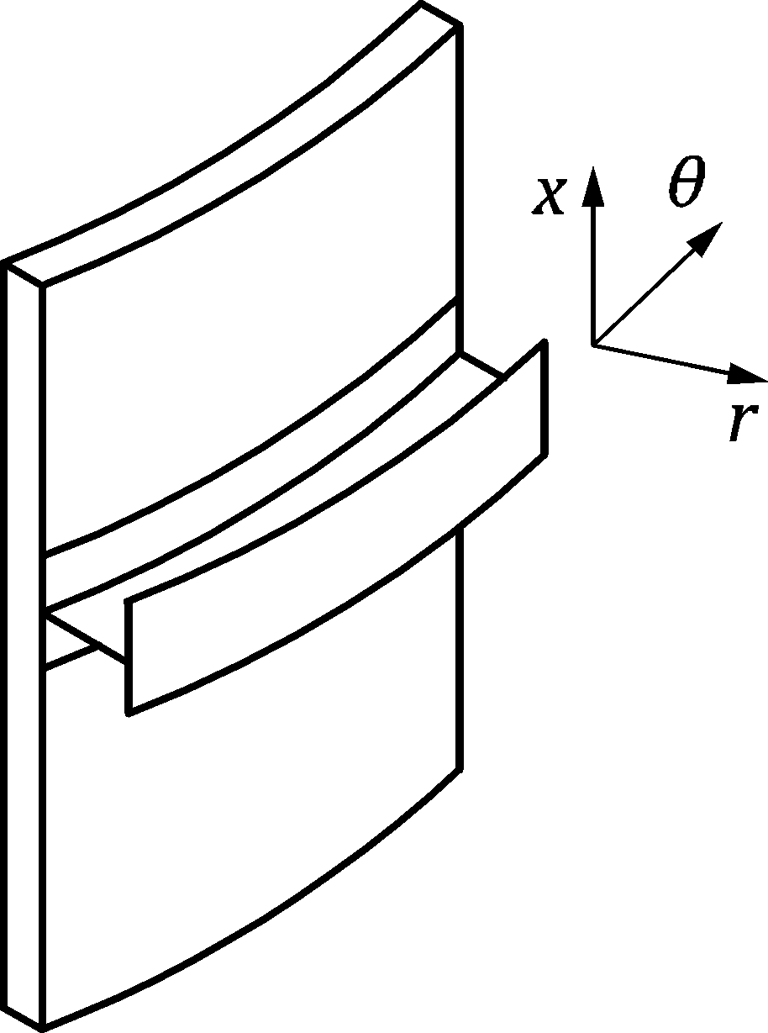

Figure 3.4 — Local coordinate system for circumferential ring stiffeners on a shell for directions of bending

NOTE 2 To match bending terminology for shell structures, the vertical stresses in both the shell and any vertical stiffener are denoted x. The bending moments inducing vertical stresses in a vertical stiffener are denoted as *M*x, and the second moment of area of a stiffener bending in the vertical direction (stresses in the vertical direction) (Figure 3.3 a) is denoted as *I*x (not *I* as would be the case for a structural member according to EN 1993‑1‑1). Similarly, the circumferential stresses in both the shell and any ring stiffener are denoted . The bending moments inducing circumferential stresses in a ring stiffener are denoted as *M*, and the second moment of area of a ring (Figure 3.4 a)) bending in the plane of the ring (stresses in the circumferential direction) is denoted by *I*. This last notation is important for the required stiffness of ring stiffeners to assist in resisting buckling under external pressure or wind.

|  |  |
| --- | --- |
|  |  |
| **a) stiffener local coordinates and directions of bending** | **b) structure local axes in different segments** |

Key

|  |  |
| --- | --- |
| 1 | roof |
| 2 | vertical wall |
| 3 | hopper |
| 4 | skirt |

Figure 3.5 — Local coordinate systems for walls and meridional stiffeners on a box

(3) The local axis convention for circumferential curved structural elements (see Figure 3.4 a)) attached to a shell wall is:

|  |  |  |
| --- | --- | --- |
| — | Circumferential coordinate axis (curved) | ** |
| — | Radial axis (axis for bending in a tangential vertical plane) | *r* |
| — | Subscript for circumferential bending | ** |
| — | Subscript for axial bending | *x* |

NOTEA circumferential ring under a bending moment *m* is subject to bending about its vertical axis *x* and the bending is compatible with circumferential bending in the cylinder (*m*). The second moment of area of this ring is defined as *I*. When the ring is subject to bending moments (*m*r) about its radial axis *r* when either acting as a ring girder, or when subject to radial forces acting at a point eccentric to the ring centroid. These bending moments also induce stresses  and *r* in the ring. The second moment of area of this ring is defined as *Ir*.

(4) The local axis convention for circumferential straight structural elements attached to a box is:

|  |  |  |
| --- | --- | --- |
| — | circumferential axis | *y* |
| — | outward axis | *x* |
| — | vertical axis | *z* |

NOTE A circumferential straight stiffener on a box is subject to bending about its vertical axis z when the bending is out of the plane of the box wall, which is the normal condition.

### Conventions for stress resultants for circular silos and rectangular silos

(1) The convention used for subscripts indicating membrane forces is:

"The subscript derives from the direction in which direct stress is induced by the force."

Membrane stress resultants:

|  |  |
| --- | --- |
| *n*x | axial membrane stress resultant in a cylindrical shell |
| *n* | meridional membrane stress resultant in a conical or spherical shell |
| *n* | circumferential membrane stress resultant in a shell |
| *n*z | vertical membrane stress resultant in a rectangular box |
| *n*y | circumferential membrane stress resultant in a rectangular box |
| *n*yz or *n*x | membrane shear stress resultant |

Membrane stresses:

|  |  |
| --- | --- |
| **mx | axial membrane stress in a cylindrical shell |
| **m | meridional membrane stress in a conical or spherical shell |
| **m | circumferential membrane stress in a shell |
| **mz | vertical membrane stress in a rectangular box |
| **my | circumferential membrane stress in a rectangular box |
| **myzor **mx | membrane shear stress |

(2) The convention used for subscripts indicating moments is: The subscript derives from the direction in which direct stress is induced by the moment.

NOTE This plate and shell convention differs from that for beams and columns as used in EN 1993-1-1 and EN 1993-1-3. Care is to be exercised when using those documents in conjunction with these rules.

Bending stress resultants:

|  |  |
| --- | --- |
| *m*x | meridional or axial bending moment per unit width |
| *m* | circumferential bending moment per unit width in shells |
| *m*y | circumferential bending stress resultant in rectangular boxes |
| *m*xy or *m*x | twisting shear moment per unit width |

Bending stresses:

|  |  |
| --- | --- |
| **bx | meridional or axial bending stress |
| **b | circumferential bending stress in shells |
| **by | circumferential bending stress in rectangular boxes |
| **bxy or **bx | twisting shear stress |

Inner and outer surface stresses:

|  |  |
| --- | --- |
| **six, **sox | meridional or axial inner, outer surface stress for boxes and shells |
| **si, **so | circumferential inner, outer surface stress in shells |
| **six, **sox | inner, outer surface shear stress in shells |
| **siy, **soy | circumferential inner, outer surface stress in rectangular boxes |
| **sixy, **soxy | inner, outer surface shear stress in rectangular boxes |

|  |  |
| --- | --- |
|  |  |
| **a) Membrane stress resultants in a cylindrical shell** | **b) Bending stress resultants in a cylindrical shell** |

Figure 3.6 — Stress resultants in the shell silo wall

# Basis of design

## Basic requirements

(1) The design of silos shall be in accordance with the general rules given in EN 1990 and EN 1991 (all parts) and the specific design provisions for steel structures given in EN 1993‑1 (all parts).

(2) Numerical values of the specific actions on steel silos shall be taken from EN 1991-4.

(3) Silos designed according to this document shall be executed according to EN 1090‑2 with construction materials and products used as specified in the relevant parts of the EN 1993 series, or in the relevant material and product specifications.

(4) Where the buckling resistance is critical, the fabrication tolerances defined in EN 1993-1-6 should be adopted.

(5) The design of the silo structure should consider all shell and plated sections of the structure, including stiffeners, ribs, rings and attachments.

(6) The supporting structure should not be treated as part of the silo structure. The boundary between the silo and its supports should be taken as indicated in Figure 1.1. Similarly, other structures supported by the silo should be treated as beginning where the silo wall or attachment ends.

(7) Silos should be designed to be damage-tolerant where appropriate, considering the use of the silo.

(8) Particular requirements for special applications can be specified by the relevant authority, or where not specified, can be agreed for a specific project by the relevant parties.

(8) This document is intended to be used in conjunction with EN 1990, with EN 1991-4, with the other Parts of EN 1991, with EN 1993-1-6 and EN 1993-4-2, with the other parts of EN 1993, with EN 1992 and with the other parts of EN 1994 to EN 1999 relevant to the design of silos. Matters that are already covered in those documents are not repeated.

(9) Numerical values for partial factors and other reliability parameters are recommended as basic values that provide an acceptable level of reliability. They have been selected assuming that an appropriate level of workmanship and quality management applies.

(10) Safety factors for ‘product type’ silos (factory production) can be specified by the appropriate authorities. When applied to ‘product type’ silos, the factors in 4.3 are for guidance purposes only. They are provided to show the likely levels needed to achieve consistent reliability with other designs.

## Units

(1) For the application of this standard S.I. units are used in accordance with ISO 1000.

(2) For calculations, the following consistent units are recommended:

|  |  |  |
| --- | --- | --- |
| dimensions and thicknesses: | m | mm |
| unit weight: | kN/m3 | N/mm3 |
| forces and loads: | kN | N |
| line forces and line loads: | kN/m | N/mm |
| pressures and area distributed actions: | kPa | MPa |
| unit mass: | t/m3 | t/mm3 |
| acceleration: | m/s2 | mm/s2 |
| membrane stress resultants: | kN/m | N/mm |
| bending stress resultants: | kNm/m | Nmm/mm |
| stresses and elastic moduli: | kPa | MPa (N/mm2) |

## Silo classifications

### **Consequence Classification for silos**

(1) For reliability differentiation by Consequence Class, see EN 1990:2023, A.4.

(2) The classification of each silo into a Consequence Class is given in EN 1990:2023, A.4, based on the consequences of failure. The classification for structural design rules combines the Consequence Class with the Structural Complexity Class into a single classification as a Silo Group.

### **Structural Complexity Classification for silos**

(1) The Structural Complexity Class for a silo shall be determined by the conditions of the individual silo.

(2) The dimensions of the silo should be used as a critical part of the evaluation of the Structural Complexity Class.

(3) The effect of silo size on selection of the Structural Complexity Class should be determined according to the parameter *w*, associated with the potential energy of the stored solid using Formula (4.1).

|  |  |
| --- | --- |
|  |  |
| **a) Height of centre of mass of the stored solid in a ground-supported silo** | **b) Height of centre of mass of the stored solid in an elevated silo** |

Figure 4.1 — Dimensions used to define Structural Complexity Classes

(4) The effect of silo size on the selection of the Structural Complexity Class should be determined according to the parameter *w,* calculated from Formula (4.1):

 (4.1)

where

|  |  |
| --- | --- |
| *d*c | is the characteristic dimension of the silo cross-section (see prEN 1991‑4:2024, Figure 1.1c) |
| *h*g | is the height of the centre of mass of the stored solid above the ground (see Figure 4.1) |

NOTE 1 The parameter *w* provides a simple understandable single dimension that is related to the potential energy of the stored solid, though the unit weight is omitted.

NOTE 2 Quantified limits of the parameter *w* for each Structural Complexity Class for silos are given in Table 4.1 (NDP), unless the National Annex gives different quantified limits.

Table 4.1 (NDP) — Descriptions and quantified limits for parameter *w* for Structural Complexity Classes for silos

| Structural Complexity Class | Descriptions and values of parameter *w* |
| --- | --- |
| Structural Complexity Class 3 | 1. Elevated discretely-supported silos *w* > 20 m 2. Silos designed to resist unsymmetrical loads with *w*> 15 m |
| Structural Complexity Class 2 | Silos with 10 < *w* ≤ 15 m |
| Structural Complexity Class 1 | Ground-supported silos with 2 < *w* ≤ 10 m |
| Structural Complexity Class 0 | Silos with *w* ≤ 2 m |

### Silo Group Categorisation

(1) Different levels of rigour should be used in the design of silo structures, depending on the Silo Group to which the silo belongs, the structural arrangement and the susceptibility to different failure modes.

NOTE The National Annex can define the conditions to distinguish between Silo Groups as a function of the location, the size, the structural form and internal structures, the stored solid and loading, and the type of operation, noting the definitions and classifications given in EN 1990:2023, Clause A.4 and EN 1991‑4. It can also provide additional information on other issues associated with the choice of Silo Group.

(2) Classification into a Silo Group should be determined by the conditions of the individual silo.

(3) Four Silo Groups are used in this standard, with requirements that produce designs with essentially comparable demands on the design assessment and considering the expense and procedures necessary to ensure the safety of different structures: Silo Groups 0, 1, 2 and 3 as indicated in Table 4.2.

NOTE 1 The classification of a silo into a Silo Group is given in Table 4.2, unless the National Annex gives a different classification.

NOTE 2 Silos that could be classified as Silo Group 4 correspond to structures in Consequence Class 4 (EN 1990), which are outside the scope of the Eurocodes since additional information is required for their design.

Table 4.2 — Silo Group (SG) (NDP) defined by the Structural Complexity Class (SCC), and Consequence Class (CC)

| Structural Complexity Class (SCC) | Higher | Normal | Lower | Lowest |
| --- | --- | --- | --- | --- |
| (CC3) | (CC2) | (CC1) | (CC0) |
| Higher (SCC3) | SG3 | SG3 | SG2 | SG1 |
| Normal (SCC2) | SG3 | SG2 | SG2 | SG0 |
| Lower (SCC1) | SG3 | SG2 | SG1 | SG0 |
| Lowest (SCC0) | SG2 | SG2 | SG1 | SG0 |

(4) The structural design should be carried out according to the provisions for the relevant Silo Group given in this part.

(5) The provisions for a higher Silo Group than that required may always be adopted for the design.

(6) The provisions for a lower Silo Group than that defined shall not be adopted for the design.

(7) Silos that are used to store materials that can induce vibrations, oscillations and shocks (quaking, honking, banging: see prEN 1991‑4:2024, D.3 and Table C.2) require special load assessments and design considerations that are outside the scope of this document.

(8) A higher Silo Group than that defined by Table 4.2 may be adopted. Any part of the procedures for a higher Silo Group may be adopted whenever it is appropriate.

NOTE Other requirements can be specified in the National Annex in reference to each Silo Group. These relate to:

* Design qualification and experience levels (DQLs);
* Design Check Levels (DCLs), Execution Classes (EXC);
* Inspection Levels (ILs);
* Minimum validation of stored materials behaviour;
* Specification of assumptions concerning differential settlements;
* Minimum validation of calculation models used in the design.

(9) Silo Group 3 should be used for all Special Silo Load Cases (SSLC) which refer to a stored solid load case associated with unsymmetrical conditions on the wall of the silo, as defined in EN 1991‑4.

(10) For silos in Silo Groups 0 and 1, simplified provisions may be adopted.

NOTE Appropriate provisions for silos in Silo Group 1 (and Silo Group 0) are set out in Annex A.

## Verification by the partial factor method

#### Partial factors for actions on silos

(1) For persistent, transient and accidental design situations, the partial factors **F shall be taken from EN 1990:2023, A.4.

(2) Partial factors for ‘product-type’ silos (factory production) may be specified by the appropriate authorities.

NOTE When applied to ‘product-type’ silos, the values of the partial factors given in Table 4.4 are for guidance purposes only. They are provided to show the likely levels needed to achieve consistent reliability with other designs.

#### Partial factors for resistances

(1) Where structural properties are determined by testing, the requirements and procedures of EN 1990 should be adopted.

(2) Fatigue verifications should satisfy Clause 10 of prEN 1993‑1‑6:2023 and EN 1993‑1‑9.

(3) The partial factors **Mi for different limit states shall be taken from Table 4.3. The specific values for those factors are recommended as given in Table 4.4.

**Table 4.3 — Partial factors for resistance**

| Resistance to failure mode | Relevant ** |
| --- | --- |
| Resistance of welded or bolted shell or box wall to plastic limit state | **M0 |
| Resistance of shell or box wall to stability | **M1 |
| Resistance of welded or bolted shell or box wall to rupture | **M2 |
| Resistance of shell or box wall to cyclic plasticity | **M4 |
| Resistance of connections | **M5 |
| Resistance of shell or box wall to fatigue | **Mf |

NOTE 1 The numerical values in Table 4.4 are given for silo structures, unless the National Annex gives different values.

Table 4.4 (NDP) — Numerical values for partial factors for resistance for silo structures

|  |  |  |
| --- | --- | --- |
| **M0 = 1,00 | **M1 = 1,10 | **M2 = 1,25 |
| **M4 = 1,00 | **M5 see EN 1993-1-8 | **Mf see EN 1993-1-9 |

NOTE 2 The required partial factor for shell buckling **M1 depends quite strongly on the structural form, the slenderness of the shell, the load case and the buckling mode, since the imperfection sensitivity and the consequent variability of the buckling resistance varies considerably with these factors. Due to lack of reliable data relevant to practical construction, the drafting committee chose to retain the historically accepted value of **M1.

(4) Where hot-rolled steel sections are used as part of a silo structure, the relevant partial factors for their resistance should be taken from EN 1993‑1‑1.

(5) Where cold-formed steel sections are used as part of a silo structure, the relevant partial factors for their resistance should be taken from EN 1993‑1‑3.

### Serviceability limit states

(1) Where simplified compliance rules are given in the relevant provisions dealing with characteristic serviceability limit states, detailed calculations using combinations of actions need not be carried out.

(2) For all serviceability limit states the values of *γ*Mser should be specified.

NOTE The partial factor for serviceability *γ*Mser = 1,0, unless the National Annex gives a different value.

(3) The limit states defined in EN 1993‑1‑6 and EN 1993‑1‑7, as appropriate, should be adopted.

* Global stability and static equilibrium as a rigid body;
* LS1: plastic limit;
* LS2: cyclic plasticity;
* LS3: buckling;
* LS4: fatigue.

## Actions and environmental effects

### General

(1) The general requirements set out in Clause 4 of EN 1990:2023 shall be satisfied.

### Wind action

(1) For specifications of wind actions not set out in EN 1991‑1‑4 for the design of silos either in isolation or in a group, appropriate additional information should be agreed.

(2) Because these large light structures are sensitive to the detailed wind pressure distribution on the wall, both with respect to the buckling resistance when empty and the holding down details required at the foundation, additional information may be used to augment the wind data provided in EN 1991‑1‑4 for the specific needs of an individual construction.

### Combination of solids pressures with other actions

(1) The combination factors on actions in silos set out in EN 1990:2023, A.4 should be used.

NOTE The National Annex can specify different combination factors on actions.

## Geometrical data

(1) The provisions concerning geometrical data given in Clause 6 of EN 1990:2023 shall be followed.

(2) The additional information specific to shell structures given in EN 1993‑1‑6 should also be applied.

(3) The shell plate thickness should be taken as the nominal thickness. In the case of hot-dipped galvanised metal-coated steel sheet conforming with EN 10346, the nominal thickness should be taken as the nominal core thickness, obtained as the nominal external thickness less the total thickness of zinc coating on both surfaces.

(4) The effects of corrosion and abrasion on the thickness of silo wall plates should be included in the design, in accordance with 6.1.4.

## Modelling of the silo for determining action effects

(1) The general requirements set out in EN 1990 shall be followed.

(2) The specific requirements for structural analysis in relation to serviceability, set out in Clause 13 of this document for each structural segment, should be followed.

(3) The specific requirements for structural analysis in relation to ultimate limit states, set out in Clauses 6 to 12 of this document and in more detail in EN 1993‑1‑6 and EN 1993‑1‑7, should be followed.

## Design assisted by testing

(1) The general requirements set out in EN 1990:2023, Annex D should be followed.

(2) For 'product-type' silos (factory production) which are subject to full-scale testing, 'deemed-to-satisfy' criteria may be adopted for design purposes.

## Action effects for limit state verifications

(1) The general requirements set out in EN 1990 shall be satisfied.

## Durability

(1) The general requirements set out in EN 1990:2023, 4.6 should be followed.

## Fire resistance

(1) The provisions set out in EN 1993‑1‑2 for fire resistance should be met.

# Properties of materials

## General

(1) All steels used for silos should be suitable for welding to permit later modifications when necessary.

(2) All steels used for silos of circular planform should be suitable for cold forming into curved sheets or curved members.

(3) The material properties given in EN 1993‑1‑1 (see Table 5.1 and Table 5.2 in EN 1993‑1‑1:2022) and EN 1993‑1‑3 (see Table 5.2 in FprEN 1993‑1‑3:2023) as appropriate, should be treated as nominal values to be adopted as characteristic values in design calculations, except as defined in 5.2.

(4) Other material properties are given in the relevant Reference Standards defined in EN 1993‑1‑1.

(5) Where the silo can be filled with hot solids, the values of the material properties should be appropriately reduced to values corresponding to the maximum temperatures to be encountered.

(6) The variation in the material properties of structural steels at temperatures above 100 °C should be obtained from EN 1993-1-2. Where these are adopted, the reduced yield stress may be conservatively taken as the temperature-dependent proportionality limit *f*p. The mechanical properties for steel grades not represented in EN 1993‑1‑2 should be based on reliable information.

## Structural steels

(1) The methods for design by calculation given in this document may be used for structural steels as defined in EN 1993‑1‑1, which conform with the European Standards and International Standards listed in Table 5.1 and Table 5.2 of EN 1993‑1‑1:2022.

(2) The mechanical properties of structural steels, according to EN 10025 series or EN 10149 series should be obtained from EN 1993‑1‑1 and EN 1993‑1‑3, as appropriate.

(3) Corrosion and abrasion allowances are given in 6.1.4.

(4) For the steels covered by this document, the design value of Poisson’s ratio should be taken as * * = 0,3. The characteristic value of the elastic modulus for structural steel should be taken as *E* = 200 000 N/mm2, in accordance with the value defined for stability calculations in EN 1993‑1‑14.

NOTE Elastic buckling is often critical in silo structures, so a conservative estimate of the elastic modulus is required, since the partial factor for buckling **M has been made consistent throughout all the EN 1993 standards.

(5) Where the design involves a stability calculation, appropriate reduced properties should be used either as appropriate to the operating temperature (see EN 1993‑1‑2) or as appropriate to the stress-strain curve higher stresses (see EN 1993‑1‑6 and EN 1993-1‑14). For stability calculations, the reduced elastic modulus *E*red should be adopted under these conditions.

## Stainless steels

(1) The mechanical properties of stainless steels should be established according to the provisions of Clause 5 in prEN 1993‑1‑6:2023.

(2) Guidance for the selection of stainless steels in view of corrosion and abrasion actions of stored solids may be obtained from appropriate sources (see also 6.1.4).

(3) Where the design involves a buckling calculation, appropriate reduced properties should be used (see EN 1993‑1‑6).

## Special alloy steels

(1) For non-standardised alloy steels, appropriate values of relevant mechanical properties should be chosen. The properties of steels should fulfil the general requirements given in EN 1993‑1‑1.

NOTE Further information on the application of non-standardized alloy steels can be given in the National Annex.

(2) Guidance for the selection of non-standardised alloy steels with respect to the corrosion and abrasion actions of stored solids should be obtained from appropriate sources.

(3) Where the design involves a buckling calculation, appropriate reduced properties should be used (see EN 1993‑1‑6 and EN 1993-1‑14).

## Toughness requirements

(1) The provisions in this standard apply to materials that satisfy the brittle fracture provisions given in EN 1993‑1‑4, EN 1993‑1‑10 and EN 1993‑1‑12.

# Basis for structural analysis

## Ultimate limit states

### Basis

(1) Steel structures and components should be so proportioned that the basic design requirements given in Clause 4 are satisfied.

### Required checks

(2) For every relevant limit state, the design shall satisfy the condition:

** (6.1)

where

*S* and *R* represent any appropriate parameter.

### Fatigue and cyclic plasticity — low cycle fatigue

(1) Parts of the structure subject to severe local bending should be checked against the fatigue and cyclic plasticity limit states using the procedures of EN 1993‑1‑6 and EN 1993‑1‑7 as appropriate.

NOTE The term “severe local bending” refers to locations where the local bending stress exceeds twice the local membrane stress.

(2) The number of cycles for a particular fatigue load case should be determined as defined in prEN 1991‑4:2023, 5.2.3(6). Consideration should also be given to the conditions identified in prEN 1991‑4:2023, 5.2.3(11).

(3) The number of cycles involved in either the cyclic plasticity or fatigue limit states are defined in prEN 1993‑1‑6:2023, 6.3.2 and 6.3.4.

(4) It is not necessary to check silos in Silo Groups 0 and 1 for fatigue or cyclic plasticity.

### Allowance for corrosion and abrasion

(1) The effects of abrasion of the stored solid on the walls of the container over the life of the structure should be included in determining the effective thickness of the wall for analysis. Solids identified as potentially leading to abrasion of steel are given in prEN 1991‑4:2024, Table C.2.

(2) Where no specific information is available, the wall should be assumed to lose an amount *t*a of its thickness due to abrasion at all points that can be in contact with moving solid during discharge.

(3) Where the stored material is a cereal grain, the value of *t*a may be taken to be *t*a = 0.

(4) Where the stored material is identified as potentially abrasive in EN 1991‑4, the value of *t*a may be taken to be *t*a = 2 mm.

NOTE Alternative recommendations for the abrasion caused by different stored solids in contact with different surfaces over different periods can be found in the literature.

(5) The effects of corrosion of the wall in contact with the stored solid over the life of the structure should be included in determining the effective thickness of the wall for analysis.

NOTE Recommendations for the corrosion caused by different stored solids in contact with different surfaces over different periods can be found in the literature.

(6) For the specification of specific values for corrosion and abrasion losses, the intended use and the nature of the solids to be stored should be taken into account. These values should be stated in the execution specification.

NOTE 1 The National Annex can choose appropriate values for corrosion and abrasion losses for particular solids in frictional contact with defined silo wall materials, recognising the mode of solids flow and the abrasive or corrosive potential of the solid as defined in EN 1991‑4.

NOTE 2 Appropriate inspection measures are needed to ensure that the design assumptions are met in service.

### Allowance for temperature effects

(1) Where hot solids are stored in the silo, the effects of differential temperature between parts of the structure in contact with hot material and those that have cooled should be included in determining the stress distribution in the wall.

## Serviceability limit states

(1) Deformations should be limited to avoid:

* 2nd order deformation problems, when they are not taken into account in the analysis;
* problems associated with the attachment of, or proximity to, adjacent structures (e.g. feeders, chutes, conveyors, pipelines, etc.);
* limitations required for the individual project by the relevant authority or client.

(2) Where no limits are defined by the relevant authority or client, see Clause 13.

## Analysis of the structure of a shell silo

### Modelling of the structural shell

(1) The modelling of the structural shell should follow the requirements of EN 1993‑1‑6. They may be deemed to be satisfied by using the following provisions.

(2) The modelling of the structural shell should include all stiffeners, large openings and attachments.

(3) The design should ensure that the assumed boundary conditions are achievable in execution.

(4) A shell formed from corrugated plate (vertically or horizontally) may be treated as an orthotropic uniform shell provided that the corrugation full wavelength is less than 0,5√(*rt*) where *t* is the local plate thickness.

### Methods of analysis

#### General

(1) The analysis of the silo shell should be carried out according to the requirements of EN 1993‑1‑6.

(2) An analysis type defined for a higher Silo Group than the subject silo may always be used.

(3) Where the silo is subject to any form of unsymmetrical bulk solids loading (proxy loads, eccentric discharge, unsymmetrical filling etc., see EN 1991‑4), the structural model should be designed to capture the membrane shear transmission within the silo wall and between the wall and rings.

NOTE The shear transmission between parts of the wall and rings has special importance in construction using bolts or other discrete connectors (e.g. between the wall and hopper, between the cylinder wall and vertical stiffeners or support, and between different courses in the cylinder).

(4) Where a ring girder is used to redistribute silo wall forces into discrete supports, and where bolts or discrete connectors are used to join the structural elements, the shear transmission between the parts of the ring due to shell bending and ring girder bending phenomena should be determined.

(5) The stiffness of the stored bulk solid in resisting wall deformations or in increasing the buckling resistance of the shell structure should only be considered where a rational analysis is used and there is clear evidence that the solid against the wall is not in motion at the specified location during discharge. In such situations, the relevant information on the flow pattern, the pressure in the solid and the properties of the specific stored bulk solid should be determined from EN 1991‑4.

(6) Where a corrugated silo exhibits mass flow (see EN 1991‑4), the solid held stationary only within the corrugations should not be considered as stationary when evaluating the support provided by internal pressure to resist buckling (see 7.9.4.3(11)).

#### Silo Group 3

(1) For silos in Silo Group 3, the internal forces and moments should be determined using a validated numerical analysis (e.g. computational shell analysis, as defined in EN 1993‑1‑6). Plastic collapse strengths under primary stress states may be used in relation to the plastic limit state as defined in EN 1993‑1‑6.

#### Silo Group 2

(1) For silos in Silo Group 2 under conditions of axisymmetric actions and support conditions, one of two alternative analyses may be used:

* Membrane theory may be used to determine the primary stresses. Bending theory elastic formulae may be used to describe all local bending effects (see EN 1993‑1‑6 for definitions);
* A validated numerical analysis may be used (e.g. computational shell analysis, as defined in EN 1993‑1‑6).

(2) Where the design loading from stored solids cannot be treated as axisymmetric, a validated numerical analysis should be used.

(3) Notwithstanding (2), where the loading varies smoothly around the shell causing global bending only (i.e. in the form of circumferential harmonic 1), membrane theory may be used to determine the primary stresses.

(4) For analyses of actions due to wind loading and/or foundation settlement and/or smoothly varying proxy loads (see EN 1991‑4 for thin walled silos), the semi-membrane theory or the membrane theory of shells may be used.

(5) Where membrane theory is used to find the primary stresses in the shell:

1. Discrete rings attached to an isotropic cylindrical silo shell under internal pressure may be deemed to have an effective area which includes a length of shell above and below the ring of 0,78 except where the ring is at a transition junction;
2. The effect of local bending stresses at discontinuities in the shell surface and supports should be evaluated separately.

(6) Where an isotropic shell wall is discretely stiffened by vertical stiffeners, the stresses in the stiffeners and the shell wall may be calculated by treating the stiffeners as smeared on the shell wall, provided the spacing of the stiffeners is not wider than .

(7) Where smeared stiffeners are used on an isotropic shell, the stress in the stiffener should be determined making proper allowance for compatibility between the stiffener and the wall and including the effect of the wall membrane stress in the orthogonal direction (see 7.8.3).

NOTE Internal pressure causes circumferential stresses which induce vertical strains (shortening) of the shell wall, but this does not apply to vertical stiffeners. Compatibility between the shell and the stiffeners then increases the axial compression in stiffeners.

(8) Where a ring girder is used above discrete supports, membrane theory may be used to determine the primary stresses, but the requirements of 7.8 and 10.1.4 concerning the evaluation of additional non-axisymmetric primary stresses should be followed.

(9) Where a ring girder is used above discrete supports, compatibility of the deformations between the ring and adjacent shell segments should be considered, see Figure 6.1. Particular attention should be paid to compatibility of the axial deformations, as the induced stresses penetrate far up the shell. Where such a ring girder is used, the eccentricity of the ring girder centroid and shear centre relative to the shell wall and the support centreline should be considered, see 10.1.4 and 10.2.3.

|  |  |
| --- | --- |
|  |  |
| **a) Traditional design model for column-supported silos** | **b) Deformation requirement on cylinder imposed by compatibility with beam deformation** |

Key

|  |  |  |  |
| --- | --- | --- | --- |
| a) | | b) | |
| 1 | cylindrical shell | 1 | shell wall |
| 2 | axisymmetric wall loading and bottom pressures | 2 | in-plane vertical deflections |
| 3 | uniform support to cylinder from ring girder | 3 | ring girder deflected shape |
| 4 | ring girder (various cross-section geometries) | 4 | discrete support |
| 5 | uniform loading of ring girder by cylinder |  |  |
| 6 | discrete local supports |  |  |

Figure 6.1 — Axial deformation compatibility between ring girder and shell

#### Silo Group 1

(1) For silos in Silo Group 1, membrane theory may be used to determine the primary stresses, with factors and simplified formulae to describe local bending effects and unsymmetrical actions.

#### Silo Group 0

(1) Silos in Silo Group 0 may be designed to the provisions defined for Silo Group 1, but they strictly lie outside the scope of this document.

### Geometric imperfections

(1) Geometric imperfections in the shell should satisfy the tolerance requirements defined in EN 1993‑1‑6.

(2) For silos in Silo Groups 2 and 3, the geometric imperfections should, where possible, be measured following construction to ensure that the assumed fabrication tolerance quality has been achieved.

(3) Geometric imperfections in the shell need not be explicitly included in determining the internal forces and moments, except where a GNIA or GMNIA analysis is used, as defined in EN 1993‑1‑6.

## Analysis of the box structure of a plate assembly silo

### Modelling of the structural box formed by an assembly of plates

(1) The modelling of the structural box should follow the requirements of EN 1993‑1‑7, but they may be deemed to be satisfied by the following provisions.

(2) The modelling of the structural box should include all stiffeners, large openings and attachments.

(3) The design should ensure that the assumed boundary conditions are satisfied.

(4) The joints between segments of the box should satisfy the modelling assumptions for strength and stiffness.

(5) Each panel of the box may be treated as an individual plate segment provided that both:

1. the forces and moments introduced into each panel by its neighbours are included;
2. the flexural stiffness of adjacent panels is included.

(6) Where corrugated wall panels are used, the bending stresses in each panel or plate segment may be calculated by treating the plate as acting in one-way bending.

(7) Where an isotropic plate wall panel is discretely stiffened with horizontal stiffeners, the stresses in the stiffeners and the box wall may be calculated by treating the stiffeners as smeared on the wall to produce an orthotropic plate, provided that the spacing of the stiffeners is no wider than 30*t*.

NOTE For further information, see EN 1993‑1‑7.

(8) Where a smeared stiffener treatment is used, the stress in the stiffener should be determined making proper allowance for the eccentricity of the stiffener from the wall plate, and for the wall stress in the direction orthogonal to the axis of the stiffener.

(9) The effective width of plate on each side of a stiffener may be taken as 15 *t*, where $ε=\sqrt{235/f_{y}}$ and *f*y is in N/mm2. For more detailed information see EN 1993‑1‑5 and EN 1993‑1‑7.

NOTE The simple value 15 *t* is chosen a safe value.

### Geometric imperfections

(1) Where geometric imperfections in the box are relevant to buckling ultimate limit states, their amplitudes should satisfy the limitations defined in EN 1993‑1‑7.

(2) Geometric imperfections in the box need not be explicitly included in determining the internal forces and moments.

### Methods of analysis

(1) The internal forces in the plate segments of the box wall may be determined using either:

1. static equilibrium for membrane forces and beam theory for bending (see prEN 1993‑1‑7:2023, Annex A);
2. an analysis based on linear plate bending and stretching theory (see prEN 1993‑1‑7:2023, Annex B);
3. an analysis based on nonlinear plate bending and stretching theory.

(2) For silos in Silo Group 1, method a) in (1) may be used.

(3) Where the design loading condition is symmetric relative to each plate segment and the silo is in Silo Group 2, method a) in (1) may be used.

(4) Where the design loading condition is not symmetric and the silo is in Silo Group 2, either method b) or method c) in (1) should be used.

(5) For silos in Silo Group 3, the internal forces and moments should be determined using either method b) or method c) in (1) (as defined in EN 1993‑1‑7).

## Analysis treatment of corrugated sheeting

(1) Where corrugated sheeting is used as part of the silo structure, the analysis may be carried out treating the sheeting as an equivalent uniform orthotropic wall.

(2) The following properties may be used in a stress analysis and in a buckling analysis of the structure, provided that the corrugation profile has either an arc-and-tangent or a sinusoidal shape. Where other corrugation profiles are used, the corresponding properties should be calculated from first principles.

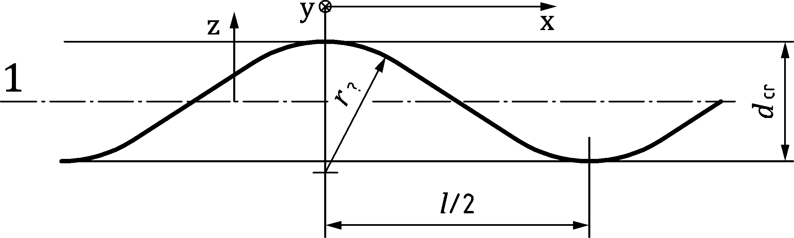

Key

|  |  |
| --- | --- |
| 1 | effective middle surface of the corrugated shell wall |

Figure 6.2 — Corrugation profile and geometric parameters

(3) The properties of the corrugated sheeting should be defined in terms of an *x, y* coordinate system in which the *y* axis runs parallel to the corrugations (straight lines on the surface) whilst *x* runs normal to the corrugations (troughs and peaks). The corrugation should be defined in terms of the following parameters, irrespective of the actual corrugation profile, see Figure 6.2:

where

|  |  |
| --- | --- |
| *d*cr | is the crest to crest transverse dimension; |
| *L* | is the wavelength (pitch) of the corrugation; |
| *r* | is the local radius of curvature at the crest or trough. |

(4) The equivalent properties of the sheeting in each of the two principal directions may be treated as independent, so that strains in one direction do not produce stresses in the orthogonal direction (i.e. no Poisson effects).

(5) The equivalent membrane properties (stretching stiffnesses) may be taken as:

 (6.2)

 (6.3)

 (6.4)

where

|  |  |
| --- | --- |
| *t*1 | is the equivalent thickness for the smeared membrane stiffness parallel to the corrugations, given by: |

 (6.5)

|  |  |
| --- | --- |
| *t*2 | is the equivalent thickness for the smeared membrane stiffness normal to the corrugations, given by: |

 (6.6)

|  |  |
| --- | --- |
| *t*12 | is the equivalent thickness for the smeared membrane shear stiffness, given by: |

 (6.7)

NOTE The surface length of one corrugation wave is given by *l(t*1/t).

(6) The equivalent bending properties (flexural stiffnesses) are defined in terms of the flexural rigidity for moments causing bending stresses in that direction, and may be taken as:

 (6.8)

 (6.9)

 (6.10)

where

|  |  |
| --- | --- |
| *I*1 | is the equivalent second moment of area per unit width for the smeared bending stiffness parallel to the corrugations. For the corrugated profiles described in (2), it may be taken as: |

 (6.11)

|  |  |
| --- | --- |
| *I*2 | is the equivalent second moment of area per unit width for the smeared bending stiffness perpendicular to the corrugations, given by: |

 (6.12)

|  |  |
| --- | --- |
| *I*12 | is the equivalent second moment of area per unit width for the smeared twisting stiffness: |

 (6.13)

NOTEThe convention for bending moments in plates relates to the direction in which the plate becomes curved, so is contrary to the convention used for beams. Bending parallel to the corrugation engages the bending stiffness of the corrugated profile, induces stresses parallel to the corrugation, and is the chief reason for using corrugated construction.

(7) In circular silos, the corrugations are commonly arranged to run circumferentially. In this arrangement, the directions *1* and *2* in the above formulae should be taken as the circumferential *θ* and vertical *x* directions respectively, see Figures 3.1a and 6.3a. In the less common arrangement in which the corrugations run vertically, the directions 1 and 2 in the above formulae should be taken as the vertical *x* and circumferential *θ* directions respectively, see Figures 3.1a and 6.3b.

NOTE For circular silos, the above formulae provide values for *C*x, *C*, *C*x, *D*x, *D* and *D*x. These can be used in treating cylindrical corrugated walls as orthotropic (see 7.9).

|  |  |
| --- | --- |
|  |  |
| **a) Corrugations running horizontally** | **b) Corrugations running vertically** |

Figure 6.3 — Corrugated sheeting and silo wall orientations

(8) The shearing properties should be taken as independent of the corrugation orientation. The value of *G* may be taken as *E* / {2(1+**)} = 80 800 MPa.

(9) In rectangular silos, the corrugations are commonly arranged to run horizontally. In this arrangement, the directions *1* and 2 in the above formulae should be taken as the horizontal *y* and vertical z directions respectively, see Figures 3.2a and 6.3a. In the less common arrangement where the corrugations run vertically, the directions 1 and 2 in the above formulae should be interchanged on the real structure and taken as the vertical z and horizontal *y* directions respectively, see Figures 3.2a and 6.3b.

# Ultimate limit state design of cylindrical shell walls

## Basis

### General

(1) Cylindrical steel silo walls should be so proportioned that the basic design requirements for the ultimate limit states given in 7.1.2 are satisfied.

(2) The safety assessment of an isotropic walled cylindrical shell should be conducted using the provisions of EN 1993‑1‑6, which may be deemed to be satisfied by the provisions of this clause.

(3) Where a silo has either corrugated or stiffened walls, the provisions of 7.4, 7.5 or 7.6 should be adopted as appropriate.

### Silo wall design

(1) The cylindrical wall of the silo should be checked for the following phenomena under the limit states defined in EN 1993‑1‑6:

* global stability and static equilibrium.

LS1: plastic limit state covering:

* resistance to bursting or rupture or plastic mechanism collapse (excessive yielding) under internal pressures or other actions;
* resistance of joints (connections).

LS2: cyclic plastification covering:

* resistance to local yielding in bending;
* local effects.

LS3: buckling covering:

* resistance to buckling under axial compression (meridional compression);
* resistance to buckling under external pressure (wind or vacuum);
* resistance to buckling under shear from unsymmetrical actions;
* resistance to buckling under shear near engaged columns;
* resistance to local failure above supports;
* resistance to local crippling near openings;
* resistance to local buckling under unsymmetrical actions.

LS4: fatigue covering:

* resistance to high cycle fatigue failure at locations where high elastic stresses are often repeated.

(2) The shell wall should satisfy the provisions of EN 1993‑1‑6, except where 7.3 to 7.6 provide conditions that are deemed to satisfy the provisions of that standard.

(3) For silos in Silo Groups 0 and 1, the cyclic plasticity and fatigue limit states may be ignored.

## Distinctions between cylindrical shell forms

(1) For a shell wall constructed from flat rolled steel sheet, termed 'isotropic' (see Figure 7.1a ), the resistances should be determined as defined in 7.3.

(2) For an isotropic shell wall with lap joints formed by connecting adjacent plates with overlapping sections, termed 'lap-jointed' (see Figure 7.1b), the resistances should be determined as defined in 7.3.6.

(3) For an isotropic shell wall with vertical stiffeners attached to the outside, termed 'externally stiffened' irrespective of the spacing of the stiffeners (see Figure 7.1c), the resistances should be determined as defined in 7.4.

NOTE The use of internal stiffeners in silos is not encouraged, since the surface of contact with the stored solid is increased, increasing vertical forces in the wall and permitting stored solid to be trapped, and also because internal stiffeners lead to a lower axial compression buckling resistance in a cylindrical shell than external stiffeners.

(4) For a shell wall constructed from corrugated steel sheets where the troughs run around the silo circumference, termed 'horizontally corrugated' (see Figure 7.1d), the resistances should be determined as defined in 7.5. For a shell wall with the troughs running up the meridian, termed 'vertically corrugated', the resistances should be determined as defined in 7.6.

|  |  |  |  |
| --- | --- | --- | --- |
|  |  |  |  |
| **Elevation profiles** | | | |
|  |  |  |  |
| **Plan profiles** | | | |
| **a) Isotropic wall** | **b) Isotropic lap-jointed wall** | **c) Isotropic wall with vertical stiffeners** | **d) Horizontally corrugated wall with vertical stiffeners** |

Figure 7.1 — Illustrations of cylindrical shell forms

## Resistance of isotropic welded or bolted cylindrical walls

### General

(1) The cylindrical shell should satisfy the provisions of EN 1993‑1‑6. These may be met using the following assessments of the design resistance.

(2) The shell wall cross-section should be proportioned to resist failure by rupture or plastic collapse.

(3) The joints should be proportioned to resist rupture on the net section using the ultimate tensile strength.

(4) The eccentricity of lap joints should be included in the strength assessment for rupture, where relevant.

(5) The shell wall should be proportioned to resist stability failure.

### Evaluation of design stress resultants

(1) Under internal pressure, frictional traction and all relevant design loads, the design stress resultants should be determined at every point in the shell using the variation in internal pressure and wall frictional traction, as appropriate.

Each set of design stress resultants for stored solid loading of a silo should be based on a single set of stored solid properties.

Where the design stress resultants are being evaluated to verify adequate resistance to the plastic limit state, in general the stored solid properties should be chosen to maximise the internal pressure under the condition of discharge with proxy loads in EN 1991‑4.

Where the design stress resultants are being evaluated to verify adequate resistance to the buckling limit state under stored solid loads, in general the stored material properties should be chosen to maximise the axial compression under the condition of discharge with proxy loads in EN 1991‑4. However, where the internal pressure is beneficial in increasing the buckling resistance, only the filling pressures (for a consistent set of material properties) should be adopted in conjunction with the discharge axial forces, since the beneficial pressures can fall to the filling values locally even though the axial compression derives from the discharge condition.

(2) Where membrane theory is used to evaluate design stresses in the shell wall, the resistance of the shell should be adequate to withstand the highest pressure at every point.

(3) Because highly localised pressures are found to induce smaller design membrane stress resultants than would be found using membrane theory, the provisions of EN 1993‑1‑6 for stress design, direct design or computer design may be used to achieve a more economical design solution.

(4) Where a membrane theory analysis is used, the resulting two-dimensional stress field of stress resultants *n*x,Ed, *n*,Ed and *n*x,Ed may be evaluated using the von Mises equivalent design membrane stress:

 (7.1)

(5) Where an elastic bending theory analysis (LA) is used, the resulting two-dimensional stress field of primary stress resultants *n*x,Ed, *n*,Ed, *n*x,Ed, *m*x,Ed, *m*,Ed, *m*x,Ed may be transformed into the fictitious stress components:

 (7.2)

 (7.3)

 (7.4)

and the von Mises equivalent design surface stress:

  (7.5)

NOTE The above formulae (Ilyushin yield criterion) give a simplified conservative equivalent stress for design purposes.

### Plastic limit state

(1) The design resistance in plates in terms of membrane stress resultants should be assessed as the equivalent stress resistance for both welded and bolted construction *f*e,Rd given by:

*f*e,Rd = *f*y/M0 (7.6)

(2) The design resistance at lap joints in welded construction *f*e,Rd should be assessed using the fictitious strength criterion:

*f*e,Rd = *j f*y/M0 (7.7)

where *j* is the joint efficiency factor.

(3) The resistance of lap joint welded details with full continuous fillet welds should be evaluated using the joint efficiency factor *j* = *j*i, as defined in EN 1993‑1‑6 with *i* = 1 or 2 depending on the joint geometry.

(4) In bolted construction, the design resistance at net section failure at the joint should be assessed in terms of membrane stress resultants as follows:

|  |  |  |
| --- | --- | --- |
| — | for meridional resistance *n*x,Rd = *f*u *t* /  M2 | (7.8) |
| — | for circumferential resistance *n*,Rd = *f*u *t* /  M2 | (7.9) |
| — | for shear resistance *n*x,Rd = 0,57 *f*y *t* /  M0 | (7.10) |

(5) The design of bolted connections should be carried out in accordance with EN 1993‑1‑8 or EN 1993‑1‑3, as appropriate. The effect of fastener holes should be taken into account according to EN 1993‑1‑1 using the appropriate requirements for tension or compression or shear as appropriate.

(6) The resistance to local loads from attachments should be treated as detailed in 8.9.

(7) At every point in the structure the design stresses should satisfy the condition:

** (7.11)

(8) At every joint in the structure the design stress resultants should satisfy the relevant conditions:

** (7.12)

** (7.13)

(9) Any combinations of shear and tension should also be satisfied:

 (7.14)

 (7.15)

## Resistance of isotropic cylindrical walls under axial compression

### Elastic buckling under uniform axial compression

(1) Under axial compression, the design resistance against buckling should be determined at every point in the shell using the prescribed fabrication tolerance quality of construction, the intensity of the guaranteed co-existent internal pressure *ps*, and the circumferential uniformity of the compressive stress. The design should consider every point on the shell wall. In buckling calculations, compressive membrane forces should be treated as positive to avoid the widespread use of negative numbers.

(2) The prescribed fabrication tolerance quality of construction should be assessed as set out in Table 7.1.

Table 7.1 — Fabrication tolerance quality classes

| Fabrication Tolerance Quality Class | Fabrication tolerance quality of construction | Quality parameter, *Q* | Silo Group restrictions |
| --- | --- | --- | --- |
| Class A | Excellent | 40 | Only permitted when the silo is designed to Silo Group 3 rules |
| Class B | High | 25 |  |
| Class C | Normal | 16 | Compulsory when the silo is designed to Silo Group 1 rules |

NOTE The tolerance requirements for the Fabrication Tolerance Quality Classes are set out in EN 1993‑1‑6 and EN 1090‑2.

(3) The representative imperfection amplitude **0 should be taken as:

 (7.16)

(4) The unpressurised elastic imperfection reduction factor *α*x0 for uniform compression should be found as:

 (7.17)

(5) Where the silo wall is subject to internal pressure from the stored solid, the elastic imperfection reduction factor **x should be taken as the smaller of the two values **xpe and **xpp, determined according to the local value of the internal pressure *p*h, termed *p*s and *p*g, associated with the load cases defined in (7) and (8) respectively (obtained from EN 1991‑4) and at the same location in the silo as the axial compression is being assessed.

(6) For silos designed to Silo Group 1 rules, the elastic imperfection factor **x should not be taken as greater than **x = **x0.

(7) The elastic pressurised imperfection reduction factor **xpe should be based on the smallest local internal normal pressure *p*h (a value that can be guaranteed to be present) at the location of the point being assessed, and coexistent with the axial compression, which should be taken as the filling value obtained when the bulk solid material parameters in prEN 1991‑4:2024, Table 6.2 are chosen as Load Case D:

 (7.18)

with

 (7.19)

where

|  |  |
| --- | --- |
| *p*s | is the smallest design value of local normal pressure *p*h at the location of the point being assessed, guaranteed to coexist with axial compression; |
| **x,Rcr | is the elastic critical buckling stress (see Formula (7.37)). |

(8) The plastic pressurised imperfection reduction factor *α*xpp should be based on the largest local internal normal pressure *p*h, denoted by *p*g, at the location of the point being assessed where the local thickness is *t*, and coexistent with the local value of axial compression that can cause buckling:

 (7.20)

with

 (7.21)

 (7.22)

 (7.23)

where

|  |  |
| --- | --- |
| *p*g | is the largest design value of local internal pressure *p*h at the location of the point being assessed, guaranteed to coexist with the axial compression. |

(9) Different extremes of the material properties for a stored solid, defined in EN 1991‑4, lead to different coupled values of axial force and internal pressure. A consistent pair of values should be used each time when applying Formulae (7.18) or (7.20).

(10) The increase in buckling resistance of the shell structure due to the elastic stiffness of a stationary stored bulk solid may only be considered using a rational analysis. The required conditions are that there is clear evidence that the solid against the wall is not in motion at the specified location during discharge, based on relevant information on the flow pattern, the pressure in the solid and the properties of the specific stored bulk solid as determined from EN 1991‑4.

### Elastic buckling under non-uniform axial compression

(1) Where a numerical analysis has identified that the axial compression stress is non-uniform around the circumference at any level, the elastic buckling resistance may be taken as a higher value than that for uniform compression, using the following evaluation.

NOTE This treatment applies irrespective of the cause of the axial compressive stress. It is valid for local high axial compressive stresses induced by wind and other loading. It is useful for stress distributions above a discrete support where the peak local axial compressive stress declines progressively as the total force is spread over a wider and wider zone, leading to progressive changes in both the peak stress and the equivalent harmonic *j*. It is also useful for high local axial stresses that develop in the silo wall under conditions such as eccentric pipe flow discharge.

(2) The stress non-uniformity should be determined from the linear elastic stress distribution of acting axial compressive stress distribution. The axial compressive membrane stress distribution around the circumference at the chosen level should be transformed as shown in Figure 7.2. The design value of axial compressive membrane stress **x,Ed at the most highly stressed point at this axial coordinate is denoted as **xo,Ed.

(3) The design value of axial compressive membrane stress at a second point, at the same axial coordinate, but separated from the first point by the circumferential distance.

 or  (7.24)

should be taken as **x1,Ed

NOTE This separation is based on the reference wavelength of the axial compression LBA square buckle.

(4) Where stress ratio

 (7.25)

lies in the range 0,3 < *s* < 0,99, the following procedure may be adopted.

(5) Where the lower stress **x1,Ed is greater than 0,99 x0,Ed, the shell should be treated as uniformly stressed, and the value of **xnu taken as **xu = **x0 as given by Formula (7.17).

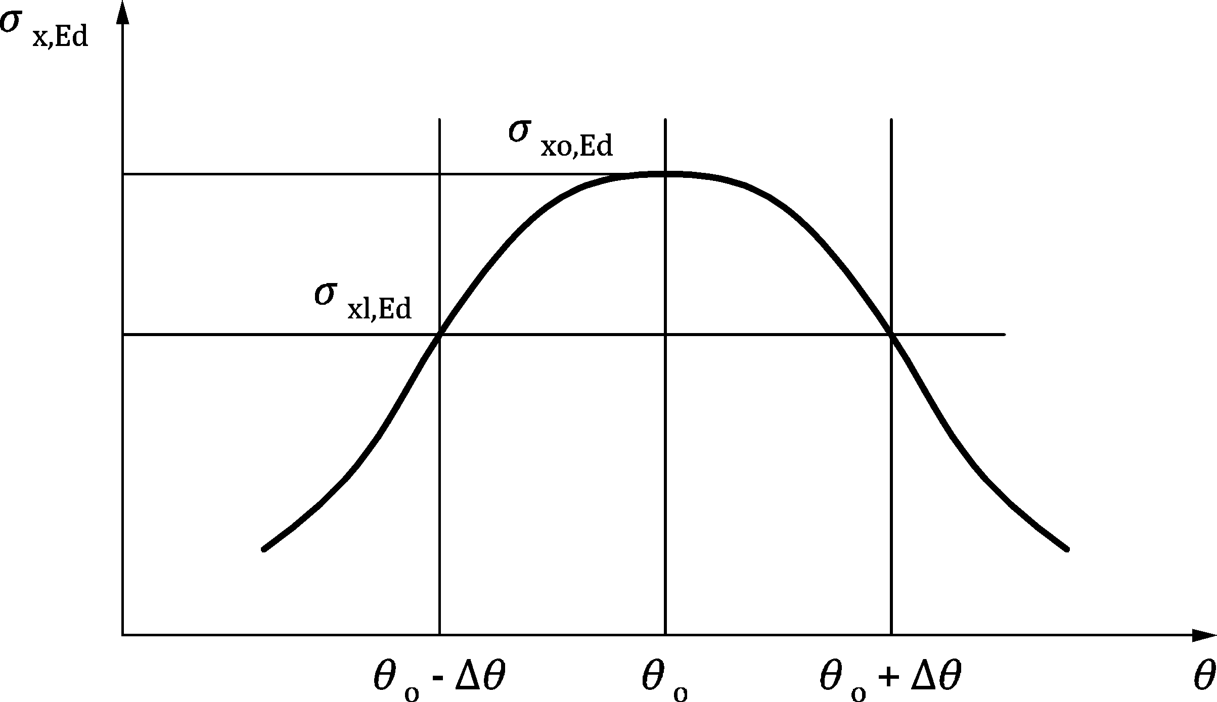

Figure 7.2 — Representation of local distribution of axial membrane stress resultant around the circumference

(6) The equivalent harmonic *j* of the stress distribution should be obtained as:

 (7.26)

and the non-uniform elastic imperfection reduction factor **nu should be determined as:

 but  (7.27)

with

 (7.28)

 (7.29)



 (7.30)

where **xb is a close approximation to the elastic imperfection reduction factor under global bending as defined in prEN 1993‑1‑6:2023, Formula (E.15).

NOTE The above formulae lead to uniform compression where the calculated stress does not vary around the circumference, lead to the global bending outcome when *j* = 1, and lead to the elimination of imperfection sensitivity when the stress peak is so sharp that plate buckling must control.

(7) The non-uniform elastic imperfection reduction factor **xnu may be used in place of **x0 (Formula (7.17)) in Formulae (7.18), (7.41) and (7.44).

(8) Where the axial compression is co-existent with internal pressure, the value of **xnu may be substituted for **x0 in Formula (7.18). However, it should not be used where the internal pressure meets the criteria of Formula (7.20), since it does not address the condition of plastic pressurised buckling, covered by the parameter *α*xpp.

### Elastic axial compression buckling above a horizontal lap joint

(1) Where a circumferential lap joint is subject to axial compression, the buckling resistance may be evaluated as for a uniform cylinder but with the value of **x0 (Formula (7.17)) reduced by the multiplying factor *kL* to

  (7.31)

 (7.32)

(2) Where a change of plate thickness occurs at the lap joint, the reference value of **x0 should be evaluated for the thinner plate as determined in 7.4.2.

NOTE The buckling strength is only reduced below the value that would otherwise apply if the lower course is not thick enough to restrain the formation of a weaker buckle when an imperfection occurs immediately above the lap joint.

### Simple treatment of buckling resistance above a discrete support

(1) The design of the shell against buckling under axial compression above a local support, a bracket (e.g. to support a conveyor gantry) or an opening should be undertaken using the following provisions.

NOTE This sub-clause relates to the local high stresses immediately above a discrete support or bracket without an associated ring. Where the silo shell rests on a discretely supported ring beam, the characteristic resistance can be found using capacity curves developed by Sonat, Topkaya and Rotter – see Bibliography reference (1).

(2) In the absence of a more detailed analysis, the buckling resistance of the silo cylindrical shell resting on a discretely supported ring beam may be found using the following resistance parameters in place of those defined in 7.4.5(5):

 (7.33)

 (7.34)

 (7.35)

 (7.36)

where

|  |  |
| --- | --- |
|  | is the stress amplification ratio (ratio of the maximum stress above the support to the uniform compressive stress). |

(3) The value of ** should be determined using the procedure of 8.6.

(4) The adopted value for the elastic critical axial compression stress, **x,Rcr, the value given by Formula (7.37) should be replaced by (**x,Rcr/**).

(5) The above procedure is valid for the stress amplification ratio range 1,25 ≤ ** ≤ 3,0.

### Buckling resistance under axial compression evaluation

(1) The critical buckling stress of the isotropic wall should be calculated as:

 (7.37)

(2) The appropriate value of **x, given by **x0, **xpe, **xpp, xnu or **x0L, based on the specific conditions considered above, should be adopted in determining the characteristic resistance **x,Rk.

(3) The characteristic buckling stress should be determined as:

**x,Rk = *χ*x *f*y (7.38)

NOTE The special convention using **Rk and **Rd for characteristic and design buckling resistances follows that of EN 1993‑1‑6 for shell structures and differs from that detailed in EN 1993‑1‑1.

(4) The buckling reduction factor *χ*x should be determined as a function of the relative slenderness of the shell  from:

 when  (7.39)

 when  (7.40)

 when  (7.41)

with

 (7.42)

 (7.43)

 (7.44)

where ** is chosen as the value of **o, **pe, **pp, nu or **L as appropriate.

(5) The shell buckling parameters **x, **x and hx should be taken as:

 (7.45)

 (7.46)

 (7.47)

 (7.48)

 (7.49)

(6) The design buckling membrane stress should be determined as:

**x,Rd = **x,Rk /**M1 (7.50)

where **M1 is given in 4.10.2.

(7) At every point in the structure the design stress resultants should satisfy the condition:

*n*x,Ed ≤ *t *x,Rd (7.51)

(8) Where the wall contains a lap joint satisfying the conditions defined in A.5.2.2(12), the measurement of the maximum permissible measurable imperfection need not be taken across the lap joint itself.

(9) The design of the shell against buckling under axial compression above a local support, near a bracket (e.g. to support a conveyor gantry) and near an opening should be undertaken as stipulated in 7.4.4 and 8.9.

## Resistance of isotropic cylindrical walls under external pressure, internal partial vacuum and wind

### Buckling of the cylindrical wall

(1) The buckling assessment should be carried out using the rules of EN 1993‑1‑6, but these may be met using the following simplified assessments of the design resistance.

(2) The lower edge of the cylindrical shell should be effectively anchored to resist vertical displacements, see 8.10.

(3) Under wind or partial vacuum, the silo wall should be divided into courses lying between the top ring and changes of plate thickness or boundary conditions.

(4) Where an intermediate stiffening ring has been introduced, the process described here should be repeated for the zone below it, beginning the numbering again with the course beneath the intermediate stiffening ring.

(5) A buckling assessment should be carried out on each course or potential group of courses where a buckle could form, including the thinnest course and adding others progressively as defined in EN 1993‑1‑6. The lowest design buckling pressure should be found from these alternative assessments and the height of the corresponding course or courses identified as ℓcr.

NOTE The buckling mode under external pressure involves many waves around the circumference, only some of which will develop under wind loading. The circumferential dimension of these buckles is not vital in determining the buckling resistance of the cylinder, but the height of the buckle is vitally important. The following treatment consequently only concerns the height of a potential buckle.

(6) Where the silo is in Silo Group 1 or 2, the following simplified calculations may be used in place of the full procedure of EN 1993‑1‑6.

(7) Buckles of different heights *h*m, each extending from the top of the cylindrical wall and ending at a change of plate thickness or a ring (Figure 7.3), should be checked to find the buckle with the lowest buckling resistance. The value of *h*m for the lowest resistance is denoted by ℓcr.

NOTE The buckling resistance under external pressure falls as the buckle height increases, but in a stepped wall the thicker courses lead to increased buckling resistance. Finding the critical buckle height consequently requires different buckle heights to be explored until the lowest buckling resistance is found.

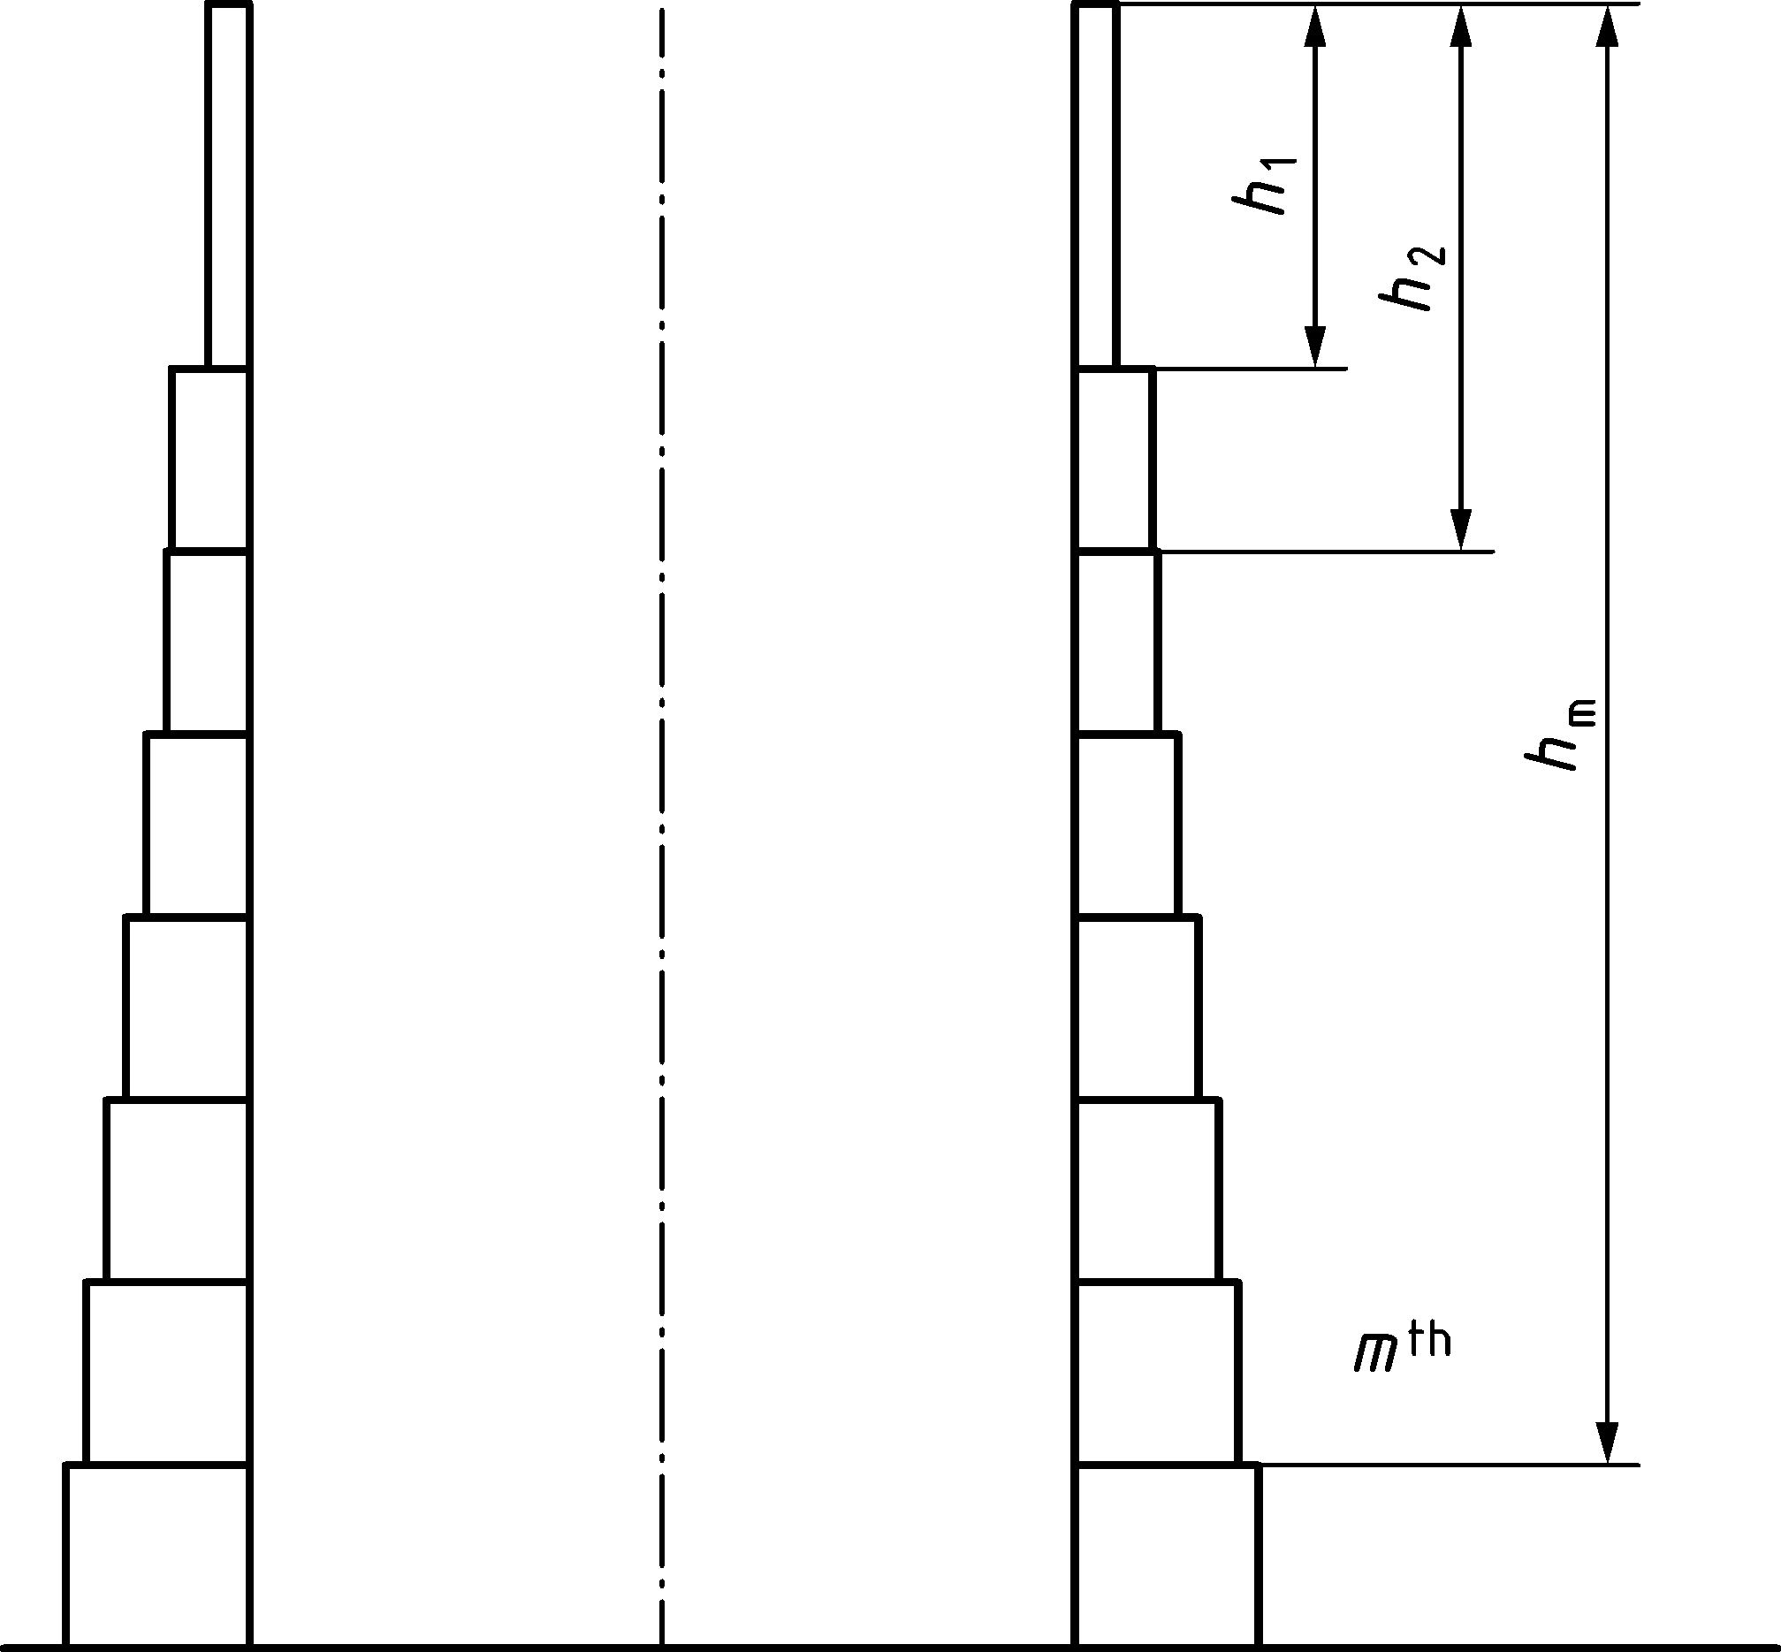

Figure 7.3 — Notation for stepped wall with different heights of courses

(8) Each potential buckle, from the top of the silo to the bottom of the *m*th section (with *m* progressively taking values 1, 2, 3 etc.) should be explored to determine the most critical height *h*m as follows.

(9) The equivalent thickness *t*eq of a stepped wall down to the base of the *m*th course should be found using the depths from the top to the base of each uniform thickness course identified as *h1, h2 ... hm* (Figure 7.3). The thickness of the course *h*i is denoted as *t*i, so that the courses of thicknesses *t1, t2, ... tm* participate in the potential buckle. The height of the potential buckle is then *hm*.

For each course within the potential buckle, the value of the parameter *Hi* should be found as

 (7.52)

The equivalent thickness  of th potential buckle of height *h*m should be found as

 (7.53)

with *H*0 = 0 when *i* = 1.

(10)For each potential buckle height *h*m, the buckling external pressure for the equivalent isotropic wall of thickness *t*eq.m should be found as:

 (7.54)

where

|  |  |
| --- | --- |
| *h*m | is the height of the potential buckle; |
| *teq,m* | is the equivalent thickness of the courses involved in the potential buckle of height *h*m; |
| *C*b | is the external pressure buckling coefficient (see (12)); |
| *C*w | is the wind pressure distribution coefficient for this potential buckle (see (15) to (16)). |

(11) The lowest evaluated critical pressure *q*Rcr,m considering all possible different buckle heights should be taken as the critical buckling pressure for the wall *q*Rcr, and the corresponding buckle height *h*m should be taken as defining the critical buckling mode, given by the dimension ℓcr = *h*m with the equivalent thickness *t*eq,cr = *t*eq,m.

(12) The parameter *C*b should be evaluated based on the condition at the upper edge according to Table 7.2.

Table 7.2 — Values of external pressure buckling parameter *C*b

| Upper edge condition | Roof integrally structurally connected to wall (continuous) | Upper edge ring satisfying 7.5.2 | Upper edge not satisfying 7.5.2 |
| --- | --- | --- | --- |
| *C*b | 1,0 | 1,0 | 0,6 |

(13) Where the silo is subject only to partial vacuum or uniform external pressure, the value of *C*w should be taken as 1,0.

(14) Where the silo is in a closely-spaced silo group, the wind pressure distribution coefficient (relating to the pressure at the windward generator of the silo) should be taken as *C*w = 1,0.

(15) Where the silo is isolated and subject only to wind loading, the wind pressure distribution coefficient (relating to the pressure at the windward generator of the silo) should be taken as the greater of:

 (7.55)

*C*w = 1,0 (7.56)

where

|  |  |
| --- | --- |
|  | is the height of the potential buckle; |
|  | is the equivalent thickness of the potential buckle. |

(16) Where the silo is subject to a combination of both wind loading and internal partial vacuum, the value of *Cw* to be used in Formula (7.54) should be modified to *Cwc*, as given by:

 (7.57)

where

|  |  |
| --- | --- |
| *q*Ed,u | is the design value of the acting uniform external pressure; |
| *q*Ed,w | is the design value of the acting stagnation external pressure of the wind; |
| *Cw* | is the wind pressure distribution coefficient given in (13), (14), or (15). |

(17) The design maximum external resistance pressure (windward generator) under wind and/or partial vacuum should be assessed using the critical buckling length ℓcr according to (11), with the corresponding value of equivalent thickness *t*eq,cr according to (11) and the corresponding value of *q*R,cr (Formula 7.54)as:

 (7.58)

where

|  |  |
| --- | --- |
| **0 | is the elastic buckling imperfection reduction factor, given by **0 = 0,50. |

(18) The design maximum external applied pressure (windward generator) should be taken as

 (7.59)

(19) The resistance check should satisfy the condition:

 (7.60)

(20) It should be verified that the buckling is in the elastic range, given by

 (7.61)

in which ** = 0,60. Where this test is not met, the resistance check should be performed using the provisions of EN 1993‑1‑6.

(21) Where the resistance check of Formula (7.60) is not validated, the highest value of *m* and its corresponding height *h*m in the preceding calculation that can meet the requirement of Formula (7.60) should be taken as the maximum free height available without an intermediate stiffening ring. An intermediate stiffening ring should then be placed below the base of the *m*th course and the calculation repeated for the part of the cylinder below the intermediate stiffening ring as defined in (4) above.

### Upper edge restraint by an eaves ring

(1) For the upper edge of a cylinder to be treated as effectively restrained by a ring, the ring should satisfy both a strength and a stiffness requirement.

(2) The procedure for evaluating the bending moment in the top ring given in prEN 1993‑1‑6:2023, Clause D.3 should be adopted, unless a numerical analysis of the complete silo is used to determine the magnitude of the stress resultants in the ring.

(3) For simpler cases involving silos in Silo Groups 1 and 2, the following alternative procedure is permitted.

(4) The design value of the circumferential (hoop) force *N* and circumferential bending moment *M* about a vertical axis in the ring may be taken as:

*N*,Ed = 0,5 *r L q*Ed,w (7.62)

** (7.63)

with

 (7.64)

 (7.65)

 (7.66)

where

|  |  |
| --- | --- |
| *q*Ed,u | is the design value of the uniform component of the external pressure under wind and/or partial vacuum; |
| *q*Ed,w | is the design value of the stagnation point pressure under wind; |
| *q*S1 | is the reference pressure for ring bending moment evaluations; |
| *M*,Ed,0 | is the design value of the bending moment associated with out-of-roundness; |
| *M*,Ed,w | is the design value of the bending moment due to wind; |
| *I* | is the second moment of area of the ring for circumferential bending; |
| *L* | is the total height of the shell wall; |
| *t* | is the thickness of the thinnest strake. |

(5) Where the ring at the upper edge of a cylinder is made as a cold formed construction, the value of *M*,Ed,0 should be increased by 15 % above that given by Formula (7.64).

(6) The flexural rigidity *EI* of a ring at the upper edge of the cylinder about its vertical axis (circumferential bending) should exceed:

 (7.67)

where

|  |  |
| --- | --- |
|  | is the height of the critical buckle (see 7.5.1); |
| *t*eq,cr | is the equivalent thickness of the shell wall in the critical buckling mode. |

and in which *k*min is given by

 (7.68)

in which

 (7.69)

 (7.70)

 (7.71)

valid for the range  and .

(7) For silos with , an LBA analysis as described in EN 1993‑1‑6 using the uniform pressure *q*Ed,u should be used to ensure that the ring at the upper edge is adequate to achieve the required buckling resistance.

NOTE For silos with , the value of *k*min can initially be taken as the for . The required values of *k*1, *k*2 and *k*3 in the above treatment rise rapidly for shorter shells, but the external pressure buckling resistance also rises, so these two effects generally cancel each other.

### Intermediate rings

(1) Where an intermediate ring is required, the stiffness requirement defined in prEN 1993‑4‑2:2024, 7.4.4 should be followed.

### Resistance of isotropic cylindrical walls under membrane shear

(1) Where a major part of the silo wall is subjected to shear loading (as with eccentric filling, earthquake loading etc.), the membrane shear buckling resistance should be taken as that for a shell in torsion at each horizontal level. The axial variation in shear may be taken into account in design.

(2) The critical shear buckling stress of the isotropic wall should be calculated as:

 (7.72)

where

|  |  |
| --- | --- |
| *t* | is the thickness of the thinnest part of the wall; |
| *h*r | is the height between stiffening rings or boundaries. |

(3) A stiffening ring that is required as the boundary for a shear buckling zone should have a flexural rigidity *EI* about the axis for bending around the circumference not less than:

** (7.73)

where the values of *h*r and *t* are taken as the same as those for the most critical buckling mode as in Formula (7.72).

NOTE The value of the coefficient *k* is *k* = 0,10, unless the National Annex gives a different value.

(4) Where the shear stress ** varies approximately linearly with height in the structure, the critical shear buckling resistance at the point of highest shear may be increased to:

 (7.74)

with o determined from:

 (7.75)

where  is the axial rate of change of shear with height averaged over the zone and **x,Ed,max is the peak value of shear stress.

(5) Where the length o exceeds the height of the structure, this rule should not be used, but the shell should be treated as subject to uniform membrane shear set out in 7.5.4.

(6) Where local shear stresses are induced by local supports and load-bearing axial stiffeners, the critical shear buckling resistance, assessed in terms of the local value of the shear transfer between the axial stiffener and the shell, may be evaluated at the point of highest shear as:

 (7.76)

in which o is found as:

o =  (7.77)

where  is the circumferential rate of change of shear with horizontal distance from the stiffener averaged over the zone, and **x,Ed,max is the peak value of shear stress.

(7) The design buckling stress should be determined as the lesser of:

**x,Rd = ** **x,Rcr /**M1 (7.78)

and

**x,Rd = 0,57 *f*y/**M1 (7.79)

where

|  |  |
| --- | --- |
| ** | is the elastic buckling imperfection reduction factor = 0,80; |
| **M1 | is the partial factor given in Table 4.4. |

(8) At every point in the structure the design stress resultants should satisfy the condition:

*n*x,Ed ≤ *t *x,Rd (7.80)

## Interactions between axial compression, circumferential compression and membrane shear in isotropic walls

(1) Where the stress state in the silo wall contains significant components of more than one compressive membrane stress or shear stress, the provisions of EN 1993‑1‑6 should be followed.

(2) The requirements of this interaction may be ignored if all but one of the design stress components are less than 20% of the corresponding buckling design resistance.

## Isotropic walls under cyclic loads

### Fatigue, LS4

(1) For silos in Silo Group 3, the provisions of EN 1993‑1‑6 should be followed.

(2) For silos in Silo Group 2, a fatigue check should be carried out if the design life of the structure involves more than 10 000 cycles of filling and discharge (see EN 1993‑1‑9).

(3) Where there is attached vibrating machinery, or where silo quaking, honking or similar phenomena can occur, an LA analysis according to EN 1993‑1‑6 should be performed and the potential number of cycles of induced stress should be evaluated. Where the number of cycles can exceed 10 000, the potential for fatigue failure should be assessed according to the provisions of EN 1993‑1‑9.

### Cyclic plasticity, LS2

(1) For silos in Silo Group 3, the provisions of EN 1993‑1‑6 should be followed. A check for failure under cyclic plasticity should be made at discontinuities, near local ring stiffeners and near attachments.

(2) For silos in other Silo Groups, this check may be omitted.

## Resistance of isotropic walls with vertical stiffeners

### General

(1) Where an isotropic wall is stiffened by vertical (stringer) stiffeners, the effect of compatibility of the Poisson shortening of the wall due to internal pressure should be taken into account in assessing the vertical compressive stress in both the wall and the stiffeners.

(2) The design stress resultants, resistances and checks should be carried out as in 7.3.2, but including the additional provisions set out here.

(3) The shell bending half-wavelength is very much longer in silos with vertical stiffeners than the short distance  that is appropriate for isotropic walls. Consideration of consequent longer wavelength bending effects in the vertical stiffeners should be given by treating the silo wall as orthotropic.

NOTE Information on the simple evaluation of local bending effects in a stiffened shell treated as an orthotropic uniform shell can be found in Rotter and Sadowski, see Bibliography reference (2).

### Plastic limit state

(1) The resistance against rupture on a vertical seam should be determined as for an isotropic shell (see 7.3.3).

(2) Where a structural connection detail includes the stiffener as part of the means of transmitting circumferential tensions, the effect of this transverse tension on the stiffener should be taken into account in evaluating the force in the stiffener and its susceptibility to rupture under circumferential tension.

NOTE This failure mode has been observed in practice.

### Buckling under axial compression

(1) The circumferential separation of the vertical stiffeners should not exceed the lesser of 24° and 1 000 mm.

(2) The axial compressive stress in the silo shell differs from that in the stiffeners due to the effect of internal pressure acting on the silo shell alone. The axial stress resultant per unit circumference in the silo shell *n*x,Ed should be determined by deducing it from the total axial force in the combined wall and stiffeners *N*x,Ed at every level, as:

 (7.81)

(3) The axial force in each stiffener *N*sx,Ed should also be determined from the total axial force in the combined wall and stiffeners *N*x,Ed at each level, as:

 (7.82)

in which

 (7.83)

where

|  |  |
| --- | --- |
| *t* | is the local value of the shell wall thickness; |
| *d*s | is the circumferential distance between adjacent stiffeners; |
| *A*s | is the cross-sectional area of each stiffener; |
| *ν* | is Poisson’s ratio (taken as 0,30); |
| *p* | is the local value of the coexistent internal normal pressure *p*h (see EN 1991‑4). |

(4) Where the silo wall is not in contact with the stored solid, the buckling resistance of the stiffener to axial compression should be calculated assuming a uniform compressive stress on the entire cross-sectional area at any level.

(5) The buckling effective length *L*e of the stiffener, to be used in determining the reduction factor *χ* according to either EN 1993‑1‑1 or EN 1993‑1‑3, should be taken as equal to:

 (7.84)

but not greater than the distance between adjacent ring stiffeners.

where

|  |  |
| --- | --- |
| *EI*sx | is the flexural rigidity of the stiffener for bending in the vertical direction normal to the plane of the wall; |
| *K* | is the stiffness offered by the shell wall per unit height of the wall to restrain buckling normal to the wall. |

NOTE Since this is a special and unusual calculation for silos, it is useful to note that consistent units give *EI*sx in Nmm2 and *K* in N/mm per mm of wall height.

(6) The stiffness of the shell wall *K* in restraining the effective length of the stiffener should be determined assuming that the wall spans between adjacent vertical stiffeners on either side. Two alternative methods may be used, as defined in (7) and (8).

(7) A simple assessment of the value of *K* may be made treating the shell wall as straight with simply supported boundary conditions (see Figure 7.5). The value of *K* may then be estimated as:

 (7.85)

where

|  |  |
| --- | --- |
| *k*s | is a stiffness coefficient, *k*s = 0,55; |
| *t* | is the local thickness of the shell wall at the location being assessed; |
| *d*s | is the circumferential separation of the vertical stiffeners. |

(8) Where *d*s/*r* exceeds (*d*s/*r)*lim, the value obtained by treating the curved wall as an arch with pinned ends spanning between adjacent stiffeners (Figure 7.5). The value of *K* may then be found using *k*s = 20.

 (7.86)

(9) Where *d*s/r is less than (*d*s/*r)*lim, the more precise assessment of the value of *K* may be found using:

 (7.87)

 (7.88)

 (7.89)

 (7.90)

(10) Where the flow pattern in the granular solid, the pressure in the solid, the properties of the solid, and the relationship of the solid’s stiffness to the local pressure can all be reliably predicted using EN 1991‑4, a rational analysis of the stiffness of the stationary solid against the silo wall may be included in the assessment of the stiffness of the shell wall *K*.

(11) The characteristic buckling resistance of the stiffened shell wall *n*x,Rk should be calculated as defined in 7.10.4.

(12) Where a rolled section is used for the stiffener, the axial compression buckling resistance of the stiffener *Ns,b,Rk* should be assessed as under concentric compression according to EN 1993‑1‑1, considering only buckling normal to the shell wall.

(13) Where a cold-formed member is used for the stiffener, the axial compression buckling resistance should assessed as under concentric compression according to EN 1993‑1‑3, considering only buckling normal to the shell wall.

(14) The connectors between the stiffener and the silo shell should be at a vertical spacing not greater than *L*e*/4*, where *L*e is determined using (5).

(15) Where the centroid of one segment of the stiffener is not co-linear with the centroid of the adjacent segment, consideration should be given to the use of a longer sleeve and the connection should be designed to transmit the bending moment arising from the eccentricity of the axial force transferred.

(16) There should be no cause that introduces unintentional bending moments into the stiffener (e.g. resulting from an eccentricity between the section centroidal axis and the centroid of the bolts used in connections, such as sleeves, overlaps, etc.).

(17) The eccentricity of the stiffener centroid to the silo shell middle surface may be ignored.

### Buckling under external pressure, partial vacuum or wind

(1) The wall should be designed for the same external pressure buckling criteria as the unstiffened wall unless a more rigorous calculation is necessary.

(2) Where a more rigorous calculation is needed, the vertical stiffeners may be smeared to give an orthotropic wall, and the buckling stress assessment carried out using the provisions of 7.5.4 with

*Cx* = *C* = *Et* (7.91)

*Cx* = 0,38 *Et* (7.92)

### Buckling under membrane shear

(1) Where a major part of the silo wall is subjected to shear loading (as with eccentric filling, earthquake loading etc.), the membrane shear buckling resistance should be found as for an isotropic unstiffened wall (see 7.5.4), but the calculated resistance may be increased if account is taken of the effect of the stiffeners. The equivalent length of shell in shear may be taken as the lesser of the height between stiffening rings or boundaries and twice the horizontal separation of the vertical stiffeners, provided that each stiffener has a flexural rigidity *EI*x for bending in the vertical direction (about a circumferential axis) greater than:

** (7.93)

where the values of and *t* are taken as the same as those used in the critical buckling mode (see 7.5.4). The value of *k*s may be taken as *k*s= 0,10.

(2) Where a discrete stiffener is abruptly terminated part way up the shell, the force in the stiffener should be taken to be uniformly redistributed into the shell over a length not exceeding *k*t. The value of *k*t may be taken as *k*t= 4,0.

(3) Where the stiffeners are terminated as in (2), or used to introduce local forces into the shell, the assessed resistance for shear transmission between the stiffener and the shell should not exceed the value given in 7.5.4 for linearly varying shear.

## Resistance of horizontally corrugated cylindrical walls

### General

(1) All calculations should be carried out with thicknesses excluding the coatings. Tolerances on thickness should be adopted according to the requirements of EN 1993‑1‑3.

(2) The design thickness of the sheeting should be taken as defined in EN 1993‑1‑3.

(3) Losses of thickness due to abrasion should be considered, taking account of the stored solid and the conditions of use of the silo (see EN 1991‑4 for abrasion information).

(4) The minimum steel core thickness for the corrugated sheeting of the wall should meet the requirements of EN 1993‑1‑3. In bolted construction, the bolt size should not be less than M8.

(5) Where the cylindrical wall is fabricated from corrugated sheeting with the corrugations running horizontally, with vertical stiffeners are attached to the wall, the corrugated wall should be assumed to carry no vertical forces unless the wall is treated as an orthotropic shell, see 7.9.4.4.

(6) Where the continuity of stiffeners is obtained by semi-rigid connections such as overlaps or sleeves etc., the rotational rigidity of the connections should be considered in the verification of their resistance and stability under actions due to stored solids as well as under wind or external pressure.

(7) Where the wall is stiffened with vertical stiffeners, the fasteners between the sheeting and stiffeners should be proportioned to ensure that the distributed shear loading from stored solids (frictional traction) on each part of the wall sheeting is transferred into the stiffeners. The sheeting thickness should be chosen to ensure that local rupture at these fasteners is prevented, taking proper account of the reduced bearing strength of fasteners in corrugated sheeting.

NOTE The curvature of the corrugation at the location of the fasteners can lead to a reduction in bearing resistance, which depends on the local detailing.

(8) The design stress resultants, resistances and checks should be carried out as in 7.3, but including the additional provisions set out in (1) to (7) above.

NOTE Common arrangements for stiffening the wall are shown in Figure 7.4.

|  |  |
| --- | --- |
|  |  |
| **a) Typical elevation** | **b) Alternative plan views** |

Figure 7.4 — Common arrangements for cold-formed vertical stiffeners on horizontally corrugated shells

### Tolerance requirements

(1) Tolerances on corrugated sheeting thickness and the geometry of the corrugation should be according to the requirements of EN 1993‑1‑3.

(2) Corrugated silos should comply with the out-of-roundness tolerances defined in prEN 1993‑1‑6:2023, 9.4.3.

(3) The global out-of-plumbness tolerance and the global straightness tolerance on any vertical stiffener should comply with the tolerances Class 1 defined in EN 1090‑2:2018, 11.2.3 for columns in single-storey-buildings. Where the stiffeners include splices, the rules governing multi-storey building columns should be used.

(4) Except where other values are relevant for the global straightness, the tolerances given in EN 1090‑2:2018, Table B.17, Row 5 apply, giving the tolerance as Δ = ±*h*/300, where *h* is the height of the structure. Verification of this tolerance should be undertaken by measuring the radial distance of the outward crest of any corrugation from a vertical line.

(5) Geometric tolerances for individual sections of cold formed axial stiffeners should be taken as those for compression members as defined in EN 1993‑1‑3 as Class 2 tolerances.

### Plastic limit state

(1) Where the wall has vertical stiffeners to support the axial forces, the plastic limit state may be assumed to relate only to rupture of the corrugated wall under circumferential tension.

(2) Where the wall is unstiffened, the requirements for the plastic limit under axial compression, given in 7.9.4.2 apply.

(3) Bolts for fastenings between panels should satisfy the requirements of EN 1993‑1‑8.

(4) The joint detail between panels should comply with the provisions of EN 1993‑1‑3 for connections in tension or compression.

(5) The circumferential spacing between fasteners should not exceed the lesser of 500 mm or 15° of the circumference, as shown in Figure 7.5.

NOTE A typical bolt arrangement detail for a panel is shown in Figure 7.5.

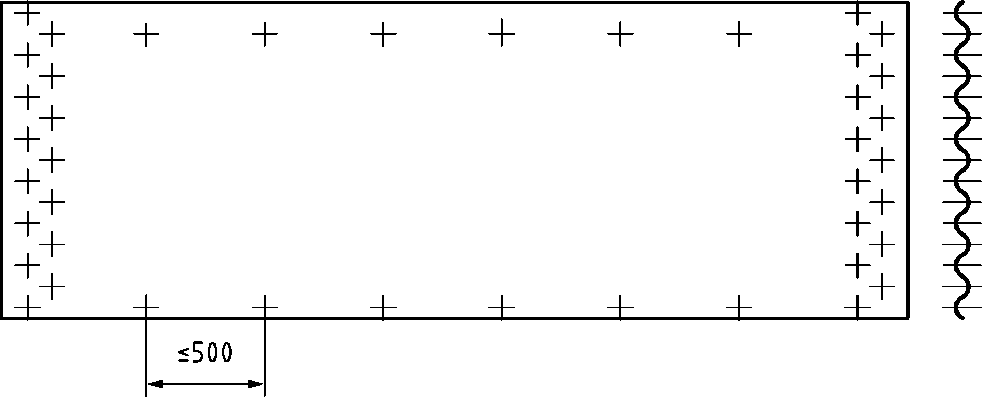

Figure 7.5 — Typical bolt arrangement for a panel of a corrugated silo

(6) Where penetrations are made in the wall for hatches, doors, augers or other items, a frame of stiffeners should be used around the penetration to ensure that the resistance to circumferential membrane tension is adequate.

(7) In addition, where penetrations are made in the wall, a thicker corrugated sheet should be used locally to ensure that the local stress raisers associated with mismatches of stiffness do not lead to local rupture.

### Buckling under axial compression

#### General

(1) Under axial compression, the design resistance should be determined at every point in the shell using the prescribed fabrication tolerance quality of construction, the intensity of the guaranteed co-existent internal pressure *p* and the circumferential uniformity of the compressive stress. The design should consider every point on the shell wall.

(2) If the horizontally corrugated wall is stiffened with vertical stiffeners, the buckling design of the wall should be carried out using one of two alternative methods:

1. buckling of the equivalent orthotropic shell (following 7.9.4.4) if the horizontal distance between stiffeners satisfies 7.9.4.3(2) and 7.9.3;
2. buckling of the individual stiffeners (corrugated wall assumed to carry no axial force, but providing restraint to the stiffeners) and following 7.9.4.3 (see also 7.5.1).

#### Unstiffened corrugated wall

(1) If the corrugated shell has no vertical stiffeners, the characteristic value of local plastic axial compression buckling resistance should be determined as the greater of:

 (7.94)

and

 (7.95)

where

|  |  |
| --- | --- |
| *t* | is the sheet thickness; |
| *d* | is the crest to trough amplitude; |
| *r* | is the local radius of curvature of the corrugation (see Figure 6.2); |
| *r* | is the cylinder radius. |

(2) The local plastic buckling resistance *n*x,Rk should be taken as independent of the value of internal pressure *p*n = *p*h.

NOTE The local plastic buckling resistance is the resistance to plastic instability of the corrugation, leading to collapse or “roll-down”, see Bibliography reference (3).

(3) The design value of the local plastic buckling resistance should be determined as:

*n*x,Rd = px *n*x,Rk /**M0 (7.96)

where

|  |  |
| --- | --- |
| **px | is the plastic buckling imperfection reduction factor, **px = 0,80; |
| **M0 | is the partial factor given in Table 4.4. |

(4) At every point in the structure the design stress resultants should satisfy the condition:

*n*x,Ed ≤ *n*x,Rd (7.97)

#### Stiffened corrugated cylindrical walls treated as carrying axial compression only in the stiffeners

(1) If the corrugated sheeting is assumed to carry no axial force (method b)) in 7.5.4.1, the sheeting may be assumed to restrain all buckling displacements of the stiffener in the plane of the wall, and the resistance to buckling should be calculated using one of the two following alternative methods:

1. ignoring the supporting action of the sheeting in resisting buckling displacements normal to the wall;
2. allowing for the stiffness of the sheeting in resisting buckling displacements normal to the wall.

(2) The horizontal distance between stiffeners ds should not be more than *d*s,max given by:

 (7.98)

where

|  |  |
| --- | --- |
| *D* | is the flexural rigidity per unit width of the thinnest sheeting parallel to the corrugations; |
| *C* | is the stretching stiffness per unit width of the thinnest sheeting parallel to the corrugations; |
| *r* | is the cylinder radius; |
| *k*dx | is the scale factor for stiffener spacing, *k*dx = 9,1. |

(3) If the corrugation form is an arc-and-tangent or sinusoidal profile, the values of *C* and *D* may be taken from 6.5(5), (6) and (7). If other corrugation forms are adopted, both the shell circumferential membrane stiffness *C* and the shell circumferential bending flexural rigidity *D* should be determined from first principles.

(4) The effective length of the stiffener for buckling calculations should be determined according to method a) or b) in (1).

(5) If method a) in (1) is used, the effective length *L*e used in determining the reduction factor *χ* according to EN 1993‑1‑1 or EN 1993‑1‑3 should be taken as the distance between adjacent ring stiffeners.

(6) If method b) in (1) is used, the buckling effective length of column *L*e used in determining the reduction factor *χ* according to EN 1993‑1‑1 or EN 1993‑1‑3 should be taken as equal to:

 (7.99)

but not greater than the distance between adjacent ring stiffeners;

where

|  |  |
| --- | --- |
| *EI*sx | is the flexural rigidity of the stiffener for bending normal to the plane of the wall; |
| *K* | is the flexural stiffness of the corrugated wall sheet spanning between vertical stiffeners. |

NOTE Since this is a special and unusual calculation for silos, it is useful to note that consistent units give *EI*sx in Nmm2) and *K* in N/mm per mm of wall height.

(7) The flexural stiffness of the corrugated wall *K* should be determined assuming that the sheeting spans between adjacent vertical stiffeners on either side. Two alternative methods may be used, as defined in (8) to (10).

(8) A simple assessment of the value of *K* may be made treating the wall as straight with simply supported boundary conditions (see Figure 7.6). The value of *K* may then be estimated as:

 (7.100)

where

|  |  |
| --- | --- |
| *D* | is the shell bending flexural rigidity of the corrugated wall sheet for circumferential bending (see 6.5); |
| *d*s | is the circumferential separation of the vertical stiffeners; |
| *k*s | is the stiffness calibration factor, *k*s = 6,0. |

NOTE The factor 6,0 corresponds to simply supported ends over the span of 2*d*s. If instead the stiffeners can be guaranteed to stiffly restrain rotation at the ends of every bay, the value of *k*s could rise to almost 24. The value 6,0 is a conservative choice.

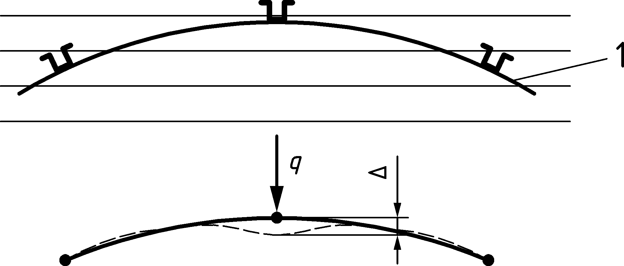

Key

|  |  |
| --- | --- |
| 1 | wall |
| *K* | = *q*/Δ |

Figure 7.6 — Evaluation of restraint stiffness against stiffener column buckling using a curved wall treatment

(9) Where *d*s/*r* exceeds (*d*s/*r)*lim, the value obtained by treating the curved wall as an arch with pinned ends spanning between adjacent stiffeners (Figure 7.6). The value of *K* may then be found using *k*s = 240.

 (7.101)

(10) Where *d*s/*r* is less than (*d*s/*r)*lim, the more precise assessment of the value of *K* may be found using:



(7.102)

 (7.103)

 (7.104)

 (7.105)

where

|  |  |
| --- | --- |
| *C* | is the shell membrane stiffness of the corrugated wall sheet for circumferentialstretching; |
| *D* | is the shell bending flexural rigidity of the corrugated wall sheet for circumferential bending; |
| *d*s | is the circumferential separation of the vertical stiffeners. |

(11) Where the flow pattern in the granular solid, the pressure in the solid, the properties of the solid, and the relationship of the solid’s stiffness to the local pressure can all be reliably predicted using EN 1991‑4, a rational analysis of the stiffness of stationary solid against the silo wall may be included in the assessment of the stiffness of the shell wall *K*.

NOTE A rational analysis refers to an assessment based strictly on the principles of mechanics.

(12) The following conditions should all be met for the simplified method of (8) to be used:

1. at each level, the cross-section of the stringer stiffener should be taken as the smallest value within the effective length *L*e determined using (4) to (10);
2. the stringer stiffener should be flexurally continuous, with moment-resisting connections between segments;
3. where the centroid of one segment of the stiffener is not colinear with the centroid of the adjacent segment, consideration should be given to the use of a longer sleeve and the connection should be designed to transmit the bending moment arising from the eccentricity of the axial force transferred;
4. there should be no cause introducing unintentional bending moments into the stringer stiffener (e.g. resulting from an eccentricity between the section centroidal axis and the centroid of the bolts used in connections, such as sleeves, overlaps, etc.). The eccentricity of the frictional traction on the silo wall to the stiffener may be ignored.

(13) If the conditions of (12) are all met, the following simple calculation may be used at every point on the shell wall. The compression on the stiffener cross-section may be assumed to be uniform and equal to the maximum compression force *N*b,Ed acting at the bottom of the stiffener segment. The resistance of the stiffener may be assessed using:

 (7.106)

where

|  |  |
| --- | --- |
| *N*b,Ed | is the design value of the maximum normal force acting in the stiffener segment; |
| *N*b,Rk | is the characteristic value of resistance to axial compression calculated according to EN 1993‑1‑1 for rolled sections and EN 1993‑1‑3 for cold‑formed sections. |

(14) The reduction factor χ used to determine the value of *N*b,Rk should be taken for buckling normal to the silo wall (i.e. about the circumferential axis).

(15) Alternatively, the simpler following treatment may be used where the conditions 7.3.3.3(4) a), b), c) and d) are not met. The resistance at any level of the stiffener should be verified taking into account:

* the variation of compression in the stiffener;
* the variation of the second moment of area of the stiffener;
* any eccentricity between the section centroidal axis and the centroid of the bolts used in connections (e.g. sleeves, overlaps etc.);
* the flexural rigidity continuity requirements of the stiffener connections (see 7.8.3(15) to (17));
* the variation of flexural stiffness of the wall.

The procedure set out in (16) to (21) may be used.

(16) A linear eigenvalue (LBA) calculation according to EN 1993‑1‑6 should be performed on any section of the stiffener, using the design value of the force in the stiffener *N*Ed at that location and including the effect of the restraint of the corrugated sheeting. This yields the elastic critical load amplifier *R*cr on the design loads.

(17) The design plastic reference load multiplier for each section of the stiffener should be taken as:

 (7.107)

where

|  |  |
| --- | --- |
| *A*eff | is the lowest effective cross-sectional area within the segment of the stiffener according to the provisions of EN 1993‑1‑3; |
| *N*Ed,max | is the maximum compression load in the segment of the stiffener. |

(18) The overall relative slenderness ${\overline{λ}}_{x}$  for the segment should be determined from:

 (7.108)

(19) The values of the buckling parameters *α*, *β*, *η*, and *λ*o should be taken as follows:

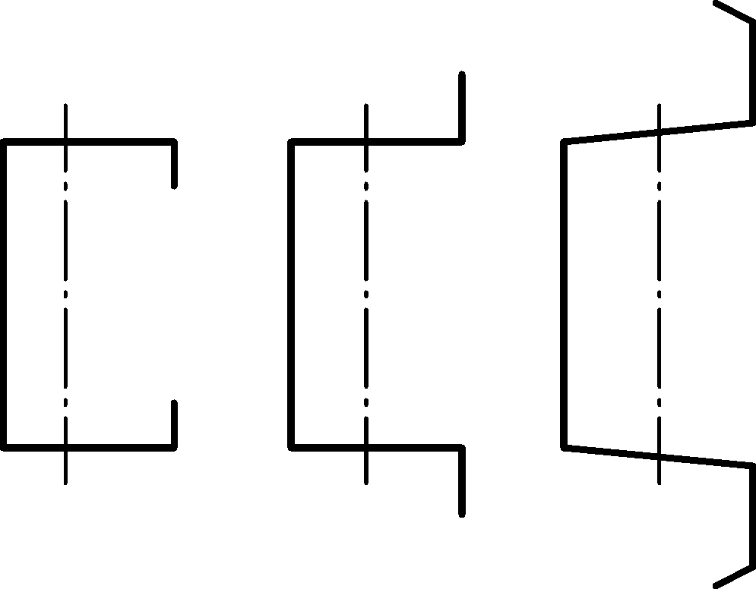

Figure 7.7 — Cold-formed stiffeners with edge stiffened flanges EN 1993‑1‑3 identifiers: buckling curve b

 (7.109)

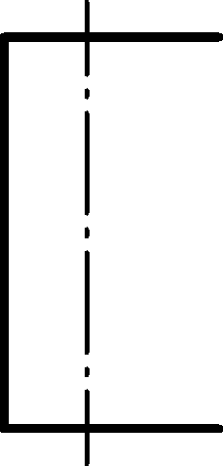

Figure 7.8 —Stiffeners with unstiffened flanges EN 1993‑1‑1 identifiers: buckling curve c

 (7.110)

NOTE The above parameters **, **, **, **o and **h provide a very close match to the buckling curves in EN 1993‑1‑1 and EN 1993‑1‑3.

(20) The general buckling relationship of 7.4.5 or EN 1993‑1‑6 should be used to obtain the buckling reduction factor *χ*, and the characteristic buckling load multiplier *R*k found as:

 (7.111)

(21) It should be verified that:

 (7.112)

#### Stiffened corrugated cylindrical wall treated as an orthotropic shell

(1) Where the corrugated wall with stiffeners is to be treated as a complete orthotropic shell, the following provisions may be used.

(2) A linear eigenvalue (LBA) calculation according to EN 1993‑1‑6 should be performed on the complete wall, using the design value of the applied frictional traction *p*w on the sheeting. The sheeting should be modelled as an orthotropic shell with properties as defined in 6.5. The variation in thicknesses of the stiffeners and sheeting with height should be included. This analysis results in the elastic critical load amplifier *R*cr on the design loads. The procedures of 7.5.3.3(5) to (9) should then be followed.

(3) The procedure set out in 7.5.3.3(9) to (13) should then be followed.

#### Local, distortional and flexural torsional failure of stiffeners

(1) The resistance of cold-formed stiffeners to local, distortional and flexural torsional buckling should be determined using EN 1993‑1‑3.

### Buckling of corrugated cylindrical shells under external pressure, partial vacuum or wind

(1) The equivalent membrane and flexural properties of the corrugated sheeting should be found using 6.5.

(2) The bending and stretching properties of the ring and stringer stiffeners, and the outward eccentricity of the centroid of each from the middle surface of the shell wall should be determined, together with the separation between the stiffeners *d*s.

(3) The horizontal distance between stiffeners *d*s should be no more than *d*s,max as given by:

 (7.113)

where

|  |  |
| --- | --- |
| *D* | is the flexural rigidity per unit width of the thinnest sheeting parallel to the corrugations; |
| *C* | is the stretching stiffness per unit width of the thinnest sheeting parallel to the corrugations; |
| *r* | is the cylinder radius; |
| *k*d | is the scale factor for stiffener spacing, *k*d = 9,1. |

(4) The critical uniform external pressure buckling resistance *q*R,cru should be evaluated at the level of the thinnest sheeting taken as:

 (7.114)

where

|  |  |
| --- | --- |
| *k*c | is the scale factor for external pressure, *k*c = 0,3. |

(5) Where the silo has no roof and is potentially subject to wind buckling, the above calculated pressure should be reduced by the factor 0,6.

(6) The design buckling pressure for the wall should be determined using Formulae (7.58) to (7.60) with *C*b = *C*w = 1,0 and taking ** = 0,5 but adopting the critical buckling pressure *q*Rcr from Formulae (7.114).

### Buckling of corrugated cylindrical shells under membrane shear

(1) Where required, the buckling resistance of the shell under membrane shear should be determined using the computational provisions of EN 1993‑1‑6 with an LBA treatment of the wall as an orthotropic shell.

NOTE The formulae in Annex D of prEN 1993‑1‑6:2023 refer only to isotropic unstiffened walls. The provisions given in the body of the standard for computation assessments are more general and can be applied to orthotropic stiffened shells.

## Vertically corrugated cylindrical walls with ring stiffeners

### General

(1) If the cylindrical wall is fabricated using corrugated sheeting with the corrugations running vertically, both of the following conditions should be met:

1. The corrugated wall should be assumed to carry no horizontal forces;
2. The corrugated sheeting should be assumed to span between attached rings, using the centre to centre separation between rings and adopting the assumption of sheeting continuity.

(2) The joints between sheeting sections should be designed to ensure that assumed flexural continuity is achieved.

(3) The evaluation of the axial compression force in the wall arising from wall frictional tractions from the bulk solid should be performed according to the provisions of EN 1991‑4, and should take account of the full circumference of the silo, allowing for the profile shape of the corrugation.

Although the axial force per unit circumference rises according to the full circumference, the wall profile means that the axial membrane stress is the unaffected by the profile shape. Where the axial force is determined and the effective thickness (Formula 6.5) is used to deduce the axial stress, the full circumference is required. The provisions of prEN 1991‑4:2024, Annex E are useful for the full circumference evaluation.

(4) If the corrugated sheeting extends to a base boundary condition, the local flexure of the sheeting near the boundary should be considered, assuming a radially restrained boundary.

(5) The design stress resultants, resistances and checks should be carried out as in 7.5, but including the additional provisions set out in 7.10.2 to 7.10.5.

### Plastic limit state

(1) In checking the plastic limit state, the corrugated wall should be assumed to carry no circumferential forces.

(2) The spacing of ring stiffeners should be determined using a beam bending analysis of the corrugated profile, assuming that the wall is continuous over the rings and including the effects of different radial displacements of ring stiffeners that have different sizes. The stresses arising from this bending should be added to those arising from axial compression when checking the buckling resistance under axial compression.

NOTE The vertical bending of the sheeting can be analysed by treating it as a continuous beam passing over flexible supports at the ring locations. The stiffness of each support is then determined from the ring stiffness to radial loading.

(3) The ring stiffeners designed to carry the horizontal load should be proportioned in accordance with EN 1993‑1‑1 and EN 1993‑1‑3 as appropriate.

### Buckling under axial compression

(1) The critical buckling stress for the wall should be determined using the provisions of EN 1993‑1‑3 (cold formed construction) and treating the corrugated sheeting cross-section as a column acting between stiffening rings. The effective length should be taken as not less than the separation of the centroids of adjacent rings.

### Buckling under external pressure, partial vacuum or wind

(1) The design resistance under external pressure should be assessed in the same manner as for horizontally corrugated silos (see 7.9.5), but taking account of the changed orientation of the corrugations according to 6.5.

### Membrane shear

(1) The design resistance under membrane shear should be assessed as for horizontally corrugated silos, see 7.9.6.

## Detailing for openings in cylindrical walls

### General

(1) Openings in the wall of the silo should be reinforced by vertical and horizontal stiffeners adjacent to the opening. If any material of the shell wall lies between the opening and the stiffener, it should be ignored in the calculation.

### Rectangular openings

(1) The vertical reinforcement to carry axial membrane forces around a rectangular opening (see Figure 7.8) should be dimensioned so that the cross-sectional area of the stiffeners is not less than the cross-sectional area of the wall that has been removed, but not more than twice this value.

(2) The horizontal reinforcement to carry circumferential membrane forces around a rectangular opening should be dimensioned so that the cross-sectional area of the stiffeners is not less than the cross-sectional area of the wall that has been removed.

(3) The flexural stiffness of the stiffeners orthogonal to the direction of each membrane stress resultant should be chosen so that the relative displacement *w* of the shell wall in the direction of the relevant stress resultant on the centreline of the opening and resulting from the presence of the opening is not greater than *w*max, determined as:

 (7.115)

where

|  |  |
| --- | --- |
| *d* | is the width of the opening normal to the direction of the relevant stress resultant; |
| *t* | is the local thickness of the shell wall; |
| *k*d1 | is the acceptable deflection coefficient, *k*d1 = 0,02. |

(4) Where the wall is formed using corrugated sheeting, the value of *t* should be taken as *t*eq given by

 (7.116)

where

|  |  |
| --- | --- |
| *t*s | is the sheet thickness; |
| *dcr* | crest to crest dimension of a corrugation and |
| *l* | is the wavelength of a corrugation (Figure 6.2). |

(5) Vertical reinforcing stiffeners should extend at least 2 above and below the opening.

(6) Horizontal reinforcing stiffeners are not required to extend significantly beyond the opening. However, it is recommended that the horizontal length of the wall reinforcement is more than or equal to the height of the opening.

(7) The shell should be designed to resist local buckling of the wall adjacent to the termination of vertical stiffeners using the provisions of 8.9 for local loads. Where this procedure is not used, the buckling resistance above a stiffener termination should be reduced by 20 % to allow for the local increased stress.

(8) For bolted or riveted joints in the wall close to the opening, special attention should be paid to local stress concentrations near the terminations of the stiffeners, leading to increased forces on adjacent bolts or rivets.

|  |  |
| --- | --- |
|  |  |
| **a) rectangular opening** | **b) circular opening** | |

Key

|  |  |
| --- | --- |
| 1 | reinforced structure (welded or bolted on silo wall) |

Figure 7.9 — Typical stiffening arrangements for openings in silo walls

# Support conditions for cylindrical walls

## Shell with its base fully supported

(1) Where the base of an isotropic cylindrical shell is fully supported, the forces and moments in the shell wall may be deemed to be only those induced under axisymmetric actions, wind and Special Silo Load Cases as defined in EN 1991‑4.

(2) Where isotropic stiffened wall construction is used, the vertical stiffeners should be fully supported by the base and connected to a base ring.

(3) For horizontally corrugated silos with vertical stiffeners, see 8.10.

## Isotropic shell supported by a skirt

(1) If an isotropic shell is supported on a skirt (see Figure 8.1a), the shell may be assumed to be uniformly supported provided that the skirt satisfies one of the two following conditions:

1. The skirt is itself fully uniformly supported by the foundation as defined in 8.1;
2. The thickness of the skirt is not less than 20 % greater than the shell, and the ring girder design procedures given in Clause 10 are used to proportion the skirt and its adjoining flanges.

(2) The skirt should be designed to carry the axial compression from the silo wall without the beneficial effect of internal pressure.

## Isotropic cylindrical shell wall with engaged columns

(1) For silos in Silo Groups 2 or 3, if an isotropic shell is supported on discrete columns that are engaged into the wall of the cylinder (see Figure 8.1 b)), the effects of the discrete forces from these supports should be included in determining the stress resultants in the shell.

(2) The length of the engagement of the column should be determined according to 8.9.

(3) The length of the rib should be chosen taking account of the limit state of buckling in shear adjacent to the rib, see 7.5.4.

|  |  |  |  |
| --- | --- | --- | --- |
|  |  |  |  |
| **a) shell supported on skirt** | **b) cylindrical shell with engaged column** | **c) column eccentrically engaged to skirt** | **d) column beneath skirt or cylinder** |

Key

|  |  |
| --- | --- |
| 1 | skirt continuous around circumference |
| 2 | cone/cylinder junction |
| 3 | skirt |
| 4 | joint centre |

Figure 8.1 — Different arrangements for support of silo with hopper

## Framework support beneath an isotropic walled silo

(1) Where a steel structural framework is used to support the silo, the relative flexibility of the support between the framework and the silo structure should be carefully evaluated to ensure uniform stiffness at the discrete support locations.

NOTE The shell structure is very stiff in the plane of the shell, so any non-uniformity of stiffness in the support leads to a significant increase in the axial compressive stress in the shell (see Figure 6.1).

(2) Where the structural framework is arranged to provide only four supports, the supporting beams (Figure 8.2) should be arranged to provide equal stiffness at each support.

NOTE 1 Equal stiffness at each support leads to the greatest uniformity of stress in the shell above the support. Unequal stiffnesses have been the cause of some silo failures.

NOTE 2 The non-uniformity of the axial stress in the cylinder above the supports is very sensitive to the number of supports. Four supports lead to non-uniformity that extends far into the shell, but this penetration reduces approximately as 1/*n*2, where n is the number of supports.

(3) Close attention should be paid to the possibility of differential settlement between the supports of the structural framework, especially where there are only four supports. Differential settlement beneath one of four supports can lead to the forces on the two remaining supports being increased by a factor of 2.

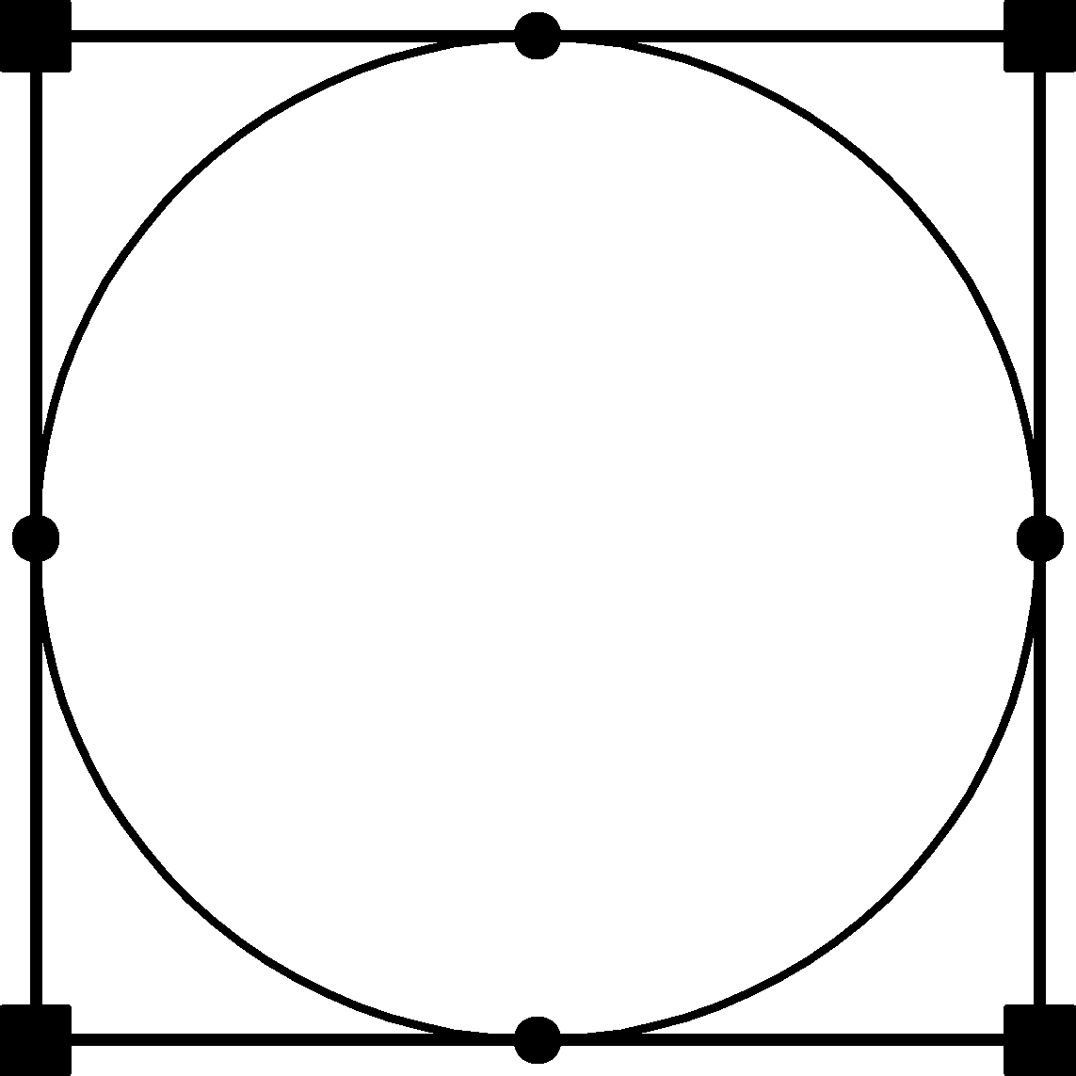

Figure 8.2 — Simple tour support framework

(4) Where the structural framework is arranged to provide eight supports (Figure 8.3), the structural configuration should ensure equal stiffness at each support by careful evaluation of both the bending stiffness of the secondary beams and the principal beams and the connections between the beams. Where the connection is not perfectly symmetrical to the axis of the principal beam, the torsional stiffness of the principal beam should be included in the assessment of the relative deflection of the secondary beam.

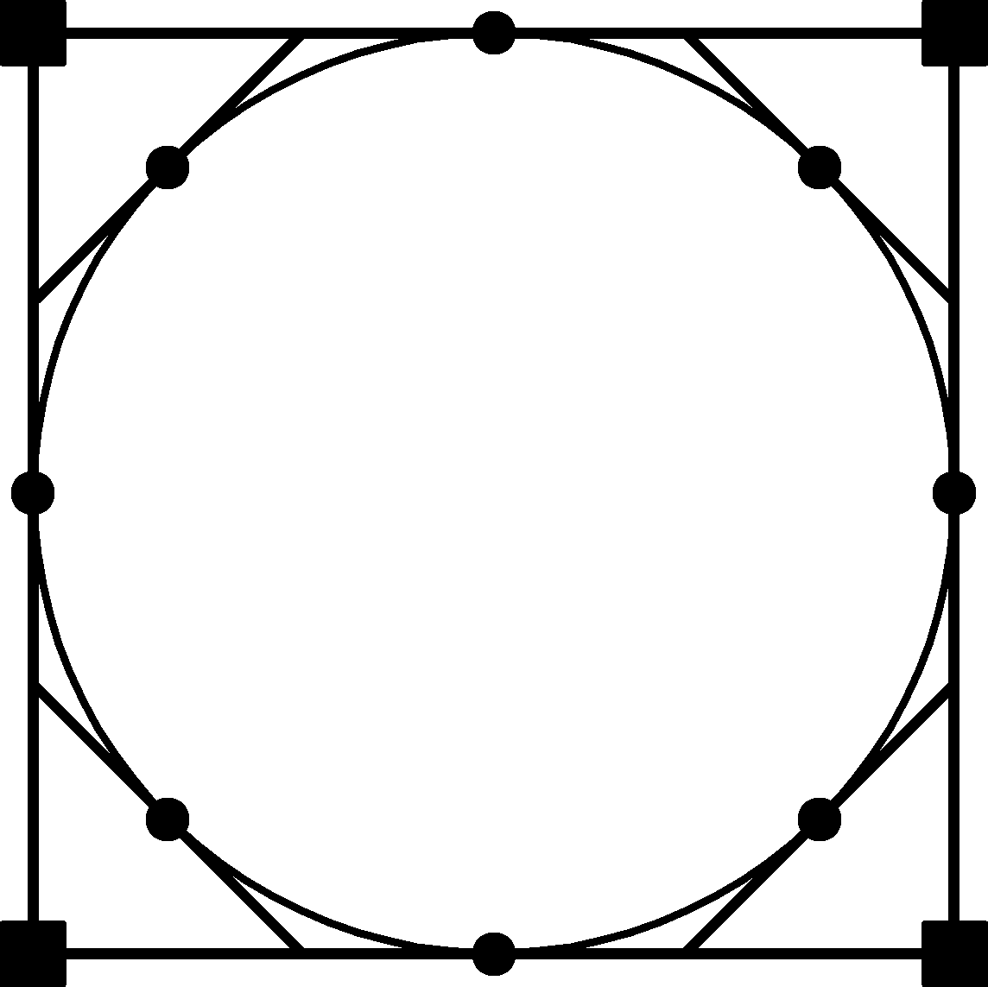

Figure 8.3 — Standard eight support framework

(5) An alternative arrangement providing 8 supports is illustrated in Figure 8.4. This has the advantage of a simple provision of equal stiffness at each support, but requires that parts of the shell should be able to overhang the supporting beams.

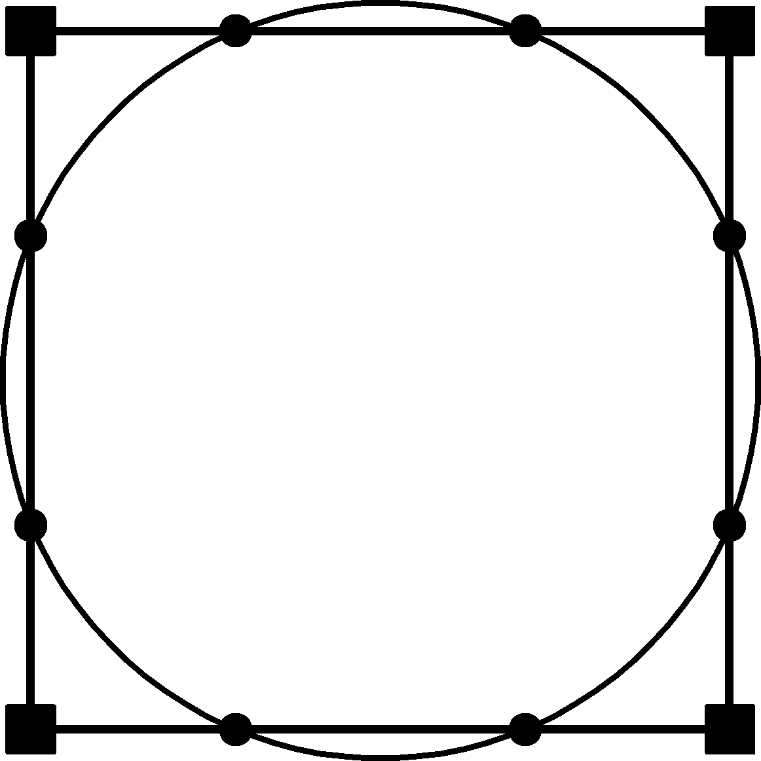

Figure 8.4 — Alternative eight support framework

(6) Where many discrete supports for the cylindrical shell extend to the foundation and are used beneath a ring girder, the effect of differential settlement beneath one support on the forces in the ring girder should be considered.

NOTE A suitable treatment can be found in AS 3774, see Bibliography reference (4).

## Discretely supported isotropic cylindrical shell without a ring girder

(1) If the shell is supported on discrete columns or supports, the effects of the discrete forces from these supports should be included in determining the internal forces in the shell.

(2) For silos in Silo Group 3, a numerical analysis (LA) should be performed including a stability check (LBA).

(3) If the silo is in either Silo Group 1 or 2, the shell may be analysed using only the membrane theory of shells for axisymmetric loading, provided the following four criteria are all satisfied:

1. The radius-to-thickness ratio *r*/*t* should not be more than (*r/t*)max = 400;
2. The eccentricity of the support beneath the shell wall should not be more than *k*1*t,* where *k*1 = 2,0;
3. The cylindrical wall should be rigidly connected to a hopper that has a wall thickness not less than *k*2*t* at the transition, where *k*2 = 1,0;

(4) The width of each support should be not less than ; where *k*3 = 1,0.

where

*t* is the thickness of the shell above the support.

(5) If the shell is analysed using only the membrane theory of shells for axisymmetric loading, one of the following criteria should also be met:

1. The upper edge boundary of the shell should be kept circular by structural connection to a roof;.
2. The upper edge boundary of the shell should be kept circular by using a top edge ring stiffener with a flexural rigidity *EI* for bending in the plane of the circle greater than *EI*,min given by:

** (8.1)

where

|  |  |
| --- | --- |
| *t* | is the thickness of the thinnest part of the wall; |
| *k*s | is the stiffness calibration factor, *k*s = 0,10. |

(6) The shell height *L* should not be less than *L*s,min, which may be calculated as:

 (8.2)

where

|  |  |
| --- | --- |
| *n* | is the number of supports around the shell circumference; |
| *L*s,min | is the minimum height for which it is valid to use membrane theory for the analysis; |
| *k*L | is the membrane limit factor, *k*L = 4,0. |

(7) If linear shell bending theory or a more precise analysis is used, the effects of locally high stresses above the supports should be included in the verification for the axial compression buckling limit state, as detailed in 7.4.2.

(8) The support for the shell should be proportioned to satisfy the provisions of 8.8 or 8.9 as appropriate.

## Discretely supported isotropic cylindrical shell with a ring girder

(1) Where a ring girder is used above discrete supports, compatibility of the deformations between the ring and adjacent shell segments should be considered (see Figure 6.1). Only a very stiff ring girder is able to transform the discrete forces from the supports into uniform axial compression. Where such a ring girder is used, the eccentricity of the ring girder centroid and shear centre relative to the shell wall and the support centreline should be considered, see 10.1 and 10.2.

Particular attention should be paid to compatibility of the axial deformations, since the induced stresses penetrate far up the shell.

(2) The variation around the circumference of the axial membrane stresses at the base of the cylindrical shell above the ring girder should be evaluated as a function of the flexibility of the ring girder in deformation normal to its plane. The shell to girder stiffness ratio  should be determined using:

 (8.3)

 (8.4)

 (8.5)

 (8.6)

 (8.7)

 (8.8)

 (8.9)

where

|  |  |
| --- | --- |
| *n* | is the number of supports beneath the ring girder; |
| *I*rx | is the second moment of area of the ring girder for vertical bending deformations (about a radial axis); |
| *t* | is the thickness of the cylindrical silo shell; |
| *r* | is the radius of the silo shell; |
| *J* | is the uniform torsion constant; |
| *C*w | is the warping constant for an open section; |
| *H* | is the height of the silo shell; |
| *E* | is the modulus of elasticity; |
| *G* | is the shear modulus; |
| ** | is the long wave bending half-wavelength (Formula 8.4). |

(3) Where the thickness of the shell wall varies with height, the thickness *t* should be replaced in the above using *t*eq found from D.3.3 in prEN 1993‑1‑6:2023, but making the evaluation starting at the bottom of the shell (just above the ring girder) in place of from the top downward.

(4) Unless a numerical model is used to obtain a more precise value, the peak axial membrane stress above the support should be found by multiplying the uniform axial membrane stress by the amplification factor , which depends on the shell to girder transverse stiffness ratio **G.

 (8.10)

(5) The resistance of the shell under these local elevated forces should be assessed using the provisions of 7.3.5 or 7.3.7.

## Discretely supported isotropic cylindrical shell with an intermediate ring

### Intermediate ring at the ideal height

(1) An intermediate ring may be used to redistribute the high forces introduced into the silo cylindrical wall from discrete supports (Figure 8.5). To achieve full redistribution into uniform axial stress above it, the ring stiffness in circumferential bending (about a vertical axis) must be greater than a minimum value and it must have an adequate resistance to the forces induced in it, as defined in this sub-clause.

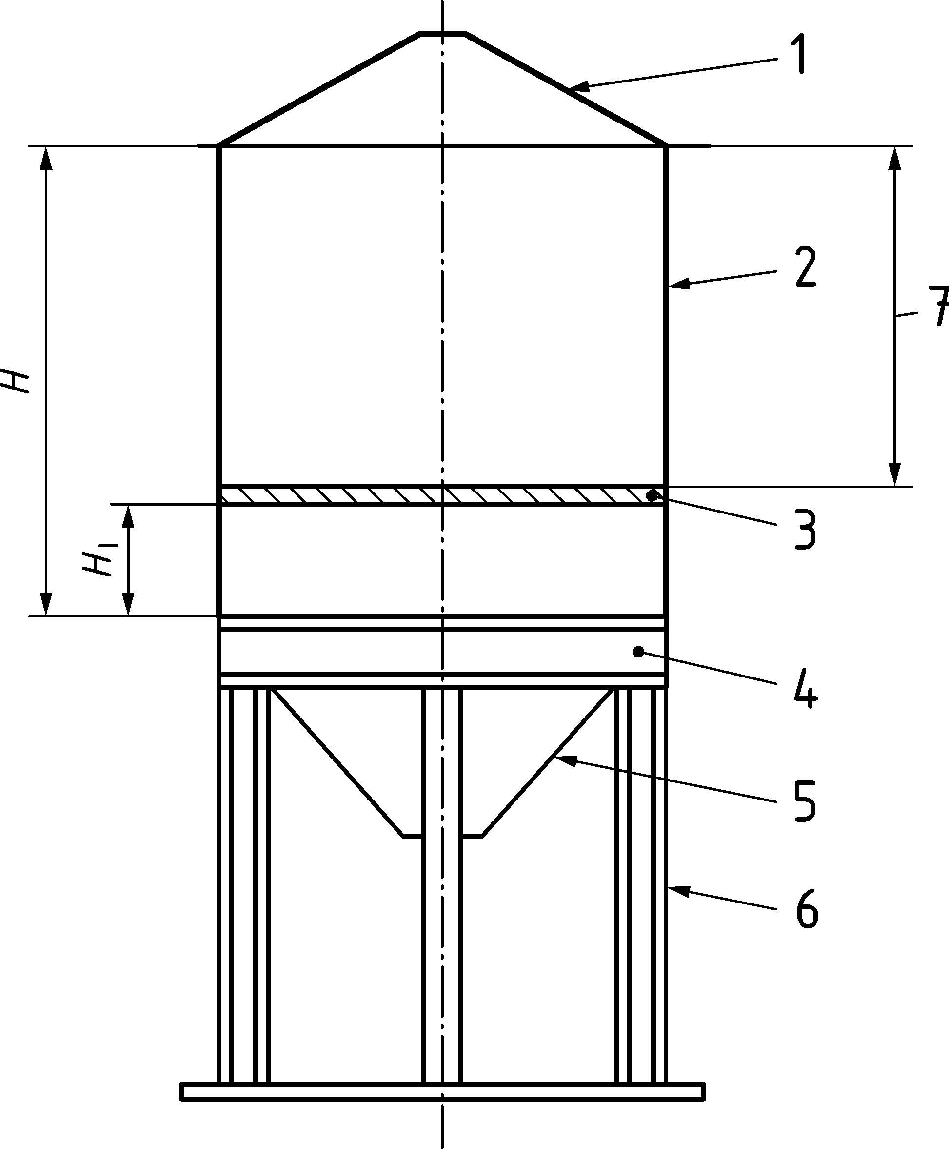

Key

|  |  |  |  |
| --- | --- | --- | --- |
| 1 | conical roof | 5 | hopper |
| 2 | cylindrical shell | 6 | column |
| 3 | intermediate ring stiffener | 7 | simplified shell design (constant axial stress) |
| 4 | ring beam |  |  |

Figure 8.5 — Discretely supported silo with intermediate ring

(2) The ideal height *HI* of the intermediate ring above the supports is chosen to effectively eliminate all non-uniformity in vertical membrane stresses above the intermediate ring. The ideal height is given by:

 (8.11)

where

|  |  |
| --- | --- |
| *r* | is the middle surface radius of the cylindrical shell; |
| *n* | is the number of supports beneath the cylindrical wall. |

NOTE The thickness of the cylindrical shell between the support and the intermediate ring is treated here as uniform. This does make the ring very high on the wall if the number of supports is only 4.

(3) The cross section of the intermediate ring should be chosen to have a cross-sectional area *A*r and second moment of area *I*rθ for circumferential bending (about a vertical axis) that satisfy the condition.

 (8.12)

(4) The stiffness of the ring relative to that of the shell is characterised by the parameter *r,*I which should be evaluated as

 (8.13)

where

|  |  |
| --- | --- |
| *r* | is the radius of the shell and intermediate ring; |
| *t* | is the uniform thickness of the shell below the ideal ring location; |
| *A*r | is cross-sectional area of the intermediate ring; |
| *r*,gyr | is the radius of gyration of the ring (= ); |
| *I*rθ | is the radius of gyration of the ring (= ); |

(5) A simple measure of the recommended ring radius of gyration *r*gyr may be found as

 (8.14)

(6) The maximum values of the stress resultants developed in the intermediate ring placed at the ideal height can be found as:

 (8.15)

 (8.16)

where

|  |  |
| --- | --- |
| *M* | is the circumferential bending moment about the vertical axis; |
| *N* | is the circumferential compressive force; |
| ** | is the stress amplification ratio (ratio of the maximum stress above the support to the uniform axial compressive stress) (see 8.6); |
| *P*u | is the total support force per unit circumference derived from all the support forces for the silo. |

### Intermediate ring placed below the ideal height

(1) An intermediate ring that is placed below the ideal height can have a beneficial effect on the axial membrane stresses above it by reducing the non-uniformity around the circumference. The ideal ring placement fully eliminates this non-uniformity. Where the intermediate ring is placed below the ideal height (*H*L < *H*I) the local maximum axial membrane stress above the intermediate ring stiffener can be estimated as:

 (8.17)

 (8.18)

with:

 (8.19)

 (8.20)

where

|  |  |
| --- | --- |
| **r | is the remaining stress amplification ratio above the intermediate ring; |
| *t*U | is the thickness of the shell above the intermediate ring; |
| *t*L | is the thickness of the shell below the intermediate ring; |
| *H*L | is the height of the silo shell from the transition to the intermediate ring. |

(2) The cross section of an intermediate ring that is placed below the ideal height should be chosen to have a cross-sectional area *A*r and second moment of area *Irθ* that satisfy the condition

 (8.21)

(3) For an intermediate ring that is placed below the ideal height, the stiffness of the ring in circumferential bending relative to that of the shell is characterised by the parameter *r,b*I which should be evaluated as:

 (8.22)

in which:

 (8.23)

 (8.24)

where

|  |  |
| --- | --- |
| *A*r | is cross-sectional area of the intermediate ring; |
| *r*,gyr | is the radius of gyration of the intermediate ring (= ); |
| *H*L | is the height of the silo shell from the transition to the intermediate ring. |

(4) The maximum values of the stress resultants developed in the intermediate ring placed below the ideal height can be found as:

 (8.25)

 (8.26)

 (8.27)

where

|  |  |
| --- | --- |
| *M* | is the circumferential bending moment about the vertical axis; |
| *Mr* | is the transverse bending moment about the radial axis; |
| *N* | is the circumferential compressive force; |
| *Irx* | is the second moment of area for vertical bending deformations (about a radial axis); |
|  | is the stress amplification ratio above the ring girder at the transition (see 8.6); |
| r | is the reduced stress amplification ratio above the intermediate ring (Formula 8.18); |
| *P*u | is the total support force per unit circumference derived from all the support forces for the silo. |

(5) It is recommended that the ratio of the out of plane bending moment *M*r to the in plane bending moment *M* should be limited to no more than 10 % (i.e. *M*r/*M* < 0,1). This can be achieved if the following condition is met:

 (8.28)

## Discretely supported isotropic silo with columns beneath the hopper

(1) A silo should be deemed to be supported beneath its hopper if the vertical line above the centroid of the supporting member is more than *t* inside the middle surface of the cylindrical shell above it.

(2) A silo supported beneath its hopper should satisfy the provisions of Clause 9 on hopper design.

(3) A silo supported by columns beneath its hopper should be analysed using linear shell bending theory or a more precise analysis. The local bending effects of the supports and the meridional compression that develops in the upper part of the hopper should be included in the verification for both the plastic limit state and the buckling limit state, and these verifications should be carried out using EN 1993‑1‑6.

## Local support details and ribs for load introduction in isotropic cylindrical walls

### Local supports beneath the wall of an isotropic cylinder

(1) A local support bracket beneath the wall of a cylinder should be proportioned to transmit the design force without localised irreversible deformation to the support or the shell wall.

(2) The support should be proportioned to provide appropriate vertical, circumferential and axial rotational restraint to the edge of the cylinder.

NOTE Some possible support details are shown in Figure 8.1 to Figure 8.4 and Figure 8.6.

|  |  |
| --- | --- |
|  |  |
| **a) Local support at transition ring with engaged column** | **b) Possible stiffening arrangement for cylindrical wall with high local support loads** |

Key

|  |  |
| --- | --- |
| 1 | stiffener |
| 2 | stiffener |

Figure 8.6 — Typical details of supports

(3) The length of engagement should be chosen taking account of the limit state of buckling of the shell in shear adjacent to the engaged column caused by vertical force transfer into the shell, see 7.5.4.

(4) Where discrete supports are used without a ring girder, the stiffener above each support should be either:

1. engaged into the shell as far as the eaves;
2. engaged by a distance not less than *L*min, determined from:

 (8.29)

where *n* is the number of supports around the shell circumference.

### Local ribs for load introduction into isotropic cylindrical walls

(1) A rib for local load introduction into the wall of a cylinder should be proportioned to transmit the design force without localised irreversible deformation to the support or the shell wall.

(2) The engagement length of the rib should be chosen taking account of the limit state of buckling of the shell in shear adjacent to the rib, see 8.9.1.

(3) The design of the rib should take account of the need for rotational restraint of the rib to prevent local radial deformations of the cylinder wall. Where necessary, stiffening rings should be used to prevent radial deformations.

NOTE Possible details for load introduction into the shell using local ribs are shown in Figure 8.7.

|  |  |
| --- | --- |
|  |  |
| **a) Local rib without rings attached to cylindrical wall** | **b) Local rib with stiffening rings to resist radial displacements** |

Key

|  |  |
| --- | --- |
| 1 | rib |
| 2 | upper ring |
| 3 | lower ring |
| 4 | shell wall |

Figure 8.7 — Typical details of loading rib attachments

## Anchorage at the base of an isotropic walled silo

(1) The design of the anchorage should take account of the circumferential non-uniformity of the actual actions on the shell wall. Particular attention should be paid to the local high anchorage requirements needed to resist wind action.

NOTE Anchorage forces are usually underestimated if the silo is treated as a cantilever beam under global bending.

(2) The separation between anchorages should not exceed the value derived from consideration of the base ring design for vertical deformations, given in 10.5.3.

(3) Unless a more thorough assessment is made using numerical analysis, the anchorage design should have a resistance adequate to sustain the local value of the uplifting force *n*x,Ed per unit circumference, evaluated as:

 (8.30)

** (8.31)

** (8.32)

** (8.33)

where

|  |  |
| --- | --- |
| *q*Ed,w | is the design value of the wind stagnation point pressure at the silo eaves; |
| *L* | is the total height of the cylindrical shell wall; |
| *t* | is the mean thickness of the cylindrical shell wall; |
| *I* | is the second moment of area of the ring at the upper edge of the cylinder in circumferential bending (about its vertical axis); |
| *C*m | are the harmonic coefficients of the wind pressure distribution around the circumference; |
| *mmax* | is the highest harmonic in the wind pressure distribution. |

NOTE The value of *q*Ed,w corresponds to the design value of the pressure *q*p in EN 1991‑1‑4 at the top of the cylindrical wall.

(4) The values for the harmonic coefficients of wind pressure *C*m should be taken from EN 1991‑1‑4.

(5) A simple treatment for Silo Group 1 is permitted using the values: *m*max = 4, *C*1 = +0,25, *C*2  = +1,0, *C*3 = +0,45 and *C*4 = −0,15.

(6) Where the anchorage is relatively flexible, the silo is not a retaining silo and the top is restrained by a ring with a second moment of area *I* greater than 1 000 *I*,min (Formula (8.1)), the following procedure is permitted.

(7) The low stiffness of the anchorage may be used to reduce the required design forces in the anchorages, by reducing the axial membrane stress resultant given by Formula (8.30) by the coefficient *k*red as:

 (8.34)

with

but (8.35)

where *K* is the calculated smeared stiffness of the discrete anchorages in (kN/mm) per metre of the circumference.

NOTE If *K* is greater than 300 kN/mm per m of the circumference, there is no reduction in the anchorage force. The reduction becomes very significant if *K* is less than about 20 (kN/mm)/m.

## Isotropic walled cylindrical shells with vertical stiffeners with the base fully supported

(1) The incompatibility of the radial displacements of the isotropic shell and the attached stiffener at the base boundary should be considered in designing the details of the base boundary.

## Corrugated stiffened cylindrical shells with the base fully supported

(1) The incompatibility of the radial displacements of the corrugated shell and the attached stiffener at the base boundary should be considered in designing the details of the base boundary.

# Ultimate limit state design of isotropic conical hoppers

## Basis

### General

(1) Conical hoppers should be so proportioned that the basic design requirements for ultimate limit states given in Clause 4 are satisfied.

(2) The provisions defined in this clause are also applicable to steel conical hoppers used within reinforced concrete silos.

(3) The safety assessment of the conical shell should be conducted using the provisions of EN 1993‑1‑6.

### Distinctions between hopper shell forms

(1) A hopper wall constructed from flat rolled steel sheet should be termed 'isotropic'.

(2) A hopper wall with stiffeners attached to the outside should be termed 'externally stiffened'.

(3) A hopper that is mounted on a structural framework or columns beneath the body of the hoper is termed ‘externally supported’.

(4) A hopper with more than one discharge orifice should be termed 'multiple outlet'.

(5) A hopper which forms part of a silo supported on discrete column or bracket supports should be termed 'discretely supported', even though the discrete supports are not directly beneath the hopper.

## Isotropic hopper wall design

(1) The conical wall of an isotropic walled hopper should be checked for:

* resistance to rupture under internal pressure and wall friction;
* resistance to local yielding in bending at the transition;
* resistance to fatigue failure;
* resistance of joints (connections);
* resistance to buckling under transverse loads from feeders and attachments;
* local effects.

(2) Where a hopper wall is structurally independent of a vertical cylindrical wall, the radial displacement of the hopper top and transition junction should be checked to ensure that no compatibility issues can arise.

(3) The hopper wall should satisfy the provisions of EN 1993‑1‑6, except where 9.3 and 9.4 provide conditions that are deemed to satisfy the provisions of that standard.

(4) The rules given in 9.3 and 9.4 may be used for hoppers with hopper half angles in the range .

(5) For hoppers in Silo Group 1, the cyclic plasticity and fatigue limit states may be ignored, provided that both the following two conditions are met:

1. The design for the rupture at the transition junction should be carried out using an enhanced partial factor of **M2 = **M2g = 1,40.
2. No local meridional stiffeners or supports are attached to the hopper wall adjacent to the transition junction.

NOTE Meridional stiffeners are not normally necessary on hoppers. The term “adjacent” is used to mean that local bending at the top of the hopper should not be affected by variations associated with discrete stiffeners.

(6) For hoppers in Silo Group 1, the simpler provisions given in Annex A may be used.

(7) For the design of hoppers in Silo Group 2 where the wall construction is corrugated with vertical stiffeners, the simpler provisions given in Annex A may also be used. For these silos, the ring girder may be designed using the provisions of Annex B.

(8) Where a hopper has sheeting (shell) that is supported on meridional stiffeners, see 9.4.2.

(9) Where the hopper is supported on discrete columns beneath the hopper body, see 9.4.3.

## Resistance of isotropic conical hoppers

### General

(1) Isotropic or externally stiffened conical hoppers should satisfy the provisions of EN 1993‑1‑6. Alternatively, these may be deemed to be satisfied using the assessments of the design resistance given here.

(2) Special attention should be paid to the possibility that different parts of the hopper can be critically loaded under the pressure patterns of either filling or discharge actions.

(3) The stress resultants arising in the body of an isotropic or externally stiffened hopper may generally be found using the membrane theory of shells.

NOTE Additional information relating to the pressure patterns which can occur and the membrane theory stress resultants in the hopper body is given in Annex B.

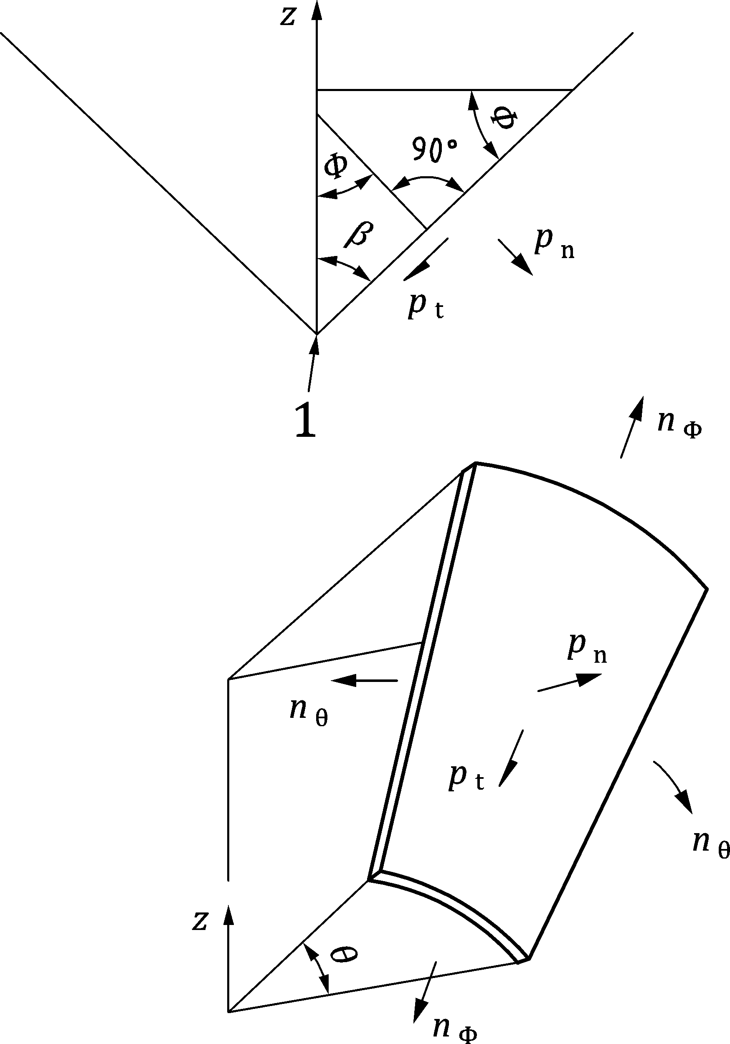

Key

|  |  |
| --- | --- |
| 1 | origin and apex |

Figure 9.1 — Hopper shell segment

### Isotropic unstiffened welded or bolted hoppers

#### General

(1) A conical hopper should be treated as a shell structure, recognising the coupling of meridional and circumferential actions in supporting loads.

#### Plastic mechanism or rupture in the hopper body

(1) The design against rupture should recognise that the hopper can be subject to different patterns and changing patterns of pressures on the wall. Because failure by rupture can easily propagate and is generally not ductile, every point in the hopper should be able to resist the most severe design condition.

(2) Welded or bolted joints running down the meridian within the conical hopper should be proportioned at each point to sustain the worst membrane forces arising from either the filling or the discharge pressure distribution.

(3) Welded or bolted joints running around the hopper circumference should be proportioned to sustain the maximum total weight of solids that can be applied below that point.

NOTE This is generally defined by the filling pressure distribution, see EN 1991‑4.

#### Rupture at the transition junction

(1) The circumferential joint between the hopper and the transition junction, see Figure 9.2, should be designed to carry the maximum total meridional load that the hopper can be required to support, allowing for possible unavoidable non-uniformities.

|  |  |  |
| --- | --- | --- |
|  |  |  |
| **a) in welded construction** | **b) in bolted construction** | **c) with corrugated cylindrical wall** |

Key

|  |  |
| --- | --- |
| 1 | conical joints |

Figure 9.2 — Hopper transition joint: potential for rupture

(2) Where the only loading under consideration is gravity and flow loading from the stored solid, the meridional membrane force per unit circumference *n*h,Ed,s caused by the symmetrical pressures defined in EN 1991‑4 (Fundamental Silo Load Case) that are transmitted through the transition joint should be evaluated using global equilibrium. Relevant formulae are available in Annex C.

(3) The design value of the local meridional membrane force per unit circumference *n*h,Ed, allowing for the possible non-uniformity of the loading, should then be obtained as

*n*h,Ed = *g*asym *n*h,Ed,s (9.1)

where

|  |  |
| --- | --- |
| *n*h,Ed,s | is the design value of the meridional membrane force per unit circumference at the top of the hopper obtained assuming the hopper loads are entirely symmetrical; |
| *g*asym | is the unsymmetrical stress augmentation factor, *g*asym = 1,2. |

(4) For silos in Silo Groups 2 or 3, an elastic bending analysis should be made of the hopper where other loads from discrete supports, feeders, attached members, non-uniform hopper pressures etc. are involved. This analysis should determine the maximum local value of the meridional membrane force per unit circumference to be transmitted through the hopper to transition junction joint.

(5) The design resistance of the hopper at the transition joint *n*h,Rd should be taken as:

*n*h,Rd = *k*r *t f*u / **M2 (9.2)

where

|  |  |
| --- | --- |
| *f*u | is the tensile strength; |
| *t* | is the local thickness of the top of the hopper (or a joint adjacent to it); |
| *k*r | is the hopper transition reduction factor, *k*r = 0,90. |

#### Plastic mechanism at thickness changes or at the transition

(1) The plastic mechanism resistance of the hopper should be evaluated in terms of the local value of meridional membrane stress resultant *n*h,Ed at the upper edge of the cone or at a change of plate thickness (Formula (9.1)).

(2) The design meridional membrane resistance *n*h,Rd should be determined from:

 (9.3)

where

|  |  |
| --- | --- |
| t | is the local wall thickness; |
| *r* | is the radius at the top of the plastic mechanism (hopper top or change of plate thickness); |
| ** | is the hopper half-angle, see Figure 9.1; |
| ** | is the wall friction coefficient for the hopper. |

(3) At each critical point in the structure, the design stresses should satisfy the condition:

*n*h,Ed ≤ *n*h,Rd (9.4)

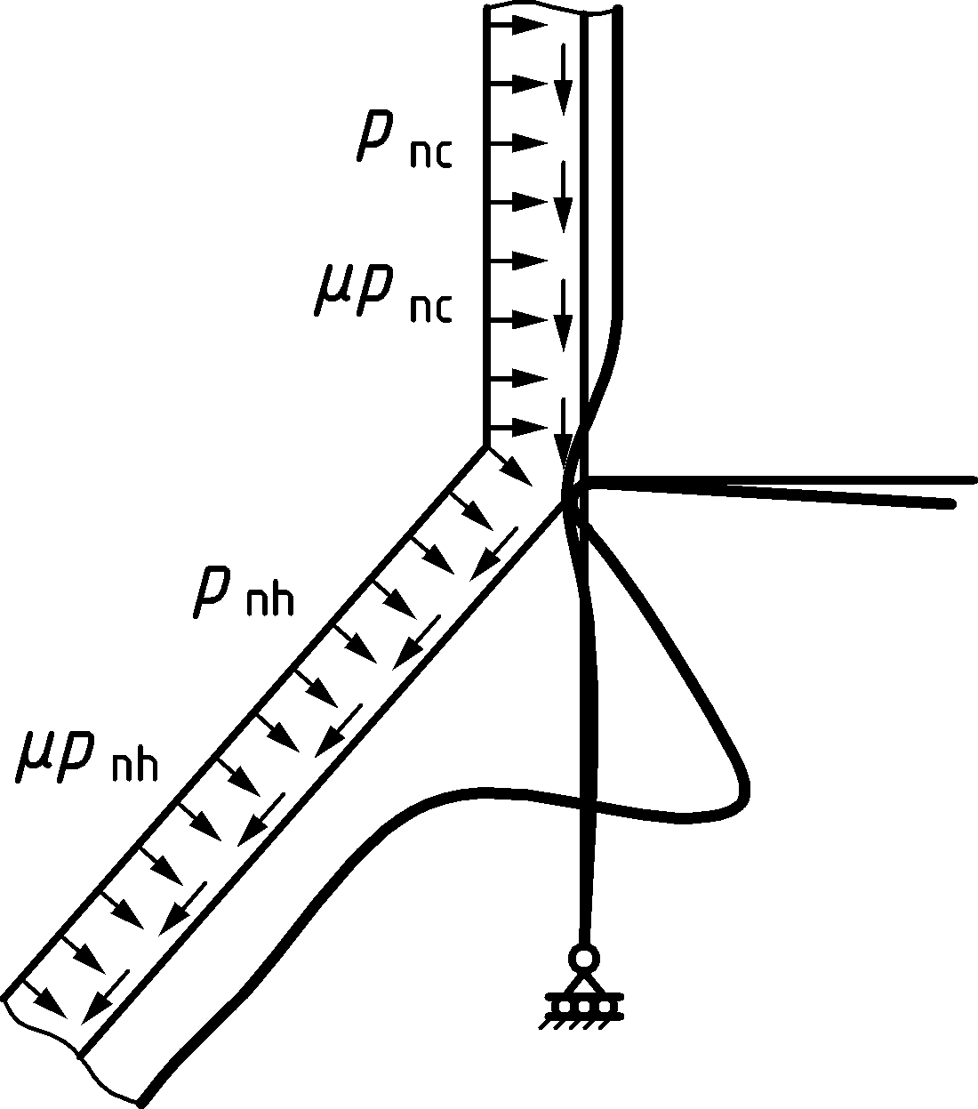

Figure 9.3 — Plastic collapse of conical hopper

#### Local flexure in the hopper below the transition

(1) To avoid cyclic plasticity and fatigue failures, the hopper should be designed to resist the severe local flexure at the top of the hopper that arises from both compatibility and equilibrium effects.

(2) This requirement may be ignored for silos of Silo Group 1.

(3) In the absence of a finite element analysis of the structure, the value of the local bending stress at the top of the hopper should be assessed using the following procedure.

(4) The effective radial force per unit circumference *P*e,Ed and moment per unit circumference *M*e,Ed applied to the transition ring by the hopper should be determined from:

*P*e,Ed = *n*h,Ed sin ** − *P*h − *P*c (9.5)

*M*e,Ed = *P*c*x*c − *P*h*x*h (9.6)

with

*P*c = 2 *x*c *p*nc (9.7)

 (9.8)

*x*c = 0,39 (9.9)

 (9.10)

where (see Figure 9.4):

|  |  |
| --- | --- |
| *t*h | is the hopper local wall thickness; |
| *t*c | is the local wall thickness of the cylinder at the transition junction; |
| *r* | is the radius of the transition junction (top of the hopper); |
| ** | is the hopper apex half angle; |
| ** | is the wall friction coefficient for the hopper; |
| *n*h,Ed | is the design value of the meridional membrane stress resultant at the top of the hopper; |
| *p*nh | is the local value of normal pressure on the hopper just below the transition; |
| *p*nc | is the local value of normal pressure on the cylinder just above the transition. |

(5) Where the cylinder is constructed using corrugated sheeting, the effective thickness of the cylinder at the transition junction *t*c should be taken as *t*c = 0.

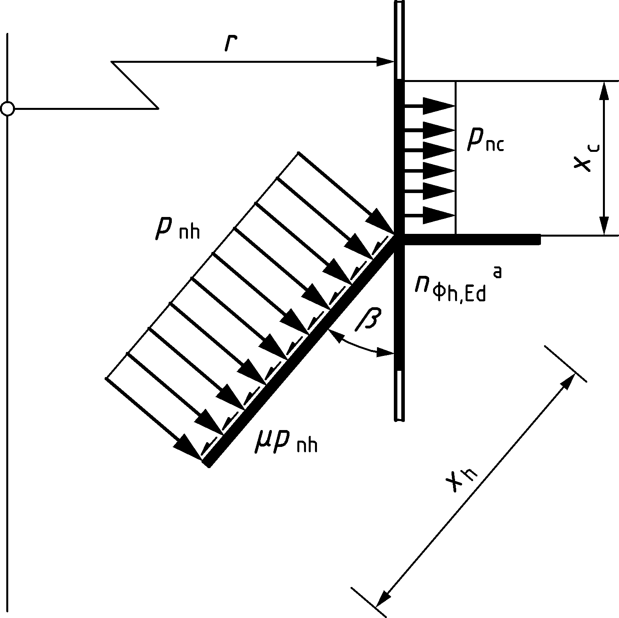

Key

|  |  |
| --- | --- |
| a | *n*h,Ed determined here |

Figure 9.4 — Notation for the top of a conical hopper

(6) The circumferential membrane stress **h,Ed at the top of the hopper should be determined from:



(7) The local bending stress **bh,Ed at the top of the hopper should be determined from:

 (9.11)

with

 (9.12)

** = 0,78 (9.13)

** = (9.14)

 (9.15)

 (9.16)

 (9.17)

where

|  |  |
| --- | --- |
| *t*s | is the local wall thickness of the skirt below the transition junction; |
| *A*ep | is the cross-sectional area of the ring at the transition junction (without any effective contributions from the adjacent shell segments). |

(8) The surface value of the meridional stress at the top of the hopper should be taken as

 (9.18)

(9) The design value of the surface von Mises equivalent stress should be found as:

 (9.19)

(10) The design value of the surface equivalent stress should satisfy the condition:

 (9.20)

#### Hoppers that are part of a silo resting on discrete supports beneath the cylindrical wall

(1) If the silo is supported on discrete supports or columns, the relative stiffness of the transition ring girder, cylinder wall and hopper should be taken into account when assessing the non-uniformity of the meridional membrane stresses in the hopper.

(2) This requirement may be ignored for silos of Silo Group 1.

(3) The hopper should be designed to sustain the highest local value of meridional tension at the hopper top (adjacent to a support) according to 9.3.2.3 and 9.3.2.4.

#### Buckling in shell hoppers

(1) Whilst shell hopper structures are normally under biaxial tension, so no problems of buckling arise, some loading conditions can lead to compressive meridional membrane stresses. These include horizontal actions from feeders or attached structures, unsymmetrical vertical actions and eccentric discharge channels in a hopper. For these conditions, it should be verified that a compressive meridional membrane stress resultant does not cause buckling.

(2) This sub-clause is only relevant if the value of *n*ϕ,Ed at some point in the hopper is compressive. The sign of both *n*ϕ,Ed and *n*ϕ,Rd is taken as positive in compression in this sub-clause.

NOTE The meridional membrane stress resultants in a hopper are normally tensile.

(3) Checks against buckling in the hopper should be performed at locations where the peak compressive membrane stress resultant is high.

(4) The design buckling resistanc *n*ϕ,Rd at any point in the hopper should be determined from:

 (9.21)

where

|  |  |
| --- | --- |
| *α*xh | is the elastic buckling imperfection sensitivity factor for the hopper; |
| *r* | is the simple radius at the point in the hopper of peak meridional compressive stress resultant; |
| *t*h | is the hopper local wall thickness at the same point; |
| **xh | is the imperfection factor for hopper buckling, **xh = 0,30. |

and *γ*M1 is given in Table 4.4, but *n*ϕ,Rd should not be taken as greater than .

NOTE Formula (9.21)) provides a simplified method of assessing the buckling resistance. For a more complete evaluation, see EN 1993‑1‑6.

(5) The meridional stress resultant at the critical point in the hopper should satisfy the condition:

 (9.22)

## Considerations for special hopper structures

### Supporting structures

(1) The effect of discrete supports beneath a silo should be treated as set out in 8.4. The supporting structures themselves should be designed to EN 1993‑1‑1, with the boundary between the silo and supporting structure as defined in 1(9).

(2) Where a hopper wall is structurally independent of a vertical cylindrical wall, the radial displacement of the hopper top and/or the transition junction should be checked to ensure that no compatibility issues can arise.

### Hoppers supported on a structural framework

(1) Where hopper platework is directly supported on a complete structural framework, the provisions of 9.3 do not apply. The separation of supporting girders should be arranged to ensure that plate bending between girders is appropriately controlled. The provisions of EN 1993‑4‑2 for roofs that are similarly supported may be used to ensure that the plates are adequately stiff.

### Column supported hopper

(1) If the hopper body itself is supported on discrete supports or columns that do not reach the hopper top edge, the hopper structure should be analysed using the bending theory of shells, see EN 1993‑1‑6.

(2) Adequate provision should be made to distribute the support forces into the hopper.

(3) The joints in the hopper should be designed for the highest local value of stress resultants to be transmitted through them.

(4) The hopper should be assessed for resistance to buckling failure in zones where compressive membrane stresses develop, see EN 1993‑1‑6.

### Unsymmetrical hopper

(1) If the axis of the hopper is not vertical, but inclined at an angle ** to the vertical (Figure 9.5), the increased meridional stresses on the steep side associated with this geometry should be evaluated, and appropriate provision made to provide an adequate local meridional resistance.

### Stiffened conical hoppers

(1) Meridional (stringer) stiffeners should be adequately anchored at the top of the hopper.

(2) If the hopper cone is stiffened with meridional stiffeners, the effects of compatibility between the wall plate and stringers should be included. The effect of the circumferential tension in the hopper wall should be included in the assessment of the forces in the stringer stiffeners and the hopper wall plate, as affected by the Poisson effect (see the comparable treatment of stiffened isotropic cylindrical walls in 7.8).

(3) The hopper plate joints should be proportioned to resist the increased tension arising from compatibility.

(4) The connection between the stringer and hopper plate should be proportioned for the interaction forces between them.

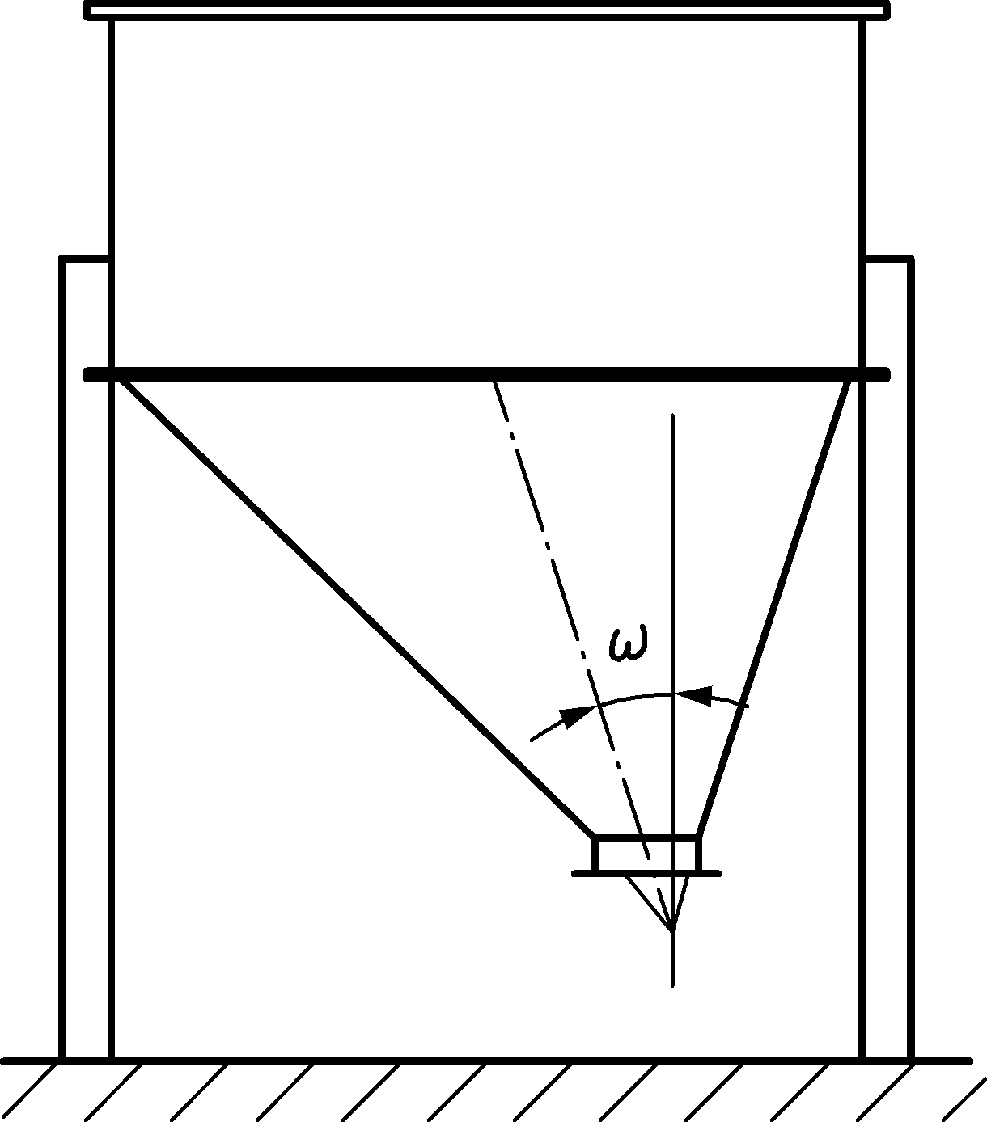

Figure 9.5 — Unsymmetrical hopper with engaged columns in cylinder

### Multi-segment conical hoppers

(1) If a hopper cone is composed of several segments with different slopes, the appropriate bulk solids actions on each segment should be evaluated and included in the structural design.

(2) The local circumferential tensions or compressions at changes in hopper slope should be evaluated, and adequate resistance provided to support them.

(3) The potential for severe local wear at such changes in hopper slope should be included in the design.

# Ultimate limit state design of transition junctions and supporting ring girders in circular silos

## Basis

### General

(1) A steel transition ring or ring girder should be so proportioned that the basic design requirements for the ultimate limit state given in Clause 4 are satisfied.

(2) The safety assessment of the ring or ring girder and its relationship to the cylindrical shell should be carried out using the provisions of EN 1993‑1‑6, except where the provisions of this Standard are deemed to satisfy them.

(3) For silos in Silo Group 1, the cyclic plasticity and fatigue limit states may be ignored, provided that the following conditions are met.

NOTE The circumferential stresses in the transition ring are treated as compression positive throughout.

### Transition ring and ring girder design

(1) The ring or ring girder should be checked for:

* resistance to plastic limit under circumferential compression;
* resistance to buckling under circumferential compression;
* resistance to local yielding under tension or compression stresses;
* resistance to local failure above supports;
* resistance to torsion;
* resistance of joints (connections).

(2) The ring girder should satisfy the provisions of EN 1993‑1‑6, except where 10.2 to 10.5 and Annex B provide conditions that are deemed to satisfy the provisions of that standard.

### Distinctions between transition junction forms

(1) A ring whose purpose is only to provide resistance to radial components of forces from the hopper should be termed a ‘transition ring’.

(2) A ring that is part of a silo with isotropic walls or vertically stiffened isotropic walls should be termed an ‘isotropic junction’.

(3) A ring whose purpose is to provide redistribution of vertical forces between different components (e.g. the cylinder wall and discrete supports) should be termed a ‘ring girder’.

(4) A ring placed higher on the cylindrical wall to provide a more uniform transfer of discrete support forces into the upper wall should be termed an ‘intermediate ring’.

(5) The point of intersection between the middle surface of the hopper plate and the middle surface of the cylindrical shell wall at the transition junction, termed the ‘joint centre’, should be used as the reference point in limit state verifications.

(6) A silo with no defined ring at the transition (see Figure 10.1a) has an effective ring formed from adjacent shell segments and should be termed a ‘natural transition ring’.

(7) An annular plate placed at the transition junction should be termed an ‘annular plate transition ring’, see Figure 10.1b.

(8) A hot-rolled steel section, used as a ring stiffener at the transition should be termed a ‘rolled section transition ring’.

(9) A hot-rolled steel section rolled around the silo circumference and used to support the shell beneath the transition should be termed a ‘rolled ring girder’.

(10) A section built up from isotropic steel plates with cylindrical and annular plate forms should be termed a ‘fabricated ring girder’, see Figure 10.1b, c and d.

(11) A cold-formed steel section, used as a ring stiffener at the transition should be termed a ‘cold-formed transition ring’.

(12) A transition junction that is part of a silo with corrugated walls with vertical stiffeners that extend to the base as columns, should be termed a ‘corrugated silo transition ring’ and may be treated using the simplified provisions of Annex B.

### Modelling of isotropic transition junctions

(1) In hand calculations, the junction should be represented by cylindrical and conical shell segments and a ring cross-section whose centroid is located at effectively the same height as the cone-cylinder intersection.

(2) Where the silo is uniformly supported, the circumferential stresses in the annular plates of the junction may be assumed to be uniform in each plate.

(3) Where the silo is supported on discrete supports or columns, the circumferential stresses in the junction plates should be taken to vary radially in each plate as a result of warping stresses.

|  |  |  |  |
| --- | --- | --- | --- |
|  |  |  |  |
| **a) Natural ring with engaged column** | **b) Annular plate ring with engaged column** | **c) Triangular box with column engaged to skirt** | **d) Triangular box with concentric column beneath skirt** |

Key

|  |  |
| --- | --- |
| 1 | cone/cylinder junction |
| 2 | joint centre |

Figure 10.1 — Example ring forms

### Limitations on ring placement

(1) The vertical eccentricity of an annular plate, or the centroid of a ring, from the transition joint centre should not be greater than , where *t* is the local thickness of the cylinder plate.

(2) If the eccentricity exceeds the limit defined in (1), a numerical model using shell bending analysis according to EN 1993‑1‑6 should be used to check the effect of the eccentricity and the effectiveness of the plate assembly in acting as a compression ring.

NOTE This rule arises from the ineffectiveness of rings placed further than this from the junction, see Figure 10.2.

(3) The provisions of 10.2 apply only where the requirements of (1) and (2) are met.

## Analysis of the transition junction

### General

(1) For silos in Silo Group 1, the transition junction may be analysed using simple formulae and loadings from adjacent shell segments derived from membrane theory.

(2) Where a computer calculation of the transition junction is performed, it should satisfy the requirements of EN 1993‑1‑6.

(3) Where a computer calculation is not used and the silo is uniformly supported, the analysis of the junction may be undertaken using 10.2.2.

(4) Where a computer calculation is not used and the silo is supported on discrete supports or columns, the analysis of the junction should be undertaken using 10.2.3.

(5) For a silo with corrugated walls and vertical stiffeners, the transition ring may be treated using the simplified provisions of Annex B.

|  |  |
| --- | --- |
|  | $$λ=2,44 \sqrt{rt}$$*r*/*t* = 500  *T*/*t*c = 2  *b*/*T* = 10  *t*h/*t*c = 1  *β* = 45° |

Key

|  |  |
| --- | --- |
| 1 | stress in hopper |
| 2 | stress in skirt |
| 3 | stress in annular plate ring |
| $$\frac{σ_{mθ}}{σ_{mθ (e=0)}}$$ | circumferential stress ratio |
| *e*/*λ* | dimensionless eccentricity |

Figure 10.2 — Example showing membrane stresses developed in an annular plate ring and adjacent shell when the ring is eccentric

### Uniformly supported isotropic transition junctions

(1) Where a transition junction is supported on a skirt extending to the foundation or is supported at a large number of points around the circumference (≥ 12), the junction may be treated as functioning axisymmetrically, and the provisions of this sub-clause are sufficient.

(2) The effective section of the transition junction in resisting the radial component of the force transmitted from the top of the hopper should be evaluated using the following calculations.

(3) The shell segments meeting at the joint centre should be separated into those above (Set A) and those below (Set B) (see Figure 10.3a). Any annular plate segment or added ring at the level of the joint centre should be initially ignored. Where a vertical leg is attached to the annular plate at a different radial coordinate from the joint centre, it should be treated as a shell segment in the same manner as the others, see Figure 10.3.

|  |  |  |
| --- | --- | --- |
|  | |  |
| *t*eqA = *t*c |  |  |
| **a) Geometry** | | **b) Effective ring beam for circumferential compression** |

Key

|  |  |
| --- | --- |
| 1 | annular plate |
| 2 | this flange not effective for circumferential compression |

Figure 10.3 — Effective section of the cylinder / hopper / ring transition

(4) The equivalent thickness *t*eqA and *t*eqB of the plate or set of plates above the joint should be determined from:

 (10.1)

whilst those from the plate or set of plates below the joint should be determined from:

 (10.2)

(5) The ratio  of the thinner to the thicker equivalent plate set should be determined from:

 (10.3)

with

(*t*eq)thinner = min(*t*eqA, *t*eqB) (10.4)

(*t*eq)thicker = max(*t*eqA, *t*eqB) (10.5)

(6) For the thinner of these two sets, the effective length of each shell segment should be determined from:

 (10.6)

where ** is the angle between the shell centreline and the silo axis (cone apex half angle) for that plate.

(7) The effective cross-sectional area of each shell segment of this set should be determined from:

 (10.7)

(8) For the thicker of the two sets, the effective length of each shell segment should be determined from:

 (10.8)

(9) For this set, the effective cross-sectional area of each shell segment of the set should be determined from:

 (10.9)

(10) The effective cross-sectional area *A*ep of an annular plate joined into the junction at the joint centre (see Figure 10.4) should be determined from the actual area *A*p (=*bt*p) as:

 (10.10)

where

|  |  |
| --- | --- |
| *r* | is the radius of the silo cylinder wall; |
| *b* | is the radial width of the annular plate ring; |
| *t*p | is the thickness of the annular plate ring. |

(11) The effective cross-sectional area *A*ep of an external ring section with its centroid located at the same level as the joint centre (see Figure 10.4) should be determined from the actual area *A*p for a rolled of fabricated section, and from the effective area for compression for a cold-formed section.

(12) The total effective area *A*et of the ring and contributing parts of the adjacent shell segments in developing circumferential compression should be determined from:

 (10.11)

(13) For the junction shown in Figure 10.5, where the hopper and skirt thicknesses exceed that of the cylinder, Formula (10.11) may be written as:

 (10.12)

with

 (10.13)

 (10.14)

where

|  |  |
| --- | --- |
| *r* | is the radius of the silo cylinder wall; |
| *t*c | is the thickness of the cylinder; |
| *t*s | is the thickness of the skirt; |
| *t*h | is the thickness of the hopper; |
| *A*ep | is the effective area of the annular plate ring. |

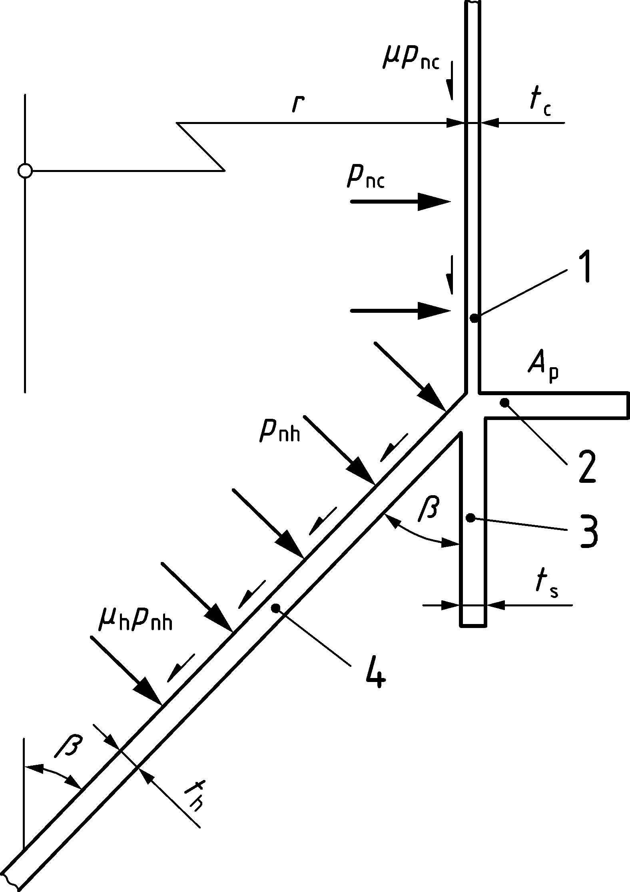

Key

|  |  |
| --- | --- |
| 1 | cylinder |
| 2 | ring |
| 3 | skirt |
| 4 | hopper |

Figure 10.4 — Notation for simple annular plate transition junction

(14) Where the junction consists only of a cylinder, skirt and hopper (see Figure 10.5), the total effective area of the ring *A*et may be found from:

 (10.15)

(15) Where the junction consists only of a skirt and hopper, the total effective area of the ring *A*et may be found using Formula (10.15) with the value of *t*c taken as zero.

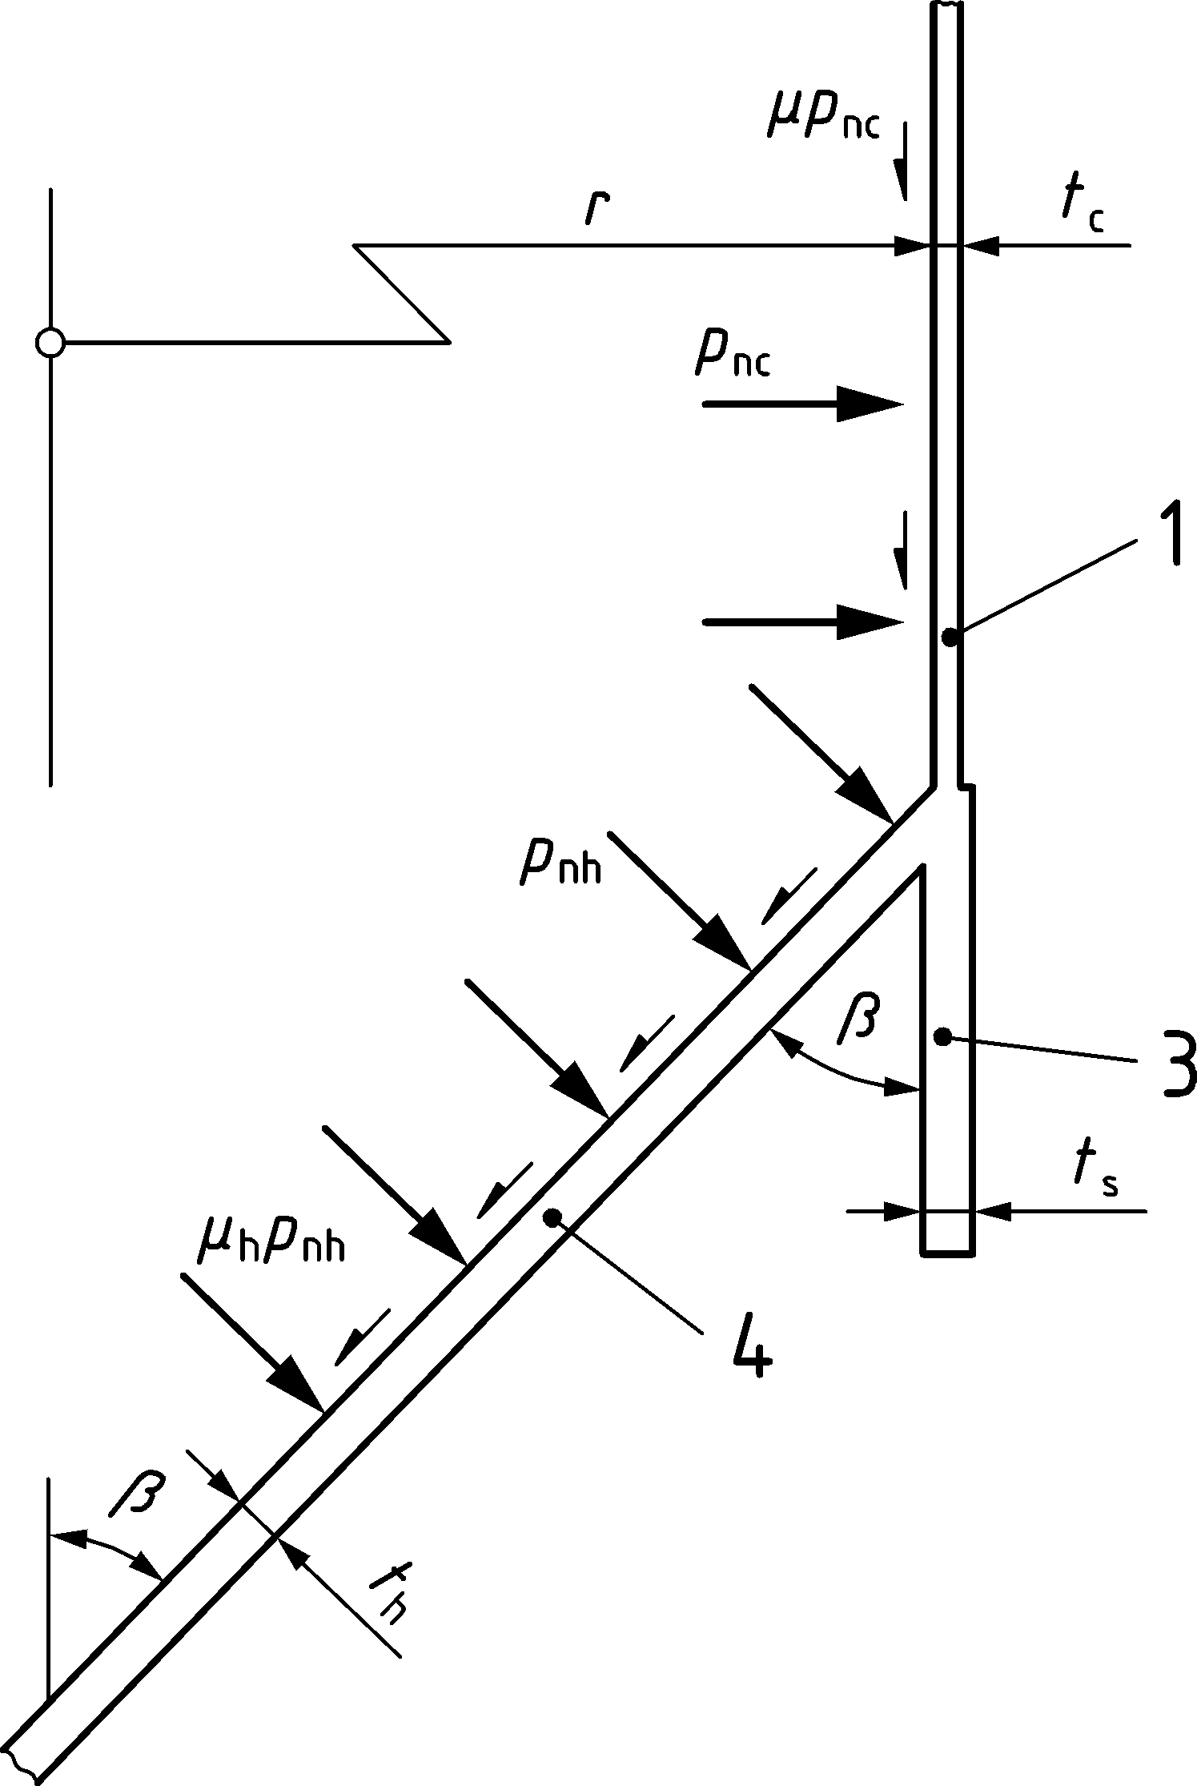

Key

|  |  |
| --- | --- |
| 1 | cylinder |
| 3 | skirt |
| 4 | hopper |

Figure 10.5 — Transition junction without added ring

(16) Where sections of more complex geometry are used at the transition junction, only ring plate segments meeting the condition of 10.1.5 should be deemed to be effective in the evaluation of the junction.

(17) The design value of the effective circumferential compressive force *N*,Ed developed in the junction should be determined from:

*N*,Ed= *n*h,Ed *r* sin** − *p*nc *r* ec − *p*nh (cos** − **sin**) *r* eh (10.16)

where (see Figure 10.6):

|  |  |
| --- | --- |
| *r* | is the radius of the silo cylinder wall; |
| ** | is the half angle of the hopper (at the top); |
| ec | is the effective length of the cylinder segment above the transition (see (4) to (8)); |
| eh | is the effective length of the cylinder segment above the transition (see (4) to (8)); |
| *n*h,Ed | is the design value of the meridional tension per unit circumference at the top of thehopper; |
| *p*nc | is the mean local pressure on the effective length of the cylinder segment; |
| *p*nh | is the mean pressure on the effective length of the hopper segment; |
| ** | is the hopper wall friction coefficient. |

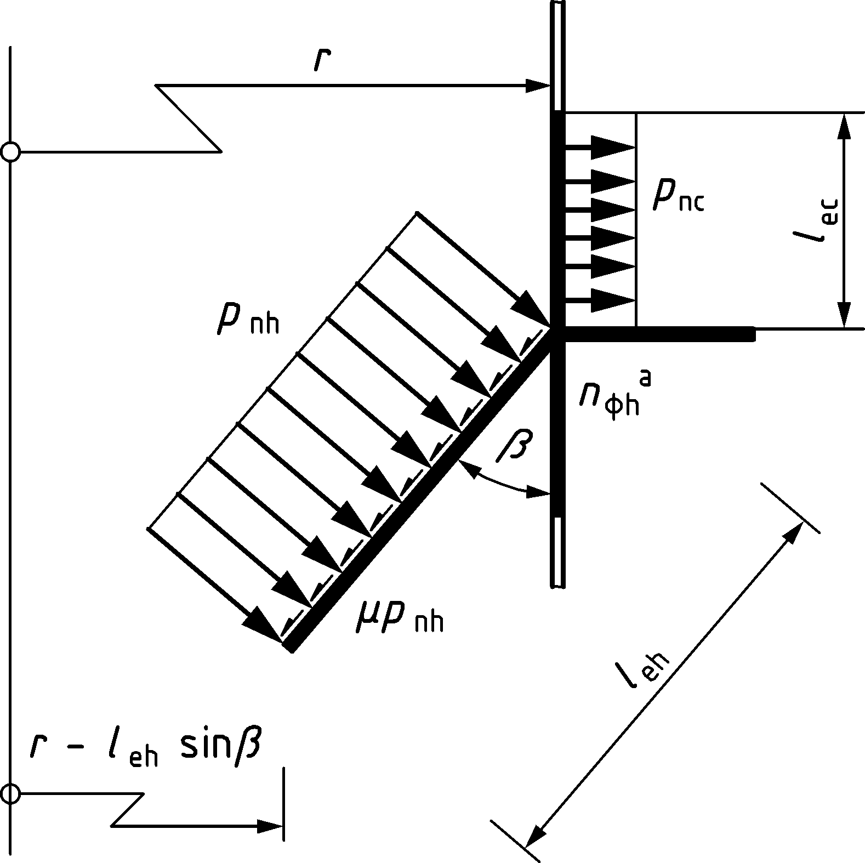

Key

|  |  |
| --- | --- |
| a | *n*h determined here |

Figure 10.6 — Local pressures and membrane stress resultant loadings on the transition ring

(18) The maximum design compressive stress **u,Ed for the uniformly supported junction should be determined from:

 (10.17)

with

 (10.18)

where

|  |  |
| --- | --- |
| *N*,Ed | is the effective circumferential compressive force, see (17); |
| *A*et | is the total effective area of the ring (Formula (10.11)); |
| *r* | is the radius of the silo cylinder wall; |
| *b* | is the width of the annular plate. |

### Transition junction isotropic ring girder above discrete supports

(1) Where a relatively large elevated silo is supported at the transition on a limited number of supports (less than 12), the discrete forces introduced into the silo from the supports can be addressed by the use of a ring beam or ring girder (see Figure 1.1a) and Figures 10.1c and d).

(2) For silos in Silo Group 3, a computational analysis of the structure should be carried out that models all plate elements as shell segments and does not assume prismatic beam action in any curved element. The analysis should take account of the finite width of the discrete supports.

(3) For silos in other Silo Groups, the bending moments and torques within the ring girder should be evaluated, recognising the critical role of the ring girder transverse stiffness and accounting for the eccentricities of loading and support from the ring girder centroid.

(4) The total circumferential compressive thrust developed in the girder should be assumed invariant around the circumference and determined from:

*N*,Ed = *n*h,Ed *r*c sin** − *p*nc *r*c ec − *p*nh(cos** − **sin**) *r*c eh (10.19)

where (see Figure 10.6):

|  |  |
| --- | --- |
| *r*c | is the radius of the silo cylinder wall; |
| ** | is the half angle of the hopper (at the top); |
| ec | is the effective length of the cylinder segment above the transition (see 10.2.2(4) to (13)); |
| eh | is the effective length of the hopper segment (see 10.2.2(4) to (13)); |
| *n*h,Ed | is the design value of the meridional tension per unit circumference at the top of the hopper; |
| *p*nc | is the mean local pressure on the effective length of the cylinder segment; |
| *p*nh | is the mean pressure on the effective length of the hopper segment; |
| ** | is the hopper wall friction coefficient. |

(5) For an isolated ring girder, where the shell above does not affect its function, the variation with circumferential coordinate ** of the design bending moment *M*r,Ed about the horizontal (radial) axis (sagging positive) and the design torsional moment *T*,Ed in the ring girder should be taken as:

*M*r,Ed = *n*v,Ed (*r*g − *e*r) [(*r*g − *e*s) **o (sin** + cot**o cos**) − *r*g + *e*r] + *n*r,Ed *e*x(*r*g − *e*r) (10.20)

*T*,Ed = *n*v,Ed (*r*g − *e*r) [(*r*g − *e*s) **o (cot**o sin** − cos**) + *r*g (**o − **)] (10.21)

with:

 (10.22)

 (10.23)

 (10.24)

where (see Figure 10.7):

|  |  |
| --- | --- |
| ** | is the circumferential coordinate (in radians) measured from an origin at one support; |
| **o | is the circumferential angle in radians subtended by the half span of the ring girder; |
| *j* | is the number of equally spaced discrete supports; |
| *r*g | is the radius of the ring girder centroid; |
| *e*r | is the radial eccentricity of the cylinder from the ring girder centroid (positive where the centroid is at a larger radius); |
| *e*s | is the radial eccentricity of the support from the ring girder centroid (positive where the centroid is at a larger radius); |
| *e*x | is the vertical eccentricity of the joint centre from the ring girder centroid (positive where the centroid lies below the joint centre). |
| *n*xc,Ed | is the design value of compressive axial membrane stress resultant at the base of the cylinder: |
| *n*h,Ed | is the design value of tensile meridional membrane stress resultant at the top of the hopper. |

NOTE The above treatment is valid for a ring girder with either no cylinder above it, or a short cylinder without a stiff ring at its top edge, or an axially flexible cylindrical wall, such as a corrugated shell. Where the shell above the ring is isotropic and has a ring or roof at its top, the defined bending moments here considerably overestimate those that will occur in the ring.

(6) The peak values of the design bending moment about the radial axis that occur over the support *M*rs,Ed and at midspan *M*rm,Ed should be determined from:

*M*rs,Ed = *n*v,Ed (*r*g − *e*r) [(*r*g − *e*s) **o cot**o − *r*g + *e*r] + *n*r,Ed *e*x(*r*g − *e*r) (10.25)

*M*rm,Ed = *n*v,Ed (*r* g − *e*r) [(*r* g − *e*s) **o / sin**o − *r* g + *e*r] + *n*r,Ed *e*x(*r* g − *e*r) (10.26)

NOTE The sign convention for these bending moments is positive bending leading to compression in the upper zone.

(7) Where an open section ring girder is used, the torque should be assumed to be resisted entirely by warping, unless a more precise analysis is used. Where warping resists the torques, the peak design values of flange moment about a vertical axis in each flange should be taken as given by *M*fs,Ed at the support and *M*fm,Ed at midspan, obtained as follows:

 (10.27)

 (10.28)

where *h* is the vertical separation between the flanges of the ring girder.

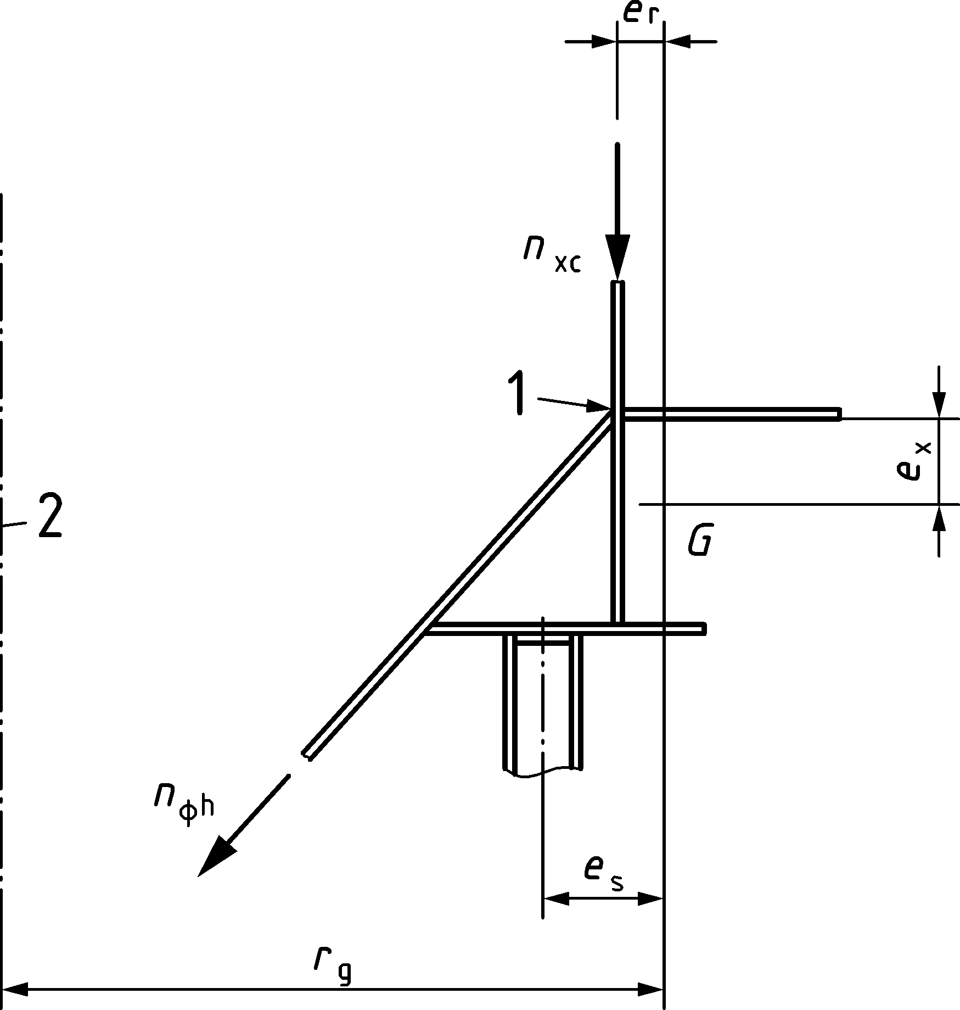

Key

|  |  |
| --- | --- |
| 1 | cylinder/cone transition junction |
| 2 | axis |
| *G* | ringbeam effective section centroid |

Figure 10.7 — Eccentricities of vertical loads at a ring girder

(8) The circumferential compressive membrane stresses  that develop in each flange of the ring girder should be determined from the thrust , radial axis moment  and warping flange moments  using engineering bending and warping theory and adopting the stress resultants defined in (4) to (7).

(9) The largest value of the circumferential membrane stress **,Ed (whether tensile or compressive) that develops in either flange of the ring girder at any position around the circumference should be determined as **m,Ed.

(10) The largest compressive value of the circumferential membrane stress **,Ed that develops in either flange of the ring girder at any position around the circumference should be determined as **c,Ed.

(11) The above design bending moments are significantly reduced by the interaction between the ring girder and the shell above it. The values of bending moments *M*r,Ed and torsional moments *T*,Ed derived from the above treatment may all be reduced by the factor *k*red if the relative stiffness of the shell and ring are evaluated (see Figure 6.1) using the ring to shell stiffness ratio **

(10.29)

where

|  |  |
| --- | --- |
| *w* | is the circumferential width of the support; |
| *C*1, *C*2, *C*3 | are constants that depend on the support width-to-radius ratio (w/r); |
| ** | is the shell to girder stiffness ratio defined in 8.6. |

(12) The values of the coefficients *C*1 to *C*3 over the support may be estimated using;

 (10.30)

 (10.31)

 (10.32)

(13) The values of the coefficients *C*1 to *C*3 at midspan may be estimated using;

 (10.33)

 (10.34)

 (10.35)

(14) The values of the coefficients *C*1 to *C*3 for maximum torsion may be estimated using;

 (10.36)

 (10.37)

 (10.38)

## Structural resistances for isotropic junctions

### General

(1) The transition junction should satisfy the provisions of EN 1993‑1‑6, but these may be met using the following assessments of the design resistance.

### Resistance to plastic limit state

#### General

(1) The design value of the resistance should be determined using the provisions of EN 1993-1-6. The following resistance assessments may be used instead as a simple safe approximation to those provisions.

#### Plastic resistance based on elastic evaluation

(1) The design value of the resistance should be determined at the most highly stressed point in the junction.

(2) The design value of the resistance of the plastic limit state should be determined using:

*f*p,Rd = *f*y /**M0 (10.39)

#### Plastic resistance based on plastic evaluation

(1) The design value of the resistance should be determined in terms of the attainable tensile membrane stress resultant *n*h,Rd in the hopper at the junction.

(2) The design value of the resistance at the plastic limit state *n*h,Rd should be determined using:

 (10.40)

with:

 (10.41)

** = 0,7 + 0,6**2 - 0,3**3 (10.42)

* for the cylinder 
* for the skirt 
* for the conical hopper segment 

where (see Figure 10.6):

|  |  |
| --- | --- |
| *r* | is the radius of the silo cylinder wall; |
| *t*c | is the thickness of the cylinder; |
| *t*s | is the thickness of the skirt; |
| *t*h | is the thickness of the hopper; |
| *A*p | is the cross-sectional area of the ring; |
| ** | is the half angle of the hopper (at the top); |
| oc | is the plastic effective length of the cylinder segment above the transition; |
| oh | is the plastic effective length of the hopper segment; |
| os | is the plastic effective length of the skirt segment below the transition; |
| *n*h,Rd | is the meridional membrane resistance per unit circumference at the top of the hopper; |
| *p*nc | is the mean local pressure on the effective length of the cylinder segment; |
| *p*nh | is the mean pressure on the effective length of the hopper segment; |
| ** | is the hopper wall friction coefficient. |

### Resistance to in-plane buckling

(1) The design value of the resistance should be determined using the provisions of EN 1993-1-6. The following resistance assessment may be used instead as a simple safe approximation to those provisions.

(2) The design value of the resistance should be assessed using the point in the junction where the highest compressive circumferential membrane stress occurs.

(3) The design value of the resistance against in-plane buckling **ip,Rd should be determined using:

 (10.43)

where

|  |  |
| --- | --- |
| *EI* | is the flexural rigidity of the ring effective cross-section (see Figure 10.3) for circumferential bending (about its vertical axis); |
| *A*et | is the effective cross-sectional area of the ring, given by 10.2.2(12) or (14); |
| *r*g | is the radius of the centroid of the ring effective cross-section. |

(4) The above resistance assessment and verification against in-plane bucking using Formula (10.43) may be omitted when the ring is rigidly connected to an isotropic cylindrical shell wall that meets the conditions set out in 10.4.1(6).

NOTE Where the ring is attached to both a cylindrical shell and a conical hopper that is not too steep (see 10.4.2 (5)), the in-plane stiffnesses of these two shell segments prevents an in-plane buckling mode in the ring.

### Resistance to out-of-plane buckling and local shell buckling near the junction

#### General

(1) The design value of the resistance should be determined using the provisions of EN 1993‑1‑6. The following resistance assessments may be used instead as a simple safe approximation to those provisions.

#### Local shell buckling near the junction

(1) For junctions in which there is either no ring at the transition (simple cone to cylinder junction), or the transition is ring stiffened, the design value of the resistance **op,Rd against shell buckling of the wall adjacent to the junction should be determined using:

 (10.44)

with

|  |  |
| --- | --- |
| *r*s = *r* | for the cylindrical wall |
|  | for the conical hopper wall |

where

|  |  |
| --- | --- |
| r | is the radius of the silo cylinder wall; |
| ** | is the hopper apex half angle; |
| *t* | is the thickness of the relevant shell segment; |
| *A*et | is the effective cross-sectional area of the ring, given by 10.2.2(12) or (14); |
| *R*g | is the radius of the centroid of the ring effective cross-section. |

#### Annular plate transition junction

(1) For junctions in which the ring at the transition is in the form of an annular plate, the design value of the resistance against out-of-plane buckling **op,Rd should be determined using:

 (10.45)

with

 (10.46)

 (10.47)

 (10.48)

 (10.49)

 (10.50)

where

|  |  |
| --- | --- |
| *r* | is the radius of the silo cylinder wall; |
| *t*c | is the thickness of the cylinder; |
| *t*s | is the thickness of the skirt; |
| *t*h | is the thickness of the hopper. |
| *t*p | is the thickness of the annular plate ring; |
| *b* | is the width of the annular plate ring; |
| *k*c | is the plate buckling coefficient for a ring with clamped inner edge; |
| *k*s | is the plate buckling coefficient for a ring with simply supported inner edge; |
| **M1 | is the partial factor, see Table 4.4. |

#### T section transition junction

(1) The following assessment should be used where the transition junction ring consists of an annular plate of width *b*p with a symmetrically placed vertical stiffening flange of height *b*f at its outer edge, forming a T-section ring with the base of the T at the joint centre.

(2) The design value of the resistance against out-of-plane buckling **op,Rd of a T-section ring beam should be determined on the basis of the maximum compressive value of the circumferential membrane stress on the inner edge of the principal annular plate of the ring. The design value of the resistance should be determined from:

 (10.51)

with

**s = 0,385 +  (10.52)

 (10.53)

 (10.54)

 (10.55)

 (10.56)

 (10.57)

where

|  |  |
| --- | --- |
| *r* | is the radius of the silo cylinder wall; |
| *t*c | is the thickness of the cylinder; |
| *t*s | is the thickness of the skirt; |
| *t*h | is the thickness of the hopper. |
| *t*p | is the thickness of the annular plate ring; |
| *t*f | is the thickness of the outer vertical flange of the T section; |
| *b*p | is the width of the annular plate ring; |
| *b*f | is the height (flange width) of the outer vertical flange of the T section; |
| *A* | is the cross-sectional area of the T-section ring beam; |
| *x*c | is the distance between the centroid of the T‑section and its inner edge; |
| *I*r | is the second moment of area of the T‑section about its radial axis; |
| *I*z | is the second moment of area of the T‑section about its vertical axis; |
| *J*t | is the uniform torsion constant for the T‑section; |
| **M1 | is the partial factor, see Table 4.4. |

## Limit state verifications for isotropic transition junctions

### Uniformly supported transition junctions

(1) Where the silo has been analysed using a computer analysis, the procedures of EN 1993‑1‑6 should be used. Where the computer analysis does not include a buckling analysis, 10.3 may be used to provide the buckling resistances for the limit state verification in EN 1993‑1‑6.

(2) Where the silo is supported on a skirt extending to a uniform foundation (see 8.2 and 10.2.2) and the calculations of 10.2 have been carried out, the transition junction may be deemed to be subject only to a uniform circumferential membrane stress **u,Ed as determined in 10.2.2(18). The following limit state verifications should then be carried out.

(3) Where the plastic limit state is assessed using an elastic evaluation, the plastic limit state for the junction should be verified using:

**u,Ed ≤ *f*p,Rd (10.58)

where

|  |  |
| --- | --- |
| **u,Ed | is the design value of the stress taken from 10.2.2; |
| *f*p,Rd | is the design value of the plastic resistance taken from 10.3.2.2. |

(4) Where the plastic limit state is assessed using a plastic evaluation, the plastic limit state for the junction should be verified using:

*n*h,Ed ≤ *n*h,Rd (10.59)

where

|  |  |
| --- | --- |
| *n*h,Ed | is the design value of the meridional membrane stress resultant at the top of the hopper; |
| *n*h,Rd | is the design value of the plastic resistance taken from 10.3.2.3. |

(5) The in-plane buckling limit state for the junction should be verified using:

**u,Ed ≤ **ip,Rd (10.60)

where

|  |  |
| --- | --- |
| **u,Ed | is the design value of the stress taken from 10.2.2; |
| **ip,Rd | is the design value of the in-plane buckling resistance taken from 10.3.3. |

(6) The limit state verification against in-plane buckling may be omitted if both of the following conditions are met:

* the cone half angle ** is greater than **lim and there is an isotropic cylindrical shell above the ring;
* if the height of the cylindrical isotropic shell *L* is less than *L*min, it is necessary that the upper boundary of the isotropic cylindrical shell is either connected to a roof or restrained against out-of-round displacements by a ring with a flexural rigidity *EI* for circumferential bending (about its vertical axis) greater than *EI*,min, where *L*min and *EI*,min are defined by:

 (10.61)

 (10.62)

where

|  |  |
| --- | --- |
| *t* | is the thickness of the thinnest strake in the isotropic cylindrical shell; |
| **lim | is the critical hopper angle to give hopper restraint, **lim = 10°; |
| *k*L | is the height adjustment coefficient, *k*L = 30; |
| *k*R | is the ring stiffness coefficient, *k*R = 0,04. |

In-plane buckling is prevented by the incompatibility of buckling displacements between a conical and cylindrical shell segment that are rigidly connected and are significantly inclined to each other. The in-plane buckling check may then be omitted provided that the cylindrical shell is isotropic and sufficiently tall. Where it is not very tall, the top of the cylindrical shell is required to be held circular to provide the same restriction on the freedom to develop in-plane buckling displacements.

NOTE  The limitation to isotropic cylindrical shells is made to ensure that corrugated shells with vertical stiffeners are not permitted the freedom to ignore in-plane buckling (see Annex B). The requirements for corrugated shells to omit an in-plane buckling check have not been investigated.

(7) The out-of-plane buckling limit state for the junction should be verified using:

**u,Ed ≤ **op,Rd (10.63)

where

|  |  |
| --- | --- |
| **u,Ed | is the design value of the stress taken from 10.2.2; |
| **op,Rd | is the appropriate design value of the out-of-plane buckling resistance taken from 10.3.4. |

### Transition junction ring girder

(1) Where the silo has been analysed using a computer analysis, the procedures of EN 1993‑1‑6 should be used. Where the computer analysis does not include a buckling analysis, 10.3 may be used to provide the buckling resistances for the limit state verification in EN 1993‑1‑6.

(2) Where the silo is discretely supported, so that the transition junction acts as a ring girder with circumferential membrane stresses which vary across the section and around the circumference, this variation should be taken into account in the limit state verifications. Where the calculations of 10.2 have been carried out, the following limit state verifications should be undertaken.

(3) The plastic limit state for the junction should use the evaluated stress **m,Ed from 10.2.3(9) and should be verified using:

**m,Ed ≤ *f*p,Rd (10.64)

where

|  |  |
| --- | --- |
| **m,Ed | is the design value of the stress taken from 10.2.3 (9); |
| *f*p,Rd | is the design value of the plastic resistance taken from 10.3.2.2. |

(4) The in-plane buckling limit state for the junction should use the evaluated stress **c,Ed from 10.2.3 (4) and should be verified using:

**c,Ed ≤ **ip,Rd (10.65)

where

|  |  |
| --- | --- |
| **c,Ed | is the design value of the stress taken from 10.2.3(4); |
| **ip,Rd | is the design value of the in-plane buckling resistance taken from 10.3.3. |

(5) The limit state verification against in-plane buckling may be omitted if both of the following conditions are met:

a) the cone half-angle ** is greater than **lim and there is a cylinder above the ring;

b) where the cylinder has a height *L* less than , the upper boundary of the cylinder is restrained against out-of-round displacements by a ring with a flexural rigidity *EI*z about its vertical axis (circumferential bending) greater than:

 (10.66)

where

|  |  |
| --- | --- |
| *t* | is the thickness of the thinnest strake in the cylinder; |
| *L* | is the height of the shell wall above the ring; |
| **lim | is the critical hopper angle to give hopper restraint, **lim = 10°; |
| *k*L | is the height adjustment coefficient, *k*L = 30; |
| *k*R | is the ring stiffness coefficient, *k*R = 0,04. |

NOTE The requirement in (5)b is only relevant for short cylinders above the ring, since taller cylinders provide sufficient restraint against this mode of buckling without being themselves restrained to remain circular.

(6) The out-of-plane buckling limit state for the junction should use the evaluated stress **c,Ed from 10.2.3 and should be verified using:

**c,Ed ≤ **op,Rd (10.67)

where

|  |  |
| --- | --- |
| **c,Ed | is the design value of the stress taken from 10.2.3; |
| **op,Rd | is the design value of the out-of-plane buckling resistance taken from 10.3.4. |

## Considerations concerning support arrangements for the junction

### Skirt supported junctions

(1) Where the silo is supported on a skirt extending to a uniform foundation (see 10.4.1(2)), the transition junction may be deemed to carry only circumferential membrane stresses.

(2) The skirt should be checked for resistance to buckling under axial compression, including the effects of openings in the skirt.

### Column supported junctions and ring girders

(1) Where the silo is supported on discrete supports or columns, and a transition ring girder is used to distribute column forces into the shell, the junction and ring girder should satisfy the conditions given in 10.2.3 and 10.4.2.

(2) Where a transition ring girder is formed by bolting together an upper and lower half, each attached to a different shell segment, the bolts should be proportioned to resist transmission of the full design value of the circumferential force to be carried in the upper ring segment, taking proper account of bending actions in the ring.

### Base ring

(1) A silo that is continuously supported on the ground should be provided with a base ring and anchorage details.

(2) The circumferential spacing of anchorage bolts or other attachment points should not exceed , where *t* is the local thickness of the shell plate adjacent to the base and *L* is the lesser of the height of the first ring stiffener above the base, or the total height of the silo wall to the eaves.

(3) The base ring should have a flexural rigidity *EI* about a vertical axis (to resist circumferential bending) greater than the minimum value *EI*,min given by:

** (10.68)

where *t* should be taken as the thickness of the wall strake adjacent to the base ring.

# Ultimate limit state design of circular conical roof structures

## Basis

(1) The design of roof structures should take into consideration permanent, transient, imposed, wind, snow, accidental and partial vacuum loads.

(2) The design should also take account of the possibility of upward forces on the roof due to accidental overfilling or unexpected fluidisation of stored solids.

NOTE More detailed information on the design of circular roof structures can be found in EN 1993‑4‑2.

## Distinctions between roof structural forms

### Descriptors for roofs

(1) A conical shell roof formed from rolled plates and without supporting beams or rings should be termed a ‘shell roof’ or an ‘unsupported roof’.

(2) A conical roof in which sheeting is supported on beams or a grillage should be termed a ‘framed roof’ or a ‘supported roof’.

(3) A conical roof formed using profiled corrugated sheeting (trapezoidal, sinusoidal, etc.) should be termed a ‘profiled sheeting roof’.

## Resistance of circular conical isotropic silo roofs

### Shell or unsupported roofs

(1) Shell roofs should be designed according to the requirements of EN 1993‑1‑6, but the following provisions may be deemed to satisfy them for conical roofs with a diameter not greater than 5 m and a roof inclination to the horizontal ** not greater than 40°.

(2) The calculated surface von Mises equivalent stresses due to combined bending and membrane action should everywhere be limited to the value:

*f*e,Rd = *f*y /**M0 (11.1)

where **M0 is obtained from Table 4.4.

(3) The critical buckling resistance against external pressure *p*n,Rcr for an isotropic conical roof should be calculated as:

 (11.2)

where

|  |  |
| --- | --- |
| *r* | is the outer radius of the roof; |
| *t* | is the smallest shell plate thickness; |
| ** | is the slope of the cone to the horizontal. |

(4) The design buckling resistance against external pressure should be determined as:

*p*n,Rd = **p *p*n,Rcr /**M1 (11.3)

in which **M1 is obtained from Table 4.4 and the value of **p should be taken as **p = 0,20.

(5) The design peak external pressure on the roof arising from the actions defined in 11.1 should satisfy the condition:

*p*n,Ed ≤ *p*n,Rd (11.4)

### Framed or supported roofs

(1) Framed or supported roofs, where the roof sheeting is supported on rafters, beams or a grillage should be designed according to the provisions of EN 1993‑4‑2 on tanks.

### Profiled sheeting roofs

(1) Profiled sheeting roofs should be designed according to the EN 1993‑1‑3.

(2) Where appropriate, a computational treatment according to EN 1993‑1‑6 should be used, using orthotropic properties according to 6.5.

### Eaves junction (roof to shell junction)

(1) The roof to shell junction, and the ring stiffener at this junction should be designed according to the provisions of EN 1993‑4‑2 on tanks.

# Ultimate limit state design of rectangular and planar-sided silos

## Basis

(1) A rectangular silo should be designed either as a stiffened box in which the structural action is predominantly bending, or as a thin membrane structure in which the action is predominantly membrane stresses developing after large deformations.

(2) The provisions of EN 1993‑1‑7 for box-like structures should be adopted where relevant.

(3) Where the box is designed for bending action, the joints should be designed to ensure that the connectivity assumed in the stress analysis is achieved in the execution.

(4) A complete treatment of the full structure should be undertaken where the panel configuration of a rectangular silo with internal ties differs from the following:

1. square configurations up to 5x5;
2. rectangular configurations of 1x2; 2x3; 2x4; 3x4; 4x5; 4x6; 5x6.

NOTE Some innovations in form and size of rectangular silos have been unsuccessful.

(5) A comprehensive analysis is necessary in the following cases:

1. where the tie layers of two adjacent cells are at different heights;
2. where the tie disposition is staggered over the height (alternative orientation);
3. any other configuration that does not have clearly distinguishable tie layers.

## Classification of planar sided structural forms

### Unstiffened silos

(1) A structure formed from flat steel plates without attached stiffeners should be termed an 'unstiffened box'.

(2) A structure stiffened only along joints between plates which are not coplanar should also be termed an 'unstiffened box'.

### Stiffened silo

(1) A structure formed from flat plates to which stiffeners are attached within the plate area should be termed a 'stiffened box'. The stiffeners can be horizontal or vertical or orthogonal (two directional).

### Silos with ties

(1) Silos with ties can be square or rectangular.

NOTE Some typical structural components for rectangular silos are shown in Figure 12.1 and Figure 12.2.

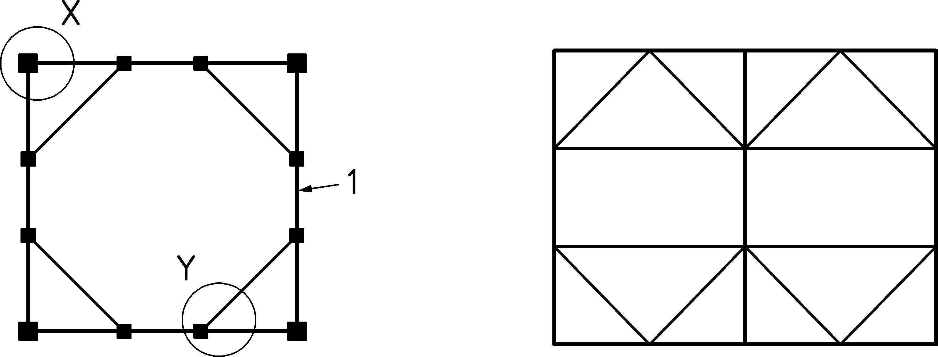

Key

|  |  |
| --- | --- |
| X | detail 1 |
| Y | detail 2 |
| 1 | vertical section |

Figure 12.1 — Plan view of tied rectangular box and multiple cells

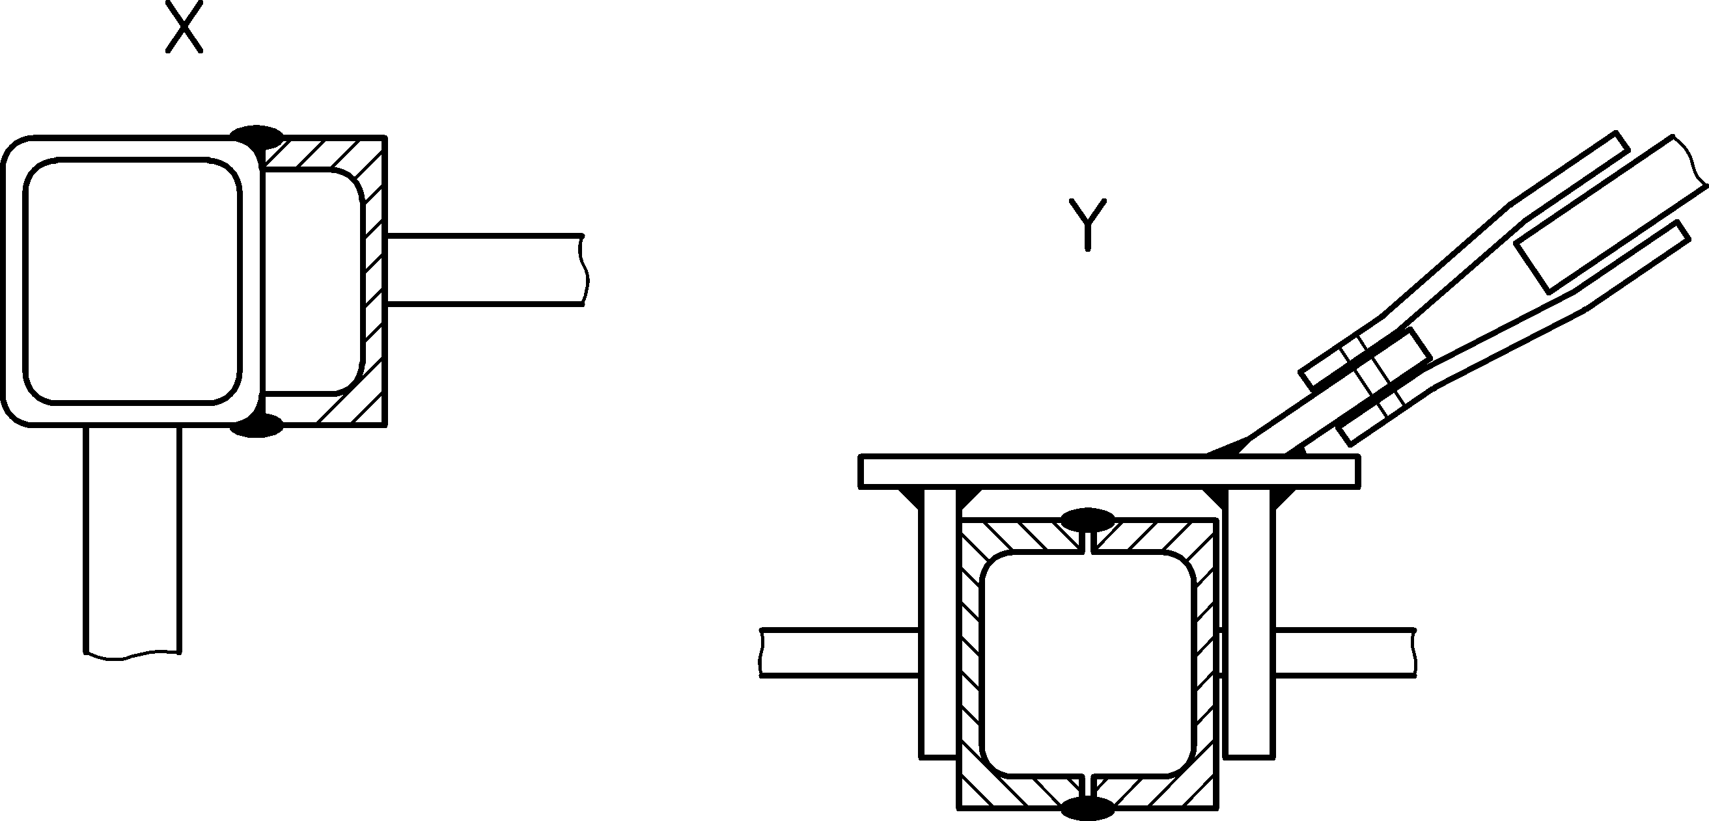

Key

|  |  |
| --- | --- |
| X | detail 1 |
| Y | detail 2 |

Figure 12.2 — Typical details of tie connections

## Resistance of unstiffened vertical walls

(1) The resistance of vertical walls should be evaluated in accordance with EN 1993‑1‑7. Alternatively, the provisions set out in 12.4 may be deemed to satisfy the provisions of that Standard.

(2) The resistance of vertical walls should be evaluated considering both the membrane and plate bending actions.

(3) The actions on the unstiffened plate can be divided into the following categories:

1. bending as a 2D plate from the stored material;
2. stresses resulting from diaphragm action;
3. local bending action from the stored material and/or equipment.

## Resistance of silo walls composed of stiffened or corrugated plates

### General

(1) The resistance of unstiffened parts of vertical walls should be evaluated in accordance with the provisions set out in 12.3. The resistance evaluation should consider both membrane and plate bending actions.

(2) Horizontally corrugated plates should be designed for (see Figure 12.3):

1. general bending action from pressures due to the stored material;
2. stresses resulting from their diaphragm action;
3. local bending action from the stored material and/or equipment.

(3) Effective bending properties and bending resistance of stiffened plates and stiffened or unstiffened horizontally corrugated plates should be derived in accordance with the provisions in EN 1993‑1‑3 and EN 1993‑1‑5.

(4) The design of the stiffeners should be made using the provisions for structural member design in EN 1993‑1‑1 and EN 1993‑1‑3, taking into account the compatibility of the stiffeners with the wall elements, the effect of the eccentricity of the sheeting in relation to the stiffener-axes, the flexural continuities of wall elements and the intersection of horizontal and vertical stiffeners. Stresses normal to the longitudinal axis arising in stiffeners, which intersect structurally continuous wall-elements, should also be taken into account in the member design.

(5) The load transfer of vertical stiffeners to base boundary elements should be designed in accordance with the specific element and the given foundation resistance.

(6) Shear stiffness and resistance of the structural elements should be derived from testing or using appropriate theoretical formulae.

(7) Unless a more precise method is available, the shear buckling resistance may be found using 7.5.4, 7.8.5 or 7.9.6, as appropriate, and treating the radius of the shell as indefinitely large.

(8) Where testing is used, the relevant shear stiffness may be taken as the secant value achieved at 2/3 of the ultimate shear strength, see Figure 12.4.

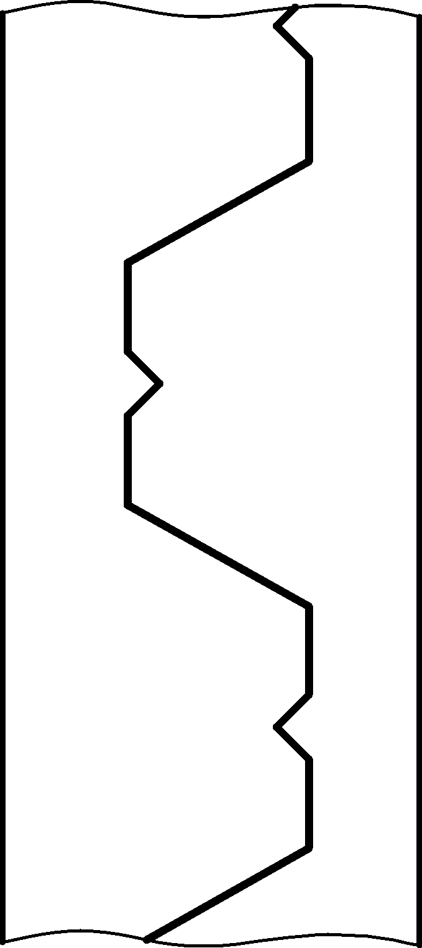

Figure 12.3 — Typical vertical section through a corrugated rectangular silo wall

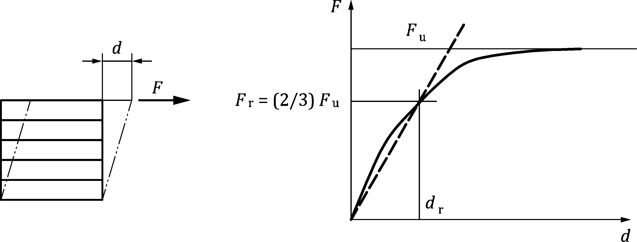

NOTE The effective shear stiffness is taken as the ratio *F*r/*d*r in the test result shown in Figure 12.4.

Figure 12.4 — Shear response of corrugated wall

### General bending from direct action of the stored material

(1) Bending stresses developing in a corrugated or trapezoidal sheet wall should be considered, taking account of the horizontal bending about a vertical axis caused by horizontal pressure acting on the wall, and local vertical bending about a horizontal axis where an axial force is transmitted through the corrugated or trapezoidal sheeting.

(2) The horizontal bending should consider the axis of bending as vertical, ignoring any effect of frictional drag on the wall from the stored solid (Figure 12.5).

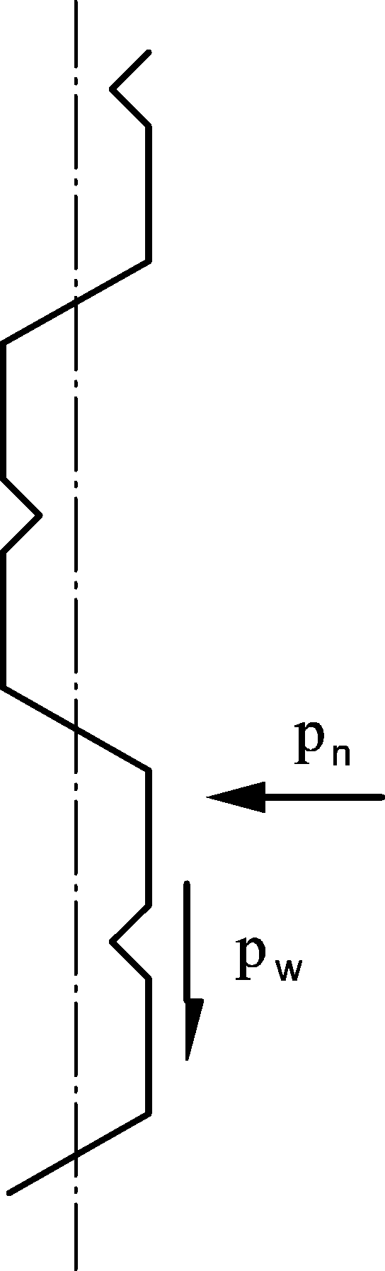

Figure 12.5 — Bending neutral axis under combined horizontal pressure and friction (vertical section)

### Membrane stresses from diaphragm action

(1) The stresses result from pressure of stored material and/or wind on the perpendicular neighbouring walls, see Figure 12.6.

|  |  |
| --- | --- |
|  |  |
| **a) Wind action** | **b) stored material pressures** |

Key

|  |  |
| --- | --- |
| 1 | diaphragm action in these walls |

Figure 12.6 — Membrane forces induced in walls by solids pressures or wind loading

(2) As a simple rule, pressures from the stored material may be taken as only normal pressures (neglecting wall friction).

(3) Direct and shear stresses from wind action may be determined using either hand calculations or a finite element calculation.

NOTE Further advice on the analysis of membrane and bending actions under solids pressures can be found in Annexes A, B and C of prEN 1993‑1‑7:2023.

### Local bending action from the stored material and/or equipment

(1) The possibility of deleterious local bending effects in any structural element due to the local stored material pressure should be taken into account.

NOTE In the situation shown in Figure 12.7, the structural check on the plate element CD can be critical.

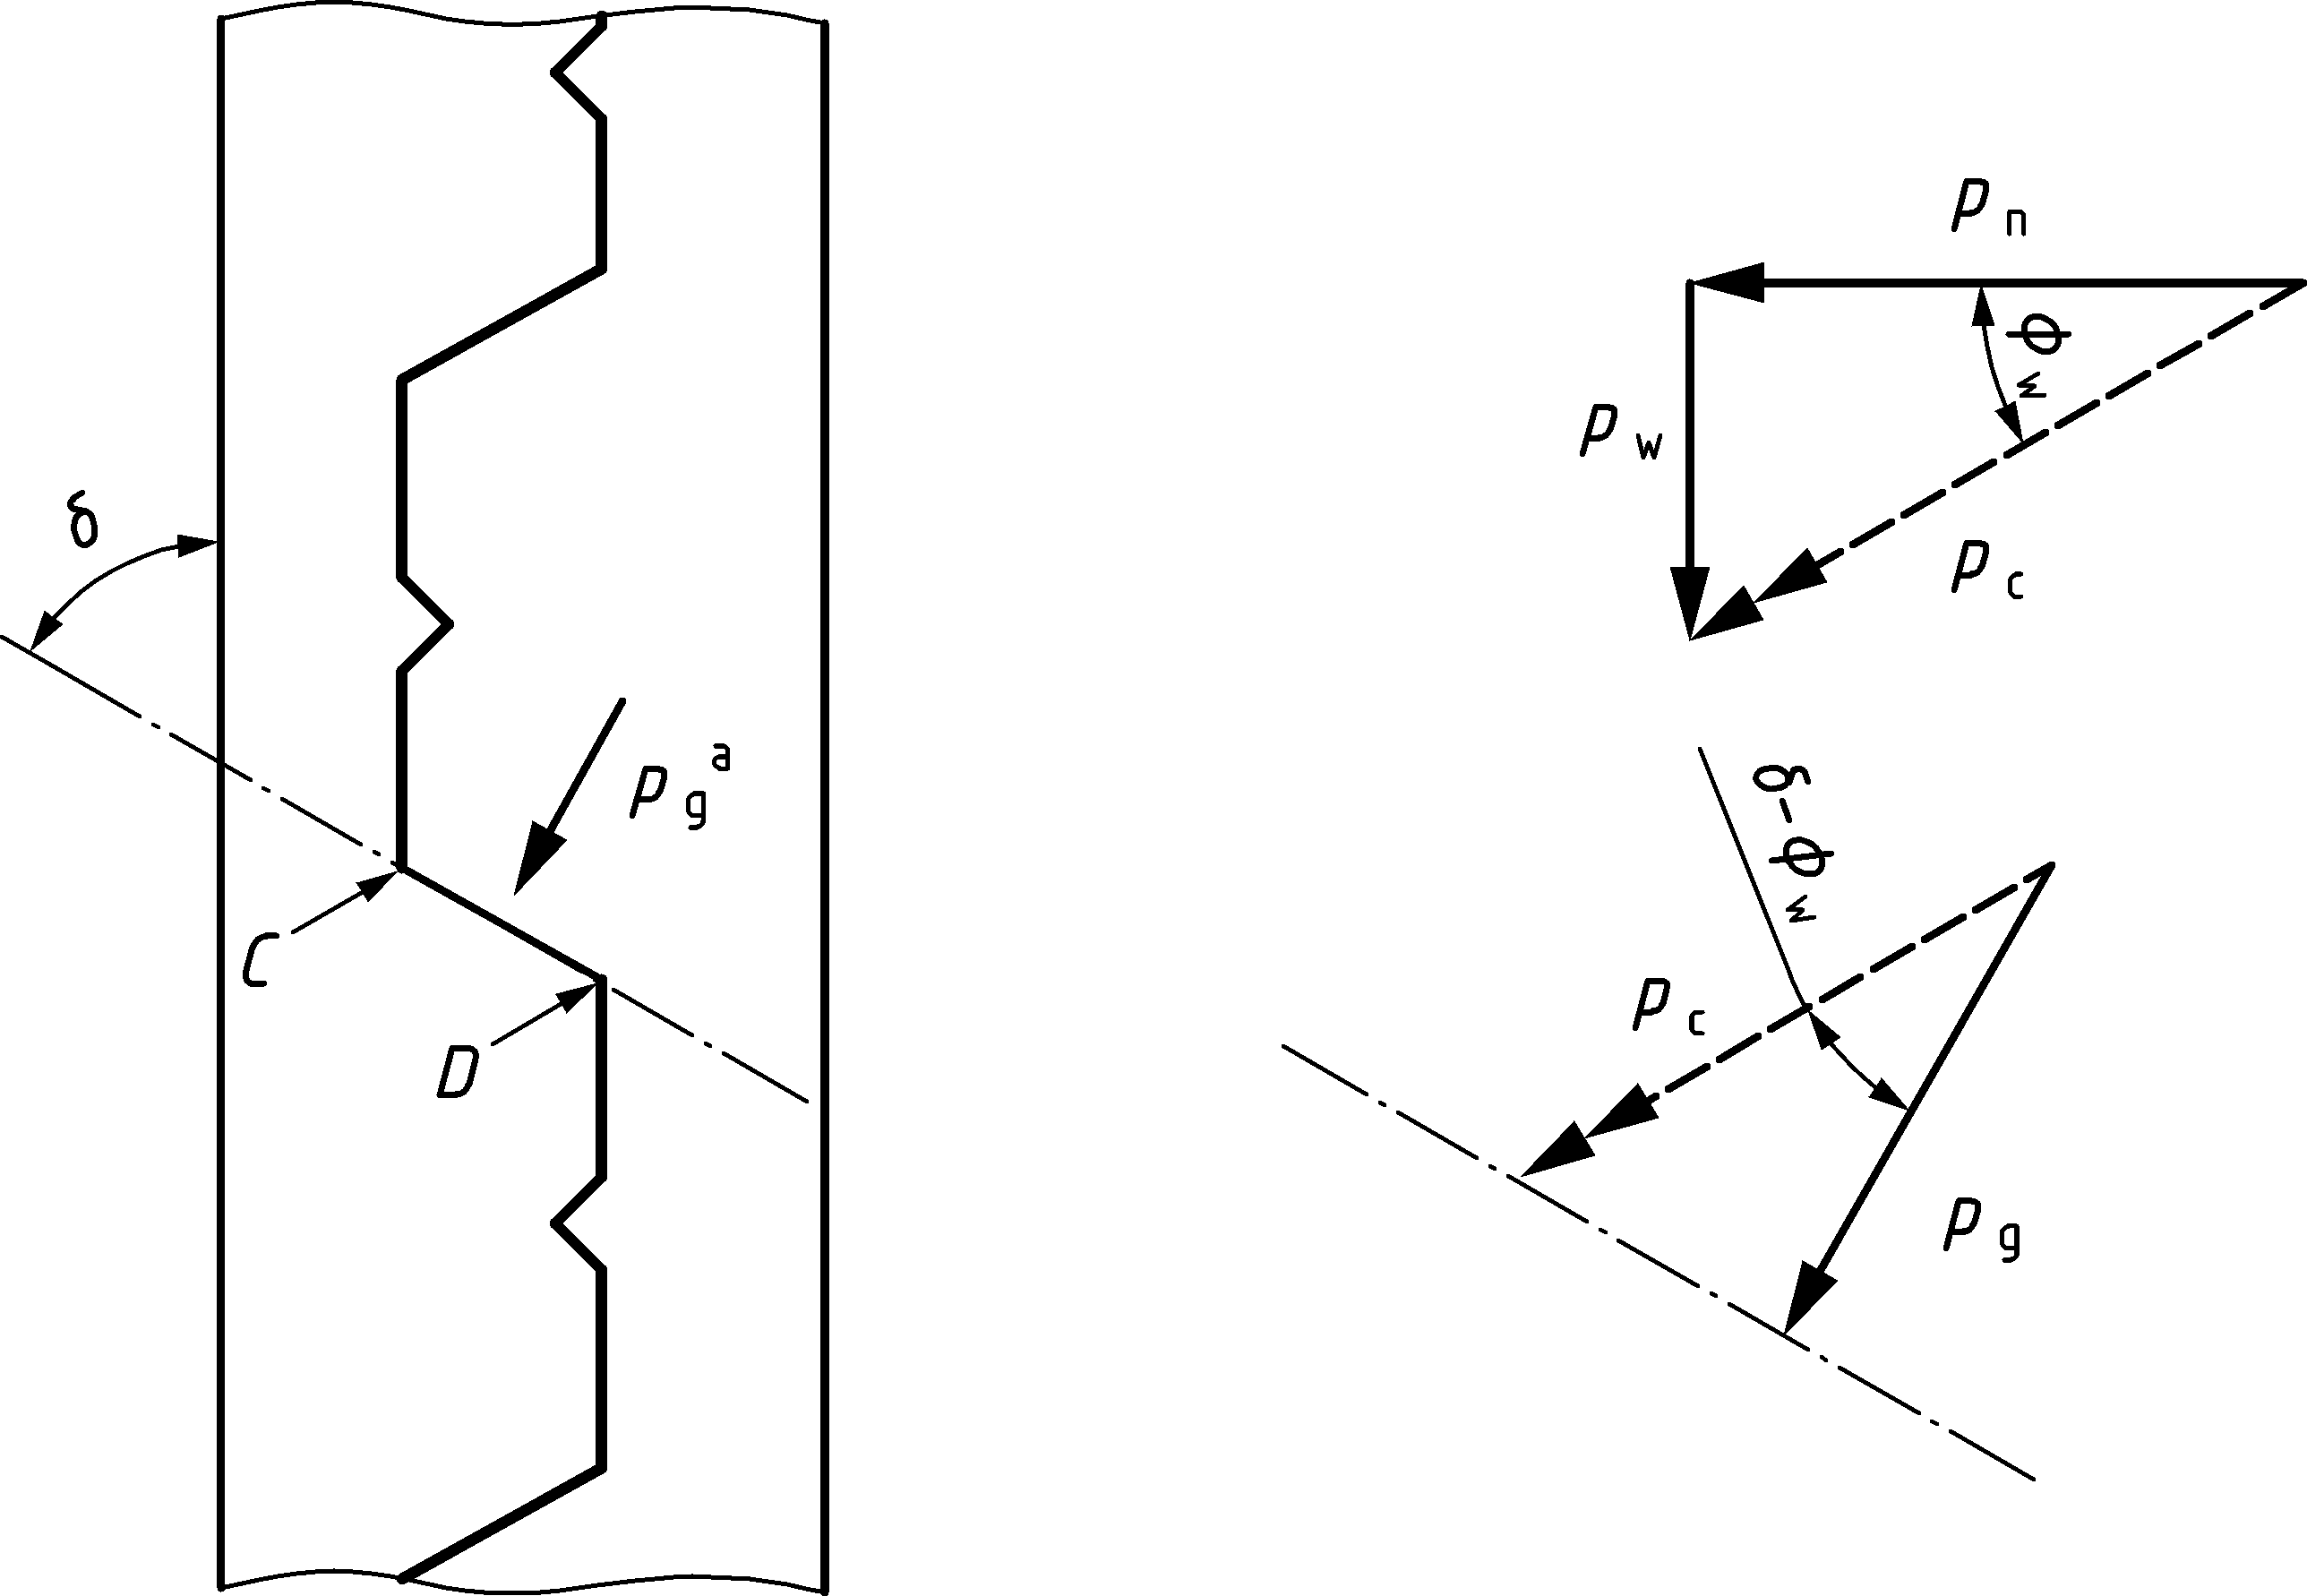

NOTE The normal pressure *p*n and the vertical stress in the solid *p*v are combined to obtain the resultant pressure *p*g normal to the plane CD on the inclined part of the wall.

Figure 12.7 — Possible causes of local bending in corrugated plates

## Silos with internal ties

### Forces in internal ties due to solids pressure on them

(1) The force exerted on the tie by the vertical stress in the stored bulk solid should be evaluated.

(2) The following provisions are restricted to ties with either a circular (smooth or rough) or square cross-section.

NOTE Rectangular section ties can cause violent vibrations and uncontrolled twisting.

(3) Unless more precise calculations are made, the transverse force *Vt* per unit length exerted on the tie by the solid of tie may be approximated by:

 (12.1)

with

 (12.2)

where

|  |  |
| --- | --- |
| *p*v | is the vertical stress within the stored material at the tie level taken from EN 1991-4, taking account of the filling or discharge condition involved; |
| *b* | is the maximum horizontal width of the tie; |
| *b*o | is the reference length of 1 m, expressed in the units that are used for *b*; |
| *C*t | is the load magnification factor; |
| *C*s | is the shape factor for the tie cross-section; |
| *k*L | is the loading state factor; |
| *β* | is the tie location factor, that depends on the position of the tie within the silo cell (see Figure 12.8 and Figure 12.9). |

NOTE The empirical Formula (12.2) would not be dimensionally consistent without the dimension *b*o. For example, if *b* is expressed in inches, *b*o = 39,37 inches.

(4) The shape factor *C*s should be taken as follows:

|  |  |  |
| --- | --- | --- |
| — | for circular smooth sections: | *C*s = *C*sc = 1,0 |
| — | for round rough or square sections: | *C*s = *C*ss= 1,2 |

(5) The loading state factor *k*L should be taken as follows:

|  |  |  |
| --- | --- | --- |
| — | for bulk solids filling: | *k*L = *k*Lf = 4,0 |
| — | for bulk solids discharge: | *k*L = *k*Le = 2,0 |

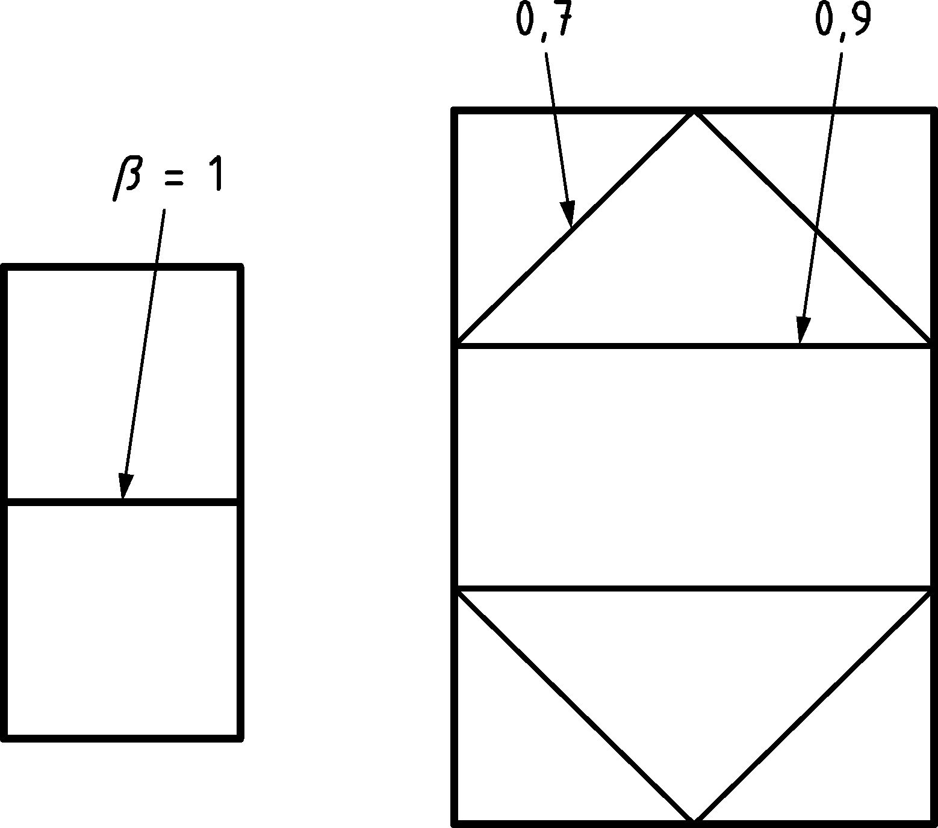

Figure 12.8 — Evaluation of factor ** for internal ties

|  |  |  |  |
| --- | --- | --- | --- |
|  |  |  |  |
| **a) two panels** | **b) three panels** | **c) four panels** | **d) five panels** |

Figure 12.9 — Corner ties for which ** = 0,7

### Modelling and principles of calculation of ties

(1) It is assumed that:

1. the ties are connected to the walls by means of joints that are effectively pinned;
2. the ties are not supported at intermediate points.

NOTE In cases where the above assumptions cannot be guaranteed, special care can be needed when assessing the bending moments in both the tie and its connection to the wall.

(2) Where the geometrical arrangement of the ties is identical in each layer, the calculation may be performed assuming that the height the silo is partitioned into isolated horizontal planar segments. Each segment is chosen to contain only ties in one layer, and extends above and below the ties by half the distance to the adjacent tie (Figure 12.10).

(3) Where the requirements of (2) do not apply, a complete spatial treatment of the structure should be adopted.

(4) Ties should be classified according to the principle means by which they support the loads:

1. where the tie is a cable, its flexural stiffness should be neglected in the calculation of the tension force and stress in the tie;
2. where the tie is a square or circular rod, its flexural stiffness may be neglected in the determination of the tension force *Nt* (Figure 12.11), but should be taken into account in the calculation of the stress due to the bending moment *Mt* as defined in (11).

|  |  |
| --- | --- |
|  |  |
| **a) Vertical section** | **b) Plan view at the selected level** |

Key

|  |  |  |  |
| --- | --- | --- | --- |
| 1 | equivalent surface | 5 | ties |
| 2 | vertical stiffeners | 6 | pinned joints |
| 3 | segment used to illustrate horizontal section | 7 | vertical stiffeners |
| 4 | ties layer | 8 | wall panels |

Figure 12.10 — Sections through a silo with internal ties

(5) The following geometrically non-linear calculation procedure (potentially iterative) should be used to determine the tension force *Nt* in the tie, based on equilibrium and assuming that the cable is anchored by horizontal elastic supports as shown in Figure 12.11,

where

|  |  |
| --- | --- |
| *N*t | is the tension force in the tie; |
| *f* | is the sag of the tie; |
| *l* | is the distance between the end nodes of the tie; |
| *V*t | is the vertical force per unit length (Formula (12.1)) exerted by the stored material acting on the tie; |
| *F*v | is the vertical reaction force transmitted from the tie onto the cell vertical stiffener. |

NOTE This calculation can be performed without iteration, see Bibliography reference (5).

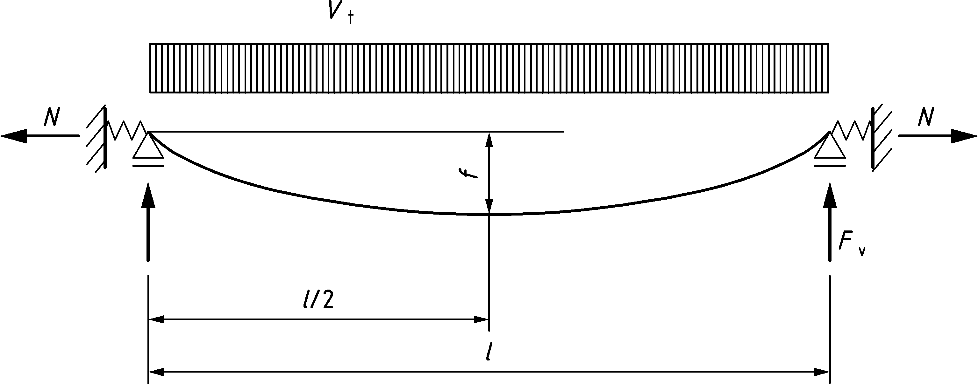

Figure 12.11 — Forces and deformation in a flexible tie fixed on horizontal elastic supports

(6) The forces *Nt* in the ties should satisfy the conditions of linear equilibrium and compatibility in the system represented by the walls and the geometrically nonlinear system represented by the ties (Figure 12.12).

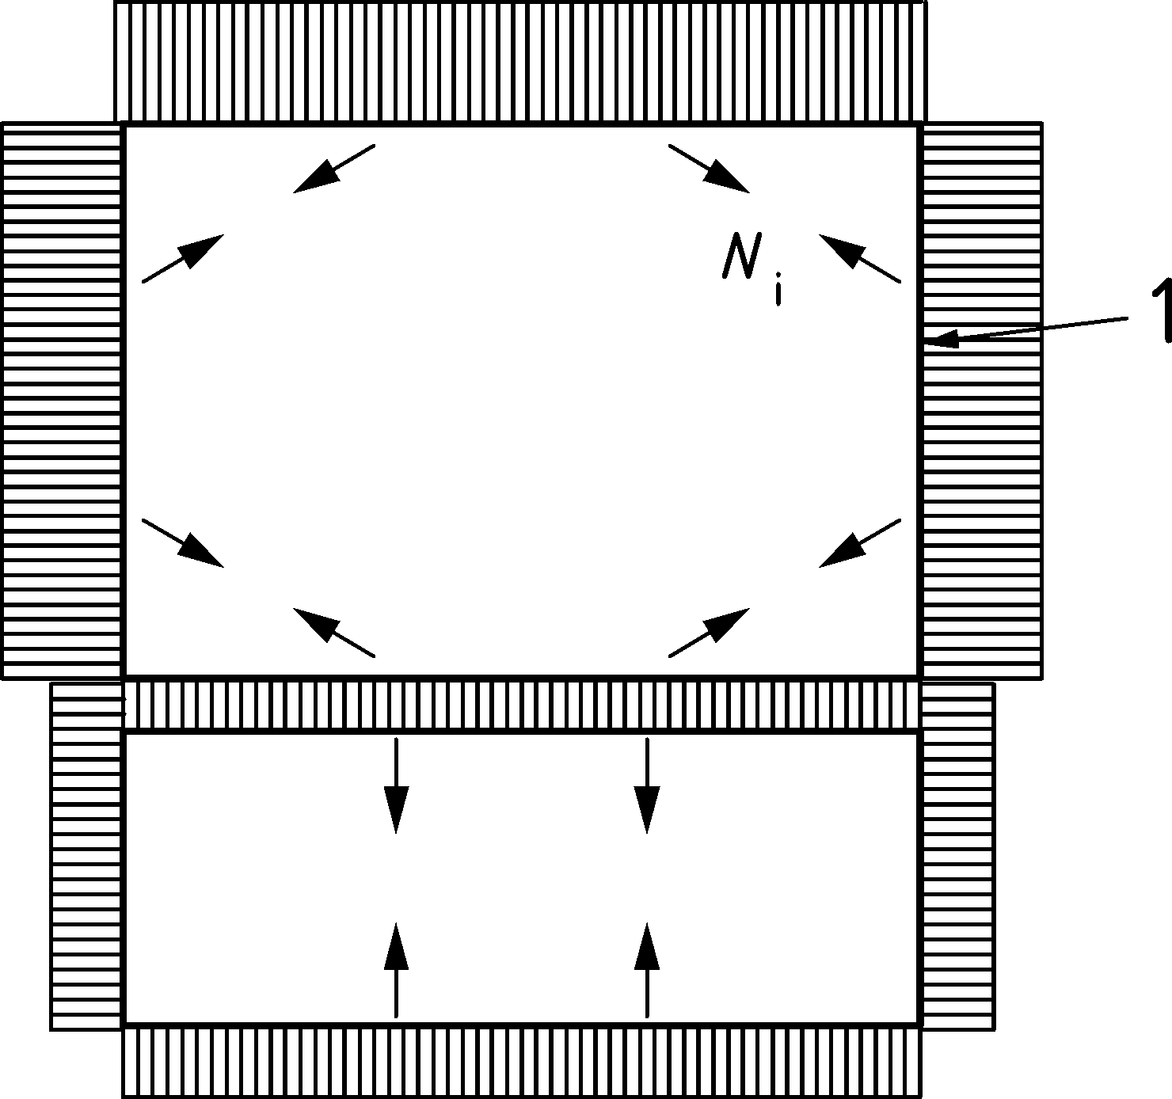

Key

|  |  |
| --- | --- |
| 1 | wall |

Figure 12.12 — Tie tension forces acting on the structural walls

(7) The analysis should be performed in the design situation of ultimate limit state (ULS) and should take account of the stiffness of the silo walls, the vertical stress *p*v (see 12.5.1 and EN 1991-4) of the stored material acting on the ties, the horizontal pressure of the stored material on the walls *p*h and the tension forces *Nt* in the ties at this layer.

(8) Alternatively, a non-linear calculation of the complete layer may be adopted, representing the wall segments as beam elements under the horizontal internal pressure *p*h from the stored material, and the ties as cable elements under the vertical stress *p*v.

(9) The adopted initial sag of each tie should be agreed between the client, the designer and the fabricator. The initial sag *f*0 of the tie should satisfy

 (12.3)

where

|  |  |
| --- | --- |
| *l*0 | is the initial distance between the end nodes of the tie (before deformation under bulk solids pressures); |
| *k*s | is the sag ratio. |

NOTE The value of the sag ratio is *k*s = 0,01, unless the National Annex gives a different value.

(10) The initial length of the tie when sagging, and before deformation, should be taken as:

$L_{0}=l_{0}+\frac{8f_{0}}{3l_{0}}$ (12.4)

(11) Where the tie is a rod and the final sag of the tie (after deformation) *f*f does not exceed 0,1 *l*0, where *f*f is the sag under design loading, the bending moment *M*t in the tie, after deformation, should be taken as:

 (12.5)

in which

 (12.6)

and

 (12.7)

where

|  |  |
| --- | --- |
| *E* | is the elastic modulus; |
| *I*t | is the second moment of area of the cross section of the tie; |
| *l*f | is the final distance between the end nodes of the tie (after deformation). |
| Lf | is the final length of the tie (after deformation); |
| *N*t | is the tension force in the tie, obtained from the calculation according to (5) to (10); |
| *A*t | is the cross sectional area of the tie. |

NOTE These provisions are based on the simplified hypothesis of a parabolic form of deformation of the tie, which is generally valid if .

(12) If the final sag of the tie (after deformation) *f*f exceeds 0,1*l*0, an appropriate method of determining *M*t should be used.

(13) The analysis should ensure that contact between ties or between ties and other elements is prevented by considering the compatibility of their deformations.

(14) Each vertical force from the ties *F*v at the supports (Figure 12.11) should be added to the axial force in the cell vertical stiffener arising from loads applied at a higher level. The single force *F*v at one end of each tie is given by:

 (12.8)

NOTE By summing all the resulting vertical forces *F*v, the total vertical force in the vertical stiffener is found as a simple safe overall outcome. This assessment ignores the global equilibrium of the stress due to the stored material.

### Load cases for silos with internal ties

(1) The analysis should take account of:

1. vertical actions on the ties *V*t and horizontal actions on the silo walls *p*h from the stored material;
2. forces transmitted to the ties due to deformations of the walls from other load cases.

(2) Two load cases should be checked as defined in (3) for each of the loading situations defined in EN 1991‑4:

1. filling loads;
2. discharge loads.

(3) For the analysis of displacements, forces and moments in the ties, attachments, walls and stiffeners of the silo, two separate load cases should be taken into account:

1. Load Case A: the values of *V*t and *N*t evaluated in 12.5.1 and 12.5.2 and *p*h evaluated according to EN 1991‑4, using consistent solids pressures and stresses from the chosen load case of either filling or discharge;
2. Load Case B: an increased value of transverse load 1,2*V*t with *V*t evaluated according to 12.5.1 and 12.5.2, and a reduced value of the horizontal pressure 0,7*p*h, where *V*t and *N*t have been evaluated according to 12.5.1 and 12.5.2 and using the same consistent values of solids pressures and stresses according to EN 1991‑4 from the chosen load case of either filling or discharge.

NOTE The above indicates that these analyses of the structure are required for a total of four different load cases for silos in SG1, but additional load cases are required for silos in SG2 and SG3 to account for the conditions of maximum normal pressure *p*h and maximum vertical stress *p*v, as defined in prEN 1991‑4:2024, Table 6.2.

### Vertical stiffeners on silos with internal ties

(1) Where vertical stiffeners are constructed using a composite section (e.g. two U-sections assembled to form a rectangular tube) the section should be welded for full resistance throughout the height unless an analysis has been used that takes account of the effect of horizontal bending of the wall adjacent to the vertical stiffener.

(2) The possibility of flexural buckling of a vertical stiffener may be assumed to be prevented where the stiffener is attached to a location where two orthogonal walls meet.

(3) When determining the buckling resistance *N*cr of the vertical stiffener in the direction normal to the wall, the following assumptions may be made:

1. bracing of the upper edge of the wall may be taken to be a fully effective restraint;
2. the flexural rigidity of the wall (out of plane) may be taken as a resisting spring stiffness;
3. where an interior wall between two cells has ties on both sides, the stiffness of the ties may be taken into account in assessing the resisting spring stiffness, provided that the tie is considered as a cable with non-linear behaviour.

NOTE Where an exterior wall has ties that lie within the height of a vertical stiffener the ties can provide some elastic restraining stiffness against buckling normal to the wall and outwards. For the buckling resistance inwards, the stored solid can give some support, but it is difficult to quantify. Information given in EN 1991‑4 on the elastic stiffness of solids can be useful.

## Strength of pyramidal hoppers

(1) Pyramidal hoppers (Figure 12.13) should be treated as box structures, using the provisions of EN 1993‑1‑7.

(2) The bending moments and membrane forces may be determined using numerical methods in accordance with EN 1993‑1‑7. The bending moments and membrane stresses in the trapezoidal plates of the hopper should be found using the formulae in prEN 1993‑1‑7:2023, Annex B. The pressure on each trapezoidal plate should be taken as the mean design value for that level in the hopper according to EN 1991‑4.

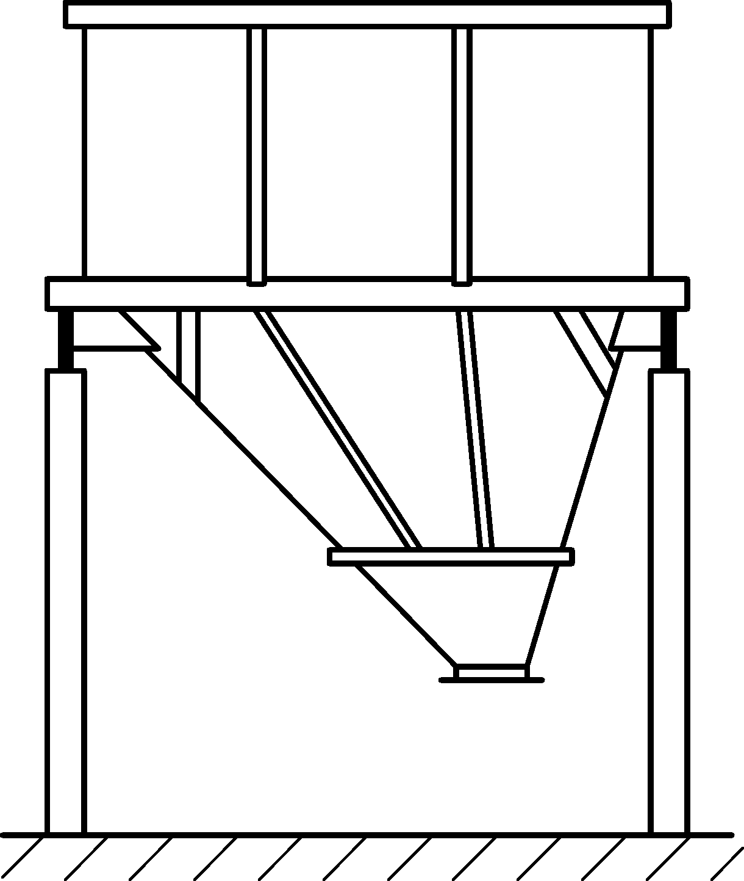

Figure 12.13 — Unsymmetrical hopper with inclined ribs

## Vertical stiffeners on box walls

(1) Vertical stiffeners on the walls of a box should be designed for:

1. the permanent actions;
2. the normal pressures on the wall due to bulk solids;
3. the friction forces on the wall;
4. the variable actions from the roof;
5. the axial forces arising from contributions from the diaphragm action in the walls.

(2) The eccentricity of the friction forces from the plate and stiffener centrelines may be neglected.

## Support requirements for plate assemblies

(1) In determining the support requirements for elevated plate assembly silos, the recommendations given in EN 1993‑1‑7 should be considered.

(2) The requirements for the lateral stiffness of upper edge stiffener beams should be considered to ensure that buckling out of the plane of the wall is prevented.

(3) Support boundary conditions should be checked to ensure that they do not cause excessive non‑uniformity of transmitted forces and do not introduce forces that are eccentric to a plate middle surface.

# Serviceability requirements

## General

(1) The serviceability limit states requirements for all silos should be taken as:

1. deformations or deflections that can adversely affect the effective use of the structure;
2. deformations, deflections, vibration or oscillation that can cause damage to both structural and non-structural elements.

(2) Deformations, deflections and vibrations should be limited to meet the above criteria.

(3) The following criteria for deflections are defined as characteristic load combinations according to EN 1990:2023, 6.5.3.

(4) Specific limiting values, appropriate to the intended use, should be specified by the relevant authority or, where not specified, agreed for a specific project by the relevant parties, taking account of the intended use and the nature of the solids to be stored.

## Cylindrical isotropic and isotropic stiffened shell walls

### Deflections

(1) The limiting value for global horizontal deflection should be taken as:

*w*max = *k*d2 *H* (13.1)

where

|  |  |
| --- | --- |
| *H* | is the height of the structure measured from the foundation to the roof; |
| *k*d2 | is the acceptable deflection coefficient, kd2 = 0,02. |

(2) The limiting value for local radial deflection (departure of cross-section from circular) under wind, eccentric discharge or other unsymmetrical loads should be taken as the lesser of:

*w*r,max = *k*d3 *r* (13.2)

*w*r,max = *k*d4 *t* (13.3)

where

|  |  |
| --- | --- |
| *t* | is the local thickness of the thinnest part of the shell wall; |
| *k*d3 | is the acceptable deflection coefficient, *k*d3 = 0,05; |
| *k*d4 | is the acceptable deflection coefficient, *k*d4 = 20. |

## Cylindrical corrugated and corrugated stiffened walls

### Basis

(1) The provisions for cylindrical isotropic and isotropic stiffened shell walls may be adopted with the following definition.

(2) For horizontally corrugated walls, *t* should be taken as the equivalent thickness *t*eq corresponding to the second moment of area *I*1 for bending about a vertical axis (Formula 6.11) which may be found as

 (13.4)

## Conical hoppers

### Basis

(1) If serviceability criteria are deemed necessary, specific limiting values for hoppers should be agreed between the designer and the client.

### Vibration

(1) Provision should be made to ensure that the hopper is not subject to excessive vibration during operation.

## Rectangular and planar-sided silos

### Basis

(1) The serviceability limit states for rectangular and other planar sided silo walls should be taken as follows:

1. deformations or deflections that adversely affect the effective use of the structure;
2. deformations, deflections, vibrations or oscillations that causes damage to both structural and non-structural elements.

(2) Deformations, deflections and vibrations should be limited to meet the above criteria.

(3) Specific limiting values, appropriate to the intended use, should be specified by the relevant authority or, where not specified, agreed for a specific project by the relevant parties, taking account of the intended use and the nature of the solids to be stored.

### Deflections

(1) The limiting value for global lateral deflection at the top should be taken as the lesser of:

*w*max = *k*d1 *H* (13.5)

*w*max = *k*d2 *teq* (13.6)

where

|  |  |
| --- | --- |
| *H* | is the height of the structure measured from the foundation to the roof; |
| *T*eq | is the thickness of the thinnest plate in the wall in an isotropic wall; |
| *T*eq | is the equivalent thickness that corresponds to the second moment of area for bending about a vertical axis in a corrugated plate; |
| *k*d1 | is the acceptable deflection coefficient, *k*d1 = 0,01; |
| *k*d2 | is the acceptable deflection coefficient, *k*d2 = 10. |

with

 (13.7)

(2) The maximum deflection *w*max within any panel section relative to its edges should be limited to:

*w*max < *k*d3 *L* (13.8)

where

|  |  |
| --- | --- |
| *L* | is the lesser of the silo height *H* and the silo width (one cell of a battery); |
| *k*d3 | is the acceptable deflection coefficient, *k*d3 = 0,01. |

Annex A  
(informative)  
  
Simplified rules for isotropic walled circular silos in Silo Group 1

* 1. Use of this Annex

(1) This Informative Annex contains simplified rules for isotropic walled circular silos in Silo Group 1.

NOTE National choice on the application of this Informative Annex is given in the National Annex. If the National Annex contains no information on the application of this informative annex, it can be used.

* 1. Scope and field of application

(1) This Informative Annex applies for silos in Silo Group 1.

* 1. Action combinations for Silo Group 1

The following simplified action combinations can be considered for silos in Silo Group 1:

* filling;
* discharge;
* wind when empty;
* filling, combined with wind.

A simplified treatment of wind loading is permitted for silos in Group 1.

* 1. Action effect assessment

(1) When designing to the formulae given in this annex, the membrane stresses should be increased by the factor *k*M to account for local bending effects, where *k*M = 1,1.

(2) When designing to the formulae given in this annex, the hopper and ring forces should be increased by the factor *k*h to account for unsymmetrical and ring bending effects, where *k*h = 1,2.

* 1. Ultimate limit state assessment
     1. General

(1) The limited provisions given here permit a faster assessment of a design, but they are often more conservative than the more complete provisions of the standard.

* + 1. Isotropic welded or bolted cylindrical walls
       1. Plastic limit state

(1) Under internal pressure and all relevant design loads, the design resistance should be determined at every point using the variation in internal pressure, as appropriate, and the local strength to resist it.

(2) At every point in the structure the design membrane stress resultants *n*x,Ed and *n*Ed (both taken as tension positive) should satisfy the condition:

 *t* *f*y / **M0 (A.1)

where

|  |  |
| --- | --- |
| *n*x,Ed | is the vertical membrane stress resultant (force per unit width of shell wall) derived by analysis from the design values of the actions (loads); |
| *n*θ,Ed | is the circumferential membrane stress resultant (force per unit width of shell wall) derived by analysis from the design values of the actions (loads); |
| *f*y | is the yield strength of the shell wall plate; |
| **M0 | is the partial factor against the plastic limit state, see Table 4.4. |

(3) At every bolted joint in the structure the design stress resultants should satisfy the conditions against net section failure:

*n*x,Ed ≤ *f*u *t* / **M2 for axial resistance (A.2)

*n*,Ed ≤ *f*u *t* / **M2 for circumferential resistance (A.3)

where

|  |  |
| --- | --- |
| *F*u | is the ultimate strength of the shell wall plate; |
| **M2 | is the partial factor against rupture (= 1,25) (see Table 4.4). |

(4) The design of connections should be carried out in accordance with EN 1993‑1‑8 or EN 1993‑1‑3. The effect of fastener holes should be taken into account according to EN 1993‑1‑1 using the appropriate requirements for tension or compression or shear as appropriate.

(5) The design resistance at lap joints in welded construction *f*e,Rd should be taken from EN 1993‑1‑6.

* + - 1. Axial compression

(1) Under axial compression, the design resistance should be determined at every point in the shell. The design should ignore the vertical variation of the axial compression, except where the provisions of EN 1993‑1-6 make provision for this. In buckling calculations, compressive membrane forces should be treated as positive to avoid widespread use of negative numbers.

(2) Where a horizontal lap joint is used, causing eccentricity of the axial force in passing through the joint, the value of **x given below should be reduced to 70% of its previous value if the eccentricity of the middle surface of the plates to one another exceeds the thickness *t*1 of the thinner plate and the change in plate thickness at the joint is not more than *t*1/4. Where the eccentricity is smaller than this value, or the change in plate thickness is greater, no reduction in the value of **x is needed.

(3) The elastic imperfection reduction factor **x should be found as:

 (A.4)

where

|  |  |
| --- | --- |
| *r* | is the radius of the silo wall; |
| *t* | is the thickness of the wall plate at the location being calculated. |

(4) The critical buckling stress **x,Rcr at any point in the isotropic wall should be calculated as:

 (A.5)

(5) The characteristic buckling stress should be found as:

**x,Rk = x *f*y (A.6)

in which

*χ*x = 1 when *−x* ≤ *−*0 (A.7)

*χ*x = 1 − 0,6  when  (A.8)

*χ*x =  when  (A.9)

with

 and 

(6) At every point in the structure the design membrane stress resultant *n*x,Ed (compression positive) should satisfy the condition:

*n*x,Ed ≤ *t* **x,Rk / **M1 (A.10)

where **M1 is given in 4.4.

(7) The maximum permitted measurable imperfection, using the procedures of EN 1993‑1‑6 and excluding measurements across lap joints, should be found as:

o = 0,0375 (A.11)

(8) The design of the shell against buckling under axial compression above a local support, near a bracket (e.g. to support a conveyor gantry), and near an opening should be undertaken as stipulated in 7.4.4 or 8.9.

* + - 1. External pressure, internal partial vacuum and wind

(1) For uniform partial internal vacuum (external pressure), where there is a structurally connected roof, the critical buckling external pressure *q*Rcu for the isotropic wall should be found as:

 (A.12)

where

|  |  |
| --- | --- |
| *r* | is the radius of the silo wall; |
| *t* | is the thickness of the thinnest part of the wall; |
|  | is the height between stiffening rings or boundaries. |

(2) The design value of the maximum external pressure *p*n,Ed acting on the structure under the combined actions of wind and partial vacuum should satisfy the condition:

 (A.13)

where

|  |  |
| --- | --- |
| ** | is the elastic buckling imperfection factor, taken as **= 0,50; |
| **M1 | is the partial factor for stability (see Table 4.4). |

(3) If the upper edge of the cylinder is not connected to the roof, this simple procedure should be replaced by that of Clause 7.

* + 1. Conical welded or bolted hoppers

(1) A simple design procedure can be used provided that both the following conditions are met:

1. An enhanced partial factor is used for the hopper of **M0 = **M0g = 1,4;
2. No local meridional stiffeners or supports are attached to the hopper wall near the transition junction.

(2) Where the only loading under consideration is gravity and flow loading from the stored solid, the meridional force per unit circumference *n*h,Ed,s caused by the symmetrical pressures defined in EN 1991‑4 that are required to be transmitted through the transition joint should be evaluated using global equilibrium, see Figure A.1. The design value of the local meridional force per unit circumference *n*h,Ed, allowing for the possible non-uniformity of the loading, should then be obtained as

*n*h,Ed = *g*asym F *n*h,Ek,s (A.14)

where

|  |  |
| --- | --- |
| *n*h,Ek,s | is the characteristic value of the meridional membrane force per unit circumference at the top of the hopper obtained assuming the hopper loads are entirely symmetrical; |
| *g*asym | is the unsymmetrical stress augmentation factor, *g*asym = 1,2; |
| **F | is the relevant partial factor on hopper pressures (see EN 1990:2023, A.4). |

NOTE Expressions for *n*h,Ek,s can be found in Annex C.

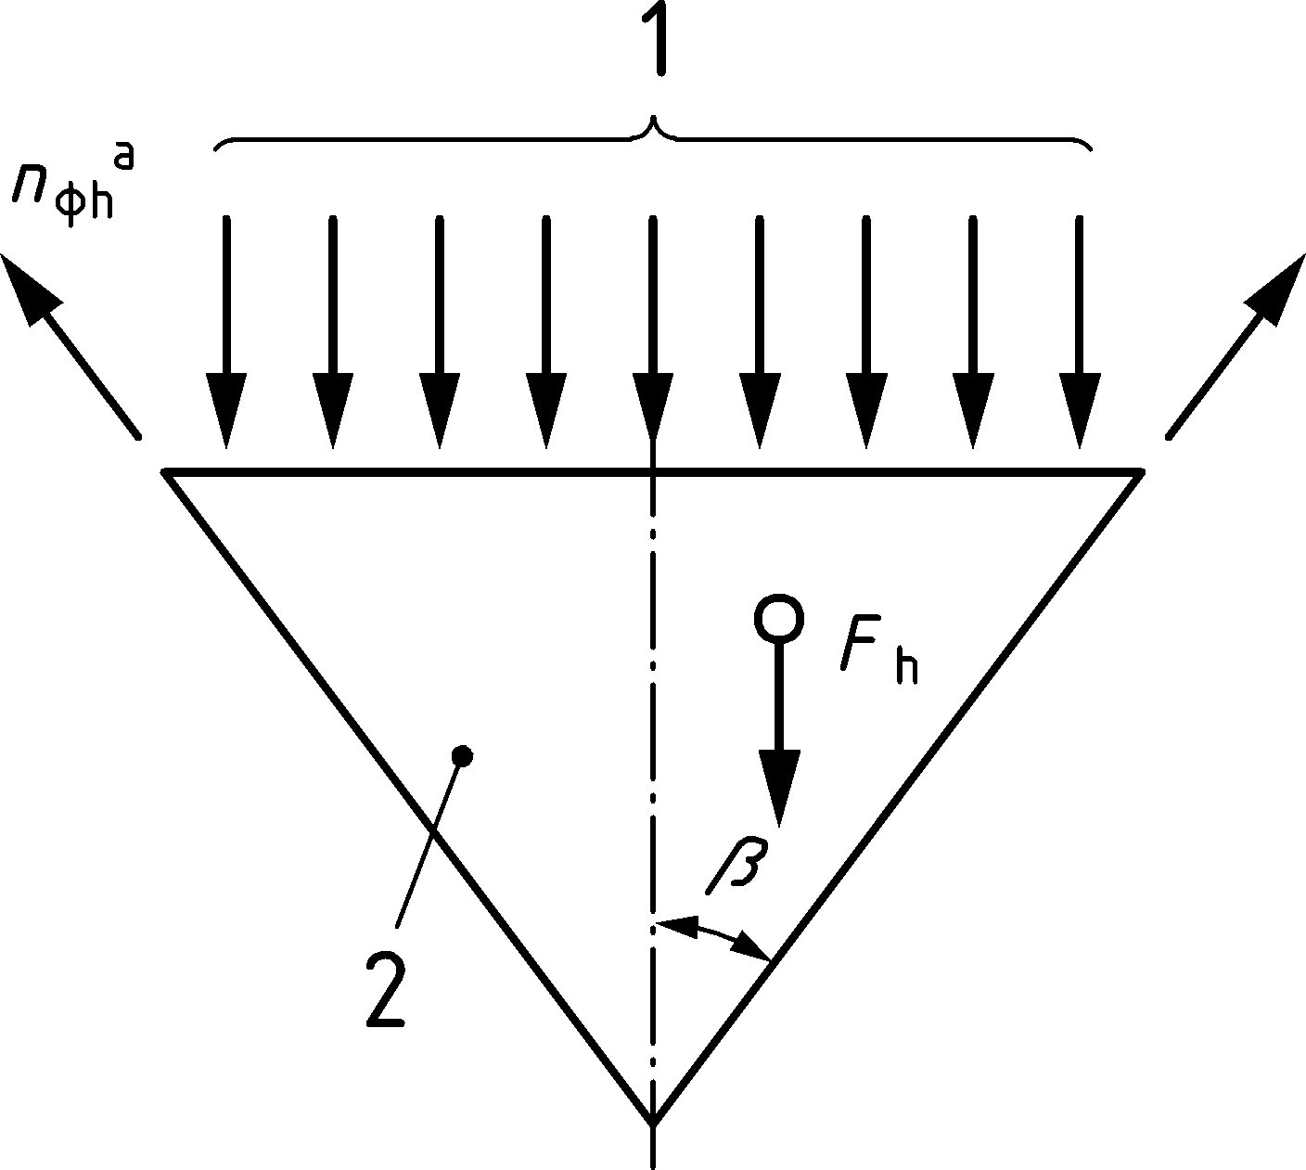

Key

|  |  |
| --- | --- |
| 1 | pressure from cylinder contents |
| 2 | stored solids |
| a | miridional tension |

Figure A.1 — Hopper global equilibrium

(3) The design value of the meridional membrane tension at the hopper top *n*h,Ed should satisfy the condition:

*n*h,Ed ≤ *k*r *t f*u / M2 (A.15)

where

|  |  |
| --- | --- |
| t | is the thickness of the hopper; |
| *f*u | is the tensile strength; |
| *k*r | is the hopper transition reduction factor, kr = 0,90; |
| **M2 | is the partial factor for rupture (see Table 4.4). |

* + 1. Transition junction

(1) This simplified design method can be used on silos of Silo Group 1 where the junction consists of a cylindrical and conical section, with or without an annular plate or a similarly compact ring at the junction, see Figure A.2.

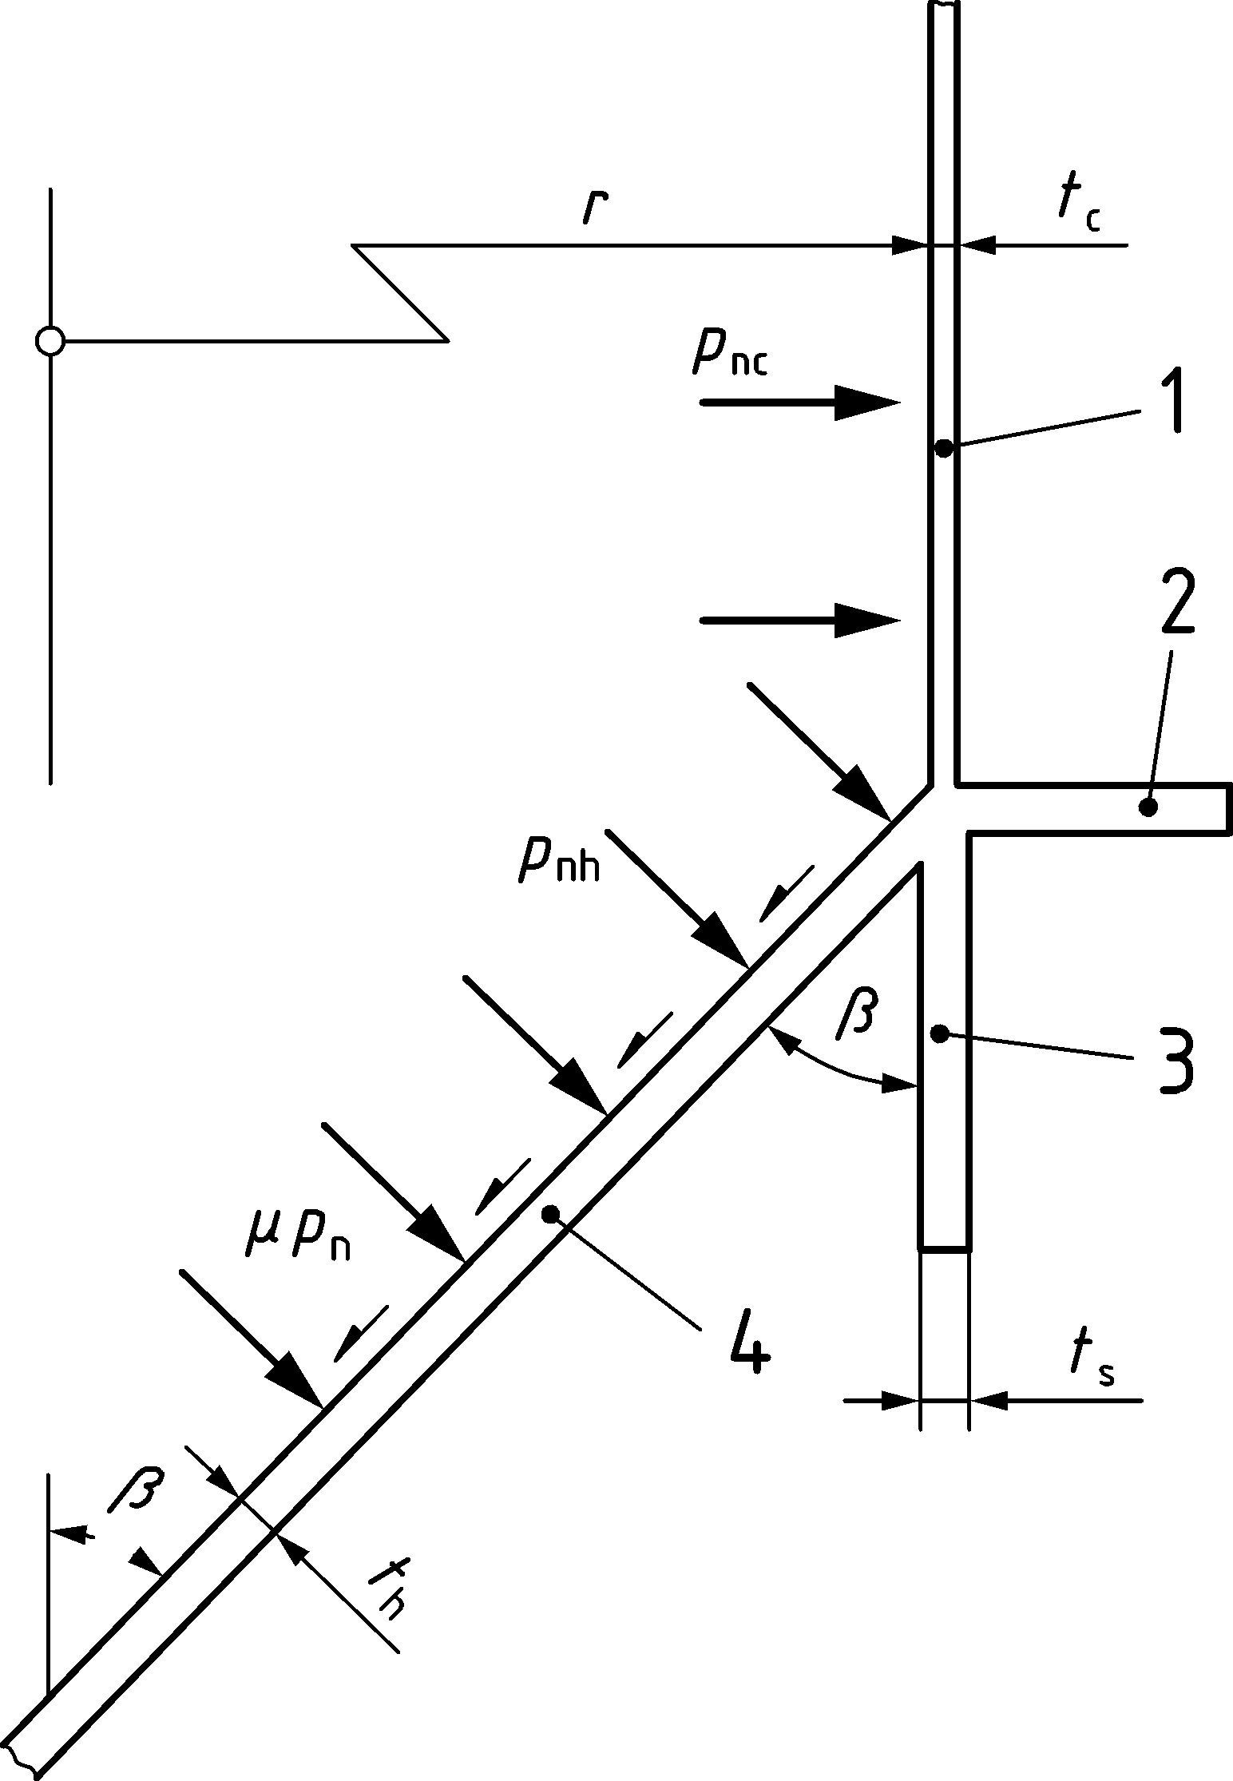

Key

|  |  |
| --- | --- |
| 1 | cylinder |
| 2 | ring |
| 3 | skirt |
| 4 | hopper |

Figure A.2 — Notation for a simple transition junction

(2) The total effective area of the ring *A*et should be found from:

 (A.16)

where

|  |  |
| --- | --- |
| *r* | is the radius of the silo cylinder wall; |
| *t*c | is the thickness of the cylinder; |
| *t*s | is the thickness of the skirt; |
| *t*h | is the thickness of the hopper; |
| ** | is the cone apex half angle of the hopper; |
| *A*p | is the area of the ring at the junction. |

NOTE Where there is no ring at the junction, *A*p = 0. Where there is no skirt, *t*s = 0.

(3) The design value of the circumferential compressive force *N*,Ed developed in the junction should be determined from:

*N*,Ed= *n*h,Ed *r* sin** (A.17)

where

|  |  |
| --- | --- |
| *n*h,Ed | is the design value of the meridional tension per unit circumference at the top of the hopper, see Figure A.1 and Formula (A.14). |

(4) The mean circumferential stress in the ring should satisfy the condition:

 (A.18)

where

|  |  |
| --- | --- |
| *f*y | is the lowest yield strength of the ring and shell materials; |
| **M0 | is the partial factor for plasticity (see Table 4.4). |

1. (informative)  
     
   Simplified rules for transition junction ring girders in circular silos with horizontally corrugated wall and vertical stiffeners
   1. Use of this Annex

(1) This Informative Annex contains simplified rules for transition junction ring girders in circular silos with horizontally corrugated wall and vertical stiffeners.

NOTE National choice on the application of this Informative Annex is given in the National Annex. If the National Annex contains no information on the application of this informative annex, it can be used.

* 1. Scope and field of application

(1) In a silo with horizontally corrugated walls and vertical stiffeners (see 7.9) with the vertical stiffeners fully supported by columns, the design of the transition ring at the cylinder to hopper transition may be designed using the procedure defined in this Annex B.

(2) The procedure of this Annex B may be used in place of the fuller evaluation defined in Clause 10, or the simpler treatment of Annex A.

(3) This procedure is only valid if the vertical stiffeners are fully supported by columns extending to the foundation, as shown in Figure B.1.

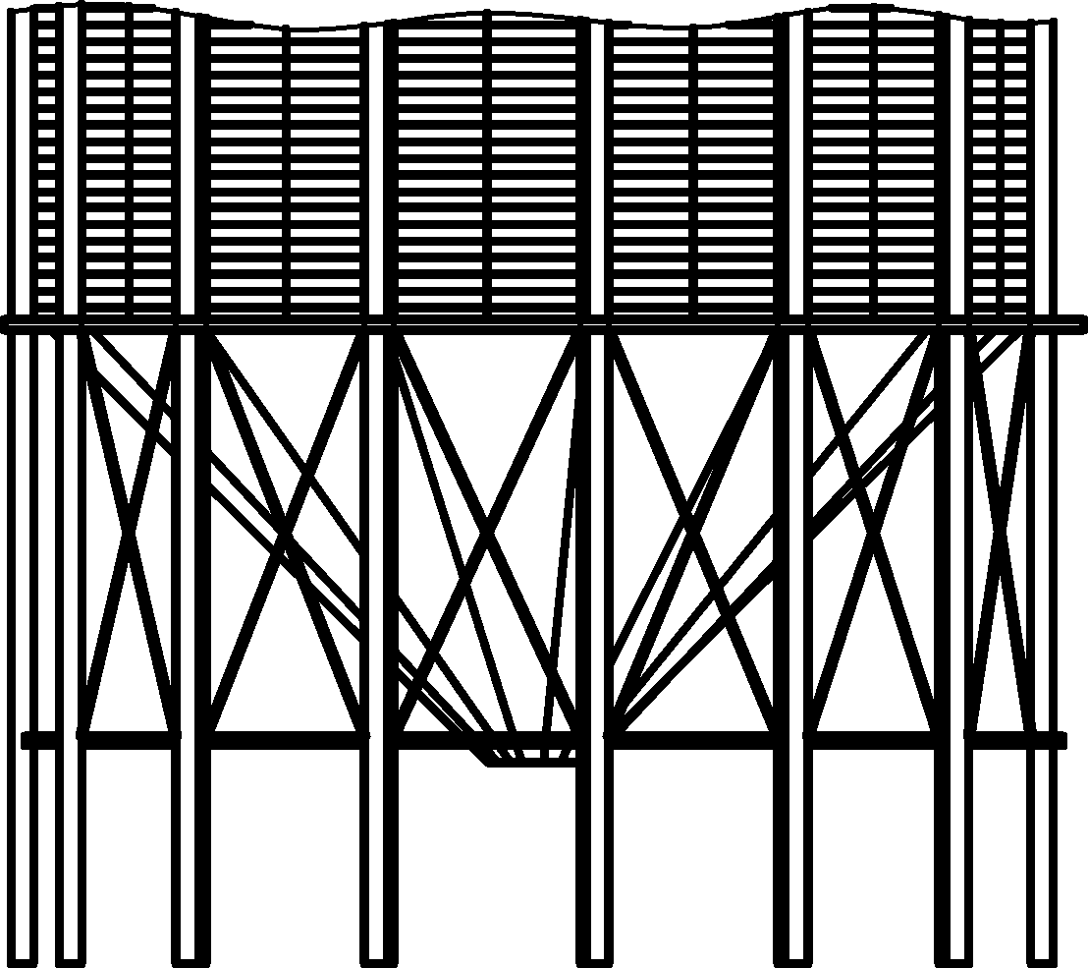

Figure B.1 — Illustration of fully supported vertical stiffeners

* 1. Evaluation of the circumferential force in the transition ring

(1) The total vertical force *F*vt from the stored solid within the cylindrical section (see Figure B.2) may be found as

 (B.1)

where

|  |  |
| --- | --- |
| *p*vt | is the vertical stress in the stored solid at the level of the transition (see EN 1991‑4); |
| *r* | is the internal radius of the cylindrical section. |

NOTE The value of *p*vt depends on the condition of filling or discharge in the silo.

(2) The characteristic value of the weight of stored solid within the hopper should be found as

 (B.2)

where

|  |  |
| --- | --- |
| *h*h | is the height of the hopper; |
| ** | is the bulk unit weight of the stored solid (see EN 1991‑4). |

(3) The design value of the total vertical force *F*tot acting at the level of the ring is

 (B.3)

where

|  |  |
| --- | --- |
| *F*s | is the weight of the hopper structure; |
| γQ | is the partial factor for variable loads (see EN 1990); |
| γG | is the partial factor for fixed loads (see EN 1990). |

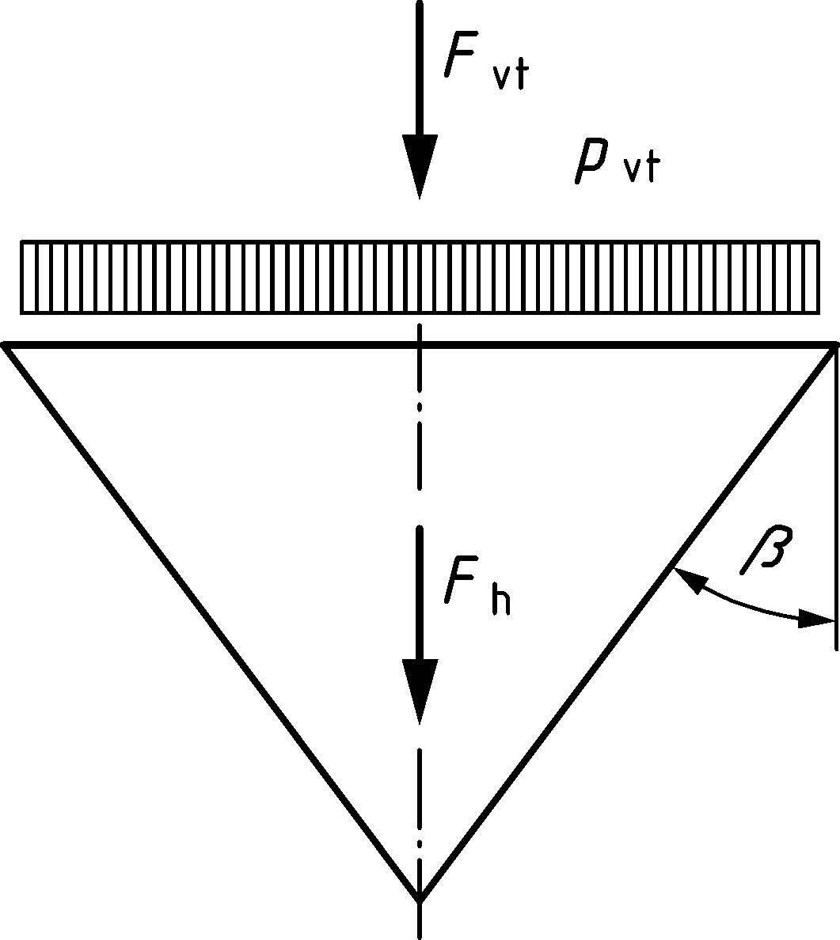

Figure B.2 — Vertical forces acting at the level of the transition

* 1. Evaluation of the circumferential force in the transition ring
     1. Geometry of the transition ring

(1) The transition ring may take different forms. The section properties of cold formed sections should be carefully evaluated.

(2) Examples of two different ring sections are shown in Figure B.3.

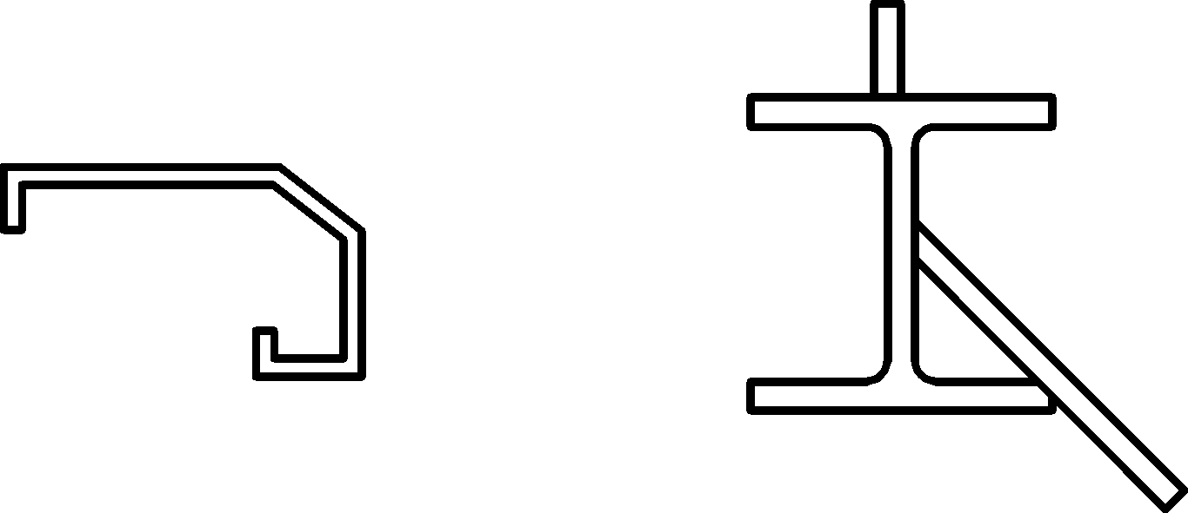

Figure B.3 — Examples of transition ring sections

NOTE For horizontally corrugated walls with vertical stiffeners, the flexibility of the corrugated profile substantially prevents the wall from contributing an effective length to the section properties of the ring. A rigidly connected hopper can contribute to the effective properties of the ring.

(3) The appropriate section properties of the ring, cross-sectional area and second moment of area about a vertical axis, should be evaluated using the chosen section enhanced by effective areas of adjacent wall plate as noted in B.4.2.

(4) Examples of two different ring sections are shown in Figure B.3.

(5) The pressure of the stored solid against the vertical wall can reduce the total circumferential force in the transition ring. Where this effect is to be considered, the effective height of the vertical wall that acts with the ring section should be assessed using a rational analysis. The corresponding treatment for isotropic walls is given in 10.2.2.

NOTE Advice on the evaluation of the effective height in a stiffened corrugated wall is given in (2).

* + 1. Determination of the circumferential force in the ring

(1) The design value of the vertical component of the force per unit circumference acting on the ring at the level of the transition *P*vt should be found as:

 (B.4)

(2) Where the hopper is rigidly connected to the ring, the local normal pressure on it *p*nt can reduce the compressive force in the ring. The effective length of the hopper that contributes to the ring cross-sectional area is given by:

 (B.5)

where

|  |  |
| --- | --- |
| *t*h | is the thickness of the hopper at the top; |
| ** | is the apex half angle of the hopper |
| *p*nt | is the value of *p*nf or *p*ne, as appropriate, at the hopper top determined from EN 1991‑4. |

NOTE For horizontally corrugated walls with vertical stiffeners, the flexibility of the corrugated profile substantially prevents the wall from contributing an effective length to the ring. But a rigidly connected hopper can contribute to the effective size of the ring.

(3) The contribution of the local normal pressure *p*nt to the radial force per unit circumference on the ring is given by:

**  (B.6)

where

** is the hopper wall friction coefficient.

NOTE If the effective length of the wall that contributes to the ring cannot be clearly identified, the value of *P*pt can be taken as zero.

(4) The net radial force per unit circumference *P*rt acting inwards on the ring may then be found as:

** (B.7)

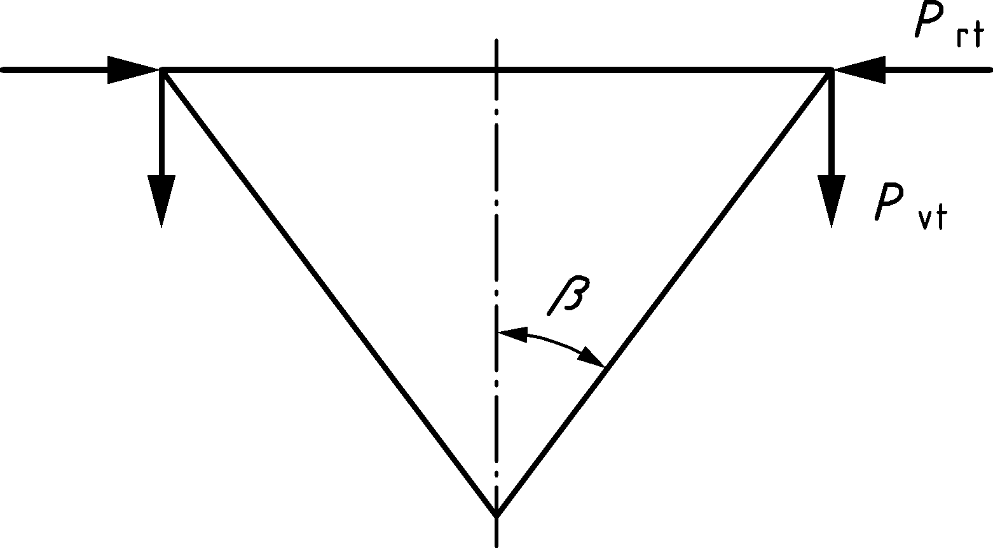

Figure B.4 — Forces acting on the transition ring

(5) The circumferential compression force in the ring is given by:

 (B.8)

(6) The circumferential compression stress in the ring should be found as:

 (B.9)

* 1. Determination of the buckling resistance of the transition ring

(1) The effective cross-section of the ring should be determined as defined in B.4.1.

NOTE Out-of-plane buckling can be prevented by rigid attachment of the ring to the vertical wall where the vertical wall is stiff in membrane shear.

(2) The in-plane elastic buckling resistance of the ring should be found as:

 (B.10)

where

|  |  |
| --- | --- |
| *I*eff | is the second moment of area of the effective ring about its vertical axis; |
| *A*eff | is the cross-sectionaly area of the effective ring; |
| *r*G | is the radius of the centroid of the effective ring. |

(3) The in-plane buckling limit state for the junction should be verified using:

 (B.11)

where

|  |  |
| --- | --- |
| **θ,Rcr | is the design value of the in-plane buckling resistance (Formula (B.10)); |
| **M1 | is the partial factor given in Table 4.4. |

(4) Where  consideration should be given to elastic-plastic buckling and the following provisions adopted.

(5) Since the ring cross-section can be cold-formed or have complex geometry, the provisions of prEN 1993‑1‑6:2023, 9.5.4(4) to (9) should be used. The value of *R*cr should be taken as

 (B.12)

and the value of *R*pl as

 (B.13)

(6) The values of **, **, and ** should be taken as

 (B.14)

NOTE The above parameters **, **, **, **o and **h provide a very close match to buckling curve c in EN 1993‑1‑1 and EN 1993‑1‑3.

1. (informative)  
     
   Expressions for membrane stress resultants in conical hoppers
   1. Use of this Annex

(1) This Informative Annex contains expressions for membrane stress resultants in conical hoppers.

NOTE National choice on the application of this Informative Annex is given in the National Annex. If the National Annex contains no information on the application of this informative annex, it can be used.

* 1. Scope and field of application

The formulae given here permit membrane theory stress analyses to be undertaken for cases which are not obtainable in standard texts on shells or silo structures. Membrane theory formulae accurately predict the membrane stress resultants in the body of the hopper (i.e. at points not adjacent to the transition or support) provided that the applied loadings are according to patterns defined in EN 1991‑4.

Formulae corresponding to the general pressure theory used in EN 1991‑4 first, but additional expressions for the stresses in hoppers under different assumed pressure regimes are also given to assist the designers of fluid-filled tanks and those required to use alternative hopper pressure theories.

Vertical axis coordinate *x* with origin at the apex.

Vertical height of hopper *h*h and cone apex half‑angle **h

* 1. General hopper theory pressures (as per EN 1991‑4)

The pressure pattern on a hopper wall is defined in terms of the normal pressure *pn* with accompanying wall frictional traction *pt* = *hpn*.

In EN 1991‑4, additional subscripts are used to distinguish between filling and discharge values, but the following formulae are valid for both cases when the appropriate values of *F* and *n* are adopted.

The pressure pattern is given by:

*pn* = *F pv* (C.1)

 (C.2)

with

*n* = 2(*F*hcot**h + *F* − 1) (C.3)

|  |  |
| --- | --- |
| ** | is the unit weight of the stored solid; |
| *p*v | is the vertical stress in the solid at height *x* above the apex; |
| *F* | is the ratio of hopper wall pressure to the vertical stress in the solid; |
| *p*vt | is the mean vertical stress in the solid at the transition. |

 (C.4)

 (C.5)

* 1. Uniform normal pressure *p*o with wall friction *p*o

 (C.6)

 (C.7)

* 1. Linearly varying normal pressure from *p*1 at apex to *p*2 at transition with wall friction *p*

 (C.8)

 (C.9)

 (C.10)

For ** = 0, the maximum von Mises equivalent stress resultant occurs in the body of the cone if *p*2 < 0,48 *p*1 at the height:

 (C.11)

* 1. “Radial stress field” normal pressure pattern with triangular switch stress below the transition

NOTE Although this pressure distribution is not specified within EN 1991‑4, it is sometimes used in preference by designers because it has frequently been used in the silo pressure literature, but the consequent stress resultants are not found easily in the literature.

 for 0 < x < *h*1 (C.12)

 for *h*1 < x < *h*h (C.13)

 for 0 < x < *h*1 (C.14)

 for *h*1 < x < *h*h (C.15)

 for 0 < x < *h*1 (C.16)

 for *h*1<z<*h*h (C.17)

in which *p*1 is the pressure at a height *h*1 above the apex and *p*2 is the pressure at the transition.

Bibliography

**References contained in recommendations (i.e. through “should” clauses)**

The following documents are referred to in the text in such a way that some or all of their content, although not requirements strictly to be followed, constitutes highly recommended choices or course of action of this document. Subject to national regulation and/or any relevant contractual provisions, alternative standards could be used/adopted where technically justified. For dated references, only the edition cited applies. For undated references, the latest edition of the referenced document (including any amendments) applies.

EN 10025 (all parts), *Hot rolled products of structural steels*

EN 10149 (all parts), *Hot rolled flat products made of high yield strength steels for cold forming*

EN 10346, *Continuously hot-dip coated steel flat products for cold forming — Technical delivery conditions*

**References contained in permissions (i.e. through “may” clauses)**

The following documents are referred to in the text in such a way that some or all of their content, although not requirements strictly to be followed, expresses a course of action permissible within the limits of the Eurocodes. For dated references, only the edition cited applies. For undated references, the latest edition of the referenced document (including any amendments) applies.

EN 1992 (all parts), *Eurocode 2 — Design of concrete structures*

EN 1997 (all parts), *Eurocode 7 — Geotechnical design*

EN 1998-4, *Eurocode 8 — Design of structures for earthquake resistance — Part 4: Silos, tanks, pipelines, towers, masts and chimneys*

**References contained in possibilities (i.e. “can” clauses) and notes**

The following documents are cited informatively in the document, for example in “can” clauses and in notes.

ISO 1000, *SI units and recommendations for the use of their multiples and of certain other units*

ISO 3898, *Bases for design of structures — Names and symbols of physical quantities and generic quantities*

**Other references**

The following documents are those not included in the above categories but are cited informatively in the document, for example in notes.

Sonat, C., Topkaya, C. and Rotter, J.M. (2015) “Buckling of cylindrical metal shells on discretely supported ringbeams”, Thin Walled Structures, Vol. 93, pp 22-35.

Rotter J.M. and Sadowski A.J. (2012) "Cylindrical shell bending theory for orthotropic shells under general axisymmetric pressure distributions" Engineering Structures, Vol. 42, Sept, pp 258-265.

Rotter, J.M., Zhang, Q. and Teng, J.G. (1987) “Corrugation Collapse in Circumferentially Corrugated Steel Cylinders”, First National Structural Engineering Conference, Melbourne, Institution of Engineers, Australia, August 1987

AS 3774:1996, *Loads on Bulk Solids Containers*

Sokol, L. (1983) “Calcul des tirants dans les cadres de silos”, Revue Construction Métallique, 1983 No. 2, pp 57-64.

1. As impacted by EN 1990:2023/prA1:2024.