CEN/TC 250

Date: 2023-08

prEN 1993‑6:2024

Secretariat: BSI

Eurocode 3 — Design of steel structures — Part 6: Crane supporting structures

Eurocode 3 — Bemessung und Konstruktion von Stahlbauten — Teil 6: Kranbahnen

Eurocode 3 — Calcul des structures en acier — Partie 6: Structures supportant des appareils de levage

ICS:

Contents Page

European foreword 5

0 Introduction 6

1 Scope 9

1.1 Scope of prEN 1993‑6 9

1.2 Assumptions 10

2 Normative references 10

3 Terms, definitions and symbols 10

3.1 Terms and definitions 10

3.2 Symbols 13

3.2.1 General 13

3.2.2 Latin upper-case symbols 13

3.2.3 Latin lower-case symbols 13

3.2.4 Greek upper-case symbols 15

3.2.5 Greek lower-case symbols 15

4 Basis of design 16

4.1 General rules 16

4.1.1 Basic requirements 16

4.1.2 Design service life 17

4.1.3 Durability 17

4.1.4 Clearances to overhead travelling cranes 17

4.1.5 Crane tests 17

4.2 Basic variables 17

4.3 Verification by the partial factor method 18

4.3.1 Design situations at ultimate and serviceability limit states (except for fatigue) 18

4.3.2 Fatigue design situations 19

5 Materials 19

5.1 Structural steels 19

5.2 Bearings 19

5.3 Other products for crane supporting structures 19

5.3.1 General 19

5.3.2 Rail steels 19

5.3.3 Special connecting devices for rails 20

6 Durability 20

7 Structural analysis 21

7.1 Structural modelling for analysis 21

7.1.1 General 21

7.1.2 Eccentricity of wheel loads 21

7.2 Global analysis 21

7.3 Imperfections 21

7.4 Methods of analysis 22

7.4.1 General 22

7.4.2 Cross-section properties 23

7.5 Analysis of crane runway beams 24

7.5.1 Global effects 24

7.5.2 Local effects of wheel loads 25

7.6 Local stresses in webs due to wheel loads 25

7.6.1 General 25

7.6.2 Local vertical compressive stresses 26

7.6.3 Local shear stresses 28

7.6.4 Local bending stresses due to eccentricity of crane-induced actions 29

7.7 Local bending stresses in bottom flanges due to wheel loads 32

7.7.1 General 32

7.7.2 Overview about calculation methods 32

7.7.3 Widely spaced wheels 33

7.7.4 Closely spaced wheels 35

7.8 Local stresses in rail welds due to wheel loads 36

7.8.1 Ultimate limit state (except for fatigue) 36

7.8.2 Fatigue design situation 38

8 Ultimate limit states 41

8.1 Consideration of local effects of crane-induced actions 41

8.2 Lateral-torsional buckling 41

8.2.1 General 41

8.2.2 Effective level of application of wheel loads 41

8.2.3 Verification methods 41

8.3 Resistance of webs to wheel loads 43

8.3.1 General 43

8.3.2 Length of stiff bearing 43

8.4 Buckling of plates 43

8.5 Resistance of bottom flanges to wheel loads 43

9 Serviceability limit states 48

9.1 General 48

9.2 Deformations 49

9.3 Limitation of web breathing 51

9.4 Elastic behaviour of runway beams 51

9.5 Lateral vibration of the bottom flange 52

10 Fasteners, welds, surge connectors and rails 52

10.1 Welded connections 52

10.2 Bolted connections 53

10.3 Surge connectors 53

10.4 Crane rails 54

10.4.1 Design service life 54

10.4.2 Rail selection 54

10.5 Rail fixings 55

10.5.1 General 55

10.5.2 Rigid fixings 55

10.5.3 Independent fixings 55

10.6 Rail joints 56

11 Fatigue design situation 57

11.1 Requirements 57

11.2 Consideration of local effects of crane actions 57

11.3 Fatigue stress range spectra 57

11.3.1 General 57

11.3.2 Simplified approach 58

11.3.3 Damage equivalent factor 60

11.4 Verifications 62

11.4.1 General 62

11.4.2 Multiple crane actions 62

11.5 Fatigue resistance 64

Annex A (informative) Design of crane rails with independent rail fixings 65

A.1 Use of this informative annex 65

A.2 Scope and field of application 65

A.3 Structural analysis 65

A.4 Action effects 65

A.5 Verification 67

Annex B (informative) Inspections of crane runway beams according to EN 1993‑1‑9 68

B.1 Use of this informative annex 68

B.2 Scope and field of application 68

B.3 Definitions 68

B.4 Preparation of inspections 69

B.5 Execution of inspections 69

B.6 Documentation of inspections 71

Annex C (informative) Guidance on crane runway beam classification for fatigue 72

C.1 Use of this informative annex 72

C.2 Scope and field of application 72

C.3 Classification without calculation 72

C.4 Classification with calculation 73

Bibliography 74

European foreword

This document (prEN 1993‑6:2024) has been prepared by Technical Committee CEN/TC 250 “Structural Eurocodes”, the secretariat of which is held by BSI. CEN/TC 250 is responsible for all Structural Eurocodes and has been assigned responsibility for structural and geotechnical design matters by CEN.

This document is currently submitted to the CEN Enquiry.

This document will supersede EN 1993‑6:2007 and its corrigenda.

The first generation of EN Eurocodes was published between 2002 and 2007. This document forms part of the second generation of the Eurocodes, which have been prepared under Mandate M/515 issued to CEN by the European Commission and the European Free Trade Association.

The Eurocodes have been drafted to be used in conjunction with relevant execution, material, product and test standards, and to identify requirements for execution, materials, products and testing that are relied upon by the Eurocodes.

The Eurocodes recognize the responsibility of each Member State and have safeguarded their right to determine values related to regulatory safety matters at national level through the use of National Annexes.

0 Introduction

**0.1 Introduction to the Eurocodes**

The Structural Eurocodes comprise the following standards generally consisting of a number of Parts:

— EN 1990, Eurocode — *Basis of structural and geotechnical design*;

— EN 1991, Eurocode 1 — *Actions on structures*;

— EN 1992, Eurocode 2 — *Design of concrete structures*;

— EN 1993, Eurocode 3 — *Design of steel structures*;

— EN 1994, Eurocode 4 — *Design of composite steel and concrete structures*;

— EN 1995, Eurocode 5 — *Design of timber structures*;

— EN 1996, Eurocode 6 — *Design of masonry structures*;

— EN 1997, Eurocode 7 — *Geotechnical design*;

— EN 1998, Eurocode 8 — *Design of structures for earthquake resistance*;

— EN 1999, Eurocode 9 — *Design of aluminium structures*;

— New parts are under development, e.g. Eurocode for design of structural glass.

The Eurocodes are intended for use by designers, clients, manufacturers, constructors, relevant authorities (in exercising their duties in accordance with national or international regulations), educators, soft-ware developers, and committees drafting standards for related product, testing and execution standards.

NOTE Some aspects of design are most appropriately specified by relevant authorities or, where not specified, can be agreed on a project-specific basis between relevant parties such as designers and clients. The Eurocodes identify such aspects making explicit reference to relevant authorities and relevant parties.

**0.2 Introduction to the** **EN** **1993** **series**

EN 1993 applies to the design of buildings and civil engineering works in steel. It complies with the principles and requirements for the safety and serviceability of structures, the basis of their design and verification that are given in EN 1990 — Basis of structural and geotechnical design.

EN 1993 is concerned only with requirements for resistance, serviceability, durability and fire resistance of steel structures. Other requirements, e.g. concerning thermal or sound insulation, are not covered.

EN 1993 is subdivided in various parts:

EN 1993‑1, *Design of Steel Structures — Part 1: General rules and rules for buildings*;

EN 1993‑2, *Design of Steel Structures — Part 2: Bridges*;

EN 1993‑3, *Design of Steel Structures — Part 3: Towers, masts and chimneys*;

EN 1993‑4, *Design of Steel Structures — Part 4: Silos and tanks*;

EN 1993‑5, *Design of Steel Structures — Part 5: Piling*;

EN 1993‑6, *Design of Steel Structures — Part 6: Crane supporting structures*;

EN 1993‑7, *Design of steel structures — Part 7: Sandwich panels*.

EN 1993‑1 in itself does not exist as a physical document, but as a document series that comprises the following 14 separate parts, the basic part being EN 1993‑1‑1:

EN 1993‑1‑1, *Design of Steel Structures — Part 1-1: General rules and rules for buildings*;

EN 1993‑1‑2, *Design of Steel Structures — Part 1-2: Structural fire design*;

EN 1993‑1‑3, *Design of Steel Structures — Part 1-3: Cold-formed members and sheeting*;

NOTE Cold formed hollow sections supplied according to EN 10219 are covered in EN 1993‑1‑1.

EN 1993‑1‑4, *Design of Steel Structures — Part 1-4: Stainless steel structures*;

EN 1993‑1‑5, *Design of Steel Structures — Part 1-5: Plated structural elements*;

EN 1993‑1‑6, *Design of Steel Structures — Part 1-6: Strength and stability of shell structures*;

EN 1993‑1‑7, *Design of Steel Structures — Part 1-7: Plate assemblies with elements under transverse loads*;

EN 1993‑1‑8, *Design of Steel Structures — Part 1-8: Joints*;

EN 1993‑1‑9, *Design of Steel Structures — Part 1-9: Fatigue*;

EN 1993‑1‑10, *Design of Steel Structures — Part 1-10: Material toughness and through-thickness properties*;

EN 1993‑1‑11, *Design of Steel Structures — Part 1-11: Tension components*;

EN 1993‑1‑12, *Design of Steel Structures — Part 1-12: Additional rules for steel grades up to S960*;

EN 1993‑1‑13, *Design of Steel Structures — Part 1-13: Beams with large web openings*;

EN 1993‑1‑14, *Design of Steel Structures — Part 1-14: Design assisted by finite element analysis*.

All subsequent parts numbered EN 1993‑1‑2 to EN 1993‑1‑14 treat general topics that are independent from the structural type like structural fire design, cold-formed members and sheeting, stainless steels, plated structural elements, etc.

All subsequent parts numbered EN 1993‑2 to EN 1993‑7 treat topics relevant for a specific structural type like steel bridges, towers, masts and chimneys, silos and tanks, piling, crane supporting structures, etc. EN 1993‑2 to EN 1993‑7 refer to the generic rules in EN 1993‑1 and supplement, modify or supersede them.

**0.3 Introduction to** **EN** **1993‑6**

EN 1993‑6 gives specific design rules for crane supporting steel structures. It is intended to be used with EN 1990, EN 1991 and the EN 1993‑1 series. Matters that are already covered in those documents are not repeated. The focus in EN 1993‑6 is on design rules that supplement, modify or supersede the equivalent provisions given in the EN 1993‑1 series.

**0.4 Verbal forms used in the Eurocodes**

The verb “shall” expresses a requirement strictly to be followed and from which no deviation is permitted in order to comply with the Eurocodes.

The verb “should” expresses a highly recommended choice or course of action. Subject to national regulation and/or any relevant contractual provisions, alternative approaches could be used/adopted where technically justified.

The verb “may” expresses a course of action permissible within the limits of the Eurocodes.

The verb “can” expresses possibility and capability; it is used for statements of fact and clarification of concepts.

**0.5 National Annex for** **EN** **1993‑6**

National choice is allowed in this standard where explicitly stated within notes. National choice includes the selection of values for Nationally Determined Parameters (NDPs).

The national standard implementing EN 1993‑6 can have a National Annex containing all national choices to be used for the design of buildings and civil engineering works to be constructed in the relevant country.

When no national choice is given, the default choice given in this standard is to be used.

When no national choice is made and no default is given in this standard, the choice can be specified by a relevant authority or, where not specified, agreed for a specific project by appropriate parties.

National choice is allowed in EN 1993‑6 through notes to the following clauses:

|  |  |  |  |
| --- | --- | --- | --- |
| 4.1.2(2) | 4.1.5(2) | 4.3.1(2) | 4.3.2(1) |
| 4.3.2(2) | 5.1(1) | 5.3.2(2) | 5.3.3(1) |
| 7.1.2(1) | 7.5.1(1) | 7.6.1(1) | 7.6.4(6) |
| 7.7.1(1) | 9.2(1) | 11.1(4) | 11.4.2(6) |

National choice is allowed in prEN 1993‑6 on the application of the following informative annexes:

|  |  |  |  |
| --- | --- | --- | --- |
| Annex A | Annex B | Annex C |  |

The National Annex can contain, directly or by reference, non-contradictory complementary information for ease of implementation, provided it does not alter any provisions of the Eurocodes.

# Scope

## Scope of prEN 1993‑6

(1) EN 1993‑6 provides rules for structural design of crane supporting structures.

(2) EN 1993‑6 is applicable to crane supporting structures, especially to indoor and outdoor overhead crane runway beams, of:

a) overhead travelling cranes, either:

— top-mounted cranes;

— underslung cranes;

b) monorail hoist blocks.

NOTE The principles of the design rules can be applied to supporting structures of other types of cranes making due allowance for differences in the crane-induced actions, if exist. For example, the design rules for supporting structures of the cranes listed in (2) assume that the horizontal crane loads occur randomly scattered along the runways in general. This assumption does not apply to other cranes such as travelling wall jib cranes.

(3) EN 1993‑6 does not apply to the tracks and suspensions of light crane systems conforming with EN 16851, see Figure 1.1.

NOTE The standardized tracks and suspensions of light crane systems are considered as parts of the crane.

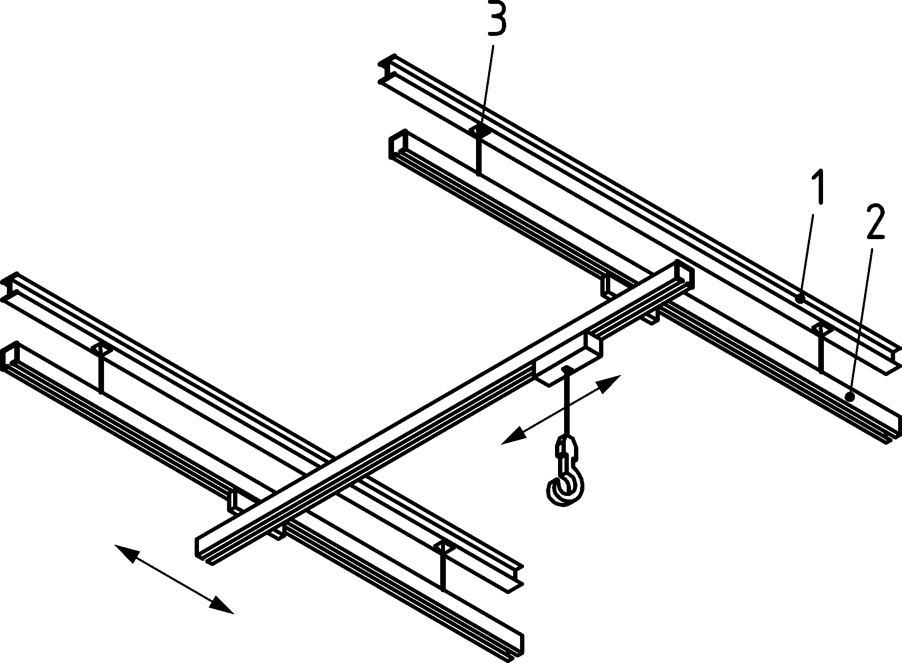

Key

|  |  |
| --- | --- |
| 1 | supporting beam designed according to EN 1993‑1 |
| 2 | standardized track of light crane system designed according to EN 16851 |
| 3 | support point |

Figure 1.1 — Light crane system

(4) Additional rules are given for ancillary runway items including crane rails, structural end stops, surge connectors and surge girders and for runway supporting structures.

(5) EN 1993‑6 does not apply to cranes and all other moving parts.

NOTE Provisions for cranes are given in EN 13001 series.

## Assumptions

(1) Unless specifically stated, EN 1990, EN 1991 and the EN 1993‑1 series apply.

(2) The design methods given in EN 1993‑6 are applicable if

— the execution quality and tolerances are as specified in EN 1090‑2, and;

— the construction materials and products used are as specified in the relevant parts of EN 1993, or in the relevant material and product specifications.

(3) Following interfaces between hoisting device and its supporting structure are assumed:

a) the top of crane rail for top-mounted cranes;

b) the top of flange on which the crane or hoist block operates for underslung cranes and monorail hoist blocks;

c) the support points as shown in Figure 1.1 for light crane systems.

# Normative references

The following documents are referred to in the text in such a way that some or all of their content constitutes requirements of this document. For dated references, only the edition cited applies. For undated references, the latest edition of the referenced document (including any amendments) applies.

NOTE See the Bibliography for a list of other documents cited that are not normative references, including those referenced as recommendations (i.e. through ‘should’ clauses) and permissions (i.e. through ‘may’ clauses).

EN 1090‑2, Execution of steel structures and aluminium structures - Part 2: Technical requirements for steel structures

EN 1990:2023,[1] Eurocode - Basis of structural and geotechnical design

EN 1991 (all parts), Eurocode 1 — Actions on structures

EN 1993 (all parts), Eurocode 3 — Design of steel structures

# Terms, definitions and symbols

## Terms and definitions

For the purposes of this document, the terms and definitions given in EN 1990:2023, EN 1991‑3, the EN 1993‑1 series and the following apply.

3.1.1

wheel load

vertical action due to crane operation

3.1.2

crane surge

horizontal actions due to crane travelling (or trolley traversing if relevant), acting longitudinally and/or laterally to the runway beams caused by acceleration/deceleration and/or by skewing

3.1.3

crane supporting structure

assembly of stationary load bearing components of a crane installation supporting the crane and transmitting all crane-induced actions to foundations; usually considered a part of a building structure and designed accordingly

Note 1 to entry: For design reasons, crane supporting structures are usually subdivided into the crane runway and the crane runway supporting structure.

3.1.4

crane runway

crane supporting structure serving as track and support system on which the crane operates comprising structural components such as crane runway beams, surge girders if relevant, surge connectors, structural end stops and non-structural components such as electrical, access and safety facilities

3.1.5

crane runway beam

beam submitted directly or through a rail to crane-induced actions

Note 1 to entry: For crane runways with surge girder, only the beam underneath the wheel loads is referred to as crane runway beam, see Figure 3.1.

3.1.6

surge girder

beam or lattice girder acting as continuous lateral support that resists the crane surge from crane runway beams

Note 1 to entry: See Figure 3.1.

3.1.7

surge connector

connecting device acting as discrete lateral support that resists the crane surge from crane runway beams or surge girders

3.1.8

structural end stop

component intended to stop a crane, trolley or hoist block reaching the end of a runway

3.1.9

crane runway supporting structure

crane supporting structure transmitting all crane-induced actions from the crane runway to foundations

Note 1 to entry: The crane runway supporting structure includes, where relevant, runway beam supports, brackets, columns, frames, bracings and foundations.

|  |  |  |  |
| --- | --- | --- | --- |
|  |  |  |  |
| **(a) separated surge girder** | **(b) integral surge girder with secondary beam** | **(c) integral surge girder with secondary truss girder** | **(d) integral surge girder shared by two crane runway beams** |

Key

|  |  |
| --- | --- |
| 1 | crane runway beam |
| 2 | secondary beam or secondary truss girder |
| 3 | truss or panel bracing (possibly used as walkway) |
| 4 | surge girder |

Figure 3.1 — Crane runway beams with surge girder (selection)

3.1.10

elastomeric bearing pad

resilient reinforced elastomeric bedding material intended for use under crane rails

3.1.11

C class

classification of the fatigue action from a crane as a whole based on its net load spectrum

Note 1 to entry: See EN 1991‑3.

3.1.12

R class

classification of the global effects of the fatigue relevant crane action (in general, the effect of the single wheel load of a crane) on the constructional details of the crane supporting structure neglecting multiple load effects

Note 1 to entry: See EN 1993‑1‑9 for further fatigue related definitions.

3.1.13

multiple load effect

effect (either global or local) on the constructional details of the crane supporting structure caused by multiple wheel loads of a crane or multiple crane actions that is not included in the R class

## Symbols

### General

For the purpose of this document the following symbols apply.

### Latin upper-case symbols

|  |  |
| --- | --- |
| *D*dup | Additional damage due to combinations of two or more cranes occasionally acting together |
| *D*i | Damage due to a single crane i acting independently |
| *F*f,Rd | Design resistance of the bottom flange of a beam subjected to a wheel load from an underslung crane or hoist block trolley |
| *F*W* | In-service wind load |
| *F*z,Ed | Design value of wheel load |
| *H*y,Ed | Lateral horizontal crane load |
| *I*f,eff | Moment of inertia of a flange with an effective width *b*f,eff about its horizontal centroidal axis |
| *I*r | Moment of inertia of a rail about its horizontal centroidal axis |
| *I*rf | Moment of inertia of a combined cross section comprising a rail and a flange with an effective width *b*f,eff about its horizontal centroidal axis |
| *I*T | Torsion constant |
| *L*z | Distance between supports of a runway beam |
| *L*y | Length between lateral restraints |
| *Q*C | crane self-weight (see EN 1991‑3) |
| *Q*e | Fatigue damage equivalent load (see EN 1991‑3) |
| *Q*H | hoist load (see EN 1991‑3) |
| *Q*max,*i* | Maximum value of the characteristic vertical wheel load *i* (see EN 1991‑3) |
| *R*i | R class i |
| *C*i | C class i |
| *T*Ed | Design value of torsional moment |
| *T*H,Ed | Design value of torsional moment caused by eccentric lateral horizontal loads |
| *T*V,Ed | Design value of torsional moment caused by eccentric wheel loads |

### Latin lower-case symbols

|  |  |
| --- | --- |
| *a* | Spacing of transverse stiffeners; length of unstiffened web panel (see EN 1993‑1‑5) |
| *a* | Effective throat thickness (see EN 1993‑1‑8) |
| *b*f | Flange width |
| *b*f,eff | Effective width of a flange |
| *b*fr | Width of the foot of a rail |
| *c* | Clearance between the crane wheel flanges and the crane rail |
| *c*T | Coefficient for local web bending of I-sections |
| *c*TB | Coefficient for local web bending of box sections |
| *c*x | Coefficient for determining the longitudinal bending stress |
| *c*x*i* | Coefficient for determining the longitudinal bending stress at location *i* (the index *i* can take the vales 0, 1 or 2) |
| *c*y | Coefficient for determining the transverse bending stress |
| *c*y*i* | Coefficient for determining the transverse bending stress at location *i* (the index *i* can take the vales 0, 1 or 2) |
| *e*y | Lateral eccentricity of wheel load (the same as *e* in 2.5.2.1(2) of prEN 1991‑3:2024) |
| *e*z | Eccentricity of lateral horizontal loads |
| *f*y | Characteristic value of yield strength |
| *h*c | Height to the level at which the crane is supported |
| *h*r | Height of crane rail |
| *h*1 | Distance between top flange and longitudinal stiffener |
| *h*w | Depth of web (see EN 1993‑1‑1) |
| *i*f,z | Radius of gyration of a flange about its z-z axis |
| ℓeff | Effective loaded length at the underside of top flange |
| ℓeff,r | Effective loaded length of rail weld |
| ℓf,eff | Effective length of bottom flange |
| *m* | Lever arm from the wheel load to the root of the flange |
| *n* | Distance from the centerline of the wheel load to the free edge of the flange |
| *r* | Radius of root fillet (see EN 1993‑1‑1) |
| *s* | Spacing between the centres of crane rails |
| *s*s | Length of stiff bearing (see EN 1993‑1‑5) |
| *t*f,1 | Flange thickness at the centerline of the wheel load |
| *t*f | Flange thickness |
| *t*f,m | Mean flange thickness |
| *t*r | Minimum thickness below the wearing surface of a crane rail |
| *t*w | Web thickness |
| *u*y | Horizontal displacement of a frame (or of a column) at crane support level |
| *w*c | Pre-camber |
| *w*max | Remaining total deflection taking into account the pre-camber (see EN 1990:2023, A.1) |
| *w*z,pay | Vertical deflection of a runway beam for a monorail hoist block, relative to its supports, due to payload only |
| *w*y | Horizontal deflection of a runway beam |
| *w*z | Vertical deflection of a runway beam |
| *x*e | Distance from the end of a member to the axis of the wheel |
| *x*w | Distance between the axes of adjacent crane wheels |
| *y* | Perpendicular distance, in the plane of triangulation, from the centroidal axis of the member to its relevant edge |
| *z* | Distance below the underside of the top flange (defined in Figure 7.4) |

### Greek upper-case symbols

|  |  |
| --- | --- |
| Δ*h*c | Difference between vertical deformations of two beams forming a crane runway |
| Δ*s* | Change of spacing between the centres of crane rails |
| Δ*u*y | Difference between horizontal displacements of adjacent frames or columns |
| Δ*σ*C | Reference value of fatigue strength for normal stress at 2 × 106 cycles |
| Δ*σ*E,2 | Damage equivalent normal stress range related to 2 × 106 cycles |
| Δ*σ*E,2,dup | Equivalent constant amplitude normal stress range due to two or more cranes acting together |
| Δ*σ*E,2,i | Equivalent constant amplitude normal stress range for a single crane i |
| Δ*τ*C | Reference value of fatigue strength for shear stress at 2 × 106 cycles |
| Δ*τ*E,2 | Damage equivalent shear stress range related to 2 × 106 cycles |
| Δ*τ*E,2,i | Equivalent constant amplitude shear stress range for a single crane i |

### Greek lower-case symbols

|  |  |
| --- | --- |
| *α* | Ratio *Q*C/*Q*H of crane self-weight *Q*C and hoist load *Q*H |
| *γ*F,test | Partial factor for crane tests |
| *γ*Ff | Partial factor for equivalent constant amplitude stress ranges (see EN 1993‑1‑9) |
| *γ*M,ser | Partial factor for checking reversible behaviour at serviceability limit state |
| *γ*M0 | Partial factor for resistance of cross-sections (see EN 1993‑1‑1) |
| *γ*M1 | Partial factor for resistance of members to instability assessed by member checks (see EN 1993‑1‑1) |
| *γ*M2 | Partial factor for resistance of cross-sections in tension to fracture (see EN 1993‑1‑1) |
| *γ*M2 | Partial factor for resistance of bolts, rivets, pins at ultimate limit states, welds and plates in bearing (see EN 1993‑1‑8) |
| *γ*M3 | Partial factor for slip resistance at ultimate limit state (see EN 1993‑1‑8) |
| *γ*M3,ser | Partial factor for slip resistance at serviceability limit state (see EN 1993‑1‑8) |
| *γ*M4 | Partial factor for bearing resistance of injection bolts (see EN 1993‑1‑8) |
| *γ*M5 | Partial factor for resistance of joints in hollow section lattice girders (see EN 1993‑1‑8) |
| *γ*M6,ser | Partial factor for resistance of pins at serviceability limit states (see EN 1993‑1‑8) |
| *γ*M7 | Partial factor for preload of high strength bolts (see EN 1993‑1‑8) |
| *γ*Mf | Partial factor for fatigue resistance (see EN 1993‑1‑9) |
| *λ*dup | Damage equivalent factor for two or more cranes occasionally acting together |
| *λi* | Damage equivalent factor for crane *i* |
| *μ* | Ratio for calculation of local bending stresses (see 7.7) |
| *σ*Ed | Design value of normal stress |
| *σ*Ed,ser | Design value of normal stress at serviceability limit state |
| *σ*eq,Ed,ser | Design value of equivalent stress at serviceability limit state |
| *σ*f,Ed | Design value of normal stress at the midline of the flange |
| *σ*ox,Ed | Design value of local longitudinal normal stress due to bottom flange bending |
| *σ*ox,Ed,ser | Design value of local longitudinal normal stress due to bottom flange bending at serviceability limit state |
| *σ*oy,Ed | Design value of local transverse normal stress due to bottom flange bending |
| *σ*oy,Ed,ser | Design value of local transverse normal stress due to bottom flange bending at serviceability limit state |
| *σ*oy,end,Ed | Design value of local transverse normal stress due to flange bending of an unstiffened bottom flange at runway beam end |
| *σ*oz,Ed | Design value of local vertical normal stress in web (always compressive stress) |
| *σ*oz,Ed,ser | Design value of local vertical normal stress in web at serviceability limit state |
| *σ*p | Normal stress taken into account for verification in fatigue design situation |
| *σ*p,max | Maximum normal stress due to simplified fatigue load in determining the damage equivalent stress range |
| *σ*p,min | Minimum normal stress due to simplified fatigue load in determining the damage equivalent stress range |
| *σ*T,Ed | Design value of local vertical normal stress in web due web bending |
| *σ*x,Ed,ser | Design value of longitudinal normal stress at serviceability limit state |
| *τ*Ed,ser | Design value of shear stress at serviceability limit state |
| *τ*oxz,Ed | Design value of local shear stress |
| *τ*p | Shear stress taken into account for verification in fatigue design situation |
| *τ*p,max | Maximum shear stress due to simplified fatigue load in determining the damage equivalent stress range |
| *τ*p,min | Minimum shear stress due to simplified fatigue load in determining the damage equivalent stress range |
| *φ*fat | Damage equivalent dynamic impact factor (see EN 1991‑3) |

# Basis of design

## General rules

### Basic requirements

(1) The design of crane supporting structures shall be in accordance with the general rules given in EN 1990:2023 and the EN 1991 series and the specific design provisions for steel structures given in the EN 1993‑1 series.

(2) Crane supporting structures designed according to EN 1993‑6 shall be executed according to EN 1090‑2 with construction materials and products used as specified in the relevant parts of EN 1993, or in the relevant material and product specifications.

(3) Other tolerances (referred to as “special tolerances” in EN 1090‑2) may be specified by the relevant authority or, if not specified, agreed for a specific project by the relevant parties.

NOTE The design of travelling cranes according to EN 15011 in connection with EN 13001 series relates to tolerances in respect of the crane supporting structure according to ISO 12488‑1. These tolerances can be stricter than those required by EN 1090‑2.

### Design service life

(1) The design service life of a crane supporting structure shall be specified and agreed with the client in accordance with EN 1990:2023, Clause A.5.

(2) The design service lives of crane runway beams should be documented (for example in the maintenance plan).

NOTE For crane runway beams, the design service life is 25 years, unless the National Annex gives a different value.

(3) For structural components that cannot be designed to achieve the total design service life of the crane supporting structure, see Clause 6(5).

### Durability

(1) Crane supporting structures shall be designed for environmental influences, such as corrosion, wear and fatigue by appropriate choice of materials, appropriate detailing and appropriate corrosion protection.

(2) Where replacement or realignment is necessary (e.g. due to expected soil subsidence) such replacement or realignment shall be taken into account in the design by appropriate detailing and verified as a transient design situation.

### Clearances to overhead travelling cranes

(1) The clearances between all overhead travelling cranes and the crane supporting structure, and the dimensions of all access routes to the cranes for drivers or for maintenance personnel, should comply with ISO 11660‑5.

### Crane tests

(1) Where a crane or a hoist block is required to be tested after erection on its supporting structure, a stress check at serviceability limit state, see 9.4, should be carried out on the supporting members affected, using the relevant crane test loads from EN 1991‑3.

(2) The ultimate limit state verifications specified in Clause 8 shall also be satisfied under the crane test loads, applied at the positions affected. The partial factor *γ*F,Test shall be applied to these test loads.

NOTE The value of *γ*F,Test is 1,1, unless the National Annex gives a different value.

## Basic variables

(1) The characteristic values, the load groups and the load arrangement of crane-induced actions shall be determined according to EN 1991‑3.

NOTE EN 1991‑3 gives rules for determining crane-induced actions in accordance with the provisions in EN 13001‑1 and EN 13001‑2 to facilitate the exchange of data with crane suppliers.

(2) Other actions on crane supporting structures shall be determined according to EN 1991.

## Verification by the partial factor method

### Design situations at ultimate and serviceability limit states (except for fatigue)

(1) For the combination of actions and partial factors *γ*F for actions, EN 1990:2023, Clause A.5 shall be used.

NOTE The partial factor for actions relevant for crane tests is given in 4.1.5.

(2) The partial factors *γ*M should be applied to the characteristic values of resistances as indicated in Table 4.1 and Table 4.2.

Table 4.1 — Partial factors for resistance for ultimate limit states

|  |  |
| --- | --- |
| a) resistance of members and cross-sections: | |
| — resistance of cross-sections | *γ*M0 |
| — resistance of members to instability assessed by member checks | *γ*M1 |
| — resistance of cross-sections in tension to fracture | *γ*M2 |
| b) resistance of joints and its components |  |
| — resistance of bolts | *γ*M2 |
| — resistance of rivets | *γ*M2 |
| — resistance of pins at ultimate limit states | *γ*M2 |
| — resistance of welds | *γ*M2 |
| — resistance of plates in bearing | *γ*M2 |
| — slip resistance at ultimate limit state (category C) | *γ*M3 |
| — bearing resistance of an injection bolt | *γ*M4 |
| — resistance of joints in hollow section lattice girders | *γ*M5 |
| — preload of high strength bolts | *γ*M7 |

Table 4.2 — Partial factors for resistance for serviceability limit states

|  |  |
| --- | --- |
| a) resistance of members and cross-sections: | |
| — resistance of cross-sections | *γ*M,ser |
| b) resistance of joints and its components |  |
| — slip resistance (category B) | *γ*M3,ser |
| — resistance of pins at serviceability limit states | *γ*M6,ser |

The recommended values of partial factors *γ*Mi for crane supporting structures are the following, unless the National Annex gives different values:

*γ*M0 = 1,00; *γ*M1 = 1,00; *γ*M2 = 1,25; *γ*M3 = 1,25; *γ*M4 = 1,00; *γ*M5 = 1,00; *γ*M7 = 1,10

*γ*M,ser = 1,00; *γ*M3,ser = 1,10; *γ*M6,ser = 1,00

### Fatigue design situations

(1) The partial factor for fatigue loads shall be taken as *γ*Ff.

NOTE The value of *γ*Ff is 1,0 unless the National Annex gives a different value.

(2) The partial factor for fatigue resistance shall be taken as *γ*Mf.

NOTE The values of *γ*Mf are given in prEN 1993‑1‑9:2023, Table 5.1 unless the National Annex gives different values.

# Materials

## Structural steels

(1) The requirements and provisions of the EN 1993 series for structural steels apply, including

— material properties,

— ductility requirements,

— fracture toughness,

— through thickness properties.

NOTE The lowest service temperature to be adopted in design for indoor crane supporting structures in terms of fracture toughness is −10°C, unless the National Annex gives a different value.

## Bearings

(1) Bearings should comply with the EN 1337 series.

## Other products for crane supporting structures

### General

(1) Any semi-finished or finished structural product used in the structural design of a crane supporting structure should comply with the relevant EN Product Standard or EAD or ETA.

### Rail steels

(1) Purpose-made crane rails and railway rails should both be made from special rail steels, with a specified minimum tensile strengths of between 500 N/mm2 and 1 200 N/mm2.

(2) Rectangular or square bars and other sections used as crane rails may be of structural steels fulfilling the requirements in EN 1993‑1‑1 or of other steels in accordance with the recommendations of the crane supplier.

NOTE Information for suitable crane rails and rail steels are provided by Table 5.1 (NDP) unless the National Annex specifies differently.

Table 5.1 (NDP) — Information for suitable crane rails and rail steels

| **Rail type** | | **Dimensions, sectional properties** | **Steel grades** |
| --- | --- | --- | --- |
| Crane rails with foot flange |  | DIN 536‑1 | |
| Flat rails |  | EN 10058 | EN 10025‑2, −3, −4, −6 |
| Square rails |  | EN 10059 |

### Special connecting devices for rails

(1) Special connecting devices for rails, including purpose-made fixings and elastomeric bearing pads should be suitable for their specific use according to the relevant product specifications.

NOTE Information for special connecting devices can be provided by the National Annex, where no appropriate product specification (EN product standard, EAD or ETA) exists.

# Durability

(1) For crane supporting structures, verifications in the fatigue design situation should be carried out according to 11.

(2) Where crane rails are assumed to contribute to the strength or stiffness of a runway beam, appropriate allowances for wear should be made in determining the properties of the combined cross-section, see 7.4.2.1(3) and 7.4.2.1(4).

(3) Where actions from soil subsidence or seismic actions are expected, tolerances for vertical and horizontal imposed deformations should be agreed with the crane supplier and included in the inspection and maintenance plans.

(4) The expected values of imposed deformations should be taken into account by appropriate detailing for readjustment.

(5) Structural components that cannot be designed with sufficient reliability to achieve the total design service life of the crane supporting structure, should be replaceable. Such parts can be:

— expansion joints,

— crane rails and their fixings,

— elastomeric bearing pads,

— surge connectors.

# Structural analysis

## Structural modelling for analysis

### General

(1) The requirements and provisions of the EN 1993‑1 series for structural modelling for analysis apply, including

— basic assumptions,

— joint modelling.

(2) The modelling of joints that are subject to fatigue should be such that sufficient fatigue life can be verified according to EN 1993‑1‑9.

### Eccentricity of wheel loads

(1) For runway beams of top-mounted cranes, an eccentricity of the wheel loads *Q*r from the rail centre line as defined in prEN 1991‑3:2024, 5.6.1(8) should be applied depending on the design situations of the limit states.

NOTE 1 Subclauses 7.5 and 7.6 provide detailed information how to account for the eccentricity in the design situations of crane runway beams.

NOTE 2 During the design service life, the wheel loads can act with randomly changing eccentricities that are unintended deviations to both sides of the rail centre line under normal service conditions. The eccentricity *e*y of a wheel load *Q*r from the rail centre line is 0,25 *b*hr, where *b*hr is the width of the rail head, see Figure 7.2, unless the National Annex specifies differently.

(2) For runway beams of underslung cranes and of monorail hoist blocks, an unintended random shift of the wheel load application points may be neglected.

## Global analysis

(1) The requirements and provisions of the EN 1993‑1 series for global analysis apply, including

— consideration of second-order effects,

— methods of analysis for ultimate limit state verifications,

— imperfections.

## Imperfections

(1) For relevant imperfections of crane supporting structures that should be taken into account, see Table 7.1.

NOTE 1 See examples for imperfections in Figure 7.1. The bow imperfections can be neglected when the verification of the buckling resistance of individual members is performed according to EN 1993‑1‑1:2022, 8.3. See provisions in EN 1993‑1‑1:2022, 7.2.2.

NOTE 2 When computing the bow imperfection, *m* is the number of crane runways to be restrained by the surge girder, see Figure 7.1b.

Table 7.1 — Relevant imperfections when considering second-order effects

| **Type of analysis** | **Crane supporting structures** | | |
| --- | --- | --- | --- |
| **Crane runway** | | **Crane runway supporting structures** |
| **Crane runway beam** | **Surge girder (if exists)** |
| Global | Bow imperfection for lateral torsional buckling according to EN 1993‑1‑1:2022, 7.3.3.2 (see NOTE 1) | Bow imperfection for surge girder as horizontal bracing system according to EN 1993‑1‑1:2022, 7.3.5.1 (see NOTE 2) | See EN 1993‑1‑1:2022, 7.3 |
| Member | Bow imperfection for flexural buckling of individual surge girder member, according to EN 1993‑1‑1:2022, 7.3.3.1 (see NOTE 1) |

|  |  |
| --- | --- |
|  |  |
| **(a) Crane runway beam** | **(b) Two crane runway beams (*m* = 2) restrained by surge girder** |

Key

|  |  |
| --- | --- |
| 1 | bow imperfection for lateral torsional buckling of crane runway beam between lateral restraints |
| 2 | bow imperfection for flexural buckling of individual surge girder member |
| 3 | bow imperfection for surge girder as horizontal bracing system |

Figure 7.1 — Examples for imperfections according to Table 7.1

(2) The combination of the eccentricity in 7.1.2 and the imperfections in 7.3 may be neglected.

## Methods of analysis

### General

(1) The rules of EN 1993‑1‑1:2022, 7.2 should be applied.

NOTE In case of plastic global analysis as basis for ultimate limit state verifications, the serviceability limit state verification according to 9.4 can be relevant.

(2) Elastic global analysis should be performed for the verification in the fatigue design situation according to EN 1993‑1‑9.

NOTE The elastic behaviour is one prerequisite for the fatigue verification by means of the stress-based method according to EN 1993‑1‑9.

### Cross-section properties

#### Runway beams for top-mounted cranes

(1) A crane rail rigidly fixed to the top flange of a runway beam, by means of either

— fitted bolts or,

— preloaded bolts in Category C connections or,

— by welding provided that the rail is of structural steel

may be included as part of the cross-section of the runway beam resisting the global effects of actions (see 7.5.1) at ultimate limit state (excluding fatigue design situation) if the bolts or welds are designed accordingly.

NOTE It is conservative to neglect the contribution of the crane rail to strength and stiffness for the design of a runway beam at ultimate limit state (excluding fatigue design situation) as the stresses are overestimated.

(2) For verifications in the fatigue design situation, the effect mentioned in (1) of the crane rail on the runway beam should be accounted for.

NOTE The rail affects the stress distribution of the runway beam and the fatigue resistance of the top flange.

(3) To allow for wear, the nominal height of the rail should be reduced when calculating the cross-section properties. This reduction should generally be taken as 25 % of the nominal thickness *t*r below the wearing surface, see Figure 7.2, unless otherwise stated by the client.

(4) For verifications in the fatigue design situation, only half of the reduction given in (3) may be made.

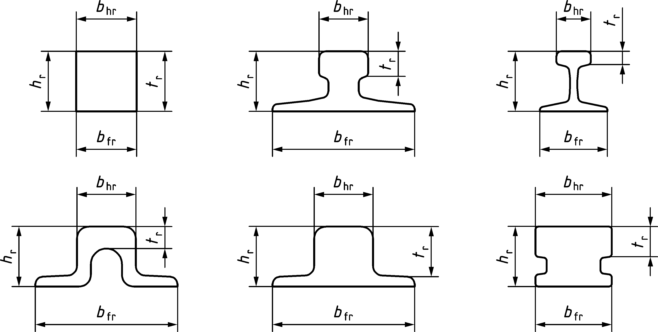

Figure 7.2 — Minimum thickness *t*r below the wearing surface of a crane rail

#### Runway beams for underslung cranes and monorail hoist blocks

(1) A reduction of the nominal thickness for wear of the runway flanges on which the underslung crane or hoist block operates may be omitted, unless otherwise stated by the client. In this case the client should give values for the reduction of the nominal thickness.

## Analysis of crane runway beams

### Global effects

(1) In addition to the global effects of the permanent actions (such as self-weight of runway beam) and non-crane induced variable actions, the following crane-induced internal forces and moments should be taken into account in the design of crane runway beams:

— biaxial bending due to wheel loads and lateral horizontal forces;

— axial compression or tension due to longitudinal horizontal forces and in case of crane runway beams with surge girders also due to lateral horizontal forces;

— torsional moment and warping torsion, if exists, due to the eccentricity *e*z of lateral horizontal forces, relative to the shear centre of the cross-section of the runway beam;

— torsional moment and warping torsion, if exists, due to the eccentricity *e*y of the wheel loads specified in 7.1.2, relative to the shear centre of the cross-section of the runway beam;

— vertical and horizontal shear forces due to wheel loads and lateral horizontal forces.

NOTE The torsional moment and warping torsion, if exists, due to the eccentricity *e*y of the wheel loads can be neglected as a global effect on the crane runway beam unless the National Annex specifies differently.

(2) For open cross sections, the normal and shear stresses due to torsion may be computed by simplified models assuming pure warping torsion and neglecting St.-Venant torsion. For the crane-induced actions, it may be assumed that:

— wheel loads are resisted by the crane runway beam provided there is no vertical load transfer between the crane runway beam and the secondary beam (if exists);

— lateral forces from top-mounted cranes are resisted by the top flange or the surge girder (if exists);

— lateral forces from underslung cranes or monorail hoist blocks are resisted by the bottom flange;

— torsional moments are resisted by couples of forces acting horizontally on the top and bottom flanges.

NOTE The simplified model cannot be applied to crane runway beams that are rigidly connected with their surge girder (including the secondary beam) to a constructional unit. For example, diagonal bracing outside the supports of crane runway beams, as shown in Figure 7.3, does not allow for differential deformations of crane runway beam and surge girder. That causes box-girder like behaviour resulting in unloading of crane runway beam in respect of wheel loads and in overloading of secondary beam and bracing in contrast to the simplified model.

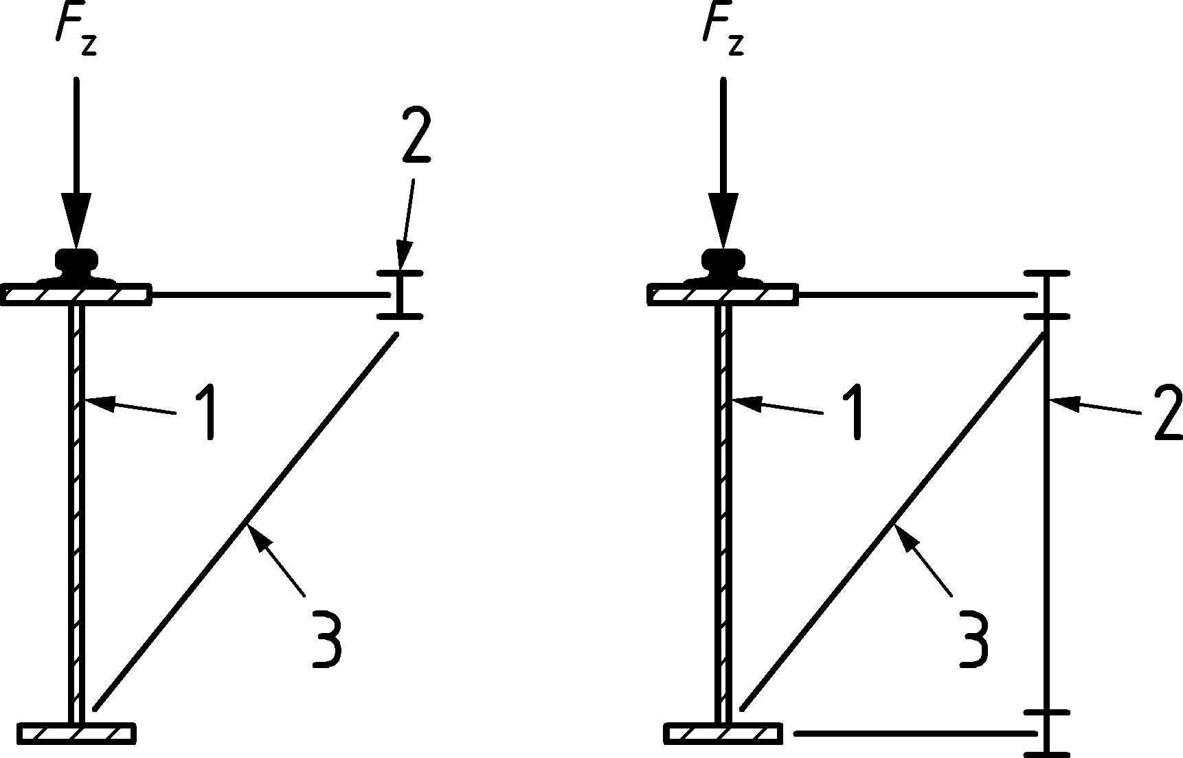

Key

|  |  |
| --- | --- |
| 1 | crane runway beam |
| 2 | secondary beam |
| 3 | diagonal bracing not only at supports |

Figure 7.3 — Examples of crane runway beams with surge girder and box-girder like behaviour

(3) The simplifications of (2) may also be applied in the fatigue design situation.

(4) For box cross-sections with torsion, the simplified model in EN 1993‑1‑1:2022, 8.2.7(4) should not be applied.

### Local effects of wheel loads

(1) In addition to the global effects in 7.5.1, local effects of the wheel loads should be taken into account.

(2) The local effects on webs defined in 7.6 should be taken into account for runway beams of top-mounted cranes.

(3) The local effects on flanges defined in 7.7 should be taken into account for runway beams of underslung cranes and monorail hoist blocks.

## Local stresses in webs due to wheel loads

### General

(1) In the web of a runway beam supporting a top-mounted crane, the following local stresses that are generally generated by the wheel loads on the top flange should be taken into account:

— local vertical compressive stress *σ*oz,Ed, 7.6.2;

— local shear stress *τ*oxz,Ed, 7.6.3;

— local bending stress *σ*T,Ed, 7.6.4.

NOTE The local stresses are accounted for in the limit state verifications as indicated in Table 7.2 (NDP) unless the National Annex specifies differently.

Table 7.2 (NDP) — Recommended consideration of local stresses in webs of runway beams for top-mounted cranes

| **Limit states** | **Consideration on local stresses due to crane load introduction** | | |
| --- | --- | --- | --- |
| **Local compressive stresses** | **Local shear stresses** | **Local bending stresses** |
| *σ*oz,Ed | *τ*oxz,Ed | *σ*T,Ed |
| Ultimate (excluding fatigue), see Clause 8 | yes | no | no |
| Serviceability (stress checks), see 9.4 | yes | no | no |
| Fatigue design situation, see Clause 11 | yes | yes | yes, but only for high and very high fatigue exposure |
| NOTE High and very high fatigue exposure is defined by Table 11.1 (NDP). | | | |

### Local vertical compressive stresses

(1) The maximum value of the local vertical compressive stress *σ*oz,Ed generated at top of the web (assumed at the underside of top flange) by a single wheel load on the top flange, see Figure 7.4, may be determined from:

 (7.1)

where

|  |  |
| --- | --- |
| *F*z,Ed | is the design value of the wheel load; |
| *ℓ*eff | is the effective loaded length; |
| *t*w | is the thickness of the web. |

(2) The effective loaded length *ℓ*eff, over which the local vertical compressive stress *σ*oz,Ed due to a single wheel load is assumed to be uniformly distributed, may be determined using Table 7.3.

(3) For the determination of the effective loaded length *ℓ*eff, crane rail wear in accordance with 7.4.2.1(3) and 7.4.2.1(4) should be taken into account.

(4) If the distance *x*w between the centres of adjacent crane wheels is less than *ℓ*eff, the stresses from the two wheels should be superposed.

|  |  |  |
| --- | --- | --- |
|  | | |
| **(a) Definition of top of the web** | **(b) local stress distribution in longitudinal direction** | **(c) effective loaded length *ℓ*eff** |

Key

|  |  |
| --- | --- |
| 1 | top of the web |

Figure 7.4 — Local stresses under concentric wheel loads at top of the web

(5) The local vertical compressive stress *σ*oz,Ed at other levels in the web may be calculated by assuming a further distribution of the each wheel load at 45° from the effective loaded length *ℓ*eff at the underside of the top flange, see Figure 7.5.

(6) If the total length of dispersion in Figure 7.5, that amounts to *ℓ*eff + 2*z*, exceeds the distance *x*w between adjacent wheels, the stresses from the two wheels should be superposed.

(7) Remote from the supports, the local vertical compressive stress *σ*oz,Ed calculated using this length should be multiplied by the reduction factor [1 − (*z*/*h*w)2] where *h*w is the overall depth of the web and *z* is the distance below the underside of the top flange, see Figure 7.5.

(8) Close to the supports, the local vertical compressive stress due to a similar dispersion of the support reaction should also be determined and the larger value of the stress *σ*oz,Ed adopted.

Table 7.3 — Effective loaded length *ℓ*eff

| **Case** | **Description** | **Effective loaded length** |
| --- | --- | --- |
| (a) | Crane rail rigidly fixed to the top flange | *ℓ*eff = 3,25 [*I*rf / *t*w]1/3 |
| (b) | Crane rail not rigidly fixed to top flange | *ℓ*eff = 3,25 [(*I*r + *I*f,eff)/*t*w]1/3 |
| (c) | Crane rail mounted on a suitable resilient elastomeric bearing pad at least 6 mm thick | *ℓ*eff = 4,25 [(*I*r + *I*f,eff)/*t*w]1/3 |
| *I*f,eff is the moment of inertia, about its horizontal centroidal axis, of the top flange with an effective width of *b*f,eff;  *I*r is the moment of inertia, about its horizontal centroidal axis, of the rail;  *I*rf is the moment of inertia, about its horizontal centroidal axis, of the combined cross-section comprising the rail and the top flange with an effective width of *b*f,eff;  *t*w is the web thickness. | | |
| *b*f,eff = *b*fr + *h*r + *t*f but *b*f,eff ≤ *b*f  where  *b*f is the overall width of the top flange;  *b*fr is the width of the foot of the rail, see Figure 7.1;  *h*r is the height of the rail, see Figure 7.1;  *t*f is the flange thickness. | | |
| NOTE Take into account crane rail wear, see 7.4.2.1(3) and 7.4.2.1(4), in determining *I*r, *I*rf and *h*r. | | |

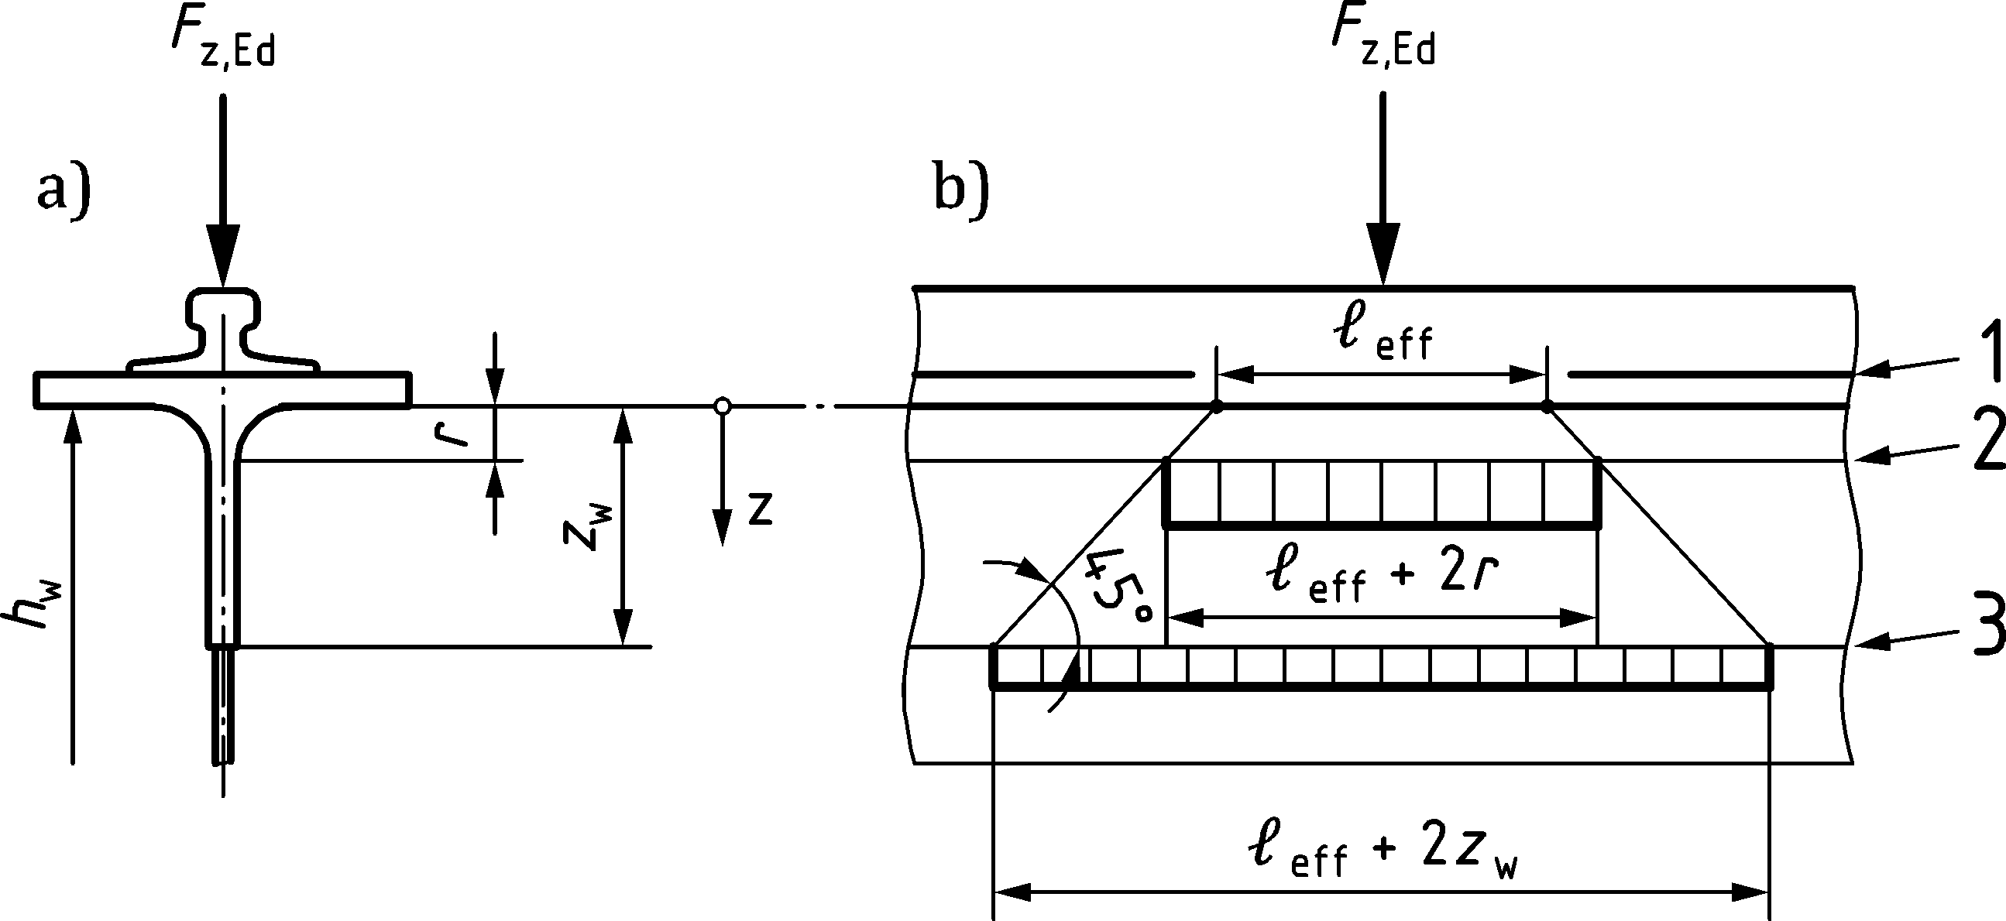

Key

|  |  |
| --- | --- |
| 1 | underside of top flange |
| 2 | root fillet end of T-section |
| 3 | web end of T-section |

NOTE Web height *h*w according to Figure 3.1 of EN 1993‑1‑1:2022.

Figure 7.5 — Local vertical compressive stress *σ*oz,Ed at different levels in the web (examples)

### Local shear stresses

(1) The maximum value of the local shear stress *τ*oxz,Ed due to a wheel load, acting at each side of the wheel load position, may be assumed to be equal to 20 % of the maximum local vertical compressive stress *σ*oz,Ed at the considered level in the web.

(2) The local shear stress *τ*oxz,Ed at any point should be taken as additional to the global shear stress due to the same wheel load, see Figure 7.6.

(3) The additional shear stress *τ*oxz,Ed may be neglected at levels in the web below *z* = 0,2 *h*w, where *h*w and *z* are as defined in 7.6.2(7).

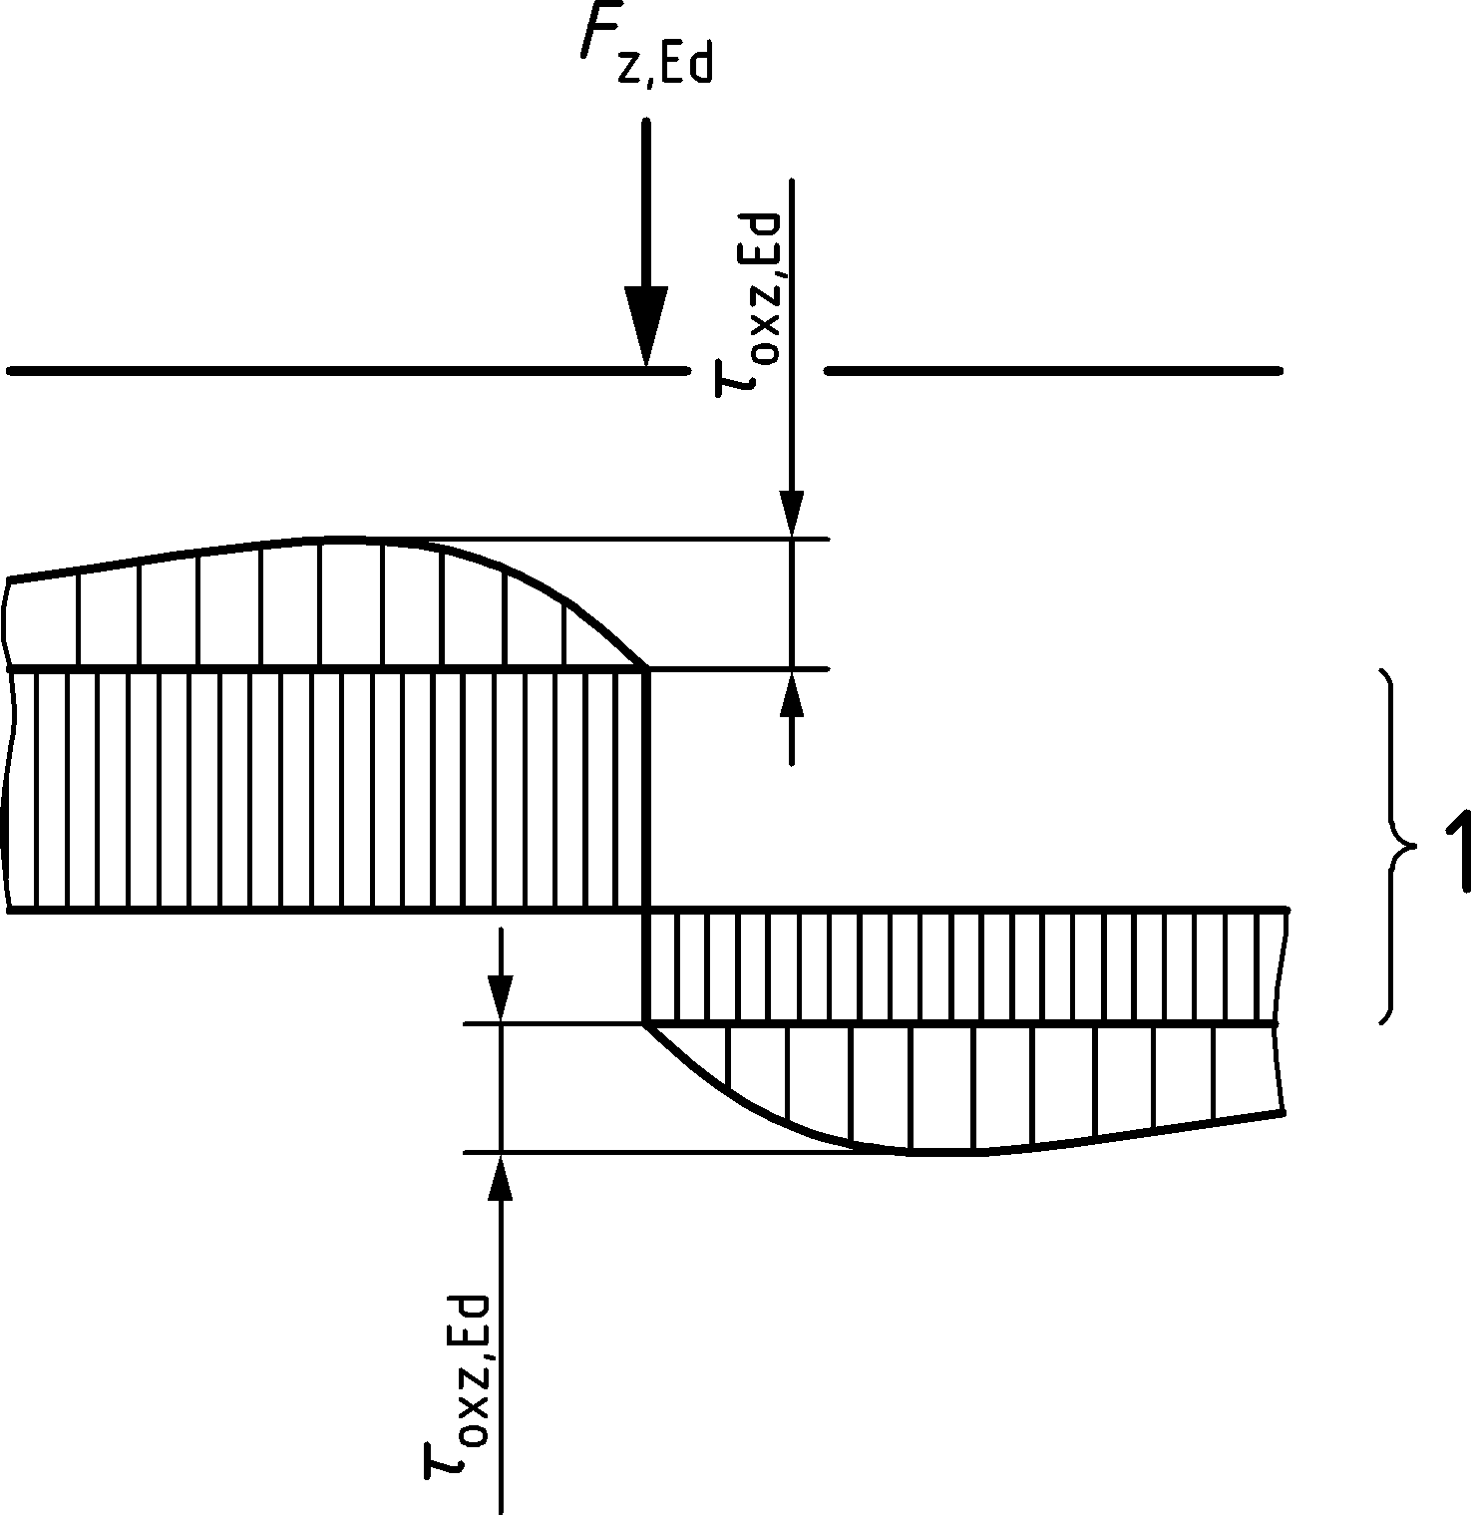

Key

|  |  |
| --- | --- |
| 1 | Distribution of global shear stress *τ*xz,Ed at the considered web level around the wheel load position |

Figure 7.6 — Addition of local and global shear stresses due to a wheel load

### Local bending stresses due to eccentricity of crane-induced actions

(1) The bending stress *σ*T,Ed at the top of a transversely stiffened web of a I-section due to the torsional moment *T*Ed may be determined from:

 (7.2)

with

 (7.3)

where

|  |  |
| --- | --- |
| *a* | is the spacing of the transverse web stiffeners; |
| *h*w | is the overall depth of the web, clear between flanges; |
| *t*w | is the thickness of the web; |
| *I*T | is the torsion constant of the cross-sectional area containing top flange and rail (including the contribution of the composite action only if the rail is rigidly fixed). |

(2) In case of longitudinally stiffened webs, the overall depth of the web *h*w in Formula (7.3) should be replaced by *h*1, see Figure 7.7b and 7.7c, unless a more accurate calculation is performed.

(3) For I-sections with T-section flanges, see Figure 7.5, *t*w may be taken as the thickness of the plated web under the T-section in Formula (7.3). The thickness of the T-section web should be used in Formula (7.2).

NOTE See (7) for stresses at different levels of the web.

|  |  |  |
| --- | --- | --- |
|  |  |  |
| **(a) Torsional moment** | **(b) I-section** | **(c) box section** |

Key

|  |  |
| --- | --- |
| 1 | considered web location under the weld or the transition radius |
| 2 | transverse stiffener |
| 3 | longitudinal stiffener |

Figure 7.7 — Local web bending

(4) The bending stress *σ*T,Ed at the top of a transversely stiffened web of a box section due to the torsional moment *T*Ed may be determined from:

 (7.4)

with:

 (7.5)

 (7.6)

 (7.7)

where

|  |  |
| --- | --- |
| *b*f | is the width of the top flange, clear between webs, see Figure 7.7c; |
| *t*f | is the thickness of the top flange; |
| *I*T,r | is the torsion constant of the rail; |
| *c*T,w | is *c*T according to Formula (7.3), but calculated with *I*T,r instead of *I*T. |

(5) For box sections with a T-section at the section corner under the wheel load, *t*w may be taken as the thickness of the plated web under the T-section in Formulae (7.5) and (7.6). The thickness of the T-section web should be used in Formula (7.4).

NOTE See (7) for stresses at different levels of the web.

(6) The torsional moment *T*Ed applied to the crane runway beam between two transverse stiffeners resulting from:

— lateral eccentricity *e*y of the wheel load *F*z,Ed, see Figure 7.8:

*T*V,Ed = *F*z,Ed *e*y (7.8)

— vertical eccentricity *e*z of the lateral horizontal load *H*y,Ed, see Figure 7.8:

*T*H,Ed = *H*y,Ed *e*z (7.9)

should be obtained from:

*T*Ed = *T*V,Ed + *T*H,Ed (7.10)

where

|  |  |
| --- | --- |
| *e*y | is the eccentricity *e* of the wheel load given in 7.1.2(1), but *e*y ≥ 0,5 *t*w; |
| *t*w | is the thickness of the web; |
| *e*z | is the distance between top of the web and top of the rail. |

NOTE The torsional moment due to the eccentricity of the lateral horizontal force can generally be omitted since local bending stresses of the web are only accounted for in the fatigue design situation when the effect (stress variation) of the horizontal crane actions is usually negligible (see 11.1) unless the National Annex set a different approach.

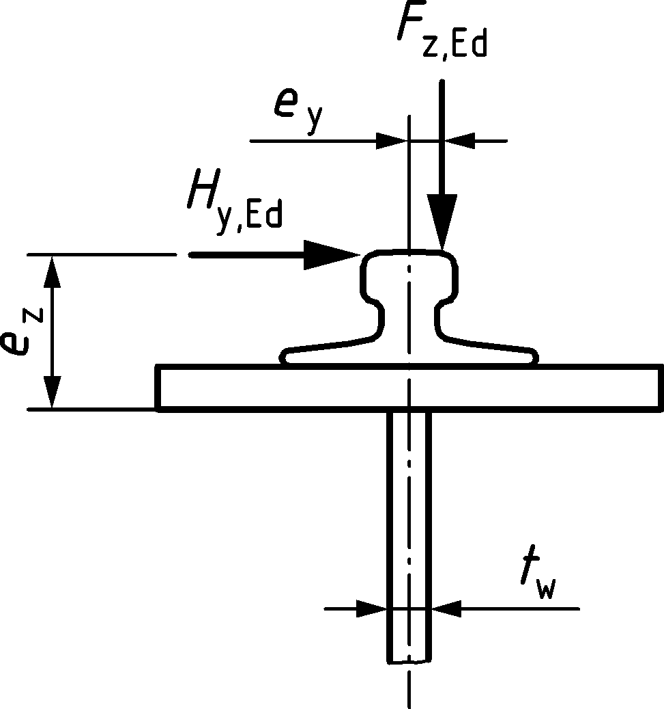

Figure 7.8 — Eccentricity of crane-induced actions

(7) In case of a uniform web, the local bending stress may be considered as linearly decreasing from the top to the bottom of the web.

(8) For levels of the web where the web thickness is reduced in comparison to the top of the web, the stresses may be assumed as in (7) but should then be increased by (*t*w1/*t*w2)2 where *t*w1 is the larger web thickness at the top of web and *t*w2 is the reduced web thickness at the considered level.

(9) For runway beams with hot-rolled I-section satisfying *h*w ≤ 800 mm and *a*/*h*w ≥ 8, Formula (7.2) may be simplified as follows:

 (7.11)

(10) For runway beams with I-section and without any transverse stiffener, the bending stress *σ*T,Ed may be determined from:

 (7.12)

NOTE In contrast to Formula (7.11), this formula considers the unstiffened end of the girder as the critical section. Transverse stiffeners can be required to prevent from lateral torsional buckling or local web buckling for example.

## Local bending stresses in bottom flanges due to wheel loads

### General

(1) In the bottom flange of a runway beam supporting an underslung crane or monorail hoist block, the following local bending stresses should be taken into account that are generally generated by the wheel loads on the bottom flange:

— longitudinal bending stress *σ*ox,Ed ;

— transverse bending stress *σ*oy,Ed.

NOTE The local stresses are accounted for in the limit state verifications as indicated in Table 7.4 (NDP) unless the National Annex specifies differently.

Table 7.4 (NDP) — Recommended consideration of local stresses in bottom flanges of runways for underslung cranes and monorail hoist blocks

| **Limit states** | **Consideration on local stresses due to wheel load introduction** | |
| --- | --- | --- |
| **Longitudinal bending stress** | **Transverse bending stress** |
| *σ*ox,Ed | *σ*oy,Ed |
| Ultimate (excluding fatigue), see Clause 8 | no, see Note to table | no, see Note to table |
| Serviceability (stress checks), see 9.4 | yes | yes |
| Fatigue design situation, see Clause 11 | yes | yes |
| NOTE The ULS verification in 8.5 is based on plastic design. | | |

### Overview about calculation methods

(1) The calculation methods for the bottom flange stresses should account for following aspects:

— plain or reinforced bottom flange;

— wheel loads far away from flange end or at flange end;

— widely or closely spaced wheels.

NOTE Table 7.5 provides an overview of the calculation methods of 7.7.

Table 7.5 — Overview of calculation methods

| **Non-Reinforced bottom flange** | | | | **Reinforced bottom flange** | |
| --- | --- | --- | --- | --- | --- |
| Far away from flange end  *x*e ≥ *b*f | | Flange end  *x*e < *b*f | | Flange end  *x*e < *b*f | |
| Widely spaced wheels  *x*w ≥ 1,15 *b*f | Closely spaced wheels  *x*w < 1,15 *b*f | Widely spaced wheels  *x*w ≥ 1,15 *b*f | Closely spaced wheels  *x*w < 1,15 *b*f | Widely spaced wheels  *x*w ≥ 1,15 *b*f | Closely spaced wheels  *x*w < 1,15 *b*f |
| Formulae (7.12) and (7.13) | Formula (7.16) | Formula (7.15) | Formula (7.15) but applied for wheel load sum | Verification for wheel load at flange end already covered by that for column 1. | Verification for both wheel loads at flange end already covered by that for column 2. |
|  |  |  |  |  |  |
| 1 | 2 | 3 | 4 | 5 | 6 |

### Widely spaced wheels

(1) If the distance *x*w between adjacent wheel loads is not less than 1,15 *b*f, where *b*f is the flange width of the beam, the following method may be used to determine the local bending stresses in the bottom flange of a I-section beam due to wheel loads applied to the bottom flange.

(2) The bending stresses due to wheel loads applied at locations more than *b*f from the end of the beam, where *b*f is the flange width, should be determined at the three locations indicated in Figure 7.9:

— location **⓪**: the web-to-flange transition;

— location **①**: centreline of the wheel load;

— location **②**: outside edge of the flange.

|  |  |
| --- | --- |
|  |  |
| **(a) parallel flange beam** | **(b) taper flange beam** |

Figure 7.9 — Locations for determining stresses due to wheel loads

(3) The local longitudinal bending stress *σ*ox,Ed and transverse bending stress *σ*oy,Ed in the bottom flange due to the application of a wheel load more than *b*f from end of the beam should be obtained from:

*σ*ox,Ed = *c*x*i F*z,Ed/*t*f,12 (7.13)

*σ*oy,Ed = *c*y*i F*z,Ed/*t*f,12 (7.14)

where

|  |  |
| --- | --- |
| *F*z,Ed | is the wheel load; |
| *t*f,1 | is the thickness of the flange at the centreline of the wheel load. |

(4) Generally the coefficients *c*x*i* and *c*y*i* for determining the longitudinal and transverse bending stresses at the three locations ⓪, ① and **②** shown in Figure 7.9 may be determined from Table 7.6 depending on whether the beam has parallel flanges or taper flanges, and the value of the ratio *μ* given by:

*μ* = 2 *n*/(*b*f − *t*w) (7.15)

where

|  |  |
| --- | --- |
| *n* | is the distance from the centreline of the wheel load to the outside edge of the flange; |
| *t*w | is the thickness of the web. |

Table 7.6 — Coefficients *c*x*i* and *c*y*i* for calculating stresses at points *i* = 0, 1 and 2

| **Stress** | **Parallel flange beams** | **Taper flange beams** (see Note) |
| --- | --- | --- |
| Longitudinal bending stress *σ*ox,Ed | *c*x0 = 0,050 − 0,580 𝜇 + 0,148e3,015 𝜇 | *c*x0 = −0,981 − 1,479 𝜇 + 1,120e1,322 𝜇 |
| *c*x1 = 2,230 − 1,490 𝜇 + 1,390e−18,33 𝜇 | *c*x1 = 1,810 − 1,150 𝜇 + 1,060e−7,700 𝜇 |
| *c*x2 = 0,730 − 1,580 𝜇 + 2,910e−6,000 𝜇 | *c*x2 = 1,990 − 2,810 𝜇 + 0,840e−4,690 𝜇 |
| Transverse bending stress *σ*oy,Ed | *c*y0 = −2,110 + 1,977 *μ* + 0,0076e6,530 𝜇 | *c*y0 = −1,096 + 1,095 𝜇 + 0,192e−6,000 𝜇 |
| *c*y1 = 10,108 − 7,408 𝜇 − 10,108e−1,364 𝜇 | *c*y1 = 3,965 − 4,835 𝜇 − 3,965e−2,675 𝜇 |
| *c*y2 = 0 | *c*y2 = 0 |
| **Sign convention**: *c*x*i* and *c*y*i* are positive for tensile stresses at the bottom face of the flange. | | |
| NOTE The coefficients for taper flange beams are for a slope of 14 % or 8°. They are conservative for beams with a larger flange slope. For beams with a smaller flange slope, it is conservative to adopt the coefficients for parallel flange beams. Alternatively, linear interpolation may be used. | | |

(5) In the absence of more accurate information, the local bending stress *σ*oy,end,Ed in an unstiffened bottom flange due to the application of a wheel load at a perpendicular end of the beam should be determined from:

*σ*oy,end,Ed = (5,6 − 3,225 *μ* − 2,8 *μ*3) *F*z,Ed/*t*f,m2 (7.16)

where

|  |  |
| --- | --- |
| *t*f,m | is the mean thickness of the flange. |

(6) Alternatively, if the bottom flange is reinforced at the end by welding on a plate of similar thickness extending across its width *b*f and for a distance of at least *b*f along the beam, see Figure 7.10, the local bending stress *σ*oy,end,Ed may be assumed not to exceed *σ*ox,Ed and *σ*oy,Ed from (3).

NOTE In case of reinforced flange ends, the bottom flange stresses far away from these ends are decisive.

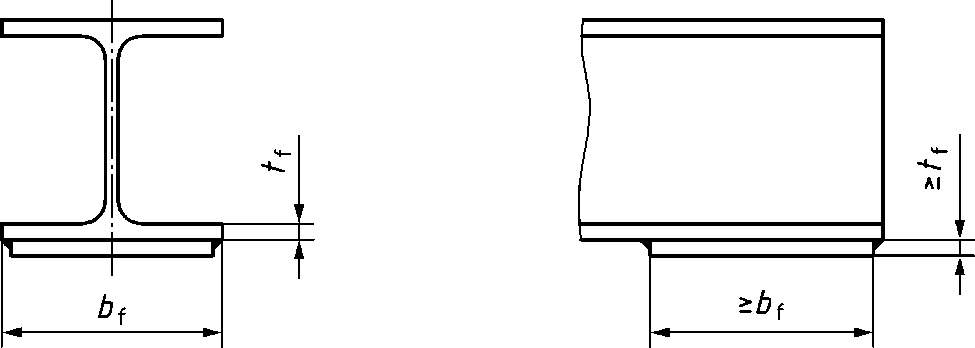

Figure 7.10 — Optional reinforcement at the end of the bottom flange

### Closely spaced wheels

(1) If the distance *x*w between adjacent wheel loads is less than 1,15 *b*f, where *b*f is the flange width of the beam, a conservative approach may be adopted by superimposing the stresses calculated for each wheel load acting separately according to 7.7.3, unless the procedure presented in (2) is followed to determine the local stresses.

(2) Where the longitudinal wheel spacing *x*w is less than 1,15 *b*f, the local bending stresses due to the combined effect of two wheel loads may be estimated from:

*σ*o2,i = *c*1 *c*2 *σ*o1,i but *σ*o2,i ≥ *σ*o1,i (7.17)

with

*c*2 = 2 − 1,1 (*x*w/*b*f) + 0,2 (*x*w/*b*f)2 but *c*2 ≥ 1,0

if *x*w ˂ 0,75 *b*f: *c*1 = 1 − 0,2 (*x*w/*b*f) *μ*

if *x*w ≥ 0,75 *b*f: *c*1 = 1 − 0,15 *μ*

where

|  |  |
| --- | --- |
| *μ* | is as defined in 7.7.3(4); |
| *σ*o1,i | is the local bending stress *σ*ox,Ed or *σ*oy,Ed due to one wheel load; |
| *σ*o2,i | is the local bending stress *σ*ox,Ed or *σ*oy,Ed due to two wheel loads. |

(3) In the absence of more accurate information, the local bending stress *σ*oy,end,Ed in an unstiffened bottom flange due to the application of two closely spaced equal wheel loads at a perpendicular end of the beam should be obtained from Formula (7.16) if *F*z,Ed is replaced by the sum of wheel loads.

## Local stresses in rail welds due to wheel loads

### Ultimate limit state (except for fatigue)

(1) The following local stresses should be considered for the ultimate limit state verification according to the directional method of EN 1993‑1‑8.

(2) If weld failure of the rail welds is verified in the fatigue design situation taking into account the local stresses defined in 7.8.2, an additional verification at the ultimate limit state may be neglected.

(3) The local stresses generated in continuous rail welds (double fillet weld) by a wheel load *F*z,Ed on the rail, see Figure 7.11, should be calculated neglecting contact between rail and flange and may be determined from:

 (7.18)

where

|  |  |
| --- | --- |
| *a* | is the throat thickness of the single fillet weld; |
| *ℓ*eff,r | is the effective loaded length at the bottom of the rail relevant for ultimate limit state. |

NOTE Wheel load eccentricity is generally not considered at the ultimate limit states (except for fatigue design).

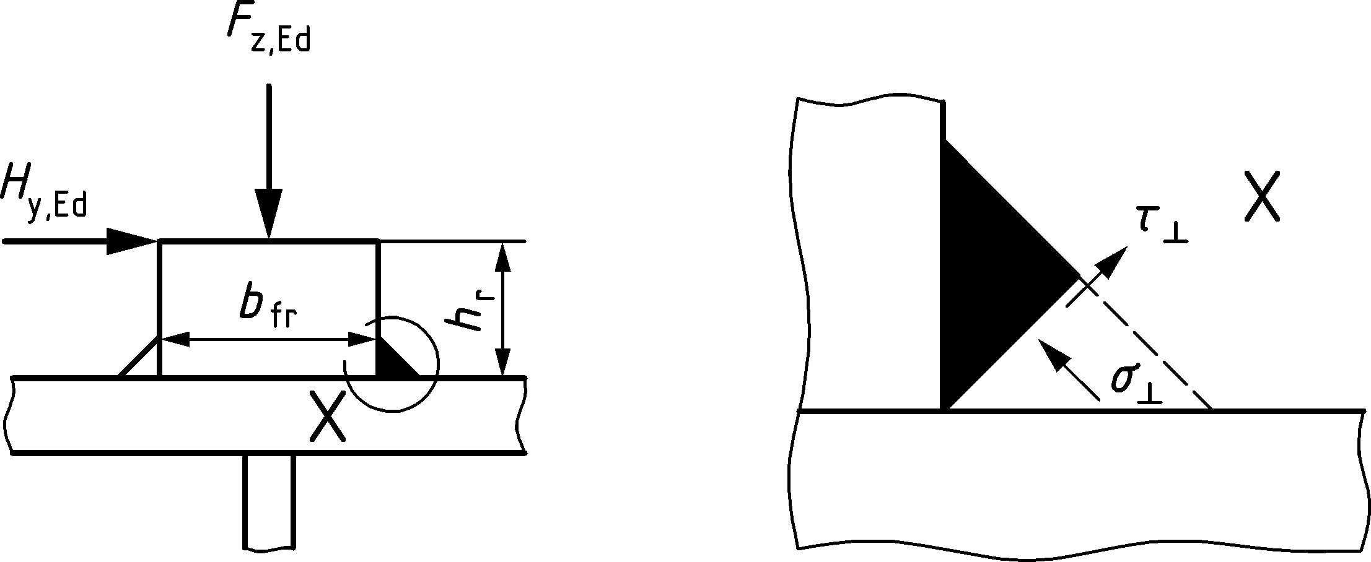

Figure 7.11 — Local stresses of rail welds for the directional method of EN 1993‑1‑8

(4) The local stresses generated in continuous rail welds (double fillet weld) by a horizontal lateral force *H*y,Ed acting at the top of the rail, see Figure 7.11, may be determined from:

 (7.19)

 (7.20)

NOTE The weld denoted with ‘A’ becomes decisive in Figure 7.11.

where

|  |  |
| --- | --- |
| *a* | is the throat thickness of the single fillet weld; |
| *h*r | is the nominal height of rail; |
| *b*fr | is the width of rail; |
| *ℓ*eff,r | is the effective loaded length relevant for ultimate limit state, see Formula (7.18). |

NOTE The effective loaded length in the first term of Formula (7.19) and (7.20) is safe-sided.

(5) The effective loaded length *ℓ*eff,r may be determined from:

 (7.21)

where

|  |  |  |
| --- | --- | --- |
| *h*r | is the nominal height of rail; | |
| Δℓ | is 20 mm | for 5 ≤ *t*w ≤ 10 mm; |
|  | is 10 mm | for 10 < *t*w ≤ 15 mm; |
|  | is 0 mm | for 15 < *t*w ≤ 20 mm. |

NOTE Formula (7.21) implicitly accounts for 25 % crane rail wear.

(6) If particular efforts on fabrication and control are made to ensure contact bearing of rail and top flange, local stresses generated in intermittent rail welds by wheel loads *F*z,Ed on the rail may be neglected for the rail configurations in Figure 7.12.

NOTE Particular efforts on fabrication and control comprise the check of contact between rail and top flange after fabrication.

(7) The local stresses generated in intermittent rail welds by a horizontal lateral force *H*y,Ed acting on top of the rail, see Figure 7.11, may be determined from:

 (7.22)

 (7.23)

where

|  |  |
| --- | --- |
| *a* | is the throat thickness of the single fillet weld; |
| ℓw | is the weld length, but not shorter than *ℓ*eff,r according to Formula (7.21); |
| *n*w | is the number of welds (1 for staggered, 2 for chain intermittent rail welds). |

|  |  |
| --- | --- |
|  |  |
| **(a) chain intermittent rails welds with**  **50 ≤ ℓw ≤ 100 mm**  **3 ≤ *g*/ℓw ≤ 5**  ***a* ≥ 4 mm** | **(b) staggered intermittent rail welds with**  **100 ≤ ℓw ≤ 200 mm**  **2 ≤ *g*/ℓw ≤ 4**  ***a* ≥ 5 mm** |

Figure 7.12 —Configurations of intermittent rail welds for which 7.8.1(6) applies

### Fatigue design situation

(1) The following local stresses should be considered for the verification of the fatigue design situation according to the nominal stress method of EN 1993‑1‑9.

— local vertical compressive stress *σ*oz,Ed, 7.8.2(2);

— local shear stress *τ*oxz,Ed, 7.8.2(5).

(2) The local vertical compressive stress *σ*oz,Ed generated in continuous rail welds (double fillet weld) by a wheel load *F*z,Ed on the rail may be determined from:

 (7.24)

where

|  |  |
| --- | --- |
| *a* | is the throat thickness of the weld; |
| *ℓ*eff,fat | is the effective loaded length relevant for the fatigue design situation. |

(3) The effective loaded length *ℓ*eff,fat, over which the local vertical compressive stress *σ*oz,Ed due to a single wheel load is assumed to be uniformly distributed, may be determined using Tables 7.7 and 7.8 for commonly used hot-rolled I sections.

NOTE For other cross sections, the effective loaded lengths *ℓ*eff,fat can be determined by “Euler, M.; Kuhlmann, U.: Aufgeschweißte Flach- und Vierkantschienen von Kranbahnträgern. Ermüdungsnachweis für Schweißnähte zur Schienenbefestigung”.

(4) For the determination of the effective loaded length *ℓ*eff,fat, crane rail wear in accordance with 7.4.2.1(4) should be taken into account.

NOTE Tables 7.7 and 7.8 account for a reduction of 12,5 % of the nominal thickness *t*r due to wear that is relevant for the fatigue design situation according to 7.4.2.1(4).

Table 7.7 — Effective loaded length *ℓ*eff,fat of continuous crane rail welds for hot-rolled I-section series HEB

| **Profile** | **Width/height of rectangular rail in mm** | | | | | | | |
| --- | --- | --- | --- | --- | --- | --- | --- | --- |
| **50/30** | **50/40** | **50/50** | **60/30** | **60/40** | **60/50** | **60/60** | **70/50** |
| HEB 200 | 67 | 89 | 113 | 70 | 94 | 120 | 146 | 126 |
| HEB 220 | 66 | 88 | 111 | 69 | 93 | 118 | 143 | 124 |
| HEB 240 | 64 | 86 | 108 | 68 | 90 | 114 | 139 | 120 |
| HEB 260 | 63 | 84 | 106 | 67 | 89 | 112 | 136 | 118 |
| HEB 280 | 63 | 84 | 105 | 66 | 88 | 111 | 135 | 117 |
| HEB 300 | 62 | 82 | 103 | 65 | 86 | 108 | 131 | 114 |
| HEB 320 | 62 | 81 | 101 | 65 | 85 | 107 | 129 | 112 |
| HEB 340 | 61 | 80 | 100 | 64 | 85 | 106 | 128 | 111 |
| HEB 360 | 61 | 80 | 99 | 64 | 84 | 105 | 126 | 110 |
| HEB 400 | 60 | 79 | 98 | 63 | 83 | 103 | 124 | 108 |
| HEB 450 | 60 | 78 | 97 | 63 | 82 | 102 | 123 | 107 |
| HEB 500 | 60 | 78 | 96 | 63 | 81 | 101 | 121 | 105 |
| HEB 550 | 60 | 77 | 95 | 62 | 81 | 100 | 120 | 105 |
| HEB 600 | 59 | 77 | 95 | 62 | 81 | 100 | 119 | 104 |
| HEB 650 | 59 | 77 | 94 | 62 | 80 | 99 | 118 | 103 |
| HEB 700 | 59 | 76 | 94 | 62 | 80 | 98 | 117 | 102 |
| HEB 800 | 59 | 76 | 93 | 61 | 79 | 97 | 116 | 101 |
| HEB 900 | 59 | 75 | 92 | 61 | 79 | 96 | 115 | 100 |
| HEB 1000 | 58 | 75 | 92 | 61 | 78 | 96 | 114 | 100 |

Table 7.8 — Effective loaded length *ℓ*eff,fat of continuous crane rail welds for hot-rolled I-section series HEA

| **Profile** | **Width/height of rectangular rail in mm** | | | | | | | |
| --- | --- | --- | --- | --- | --- | --- | --- | --- |
| **50/30** | **50/40** | **50/50** | **60/30** | **60/40** | **60/50** | **60/60** | **70/50** |
| HEA 200 | 72 | 98 | 126 | 76 | 105 | 134 | 164 | 141 |
| HEA 220 | 71 | 96 | 123 | 75 | 102 | 130 | 160 | 137 |
| HEA 240 | 68 | 92 | 118 | 72 | 98 | 125 | 153 | 132 |
| HEA 260 | 67 | 90 | 115 | 71 | 96 | 122 | 150 | 129 |
| HEA 280 | 66 | 89 | 113 | 70 | 94 | 120 | 147 | 127 |
| HEA 300 | 65 | 86 | 110 | 68 | 91 | 116 | 142 | 122 |
| HEA 320 | 64 | 85 | 108 | 67 | 90 | 114 | 139 | 120 |
| HEA 340 | 63 | 84 | 106 | 67 | 89 | 112 | 137 | 118 |
| HEA 360 | 63 | 83 | 105 | 66 | 88 | 111 | 135 | 116 |
| HEA 400 | 62 | 82 | 103 | 65 | 86 | 108 | 131 | 114 |
| HEA 450 | 61 | 81 | 101 | 65 | 85 | 107 | 129 | 112 |
| HEA 500 | 61 | 80 | 100 | 64 | 84 | 105 | 127 | 110 |
| HEA 550 | 61 | 79 | 99 | 64 | 83 | 104 | 126 | 109 |
| HEA 600 | 60 | 79 | 98 | 63 | 83 | 103 | 124 | 108 |
| HEA 650 | 60 | 78 | 97 | 63 | 82 | 102 | 123 | 107 |
| HEA 700 | 60 | 78 | 96 | 63 | 82 | 101 | 122 | 106 |
| HEA 800 | 59 | 77 | 95 | 62 | 80 | 99 | 119 | 104 |
| HEA 900 | 59 | 76 | 94 | 62 | 80 | 99 | 118 | 103 |
| HEA 1000 | 59 | 76 | 94 | 62 | 80 | 98 | 117 | 102 |

(5) The maximum value of the local shear stress *τ*oxz,Ed due to a wheel load, acting at each side of the wheel load position, may be assumed to be equal to 20 % of the maximum local vertical compressive stress *σ*oz,Ed.

(6) The local shear stress *τ*oxz,Ed should be taken as additional to the global shear stress in the rail welds due to the same wheel load.

NOTE Compare addition of global and local shear stresses in Figure 7.6.

(7) The local vertical compressive stress *σ*oz,Ed by a wheel load *F*z,Ed generated in chain intermittent rail welds (double fillet welds) according to Figure 7.12a with 𝑙w = 50 mm may be determined from Formula (7.25).

 (7.25)

where

|  |  |
| --- | --- |
| *b*fr | is the width of rail; |
| *h*r | is the nominal height of rail. |

# Ultimate limit states

## Consideration of local effects of crane-induced actions

(1) For local stresses in webs, including connections like the flange-to-web connection, of runway beams for top-mounted cranes that should be accounted for, see Table 7.2 (NDP) in 7.6.1.

(2) For local stresses in bottom flanges, including connections like the flange-to-web connection, of runway beams for underslung cranes or monorail hoist blocks that should be accounted for, see Table 7.4 (NDP) in 7.7.1.

## Lateral-torsional buckling

### General

(1) In checking the lateral-torsional buckling resistance of a runway beam, the torsional moments due to the relevant eccentricities of vertical actions and lateral horizontal actions relative to the shear centre should be taken into account.

NOTE The relevant eccentricities are mentioned in 7.1.2 and 7.3(2).

(2) Following runway beams should be treated as mono-symmetric, welded sections in terms of lateral torsional buckling according to EN 1993‑1‑1:

— mono-symmetric hot-rolled runway beam with a rail welded to the top flange,

— mono-symmetric hot-rolled runway beam with angular sections to the top flange,

— mono-symmetric welded runway beam with web thickness transition.

### Effective level of application of wheel loads

(1) In the case of wheel loads from a monorail hoist block or an underslung crane, the stabilizing effect of applying the loads to the bottom flange may be taken into account.

(2) In the absence of a more precise analysis the vertical reaction should not be taken as being effectively applied below the level of the top surface of the bottom flange.

### Verification methods

(1) For member buckling verification, the methods in EN 1993‑1‑1:2022, 8.3 may be applied.

(2) The lateral torsional buckling resistance of a simply supported single span member with end fork conditions and with mono-symmetric or doubly symmetric I- and H-section may be verified by checking the isolated compression flange with following simplification of Formula (8.89) in EN 1993‑1‑1:2022:

 (8.1)

with

 (mono-symmetric I-section)

 (doubly symmetric I- or H-section)

where

|  |  |  |
| --- | --- | --- |
| *N*cf,Ed | is the normal force acting on the compression flange; | |
| *A*cf | is the cross-sectional area of the compression flange, see Figure 8.1a; | |
| *A*tf | is the cross-sectional area of the tension flange; | |
| *S*y,cf | is the first moment of area of the compression flange with respect to the centroid of the full cross section; | |
| *S*y,tf | is the first moment of area of the tension flange with respect to the centroid of the full cross section; | |
| *h*f | is the distance of the flange centroids; | |
| *W*z,cf | is the section modulus of the compression flange about the minor axis of the full cross section; | |
|  | *W*z,cf = *W*pl,z | for classes 1 and 2; |
|  | *W*z,cf = *W*el,z | for class 3; |
| *χ*c,z | is buckling reduction factor, see (3); | |
| *k*zz | is the interaction factor, see (4). | |

NOTE The bending moment *M*z,Ed about the minor axis is exclusively attributed to the flange by Formula (8.1) to account for the torsional moment effect caused by horizontal forces acting on top of rail with an eccentricity to the centroid of the crane runway beam cross section.

|  |  |
| --- | --- |
|  |  |
| **(a) Compression flange within full cross-section** | **(b) Equivalent compression flange according to EN 1993‑1‑1:2022, Formula (8.89)** |

Key

|  |  |
| --- | --- |
| 1 | portion of web depending on load application point |

Figure 8.1 — Compression flange to be considered

(3) The buckling reduction factor *χ*c,z in Formula (8.1) should be calculated for the equivalent compression flange according to 8.3.2.4 of EN 1993‑1‑1:2022, see Figure 8.1b. For determining the buckling factor, *β*c and *k*c should be set to 1 for *n*z > 0.3.

NOTE The ratio *n*z is calculated for the full cross-section. It is safe sided to set *β*c and *k*c to 1.

(4) The interaction factor *k*zz in Formula (8.1) should be calculated according to EN 1993‑1‑1:2022, Table 8.8. It may be set to 1.

## Resistance of webs to wheel loads

### General

(1) The web of a crane runway beam subjected to wheel loads from a top-mounted crane should be checked for resistance to transverse forces.

NOTE 7.5.1 specifies the global effects and Table 7.2 the local effects of the wheel load to be taken into account for this check.

(2) The resistance of the web of a rolled or welded section to a transverse force applied through a flange should be determined using Clause 8 of FprEN 1993‑1‑5:2023.

(3) The interaction of transverse forces with moments and axial force should be verified according to 9.2 in FprEN 1993‑1‑5:2023.

### Length of stiff bearing

(1) The length of stiff bearing *s*s on the upper surface of the top flange, due to a wheel load applied through a rail, to be used in 8.5 of FprEN 1993‑1‑5:2023, may be obtained by using:

*s*s = ℓeff − 2 *t*f (8.2)

where

|  |  |
| --- | --- |
| ℓeff | is the effective loaded length at the underside of the top flange, from Table 7.3; |
| *t*f | is the thickness of the top flange. |

## Buckling of plates

(1) For buckling of plates in a welded section, the rules in EN 1993‑1‑5 should be applied.

(2) For stiffeners in stiffened plates loaded in compression which receive additional bending moments from loads transverse to the plane of the stiffened plate, the stability may be verified according to 8.3.3 of EN 1993‑1‑1:2022.

## Resistance of bottom flanges to wheel loads

(1) The bottom flange of a runway beam subject to a pair of equal wheel loads *F*z,Ed from an underslung crane or monorail hoist block should be checked with:

 (8.3)

where

|  |  |
| --- | --- |
| *F*z,Ed | is the single wheel load acting on one side of the bottom flange, see Figure 8.2; |
| *F*f,Rd | is the design resistance of a bottom flange side when the bottom flange is subject to equal wheel loads on both flange sides. |

(2) The design resistance *F*f,Rd of the bottom flange side of a runway beam to a wheel load *F*z,Ed from an underslung crane or hoist block, see Figure 8.2, should be determined from:

 (8.4)

where

|  |  |
| --- | --- |
| *ℓ*f,eff | is the effective length of flange resisting the wheel load, see (4); |
| *m* | is the lever arm from the wheel load to the root of the flange, see (3); |
| *t*f | is the flange thickness; |
| *σ*f,Ed | is the longitudinal normal stress at the midline of the flange due to the overall internal moment in the beam. |

(3) The lever arm *m* from the wheel load to the root of the flange should be determined as follows, see Figure 8.2d and Figure 8.2e:

— for a rolled section:

*m* = 0,5 (*b*f − *t*w) − 0,8 *r* − *n* (8.5)

— for a welded section:

*m* = 0,5 (*b*f − *t*w) − 0,8 *a* − *n* (8.6)

where

|  |  |
| --- | --- |
| *a* | is the throat size of a fillet weld; |
| *b*f | is the flange width; |
| *n* | is the distance from the centreline of the wheel load to the outside edge of the flange; |
| *r* | is the root radius; |
| *t*w | is the web thickness. |

(4) The effective length of flange ℓf,eff resisting one wheel load should be determined from Table 8.2.

(5) In addition, a serviceability limit state stress check, see 9.4, should be carried out.

Table 8.2 — Effective length ℓf,eff

| **Case** | **Wheel position** | ℓf,eff | |
| --- | --- | --- | --- |
| (a) | Wheel adjacent to a non-reinforced simple joint, see Figure 8.2a |  | |
| (b) | Wheel remote from the end of a member, see Figure 8.2b |  | for |
|  | for |
| (c) | Wheel adjacent to an end stop at a distance from the end of the member, see Figure 8.2c | for | but |
| for |  |
| (d) | Wheel adjacent to an end that is fully supported either from below, see Figure 8.3a, or by a welded closer plate, see Figure 8.3b, at a distance from the end of the member |  | |
|  | |
| where  *x*e is the distance from the end of member to the centreline of the wheel;  *x*w is the wheel spacing. | | | |

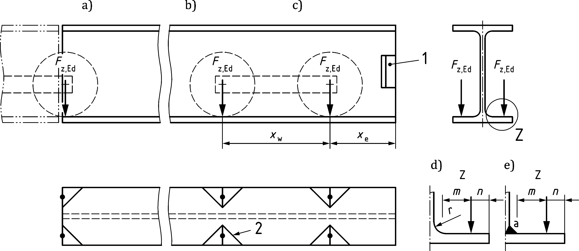

Key

|  |  |
| --- | --- |
| 1 | end stop |
| 2 | yield line pattern |
| a) | at a non-reinforced joint – case a; |
| b) | remote from member end – case b; |
| c) | adjacent to an end stop – case c; |
| d) | rolled section; |
| e) | welded section |

Figure 8.2 — Bottom flange bending by wheel loads with respect to Table 8.2

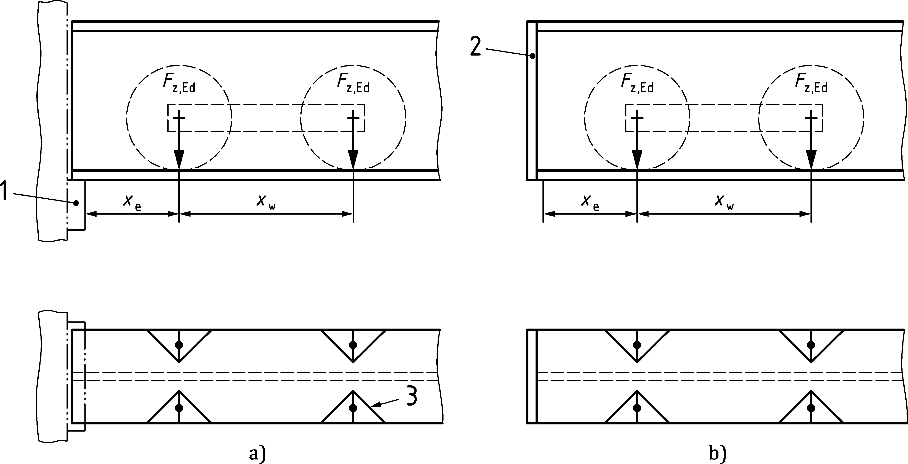

Key

|  |  |
| --- | --- |
| 1 | seat |
| 2 | closer plate |
| 3 | yield line pattern |
| a) | supported from below |
| b) | welded closer plate |

Figure 8.3 — Bending of bottom flange at fully supported ends

# Serviceability limit states

## General

(1) Following relevant serviceability limit state criteria should be satisfied:

a) deformations and displacements according to Table 9.1, see 9.2:

Table 9.1 — Serviceability limit state criteria on deformations

| **Criterion** | **Goal** | **Table** |
| --- | --- | --- |
| Vertical **deflection** of crane runway beams | Avoid excessive vibrations caused by crane operations; avoid excessive slope of crane runway beams to reduce differences in elevation during crane travel | 9.2, line a |
| Differential vertical **deflection** of crane runway beams supporting the same crane | Avoid excessive slope of crane bridge to reduce differences in elevation during trolley travel | 9.2, line b |
| Vertical **deflection** of runway beams for monorail hoist blocks | Reduce differences in elevation during travel of hoist block | 9.2, line c |
| Horizontal **deflection** of crane runway beams | Reduce skewing of the crane at midspan of crane runways | 9.3, line a |
| Lateral **displacement** of crane runway supporting structure (such as columns or frames) at crane support level | Avoid excessive transversal oscillation of crane runway supporting structure by lifting and releasing loads | 9.3, line b |
| Differential lateral **displacement** of adjacent crane runway supporting structures (such as columns or frames) at crane support level | Reduce skewing of the crane at the end supports of adjacent crane runway supporting structures;  avoid abrupt changes in horizontal alignment of crane rails | 9.3, line c and 9.3, line d |
| Lateral **deformation** dependent change in spacing of crane runway beams supporting the same crane | Avoid excessive wear to wheel flanges, rail fixings or crane structures | 9.3, line e |

b) plate slenderness, in order to exclude visible buckling or breathing of web plates, see 9.3;

c) stresses, in order to ensure elastic behaviour, see 9.4, for example:

— where wheels are supported directly on the bottom flange of a runway beam, see 8.5(5);

— under crane test loading, see 4.1.5;

— where plastic global analysis is used for the ultimate limit state verification, see 7.4.1.

(2) For local stresses in webs, including connections like the flange-to-web connection, of runway beams for top-mounted cranes that should be accounted for, see Table 7.2 in 7.6.1.

(3) For local stresses in bottom flanges, including connections like the flange-to-web connection, of runway beams for underslung cranes or monorail hoist blocks that should be accounted for, see Table 7.4 in 7.7.1.

## Deformations

(1) Deformation limits should be as specified by the relevant authority or, where not specified, agreed for a specific project by the relevant parties.

NOTE Table 9.2 (NDP) and Table 9.3 (NDP) contain indicative deformation limits under specified actions or combinations of actions without any dynamic factors unless the National Annex specifies differently.

Table 9.2 (NDP) — Indicative limiting values of vertical deformation

| **Description of deformation criterion** | | **Diagram** |
| --- | --- | --- |
| a) Vertical deflection *w*z of a crane runway beam, where *w*z is taken as the total deformation, *w*max, less the possible pre-camber, *w*c: | |  |
| *w*z ≤ *L*z / 600  and  *w*c ≤ *L*z / 600  and  *w*max ≤ 25 mm | due to vertical loads |
| b) Difference ∆*h*c between the vertical deflection of crane runway beams supporting the same crane: | |  |
| ∆*h*c ≤ *s* / 600 | due to vertical loads |
| c) Vertical deflection *w*z,pay of a runway beam for a monorail hoist block | | see under a) |
| *w*z,pay ≤ *L*z / 500 | due to the payload |

Table 9.3 (NDP) — Indicative limiting values of horizontal deformations

| **Description of deformation criterion** | | | **Diagram** | | |
| --- | --- | --- | --- | --- | --- |
| a) Horizontal deflection *w*y of a runway beam, measured at the level of the top of the crane rail (Note i) | | |  | | |
| *w*y ≤ *L*y/600 | due to crane-induced actions | |
| b) Lateral displacement *u*y of a crane runway supporting structure (such as frame or column) at crane support level, depending on the stiffness class (HC) | | |  | | *h*C is the member height of crane runway supporting structure from the floor level to the level at which the crane is supported (on a rail or on a flange) |
| *u*y ≤ *h*C/250 for HC 1  *u*y ≤ *h*C/300 for HC 2  *u*y ≤ *h*C/350 for HC 3  *u*y ≤ *h*C/400 for HC 4 | | due to lateral crane-induced forces |
| Difference ∆*u*y between the horizontal displacements of adjacent crane runway supporting structures (such as frames or columns):  c) for indoor crane runways: | | |  | | |
| ∆*u*y ≤ *L*y / 600 | due to lateral crane-induced forces | |
| d) for outdoor crane runways: | | |
| ∆*u*y ≤ *L*y/600 | due to group of loads comprising lateral crane-induced forces and in-service wind load according to EN 1991‑3 | |
| ∆*u*y ≤ *L*y/400 | due to the out-of-service wind load | |
| e) Change of spacing ∆*s* between the centres of crane rails caused by deformation of runway supporting structure | | |  | | |
| ∆*s* ≤ 10 mm  see Note iii | due to frequent combination of vertical crane-induced forces (see Note ii) and non-crane-induced actions including the effects of thermal changes | |
| NOTE 1 This criterion can also be considered for the horizontal deflection of the bottom flange in order to limit the rotation (distortion) of the runway beam.  NOTE 2 Lateral crane-induced forces (crane surge) occur randomly and, therefore, they are only accounted for in cases when the crane or trolley regularly accelerates and brakes in a certain part of the runway as specified by the client. | | | | | |
| NOTE 3 Horizontal deflections and deviations of crane runways are considered together in crane design. Acceptable deflections and tolerances depend on the details and clearances in the guide means. Provided that the clearance *c* between the crane wheel flanges and the crane rail (or between the alternative guide means and the crane beam) is also sufficient to accommodate the necessary tolerances, larger or smaller deflection limits can be specified for each project if agreed with the crane supplier and the client. | | | |  | |

## Limitation of web breathing

(1) The slenderness of web plates should be limited to avoid excessive breathing that might result in fatigue at, or adjacent to, the web-to-flange connections.

NOTE Web plates can be subdivided into web panels through transverse and longitudinal stiffeners.

(2) Excessive web breathing may be neglected in web panels where the following criterion is satisfied under the frequent load combination, see 8.4.3.3 in EN 1990:2023:

 (9.1)

where

|  |  |
| --- | --- |
| *σ*x,Ed,ser, *τ*Ed,ser | are the stresses in the web panel; |
| *σ*cr,p and *τ*cr | are the critical buckling stresses of the web panel according to EN 1993‑1‑5. |

(3) If relevant, *σ*cr,p should take the column type buckling behaviour of the web panel into account.

(4) If the stresses are not uniform along the length *a* of the web panel, FprEN 1993‑1‑5:2023, 6.7(4) should be considered.

(5) The stress *σ*x,Ed,ser should be taken as the stress at the compressive edge of the web panel being checked.

(6) For panels wholly in tension, *σ*x,Ed,ser/*σ*cr,p may be taken equal to zero.

(7) Excessive web breathing may be neglected in web plates without longitudinal stiffeners, in which the ratio *b*/*t*w is less than 120, where *t*w is the web thickness.

## Elastic behaviour of runway beams

(1) To ensure elastic behaviour, the stresses *σ*Ed,ser and *τ*Ed,ser resulting from the relevant characteristic load combination or test load combination including the dynamic factors, calculated making due allowance where relevant for the effects of shear lag in wide flanges and for the secondary effects induced by deformations (for instance secondary moments in trusses) should be limited as follows:

*σ*Ed,ser ≤ *f*y/*γ*M,ser (9.2)

 (9.3)

*σ*eq,Ed,ser ≤ *f*y/*γ*M,ser (9.4)

where

|  |  |
| --- | --- |
| *σ*Ed,ser | is the design value of the maximum normal stress in any direction; |
| *τ*Ed,ser | is the design value of the maximum shear stress in any direction; |
| *σ*eq,Ed,ser | is the design value of the maximum equivalent stress according to Mises yield criterion, see (2) and (3). |

NOTE 1 See note to 7.4.1.

NOTE 2 See Table 4.2 for partial factor *γ*M,ser .

(2) For the web of a runway beam supporting a top-mounted crane, the relevant equivalent stress representing the simultaneous action of the stresses acting at the top of the web at wheel load position should be obtained from:

 (9.5)

where

|  |  |
| --- | --- |
| *σ*x,Ed,ser | is the global longitudinal normal stress; |
| *σ*oz,Ed,ser | is the local transverse normal stress, see 7.6.2; |
| *τ*xz,Ed,ser | is the global shear stress. |

(3) For the bottom flange of a runway beam supporting an underslung crane or a monorail hoist block, the relevant equivalent stress of the flange edges at wheel load position should be obtained from:

 (9.6)

where

|  |  |
| --- | --- |
| *σ*x,Ed,ser | is the global longitudinal normal stress; |
| *σ*ox,Ed,ser | is the local longitudinal normal stress, see 7.7.3 and 7.7.4; |
| *σ*oy,Ed,ser | is the local transverse normal stress, see 7.7.3 and 7.7.4; |
| *τ*xz,Ed,ser | is the global shear stress. |

## Lateral vibration of the bottom flange

(1) The possibility of noticeable lateral vibration of the bottom flange of a simply supported crane runway beam, induced by crane operation or movement, should be avoided.

(2) This may be assumed to be satisfied if the slenderness ratio *L/i*f,z of the bottom flange is not more than 250, where *i*f,z is the radius of gyration of the bottom flange and *L* is its length between lateral restraints.

# Fasteners, welds, surge connectors and rails

## Welded connections

(1) In crane supporting structures, intermittent fillet welds should not be used where they would result in the formation of rust pockets.

NOTE They can be used where the connection is protected from the weather, e.g. inside box sections.

(2) Intermittent fillet welds should not be used for the flange-to-web connections of runway beams where the welds are subject to local stresses due to the wheel loads.

(3) For very high fatigue exposure according to Table 11.1 (NDP), transverse web stiffeners or other attachments should not be welded to the top flanges of runway beams, unless that influence is taken into account in the verification of the fatigue design situation.

## Bolted connections

(1) In runway beams, bolts acting in shear in bolted connections where the bolts are subject to forces that include load reversals, should either be fitted bolts or else be preloaded bolts designed to be slip-resistant, Category B or C of EN 1993‑1‑8.

## Surge connectors

(1) Surge connectors attaching the top flange of a runway beam to the supporting structure should be capable of accommodating:

— the movements generated by the end rotation of the runway beam due to vertical loading, see Figure 10.1

— the movements generated by the end rotation of the top flange of the runway beam due to lateral crane forces, see Figure 10.2

— the vertical movements associated with the vertical compression of the runway beam and its support, plus wear and settlement of the bearings of the runway beam.

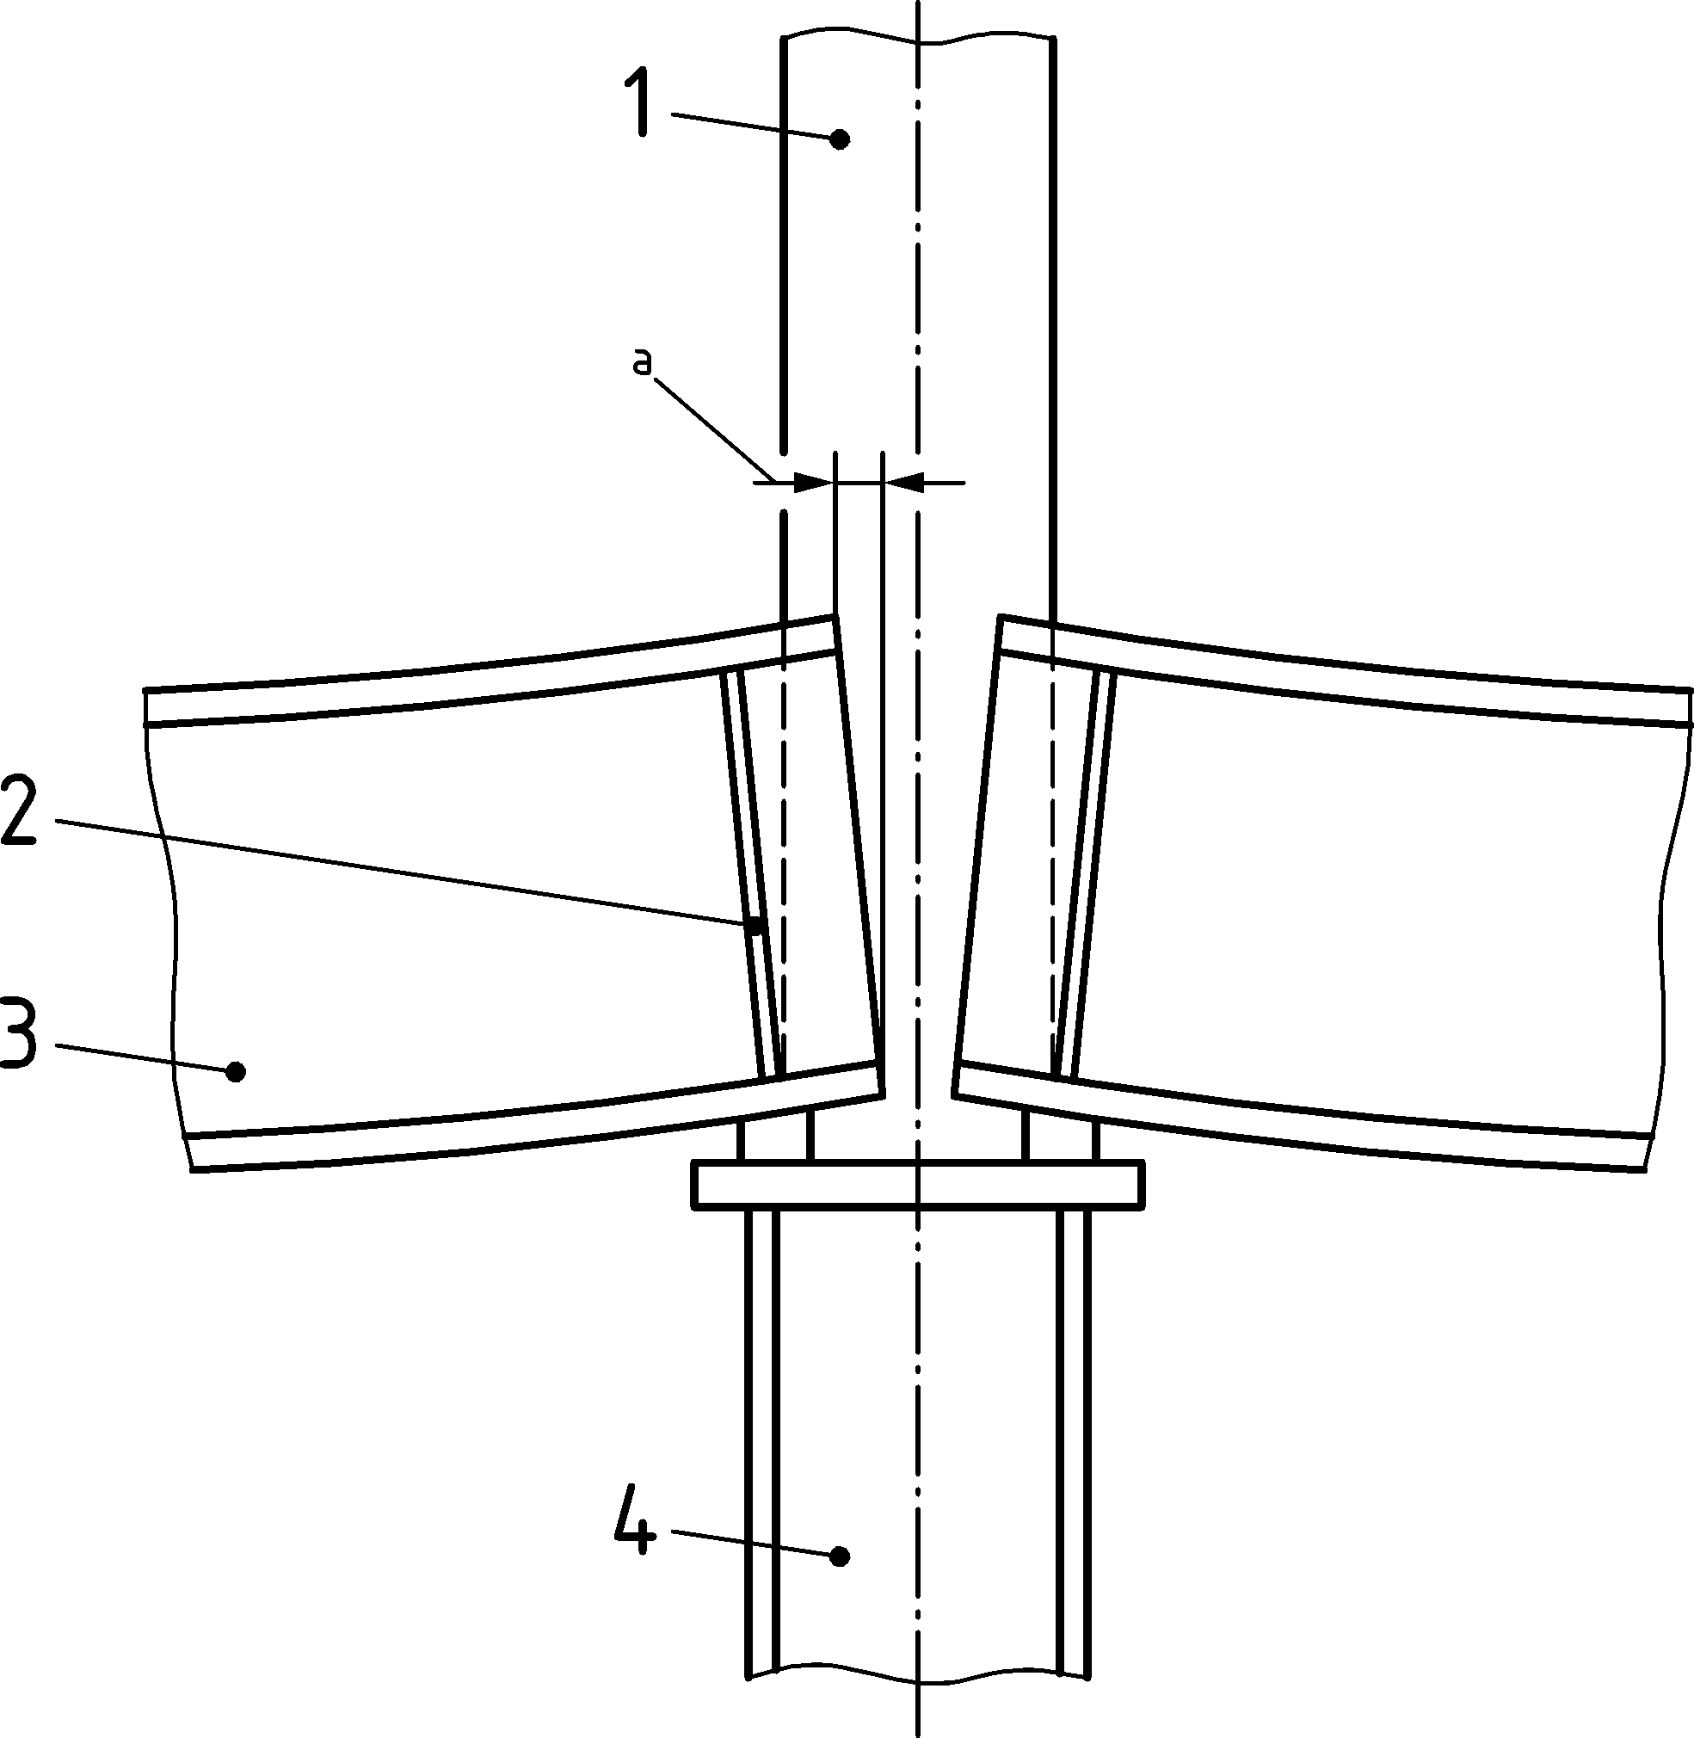

Key

|  |  |
| --- | --- |
| 1 | building column |
| 2 | bearing stiffener |
| 3 | runway beam |
| 4 | crane column |
| a | Movement of the top flange relative to the building column |

Figure 10.1 — End rotation of runway beams

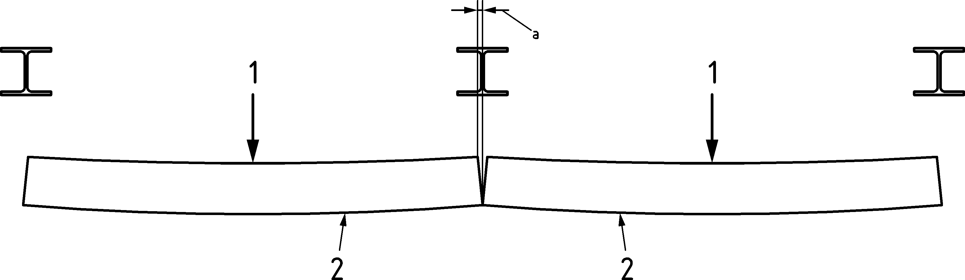

Key

|  |  |
| --- | --- |
| 1 | lateral crane force(s) |
| 2 | plan view of the top flange |
| a | Displacement due to lateral bending of the top flange of the crane runway beam |

Figure 10.2 — End rotation of runway beams due to lateral crane forces

(2) The detailing of the surge connectors and their connections should take into account the possible need for lateral and vertical adjustment of the runway beams in order to maintain the alignment of the crane runway, whilst also respecting the tolerance on location of the rail relative to the centreline of the web of the runway beam.

## Crane rails

### Design service life

(1) Generally, the grade of rail steel should be selected to give the rail an appropriate design service life. Where the design service life of the rail is less than that of the runway beam, see 4.1.2, account should be taken of the need for rail replacement in selecting the rail fixings, see 10.5.

### Rail selection

(1) The selection of crane rails should take into account the following:

— grade of rail steel;

— minimum rail width required by crane;

— maximum crane-induced actions;

— material, diameter and number of wheels;

— crane utilization;

— kind of guide means (wheel flanges, guide rollers).

(2) The contact pressure (Hertz bearing pressure) between crane wheel and rail should be limited to an appropriate value in order:

— to reduce friction;

— to avoid excessive wear of the rail;

— to avoid excessive wear of the wheels.

(3) The method given in EN 13001‑3‑3 for the verification of the contact pressure should be applied. Multiple crane actions (increased number of contacts) should be taken into account, where relevant.

NOTE The check of contact pressure is a part of crane design. The method given in EN 13001‑3‑3 applies for single crane action.

(4) A verification of crane rails of steels according to 5.3.2(1) with independent rail fixings may be omitted if the spacing between the fixings does not exceed 600 mm and if the contact pressure is verified according to (3).

NOTE 1 Independent rail fixings are defined in 10.5.3(1).

NOTE 2 Annex A provides design rules for crane rails with independent rail fixings that do not meet the required maximum spacing between fixings.

## Rail fixings

### General

(1) Depending on their details, crane rail fixings should be classified as rigid or independent.

### Rigid fixings

(1) The following types of crane rail fixings should be classified as rigid:

— rails welded to runway beams,

— rails fixed to runway beams by fitted bolts, preloaded bolts or rivets that pass through the flange of the rail.

(2) Depending on the design situation to be considered, crane rails that have rigid rail fixings should be treated as part of the cross-section of the runway beam, see 7.4.2.1(1) and 7.4.2.1(2), provided that due allowance is made for wear of the rail, see 7.4.2.1(3) and 7.4.2.1(4).

(3) Rigid rail fixings should be designed to resist the longitudinal forces developed between the rail and the runway beam plus the vertical and lateral forces applied to the rail by the crane wheels.

(4) Rigid rail fixings should be checked against fatigue.

### Independent fixings

(1) All crane rail fixings that are not classified as rigid should be classified as independent fixings.

NOTE Rail clamps are considered as independent fixings.

(2) Independent rail fixings should be designed to resist the lateral forces applied to the rail by the crane wheels.

(3) Each independent rail fixing should normally be designed to resist the maximum lateral horizontal force from one crane wheel. If the wheel spacing is less than the spacing between fixings, their resistance should be increased accordingly.

(4) A crane rail with independent rail fixings may have suitable elastomeric bearing pads between the rail and the beam.

(5) In order to prevent progressive longitudinal movements of crane rails with independent fixings, they should have either a fixpoint in the middle of the rail or end stops with sufficient clearance for longitudinal rail expansion.

NOTE The independent fixings such as rail clamps are chosen according to the relevant product specification, see 5.3.3(1), making due allowance where relevant for elastomeric bearing pads and rail dilatation.

## Rail joints

(1) Rails with independent rail fixings should be either:

— continuous over the joints of runway beams;

— discontinuous, with expansion joints.

(2) In the case of continuous rails, the analysis of the crane supporting structure should be based upon the relevant values of the properties of the rail fixings and bedding for:

— differential thermal movement;

— transmission of acceleration and braking forces from the rail to the beam.

(3) Weld splices of continuous rails should be located at a minimum distance of *L*/10 from the support of crane runway beam but not less than 500 mm where *L* is the span of the crane runway beam, see Figure 10.3a.

NOTE For continuous rails with elastomeric rail pads a reduced distance of *L*/20 from the end support of crane runway beam but not less than 500 mm can be appropriate.

(4) Rails with independent fixings and suitable elastomeric bearing pad may be continuous at expansion joints making due allowance for (3).

(5) Rails with rigid fixings should be discontinuous near the end of the runway beam (see Figure 10.3b) to prevent any continuity effect.

(6) Rail joints should be detailed to minimize impact. As a minimum, a bevel joint offset from the ends of the runway beams (see Figure 10.3b) should be used.

|  |  |
| --- | --- |
|  |  |
| **(a) Weld splice in continuous crane rail** | **(b) Offset bevel joint in crane rail** |

Key

|  |  |
| --- | --- |
| 1 | weld splice |
| 2 | elastomeric bearing pad |
| 3 | offset bevel joint |

Figure 10.3 — Examples for joints in crane rail at crane runway beam supports

# Fatigue design situation

## Requirements

(1) Verifications of the fatigue design situation according to EN 1993‑1‑9 should be carried out for all critical constructional details.

(2) Verifications are generally required only for those components of the crane supporting structure that are subject to stress variations from wheel loads.

NOTE Horizontal crane loads occur randomly scattered along the runways. Due to this irregular occurrence, they are generally negligible in the fatigue design situation, except for cases where acceleration and braking actions are planned to occur regularly at certain parts of the runways as specified by the client.

(3) The fatigue action from the crane on the crane supporting structure should be classified through R-classes taking into account:

— Net load spectrum of the crane (variation of lifted loads);

— Self-weight of the crane (influence of crane travels without payload);

— Trolley position (load traversing along the crane bridge).

NOTE Annex C contains guidance on the determination of R-classes.

(4) The requirements for fatigue design should depend on the degree of fatigue exposure.

NOTE Table 11.1 (NDP) defines the different degrees of fatigue exposure unless the National Annex specifies differently.

Table 11.1 (NDP) — Degrees of fatigue exposure

| **Degree of fatigue exposure** | **Very low** | **Low** | **High** | **Very high** |
| --- | --- | --- | --- | --- |
| R Class | R02, R01, R0 | R1, R2, R3 | R4, R5, R6 | R7, R8, R9 |

## Consideration of local effects of crane actions

(1) For local stresses in webs of runway beams for top-mounted cranes that should be accounted for, see Table 7.2 in 7.6.1. In the web-to-flange welds, the corresponding local stresses should be taken into account.

(2) For local stresses in bottom flanges of runway beams for underslung cranes or monorail hoist blocks that should be accounted for, see Table 7.4 in 7.7.1.

(3) If the rail is welded to the flange, the local stresses in the welds connecting the rail to the flange should be taken into account, see 7.8.2.

## Fatigue stress range spectra

### General

(1) The stresses *σ*p and *τ*p taken into account for verifications of the fatigue design situation should be the nominal stresses according to EN 1993‑1‑9. When necessary, different normal and shear stress components should be considered. If a stress component comprises global and local stress parts, these parts should be superposed for the verification.

NOTE The stress index can stand for the Carthesian coordinates (such as *σ*x or *σ*z or *τ*xz) or for the stress directions with respect to the weld (such as *σ*⊥ or *τ*||).

(2) Where sufficient information on the details of crane operation and data on the cranes are all available during design, the fatigue stress history from crane operations should be determined and evaluated by stress counting methods to obtain a variable amplitude stress spectrum for each critical constructional detail that is verified using Annex A of prEN 1993‑1‑9:2023.

(3) Where such information does not exist or where a simplified approach needs to be used, the fatigue action from crane operations may be taken from 5.9.3(3) of prEN 1991‑3:2024 and the simplified approach according to 11.3.2 should be followed.

### Simplified approach

(1) Following procedure may be used to determine the stress range spectrum from the simplified fatigue loading provided by 5.9.3(3) of prEN 1991‑3:2024.

(2) The crane should be represented by a fatigue load model containing the fatigue damage equivalent loads *Q*e of its wheel loads *Q*r.

NOTE The fatigue damage equivalent load is defined as *Q*e = *ϕ*fat *λ Q*r,max by EN 1991‑3. The dynamic factor *ϕ*fat is defined by prEN 1991‑3:2024, 5.9.3(5). See 11.3.3 for the damage equivalent factor *λ*.

(3) The maximum stresses Δ*σ*p,max and Δ*τ*p,max and the minimum stresses Δ*σ*p,min and Δ*τ*p,min resulting from the transit of the fatigue load model along the crane runway beam should be determined for the constructional details to be verified, see Figure 11.1a.

(4) The damage equivalent constant amplitude stress range related to 2 × 106 cycles Δ*σ*E,2 and Δ*τ*E,2 may be obtained from:

 (11.1)

 (11.2)

(5) Where multiple stress ranges occur per transit of the fatigue load model along the crane runway beam, see Figure 11.1b, the damage due the additional stress ranges should be taken into account for separately.

NOTE The fatigue load model generally comprises more than one fatigue load *Q*e. Depending on the wheel base *a* in relation of the static system of the runway beam, more than one stress range for global effects (beam bending) can be induced per transit of the fatigue load model, see Figure 11.1b. Moreover, each additional wheel load generally induces a further local stress range, independently on the static system of the runway beam, see Figure 11.1b.

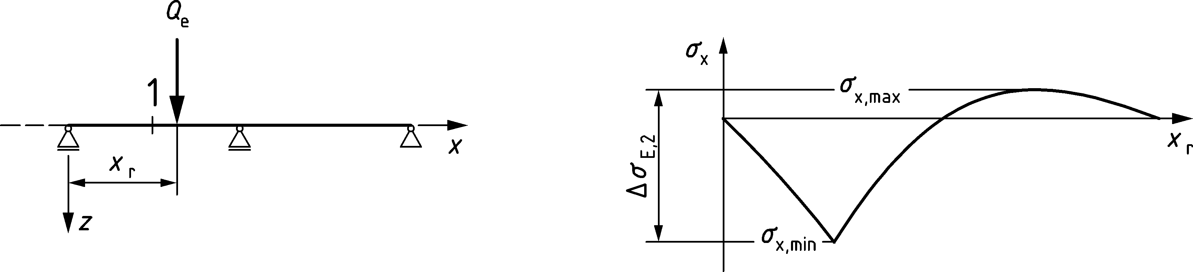

(a) runway beam with one wheel load

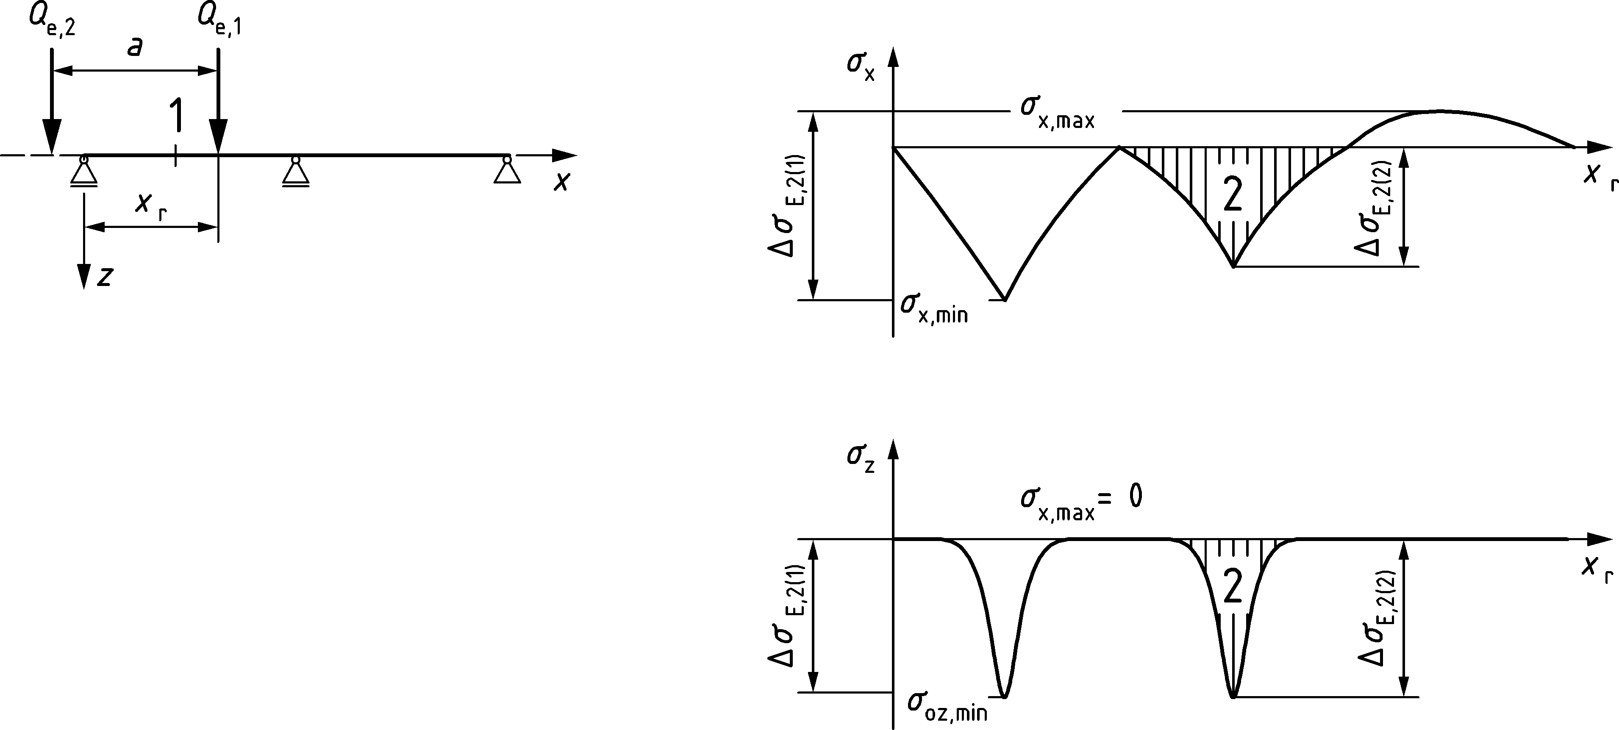

(b) runway beam with two wheel loads and an additional stress range for global and local effects (assuming top-mounted crane)

Key

|  |  |
| --- | --- |
| 1 | cross-section containing the considered constructional detail |
| 2 | additional stress range in case of multiple wheel load action |

Figure 11.1 —Determination of stress range Δ*σ*E,2 from stress distribution of a constructional detail

(6) The damage due to the additional stress ranges should be accounted for in the verification by Formula (11.9) summing up the damage of all occurring normal and shear stress ranges (if necessary, separately for different stress components).

(7) As alternative to (6), the equivalent loads *Q*e according to 5.9.3(3) of prEN 1991‑3:2024 should be determined using a higher total number of wheel load cycles.

NOTE When one additional stress range occurs, see Figures 11.1b, the total number of wheel load cycles is doubled, etc. This approach is conservative when the additional stress ranges are smaller than Δ*σ*E,2 and Δ*τ*E,2 determined by (4), see Figure 11.1b.

(8) For the middle third of the spans of single and double span crane runway beams, additional stress ranges may be neglected in verifying the longitudinal normal stresses due to global bending caused by four-wheeled cranes with wheel bases *a* ≤ 0,6 *L* where *L* is the span of the crane runway beam.

NOTE Two identical wheel loads are assumed per crane runway beam. Identical spans are assumed for double span crane runway beams.

### Damage equivalent factor

#### General remark

(1) Depending on the available information, the damage equivalent factor should be determined by the most appropriate method in 11.3.3.2 to 11.3.3.4, see Figure 11.2.

(2) Methods 1 and 2 according to 11.3.3.2 and 11.3.3.3 may only be used in absence of more specific information.

NOTE These two methods suggest an empirical procedure that is only based on the type of crane service.

(3) Method 3 according to 11.3.3.4 should be used for cases where detailed information about the crane service is available.

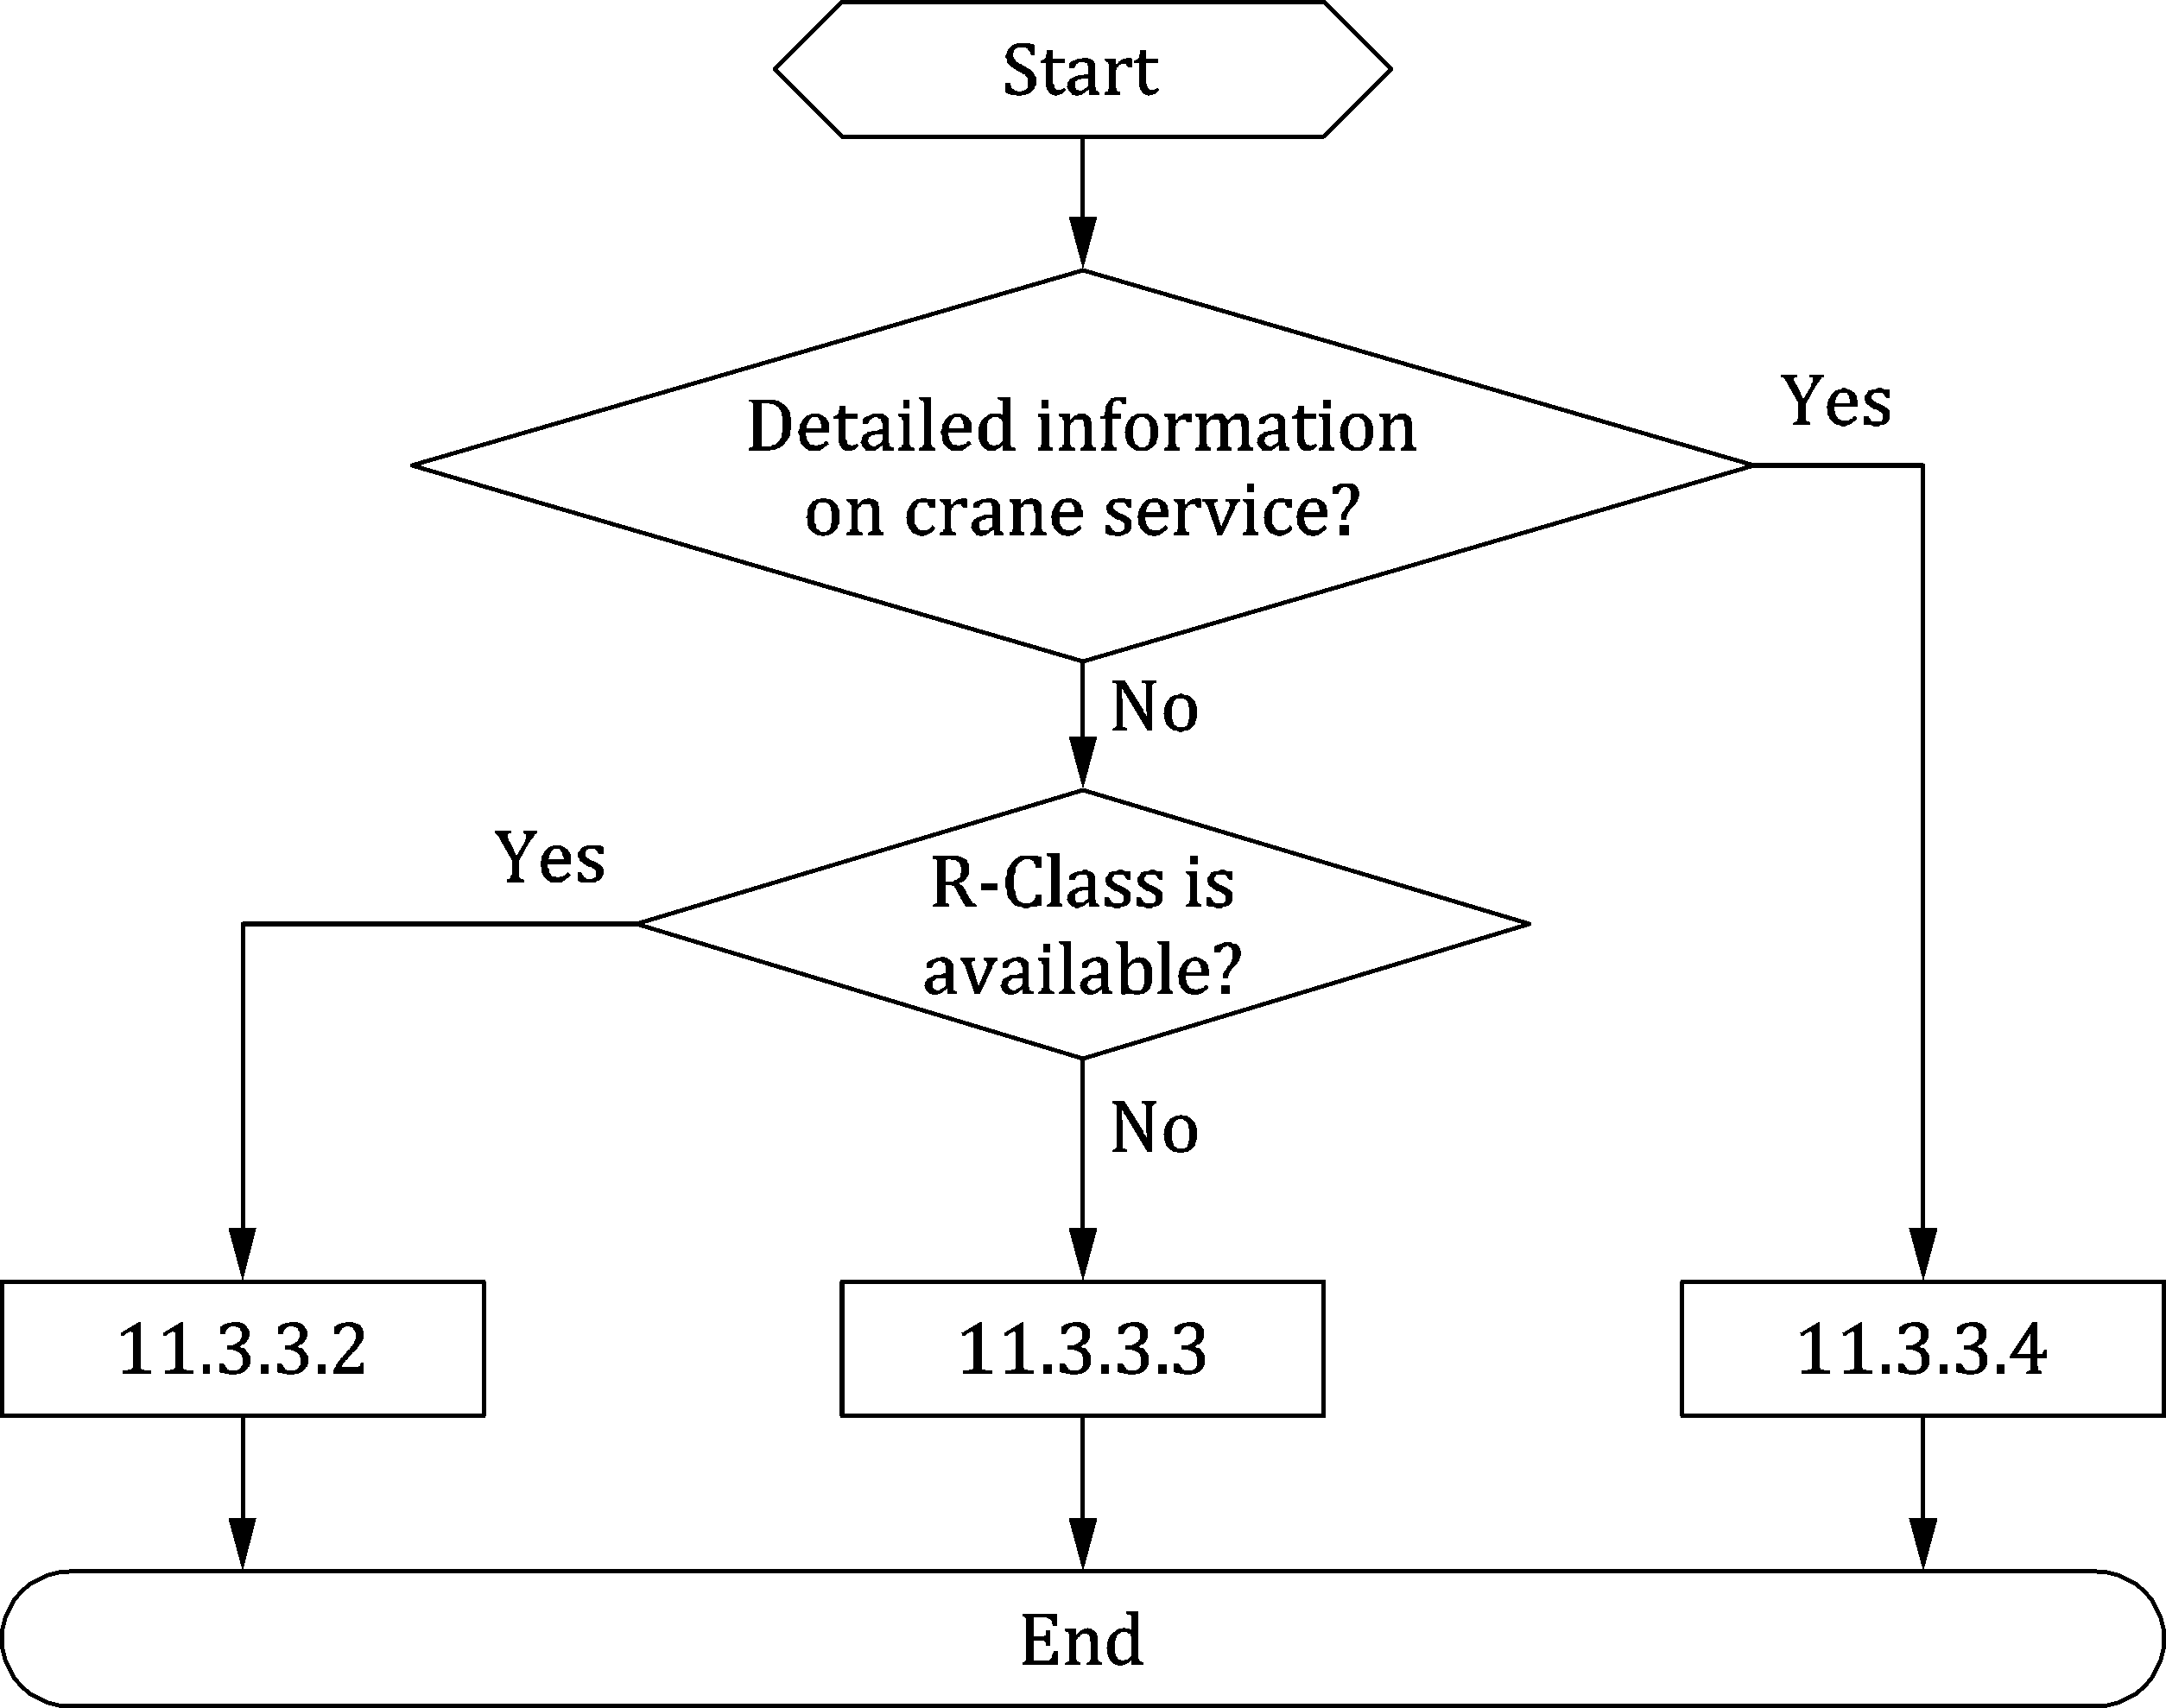

Figure 11.2 — Determination of damage equivalent factor depending on available information

#### Estimation based on R class of crane runway beam — Method 1

(1) In absence of more specific information, the determination of damage equivalent factor *λ* may be based on the R class of crane runway beams for selected travelling cranes according to Clause C.3.

NOTE The R classes in Clause C.3 account for the influence of travels of unloaded crane and the variation of trolley position.

(2) Based on the R class, the damage equivalent factor *λ* should be obtained from Table 11.2.

Table 11.2 — Damage equivalent factor *λ* depending on R class

| **Class R** | **R02** | **R01** | **R0** | **R1** | **R2** | **R3** | **R4** | **R5** | **R6** | **R7** | **R8** | **R9** |
| --- | --- | --- | --- | --- | --- | --- | --- | --- | --- | --- | --- | --- |
| Normal stresses | 0,125 | 0,157 | 0,198 | 0,250 | 0,315 | 0,397 | 0,500 | 0,630 | 0,794 | 1,00 | 1,260 | 1,587 |
| Shear stresses | 0,287 | 0,330 | 0,379 | 0,436 | 0,500 | 0,575 | 0,660 | 0,758 | 0,871 | 1,00 | 1,149 | 1,320 |
| NOTE In determining the *λ*-values standardized spectra with a Gaussian distribution of the load effects, the Miner rule and fatigue strength *S*-*N* lines with a slope *m* = 3 for normal stresses and *m* = 5 for shear stress have been used. | | | | | | | | | | | | |

#### Estimation based on C class of crane — Method 2

(1) For the case that only the C class of the crane according to EN 1991‑3 is known, the damage equivalent factor *λ* relevant for the crane runway beam design may be determined as follows:

 (11.3)

where

|  |  |
| --- | --- |
| *λ*S | is the damage equivalent factor from Table 11.2 for the R class with the same subscript as the C class; |
| *m*λ | is a magnifier according to Table 11.3. |

Table 11.3 — Magnifier *m*λ

| **Trolley** | **C-class** | **Magnifier *m*λ** | | | | | | |
| --- | --- | --- | --- | --- | --- | --- | --- | --- |
| **position** | **of** | Portion (*α*) of crane self-weight and hoist load according to 3.2.5 | | | | | | |
|  | **crane** | 0 | 0,5 | 0,75 | 1 | 2 | 3 | 4 |
| Trolley at end position | C7 | 1,00 | 1,00 | 1,00 | 1,01 | 1,04 | 1,06 | 1,09 |
| C6 | 1,00 | 1,05 | 1,08 | 1,10 | 1,18 | 1,25 | 1,30 |
| C5 | 1,00 | 1,11 | 1,17 | 1,21 | 1,37 | 1,48 | 1,56 |
| C4 | 1,00 | 1,19 | 1,28 | 1,36 | 1,61 | 1,78 | 1,90 |
| C3 | 1,00 | 1,29 | 1,42 | 1,55 | 1,91 | 2,15 | 2,32 |
| ≤ C2 | 1,00 | 1,38 | 1,56 | 1,74 | 2,26 | 2,60 | 2,83 |
| No preferential position | C7 | 0,63 | 0,68 | 0,71 | 0,74 | 0,84 | 0,91 | 0,97 |
| C6 | 0,63 | 0,73 | 0,78 | 0,83 | 0,99 | 1,10 | 1,18 |
| C5 | 0,64 | 0,80 | 0,88 | 0,95 | 1,18 | 1,34 | 1,45 |
| C4 | 0,64 | 0,88 | 1,00 | 1,11 | 1,43 | 1,64 | 1,79 |
| C3 | 0,65 | 0,98 | 1,15 | 1,30 | 1,75 | 2,03 | 2,22 |
| ≤ C2 | 0,67 | 1,10 | 1,32 | 1,53 | 2,12 | 2,49 | 2,75 |

NOTE The magnifier *m*λ accounts for the variation of trolley position and the influence of travels of unloaded crane. In case of fixed trolley position and negligible crane self-weight (no influence of travels of unloaded crane), *m*λ approaches 1.

#### Exact calculation — Method 3

(1) Where sufficient information on service conditions and data of the crane are available during design, the damage equivalent factor *λ* for wheel load *Q*r,*i* should be determined as follows:

 (11.4)

 (11.5)

 (11.6)

 (11.7)

where

|  |  |
| --- | --- |
| *Q*r,*i*,*j* and *ni*,*j* | are the *j*th load level of the wheel load *Q*r,*i* and the corresponding number of load cycles; |
| *Q*r,*i*,max | is the maximum load level; |
| *N*r | is the total number of load cycles of *Q*r,*i*; |
| *m* | is the first slope parameter of the fatigue resistance curve of the considered constructional detail according to EN 1993‑1‑9. |

NOTE The first slope parameter of the fatigue resistance curve can be set to *m* = 3 for constructional details under normal stresses and to *m* = 5 under shear stresses.

## Verifications

### General

(1) See prEN 1993‑1‑9:2023, Clause 9.

### Multiple crane actions

(1) For a member loaded by two or more cranes, the total damage should satisfy the criterion:

 (11.8)

where

|  |  |
| --- | --- |
| *Di* | is the damage due to a single crane *i* acting independently; |
| *D*dup | is the additional damage due to combinations of two or more cranes occasionally acting together. |

(2) The damage *Di* due to a single crane *i* acting independently should be calculated from the normal stress range or the shear stress range or both, depending upon the constructional detail, see EN 1993‑1‑9, using:

 (11.9)

where

|  |  |
| --- | --- |
| Δ*σ*E,2(*j*) | is the normal stress ranges per transit of fatigue load model of crane *i* along the crane runway beam; |
| Δ*τ*E,2(*k*) | is shear stress ranges per transit of fatigue load model of crane *i* along the crane runway beam; |
| *mσ* | is the first slope parameter for normal stress loading of the considered constructional detail according to EN 1993‑1‑9; |
| *mτ* | is the first slope parameter for shear stress loading of the considered constructional detail according to EN 1993‑1‑9. |

NOTE See 9.4 of prEN 1993‑1‑9:2023 for the combination of different stresses and stress components.

(3) The additional damage *D*dup due to two or more cranes occasionally acting together should be calculated from the normal stress range or the shear stress range or both, depending on the constructional detail, see EN 1993‑1‑9, using:

 (11.10)

where

|  |  |
| --- | --- |
| Δ*σ*E,2,dup | is the equivalent constant amplitude normal stress range due to two or more cranes acting together; |
| Δ*τ*E,2,dup | is the equivalent constant amplitude shear stress range due to two or more cranes acting together. |

(4) Where multiple stress ranges occur per travel of the fatigue load model along the crane runway beam for the multiple crane action, Formula (11.10) should be extended through summation as Formula (11.9).

(5) If two cranes are intended to act together (in tandem or otherwise) to a substantial extent, the two cranes should be treated as comprising one single crane.

(6) In the absence of better information, the equivalent constant amplitude stress range Δ*σ*E,2 due to two or more cranes occasionally acting together may be obtained by applying damage equivalence factors *λ*dup.

The recommended values of *λ*dup are equal to the values *λi* for a class R as follows unless the National Annex gives different values:

— for 2 cranes: 2 classes below the R class of the crane with the lower R class;

— for 3 or more cranes: 3 classes below the R class of the crane with the lowest R class.

A classification by 2 classes below the R class of the single crane with the lower R class assumes that 25 % of this crane’s working cycles are performed in combination with another crane. That means multiple crane action is expected every fourth working cycles.

A classification by 3 classes below the R class of the single crane with the lower R class assumes that 12,5 % of this crane’s working cycles are performed in combination with other cranes. That means multiple crane action is expected every eighth working cycles.

## Fatigue resistance

(1) See Tables 10.1 to 10.11 of prEN 1993‑1‑9:2023.

(2) For chain intermittent rail welds, the detail category given in Table 11.4 should be used with the nominal stress method.

Table 11.4 — Detail category for stress ranges of vertical compressive stress in intermittent rail welds subjected to wheel loads

| **Detail category** | **Constructional detail** | **Symbol** | **Description** | **Supplementary Requirements** |
| --- | --- | --- | --- | --- |
| 40 |  |  | Crane rail as hot-rolled flat or square steel bar subject to wheel loads, fastened to the top flange above supporting webs by chain intermittent rail welds according to Figure 7.12a with ℓw = 50 mm | Δ𝜎 should be calculated using vertical compressive stress in rail welds due to wheel loads according to 7.8.2 (7) with an ensured technical contact between rail and flange, see Note |
| NOTE Technical contact between rail and flange can be ensured by production measures such as mechanical clamping while welding and removing surface imperfections. Technical contact can be checked by appropriate measurements using e.g. a feeler gauge. | | | | |

(3) For the verification of the longitudinal stress in the top flange with chain intermittent fillet welds according to Figure 7.12a with ℓw = 50 mm, the detail category of Detail 7 in Table 10.3 of prEN 1993‑1‑9:2023 may be increased from 80 to 90.

NOTE An interaction of the vertical compressive stresses according to 7.8.2(7) due to vertical wheel loads and the longitudinal stresses in the flange can be neglected. The influence of the global shear stress in the weld on the fatigue verification is considered indirectly by the limitation of the ratio of *g*/ℓw.

1. (informative)  
     
   Design of crane rails with independent rail fixings
   1. Use of this informative annex

This Informative Annex provides supplementary guidance to 10.4.2(4).

NOTE National choice on the application of this Informative Annex is given in the National Annex. If the National Annex contains no information on the application of this informative annex, it can be used.

* 1. Scope and field of application

(1) This Informative Annex applies to continuous crane rails with foot flange and independent rail fixings, see Figure A.1.

NOTE Rails according to DIN 536‑1 fall in the scope of this Annex.

* 1. Structural analysis

(1) The design of crane rails with independent rail fixings should take into account:

— vertical bending due to wheel loads making due allowance for elastomeric bearing pads if relevant;

— horizontal bending due to lateral horizontal forces;

— warping torsion due to eccentricity of wheel loads and lateral horizontal forces.

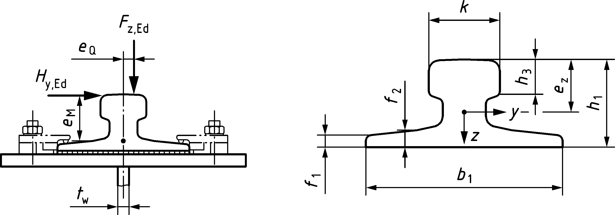

Figure A.1 — Action on crane rail and relevant cross-sectional dimensions

* 1. Action effects

(1) The maximum normal stress *σ*x1,Ed of the rail head due to vertical bending caused by a wheel load may be calculated as follows:

 (A.1)

where

|  |  |
| --- | --- |
| *F*z,Ed | is the design value of the wheel load; |
|  | |
| *E* | is the modulus of elasticity (210 000 N/mm2); |
| *I*y | is the moment of inertia, about its horizontal centroidal axis, of the rail; |
| *c* | is the bedding stiffness parameter of the elastomeric bearing pad, if exists; otherwise *c* = ∞; |
| *b*1 | is the width of the rail foot; |
| *h*w | is the web height of the crane runway beam; |
| *t*w | is the web thickness of the crane runway beam; |
| *e*z | is the perpendicular distance from neutral axis (centroid) to the top of the rail. |

NOTE 1 Table A.1 contains the cross-sectional properties for DIN 536‑1 rails accounting for wear.

NOTE 2 The value *c* can be set to 20 kN/cm3 unless the relevant product specification requires a lower value for the elastomeric bearing pads, see 5.3.3(1).

Table A.1 — Cross-sectional properties of DIN 536‑1 rails accounting for 25 % wear

| **Rail** | ***k*** | ***b*1** | ***f*2** | ***h*1** | ***h*3** | ***e*M** | ***e*z** | ***I*y** | ***I*z** | ***I*T** |
| --- | --- | --- | --- | --- | --- | --- | --- | --- | --- | --- |
|  | [mm] | [mm] | [mm] | [mm] | [mm] | [mm] | [mm] | [×104 mm4] | [×104 mm4] | [×104 mm4] |
| A45 | 45 | 125 | 11 | 50,0 | 15,0 | 38,16 | 30,84 | 67,41 | 164,7 | 30,77 |
| A55 | 55 | 150 | 12,5 | 58,7 | 18,7 | 43,96 | 35,91 | 131,9 | 327,1 | 68,50 |
| A65 | 65 | 175 | 14 | 67,5 | 22,5 | 49,99 | 40,99 | 235,4 | 590,4 | 133,4 |
| A75 | 75 | 200 | 15,4 | 76,2 | 26,2 | 55,92 | 45,99 | 388,3 | 979,3 | 236,5 |
| A100 | 100 | 200 | 16,5 | 85,0 | 30,0 | 56,02 | 47,97 | 628,5 | 1259 | 499,3 |
| A120 | 120 | 220 | 20 | 93,1 | 35,6 | 57,52 | 51,94 | 973,4 | 2173 | 953,7 |
| A150 | 150 | 220 | 22,8 | 137,5 | 37,5 | 79,06 | 71,93 | 3412 | 3301 | 2359 |
| NOTE Value *f*2 for rail A150 is assumed with the mean thickness of the foot flange. | | | | | | | | | | |

(2) The maximum normal stress *σ*x2,Ed of the rail head due to horizontal bending caused by a lateral horizontal force may be calculated as follows, if the spacing between fixings is less than the wheel spacing:

 (A.2)

where

|  |  |
| --- | --- |
| *H*y,Ed | is the design value of the lateral horizontal force; |
| *a* | is the spacing of fixings; |
| *k* | is the width of the rail head; |
| *I*z | is the moment of inertia, about its vertical axis, of the rail, see Table A.1. |

(3) The maximum normal stress *σ*x3,Ed of the rail head caused by warping torsion may be calculated as follows, if the spacing between fixings is less than the wheel spacing:

 (A.3)

where

|  |  |
| --- | --- |
| *M*D,Ed = *H*y,Ed *e*M + *F*z,Ed *e*Q (see Figure A.1); | |
| *e*M, *e*Q | are the eccentricities of actions with respect to shear centre of rail, see Figure A.1; |
| *G* | is the shear modulus (81 000 N/mm2); |
| *I*T | is the torsional constant of the rail; |
| *E* | is the modulus of elasticity (210 000 N/mm2); |
|  | is the warping constant of the rail; |
| *I*z,h = *k*3 *h*3/12 | is the moment of inertia, about its vertical axis, of the rail head, see Figure A.1; |
| *I*z,f = (*b*1)3 *f*2/12 | is the moment of inertia, about its vertical axis, of the rail foot, see Figure A.1; |
| *h*r = *h*1 − 0,5 (*h*3 + *f*2) | is the distance between centroid of rail head and rail foot, see Figure A.1. |

* 1. Verification

(1) The design value of rail head’s normal stress may be verified at ultimate limit state as follows:

*σ*x1,Ed + *σ*x2,Ed + *σ*x3,Ed ≤ *f*y/*γ*M0 (A.4)

NOTE The yield strength of DIN 536‑1 rails can be set to 60 % of tensile strength.

(2) See 10.4.2(2) and (3) for verification of contact pressure between crane wheel and rail.

(3) If the provisions of 10.6(3) are followed with respect to the location of welded rail splices, the fatigue verification may be omitted.

NOTE The welded rail splices are usually the decisive constructional detail of continuous crane rails in respect of fatigue.

1. (informative)  
     
   Inspections of crane runway beams according to EN 1993‑1‑9
   1. Use of this informative annex

This Informative Annex provides supplementary guidance for 4.1.2, 4.1.3 and Clause 11.

NOTE National choice on the application of this Informative Annex is given in the National Annex. If the National Annex contains no information on the application of this informative annex, it can be used.

* 1. Scope and field of application

(1) This Informative Annex applies to crane runway beams designed according to the damage tolerant design concept of EN 1993‑1‑9 in respect of fatigue. This Annex provides recommendations for the preparation, execution and documentation of inspections required by this fatigue design concept.

NOTE 1 An increasing number of inspections allows for lower partial factors for fatigue resistance because the propagation of undetected fatigue cracks and, consequently, the danger of brittle failure are limited.

NOTE 2 Through the verification in the fatigue design situation according to EN 1993‑1‑9, the possibility of fatigue cracks is reduced to an acceptable level of probability, but not completely excluded. Due to scatter of fatigue resistance and possible inaccuracy of the predicted fatigue action, the inspections required by EN 1993‑1‑9 do not substitute the inspecting measures as a part of maintenance of the crane runway beams as well as additional inspections required by other authorities/parties such as health and safety regulations.

* 1. Definitions

**B.3.1**

**inspection in accordance with EN 1993‑1‑9**

safety relevant evaluation of as-is state and determination of deviations from as-planned state, including search for fatigue failures (cracks)

**B.3.2**

**maintenance**

periodically repeated measures that preserve a crane runway beam from excessive wear and tear in order to maintain its serviceability during the design service life

Note 1 to entry: Examples of maintenance are functional tests in operation, cleaning, greasing of wheel bearings, planned replacement of replaceable parts, documentation of abnormalities such as abnormal noises and untightened bolts.

**B.3.3**

**repair**

occasional measures to reset a crane runway beam into its as-planned state

Note 1 to entry: Examples are repair and replacement of defect parts, repair of corrosion protection, re-adjustment of spacing between the centres of crane rails.

* 1. Preparation of inspections
     1. Necessary documents

(1) The inspection should be prepared on basis of following documents:

— technical data file of the crane;

— static calculation and workshop drawings of the crane runway beams;

— documentations of modifications, if exist;

— records of past inspections, if exist;

— protocols of maintenance with executed past repairs, if exist.

* + 1. Evaluation of as-is state

(1) The as-is state of the crane runway beams should be evaluated. It should be checked if the workshop drawings contain all fatigue relevant constructional details of the as-is state and if these details are verified in the static calculation.

NOTE The documents listed under B.4.1 do not account for the effect of occasionally afterwards added non-structural components (such as conductors) on the fatigue resistance of the crane runway beam.

(2) The evaluation of the as-is state should comprise an interview with the crane operator to determine abnormalities of the structural behaviour of the crane runway beams.

* + 1. Number of inspections

(1) The number of inspections should be determined in accordance with the assumptions of EN 1993‑1‑10 and EN 1993‑1‑9.

* + 1. Distribution of inspections

(1) The inspections should be distributed over the design service life in accordance with the utilization of the crane.

(2) The period of time between the inspections should be decreased when the crane runway beam approaches the end of its design service life.

NOTE The probability of fatigue damage increases with the age of the crane runway beam.

(3) For cranes with longer phases of low utilization or standstill and with shorter phases of intensive utilization, the distribution of inspections should follow practical considerations.

(4) An inspection should be performed after accidental events.

* 1. Execution of inspections
     1. Identification of critical constructional details

(1) The critical constructional details should be identified on basis of the static calculation, structural design and detailing as well as and practical considerations.

(2) Constructional details which had already been repaired in the past should be considered as critical.

NOTE Figure B.1 illustrates critical spots of a typical crane runway beam with hot-rolled section and rail welded to the top flange and of a typical crane runway beam with plated section and clamped rail.

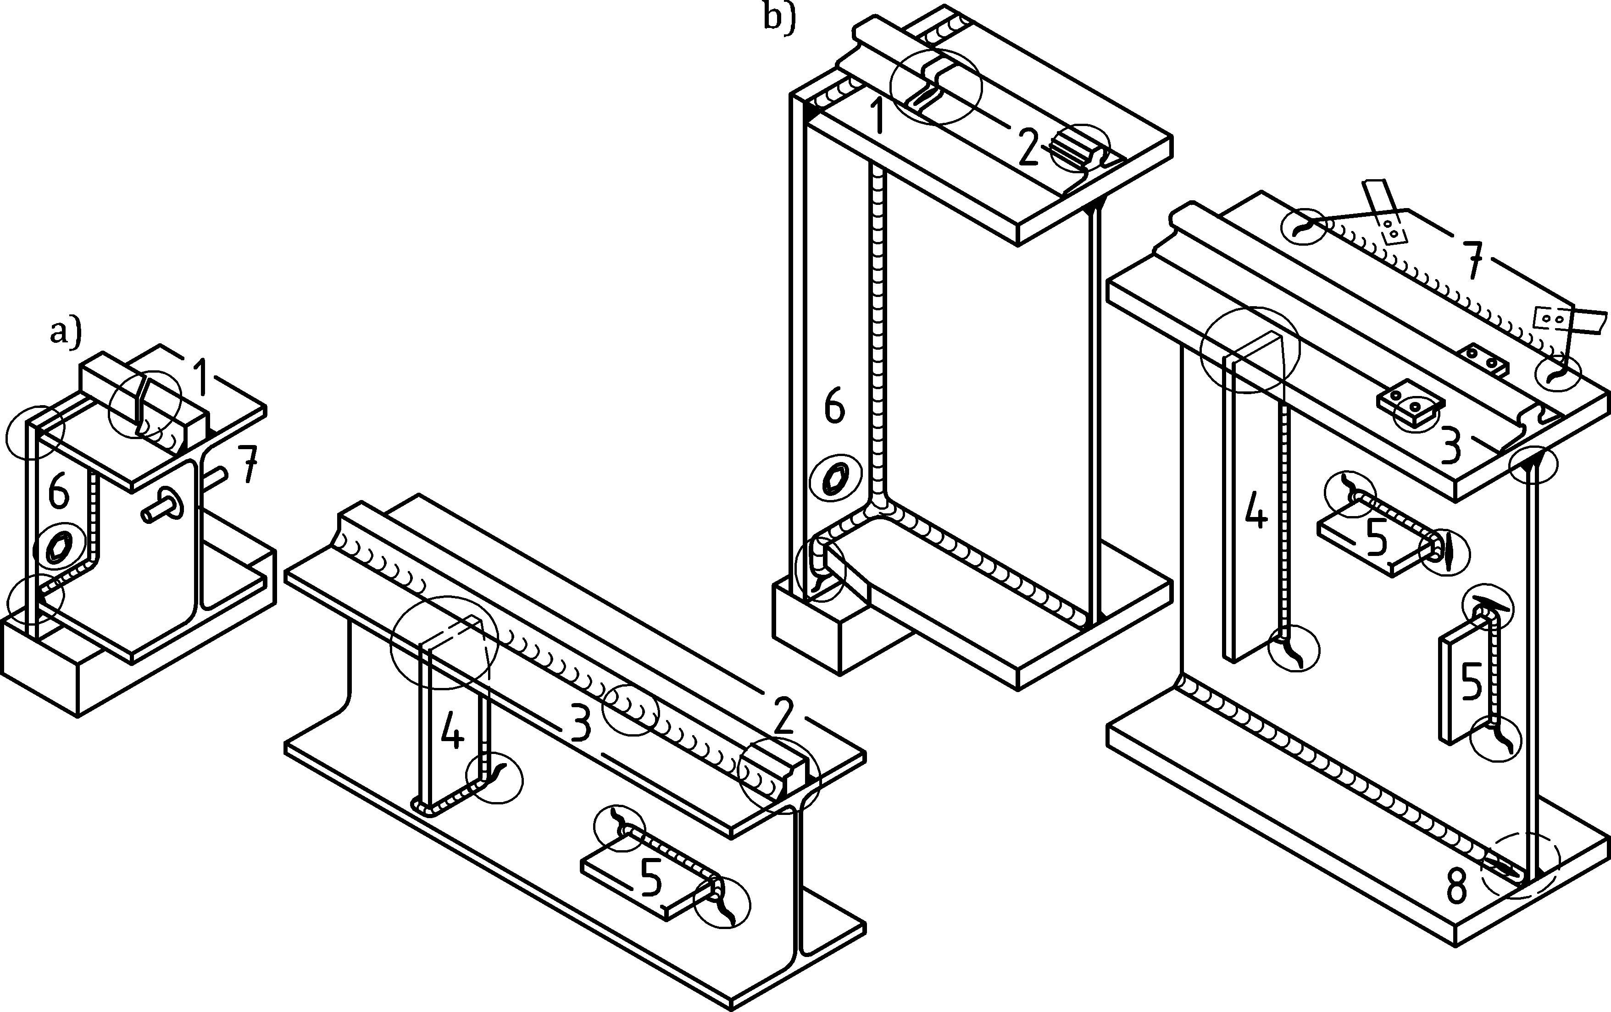

Key

|  |  |  |  |
| --- | --- | --- | --- |
| 1 | rail joint | 6 | end plates |
| 2 | excessive rail wear | 7 | surge connector or surge girder |
| 3 | rail fastening | 8 | flange to web connection |
| 4 | stiffeners | a) | hot-rolled section with crane rail welded to the top flange |
| 5 | attachments | b) | plated cross-section with clamped crane rail |

Figure B.1 — Critical spots of crane runway beams

* + 1. Content of inspections
       1. General case

(1) The crane runway beams should be visually inspected along their complete length at appropriate conditions (close-up visual examination, sufficient lighting, etc.) that allow for the discovery of cracks at the critical constructional details, in particular welded details.

NOTE Local corrosion can be an indication of cracks.

(2) The deformations of the crane runway beams should be checked and recorded.

(3) Bolted connections of the crane runway beams and surge girders (if exist) including bolted rail fixings should be checked for possible loosening. The preload of preloaded connections with category B, C or E according to EN 1993‑1‑8 should be checked.

(4) The focus of inspection should be laid on the crane rail. The rail wear should be determined and recorded. Crane runway beam segments with abnormalities such as intense one-sided rail wear should be recorded. Offset bevel joints of rail should be checked for surface tolerances. The distance of welded rail joints from the crane runway beam ends should be checked if greater rail movements occurred in the past.

(5) In case of loosing or damaged bolts, cracks or any other damage, a safety estimation should be performed. In case of cracks, an in-depth check according to B.5.2.2 should be performed. All loosing bolts, cracks and other damage should be clearly marked.

* + - 1. In-depth check

(1) If cracks of a welded constructional detail are determined by visual inspections or assumed based on the document analysis in B.4.1, the intact welds of this constructional detail should be checked by non-destructive crack testing to possibly detect further cracks close to the surface or open to the surface. This testing should be performed in order to clarify if the found cracks are exceptions or if they are onsets of a systematic weakness of the detail. The corrosion protection of the constructional detail should be removed if necessary.

* + - 1. Check of long crane runways

(1) For long crane runways composed of identical beams, the inspection may focus on selected beams (sample). The most unfavourable stressed crane runway beams should be chosen based on information of the client and crane operator.

(2) If the inspection of the selected crane runway beams reveals damages, the inspection should be widened to further beams.

* 1. Documentation of inspections

(1) The findings of the inspections should be documented. Crane runway beams with need for repair should be unambiguously described in order to be repeatedly checked by future inspections.

(2) Repair measures that are not immediately undertaken but necessary before the next planned inspection should be clearly defined.

(3) A time for the next inspection should be proposed.

1. (informative)  
     
   Guidance on crane runway beam classification for fatigue
   1. Use of this informative annex

(1) This Informative Annex provides supplementary guidance for Clause 11.

NOTE National choice on the application of this Informative Annex is given in the National Annex. If the National Annex contains no information on the application of this informative annex, it can be used.

* 1. Scope and field of application

(1) This Informative Annex covers the selection of R-classes relevant for the verification of crane runway beams in the fatigue design situation.

* 1. Classification without calculation

(1) In absence of more specific information, the classification in Table C.1 may be used based on type of crane operation.

Table C.1 — Indications of typical R-classes

| **No.** | **Type of crane operation** | **C-Class** | **Trolley without preferential position** | | | | **Trolley fixed at end position** | | | |
| --- | --- | --- | --- | --- | --- | --- | --- | --- | --- | --- |
|  |  |  | *α* = 0,5 | 1 | 2 | 4 | 0,5 | 1 | 2 | 4 |
| 1 | Hand-operated cranes | C0 | R1 | R2 | R4 | R4 | R2 | R3 | R4 | R5 |
| 2 | Assembly cranes and maintenance crane, intermittent operation | C01 | R0 | R1 | R3 | R4 | R1 | R2 | R3 | R4 |
| 3 | Factory and warehouse cranes, intermittent operation | C2 | R3 | R4 | R6 | R6 | R4 | R5 | R6 | R7 |
| 4 | Warehouse cranes, continuous operation | C5 | R5 | R5 | R6 | R7 | R6 | R6 | R7 | R7 |
| 5 | Workshop cranes – hook service | C1 | R2 | R3 | R5 | R5 | R3 | R4 | R5 | R6 |
| 6 | Paper mill cranes in process operation | C4 | R4 | R5 | R6 | R7 | R5 | R6 | R7 | R7 |
| 7 | Cranes in steel production processes | C5 | R5 | R5 | R6 | R7 | R6 | R6 | R7 | R7 |
| *α* according to 3.2.5 | | | | | | | | | | |
| NOTE This table is based on the U- and Q-classes specified by Table A.3 of EN 15011:2011+A1:2014. In contrast to the C-class of the crane according to EN 1991‑3 that only depends on the U- and Q-class of the crane, the R-class of the crane runway beam additionally accounts for the influence of the crane self-weight and the trolley position. The R-class assumes two stress cycles in the crane runway beam per working cycle of the crane, the first due to the loaded crane and the second due to the unloaded crane. | | | | | | | | | | |

NOTE If the trolley is fixed at its end position, it does not move along the crane girder. This assumption always results in safe-sided actions on the crane runway beam that is closest to the considered trolley end position.

(2) For *α* < 0,5, the R class for *α* = 0,5 according to Table C.1 may be used.

(3) For *α* > 4, the R class should be determined individually.

NOTE For the theoretical case of heavy crane self-weight and negligible hoist loads (*α* → ∞), Table C.2 can be used with *kQ*r = 1 (identical wheel loads for all crane travels) to determine the R class.

* 1. Classification with calculation

(1) Where specific information is available, the classification in Table C.2 should be used.

Table C.2 — Determination of R-classes

|  | **Wheel load spectrum factor *kQ*r** | | | | | |
| --- | --- | --- | --- | --- | --- | --- |
| **Total number *N*r of load cycles** | *kQ*r ≤ 0,0313 | 0,0313 < *kQ*r ≤ 0,0625 | 0,0625 < *kQ*r ≤ 0,125 | 0,125 < *kQ*r ≤ 0,25 | 0,25 < *kQ*r ≤ 0,5 | 0,5 < *kQ*r ≤ 1,0 |
| *N*r ≤ 1,6 < 104 | R02 | R02 | R02 | R02 | R01 | R0 |
| 1,6 × 104 < *N*r ≤ 3,15 × 104 | R02 | R02 | R02 | R01 | R0 | R1 |
| 3,15 × 104 < *N*r ≤ 6,30 × 104 | R02 | R02 | R01 | R0 | R1 | R2 |
| 6,30 × 104 < *N*r ≤ 1,25 × 105 | R02 | R01 | R0 | R1 | R2 | R3 |
| 1,25 × 105 < *N*r ≤ 2,50 × 105 | R01 | R0 | R1 | R2 | R3 | R4 |
| 2,50 × 105 < *N*r ≤ 5,00 × 105 | R0 | R1 | R2 | R3 | R4 | R5 |
| 5,00 × 105 < *N*r ≤ 1,00 × 106 | R1 | R2 | R3 | R4 | R5 | R6 |
| 1,00 × 106 < *N*r ≤ 2,00 × 106 | R2 | R3 | R4 | R5 | R6 | R7 |
| 2,00 × 106 < *N*r ≤ 4,00 × 106 | R3 | R4 | R5 | R6 | R7 | R8 |
| 4,00 × 106 < *N*r ≤ 8,00 × 106 | R4 | R5 | R6 | R7 | R8 | R9 |
| where  *kQ*r is a wheel load spectrum factor according to Formula (11.5);  *N*r is the total number of load cycles per wheel load of the crane during the design service life of the crane runway according to Formula (11.7) accounting for crane travels with and without payload along the crane runway | | | | | | |

Bibliography

**References contained in recommendations (i.e. “should” clauses)**

The following documents are referred to in the text in such a way that some or all of their content constitutes highly recommended choices or course of action of this document. Subject to national regulation and/or any relevant contractual provisions, alternative documents could be used/adopted where technically justified. For dated references, only the edition cited applies. For undated references, the latest edition of the referenced document (including any amendments) applies.

EN 1337 (all parts), Structural bearings

EN 13001‑3‑3, Cranes — General design — Part 3-3: Limit states and proof of competence of wheel/rail contacts

ISO 11660‑5, Cranes — Access, guards and restraints — Part 5: Bridge and gantry cranes

**References contained in permissions (i.e. “may” clauses)**

The following documents are referred to in the text in such a way that some or all of their content expresses a course of action permissible within the limits of the Eurocodes. For dated references, only the edition cited applies. For undated references, the latest edition of the referenced document (including any amendments) applies.

DIN 536‑1, Crane rails — Dimensions, sectional properties, steel grades for crane rails with foot flange, form A

EN 10025‑2, Hot rolled products of structural steels — Part 2: Technical delivery conditions for non-alloy structural steels

EN 10025‑3, Hot rolled products of structural steels — Part 3: Technical delivery conditions for normalized/normalized rolled weldable fine grain structural steels

EN 10025‑4, Hot rolled products of structural steels — Part 4: Technical delivery conditions for thermomechanical rolled weldable fine grain structural steels

EN 10025‑6, Hot rolled products of structural steels — Part 6: Technical delivery conditions for flat products of high yield strength structural steels in the quenched and tempered condition

EN 10058, Hot rolled flat steel bars and steel wide flats for general purposes — Dimensions and tolerances on shape and dimensions

EN 10059, Hot rolled square steel bars for general purposes — Dimensions and tolerances on shape and dimensions

**References contained in possibilities (i.e. “can” clauses) and notes**

The following documents are cited informatively in the document, for example in “can” clauses and in notes.

EN 13001 (all parts), Cranes — General design

EN 15011:2011+A1:2014, Cranes — Bridge and gantry cranes

EN 16851, Cranes — Light crane systems

ISO 12488‑1, Cranes — Tolerances for wheels and travel and traversing tracks — Part 1: General

Euler, M.; Kuhlmann, U.: Aufgeschweißte Flach- und Vierkantschienen von Kranbahnträgern. Ermüdungsnachweis für Schweißnähte zur Schienenbefestigung. In: Stahlbau 87 (2018), S. 1101–1120

1. As impacted by EN 1990:2023/prA1:2024