CEN/TC 250

Date: 2022-02-012

prEN 1996-1-2:2022

Secretariat: BSI

Eurocode 6 — Design of masonry structures — Part 1-2:  
 Structural fire design

*Eurocode 6 — Bemessung und Konstruktion von Mauerwerksbauten* — *Teil 1-2: Tragwerksbemessung für den Brandfall*

*Eurocode 6 — Calcul des ouvrages en maçonnerie* — *Partie 1-2:  
 Calcul du comportement au feu*

ICS:

Descriptors:

Contents Page

European foreword 4

0 Introduction 5

1 Scope 7

1.1 Scope of prEN 1996‑1-2 7

1.2 Assumptions 7

2 Normative references 7

3 Terms, definitions and symbols 8

3.1 Terms and definitions 8

3.1.1 Terms relating to fire design in general 8

3.1.2 Special terms relating to calculation methods 9

3.2 Symbols 9

4 Basis of design 11

4.1 General 11

4.2 Nominal fire exposure 11

4.3 Physically based fire exposure 12

4.4 Actions 12

4.5 Design values of material properties 12

4.6 Verification methods 12

4.7 Member analysis 13

4.8 Analysis of parts of the structure 13

4.9 Global structural analysis 13

5 Material properties 14

5.1 General 14

5.2 Thermal properties 14

5.2.1 Emissivity coefficient 14

5.2.2 Thermal conductivity 14

5.2.3 Specific heat 14

5.2.4 Specific weight 14

5.3 Mechanical properties 14

5.3.1 Mechanical properties of masonry at normal temperature 14

5.3.2 Mechanical properties of masonry at elevated temperature 14

6 Tabulated design data 14

6.1 General 14

6.2 Walls 15

6.2.1 General 15

6.2.2 Cavity walls and untied walls comprising independent leaves 15

6.2.3 Surface finishes 17

6.2.4 Additional requirements 17

7 Detailing 17

7.1 General 17

7.2 Junctions and joints 17

7.3 Fixtures, pipes and cables 18

7.4 Execution of head joints 18

Annex A (normative) Tabulated fire resistance of masonry walls 19

A.1 Use of this annex 19

A.2 Scope and field of application 19

A.3 General 19

A.4 Clay masonry 20

A.5 Calcium silicate masonry 34

A.6 Dense and lightweight aggregate concrete masonry 42

A.7 Autoclaved aerated concrete masonry 56

A.8 Manufactured stone masonry 62

Annex B (informative) Input parameters for calculation models 63

B.1 Use of this informative annex 63

B.2 Scope and field of application 63

B.3 Thermal and physical properties of masonry as a function of temperature 63

B.4 Mechanical properties 67

B.4.1 General 67

B.4.2 Determination of the mechanical property functions of temperature by test 68

B.4.3 Pre-set mechanical property as functions of temperature 70

Annex C (informative) Examples of connections that meet the requirements for detailing 81

C.1 Use of this informative annex 81

C.2 Scope and field of application 81

C.3 Examples 81

Bibliography 86

European foreword

This document (prEN 1996-1-2:2022) has been prepared by Technical Committee CEN/TC 250 “Structural Eurocodes”, the secretariat of which is held by BSI. CEN/TC 250 is responsible for all Structural Eurocodes and has been assigned responsibility for structural and geotechnical design matters by CEN.

This document is currently submitted to the CEN Enquiry.

This document will supersede EN 1996-1-2:2005.

The first generation of EN Eurocodes was published between 2002 and 2007. This document forms part of the second generation of the Eurocodes, which have been prepared under a Mandate M/515 given to CEN by the European Commission and the European Free Trade Association.

The Eurocodes have been drafted to be used in conjunction with relevant execution, material, product and test standards, and to identify requirements for execution, materials, products and testing that are relied upon by the Eurocodes.

The Eurocodes recognize the responsibility of each Member State and have safeguarded their right to determine values related to regulatory safety matters at national level through the use of National Annexes.

0 Introduction

**0.1 Introduction to the Eurocodes**

The Structural Eurocodes comprise the following standards generally consisting of a number of Parts:

— EN 1990, *Eurocode: Basis of structural and geotechnical design*

— EN 1991, *Eurocode 1: Actions on structures*

— EN 1992, *Eurocode 2: Design of concrete structures*

— EN 1993, *Eurocode 3: Design of steel structures*

— EN 1994, *Eurocode 4: Design of composite steel and concrete structures*

— EN 1995, *Eurocode 5: Design of timber structures*

— EN 1996, *Eurocode 6: Design of masonry structures*

— EN 1997, *Eurocode 7: Geotechnical design*

— EN 1998, *Eurocode 8: Design of structures for earthquake resistance*

— EN 1999, *Eurocode 9: Design of aluminium structures*

— New parts are under development, e.g. Eurocode for design of structural glass.

The Eurocodes are intended for use by designers, clients, manufacturers, constructors, relevant authorities (in exercising their duties in accordance with national or international regulations), educators, software developers, and committees drafting standards for related product, testing and execution standards.

NOTE Some aspects of design are most appropriately specified by relevant authorities or, where not specified, can be agreed on a project-specific basis between relevant parties such as designers and clients. The Eurocodes identify such aspects making explicit reference to relevant authorities and relevant parties.

**0.2 Introduction to** **EN** **1996 (all parts)**

EN 1996 (all parts) applies to the design of building and civil engineering works, or parts thereof, in unreinforced, reinforced, prestressed and confined masonry.

EN 1996 (all parts) deals only with the requirements for resistance, serviceability, and durability of structures. Other requirements, for example, concerning thermal or sound insulation, are not considered.

EN 1996 (all parts) does not cover the special requirements of seismic design. Provisions related to such requirements are given in EN 1998, which complements, and is consistent with EN 1996.

EN 1996 (all parts) does not cover numerical values of the actions on building and civil engineering works to be taken into account in the design. They are provided in EN 1991.

**0.3 Introduction to prEN 1996-1-2**

This document, together with EN 1991-1-2, supplements EN 1996-1-1 so that the design of masonry structures complies with fire requirements.

**0.4 Verbal forms used in the Eurocodes**

The verb “shall" expresses a requirement strictly to be followed and from which no deviation is permitted in order to comply with the Eurocodes.

The verb “should” expresses a highly recommended choice or course of action. Subject to national regulation and/or any relevant contractual provisions, alternative approaches could be used/adopted where technically justified.

The verb “may” expresses a course of action permissible within the limits of the Eurocodes.

The verb “can” expresses possibility and capability; it is used for statements of fact and clarification of concepts.

**0.5 National Annex for prEN 1996-1-2**

National choice is allowed in this standard where explicitly stated within notes. National choice includes the selection of values for Nationally Determined Parameters (NDPs).

The national standard implementing this document can have a National Annex containing all national choices to be used for the design of buildings and civil engineering works to be constructed in the relevant country.

When no national choice is given, the default choice given in this standard is to be used.

When no national choice is made and no default is given in this standard, the choice can be specified by a relevant authority or, where not specified, agreed for a specific project by appropriate parties.

National choice is allowed in prEN 1996-1-2 through notes to the following clauses:

|  |  |  |  |
| --- | --- | --- | --- |
| 4.5(1) | 5.2.2(1) | 5.2.3(1) | A.4(1) |
| A.5(1) | A.6(1) | A.7(1) | A.8(1) |

National choice is allowed in prEN 1996-1-2 on the application of the following informative annexes:

|  |  |  |  |
| --- | --- | --- | --- |
| Annex B | Annex C |  |  |

The National Annex can contain, directly or by reference, non-contradictory complementary information for ease of implementation, provided it does not alter any provisions of the Eurocodes.

# Scope

## Scope of prEN 1996-1-2

(1) This document gives rules for the design of masonry structures for the accidental situation of fire exposure. This document only identifies differences from, or supplements to, normal temperature design.

(2) This document applies to structures, or parts of structures, that are within the scope of EN 1996-1-1 or EN 1996-3 and are designed accordingly.

(3) This document gives rules for the design of structures for specified requirements in respect of the aforementioned functions and the levels of performance.

(5) This document does not cover masonry built with natural stone units according to EN 771-6.

(6) This document deals with:

— non-loadbearing internal walls;

— non-loadbearing external walls;

— loadbearing internal walls with separating or non-separating functions;

— loadbearing external walls with separating or non-separating functions.

## Assumptions

(1) The assumptions of EN 1990 and EN 1996-1-1 apply to this document.

(2) This document is intended to be used together with EN 1990, EN 1991-1-2, EN 1996-1-1, EN 1996‑2 and EN 1996-3.

(3) In addition to the general assumptions of EN 1990 and EN 1996-1-1, the following assumptions apply:

— the choice of the relevant design fire scenario is made by appropriate qualified and experienced personnel, or is given by the relevant national regulation;

— any fire protection measure taken into account in the design will be adequately maintained.

# Normative references

The following documents are referred to in the text in such a way that some or all of their content constitutes requirements of this document. For dated references, only the edition cited applies. For undated references, the latest edition of the referenced document (including any amendments) applies.

NOTE See the Bibliography for a list of other documents cited that are not normative references, including those referenced as recommendations (i.e. in ‘should’ clauses), permissions (‘may’ clauses), possibilities ('can' clauses), and in notes.

EN 772-13, Methods of test for masonry units — Part 13: Determination of net and gross dry density of masonry units (except for natural stone)

EN 1363‑2, Fire resistance tests — Part 2: Alternative and additional procedures

EN 1364‑1, Fire resistance tests for non-loadbearing elements — Part 1: Walls

EN 1366‑4, Fire resistance tests for service installations — Part 4: Linear joint seals

EN 1990, Eurocode — Basis of structural and geotechnical design

prEN 1991-1-2:2021, Eurocode 1: Actions on structures — Part 1-2: General actions — Actions on structures exposed to fire

EN 1996‑1-1, Eurocode 6 — Design of masonry structures — Part 1-1: General rules for reinforced and unreinforced masonry structures

EN 1996‑2, Eurocode 6 — Design of masonry structures — Part 2: Design considerations, selection of materials and execution of masonry

EN 1996‑3, Eurocode 6 — Design of masonry structures — Part 3: Simplified calculation methods for unreinforced masonry structures

# Terms, definitions and symbols

## Terms and definitions

For the purposes of this document, the terms and definitions given in EN 1990, in EN 1991-1-2, EN 1996-1-1 and the following apply.

### Terms relating to fire design in general

3.1.1.1

fire protection material

any material or combination of materials applied to a structural member for the purpose of increasing its fire resistance

3.1.1.2

impact

M

ability of a separating wall, when exposed to fire, to resist horizontal loading according to EN 1363-2

3.1.1.3

fire wall

wall separating two spaces (generally two fire compartments or buildings) that is designed for fire resistance and structural stability, and may include resistance to horizontal loading (criterion M) such that in case of fire and failure of the structure on one side of the wall, fire spread beyond the wall is avoided

Note 1 to entry: A fire wall is designated with REI-M or EI-M.

3.1.1.4

loadbearing wall

flat, membrane-like component predominantly subjected to compressive stress, for supporting vertical and horizontal loads

Note 1 to entry: Examples of vertical loads include floor loads. Examples of horizontal loads include wind loads.

3.1.1.5

non-loadbearing wall

flat membrane-like building component loaded predominantly only by its self-weight, and which does not provide bracing for loadbearing walls

Note 1 to entry: It may, however, be required to transfer horizontal loads acting on its surface to loadbearing building components such as walls or floors.

3.1.1.6

separating wall

wall exposed to fire on one side only

Note 1 to entry: External walls with a length of 1,0 m or more can be treated as separating walls for the purposes of fire design.

3.1.1.7

non-separating wall

loadbearing wall exposed to fire on two or more sides

3.1.1.8

normal temperature design

ultimate limit state design for ambient temperatures in accordance with EN 1996-1-1

3.1.1.9

part of structure

isolated part of an entire structure with appropriate support and boundary conditions

### Special terms relating to calculation methods

3.1.2.1

structural failure of a wall in the fire situation

when the wall loses its ability to carry a specified load after a certain period of time

3.1.2.2

maximum stress level

for a given temperature, the stress level at which the stress-strain relationship of masonry is truncated to a yield plateau

## Symbols

For the purposes of this document, the material-independent symbols given in EN 1990, the material-dependent symbols given in EN 1991-1-2, EN 1996-1-1 and the following symbols apply.

*Latin upper case letters*

|  |  |
| --- | --- |
| E 30 or E 60 | member meeting the integrity criterion, E, for 30, or 60 minutes in standard fire exposure |
| I 30 or I 60 | member meeting the thermal insulation criterion, I, for 30, or 60 minutes in standard fire exposure |
| M 90 or M 120 | member meeting the mechanical resistance criterion, M, for 90, or 120 minutes in standard fire exposure |
| *A*0 | fitting parameter based on experimental data to represent the value of a generic mechanical property at room temperature |
| *A*1 | fitting parameter based on experimental data to represent the variation of a generic mechanical property with the temperature *θ* |
| *A*2 | fitting parameter based on experimental data to represent the variation of a generic mechanical property with the square of the temperature *θ* |
| *N*Ed,fi | Design load in the fire situation |
| *N*Rd,fi,0 | Design resistance in the fire situation at time *t* = 0 |
| *S(·)* | summation function |
| *SD*θi | standard deviation of the compressive strength readings *f*M,𝜃i,j |
| *X* | generic strength or deformation property of the material (e.g. *fc*) for normal temperature design to EN 1996‑1‑1 |
| *X*fi,d | Design values of mechanical (strength and stiffness) material properties for the fire situation |
| *X*k | is the characteristic value of the strength or deformation property of the material (e.g. *f*k) at normal temperature design to EN 1996‑1‑1 |

*Latin lower case letters*

|  |  |
| --- | --- |
| *c*a | specific heat capacity of masonry |
| *ct* | combined thickness of webs and shells (given as a percentage of the width of a unit) |
| *f*mat,θi,j | compressive strength of the *j*-th sample tested at the temperature *θ*i |
| *f*mat,θi,m | mean compressive strength of all samples tested at the temperature *θ*i |
| *f*mat,θi,k | characteristic compressive strength of all samples tested at the temperature *θ*i |
| *k*θ | generic modification factor for a strength or deformation property (e.g. *X*k,θ/*X*k), dependent on the temperature |
| *k*fmat,k | modification factor for the characteristic compressive strength |
| *k*fmat,m | modification factor for the mean value of the compressive strength |
| *k*εmat,u | modification factor for the ultimate strain in absence of preload |
| *l* | length at 20 °C |
| *l*F | length of a wall for a period of fire resistance |
| *n*M | dimensionless factor used to define the shape of stress-strain curves |
| *n*s | number of samples tested at the temperature *θ*i |
| *n*θ | number of tested temperatures *θ*i |
| nvg | no value given |
| *t*F | thickness of a wall for a period of fire resistance |
| *t*fi,d | time of fire classification (e.g. 30 minutes) for a standard fire in accordance with EN 1363 |

*Greek upper case letters*

|  |  |
| --- | --- |
| *Δt* | time interval |
| *ΔΘ*1 | average temperature rise of the unexposed side |
| *ΔΘ*2 | maximum temperature rise of the unexposed side at any point |

*Greek lower case letters*

|  |  |
| --- | --- |
| *α* | the ratio of the applied design load on the wall to the design resistance of the wall |
| *ε*T | free thermal strain |
| *ε*mat,u | ultimate strain in absence of preload of the masonry material (unit or mortar) determined on cylindrical samples in accordance with EN 12390-1 |
| *ε*mat,u,θi,j | ultimate strain in absence of preload of the *j*-th sample tested at the temperature *θ*i |
| *ε*mat,u,θi,m | mean ultimate strain in absence of preload of all samples tested at the temperature *θ*i |
| *σd* | design value of the compressive stress |
| *θ* | temperature |
| *θ*i | *i*-th test temperature |
| *η*fi | reduction factor for design load level in the fire situation |
| *λ*a | thermal conductivity |
| *μ*0 | degree of utilisation at time *t* = 0 |
| *ρ* | gross dry density of the masonry units, measured in accordance with EN 772-13 |

# Basis of design

## General

(1) Where mechanical resistance is required, masonry structures shall be designed and constructed in such a way that they maintain their loadbearing function during the relevant fire exposure.

(2) Where compartmentation is required, the elements forming the boundaries of the fire compartment, including joints, shall be designed and constructed in such a way that they maintain their separating function during the relevant fire exposure and to ensure that:

— integrity failure does not occur;

— insulation failure does not occur.

## Nominal fire exposure

(1) For standard fire exposure, elements shall comply with the following functions defined in EN 1991‑1‑2:

— loadbearing function: loadbearing capacity, mechanical resistance (R);

— separating function: integrity (E) and, when requested, insulation (I);

— separating and loadbearing functions: (R), (E) and, when requested, (I).

NOTE 1 The loadbearing function (R) is assumed to be satisfied when the loadbearing capacity is maintained during the required time of fire exposure.

NOTE 2 The separating function is assumed to be satisfied when integrity and, when requested, insulation, are maintained.

NOTE 3 The separating function (E) is assumed to be maintained when a separating element of building construction, exposed to fire on one side, prevents the passage through it of flames and hot gases and the occurrence of flames on the unexposed side.

NOTE 4 The insulation function (I) is assumed to be maintained when the average temperature rise over the whole of the unexposed surface is limited to 140 K, and the maximum temperature rise at any point of that surface does not exceed 180 K.

(2) With the external fire exposure curve the same functions (R, E, I) shall apply. However, the reference to this specific curve shall be identified by the letters “ef”.

(3) With the hydrocarbon fire exposure curve the same functions (R, E, I) shall apply. However, the reference to this specific curve shall be identified by the letters “HC”.

(4) Where a wall with or without loadbearing function has to comply with impact resistance requirement (ciriterion M), the wall shall resist a horizontal impact load as specified in EN 1363-2.

## Physically based fire exposure

(1) The loadbearing function shall be ensured to prevent collapse during the complete duration of the fire, including the cooling phase, or during a required period of time according to prEN 1991-1-2:2021, 4.4 (4).

(2) For the verification of the separating function the following applies, assuming that the normal temperature is 20 °C:

— the average temperature rise of the unexposed side of the construction should be limited to 140 K and the maximum temperature rise of the unexposed side should not exceed 180 K during the heating phase until the maximum temperature in the fire compartment is reached;

— the average temperature rise of the unexposed side of the construction should be limited to 200 K and the maximum temperature rise of the unexposed side should not exceed 240 K during the cooling phase.

## Actions

(1) The thermal and mechanical actions shall be obtained from EN 1991-1-2.

## Design values of material properties

(1) Design values of mechanical (strength and stiffness) material properties for the fire situation *X*fi,d shall be derived as follows:

 (4.1)

where

|  |  |
| --- | --- |
| *X*k | is the characteristic value of a strength or stiffness property (generally *f*k or *E*) for normal temperature design according to EN 1996-1-1; |
| *k*θ | is the temperature-dependent modification factor (*X*k,θ / *X*k) for a strength or stiffness property; |
| *γ*M,fi | is the partial factor for the relevant mechanical material property for the fire situation. |

NOTE The value of *γ*M,fi is 1,0 unless the National Annex gives a different value.

(2) Design values of thermal material properties for the fire situation should be taken equal to their characteristic values.

NOTE The characteristic values of thermal properties correspond to mean values.

## Verification methods

(1) The model of the structural system adopted for design shall reflect the performance of the structure in the fire situation.

(2) Mechanical resistance shall be verified for the required duration of fire exposure according to Formula (4.2):

*E*d,fi *≤ R*d,t,fi (4.2)

where

|  |  |
| --- | --- |
| *E*d,fi | is the design effect of actions for the fire situation, determined in accordance with EN 1991-1-2, including effects of thermal expansions and deformations; |
| *R*d,t,fi | is the corresponding design resistance in the fire situation. |

(3) The structural analysis for the fire situation should be carried out according to prEN 1990:2021, 7.1.5.

NOTE For verifying resistance requirements based on the standard fire curve a member analysis is sufficient, unless otherwise specified.

(4) The following design methods may be used in order to satisfy 4.6(2):

— use of tabulated design data for specific types of members, see Clause 6;

— use of the results of fire tests.

## Member analysis

(1) The design effect of actions should be determined for time *t* = 0 using combination factors according to prEN 1991-1-2:2021, 6.3.

(2) The reduction factor *η*fi for the design load level for the fire situation as defined in prEN 1991-1-2:2021, 6.3, should be taken as 0,65, except for imposed loads according to category E as given in EN 1991-1-1 (areas susceptible to accumulation of goods, including access areas) where the value *η*fi = 0,7 should be used.

(3) In buildings with timber floors *η*fi may be taken as 0,60 according to EN 1995-1-2.

(4) The effects of thermal deformations resulting from thermal gradients across the cross-section shall be considered.

(5) The effects of axial or in-plane thermal expansions may be neglected.

(6) The kinematic boundary conditions at supports and ends of member, applicable at time *t* = 0, may be assumed to remain unchanged throughout the fire exposure.

(7) Tabulated design data given in Annex A should be used for verifying members under fire conditions.

## Analysis of parts of the structure

(1) The design effect of actions should be determined for time *t* = 0 using combination factors according to prEN 1991-1-2:2021, 6.3.

(2) As an alternative to 4.8(1), the reactions at supports and internal forces and moments at boundaries of part of the structure may be obtained from a structural analysis for normal temperature design as given in 4.7.

(3) Within the part of the structure to be analysed, the relevant failure mode in fire, the temperature-dependent material properties and member stiffness, effects of thermal expansions and deformations (indirect fire actions) shall be taken into account.

(4) The part of the structure to be analysed should be specified on the basis of the potential thermal expansions and deformations such that their interaction with other parts of the structure can be approximated by time-independent support and boundary conditions during fire exposure.

## Global structural analysis

(1) A global structural analysis for the fire situation shall take into account:

— the relevant failure mode in fire exposure;

— the temperature-dependent material properties and member stiffness;

— effects of thermal expansions and deformations (indirect fire actions).

# Material properties

## General

(1) Unless given as design values, the values of material properties given in Clause 5 shall be treated as characteristic values.

## Thermal properties

### Emissivity coefficient

(1) The emissivity of a masonry surface should be taken as defined in EN 1991-1-2.

### Thermal conductivity

(1) The thermal conductivity, *λ*a, should be determined from tests or from a database.

NOTE Graphs of thermal conductivity for some materials are given in Annex B.

### Specific heat

(1) The specific heat capacity of masonry, ca, should be determined from tests or from a database.

NOTE Graphs of specific heat capacity for some materials are given in Annex B.

### Specific weight

(1) The specific weight of masonry should be obtained from the specific weight of the masonry materials, as given in EN 1991-1-1.

(2) The specific weight of masonry may be considered to be independent of the masonry temperature.

## Mechanical properties

### Mechanical properties of masonry at normal temperature

(1) The mechanical properties of masonry at 20 °C shall be taken as those given in EN 1996-1-1 for normal temperature design.

### Mechanical properties of masonry at elevated temperature

(1) The mechanical properties of masonry at elevated temperatures may be obtained from tests for a project or from a database.

NOTE A method to determine the mechanical properties at elevated temperatures is given in Annex B.

# Tabulated design data

## General

(1) Tabulated design data relate to member analysis according to 4.7. They shall be used only for the standard fire exposure and the same temperature distribution is assumed to exist along the length of the structural members.

## Walls

### General

(1) Assessment of masonry walls may be carried out using Tables A.4 to A.8 in Annex A, which give the minimum thickness of masonry required, for the relevant criterion, to achieve the stated period of fire resistance, when constructed using units of the material, Group and density given.

NOTE In the tables, the minimum wall thickness given is for fire resistance purposes only. The thickness required for other considerations as defined in EN 1996-1-1, or which is needed to meet other requirements, for example acoustic performance, is not taken into account.

(3) For all types of masonry walls and columns, the fire resistance may be obtained from tests made in accordance with EN 1363-1, EN 1363-2, EN 1364-1, EN 1365-1 and EN 1365-4 where appropriate

### Cavity walls and untied walls comprising independent leaves

(1) When both leaves of a cavity wall are loadbearing and carry approximately equal loads, the fire resistance of a cavity wall with leaves of approximately equal thickness should be taken as the fire resistance of an equivalent single leaf wall of thickness equal to the sum of the thicknesses of the two leaves, (see Figure 6.1, a), providing that no combustible material is included in the cavity.

|  |  |
| --- | --- |
| a) Cavity wall (both leaves loaded) | b) Cavity wall (one leaf loaded) |
| c) Cavity wall (non-loadbearing) | d) Untied wall (loadbearing or non-loadbearing) |

Key

|  |  |
| --- | --- |
| 1 | Wall ties or bed joint reinforcement |
| 2 | Cavity unfilled or partially filled |
| 3 | Untied wall |

Figure 6.1 — Illustration of cavity walls and double leaf walls

(2) When only one leaf of a cavity wall is loadbearing, the fire resistance of the cavity wall should be taken at least as high as the resistance of the loadbearing leaf plastered on the side of the non-loadbearing leaf.

(3) The fire resistance of a cavity wall comprising two non-loadbearing leaves (Figure 6.1, c) may be taken as the sum of the fire resistances of the individual leaves, limited to a maximum of 240 min when fire resistance time is determined according to this document.

(4) For untied walls comprising independent leaves, the fire resistance of the wall shall be determined by reference to the appropriate table in Annex A for the single leaf wall (see Figure 6.1, d) which is to be assessed as being exposed to fire.

### 6.2.3 Surface finishes

(1) The fire resistance of masonry walls may be increased by the application of a layer of a suitable surface finish, for example:

— gypsum premixed plaster in accordance with EN 13279-1;

— plaster type GP, OC, LW or T in accordance with EN 998-1.

(2) For cavity and untied walls, the surface finish shall be provided only on the outside faces of the leaves and not between the two leaves.

(3) A cavity wall with plaster on one side and a masonry leaf on the other side may be treated as a wall plastered on both sides.

### 6.2.4 Additional requirements

(1) Any supporting, or stiffening, part of a structure shall have at least the same fire resistance as the structure being supported.

(2) Combustible thin damp proof materials incorporated into a wall may be ignored in assessing fire resistance.

(3) Masonry units containing holes through the unit should not be laid so that the holes are at right angles to the face of the wall, i.e. the wall should not be penetrated by the holes of the masonry units.

(4) A non-combustible thermal insulation system used on a single leaf external wall may be considered as a suitable surface finish to apply the values for plastered wall in the tables in Annex A.

(5) Stiffening elements, such as cross walls, floors, beams, columns or frames, shall have at least the same fire resistance as the wall under consideration.

NOTE If assessment shows that the failure of the stiffening elements on one side of a fire wall would not lead to a failure of the fire wall, the stiffening elements do not need fire resistance.

(6) Lintels shall have at least the same EI classification as the structure being supported.

# Detailing

## General

(1) The detailing of masonry in a structure shall not reduce the fire resistance of the construction.

## Junctions and joints

(1) Floors or the roof shall provide lateral support to the top and bottom of the wall, unless stability under normal conditions is provided by other means, for example buttresses or special ties.

(2) Joints, including movement joints, in walls, or between walls and other fire separating members, shall be designed and constructed so as to achieve the fire resistance requirement of the walls.

(3) Where fire insulating layers are required in movement joints, they shall consist of mineral based materials having a melting point of not less than 1 000 °C. Any joints should be tightly sealed with non-combustible material so that movement of the wall shall not adversely affect the fire resistance. If other materials are to be used, it shall be shown by testing that they meet criteria E and I in accordance with EN 1366-4.

(4) Detailing for connections between non-loadbearing masonry walls should be according to EN 1996-2.

NOTE Examples of connections are given in Annex C.

(5) Detailing for connections between loadbearing masonry walls should be according to in EN 1996‑1‑1.

(6) Connections of fire walls to reinforced, unreinforced concrete and masonry structures which are required to fulfil mechanical requirements (i.e., connections which are required to fulfil the mechanical impact requirement M in accordance with EN 1363-2) should be constructed with joints that are completely filled with mortar or concrete or they should be constructed with properly protected mechanical fixings. Where connections are not required to provide mechanical resistance, they may be built in accordance with (4) or (5) as appropriate.

## Fixtures, pipes and cables

(1) The presence of recesses and chases, as permitted by EN 1996-1-1 in loadbearing walls without the need for separate calculation, may be neglected, if the tables in Annex A are applied.

(2) For non-loadbearing walls, vertical chases and recesses should leave at least 2/3 of the required minimum thickness of the wall, but not less than 60 mm, including any integrally applied fire resistance finishes such as plaster, if the tables according to Annex A are applied.

(3) Horizontal and inclined chases and recesses in non-loadbearing walls should leave at least 5/6 of the required minimum thickness of the wall, but not less than 60 mm, including any integrally applied fire-resistant finishes such as plaster, if the tables according to Annex A are applied. Horizontal and inclined chases and recesses should not be positioned within the middle one-third height of the wall. The width of individual chases and recesses in non-loadbearing walls should be not greater than twice the required minimum thickness of the wall, including any integrally applied fire-resistant finishes such as plaster.

(4) If chases or recesses in non-loadbearing walls do not comply with (2) and (3), the remaining wall thickness may be taken as input parameter for the evaluation according to Annex A or the wall shall be tested according to EN 1364-1.

(5) Individual cables may pass through holes sealed with non-combustible material. Additionally, non-combustible pipes up to 100 mm diameter may pass through non combustibly sealed holes, if the effects of heat conduction through the pipes do not infringe the criteria E and I, and any expansion does not impair fire resistance performance.

(6) Groups of cables and pipes of combustible materials, or individual cables in holes not sealed with mortar, may pass through walls if either:

— the method of sealing has been evaluated by testing in accordance with EN 1366-3 or

— guidance based on satisfactory experience in use is followed.

## Execution of head joints

(1) Masonry having unfilled vertical joints of more than 2 mm, but less than 5 mm width, may be assessed using the tables in Annex A providing a suitable surface finish of at least 1 mm thickness is used on at least one side. In such cases, the fire resistance periods are those given for walls without a layer of surface finish.

(2) For walls having vertical joints with a thickness less than or equal to 2 mm, no additional finish is required in order to use the tables in Annex A appropriate to walls with no applied finish.

(3) Masonry made with tongued and grooved masonry units and having unfilled vertical joints less than 5 mm wide, may be assessed using the tables in Annex A appropriate to walls without a layer of surface finish.

1. (normative)  
     
   Tabulated fire resistance of masonry walls
   1. Use of this annex

(1) This normative annex contains additional provisions to 4.7(7) for the minimum thickness (or length depending on the case) of masonry walls for fire resistance.

* 1. Scope and field of application

(1) This normative annex provides tabulated values for the minimum thickness *t*F (or minimum length *l*F depending on the case) of the following types of masonry walls for different periods of fire resistance, *t*fi,d:

— clay masonry;

— calcium silicate masonry;

— dense and lightweight aggregate concrete masonry;

— autoclaved aerated concrete masonry;

— manufactured stone masonry.

NOTE 1 The periods of fire resistance given in the tables contained in this annex cover the range given in the Commission Decision of 3rd May 2000 in the Official Journal L133/26 dated 6.6.2000.

NOTE 2 The tables were developed on the basis of tests on unreinforced masonry walls.

(2) The tables provided in this annex are valid only for walls complying with EN 1996-1-1, EN 1996-2 and EN 1996-3, as appropriate to the type of wall and its function (for example, non-loadbearing).

(3) Walls that include bed-joint reinforcement according to EN 845-3, should be considered as covered by the tables provided in this annex.

(4) The mortar cover for reinforcement should meet the rules of EN 1996-1-1.

(5) Thicknesses of walls given in these tables for non-loadbearing masonry, i.e. classification EI or EI-M, are only valid for walls having a height to thickness ratio less than 40.

(6) For fire walls, the thickness given in the tables is for a single leaf wall.

* 1. General

(1) In the tables provided in this annex, the thickness referred to is that of the masonry itself, excluding finishes, if any.

(2) The first row of pairs of rows defines the resistance for walls without a suitable surface finish (see 6.2.3(1)). Values in brackets ( ) in the second row of pairs of rows are for walls having an applied finish in accordance with 6.2.3 (1), of minimum thickness 10 mm on both faces of a single leaf wall or on the fire-exposed face of a cavity wall.

NOTE Pairs of rows are, for example 1.1.1 and 1.1.2 in Table A.4.1.

(3) The utilisation factor *μ*0 is given in Formula (A.1):

*μ*0 = *N*Ed,fi / *N*Rd (A.1)

where

|  |  |
| --- | --- |
| *N*Ed,fi | is the design load in the fire situation; |
| *N*Rd | is the design resistance in the ultimate limit state according to EN 1996-1-1. |

(4) To determine the values to be inserted in the National Annex, a country should take into account the available test results, the applied loads, the masonry characteristics and the partial factors to be used in that country.

* 1. Clay masonry

(1) The minimum thickness of a masonry wall, tF, (or minimum length lF depending on the case) shall be determined for clay masonry based on the period of fire resistance *t*fi,d.

NOTE Tables A.4.1 (NDP) to A.4.6 (NDP) provide minimum values of *t*F or *l*F for the commonly used range of units, grouping, mortar density and load levels. Based on available test results, the masonry characteristics and the partial factors used in a country, the National Annex can set different minimum values of *t*F or *l*F, different periods of fire resistance and, for loadbearing walls, the level of loading applicable to the wall, and can distinguish between single and double leaf walls by introducing additional lines increasing the total thickness for double leaf walls if required.

Table A.4.1 — (NDP) Clay masonry - Minimum thickness of separating non-loadbearing walls  
(Criteria EI) for fire resistance classifications

| **Row number** | **Material properties:**  **gross dry density *ρ* (kg/m3)** | **Minimum wall thickness (mm) *t*F for fire resistance classification EI for time (minutes) *t*fi,d** | | | | | | |
| --- | --- | --- | --- | --- | --- | --- | --- | --- |
| **30** | **45** | **60** | **90** | **120** | **180** | **240** |
| 1 | **Group 1S, 1, 2, 3 and 4 units** | | | | | | | |
| 1.1 | mortar: general purpose, thin layer, lightweight  500 ≤ *ρ* ≤ 2 400 | | | | | | | |
| 1.1.1  1.1.2 |  | 60  (50) | 90  (50) | 90  (60) | 100  (70) | 100  (90) | 160  (110) | 190  (170) |

Table A.4.2 — (NDP) Clay masonry - Minimum thickness of separating loadbearing single-leaf walls (Criteria REI) for fire resistance classifications

| **Row number** | **Material properties:**  **unit strength *f*b (N/mm2)**  **gross dry density *ρ* (kg/m3)**  **combined thickness *ct* (% of wall thickness)** | | **Minimum wall thickness (mm) *t*F for fire resistance classification REI for time (minutes) *t*fi,d** | | | | | | | | | | | |
| --- | --- | --- | --- | --- | --- | --- | --- | --- | --- | --- | --- | --- | --- | --- |
| **30** | | **45** | | **60** | | | | **90** | **120** | **180** | **240** |
| 1S | **Group 1S units** | | | | | | | | | | | | | |
| 1S.1 | 5 ≤ *f*b ≤ 75 general purpose mortar  5 ≤ *f*b ≤ 50 thin layer mortar  1 000 ≤ *ρ* ≤ 2 400 | | | | | | | | | | | | | |
| 1S.1.1  1S.1.2 | *μ0* ≤ 0,7 | | 90  (70) | | 90  (70) | | | 90  (70) | | | 100  (70) | 100  (90) | 170  (110) | 170  (170) |
| 1S.1.3  1S.1.4 | *μ0* ≤ 0,42 | | 90  (70) | | 90  (70) | | | 90  (70) | | | 100  (70) | 100  (90) | 170  (110) | 170  (140) |
| 1 | **Group 1 units**  mortar: general purpose, thin layer | | | | | | | | | | | | | |
| 1.2 | 5 ≤ *f*b ≤ 75  1000 < *ρ* ≤ 2 400 | | | | | | | | | | | | | |
| 1.2.1  1.2.2 | *μ0* ≤ 0,7 | | 90  (70) | | 90  (70) | | | 90  (70) | | | 100  (70) | 140  (100) | 170  (110) | 190  (170) |
| 1.2.3  1.2.4 | *μ0* ≤ 0,42 | | 90  (70) | | 90  (70) | | | 90  (70) | | | 100  (70) | 140  (100) | 140  (110) | 190  (170) |
| 1.3 | 5 ≤ *f*b ≤ 25  500 ≤ *ρ* ≤ 1 000 | | | | | | | | | | | | | |
| 1.3.1  1.3.2 | *μ0* ≤ 0,7 | | 100  (100) | | 200  (170) | 200  (170) | | | | | 200  (170) | 200  (200) | 200  (200) | 300  (300) |
| 1.3.3  1.3.4 | *μ0* ≤ 0,42 | | 100  (100) | | 170  (140) | 170  (140) | | | | | 200  (170) | 200  (200) | 200  (200) | 300  (300) |
| 2 | **Group 2 units** | | | | | | | | | | | | | |
| 2.1 | Mortar: general purpose, thin layer  5 ≤ *f*b ≤ 35  800 < *ρ* ≤ 2 200  *ct* ≥ 25 % | | | | | | | | | | | | | |
| 2.1.1  2.1.2 | *μ0* ≤ 0,7 | | 90  (90) | | 90  (90) | | 90  (90) | | | | 100  (100) | 140  (140) | 190  (190) | 190  (190) |
| 2.1.3  2.1.4 | *μ0* ≤ 0,42 | | 90  (90) | | 90  (90) | | 90  (90/100) | | | | 100  (100) | 140  (100) | 190  (140) | 190  (190) |
| 2.2 | Mortar: general purpose, thin layer and lightweight  5 ≤ *f*b ≤ 25  700 ≤ *ρ* ≤ 800  *ct* ≥ 25 % | | | | | | | | | | | | | |
| 2.2.1  2.2.2 | *μ0* ≤ 0,7 | | nvg  (100) | | nvg  (100) | | nvg  (90) | | | | nvg  (100) | nvg  (140) | nvg  (170) | nvg  nvg |
| 2.2.3  2.2.4 | *μ0* ≤ 0,42 | | nvg  (90) | | nvg  (90) | | nvg  (90) | | | | nvg  (100) | nvg  (100) | nvg  (170) | nvg  (190) |
| 2.3 | mortar: general purpose, thin layer and lightweight  5 ≤ *f*b ≤ 25  500 < *ρ* ≤ 900  16 % ≤ *ct* < 25 % | | | | | | | | | | | | | |
| 2.3.1  2.3.2 | *μ0* ≤ 0,7 | | nvg  (90) | | nvg  (90) | | nvg  (90) | | | | nvg  (140) | nvg  (140) | nvg  (365) | nvg  nvg |
| 2.3.3  2.3.4 | *μ0* ≤ 0,42 | | 190  (90) | | 190  (90) | | 190  (90) | | | | 190  (100) | 190  (140) | 190  (190) | 190  (190) |
| 3 | **Group 3 units**  mortar: general purpose, thin layer and lightweight | | | | | | | | | | | | | |
| 3.1 | 5 ≤ *f*b ≤ 35  500 ≤ *ρ* ≤ 1 200  *ct* ≥ 12 % | | | | | | | | | | | | | |
| 3.1.1  3.1.2 | *μ0* ≤ 0,7 | | nvg  (100) | | nvg  (200) | | nvg  (240) | | | nvg  (300) | | nvg  (365) | nvg  (425) | nvg  nvg |
| 3.1.3  3.1.4 | *μ0* ≤ 0,42 | | 300  (100) | | 300  (200) | | 300  (240) | | | 300  (300) | | 300  (300) | 300  (300) | 365  (365) |
| 4 | **Walls in which holes in units are filled with mortar or concrete**  mortar: general purpose, thin layer | | | | | | | | | | | | | |
| 4.1 | 10 ≤ *f*b ≤ 35  500 ≤ *ρ* ≤ 1 200  *ct* ≥ 10 % | | | | | | | | | | | | | |
| 4.1.1  4.1.2 | *μ0* ≤ 0,7 | | 90  (90) | | 90  (90) | | 90  (90) | | | 140  (100) | | 140  (140) | 170  (170) | 190  (190) |
| 4.1.3  4.1.4 | *μ0* ≤ 0,42 | | 90  (90) | | 90  (90) | | 90  (90) | | | 100  (100) | | 100  (100) | 140  (140) | 190  (190) |
| 5 | **Group 4 units**  mortar: general purpose, thin layer and lightweight | | | | | | | | | | | | | |
| 5.1 | 5 ≤ *f*b ≤ 35  500 ≤ *ρ* ≤ 1 200 | | | | | | | | | | | | | |
| 5.1.1  5.1.2 | *μ0* ≤ 0,7 | nvg  (200) | | nvg  (200) | | | | | nvg  (200) | | nvg  (300) | nvg  (365) | nvg  (425) | nvg  nvg |
| 5.1.3  5.1.4 | *μ0* ≤ 0,42 | nvg  (200) | | nvg  (200) | | | | | nvg  (200) | | nvg  (240) | nvg  (300) | nvg  (365) | nvg  nvg |

Table A.4.3 — (NDP) Clay masonry - Minimum thickness of non-separating loadbearing single-leaf walls ≥1,0 m in length (Criterion R) for fire resistance classifications

| **Row number** | **Material properties:**  **unit strength *f*b (N/mm2)**  **gross dry density *ρ* (kg/m3)**  **combined thickness *ct* (% of wall thickness)** | | **Minimum wall thickness or length (mm) *t*F for fire resistance classification R for time (minutes) *t*fi,d** | | | | | | | | | | | | | | | |
| --- | --- | --- | --- | --- | --- | --- | --- | --- | --- | --- | --- | --- | --- | --- | --- | --- | --- | --- |
| **30** | | **45** | | | **60** | | **90** | | **120** | | **180** | | | | **240** |
| 1S | **Group 1S units** | | | | | | | | | | | | | | | | | |
| 1S.1 | 5 ≤ *f*b ≤ 75 general purpose mortar  5 ≤ *f*b ≤ 50 thin layer mortar  1 000 ≤ *ρ* ≤ 2 400 | | | | | | | | | | | | | | | | | |
| 1S.1.1  1S.1.2 | *μ0* ≤ 0,7 | | 100  (100) | | 100  (100) | | | 100  (100) | | 240  (100) | | 365  (170) | | 490  (240) | | nvg  nvg | | |
| 1S.1.3  1S.1.4 | *μ0* ≤ 0,42 | | 100  (100) | | 100  (100) | | | 100  (100) | | 170  (100) | | 240  (100) | | 300  (200) | | nvg  nvg | | |
| 1 | **Group 1 units** | | | | | | | | | | | | | | | | | |
| 1.1 | mortar: general purpose, thin layer  5 ≤ *f*b ≤ 75  1000 ≤ *ρ* ≤ 2 400 | | | | | | | | | | | | | | | | | |
| 1.1.1  1.1.2 | *μ0* ≤ 0,7 | | 100  (100) | | 100  (100) | | | 100  (100) | | 240  (100) | | 365  (170) | | 490  (240) | | nvg  nvg | | |
| 1.1.3  1.1.4 | *μ0* ≤ 0,42 | | 100  (100) | | 100  (100) | | | 100  (100) | | 170  (100) | | 240  (100) | | 300  (200) | | nvg  nvg | | |
| 1.2 | 5 ≤ *f*b ≤ 25  500 ≤ *ρ* ≤ 1000 | | | | | | | | | | | | | | | | | |
| 1.2.1  1.2.2 | *μ0* ≤ 0,7 | | 100  (100) | | 100  (100) | | | 100  (100) | | 240  (100) | | 365  (170) | | 490  (240) | | | nvg  nvg | |
| 1.2.3  1.2.4 | *μ0* ≤ 0,42 | | 100  (100) | | 100  (100) | | | 100  (100) | | 170  (100) | | 240  (100) | | 300  (200) | | | nvg  nvg | |
| 2 | **Group 2 units** | | | | | | | | | | | | | | | | | |
| 2.1 | mortar: general purpose, thin layer  5 ≤ *f*b ≤ 35  1000 ≤ *ρ* ≤ 2 200  *ct* ≥ 25 % | | | | | | | | | | | | | | | | | |
| 2.1.1  2.1.2 | *μ0* ≤ 0,7 | | 100  (100) | | 100  (100) | | | 100  (100) | | 240  (100) | | 365  (170) | | 490  (240) | | | | nvg  nvg |
| 2.1.3  2.1.4 | *μ0* ≤ 0,42 | | 100  (100) | | 100  (100) | | | 100  (100) | | 170  (100) | | 240  (100) | | 300  (200) | | | | nvg  nvg |
| 2.2 | 5 ≤ *f*b ≤ 25  700 ≤ *ρ* ≤ 1 000  *ct* ≥ 25 % | | | | | | | | | | | | | | | | | |
| 2.2.1  2.2.2 | *μ0* ≤ 0,7 | | 100  (100) | | 100  (100) | | | 100  (100) | | 240  (100) | | 365  (170) | | 490  (240) | | | | nvg  nvg |
| 2.2.3  2.2.4 | *μ0* ≤ 0,42 | | 100  (100) | | 100  (100) | | | 100  (100) | | 170  (100) | | 240  (100) | | 300  (200) | | | | nvg  nvg |
| 2.3 | mortar: general purpose, thin layer and lightweight  5 ≤ *f*b ≤ 25  500 ≤ *ρ* ≤ 900  16 % ≤ *ct* ≤ 25 % | | | | | | | | | | | | | | | | | |
| 2.3.1  2.3.2 | *μ0* ≤ 0,7 | | nvg  (100) | | nvg  (100) | | | nvg  (100) | | nvg  (100) | | nvg  (170) | | nvg  (240) | | | | nvg  nvg |
| 2.3.3  2.3.4 | *μ0* ≤ 0,42 | | nvg  (100) | | nvg  (100) | | | nvg  (100) | | nvg  (100) | | nvg  (100) | | nvg  (200) | | | | nvg  nvg |
| 3 | **Group 3 units** | | | | | | | | | | | | | | | | | |
| 3.1 | mortar: general purpose, thin layer and lightweight  5 ≤ *f*b ≤ 35  500 ≤ *ρ* ≤ 1 200  *ct* ≥ 12 % | | | | | | | | | | | | | | | | | |
| 3.1.1  3.1.2 | *μ0* ≤ 0,7 | nvg  (100) | | nvg  (170) | | | nvg  (240) | | nvg  (300) | | nvg  (365) | | nvg  (425) | | nvg | | | |
| 3.1.3  3.1.4 | *μ0* ≤ 0,42 | nvg  (100) | | nvg  (140) | | | nvg  (170) | | nvg  (240) | | nvg  (300) | | nvg  (365) | | nvg | | | |
| 4 | **Walls in which holes in units are filled with mortar or concrete** | | | | | | | | | | | | | | | | | |
| 4.1 | mortar: general purpose, thin layer  10 ≤ *f*b ≤ 35  500 ≤ *ρ* ≤ 1 200  *ct* ≥ 10 % | | | | | | | | | | | | | | | | | |
| 4.1.1  4.1.2 | *μ0* ≤ 0,7 | 100  (100) | | 100  (100) | | 100  (100) | | | 240  (100) | | 365  (170) | | 490  (240) | | nvg  nvg | | | |
| 4.1.3  4.1.4 | *μ0* ≤ 0,42 | 100  (100) | | 100  (100) | | 100  (100) | | | 170  (100) | | 240  (100) | | 300  (200) | | nvg  nvg | | | |
| 5 | **Group 4 units** | | | | | | | | | | | | | | | | | |
| 5.1 | mortar: general purpose, thin layer and lightweight  5 ≤ *f*b ≤ 35  500 ≤ *ρ* ≤ 1 200 | | | | | | | | | | | | | | | | | |
| 5.1.1  5.1.2 | *μ0* ≤ 0,7 | nvg  (100) | | nvg  (170) | | nvg  (240) | | | nvg  (300) | | nvg  (365) | | nvg  (425) | | nvg  nvg | | | |
| 5.1.3  5.1.4 | *μ0* ≤ 0,42 | nvg  (100) | | nvg  (140) | | nvg  (170) | | | nvg  (240) | | nvg  (300) | | nvg  (365) | | nvg  nvg | | | |

Table A.4.4 — (NDP) Clay masonry - Minimum length of non-separating loadbearing single-leaf walls <1,0 m in length (Criterion R) for fire resistance classifications

| **Row**  **number** | **Material properties:**  **unit strength *f*b (N/mm2)**  **gross dry density *ρ* (kg/m3)**  **combined thickness *ct* (% of wall thickness)** | **Wall thickness (mm)** | **Minimum wall length (mm) *l*F for fire resistance classification R for time (minutes) *t*fi,d** | | | | | | | | | | | | | | | | |
| --- | --- | --- | --- | --- | --- | --- | --- | --- | --- | --- | --- | --- | --- | --- | --- | --- | --- | --- | --- |
| **30** | | **45** | | | **60** | | | **90** | | | **120** | | | **180** | | **240** |
| 1 | **Group 1S and Group 1 units** | | | | | | | | | | | | | | | | | | |
| 1.1 | mortar: general purpose, thin layer  5 ≤ *f*b ≤ 75  1000 ≤ *ρ* ≤ 2 400 | | | | | | | | | | | | | | | | | | |
| 1.1.1  1.1.2. | *μ0* ≤ 0,7 | 100 | 990  (490) | | | | 990  (600) | | | 990  (600) | | | nvg  (730) | | | nvg  nvg | | nvg  nvg | nvg  nvg |
| 1.1.3  1.1.4 | 170 | 490  (240) | | | | 490  (240) | | | 490  (240) | | | 490  (365) | | | nvg  (365) | | nvg  nvg | nvg  nvg |
| 1.1.5  1.1.6 | 240 | 365  (170) | | | | 490  (170) | | | 490  (170) | | | 490  (240) | | | nvg  (240) | | nvg  (365) | nvg  nvg |
| 1.1.7  1.1.8 | ≥ 300 | 300  (170) | | | | 365  (170) | | | 365  (170) | | | 490  (200) | | | nvg  (240) | | nvg  (300) | nvg  nvg |
| 1.1.9  1.1.10 | *μ0* ≤ 0,42 | 100 | 600  (365) | | | | 730  (490) | | | 730  (490) | | | 990  (600) | | | nvg  (730) | | nvg  nvg | nvg  nvg |
| 1.1.11  1.1.12 | 170 | 490  (240) | | | | 490  (240) | | | 490  (240) | | | 490  (240) | | | 990  (300) | | nvg  nvg | nvg  nvg |
| 1.1.13  1.1.14 | 240 | 200  (170) | | | | 240  (170) | | | 240  (170) | | | 300  (170) | | | 365  (240) | | 490  (300) | nvg  nvg |
| 1.1.15  1.1.16 | ≥ 300 | 200  (170) | | | | 200  (170) | | | 200  (170) | | | 240  (170) | | | 365  (170) | | 490  (240) | nvg  nvg |
| 1.2 | mortar: general purpose, thin layer  5 ≤ *f*b ≤ 25  500 ≤ *ρ* ≤ 800 | | | | | | | | | | | | | | | | | | |
| 1.2.1  1.2.2 | *μ0* ≤ 0,7 | 100 | | 990  (490) | | 990  (600) | | | 990  (600) | | | nvg  (730) | | | nvg  nvg | | | nvg  nvg | nvg  nvg |
| 1.2.3  1.2.4 | 170 | | 600  (240) | | 730  (240) | | | 730  (240) | | | 990  (365) | | | nvg  (365) | | | nvg  nvg | nvg  nvg |
| 1.2.5  1.2.6 | 240 | | 365  (170) | | 490  (170) | | | 490  (170) | | | 600  (240) | | | nvg  (240) | | | nvg  (365) | nvg  nvg |
| 1.2.7  1.2.8 | ≥ 300 | | 300  (170) | | 365  (170) | | | 365  (170) | | | 490  (200) | | | nvg  (240) | | | nvg  (300) | nvg  nvg |
| 1.2.9  1.2.10 | *μ0* ≤ 0,42 | 100 | | 600  (365) | | 730  (490) | | | 730  (490) | | | 990  (600) | | | nvg  (730) | | | nvg  nvg | nvg  nvg |
| 1.2.11  1.2.12 | 170 | | 490  (240) | | 600  (240) | | | 600  (240) | | | 730  (240) | | | 990  (300) | | | nvg  nvg | nvg  nvg |
| 1.2.13  1.2.14 | 240 | | 200  (170) | | 240  (170) | | | 240  (170) | | | 300  (170) | | | 365  (170) | | | 490  (240) | nvg  nvg |
| 1.2.15  1.2.16 | ≥ 300 | | 200  (170) | | 200  (170) | | | 200  (170) | | | 240  (170) | | | 365  (170) | | | 490  (240) | nvg  nvg |
| 2 | **Group 2 units** | | | | | | | | | | | | | | | | | | |
| 2.1 | mortar: general purpose, thin layer  5 ≤ *f*b ≤ 35  1000 < *ρ* ≤ 2 200  *ct* ≥ 25 % | | | | | | | | | | | | | | | | | | |
| 2.1.1  2.1.2 | *μ0* ≤ 0,7 | 100 | | 990  (490) | | 990  (600) | | | 990  (600) | | | nvg  (730) | | | nvg  nvg | | | nvg  nvg | nvg  nvg |
| 2.1.3  2.1.4 | 170 | | 490  (240) | | 490  (240) | | | 490  (240) | | | 490  (365) | | | nvg  (365) | | | nvg  nvg | nvg  nvg |
| 2.1.5  2.1.6 | 240 | | 365  (170) | | 490  (170) | | | 490  (170) | | | 490  (240) | | | nvg  (240) | | | nvg  (365) | nvg  nvg |
| 2.1.7  2.1.8 | ≥ 300 | | 300  (170) | | 365  (170) | | | 365  (170) | | | 490  (200) | | | nvg  (240) | | | nvg  (300) | nvg  nvg |
| 2.1.9  2.1.10 | *μ0* ≤ 0,42 | 100 | | 600  (365) | | 730  (490) | | | 730  (490) | | | 990  (600) | | | nvg  (730) | | | nvg  nvg | nvg  nvg |
| 2.1.11  2.1.12 | 170 | | 490  (240) | | 490  (240) | | | 490  (240) | | | 490  (240) | | | 990  (300) | | | nvg  nvg | nvg  nvg |
| 2.1.13  2.1.14 | 240 | | 200  (170) | | 240  (170) | | | 240  (170) | | | 300  (170) | | | 365  (240) | | | 490  (300) | nvg  nvg |
| 2.1.15  2.1.16 | ≥ 300 | | 200  (170) | | 200  (170) | | | 200  (170) | | | 240  (170) | | | 365  (170) | | | 490  (240) | nvg  nvg |
| 2.2 | 5 ≤ *f*b ≤ 25  700 ≤ *ρ* ≤ 1 000  *ct* ≥ 25 % | | | | | | | | | | | | | | | | | | |
| 2.2.1  2.2.2 | *μ0* ≤ 0,7 | 100 | 990  (490) | | 990  (600) | | | 990  (600) | | | nvg  (730) | | | nvg  nvg | | | nvg  nvg | | nvg  nvg |
| 2.2.3  2.2.4 | 170 | 600  (240) | | 730  (240) | | | 730  (240) | | | 990  (365) | | | nvg  (365) | | | nvg  nvg | | nvg  nvg |
| 2.2.5  2.2.6 | 240 | 365  (170) | | 490  (170) | | | 490  (170) | | | 600  (240) | | | nvg  (240) | | | nvg  (365) | | nvg  nvg |
| 2.2.7  2.2.8 | ≥ 300 | 300  (170) | | 365  (170) | | | 365  (170) | | | 490  (200) | | | nvg  (240) | | | nvg  (300) | | nvg  nvg |
| 2.2.9  2.2.10 | *μ0* ≤ 0,42 | 100 | 600  (365) | | 730  (490) | | | 730  (490) | | | 990  (600) | | | nvg  (730) | | | nvg  nvg | | nvg  nvg |
| 2.2.11  2.2.12 | 170 | 490  (240) | | 600  (240) | | | 600  (240) | | | 730  (240) | | | 990  (300) | | | nvg  nvg | | nvg  nvg |
| 2.2.13  2.2.14 | 240 | 200  (170) | | 240  (170) | | | 240  (170) | | | 300  (170) | | | 365  (240) | | | 490  (300) | | nvg  nvg |
| 2.2.15  2.2.16 | ≥ 300 | 200  (170) | | 200  (170) | | | 200  (170) | | | 240  (170) | | | 365  (170) | | | 490  (240) | | nvg  nvg |
| 2.3 | 5 ≤ *f*b ≤ 25  500 ≤ *ρ* ≤ 900  16 % < *ct* ≤ 25 % | | | | | | | | | | | | | | | | | | |
| 2.3.1  2.3.2 | *μ0* ≤ 0,7 | 100 | nvg  (490) | | nvg  (600) | | | nvg  (600) | | | nvg  (730) | | | nvg  nvg | | | nvg  nvg | | nvg  nvg |
| 2.3.3  2.3.4 | 170 | nvg  (240) | | nvg  (240) | | | nvg  (240) | | | nvg (240) | | | nvg  (365) | | | nvg  (365) | | nvg  nvg |
| 2.3.5  2.3.6 | 240 | nvg  (170) | | nvg  (170) | | | nvg  (170) | | | nvg  (240) | | | nvg  (240) | | | nvg  (365) | | nvg  nvg |
| 2.3.7  2.3.8 | ≥ 300 | nvg  (170) | | nvg  (170) | | | nvg  (170) | | | nvg  (200) | | | nvg  (240) | | | nvg  (300) | | nvg  nvg |
| 2.3.9  2.3.10 | *μ0* ≤ 0,42 | 100 | nvg  (365) | | nvg  (490) | | | nvg  (490) | | | nvg  (600) | | | nvg  (730) | | | nvg  nvg | | nvg  nvg |
| 2.3.11  2.3.12 | 170 | nvg  (240) | | nvg  (240) | | | nvg  (240) | | | nvg  (240) | | | nvg  (300) | | | nvg  nvg | | nvg  nvg |
| 2.3.13  2.3.14 | 240 | nvg  (170) | | nvg  (170) | | | nvg  (170) | | | nvg  (170) | | | nvg  (240) | | | nvg  (300) | | nvg  nvg |
| 2.3.15  2.3.16 | 300 | nvg  (170) | | nvg  (170) | | | nvg  (170) | | | nvg  (170) | | | nvg  (170) | | | nvg  (240) | | nvg  nvg |
| 2.3.17  2.3.18 | ≥ 365 | nvg  (100) | | nvg  (170) | | | nvg  (170) | | | nvg  (170) | | | nvg  (170) | | | nvg  (240) | | nvg  nvg |
| 3 | **Group 3 units** | | | | | | | | | | | | | | | | | | |
| 3.1 | mortar: general purpose and lightweight  5 ≤ *f*b ≤ 35  500 ≤ *ρ* ≤ 1 200  *ct* ≥ 12 % | | | | | | | | | | | | | | | | | | |
| 3.1.1  3.1.2 | *μ0* ≤ 0,7 | 240 | nvg  (240) | | nvg  (240) | | | nvg  (240) | | | nvg  (300) | | | nvg  (300) | | | nvg  (365) | | nvg  nvg |
| 3.1.3  3.1.4 | 300 | nvg  (240) | | nvg  (240) | | | nvg  (240) | | | nvg  (240) | | | nvg  (240) | | | nvg  (300) | | nvg  nvg |
| 3.1.5  3.1.6 | ≥ 365 | nvg  (240) | | nvg  (240) | | | nvg  (240) | | | nvg  (240) | | | nvg  (240) | | | nvg  (240) | | nvg  nvg |
| 3.1.7  3.1.8 | *μ0* ≤ 0,42 | 240 | nvg  (240) | | nvg  (240) | | | nvg  (240) | | | nvg  (240) | | | nvg  (240) | | | nvg  (365) | | nvg  nvg |
| 3.1.9  3.1.10 | 300 | nvg  (170) | | nvg  (170) | | | nvg  (170) | | | nvg  (170) | | | nvg  (240) | | | nvg  (240) | | nvg  nvg |
| 3.1.11  3.1.12 | ≥ 365 | nvg  (170) | | nvg  (170) | | | nvg  (170) | | | nvg  (170) | | | nvg  (240) | | | nvg  (240) | | nvg  nvg |
| 4 | **Walls in which holes in units are filled with mortar or concrete** | | | | | | | | | | | | | | | | | | |
| 4.1 | mortar: general purpose and thin layer  10 ≤ *f*b ≤ 35  500 ≤ *ρ* ≤ 1 200  *ct* ≥ 10 % | | | | | | | | | | | | | | | | | | |
| 4.1.1  4.1.2 | *μ0* ≤ 0,7 | 100 | 990  (490) | | 990  (600) | | | 990  (600) | | | nvg  (730) | | | nvg  nvg | | | nvg  nvg | | nvg  nvg |
| 4.1.3  4.1.4 | 170 | 600  (240) | | 730  (240) | | | 730  (240) | | | 990  (365) | | | nvg  (365) | | | nvg  nvg | | nvg  nvg |
| 4.1.5  4.1.6 | 240 | 365  (240) | | 490  (170) | | | 490  (170) | | | 600  (240) | | | nvg  (2 40) | | | nvg  (365) | | nvg  nvg |
| 4.1.7  4.1.8 | ≥ 300 | 300  (170) | | 365 (170) | | | 365 (170) | | | 490  (200) | | | nvg  (240) | | | nvg  (300) | | nvg  nvg |
| 4.1.9  4.1.10 | *μ0* ≤ 0,42 | 100 | 600  (365) | | 730  (490) | | | 730  (490) | | | 990  (600) | | | nvg  (730) | | | nvg  nvg | | nvg  nvg |
| 4.1.11  4.1.12 | 170 | 490  (240) | | 600  (240) | | | 600  (240) | | | 730  (240) | | | 990  (300) | | | nvg  nvg | | nvg  nvg |
| 4.1.13  4.1.14 | 240 | 200  (170) | | 240  (170) | | | 240  (170) | | | 300  (170) | | | 365 (240) | | | 490  (300) | | nvg  nvg |
| 4.1.15  4.1.16 | ≥ 300 | 200  (170) | | 200  (170) | | | 200  (170) | | | 240  (170) | | | 365 (170) | | | 490  (240) | | nvg  nvg |
| 5 | **Group 4 units** | | | | | | | | | | | | | | | | | | |
| 5.1 | mortar: general purpose and lightweight  5 ≤ *f*b ≤ 35  500 ≤ *ρ* ≤ 1 200 | | | | | | | | | | | | | | | | | | |
| 5.1.1  5.1.2 | *μ0* ≤ 0,7 | 240 | nvg  nvg | | nvg  nvg | | | nvg  nvg | | | nvg  nvg | | | nvg  nvg | | | nvg  nvg | | nvg  nvg |
| 5.1.3  5.1.4 | 300 | nvg  nvg | | nvg  nvg | | | nvg  nvg | | | nvg  nvg | | | nvg  nvg | | | nvg  nvg | | nvg  nvg |
| 5.1.5  5.1.6 | ≥ 365 | nvg  nvg | | nvg  nvg | | | nvg  nvg | | | nvg  nvg | | | nvg  nvg | | | nvg  nvg | | nvg  nvg |
| 5.1.7  5.1.8 | *μ0* ≤ 0,42 | 240 | nvg  nvg | | nvg  nvg | | | nvg  nvg | | | nvg  nvg | | | nvg  nvg | | | nvg  nvg | | nvg  nvg |
| 5.1.9  5.1.10 | 300 | nvg  nvg | | nvg  nvg | | | nvg  nvg | | | nvg  nvg | | | nvg  nvg | | | nvg  nvg | | nvg  nvg |
| 5.1.11  5.1.12 | ≥ 365 | nvg  nvg | | nvg  nvg | | | nvg  nvg | | | nvg  nvg | | | nvg  nvg | | | nvg  nvg | | nvg  nvg |

Table A.4.5 — (NDP) Clay masonry - Minimum thickness of separating loadbearing and non-loadbearing single and double leaf fire walls (Criteria REI-M and EI-M) for fire resistance classifications

| **Row number** | **Material properties:**  **unit strength *f*b (N/mm2)**  **gross dry density *ρ* (kg/m3)**  **combined thickness *ct* (% of wall thickness)** | **Minimum wall thickness (mm) *t*F for fire resistance classification REI-M and EI-M for time (minutes) *t*fi,d** | | | | | | | |
| --- | --- | --- | --- | --- | --- | --- | --- | --- | --- |
| **30** | **45** | | **60** | **90** | **120** | **180** | **240** |
| 1S | **Group 1S units** | | | | | | | | |
| 1S.1 | 5 ≤ *f*b ≤ 75 general purpose mortar  5 ≤ *f*b ≤ 50 thin layer mortar  1 000 ≤ *ρ* ≤ 2 400 | | | | | | | | |
| 1S.1.1  1S.1.2 | *μ0* ≤ 0,7 | 170  (170) | 170  (170) | | 170  (170) | 170  (170) | 365  (365) | 365  (365) | nvg  nvg |
| 1S.1.3  1S.1.4 | *μ0* ≤ 0,42 | 170  (170) | 170  (170) | | 170  (170) | 170  (170) | 365  (365) | 365  (365) | nvg  nvg |
| 1 | **Group 1 units** | | | | | | | | |
| 1.1 | 5 ≤ *f*b ≤ 75  1 000 ≤ *ρ* ≤ 2 400 | | | | | | | | |
| 1.1.1  1.1.2 | *μ0* ≤ 0,7 | 170  (170) | 170  (170) | | 170  (170) | 170  (170) | 365  (365) | 365  (365) | nvg  nvg |
| 1.1.3  1.1.4 | *μ0* ≤ 0,42 | 170  (170) | 170  (170) | | 170  (170) | 170  (170) | 365  (365) | 365  (365) | nvg  nvg |
| 1.2 | 5 ≤ *f*b ≤ 25  500 ≤ *ρ* ≤ 1 000 | | | | | | | | |
| 1.2.1  1.2.2 | *μ0* ≤ 0,7 | 240  (170) | 240  (170) | | 240  (170) | 240  (170) | 365  (365) | 365  (365) | nvg  nvg |
| 1.2.3  1.2.4 | *μ0* ≤ 0,42 | 240  (170) | 240  (170) | | 240  (170) | 240  (170) | 365  (365) | 365  (365) | nvg  nvg |
| 2 | **Group 2 units** | | | | | | | | |
| 2.1 | mortar: general purpose, thin layer  5 ≤ *f*b ≤ 35  1 000 ≤ *ρ* ≤ 2 200  *ct* ≥ 25 % | | | | | | | | |
| 2.1.1  2.1.2 | *μ0* ≤ 0,7 | 170  (170) | 170  (170) | | 170  (170) | 170  (170) | 365  (365) | 365  (365) | nvg  nvg |
| 2.1.3  2.1.4 | *μ0* ≤ 0,42 | 170  (170) | 170  (170) | | 170  (170) | 1700  (170) | 365  (365) | 365  (365) | nvg  nvg |
| 2.2 | mortar: general purpose, thin layer and lightweight  5 ≤ *f*b ≤ 25  700 ≤ *ρ* ≤ 1 000  *ct* ≥ 25 % | | | | | | | | |
| 2.2.1  2.2.2 | *μ0* ≤ 0,7 | 240  (170) | 240  (170) | | 240  (170) | 240  (170) | 365  (365) | 365  (365) | nvg  nvg |
| 2.2.3  2.2.4 | *μ0* ≤ 0,42 | 240  (170) | 240  (170) | | 240  (170) | 240  (170) | 365  (365) | 365  (365) | nvg  nvg |
| 2.3 | mortar: general purpose, thin layer and lightweight  5 ≤ *f*b ≤ 25  500 ≤ *ρ* ≤ 900  16 % ≤ *ct* ≤ 25 % | | | | | | | | |
| 2.3.1  2.3.2 | *μ0* ≤ 0,7 | 365  (170) | 365  (170) | 365  (170) | | 365  (170) | nvg  (365) | nvg  (365) | nvg  nvg |
| 2.3.3  2.3.4 | *μ0* ≤ 0,42 | 365  (170) | 365  (170) | 365  (170) | | 365  (170) | nvg  (365) | nvg  (365) | nvg  nvg |
| 3 | **Group 3 units** | | | | | | | | |
| 3.1 | mortar: general purpose, lightweight, thin layer,  vertical perforation  5 ≤ *f*b ≤ 35  500 ≤ *ρ* ≤ 1 200  *ct* ≥ 12 % | | | | | | | | |
| 3.1.1  3.1.2 | *μ0* ≤ 0,7 | nvg  (365) | nvg  (365) | | nvg  (365) | nvg  (365) | nvg  nvg | nvg  nvg | nvg  nvg |
| 3.1.3  3.1.4 | *μ0* ≤ 0,42 | nvg  (365) | nvg  (365) | | nvg  (365) | nvg  (365) | nvg  nvg | nvg  nvg | nvg  nvg |
| 4 | **Walls in which holes in units are filled with mortar or concrete** | | | | | | | | |
| 4.1 | mortar: general purpose, thin layer,  5 ≤ *f*b ≤ 35  500 ≤ *ρ* ≤ 1 200  *ct* ≥ 10 % | | | | | | | | |
| 4.1.1  4.1.2 | *μ0* ≤ 0,7 | 240  (170) | 240  (170) | | 240  (170) | 240  (170) | nvg  nvg | nvg  nvg | nvg  nvg |
| 4.1.3  4.1.4 | *μ0* ≤ 0,42 | 240  (170) | 240  (170) | | 240  (170) | 240  (170) | nvg  nvg | nvg  nvg | nvg  nvg |
| 5 | **Group 4 units** | | | | | | | | |
| 5.1 | mortar: general purpose, lightweight, thin layer,  5 ≤ *f*b ≤ 35  500 ≤ *ρ* ≤ 1 200  *ct* ≥ 12 % | | | | | | | | |
| 5.1.1  5.1.2 | *μ0* ≤ 0,7 | nvg  nvg | nvg  nvg | | nvg  nvg | nvg  nvg | nvg  nvg | nvg  nvg | nvg  nvg |
| 5.1.3  5.1.4 | *μ0* ≤ 0,42 | nvg  nvg | nvg  nvg | | nvg  nvg | nvg  nvg | nvg  nvg | nvg  nvg | nvg  nvg |

Table A.4.6 — (NDP) Clay masonry - Minimum thickness of each leaf of separating loadbearing cavity walls with one leaf loaded (Criteria REI) for fire resistance classifications

| **Row number** | **Material properties:**  **unit strength *f*b (N/mm2)**  **gross dry density *ρ* (kg/m3)**  **combined thickness *ct* (% of wall thickness)** | **Minimum wall thickness (mm) *t*F for fire resistance classification REI for time (minutes) *t*fi,d** | | | | | | |
| --- | --- | --- | --- | --- | --- | --- | --- | --- |
| **30** | **45** | **60** | **90** | **120** | **180** | **240** |
| 1S | **Group 1S units** | | | | | | | |
| 1S.1 | 5 ≤ *f*b ≤ 75 general purpose mortar  5 ≤ *f*b ≤ 50 thin layer mortar  1 000 ≤ *ρ* ≤ 2 400 | | | | | | | |
| 1S.1.1  1S.1.2 | *μ0* ≤ 0,7 | 90  (90) | 90  (90) | 90  (90) | 100  (90) | 100  (100) | nvg  nvg | nvg  nvg |
| 1S.1.3  1S.1.4 | *μ0* ≤ 0,42 | 90  (90) | 90  (90) | 90  (90) | 100  (90) | 100  (100) | nvg  nvg | nvg  nvg |
| 1 | **Group 1 units** | | | | | | | |
| 1.1 | mortar: general purpose, thin layer  5 ≤ *f*b ≤ 75  1 000 ≤ *ρ* ≤ 2 400 | | | | | | | |
| 1.1.1  1.1.2 | *μ0* ≤ 0,7 | 90  (90) | 90  (90) | 90  (90) | 100  (90) | 100  (100) | nvg  nvg | nvg  nvg |
| 1.1.3  1.1.4 | *μ0* ≤ 0,42 | 90  (90) | 90  (90) | 90  (90) | 100  (90) | 100  (100) | nvg  nvg | nvg  nvg |
| 1.2 | mortar: general purpose, thin layer  5 ≤ *f*b ≤ 25  500 ≤ *ρ* ≤ 1 000 | | | | | | | |
| 1.2.1  1.2.2 | *μ0* ≤ 0,7 | 100  (100) | 170  (140) | 170  (140) | 240  (200) | 365  (300) | nvg  nvg | nvg  nvg |
| 1.2.3  1.2.4 | *μ0* ≤ 0,42 | 100  (100) | 140  (140) | 170  (140) | 200  (170) | 300  (300) | nvg  nvg | nvg  nvg |
| 2 | **Group 2 units** | | | | | | | |
| 2.1 | mortar: general purpose, thin layer,  5 ≤ *f*b ≤ 35  800 < *ρ* ≤ 2 200  *ct* ≥ 25 % | | | | | | | |
| 2.1.1  2.1.2 | *μ0* ≤ 0,7 | 100  (100) | 100  (100) | 100  (100) | 140  (100) | 170  (100) | nvg  nvg | nvg  nvg |
| 2.1.3  2.1.4 | *μ0* ≤ 0,42 | 100  (100) | 100  (100) | 100  (100) | 100  (100) | 170  (100) | nvg  nvg | nvg  nvg |
| 2.2 | 15 ≤ *f*b ≤ 25  700 ≤ *ρ* ≤ 800  *ct* ≥ 25 % | | | | | | | |
| 2.2.1  2.2.2 | *μ0* ≤ 0,7 | 100  (100) | 100  (100) | 100  (100) | 170  (100) | 240  (140) | nvg  nvg | nvg  nvg |
| 2.2.3  2.2.4 | *μ0* ≤ 0,42 | 100  (100) | 100  (100) | 100  (100) | 140  (100) | 170  (100) | nvg  nvg | nvg  nvg |
| 2.3 | mortar: general purpose, thin layer and lightweight  5 ≤ *f*b ≤ 25  500 ≤ *ρ* ≤ 900  16 % ≤ *ct* < 25 % | | | | | | | |
| 2.3.1  2.3.2 | *μ0* ≤ 0,7 | nvg  (100) | nvg  (100) | nvg  (100) | nvg  (100) | nvg  (140) | nvg  nvg | nvg  nvg |
| 2.3.3  2.3.4 | *μ0* ≤ 0,42 | 100  (100) | 100  (100) | 100  (100) | 140  (100) | 170  (100) | nvg  nvg | nvg  nvg |
| 3 | **Group 3 units** | | | | | | | |
| 3.1 | mortar: general purpose, thin layer and lightweight  5 ≤ *f*b ≤ 35  500 ≤ *ρ* ≤ 1 200  *ct* ≥ 12 % | | | | | | | |
| 3.1.1  3.1.2 | *μ0* ≤ 0,7 | nvg  (100) | nvg  (170) | nvg  (240) | nvg  (300) | nvg  (365) | nvg  nvg | nvg  nvg |
| 3.1.3  3.1.4 | *μ0* ≤ 0,42 | nvg  (100 | nvg  (140) | nvg  (170) | nvg  (240) | nvg  (300) | nvg  nvg | nvg  nvg |
| 4 | **Walls in which holes in units are filled with mortar or concrete** | | | | | | | |
| 4.1 | mortar: general purpose and thin layer  10 ≤ *f*b ≤ 35  500 ≤ *ρ* ≤ 1 200  *ct* ≥ 10 % | | | | | | | |
| 4.1.1  4.1.2 | *μ0* ≤ 0,7 | 100  (100) | 100  (100) | 100  (100) | 170  (100) | 240  (140) | nvg  nvg | nvg  nvg |
| 4.1.3  4.1.4 | *μ0* ≤ 0,42 | 100  (100) | 100  (100) | 100  (100) | 140  (100) | 170  (100) | nvg  nvg | nvg  nvg |
| 5 | **Group 4 units** | | | | | | | |
| 5.1 | mortar: general purpose, thin layer and lightweight  5 ≤ *f*b ≤ 35  500 ≤ *ρ* ≤ 1 200 | | | | | | | |
| 5.1.1  5.1.2 | *μ0* ≤ 0,7 | nvg  (100) | nvg  (170) | nvg  (240) | nvg  (300) | nvg  (365) | nvg  nvg | nvg  nvg |
| 5.1.3  5.1.4 | *μ0* ≤ 0,42 | nvg  (100) | nvg  (140) | nvg  (170) | nvg  (240) | nvg  (300) | nvg  nvg | nvg  nvg |

* 1. Calcium silicate masonry

(1) The minimum thickness of a masonry wall, tF, (or minimum length lF depending on the case) shall be determined for calcium silicate masonry based on the period of fire resistance *t*fi,d.

NOTE Tables A.5.1 (NDP) to A.5.6 (NDP) provide minimum values of *t*F or *l*F for the commonly used range of units, grouping, mortar density and load levels. Based on available test results, the masonry characteristics and the partial factors used in a country, the National Annex can set different minimum values of *t*F or *l*F, different periods of fire resistance and, for loadbearing walls, the level of loading applicable to the wall, and can distinguish between single and double leaf walls by introducing additional lines increasing the total thickness for double leaf walls if required.

Table A.5.1 — (NDP) Calcium silicate masonry - Minimum thickness of separating non-loadbearing separating walls (Criteria EI) for fire resistance classifications

|  |  |  |  |  |  |  |  |  |
| --- | --- | --- | --- | --- | --- | --- | --- | --- |
| **Row number** | **Material properties:**  **gross dry density *ρ* (kg/m3)** | **Minimum wall thickness (mm) *t*F for fire resistance classification EI for time (minutes) *t*fi,d** | | | | | | |
| **30** | **45** | **60** | **90** | **120** | **180** | **240** |
| 1 | **Group 1S , 1, 2 and 3 units** |  | | | | | | |
| 1.1 | mortar: general purpose,  600 ≤ *ρ* ≤ 2 600 | | | | | | | |
| 1.1.1  1.1.2 |  | 70  (50) | 70  (70) | 70  (70) | 100  (70) | 100  (90) | 140  (115) | 140  (140) |
|  |  | | | | | | | |
| 1.2 | mortar: thin layer  600 ≤ *ρ* ≤ 2 600 | | | | | | | |
| 1.2.1  1.2.2 |  | 70  (50) | 70/90  (70) | 70/90  (70) | 100  (70) | 100  (100) | 140  (115) | 140  (140) |

Table A.5.2 — (NDP) Calcium silicate masonry - Minimum thickness of separating loadbearing single-leaf walls (Criteria REI) for fire resistance classifications

| **Row**  **number** | **Material properties:**  **unit strength *f*b (N/mm2)**  **gross dry density *ρ* (kg/m3)** | **Minimum wall thickness (mm) *t*F for fire resistance classification REI for time (minutes) *t*fi,d** | | | | | | | | | | | |
| --- | --- | --- | --- | --- | --- | --- | --- | --- | --- | --- | --- | --- | --- |
| **30** | **45** | | | **60** | **90** | **120** | | **180** | | **240** | |
| 1S | **Group 1S units** | | | | | | | | | | | | |
| 1S.1 | mortar: general purpose  12 ≤ *f*b ≤ 75  1 600 ≤ *ρ* ≤ 2 600 | | | | | | | | | | | | |
| 1S.1.1  1S.1.2 | *μ0* ≤ 0,7 | 90  (90) | | 90  (90) | | 90  (90) | 100  (90) | | 100  (100) | | 140  (115) | 140  (140) | |
| 1S.1.3  1S.1.4 | *μ0* ≤ 0,42 | 90  (90) | | 90  (90) | | 90  (90) | 100  (90) | | 100  (100) | | 140  (115) | 140  (140) | |
| 1S.2 | mortar: thin layer  12 ≤ *f*b ≤ 75  1 600 ≤ *ρ* ≤ 2 600 | | | | | | | | | | | | |
| 1S.2.1  1S.2.2 | *μ0* ≤ 0,7 | 90  (90) | | 90  (90) | | 90  (90) | 100  (90) | | 100  (100) | | 140  (115) | 140  (140) | |
| 1S.2.3  1S.2.4 | *μ0* ≤ 0,42 | 90  (90) | | 90  (90) | | 90  (90) | 100  (90) | | 100  (100) | | 140  (115) | 140  (140) | |
| 1 | **Group 1 units** | | | | | | | | | | | | |
| 1.1 | mortar: general purpose  12 ≤ *f*b ≤ 75  1 200 ≤ *ρ* ≤ 2 600 | | | | | | | | | | | | |
| 1.1.1  1.1.2 | *μ0* ≤ 0,7 | 90  (90) | | 90  (90) | 90  (90) | | 100  (90) | | 140  (115) | | 150  (115) | 170  (140) | |
| 1.1.3  1.1.4 | *μ0* ≤ 0,42 | 90  (90) | | 90  (90) | 90  (90) | | 100  (90) | | 115  (100) | | 150  (115) | 170  (140) | |
| 1.2 | mortar: thin layer  12 ≤ *f*b ≤ 75  1 200 ≤ *ρ* ≤ 2 600 | | | | | | | | | | | | |
| 1.2.1  1.2.2 | *μ0* ≤ 0,7 | 90  (90) | | 90  (90) | 90  (90) | | 100  (90) | | 140  (115) | | 150  (115) | 170  (140) | |
| 1.2.3  1.2.4 | *μ0* ≤ 0,42 | 90  (90) | | 90  (90) | 90  (90) | | 100  (90) | | 115  (100) | | 150  (115) | 170  (140) | |
| 2 | **Group 2 units** | | | | | | | | | | | | |
| 2.1 | mortar: general purpose  6 ≤ *f*b ≤ 35  600 ≤ *ρ* ≤ 1 600 | | | | | | | | | | | | |
| 2.1.1  2.1.2 | *μ0* ≤ 0,7 | 100  (100) | | 100  (100) | 100  (100) | | 100  (100) | | 200  (140) | | 240  (170) | | nvg  nvg |
| 2.1.3  2.1.4 | *μ0* ≤ 0,42 | 100  (100) | | 100  (100) | 100  (100) | | 100  (100) | | 115  (100) | | 200  (140) | | nvg  nvg |
| 2.2 | mortar: thin layer  6 ≤ *f*b ≤ 35  600 ≤ *ρ* ≤ 1 600 | | | | | | | | | | | | |
| 2.2.1  2.2.2 | *μ0* ≤ 0,7 | 100  (100) | | 100  (100) | 100  (100) | | 100  (100) | | 200  (140) | | 240  (170) | | nvg  nvg |
| 2.2.3  2.2.4 | *μ0* ≤ 0,42 | 100  (100) | | 100  (100) | 100  (100) | | 100  (100) | | 115  (100) | | 200  (140) | | nvg  nvg |

Table A.5.3 — (NDP) Calcium silicate masonry - Minimum thickness of non-separating loadbearing single-leaf walls ≥1,0 m in length (Criterion R) for fire resistance classifications

| **Row number** | **Material properties:**  **unit strength *f*b (N/mm2)**  **gross dry density *ρ* (kg/m3)** | **Minimum wall thickness or length (mm) *t*F for fire resistance classification R for time (minutes) *t*fi,d** | | | | | | |
| --- | --- | --- | --- | --- | --- | --- | --- | --- |
| **30** | **45** | **60** | **90** | **120** | **180** | **240** |
| 1S | **Group 1S units** | | | | | | | |
| 1S.1 | mortar: general purpose  12 ≤ *f*b ≤ 75  1 600 ≤ *ρ* ≤ 2 600 | | | | | | | |
| 1S.1.1  1S.1.2 | *μ0* ≤ 0,7 | 100  (100) | 100  (100) | 100  (100) | 100  (100) | 150  (150) | 175  (150) | nvg  nvg |
| 1S.1.3  1S.1.4 | *μ0* ≤ 0,42 | 100  (100) | 100  (100) | 100  (100) | 100  (100) | 150  (115) | 150  (140) | nvg  nvg |
| 1S.2 | mortar: thin layer  12 ≤ *f*b ≤ 75  1 600 ≤ *ρ* ≤ 2 600 | | | | | | | |
| 1S.2.1  1S.2.2 | *μ0* ≤ 0,7 | 100  (100) | 100  (100) | 100  (100) | 100  (100) | 150  (150) | 175  (150) | nvg  nvg |
| 1S.2.3  1S.2.4 | *μ0* ≤ 0,42 | 100  (100) | 100  (100) | 100  (100) | 100  (100) | 150  (115) | 150  (140) | nvg  nvg |
| 1 | **Group 1 units** | | | | | | | |
| 1.1 | mortar: general purpose  12 ≤ *f*b ≤ 75  1 200 ≤ *ρ* ≤ 2 600 | | | | | | | |
| 1.1.1  1.1.2 | *μ0* ≤ 0,7 | 100  (100) | 100  (100) | 100  (100) | 100  (100) | 150  (150) | 175  (150) | nvg  nvg |
| 1.1.3  1.1.4 | *μ0* ≤ 0,42 | 100  (100) | 100  (100) | 100  (100) | 100  (100) | 150  (115) | 150  (140) | nvg  nvg |
| 1.2 | mortar: thin layer  12 ≤ *f*b ≤ 75  1 200 ≤ *ρ* ≤ 2 600 | | | | | | | |
| 1.2.1  1.2.2 | *μ0* ≤ 0,7 | 100  (100) | 100  (100) | 100  (100) | 100  (100) | 150  (150) | 175  (150) | nvg  nvg |
| 1.2.3  1.2.4 | *μ0* ≤ 0,42 | 100  (100) | 100  (100) | 100  (100) | 100  (100) | 150  (115) | 150  (140) | nvg  nvg |
| 2 | **Group 2 units** | | | | | | | |
| 2.1 | mortar: general purpose,  6 ≤ *f*b ≤ 35  600 ≤ *ρ* ≤ 1 600 | | | | | | | |
| 2.1.1  2.1.2 | *μ0* ≤ 0,7 | 100  (100) | 100  (100) | 100  (100) | 140  (100) | 150  (150) | 170  (150) | nvg  nvg |
| 2.1.3  2.1.4 | *μ0* ≤ 0,42 | 100  (100) | 100  (100) | 100  (100) | 115  (100) | 150  (115) | 150  (140) | nvg  nvg |
| 2.2 | mortar: thin layer  6 ≤ *f*b ≤ 35  600 ≤ *ρ* ≤ 1 600 | | | | | | | |
| 2.2.1  2.2.2 | *μ0* ≤ 0,7 | 100  (100) | 100  (100) | 100  (100) | 140  (100) | 150  (150) | 175  (150) | nvg  nvg |
| 2.2.3  2.2.4 | *μ0* ≤ 0,42 | 100  (100) | 100  (100) | 100  (100) | 115  (100) | 150/170  (115) | 150  (140) | nvg  nvg |

Table A.5.4 — (NDP) Calcium silicate masonry - Minimum length of non-separating loadbearing single-leaf walls <1,0 m in length (Criterion R) for fire resistance classifications

| **Row number** | **Material properties:**  **unit strength *f*b (N/mm2)**  **gross dry density *ρ* (kg/m3)** | **Wall thickness (mm)** | **Minimum wall length (mm) *l*F for fire resistance classification R for time (minutes) *t*fi,d** | | | | | | |
| --- | --- | --- | --- | --- | --- | --- | --- | --- | --- |
| **30** | **45** | **60** | **90** | **120** | **180** | **240** |
| 1 | **Group 1S, Group 1 and Group 2 units** | | | | | | | | |
| 1.1 | mortar: general purpose, thin layer  12 ≤ *f*b ≤ 75  600 ≤ *ρ* ≤ 2 600 | | | | | | | | |
| 1.1.1  1.1.2 | *μ0* ≤ 0,7 | 100 | 490  (365) | 630  (490) | 630  (490) | 990  (730) | nvg  nvg | nvg  nvg | nvg  nvg |
| 1.1.3  1.1.4 | 140 | 365  (300) | 490  (365) | 490  (365) | 730  (630) | nvg  nvg | nvg  nvg | nvg  nvg |
| 1.1.5  1.1.6 | 150 | 300  (300) | 300  (300) | 300  (300) | 300  (300) | 490  (490) | nvg  nvg | nvg  nvg |
| 1.1.7  1.1.8 | 170 | 240  (240) | 240  (240) | 240  (240) | 240  (240) | 240  (240) | 490  (300) | nvg  nvg |
| 1.1.9  1.1.10 | 200 | 200  (200) | 200  (200) | 200  (200) | 240  (240) | 240  (240) | 490  (240) | nvg  nvg |
| 1.1.11  1.1.12 | 240 | 170  (170) | 170  (170) | 170  (170) | 170  (170) | 170  (170) | 365  (200) | nvg  nvg |
| 1.1.13  1.1.14 | 300 | 150  (140) | 150  (150) | 150  (150) | 150  (150) | 170  (170) | 300  (170) | nvg  nvg |
| 1.1.15  1.1.16 | ≥ 365 | 140  (100) | 150  (140) | 150  (140) | 150  (150) | 170  (170) | 240  (170) | nvg  nvg |
| 1.1.17  1.1.18 | *μ0* ≤ 0,42 | 100 | 365  (300) | 490  (365) | 490  (365) | 730  (615) | nvg  (990) | nvg  nvg | nvg  nvg |
| 1.1.19  1.1.20 | 140 | 300  (240) | 300  (300) | 300  (300) | 615  (490) | nvg  (615) | nvg  (730) | nvg  nvg |
| 1.1.21  1.1.22 | 150 | 300  (240) | 300  (300) | 300  (300) | 300  (300) | 365  (365) | 898  (730) | nvg  nvg |
| 1.1.23  1.1.24 | 170 | 240  (240) | 240  (240) | 240  (240) | 240  (240) | 240  (240) | 365  (300) | nvg  nvg |
| 1.1.25  1.1.26 | 200 | 200  (200) | 200  (200) | 200  (200) | 200  (200) | 200  (200) | 365  (240) | nvg  nvg |
| 1.1.27  1.1.28 | 240 | 170  (140) | 170  (170) | 170  (170) | 170  (170) | 170  (170) | 300  (200) | nvg  nvg |
| 1.1.29  1.1.30 | 300 | 140  (100) | 140  (140) | 140  (140) | 150  (150) | 170  (170) | 240  (170) | nvg  nvg |
| 1.1.31  1.1.32 | ≥ 365 | 100  (100) | 140  (100) | 140  (100) | 150  (150) | 150  (150) | 170  (170) | nvg  nvg |

Table A.5.5 — (NDP) Calcium silicate masonry - Minimum thickness of separating loadbearing and non-loadbearing single and double leaf fire walls (Criteria REI-M and EI-M) for fire resistance classifications

| **Row number** | **Material properties:**  **unit strength *f*b (N/mm2)**  **gross dry density *ρ* (kg/m3)** | **Minimum wall thickness (mm) *t*F for fire resistance classification REI-M and EI-M for time (minutes) *t*fi,d** | | | | | | |
| --- | --- | --- | --- | --- | --- | --- | --- | --- |
| **30** | **45** | **60** | **90** | **120** | **180** | **240** |
| 1S | **Group 1S units** | | | | | | | |
| 1S.1 | mortar: general purpose  12 ≤ *f*b ≤ 75  1 600 ≤ *ρ* ≤ 2 600 | | | | | | | |
| 1S.1.1  1S.1.2 | *μ0* ≤ 0,7 | 170  (170) | 170  (170) | 170  (170) | 170  (170) | 240  (240) | 240  (240) | nvg  nvg |
| 1S.1.3  1S.1.4 | *μ0* ≤ 0,42 | 170  (170) | 170  (170) | 170  (170) | 170  (170) | 240  (240) | 240  (240) | nvg  nvg |
| 1S.2 | mortar: thin layer  12 ≤ *f*b ≤ 75  1 600 ≤ *ρ* ≤ 2 600 | | | | | | | |
| 1S.2.1  1S.2.2 | *μ0* ≤ 0,7 | 170  (170) | 170  (170) | 170  (170) | 170  (170) | 240  (240) | 240  (240) | nvg  nvg |
| 1S.2.3  1S.2.4 | *μ0* ≤ 0,42 | 170  (170) | 170  (170) | 170  (170) | 170  (170) | 240  (240) | 240  (240) | nvg  nvg |
| 1 | **Group 1 units** | | | | | | | |
| 1.1 | mortar: general purpose  12 ≤ *f*b ≤ 75  1 200 ≤ *ρ* ≤ 2 600 | | | | | | | |
| 1.1.1  1.1.2 | *μ0* ≤ 0,7 | 170  (170) | 170  (170) | 170  (170) | 170  (170) | 240  (240) | 240  (240) | nvg  nvg |
| 1.1.3  1.1.4 | *μ0* ≤ 0,42 | 170  (170) | 170  (170) | 170  (170) | 170  (170) | 240  (240) | 240  (240) | nvg  nvg |
| 1.2 | mortar: thin layer  12 ≤ *f*b ≤ 75  1 200 ≤ *ρ* ≤ 2 600 | | | | | | | |
| 1.2.1  1.2.2 | *μ0* ≤ 0,7 | 170  (170) | 170  (170) | 170  (170) | 170  (170) | 240  (240) | 240  (240) | nvg  nvg |
| 1.2.3  1.2.4 | *μ0* ≤ 0,42 | 170  (170) | 170  (170) | 170  (170) | 170  (170) | 240  (240) | 240  (240) | nvg  nvg |
| 2 | **Group 2 units** | | | | | | | |
| 2.1 | mortar: general purpose  6 ≤ *f*b ≤ 35  600 ≤ *ρ* ≤ 1 600 | | | | | | | |
| 2.1.1  2.1.2 | *μ0* ≤ 0,7 | 300  (300) | 300  (300) | 300  (300) | 300  (300) | 300  (300) | 365  (365) | nvg  nvg |
| 2.1.3  2.1.4 | *μ0* ≤ 0,42 | 300  (300) | 300  (300) | 300  (300) | 300  (300) | 300/365  (300/365) | 365  (365) | nvg  nvg |
| 2.2 | mortar: thin layer  6 ≤ *f*b ≤ 35  600 ≤ *ρ* ≤ 1 600 | | | | | | | |
| 2.2.1  2.2.2 | *μ0* ≤ 0,7 | 300  (300) | 300  (300) | 300  (300) | 300  (300) | 300  (300) | 365  (365) | nvg  nvg |
| 2.2.3  2.2.4 | *μ0* ≤ 0,42 | 300  (300) | 300  (300) | 300  (300) | 300  (300) | 300  (300) | 365  (365) | nvg  nvg |

Table A.5.6 — (NDP) Calcium silicate masonry - Minimum thickness of each leaf of separating loadbearing cavity walls with one leaf loaded (Criteria REI) for fire resistance classifications

|  |  |  |  |  |  |  |  |  |
| --- | --- | --- | --- | --- | --- | --- | --- | --- |
| **Row number** | **Material properties:**  **unit strength *f*b (N/mm2)**  **gross dry density *ρ* (kg/m3)** | **Minimum wall thickness (mm) *t*F for fire resistance classification REI for time (minutes) *t*fi,d** | | | | | | |
| **30** | **45** | **60** | **90** | **120** | **180** | **240** |
| 1S | **Group 1S units** | | | | | | | |
| 1S.1 | mortar: general purpose  12 ≤ *f*b ≤ 75  1 600 ≤ *ρ* ≤ 2 600 | | | | | | | |
| 1S.1.1  1S.1.2 | *μ0* ≤ 0,7 | 90  (90) | 90  (90) | 90  (90) | 100  (90) | 100  (100) | 140  (115) | 140  (140) |
| 1S.1.3  1S.1.4 | *μ0* ≤ 0,42 | 90  (90) | 90  (90) | 90  (90) | 100  (90) | 100  (100) | 140  (115) | 140  (140) |
| 1S.2 | mortar: thin layer  12 ≤ *f*b ≤ 75  1 600 ≤ *ρ* ≤ 2 600 | | | | | | | |
| 1S.2.1  1S.2.2 | *μ0* ≤ 0,7 | 90  (90) | 90  (90) | 90  (90) | 100  (90) | 100  (100) | 140  (115) | 140  (140) |
| 1S.2.3  1S.2.4 | *μ0* ≤ 0,42 | 90  (90) | 90  (90) | 90  (90) | 100  (90) | 100  (100) | 140  (115) | 140  (140) |
| 1 | **Group 1 units** | | | | | | | |
| 1.1 | mortar: general purpose  12 ≤ *f*b ≤ 75  1 200 ≤ *ρ* ≤ 2 600 | | | | | | | |
| 1.1.1  1.1.2 | *μ0* ≤ 0,7 | 90  (90) | 90  (90) | 90  (90) | 100  (90) | 140  (115) | 150  (115) | 175  (140) |
| 1.1.3  1.1.4 | *μ0* ≤ 0,42 | 90  (90) | 90  (90) | 90  (90) | 100  (90) | 115  (100) | 150  (115) | 175  (140) |
| 1.2 | mortar: thin layer  12 ≤ *f*b ≤ 75  1 200 ≤ *ρ* ≤ 2 400 | | | | | | | |
| 1.2.1  1.2.2 | *μ0* ≤ 0,7 | 90  (90) | 90  (90) | 90  (90) | 100  (90) | 140  (115) | 150  (115) | 175  (140) |
| 1.2.3  1.2.4 | *μ0* ≤ 0,42 | 90  (90) | 90  (90) | 90  (90) | 100  (90) | 115  (100) | 150  (115) | 175  (140) |
| 2 | **Group 2 units** | | | | | | | |
| 2.1 | mortar: general purpose  6 ≤ *f*b ≤ 35  600 ≤ *ρ* ≤ 1 600 | | | | | | | |
| 2.1.1  2.1.2 | *μ0* ≤ 0,7 | 100  (100) | 100  (100) | 100  (100) | 100  (100) | 200  (140) | 240  (170) | nvg  nvg |
| 2.1.3  2.1.4 | *μ0* ≤ 0,42 | 100  (100) | 100  (100) | 100  (100) | 100  (100) | 115  (100) | 200  (140) | nvg  nvg |
| 2.2 | mortar: thin layer  6 ≤ *f*b ≤ 35  600 ≤ *ρ* ≤ 1 600 | | | | | | | |
| 2.2.1  2.2.2 | *μ0* ≤ 0,7 | 100  (100) | 100  (100) | 100  (100) | 100  (100) | 200  (140) | 240  (170) | nvg  nvg |
| 2.2.3  2.2.4 | *μ0* ≤ 0,42 | 100  (100) | 100  (100) | 100  (100) | 100  (100) | 115  (100) | 200  (140) | nvg  nvg |

* 1. Dense and lightweight aggregate concrete masonry

(1) The minimum thickness of a masonry wall, tF, (or minimum length lF depending on the case) shall be determined for calcium silicate masonry based on the period of fire resistance *t*fi,d.

NOTE Tables A.6.1 (NDP) to A.6.6 (NDP) provide minimum values of *t*F or *l*F for the commonly used range of units, grouping, mortar density and load levels. Based on available test results, the masonry characteristics and the partial factors used in a country, the National Annex can set different minimum values of *t*F or *l*F, different periods of fire resistance and, for loadbearing walls, the level of loading applicable to the wall, and can distinguish between single and double leaf walls by introducing additional lines increasing the total thickness for double leaf walls if required.

Table A.6.1 — (NDP) Dense and lightweight aggregate concrete masonry - Minimum thickness of separating non-loadbearing separating walls (Criteria EI) for fire resistance classifications

| **Row number** | **Material properties:**  **unit strength *f*b (N/mm2)**  **gross dry density *ρ* (kg/m3)** | **Minimum wall thickness (mm) *t*F for fire resistance classification EI for time (minutes) *t*fi,d** | | | | | | |
| --- | --- | --- | --- | --- | --- | --- | --- | --- |
| **30** | **45** | **60** | **90** | **120** | **180** | **240** |
| 1 | **Group 1 units**  mortar: general purpose, thin layer, lightweight | | | | | | | |
| 1.1 | lightweight aggregate  2 ≤ *f*b ≤ 15  400 ≤ *ρ* ≤ 1 600 | | | | | | | |
| 1.1.1  1.1.2 |  | 50  (50) | 70  (50) | 70  (50) | 70  (60) | 70/  (70/) | 90  (70) | 100  (70) |
| 1.2 | dense aggregate  6 ≤ *f*b ≤ 35  1 200 ≤ *ρ* ≤ 2 400 | | | | | | | |
| 1.2.1  1.2.2 |  | 50  (50) | 70  (50) | 70  (50) | 90  (70) | 90  (70) | 100  (90) | 100  (100) |
| 2 | **Group 2 units**  mortar: general purpose, thin layer, lightweight | | | | | | | |
| 2.1 | lightweight aggregate  2 ≤ *f*b ≤ 15  240 ≤ *ρ* ≤ 1 200 | | | | | | | |
| 2.1.1  2.1.2 |  | 50  (50) | 70  (50) | 70  (50) | 70  (70) | 100  (70) | 100  (90) | 140  (100) |
| 2.2 | dense aggregate  6 ≤ *f*b ≤ 35  720 ≤ *ρ* ≤ 1 650 | | | | | | | |
| 2.2.1  2.2.2 |  | 50  (50) | 70  (50) | 70  (50) | 70  (70) | 90  (90) | 100  (90) | 125  (100) |
| 3 | **Group 3 units**  mortar: general purpose, thin layer, lightweight | | | | | | | |
| 3.1 | lightweight aggregate  2 ≤ *f*b ≤ 10  160 ≤ *ρ* ≤ 1 000 | | | | | | | |
| 3.1.1  3.1.2 |  | nvg  nvg | nvg  nvg | nvg  nvg | nvg  nvg | nvg  nvg | nvg  nvg | nvg  nvg |
| 3.2 | dense aggregate  6 ≤ *f*b ≤ 20  480 ≤ *ρ* ≤ 1 000 | | | | | | | |
| 3.2.1  3.2.2 |  | 100  nvg | nvg  nvg | 150  nvg | 200  nvg | nvg  nvg | nvg  nvg | nvg  nvg |
| 4 | **Walls in which holes in units are filled with mortar or concrete**  mortar: general purpose and thin layer | | | | | | | |
| 4.1 | lightweight aggregate  2 ≤ *f*b ≤ 10  160 ≤ *ρ* ≤ 1 000 | | | | | | | |
| 4.1.1  4.1.2 |  | nvg  nvg | nvg  nvg | nvg  nvg | nvg  nvg | nvg  nvg | nvg  nvg | nvg  nvg |
| 4.2 | dense aggregate  6 ≤ *f*b ≤ 20  480 ≤ *ρ* ≤ 1 000 | | | | | | | |
| 4.2.1  4.2.2 |  | nvg  nvg | nvg  nvg | nvg  nvg | nvg  nvg | nvg  nvg | nvg  nvg | nvg  nvg |

Table A.6.2 — (NDP) Dense and lightweight aggregate concrete masonry - Minimum thickness of separating loadbearing single-leaf walls (Criteria REI) for fire resistance classifications

| **Row number** | **Material properties:**  **unit strength *f*b (N/mm2)**  **gross dry density *ρ* (kg/m3)** | **Minimum wall thickness (mm) *t*F for fire resistance classification REI for time (minutes) *t*fi,d** | | | | | | | |
| --- | --- | --- | --- | --- | --- | --- | --- | --- | --- |
| **30** | | **45** | **60** | **90** | **120** | **180** | **240** |
| 1 | **Group 1 units**  mortar: general purpose, thin layer, lightweight | | | | | | | | |
| 1.1 | lightweight aggregate  2 ≤ *f*b ≤ 15  400 ≤ *ρ* ≤ 1 600 | | | | | | | | |
| 1.1.1  1.1.2 | *μ0* ≤ 0,7 | 90  (90) | | 90  (90) | 90  (90) | 100  (90) | 100  (90) | 140  (100) | 150  (100) |
| 1.1.3  1.1.4 | *μ0* ≤ 0,42 | 70  (60) | | 70  (60) | 70  (60) | 90  (70) | 90  (70) | 100  (90) | 100  (90) |
| 1.2 | dense aggregate  6 ≤ *f*b ≤ 35  1 200 ≤ *ρ* ≤ 2 400 | | | | | | | | |
| 1.2.1  1.2.2 | *μ0* ≤ 0,7 | 90  (90) | | 90  (90) | 90  (90) | 90  (90) | 100  (90) | 140  (100) | 150  (100) |
| 1.2.3  1.2.4 | *μ0* ≤ 0,42 | 70  (60) | | 70  (70) | 70  (70) | 90  (70) | 90  (70) | 100  (90) | 140  (100) |
| 2 | **Group 2 units**  mortar: general purpose, thin layer, lightweight | | | | | | | | |
| 2.1 | lightweight aggregate  2 ≤ *f*b ≤ 15  240 ≤ *ρ* ≤ 1 200 | | | | | | | | |
| 2.1.1  2.1.2 | *μ0* ≤ 0,7 | 90  (90) | | 100  (90) | 100  (90) | 100  (90) | 100  (100) | 140  (140) | 150  (140) |
| 2.1.3  2.1.4 | *μ0* ≤ 0,42 | 70  (70) | | 70  (70) | 90  (70) | 90  (70) | 100  (90) | 125  (100) | 140  (125) |
| 2.2 | dense aggregate  6 ≤ *f*b ≤ 35  720 ≤ *ρ* ≤ 1 650 | | | | | | | | |
| 2.2.1  2.2.2 | *μ0* ≤ 0,7 | 90  (90) | | 100  (90) | 100  (90) | 100  (100) | 100  (100) | 140  (140) | 150  (150) |
| 2.2.3  2.2.4 | *μ0* ≤ 0,42 | 90  (70) | | 90  (90) | 100  (90) | 100  (90) | 100  (100) | 140  (125) | 150  (140) |
| 3 | **Group 3 units**  mortar: general purpose, thin layer, lightweight | | | | | | | | |
| 3.1 | lightweight aggregate  2 ≤ *f*b ≤ 10  160 ≤ *ρ* ≤ 1 000 | | | | | | | | |
| 3.1.1  3.1.2 | *μ0* ≤ 0,7 | nvg  nvg | | nvg  nvg | nvg  nvg | nvg  nvg | nvg  nvg | nvg  nvg | nvg  nvg |
| 3.1.3  3.1.4 | *μ0* ≤ 0,42 | nvg  nvg | | nvg  nvg | nvg  nvg | nvg  nvg | nvg  nvg | nvg  nvg | nvg  nvg |
| 3.2 | dense aggregate  6 ≤ *f*b ≤ 20  480 ≤ *ρ* ≤ 1 000 | | | | | | | | |
| 3.2.1  3.2.2 | *μ0* ≤ 0,7 | nvg  nvg | | nvg  nvg | nvg  nvg | 140  nvg | 140  nvg | 200  nvg | nvg  nvg |
| 3.2.3  3.2.4 | *μ0* ≤ 0,42 | nvg  nvg | | nvg  nvg | nvg  nvg | nvg  nvg | nvg  nvg | nvg  nvg | nvg  nvg |
| 4 | **Walls in which holes in units are filled with mortar or concrete**  mortar: general purpose and thin layer | | | | | | | | |
| 4.1 | lightweight aggregate  2 ≤ *f*b ≤ 10  160 ≤ *ρ* ≤ 1 000 | | | | | | | | |
| 4.1.1  4.1.2 | *μ0* ≤ 0,7 | nvg  nvg | | nvg  nvg | nvg  nvg | nvg  nvg | nvg  nvg | nvg  nvg | nvg  nvg |
| 4.1.3  4.1.4 | *α* ≤ 0,42 | nvg  nvg | | nvg  nvg | nvg  nvg | nvg  nvg | nvg  nvg | nvg  nvg | nvg  nvg |
| 4.2 | dense aggregate  6 ≤ *f*b ≤ 20  480 ≤ *ρ* ≤ 1 000 | |  | | | | | | |
| 4.2.1  4.2.2 | *μ0* ≤ 0,7 | nvg  nvg | | nvg  nvg | nvg  nvg | nvg  nvg | nvg  nvg | nvg  nvg | nvg  nvg |
| 4.2.3  4.2.4 | *μ0* ≤ 0,42 | nvg  nvg | | nvg  nvg | nvg  nvg | nvg  nvg | nvg  nvg | nvg  nvg | nvg  nvg |

Table A.6.3 — (NDP) Dense and lightweight aggregate concrete masonry - Minimum thickness of non-separating loadbearing single-leaf walls ≥1,0 m in length (Criterion R) for fire resistance classifications

| **Row number** | **material properties:**  **unit strength *f*b (N/mm2)**  **gross dry density *ρ* (kg/m3)** | **Minimum wall thickness or length (mm) *t*F for fire resistance classification   for time (minutes) *t*fi,d** | | | | | | | |
| --- | --- | --- | --- | --- | --- | --- | --- | --- | --- |
| **30** | | **45** | **60** | **90** | **120** | **180** | **240** |
| 1 | **Group 1 units**  mortar: general purpose, thin layer, lightweight | | | | | | | | |
| 1.1 | lightweight aggregate  2 ≤ *f*b ≤ 8  400 ≤ *ρ* ≤ 1 400 | | | | | | | | |
| 1.1.1  1.1.2 | *μ0* ≤ 0,7 | 170  (170) | | 170  (170) | 170  (170) | 240  (170) | 300  (240) | 300  (240) | 365  (300) |
| 1.1.3  1.1.4 | *μ0* ≤ 0,42 | 170  (140) | | 170  (140) | 170  (140) | 190  (170) | 240  (190) | 240  (240) | 300  (240) |
| 1.2 | dense aggregate  6 ≤ *f*b ≤ 20  1 400 ≤ *ρ* ≤ 2 000 | | | | | | | | |
| 1.2.1  1.2.2 | *μ0* ≤ 0,7 | 170  (170) | | 170  (170) | 170  (170) | 240  (170) | 300  (240) | 300  (240) | 365  (300) |
| 1.2.3  1.2.4 | *μ0* ≤ 0,42 | 170  (140) | | 170  (140) | 170  (140) | 190  (170) | 240  (190) | 240  (240) | 300  (240) |
| 2 | **Group 2 units**  mortar: general purpose, thin layer, lightweight | | | | | | | | |
| 2.1 | lightweight aggregate  2 ≤ *f*b ≤ 8  400 ≤ *ρ* ≤ 1 400 | | | | | | | | |
| 2.1.1  2.1.2 | *μ0* ≤ 0,7 | 170  (170) | | 170  (170) | 170  (170) | 240  (170) | 300  (240) | 300  (240) | 365  (300) |
| 2.1.3  2.1.4 | *μ0* ≤ 0,42 | 170  (140) | | 170  (140) | 170  (140) | 190  (170) | 240  (190) | 240  (240) | 300  (240) |
| 2.2 | dense aggregate  6 ≤ *f*b ≤ 20  1 400 ≤ *ρ* ≤ 2 000 | |  | | | | | | |
| 2.2.1  2.2.2 | *μ0* ≤ 0,7 | 170  (170) | | 170  (170) | 170  (170) | 240  (170) | 300  (240) | 300  (240) | 365  (300) |
| 2.2.3  2.2.4 | *μ0* ≤ 0,42 | 170  (140) | | 170  (140) | 170  (140) | 190  (170) | 240  (190) | 240  (240) | 300  (240) |
| 3 | **Group 3 units**  mortar: general purpose, thin layer, lightweight | | | | | | | | |
| 3.1 | lightweight aggregate  2 ≤ *f*b ≤ 8  400 ≤ *ρ* ≤ 1 400 | | | | | | | | |
| 3.1.1  3.1.2 | *μ0* ≤ 0,7 | nvg  nvg | | nvg  nvg | nvg  nvg | nvg  nvg | nvg  nvg | nvg  nvg | nvg  nvg |
| 3.1.3  3.1.4 | *μ0* ≤ 0,42 | nvg  nvg | | nvg  nvg | nvg  nvg | nvg  nvg | nvg  nvg | nvg  nvg | nvg  nvg |
| 3.2 | dense aggregate  6 ≤ *f*b ≤ 20  1 400 ≤ *ρ* ≤ 2 000 | |  | | | | | | |
| 3.2.1  3.2.2 | *μ0* ≤ 0,7 | nvg  nvg | | nvg  nvg | nvg  nvg | nvg  nvg | nvg  nvg | nvg  nvg | nvg  nvg |
| 3.2.3  3.2.4 | *μ0* ≤ 0,42 | nvg  nvg | | nvg  nvg | nvg  nvg | nvg  nvg | nvg  nvg | nvg  nvg | nvg  nvg |
| 4 | **Walls in which holes in units are filled with mortar or concrete**  mortar: general purpose and thin layer | | | | | | | | |
| 4.1 | lightweight aggregate  2 ≤ *f*b ≤ 8  400 ≤ *ρ* ≤ 1 400 | | | | | | | | |
| 4.1.1  4.1.2 | *μ0* ≤ 0,7 | nvg  nvg | | nvg  nvg | nvg  nvg | nvg  nvg | nvg  nvg | nvg  nvg | nvg  nvg |
| 4.1.3  4.1.4 | *μ0* ≤ 0,42 | nvg  nvg | | nvg  nvg | nvg  nvg | nvg  nvg | nvg  nvg | nvg  nvg | nvg  nvg |
| 4.2 | dense aggregate  6 ≤ *f*b ≤ 20  1 400 ≤ *ρ* ≤ 2 000 | | | | | | | | |
| 4.2.1  4.2.2 | *μ0* ≤ 0,7 | nvg  nvg | | nvg  nvg | nvg  nvg | nvg  nvg | nvg  nvg | nvg  nvg | nvg  nvg |
| 4.2.3  4.2.4 | *μ0* ≤ 0,42 | nvg  nvg | | nvg  nvg | nvg  nvg | nvg  nvg | nvg  nvg | nvg  nvg | nvg  nvg |

Table A.6.4 — (NDP) Dense and lightweight aggregate concrete masonry - Minimum length of non-separating loadbearing single-leaf walls <1,0 m in length (Criterion R) for fire resistance classifications

| **Row number** | **Material properties:**  **unit strength *f*b (N/mm2)**  **gross dry density *ρ* (kg/m3)** | **Wall thickness (mm)** | **Minimum wall length (mm) *l*F for fire resistance classification R for time (minutes) *t*fi,d** | | | | | | | | | | | | |
| --- | --- | --- | --- | --- | --- | --- | --- | --- | --- | --- | --- | --- | --- | --- | --- |
| **30** | | **45** | | **60** | | **90** | | **120** | | **180** | | **240** |
| 1 | **Group 1 units**  mortar: general purpose, thin layer, lightweight | | | | | | | | | | | | | | |
| 1.1 | lightweight aggregate  2 ≤ *f*b ≤ 8  400 ≤ *ρ* ≤ 1 400 | | | | | | | | | | | | | | |
| 1.1.1  1.1.2 | *μ0* ≤ 0,7 | 100 | nvg  nvg | nvg  nvg | | nvg  nvg | | nvg  nvg | | nvg  nvg | | nvg  nvg | | nvg  nvg | |
| 1.1.3  1.1.4 | 170 | 365  (365) | 490  nvg | | 490  nvg | | 990  (490) | | 990  nvg | | 990  nvg | | 990  nvg | |
| 1.1.5  1.1.6 | 240 | 240  nvg | 300  nvg | | 300  nvg | | 365  nvg | | 990  nvg | | 990  nvg | | nvg  nvg | |
| 1.1.7  1.1.8 | ≥ 300 | 240  nvg | 240  nvg | | 240  nvg | | 300  nvg | | 365  nvg | | 490  nvg | | nvg  nvg | |
| 1.1.9  1.1.10 | *μ0* ≤ 0,42 | 100 | nvg  nvg | nvg  nvg | | nvg  nvg | | nvg  nvg | | nvg  nvg | | nvg  nvg | | nvg  nvg | |
| 1.1.11  1.1.12 | 170 | 240  nvg | 365  nvg | | 365  nvg | | 490  nvg | | 990  nvg | | 990  nvg | | nvg  nvg | |
| 1.1.13  1.1.14 | 240 | 170  nvg | 240  nvg | | 240  nvg | | 300  nvg | | 365  nvg | | 365  nvg | | nvg  nvg | |
| 1.1.15  1.1.16 | ≥ 300 | 170  nvg | 240  nvg | | 240  nvg | | 240  nvg | | 300  nvg | | 300  nvg | | nvg  nvg | |
| 1.2 | dense aggregate  6 ≤ *f*b ≤ 20  1 400 ≤ *ρ* ≤ 2 000 | | | | | | | | | | | | | | |
| 1.2.1  1.2.2 | *μ0* ≤ 0,7 | 100 | nvg  nvg | nvg  nvg | | nvg  nvg | | nvg  nvg | | nvg  nvg | | nvg  nvg | | nvg  nvg | |
| 1.2.3  1.2.4 | 170 | 300  (240) | 365  nvg | | 365  nvg | | 365  (300) | | 990  (365) | | 990  (490) | | nvg  nvg | |
| 1.2.5  1.2.6 | 240 | 240  (170) | 300  nvg | | 300  nvg | | 365  nvg | | 990  nvg | | 990  nvg | | nvg  nvg | |
| 1.2.7  1.2.8 | ≥ 300 | 170  nvg | 240  nvg | | 240  nvg | | 300  nvg | | 365  nvg | | 490  nvg | | nvg  nvg | |
| 1.2.9  1.2.10 | *μ0* ≤ 0,42 | 100 | nvg  nvg | nvg  nvg | | nvg  nvg | | nvg  nvg | | nvg  nvg | | nvg  nvg | | nvg  nvg | |
| 1.2.11  1.2.12 | 170 | 240  (240) | nvg  nvg | | nvg  nvg | | 300  (240) | | 365  (300) | | 490  (365) | | nvg  nvg | |
| 1.2.13  1.2.14 | 240 | 170  nvg | 240  nvg | | 240  nvg | | 300  nvg | | 365  nvg | | 490  nvg | | nvg  nvg | |
| 1.2.15  1.2.16 | ≥ 300 | 170  nvg | 240  nvg | | 240  nvg | | 240  nvg | | 300  nvg | | 365  nvg | | nvg  nvg | |
| 2 | **Group 2 units**  mortar: general purpose, thin layer, lightweight | | | | | | | | | | | | | | |
| 2.1 | lightweight aggregate  2 ≤ *f*b ≤ 8  400 ≤ *ρ* ≤ 1 400 | | | | | | | | | | | | | | |
| 2.1.1  2.1.2 | *μ0* ≤ 0,7 | 100 | nvg  nvg | | nvg  nvg | | nvg  nvg | | nvg  nvg | | nvg  nvg | | nvg  nvg | | nvg  nvg |
| 2.1.3  2.1.4 | 170 | 365  (365) | | 490  nvg | | 490  nvg | | 990  (490) | | 990  nvg | | 990  nvg | | nvg  nvg |
| 2.1.5  2.1.6 | 240 | 240  nvg | | 300  nvg | | 300  nvg | | 365  nvg | | 990  nvg | | 990  nvg | | nvg  nvg |
| 2.1.7  2.1.8 | ≥ 300 | 240  nvg | | 240  nvg | | 240  nvg | | 300  nvg | | 365  nvg | | 490  nvg | | nvg  nvg |
| 2.1.9  2.1.10 | *μ0* ≤ 0,42 | 100 | nvg  nvg | | nvg  nvg | | nvg  nvg | | nvg  nvg | | nvg  nvg | | nvg  nvg | | nvg  nvg |
| 2.1.11  2.1.12 | 170 | 240  nvg | | 365  nvg | | 365  nvg | | 490  nvg | | 990  nvg | | 990  nvg | | nvg  nvg |
| 2.1.13  2.1.14 | 240 | 170  nvg | | 240  nvg | | 240  nvg | | 300  nvg | | 365  nvg | | 490  nvg | | nvg  nvg |
| 2.1.15  2.1.16 | ≥ 300 | 170  nvg | | 240  nvg | | 240  nvg | | 240  nvg | | 300  nvg | | 365  nvg | | nvg  nvg |
| 2.2 | dense aggregate  6 ≤ *f*b ≤ 20  1 400 ≤ *ρ* ≤ 2 000 | | | | | | | | | | | | | | |
| 2.2.1  2.2.2 | *μ0* ≤ 0,7 | 100 | nvg  nvg | | nvg  nvg | | nvg  nvg | | nvg  nvg | | nvg  nvg | | nvg  nvg | | nvg  nvg |
| 2.2.3  2.2.4 | 170 | 300  (240) | | 365  (300) | | 365  (300) | | 365  (300) | | 990  (365) | | 990  (490) | | nvg  nvg |
| 2.2.5  2.2.6 | 240 | 240  nvg | | 300  nvg | | 300  nvg | | 365  nvg | | 990  nvg | | 990  nvg | | nvg  nvg |
| 2.2.7  2.2.8 | ≥ 300 | 170  nvg | | 240  nvg | | 240  nvg | | 300  nvg | | 365  nvg | | 490  nvg | | nvg  nvg |
| 2.2.9  2.2.10 | *μ0* ≤ 0,42 | 100 | nvg  nvg | | nvg  nvg | | nvg  nvg | | nvg  nvg | | nvg  nvg | | nvg  nvg | | nvg  nvg |
| 2.2.11  2.2.12 | 170 | 240  (240) | | 300  (240) | | 300  (240) | | 300  (240) | | 365  (300) | | 490  (365) | | nvg  nvg |
| 2.2.13  2.2.14 | 240 | 170  nvg | | 240  nvg | | 240  nvg | | 300  nvg | | 365  nvg | | 490  nvg | | nvg  nvg |
| 2.2.15  2.2.16 | ≥ 300 | 170  nvg | | 240  nvg | | 240  nvg | | 240  nvg | | 300  nvg | | 365  nvg | | nvg  nvg |
| 3 | **Group 3 units**  mortar: general purpose, thin layer, lightweight | | | | | | | | | | | | | | |
| 3.1 | Lightweight aggregate  2 ≤ *f*b ≤ 8  400 ≤ *ρ* ≤ 1 400 | | | | | | | | | | | | | | |
| 3.1.1  3.1.2 | *μ0* ≤ 0,7 | 240 | nvg  nvg | | nvg  nvg | | nvg  nvg | | nvg  nvg | | nvg  nvg | | nvg  nvg | | nvg  nvg |
| 3.1.3  3.1.4 | 300 | nvg  nvg | | nvg  nvg | | nvg  nvg | | nvg  nvg | | nvg  nvg | | nvg  nvg | | nvg  nvg |
| 3.1.5  3.1.6 | 365 | nvg  nvg | | nvg  nvg | | nvg  nvg | | nvg  nvg | | nvg  nvg | | nvg  nvg | | nvg  nvg |
| 3.1.7  3.1.8 | *μ0* ≤ 0,42 | 240 | nvg  nvg | | nvg  nvg | | nvg  nvg | | nvg  nvg | | nvg  nvg | | nvg  nvg | | nvg  nvg |
| 3.1.9  3.1.10 | 300 | nvg  nvg | | nvg  nvg | | nvg  nvg | | nvg  nvg | | nvg  nvg | | nvg  nvg | | nvg  nvg |
| 3.1.11  3.1.12 | 365 | nvg  nvg | | nvg  nvg | | nvg  nvg | | nvg  nvg | | nvg  nvg | | nvg  nvg | | nvg  nvg |
| 3.2 | dense aggregate  6 ≤ *f*b ≤ 20  1 400 ≤ *ρ* ≤ 2 000 | | | | | | | | | | | | | | |
| 3.2.1  3.2.2 | *μ0* ≤ 0,7 | 240 | nvg  nvg | | nvg  nvg | | nvg  nvg | | nvg  nvg | | nvg  nvg | | nvg  nvg | | nvg  nvg |
| 3.2.3  3.2.4 | 300 | nvg  nvg | | nvg  nvg | | nvg  nvg | | nvg  nvg | | nvg  nvg | | nvg  nvg | | nvg  nvg |
| 3.2.5  3.2.6 | 365 | nvg  nvg | | nvg  nvg | | nvg  nvg | | nvg  nvg | | nvg  nvg | | nvg  nvg | | nvg  nvg |
| 3.2.7  3.2.8 | *μ0* ≤ 0,42 | 240 | nvg  nvg | | nvg  nvg | | nvg  nvg | | nvg  nvg | | nvg  nvg | | nvg  nvg | | nvg  nvg |
| 3.2.9  3.2.10 | 300 | nvg  nvg | | nvg  nvg | | nvg  nvg | | nvg  nvg | | nvg  nvg | | nvg  nvg | | nvg  nvg |
| 3.2.11  3.2.12 | 365 | nvg  nvg | | nvg  nvg | | nvg  nvg | | nvg  nvg | | nvg  nvg | | nvg  nvg | | nvg  nvg |
| 4 | **Walls in which holes in units are filled with mortar or concrete**  mortar: general purpose and thin layer | | | | | | | | | | | | | | |
| 4.1 | lightweight aggregate  2 ≤ *f*b ≤ 8  400 ≤ *ρ* ≤ 1 400 | | | | | | | | | | | | | | |
| 4.1.1  4.1.2 | *μ0* ≤ 0,7 | 240 | nvg  nvg | | nvg  nvg | | nvg  nvg | | nvg  nvg | | nvg  nvg | | nvg  nvg | | nvg  nvg |
| 4.1.3  4.1.4 | 300 | nvg  nvg | | nvg  nvg | | nvg  nvg | | nvg  nvg | | nvg  nvg | | nvg  nvg | | nvg  nvg |
| 4.1.5  4.1.6 | 365 | nvg  nvg | | nvg  nvg | | nvg  nvg | | nvg  nvg | | nvg  nvg | | nvg  nvg | | nvg  nvg |
| 4.1.7  4.1.8 | *μ0* ≤ 0,42 | 240 | nvg  nvg | | nvg  nvg | | nvg  nvg | | nvg  nvg | | nvg  nvg | | nvg  nvg | | nvg  nvg |
| 4.1.9  4.1.10 | 300 | nvg  nvg | | nvg  nvg | | nvg  nvg | | nvg  nvg | | nvg  nvg | | nvg  nvg | | nvg  nvg |
| 4.1.11  4.1.12 | 365 | nvg  nvg | | nvg  nvg | | nvg  nvg | | nvg  nvg | | nvg  nvg | | nvg  nvg | | nvg  nvg |
| 4.2 | dense aggregate  6 ≤ *f*b ≤ 20  1 400 ≤ *ρ* ≤ 2 000 | | | | | | | | | | | | | | |
| 4.2.1  4.2.2 | *μ0* ≤ 0,7 | 240 | nvg  nvg | | nvg  nvg | | nvg  nvg | | nvg  nvg | | nvg  nvg | | nvg  nvg | | nvg  nvg |
| 4.2.3  4.2.4 | 300 | nvg  nvg | | nvg  nvg | | nvg  nvg | | nvg  nvg | | nvg  nvg | | nvg  nvg | | nvg  nvg |
| 4.2.5  4.2.6 | 365 | nvg  nvg | | nvg  nvg | | nvg  nvg | | nvg  nvg | | nvg  nvg | | nvg  nvg | | nvg  nvg |
| 4.2.7  4.2.8 | *μ0* ≤ 0,42 | 240 | nvg  nvg | | nvg  nvg | | nvg  nvg | | nvg  nvg | | nvg  nvg | | nvg  nvg | | nvg  nvg |
| 4.2.9  4.2.10 | 300 | nvg  nvg | | nvg  nvg | | nvg  nvg | | nvg  nvg | | nvg  nvg | | nvg  nvg | | nvg  nvg |
| 4.2.11  4.2.12 | 365 | nvg  nvg | | nvg  nvg | | nvg  nvg | | nvg  nvg | | nvg  nvg | | nvg  nvg | | nvg  nvg |

Table A.6.5 — (NDP) Dense and lightweight aggregate concrete masonry - Minimum thickness of separating loadbearing and non-loadbearing single and double leaf fire walls (Criteria REI-M and EI-M) for fire resistance classifications

| **Row number** | **Material properties:**  **unit strength *f*b (N/mm2)**  **gross dry density *ρ* (kg/m3)** | **Minimum wall thickness (mm) *t*F for fire resistance classification REI-M and EI-M for time (minutes) *t*fi,d** | | | | | | |
| --- | --- | --- | --- | --- | --- | --- | --- | --- |
| **30** | **45** | **60** | **90** | **120** | **180** | **240** |
| 1 | **Group 1 units**  mortar: general purpose, thin layer, lightweight | | | | | | | |
| 1.1 | lightweight aggregate  2 ≤ *f*b ≤ 8  400 ≤ *ρ* ≤ 1 400 | | | | | | | |
| 1.1.1  1.1.2 | *μ0* ≤ 0,7 | nvg  nvg | nvg  nvg | nvg  nvg | 300  (240) | nvg  nvg | nvg  nvg | nvg  nvg |
| 1.1.3  1.1.4 | *μ0* ≤ 0,42 | nvg  nvg | nvg  nvg | nvg  nvg | nvg  nvg | nvg  nvg | nvg  nvg | nvg  nvg |
| 1.2 | dense aggregate  6 ≤ *f*b ≤ 20  1 400 ≤ *ρ* ≤ 2 000 | | | | | | | |
| 1.2.1  1.2.2 | *μ0* ≤ 0,7 | nvg  nvg | nvg  nvg | nvg  nvg | 240  (170) | nvg  nvg | nvg  nvg | nvg  nvg |
| 1.2.3  1.2.4 | *μ0* ≤ 0,42 | nvg  nvg | nvg  nvg | nvg  nvg | nvg  nvg | nvg  nvg | nvg  nvg | nvg  nvg |
| 2 | **Group 2 units**  mortar: general purpose, thin layer, lightweight | | | | | | | |
| 2.1 | lightweight aggregate  2 ≤ *f*b ≤ 8  400 ≤ *ρ* ≤ 1 400 | | | | | | | |
| 2.1.1  2.1.2 | *μ0* ≤ 0,7 | nvg  nvg | nvg  nvg | nvg  nvg | 300  (240) | nvg  nvg | nvg  nvg | nvg  nvg |
| 2.1.3  2.1.4 | *μ0* ≤ 0,42 | nvg  nvg | nvg  nvg | nvg  nvg | nvg  nvg | nvg  nvg | nvg  nvg | nvg  nvg |
| 2.2 | dense aggregate  6 ≤ *f*b ≤ 20  1 400 ≤ *ρ* ≤ 2 000 | | | | | | | |
| 2.2.1  2.2.2 | *μ0* ≤ 0,7 | nvg  nvg | nvg  nvg | nvg  nvg | 240  (170) | nvg  nvg | nvg  nvg | nvg  nvg |
| 2.2.3  2.2.4 | *μ0* ≤ 0,42 | nvg  nvg | nvg  nvg | nvg  nvg | nvg  nvg | nvg  nvg | nvg  nvg | nvg  nvg |
| 3 | **Group 3 units**  mortar: general purpose, thin layer, lightweight | | | | | | | |
| 3.1 | lightweight aggregate  2 ≤ *f*b ≤ 8  400 ≤ *ρ* ≤ 1 400 | | | | | | | |
| 3.1.1  3.1.2 | *μ0* ≤ 0,7 | nvg  nvg | nvg  nvg | nvg  nvg | nvg  nvg | nvg  nvg | nvg  nvg | nvg  nvg |
| 3.1.3  3.1.4 | *μ0* ≤ 0,42 | nvg  nvg | nvg  nvg | nvg  nvg | nvg  nvg | nvg  nvg | nvg  nvg | nvg  nvg |
| 3.2 | dense aggregate  6 ≤ *f*b ≤ 20  1 400 ≤ *ρ* ≤ 2 000 | | | | | | | |
| 3.2.1  3.2.2 | *μ0* ≤ 0,7 | nvg  nvg | nvg  nvg | nvg  nvg | nvg  nvg | nvg  nvg | nvg  nvg | nvg  nvg |
| 3.2.3  3.2.4 | *μ0* ≤ 0,42 | nvg  nvg | nvg  nvg | nvg  nvg | nvg  nvg | nvg  nvg | nvg  nvg | nvg  nvg |
| 4 | **Walls in which holes in units are filled with mortar or concrete**  mortar: general purpose and thin layer | | | | | | | |
| 4.1 | lightweight aggregate  2 ≤ *f*b ≤ 8  400 ≤ *ρ* ≤ 1 400 | | | | | | | |
| 4.1.1  4.1.2 | *μ0* ≤ 0,7 | nvg  nvg | nvg  nvg | nvg  nvg | nvg  nvg | nvg  nvg | nvg  nvg | nvg  nvg |
| 4.1.3  4.1.4 | *μ0* ≤ 0,42 | nvg  nvg | nvg  nvg | nvg  nvg | nvg  nvg | nvg  nvg | nvg  nvg | nvg  nvg |
| 4.2 | dense aggregate  6 ≤ *f*b ≤ 20  1 400 ≤ *ρ* ≤ 2 000 | | | | | | | |
| 4.2.1  4.2.2 | *μ0* ≤ 0,7 | nvg  nvg | nvg  nvg | nvg  nvg | nvg  nvg | nvg  nvg | nvg  nvg | nvg  nvg |
| 4.2.3  4.2.4 | *μ0* ≤ 0,42 | nvg  nvg | nvg  nvg | nvg  nvg | nvg  nvg | nvg  nvg | nvg  nvg | nvg  nvg |

Table A.6.6 — (NDP) Dense and lightweight aggregate concrete masonry - Minimum thickness of each leaf of separating loadbearing cavity walls with one leaf loaded (Criteria REI) for fire resistance classifications

| **Row number** | **Material properties:**  **unit strength *f*b (N/mm2)**  **gross dry density *ρ* (kg/m3)** | **Minimum wall thickness (mm) *t*F for fire resistance classification REI for time (minutes) *t*fi,d** | | | | | | |
| --- | --- | --- | --- | --- | --- | --- | --- | --- |
| **30** | **45** | **60** | **90** | **120** | **180** | **240** |
| 1 | **Group 1 units**  mortar: general purpose, thin layer, lightweight | | | | | | | |
| 1.1 | lightweight aggregate  2≤ *f*b ≤ 15  400 ≤ *ρ* ≤ 1 600 | | | | | | | |
| 1.1.1  1.1.2 | *μ0* ≤ 0,7 | 90  (90) | 90  (90) | 90  (90) | 100  (90) | 100  (90) | nvg  nvg | nvg  nvg |
| 1.1.3  1.1.4 | *μ0* ≤ 0,42 | 70  (60) | 70  (60) | 70  (60) | 90  (70) | 90  (70) | nvg  nvg | nvg  nvg |
| 1.2 | dense aggregate  6 ≤ *f*b ≤ 20  1 200 ≤ *ρ* ≤ 2 200 | | | | | | | |
| 1.2.1  1.2.2 | *μ0* ≤ 0,7 | 90  (90) | 90  (90) | 90  (90) | 90  (90) | 100  (90) | nvg  nvg | nvg  nvg |
| 1.2.3  1.2.4 | *μ0* ≤ 0,42 | 70  (60) | 70  (70) | 70  (70) | 90  (70) | 90  (70) | nvg  nvg | nvg  nvg |
| 2 | **Group 2 units**  mortar: general purpose, thin layer, lightweight | | | | | | | |
| 2.1 | lightweight aggregate  2 ≤ *f*b ≤ 8  400 ≤ *ρ* ≤ 1 400 | | | | | | | |
| 2.1.1  2.1.2 | *μ0* ≤ 0,7 | 90  (90) | 100  (90) | 100  (90) | 100  (90) | 100  (100) | nvg  nvg | nvg  nvg |
| 2.1.3  2.1.4 | *μ0* ≤ 0,42 | 70  (70) | 70  (70) | 90  (70) | 90  (70) | 100  (90) | nvg  nvg | nvg  nvg |
| 2.2 | dense aggregate  6 ≤ *f*b ≤ 35  1 400 ≤ *ρ* ≤ 2 000 | | | | | | | |
| 2.2.1  2.2.2 | *μ0* ≤ 0,7 | 90  (90) | 100  (90) | 100  (90) | 100  (100) | 100  (100) | nvg  nvg | nvg  nvg |
| 2.2.3  2.2.4 | *μ0* ≤ 0,42 | 90  (70) | 100  (90) | 100  (90) | 100  (90) | 100  (100) | nvg  nvg | nvg  nvg |
| 3 | **Group 3 units**  mortar: general purpose, thin layer, lightweight | | | | | | | |
| 3.1 | lightweight aggregate  2 ≤ *f*b ≤ 10  400 ≤ *ρ* ≤ 1 400 | | | | | | | |
| 3.1.1  3.1.2 | *μ0* ≤ 0,7 | nvg  nvg | nvg  nvg | nvg  nvg | nvg  nvg | nvg  nvg | nvg  nvg | nvg  nvg |
| 3.1.3  3.1.4 | *μ0* ≤ 0,42 | nvg  nvg | nvg  nvg | nvg  nvg | nvg  nvg | nvg  nvg | nvg  nvg | nvg  nvg |
| 3.2 | dense aggregate  6 ≤ *f*b ≤ 20  1 400 ≤ *ρ* ≤ 2 000 | | | | | | | |
| 3.2.1  3.2.2 | *μ0* ≤ 0,7 | nvg  nvg | nvg  nvg | nvg  nvg | nvg  nvg | nvg  nvg | nvg  nvg | nvg  nvg |
| 3.2.3  3.2.4 | *μ0* ≤ 0,42 | nvg  nvg | nvg  nvg | nvg  nvg | nvg  nvg | nvg  nvg | nvg  nvg | nvg  nvg |
| 4 | **Walls in which holes in units are filled with mortar or concrete**  mortar: general purpose and thin layer | | | | | | | |
| 4.1 | lightweight aggregate  2 ≤ *f*b ≤ 15  400 ≤ *ρ* ≤ 1 400 | | | | | | | |
| 4.1.1  4.1.2 | *μ0* ≤ 0,7 | nvg  nvg | nvg  nvg | nvg  nvg | nvg  nvg | nvg  nvg | nvg  nvg | nvg  nvg |
| 4.1.3  4.1.4 | *μ0* ≤ 0,42 | nvg  nvg | nvg  nvg | nvg  nvg | nvg  nvg | nvg  nvg | nvg  nvg | nvg  nvg |
| 4.2 | dense aggregate  6 ≤ *f*b ≤ 20  1 400 ≤ *ρ* ≤ 2 000 | | | | | | | |
| 4.2.1  4.2.2 | *μ0* ≤ 0,7 | nvg  nvg | nvg  nvg | nvg  nvg | nvg  nvg | nvg  nvg | nvg  nvg | nvg  nvg |
| 4.2.3  4.2.4 | *μ0* ≤ 0,42 | nvg  nvg | nvg  nvg | Nvg  nvg | nvg  nvg | nvg  nvg | nvg  nvg | nvg  nvg |

* 1. Autoclaved aerated concrete masonry

(1) The minimum thickness of a masonry wall, tF, (or minimum length lF depending on the case) shall be determined for autoclaved aerated concrete masonry based on the period of fire resistance *t*fi,d.

NOTE Tables A.7.1 (NDP) to A.7.6 (NDP) provide minimum values of *t*F or *l*F for the commonly used range of units, grouping, mortar density and load levels. Based on available test results, the masonry characteristics and the partial factors used in a country, the National Annex can set different minimum values of *t*F or *l*F, different periods of fire resistance and, for loadbearing walls, the level of loading applicable to the wall, and can distinguish between single and double leaf walls by introducing additional lines increasing the total thickness for double leaf walls if required.

Table A.7.1 — (NDP) Autoclaved aerated concrete masonry - Minimum thickness of separating non-loadbearing walls (Criteria EI) for fire resistance classifications

|  |  |  |  |  |  |  |  |  |
| --- | --- | --- | --- | --- | --- | --- | --- | --- |
| **Row number** | **Material properties:**  **gross dry density *ρ* (kg/m3)** | **Minimum wall thickness (mm) *t*F for fire resistance classification EI for time (minutes) *t*fi,d** | | | | | | |
| **30** | **45** | **60** | **90** | **120** | **180** | **240** |
| 1 | **Group 1S and 1 units** | | | | | | | |
| 1.1 | Mortar: general purpose, thin layer | | | | | | | |
| 1.1.1 | 300 ≤ *ρ* < 350 | 100  (100) | 100  (100) | 100  (100) | 100  (100) | 100  (100) | 175  (175) | 175  (175) |
| 1.1.2 |
| 1.1.3  1.1.4 | 350 ≤ *ρ* < 500 | 50  (50) | 60  (60) | 60  (60) | 60  (60) | 70  (70) | 90  (90) | 100  (100) |
| 1.1.5  1.1.6 | 500 ≤ *ρ* ≤ 1 000 | 50  (50) | 60  (50) | 60  (50) | 60  (50) | 60  (60) | 90  (90) | 100  (100) |

Table A.7.2 — (NDP) Autoclaved aerated concrete masonry - Minimum thickness of separating loadbearing single-leaf walls (Criteria REI) for fire resistance classifications

| **Row number** | **Material properties:**  **unit strength *f*b (N/mm2)**  **gross dry density *ρ* (kg/m3)** | **Minimum wall thickness (mm) *t*F for fire resistance classification REI for time (minutes) *t*fi,d** | | | | | | |
| --- | --- | --- | --- | --- | --- | --- | --- | --- |
| **30** | **45** | **60** | **90** | **120** | **180** | **240** |
| 1 | **Group 1S and 1 units** | | | | | | | |
| 1.1 | mortar: general purpose, thin layer  1,5 ≤ *f*b < 2  300 ≤ *ρ* < 350 | | | | | | | |
| 1.1.1  1.1.2 | *μ0* ≤ 0,7 | 175  (175) | 175  (175) | 175  (175) | 175  (175) | 175  (175) | 175  (175) | 175  (175) |
| 1.1.3  1.1.4 | *μ0* ≤ 0,42 | 175  (175) | 175  (175) | 175  (175) | 175  (175) | 175  (175) | 175  (175) | 175  (175) |
| 1.2 | mortar: general purpose, thin layer  2 ≤ *f*b < 4  350 ≤ *ρ* < 500 | | | | | | | |
| 1.2.1  1.2.2 | *μ0* ≤ 0,7 | 90  (90) | 90  (90) | 90  (90) | 90  (90) | 90  (90) | 140  (140) | 150  (150) |
| 1.2.3  1.2.4 | *μ0* ≤ 0,42 | 90  (90/115) | 90  (90) | 90  (90) | 90  (90) | 90/175  (90/150) | 140/200  (140/200) | 150  (150) |
| 1.3 | mortar: general purpose, thin layer  4 ≤ fb ≤ 8  500 ≤ *ρ* ≤ 1 000 | | | | | | | |
| 1.3.1  1.3.2 | *μ0* ≤ 0,7 | 90  (90) | 90  (90) | 90  (90) | 90  (90) | 90  (90) | 125  (100) | 150  (100) |
| 1.3.3  1.3.4 | *μ0* ≤ 0,42 | 90  (90) | 90  (90) | 90  (90) | 90  (90) | 90  (90) | 125  (100) | 150  (100) |

Table A.7.3 — (NDP) Autoclaved aerated concrete masonry - Minimum thickness of non-separating loadbearing single-leaf walls ≥1,0 m in length (Criterion R) for fire resistance classifications

| **Row number** | **Material properties:**  **unit strength *f*b (N/mm2)**  **gross dry density *ρ* (kg/m3)** | **Minimum wall thickness or length (mm) *t*F for fire resistance classification R for time (minutes) *t*fi,d** | | | | | | |
| --- | --- | --- | --- | --- | --- | --- | --- | --- |
| **30** | **45** | **60** | **90** | **120** | **180** | **240** |
| 1 | **Group 1S and 1 units** | | | | | | | |
| 1.1 | mortar: general purpose, thin layer  2 ≤ *f*b < 4  350 ≤ *ρ* < 500 | | | | | | | |
| 1.1.1  1.1.2 | *μ0* ≤ 0,7 | 170  (150) | 170  (150) | 170  (150) | 240  (170) | 240  (240) | 300  (240) | 300  (300) |
| 1.1.3  1.1.3 | *μ0* ≤ 0,42 | 125  (100) | 150  (125) | 150  (125) | 170  (150) | 170  (150) | 240  (170) | 300  (200) |
| 1.2 | mortar: general purpose, thin layer  4 ≤ fb ≤ 8  500 ≤ *ρ* ≤ 1 000 | | | | | | | |
| 1.2.1  1.2.2 | *μ0* ≤ 0,7 | 125  (100) | 125  (100) | 150  (125) | 170  (150) | 240  (170) | 240  (170) | 240  (240) |
| 1.2.3  1.2.4 | *μ0* ≤ 0,42 | 100  (100) | 100  (100) | 125  (100) | 150  (125) | 150  (125) | 170  (150) | 240  (170) |

Table A.7.4 — (NDP) Autoclaved aerated concrete masonry - Minimum length of non-separating loadbearing single-leaf walls <1,0 m in length (Criterion R) for fire resistance classifications

| **Row number** | **Material properties:**  **unit strength *f*b (N/mm2)**  **gross dry density *ρ* (kg/m3)** | **Wall thickness (mm)** | **Minimum wall length (mm) *l*F for fire resistance classification R  for time (minutes) *t*fi,d** | | | | | | |
| --- | --- | --- | --- | --- | --- | --- | --- | --- | --- |
| **30** | **45** | **60** | **90** | **120** | **180** | **240** |
| 1 | **Group 1S and 1 units** | | | | | | | | |
| 1.1 | mortar: general purpose, thin layer  2 ≤ *f*b < 4  350 ≤ *ρ* < 500 | | | | | | | | |
| 1.1.1  1.1.2 | *μ0* ≤ 0,7 | 100 | nvg  nvg | nvg  nvg | nvg  nvg | nvg  nvg | nvg  nvg | nvg  nvg | nvg  nvg |
| 1.1.3  1.1.4 | 125 | nvg  nvg | nvg  nvg | nvg  nvg | nvg  nvg | nvg  nvg | nvg  nvg | nvg  nvg |
| 1.1.5  1.1.6 | 150 | nvg  nvg | nvg  nvg | nvg  nvg | nvg  nvg | nvg  nvg | nvg  nvg | nvg  nvg |
| 1.1.7  1.1.8 | 170 | 490  nvg | 490  nvg | 490  nvg | 990  nvg | 990  nvg | 990  nvg | 990  nvg |
| 1.1.9  1.1.10 | 200 | 365  nvg | 490  nvg | 490  nvg | 990  nvg | 990  nvg | 990  nvg | 990  nvg |
| 1.1.11  1.1.12 | 240 | 300  nvg | 365  nvg | 365  nvg | 615  nvg | 730  nvg | 730  nvg | 730  nvg |
| 1.1.13  1.1.14 | 300 | 240  nvg | 300  nvg | 300  nvg | 490  nvg | 490  nvg | 615  nvg | 615  nvg |
| 1.1.15  1.1.16 | ≥ 365 | 200  nvg | 240  nvg | 240  nvg | 365  nvg | 490  nvg | 615  nvg | 615  nvg |
| 1.1.17  1.1.18 | *μ0* ≤ 0,42 | 100 | nvg  nvg | nvg  nvg | nvg  nvg | nvg  nvg | nvg  nvg | nvg  nvg | nvg  nvg |
| 1.1.19  1.1.20 | 125 | nvg  nvg | nvg  nvg | nvg  nvg | nvg  nvg | nvg  nvg | nvg  nvg | nvg  nvg |
| 1.1.21  1.1.22 | 150 | nvg  nvg | nvg  nvg | nvg  nvg | nvg  nvg | nvg  nvg | nvg  nvg | nvg  nvg |
| 1.1.23  1.1.24 | 170 | 365  nvg | 365  nvg | 365  nvg | 490  nvg | 490  nvg | 490  nvg | 990  nvg |
| 1.1.25  1.1.26 | 200 | 240  nvg | 365  nvg | 365  nvg | 365  nvg | 490  nvg | 490  nvg | 990  nvg |
| 1.1.27  1.1.28 | 240 | 240  nvg | 240  nvg | 240  nvg | 300  nvg | 365  nvg | 365  nvg | 730  nvg |
| 1.1.29  1.1.30 | 300 | 240  nvg | 240  nvg | 240  nvg | 240  nvg | 300  nvg | 300  nvg | 615  nvg |
| 1.1.31  1.1.32 | ≥ 365 | 170  nvg | 170  nvg | 170  nvg | 240  nvg | 240  nvg | 240  nvg | 490  nvg |
| 1.2 | mortar: general purpose, thin layer  4 ≤ fb ≤ 8  500 ≤ *ρ* ≤ 1 000 | | | | | | | | |
| 1.2.1  1.2.2 | *μ0* ≤ 0,7 | 100 | nvg | nvg | nvg | nvg | nvg | nvg | nvg |
| 1.2.3  1.2.4 | 125 | nvg  nvg | nvg  nvg | nvg  nvg | nvg  nvg | nvg  nvg | nvg  nvg | nvg  nvg |
| 1.2.5  1.2.6 | 150 | nvg  nvg | nvg  nvg | nvg  nvg | nvg  nvg | nvg  nvg | nvg  nvg | nvg  nvg |
| 1.2.7  1.2.8 | 170 | 365  nvg | 365  nvg | 365  nvg | 730  nvg | 990  nvg | 990  nvg | 990  nvg |
| 1.2.9  1.2.10 | 200 | 240  nvg | 365  nvg | 365  nvg | 615  nvg | 730  nvg | 730  nvg | 730  nvg |
| 1.2.11  1.2.12 | 240 | 200  nvg | 240  nvg | 240  nvg | 490  nvg | 615  nvg | 615  nvg | 615  nvg |
| 1.2.13  1.2.14 | 300 | 200  nvg | 240  nvg | 240  nvg | 365  nvg | 365  nvg | 490  nvg | 490  nvg |
| 1.2.15  1.2.16 | ≥ 365 | 170  nvg | 170  nvg | 170  nvg | 300  nvg | 365  nvg | 365  nvg | 365  nvg |
| 1.2.17  1.2.18 | *μ0* ≤ 0,42 | 100 | nvg  nvg | nvg  nvg | nvg  nvg | nvg  nvg | nvg  nvg | nvg  nvg | nvg  nvg |
| 1.2.19  1.2.20 | 125 | nvg  nvg | nvg  nvg | nvg  nvg | nvg  nvg | nvg  nvg | nvg  nvg | nvg  nvg |
| 1.2.21  1.2.22 | 150 | 365  nvg | 365  nvg | 365  nvg | nvg  nvg | nvg  nvg | nvg  nvg | nvg  nvg |
| 1.2.23  1.2.24 | 170 | 300  nvg | 300  nvg | 300  nvg | 365  nvg | 365  nvg | 490  nvg | 615  nvg |
| 1.2.25  1.2.26 | 200 | 200  nvg | 240  nvg | 240  nvg | 300  nvg | 365  nvg | 490  nvg | 615  nvg |
| 1.2.27  1.2.28 | 240 | 200  nvg | 200  nvg | 200  nvg | 240  nvg | 300  nvg | 490  nvg | 615  nvg |
| 1.2.29  1.2.30 | 300 | 170  nvg | 170  nvg | 170  nvg | 200  nvg | 240  nvg | 365  nvg | 490  nvg |
| 1.2.31  1.2.32 | ≥ 365 | 150  nvg | 150  nvg | 150  nvg | 170  nvg | 200  nvg | 300  nvg | 365  nvg |

Table A.7.5 — (NDP) Autoclaved aerated concrete masonry - Minimum thickness of separating loadbearing and non-loadbearing single and double leaf fire walls (Criteria REI-M and EI-M) for fire resistance classifications

| **Row number** | **Material properties:**  **unit strength *f*b (N/mm2)**  **gross dry density *ρ* (kg/m3)** | **Minimum wall thickness (mm) *t*F for fire resistance classification REI-M and EI-M for time (minutes) *t*fi,d** | | | | | | |
| --- | --- | --- | --- | --- | --- | --- | --- | --- |
| **30** | **60** | **90** | **120** | **180** | **240** | |
| 1 | **Group 1S and 1 units** | | | | | | | |
| 1.1 | mortar: general purpose, thin layer  2 ≤ *f*b < 4  350 ≤ *ρ* < 500 | | | | | | | |
| 1.1.1  1.1.2 | *μ0* ≤ 0,7 | 240a)/300  nvg | 240a)/300  nvg | 240a)/300  nvg | 365  nvg | 365  nvg | | nvg  nvg |
| 1.1.3  1.1.4 | *μ0* ≤ 0,42 | 240a)/300  nvg | 240a)/300  nvg | 240a)/300  nvg | 365  nvg | 365  nvg | | nvg  nvg |
| 1.2 | mortar: general purpose, thin layer  4 ≤ fb ≤ 8  500 ≤ *ρ* ≤ 1 000 | | | | | | | |
| 1.2.1  1.2.2 | *μ0* ≤ 0,7 | 240  nvg | 240  nvg | 240  nvg | 300  nvg | 300  nvg | | nvg  nvg |
| 1.2.3  1.2.4 | *μ0* ≤ 0,42 | 240  nvg | 240  nvg | 240  nvg | 300  nvg | 300  nvg | | nvg  nvg |
| a) High precision units with thin layer mortar; fully filled head-joints (thin layer mortar) and supported by a slab with at least the same fire resistance period on top of the wall | | | | | | | | |

Table A.7.6 — (NDP) Autoclaved aerated concrete masonry - Minimum thickness of each leaf of separating loadbearing cavity walls with one leaf loaded (Criteria REI) for fire resistance classifications

| **Row number** | **Material properties:**  **unit strength *f*b (N/mm2)**  **gross dry density *ρ* (kg/m3)** | **Minimum wall thickness (mm) *t*F for fire resistance classification REI for time (minutes) *t*fi,d** | | | | | | |
| --- | --- | --- | --- | --- | --- | --- | --- | --- |
| **30** | **45** | **60** | **90** | **120** | **180** | **240** |
| 1 | **Group 1S and 1 units** | | | | | | | |
| 1.1 | mortar: general purpose, thin layer  2 ≤ *f*b < 4  350 ≤ *ρ* < 500 | | | | | | | |
| 1.1.1  1.1.2 | *μ0* ≤ 0,7 | 90  (90) | 90  (90) | 90  (90) | 100  (100) | 100  (100) | 150  (150) | 150  (150) |
| 1.1.3  1.1.4 | *μ0* ≤ 0,42 | 90  (90) | 90  (90) | 90  (90) | 90  (90) | 90  (90) | 150  (150) | 150  (150) |
| 1.2 | mortar: general purpose, thin layer  4 ≤ fb ≤ 8  500 ≤ *ρ* ≤ 1 000 | | | | | | | |
| 1.2.1  1.2.2 | *μ0* ≤ 0,7 | 90  (90) | 90  (90) | 90  (90) | 100  (100) | 100  (100) | 125  (100) | 150  (100) |
| 1.2.3  1.2.4 | *μ0* ≤ 0,42 | 90  (90) | 90  (90) | 90  (90) | 100  (100) | 100  (100) | 125  (125) | 150  (150) |

* 1. Manufactured stone masonry

(1) The minimum thickness of a masonry wall, tF, (or minimum length lF depending on the case) shall be determined for manufactured stone masonry based on the period of fire resistance *t*fi,d.

NOTE Tables A.8.1 (NDP) and A.8.2 (NDP) provide minimum values of *t*F or *l*F for the commonly used range of units, grouping, mortar density and load levels. Based on available test results, the masonry characteristics and the partial factors used in a country, the National Annex can set different minimum values of *t*F or *l*F, different periods of fire resistance and, for loadbearing walls, the level of loading applicable to the wall, and can distinguish between single and double leaf walls by introducing additional lines increasing the total thickness for double leaf walls if required.

Table A.8.1 — (NDP) Manufactured stone masonry - Minimum thickness of separating non-loadbearing separating walls (Criteria EI) for fire resistance classifications

| **Row**  **number** | **Material properties:**  **gross dry density *ρ* (kg/m3)** | **Minimum wall thickness (mm) *t*F for fire resistance classification EI for time (minutes) *t*fi,d** | | | | | |
| --- | --- | --- | --- | --- | --- | --- | --- |
| **30** | **60** | **90** | **120** | **180** | **240** |
| 1 | **Group 1 units** | | | | | | |
| 1.1 | Mortar: general purpose, thin layer, lightweight  1 200 ≤ *ρ* ≤ 2 200 | | | | | | |
| 1.1.1  1.1.2 |  | 50  (50) | 70  (50) | 90  (70) | 90  (70) | 100  (90) | 100  (100) |

Table A.8.2 — (NDP) Manufactured stone masonry - Minimum thickness of separating loadbearing single-leaf walls (Criteria REI) for fire resistance classifications

|  |  |  |  |  |  |  |  |
| --- | --- | --- | --- | --- | --- | --- | --- |
| **Row**  **number** | **Material properties:**  **gross dry density *ρ* (kg/m3)** | **Minimum wall thickness (mm) *t*F for fire resistance classification REI for time (minutes) *t*fi,d** | | | | | |
| **30** | **60** | **90** | **120** | **180** | **240** |
| 1 | **Group 1 units** | | | | | | |
| 1.1 | Mortar: general purpose, thin layer, lightweight  1 200 ≤ *ρ* ≤ 2 200 | | | | | | |
| 1.1.1  1.1.2 | *μ0* ≤ 0,7 | 90  (90) | 90  (90) | 90  (90) | 100  (90) | 140  (100) | 150  (100) |
| 1.1.3  1.1.4 | *μ0* ≤ 0,42 | 70  (60) | 70  (70) | 90  (70) | 90  (70) | 100  (90) | 140  (100) |

1. (informative)  
     
   Input parameters for calculation models
   1. Use of this informative annex

(1) This informative annex provides additional information to 5.2 and 5.3 for the determination of the thermo-mechanical behaviour of masonry panels.

NOTE National choice on the application of this informative annex is given in the National Annex. If the National Annex contains no information on the application of this informative annex, it can be used.

* 1. Scope and field of application

(1) This informative annex gives information on the determination of the mechanical properties of masonry materials as a function of temperature that should be used as input parameters for calculation models.

(2) This informative annex also provides some pre-set functions for the modification factor of mechanical properties *k*θ defined in 4.5, thermal properties and stress-strain curves for some specific materials as a function of temperature.

* 1. Thermal and physical properties of masonry as a function of temperature

(1) The effect of the temperature *T* on the thermal conductivity *λ*a, specific heat capacity *c*a, and gross dry density *ρ* should be taken from the relation given in Figure B.1(a) to Figure B.1(d).

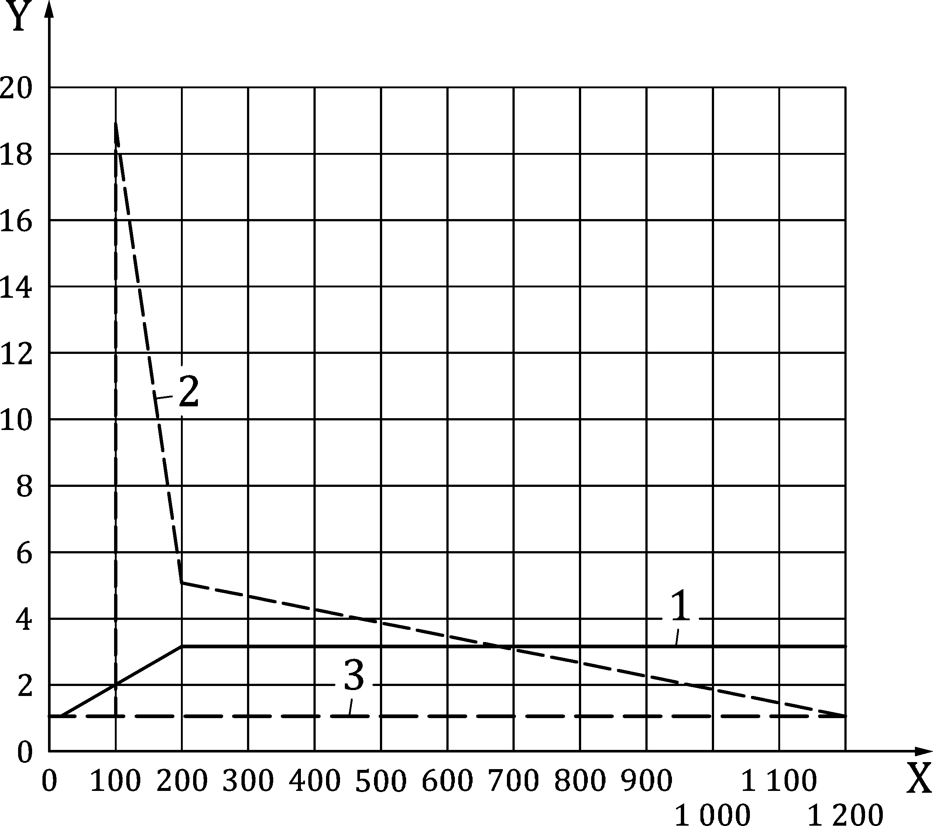

Key

|  |  |
| --- | --- |
| X | T (°C) |
| Y | ratio of value at temperature T to that at 20 °C |
| 1 | λa(T); λa(20 °C) = 0,42 W/m K |
| 2 | ca(T); ca(20 °C) = 564 J/kg K |
| 3 | ρ(T); ρ(20 °C) = 900 to 1 200 kg/cm3 |

Figure B.1(a) — Calculation values of temperature-dependant material properties of clay units over the density range 900 kg/m3 to 1 200 kg/m3

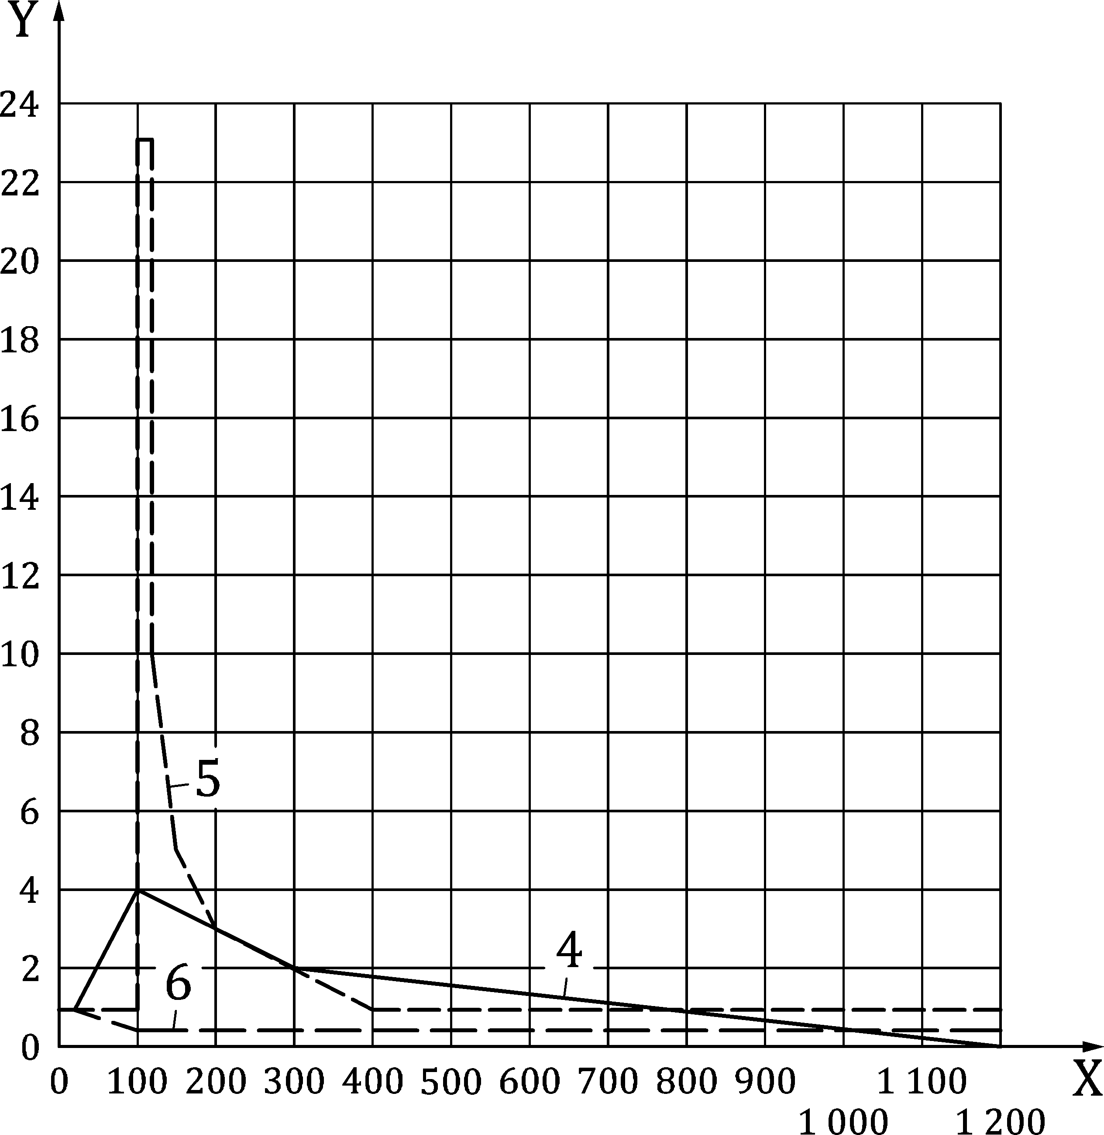

Key

|  |  |
| --- | --- |
| X | T (°C) |
| Y | ratio of value at temperature T to that at 20 °C |
| 4 | λa(T); λa(20 °C) = 1,0 W/m K |
| 5 | ca(T); ca(20 °C) = 1 020 J/kg K |
| 6 | ρ(T); ρ(20 °C) = 1 600 to 2 000 kg/cm3 |

Figure B.1(b) — Calculation values of temperature-dependant material-properties of calcium silicate units over the density range 1 600 kg/m3 to 2 000 kg/m3

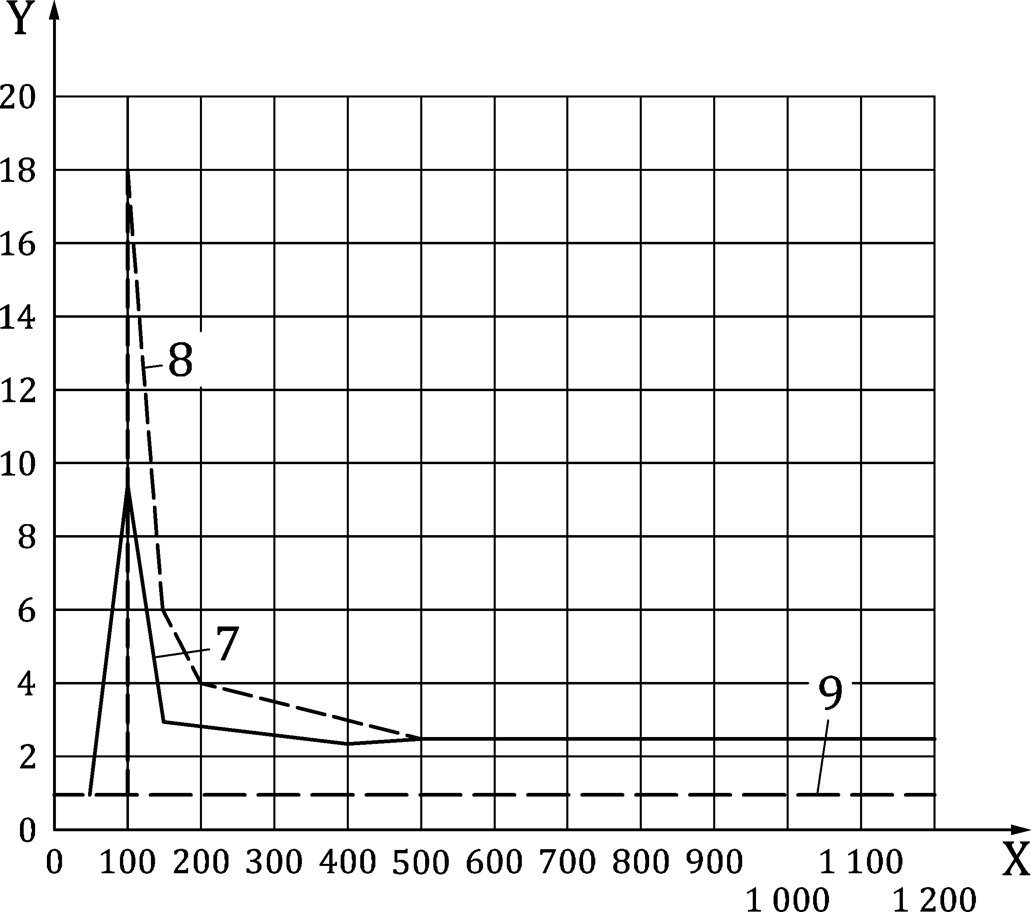

Key

|  |  |
| --- | --- |
| X | T (°C) |
| Y | ratio of value at temperature T to that at 20 °C |
| 7 | λa(T); λa(20 °C) = 0,21 W/m K |
| 8 | ca(T); ca(20 °C) = 1 170 J/kg K |
| 9 | ρ(T); ρ(20 °C) = 600 to 1 000 kg/cm3 |

Figure B.1(c) — Calculation values of temperature-dependant material properties of lightweight aggregate concrete units (pumice) over the density range 600 kg/m3 to 1 000 kg/m3

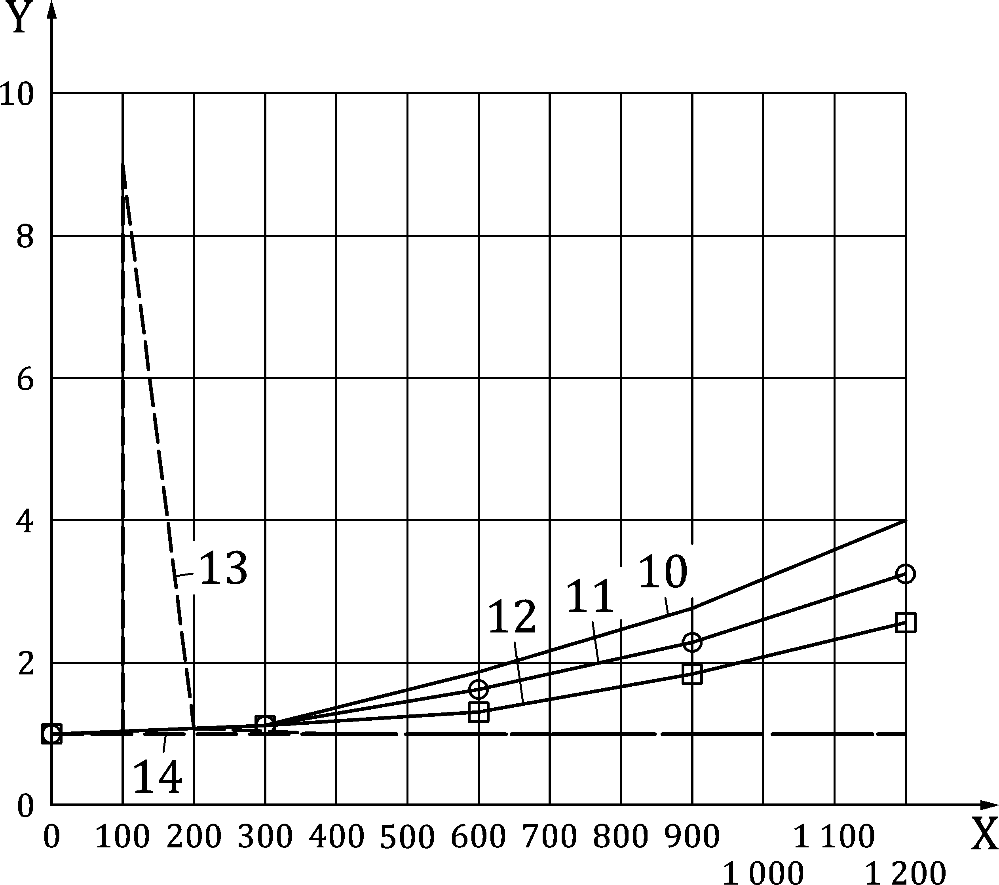

Key

|  |  |
| --- | --- |
| X | T (°C) |
| Y | ratio of value at temperature T to that at 20 °C |
| 10 | λa(T) ‐ ρ = 400 kg/cm3; λa(20 °C) = 0,10 W/m K |
| 11 | λa(T) ‐ ρ = 500 kg/cm3; λa(20 °C) = 0,12 W/m K |
| 12 | λa(T) ‐ ρ = 600 kg/cm3; λa(20 °C) = 0,15 W/m K |
| 13 | ca(T); ca(20 °C) = 1 050 J/kg K |
| 14 | ρ(T); ρ(20 °C) = 400 to 600 kg/cm3 |

Figure B.1(d) — Calculation values of temperature-dependant material properties of autoclaved aerated concrete units over the density range 400 kg/m3 to 600 kg/m3

* 1. Mechanical properties
     1. General

(1) The effects of thermally induced strains and stresses should be considered.

(2) The modification factors *k*θ, see 4.5, may be determined from Formula (B.1) [12]:

 (B.1)

where

|  |  |
| --- | --- |
| *A*0 | is a parameter based on experimental data to represent the value of a generic mechanical property at room temperature; |
| *A*1 | is a parameter based on experimental data to represent the variation of a generic mechanical property with temperature *θ*; |
| *A*2 | is a parameter based on experimental data to represent the variation of a generic mechanical property with the square of temperature *θ.* |

(3) *A*0, *A*1 and *A*2, are parameters that can be defined by a regression analysis of the results of experimental tests carried out in accordance with B.4.2.

(4) The stress-strain relationship in compression as a function of temperature may be determined from Formula (B.2) [13],[14]:

 (B.2)

where

|  |  |
| --- | --- |
| *σ*d(*ε*, 𝜃) | is the design compressive stress in the material (unit or mortar); |
| *k*fmat,k(𝜃) | is the modification factor *k*θ for the characteristic compressive strength *f*mat,k as a function of the temperature *θ*; |
| *k*εmat,u(𝜃) | is the modification factor *k*θ for the ultimate strain *ε*mat,u as a function of the temperature *θ*; |
| *n*mat | is the parameter characterizing each type of material, regardless of the temperature; |
| *ε* | is the strain in the material (unit or mortar) corresponding to the stress *σ*d. |

(5) Values of the parameters *n*mat, *A*0, *A*1 and *A*2 may be determined by testing carried out in accordance with B.4.2 [12].

NOTE Pre-set values for some given materials are reported in B.4.3.

* + 1. Determination of the mechanical property functions of temperature by test
       1. Test procedure

(1) The determination of the mechanical property functions of temperature should be carried out on cylindrical material samples with a diameter of 100 mm and a height of 200 mm, in accordance with EN 12390-1. Samples should be representative of the material under investigation.

(2) Tests should be executed at least at 2 different temperatures *θ*i in addition to ambient conditions (e.g. *θ*1 = 20 °C, *θ*2 = 300 °C and *θ*3 = 600 °C). Each test temperature should not differ from the previous one by more than 300 °C.

(3) There should be at least 3 samples for each temperature value *θ*i investigated.

(4) Each sample should be heated in accordance with the regime indicated in Table B.1.

(5) Once the test temperature *θ*i has been reached the free thermal strain *ε*T of the sample should be measured and a compressive test having the same accuracy and loading rates of EN 12390-3 should be performed, recording displacements and applied load, such that the temperature decay on the lateral surface of the sample is limited to 5 % of *θ*i [12]. From the applied load and the displacement readings, the related values of stress *σ*j and strain *ε*j may be evaluated for the tested sample *j*.

Table B.1 — Heating regime of the oven for experimental tests.

|  |  |  |
| --- | --- | --- |
| **Temperature** | **Period of time**  h | **Temperature rate**  °C/min |
| From 20 °C to 100 °C | 0,5 | 2,67 |
| 100 °C | 2,0 | 0 |
| From 100 °C to the test temperature | 1,5 | Test temperature *θ*i / 90 min |
| Test temperature *θ*i | 2,5 | 0 |

* + - 1. Analysis of the results

(1) From the stress-strain curve recorded for the sample j tested at the temperature *θ*i, the maximum stress is identified as the compressive strength *f*mat,i,j and the corresponding strain as the ultimate strain *ε*mat,u,𝜃i,j. The mean and the characteristic compressive strength and the ultimate strain at *θ*i should be calculated from Formula (B.3) [14]:

 (B.3)

where

|  |  |
| --- | --- |
| *f*mat,θi,m | is the average compressive strength of all samples tested at temperature *θ*i; |
| *f*mat,θi,k | is the characteristic compressive strength of all samples tested at temperature *θ*i; |
| *ε*mat,u,θi,m | is the mean ultimate strain in absence of preload of all samples tested at temperature *θ*i; |
| *n*s | is the number of samples tested at temperature *θ*i, with *n*s ≥ 3; |
| *SD*θi | is the standard deviation of the compressive strength readings *f*mat,θi,j. |

(2) *SD*𝜃i should be calculated from Formula (B.4):

 (B.4)

(3) The coefficients *A*0, *A*1 and *A*2 for the characteristic compressive strength *f*mat,k may be determined by means of the least squares method for a quadratic regression, which is based on minimizing the minimum of the sum *S*(*A*0, *A*1, *A*2) is given by Formula (B.5):

 (B.5)

where

|  |  |
| --- | --- |
| *n*𝜃 | is the number of test temperatures *θ*i, with *n*θ ≥ 3. |

(4) Similar coefficients as *A*0, *A*1 and *A*2 for the characteristic compressive strength may be determined for the mean compressive strength and the ultimate strain.

(5) The coefficient *n*mat may be determined by minimizing the sum *S*(*n*mat) given by Formula (B.6):

 (B.6)

* + 1. Pre-set mechanical property as functions of temperature

(1) The values of the ratios *A*1/*A*0 and *A*2/*A*0 in Formula B.1 given in Tables B.2(a) and B.2(b) for some materials should be used for the calculation of *f*mat,m, *f*mat,k and *ε*mat,u.

(2) Related modification factors as functions of temperature given in Figures B.2(a) to (c) should be used. The values of *n*mat for the same materials given in Table B.3 should be used.

(3) The free thermal strain and the stress-strain relationships for some different masonry materials given in Figure B.3(a) to (h) should be used.

Table B.2(a) — Ratios *A*1*/A*0 and *A*2*/A*0 of Formula (B.1) for unit materials

|  |  |  |
| --- | --- | --- |
| **Mechanical**  **Property** | ***A*1*/A*0** | ***A*2*/A*0** |
| **Autoclaved aerated concrete having a density of 500 kg/m3** | | |
| *f*mat,m | 9,34 × 10-4 | -1,67 × 10-6 |
| *f*mat,k | 7,13 × 10-4 | -1,42 × 10-6 |
| *ε*mat,u | 1,12 × 10-3 | 0 |
| **Lightweight aggregate concrete having a density of 1 600 kg/m3** | | |
| *f*mat,m | 9,65 × 10-5 | -1,08 × 10-6 |
| *f*mat,k | 2,16 × 10-4 | -1,11 × 10-6 |
| *ε*mat,u | 6,02 × 10-4 | 2,08 × 10-6 |
| **Lightweight aggregate concrete (Lapillus) having a density of 1800 kg/m3** | | |
| *f*mat,m | -5,58 × 10-4 | 0 |
| *f*mat,k | -6,91 × 10-4 | 0 |
| *ε*mat,u | 2,27 × 10-3 | -1,19 × 10-6 |
| **Lightweight aggregate concrete having a density of 2000 kg/m3** | | |
| *f*mat,m | -2,34 × 10-4 | 0 |
| *f*mat,k | -8,79 × 10-5 | 0 |
| *ε*mat,u | 1,23 × 10-3 | 4,60 × 10-7 |

Table B.2(b) — Ratios *A*1*/A*0 and *A*2*/A*0 of Formula (B.1) for mortars

|  |  |  |
| --- | --- | --- |
| **Mechanical**  **Property** | ***A*1*/A*0** | ***A*2*/A*0** |
| **Mortar M5 (EN 998-2 and EN 1015-11)** | | |
| *f*mat,m | 1,72 × 10-3 | -3,89 × 10-6 |
| *f*mat,k | 2,14 × 10-3 | -4,92 × 10-6 |
| *ε*mat,u | 6,11 × 10-4 | 2,24 × 10-6 |
| **Mortar M10 (EN 998-2 and EN 1015-11)** | | |
| *f*mat,m | 9,01 × 10-4 | -1,92 × 10-6 |
| *f*mat,k | 1,43 × 10-3 | -2,97 × 10-6 |
| *ε*mat,u | 2,50 × 10-3 | 8,12 × 10-7 |

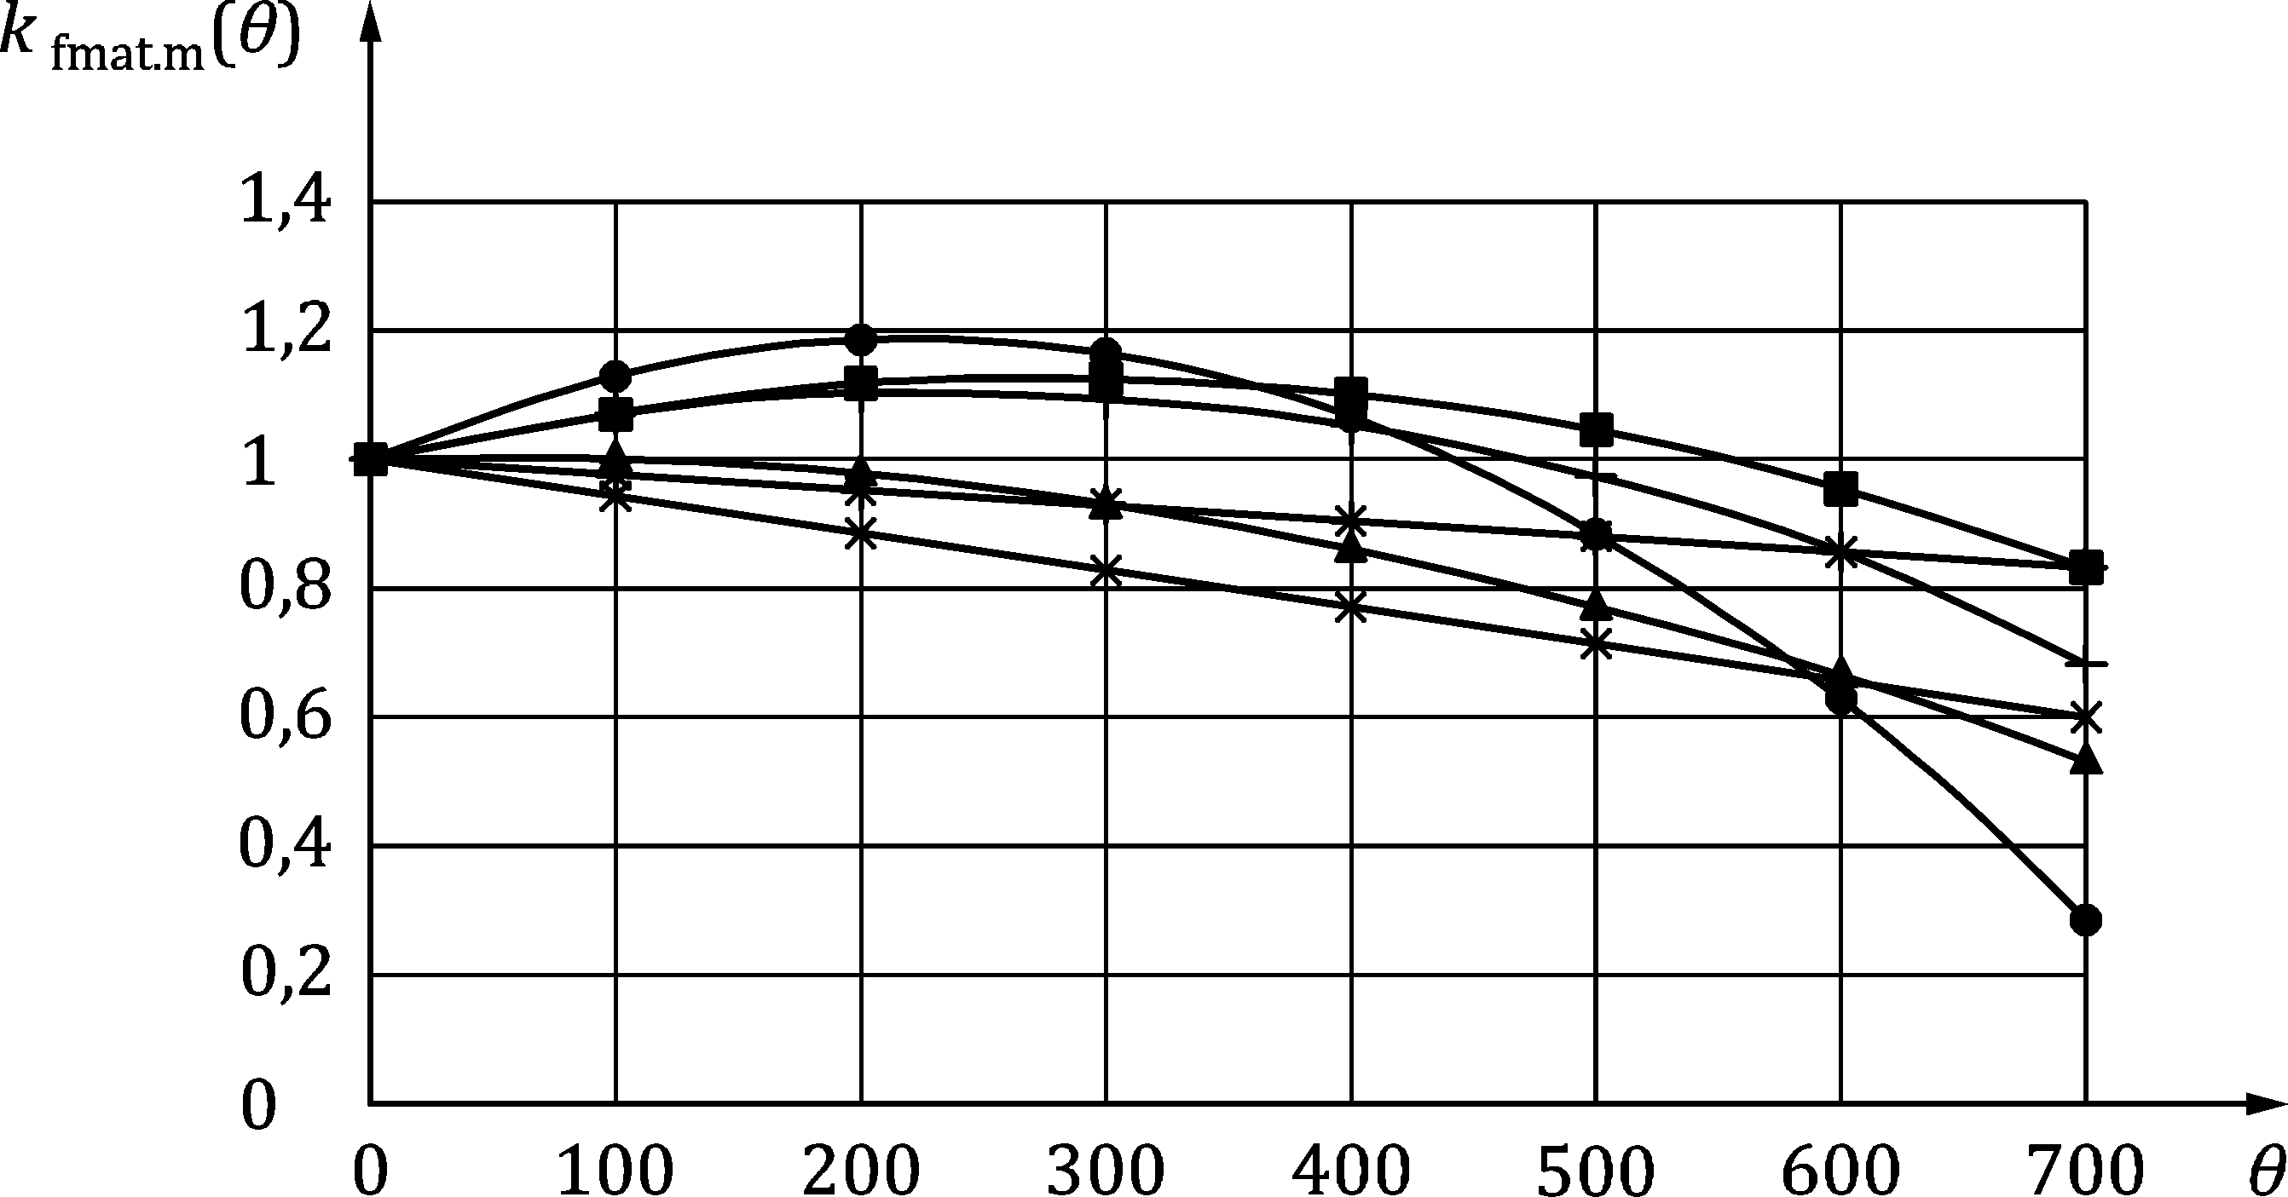

Key

|  |  |
| --- | --- |
|  | Autoclaved aerated concrete having a density of 500 kg/m3 |
|  | Lightweight aggregate concrete having a density of 1 600 kg/m3 |
|  | Lightweight aggregate concrete (Lapillus) having a density of 1 800 kg/m3 |
|  | Lightweight aggregate concrete having a density of 2 000 kg/m3 |
|  | Mortar M5 |
|  | Mortar M10 |

Figure B.2(a) — Modification factor *k*fmat,m(𝜃) as a function of temperature 𝜃 (°C)

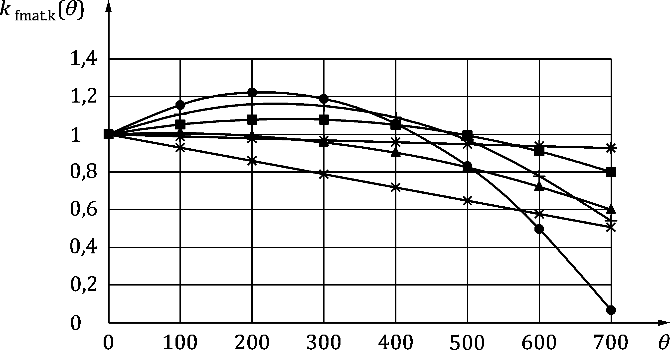

Key

|  |  |
| --- | --- |
|  | Autoclaved aerated concrete having a density of 500 kg/m3 |
|  | Lightweight aggregate concrete having a density of 1 600 kg/m3 |
|  | Lightweight aggregate concrete (Lapillus) having a density of 1 800 kg/m3 |
|  | Lightweight aggregate concrete having a density of 2 000 kg/m3 |
|  | Mortar M5 |
|  | Mortar M10 |

Figure B.2(b) — Modification factor *k*fmat,k(𝜃) as a function of temperature 𝜃 (°C)

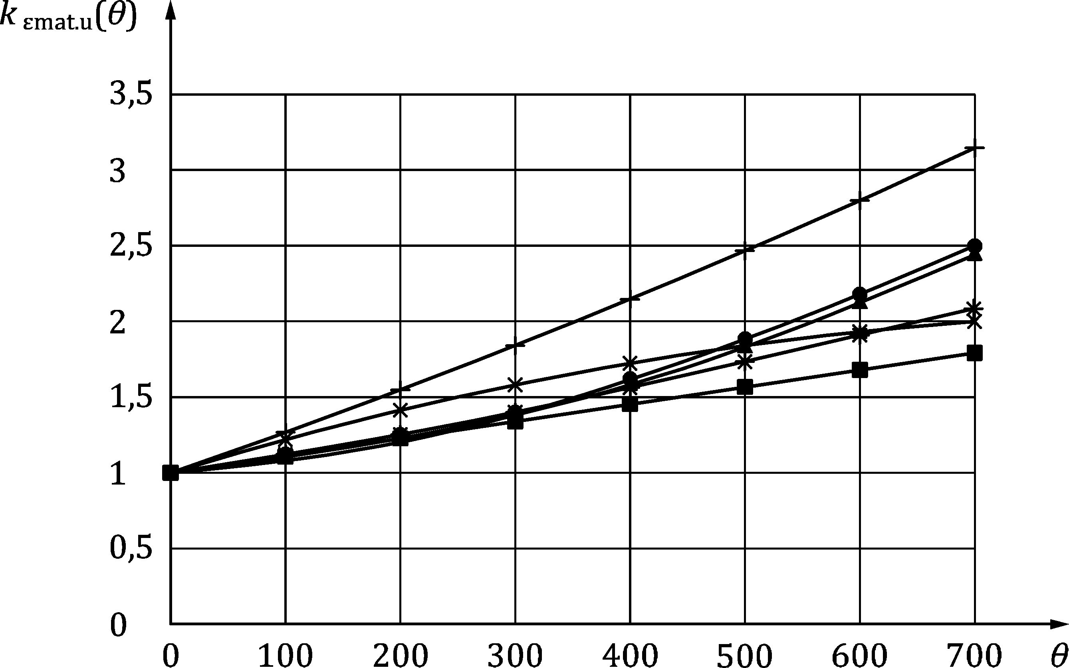

Key

|  |  |
| --- | --- |
|  | Autoclaved aerated concrete having a density of 500 kg/m3 |
|  | Lightweight aggregate concrete having a density of 1 600 kg/m3 |
|  | Lightweight aggregate concrete (Lapillus) having a density of 1 800 kg/m3 |
|  | Lightweight aggregate concrete having a density of 2 000 kg/m3 |
|  | Mortar M5 |
|  | Mortar M10 |

Figure B.2(c) — Modification factor *k*εmat,u(𝜃) as a function of temperature 𝜃 (°C)

Table B.3 — Parameter *n*mat for masonry units and mortars.

|  |  |
| --- | --- |
| **Material** | ***n*mat** |
| Autoclaved aerated concrete having a density of 500 kg/m3 | 7,9 |
| Lightweight aggregate concrete having a density of 1 600 kg/m3 | 8,2 |
| Lightweight aggregate concrete (Lapillus) having a density of 1 800 kg/m3 | 10,8 |
| Lightweight aggregate concrete having a density of 2 000 kg/m3 | 9,1 |
| Mortar M5 | 3,4 |
| Mortar M10 | 5,6 |

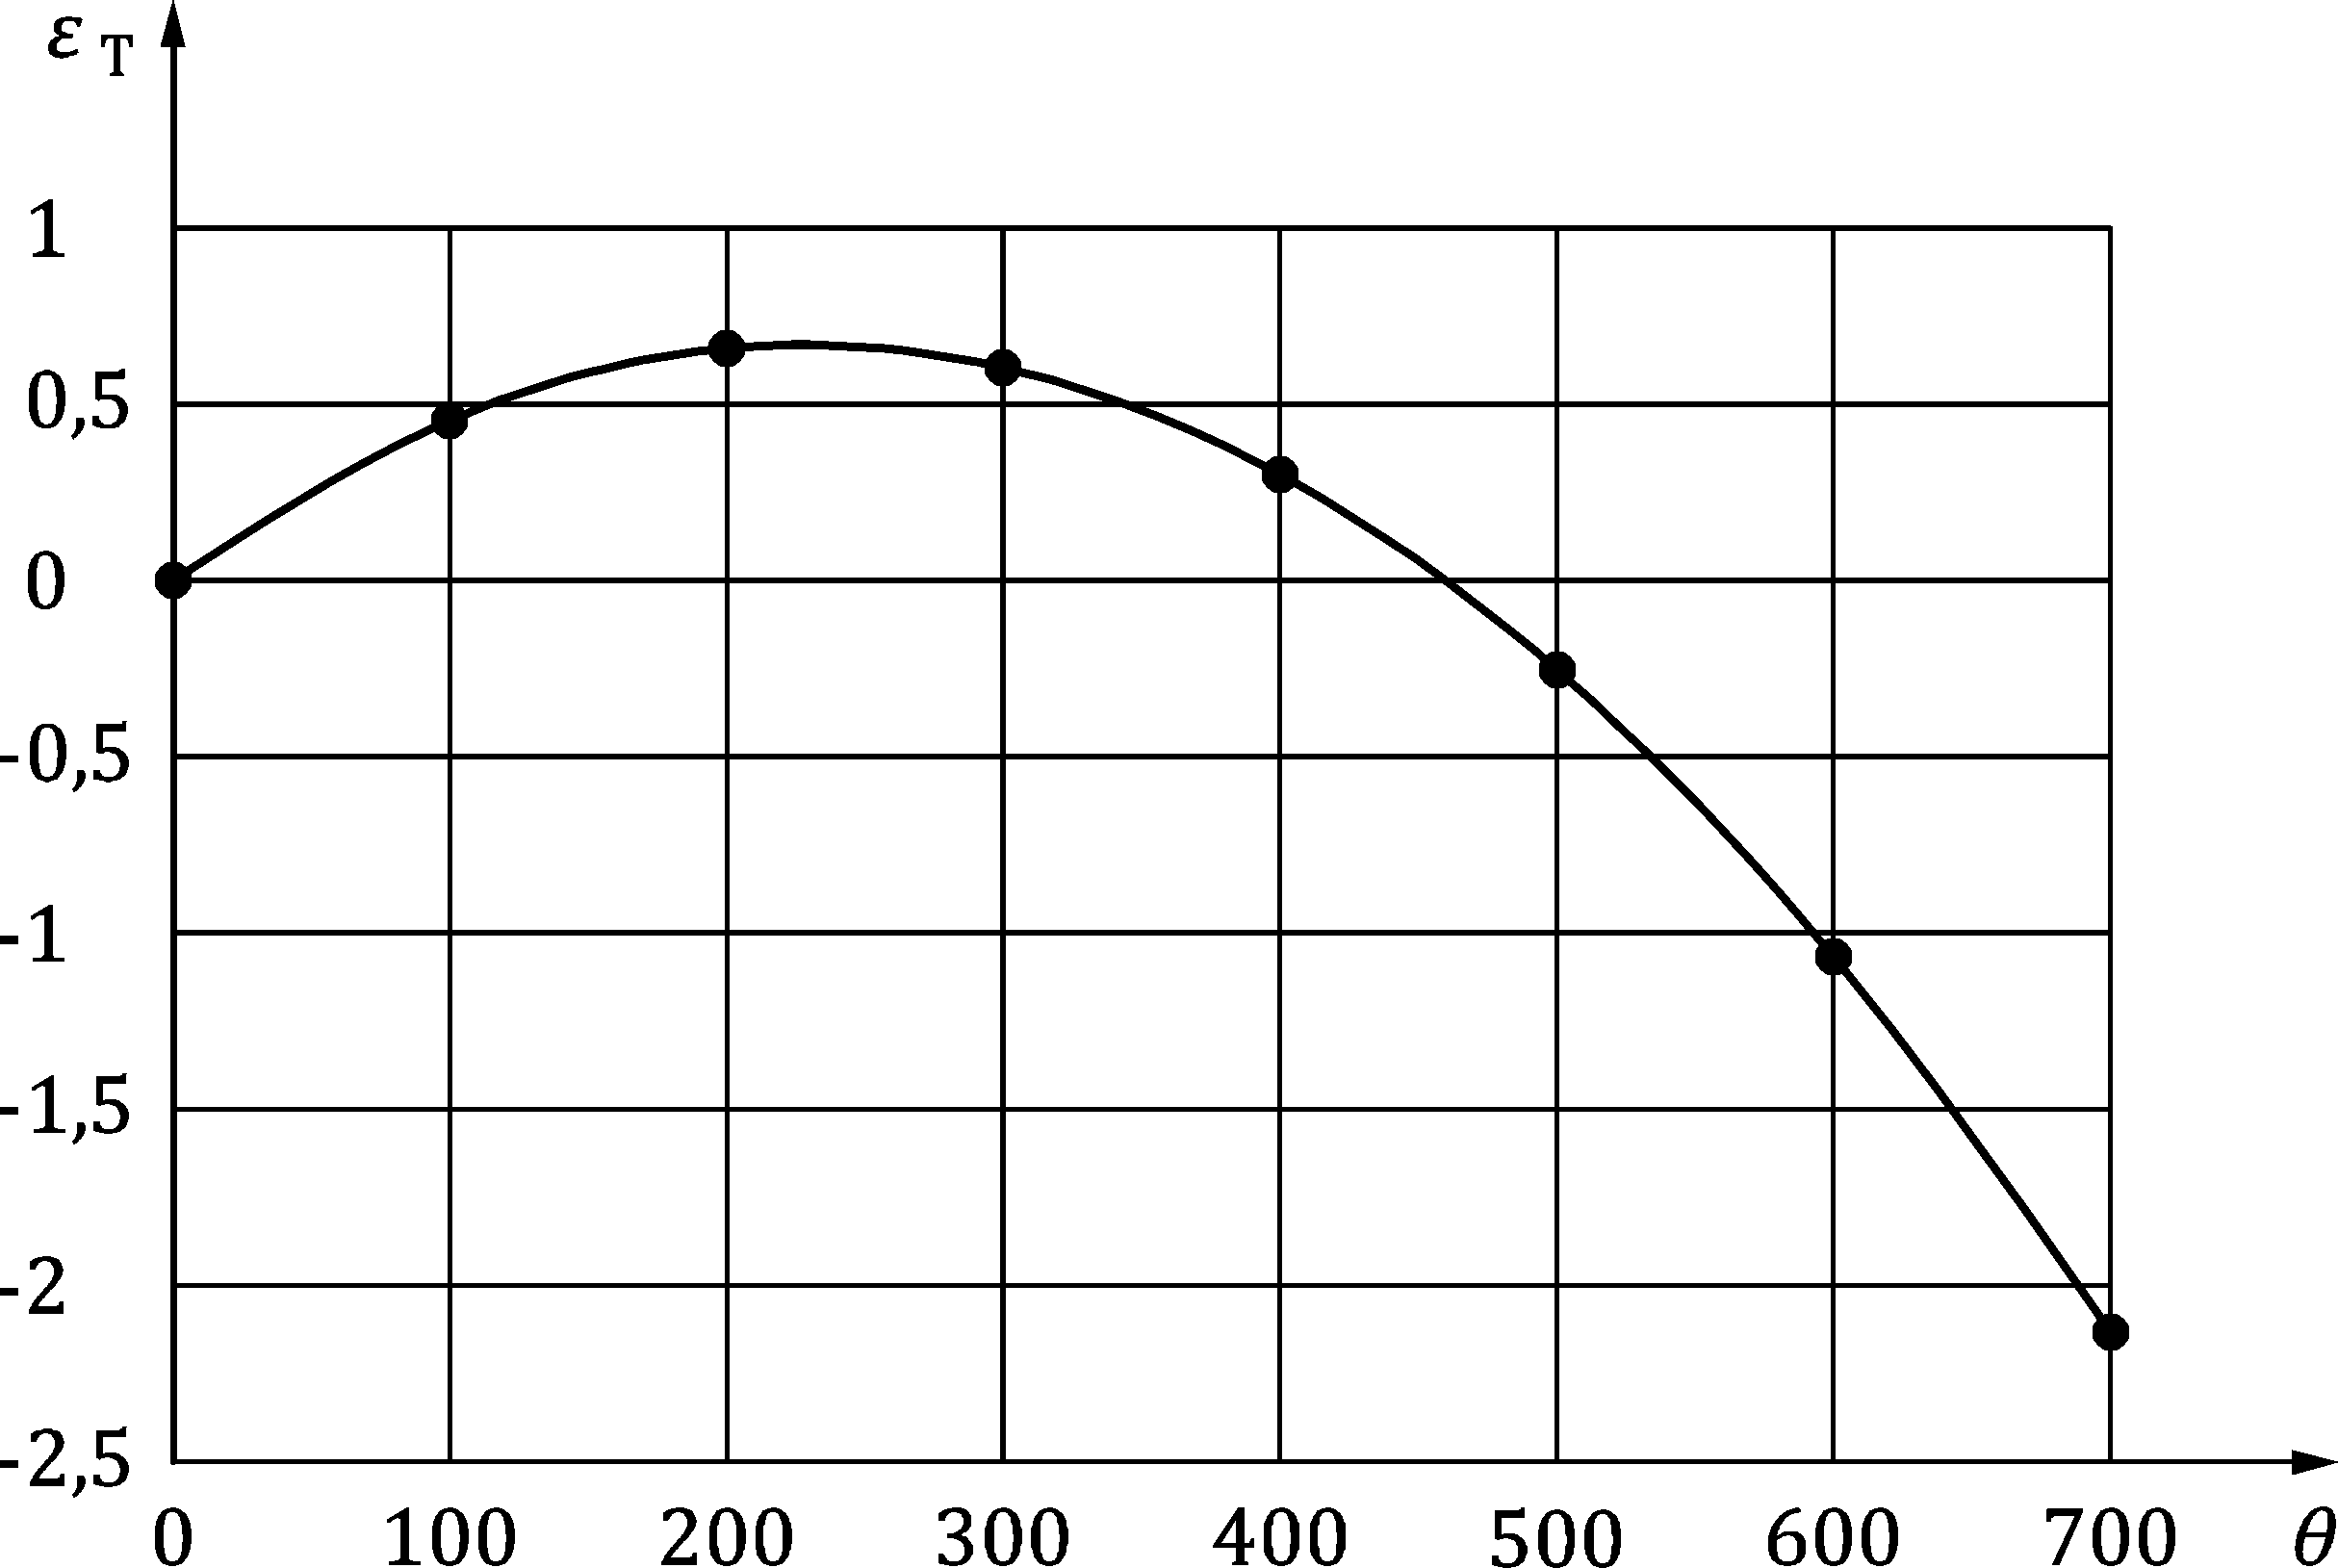

Figure B.3(a) — Design values of thermal strain εT (‰) of autoclaved aerated concrete having a density of 500 kg/m3 as a function of temperature 𝜃 (°C)

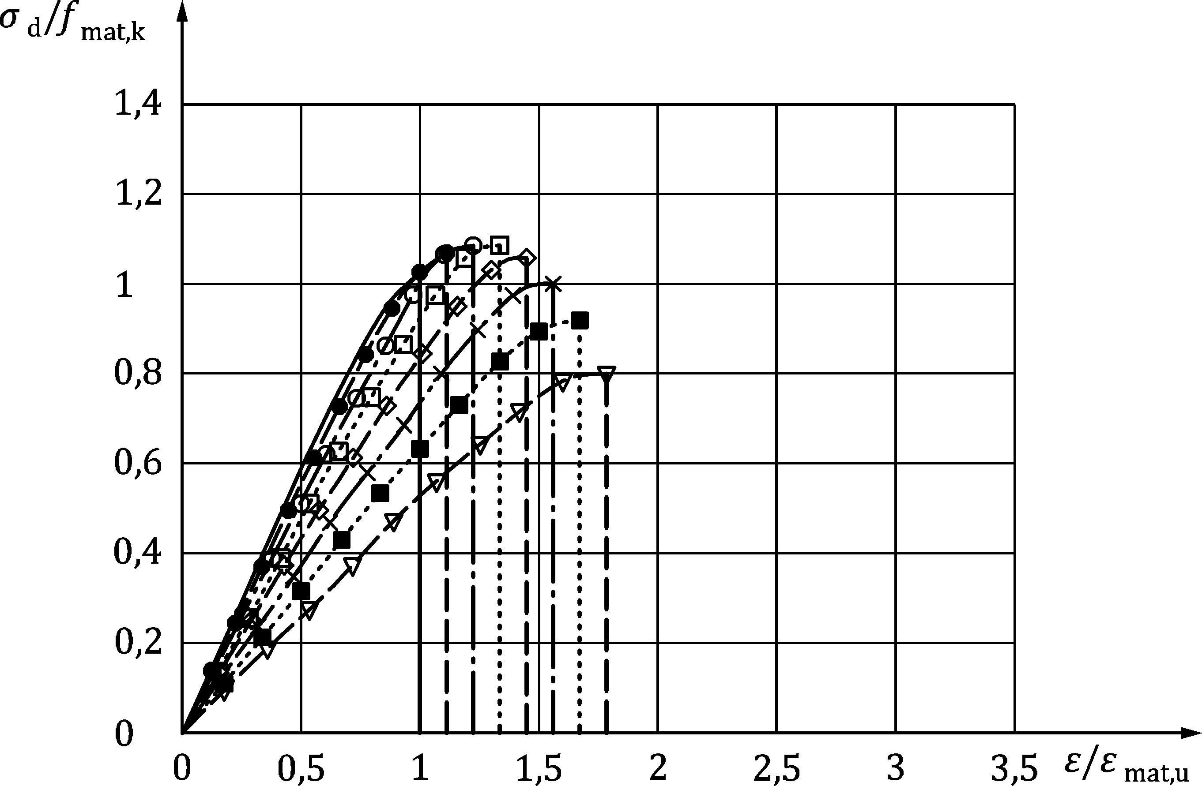

Key

|  |  |
| --- | --- |
| Symbol | Temperature 𝜃 (°C) |
|  | 20 |
|  | 100 |
|  | 200 |
|  | 300 |
|  | 400 |
|  | 500 |
|  | 600 |
|  | 700 |

Figure B.3(b) — Design values of temperature-dependant stress and strain of autoclaved aerated concrete having a density of 500 kg/m3

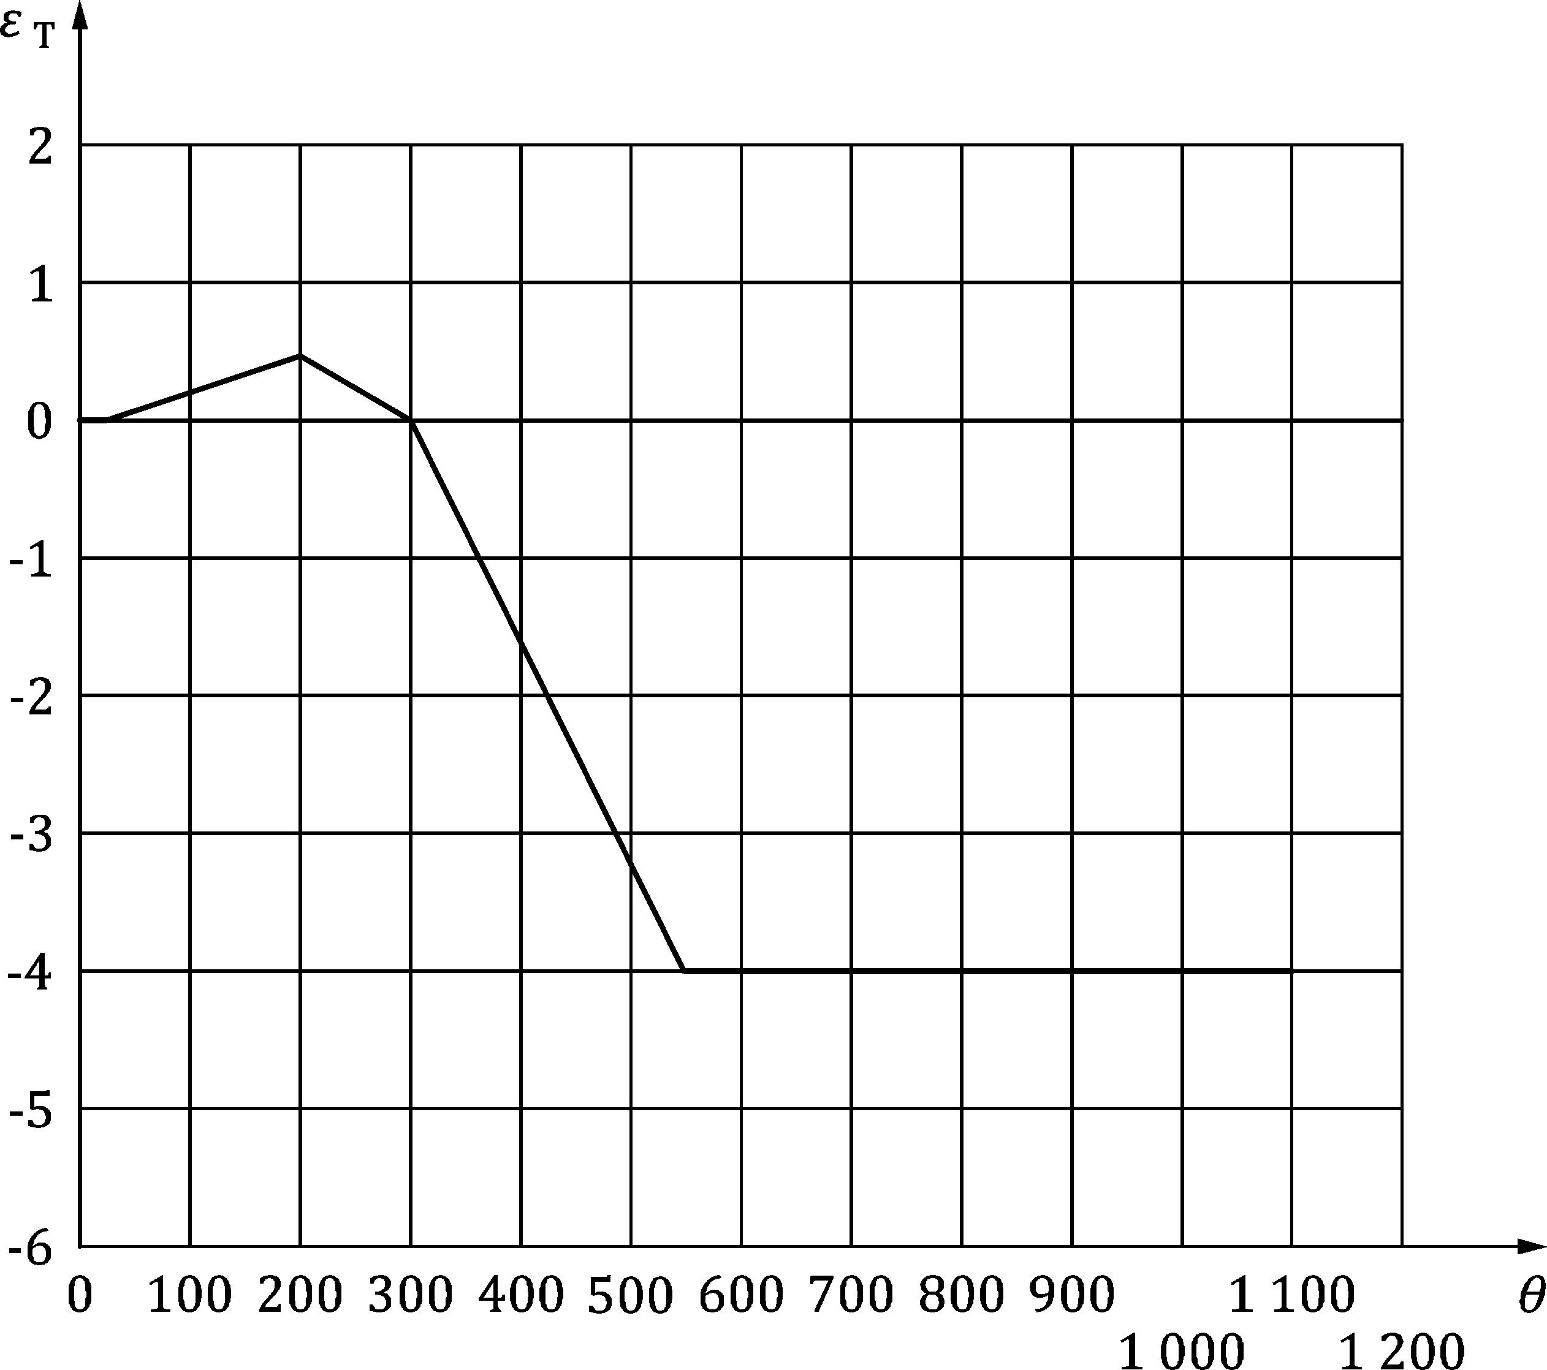

Figure B.3(c) — Design values of thermal strain εT (‰) for lightweight aggregate concrete units having a gross dry density range of 600 kg/m3 to 1 000 kg/m3 as a function of temperature 𝜃 (°C)

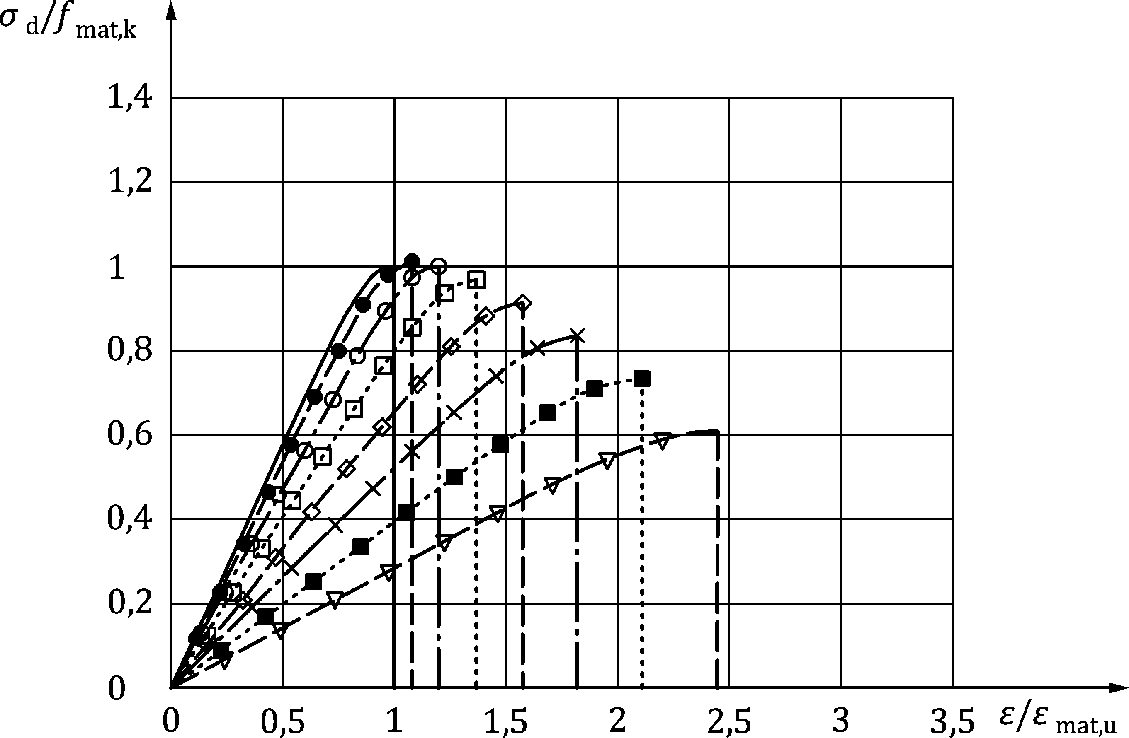

Key

|  |  |
| --- | --- |
| Symbol | Temperature 𝜃 (°C) |
|  | 20 |
|  | 100 |
|  | 200 |
|  | 300 |
|  | 400 |
|  | 500 |
|  | 600 |
|  | 700 |

Figure B.3(d) — Design values of temperature-dependant stress-strain for lightweight aggregate concrete having a density of 1 600 kg/m3

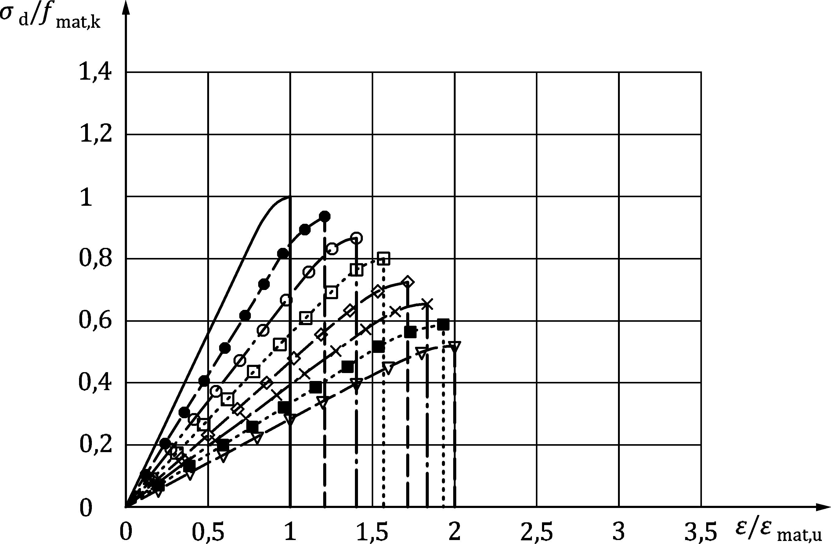

Key

|  |  |
| --- | --- |
| Symbol | Temperature 𝜃 (°C) |
|  | 20 |
|  | 100 |
|  | 200 |
|  | 300 |
|  | 400 |
|  | 500 |
|  | 600 |
|  | 700 |

Figure B.3(e) — Design values of temperature-dependant stress-strain for lightweight aggregate concrete (Lapillus) having a density of 1 800 kg/m3

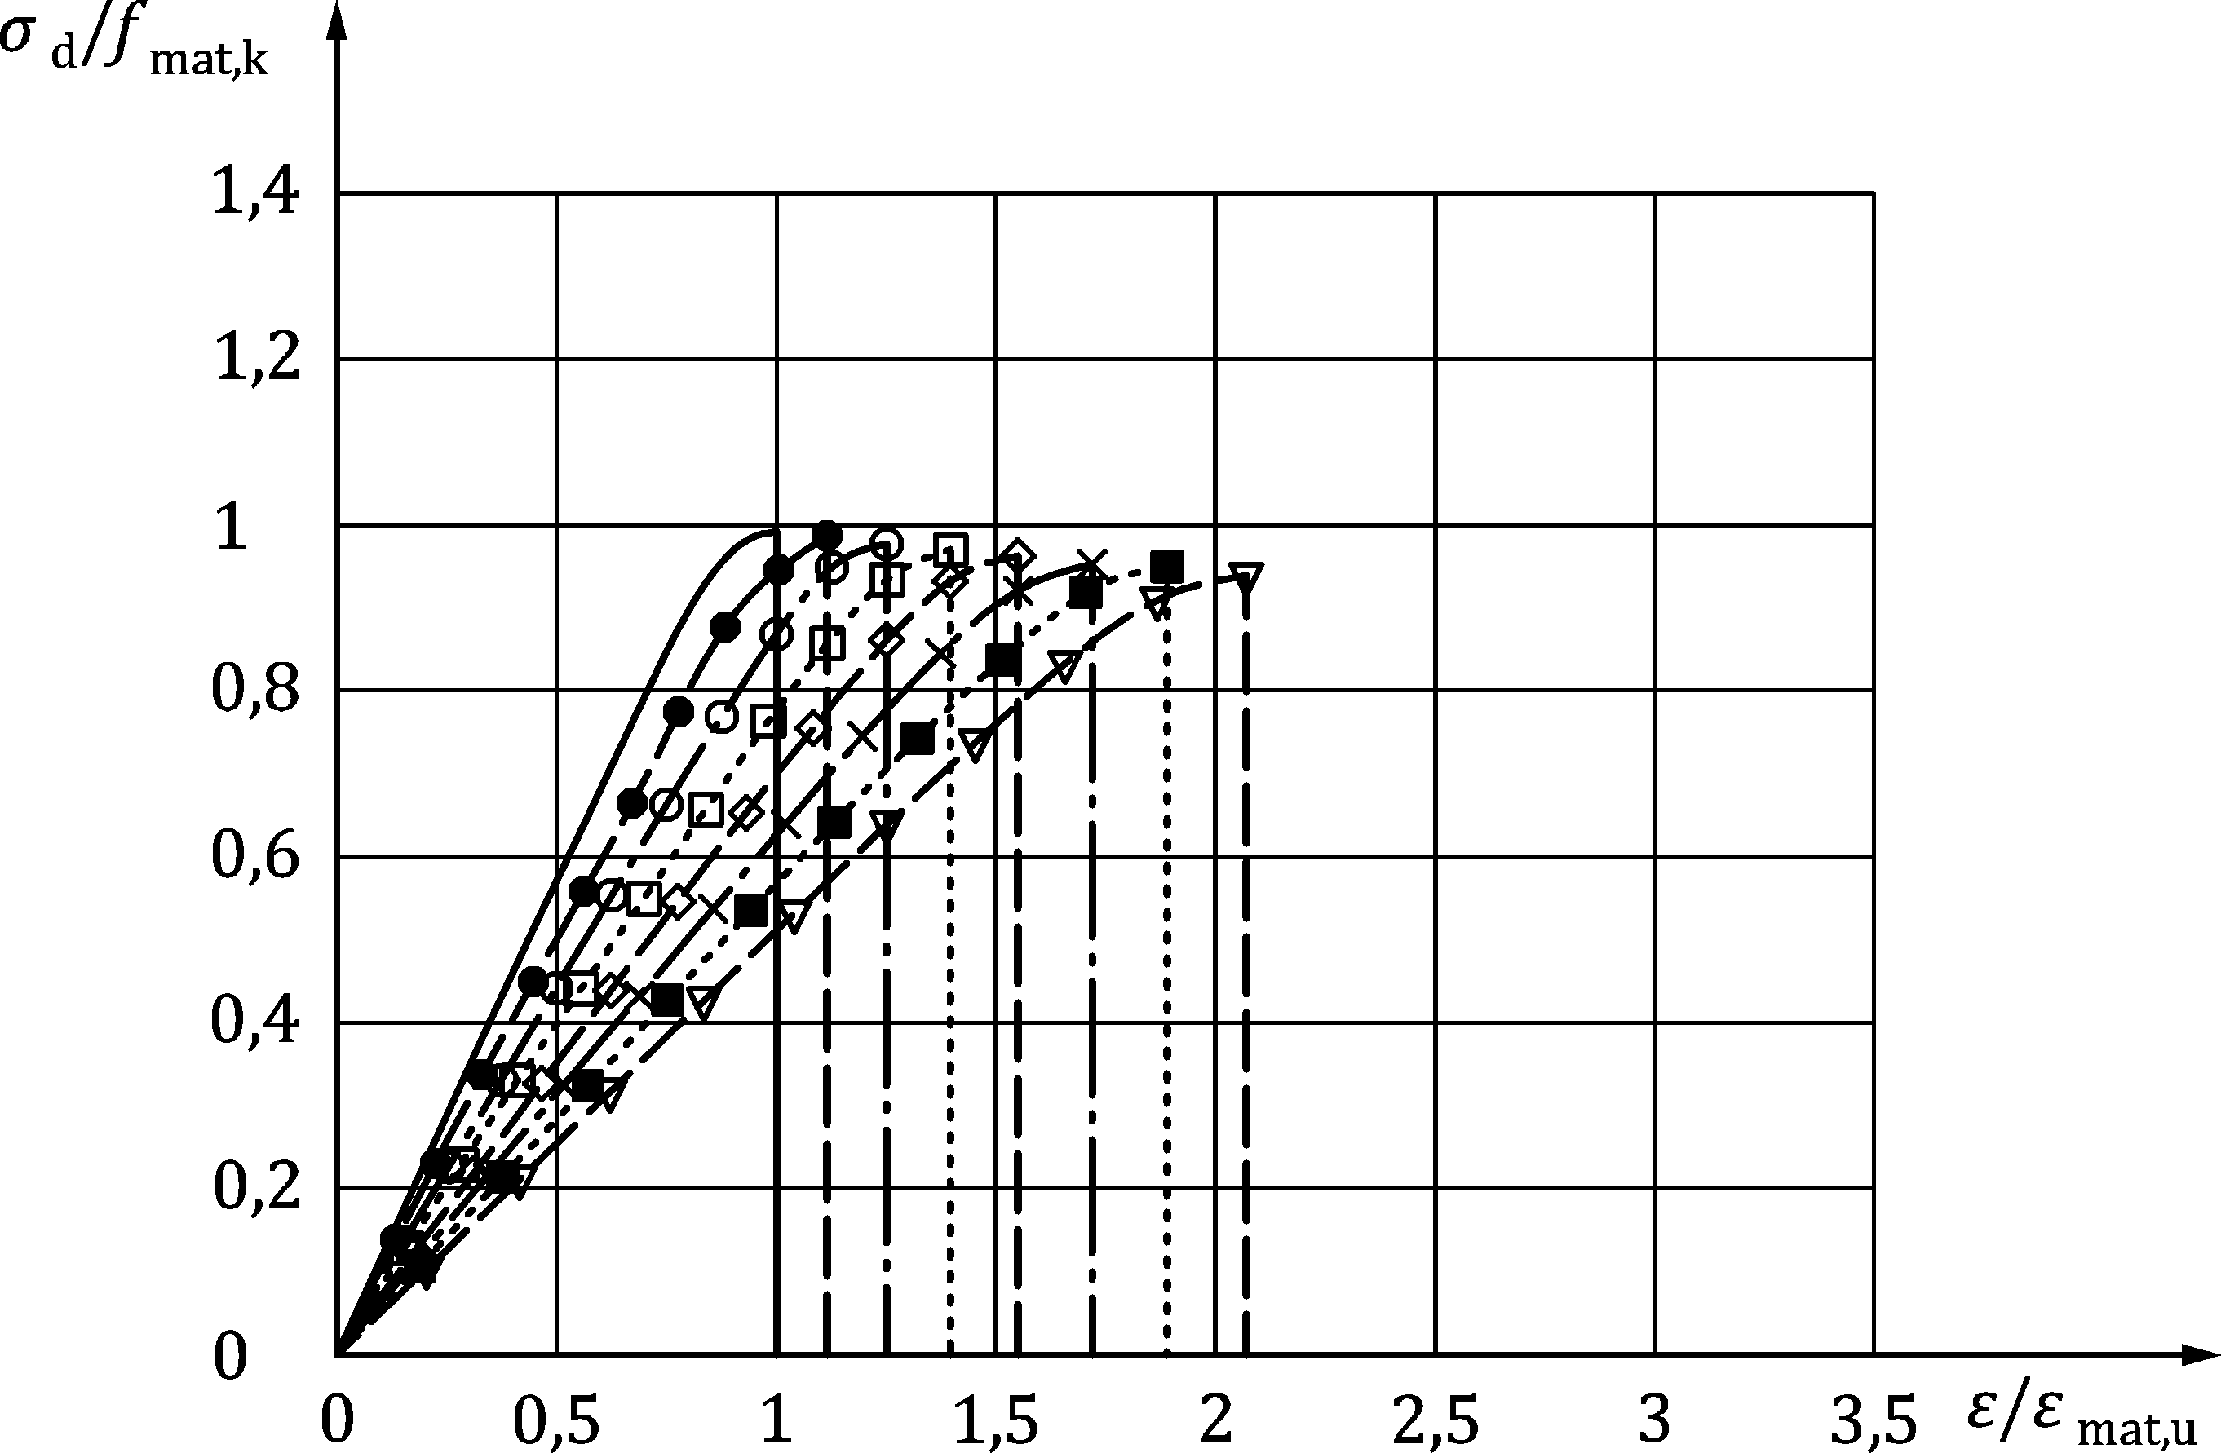

Key

|  |  |
| --- | --- |
| Symbol | Temperature 𝜃 (°C) |
|  | 20 |
|  | 100 |
|  | 200 |
|  | 300 |
|  | 400 |
|  | 500 |
|  | 600 |
|  | 700 |

Figure B.3(f) — Design values of temperature-dependant stress-strain for lightweight aggregate concrete having a density of 2 000 kg/m3

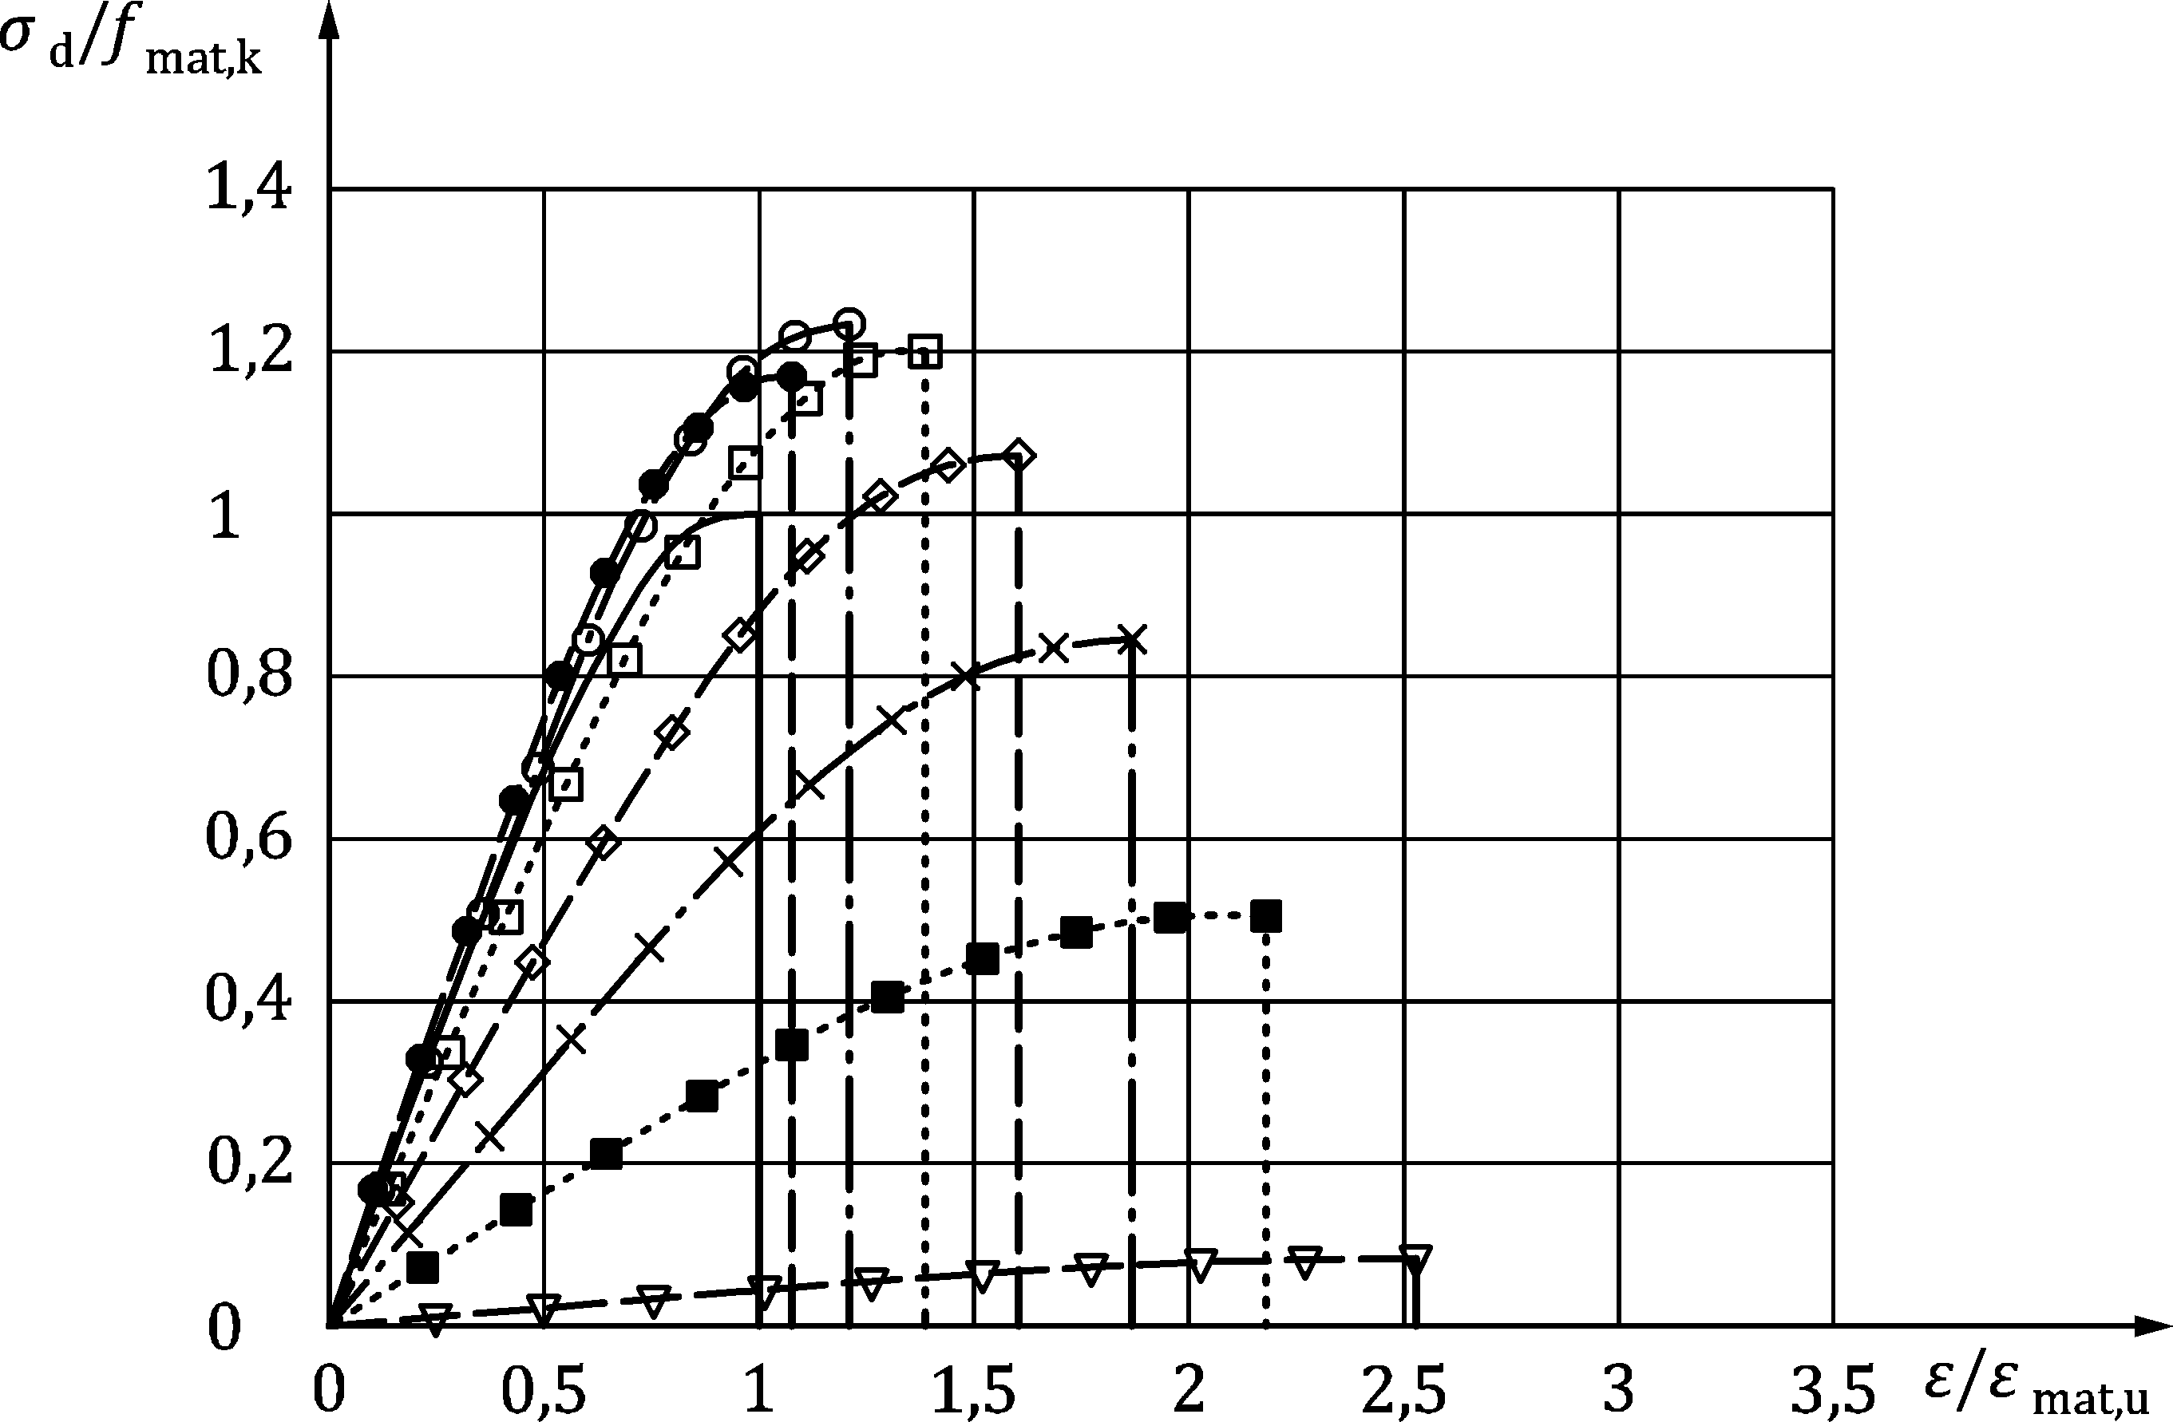

Key

|  |  |
| --- | --- |
| Symbol | Temperature 𝜃 (°C) |
|  | 20 |
|  | 100 |
|  | 200 |
|  | 300 |
|  | 400 |
|  | 500 |
|  | 600 |
|  | 700 |

Figure B.3(g) — Design values of temperature-dependant stress and strain of cement mortar M5

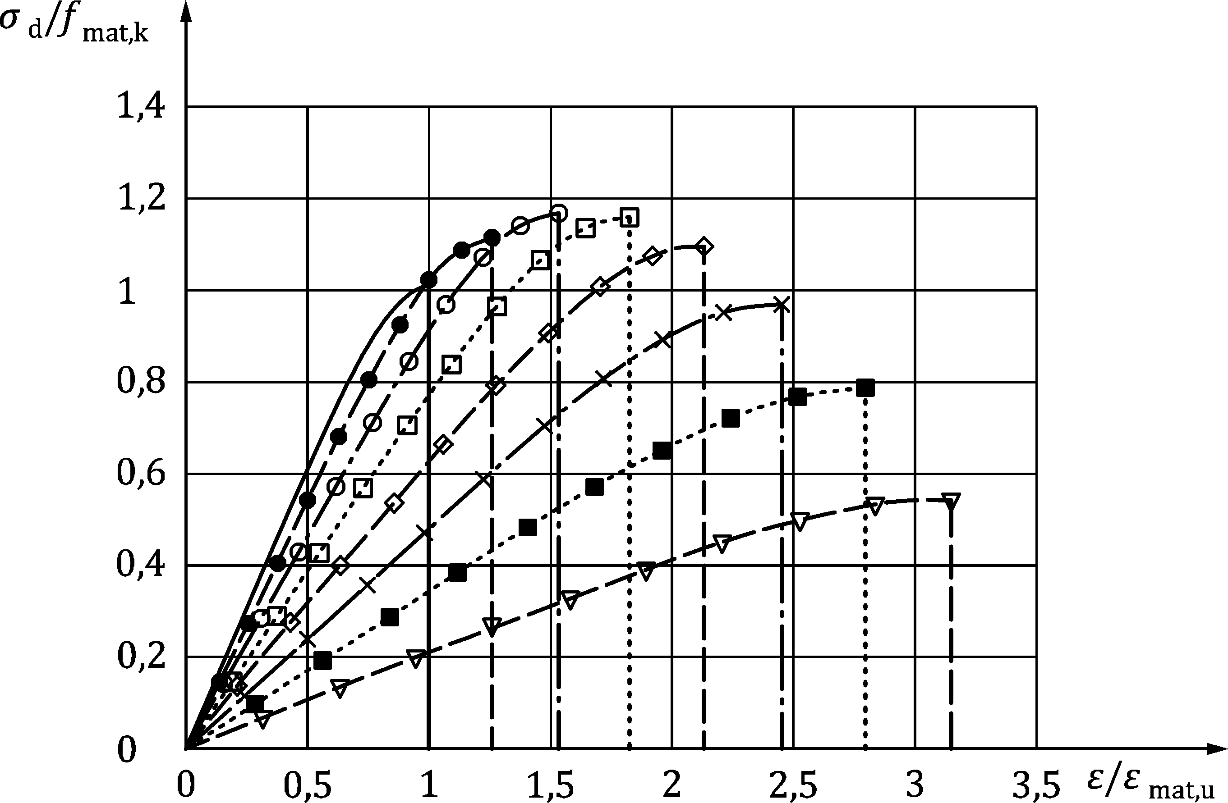

Key

|  |  |
| --- | --- |
| Symbol | Temperature 𝜃 (°C) |
|  | 20 |
|  | 100 |
|  | 200 |
|  | 300 |
|  | 400 |
|  | 500 |
|  | 600 |
|  | 700 |

Figure B.3(h) — Design values of temperature-dependant stress and strain of cement mortar M10

1. (informative)  
     
   Examples of connections that meet the requirements for detailing
   1. Use of this informative annex

(1) This informative annex provides examples (see Figure C.1 to Figure C.7) in accordance with 7.2 (4) and 7.2 (5).

NOTE National choice on the application of this informative annex is given in the National Annex. If the National Annex contains no information on the application of this informative annex, it can be used.

* 1. Scope and field of application

(1) This informative annex gives examples of connections that allow the application of the Annex A tabulated data.

* 1. Examples

Dimensions in mm

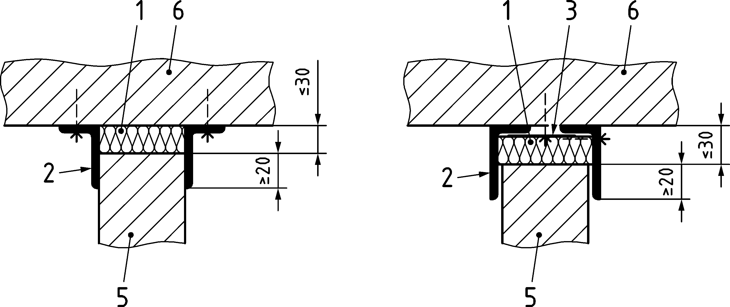

Key

|  |  |
| --- | --- |
| 1 | Insulating layer - mineral wool, material class A (non-combustible), melting point ≥ 1 000 °C |
| 2 | Steel angle |
| 3 | Flat steel 65x5mm, a>600mm |
| 5 | Masonry |
| 6 | Concrete |

Figure C.1 — Cross-section of connections, wall to floor or roof, for  
non-loadbearing masonry walls

|  |  |
| --- | --- |
|  |  |
| a) Connection through plaster work | b) Connection through tie |
|  |  |
| c) Connection through recessed joint, insulation layer or mortar |  |

Key

|  |  |
| --- | --- |
| 1 | Plaster |
| 2 | Insulating layer - mineral wool, material class A (non-combustible), melting point ≥ 1 000 °C |
| 3 | Flat steel tie, spacing according to structural requirements |
| 4 | Mortar |

Figure C.2 — Plan cross-section of connections wall (column) to wall

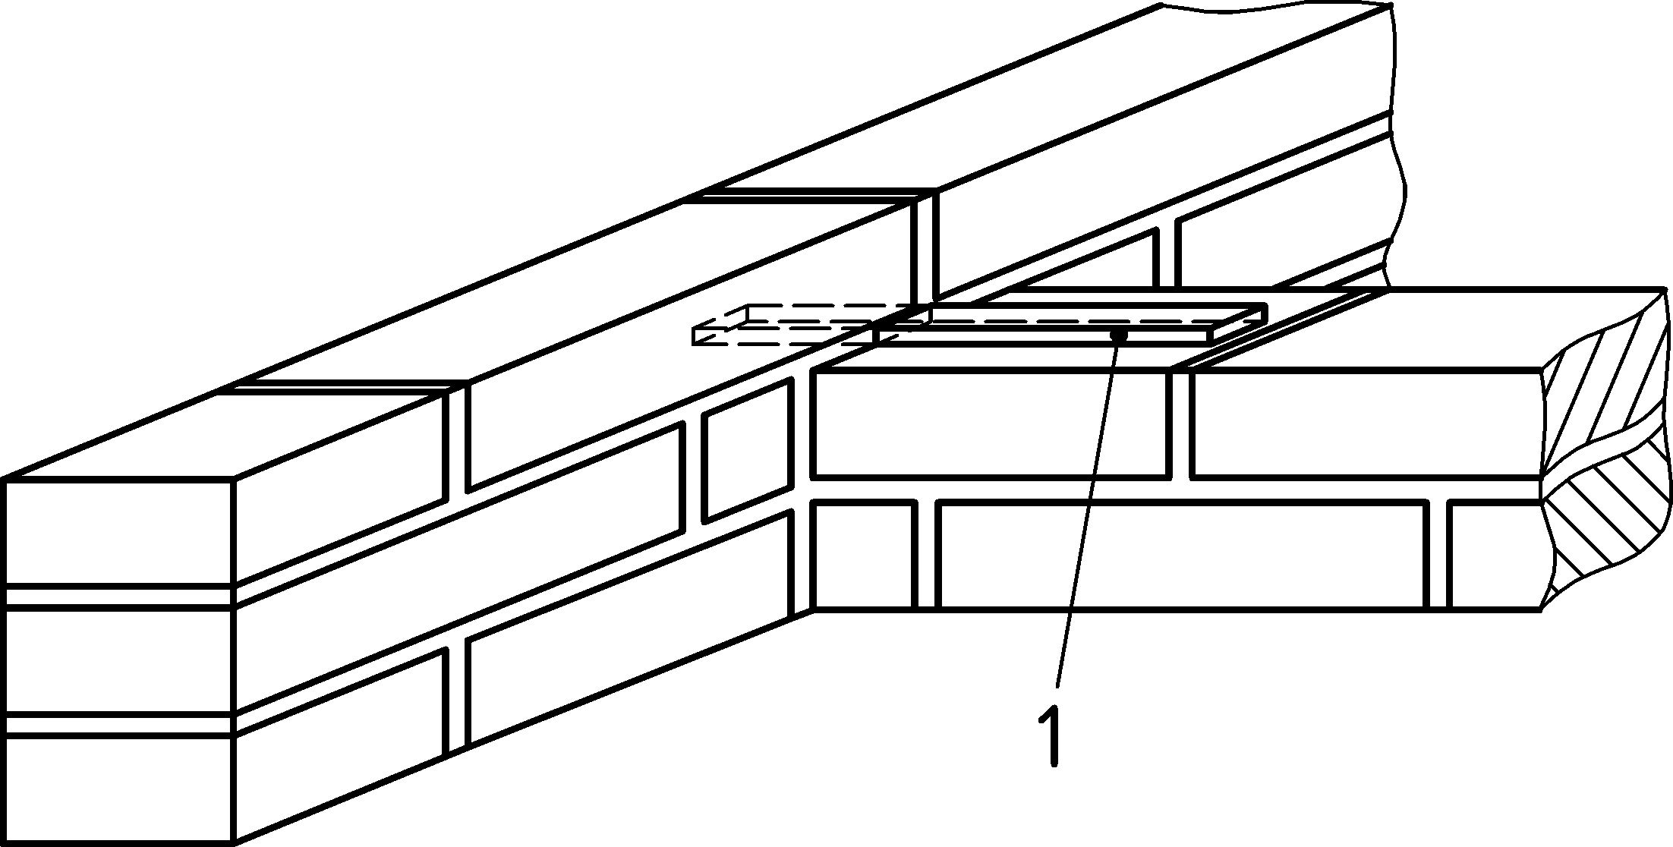

Key

|  |  |
| --- | --- |
| 1 | Flat steel tie, spacing according to structural requirements |

Figure C.3 — Connection of loadbearing masonry walls

|  |  |
| --- | --- |
|  |  |
| a) | b) |

Key

|  |  |
| --- | --- |
| 1 | Joint seal |
| 2 | Trowel cut or plaster cut (optional) |
| 3 | Insulating layer - mineral wool, material class A (non-combustible), melting point ≥ 1 000 °C |
| 5 | Masonry |
| 6 | Concrete |
| 7 | Anchor |
| 8 | Vertical sliding anchor |
| 9 | Insulating layer - mineral wool, material class A (non-combustible), melting point ≥ 1 000 °C, or mortar |
| 10 | Joint seal |

Figure C.4 — Movement connection of masonry wall (column) to concrete wall

Dimensions in mm

|  |  |  |
| --- | --- | --- |
|  |  |  |
| a) wall-wall | b) wall-floor | c) wall-wall |

Key

|  |  |
| --- | --- |
| 1 | Insulating layer - mineral wool, material class A (non-combustible), melting point ≥ 1 000 °C, or mortar |
| 2 | Steel angle |
| 3 | Trowel cut or plaster cut (optional) |
| 4 | Joint seal |
| 5 | Masonry |
| 6 | Concrete |

Figure C.5 — Structural connections of Fire walls to walls and floors

|  |  |
| --- | --- |
|  | **Key**  1 Insulating layer - mineral wool, material class A (noncombustible), melting point ≥ 1 000 °C, or mortar  2 Joint seal (optional)  3 Masonry  4 Concrete |

Figure C.6 — Connection with no structural requirements

|  |
| --- |
|  |
| a) Steel column |
|  |
| b) Steel beam |

Key

|  |  |
| --- | --- |
| 1 | Cladding corresponding to fire resistance class |
| 2 | Masonry or concrete |
| 3 | Sheet metal encasement |
| 4 | Masonry |

Figure C.7 — Connections of fire walls to steel structures

Bibliography

**References contained in recommendations (i.e. “should” clauses)**

The following documents are referred to in the text in such a way that some or all of their content constitutes highly recommended choices or course of action of this document. Subject to national regulation and/or any relevant contractual provisions, alternative documents could be used/adopted where technically justified. For dated references, only the edition cited applies. For undated references, the latest edition of the referenced document (including any amendments) applies.

[1] EN 1991‑1-1, Eurocode 1: Actions on structures — Part 1-1: General actions — Densities, self-weight, imposed loads for buildings

[2] EN 12390‑1, Testing hardened concrete — Part 1: Shape, dimensions and other requirements for specimens and moulds

**References contained in permissions (i.e. “may” clauses)**

The following documents are referred to in the text in such a way that some or all of their content expresses a course of action permissible within the limits of the Eurocodes. For dated references, only the edition cited applies. For undated references, the latest edition of the referenced document (including any amendments) applies.

[3] EN 998‑1, Specification for mortar for masonry — Part 1: Rendering and plastering mortar

[4] EN 998‑2, Specification for mortar for masonry — Part 2: Masonry mortar

[5] EN 1015-11, Methods of test for mortar for masonry — Part 11: Determination of flexural and compressive strength of hardened mortar

[6] EN 1363‑1, Fire resistance tests — Part 1: General requirements

[7] EN 1365‑1, Fire resistance tests for loadbearing elements — Part 1: Walls

[8] EN 1365‑4, Fire resistance tests for loadbearing elements — Part 4: Columns

[9] EN 1366‑3, Fire resistance tests for service installations — Part 3: Penetration seals

[10] EN 1995-1-2, Eurocode 5: Design of timber structures — Part 1-2: General — Structural fire design

[11] EN 13279‑1, Gypsum binders and gypsum plasters — Part 1: Definitions and requirements

**References contained in permissions (i.e. “can” clauses) and notes**

The following documents are cited informatively in the document, for example in “can” clauses and in notes.

[12] Andreini, M., Caciolai, M., La Mendola, S., Mazziotti, L., & Sassu, M. (2015). Mechanical behaviour of masonry materials at high temperatures. Fire and Materials, 39(1), 41–57. <https://doi.org/10.1002/fam.2229>

[13] Andreini, M., De Falco, A., & Sassu, M. (2014). Stress-strain curves for masonry materials exposed to fire action. Fire Safety Journal, 69. <https://doi.org/10.1016/j.firesaf.2014.08.005>

[14] Meyer, U., van der Pluijm, R., Andreini, M., Pettit, G. & Miccoli, L. (2020). Design of masonry panels subjected to fire in Europe: an overview on the new draft of EN 1996-1-2. Proceedings of the 17th International Brick and Block Masonry Conference (IB2MaC 2020), July 5th – 8th, 2020. Kraków, Poland. CRC Press/Balkema – Taylor & Francis Group