CEN/TC 250

Date: 2022-02

prEN 1998-5:2022

Secretariat: BSI

Eurocode 8 — Design of structures for earthquake resistance — Part 5: Geotechnical aspects, foundations, retaining and underground structures

Einführendes Element — Haupt-Element — Ergänzendes Element

Élément introductif — Élément central — Élément complémentaire

ICS:

Contents Page

European foreword 6

0 Introduction 7

1 Scope 9

1.1 Scope of prEN 1998-5 9

1.2 Assumptions 9

2 Normative references 9

3 Terms, definitions and symbols 10

3.1 Terms and definitions 10

3.1.1 General 10

3.2 Symbols and abbreviations 12

3.2.1 General 12

3.2.2 Symbols 13

3.2.3 Abbreviations 19

3.3 S.I. Units 20

4 Basis of design 20

4.1 Performance requirements 20

4.2 Consequence classes 20

4.3 Limit states and associated seismic action 21

4.4 Compliance criteria 22

4.5 Methods of analysis 22

4.6 Verification of seismic performance 23

5 Seismic action 24

5.1 Definition of the seismic action 24

5.2 Seismic action for geotechnical systems and geotechnical structures 24

6 Ground properties 25

6.1 Ground investigations 25

6.2 Water levels 25

6.3 Strength parameters 25

6.4 Stiffness and energy dissipation properties 26

6.5 Partial factors and design cases 27

7 Evaluation of the seismic response of the construction site 28

7.1 Siting 28

7.1.1 General 28

7.1.2 Potentially active seismic faults 28

7.2 Slope stability 29

7.2.1 General 29

7.2.2 Methods of analysis 29

7.3 Potentially liquefiable soils 31

7.3.1 General 31

7.3.2 Consideration of site conditions 31

7.3.3 Evaluation of cyclic resistance ratio (CRR) 32

7.3.4 Evaluation of cyclic stress ratio (CSR) 33

7.3.5 Liquefaction assessment 33

7.3.6 Liquefaction remediation 34

7.4 Settlements of soils under cyclic loading 34

7.5 Site-specific response analyses 35

7.5.1 General 35

7.5.2 Ground response analysis 35

8 Soil-structure interaction 35

8.1 General 35

8.2 Analysis of inertial effects 37

8.2.1 General 37

8.2.2 Force-based approach 37

8.2.3 Displacement-based approach 38

8.3 Modelling of kinematic effects 39

8.4 Combination of inertial and kinematic effects for internal forces 40

8.5 Simultaneous modelling of kinematic and inertial effects 40

9 Foundation system 40

9.1 General requirements 40

9.2 Design values of the action effects 41

9.3 Foundation horizontal connections 42

9.4 Surface and shallow embedded foundations 43

9.4.1 General 43

9.4.2 Verifications 43

9.4.3 Structural design 46

9.5 Pile foundations 47

9.5.1 General 47

9.5.2 General design requirements 47

9.5.3 Methods of analysis 48

9.5.4 Design verifications 49

9.5.5 Detailing and minimum reinforcement ratio for reinforced concrete piles 51

10 Earth retaining structures 52

10.1 General 52

10.2 General design considerations 52

10.3 Analysis and verification of performance 53

10.3.1 General principles 53

10.3.2 Earth pressures for active and passive limit states 53

10.3.3 Calculation of the hydrodynamic pressures 54

10.3.4 Verification of seismic performance 55

10.3.5 Specific rules for displacing retaining structures 55

10.3.6 Specific rules for gravity retaining walls 56

10.3.7 Specific rules for retaining walls founded on piles 57

10.3.8 Specific rules for anchored retaining walls 57

10.3.9 Specific rules for non-displacing retaining systems 57

10.3.10 Specific rules for bridge abutments 58

11 Underground structures 58

11.1 General 58

11.2 Seismic actions 59

11.2.1 General 59

11.2.2 Ground motion parameters 59

11.2.3 Ground motion parameters 60

11.3 Methods of analysis 60

11.3.1 Seismic action for underground structures 60

11.3.2 Transient seismic action 60

11.3.3 Permanent ground deformation 61

11.4 Seismic loading for large underground spaces 62

11.4.1 Ground shaking 62

11.4.2 Permanent ground displacements 63

11.5 Culverts 63

Annex A (informative) Reduction of the seismic action as an effect of wall height and predominant wavelength 65

A.1 Use of this annex 65

A.2 Scope and field of application 65

A.3 Simplified evaluation 65

A.4 Use of site-specific ground response analyses 66

Annex B (informative) Procedure for liquefaction analyses 68

B.1 Use of this informative annex 68

B.2 Scope and field of application 68

B.3 General 68

B.4 Assessment of liquefaction susceptibility 68

B.5 In situ evaluation of CRR 69

B.5.1 General 69

B.5.2 SPT-based method 69

B.5.3 CPT-based method 71

B.6 Evaluation of the stress reduction factor 72

B.7 Simplified liquefaction index 73

Annex C (informative) Evaluation of settlements of coarse-grained soils 74

C.1 Use of this annex 74

C.2 Scope and field of application 74

C.3 Free-field settlement 74

C.4 Volumetric strain in saturated sands 74

C.4.1 Method based on Factor of Safety (FS) against liquefaction 74

C.4.2 Method based on SPT data 75

C.4.3 Method based on CPT 76

C.5 Volumetric strain in dry sand 77

C.6 Settlement under a building 78

C.7 Lateral spreading due to liquefaction 80

Annex D (informative) Impedance functions for surface and deep foundations 82

D.1 Use of this annex 82

D.2 Scope and field of application 82

D.3 Impedance of a rectangular foundation on a homogeneous half-space 82

D.3.1 Stiffness coefficient 82

D.3.2 Dashpot coefficient 83

D.4 Static impedance of embedded footings in a homogeneous half-space 86

D.5 Static lateral impedance of a single pile in a homogeneous layer 87

D.6 Static lateral impedance of a single pile in a linearly inhomogeneous layer 88

D.7 Lateral impedance of a pile group 89

Annex E (informative) Seismic bearing capacity of shallow foundations 90

E.1 Use of this annex 90

E.2 Scope and field of application 90

E.3 Surface strip foundation 90

E.4 Surface circular foundation on fine-grained soils 92

E.5 Shallow embedded rectangular foundation on fine-grained soils 92

E.6 Shallow embedded rectangular foundation on coarse-grained soils 93

E.7 Use of a global safety factor on resistance 93

Annex F (informative) Evaluation of earth pressures on retaining structures 95

F.1 Use of this annex 95

F.2 Scope and field of application 95

F.3 Coefficients of active and passive earth pressure 95

F.4 Earth pressure on non-displacing retaining structures 96

Annex G (informative) Simplified evaluation of peak ground parameters for seismic design of underground structures 98

G.1 Use of this annex 98

G.2 Scope and field of application 98

G.3 Seismic action 98

G.4 Effects of seismic action on underground structures 99

G.5 Variability of ground motion 99

Annex H (informative) Simplified analytical expressions for the seismic design of tunnels 100

H.1 Use of this annex 100

H.2 Scope and field of application 100

H.3 Circular shape tunnels – Transverse response 100

H.4 Rectangular shape tunnels – Transverse response 103

H.5 Longitudinal response 106

Annex I (informative) Impedance functions for underground structures 110

I.1 Use of this annex 110

I.2 Scope and field of application 110

I.3 Transverse response 110

I.4 Longitudinal response 111

Bibliography 113

European foreword

This document (prEN 1998-5:2022) has been prepared by Technical Committee CEN/TC 250 “Structural Eurocodes”, the secretariat of which is held by BSI. CEN/TC 250 is responsible for all Structural Eurocodes and has been assigned responsibility for structural and geotechnical design matters by CEN.

This document is currently submitted to the CEN Enquiry.

This document will supersede EN 1998-5:2004.

The first generation of EN Eurocodes was published between 2002 and 2007. This document forms part of the second generation of the Eurocodes, which have been prepared under Mandate M/515 issued to CEN by the European Commission and the European Free Trade Association.

The Eurocodes have been drafted to be used in conjunction with relevant execution, material, product and test standards, and to identify requirements for execution, materials, products and testing that are relied upon by the Eurocodes.

The Eurocodes recognise the responsibility of each Member State and have safeguarded their right to determine values related to regulatory safety matters at national level through the use of National Annexes.

0 Introduction

**0.1 Introduction to the Eurocodes**

The Structural Eurocodes comprise the following standards generally consisting of a number of Parts:

— *EN 1990 Eurocode: Basis of structural and geotechnical design*

*— EN 1991 Eurocode 1: Actions on structures*

*— EN 1992 Eurocode 2: Design of concrete structures*

*— EN 1993 Eurocode 3: Design of steel structures*

*— EN 1994 Eurocode 4: Design of composite steel and concrete structures*

*— EN 1995 Eurocode 5: Design of timber structures*

*— EN 1996 Eurocode 6: Design of masonry structures*

*— EN 1997 Eurocode 7: Geotechnical design*

*— EN 1998 Eurocode 8: Design of structures for earthquake resistance*

*— EN 1999 Eurocode 9: Design of aluminium structures*

— New parts are under development, e.g. Eurocode for design of structural glass.

The Eurocodes are intended for use by designers, clients, manufacturers, constructors, relevant authorities (in exercising their duties in accordance with national or international regulations), educators, software developers, and committees drafting standards for related product, testing and execution standards.

NOTE Some aspects of design are most appropriately specified by relevant authorities or, where not specified, can be agreed on a project-specific basis between relevant parties such as designers and clients. The Eurocodes identify such aspects making explicit reference to relevant authorities and relevant parties.

**0.2 Introduction to** **EN** **1998** **Eurocode 8**

EN 1998 defines the rules for the seismic design of new buildings and engineering works and the assessment and retrofit of existing ones, including geotechnical aspects, as well as temporary structures.

For the design of structures in seismic regions, the provisions of EN 1998 should be applied in addition to the relevant provisions of EN 1990 to EN 1997 and EN 1999.

By nature, perfect protection (a null seismic risk) against earthquakes is not feasible in practice, in particular because the knowledge of the hazard itself is characterised by a significant uncertainty. Therefore, in Eurocode 8, the seismic action is represented in a conventional form, proportional in amplitude to earthquakes likely to occur at a given location and representative of their frequency content. This representation is not the prediction of a particular seismic movement, and such a movement could give rise to more severe effects than those of the seismic action considered, inflicting damage greater than the one described by the Limit States contemplated in this Standard.

Not only the seismic action cannot be predicted but, in addition, it should be recognised that engineering methods are not perfectly predictive when considering the effects of this specific action, under which structures are assumed to respond in the non-linear regime. Such uncertainties are taken into account according to the general framework of EN 1990, with a residual risk of underestimation of their effects.

**0.3 Introduction to** **prEN** **1998-5**

This document provides general requirements for earthquake resistant design of geotechnical structures and geotechnical systems, including the definition of the seismic action, of the ground characteristics, general requirements for siting and foundations soils, design of foundation systems, retaining structures and underground structures, as well as rules for consideration of soil-structure interaction.

This document also contains provisions for the assessment of existing geotechnical structures and geotechnical systems.

**0.4 Verbal forms used in the Eurocodes**

The verb “shall” expresses a requirement strictly to be followed and from which no deviation is permitted in order to comply with the Eurocodes.

The verb “should” expresses a highly recommended choice or course of action. Subject to national regulation and/or any relevant contractual provisions, alternative approaches could be used/adopted where technically justified.

The verb “may” expresses a course of action permissible within the limits of the Eurocodes.

The verb “can” expresses possibility and capability; it is used for statements of fact and clarification of concepts.

**0.5 National annex for** **prEN** **1998-5**

National choice is allowed in this document where explicitly stated within notes. National choice includes the selection of values for Nationally Determined Parameters (NDPs).

The national standard implementing EN 1998-5 can have a National Annex containing all national choices to be used for the design of buildings, civil engineering and geotechnical works to be constructed in the relevant country.

When no national choice is given, the default choice given in this document is to be used.

When no national choice is made and no default is given in this document, the choice can be specified by a relevant authority or, where not specified, agreed for a specific project by appropriate parties.

National choice is allowed in prEN 1998-5 through notes to the following:

|  |  |  |  |
| --- | --- | --- | --- |
| 4.2(3) | 4.2(6) | 4.3(3) NOTE 1 | 4.3(3) NOTE 2 |
| 6.5(2) | 6.5(3) | 7.3.1(2) | 9.4.2.1.3(7) NOTE 1 |

National choice is allowed in prEN 1998-5 on the application of the following informative annexes:

|  |  |  |  |
| --- | --- | --- | --- |
| Annex A | Annex B | Annex C | Annex D |
| Annex E | Annex F | Annex G | Annex H |
| Annex I |  |  |  |

The National Annex can contain, directly or by reference, non-contradictory complementary information for ease of implementation, provided it does not alter any provisions of the Eurocodes.

# Scope

## Scope of prEN 1998-5

(1) This document establishes general principles for the design and assessment of geotechnical systems in seismic regions. It gives general rules relevant to all families of geotechnical structures, to the design of foundations, retaining structures and underground structures and complements EN 1997-3 for the seismic design situation.

(2) This document contains the basic performance requirements and compliance criteria applicable to geotechnical structures and geotechnical systems in seismic regions.

(3) This document refers to the rules for the representation of seismic actions and the description of the seismic design situations defined in EN 1998-1-1 and provides specific definition of the seismic action applicable to geotechnical structures.

## Assumptions

(1) The general assumptions of prEN 1990:2021, 1.2, are assumed to be applied.

(2) The provisions of this Standard assume that the parties of the project in charge of the analyses, for assessment and possible design of the retrofitting of existing geotechnical structures, have appropriate experience of the type of structures being strengthened or repaired.

# Normative references

The following documents are referred to in the text in such a way that some or all of their content constitutes requirements of this document. For dated references, only the edition cited applies. For undated references, the latest edition of the referenced document (including any amendments) applies.

NOTE See the Bibliography for a list of other documents cited that are not normative references, including those referenced as recommendations (i.e. in ‘should’ clauses), permissions (‘may’ clauses), possibilities ('can' clauses), and in notes.

prEN 1990:2021, Basis of structural and geotechnical design

prEN 1997-1:2022, Eurocode 7 — Geotechnical design — Part 1: General rules

prEN 1997-2:2022, Eurocode 7 — Geotechnical design — Part 2: Ground investigation

prEN 1997-3:2022, Eurocode 7 — Geotechnical design — Part 3: Geotechnical structures

prEN 1998-1-1:2022, Eurocode 8 — Design of structures for earthquake resistance — Part 1-1: General rules and seismic action

prEN 1998-3, Eurocode 8 — Design of structures for earthquake resistance — Part 3: Assessment and retrofitting of buildings and bridges (under development)

ISO 80000, Quantities and units

# Terms, definitions and symbols

## Terms and definitions

### General

(1) For the purposes of this document, the terms and definitions given in EN 1990 and in prEN 1998-1-1:2022, 3.1, apply.

(2) The terms and definitions in EN 1997-1, EN 1997-2 and EN 1997-3 apply, while the definitions of other geotechnical terms specifically related to earthquakes are given in this standard.

(3) Additional terms in 3.1.2 to 3.1.29 are used in this document with the corresponding definitions.

3.1.2

apparent wave velocity

horizontal surface velocity of the wave field under an incident angle within the ground

Note 1 to entry: It can be closer to the velocity of seismic waves through deep rocks.

3.1.3

clay fraction

percent in dry weight of soil with particle size smaller than 2 μm

3.1.4

coarse-grained soil

soil where particle sizes between 0,063 mm and 63 mm predominate

3.1.5

critical layer

soil layer within a soil profile identified on the basis of its depth, relative density, and thickness, as the most likely to liquefy and be responsible for the greatest amount of damage

3.1.6

critical zone (of piles)

section in a pile where the action effect reaches the elastic limit expressed in terms of stresses or deformations

3.1.7

critical seismic coefficient

minimum value of the seismic coefficient that leads to pseudo-static failure

3.1.8

cyclic undrained shear strength

shear strength of a ground material under the cyclic undrained loading produced by the considered earthquake, also referred to as the cyclic resistance of a material

3.1.9

cyclic stress ratio

CSR

cyclic shear stress normalised by the initial vertical effective stress for a given depth. Described also as the cyclic load on the soil

3.1.10

cyclic resistance ratio

CRR

cyclic undrained shear strength normalised by the initial vertical effective stress for a given depth, described also as the resistance of a soil to liquefaction triggering

3.1.11

displacing retaining structure

retaining structure that is able to undergo permanent seismic displacements

3.1.12

fine-grained soil

soil where particle sizes smaller than 0,063 mm predominate

3.1.13

fines content

percent in dry weight of material smaller than 63 μm

3.1.14

foundation element

structural member of a foundation system

EXAMPLE footings, foundation beams, rafts, pile caps, tie-beams

3.1.15

geotechnical structure

structure that includes ground or a structural member that relies on the ground for resistance

3.1.16

geotechnical system

complex system where one geotechnical structure interacts with other structures or geotechnical structures

EXAMPLE retaining walls with a supported structure at the crest, slopes with a structure at the crest or toe

3.1.17

inertial effect

action effect induced in the seismic design situation by the inertia forces

3.1.18

kinematic effect

action effect induced in the seismic design situation caused by the seismic ground displacement

3.1.19

liquefaction susceptibility

potential for a soil deposit to trigger liquefaction in the seismic design situation

3.1.20

material damping

energy dissipated by the material in cyclic loading

3.1.21

non-displacing retaining structure

retaining structure that is not able to undergo permanent seismic displacements

3.1.22

p-y curve

relationship between the resultant of the normal contact stresses per unit length of the pile and the corresponding horizontal displacement

3.1.23

permanent seismic displacement

seismic induced displacements that remain after the earthquake

3.1.24

pile group effect

modification of the pile group response due to the pile–soil–pile interaction

3.1.25

precarious slope

slope with a low margin of safety in a static situation as calculated according to EN 1997-3 or slopes classified with a geotechnical complexity GCC3 according to prEN 1997-1:2022, 4.1.2.3

3.1.26

radiation damping

energy dissipated in the ground by waves travelling away from the foundation

3.1.27

residual strength

shear strength of a liquefied material, or lower limit of the shear strength of a fine-grained soil reached after extensive shearing and particle reorientation as defined in prEN 1997-2:2022, 3.1.5.6

3.1.28

t-z curve

relationship between the resultant of the shear contact stresses per unit length of the pile and the corresponding vertical displacement

3.1.29

yielding (non-yielding) pile

pile that undergoes (does not undergo) inelastic deformation in the seismic design situation

## Symbols and abbreviations

### General

(1) The symbols and abbreviations listed in prEN 1990:2021, 3.2 should be used.

(2) The symbols and abbreviations listed in prEN 1998-1-1:2022, 3.2 should be used.

(3) For the symbols related to materials, as well as for symbols not specifically related to the seismic design situation, the provisions of the relevant Eurocodes should be applied.

(4) Further symbols and abbreviations, used in connection with the seismic situation, are defined in the present standard where they occur, for ease of use. However, in addition, the most frequently occurring symbols used in EN 1998-5 are listed and defined in 3.2.2 and additional abbreviations are given in 3.2.3.

### Symbols

#### Symbols used in EN 1998–5

##### Upper case Latin symbols

|  |  |
| --- | --- |
| *A*b | Area of the base of the footing in contact with the ground |
| *A*T | Area of the cross-section of the tunnel |
| *A*Sw | Amplitude of the shear wave |
| *B* | Foundation width |
| *B*b | Building width |
| *CAV*dp | Filtered cumulative absolute velocity |
| *C*E | Hammer energy correction factor in SPTs |
| *C*N | Overburden stress correction factor for normalisation to atmospheric pressure |
| *C*R | Flexibility ratio for tunnels |
| *C*xx | Radiation dashpot in the horizontal X direction |
| *C*yy | Radiation dashpot in the horizontal Y direction |
| *C*zz | Radiation dashpot in the vertical Z direction |
| *C*rx | Radiation dashpot around the horizontal X direction |
| *C*ry | Radiation dashpot around the horizontal Y direction |
| *C*rz | Radiation dashpot around the vertical Z direction |
| CRR | Cyclic resistance ratio in liquefaction assessment |
| CSR | Cyclic stress ratio in liquefaction assessment |
| *C*α | Dashpot coefficient for degree of freedom α corresponding to radiation damping |
| *C*ατ | Dashpot coefficient for degree of freedom α corresponding to foundation damping (material + radiation) |
| *D*e | Depth from the ground surface to the base of the foundation |
| *D*H | Lateral displacement due to lateral spreading |
| *D*R | Sand relative density in percent |
| *D*S | Settlement under building |
| *E*di | Design value of the action effect on the zone or element *i* in the seismic design situation |
| *E*Fd | Design value of the action effect in the seismic situation |
| *E*Fd,G | Design value of the action effect in non–seismic situations |
| *E*Fd,E | Action effect of the design seismic situation calculated from the seismic analysis |
| *E*L | Young's modulus of the tunnel lining |
| *E*P | Pile Young's modulus |
| *ER* | Energy ratio, in percent, specific to the testing equipment, in SPTs |
| *E*R*I*R | Bending stiffness, per unit length, of the retaining wall |
| *E*S | Soil Young's modulus compatible with a representative in space and time shear strain |
| *E*str | Young's modulus of a box structure |
| *F* | Normalised friction ratio in CPTs |
|  | Dimensionless soil inertia force |
| *F*A | Ratio of *S*α to the zero-period acceleration |
| *F*R | Flexibility ratio for tunnels |
| *F*Rd | Design value of the sliding resistance of a footing |
| *FS* | Factor of safety against liquefaction |
| *G* | Secant shear modulus compatible with a representative in space and time shear strain |
| *G*0 | Shear modulus at very small strain |
| *H* | Total height of a slope, or height of the retaining structure in contact with the ground |
| *H*cov | Thickness of soil cover between the rock formation and the foundation elevation |
| *H*heav | Heaviside function |
| *H*L | Thickness of liquefiable layer |
| *H*R | Total height of the retaining system |
| *H*st | Total height of the underground structure from roof to the invert slab elevation |
| *H*w | Total height of water in contact with the retaining structure |
| *I*c | Soil behaviour type index for CPTs |
| *I*e | Effective moment of inertia per unit length of the lining of a circular segmented tunnel |
| *I*j | Moment of inertia per unit length of the joint of a segmental lining of a circular tunnel |
| *I*I | Moment of inertia per unit length of the invert slab of the structure |
| *I*L | Moment of inertia per unit length of the tunnel lining |
| *I*P | Plasticity Index of soil |
| *I*R | Moment of inertia per unit length of the roof slab of the structure |
| *J*bx*, J*by*, J*bz | Moments of inertia (about the x, y and z axes, respectively) of the base of the footing in contact with the ground |
| *I*W | Moment of inertia per unit length of the side walls of the structure |
| *K*a | Soil spring stiffness in the longitudinal horizontal direction |
| *K*AE | Active earth pressure coefficient in the seismic design situation |
| *K*h | Soil spring stiffness in the transverse horizontal direction |
| *K*ii,D | Foundation impedance for embedded foundation |
| *K*ii | Foundation impedance for surface foundation |
| *K*xx | Zero-frequency value of the impedance in the horizontal X direction |
| *K*yy | Zero-frequency value of the impedance in the horizontal Y direction |
| *K*zz | Zero-frequency value of the impedance in the vertical Z direction |
| *K*rx | Zero-frequency value of the rocking impedance around the horizontal X direction |
| *K*ry | Zero-frequency value of the rocking impedance around the horizontal Y direction |
| *K*rz | Zero-frequency value of the torsional impedance around the vertical Z direction |
| *K*PE | Passive earth pressure coefficient in the seismic design situation |
| *K*α | Spring coefficient for degree of freedom α |
| *K*σ | Overburden stress factor |
| *L* | Largest in-plane foundation dimension |
| *L*e | Distance of anchors from wall in seismic conditions |
| *L*P | Pile length |
| *L*V | Distance from the centre of the pile top plastic hinge to the pile point of contraflexure |
| *L*s | Distance of anchors from wall under static conditions |
| *LSN* | Liquefaction severity number |
| *M*Ed | Design value of the action in terms of moments |
| *M*ff | Bending moment in the lining in absence of SSI |
| *MSF* | Magnitude scaling factor |
| *M*ssi | Bending moment in the lining in presence of SSI |
| *M*w | Moment magnitude |
| *M*wT | Moment magnitude threshold for liquefaction assessment |
| *N* | SPT blow count |
|  | Dimensionless vertical force, shear force and overturning moment acting on the foundation |
| (*N*1)60 | Normalized SPT blow count for overburden and energy ratio |
| (*N*1)60,cs | Normalized SPT blow count for overburden, energy ratio and fines content |
| *N*c | Bearing capacity factor |
| *N*Ed | Mean value of the design axial forces of the connected vertical elements in the seismic design situation |
| *N*ff | Normal force in the lining in absence of SSI |
| *N*max | Ultimate bearing capacity of the foundation under a vertical centred load |
| *N*pl,Rd | Design value of the yield resistance in tension of the gross cross-section of a member in accordance with EN 1993-1-1 |
| *N*SSI | Normal force in the lining in presence of SSI |
| *PGA*e | Design value of horizontal peak ground acceleration defined in prEN 1998-1-1:2022, 5.2.2.4 (equal to *a*H) |
| *PGA* | Horizontal peak ground acceleration at depth |
| *PGV* | Horizontal peak ground velocity at depth |
| *PGD* | Horizontal peak ground displacement at depth |
| *Q* | Normalized point resistance in CPTs |
| *Q*L | Foundation contact pressure |
| *R* | Horizontal distance from site to seismic source |
| *R*c | Ovaling ratio |
| *R*di | Design value of the resistance of the zone or element *i* |
| *R*d | Design value of the resistance |
| *R*r | Racking ratio |
| *S*1 | Spectral ordinate at 1 s of the horizontal acceleration elastic response spectrum (5% damping) |
| *S*ff | Free-field settlement |
| *S*Ru | Required force to cause a unit racking deflection of the underground structure |
| *T*0 | Fundamental period of the soil deposit |
| *T*m | Average period of the seismic action |
| *T*B, *T*C | Lower and upper-corner periods of the constant spectral acceleration range |
| *U* | Resultant of pore water pressure acting on the foundation |
| *V*app | Apparent shear wave velocity |
| *V*Ed | Design value of the horizontal shear force acting at the lower face of the foundation |
| *V*ff | Shear force in the lining in absence of SSI |
| *V*pl,Rd | Design value of the shear resistance of a member in accordance with EN 1993-1-1 |
| *V*Rd,1 | Design value of the shear force acting at the lower face of a horizontal foundation |
| *V*Rd,2 | Design value of the shear resistance between the vertical sides of a cast-in place foundation and the ground |
| *V*Rd,3 | Design value of the horizontal component of passive earth pressure on the sides of a foundation |
| *V*SSI | Shear force in the lining in presence of SSI |
| *W* | Weighting factor |
| *W*t | Width of the transverse section of the underground structure |

##### Lower case Latin symbols

|  |  |
| --- | --- |
| *a*(*t*) | Time-history of acceleration |
| *a*1 | Free-face ratio (in %), i.e. ratio of height of free-face to the distance from the free-face to the point of interest |
| *a*2 | Cumulative thickness of liquefiable layers |
| *a*3 | Average fines content in liquefiable layers |
| *a*4 | Mean grain size of granular material in the liquefiable layers |
| *a*5 | Ground slope (in %) |
|  | Average value of the equivalent acceleration, taking into account variation with depth and time |
| *a*H | Conventional horizontal ground acceleration |
| *c*′ | Cohesion of soil in terms of effective stress |
| *c*s | Apparent velocity of shear waves |
| *c*p | Apparent velocity of dilatational waves |
| *c*R | Apparent velocity of Rayleigh waves |
|  | Frequency dependent coefficients for rocking radiation dashpots |
| *c*u | Undrained shear strength of soil |
| *d* | Pile diameter |
| *d*b | Diameter of the pile longitudinal reinforcement |
| *d*e | Foundation thickness |
| *d*t | Tunnel diameter |
| *f* | Wall flexibility coefficient |
| *f*s | Measured sleeve resistance in CPTs |
| *f*y | Yield strength of the longitudinal reinforcement in a pile |
| g | Acceleration of gravity |
| *l*P | Length of the critical section for detailing in yielding piles |
| *m* | Stress exponent for overburden correction in SPTs and CPTs |
| *m*a | Added mass of water |
| *n* | Stress exponent for overburden correction in CPTs |
| *n*s | Number of segments of a segmented tunnel |
| *p*a | Atmospheric pressure (=100 kN/m2) |
| *p*w | Hydrodynamic water pressure acting on a retaining structure |
| *q*c | Measured cone tip resistance as per EN ISO 22476-1; for sand *q*c can be taken equal to *q*t, the cone resistance corrected for water pressure as per EN ISO 22476-1 |
| *q*c1N | Tip resistance in CPTs, normalised and corrected for overburden |
| *q*c1N,cs | Tip resistance in CPTs, normalised and corrected for overburden and fines content |
| *q*u | Unconfined compressive strength |
| *r*d | Reduction factor for the amplitude of the maximum cyclic shear stress with depth |
| *r*dt | Depth-dependent stress reduction function for underground structures |
| *r*L | Radius of the tunnel lining |
| *t*L | Thickness of the tunnel lining |
| *u* | Pore water pressure |
|  | Peak particle velocity associated with shear waves |
|  | Peak particle velocity associated with dilatational waves |
|  | Peak particle velocity associated with the dilatational component of Rayleigh waves |
|  | Peak particle velocity associated with the shear component of Rayleigh waves |
| *v*s | Shear wave velocity |
| *v*sc | Shear wave velocity compatible with the average strain amplitude |
| *z* | Depth below ground surface |
| *z*w | Depth below water table |

##### Upper case Greek symbols

|  |  |
| --- | --- |
| *Δ* | Unit deflection of the underground structure |
| *Λ*s | Wave length |
| *Ω*d | Value of (*R*di/*E*di) of the dissipative zone of element *i* of the structure which has the highest influence on the effect *E*F under consideration |
|  | Corrections factors to surface foundation impedances |

##### Lower case Greek symbols

|  |  |
| --- | --- |
| *α*C | Critical seismic coefficient |
| *α*Ca | Critical seismic coefficient of a mechanism that activates the resistance of anchors |
| *α*H | Horizontal seismic coefficient |
| *α*p | Peak acceleration of dilatational waves |
| *α*s | Peak acceleration associated with shear waves |
| *α*Rp | Peak acceleration associated with the dilatational component of Rayleigh waves |
| *α*Rs | Peak acceleration associated with the shear component of Rayleigh waves |
| *α*V | Vertical seismic coefficient |
| *β*H | Coefficient reflecting the spatial variation with depth of horizontal ground motion |
| *β*DR | Coefficient function of *D*R for calculation of volumetric shear strain |
| *β*sl | Inclination of the ground surface |
| *γ* | Weight density of ground |
| *γ*R | Global resistance factor |
| *γ*cyc | Earthquake induced effective cyclic shear strain |
| *γ*M | Partial factor for material strength |
| *γ*max | Maximum free-field shear strain |
| *γ*Rd | Overstrength factor |
| *γ*ref | Reference shear strain |
| *γ*s, *γ*sm | Shear strain, respectively maximum shear strain in tunnels |
| *γ*w | Weight density of water |
| *δ*f | Friction angle between the ground and the footing or retaining wall |
| *δ*ff | Free-field racking displacement at the burial depth of the structure |
| *δ*str | Structural horizontal deflection of the lining |
| *ε*c | Extreme fibre concrete compressive strain |
|  | Longitudinal strain, respectively maximum longitudinal strain in tunnels in absence of SSI |
|  | Normal strain, respectively maximum normal strain in tunnels in absence of SSI |
| *ε*sd | Longitudinal reinforcement tensile strain |
| *ε*shear | Liquefaction-induced free-field shear strain |
| *ε*smd | Strain at peak stress of longitudinal reinforcement in piles |
| *ε*ss | Steel shell extreme fibre strain in piles |
| *ε*vi | Earthquake induced volumetric strain in layer *i* |
|  | Curvature, respectively maximum curvature |
| *θ* | Interstorey drift sensitivity coefficient |
| *θ*eq | Apparent inclination of the gravity field in the seismic design situation |
| *κ* | Parameter reflecting the non-simultaneity of the design action effects in the ground and on the foundation |
| *λ* | Coefficient expressing the decrease of *PGA*e with depth for underground structures |
| *ν* | Ground Poisson's ratio |
|  | Poisson's ratio of the tunnel lining |
| *ξ* | Damping ratio |
| *ρ* | Mass density |
| *ρ*s | Effective volumetric ratio of confining steel = (volume of confining steel in one loop) / (volume of concrete core for a length equal to the confining steel spacing along the pile length) |
| *σ*a | Total contact stress normal to a vertical wall for an active limit state |
| *σ*p | Total contact stress normal to a vertical wall for a passive limit state |
| *σ*v | Total overburden pressure, same as total vertical stress |
| *σ*v,H | Total vertical stress at depth *H* |
|  | Effective overburden pressure, same as effective vertical stress |
| *τ*cy,u | Cyclic undrained shear strength of soil of coarse-grained soils |
| *τ*max | Maximum cyclic shear stress |
|  | Angle of shearing resistance in terms of effective stress |
| *χ*H | Coefficient related to the amplitude of acceptable permanent displacement induced by the ground motion |
| *ψ* | Angle between the direction of wave propagation and the tunnel axis |

### Abbreviations

|  |  |
| --- | --- |
| CPT | Cone penetration test |
| SPT | Standard penetration test |

## S.I. Units

(1) S.I. Units in accordance with ISO 80000 shall be used.

(2) For calculations, the following units should be used when applicable:

— mass: kg, t, kt

— mass density: kg/m3, t/m3, kt/m3

— forces and loads: kN, kN/m, MN/m

— weight density: N/m3, kN/m3, MN/m3

— stresses and strengths: Pa (=N/m2), kPa (kN/m2), MPa (= MN/m2)

— moments (bending, etc.): Nm, kNm, MNm

— acceleration: m/s2

# Basis of design

## Performance requirements

(1) For geotechnical systems, the fundamental requirements shall refer to the state of damage in the structure, herein described through the Limit States (LS) defined in prEN 1998-1-1:2022, 4.3(1).

(2) For geotechnical structures, the requirements of this standard under the prescribed design seismic actions shall be applied.

## Consequence classes

(1) The consequence classes of geotechnical systems should be the same as the consequence classes of the structure, as defined in the corresponding part of EN 1998 for the considered type of structure.

(2) The consequence of failure of geotechnical systems shall be classified according to prEN 1990:2021, 4.3.

(3) Geotechnical structures shall be classified in consequence classes CC1, CC2 and CC3.

NOTE Table 4.1 (NDP) gives a classification of geotechnical structures in consequence classes CC1 to CC3, unless the relevant Authorities or the National Annex give a different classification for use in a country or, in the absence of such requirement, the classification is agreed for a specific project by the relevant parties.

Table 4.1 (NDP) — Consequence classes for geotechnical structures

|  |  |  |
| --- | --- | --- |
| **Consequence Class** | **Description of consequence** | **Examples** |
| CC1 | Lower | Retaining walls and foundations supporting buildings which are considered CC1 according to prEN 1990:2021, A1.2, (e.g. an agricultural building).  Man-made slopes and cuts, in areas where a failure will have low impact on the society.  Minor road embankments and/or bridge foundations which, according to prEN 1998-21, are not critical for communications.  Underground constructions which have a low exposure and are not critical for society (e.g. small animal culvert). |
| CC2 | Normal | All geotechnical structures not classified as CC1 or CC3. |
| CC3 | Higher | Retaining walls and foundations supporting buildings which are considered CC3 according to prEN 1990:2021, A1.2, (e.g. a hospital).  Man-made slopes and cuts, retaining structures with high exposure to society or infrastructure.  Major road/railway embankments, and/or bridge foundations, which, according to prEN 1998-21, are of critical importance for maintaining communications, especially in the immediate post-earthquake period.  Underground constructions which have a high exposure to society and have critical importance (e.g. major railway or motorway tunnel, major river culvert). |

1 Under development.

(4) The seismic action classes are those defined in prEN 1998-1-1:2022, 4.1(4), depending on the seismic action index coefficient *δ* also defined in prEN 1998-1-1:2022, 4.1(4).

(5) For geotechnical systems, the values of *δ* are equal to those of the structure and are given in the relevant parts of EN 1998.

(6) For geotechnical structures, *δ* should be determined.

NOTE The values of *δ* applicable to geotechnical structures are given in Table 4.2 (NDP), unless the relevant Authorities or National Annex give different values for use in a country.

Table 4.2 (NDP) — *δ* values for geotechnical structures

|  |  |  |  |
| --- | --- | --- | --- |
|  | **Consequence class** | | |
| CC1 | CC2 | CC3 |
| ***δ*** | 0,6 | 1,0 | 1,5 |

## Limit states and associated seismic action

(1) The state of damage should be referred to the four limit states (LS), defined prEN 1998-1-1:2022, 4.3(1).

NOTE For the geotechnical systems, the limit states are similar to those defined for the structures.

(2) For geotechnical systems, the seismic actions associated to each specified limit state should be the same as the seismic action of the structure.

NOTE The seismic action is defined numerically by a return period *T*LS,CC or by a performance factor *γ*LS,CC.

(3) For geotechnical structures, prEN 1998-1-1:2022, 4.3(3) and (4), should be applied.

NOTE 1 The values of *T*LS,CC according to prEN 1998-1-1:2022, 4.3(3), are those given in Table 4.3 (NDP), unless the relevant Authorities or the National Annex give different values for use in a country.

Table 4.3 (NDP) — Return periods of seismic actions, in years, for geotechnical structures

|  |  |  |  |
| --- | --- | --- | --- |
| **Limit State** | **Consequence class** | | |
| CC1 | CC2 | CC3 |
| NC | 800 | 1600 | 2500 |
| SD | 250 | 475 | 800 |
| DL | 50 | 60 | 60 |

NOTE 2 When performance factors are used according to prEN 1998-1-1:2022, 4.3(5), the values of *γ*LS,CC are those given in Table 4.4 (NDP), unless the relevant Authorities or the National Annex give different values for use in a country.

Table 4.4 (NDP) — Performance factors

|  |  |  |  |
| --- | --- | --- | --- |
| **Limit State** | **Consequence class** | | |
| CC1 | CC2 | CC3 |
| NC | 1,2 | 1,5 | 1,8 |
| SD | 0,8 | 1,0 | 1,2 |
| DL | 0,4 | 0,5 | 0,5 |

## Compliance criteria

(1) For new geotechnical systems, the relevant requirements of prEN 1998-1-1:2022, 4.4, should be applied.

(2) For new geotechnical structures, to satisfy the performance requirements, non-exceedance of the SD limit state should be verified according to the relevant clauses of the present standard.

(3) For existing geotechnical systems, the relevant clauses of prEN 1998-31 should be applied.

1 Under development.

(4) For existing geotechnical structures, to satisfy the performance requirements, non-exceedance of the NC limit state should be verified according to the relevant clauses of the present standard.

## Methods of analysis

(1) The seismic action effects should be calculated using either a) or b):

a) a force-based approach;

b) a displacement-based approach.

(2) In the force-based approach, compliance should be checked in terms of generalised stresses.

(3) In the displacement-based approach, compliance should be checked by comparison of calculated permanent displacements to acceptable ones.

NOTE 1 The values of the acceptable displacements can be agreed for a specific project by the relevant parties.

NOTE 2 The permanent displacements values and the eventual application of a safety factor are considered in accordance with the calculation models.

## Verification of seismic performance

(1) Geotechnical structures and geotechnical systems shall be verified according to Formula (4.1).

 (4.1)

where

|  |  |
| --- | --- |
| *E*Fd | is the design value of the effect of actions expressed as generalised stresses in the force-based approach, or expressed as calculated displacement in the displacement-based approach; |
| *R*d | is the design value of the resistance in the force-based approach, or the allowable displacement in the displacement-based approach. |

(2) Structural members of geotechnical structures and geotechnical systems shall be verified according to Formula (4.1),

where

|  |  |
| --- | --- |
| *E*Fd | is the design value of the effect of actions (generalised stresses in the structural member) in the force-based approach; in the displacement-based approach, it is either a generalised stress in brittle elements or the deformations of the structural member in ductile elements; |
| *R*d | is the design value of the resistance of the structural member, in the same terms used for the action effect (internal force or deformations of the structural member). |

(3) Anchors employed in geotechnical structures or geotechnical systems should comply with prEN 1997-3:2022, Clause 8.

(4) Members of geotechnical structures or geotechnical systems made with reinforced earth, ground reinforcing elements, and ground improvement should be verified in accordance with prEN 1997-3:2022, Clause 9, 10 and 11.

(5) The post-seismic static stability of geotechnical structures and geotechnical systems should be verified.

(6) The post-seismic stability should be checked with the material parameters applicable to the post-earthquake condition.

(7) Verifications in (1) and (2) that use the force-based approach may be carried out either with the material factor approach (MFA) or with the resistance factor approach (RFA), unless a specific partial factor approach is indicated in this standard.

NOTE Since in the combination of actions for the seismic design situation, given in prEN 1990:2021, 8.3.4.4(1), and in prEN 1990:2021, 8.4.3.5(1), permanent and variable actions are not factored, the Effect Factor Approach (EFA) in prEN 1997-1:2022, 8.2(7), does not apply in the seismic design situation.

(8) Verifications in (1) and (2) that use the displacement-based approach should be carried out with the material factor approach (MFA).

# Seismic action

## Definition of the seismic action

(1) The seismic action should be defined according to prEN 1998-1-1:2022, 5.2.2, based on the type of analysis used.

(2) Simplifications in the definition of the seismic action for geotechnical systems and geotechnical structures may be assumed as given in 5.2.

## Seismic action for geotechnical systems and geotechnical structures

(1) For geotechnical systems and geotechnical structures, the horizontal ground acceleration should be defined as given in Formula (5.1).

 (5.1)

where

|  |  |
| --- | --- |
| *S*α | defined in prEN 1998-1-1:2022, 5.2.2.2, is the maximum response spectral acceleration (5% damping) corresponding to the constant acceleration range of the elastic response spectrum; |
| *F*A | defined in prEN 1998-1-1:2022, 5.2.2.2, is the ratio of *S*α to the zero-period spectral acceleration; |
| *β*H | is a coefficient reflecting the spatial variation with depth of the horizontal ground motion within the ground mass under consideration; |
|  | is a coefficient reflecting the amplitude of accepted permanent displacements of the soil-structure system induced by the horizontal ground motion for the considered consequence class and limit state; |
| *PGA*e | is the design value of horizontal peak ground acceleration. |

NOTE 1 In force-based or displacement-based approaches, *β*H varies with the model and the method of analysis and can take values 0 < *β*H ≤ 1. It is specified accordingly in the relevant clauses of this standard.

NOTE 2 *χ*Η is specified in the relevant clauses of this standard. It accounts for non-linear behaviour and depends on the type of soil-structure system and on the considered LS. In displacement-based approaches *χ*Η = 1,0.

(2) Alternatively, when given in this standard (e.g. for retaining structures, slopes), the horizontal ground acceleration may be expressed as a horizontal seismic coefficient *α*H given by Formula (5.2).

 (5.2)

where g is the acceleration of gravity.

(3) In a displacement-based approach involving calculation of permanent ground deformations, the representation of the seismic action should consist of recorded accelerograms selected according to prEN 1998-1-1:2022, 5.2.3.1, or evaluated from appropriate site–specific ground response studies, in accordance with 7.5, where appropriate.

NOTE Although EN 1998-1-1 allows for the use of artificial or spectrally matched accelerograms, determination of ground permanent deformations or displacements are better estimated with natural accelerograms recorded in real earthquakes, provided spurious baseline displacement trends are removed from input records.

# Ground properties

## Ground investigations

(1) The ground investigation related to seismic design shall be performed according to prEN 1997-2.

(2) Derived and representative values of ground parameters used for seismic design should be given respectively in the ground model and the geotechnical design model as defined in prEN 1997-2.

(3) Site-specific investigations related to seismic response of the ground may be omitted for low seismic action classes.

(4) For moderate seismic action class as defined in prEN 1998-1-1:2022, 4.1(4), data from adjacent sites likely to have similar geotechnical properties may be used as documented by conventional geotechnical investigations.

(5) For application of (4), existing seismic microzonation studies and maps may be taken into account, provided they are supported by specific geotechnical investigations at the construction site as defined in prEN 1997-2.

(6) The profile of the shear wave velocity *v*s in the ground should be regarded as the most reliable indicator of the stiffness of the ground layers for seismic design.

(7) In analyses requiring the shear wave velocity, or the shear modulus, of the ground, a direct measurement of the *v*s profile should be used for moderate and high seismic action classes as defined in prEN 1998-1-1:2022, 4.1(4).

(8) For all other cases, the *v*s profile may be estimated by empirical correlations using the in-situ penetration resistance or other geotechnical properties, accounting for the scatter of such correlations. In that case, the coefficient of variation taken for *v*s should not be smaller than 0,3.

(9) In addition to the shear wave velocity, additional investigations in a) or b) should be considered for the purpose of this standard:

a) Standard penetration tests (SPTs) and/or static cone penetration tests (CPTs), according to prEN 1997-2:2022, 7.3;

b) Cyclic and dynamic laboratory tests, according to prEN 1997-2:2022, 7.2, 7.3, 7.4, 8, 9 and 10.

## Water levels

(1) The water level to be considered in the seismic design situation should be equal to its quasi-permanent value, as defined in prEN 1990:2021, 6.1.2.3(1) and prEN 1990:2021, 6.1.3.2(4).

## Strength parameters

(1) In the seismic design situation, saturated soils should be considered to behave under undrained conditions.

NOTE Only pervious materials, with coefficient of permeability larger than 5x10-3 m/s can be considered as behaving in drained conditions.

(2) To comply with (1), the soil undrained behaviour may be studied in terms of total stresses, or in terms of effective stresses with due account of the pore water pressure.

(3) In terms of total stresses, the value of the soil strength parameters applicable under static undrained conditions may be used, considering a) or b):

a) For fine-grained soils, the appropriate strength parameter should be the undrained shear strength *c*u; *c*u should consider cyclic degradation effects under long duration earthquake actions.

b) For coarse-grained soil, the appropriate strength parameter should be the cyclic undrained shear strength *τ*cy,u.

NOTE With reference to Table 5.6 of prEN 1998-1-1:2022, long duration earthquake actions are earthquakes with *D*R ≥ 12 s.

(4) The potential increase in *c*u due to the rapid rate of loading may be taken into account on the basis of laboratory data.

(5) Where potentially sensitive clays are present, the reduction in *c*u due to large strain cycles may be estimated based on literature data. For high seismic action class, it should be based on laboratory data.

(6) Alternatively to (3), effective strength parameters with appropriate pore water pressure generated during cyclic loading may be used.

(7) For rocks, strength properties may be defined on the basis of the unconfined compressive strength, *q*u.

## Stiffness and energy dissipation properties

(1) Due to its influence on the design values of the seismic actions, the main stiffness parameter of the ground under seismic actions should be the shear modulus *G*. The small strain stiffness value, *G*0, should be taken from Formula (6.1) (see also prEN 1997-2:2022, 10.4.1(1)).

 (6.1)

where

|  |  |
| --- | --- |
| *ρ* | is the mass density; |
| *v*s | is the small strain shear wave propagation velocity of the ground. |

(2) In calculations involving dynamic ground properties, the difference between the small-strain values *G*0, such as those derived from measured *v*S, and the shear stiffness values, *G*, compatible with the strain amplitudes induced by the seismic design motion should be taken into account.

NOTE See prEN 1997-2:2022, Annex F, F.2 and F.3.

(3) When appropriate, energy dissipation caused by inelastic behaviour under cyclic loading should be considered as an additional ground property.

NOTE Energy dissipation caused by inelastic behaviour is often modelled by a linear visco-elastic model with frequency-independent hysteretic damping factor *ξ*.

(4) The variation of the damping ratio *ξ* with the strain amplitudes induced by the seismic design motion should be taken into account in analyses involving dynamic ground properties.

NOTE See prEN 1997-2:2022, Annex F, F.2 and F.3.

(5) In the absence of specific data, the values given in Table 6.1, for materials with plasticity index *I*P < 50, may be used to comply with (2) and (4).

NOTE The values in Table 6.1 are indicative. More accurate values can be obtained from published data or specific analyses.

Table 6.1 — Damping ratios and average reduction factors (± one standard deviation) of the normalised shear modulus *G*/*G*0 within 20 m depth

|  |  |  |  |  |  |  |  |  |
| --- | --- | --- | --- | --- | --- | --- | --- | --- |
| **Seismicity level** | **150 ≤ *v*s <250 m/s** | | **250 ≤ *v*s <400 m/s** | | **400 ≤ *v*s <800 m/s** | | **800 m/s ≤ *v*s** | |
| ***G*/*G*0** | ***ξ*** | ***G*/*G*0** | ***ξ*** | ***G*/*G*0** | ***ξ*** | ***G*/*G*0** | ***ξ*** |
| **Very low** | 0,70  (±0,08) | 0,04 | 0,80  (±0,09) | 0,03 | 1,00 | 0,03 | 1,00 | 0,02 |
| **Low** | 0,50  (±0,14) | 0,07 | 0,65  (±0,16) | 0,05 | 0,80  (±0,10) | 0,03 | 1,00 | 0,02 |
| **Moderate** | 0,30  (±0,10) | 0,10 | 0,50  (±0,20) | 0,07 | 0,70  (±0,10) | 0,05 | 1,00 | 0,02 |
| **High** | 0,20  (±0,10) | 0,20 | 0,40  (±0,20) | 0,12 | 0,60  (±0,20) | 0,10 | 0,90  (±0,10) | 0,02 |
| NOTE 1 The seismicity level is defined in Table 5.2 of prEN 1998-1-1:2022.  NOTE 2 *G*0 is the best estimate value at small strains (< 10-5), see also prEN 1997-2:2022, 9.1.4 and Annex F. | | | | | | | | |

(6) Except for moderate and high seismicity levels, the values in Table 6.1 listed for 150 m/s ≤ *v*s < 250 m/s may also be adopted for the case of very soft soils with 100 m/s < *v*s,H ≤ 150 m/s.

(7) In application of (5), uncertainty should be accounted for by considering the plus or minus one standard deviation ranges (given in parenthesis in Table 6.1), depending on such factors as stiffness and layering of the ground profile, whichever is the most unfavourable.

## Partial factors and design cases

(1) In the verifications expressed by Formula (4.1) that use the material factor approach (MFA), partial factors *γ*M should be applied to the ground strength parameters.

(2) The partial factors *γ*M which should be applied on the ground strength properties for *c*u, *τ*cy,u, *q*u, *c'*, tan *ϕ*′ and tan*δ*f are denoted by *γ*cu, *γ*τcy,u, *γ*qu, *γ*c' *, γ*ϕ′ and *γ*δ respectively.

NOTE The values assigned to *γ*cu, *γ*τcy, *γ*qu,, *γ*c', *γ*tanϕ'*,* and *γ*δ in the seismic design situation for the SD and NC limit states are *γ*cu = 1,0, *γ*τcy,u = 1,25, *γ*qu = 1,0, *γ*c' = 1,0, *γ*ϕ' = 1,0 and *γ*δ = 1,0, unless different values for use in a country are specified in the National Annex.

(3) In the verifications expressed by Formula (4.1) that use the resistance factor approach (RFA), partial factors *γ*R should be applied to the resistance according to prEN 1990:2021, 8.3.5.3, Formula (8.20).

NOTE The values assigned to *γ*R are equal to 1,0, unless different values are given in this standard or different values for use in a country are specified in the National Annex.

(4) In the force-based approach, the design cases to use for the verifications should be those given in prEN 1997-3, except when specifically indicated in this standard.

# Evaluation of the seismic response of the construction site

NOTE 7 gives guidance on how structures can be analysed against the seismic hazards listed in 7.1.1 (1).

## Siting

### General

(1) An assessment of the stability of the site of construction shall be carried out with respect to the hazards related to fault rupture, slope instability, liquefaction, lateral spreading, and high densification in the event of an earthquake.

### Potentially active seismic faults

(1) In the vicinity of potentially active faults, if the conditions given in prEN 1998-1-1:2022, 5.1.1(5)a) and 5.1.1(5)c), are met, structures of Consequence Classes CC2 and CC3 may be constructed only if a) and b) are satisfied:

a) a continuous stiff foundation is provided;

b) the soil cover exceeds a certain thickness *H*cov.

NOTE A seismically active fault is determined either from an official map, or from a specific tectonic investigation certified by a recognised National Authority.

(2) The depth *H*cov defined in (1) may be taken from Figure 7.1.

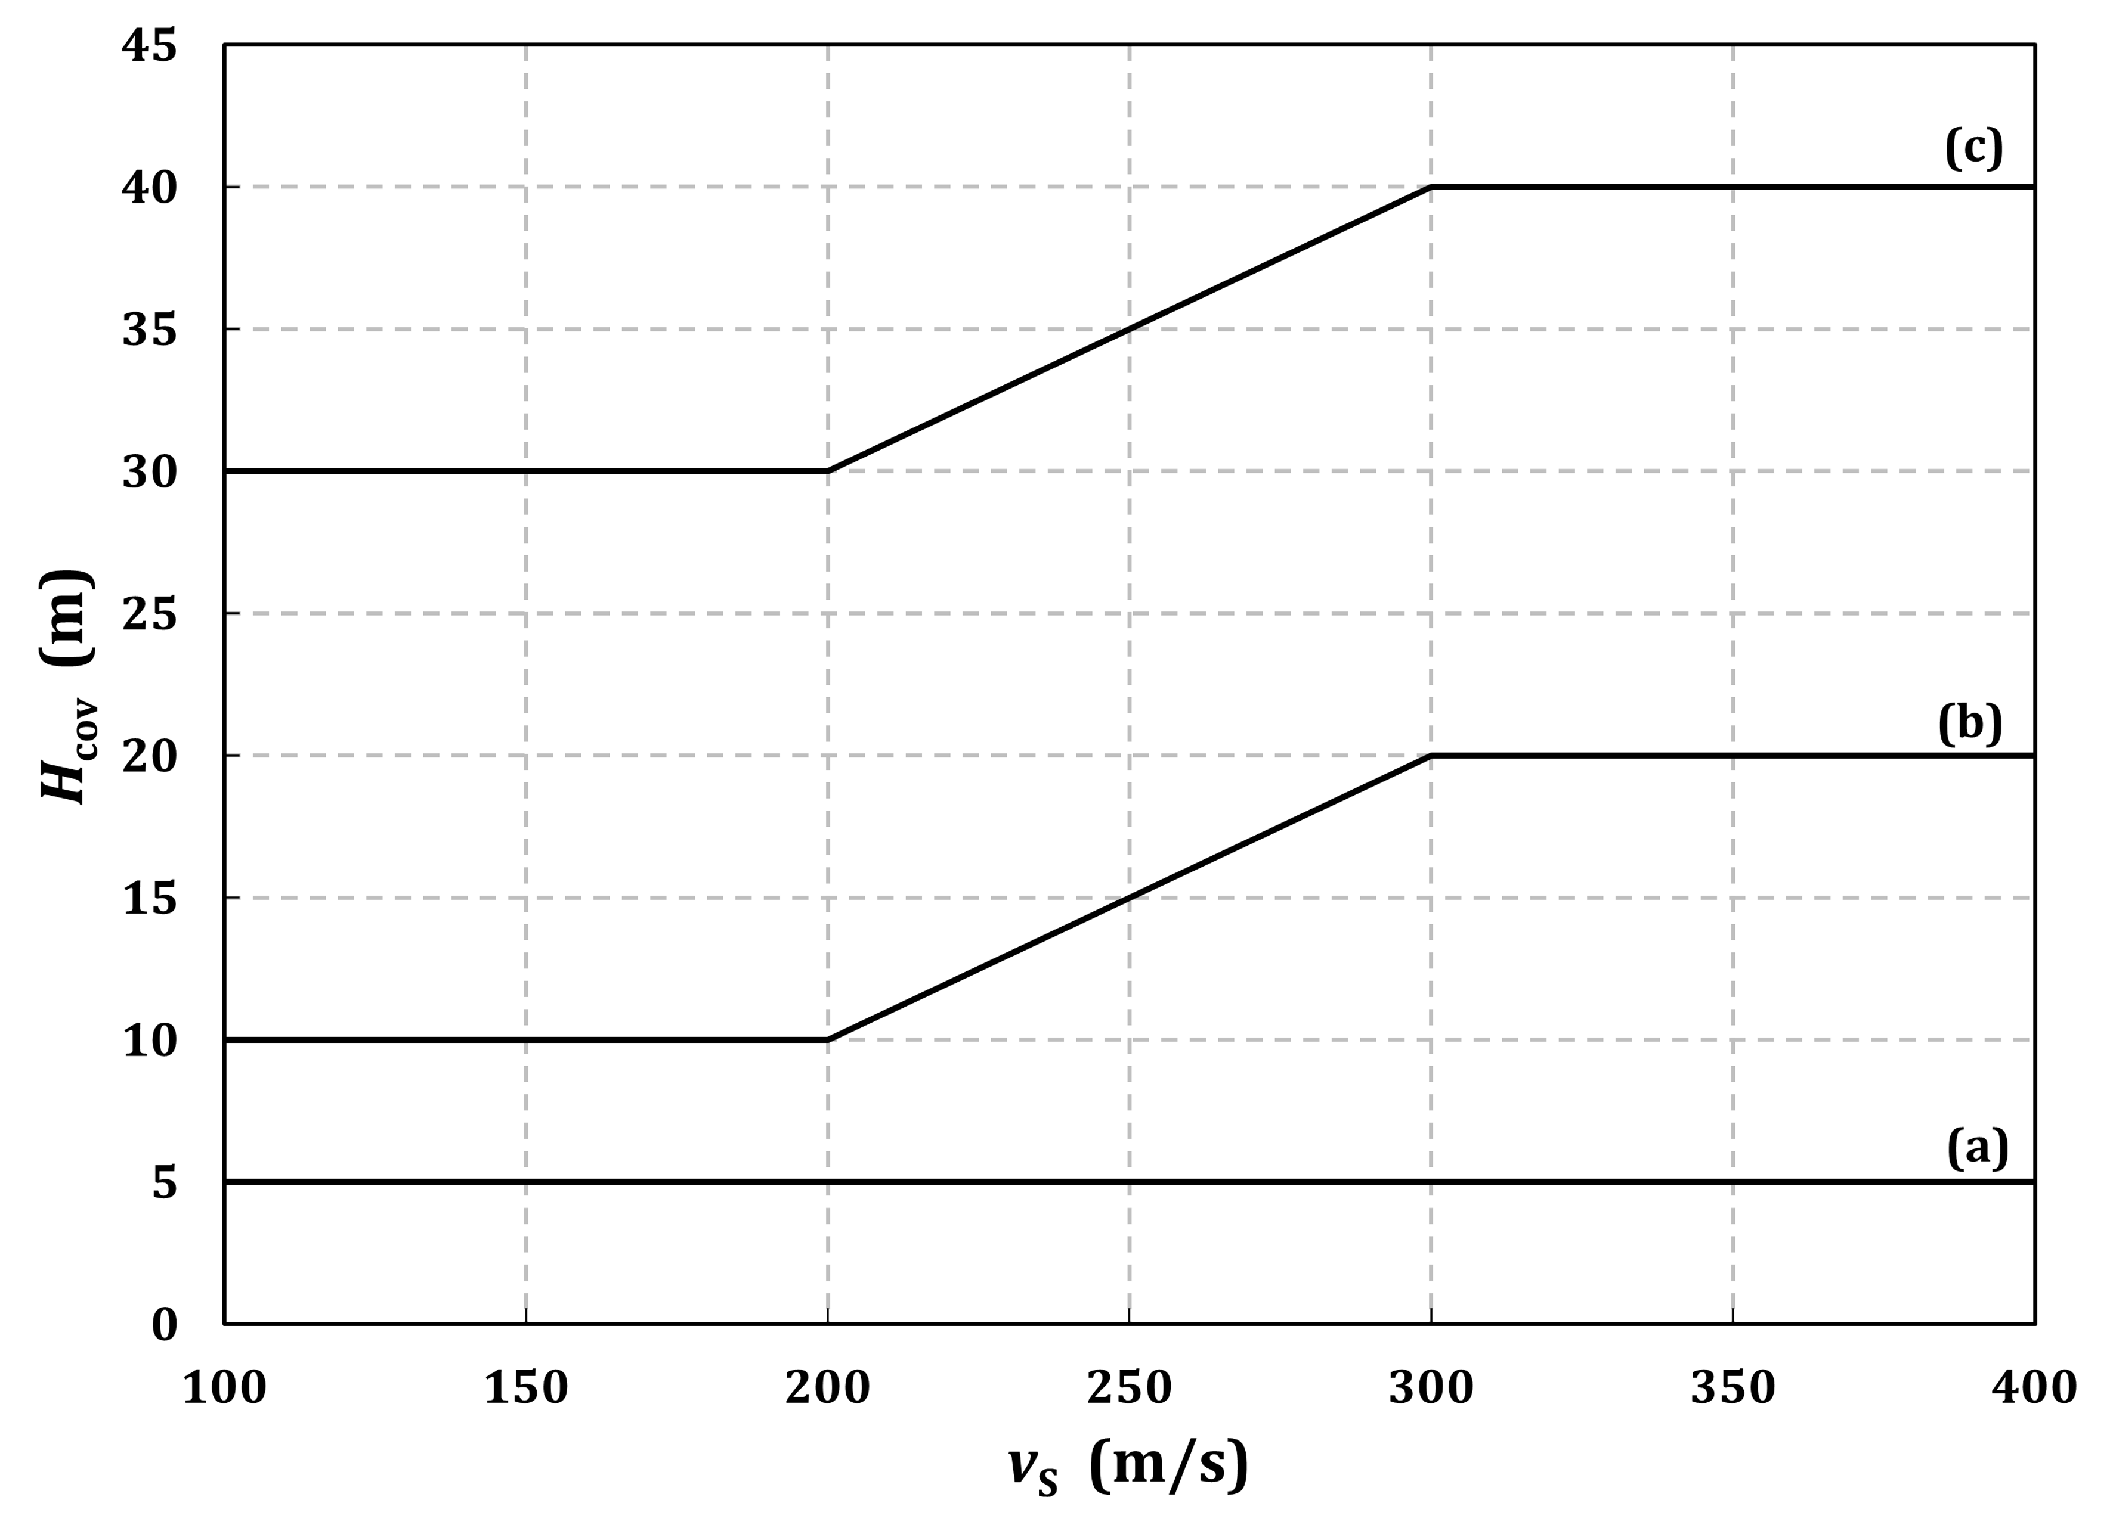

Figure 7.1 — Thickness *H*cov of minimum allowed soil cover versus average soil shear wave velocity *v*s within the depth of influence of the foundation: (a) low seismic action class; (b) moderate seismic action class; (c) high seismic action class

NOTE The average shear wave velocity can be calculated according to prEN 1998-1-1:2022, 5.1.2(7), with *H* equal to the depth of influence of the foundation.

(3) The foundations of structures of Consequence Classes CC2 and CC3 satisfying (2), constructed in the vicinity of tectonic faults, should be designed to minimise the effect of faulting on the structural performance of the structure.

NOTE 1 The vicinity of a potential fault means a relative broad region (of the order of a few hundred meters) from a hypothesised (or even previously activated) fault line.

NOTE 2 To satisfy (3), design of appropriate foundations can include interventions in the soil under and/or surrounding the structure.

(4) Bearing piles should not be designed to cross the potential fault plane, and their tip should be located at least 10 diameters above this plane.

(5) For extended structures, like bridges, underground structures and tunnels, special provisions should be taken to design adequately stiff foundations and/or to accommodate differential displacements.

NOTE For tunnels, provisions are given in 11.

(6) The simultaneous effects of fault rupture with structural vibrations due to ground shaking may be neglected.

## Slope stability

### General

(1) A verification of slope stability should be carried out for structures to be constructed on or near natural or man-made slopes, in order to ensure that the safety and/or serviceability of the structures is preserved in the design seismic situation. Verification should also be carried out in situations where slope instability itself results in an unsafe situation, for instance in the case of levees.

NOTE See also prEN 1997-3: 2022, 4.

(2) When slope instability can affect an adjacent structure, the consequence class and the limit states to be considered for the slope should be taken as the same as those of the structure.

(3) The limit states for slopes should be associated to acceptable permanent ground displacements, compatible with the limit states considered for the structure.

(4) Modelling the mechanical behaviour of the ground under the combined static and seismic actions should be done according to 6.3.

### Methods of analysis

#### General

(1) The analysis of a slope may be carried out with a force-based approach, in accordance with 7.2.2.2, whereby the seismic action is applied using the pseudo-static method.

(2) If an evaluation of permanent displacements is required, a displacement-based approach should be used in accordance with 7.2.2.3.

#### Force-based approach

(1) A force-based approach should not be carried out when there is significant reduction in soil strength, as defined in 6.3(3) to 6.3(6), or potential for liquefaction.

(2) The seismic demand for the slope should be expressed by a horizontal seismic coefficient *α*H defined in 5.2.

(3) Coefficient *β*H in Formula (5.2) should be related to the slope height and predominant wave length of the seismic motion.

NOTE Annex A provides guidance for the calculation of *β*H.

(4) Coefficient *χ*Η ≥ 1,0 in Formula (5.1) should be related to the permanent ground displacements and may take different values depending on the considered limit state (DL, SD or NC).

(5) In a force-based approach, the design value of the action effects should be calculated for the relevant limit state using Formula (5.1) with the values for *χ*Η given in Table 7.1, which indicatively correspond to the given range of permanent displacements.

Table 7.1 — Values of *χ*H for slope stability analyses

|  |  |  |  |
| --- | --- | --- | --- |
| ***χ*H** | **1,5** | **2,0** | **2,5** |
| **Range of permanent displacements (mm)** | 30-50 | 60-100 | 120-200 |
| NOTE Values of *χ*H in Table 7.1 are calibrated for the recommended values of material factors and global resistance factors. Values of *χ*H for other values of the material factors or global resistance factors are not provided in this standard. | | | |

(6) Except for high seismic action class, the vertical component of the seismic action may be neglected.

(7) When (6) does not apply, the equivalent vertical static seismic forces using a vertical seismic coefficient as given in Formula (7.1) should be used.

 (7.1)

(8) The safety verification of the ground slope should be performed with the material factor approach (MFA), using the partial factors defined in 6.5 and should consider the least safe potential slip surface.

(9) The seismic resistance of the slope should be expressed by its critical seismic coefficient *α*C, defined as the minimum value of the horizontal seismic coefficient that leads to pseudo-static failure.

#### Displacement-based approach

(1) Displacement-based approaches should be used when an evaluation of displacements is needed.

(2) The performance of a slope should be evaluated based on acceptable permanent displacements for the considered limit states.

NOTE Acceptable permanent displacements depend on the environment of the slope like the presence of adjacent structures.

(3) The permanent displacement of a slope due to the seismic action may be calculated either by means of established rigid block models or by non-linear dynamic analysis with modelling of the ground domain.

NOTE 1 For non-linear response history analyses, a representative assessment of the initial state of stresses is essential.

NOTE 2 A rigid-block model cannot be used where there is significant reduction in soil strength unless the residual soil shear strength is used and the block is stable under gravity loads.

(4) In rigid-block analyses, the effects of ground deformability and damping may be considered with simplified uncoupled analyses.

NOTE Uncoupled analyses are analyses in which the applied seismic action is not affected by the system displacements.

(5) Acceleration time-histories used in a displacement-based approach should be selected according to 5.2(3).

(6) Except for high seismic action class, the vertical component of the seismic action may be neglected.

(7) The seismic demand of a slope should be expressed as its permanent displacement produced by the seismic action, calculated as in (3).

(8) The seismic capacity of a slope should be expressed as the maximum acceptable permanent displacement as defined in (2).

## Potentially liquefiable soils

### General

(1) Liquefaction assessment should be performed for the free-field site conditions (ground surface elevation, ground water level) prevailing during the design service life of the structure.

NOTE Liquefaction is hereinafter referred to as a substantial decrease in the shear strength of the soil and/or as a transient softening of the soil caused by the increase in pore water pressures in saturated materials during the propagation of shear waves, such as to give rise to significant permanent deformations or even to a condition of near-zero effective stress in the soil.

(2) Liquefaction assessment may be neglected for magnitudes smaller than *M*wT.

NOTE The value assigned to the threshold magnitude is *M*wT = 5,0, unless a different value for use in a country is specified in the National Annex.

(3) The relevant data for liquefaction assessment should be the cyclic undrained shear strength as defined in 6.3(3) and soil classification as determined by grain size distribution or other state properties (see prEN 1997-2:2022, Clause 7).

(4) The cyclic undrained shear strength in (3) may be preferably obtained by correlations with in situ standard penetration tests (SPTs) or cone penetration tests (CPTs). Laboratory tests (prEN 1997-2:2022, Clause 10) may also be used.

NOTE In situ-based methods are preferred over laboratory-based methods for liquefaction assessment because of the difficulty and high cost associated with securing high-quality, undisturbed samples for laboratory testing that satisfactorily represent in situ conditions.

### Consideration of site conditions

(1) For structures on foundations other than piles, in low seismic action classes, the consequences of liquefaction may be ignored if liquefaction is found at depths greater than 15 m below the foundation base.

(2) Soils that should be evaluated for liquefaction susceptibility include sands, gravelly sands, silts, mine tailings, and fine-grained soils with plasticity index not greater than 15. In soil layers with a clay fraction greater than 15%, evaluation of liquefaction susceptibility may be omitted.

### Evaluation of cyclic resistance ratio (CRR)

#### General requirement

(1) The cyclic resistance ratio, CRR, should be calculated using Formula (7.2).

 (7.2)

where  is the vertical effective overburden pressure.

#### Evaluation of cyclic resistance ratio (CRR) using in situ-based methods

(1) For coarse-grained soils and fine-grained soils with plasticity index less than 7, evaluation of CRR for the soil should be performed using accepted SPT-, or CPT-based methods.

NOTE CPT-based methods are generally considered more reliable than SPT-based methods. Annex B provides examples of SPT-, or CPT-based methods.

(2) Normalisation and corrections factors that may be applied to the CRR value include a) to f):

a) SPT hammer impact energy (for SPT-based methods only);

b) overburden pressure;

c) fines content;

d) thin layer correction;

e) ageing effects;

f) shaking history.

(3) Additional correction factors should be applied to CRR to account for conditions in a) to c) if relevant:

a) earthquake magnitude correction;

b) effective overburden pressure;

c) initial static shear stress correction.

NOTE Examples of normalisation and correction factors are given in Annex B.

(4) For fined-grained soils classified according to Table B.1 as susceptible or moderately susceptible to liquefaction, and for high seismic action classes, the cyclic undrained shear strength should be determined by laboratory tests.

#### Evaluation of cyclic resistance ratio (CRR) using laboratory-based methods

(1) Testing conditions and sample preparation should maintain realistic in situ conditions in order to achieve meaningful CRR values: in situ stress conditions, relative density, soil fabric, and saturation level should be considered.

### Evaluation of cyclic stress ratio (CSR)

(1) CSR may be calculated from Formula (7.3) unless (2) is applied.

 (7.3)

where *τ*max is the maximum cyclic shear stress calculated from Formula (7.4) using empirical correlations to estimate the input parameters.

 (7.4)

where

|  |  |
| --- | --- |
| *α*H | is given by Formula (5.2) with *β*H = *χ*H = 1,0; |
| σv | is the vertical total overburden pressure; |
| *r*d | is a stress reduction factor. |

NOTE Annex B provides guidance for the calculation of the stress reduction factor.

(2) The maximum shear stress *τ*max may be calculated from site-specific ground response analysis, according to 7.5 and prEN 1998-1-1:2022, 5.2.2.2(11). For strongly heterogeneous soil profiles, site-specific ground response analyses should be used.

NOTE A layered profile with two consecutive layers having a stiffness ratio larger than 3 can be considered as strongly inhomogeneous.

### Liquefaction assessment

(1) The verifications for liquefaction should be carried out with the resistance factor approach (MFA), as indicated in (2).

(2) A soil should be considered as liquefiable whenever (CRR/*γ*τcy,u)/CSR ≤ 1,0.

(3) For low seismic action classes, if (2) is not satisfied, the consequences of liquefaction may be assessed using a simplified liquefaction index.

NOTE An example of such an index is given in Annex B.

(4) For moderate seismic action classes, if (2) is not satisfied, the consequences of liquefaction may be assessed using a combination of a simplified liquefaction index and an evaluation of the free-field settlements.

NOTE Annex C provides guidance for the calculations of settlements.

(5) For high seismic action classes, if (2) is not satisfied, the potential consequences of liquefaction should be evaluated. The potential aspects in a) to d) should be considered:

a) exceedance of load bearing capacity;

b) instability of foundations;

c) settlement and differential settlement of the structure;

d) lateral spreading.

(6) For evaluation of potential consequences of c) and d) in (5), numerical analyses or empirical methods may be used.

NOTE Annex C provides guidance for the calculations of settlements from empirical methods.

(7) For evaluation of potential consequences of a) and b) in (5), the residual strength of a liquefied soil may be estimated using laboratory testing or empirical correlations, as defined in prEN 1997-2:2022, 8.3.

### Liquefaction remediation

(1) In case the soil is liquefiable according to 7.3.5(2), measures such as ground improvement or use of piles (to transfer loads to layers not susceptible to liquefaction) may be taken to ensure foundation stability.

NOTE Ground improvement is treated in prEN 1997-3:2022, Clause 10.

(2) Effective ground improvement may include methods such as densification, grouting, stone columns, chemical injection, and vertical drains.

NOTE The feasibility of densification is mainly governed by the fines content.

(3) When ground improvement is implemented, reduction of liquefaction susceptibility of the deposit to an acceptable level should be demonstrated. This may be accomplished by using post-improvement in-situ tests to show increases in cyclic resistance to a satisfactory level.

(4) The design of pile foundations should take into account the forces induced in the piles due to loss of soil support in the liquefiable layer or layers, to lateral movements induced by lateral spreading, and the uncertainties in determining the location and thickness of such a layer or layers.

NOTE 1 Annex C provides guidance for the calculations of the amplitude of the liquefied soil displacements caused by lateral spreading.

NOTE 2 Liquefaction of a layer at a certain depth can induce settlements of all layers above it; in this situation all layers develop negative friction on the pile.

## Settlements of soils under cyclic loading

(1) (2) to (7) should be applied in the case of moderate or high seismic action class.

(2) The susceptibility of unsaturated soils to densification and to excessive settlements caused by earthquake-induced cyclic stresses should be taken into account when extended layers or thick lenses of loose, coarse-grained materials exist within a depth where it can affect the response of the foundation.

(3) Earthquake induced settlements and densification in unsaturated coarse-grained soils may be estimated using empirical relationships between volumetric strain, cyclic strain and soil properties.

NOTE Annex C provides guidance for these calculations.

(4) Settlements in soft fine-grained soils, due to cyclic degradation under ground shaking of long duration, and dissipation of induced excess pore water pressures, should be addressed.

(5) Settlements in saturated coarse-grained soils, due to dissipation of earthquake–induced excess pore water pressures, should be addressed.

NOTE 1 Annex C provides guidance on the relationship between the volumetric strains and the safety factor.

NOTE 2 For application of (3), (4) and (5), the values of the acceptable settlements can be agreed for a specific project by the relevant parties.

(6) For liquefiable saturated soils according to 7.3.5(2), volumetric strains due to dissipation of excess pore water pressure should be considered.

(7) The densification and settlement potential of soils may be also evaluated with appropriate cyclic laboratory tests on representative specimens of the investigated soil materials.

## Site-specific response analyses

### General

(1) When the conditions in prEN 1998-1-1:2022, 5.1.2(2) and 5.2.2.1(4), apply, the seismic action used for the assessments in 7.2, 7.3 and 7.4, for the design of foundation systems as in 8 and 9, earth retaining structures as in 10 and underground structures as in 11, should be derived from the results of site-specific ground response studies.

(2) The input seismic action in site-specific ground response studies should consist of recorded acceleration time-histories complying with prEN 1998-1-1:2022, Annex C, C.3.

### Ground response analysis

(1) The analysis used in a site-specific ground response study should be carried out in accordance with prEN 1998-1-1:2022, Annex B, B.4, and should provide action effects along the depth.

(2) The representation of the seismic action may be restricted to vertically propagating shear waves.

NOTE There are specific situations (topographic irregularities, for instance) where other types of waves or polarisation directions are determinant to the site response.

(3) The analysis should take into account the aspects in a) to c):

a) the non-linear mechanical behaviour of the soil expressed through the decrease of the secant stiffness with increasing strain;

b) the dependence of the damping ratio of the soil on the strain level;

c) the small strain stiffness of the underlying soil assumed as a half-space.

NOTE The properties defined in a) and b) refer to an equivalent linear visco-elastic constitutive model.

(4) The discretisation of the soil volume should be adapted to the specific technique used to account for non-linear effects in (3)a) and (3)b).

(5) If the ground response analysis is carried out in terms of effective stresses, a non-linear constitutive model accounting for the initial effective stress state in the soil deposit, the volumetric and deviatoric behaviour of the soil and the appropriate drainage conditions should be considered.

NOTE For saturated soils, the assumption of fully undrained condition is usually appropriate.

# Soil-structure interaction

## General

(1) The analysis of seismic soil-structure interaction (SSI) effects should consider two effects as given in a) and b):

a) Inertial effects that modify the dynamic response of the structure by changing the fundamental period and damping of the soil-structure system;

b) Kinematic effects that modify the seismic excitation at the base of the structure with respect to the free-field and produce loading of foundation elements.

NOTE Foundation motion can include a rotational component even without a rotational component in the free-field motion.

(2) In case of improvement of the ground, the new ground conditions should be considered in SSI analyses.

(3) SSI may be neglected for low seismic action classes.

(4) SSI may be neglected for embedded foundations founded on ground with a shear wave velocity larger than 800 m/s.

(5) The inertial effects of SSI should be considered for cases where at least one condition a) to d) applies:

a) For soil-structure systems in which an increase in the fundamental period due to SSI effects increases spectral accelerations;

b) When the displacement of the structure controls the width of joints separating nearby buildings (existing or planned) or other performance criteria;

c) For structures supported on soft soils in which the shear velocity *v*s averaged over a depth equal to 3 times the maximum foundation width in case of footings or to the maximum width in case of a raft foundation, is less than 250 m/s;

d) Structures in which geometric non-linearity (known as second order effect or *P*-*Δ* effect) plays a significant role.

NOTE Condition in d) corresponds to the situation when *θ*, defined in prEN 1998-1-2 (under development), 6.2.4(1), for buildings, and prEN 1998-2 (under development), 5.1.3(1)*,* for bridges, is greater than 0,1.

(6) Modification of the foundation input motion should be considered for situations a) to d):

a) deep foundations;

b) foundations embedded to a depth of at least two floors, or to a depth larger than *L*/4, where *L* is the largest dimension of the foundation in plan, with the foundation vertical surfaces in full contact with the surrounding ground;

c) abutments of bridges with large embankments, or integral bridges without specific provisions for minimising SSI effects;

d) foundations with one or two large dimensions in plan (larger than 50 m) consisting of a slab, or a single box foundation, or footings interconnected with tie beams.

NOTE Kinematic interaction for foundations of large dimensions arises from the spatial incoherence of the ground motion. Models for spatial variability of the seismic motion are given in prEN 1998-1-1:2022, 5.2.3.2.

(7) For flexible pile foundations, modification of the free-field motion, as required in 8.1(6)a), may be neglected and the free-field motion may be used for the foundation input motion.

(8) A pile foundation may be considered as flexible when the ratio *E*P /*E*S of the pile elastic modulus to that of the soil satisfies *E*P /*E*S ≤ (*L*P/1,5*d*)4, where *L*P and *d* are the pile length and pile diameter.

NOTE *E*s is the average soil modulus along the active length of the pile, compatible with the average strain amplitude (as in 6.4); the active length of the pile is the pile length below which the pile deflection can be neglected. It is typically equal to 6 to 10 pile diameters.

(9) Kinematic interaction may be neglected for the vertical component of the seismic action.

## Analysis of inertial effects

### General

(1) The seismic actions effects in the structure and the foundations should be determined with a suitable model of the structure, including the foundation mass, supported through its footings/foundations on ground.

(2) Ground reaction may be represented by springs for all degrees of freedom.

NOTE 1 In general, the springs are non-linear and frequency-dependent.

NOTE 2 A rigid foundation on deformable ground has 6 degrees of freedom, 3 translational (in x, y, z directions) and 3 rotational (*r*x, *r*y, *r*z about the x, y and z axes).

(3) Coupling of horizontal and rotational springs should be considered for piled foundations and deeply embedded foundations or caissons.

(4) For certain foundation shapes (circle, strip, rectangle), piles and ground profiles (for example, homogeneous half-space and soil layer on rock), values for spring stiffnesses may be obtained from available elasticity-based solutions.

NOTE Annex D provides guidance to calculate the spring stiffnesses of shallow foundations and piles.

(5) A frequency-independent stiffness value may be assigned to each spring, corresponding to the period of the fundamental mode, accounting for SSI in the considered direction. If this period is difficult to determine reliably, the static stiffnesses may be used instead.

NOTE The static stiffness refers to the stiffness at zero frequency.

(6) For design limit states SD and NC, the equivalent-linear stiffnesses for non-linear horizontal and rotational springs to be used should be compatible with the amplitude of horizontal displacements and rotations of the foundation.

(7) To apply (6), the equivalent-linear stiffnesses of each spring may be calculated with the soil moduli compatible with the strain amplitude developed in the free-field.

NOTE Stiffnesses compatible with strain amplitude can be calculated from an iterative analysis.

### Force-based approach

#### General

(1) When numerical analyses of the foundation soil system are used to derive the foundation stiffnesses, they should comply with 8.5.

#### Structures designed to DC1

(1) When damping due to SSI is taken into account, the seismic action is defined using the elastic spectrum (with *q* = 1) as per prEN 1998-1-1:2022, 5.2.2.2, and a damping correction should be performed in accordance with prEN 1998-1-1:2022, 5.2.2.2(12).

(2) Radiation damping may be considered only for periods shorter than the fundamental period *T*0 of the soil deposit. Unless supported by numerical calculations which model the layers properties down to a depth where *v*s > 600 m/s, radiation damping should be limited to 20%.

NOTE 1 Damping in SSI analyses is composed of radiation damping and material damping.

NOTE 2 *T*0 is the inverse of the fundamental frequency of the soil deposit; see prEN 1998-1-1:2022, Annex A.

(3) The resistance condition of the structural members of the substructure and the superstructure may be satisfied taking into account the seismic action effects divided by a behaviour factor *q* = 1,5.

#### Structures designed to DC2 and DC3

(1) The effect of damping due to SSI may be taken into account in the force-based approach with *q*D calculated according to prEN 1998-1-1:2022, 6.4.1(5).

(2) When damping due to SSI is taken into account according to (1), the damping correction factor *η* should not be considered smaller than 0,7.

### Displacement-based approach

#### Non-linear static analysis

(1) In non-linear static analysis of surface or shallow foundations, translational and rotational inelastic springs may be used.

NOTE As a minimum, such springs are composed of two branches: an equivalent-linear stiffness as the linear branch and the plastic branch at the corresponding ultimate resistance.

(2) When springs are not used, the lateral force-displacement relation of the soil-foundation system under large deformations may be calculated from a suitable non-linear static analysis in which the ground is modelled as an inelastic continuum. The possibility of uplift on the tension side of the foundation, as well as of slippage at the ground-foundation contact surface, may be included in the model.

NOTE The non-linear static analysis often uses finite elements or finite differences.

(3) Calculation of the target displacement should be done according to prEN 1998-1-1:2022, 6.5.4.

#### Response history analyses

(1) The effect of inertial SSI in response history analyses may be taken into account by modelling the soil-foundation system with springs and dashpots.

NOTE 1 Spring stiffnesses are defined in 8.2.1(2). Dashpots represent the total damping of the soil-foundation system.

NOTE 2 The seismic motion is applied to the supports of the springs.

(2) A frequency-independent stiffness value may be assigned to each spring, corresponding to the period of the fundamental mode, accounting for SSI in the considered direction.

NOTE The frequency-dependence of the springs and dashpots can be modelled in response history analyses with lumped models composed of constant springs, dashpots and masses.

(3) Radiation damping may be added to material damping using Formula (8.1).

 (8.1)

where

|  |  |
| --- | --- |
| *C*αt | is the dashpot coefficient that multiplies the response velocity in the equation of motion; |
| *ξ* | is the material damping ratio; |
| *Τ* | is the period of the fundamental mode, accounting for SSI; |
| *C*α and *K*α | are, respectively, the dashpot coefficient (associated to radiation damping) and spring stiffness corresponding to the period of the fundamental mode, accounting for SSI in the considered direction. |

NOTE 1 Annex D provides guidance on the simplified formulas.

NOTE 2 Radiation damping is strongly affected by ground layering. Solutions for a homogeneous elastic half-space result in unrealistically large values of radiation damping.

## Modelling of kinematic effects

(1) Kinematic interaction effects may be calculated in accordance with 8.5 as part of the whole structure-foundation-soil system, or with a separate analysis in which only the foundation and the soil are included.

NOTE For such analysis, the footing and pile cap are modelled without their mass; the mass of the piles is taken into account in the model.

(2) The separate analysis in (1) may be performed through finite element or finite difference modelling. For piles, a suitable Winkler-type model may be used with lateral soil springs and dashpots representing the action of the soil in contact with the foundation elements.

(3) In the finite element/difference modelling of a pile-soil system, the seismic excitation should be imposed at the base of the ground stratum and the lateral boundaries should be capable of deforming similarly to the free-field.

NOTE Other prerequisites for a proper numerical analysis are given in 8.5(2).

(4) When Winkler-type modelling is used, ground should be discretised into horizontal layers. One-dimensional ground response analysis should be conducted to obtain the time-histories of displacement at each layer. These displacements should be imposed at the supports of the lateral springs-and-dashpots.

(5) When Winkler-type modelling is used, an alternative to (4) may be used to impose the ground displacements by representing the action of the surrounding ground with a shear beam connected to the free ends of the springs and dashpots.

(6) In (5), the shear beam should have masses an order of magnitude larger than the pile masses.

(7) To obtain the induced bending moments in a pile, the analysis in (4) may replace the time-histories of displacement with the respective peak values to be imposed statically at the supports of the springs, with the dashpots neglected. The analysis may be performed statically.

## Combination of inertial and kinematic effects for internal forces

(1) When inertial effects and kinematic effects are evaluated separately, the forces in the foundation elements from the two analyses may be combined according to either a) or b):

a) when the frequency of the mode contributing most to the SSI response differs by more than 15% from the fundamental frequency of the soil deposit, the action effects are combined with a SRSS rule (square root of the sum of the squares) as defined in prEN 1998-1-1:2022, 6.4.3.2(2);

b) when the condition in a) is not satisfied, the absolute values of the action effects of the two analyses are summed up.

## Simultaneous modelling of kinematic and inertial effects

(1) Dynamic response-history analysis of the whole structure-foundation-soil system, using finite elements/differences, may be used to capture both kinematic and inertial effects in a single step. In this case, (2) and (3) should be applied.

(2) The analysis model for (1) should allow for the transmission of seismic wave across the lateral and bottom boundaries of the system.

NOTE 1 Improper modelling of the boundary conditions creates wave reflections, which can be damped with non-reflecting boundaries. The presence of a rock layer or of a layer of site category A at some depth, not included in the numerical model, contributes to wave reflection and reduction in radiation damping.

NOTE 2 Accurate modelling of the relevant frequencies of the structure requires element sizes smaller than 1/6 (frequency-domain solutions) to 1/10 (time-domain solution) of the smallest wave length of interest.

(3) Base excitation acceleration time histories should be selected according to prEN 1998-1-1:2022, 5.2.3.1. They should be compatible with the elastic response spectrum defined in prEN 1998-1-1:2022, 5.2.2.2. The effect of the selected acceleration time histories should comply with prEN 1998-1-1:2022, Annex B, B.3, at the ground surface in the free-field.

# Foundation system

## General requirements

(1) The foundation of a structure in a seismic zone shall transfer the action effects in the structure for the seismic design situation, from the structure to the ground, without structurally unacceptable permanent displacements.

NOTE Relevant criteria are given in 9.3.

(2) As per 6.4, due account should be taken of the strain dependence of the dynamic properties of the foundation ground and of effects related to the cyclic nature of seismic action.

(3) The verifications of foundations according to Formula (4.1) should be carried out either with the material factor approach (MFA) or with the resistance factor approach (RFA).

(4) Different foundation types for different vertical elements of the same structural system, e.g. piles combined with shallow foundations, may be used only if a specific study is carried out. In this case, foundation stiffness and differential displacements should be taken into account in the verification of the structure.

(5) Different foundation types may be used in dynamically independent units of the same structure.

(6) Partial factors for resistance of materials should be as given in the relevant parts of EN 1998 for structural members.

## Design values of the action effects

(1) The actions on the foundation to verify the ground resistance should be calculated at the lower face of the foundation elements, or for pile foundations at the head of the piles.

(2) In a force-based approach, the design values of the action effects should be calculated with Formula (9.1).

 (9.1)

where

|  |  |
| --- | --- |
| “+” | means combined with +or – sign; |
| γRd | is an overstrength factor; |
| χΗ | reflects the amplitude of accepted permanent displacements as defined in 5.2; |
| ΕFd | is the design value of the action effects acting on the foundation in the seismic design situation; |
| *E*Fd,G | is the action effect of the non-seismic actions included in the combination of actions for the seismic design situation (prEN 1990:2021, 8.4.3.5); |
| *E*Fd,E | is the action effect of the design seismic action calculated from the seismic analysis of the structure taking into account the behaviour factor *q*; |
| Ωd | unless specified otherwise in (4) to (12), is the value of (*R*di/*E*di) ≤ *q* of the dissipative zone of element *i* of the structure which has the highest influence on the effect *E*F under consideration; |
| Rdi | is the design value of the resistance of the zone of element *i*; |
| *E*di | is the design value of the action effect on the zone of element *i* in the seismic design situation. |

(3) To verify the foundation elements, (4) to (11) should be applied with *χ*Η = 1,0 in Formula (9.1).

(4) If the action effects on the foundation have been determined using the value of the behaviour factor *q* applicable to ductility class DC1, the action effects should be taken from the analysis in the seismic design situation and *Ω*d *γ*Rd = 1,0.

(5) If the action effects on the foundation have been determined using the value of the behaviour factor *q* applicable to ductility classes DC2 and DC3, the design value of the action effects for the foundation elements should be derived as indicated in (6), (7), (8) and (9).

NOTE The foundation elements refer to the footing, pile cap and raft.

(6) For raft or caisson foundations of structures designed according to ductility class DC2 or DC3, the product *Ω*d *γ*Rd should be taken equal to 1,25 *q*R, where *q*R is the behaviour factor component accounting for overstrength due to the redistribution of seismic action effects in redundant structures.

NOTE The values of *q*R should be taken for each structural type and material, as given in the relevant part of EN 1998. For buildings, they are given in prEN 1998-1-2 (under development), 10 to 15, as relevant.

(7) For isolated footings in structures designed according to ductility class DC2 or DC3, the product *Ω*d *γ*Rd should be taken equal to 1,25 *q*R for calculation of the overturning moment or shear force and equal to *Ω* for the normal force where *Ω* is the force amplification factor defined in DC2 for each material and structural type.

NOTE For buildings, *Ω* is given in prEN 1998-1-2 (under development), 10 to 15, as relevant.

(8) For foundation beams designed to DC1 in structures designed to DC2 and DC3, the product *Ω*d *γ*Rd should be taken equal to 1,25 *q*R for the calculation of all action effects in the foundation beams.

(9) For foundation beams and structures both designed to DC2 and DC3, the product *Ω*d *γ*Rd should be taken equal to 1,0 and the design of the foundation beams should be made applying prEN 1998-1-21, 10, for reinforced concrete beams and 12 for encased composite beams.

1 Under development.

(10) For the design of piles that are not allowed to yield according to 9.5 in structures designed according to ductility class DC2 or DC3, (7) should be applied.

(11) For the design of piles that are allowed to yield according to 9.5, the product *Ω*d *γ*Rd in Formula (9.1) may be taken equal to 1,0.

(12) For checking the soil capacity of the foundation of structures designed with DC2 or DC3, the product *Ω*d *γ*Rd in Formula (9.1) may be taken equal to 1,2 for bearing capacity verifications and to 1,0 for sliding verifications.

## Foundation horizontal connections

(1) Any action effects induced in the structure by horizontal relative displacements between foundation elements should be calculated and appropriate measures to adapt the design should be taken.

NOTE This requirement is consistent with 9.1(1).

(2) (3) to (7) should be applied to building foundations.

(3) (1) may be satisfied if the foundations are arranged on the same horizontal plane and tie-beams or an adequate foundation slab meeting (7) are provided at the level of the footings or pile caps, except as specified in (6).

(4) Beams or a foundation slab may be considered as tie-beams, provided that they are safely connected to the structure and located less than 1,0 m from the bottom face of the footings or pile caps.

(5) When (4) is used, the stub column resistance to shear should be greater than the design value of the shear *V*Ed calculated in the column section above the tie beam or foundation slab.

(6) Unless the structure is in the vicinity of precarious slopes, tie-beams may be omitted, in case of ground category A, as defined in prEN 1998-1-1:2022, 5.1.2, Table 5.1**,** or if relative displacements between isolated foundations are taken into account in the seismic design of the superstructure.

(7) The foundation connections may be considered adequate if (a) and (b) are met:

a) Tie-beams are designed to withstand an axial force, considered both in tension and compression, equal, according to the ground class defined in prEN 1998-1-1:2022, 5.1.2, Table 5.1, to a value given in i. to iii., as appropriate:

i. ± 0,2 *α*H *N*Ed for stiff ground class;

ii. ± 0,3 *α*H *N*Ed for medium stiff ground class;

iii. ± 0,4 *α*H *N*Ed for soft ground class.

where

|  |  |
| --- | --- |
| *N*Ed | is the mean of absolute values of the design value of the axial forces of the connected vertical elements in the seismic design situation; |
| αH | is calculated from Formula (5.2) with *β*H = *χ*Η = 1,0. |

b) The longitudinal reinforcement of tie beams is fully anchored into the body of the footing, into other tie-beams or into the foundation slab.

## Surface and shallow embedded foundations

### General

(1) (2) to (4) should be verified for transferring horizontal forces, vertical forces and overturning moment to the ground.

(2) The design horizontal force *V*Ed should be transferred by one or more of the mechanisms in a) to c):

a) by means of a design shear resistance *V*Rd,1 which develops between the horizontal base of a footing or of a foundation-slab and the ground, as given in 9.4.2.1.1(2);

b) by means of a design shear resistance *V*Rd,2 between the vertical sides of a cast-in place foundation that are parallel to the direction of motion and the ground;

c) by means of the design horizontal component of the passive earth pressures *V*Rd,3, calculated according to 10.3.2, on the side of the foundation, under the limitations and conditions given in (3).

(3) In a force-based approach, the total sliding resistance should not be taken larger than the combination of the shear resistance obtained in adding resistances given in (2)a) and b) and up to 30% of the resistance arising from fully-mobilised passive earth pressures given in (2)c).

(4) Design values of vertical forces *N*Ed and overturning moments *M*Ed should be transferred to the ground by means of one or a combination of the values associated to the mechanisms in a) and b):

a) the design value of resisting vertical forces acting at the base of the foundation;

b) the design value of forces and moments developed by the design values of the shear and normal force resistance between the sides of embedded cast-in place foundation elements and the ground.

### Verifications

#### Footings

##### General

(1) In accordance with the limit state under consideration, footings shall be verified against sliding failure, bearing capacity failure and rotational failure.

NOTE Failure refers to a situation in which unacceptable displacements, according to 9.1(1), are attained.

##### Sliding

(1) In a force-based approach, sliding of foundation should be resisted through friction and lateral resistance forces, under the conditions given in (4).

(2) The design value of the sliding resistance may be calculated using Formula (9.2).

 (9.2)

where

|  |  |
| --- | --- |
| *δ* f | is the angle of shearing resistance at the ground-to-foundation base; |
| *U* | is the resultant hydrostatic pore water pressure at the base. |

NOTE Formula (9.2) assumes no modification of the pore water pressure due to the seismic action.

(3) The design value of the lateral resistance *V*Rd,3 arising from earth pressure on the side of the footing may be taken into account as specified in 9.4.1(2) and 9.4.1(3).

(4) To ensure that there is no failure by sliding on a horizontal base, the condition given by Formula (9.3) should be satisfied.

 (9.3)

where

|  |  |
| --- | --- |
| *V*Ed | is the design value of the shear force acting at the lower face of the foundation calculated according to Formula (9.1). |

(5) In a force-based approach, the design values of the action effects should be calculated for the relevant limit state using Formula (9.1) with the values for *χ*Η given in Table 9.1, which may be considered to correspond to the given range of permanent displacements.

Table 9.1 — Values of *χ*Η for sliding analyses

|  |  |  |  |
| --- | --- | --- | --- |
| ***χ*H** | **1,25** | **1,5** | **1,75** |
| **Range of permanent displacements (mm)** | ≤ 15 | 20 to 50 | 50 to 100 |
| NOTE Values of *χ*H in Table 9.1 are calibrated for the recommended values of material factors and global resistance factors. Values of *χ*H for other values of the material factors or global resistance factors are not provided in this standard. | | | |

(6) In a force-based approach, the action effects in the superstructure should be calculated without considering sliding.

(7) In a displacement-based approach at the Significant Damage Limit State or at the Near Collapse Limit State, sliding may be accepted provided that the calculated displacements due to sliding satisfy both a) and b):

a) are acceptable for the superstructure;

b) do not adversely affect the performance of any lifelines (e.g. water, gas, access or telecommunication lines) connected to the structure.

(8) In a displacement-based approach, *χ*Η should be taken equal to 1,0 and the limitation in 9.4.1(3) does not apply.

##### Bearing capacity

(1) In a force-based approach, the bearing capacity of the foundation should be verified under the action effects *N*Ed, *V*Ed, and *M*Ed in the seismic design situation.

NOTE Annex E provides a general expression taking into account the load inclination and eccentricity arising from the inertia forces in the structure as well as the possible effects of the inertia forces in the supporting ground itself.

(2) In force-based or displacement-based approaches, the action effects for the verification of the bearing capacity should be calculated using Formula (9.1) with *Ω*d*γ*Rd from 9.2 and *χ*H from 9.4.2.1.2.

(3) For low seismic action classes and for coarse-grained and fine-grained soils, or for moderate seismic action classes and for fine-grained soils only, the effects of the inertia forces in the supporting ground may be neglected.

(4) The inertia effects in the ground may be neglected when the horizontal seismic coefficient *α*H defined in Formula (5.2) with *χ*H = 1,0 is smaller than 0,5*V*Ed/*N*Ed.

NOTE Methods for verification of the foundation bearing capacity without accounting for ground inertia effect are given in prEN 1997-3:2022, 5.5.2.

(5) Calculation of the bearing capacity of saturated soil should consider undrained conditions.

(6) The bearing capacity in undrained conditions should be calculated in terms of total stresses unless (8) applies.

(7) The undrained shear strength of the soil used in (5) should be evaluated taking into account the stresses induced by the permanent loads of the structure, with the material partial factors defined in 6.5.

NOTE 1 In a total stress calculation in the presence of saturated coarse-grained soils, the partial coefficient on the undrained shear strength to be used in the MFA is defined in 6.5; the value assigned to the partial coefficient on the soil resistance in the RFA is *γ*R = 1,2 unless different values for use in a country are specified in the National Annex. Annex E provides guidance on the use of a global resistance factor.

NOTE 2 prEN 1997-1:2022, 4.4.3, also indicates how to apply the global resistance factor.

(8) The bearing capacity in undrained conditions may be verified in terms of effective stresses if it is demonstrated that the excess pore water pressure induced by the earthquake in the soil affected by the foundation is less than 50% of the initial effective stress.

##### Rotational failure

(1) Loss of contact between the foundation and the ground may take place at any Limit State.

NOTE Rocking of foundations and loss of contact with the ground can reduce the inertial forces entering the superstructure and therefore protect it with regard to these forces. Loss of contact can be allowed provided the induced permanent rotation and settlement of the foundation are compatible with the performance criteria of the superstructure at the relevant limit state.

(2) In the force-based approach, the area of the foundation not in contact with the ground should be smaller than 1/3 of the total area.

NOTE The 1/3 criterion is not related to a physical constraint on the contact area but is set to ensure the validity of a linear elastic analyses to calculate the forces acting on the ground.

(3) If the condition in (2) is not met, a displacement-based approach should be used to check the design either with static non-linear or with a response-history analysis and modelling of the non-linear behaviour of the soil-foundation interface and of the ground.

##### Settlements

(1) The foundation system should be verified against soil densification and settlements, calculated under free-field conditions according to 7.4.

(2) For moderate and high seismic action classes, additional settlement of the foundation due to the response of the structure in the seismic design situation should be calculated.

NOTE 1 Annex C provides guidance on the calculation of the foundation settlement.

NOTE 2 Reduction of settlements can be achieved by introducing a global resistance factor to the bearing capacity of the foundation.

(3) If the settlements caused by densification or cyclic degradation affect the stability of the foundations, ground improvement methods should be applied.

#### Raft foundations

(1) All the provisions of 9.4.2.1 should be applied to raft foundations, with the complements in a) and b):

a) The global sliding resistance may be taken into account in the case of a single foundation slab. For simple grids of foundation beams, an equivalent footing area may be considered at each beam crossing;

b) Foundation beams and/or slabs may be considered as being the connecting ties, in which case 9.3(6) should be applied. An effective width corresponding to the width of the foundation beam or to a slab width equal to ten times its thickness should then be considered for their design.

### Structural design

(1) Structural members of foundations shall be verified in accordance with 4.6(2).

(2) Concrete foundations should be designed for the demands imposed by the framing supported elements (e.g. columns, walls, abutments, piers), accounting for their overstrength, according to 9.2. Joints between foundation elements and framing supported elements (columns and walls) should be designed to comply with the rules for joints in prEN 1998-1-21, 10 to 15.

1 Under development.

(3) The longitudinal reinforcement of the supported elements should be anchored in the foundation element (column footing, wall footing or foundation slab) according to prEN 1998-1-21, 10.11, to guarantee the transfer of the tension forces developed accounting for overstrength.

1 Under development.

(4) The longitudinal reinforcement of the columns framing into the foundations should be bent near the bottom of the foundation at 90° and toward the centre of the column.

(5) When the distance between the lateral edge of the vertical supported element and the lateral foundation edge is less than one half of the foundation depth, the transverse reinforcement in the critical region of the columns or boundary element in walls should be extended below the top of the foundation up to a distance equal to the length of the critical region of the column or boundary element or down to the foundation depth, whichever is less (see Figure 9.1).

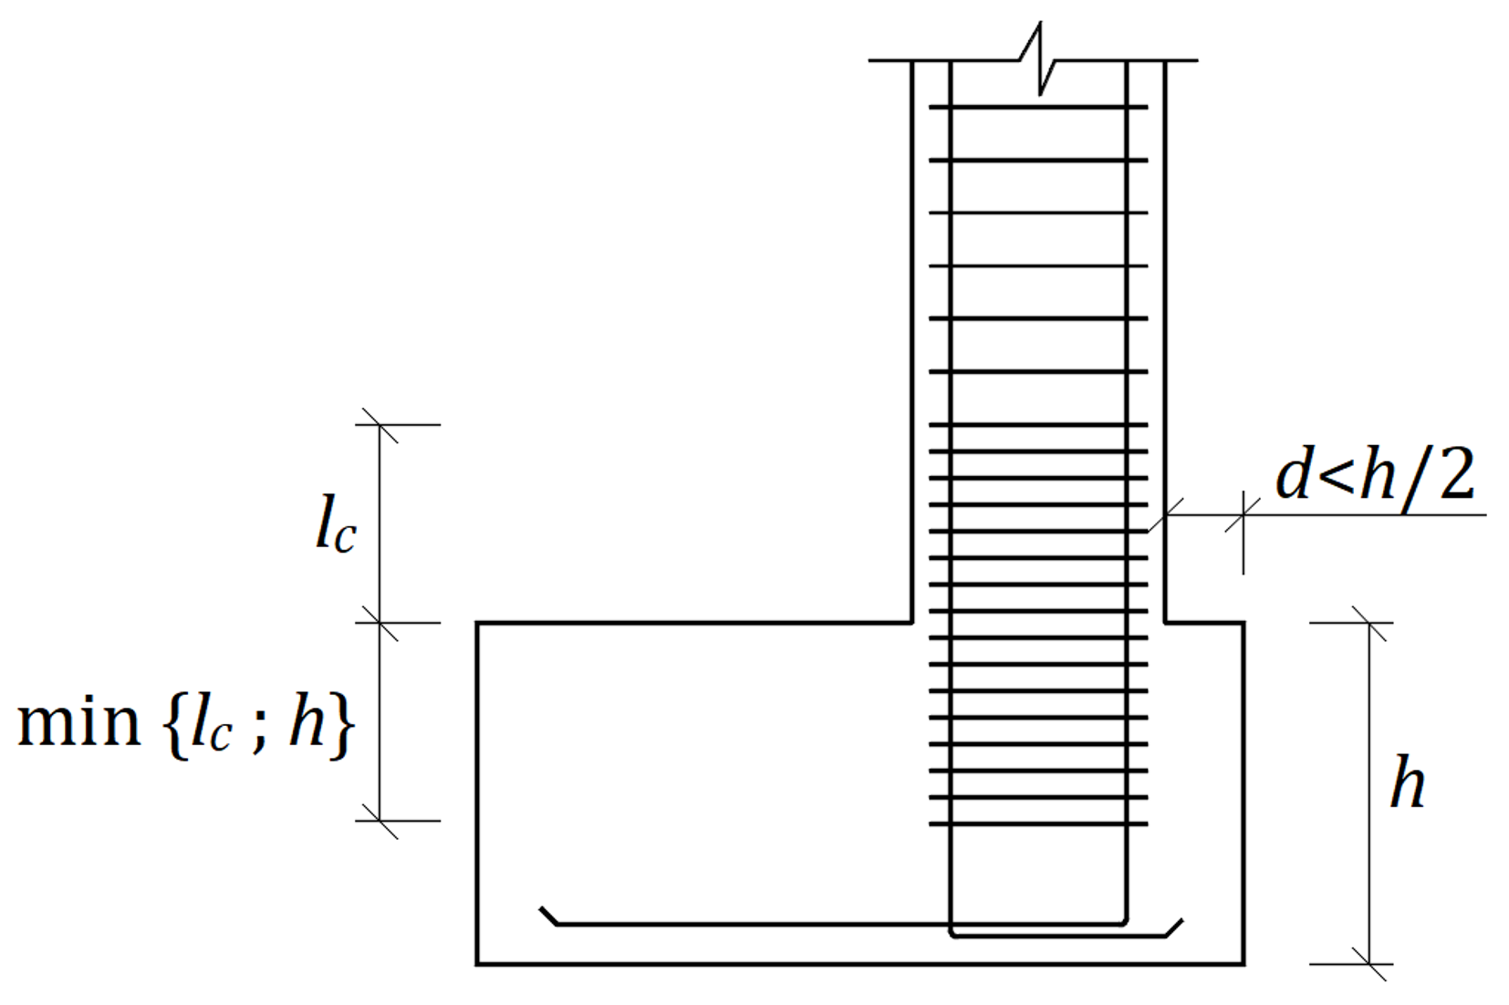

Key

|  |  |
| --- | --- |
| *l*c | length of critical region |
| *d* | distance to edge of footing |
| *h* | foundation depth |

Figure 9.1 — Detailing at connection of vertical supported element to the foundation

(6) In other situations, not contemplated in (5), the transverse reinforcement of column or boundary elements in walls should be extended below the top of the foundation up to one-third of the largest cross-sectional dimension of the column or of the wall boundary element, or up to 200 mm, whichever is less.

(7) Top reinforcement of column footings and wall footings should be designed and detailed in the seismic design situation taking into account the potential foundation uplift.

(8) Slab foundations should be designed and detailed according to prEN 1998-1-21, 10.10.

1 Under development.

## Pile foundations

### General

(1) Piled foundations shall be designed in accordance with prEN 1997-3:2022, Clause 6.

(2) In addition, piled foundations should comply with 9.5.2.

(3) 9.5 should also be applied to other deep slender foundations like barrettes.

### General design requirements

(1) Piles shall be verified in accordance with 4.6(1) and 4.6(2).

(2) Piles shall be designed to resist action effects given in a) and b):

a) inertial forces and moments transmitted by the superstructure in the seismic design situation;

NOTE Such loads, transmitted directly to the piles or indirectly by the pile cap, induce oscillatory axial forces, shear forces, and bending moments along the piles.

b) Kinematic action effects of the deformation of the surrounding ground due to the passage of seismic waves.

(3) Both inertial and kinematic action effects should be taken with a plus (+) and a minus (-) sign and combined according to 8.4.

NOTE These forces express amplitudes of oscillatory quantities.

(4) The effects of the different components of the seismic action should be combined.

(5) Kinematic effects may be neglected if one of the cases given in a) to d) applies:

a) in structures of Consequence Class CC1;

b) for low seismic action class defined in prEN 1998-1-1:2022, 4.1, Table 4.1**;**

c) in soil profiles belonging to stiff and medium ground classes defined in prEN 1998-1-1:2022, 5.1.2, Table 5.1**.**

d) if the shear wave velocity ratio between two successive layers along the pile length, excluding layers thinner than 3 diameters, does not exceed 2,0 and if the equivalent shear wave velocity in the shallowest five diameters is larger than 150 m/s.

(6) Foundation piles may develop inelastic structural deformations if the relevant provisions in 9.5.4 are met.

NOTE The term “yielding piles” is used for foundation piles that can undergo inelastic deformation in the seismic design situation.

(7) Battered (inclined) piles should, in addition to (1), be designed to carry the residual axial load, bending moment and shear force after the earthquake.

NOTE Earthquake induced settlements can create residual bending moments in piles. The present standard does not cover the corresponding verification.

### Methods of analysis

#### General

(1) In a force-based approach, the analysis of a group of piles connected by an embedded cap may consider a resistance of the ground in front of the cap not exceeding 30% of the full passive resistance.

(2) In the analysis of a group of piles connected by an embedded or surface cap, the contribution of the ground immediately underneath the cap to the vertical and horizontal foundation stiffness and resistance of the pile cap should be limited to 30 % of the contribution assuming full contact of the ground with the cap. No contribution should be considered if the minimum pile spacing is less than 6 pile diameters.

#### Force-based approach

(1) In a force-based approach, the analysis of the inertial effects in a piled foundation should provide the forces and moments transferred by the superstructure to the top of each pile, the corresponding deflection and rotation, and the distribution of internal forces along the piles.

(2) In a force-based approach, the analysis of the kinematic effects in a piled foundation should provide at least the bending moments in the piles at the contact between layers of different stiffness, and at the pile head.

(3) The analysis methods should take into account a) to d):

a) the bending stiffness of the piles;

b) the distribution of ground reactions along the piles;

c) the fixity condition at the pile head;

d) the pile-group effects.

NOTE Pile group effects can be significant even for piles’ spacing for which the static pile group effect can be neglected.

(4) For piles undergoing small lateral deflection, analysis methods based on linear elasticity may be used.

NOTE A displacement smaller than 1% of the pile diameter or 10 mm, whichever is largest, can usually be considered as a small deflection.

(5) The ground stiffness should be consistent with the level of deformation in the ground as specified in 8.2(7).

NOTE Annex D provides guidance on the calculation of the elastic pile stiffness.

(6) The ground interacting with the piles may be represented by independent linear springs complying with the requirements for static pile analysis defined in prEN 1997-3:2022, 6.5.5.

(7) For piles undergoing large lateral deflections, the non-linear behaviour of the ground should be taken into account.

(8) To comply with (7), the ground may be represented with non-linear independent springs, described by horizontal and vertical load transfer curves (*p*–*y* and *t*–*z* type curves), or equivalent-linear strain-dependent springs, accounting for the potential reduction in strength due to cyclic loading.

NOTE *p*–*y* and *t*–*z* curves express the relationship between the resultant of contact stresses per unit length of the pile and the corresponding displacement; they can be obtained from the literature, or from field trial tests, or from soil parameters obtained from laboratory or in situ testing.

(9) The effects of kinematic loading may be determined assuming the seismic motion is only due to vertically propagating shear waves.

(10) In pile groups, the effects of kinematic loading may be determined considering a single pile in the group.

#### Displacement-based approach

(1) In a displacement-based approach, the analysis of the inertial and the kinematic effects in a piled foundation should provide the maximum displacement of the piles, and the corresponding curvature demand.

(2) The analysis of a piled foundation may be carried out with numerical methods. In this case, 8.5(2) should be applied and, in addition, potential gapping between the pile and the soil should be considered when unfavourable.

NOTE On the one hand, gapping tends to increase the flexibility of the system and to reduce the forces transmitted to the superstructure. On the other hand, it can increase the internal forces in the pile and its displacements.

### Design verifications

(1) The pile-soil system shall be designed to carry the forces transmitted by the superstructure to the piles heads. In addition, each pile shall be designed to carry the combination of axial loads, bending moments and shear forces in the seismic design situation.

(2) At the SD and NC limit states structural design of piles may be carried out allowing or not for yielding in the piles. If yielding is taken into account, (3) to (6) should be applied. Otherwise, (7) should be applied.

(3) Tubular steel pile and concrete filled tubular steel piles designed for yielding should belong to cross-sectional class 1 or 2 as defined in FprEN 1993-1-1:2022, Table 11.5, for steel pipes and in prEN 1998-1-21, Table 12.4, for concrete filled tubular steel pipes.

1 Under development.

NOTE The plastic rotation capacity at a plastic hinge is greater than 30 mrad and 20 mrad with cross-sectional class 1 or 2, or, equivalent, the steel shell extreme fibre strain capacity *ε*SS of cross-sectional class 1 or 2 is greater than 0,03 and 0,02 respectively.

(4) For the structural design of yielding piles, in a force-based approach, each pile should be verified against the design value of the action effects according to 9.2(11), with *χ*H =1,0.

(5) Brittle mechanisms and instabilities should be avoided in the design of piles.

(6) To apply (5) for yielding piles, the shear resistance of a concrete pile should be larger than the lateral bearing capacity of the soil-pile system, multiplied by an overstrength factor *γ*Rd = 1,2.

(7) For concrete piles, when (4) is applied, the details should be in accordance with 9.5.5.

(8) For the structural design of non-yielding piles, in a force-based approach each pile should be verified against the design value of the action effects on the foundation according to 9.2(1) to 9.2(10).

(9) In a force-based approach, the lateral and axial bearing capacity of the piled foundation should be verified against the ultimate ground resistance in accordance with prEN 1997-3:2022, 6.5, evaluating the design value of the action effect as in 9.2, using *χ*H =1,0 for the axial bearing capacity and the *χ*Η values in Table 9.2 for the lateral bearing capacity.

Table 9.2 — Values of *χ*Η for piles under lateral loading

|  |  |  |  |
| --- | --- | --- | --- |
| ***χ*H** | **1,25** | **1,5** | **1,75** |
| **Range of permanent displacements (mm)** | ≤15 | 20 to 50 | 50 to 100 |
| NOTE Values of *χ*H in Table 9.2 are calibrated for the recommended values of material factors and global resistance factors. Values of *χ*H for other values of the material factors or global resistance factors are not provided in this standard. | | | |

(10) When checking axial capacity in potentially liquefiable soils or those which could experience settlements, the impact of negative skin friction should be considered for the post-earthquake situation.

(11) In a displacement-based approach for yielding piles, the verifications should be made in two steps:

a) Step 1. Action effects and resistances may be expressed either in terms of generalised deformations or in terms of generalised forces. Critical zones are those where actions effects exceed resistances in terms of generalised forces.

b) Step 2. In critical zones, action effects and resistances should be expressed in terms of generalised deformations. The verification should check the deformation demand against the deformation capacity of the pile, subjected to the axial force in the seismic design situation.

(12) In a displacement-based approach, the verification of the bearing capacity should be made in terms of displacement demands versus capacities of the piled foundation.

(13) In a displacement-based approach, the deformation capacity may be evaluated from the strain limits, or plastic hinge rotations, given in Table 9.3. For yielding concrete piles, 9.5.5 should be applied.

Table 9.3 — Plastic hinge strain limits/plastic hinge rotation limits (rad)

|  |  |  |  |  |
| --- | --- | --- | --- | --- |
| **Pile** | **In-ground plastic hinge location** | **Limit State** | | |
| **DL** | **SD** | **NC** |
| **Solid concrete** | Hinge forms at depth  ≤ 10 *d* | *ε*c ≤ 0,005  *ε*sd ≤ 0,015 | *ε*c ≤ (0,005+1,1*ρ*s)  ≤ 0,008  *ε*sd ≤ 0,025 | *ε*c ≤ (0,005+1,1*ρ*s)  ≤ 0,025  *ε*sd ≤ 0,035 |
| Hinge forms at depth  > 10 *d* | *ε*c ≤ 0,008  *ε*sd ≤ 0,015 | *ε*c ≤ 0,012  *ε*sd ≤ 0,025 | *ε*c no limit  *ε*sd ≤ 0,050 |
| **Steel tubular pile filled with concrete** | Hinge forms at depth  ≤ 10 *d* | *ε*ss ≤ 0,010 | *ε*ss ≤ 0,03 | *ε*ss ≤ 0,050 |
| Hinge forms at depth  > 10 *d* | *ε*ss ≤ 0,010 | *ε*ss ≤ 0,03 | *ε*ss ≤ 0,050 |
| **Steel tubular pile** | Hinge forms at depth  ≤ 10 *d* | *ε*ss ≤ 0,010 | *ε*ss ≤ 0,02 | *ε*ss ≤ 0,035 |
| Hinge forms at depth  > 10 *d* | *ε*ss ≤ 0,010 | *ε*ss ≤ 0,03 | *ε*ss ≤ 0,050 |

where

|  |  |
| --- | --- |
| *ε*c | is the extreme fibre concrete compressive strain; |
| ρs | is the effective volumetric ratio of confining steel = (volume of confining steel in one loop) / (volume of concrete core for a length equal to the confining steel spacing along the pile length); |
| εsd | is the longitudinal reinforcement tensile strain; |
| *ε*smd | is the strain at peak stress of longitudinal reinforcement; |
| *d* | is the pile diameter; |
| *ε*ss | is the steel shell extreme fibre strain. |

(14) Piles crossing potentially liquefiable layers should be designed according to 7.3.6(4), unless soil improvement is implemented.

(15) To comply with 7.3.6(4), the passive-type forces exerted by the moving soil layers above the liquefied layer, the kinematic constraints imposed on the pile deformation by the superstructure and the magnitude of the liquefied soil displacements should be taken into account.

### Detailing and minimum reinforcement ratio for reinforced concrete piles

(1) The longitudinal reinforcement in (yielding or non-yielding) concrete piles should be based on the calculated forces in the cross-section combining both kinematic and inertial forces. The concrete tensile strength should be neglected for this verification. If a longitudinal reinforcement is required, prEN 1998-1-21, 6, should be applied.

1 Under development.

(2) For yielding concrete piles, an effective volumetric ratio of confining steel equal to *ρ*s = 0,016 should be used in the portion of the pile extending from the pile head to a depth larger than 2 *l*P, where *l*P is given by Formula (9.4).

 (9.4)

where

|  |  |
| --- | --- |
| *L*V | is the distance from a point at *l*p below the pile top to the pile point of contra-flexure; |
| fy | is the yield strength of the longitudinal reinforcement in MPa; |
| *d*b | is the diameter of the longitudinal reinforcement in the same units as *l*P and *L*V. |

(3) For an in-ground plastic hinge of yielding concrete piles, an effective volumetric ratio of confining steel equal to 0,016 should be used along a length of the pile extending 0,5 *l*P above and below the top and bottom of the plastic hinge, with *l*P given by Formula (9.5).

 (9.5)

(4) 9.4.3 should be applied to pile caps, as relevant.

# Earth retaining structures

## General

(1) Earth retaining structures shall be designed to provide a seismic performance consistent with the limit states defined in prEN 1998-1-1:2022, 4.3.

(2) For new structures, in accordance with prEN 1998-1-1:2022, 4.4.1(1), to satisfy the performance requirements, the seismic design shall satisfy at least the SD limit state.

(3) For existing structures, in accordance with prEN 1998-31, 4.1(2), to satisfy the performance requirements, the seismic design shall satisfy at least the NC limit state.

1 Under development.

(4) When required, the seismic design should satisfy the DL limit state.

NOTE This requirement can be agreed for a specific project by the relevant parties.

## General design considerations

(1) The choice of the structural type and the definition of the construction sequence should conform to prEN 1997-3:2022, Clause 7.

NOTE Retaining structures can be subdivided into three types: gravity retaining walls, embedded retaining walls, and composite retaining walls, as defined in prEN 1997-3:2022, 3.1.5.

(2) Permanent displacements of retaining structures should be compatible with the limit state under consideration.

NOTE As the limit values of the displacement depend on the built context and the specific usage of the structure, these values can be agreed for a specific project by the relevant parties.

(3) The effect of pore water pressures (static and seismically induced) shall be considered in the seismic design of earth retaining structures.

(4) The potentially beneficial effect of a drainage system may be considered in accordance with prEN 1997-3:2022, 7.2.5.3.

(5) For backfilled retaining structures, the backfill should be chosen so that it will not be susceptible to liquefaction, according to 7.3.2.

(6) In cases requiring a liquefaction analysis, 7.3 should be applied.

## Analysis and verification of performance

### General principles

(1) The seismic design should consider the inertial forces associated to the mass of the retaining structure, except when (2) applies.

(2) The effect of the inertial forces associated to the mass of the retaining structure may be neglected for embedded retaining structures.

(3) The effect of the vertical component of the seismic action may be neglected for the design of the retaining structure.

(4) The design of a retaining-structure for the limit states in 10.1(2) and 10.1(3) should be carried out considering the performance of the system as defined in (5).

(5) The seismic performance of a retaining structure should be expressed by a) and b):

a) a measure of its permanent displacement for the limit state under consideration;

b) the capacity/demand ratio for the structural members.

(6) The analysis of a retaining structure may be carried out with a force-based approach in which a pseudo-static seismic action is calculated on the basis of the required seismic performance.

(7) In a force-based approach, the equivalent horizontal static seismic forces (seismic demand) may be calculated by multiplying the gravity forces by a horizontal seismic coefficient *α* H, as defined i**n 5.2.**

(8) The coefficient *β*H in Formula (5.1) should be related to the height of the wall in contact with the ground and to the predominant wave length of the seismic motion.

NOTE Annex A provides guidance on the calculation of *β*H.

(9) If the seismic actions are calculated from the results of a site-specific ground response analysis, the term *β*H *S*α/*F*A in formula (5.1) should be calculated.

NOTE Annex A provides guidance on the calculation of this term.

### Earth pressures for active and passive limit states

(1) The total earth pressure acting perpendicular to a vertical or nearly vertical retaining structure may be evaluated as given in Formulas (10.1) and (10.2).

, for the active limit state (10.1)

, for the passive limit state (10.2)

where

|  |  |
| --- | --- |
| *c'* | is the soil cohesion; |
| *u* | is the pore water pressure, including any variation due to cyclic effects; |
| σv | is the total vertical stress; |
| *K*AE , *K*PE | are respectively the active and passive earth pressure coefficients. |

(2) For a given geometry, coefficients *K*AE and *K*PE should be expressed as functions of the angle of shearing resistance *ϕ* ' of the soil, of the angle of shearing resistance of the ground-structure contact *δ* f, of the inclination of the ground surface *β* sl and of the inclination *θ*eq of the body forces with respect to the vertical, where *θ*eq is given in (3).

NOTE 1 Annex F provides guidance on the calculation of the earth pressure coefficients.

NOTE 2 Terms  and  in Formulas (10.1) and (10.2) are equivalent to coefficients *K*ac and *K*pc in prEN 1997-3:2022, 7.5.4.

(3) The inclination *θ*eq should be taken as given by Formula (10.3) or Formula (10.4), as appropriate.

, in the absence of pore water pressure (10.3)

, in the presence of pore water pressure (10.4)

NOTE Formula (10.4) applies for coefficients of permeability smaller than 5×10–3 m/s. For coefficients of permeability of the soil interacting with the retaining structure larger than 5×10–3 m/s, hydrodynamic water pressure can develop in the backfill and Formula (10.4) is no longer valid. This situation is not covered by this standard.

(4) When *δ* f is taken larger than *ϕ* '/3 (both defined in (2)), *K*PE should account for the curvature of the slip surfaces (in a kinematic approach) or the rotation of the principal stress directions (in a static approach).

NOTE The formulas given in Annex F take into account the curvature of the slip surfaces or the rotation of the principal stress directions.

### Calculation of the hydrodynamic pressures

(1) If a portion of a retaining structure is in direct contact with a water basin, the water pressure acting on this portion should be either increased or decreased (whichever gives the most unfavourable action effect) by a hydrodynamic water pressure *p*w.

(2) The hydrodynamic water pressure *p*w at a depth *z*w on a nearly-vertical retaining structure in direct contact with a water basin may be evaluated using Formula (10.5).

 (10.5)

where

|  |  |
| --- | --- |
| *H*w | is the total height of water in contact with the retaining structure; |
| zw | is the depth below the water table; |
| γw | is the weight density of water; |
| *α*H | is the seismic coefficient given by Formula (5.2). |

(3) In response-history dynamic analyses, hydrodynamic water pressure may be modelled with added masses. The added mass may be calculated with Formula (10.6).

 (10.6)

where *m*a is the added mass per unit area of the wall.

### Verification of seismic performance

(1) Overall stability of the retaining structure and the surrounding ground shall be verified in accordance with 7.2.

(2) Structural members of a retaining structure shall be verified in accordance with 4.6(2).

(3) In steel sheet pile walls, yielding of the structural members may be accepted. The behaviour factor *q* in a force-based approach should not be larger than 2,0. Detailing should conform to EN 1993–5**.**

(4) For reinforced fill retaining structures, resistance of reinforcing elements, pull-out resistance, and resistance of connections should be verified in accordance with prEN 1997-3:2022, 9.5, using the partial factors given in prEN 1997-3:2022, 9.6.2.6, for internal verifications.

(5) For retaining structures using ground reinforcing elements, the verification of the reinforcing elements should be carried out in accordance with prEN 1997-3:2022, Clause 10.

### Specific rules for displacing retaining structures

NOTE The expressions “displacing retaining structures” and “non-displacing retaining structures” refer to systems that respectively can or cannot experience permanent seismic displacements.

#### Force-based approach

(1) In a force-based approach, for a displacing retaining structure the design value of the action (seismic demand) should be calculated with Formulas (5.1) and (5.2).

(2) To apply (1), unless (3) applies, the design value of the action effects should be calculated for the relevant limit state with the values of *χ*H in Formula (5.1) given in Table 10.1; they correspond indicatively to the range of permanent displacements given in the same table.

Table 10.1 — Values of *χ*Η for retaining structures

|  |  |  |  |
| --- | --- | --- | --- |
| ***χ*H for gravity retaining structure** | 1,5 | 2,0 | 2,5 |
| ***χ*H for embedded retaining structure** | 1,0 | 1,5 | 2,0 |
| **Range of displacements (mm)** | 30-100 | 100-150 | 150-200 |
| NOTE Values of *χ*H in Table 10.1 are calibrated for the recommended values of material factors and global resistance factors. Values of *χ*H for other values of the material factors or global resistance factors are not provided in this standard. | | | |

(3) Values of *χ*H smaller than those given in Table 10.1 may be used to ensure lower permanent displacements.

NOTE To comply with (3), it can be necessary to calculate the design value of the action effects using values of *χ*H < 1. However, *χ*H needs not be smaller than 0,6.

(4) The design value of the resistance (seismic capacity) should be expressed by the critical seismic coefficient *α*C, defined as the minimum horizontal seismic coefficient that leads to failure of the geotechnical structure in a pseudo-static analysis.

(5) The critical seismic coefficient *α*C should be calculated considering the equilibrium of the retaining structure and assuming that the strength of the ground volume interacting with the structure is fully mobilised.

(6) To apply (5), the soil strength should be expressed in terms of effective stresses, considering explicitly, where appropriate, the effect of pore water pressure.

(7) To apply (5), equilibrium formulas should consider total stresses (i.e. effective stresses plus pore water pressures) at the structure-ground contact surfaces and the body forces in the retaining structure deriving from gravity and from the seismic action, where applicable in accordance with 10.3.1(1).

(8) For vertical or nearly-vertical ground-structure contact surfaces, the contact stresses may be calculated from the analysis of the earth pressure in active and passive limit states, as given in10.3.2.

(9) For horizontal or nearly-horizontal ground-structure contact surfaces, the contact stresses may be calculated as for shallow foundations in 9.4.2.

(10) It should be verified that the calculated seismic capacity defined in (4) is not smaller than the equivalent seismic action defined in (1): *α*C ≥ *α*H.

(11) For a limit state implying a permanent seismic deformation of the retaining structure, the internal forces in the structural members should be calculated using the critical seismic coefficient *α*C defined in (4).

(12) For a limit state implying a negligible displacement of the retaining structure, the internal forces in the structural members should be calculated with the design value of the action in Formula (5.1) taking *χ*H = 1.

(13) The design value of the action effects *E*Fd in structural members should be taken as the internal forces calculated in (11) and (12) multiplied by an overstrength factor *γ*Rd = 1,2.

#### Displacement-based approach

(1) In a displacement-based approach the ground and the structure may be modelled as a continuum in a global analysis or the seismic resistance may be calculated from a separate analysis.

(2) When the seismic resistance is calculated from a separate analysis, 10.3.5.1(4) to 10.3.5.1(9) should be applied.

(3) In a displacement-based approach, the seismic demand should be expressed as the permanent displacement produced by the seismic action; it may be calculated through a dynamic analysis with acceleration time-histories in accordance with 5.2(3) and prEN 1998-1-1:2022, 5.2.3.1.

(4) In a displacement-based approach, the seismic capacity should be expressed as the maximum permanent displacement acceptable for the limit state under consideration.

(5) It should be verified that the seismic capacity defined in (4) (maximum acceptable displacement) is not smaller than the seismic demand defined in (3) (maximum calculated displacement).

(6) In a displacement-based approach, the structural members may be verified in terms of forces. In this case, when the seismic resistance is calculated from a separate analysis as in (1), 10.3.5.1(11) to (13) should be applied.

### Specific rules for gravity retaining walls

(1) Gravity retaining walls may be considered displacing retaining structures if they have shallow foundations and if they are not constrained by additional structural members, such as props and anchors. In this case, 10.3.5 should be applied.

(2) For the foundations of gravity retaining walls, the seismic resistance (in terms of the critical seismic coefficient) of overturning mechanisms should be larger than the seismic resistance against sliding and bearing capacity.

### Specific rules for retaining walls founded on piles

(1) A retaining wall founded on piles may be regarded as a displacing retaining structure if it is demonstrated that the available deformation capacity of the foundation piles is sufficient for the displacements produced by the seismic action.

(2) If the condition in (1) is not met, the retaining wall founded on piles should be considered as a non-displacing retaining structure, covered in 10.3.9.

(3) Seismic design of the foundation piles should comply with 9.5.

### Specific rules for anchored retaining walls

NOTE Anchor design is treated in prEN 1997-3:2022, Clause 8.

(1) An anchored retaining wall may be considered a retaining structure complying with 10.3.5 if a global plastic mechanism including the ground, the retaining structure and the anchors does not occur.

(2) (1) may be considered satisfied if the seismic capacity *α*Ca of a mechanism that activates the resistance of the anchors is smaller than the seismic capacity *α*C of the global mechanism defined in (1).

(3) If (2) is not met, 10.3.5 may be applied, but the internal forces in the structural members should be calculated using the minimum between the critical acceleration of the local mechanism *α*Ca and the maximum acceleration calculated with formula (5.2) assuming *χ*H = 1.

(4) For anchored retaining walls, the strength hierarchy given in a) to c) should be implemented:

a) the resistance of the connection of the anchor to the retaining system and of any couplers of the anchor should be larger than the tensile resistance of the tendon multiplied by an overstrength factor of 1,2;

b) for grouted anchors, the tendon-grout adherence should be larger than the pull-out resistance of the anchor-ground contact multiplied by an overstrength factor of 1,2;

c) the tensile resistance of the tendon may be lower than the pull-out resistance of the anchor-ground contact, if tendon deformation capacity allows development of the displacements produced by the seismic action.

(5) The fixed length of the anchors should be at a distance from the wall larger than *L*e given by Formula (10.7).

 (10.7)

where *L*s is the minimum distance between the wall and the fixed length of the anchor required under static conditions.

### Specific rules for non-displacing retaining systems

(1) The resistance of non-displacing retaining systems in the seismic design situation should be verified taking into account the existing stress state of the ground.

(2) To comply with (1), if before the occurrence of the earthquake most of the soil behind the retaining structure is in limit conditions, the seismic actions on a non-displacing retaining system may be calculated with Formula (5.2), assuming *χ*H = 1.

NOTE Formulas covering other cases can be found in Annex F or in 11.4.1.

### Specific rules for bridge abutments

(1) The seismic design of a bridge abutment should consider, in addition to the actions transmitted to the abutment by the bridge in the seismic design situation, the forces transmitted by the retained ground under seismic conditions and the inertial forces associated to the masses of the abutment.

(2) The combination of the forces in (1) should be selected to produce the most unfavourable conditions with respect to the performance of a) and b):

a) the foundation;

b) the structure of the abutment.

NOTE For a bridge abutment, the most unfavourable condition for the foundation is usually produced by inertial forces directed towards the bridge structure, combined with forces transmitted by the bridge structure having the same sense of action. The worst conditions for the structural members of an abutment can arise from different combinations of the forces in (1).

(3) The allowable permanent displacement for the limit state under consideration should be compatible with the structural scheme of the bridge and with the potential presence of a piled foundation, according to 10.3.7 and 9.5.

# Underground structures

NOTE 11 is limited to the determination of action effects on underground structures. It does not cover design verifications.

## General

(1) Tunnels of different types (bored, cut and cover, immersed) and other underground structures (i.e. culverts and underground large works, like metro and parking stations, pipelines) shall be designed to provide seismic performance consistent with the limit states defined in prEN 1998-1-1:2022, 4.4.1(1), prEN 1998-31, 4.1(2), and the associated seismic actions.

1 Under development.

(2) Underground structures, generally constrained by the surrounding ground, shall be designed against a) and b):

a) ground shaking;

b) permanent ground deformations due to seismic fault crossing, seismically induced landslides and liquefaction induced phenomena.

(3) Tunnels and other underground structures should primarily be designed to accommodate the transient and permanent deformations.

NOTE In general, underground structures are subjected to lower shaking intensity compared to above ground structures. Furthermore, the imposed ground deformations (transient and permanent) are more important than transient seismic loads related to the structure’s inertia.

(4) If the underground structure is spatially extended, its seismic design in the transverse and longitudinal direction should consider the spatial variability of the ground motion and the associated phenomena, prEN 1998-1-1:2022, 5.2.3.2.

NOTE Due to their spatial extension special design consideration of joints and intersections is necessary for transient seismic loading and permanent ground deformations.

(5) Soil-structure interaction effects should be considered according to the general rules in 8, complemented with 11.3.

(6) When required, seismic earth pressures may be calculated according to 10.3 and 11.3.

## Seismic actions

### General

(1) Seismic actions due to ground shaking should be calculated according to prEN 1998-1-1:2022, 5.2.2, after adjustment accounting for the depth and dimensions of the underground structure and the spatial variability of ground motion.

NOTE Annex A provides guidance on these calculations.

(2) In the presence of potentially active faults as defined in 7.1.2, the necessary parameters that should be estimated are the angle of incidence, dip and offset at the location of the structure.

(3) When underground structures, especially tunnels and culverts, are affected by precarious slopes, specific ground response and slope stability analyses should be carried out to estimate the type and magnitude of permanent slope displacements in the seismic design situation, according to 7.2.

(4) When underground structures are affected by potentially liquefiable soils, specific ground response and liquefaction assessment should be carried out according to 7.5 and 7.3 and aimed at estimating the spatial variability of liquefaction and the severity of buoyancy effects.

(5) Sites susceptible to hazards described in (2) to (4) should be avoided, unless specific design and construction actions reduce the risk to acceptable limits.

NOTE Tunnels and other underground structures are especially vulnerable to hazards as in (2) to (4). The acceptable limits are given in the relevant standards covering the design of the structures under consideration or can be decided by the relevant parties of the project.

### Ground motion parameters

(1) Ground motion parameters should be established for the seismic design of tunnels and underground structures.

(2) For low and moderate seismic action classes, peak ground motion parameters depending on depth *PGA*(z), *PGV*(z), *PGD*(z) may be used. Design response spectra should be consistent with these parameters.

(3) All parameters in (1) and (2) should be evaluated at the surface, as well as at various depths of the embedded structure including the depth at the base of the underground structure. For this purpose, a ground-specific response analysis may be carried out.

(4) Site-specific ground response analysis along the total length of the structure should be carried out for moderate and high seismic action classes.

(5) For low seismic action classes and in the absence of site-specific ground response analysis, the ground motion parameters at depth *z* in (1) and (2) may be calculated from *PGA*e, prEN 1998-1-1:2022, 5.2.2.4, using simplified expressions.

NOTE Annex G provides such simplified expressions.

(6) For the seismic action in the longitudinal direction of tunnels and pipelines, an apparent velocity, *V*app, should be considered.

(7) In the absence of site-specific studies, the apparent velocity may be taken equal to 1000 m/s.

### Ground motion parameters

(1) For seismic faulting, seismically triggered landslides, or liquefaction, as defined in 7.1.1, 7.2 and 7.3, the permanent ground displacements should be calculated together with other relevant design values of the parameters for the design value of the return period and the category of structure under consideration.

(2) For permanent ground displacements not covered in (1), specific studies should be performed.

## Methods of analysis

### Seismic action for underground structures

(1) For the seismic design of underground structures, the transient effect of the seismic action may be expressed in terms of a) or b):

a) Forces in the transverse direction. In this case, 11.3.2.1 should be applied;

b) Ground deformations in both transverse and longitudinal directions. In this case, 11.3.2.2 should be applied.

(2) The effect of seismic action due to permanent ground deformation should be expressed in terms of displacements. In this case, 11.3.3 should be applied.

### Transient seismic action

#### Forces in the transverse direction

(1) Methods to estimate the seismic earth pressures acting on the structures in the transverse direction may be used according to the relevant subclauses of 10.3.

NOTE Methods as in 10.3 are appropriate for shallow tunnels, culverts, and other shallow underground, mainly cut-and-cover, structures. For deep tunnels and deep large space structures, like metro and parking stations, this approach involves uncertainties and the method in 11.3.2.2 is preferred.

#### Ground deformation in transverse and longitudinal direction

(1) The analysis methods should be based on the main dynamic response patterns due to the seismic ground excitation and wave propagation. Two main deformation modes should be considered for transverse response of tunnels, in a) or b) as appropriate:

a) Ovaling response in circular or horse-shoe type tunnels;

b) Racking-rocking response in rectangular cut-and-cover tunnels.

(2) Analytical solutions, with or without consideration of soil-structure interaction effects, or advanced numerical methods, may be applied.

NOTE 1 Annex H provides expressions for analytical solutions.

NOTE 2 For high seismic action classes, numerical methods are preferable.

(3) If soil-structure interaction is ignored, it may be assumed that the free-field ground shear deformations along the depth of the tunnel are directly applied statically to the lining. Internal forces in the lining, with both plus (+) and minus (–) sign alternatingly, should be superimposed to the static action effects.

NOTE 1 Annex H provides guidance for the calculations of the internal forces.

NOTE 2 The ovaling response dominates in circular tunnels. Ovaling is primarily caused by seismic waves propagating perpendicularly to the tunnel axis, resulting in stress concentrations with alternating compressive and tensile stresses in the lining.

(4) When soil-structure-interaction effects are considered in the seismic analysis of circular tunnels, simplified analytical expressions accounting for the relative flexibility of the structure and the soil may be used.

NOTE Annex H provides such simplified analytical expressions.

(5) When soil-structure-interaction effects are considered in the seismic analysis of cut-and-cover rectangular tunnels, the seismic analysis may be based on methods accounting for the flexibility ratio of the tunnel to the surrounding ground.

NOTE Annex H provides guidance on these methods.

(6) An approach similar to (3) may be applied for cut-and-cover underground structures of rectangular shape, when soil-structure-interaction effects are ignored. In this case, the dominant deformation pattern should be a combination of racking and rocking response of the underground structure during the passage of seismic waves in the vertical direction.

(7) When soil-structure interaction effects are considered for the seismic analysis in the transverse direction, the model may follow 8.3 using springs (normal and tangential) consistent with the vibration modes and the dominating deformation pattern*.* The ground displacements should be applied to the springs’ support.

(8) Springs’ stiffnesses in (7) should depend on the soil type where the underground structure is embedded, the type of the underground structure, the deformation modes, the seismic strain amplitude for the design ground shaking and the soil strength limit states.

NOTE Annex I provides guidance for the calculation of the springs’ stiffnesses.

(9) For the seismic analysis in the longitudinal direction of tunnels and other long underground structures, when soil-structure interaction effects are neglected, the analysis may assume that the longitudinal strains in the tunnel are equal to the ground motion strains in the free-field due to the passage of seismic waves.

NOTE Annex H provides guidance for the calculation of the strains.

(10) For the seismic analysis in the longitudinal direction of tunnels and other long underground structures, when soil-structure interaction effects are accounted for, the analysis may be based on the beam-on-dynamic-Winkler foundation approach with selection of the values of springs and dashpots to simulate the shear (tangential) and normal soil-structure interaction.

NOTE 1 Annex I provides guidance for the calculation of the springs and dashpots.

NOTE 2 Soil-structure interaction effects in the longitudinal direction generally reduce the internal forces in the lining. The reduction for ordinary ratios of soil to structure stiffness is relatively small.

### Permanent ground deformation

NOTE The greatest risk to tunnels and underground structures is the potential for large ground movements as a result of fault crossing, landslides and liquefaction hazards. In general, it is not easy to design underground structures to withstand large permanent ground displacements. Consequently, a preferred strategy is to avoid any potential site susceptible to these hazards.

(1) The amplitudes of the permanent ground displacements for landslide and liquefaction hazards may be calculated according to 7.2.2.3 and 7.3.5(6) or other properly validated approaches. The amplitude of fault dislocation may be calculated using established empirical relationships that correlate displacements to earthquake magnitude and fault type. The fault type and location of the fault offset in relation to the tunnel axis should be properly estimated.

(2) When it is impossible to avoid crossing landslide and liquefaction prone areas, ground stabilisation should be undertaken.

NOTE Different techniques are available depending on the specific features of the problem, including: ground stabilisation, removal and replacement of the problematic soils, compaction, installation of drainage systems, slope stabilisation.

(3) If ground stabilisation against seismically triggered landslides or liquefaction is not feasible, the structure should be designed to accommodate the longitudinal deformation within acceptable limits.

NOTE Acceptable limits are given in the relevant standards covering the design of the structures under consideration or can be decided by the relevant parties of the project.

(4) In case it cannot be verified that liquefaction will not occur in the seismic design situation, the design should account for buoyancy effects.

(5) For dip-slip faulting (normal and reverse), the analysis of tunnels against fault rupture perpendicular to the tunnel axis (causing deformation in the longitudinal direction) may be based on a procedure applied to pipelines. Against fault rupture parallel to the tunnel axis (causing deformation in the lateral direction), the analysis may follow 7.1.2.

NOTE To comply with (5), different techniques, methods and technologies can be also applied (i.e. oversize excavation, use of compressible backfill material, design and manufacture of the joints to absorb gradually the longitudinal fault displacements).

(6) For strike slip faulting, countermeasures similar to (5) should be taken to minimise the consequences of the faulting offset.

(7) The spatial distribution and attenuation of the maximum fault displacements along the tunnel axis may be calculated empirically or numerically using appropriate 2D or 3D numerical approaches simulating the ground and the fault offset geometry and mechanism.

(8) For high seismic action classes, numerical 2D or 3D approaches should be used in which the soil-segmented tunnel interaction is adequately modelled.

(9) To comply with (5), the joints of segmented lining should be able to accommodate the progressive decrease of permanent ground displacements along the tunnel axis and on both sides of the faulting zone. Joints having special design features and capacities should be used in case of large fault displacements.

NOTE When empirically estimated fault displacements exceed 800 mm-1000 mm, it can be difficult to structurally accommodate the imposed ground displacements using specially designed joints, and other solutions need to be investigated and implemented.

(10) Similar approaches to (7) should be applied in case of excessive permanent displacements caused by landslides and liquefaction.

## Seismic loading for large underground spaces

### Ground shaking

(1) The analysis of large underground structures should be carried out considering the response of the coupled soil-underground structure system, accounting explicitly for structure and ground response, including soil-structure interaction effects.

NOTE Examples of large underground structures are parking garages and metro stations.

(2) Pseudo-static analysis, as per 10.3.2, where the underground structure is modelled as a frame structure subjected to static and dynamic earth pressures, should not be used unless both a) and b) apply:

a) the distribution of total earth pressures (static and dynamic) with depth satisfies the hypotheses of 10.3.2;

b) the underground structure has a limited depth, in order to fulfil the conditions for the development of earthquake earth pressures according to 10.3.2.

(3) Large underground structures subjected to seismic shaking may be analysed using a two–dimensional (2D) model applying a simplified equivalent static analysis of a frame-spring model.

NOTE Annex I provides specifications for such an analysis.

(4) The seismic loads may be introduced statically, applying an equivalent inertial force induced by the maximum ground acceleration or equivalent ground displacement at the individual springs, both calculated under free-field conditions from a site response analysis.

NOTE 1 Annex I provides guidance for approximate estimates of strain compatible soil springs.

NOTE 2 These estimates can only be used for rather shallow structures with depth not exceeding 10-15 m. For deeper structures, the use of spring expressions provided in Annex I can lead to large differences in the calculated internal forces. In this case, the approach in (4) is not recommended.

NOTE 3 The accuracy of this approach can be strongly affected by improper simulation of stratified heterogeneous soils and inappropriate modelling of the non-linear ground response.

(5) For underground structures in high seismic action classes, full dynamic response-history 2D or 3D analysis of the coupled soil-structure system should be used. 8.5(2) to 8.5(3) should be applied to these numerical analyses of the soil-structure system. Ground and structure properties should be simulated in a wide range of strains.

### Permanent ground displacements

NOTE For large underground structures, it can be difficult to accommodate moderate to large permanent ground displacements due to seismic fault failure. For this reason, the best strategy for seismic design is to relocate these structures far from the fault offset.

(1) For very stiff structures crossing a fault, 7.1.2 may be applied.

## Culverts

NOTE 1 Culverts are typical structures in transportation and hydraulic networks and systems. They are structures having generally less than 6 m span, fully surrounded and supported by embankment or earth fill at or near existing grade level. Their capacity to withstand static and seismic forces is controlled by the stability of the surrounding ground under static, environmental and seismic loading.

NOTE 2 Culverts can be either flexible or rigid structures. Flexible culverts are generally of circular or ellipsoidal shape. Rigid culverts can have various shapes.

(1) The seismic design of culverts of any size, length, shape and typology should consider the seismic response of the ground, the embankment and earth fill in which they are embedded.

NOTE Culverts of any size and typology are particularly vulnerable to permanent ground deformations and failure associated to surface faulting, liquefaction, landslides, slumping of fill, lateral spreading, embankment penetration and spreading.

(2) Evaluation of permanent ground deformations and failure of foundation soils, slopes, embankments and earth fills may be performed using 7.2.2.3, 7.3.5(6) and C.5.

(3) Transient ground shaking may be ignored for the design of small size culverts, of any shape and typology, with less than 2,0 m span.

(4) Large size culverts having more than 2,0 m span should be designed, depending on their shape, according to 11.1 to 11.3 for underground tunnels.

(5) For application of (2) and (4), in particular for segmented rigid culverts, the joints should be designed with enough deformation capacity in tension and compression to withstand transient and permanent longitudinal ground displacements.

(6) Permanent longitudinal ground displacements should be calculated using 7.2.2.3, 7.3.5(6) and EN 1998-1-1:2019, 5.2.2.4.

NOTE Annex H, H.3, provides guidance for the calculation of transient longitudinal ground displacements.

1. (informative)  
     
   Reduction of the seismic action as an effect of wall height and predominant wavelength
   1. Use of this annex

(1) This informative annex provides additional guidance to that given in 5.2, 7.2.2, 10.3.1, 11.2.1 for simplified calculations of *β*H.

NOTE National choice on the application of this informative annex is given in the National Annex. If the National Annex contains no information on the application of this informative annex, it can be used.

* 1. Scope and field of application

(1) This informative annex covers the procedure for the calculation of *β*H in Formula (5.1) either with a simplified evaluation or from a site-specific ground response analysis.

* 1. Simplified evaluation

(1) *β*H in Formula (5.1) may be determined from Figure A.1.

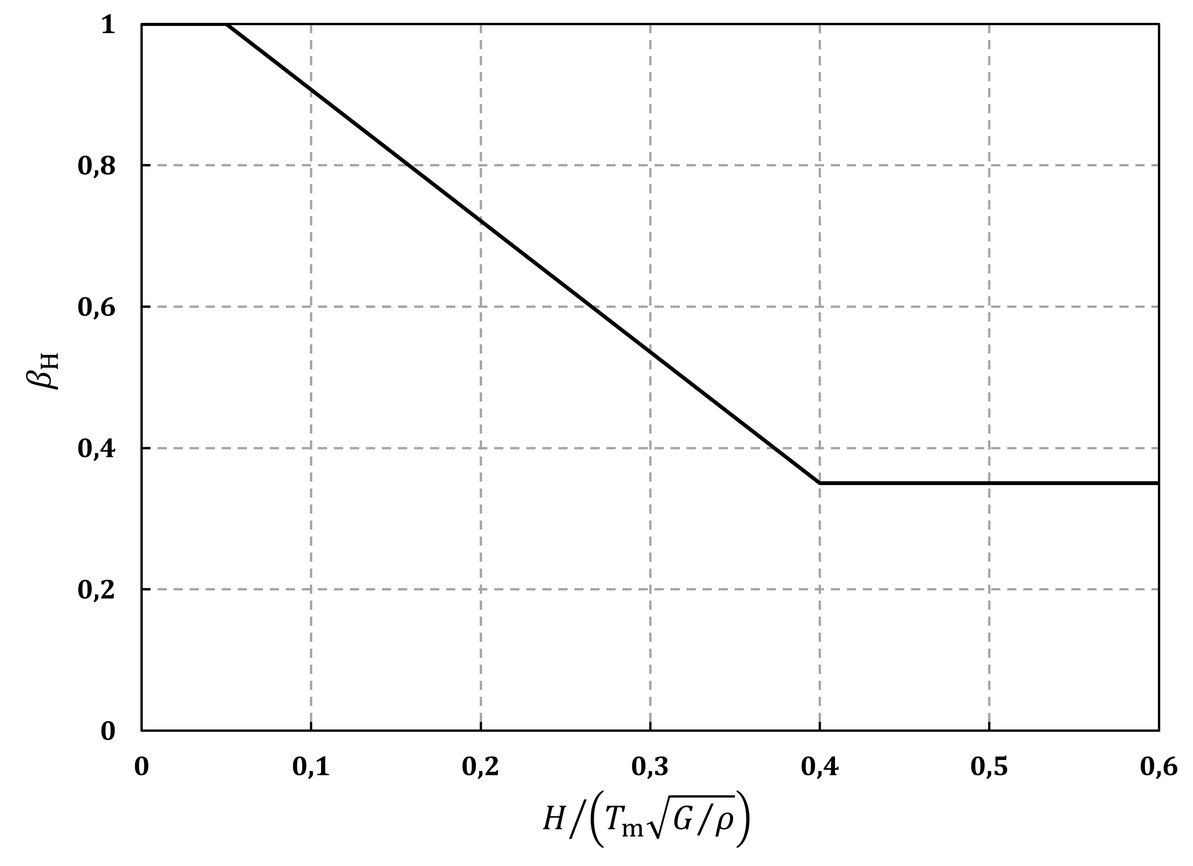

Figure A.1 — Simplified evaluation of *β*H

where

|  |  |
| --- | --- |
| *H* | is the total height of the slope, for use in 7.2.2.2(3), or the height of the portion of the retaining structure in direct contact with the ground, for use in 10.3.1(8). Examples of *H* are illustrated in Figure A.2; |
| *G* | is the shear modulus of the ground modified using the reduction factors listed in Table 6.1. For a non-homogeneous profile, *G* may be calculated from *v*S,H in Formula (5.1) of prEN 1998-1-1:2022, 5.1.2(7) with *H* as defined above; |
| *ρ* | is the mass density; |
| *T*m | is a period representative of the frequency content of the seismic action (on site category A) and of the frequency response of the soil deposit. In the absence of more specific studies, *T*m may be calculated using Formula (A.1). |

 (A.1)

where *T*B and *T*C are the lower-corner and upper-corner periods of the constant spectral acceleration range of the reference seismic action defined in prEN 1998-1-1:2022, 5.2.2.2(1).

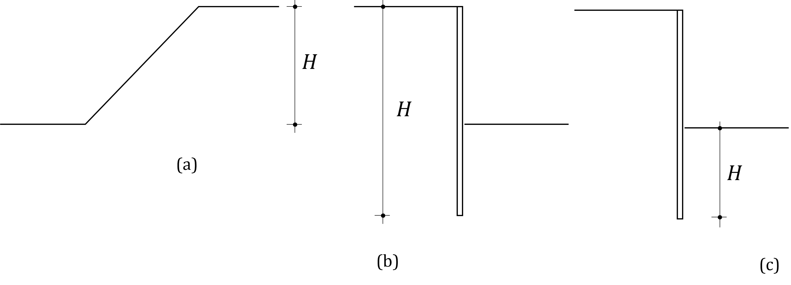

Figure A.2 — Evaluation of *H* for use of Figure A.1: (a) slopes; (b) embedded retaining wall, active side; (c) embedded retaining wall, passive side

* 1. Use of site-specific ground response analyses

(1) In accordance with 10.3.1(8) and with 7.5, the term *β*H *S*α/*F*A in Formulas (7.1) and (10.1) may be calculated from the results of a site-specific ground response analysis, using Formula (A.2).

 (A.2)

where  is the average value of the equivalent acceleration, calculated using Formula (A.3).

 (A.3)

where

|  |  |
| --- | --- |
|  | is the maximum value of the shear stress calculated with the *i*th accelerogram at depth *H* defined in A.1(1) |
| *σ*v,H | is the total vertical stress at a depth *H*; |
| *n* | is the number of accelerograms used in the site-specific ground response analysis. |

1. (informative)  
     
   Procedure for liquefaction analyses
   1. Use of this informative annex

(1) This informative annex provides additional guidance to that given in 7.3 for potentially liquefiable soils.

NOTE National choice on the application of this informative annex is given in the National Annex. If the National Annex contains no information on the application of this informative annex, it can be used.

* 1. Scope and field of application

(1) This informative annex covers procedures for the assessment of the liquefaction potential of soils.

* 1. General

(1) For footing-type foundations, the soil volume to consider for liquefaction susceptibility should be related to the width of the entire bearing area rather than to the width of individual footings, Figure B.1.

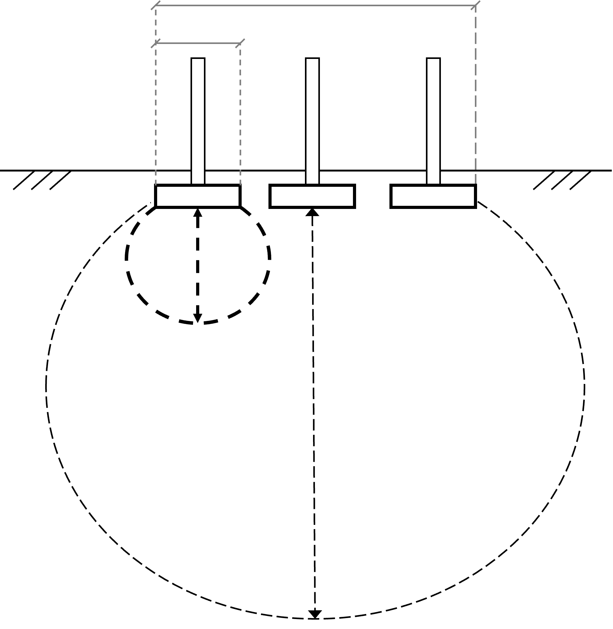

Figure B.1 — Sketch (not to scale) of involved soil volume for footing-type foundations (large circle)

* 1. Assessment of liquefaction susceptibility

(1) Saturated soils with Plasticity Index (*I*P) less than 10 should be considered susceptible to liquefaction.

(2) A detailed evaluation of susceptibility may be based on the combination of *I*P and ratio of water content to Liquid Limit, as given in Table B.1.

Table B.1 — Liquefaction susceptibility based on *I*P and ratio of water content to Liquid Limit

|  |  |  |
| --- | --- | --- |
| **Plasticity Index** | **Water content / Liquid Limit** | **Susceptibility** |
| < 10 | > 0,85 | susceptible |
| 10 to 15 | > 0,80 | moderately susceptible |
| 0 to 10 | 0,80 to 0,85 | moderately susceptible |
| < 15 | < 0,80 | not susceptible |
| > 15 |  | not susceptible |

* 1. In situ evaluation of CRR
     1. General

(1) In situ evaluation of CRR should be performed using either SPT or CPT-based methods.

NOTE Annex B provides a consistent set of formulas that cannot be mixed with Formulas from other procedures.

* + 1. SPT-based method

(1) The measured values of the SPT blow count *N*, expressed in blows/300 mm, should be corrected for the hammer impact energy and the effective vertical stress.

(2) For application of (1), the corrected SPT blow count (*N*1)60 should be calculated using Formulas (B.1) to (B.4).

 (B.1)

 (B.2)

 (B.3)

 (B.4)

where

|  |  |
| --- | --- |
| *C*N | is the overburden stress correction factor for normalisation to atmospheric pressure; the normalisation factor *C*N for the SPT method should not be taken smaller than 0,5 or greater than 1,7; |
| *C*E | is the hammer energy correction factor; |
| *ER* | is the energy ratio, in percent, specific to the testing equipment; |
| *p*a | is the atmospheric pressure (= 100 kN/m2); |
|  | is the vertical effective overburden pressure acting at the depth where measurement has been made and at the time of its execution; |

NOTE Use of Formulas (B.2) and (B.3) requires iterations.

(3) The SPT blow count should be further corrected using Formulas (B.5) and (B.6) to obtain , the clean-sand equivalent blow count for the effects of fines content.

 (B.5)

 (B.6)

where *FC* is the fines content.

(4) CRR for a reference earthquake magnitude of *M*w = 7,5 and a vertical effective overburden pressure of  = *p*a (100 kPa) may be calculated using Formula (B.7).

 (B.7)

(5) CRR should be multiplied by the earthquake magnitude scaling factor (*MSF*), which accounts for magnitudes other than the reference value.

(6) *MSF* may be calculated using Formula (B.8).

 (B.8)

where *M*w is the moment magnitude and *MSF*max is given by Formula (B.9).

 (B.9)

(7) CRR should be multiplied by the effective overburden stress factor, *K*σ.

(8) The effective overburden stress factor may be calculated using Formula (B.10).

 (B.10)

NOTE Formula (B.10) is valid for (*N*1)60,cs smaller than 37. Higher values are of no practical significance.

(9) CRR for the seismic design situation and for a vertical effective overburden pressure  may be calculated using Formula (B.11).

 (B.11)

* + 1. CPT-based method

(1) The CPT penetration resistance *q*c should be corrected to account for the effects of overburden.

NOTE For sands, the penetration resistance *q*c is approximately equal to the cone tip resistance corrected for unequal end area effects, *q*t.

(2) The normalised corrected *q*c1N value may be calculated from the measured cone tip resistance *q*c using Formulas (B.12) and (B.13).

 (B.12)

 (B.13)

where *C*N is given by Formula (B.2), with *m* now given by Formula (B.13).

NOTE Use of Formulas (B.12) and (B.13) requires iterations.

(3) The point resistance should be further corrected using Formulas (B.14) and (B.15) to obtain , the clean-sand equivalent blow count for the effects of fines content.

 (B.14)

 (B.15)

(4) The fines content in Formula (B.15) is best determined from site measurements.

NOTE *FC* is highly variable, geological layer dependent and site dependent.

(5) If the fines content is not available from site measurements, Formulas (B.16) to (B.19) may be used, provided the variability represented by the parameter *C*fc = ±0,29, i.e. plus or minus one standard deviation, is taken into account.

 (B.16)

where *I*c is the soil behaviour type index defined in Formulas (B.17) to (B.19).

 (B.17)

 (B.18)

 (B.19)

where

|  |  |
| --- | --- |
| *σ*v | is vertical total overburden pressure acting at the depth where measurement has been made and at the time of its execution; |
| fs | is the measured sleeve resistance in the CPT; |
| *n* | is a stress exponent for overburden correction in CPT. |

NOTE The terms *Q* and *F* are used in soil behaviour type classification charts; the exponent *n* varies from 0,5 in sands to 1,0 in clays.

(6) For a reference earthquake magnitude of *M*w = 7,5 and effective overburden pressure of  = *p*a (100 kPa), CRR may be calculated using Formula (B.20).

 (B.20)

(7) CRR should be multiplied by the earthquake magnitude scaling factor (*MSF*) given in Formula (B.8), with *MSF*max given by Formula (B.21), and by the effective overburden stress factor (*K*σ) given in Formula (B.22).

 (B.21)

 (B.22)

NOTE Formula (B.22) is valid for *q*c1N,cs smaller than 210. Higher values are of no practical significance.

(8) Other correction factors may be applied to the value of *q*c1N,cs including a thin layer correction.

* 1. Evaluation of the stress reduction factor

(1) The stress reduction factor defined in Formula (7.3) should be calculated with Formulas (B.23) to (B.25).

 (B.23)

 (B.24)

 (B.25)

where *z* is the depth below the ground surface in meters and the arguments inside the sin( ) function are in radians.

NOTE Formulas (B.23) to (B.25) are valid for z < 30 m.

* 1. Simplified liquefaction index

(1) To apply 7.3.5(3) for a low seismic action class, the consequences of liquefaction may be considered negligible if the liquefaction severity index, *LSN*, defined in Formula (B.26), is less than 15.

 (B.26)

where

|  |  |
| --- | --- |
| *ε*v | is the calculated post-liquefaction volumetric reconsolidation strain (entered as a decimal); |
| *z* | is the depth (in metres, *z* > 0). |

NOTE C.2 gives relationships to calculate *ε*v.

1. (informative)  
     
   Evaluation of settlements of coarse-grained soils
   1. Use of this annex

(1) This informative annex provides additional guidance to that given in 7.3.5, 7.3.6, 7.4, 9.4.2.1.4 for simplified calculations of earthquake induced settlements and lateral movements.

NOTE National choice on the application of this informative annex is given in the National Annex. If the National Annex contains no information on the application of this informative annex, it can be used.

* 1. Scope and field of application

(1) This informative annex covers procedures for the calculations of seismic settlements and lateral movements under free-field conditions and under a building in saturated and dry soils.

* 1. Free-field settlement

(1) Settlements in the free field may be calculated using Formula (C.1).

 (C.1)

where

|  |  |
| --- | --- |
| *ε*vi | is the earthquake induced volumetric strain in layer *i*; |
| Δ*z*i | is the thickness of the layer. |

(2) The volumetric strains may be calculated from C.4.

* 1. Volumetric strain in saturated sands
     1. Method based on Factor of Safety (FS) against liquefaction

(1) For saturated clean sands the post-liquefaction volumetric strains may be calculated using the chart in Figure C.1.

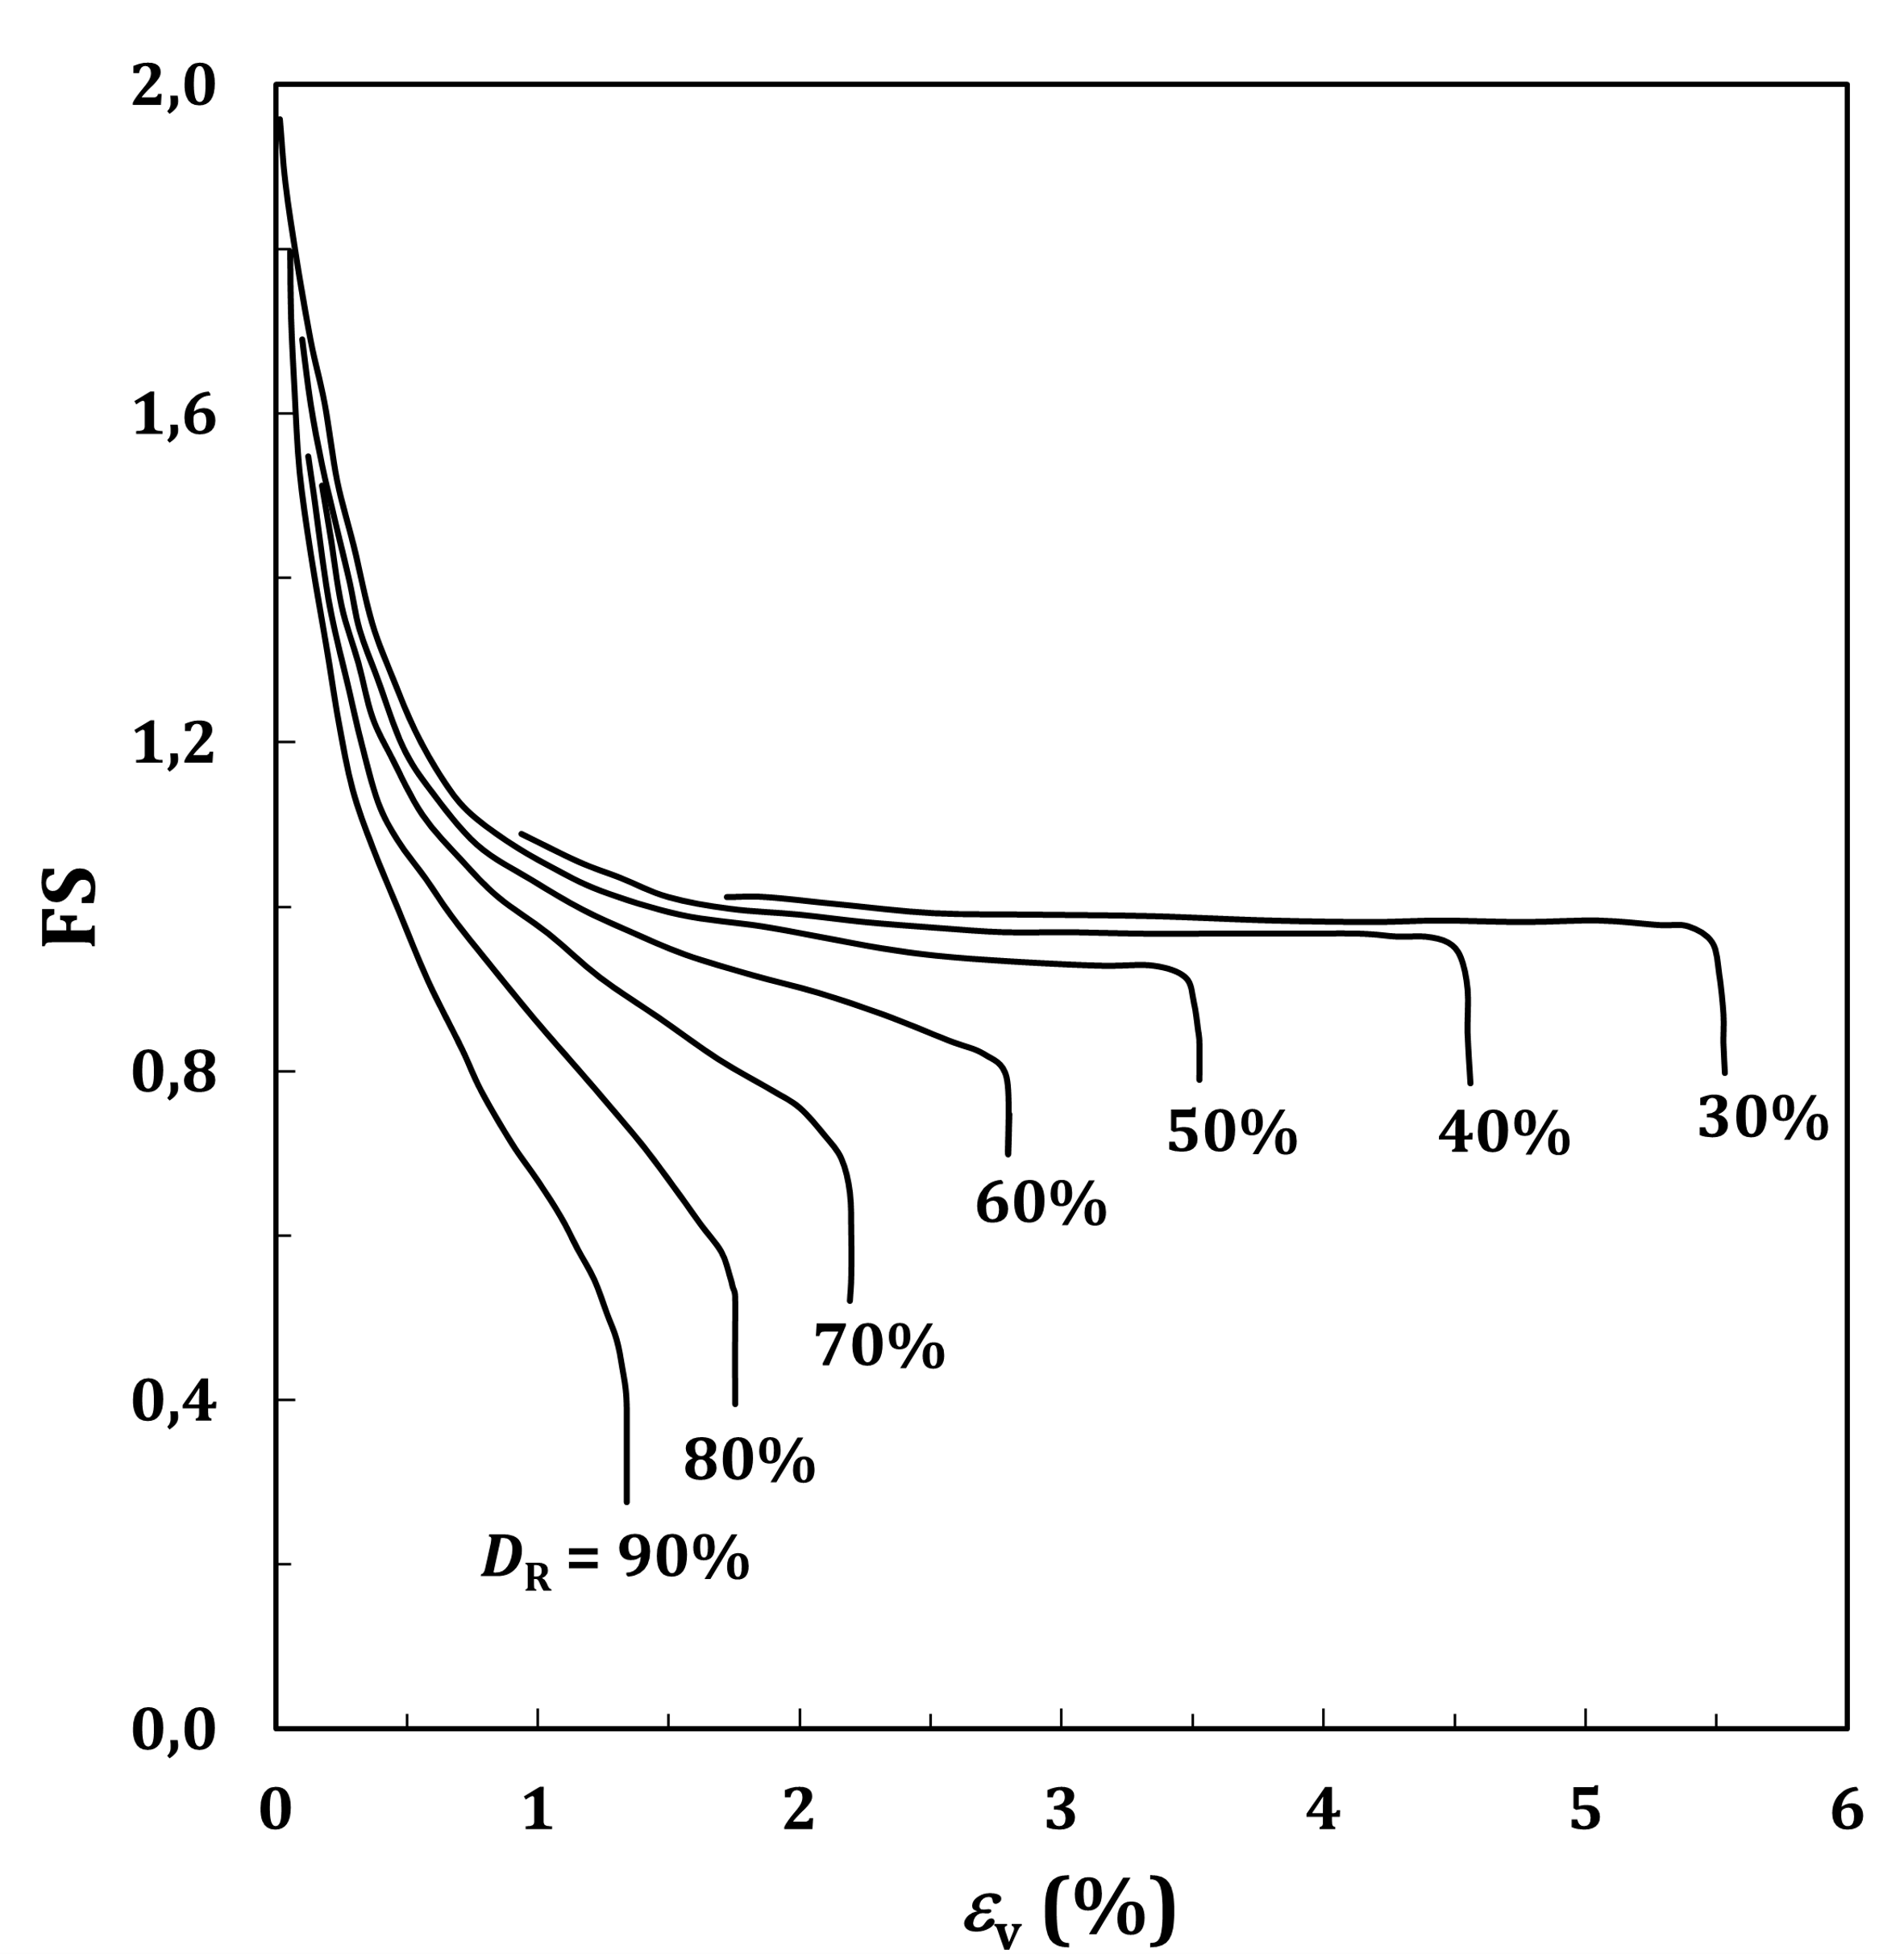

Figure C.1 — Factor of safety versus post-liquefaction volumetric strain (%)

where

|  |  |
| --- | --- |
| *FS* | is the factor of safety against liquefaction = CRR/CSR; |
| *D*r | is the sand relative density. |

* + 1. Method based on SPT data

(1) For saturated clean sand, the post-liquefaction volumetric strain may be calculated from the chart in Figure C.2, where (*N*1)60 is the normalised SPT blow count defined in B.5.2.

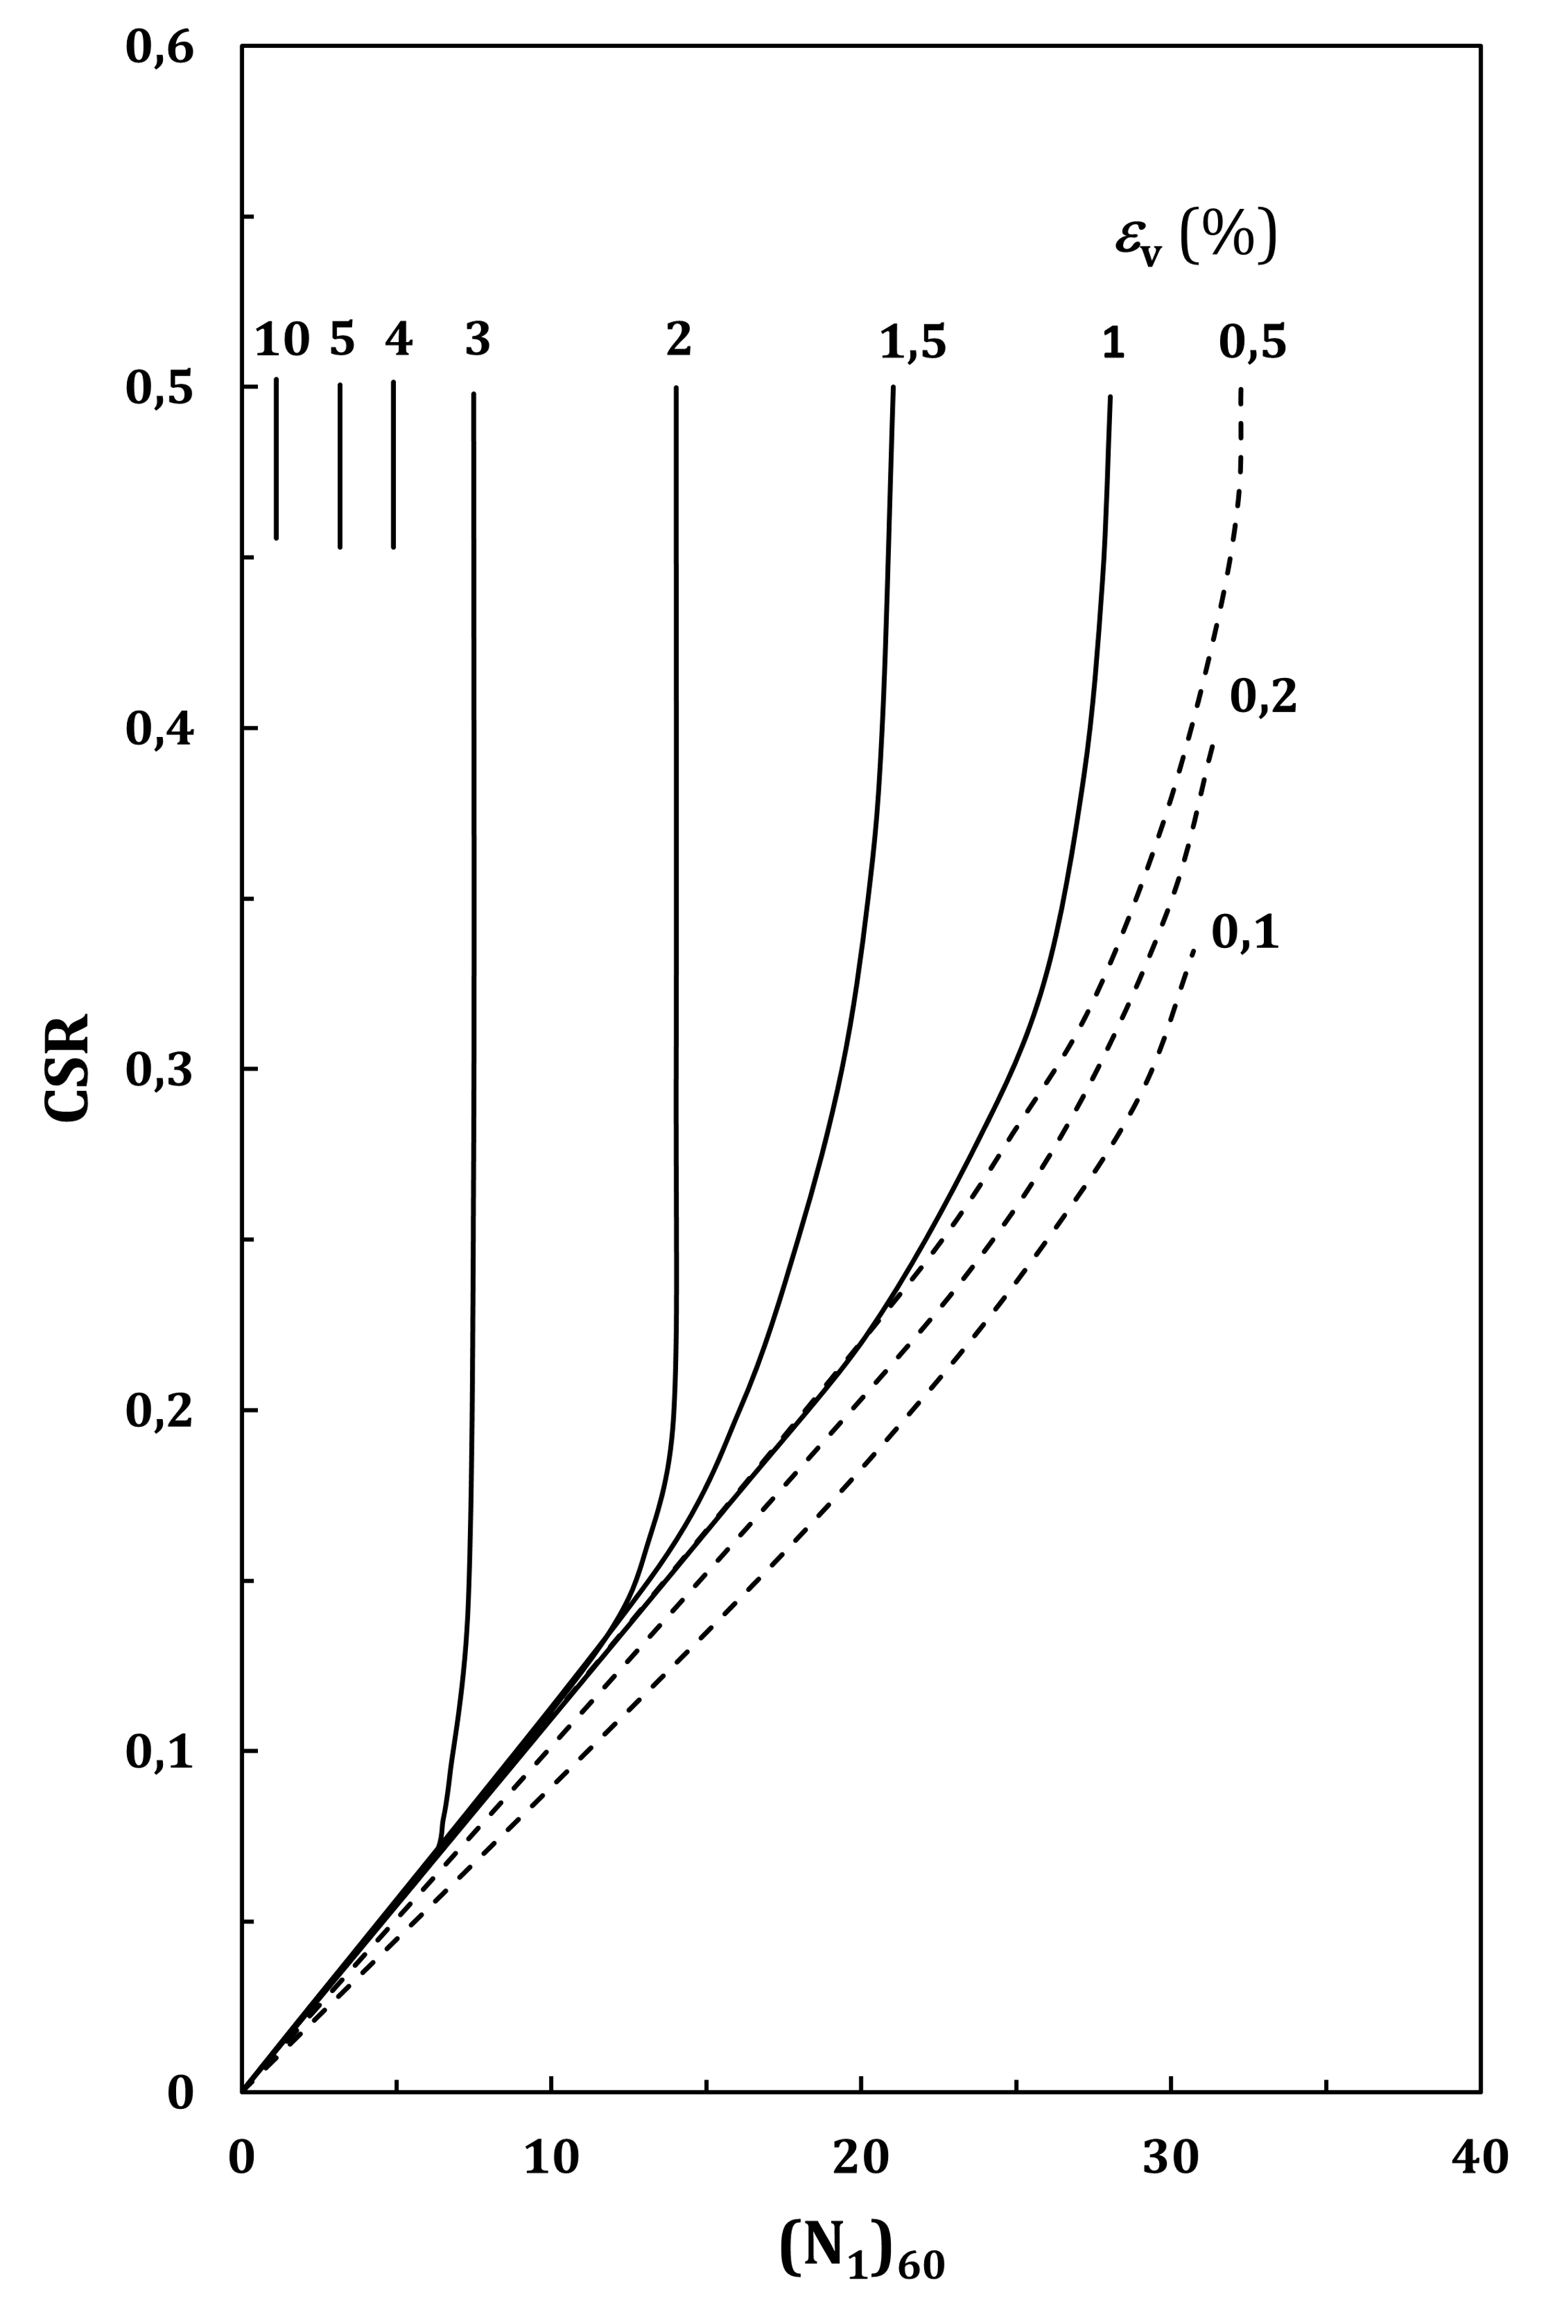

Figure C.2 — Calculation of post-liquefaction volumetric strain using SPT data. Each curve corresponds to a constant volumetric strain (%) and is plotted as a function of CSR versus (*N*1)60

* + 1. Method based on CPT

(1) For saturated clean sand, the post-liquefaction volumetric strain may be calculated from the chart in Figure C.3, where *q*c1N,cs is the normalised cone tip resistance defined in B.5.3.

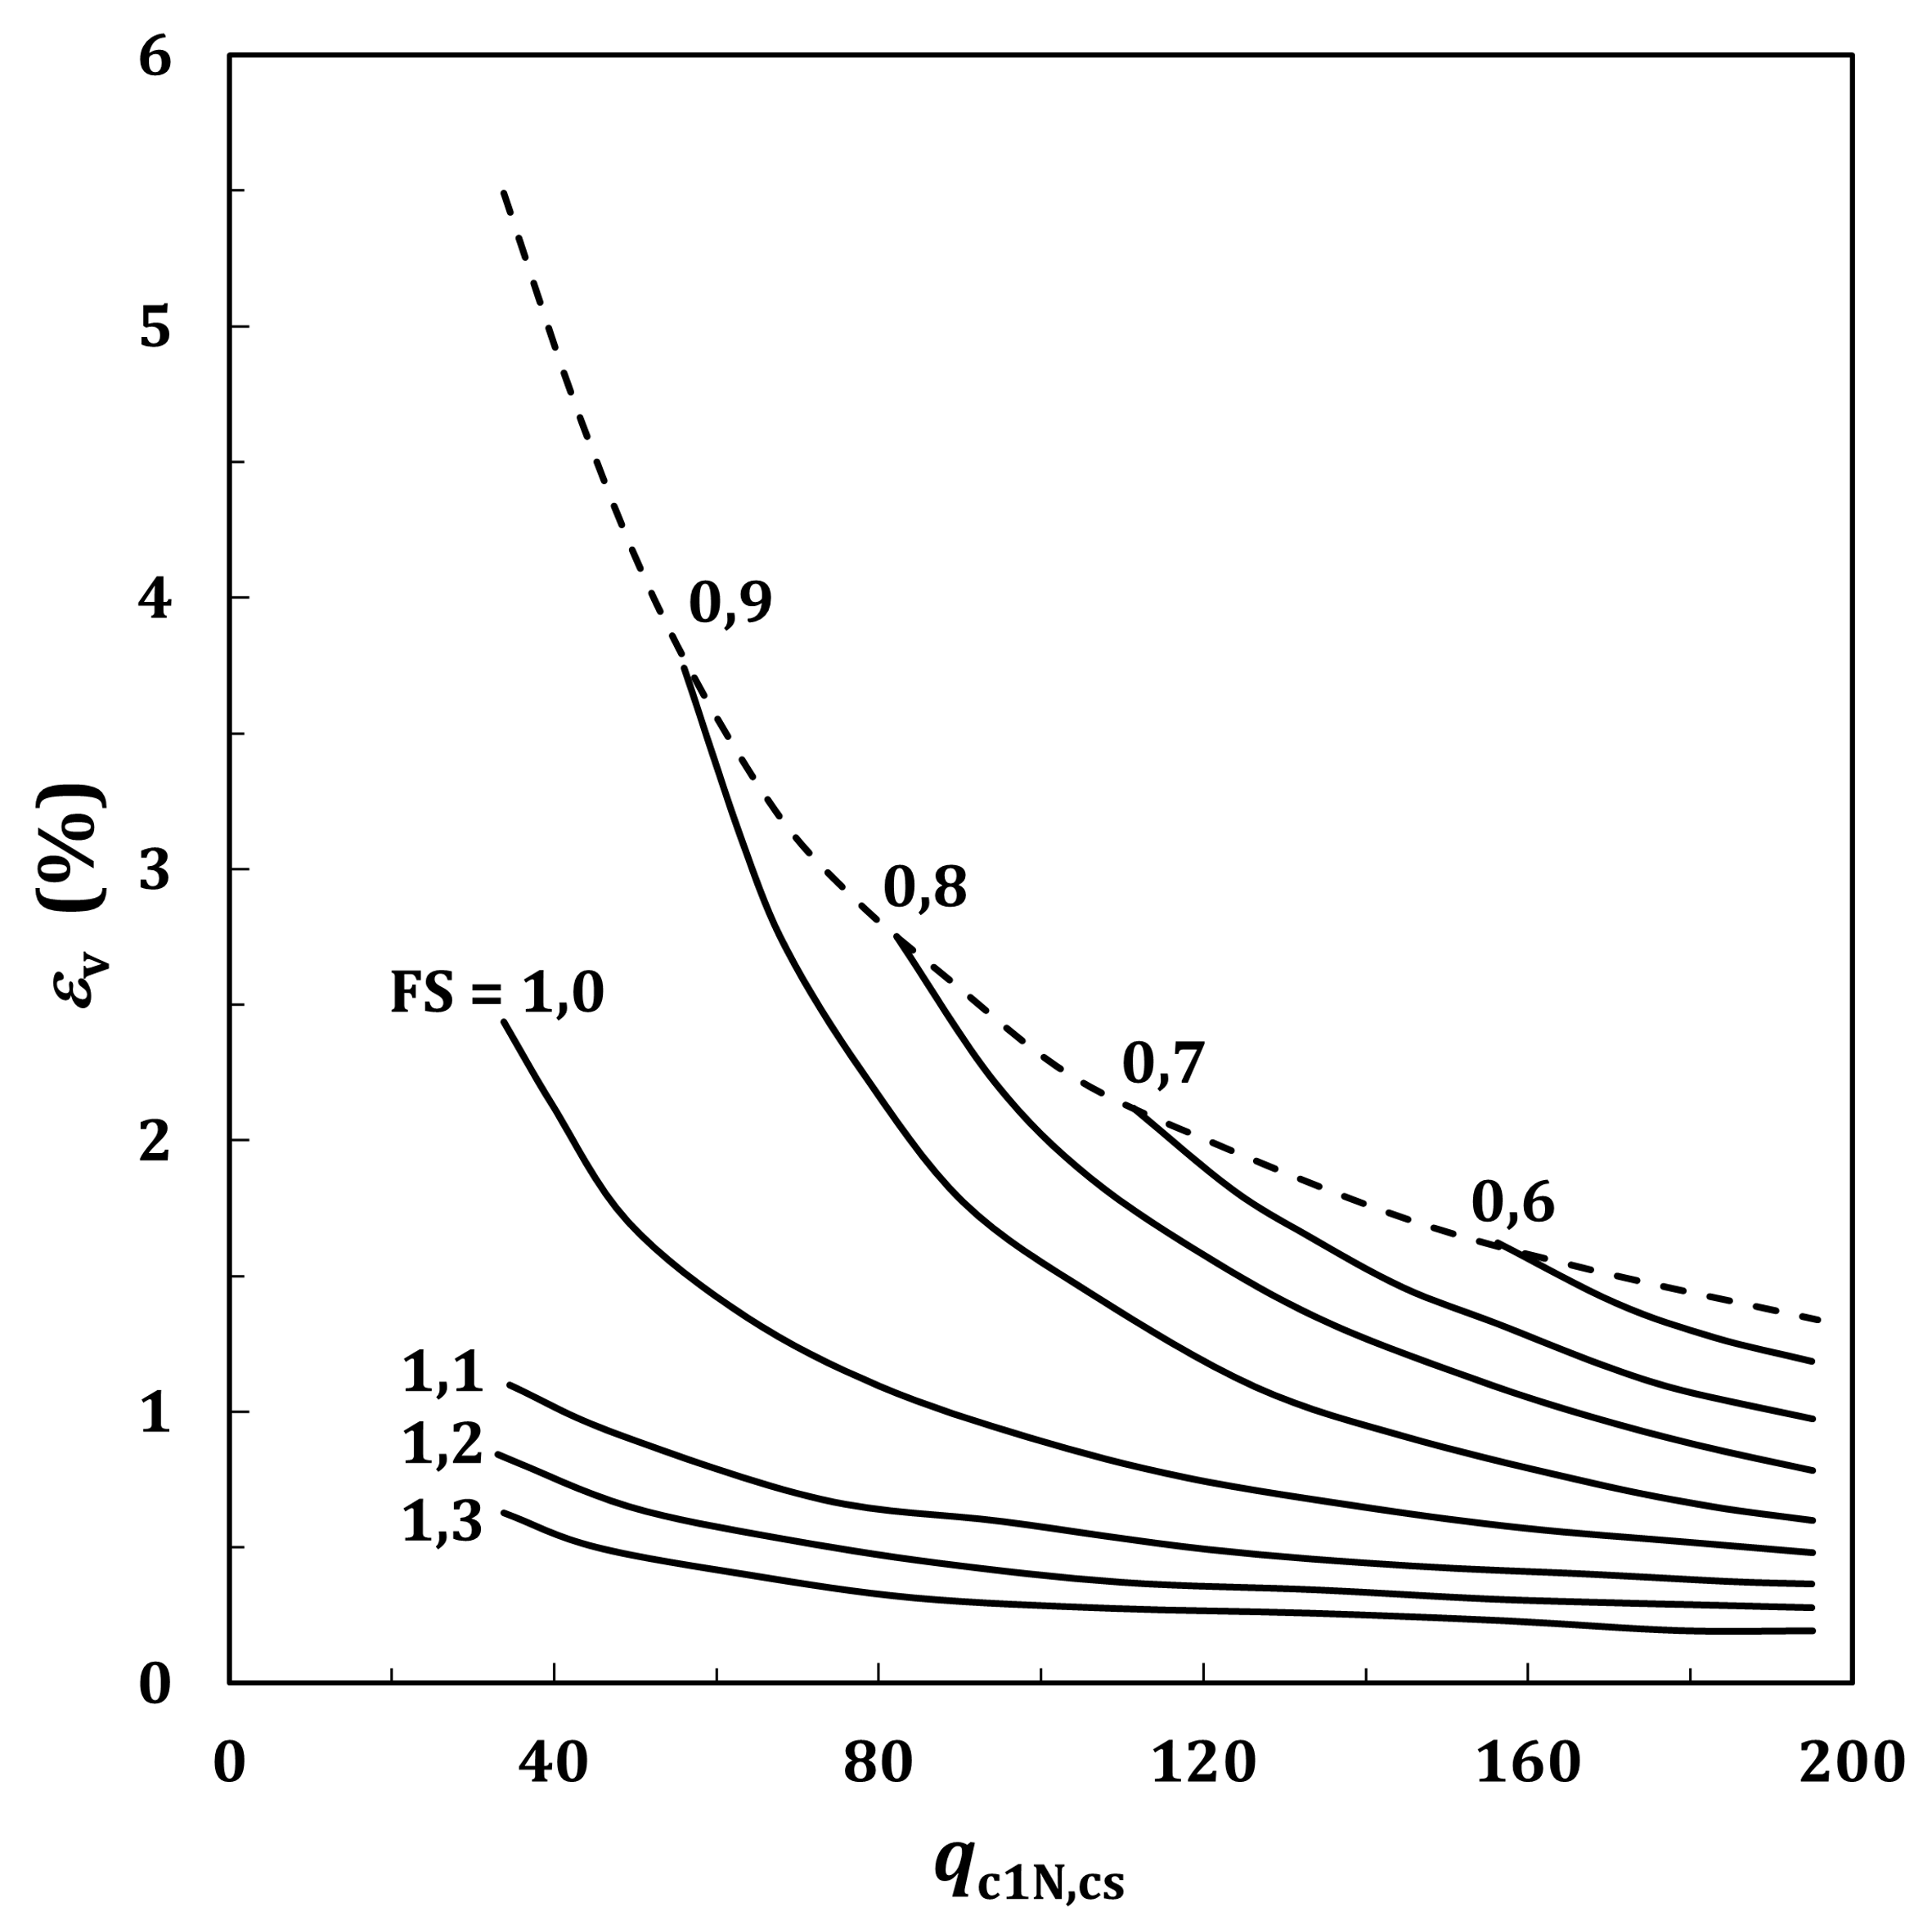

Figure C.3 — Post-liquefaction volumetric strain (%) versus normalised equivalent clean sand tip resistance

* 1. Volumetric strain in dry sand

(1) Volumetric strain for dry sand may be calculated using Formulae (C.2) and (C.3) as a function of relative density, *D*r, and earthquake magnitude *Mw*.

 (C.2)

 (C.3)

where

|  |  |
| --- | --- |
| *Mw* | is the earthquake magnitude; |
| Dr | is the sand relative density (in %); |
| *γ*cyc | is the effective cyclic shear strain (in %) due to the earthquake, calculated from a site response analysis, see 7.5. |

(2) When a site response analysis is not available, *γ*cyc may be calculated as a function of  using Figure C.4 and Formula (C.4).

 (C.4)

where

|  |  |
| --- | --- |
| CSR | is the cyclic stress ratio defined in 7.3.4; |
|  | is the vertical effective stress; |
| pa | is the atmospheric pressure; |
| G0 | is the elastic shear modulus defined in 6.4; |
| *γ*cyc, *γ*ref | are the cyclic shear strain and the reference shear strain in absolute dimensionless value (not in %). |

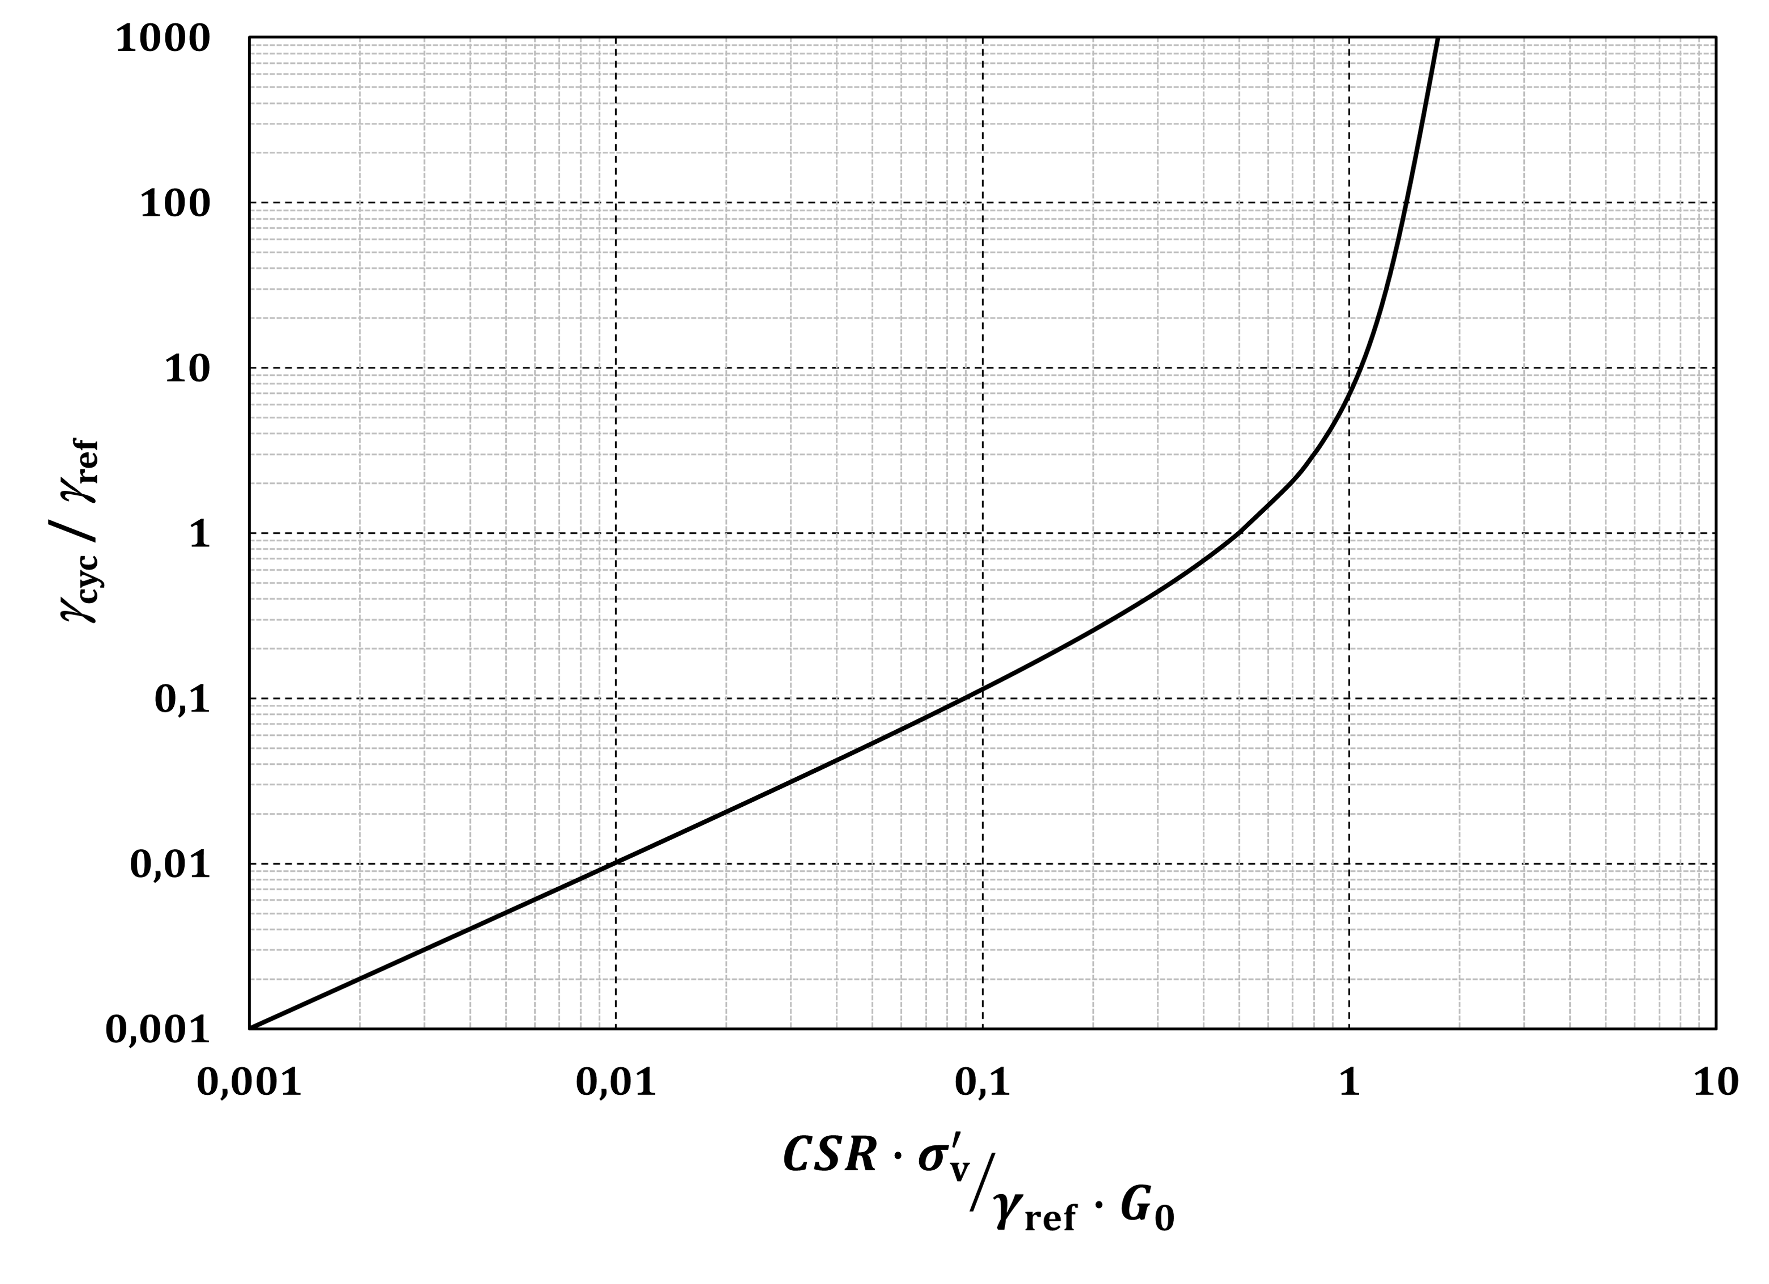

Figure C.4 — Effective cyclic shear strain versus reference shear strain

(3) For  ≤ 0,1, *γ*cyc is given by Formula (C.5).

 (C.5)

NOTE Formula (C.5) is an approximation to the curve in Figure C.4 for  ≤ 0,1.

* 1. Settlement under a building

(1) The total settlement of a building on shallow foundation should be taken as the sum of two components given in a) and b):

a) the volumetric settlement described in C.4 and C.5;

b) the shear-induced settlement due to the inertial load in the structure.

(2) The shear-induced settlement (50% fractile) may be calculated using Formulas (C.6) to (C.8).



 (C.6)

 (C.7)

 (C.8)

where

|  |  |
| --- | --- |
| *D*S | is the settlement (in millimetres); |
| *z* | is the depth (in metres) measured from the ground surface; |
| *z*min | should be greater than 0; |
| *z*max | extends to all layers that contribute to liquefaction-associated settlements; |
| *W* | is a foundation-weighting factor equal to *W* = 0 for *z* < foundation depth, and equal to *W* = 1,0 otherwise; |
| *ε*shear | is the liquefaction-induced free-field shear strain (in percent) which may be obtained from Figure C.5; |
| Hheav | is the Heaviside step function; |
| Bb | is the building width (in metres); |
| HL | is the cumulative thickness of liquefiable layers (in metres); |
| QL | is the foundation contact pressure (in kN/m2); |
| S1 | is the value of the spectral acceleration (for 5% damping) at 1 s period of the horizontal elastic response spectrum; |
| g | is the acceleration of gravity; |
| *n* | is the number of discrete 1 s time intervals; |
| PGAi | is the value of the peak ground acceleration (in m/s2) in time interval *i* (inclusive of the first and last values); |
| CAVdp | is taken as 0 if *CAV*dp is less than or equal to 1,6 m/s, or if the maximum value of the spectral acceleration in the periods range from 0,1 to 0,5 s is less than or equal to 2 m/s2; |
| a(t) | is the acceleration (in m/s2); |
| c1 | is a constant equal to (–7,48) if *LBS* > 16, and to (–8,35) otherwise; |
| *c*2 | is a constant equal to 0,014 if *LBS* > 16, and to 0,072 otherwise. |

NOTE 1 The coefficient of variation of the settlement, given its 50% fractile (median) from Formula (C.4), is around 50%.

NOTE 2 In absence of specific data for *CAV*dp, this quantity may be replaced in Formula (C.6) by *S*α, where *S*α is defined in prEN 1998-1-1:2022, Formula (5.11).

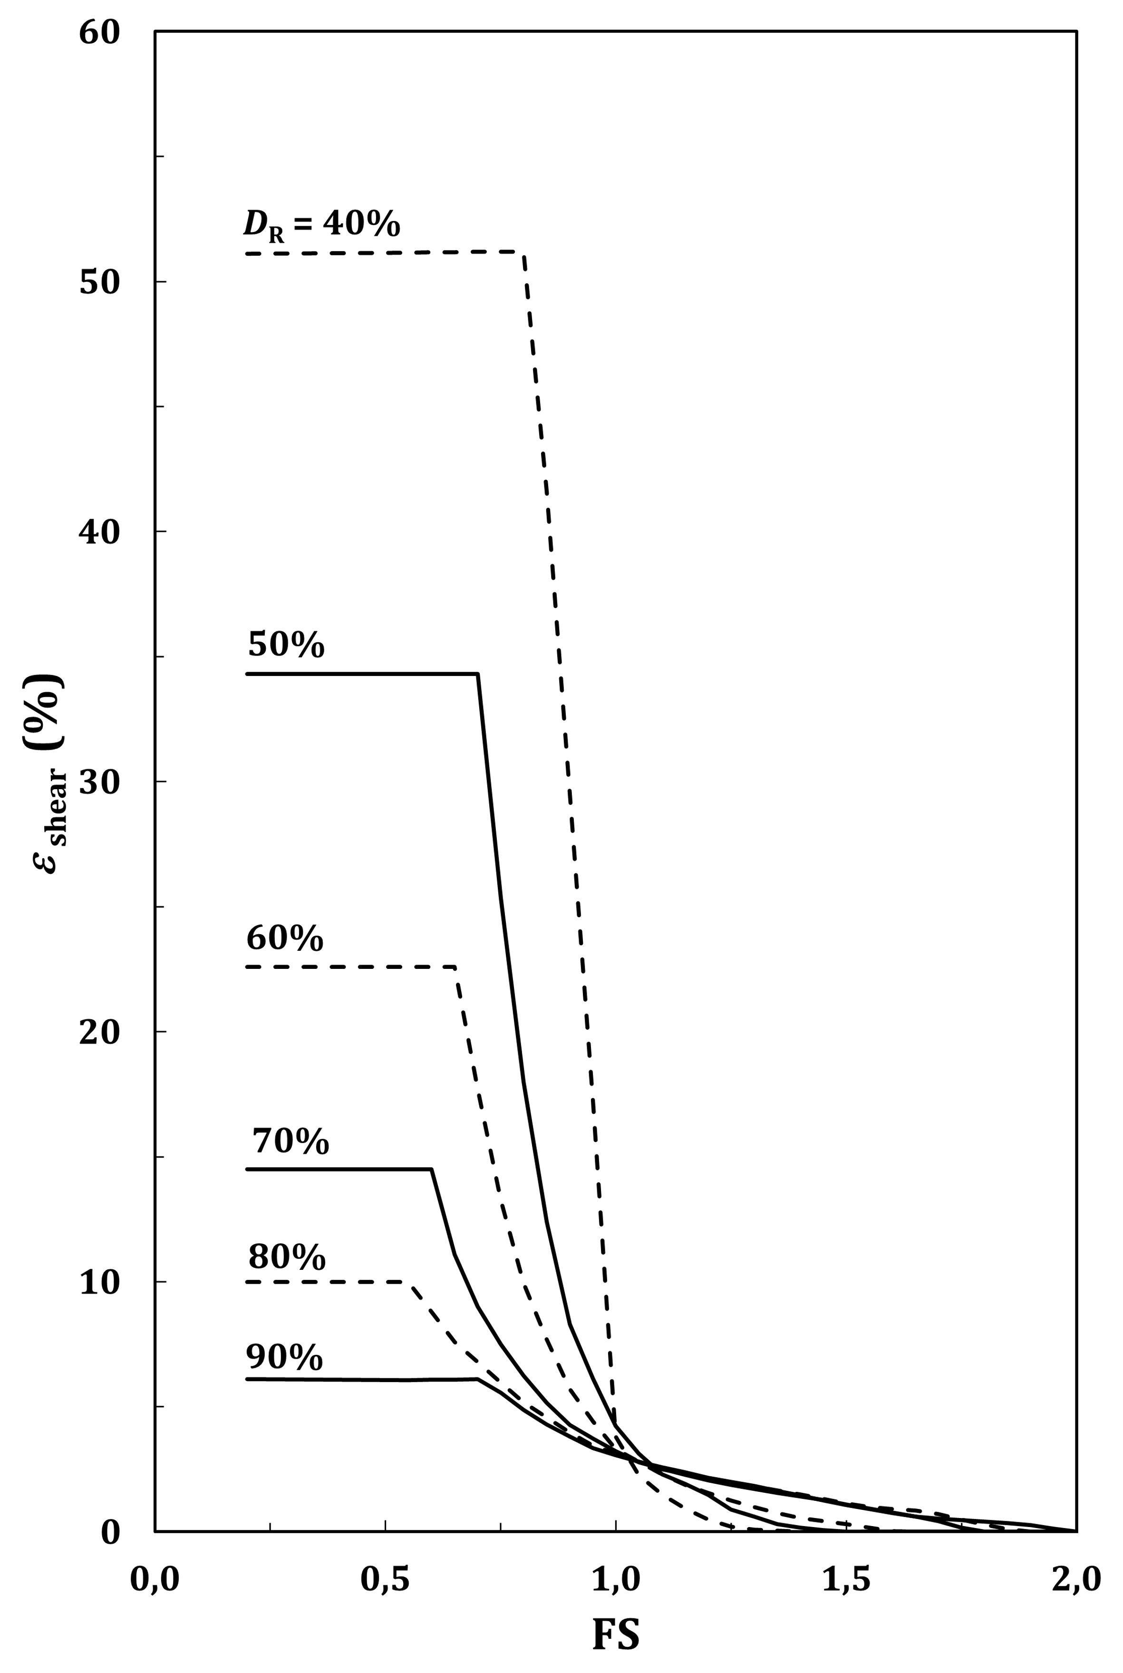

Figure C.5 — Liquefaction free-field shear strain versus factor of safety

* 1. Lateral spreading due to liquefaction

(1) The lateral displacement due to liquefaction may be calculated using Formula (C.9), for the free-face case where the lateral spread moves toward an open face, and Formula (C.10), for a gentle slope where the soil tends to slip down the slope.

NOTE The first situation occurs in presence of a nearby river or canal bank.



 (C.9)



 (C.10)

where

|  |  |
| --- | --- |
| *D*H | is the lateral displacement (in m); |
| Mw | is the moment magnitude; |
| *R* | is the horizontal distance from the site to seismic source (in km); |
| a1 | is the free-face ratio (in %), i.e. the ratio of height of free-face to the distance from the free-face to the point of interest; |
| a2 | is the cumulative thickness of liquefiable layers (in m); |
| a3 | is the average fines content (% in dry weight of material smaller than 80 μm) in liquefiable layers; |
| a4 | is the average mean grain size (in mm) for granular material in the liquefiable layers; |
| a5 | is the ground slope (in %); |
|  | is defined by Formula (C.11). |

 (C.11)

where *R*0 is defined by Formula (C.12).

 (C.12)

1. (informative)  
     
   Impedance functions for surface and deep foundations
   1. Use of this annex

(1) This informative annex provides additional guidance to that given in 8.2 for calculations of foundation impedances.

NOTE National choice on the application of this informative annex is given in the National Annex. If the National Annex contains no information on the application of this informative annex, it can be used.

* 1. Scope and field of application

(1) This informative annex covers procedures for the calculations of impedances (springs and dashpots) in situations a) to c):

a) surface and embedded foundations in a homogeneous half-space;

b) isolated piles;

c) pile group.

* 1. Impedance of a rectangular foundation on a homogeneous half-space
     1. Stiffness coefficient

(1) The static impedance functions, defined in 8.2(2), of a rectangular foundation at the surface of a homogeneous half-space may be calculated using Formulas (D.1) to (D.6).

 (D.1)

 (D.2)

 (D.3)

 (D.4)

 (D.5)

 (D.6)

where

|  |  |
| --- | --- |
|  | geometric symbols are defined in Figure D.1; |
| *G* | is the soil shear modulus; |
| *B* | is the foundation width (smallest dimension); |
| *L* | is the foundation length (largest dimension); |
| Kxx | is the static impedance in the horizontal X direction; |
| Kyy | is the static impedance in the horizontal Y direction; |
| Kzz | is the static impedance in the vertical Z direction; |
| Krx | is the static rocking impedance around the horizontal X direction; |
| Kry | is the static rocking impedance around the horizontal Y direction; |
| Krz | is the static torsional impedance around the vertical Z direction; |
| *ν* | is the soil Poisson's ratio. |

NOTE 1 The definition of the geometry and the geometric symbols is given in Figure D.1, which also identifies the degrees of freedom of the surface foundation.

NOTE 2 Modification of the static stiffness coefficients due to the loading frequency can be evaluated from the relevant literature.

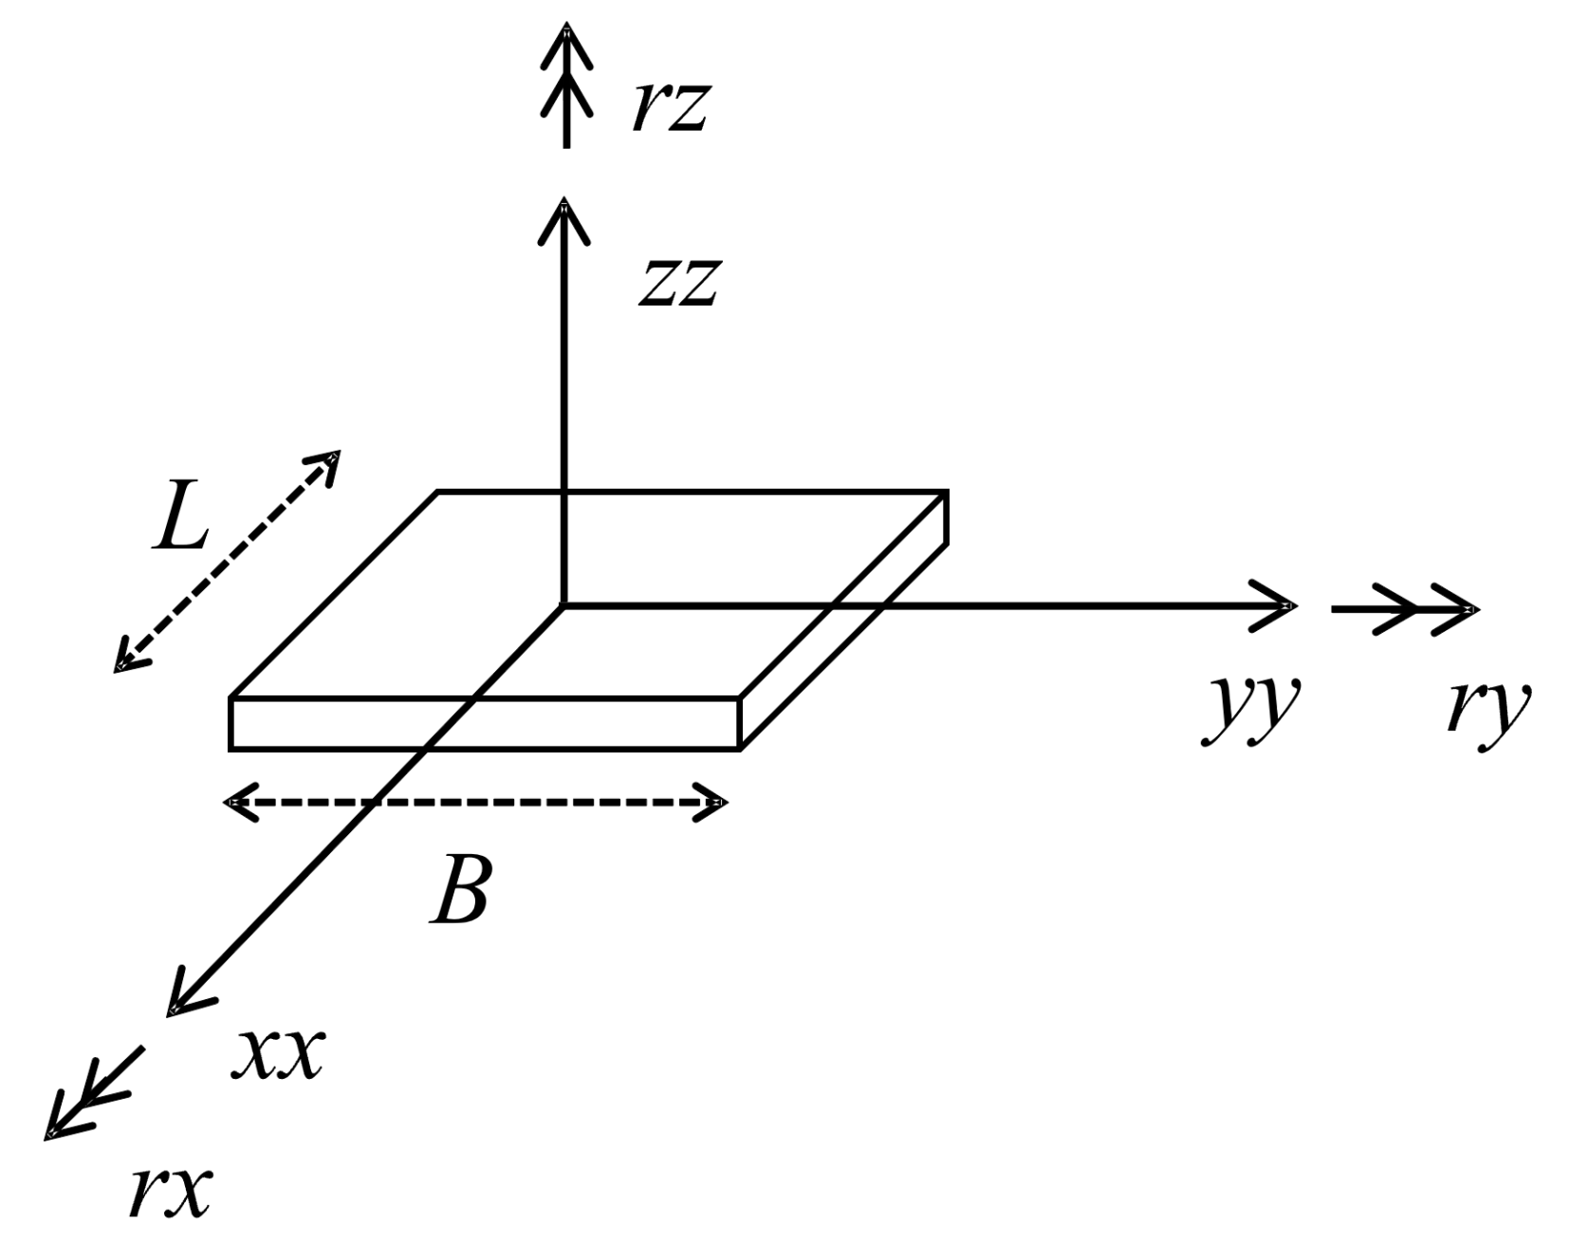

Figure D.1 — Definition of the geometry and degrees of freedom

* + 1. Dashpot coefficient

(1) The radiation damping coefficient (term in the diagonal damping matrix that multiplies the vector of velocities at the centre of the footing-soil contact area), defined in 8.2.3.2(3), of a rectangular footing at the surface of a homogeneous half-space may be calculated using Formulas (D.7) to (D.11).

 (D.7)

 (D.8)

 (D.9)

 (D.10)

 (D.11)

where

|  |  |
| --- | --- |
| *A*b | is the area of the base of the footing in contact with the soil; |
| *J*bx, *J*by, *J*bz, | are the moments of inertia (about the *x*, *y* and *z* axes, respectively) of the base of the footing in contact with the ground; |
| Cxx | is the radiation dashpot coefficient in the horizontal X direction; |
| Cyy | is the radiation dashpot coefficient in the horizontal Y direction; |
| Czz | is the radiation dashpot coefficient in the vertical Z direction; |
| Crx | is the radiation dashpot coefficient around the horizontal X direction; |
| Cry | is the radiation dashpot coefficient around the horizontal Y direction; |
| Crz | is the radiation dashpot coefficient around the vertical Z direction; |
| *c'*rx, *c'*ry, *c'*rz | are frequency-dependent coefficients for the rotational modes, given in Figure D.2, where *f* is the fundamental frequency of the system in the direction considered as appropriate. |

NOTE Radiation damping depends strongly on the distribution of ground stiffness with depth, in addition to the period of vibration which controls the rotational (only) components. Particularly significant is the effect of the presence of a rock-like stiff formation at relatively shallow depth from the ground surface: at periods of oscillation higher than the fundamental period of the soil deposit, radiation damping vanishes, and hence only material damping in Formula (8.1) exists. Radiation damping also tends to become insignificant whenever the ground stiffness increases consistently with depth.

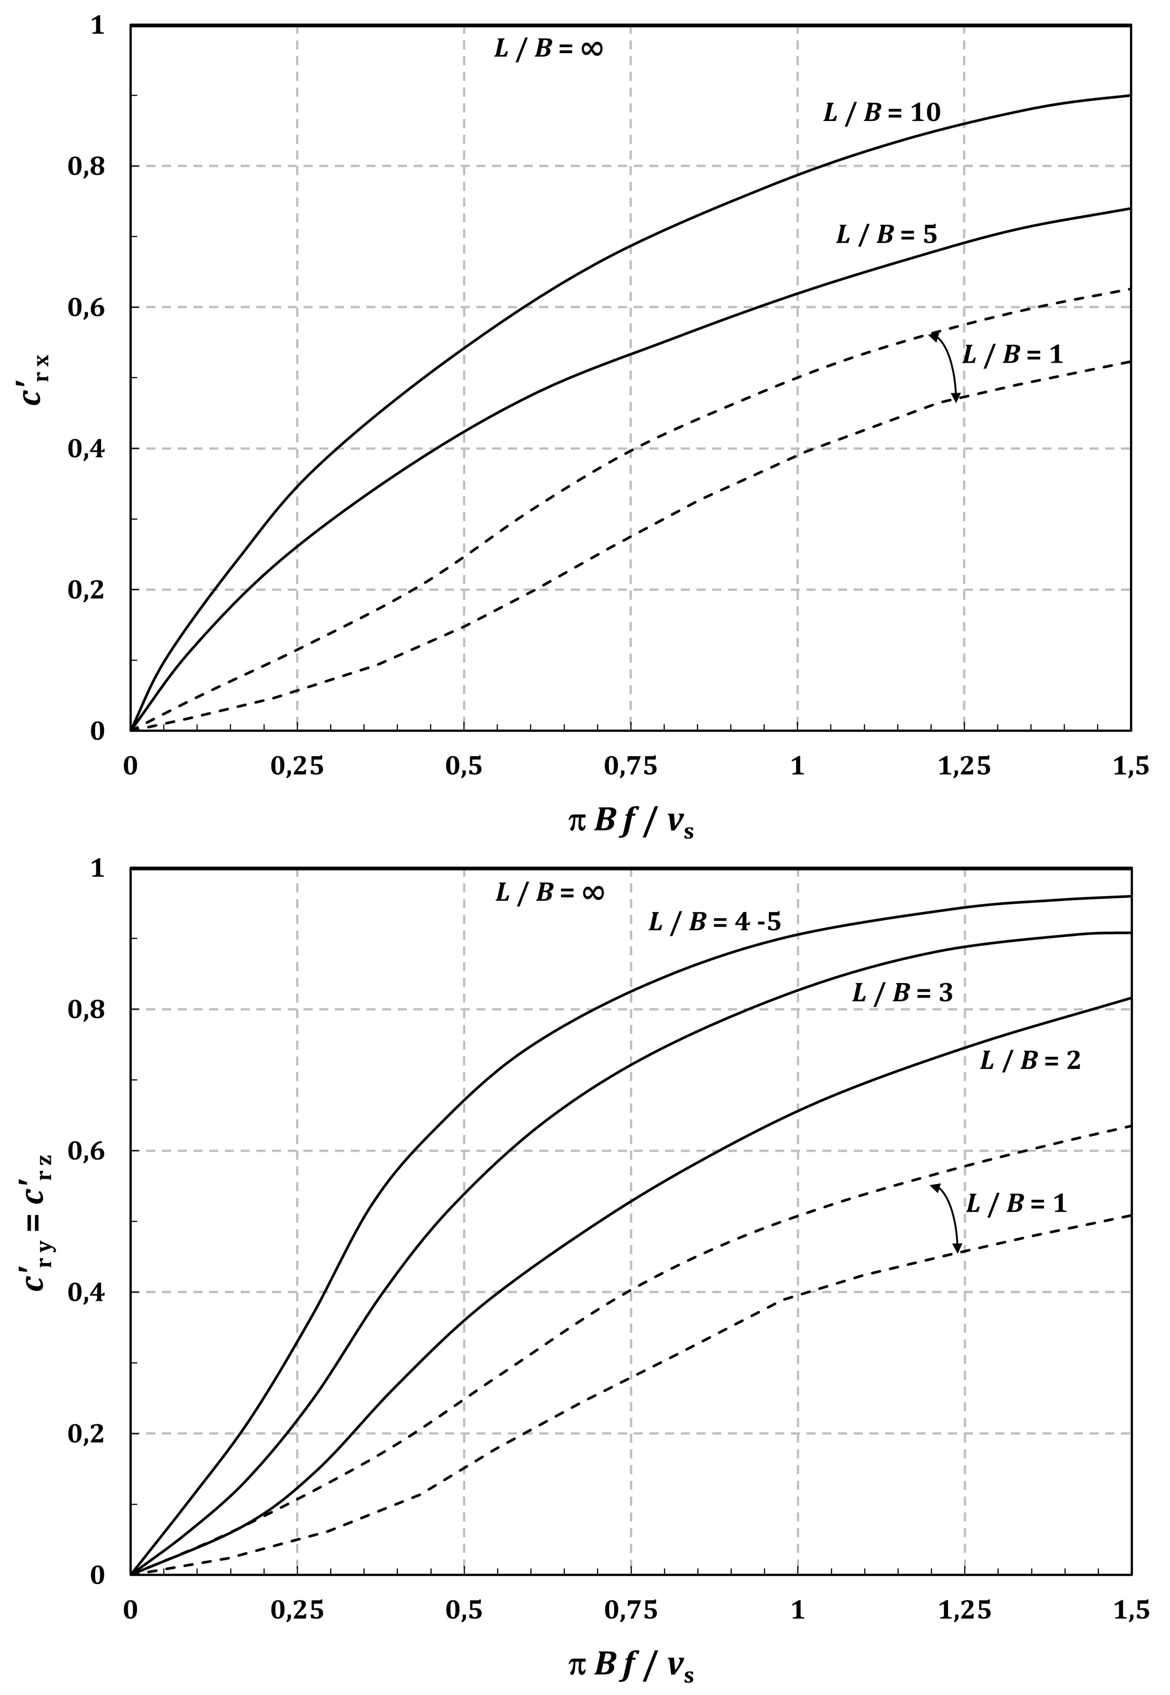

Figure D.2 — Frequency dependent coefficients for rocking radiation dashpots: dashed lines correspond to the range of values applicable to square and circular foundations

* 1. Static impedance of embedded footings in a homogeneous half-space

(1) The static impedances of footings embedded in a homogeneous half-space may be calculated using Formula (D.12).

 (D.12)

where

|  |  |
| --- | --- |
| *K*ii,D | is the static impedance for degree of freedom *ii* of the embedded foundation; |
| Kii | is the static impedance of the same surface foundation given in Formulas (D.1) to (D.6); |
| De | is the depth from the ground surface to the base of the foundation; |
| de | is the foundation thickness; |
| *h* | = *D*e–*d*e/2 (see Figure D.3); |
|  | are corrections factors to the surface impedances, given by Formulas (D.13) to (D.18). |

 (D.13)

 (D.14)

 (D.15)

 (D.16)

 (D.17)

 (D.18)

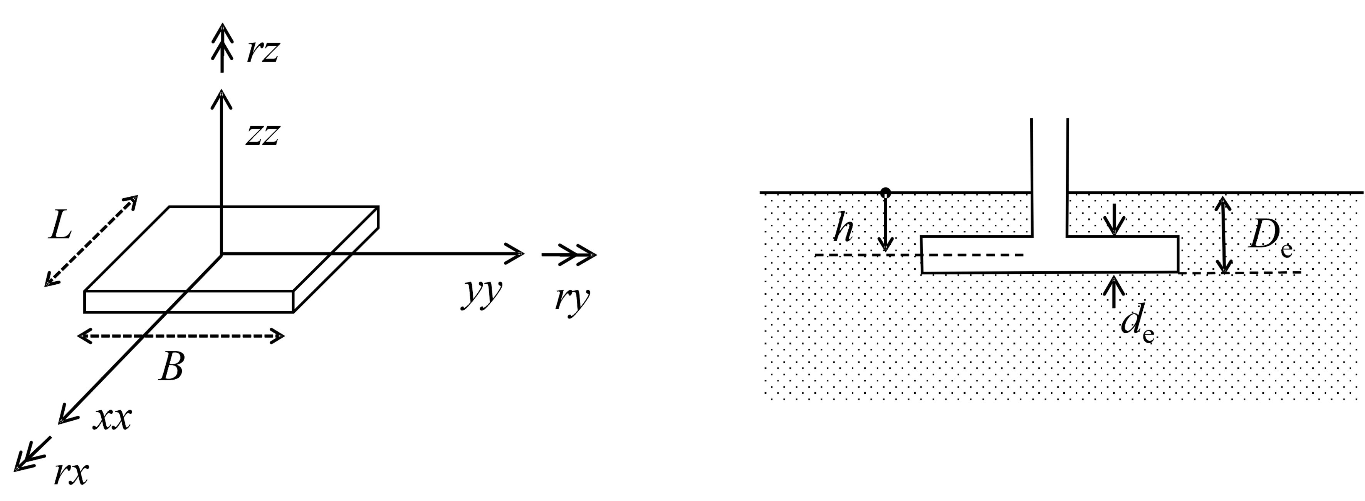

Figure D.3 — Definition of the geometry and degrees of freedom of the embedded footing

NOTE No values are provided for the radiation dashpots because elastic analytical solutions strongly overestimate the true radiation damping which depends on the contact condition between the embedded foundation and the ground and on the lateral heterogeneity introduced in the ground by the construction (existence of a stiffness contrast between the backfill and the slope of the excavation in the natural ground). Dashpots for shallow foundations can be used for this situation.

* 1. Static lateral impedance of a single pile in a homogeneous layer

(1) The static impedance functions, defined in 8.2, 8.3 of an isolated flexible pile in a homogeneous layer may be calculated using Formulae (D.19) to (D.21).

 (D.19)

 (D.20)

 (D.21)

where

|  |  |
| --- | --- |
| *d* | is the pile diameter; |
| ES | is the soil Young's modulus; |
| EP | is the pile Young's modulus; |
| KHH | is the static impedance in the horizontal direction; |
| KMM | is the rocking impedance around the horizontal direction; |
| *K*MH (= *K*HM) | is the cross-coupling static impedance. |

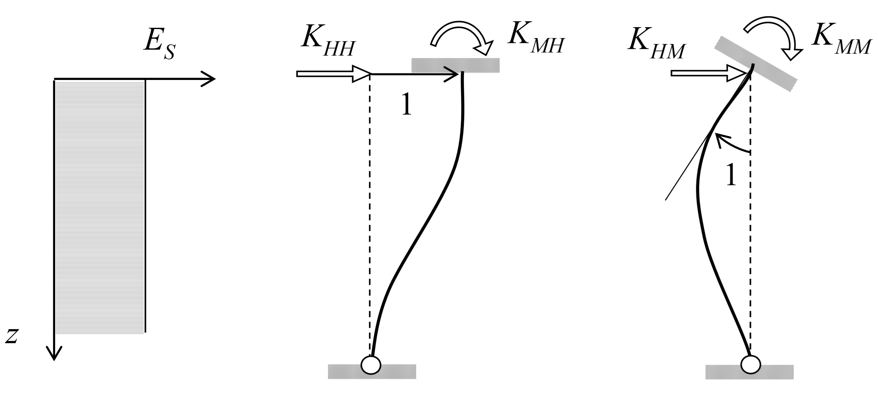

Figure D.4 — Definition of the static lateral impedance of a single pile in a homogeneous layer

* 1. Static lateral impedance of a single pile in a linearly inhomogeneous layer

(1) The static impedance functions, defined in 8.2 and 8.3, of an isolated pile in an inhomogeneous layer with a modulus increasing linearly with depth may be calculated using Formulas (D.22) to (D.24).

 (D.22)

 (D.23)

 (D.24)

where  is the soil Young's modulus at one-diameter depth.

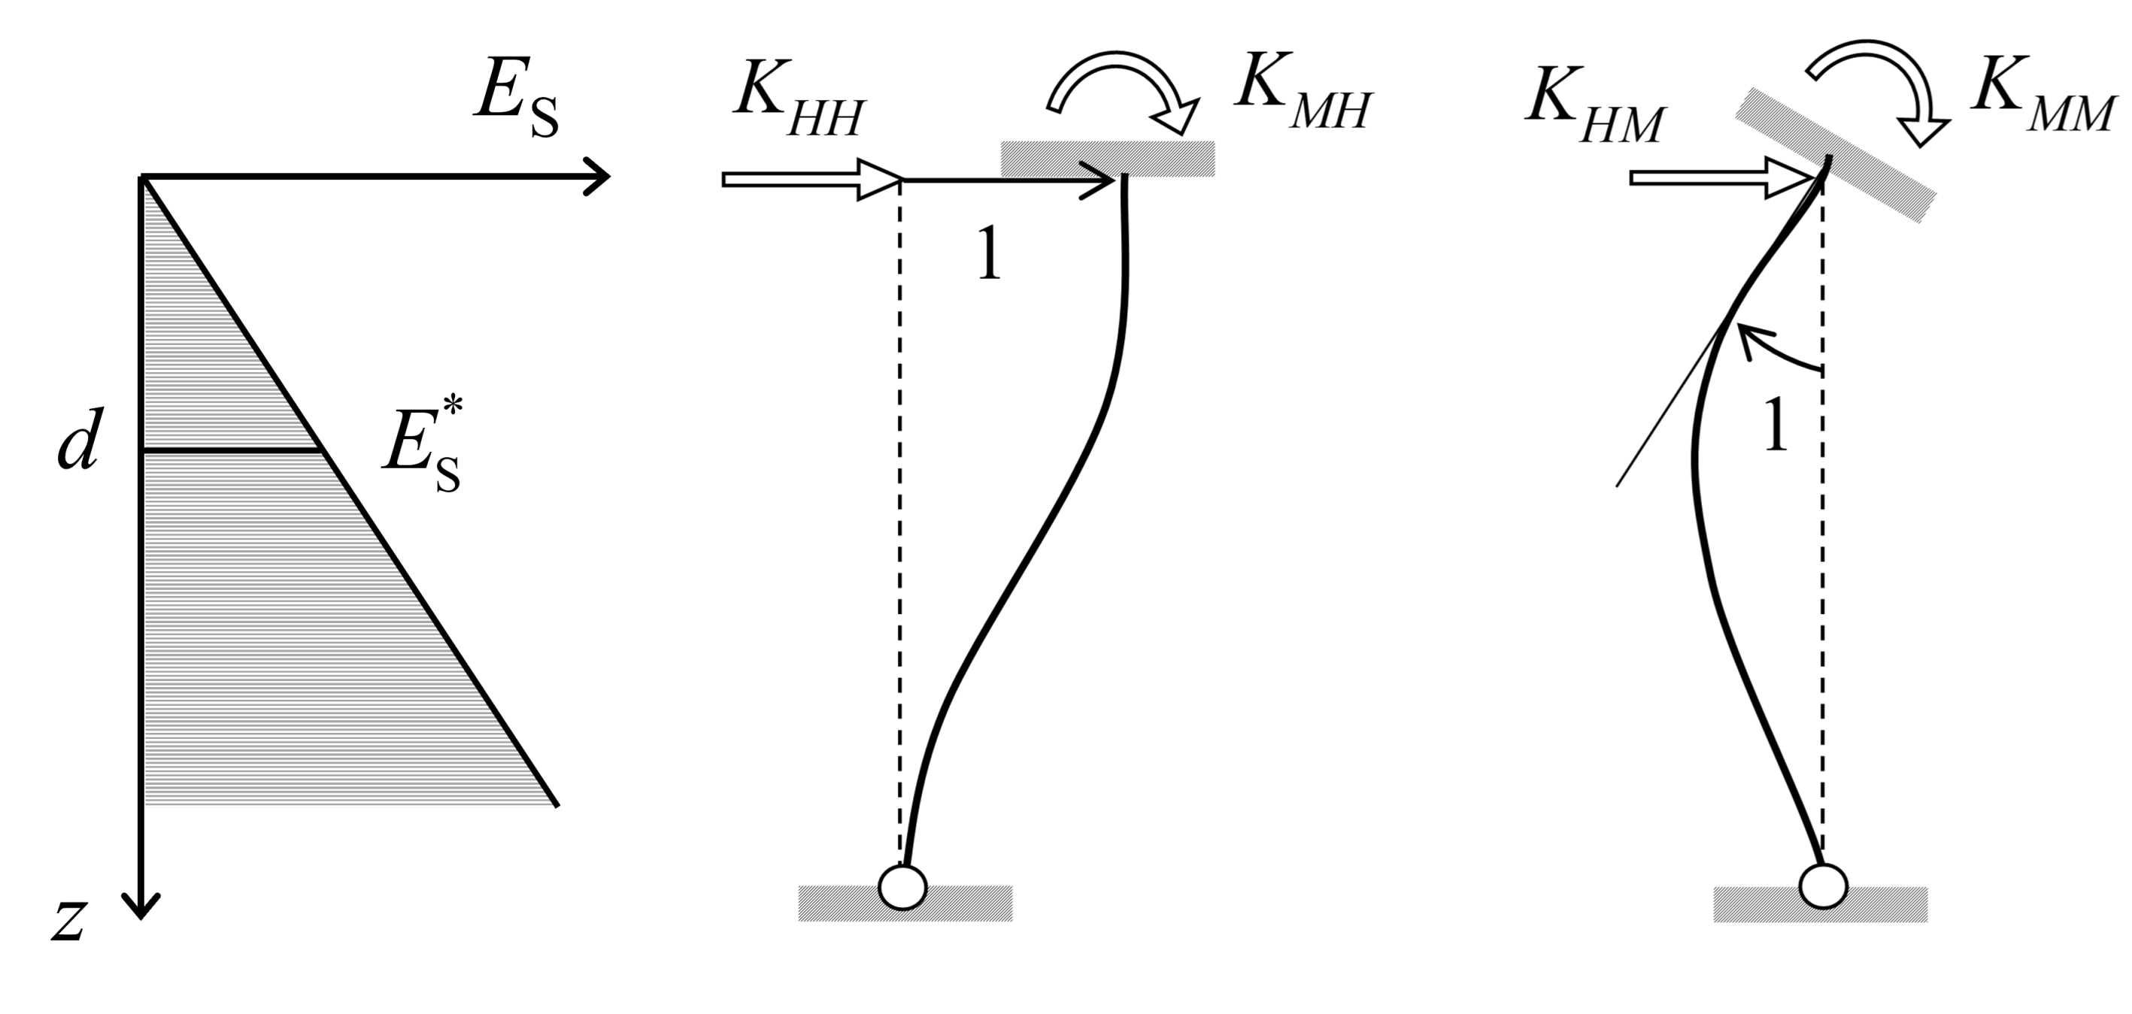

Figure D.5 — Definition of the static lateral impedance of a single pile in an inhomogeneous layer

* 1. Lateral impedance of a pile group

(1) The impedances of pile groups should not be obtained simply by combining the impedances of the individual piles, due to the coupling of the response of piles through the soil.

(2) This interaction may be calculated with the use of pile-to-pile interaction factors which are different for axial and lateral loading.

(3) For close spacing between neighbouring piles (axial distance not larger than 4 pile diameters) the interaction factors at relative long periods (longer than 0,5 s) may be taken equal to the static factors.

NOTE Under seismic loading the interaction factors are oscillating functions of frequency; (3) is a simplification of the actual situation.

(4) The dynamic interaction factors depend on a) to e):

a) the distance between the piles;

b) the nature of the soil and the distribution of soil stiffness and strength with depth;

c) the installation procedure and the slenderness of the piles (*L*P/*d*);

d) the frequency of the forces/moments acting on the group;

e) the intensity of the loading and the soil stiffness.

(5) For strong rotational loading of piles in soft/loose soils producing soil non-linearity, the interaction between piles may be ignored. For lateral and axial loading the interaction factors attain a small fraction of their linear values.

NOTE 1 Under small intensity loading, the interaction factors attain large values in both axial and lateral loading (but not necessarily in moment-induced rotation).

NOTE 2 Under large intensity loading, the effect of soil non-linearity on the interaction factors is very significant reducing the interaction factors so substantially that ignoring non-linearity can lead to erroneous results.

1. (informative)  
     
   Seismic bearing capacity of shallow foundations
   1. Use of this annex

(1) This informative annex provides additional guidance to that given in 9.4.2.1.2 for the calculation of the foundation bearing capacity in the seismic design situation.

NOTE National choice on the application of this informative annex is given in the National Annex. If the National Annex contains no information on the application of this informative annex, it can be used.

* 1. Scope and field of application

(1) This informative annex covers procedures for the calculations of the seismic foundation bearing capacity of rectangular and circular surface and embedded foundations. It also covers the use of a global resistance factor in the foundation bearing capacity calculations.

* 1. Surface strip foundation

(1) The stability against seismic bearing capacity failure of a shallow strip footing resting on the surface of homogeneous soil may be checked using Formulae (E.1) and (E.2).

 (E.1)

 (E.2)

where

|  |  |
| --- | --- |
| *N*max | is the design value of the ultimate bearing capacity of the foundation under a vertical centred load defined in (2); |
| *N*Ed, *V*Ed, *M*Ed | are the design values of the vertical force, horizontal force and overturning moment at the lower face of the foundation; |
| *B* | is the foundation width; |
|  | is the dimensionless soil inertia force defined in Formulas (E.3) and (E.5); |
| *a*, *b*, *c*, *d*, *e*, *f*, *m*, *k*, *k'*, *c*T, *c*M, *c'*M, *β*, *γ* | are numerical parameters depending on the type of soil, as given in Table E.1. |

(2) The vertical bearing capacity *N*max may be calculated according to prEN 1997-3:2022, 5.6.2, from field tests, through empirical correlations, or from strength parameters.

(3) For fine-grained soils or for saturated coarse-grained soils, when using strength parameters in (2), *N*max should be calculated from the undrained strength parameters, i.e. cohesion *c*u or undrained cyclic shear strength *τ*cy,u, divided by the material factors defined in 6.5.

(4) For dry soils, partially saturated or saturated coarse-grained soils without significant pore water pressure build-up, when using strength parameters in (2), *N*max should be calculated from the drained strength parameters, applying the material factors defined in 6.5.

(5) For fine-grained soils or saturated coarse-grained soils, the dimensionless soil inertia force  should be calculated using Formula (E.3).

 (E.3)

where

|  |  |
| --- | --- |
| *ρ* | is the soil mass density; |
| aH | is the design value of the ground acceleration defined in 5.1 and calculated with *β*H = 1,0; |
| *B* | is the foundation width; |
|  | is the undrained strength parameter calculated according to (3); |
| *κ* | is a parameter that reflects the non-simultaneity of the design values of the action effects in the ground and on the foundation. |

(6) *κ* is equal to 1,0 but smaller values, not less than 0,3, may be taken if they are justified.

NOTE 2 A value of *κ* smaller than 1,0 can be justified when the fundamental period of the soil deposit and the fundamental period of the structure are significantly different.

(7) For application of (3) and (5), the limits given in Formula (E.4) should be applied when using Formula (E.1).

 (E.4)

(8) For dry soils, partially saturated coarse-grained soils or saturated coarse-grained soils without significant pore water pressure build-up, the dimensionless soil inertia force should be calculated using Formula (E.5).

 (E.5)

where  is the horizontal seismic coefficient defined in 5.2 and calculated with *β*H = 1,0.

(9) For application of (4) and (8), the limits given in Formula (E.6) should be applied when using Formula (E.1).

 (E.6)

(10) The values of the numerical parameters in Formula (E.1) should be taken from Table E.1.

Table E.1 — Values of numerical parameters used in Formula (E.1)

|  |  |  |
| --- | --- | --- |
| **Parameter** | **Fine-grained soil** | **Coarse-grained soil** |
| *a* | 0,70 | 0,92 |
| *b* | 1,29 | 1,25 |
| *c* | 2,14 | 0,92 |
| *d* | 1,81 | 1,25 |
| *e* | 0,21 | 0,41 |
| *f* | 0,44 | 0,32 |
| *m* | 0,21 | 0,96 |
| *k* | 1,22 | 1,00 |
| *k'* | 1,00 | 0,39 |
| *cT* | 2,00 | 1,14 |
| *cM* | 2,00 | 1,01 |
| *c'M* | 1,00 | 1,01 |
| *β* | 2,57 | 2,90 |
| *γ* | 1,85 | 2,80 |

(11) The soil inertia forces may be neglected according to 9.4.2.1.2(3) and (4).

* 1. Surface circular foundation on fine-grained soils

(1) Formula (E.1) may be applied to a circular foundation on the surface of a fine-grained soil, provided the changes given in a) to c) are made:

a) The vertical bearing capacity *N*max is calculated for a circular foundation;

b) The foundation width *B* is replaced by the foundation diameter in Formula (E.2);

c) The foundation width *B* is replaced by the foundation radius in Formula (E.3).

* 1. Shallow embedded rectangular foundation on fine-grained soils

(1) Formula (E.1) may be applied for a shallow embedded foundation in a fine-grained soil provided that the changes given in a) and b) are made:

a) The design value of the ultimate vertical bearing capacity *N*max is calculated for a rectangular embedded foundation;

b) The normalised horizontal force in Formula (E.2) is replaced with that given by Formula (E.7).

 (E.7)

where  is given by Formula (E.8)

 (E.8)

and where *α*1 = 0,12, *α*2 = 0,17, *β*1 = 0,27 and

|  |  |
| --- | --- |
| *De* | is the depth of embedment; |
| *L* | is the foundation length; |
| *γ* | is the soil weight density; |
| *N*c | is the bearing capacity factor. |

NOTE A shallow embedded foundation is a foundation with an embedment ratio *D*e/*B* less than 1,0.

* 1. Shallow embedded rectangular foundation on coarse-grained soils

(1) Formula (E.1) may be applied for a shallow embedded foundation in a coarse-grained soil, with the limits given in Formula (E.10), provided that the changes given in a) and b) are made:

a) The vertical bearing capacity *N*max is calculated for a rectangular embedded foundation;

b) The normalised horizontal force and normalized overturning moment in Formula (E.2) are replaced by those given in Formula (E.9).

 (E.9)

where *Ω*s = 1,3 and the domain of validity of Formula (E.9) is

 (E.10)

* 1. Use of a global safety factor on resistance

(1) For application of 6.5(3) and 9.4.2.1.2(7), a global resistance factor *γ* R may be introduced in Formula (E.1), provided that the changes given in a) to c) are made:

a) Formula (E.2) is replaced by Formula (E.11);

 (E.11)

b) Formula (E.3) is replaced by Formula (E.12);

 (E.12)

c) Formula (E.5) is replaced by Formula (E.13).

 (E.13)

1. (informative)  
     
   Evaluation of earth pressures on retaining structures
   1. Use of this annex

(1) This informative annex provides additional guidance to that given in 10.3.2 and 10.3.9 for the calculation of earth pressures on retaining structures in the seismic design situation.

NOTE National choice on the application of this informative annex is given in the National Annex. If the National Annex contains no information on the application of this informative annex, it can be used.

* 1. Scope and field of application

(1) This informative annex covers procedures for the calculations of the seismic earth pressures on retaining structures. It covers the cases of displacing and non-displacing retaining structures.

* 1. Coefficients of active and passive earth pressure

(1) For a vertical retaining wall, the coefficients of active and passive earth pressure *K*AE and *K*PE for use in Formulae (10.1) and (10.2) may be evaluated using Formulae (F.1) and (F.2).

 (F.1)

 (F.2)

where *ψ*A and *ψ*P are given by Formulas (F.3) and (F.4)

 (F.3)

 (F.4)

and where

|  |  |
| --- | --- |
| *ϕ ’* | is the angle of shearing resistance (in radians) of the soil in terms of effective stresses; |
| *δ* f | is the friction angle (in radians) between the ground and the retaining wall; |
| *β* sl | is the inclination (in radians) of the ground surface; |
| *θ*eq | is the apparent inclination (in radians) of the gravity field in the seismic design situation, given by Formulas (10.3) and (10.4). |

NOTE 1 Positive orientations for angles *δ* f, *β* sl and *θ* eq are depicted in Figure F.1.

NOTE 2 The coefficient *K*AE cannot be taken larger than the value corresponding to *θ* eq = *ϕ ’*-*β* sl; the coefficient *K*PE cannot be taken smaller than the value corresponding to *θ* eq = *ϕ ’*+*β* sl where *β* sl is taken with the sign convention of Figure F.1.

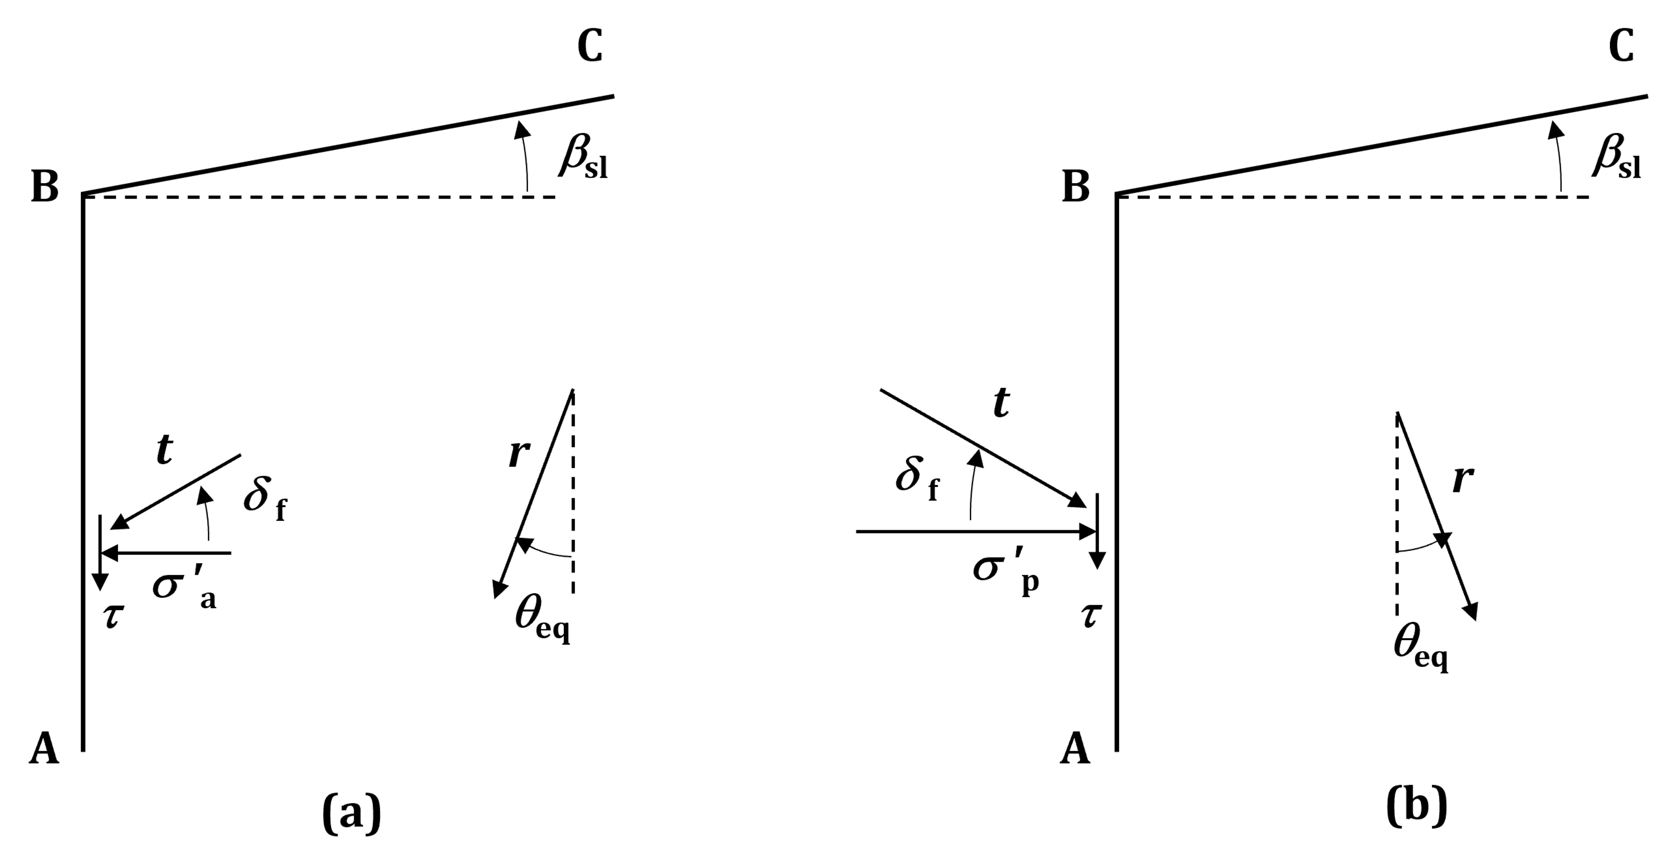

Key

|  |  |
| --- | --- |
| AB | position of the retaining structure |
| BC | ground surface |
| *r* | resultant body force |
| *t* | resultant effective stress acting on the retaining structure |
| *σ*'a | normal effective stress in the active limit state, applied by the ground on the retaining structure |
| *σ*'p | normal effective stress in the passive limit state, applied by the retaining structure on the ground |
| *τ* | shear stress |

Figure F.1 — Sign convention for (a) active and (b) passive limit states

* 1. Earth pressure on non-displacing retaining structures

(1) If in its existing state the soil interacting with a non-displacing retaining wall is not in a limit equilibrium condition, the effect of the seismic action may be calculated using Formula (F.5).

 (F.5)

where

|  |  |
| --- | --- |
| Δ*σ*H | is the increment of the horizontal effective earth pressure produced by the seismic action; |
| *H*R | is the total height of the retaining system defined in Figure F.2; |
| *γ* | is the ground weight density; |
| *f* | is a flexibility coefficient that may be determined from Figure F.2 and Formula (F.6). |

 (F.6)

where

|  |  |
| --- | --- |
| *d*P | is the relative ground-wall stiffness; |
| *G* | is the strain compatible soil shear modulus; |
| *E*R*I*R | is the flexural rigidity, per unit length, of the retaining wall. |

NOTE *f* is a function of the static scheme of the wall, as depicted in Figure F.2, and of *d*P.

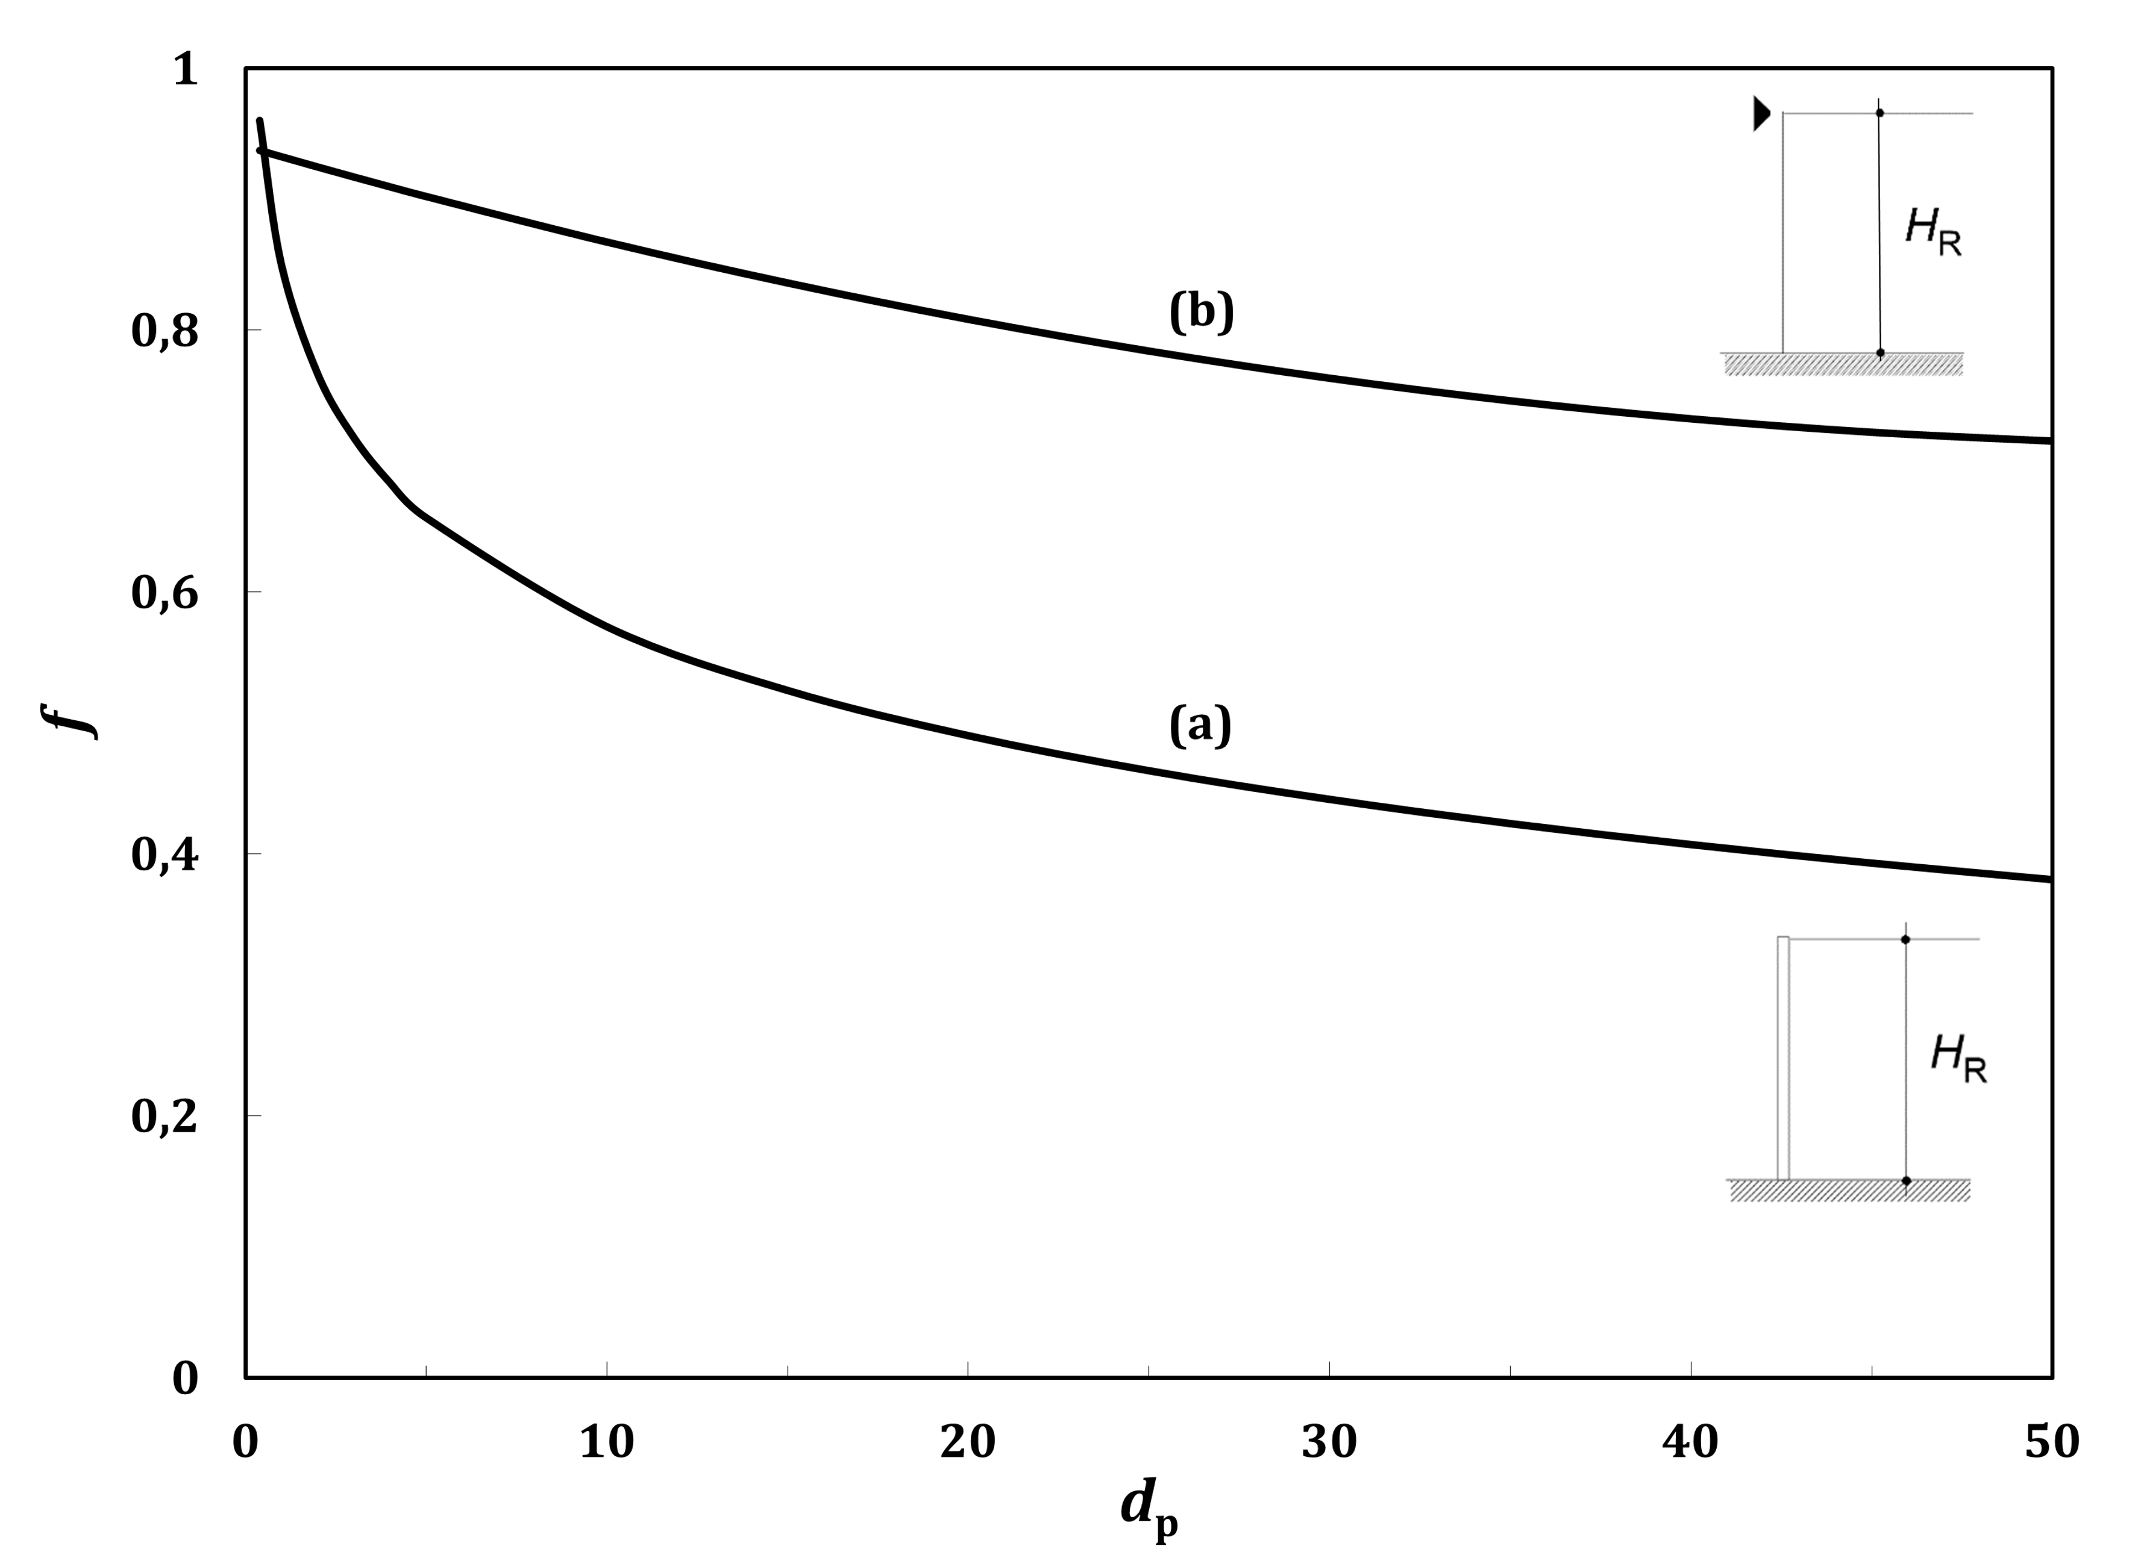

Figure F.2 — Flexibility coefficient for: (a) cantilever wall; (b) propped cantilever wall

1. (informative)  
     
   Simplified evaluation of peak ground parameters for seismic design of underground structures
   1. Use of this annex

(1) This informative annex provides complementary information to that given in 11.2 for the simplified evaluation of the seismic action on underground structures.

NOTE National choice on the application of this informative annex is given in the National Annex. If the National Annex contains no information on the application of this informative annex, it can be used.

* 1. Scope and field of application

(1) This informative annex covers procedures for the evaluation of peak ground parameters for the seismic design of underground structures.

* 1. Seismic action

(1) The seismic action for the design of underground structures should be defined according to prEN 1998-1-1:2022, Clause 5.

(2) For high seismic action classes according to 7.5, site-specific response analyses along the length of the underground structures should be carried out.

(3) For low and moderate seismic action classes, actions at the ground surface should be defined according to 5.1.

(4) In the absence of site-specific response analyses, the seismic actions on the underground structure at depth *z* may be taken as given by Formula (G.1).

 (G.1)

where *PGA*e is the design value of the peak ground acceleration at the surface.

(5) *λ* in Formula (G.1) may be calculated using Formulas (G.2) and (G.3), as given in a) or b):

a) For tunnels embedded at *h*t < 30,0 m

 (G.2)

b) For tunnels embedded at *h*t > 30,0 m

 (G.3)

(6) For application of (5), *h*t should be defined as the soil cover thickness measured from the ground surface to the roof elevation of the underground structure.

(7) In the absence of site-specific response analyses, *PGV*(*z*) and *PGD*(*z*) may be estimated using prEN 1998-1-1:2022, Formulas (5.25) and (5.26), with the variation with depth defined by Formulas (G.2) and (G.3).

* 1. Effects of seismic action on underground structures

(1) For low and moderate seismic action classes, and in the absence of site-response analyses, the ground free-field shear strain for the transverse analysis of underground structures due to vertically propagating shear waves may be calculated using a) or b):

a) Formula (G.5) for large embedment depth;

b) Formulas (G.6) to (G.8) for shallow burial depths.

(2) In Formulas (G.5) to (G.8), the burial depth at which all quantities are calculated may be defined by Formula (G.4).

 (G.4)

 (G.5)

 (G.6)

 (G.7)

 (G.8)

where

|  |  |
| --- | --- |
| *PGV* | is the particle velocity at depth *z*t; |
| PGAe | is the design value of the peak value of the horizontal ground acceleration defined in prEN 1998-1-1:2022, 5.2.2.4; |
| g | is the acceleration of gravity expressed in the same units as *PGA*e; |
| *γ*max | is the maximum shear strain at free-field; |
| *τ*max | is the maximum shear stress at free-field; |
| vsc | is the shear wave velocity compatible with the average strain amplitude; |
| *G* | is the strain-compatible soil shear modulus; |
| Hst | is the total height of the underground structure from roof to the invert slab elevation; |
| rdt | is a depth-dependent stress reduction function calculated using Formula (G.9). |

 (G.9)

(3) Approximate expressions may be used to calculate *PGV* at depth *z* in Formula (G.5).

* 1. Variability of ground motion

(1) Spatial variation and incoherence of the ground motion should be considered according to prEN 1998-1-1:2022, 5.2.3.2, based on local geology and tectonics.

1. (informative)  
     
   Simplified analytical expressions for the seismic design of tunnels
   1. Use of this annex

(1) This informative annex provides additional guidance to that given in 11.3.2.2 and 11.5 for simplified calculations of the seismic design action in tunnels.

NOTE National choice on the application of this informative annex is given in the National Annex. If the National Annex contains no information on the application of this informative annex, it can be used.

* 1. Scope and field of application

(1) This informative annex covers procedures for the calculations of the seismic design value of the action in tunnels. It covers the cases of circular and rectangular shaped tunnels loaded both in the transverse and longitudinal directions.

* 1. Circular shape tunnels – Transverse response

(1) The maximum diametral change of the cross-section of circular shaped tunnels may be calculated using Formula (H.1) when the presence of the cavity is ignored.

NOTE Formula (H.1) assumes full compatibility between the tunnel deformation and the imposed ground shear deformations.

 (H.1)

where

|  |  |
| --- | --- |
| Δ*d*t | is the diametral change of the cross-section; |
| dt | is the tunnel diameter; |
| *γ*max | is the maximum shear strain at free field. |

(2) The maximum diametral change of the lining of circular shaped tunnels due to the presence of the cavity may be calculated using Formula (H.2).

 (H.2)

where *ν* is the soil Poisson's ratio at the depth of the tunnel.

NOTE Approximate Formulas (H.1) and (H.2) provide reasonable results for circular tunnels in rock or stiff soils. For other ground conditions, this approach can lead to overestimation or underestimation of the actual diametral deflection of the lining, depending on the relative stiffness of the tunnel lining with respect to the surrounding ground.

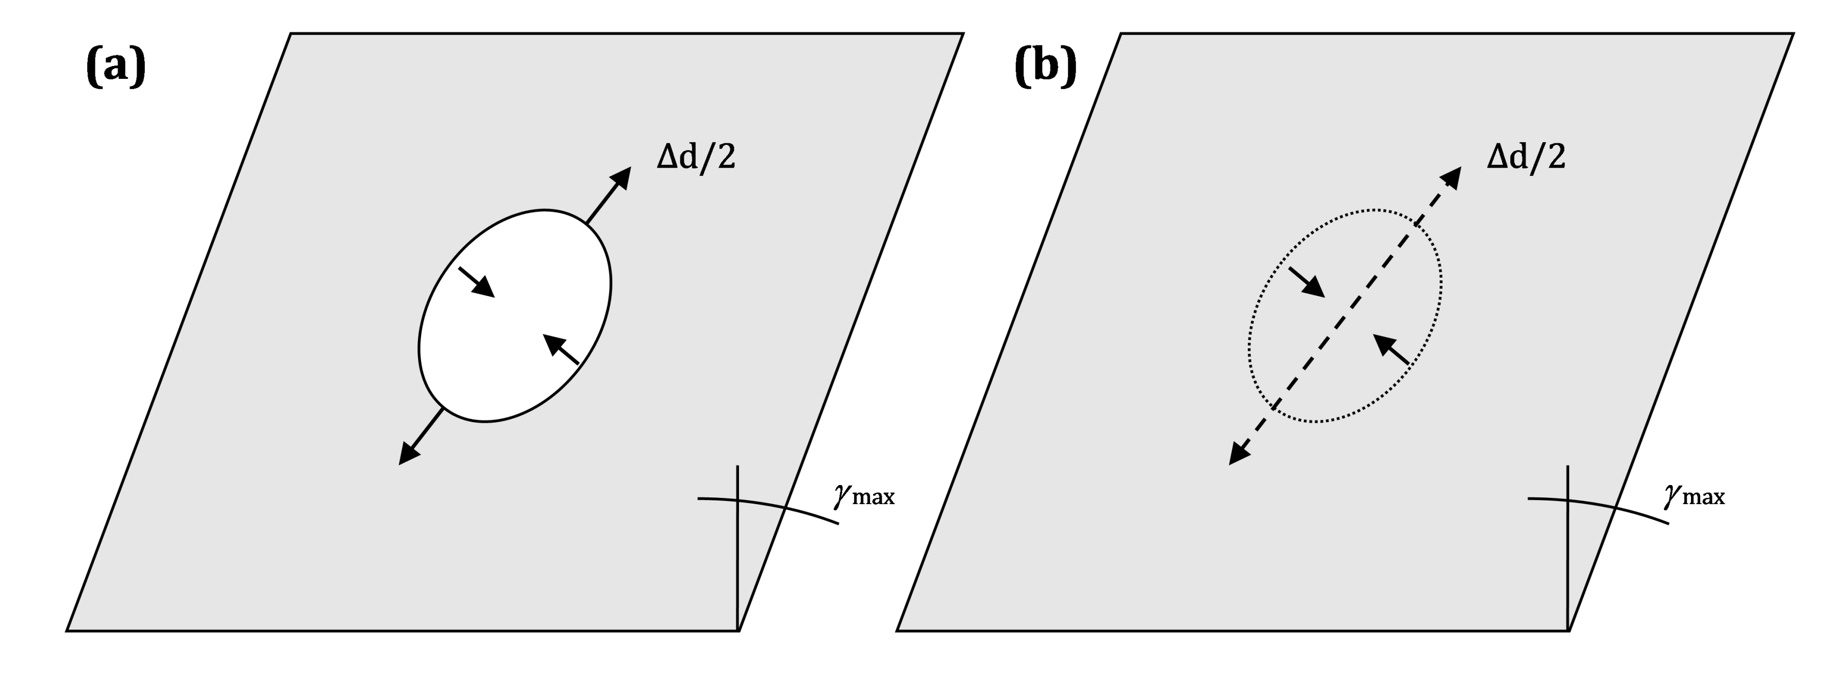

Figure H.1 — Free field shear distortions for (a) perforated (circular shape) and (b) non-perforated cavity

(3) When soil-structure interaction effects are accounted for, the diametral change and the seismic forces in the lining of a circular shaped tunnel may be calculated using the flexibility ratios *F*R and *C*R given by Formulas (H.3) and (H.4).

NOTE Formulas (H.3) and (H.4) assume that the tunnel is embedded in an elastic, isotropic medium, subjected to ground shaking in the transverse direction.

 (H.3)

 (H.4)

where

|  |  |
| --- | --- |
| *E*L | is the elastic modulus of the tunnel lining; |
| νL | is the Poisson's ratio of the tunnel lining; |
| rL | is the radius of the tunnel lining; |
| tL | is the thickness of the tunnel lining; |
| IL | is the moment of inertia per unit length of the tunnel lining's cross-section by a meridional plane. |

(4) When full slip is considered at the interface between the ground and the tunnel, Formulas (H.5) to (H.8) may be used to calculate the diametral change and the seismic forces in the lining.

 (H.5)

 (H.6)

 (H.7)

 (H.8)

where

|  |  |
| --- | --- |
| *F*R | is given by Formula (H.3); |
| NEd | is the maximum design value of the axial force; |
| MEd | is the maximum design value of the bending moment. |

(5) The ovaling ratio of the circular shaped tunnel may be calculated using Formula (H.9).

 (H.9)

where

|  |  |
| --- | --- |
| Δ*d*t | is given by Formula (H.1); |
| Δ*d*stru | is the diametral change of the cross-section in presence of the structure and the lining. |

(6) When no slip is considered at the interface between the ground and the tunnel, Formulas (H.10) and (H.11) may be used.

 (H.10)

 (H.11)

where *F*R and *C*R are given by Formulas (H.3) and (H.4), respectively.

NOTE The analytical solutions given by Formulas (H.10) and (H.11) are based on the assumption of a monolithic and continuous elastic lining.

(7) For segmental lining, Formula (H.12) may be used to calculate the effective stiffness of a lining ring composed of *n*s segments.

 (H.12)

where

|  |  |
| --- | --- |
|  | is the effective moment of inertia per unit length of the lining of a circular segmented tunnel; |
| *I*j | is the moment of inertia per unit length of the joint of a segmental lining of a circular tunnel; |
|  | is the number of segments. |

* 1. Rectangular shape tunnels – Transverse response

(1) For a rectangular cross-section, soil-structure interaction is affected significantly by the soil-to-structure relative stiffness, which for a rectangular cross-section may be calculated with the flexibility ratio *F*R given by Formula (H.13).

 (H.13)

where *S*Ru is the horizontal force applied to the roof and the bottom invert slab of the tunnels' section to cause a unit racking deflection of the section, estimated through simple static elastic frame analysis (see Figure H.2).

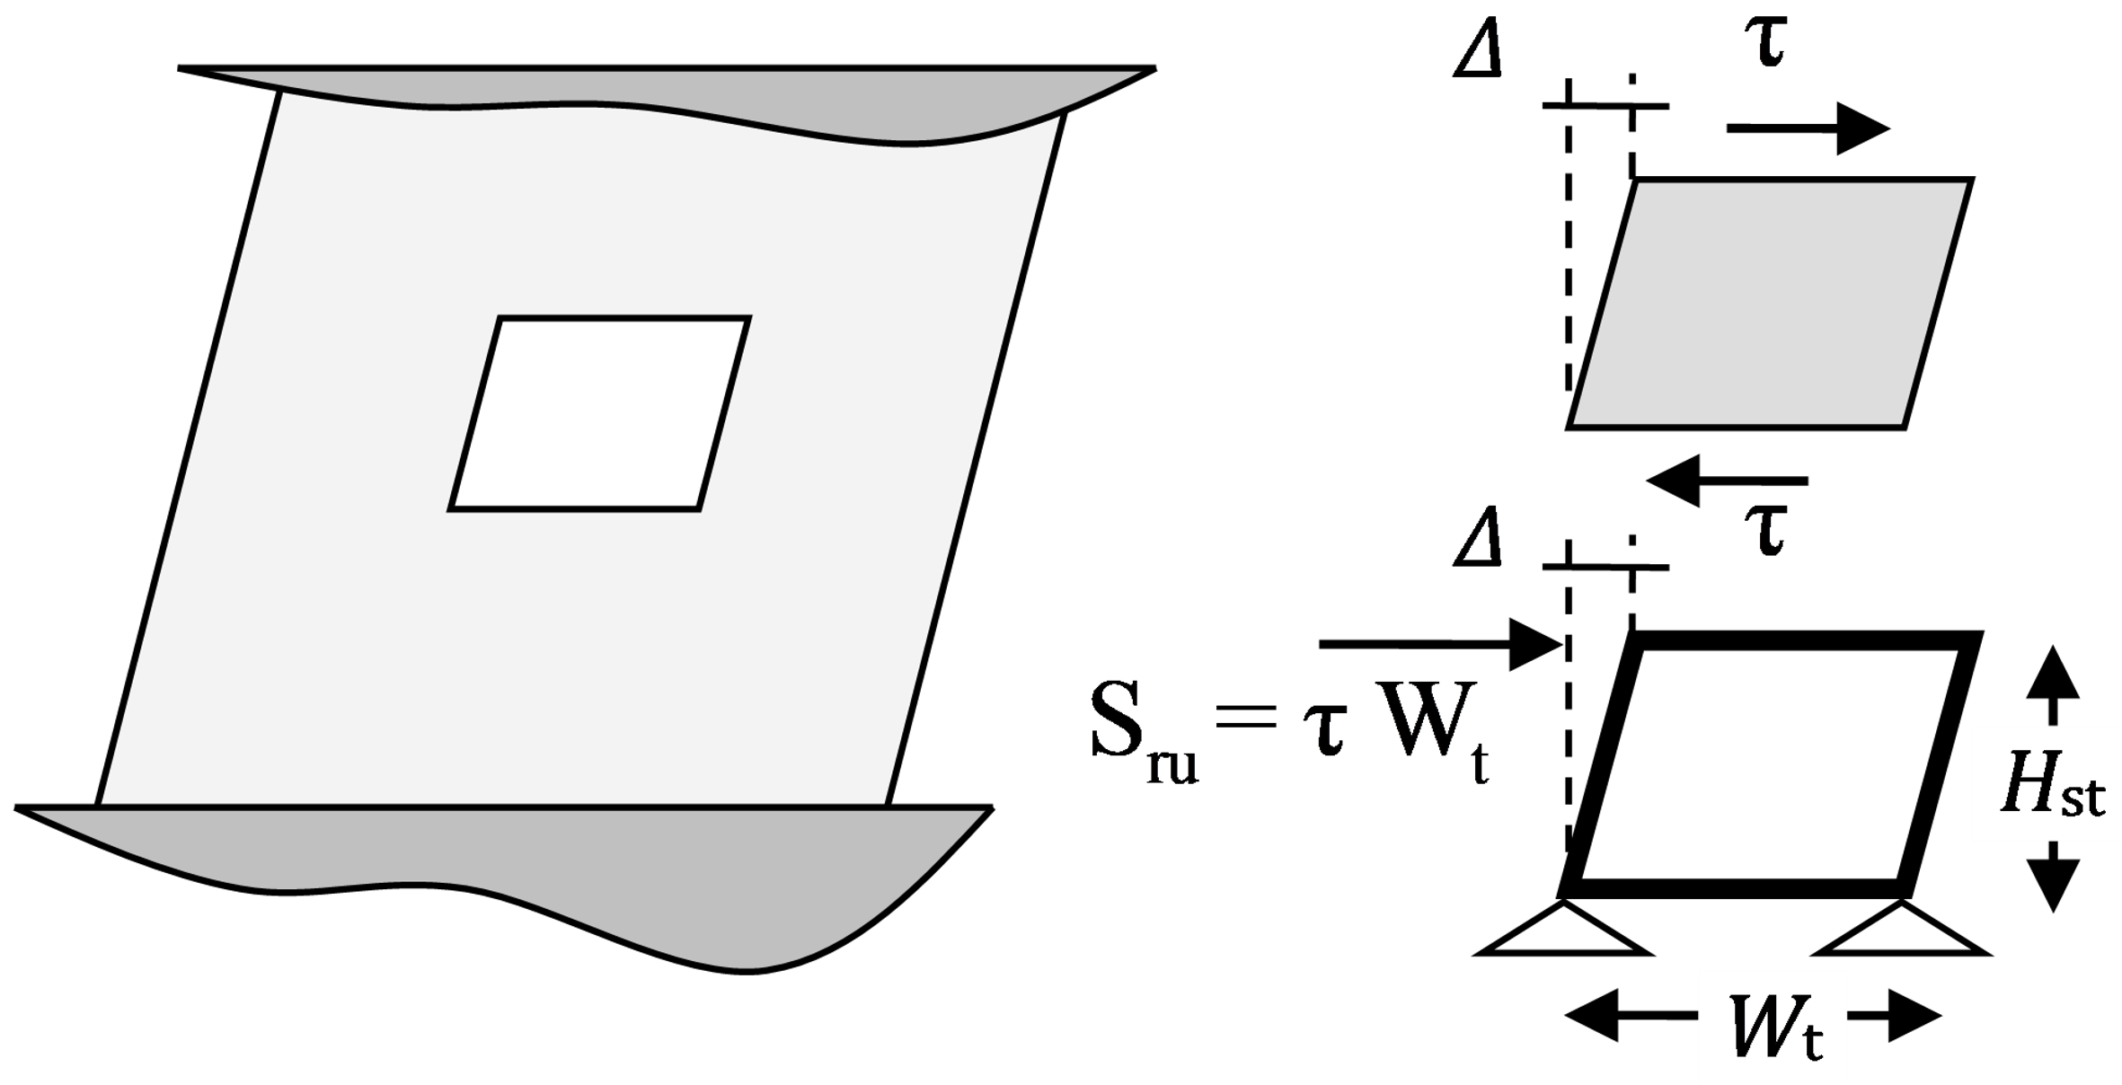

Figure H.2 — Simplified model to evaluate the flexibility ratio *F*R for rectangular underground structures

(2) For a single box structure with the same moment of inertia for the roof and the invert slabs, and the same moment of inertia for the side-walls, the flexibility ratio may be calculated using Formula (H.14).

 (H.14)

where

|  |  |
| --- | --- |
| *W*t | is the width of the transverse section of the underground structure; |
| *E*str | is the Young's modulus of the structure; |
| *I*W and *I*R | are the moment of inertia per unit length of the side walls of the structure and of the roof slab in cross-sections defined by a plane passing through the axis of the tunnel. |

(3) For a single-box structure, the flexibility ratio may be calculated using Formulas (H.15) to (H.17).

 (H.15)

 (H.16)

 (H.17)

where *I*I is the moment of inertia per unit length of the invert slab of the structure in cross-sections defined by a plane passing through the axis of the tunnel.

(4) Due to soil-structure interaction effects, rectangular shaped tunnels may exhibit both racking and rocking deformation.

(5) For pure racking response, the racking deformation may be calculated with the racking ratio *R*r defined in Formulas (H.18) to (H.20), using a) or b) to calculate *R*r.

 (H.18)

a) No-slip interface condition: *R*r is given by Formula (H.19).

 (H.19)

b) Full-slip interface condition: *R*r is given by Formula (H.20).

 (H.20)

where

|  |  |
| --- | --- |
| δff | is the free-field racking displacement at the burial depth of the structure; |
| *δ*str | is the structural horizontal deflection of the lining. |

(6) For shallow-buried structures, racking and rocking response should be considered using the *R*r*‐F*R relationships given in Table H.1 and Figure H.3.

Table H.1 — *R*r-*F*R relationships for combined racking and rocking response of rectangular tunnels or structures

|  |  |  |  |  |  |  |
| --- | --- | --- | --- | --- | --- | --- |
| **Flexibility ratio *F*R** | **Racking ratio *R*r** | | | | | |
| Soil Poisson's ratio *v* = 0,3 | | | Soil Poisson's ratio *v* = 0,5 | | |
| *h* = 0 m | *h* = 3 m | *h* = 12 m | *h* = 0 m | *h* = 3 m | *h* = 12 m |
| 0,1 | 0,12 | 0,12 | 0,13 | 0,14 | 0,14 | 0,14 |
| 0,2 | 0,23 | 0,23 | 0,24 | 0,26 | 0,26 | 0,27 |
| 0,5 | 0,53 | 0,53 | 0,55 | 0,56 | 0,56 | 0,57 |
| 1 | 1,00 | 1,00 | 1,00 | 1,00 | 1,00 | 1,00 |
| 2 | 1,48 | 1,45 | 1,39 | 1,37 | 1,35 | 1,31 |
| 5 | 2,31 | 2,24 | 2,00 | 1,99 | 1,91 | 1,74 |
| 10 | 2,92 | 2,74 | 2,36 | 2,39 | 2,26 | 1,99 |

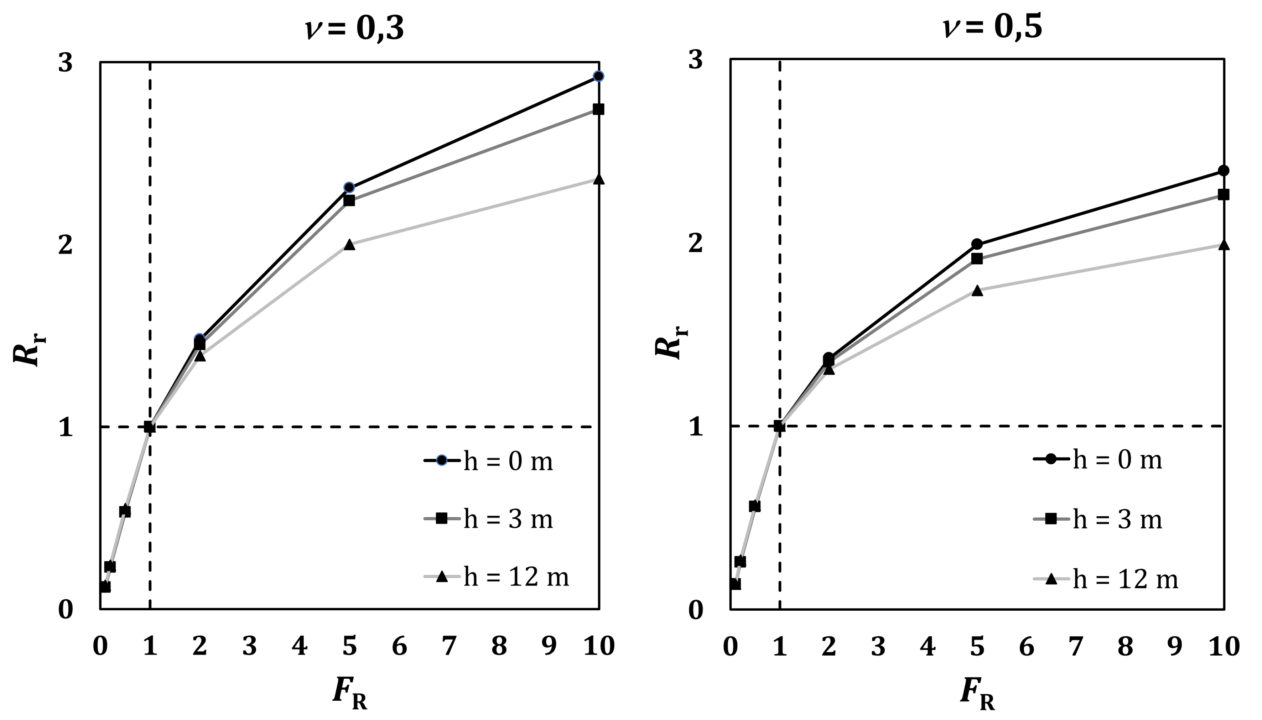

Figure H.3 — Racking ratio *R*r versus flexibility ratio *F*R for combined racking and rocking response

(7) The structural seismic lining forces may be calculated from an elastic frame analysis subjected to a concentrated horizontal force for deeply embedded structures or to a triangular pressure distribution along the side-walls for shallow buried structures (Figure H.4).

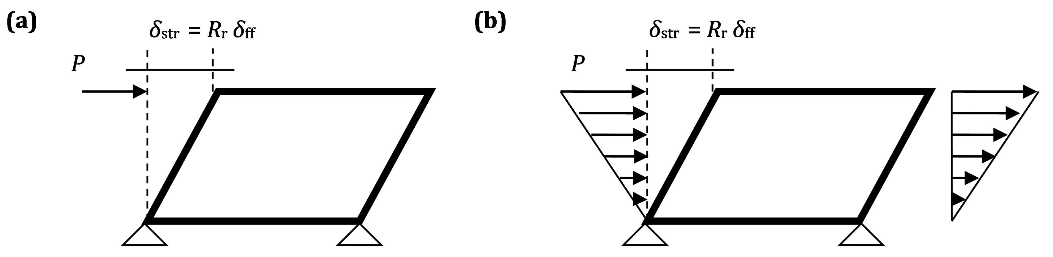

Figure H.4 — Simplified frame analysis models and loading configurations: (a) concentrated force for deep tunnels; (b) triangular distribution for shallow tunnels

* 1. Longitudinal response

(1) When soil-structure interaction effects are ignored, the induced strains and curvature on the underground structure due to ground shaking in the longitudinal direction may be evaluated using Table H.2.

Table H.2 — Strains and curvature imposed by body and surface waves on an embedded structure, when SSI effects are neglected

|  |  |  |  |  |  |
| --- | --- | --- | --- | --- | --- |
| **Wave type** | | **Longitudinal strain** | **Normal strain** | **Shear strain** | **Curvature** |
| P waves | |  |  |  |  |
| S waves | |  |  |  |  |
| Rayleigh waves | Compression |  |  |  |  |
| Shear | - |  |  |  |

where

|  |  |
| --- | --- |
| *ψ* | is the angle between the direction of wave propagation and the tunnel axis; |
|  | is the peak particle velocity associated with shear waves; |
|  | is the peak particle velocity associated with dilatational waves; |
|  | is the peak particle velocity associated with the dilatational component of Rayleigh waves; |
|  | is the peak particle velocity associated with the shear component of Rayleigh waves; |
| cs | is the apparent velocity of shear waves; |
| cp | is the apparent velocity of dilatational waves; |
| cR | is the apparent velocity of Rayleigh waves; |
| *ε* l, *ε* lm | are the longitudinal strain and its maximum value, respectively; |
| *ε* n, *ε* nm | are the normal strain and its maximum value, respectively; |
| *γ* s, *γ* sm | are the shear strain and its maximum value, respectively; |
|  | are the curvature and its maximum value, respectively; |
| αp | is the peak acceleration associated with dilatational waves; |
| αs | is the peak acceleration associated with shear waves; |
| αRp | is the peak acceleration associated with the dilatational component of Rayleigh waves; |
| αRs | is the peak acceleration associated with the shear component of Rayleigh waves. |

(2) As the angle of incidence is generally not known, the most critical angle of incidence and the maximum values of strain and curvature may be used.

(3) Unless specific seismological studies are carried out, the ground motion and the corresponding peak values may be assumed associated with *S*-waves for epicentral distance < 50 km and with Rayleigh waves otherwise.

(4) In presence of strong geological discontinuities crossed by the axis of the tunnel, site-specific investigations should be performed to estimate ground strains at the interface

NOTE Formulas in Table H.2 are valid for seismic wave propagation in homogeneous media and structures longer than 3 times the wave length.

(5) When soil-structure interaction effects are neglected, the seismic forces in the lining subjected to a harmonic horizontal shear wave travelling in the horizontal direction may be calculated using Formulas (H.21) to (H.23).

 (H.21)

 (H.22)

 (H.23)

where

|  |  |
| --- | --- |
| Mff | is the bending moment in the lining; |
| Vff | is the shear force in the lining; |
| Nff | is the normal force in the lining; |
| AT | is the area of the cross-section of the tunnel; |
| ASw | is the amplitude of the shear wave; |
|  | is the wave length; |
| *x* | is the distance along the tunnel axis. |

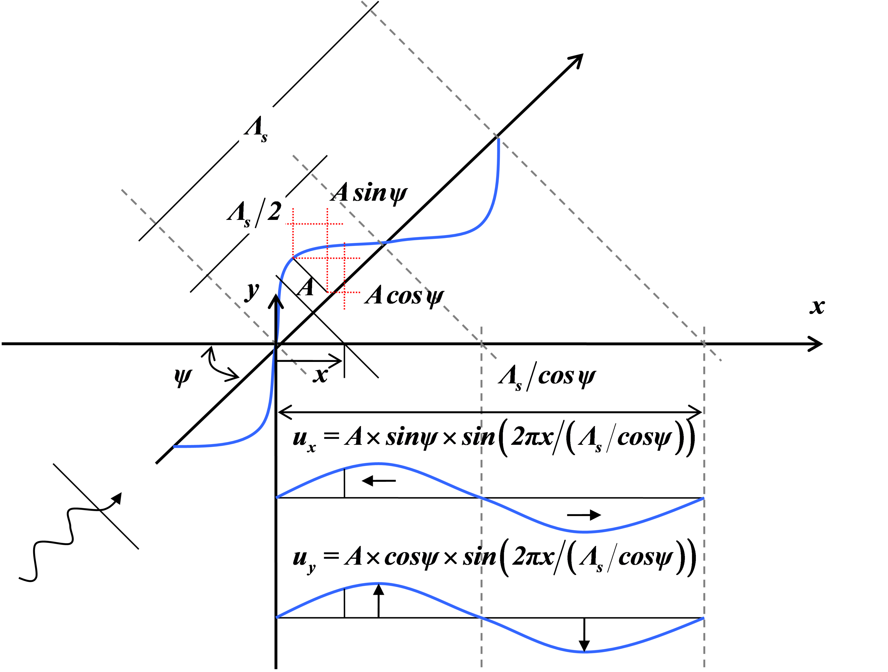

Figure H.5 — Tunnel or underground structure subjected to a simple harmonic wave

(6) When soil-structure interaction effects are considered, the seismic internal forces on the lining of a tunnel or an underground structure may be calculated using Formulas (H.24) to (H.26).

 (H.24)

 (H.25)

 (H.26)

where

|  |  |
| --- | --- |
| *M*SSI | is the bending moment in the lining in presence of SSI; |
| *V*SSI | is the shear force in the lining in presence of SSI; |
| *N*SSI | is the normal force in the lining in presence of SSI; |
| Kh | is the soil spring stiffness in the transverse horizontal direction, given in I.1; |
| Ka | is the soil spring stiffness in the longitudinal horizontal direction, given in I.2. |

1. (informative)  
     
   Impedance functions for underground structures
   1. Use of this annex

(1) This informative annex provides additional guidance to that given in 11.3.2.2 and 11.4.1 for simplified calculations of the impedance functions of underground structures.

NOTE National choice on the application of this informative annex is given in the National Annex. If the National Annex contains no information on the application of this informative annex, it can be used.

* 1. Scope and field of application

(1) This informative annex covers procedures for the calculation of the impedance functions of underground structures. It covers the cases of calculations in the transverse and longitudinal directions.

* 1. Transverse response

(1) Underground structures subjected to seismic loading in the transverse direction may be analysed using a frame-spring model. The equivalent seismic loading may be statically introduced in terms of a) to c):

a) equivalent inertial static loads of the structure and of the overburden ground mass;

b) seismic shear stresses developed along the perimeter of the structure;

c) seismic earth pressures or imposed ground deformations on the side walls of the structure.

(2) Soil compliance may be simulated by means of soil springs.

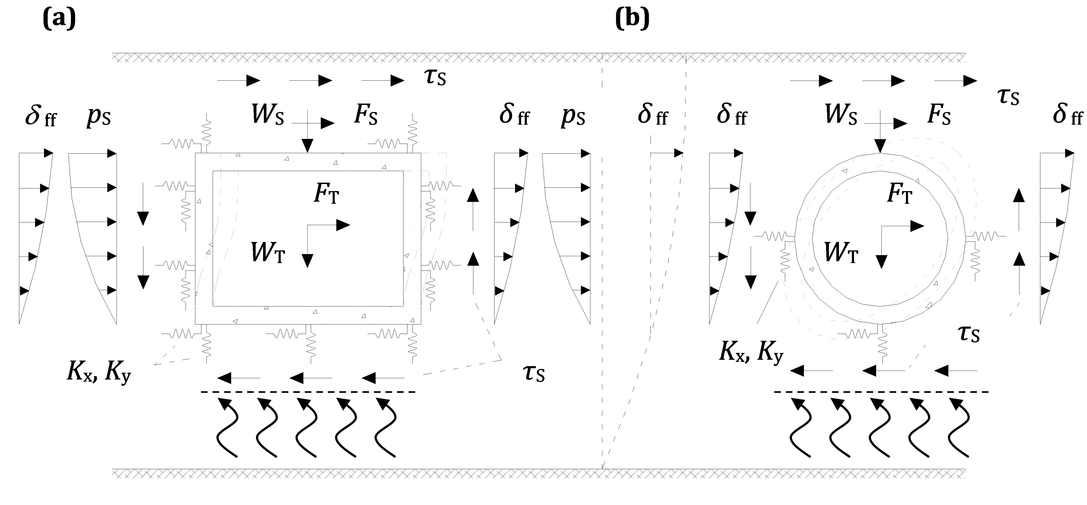

Figure I.1 — Frame-spring models for the transverse seismic analysis of embedded structures (a) rectangular structure, (b) circular tunnel; *δ*ff: free-field seismic ground deformation; *p*s: seismic earth pressures on the side-walls of the rectangular structure; *τ*s: seismic shear stresses around the perimeter of the tunnel; *W*S: weight of overburden ground; *F*S: inertial forces of overburden ground; *W*T: weight of tunnel; *F*T: inertial forces of tunnel; *K*x, *K*y normal and shear soil springs along the perimeter of the tunnel lining

(3) The stiffness of the soil springs for underground tunnels may be calculated with Formula (I.1).

 (I.1)

* 1. Longitudinal response

(1) Circular or rectangular shape tunnels subjected to seismic ground shaking in the longitudinal direction may be analysed with a beam on soil-springs model. The seismic loading may be introduced either statically or in terms of time-history ground displacements at the free-end of the springs.

(2) Spatial variation of the ground motion should be considered.

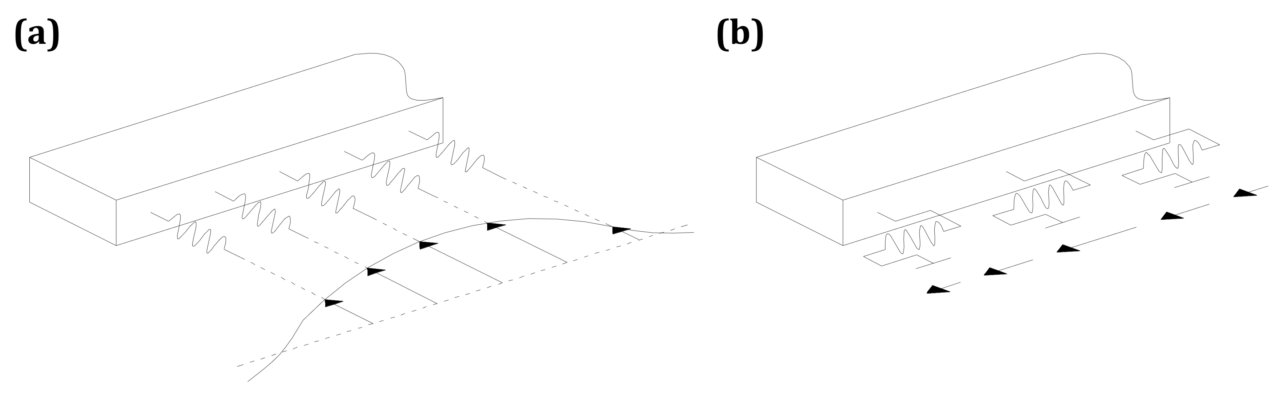

Figure I.2 — Analysis models for the longitudinal analysis of tunnels: (a) transverse direction; (b) longitudinal direction

(3) Formulas (I.2) and (I.3) may be used for calculation of the tunnel impedances.

 (I.2)

 (I.3)

where Formula (I.2) is valid for motion in both horizontal directions (longitudinal and transverse) and Formula (I.3) for motion in the vertical direction.

NOTE The above simplified formulations can lead to soil spring stiffness that deviates considerably from the actual soil stiffness.

Bibliography

**References given in recommendations (i.e. “should” clauses)**

The following documents are referred to in the text in such a way that some or all of their content constitutes highly recommended choices or course of action of this document. Subject to national regulation and/or any relevant contractual provisions, alternative standards could be used/adopted where technically justified. For dated references, only the edition cited applies. For undated references, the latest edition of the referenced document (including any amendments) applies.

FprEN 1993-1-1:2022, Eurocode 3 — Design of steel structures – Part 1-1: General rules and rules for buildings

EN 1993‑5, Eurocode 3 — Design of steel structures — Part 5: Piling

prEN 1998-1-2, Eurocode 8 — Design of structures for earthquake resistance — Part 1-2: Buildings (under development)

**References given in permissions (i.e. “may” clauses)**

The following documents are referred to in the text in such a way that some or all of their content expresses a course of action permissible within the limits of the Eurocodes. For dated references, only the edition cited applies. For undated references, the latest edition of the referenced document (including any amendments) applies.

**References given in possibilities (i.e. “can” clauses and notes)**

The following documents are cited informatively in the document, for example in “can” clauses and in notes.

prEN 1998-2, Eurocode 8 — Design of structures for earthquake resistance — Part 2: Bridges (under development)

EN ISO 22476‑1, Geotechnical investigation and testing — Field testing — Part 1: Electrical cone and piezocone penetration test (ISO 22476-1)