prEN 1999-1-5:2020 (E) 511Eurocode 9 — Calcul des structures en aluminium — Partie 1-5 : CoquesEurocode 9 — Bemessung und Konstruktion von Aluminiumtragwerken — Teil 1-5: SchalenEurocode 9 — Design of aluminium structures — Part 1-5: Shell structuresE0   00    202009CEN EnquiryCEN 1European StandardEuropean StandardEN 1999-1-5prEN 1999-1-5:2020 0False1-5 BSITC250250 2Overskrift 2;ChapterTitle 2;ChapterTitle 21;ChapterTitle 22;ChapterTitle 23;ChapterTitle 24;ChapterTitle 25;ChapterTitle 211;ChapterTitle 221;ChapterTitle 231;ChapterTitle 241;ChapterTitle 26;ChapterTitle 212;ChapterTitle 222;ChapterTitle 232Overskrift 1     0 STD Version 2.9p40   1https://standardnorge1-my.sharepoint.com/personal/ros_standard_no/Documents/Mine Dok 1/K CEN TC 250/CEN TC 250 SC 9 ALUMINIUM/NS-EN 1999 - Enquiry 2020/EN 1999-1-5/EN 1999-1-5 2020-09-10 - Updated after TC250 review, CLEAN.docx            CEN/TC 250

Date: 2020-09

prEN 1999-1-5:2020

CEN/TC 250

Secretariat: BSI

Eurocode 9 — Design of aluminium structures — Part 1-5: Shell structures

*Eurocode 9 — Bemessung und Konstruktion von Aluminiumtragwerken — Teil 1-5: Schalen*

*Eurocode 9 — Calcul des structures en aluminium — Partie 1-5 : Coques*

ICS:

Descriptors:

Contents Page

European foreword 5

Introduction 6

1 Scope 8

1.1 Scope of EN 1999‑1‑5 8

1.2 Assumptions 9

2 Normative references 10

3 Terms, definitions and symbols 10

3.1 Terms and definitions 10

3.1.1 Structural forms and geometry 10

3.1.2 Special definitions for buckling calculations 11

3.2 Symbols 12

3.3 Sign conventions 16

3.4 Coordinate systems 17

4 Basis of design 18

4.1 General 18

4.2 Consequence class and execution class 18

5 Materials and geometry 18

5.1 Material properties 18

5.2 Design values of geometrical data 19

5.3 Geometrical tolerances and geometrical imperfections 19

6 Durability 19

7 Structural analysis 19

7.1 Geometry 19

7.2 Boundary conditions 20

7.3 Actions and environmental influences 21

7.4 Stress resultants and stresses 21

7.5 Types of analysis 21

8 Ultimate limit state 23

8.1 Resistance of cross section 23

8.1.1 Design values of stresses 23

8.1.2 Design values of resistance 24

8.1.3 Stress limitation 24

8.1.4 Design by numerical analysis 24

8.2 Buckling resistance 25

8.2.1 General 25

8.2.2 Buckling-relevant geometrical tolerances 26

8.2.3 Shell in compression and shear 27

8.2.4 Effect of welding 30

8.2.5 Design by numerical analysis 33

9 Serviceability limit states 33

9.1 General 33

9.2 Deflections 33

A.1 Use of this annex 34

A.2 Scope and field of application 34

A.3 Unstiffened cylindrical shells of constant wall thickness 34

A.3.1 Notations and boundary conditions 34

A.3.2 Meridional (axial) compression 35

A.3.3 Circumferential (hoop) compression 37

A.3.4 Shear 40

A.3.5 Meridional (axial) compression with coexistent internal pressure 41

A.3.6 Combinations of meridional (axial) compression, circumferential (hoop) compression and shear 42

A.4 Unstiffened cylindrical shells of stepwise wall thickness 43

A.4.1 General 43

A.4.2 Meridional (axial) compression 44

A.4.3 Circumferential (hoop) compression 45

A.4.4 Shear 48

A.5 Unstiffened lap jointed cylindrical shells 48

A.5.1 Geometry and stress resultants 48

A.5.2 Meridional (axial) compression 49

A.5.3 Circumferential (hoop) compression 49

A.5.4 Shear 49

A.6 Unstiffened conical shells 49

A.6.1 General 49

A.6.2 Design buckling stresses 50

A.6.3 Buckling strength verification 51

A.7 Stiffened cylindrical shells of constant wall thickness 52

A.7.1 General 52

A.7.2 Isotropic walls with meridional stiffeners 52

A.7.3 Isotropic walls with circumferential stiffeners 53

A.7.4 Circumferentially corrugated walls with meridional stiffeners 54

A.7.5 Axially corrugated walls with ring stiffeners 57

A.7.6 Stiffened wall treated as an orthotropic shell 58

A.7.7 Equivalent orthotropic properties of corrugated sheeting 61

A.8 Unstiffened spherical shells under uniform circumferential compression 63

A.8.1 Notations and boundary conditions 63

A.8.2 Critical buckling stresses 63

A.8.3 Circumferential buckling parameter 64

B.1 Use of this Annex 65

B.2 Scope and field of application 65

B.3 Notations and boundary conditions 65

B.4 External pressure 66

B.4.1 Critical external pressure 66

B.4.2 Uniform squash limit external pressure 67

B.4.3 External pressure buckling parameter 69

B.5 Internal pressure 69

B.5.1 Critical internal pressure 69

B.5.2 Uniform squash limit internal pressure 70

B.5.3 Internal pressure buckling parameter 71

Bibliography 73

European foreword

This document (prEN 1999‑1‑5:2021) has been prepared by Technical Committee CEN/TC250 “Structural Eurocodes”, the secretariat of which is held by BSI. CEN/TC 250 is responsible for all Structural Eurocodes and has been assigned responsibility for structural and geotechnical design matters by CEN.

This document is currently submitted to the CEN Enquiry.

This document will supersede EN 1999‑1‑5:2007.

The first generation of EN Eurocodes was published between 2002 and 2007. This document forms part of the second generation of the Eurocodes, which have been prepared under Mandate M/515 issued to CEN by the European Commission and the European Free Trade Association.

The Eurocodes have been drafted to be used in conjunction with relevant execution, material, product and test standards, and to identify requirements for execution, materials, products and testing that are relied upon by the Eurocodes.

The Eurocodes recognize the responsibility of each member State and have safeguarded their right to determine values related to regulatory safety matters at national level through the use of National Annexes.

Introduction

**0.1 Introduction to the Eurocodes**

The Structural Eurocodes comprise the following standards generally consisting of a number of Parts:

— EN 1990 Eurocode: Basis of structural and geotechnical design

— EN 1991 Eurocode 1: Actions on structures

— EN 1992 Eurocode 2: Design of concrete structures

— EN 1993 Eurocode 3: Design of steel structures

— EN 1994 Eurocode 4: Design of composite steel and concrete structures

— EN 1995 Eurocode 5: Design of timber structures

— EN 1996 Eurocode 6: Design of masonry structures

— EN 1997 Eurocode 7: Geotechnical design

— EN 1998 Eurocode 8: Design of structures for earthquake resistance

— EN 1999 Eurocode 9: Design of aluminium structures

— < New parts >

The Eurocodes are intended for use by designers, clients, manufacturers, constructors, relevant authorities (in exercising their duties in accordance with national or international regulations), educators, software developers, and committees drafting standards for related product, testing and execution standards.

NOTE Some aspects of design are most appropriately specified by relevant authorities or, where not specified, can be agreed on a project-specific basis between relevant parties such as designers and clients. The Eurocodes identify such aspects making explicit reference to relevant authorities and relevant parties.

**0.2 Introduction to** **EN** **1999** **Eurocode 9**

EN 1999 applies to the design of buildings and civil engineering and structural works made of aluminium. It complies with the principles and requirements for the safety and serviceability of structures, the basis of their design and verification that are given in EN 1990 – Basis of structural design.

EN 1999 is only concerned with requirements for resistance, serviceability, durability and fire resistance of aluminium structures. Other requirements, e.g. concerning thermal or sound insulation, are not considered.

EN 1999 does not cover the special requirements of seismic design. Provisions related to such requirements are given in EN 1998, which complements, and is consistent with EN 1999.

EN 1999 is subdivided in five parts:

— EN 1999‑1‑1 Design of Aluminium Structures: General structural rules.

— EN 1999‑1‑2 Design of Aluminium Structures: Structural fire design.

— EN 1999‑1‑3 Design of Aluminium Structures: Structures susceptible to fatigue.

— EN 1999‑1‑4 Design of Aluminium Structures: Cold-formed structural sheeting.

— EN 1999‑1‑5 Design of Aluminium Structures: Shell structures.

**0.3 Introduction to** **EN** **1999‑1‑5**

EN 1999‑1‑5 applies to the structural design of aluminium structures, stiffened and unstiffened, that have the form of a shell of revolution or of a round panel in monocoque structures.

**0.4 Verbal forms used in the Eurocodes**

The verb “shall” expresses a requirement strictly to be followed and from which no deviation is permitted in order to comply with the Eurocodes.

The verb “should” expresses a highly recommended choice or course of action. Subject to national regulation and/or any relevant contractual provisions, alternative approaches could be used/adopted where technically justified.

The verb “may” expresses a course of action permissible within the limits of the Eurocodes.

The verb “can” expresses possibility and capability; it is used for statements of fact and clarification of concepts.

**0.5 National annex for** **prEN** **1999‑1‑5**

National choice is allowed in this document where explicitly stated within notes. National choice includes the selection of values for Nationally Determined Parameters (NDPs).

The national standard implementing EN 1999‑1‑5 can have a National Annex containing all national choices to be used for the design of buildings and civil engineering works to be constructed in the relevant country.

When no national choice is given, the default choice given in this document is to be used.

When no national choice is made and no default is given in this document, the choice can be specified by a relevant authority or, where not specified, agreed for a specific project by appropriate parties.

National choice is allowed in EN 1999‑1‑5 through the following clauses:

— N/A

National choice is allowed in EN 1999‑1‑5 on the application of the following informative annexes:

Annex B (informative) Formulae for buckling analysis of tori-conical and tori-spherical shells.

# Scope

## Scope of EN 1999‑1‑5

(1) EN 1999‑1‑5 applies to the structural design of aluminium structures, stiffened and unstiffened, that have the form of a shell of revolution or of a round panel in monocoque structures.

(2) EN 1999‑1‑5 covers additional provisions to those given in the relevant parts of EN 1999 for design of aluminium structures.

NOTE Supplementary information for certain types of shells is given in EN 1993‑1‑6 and the relevant application parts which include:

— Part 3-1 for towers and masts;

— Part 3-2 for chimneys;

— Part 4-1 for silos;

— Part 4-2 for tanks;

— Part 4-3 for pipelines.

(4) The provisions in EN 1999‑1‑5 apply to axisymmetric shells (cylinders, cones, spheres) and associated circular or annular plates, beam section rings and stringer stiffeners, where they form part of the complete structure.

(5) Single shell panels (cylindrical, conical or spherical) are not explicitly covered by EN 1999‑1‑5. However, the provisions can be applicable if the appropriate boundary conditions are duly taken into account.

(6) Types of shell walls covered in EN 1999‑1‑5 can be (see Figure 1.1):

— shell wall constructed from flat rolled sheet with adjacent plates connected with butt welds, termed ‘isotropic’;

— shell wall with lap joints formed by connecting adjacent plates with overlapping sections, termed lap-jointed;

— shell wall with stiffeners attached to the outside, termed ‘externally stiffened’ irrespective of the spacing of stiffeners;

— shell wall with the corrugations running up the meridian, termed ‘axially corrugated’;

— shell wall constructed from corrugated sheets with the corrugations running around the shell circumference, termed ‘circumferentially corrugated’.

|  |  |  |  |  |
| --- | --- | --- | --- | --- |
|  | | | | |
| **a) Elevation** | | | | |
|  | | | | |
| **b) Plan** | | | | |
| Isotropic  (unstiffened) | Lap-jointed | Externally  stiffened | Axially corrugated | Circumferentially corrugated |

Figure 1.1 — Illustration of cylindrical shell forms

(7) The provisions of EN 1999‑1‑5 are intended to be applied within the temperature range defined in EN 1999‑1‑1. The maximum temperature is restricted so that the influence of creep can be neglected. For structures subject to elevated temperatures associated with fire see EN 1999‑1‑2.

(8) EN 1999‑1‑5 does not cover the aspect of leakage.

## Assumptions

(1) The general assumptions of EN 1990 apply.

(2) The provisions of EN 1999‑1‑1 apply.

(3) The design procedures are valid only when the requirements for execution in EN 1090‑3 or other equivalent requirements are complied with.

(4) For the design of new structures, prEN 1999 (all parts) is intended to be used, for direct application, together with EN 1990, EN 1991, EN 1992, EN 1993, EN 1994, EN 1995, EN 1997 and EN 1998.

(5) EN 1999 (all parts) is intended to be used in conjunction with:

— European Standards for construction products relevant for aluminium structures

— EN 1090‑1: Execution of steel structures and aluminium structures - Part 1: Requirements for conformity assessment of structural components

— EN 1090‑3: Execution of steel structures and aluminium structures – Part 3: Technical requirements for aluminium structures

# Normative references

The following documents are referred to in the text in such a way that some or all of their content constitutes requirements of this document. For dated references, only the edition cited applies. For undated references, the latest edition of the referenced document (including any amendments) applies.

EN 1990, Basis of structural design

prEN 1999‑1‑1:2021, Design of aluminium structures — Part 1-1: General rules

# Terms, definitions and symbols

## Terms and definitions

For the purposes of this document, the terms and definitions given in EN 1999‑1‑1 and the following apply.

### Structural forms and geometry

3.1.1.1

shell

thin-walled body shaped as a curved surface with the thickness measured normal to the surface being small compared to the dimensions in the other directions

Note 1 to entry: A shell carries its loads mainly by membrane forces. The middle surface may have finite radius of curvature at each point or infinite curvature in one direction, e.g. cylindrical shell.

Note 2 to entry: In EN 1999‑1‑5, a shell is an aluminium structure or structural component formed from curved sheets or extrusions.

3.1.1.2

shell of revolution

shell composed of a number of parts, each of which is a complete axisymmetric shell

3.1.1.3

complete axisymmetric shell

shell whose form is defined by a meridional generator line rotated around a single axis through 360°

Note 1 to entry: The shell can be of any length.

3.1.1.4

shell segment

part of shell of revolution in the form of a defined shell geometry with a constant wall thickness

Note 1 to entry: Examples are a cylinder, a conical frustum, a spherical frustum, an annular plate or another form.

3.1.1.5

shell panel

incomplete axisymmetric shell where the shell form is defined by a rotation of the generator about the axis through less than 360°

3.1.1.6

middle surface

surface that lies midway between the inside and outside surfaces of a shell at every point

Note 1 to entry: If the shell is stiffened on only one surface, the reference middle surface is still taken as the middle surface of the curved shell plate. The middle surface is the reference surface for analysis, and can be discontinuous at changes of thickness or shell junctions, leading to eccentricities that are important to the shell response.

3.1.1.7

junction

point at which two or more shell segments meet

Note 1 to entry: It can include a stiffener or not: the point of attachment of a ring stiffener to the shell can be treated as a junction.

3.1.1.8

stringer stiffener

local stiffening member that follows the meridian of the shell, representing a generator of the shell of revolution

Note 1 to entry: It is provided to increase stability, or to assist with the introduction of local loads. It is not intended to provide a primary resistance for bending due to transverse loads.

3.1.1.9

rib

local member that provides a primary load carrying path for bending down the meridian of the shell, representing a generator of the shell of revolution

Note 1 to entry: It is used to transfer or distribute transverse loads by bending.

3.1.1.10

ring stiffener

local stiffening member that passes around the circumference of the shell of revolution at a given point on the meridian

Note 1 to entry: It is assumed to have no stiffness in the meridional plane of the shell. It is provided to increase the stability or to introduce axisymmetric local loads acting in the plane of the ring by a state of axisymmetric normal forces. It is not intended to provide primary resistance to bending.

3.1.1.11

base ring

structural member that passes around the circumference of the shell of revolution at the base and provides means of attachment of the shell to a foundation or other element

Note 1 to entry: It is needed to ensure that the assumed boundary conditions are achieved in practice.

### Special definitions for buckling calculations

3.1.2.1

critical buckling load

smallest bifurcation or limit load determined assuming the idealised conditions of elastic material behaviour, perfect geometry, perfect load application, perfect support, material isotropy and absence of residual stresses (LBA analysis)

3.1.2.2

critical buckling stress

nominal membrane stress associated with the elastic critical buckling load

3.1.2.13

characteristic buckling stress

nominal membrane stress associated with buckling in the presence of inelastic material behaviour and of geometrical and structural imperfections

3.1.2.4

design buckling stress

design value of the buckling stress, obtained by dividing the characteristic buckling stress by the partial factor for resistance

3.1.2.5

key value of the stress

value of stress in a non-uniform stress field that is used to characterise the stress magnitude in the buckling limit state assessment

3.1.2.6

tolerance class

class of requirements to geometrical tolerances for work execution

Note 1 to entry: Geometrical tolerances for work execution are built up from fabrication of components and execution of the components *in situ*.

## Symbols

For the purposes of this document, the symbols given in EN 1999‑1‑1 and the following apply.

|  |  |
| --- | --- |
| **Coordinate system (see Figure 3.1):** | |
| *r* | radial coordinate, normal to the axis of revolution; |
| *x* | meridional coordinate; |
| *z* | axial coordinate; |
| *θ* | circumferential coordinate; |
| *ϕ* | meridional slope: angle between axis of revolution and normal to the meridian of the shell. |
| **Pressures:** | |
| *p*n | normal to the shell; |
| *p*x | meridional surface loading parallel to the shell; |
| *p*θ | circumferential surface loading parallel to the shell; |
| **Line forces:** | |
| *P*n | load per unit circumference normal to the shell; |
| *Px* | load per unit circumference acting in the meridional direction; |
| *P*θ | load per unit circumference acting circumferentially on the shell; |
| **Membrane stress resultants (see Figure 3.2a):** | |
| *n*x | meridional membrane stress resultant; |
| *n*θ | circumferential membrane stress resultant; |
| *n*xθ | membrane shear stress resultant; |
| **Bending stress resultants (see Figure 3.2b):** | |
| *m*x | meridional bending moment per unit width; |
| *m*θ | circumferential bending moment per unit width; |
| *m*xθ | twisting shear moment per unit width; |
| *θ*xn | transverse shear force associated with meridional bending; |
| *θ*θn | transverse shear force associated with circumferential bending; |
| **Stresses:** | |
| *σ*x | meridional stress; |
| *σ*θ | circumferential stress; |
| *σ*eq | von Mises equivalent stress (can be negative in cyclic loading conditions); |
| *τ, τ*xθ | in-plane shear stress; |
| *τ*xn, *τ*θn | meridional, circumferential transverse shear stresses associated with bending; |
| **Displacements:** | |
| *u* | meridional displacement; |
| *v* | circumferential displacement; |
| *w* | displacement normal to the shell surface, |
| *β*ϕ | meridional rotation (see 7.2); |
| **Shell dimensions:** | |
| *d* | internal diameter of shell; |
| *L* | total length of shell; |
| *l* | length of shell segment; |
| *l*g | gauge length for measurement of imperfections; |
| *l*g,θ | gauge length for measurement of imperfections in circumferential direction; |
| *l*g,w | gauge length for measurement of imperfections across welds; |
| *l*R | limited length of shell for buckling strength assessment; |
| *r* | radius of the middle surface, normal to the axis of revolution; |
| *t* | thickness of shell wall; |
| *t*max | maximum thickness of shell wall at a joint; |
| *t*min | minimum thickness of shell wall at a joint; |
| *t*ave | average thickness of shell wall at a joint; |
| *β* | apex half angle of cone; |

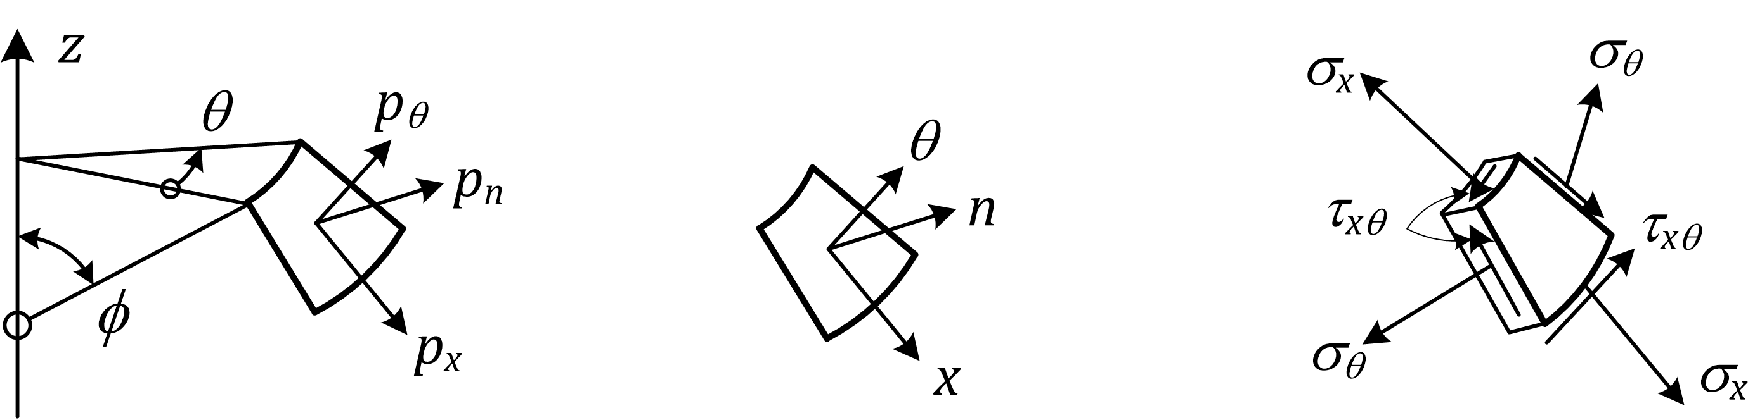

|  |  |  |
| --- | --- | --- |
| a) | b) | c) |

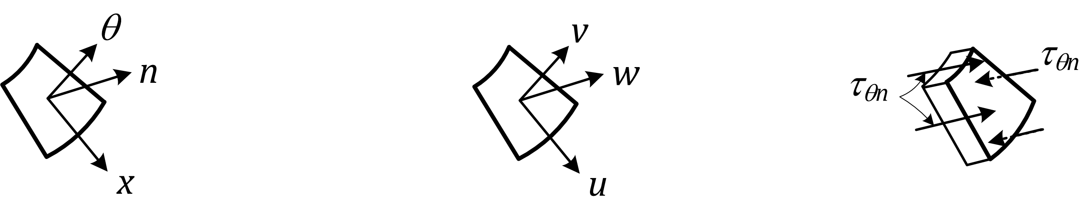

|  |  |  |
| --- | --- | --- |
| d) | e) | f) |

Key

|  |  |
| --- | --- |
| a) | Surface pressures |
| b) | Coordinates |
| c) | Membrane stresses |
| d) | Directions *θ* = circumferential *n* = normal *x* = meridional |
| e) | Displacements |
| f) | Transverse shear stresses |

Figure 3.1 — Symbols in shells of revolutions

|  |  |
| --- | --- |
|  | |
| a) Membrane stress resultants | b) Bending stress resultants |

Figure 3.2 — Stress resultants in the shell wall (In this figure *x* is meridional and *y* circumferential)

|  |  |
| --- | --- |
| **Tolerances (see 8.2.2):** | |
| *e* | eccentricity between the middle surfaces of joined plates; |
| *U*e | non-intended eccentricity tolerance parameter; |
| *U*r | out-of-roundness tolerance parameter; |
| *U*0 | initial dent tolerance parameter; |
| Δ*w*0 | tolerance normal to the shell surface; |
| **Properties of materials:** | |
| *f*eq | von Mises equivalent strength; |
| *f*u | characteristic value of ultimate tensile strength; |
| *f*o | characteristic value of 0,2 % proof strength; |
| **Parameters in strength assessment:** | |
| *C* | coefficient in buckling strength assessment; |
| *C*ϕ | sheeting stretching stiffness in the axial direction; |
| *C*θ | sheeting stretching stiffness in the circumferential direction; |
| *C*ϕθ | sheeting stretching stiffness in membrane shear; |
| *D*ϕ | sheeting flexural rigidity in the axial direction; |
| *D*θ | sheeting flexural rigidity in the circumferential direction; |
| *D*ϕθ | sheeting twisting flexural rigidity in twisting; |
| *R* | calculated resistance (used with subscripts to identify the basis); |
| *R*pl | plastic reference resistance (defined as a load factor on design loads); |
| *R*cr | elastic critical buckling load (defined as a load factor on design loads); |
| *k* | calibration factor for nonlinear analyses; |
| *k*(…) | power of interaction Formulae in buckling strength interaction Formulae; |
| *μ* | alloy hardening parameter in buckling curves for shells; |
| *a*(…) | imperfection reduction factor in buckling strength assessment; |
| Δ | range of parameter when alternating or cyclic actions are involved; |
| **Design stresses and stress resultants** | |
| *σ*x,Ed | design values of the buckling-relevant meridional membrane stress (positive when compression); |
| *σ*θ,Ed | design values of the buckling-relevant circumferential membrane (hoop) stress (positive when compression); |
| *τ*Ed | design values of the buckling-relevant shear membrane stress; |
| *n*x,Ed | design values of the buckling-relevant meridional membrane stress resultant (positive when compression); |
| *n*θ,Ed | design values of the buckling-relevant circumferential membrane (hoop) stress resultant (positive when compression); |
| *n*xθ,Ed | design values of the buckling-relevant shear membrane stress resultant. |
| **Critical buckling stresses and stress resistances:** | |
| *σ*x,cr | meridional critical buckling stress; |
| *σ*θ,cr | circumferential critical buckling stress; |
| *τ*cr | shear critical buckling stress; |
| *σ*x,Rd | meridional design buckling stress resistance; |
| *σ*θ,Rd | circumferential design buckling stress resistance; |
| *τ*Rd | shear design buckling stress resistance. |

## Sign conventions

(1) In general the sign conventions are the following, except as noted in (2)

— outward direction positive;

— internal pressure positive;

— outward displacement positive;

— tensile stresses positive;

— shear stresses as shown in Figure 3.1.

(2) For simplicity, for buckling analysis, compressive stresses are treated as positive. For these cases both external pressures and internal pressures are treated as positive.

## Coordinate systems

(1) In general, the convention for the global shell structure axis system is in cylindrical coordinates (see Figure 3.3) as follows:

— coordinate along the central axis of a shell of revolution *z*

— radial coordinate *r*

— circumferential coordinate *θ*

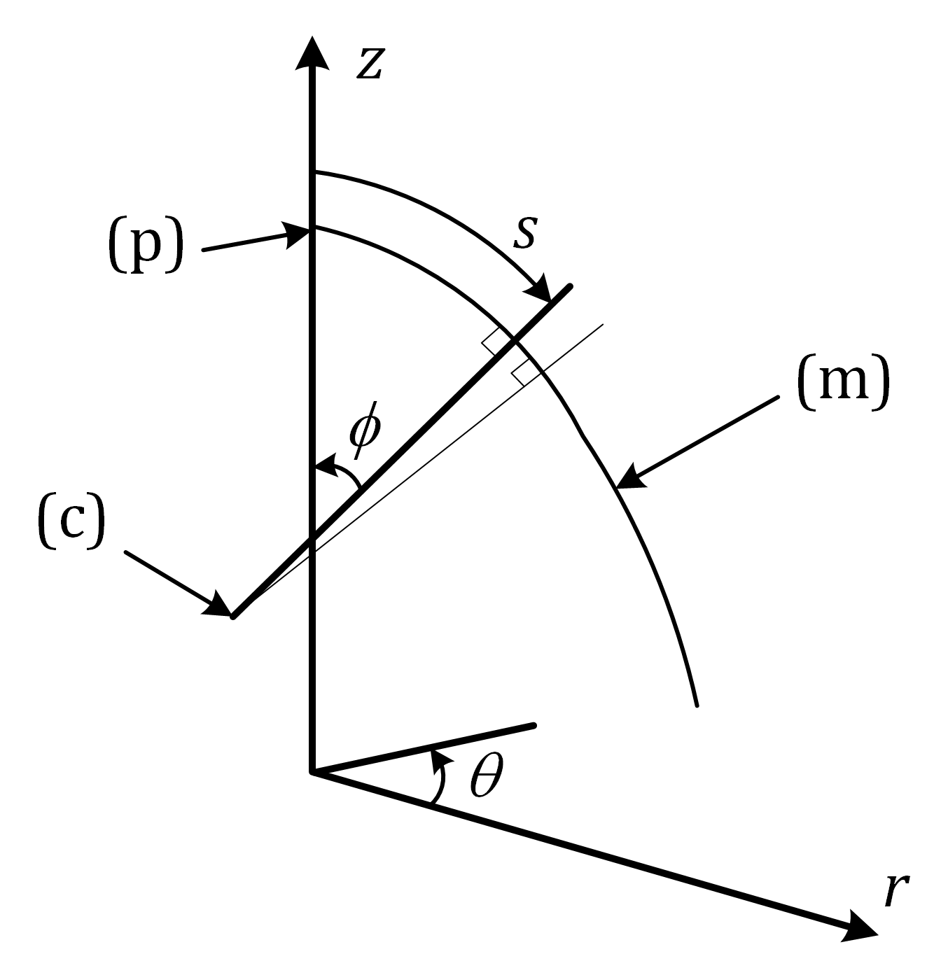

Key

|  |  |
| --- | --- |
| (p) | pole |
| (m) | shell meridian |
| (c) | instantaneous centre of meridional curvature |

Figure 3.3 — Coordinate systems for a circular shell

(2) The convention for structural elements attached to the shell wall (see Figure 3.4) is different for meridional and circumferential members.

(3) The convention for meridional straight structural elements (see Figure 3.4(I)) attached to the shell wall is:

— meridional coordinate for barrel, hopper and roof attachment *x*

— strong bending axis (parallel to flanges: axis for meridional bending) *y*

— weak bending axis (perpendicular to flanges) *z*

(4) The convention for circumferential curved structural elements (see Figure 3.4(II)) attached to a shell wall is:

— circumferential coordinate axis (curved) *θ*

— radial axis (axis for bending in the meridional plane) *r*

— meridional axis (axis for circumferential bending) *z*

|  |  |
| --- | --- |
|  | |
| a) meridional stiffener | b) circumferential stiffener |

Figure 3.4 — Local coordinate system for meridional and circumferential stiffeners on a shell

# Basis of design

## General

(1) The design of shells shall be in accordance with the rules given in EN 1990 and EN 1999‑1‑1.

(2) Appropriate partial factors shall be adopted for ultimate limit states and serviceability limit states.

(3) For verification by calculation at ultimate limit states the partial factor, *γ*M, shall be taken as follows:

— resistance to yielding and instability: *γ*M1

— resistance of plate in tension to fracture: *γ*M2

— resistance of joints: see EN 1999‑1‑1

NOTE For values of *γ*Mi, see EN 1999‑1‑1.

## Consequence class and execution class

(1) The choice of Consequence Class, see EN 1990 and EN 1999‑1‑1, should be agreed between the designer and the owner of the construction work in cooperation, taking national provisions into account.

(2) The Execution Class, see EN 1999‑1‑1, should be defined in the execution specification.

# Materials and geometry

## Material properties

(1) EN 1999‑1‑5 applies to wrought materials (alloys and tempers) listed in prEN 1999‑1‑1:2021, Tables 5.2a and b and prEN 1999‑1‑4:2021, Table 5.1 for cold-formed sheeting.

(2) For service temperatures between 80 °C and 100 °C the material properties should be obtained from EN 1999‑1‑1.

(3) For a global numerical analysis using material nonlinearity, guidance for the appropriate stress-strain curve to be selected is given in prEN 1999‑1‑1:2021, Annex F.

## Design values of geometrical data

(1) The thickness, *t*, of the shell should be taken as defined in EN 1999-1-1 and EN 1999-1-4.

(2) The middle surface of the shell should be taken as the reference surface for loads.

(3) The radius, *r*, of the shell should be taken as the nominal radius of the middle surface of the shell, measured normal to the axis of revolution.

## Geometrical tolerances and geometrical imperfections

(1) The following geometrical deviations of the shell surface from the nominal shape should be considered:

— out-of-roundness (deviation from circularity);

— eccentricities (deviations from a continuous middle surface in the direction normal to the shell along junctions of plates);

— local dents (local normal deviations from the nominal middle surface).

NOTE EN 1090‑3 contains requirements for geometrical tolerances for shell structures.

(2) For geometrical tolerances related to buckling resistance, see 8.2.2.

# Durability

(1) The basic requirements given in prEN 1999‑1‑1:2021, Clause 6 shall apply.

(2) Special attention should be given to cases in which different materials are intended to act compositely, if these materials are such that electrochemical phenomena might produce conditions leading to corrosion.

NOTE For corrosion resistance of fasteners for the environmental corrosivity categories according to EN ISO 12944‑2, see EN 1999‑1‑4.

(3) The environmental conditions prevailing from the time of manufacture, including those during transport and storage on site, should be taken into account.

# Structural analysis

## Geometry

(1) The shell should be represented by its middle surface.

(2) The radius of curvature should be taken as the nominal radius of curvature.

(3) An assembly of shell segments should not be subdivided into separate segments for analysis, unless the boundary conditions for each segment are chosen in such a way as to represent interactions between them in a conservative manner.

(4) If compatible with actual restraint conditions, a rigid base ring intended to transfer support forces into the shell may be included in the analysis model.

(5) Constructional eccentricities and steps in the shell middle surface should be included in the analysis model, as they can induce significant bending effects as a result of the membrane stress resultants following an eccentric path.

(6) At junctions between shell segments, any eccentricity between the middle surfaces of the shell segments should be considered in the modelling.

(7) A ring stiffener should be treated as a separate structural component of the shell, except where the spacing of the rings is less than .

(8) A shell that has discrete stringer stiffeners attached to it may be treated as an orthotropic uniform shell provided that the stringer stiffeners are no further apart than .

(9) A shell that is corrugated (axially or circumferentially) may be treated as an orthotropic uniform shell provided that the corrugation wavelength is less than  (see A.7.7).

(10) A hole in the shell may be neglected in the modelling, provided its largest dimension is smaller than .

(11) The overall stability of the complete structure should be verified as detailed in EN 1993-3-1, EN 1993-3-2, EN 1993-4-1, EN 1993-4-2 or EN 1993-4-3 as appropriate.

## Boundary conditions

(1) The appropriate boundary conditions should be used in analyses for the assessment of limit states, according to the conditions shown in Table 7.1. For the special conditions needed for buckling calculations, reference should be made to 8.2.

(2) Rotational restraints at shell boundaries may be neglected in modelling for ultimate limit state in all cases where collapse takes place far away from the shell restrained ends. For short and/or thick shells, axially loaded cylinders with tolerance class 4, and more generally in all cases where collapse (e.g. due to buckling) is liable to occur in proximity of the shell restrained ends (see Annex A), the rotational restraint should be included in buckling calculation.

(3) Support boundary conditions should be checked to ensure that they do not cause excessive non-uniformity of transmitted forces or introduce forces that are eccentric to the shell middle surface.

(4) When a global numerical analysis is used, the boundary condition for the normal displacement, *w*, should also be used for the circumferential displacement, *v*, except where special circumstances make this inappropriate.

Table 7.1 — Boundary conditions for shells

| **Boundary condition code** | **Simple term** | **Description** | | | **Normal displace-ments** | **Meridional displace-ments** | **Meridional rotation** |
| --- | --- | --- | --- | --- | --- | --- | --- |
| **radial** | **meridional** | **rotation** |
| BC1r | Clamped | restrained | restrained | restrained | *w* = 0 | *u* = 0 | *β*ϕ = 0 |
| BC1f |  | restrained | restrained | free | *w* = 0 | *u* = 0 | *β*ϕ ≠ 0 |
| BC2r |  | restrained | free | restrained | *w* = 0 | *u* ≠ 0 | *β*ϕ = 0 |
| BC2f | Pinned | restrained | free | free | *w* = 0 | *u* ≠ 0 | *β*ϕ ≠ 0 |
| BC3 | Free edge | free | free | free | *w* ≠ 0 | *u* ≠ 0 | *β*ϕ ≠ 0 |
| NOTE The circumferential displacement, *v*, is very closely linked to the displacement, *w*, normal to the surface; so separate boundary conditions are not needed. | | | | | | | |

## Actions and environmental influences

(1) Actions should all be assumed to act at the shell middle surface. Eccentricities of load should be represented by static equivalent forces and moments at the shell middle surface.

(2) Local actions and local patches of action should not be represented by equivalent uniform loads unless otherwise stated.

(3) In addition to the actions and combinations of actions given in EN 1991 series and EN 1990, those of the following actions that are relevant for the structure should be considered in the structural analysis:

— local settlement under shell walls;

— local settlement under discrete supports;

— uniformity of support of structure;

— thermal differentials from one side of the structure to the other;

— thermal differentials from inside to outside the structure;

— wind effects on openings and penetrations;

— interaction of wind effects for groups of structures;

— connections to other structures;

— conditions during erection.

(4) Shells could, due to how the loads are carried by membrane forces, be sensitive to a change in geometry e.g. by dents. In addition to unavoidable deviations in geometry from execution, dents can come from unforeseen actions during service. The sensitivity will be increased where the members consists of relatively thin sections. In case dents are introduced that exceeds the values given in EN 1090‑3, the consequences for the load bearing capacity should be investigated.

(5) A program for periodical check of the geometry should be followed, in particular when a high tolerance class (3 or 4) is concerned.

(6) When selecting the design concept, appropriate means to avoid the risk of unacceptable dents should be considered. Such means may be, for example, using a thickness larger than that required for the verifications of the action effects from the analysis, or providing protective means in areas where the risk is judged to be significant.

## Stress resultants and stresses

(1) Provided that the radius to thickness ratio is greater than (*r/t*)min = 25, the curvature of the shell may be ignored when calculating the stress resultants from the stresses in the shell wall.

## Types of analysis

(1) The design should be based on one or more of the types of analysis given in Table 7.2 depending on the limit state and other considerations. The types of analysis are further explained in Table 7.3. For more details, reference is made to EN 1993‑1‑6.

Table 7.2 — Types of shell analysis

|  |  |  |  |  |
| --- | --- | --- | --- | --- |
| **Type of analysis** |  | **Shell theory** | **Material law** | **Shell geometry** |
| Membrane theory analysis | MTA | membrane equilibrium | not applicable | perfecta |
| Linear elastic shell analysis | LA | linear bending and stretching | linear | perfecta |
| Linear elastic bifurcation analysis | LBA | linear bending and stretching | linear | perfecta |
| Geometrically nonlinear elastic analysis | GNA | nonlinear | linear | perfecta |
| Materially nonlinear analysis | MNA | linear | nonlinear | perfecta |
| Geometrically and materially nonlinear analysis | GMNA | nonlinear | nonlinear | perfecta |
| Geometrically nonlinear elastic analysis with imperfections | GNIA | nonlinear | linear | imperfectb |
| Geometrically and materially nonlinear analysis with imperfections | GMNIA | nonlinear | nonlinear | imperfectb |
| a Perfect geometry means that the nominal geometry is used in the analytical model without taking the geometrical deviations into account.  b Imperfect geometry means that the geometrical deviations from the nominal geometry (tolerances) are taken into account in the analytical model. | | | | |

(2) For the purpose of buckling analysis two approaches may be used:

— Linear elastic bifurcation buckling analysis, to determine the bifurcation load (LBA) of the perfect structure and then apply reduction factors according to 8.1 to account for geometric and material nonlinearity;

— Fully nonlinear analysis modelling the deflections, geometric and material nonlinearity (GMNIA), using the form and amplitude of geometric imperfections given in EN 1090‑3 and nonlinear analytical model for stress-strain relationship.

NOTE For models of stress-strain relations, see prEN 1999‑1‑1:2021, Annex F.

Table 7.3 — Description of types of shell analysis

|  |  |
| --- | --- |
| Membrane theory analysis (MTA) | Analysis under distributed loads assuming a set of membrane forces that satisfy equilibrium with the external loads. |
| Linear elastic analysis (LA) | Analysis on the basis of the small deflection linear elastic shell bending theory assuming perfect geometry. |
| Linear elastic bifurcation (eigenvalue) analysis (LBA) | Analysis that calculates the linear elastic bifurcation eigenvalue on the basis of small deflections using the linear elastic shell bending theory, assuming perfect geometry. Note that eigenvalue in this context does not refer to vibration modes. |
| Geometrically nonlinear analysis (GNA) | Analysis on the basis of the shell bending theory assuming perfect geometry, considering nonlinear large deflection theory and linear elastic material properties. |
| Materially nonlinear analysis (MNA) | Analysis similar to (LA), however, considering nonlinear material properties. For welded structure the material in the heat-affected zone should be modelled. |
| Geometrically and materially nonlinear analysis (GMNA) | Analysis applying the shell bending theory assuming perfect geometry, considering nonlinear large deflection theory and nonlinear material properties. For welded structure the material in the heat-affected zone should be modelled. |
| Geometrically nonlinear elastic analysis with imperfections included (GNIA)a | Analysis similar to (GNA), however, considering an imperfect geometry. |
| Geometrically and materially nonlinear analysis with imperfections included (GMNIA) | Analysis similar to (GMNA), however, considering an imperfect geometry. |
| a This type of analyses is not covered in this document. However, it is listed here for the purpose of having a complete presentation of types of shell analysis. | |

# Ultimate limit state

## Resistance of cross section

### Design values of stresses

(1) At each point in the structure the design value of the stress, *σ*eq,Ed, should be taken as the highest stress determined in a structural analysis.

(2) If a *membrane theory analysis* (MTA) is used, the resulting two dimensional field of stress resultants, *n*x,Ed, *n*θ,Ed*, n*xθ,Ed, may be represented by the equivalent design stress, *σ*eq,Ed, obtained from Formula (8).1):

 (8.1)

(3) If a *linear elastic analysis* (LA) or a *geometrically nonlinear elastic analysis* (GNA) is used, the resulting two-dimensional field of stresses may be represented by the von Mises equivalent design stress given by Formulae (8.2) to (8.4):

 (8.2)

where

,     , (8.3)

,     ,  (8.4)

*η* being a correction factor due to inelastic behaviour of material and depending on both hardening and ductility features of the alloy.

NOTE 1 The above Formulae give a simplified conservative equivalent stress for design purposes.

NOTE 2 Guidance on values for *η* is given in prEN 1999‑1‑1:2021, Annex K as a function of alloy features (strain hardening and ductility).

(4) Values of *η* corresponding to a geometrical shape factor *α*0 = 1,5 should be taken.

(5) The values of *τ*xn,Ed and *σ*xn,Ed are usually very small and do not affect the resistance, so they may generally be ignored.

### Design values of resistance

(1) The von Mises equivalent design strength should be taken from Formula (8.5) and (8.6):

     in section without HAZ (8.5)

     in section with HAZ (8.6)

where

|  |  |
| --- | --- |
| *f*o | is the characteristic value of the 0,2 % proof strength, as given in EN 1999‑1‑1; |
| *f*u | is the characteristic value of the ultimate strength. as given in EN 1999‑1‑1; |
| *ρ*u,haz | is the ratio between the ultimate strength in the heat affected zone HAZ and in the parent material, as given in EN 1999‑1‑1; |
| *γ*M1, *γ*M2 | are the partial factors for resistance (see 4.1(3)). |

(2) The effect of fastener holes should be taken into account in accordance with EN 1999‑1‑1.

### Stress limitation

(1) In every verification of this limit state, the design stresses shall satisfy the Formula (8).7):

*σ*eq,Ed ≤ *f*eq,Rd (8.7)

### Design by numerical analysis

(1) The design plastic limit resistance should be determined as a load ratio, *R*, applied to the design values of the combination of actions for the relevant design situation.

(2) The design values of the actions should be determined as detailed in 7.3.

(3) In *materially nonlinear analysis* (MNA) and in *geometrically and materially nonlinear analysis* (GMNA) based on the design limiting strength, *f*o/*γ*M, the shell should be subject to the design value of the combination of actions, progressively increased by the load ratio, *R*, until the plastic limit condition is reached.

(4) If *materially nonlinear analysis* (MNA) is used, the load ratio, *R*MNA, may be taken as the largest value attained in the analysis. The effect of strain hardening may be included, provided that a corresponding limit value of allowable material deformation is considered.

(5) In *geometrically and materially nonlinear analysis* (GMNA), if the analysis predicts a maximum load followed by a descending path, the maximum value should be used to determine the load ratio, *R*GMNA. If a GMNA analysis does not predict a maximum load, but produces a progressively rising action-displacement relationship (with or without strain hardening of the material), the load ratio, *R*GMNA, should be taken as no larger than the value at which the maximum plastic strain in the structure attains the alloy ultimate deformation limit value as given in prEN 1999‑1‑1:2021, Clause 5. For design purposes, an ultimate plastic strain value equal to 5(*f*o/*E*) or 10(*f*o/*E*) may be approximately assumed, depending on the alloy ductility features.

(6) The final value of *R* from the analysis shall satisfy Formula (8).8):

*R ≥* 1,0 (8.8)

## Buckling resistance

### General

(1) All relevant combinations of actions causing compressive membrane stresses or shear membrane stresses in the shell wall should be taken into account.

(2) In the calculations for buckling compression should be taken as positive for meridional and circumferential stresses and stress resultants.

(3) Special attention should be paid to the boundary conditions which are relevant to the incremental displacements due to buckling (as opposed to pre-buckling displacements). Examples of relevant boundary conditions are shown in Figure 8.1.

|  |  |  |
| --- | --- | --- |
|  | | |
| tank without anchors | silo without anchors | tank with anchors |
|  | | |
| open tank with anchors | section of long ring-stiffened cylinder | |

Key

|  |  |
| --- | --- |
| (a) | roof; |
| (b) | bottom plate; |
| (c) | no anchoring; |
| (d) | closely spaced anchor bolts; |
| (e) | no stiffening ring; |
| (f) | free edge; |
| (g) | ring stiffener. |

Figure 8.1 — Schematic examples of boundary conditions for buckling limit state

### Buckling-relevant geometrical tolerances

(1) The geometrical tolerance limits given in EN 1090‑3 should be met if buckling is one of the ultimate limit states to be considered.

NOTE 1 The design buckling stresses determined hereafter include imperfections that are based on geometric tolerances expected to be met during execution.

NOTE 2 The geometric tolerances in EN 1090‑3 are those known to have a large impact on safety of structures.

(2) The tolerance class (Class 1, Class 2, Class 3 or Class 4) should be chosen according to both load case and tolerance definitions given in EN 1090‑3. The description of each class relates only to the strength evaluation.

(3) Each of the imperfection types should be classified separately according to the defined tolerance classes; the lowest class should then govern the entire design.

(4) The different tolerance types may each be treated independently, and no interactions need normally be considered.

### Shell in compression and shear

#### Design values of stresses

(1) Under purely axisymmetric conditions of loading and support, and in other simple load cases, membrane theory may generally be used. The maximum value of the design values of stresses, *σ*x,Ed, *σ*θ,Ed, and *τ*Ed, obtained by *linear shell analysis* (LA), should be taken as the key values of compressive and shear membrane stresses, unless specific provisions are given in Annex A.

NOTE In some cases (e.g. stepped walls under circumferential compression, see A.4.3), the key values of membrane stresses are fictitious and larger than the real maximum values.

(2) For basic loading cases the membrane stresses may be taken from relevant standard Formulae.

#### Buckling strength

(1) The design buckling resistances should be obtained from Formulae (8.9) to (8.11):

 (8.9)

 (8.10)

 (8.11)

for unstiffened shells, and from Formula (8.11) and Formulae (8.12) and (8.13):

 (8.12)

 (8.13)

for stiffened and/or corrugated shell where

|  |  |
| --- | --- |
| *n*x,Rk | is the axial squash limit of the stiffened shell; |
| *p*n,Rk | is the uniform squash limit pressure of the stiffened shell or the tori-conical and tori-spherical shell; |
| *α*i | is the imperfection reduction factor from Annex A; |
| *ρ*i,w | is the reduction factor due to heat-affected zones according to 8.2.4.4. For shells without welds *ρ*i,w = 1; |
| *χ*i,perf | is the reduction factor due to buckling of a perfect shell given in (2); |
| *γ*M1 | is the partial factor for resistance (see 4.1 (3)). |

NOTE 1 Formula (8).13) is also valid for tori-conical and tori-spherical shells, see Annex B

NOTE 2 *α*i for tori-conical and tori-spherical shells, see Annex B

NOTE 3 For circumferentially corrugated walls with meridional stiffeners, A.7.6.2(3) applies.

(2) The reduction factor due to buckling in a perfect shell should be taken as given by Formulae (8.14) and (8.15):

 but *χ*i,perf ≤ 1,00 (8.14)

with:

 (8.15)

where

|  |  |
| --- | --- |
| *μi* | is a parameter depending on the alloy and loading case, from Annex A; |
|  | is the squash limit relative slenderness, from Annex A; |
| *i* | is subscript standing for *x*, *θ* or *τ*, depending on the loading type. |

(3) The shell slenderness parameters for different stress components in unstiffened shells should be determined from Formulae (8.16) to (8.19):

 (8.16)

 (8.17)

 (8.18)

The shell slenderness parameters in stiffened and/or corrugated shells should be determined from Formula (8.18) and Formulae (8.19) and (8.20):

 (8.19)

 (8.20)

where

|  |  |
| --- | --- |
| *σ*x,cr, *σ*θ,cr and *τ*cr | are the critical buckling stresses as given in Annex A or obtained by *linear elastic bifurcation (eigenvalue) analysis* (LBA); |
| *n*x,cr, *p*n,cr | are the critical buckling stress resultants for stiffened shells or tori-conical and tori-spherical shells as given in Annex A or obtained by *linear elastic bifurcation (eigenvalue) analysis* (LBA). |

NOTE 1 Formulae (8.19) and (8.20) are also valid for tori-conical and tori-spherical shells, see Annex B.

NOTE 2 *p*n,cr for tori-conical and tori-spherical shells, see Annex B.

#### Buckling strength verification

(1) Although buckling is not a purely stress-initiated failure phenomenon, the buckling strength verification may be represented by limiting the design values of membrane stresses or stress resultants. The influence of bending stresses on buckling strength may be neglected, provided they arise as a result of boundary compatibility effects. Special consideration should be given to bending stresses from local loads or from thermal gradients.

(2) Depending on the loading and stressing situation, one or more of the verifications given by Formulae (8.21) to (8.23) for the key values of single membrane stress components should be carried out:

*σ*x,Ed ≤ *σ*x,Rd (8.21)

*σ*θ,Ed ≤ *σ*θ,Rd (8.22)

*τ*Ed ≤ *τ*Rd (8.23)

(3) If more than one of the three buckling-relevant membrane stress components are present in the design situation under consideration, the interaction given by Formulae (8.24) and (8.25) for the combined membrane stress state should be carried out:

 (8.24)

where *σ*x,Ed, *σ* θ,Ed and *τ*Ed are the interaction-relevant groups of the significant values of compressive and shear membrane stresses in the shell. The interaction parameters, *k*x, *k*θ, *k*τ and *k*i, should be taken as:







 (8.25)

(4) In unstiffened cylinders under combined axial compression, circumferential compression and shear, the formulae in A.3.6 for the interaction parameters may be used.

(5) The above rules could sometimes be very conservative, but they have the two limiting cases which are well established as safe for a wide range of cases: a) in very thin shells the interaction between *σ*x and *σ*θ is linear; and b) in very thick shells the interaction between stresses may be formulated as that of von Mises equivalent stress or that of alternative interaction formulae as given in EN 1999‑1‑1.

(6) If *σ*x,Ed or *σ*θ,Ed is tensile, its value should be taken as zero in Formula (8.24).

NOTE For axially compressed cylinders with internal pressure (leading to circumferential tension), special provisions are given in Annex A. The resulting value of *σ*x,Rd accounts for both the strengthening effect of internal pressure on the elastic buckling resistance and the weakening effect of the elastic plastic elephant's foot phenomenon (see A.3.5.2). If the tensile stress, *σ*θ,Ed, is then taken as zero in Formula (8.24), the buckling strength is accurately represented.

(7) The locations and values of each of the buckling-relevant membrane stresses to be used together in combination in Formula (8.24) are given in Annex A.

### Effect of welding

#### General

(1) General criteria and rules for welded structures given in EN 1999‑1‑1 should be followed in the design of aluminium shell structures.

(2) In the design of welded shell structures using strain hardened or artificially aged precipitation hardening alloys, the reduction in strength properties in the vicinity of welds, i.e. in the heat affected zone (HAZ) should be taken into account. Exceptions to this rule are given in EN 1999‑1‑1.

(3) For design purposes it is assumed that throughout the heat affected zone the strength properties are reduced to a constant level.

NOTE Even though the reduction mostly affects the 0,2 % proof strength and the ultimate tensile strength of the material, its effects can be significant on the compressed parts of shells structures susceptible to buckling depending on structural slenderness and alloy properties.

(4) Welds in large unstiffened parts subject to compression should be avoided where applicable.

NOTE 1 The effect of softening due to welding is more significant for buckling of shells in the plastic range. Also local welds in areas with risk of buckling can considerably reduce the buckling resistance due to the HAZ.

NOTE 2 The effects of HAZ softening can sometimes be mitigated by means of artificial ageing applied after welding, see EN 1999‑1‑1.

(5) For design purposes welding may be assumed as a linear strip across the shell surface whose affected region extends immediately around the weld. Beyond this region the strength properties rapidly recover to their full unwelded values. A premature onset of yielding lines can occur along these lines when shell buckling takes place.

(6) The effect of softening due to welding on the shell buckling resistance should be checked for all welds which are directly or indirectly subject to compressive stress according to the rules in 8.2.4.2.

#### Severity of softening

(1) The severity of softening due to welding should be expressed through the reduction factors, *ρ*o,haz and *ρ*u,haz, given by the ratios of Formula (8.26):

*ρ*o,haz = *f*o,haz/*f*o and *ρ*u,haz = *f*u,haz/*f*u (8.26)

between the characteristic value of the 0,2 % proof strength *f*o,haz (ultimate strength *f*u,haz) in the heat affected zone and the one *f*o (*f*u) in the parent material.

(2) The characteristic values of strength *f*o,haz and *f*u,haz and the values of *ρ*o,haz and *ρ*u,haz are listed in prN 1999‑1‑1:2021, Table 5.2a for wrought aluminium alloys in the form of sheet, strip and plate and in Table 5.2b for extrusions.

(3) Recovery times after welding should be evaluated according to provisions in EN 1999‑1‑1.

#### Extent of HAZ

(1) General indications on the HAZ extent given in EN 1999‑1‑1 should be followed.

(2) For the purposes of buckling checks, the HAZ in shell sheeting in areas at risk of buckling is assumed to extend for a distance *b*haz in any direction from a weld, measured transversely from the centre line of an in-line butt weld or from the point of intersection of the welded surfaces at fillet welds, (see Figure 8.2).

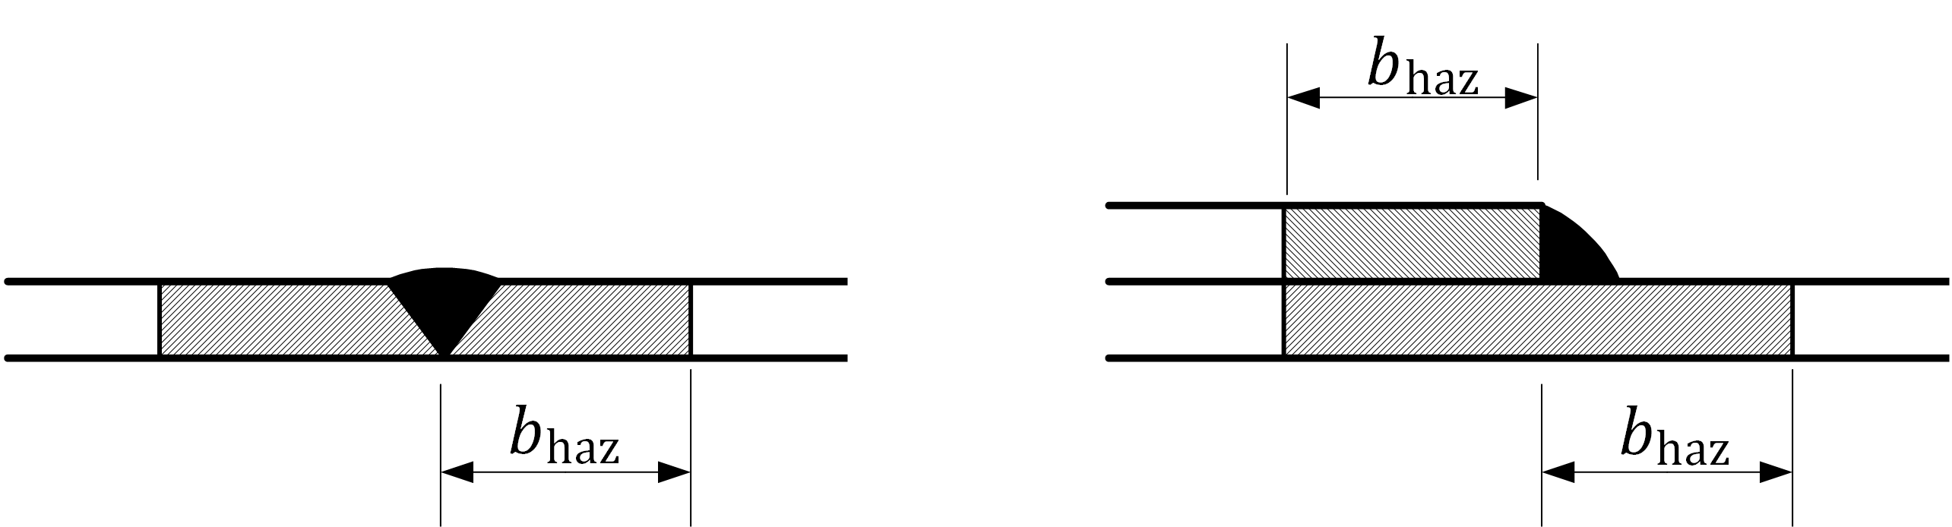

Figure 8.2 — Extent of heat-affected zones (HAZ) in shell sheeting

#### Buckling resistance of unstiffened welded shells

(1) The buckling resistance of unstiffened welded shells should be assessed wherever compressive stress resultants acting in laterally unrestrained welded panels are present in the shell.

(2) Checking the weld effect on buckling may be avoided if all welds in the shells are parallel to the compressive stress resultants acting in the structure in any design situation, provided that the reduction factor, *ρ*o,haz, due to HAZ is not lower than 0,60.

(3) The effect of welding on buckling resistance may be evaluated by means of a *geometrically and materially nonlinear analysis with imperfections* (GMNIA), accounting for the actual properties of both parent material and HAZ zones.

(4) If an accurate GMNIA analysis cannot be performed, the shell buckling resistance may be evaluated in a simplified way through the reduction factor given by the ratio *ρ*i,w = *χ*i,w/*χ*i between the buckling factor of the welded structure, *χ*w,i, and the one of the unwelded structure *χ*i.

NOTE 1 Compressive stress resultants in shells could arise not only due to direct compression, but also to external pressure, shear and localized loads. Whatever the load condition, reduction factors, *χ*w,i, are to be applied on welds which are orthogonal to compressive stress resultants, as they can produce a concentrated source of plastic deformation.

NOTE 2 The subscript “*i*” in (4) and (5) is intended as “*x*”, “*θ*” or “*τ*” depending on whether the reduction factors, *χ* and *ρ*, refer to axial compression, circumferential compression or shear, respectively.

(5) The reduction factor to allow for HAZ softening in shell structures is given by Formulae (8.27) and (8.28):

 but *ρ*i,w ≤ 1 and *ρ*i,w ≥ *ω*0 (8.27)

where

 but *ω*0 ≤ 1 (8.28)

|  |  |
| --- | --- |
| *ρ*u,haz and *ρ*o,haz | are the reduction factors due to HAZ, to be taken from prEN 1999‑1‑1:2021, Table 5.2a or Table 5.2b; |
|  | is the relative squash limit slenderness parameter for the design situation under consideration from Annex A; |
|  | is the limit value of the relative slenderness parameter beyond which the effect of weld on buckling vanishes, given by , but , see Figure 8.3; |
|  | is the absolute slenderness upper limit for the weld effect, depending on load case, structural material and tolerance class of the shell, as given in Table 8.5. |

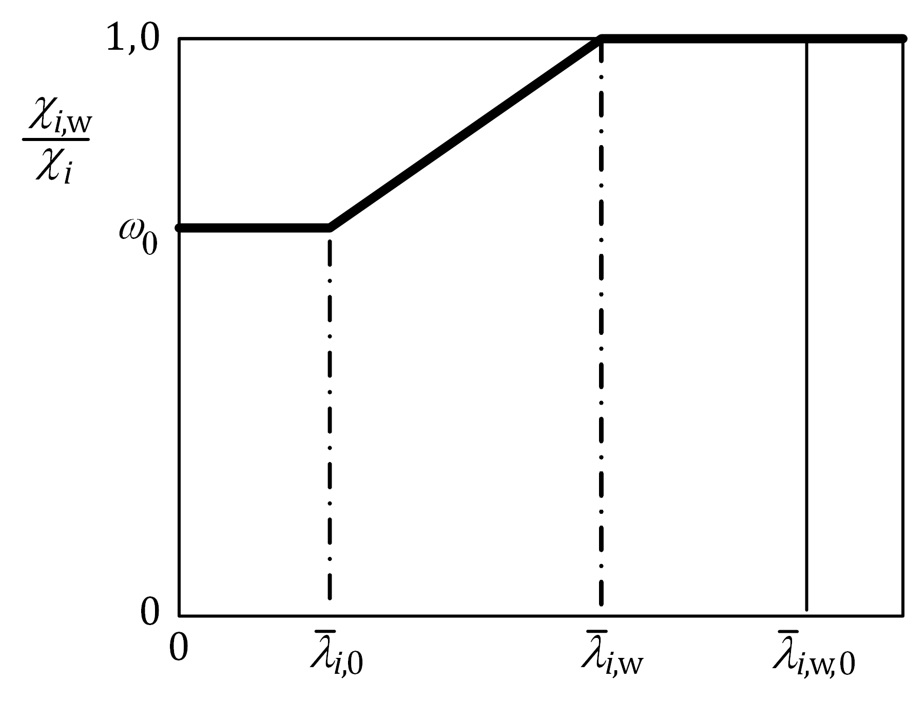

Figure 8.3 — Definition of the reduction factor, *ρ*i,w, due to HAZ

Table 8.5 — Values of  for relevant load cases allowed for in Annex A

| **Tolerance class** | **Axial compression** | | **Circumferential compression,** | | **Torsion and shear,** | |
| --- | --- | --- | --- | --- | --- | --- |
|  | |  | |  | |
| **Class A material** | **Class B material** | **Class A material** | **Class B material** | **Class A material** | **Class B material** |
| Class 1 | 0,8 | 0,7 | 1,2 | 1,1 | 1,4 | 1,3 |
| Class 2 | 1,0 | 0,9 | 1,3 | 1,2 | 1,5 | 1,4 |
| Class 3 | 1,2 | 1,1 | 1,4 | 1,3 | 1,6 | 1,5 |
| Class 4 | 1,3 | 1,2 | - | - | - | - |

#### Buckling resistance of stiffened welded shells

(1) The effect of welding on stiffened welded shells do not need to be checked against buckling if stiffeners have adequate lateral restraint to welded panels. If this is not the case the provisions in 8.2.4.4 apply.

### Design by numerical analysis

(1) The procedure in 7.5 and 8.1.4 for *geometrically and materially nonlinear analysis with imperfections* (GMNIA) may be followed. The GMNIA analysis may be performed, as an alternative to the method given in 8.2.3, by assuming as initial geometrical imperfections the maximum values of tolerances in 8.2.2.

(2) For welded structures the material in the heat-affected zone should be modelled, see 8.2.4.2, 8.2.4.3 and 8.2.4.4.

# Serviceability limit states

## General

(1) The rules for serviceability limit states given in EN 1999‑1‑1 apply to shell structures.

## Deflections

(1) Deflections may be calculated assuming elastic behaviour.

(2) With reference to EN 1990 limits for deflections should be specified for each project and agreed with the owner.

1. (normative)  
     
   Formulae for shell buckling analysis
   1. Use of this annex

(1) This Normative Annex contains additional provisions to 7.2, 8.2.3.1, 8.2.3.2, 8.2.3.3 and 8.2.4.4 on formulae for shell buckling analysis.

* 1. Scope and field of application

(1) This Normative Annex gives formulae for shell buckling analysis. It covers unstiffened cylindrical shells of constant wall thickness, unstiffened cylindrical shells of stepwise wall thickness, unstiffened lap jointed cylindrical shells, unstiffened conical shells, stiffened cylindrical shells of constant wall thickness and unstiffened spherical shells under uniform circumferential compression.

* 1. Unstiffened cylindrical shells of constant wall thickness
     1. Notations and boundary conditions

(1) General quantities (Figure A.1):

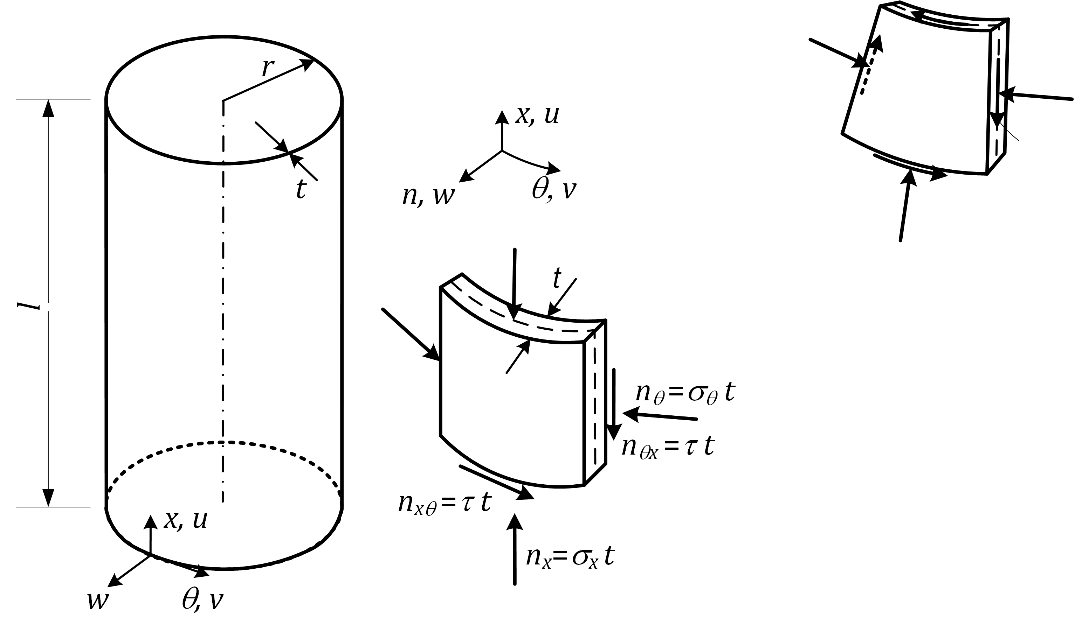

Key

|  |  |
| --- | --- |
| *l* | cylinder length between boundaries; |
| *r* | radius of cylinder middle surface; |
| *t* | thickness of shell |

Figure A.1 — Cylinder geometry and membrane stresses and stress resultants

(2) The boundary conditions are set out in 7.2 and 8.2.1.

* + 1. Meridional (axial) compression
       1. General

(1) Checking of cylinders against meridional shell buckling may be omitted, if the Formula (A.1) is satisfied:

 (A.1)

* + - 1. Critical meridional buckling stresses

(1) Formulae (A.2) to (A.5) may only be used for shells with boundary conditions BC 1 or BC 2 at both edges.

(2) The length of the shell segment should be characterized in terms of the dimensionless parameter *ω* given by Formula (A.2):

 (A.2)

(3) The critical meridional buckling stress, using values of *C*x from Table A.1, should be obtained from Formula (A.3):

*σ*x,cr = 0,605*EC*x*t*/*r* (A.3)

Table A.1 — Factor, *C*x, for critical meridional buckling stress

|  |  |  |
| --- | --- | --- |
| Cylindrical shell |  | Factor *C*x |
| Short | *ω* ≤ 1,7 | *C*x = 1,36 – 1,83/*ω* + 2,07/*ω*2 |
| Medium-length | 1,7 < *ω* < 0,5*r*/*t* | *C*x = 1 |
| Long | *ω* ≥ 0,5*r*/*t* | but *C*x ≥ 0,6  where *C*xb is given in Table A.2 |

Table A.2 — Parameter, *C*xb, for the effect of boundary conditions on long cylinder

|  |  |  |  |
| --- | --- | --- | --- |
| **Case** | **Cylinder end** | **Boundary condition** | **C**xb |
| 1 | end 1  end 2 | BC 1  BC 1 | 6 |
| 2 | end 1  end 2 | BC 1  BC 2 | 3 |
| 3 | end 1  end 2 | BC 2  BC 2 | 1 |
| NOTE BC 1 includes both BC1f and BC1r | | | |

(4) For long cylinders, as defined in Table A.1, that satisfy the additional conditions of Formulae (A.4) and (A.5):

*r*/*t* ≤ 150, *ωt*/*r* ≤ 6 and 500 ≤ *E*/*f*o ≤ 1000 (A.4)

Factor, *C*xb, may alternatively be obtained by:

 (A.5)

where

|  |  |
| --- | --- |
| *C*x,N | is the parameter for long cylinder in axial compression according to Table A.1; |
| *σ*x,Ed | is the design value of the meridional stress, (*σ*x,Ed *= σ*x,N,Ed + *σ*x,M,Ed); |
| *σ*x,N,Ed | is the stress component from axial compression (circumferentially uniform component); |
| *σ*x,M,Ed | is the stress component from tubular global bending (peak value of the circumferentially varying component). |

* + - 1. Meridional buckling parameter

(1) The meridional imperfection factor should be obtained from Formula (A.6):

 but *α*x ≤ 1,00 (A.6)

where

|  |  |
| --- | --- |
|  | is the meridional squash limit slenderness parameter; |
| *Q* | is the meridional compression tolerance parameter. |

(2) The tolerance parameter, *Q*, should be taken from Table A.3 for the specified tolerance class. For tolerance class 4 tolerance parameter, *Q*, depends also on boundary conditions as defined in Table 7.1.

(3) The alloy factor and the meridional squash limit slenderness parameter defined in 8.2.3.2 should be taken from Table A.4, according to the material buckling class as defined in EN 1999‑1‑1.

Table A.3 — Tolerance parameter, *Q*, for Formula (A.6)

|  |  |  |
| --- | --- | --- |
| **Tolerance class** | **Value of *Q* for boundary conditions** | |
| **BC1r, BC2r** | **BC1f, BC2f** |
| Class 1 | 16 | |
| Class 2 | 25 | |
| Class 3 | 40 | |
| Class 4 | 60 | 50 |

Table A.4 — Values of  and *μ*x for meridional compression

|  |  |  |
| --- | --- | --- |
| **Material buckling class** |  | ***μ*x** |
| A | 0,6 | 0,3 |
| B | 0,65 | 0,35 |
| C | 0,7 | 0,4 |

(4) For long cylinders that satisfy the special conditions of A.3.2.2(4), the meridional squash limit slenderness parameter may be obtained from Formula (A.7):

 (A.7)

where  should be taken from Table A.4 and *σ*x,Ed and *σ*x,M,Ed are as given in A.3.2.2(4).

* + 1. Circumferential (hoop) compression
       1. General

(1) Checking of cylinders against circumferential shell buckling may be omitted if they satisfy Formula (A.8)::

 (A.8)

* + - 1. Critical circumferential buckling stresses

(1) The following Formulae may be applied to shells with any boundary condition.

(2) The length of the shell segment should be characterized in terms of the dimensionless parameter *ω* of Formula (A.9):

 (A.9)

(3) The critical circumferential buckling stress, using values of *C*θ from Table A.5 for medium length cylinders and Table A.6 for short cylinders, should be obtained from Formula (A.10):

*σ*θ,cr = 0,92*EC*θ*t*/*ωr* (A.10)

Table A.5 — External pressure buckling factor, *C*θ, for Formula (A.10) in medium-length cylinders (20 < *ω*/*C*θ < 1,63*r*/*t*)

| **Case** | **Cylinder end** | **Boundary condition** | **Factor *C*θ** |
| --- | --- | --- | --- |
| 1 | end 1  end 2 | BC 1  BC 1 | 1,5 |
| 2 | end 1  end 2 | BC 1  BC 2 | 1,25 |
| 3 | end 1  end 2 | BC 2  BC 2 | 1,0 |
| 4 | end 1  end 2 | BC 1  BC 3 | 0,6 |
| 5 | end 1  end 2 | BC 2  BC 3 | 0 |
| 6 | end 1  end 2 | BC 3  BC 3 | 0 |
| NOTE BC 1 includes both BC1f and BC1r | | | |

Table A.6 — External pressure buckling factor, *C*θ, in Formula (A.10) for short cylinders (ω/*C*θ ≤ 20)

|  |  |  |  |
| --- | --- | --- | --- |
| **Case** | **Cylinder end** | **Boundary condition** | **Factor *C*θ** |
| 1 | end 1  end 2 | BC 1  BC 1 |  |
| 2 | end 1  end 2 | BC 1  BC 2 |  |
| 3 | end 1  end 2 | BC 2  BC 2 |  |
| 4 | end 1  end 2 | BC 1  BC 3 |  |
| NOTE BC 1 includes both BC1f and BC1r | | | |

(4) For long cylinders (*ω*/*C*θ ≥ 1,63*r*/*t*) the circumferential buckling stress should be obtained from Formula (A.11):

*σ*θ,cr = 0,56*Et*2/*r*2 (A.11)

* + - 1. Circumferential buckling parameter

(1) The circumferential imperfection factor should be obtained from Formula (A.12):

 but *α*θ ≤ 1,00 (A.12)

(2) The circumferential reference imperfection factor, *α*θ,ref, should be taken from Table A.7 for the specified tolerance class.

Table A.7 — Factor, *α*θ,ref, in Formula (A.12) based on tolerance class

| **Tolerance class** | **Parameter *α*θ,ref** |
| --- | --- |
| Class 1 | 0,50 |
| Class 2 | 0,65 |
| Class 3 and 4 | 0,75 |

(3) The alloy factor and the circumferential squash limit slenderness parameter defined in 8.2.3.2 should be taken from Table A.8 according to the material buckling class as defined in EN 1999‑1‑1.

Table A.8 — Values of  and *μ*θ for circumferential compression

|  |  |  |
| --- | --- | --- |
| **Material buckling class** |  | ***μ*θ** |
| A | 0,4 | 0,3 |
| B | 0,45 | 0,35 |
| C | 0,5 | 0,4 |

(4) The non-uniform distribution of pressure, *q*eq, due to external wind loading on cylinders (see Figure A.2) may be substituted, for the purpose of shell buckling design, by the equivalent uniform external pressure given by Formula (A.13):

*q*eq = *k*w*q*w,max (A.13)

where *q*w,max is the maximum wind pressure and *k*w should be obtained from Formula (A.14):

 (A.14)

with *k*w in the range 0,65 ≤ *k*w ≤ 1,0 and *C*θ from Table A.5 according to the boundary conditions.

(5) The circumferential design stress to be used in 8.2.3.3 follows from Formula (A.15):

 *σ*θ,Ed = (*q*eq + *q*s)*r*/*t* (A.15)

where *q*s is the internal suction caused by venting, internal partial vacuum or other phenomena, where present.

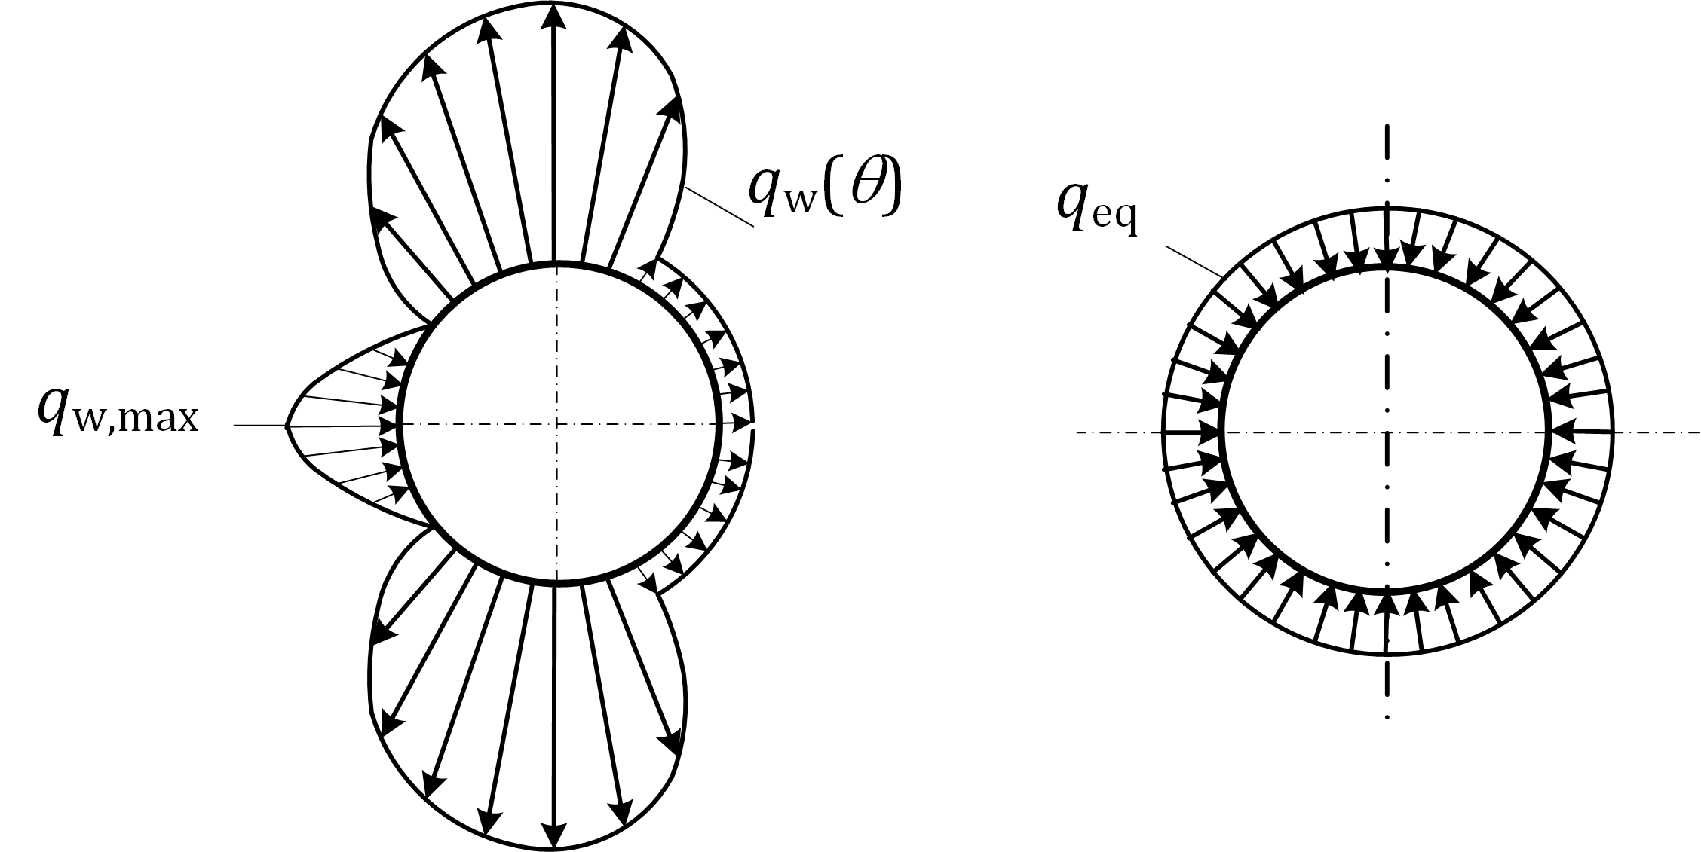

|  |  |  |
| --- | --- | --- |
| a) Wind pressure distribution around shell circumference |  | b) Equivalent axisymmetric pressure distribution |

Figure A.2 — Transformation of typical wind external pressure load distribution

* + 1. Shear
       1. General

(1) Checking of cylinders against shear buckling may be omitted if they satisfy Formula (A.16):

 (A.16)

* + - 1. Critical shear buckling stresses

(1) The following Formulae may only be used for shells with boundary conditions BC 1 or BC 2 at both edges.

(2) The length of the shell segment should be characterized in terms of the dimensionless parameter *ω* given by Formula (A.17):

 (A.17)

(3) The critical shear buckling stress, using values of *C*τ from Table A.9, should be obtained from Formula (A.18):

 (A.18)

Table A.9 — Factor, *C*τ in Formula (A.18) for critical shear buckling stress

| **Cylindrical shell** |  | **Factor *C*τ** |
| --- | --- | --- |
| Short | *ω* ≤ 10 |  |
| Medium-length | 10 < *ω* < 8,7*r*/*t* | *C*τ = 1 |
| Long | *ω* ≥ 8,7*r*/*t* |  |

* + - 1. Shear buckling parameters

(1) The shear imperfection factor should be obtained from Formula (A.19):

 but *α*τ ≤ 1,00 (A.19)

(2) The shear imperfection factor, *α*τ,ref, should be taken from Table A.10 for the specified tolerance class.

Table A.10 — Factor, *α*τ,ref, in Formula (A.19) based on tolerance

|  |  |
| --- | --- |
| **Tolerance class** | **Parameter *α*τ,ref** |
| Class 1 | 0,50 |
| Class 2 | 0,65 |
| Class 3 and 4 | 0,75 |

(3) The alloy factor and the shear squash limit slenderness parameter defined in 8.2.3.2 should be taken from Table A.11 according to the material buckling class as defined in EN 1999‑1‑1.

Table A.11 — Values of  and *μ*τ for shear

|  |  |  |
| --- | --- | --- |
| **Material buckling class** |  | ***μ*τ** |
| A | 0,5 | 0,4 |
| B | 0,55 | 0,35 |
| C | 0,6 | 0,3 |

* + 1. Meridional (axial) compression with coexistent internal pressure
       1. Pressurized critical meridional buckling stress

(1) The critical meridional buckling stress, *σ*x,cr, may be assumed to be unaffected by the presence of internal pressure and may be obtained as specified in A.3.2.2.

* + - 1. Pressurized meridional buckling parameters

(1) The pressurized meridional buckling strength should be verified analogously to the unpressurised meridional buckling strength, as specified in 8.2.3.3 and A.3.2.3. However, the unpressurised imperfection factor, *α*x, may be replaced by the pressurized imperfection factor, *α*x,p, given by Formulae (A.20) to (A.23):

 (A.20)

where

 (A.21)

 (A.22)

 (A.23)

|  |  |
| --- | --- |
| *p* | is the smallest value of internal pressure at the location of the point being assessed, and guaranteed to coexist with the meridional compression; |
| *α*x | is the unpressurised meridional imperfection factor according to A.3.2.3; |
| *σ*x,cr | is the elastic critical meridional buckling stress according to A.3.2.2(3); |
| *n*p | is the Ramberg-Osgood parameter given in prEN 1999‑1‑1:2021, Table 5.2a or 5.2b. |

(2) Factor, *α*x,pe, should be set equal to 1,0 in cylinders that are long according to A.3.2.2(3), Table A.1. Further, *α*x,pe, should be set equal to 1,0 unless:

— the cylinder is medium-length according to A.3.2.2(3), Table A.1;

— the cylinder is short according to A.3.2.2(3), Table A.1 and *C*x = 1 has been adopted in A.3.2.2(3).

* + 1. Combinations of meridional (axial) compression, circumferential (hoop) compression and shear

(1) The buckling interaction parameters to be used in 8.2.3.3(3) may be obtained from Formulae (A.24) and (A.25):

 (A.24)

*k*i = (*χ*x*χ*θ)2 (A.25)

where *χ*x, *χ*θ and *χ*τ are the buckling reduction factors defined in 8.2.3.2, using the buckling parameters given in A.3.2 to A.3.4.

(2) The three membrane stress components should be deemed to interact in combination at any point in the shell, except adjacent to the boundaries. The buckling interaction check may be omitted for all points that lie within the boundary zone length, *l*s, adjacent to either end of the cylindrical segment. The value of *l*s is the smaller of the values given by Formula (A.26):

*l*s = 0,1*l* and  (A.26)

(3) If the maximum value of any of the buckling-relevant membrane stresses in a cylindrical shell occurs in a boundary zone of length, *l*s, adjacent to either end of the cylinder, the interaction check of 8.2.3.3(3) may be undertaken using the maximum value of any of the buckling-relevant membrane stresses over the free length, *l*f, outside the boundary zones (see Figure A.3a), where *l*f is given by Formula (A.27):

*l*f = *l* - 2*l*s (A.27)

(4) For long cylinders as defined A.3.2.2(3), Table A.1, the stresses deemed to be in interaction-relevant groups may be restricted to any section of length, *l*int, falling within the free remaining length, *l*f, for the interaction check (see Figure A.3b), where *l*int is given by Formula (A.28):

 (A.28)

(5) If (3) or (4) above do not provide specific provisions for defining the relative locations or separations of interaction-relevant groups of membrane stress components, the maximum value of each membrane stress, irrespective of location in the shell, may be conservatively used in Formula (8.24).

|  |
| --- |
|  |
| a) short cylinder b) long cylinder |

Figure A.3 — Examples of interaction-relevant groups of membrane stress components

* 1. Unstiffened cylindrical shells of stepwise wall thickness
     1. General
        1. Notations and boundary conditions

(1) In this clause the following notations are used:

|  |  |
| --- | --- |
| *l* | overall cylinder length between boundaries; |
| *r* | radius of cylinder middle surface; |
| *j* | index of individual cylinder sections with constant wall thickness (for *j* = 1 to *n*); |
| *tj* | the constant wall thickness of section, *j*, of the cylinder; |
| *lj* | the length of section, *j*, of the cylinder. |

(2) The following Formulae may only be used for shells with boundary condition BC 1 and BC 2 at both edges (see 7.2), with no distinction made between them.

* + - 1. Geometry and joint offsets

(1) Provided that the wall thickness of the cylinder increases progressively stepwise from top to bottom (see Figure A.4(I)), the procedures given in this clause may be used. Alternatively, *linear elastic bifurcation analysis* LBA may be used to calculate the critical circumferential buckling stress, *σ*θ,cr,eff, in A.4.3.1(7).

(2) Intended offsets, *e*0, between plates of adjacent sections (see Figure A.5) may be treated as covered by the following Formulae provided that the intended value, *e*0, is less than the permissible value, *e*0,p, which should be taken as the smaller of the values given by Formula (A.29):

*e*0,p = 0,5(*t*max – *t*min) and *e*0,p = 0,5*t*min (A.29)

where

|  |  |
| --- | --- |
| *t*max | is the thickness of the thicker plate at the joint; |
| *t*min | is the thickness of the thinner plate at the joint. |

(3) For cylinders with permissible intended offsets between plates of adjacent sections according to (2), the radius, *r*, may be taken as the mean value of all sections.

(4) For cylinders with overlapping joints (lap joints), the provisions for lap-jointed construction given in A.5 should be used.

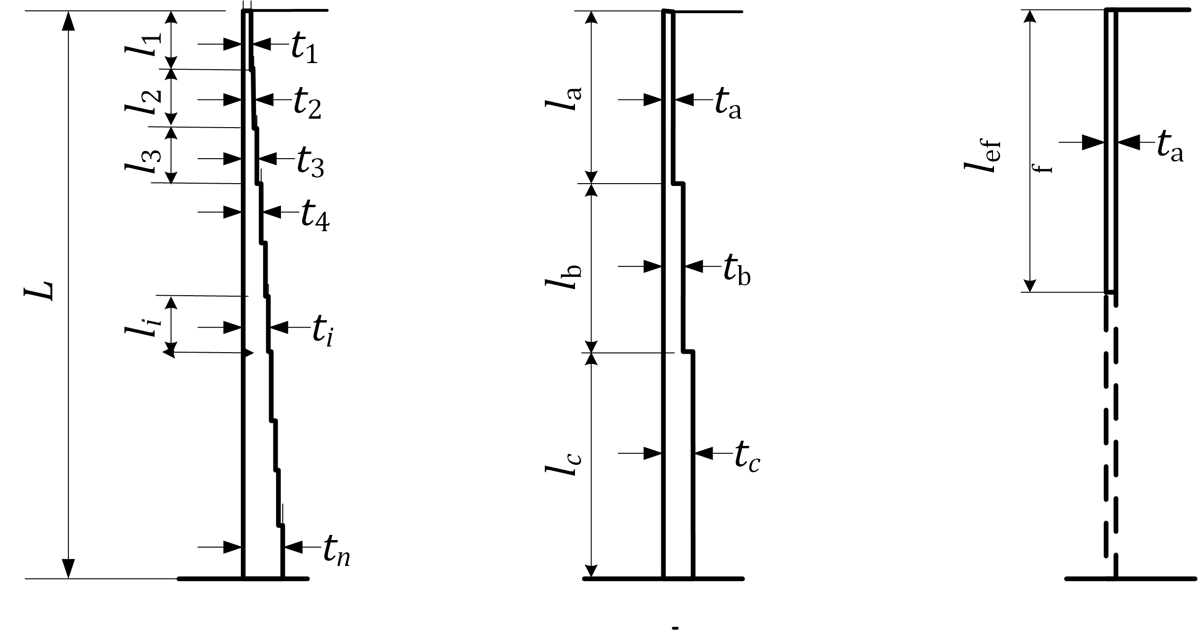

|  |  |  |
| --- | --- | --- |
| (I) Cylinder of stepwise variable wall thickness | (II) Equivalent cylinder comprising of three sections | (III) Equivalent single cylinder with uniform wall thickness |

Figure A.4 — Transformation of stepped cylinder into equivalent cylinder

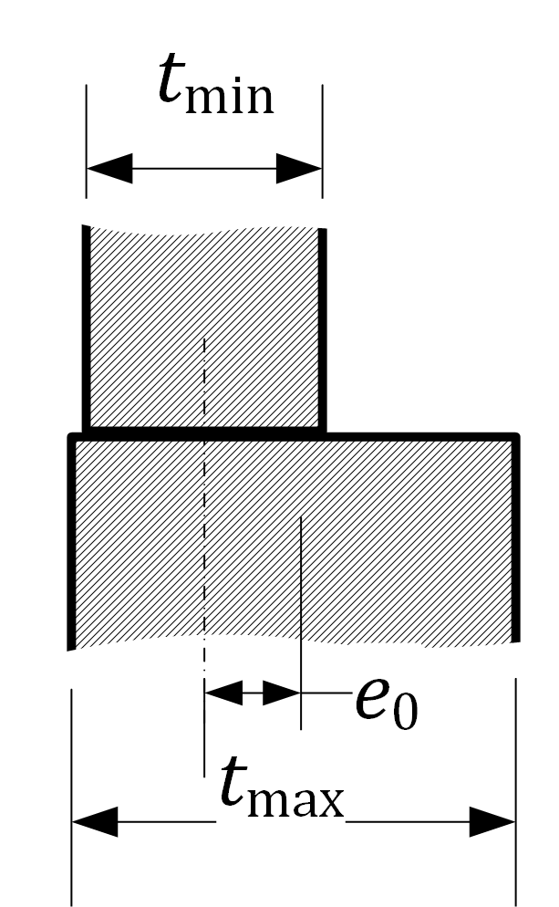

Figure A.5 — Intended offset, *e*0, in a butt-jointed shell

* + 1. Meridional (axial) compression

(1) Each cylinder section, *j*, of length, *l*j, should be treated as an equivalent cylinder of overall length, *l* = *L*, and of uniform wall thickness, *t = t*j, according to A.3.2.

(2) For long equivalent cylinders, as governed by A.3.2.2(3), Table A.1, parameter, *C*xb, should be conservatively taken as *C*xb = 1, unless a more accurate value is justified by more rigorous analysis.

* + 1. Circumferential (hoop) compression
       1. Critical circumferential buckling stresses

(1) If the cylinder consists of three sections with different wall thickness, the procedure according to (4) to (7) should be applied, see Figure A.4(II)

(2) If the cylinder consists of only one section (i.e. constant wall thickness), A.3 should be applied.

(3) If the cylinder consists of two sections of different wall thickness, the procedure of (4) to (7) should be applied, treating two of the three fictitious sections, a and b, as being of the same thickness.

(4) If the cylinder consists of more than three sections with different wall thicknesses (see Figure A.4(I)), it should first be replaced by an equivalent cylinder comprising three sections a, b and c (see Figure A.4(II)). The length of its upper section, *l*a, should extend to the upper edge of the first section that has a wall thickness greater than 1,5 times the smallest wall thickness, *t*j, but should not comprise more than half the total length, *L*, of the cylinder. The length of the two other sections, *l*b and *l*c, should be taken as given by Formulae (A.30) and (A.31):

*l*b = *l*a and *l*c = *L* – 2*l*a     if *l*a ≤ *L*/3 (A.30)

*l*b = *l*c = 0,5(*L* - *l*a)     if *L*/3 < *l*a ≤ *L*/2 (A.31)

(5) The fictitious wall thickness, *t*a, *t*b and *t*c, of the three sections should be determined as the weighted average of wall thickness over each of the three fictitious sections given by Formulae (A.32) to (A.34):

 (A.32)

 (A.33)

 (A.34)

(6) The three-section-cylinder (i.e. the equivalent or real one) should be replaced by an equivalent single cylinder of uniform wall thickness, *t = t*a, (see Figure A.4(III)) and effective length determined from Formula (A.35):

*l*eff = *l*a/*κ* (A.35)

in which, *κ*, is a dimensionless factor obtained from Figure A.6.

(7) For cylinder sections of moderate or short length, the critical circumferential buckling stress of each cylinder section, *j*, of the original cylinder of stepwise variable wall thickness should be determined from Formula (A.36):

*σ*θ,cr,j = (*t*a/*t*j)*σ*θ,cr,eff (A.36)

where *σ*θ,cr,eff is the critical circumferential buckling stress derived from A.3.3.2(3) or A.3.3.2(4) as appropriate, of the equivalent single cylinder of length, *l*eff, according to (6). The factor, *C*θ, in these Formulae should be, *C*θ = 1,0.

(8) The length of the shell segment should be characterized in terms of the dimensionless parameter *ω*j given by Formula (A.37):

 (A.37)

(9) If cylinder section, *j*, is long, a second additional assessment of its buckling stress should be made, using the smaller of the two values from (7) and (10) for its buckling design.

(10) The cylinder section, *j*, should be treated as long if Formula (A.38) is satisfied:

 (A.38)

in which case the critical circumferential buckling stress should be obtained from Formula (A.39):

 (A.39)

where, *C*θ, should be adopted from Table A.5 or Table A.6 depending on the length of cylinder section, *j*.

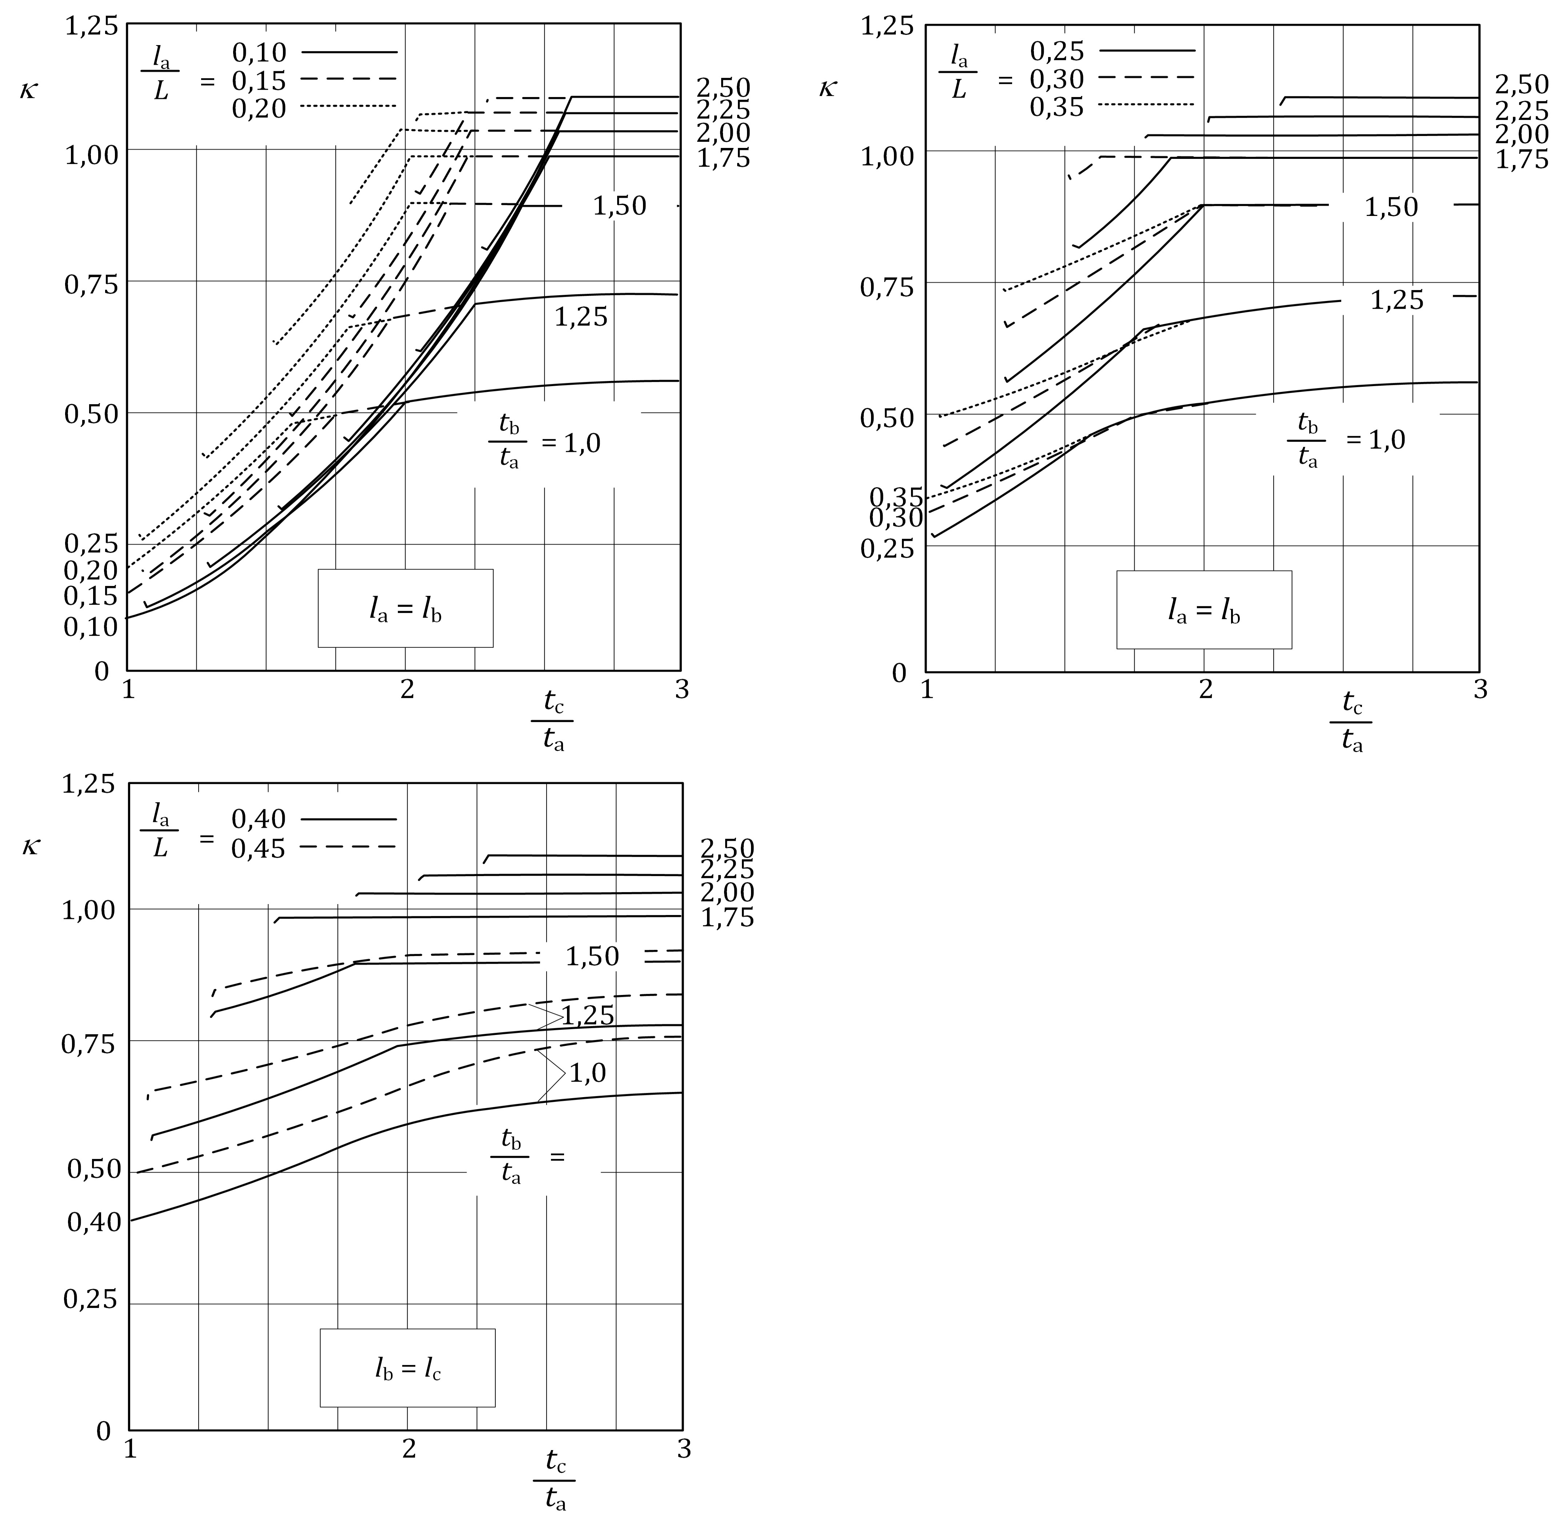

Figure A.6 — Factor, *κ*, for determining the effective length, *l*eff

* + - 1. Buckling strength verification for circumferential compression

(1) For each cylinder section, *j*, the conditions of 8.2.3 should be met, and the verification by Formula (A.40) should be carried out:

*σ*θ,Ed,j ≤ *σ*θ,Rd,j (A.40)

where

|  |  |
| --- | --- |
| *σ*θ,Ed,j | is the key value of the circumferential compressive membrane stress, as detailed in the following clauses; |
| *σ*θ,Rd,j | is the design circumferential buckling stress, as derived from the critical circumferential buckling stress according to A.3.3.3. |

(2) If the design value of the circumferential stress resultant, *n*θ,Ed, is constant throughout length, *L*, the key value of the circumferential compressive membrane stress in section, *j*, should be taken as given by Formula (A.41):

*σ*θ,Ed,j ≤ *n*θ,Ed/*t*j (A.41)

(3) If, *n*θ,Ed, varies within, *L*, the key value of the circumferential compressive membrane stress should be taken as a fictitious value, *σ*θ,Ed,j,mod, determined from the maximum value of the circumferential stress resultant, *n*θ,Ed, anywhere within, *L*, divided by the local thickness, *t*j, as given by Formula (A.42) (see Figure A.7):

*σ*θ,Ed,j,mod, = max(*n*θ,Ed)/*t*j (A.42)

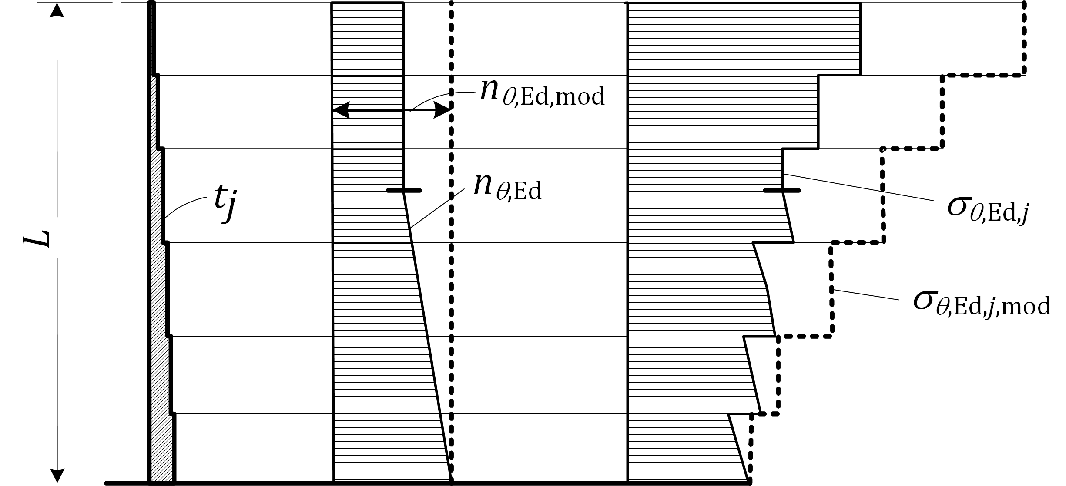

Figure A.7 — Key values of the circumferential compressive membrane stress in cases where, *n*θ,Ed, varies within the length, *L*

* + 1. Shear
       1. Critical shear buckling stress

(1) If no specific rule for evaluating an equivalent single cylinder of uniform wall thickness is available, the Formulae of A.4.3.1(1) to (6) may be applied.

(2) The further determination of the critical shear buckling stresses may be performed as in A.4.3.1(7) to (10), but replacing the circumferential compression Formulae from A.3.3.2 by the relevant shear Formulae from A.3.4.2.

* + - 1. Buckling strength verification for shear

(1) The rules of A.4.3.2 may be applied, but replacing the circumferential compression Formulae by the relevant shear Formulae.

* 1. Unstiffened lap jointed cylindrical shells
     1. Geometry and stress resultants

(1) If a cylindrical shell is constructed using lap joints (see Figure A.8), the following provisions may be used in place of those set out in A.4.

(2) The following provisions apply both to lap joints that increase, and to lap joints that decrease the radius of the middle surface of the shell. If the lap joint runs in a circumferential direction around the shell axis (circumferential lap joint), the provisions of A.5.2 should be used for meridional compression. If many lap joints run in a circumferential direction around the shell axis with changes of plate thickness down the shell, the provisions of A.5.3 should be used for circumferential compression. If a single lap joint runs parallel to the shell axis (meridional lap joint), the provisions of A.5.3 should be used for circumferential compression. In other cases, no special consideration need to be given to the influence of lap joints on buckling resistance.

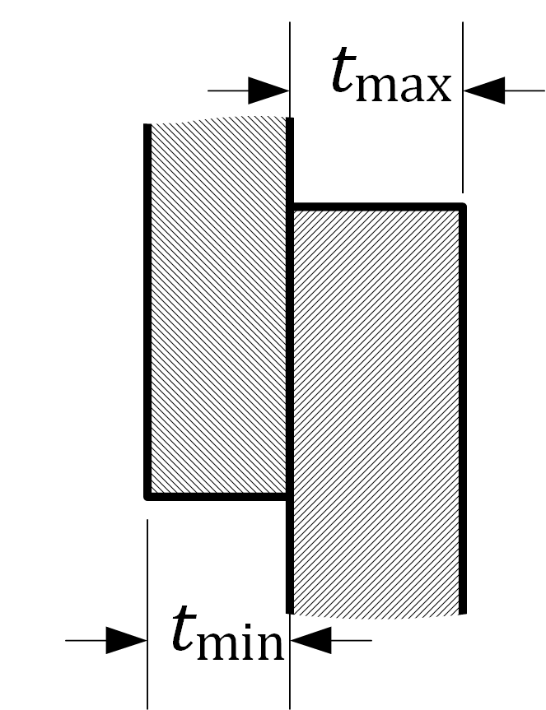

Figure A.8 — Lap jointed shell

* + 1. Meridional (axial) compression

(1) If a lap jointed cylinder is subject to meridional compression with meridional lap joints, the buckling resistance may be evaluated as for a uniform or stepped-wall cylinder, as appropriate, but with the design resistance multiplied by 0,70.

(2) If a change of plate thickness occurs at the lap joint, the design buckling resistance may be taken as the same value as for that of the thinner plate as determined in (1).

* + 1. Circumferential (hoop) compression

(1) If a lap jointed cylinder is subject to circumferential compression across meridional lap joints, the design buckling resistance may be evaluated as for a uniform or stepped-wall cylinder, as appropriate, but with a reduction factor of 0,90.

(2) If a lap jointed cylinder is subject to circumferential compression, with many circumferential lap joints and a changing plate thickness down the shell, the procedure of A.4 should be used without the geometric restrictions on joint eccentricity, and with the design buckling resistance multiplied by 0,90.

(3) If the lap joints are used in both directions, with staggered placement of the meridional lap joints in alternate strakes or courses, the design buckling resistance should be evaluated as the lower of those found in (1) or (2). No further resistance reduction is needed.

* + 1. Shear

(1) If a lap jointed cylinder is subject to membrane shear, the buckling resistance may be evaluated as for a uniform or stepped-wall cylinder, as appropriate.

* 1. Unstiffened conical shells
     1. General
        1. Notation

(1) In this clause the following notations are used:

where

|  |  |
| --- | --- |
| *h* | is the axial length (height) of the truncated cone; |
| *L* | is the meridional length of the truncated cone; |
| *r* | is the radius of the cone middle surface, perpendicular to axis of rotation, that varies linearly down the length; |
| *r*1 | is the radius at the small end of the cone; |
| *r*2 | is the radius at the large end of the cone; |
| *β* | is the apex half angle of the cone. |

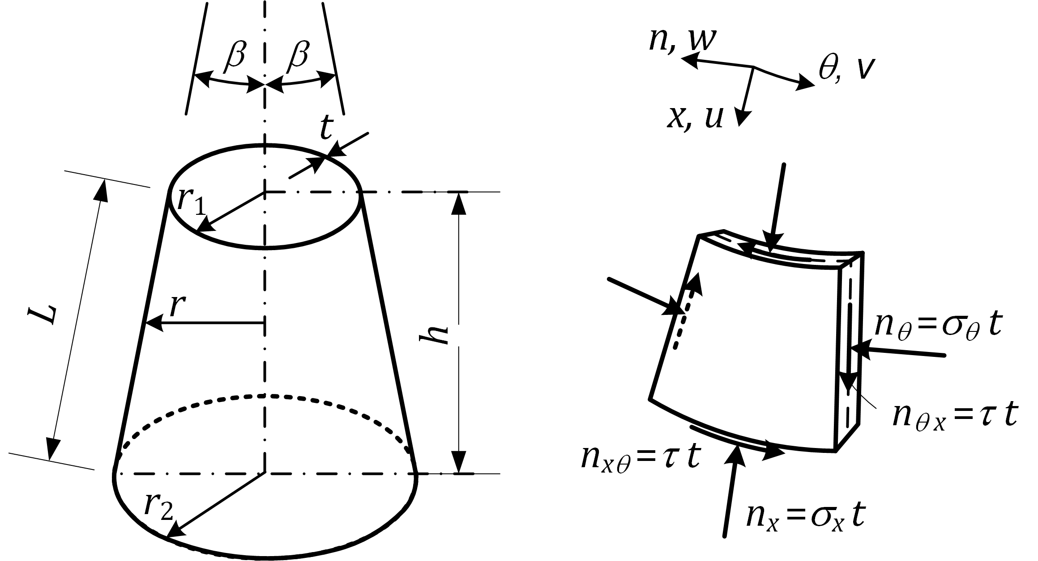

Figure A.9 — Cone geometry, membrane stresses and stress resultants

* + - 1. Boundary conditions

(1) The following Formulae should be used only for shells with boundary conditions BC 1 or BC 2 at both edges (see 7.2 and 8.2), with no distinction made between them. They should not be used for a shell in which any boundary condition is BC 3.

(2) The rules in A.6.1 should be used only for the following two radial displacement restraint boundary conditions, at either end of the cone:

— “cylinder condition” *w* = 0;

— “ring condition” *u*sin *β* + *w*cos *β* = 0

* + - 1. Geometry

(1) Only truncated cones of uniform wall thickness and with apex half angle, *β* ≤ 65°, (see Figure A.9) are covered by the following rules.

* + 1. Design buckling stresses
       1. Equivalent cylinder

(1) The design buckling stresses that are needed for the buckling strength verification according to 8.2.3 may be derived from an equivalent cylinder of length, *l*e, and radius, *r*e, which depend on the type of stress according to Table A.12.

Table A.12 — Equivalent cylinder length and radius

| **Loading** | **Equivalent length** | **Equivalent cylinder radius** | |
| --- | --- | --- | --- |
| Meridional compression | *l*e = *L* |  | |
| Circumferential (hoop) compression | *l*e = *L* |  | |
| Uniform external pressure, *q*  Boundary conditions: Either BC 1 at both ends or BC 2 at both ends | *l*e is the lesser of  *l*e1 = *L* and  (*β* in radians, see Figure A.9) | if *l*e = *l*e1 | (shorter cones) |
| if *l*e = *l*e2 | (longer cones) |
| Shear | *l*e = *h* | in which | |
| Uniform torsion | *l*e = *L* | in which | |

(2) For cones under uniform external pressure, *q,* the buckling strength verification should be based on the membrane stress as given by Formula (A.43):

*σ*θ,Ed = *qr*e/*t* (A.43)

* + 1. Buckling strength verification
       1. Meridional compression

(1) The buckling design check should be carried out at that point of the cone where the combination of acting design meridional stress and design buckling stress according to A.3.2.2 is most critical.

(2) If meridional compression is caused by a constant axial force on a truncated cone, both the small radius, *r*1, and the large radius, *r*2, should be considered as possible location of the most critical position.

(3) In the case of meridional compression caused by a constant global bending moment on the cone, the small radius, *r*1, should be taken as the most critical.

(4) The design buckling stress should be determined for the equivalent cylinder according to A.3.2.

* + - 1. Circumferential (hoop) compression

(1) If the circumferential compression is caused by uniform external pressure, the buckling design check should be carried out using the acting design circumferential stress, *σ*θ,Ed,env, determined using Formula (A.43).

(2) If the circumferential compression is due to actions other than uniform external pressure, the calculated stress distribution, *σ*θ,Ed(*x*), should be replaced by a stress distribution, *σ*θ,Ed,env(*x*), that everywhere exceeds the calculated value, which would arise from a fictitious uniform external pressure. The buckling design check should then be carried out as in (1), but using *σ*θ,Ed,env instead of *σ*θ,Ed.

(3) The design buckling stress should be determined for the equivalent cylinder according to A.3.3.

* + - 1. Shear and uniform torsion

(1) In the case of shear caused by a constant global torque on the cone, the buckling design check should be carried out using the acting design shear stress, *τ*Ed, at the point with *r* = *r*ecos *β*.

(2) If the shear is caused by actions other than a constant global torque (such as a global shear force on the cone), the calculated stress distribution, *τ*Ed(*x*), should be replaced by a fictitious stress distribution, *τ*Ed,env(*x*), that everywhere exceeds the calculated value, but which would arise from a fictitious global torque. The buckling design check should then be carried out as in (1), but using, *τ*Ed,env, instead of *τ*Ed.

(3) The design buckling stress, *τ*Rd, should be determined for the equivalent cylinder according to A.3.4.

* 1. Stiffened cylindrical shells of constant wall thickness
     1. General

(1) Stiffened cylindrical shells can be made of either:

— isotropic walls stiffened with meridional and circumferential stiffeners;

— corrugated walls stiffened with meridional and circumferential stiffeners.

(2) In both cases, buckling checks may be made by assuming the stiffened wall to behave as an equivalent orthotropic shell according to the rules in A.7.6, provided that the conditions in A.7.6 are met.

(3) In case of circumferentially corrugated sheeting without meridional stiffeners, the plastic buckling resistance can be calculated according to the rules given in A.7.4.2(3), (4) and (5).

(4) If the circumferentially corrugated sheeting is assumed to carry no axial load, the buckling resistance of an individual stiffener may be evaluated according to A.7.4.3.

* + 1. Isotropic walls with meridional stiffeners
       1. General

(1) If an isotropic wall is stiffened by meridional (stringer) stiffeners, the effect of compatibility of the shortening of the wall due to internal pressure should be taken into account in assessing the meridional compressive stress in both the wall and the stiffeners.

(2) The resistance against rupture on a meridional seam should be determined as for an isotropic shell.

(3) If a structural connection detail includes the stiffener as part of the means of transmitting circumferential tension, the effect of this tension on the stiffener should be taken into account in evaluating the force in the stiffener and its susceptibility to rupture under circumferential tension.

* + - 1. Meridional (axial) compression

(1) The wall should be designed for the same axial compression buckling criteria as the unstiffened wall, unless the maximum meridional distance between stiffeners, *d*s,max, (Figure A.10) is less than, where, *t*, is the local thickness of the wall.

(2) Where meridional stiffeners are placed at closer spacing than, the buckling resistance of the complete wall should be assessed using the procedure in A.7.6.

(3) The axial compression buckling strength of the stiffeners themselves should be evaluated using the provisions of EN 1999‑1‑1, accounting for the actual boundary conditions of the stiffeners.

(4) The eccentricity of the stiffener to the shell wall should be taken into account, where appropriate.

* + - 1. Circumferential (hoop) compression

(1) The wall should be checked for the same external pressure buckling criteria as the unstiffened wall, unless a more rigorous calculation is carried out.

(2) In a more rigorous calculation the meridional stiffeners may be smeared to give an orthotropic wall, and the buckling stress assessment carried out using the provisions of A.7.6, assuming a stretching stiffness, *C*φ = *C*θ = *Et*, and a shear membrane stiffness, *C*φθ = 0,38*Et*.

* + - 1. Shear

(1) If a major part of the shell wall is subject to shear loading (as with eccentric filling, earthquake loading etc.), the membrane shear buckling resistance should be found as for an isotropic unstiffened wall (see A.5. 4), but the resistance may be increased by taking account of the stiffeners. The equivalent length, *l*, of the shell in shear may be taken as the lesser of the height between stiffening rings or boundaries and twice the meridional spacing of the meridional stiffeners, provided that each stiffener has a flexural rigidity, *EI*y, for bending in the meridional direction (about a circumferential axis) greater than the value given in Formula (A.44):

 (A.44)

where the values of, *l*, and, *t*, are those used in the most critical buckling mode.

(2) If a discrete stiffener is abruptly terminated part way up the shell, the force in the stiffener should be taken to be uniformly redistributed into the shell over a length not exceeding .

(3) If the stiffeners are terminated as above, or used to introduce local forces into the shell, the assessed resistance for shear transmission between the stiffener and the shell should not exceed the value in A.3.4.

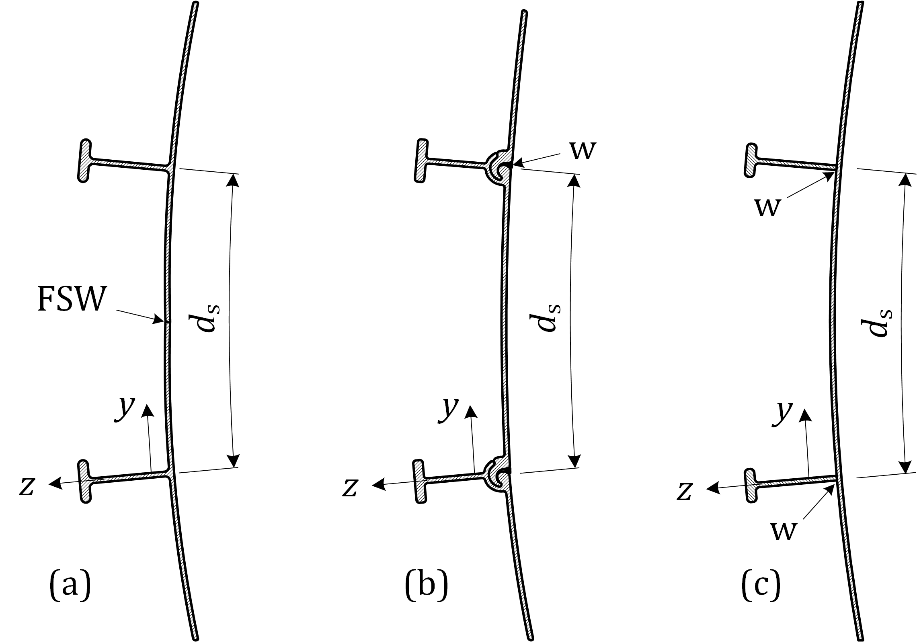

Key

|  |  |
| --- | --- |
| w | weld; |
| FSW | friction stir welding. |

Figure A.10 — Typical axially stiffened shells made of (a) and (b) extrusions and (c) plates and extrusions

* + 1. Isotropic walls with circumferential stiffeners

(1) For the purpose of buckling checks, rules given in A.7.6 apply assuming the stiffened wall to behave as an orthotropic shell.

* + 1. Circumferentially corrugated walls with meridional stiffeners
       1. General

(1) All calculations should be carried out with thickness exclusive of coatings and geometric tolerances.

(2) The minimum core thickness for the corrugated sheeting of the wall should be 0,68 mm.

(3) If the cylindrical wall is fabricated from corrugated sheeting with the corrugations running circumferentially and meridional stiffeners are attached to the wall, the corrugated wall should be assumed to carry no meridional forces, unless the wall is treated as an orthotropic shell, see A.7.6.

(4) Particular attention should be paid to ensure that the stiffeners are flexurally continuous with respect to bending in the meridional plane normal to the wall, because the flexural continuity of the stiffener is essential for the resistance to buckling.

(5) If the wall is stiffened with meridional stiffeners, the fasteners between the sheeting and stiffeners should be designed to ensure that the distributed shear loading on each part of the wall sheeting is transferred into the stiffeners. The sheeting thickness should be chosen to ensure that local rupture at these fasteners is prevented, taking proper account of the reduced bearing strength of fasteners in corrugated sheeting.

(6) The design stress resultants, resistances and checks should be carried out as in Clause 7, 8.1 and A.3, but including the additional provisions set out in (1) to (5) above.

NOTE Example of arrangement for stiffening the wall is shown in Figure A.11.

(7) Bolts for fastenings between panels should satisfy the requirements of EN 1999‑1‑1. The bolt size should not be less than M8.

(8) The joint detail between panels should comply with the provisions of EN 1999‑1‑4 for bolts loaded in shear.

(9) The spacing between fasteners around the circumference should not exceed 3° of the circumference.

(10) If penetrations are made in the wall for hatches, doors, augers or other items, a thicker corrugated sheet should be used locally to ensure that the local stress raisers associated with mismatches of stiffness do not lead to local rupture.

NOTE A typical bolt arrangement detail for a panel is shown in Figure A.12.

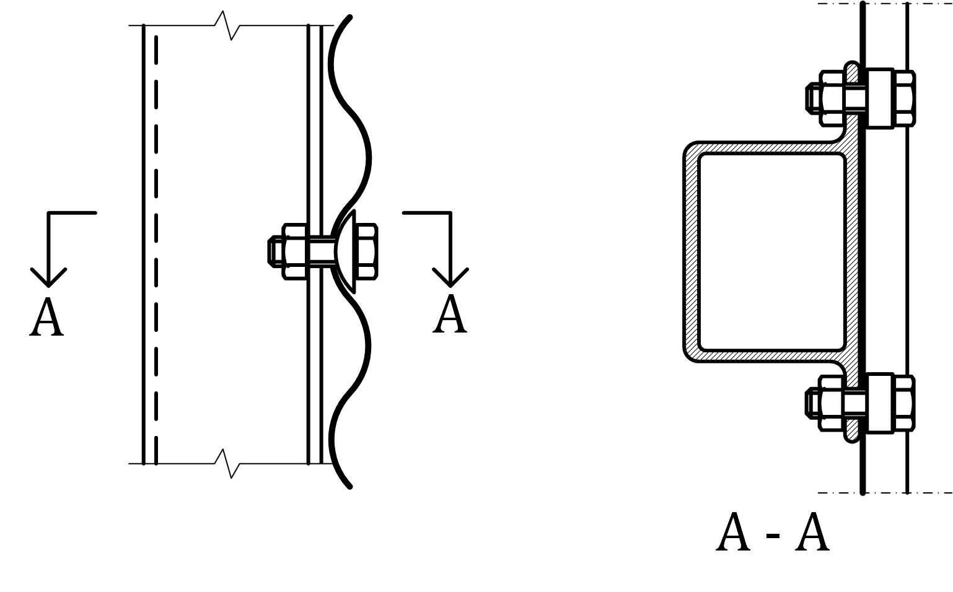

Figure A.11 — Example of arrangement of meridional stiffeners on circumferentially corrugated shells

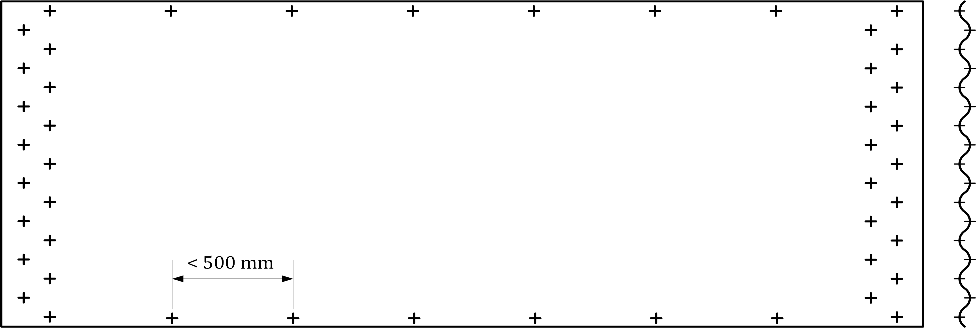

Figure A.12 — Typical bolt arrangement for panel of a corrugated shell

* + - 1. Axial compression

(1) Under axial compression, the design resistance should be determined at every point in the shell using the specified tolerance class for execution, the value of the internal pressure, *p*, and the circumferentially uniform compressive stress. The design should consider every point on the shell wall, including the meridional variation of axial compression, except where the provisions of this Part allow for this.

(2) If the wall is stiffened with meridional stiffeners, the buckling design of the wall should be carried out using one of two alternative methods:

a) buckling of the equivalent orthotropic shell (following A.7.6) if the meridional distance between stiffeners satisfies A.7.6.1(3);

b) buckling of the individual stiffeners (with the corrugated wall assumed to carry no axial force, but providing restraint to the stiffeners) and following A.7.4.3 if the meridional distance between stiffeners does not satisfy A.7.6.1(3).

(3) If the corrugated shell has no meridional stiffeners, the value of the local plastic buckling resistance (resistance to corrugation collapse or “roll-down”) should be determined as the greater of the values given by Formulae (A.45) and (A.46):

*n*x,Rk = *t*2*f*o/2*d* (A.45)

and

*n*x,Rk = *r*ϕ*tf*o/*r* (A.46)

where

|  |  |
| --- | --- |
| *t* | is the sheet thickness; |
| *d* | is the crest to trough amplitude; |
| *r*ϕ | is the local curvature of the corrugation (see Figure A.14); |
| *r* | is the cylinder radius. |

The local plastic buckling resistance, *n*x,Rk, should be taken as independent of the internal pressure, *p*n.

(4) The design value of the local plastic buckling resistance should be determined by Formula (A.47):

*n*x,Rd = *α*x*n*x,Rk/*γ*M1 (A.47)

in which *α*x = 0,80. For *γ*M1 see 4.1.

(5) At every point in the structure the design stresses should satisfy Formula (A.48):

*n*x,Ed ≤ *n*x,Rd (A.48)

* + - 1. Stiffened wall treated as carrying axial compression only in the stiffeners

(1) If the corrugated sheeting is assumed to carry no axial force (method (b) in A.7.4.2(2)), the sheeting may be assumed to restrain all buckling displacements of the stiffener in the plane of the wall, and the resistance to buckling should be calculated using one of the two alternative methods:

a) ignoring the supporting action of the sheeting in resisting buckling displacements normal to the wall;

b) allowing for the stiffness of the sheeting in resisting buckling displacements normal to the wall.

(2) Using method (a) in (1), the resistance of an individual stiffener may be taken as the resistance of the stiffener to concentric compression. The design buckling resistance, *N*s,Rd, should be obtained from Formula (A.49):

*N*s,Rd = *χA*eff*f*o/*γ*M1 (A.49)

where, *A*eff, is the effective cross-sectional area of the stiffener.

(3) The reduction factor, *χ*, should be obtained from EN 1999‑1‑1 for flexural buckling normal to the wall (about the circumferential axis) according to the type of alloy and using buckling curve 2 irrespective of the alloy adopted (*α* = 0,32 and ). The effective length of column used in determining the reduction factor, *χ*, should be taken as the distance between adjacent ring stiffeners.

(4) The elastic restraint provided by the wall against buckling of the stiffener may be considered as a spring distribution, the rigidity of which can be evaluated according to the following conditions:

a) The section of wall deemed to provide restraint to the stiffener should be the sum of the lengths of the wall at each side of the stiffener (see Figure A.13), with simply supported conditions at the two ends.

b) No account should be taken of the possible stiffness of stored bulk solid.

(5) Unless more accurate calculations are made, the elastic critical buckling load, *N*s,cr, should be calculated assuming uniform compression on the cross-section at any level, using Formula (A.50):

 (A.50)

where

|  |  |
| --- | --- |
| *EI*s | is the flexural rigidity of the stiffener for bending out of the plane of the wall (Nmm2); |
| *k* | the flexural stiffness of the sheeting (N/mm per mm of wall height) spanning between meridional stiffeners, as indicated in Figure A.13; |

(6) The flexural stiffness of the wall plate, *k*, should be determined assuming that the sheeting spans between adjacent meridional stiffeners on either side with simply supported boundary conditions, see Figure A.13. The value of, *k*, may be found using Formula (A.51):

 *k* = 6 *D*θ/*d*s3 (A.51)

where

|  |  |
| --- | --- |
| *D*θ | is the flexural rigidity of the sheeting for circumferential bending; |
| *d*s | is the spacing of meridional stiffeners. |

(7) If the corrugation is an arc-and-tangent or sinusoidal profile, the value of, *D*θ*,* may be taken from A.7.7(6). If other corrugation sections are adopted, the flexural rigidity for circumferential bending should be determined for the actual cross section.

(8) At every point of the stiffener, the design stresses should satisfy Formula (A.52):

*N*s,Ed ≤ *N*s,Rd (A.52)

(9) The resistance of the stiffeners to local and flexural torsional buckling should be determined using EN 1999‑1‑1.

* + - 1. Circumferential (hoop) compression

(1) For the purpose of buckling checks, rules in A.7.6.3 apply assuming the stiffened wall to behave as an orthotropic shell.

|  |  |
| --- | --- |
|  |  |

Figure A.13 — Plate restraint stiffness for evaluation of column buckling

* + 1. Axially corrugated walls with ring stiffeners
       1. General

(1) If the cylindrical wall is fabricated using corrugated sheeting with the corrugations running axially, both of the following conditions should be met:

a) the corrugated wall should be assumed to carry no meridional forces;

b) the corrugated sheeting should be assumed to span between attached rings, using the centre to centre spacing of rings and assuming sheeting continuity.

(2) The joints between sheeting sections should be designed to ensure that the assumed flexural continuity is achieved.

(3) The evaluation of the axial compression force in the wall arising from wall frictional tractions from the bulk solid should take account of the full circumference of the shell, considering the profile shape of the corrugation.

(4) If the corrugated sheeting extends to a base where a boundary condition is specified, the local flexure of the sheeting near the boundary should be considered, assuming a radially restrained boundary.

(5) The corrugated wall should be assumed to carry no circumferential forces.

(6) The spacing of ring stiffeners should be determined using a beam bending analysis of the corrugated profile, assuming that the wall is continuous over the rings and including the consequences of different radial displacements of ring stiffeners of different size. The stresses arising from this bending should be added to those due to axial compression when checking the buckling resistance under axial compression.

NOTE Meridional bending of the sheeting can be analysed by treating it as a continuous beam over flexible supports at the ring locations. The stiffness of each support is determined from the ring stiffness to radial loading.

(7) The ring stiffeners designed to carry the meridional load should be designed in accordance with EN 1999‑1‑1.

* + - 1. Axial compression

(1) For the purpose of buckling checks, the rules given below in A.7.6.2 should be applied, considering the stiffened wall as an orthotropic shell.

* + - 1. Circumferential (hoop) compression

(1) For the purpose of buckling checks, the rules given below in A.7.6.3 should be applied, considering the stiffened wall as an orthotropic shell.

* + 1. Stiffened wall treated as an orthotropic shell
       1. General

(1) If the stiffened wall, either isotropic or corrugated, is treated as an orthotropic shell, the resulting smeared stiffness should be taken to be uniformly distributed. In case of corrugated walls, the stiffness of the sheeting in different directions should be taken from A.7.7.

(2) The bending and stretching properties of the ring and stringer stiffeners, as well as the outward eccentricity of the centroid of each one from the middle surface of the shell wall, should be determined, together with the spacing between the stiffeners, *d*s.

(3) The meridional distance between stiffeners, *d*s, (Figure A.10) should not exceed, *d*s,max, given by Formula (A.53):

 (A.53)

where

|  |  |
| --- | --- |
| *D*y and *C*y | are the flexural rigidity and the stretching stiffness per unit width in the circumferential direction (parallel to the corrugations for circumferentially corrugated sheeting). |

* + - 1. Axial compression

(1) The critical buckling stress resultant, *n*x,cr, per unit circumference of the orthotropic shell should be evaluated at each appropriate level in the shell by minimizing Formula (A.54) with respect to the critical circumferential wave number, *j*, and the buckling height, *l*i:

 (A.54)

with Formulae (A.55) to (A.57):

 (A.55)

 (A.56)

 (A.57)

with:

|  |  |  |
| --- | --- | --- |
|  |  |  |
|  |  |  |
|  |  |  |
|  |  |  |
|  |  |  |
|  |  |  |

where

|  |  |
| --- | --- |
| *l*i | half wavelength of the potential buckle in the meridional direction; |
| *j* | number of buckling waves in the circumferential direction; |
| *A*s | cross-sectional area of a stringer stiffener; |
| *I*s | moment of inertia of a stringer stiffener about the circumferential axis in the shell middle surface (meridional bending); |
| *d*s | spacing between stringer stiffeners; |
| *I*ts | uniform torsion constant of a stringer stiffener; |
| *e*s | outward eccentricity from the shell middle surface of a stringer stiffener; |
| *A*r | cross-sectional area of a ring stiffener; |
| *I*r | is the moment of inertia of a ring stiffener about the meridional axis axis in the shell middle surface (circumferential bending); |
| *d*r | is the separation between ring stiffeners; |
| *I*tr | is the uniform torsion constant of a ring stiffener; |
| *e*r | is the outward eccentricity from the shell middle surface of a ring stiffener; |
| *C*ϕ | is the stretching stiffness in the axial direction; |
| *C*θ | is the stretching stiffness in the circumferential direction; |
| *C*ϕθ | is the stretching stiffness in membrane shear; |
| *D*ϕ | flexural rigidity in the axial direction; |
| *D*θ | flexural rigidity in the circumferential direction; |
| *D*ϕθ | twisting flexural rigidity in twisting; |
| *r* | radius of the shell. |

NOTE 1 In case of corrugated sheeting, the above properties for the stiffeners (*A*s, *I*s , *I*ts etc.) relate to the stiffener section alone: no allowance can be made for an “effective” section including parts of the shell wall.

NOTE 2 For both stretching stiffness and flexural rigidity of corrugated sheeting, see A.7(5) and (6)

NOTE 3 The lower boundary of the buckle can be taken at the point at which either the sheeting thickness changes or the stiffener cross-section changes: the buckling resistance at each such change needs to be checked independently.

(2) The design buckling resistance, *n*x,Rd, of the orthotropic shell should be determined as stated in A.3.2 and 8.2.3.2. The critical buckling resistance, *n*x,cr, should be obtained from (1).

(3) The reduction factor, *χ*x,perf, should be obtained according to 8.2.3.2(2) for flexural buckling of the stiffeners normal to the wall, using the values given in Table A.13:

Table A.13 — Values of  and *μ*x for stiffened shells under meridional compression

|  |  |  |
| --- | --- | --- |
| **Material buckling class** |  | ***μ*x** |
| A | 0,9 | 0,3 |
| B | 0,85 | 0,4 |
| C | 0,7 | 0,5 |

The effective length of column used in determining the reduction factor, *χ*x,perf, of the stiffened shell should be taken as the distance between adjacent ring stiffeners, *d*r. The imperfection factor value*α*x = 0,8 should be used.

* + - 1. Circumferential (hoop) compression

(1) The critical buckling stress for uniform external pressure, *p*n,cr, should be evaluated by minimizing Formula (A.58) with respect to the critical circumferential wave number, *j*:

 (A.58)

with *A*1, *A*2 and *A*3 as given in A.7.6.2 (1).

(2) If the stiffeners or the sheeting change with height up the wall, several potential buckling lengths, *l*i, should be examined to determine which is the most critical, assuming always that the upper end of a buckle is at the top of the zone of thinnest sheeting.

NOTE If a zone of thicker sheeting is used above the zone that includes the thinnest sheeting, the upper end of the potential buckle could occur either at the top of the thinnest zone, or at the top of the wall.

(3) Unless more precise calculations are made, the thickness assumed in the above calculation should be taken as the thickness of the thinnest sheeting throughout.

(4) If the shell has no roof and is potentially subject to wind buckling, the above calculated pressure should be reduced by a factor of 0,6.

(5) The buckling resistance for the wall should be determined as stated in 8.2.3.2 and A.3.3 according to the shell tolerance class. The critical buckling pressure, *p*n,cr, should be obtained from (1) above. Coefficient, *C*θ, in A.3.3.2 should be taken as *C*θ = 1,0.

* + - 1. Shear

(1) Rules given in A.7.2.4 for isotropic walls with meridional stiffeners apply.

* + 1. Equivalent orthotropic properties of corrugated sheeting

(1) If corrugated sheeting is used as part of the shell structure, the analysis may be carried out treating the sheeting as an equivalent uniform orthotropic wall.

(2) The following properties may be used in a stress analysis and in a buckling analysis of the structure, provided that the corrugation profile has either an arc-and-tangent or a sinusoidal shape. If other corrugation profiles are used, the corresponding properties should be calculated for the actual cross section, see EN 1999‑1‑4.

(3) The properties of the corrugated sheeting should be defined in terms of an *x-y* coordinate system in which the *y* axis runs parallel to the corrugations (straight lines on the surface) whilst *x* runs normal to the corrugations (troughs and peaks). The corrugation should be defined in terms of the following parameters, irrespective of the actual corrugation profile, see Figure A.14,

where

|  |  |
| --- | --- |
| *d* | is the crest to crest dimension; |
| *l* | is the wavelength of the corrugation; |
| *r*ϕ | is the local radius at the crest or trough. |

(4) All properties may be treated as one-dimensional, without Poisson effects between different directions.

(5) The equivalent membrane properties (stretching stiffness) may be taken as given by Formulae (A.59) to (A.61):

 (A.59)

 (A.60)

 (A.61)

where

|  |  |
| --- | --- |
| *t*x | is the equivalent thickness for smeared membrane forces normal to the corrugations; |
| *t*y | is the equivalent thickness for smeared membrane forces parallel to the corrugations; |
| *t*xy | is the equivalent thickness for smeared membrane shear forces. |

(6) The equivalent bending properties (flexural stiffness) are defined in terms of the flexural rigidity for moments causing bending in that direction (not about an axis), and may be taken as given by Formulae (A.62) to (A.64):

 (A.62)

 (A.63)

 (A.64)

where

|  |  |
| --- | --- |
| *I*x | is the equivalent moment of inertia for smeared bending normal to the corrugations; |
| *I*y | is the equivalent moment of inertia for smeared bending parallel to the corrugations; |
| *I*xy | is the equivalent moment of inertia for twisting. |

NOTE Bending parallel to the corrugation engages the bending stiffness of the corrugated profile and is the chief reason for using corrugated construction.

(7) In circular shells, where the corrugations run circumferentially, the directions *x* and *y* in the above Formulae should be taken as the axial, *ϕ,* and circumferential, *θ*, directions respectively. When the corrugations run meridionally, the directions *x* and *y* in the above Formulae should be taken as the circumferential, *θ*, and axial, *ϕ,* directions respectively, see Figure A.14.

(8) The shearing properties should be taken as independent of the corrugation orientation. The value of *G* may be taken as *E*/2,6.

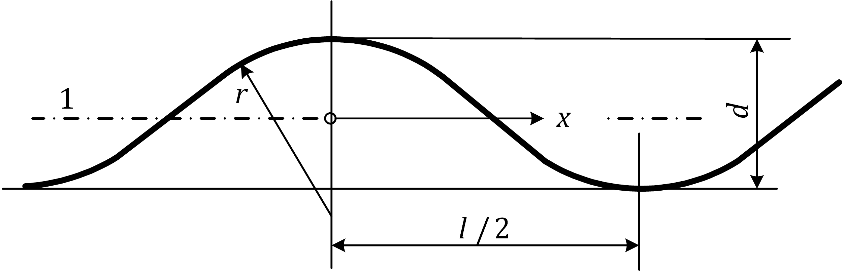

Key

|  |  |
| --- | --- |
| 1 | effective middle surface |

Figure A.14 — Corrugation profile and geometric parameters

* 1. Unstiffened spherical shells under uniform circumferential compression
     1. Notations and boundary conditions

(1) The general quantities are illustrated in Figure A.15.

(2) The boundary conditions are set out in 7.2 and 8.2.2.

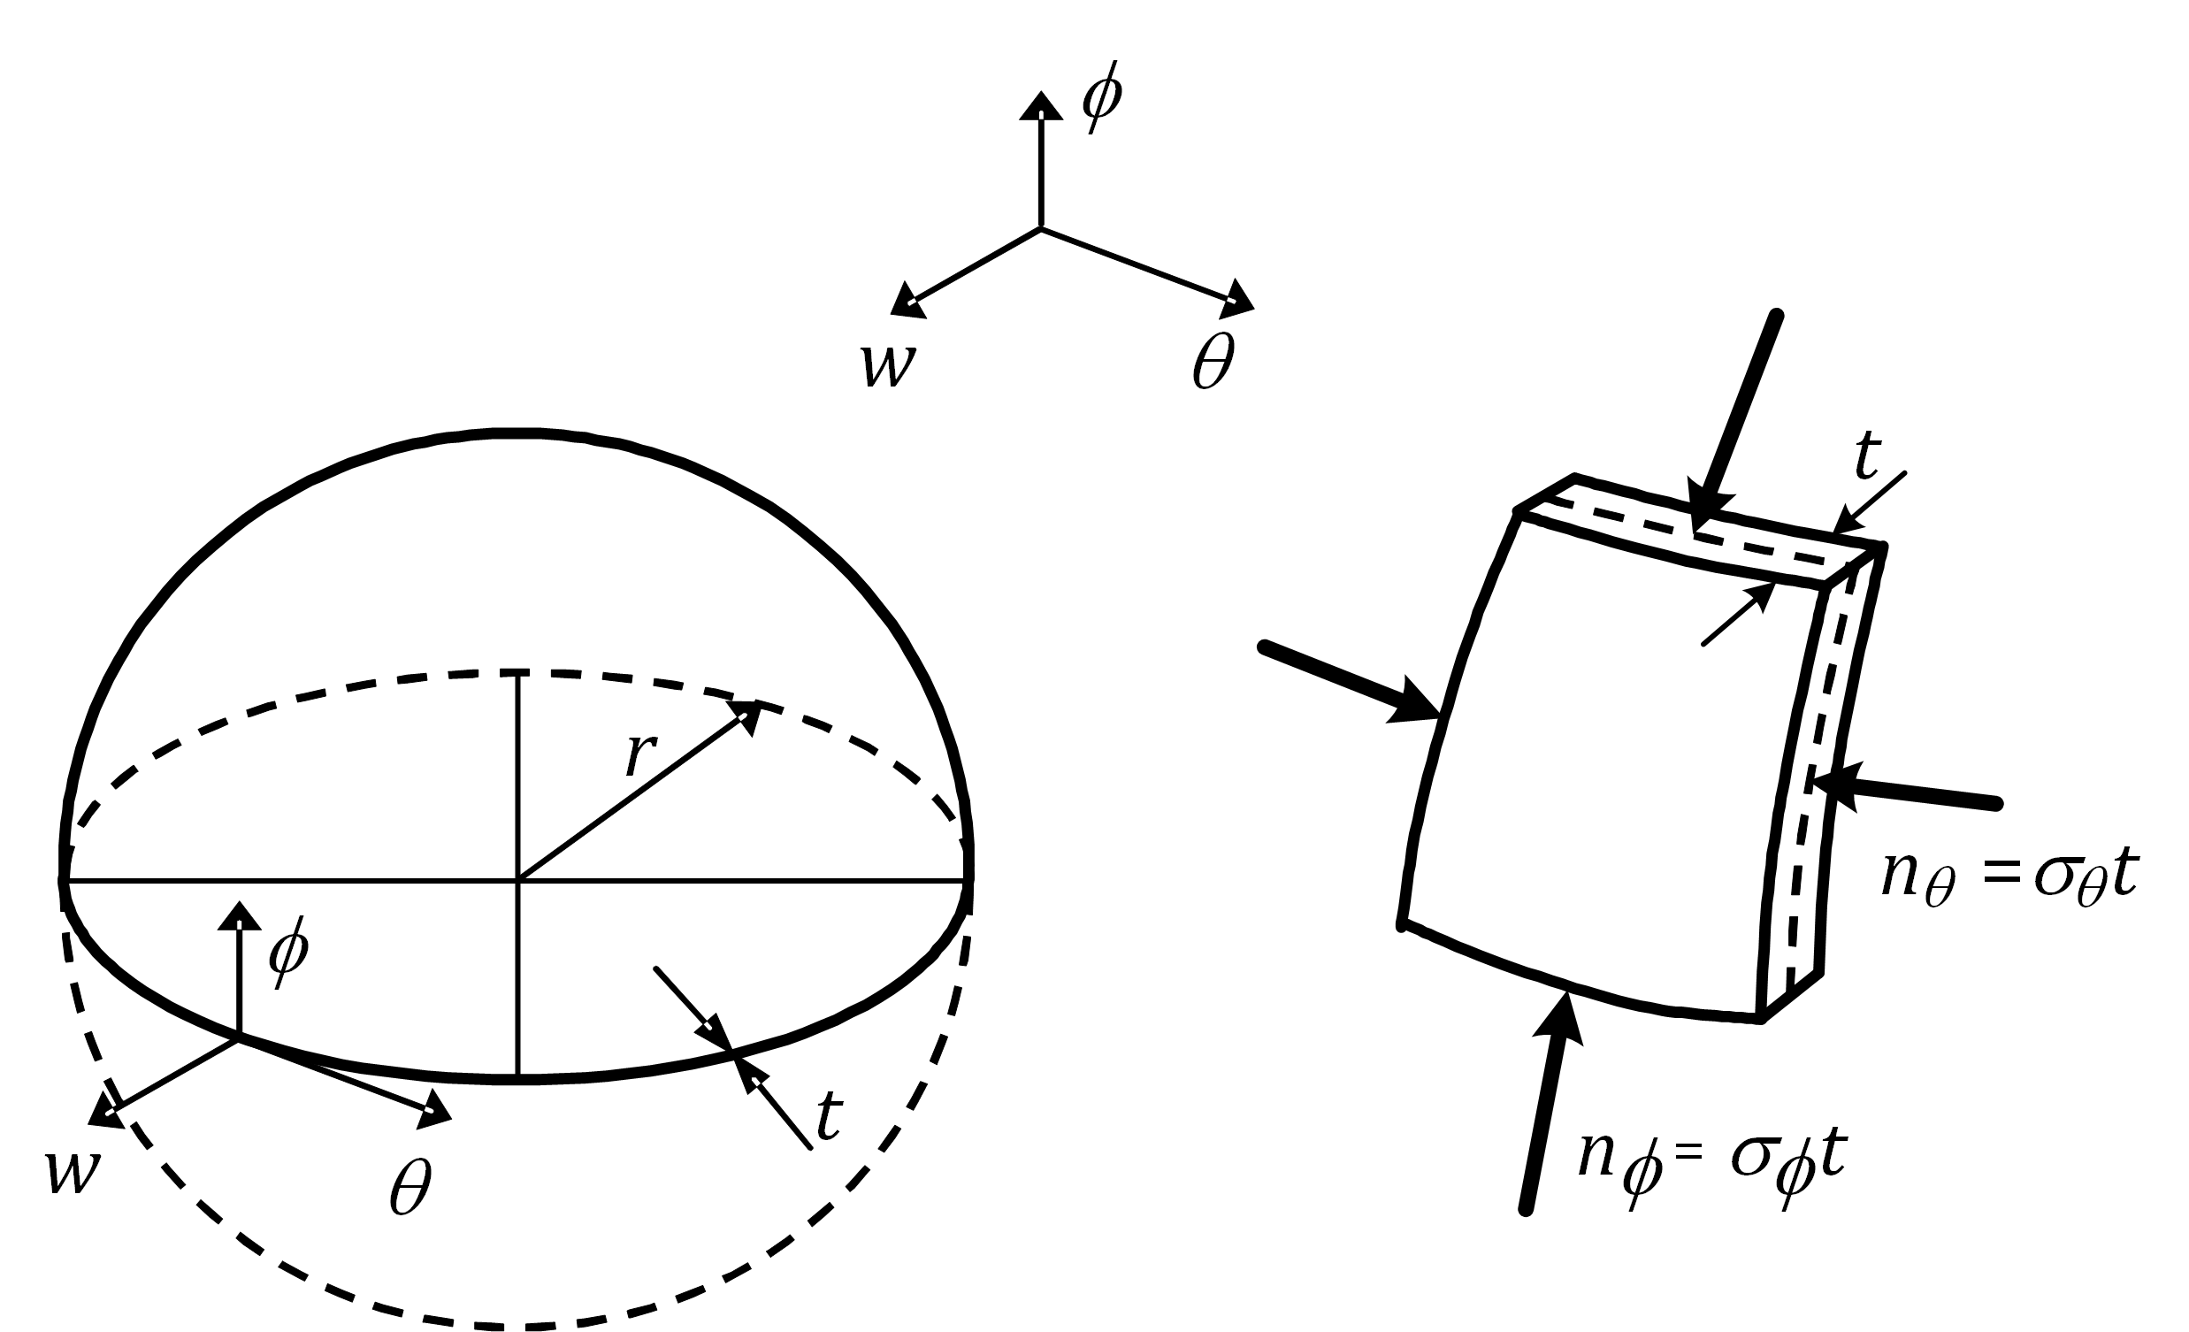

Key

|  |  |
| --- | --- |
| *r* | radius of sphere middle surface; |
| *t* | thickness of shell |

Figure A.15 — Sphere geometry and membrane stresses and stress resultants

* + 1. Critical buckling stresses

(1) The following Formulae may only be used for complete spheres or spherical caps with boundary conditions BC1r or BC1f at the base edge. The external pressure results in two stress components. The check of the circumferential stress takes into account both components.

(2) Uniform circumferential compression in spheres or spherical caps is induced by uniform external pressure or may result from blowing action on circular silos or tank roof during download.

(3) In case of circumferential compression due to uniform external pressure *p* the corresponding stress can be evaluated from Formula (A.65):

*σ*θ = *σ*φ = *pr*/2*t* (A.65)

(4) The critical buckling stress under uniform circumferential compression should be obtained from Formula (A.66):

*σ*θ,cr = *σ*φ,cr = 0,605*Et*/*r* (A.66)

* + 1. Circumferential buckling parameter

(1) The imperfection factor should be obtained from Formula (A.67):

 but *α*θ ≤ 1,00 (A.67)

where

|  |  |
| --- | --- |
|  | is the squash limit slenderness parameter; |
| *Q* | is the tolerance parameter. |

(2) The tolerance parameter, *Q*, should be taken from Table A.14 for the specified tolerance class.

(3) The alloy factor and the squash limit slenderness parameter should be taken from Table A.15 according to the material buckling class as defined in EN 1999‑1‑1.

Table A.14 — Tolerance parameter *Q*

|  |  |
| --- | --- |
| **Tolerance class** | ***Q*** |
| Class 1 | 16 |
| Class 2 | 25 |
| Class 3 and 4 | 40 |

Table A.15 — Values of  and *μ*θ for uniform circumferential compression

|  |  |  |
| --- | --- | --- |
| **Material buckling class** |  | ***μ*θ** |
| A | 0,6 | 0,3 |
| B | 0,65 | 0,35 |
| C | 0,7 | 0,4 |

1. (informative)  
     
   Formulae for buckling analysis of tori-conical and tori-spherical shells
   1. Use of this Annex

(1) This Informative Annex provides additional guidance to that given in 8.2.3.2.

NOTE National choice on the application of this informative Annex is given in the National Annex. If the National Annex contains no information on the application of this informative annex, it can be used.

* 1. Scope and field of application

(1) This Informative Annex applies to conical and spherical ends of cylindrical shells or equivalent structures connected by means of a torus or directly to the cylinder (*r*T = 0).

* 1. Notations and boundary conditions

(1) In this clause the following notations are used, see Figure B.1:

where

|  |  |
| --- | --- |
| *r* | radius of middle surface of the cylindrical shell; |
| *r*S | radius of spherical shell; |
| *α* | angle of the torus shell or half apex angle of the conical shell; |
| *r*T | radius of torus; |
| *t*T | thickness of torus, cone or spherical shell; |
| *l* | length of connecting cylinder; |
| *t*C | wall thickness of connecting cylinder. |

(2) The rules are valid for constant external or internal pressure acting normal to the shell surface.

(3) The range of applicability is as given by Formulae (B.1) to (B.6):

*t*T ≤ *t*C (B.1)

35 ≤ *r*/*t*C ≤ 1250 (B.2)

45° ≤ *α* ≤ 75° (B.3)

0 ≤ *r*T/*r* ≤ 0,4 (B.4)

1,2 ≤ *r*S/*r* ≤ 3 (B.5)

1 ≤ 1000*f*o/*E* ≤ 4 (B.6)

|  |
| --- |
|  |
| **a) tori-conical shape** |
|  |
| **b) tori-spherical shape** |

Figure B.1 — Geometry and loads on vessel ends

* 1. External pressure
     1. Critical external pressure

(1) The critical (buckling) external pressure for a tori-conical shell is given by Formula (B.7):

 or (B.7)

 for *ν* = 0,3

where

 but 

(2) The critical buckling external pressure for a tori-spherical shell is given by Formula (B.8):

 (B.8)

with 

where, *β,* is the larger of *β* = 0,105(*t*C/*r*)0,19 and *β* = 0,088(*r*T/*r*)0,23.

* + 1. Uniform squash limit external pressure

(1) The uniform squash limit external pressure for tori-conical and tori-spherical shells is given by Formula (B.9) or may be found in the graph in Figure B.2 or may, for *r*T = 0, be approximated by Formula (B.10) or (B.11)

 (B.9)

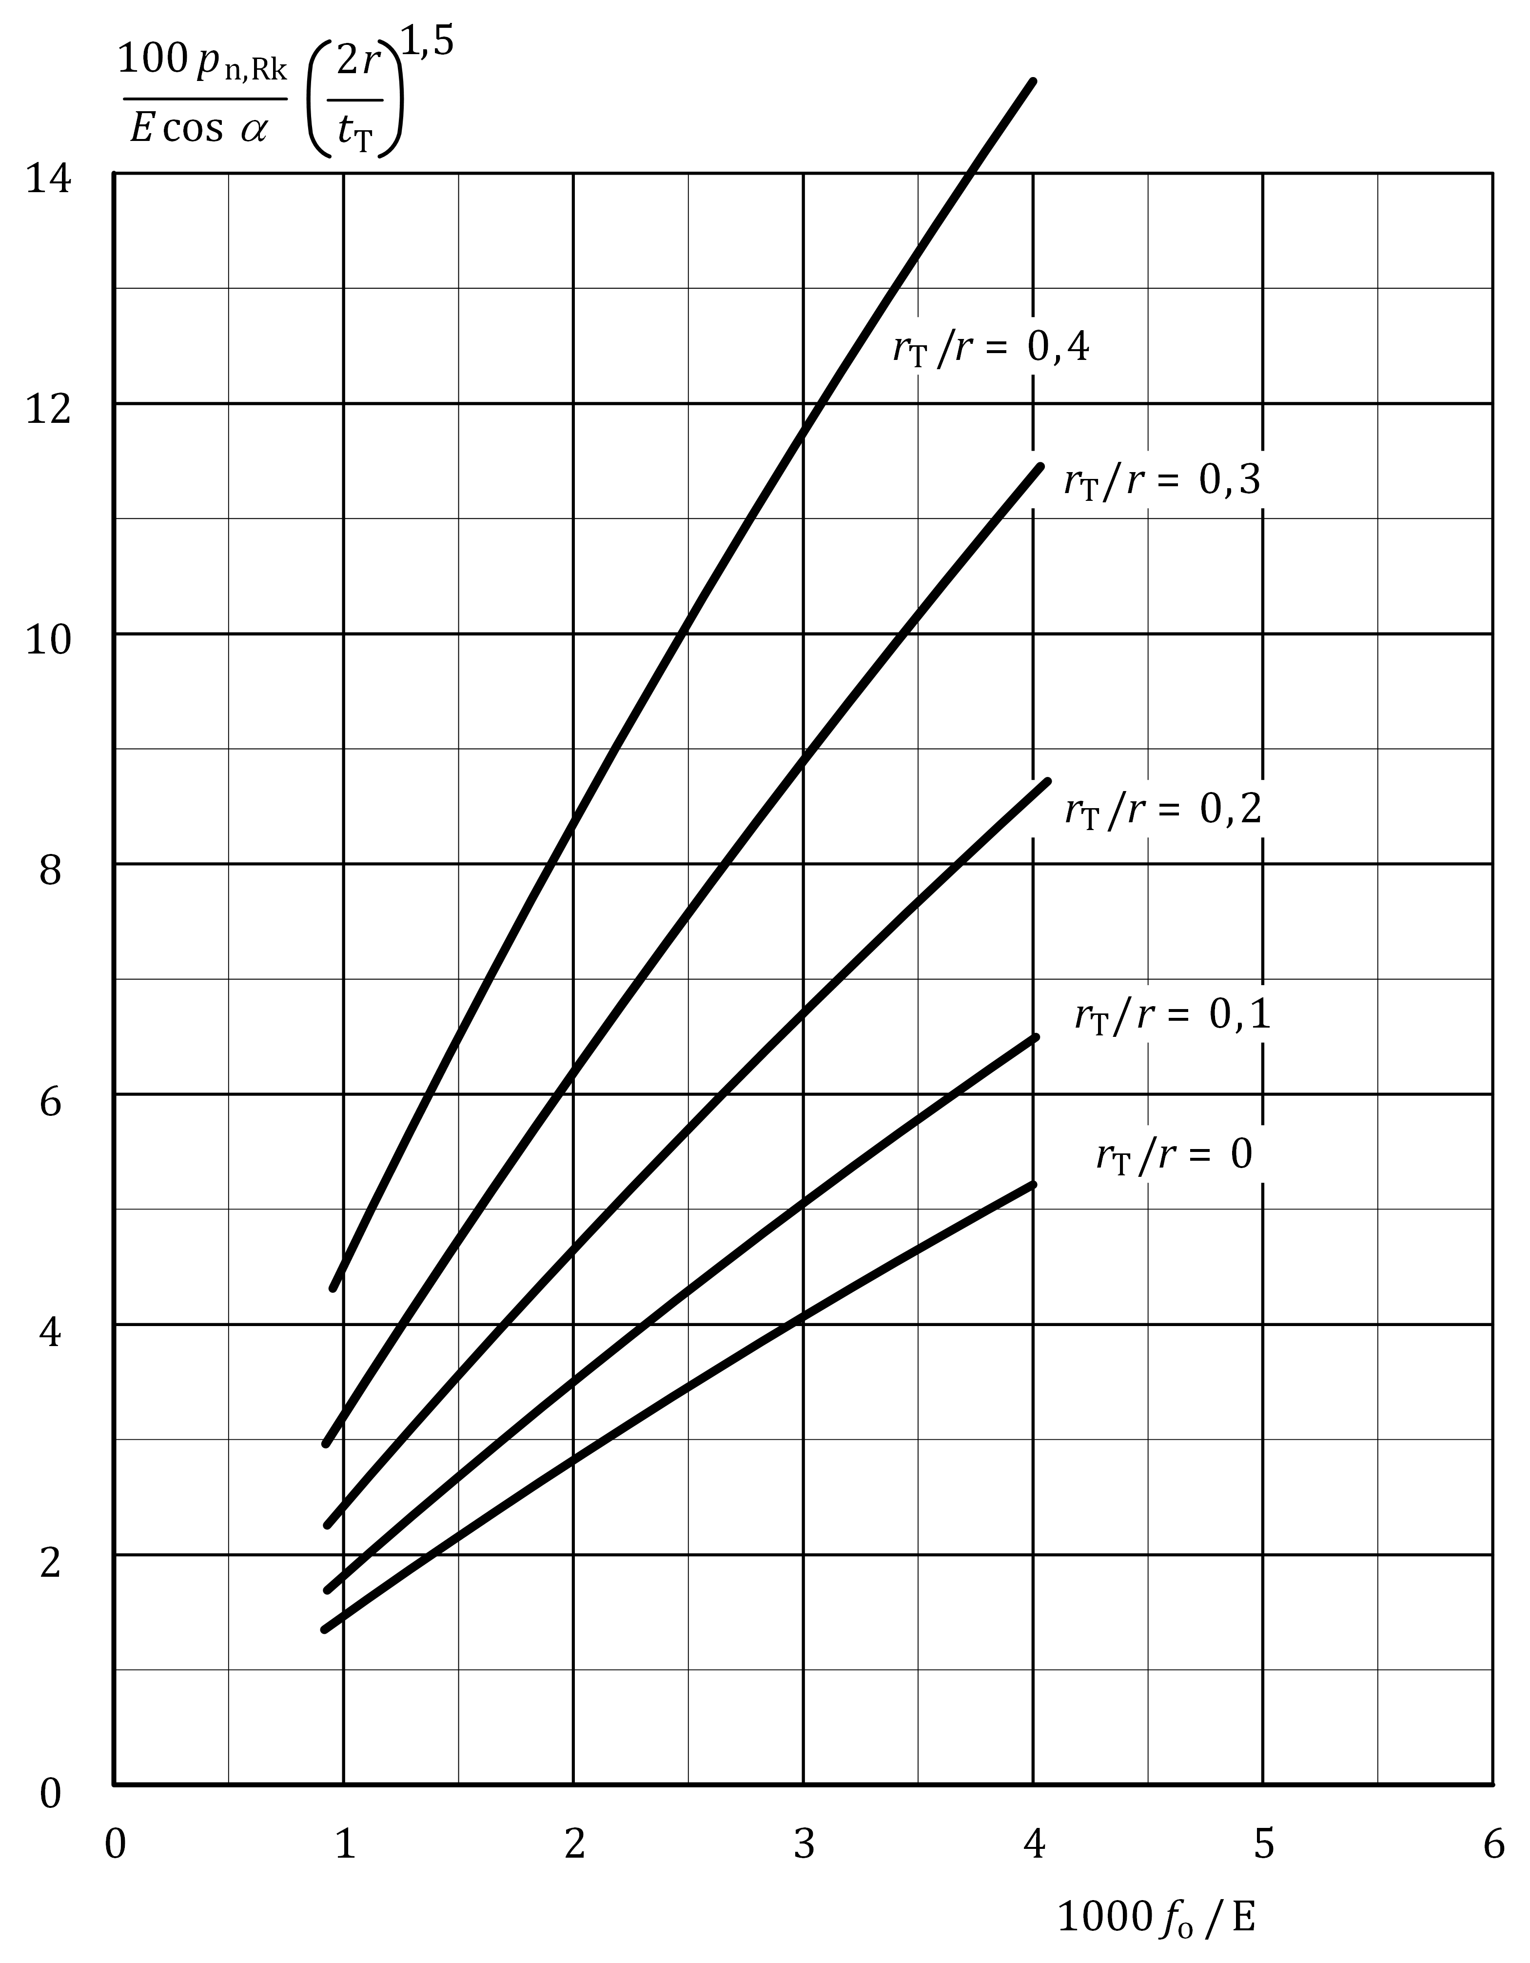

Figure B.2 — Plastic external pressure for tori-conical and tori-spherical shells

— for a tori-conical shell

 (B.10)

— for a tori-spherical shell

 (B.11)

* + 1. External pressure buckling parameter

(1) The imperfection factor should be obtained from Formula (B.12):

 but *α*θ,x ≤ 1,00 (B.12)

where

|  |  |
| --- | --- |
| *Q* | is the tolerance parameter. |

(2) In Formula (8.17) for, *σ*θ,cr, Formula (A.10) should be used with, *t*T/*r*s or *t*T/*r*, as slenderness parameter for tori-spherical and tori-conical shells respectively.

(3) The tolerance parameter, *Q,* should be taken from Table B.1 for the specified tolerance class.

(4) The alloy factor and the squash limit slenderness parameter should be taken from Table B.2 according to the material buckling class as defined in EN 1999‑1‑1.

Table B.1 — Tolerance parameter, *Q*

|  |  |
| --- | --- |
| **Tolerance class** | ***Q*** |
| Class 1 | 16 |
| Class 2 | 25 |
| Class 3 and 4 | 40 |

Table B.2 — Values of  and *μ*θ for external pressure

|  |  |  |
| --- | --- | --- |
| **Material buckling class** |  | ***μ*θ** |
| A | 0,6 | 0,3 |
| B | 0,65 | 0,35 |
| C | 0,7 | 0,4 |

* 1. Internal pressure
     1. Critical internal pressure

(1) The critical (buckling) internal pressure for a tori-conical shell is given by Formulae (B.13) and (B.14):

     if *r*T/2*r* = 0 (B.13)

     if *r*T/2*r* ≠ 0 (B.14)

where parameter, *η*, should be taken from Figure B.3.

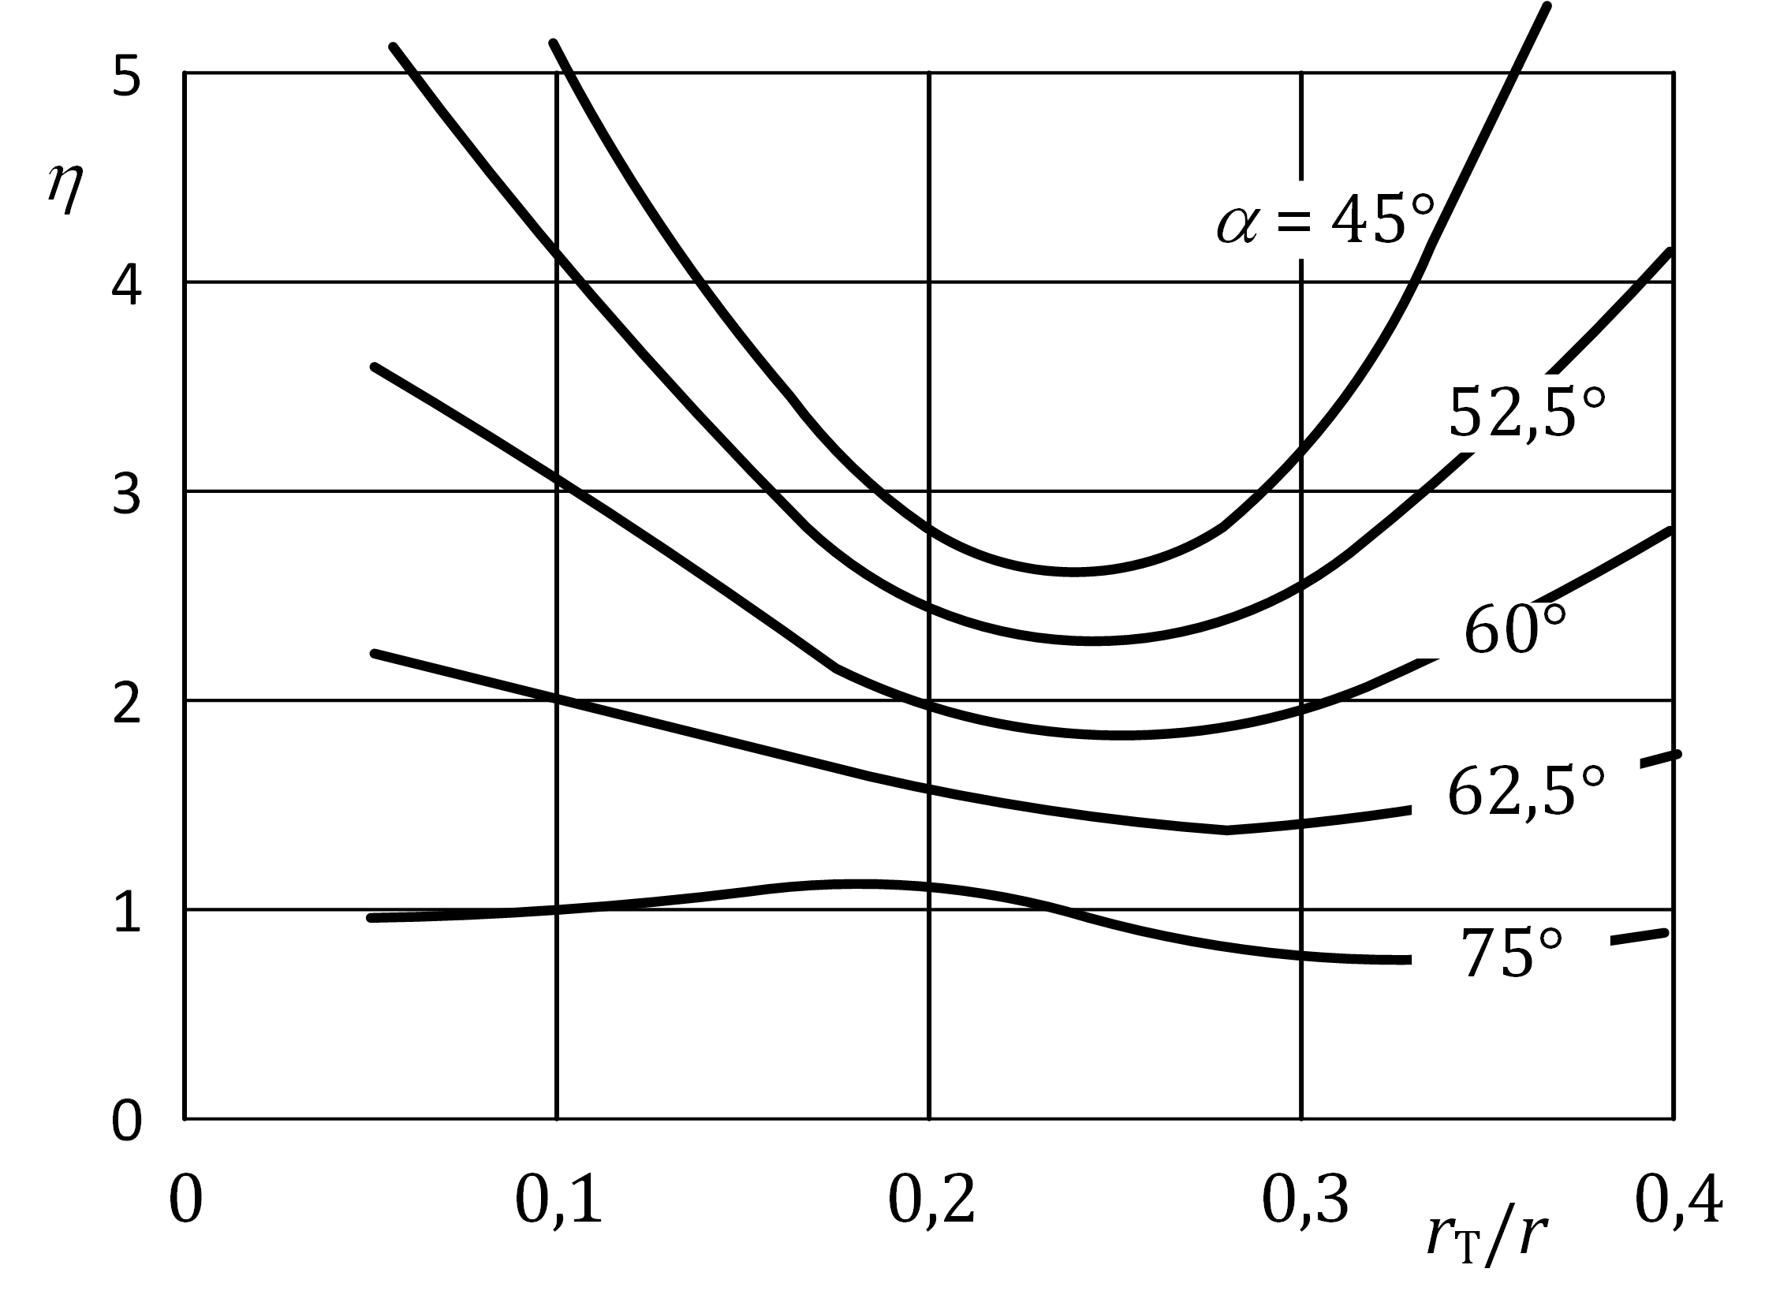

Figure B.3 — Parameter, *η*, for Formula (B.14)

(2) The critical (buckling) internal pressure for a tori-spherical shell is given by Formula (B.15):

 (B.15)

* + 1. Uniform squash limit internal pressure

(1) The uniform squash limit internal pressure for tori-conical and tori-spherical shells is given by Formula (B.16) or may be found in the graph in Figure B.4.

 (B.16)

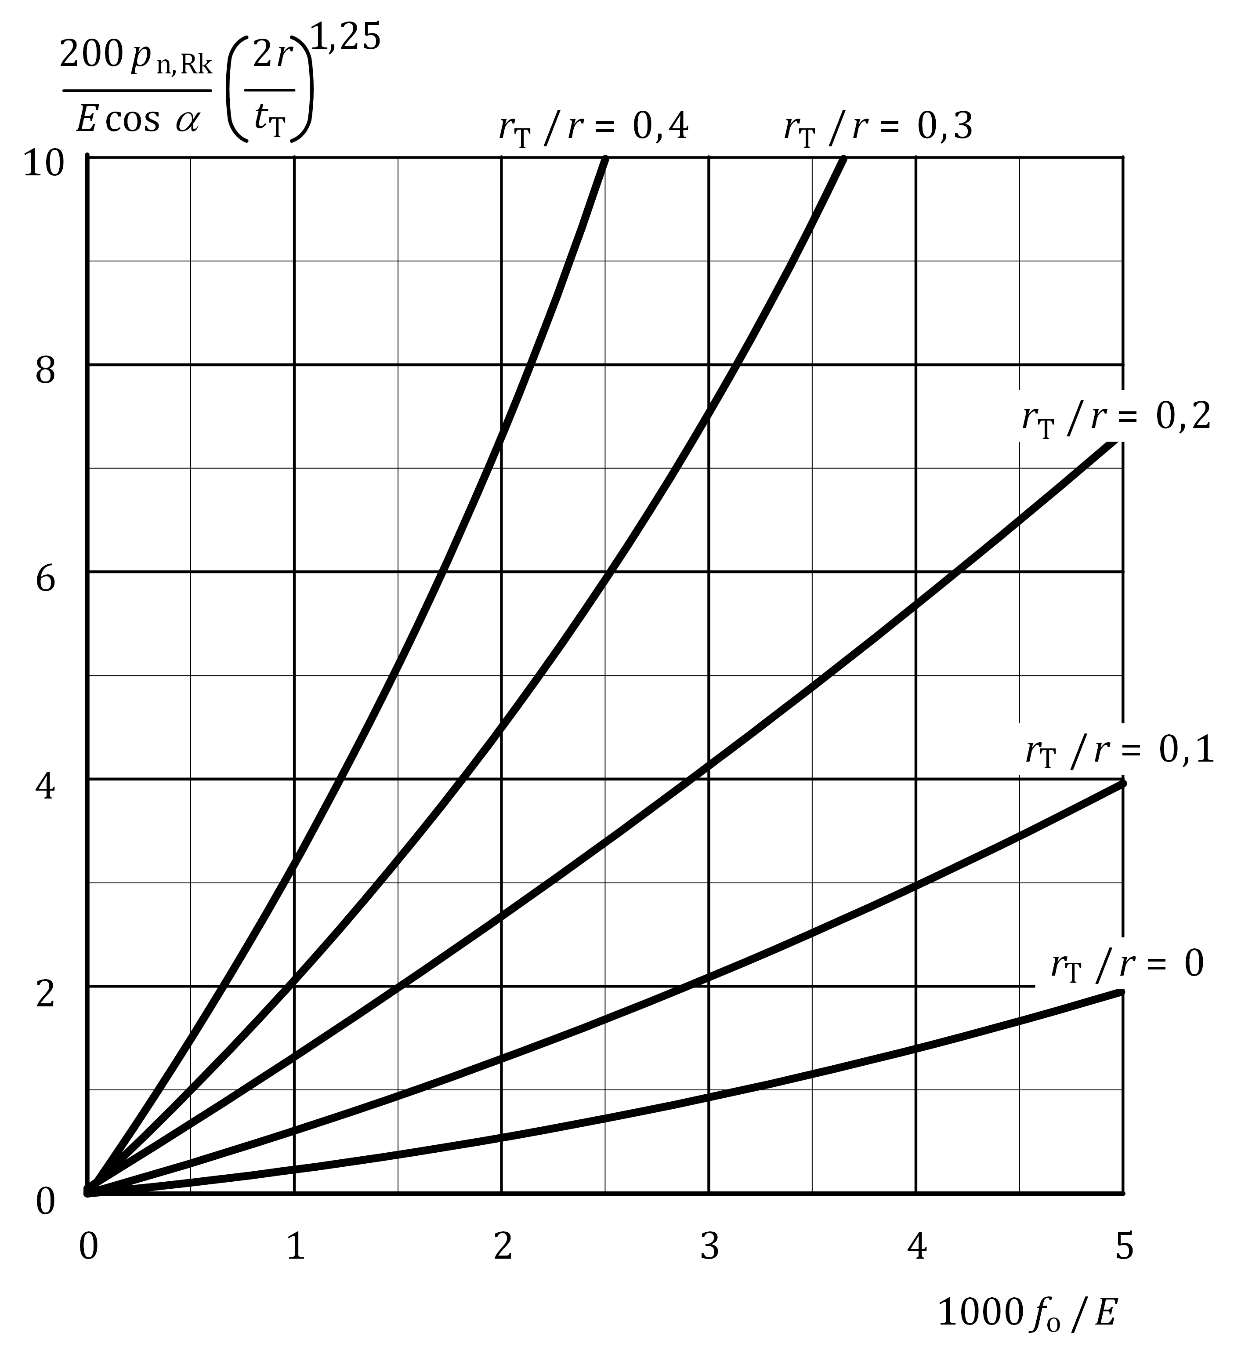

Figure B.4 — Plastic internal pressure for tori-conical and tori-spherical shells

* + 1. Internal pressure buckling parameter

(1) The imperfection factor should be obtained from Formula (B.17):

 but *α*θ,x ≤ 1,00 (B.17)

where

|  |  |
| --- | --- |
| *Q* | is the tolerance parameter. |

(2) In Formula (8).17) for, *σ*θ,cr, Formula (A.10) should be used with, *t*T/*r*s or *t*T/*r*, as slenderness parameter for tori-spherical and tori-conical shells respectively.

(3) The tolerance parameter, *Q*, should be taken from Table B.3 for the specified tolerance class.

(4) The alloy factor and the squash limit slenderness parameter should be taken from Table B.4 according to the material buckling class as defined in EN 1999‑1‑1.

Table B.3 — Tolerance parameter, *Q*, for internal pressure

|  |  |
| --- | --- |
| **Tolerance class** | **Q** |
| Class 1 | 16 |
| Class 2 | 25 |
| Class 3 and 4 | 40 |

Table B.4 — Values of  and *μ*θ for internal pressure

|  |  |  |
| --- | --- | --- |
| **Material buckling class** |  | ***μ*θ** |
| A | 0,6 | 0,3 |
| B | 0,65 | 0,35 |
| C | 0,7 | 0,4 |

Bibliography

References contained in permissions (i.e. through “may” clauses)

The following documents are referred to in the text in such a way that some or all of their content, although not requirements strictly to be followed, expresses a course of action permissible within the limits of the Eurocodes. For dated references, only the edition cited applies. For undated references, the latest edition of the referenced document (including any amendments) applies.

[1] EN 1090‑3, Execution of steel structures and aluminium structures - Part 3: Technical requirements for aluminium structures

[2] EN 1991 (all parts), Eurocode 1: Actions on structures

[3] EN 1993 (all parts), Eurocode 3: Design of steel structures

[4] EN 1999‑1‑4:2007﻿[1], Design of aluminium structures — Part 1-4: Cold-formed structural sheeting

References contained as information (e.g. through “can” clauses)

[5] EN 1999‑1‑2, Eurocode 9 - Design of aluminium structures - Part 1-2: Structural fire design

1. As impacted by EN 1999-1-4:2007/A1:2011 and EN 1999-1-4:2007/AC:2009.