prEN EN 1999-1-3:2020 (E) 511Eurocode 9 — Calcul des structures en aluminium — Partie 1-3 : Structures sensibles à la fatigueEurocode 9 — Bemessungen und Konstruktion von Aluminiumtragwerken — Teil 1-3: Ermüdungsbeanspruchte TragwerkeEurocode 9 — Design of aluminium structures — Part 1-3: Structures susceptible to fatigueE0   00    202009CEN EnquiryCEN 1European StandardEuropean StandardEN EN 1999-1-3prEN EN 1999-1-3:2020 0False1-3 SNEN1999-1-3250 2Overskrift 2Overskrift 1     0 STD Version 2.9p40   1https://standardnorge1-my.sharepoint.com/personal/ros_standard_no/Documents/Mine Dok 1/K CEN TC 250/CEN TC 250 SC 9 ALUMINIUM/NS-EN 1999 - Enquiry 2020/EN 1999-1-3/EN 1999-1-3 2020-09-10 Update after TC250 review, CLEAN.docx            CEN/TC 250

Date: 2020-09

prEN 1999‑1‑3:2021

CEN/TC 250

Secretariat: SN

Eurocode 9 — Design of aluminium structures — Part 1-3: Structures susceptible to fatigue

*Eurocode 9 — Bemessungen und Konstruktion von Aluminiumtragwerken — Teil 1-3: Ermüdungsbeanspruchte Tragwerke*

*Eurocode 9 — Calcul des structures en aluminium — Partie 1-3 : Structures sensibles à la fatigue*

ICS:

Descriptors:

Contents Page

European foreword 7

Introduction 8

1 Scope 11

1.1 Scope of EN 1999‑1‑3 11

1.2 Assumptions 11

2 Normative references 11

3 Terms, definitions and symbols 11

3.1 Terms and definitions 11

3.2 Symbols 15

4 Basis of design 17

4.1 Basic rules 17

4.2 Methods of fatigue design 18

4.2.1 Safe life design (SLD) 18

4.2.2 Damage tolerant design (DTD) 18

4.2.3 Design assisted by testing 19

4.3 Fatigue loading 19

4.3.1 Sources of fatigue loading 19

4.3.2 Derivation of fatigue loading 19

4.3.3 Equivalent fatigue loading 20

4.4 Partial factors for fatigue loads 20

4.5 Execution requirements 20

4.5.1 General 20

4.5.2 Execution classes 21

4.5.3 Execution specification 21

4.5.4 Operation manual 21

4.5.5 Inspection and maintenance manual 21

5 Materials, constituent products and connecting devices 21

6 Durability 22

7 Structural analysis 22

7.1 Global analysis 22

7.1.1 General 22

7.1.2 Use of beam elements 24

7.1.3 Use of membrane, shell and solid elements 24

7.2 Types of stresses 24

7.2.1 General 24

7.2.2 Nominal stresses 25

7.2.3 Modified nominal stresses 25

7.2.4 Hot spot stresses 25

7.3 Derivation of stresses 27

7.3.1 Derivation of nominal stresses 27

7.3.2 Derivation of modified nominal stresses 27

7.3.3 Derivation of hot spot stresses 28

7.3.4 Stress orientation 28

7.4 Stress ranges for specific initiation sites 29

7.4.1 Parent material, welds, and mechanically fastened joints 29

7.4.2 Fillet and partial penetration butt welds 29

7.5 Adhesive bonds 30

7.6 Castings 30

7.7 Stress spectra 30

7.8 Calculation of equivalent stress range for standardized fatigue load models 30

7.8.1 General 30

7.8.2 Design value of stress range 31

8 Fatigue resistance and detail categories 31

8.1 Detail categories 31

8.1.1 General 31

8.1.2 Factors affecting detail category 31

8.1.3 Constructional details 32

8.2 Fatigue strength data 32

8.2.1 Classified constructional details 32

8.2.2 Unclassified details 35

8.2.3 Adhesively bonded joints 35

8.2.4 Determination of the reference hot spot strength values 35

8.3 Effect of mean stress 35

8.3.1 General 35

8.3.2 Plain material and mechanically fastened joints 35

8.3.3 Welded joints 35

8.3.4 Adhesive joints 36

8.3.5 Low endurance range 36

8.3.6 Cycle counting for *R*-ratio calculations 36

8.4 Effect of exposure conditions 36

8.5 Improvement techniques 37

Annex A (normative) Basis for calculation of fatigue resistance 38

A.1 Use of this annex 38

A.2 Scope and field of application 38

A.3 General 38

A.3.1 Influence of fatigue on design 38

A.3.2 Mechanism of failure 38

A.3.3 Potential sites for fatigue cracking 39

A.3.4 Conditions for fatigue susceptibility 39

A.4 Safe life design 40

A.4.1 General 40

A.4.2 Prerequisites for safe life design 41

A.4.3 Design approach 41

A.4.4 Cycle counting 43

A.4.5 Derivation of stress spectrum 44

A.5 Damage tolerant design 45

A.5.1 Prerequisites for damage tolerant design 45

A.5.2 Structural layout and detailing 46

A.5.3 Determination of inspection strategy for damage tolerant design 46

Annex B (informative) Guidance on assessment of crack growth by fracture mechanics 49

B.1 Use of this Informative Annex 49

B.2 Scope and field of application 49

B.3 Principles 49

B.3.1 Flaw dimensions 49

B.3.2 Crack growth relationship 50

B.4 Crack growth data *A* and *m* 51

B.5 Geometry function *y* 52

B.6 Integration of crack growth 52

B.7 Assessment of maximum crack size *a*2 53

Annex C (informative) Testing for fatigue design 62

C.1 Use of this Informative Annex 62

C.2 Scope and field of application 62

C.3 Derivation of action loading data 62

C.3.1 Fixed structures subject to mechanical action 62

C.3.2 Fixed structures subject to actions due to exposure conditions 63

C.3.3 Moving structures 63

C.4 Derivation of stress data 63

C.4.1 Component test data 63

C.4.2 Structure test data 64

C.4.3 Verification of stress history 64

C.5 Derivation of endurance data 64

C.5.1 Component testing 64

C.5.2 Full scale testing 65

C.5.3 Acceptance 65

C.6 Crack growth data 68

C.7 Reporting 68

Annex D (informative) Stress analysis 70

D.1 Use of this Informative Annex 70

D.2 Scope and field of application 70

D.3 Use of finite elements for fatigue analysis 70

D.3.1 Element types 70

D.3.2 Further guidance on use of finite elements 71

D.4 Stress concentration factors 71

D.5 Limitation of fatigue induced by repeated local buckling 73

Annex E (informative) Adhesively bonded joints 74

E.1 Use of this Informative Annex 74

E.2 Scope and field of application 74

Annex F (informative) Low cycle fatigue range 77

F.1 Use of this Informative Annex 77

F.2 Scope and field of application 77

F.3 Modification to fatigue strength curves 77

F.4 Test data 77

Annex G (informative) Influence of applied stress ratio *R* 79

G.1 Use of this Informative Annex 79

G.2 Scope and field of application 79

G.3 Enhancement of fatigue strength 79

G.4 Enhancement cases 79

G.4.1 Case 1 79

G.4.2 Case 2 80

G.4.3 Case 3 81

Annex H (informative) Fatigue strength improvement of welds 82

H.1 Use of this Informative Annex 82

H.2 Scope and field of application 82

H.3 Machining or grinding 83

H.4 Dressing by TIG or plasma 83

H.5 Peening 84

Annex I (informative) Castings 85

I.1 Use of this Informative Annex 85

I.2 Scope and field of application 85

I.3 Fatigue strength data 85

I.3.1 Plain castings 85

I.3.2 Welded material 85

I.3.3 Mechanically joined castings 86

I.3.4 Adhesively bonded castings 86

I.4 Quality requirements 86

Annex J (informative) Detail category tables 87

J.1 Use of this Informative Annex 87

J.2 Scope and field of application 87

Annex K (informative) Hot spot reference detail method 116

K.1 Use of this Informative Annex 116

K.2 Scope and field of application 116

K.3 Hot spot reference detail method 116

Annex L (informative) Guidance on use of design methods, selection of partial factors, limits for damage values, inspection intervals and execution parameters if Annex J is adopted 117

L.1 Use of this Informative Annex 117

L.2 Scope and field of application 117

L.3 Safe life design approach 117

L.3.1 General 117

L.3.2 SLD-I 117

L.3.3 SLD-II 118

L.4 Damage tolerant design approach 118

L.4.1 General 118

L.4.2 DTD-I 118

L.4.3 DTD-II 119

L.5 Start of inspection and inspection intervals 119

L.6 Partial factors *γ*Mf and the values of *D*Lim 120

L.7 Parameters for execution 122

L.7.1 Service category 122

L.7.2 Calculation of utilization grade 123

Bibliography 125

European foreword

This document (prEN 1999‑1‑3:2021) has been prepared by Technical Committee CEN/TC250 “Structural Eurocodes”, the secretariat of which is held by BSI. CEN/TC 250 is responsible for all Structural Eurocodes and has been assigned responsibility for structural and geotechnical design matters by CEN.

This document is currently submitted to the CEN Enquiry.

This document will supersede EN 1999‑1‑3:2007.

The first generation of EN Eurocodes was published between 2002 and 2007. This document forms part of the second generation of the Eurocodes, which have been prepared under Mandate M/515 issued to CEN by the European Commission and the European Free Trade Association.

The Eurocodes have been drafted to be used in conjunction with relevant execution, material, product and test standards, and to identify requirements for execution, materials, products and testing that are relied upon by the Eurocodes.

The Eurocodes recognize the responsibility of each member State and have safeguarded their right to determine values related to regulatory safety matters at national level through the use of National Annexes.

Introduction

**0.1 Introduction to the Eurocodes**

The Structural Eurocodes comprise the following standards generally consisting of a number of Parts:

— EN 1990 Eurocode: Basis of structural and geotechnical design

— EN 1991 Eurocode 1: Actions on structures

— EN 1992 Eurocode 2: Design of concrete structures

— EN 1993 Eurocode 3: Design of steel structures

— EN 1994 Eurocode 4: Design of composite steel and concrete structures

— EN 1995 Eurocode 5: Design of timber structures

— EN 1996 Eurocode 6: Design of masonry structures

— EN 1997 Eurocode 7: Geotechnical design

— EN 1998 Eurocode 8: Design of structures for earthquake resistance

— EN 1999 Eurocode 9: Design of aluminium structures

— < New parts >

The Eurocodes are intended for use by designers, clients, manufacturers, constructors, relevant authorities (in exercising their duties in accordance with national or international regulations), educators, software developers, and committees drafting standards for related product, testing and execution standards.

NOTE Some aspects of design are most appropriately specified by relevant authorities or, where not specified, can be agreed on a project-specific basis between relevant parties such as designers and clients. The Eurocodes identify such aspects making explicit reference to relevant authorities and relevant parties.

**0.2 Introduction to** **EN** **1999** **Eurocode 9**

EN 1999 (all parts) applies to the design of buildings and civil engineering and structural works made of aluminium. It complies with the principles and requirements for the safety and serviceability of structures, the basis of their design and verification that are given in EN 1990 – Basis of structural design.

EN 1999 (all parts) is only concerned with requirements for resistance, serviceability, durability and fire resistance of aluminium structures. Other requirements, e.g. concerning thermal or sound insulation, are not considered.

EN 1999 (all parts) does not cover the special requirements of seismic design. Provisions related to such requirements are given in EN 1998, which complements, and is consistent with EN 1999.

EN 1999 is subdivided in five parts:

— EN 1999‑1‑1 Design of Aluminium Structures: General structural rules.

— EN 1999‑1‑2 Design of Aluminium Structures: Structural fire design.

— EN 1999‑1‑3 Design of Aluminium Structures: Structures susceptible to fatigue.

— EN 1999‑1‑4 Design of Aluminium Structures: Cold-formed structural sheeting.

— EN 1999‑1‑5 Design of Aluminium Structures: Shell structures.

**0.3 Introduction to** **EN** **1999‑1‑3**

This document gives the basis for the design of aluminium alloy structures subject to fatigue in the ultimate limit state.

**0.4 Verbal forms used in the Eurocodes**

The verb “shall” expresses a requirement strictly to be followed and from which no deviation is permitted in order to comply with the Eurocodes.

The verb “should” expresses a highly recommended choice or course of action. Subject to national regulation and/or any relevant contractual provisions, alternative approaches could be used/adopted where technically justified.

The verb “may” expresses a course of action permissible within the limits of the Eurocodes.

The verb “can” expresses possibility and capability; it is used for statements of fact and clarification of concepts.

**0.5 National annex for** **prEN** **1999‑1‑3**

National choice is allowed in this document where explicitly stated within notes. National choice includes the selection of values for Nationally Determined Parameters (NDPs).

The national standard implementing EN 1999‑1‑3 can have a National Annex containing all national choices to be used for the design of buildings and civil engineering works to be constructed in the relevant country.

When no national choice is given, the default choice given in this document is to be used.

When no national choice is made and no default is given in this document, the choice can be specified by a relevant authority or, where not specified, agreed for a specific project by appropriate parties.

National choice is allowed in EN 1999‑1‑3 through the following clauses:

4.1(2) NOTE

4.3.1(2) NOTE

4.3.2(6) NOTE

4.4(1) NOTE 1

4.4(1) NOTE 2

5(1) NOTE

6(2) NOTE

7.8.1(1) NOTE

7.8.2(1) NOTE 1

8.1.3(1) NOTE 1

8.1.3(1) NOTE 2

8.2.1(2) NOTE 2

8.2.1(6) NOTE

8.2.1(9) NOTE

A.4.1(4) NOTE

A.4.1(5) NOTE

E.2(6) NOTE

E.2(8) NOTE

I.3.2(1) NOTE

I.3.3.2(1) NOTE 2

I.3.4(1) NOTE

L.4.2 (5) NOTE

L.5 (2) NOTE

L.6 (3) NOTE 1

L.6 (3) NOTE 2

L.6 (4) NOTE

L.6 (5) NOTE

L.7.1 (1) NOTE

National choice is allowed in EN 1999‑1‑3 on the application of the following informative annexes:

Annex B (informative) Guidance on assessment of crack growth by fracture mechanics

Annex C (informative) Testing for fatigue design

Annex D (informative) Stress analysis

Annex E (informative) Adhesively bonded joints

Annex F (informative) Low cycle fatigue range

Annex G (informative) Influence of applied stress ratio R

Annex H (informative) Fatigue strength improvement of welds

Annex I (informative) Castings

Annex J (informative) Detail category tables

Annex K (informative) Hot spot reference detail method

Annex L (informative) Guidance on use of design methods, selection of partial factors, limits for damage values, inspection intervals and execution parameters if Annex J is adopted

The National Annex can contain, directly or by reference, non-contradictory complementary information for ease of implementation, provided it does not alter any provisions of the Eurocodes.

# Scope

## Scope of EN 1999‑1‑3

(1) This document gives the basis for the design of aluminium alloy structures subject to fatigue in the ultimate limit state.

(2) This document gives rules for:

— safe life design;

— damage tolerant design;

— design assisted by testing.

(3) This document does not cover pressurized containment vessels or pipework.

## Assumptions

(1) The general assumptions of EN 1990 apply.

(2) The provisions of EN 1999‑1‑1 apply.

(3) EN 1999‑1‑3 is intended to be used in conjunction with EN 1990, EN 1991 (all parts), relevant parts in EN 1992 to EN 1999, EN 1090‑1 and EN 1090‑3 for requirements for execution, and ENs, EADs and ETAs for construction products relevant to aluminium structures.

# Normative references

The following documents are referred to in the text in such a way that some or all of their content constitutes requirements of this document. For dated references, only the edition cited applies. For undated references, the latest edition of the referenced document (including any amendments) applies.

EN 1090‑3:2019, Execution of steel structures and aluminium structures - Part 3: Technical requirements for aluminium structures

EN 1990, Eurocode - Basis of structural design

EN 1991 (all parts), Eurocode 1: Actions on structures (All parts)

prEN 1999‑1‑1:2021, Design of aluminium structures — Part 1-1: General structural rules

# Terms, definitions and symbols

## Terms and definitions

For the purposes of this document, the terms and definitions given in EN 1990 and EN 1999‑1‑1 and the following apply.

3.1.1

fatigue

weakening of a structural part, through crack initiation and propagation caused by repeated stress fluctuations

3.1.2

fatigue loading

set of typical load events described by the positions or movements of actions, their variation in intensity and their frequency and sequence of occurrence

3.1.3

loading event

defined load sequence applied to the structure, which, for design purposes, is assumed to repeat at a given frequency

3.1.4

nominal stress

stress in the parent material adjacent to a potential crack location, calculated in accordance with simple elastic strength of materials theory, i.e. assuming that plane sections remain plane and that all stress concentration effects are ignored

3.1.5

modified nominal stress

nominal stress increased by an appropriate geometrical stress concentration factor, *K*gt, to allow only for geometric changes of cross section which have not been taken into account in the classification of a particular constructional detail

3.1.6

geometric stress

structural stress

elastic stress at a point, taking into account all geometrical discontinuities, but ignoring any local singularities where the transition radius tends to zero, such as notches due to small discontinuities, e.g. weld toes, cracks, crack like features, normal machining marks etc., and is in principle the same stress parameter as the modified nominal stress, but generally evaluated by a different method

3.1.7

geometric stress concentration factor

ratio between the geometric stress evaluated with the assumption of linear elastic behaviour of the material and the nominal stress

3.1.8

hot spot stress

geometric stress at a specified initiation site in a particular type of geometry, such as a weld toe in an angle hollow section joint, for which the fatigue strength, expressed in terms of the hot spot stress range, is usually known

3.1.9

stress history

continuous chronological record, either measured or calculated, of the stress variation at a particular point in a structure for a given period of time

3.1.10

stress turning point

value of stress in a stress history where the rate of change of stress changes sign

3.1.11

stress peak

turning point where the rate of change of stress changes from positive to negative

3.1.12

stress valley

turning point where the rate of change of stress changes from negative to positive

3.1.13

constant amplitude

relating to a stress history where the stress alternates between stress peaks and stress valleys of constant values

3.1.14

variable amplitude

relating to any stress history containing more than one value of peak or valley stress

3.1.15

stress cycle

part of a constant amplitude stress history where the stress starts and finishes at the same value but, in doing so passes through one stress peak and one stress valley (in any sequence) and a specific part of a variable amplitude stress history as determined by a cycle counting method

3.1.16

cycle counting

process of transforming a variable amplitude stress history into a spectrum of stress cycles, each with a particular stress range, e.g. the 'rainflow' method and the 'reservoir' method

3.1.17

rainflow method

particular cycle counting method of producing a stress-range spectrum from a given stress history

3.1.18

reservoir method

particular cycle counting method of producing a stress-range spectrum from a given stress history

3.1.19

stress amplitude

half the value of the stress range

3.1.20

stress ratio

minimum stress divided by the maximum stress in a constant amplitude stress history or a cycle derived from a variable amplitude stress history

3.1.21

stress intensity ratio

minimum stress intensity divided by the maximum stress intensity, derived from a constant amplitude stress history or from a cycle in a variable amplitude stress history

3.1.22

mean stress

mean value of the algebraic sum of maximum and minimum stress values

3.1.23

stress range

algebraic difference between the stress peak and the stress valley in a stress cycle

3.1.24

stress intensity range

algebraic difference between the maximum stress intensity and the minimum stress intensity derived from the stress peak and the stress valley in a stress cycle

3.1.25

stress-range spectrum

stress spectrum

histogram of the frequency of occurrence for all stress ranges of different magnitudes recorded or calculated for a particular load event

3.1.26

design spectrum

total of all stress-range spectra relevant to the fatigue assessment

3.1.27

detail category

designation given to a particular fatigue initiation site for a given direction of stress fluctuation in order to indicate which fatigue strength curve is applicable for the fatigue assessment

3.1.28

endurance

life to failure expressed in cycles, under the action of a constant amplitude stress history

3.1.29

fatigue strength curve

quantitative relationship relating stress range and endurance, used for the fatigue assessment of a category of constructional detail, plotted with logarithmic axes in this document

Note 1 to entry: The fatigue resistance curves are also known as logΔσ-logN curves, S-N curves, or Wöhler curves.

3.1.30

reference fatigue strength

constant amplitude stress range Δ*σ*c for a particular detail category for an endurance *N*C = 2×106cycles

3.1.31

constant amplitude fatigue limit

stress range below which all stress ranges in the design spectrum should lie for fatigue damage to be ignored

3.1.32

cut-off limit

limit below which stress ranges of the design spectrum may be omitted from the cumulative damage calculation

3.1.33

design service life

assumed period for which a structure or part of it is to be used for its intended purpose with anticipated maintenance but without major repair being necessary

3.1.34

safe life

period of time for which a structure is estimated to perform safely with an acceptable probability that failure by fatigue cracking will not occur, when using the safe life design approach

3.1.35

damage tolerance

ability of the structure to accommodate fatigue cracking without structural failure or unserviceability

3.1.36

fatigue damage

ratio of the number of cycles of a given stress range which is required to be sustained during a specified period of service to the endurance of the constructional detail under the same stress range

3.1.37

Miner's summation

summation of the damage due to all cycles in a stress-range spectrum (or a design spectrum), based on the Palmgren-Miner rule

3.1.38

equivalent fatigue loading

simplified loading, usually a single load applied a prescribed number of times in such a way that it may be used in place of a more realistic set of loads, within a given range of conditions, to give an equivalent amount of fatigue damage, to an acceptable level of approximation

3.1.39

equivalent stress range

stress range at a constructional detail caused by the application of an equivalent fatigue load

3.1.40

equivalent constant amplitude loading

simplified constant amplitude loading causing the same fatigue damage effects as a series of actual variable amplitude load events

## Symbols

|  |  |
| --- | --- |
| **Latin upper-case letters** | |
| *A* | constant in the crack growth relationship |
| *D* | fatigue damage value calculated for a given period of service |
| *D*L | fatigue damage value calculated for the full design service life |
| *D*L,d | design fatigue damage value calculated for the full design service life |
| *D*lim | prescribed limit of the fatigue damage value |
| *K* | stress intensity factor |
| *K*gt | geometric stress concentration factor |
| *L*adh | effective length of adhesively bonded lap joints |
| *N* | number (or total number) of stress range cycles |
| *N*C | number of cycles (2 × 106) at which the reference fatigue strength is defined |
| *N*D | number of cycles (5 × 106) at which the constant amplitude fatigue limit is defined |
| *N*i | predicted number of cycles to failure of a stress range Δ*σ*i |
| *N*L | number of cycles (108) at which the cut-off limit is defined |
| *P* | probability |
| *R* | stress ratio |
| *T*F | recommended time after completed erection for the start of fatigue inspection, where the fatigue inspection comprises the inspection of areas with high probability for cracks |
| *T*f | time for a crack to grow from a detectable size to a fracture critical size |
| *T*G | recommended time after completed erection for start of general inspection, where the general inspection comprises checking that the structure is as it was when it was completed and approved, i.e. that no deterioration has taken place, such as deterioration caused by adding detrimental holes or welds for additional elements, damage due to vandalism or accidents, unexpected corrosion etc. |
| *T*i | inspection interval |
| *T*L | design service life |
| *T*S | safe life |
| **Latin lower-case letters** | |
| *a* | fillet weld throat |
| *a*c | crack width on surface |
| *da*/*dN* | crack growth rate (m/cycle) |
| *f*v,adh | characteristic shear strength of adhesive |
| *k*adh | fatigue strength factor for adhesive joints |
| *k*F | number of standard deviations above mean predicted intensity of loading |
| *k*N | number of standard deviations above mean predicted number of cycles of loading |
| *l*d | minimum detectable length of crack |
| *l*f | fracture critical length of crack |
| log | logarithm to base 10 |
| *m* | inverse slope constant of logΔ*σ* - log*N* fatigue strength curve, or respectively crack growth rate exponent |
| *m*1 | value of *m* for *N* ≤ 5 × 106 cycles |
| *m*2 | value of *m* for 5 × 106 < N ≤ 108 cycles |
| *n*i | number of cycles of stress range Δ*σ*i |
| *t* | thickness |
| *y* | crack geometry factor in crack growth relationship |
| **Greek upper-case letters** | |
| Δ*K* | stress intensity range |
| Δ*τ* | effective shear stress range |
| Δ*σ* | nominal stress range (normal stress) |
| NOTE | Δ*σ* refers either to action effects or to fatigue strength depending on context. |
| Δ*T*F | recommended maximum time interval for general inspection |
| Δ*T*G | recommended maximum time interval for fatigue inspection |
| Δ*σ*C | reference fatigue strength at 2 × 106 cycles (normal stress) |
| Δ*σ*D | constant amplitude fatigue limit |
| Δ*σ*E | nominal stress range from fatigue actions |
| Δ*σ*E,2e | equivalent constant amplitude stress range related to 2 × 106 cycles |
| Δ*σ*E,Ne | equivalent constant amplitude stress range related to *N*max |
| Δ*σ*i | constant stress range for the principal stresses in the construction detail for *n*i cycles |
| Δ*σ*L | cut-off limit |
| Δ*σ*R | fatigue strength (normal stress) |
| **Greek lower-case letters** | |
| *γ*Ff | partial factor for fatigue load intensity |
| *λ*i | damage equivalent factor depending on the load situation and the structural characteristics, see 7.8.2 |
| *γ*Mf | partial factor for fatigue strength |
| *σ*m | mean stress |
| *σ*max, *σ*min | maximum and minimum values of the fluctuating stresses in a stress cycle |

# Basis of design

## Basic rules

(1)P When designing a structure in the fatigue design situation, it shall be ensured, with an acceptable level of probability, that its performance is satisfactory during its entire design service life, i.e. the structure does not fail by fatigue nor is likely to require undue repair of damage caused by fatigue during the design service life.

(2) The design of aluminium structures in the fatigue design situation may be based on one of following methods:

a) safe life design (SLD) (see 4.2.1);

b) damage tolerant design (DTD) (see 4.2.2).

Either of methods a) and b) may be supplemented or replaced by design assisted by testing (see 4.3.3).

NOTE Conditions for the application of the above methods of design can be given by the National Annex.

(3) The method for design against fatigue should be selected taking the use of the structure into account, considering the consequence class of the components of the structure. In particular the accessibility for inspection of components and details where fatigue cracks are likely to occur should be considered.

(4) Fatigue assessment of components and structures should be considered in cases where the loads are frequently changing, particularly if reversing.

NOTE 1 Common situations where this can occur are e.g.:

— members supporting lifting appliances or rolling loads;

— members subject to repeated stress cycles from vibrating machinery;

— members subject to wind-induced oscillations;

— members subject to crowd-induced oscillations;

— moving structures (structures subject to inertia forces);

— members subject to fluid flow induced oscillations or wave action.

NOTE 2 The provisions for fatigue resistance given in this document apply generally to high cycle fatigue. For low cycle fatigue, guidelines are given in Annex F.

(5) The basis for calculation of fatigue resistance given in Annex A should be observed.

## Methods of fatigue design

### Safe life design (SLD)

(1) The safe life design approach should be used when when no in-service inspection for fatigue damage is foreseen.

(2) When using the safe life design approach, the basis for calculation of fatigue resistance given in A.4 should be followed.

### Damage tolerant design (DTD)

(1)P The damage tolerant design approach should be used when a prescribed inspection and maintenance programme for detecting and correcting any fatigue damage is prepared and followed throughout the design service life of the structure. It should provide an acceptable reliability that a structure will perform satisfactorily for its design service life.

NOTE 1 Damage tolerant design can be suitable for applications where a safe life assessment shows that fatigue has a significant effect on design economy and where a higher risk of fatigue cracking during the design service life can be justified than is permitted using safe life design principles. The approach is intended to result in the same reliability level as obtained by using the approach of safe life design.

NOTE 2 Damage tolerant design can be applied in two different types of approach, DTD-I and DTD-II, see Annex L.

(2) When using the damage tolerant design approach, the prerequisites for its use and the rules for the inspection strategy given in A.5 should be followed.

### Design assisted by testing

(1) This approach should be used where the necessary loading data, response data, fatigue strength data or crack growth data are not available from standards or other sources for a particular application, and for optimization of construction details. Test data should only be used in lieu of standard data if they are obtained and applied under controlled conditions.

NOTE Guidance for the verification of design by testing is given in Annex C.

## Fatigue loading

### Sources of fatigue loading

(1) All sources of fluctuating stress in the structure should be identified.

NOTE 1 Common fatigue loading situations are given in 4.1(4).

NOTE 2 For limitation of fatigue induced by repeated local buckling, see D.5.

(2) The fatigue loading should be obtained from EN 1991 (all parts) or other relevant European Standards. In addition to that, 4.3.2 should be considered.

NOTE Determination of the fatigue loads for cases not covered by a European Standard can be given by the National Annex.

(3) Dynamic effects should be taken into account unless already allowed for in the fatigue load effects.

### Derivation of fatigue loading

(1) Loading for fatigue should be described in terms of a design load spectrum, which defines a range of intensities of a specific live load event and the number of times that each intensity level is applied during the structure's design service life. If two or more independent live load events are likely to occur, the phasing between them should be specified.

(2) Realistic assessment of the fatigue loading is crucial to the calculation of the life of the structure. Where no published data for live load exists, fatigue loading data from existing structures subject to similar load effects should be used.

(4) By recording continuous strain or deflection measurements over a suitable sampling period, fatigue loading data should be inferred from subsequent analysis of the structural responses. Particular care should be taken to assess dynamic magnification effects where load frequencies are close to one of the natural frequencies of the structure.

NOTE Further guidance is given in Annex C.

(5) The design load spectrum should be selected as an upper bound estimate of the accumulated service conditions over the full design service life of the structure. Account should be taken of all likely operational and exposure condition effects arising from the foreseeable usage of the structure during that period.

(6) The confidence limit to be used for the intensity of the design load spectrum should be based on the mean predicted value plus *k*F standard deviations. The confidence limit to be used for the number of cycles in the design load spectrum should be based on the mean predicted value plus *k*N standard deviations.

NOTE The value of *k*F is 2,0 and the value of *k*N is 2,0 unless the National Annex gives different values. See also NOTE 2 under 4.4(1).

### Equivalent fatigue loading

(1) A simplified equivalent fatigue loading may be used if the following conditions are satisfied:

a) the structure falls within the range of basic structural forms and size for which the equivalent fatigue loading was originally derived;

b) the real fatigue loading is of similar intensity and frequency and is applied in a similar way to that assumed in the derivation of the equivalent fatigue loading;

c) the values of *m*1, *m*2, *N*D and *N*L, see Figure 8.1, assumed in the derivation of equivalent fatigue loading are the same as those appropriate to the construction detail being assessed;

NOTE Some equivalent fatigue loads can have been derived assuming a simple continuous slope where *m*2 = *m*1 and Δ*σ*L = 0. For many applications involving numerous low amplitude cycles this will result in a very conservative estimate of life.

d) the dynamic response of the structure is sufficiently low that the resonant effects, which will be affected by differences in mass, stiffness and damping coefficient, will have little effect on the overall Miner's summation.

(2) In the event that an equivalent fatigue loading is derived specifically for an aluminium alloy structural application, all the matters addressed in (1) above should be taken into account.

## Partial factors for fatigue loads

(1) Where the fatigue loads *F*Ek have been derived in accordance with the requirements of 4.3.1(2) and 4.3.2 a partial factor for fatigue loads *γ*Ff should be applied to the loads to obtain the design load *F*Ed as given by Formula (4).4):

*F*Ed = *γ*Ff*F*Ek (4.4)

NOTE 1 The value of *γ*Ff is 1,0 unless the National Annex gives a different value.

NOTE 2 Where fatigue loads have been based on confidence limits other than those in 4.3.2(6), the values for partial factors on loads are given in Table 4.1 (NDP) unless the National Annex gives different values.

Table 4.1 (NDP) — Recommended partial factors *γ*Ff for intensity and number of cycles in the fatigue load spectrum

|  |  |  |
| --- | --- | --- |
| *k*F | *γ*Ff | |
| *k*N = 0 | *k*N = 2 |
| 0  1  2 | 1,5  1,3  1,1 | 1,4  1,2  1,0 |

## Execution requirements

### General

(1) An execution specification shall be prepared (see 4.5.3).

(2) An Operation manual should be prepared (see 4.5.4).

(3) An Inspection and Maintenance manual should be prepared (see 4.5.5).

### Execution classes

(1) The relevant execution class should be selected in accordance with EN 1999‑1‑1.

NOTE 1 EN 1090‑3 requires execution classes to be selected. These can be related to service category.

NOTE 2 Guidance on utilization grade is given in L.7 for use when Annex J resistance data are adopted. Definition of Utilization grade is given in prEN 1999‑1‑1:2021, Annex A.

### Execution specification

(1) The execution specification should include all requirements for material preparation, assembly, joining, post treatment and inspection in order that the required fatigue strengths are achieved.

(2) The execution specification shall specify that execution is to be carried out in accordance with EN 1090‑3.

### Operation manual

(1) The operation manual should include:

— details of the fatigue loading and the design service life assumed in the design;

— any necessary requirements to monitor loading intensity and frequency during service;

— an instruction forbidding any modification of the structure, e.g. making of holes or welding, without qualified analysis of any structural consequences;

— instructions for dismantling and reassembly of parts, e.g. tightening of fasteners;

— acceptable repair methods in the event of accidental damage in-service (e.g. dents, penetrations, tears, etc).

### Inspection and maintenance manual

(1) The maintenance manual should include a schedule of any necessary in-service inspection of fatigue critical parts. In particular, where damage tolerant design has been used, this should include:

— the methods of inspection;

— the locations for inspection;

— the frequency of inspections;

— the maximum permissible crack size before correction is necessary;

— details of methods of repair or replacement of fatigue cracked parts.

# Materials, constituent products and connecting devices

(1) The design rules of this document shall apply to constituent products in components and structures as listed in EN 1999‑1‑1, with the exception of the low strength alloys EN AW-3005, EN AW-3103, EN AW-5005, EN AW-8011A in all tempers, and EN AW-6060 in temper T5.

NOTE 1 For the above-mentioned low strength alloys and tempers, no reliable fatigue data exist. Fatigue data for such alloys and tempers, respectively, can be given by the National Annex.

NOTE 2 Guidance on how to obtain data from testing is given in Annex C.

NOTE 3 Guidance on castings is given in Annex I.

(2) This document covers components with open and hollow sections, including members built up from combinations of these products.

(3) This document covers components and structures with the following connecting devices:

— arc welding (metal inert gas and tungsten inert gas);

— Friction Stir Welding;

— steel bolts listed in prEN 1999‑1‑1:2021, Table 5.9.

NOTE 1 Guidance on adhesive bonding is given in Annex E.

NOTE 2 For the fatigue design and verification of steel bolts in tension and shear, see EN 1993‑1‑9.

# Durability

(1) Fatigue resistance data given in this document are applicable under normal atmospheric conditions up to temperatures of 100 °C. However, in the case of alloy EN AW-5083, at temperatures of more than 65 °C fatigue strength data in this document do not apply, unless an efficient corrosion preventing coating is provided.

(2) Fatigue resistance data are not applicable under all conditions of aggressive exposure. The provisions in 8.2 and 8.4 on materials and exposure conditions should be followed.

NOTE Further information on durability, based on local exposure conditions, can be given by the National Annex.

(3) For adhesively bonded joints, special environmental conditions and effects should be considered.

NOTE For guidance, see Annex E.

# Structural analysis

## Global analysis

### General

(1) The method of analysis should be selected to provide an accurate prediction of the elastic stress response of the structure to the specified fatigue action, so that the maximum and minimum stress peaks in the stress history are determined, see Figure 7.1.

NOTE An elastic model used for static assessment (for the ultimate or serviceability limit state) in accordance with EN 1999‑1‑1 is not necessarily adequate for fatigue assessment.

|  |
| --- |
|  |
| a) Constant amplitude |
|  |
| b) Variable amplitude |

Key

|  |  |
| --- | --- |
| 1 | stress peak |
| 2 | stress valley |
| 3 | stress cycle |
| 0 | stress turning point |
| σmax | maximum stress |
| σmin | minimum stress |
| σm | mean stress |
| Δσ | stress range |
| σa | stress amplitude |

Figure 7.1 — Terminology relating to stress histories and cycles

(2) Dynamic effects should be included in the calculation of the stress history, except where an equivalent action is being applied which already allows for such effects.

(3) Where the elastic response is affected by the degree of damping, its value should be determined by test.

NOTE Guidance on testing is given in Annex C.

(4) Plastic redistribution of forces between members should not be assumed in statically indeterminate structures.

(5) The stiffening effect of any other materials which are permanently fixed to the aluminium structure should be taken into account in the elastic analysis.

(6) Models for global analysis of statically indeterminate structures and latticed frames with rigid or semi rigid joints (e.g. finite element models) should be based on elastic material behaviour, except where strain data have been obtained from prototype structures or accurately scaled physical models.

### Use of beam elements

(1) Beam elements should be applicable to the global analysis of beam, framed or latticed structures subject to the limitations in (2) to (7).

(2) Beam elements should not be used for the fatigue analysis of stiffened plate structures of flat or shell type members or for cast or forged members, unless of simple prismatic form.

(3) The axial, bending, shear and torsional section stiffness properties of the beam elements should be calculated in accordance with linear elastic theory, assuming plane sections remain plane. However warping of the cross-section due to torsion should be considered.

(4) Where beam elements are used in structures with open section members or hollow section members prone to warping, which are subject to torsional forces, the elements should have a minimum of 7 degrees of freedom including warping. Alternatively, shell elements should be used to model the cross-section.

(5) The section properties for the beam elements adjacent to member intersections should take into account the increased stiffness due to the size of the joint region and the presence of additional components (e.g. gussets, splice plates, etc.).

(6) The stiffness properties of beam elements used to model joint regions at angled intersections between open or hollow members where their cross-sections are not carried fully through the joint (e.g. unstiffened tubular nodes), or where the constructional detail is semi-rigid (e.g. bolted end plate or angle cleat connections), should be assessed either using shell elements or by connecting the elements via springs. The springs should possess sufficient stiffness for each degree of freedom and their stiffness should be determined either by tests or by shell element models of the joint.

(7) Where beam elements are used to model a structure with eccentricities between member axes at joints or where actions and restraints are applied to members other than at their axes, rigid link elements should be used at these positions to maintain static equilibrium. Similar springs as in (6) should be used if necessary.

### Use of membrane, shell and solid elements

(1) Membrane elements should only be used in those parts of a structure where out-of-plane bending stresses are known to be negligible.

(2) Shell elements may be used for all structural types except where cast, forged or machined members of complex shape involving 3-dimensional stress fields are used, in which case solid elements should be used.

(3) Where membrane or shell elements are used within the global analysis, to take account of gross stress concentrating effects such as those listed in 7.2.3, the mesh size should be small enough in the part of the member containing the initiation site to assess the effect fully.

NOTE Guidance on stress analysis is given in Annex D.

## Types of stresses

### General

(1) Three different types of stresses may be used, namely:

a) nominal stresses, see 7.2.2 and 7.3.1;

b) modified nominal stresses, see 7.2.3 and 7.3.2;

c) hot spot stresses, see 7.2.4 and 7.3.3.

### Nominal stresses

(1) Nominal stresses, see Figure 7.2, should be used directly for the assessment of initiation sites in simple members and joints where the following conditions apply:

a) the constructional details associated with the initiation site are represented by detail categories; and

NOTE For detail categories, see 8.1.

b) the detail category has been established by tests where the results have been expressed in terms of the nominal stresses; and

NOTE Guidance on testing is given in Annex C.

c) gross geometrical effects, such as those listed in 7.2.3, are not present in the vicinity of the initiation site.

### Modified nominal stresses

(1) Modified nominal stresses should be used, in place of nominal stresses, where the initiation site is in the vicinity of one or more of the following gross geometrical stress concentrating effects (see Figure 7.2), provided that conditions 7.2.2(a) or (b) still apply:

a) gross changes in cross section shape, e.g. at cut-outs or re-entrant corners;

b) gross changes in stiffness around the member cross-section at unstiffened angled junctions between open or hollow sections;

c) changes in direction or alignment beyond those permitted in detail category tables;

d) shear lag in wide plates;

NOTE See prN 1999‑1‑1:2021, Annex J.

e) distortion of hollow members;

f) nonlinear out-of-plane bending in slender flat plates, e.g. class 4 sections, where the static stress is close to the elastic critical stress, e.g. tension-field in webs.

NOTE Guidance on stress analysis is given in Annex D.

(2) The above geometrical stress concentrating effects should be taken into account through the factor, *K*gt, see Figure 7.2, defined as the theoretical stress concentration evaluated for linear elastic material omitting all the influences (local or geometric) already included in the *Δσ-N* fatigue strength curve of the classified constructional detail considered as a reference.

### Hot spot stresses

(1) Hot spot stresses may be used only where one of the following conditions apply:

a) the initiation site is a weld toe in a joint with complex geometry where the nominal stresses are not clearly defined;

NOTE Due to the large influence of the heat affected zone in the strength of welded aluminium components, the experience from structural steel details is not generally applicable to aluminium.

b) a hot spot detail category has been established by tests and the results have been expressed in terms of the hot spot stress, for the appropriate action mode;

c) shell bending stresses are generated in flexible joints and taken into account according to 7.1.2(6);

NOTE 1 For guidance, see Annexes C, D and K.

NOTE 2 For derivation of hot spot stresses, see 7.3.3 and 8.2.4.

|  |
| --- |
|  |
| a) Local stress concentration at weld toe |
|  |
| b) Gross stress concentration at large opening |
|  |
| c) Hard point in connection |

Key

|  |  |
| --- | --- |
| 1 | crack initiation site |
| 2 | linear stress distribution, weld toe stress factor at z not calculated |
| 3 | non-linear stress distribution |
| 4 | weld |
| 5 | large opening |
| Δ*σ* | nominal stress range |
| Δ*σK*gt | modified nominal stress range at initiation site x due to the opening  modified nominal stress range at initiation site x due to the geometrical stress concentration effects |

Figure 7.2 — Examples of nominal and modified nominal stresses

## Derivation of stresses

### Derivation of nominal stresses

#### Structural models using beam elements

(1) The axial and shear stresses at the initiation site should be calculated from the axial, bending, shear and torsional action effects at the section concerned, using linear elastic section properties.

(2) The cross-sectional areas and section moduli should take account of any specific requirements of a constructional detail.

#### Structural models using membrane, shell or solid elements

(1) Where the axial stress distribution is linear across the member section about both axes, the stresses at the initiation point may be used directly.

(2) Where the axial distribution is nonlinear across the member section about either axis, the stresses across the section should be integrated to obtain the axial force and bending moments. The latter should be used, along with the appropriate cross-sectional area and section moduli, to obtain the nominal stresses.

### Derivation of modified nominal stresses

#### Structural models using beam elements

(1) The nominal stresses should be multiplied by the appropriate elastic stress concentration factors *K*gt according to the location of the initiation site and the type of stress field.

(2) Elastic stress concentration factors *K*gt should take into account all geometrical discontinuities, except for those already incorporated within the detail category.

(3) Elastic stress concentration factors *K*gt should be determined by one of the following approaches:

a) standard solutions for stress concentration factors;

NOTE Guidance on stress concentration factors is given in D.4.

b) sub structuring of the surrounding geometry using shell elements, taking into account (2), and applying the nominal stresses to the boundaries;

c) measurement of elastic strains on a physical model which incorporates the gross geometrical discontinuities, but excludes those features already incorporated within the detail category (see (2)).

#### Structural models using membrane, shell or solid elements

(1) Where the modified nominal stress is to be obtained from the global analysis in the region of the initiation site, it should be selected on the following basis:

a) local stress concentrations, such as the classified constructional detail and the weld profile, already included in the detail category, should be omitted;

b) the mesh in the region of the initiation site should be fine enough to predict the general stress field around the site accurately, but without incorporating the effects in (a).

NOTE Guidance on the use of finite elements for fatigue analysis is given in D.3.

### Derivation of hot spot stresses

(1) The hot spot stress is the principal stress predominantly transverse to the weld toe line and should be evaluated in general by numerical or experimental methods, except where standard solutions are available.

NOTE For guidance, see D.3.

(2) For simple cases, as the one shown in Figure 7.2 (c), the hot spot stress may be taken as the modified nominal stress and calculated according to 7.2.3.

(3) In general, for structural configurations for which standard stress concentration factors are not applicable and which therefore require special analysis, the fatigue stress at the weld toe should omit the stress concentration effects due to the classified constructional detail considered as a reference, i.e. the weld toe geometry.

### Stress orientation

(1) The principal stress range shall be the greatest algebraic difference between the values of principal stresses acting in principal planes no more than 45° apart.

(2) If the direction of the principal tensile stress is less than 45° to the weld axis, a constructional detail should be assumed to be parallel to that axis.

## Stress ranges for specific initiation sites

### Parent material, welds, and mechanically fastened joints

(1) Cracks initiating from weld toes, weld caps, fastener holes, fraying surfaces, etc. and propagating through parent material or weld metal, should be assessed using the nominal principal stress range in the member at that point.

(2) The local stress concentration effects of weld profiles, bolt and rivet holes are taken into account in the *Δσ-N* strength data for the appropriate constructional detail category.

### Fillet and partial penetration butt welds

(1) Cracks initiating from weld roots and propagating through the weld throat should be assessed using stress range Δ*σ* where *σ* is the vector sum of the stresses in the weld metal based on the effective throat thickness, see Figure 7.3.

NOTE The reference strength value can be taken as in constructional detail 9.2, Table J.9.

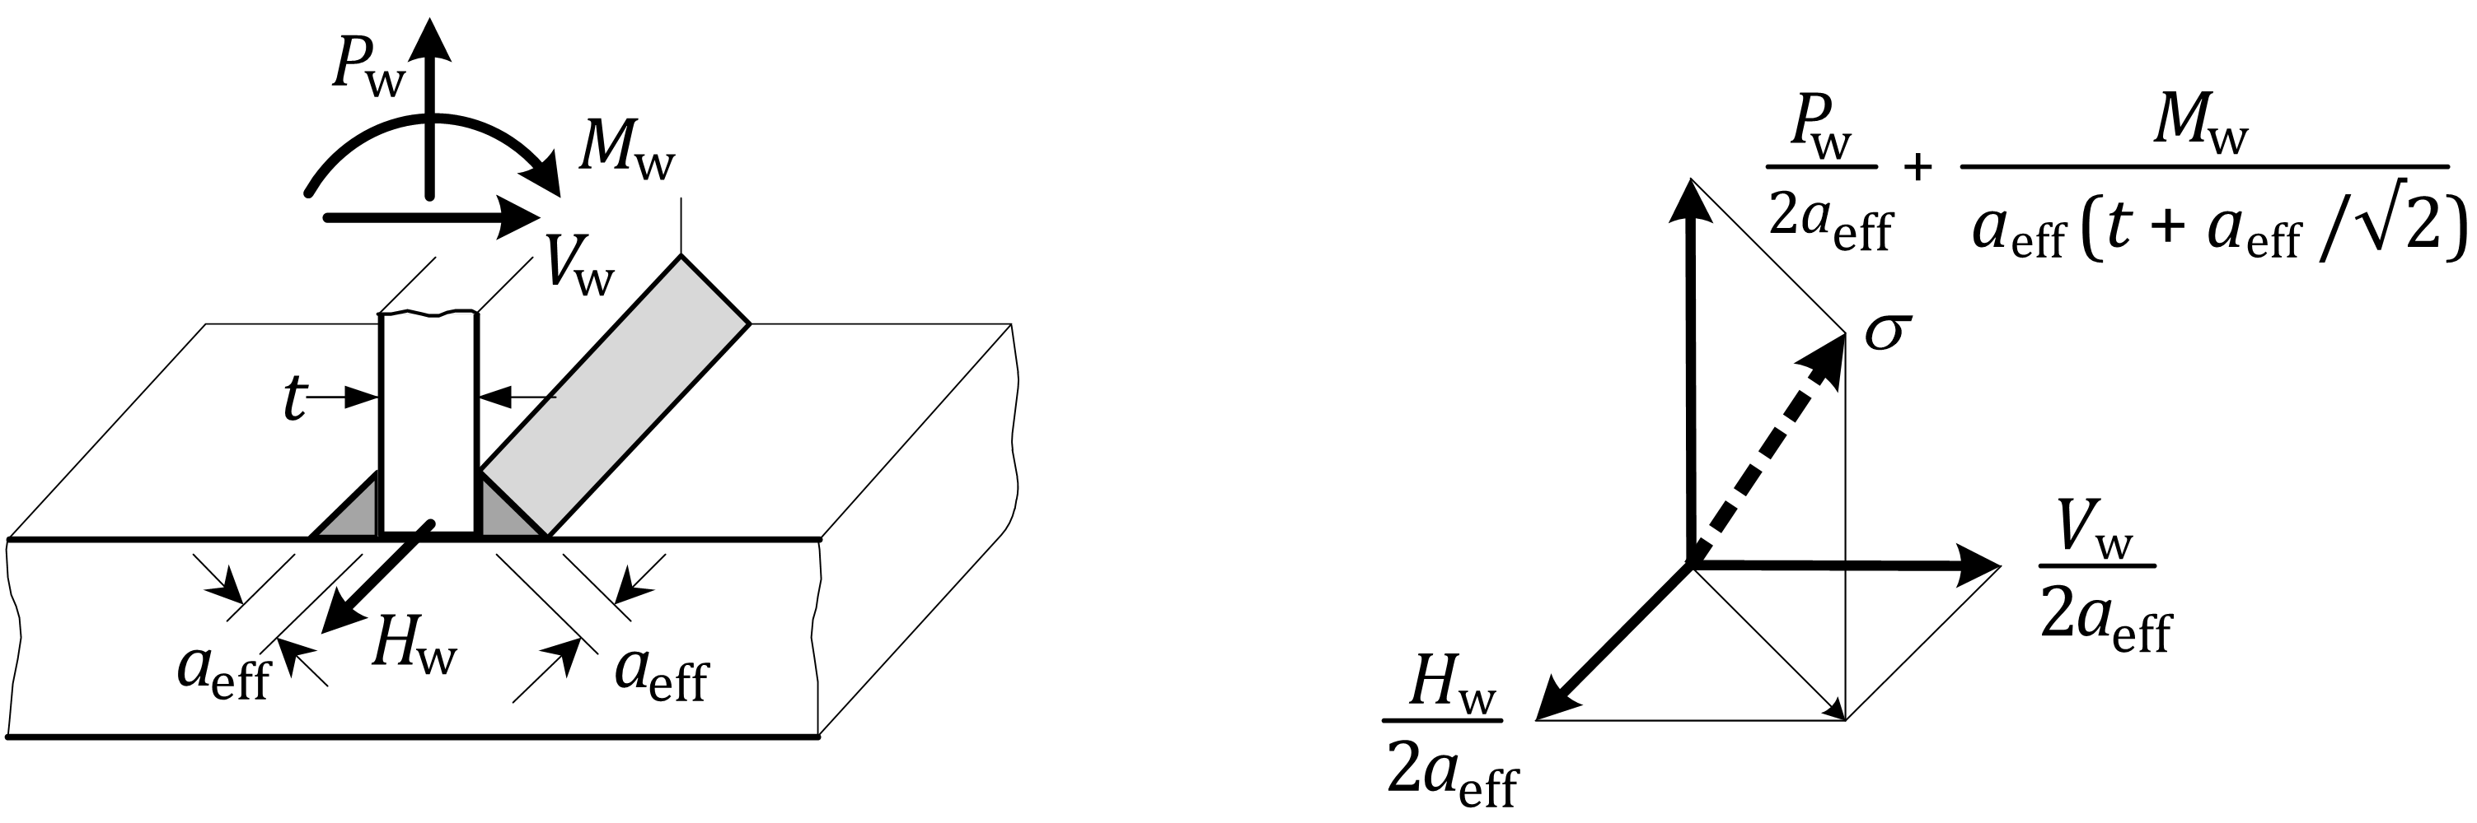

Key

|  |  |
| --- | --- |
| *P*w, *H*w and *M*w | are forces (moment) per unit length |

Figure 7.3 — Stresses in weld throats

(2) In lapped joints in a single plane, the stress per unit length of weld may be calculated on the basis of the average area for axial forces and of an elastic polar modulus of the weld group for in-plane moments (see Figure 7.4).

NOTE The reference strength value can be taken as in constructional detail 9.4, Table J.9.

|  |  |  |  |
| --- | --- | --- | --- |
|  | | | |
|  |  | Stress distribution due to shear force *F* | Stress distribution due to moment *M = Fe* |

Key

|  |  |
| --- | --- |
| 1 | fillet weld; |
| 2 | lapped area |

Figure 7.4 — Stresses in lapped joints

## Adhesive bonds

(1) Fatigue assessment should be based on a failure surface through the bond plane.

NOTE Guidance is given in Annex E.

## Castings

(1) The principal geometric stress should be used.

(2) Finite Element stress analysis or strain gauging in the case of complex shapes may be required, if standard calculations are not available.

## Stress spectra

(1) The methods in Annex A for cycle counting of stress ranges should be used to derive stress spectra.

## Calculation of equivalent stress range for standardized fatigue load models

### General

(1) The fatigue assessment for standardized fatigue loads as specified in EN 1991 (all parts) should be carried out according to one of the following approaches:

a) nominal stress ranges for constructional details shown in the detail category information;

b) modified nominal stress ranges, where abrupt changes of section occur close to the initiation site which are not included in the constructional detail information;

c) geometric stress ranges where high stress gradients occur close to a weld toe.

NOTE The National Annex can give information on the use of the nominal stress ranges or modified nominal stress ranges.

(2) The design value of stress range to be used for the fatigue assessment should be the stress ranges *γ*FfΔ*σ*E,2e corresponding to *N*C = 2 × 106 cycles.

### Design value of stress range

(1) The design value of nominal stress ranges *γ*FfΔ*σ*E,2e should be determined according to Formulae (7).1) and (7.2):

*γ*FfΔ*σ*E,2e = *λ*1 × *λ*2 × … *λ*i × … *λ*n × Δ*σ*(*γ*Ff*Q*k) for nominal stress (7.1)

 for modified nominal stress (7.2)

where

|  |  |
| --- | --- |
| Δ*σ*(*γ*Ff*Q*k) | is the stress range caused by the fatigue loads specified in EN 1991 (all parts); |
| *λ*i | are damage equivalent factors depending on the load situation. the structural characteristics and other relevant factors; |
| *K*gt | is the stress concentration factor to take account of the local stress magnification in relation to detail geometry not included in the reference fatigue strength curve, see 7.3.2.1. |

NOTE 1 The values of *λ*i can be given in the National Annex.

NOTE 2 *λ*i –values for steel components might not be applicable to aluminium components.

# Fatigue resistance and detail categories

## Detail categories

### General

(1) The verification of fatigue resistance should be based on the resistance values of a number of standardized detail categories.

(2) A detail category may comprise one or more frequently used and classified constructional details. The detail categories should be defined by their reference fatigue strength and the corresponding value for the inverse slope of the main part of the linearized Δ*σ-N* relationship, and should comply with the provisions in 8.2.

### Factors affecting detail category

(1) The fatigue strength of a constructional detail should take into account the following factors:

a) the direction of the fluctuating stress relative to the constructional detail;

b) the location of the initiating crack in the constructional detail;

c) the geometrical arrangement and relative proportion of the constructional detail.

NOTE The fatigue strength depends on the following:

a) the product form;

b) the material (unless welded);

c) the method of execution;

d) the quality level (in the case of welds and castings);

e) the type of connection.

### Constructional details

(1) Constructional details may be divided into the following three main groups:

a) plain-members, welded members and bolted joints;

b) adhesively bonded joints;

c) castings.

NOTE 1 Guidelines for the detail categories and constructional details with Δ*σ-N* relationships for fatigue strength of group a) members subject to ambient temperatures and which do not require surface protection (see Table 8.2 (NDP)) are given in Annex J.

NOTE 2 The National Annex can specify a set of detail categories and constructional details together with a set of consistence criteria for such members, taking the provisions in 8.1.2 and 8.3 into account.

NOTE 3 In addition to the constructional details given in Annex J, other constructional details can be provided by the National Annex.

NOTE 4 For guidance on castings, see Annex I.

NOTE 5 For guidance on adhesively bonded joints, see Annex E.

## Fatigue strength data

### Classified constructional details

(1) The generalized form of the Δ*σ*-N relationship should be as defined in Figure 8.1.

NOTE Figure 8.1 is plotted on logarithmic scales with the fatigue strength curve as the mean line minus 2 standard deviations from the experimental data.

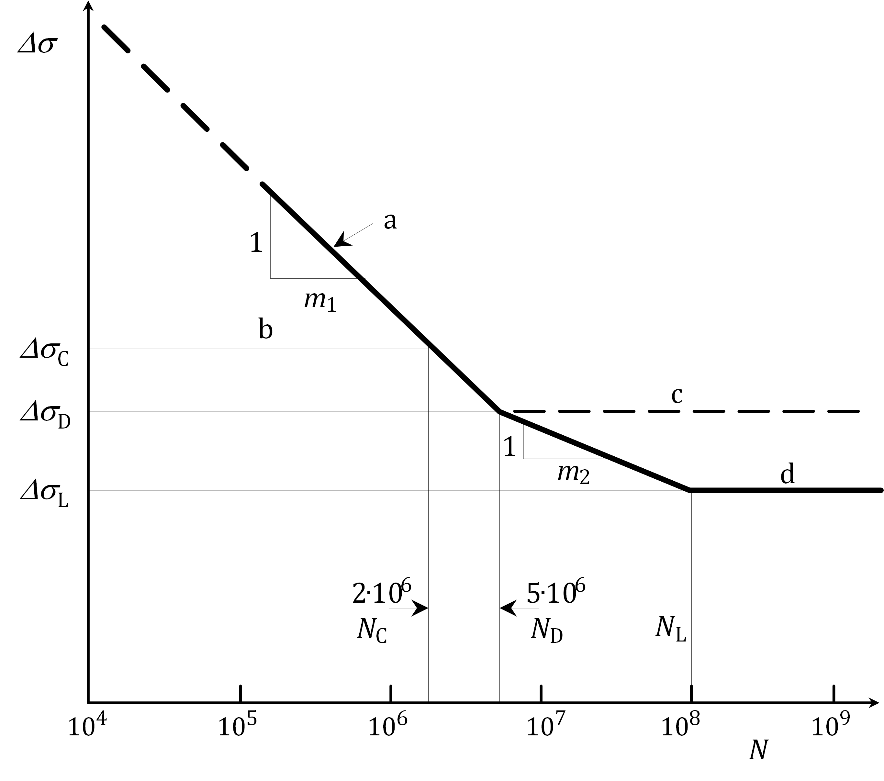

Key

|  |  |
| --- | --- |
| a | fatigue strength curve |
| b | reference fatigue strength |
| c | constant amplitude fatigue limit |
| d | cut-off limit |

Figure 8.1 — Fatigue strength curve logΔ*σ*-log*N*

(2) The fatigue design relationship for endurances in the range between 105 to 5 × 106 cycles should be defined by the Formula (8).1):

 (8.1)

where

|  |  |
| --- | --- |
| *N*i | is the predicted number of cycles to failure of a stress range Δ*σ*i; |
| Δ*σ*c | is the reference value of fatigue strength at 2 × 106 cycles, depending on the detail category, with standardized values given for information in Table 8.1; |
| Δ*σ*i | is the constant stress range for the principal stresses in the construction detail for *n*i cycles; |
| *m*1 | is the inverse slope of the fatigue strength curve and depends on the construction detail category; |
| *γ*Ff | is the partial factor for uncertainties in the loading spectrum and analysis of the response; |
| *γ*Mf | is the partial factor for materials and execution. |

NOTE 1 For values of *γ*Ff, see 4.4.

NOTE 2 The partial factor *γ*Mf takes the values given in L.6 for specific construction detail types and in Annex E for adhesively bonded joints, for use when Annex J resistance data are adopted, unless the National Annex gives different values.

Table 8.1 — Standardized Δ*σ*c values (N/mm2)

|  |
| --- |
| 140, 125, 112, 100, 90, 80, 71, 63, 56, 50, 45, 40, 36, 32, 28, 25, 23, 20, 18, 16, 14, 12 |

(3) For *N*D under certain exposure conditions, 8.4 should be followed.

(4) The fatigue design relationship for endurances in the range between 5 × 106 to 108 cycles should be defined by the Formula (8).2):

 (8.2)

(5) Constant amplitude stress cycles below the constant amplitude fatigue limit, Δ*σ*D, at 5 × 106 cycles (for plain material at 2 × 106 cycles), may be assumed to be non-damaging.

(6) In case of variable amplitude stress cycles, as occasional cycles above the constant amplitude fatigue limit can cause crack propagation resulting in lower amplitude cycles to become damaging, the inverse logarithmic slope of the basic fatigue strength curves between 5 × 106 and 108 cycles should be changed to *m*2 for general spectrum action conditions, where *m*2 = *m*1+2.

NOTE The use of the inverse slope constant *m*2 = *m*1 + 2 can be conservative for some spectra.

(6) Any stress cycles below the cut-off limit Δ*σ*L, assumed at 108 cycles, may be assumed to be non-damaging.

NOTE For stress ranges applied less than 105 times the resistance values according to Figure 8.1 can be too conservative for certain constructional details. Fatigue design provisions for endurances below 105 cycles can be given by the National Annex. Guidance is given in Annex F.

(7) In the range between 103 and 105 stress cycles a check should be made that the design stress range does not result in a maximum tensile stress that exceeds other ultimate limit state design resistance values for the constructional detail, see EN 1999‑1‑1.

(8) The detail categories apply to all values of mean stress, unless otherwise stated.

NOTE For guidance on enhanced fatigue strength values for compressive or low tensile stress values see Annex G.

(9) For flat members under bending stresses where Δ*σ*1 and Δ*σ*2 (see Figure 8.2) are of opposite sign, the respective fatigue stress value for certain detail types may be increased by one or two detail categories according to Table 8.1 for *t* ≤ 15mm.

NOTE 1 The detail type and the thickness range for which an increase in fatigue stress values can be permitted, as well as the number of categories, can be given in the National Annex.

NOTE 2 For the purpose of defining a finite range of detail categories and to enable a detail category to be increased or decreased by a constant geometric interval, a standard range of Δ*σ*c values is given in Table 8.1. An increase (or decrease) of 1 detail category means selecting the next larger (or smaller) Δ*σ*c value whilst leaving *m*1 and *m*2 unchanged. This does not apply to adhesively bonded joints.

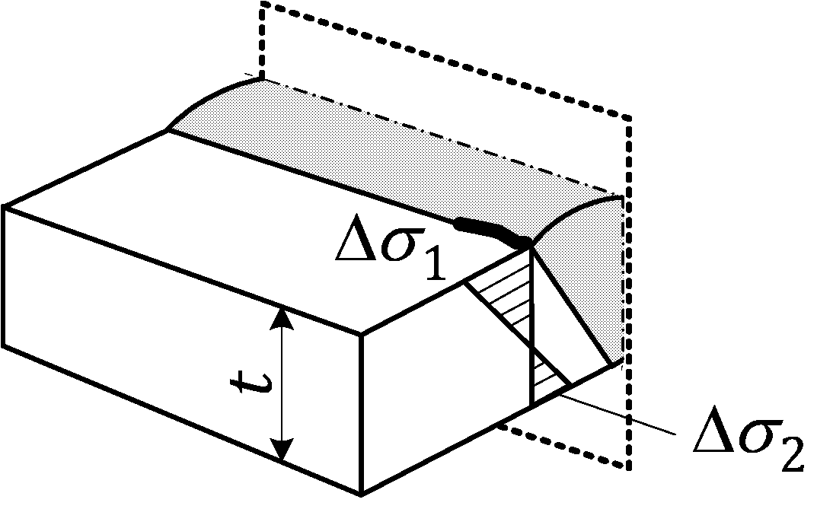

Figure 8.2 — Flat member under bending stresses

### Unclassified details

(1) Details not fully covered by a given detail category should be assessed by reference to published data where available. Alternatively fatigue acceptance tests may be carried out.

NOTE Guidance on fatigue tests is given in Annex C.

### Adhesively bonded joints

(1) Fatigue strengths of adhesively bonded joints should be based on test data specific to the application, taking the relevant exposure conditions into account.

NOTE Guidance on design of adhesively bonded joints is given in Annex E.

### Determination of the reference hot spot strength values

(1) The design values for the reference hot spot strength should be correlated to the hot spot design method used, as this affects the calculated hot spot stresses.

NOTE Annex K contains guidance on a hot spot reference detail method. Annex K can be used in combination with Annex J to determine the reference hot spot strength values.

## Effect of mean stress

### General

(1) As the fatigue strength data given in detail category tables refer to high tensile mean stress conditions, where the mean stress is compressive or of low tensile value, the fatigue life may be enhanced under certain conditions.

NOTE Further guidance is given in Annex G.

### Plain material and mechanically fastened joints

(1) If the effects of tensile residual and lack of fit stresses are added to the applied stresses, a fatigue enhancement factor may be applied.

NOTE For guidance, see Annex G.

### Welded joints

(1) No allowance should be made for mean stress in welded joints except in the following circumstances:

a) where tests have been conducted which represent the true final state of stress (including residual and lack of fit stresses) in the type of joint, and demonstrate a consistent increase in fatigue strength with decreasing mean stress;

b) where improvement techniques are to be used which have been proven to result in residual compressive stresses and where the applied stress is not of such a magnitude that the compressive residual stresses will be reduced by yielding in service.

NOTE For guidance, see Annex G.

### Adhesive joints

(1) The effect of mean stress may be neglected without justification by tests.

### Low endurance range

(1) For certain constructional details higher fatigue strengths may be used for negative minimum-to-maximum stress ratios, *R*, for *N* < 105 cycles.

NOTE For guidance, see Annex G.

### Cycle counting for *R*-ratio calculations

(1) The method of obtaining the maximum, minimum and mean stress for individual cycles in a spectrum using the reservoir counting method should be according to Annex A, Figure A.2.

## Effect of exposure conditions

(1) For certain combinations of alloy and exposure conditions, the detail category number given for a constructional detail should be downgraded.

NOTE For the detail categories covered by the guidance in Annex J, Table 8.2 (NDP) gives the number of detail categories (see also Table 8.1), by which they can be reduced according to exposure conditions and alloy.

(2) The fatigue strength data given in this document should not apply in case of ambient temperature of more than 65 °C or more than 30 °C in marine environment, unless an efficient corrosion prevention is provided.

Table 8.2 (NDP) — Number of detail categories by which Δ*σ*c should be reduced according to exposure conditions and alloy

| **Material** | | | **Exposure conditions** | | | | |
| --- | --- | --- | --- | --- | --- | --- | --- |
| **Alloy series** | **Basic composition** | **Protection ratings (see EN 1999‑1‑1)** | **Atmospheric** | | | **Immersed** | |
| **C1-C4** | **C5** | **CX** b | **Im1** | **Im2** b |
| 3xxx | AlMn | A | 0 | (P)a | 0 | 0 | 0 |
| 5xxx | AlMg | A | 0 | (P)a | 0 | 0 | 0 |
| 5xxx | AlMgMn | A | 0 | (P)a | 0 | 0 | 1 |
| 6xxx | AlMgSi | B | 0 | (P)a | 1 | 0 | 2 |
| 7xxx | AlZnMg | C | 0 | (P)a | 2 | 1 | 3 |
| NOTE Downgrading is not needed for detail categories < 25 N/mm2. | | | | | | | |
| a (P) very dependent on exposure conditions; regularly maintained protection could be required to avoid risk of local exposures which could be particularly detrimental to crack initiation.  b The value of *N*D should be increased from 5 × 106 to 107 cycles. | | | | | | | |

## Improvement techniques

(1) Methods for improving the fatigue strength of certain welded constructional details may be used.

NOTE Improvement techniques are generally expensive to apply and present quality control difficulties. They cannot be relied upon for general design purposes, unless fatigue is particularly critical to the overall economy of the structure, in which case specialist advice can be sought. They are more commonly used to overcome existing design deficiencies. Guidance is given in Annex H.

1. (normative)  
     
   Basis for calculation of fatigue resistance
   1. Use of this annex

(1) This Normative Annex contains additional provisions to 4.1, 7.7 and 8.3.6 on the basis for calculation of fatigue resistance.

* 1. Scope and field of application

(1) This Normative Annex gives provisions on the influence of fatigue on design, mechanism of failure, potential sites for fatigue cracking, conditions for fatigue susceptibility, safe life design and damage tolerant design.

* 1. General
     1. Influence of fatigue on design

(1)P Structures subject to frequently fluctuating service loads can be susceptible to failure by fatigue and shall be checked for that limit state.

(2) The degree of compliance with the ultimate or serviceability limit state criteria given in EN 1999‑1‑1 should not be used as a measure of the risk of fatigue failure (see A.3.3).

(3) The extent to which fatigue is likely to govern the design should be established at the conceptual stage of design. To obtain sufficient accuracy in prediction of the safety against fatigue failure:

a) a realistic prediction of the complete service load sequence throughout the design service life should be made;

b) the elastic response of the structure under the predicted loads should be assessed with good accuracy;

c) constructional detail design and specification of methods of manufacturing and of the quality control should be carried out with increased attention and diligence than in design for other limit states, as these issues can have a major influence on fatigue strength and require strict control.

NOTE For information on requirements for execution, see EN 1090‑3.

* + 1. Mechanism of failure

(1) It should be assumed that fatigue failure usually initiates at a highly stressed point (due to abrupt geometry change, tensile residual stress or sharp crack-like discontinuities) and that fatigue cracks will extend incrementally when the loads and stresses change, although they normally remain stable under constant load, leading to failure if the remaining cross section is insufficient to carry the peak applied load.

(2) It should be assumed that fatigue cracks propagate approximately at right angles to the direction of maximum principal stress range and that the rate of propagation increases exponentially, despite being slow in the early stages and fatigue cracks being inconspicuous for the major part of their life. The associated problems of detection in service should be recognized.

* + 1. Potential sites for fatigue cracking

(1) The following initiation sites for fatigue cracks associated with specified constructional details should be considered:

a) toes and roots of fusion welds;

b) machined corners;

c) punched or drilled holes;

d) sheared or sawn edges;

e) surfaces under high contact pressure (fretting);

f) roots of fastener threads.

(2) The following should also be considered for potential initiation of fatigue cracks, where relevant:

a) material discontinuities or weld flaws;

b) notches or scoring from mechanical damage;

c) corrosion pits.

* + 1. Conditions for fatigue susceptibility

(1) In assessing the likelihood of susceptibility to fatigue, the following should be taken into account:

a) high ratio of dynamic to static loading: Moving or lifting structures, such as land or sea transport vehicles, cranes, etc. are more likely to be prone to fatigue problems than fixed structures, unless the latter are predominantly carrying moving loads, as in the case of bridges;

b) frequent applications of load, resulting in a high number of cycles in the design service life. Slender structures or members with low natural frequencies are particularly prone to resonance and magnification of dynamic stress, even when the static design stresses are low. Structures subject predominantly to wind or wave actions, and structures supporting machinery should be carefully checked for resonant effects;

c) use of welding, as some commonly used welded details have low fatigue strength. This applies not only to joints between members, but also to any attachment to a loaded member, whether or not the resulting connection is considered to be 'structural';

d) complexity of joint detail, as complex joints frequently result in high stress concentrations due to local variations in stiffness along the load path. Whilst these often have little effect on the ultimate static capacity of the joint, they can have a severe effect on fatigue resistance. If fatigue is dominant the member cross-sectional shape should be selected to ensure smoothness and simplicity of joint design, so that stresses can be calculated with confidence and adequate standards of fabrication and inspection can be ensured;

e) certain thermal and chemical exposure conditions which can reduce fatigue strength if the surface of the metal is unprotected.

* 1. Safe life design
     1. General

(1) The safe life design approach is based on the calculation of damage accumulation during the structure's design service life or comparing the maximum stress range with the constant amplitude limit, using standard lower bound endurance data and an upper bound estimate of the fatigue loading, all based on design values.

NOTE 1 The approach provides a conservative estimate of the fatigue strength and does not normally depend on in-service inspection for fatigue damage.

NOTE 2 Options considering in-service inspection are given in L.1 for use when Annex J resistance data are adopted.

(2) The fatigue design involves prediction of the stress histories at potential crack initiation sites, followed by counting of load cycles with the associated stress ranges and compilation of stress spectra. From this information an estimate of the design service life is made using the appropriate stress range endurance data for the construction detail concerned. This method is given in A.4.

(3) The safe life design approach may be based on one of two procedures to ensure sufficient resistance of the component or structure. The procedures are respectively based on:

a) the linear damage accumulation calculation, see (4);

b) the equivalent stress range approach, see (5).

NOTE A third procedure, for the case where all design stress ranges are less than the design constant amplitude fatigue limit, is given in L.3.1(3).

(4) For safe life design based on the assumption of linear damage accumulation (Miner's summation) the damage value *D*L for all cycles should fulfil the condition in Formulae (4).1) and (4.2):

*D*L,d ≤ 1 (A.1)

where

|  |  |
| --- | --- |
| *D*L,d | = Σ*n*i/*N*i is calculated in accordance with the procedure given in A.4. |

or

*D*L ≤ *D*lim (A.2)

where

|  |  |
| --- | --- |
| *D*L | = Σ*n*i/*N*i is calculated in accordance with the procedure given in A.4 with *γ*Mf = *γ*Ff = 1,0. |

NOTE The values of Dlim, are those given in L.6 for use when resistance data in Annex J is adopted unless the National Annex gives different values.

(5) In case the design is based on the equivalent stress range approach (*Δσ*E,2e) the condition in Formula (4).3) should be verified:

 (A.3)

NOTE The values of *γ*Mf, are those given in L.6 unless the National Annex gives different values. For *γ*Ff, see 4.4.

* + 1. Prerequisites for safe life design

(1) The predicted service history of the structure should be available in terms of a loading sequence and frequency. Alternatively the stress response at all potential initiation sites should be available in terms of stress histories.

(2) The fatigue strength characteristics at all potential initiation sites should be available in terms of fatigue strength curves.

(3) All potential fatigue crack initiation sites which have high stress fluctuations and/or severe stress concentrations should be checked.

(4) The quality standards used in the manufacture of the components containing potential initiation sites should be consistent with the constructional detail being used.

* + 1. Design approach

(1) The basic procedure should be as follows (see Figure A.1):

a) obtain an upper bound estimate of the service load sequence for the structure's design service life (see 4.3);

b) estimate the resulting stress history at the potential crack initiation site being checked (see A.4.5);

c) where nominal stresses are being used, modify the stress history in any region of geometrical stress concentration which is not already included in the detail category, by applying an appropriate stress concentration factor (see 7.3.2);

d) reduce the stress history to an equivalent number of cycles (*n*i) of different stress ranges Δ*σ*i using a cycle counting technique (see A.4.5);

e) rank the cycles in descending order of range Δ*σ*i to form a stress-range spectrum, where *i* = 1, 2, 3 etc. for the first, second, third band in the spectrum (see A.4.5);

f) categorize the construction detail in accordance with the given set of detail categories. For the appropriate detail category and the respective Δ*σ*-*N* relationship determine for the design stress range (Δ*σ*i) the permissible endurance (*N*i);

g) calculate the total damage value *D*L,d caused by all cycles based on linear damage accumulation according to Formula (A.4):

 (A.4)

h) calculate the safe life *T*s, according to Formula (A.5):

 (A.5)

i) take one or more of the following actions if *T*S is less than *T*L:

— redesign the structure or member to reduce the stress levels;

— change the construction detail to one in a higher category; use a damage tolerant design approach, where appropriate (see A.5).

|  |
| --- |
|  |
| a) System, constructional detail X-X and loading |
|  |
| b) Typical load cycle (repeated *n* times in design). *T* = time |
|  |
| c) Stress history at detail X-X |
|  |
| d) Cycle counting, reservoir method |
|  |
| e) Stress range spectrum |
|  |
| f) *N*i = cycles to failure at stress range level fatigue strength curve for constructional detail X-X |
|  |
| g) Damage summation, Miner's-rule |

Figure A.1 — Fatigue assessment procedure

* + 1. Cycle counting

(1) Cycle counting procedures should be used for breaking down a complex stress history into a convenient spectrum of cycles in terms of stress range, Δ*σ*, number of cycles, *n*, and, if necessary, *R*, stress ratio.

(2) For short stress histories where simple action events are repeated a number of times, the Reservoir method should be used. It is easy to visualize and simple to use (see Figure A.2). Where long stress histories are used, such as those obtained from measured strains in actual structures (see Annex C) the Rain-Flow method is recommended.

NOTE Both methods are suitable for computer analysis.

|  |
| --- |
|  |
| Step 1: Determine stress history for loading event. Identify peak B |
|  |
| Step 2: Move stress history on left of peak B to right |
|  |
| Step 3: Fill “reservoir” with “water”. Greatest depth is major cycle |
|  |
| Step 4: Drain at greatest depth. Find new maximum depth. This is second largest cycle |
|  |
| Step 5: Onwards. Repeat until all “water” drained. Sum of all cycles is stress spectrum for above history |

Figure A.2 — Reservoir cycle counting method

* + 1. Derivation of stress spectrum

(1) For ease of calculation, a complex spectrum may be simplified into fewer bands.

NOTE 1 The listing of cycles in descending order of stress range, Δ*σ*, results in a stress spectrum.

NOTE 2 A conservative method is to group bands together into larger groups containing the same total number of cycles, but whose stress range is equal to that of the highest band in the group.

More accurately, the weighted average of all the bands in one group may be calculated using the power, *m*, where *m* is the inverse slope of the Δ*σ*-*N* curve most likely to be used (see Figure A.3).

NOTE 3 The use of an arithmetic mean value will always be unconservative.

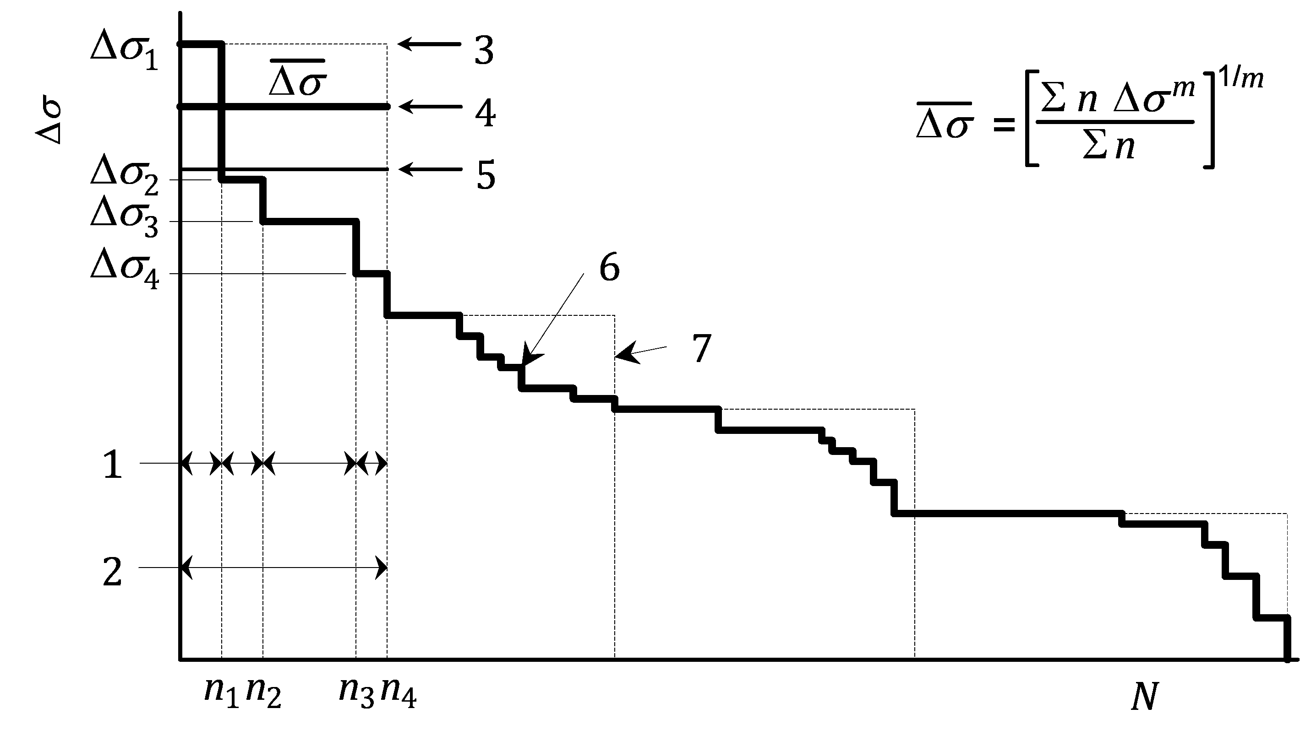

Key

|  |  |
| --- | --- |
| 1 | original bands |
| 2 | simplified band |
| 3 | peak (conservative) |
| 4 | weighted mean (most accurate) |
| 5 | arithmetic mean (non-conservative) |
| 6 | recorded spectrum |
| 7 | simplified spectrum for design |
| *N* | cumulative frequency (any cycle number) |
| Δ*σ* | stress range |

Figure A.3 — Simplified stress range spectrum

* 1. Damage tolerant design
     1. Prerequisites for damage tolerant design

(1) Damage tolerant design should only be used where the following conditions apply:

a) the fatigue crack initiation sites are on or close to a surface which would be readily accessible in service;

b) practical inspection methods are available which are capable of detecting the cracks and measuring their extent well before they have reached their fracture critical size. See 4.5.5;

c) the procedure in A.5.3 is applied to determine the minimum inspection frequency and maximum permissible crack size before correction becomes necessary;

NOTE An alternative method of determining inspection frequency is given in L.4 and L.5 for use when Annex J resistance data are adopted.

(2) The maintenance manual should specify the information listed in 4.5.5 for each potential crack location.

* + 1. Structural layout and detailing

(1) The following guidelines should be considered for the structural layout and detailing:

— details, material and stress levels should be selected so that in the event of the formation of cracks a low rate of crack propagation and a long critical crack length would result;

— wherever possible a structural concept should be adopted where in the event of fatigue damage a redistribution of load effects within the structure or within the cross section of a member can occur (principle of redundancy);

— crack-arresting details should be provided;

— it should be ensured that critical components and details are readily inspectable during regular inspection;

— it should be ensured that cracks can be kept under control by monitoring or, if needed, that components are readily repairable or replaceable.

* + 1. Determination of inspection strategy for damage tolerant design

(1) At each potential initiation site where the safe life, *T*s, calculated in accordance with Formula (A.5) is less than the design service life, *T*L, the inspection interval, *T*i, should be calculated.

(2) The maintenance manual should specify that the first inspection of each potential initiation site is to take place before the safe life has elapsed.

(3) The maintenance manual should specify that subsequent inspections are to take place at regular intervals, *T*i, according to Formula (A.6):

*T*i ≤ 0,5 *T*f (A.6)

where *T*f is the calculated time for a crack, having initiated at the site being assessed, to grow from a detectable surface length, *l*d, to a fracture critical length, *l*f, (see Figure A.4).

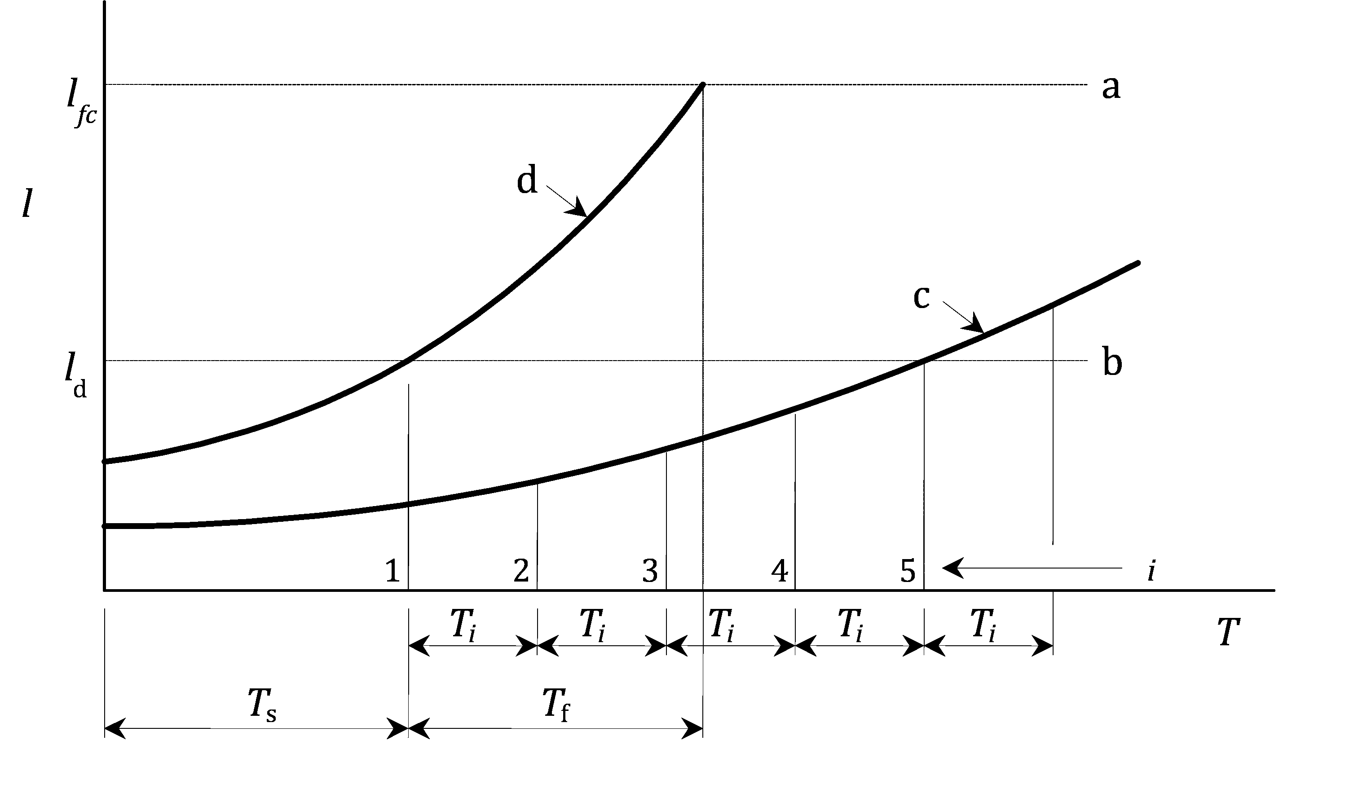

Key

|  |  |
| --- | --- |
| a | fracture critical length |
| b | assumed minimum detectable length |
| c | actual growth curve |
| d | assumed fastest growth curve, see Annex B for upper boundary |
| *i* | inspection number |
| *T*i | inspection interval |
| *T*s | time interval to detectable crack length |
| *T*f | time interval for crack growth from detectable crack length to critical crack length |

Figure A.4 — Inspection strategy for damage tolerant design

(4) The assumed minimum exposed length of surface crack should take into account the accessibility, location, likely surface condition and method of inspection. Unless specific testing is undertaken to demonstrate that shorter lengths can be detected with a probability exceeding 90 %, the assumed value of *l*d should be not less than the recommended value in Table A.1 where the full crack length is accessible for inspection.

Table A.1 — Recommended safe values of detectable surface crack length *l*d in mm

|  |  |  |  |
| --- | --- | --- | --- |
| Method of Inspection | Crack location | | |
| Plain smooth surface | Rough surface,  Weld cap | Sharp corner,  Weld toe |
| Visual, with magnifying aid | 20 | 30 | 50 |
| Liquid penetrant testing | 5 | 10 | 15 |
| NOTE The above values assume close access, good lighting and removal of surface coatings. | | | |

(5) Where any other permanent structural or non-structural part prevents full access to the crack, the obscured length of crack should be added to the appropriate value in Table A.1 to derive the value of *l*d for calculation purposes.

(6) Where large constructional thickness is used and where the initiation site is on an inaccessible surface, (e.g. the root of a single sided butt weld in a tubular member), an inspection strategy should be planned based on the use of ultrasonic testing to detect and measure cracks before they reach the accessible surface. Such a strategy should not be undertaken without prior testing and evaluation.

(7) The value of *l*f should be such that the net section, taking into account the likely shape of the crack profile through the thickness, should be able to sustain the maximum static tensile forces under the factored load, calculated in accordance with EN 1999‑1‑1, without unstable crack propagation.

(8) Time interval for crack growth from detectable crack length to critical crack length, *T*f should be estimated by means of calculation and/or by test, assuming the ULS combinations of actions, as follows:

a) the calculation method should be based on fracture mechanics principles (see Annex B). An upper bound, defined as mean plus two standard deviations, crack growth relationship should be used. Alternatively specific crack growth data may be obtained from standard test specimens using the same material as in the crack propagation path. In that case the crack growth rate should be factored in accordance with the fatigue test factor, *F* (see Table C.1);

b) where crack growth is obtained from structural or component tests simulating the correct materials, geometry and method of manufacture, the relevant applied force pattern should be applied to the test specimen (see Annex C);

c) the crack growth rates recorded between the crack lengths, *l*d and *l*f, should be factored by the fatigue test factor, *F* (see Table C.1).

(9) The maintenance manual should specify the actions to be taken in the event of discovery of a fatigue crack during a regular maintenance inspection, as follows:

a) if the measured crack length is less than *l*d, remedial actions may be neglected;

b) if the measured crack length is equal to or exceeds, *l*d, the component should be assessed on a fitness-for-purpose basis, with a view to determining how long the structure can safely be allowed to operate without rectification or replacement. In the event of continuation of operation, consideration should be given to increasing the frequency of inspection at the location in question;

c) if the measured crack length exceeds, *l*f, the structure should be immediately taken out of service.

NOTE Further guidance is given in Annex L for use when Annex J resistance data are adopted.

1. (informative)  
     
   Guidance on assessment of crack growth by fracture mechanics
   1. Use of this Informative Annex

(1) This Informative Annex provides supplementary guidance to A.5.3, C.6, L.4.3 on assessment of crack growth by fracture mechanics.

NOTE National choice on the application of this Informative Annex is given in the National Annex. If the National Annex contains no information on the application of this informative annex, it can be used.

* 1. Scope and field of application

(1) The objective of this annex is to provide information on the use of fracture mechanics for assessing the growth of fatigue cracks from sharp planar discontinuities. Main uses are in the assessment of:

— known flaws (including fatigue cracks found in service);

— assumed flaws (including consideration of the original joint or NDT detection limits);

— tolerance to flaws (including fitness for purpose assessment of fabrication flaws for particular service requirements).

(2) The method covers fatigue crack growth normal to the direction of principal tensile stress (Mode 1).

* 1. Principles
     1. Flaw dimensions

(1) Fatigue propagation is assumed to start from a pre-existing planar flaw with a sharp crack front orientated normal to the direction of principle tensile stress range Δ*σ* at that point.

(2) The dimensions of the pre-existing flaws are shown in Figure B.1 depending on whether they are surface breaking or fully embedded within the material.

|  |
| --- |
| a b |
| a) Surface braking flaw |
|  |
| b) Embedded flaw |

Key

|  |  |
| --- | --- |
| 1 | free surface |
| 2 | flaw |

Figure B.1 — Pre-existing planar flaw

* + 1. Crack growth relationship

(1) Under the action of cyclic stress range Δ*σ*, the crack front will move into the material according to the crack propagation law. In the direction of '*a*', the rate of propagation given by Formula (B.1) should be used:

 (B.1)

where:

|  |  |
| --- | --- |
| *A* | is the fatigue crack growth rate (FCGR) material constant |
| *m* | is the crack growth rate exponent |
| *y* | is the crack geometry factor depending on the crack shape, orientation and surface boundary dimensions. |

NOTE The units for stress intensity factors, Δ*K*, are Nmm-2m0,5[MPa m0,5] and for crack growth rate *da/dN* is [m/cycle]. Data given in B.4 are only valid for these units.

(2) Formula (B.1) may be rewritten in the form of Formula (B.2):

 (B.2)

where Δ*K* is the stress intensity range and equals Δ*σa*0,5*y*.

(3) After the application of *N* cycles of stress range Δ*σ*. the crack will grow from dimension *a*1 to dimension *a*2 and the integration Formula (B.3) should be used:

 (B.3)

(4) In the general case *A*, Δ*K* and *m* depend on *a*.

* 1. Crack growth data *A* and *m*

(1) *A* and *m* are obtained from crack growth measurements on standard notched specimens (e.g. see Figure B.2) orientated in the LT, TL or ST direction using standardized test methods. The specimen design should be one for which an accurate stress intensity factor (*K*) solution (i.e. the relationship between applied action and crack size '*a*') is available.

NOTE The first letter designates the direction normal to the crack plane and the second letter the expected direction of the crack propagation where “L” means longitudinal, “T” transverse and “S” short transverse, referring to the extrusion or rolling direction.

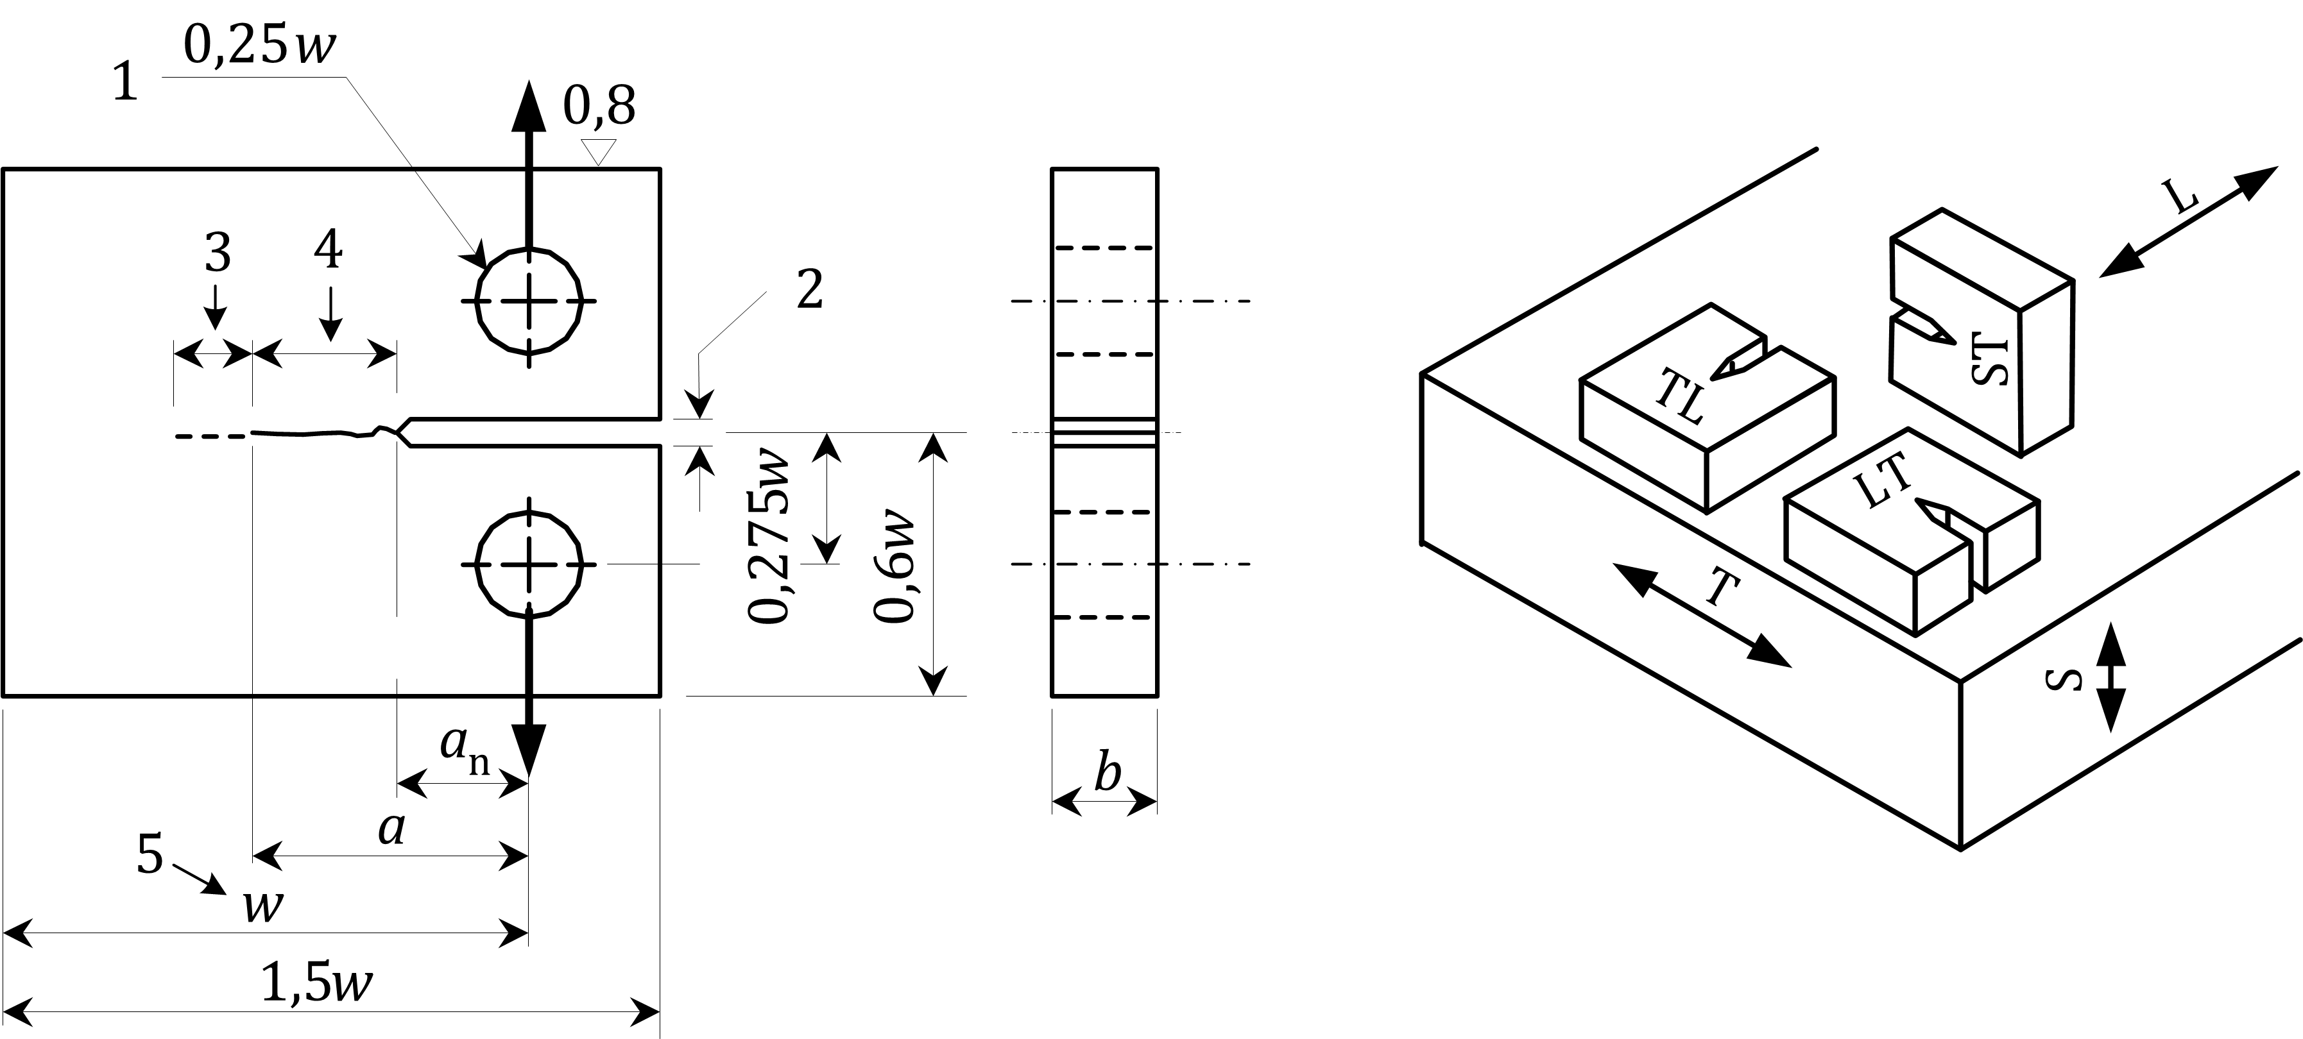

Key

|  |  |
| --- | --- |
| w | effective width of the specimen (being the distance between the centreline of the holes and the back-face of the coupon) |
| *L* | longitudinal in the production direction (rolling or extrusion) |
| 1 | hole diameter |
| 2 | mouth opening displacement |
| 3 | increment |
| 4 | fatigue pre-crack |
| Recommended thickness w/20 ≤ b ≤ w/4 | |

Figure B.2 — Typical crack growth specimen

(2) The tests are carried out under computer controlled cyclic action of the specimen at constant applied stress intensity ratio *R* = *K*min/*K*max, for either constant *R* or constant *K*max testing conditions and accurate measurement of the growth of the crack from the notch.

(3) If discrete values of crack length, *a*, are obtained, a smooth curve is fitted to the data using the method specified in the test standard. The crack growth rate, *da*/*dN*, at a given crack length is then calculated as the gradient of the curve at that a value.

(4) The corresponding value of the stress intensity factor range, Δ*K*, is obtained using the appropriate *K* solution for the test specimen, along with the applied action range. The results *da*/*dN* versus Δ*K* are plotted using logarithmic scales.

(5) For general use, crack growth curves may be required for different *R* values. Figure B.3 shows a typical set of *da*/*dN* versus Δ*K* curves for the aluminium extrusion alloy EN AW-6005A T6. In Figure B.3(a) the testing condition was constant ratio of stress intensity *K*min/*K*max, and in Figure B.3(b) the result of a test at constant *K*max = 10 Nmm-2m0,5 is combined with the conservative branches of the curves from Figure B.3(a). This combination of the results of the constant *R* and constant *K* data are a conservative engineering approximation and can be used for the fatigue life prediction in case of high residual tensile stresses or short fatigue crack evaluations. The values of *m* and *A* for Figure B.3 are given in Tables B.1(a) and (b).

(6) In Figure B.4(a) the constant R-FCGR of wrought aluminium alloys of *R* = 0,1 are plotted and in Figure B.4(b) the corresponding data for constant *R* = 0,8 are added. Figure B.5 shows the set of constant R-FCGR curves of three gravity die cast alloys at *R* = 0,1 and *R* = 0,8. Figure B.6 represents the combined data of constant *R* and constant *K*max-tests of wrought aluminium alloys for *R* = 0,1 and *R* = 0,8. The values of *m* and *A* of the upper bound FCGR envelopes shown in Figures B.4 to B.6 are given in Tables B.2 to B4 respectively.

(7) Corrosive exposure conditions can affect *A* and *m*. Test data obtained under conditions of ambient humidity will be adequate to cover most normal atmospheric conditions.

* 1. Geometry function *y*

(1) The geometry function *y* depends on crack geometry (shape and size), the boundary dimensions of the surface of the surrounding material and the stress pattern in the region of the crack path.

(2) This information can be obtained from finite element analyses of the constructional detail using crack tip elements. The stress intensity for different crack lengths may be calculated using the *J* integral procedure. Alternatively it may be calculated from the displacement or stress field around the crack tip, or the total elastic deformation energy.

(3) Published solutions for commonly used geometries (plain material and welded joints) are an alternative source of *y* values. Standard data are often given in terms of *Y* where *Y* = *y*π-0,5. A typical example for a surface breaking crack in a plain plate is shown in Figure B.7(a). If the crack is located at a weld toe on the plate surface, then a further adjustment for the local stress concentration effect may be made using the magnification factor *M*K (see Figure B.7(b)).

(4) The product of *Y* for the plain plate and *M*K for the weld toe gives the variation of *y* as the crack grows through the thickness of the material (see Figure B.7.(c)).

* 1. Integration of crack growth

(1) For the general case of a variable amplitude stress history, a stress spectrum should be derived (see 4.2.1). In practice the complete spectrum should be applied in at least 10 identical sequences with the same stress ranges and *R*-ratios, but with one tenth of the number of cycles. The block with the greatest stress range should be applied first in each sequence (see Figure A.3). The incremental crack growth is calculated using the crack growth polygon for the appropriate *R*-ratio, for each block of constant amplitude stress cycles.

(2) In the region of welds, unless the residual stress pattern is actually known, either a high *R*-ratio (*R* = 0,8) or a *K*max constant crack growth curve should be used.

(3) The crack length, *a*, is integrated on this basis until the maximum required crack size *a*2 is reached and the numbers calculated.

* 1. Assessment of maximum crack size *a*2

(1) The maximum crack size *a*2 should be assessed on the basis of net section ductile tearing under the maximum applied tensile action with the appropriate partial factor, see EN 1999‑1‑1.

|  |
| --- |
| *da*/*dN* [m/cycle] |
| a) *R* = *K*min/*K*max = constant |
| *da*/*dN* [m/cycle] |
|  |
| b) *K*max = 10 Nmm-2m0,5 |

Figure B.3 — Typical fatigue crack growth curves for aluminium alloy EN AW-6005A T6 LT

Table B.1 — Fatigue crack growth rate data, Δ*K* [Nmm-2m0,5]

|  |  |  |  |  |  |  |  |  |  |  |  |  |  |  |  |
| --- | --- | --- | --- | --- | --- | --- | --- | --- | --- | --- | --- | --- | --- | --- | --- |
| **EN AW-6005A T6 LT,  *R = K*min/*K*max = constant** | | | | | | | | **EN AW-6005A T6 LT,  *K*max = 10 Nmm-2m0,5 = constant** | | | | | | | |
| *R* | Δ*K* | *m* | *A* | *R* | Δ*K* | *m* | *A* | *R* | Δ*K* | *m* | *A* | *R* | Δ*K* | *m* | *A* |
| 0,10 | 3,30  4,50  8,00  32,4  41,6  60,0 | 15,0  7,52  2,96  12,0  12,0  12,0 | 1,658 × 10−19  1,293 × 10−14  1,674 × 10−10  4,100 × 10−24  4,100 × 10−24  4,100 × 10−24 | 0,50 | 2,00  2,72  4,20  6,50  21,0  29,2  42,5 | 16,3  3,85  4,87  2,81  12,2  12,2  12,2 | 1,243 × 10−16  3,174 × 10−11  7,415 × 10−12  3,507 × 10−10  1,211 × 10−22  1,211 × 10−22  1,211 × 10−22 | 0,10 | 0,85  1,16  1,60  8,00  32,4  41,6 | 11,1  3,74  2,69  2,96  12,0  12,0 | 6,068 × 10−11  1,807 × 10−10  2,970 × 10−10  1,674 × 10−10  4,103 × 10−24  4,103 × 10−24 | 0,50 | 0,85  1,16  1,60  5,55  6,50  21,0  29,2 | 11,0  3,74  2,70  5,09  2,81  12,2  12,2 | 6,069 × 10−11  1,807 × 10−10  2,958 × 10−10  4,923 × 10−12  3,507 × 10−10  1,210 × 10−22  1,210 × 10−22 |
| 0,20 | 2,90  3,80  7,50  29,6  38,0  55,0 | 18,5  5,87  2,93  12,4  12,4  12,4 | 2,680 × 10−20  5,950 × 10−13  2,229 × 10−10  2,253 × 10−24  2,253 × 10−24  2,253 × 10−24 | 0,65 | 1,50  1,95  2,20  3,55  6,00  15,0  22,2 | 16,9  4,43  2,39  4,77  3,05  12,0  12,0 | 1,042 × 10−14  4,419 × 10−11  2,207 × 10−10  1,067 × 10−11  2,326 × 10−10  6,085 × 10−21  6,085 × 10−21 | 0,30 | 0,85  1,16  1,60  6,70  7,35  26,0  34,5 | 11,1  3,74  2,71  5,52  2,82  12,4  12,4 | 6,069 × 10−11  1,807 × 10−10  2,936 × 10−10  1,413 × 10−12  3,061 × 10−10  8,421 × 10−24  8,421 × 10−24 | 0,65 | 0,85  1,16  1,60  4,95  6,00  15,0  22,2 | 11,1  3,74  2,69  4,76  3,05  12,0  12,0 | 6,069 × 10−11  1,807 × 10−10  2,960 × 10−10  1,081 × 10−11  2,326 × 10−10  6,081 × 10−21  6,081 × 10−21 |
| 0,30 | 2,60  3,40  7,35  26,0  34,5  50,0 | 18,6  5,24  2,82  12,4  12,4  12,4 | 1,775 × 10−19  2,471 × 10−12  3,061 × 10−10  8,412 × 10−24  8,412 × 10−24  8,412 × 10−24 | 0,80 | 1,00  1,28  1,55  3,50  4,60  9,20  13,5 | 13,0  4,99  2,50  6,03  3,12  15,9  15,9 | 1,000 × 10−11  7,290 × 10−11  2,169 × 10−11  2,611 × 10−12  2,225 × 10−10  9,830 × 10−23  9,830 × 10−23 |  |  |  |  | 0,80 | 0,85  1,16  1,60  4,15  4,60  9,20  13,5 | 11,1  3,74  2,72  6,01  3,12  15,9  15,9 | 6,069 × 10−11  1,807 × 10−10  2,928 × 10−10  2,690 × 10−10  2,225 × 10−10  9,819 × 10−23  9,819 × 10−23 |

|  |
| --- |
| *da/dN* [m/cycle] |
|  |
| a) *R* = 0,1 |
| *da/dN* [m/cycle] |
|  |
| b) *R* = 0,8 |

NOTE Alloys 2024 TL Ro and 7075 LT Ro are not for use in buildings and civil engineering works. They are given here for comparative reasons.

Figure B.4 — Typical fatigue crack growth rate curves for various wrought alloys

|  |
| --- |
| *da/dN* [m/cycle] |
|  |
| a) *R* = 0,1 |
| *da/dN* [m/cycle] |
|  |
| b) *R* = 0,8 |

NOTE Alloys EN AC-21100 and EN AC-211000 are not for use in buildings and civil engineering works. They are given here for comparative reasons.

Figure B.5 — Typical fatigue crack growth curves for various cast alloys

|  |
| --- |
| *da/dN* [m/cycle] |
|  |
| a) *R* = 0,1; *K*max = 10 Nmm-2m0,5 |
| *da/dN* [m/cycle] |
|  |
| b) *R* = 0,8; *K*max = 10 Nmm-2m0,5 |

Figure B.6 — Typical fatigue crack growth curves for various wrought alloys

Table B.2 — Fatigue crack growth rate data, Δ*K* [Nmm-2m0,5]

|  |  |  |  |  |  |  |  |  |  |  |  |
| --- | --- | --- | --- | --- | --- | --- | --- | --- | --- | --- | --- |
| Wrought alloys, *R* = *K*min/*K*max = constant | | | | Cast alloys *R* = *K*min/*K*max = constant | | | | Wrought alloys,  *K*max = 10 Nmm-2m0,5 = constant | | | |
| *R* | Δ*K* | *m* | *A* | *R* | Δ*K* | *m* | *A* | *R* | Δ*K* | *m* | *A* |
| a)  0,10 | 1,68  1,89  2,96  4,75  6,70  19,5  28,7  34,5 | 34,8  4,23  1,94  6,69  2,80  5,96  8,74  8,74 | 1,472 × 10−19  4,065 × 10−11  4,886 × 10−10  2,951 × 10−13  4,825 × 10−10  4,123 × 10−14  3,575 × 10−18  3,575 × 10−18 | a)  0,10 | 3,28  3,45  4,60  12,2  23,1  27,3 | 35,5  11,0  4,37  5,78  19,1  19,1 | 5,102 × 10−30  7,184 × 10−17  1,822 × 10−12  5,372 × 10−14  3,475 × 10−32  3,475 × 10−32 | a)  0,10 | 0,76  1,26  19,5  28,7  34,5 | 9,13  2,77  5,95  8,79  8,79 | 1,211 × 10−10  5,266 × 10−10  4,190 × 10−14  3,072 × 10−18  3,072 × 10−18 |
| b)  0,80 | 0,87  1,24  2,27  3,40  6,44  11,5 | 10,4  3,33  2,98  4,69  10,8  10,8 | 4,276 × 10−11  1,959 × 10−10  2,603 × 10−10  3,246 × 10−11  3,730 × 10−16  3,730 × 10−16 | b)  0,80 | 1,42  1,76  5,82  8,70 | 21,2  3,55  18,1  18,1 | 6,085 × 10−15  1,342 × 10−10  1,055 × 10−21  1,055 × 10−21 | b)  0,80 | 0,76  1,22  4,37  6,76  11,5 | 9,27  2,84  5,28  11,0  11,0 | 1,275 × 10−10  4,560 × 10−10  1,243 × 10−11  2,128 × 10−16  2,128 × 10−16 |
| NOTE These values are upper bound envelopes derived from curves in Figure B.4(a) and (b). | | | | NOTE These values are upper bound envelopes derived from curves in Figure B.5. | | | |  | | | |

|  |
| --- |
|  |
| a) *Y* value for plain plate; *a*/*b* = crack depth ratio |
|  |
| b) *M*k value for weld toe stress concentration |
|  |
| c) *Y* values for welded joint |

Figure B.7 — Use of typical standard geometry solutions for *Y* and *M*k

1. (informative)  
     
   Testing for fatigue design
   1. Use of this Informative Annex

(1) This Informative Annex provides supplementary guidance to 4.2.3, 4.3.2, 5, 7.1.1, 7.2.2, 7.2.4, 8.2.2, A.4.3, A.5.3, E.2, H.2, I.2 on testing for fatigue design.

NOTE National choice on the application of this Informative Annex is given in the National Annex. If the National Annex contains no information on the application of this informative annex, it can be used.

* 1. Scope and field of application

(1) Where there are insufficient data for complete verification of a structure by calculations in accordance with 4.3.1 or 4.3.2, supplementary evidence should be provided by a specific testing programme. In this case test data may be required for one or more of the following reasons:

a) the applied load history or spectrum, for either single or multiple loads, is not available and is beyond practical methods of structural calculations (see 4.3.1 and 4.3.2). This may apply particularly to moving, hydraulically or aerodynamically loaded structures where dynamic or resonance effects can occur;

b) the geometry of the structure is so complex that estimates of member forces or local stress fields cannot be obtained by practical methods of calculations (see 7.2 and 7.4);

c) the materials, dimensional details, or methods of manufacture of members or joints are different from those given in detail category tables;

d) crack growth data are needed for damage tolerant design verification.

(2) Testing may be carried out on complete prototypes, on structures equal to the one to be built or on component parts thereof. The type of information being derived from the test should take into account the degree to which the loading, materials, constructional details and methods of manufacture of the test structure or components thereof reflect the structure to be built.

(3) Test data should only be used in lieu of standard data, if obtained and applied using controlled procedures.

* 1. Derivation of action loading data
     1. Fixed structures subject to mechanical action

(1) Structures such as bridges, crane girders and machinery supports should be classified as fixed structures subject to mechanical action. Existing similar structures subject to the same loading sources may be used to obtain the amplitude, phasing and frequency of the applied loads.

(2) Strain, deflection or acceleration transducers fixed to selected components which have been calibrated under known applied loads can record the force pattern over a typical working period of the structure, using analog or digital data acquisition equipment. The components should be selected in such a way that the main load components can be independently deduced using the influence coefficients obtained from the calibration loads.

(3) Alternatively, load cells may be mounted at the interfaces between the applied load and the structure and a continuous record obtained using the same equipment.

(4) The mass, stiffness and logarithmic decrement of the test structure should be within 30 % of that in the final design and the natural frequency of the modes giving rise to the greatest strain fluctuations should be within 10 %. If this is not the case the loading response should be subsequently verified on a structure made to the final design.

(5) The frequency component of the load spectrum obtained from the working period should be multiplied by the ratio of the design service life to the working period to obtain the final design spectrum. Allowance for growth in intensity or frequency, or statistical extrapolation from measured period to design service life should also be made as required.

* + 1. Fixed structures subject to actions due to exposure conditions

(1) Structures such as masts, chimneys, and offshore topside structures should be classified as fixed structures subject to actions due to exposure conditions. The methods of derivation of the loading spectrum provided in C.3.1 should be followed, except that the working period will generally need to be longer due to the need to obtain a representative spectrum of exposure condition loads such as wind and wave actions. The fatigue damage tends to be confined to a specific band in the overall loading spectrum due to effects of fluid flow induced resonance. This tends to be very specific to direction, frequency and damping. For this reason, greater precision is needed in simulating both the structural properties (mass, stiffness and damping) and aerodynamic properties (cross-sectional geometry).

(2) The loading should be verified if the original loading data are obtained from structures with a natural frequency or damping differing by more than 10 %, or if the cross-sectional shape is not identical.

(3) A final design spectrum may be obtained in terms of direction, intensity and frequency of loading, suitably modified by comparing the loading data during the data collection period with the meteorological records obtained over a typical design service life of the structure.

* + 1. Moving structures

(1) Structures such as travelling cranes and other structures on wheels, vehicles and floating structures should be classified as moving structures. In these types of structure, the geometry of the riding surface should be adequately defined in terms of shape and amplitude of undulations and frequency, as this will have a significant effect on the dynamic loading on the structure.

(2) Other load effects, such as cargo on and offloading, may be measured using the principles outlined in C.3.1.

(3) Riding surfaces, such as purpose-built test tracks, may be used to obtain load histories for prototype designs. Load data from previous structures should be used with caution, as small differences, particularly in bogie design, for example, can substantially alter the dynamic response. It is recommended that loading is verified on the final design if full scale fatigue testing is not to be adopted (see C.4).

* 1. Derivation of stress data
     1. Component test data

(1) Where simple members occur, such that the main force components in the member can be calculated or measured easily, components containing the joint or constructional detail to be analysed should be tested.

(2) A suitable specimen of identical dimensions to that used in the final design should be gauged according to the simplified geometric stress assessment (see Annex D) using a convenient method such as electric resistance strain gauges, moiré fringe patterns or thermal elastic techniques. The ends of the component should be sufficiently far from the local area of interest that the local effects at the point of application of the applied loads do not affect the distribution of stress at the point. The force components and the stress gradients in the region of interest should be identical to those in the whole structure.

(3) Influence coefficients may be obtained from statically applied loads which will enable the stress pattern to be determined for any desired combination of load component. If required the coefficients may be obtained from scaled down specimens, provided the whole component is scaled equally.

* + 1. Structure test data

(1) In certain types of structures such as shell structures where the continuity of the structural material can make it impracticable to isolate components with simple applied forces, stress data should be obtained from prototypes or production structures.

(2) Similar methods for measurement may be used as for component testing. For most general use static loads should be applied as independent components so that the stresses can be combined using the individual influence coefficients for the point of interest. The load should go through a shakedown cycle before obtaining the influence coefficient data.

* + 1. Verification of stress history

(1) The same method as described in C.4.2 may be used to verify the stress history at a point during prototype testing under a specified loading. In this case, data acquisition equipment as used in C.3.1 should be used to record either the full stress history or to perform a cycle counting operation. The latter may be used to predict life once the appropriate fatigue strength curve has been chosen.

(2) In the case of uncertain load histories, an alternative option may be to keep the cycle counting device permanently attached to the structure in service.

* 1. Derivation of endurance data
     1. Component testing

(1) Whenever force spectra or stress history data are known, component testing may be undertaken to verify the design of critical parts of the structure. The component to be tested should be manufactured to exactly the same dimensions and procedures as are intended to be used in the final design. All these aspects should be fully documented before manufacture of the test component is carried out. In addition, any method of non-destructive testing and the acceptance criteria should be documented, together with the inspector's report on the quality of the joints to be tested.

(2) The test specimens or components should be loaded in a similar manner to that described in C.3.1. Strain gauges, especially in the case of components, should be used to verify that the stress fluctuations are as required. The location of strain gauges should be such that they are recording the correct stress parameter. If the nominal stress is being recorded, the gauge should be at least 10 mm from any weld toe. Where the stress gradient is steep, three gauges should be used to enable interpolation to be carried out.

(3) Derivation of design endurance data from tests should follow the same statistical evaluation procedures as have been used for the establishment of the fatigue strength design values in 8.2. Usually this involves a statistical evaluation, based on estimates of mean and standard deviation, assuming a normal distribution, of observed logarithmic life cycles (dependent variable) for given logarithmic stress values (independent variable) or respectively a linear logΔ*σ*-log*N* regression analysis for the different life ranges, see Figure 8.1. Thereby a mean regression line or a characteristic regression line for a specific probability of survival (usually ca. 97,7 % or at 2 standard deviations from the mean) will be established. For design purposes the latter is assumed parallel to the first. The characteristic regression line, defined as above, should not be greater than 80 % of the corresponding mean strength value. This allows for wider variations in production than is normally expected in a single set of fatigue specimens.

(4) This simplified procedure of derivation of regression parameters is often applied although it should not be reliable in the case of small samples. For respective correction factors, the procedures under C.5.3 give guidance.

(5) For damage tolerant design, a record of fatigue crack growth with a number of cycles should be obtained.

(6) Alternatively, if the design stress history is known and a variable amplitude facility is available, the specimen may be tested under the un-factored stress history.

* + 1. Full scale testing

(1) Full scale testing may be carried out under actual operating conditions, or in a testing facility with the test load on the components applied by hydraulic or other methods of control.

(2) The loads applied should not exceed the nominal loads.

(3) Where the service loads vary in a random manner between limits, they should be represented by an equivalent series of loads agreed between the supplier and the purchaser.

(4) Alternatively, the test loads should equal the characteristic combination of actions.

(5) The application of loads to the sample should reproduce exactly the application conditions expected for the structure or component in service.

(6) Testing should continue until fracture occurs or until the sample is incapable of resisting the full test load because of damage sustained.

(7) The number of applications of test load(s) to failure should be accurately counted and recorded with observations of the progressive development of cracks.

* + 1. Acceptance

(1) The criterion for acceptance depends upon whether the structure is required to give a safe life performance, see (2) to (7), or damage tolerance performance, see (11).

(2) For acceptance of a safe life design, the life to failure determined by test, adjusted to take account of the number of test results available, should not be less than the design service life (defined in A.4.2) according to Formula (C.1):

*T*L = *T*m/*F* (C.1)

where

|  |  |
| --- | --- |
| *T*L | is the design service life (in cycles); |
| *T*m | is the mean life to failure determined by test (in cycles); |
| *F* | is the fatigue test factor depending upon the effective number of test results available, as defined in Table C.1. |

(3) In estimating *F* factor values the following general statistical principles and assumptions apply. A characteristic statistical value is obtained by the Formula (C.2):

*χ*c = *μ* - *Kσ* (C.2)

where *K* depends on the probability distribution and the required probability of survival for a statistical distribution with mean *µ* and standard deviation *σ*.

In practice only estimates for the mean and standard deviation, i.e. *x*m and *s* respectively, may be calculated for a sample size *n*. Accordingly correction factors expressing the confidence intervals of both the mean and the variance (or standard deviation) should be applied. Formula (C.2) may thus be expressed by Formula (C.3):

*x*c = *x*m - *k* (C.3)

where

|  |  |
| --- | --- |
| *k* | = *k*1*k*2 + *k*3 |
| *k*1 | the theoretical value of the distribution belonging to a specific probability of survival; |
| *k*2 | the correction for the confidence interval of the standard deviation; |
| *k*3 | the correction for the confidence interval of the mean. |

NOTE *k*2 and *k*3 are dependent on the standard deviation *s*, sample size *n*, and on the prescribed level of confidence.

In the general case Formula (C.4) applies:

 (C.4)

where

|  |  |
| --- | --- |
| *n* | is the sample size; |
| *α* | is the confidence level or probability value (in case of normal distribution); |
| *Z*(1-*α*/2) | is the value of the normal probability distribution with given probability of survival (1-*α*/2), corresponding to a two-sided-probability of (1-*α*); |
| *Χ*2(α/2,n-1) | is the value of the chi-square probability distribution for a given confidence interval of *α*/2 and *n*-1 degrees of freedom; |
| *t*(1-α/2,n-1) | is the value of the t-probability distribution for a given probability (1-*α*/2), corresponding to a two sided probability of (1-*α*) and *n*-1 degrees of freedom. |

For the purpose of these rules the following assumptions are made:

— the standard deviation value is known from previous experience, i.e. based on a sufficiently large sample size, this allows *k*2 to be set to unity;

— sufficient knowledge of the underlying distribution is available or no significant deviation from the normal distribution;

— in the correction for the confidence interval for the mean, the *t*-distribution may be replaced by the normal distribution.

(4) In the general case of more specimens all tested to failure, Formula (C.5) should be used:

 (C.5)

NOTE This is a variation of Formula (C.3).

(5) In the case of more specimens, simultaneously tested until failure of the first specimen and in order to estimate *k*, it is assumed that:

— the resulting life of the first specimen – relating to *T*L from Formula (C.1) – will lie on the upper boundary of the respective distribution;

— the required or design service life – relating to *T*m from Formula (C.1) – will be at the lower boundary of the distribution.

The lower boundary will be derived from *x*m – *k*1 *s*, with *k*1 according to Formula (C.4). The upper boundary will be derived correspondingly from *x*m + *k*4 *s*. The appropriate value of *k*4 is calculated from the assumption that if the probability of survival of one specimen, failing at the corresponding life, is *P*, then the probability of survival of *n* specimens at the same level will be *P*n. To be on the safe side a sufficiently low value for *P*n = *c* will be defined, and *k*4 is calculated from the normal distribution at *c*1/n probability for corresponding values *n*.

The factor *k* is then calculated from Formula (C.6):

*k* = *k*1 + *k*2 = *z*(1–α/2) + *z*p (C.6)

(6) From Formula (C.1), the Formula (C.7) Formula (C.7) is obtained:

log*T*L = log*T*m – log*F* (C.7)

which by comparison to Formula (C.2) gives Formula (C.8):

log*F* = *k s* (C.8)

or Formula (C.9):

*F* = 10ks (C.9)

and *F* from Table C.1.

(7) The value of the standard deviation should be estimated. Previous experience with similar structural cases provides more reliable values. Data available (References C.1 and C.2) for various aluminium welded constructional details give a range of different standard deviation values *s*logΔσ. These may be transformed by the respective average regression line slope of *m* = 4 to values *s*logN for the life range up to the constant amplitude fatigue limit of 5 × 106 cycles. For lives up to 108 cycles, it larger scatter values may be used according to the slope *m* + 2. Special consideration should be given beyond this limit.

(8) The values *F* calculated on the basis of the above statistical relations are given in Table C.1.

Table C.1 — Fatigue test factor *F*

|  |  |  |  |  |  |  |  |  |  |  |  |  |
| --- | --- | --- | --- | --- | --- | --- | --- | --- | --- | --- | --- | --- |
| Test result | Sample size *n* | | | | | | | | | | | |
| 1 | 2 | 3 | 4 | 5 | 6 | 8 | 10 | 15 | 20 | 30 | 100 |
| Identical samples all tested to failure. | 3,91 | 3,20 | 2,93 | 2,78 | 2,68 | 2,61 | 2,52 | 2,45 | 2,36 | 2,30 | 2,24 | 2,12 |
| Identical samples all tested simultaneously. First sample to fail. | 3,91 | 2,71 | 2,27 | 2,03 | 1,88 | 1,77 | 1,61 | 1,51 | 1,36 | 1,26 | 1,15 | 0,91 |

(9) The values in Table C.1 are based on a probability of survival of 95 % and a confidence level of 0,95 for the normal distribution and a standard deviation value of *s*logN = 0,18. In the case of first sample to fail a probability of survival value of *P*n = 5 % is assumed.

(10) Criteria for factoring the measured life and for acceptance will vary from one application to another and should be agreed with the party responsible for acceptance.

(11) Acceptance of a damage tolerance design is dependent upon the life of a crack reaching a size which could be detected by a method of inspection which can be applied in service. It also depends on the rate of growth of the crack, critical crack length considerations, and the implications for the residual safety of the structure and the costs of repair.

* 1. Crack growth data

(1) Guidance on derivation of crack growth data are given in Annex B.

* 1. Reporting

(1) At the conclusion of any testing performed in accordance with this section, a test certificate should be compiled containing the following information:

a) name and address of the testing laboratory;

b) accreditation reference of the test facility (where appropriate);

c) date of test;

d) name(s) of the person responsible for the testing;

e) description of sample tested, by means of:

1) reference to serial number where appropriate; or

2) reference to drawing number(s) where appropriate; or

3) description with sketches or diagrams; or

4) photographs;

f) description of load systems applied including references to other European Standards where appropriate;

g) record of load applications and measured reactions to load, i.e. deflection, strain, life;

h) summary of loads and deformations and stress at critical acceptance points;

i) record of endurance and mode of failure;

j) record of locations of observations by reference to e)2) to e)4) above;

k) notes of any observed behaviour relevant to the safety or serviceability of the object under test, e.g. nature and location of cracking in fatigue test;

l) record of exposure conditions at time of testing where relevant;

m) statement of validation authority for all measuring equipment used;

n) definition of purpose or objectives of test;

o) statement of compliance or non-compliance with relevant acceptance criteria as appropriate;

p) record of names and status of persons responsible for testing and issuing of report;

q) report denotation and date of issue.

1. (informative)  
     
   Stress analysis
   1. Use of this Informative Annex

(1) This Informative Annex provides supplementary guidance to 7.1.3, 7.2.3, 7.2.4, C.4.1 on stress analysis.

NOTE National choice on the application of this informative Annex is given in the National Annex. If the National Annex contains no information on the application of this informative annex, it can be used.

* 1. Scope and field of application

(1) This Informative Annex covers selection of methods of analysis which provide an accurate prediction of the elastic stress response of the structure to the specified fatigue action, so that the maximum and minimum stress peaks in the stress history are determined.

* 1. Use of finite elements for fatigue analysis
     1. Element types
        1. Beam elements

(1) Beam elements are mainly used for analysis of nominal stresses in frames and similar structures. A conventional beam element for analysis of three-dimensional frames has 6 degrees of freedom at each end node: three displacements and three rotations. This element can describe the torsional behaviour correctly only in cases in which the cross-section is not prone to warp, or warping can occur freely.

(2) Analysis of warping stresses is impossible, when open section members or hollow section members prone to warping are analysed, unless suitable beam elements having 7 degrees of freedom including warping are employed.

(3) Usually, the beam elements are rigidly connected to each other at the nodal points. Alternatively, pinned joints can also be specified. However, in many structures the joints are semi-rigid. In addition, in tubular joints, the stiffness is unevenly distributed, which causes additional bending moments. Such structural features require more sophisticated modelling than the use of rigid or pinned joints.

* + - 1. Membrane elements

(1) Membrane elements are intended for modelling plated structures which work in-plane. They cannot deal with shell bending stresses. Triangular and rectangular plate elements are suitable for solving nominal membrane stress fields in large stiffened plate structures.

* + - 1. Thin shell elements

(1) Finite element programs contain various types of thin shell elements. These include flat elements, single curvature elements and double curvature elements. The deformation fields are usually formulated as linear (4-noded element) or parabolic (8-noded element). In general, thin shell elements are suitable for solving the elastic structural stresses according to the theory of shells. The mid-plane stress is equal to the membrane stress, and the top and bottom surface stresses are superimposed membrane and shell bending stresses.

(2) Thin shell elements can only model the mid-planes of the plates. The actual material thickness is given as a property only for the element. There are also thin shells with tapered thickness, which are useful for modelling cast structures, for example. The most important drawback with thin shell elements is that they cannot model the real stiffness and stress distribution inside, and in the vicinity of, the weld zone of intersecting shells.

* + - 1. Thick shell elements

(1) Some finite element packages also include so-called thick shell elements. These allow transverse shear deformation of the shell in the thickness direction to be taking into account. Thick shell elements work better than thin shell elements in e.g. constructional details in which the distance between adjacent shell intersections is small, giving rise to significant shear stresses.

* + - 1. Plane strain elements

(1) Sometimes it is useful to study the local stress fields around notches with a local 2-D model. A cross section of unit thickness can then be modelled as a two-dimensional structure using plane strain elements.

* + 1. Further guidance on use of finite elements

(1) Solid elements are needed for modelling structures with three-dimensional stress and deformation fields. Curved isoparametric 20-noded elements are generally the most suitable. In welded components, they are sometimes required for modelling the intersection zone of the plates or shells.

(2) Solid elements with linear displacement formulation are not recommended because of insufficient convergence with increasing mesh refinement.

(3) 10-node quadratic tetrahedron solid elements are very efficient for automatic mesh generation and have good convergence behaviour.

* 1. Stress concentration factors

(1) Values of stress concentration factors and notch factors for commonly occurring geometries may be obtained from the literature.

(2) Typical values of *K*gt for rounded corners in flat plate are given in Figures D.1 and D.2.

|  |  |
| --- | --- |
| *K*gt |  |

Key

|  |  |
| --- | --- |
| 1 | free edge |
| 2 | stress fluctuation |

Figure D.1 — Typical stress concentration factors from rounded corners in flat plate — Fatigue stress concentration factor *K*gt for unreinforced apertures based on net stress at *X*

|  |  |
| --- | --- |
|  |  |
| *Kgt* |
|  |

Key

|  |  |
| --- | --- |
| 1 | length of straight > 2*r* |
| 2 | stress fluctuation |

Figure D.2 — Typical stress concentration factors from rounded corners in flat plate — Fatigue stress concentration factor *K*gt for re-entrant corners based on net stress at *X*

* 1. Limitation of fatigue induced by repeated local buckling

(1) The slenderness of plate elements should be limited to avoid repeated local buckling that might result in fatigue at or adjacent to edge connections.

(2) Excessive repeated local buckling may be neglected if the criterion of Formula (D.1) is met:

 (D.1)

where

|  |  |
| --- | --- |
| *σ*x,Ed,ser, *τ*x,Ed,ser | are the stresses for the frequent load combination; |
| *k*σ, *k*τ | are the linear elastic buckling coefficients assuming hinged edges of the plate element; |
| *σ*E | = 0,904 *E* (*t*w/*b*w)2 |
| *t*w, *b*w | are the thickness and the depth of the web panel. |

NOTE The term web breathing can be encountered in literature having the same meaning as repeated local buckling.

1. (informative)  
     
   Adhesively bonded joints
   1. Use of this Informative Annex

(1) This Informative Annex provides supplementary guidance to 5, 6, 7.5, 8.1, 8.2, L.6 on adhesively bonded joints.

NOTE National choice on the application of this Informative Annex is given in the National Annex. If the National Annex contains no information on the application of this informative annex, it can be used.

* 1. Scope and field of application

(1) Design of adhesively bonded joints should consider the following:

— peel action should be reduced to a minimum;

— stress concentrations should be minimized;

— strains in the parent metal should be kept below yield;

— chemical conversion or anodizing of the surfaces improves adhesion compared to degreasing or mechanical abrasion;

— aggressive exposure conditions usually reduce fatigue life.

(2) For lap joints failing in the bond plane, the effective shear stress range, Δ*τ*, should be based on the force per unit width of the joint divided by the effective length of the lap *L*adh, where:

*L*adh = lap length *L*, where *L* ≤ 15 mm

*L*adh = 15 mm, where *L* > 15 mm

(3) Fatigue data for adhesively bonded joints are given in Table E.1, Table E.2 and Figure E.1.

(4) The reference fatigue strength of an adhesively bonded double lap joint which fails in the bond line should be calculated from Formula (E.1):

Δ*τ*C,adh = *k*C,adh*f*v,adh (E.1)

where

|  |  |
| --- | --- |
| *k*C,adh | is the value of the adhesive joint fatigue strength factor *k*adh at *N*C = 2 × 106 cycles; |
| *f*v,adh | is the characteristic shear strength of the adhesive obtained from a standard static lap shear test (see EN 1999‑1‑1). |

Table E.1 — Adhesively bonded joints

|  |  |  |  |
| --- | --- | --- | --- |
| Detail category | Product forms  Constructional detail Initiation site | Stress analysis | Execution requirements |
| 0,11 *f*v,adh  *m*1 = 6  *m*2 = 6 | Rolled, extruded and forged products  Single and two-component epoxies  Lap joint, thickness of thinner part ≤ 8 mm  In bond line at leading edge | Stress normal to leading edge  Stress peak at leading edge, eccentricity of load path in symmetrical double covered lap joints only | Machining only by high-speed milling cutter  Surface preparation: degreasing or chromate conversion  Assembly: bondline thickness within tolerances specified for shear strength test |

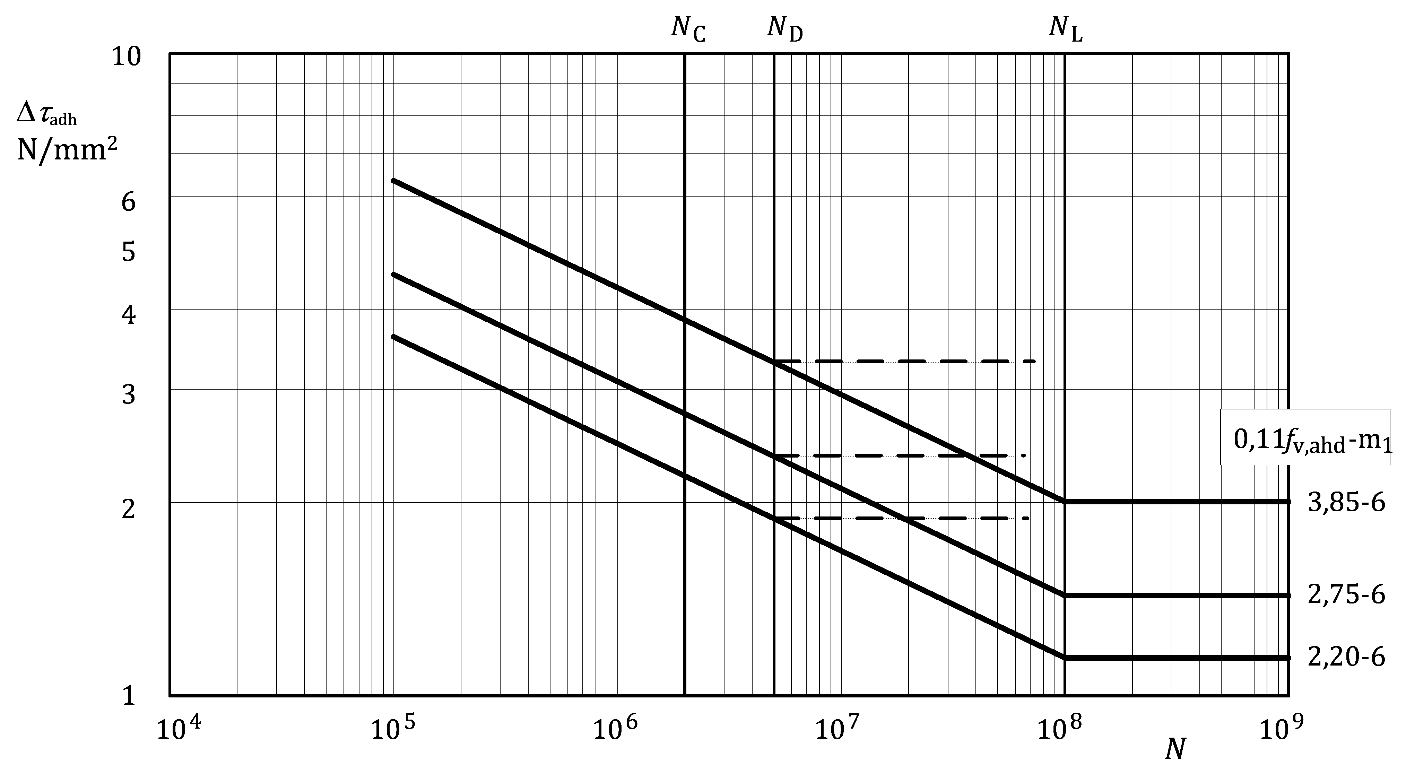

Key

|  |  |
| --- | --- |
| Fatigue shear strength curve: | 3,85-6 single-component, heat cured, modified epoxide,*f*v,adh = 35 N/mm2 |
| Fatigue shear strength curve: | 2,75-6 two-components, cold cured, modified epoxide, *f*v,adh = 25 N/mm2 |
| Fatigue shear strength curve: | 2,20-6 two-components, cold cured, modified acrylic, *f*v,adh = 20 N/mm2 |

Figure E.1 — Fatigue shear strength curve for adhesively bonded joints

Table E.2 — Numerical values for *k*adh (=Δ*τ*/*f*v,adh) for adhesively bonded joints

|  |  |  |  |  |
| --- | --- | --- | --- | --- |
| Detail category (*N* = 2 × 106) | | *N* = 105 | *N*D = 5 × 106 | *N*L = 108 |
| Δ*τ*C,adh*/f*v,adh | *m*1 | Δ*τ/f*v,adh | Δ*τ*D*/f*v,adh | Δ*τ*L*/f*v,adh |
| 0,11 | 6 | 0,181 | 0,094 | 0,065 |

(5) The fatigue design relationship for endurances in the range between 105 to 5 × 106 cycles or in the range between 5 × 106 to 108 cycles is defined as in 8.2.1(2) and 8.2.1(4), respectively.

(6) The design strength values for adhesively bonded joints should apply a partial factor *γ*Mf to the above given strength values.

NOTE The value of the partial factor *γ*Mf for specific constructional detail types is 1,0 and for adhesively bonded joints is 3,0, unless the National Annex gives different values.

(7) Testing under representative conditions of geometry, workmanship and exposure conditions should be undertaken for critical applications.

(8) Fatigue data for adhesively bonded joints applies only within a temperature range of −20 °C and +60 °C.

NOTE The temperature limits given are based on available test data. Other values can be defined by the National Annex, if they are justified by testing. Guidance for testing is given in Annex C.

(9) No allowance should be made for effect of mean stress without justification by testing.

NOTE Guidance for testing is given in Annex C.

1. (informative)  
     
   Low cycle fatigue range
   1. Use of this Informative Annex

(1) This Informative Annex provides supplementary guidance to 4.1 and 8.2.1 on low cycle fatigue range.

NOTE National choice on the application of this informative Annex is given in the National Annex. If the National Annex contains no information on the application of this informative annex, it can be used.

* 1. Scope and field of application

(1) Where significant damage is done by high stress ranges which are applied less than 105 times, the fatigue strength curves given in 8.2 for certain constructional details and *R*-ratios can be unnecessarily conservative. The data below may be used to obtain a more accurate life prediction.

* 1. Modification to fatigue strength curves

(1) For endurance between 103 and 105 cycles, the fatigue strength design curve may be defined using by Formula (F.1):

 (F.1)

where

|  |  |
| --- | --- |
| *N*i | is the calculated number of cycles to failure of a stress range Δ*σ*i; |
| Δ*σ*c | is the reference value of fatigue strength at 2 × 106 cycles depending on the detail category; |
| Δ*σ*i | is the stress range for the principal stresses at the detail and is constant for all cycles; |
| *m*0 | is the inverse logarithmic slope of the fatigue strength curve in the range 103 to 105 cycles, depending on the detail category, alloy and *R*-value; |
| *m*1 | is the inverse logarithmic slope of the fatigue strength curve, depending on the detail category; |
| *γ*Ff | is the partial factor for uncertainties in the loading spectrum and analysis of response (see 4.4); |
| *γ*Mf | is the partial factor for uncertainties in materials and execution (see 8.2.1(2)). |

* 1. Test data

(1) The values of *m*0, which have been derived from test data for selected constructional details in certain wrought alloy products given in Table F.1, should be used.

(2) For *R*-ratios between *R* = −1 and *R* = 0 a linear interpolation of inverse *m*0 value may be used.

(3) The *R*-value may be based on the applied stresses only, without taking into account residual stresses.

Table F.1 — Values of *m*0

|  |  |  |  |  |  |
| --- | --- | --- | --- | --- | --- |
| Detail type | Detail category Table | Alloys | Product Form | *m*0 | |
| *R* = −1 | *R* ≥ 0 |
| 1.1  1.2  1.3  1.4 | Table J.1 | 7020  6000 series a  7020  6000 series a | Sheet, plate and simple extrusions  Sheet, plate and simple extrusions  Shaped extrusions  Shaped extrusions | 5,0  4,0  4,0  4,0 | *m*1  *m*1  *m*1  *m*1 |
| 7.6  9.1  9.2  9.3  9.4 | Tables J.7 and J.9 | prEN 1999‑1‑1:2021, Table 5.1 a | | 3,0  3,0  3,0  3,0  3,0 | *m*1  *m*1  *m*1  *m*1  *m*1 |
| 15.1  15.2 | Table J.15 | 7020  7020 | prEN 1999‑1‑1:2021, Table 5.1 | 3,3  3,3 | *m*1  *m*1 |
| a Exceptions - see 3(1) | | | | | |

1. (informative)  
     
   Influence of applied stress ratio *R*
   1. Use of this Informative Annex

(1) This Informative Annex provides supplementary guidance to 8.2, 8.3, 8.4 on the influence of applied stress ratio *R*.

NOTE National choice on the application of this Informative Annex is given in the National Annex. If the National Annex contains no information on the application of this informative annex, it can be used.

* 1. Scope and field of application

(1) This Informative Annex gives guidance on enhanced fatigue strength values for compressive or low tensile stress values.

* 1. Enhancement of fatigue strength

(1) For applied stress ratio values less than *R* = +0,5 an enhanced reference fatigue strength Δ*σ*C(R) may be used in place of Δ*σ*C as given by Formula (G.1):

Δ*σ*C(R) = *f*(*R*) Δ*σ*C (G.1)

where:

|  |  |
| --- | --- |
| *f*(*R*) | is the enhancement factor depending on the *R*-ratio and the type of component and constructional detail, as given in G.4 below. |

Drawn tubes and formed profiles (folded; roll-formed) can have residual stresses, which are not negligible, so that an enhancement according to this Annex should not be made.

* 1. Enhancement cases
     1. Case 1

(1) Case 1 applies to initiation sites in the base material and wrought products in structural elements away from connections.

(2) Any pre-action or lack of fit in addition to the applied stresses should be taken into account.

(3) The values of the enhancement factor *f*(*R*) should be taken as derived from Formula (G.2):

*f(R) = 1,2 – 0,4R* (G.2)

as given in Table G.1 and Figure G.1.

Table G.1 — Values of *f*(*R*) for Case 1

|  |  |
| --- | --- |
| *R* | *f*(*R*) |
| ≤ −1 | 1,6 |
| > −1  < + 0,5 | 1,2 – 0,4*R* |
| ≥ + 0,5 | 1,0 |

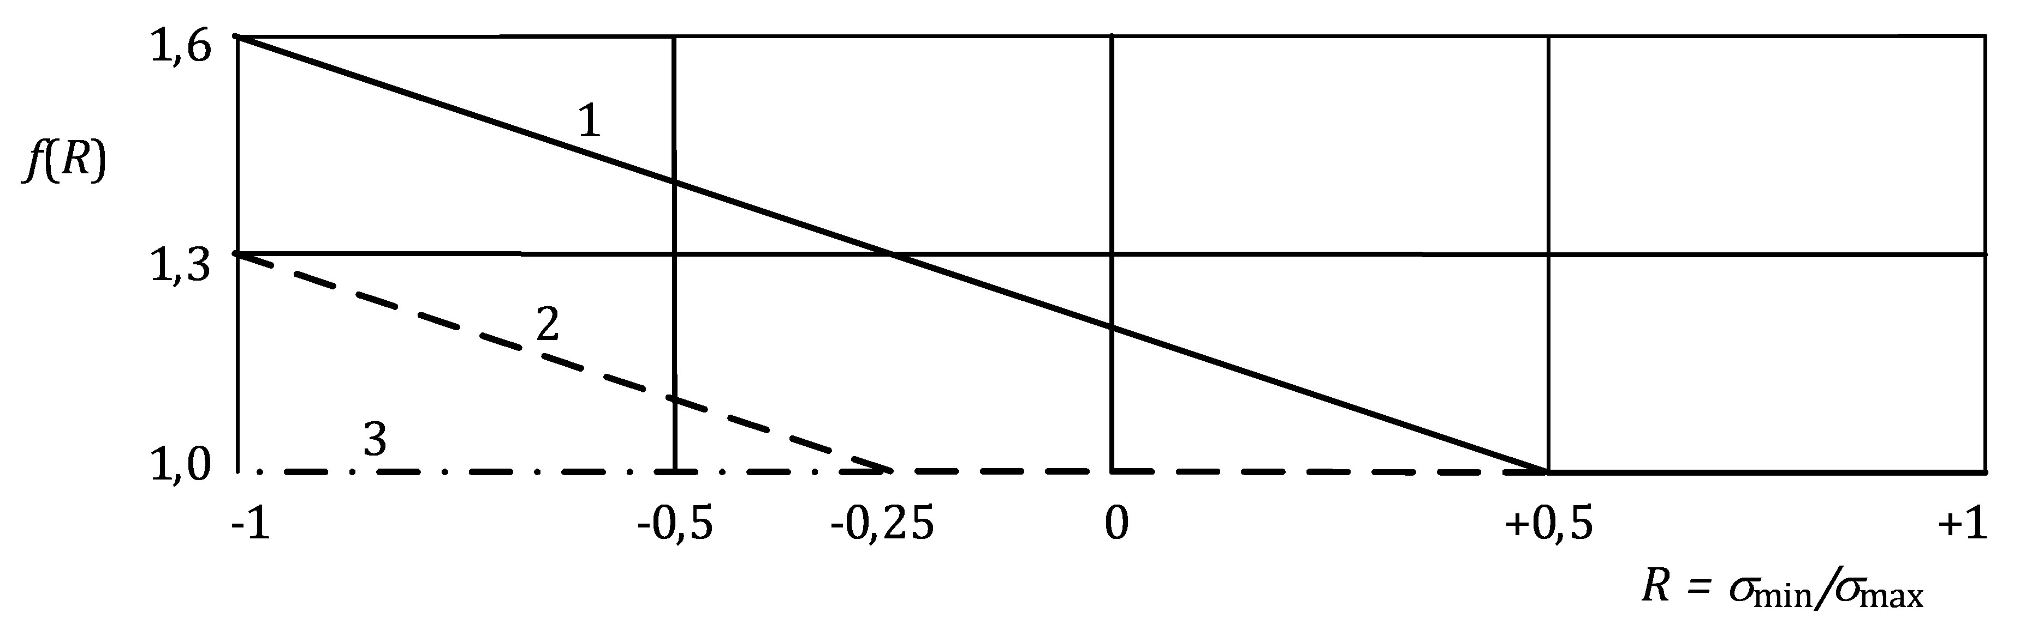

Key

|  |  |
| --- | --- |
| 1 | fully stress free regions; |
| 2 | partially stress free regions; |
| 3 | regions with residual stresses. |

Figure G.1 — Strength enhancement factor *f*(*R*) at 2 × 102 cycles

* + 1. Case 2

(1) Case 2 applies to initiation sites associated with welded or mechanically fastened connections in simple structural elements, where residual stresses *σ*res have developed, taking into account any pre-action or lack of fit.

(2) The effective *R*-ratio *R*eff should be estimated as given by Formula (G.3):

 (G.3)

where

|  |  |
| --- | --- |
| Δ*σ* | is the applied stress range. |

(3) The values of *f*(*R*) should be calculated from Formula (G.4):

*f*(*R*) = 0,9 – 0,4*R* (G.4)

NOTE See also Table G.2 and Figure G.1.

Table G.2 — Values of *f(R)* for Case 2

|  |  |
| --- | --- |
| *R*eff | *f*(*R*) |
| ≤ −1 | 1,3 |
| > −1  < −0,25 | 0,9 – 0,4*R* |
| ≥ −0,25 | 1,0 |

* + 1. Case 3

(1) Case 3 applies to near welded connections and too complex structural assemblies where control of residual stresses is not practicable.

(2) In this case, *f*(*R*) should be taken as unity for all *R*-ratios (see also Figure G.1).

1. (informative)  
     
   Fatigue strength improvement of welds
   1. Use of this Informative Annex

(1) This Informative Annex provides supplementary guidance to 8.5 on Fatigue strength improvement of welds.

NOTE National choice on the application of this Informative Annex is given in the National Annex. If the National Annex contains no information on the application of this informative annex, it can be used.

* 1. Scope and field of application

(1) In cases where the fatigue cracks would initiate at the weld toe, the capacity of welded joints can be improved. Such methods are normally used at the most highly stressed welds or for improving welds having low strength.

(2) The following methods are considered here:

— machining or grinding;

— dressing by TIG or plasma;

— peening (shot peening, needle peening or hammer peening).

(3) In cases where specified improvement techniques have been employed, an improvement at the mid and long fatigue life region up to 30 % measured by stress range can be obtained. The highest improvement is achieved by the combination of two methods like machining (or grinding) and hammer peening, where doubling the improvement due to the individual methods is possible.

(4) For all methods, the following aspects should be considered:

a) a suitable work procedure should be available;

b) before applying the measures for improvement, it should be ensured that no surface cracks are present in the critical locations. This should be done by dye penetrant or other suitable NDT methods;

c) in the short life region where the local stresses exceed the yield strength, the initiation period is a small fraction (irrespective of the notch case) and improvement is thus small. There will be no improvement at 105 cycles. (The fatigue strength curve is thus rotated with fixed values at 105.);

d) potential fatigue fracture locations other than that being improved should be considered: e.g. if the weld toe area is improved, then locations like the weld throat or internal cracks (partial penetration), might be the limiting factor;

e) the fatigue life and the usefulness of improvement methods should be considered;

f) under freely corroding conditions in water, the improvement is often lost. Methods involving compressive residual stresses (peening) are less susceptible. Corrosion protection is therefore needed, if improvement is to be achieved.

(5) Design values for improved welds should be established by testing, see Annex C.

* 1. Machining or grinding

(1) Machining may be performed by a high-speed rotary burr cutter and has the advantages of producing a more precise radius definition, leaving marks parallel to the stress direction and gaining access to corners. Alternatively, a disk grinder may be used if access permits, see Figure H.1. In both cases, the radius of the cutting tip or edge should be correctly chosen.

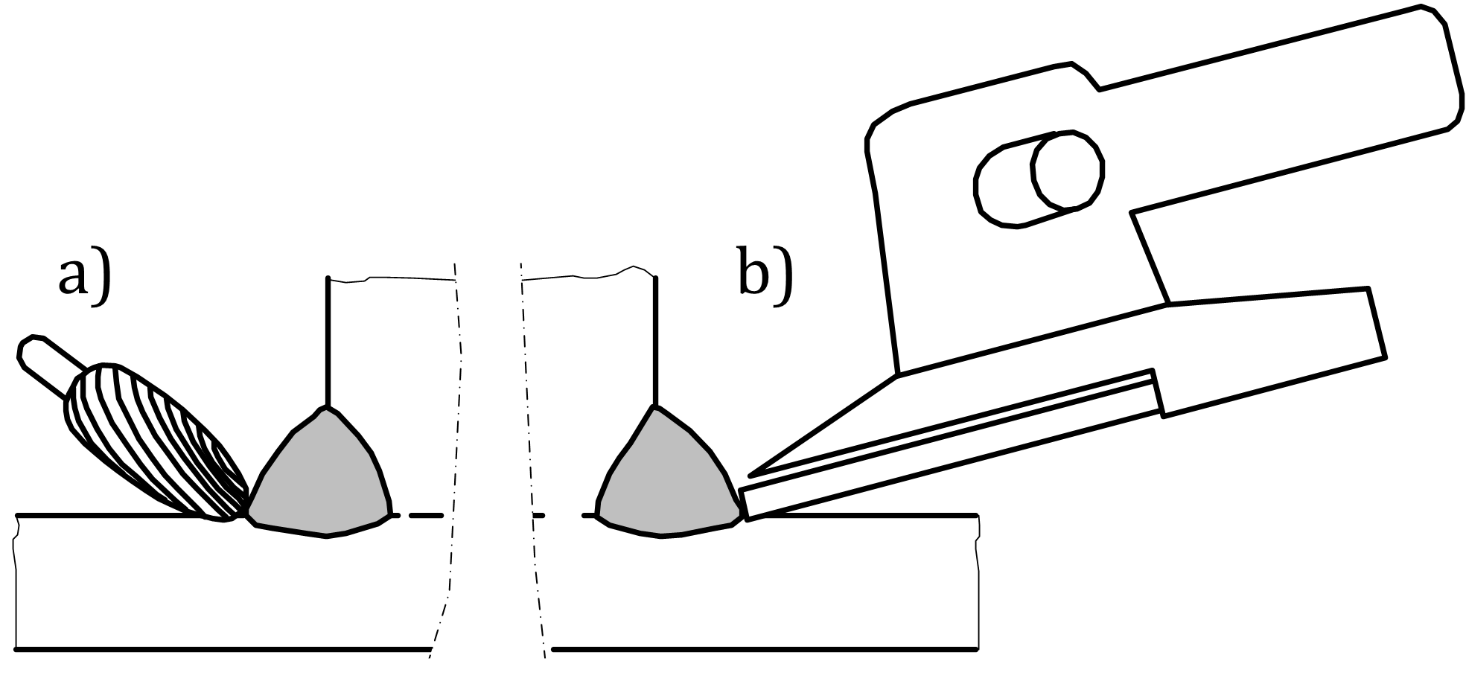

Key

|  |  |
| --- | --- |
| a) | burr machining; |
| b) | disk grinding |

Figure H.1 — Machining/grinding techniques

(2) To ensure the removal of intrusions etc. burr machining should be extended to a depth of minimum 0,5 mm below the bottom of any visible undercut etc., but should not exceed 2 mm or 5 % of the plate thickness, whichever is less (see Figure H.2). The slight reduction in plate thickness and corresponding increase in nominal stress is insignificant for thickness of 10 mm or larger. In the case of multipass welds, at least two weld toes should be treated. Care should also be taken to ensure that the required throat size is maintained.

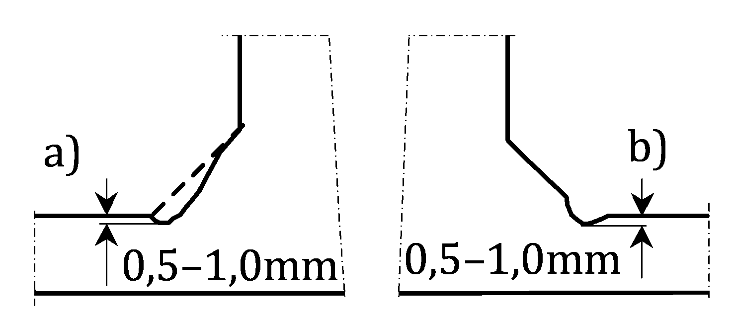

Key

|  |  |
| --- | --- |
| a) | full profile; |
| b) | weld toe |

Figure H.2 — Profile Geometries

* 1. Dressing by TIG or plasma

(1) While TIG welding is only a practical process for structures made of plates 4 mm thick or less, it may be used for improving the fatigue strength in cases where the weld toe is the critical site. When re-melting the existing toe region inclusions and undercuts may be removed and the toe radius may be increased, reducing the local stress concentration factor.

(2) Standard TIG dressing equipment should be used, without the addition of any filler material. TIG dressing is sensitive to operator skills. It is important to have clean surfaces to avoid pores. Detailed procedures should be prepared.

(3) The improvement should be verified by tests.

* 1. Peening

(1) The largest benefits are normally obtained with methods where compressive residual stresses are introduced. The most common methods are hammer peening, needle peening, and shot peening. Peening is a cold working process where the impact of a tool deforms the surface plastically. The surrounding (elastic) material will compress the deformed volume. High compressive service action can decrease the level of residual stress and should be taken into account when applying random action spectra.

(2) Procedures for all peening methods should be prepared: Passes, weld toe deformation, and indentation for hammer and wire bundle peening; intensity, coverage, and Almen strip deformation for shot peening.

1. (informative)  
     
   Castings
   1. Use of this Informative Annex

(1) This Informative Annex provides supplementary guidance to 5, 8.1.3 on Castings.

NOTE National choice on the application of this Informative Annex is given in the National Annex. If the National Annex contains no information on the application of this informative annex, it can be used.

* 1. Scope and field of application

(1) The following data may be used for castings provided that the rules for calculation of stresses in prEN 1999‑1‑1:2021, E.1 are applied.

(2) The design rules in this document for castings under fatigue loading, for the alloys given in prEN 1999‑1‑1:2021, Table 5.8, may be used if the additional requirements in I.4 are observed.

* 1. Fatigue strength data
     1. Plain castings

(1) Depending on the required level of quality, see I.4, the numerical values for Δ*σ* of Table I.1 may be applied.

Table I.1 — Numerical values of Δ*σ* (N/mm2) for plain material

|  |  |  |  |  |
| --- | --- | --- | --- | --- |
| Detail category (*N*C = 2 × 106) | | *N* = 105 | *N*D = 2 × 106 | *N*L = 108 |
| Δ*σ*C | *m*1 = *m*2 | Δ*σ* | Δ*σ*D | Δ*σ*L |
| **71** a | 7 | 108,9 | 71 | 40,6 |
| **50** | 7 | 76,7 | 50 | 28,6 |
| **40** | 7 | 61,4 | 40 | 22,9 |
| **32** | 7 | 49,1 | 32 | 18,3 |
| **25** | 7 | 38,4 | 25 | 14,3 |
| a see NOTE in I.4 | | | | |

* + 1. Welded material

(1) Fatigue strength values for welded castings are not covered by this document.

NOTE Fatigue strength values for welded joints of castings can be defined in the National Annex.

* + 1. Mechanically joined castings
       1. Bolted joints

(1) The numerical values Δ*σ* of Table I.2 may be applied for bolts of Category A: Bearing Type, see EN 1999‑1‑1.

Table I.2 — Numerical values of Δ*σ* (N/mm2) for bolted joints

|  |  |  |  |  |  |
| --- | --- | --- | --- | --- | --- |
| Detail category  (*N*C = 2 × 106) for plain material | Corresponding Detail category (*N*C = 2 × 106) for bolted joints | | N = 105 | ND = 5 × 106 | NL = 108 |
| Δ*σ*C | *m*1 = *m*2 | Δ*σ* | Δ*σ*D | Δ*σ*L |
| 71 | 45 | 4 | 95,2 | 35,8 | 16,9 |
| 50 | 40 | 4 | 84,6 | 31,8 | 15,0 |
| 40 | 25 | 4 | 52,9 | 19,9 | 9,4 |
| 32 | 20 | 4 | 42,3 | 15,9 | 7,5 |
| 25 | 16 | 4 | 33,8 | 12,7 | 6,0 |

* + - 1. Pinned joints

(1) Fatigue strength values for pinned joints are not covered by this document.

NOTE 1 Fatigue strength values of Table J.15 for bolted joints can be used, provided that design analysis considers adequately and reliably the stress distribution along the pin and the member, e.g. by geometric stress calculation.

NOTE 2 Fatigue strength values for pinned joints of castings can be defined in the National Annex.

* + 1. Adhesively bonded castings

(1) Adhesively bonded joints in castings are not covered by this document.

NOTE Fatigue strength values for adhesively bonded joints in castings can be defined in the National Annex.

* 1. Quality requirements

(1) The additional limitations in Table I.3 concerning maximum pore diameter should be observed.

Table I.3 — Values for maximum pore diameter (mm) for castings

|  |  |
| --- | --- |
| Detail category (*N*C = 2 × 106) | Maximum pore diameter |
| 71 | 0,2 |
| 50 | 0,5 |
| 40 | 0,9 |
| 32 | 1,5 |
| 25 | 2,0 (normal) |

NOTE Producing castings with pore diameter less than 0,6 mm requires special skill, experience and casting technique and technology. Furthermore, detecting pores less than 0,6 mm requires special equipment especially for the range up to 0,2 mm, where the possibility of detecting flaws of such a size depends also on the shape (thickness) of the casting. Assumptions made for the material properties of castings, to be used in the structural design, can be confirmed by the casting manufacturer.

1. (informative)  
     
   Detail category tables
   1. Use of this Informative Annex

(1) This Informative Annex provides supplementary guidance to 4.2.1, 4.5.2(1), 8.1.3, 8.2.1, 8.2.4, A.5.1, A.5.3, K.2, Lon Detail Categories.

NOTE National choice on the application of this Informative Annex is given in the National Annex. If the National Annex contains no information on the application of this informative annex, it can be used.

* 1. Scope and field of application

(1) The supplementary guidance on detail categories is given in Table J.1 to J.18 and on Δ*σ* – *N* relationships in Figure J.1 to J.9.

(2) The detail categories given in Table J.1 to J.18 and the Δσ – N relationships given in Figure J.1 to J.9 may only be used with the provisions of Clause 8.

(3) The detail category values are valid for ambient temperature, exposure conditions which do not require any surface protection (see Table 8.2), and in connection with the execution requirements of EN 1090‑3. These values are derived for stress ratio values not smaller than 0,5.

Table J.1 — Detail categories for plain members

|  |  |  |  |  |  |  |
| --- | --- | --- | --- | --- | --- | --- |
| Detail type | Detail category  **Δ***σ*-*m*1a  Alloy restriction | Product forms  Constructional detail  Initiation site | Stress orientation | Stress analysis | Execution requirements | |
| 1.1 | **125–7**  7020 only | Sheet, plate and simple extruded rod and bar, machined parts  Surface irregularity | Parallel or normal to rolling or extrusion direction. If the stress orientation is normal to the extrusion direction the manufacturer should be consulted concerning the quality assurance in case of extrusions by port hole or bridge die. | Principal nominal stress at initiation site | Surface free of sharp corners unless parallel to stress direction, edges free of stress raisers | No re-entrant corners in profile, no contact with other parts  Machined with a surface finish Rz5 < 40 *μ*m b  Visual inspection |
| 1.2 | **90–7** |
| 1.3 | **80–7**  7020 only | Sheet, plate, extrusions, tubes, forgings  Surface irregularity | Hand grinding not permitted unless parallel to stress direction  No score marks transverse to stress direction  Visual inspection |
| 1.4 | **71–7** |
| 1.5 | **140–7**  7020 only | Notches, holes  Surface irregularity | Account for stress concentration: see D.2 | Holes drilled and reamed  No score marks transverse to stress orientation  Visual inspection |
| 1.6 | **100–7** |
| a *m*1 = *m*2, constant amplitude fatigue limit at 2 × 106 cycles  b *R*z5 see EN ISO 4287 and EN ISO 4288 | | | | | | |

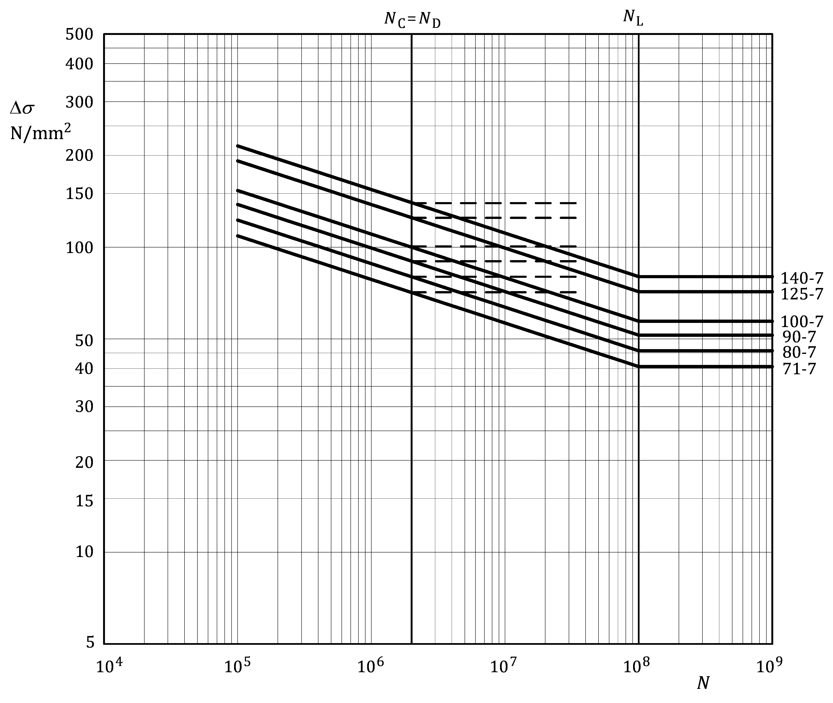

Figure J.1 — Fatigue strength curves for plain members –detail categories as in Table J.1

Table J.2 — Numerical values of Δ*σ* (N/mm2) for plain members –  
detail categories as in Table J.1

|  |  |  |  |  |  |  |  |  |  |
| --- | --- | --- | --- | --- | --- | --- | --- | --- | --- |
| Detail category | Slope | | Cycles *N* | | | | | | |
| *m*1 | *m*2 | 1 × 105 | 1 × 106 | **2 × 106** | 5 × 106 | 1 × 107 | 1 × 108 | 1 × 109 |
| **140–7** | **7,0** | **7,0** | 214,8 | 154,6 | **140,0** | 122,8 | 111,2 | 80,1 | 80,1 |
| **125–7** | **7,0** | **7,0** | 191,8 | 138,0 | **125,0** | 109,7 | 99,3 | 71,5 | 71,5 |
| **100–7** | **7,0** | **7,0** | 153,4 | 110,4 | **100,0** | 87,7 | 79,5 | 57,2 | 57,2 |
| **90–7** | **7,0** | **7,0** | 138,1 | 99,4 | **90,0** | 79,0 | 71,5 | 51,5 | 51,5 |
| **80–7** | **7,0** | **7,0** | 122,7 | 88,3 | **80,0** | 70,2 | 63,6 | 45,7 | 45,7 |
| **71–7** | **7,0** | **7,0** | 108,9 | 78,4 | **71,0** | 62,3 | 56,4 | 40,6 | 40,6 |

Table J.3 — Detail categories for members with welded attachments — transverse weld toe

| Detail type | Detail category  **Δ***σ*-*m*1a, b | Constructional detail  Initiation site | Dimensions  (mm) | Stress analysis | | Execution requirements | |
| --- | --- | --- | --- | --- | --- | --- | --- |
| Stress parameter | Stress already allowed for | - | **Quality level c** |
| 3.1 | **32–3,4** | At transverse weld toe on stressed member, away from edge (weld continued longitudinally at flange edge) | *L* ≤ 20 | Nominal stress at initiation site | Stiffening effect of attachment | Grind undercut smooth | C |
| 3.2 | **25–3,4** *t* ≤ 4  **23–3,4** 4 < *t* ≤ 10  **20–3,4** 10 < *t* ≤ 15 | *L* > 20 | C |
| 3.3 | **28–3,4** | At transverse weld toe on stressed member at corner (weld continued longitudinally at flange edge) | *L* ≤ 20 | C |
| 3.4 | **23–3,4** *t* ≤ 4  **20–3,4** 4 < *t* ≤ 10  **18–3,4** 10 < *t* ≤ 15 | *L* > 20 | C |
| 3.5 | **18–3,4** | Member surface on edge | No radius | C |
| 3.6 | **36–3,4** | In ground weld toe on edge | *r* ≥ 50 | Nominal stress at initiation site | Stiffening effect of attachment | Grind radius parallel to stress direction.  Weld toe should be fully ground out | C |
| 3.7 | **36–3,4** | In ground weld toe on edge at weld end | *r* ≥ 50 | - | - | C |
| 3.8 | **23–3,4** | On member surface at transverse weld | No radius | - | - | - | C |
| a *m*2 = *m*1 + 2  b For flat members under bending stresses see 8.2.1(11) and increase by two detail categories.  c According to EN ISO 10042:2018. | | | | | | | |

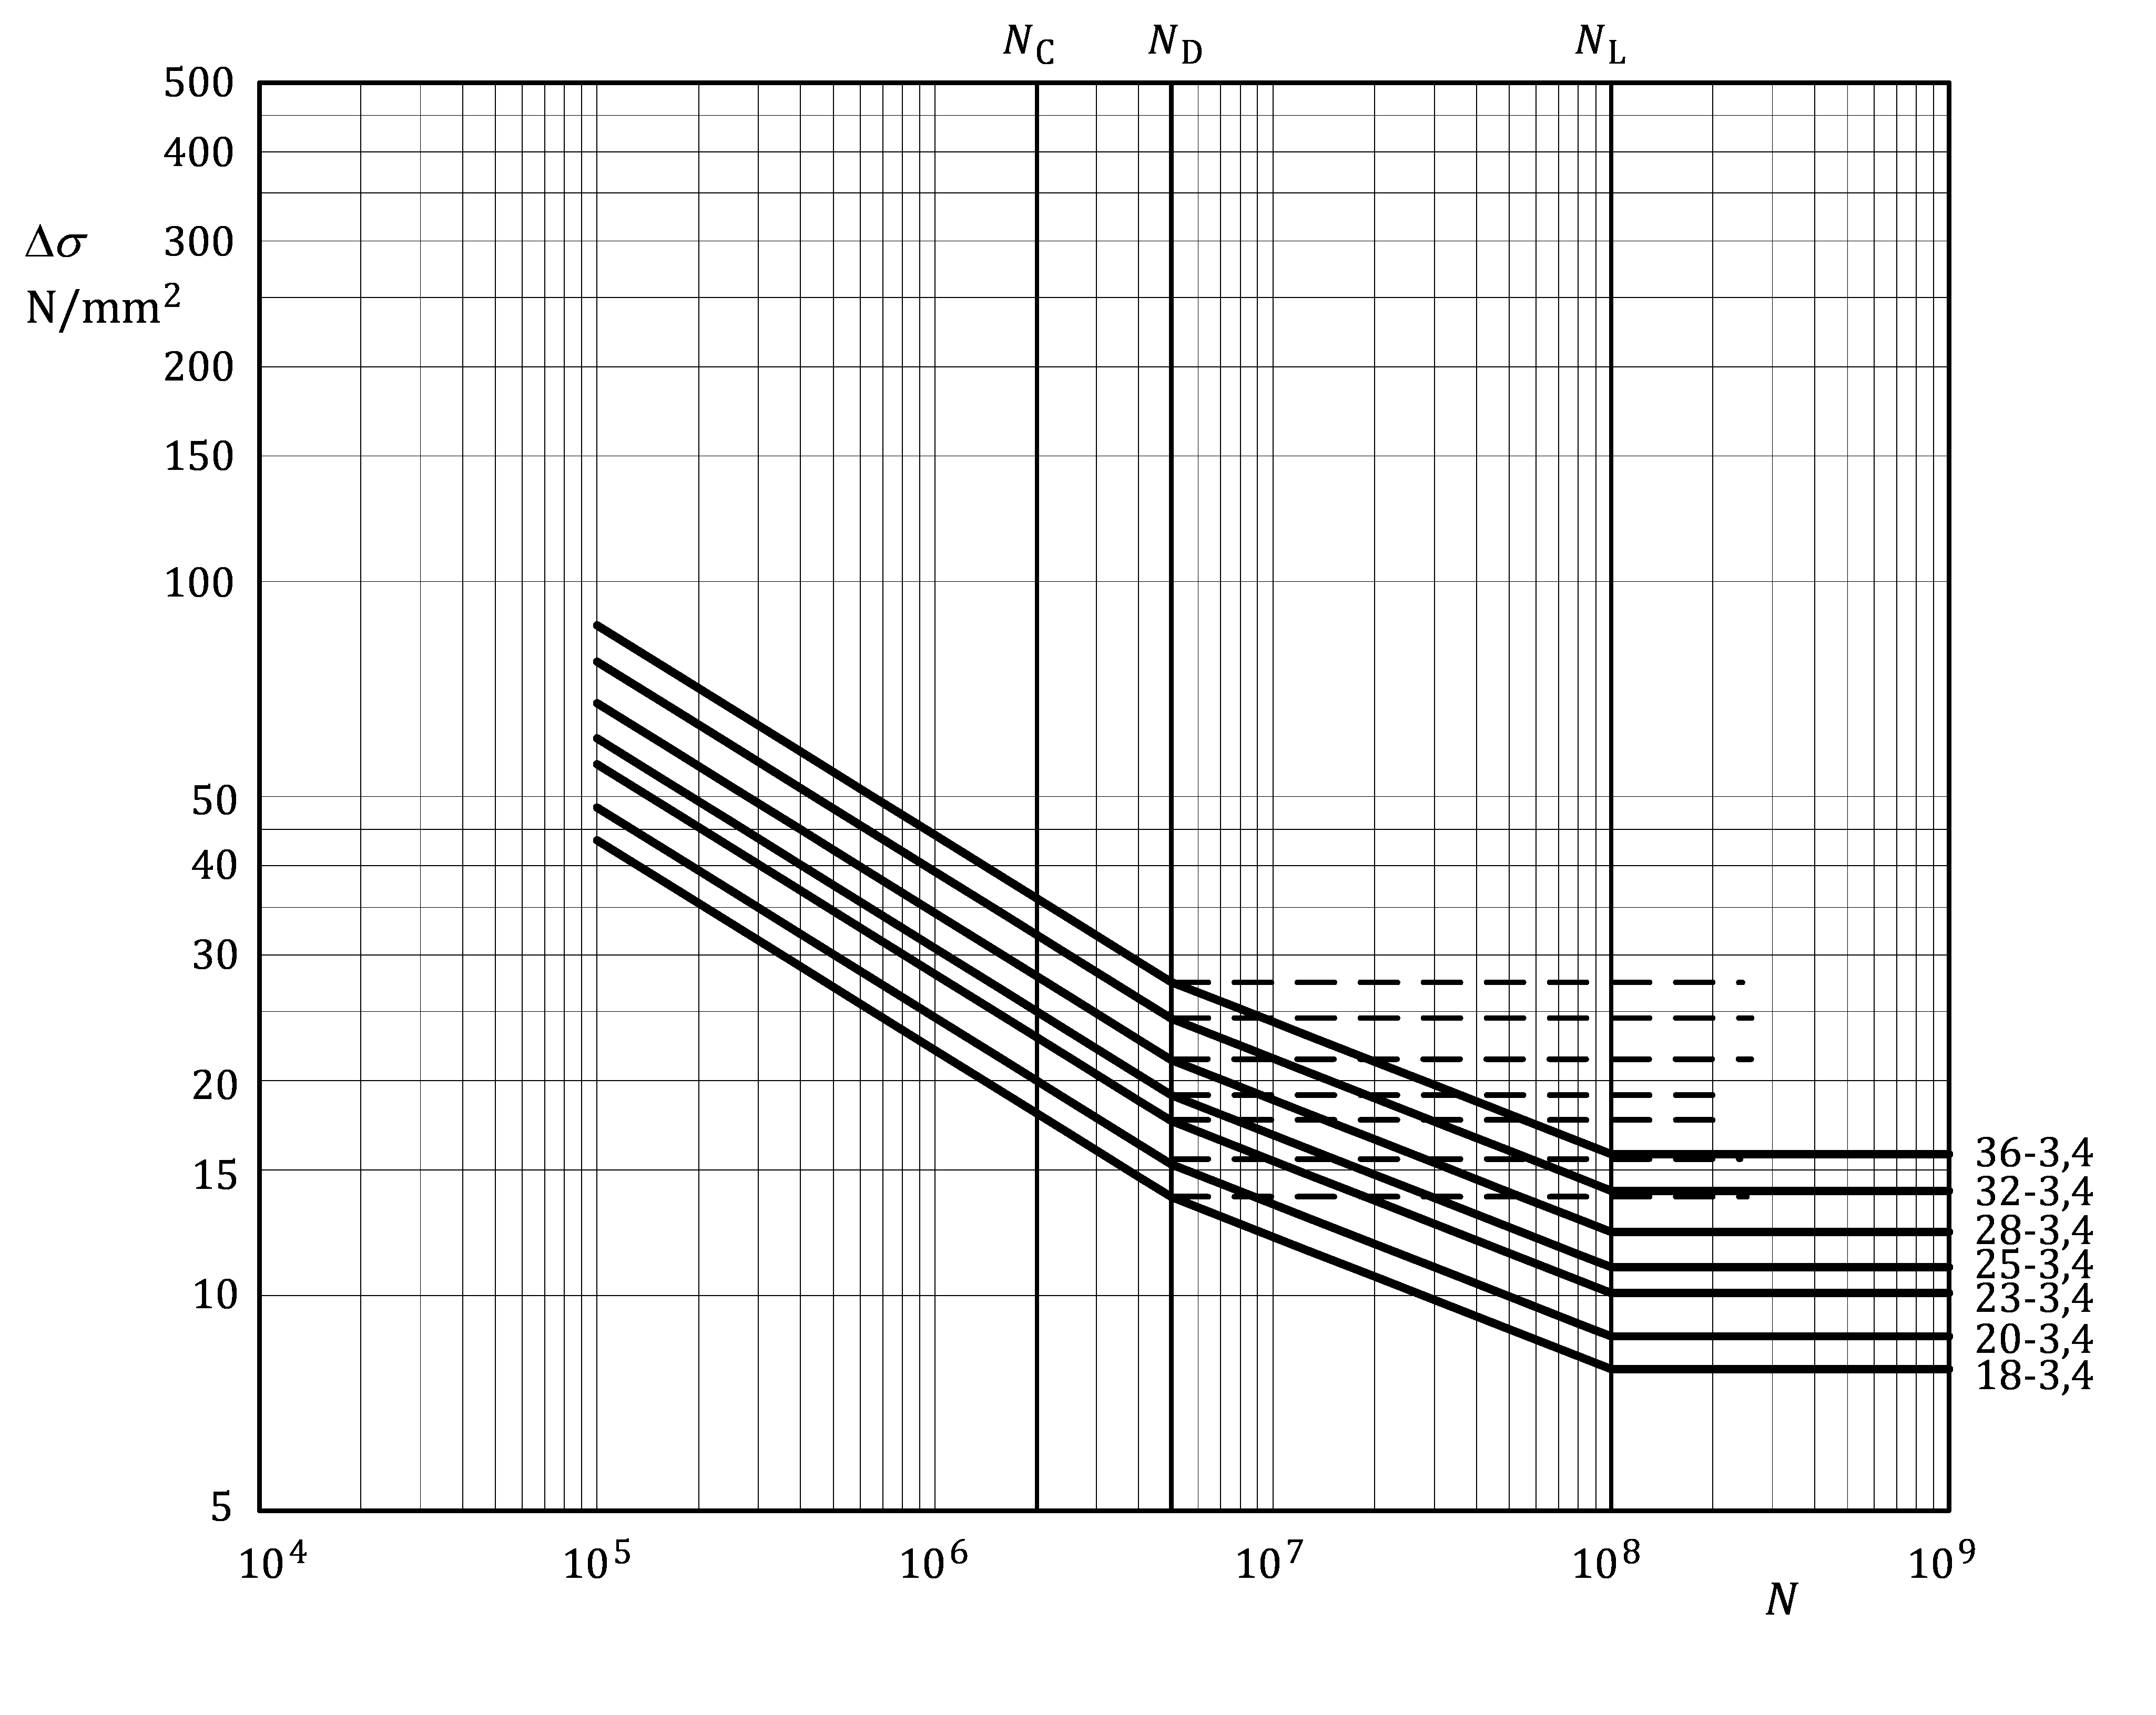

Figure J.2 — Fatigue strength curves for welded attachments, transverse weld toe —   
detail categories as in Table J.3

Table J.4 — Numerical values of Δ*σ* (N/mm2) for welded attachments, transverse weld toe —   
detail categories as in Table J.3

|  |  |  |  |  |  |  |  |  |  |
| --- | --- | --- | --- | --- | --- | --- | --- | --- | --- |
| Detail category | Slope | | Cycles *N* | | | | | | |
| *m*1 | *m*2 | 1 × 105 | 1 × 106 | **2 × 10**6 | 5 × 106 | 1 × 107 | 1 × 108 | 1 × 109 |
| **36–3,4** | **3,4** | **5,4** | 86,9 | 44,1 | **36,0** | 27,5 | 24,2 | 15,8 | 15,8 |
| **32–3,4** | **3,4** | **5,4** | 77,2 | 39,2 | **32,0** | 24,4 | 21,5 | 14,0 | 14,0 |
| **28–3,4** | **3,4** | **5,4** | 67,6 | 34,3 | **28,0** | 21,4 | 18,8 | 12,3 | 12,3 |
| **25–3,4** | **3,4** | **5,4** | 60,3 | 30,7 | **25,0** | 19,1 | 16,8 | 11,0 | 11,0 |
| **23–3,4** | **3,4** | **5,4** | 55,5 | 28,2 | **23,0** | 17,6 | 15,5 | 10,1 | 10,1 |
| **20–3,4** | **3,4** | **5,4** | 48,3 | 24,5 | **20,0** | 15,3 | 13,4 | 8,8 | 8,8 |
| **18–3,4** | **3,4** | **5,4** | 43,4 | 22,1 | **18,0** | 13,7 | 12,1 | 7,9 | 7,9 |

Table J.5 — Detail categories for members with longitudinal welds

| Detail type | Detail category  **Δ***σ*-*m*1a | Constructional detail  Initiation site | Weld type | Stress analysis | | Execution requirements | | | |
| --- | --- | --- | --- | --- | --- | --- | --- | --- | --- |
| Stress parameter | Stress concentrations already allowed for | Welding requirements | Quality level b | | Additional |
| Internal | Surface and geometric |
| 5.1 | 63–4,3 | At weld discontinuity | Full penetration butt weld  Weld caps ground flush | Nominal stress at initiation site | - | Continuous automatic welding | B | C |  |
| 5.2 | 56–4,3 | - | C | C |  |
| 5.3 | 45–4,3 | At weld discontinuity | Full penetration butt weld | Any backing bars to be continuous | C | D | c |
| 5.4 | 45–4,3 | At weld discontinuity | Continuous fillet weld | - | B | C |
| 5.5 | 40–4,3 | - | C | D |
| 5.6 | 36–4,3 | Weld toe or crater | Intermittent fillet weld  *g* ≤ 25*L* | - | - | - | C | D |  |
| 5.7 | 28–4,3 | Weld toe or crater | Cope hole centred on weld axis  *r* ≤ 25 | Presence of cope hole | - | C | D |  |
| a *m*2 = *m*1 + 2  b According to EN ISO 10042:2018.  c Discontinuity in direction of longitudinal weld should be not longer than 1/10 of the plate thickness or exhibit a slope steeper than 1:4. | | | | | | | | | |

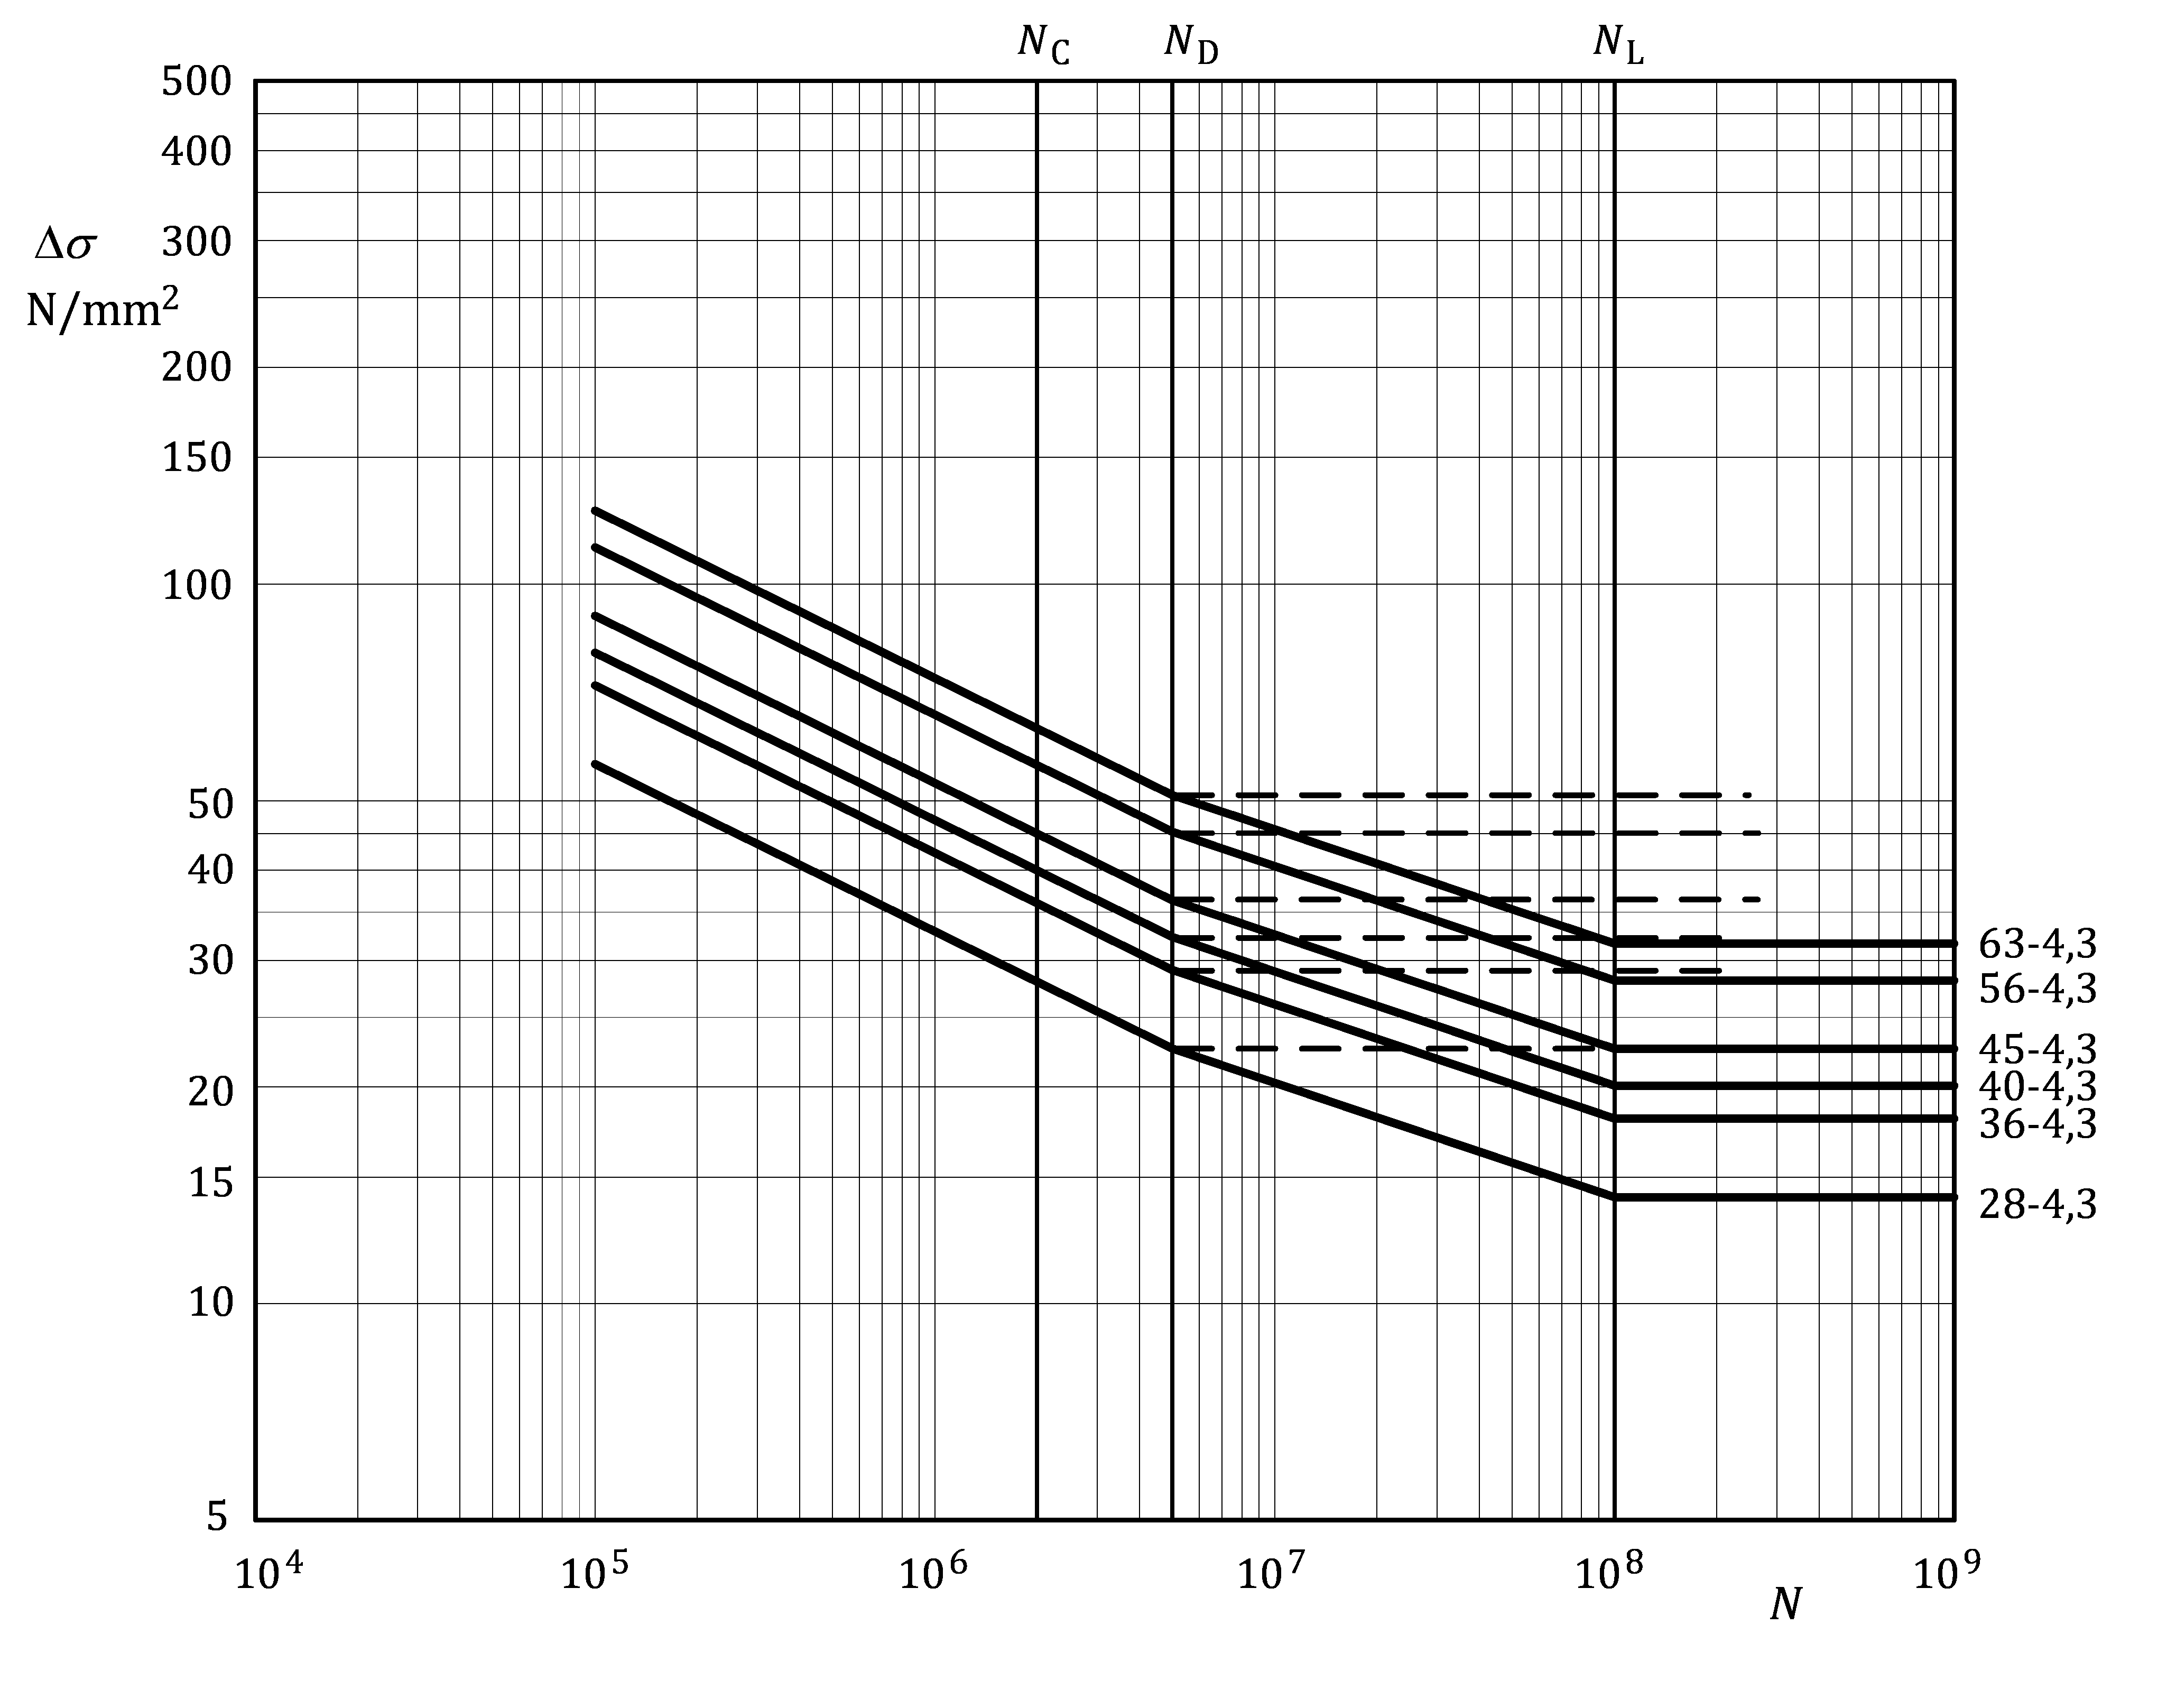

Figure J.3 — Fatigue strength curves for members with longitudinal welds —   
detail categories as in Table J.5

Table J.6 — Numerical values of Δ*σ* (N/mm2) with longitudinal welds —   
detail categories as in Table J.5

|  |  |  |  |  |  |  |  |  |  |
| --- | --- | --- | --- | --- | --- | --- | --- | --- | --- |
| Detail category | Slope | | Cycles *N* | | | | | | |
| ***m*1** | ***m*2** | **1 × 105** | **1 × 106** | 2 × 106 | **5 × 106** | **1 × 107** | **1 × 108** | **1 × 109** |
| **63–4,3** | **4,3** | **6,3** | 126,4 | 74,0 | **63,0** | 50,9 | 45,6 | 31,6 | 31,6 |
| **56–4,3** | **4,3** | **6,3** | 112,4 | 65,8 | **56,0** | 45,3 | 40,5 | 28,1 | 28,1 |
| **45–4,3** | **4,3** | **6,3** | 90,3 | 52,9 | **45,0** | 36,4 | 32,6 | 22,6 | 22,6 |
| **40–4,3** | **4,3** | **6,3** | 80,3 | 47,0 | **40,0** | 32,3 | 29,0 | 20,1 | 20,1 |
| **36–4,3** | **4,3** | **6,3** | 72,3 | 42,3 | **36,0** | 29,1 | 26,1 | 18,1 | 18,1 |
| **28–4,3** | **4,3** | **6,3** | 56,2 | 32,9 | **28,0** | 22,6 | 20,3 | 14,1 | 14,1 |

Table J.7 — Detail categories for butt-welded joints between members

| Detail type | Detail category  Δ***σ*-*m*1a** | Constructional detail  **Initiation site** | Weld type | Joint Part | Stress analysis | Execution requirements | | | | |
| --- | --- | --- | --- | --- | --- | --- | --- | --- | --- | --- |
| Welding requirements | | Quality level b | | Additional |
| Internal | Surface and geometric |
| 7.1.1 | **56–7** | Weld | Full penetration, caps ground flush both sides | Flats, solids | Net section | Root ground off | Extension plates used on ends, cut off and ground flush in direction of stress | B | B | c |
| 7.1.2 | **45–7** | Open shapes | C | C |
| 7.2.1 | **50–4,3** | Weld toe | Welded from both sides, full penetration | Flats, solids | B | B | c, d |
| 7.2.2 | **40–3,4** | Open shapes | B | C | c |
| 7.2.3 | **36–3,4** | C | C |
| 7.3.1 | **40–4,3** | Weld toe | Welded one side only, full penetration with permanent backing | Flats, solids | - | C | C | c |
| 7.3.2 | **32–3,4** | Open shapes, hollow, tubular | C | C |
| 7.4.1 | **45–4,3** | Weld toe | Welded one side only, full penetration without backing | Flats, solids | B | B | c, e |
| 7.4.2 | **40–4,3** | C | C | c |
| 7.4.3 | **32–3,4** | Open shapes, hollow, tubular | C | C |
| 7.5 | **18–3,4** | Weld | Partial penetration | - | Net throat | - | Extension plates used on ends, cut off and ground flush in direction of stress | D | D | - |
| 7.6 | **36–3,4** | Weld toe | Full penetration | - | Net section f | - | B | B | - |
| a *m*2 = *m*1 + 2  b According to EN ISO 10042:2018.  c Taper slope < 1:4 at width or thickness changes.  d Overfill angle ≥ 150° for both sides of the weld.  e Overfill angle ≥ 150°.  f Stress concentration of stiffening effect of transverse element already allowed for. | | | | | | | | | | |

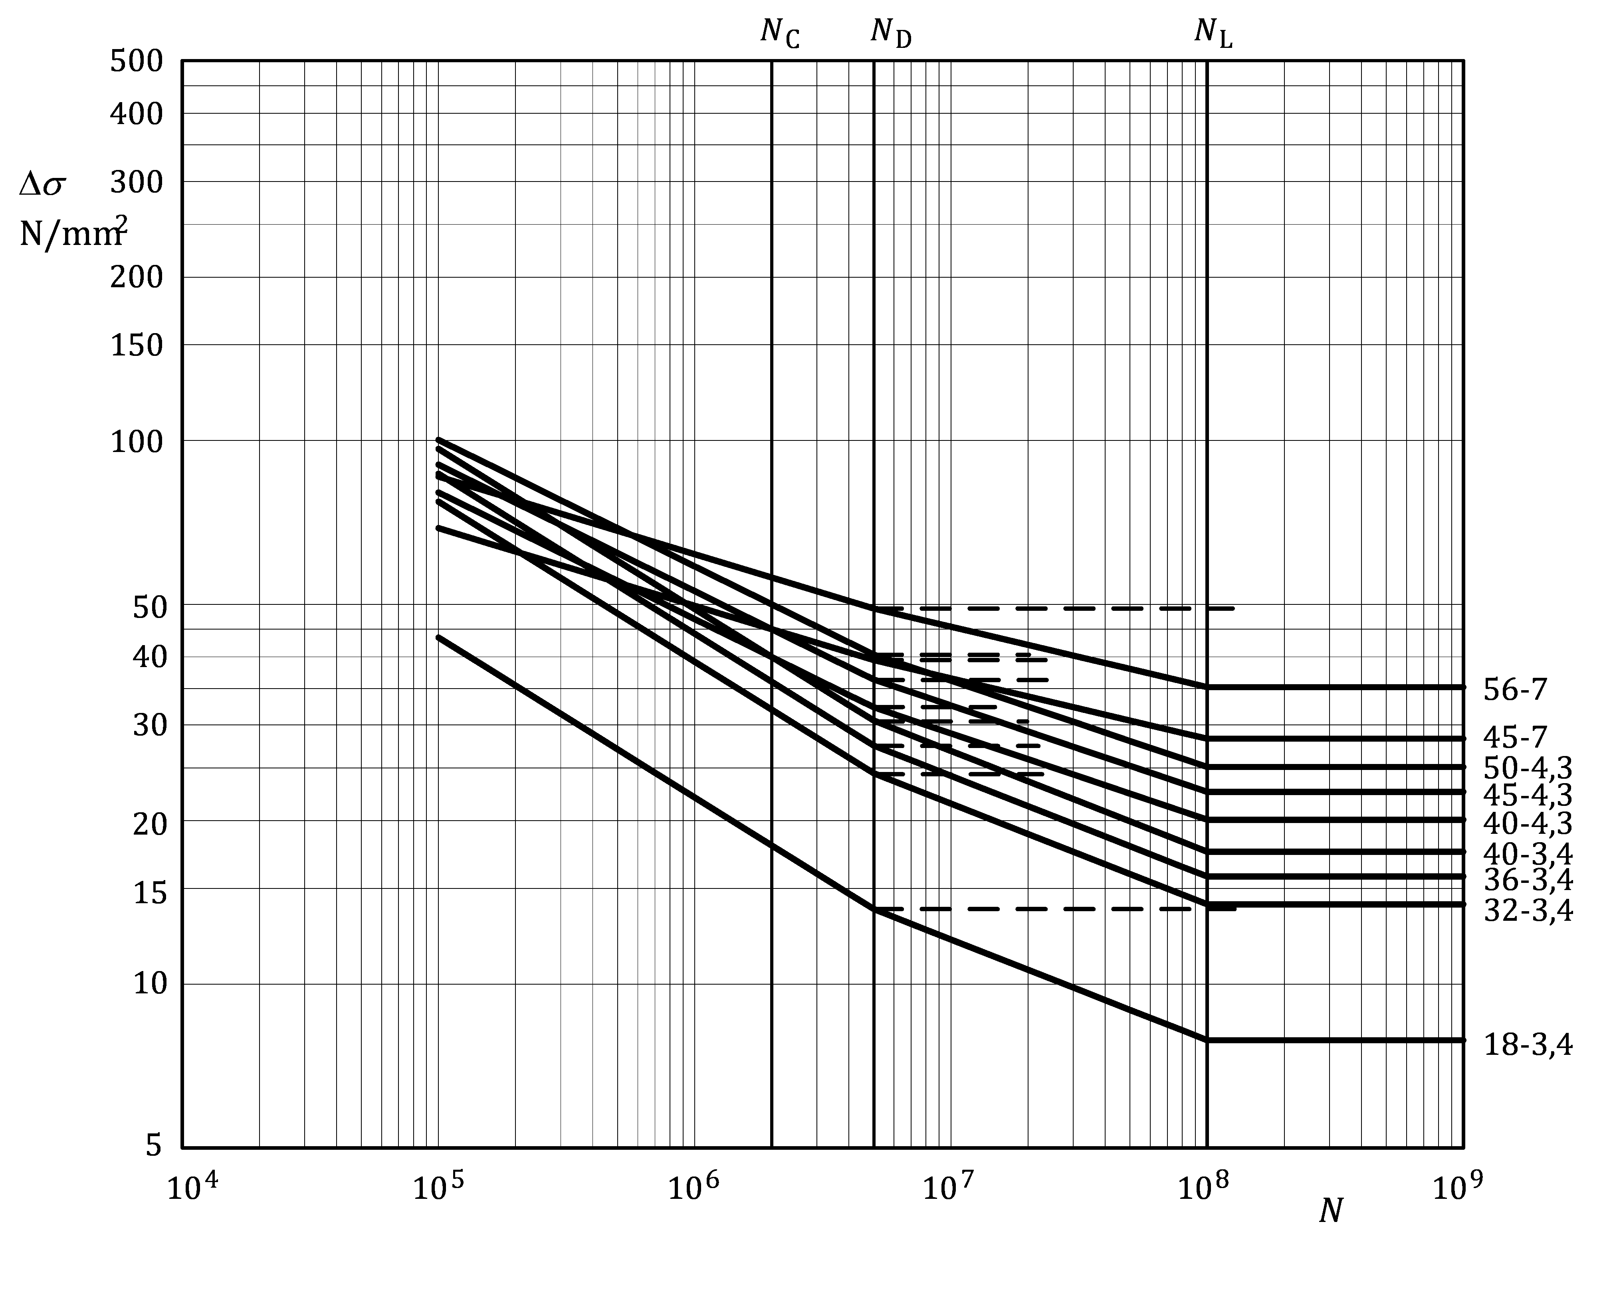

Figure J.4 — Fatigue strength curves for butt welded joints between members —   
detail categories as in Table J.7

Table J.8 — Numerical values of Δ*σ* (N/mm2) for butt welded joints between members —   
detail categories as in Table J.7

| Detail category | Slope | | Cycles *N* | | | | | | |
| --- | --- | --- | --- | --- | --- | --- | --- | --- | --- |
| ***m*1** | ***m*2** | **1 × 105** | **1 × 106** | 2 × 106 | **5 × 106** | **1 × 107** | **1 × 108** | **1 × 109** |
| **56–7** | **7** | **9** | 85,9 | 61,8 | **56,0** | 49,1 | 45,5 | 35,2 | 35,2 |
| **45–7** | **7** | **9** | 69,0 | 49,7 | **45,0** | 39,5 | 36,6 | 28,3 | 28,3 |
| **50–4,3** | **4,3** | **6,3** | 100,4 | 58,7 | **50,0** | 40,4 | 36,2 | 25,1 | 25,1 |
| **45–4,3** | **4,3** | **6,3** | 90,3 | 52,9 | **45,0** | 36,4 | 32,6 | 22,6 | 22,6 |
| **40–3,4** | **3,4** | **5,4** | 96,5 | 49,0 | **40,0** | 30,6 | 26,9 | 17,5 | 17,5 |
| **40–4,3** | **4,3** | **6,3** | 80,3 | 47,0 | **40,0** | 32,3 | 29,0 | 20,1 | 20,1 |
| **36–3,4** | **3,4** | **5,4** | 86,9 | 44,1 | **36,0** | 27,5 | 24,2 | 15,8 | 15,8 |
| **32–3,4** | **3,4** | **5,4** | 77,2 | 39,2 | **32,0** | 24,4 | 21,5 | 14,0 | 14,0 |
| **18–3,4** | **3,4** | **5,4** | 43,4 | 22,1 | **18,0** | 13,7 | 12,1 | 7,9 | 7,9 |

Table J.9 — Detail categories for fillet-welded joints between members

| Detail type | Detail category  **Δ***σ*-*m*1**a** | Constructional detail  Initiation site | Weld type | Stress analysis | | Execution requirements | | | |
| --- | --- | --- | --- | --- | --- | --- | --- | --- | --- |
| Stress parameter | Stress concentrations already allowed for | Welding requirements | Quality level d | | Additional |
| Internal | Surface and geometric |
| 9.1 | 28–3,4 | Weld toe | Fillet or partial penetration weld; toe crack (check also detail 9.2 or 9.6) | Net section | Stiffening effect of transverse element | Extension plates used on ends, cut off and ground flush in direction of Δ*σ* | C | C | - |
| 9.2 | 25–3,4 | Weld | Double sided fillet or partial penetration weld; root crackb (check also detail 9.1) | Net throat | Stiffening effect of transverse element | Extension plates used on ends, cut off and ground flush in direction of Δ*σ* | C | C | - |
| 9.3 | 28–3,4 | Tubular cross-section  Weld toe | One-sided fillet or partial penetration weld; toe crack for a/t > 1,1 | Net section | Stiffening effect of transverse element | Extension plates used on ends, cut off and ground flush in direction of Δ*σ* | C | C | - |
| 9.4 | 25–3,4 | Tubular cross-sectione  Weld toe | One-sided fillet or partial penetration weld; root crack for a/t ≤ 1,1 | Net throat | Stiffening effect of transverse element | Extension plates used on ends, cut off and ground flush in direction of Δ*σ* | C | C | - |
| 9.5 | 32–3,4 | Non-tubular cross-section  Weld | One-sided fillet or partial penetration weld | Net throat c | Stiffening effect of transverse element | Extension plates used on ends, cut off and ground flush in direction of Δ*σ* | C | C | **-** |
| 9.6 | 23–3,4 | Weld toe | Fillet weld | Net section | Stress peak at weld ends | - | C | C | - |
| 9.7 | 18–3,4 | Weld toe | Fillet weld | Net section | - | - | C | C | - |
| 9.8 | 14–3,4 | Weld | Fillet weld | Net throat, see 7.4.2 | - | - | C | C | - |
| a m2 = m1 + 2  b A small penetration is required even for the fillet welds.  c Multiply the net throat stress with a factor (1+6e/a), where a is the throat including penetration and e is the eccentricity between the rotated weld throat and the plate; e = n + a/2 – t/2.  d According to EN ISO 10042:2018.  e May also be applied on details where the geometry, load condition, and out-of-plane deformation of the plates, are the same as for tubular cross-sections. | | | | | | | | | |

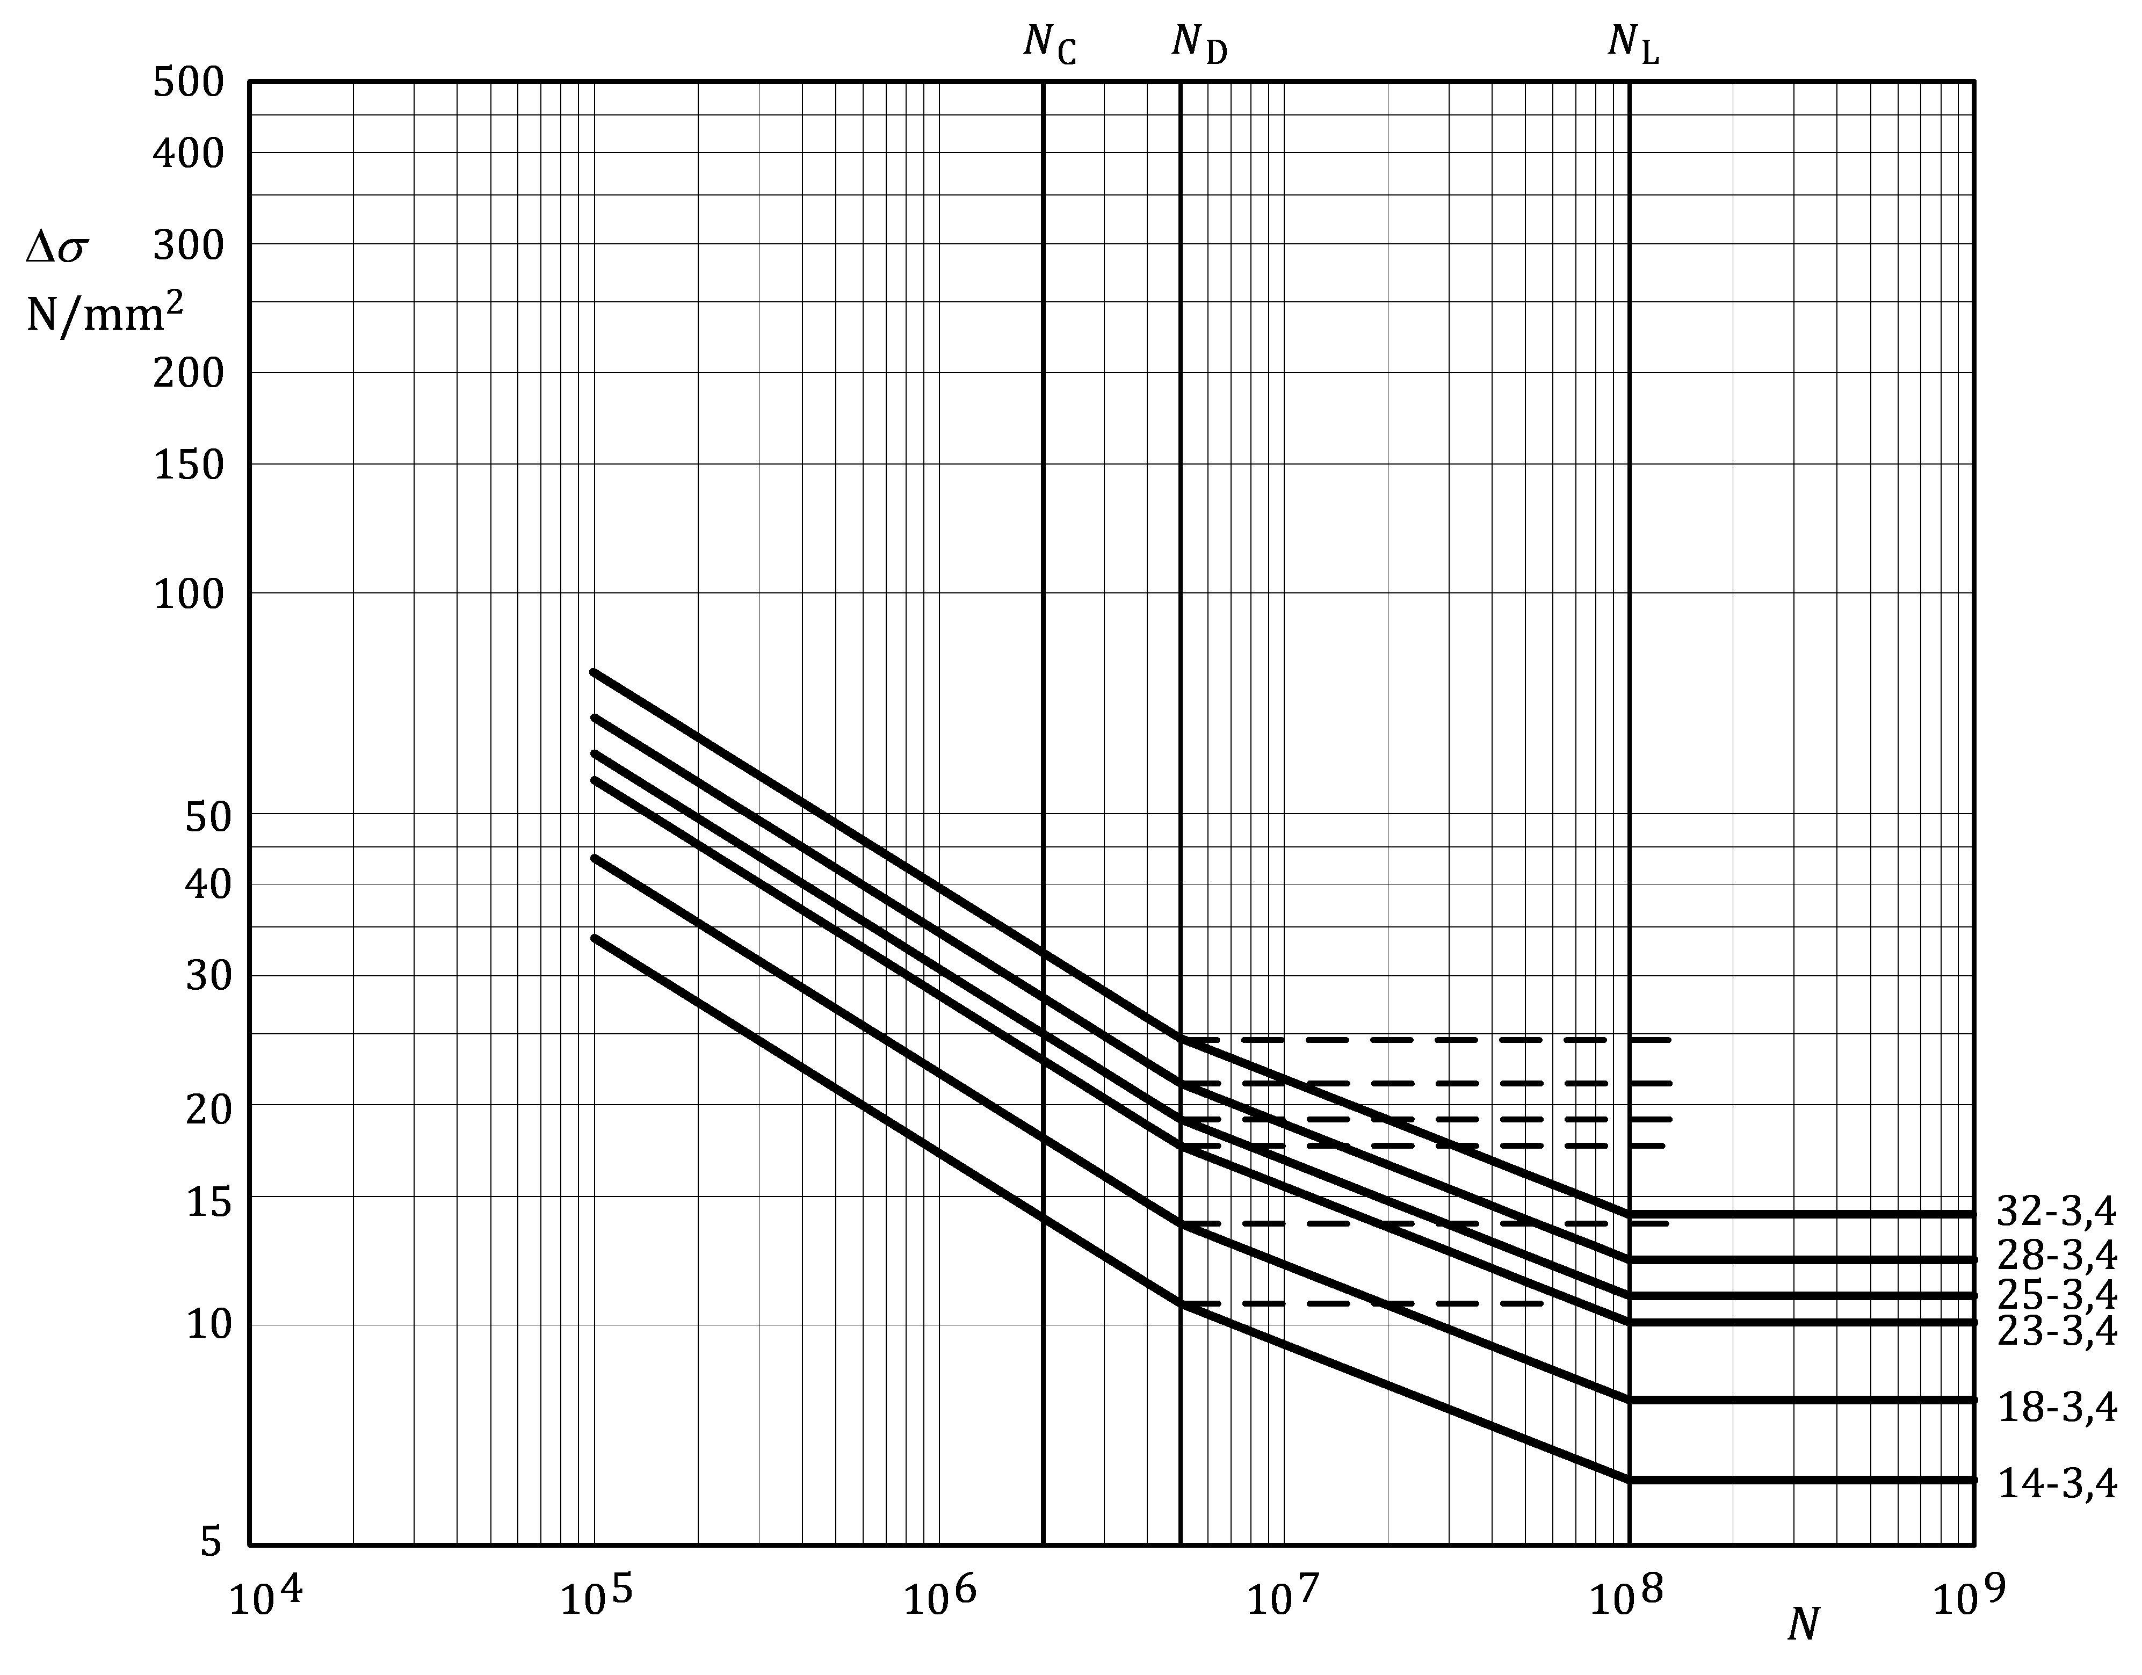

Figure J.5 — Fatigue strength curves for fillet-welded joints between members —   
detail categories as in Table J.9

Table J.10 — Numerical values of Δ*σ* (N/mm2) for fillet-welded joints between members —   
detail categories as in Table J.9

|  |  |  |  |  |  |  |  |  |  |
| --- | --- | --- | --- | --- | --- | --- | --- | --- | --- |
| Detail category | Slope | | Cycles *N* | | | | | | |
| ***m*1** | ***m*2** | **1 × 105** | **1 × 106** | 2 × 10**6** | **5 × 106** | **1 × 107** | **1 × 108** | **1 × 109** |
| **32–3,4** | **3,4** | **5,4** | 77,2 | 39,2 | **32,0** | 24,4 | 21,5 | 14,0 | 14,0 |
| **28–3,4** | **3,4** | **5,4** | 67,6 | 34,3 | **28,0** | 21,4 | 18,8 | 12,3 | 12,3 |
| **25–3,4** | **3,4** | **5,4** | 60,3 | 30,7 | **25,0** | 19,1 | 16,8 | 11,0 | 11,0 |
| **23–3,4** | **3,4** | **5,4** | 55,5 | 28,2 | **23,0** | 17,6 | 15,5 | 10,1 | 10,1 |
| **18–3,4** | **3,4** | **5,4** | 43,4 | 22,1 | **18,0** | 13,7 | 12,1 | 7,9 | 7,9 |
| **14–3,4** | **3,4** | **5,4** | 33,8 | 17,2 | **14,0** | 10,7 | 9,4 | 6,1 | 6,1 |

Table J.11 — Detail categories for crossing welds on built-up-members

| Detail type | Detail category  Δ***σ*-*m*1a** | Constructional detail  **Initiation site** | Weld type b, c | Stress analysis | Execution requirements | | | | |
| --- | --- | --- | --- | --- | --- | --- | --- | --- | --- |
| Welding requirements | | Quality level d | | Additional |
| Internal | Surface and geometric |
| 11.1 | 40–3,4 | Weld | Double sided butt weld, full penetration, caps ground flush both sides | Net section | Extension plates used on ends, cut off and ground flush in direction of Δ*σ* | Root ground off | B | B | For web-to-flange fillet welds, see Table J.5, type no. 5.4 or 5.5 |
| 11.2 | 40–3,4 | Weld | Single sided butt weld, full penetration, root and cap ground flush | Net section | Extension plates used on ends, cut off and ground flush in direction of Δ*σ* | - | B | B |
| 11.3 | 36–3,4 | Weld toe | Double sided butt weld, full penetration | Net section | Extension plates used on ends, cut off and ground flush in direction of Δ*σ* | Overfill angle ≥ 150° root ground off | B | C |
| 11.4 | **32–3,4** | Weld toe | Single sided butt weld, full penetration | Net section | Extension plates used on ends, cut off and ground flush in direction of Δ*σ* | - | C | C | For web-to-flange fillet welds, see Table J.5, type no. 5.4 or 5.5 |
| a *m*2 = *m*1 + 2  b Transverse web and flange butt joint before final assembly of beam with longitudinal welds.  c Taper slope < 1:4 at width or thickness change.  d According to EN ISO 10042:2018. | | | | | | | | | |

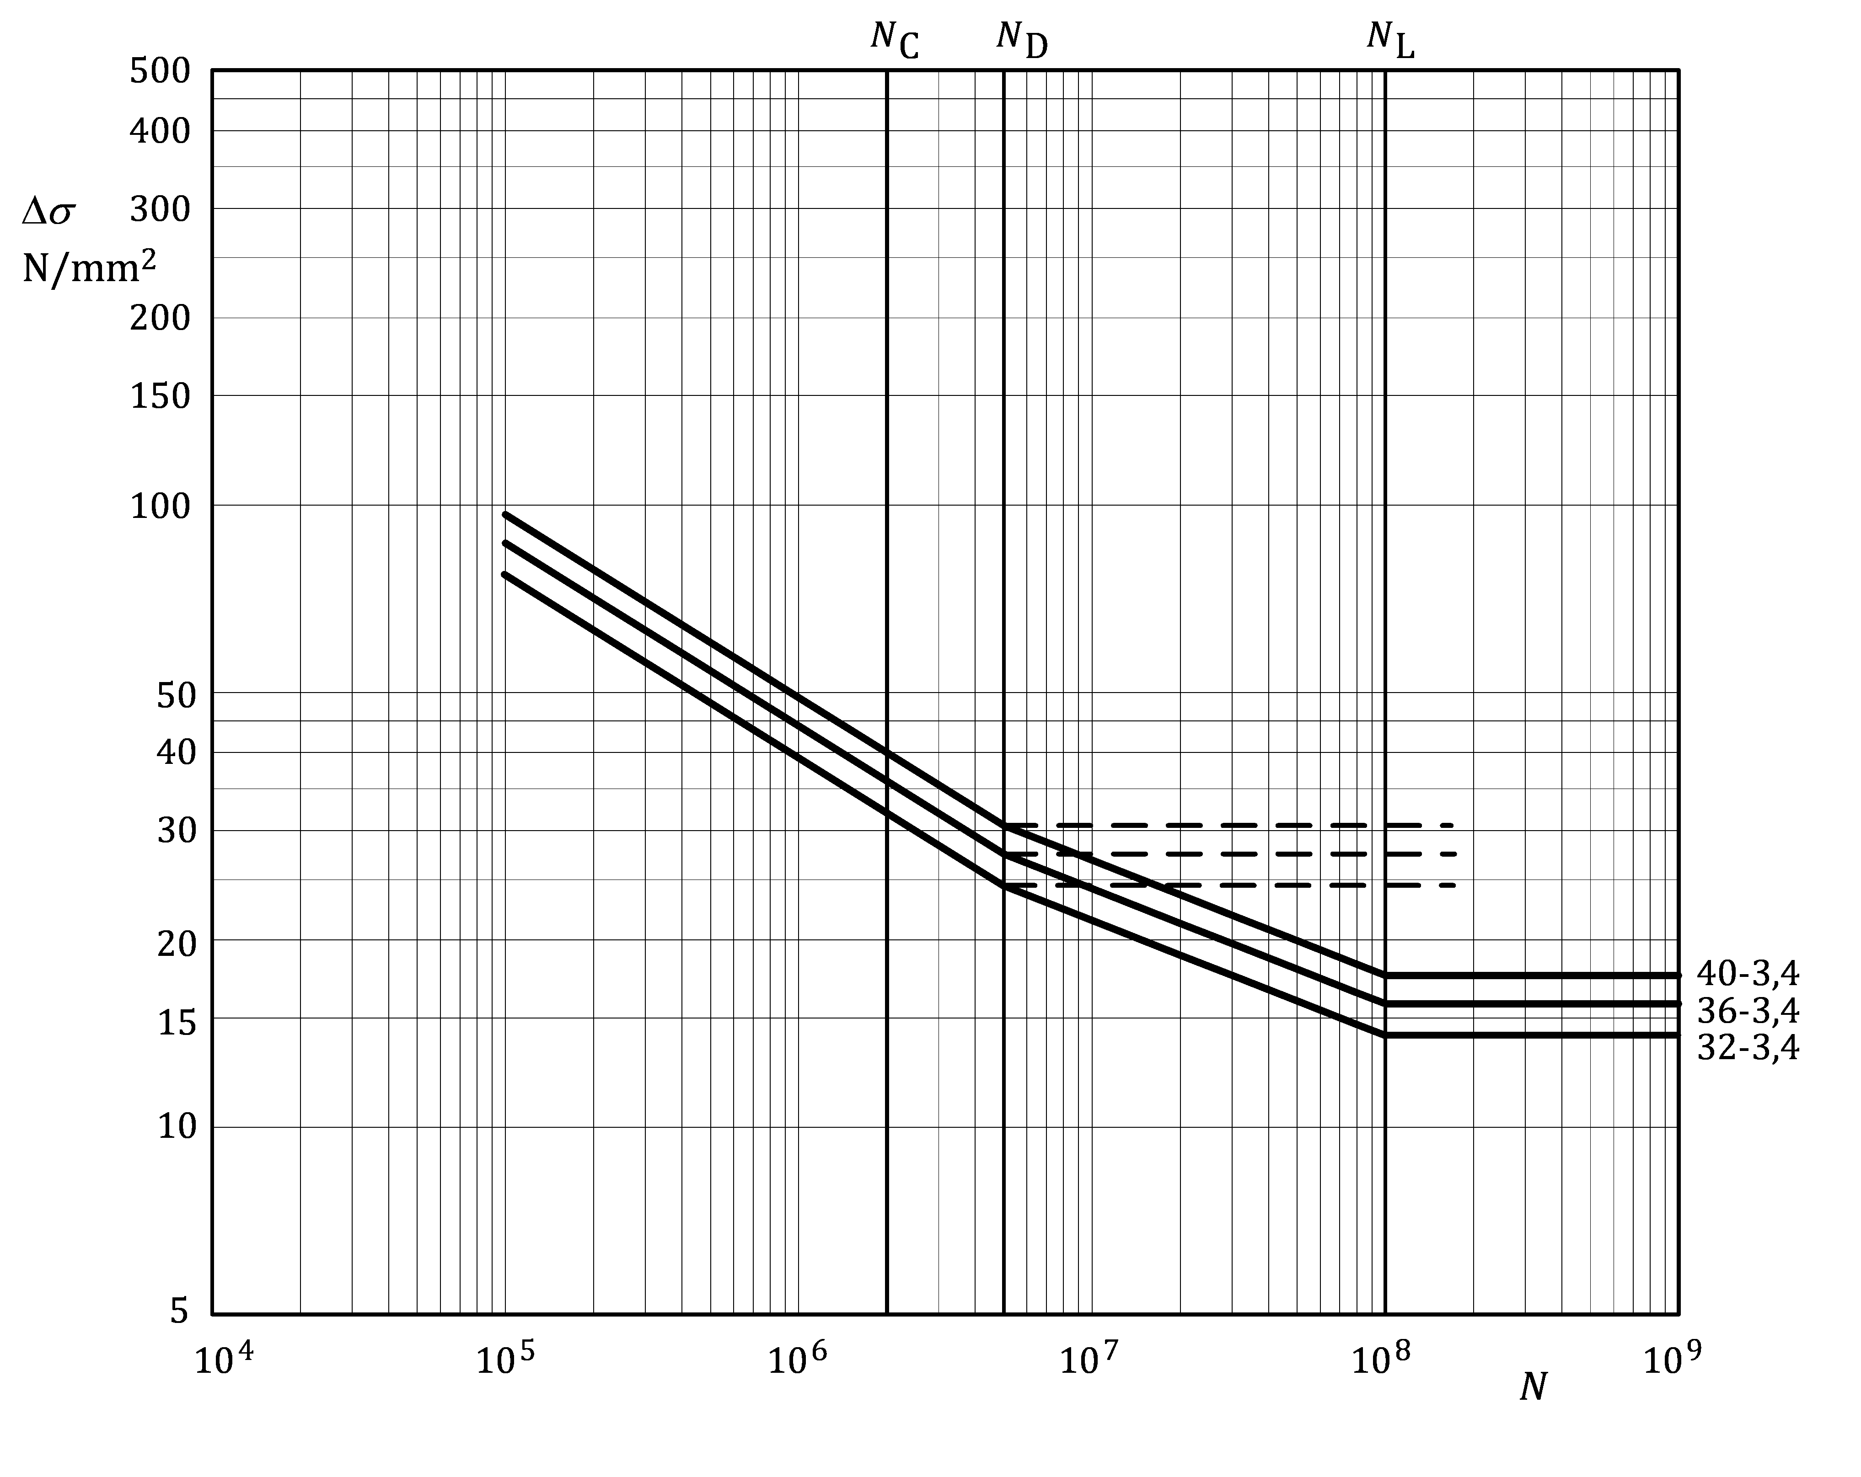

Figure J.6 — Fatigue strength curves for crossing welds on built-up beams —   
detail categories as in Table J.11

Table J.12 — Numerical values of Δ*σ* (N/mm2) crossing welds on built-up beams —   
detail categories as in Table J.11

|  |  |  |  |  |  |  |  |  |  |
| --- | --- | --- | --- | --- | --- | --- | --- | --- | --- |
| Detail category | Slope | | Cycles *N* | | | | | | |
| ***m*1** | ***m*2** | **1 × 105** | **1 × 106** | 2 × 10**6** | **5 × 106** | **1 × 107** | **1 × 108** | **1 × 109** |
| **40–3,4** | **3,4** | **5,4** | 96,5 | 49,0 | **40,0** | 30,6 | 26,9 | 17,5 | 17,5 |
| **36–3,4** | **3,4** | **5,4** | 86,9 | 44,1 | **36,0** | 27,5 | 24,2 | 15,8 | 15,8 |
| **32–3,4** | **3,4** | **5,4** | 77,2 | 39,2 | **32,0** | 24,4 | 21,5 | 14,0 | 14,0 |

Table J.13 — Detail categories for attachments on built-up beams

| Detail type | Detail category  **Δ***σ*-*m*1a | Constructional detail  Initiation site | Weld type | Stress analysis | | Execution requirements | | |
| --- | --- | --- | --- | --- | --- | --- | --- | --- |
| Stress parameter | Stress concentrations already allowed for | Quality level b | | Additional |
| Internal | Surface and geometric |
| 13.1 | 23–3,4 | Weld toe | Transverse attachment, thickness < 20 mm, welded on one or both sides | Net section | Stiffening effect of attachment / stress concentration at “hard point” of connection (compare to Figure 7.2) | C | C | For web-to-flange fillet welds, see Table J.5, type no. 7.4 or 7.5 |
| 13.2 | 18–3,4 | Weld toe | Longitudinal attachment length ≥ 100 mm, welded on all sides | Net section | C | C |
| 13.3 | 32–4,3 | Weld toe | Cruciform or tee, full penetration | Net section | C | C |
| 13.4 | 28–4,3 | Weld toe | Cruciform or tee, double sided fillet welds, toe crack for *a/t* > 0,6 | - | C | C |
| 13.5 | 25–4,3 | Weld | Cruciform or tee, double sided fillet welds; root crack for *a/t* ≤ 0,6 | Net throat | Stiffening effect of attachment / stress concentration at “hard point” of connection (compare to Figure 7.2) | C | C | For web-to-flange fillet welds, see Table J.5, type no. 7.4 or 7.5 |
| 13.6 | 20–4,3 | Weld toe | Cover plate length ≥ 100 mm, welded on all sides | Net section | C | C |
| a *m*2 = *m*1 + 2  b According to EN ISO 10042:2018. | | | | | | | | |

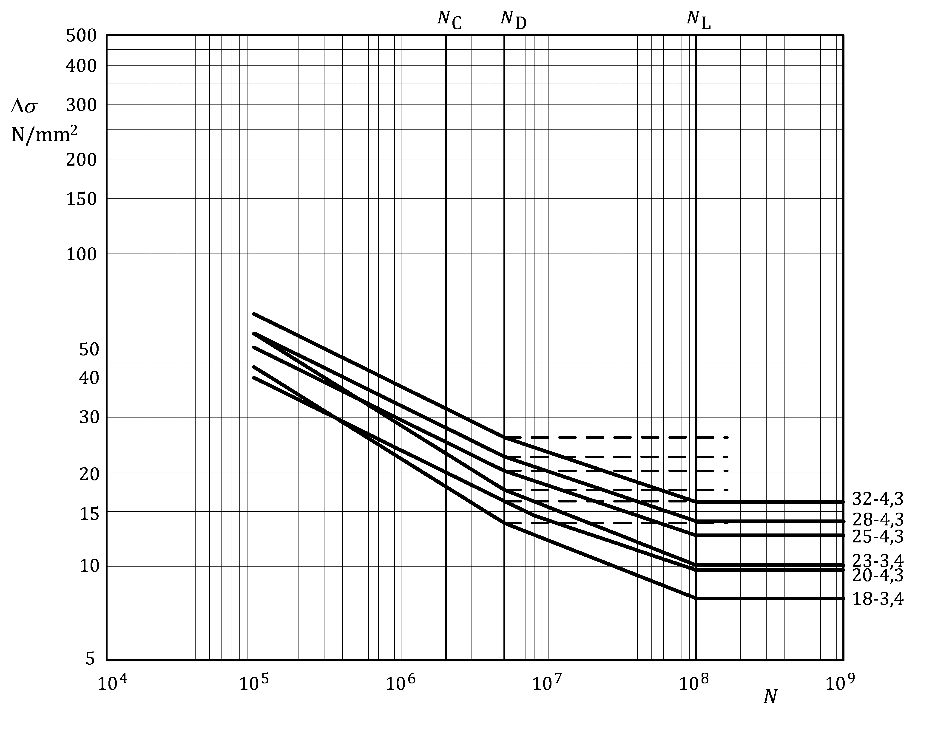

Figure J.7 — Fatigue strength curves for attachments on built-up members —   
detail categories as in Table J.13

Table J.14 — Numerical values of Δ*σ* – *N* (N/mm2) for attachments on built-up members —   
detail categories as in Table J.13

|  |  |  |  |  |  |  |  |  |  |
| --- | --- | --- | --- | --- | --- | --- | --- | --- | --- |
| Detail category | Slope | | Cycles *N* | | | | | | |
| ***m*1** | ***m*2** | **1 × 105** | **1 × 106** | 2 × 106 | **5 × 106** | **1 × 107** | **1 × 108** | **1 × 109** |
| **32–4,3** | **4,3** | **6,3** | 64,2 | 37,6 | **32** | 25,9 | 23,2 | 16,1 | 16,1 |
| **28–4,3** | **4,3** | **6,3** | 56,2 | 32,9 | **28** | 22,6 | 20,3 | 14,1 | 14,1 |
| **25–4,3** | **4,3** | **6,3** | 50,2 | 29,4 | **25** | 20,2 | 18,1 | 12,6 | 12,6 |
| **23–3,4** | **3,4** | **5,4** | 55,5 | 28,2 | **23** | 17,6 | 15,5 | 10,1 | 10,1 |
| **20–4,3** | **4,3** | **6,3** | 40,1 | 23,5 | **20** | 16,2 | 14,5 | 10,0 | 10,0 |
| **18–3,4** | **3,4** | **5,4** | 43,4 | 22,1 | **18** | 13,7 | 12,1 | 7,9 | 7,9 |

Table J.15 — Detail categories for bolted joints a, b, c

| Detail type | Detail category  **Δ***σ*-*m*1d | Constructional detail  Initiation site | Stress analysis | | Execution requirements |
| --- | --- | --- | --- | --- | --- |
| Stress parameter | Stress concentrations already allowed for |
| 15.1 | **56–4** | Double covered symmetrical joint with preloaded (friction type), high strength steel bolt  In front of hole (sometimes at edge of hole) | Nominal stress based on gross section properties | Surface texture, fastener hole geometry;  unequal load distribution between rows of bolts;  eccentricity of load path in symmetrical double covered lap joints only. | Flat parallel surfaces  Machining only by high-speed milling cutter; holes drilled (with optional reaming) or punched (with compulsory reaming if thickness > 6 mm)  Class of preloaded bolts should be 8.8 or 10.9, see EN 1999‑1‑1. |
| 15.2 | **56–4** | Double covered symmetrical joint with fitted steel bolts  At edge of hole | Nominal stress based on net section properties | Surface texture, fastener hole geometry;  unequal load distribution between rows of bolts;  eccentricity of load path in symmetrical double covered lap joints only. | Flat parallel surfaces  Machining only by high-speed milling cutter; holes drilled (with optional rea-ming) or punched (with compulsory reaming if thickness > 6 mm)  For steel bolts, EN 1999‑1‑1. |
| 15.3 | **45–4** | One-sided connection with preloaded (friction type), high strength steel bolt  In front of hole (some-times at edge of hole) | Nominal stress based on gross section properties | Surface texture, fastener hole geometry;  unequal load distribution between rows of bolts. | Flat parallel surfaces  Machining only by high-speed milling cutter; holes drilled (with optional reaming) or punched (with compulsory reaming if thickness > 6 mm)  Rotation of the joint under load should be prevented by structural means.  Class of preloaded bolts should be 8.8 or 10.9, see EN 1999‑1‑1. |
| 15.4 | **40–4** | One-sided connection with fitted steel bolts  At edge of hole | Nominal stress based on net section properties | Surface texture, fastener hole geometry;  unequal load distribution between rows of bolts. | Flat parallel surfaces  Machining only by high-speed milling cutter; holes drilled (with optional reaming) or punched (with compulsory reaming if thickness > 6 mm)  Rotation of the joint under load should be prevented by structural means.  For steel bolts see EN 1999‑1‑1. |
| a Aluminium bolts should not be used in fatigue loaded structures.  b Verification of the resistance of steel bolts and stainless steel bolts (grade A4–70 and A4–80) in tension or shear: see EN 1993‑1‑9.  c Slip-resistant joints should be used only if the 0.2 % proof stress of the material of the connected parts is higher than 200 N/mm2, see EN 1999‑1‑1.  d *m*1  =  *m*2 | | | | | |

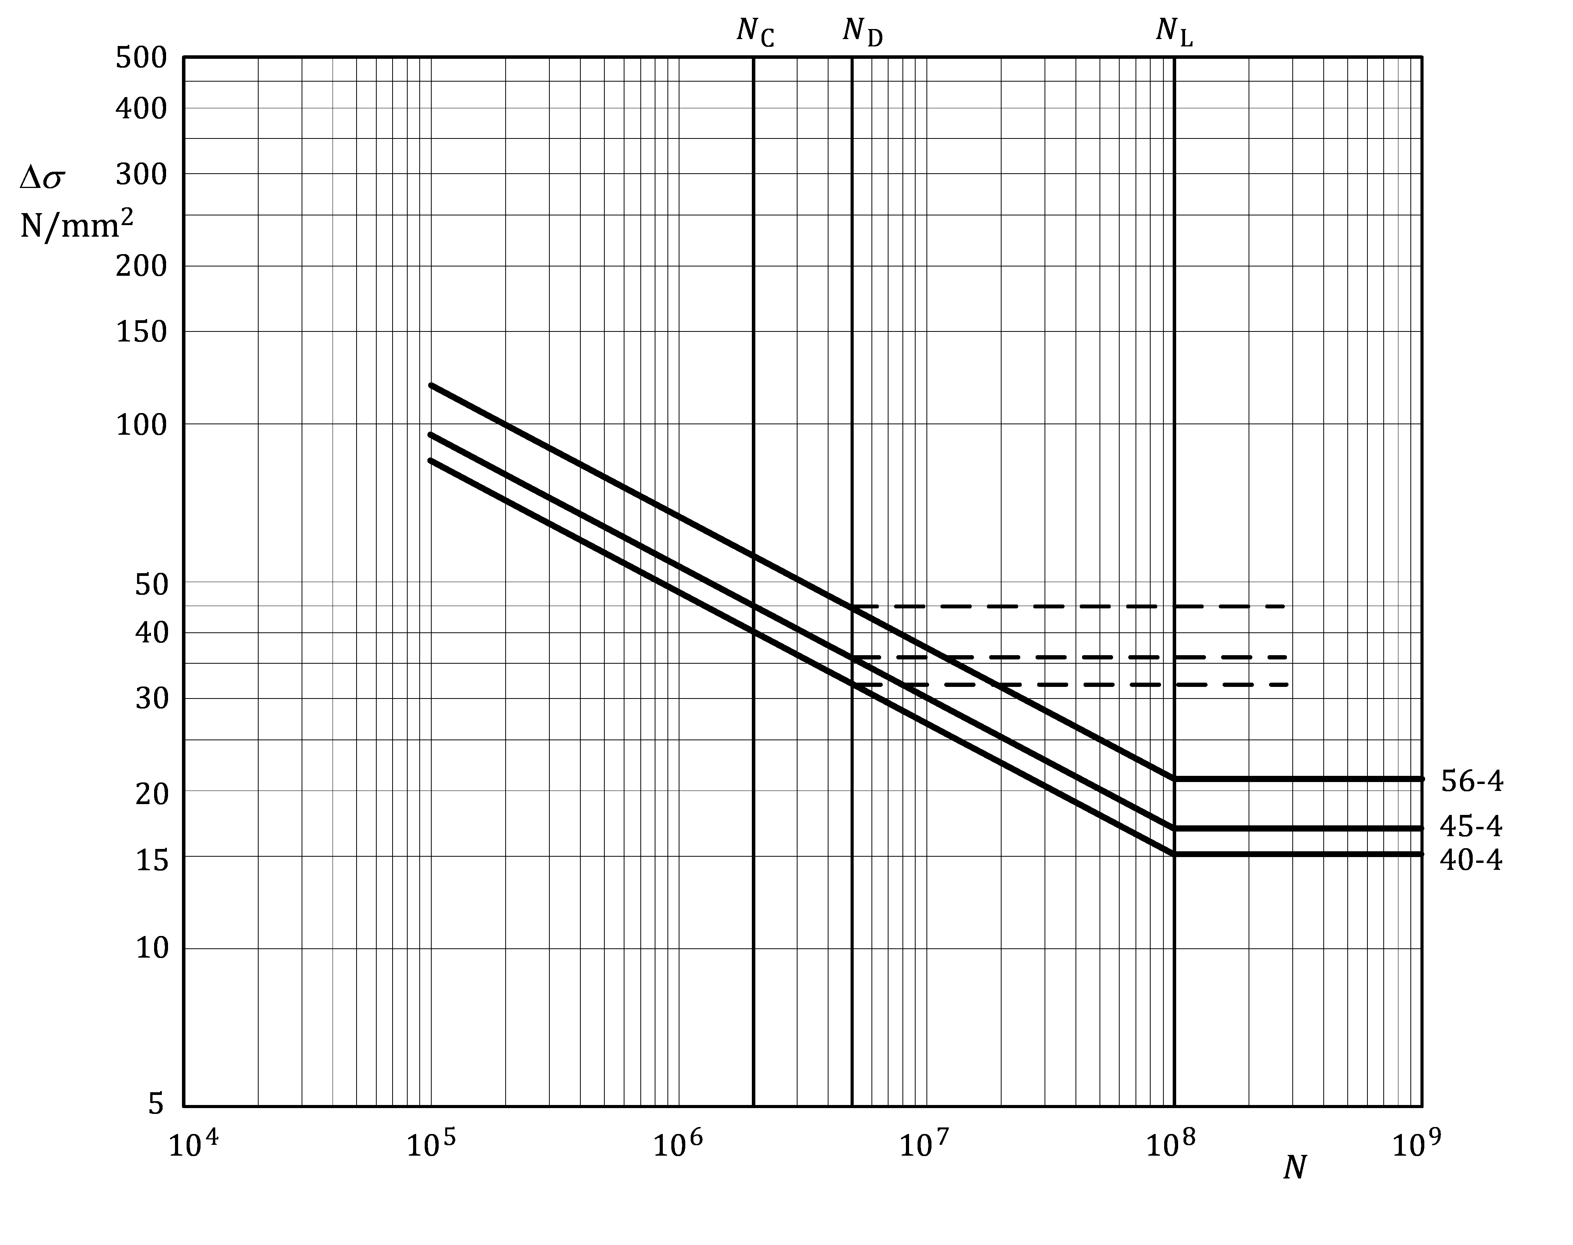

Figure J.8 — Fatigue strength curves for bolted joints —   
detail categories as in Table J.15

Table J.16 — Numerical values of Δ*σ* (N/mm2) for bolted joints —   
detail categories as in Table J.15

|  |  |  |  |  |  |  |  |  |  |
| --- | --- | --- | --- | --- | --- | --- | --- | --- | --- |
| Detail category | Slope | | Cycles *N* | | | | | | |
| ***m*1** | ***m*2** | **1 × 105** | **1 × 106** | 2 × 106 | **5 × 106** | **1 × 107** | **1 × 108** | **1 × 109** |
| **56–4** | **4** | **4** | 118 | 66,6 | **56** | 44,5 | 37,4 | 21,1 | 21,1 |
| **45–4** | **4** | **4** | 95,2 | 53,5 | **45** | 35,8 | 30,1 | 16,9 | 16,9 |
| **40–4** | **4** | **4** | 84,6 | 47,6 | **40** | 31,8 | 26,7 | 15,0 | 15,0 |

Table J.17 — Detail categories for members with friction stir welds

| Detail type | Detail category  **Δ***σ*-*m*1a | Constructional detail  Initiation site  Stress orientation | Weld type | Stress analysis | | Execution requirements | | | |
| --- | --- | --- | --- | --- | --- | --- | --- | --- | --- |
| Stress parameter | Stress concentrations already allowed for | Welding requirements | Quality level b | | Additional |
| Internal | Surface and geometric |
| 17.1 | **56–7** | At weld surface or backing Stress due to longitudinal axial force | Full penetration  FSW | Nominal stress at initiation site | - | Continuous automatic welding | - | As welded,  no start and stop at initiation site |  |
| 17.2 | **56–7** | At weld surface or backing Stress due to transverse axial force | Full penetration  FSW | Nominal stress at initiation site | - | Continuous automatic welding | - | As welded,  no start and stop at initiation site |  |
| 17.3 | **56–7** | At weld toe or weld surface Stress due to longitudinal bending, axial and or shear force on profiles | Continuous FSW,  no backing | Nominal stress based on weld depth | - | Continuous automatic welding | - | As welded,  no start and stop at initiation site |  |
| 17.4 | **45–4,3** | At weld toe Stress due to transverse bending, axial and/or shear force on profiles | Continuous FSW,  no backing | Nominal stress based on weld depth | - | Continuous automatic welding | - | Ss welded,  no start and stop at initiation site | - |
| 17.5 | **32–4,3** | At weld toe Stress due to transverse bending, axial and/or shear force on profiles | Continuous FSW,  no backing | Nominal stress based on material thickness | - | Continuous automatic welding | - | As welded,  no start and stop at initiation site | - |
| 17.6 | **32–4,3** | At weld toe Stress due to transverse bending, axial and/or shear force on profiles | Continuous FSW,  no backing | Nominal stress based on material thickness | - | Continuous automatic welding | - | As welded,  no start and stop at initiation site | - |
| a *m*2 = *m*1 + 2  b EN ISO 25239‑5 | | | | | | | | | |

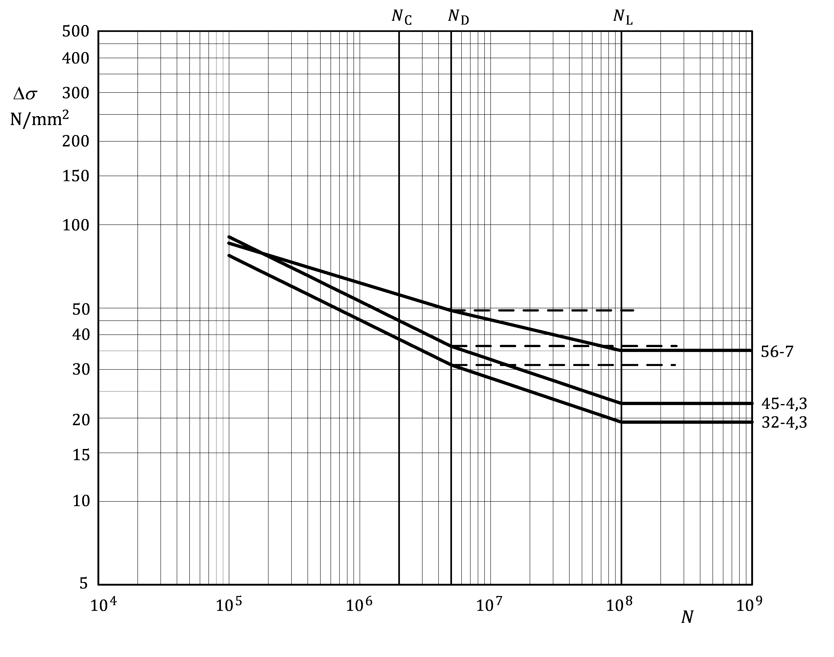

Figure J.9 — Fatigue strength curves for members with friction stir welds —   
detail categories as in Table J.17

Table J.18 — Numerical values of Δ*σ* (N/mm2) for members with friction stir welds —   
detail categories as in Table J.17

|  |  |  |  |  |  |  |  |  |  |
| --- | --- | --- | --- | --- | --- | --- | --- | --- | --- |
| Detail category | Slope | | Cycles *N* | | | | | | |
| ***m*1** | ***m*2** | **1 × 105** | **1 × 106** | 2 × 106 | **5 × 106** | **1 × 107** | **1 × 108** | **1 × 109** |
| **56–7** | **7** | **9** | 85,9 | 61,8 | **56** | 49,1 | 45,5 | 35,2 | 35,2 |
| **45–4,3** | **4,3** | **6,3** | 90,3 | 52,9 | **45** | 36,4 | 32,6 | 22,6 | 22,6 |
| **32–4,3** | **4,3** | **6,3** | 64,2 | 37,6 | **32** | 25,9 | 23,2 | 16,1 | 16,1 |

1. (informative)  
     
   Hot spot reference detail method
   1. Use of this Informative Annex

(1) This Informative Annex provides supplementary guidance to 7.2.4, 8.2.4 on the Hot spot reference detail method.

NOTE National choice on the application of this Informative Annex is given in the National Annex. If the National Annex contains no information on the application of this informative annex, it can be used.

* 1. Scope and field of application

(1) This Informative Annex gives guidance on use of the hot spot reference detail method which may be used in combination with Annex J to determine the reference hot spot strength values.

* 1. Hot spot reference detail method

(1) For the hot spot reference detail fatigue strength method, as defined in this Annex, data determined under the requirements of this document should be used.

(2) The calculation procedure is as follows:

a) select a reference detail with known fatigue resistance from the detail category tables, which is as similar as possible to the detail being assessed with respect to weld quality and to geometric and loading parameters;

b) identify the type of stress in which the fatigue resistance is expressed. This is usually nominal stress (as in the detail category tables);

c) establish a FEM model of the reference detail and the detail to be assessed with type of meshing and elements following the recommendations of 7.1;

d) apply as loading on the reference detail and the detail to be assessed the stress system identified in b);

e) determine the hot spot stress ranges Δ*σ*HS,ref of the reference detail and the hot spot stress ranges Δ*σ*HS,assess of the detail to be assessed;

f) the fatigue strength for 2 × 106 cycles of the detail to be assessed, Δ*σ*C,assess, is then calculated from the fatigue class of the reference detail Δ*σ*C,ref as given by Formula (K.1):

 (K.1)

g) assume for the detail to be assessed the same slopes *m*1, *m*2 as those of the reference detail.

(3) In case control measurements are performed to verify the calculated stresses, a correct positioning of the strain gauges outside the heat affected zone should be ensured.

1. (informative)  
     
   Guidance on use of design methods, selection of partial factors, limits for damage values, inspection intervals and execution parameters if Annex J is adopted
   1. Use of this Informative Annex

(1) This Informative Annex provides supplementary guidance to that in 4.2.2, A.5.3 on design methods, selection of partial factors, limits for damage values, inspection intervals and execution parameters if Annex J is adopted.

NOTE National choice on the application of this Informative Annex is given in the National Annex. If the National Annex contains no information on the application of this informative annex, it can be used.

* 1. Scope and field of application

(1) This Informative Annex gives guidance on use of design methods, selection of partial factors, limits for damage values, inspection intervals and execution parameters if Annex J is adopted.

* 1. Safe life design approach
     1. General

(1) This guidance is only applicable when the fatigue resistance data in Annex J is adopted.

(2) The safe life design approach should be used where there is no accessibility for fatigue inspection or where a fatigue inspection by other reasons is not presupposed.

NOTE SLD might give the most cost-effective solution if the cost of repair is assessed to be relatively high.

(3) If all design stress ranges are under the design constant amplitude fatigue limit, the condition given by Formula (L.1) should be fulfilled:

 (L.1)

NOTE For *γ*Mf, see L.6. For *γ*Ff, see 4.4.

(4) Stress range spectra may be modified by neglecting design peak values of stress ranges representing a contribution to the damage value (*D*L,d) of less than 0,01.

(5) One of two types of the Safe Life Design approach may be used: SLD-I and SLS-II, see L.3.2 and L.3.3.

* + 1. SLD-I

(1) When using SLD-I, a programme of regular inspection should not be undertaken.

NOTE Regular inspection covers both general inspection and fatigue inspection. See Table L.2 for clarification of the terms.

* + 1. SLD-II

(1) When using SLD-II, a programme for general inspection shall/should be undertaken, which should be prepared in accordance with L.5.

NOTE As the proper implementation of the inspection programme during maintenance is a presumption for design, it is important for the structure’s owner(s) to ensure that the inspection programme is followed during the lifetime of the structure.

* 1. Damage tolerant design approach
     1. General

(1) This guidance is only applicable when the fatigue resistance data in Annex J is adopted.

(2) One of two types of Damage Tolerant Design may be used: DTD-I and DTD-II, see L.4.2 and L.4.3.

* + 1. DTD-I

(1) DTD-I is based on any crack detected during inspection being repaired or the component being replaced.

(2) When using DTD-I, a programme for regular inspection should be prepared in accordance with L.5.

NOTE As the proper implementation of the inspection programme during maintenance is a presumption for design, it will be important for the owner(s) to ensure that the inspection programme is followed during the lifetime of the structure.

(3) One of the following options for DTD-I should be used:

a) for option DTD-IA, the structure should have sufficient redundancy, i.e. be statically indeterminate, to redistribute the load effects so that any initiated crack propagation stops, and the structure remains capable of carrying the redistributed load effects;

b) for option DTD-IB, the structure should have sufficiently large sections to carry the load effects after the first cracks detectable by naked eye have appeared. Such cracks should not lead to collapse of the structure. The residual capacity for the quasi-static design loads after cracking should be demonstrated. It should be required that in the event of detected cracks, the structure should be repaired or the crack growth stopped by efficient means.

(4) The DTD-I type of approach may be based on one of two methods to ensure sufficient resistance of the component or structure, based on:

a) linear damage accumulation calculation, see (5);

b) equivalent stress range, see (6).

(5) In DTD-I the design damage value *D*L for all cycles based on a linear damage accumulation should fulfil the condition of Formula (L.2):

*D*L,d ≤ 1 (L.2)

or Formula (L.3):

*D*L ≤ *D*lim (L.3)

where

|  |  |
| --- | --- |
| *D*L,d | = Σ*n*i/*N*i is calculated with the procedure in A.4; |
| *D*L | = Σ*n*i/*N*i is calculated with the procedure in A.4 but with *γ*Mf = *γ*Ff = 1,0. |

NOTE The values of *D*lim are those given in L.6 unless the National Annex gives different values.

(6) If design uses the equivalent stress range approach (Δ*σ*E,2e) the condition of Formula (L.4) should be met:

 ≤ 1 (L.4)

* + 1. DTD-II

(1)P DTD-II allows fatigue induced cracks in the structure, provided that the crack growth is monitored and kept under control by means of a fatigue inspection programme based on fracture mechanics.

NOTE For inspection programmes, see L.5.

(2) The minimum detectable crack size at potential crack initiation sites should be determined.

(3)P The structure shall have sufficient large sections to carry the design load effects after the first cracks detectable by naked eye.

(4) The stress histories at the crack initiation sites, followed by counting of stress intensity ranges and compilation of stress intensity spectra should be calculated.

(5) Based on (2) and (4), the crack growth relationship for the alloy should be used to calculate the crack growth rate through a fracture mechanics approach. Using this approach, the time taken for the minimum detectable crack size to grow to the maximum safe crack size should be estimated and accounted for in the specifications of the corresponding fatigue inspection programme.

NOTE Guidance on crack growth data are given in Annex B.

(6) The residual capacity for quasi-static design loads after cracking should be demonstrated.

(7) A programme for regular inspection and monitoring of any crack growth should be prepared based on (6). The time for starting the inspections and the longest inspection intervals should be specified, see L.5.

NOTE The last Note in L.3(2) applies.

(8) *D*L for DTD-II should satisfy Formula (L.5):

*D*L,d ≤ *D*lim (L.5)

where

|  |  |
| --- | --- |
| *D*lim | is greater than 1,0, but should be limited, see L.6. |

* 1. Start of inspection and inspection intervals

(1) This guidance is only applicable when the fatigue resistance data in Annex J is adopted.

(2) The inspection programmes should specify a time after erection for start of inspection and the inspection intervals.

NOTE The start of inspection and the inspection intervals are those given in Table L.1 unless the National Annex gives different values.

(3) For DTD-I, the value of *T*S to be used to determine *T*F and Δ*T*F should be calculated according to A.4.3(1). Unless otherwise specified, the time interval between the inspections should not exceed *T*S/4.

(4) For DTD-II the value of *T*S to be used to determine *T*F should be calculated according to A.4.3(1). Δ*T*F should be determined using fracture mechanics.

Table L.1 (NDP) — Recommended start of inspection and maximum inspection intervals

|  |  |  |  |  |
| --- | --- | --- | --- | --- |
| Design approach | Design procedure | Type of design approach | Recommended start of inspection a | Recommended maximum inspection intervals |
| Safe Life Design  SLD | Damage accumulation | SLD-I | - | - |
| SLD-II | *T*G = 0 | Δ*T*G = 6 years |
| Constant amplitude fatigue limit (i.e. max Δ*σ*E,d < Δ*σ*D,d) | SLD-I | - | - |
| SLD-II | *T*G = 0 | Δ*T*G = 6 years |
| Damage Tolerant Design  DTD | Damage accumulation | DTD-IA | *T*G = 0  *T*F = 0,5 *T*S | Δ*T*G = 6 years  Δ*T*F = 0,25 *T*S |
| DTD-IB | *T*G = 0  *T*F = 0,5 *T*S | Δ*T*G = 6 years  Δ*T*F = 0,25 *T*S |
| Damage accumulation and fracture mechanics | DTD-II | *T*G = 0  *T*F = 0,8 *T*S | Δ*T*G = 6 years  Δ*T*F determined by fracture mechanics |
| a *T*G is the recommended time after completed erection for start of general inspection. The general inspection comprises checking that the structure is as it was when it was completed and approved, i.e. that no deterioration has taken place, such as deterioration caused by adding detrimental holes or welds for additional elements, damage due to vandalism or accidents, unexpected corrosion etc. Δ*T*G is the recommended maximum time interval for general inspection. *T*F is the recommended time after completed erection for the start of fatigue inspection. The fatigue inspection comprises the inspection of areas with high probability for cracks. Δ*T*F is the recommended maximum time interval for fatigue inspection. | | | | |

* 1. Partial factors *γ*Mf and the values of *D*Lim

(1) This guidance is only applicable when the resistance data in Annex J is adopted.

(2) Fatigue assessment should be based either on a design fatigue strength value derived by using a partial safety factor *γ*Mf for the characteristic fatigue strength Δ*σ*if, or by defining a limit value *D*Lim for the design damage value *D*L, taking into account the consequence class and the design method used.

(3) The safety concept should be based on the application of *γ*Ff, *γ*Mf and *D*Lim and the requirements for the inspection programmes as given in L.5.

NOTE 1 The values of *γ*Mf, which are based on a value for *γ*Ff equal to 1,0, are given in Table L.2 (NDP) unless the National Annex gives different values.

NOTE 2 Execution class instead of consequence class as a criterion for selection of the value for *γ*Mf in Table L.2 (NDP) can be specified by The National Annex.

Table L.2 (NDP) — Recommended *γ*Mf – values in relation to the consequence class

|  |  |  |  |  |
| --- | --- | --- | --- | --- |
| Design approach | Design procedure | Consequence class | | |
| CC1 | CC2 | CC3 |
| *γ*Mfa b c d | *γ*Mfa b c d | *γ*Mfa b c d |
| SLD-I | Damage accumulation | 1,1 | 1,2 | 1,3 |
| Constant amplitude fatigue  (i.e. max Δ*σ*E,d < Δ*σ*D,d) | 1,1 | 1,2 | 1,3 |
| SLD-II | Damage accumulation | 1,0 | 1,1 | 1,2 |
| Constant amplitude fatigue  (i.e. max Δ*σ*E,d < Δ*σ*D,d) | 1,0 | 1,1 | 1,2 |
| DTD-I | Damage accumulation | 1,0 | 1,0 | 1,1 |
| DTD-II | Damage accumulation | 1,0 | 1,0 | 1,1 |
| a The values of the table may be reduced according to footnotes a to d below, provided that the value of *γ*Mf does not become less than 1,0.  b The above tabled *γ*Mf-values may be reduced by 0,1 if one of the following conditions apply:  – non-welded areas of welded components; – detail categories where Δ*σ*C < 25 N/mm2;  – welded components where the largest stress range represents all cycles;  – additional NDT for a minimum of 50 % is carried out. For adhesively bonded joints, see E.2(6).  c The above tabled *γ*Mf-values may be reduced by 0,2 if one of the following conditions apply: – non-welded areas of welded components where the largest stress range represents all cycles;  – detail categories where Δ*σ*C < 25 N/mm2 and where the largest stress range represents all cycles; – non-welded components and structures; – additional NDT for a minimum 50 % is carried out, where the largest stress range represents all cycles;  – if additional NDT of 100 % is carried out.  d The above tabled *γ*Mf-values may be reduced by 0,3 if one of the following conditions apply: – non-welded components and structures where the largest stress range represents all cycles; – additional NDT for 100 % is carried out where the largest stress range represents all cycles. | | | | |

(4) The values of the safety element *D*Lim should be specified.

NOTE The values for *D*Lim are within the range of Formula (L.6) unless the National Annex gives different value:

 (L.6)

(5) For DTD-II the Value of *D*lim is larger than 1 but should be limited.

NOTE Values for *D*lim are 2,0 for welded, bolted or riveted details and 4,0 for plain parts, unless the National Annex gives different values.

* 1. Parameters for execution
     1. Service category

(1) If the resistance data of Annex J are adopted, the criteria a), b) or c) below should be used to classify components as service category SC1:

a) if the largest nominal stress range Δ*σ*E,k satisfies Formulas (L.7) and (L.8):

 for parent material (including HAZ and butt welds); (L.7)

 for fillet welds, (L.8)

where

|  |  |
| --- | --- |
|  | values for *γ*Mf for SLD-I should be used: |
| *Δσ*E,k | is the characteristic value of the action effect (stress range). |

b) for cases of fatigue loading spectra (Δ*σ*E,k,i), if L.7.2 is used to calculate the fatigue utilization grade U, and U does not exceed the value 1,0 where the fatigue resistance is based on:

— for parent material (including HAZ and butt welds), detail category 18-3,4;

— for fillet welds, detail category 12-3,4.

Values of *γ*Mf for SLD-I should be used. For cases where the largest stress amplitude represents all cycles, the values may be reduced by 0,1.

c) for cases where the limit values according to the criteria of a) or b) are exceeded, and if the fatigue utilization grade *U* according to L.7.2 does not exceed the value of 0,5, and where the fatigue resistance is based on the lowest values for the following cases:

— for parent material (not influenced by welding), detail category 71-7;

— for continuous longitudinal welds (stress direction parallel to weld axis), detail category 40-4,3;

— for butt welds, detail category 36-3,4.

Values of *γ*Mf for SLD-I should be used. For cases where the largest stress amplitude represents all cycles, the values may be reduced by 0,1, but with the resulting *γ*Mf not less than 1,0.

NOTE Other or additional criteria for defining the service category can be given in the National Annex .

* + 1. Calculation of utilization grade

(1) This clause gives provisions for calculation of the utilization grade U for components subject to fatigue, if fatigue resistance data according to Annex J have been used for design and EN 1090‑3:2019, Annexes K and L have been selected for specifying quality and inspection requirements. The calculated values are used to distinguish between the two service categories SC1 and SC2.

NOTE 1 Service category is defined in EN 1090‑3:2019 as “Category that characterises a component or structure in terms of the circumstances of its use”. Service category 1 (SC1) concerns predominantly static loading or seismic ductility DC1. Service category 2 (SC2) concerns Fatigue or seismic ductility DC2. See prEN 1999‑1‑1:20211, Annex A.

NOTE 2 EN 1090‑3 gives the criteria for determination of the scope of inspection and the quality level requirements for the two service categories as well as quantitative criteria for inspection of welds, depending on the execution class and the utilization grade.

(2) The utilization grade for fatigue for a constant stress range for a limited number of cycles *n* should be calculate from Formula (L.9):

 (L.9)

where

|  |  |
| --- | --- |
| Δ*σ*E,k | is the characteristic stress range (for combined stress, the principal stress) in the section under consideration for a given number of cycles *n*; |
| Δ*σ*R,k | is the corresponding strength range value of the relevant fatigue strength curve for the given number of cycles *n*. |

(3) For the case of fatigue with all stress ranges less than Δ*σ*D and an unlimited number of cycles, the utilization grade should be calculated from Formula (L.10):

 (L.10)

where

|  |  |
| --- | --- |
| Δ*σ*E,k | is the largest stress range; |
| Δ*σ*D | is the constant amplitude fatigue limit. |

(4) If the calculation is based on the equivalent constant amplitude stress range Δ*σ*E,2e the utilization grade should be calculated from Formula (L.11):

 (L.11)

where

|  |  |
| --- | --- |
| Δ*σ*C | is the fatigue strength for 2 × 106 cycles. |

(5) If the utilization grade *U* is based on the calculation of fatigue damage values according to linear damage accumulation, its value may, for the purpose of this Annex, be calculated by Formula (L.12):

 (L.12)

where

|  |  |
| --- | --- |
| *D*L,d | is calculated according to 4.3.1 and 8.2.1. |

Bibliography

References contained as information (e.g. through “can” clauses):

[1] EN ISO 4287, Geometrical product specifications (GPS) - Surface texture: Profile method - Terms, definitions and surface texture parameters (ISO 4287)

[2] EN ISO 4288, Geometrical product specifications (GPS) - Surface texture: Profile method - Rules and procedures for the assessment of surface texture (ISO 4288)

[3] EN ISO 10042:2018, Welding - Arc-welded joints in aluminium and its alloys - Quality levels for imperfections (ISO 10042)

[4] EN ISO 25239‑5, Friction stir welding - Aluminium - Part 5: Quality and inspection requirements (ISO 25239-5)

[5] EN 1999‑1‑2, Eurocode 9 - Design of aluminium structures - Part 1-2: Structural fire design

[6] EN 1999‑1‑4, Eurocode 9 - Design of aluminium structures - Part 1-4: Cold-formed structural sheeting

[7] EN 1999‑1‑5, Eurocode 9 - Design of aluminium structures - Part 1-5: Shell structures