NATIONAL ANNEX

TO

CYS EN 1991-1-3:2025

Eurocode 1: Actions on Structures

Part: 1-3 Snow Loads

CYS EN 1991-1-3:2025

For Public Enquiry– April 21, 2026

Prepared by: CYS TC 18 EUROCODES

Cyprus Organisation for Standardisation (CYS)

INTRODUCTION
This National Annex has been prepared by the CYS TC 18: Eurocodes National Standardisation Technical Committee of Cyprus Organisation for Standardisation. (CYS)

NA 1.1 SCOPE
This National Annex is to be used together with CYS EN 1991-1-3:2025. Any reference in the rest of this text to CYS EN 1991-1-3 means the above document.
This National Annex gives:
- Nationally determined parameters for the following clauses of CYS EN 1991-1-3:2025 where National choice is allowed (see Section NA 2)
- 4.3(1)
- 6.1(1) - 2 choices
- 6.1(3) - 2 choices
- 6.2(1)
- 7.2(4)
- 7.3(2)
- 7.4(1)
- 7.4(2) - 2 choices.
- 7.4(3)
- 7.5.2.2(1)
- 7.5.3(3)
- 7.5.3(4)
- 7.5.4(2)
- 7.5.7(4) - 2 choices
- 8.1(1) - 2 choices
- 8.2(1)
- 8.3(1)
- 8.4(1)
- 8.4(3) - 2 choices
- 8.6(1)
- Guidance on the use of Informative Annexes A, B and C (see Section NA 3)
- References to non-contradictory complementary information to assist the user to apply CYS EN 1991-1-3:2025. In this National Annex such information is provided for the following clauses in CYS EN 1991-1-3:2025 (see Section NA 4)

NATIONALLY DETERMINED PARAMETERS

Clause 4.3(1) Exceptional conditions
No locations with exceptional conditions are specified.

Clause 6.1(1) Characteristic Values
The characteristic value of snow load (sk) shall be obtained from equation
sk=0.289*[(1+(A/452)² ]
Where:
sk: is the characteristic snow load on the ground (KN/m2)
A: is the site attitude above sea level (m)

No rules for the treatment of snow loads for altitudes above 1 500 m provided in this National Annex.

Clause 6.1(3) Effects of climate change
The effects of climate change are taken into account by multiplying the characteristic value of snow load on the ground (s_{k}) by a scaling factor, f_{s,cc}, greater than or equal to 1.
No further guidance provided for minimum values for the scaling factor f_{s,cc} in this National Annex.

Clause 6.2(1) Treatment of exceptional snow loads on the ground
The value of coefficient for exceptional snow loads C_{esl} is equal 2,0.

Clause 7.2(4) Determination of snow load
The rain-on-snow surcharge s_{R} is 0,25 kN/m² for s_{k} ≤ 0,75 kN/m² and (1,0 kN/m² - s_{k}) for 0,75 < s_{k} ≤ 1,0 kN/m².

Clause 7.3(2) Exposure coefficient
The wind exposure conditions, and the corresponding values of C_{e} are given in Table 7.1 (CYS).

Table 7.1 (CYS) — Values of C_{e} for different wind exposure conditions
Wind exposure conditions | C_{e}
Windsweptª | 0,8
Normal^{b} | 1,0
Sheltered^{c} | 1,2
ª Windswept: flat unobstructed areas exposed on all sides without, or little shelter afforded by terrain, higher construction works or trees, e.g. as terrain category 0, I and II defined in EN 1991-1-4. The wind velocity (at the height of 10 m above flat open country terrain, 10-min mean) in windswept sites averaged over the coldest month of the year is assumed to be higher than 4,5 m/s. For lower mean wind velocity Normal conditions apply.
^{b} Normal: areas where there is no significant removal of snow by wind on construction work, because of terrain, other construction works or trees, e.g. as terrain category III defined in EN 1991-1-4.
^{c} Sheltered: areas in which the construction work being considered is considerably lower than the surrounding terrain or surrounded by high trees and/or surrounded by higher construction works.

Clause 7.4(1) Thermal coefficient
For cases other than those described in (2) and (3) the value of C_{t} is equal to 1,0.

Clause 7.4(2) Thermal coefficient
Locations where the duration of the snow load is long enough can be selected on the basis of the characteristic snow load on the ground greater than a threshold value s_{k,min}, s_{k,min} is 1,5 kN/m².
Note 2: Based on the thermal insulating properties of the roof and the geometry of the construction work, a reduced Ct value below 1,0 can be used, assuming that a meltwater drainage system preventing melt water to accumulate on the roof is provided and maintained.

Clause 7.4(3) Thermal coefficient
For buildings where the internal temperature is intentionally kept below 0 °C the value of coefficient C_{t} is equal to 1.2.

Clause 7.5.2.2(1) Snow load shape coefficients
The value of snow weight density γ is equal to 2kN/m³.(see also information in Annex G).

Clause 7.5.3(3) Snow load shape coefficients
The value of δ_{w} is equal to 0,16

The value of δ_{w} is equal to 0,16. Clause 7.5.3(4) Snow load shape coefficients
The value of coefficient μ_{2,p} is equal to γh_{p}/(C_{t} s_{k}) where γ is defined in subclause 7.5.2.2(1) and h_{p} is defined in subclause 8.3(1).

Clause 7.5.4(2) Snow load shape coefficients
The value of coefficient μ_{3max} is equal to 1,6.

Clause 7.5.7(4) Snow load shape coefficients
The value of μ_{w,M} is 4.
Limiting values to l_{s} are set to 5 m ≤ l_{s} ≤ 15 m.

Clause 8.1(1) Local Effects
No further guidance is provided on which design situation applies for a particular local effect.
Local effects can be relevant for the design of members in the vicinity of obstructions, parapets, snow fences, snow guards, etc. and are generally not relevant for the global verification of the structure. No further conditions for local verifications are provided.

Clause 8.2(1) Local Effects
The range for μ₆is : μ₁ ≤ μ₆ ≤ 2.

Clause 8.3(1) Local Effects
The value of μ_{7max} is 4,0.

Clause 8.4(1) Local Effects
The value of altitude A is 800 m.

Clause 8.4(3) Local Effects
In Formula (8.5) γ is taken as 3 kN/m³
In Formula (8.5) k is taken as 3/d, but k ≤ d γ, where d is the depth of the snow layer on the roof in meters (see Figure 8.3 (CYS))
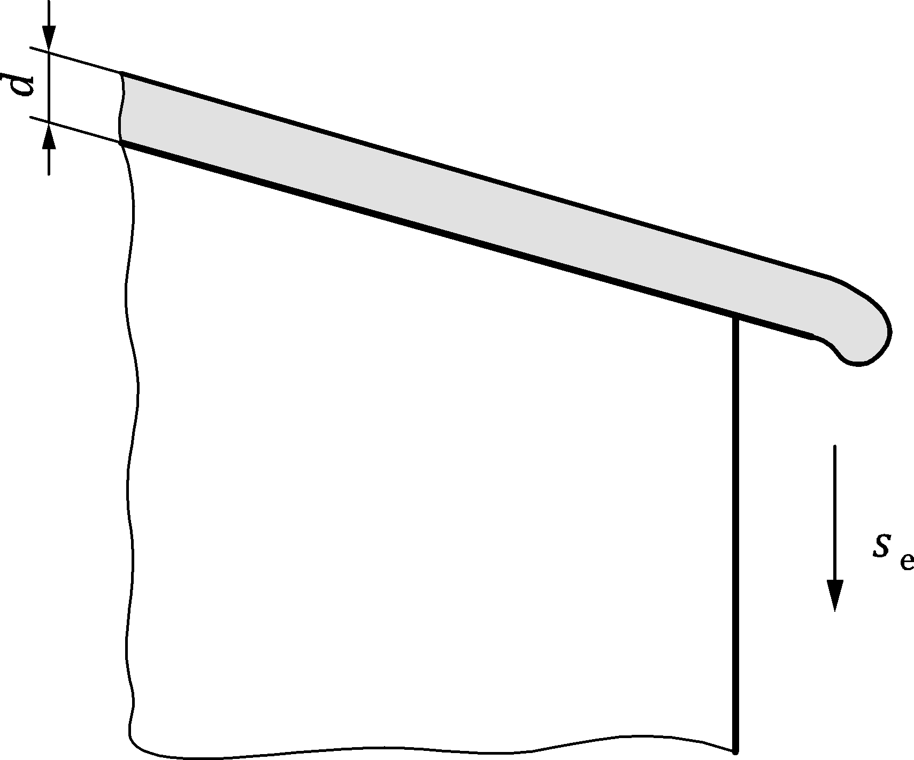

Figure 8.3(CYS) — Snow overhanging the edge of a roof

Clause 8.6(1) Snow loads at intersecting pitched roofs
- The coefficient μ_{8max} is taken as 1,6.

DECISION ON USE OF THE INFORMATIVE ANNEXES A, B and C

Annex A
Annex A may be used

Annex B
Annex B may be used

Annex C
Annex C should be used

REFERENCES TO NON-CONTRADICTORY COMPLEMENTARY INFORMATION
None

